

# Introduction

**The European economy is growing for the seventh consecutive year.** During the Juncker Commission, investment has gone back to pre-crisis levels; the number of people in employment has reached the highest level ever recorded and public debt has declined overall.

**The European economy will continue its expansion this and next year, with all Member States registering positive rates of growth, despite less favourable conditions.** The European economy was affected last year by global weaknesses in a context of persistent trade tensions, elevated uncertainty and a significant tightening of international financial conditions at the turn of the year. Domestic demand should continue to be the main driver of economic growth this and next year, supported by further rises in employment and incomes, low financing costs and supportive fiscal measures in some Member States.

**Effective structural reforms, accompanied by well-targeted investment strategies and responsible fiscal policies, continue to provide a successful compass for modernising the European economy.**  The country-specific recommendations adopted in the context of the European Semester provide guidance to Member States to respond adequately to persisting and new challenges and deliver on their shared key policy objectives. It is crucial in the context of the European Semester to continue the push for the “virtuous triangle” of boosting investments, pursuing effective reforms that foster sustainable and inclusive growth, and sound fiscal policies. Country-specific recommendations also include guidance on strengthening the performance and governance of our Economic and Monetary Union as well as the resilience of euro area economies in line with the 2019 recommendation on the economic policy of the euro area[1], and advancing social convergence in line with the European Pillar of Social Rights.

**The weaknesses in global growth reinforce the need to continuously tackle the structural challenges of the EU economies.** A stronger reform implementation and prioritisation of reforms are crucial to strengthen the resilienceand growth potentialof our economies in view of the mounting economic risks and uncertainty. This includes increasing the impact and scale of innovation and ensuring the quality and labour market relevance of skills. Fostering social inclusion, protecting and promoting investment, and raising the quality of public finances are key to smoothen the impact of slower growth on employment and inequality. The slowing economic momentum also underscores the need for a more symmetric rebalancing across the euro area. Member States should continue to improve the sustainability of public finances in particular where debt ratios are high. At the same time, those Member States with available fiscal space and low levels of investments should use it to support growth potential. Strengthening the single market and improving the complementarities between single market policies and national structural reforms will contribute to improving the productivity and resilience of the EU economy. On the global level, the renewed EU strategy on China highlights major opportunities for job creation and growth in Europe[2].

**Investment and reforms need to go hand in hand.** With this package, the Commission particularly aims to ensure that investment and reforms are further aligned and provide a more coherent policy framework. In line with the enhanced Commission analysis on investment needs and bottlenecks faced by each Member State in the country reports, the 2019 country-specific recommendations include a stronger focus on investment.

**While not all investment needs can be addressed by EU funds, these provide considerable opportunities to addressing the concrete investment gaps identified in the country-specific recommendations.** With the more effective policy link between the European Semester and EU funding for 2021-2027 as set out in the Commission’s proposals for the next EU multiannual financial framework, EU financial programmes like InvestEU, Connecting Europe Facility, Horizon Europe and Cohesion Policy Funds provide significant opportunities. In particular, the exercise of programming the next EU cohesion policy funds is crucial. The dialogue with national and regional authorities on how to better use the European Structural and Cohesion Funds[3] at national level for the period 2021-2027 has just started and the country-specific recommendations, together with the Country Reports, provide the analytical framework for a successful programming.

# Economic outlook, overall progress in reforms and correcting imbalances

**The European Union’s economy is expected to continue growing this and next year, albeit at a slower pace.** The expected slowdown in the economic growth in 2019 is partly due to the sizeable negative impact of the external environment on export-oriented sectors. Some country- and sector-specific factors (e.g. in the car industry) have also affected manufacturing figures in some large European economies. Domestic policy uncertainty and reform reversal has weighted on confidence and growth prospects in some countries. Additional jobs, coupled with moderately rising wages for employees, are expected to support consumption and economic activity while uncertainty about economic prospects keeps weighing on sentiment. Investment is set to continue expanding, but at a slower pace due to the less favourable external environment and the levels of uncertainty regarding trade policies. Overall, favourable financing conditions and supportive fiscal measures in some Member States should further sustain domestic demand growth.

**While the fundamentals have significantly improved in recent years, we need to continue improving the resilience and growth potential of the European econom**y.It is crucial to raise potential growth and reinforce the fiscal space to counter future negative economic shocks. Given the large and interrelated risks surrounding the economic outlook, efforts need to be stepped up to address structural challenges and weaknesses that the softening economic momentum may bring more to the fore. Promoting and protecting investment in education and skills, quality infrastructure and innovation will simultaneously strengthen the growth potential of our economies and support aggregate demand. Fostering respect for the rule of law, in particular independent justice systems and robust anti-corruption frameworks is also crucial in this context. As regards public finances, high-debt countries should pursue policies that increase fiscal buffers and put debt ratios on a sustained downward path. At the same time, it is important to use now the fiscal space where it exists. Specific attention should be paid to the growth-friendliness and redistributive effects of expenditures and the tax system in all Member States. Finally, a more symmetric rebalancing across the euro area will contain the negative impact of debt deleveraging on growth and make our economic performance depend less on external demand.

**More than two thirds of the country-specific recommendations issued until 2018 have been implemented with at least ‘*some progress’*** (see Figure 1).Implementation of the various recommendations agreed with Member States since 2011 continues on a stable path. In some cases there is evidence of backtracking on elements of major reforms adopted in the past. Most progress has been achieved in financial services, followed by progress with legislation governing labour relations and employment protection. Progress has been particularly slow on broadening the tax base, health and long-term care, as well as on competition in services.

*Figure 1: Level of implementation today of 2011-2018 CSRs*

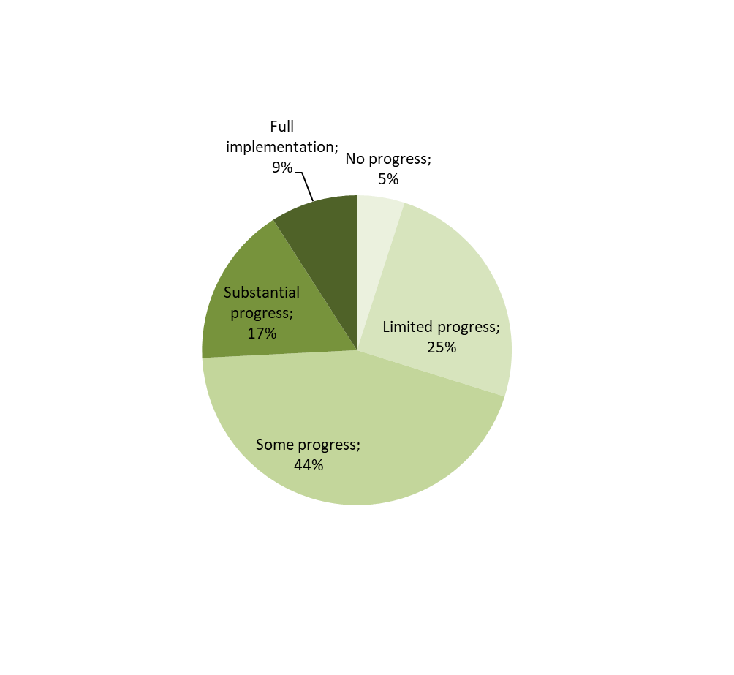

*Note: The multiannual assessment looks at implementation from the time the recommendations were first adopted until publication of this Communication in May 2019. The overall assessment of the country-specific recommendations related to fiscal policy includes compliance with the Stability and Growth Pact.*

**Looking at reform progress from an annual perspective, Member States have made at least '*some progress'* in 4 out of 10 of the recommendations addressed to them in July 2018** (see Figure 2). This performance is worse than in previous years. Since the assessment carried out in the context of the country reports in February, no significant further reform progress has been made from an aggregate perspective. This however hides differences across Member States and policy areas. Reform implementation continues to be strong in financial services, even if progress is somewhat smaller compared to the bold steps taken in the immediate aftermath of the crisis. Progress remains low in addressing recommendations about broadening the tax base and strengthening competition in services. In view of the remaining economic and social challenges and downside risks to the economic outlook, stronger reform implementation is crucial to strengthen the resilience of EU economies.

*Figure 2: Implementation of country-specific recommendations: annual assessment in each consecutive year since 2011 versus implementation to date*

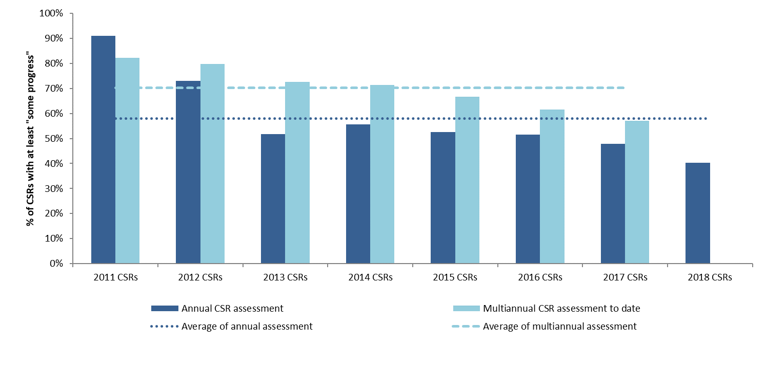

*Note: The multiannual assessment looks at implementation from the time the recommendations were first adopted until publication of this Communication in May 2019. For the years 2011 and 2012 it is more difficult to compare the annual with the multiannual assessment due to different assessment of categories of the country–specific recommendations.*

**The progress in the correction of macroeconomic imbalances continues but further policy action is needed.** Some Member States continue to record private and public debts at historically high levels, which reduce the latitude for manoeuvre to address negative shocks. Some other Member States see signs of possible overheating related to the dynamic house price growth and raising unit labour costs. The rebalancing of external positions remains incomplete. While large external deficits have been corrected, large current account surpluses despite some modest signs of adjustment persist in several countries. The large euro area current account surplus remains broadly unchanged, reflecting on the one hand aggregate domestic demand lagging behind economic activity, and improved competitive position with sustained exports on the other. Further rebalancing requires differentiated responses. Member States with current account deficits or high external debt need to sustain improvements in competitiveness, while Member States with large current account surpluses should strengthen the conditions that support higher wage growth and investment. For all Member States, measures to enhance productivity and increase investment are key to promote higher potential growth.

# Key objectives of the 2019-2020 recommendations

**The overall objective of the recommendations is to encourage the Member States to increase their growth potential by modernising their economies and further strengthen their resilience.** Given the expected slowdown, all Member States should prioritise reforms aiming at sustainable and inclusive growth. Moreover, the increasingly digitalised and globalised economies require smarter investments in relevant infrastructure, innovation, education and skills. Furthermore, digitalisation, the changing labour market and ageing population and the greening of the economy require additional efforts to support the creation of quality jobs and ensure sustainable, adequate and inclusive social welfare systems.

**National socio-economic trends hide regional differences that are significant in some countries.** Looking backward, the benefits of economic growth have not spread equally across regions. Looking forward, the socio-economic challenges of the future do not affect all parts of society in the same way. Thus, building upon the findings of the 2019 country reports, this year’s recommendations have references to regional and territorial disparities where relevant. The aim is to better identify specific investment needs and promote accelerated economic and social convergence with the help of those investments that will be co-financed by the EU cohesion policy funds in the period 2021-2027.

**Increasing uncertainties in global markets are underlining the importance of the single market.** The good functioning of the single market is essential to facilitate high quality inputs to firms at a competitive price and to offer large and liquid markets to EU goods and services providers. The relatively lower level of integration in service markets has been the subject of attention in the past, but the pace of reforms has often been disappointing. The opportunity cost of insufficient integration in service markets is increasing and these costs spill over across Member States. In addition, improvements are also possible in some areas of goods markets, especially in the application of mutual recognition. Creating a genuine single market for capital in Europe through the Capital Markets Union will increase the ability of the financial system to absorb shocks, by diversifying access to funding for businesses, and promote new investment opportunities. The consolidation of the single market requires additional reform efforts at Member State level to make progress in the integration of its digital, energy, capital and transport dimensions. For instance, Italy is recommended to improve the quality of its infrastructure, taking into account its regional disparities.

**In February 2019, the Commission identified imbalances in 13 Member States.** Country-specific recommendations need appropriate follow-up to address these imbalances.Based on in-depth reviews, the Commission concluded that 10 Member States experience imbalances for the purposes of the macroeconomic imbalance procedure (Bulgaria, Croatia, France, Germany, Ireland, Portugal, the Netherlands, Romania Spain, and Sweden) and three Member States experience excessive imbalances (Cyprus, Greece, and Italy).[4]

* In the case of Croatia, it was concluded that the imbalances are no longer excessive in view of improvements in the economic situation and policy progress.
* Greece was subject to an in-depth review for the first time after having exited the financial assistance programme and policies to address imbalances are monitored under an enhanced surveillance framework for post-programme surveillance.
* In Cyprus, significant vulnerabilities persist despite an improved economic context and some recent stepping up of policy commitments.
* In Italy, prospects for growth and public finances have worsened, and recent policy measures enacted backtrack on elements of previous reforms, including relating to the pension system. The Commission announced in February that since the aggravation or alleviation of macroeconomic imbalances for Italy will crucially depend on future policy action, it will monitor closely the commitments taken by Italy to address its imbalances. In this respect, Italy’s 2019 National Reform Programme only partly addresses the structural issues raised by the 2018 country-specific recommendations, and details on the few new commitments it contains, as well as on the timeline for their implementation, are often missing. However, its reform strategy builds on major reforms already in the pipeline in different areas, showing broad continuity compared to past National Reform Programmes.

As in previous years, specific monitoring under the macroeconomic imbalance procedure will also take place for all countries with identified imbalances or excessive imbalances.

*Public finances and taxation*

**Government debt is declining, but progress is uneven among Member States.** Some have insufficiently taken advantage of the favourable cyclical conditions and low interest rates in recent years to rebuild fiscal buffers. Others have reached sound budgetary positions, providing them with fiscal space to support investment. On aggregate, the euro area fiscal stance remained broadly neutral over 2015–2018 and, based on the Commission forecast, it is projected to become slightly expansionary in 2019.

**Government debt remains high in several Member States.** The impact of an ageing population poses additional challenges and calls for continued reforms of the pension, healthcare and long-term care systems to increase their efficiency, effectiveness and adequacy and preserve their long-term fiscal sustainability. Pension reforms aimed at adapting the balance between working life and retirement and supporting complementary retirement savings remain essential. Where necessary, welfare system reforms need to be agreed promptly taking into account their impact on the affected groups. Experience has proven that those areas are among the most challenging to reform, which is why the reform process need to be set in motion without delay. At the same time, it needs to entail an enhanced consultation with stakeholders from the start. Reform reversals should be clearly avoided and corrected as this could jeopardise fiscal sustainability, reduce growth potential and intergenerational fairness.

**The strengthening of fiscal sustainability of the euro area and its Member States requires differentiated national fiscal policies.** Available fiscal space and spillovers across countries need to be taken into account. Member States with still high levels of public debt should continue to rebuild fiscal buffers. Doing so would reduce their vulnerability to shocks and allow for the full functioning of automatic stabilisers in the next downturn. The country-specific recommendations set a required fiscal adjustment effort consistent with the Stability and Growth Pact for Member States that have not yet reached their medium-term budgetary objective. Member States with adequate scope are also recommended to use fiscal and structural policies within the rules of the Stability and Growth Pact to increase public investment to support growth and facilitate economic rebalancing.

**Improving the quality of public spending could enhance the ability of public finances to support growth and social cohesion.** Moving towards a structure of public expenditure and revenue that favours education, employment and investment is a means to increase the growth potential. Alongside efforts to keep expenditure in check and improve efficiency, steps towards a growth-enhancing composition of public spending should therefore continue. Provided they are well designed and rigorously implemented, spending reviews are an effective tool to improve the composition of public expenditure, including by expanding the room for productive and well-targeted public investment. While a large number of Member States has already embarked on various types of spending reviews (e.g. Cyprus, Estonia, Luxembourg, Slovakia and Spain), there is still scope to increase the use of such processes, expand their scope, improve the underpinning methodology and better link the reviews with the budgetary cycle. Finally, as in some Member States reviews have been successful in identifying areas for improving spending efficiency, it is necessary to translate those findings into policy action.

**Over the years, Member States have significantly improved their fiscal frameworks and in many countries they support the conduct of sound fiscal policies.** There is however a number of Member States where reforms have to continue with a view to establishing a well-designed and effective fiscal framework. Croatia and Spain are recommended to reinforce their budgetary frameworks, Austria and Belgium require further improvements of their fiscal coordination arrangements, whereas further strengthening of budgetary procedures is warranted in Poland. At the same time, in other Member States, reforms have stalled and a new impetus is necessary to revive the reform efforts. In addition, continuous focus on implementation is key everywhere to ensure that fiscal frameworks deliver on their objective of achieving or maintaining sound fiscal policy.

**Tax and benefit systems can help support inclusive growth.** Well-designed tax and benefit systems can support private investment and improve the business environment, encourage labour market participation and employment, reduce inequalities and contribute to a socially and environmentally resilient economy. In this light, several Member States received a recommendation to shift the tax burden away from labour to encourage more sustainable economic growth.

**As the fight against aggressive tax planning is a priority, the Commission has presented legislative proposals to make the tax system more transparent, effective and coherent.** The transposition of EU legislation and of internationally agreed initiatives will help curtailing aggressive tax planning practices. Certain features of some Member States’ tax systems, i.e. Cyprus, Hungary, Ireland, Luxembourg, Malta and the Netherlands however, may be used by companies that engage in aggressive tax planning.

|  |
| --- |
| Box 1. Update on surveillance under the Stability and Growth Pact  Based on the assessment of the 2019 Stability and Converge Programmes, the Commission has also taken a number of steps under the Stability and Growth Pact.  The Commission recommends that the excessive deficit procedure is closed for Spain. There would be no more Member States under the corrective arm of the Pact.  The Commission has adopted reports for France, Belgium, Cyprus and Italy under Article 126(3) TFEU, in which it reviews their compliance with the deficit and debt criteria of the Treaty. For France, the deficit and debt criteria should be considered as currently complied with. For Belgium, the current analysis is not fully conclusive as to whether the debt criterion is or is not complied with. Regarding Cyprus, the Commission considers that further steps leading to a decision on the existence of an excessive deficit should not be taken. In the case of Italy, the analysis suggests that the debt criterion should be considered as not complied with and that a debt-based Excessive Deficit Procedure is thus warranted.  The Commission also recommends the Council to decide that Hungary and Romania have not taken effective action in response to the Council Recommendation of December 2018 under the significant deviation procedure. For Romania, the latter was opened in June 2017 following the observed significant deviation in 2016. For Hungary, the significant deviation procedure was opened in June 2018 following the observed significant deviation in 2017. Furthermore, the Commission is addressing warnings to Hungary and Romania on the existence of a significant deviation from the adjustment path toward the medium-term budgetary objective in 2018. This is the third warning addressed to Romania and the second one for Hungary. The Commission recommends the Council to adopt a recommendation for Hungary and Romania to respond appropriately with a view to correcting this significant deviation. |

*Labour market, education and social policies*

**Labour market conditions keep improving.** EU employment rate figures are at record high levels, and unemployment is at a record low this century. At the same time there are still considerable divergences between countries, regions and population groups. In order to improve the functioning of the labour market, targeted interventions to strengthen the effectiveness of active labour market policies and/or to reinforce the capacity of employment services are recommended to Belgium, Bulgaria, Cyprus, Finland, Greece, Hungary, Ireland, Slovenia and Spain. Poland, Portugal and Spain should tackle the high share of workers on temporary contracts, while promoting transitions towards open-ended jobs.

**Participation of women in the labour market continues to grow, but gender inequalities in terms of employment and pay persist.** This is often caused by disincentives to work, insufficient work-life balance arrangements or a lack of affordable childcare and long-term care facilities. Recommendations on these issues have been addressed to Austria, the Czech Republic, Estonia, Germany, Ireland, Italy, Poland, and Slovakia.

**Access to quality education and training is key to provide skills and competences to all citizens, in a life-long learning perspective that takes into account future needs**. Investing in human capital is key to boosting knowledge-intensive, sustainable and inclusive growth, in a context of rising skills shortages and mismatches and a changing world of work. Nevertheless, skills levels remain low for several population groups. A large number of Member States are therefore recommended to strengthen and modernise their education and training systems. A future-oriented acquisition of skills, including measures to promote adult learning, should be considered for instance in Bulgaria, Croatia, the Czech Republic, Estonia, France, Greece, Ireland, Italy, Latvia, Lithuania, Poland, Portugal, Slovakia and Slovenia. Recommendations have been addressed to Belgium, Bulgaria, Cyprus, Croatia, Greece, Lithuania, Portugal, Romania and Spain to improve labour market relevance of their education and training systems. Spain is also recommended to reduce early school leaving and Cyprus, Greece and Latvia to increase the capacity of vocational education and training. Additional efforts to improve quality and inclusiveness of education and training systems, with particular attention to disadvantaged groups are needed in several Member States, while the Czech Republic and Italy should strengthen the attractiveness of the teaching profession.

**The social situation continues to improve, but gaps in coverage of social protection systems and access to services persist.** Poverty is declining, but it remains high in some Member States. In-work poverty is also a challenge in several Member States. Moreover, some disadvantaged groups, such as people with disabilities and people with a migrant background, face persistent challenges. Ensuring adequate access to social protection for non-standard workers and self-employed is crucial for the wellbeing of the workforce and well-functioning labour markets. Measures to improve the coverage, adequacy or effectiveness of the social safety net, including minimum income schemes, are recommended to Bulgaria, Estonia, Hungary, Latvia, Portugal, Romania and Spain, while the completion of more comprehensive reforms of welfare benefits are recommended to Croatia and Greece. A better access to quality social services is needed in Bulgaria, Estonia and Finland. A recommendation to the Netherlands aims to promote adequate social protection for the self-employed. Specific recommendations to promote support to people with disabilities are addressed to the Czech Republic and Latvia.

**Reforms of the health systems are ongoing in several countries to ensure the accessibility of healthcare for all, while enhancing their cost-effectiveness and sustainability.** Member States should continue their efforts, giving priority to the careful design of comprehensive measures and to stepping up the adoption and implementation of health service delivery reforms. Further investment is often necessary to support and implement reforms of the health systems. In that light, recommendations to improve effectiveness, accessibility and sustainability of health care are addressed to Austria, Bulgaria, Cyprus, the Czech Republic, Greece, Finland, Hungary, Italy, Latvia, Lithuania, Malta, Poland, Romania, Slovakia and Slovenia.

**Social dialogue is a key factor for a successful design and implementation of policies*.*** The involvement of social partners and other stakeholders improves ownership of policies and leads to better and more sustainable policy outcomes. Following up on past country-specific recommendations, some Member States have increased opportunities for structured dialogue and the participation of employers’ organisations and trade unions. While there is no single model that serves as a reference, there is room for a better functioning social dialogue and a greater involvement of social partners in policy design in several other Member States such as Hungary, Poland and Romania whilst important challenges also remain in Croatia and Greece.

*Investment, competitiveness policies, and improved business environment to deliver higher productivity*

**In line with the progress of the Investment Plan for Europe, i.e. the “Juncker Plan”, developing a comprehensive EU investment policy agenda remains crucial to address current and future growth.** Since the launch of the Investment Plan for Europe, substantial private and public funds have been and continue to be mobilised for investments across strategic sectors of the EU economy, which gave a substantial boost to growth and job creation. As of May 2019, the Juncker Plan is set to trigger close to EUR 400 billion in investments and create 750.000 jobs with the figure set to rise to 1.4 million jobs by 2020. In addition to unlocking investments, the Juncker Plan created relevant project pipelines and focused on measures making the business environment more conducive to investment.

**The EU Cohesion Policy Funds should be utilised in an optimal way to enhance investments in the relevant policy areas.** This should also help decrease persistent regional disparities across the EU. Against this background, this year’s country reports and country-specific recommendations provide specific guidance to inform the programming of EU funds under the next multiannual financial framework.

**This year’s focus on investment in the analysis of the European Semester has helped to single out those investment priorities in the Member States with the highest macro-economic return and to point towards those regulatory and structural bottlenecks that are hindering long-term growth potential.** The pick-up in investment in recent years has been uneven across sectors, countries and types of assets. Differences persist between investment in the public and in the private sector: private investment has been increasing steadily since 2013 and it is now reaching its pre-crisis average, whereas public investment only started to pick up in 2017. Furthermore, whilst the increase in investment occurred inall Member States, in some of them investment rates are still substantially below the pre-crisis long-term average.

**Box: Investment-relevant country-specific recommendations and EU Cohesion Policy in 2021-2027**

The European Commission has been emphasising the prominent role of investment within a “virtuous” policy triangle including prudent fiscal policies and structural reforms.

The 2019 European Semester deepens the focus on investment. The investment advice provided to the Member States in this Semester package operationalises the Commission’s commitment to establish a stronger link to the EU budget and more specifically to the EU cohesion policy funds for 2021-2027, taking regional specificities into account[5].

The stronger link between the European Semester and the EU cohesion policy funds will lead to better and more effective programming exercise and thus to better and more focused investments resulting in higher productivity and growth in the long-term. This operational link streamlines existing processes and ensures greater coherence between the coordination of economic policies and the use of EU funds without adding additional red tape.

The analytical underpinnings of the European Semester can effectively guide Member States and the Commission in the dialogue leading to the programming of the funds. This Box explains how the investment-related guidance in the European Semester should inform the programming process.

The starting point of the Semester, the 2019 Annual Growth Survey, called for more targeted investment policies across Member States. This year’s winter package country reports analysed each country’s investment needs based on an expert reading of the latest socio-economic trends, with a focus on sectoral competitiveness and particular attention for the need to foster inclusive and sustainable growth. Regional and territorial disparities within the Member States have been taken into account, where relevant. This analysis substantiated the Commission view on the best use of EU cohesion policy funds for 2021-2027[6], as laid down in an annex to the country reports (annex D) that offers guidance on investment priorities for these funds. These annexes have been designed as a solid input to the programming dialogue with Member States. The investment priorities identified in annex D have been ranked in three categories (needs, priority needs and high priority needs) based on their relevance for socio-economic and territorial development and taking into account the thematic concentration requirements set out in the Commission proposals for the EU cohesion policy funds 2021-2027. Together with the other analytical findings of the country reports, the annexes have already been presented to Member States to initiate the dialogue on programming the next generation of EU cohesion policy funds, aimed at adopting programming documents as early as possible.

In this spring package, the Commission presents its proposal for country-specific recommendations. The country-specific recommendations are of much broader nature than the investment guidance contained in the annexes to the country reports. The recommendations refer to the reform and investment needs of the whole economy. They can be addressed both through financing and regulatory measures. It is worth highlighting that not all Member States’ investment needs can be financed with EU funds but those funds can make a significant contribution to address the challenges identified in the Semester, taking into account their specificities (like thematic concentrations).

The country-specific recommendations, while differing in scope and detail, are coherent with the investment guidance provided in the country reports’ annexes that focused exclusively on those investment needs that the EU cohesion policy funds are suggested to provide co-financing.

Progress with implementing the investment-related aspects of all country-specific recommendations will be monitored as part of the future European Semester cycles. The monitoring of the contribution of the 2021-2027 EU cohesion policy funds to the country-specific recommendations will be based on the information gathered in established fora and processes (annual review meetings and reports, monitoring committees).

**Barriers to investment persist throughout the EU.** In general, regulatory bottlenecks, institutional shortcomings and barriers to entry, activity and exit reduce the incentive of firms to invest and hamper the reallocation of resources. The Commission has addressed and will continue to address regulatory and administrative barriers, at national and at EU level. Initiatives at EU level and structural reforms in Member States are complementary. Although progress in addressing investment barriers has been made both at national and at EU level, important barriers remain across countries and policy areas.For instance, in Italy, difficulties in access to finance constrains investment by small and medium-sized enterprises and innovative firms, while administrative capacity and uncertainty on the implementation procurement rules limits investment by public authorities. Skills shortages, institutional shortcomings and regulatory uncertainty remain among the main obstacles to investment in Bulgaria. Unstable regulatory environment and insufficient availability of adequately skilled labour in some sectors remain the barriers in Poland. Weak business environment and access to finance are the main barriers in Cyprus.

**Investment requires a climate of business confidence, predictability and legal certainty and full respect for the rule of law.** There have been considerable regulatory improvements in some Member States, such as Austria, Slovakia and Slovenia though there remains scope for further improvements. Global competitors are improving their business environments too and reforms must be permanently updated to maintain a competitiveness lead. Regulatory stability, predictability and high quality institutions based on respect for the rule of law, including effective and independent justice systems are critical to preserving an investment-friendly environment. The rule of law, effective justice systems and the fight against corruption will improve the business environment bringing long run benefits in the form of investments and jobs. Some Member States have continued anti-corruption efforts, but the issue remains acute in several Member States, with negative impacts on the business environment and investment. Strengthening the effectiveness of investigation and prosecution of corruption and improving its prevention remain key objectives. Czech Republic, Croatia, Hungary, Italy, Malta, Cyprus and Slovakia have received recommendations focusing on these aspects.

**Efficient public administrations and continued efforts to lower administrative burden support the competitiveness of European firms.** Administrative burden remains a drag on investment, innovation and company growth. In particular smaller and highly innovative companies struggle most with burden and inefficiencies of public administration. Recommendations for burden reduction and improving various aspects of efficiency and quality of public administration, notably to improve the efficiency of public procurement, are issued this year for example to Belgium, Cyprus, Croatia, the Czech Republic, Hungary, Latvia, Poland, Portugal, Romania, Slovakia, Slovenia, and Spain. Increasing the pace of digitisation of public services will ensure high-level public services for an ageing population and public budgets that are under strain. Ensuring sound economic governance by addressing weaknesses in anti-corruption and anti-money laundering frameworks is a pre-condition for long-term sustainable growth.

**Skills shortages and mismatches can be major investment obstacles.** In this perspective, investment in people is a key complement to investment in innovation, research and infrastructure, offering positive returns in terms of human capital, a more employable labour force and stronger social cohesion. They, in turn, translate into better and more resilient economic outcomes. In particular, improving skills levels and their matching with labour market needs is key to raise productivity and adaptability of the workforce. Well-functioning and inclusive education and training systems can help prevent or reduce the risks of skills shortages and mismatches that are costly to society, both economically and socially, in terms of foregone growth opportunities and shrinking job opportunities for certain population groups.

**Strengthening research and innovation activities are key for Europe’s growth.** In many Member States and regions there is significant scope to reinforce the cooperation ties between businesses (notably small and medium-sized enterprises), academia, research and public sector actors, e.g. in Bulgaria, , Estonia, Latvia, Lithuania and Romania. Public support to breakthrough innovations and to the creation and scale up of high growth firms, alongside sound framework conditions for business research and development creates market opportunities and raises the innovation capacity of the economy.

**Digitalisation is a political priority in the European Union but additional timely efforts are needed in many Member States.** Digitalisation is a key lever of productivity, competitiveness and growth. Traditional sectors and small and medium-sized enterprises s are particularly lagging behind in their digital transformation. The EU as a whole must speed up the process. Adequate support is necessary. This mandates a better alignment of Union, Member States and regional policies, and pooling of public and private resources to increase investment and develop stronger synergies in the digital economy and society.

**Environmental and energy infrastructure gaps have a negative impact on growth and job creation.** Transition to a carbon neutral, resource-efficient, circular economy and the process of decarbonisation that it entails, require considerable investments. In a number of Member States, notably in Austria, Cyprus, France, Germany, Malta, the Netherlands, Poland, additional efforts are needed towards meeting their greenhouse gas emission targets. Further investments in water and waste infrastructure are required in many Member States. The joint effort of public investments and the introduction of incentives for additional private investments will bring EU targets in those areas within reach. The rise of the circular economy will also demand regional and local public investments to enable the transformation of some production processes.

**Capital investment needs vary across Member States.** Fixed capital investments are needed in sectors, regions and countries for the upgrading of production capacities. This applies in particular to laggard regions to continue their catching up process. In addition, advanced regions and sectors such as the automobile sector need investments to speed up technological changes to face new challenges. Investments in intangible capital are particularly necessary across the board to facilitate the adoption of new technologies.

**Several Member States have further progressed in strengthening financial stability.** Action has been taken to reduce non-performing loans, strengthen the supervisory frameworks, and improve the insolvency frameworks. Despite their significant reduction over the last year, a number of Member States are still marked by high levels of non-performing loans. Bank profitability remains subdued and affected by high non-performing loans ratios, inadequate business models in several cases, overbanked markets and financial market volatility (which has re-emerged since the first half of 2018). Supervision and enforcement of anti-money laundering frameworks remains an issue in several Member States; country-specific recommendations are addressed to Bulgaria, Denmark, Estonia, Latvia, Malta and Sweden. Country-specific recommendations are addressed to Bulgaria, Cyprus, Ireland, Italy, and Portugal to further reduce non-performing loans. Further actions are also recommended to Bulgaria and Cyprus to strengthen the supervision of the non-banking financial sectors.

**Developments in the housing market can affect financial stability and thereby require action** **in some Member States.** Housing is often the main asset held by households, and, at the same time, housing-related lending accounts for a large share of total lending in the economy. Moreover, scarcity of adequate and affordable housing is a growing problem in several Member States. On that account, Ireland, Luxembourg, the Netherlands, Sweden, and the United Kingdom are recommended to reduce bottlenecks to housing supply and remove distortions in their housing markets. As large private debt levels can amplify movements in the housing market, reducing the high indebtedness of households is important for financial stability. Therefore, the Netherlands and Sweden are recommended to reduce the debt bias created notably by the tax system, such as mortgage interest deductibility.

# The European Semester: a joint effort between EU Institutions and Member States

**Member States created the European Semester during the economic crisis to coordinate their economic policies throughout the year and address their economic and social challenges.** Today the European Semester is a unique platform for the economic policy dialogue with and between EU Member States. It allows the Commission and Member States to have a continuous coordination of economic policy priorities. As part of the economic governance framework, the European Semester monitors, prevents, and corrects economic trends that could weaken national economies or the EU as a whole. The Commission is in a continuous contact with Member States multilaterally and bilaterally, including in the capitals with the European Semester Officers.

**This dialogue results in a shared analysis between the Commission and EU Member States.** Every year the Commission recommendations are endorsed by the European Council and formally adopted by the ECOFIN Council, after discussion with other relevant Council formations.

**The Commission has developed tools to help Member States with the implementation of the Country-Specific Recommendations.** For instance, the Structural Reform Support Service helps EU countries to design and carry out structural reforms as part of their efforts to support job creation and sustainable growth. It coordinates and provides tailor-made technical support to EU countries, in cooperation with the relevant Commission services. [The support is notably provided through the Structural Reform Support Programme.](https://ec.europa.eu/info/funding-tenders/funding-opportunities/funding-programmes/overview-funding-programmes/structural-reform-support-programme-srsp_en) The objective is to help EU countries build more effective institutions, stronger governance frameworks and efficient public administrations. Such support reinforces the capacity of EU countries to design and implement policies to support job creation and sustainable growth. The Budgetary Instrument on Convergence and Competitiveness currently under discussion in the Eurogroup could provide further incentives for reforms and builds on the Commission proposal for the new Reform Support Programme in the multi-annual financial framework for the period 2021-2027.

**The ultimate responsibility on the implementation of the country-specific recommendations lies with the Member States.**

# Next steps

**The Commission calls on the Council to endorse the proposed approach for the 2019-2020 country-specific recommendations and related decisions under the Stability and Growth Pact.**

**The Commission also calls on Member States to implement them fully and in a timely manner, in a dialogue with social partners, civil society organisations and other stakeholders at all levels.** The Commission will continue to engage with Member States and national stakeholders throughout the Semester process to ensure broad ownership and effective follow-up and implementation. The Commission is also available to provide on-request reform support to the Member States through the Structural Reform Support Service and help the authorities make the best use of the EU funds.

**The European Semester country-specific recommendations and the underlying analysis in the country reports serve as a relevant analytical basis for the programming of the EU Cohesion Policy Funds in 2021-2027.** Discussions between the European Commission and Member States should continue for a successful programming of the EU funds in line with the Semester analysis and recommendations.

**Table 1 - Overview of issues covered in 2019 CSRs**



1. <https://data.consilium.europa.eu/doc/document/ST-5097-2019-INIT/en/pdf>
2. <https://ec.europa.eu/commission/sites/beta-political/files/communication-eu-china-a-strategic-outlook.pdf>
3. The EU Cohesion Policy Funds refer to the European Regional Development Fund, the European Social Fund+ and the Cohesion Fund
4. Communication from the Commission to the European Parliament, the Council, the European Central Bank and the Eurogroup: 2019 European Semester: Assessment of progress on structural reforms, prevention and correction of macroeconomic imbalances, and results of in-depth reviews under Regulation (EU) No 1176/2011, COM(2019) 150 final.
5. Commission Communication “A Modern Budget for a Union that Protects, Empowers and Defends,” COM(2018) 321 final.
6. The European Regional Development Fund, the European Social Fund Plus and the Cohesion Fund.