

COMMISSION STAFF WORKING DOCUMENT

Accompanying the document

COMMUNICATION FROM THE COMMISSION TO THE EUROPEAN PARLIAMENT AND THE COUNCIL

on the State of Play of the Common Fisheries Policy and Consultation on the Fishing Opportunities for 2020

This staff working document accompanies the Communication from the Commission on the state of play of the common fisheries policy (CFP) and consultation on the fishing opportunities for 2020. It looks in greater depth at:

1. the state of stocks;
2. the setting of fishing opportunities for 2019;
3. specific actions in the Mediterranean and Black Seas;
4. the balance between fleet capacity and fishing opportunities;
5. the economic performance of the EU fishing fleet;
6. progress in implementing the landing obligation; and
7. the role of recommendations by Advisory Councils in EU decision-making.
8. **The state of stocks**

**CFP progress report**

Each year, the Commission requests the Scientific, Technical and Economic Committee for Fisheries (STECF) to assess progress in achieving the maximum sustainable yield exploitation rate (FMSY) in line with the objectives of the CFP. The exploitation rate relative to FMSY is calculated by the STECF, the International Council for the Exploration of the Sea (ICES) and the General Fisheries Commission for the Mediterranean (GFCM).

In line with recommended best practice, all historic data series have been updated. This means that some new methods have been introduced, new science taken into account, and new data added.

The main findings as well as the graphs of the STECF technical report[1] are summarised below.

* 1. **Stock status** 
     1. **ICES area**[2]

The status of stocks in the **ICES area** has significantly improved, although the rate of progress has remained steady. Among the 64 to 70 stocks which are fully assessed, the proportion of overexploited stocks (i.e. F>Fmsy) decreased from around 75% to close to 40% over the last 10 years, although in recent years the decrease was less pronounced. The proportion of stocks outside the safe biological limits (F>Fpa or B<Bpa), computed for the 46 stocks for which both reference points are available, follows the same decreasing trend, from 65% in 2003 to around 35% in 2017 (Figure 1).

**Figure 1. Trends in stock status in the ICES area, 2003-2017.**

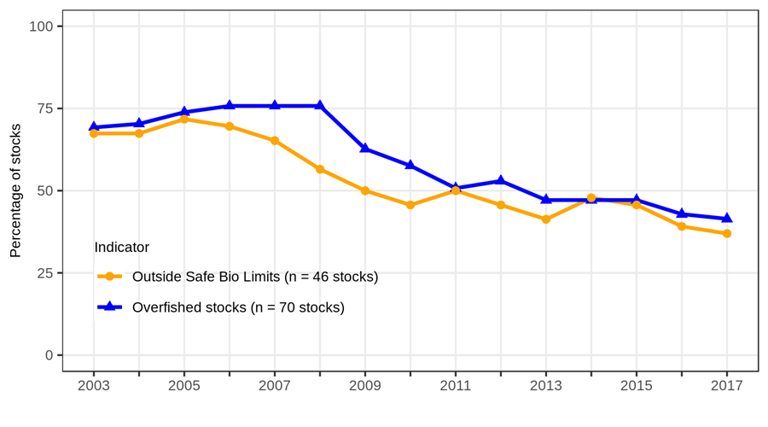

* + 1. **Mediterranean and Black Seas**

In the **Mediterranean and Black Seas**, of the 47 stocks assessed in 2016, only around 13% (6 stocks) are not overfished, while the majority of assessed stocks are overfished.

* 1. **Trends in fishing pressure (ratio of F/Fmsy)**
     1. **ICES area**

In the **ICES area,** the fishing pressure (F/Fmsy) shows an overall downward trend between 2003 and 2017 (Figures 2, 3, 5, 6 and Table 1). In the early 2000s, the median fishing mortality was more than 1.5 times larger than Fmsy, but this has gone down and has now stabilised at around 1.0. This indicator has stabilised and been near the value of 1 since 2011.

With regard to 11 stocks located in the ICES areas but **outside EU waters**, the positive overall trend observed in EU waters until 2014 is confirmed, with the median value of the F/Fmsy indicator closely tracking that produced for EU waters. After 2014, however, the indicator seems to show an increasing number of stocks exploited above Fmsy, although the STECF notes that the indicator for ICES area stocks outside EU waters is based on comparatively few stocks, where uncertainty is high.

* + 1. **Mediterranean and Black Seas**

The F/Fmsy indicator for the **Mediterranean and Black Seas** remained at a very high level for the entire 2003-2016 period. Since the peak in 2011 when F/Fmsy reached its highest historical level, the value of F/Fmsy has remained at around 2.2. This indicates that the stocks are being exploited on average at rates well above the Fmsy CFP objective (Figure 4).

**Figure 2. Trends in fishing pressure (ICES area and Mediterranean and Black Seas)**

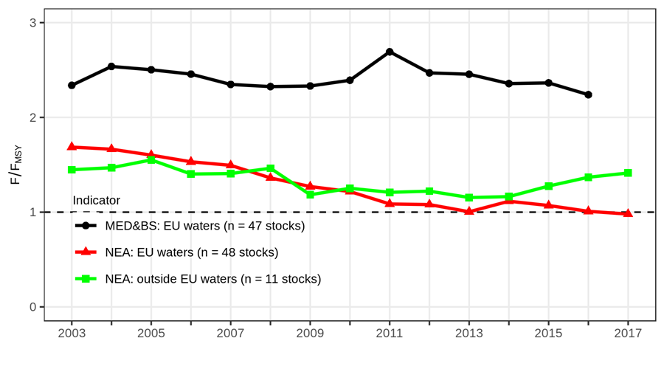

**Figure 3. Trend in F/FMSY in ICES area[3]**

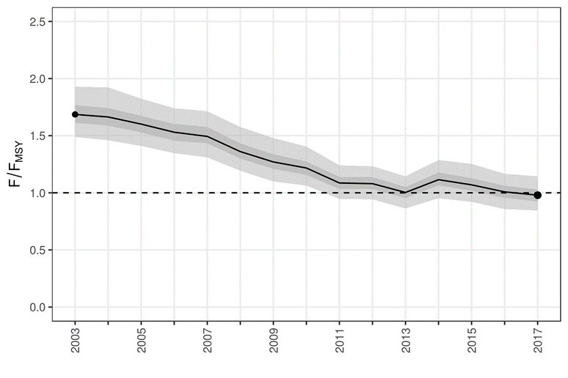

**Figure 4. Trend in F/Fmsy in Mediterranean and Black Seas[4]**

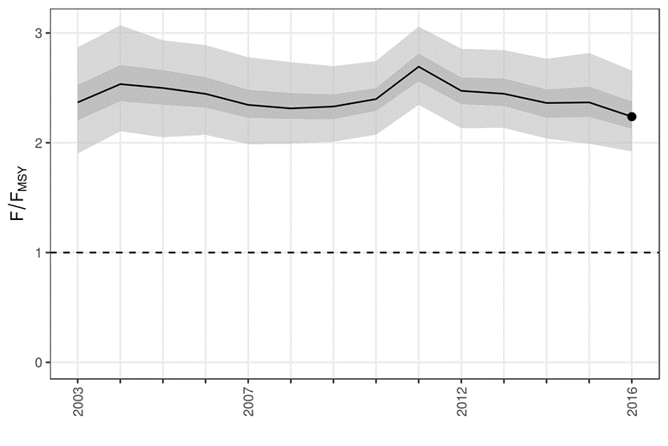

**Figure 5. Percentage of stocks in ICES area where fishing mortality was equal to, or less than, Fmsy**

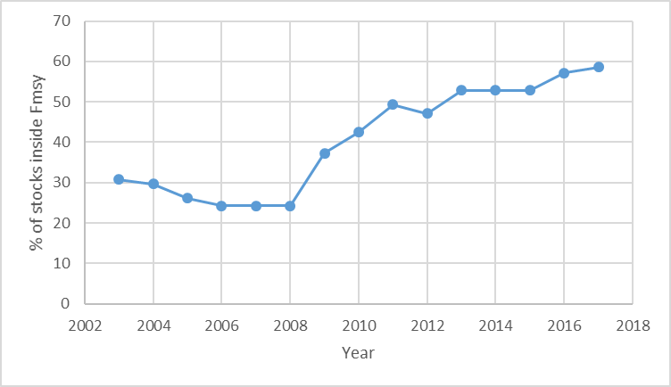

**Figure 6. Number of stocks by year by ecoregion for which fishing mortality (F) did not exceed Fmsy**

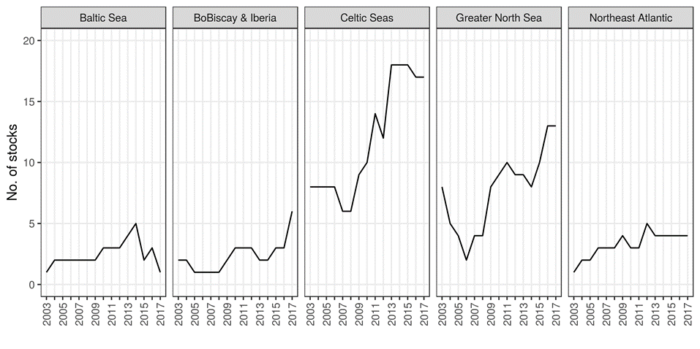

**Table 1. Number of stocks by ecoregion for which fishing mortality (F) did not exceed Fmsy**

|  |  |  |  |  |  |  |  |  |  |  |  |  |  |  |  |
| --- | --- | --- | --- | --- | --- | --- | --- | --- | --- | --- | --- | --- | --- | --- | --- |
| EcoRegion | 2003 | 2004 | 2005 | 2006 | 2007 | 2008 | 2009 | 2010 | 2011 | 2012 | 2013 | 2014 | 2015 | 2016 | 2017 |
| ALL | 20 | 19 | 17 | 16 | 16 | 16 | 25 | 28 | 33 | 32 | 37 | 37 | 37 | 40 | 41 |
| Baltic Sea | 1 | 2 | 2 | 2 | 2 | 2 | 2 | 3 | 3 | 3 | 4 | 5 | 2 | 3 | 1 |
| BoBiscay & Iberia | 2 | 2 | 1 | 1 | 1 | 1 | 2 | 3 | 3 | 3 | 2 | 2 | 3 | 3 | 6 |
| Celtic Seas | 8 | 8 | 8 | 8 | 6 | 6 | 9 | 10 | 14 | 12 | 18 | 18 | 18 | 17 | 17 |
| Greater North Sea | 8 | 5 | 4 | 2 | 4 | 4 | 8 | 9 | 10 | 9 | 9 | 8 | 10 | 13 | 13 |
| Northeast Atlantic | 1 | 2 | 2 | 3 | 3 | 3 | 4 | 3 | 3 | 5 | 4 | 4 | 4 | 4 | 4 |

* 1. **Trends in biomass** 
     1. **ICES area**

There has been improvement in the **ICES area** and particularly for data limited stocks (ICES category 3 stocks). The biomass has been generally increasing since 2007, and in 2017 was on average around 36% higher than in 2003 (Figure 7).

* + 1. **Mediterranean and Black Seas**

In the **Mediterranean and Black Seas,** the situation has remained essentially unchanged since the start of the series in 2003, although since 2012 there has been a slight increase in biomass. The STECF notes, however, the large uncertainty surrounding this indicator.

**Figure 7. Trends in the indicators of stock biomass**



* 1. **Coverage of scientific advice**

The STECF notes that 156 Total Allowable Catches (TACs) (combination of species and fishing management zones) were in place in 2017 in the EU waters of the ICES area. As in many cases, the boundaries of the TAC management areas are not aligned with the biological limits of stocks used in ICES assessments. The STECF considered a TAC to be ‘covered’ by a stock assessment when at least one of its divisions matched the spatial distribution of a stock for which reference points have been estimated from an ICES full assessment. Based on this indicator, 55% of the 156 TACs are covered, at least partially, by stock assessments that provide estimates of Fmsy (or a proxy), 50% by stock assessments that have Bpa, but only 20% by stock assessments that provide estimates of MSY-Btrigger (Figures 8 and 9, Table 2).

**Figure 8. Number of stocks in the ICES area for which estimates of F/Fmsy are available by year.**

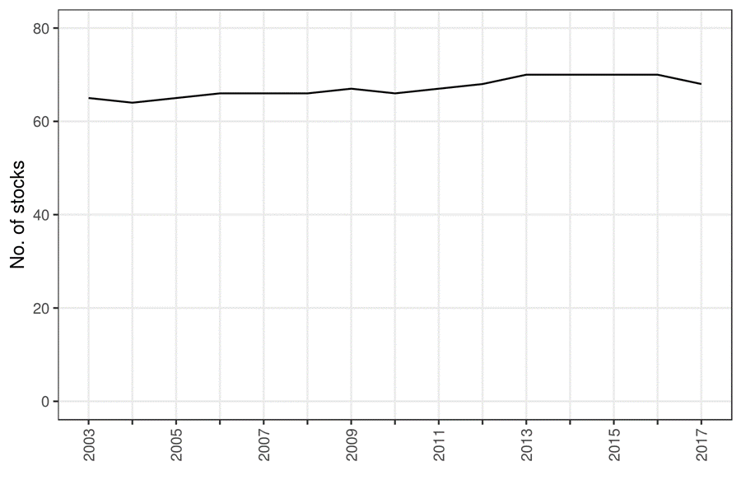

**Table 2. Number of stocks in the ICES area for which estimates of F/Fmsy are available by ecoregion and year**

|  |  |  |  |  |  |  |  |  |  |  |  |  |  |  |  |
| --- | --- | --- | --- | --- | --- | --- | --- | --- | --- | --- | --- | --- | --- | --- | --- |
| EcoRegion | 2003 | 2004 | 2005 | 2006 | 2007 | 2008 | 2009 | 2010 | 2011 | 2012 | 2013 | 2014 | 2015 | 2016 | 2017 |
| ALL | 65 | 64 | 65 | 66 | 66 | 66 | 67 | 66 | 67 | 68 | 70 | 70 | 70 | 70 | 68 |
| Baltic Sea | 8 | 8 | 8 | 8 | 8 | 8 | 8 | 8 | 8 | 8 | 8 | 8 | 8 | 8 | 8 |
| BoBiscay & Iberia | 9 | 9 | 9 | 9 | 9 | 9 | 9 | 9 | 9 | 9 | 9 | 9 | 9 | 9 | 9 |
| Celtic Seas | 21 | 20 | 21 | 22 | 22 | 22 | 23 | 22 | 23 | 24 | 26 | 26 | 26 | 26 | 24 |
| Greater North Sea | 21 | 21 | 21 | 21 | 21 | 21 | 21 | 21 | 21 | 21 | 21 | 21 | 21 | 21 | 21 |
| Northeast Atlantic | 6 | 6 | 6 | 6 | 6 | 6 | 6 | 6 | 6 | 6 | 6 | 6 | 6 | 6 | 6 |

**Figure 9. Number of stock assessments available in the Mediterranean and Black Sea. The totals include stocks in GSAs 1, 5-7, 9, 10-19, 22-23, 25 and 29**

***(data 2017, pending GFCM assessment)***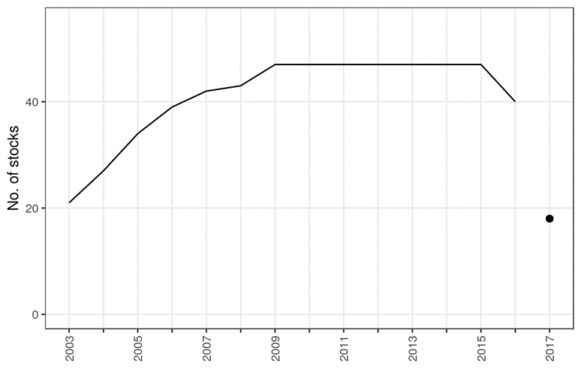

1. **Setting of fishing opportunities**

For 2019, the number of total allowable catches (TACs) set in line with Fmsy increased from 53 in 2017 to 59 in 2019, representing 73% of the Fmsy-assessed TACs fished in the North-East Atlantic, North Sea and Baltic Sea. Of the overall expected catches for 2019, around 11% do not have Fmsy advice, but are assessed by ICES based on precautionary advice. During the discussions with Member States, socio-economic considerations were taken into account, with Member States sending detailed submissions to the Commission (Tables 3-4).

**Table 3: TACs with** **Fmsy advice (in tonnes)**

|  |  |  |  |  |
| --- | --- | --- | --- | --- |
|  | **EU stocks** | **EU/NO jointly**  **managed stocks** | **Coastal state stocks** | **Total** |
| Total TAC  (Fmsy assessed stocks) | 1,664,083 | 568,203 | 716,986 | 3,278,779 |
| TAC fished at Fmsy | 1,645,833 | 219,054 | 0 | 2,228,595 |
| TAC not fished at Fmsy | 18,250 | 349,149 | 716,986 | 1,043,583 |
| % fished at Fmsy | 99% | 39% | 0% | 63% |
| % not fished at Fmsy | 1% | 61% | 100% | 37% |

**Table 4: Number of TACs with Fmsy advice[5][2]**

|  |  |  |  |  |  |  |  |  |  |  |  |  |  |  |  |
| --- | --- | --- | --- | --- | --- | --- | --- | --- | --- | --- | --- | --- | --- | --- | --- |
| **Number of TACs with MSY advice** | |  |  |  |  |  |  |  |  |  |  |  |  |  |  |
|  | **2005** | **2006** | **2007** | **2008** | **2009** | **2010** | **2011** | **2012** | **2013** | **2014** | **2015** | **2016** | **2017** | **2018** | **2019** |
| **TACs with MSY advice** | 34 | 23 | 32 | 33 | 35 | 39 | 35 | 38 | 41 | 46 | 62 | 72 | 75 | 76 | 81 |
| **TACs set in accordance with or lower than advice** | 2 | 2 | 2 | 4 | 5 | 11 | 13 | 20 | 25 | 27 | 36 | 36 | 44 | 54 | 59 |
| **TACs set above advice** | 32 | 21 | 30 | 29 | 30 | 28 | 22 | 18 | 16 | 19 | 30 | 36 | 31 | 23 | 22 |
| **% of TACs in accordance with or lower than advice** | 6% | 9% | 6% | 12% | 14% | 28% | 37% | 53% | 61% | 59% | 58% | 50% | 59% | 71% | 73% |

The following paints a more detailed picture for each sea basin:

The **Baltic Sea** is the sea basin with the longest experience of Member States and stakeholders working together on fisheries management measures in regionalisation. Considerable effort has been put into developing new gears and putting them in place through joint recommendations that are sent to the Commission. The result of the commitment of stakeholders and Member States to sustainable fisheries management can be seen in the responsible decisions taken on the TACs for 2019. These followed the Baltic Sea multiannual plan for 7 out of 8 TACs, for which the Commission received Fmsy advice set in line with Fmsy. In terms of volume of landings, this means that 95% of the total catch in the Baltic Sea is from sustainably managed stocks in line with Fmsy, while 4% is from TACs where the precautionary advice is followed.

All TACs with analytical advice were set at Fmsy except for western Baltic herring whose TAC was reduced by -48% following a 0-catch advice from ICES. TAC reductions were adopted for eastern cod (-15%) and Gulf of Finland salmon (-3%) under the precautionary approach. The main basin salmon TAC was rolled over from 2018 to continue helping the stocks in the weakest salmon rivers improve.

In the **North Sea, Skagerrak and Kattegat**, for the Fmsy assessed stocks that are managed by the EU alone, 100% of expected landings are from sustainably managed stocks. However, this rate is considerably lower for those stocks that are shared with Norway (39%). Many TACs had to decrease this year, including for cod (-32%), haddock (-31%), whiting (-22%) and herring (-36%). The TACs for plaice and saithe could be increased by 11% and 16% respectively, in line with MSY advice.

In **North-Western Waters,** for the Fmsy assessed stocks that are managed by the EU alone, 98% of the expected landings are from sustainably managed stocks.

In line with MSY advice, the TACs for many stocks could be increased, proving that sustainable management also pays off economically. The TACs for Northern hake could be increased again at a range between 23 and 37%. Horse mackerel could be increased by 18%. Another success story is the Nephrops TAC West of Scotland which went up by 24%. All TACs for megrim in the area were increased (6% for the West of Scotland and 47%for the Celtic and Irish Seas).

Due to natural fluctuations and changes in the perception of the stock by ICES, some sustainably managed TACs had to be reduced to allow yields to stay high in the long run. These reductions include Eastern Channel sole (-26%), Celtic Seas Nephrops (-32%) and Celtic Sea herring (-53%). A significant challenge was to prevent low TACs from choking other fisheries due to the landing obligation. This was prevented by introducing ‘by-catch TACs’ at the level of unavoidable catches of the respective species. This new concept was used for West of Scotland cod, West of Scotland whiting, Celtic Sea cod, Celtic Sea plaice and Irish Sea whiting. Member States committed to introducing by-catch reduction measures, as a tool to limit fishing mortality for these stocks. These measures will be reviewed by STECF in order to assess their effectiveness.

For **South-Western Waters,** of the Fmsy assessed stocks that are managed by the EU alone, 100% of expected landings come from sustainably managed stocks. An important success story for this sea basin is Bay of Biscay sole, which delivered a 7% increase. Among others, TACs were agreed in line with Fmsy for Iberian anglerfish (+5%), and horse mackerel (+69%), Bay of Biscay anglerfish (-7%) and horse mackerel (+18%). The overall increase of TACs translate into higher and sustainable incomes for the fishing industry.

For **stocks subject to Coastal States consultations,** no progress has been achieved in terms of MSY, and the number of TACs set in line with MSY is at zero. The Commission is determined to achieve progress on this, in cooperation with our international partners the Faroe Islands, Iceland, Norway and Russia.

1. **Specific actions for the Mediterranean and Black Seas**

The Commission has stepped up its efforts to implement the March 2017 ‘Malta MedFish4Ever Declaration’. Increased cooperation and political engagement enshrined in the Declaration enabled further progress to be made in 2018. The main achievements are summarised below.

*Within the framework of the GFCM*

At the 42nd session of the General Fisheries Commission for the Mediterranean (GFCM) in October 2018, 11 EU proposals were adopted as binding recommendations. The adopted proposals include two multiannual plans for sustainable fishing activities in the Ionian and the Levant Seas involving high value species. With these measures, the entire central and eastern Mediterranean are now covered by:

* conservation and control measures;
* a multiannual plan for European eel, which includes introducing a three-month closure period;
* emergency measures for small pelagics in the Adriatic, with a progressive 5% reduction of catches, a limitation of effort and closure periods;
* two regional research programmes for non-indigenous species (blue crab in the Mediterranean and rapa whelk in the Black Sea);
* control measures in the Strait of Sicily, extending the duration of the international inspection scheme in that area;
* the marking of gears to allow better traceability for vessels over 15 metres;
* the exchange of information concerning monitoring, control and surveillance data in areas where joint inspection schemes are deployed;
* a recommendation on shark fins naturally attached.

*At EU level*

An important milestone has been the **adoption of the first EU MAP in the Mediterranean with the plan for demersal stocks in the western Mediterranean Sea**. It introduces a fishing effort regime at EU level for trawls exploiting the main demersal stocks, i.e. hake, red mullet, deep-water rose shrimp, Norway lobster, giant red shrimp and blue and red shrimp. The fishing effort regime is to be applied starting on 1 January 2020. The MAP is also complemented with technical conservation measures such as closure areas.

On **discard plans**, in 2018 the Commission extended the discard plan for demersal fisheries in the Mediterranean. Some of the high survivability and *de minimis* exemptions were extended for 1 year only (until December 2019), and the Member States have been requested to submit further data allowing the Commission to assess the exemptions granted.

On the **implementation of the Mediterranean Regulation**[6], the Commission will focus on assessing 22 national management plans in force to ensure they are aligned with the objectives of the CFP.

*Fishing opportunities for the Mediterranean and Black Seas*

As a result of the actions mentioned above, the Commission will for the first time present a single proposal for **fishing opportunities** in these two sea basins. This proposal will:

1. implement the 10% reduction of the fishing effort for demersal stocks in the western Mediterranean Sea, following the adoption of the MAP;
2. implement the measures adopted at the 2018 annual session of the GFCM, in particular for small pelagic species in the Adriatic and for eel, and implement the additional measures adopted by the GFCM in November 2019; and
3. set fishing opportunities for the Black Sea, including an autonomous quota for sprat, as in previous years, and put forward the new regional allocation scheme to be adopted by the GFCM for turbot. Measures to be adopted by the GFCM in November 2019 will be in *pm*, pending the outcome of the annual session.
4. **Report on the balance between fishing capacity and fishing opportunities**

In line with Article 22(4) of Regulation 1380/2013 (the CFP Regulation), the Commission must report annually to the European Parliament and to the Council on the balance between fishing capacity and fishing opportunities, taking into account the assessment by the STECF [7].

This report covers the year 2017. It assesses the annual capacity of all the EU fleet segments based on the information included in the Member States’ reports submitted to the Commission in 2018[8]. These reports must follow the 2014 Commission Guidelines[9] and, for the fleet segments for which structural overcapacity has been identified, they must contain an action plan. The action plan must set out the adjustment targets, tools and a clear time-frame for its implementation.

The submission of the annual fleet reports is an *ex ante* conditionality, i.e. a pre-requisite, under the European Maritime Fisheries Fund (EMFF)[10]. Not submitting the annual fleet report and/or failing to implement the action plan could result in a proportionate suspension or interruption of relevant EU financial assistance to the Member States for the fleet segments concerned as provided for by the EMFF Regulation.

* 1. **Member States' annual reports and action plans, STECF assessment**

All 23 coastal Member States submitted their reports for 2017 to the Commission[11], and 10 of the reports included an action plan[12]. The Commission asked the STECF to:

* assess balance indicators for all EU Member States’ fleet segments, including for the outermost regions of France, Portugal and Spain;
* review national reports on Member State efforts to achieve balance between fleet capacity and fishing opportunities; and
* assess action plans submitted for fleet segments where Member States identified structural overcapacity.

The data used to compile the various indicators were collected under the data collection framework (DCF)[13]. All balance indicators provided and used in the STECF Expert Working Group (EWG) 18-14 were calculated in accordance with the 2014 Commission Guidelines, which provide a common approach for estimating the balance over time between fishing capacity and fishing opportunities. On the coverage of the data, the STECF concluded that, overall, there has been an improvement in the quality and coverage of the data compared to previous years despite some discrepancies. The main problem, as also highlighted in the STECF’s 2018 annual economic report (AER), is the incomplete data set for Greece and the consequent exclusion of this Member State from the analysis at EU and regional level.

Concerning coverage of the fleet segment, the STECF noted that some of the indicators could not be calculated for all fleet segments. This is either due to a lack of data or, in the case of economic and technical indicators, due to a clustering of segments (to protect commercial confidentiality). Data deficiencies led to difficulties in calculating balance indicators for fleet segments, making them unreliable or non-representative. In some cases, only landings in weight were provided without the corresponding landed values for all active fleet segments reported by a Member State.

The STECF analysis also confirmed a significant number of inactive vessels, especially in the fleet segments with vessels under 10 m (small-scale coastal fleets), where many vessels are only used part-time and fishing is often not the only source of income.

Since the entry into force of the 2013 CFP, 20 Member States[14] have identified, using biological, economic or technical indicators and/or supplementary information, fleet segments whose fishing capacity is not effectively balanced with fishing opportunities, or shows latent signs of being imbalanced. Over that period, only 3 Member States concluded that no fleet segments clearly demonstrated an imbalance and did not submit action plans[15].

The Commission also asked the STECF to propose and justify an improved suite of environmental indicators to help assess the balance between fleet capacity and fishing opportunities. In this regard, the STECF concluded that over the years alternative biological indicators have been proposed but not thoroughly tested. To justify introducing new indicators to replace or integrate the current ones, a deeper analysis and testing of those new indicators is necessary. The STECF concluded that without such a deep and robust analysis, it might be confusing for Member States to start applying new or revised indicators in their upcoming fleet report.

**Table 5. Active fleet segments out of balance**

|  |  |  |  |  |  |  |  |
| --- | --- | --- | --- | --- | --- | --- | --- |
| **Active fleet segments out of balance\*** | | | | | | | |
| **Member States** | **Total number of active fleet segments** | **Number of fleet segments assesssed**  **(including clustering)** | **Number of assessed fleet segments out of balance** | **Percentage of assessed fleet segments out of balance (%)** | **Area 27 Atlantic Northeast** | **Area  37 Mediterrean and Black Sea** | **Other fishing regions** |
| **BE** | 10 | 2 | 2 | 100 | 2 | - | - |
| **BG** | 25 | 25 | 25 | 100 | - | 25 | - |
| **HR** | 31 | 11 | 9 | 82 | - | 9 | - |
| **CY** | 6 | 1 | 0 | 0 | - | 0 | - |
| **DK** | 19 | 14 | 7 | 50 | 7 | - | - |
| **EE** | 5 | 4 | 4 | 80 | 4 | - | - |
| **FI** | 11 | 4 | 4 | 100 | 4 | - | - |
| **FR** | 87 | 33 | 20 | 61 | 12 | 7 | 1 |
| **DE** | 20 | 10 | 10 | 100 | 10 | - | - |
| **GR** | 14 | 4 | 4 | 100 | - | 4 | - |
| **IE** | 33 | 15 | 11 | 73 | 11 | - | - |
| **IT** | 31 | 18 | 17 | 94 | - | 17 | - |
| **LV** | 3 | 3 | 3 | 100 | 3 | - | - |
| **LT** | 12 | 6 | 4 | 67 | 4 | - | 0 |
| **MT** | 21 | 4 | 4 | 100 | - | 4 | - |
| **NL** | 27 | 7 | 6 | 86 | 6 | - | - |
| **PL** | 15 | 2 | 2 | 100 | 2 | - | - |
| **PT** | 59 | 11 | 8 | 73 | 6 | - | 2 |
| **RO** | 6 | 6 | 6 | 100 | - | 6 | - |
| **SI** | 14 | 2 | 2 | 100 | - | 2 | - |
| **ES** | 85 | 36 | 21 | 61 | 11 | 10 | 0 |
| **SE** | 25 | 17 | 10 | 59 | 10 | - | - |
| **UK** | 43 | 20 | 11 | 55 | 11 | - | 0 |
| **Total** | 602 | 255 | 190 |  | 103 | 84 | 3 |

* Sustainable harvest indicator assessment by STECF 18-14

To address situations of imbalance, Member States proposed a variety of management tools in their action plans, including[16]:

* *fleet measures* (ban of new vessels, fleet conversion, reduction of the fishing capacity, permanent or temporary cessation of activities and modernisation of fishing fleet);
* *technical measures* (monitoring of landings, more selectivity or energy-efficient gear, permitting schemes for certain fisheries, space and time-related fishing restrictions);
* *economic measures* (support to develop marketing initiatives or assistance to improve competitiveness).

Support for the permanent cessation of fishing activities by scrapping vessels was eligible for funding under the EMFF until 31 December 2017 only for the fleet segments considered not in balance. Between 1 January 2014 and 31 December 2017, 1260 fishing vessels were decommissioned or were going to be decommissioned with public support, with a total public expenditure of almost EUR 149 million, of which more than EUR 75 million from the EMFF (Table 6).

**Table 6. Support for the permanent cessation under the EMFF**

|  |  |  |  |
| --- | --- | --- | --- |
| **Member State** | **Number of vessels** | **Total eligible public cost committed** | **EMFF support committed** |
| BG | 8 | €247,046.22 | €123,523.88 |
| CY | 66 | €2,955,480.70 | €1,486,490.36 |
| DE | 6 | €542,462.00 | €271,231.00 |
| EL | 766 | €46,029,264.00 | €23,014,632.00 |
| ES | 25 | €3,655,932.20 | €2,612,733.65 |
| FR | 15 | €1,655,080.70 | €827,540.35 |
| HR | 85 | €15,688,234.10 | €7,844,117.04 |
| IT | 230 | €62,022,503.81 | €31,011,251.89 |
| LV | 5 | €1,367,637.11 | €683,818.54 |
| PL | 48 | €12,854,547.87 | €6,427,273.91 |
| PT | 6 | €1,907,740.96 | €953,870.49 |
| **Total** | **1,260** | **€148,925,929.66** | **€75,256,483.12** |

The significant decommissioning of vessels with EMFF support over the past period in the Mediterranean shows the increased efforts undertaken to balance the fleets and adjust fishing capacity in this region.

The evaluation on the entry/exit scheme also confirms that provided that Member States ensure an accurate measurement, verification and reporting of the capacity indicators GT and kW, capacity policies continue to be of relevance, in particular in situations where conservation and management measures are not effective enough to regulate the use of fishing capacity and many fleet segments are not in balance with fishing opportunities.

* 1. **Overall capacity of EU fishing fleet**

The capacity of the EU fleet continued to decrease. In December 2018, the EU fleet register (including outermost regions) contained 81,644 vessels with an overall capacity of 1,533,180 in gross tonnage (GT) and 6,075,634 in kilowatts (kW). This is a reduction of 1.32% since the previous year in terms of number of vessels, 2.46% in GT and 2.61% in kW.

The information recorded in the EU fleet register has become more accurate since the 2017 Commission Regulation on the Union fishing fleet register[17], which introduced a new procedure guaranteeing the update of the EU fleet register in real time. It gives the Commission the possibility to check the correctness and correspondence between data submitted by Member States and vessel data already registered. However, some countries are not yet fully compliant with the Commission Regulation on the Union fishing fleet register. They are not yet in a position to submit their data in real time but only on a monthly basis, and/or they cannot yet send snapshots (data for a set of vessels) requested by the Commission.

The veridicity of the data recorded in the EU fleet register is also an issue of concern. The results of a recent study commissioned by the Commission on engine power verifications showed, in almost every Member State, widespread non-compliance in almost every fleet segment tested for the engine power declared[18]. The lack of compliance with declared engine power undermines control effort regimes, but also raises questions about the overall compliance of the Member States with the fishing capacity ceilings set by the CFP Regulation.

**Figure 10. Compliance with capacity ceilings based on the Fleet Register (effective capacity as percentage of capacity ceiling by Member State (Mainland fleets), situation in December 2018)**

* 1. **Regional assessment**

In the **North East Atlantic**, the fishing capacity continues to decrease both in GT and KW. However, according to the STECF, there are fleet segments which are not in balance with their fishing opportunities. Based upon assessment with the sustainable harvest indicator, of the 350 fleet segments active in this area in 2016, 103 were out of balance. In terms of the level of activity of the fleet, 56 fleet segments with 8,555 inactive vessels are reported. 20 fleet segments show a decrease in the number of inactive vessels, 12 show an increasing trend. The vessel use indicator shows that out of the 208 segments assessed for this indicator, 95 fleet segments appear not to be in balance with their fishing opportunities. An increasing trend in the vessel use indicator can be observed for 14 segments, while a decreasing trend is shown for 12 segments.

In the **Mediterranean and Black Seas**, a large number of fleet segments may not be in balance with their fishing opportunities. According to the STECF analysis, of the 92 fleet segments for which the sustainable harvest indicator may be considered meaningful to assess balance or imbalance, it was concluded that 84 fleet segments may not be in balance with their fishing opportunities. The inactive vessel indicator shows that out of 38 assessed fleet segments there is an increasing trend for 7 fleet segments, while 18 segments show decreasing trends. The vessel use indicator shows that out of the 119 segments assessed for this indicator, 54 fleet segments appear not to be in balance with their fishing opportunities. An increasing trend in the vessel use indicator can be observed for 14 segments, while a decreasing trend is shown for 17 segments.

Finally, for the fleet in the outermost regions, the STECF noted that 3 assessed fleet segments were out of balance according to the sustainable harvest indicator: small vessels (under 10 metres) in the French outermost regions and two segments in Madeira. The latter segments comprise small vessels under 10 metres which received 40% of their 2016 landed value from bigeye tuna landings and vessels between 24-40 metres for which bigeye tuna was also a significant landing (28%), but with blue shark making up 34% of total landed value and thus being the most valuable component of the catch.

**Figure 11. Number of vessels in outermost regions (situation in December 2018)**

**Figure 12. Total GT in outermost regions (situation in December 2018)**

**Figure 13. Total KW in outermost regions (situation in December 2018)**

* 1. **Conclusions**

The capacity of the EU fleet continued to decrease, following the same trend of previous years. Between December 2017 and December 2018, the overall EU fleet decreased by 1.32% in number of vessels, 2.46% in GT and 2.61% in kW.

In 2018, all 23 coastal Member States complied with their obligation to report information on the capacity of their fleet segments. Ten of the Member States’ reports included an action plan. Action plans contain a large variety of measures to address overcapacity. These measures range from fleet measures, such as temporary or permanent cessation, to technical, economic and control measures.

For the fleet segments that are not in balance, EMFF support for the permanent cessation of fishing activities through the scrapping of vessels was eligible until 31 December 2017. Partly due to the continued effect of these permanent cessation measures, in December 2018, the fishing capacity of the overall EU fleet was 23.1% below the capacity ceilings for tonnage and 17.6% below the power ceilings. This is expected to have some positive effect on the conservation of marine biological resources, considering that capacity measures can be of relevance for countries and regions where conservation and management measures are not (yet) effective enough to regulate the use of fishing capacity through enforceable input and output measures.

1. **Economic performance of the EU fishing fleet**

The 2018 AER on the Union fishing fleet provides a comprehensive overview of the latest information available on the structure and economic performance of the 23 coastal EU Member State fishing fleets. The results indicate that the profitability of the EU fleet improved further in 2016, registering record-high net profits of EUR 1.35 billion, up from EUR 789 million in 2015. Continued improvements into 2016 were mainly a result of higher average fish prices (more value for less quantity landed) and continued low fuel prices, while the improved status of some important stocks and technological advances also contributed (Figures 14-16). Forecasts for 2018 suggest that developments are slightly offset by higher fuel prices compared to 2017.

Direct employment generated by the sector, including Greece, amounted to 152 331 fishers, corresponding to 114 776 Full Time Employees (FTEs). Average annual wage per FTE[19] was estimated at EUR 26.4 thousand, ranging from EUR 1.8 thousand for Cypriot fishers to EUR 131 thousand for Belgian fishers. The EU fleet, excluding Greece, spent 4.85 million days at sea and consumed 2.25 billion litres of fuel, to land 4.9 million tonnes of seafood in 2016 with a reported landed value of EUR 7.7 billion. In 2016, the EU fishing fleet had an estimated, depreciated replacement value (tangible asset value) of EUR 5.2 billion and in-year investments amounted to EUR 531 million. The amount of gross value added (GVA) and gross profit (all excluding subsidies) generated by the fleet (excluding Greece) in 2016 was EUR 4.5 billion and EUR 2.07 billion, respectively. GVA as a proportion of revenue was estimated at 58%, up from 53.6% in 2015 and gross profit margin at 26.7%, up from 22.4%. With a total net profit of EUR 1.35 billion, 17.4% of the revenue generated by the EU fleet was retained as net profit.

**Figure 14. Landings by the EU fleet, weight (tonnes), value (EUR) million and average price (2008=100)[20]**

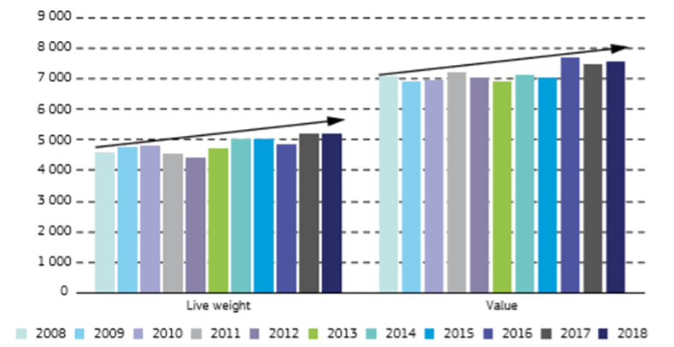

**Figure 15. EU fleet economic performance indicators**

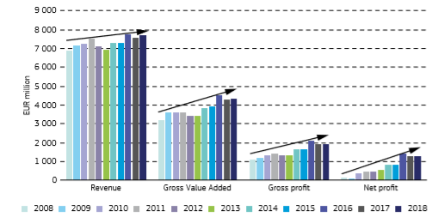

**Figure 16. Revenue and total costs for 2016 and estimates for 2017 and 2018 by Member State[21]**

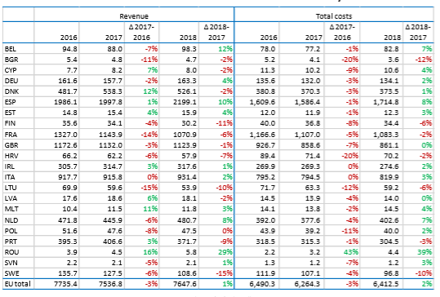

Results, however, varied by fishing region as indicated below:

The overall performance of EU fleets operating in the **North Sea & eastern Arctic** region was positive in 2016, and improved further compared to previous years. The most profitable fleets were the large pelagic trawlers (>40 m Length Overall (LOA)), with average gross profits estimated at around EUR 36 thousand per day at sea. Only the Lithuanian fleet operating in the region suffered small net losses in 2016, while all other Member State fleets generated net profits. The overall changes have been mostly driven by large-scale vessels, whereas trends for the small scale coastal fleet (SSCF) are less clear. Depending on the terms and conditions, the withdrawal of the United Kingdom could have a significant impact on the operations of segments of the North Sea fleet.

Overall, the EU **Baltic Sea** fleet spent almost 415 thousand days at sea in 2016 to land approximately 652 thousand tonnes of seafood valued at EUR 228 million. While the weight landed has increased since 2012, both effort (days at sea, LSF down 5% and SSCF down 2%) and landed value declined (from EUR 246 to EUR 228 million) during the period. More recently, the landed value increased 8% between 2015 to 2016, and this, combined with significant reductions in operating costs, helped the overall situation of the Baltic Sea fleet move from a loss-making position in 2015 to a modest net profit-making position in 2016. GVA was estimated at EUR 119 million, up 3% compared to 2015. After accounting for operating costs, the fleet made an estimated EUR 56 million in gross profit, also a marked increase (13%) compared to 2015. These improvements were largely due to relatively stable revenues (-2%) combined with lower costs, in particular fuel (-19%) and labour (-6%) costs.

The major players in the **Northeast Atlantic** are the Spanish, French, British, Portuguese and Irish fleets. The most important species include Atlantic mackerel, horse mackerel, hake, Norway lobster and monkfish. The weight and value of landings generated by the NortheastAtlantic fleet amounted to approximately 1.4 million tonnes and EUR 2.48 billion respectively. In terms of production, the UK, French, Spanish, Portuguese and Irish fleets are the most important and collectively were responsible for 85% of the landed weight and 94% of the value landed in 2016. The overall performance of the fleet improved, with the majority of Member State fleets generating gross and net profits in 2016. GVA was estimated at EUR 1.57 billion, and after accounting for operating costs, the fleet made EUR 620 million in gross profit. GVA increased by 12% and gross profit increased by 29%. Net profit was estimated at EUR 417 million, an 84% increase from 2015. The SSCF generated EUR 298 million in GVA and EUR 103 million in gross profits. The large-scale fleet generated over EUR 1.28 billion in GVA and EUR 518 million in gross profit. In 2016, fuel prices decreased and remained low in 2017, while most fish prices remained stable or increased compared to 2016. Therefore, it is expected that economic performance will further improve as revenues are likely to increase and costs decrease. Overall, performance is mostly driven by the large-scale fleets.

Overall, the economic situation of EU fleets operating in the **Mediterranean Sea** improved with increased gross profit and net profit even if wide variations across Member States are observed; the positive trend was mainly driven by the Italian fleet. Revenues benefited from an increase in landings and higher average fish prices. In particular, the SSCF sold at higher prices compared to the large-scale fleet, mainly directed to the local market through very short supply chains (either direct to consumers or to restaurants in tourist areas). There are some examples of fisheries where stocks are being exploited at rates consistent with achieving Fmsy, and fleets are showing positive trends, particularly in landings. The overall level of overfishing, however, remains generally too high. A number of specific actions have been taken for the Mediterranean Sea to tackle overfishing by improving control and enforcement and aligning the Mediterranean strategy with the CFP, both within EU waters and with its international partners. This has already had an effect with the review and update of five national management plans in line with STECF advice. It is expected that the process will have accelerated in 2018 and beyond. Better enforcement and control is a priority in this sea basin.

After the visible improvement in the economic performance of the EU’s **Black Sea** fleet in 2015, with an increase in both gross and net profit, there was a slight decrease in 2016. The Black Sea fishery is highly dependent on a very small number of species, and several commercially important stocks continue to be exploited above Fmsy. The fishery resources of the Black Sea are shared by Bulgaria, Georgia, Romania, the Russian Federation, Ukraine and Turkey. The overall economic situation in the region is rather unstable. Revenue increased gradually between 2008 and 2016, peaking in 2015 and subsequently falling 19% in 2016. GVA as a proportion of revenue was estimated at 65% for 2016, which means that the Black Sea fishing fleet transformed more than half its total revenue into capital, salaries and profits, thereby having a positive impact on the economies of the region and their fishing communities.

The EU **SSCF** totalled 49 029 vessels in 2016, employing 78 304 fishers or 46 647 in FTE (including Greece). As a whole, the EU SSCF was profitable in 2016: lower energy and capital costs in 2016 together with higher revenues fostered a 14% increase in GVA and a 16% increase in gross profit. Net profit increased from EUR 96.8 million in 2015 to EUR 132 million in 2016, i.e., a 36% increase (excluding Greece). Projection results suggest that landings in weight decreased slightly in 2017, at around 254 thousand tonnes with a corresponding decrease in landed value, estimated at EUR 830 million; a 7% drop compared to 2016. Findings suggest that in 2017 the EU SSCF generated EUR 626 million in GVA, a decrease of 11% compared to 2016 results, while gross profit was estimated at EUR 222 million, a 9% decrease. Nonetheless, in 2017 the performance indicators remained positive — GVA to revenue (67%) and gross profit margin (24%) and net profit margin (15%). In 2018, the increase in energy costs were counterbalanced by an increase in revenue, and performance results improved slightly from 2017. The SSCF remains profitable, with gross and net profit margins of 24% and 15% respectively. While the EU SSCF as a whole was profitable over the time period analysed, results at the regional and Member State level are mixed. By Member State, projected results suggest that six Member States’ SSCFs suffered gross losses in 2017. Only the Polish SSCF is projected to have recovered in 2018.

1. **Implementation of the landing obligation**

The first of January 2019 marked an important date when the landing obligation came into full force. The landing obligation was introduced to gradually eliminate, between 2015 and 2019, the wasteful practice of discarding. The landing obligation represents a fundamental shift in the management approach to EU fisheries. Since its phasing in, this fundamental shift has required the industry and stakeholders involved to change their behaviour, and it has brought challenges with feasibility and compliance. Through intensive collaboration between the various stakeholders, the European Parliament, the Council, the Member States, the industry, NGOs, the scientists and the European Commission, a common understanding is being reached on discard causes and certain challenges linked to the landing obligation.

Also this year, the Commission obtained information from Member States, Advisory Councils and other relevant sources to use as a basis for the mandatory annual report on the implementation of the landing obligation, as stated in [Regulation (EU) 2015/812](https://eur-lex.europa.eu/legal-content/EN/TXT/?uri=uriserv:OJ.L_.2015.133.01.0001.01.ENG)[22]. Since 2016, these reports have been based on a questionnaire developed by the STECF. For 2018, the Commission has received reports from 18 Member States and 5 Advisory Councils. As in previous years, year-on-year change has to be interpreted with care, since the composition of respondents in the different areas has changed. It is also important to recognise that changes reported in the questionnaire do not necessarily imply a successful implementation of the landing obligation. An effective and successful implementation of the landing obligation depends on significant changes in fishing practises at sea, adequate control and enforcement of all fishing operations to ensure compliance and full accounting of all catches, and significant reductions in unwanted catches.

In line with Article 9 of Regulation (EU) 2015/812, the obtained information includes the following elements:

* steps taken by Member States and producer organisations to comply with the landing obligation;
* steps taken by Member States to verify compliance with the landing obligation;
* information on the socioeconomic impact of the landing obligation;
* information on how the landing obligation has affected safety on board fishing vessels;
* information on the use and outlets of catches below the minimum conservation reference size of a species subject to the landing obligation;
* information on port infrastructures and vessels' fitting with regard to the landing obligation;
* for each fishery concerned, information on the difficulties encountered in implementing the landing obligation and recommendations to address them.

This section focuses on these elements and on the state of play of the discard plans and the use of the EMFF to implement the landing obligation.

* 1. **Progress report**

The fundamental shift in the management approach since the most recent reform of the CFP with the landing obligation creates a change of focus from landed catches to all catches, including discards. This shift required intensive collaboration with the stakeholders where the regionalisation aspect of the CFP assisted tremendously, but the fishing industry still seems reluctant to embrace the change. The main concerns involve the lack of accurate reporting by most countries of fish discarded under exemptions allowed for under the landing obligation, the very low volumes of fish below minimum conservation reference sizes (MCRS) being landed, and the difficulties experienced by Member States in ensuring effective control and enforcement of fishing activity. These concerns will be elaborated on in this section, as will the initiatives carried out by all stakeholders involved to address these issues.

* + 1. **Implementation of the landing obligation – state of play**

Progress in implementing the landing obligation across species subject to TAC in Union waters and non-Union waters, excluding the Mediterranean Sea, is shown in Figures 17 and 18. A steep increase can be seen from 2018 to 2019, since a further 43% of all TACs are due to come under the landing obligation. From 2015 to 2018, progress was made in increasing the number of TACs at least partially covered from 26% to 57%.

**Figure 17. Summary of no. of TACs subject to the landing obligation since 2015 [23]**

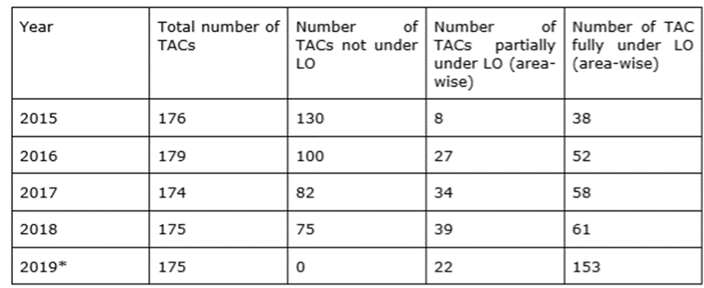

**Figure 18. Percentage of TACs at least partially subject to the landing obligation from 2015 to 2019[24]**

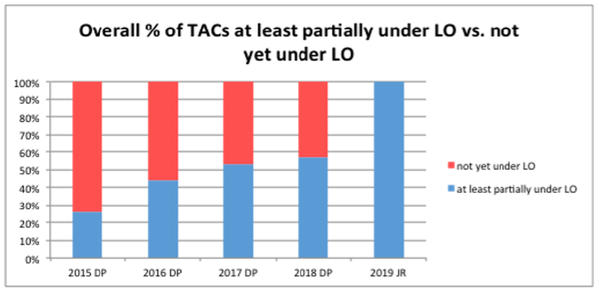

This does not imply that all catches of TAC species will have to be landed from 2019 onwards, because some TAC species are subject to exemptions. These exemptions will be discussed in the following section (State of play - discard plans).

The steps taken by the Member States and producer organisations to promote compliance with the landing obligation diverge widely in approach. Member States continue to make a big effort to inform fishermen and to engage with the relevant Advisory Councils. One such example can be seen in conducting the analysis on choke species, which was a prominent activity in 2018 within the regional groups, the Advisory Councils and the Commission. A number of Member States continue specific studies and pilot projects that test selective gears and avoidance strategies, with some Member States reporting outcomes for 2017 and 2018 including on their strategies to increase the uptake of the outcomes. There has been no increase in actions by Member States in the Mediterranean and Black Seas where less difficulty implementing the landing obligation has been reported.

The uptake by the Member States of the several tools available in the CFP for mitigating the impact or challenges of the landing obligation has continued. The inter-annual flexibility mechanism has been used throughout the year, whereas inter-species quota flexibility has mostly not been used. Since 2017, more emphasis has been put on the quota management system, with a few Member States adjusting their national quota management system. In 2019, for stocks with advice for zero catches (0 TAC), a by-catch mechanism was introduced to provide a small quota to Member States, via exchanges with other Member States, who would otherwise have no quota, or an insufficient quota, for their unavoidable by-catches when implementing the landing obligation. This mechanism allows mixed fisheries to continue to a reasonable extent but also ensures that improvements in selectivity are made. It was established for 5 TACs with zero catch advice for 2019 and will be assessed every year, taking into account the choke situations, the annual by-catch reduction plans of the Member States, and the improvements made in selectivity. The TAC composition depends on the annual advice of ICES on the fishing opportunities.

Following previous discussions on quota management and quota swaps being able to help avoid choke situations, the Commission organised a technical workshop on quota swaps for the Member States in December 2018. For the stakeholders involved, the system is considered transparent and fluid enough, and possible mechanisms to alleviate the matters should be (further) discussed in the regional groups. The Member States use the quota swap system. However, no significant increases can be seen during the phasing-in of the landing obligation (Figure 19.)

**Figure 19. Changes in quota swaps[25]**

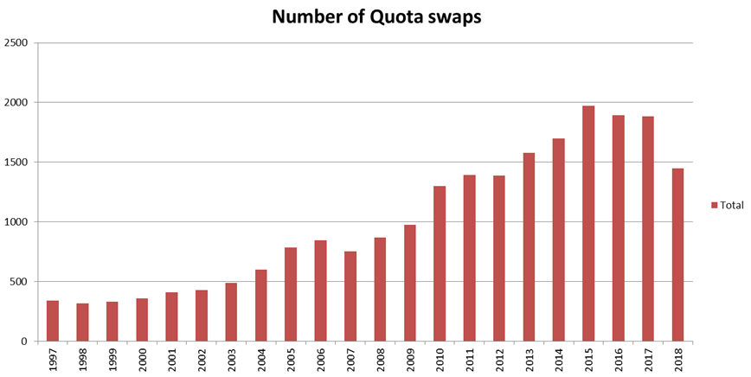

* + 1. **Socio-economic impact and port infrastructure and vessels fit for purpose**

As in previous years, most Member States report that it remains difficult to assess the socio-economic impacts of the landing obligation, and problems have been minimal so far but could increase when more or all species are included. In their advice, the Advisory Councils identify a variety of perceived socio-economic and practical or technical difficulties that have not been experienced yet but are likely to emerge. The analysis of certain fisheries has shown that the economic outcome will be negatively affected in the long term by the landing obligation, when compared to the expected outcome with no landing obligation[26]. However, efficient mitigation strategies may reduce this negative economic effect of the landing obligation in some of the fisheries. The possibility to swap quotas may also reduce the economic losses caused by the landing obligation. These possibilities are available within the current framework, and it is important to further intensify collaboration in 2019.

**Horizon2020 DiscardLess project**

The four-year H2020 DiscardLess project was completed in 2018. One of the results of the project is a compilation of articles in one open access book *‘*[*The European Landing Obligation*](https://link.springer.com/book/10.1007%2F978-3-030-03308-8)*’* covering various elements of the landing obligation. The project sheds light upon the different elements of the landing obligation and on the uncertainties and challenges still ahead of us. It emphasizes the time it takes for other international countries to have implemented a similar discard ban, as well as the challenges identified for the EU. It also underlines the strengthened collaboration on EU and international level, between scientists and fishermen, creating possibilities for a sustainable fisheries management.

The reports of the Member States show no clear evidence of the landing obligation causing safety issues on board the fishing vessels, which is consistent with the reports from previous years. Member States highlight potential problems or safety issues that will be faced by fishermen on board when handling unwanted catches. However, no actual incidences were reported on these matters, including in the pelagic fisheries and in the Baltic Sea where the landing obligation has been in place for more than 2 years. Pilot projects carried out by producer organisations, scientists and Member States sometimes show results on this specific issue, concluding that to keep the work pressure stable one to three extra crew members are needed to handle unwanted catches. Part of the vessel’s capacity will have to be used to store the unwanted catches in order to land them.

* + 1. **Control and enforcement**

It is the responsibility of Member States to ensure the detailed and accurate documentation of catches and to ensure control, enforcement and inspection of activities that fall under the scope of the CFP, including the landing obligation. Effective control and enforcement is pivotal for the successful implementation of the landing obligation. The complexity of ensuring control and enforcement of the landing obligation means that the control authorities must be able to identify discarding events and accurately identify the species concerned. Remote electronic monitoring (REM) tools, such as closed-circuit television (CCTV) and sensor data, have been demonstrated as the most effective and cost-efficient means to control the landing obligation at sea. This has been confirmed in numerous trials conducted by the Member States, and these tools continued to be tested in 2018 by some countries on a voluntary basis. However, the tools have not been implemented yet. The Commission supported the use of these measures in its proposal for a revised Fisheries Control System[27]. An obligation is introduced for Member States to use CCTV and other REM systems on a minimum percentage of fishing vessels according to risk. By doing so, the Commission intends to provide a harmonised approach and ensure a level playing field in terms of the use of effective controls at sea. Establishing a level playing field is of utmost importance for the necessary support of the co-legislators, Member States and the fishing industry.

The European Fisheries Control Agency (EFCA) has assisted Member States in delivering specific training events and dedicated workshops for inspectors on the control elements of the landing obligation. The EFCA has also shown that the last haul analysis makes it easier to evaluate compliance with the landing obligation provisions and to provide information on catch composition across different fisheries in different sea basins. Last haul analysis is a method of estimating representative size- and species-distribution of the catch of a fishing fleet based on the contents of trawls which are hauled in the presence of inspectors at sea. Figure 20 below provides an overview of the number of last haul inspections conducted in 2018. Although the results of the last haul analysis point in the direction of a very poor implementation of the landing obligation and of a generally widespread non-compliance, to date Member States have not introduced appropriate measures to ensure control of the landing obligation at sea and as a result there has been a very low detection rate for infringement.

Despite recent advancements in REM technologies and the increasing use of these measures in fisheries around the world, there has been a very limited uptake of REM control systems by Member States. Inspections at sea and aerial surveillance are widely regarded as being inadequate to ensure control and enforcement of the landing obligation, and the use of observers is costly and impractical. In order to support the Member States and establish a basis for the harmonised introduction of REM systems, a technical working group was created by the EFCA in 2018. The group focused on defining REM systems requirements and technical guidelines to monitor the implementation of the landing obligation across EU waters, and its work resulted in a set of guidelines[28]. Member States supported the continuation of the Technical Working Group. Aside from this, the EFCA conducted a risk assessment at fleet segment level where a series of specific actions, addressing priority threats in the most relevant segments and implementing some of the risk treatment measures, were agreed upon for the joint deployment programmes in 2019.

**Figure 20. Number of last haul inspections conducted in 2018**

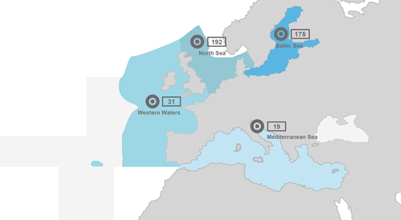

* + 1. **Market outlets for catches below minimum conservation reference sizes**

One of the challenges identified of successfully implementing the landing obligation involves the market outlets for catches below MCRS. These landings of fish below MCRS that Member States reported for 2018 are generally low across the different regions. No major changes were noticed in the use of the landed material, which is mainly used for fish meal, pet food or as bait for pot fisheries. Studies have been carried out on how best to use unwanted catches below MCRS, knowing that these can be used in many different ways depending on their composition. The results of a 2018 study on the alternative uses of catches below MCRS suggest that although alternatives exist and transport links are available, transport costs make the alternatives economically unattractive. In 2017 and 2018, an increase was seen in the use of the EMFF by Member States to improve the infrastructure of ports and make modifications on board fishing vessels. However, more focus should be given to improving selectivity (gear).

* + 1. **State of play – discard plans**

Exemptions from the obligation are provided within the common fisheries policy, Article 15(2) and (4), to ensure successful and feasible implementation. In principle, the details of *de minimis* and survivability exemptions are specified in multiannual plans (MAP). In addition, in the absence of a MAP, the Commission is empowered by the co-legislators to adopt discard plans through delegated acts via joint recommendations submitted by the regional groups for a period of three years. For the sea basins for which no MAP is in place, the possibility to introduce exemptions to ensure successful and feasible implementation of the landing obligation would be lost. This required an extension of discard plans for an additional period of three years, a proposal agreed upon by the co-legislators[29].

In 2018, amendments to four discard plans for demersal stocks were adopted for the period 2019 to 2021: 3 discard plans covering the Atlantic[30] were submitted separately by three regional groups (Scheveningen, North Western Waters, and South-Western Waters); and 1 discard plan covering the Mediterranean Sea[31] was submitted as a combined joint recommendation by three regional groups (Pescamed, Adriatica and SudestMed). Despite the Member States being pro-active in carrying out experiments with (more) selective gears or avoidance measures, a few of these measures have been included in the discard plans. Regional groups have tended to focus on developing cases for *de minimis* or high survivability exemptions rather than including improvement of selectivity in the discard plans. An annual stabilisation or increase in the use of exemptions in the different seabasins can be observed (see Figures 21 and 22).

**Figure 21. Number of *de minimis* exemptions by area**

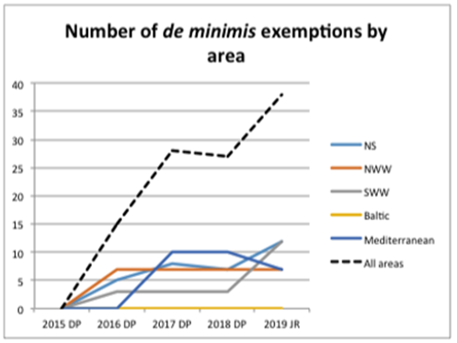

**Figure 22. Number of high survival exemptions by area**

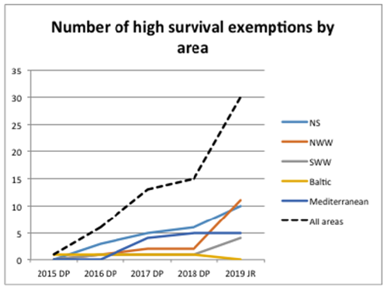

These exemptions, for example the high survivability exemption where scientific evidence demonstrates high survival rates taking into account the characteristics of the gear, the fishing practices and the ecosystem, need to be supported by scientific evidence. The Commission scrutinises the exemptions and the scientific evidence provided by the STECF.

In the Mediterranean, the implementation of the landing obligation has been facilitated through the adoption of different discard plans on small pelagic and demersal stocks. In 2018, the Commission adopted amendments to the discard plan for demersal stocks, extending the applicability of both survivability and *de minimis* exemptions already granted and introducing new ones. As for the Atlantic, the adoption of different discard plans on certain pelagic and demersal fisheries has made it easier to implement the landing obligation, and the Commission adopted the amendments to the three discard plans for demersal stocks. Some exemptions were granted for a period of 3 years until the validity of the discard plan ends, while others were only granted until the end of 2019. The exemptions granted only until the end of 2019 are conditional on the Member States providing the additional data and supporting information requested by the STECF to justify the exemption. This information has to be submitted in order for these exemptions to be extended, and the Commission closely scrutinises the progress and development of this.

* + 1. **European Maritime Fund for Fisheries**

Because of the fundamental shift in management approach that the landing obligation requires, several measures are eligible for funding under the EMFF to help meet the obligation. The total amount of funding that Member States committed to projects selected under measures to help implement the landing obligation increased from the anticipated potential commitment of EUR 49 million[32] to EUR 89 million in 2018[33]. The level of commitment accelerated in 2017-2018 with EUR 75 million, compared to EUR 14 million in total between 2014 and 2016. This is the result of the EMFF programme taking longer to implement in most Member States and the result of the increased demand of the measures supporting the (gradual) implementation of the landing obligation. By the end of 2018, Member States had spent EUR 40 million of the total amount of EMFF support committed.

During 2014-2017, Member States used the EMFF to help implement the landing obligation (see Figure 7). In particular, Denmark focused on improving the fishing gear (Article 38 of the EMFF Regulation) and exploring ways to use unwanted catches (Article 42). Latvia invested a significant amount (i.e. EUR 6.6 million) to use unwanted catches (Article 42). The United Kingdom and Portugal used EMFF support to improve the port conditions for handling unwanted catches (Article 43.2). The EMFF investments by Member States for marketing (Article 68) may support the use of unwanted catches but are not the only investment possibilities for this.

In the Member State reports, there were quite a few references to using funding under Article 38 of the EMFF Regulation to improve the selective fishing gear and handle unwanted catches. This suggests that the Member States increased their efforts to mitigate the problems of the landing obligations by improving selectivity as the full entry into force of the landing obligations became more imminent. However, some Member States for which the landing obligation may prove challenging to implement because of their large fleets do not appear to have significantly mobilised relevant EMFF resources so far.

Although an increase is noticed in the total commitment by the Member States, the total of EUR 89 million committed remains very low when taking into account the EUR 1.5 billion in total funds available under Union priority 1: Promoting environmentally sustainable, resource-efficient, innovative, competitive and knowledge-based fisheries (UP1).

**Figure 23. EMFF measures concerning the landing obligation implemented by Member States and their commitment. Source: EMFF AIR 2017, FAME compilation**

|  |  |  |
| --- | --- | --- |
| ***EMFF measure (article number)*** | ***MSs having implemented the measure during 2014-2017*** | ***Three / four highest committed EMFF amounts*** |
| Limiting the impact of fishing (Article 38) | 9 Member States: BE, DK, EE, ES, FI, IE, LT, SE, UK | DK: EUR 9.8 m  UK: EUR 2.3 m  EE: EUR 1.5 m |
| Innovation (Articles 26 and 39) | 12 Member States: BE, DK, EE, ES, FI, FR, IE, IT, LV,  PT, SE, UK | PT: EUR 2.5 m  ES: EUR 1.5 m  DK: EUR 1.3 m  EE: EUR 1.2 m |
| Use of unwanted catches (Article 42) | 9 Member States: DE, DK, ES, FI, IE, LV, PT, SE, UK | LV: EUR 6.6 m  UK: EUR 2.5 m  DK: EUR 1.9 m |
| Ports, etc. (Article 43(2)) | 7 Member States: DK, ES, IE, PL, PT, SE, UK | UK: EUR 7.7 m  PT: EUR 4.2 m  PL: EUR 1 m |
| Marketing (Article 68) | 19 Member States: AT, BE, BG, CZ, DE, DK, EE, ES, FI, FR, HR, IE, LT, LV, NL, PL, PT, RO, SE, UK | IT: EUR 10.1 m  ES: EUR 9.3 m  HR: EUR 3 m |

Stakeholders have been emphasising the importance of finding market outlets for unwanted catches, which projects carried out under Article 68 of the EMFF Regulation (marketing of unwanted catches) can elaborate on. Three Member States are currently carrying out 21 projects under this measure. All the projects involve the marketing and promotion of fisheries products. In particular, they aim to create value added products from the unwanted catches, and most of the beneficiaries are small and medium-sized fishing companies who are also involved in processing their catches.

1. **The role of Advisory Councils in 2018**

In 2018, the 10 Advisory Councils submitted 73 advices to the Commission (Figure 24). Most of the 2018 recommendations by the ACs Advisory Councils 2018 recommendations related to the landing obligation, its challenges and possible solutions. These recommendations were very useful in the context of the intensive discussions on choke issues that took place in 2018 in all regional groups. Furthermore, Advisory Councils were involved in preparing joint recommendations for four discard plans adopted in 2018. In addition to the landing obligation, Advisory Councils provided input for other legislative processes such as the fishing opportunities for 2019, the post-2020 EMFF proposal[34], the control regulation proposal and the technical measures proposal. Advisory Councils have also helped to develop the two management strategies for sole in the Bay of Biscay and the Eastern Channel, which produced fisheries in line with Fmsy and led to increased quotas for fishermen.

Most recommendations concerned specific CFP issues and many concerned legislative texts under preparation. In most cases, the advice was taken on board as described below.

**Figure 24. Number of recommendations received from Advisory Councils**

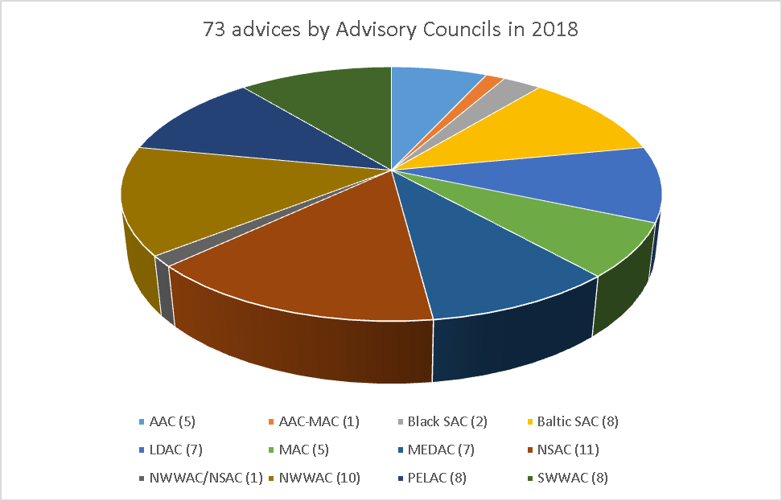

* 1. **Recommendations by Advisory Councils on specific CFP-related issues**

Most of the recommendations made by the Advisory Councils in 2018 related to the landing obligation. They were extremely helpful in identifying potential choke situations, solutions and the best available tools to deal with them such as increased swaps, inter-area and inter-species flexibility.

In 2018, 4 discard plans were adopted further to a proposal by the Commission. These discard plans were prepared on the basis of joint recommendations developed by Member States in consultation with the relevant Advisory Councils. In 2018, the Commission also prepared a proposal for a multiannual plan for demersal stocks in the western Mediterranean Sea. The MEDAC was largely involved in its preparation. Most of the elements it recommended have been included in the Commission proposal, namely:

* its scope as regards geographical coverage, stocks and fishing gear;
* the use of fishing opportunities based on effort limits in accordance with the scientific advice;
* the extension of the ban on bottom towed gears from 50 m to an appropriate depth to increase the protection of essential coastal fish habitats;
* the use of spatial-temporal closures to protect spawning and nursery areas; and
* updates on the minimum landing sizes of species listed in Annex III of Council Regulation (EC) No 1967/2006.

Two elements (i.e. the introduction of electronic monitoring systems for all vessels subject to the multiannual plan and the additional support from the EMFF) have not been taken up in the proposal, because cross-cutting legal frameworks were considered more suitable for this.

Advisory Councils have been actively reflecting on the United Kingdom’s withdrawal and the possible consequences this will have on fisheries. In their letters to the Commission, the Advisory Councils have emphasised the need to maintain current fishing activities for EU fleets.

* 1. **Contributions of Advisory Councils** **to legislative proposals under preparation**

*Fishing opportunities*

The Commission paid great attention to the recommendations of Advisory Councils on fishing opportunities when elaborating its proposals. The origin of most differences between the Commission’s proposals and the advice of the Advisory Councils is the method used by the Commission to set quotas. In the method used by the Commission, the amount corresponding to *de minimis* exemptions was deducted from the amount proposed by ICES where calculations have been done on the basis of catches and no longer on landings due to full entry into force of the landing obligation from January 2019. In some cases, the Commission proposal was the same as the proposal of the Advisory Councils. This was the case in the Baltic Sea for instance, for which the Commission proposal was the BSAC recommendation for some stocks while for some others the Commission retained the minority proposal by the Other Interest Groups. For some pelagic stocks as well, the Commission proposal was the same as the PELAC’s recommendation.

*The EMFF proposal*

Seven Advisory Councils answered the Commission’s consultation on the post-2020 EMFF proposal. They all outlined the complexity of the current financial instrument and difficulties encountered in getting access to funds. The priorities that some of them identified were the permanent reduction of active fleet capacity in case of risk for overcapacity; research and development; the improvement of health, safety and working conditions for fishers; or additional control to stop high level of discards. For others, priority should be given to commercialising and adding value to fish products, collecting data, protecting the environment and implementing management plans. All Advisory Councils noted the need to support small-scale fisheries. Flexible access to financial mechanisms such as direct grants and financial instruments was also mentioned. All these priorities and recommendations were incorporated in the EMFF proposal, some with certain conditions.

Although Few Advisory Councils requested the construction of small vessels or the renewal of the fishing fleet to be eligible, this was not taken up in the Commission proposal. This is because it would inevitably increase fishing capacity, and this has not been eligible for public funding in the Union since 2002. Such support would therefore also be inconsistent with the EU’s international commitments, notably in the context of Sustainable Development Goal 14, and the EU’s position on harmful fisheries subsidies at the WTO. However, the EMFF proposal includes support for engine replacement for small-scale fleets under certain conditions.

*Fisheries control system*

Six Advisory Councils submitted a position paper for the Commission’s stakeholder consultation on its proposal concerning the EU fisheries control system. All stated that a revision of the current legislative framework is necessary. They emphasised the importance of the existing good cooperation with the EFCA and welcomed its extended role. They generally supported tracking vessels less than 12m, but warned that the system should be user-friendly, cost-effective and in general not burdensome. They also called for a harmonised implementation of sanctions and greater clarification on sanctions and the point system for serious infringement.

Advisory Councils expressed reservations on the use of remote electronic tools (e.g. CCTV), as they considered that it might constitute an invasion of privacy and business confidentiality. However, as the landing obligation is an important element under the CFP that is difficult to control and as the level of proof required is practically impossible to obtain using traditional means, the Commission proposed its utilisation only for certain vessels which would be selected according to their level of discard risk. In this context, major attention will be given to personal data protection.

*Technical measures and eel recovery measures*

In 2018, many Advisory Councils sent letters to the Commission regarding inter-institutional negotiations on the technical measures, stressing the need to adopt a new framework for technical measures that is fit for purpose before 1 January 2019.

Advisory Councils were also consulted in 2018 on the measures to be taken for the recovery of European eel stocks. Further to the Advisory Council’s recommendation to quantify the impact of recreational fisheries on eel stocks, the Commission assessed internally the available information and data on recreational fisheries. Further to this analysis and the ICES scientific advice on the state of the eel stock, eel recreational fishing was included in the three-month fishing closure for all eel life stages decided in December 2018 under the 2019 Fishing Opportunities Regulation.

1. STECF Ad Hoc 19-01: *Monitoring the performance of the Common Fisheries Policy (WP)*. STECF ISSN 2467-0715. The information provided in this Annex is a selection of most relevant findings coming from the STECF report, and is not an exhaustive reproduction of the whole report.
2. Reference to the ICES area or ‘North-East Atlantic’ covers FAO area 27 and includes the waters of the Baltic Sea, North Sea, Irish Sea, Celtic Sea and adjacent waters.
3. Based on 48 stocks. Dark grey zone shows the 50% confidence interval; the light grey zone shows the 95% confidence interval.
4. Based on 47 stocks. Dark grey zone shows the 50% confidence interval; the light grey zone shows the 95% confidence interval.
5. [2] Figures for 2005-2018 are from previous Communications.
6. Council Regulation (EC) No 1967/2006 of 21 December 2006 (OJ L 36, 8.2.2007, p.6)
7. See: <https://stecf.jrc.ec.europa.eu/reports/balance>
8. Article 22(2) of Regulation (EU) No 1380/2013 of the European Parliament and of the Council of 11 December 2013 on the Common Fisheries Policy, amending Council Regulations (EC) No 1954/2003 and (EC) No 1224/2009 and repealing Council Regulations (EC) No 2371/2002 and (EC) No 639/2004 and Council Decision 2004/585/EC, OJ L 354, 28.12.2013, p. 22.
9. Guidelines for the analysis of the balance between fishing capacity and fishing opportunities according to Article 22 of Regulation (EU) No 1380/2013 of the European Parliament and the Council on the Common Fisheries Policy, COM(2014) 545 final.
10. See Annex IV of Regulation (EU) No 508/2014 on the European Maritime and Fisheries Fund and repealing Council Regulations (EC) No 2328/2003, (EC) No 861/2006, (EC) No 1198/2006 and (EC) No 791/2007 and Regulation (EU) No 1255/2011 of the European Parliament and of the Council, OJ L 149, 20.05.2014, p. 1.
11. All reports and action plans can be found at: <http://ec.europa.eu/fisheries/fleet/index.cfm?method=FM_Reporting.AnnualReport>
12. Croatia, France, Germany, Italy, Malta, Poland, Portugal, Romania, Spain and the UK.
13. Regulation (EU) 2017/1004 of the European Parliament and the Council on the establishment of a Union framework for the collection, management and use of data in the fisheries sector and support for scientific advice regarding the common fisheries policy and repealing Council Regulation (EC) No 199/2008, OJ 157, 20.06.2017, p. 1.
14. Belgium, Bulgaria, Croatia, Cyprus, Denmark, France, Germany, Greece, Ireland, Italy, Latvia, Lithuania, Malta, Poland, Portugal, Romania, Slovenia, Spain, Sweden and the United Kingdom.
15. Estonia, Finland and the Netherlands.
16. See STECF-18-14, p.121-142.
17. Commission Implementing Regulation (EU) 2017/2018 of 6 February 2017 on the Union fishing fleet register, OJ, L 34, 9.5.2017, p.9.
18. Tests were conducted on 68 fishing vessels across 14 Member States.
19. Gross wage (i.e. total remuneration before taxes and other deductions).
20. Source: STECF and European Commission
21. Source: STECF
22. Regulation (EU) 2015/812 of the European Parliament and of the Council of 20 May 2015 amending Council Regulations (EC) No 850/98, (EC) No 2187/2005, (EC) No 1967/2006, (EC) No 1098/2007, (EC) No 254/2002, (EC) No 2347/2002 and (EC) No 1224/2009, and Regulations (EU) No 1379/2013 and (EU) No 1380/2013 of the European Parliament and of the Council, as regards the landing obligation, and repealing Council Regulation (EC) No 1434/98, OJ L 133, 29.5.2015, p. 1–20.
23. Based on Joint Recommendations for 2019, all other years based on relevant discard plans. Source: STECF 18-6
24. 2015 to 2018 data based on respective discard plans, 2019 data based on current set of joint recommendations. Source: STECF 18-06
25. Source: Directorate General for Maritime Affairs and Fisheries, European Commission (QUOTA).
26. Chapter 6, Potential Economic Consequences of the Landing Obligation in: The European Landing Obligation, (2019) Uhlmann, Ulrich and Kennely (eds.).
27. COM(2018)368 final.
28. https://www.efca.europa.eu/sites/default/files/Technical%20guidelines%20and%20specifications%20for%20the%20implementation%20of%20Remote%20Electronic%20Monitoring%20%28REM%29%20in%20EU%20fisheries.pdf
29. Regulation (EU) 2017/2092 of the European Parliament and of the Council of 15 November 2017 amending Regulation (EU) No 1380/2013 on the Common Fisheries Policy (OJ L 302, p. 1).
30. Commission Delegated Regulation (EU) 2018/2035 of 18 October 2018 specifying details of implementation of the landing obligation for certain demersal fisheries in the North Sea for the period 2019-2021.

    Commission Delegated Regulation (EU) 2018/2034 of 18 October 2018 establishing a discard plan for certain demersal fisheries in North-Western waters for the period 2019-2021.

    Commission Delegated Regulation (EU) 2018/2033 of 18 October 2018 establishing a discard plan for certain demersal fisheries in South-Western waters for the period 2019-2021.
31. Commission Delegated Regulation (EU) 2018/2036 of 18 October 2018 amending Delegated Regulation (EU) 2017/86 establishing a discard plan for certain demersal fisheries in the Mediterranean Sea.
32. ‘FAME Support Unit, AT01.2 ad-hoc consultancy Landing Obligation Final Report (AT1.2 5/5)’, Version 1.0, February 2018. - These projects include: investments in equipment improving selectivity of fishing gears; investments on board or in equipment that eliminates discards; investments in fishing ports, auction halls, landing sites and shelters; marketing measures aimed at finding new markets and improving the conditions for the placing on the market of fishery products, including unwanted catches landed
33. The data provided here are based on the EMFF ‘Infosys database’ of 29 April 2019. The reference period is 1 January 2015 to 31 December 2018.
34. Proposal for a REGULATION OF THE EUROPEAN PARLIAMENT AND OF THE COUNCIL on the European Maritime and Fisheries Fund and repealing Regulation (EU) No 508/2014 of the European Parliament and of the Council, COM/2018/390 final; Proposal for a REGULATION OF THE EUROPEAN PARLIAMENT AND OF THE COUNCIL amending Council Regulation (EC) No 1224/2009, and amending Council Regulations (EC) No 768/2005, (EC) No 1967/2006, (EC) No 1005/2008, and Regulation (EU) No 2016/1139 of the European Parliament and of the Council as regards fisheries control, COM/2018/368 final; and Proposal for a REGULATION OF THE EUROPEAN PARLIAMENT AND OF THE COUNCIL on the conservation of fishery resources and the protection of marine ecosystems through technical measures, amending Council Regulations (EC) No 1967/2006, (EC) No 1098/2007, (EC) No 1224/2009 and Regulations (EU) No 1343/2011 and (EU) No 1380/2013 of the European Parliament and of the Council, and repealing Council Regulations (EC) No 894/97, (EC) No 850/98, (EC) No 2549/2000, (EC) No 254/2002, (EC) No 812/2004 and (EC) No 2187/2005

    COM/2016/0134 final - 2016/074 (COD)