

# Introduction

On 21 June 2019, EU Leaders will meet in Brussels to review progress of an agenda that lies at the heart of the European project and has been central to the EU's response to the post-2007 economic, financial and social crises: a deeper and fairer Economic and Monetary Union.

When the global crisis hit the EU and the euro area a decade ago, Europe was soon faced with a rapid worsening of its economic and social situation, the worst since the Second World War. A financial crisis quickly unfolded into an economic and sovereign debt crisis in the euro area. The EU was confronted with two major challenges. First, in the short term, it had to preserve the stability and integrity of the euro area and tackle unprecedented economic and social dislocations. Second, it had to design and launch an ambitious project addressing vulnerabilities in the architecture of the single currency area to ensure its viability in the longer term.

Since then, important progress has been made on both fronts. The European economy is now growing for the seventh consecutive year and is set to continue growing next year. Employment is at record high and unemployment at record low. The economies of the Member States are converging again. The overall stability and integrity of the euro area has been strengthened, the Banking Union has been created and the architecture of the euro area has been significantly enhanced. That progress required strong leadership and major decisions. The Five Presidents’ Report[1] of June 2015 gave a strong steer. Deepening Europe’s Economic and Monetary Union was also one of the ten priorities set out by this Commission at the beginning of its mandate[2].

Figure 1: Key facts and figures for the EU and the euro area

|  |
| --- |
| **The euro** |
| * 75% of the citizens support the euro in 2019 compared to 67% when this Commission took office |
| * Around 60 countries in the world are either using, will use or link their currency to the euro |
| **Progress on the economic situation** |
| * 13.4 million jobs have been created in the EU since the start of the Juncker Commission |
| * The unemployment rate in the EU, at 6.4% in April 2019, is the lowest rate recorded since the start of the century, when harmonised data started being recorded for all EU Member States |
| * Youth unemployment in the EU decreased from 21.7% in 2014 to 14.2% in April 2019 in the EU |
| * The EU economy has enjoyed 7 years of uninterrupted growth |
| * Wages declined in the aftermath of the crisis, but have grown in particular since 2017. Wages per employee have increased by around 10% in both the EU and in the euro area between 2014 and 2019 |

While the crisis gave a strong momentum to reform, the political will to push towards completing the Economic and Monetary Union has slowed somewhat, against the backdrop of a more favourable economic context. As a result, and in spite of undeniable improvements, important gaps remain in the architecture of the Economic and Monetary Union, which ultimately weigh on the international attractiveness of the euro and the EU's capacity to deliver jobs, economic growth, social fairness and macroeconomic stability. Following extensive consultations[3], the Commission presented in December 2017 a roadmap and a series of proposals to address the remaining gaps[4].

At the Euro Summit of June 2018 (held in inclusive format at 27), Leaders mandated the Eurogroup to work on a number of issues in view of reaching an agreement at the December 2018 Euro Summit. At that occasion, Leaders launched a fresh attempt to advance on crucial issues, notably (i) implementing the common backstop for the Single Resolution Fund, agreed in principle already in 2012[5], (ii) strengthening the role of the European Stability Mechanism, (iii) defining the next steps towards the establishment of a European Deposit Insurance Scheme, (iv) outlining the design of a budgetary instrument for convergence and competitiveness for the euro area as part of the EU budget, and (v) taking forward work aimed to strengthen the international role of the euro. While some progress has been made, all those work strands still remain to be completed.

Almost exactly four years after the publication of the Five Presidents’ Report, this Communication is taking stock of the progress towards a deeper and fairer Economic and Monetary Union, in light of the overall economic context. The sustained economic recovery in the euro area has recently shown certain signs of weakness, exacerbated by a more complex geopolitical context and trade tensions. Monetary policy has been heavily mobilised in the past several years in support of growth. Fiscal policy has turned mildly supportive in the euro area as a whole, but the room for manoeuvre remains limited in high debt countries. The capacity of our economies to withstand crises and bounce forward and to deliver long-term income growth and social fairness will depend in large parts on sound national policies and institutions, on the resilience of domestic economic and social structures and the quality of public finances.

In addition, given the close integration of our economies, particularly within the euro area, which accounts for 85% of the gross domestic product of the EU27, the ability to fare well and grow again will ultimately also depend on how resilient the construction of Europe’s Economic and Monetary Union will be. The future of the Economic and Monetary Union is therefore not just a matter of concern for countries fully participating in the monetary union, but for the EU as a whole and in particular for countries that will adopt the euro going forward[6].

An assessment of what has already been achieved is a way of collectively focussing minds. While sensitivities and diverging views on how to move forward with the Economic and Monetary Union are well known, they should not prevent us from reaching compromises. The hard-won achievements reached over the past 10 years are at stake. It is time to move away from entrenched views and to revive our collective ambition.

# Where we come from

In the wake of the financial and debt crises, as one of the first major steps, the euro area was equipped with crisis management mechanisms supporting governments that lose market access at sustainable interest rates. The European Stability Mechanism can now provide financial assistance to euro-area Member States experiencing or threatened by severe financing problems, with an overall firepower of EUR 500 billion.

Second, key elements of the Banking Union have been put in place in order to strengthen the financial sector, weaken the link between banks and their sovereigns, limit public bailouts of banks and overcome the disruptive effects of regulatory and supervisory fragmentation along national borders. The Single Rulebook for banks provides a single set of prudential rules applicable throughout the EU. It also acts as a foundation for the single market in banking. The Single Supervisory Mechanism oversees the most significant banks in the Banking Union. In case a significant bank fails and its resolution is in the public interest, it is resolved centrally by the Single Resolution Mechanism in accordance with a consistent set of rules.

Third, the progress on Capital Markets Union contributes to the resilience of the financial system and to risk reduction via private risk sharing. It makes it easier for companies to access capital and for individuals to invest and diversify their savings in new ways. An effective insolvency framework is an essential part of an adaptive and growth-friendly business environment and as such a critical element of a well-functioning Economic and Monetary Union. The EU made substantial progress in recent years to improve the insolvency framework; for instance, the European Parliament and the Council recently reached a political agreement on a directive[7], which will give entrepreneurs the opportunity of a fresh start in case of a business failure and will improve the effectiveness of restructuring and insolvency procedures.

Fourth, the EU's macroeconomic and fiscal surveillance of Member States has been significantly strengthened with the introduction of the Macroeconomic Imbalances Procedure, with enhanced national fiscal frameworks, and with a reform of the Stability and Growth Pact, the set of rules designed to ensure that Member States pursue sound fiscal policies. All new elements have been embedded in the European Semester, the EU’s process for economic policy coordination. Two points deserve to be highlighted: Member States are now required to submit their draft budgetary plans for an assessment at the EU level before they are adopted nationally, and policy coordination looks beyond individual Member States by taking into account matters that are relevant for the euro area as a whole.

The main institutional and procedural innovations have been complemented by additional, more targeted improvements in the governance framework: The European Semester has been revamped and alongside the coordination and monitoring of national economic policies, greater attention is now paid to the challenges of the euro area as a whole and to fostering economic and social convergence. The Commission has given guidance on the use of flexibility within the rules of the Stability and Growth Pact to support economic growth and facilitate reforms and investment, in order to achieve a better balance between stabilisation and sustainability needs of Member States[8]. The additional breathing space allowed by the flexibility under the Stability and Growth Pact is estimated to have boosted the EU’s gross domestic product by 0.8% over the last four years and resulted in around 1.5 additional million jobs. The Investment Plan for Europe (the ‘Juncker Plan’) was launched in addition to the European structural and investment funds. The EUR 400 billion mobilised via the new instrument are estimated to have increased the EU’s gross domestic product by 0.6% and created 750 000 jobs[9].

The Commission also brought to the fore social considerations by proposing a European Pillar of Social Rights, proclaimed by the other EU Institutions, and mainstreaming social priorities in the European Semester. The Commission also developed, in consultation with Member States, benchmarking frameworks to support convergence in a number of policy areas in the employment and social field. To inform and support the process of reforms at national level, the Council adopted a Recommendation for euro-area Member States to set up advisory National Productivity Boards. Finally, the Commission set up a Structural Reform Support Service to pool expertise from across Europe and provide technical support to Member States.

In the first months of its mandate, the Juncker Commission had to deal with a renewed crisis when Greece failed to complete its second economic adjustment programme and the danger of a ‘Grexit’ became real for several weeks. The Commission helped prepare the ground for a new Stability Support Programme that was agreed at the July 2015 Euro Summit. The Commission also designed a plan to help Greece stabilise its economy and maximise the use of EU funds to boost jobs, growth and investment. The EU mobilised up to EUR 35 billion for Greece under various funding programmes in 2014-2020, which triggered an estimated 2% increase of the country’s gross domestic product. At a critical juncture in July 2015, the Commission, through a short-term loan, helped mobilise EUR 7 billion in bridge financing under the European Financial Stabilisation Mechanism, effectively preventing Greece from crashing out of the euro area by accident[10]. In August 2018, Greece successfully emerged from the three-year Stability Support Programme, which had provided a total of EUR 61.9 billion in loans based on the implementation of a comprehensive and unprecedented reform programme. This helped Greece anchor its place firmly at the heart of the EU and the euro area and allowed the EU to leave the remains of the crisis behind it.

Figure 2: A strengthened toolbox

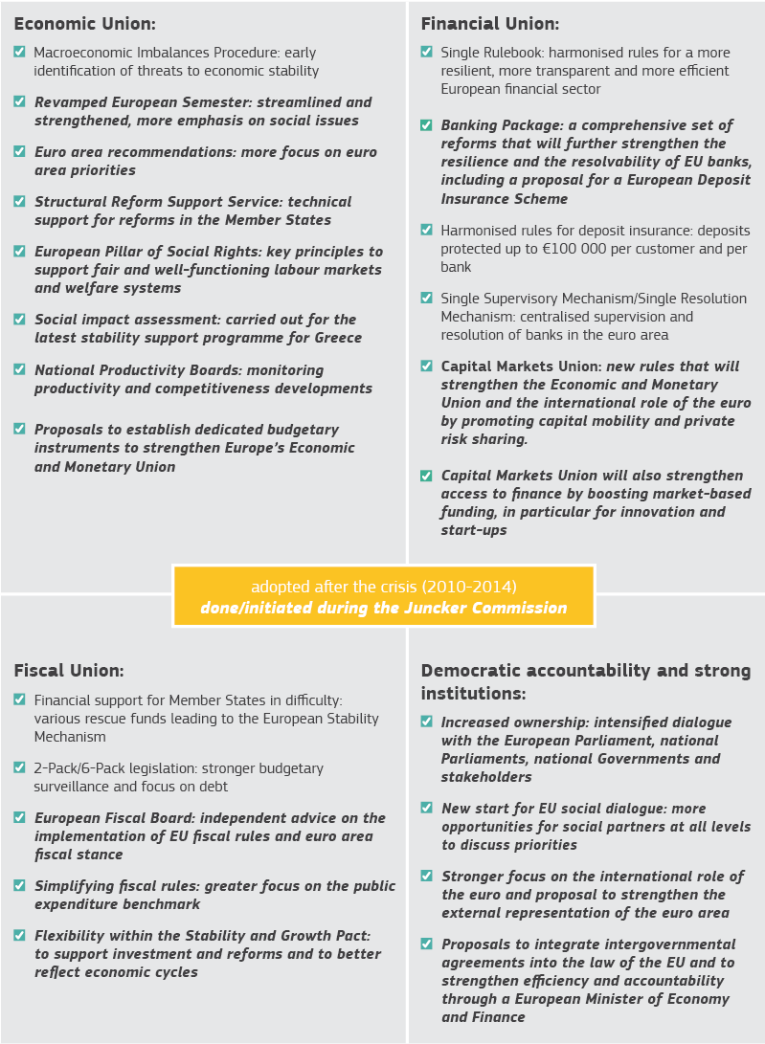

The European Central Bank has played a crucial role in restoring the confidence in the euro area. Since the onset of the 2008 global financial crisis and the subsequent euro-area sovereign debt crisis, the monetary policy measures of the European Central Bank have contributed significantly to improving financial conditions for companies and households, and to higher economic growth and inflation in the euro area. These measures, taken to maintain price stability, include very low - and even negative - interest rates, offering refinancing operations with long maturities to banks, conditional liquidity insurance via potential outright purchases of sovereign bonds and the purchase and holding of private and public sector bonds. Lending rates for euro area firms and households remained close to their historical lows, and growth in bank lending volumes continued their gradual upward trend. This supported the economic expansion, evolving from a fragile and uneven recovery into an ongoing expansion, while deflationary risks have largely disappeared. Considering all the monetary policy measures taken between mid-2014 and those decided upon in June 2018, the overall impact on inflation and the growth rate of real gross domestic product in the euro area is estimated to be, in both cases, around 1.9% cumulatively between 2016 and 2020[11].

Overall, the EU has taken decisive actions to address many of the gaps and shortcomings of the original architecture of the Economic and Monetary Union. As illustrated in Figure 2, the toolbox has been reinforced.

In parallel, market confidence has been regained. Government bond spreads gauge the perceived risks by investors. Figure 3 highlights the substantial differences in government bond yields that existed before the introduction of the euro, how these differences virtually disappeared following the introduction of the euro, their abrupt widening in the aftermath of the crisis and their progressive decline since 2012, with notable differences across countries. While the assessment of market participants may not always be fully rational, the evolution of government spreads nevertheless provides some indication of the credibility of existing institutional settings and current economic policies at both the European and the national level[12].

Figure 3: Confidence in euro area sovereigns largely regained

# Where we stand

The results achieved over recent years are noteworthy, both from an institutional and economic perspective. Today, the set of rules and institutions underpinning the Economic and Monetary Union bear little resemblance to the skeleton of twenty years ago. Moreover, the economic situation has significantly improved and the legacies of the financial and sovereign debt crises have significantly receded, even if it took too much time to heal the social scars and progress is still uneven across Europe.

Despite undeniable achievements, more work is needed. Important elements are still missing in the overall construction of Europe’s Economic and Monetary Union as laid down in the Five Presidents’ Report of 2015, the blueprint that has guided the Commission’s work over the past four years.

The December 2018 Euro Summit was the most recent attempt to provide a renewed push on immediate deliverables. Since January 2019, the discussions among the euro-area Member States on the implementation of those political agreements have been taking place in the Eurogroup and other partly intergovernmental forums, in particular on the Budgetary Instrument for Convergence and Competitiveness[13], the reform of the European Stability Mechanism and the future of the Banking Union. The Commission has played an active role, in particular by providing technical expertise to foster progress. The Commission’s effort also aims to ensure the emerging political compromises are consistent with the EU’s legal framework and do not prejudge possible future changes to that framework, in particular with regard to the prudential and resolution legislation relating to banks, the future integration of the European Stability Mechanism into EU law, and the rules governing economic policy coordination, fiscal and macroeconomic surveillance and financial stability.

*Budgetary Instrument for Convergence and Competitiveness for the euro area*

The Budgetary Instrument for Convergence and Competitiveness for the euro area will promote cohesion within the Union by strengthening the resilience of the Economic and Monetary Union. The primary objective is to support structural reforms and investment in euro-area Member States with a view to enhancing national economic and social structures that help absorb and adapt to economic disruptions. It will be complementary to existing EU funds.

Right from the start and in line with the indications by the Leaders, the Commission proposal for a Reform Support Programme of May 2018 has been the basis for the discussions among euro-area Member States[14]. Discussions have been very productive and good progress has been made; an agreement on the main features of a future Budgetary Instrument for Convergence and Competitiveness is within reach.

The budgetary instrument would be aligned with the European Semester, the EU’s well-established cycle of economic policy coordination. Euro-area Member States would submit, on a voluntary basis, duly substantiated and coherent proposals for investment and reforms, which would be assessed by the Commission based on transparent criteria. Financial support would be made available in instalments subject to achieving agreed milestones. It would consist of direct financial contributions and could also be used by euro-area Member States under the InvestEU programme.

The euro-area Member States meeting within the Council and the Eurogroup/Euro Summit would provide strategic orientation and guidance based on the Council recommendation on the economic policy of the euro area. In order to set up this governance framework, the Commission stands ready to propose a new regulation on the basis of Article 136 of the Treaty in full respect of the prerogatives of the EU and the Commission as regards budget and programme implementation.

The new budgetary instrument is planned to be part of the EU budget and its size will be determined in the context of the negotiations on the Multiannual Financial Framework 2021-2027 taking into account the implications for non euro-area Member States. Contributions from the EU budget could be complemented by additional financing via external assigned revenues on the basis of an intergovernmental agreement.

*European Stability Mechanism*

The establishment of the European Stability Mechanism during the crisis was a major milestone on the way towards a more stable Economic and Monetary Union. In due course, it should be included in the EU legal framework, as proposed by the Commission in December 2017[15]. The ongoing revision of the Treaty establishing the European Stability Mechanism, as an intermediate solution, is meant to further strengthen crisis prevention and resolution in the euro area. It should neither duplicate tasks with EU institutions nor add to the complexity of the economic surveillance framework. In that regard, the Commission and the European Stability Mechanism reached a common understanding in 2018 on future cooperation to clarify their respective roles[16].

The planned reform of the European Stability Mechanism includes a revision of the precautionary financial instruments that are meant to support countries with sound economic fundamentals which could be affected by an adverse shock beyond their control. Clarifying access conditions for such instruments is crucial as it ensures transparency and guides expectations. At the same time, eligibility conditions should not defeat the purpose of precautionary instruments, should be consistent with those required under the EU surveillance framework and should be designed in a way to respect the competences of the EU institutions.

It has been agreed that the European Stability Mechanism will provide a common backstop to the Single Resolution Fund in the form of a credit line. The Leaders agreed to introduce the backstop as of 2020 and by 2023 at the latest. As a last resort, the common backstop will support effective and credible bank crises management within the Single Resolution Mechanism, and will be repaid via contributions from the European banking sector. To ensure a credible resolution framework of banks, the agreement on the common backstop needs to ensure that resources will be made available swiftly. In that regard, short time limits for decision-making (12/24 hours) are essential, together with an emergency voting procedure. In addition, it is important that the responsibilities of the European Stability Mechanism are clearly defined and do not overlap or create frictions with the EU institutions and bodies that have been tasked to supervise banks or manage bank crises. Most importantly, the reform of the Treaty establishing the European Stability Mechanism must not create obstacles to future amendments of EU legislation, which would give rise to fundamental problems affecting the autonomy of the EU legal order. The EU’s banking legislation must remain open to further developments in accordance with the Community method to adjust to changing market circumstances and complete the Banking Union.

*Banking Union*

Today the EU banking sector is in much better shape than it was 10 years ago and a significant amount of risk-reduction has taken place. Overall, banks are better capitalised and less leveraged, making them better prepared to withstand economic shocks. Important strides have been made in reducing the existing stock of non-performing loans alongside determined action to prevent a renewed build-up in the future and the level of non-performing loans are approaching pre-crisis levels. While the stock of non-performing loans remains high in some Member States, significant progress is being made. All relevant stakeholders need to uphold those efforts[17].

Figure 4: Non-performing loans have significantly declined

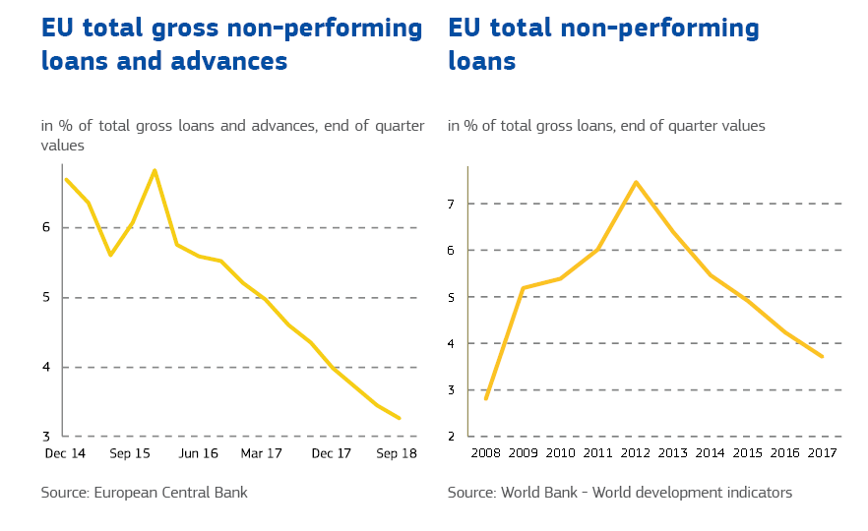

Recently agreed legislation will reduce risk further and enhance further the resilience of the European banking sector. In particular, the Regulation on non-performing loans[18] adopted by the European Parliament and the Council in April 2019 introduces minimum levels of loan loss coverage for new non-performing loans (the ‘statutory prudential backstop’) in order to limit the risk of under-provisioning of future non-performing loans. The banking package adopted by the European Parliament and the Council in May 2019 puts in place a more robust framework to regulate and supervise banks. Banks are also making progress in building up their buffers to absorb losses in a crisis (Minimum Requirement for Eligible Liabilities - MREL). The Directive on the ranking of unsecured debt instruments in insolvency[19] helps banks to build up sufficient loss-absorbing capacity and helps to ensure that their critical functions can be continued without public funds. Those measures mark major milestones in the post-crisis risk reduction agenda and implement international standards.

In December 2018, the Leaders called for the work on the Banking Union to advance, and in particular to define a roadmap for starting political negotiations on the European Deposit Insurance Scheme, the third and still missing pillar of the Banking Union. Regrettably, the impasse that characterised the past several years has persisted and no tangible progress has been made. Despite the significant risk reduction that has taken place in the EU financial sector, certain stakeholders remain firmly opposed to the pooling of resources and risk-sharing at this point.

In addition, the Banking Union will not be complete until a robust system for dealing with ailing banks has been put in place; doing so requires having an effective mechanism to provide sufficient liquid assets to banks in resolution to withstand short term deposit outflows which are inevitable in a resolution. Based on the lessons learnt from recent resolution cases, any effective solution to provide liquidity in resolution must go beyond a limited improvement of existing practices.

**In view of the meeting of the Euro Summit on 21 June 2019, the Commission invites EU Leaders:**

* **To reach an agreement on the main features of the Budgetary Instrument for Convergence and Competitiveness with a view to supporting a swift adoption by the European Parliament and the Council. To agree on its size in the context of the Multiannual Financial Framework.**
* **To finalise the changes to the Treaty establishing the European Stability Mechanism with a view to a swift ratification by the euro-area Member States, including an operational and effective common backstop, the provision of liquidity in resolution and active and effective precautionary instruments. To preserve a clear delineation of responsibilities between actors and the possibility to adjust the EU Single Rulebook for banks according to the Community method. To integrate the European Stability Mechanism into EU law over time.**
* **To make a renewed effort to complete the Banking Union starting with political negotiations on the European Deposit Insurance Scheme.**
* **To accelerate progress on the Capital Markets Union and step up work to strengthen the international role of the euro.**

# The way forward

Going forward, the Commission will continue to engage with the European Parliament, the Member States, the European Central Bank and other bodies to pursue the deepening of the Economic and Monetary Union. Besides the early deliverables that should be implemented this year, the completion of the Economic and Monetary Union requires a long term vision. By 2025, progress should be made to reinforce the EU economic surveillance and governance framework underpinned by more democratic accountability, to set up a fiscal stabilisation function and to finalise the implementation of the Banking Union and Capital Markets Union. This progress should also be used to further strengthen the international role of the euro.

*Economic surveillance*

Good progress has been made in recent years in returning Member States and the overall euro-area economy towards sound and sustainable growth paths. In particular, the fiscal deficit and debt of the euro area as a whole have been considerably reduced, and more so than in other advanced economies. At the same time, fiscal positions are now uneven: government debt levels are declining fast in some Member States, in others they are still high.

The Commission will take stock of the implementation of the framework for economic and fiscal surveillance with the review of the two-pack and six-pack legislations, which should eventually pave the way towards simpler EU fiscal rules. The review could also provide the basis for further improvements in the transparency and effectiveness of the policy coordination framework and to reinforce the social dimension of the surveillance framework.

*Institutional strengthening*

New rules should go hand in hand with a streamlining of competences in the Economic and Monetary Union. While the European Parliament has already played a more active role in recent years, its standing should be further strengthened. To increase transparency and democratic accountability, the Commission proposed in December 2017[20] to appoint the same person for the positions of the Vice-President of the Commission in charge of the Economic and Monetary Union and the President of the Eurogroup. This could lead to a significant improvement in accountability at the European level, without transferring competences away from Member States. This person, representing both the euro area Member States and the Commission, would also represent the euro area externally, a critical point for the standing of the euro on the global scene.

Ultimately, the European Stability Mechanism should be in the EU legal framework. This would offer institutional clarity, recognising the European Stability Mechanism’s importance for the Economic and Monetary Union. Such an integration would also allow increasing the political and legal accountability of the European Stability Mechanism for the execution of its important tasks in euro area crisis management. Stronger political accountability towards the European Parliament, as well as to the national parliaments of the euro-area Member States, is indispensable to ensure that the common euro area interest is adequately taken into account and to achieve long-term acceptance by citizens. In addition, the Court of Justice has underlined the responsibility of the Commission as guardian of the Treaties for monitoring the application of the framework of the European Stability Mechanism in practice and for helping to ensure that fundamental rights of individuals are fully protected in this context[21].

In addition, a euro-area Treasury could take shape, to access financial markets on behalf of its members to fund part of their regular refinancing needs. The euro-area Treasury could bring together existing competences and services that are today scattered across different institutions and bodies, including the European Stability Mechanism, after its integration into the EU legal framework.

*Fiscal Stabilisation*

One important lesson of the financial and economic crisis was that the current framework is ill-equipped to tackle very large country-specific or euro area-wide shocks. A common stabilisation function would be an important complement to national budgets. In 2018, the Commission made a proposal for a European Investment Stabilisation Function[22] to provide up to EUR 30 billion in back-to-back loans to stabilise public investment levels in the event of severe economic shocks. This proposal remains relevant and should be seen as a complement to the Budgetary Instrument for Convergence and Competitiveness for the euro area. The latter is meant to enhance a Member State’s growth potential and economic resilience by implementing reforms and relevant investment projects while a common stabilisation function would help mitigate the impact of major shocks if they hit nevertheless. A common unemployment re-insurance scheme could also be considered[23].

*Banking Union*

The journey towards a complete Banking Union requires further effort to put in place the missing elements necessary for a thriving Economic and Monetary Union. The Banking Union was always intended to consist of three pillars – single supervision, single resolution, and a single deposit insurance scheme. Both the Single Supervisory Mechanism and the Single Resolution Mechanism are already operational. Time has now come to make concrete progress on the third pillar: a common depositor protection mechanism. Guaranteeing deposits on a European level would ensure that all deposits are equally protected across the Banking Union and thereby strengthen the confidence of depositors and mitigate the risk of bank runs. While significant progress has been achieved in harmonising the Single Rulebook, more should be done to remove unnecessary obstacles to the cross-border integration of the banking system. A Banking Union in its steady state should deliver the regulatory frameworks and institutional design necessary to strengthen the resilience and competitiveness of the EU banking sector.

Diversified banks’ balance sheets should form the basis for more effective private risk sharing and for loosening the feedback-loops between banks and their national sovereigns. To this end, the Commission proposed in May 2018 an enabling regulatory framework for Sovereign Bond-Backed Securities[24]. Revising the regulatory treatment of sovereign exposures could be another way to provide incentives for banks to diversify their holdings away from home-sovereign bonds. A careful design and a significant phase-in period would be necessary to ensure a smooth transition to the new regime.

An appropriate common safe asset would strengthen the euro area and increase the efficiency of the Economic, Monetary and Financial Union through several channels, including by mitigating the sovereign-banks doom loops. It could spur the development and integration of capital markets by providing a single benchmark for assessing other assets and would facilitate the conduct of monetary policy. A common safe asset has also the potential to reduce the scope for destabilising intra-euro-area capital flows in times of elevated risk aversion, the so-called flight-to-safety that hurts investment, and to support a stronger international role of the euro.

Changing the regulatory treatment of banks’ sovereign exposures and introducing a common safe asset are two measures that raise a number of economic, legal, political and institutional questions that will need to be tackled in parallel, in close cooperation with the Member States.

*Capital Markets Union*

Together with the Banking Union, the Capital Markets Union supports a well-functioning Economic and Monetary Union and a strong role of the euro. It ensures more funding and asset diversification for companies and investors alike. A Capital Markets Union supports investment, economic growth and job creation especially when the traditional credit channels via banks are under major stress. The Capital Markets Union also promotes convergence, as it seeks to remove unnecessary regulatory and non-regulatory barriers to the free movement of capital across the Single Market.

The Capital Markets Union enjoyed strong support from the European Parliament and the Member States, as the benefits of wider diversification and better integration of markets are well recognised for economic growth and job creation. As a result, 11 out of 13 proposals put forward by the Commission as part of its Action Plan and Mid-Term Review have been adopted[25]. Nonetheless, in some instances, the project has hit strong resistance from Member States on politically sensitive matters such as more effective EU supervision and tackling excessive national rules in the cross-border provision of services. While the Capital Markets Union has continued to generate wide support at the highest political level, concrete support on specific legislative files has sometimes been lacking.

The completion of the Capital Markets Union is essential to guarantee that Europe’s capital markets can stand up to the significant internal and external challenges for the stability of the Economic and Monetary Union, as well as to address new challenges arising from the United Kingdom’s departure from the EU. The agreed legislation must now be implemented in full. Besides the recent achievements, the remaining barriers, such as divergent insolvency regimes and ineffective cross-border taxation, have to be tackled to ensure a better integration of capital markets in Europe. Determined action is needed also at the level of Member States and market participants themselves. In addition, the governance, tools and mandates of the European Supervisory Authorities should continue to be revised as the Capital Markets Union progresses to ensure that authorities are able to address potential risks stemming from the development and integration of capital markets.

This needs to be complemented by more convergence of supervisory practices, in particular to deal with money laundering, which is a continued threat to the reputation and stability of the European capital markets and banking sector. The European Parliament and the Council agreed recently a package of measures[26] to reinforce among others the role of the European Banking Authority for purposes of combating money laundering and terrorist financing. While the reform, combined with the forthcoming application of the fifth Anti-Money Laundering Directive[27], will further promote the integrity of the Union's financial system, it may not be enough to tackle the full scale of the problem. Building on the Commission’s on-going analysis of recent money laundering scandals in the banking sector, there will be a need to consider whether a more unified body would be more effective in addressing the cross-border aspects of money laundering.

*International role of the euro*

Following the publication of a Communication on the international role of the euro in December 2018[28], the December 2018 Euro Summit encouraged the Commission to continue working towards developing the international use of the euro. The euro is twenty years young and is the world’s second currency. It remained strong even during the worst moments of the financial and sovereign debt crises. At the same time, the global order has become more multi-polar with new economic powers, institutions and technologies emerging and existing powers repositioning themselves. This calls for strengthening Europe’s economic and monetary sovereignty.

The Commission has engaged in active consultations with market participants, public and private, over the past months[29]. There is broad support for reducing dependence on a single dominant global currency. Moreover, the euro stands out as the only strong candidate that has all the necessary attributes of a global currency that market participants use already today as an alternative to the US dollar. Finally, there is recognition that the EU, through the euro, can reinforce its economic sovereignty and play a more important global role to benefit EU business and consumers and contribute to international financial stability. The completion of the Banking Union and Capital Markets Union is essential in that context, to strengthen the resilience and stability of the euro, to promote deep and liquid equity and debt markets and to foster further financial market integration. The Commission, with the European Central Bank, will continue to work with Member States, market participants and other stakeholders on actions to achieve a stronger role of the euro, and calls upon the European Parliament, the Council and all interested parties to support these efforts. Going forward, it is suggested to regularly take stock of progress at political level.

# Conclusions

With this Communication, the Commission calls on the European Parliament, the European Council, the Council, the European Central Bank and all other stakeholders to continue firmly on the path to complete the Economic and Monetary Union.

**In view of the meeting of the Euro Summit on 21 June 2019, the Commission invites EU Leaders:**

* **To reach an agreement on the main features of the Budgetary Instrument for Convergence and Competitiveness with a view to supporting a swift adoption by the European Parliament and the Council. To agree on its size in the context of the Multiannual Financial Framework.**
* **To finalise the changes to the Treaty establishing the European Stability Mechanism with a view to a swift ratification by the euro-area Member States, including an operational and effective common backstop, the provision of liquidity in resolution and active and effective precautionary instruments. To preserve a clear delineation of responsibilities between actors and the possibility to adjust the EU Single Rulebook for banks according to the Community method. To integrate the European Stability Mechanism into EU law over time.**
* **To make a renewed effort to complete the Banking Union starting with political negotiations on the European Deposit Insurance Scheme.**
* **To accelerate progress on the Capital Markets Union and step up work to strengthen the international role of the euro.**

Further determined collective efforts will be needed to advance on the deepening of the Economic and Monetary Union and the completion of the Banking and Capital Markets Union by 2025 at the latest.

1. ‘The Five Presidents’ Report: Completing Europe's Economic and Monetary Union’, by: Jean-Claude Juncker in close cooperation with Donald Tusk, Jeroen Dijsselbloem, Mario Draghi and Martin Schulz, 22.06.2015. The report was preceded by an ‘Analytical Note on the Economic and Monetary Union (EMU)’ by Jean-Claude Juncker, Donald Tusk, Jeroen Dijsselbloem, Mario Draghi, discussed at the informal European Council on 12 February 2015.
2. ‘A New Start for Europe: My Agenda for Jobs, Growth, Fairness and Democratic Change’ – Political Guidelines for the next European Commission, 15.7.2014, President Juncker.
3. Reflection Paper on the deepening of the Economic and Monetary Union, 31.05.2017, European Commission.
4. In his State of the Union address on 13 September 2017, President Juncker unequivocally stated ‘The euro is meant to be the single currency of the European Union as a whole’ as required by the Treaty. Since then, Bulgaria (the currency of which is already pegged to the euro) has applied for close cooperation with the European Central Bank and announced a number of prior commitments in July 2018 to pave the way for ERMII membership, while Croatia has just submitted its request for close cooperation with the European Central Bank and is expected to apply for joining Banking Union soon.
5. A backstop to the Single Resolution Mechanism was already envisaged in the conclusions of the European Council of December 2012.
6. COM(2017) 821. Communication from the Commission - Further steps towards completing Europe’s Economic and Monetary Union: a roadmap.
7. COM(2016) 723. Proposal for a directive on preventive restructuring frameworks, second chance and measures to increase the efficiency of restructuring, insolvency and discharge procedures.
8. COM (2015) 12. Making the best use of the flexibility within the existing rules of the Stability and Growth Pact.
9. Figures in this paragraph are Commission estimates; see also The State of the Union address by President Juncker, 12 September 2018, and Commission contribution to the informal EU27 leaders' meeting in Sibiu (Romania) on 9 May 2019.
10. On 17 July 2015, the Council adopted a decision granting short term financial assistance to Greece under the European Financial Stabilisation Mechanism. The short term financial assistance allowed the country to clear its arrears with the International Monetary Fund and the Bank of Greece and to repay the European Central Bank, until Greece would start receiving financing under a new programme from the European Stability Mechanism.
11. European Central Bank, Economic Bulletin, March 2019.
12. These aspects were already flagged in the ‘Report on economic and monetary union in the European Community’, 1989, prepared by the Committee for the study of economic and monetary union chaired by Mr Jacques Delors. See for instance: ‘To some extent market forces can exert a disciplinary influence. […] However, experience suggests that market perceptions do not necessarily provide strong and compelling signals […]’.
13. Discussions on the Budgetary Instrument for Convergence and Competitiveness took place in the inclusive format of the Eurogroup Working Group, i.e. the EU at 27.
14. COM(2018) 391. Proposal for a Regulation on the establishment of the Reform Support Programme.
15. COM(2017) 827. Proposal for a Council Regulation on the establishment of the European Monetary Fund.
16. <https://ec.europa.eu/info/business-economy-euro/economic-and-fiscal-policy-coordination/eu-financial-assistance/loan-programmes/european-stability-mechanism-esm_en>.
17. The fourth progress report on the reduction of non-performing loans published alongside this Communication documents progress with risk reduction.
18. Regulation (EU) 2019/630 as regards minimum loss coverage for non-performing exposures.
19. Directive (EU) 2017/2399 as regards the ranking of unsecured debt instruments in insolvency hierarchy.
20. COM(2017) 823. Communication from the Commission – A European Minister of Economy and Finance.
21. Judgment of the Court of 20 September 2016, Ledra advertising e.a. v. Commission, joined cases C-8/15 P to C-10/15 P, ECLI:EU:C:2016:701, para. 55-59 and 67.
22. COM(2018) 387. Proposal for a Regulation of the European Parliament and of the Council: The establishment of a European Investment Stabilisation Function.
23. Commission contribution to the informal EU27 leaders' meeting in Sibiu (Romania) on 9 May 2019.
24. COM(2018) 339. Proposal for a Regulation on Sovereign bond-backed securities.
25. COM(2019) 136. Communication from the Commission - Capital Markets Union: progress on building a single market for capital for a strong Economic and Monetary Union.
26. COM(2017) 536. Proposal of the Commission to reform the European Supervisory Authorities.
27. Directive (EU) 2018/843 on the prevention of the use of the financial system for the purposes of money laundering or terrorist financing.
28. COM(2018) 796. Communication from the Commission - Towards a stronger international role of the euro.
29. SWD(2019) 600. Commission Staff Working Document – ‘Strengthening the international role of the euro. Results of consultations’.