

INTRODUCTION

The ninth edition of the Trade and Investment Barriers Report analyses the new barriers faced by EU business in 2018 as well as those removed for our companies in the same year thanks to the EU Market Access Partnership, which brings together the Commission, Member States and European businesses.[1] This Partnership is driven by and for stakeholders. It identifies barriers that EU firms face in third countries, defines a common strategy to remove them —and follows this strategy through.

To respond to the rise in protectionism, the Commission has made enforcement – along with the sharper focus on the implementation of trade agreements - a top priority. This follows the thread of our "Trade for All"[2] communication, which married a more robust approach to traditional barrier removal with sharper efforts to implement the important commitments obtained in our wide hub of Free Trade Agreements.[3]

With respect to the traditional market access element, we have worked in three directions. First we have strenghtened coordination among EU institutions and stakeholders (in Brussels, Member States, and in our large network of diplomatic missions). Second, the Commission has improved its communication efforts to explain, especially to small and medium-sized enterprises (SMEs), how they can report any new barriers they might be facing outside the EU and how the Commission and Member States can design and implement a tailor-made strategy to resolve them. This has benefitted from the Market Access Days initiative, where sessions adapted to the needs of local business are held in our Member States—events have already taken place in Denmark, Spain, the Netherlands, Lithuania, Portugal and France. Third, we have engaged in a savvier prioritisation of barriers—allowing us to focus resources more effectively to achieve results.

This current report offers new improvements in this regard, in order to identify and describe in more detail the barriers most significantly impacting EU companies. While previous reports have traditionally focused on partners with the highest number of new and resolved barriers, this year's report also puts an emphasis on the barriers that have weighed most on EU exports, shedding new light on their relative significance.

The first section of the report presents a quantitative and qualitative analysis, per country, per type of barrier and per sector, of the total stock of 425 active[4] trade and investment barriers and the 45 new barriers recorded in 2018, as reported to the Commission and recorded in the EU's Market Access Database.[5]

The second section provides a more detailed analysis of the new barriers reported in 2018 (1 January – 31 December 2018), describing specific trends in various countries and assessing potentially affected trade flows.

The third section identifies the tools used in our Market Access Strategy to address these barriers and reviews the 35 barriers successfully resolved in 2018. It also analyses in more detail some of the most impactful barriers resolved. Finally, it also elaborates on the economic gains generated by our Market Access Partnership since the start of this Commission on the basis of economic modelling.

**I. OVERVIEW OF TRADE AND INVESTMENT BARRIERS**

Our stakeholder-driven approach implies that the report focuses exclusively on those obstacles that business has flagged. This chapter analyses such trade barriers faced by EU companies in third countries and the related trends and actions taken to remove them in the framework of our Market Access Partnership. While the database and this report do not prejudge the (il)legality of the recorded measures, these barriers have all been identified as problematic for EU companies and prioritized for further action in our market access work as they might be discriminatory, disproportionate or otherwise trade-restrictive. They are all included in our Market Access Database.

**A. OVERALL STOCK OF TRADE AND INVESTMENT BARRIERS**

At the end of 2018, 425 active trade and investment barriers in 59 third countries[6] existed in the EU's Market Access Database.[7] This record figure confirms the continued rise of protectionism affecting EU stakeholders. At the same time, it also shows the increasing success of our Market Access Partnership as the forum our stakeholders ever more often turn to in order to identify and address trade barriers. The database allows distinguishing recorded trade barriers per third country, per type of measure and per sector. This report follows this breakdown.

1. Barriers per third country

Compared to 2017, the top ten countries with the highest number of barriers have remained the same, although in a slightly different order. Most notably, and for the first time, China has taken over as the country with the highest stock of recorded barriers, with 37 obstacles hindering EU export and investment opportunities. Russia came a close second with 34 barriers currently in place, followed by India (25), Indonesia (25) and the United States with 23 barriers.

Other third countries with ten or more trade barriers in place include Turkey (20), Brazil (18), South Korea (17), Australia (15), Thailand (12), Mexico (11) and Algeria (10). Figure 1 provides a more detailed breakdown of barriers across the world.

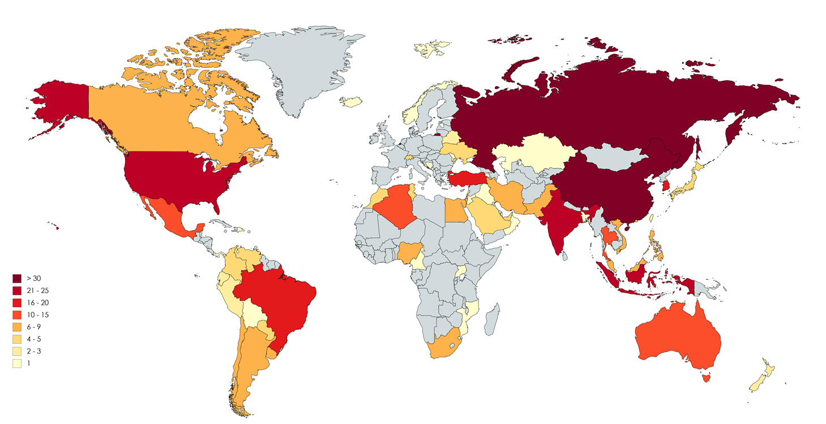

**Number of barriers**

*Figure 1[8]: Geographical breakdown of trade and investment barriers in the MADB*

2. Barriers per type of measure

Figure 2 shows that behind the border measures (234) are more numerous than traditional border measures (191), following the evolution observed already last year.

Behind the border measures are restrictions related to services, investments, government procurement, intellectual property rights or unjustified technical barriers to trade concerning trade in goods. Most of these measures are recorded in China (25), Russia (18) and Brazil (15).

Border measures are restrictions that directly affect imports and exports, typically through tariff increases, quantitative restrictions, certain sanitary and phytosanitary (SPS) measures, import licensing or through outright trade bans. Russia (16) is the country that recorded the highest number of such measures, followed by Indonesia (13) and the United States (13).

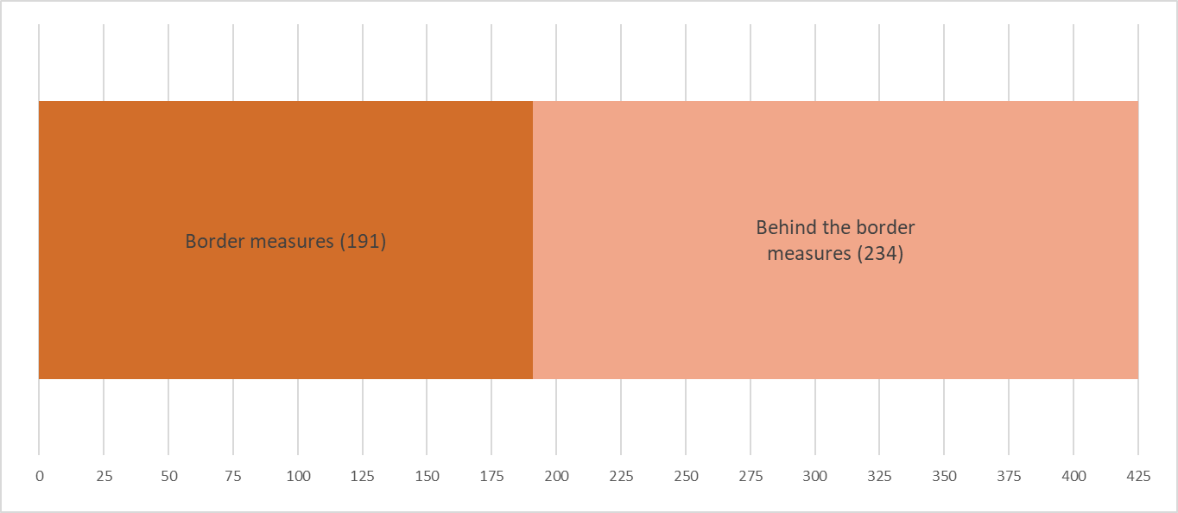

*Figure 2: Breakdown of trade and investment barriers recorded in the MADB per type (number of measures)*

**B. NEW TRADE AND INVESTMENT BARRIERS REPORTED IN 2018**

A total of 45 new barriers in 23 third countries[9] were registered in 2018, approximately one third lower than the 67 new obstacles reported in 2017. However, as described below in more detail, the estimated economic impact of barriers reported in 2018 is significantly higher than those of last year. EU exporters have been facing increasingly complex and more systemic barriers in significant markets, re-confirming the trend of increasing protectionism highlighted in the previous two reports.

Trade flows affected by the new barriers in 2018 amount to EU28 exports worth up to €51.4 billion, a figure that has more than doubled compared to 2017 (€23.1 billion). As this figure does not include services barriers or those where the product coverage is not easily identifiable, trade flows potentially affected are likely to be somewhat underestimated.[10]

1. New barriers reported in 2018 per third country

Table I and Figure 3 provide an overview of the geographical breakdown of new barriers recorded in 2018. This shows that the highest number of new barriers were reported in our trade an investment relations with Algeria and India, which both registered five new barriers. China and the United States follow closely as they registered four new barriers each. Three barriers have been reported in Indonesia, Iran and the United Arab Emirates, respectively. Brazil and Turkey furthermore introduced two new barriers while the remaining fourteen barriers were recorded for other third countries. Looking at the regional tendencies, we observe that a vast majority of the new obstacles in 2018 were imposed in Asia (17), and South Mediterranean and Middle East region (17).

Comparing these figures with the the 2017 results, the continued presence of China (ten new barriers last year) and India (three new barriers last year) point to a negative trend. It is also worth mentioning that Algeria was also touched upon in last year's report as part of a contagion effect that was emerging in the South Mediterranean region; the five new barriers in 2018 appear to have confirmed this tendency.

*Table I: Geographical breakdown of new barriers reported in 2018*

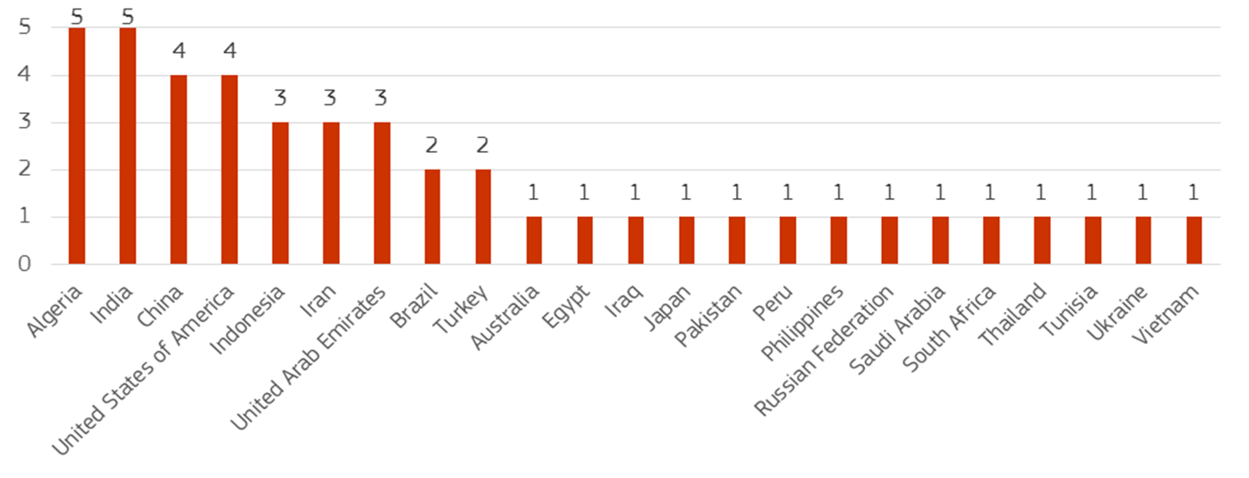

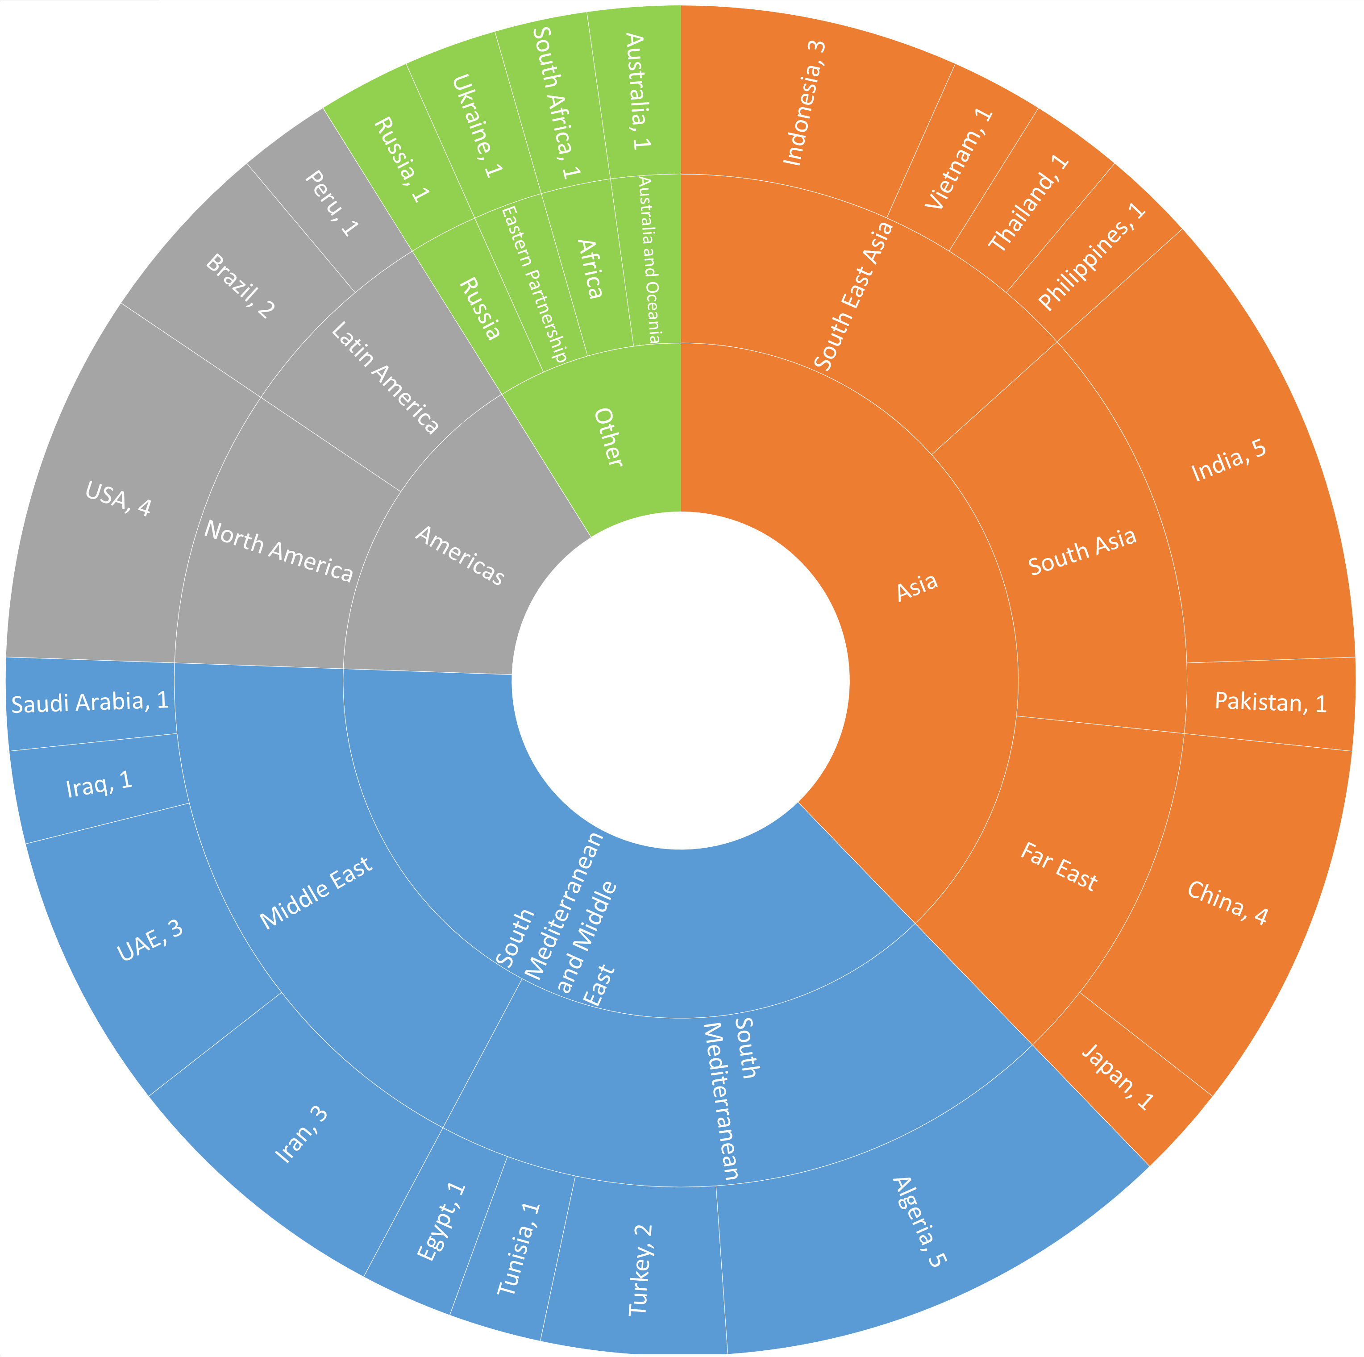

*Figure 3: Geographical breakdown of new barriers reported in 2018, per region*

As indicated above, this report puts an increased emphasis on the economic weight of new barriers. Figure 4 illustrates the estimated trade flows affected against the number of barriers recorded in 2018 for specific partners and regions. It shows that new barriers recorded in China (4) have significantly more impact on trade flows affected (€25.7 billion) in comparison to barriers recorded in other third countries. It is worth mentioning this substantial figure of trade potentially affected is caused in particular by one new barrier in the ICT sector that could have a major economic impact for EU operators' exports to China – this barrier is described in more detail in Chapter II.

Figure 4 also shows that China, the United States, India and Algeria rank the highest –albeit in a different order- regarding both the number of new barriers recorded in 2018 and the magnitude of EU28 trade flows affected by these new barriers. Those four partners represent 81 percent (€41.8 billion) of all 2018 EU28 trade affected and 40 percent of new reported barriers (18).

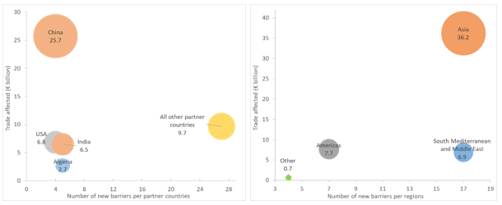

***Figure 4: Number of new barriers reported and trade affected for EU28 (€ billion), selected partner countries and regions***

Table II reports on the trade flows affected for all 23 partner countries that introduced new trade barriers in 2018. However, the assessment of the economic impact of new market access barriers may not at times fully reflect the real impact of obstacles. This might be the case concerning barriers in services or of horizontal nature, which are difficult to quantify, or when it comes to overlapping restrictions covering the same products.

*Table II: EU28 trade flows affected by new barriers reported in 2018 by partner countries, (€ billion)*

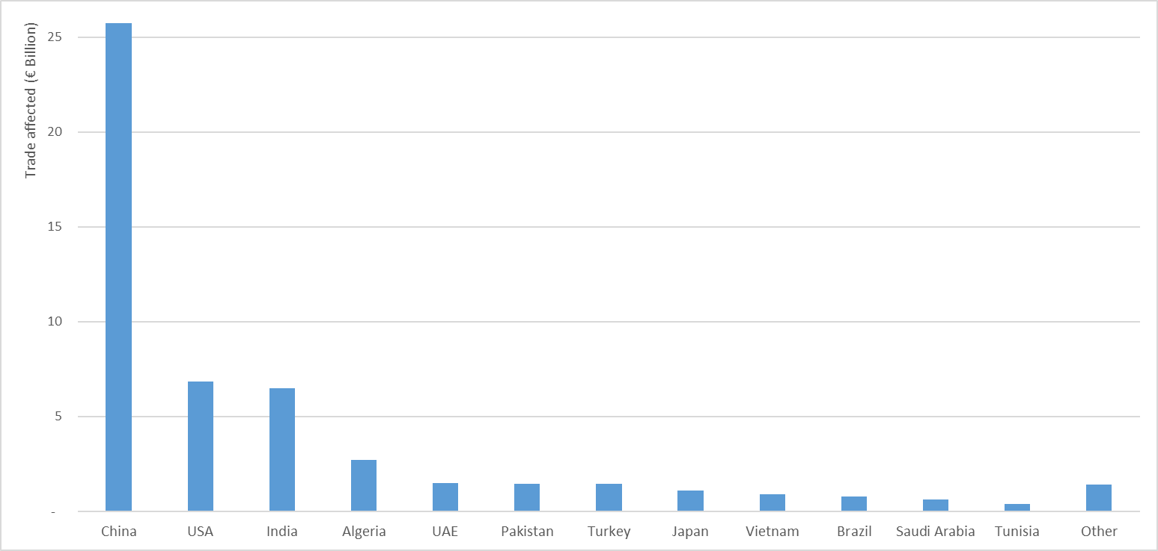

2. New barriers reported in 2018 per type of measure

A breakdown of the new barriers per type of measures shows a similar range of new behind the border (23) and border measures (22), underlining that third countries continue to resort to both sets of restrictions.

Most of behind the border measures refer to labelling requirements, tax measures and new regulatory requirements that have been introduced by several third countries. The majority of border measures are SPS restrictions[11] and measures relative to increased custom duties, tariffs and quotas. This year, two new barriers were also reported in the field of services.

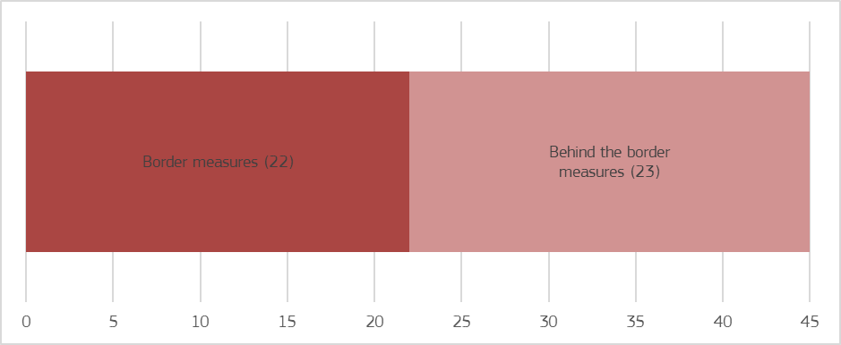***Figure 5: Breakdown of new trade and investment barriers reported in 2018 per type (number of measures)***

3. New barriers reported in 2018 per sector

The new barriers reported in 2018 affected EU trade in 13 specific sectors of economic activity, as well as in the form of horizontal or cross-cutting barriers impacting several areas.

The highest number of new barriers were reported in the *wines and spirits* (9) and *agriculture and fisheries* (8) sectors. A total of ten barriers were also recorded that were either fully *horizontal* (5)*[12]* or cross-cutting restrictions affecting *various industries* (5). The *cosmetics* and *automotive sectors* faced the emergence of four and three new barriers respectivelywhile the *pharmaceuticals* and *textiles & leather* industries each saw two new hurdles appear in 2018. Finally, several other sectors were each affected by one newly imposed barrier to trade: *ICT*; *ceramics and glass*; *iron, steel and non-ferrous metals*; *mineral products*; *paper, wood & pulp*; *plastics and precious metals.*

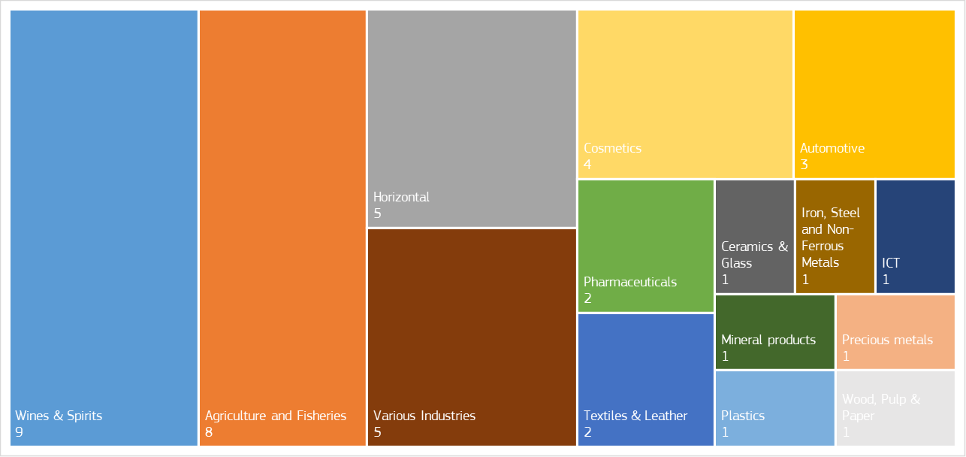

***Figure 6: Sectorial breakdown of trade and investment barriers reported in 2018 (number of barriers)***

While the number of measures identified is an important indicator, the analysis of trade affected sheds more light on the actual weight of each barrier. As displayed in Figure 7, industrial sectors accounted for about 97 percent of the trade affected, with barriers in only three sectors (*ICT*; *iron, steel and non-ferrous metals; precious metals*) corresponding to 72 percent of all EU28 exports affected by new reported barriers.[13]

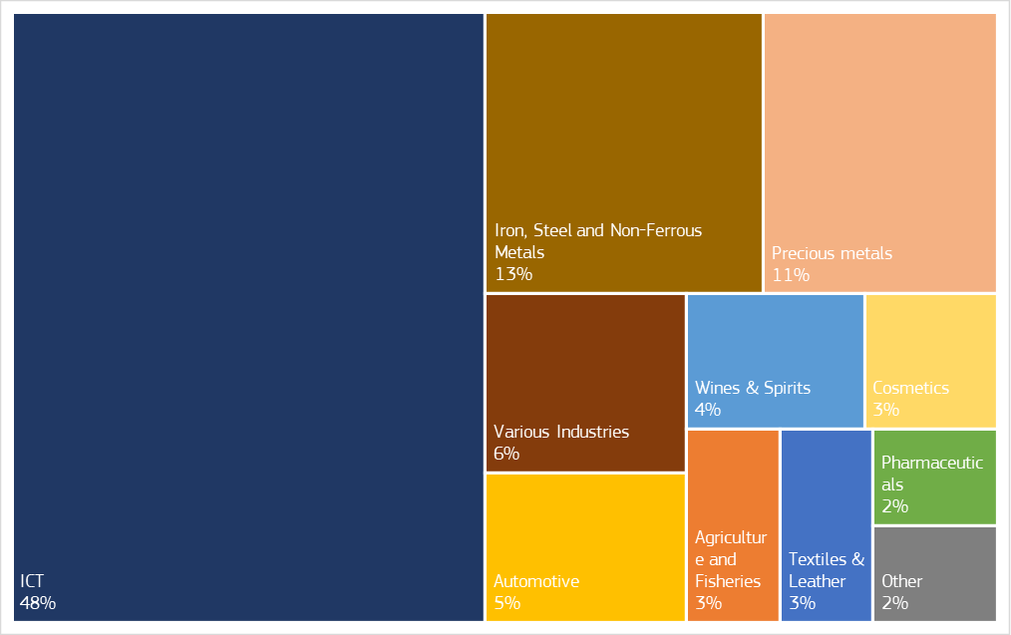

***Figure 7: EU28 trade flows affected by barriers reported in 2018, per sector (percentage of trade flows affected)***

**II. MAIN NEW TRADE AND INVESTMENT BARRIERS REPORTED IN 2018**

This chapter provides an analysis of new barriers reported in trading partners for which four or more barriers were recorded in 2018 and which represent the lion's share of the EU's potentially affected trade flows (81 percent), namely China, the United States of America, India and Algeria.

**A. QUALITATIVE ANALYSIS OF THE NEW BARRIERS**

**1. China**

The EU-China trade relationship is among the most complex ones. While China remains an important market for EU companies, a plethora of trade distortions and market access barriers have considerably affected our bilateral trade relationship for years, encompassing various systemic concerns such as massive subsidisation, obligations to transfer technology, overcapacity in traditional sectors - such as steel and aluminium - but also increasingly in high-tech areas (Made in China 2025), or unjustifiable cybersecurity and encryption regulations.

In this context, China resorted to four new barriers in 2018, confirming the trend observed last year when a record of ten new barriers were reported – these developments have now established China as the most trade-restrictive partner for the EU with an overall stock of 37 barriers. Taken together, these four new barriers could affect EU exports up to €25.7 billion.

As already highlighted in last year's report, China has been introducing various trade-restricting measures in the area of high-tech industries, which have also been complemented by overarching industrial policy considerations and various trade distortions under the Made in China 2025 strategy. In 2018, China continued to add to the dozens of implementing measures in the ICT area to operationalise the Cybersecurity Law that entered into force on 1 June 2017. As part of this development, **the draft Regulation on Classified Cybersecurity Protection, also known as Cyber Multi-Level Protection Scheme (or Cyber-MLPS)** was issued by the Ministry of Public Security for public consultation in June 2018 and could replace the original Multi-Level protection Scheme (MLPS) of 2007. The aim of these regulations is to classify all information systems by their level of security. Based on the perceived level of sensitivity, foreign companies could be excluded from certain market segments. In general, it is problematic that the draft leaves considerable room for interpretation as key concepts are not defined. In addition, the burden of proof for companies could increase even in lower risk applications, more applications could unjustifiably fall under higher risk categories, and unnnecessary testing and certification requirements could apply for cryptography applications. The measures are also a concern from an intellectual property perspective. Finally, the longstanding issue of the lack of access to relevant Chinese standardisation bodies (TC 260 Working Group 3, Cybersecurity Standardisation Technical Committee) has also become even more pressing in conjunction with this Cyber-MLPS, due to the nexus with the standards these bodies develop. This single barrier would considerably affect EU exports: trade flows affected in the ICT and electronics sector are valued at €24.9 billion – while noting that this measure could in fact also have considerable implications on EU investments in China, and would also stretch beyond the ICT sector to various other high-tech industries.

In addition, distributors of **culinary gas-filled whippers and chargers** for the food service market encountered difficulties caused by unclear requirement to hold a licence for the storage and distribution of “dangerous goods” under China's current regulatory framework. This concerns exports up to €383 million.

Third, **standards into food regulation** set restrictive yeast parameters that prevented EU export of certain cheeses and created delays inthe authorization procedures for the export of sterilized milk. This could concern exports up to €469 million.

Finally, China revised its **salt monopoly rules** through measures published inDecember 2017 and May 2018**.** As a result, all imports of salt have effectively been stopped by Chinese customs and therules provide that only designated salt wholesale companies can retail salt in China. It is unclear whether foreign companies can be designated.

While the EU has used all avenues to address the challenges it faces with China, including bilateral dialogues (Economic and Trade Working Group, ICT Dialogue, Cyber Task Force, Trade and Investment Policy Dialogue, High Level Economic Dialogue, Summit) and multilateral fora (various WTO Committees), the recent developments require additional, well-coordinated efforts to better address market access issues vis-à-vis China.

In parallel, in situations where dialogues have not led to satisfactory outcomes, the Commission did not hesitate to take resolute action to enforce international trade rules: on 1 June 2018 the EU launched legal proceedings in the WTO against Chinese measures on the transfer of technology" (DS549) that undermine the intellectual property rights of European companies. At the same time, it has become clear that certain trade distortions now risk threatening the integrity of the global trading system. While the EU will continue to make full use of its wide toolbox to address trade distorting practices within the existing international rulebook, it has also become evident that WTO rules must be modernised to find genuine, lasting remedies. In this context, a bilateral Working Group on WTO Reform was launched at the 2018 EU-China Summit.

Negotiations are also ongoing for a Comprehensive Agreement on Investment (CAI) to facilitate the investment market access conditions faced by EU companies in China. Following the 2018 EU-China Summit, both sides exchanged market access offers.

**2. USA**

The EU and the United States have the largest economic relationship in the world. With the transatlantic economy supporting 15 million EU and US jobs, EU-US collaboration is essential for the stability of significant trade flows and the multilateral trading system.

Trade tensions between the EU and US increased in 2018, as the US imposed four new trade barriers, bringing the overall barrier count to 23. While one of these issues has already been successfully resolved in 2018, the remaining three barriers concern EU exports worth up to €6.8 billion.[14]

Trade tensions between the EU and US increased notably as a result of the imposition on 1 June 2018 of additional so-called **''Section 232'' duties** on imports of EU steel (25%) and aluminium (10%) on alleged national security grounds. The EU reacted promptly and proportionately to these measures by requesting consultations under the WTO Dispute Settlement Understanding, implementing rebalancing through additional tariffs on selected goods imported from the US on €2.8 billion of US exports; and introducing safeguard measures of its own to guard against potential trade diversion and protect European businesses from indirect negative effects of the US measures.

Further, the launch in May 2018 of a separate investigation into the national security dimension of US imports of cars and car parts are a cause for serious concern for the EU as any adverse measures could have a significant impact on two-way transatlantic trade.[15]

It was against this backdrop that President Juncker and President Trump met on 25 July 2018. Their discussions were successful and the Presidents reached an agreement to launch a new phase in the trade relationship with a view to facilitate trade and deescalate trade tensions. Their Joint Statement of 25 July 2018 defined a set of work streams to achieve this objective. In addition, the EU and US agreed to refrain from any measures that would go against the spirit of their agreement while work on this joint agenda is ongoing.

Other recent trade barriers imposed by the US, outside the scope of the Joint Statement, relate first to two specific provisions of the **US Tax Cuts and Jobs Act 2017**, i.e**.** the Base Erosion and Anti-abuse Tax (BEAT), which has some discriminatory aspects, and the Deduction for Foreign Derived Intangible Income (FDII), which may configure a prohibited subsidy. The EU has concerns that the two provisions would negatively impact European businesses (notably banks and insurers) and has raised them at political and technical level with US counterparts.

Second, certain custom classification discrepancies, i.e. the fact the US Customs Administration does not follow the World Customs Organisation **classification of multilayer parquet for customs purposes,** result in the imposition of a 5% import duty instead of 0%, or even of 8% when multilayer parquet is considered as plywood.

Finally, a barrier introduced in 2018 under the **''Formaldehyde Act''**, which sets out emission standards of formaldehyde for domestically manufactured and imported composite wood products, was resolved. The issue had been caused due to earlier compliance date than originally announced (June 2018 instead of December 2018). As a result, some EU companies were concerned about the short deadline, especially for the shipments that were already on their way to the US. Following EU demarches before the US administration (including a letter to the US Environmental Protection Agency) and consultation with EU stakeholders it was confirmed that the issue was resolved as no shipments had been put on hold by the US customs.

The long-standing issue of undue delays in the publication of the final rule permitting eight EU Member States (Belgium, Netherlands, France, Italy, Spain, Germany, Portugal and Poland) to export **apples and pears** to the US has not yet been solved and merits particular note. The application is pending since 2008 and the publication of the final rule allowing trade is unreasonably postponed despite the lack of Sanitary/Phytosanitary grounds.

**3. India**

The year 2018 was marked by a continued protectionist trend in India with the persistence, and to some extent amplification, of barriers to EU imports. This includes prohibitive imports duties on goods in key sectors, sanitary and phyto-sanitary (SPS) restrictions on agricultural imports, and a growing number of technical barriers to trade in various forms, including deviations from agreed international standards. Additional difficulties for EU operators are linked to local content requirements in government procurement and the absence of a protection framework for foreign investments.

In this context, five new trade barriers were recorded in 2018 which brings the number of barriers in India to a total of 25. While one of these barriers has already been partially resolved in 2018, the remaining four barriers concern EU exports up to €6.5 billion.

Of the new barriers, one concerns the **registration process of cosmetics**, with discriminatory registration requirements for imports and deviation from internationally-agreed standards, while another is related to a new **increase of import tariffs on polished diamonds** – the fourth such duty hike in six years. These new barriers, which have yet to be the subject of extensive discussions with Indian authorities, concern a substantial value of EU exports worth up to €6.1 billion and could become a serious obstacle to EU trade with India.

In addition, on top of longstanding high duties and taxes in the **automotive** sector, India has over the years introduced over 1000 new country-specific **standards,** an increasing number of which do not correspond to internationally-agreed standards.The combination of these measures prevent European manufacturers from competing with local manufacturers on an equal footing, affecting trade flows currently worth up to €144 million - an amount that is comparatively low in a sector for wich EU exports are traditionally high which is demonstrative of the limited market access EU companies currently enjoy in this important sector.

Moreover, in April 2018, the Food Safety and Standards Authority of India (FSSAI) published a new regulation on food safety and standards that includes new **standards for** **distilled alcoholic beverages, wine and beer.** Despite some positive elements, the regulation contains provisions that would harm EU imports into India worth up to €193 million. This for instance includes the non-recognition of geographical indications, technical specification that diverge from international standards and practices, or excessive labelling requirements.

Positively, one of the new barriers reported in 2018 regarding **mandatory veterinary certificates upon importation of leather goods** has already been partially resolved and is examined in the resolved barriers section of the present report.

In addition to these new barriers, further negative developments concerning an existing barrier should also be noted as India has pursued the negative trend, started in 2014, of **increasing customs duties on ICT products**. The most recent duty hikes were introduced in October 2018, further expanding the list of products and increasing their applied duties. The increased rates affect imports of numerous ICT products such as base stations, mobile phones, as well as their components and accessories, at a level of around €800 million.[16] The Commission launched a WTO case on these measures on 2 April 2019.[17]

As highlighted in the new “EU Strategy on India”[18], the EU values its Strategic Partnership with India and is fully aware of the untapped potential and mutual benefit of the bilateral economic and trade relations. It is therefore fully committed to working constructively with India towards an improved business environment, enhanced and fair market access, and investment protection. In this context, the EU has consistently taken actions and will remain vigilant to tackle both new and longstanding barriers in India. The EU and India have a regular bilateral trade dialogue aimed at addressing trade barriers in the context of the EU-India Sub-Commission on Trade and its specialised working groups, for instance on SPS and TBT issues. However, this is a gradual process which last year yielded only limited results in addressing EU concerns. The difficulties encountered by EU exporters and lack of progress on finding solutions appear to be linked to the Indian government’s economic priority of turning India into a manufacturing hub through the "Make in India" initiative, which aims to attract foreign investment but does not prioritise trade openness.

**4. Algeria**

The trend of growing protectionism identified in the Mediterranean region in the 2017 edition of this report continued in 2018. An increased stock of 36 trade and investment barriers was in place in the region (Algeria, Egypt, Israel, Lebanon, Morocco and Tunisia), with Algeria now accounting for the highest number of obstacles (10), followed by Egypt (8) and Israel (6).

In addition to a series of long-standing barriers hampering EU exports and despite continuous EU engagement for a constructive dialogue, Algeria introduced five new barriers in 2018, tied with India for the most among all EU trading partners. While one of these issues has already been successfully resolved in 2018, the overall impact of these barriers remains very significant, as EU exports concerned are worth up to €2.7 billion.

First, Algeria introduced a wide-ranging temporary **import ban** on 851 products in about 45 product families through the Budget Law and related implementing decree adopted on 7 January 2018 and then extended the ban to 877 products later in May (the measure was further amended in 2019). The 2018 Budget Law also significantly **increased custom duties** on a list of 129 tariff lines. This list includes important products for European exporters such as telephone components, modems, cables and electrical appliances, with tariffs amounting to up to 60%.

Moreover, European shipping companies were heavily affected by two new measures introduced in 2018.[19] First, a **VAT obligation** was imposed as of 1 January 2018. Services provided by shipping vessels and relating to their cargo are now subject to a VAT rate of 19 percent.  In contrast to Algerian shipping companies - subject to a zero VAT rate in the Member States of the European Union - European shipping companies cannot recover the VAT. Second, as of 20th May 2018, a new Circular designated the Algerian Custom authorities as a competent authority to identify, on a random basis, the **dry ports where ships are directed to discharge** **goods** in the port of Algiers. The circular is causing European shipping companies serious operational, legal and financial issues.

The EU has been addressing the various existing and newly implemented trade-restrictive measures in all possible fora with the Algerian authorities (e.g. Association Council, Association Committee, Trade Sub-Committee and other relevant Sub-Committees); and a high level working group has also been established in 2018 to discuss these issues in order to find a commonly agreed solution within the framework of the EU-Algeria Association Agreement. Notwithstanding those efforts, Algeria has continued to act unilaterally, imposing trade barriers and becoming one of the most challenging trading partners for the EU from a market access perspective. The Commission will spare no effort to correct this situation.

Finally, as mentioned above, one of the new barriers introduced in 2018 has been resolved. The Algerian authorities had required importers to produce an official **certificate of free movement** issued in the country of origin. The measure did not specify which authority would have had to issue the certificate and the practical implementation of the measure was not always consistent, thus creating legal uncertainty among operators and potentially impacting all imports from all EU Member States. In April 2018, at a meeting of the newly established EU-Algeria Trade Contact Group in Algiers, and thanks to EU stakeholders' input in the framework of our Market Access Partnership, the Commission submitted to Algeria a template form that could be issued by all EU Member States Chambers of Commerce. In May 2018, the Algerian authorities officially confirmed that the proposed form was accepted, allowing all EU exporters to comply with the requirement. While this is a positive development, the overall situation of market access for EU companies due to the number and impact of outstanding barriers, as explained above, remains of serious concern.

**III. MAIN TRADE AND INVESTMENT BARRIERS RESOLVED IN 2018**

This chapter analyses the 35 barriers that were totally or partially resolved in 25 different third countries in 2018 and outlines the European Commission's strategy to address trade and investment barriers.

**A. EU STRATEGY TO ADDRESS TRADE AND INVESTMENT BARRIERS**

Removing trade barriers in a world where protectionism is on the rise became an essential task of the Commission’s work. To that end, the EU’s Market Access Strategy has been reinforced, the coordination among EU institutions and stakeholders strengthened, the prioritisation of barriers improved and the communication and awareness-raising enhanced. These efforts resulted in 23 obstacles addressed in 2015, 20 resolved barriers in 2016, a record number of 45 successfully tackled barriers in 2017 and 35 removed barriers in 2018. Overall, under the mandate of the current Commission, 123 barriers were resolved; a result that reflects the increased prioritiy given to implementation and enforcement in the current more transactional global trading environment. In addition, the various channels of our Market Access Strategy also serve as an early warning system to prevent barriers even before they could occur.

EU companies can use different channels to report trade and investment barriers to the European Commission. Once identified, the Commission relies on its wide arsenal of tools to tackle obstacles to trade.

**Tool 1: Diplomatic actions.** There is a stream of diplomatic work, where the European Commission, the European External Action Service, the EU Member States and industry engage in a close collaboration through the network of EU Delegations and Member States’ embassies in third countries. This encompasses a wide variety of activities – ranging from technical trade projects, such as dialogues and committees, to formal demarches, like High Level Missions of Commissioners and ministerial and presidential actions. Wherever it enhances the effectiveness of our work, action is coordinated with like-minded partners. In this context, it is also worth noting that the Commission has continued to advance in the European Economic Diplomacy initiative – closing the first cycle of identification of economic diplomacy priorities which has covered 107 countries. In virtually all these countries, market access is listed as a key priority, and thus benefits from the concerted efforts of all players on the ground – that is Member States, business associations and EU Delegations – to advance in this area and contribute to the removing of barriers.

**Tool 2: Dispute Settlement.** Regular WTO committee work is complemented by the Commission's robust activity in the context of the Dispute Settlement. In 2018, the EU has launched two new WTO disputes: a dispute against the US' steel and aluminium measures (DS548), and a dispute against China on its measures related to technology transfer (DS549). The EU also initiated compliance proceedings with respect to Russia's measures relating to the importation of pork (in DS 475). The EU has also ensured the correct implementation of WTO rulings by third countries: for example by Russia in the disputes relating to tariffs (DS485) and to anti-dumping measures on Light Commercial Vehicles (DS479), and by China in the third dispute on raw materials ("Raw materials III", DS 509). The WTO also issued its final rulings in EU’s dispute against Brazil on wide-ranging import-substitution measures, confirming the EU position that these measures violated WTO rules. Again, the EU is now vigilantly monitoring the situation to make sure that these rulings are properly implemented.

The EU has also, for the first time, requested consultations relating to sustainable development commitments in a bilateral free trade agreement, namely with the Republic of Korea. The case with the recent launch of proceedings with Ukraine under the Association Agreement (wood export ban) – which is strictly speaking a 2019 development -, demonstrates that, if necessary, the Commission does not hesitate to turn to bilateral dispute settlement as provided for in its Free Trade Agreements.

Finally, as an additional tool, the Commission can also make use, at the request of exporters, of the procedure foreseen by the Trade Barrier Regulation (TBR), as for example done in the case of Turkey in 2017 concerning paper products. This mechanism provides stakeholders the possibility to request the Commisison to consider resorting to Dispute Settlement. TBR investigations may also lead to a negotiated solution with the third country concerned before a formal WTO case is launched, contributing to the quicker resolution of barriers to the benefit of our companies and consumers.

**Tool 3: EU Free Trade Agreements.** Barriers detected via our market access work are channelled directly into trade negotiations —or, where free trade agreements exist, into the relevant implementation mechanisms— to ensure that market access priorities are effectively addressed. The current Commission continued its ambitious agenda of expanding its wide array of well-balanced trade and investment agreements. This resulted in the implementation of eight agreements with 15 countries[20], bringing the overall number to 40 EU trade agreements with 72 partners across the world. Our intense agenda of negotiation continues apace.[21] In addition, agreements are reviewed, not least to resolve new barriers not covered by the existing framework.[22]

The Commission also reinforced its implementation and enforcement efforts in order to ensure that businesses, including SMEs, can take advantage of existing commitments. The EU has the tools and uses them effectively to eliminate trade barriers, to improve the protection and enforcement of intellectual property rights (IPR), to bring dispute settlement action, and impose trade defence measures in cases of unfair trade – and has enhanced coordination of these various pillars of its enforcement activities. In this regard, in 2018, the Commission adopted its second Report on Implementation of EU Free Trade Agreements [23], published its Report on the protection and enforcement of IPRs[24] in third countries and published the 36th annual Report on the EU's Anti-Dumping, Anti-Subsidy and Safeguard activities.[25]

**B. OVERVIEW OF THE BARRIERS RESOLVED IN 2018**

Thanks to the combined efforts of all stakeholders in our market access partnership, a total of 35 barriers have been fully or partially resolved in 2018 in 25 different third countries and in mainly 8 sectors of economic activity, as well as horizontally. When accounting for all quantifiable barriers, EU exports concerned by the removed trade barriers in 2018 reached €7.8 billion for the EU28.[26]

1. Barriers resolved in 2018 per third country

Figure 8 shows third countries where barriers were successfully tackled. Egypt ranks first in line with three barriers resolved in 2018, followed by Brazil, Turkey, Argentina, China, South Korea, India, Algeria, and Russia (two each). Sixteen additional trade barriers faced by European companies in sixteen other third countries were also removed in 2018.

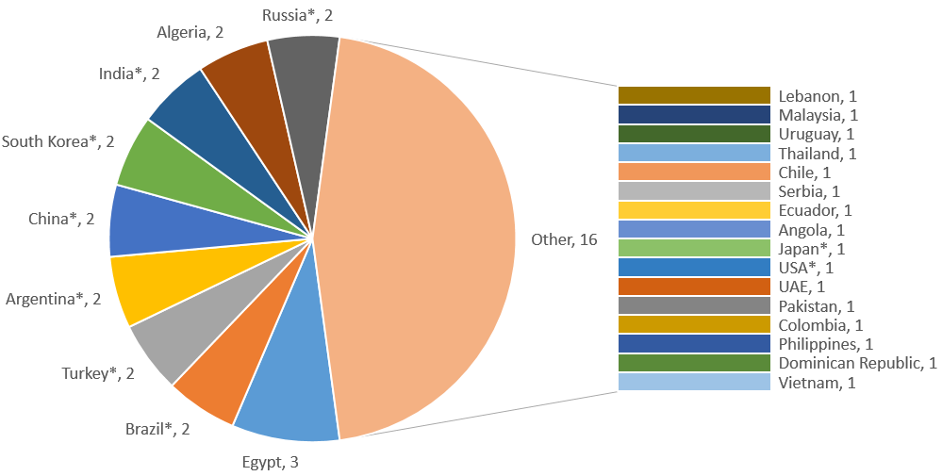

***Figure 8: Geographical breakdown of barriers resolved in 2018*** *(*-G20 countries)*

Based on the value of trade affected (Table III) of removed barriers, the most significant obstacles were removed in Russia, corresponding to a share of 23 percent of all trade flows affected, followed by the United Arab Emirates (16 percent) and China (15 percent). 18 percent of trade flows affected by resolved barriers were in South Mediterranean countries.

*Table III: EU28 trade flows affected by barriers resolved in 2018 by partner countries, (€ million)[27]*

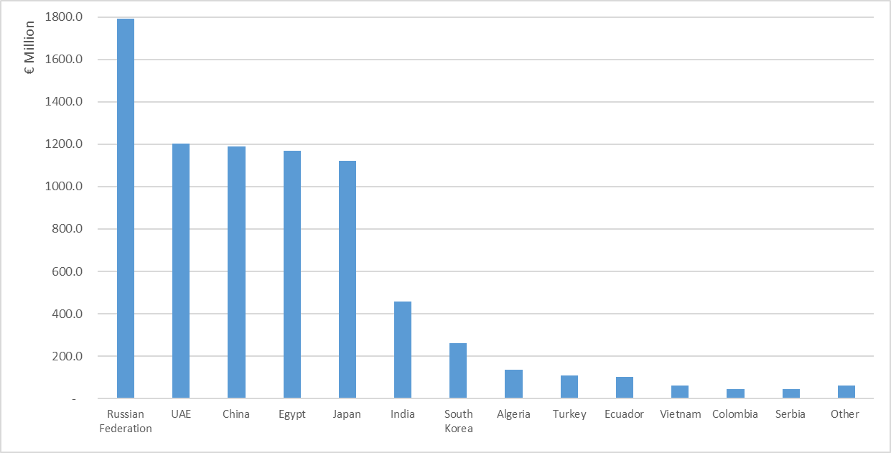

2. Barriers resolved in 2018 per type of measure

Our market access partnership efforts have contributed more considerably to the removal of border measures (26) compared to behind the border restrictions (9). This is comparable to last year’s findings when 34 border and eleven behind the border measures were tackled.

Almost a third of the border measures that have been removed in 2018 relate to SPS matters in the agriculture and fisheries sector. Other obstacles addressed were impacting EU businesses in the form of customs duties, customs administrative procedures, export taxes or export bans. Finally, one barrier in trade in services was also successfully resolved in 2018.

For the nine behind the border measures, successes were achieved in the area of technical barriers to trade and standards, as well as trade related taxation measures.

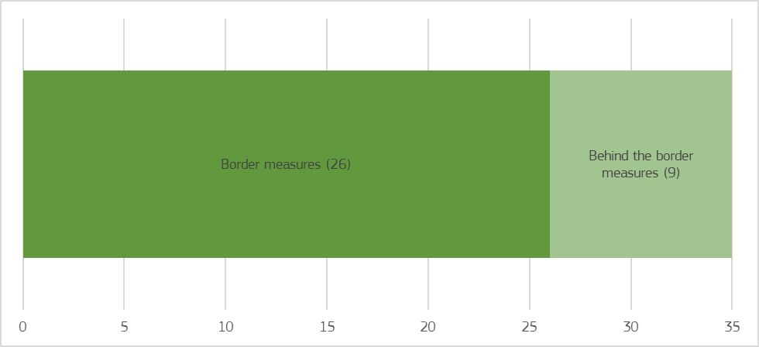

***Figure 9: Breakdown of barriers resolved in 2018 per type (number of measures)***

3. Barriers resolved in 2018 per sector

Figure 10 gives an overview of the number of barriers resolved in the various areas of economic activity. *Agriculture and fisheries* was the sector with the most measures resolved (10), followed by five barriers tackled in the *automotive* sector. The *textiles and leather*, as well as the *wines and spirits* sectors each accounted for four resolved barriers. A total of eight barriers were also addressed that were either fully *horizontal* (4)or affected *various industries* (4). Finally, individual barriers were resolved in the *cosmetics* and *mineral products* sectors, alongside with partially resolved barriers related to *aircraft parts* and the *ICT* sector, respectively.

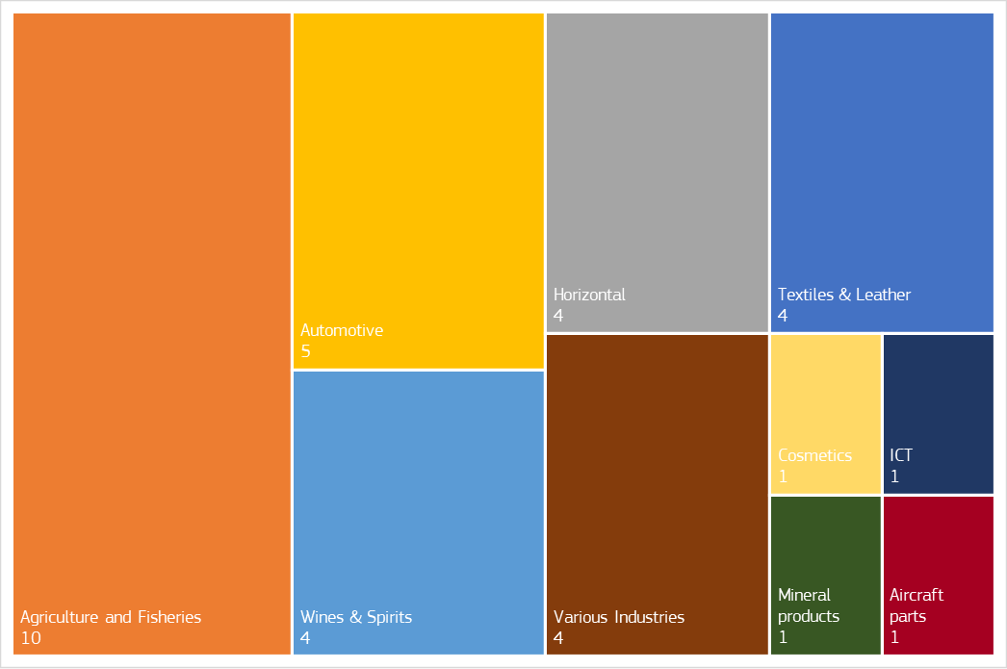

***Figure 10: Sectorial breakdown of barriers resolved in 2018 as recorded in MADB (number of barriers)***

Based on calculations of affected trade flows, figure 11 displays the economic weight of the resolved barriers in the different sectors, highlighting that their resolution in 2018 could positively affect EU exports first and foremost in the *automotive* sector, which corresponds to 32 percent of the overall potentially affected trade flows. The *wines & spirits* (17 percent) and *cosmetics* (16 percent) sectors also benefitted considerably from the removal of barriers. Overall, *industrial sectors* accounted for 83 percent of the economic significance of resolved barriers, while *agriculture and fisheries* took up 17 percent.

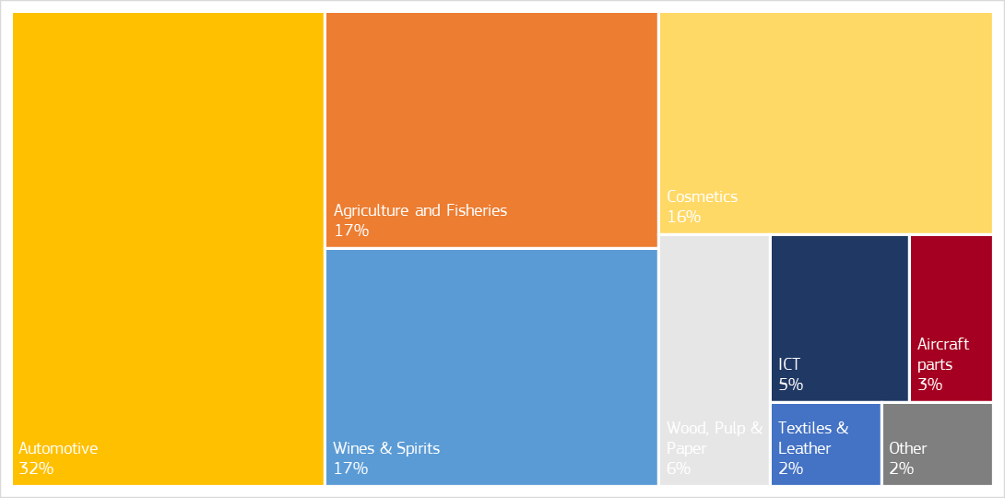

***Figure 11: EU28 trade flows affected by barriers resolved in 2018, per sector (percentage of trade flows affected)[28]***

**C. QUALITATIVE ANALYSIS OF BARRIERS RESOLVED IN 2018**

This chapter provides a more in-depth analysis of a selected number of barriers that the enhanced Market Access Partership managed to tackle. Contrary to last year, when this qualitative analysis concentrated on partners with the highest *number* of barriers resolved[29], we now shift the focus to the countries with the most significant *trade flows potentially affected* by the resolved measures. As a result, we will analyse how effective the EU was in tackling barriers in the following partner countries: Russia, China, the United Arab Emirates, Egypt, Japan, India and South Korea. These seven partners correspond to 93 percent of trade flows potentially affected by resolved measures in 2018.

**1. Russia**

As explained in Chapter I, the trends in market access terms have been generally negative with Russia as EU exporters face a second-highest stock of 34 barriers in the country, which continued to pursue an import substitution policy via a wide array of means. For example, barriers reported in previous years, such as the restrictions to shipping in the Arctic and export quotas on birch logs, have indeed started to affect EU operators in 2018. In addition, further negative developments regarding an existing barrier should also be noted concerning the requirements on labelling, which were further extended to other products such as electronics.

While several measures are questionable in terms of compatibility with Russia’s international commitments - and the EU has used the relevant fora to challenge them - they have not proven to be efficient to boost Russia’s competitiveness and ability to attract foreign investments. On the contrary, they have contributed, among other factors, to prevent an increase of trade between the EU and Russia.

Against this challenging trade environment, the EU used the most resolute tools at its disposal and produced considerable results in 2018 by ensuring the correct implementation of two WTO rulings in Russia, which concerned EU exports in the range of €1.8 billion. This corresponds to a 23 percent share of EU exports affected by the 35 overall resolved measures in 2018.

One of these instances featured a *barrier affecting various industries*, concerning which Russia has fully implemented the WTO ruling in a tariffs-related dispute (DS485). In addition, on the basis of the panel findings in DS485, a second dispute against Russia on tariffs (additional tariff lines of interest to the EU) was prepared back in 2017. However, following bilateral discussions with Russia end of 2017 and early 2018 it did not become necessary to launch the dispute since Russia fully removed the inconsistencies on the tariff lines concerned. This is a good example where the Commission's concerted action has led to concrete results without the need to actually resort to WTO litigation.

Similarly, the dispute the EU launched with respect to the *automotive* sector concerning anti-dumping measures on Light Commercial Vehicles (DS479) from Germany and Italy has led to a positive outcome as the measures expiring in mid-2018 have not been renewed.

**2. China**

As highlighted in Chapter I, China has become the EU's most restrictive trading partner with 37 barriers in place overall and with 14 obstacles introduced since 2017. However, some progress if mostly incremental has been achieved, demonstrating that the EU barrier removal strategy can produce results even in the most challenging environments. Such progress was achieved in the SPS area, with the partial removal of two barriers and further improvements on another long-standing issue. The two partially resolved barriers in the *agriculture and fisheries* sector correspond to a combined share of 15 percent of all EU exports concerned by resolved measures in 2018.

First, while demand for cheese from China is expected to increase, Chinese standards in the dairy sector are not aligned with international standards creating an unjustified barrier to trade for EU exporters. After this issue has been raised by the EU in different bilateral meetings, China decided not to enforce these standards for products that have already been imported for many years (traditional products). In addition, China also informed that it would now be reviewing its cheese standards in more general terms, which the EU welcomed. Although the underlying issue is still pending and the Food Safety Standard need to be revised to fully resolve the EU concerns, the trade impact has already been managed as a result of the solution found on traditional products, and could positively affect EU exports up to €1.2 billion.

Second, early 2012, China took a temporary trade restrictive measure on imports of bovine semen, bovine embryo, ovine semen and ovine embryo, which are produced after 1 June 2011 from several EU Member States. The EU invited Chinese experts at two occasions to come to Europe and Chinese scientists have visited veterinary institutes and research centres of several EU Member States. As a result, China announced the lifting of the trade restrictions on exports of bovine/ovine genetic material from several Member States.

Finally, with respect to a partially resolved barrier already reported in last year's edition, it is worth mentioning that further progress has been achieved with regard to the import ban on EU bovine products and beef, with Ireland and the Netherlands now granted access to the market. As the process for other Member States is not yet finalised, the Commission will continue to raise this matter at all possible occasions.

**3. United Arab Emirates**

The United Arab Emirates (UAE) is an important trading partner. Thus, the Commission has made great efforts and resolved an important market access barrier in 2018 in the *cosmetics* sector, a measure that corresponds to a share of 16 percent of EU exports concerned by all resolved measures in 2018.

This obstacle concerned new labelling requirements, which would have banned the use of a sticker over the original packaging and made mandatory the printing of a logo on all cosmetics packaging by the end of 2018. This measure obliged companies to create a specific artwork for the UAE market only. The Commission reached out to the UAE through the WTO TBT enquiry point and EU businesses and the EU Delegation shared concerns with the Ministry of Economy and the Emirates Authority for Standardization and Metrology (ESMA). As a result, ESMA confirmed at a meeting with the EU Delegation that the cosmetic sector was finally exempted from this requirement before its entry into force, allowing EU companies to continue exporting to the UAE market, and positively affecting EU exports up to €1.2 billion.

**4. Egypt**

EU-Egypt trade relations are based on an Association Agreement. With one new barrier each in 2017 and in 2018 adding to several long-standing issues, Egypt now accounts for a total stock of eight barriers; which appears to confirm the trends for new protectionist measures observed in the South Mediterranean region in last year's report. Faced with this challenging tendency, the EU market access strategy also contributed to the removal of one barrier in 2018 in the *automotive sector* and two barriers in the *textiles and leather sector.* EU exports concerned by the removal of these barriers are worth up to €1.2 billion.

Regarding the *automotive sector*, following a high-level dialogue and exchange, Egypt has totally eliminated duties on cars originating in the EU, now coming into compliance with the tariff dismantling schedule agreed in the Association Agreement. This could positively affect EU exports in the range of €1.1 billion.

Furthermore, the *textiles and leather sector* faced a disproportionate restriction of trade in textiles products due to mandatory labelling requirements that resulted in a time-consuming and costly operation for producers, taking into account that it had to be done manually. The form of the labelling and the type of information requested on the label were eventually relaxed following bilateral discussions with the EU.

Finally, another long-standing issue in the *textiles and leather sector* related to the handling by the Egyptian customs of mixed invoices containing preferential and non-preferential goods was finally resolved in 2018 after it had been raised repeatedly by the EU with the Egyptian authorities.

**5. Japan**

EU-Japan trade relations are now based on the Economic Partnership Agreement that entered into force on 1 February 2019. In parallel, a barrier was successfully tackled in the *wine and spirit sector*.

In 2018, the Ministry of Health, Labour and Welfare of Japan considered deleting some additives for food and beverages from the list of authorized additives in Japan. If delisted, many companies in the EU *wine and spirit sector* would have been negatively impacted. The Commission wrote to the competent authorities in Japan (April 2018) and provided comments on the list of additives envisaged for delisting (September 2018). Japan accepted the comments provided, and as a result, none of the additives identified as used by EU producers will be delisted. This could facilitate EU exports in the range of €1.1 billion.

**6. India**

As described in section II, the protectionist trend in India continued in 2018. Despite this difficult context, the Market Access Strategy also delivered some positive results. A barrier in the *ICT sector* and a barrier in the *textiles and leather sector* were partially resolved, accounting for six percent of all EU exports concerned by resolved measures in 2018 (€457 million).

Indian authorities asked for mandatory veterinary certificates upon importation of leather goods. Consequently, imports offinished products – that have no longer the attributes of the raw animal product – continued to be subject to sanitary requirements. However, according to the international standards of the *World Organization for Animal Health* (OIE) and the WTO SPS Agreement, such requirements should only apply to raw animal products or should otherwise be scientifically justified by India. As a result of the efforts of the EU in raising the issue with relevant authorities in India, this barrier had been resolved for selected finished products through the adoption of a new notification by India. Notwithstanding this partial success, the EU will pursue its efforts to fully resolve the matter.

Regarding the ICT sector, India remains a challenging partner due to the various restrictions hampering the market access of EU companies, such as continued duty increases (as mentioned in Chapter II), mandatory testing and licensing[30], as well as compulsory registration and labelling requirements. Yet, one barrier regarding used telecommunications equipment has been partially resolved as India substantially relaxed the norms for exported goods which need to be imported back for repair. As per the notification issued by the Central Board of Indirect Taxes and Customs (CBIC), these goods can be imported duty-free under the condition that they will be re-exported after repairs. The exported electronic goods can now be imported back for repairs within seven years of its export (previously three years) and have to be exported back within one year of the import (previously six months). Should EU operators continue to face difficulties in spite of these positive steps, the Commission stands ready to keep addressing this issue with India.

**7. South Korea**

EU-South Korea trade relations are based on the EU-South Korea Free Trade Agreement (FTA) that was provisionally applied since July 2011 and was formally ratified in December 2015. While there remain seventeen barriers in South Korea, one was successfully resolved in the *automotive sector* and one was partially resolved in the *aircraft parts sector*.

Regarding the *automotive sector*, South Korea required that the ground clearance of an unloaded vehicle should be greater than 12cm. As the EU did not have an equivalent regulation, since it was considered to be an outdated safety criterion, this resulted in difficulties to specific categories of vehicles (sport vehicles) to enter the market. Following interventions of the EU Delegation, South Korea considered positively the amendment of the measure so as to reflect EU requirements. Accordingly, the ground clearance was amended from 12 to 10 cm and some sport vehicles can now be marketed in South Korea without the need to make costly adaptations in this regard. The EU will continue to use all avenues to address remaining automotive barriers in South Korea, such as the certification of car parts, truck tractors or cumbersome customs and administrative procedures.

As the FTA has no provision exempting repaired goods from customs duties on re-entry to South Korea after repair in the EU, certain goods such as *aircraft parts* repaired in the EU could have been subject to customs duties (3% to 8%) when re-entering South Korea. Back in 2016, following the Commission's frequent interventions, South Korea extended duty exemptions for these products until the end of 2018 – which were now set to expire. Following various interventions from the EU Delegation and discussion in the  
Trade in Goods Committee and in the Customs Committee of the EU-Korea FTA in 2018, the National Assembly has now further extended the exemption for repaired aircraft parts for three years until 31 December 2021. Notwithstanding this welcomed temporary solution, the EU will continue to seek a permanent solution to this matter.

**D. IMPACT OF THE BARRIERS RESOLVED**

In previous chapters of this report, we analysed the trade flows linked to barriers resolved in 2018. That methodology is based on bilateral EU export figures for the relevant Harmonised System (HS) tariff codes and quantifies the trade that happens despite the barrier.

In addition to that, since last year, this report includes a refined analysis based on an econometric model which is able to assess how much the trade flows with the partner countries that have imposed a barrier have changed after its removal. In order to do so, a regression analysis has been used to quantify the impact of the removal of barriers on EU exports.[31]

The result of this econometric analysis might not show the full impact of the Market Access Strategy as we have focused only on the barriers completely removed, and because the analysis does not cover more complex horizontal barriers that affect for instance investment or intellectual property rights. We have analysed the effects of this reduced set of barriers removed between 2014 and 2017.[32]

Results show that the removal of this subset of barriers generated tangible benefits for EU exporters. The estimates point to an average increase in trade of about 57% after the removal of the barriers. This implies, in value terms, that the resolution of these barriers generated €6.1 billion additional exports for our companies in 2018. This is in the order of magnitude of the benefits of many of our trade agreements. For example, this is more than the combined impact of our agreements with Colombia and Peru.

Last year, the analysis using the same methodology yielded a figure of €4.8 billion.

**IV. CONCLUSION**

This report gives an overview of trade and investment barriers directly affecting EU businesses, as reported and addressed through the EU's enhanced Market Access Partnership between the Commission, Member States and European business.

In 2018, 45 new barriers were reported to the Commission, bringing the total stock to a record 425 trade-restrictive measures. For the first time, China has taken over as the country with the highest overall stock of barriers (37) for our companies, followed by Russia (34), India (25), Indonesia (25) and the United States (23).

As for the 45 new barriers reported in 2018, China, the United States, India and Algeria rank the highest regarding both the number of new barriers recorded in 2018 (18) and the magnitude of their potential impact on trade flows (€41.8 billion) - 81% of the total. From a regional perspective, Asia and South Mediterranean regions are those which have introduced the highest number of new trade-restrictive measures in 2018, applying 26 new barriers and confirming the negative trend of 2017.

Most sector-specific measures targeted the wines and spirits and agriculture and fisheries, cosmetics and automotive industries. In terms of their possible impact, barriers in industrial sectors such as ICT; precious metals; and iron, steel and non-ferrous metals sectors stood out, combining for 73 percent of the affected exports, which overall amounted to €51.4 billion (more than double than last year: €23.1 billion).

This confirms that protectionism is on the rise and that trade barriers increasingly affect EU stakeholders. In response, the EU has made enforcement and implementation of its trade policy a top priority. Indeed, the Commission reinforced its Market Access Strategy, with strengthened coordination among EU institutions and stakeholders, improved prioritisation of barriers and enhanced communication and awareness-raising (such as through the Market Access Days initiative). The EU has not only continued to make full use of but also further extended its wide array of tools to effectively eliminate trade barriers, ranging from multilateral and bilateral dispute settlement action to an ambitious agenda for trade negotiations, FTA implementation, diplomatic demarches, as well as the launch of the overarching European Economic Diplomacy initiative.

With 23 obstacles addressed in 2015, 20 resolved barriers in 2016, a record number of 45 successfully tackled barriers in 2017 and an additional 35 removed barriers in 2018, the tally of resolved barriers under the current Commission reached 123. This robust enforcement record reflects the EU’s firm response to a more transactional global trading environment.

In 2018, the 35 barriers removed helped particularly eight different sectors of economic activity – among others agriculture and fisheries, automotive, textiles and leather, wines and spirits, cosmetics, mineral products, aircraft parts, ICT. In terms of trade concerned, 17 percent of the potential benefits are linked to agriculture and fisheries area and 83 percent to industrial sectors, with the automotive (32 percent), wines and spirits (17 percent) and cosmetics (16 percent) sectors benefitting most significantly. Overall, our market access partnership could positively affect EU28 exports in the range of €7.8 billion.

As of last year, these reports have also contained a refined regression analysis to more precisely quantify the real impact of the removal of barriers on EU exports. Estimates indicate that the removal of barriers over the 2014-2017 period have generated additional exports of at least €6.1 billion for our companies in 2018*.* This is in the order of magnitude of many of our trade agreements. Last year, the analysis using the same methodology yielded a figure of € 4.8 billion.

This underlines that, as protectionism has risen abroad, so have our efforts to bring down barriers. Implementation and enforcement are more important than ever before to deliver growth, jobs and competitiveness to the benefit of our companies and citizens.

In the closest cooperation with Member States and stakeholders, the Commission remains fully committed to continue further reinforcing the Market Access Partnership to effectively tackle barriers and enhance opportunities for EU operators operating around the world.

1. The Market Access Partnership was set up in 2007 to deepen the cooperation between the Commission, Member States and EU business both in Brussels and locally. It is based on monthly meetings of the Market Access Advisory Committee (MAAC) and sectorial Market Access Working Groups (MAWGs) in Brussels and regular meetings of the Market Access Teams (MATs) or Trade counsellors' meetings in third countries.
2. <http://trade.ec.europa.eu/doclib/docs/2015/october/tradoc_153846.pdf>
3. <http://trade.ec.europa.eu/doclib/press/index.cfm?id=1933>
4. "Active" barriers are the barriers that are actively followed-up in the Market Access Partnership (as opposed to resolved barriers that have become inactive once resolved).
5. The market access database (http://madb.europa.eu/madb/indexPubli.htm) gives information to companies exporting from the EU about import conditions in third country markets. This includes information on trade barriers, but also on tariffs and rules of origin, procedures and formalities for importing into third countries, sanitary and phytosanitary (SPS) measures, statistics, and on specific export-services provided to SMEs. Conversely, the EU’s Export Helpdesk (http://exporthelp.europa.eu/thdapp/index.htm) also provides information on conditions for importing from trade partners into the EU (including applicable tariffs and requirements, preferential arrangements, and quotas and statistics).
6. Algeria, Argentina, Armenia, Australia, Bangladesh, Belarus, Bolivia, Bosnia and Herzegovina, Brazil, Cameroon, Canada, Chile, China, Colombia, Dominican Republic, Ecuador, Egypt, Hong Kong, Iceland, India, Indonesia, Iran, Iraq, Israel, Japan, Jordan, Kazakhstan, Lebanon, Malaysia, Mexico, Moldova, Morocco, Mozambique, New Zealand, Nigeria, Norway, Oman, Pakistan, Paraguay, Peru, Philippines, Russian Federation, Saudi Arabia, Singapore, South Africa, South Korea, Switzerland, Taiwan, Thailand, Tunisia, Turkey, Uganda, Ukraine, United Arab Emirates, United States of America, Uruguay, Venezuela, Vietnam and Panama.
7. Tallying last year's measures (396 active barriers) with 2018 figures (45 new and 35 resolved barriers) would yield 406 barriers. The difference resides in the fact that the Commission has started encoding active barriers in a more granular fashion as of 2018 – as anticipated already in footnote 9 of last year's report-, leading to a nominally higher number of barriers while not altering the underlying trends. Recording each different aspect of a barrier separately allows for a more effective monitoring of each obstacle, as well as the possibility to design removal strategies in a more tailor-made fashion.
8. Created with mapchart.net ©.
9. Algeria, Australia, Brazil, China, Egypt, India, Indonesia, Iran, Iraq, Japan, Pakistan, Peru, Philippines, Russian Federation, Saudi Arabia, South Africa, Thailand, Tunisia, Turkey, Ukraine, United Arab Emirates, United States of America and Vietnam.
10. Concerning the quantification of trade potentially affected (based on bilateral EU export figures for the relevant Harmonised System tariff codes quantifying the trade that happens despite the barrier) the analysis of non-tariff barriers and their impact remains particularly difficult. The main reason is that non-tariffs barriers are characterized by different degrees of restriction. Other than outright bans, most trade-restrictive measures do not fully eliminate trade but rather reduce it. Moreover, restrictions regarding the same products or services may overlap. As a result, additional barriers may not necessarily mean additional impact, nor does the removal of one barrier imply automatic improvement in market access.
11. For SPS, new barriers have been raised whereby third countries banned exports from the whole territory of certain EU Member States, instead of limiting restrictions to areas affected by the animal disease. Thus the EU regionalization policy was not recognized. The EU has worked to tackle these barriers and continue working on similar barriers raised before 2018.
12. Including two horizontal barriers related to trade in services.
13. "Other" includes the following sectors of economic activity: Ceramics and Glass; Mineral Products; Plastics; Wood, Pulp and Paper.
14. In line with the methodology applied in this report, this amount was calculated on the basis of 2018 trade flows in the products concerned.
15. This could be a very important additional barrier if the US were to take measures.
16. As this barrier has not been considered as a new obstacle for 2018, this amount is not included in the overall calculations of trade affected.
17. <http://trade.ec.europa.eu/doclib/press/index.cfm?id=2001>
18. See Joint Communication on “Elements for an EU strategy on India” (<https://eeas.europa.eu/delegations/india/54057/joint-communication-elements-eu-strategy-india_en>) and Council Conclusions on “EU strategy on India” (<https://www.consilium.europa.eu/media/37410/st14638-en18.pdf>).
19. Potential economic impact for EU shipping companies could not be quantified.
20. The latest were the Economic Partnership Agreement with Japan, which was ratified by both parties in December 2018 and fully entered into force on 1 February 2019; and a Free Trade Agreement and Investment Protection Agreement (IPA) with Singapore. The Commission adopted and presented to the Council an FTA and an IPA with Vietnam, which are currently in preparations for signature.
21. Intense negotiations took place with MERCOSUR with important progress, and the Commission also started trade negotiations with Australia and New Zealand. Negotiations for a Deep and Comprehensive Free Trade Area (DCFTA) with Tunisia are also on-going.
22. A deal at the political level was reached with Mexico for the modernisation of the trade agreement, and negotiations with Chile are on-going.
23. <http://trade.ec.europa.eu/doclib/docs/2018/october/tradoc_157468.pdf>
24. <http://trade.ec.europa.eu/doclib/docs/2018/march/tradoc_156634.pdf>
25. <http://trade.ec.europa.eu/doclib/docs/2018/july/tradoc_157212.pdf>
26. Last year, for the removal of 45 barriers, the corresponding figure was €8.2 billion.
27. "Other" includes the following partner countries: Argentina, Angola, Brazil, Chile, Colombia, Malaysia, Uruguay, and Thailand.
28. "Other" includes the following sectors of economic activity: Ceramics and Glass; Electronics; Mineral products; Plastics; Precious metals.
29. This year, the highest number of resolved or partially resolved barriers (at least two) was recorded in nine trade partners: Algeria, Argentina, Brazil, China, Egypt, India, South Korea, Turkey, and Russia.
30. Application of this measure for telecom equipment has been further extended until 1 August 2019.
31. More specifically, we adopted a Difference-in-Difference methodology and analysed the impact on trade flows only between the EU and the countries that has imposed the barrier on the specific products involved.
32. The analysis does not cover the number of barriers removed in 2018 as we need at least one full year of data after barrier removal to establish the impact on trade.