

# INTRODUCTION – THE ROLE OF INTEGRATED NATIONAL ENERGY AND CLIMATE PLANS

The European Union is determined to deliver on its commitments to reduce greenhouse gas emissions and to provide secure, affordable and sustainable energy for its citizens. We are the first major economy to put in place a legally binding framework to deliver and go beyond what we promised under the Paris Agreement. Based on the proposals of the Commission, we have adopted an ambitious legislative framework for 2030, putting in place an Energy Union with a forward-looking climate action. We have set ambitious targets for 2030 for greenhouse gas emissions reduction, renewable energy and energy efficiency, which will require sustained and combined efforts to be reached. This represents an important step in the long-term clean energy transition in a 2050 perspective, as presented in the long-term strategy[1]. These targets are not ceilings but rather floors and with the right incentives they can even be surpassed.

The EU Governance Regulation[2] has created a unique system of energy and climate governance ensuring that the Union and its Member States can plan together and fulfil collectively these 2030 targets, as well as ensure a transition to a climate neutral economy that is fair and cost-effective for all. The Sibiu Declaration[3] reaffirmed at the highest level the Union’s commitment to be a responsible global leader on climate change, while protecting our citizens, preserving our environment and upholding the principle of fairness.

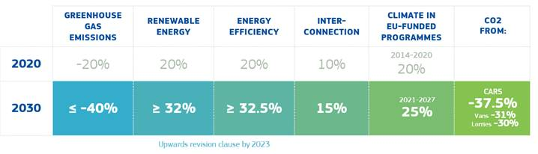

*Figure 1: 2030 framework for climate and energy*

For the first time, all Member States have prepared draft integrated National Energy and Climate Plans (NECPs)[4]. They have worked to break silos – across policies and sectors, across government departments, with stakeholders and the public, and cross-border – to define a pathway to 2030 goals. There are still gaps, but this is only the first step of many before 2030 and we will learn from it. Building on the excellent spirit of cooperation over the past three years, the Commission will continue to work constructively and intensively with Member States to finalise and then to implement their national plans. The Recommendations for the final plans that accompany this Communication will guide this work in a continued spirit of collaboration. In the 2020 State of the Energy Union report the Commission will take stock of the final plans and confirm whether they are consistent with the Union’s 2030 targets or whether further efforts might be needed. The governance process also provides an opportunity to update the plans in 2024 to reflect experience and to take advantage of new opportunities for the remainder of the decade.

The NECPs play a key role in our governance system to ensure that we join forces and deliver on our objectives together. They should provide as much clarity and predictability as possible for the business and finance sector to stimulate necessary private investments. They will also facilitate Member States’ programming of funding and investments in the next multi-annual financial framework 2021-2027.

This Communication analyses the draft NECPs and looks at their aggregated effects in reaching the EU Energy Union objectives and 2030 targets. It complements the detailed analyses at national[5] and European level[6], and the specific Recommendations addressed to each Member State.[7] Together these will help Member States finalise their NECPs by the end of 2019. Implementing the Recommendations will involve an on-going iterative dialogue leading to finalisation of the NECPs. Ultimately the process aims at contributing to the modernisation of the Union economy in line with the long term goal of climate neutrality.

The Commission will work with Member States to help them take due account[8] of the Recommendations in a spirit of solidarity between Member States and the Union but also among Member States.

# ASSESSMENT OF THE DRAFT INTEGRATED NATIONAL ENERGY AND CLIMATE PLANS

## EU-wide assessment for the 2030 renewable energy, energy efficiency and greenhouse gas targets and electricity interconnections

The Union’s 2030 renewables and energy efficiency targets have been expressed and agreed at EU level without underpinning binding targets at national levels. Instead, new working methods and new instruments have been established to enable the collective achievement of the objectives of the Energy Union. As a first step in this process, the Governance Regulation requires Member States to include in their draft NECPs national contributions that are sufficient for the collective achievement of the Union’s 2030 targets. As a second step, the Commission is to assess and promote a sufficient level of collective “ambition” in view of those Union targets.

## Renewable energy

The Union should retain and reinforce its world leadership in renewables. This is not only a matter of security of supply and responsible climate change policy. It is also an industrial policy imperative to fully exploit the green growth potential.

Almost all Member States have submitted their contributions to the Union renewable energy target. About a third of Member States submitted ambitious contributions, with **Denmark**, **Estonia**, **Spain**, **Lithuania** and **Portugal** putting forward significantly high contributions[9].

**However, there is still a gap for the EU28.** Under current draft plans, instead of at least 32%, the share of renewable energy would reach between 30.4% and 31.9% in 2030 at Union level[10].

**Consequently, the Recommendations call on several Member States to reconsider their level of ambition to ensure that this identified EU “ambition” gap is closed with the submission of the final NECPs.** Increasing national contributions as appropriate - while ambitious Member States maintain their contributions as included in the draft NECPs - is crucial to allow for a balanced and cost-effective achievement of the Union-level target, paving the way for the creation of a true European market for renewable energy. This would allow the Union as a whole to exploit fully its potential for the cost-effective deployment of renewable energy, to contribute to reducing air pollution and fossil fuel import dependency, and to benefit from a leading position in the energy transition process.

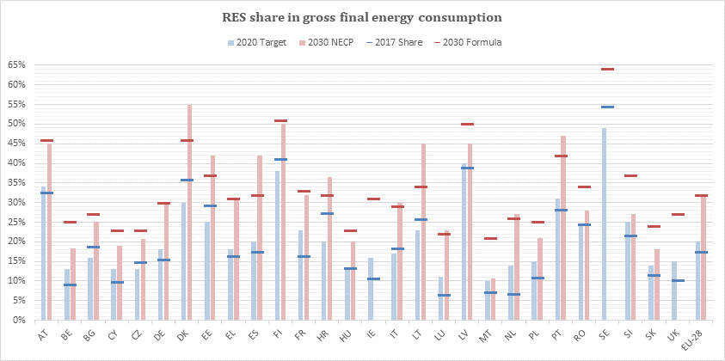

*Figure 2: National renewables contributions (Source: EU Commission calculations based on information from the draft NECPs).*

## Energy efficiency

The Energy Union strategy is based on the “energy efficiency first” principle.However, the 2020 energy efficiency targets are at risk as a result of increased energy consumption in recent years. Based on the national contributions put forward in the draft NECPs, only a few Member States have proposed a sufficient level of contributions for 2030. Those are notably **Italy,** **Luxembourg** and **Spain** (both primary energy consumption and final energy consumption), **Netherlands** (for primary energy consumption) and **France** (for final energy consumption). Some Member States still need to submit a national contribution.

As a consequence, the aggregate assessment **shows a substantial gap with the Union target levels of primary and final energy consumption** of at least 32.5 % by 2030[11]. **For primary energy consumption**, the **gap ranges from 118 to 43 Mtoe** (with the considerable range depending on whether more conservative or more ambitious assumptions are made for the countries which have not submitted a national contribution), which correspond to attaining 26.3 % to 30.2 %, while for **final energy consumption** the **gap ranges from 85 to 26 Mtoe**, which corresponds to attaining 26.5% to 30.7 %.

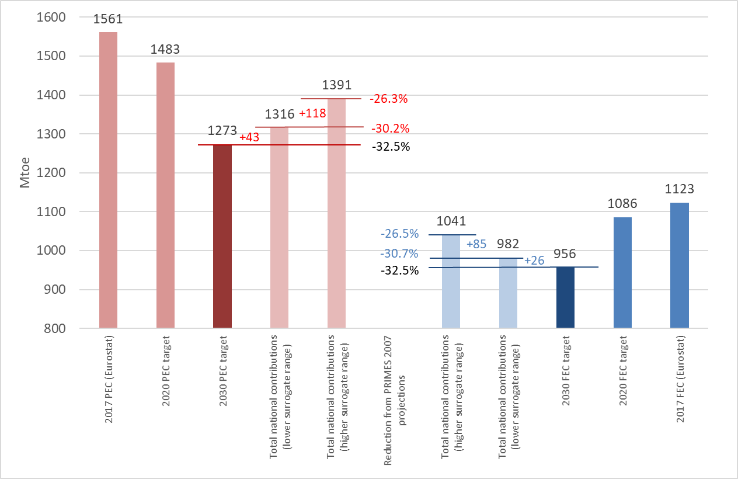

*Figure 3: Collective gap for energy efficiency contributions in primary and final energy consumption. (Source: EU Commission calculations based on information from the draft NECPs).*

**Against this background, all Member States whose contributions are assessed as not sufficient at this stage are recommended to review them and consider increasing the level of ambition**, so that the identified “ambition gap” is closed with the submission of the final NECPs.

## Greenhouse gas emissions

The Union has communicated a nationally determined contribution under the Paris Agreement of **at least 40% domestic greenhouse gas emission reductions by 2030** compared to 1990. Thanks to the adoption of all the Energy Union legislation proposed by the Commission under the mandate of President Juncker, the Union has been the first major world economy to translate its Paris Agreement contribution into concrete legislation.The effective implementation of all climate, energy and clean mobility targets laid down in Union lawcould even lead to greenhouse gas reductions of around -45% in 2030 compared to 1990.

Based on the planned measures or stated ambitions for national greenhouse gas reductions included in the draft NECPs, and on the basis of conservative assumptions for the countries which have submitted neither of the two, the overall greenhouse gas reduction for the Union is estimated to be already in line with the -40% greenhouse gas emission reduction target for 2030 compared to 1990. This represents significant progress compared to previous reductions which Member States projected.

The Effort Sharing Regulation[12] mandates Union-wide reductions in sectors not covered by the EU Emission Trading System (ETS) of -30% compared to 2005. Member States’ national targets range from 0 to -40%, and they have significant flexibility on how to achieve them, e.g. transfers between Member States or using a certain amount of additional emission removals in the land use sector. Spain, Luxembourg and Sweden have set more ambitious national targets in the sectors outside the EU ETS[13].

**An aggregation of the national measures currently planned in these sectors provided in the draft NECPs shows that the Union could already achieve a -28% emission reduction** in non-ETS sectors (see Figure 4, excluding the land use, land use change and forestry sector). This represents significant progress compared to projections reported in the EU 2018 Climate Action Progress Report[14], i.e. -21% reduction with existing measures, -23% reduction with planned measures. **However, to fill the remaining Union-wide gap of 2 percentage points, Member States will need to identify additional measures in the final NECPs.**

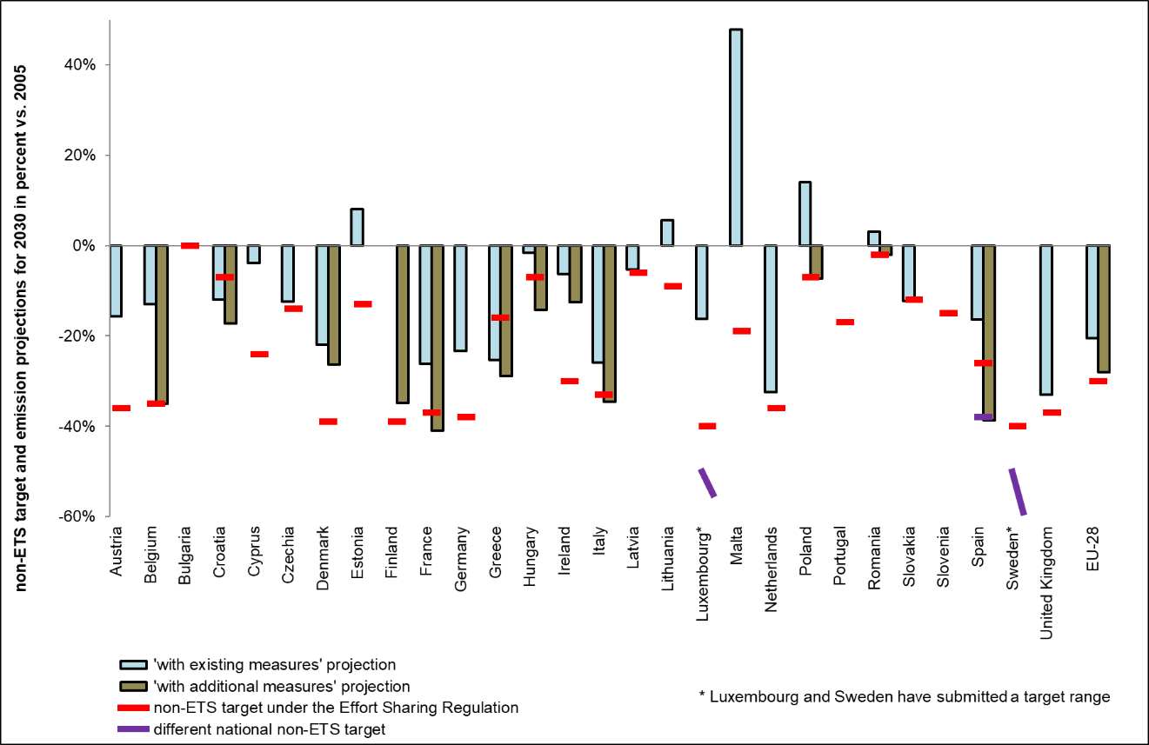

*Figure 4: Member States’ 2030 Effort Sharing targets and greenhouse gas emissions with existing and planned measures (Source: Commission calculations based on information from the draft NECPs).*

These considerations are based on the assumption that all Member States will comply with the “**no debit” rule for the land use, land use change and forestry sector i.e. that emissions do not exceed removals.** If this sector creates net emissions, these would need to be compensated by using allocations from the effort sharing sectors.

## Electricity interconnections

Interconnections between national markets represent the hardware for completing the Union internal electricity market, ensuring security of supply, reaping the full potential of renewable energy sources, and facilitating sector coupling and integration.

Five Member States (**Czechia, Germany**, **Greece**, **Spain** and **Portugal**) clearly refer to the electricity interconnectivity level they are aiming for in 2030 in their draft NECPs. Several other Member States (**Belgium**, **Bulgaria**, **France**, **Lithuania**, **Luxembourg**, **Malta**, **Netherlands**, **Slovakia,** **Finland** and **Sweden**) indicate a projected level of electricity interconnectivity in 2030. The draft NECPs often reflects the process laid-out by the trans-European energy network (TEN-E) Regulation in identifying and supporting at European level the realisation of infrastructure Projects of Common Interest, which are necessary for reaching the interconnectivity objectives of the Governance Regulation. The 4th list of Projects of Common Interest – to be adopted in October 2019 based on an objective and inclusive process at European level – will aim at tackling the remaining bottlenecks in the internal energy market, for instance between the Iberian peninsula and the rest of Europe or in South Eastern Europe.

**When finalising their NECPs, Member States that are currently below 15% of electricity interconnection should indicate their target for electricity interconnectivity in 2030.** Member States already above this threshold should consider their level of interconnectivity foreseen by 2030 in the context of maintaining the adequacy of their electricity system vis-à-vis the expected significant development of renewable energy[15]. The final NECPs should make the link between the expected infrastructure developments and the necessary steps to ensure that these interconnectors are available to the market for cross-border electricity trade in line with relevant legislation.

## Main findings for each of the five dimensions of the draft NECPs

***2.2.1 Decarbonisation (greenhouse gases and renewable energy)***

***A) Greenhouse gas emissions and removals***

**Several draft NECPs would benefit from providing further details on the strategy to be followed for reaching the non-ETS targets over the entire period 2021-2030**, including estimates for the emission reduction trajectory based on latest data and the intended use of flexibilities, as already done for example by **Ireland** and **Latvia**. Through the possibility to transfer emission allocations between Member States[16], several Member States have the opportunity to mobilise financing from other Member States to modernise their economy e.g. through investing in energy efficiency of buildings or by fully realising their cost effective potential of renewable energy in non-ETS sectors. This enhanced bilateral cooperation among Member States will allow the Union to achieve its ambitious 2030 objectives in a cost efficient manner.

**Transport** is responsible for around a quarter of greenhouse gas emissions in the Union and is the largest sector by emissions under the Member States’ non-ETS targets. **It therefore needs to be at the centre of the NECPs.** Most Member States set out emission reduction measures in the transport sector. Some Member States already combine quantified emission reduction objectives with planned measures. The final NECPs will give Member States the opportunity to develop an even more integrated approach for the transport sector. In their final plans, Member States should be more concrete and a number of them still need to quantify the expected impacts. Electromobility is often among the objectives pursued, but measures are often not described in a very detailed manner. Planning and investing in the corresponding alternative fuel infrastructure will be crucial for cars, vans and lorries manufacturers to achieve the CO2 emission performance standards for 2025 and 2030 and to reduce the fuel bills of drivers and transport operators. Effective coordination on the rollout of intelligent transport systems needs to be guaranteed. The NECPs should also be an opportunity for some Member States to specify steps to restructure taxation so as to contribute to our policy objectives in the transport sector.

|  |
| --- |
| **Good practice examples – policies and measures in the transport sector**  The **Austrian** and **Spanish** draft NECPs provide good examples of how to combine quantified emission reduction objectives for the transport sector with the underpinning policies and measures to achieve them. For instance, **Italy** provides considerable detail on the planned measures and goes beyond the mandatory renewable target for transport. While a number of Member States have set indicative electromobility targets, **Slovenia** underpins this with concrete measures including a quantification of the charging infrastructure required. |

**European buildings** are responsible for40% of energy consumption and around 15% of greenhouse gas emissions.The draft NECPs cover this sector mainly in the context of its role in achieving the energy efficiency and renewable energy contributions. The potential of efficiency measures that would achieve cost-efficient emission reductions, while reducing energy bills for households and increasing employment in the construction sector could be exploited more rapidly in some Member States.

Under Union legislation adopted in May 2018[17], EU Member States have to ensure that greenhouse gas emissions **from land use, land use change or forestry** (LULUCF) are offset by at least an equivalent removal of CO₂ from the atmosphere in the period 2021 to 2030. With an additional removal potential in accounted terms corresponding to 2% of greenhouse gas emissions, LULUCF will have to make an increasing contribution to achieving the Union climate targets in the coming decades, e.g. through enhanced sequestration of CO2 from the atmosphere while increasing production and efficient use of biomass for a broad range of uses with due account given to biodiversity and air quality concerns. **Denmark** and **France** are examples of Member States which provide a strategy or specific information on the policies and measures, e.g. to support private afforestation on agricultural land, that can, in a sustainable way, enhance carbon sinks while promoting the bioeconomy and that can provide additional incentives for farmers and foresters to improve land management and sustainable increase in productivity. Otherwise, the related information is limited in the draft NECPs. In addition, it will only be possible to assess fully whether emissions exceed removals if Member States provide more detailed information on LULUCF accounting and the use of flexibilities. This information is provided to some extent by **Czechia**, **Denmark** and **Ireland**.

A key element in this regard is the establishment of transparent and accurate Forest Reference Levels to account properly for the emissions or removals of CO2 from forest management. National Forestry Accounting Plans are the tool for doing for this, and Member States should revise them by 31 December 2019 based on the technical recommendations presented with this Communication[18]. This will enable them to be used fully and consistently in the final NECPs, in particular with a view to the planning of flexibility towards effort sharing sectors.

The relevance of **other sectors such as agriculture, waste and industry,** for emissions from sectors not covered by the EU ETS, varies across Member States. This should be reflected in the planning of policies and measures, as **Ireland** does, for example, for agriculture. For the agriculture sector, the Commission proposal for the Common Agricultural Policy (CAP) post-2020 enhances the level of climate and environmental ambition, with at least 40% of the overall financial envelope of the CAP expected to be climate-relevant. In addition, the Commission proposed ‘eco-schemes’ which will provide Member States with the opportunity to support on a wide scale mitigation and adaptation actions better tailored to specific local needs. The Commission proposal also establishes that the Member States, in the design of their CAP Strategic Plans, should take into account the national environmental and climate planning tools in relevant EU legislative instruments, including the NECPs. In this sense, it will be crucial for the final NECPs to provide concrete indications of planned emission reduction measures in the agriculture and forestry sectors that the CAP could support, e.g. through support for testing farm carbon schemes.

For the **power** sector, which is responsible for around 25% of greenhouse gas emissions, Member States’ decarbonisation policies focus on the increased use of renewable electricity and on the phase out of coal from electricity generation.

|  |
| --- |
| **Towards a phase out of coal in Europe?**  Several Member States introduce or confirm ambitious objectives and timelines to phase out coal for electricity generation. **France** intends to do so by 2022. **Italy** and **Ireland** by 2025. **Denmark**, **Spain,** **Netherlands**, **Portugal** and **Finland**, by 2030. **Germany** has also indicated that it will set an end date for coal based electricity. Member States actively phasing out coal are invited to provide further indications on how they intend to pursue these goals and whether they plan to make use of the option to cancel EU ETS allowances. Measures to assist workers and families affected by coal phase out should also be addressed. |

The decarbonisation of **industry**, which is responsible for around 15% greenhouse gas emissions, is much less addressed in the draft NECPs compared to the energy sector. In these industrial sectors, technology development and innovation will have to accelerate during the coming decade to reduce the carbon footprint of the industry. Governments will have to play a role in this process, e.g. by applying state aid rules accordingly. The earlier Member States make clear their intentions, the earlier industry will be able to tap into best available techniques, electrification options and new technological opportunities that can help reducing greenhouse gas emissions.

|  |
| --- |
| Many Member States with **climate adaptation** goals have included them in the draft plans, and some have indicated new goals. Several Member States cover adaptation goals and measures in some detail. The **Irish**, **Lithuanian**, **Polish**, **Slovak** and **Slovenian** draft NECPs are examples of good practice on how to cover adaptation goals and measures. Only few Member States provide details on adaptation to adverse effects of climate change related to the security of the Union's energy supply. |

***B) Renewable energy***

The Union reached a 17.5 % renewable energy share in 2017, but the pace of increase has slowed since 2014. It is crucial to redouble efforts to reach the 2030 target. The NECPs need to substantiate fully Member States’ contributions to the 2030 collective target and underpin them with robust policies and measures.

Heating and cooling currently accounts for 50% of the Union’s annual energy consumption. The share of renewables in this reached 19.5 % in 2017, and has increased by only 6 percentage points in the last ten years. The NECPs should reflect the annual increase of the renewable energy share in the heating and cooling sector provided for in Directive (EU) 2018/2001 and the role of waste heat and cold to make the sector contribute cost-effectively to the overall renewables share.

The same applies to the transport sector, where Member States must require fuel suppliers to supply a minimum of 14% of the energy consumed in road and rail transport by 2030 as renewable energy. This will provide the industry with certainty about future market demand.

|  |
| --- |
| **Identifying renewable energy potential - good methodology examples:**  Looking at the national objectives section, the **Czech**, **Irish** and **Italian** draft NECPs provide good examples of completeness of the objectives and trajectories which need to be included in the final plans. **Czechia** and **Ireland** include the contributions of each sector and the respective technologies on a yearly basis and in absolute values. **Ireland** is one of the very few Member States that also includes trajectories for bioenergy demand and biomass supply by feedstock and provides renewable heat by renewable technology contributions split for industry, residential and the tertiary sector. **Czechia** provides a sensitivity analysis of how the overall renewable contribution could fluctuate due to economic growth and energy demand. **Italy** includes a breakdown of the transport target taking into account the applicable multipliers for each technology. |

The final plans should provide **robust information on policies and measures which support the timely achievement of the proposed objectives and contributions for renewable energy.** Policies and measures need to demonstrate that the proposed objectives and contributions can be achieved, notably in view of the first reference point set for 2022. Member States should provide detailed information on their support schemes including detailed auction schedules for renewable energy and their evolution over the 2021-2030 period. Support schemes should support investor confidence and decrease the cost of developing renewables over the long term. To provide guidance to market players and attract new investments in renewable generation, Member States should spell out in greater detail in the main policies and measures, elements such as (i) expected results, (ii) indicative timeline, (iii) source and amount of budget required.

Information on measures to promote self-consumption and renewable energy communities, as well as provisions facilitating the uptake of power purchase agreements and planned auctions are key to boost citizens’ buy-in of the energy transition, attract private investment and facilitate cost-effective achievement of targets. Furthermore, simplifying administrative procedures, such as facilitating the introduction of contact points or having swift procedures in place for repowering, will be crucial for the deployment of renewables in the next decade.

By 2021, a new Renewable Energy Financing mechanism[19] will be put in place to support renewable energy deployment across the Union.

***2.2.2. Energy Efficiency***

**The final plans need to be more robust and indicate clearer energy consumption trajectories.** Better defining the overall national policy framework underpinning the national contributions is key for ensuring credibility of the proposed level of ambition, identification of gaps and best practice.A more detailed explanation of the scale, timeframe and expected energy savings of the planned policies and measures is needed.

**This applies in particular to the implementation of the energy savings obligation and the long-term renovation strategy.** All Member States should include in their final NECP the information required by Annex III of the Governance Regulation (energy efficiency obligation schemes and alternative policy measures under Article 7 of the Energy Efficiency Directive) as this will help consolidate the policy framework and integrate all its components. Including the long-term building renovation strategy will provide a comprehensive picture of the planned actions to renovate the national stock of buildings in view of the cost-effective transformation of existing buildings into nearly zero-energy buildings.

Furthermore, identifying investment needs and funding sources is necessary for mobilising private investments in energy savings and growth of the energy efficiency services market. The final plans should further elaborate on the role of public bodies’ buildings and explore the ways energy efficiency policies could address energy poverty.

***2.2.3 Energy security***

**Energy security is an important dimension of the Energy Union and hence the NECPs**.The Union still imports more than half of all the primary energy it consumes, with important repercussions in terms of import bills and vulnerability to supply and price disruptions.

**Diversification of supply, import sources and routes are key aspects of energy security**.The NECPs should encourage efficient investments in infrastructure supporting national energy security goals, while taking into account synergies across the different dimensions of the plans. The NECPs should support the completion of the gas infrastructure projects required to give all regions an access to LNG terminals, in particular in **Croatia** and **Greece**, and to give all Member States access to several routes of supply, in particular **Finland**, **Ireland**, **Romania** and **Bulgaria**. The NECPs should also promote the development of domestic sources, in essence, renewables, as well as key components and raw materials necessary for the decarbonisation of energy intensive industries. More concrete objectives and targets with concrete timelines would better inform the political discussion around the final NECPs.

The continuously growing generation of variable renewable energy sources will pose increasing challenges for the energy system. While it should primarily be for the market to ensure a continuous balance between supply and demand (including through increased sector coupling), residual risks should be addressed in a coordinated fashion between Member States. The NECPs should reflect this. Properly addressing the energy security challenge means adequacy should be assessed, taking into account not only the demand and generation on Member States' territory, but also on the territory of connected Member States, as well as the long-term climate objectives.

The role of flexibility instruments, such as demand response and storage, is key to ensuring energy security. Member States with existing or planned capacity mechanisms for electricity generation will need to take into account the new rules under the new Electricity Regulation and reflect, in the final NECPs how they plan to do this.

For those Member States which have nuclear energy as part of their energy mix, the NECPs could introduce policies to maintain adequate capacities in all the parts of the nuclear supply chain and to ensure security of fuel supply.

To **ensure resilience of the energy system**, Member States should ensure that adequate links are made between the final NECPs and emergency plans for oil, gas and electricity. The high levels of digitalisation increase exposure to cyber-attacks, which could jeopardise security of supply and/or the data privacy of consumers. Cyber security represents a new, emerging element of energy security that both the final plans and the plans required under the Regulation on gas security of supply and the Regulation on electricity risk preparedness should address. Member States are encouraged to identify other types of risks, such as those associated with raw material supply, the impacts of climate change or accidental, man-made, natural or terrorist threats to critical energy infrastructure in the final version of their NECPs.

***2.2.4 Internal Energy market***

**A fully integrated and well-functioning internal energy market is needed to** ensure affordable energy prices, secure energy supplies and to allowing cost-efficient integration of increasing renewable sources. The NECPs should clarify that the right regulatory framework is in place to reap the benefits of more integrated energy markets.

With the transition in the Union energy systems, common challenges around flexibility, decentralisation, incentive regulation for investment in infrastructure, and competition are emerging. NECPs need to provide more detailed information on the current state of national electricity and gas markets and how the challenges will be tackled. Concrete and measurable national objectives for the future market development, supported by appropriate policies and measures, should be included.

|  |
| --- |
| **Internal energy market objectives – good practice**: The creation of a joint regional gas market between the **Baltic States** and **Finland** is an example of market integration outlined in the respective draft plans, where the hardware component – the construction of the Balticconnector pipeline – is supplemented by harmonised market rules. Countries that have implemented EU gas market legislation to the fullest extent also have the most liquid markets and benefit most from the internal energy market. NECPs should provide a useful stocktaking on progress towards implementing the applicable gas market rules. |

The objectives, programmes and timelines for **energy market reforms** which Member States set out in the NECPs need to be in line with the legislation adopted under the Clean Energy for all Europeans’ Package and with existing network codes and guidelines.Given its importance for European security of supply, generation adequacy and market functioning, there is a need to enable reliable access to adequate interconnection capacity for trading electricity and gas across borders. The NECPs and the ‘Implementation Plans’ required by the Electricity Regulation[20] should be fully coherent. The NECPs also need to take into account the monitoring reports of national regulators and the Agency for the Cooperation of Energy Regulators (ACER).

The NECPs should support the reforms of wholesale markets. The NECPs are an opportunity for Member States to include more forward looking concepts of energy system integration and sector coupling, including the further integration of the power, gas and heat sectors, as they become central for a decarbonised energy system.

|  |
| --- |
| **Energy subsidies**. It is of utmost importance that public resources are spent in a coherent and cost-effective manner while not distorting the energy market and inhibiting investment in the clean energy transition and innovation. It is essential to have a good account of explicit and implicit energy subsidies and of future plans to phase out those that do not contribute to long-term objectives. While most draft NECPs have partially addressed the issue of energy subsidies, the final plans should systematically describe and quantify all types of such subsidies, from grants, support schemes, tax benefits to subsidies resulting from regulatory obligations, based on existing definitions used internationally. The draft NECP submitted by **Italy** is a good example in this respect. It is important that all Member States indicate in the final NECPs their future efforts and the timelines to phase out fossil fuels subsidies while taking into account the impact these might have on vulnerable consumer groups. |

**The NECPs should support the introduction of forward-looking policies aimed at developing competitive retail markets in Europe**, allowing consumers to take advantage of smart infrastructures. On system flexibility and consumer participation, a considerable number of draft NECPs refer to smart meter deployment with concrete and measurable target. By the end of 2017, around 37% of EU households were equipped with an electricity smart meter, while 7 Member States have completed their national rollouts. The NECPs need to reflect updates to the existing framework as introduced by the Clean Energy for all Europeans package to ensure that final customers have access to a smart meter. NECPs should report planned measures allowing citizens and businesses (in particular SMEs) to have greater control over their electricity consumption and costs, such as dynamic price contracts.

Consumer empowerment, awareness raising and protection also need to be ensured and promoted in the NECPs, which can also introduce a more structured approach to addressing energy poverty issues (see also section 2.3.5).

***2.2.5 Research, innovation and competitiveness***

**Research and innovation** are crucial for the Union to achieve the ambitious energy and climate objectives and to ensure security, reliability and resilience of energy supply.At the same time, the EU needs to ensure **a competitive landscape for its industry.** Both processes should go hand in hand. As part of the Energy Union Strategy, theEuropean Strategic Energy Technology Plan (SET Plan) and the Communication on Accelerating Clean Energy Innovation[21]identified the strategic research and innovation priorities and actions needed at EU level to accelerate this energy system transformation in a cost-effective way.The NECPs are intended to set out specifically which of these objectives are being pursued nationally, thereby effectively translating the SET Plan into national objectives and measures.

**Member States need to make additional efforts to integrate research, innovation and competitiveness into their NECPs**. The NECPs should set policies specifically focusing on energy and climate priorities, including research and innovation programmes and related funding targets and the use of Union funding and financing instruments. The NECPs should consider how planned national public investments can support market uptake of available technologies and large-scale deployment of new breakthrough technologies and their integration into the energy system. There is also a need for an appropriate infrastructure that could support the transition towards climate neutrality for energy intensive, automotive and building sectors. The contribution of the national innovation/industrial ecosystems to building European strategic sustainable value chains (e.g. batteries, hydrogen, emerging bio-based products, clean, connected and autonomous driving, heat pumps, integrated energy management systems) should also be developed.

Building on the success of Horizon 2020, Horizon Europe (2021-2027) will streamline and rationalise the Union funding for research and innovation to increase its relevance and impact towards more renewables, energy efficiency and decarbonisation. The Innovation Fund[22] will support investments in all Member States that bring clean innovative technologies to the market.

|  |
| --- |
| **Research and innovation efforts for the transition to a climate-neutral economy by 2050**  The Commission’s strategic long-term vision for a climate neutral economy – the “Clean Planet for all” Communication[23] - highlighted the need for a massive coordinated research and innovation effort. European research should focus on transformational carbon-neutral solutions in areas such as energy and transport, hydrogen and fuel cells, energy storage, carbon-neutral transformation of energy intensive industries, the circular economy, the bio-economy, smart cities and sustainable intensification of agriculture, aquaculture and forestry. |

## Robustness, consistency of the draft NECPs and consideration of policy interactions

***2.3.1 Is the analytical framework adequate?***

**The solidity, credibility and robustness of the final NECPs will determine the extent to which they will be able to support the delivery of the Energy Union goals.** The quality and credibility of the analytical framework largely depend on the modelling approach, the data sources used, the transparency of the analysis as well as on the comprehensive assessment of the proposed policies and measures. All those aspects are crucial to demonstrate to what extent Member States have carefully weighed all main factors in setting their objectives and policies. Detailed projections resulting from a solid modelling, and analysis of the impact of planned policies and measures are both crucial aspects.

Comparability of the NECPs requires as much as possible a **common approach of metrics** used and an alignment of base year figures to reported data points. While the majority of the draft NECPs document key assumptions and data sources, **the completeness of the information** can still be improved. The Commission has offered assistance and common templates to ensure consistency and completeness. Member States should use official Eurostat statistics to the maximum extent possible. This planning exercise offers the possibility to enhance further the co-ordination among the bodies in charge of energy and climate statistics.

***2.3.2 How have interactions between Energy Union dimensions been considered?***

To enable the clean energy transition,Member States should assess and adequately address the interactions between different dimensions. **The NECPs should allow a structured assessment of the impacts of national policies and the interaction between European and national measures on energy and climate**. A more systematic assessment of the interactions between policies could be provided in the impact assessments, e.g. between energy efficiency and energy infrastructure policies or policy impacts with respect to the sustainable use of bioenergy for different purposes. The political implications of the assessed interactions and synergies between different energy and climate policies and objectives should however be explored further, in particular between security of supply, internal energy market goals and renewables and energy efficiency policies.

For instance, digital technologies are fundamentally changing the energy market. However, if not properly implemented, the positive effects of digitalisation on reducing energy consumption and greenhouse gas emission can be offset by a drastic increase of electricity consumption, by data centres and telecom networks.

|  |
| --- |
| The **Energy Efficiency First Principle** provides a clear example of a cross-cutting policy. It implies that authorities should verify, before introducing new energy policies or deciding on investments, whether the same objectives could be achieved more cost-efficiently by means of energy efficiency. Some draft NECPs provide concrete examples, notably on how this principle was taken into account to ensure the coherence between the projected evolutions of energy demand in the design of energy security measures. The final NECPs should develop the application of the principle further. |

***2.3.3 How can the draft NECPs trigger the required investments?***

The transition towards climate neutrality means a profound change for our economies. **Identifying investment needs and securing the necessary funding** is essential to deliver the yearly additional investment of around EUR 260 billion[24] necessary to achieve the EU’s climate and energy targets by 2030. NECPs can be an important tool to plan national investments in the areas of energy and climate. Public funding will also be necessary to upgrade of digital and sustainable skills, to boost the recycling facilities and the renovation of public buildings and to maintain and renovate infrastructure. The coordination of new investments between public authorities, private sectors and citizens will mainstream funding, avoid stranded assets and address new needs for businesses and citizens.

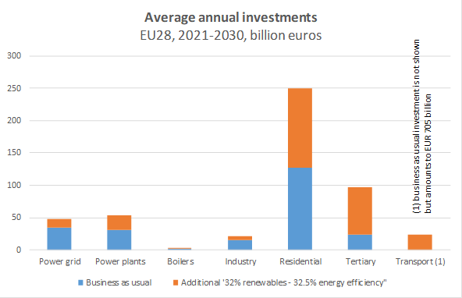

*Figure 5: Average annual investment need 2021-30 (Source: Commission modelling).*

The European Fund for Strategic Investments[25], the Connecting Europe Facility[26], the European Structural and Investment Funds and other existing initiatives have been successful in supporting investments in renewable energy and energy efficiency. Building on these, the Commission’s proposals for the next multi-annual financial framework running from 2021-2027 foresee that at least 25% of Union funds should contribute to support climate mitigation and adaptation. To mobilise private capital in sustainable investments, 30% of the overall financial envelope of the InvestEU programme[27] is expected to support the climate objectives. Under its Sustainable Infrastructure Window, the contribution to Union objectives on climate and environment should be even higher (55%). As part of the Connecting Europe Facility, a dedicated proportion of funds has been allocated to support cross-border renewable energy projects. All Member States are also encouraged to use EU ETS auction revenues for funding investments in emission reductions and removals, renewable energy, energy efficiency, research and innovation for clean energy and industry technologies.

|  |
| --- |
| **Identifying and quantifying the expected investment needs and the potential sources of finance are** an essential part of delivering the Energy Union objectives. Eleven Member Stateshave estimatedeither the **overall investment needs** to achieve their objectives**, (France, Italy** and **Spain**) or **parts** of their investment needs (**Greece, Finland, Hungary, Ireland, Italy, Latvia, Poland and Romania**), while providing varying levels of detail on the sources of finance. A majority of Member States have included in their draft NECPs some concrete investment figures. |

In parallel, the European Commission has addressed this topic as part of the **2018-2019 European Semester cycle**, with a strong focus on Member States’ investment needs, both in the 2019 Country Reports and in the Commission’s proposal for 2019 Semester country-specific recommendations issued on 5 June 2019, where most Member States received recommendations on the importance of investing in energy efficiency, renewable energy and/or climate action. This assessment of the draft NECPs takes into account these latest European Semester findings and recommendations.

Several Member States are already making the link between the NECPs and the Country Specific Recommendations as part of the European Semester and all Member States should ensure this link[28]. More generally, dialogue should continue to maximise consistency and synergies between energy and climate policies and the European Semester, as a key tool to promote structural reforms. In this context, a robust macro-economic assessment of the proposed policies and measures in the final NECP is important to understand the overall economic implications of the planned policies. Progress made towards finalising the NECPs will inform the 2020 European Semester country reports.

The Commission has proposed[29] that **cohesion policy funds** take into account the national and regional needs that the NECPs identify. The priorities for investments identified in the Country Reports under the 2019 European Semester cycle and outlined in the draft NECPs are complementary. Particularly relevant will be the support that can help build capacity for local, regional and national authorities, provide technical assistance and cross-border cooperation. For the period 2021-2027, there will be a strong focus on a clean and fair energy transition, R&I and industrial transition based on smart specialisation, cross-sectoral coupling of industrial clusters and support for interregional cooperation in innovation activities. In addition, in the Commission’s proposals, the adoption of a complete NECP is a “thematic enabling condition” for access to the European Regional Development Fund and Cohesion Fund for energy efficiency and renewable energy investments in particular.

***2.3.4 How can the draft NECPs promote competitiveness of the Union?***

Between now and 2030, each Member State needs to **create the right framework conditions to develop strategic value chains**, to be ready for the next investment cycle and to support climate neutrality by 2050. The draft NECPs could generally benefit from a more detailed overview of the way Member States intend to promote these conditions, by coordinating policies and measures addressed to promote cost-effectively the industrial transformation towards a climate neutral, circular and sustainable industry between now and 2030. These framework conditions should act as drivers for change benefiting the society and the planet without losing the competitive edge of the European industry.

More generally, the NECPs should help **identify and develop Member States’ competitive advantages** whilst duly assessing the impact of proposed measures. Clearer analysis of the macro-economic impacts of proposed policies and of the competitiveness challenges faced by industries, are crucial to successfully navigate the energy and climate transition. The approach proposed by several Member States to launch a broad industry consultation process in this regard is a good practice.

**Competition policy** ensures that government spending in support of the low emission and clean energy transition is efficient and does not create distortions in the internal energy market. While not substituting existing legal requirements in terms of notification, the NECPs could be useful to identify future needs for state aid pre-notification. Member States also need to ensure that policies and measures respect international obligations, notably in the context of WTO Agreements.

***2.3.5 How do the draft NECPs promote a fair transition?***

**The envisaged transformation of our economies will require an integrated approach to assess carefully social, territorial and employment impacts in the short term and in the long run. This assessment is the basis for a comprehensive policy mix to ensure a just transition**. The public funding for upgrading skills, research, innovation, infrastructure and social protection has to be aligned with the new needs of society. For the success of the EU’s energy and climate plans, the social dimension must be integrated from the outset. This will help to ensure a socially fair, just transition, including in rural areas, and, eventually, social acceptance and public support for reform, in particular for large-scale projects and breakthrough technologies.

Where needed, mitigating or compensatory measures, including to reduce energy poverty, need to be part of the reforms and the NECPs should highlight these.

|  |
| --- |
| **Energy poverty still affects nearly 50 million people across the Union.** The NECPs should address energy poverty in a more structured way, starting with an assessment of the number of households in energy poverty as well as their main characteristics (composition, income levels, etc.) and their potential geographic concentration[30]. Where the number is significant or where specific groups or regions are exposed to hardship, an indicative objective to reduce energy poverty coupled with relevant target groups, policies and measures as well as potential funding sources should be identified. There are already some positive elements in a number of draft NECPs. For example**, Greece** sets specific objectives, while the assessments by **Italy, Malta,** and **Finland** provide a good level of detail. |

The European Social Fund (ESF+) and the Skills Agenda for Europe are also important instruments to accompany the low carbon and energy transition. Together with the European Pillar of Social Rights, they further help ensure that people are granted equal opportunities and access to a labour market subject to changes in skill requirements and sectoral composition. In particular, the Pillar highlights the right to retraining, reskilling, upskilling and social protection – all crucial elements of a just transition.

In parallel, the Modernisation Fund financed by the EU ETS is dedicated to the modernisation of the energy systems of the ten lower-income Member States and will also help spur the transition to a climate neutral economy while promoting upward convergence.

The Commission will further explore possible synergies with other initiatives aimed at addressing the clean energy transition challenges and potential in specific European territories, such as the EU Covenant of Mayors for Climate and Energy, the Clean energy for EU Islands Initiative, the Commission strategy towards the outermost regions, the European Battery Alliance and the Coal Region in Transition Initiative.

***2.3.6 How do the draft NECPs relate to environmental policies?***

Energy and climate actions can bring benefits to **air quality**. Addressing **biodiversity loss and climate change** are policies that must go hand in hand. The benefits of the **circular economy** for decarbonisation are widely acknowledged.

Some Member States have already integrated these elements in their draft NECPs. Member States should ensure the consistency between their NECPs and the National Air Pollution Control Programmes (NAPCPs)[31], including their quantitative aspects, as required by the respective legislation. The links between energy and climate strategies and biodiversity preservation, circular economy, bioeconomy and resource efficiency should be made explicit, identifying concrete measures, assessing their impacts and establishing corrective actions when appropriate. For example, more re-use of products and better recycling of certain secondary raw materials can reduce energy demand.

The Commission can help Member States to incorporate these aspects in their NECPs, through policy dialogues and sharing of best practice, using instruments such as Clean Air Dialogues, Virtuous Circle Missions, TAIEX (Technical Assistance and Information Exchange) peer2peer, action plans for the circular economy, LIFE, guidance on Natura 2000 and renewable energy and climate, or the support provided by the Structural Reform Support Service.

# NEXT STEPS – TOWARDS THE FINAL NATIONAL PLANS

## 3.1. An ongoing iterative process

The analysis in this Communication and the country-specific Recommendations on the draft NECPs underpinned by the country-specific Staff Working Documents are the first milestones of the iterative process for the finalisation of the NECPs.

Since 2015, the European Commission and Member States have been working hand in hand on the preparation and submission of the first draft NECPs. In the coming months, the Commission will continue and intensify technical exchanges with Member States, including via Technical Working Group meetings and bilateral meetings.

**The agreed 2030 energy and climate targets are very ambitious and require concrete efforts across the economy. The draft** **NECPs offer a common, solid and comparable platform to engage and discuss across the Union with civil society, business,** **social partners and local governments the Union’s common challenges and long-term priorities in the field of energy and climate.** Thanks to their publication at the time of submission, these discussions have already started in a transparent manner. These interactions should help to increase the level of ambition of the final NECPs, as well as providing tangible examples of projects and policies to be implemented in the next ten years. Member States need to ensure that the public has early and effective opportunities to participate in preparing the final plans, which should then include a summary of the public’s views.

In parallel, the Commission will also continue to secure the participation of all levels of society in a systemic way, while enhancing stronger synergies between European, national and local efforts via the NECPs. In the second half of 2019 and beyond, the European Commission will continue to promote an inclusive debate on the NECPs.

## 3.2. Priorities for the next six months

The next six months – until the end of 2019 – will be crucial for Member States to develop their solid, robust, complete and reliable final NECPs. To maximise the impact of forthcoming exchanges, the Commission would like to steer those iterations around seven main priorities.

In the recommendations addressed to Member States, the Commission has put the emphasis on delivering on the Energy Union dimensions themselves, but also on issues of specific importance, in particular investment, a socially just and fair transition, and air quality.

In finalising the NECPs, Member States should consider the following priorities in addition to the country specific Recommendations.

***3.2.1 Close all 2030 “ambition” and policy gaps***

There is **still scope to close several gaps when finalising the NECPs**. On the **energy efficiency and renewable contributions,** some Member States are called to better exploit their national potential while others will need to confirm their already ambitious objectives. In finalising the NECPs, Member States should **collectively step up efforts to achieve the Union 2030 energy and climate goals, since continuation of existing policies at the same scale would not be sufficient to meet these targets.**

Many Member States are also called upon to further substantiate the achievement of their national targets and contributions towards the European level targets **with more concrete additional policies and measures,** underpinned where relevant by funding sources,and to work further on the analytical foundation of their NECPs. Final NECPs have to be complete and comprehensive to allow efforts and progress to be adequately monitored and revised as needed. The Commission previously published guidance that can be used to set measurable, achievable, realistic and time-related objectives across all five dimensions[32].

Should the ambition of final NECPs remain insufficient for the collective achievement of the Energy Union objectives and, in particular the 2030 targets for renewable energy and energy efficiency, the Commission will need to consider additional measures at Union level in order to ensure that they are met.

***3.2.2 Involve all relevant ministries at the national level***

The draft **NECPs represent an unprecedented opportunity for Member States to explore better the synergies between policy areas and to adopt a true ‘whole of government’ approach**.

While several Member States have already developed a new institutional set-up allowing better coordination across different policy areas, further work has to be done in view of finalising and implementing the NECPs. This is particularly the case for synergies and cooperation with ministries of finance and economy. The described synergies of energy and climate policies with areas such as regional, industrial, transport, digital, social agricultural and environmental policy can be better explored. This includes full coherence between the alternative fuel aspects in the final plans and the National Policy Framework that each Member State has to submit by November 2019 under the Alternative Fuels Infrastructure Directive[33].

***3.2.3 Make the best of cooperation with neighbouring Member States***

Ongoing efforts on **regional cooperation** should be brought to the next level to facilitate market integration and cost-efficient policies and measures. Member States are also encouraged to further pursue cooperation, not only with their neighbouring Member States, but also with signatories to the Energy Community and with third-country members of the European Economic Area.

|  |
| --- |
| **Regional cooperation – good practice:**  To help with preparing the draft NECPs, the **Nordic Energy Research** coordinated a scenario-based energy system analysis that explores the changes in the Baltic countries’ energy systems. Within the **Benelux cooperation framework** a declaration was signed on the margins of the Energy Council on 11 June 2018 to strengthen cooperation in preparing the draft NECPs. The members of the **Pentalateral Energy Forum** signed, in the margins of the Energy Council on 4 March 2019, a political declaration confirming their intention to maintain and strengthen cooperation in developing and monitoring the NECPs with a specific focus on issues with high cross-border relevance. Within the **North Seas Energy Cooperation,** several Member States have committed to developing coordinated elements for their NECPs to facilitate the cost-effective use of offshore renewable energy, particularly wind energy. The Commission looks forward to similar cooperation in other sea basins taking into account that achieving a climate neutral economy by 2050 will require substantial part of Europe’s electricity to be generated offshore[34]. |

More generally, without the leadership of the European Union, it will be difficult to achieve the objective of accelerating a worldwide energy and climate transition. At the same time, Union efforts will have little impact on a global scale if third countries do not follow the same path. Against this background, Member States are encouraged to complement their NECPs with practical, potentially transferable and scalable policies that could be shared beyond Europe as part of Union efforts to lead the global clean energy transition. If deemed appropriate, Member States may also consult third countries that have expressed an interest.

***3.2.4 Use NECPs to support industry, competitiveness and innovation***

**A wide range of reforms will be needed to fully exploit the growth potential of climate and energy policies.** The NECPs need to **help** **identify and develop Member States’ competitive advantages** by setting the right reforms as well as the correct investment signals and incentives, including by further developing taxation. NECPs should set out the necessary objectives while supporting national structural reforms and the deployment of integrated industrial strategies prioritising competitiveness, sustainability, investments, trade infrastructure and innovation. **Clearer strategies in terms of research and innovation priorities** could also reinforce European long-term priorities while sustaining EU exports in cutting-edge sectors.

The NECPs can become useful **platforms to develop with the banking sector, new programmes for financing long-term investment and to stimulate the mobilisation of private resources or to support new initiatives between industry players across sectors and value chains**, and enhance the ones already launched by the Commission in 2017, such as the one on batteries and plastics (European Battery Alliance and Circular Plastic Alliance).

***3.2.5 Attract investment and identify financing opportunities***

**Mobilising new investments and private finance will be key part of implementing the NECPs over the coming years. Clarity on policy objectives and instruments will be essential for identifying both the scope and scale of additional investment needs**, thus making it easier to plan and mobilise different sources of funding. In the coming months Member States should therefore clarify the instruments and reinforce the analysis of projected investment needs, existing barriers and possible sources of financing, also taking into account the synergies with the European Semester process.

This detailed assessment is essential to ensure efficient and more targeted spending of State resources, to better inform industry on the direction of policies, and to attract new investments, with positive repercussions in terms of jobs and growth. The European Commission’s current work on sustainable finance, aiming to reorient capital flows from private investors to environmentally sustainable investments, could help identify investment opportunities and mobilise private finance.

Synergies will have to be exploited with **existing and future Union policies and Union financial instruments**. In parallel, the Commission will continue to support Member States in finalising and implementing their NECPs by delivering a number of enabling measures as described above.

***3.2.6. Fully integrate the social dimension***

Addressing social aspects will be essential in securing a successful clean energy transition. In their final NECPs, Member States are encouraged to fully tackle the issue of ensuring a **socially just and fair transition**.

This encompasses notably **employment** aspects, including training, upskilling and reskilling, as well as adequate social protection for people concerned by the energy transition. Properly addressing the **energy poverty** dimension is also needed, including by assessing the number of households in energy poverty and where necessary defining an indicative objective to reduce energy poverty.

Finally, those Member States concerned should consider the impact of the transition on the populations living in **coal or carbon-intensive regions** and make the link with existing, planned or necessary actions in this regard.

***3.2.7 Factor-in long term objectives and a long-term vision***

In parallel to finalising their NECPs, the Governance Regulation requires Member States to develop their national **long-term greenhouse gas emission reduction strategies** with a perspective of at least 30 years. More than half the draft NECPs already include 2050 objectives or visions, albeit with varying degrees of detail. Both the NECPs and the long term strategies will need to be developed in a complementary way, while also contributing to the ongoing work to finalise the European long-term strategy that the European Union will have to submit by 2020 under the Paris Agreement and the UN Framework Convention on Climate Change. While focusing on the 2030 horizon, the 2050 horizon should be included in the NECPs, including a reflection of consistency of the targets and objectives with the long term decarbonisation goal and further efforts to **better qualify long terms objectives** across all five dimensions.

In the second half of 2019, relevant Council formations should be able to finalise their ongoing policy debates on the European vision for a climate neutral Europe by 2050 with a reflection on this aspect in the final NECPs.

|  |
| --- |
| More than half the draft NECPs include 2050 objectives or visions, albeit with varying degree of detail. **Denmark**, **Spain, France**, **Netherlands**, **Portugal**, and **Sweden** aim for **climate neutrality** at latest by 2050. **France** and the **United Kingdom** have established **legally binding 2050 targets** in their domestic legislation and use carbon budgets as mechanism to ensure consistency of medium and long term objectives. **Netherlands**, **Portugal** and **Sweden** **increased** their national **2030 greenhouse gas targets** to be consistent with their long term targets. Other Member States with 2050 decarbonisation objectives include **Czechia**, **Germany, Estonia**, **Ireland**, **Italy, Lithuania**, **Hungary**, **Austria**, and **Finland**. |

# CONCLUSIONS

Delivering the Energy Union’s commitments requires further close cooperation between the Commission, Member States and all segments of society, including stakeholders, social partners and the general public. It is a joint process in which the timely submission by Member States of final integrated NECPs for the post-2020 period is a key milestone.

In order to ensure that the final NECPs submitted by the end of 2019 meet all requirements and reach the ambitious EU 2030 targets, the Commission invites the Council to open a debate around the main priorities identified by this Communication and the Commission’s Recommendations to ensure that the final NECPs contain an adequate level of ambition to fulfil, in particular, the European-level renewable and energy efficiency targets. The Commission will keep a close dialogue with the European Parliament and the Council on progress achieved by the Energy Union on all dimensions of energy and climate policies.

In parallel, the European Commission will support Member States in finalising their NECPs by the end of 2019, building on the excellent cooperative process to date.

Solid and comprehensive NECPs will be crucial to achieve the Energy Union’s objectives, their implementation and the Union’s contribution to the Paris Agreement, while generating investor confidence and investment certainty.

Beyond our borders, the integrated national energy and climate plans will be an expression of the European Union's credibility on international climate policy, including the clean energy transition, and contribute to the **long-term decarbonisation goals** in the context of the **Paris Agreement** and the UN Sustainable Development Goals. They could become an international best practice on developing sound mid-term energy and climate policy planning and be a tool to foster international cooperation around those aims.

The delivery of these final NECPs will be a start, not an endpoint – continued dialogue, cooperation and reviews of the ambition level will remain critical all the way to 2030 and beyond.

1. COM(2018) 773 final.
2. Regulation (EU) 2018/1999 of the European Parliament and of the Council of 11 December 2018 on the Governance of the Energy Union and Climate Action.
3. Sibiu Declaration, Informal meeting of heads of state or government, Sibiu, Romania 9 May 2019.
4. As required by Article 9 of the Regulation (EU) 2018/1999 of the European Parliament and of the Council of 11 December 2018 on the Governance of the Energy Union and Climate Action.
5. SWD(2019) 211; SWD(2019) 225; SWD(2019) 214; SWD(2019) 275; SWD(2019) 229; SWD(2019) 277; SWD(2019) 230; SWD(2019) 261; SWD(2019) 262; SWD(2019) 263; SWD(2019) 224; SWD(2019) 264; SWD(2019) 223; SWD(2019) 265; SWD(2019) 228; SWD(2019) 266; SWD(2019) 267; SWD(2019) 268; SWD(2019) 227; SWD(2019) 226; SWD(2019) 281; SWD(2019) 272; SWD(2019) 273; SWD(2019) 271; SWD(2019) 274; SWD(2019) 276; SWD(2019) 278; SWD(2019) 279.
6. SWD(2019) 212.
7. C(2019) 4401; C(2019) 4402; C(2019) 4403; C(2019) 4404; C(2019) 4405; C(2019) 4406; C(2019) 4407; C(2019) 4408; C(2019) 4409; C(2019) 4410; C(2019) 4411; C(2019) 4412; C(2019) 4413; C(2019) 4414; C(2019) 4415; C(2019) 4416; C(2019) 4417; C(2019) 4418; C(2019) 4419; C(2019) 4420; C(2019) 4421; C(2019) 4422; C(2019) 4423; C(2019) 4424; C(2019) 4425; C(2019) 4426; C(2019) 4427; C(2019) 4428.
8. In accordance to Article 34 of the Governance Regulation, in case of an ambition gap, the Commission shall as appropriate issue recommendations to Member States to ensure the achievement of the objectives of the Energy Union. The Member State concerned shall take due account of the recommendations.
9. In accordance with Article 31 of the Governance Regulation, the Commission's recommendations on the Member States’ renewable ambitions are based on the formula set out in Annex II of the Regulation, which is based on the objective criteria listed in Article 5, whilst having due regard to relevant circumstances affecting renewable energy deployment as indicated by the Member States. The methodology followed by the Commission to assess renewable energy contributions is further detailed in Section II of the SWD(2019) 212.
10. In addition to the gap identified for the EU28, the overall level to be achieved in 2030 remains highly dependent on the contribution of the ambitious Member States and on the gross final consumption of energy.
11. The methodology followed by the Commission to assess energy efficiency contributions is further detailed in Section III of the SWD(2019) 212.
12. Regulation (EU) 2018/842 of the European Parliament and of the Council of 30 May 2018 on binding annual greenhouse gas emission reductions by Member States from 2021 to 2030 contributing to climate action to meet commitments under the Paris Agreement and amending Regulation (EU) No 525/2013 OJ L 156, 19.6.2018, p. 26–42.
13. The non-ETS sectors include, for example, transport, buildings, agriculture, waste.
14. COM/2018/716 final.
15. In both cases, the forthcoming 10-Year Network Development Plan (TYNDP) and Projects of Common Interest selection processes have to be taken into account.
16. Article 5 of Regulation (EU) 2018/842 of the European Parliament and of the Council of 30 May 2018 on binding annual greenhouse gas emission reductions by Member States from 2021 to 2030 contributing to climate action to meet commitments under the Paris Agreement and amending Regulation (EU) No 525/2013, OJ L 156, 19.6.2018, p. 26–42.
17. Regulation (EU) 2018/841 - Inclusion of greenhouse gas emissions and removals from land use, land use change and forestry in the 2030 climate and energy framework, and amending Regulation (EU) No 525/2013 and Decision No 529/2013/EU.
18. In parallel with the draft NECPs, Member States submitted National Forestry Accounting Plans (NFAPs), including their national Forest Reference Level. In April 2019, an expert group comprised of technical specialists from Member States, NGOs and research organisations, among others, made a first assessment of the NFAPs. The resulting technical recommendations (SWD(2019) 213) reflect the generally high quality of the submitted plans while pointing to some country-specific approaches that will require further careful analysis.
19. In accordance with Article 33 of the Governance Regulation, the mechanism will have the double aim of covering any potential gap to the indicative Union trajectory for renewables and contributing to the enabling framework under the recast Renewable Energy Directive.
20. As required by the Electricity Regulation for those Member States which envisage starting or continuing capacity mechanisms and which therefore need to upgrade their markets.
21. COM(2016) 763 final.
22. The Innovation Fund is an European Union investment programme of about EUR 10 billion financed through the sale of allowances from the EU ETS.
23. A Clean Planet for all - A European strategic long-term vision for a prosperous, modern, competitive and climate neutral economy, COM/2018/773 final.
24. Figure derived from the EUCO32-32.5 scenario (in line with key technology assumptions of the EUCO family scenarios, see <https://ec.europa.eu/energy/en/data-analysis/energy-modelling/euco-scenarios>).
25. Regulation (EU) 2015/1017 of the European Parliament and of the Council of 25 June 2015 on the European Fund for Strategic Investments, the European Investment Advisory Hub and the European Investment Project Portal and amending Regulations (EU) No 1291/2013 and (EU) No 1316/2013 — the European Fund for Strategic Investments.

    OJ L 169, 1.7.2015, p. 1–38.
26. Regulation (EU) No 1316/2013.
27. COM/2018/439 final.
28. The Governance Regulation explicitly mention that Member States should ensure that their integrated national energy and climate plans take into consideration the latest country-specific recommendations issued in the context of the European Semester.
29. Proposal for a Regulation of the European Parliament and of the Council laying down common provisions on the European Regional Development Fund, the European Social Fund Plus, the Cohesion Fund, and the European Maritime and Fisheries Fund and financial rules for those and for the Asylum and Migration Fund, the Internal Security Fund and the Border Management and Visa Instrument, COM/2018/375 final - 2018/0196 (COD).
30. A significant share of households exposed to energy poverty e.g. are middle income households (based on EU-Statistics on Income and Living Conditions (EU-SILC) data).
31. Directive (EU) 2016/2284 of the European Parliament and of the Council of 14 December 2016 on the reduction of national emissions of certain atmospheric pollutants, amending Directive 2003/35/EC and repealing Directive 2001/81/EC, OJ L 344, 17.12.2016. p. 1–31. The National Air Pollution Control Programme under Article 6 is the main governance measure by which Member States must ensure that the reduction commitments for 2020 and 2030 are met.
32. In 2015, the Commission produced a SWD on monitoring progress towards the Energy Union objectives as part of first State of the Energy Union package. This document includes a set of relevant key indicators to quantify and measure progress on EU energy and climate objectives and targets. SWD(2015) 243 final. <https://eur-lex.europa.eu/legal-content/EN/TXT/?qid=1449767808781&uri=CELEX:52015SC0243>.
33. Directive 2014/94/EU of the European Parliament and of the Council of 22 October 2014 on the deployment of alternative fuels infrastructure, *OJ L 307, 28.10.2014, p. 1–20.*
34. The EU directive on maritime spatial planning, ongoing EU efforts to stimulate innovation and improve access to reliable ocean data as well as targeted opportunities within InvestEU for the necessary cabling and port infrastructure will support this transition.