

**List of abbreviations**

|  |  |
| --- | --- |
| AA | Association Agreement |
| CIS | Commonwealth of Independent States |
| CPI | Consumer price index |
| DCFTA | Deep and Comprehensive Free Trade Area |
| EC | European Community |
| ECF | Extended Credit Facility |
| EEU | Eurasia Economic Union |
| EFF | Extended Fund Facility |
| EFTA | European Free Trade Association |
| EIB | European Investment Bank |
| ENP | European neighbourhood policy |
| ENI | European neighbourhood instrument |
| EU | European Union |
| EUR | Euro |
| FATF | Financial Action Task Force |
| FDI | Foreign direct investment |
| FSAP | Financial sector assessment programme |
| GAFTA | Greater Arabic Free Trade Area |
| GCC | Gulf Cooperation Council |
| GDP | Gross domestic product |
| IMF | International Monetary Fund |
| MFA | Macro-financial assistance |
| MoU | Memorandum of understanding |
| OECD | Organisation for Economic Cooperation and Development |
| OJ | Official Journal of the European Union |
| PFM | Public finance management |
| PPP | Public‑private partnership |
| SBA | Stand-By Arrangement |
| SDR | Special drawing rights |
| SOE | State-owned enterprise |
| SREP | Supervisory review and evaluation process |
| USD | United States dollar |
| TFEU | Treaty on the Functioning of the European Union |
| VAT | Value added tax |
| WTO | World Trade Organisation |
| y-o-y | year-on-year |

**Contents**

Introduction 3

Background analysis of beneficiaries of macro-financial assistance 4

1. Georgia 4

1.1. Macroeconomic performance 4

1.2. Structural reforms 5

1.3. Implementation of macro-financial assistance 6

2. Jordan 8

2.1. Macroeconomic performance 8

2.2. Structural reforms 9

2.3. Implementation of macro-financial assistance 9

3. Moldova 12

3.1. Macroeconomic performance 12

3.2. Structural reforms 13

3.3. Implementation of macro-financial assistance 14

4. Tunisia 16

4.1. Macroeconomic performance 16

4.2. Structural reforms 17

4.3. Implementation of macro-financial assistance 18

5. Ukraine 21

5.1. Macroeconomic performance 21

5.2. Structural reforms 22

5.3 Implementation of macro-financial assistance 23

Annexes 25

Annex 1: Selected macroeconomic indicators by country 25

Annex 2: MFA operations by date of decision, 1990-2018 27

Annex 2A: Status of effective disbursements by date of decision at end-December 2018 28

Annex 2B: Status of effective disbursements by region at end-December 2018 (in millions of €) 34

Annex 3: MFA amounts authorised by year, 2005-2018 (EUR million) 41

Chart 3A: MFA amounts authorised by year, 2005-2018 (EUR million) 41

Chart 3B: MFA amounts authorised by region, 2005-2018 (%) 41

Annex 4: MFA amounts disbursed by year, 2005-2018 (EUR million) 42

Chart 4A: MFA amounts disbursed by year, 2005-2018 (EUR million) 42

Chart 4B: MFA amounts disbursed by region, 2005-2018 (%) 42

Annex 5: Outstanding Amounts in respect of operations disbursed at end-December 2018 43

# Introduction

This staff working document complements the Commission’s report to the European Parliament and the Council on the implementation of macro-financial assistance (MFA) to third countries in 2018.

Over 2018, two countries in the Eastern Neighbourhood, Georgia and Ukraine, benefited from macro-financial assistance disbursements. The year was also characterised by progress in the implementation of the ongoing MFA programmes in Jordan and Tunisia in the Southern Neighbourhood, and Moldova in the Eastern Neighbourhood. For each beneficiary country, the report provides more detailed information on: (i) their macroeconomic and financial situation; (ii) progress in accomplishing their structural reforms agenda; and (iii) implementation of their MFA operations.

The annexes include overview tables on the effective disbursements of MFA operations since 1990 by date of adoption of the decisions and by region, as well as tables on MFA commitment and payment amounts in 2005‑2018, by year and by region.[1]

# Background analysis of beneficiaries of macro-financial assistance [2]

1. **Georgia**

## Macroeconomic performance

Georgia has experienced a solid recovery from the slowdown of 2015-2016. Nonetheless, external vulnerabilities, notably a large current account deficit and high external debt, persist and are further amplified by global and regional factors such as the risks associated with a global economic slowdown.

In 2018, Georgia’s real GDP is estimated to have increased by 4.8%, driven by both domestic and external demand, although growth was slower in the second half of the year. This positive trend builds on a broad-based recovery in 2017, following two years of deceleration due to external shocks. In terms of demand components, private consumption and investment remain the main drivers of growth, bolstered by lower inflation, expansion of credit and higher remittances. On the supply side, Georgia’s economic growth is mainly fuelled by growth in services (financial intermediation, tourism and transport) and – to a lesser extent – industry (mining and manufacturing).

The unemployment rate in Georgia has been on a downward trend since 2009 (18.3%) but it remains high (12.2% in the third quarter of 2018) despite economic growth. Skills mismatch and large regional disparities are important challenges.

The fiscal deficit of the general government is estimated to have been reduced from 3.9% GDP in 2017 to 3.3% GDP in 2018, on the back of economic growth and consolidation efforts. This also allowed Georgia to slightly reduce its public debt to 43% of GDP in 2018, from 45% of GDP in 2017.

Consumer price inflation slowed down to 1.5% in December 2018. This is a considerable moderation compared to December 2017 when inflation of 6.7% was much above the central bank’s target. The deceleration in headline inflation has allowed the central bank to reduce the refinancing rate from 7.25% to 7% in July 2018 and further to 6.75% in January 2019, following three increases in 2017 of a cumulative 75 basis points.

Regarding the exchange rate, the Georgian lari has depreciated by around 3% against the US dollar in 2018, partly in the wake of the currency crisis in Turkey, one of Georgia’s foremost trading partners. Given the decreasing but still high dollarisation (63% of deposits and 57% of loans were denominated in US dollars as of end-2018), Georgia remains vulnerable to exchange rate risk.

Georgia’s balance-of-payments position remains vulnerable due to a decreasing but still large current account deficit (6.7% GDP in the first three quarters of 2018, compared to 7.5% GDP in the same period of 2017) and high external debt (109% in 2018, compared to 113% GDP in 2017). The current account deficit is mainly driven by the trade in goods deficit, which is only partly offset by the trade in services surplus and income and transfers from abroad, including remittances. Foreign direct investment (6.7% GDP in the first three quarters of 2018, compared to 10.7% GDP in 2017) remains the main source of inflows. Georgia’s international reserves have been increasing in recent years, totalling USD 3.3 billion at end-2018 (3.4 months of import cover). However, reserve needs have also been increasing (partly due to additional liquidity buffers warranted by dollarisation-associated risks in a floating exchange rate regime), and the reserves are currently below the level estimated by the IMF to be adequate.

## Structural reforms

Georgia’s structural reform agenda focuses on improving the business environment and education, as well as investing in infrastructure. The Georgian authorities intend to complement structural reforms with fiscal reforms, strengthening of the financial sector, as well as deepening trade relations with the rest of the world.

In terms of improving the business environment, the Georgian authorities plan to reform the insolvency law and improve revenue administration, e.g. by automatically refunding VAT credits. The authorities are also pursuing land reform. The land registration process was temporarily simplified in 2017-2018. The completion of land registration should facilitate transactions and make it easier to use land as collateral for borrowing, thereby contributing to rural development and making agricultural production more efficient.

As part of the education reform, the Georgian authorities plan to improve the education system by setting curriculum standards and formalising vocational education and training. Regarding the latter, a major milestone was the adoption of the Vocational Education and Training law in September 2018, which should allow for greater involvement of the private sector. More generally, the education reform should help to address the skills mismatch, which is one of the main structural weaknesses of the Georgian economy and contributes to high unemployment.

In terms of investing in infrastructure (highways, ports, airports and railways), further progress is expected to help Georgia utilise its potential as a transit country between Europe and Asia, facilitate regional trade, and support the development of the growing tourism sector. Major ongoing projects include the completion of East-West and North-South highway corridors, and the Anaklia deepwater port.

Fiscal reforms aim to reduce current expenditure and create space for more capital expenditure. The Georgian authorities have improved the management of fiscal risks stemming from public-private partnerships (PPPs) and state-owned enterprises (SOEs). In May 2018, the Georgian Parliament adopted the law on PPPs, which notably establishes reporting and monitoring of government exposure in PPPs. For SOEs, the Georgian authorities have expanded the analysis of contingent liabilities associated with such enterprises, as part of the Fiscal Risk Statement accompanying the budget. Further efforts will include restructuring of the Revenue Service and improving the fiscal framework.

In the financial sector, the Georgian authorities have introduced a deposit guarantee scheme and improved regulatory, supervisory and resolution frameworks for banks. The authorities are developing the country’s capital markets. Georgia also introduced a second (funded) pillar of the pension system with effect from January 2019. The latter should not only increase the currently low income replacement rate but also create demand for long-term financial instruments denominated in the national currency and thereby further reduce dollarisation. In addition, the authorities plan to introduce mandatory third-party vehicle insurance in 2019, which would support the development of the insurance sector.

In terms of deepening trade relations, aside from its Association Agreement with the EU, which includes the creation of a Deep and Comprehensive Free Trade Area (DCFTA), Georgia also has a Free Trade Agreement (FTA) with China, which has been in place since 2017. These agreements complement FTAs that Georgia already had with its key trading partners such as Turkey and should over time contribute to the diversification of Georgia’s exports.

Georgia’s national reform agenda is supported by MFA conditionality. For example, the conditions for the 2015-2017 MFA operation contributed to the adaptation to DCFTA requirements regarding certificates of origin and competition. Conditions of the current MFA operation notably require an improved public investment management framework, continuation of the land and education reforms, and support further de-dollarisation.

## Implementation of macro-financial assistance

The first and second MFA operations for Georgia were pledged at the International Donors’ Conference in Brussels in October 2008, following Georgia’s military conflict with Russia in August 2008. The first operation of EUR 46 million, fully in the form of grants, was implemented in 2009-2010. The second operation of EUR 46 million, half in grants and half in loans, was implemented in 2015-2017.

In June 2017, Georgia requested further MFA from the EU. In September 2017, the Commission submitted to the EU co-legislators a proposal for up to EUR 45 million (EUR 10 million in grants and EUR 35 million in loans) in further MFA to Georgia. The European Parliament and the Council adopted the Decision on further MFA in April 2018. Aside from covering part of Georgia’s financing needs and supporting structural reforms, further MFA complements IMF funds (USD 285 million) under a three-year (2017-2020) Extended Fund Facility (EFF) programme with Georgia, approved in April 2017. The Memorandum of Understanding (MoU), the Grant Agreement and the Loan Facility Agreement relating to the current MFA operation were signed by exchange of letters in August 2018.

Following the entry into force of the MoU and the accompanying agreements in November 2018, the first instalment of EUR 20 million (EUR 5 million in grants and EUR 15 million in loans) was disbursed to Georgia in December 2018. The first disbursement was subject to the general political pre-condition for MFA (respect for effective democratic mechanisms, including a multi-party parliamentary system, the rule of law and human rights) and the IMF programme remaining on track.

The second (final) instalment of EUR 25 million (EUR 5 million in grants and EUR 20 million in loans) is subject, aside from the political precondition and good progress with the IMF programme, to specific policy conditionality agreed between Georgia and the EU in the MoU. These policy conditions aim to strengthen the Georgian economy in the areas of public financial management, the financial sector, social and labour market policies, and the business environment. The disbursement of the second instalment is tentatively planned for mid-2019, as long as Georgia meets all relevant conditions.

|  |
| --- |
| **Status of economic reforms — Georgia** |
| **1. Price liberalisation** Prices are largely market-driven. |
| **2. Trade regime**  Georgia (WTO member since 2000) has a liberal trade policy, with no quantitative restrictions on imports or exports. In June 2014, it signed an Association Agreement with the EU, including a deep and comprehensive free trade area (DCFTA) agreement, which entered into force in September 2014. Georgia also has FTAs with its other key trading partners such as Turkey and China. |
| **3. Exchange rate regime**  There is a floating exchange rate for the lari, with limited official intervention by the National Bank of Georgia. There are no restrictions on current international transactions, in accordance with Article VIII of the IMF’s Articles of Agreement, and Georgia does not operate capital controls. |
| **4. Foreign direct investment**  Georgia has a liberal regime for FDI and unlimited repatriation of capital and profits. FDI inflows in recent years (6.7% GDP in the first three quarters of 2018) have consistently been among the highest in the region. |
| **5. Monetary policy**  The Central Bank’s main monetary policy objective is price stability. The Bank is currently applying an inflation-targeting regime, with a target of 3% for 2019-2022. The effectiveness of monetary policy is significantly constrained by the high level of dollarisation: as of end-2018, 57% of loans and 63% of deposits were denominated in US dollars. |
| **6. Public finances and taxation**  The public finance management system is essentially sound and transparent. Further needed reforms are ongoing to strengthen public investment management and manage contingent liabilities from state-owned companies and public-private partnerships. Public revenues are constrained by the Constitution, which prescribes a referendum for the introduction of new taxes or the raising of tax rates (Article 94), while the budget deficit, public debt and public spending are capped by the Liberty Act, in force since January 2014, at 3%, 60% and 30% of GDP respectively. The autorities are currently reviewing the fiscal framework, with the aim to focus on medium-term sustanability and enforcement. |
| **7. Privatisation and enterprise restructuring**  Most state-owned enterprises (SOEs) have been privatised, with their number falling from around 1 300 in 2009 to around 100 currently. The remaining SOEs generate around 7% of GDP in revenue and hold liabilities worth 17% of GDP. In 2018, the Georgian government annouced plans to privatise postal and railway companies. |
| **8. Financial sector**  Georgia’s financial sector is small and dominated by banks, which hold more than 90% of total financial sector assets. However, banking sector credit to the economy is only around 60% of GDP. The sector is concentrated, with the two largest banks, out of 16 in total, holding around two thirds of the assets. Georgia’s banking sector has a low-risk profile and has generally remained resilient, reporting sufficient capital and liquidity. In November 2018, the liquidity coverage ratio was 122% and the capital adequacy ratio was around 18% (both ratios being in line with their average levels in 2015-2017). |

2. **Jordan**

## Macroeconomic performance

The Syrian crisis has continued to act as a drag on Jordan’s economy and to weigh on its external and fiscal positions. Real GDP increased modestly by an estimated 2.1% in 2018, essentially unchanged since 2016. Economic growth remained insufficient to contain unemployment, which rose slightly to 18.7% in the fourth quarter of 2018 from 18.5% in the fourth quarter of 2017 and 15.3% in 2016. Headline inflation rose to 4.5% at end-2018 from 3.3% at end-2017. This reflected higher oil prices and the impact of the increases in the General Sales Tax (GST) on basic products including food and bread.

Progress in fiscal consolidation was slow-paced. The overall fiscal deficit, which includes transfers to NEPCO (the electricity company) and the Water Authority of Jordan and grants, narrowed to 2.4% of GDP at end-2018 from 2.6% of GDP at end-2017. This was the result of a 5.5% increase in total expenditure, which outweighed the 4.8% increase in total revenues. Without grants (which increased by 26% in 2018 and reached 3% of GDP) the fiscal deficit would amount to 5.4% at end-2018 from 5% in 2017.

Tax revenues were underpinned by the increase of the GST (supported by an MFA condition) to 10% for commodities that were previously subject to rates of 0%-4%. In addition, the authorities decided to lift food subsidies on bread, to introduce a levy of JOD 500-JOD 1,500 (about EUR 630 – EUR 1,900) on imported cars and to raise a special tax on carbonated drinks from 10% to 20%. Finally, an increase in excise tax on Octane-95 and 98 gasoline to 30% was enacted, as well as an increase in tax on cigarettes to reach JOD 0.20 per pack. A new income tax law was adopted in November 2018 following a period of social unrest over an earlier draft of the law which had led to the resignation of the previous government in May 2018. Supported by an MFA condition, the new income tax law broadened the tax base and progressivity in personal income taxation. It is expected to enhance tax revenues by 0.5% of GDP in 2019 and 1% of GDP in the years after, depending also on efforts to combat tax evasion and to raise the capacity of the tax administration. Taxation on industrial sector was increased (from 14% to 20%) and a national contribution tax was introduced at different rates depending on the type of business. Jordan’s gross public debt was reduced to 94 % of GDP at end-2018 from 94.3% of GDP a year earlier. Around 40.2% of GDP was external public debt.

Exports grew by 3% while imports decreased by 0.8% in the first eleven months of 2018. In combination with a strong increase in travel receipts (13%) this contributed to the narrowing of the current account deficit in the first nine months of 2018 to 9% of GDP (10.2% of GDP excluding grants) from 11.2% of GDP in the same period in 2017. However, it remains at high levels and would be even higher (11.4% of GDP) excluding foreign grants, which indicates the vulnerability of the external position. Foreign direct investment plummeted to USD 754 million in the first nine months down by 54%.

The Central Bank of Jordan increased the re-discount rate in seven steps from 3.75% to 5.75% between February 2017 and December 2018. This broadly mirrors the Fed’s rate rises, given the peg of the Jordanian dinar to the US dollar.

Foreign currency reserves fell from USD 14.2 billion (equivalent to 7.9 months of imports) at end-2017 to USD 13.3 billion (or 7.3 months) at end-2018. Given the vulnerability of the external position, the elevated risks from regional conflicts, the exchange rate peg and exposure to oil price shocks, the current level of reserves should be preserved or increased to help the country withstand possible shocks stemming from the factors mentioned above.

## Structural reforms

During 2018, the authorities continued efforts for the implementation of their reform agenda in order to reduce macro-economic imbalances and to generate employment. This reform agenda drew broadly from “Jordan 2025” — a 10‑year economic blueprint published in May 2015 —, the “Jordan Economic Growth Plan 2018-2022” (JEGP) — aiming to revitalise growth in specific sectors — and the National Strategy for Human Resources Development. In addition, structural reforms were complemented by programmes agreed with international donors (in particular, the IMF and the World Bank) and the EU (including the MFA II). However, Jordan’s efforts delivered only uneven success as the reform process was challenged by regional instability, the low growth environment, as well as by domestic political and social tensions, which led to the resignation of the government in May 2018.

Important reforms for enhancing the growth performance were completed in 2018. Four by-laws for businesses’ monitoring and inspection were enacted following the adoption of the relevant law in 2017, leading to around 94,000 inspections in 2018. The streamlining of inspection regulations is expected to reduce duplication of inspections by different government departments as well as to enhance monitoring of business activities in an effort to reduce informal employment. The law on secured lending was adopted in May 2018 with relevant by-laws following in November 2018. Along with the completion of an online Movable Collateral Registry, this reform is expected to increase lending to SMEs by 7% annually. The insolvency law, which was enacted in May 2018, enables the re-organisation of businesses (under certain deals reached with creditors) and regulates the insolvency proceedings of foreign companies in Jordan according to international conventions. The abolition of pre-registration approvals issued by the Ministry of Interior for business activities that have low or no impact on public safety and security was also adopted in 2018, while a “Regulatory Predictability Framework” was developed to improve the process of issuing regulations that affect businesses, including instructions and decisions. Finally, new governance frameworks were adopted for Public Investment Management – Public-Private Partnership as well as for Venture Capital including specific tax treatment for the Venture Capital funds in Jordan.

In 2018, Jordan embarked on intensive discussions with the World Bank to formulate a comprehensive reform plan, the so-called Five-Year Growth and Reform Matrix, aiming at boosting growth and containing unemployment. This reform plan was presented in the London Initiative on 28 February 2019, an event that mobilised donour support and investments for Jordan.

## Implementation of macro-financial assistance

As regional instability deepened, with negative repercussions for the economy, the Jordanian authorities requested a second MFA programme on 3 March 2016. In line with the EUR 2.4 billion the Commission pledged at the ‘Supporting Syria and the Region’ conference in London on 4 February 2016, the Commission adopted a proposal on 29 June 2016 for a decision on a second MFA operation to Jordan worth EUR 200 million in loans. The new MFA programme, which was approved on 14 December 2016, followed the successful implementation of the first MFA operation of EUR 180 million in loans, which was fully disbursed in 2015.

Following the signature of the MoU and the loan facility agreement of the MFA II on 19 September 2017, the Commission released the first instalment of EUR 100 million on 25 October 2017. A mission to review compliance with the conditions of the second instalment took place in Amman in early December 2017. This mission was then followed-up through regular contacts to monitor the implementation of the MFA conditions, which included important measures to enhance debt sustainability, improve the independence of external audits in the public sector, increase transparency in public procurement, expand the tax base and increase progressivity of taxation, strengthen the social safety nets, increase employment opportunities for Syrians in Jordan and enhance the financial viability of the water sector). These conditions were fulfilled during the first semester of 2019, which enabled the approval of the release of the second disbursement of EUR 100 million on 24 June 2019.

Delays have also been observed in implementing the three-year IMF programme that is supported by the USD 723 million Extended Fund Facility arrangement, and which was approved by the IMF in August 2016. The first IMF programme review (initially planned for December 2016) was only approved by the IMF Board in June 2017, while the IMF only reached staff-level agreement with the Jordanian authorities in February 2019 over the completion of the second review and the policies that should be implemented in the remaining period of the programme. The second EFF review was completed on 6 May 2019 by the IMF Executive Board after the provision by the international community of sufficient financial assurances to cover Jordan’s external financing gap for the period 2019-2020. At the same time, the IMF Board decided to extend the time-span of the programme until March 2020.

The European Parliament, the Council and the Commission adopted a joint declaration attached to the decision approving the second MFA operation. The declaration committed the Commission to submit, if appropriate, a new proposal for extending and increasing MFA to Jordan, on condition that the second MFA was successfully completed, the usual preconditions were met for this type of assistance and there was an updated assessment by the Commission of Jordan’s external financing needs.

|  |
| --- |
| **Status of economic reforms — Jordan** |
| 1**. Price liberalisation**  Prices are largely market-driven, but there are oligopolistic conditions in several sectors. Fuel subsidies were eliminated in November 2012. Electricity tariffs and prices for some basic foodstuffs are still subject to administrative controls. In 2017 the government adopted an automatic adjustment of electricity tariffs based on fuel prices and abolished subsidies on bread. |
| **2. Trade regime**  Jordan has a relatively liberal trade regime. It joined the WTO in 2000 and ratified an Association Agreement with the EU in 2002. It is also one of the EU’s partner countries that could potentially benefit from a DCFTA agreement. It is a member of both the Greater Arabic Free Trade Area (GAFTA) and the Agadir Agreement and has also concluded FTAs with the United States, Syria, the European Free Trade Association (EFTA) and Singapore. On 19 July 2016, the EU approved a 10-year relaxation of rules of origin for a wide range of industrial products produced in 18 selected special economic zones, provided that each company uses a minimum percentage of Syrian refugee labour in the production. |
| **3. Exchange rate regime**  Since October 1995, the dinar has been pegged to the US dollar. |
| **4. Foreign direct investment**  Jordan is largely open to foreign investment. It signed the OECD’s Declaration on International Investment and Multinational Enterprises in 2013. However, there are still significant land ownership restrictions, minimum capital requirements and restrictions on foreign investment in certain sectors, such as the wholesale and retail trade. |
| **5. Monetary policy**  The Central Bank of Jordan has become more independent. Its main monetary policy tools are the certificates of deposit, through which it influences retail interest rates in the banking system. The Central Bank has developed a credible track record of ensuring price stability, maintaining exchange rate stability and promoting growth. |
| **6. Public finances and taxation**  In 2007-2017, Jordan’s tax-to-GDP ratio dropped from 20.4% to 15.9%, reflecting structural weaknesses in the taxation system: high exemption threshold in income tax, widespread tax exemptions and capacity constraints in tax administration. There is scope for improving public debt management, including by developing the domestic bond market. The public procurement system is fragmented and is not in line with international standards. |
| **7. Privatisation and enterprise restructuring**  Privatisation started in 1986 in the aftermath of an economic crisis and has made significant progress since then. Nevertheless, direct state ownership in certain sectors such as mining and public utilities remains significant. |
| **8. Financial sector**  The financial sector is relatively well developed and dominated by banks, which are generally profitable and well capitalised. Banks have already started implementing Basel III. However, the narrow and shallow institutional investors’ base restricts the development of domestic capital markets. The Central Bank implements a financial inclusion strategy to increase access to and the use and quality of financial services. |

3. **Moldova**

## Macroeconomic performance

Moldova experienced a period of relative stability in the last years, as it continued to recover from the banking crisis in 2014-2015. Economic performance is expected to remain solid over the medium term, with steady growth, moderate inflation and a sound fiscal situation. Economic growth was 4.0 % in 201 moderating from a 4.7% expansion in 2017.

Looking ahead, the economy is likely to continue to grow moderately in the range of 3.5 %-4.0 % in 2019-2021 driven by private consumption and public and private investment. Downside risks on macro-economic stability and economic growth are increasing due to political developments ahead and following the parliamentary elections in February 2019. Economic reforms and other key structural reforms such as in the justice sector may become compromised.

The annual inflation decreased to 0.9% in 2018, below the target corridor of 5% (± 1.5 percentage points) and the 6.6% inflation rate of 2017. This development was supported by currency appreciation and effects of regulated prices such as utility tariffs and excise duties. In 2019 and over the medium term, inflation is expected to move towards the lower end of the target corridor as previous adjustments to regulated prices will fade.

The fiscal situation has been improving significantly in the last years. The fiscal deficit of 0.9% of GDP for 2018 was significantly smaller than the budget deficit target of 2.9% of GDP following better-than-expected revenue performance and delays in spending. Revenues increased by 8.6% compared to 2017 due to increasing economic growth and tax administration reforms. Under-execution of spending relates to delays in implementing investment projects and uncertainty over external financing. In agreement with the IMF programme, the overall budget deficit for 2019 is targeted at 2.7 % of GDP.

Moldova’s total external debt reached 64.6 % of GDP by end-2018, down from 72.8 % of GDP at end-2017. The reduction largely reflects a continued increase in capital inflows following further economic stabilisation. Private external debt makes up two-thirds of the external debt and is primarily comprised of trade credits and intercompany loans. Public and publicly guaranteed external debt is held mainly by multilateral and bilateral donors and is mostly medium and long term and on concessional terms.

The current account deficit has widened significantly in 2018 to 10.5 % of GDP from 5.9 % in 2017. According to the IMF, the current account is projected to narrow in 2019 to 6.3 % and then gradually decline to about 5.5 % in the medium term. The deterioration in 2018 reflects rapid growth in non-energy imports which outpaced strong growth in exports. Exports to the EU went up by 17% partly due to an increase in investment by international companies in Moldova with the aim to export manufactured goods to the EU. At same time, exports to Russia decreased by 11%. Remittances have picked up in recent years, but remain below 2014 levels.

As a result of the crisis in the financial sector, international reserves fell by 35 % between September 2014 and February 2015, to USD 1.7 billion. Following the stabilisation and recovery of the foreign exchange market, the country’s central bank had built up USD 2.9 billion in foreign reserves by December 2018, representing an estimated 5.3 months of projected imports.

## Structural reforms

The overall framework for structural reforms in Moldova is the commitments made under the Association Agreement with the European Union, including the Deep and Comprehensive Free Trade Agreement, and the revised Association Agenda, which sets out 13 key priorities for reform actions for 2017-2019.

The reform progress in 2018 has been mixed. Monetary and fiscal policies have been strengthened and substantial structural reforms have been carried out, notably in the banking sector. These reforms has been at the core of the ongoing IMF programme and have helped to restore economic and financial stability. On the other hand, progress in efforts to strengthen anti-corruption institutions and the justice sector, including the recovery of assets from the 2014-2015 bank fraud, have been more limited.

The banking sector in Moldova has been going through a major restructuring since the banking crisis triggered by large-scale money laundering and the USD 1 billion bank fraud in 2014-2015. Unfit shareholders have been removed from a large number of banks and the control of the three remaining systemic banks has been taken over by international actors. A new banking law entered into force on 1 January 2018. The law introduced an updated regulatory and supervision framework in line with Basel III standards.

A number of new institutions with the aim to more effectively tackling corruption have been established in the last years. Among them is the National Integrity Autority, which is responsible for verifying asset declarations and conflict of interests of public officials. Submissions of asset declarations are done electronically and they are accessible to the general public. The operationalisation of the new institutions has however been prolonged due to slow recruitment of key personnel and lengthy budget discussions.

Some progress was made in 2018 on the gas and electricity interconnection projects with Romania. Vestmoldtransgaz that operates the gas transmission network between Romanian Iasi and Ungheni, including a planned pipeline to Chisinau, was purchased by the Romanian Transgaz and the construction of the gas pipeline between Ungheni and Chisinau has commenced. Moldova would still need to complete energy sector reform in line with the EU Third Energy Package, in particular when it comes to unbundling gas and electricity transmission and distribution.

A strategy of recovering of the stolen assets from Banca de Economii, Unibank and Banca Socială was presented jointly by the Prosecutor’s Office, the National Anticorruption Centre, and the Asset Recovery Office in June 2018. The strategy outlines the actions that should be taken by the different responsible agencies to identify the final beneficiaries of the funds withdrawn from the three banks and the actions to be taken to recover them. A total amount of 13.34 billion lei (about EUR 670 million) should be recovered, which corresponds to the value of the emergency loans that was made by the National Bank of Moldova to the three banks in 2014 and 2015. However, legal proceedings against key actors involved in the bank fraud have been slow and progress in recovering assets, in particular from outside of Moldova has been limited. In July 2018, the Moldovan Parliament adopted a package of laws for fiscal reform. The package includes a list of measures, including reductions in tax rates, downgrading of the seriousness and decriminalisation of some financial-economic crimes, a capital amnesty (voluntary declaration of assets) and a tax amnesty, some of which were considered problematic by international partners. These measures raised governance, anti-money laundering and fiscal concerns, which were only partly addressed by amendments adopted in October 2018 following pressure from IMF, World Bank and the EU.

## Implementation of macro-financial assistance

On 13 September 2017, the European Parliament and Council adopted the decision to provide EUR 100 million of MFA to the Republic of Moldova. In a joint statement by the European Parliament, the Council and the Commission, adopted together with the decision, it was recalled that, in light of the initiatives related to the changes of the electoral system in the Republic of Moldova, a pre-condition for granting macro-financial assistance is that the beneficiary country respects effective democratic mechanisms, including a multi-party parliamentary system and the rule of law and guarantees respect for human rights. The Commission and the European External Action Service shall monitor the fulfilment of this pre-condition throughout the lifecycle of the macro-financial assistance and will thereby pay utmost attention to the consideration by the authorities of the Republic of Moldova of the recommendations of relevant international partners.

A Memorandum of Understanding with the Moldovan authorities outlining a set of economic policy conditions was signed in Brussels on 24 November 2017. The MoU and related documents (loan facility agreement, grant agreement) entered into force in January 2018.

The 28 policy conditions of the MoU focus on five areas of reform: public sector governance, governance and supervision of the financial sector, fight against corruption and money laundering, energy sector reforms and improving the business climate and implementation of the DCFTA.

In July 2018, the release of the first instalment of MFA of EUR 30 million (of which EUR 20 million in loans and EUR 10 million in grants) was put on hold as the political pre-condition was not met, following a number of worrying developments, including the invalidation of the results of the mayoral elections in Chisinau, pointing to a serious democratic backsliding in Moldova.

In September 2018, Commissioner Hahn handed over a list of actions to Moldovan PM Pavel Filip to be taken by the Moldovan authorities ahead of the parliamentary elections of 24 February 2019 to protect democratic standards and keep the focus on the Association Agreement related reforms. The European Union expects the Moldovan authorities to take urgent and immediate action to rectify the ongoing deterioration of the rule of law and democracy in the country. In particular the EU called for parliamentary elections held in February 2019 to be conducted in a credible, inclusive and transparent manner and expects the formation of a new government in ways that represent the results of the elections and does not rely on support from members prosecuted for the 2014 banking fraud.

On 29 June 2018, the IMF completed the third review of the programme, which made available SDR 24 million (about USD 33.8 million). However, the programme was put on hold in the autumn following the introduction of a capital amnesty and a series of costly reforms with an uncertain fiscal impact. The completion of the fourth review will depend on the new government delivering on a number of prior actions and structural benchmarks, as identified during the technical mission of 25-29 March 2019.

The disbursement of the first MFA instalment will therefore continue to be put on hold until political pre-conditions are considered to be met.

|  |
| --- |
| **Status of economic reforms — Republic Of Moldova** |
| **1.** **Price liberalisation**  Most prices are market-driven, but regulated prices continue to exist for electricity, natural gas, water and sanitation, housing and medical services and rail and urban passenger transport. |
| **2. Trade regime**  Moldova (a WTO member since 2001) has a liberal trade regime. The EU and the Republic of Moldova have developed a close trading relationship over the years. This led to the conclusion of an Association Agreement, including a DCFTA, which was signed on 27 June 2014 and entered fully into force on 1 July 2016. |
| **3. Exchange rate regime**  Moldova’s vulnerability to external shocks requires it to have a flexible exchange rate arrangement that serves as an efficient absorber of such shocks. In this context, the National Bank of Moldova follows flexible exchange rate policies and intervenes on the market to smooth sporadic volatility. |
| **4. Foreign direct investment**  There are no controls on inward investment. Net FDI inflows are projected to remain moderate, averaging USD 150 million per year in 2018-2020. |
| **5. Monetary policy**  As part of the medium-term monetary policy strategy adopted in December 2010, the central bank targets inflation of 5 % annually (measured by the consumer price index), with a possible deviation of ± 1.5 percentage points. This is considered to be optimal for the growth and development of Moldova’s economy over the medium term. |
| **6. Public finances and taxation**  The fiscal reform package adopted in July 2018 included the introduction of a 12% flat rate income tax (the earlier system had two levels 7% and 18%). Social contributions were also cut from 23% to 18%. Further revenue measures include significantly increasing the excise rates on tobacco, petroleum and alcoholic products. A reform of the VAT system is planned for 2019, including an overhaul of the VAT rates and exemptions. |
| **7. Privatisation and enterprise restructuring**  Moldova has gradually sought to privatise state-owned assets and enterprises. In 2018, the national airliner Air Moldova, the gas transmission company Vestmoldtransgaz, a tobacco producer and a number of other smaller properties were privatised. The Law on State-Owned Enterprise and Municipal Enterprise adopted in the end of 2017 aims to strengthen governance and transparency of SOEs. |
| **8. Financial sector**  The financial sector reform is one of the major successes of the last reform period. Major achievements include the liquidation of the three banks involved in the 2014 bank fraud (while investigation and asset recovery of the fraud has been less successful) and strengthened governance in the three banks that was put under special supervision by the central bank in June 2015 (followed by sales of suspended shares to international actors). A strengthened regulatory and supervisory framework for banks (aligning with Basel III standards) and non-financial institutions, particularly in the insurance sector, has been adopted. The impact of these reforms will depend on their implementation. |

4. **Tunisia**

## Macroeconomic performance

The Tunisian economy registered a moderate expansion in 2018, with GDP growth estimated at 2.5% throughout the year (against 1.9% in 2017, and nearly no growth in 2016 and 2015), mostly thanks to an excellent performance of the agricultural sector. The rest of the economy did not show particular signs of dinamism, as also proven by the growing rate of unemployment (15.5% at the end of 2018 against 15.4% one year earlier).

Inflation grew rapidly in the first half of 2018, from a level of 6.4% in January to a decade-high level of 7.8% in June and slightly declined to 7.5% by the end of the year. As a response to the mounting inflation, the Central Bank of Tunisia increased its base interest rate twice in 2018, first in April (from 5% to 5.75%) and then in June (to 6.75%), keeping the door open for possible further increases.

The fiscal deficit in 2018 was estimated at around 5.3% against an initial target of 4.9%. This deviation can be largely attributed to the increase in oil prices throughout the year, which implied higher spending on energy subsidies[3] than foreseen in the 2018 Budget Law. According to the complementary Budget Law for 2018, the wage bill should have reached about 40% of total expenditures throughout the year, or about 14% of GDP (41.8% of total expenditures and 14.8% of GDP in 2017). Substantial reductions in the wage bill (at least 1% of GDP) were expected from the implementation of early retirement and voluntary resignation programmes, however, they had a much lower impact on public finances (about 0.4-0.5% of GDP).

Total public debt is expected to have reached a level of 72% of GDP at the end of 2018, from 70% of GDP at the end of 2017. Debt service costs had once again a considerable impact on total expenditures in 2018. At the end of August 2018 debt service costs amounted to TND 5 billion (about EUR 1.6 billion), 7.4% lower than one year earlier; however, the 2018-end figure as envisaged by the Complementary Budget Law for 2018 is TND 7.8 billion (about EUR 2.3 billion), 11.9% higher than at the end of 2017.

The balance of payments deteriorated in 2018 and the current account deficit reached 11.2% of GDP at the end of 2018, against 10.2% one year earlier. The trade account deficit reached about 16.3% at the end of November 2018, up from 15% a year later. Growing volumes of imported energy, coupled with the increasing price of oil and the depreciating dinar, translated into a widening import bill overall, which was not offset by exports in spite of the latter’s increasing prices. The tourism sector experienced a revival in 2018 while remittances from abroad decreased slightly throughout the year. The combined inflow was 22% higher than in 2017.

The external debt continued growing in 2018, and is expected to have reached about 85% of GDP at the end of the year, against 80.1% at the end of 2017. In 2018, most of the external financing came from concessional funding from IFIs and bilateral donors. In October, Tunisia issued Eurobonds for EUR 500 million with a yield of 6.75% and a maturity of 5 years.

There was a continuous deterioration of foreign reserves, which after a record low of 69 days of imports in September, ended at 80 days of imports in December 2018 (against 90 days at the end of 2017). In 2018 the Tunisian dinar depreciated by 17% against the USD and by 14% against the EUR.

## Structural reforms

A number of structural challenges and imbalances hinder the Tunisian economy to develop its potential, despite a higher degree of sector diversification than other middle-income countries. Economic activities are mostly clustered along the coast, leaving the interior regions less economically and social developed. A perceived excess of bureaucracy acts as a discouraging factor to private investment while insufficient measures are taken to halt the development of the informal sector. The civil service persists as the most attractive employment option, in turn weighing down on private entrepreneurship.

The Tunisian government has committed to an ambitious plan of reforms, aimed to address most of the bottlenecks hampering growth in the country. However, the reform process is progressing at a moderate rate, also concerning some measures that are linked to the implementation of MFA II.

The 2018 Budget Law introduced a number of fiscal policy changes. The three VAT rates were all increased by one percentage point (6 to 7%; 12 to 13%; and 18 to 19%) although initial plans to streamline the VAT system, including through the elimination of the middle rate, were not further pursued. The 2018 Budget Law also revised corporate income tax rates in order to promote private investments, specifically in a number of sectors considered as key to promote sustainable growth and regional development.

Work towards the enhancement of state-owned enterprises’ (SOEs) efficiency progressed with the finalisation of performance-based contracts between the government and four of the five largest SOEs in early 2018.

A new law aimed to reform the social security system (Loi Amen) was adopted on 16 January 2018. It introduces a conceptual change in the legal approach to social security, elevating it from a "privilege" to a "right by law" of the most disadvantaged families. At the same time, fieldwork for the creation of a comprehensive database of low-income families continued, with the ultimate aim to better target the currently complex system of social allowances. The government also increased by TND 30 (about EUR 10) the monthly social subsidy for lower-income households, and introduced a top-up for pensions below the minimum wage.

The government proceeded in modernising the public procurement system, through extending, since September 2018, the use of the online procurement portal to all ministries, SOEs and parastatal entities as well as opening access to foreign companies through an online platform.

In April, the Parliament adopted a “StartUp Act” providing for a number of incentives aimed at encouraging local investment by young entrepreneurs.

Negotiations on the EU-Tunisia Deep and Comprehensive Free Trade Agreement (DCFTA) progressed in 2018 through two negotiation rounds, in May and December. At the end of November 2018, the Government introduced, with no previous notice to trade partners, the obligation of providing import authorisations for a number of products, as a measure to curbe the widening trade deficit.

## Implementation of macro-financial assistance

In February 2016, following a request from Tunisia, the Commission submitted a proposal to the European Parliament and the Council to grant a second MFA operation to Tunisia (MFA II) for a maximum of EUR 500 million, in the form of medium-term loans, which would follor a first MFA operation implemented between 2014 and 2017. The legislative decision on this new operation was adopted in July 2016[4] and the draft MoU was agreed on with the Tunisian authorities in December 2016.

The MoU and the loan facility agreement were signed on 27 April 2017. Following the Tunisian Parliament’s ratification on 28 July 2017, the MoU entered into force on 11 August 2017. The first instalment of EUR 200 million was disbursed on 25 October 2017 and was only conditional on good progress under the IMF’s Extended Fund Facility.

The second and third instalments of MFA II are conditional on a number of measures, listed in the MoU, whose focus spans from public finance management and fiscal policy, through the social security system and the labour market, to the improvement of the business climate. A Commission monitoring mission in January 2018 evaluated most of the conditions required for disbursing the second instalment as fulfilled. The main obstacle to the disbursement of the second instalment was the adoption of the Law on the Court of Auditors (“Loi organique sur la Cour des Comptes”) – which was adopted by the Tunisian Parliament on 15 April 2019, and which should ensure the administrative and financial independence of the Court of Auditors.

The 4th review of the IMF programme under the Extended Fund Facility (EFF) was approved by the Board on 28 September 2018, based on the attainment of all Quantitative Performance Criteria, on the fulfilment of two out of three Structural Benchmarks, and on the engagements taken by the Tunisian authorities to implement energy and fuel price increases in the remainder of the year (prior actions). The 5th review mission, initially planned for November 2018, finally took place in March/April 2019. A staff-level agreement was reached on 17 April 2019. The authorities and IMF staff agreed on policy and reform steps to ensure that the budget deficit target of 3.9% of GDP (before grants) for 2019 could be met to contain the high public debt and elevated financing needs. Completion of the Review was subject to the approval by the IMF’s Executive Board which finally took place on 12 June 2019. The Board also approved the authorities’ request for a number of waivers of non-observance, granted on the ground of the corrective measures undertaken by the authorities. Tunisia will now benefit from a sixth disbursement of approximately SDR 177 million (around USD 245 million). This will bring total disbursements under the EFF to about USD 1.6 billion and will help unlock additional financing from Tunisia’s other external partners.

Following the fulfillment of the policy commitments agreed with the EU during the first semester of 2019, the EU approved the release of the second disbursement of EUR 150 million on 24 June 2019. The Commission expects the disbursement of the third instalment of the MFA II to take place by end of 2019.

The Joint Communication of 29 September 2016 of the HRVP and the Commission to the European Parliament and the Council also envisaged the possibility of granting further macro-financial assistance to Tunisia, if appropriate, on the basis of an assessment of the country’s economic and financial needs.

|  |
| --- |
| **Status of economic reforms — Tunisia** |
| **1. Price liberalisation**  Most prices are market-driven, but regulated prices exist for fuel, electricity, transport and food products. The government started reducing its fuel subsidies in 2017, and continued throughout 2018 with price hikes in January, March, June, August and September. Electricity and gas prices also rose, according to the same principle of reducing state subsidies, in January, June and August, and September. |
| **2. Trade regime**  Tunisia joined the WTO in 1995 and was the first Mediterranean country to sign an Association Agreement with the EU in 1995. Tariff dismantling under the Agreement was completed in 2008. In April 2016, negotiations started for an EU-Tunisia DCFTA. The second and third negotiations rounds took place respectively in May and December 2018. In November 2018, the Tunisian government introduced the requirement for import authorisations for a number of industrial products, aimed at curbing imports in the face of a worsening trade balance. |
| **3. Exchange rate regime**  The Central Bank of Tunisia changed its operational framework for exchange rate policy in 2012 to make rates more flexible. The Central Bank has more recently moved towards a greater exchange rate flexibility by implementing competitive multiple-price foreign exchange auctions since August 2018. |
| **4. Foreign direct investment**  Since 1972, FDI has benefited from incentives for exporting enterprises. A major part of the government’s 2016-2020 development plan regards increasing the attractiveness of the Tunisian business climate for both local and foreign investors, and started being implemented with the adoption of the new Investment Law in 2016. In 2018, the implementation work of the law continued, namely through the operationalisation of the Tunisia Investment Authority in February 2018. The 2018 Budget Law also reduced the gap in taxation between on-shore and off-shore companies. |
| **5. Monetary policy**  The Central Bank is independent and its mandate is to ensure price stability. Since the revolution, the Bank’s independence and good governance has been strengthened through new legislation. Throughout 2018, the Bank tightened its policy in order to contrast the mounting inflation. |
| **6. Public finances and taxation**  Tunisia’s public finances keep being characterised by an ingent degree of spending in salaries and subsidies, which are not sufficiently compensated by the relatively heavy fiscal burden (tax revenues make up over 20% of GDP). The government committed to undertake fiscal consolidation in order to gradually reduce the annual fiscal deficit until a level of 3% in 2020. Changes in corporate and income tax rates, as well as in the VAT system, were implemented in 2018. A number of measures aimed at reducing tax evasion are in place, although their effectiveness is low. |
| **7. Privatisation and enterprise restructuring**  The privatisation and restructuring of public banks and state-owned enterprises (SOEs) has long been under discussion, and little progress has been made in that direction, mainly because of political opposition, especially by trade unions. Nevertheless, a process of performance optimisation of both public banks and SOEs has recently been undertaken by the authorities. |
| **8. Financial sector**  Since the Revolution in 2011, Tunisia’s financial sector has been affected by a progressively growing demand for credit and high rates of non-performing loans (NPLs), which in turn increased its liquidity needs. Both public and private banks have therefore increasingly resorted to recapitalisation by the Central Bank of Tunisia. However, in the last few years banks managed to improve their profitability and to better manage risks, also enabling a slight reduction in the overall rate of NPLs (from 16% in 2015 to 14% in 2017). The process of restructuring of the three largest public banks was launched in 2017, but has not yet taken off. Following a negative evaluation by the Financial Action Task Force (FATF) on Tunisia’s compliance with anti-money laundering and counter-terrorism financing practices (AML-CTF) practices, the Tunisian authorities have undertaken measures to address a number of technical compliance deficiencies identified in its financial sector. |

5. **Ukraine**

## 5.1. Macroeconomic performance

Ukraine’s economy has returned to growth after the deep recession in 2014-15 and accelerated in 2018. After 2.5% in 2017, real GDP growth for the whole 2018 was 3.3%. In terms of demand components, growth was mainly driven by strong investment activity (+14% in 2018) and consumption (+7%). The situation in the labour market has recently improved: the survey-based unemployment rate fell to 8.6% in January-September 2018 from 9.4% a year before.

Consumer price inflation slowed down from 13.7% in December 2017 to 8.6% in March 2019, a substantial improvement but still above the target range set by the Monetary Policy Guidelines for end 2018 (6% ±2 percentage points). Disinflation was mainly due to contractionary monetary policy of the central bank, which raised its key interest rate by a cumulative 6- percentage points since October 2017 to 17.5% now. Recently the central bank pointed to a number of disinflationary factors which may trigger relaxation of monetary policy in the future: prudent fiscal policy, slower wage growth forecasts, stable currency, decreasing global energy prices. Regarding the exchange rate, the hryvnia appreciated in 2018 (by 8% against the EUR) and then by another 3% in the first quarter of 2019

Ukraine has made significant progress in the consolidation of its public finances in the last years. The fiscal deficit in 2018 was 2% of estimated GDP, below the target of 2.3% of GDP. The government financed the 2018 budget deficit with USD 1.7 billion of net external borrowing and USD 0.4 billion of net domestic borrowing, as well as with some cash leftovers. Privatization revenues were close to zero. Ukraine’s public debt decreased from 72% of GDP at end-2017 to 61% of GDP at the end of 2018, reflecting strong nominal GDP growth (denominator effect) and a slight appreciation of UAH vs. USD.

Ukraine’s foreign trade balance saw a significant adjustment in the wake of the crisis in 2014-15, but is now widening again. In 2018, imports, spurred by strong investment and consumer demand, increased by 14% year-on-year; exports increased by 9%. The widening of the trade deficit was counterbalanced by increasing remittances from Ukrainians working abroad, while the balance of investment income was strongly negative. Altogether the current account deficit widened significantly, to USD 4.7 billion in 2018 (from USD 2.4 billion in 2017). In terms of the financial account, net FDI remains low, while foreign long-term loans taken out by Ukrainian companies increased substantially. Ukraine’s international reserves amounted to USD 20.8 billion on 1 January 2019, an equivalent of 3.5 months of imports.

Looking ahead, economic growth is expected to slow down from 3.3% in 2018 to 2.5%-2.7% in 2019 and around 3% in 2020. Lower growth in 2019 is expected, due to a slowdown of investment activity and private consumption, driven by several factors: uncertainty related to the presidential[5] and parliamentary elections, continuation of tight fiscal and monetary policy, slower increase in wages and remittances. The Central Bank expects inflation to decline to 6.3% at the end of 2019, slightly above the medium-term inflation target range of 5% +/- 1 percentage points. A key short-term economic policy challenge concerns government financing in light of an upcoming peak in public debt payments in 2019 and 2020. Continued support from the EU, the IMF and other Ukraine’s international partners therefore remains essential.

## 5.2. Structural reforms

With the political transition in 2014, Ukraine embarked on an ambitious and wide-ranging reform programme. Despite the difficult external environment and significant internal challenges, Ukraine managed to push through reforms in a variety of sectors, notably as part of the policy programmes attached to the EU MFA, the IMF and the World Bank assistance. Following a slowdown in reform momentum in 2016-17, the year 2018 saw renewed reform activity.

In the field of public financial management, the authorities decided in December 2018 to consolidate current central and regional tax and customs units of the State Fiscal Service into two separate legal entities: a State Tax Service and a Customs Service. The actual reorganisation of these services will take place in 2019. In order to increase the transparency of the tax system, the Ministry of Finance started issuing clarifications on tax legislation where there is a risk of inconsistent interpretation. Moreover, new laws adopted in 2018 strengthened fiscal governance by introducing medium-term budgeting and by strengthening program-based budgeting.

As regards the fight against corruption, a law establishing the High Anti-Corruption Court, considered as a missing element in the anticorruption enforcement chain, was adopted in June 2018. The court is expected to become operational in the course of 2019. The authorities also made progress towards making the compulsory electronic asset declaration system for public officials fully operational. They also amended the company registration process to ensure effective verification of information on companies’ beneficial ownership.

In order to improve corporate governance of Ukrainian state-owned enterprises, a number of independent supervisory boards have been established in several major enterprises in banking, energy, transport and postal sectors, and further supervisory board members are being selected. In the absence of successful large-scale privatisations, Ukraine has improved its legal framework for privatisation and has launched a successful electronic platform of sales of small companies and assets, ProZorro.Sale.

In the energy sector, the authorities and the energy regulator progressed on implementation of the electricity market law, aimed at introducing market rules in this sector. In the gas sector, household gas tariffs were increased considerably in November 2018 to better reflect international gas prices.

The situation of the financial sector continues to improve, with improving capital and liquidity ratios, as well as profitability. The very high share of non-performing loans (55%) remains a major challenge; a new insolvency law was approved in October 2018. In order to improve governance in state-owned banks (which account for more than half of the banking system’s assets), a law was adopted in July 2018 that will establish independent supervisory boards in these banks.

Among the social policies, substantial progress has been made in the reform of healthcare financing, with a launch of the National Health Service which signed contracts with primary health providers. Household subdidy reforms progressed well with the launch of a subsidy monetisation (subsidies will be paid from 2019 to households and no more to utilities) and an eligibility verification. Ukraine also started a pension reform in 2017, in order to make the system less costly for the state while ensuring more adequate pension income for the majority of retirees.

## 5.3 Implementation of macro-financial assistance

In January 2015, the Commission proposed a MFA operation (the third one since 2014) consisting of loans of up to EUR 1.8 billion, to be made available in three equal instalments of EUR 600 million. This was done against the backdrop of Ukraine’s rapidly deteriorating economic situation and weak balance‑of‑payments position resulting from the armed conflict in the eastern part of the country. The co-legislators adopted the Commission proposal in April 2015. Two instalments of EUR 600 million each were disbursed to Ukraine in July 2015 and in April 2017. A third instalment of the same amount was also available to Ukraine under this MFA programme. Ukraine fulfilled 17 of the 21 policy commitments attached to this disbursement, including reforms in public finance management, public administration, the energy sector and the judiciary. However, Ukraine had not implemented several measures when the validity period of the MFA expired. These included two measures to fight corruption, notably the introduction of a mechanism to verify asset declarations submitted by public officials. As a result, the third instalment of MFA was cancelled in January 2018.

In November 2017, Ukraine requested additional MFA from the EU to cover its external financing gap and support the authorities’ reform agenda. Following an assessment of this request, the Commission proposed a fourth Macro-Financial Assistance programme (MFA IV) in March 2018 of up to EUR 1 billion in the form of low-interest loans. The European Parliament and the Council adopted this proposal in July 2018. The Commission and Ukraine signed the Memorandum of Understanding (MoU) – setting specific policy conditions of the Macro-Financial Assistance programme – and the Loan Agreement in September 2018. Ukraine ratified the two documents in November 2018.

In October 2018, Ukraine and the IMF agreed at staff level on a new 14-month Stand-By Arrangement of USD 3.9 billion. The new SBA replaces Ukraine’s previous Extended Fund Facility (EFF) programme and provides an anchor for prudent economic policies during 2019, with presidential and parliamentary elections scheduled for, respectively, March and October of that year. The IMF Board approved in December 2018 the new Stand-by Arrangement, with a first disbursement of USD 1.4 billion. The first review mission of the IMF in May/June 2019 may unblock the second disbursement (around USD 1.3 billion).

The first disbursement of EUR 500 million was made in December 2018 after Ukraine fulfilled the policy conditions, which covered the areas of fight against corruption, public finance management, governance of state-owned companies and privatisation of small companies. Notably, as part of the implementation effort of MFA IV first trancheconditions, Ukraine made significant progress in the areas of anti-corruption policy that had blocked the final disbursement under MFA III. The second instalment (another EUR 500 million) can be disbursed in 2019, if the relevant conditions are fulfilled.

|  |
| --- |
| **Status of economic reforms — Ukraine** |
| 1. **Price liberalisation**   While most prices are determined freely, regulated prices remain for utilities (particularly gas and electricity for households) and public transport. As part of the IMF programme, Ukraine has committed to move to market pricing on gas retail market from 2020. |
| 1. **Trade regime**   Ukraine joined the WTO in May 2008. The EU-Ukraine Association Agreement entered into force on 1 September 2017; the provisions on the Deep and Comprehensive Free Trade Area (DCFTA) had been provisionally applied since January 2016. |
| 1. **Exchange rate regime**   Following the decision to abandon the currency peg in February 2014, Ukraine’s central bank has implemented a managed float regime. In 2018, the central bank continued to ease the various administrative measures that were introduced to contain the currency crises from 2014 and early 2015. The central bank intervenes on the foreign exchange market only to reduce exchange rate volatility and replenish its reserves. |
| 1. **Foreign direct investment**   Some restrictions on FDI-related flows exist, such as a ban on the purchase of agricultural land. Capital controls that affect foreign investment activity persist, despite their gradual elimination. The inflow of FDI was around 2% of GDP in 2018. |
| 1. **Monetary policy**   The central bank’s primary objective is to achieve and maintain price stability under an inflation targeting framework. Due to contractionary monetary policy of the central bank in 2018, inflation was reduced from 13.7% at the end of 2017 to 9.8% at the end of 2018. The inflation target for the end of 2019 is 5% +/- 1 percentage point. |
| 1. **Public finances and taxation**   Ukraine has made significant progress in the consolidation of its public finances in the last years; the fiscal deficit in 2018 was 2% of GDP. General government expenditures remain high, including a heavy burden of spendings on pensions, defence and public debt services. On the revenue side, the tax base has been gradually widened; nonetheless, revenue mobilisation and tax administration reform remain high on the agenda. |
| 1. **Privatisation and enterprise restructuring**   Despite ambitious privatisation plans, no major sales of state assets took place in 2018. Ukraine has, however, improved its legal framework for privatisation and launched a successful electronic platform of sales of small companies and assets, ProZorro.Sale. In order to improve corporate governance of state-owned enterprises, a number of independent supervisory boards have been established in several major enterprises, and further supervisory board members are being selected. |
| 1. **Financial sector**   The situation of the financial sector continues to improve, with improving capital and liquidity ratios and better supervision standards. The very high share of non-performing loans (55%) and the quality of governance of state-owned banks remain challenging. |

# Annexes

## Annex 1: Selected macroeconomic indicators by country

MFA complements and is conditional on the existence of an adjustment and reform programme agreed with the International Monetary Fund (IMF). To facilitate comparability, this section thus quotes the latest IMF data available for the selected macroeconomic indicators.[6]











## Annex 2: MFA operations by date of decision, 1990-2018



## Annex 2A: Status of effective disbursements by date of decision at end-December 2018









 

## Annex 2B: Status of effective disbursements by region at end-December 2018 (in millions of €)



 



 



## Annex 3: MFA amounts authorised by year, 2005-2018 (EUR million)



## Chart 3A: MFA amounts authorised by year, 2005-2018 (EUR million)

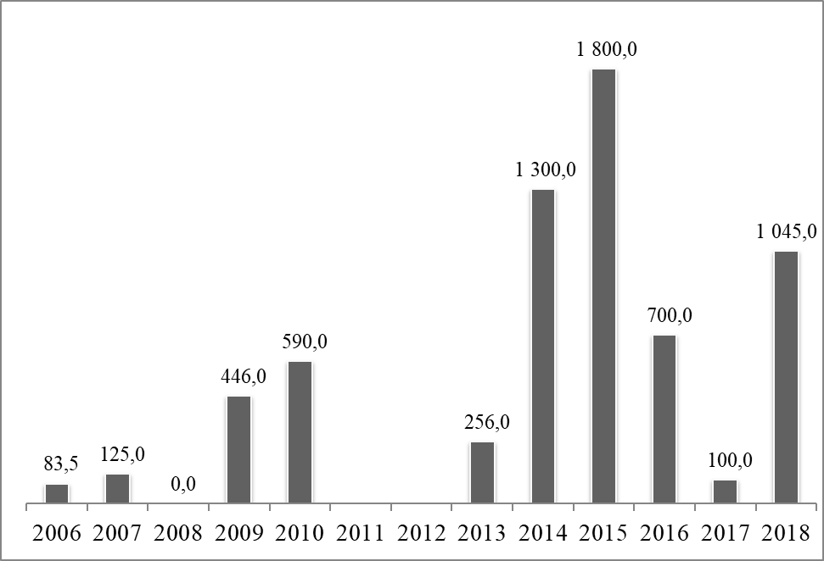

## Chart 3B: MFA amounts authorised by region, 2005-2018 (%)

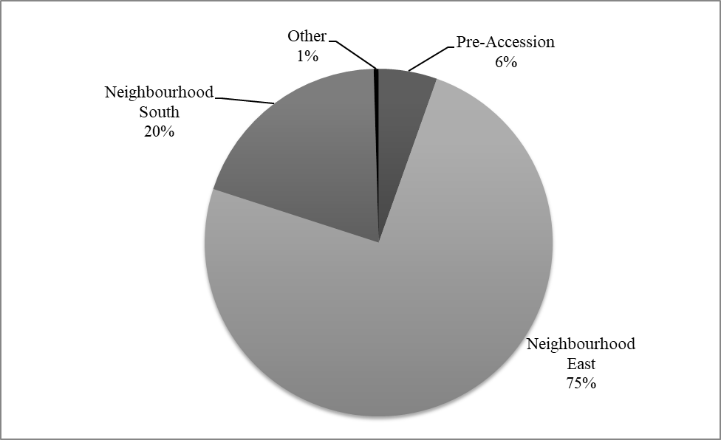

## Annex 4: MFA amounts disbursed by year, 2005-2018 (EUR million)



## Chart 4A: MFA amounts disbursed by year, 2005-2018 (EUR million)

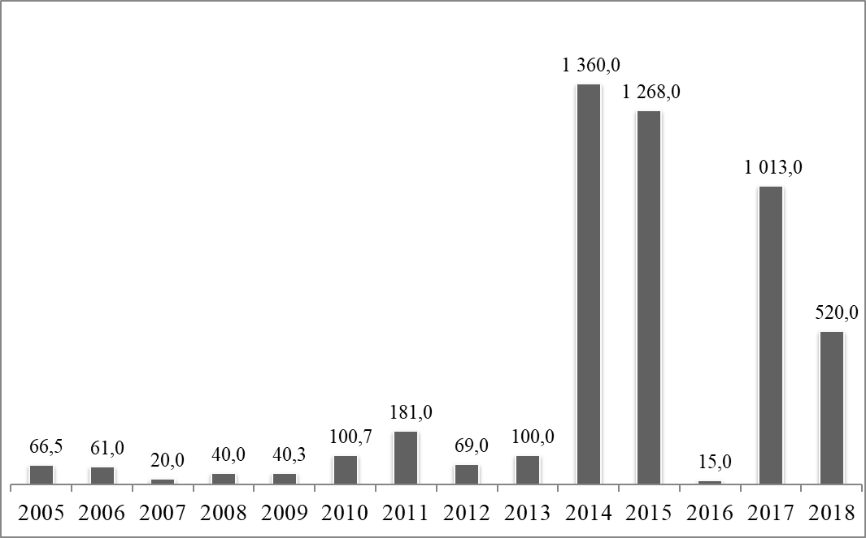

## Chart 4B: MFA amounts disbursed by region, 2005-2018 (%)

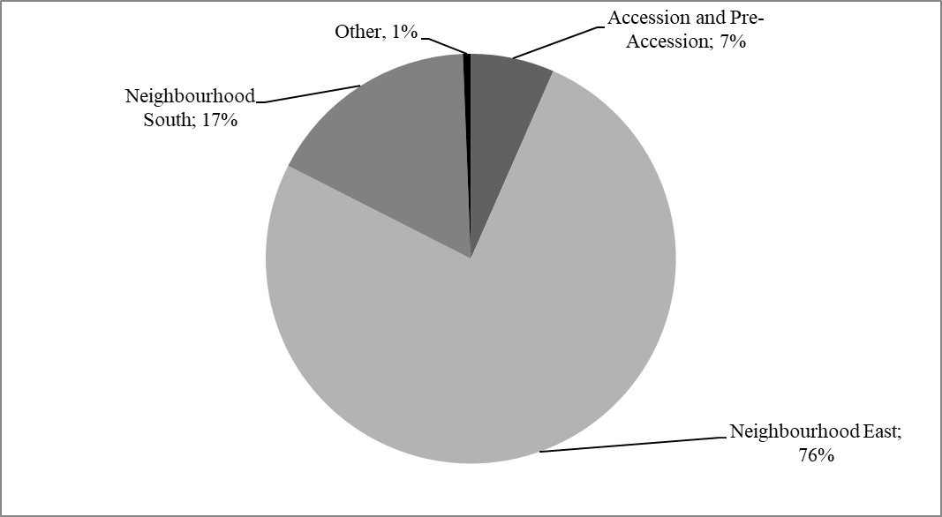

## Annex 5: Outstanding Amounts in respect of operations disbursed at end-December 2018



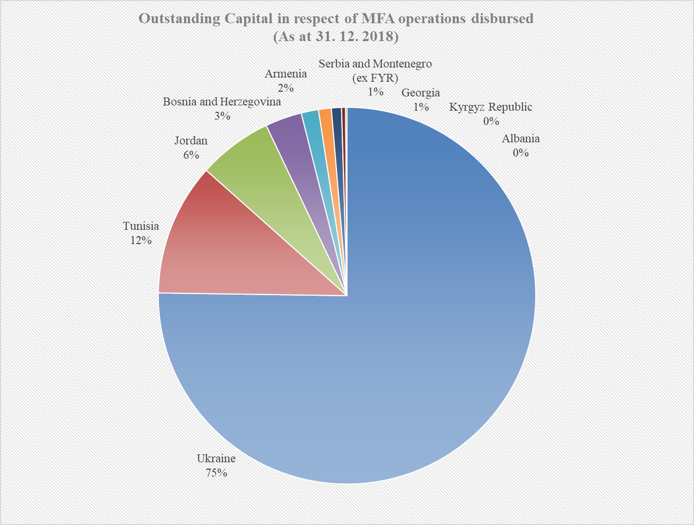

1. The document and the annexes distinguish between authorised amounts, which refer to the amounts made available to the beneficiary country as per the MFA Decision, and disbursed amounts, which refer to the amounts actually extended to the beneficiary country.
2. This section quotes statistics supplied by national authorities and other relevant sources.
3. The Complementary Budget Law envisaged an 80% increase in such expenses in 2018 overall.
4. Decision No 1112/2016/EU of the European Parliament and of the Council of 6 July 2016 providing further macro-financial assistance to Tunisia (OJ L186, 9.7.2016).
5. Vladimir Zelensky, an actor and producer not involved in politics so far, won the presidential elections held in March and April 2019.
6. These may vary from the statistics quoted in the country-analysis section of this document.