

**Table of contents**

1. General overview 3

1.1. Mainstream or targeted? 3

1.2. Reaching the final beneficiaries 4

1.3. Type of implementing entities and level of implementation 5

1.4. An integrated approach to Roma inclusion? 7

1.5. A firm commitment? 8

2. Overview by key thematic areas 9

2.1. Education 11

2.2. Employment 15

2.3. Healthcare 19

2.4. Housing 22

2.5. Anti-discrimination 27

2.6. Poverty reduction 31

2.7. Legislative measures 35

3. Selected outcome indicators on Roma inclusion 37

3.1. Education 37

3.2. Employment 39

3.3. Health 40

3.4. Housing 40

3.5. Poverty 42

3.6. Discrimination and antigypsyism 43

This Staff Working Document and its annexes complement the Communication, providing more in-depth thematic and country-by-country information on the implementation of national Roma integration strategies (NRIS) based on reports from:

* national Roma contact points (NRCPs) in 2018 (presenting the implementation of Roma inclusion measures in 2017);
* national civil society coalitions involving over 90 non-governmental organisations and experts across 27 Member States.

The 2017-2020 Roma Civil Monitor (RCM) Project has been initiated by the European Parliament, managed by the European Commission (DG Justice and Consumers) and coordinated by the Center for Policy Studies of the Central European University, in partnership with the European Roma Grassroots Organisations Network, the European Roma Rights Centre, the Fundación Secretariado Gitano and the Roma Education Fund. Annex 1 of this report contains country-specific information on EU Member States summarising both the reports from Member States’ NRCPs and the assessment by civil society involved in the Roma Civil Monitor project.

Annex 2 is dedicated to Roma inclusion in the enlargement region, including both an in-depth assessment of the evolution of the situation of Roma in the period 2011-2017; as well as country summaries from NRCPs and civil society in the enlargement region.

The EU Agency for Fundamental Rights (FRA) has contributed to the development of this Staff Working Document, by: (i) helping Member States to report on the implementation of integration measures; and (ii) helping the Commission in its monitoring as part of the EU framework for NRIS. FRA survey data on the situation of Roma in education, employment, healthcare, housing, and experience of discrimination and poverty helped to put in context the reviewed Roma inclusion efforts and highlight remaining challenges and gaps.

This Staff Working Document is based on information on measures implemented to improve the situation of Roma in education, employment, healthcare, housing, poverty reduction, and the fight against discrimination and antigypsyism in response to the Council Recommendation from December 2013[1]. The overview summarises information provided by the NRCPs from 23 EU Member States through the Roma Integration Measures Reporting Tool developed by the European Commission and the FRA[2].

The overview uses this information to populate a set of ‘process’ indicators, which show the level of engagement and investment of Member States in Roma inclusion. These indicators measure — in a manner that makes it possible to compare EU countries — how far the ‘process’ matches the objectives set out in the 2013 Council Recommendation and the national Roma integration strategies. Data are used from 2011 and 2016 FRA surveys[3] to assess how far these measures have made a tangible difference to Roma people’s lives (with due reference to lack of more recent data reflecting the results of 2017 measures).

# General overview

In 2017, 23 Member States provided detailed information on their Roma integration measures. Overall, 863 measures were reported. This section presents a snapshot of all implemented measures by their key characteristics (type of measure; funding allocated; identifiable Roma beneficiaries; and existence of safeguards to secure equal access for various vulnerable people, including vulnerable Roma, to mainstream measures and thus prevent indirect discrimination). Analysing the reported data, it is necessary to keep in mind the different meaning of the term ‘measure’ in different countries. In some cases, a ‘measure’ means a small local-level project with a few thousand euro in funding; in other cases, it means a massive programme with funding in the tens of millions of euro.

## Mainstream or targeted?

Of all the 863 measures reported, 44% were mainstream and 56% were targeted (Figure 1). Targeted measures dominate in BE, CY, CZ, EE, ES, HR, IT, LV, LT, PL, PT, SE, SI and SK. In all these countries, targeted measures account for 60% or more of all implemented measures. FR and LU implement only mainstream approaches to Roma integration, while mainstream measures dominate in BG, EL, HU, NL, and UK.

**Figure 1: Number of Roma integration measures implemented in 2017 (mainstream or targeted)**

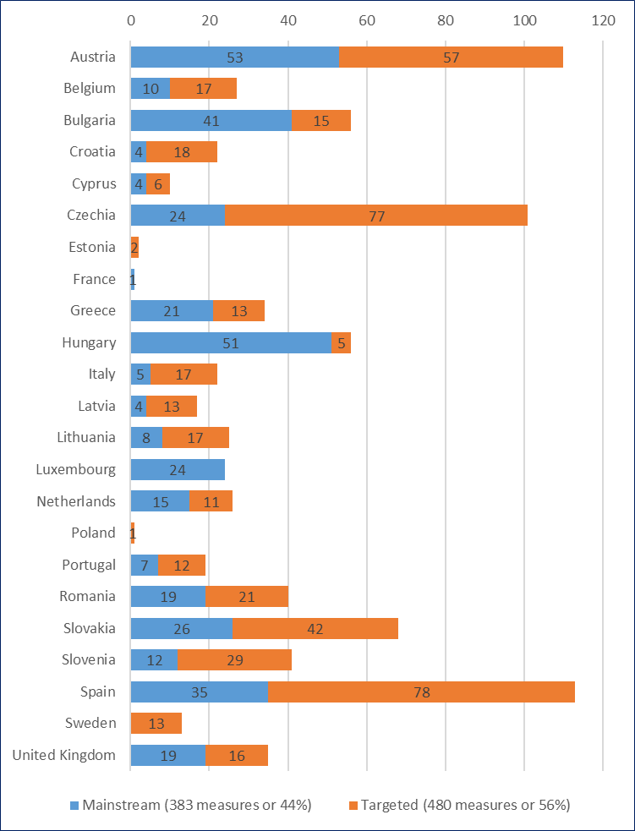  
Source: EC (2018), NRCPs’ reporting on Roma integration measures implemented in 2017

## Reaching the final beneficiaries

Ideally, it should be possible to estimate how many people benefit from the projects and funding intended for Roma. One way to achieve this goal is to target measures at individuals from a particular disadvantaged group, such as Roma.

However, targeting on its own is not sufficient. For example, targeting does not make it possible to know how many people benefited from the particular measure or what was the return on investment in the measure. Figure 2 shows that being able to identify (i.e. estimate the number of Roma among) the final beneficiaries is not necessarily correlated with the existence of targeted measures. On average, it was only possible to identify the number of Roma beneficiaries in 27% of the targeted measures.

The share of targeted measures with Roma as final beneficiaries was higher than the average in 10 Member States (CY, EE, EL, ES, HR, LT, LV, PL, RO, and SK).

**Figure 2: Number of targeted measures with identifiable Roma as final beneficiaries**

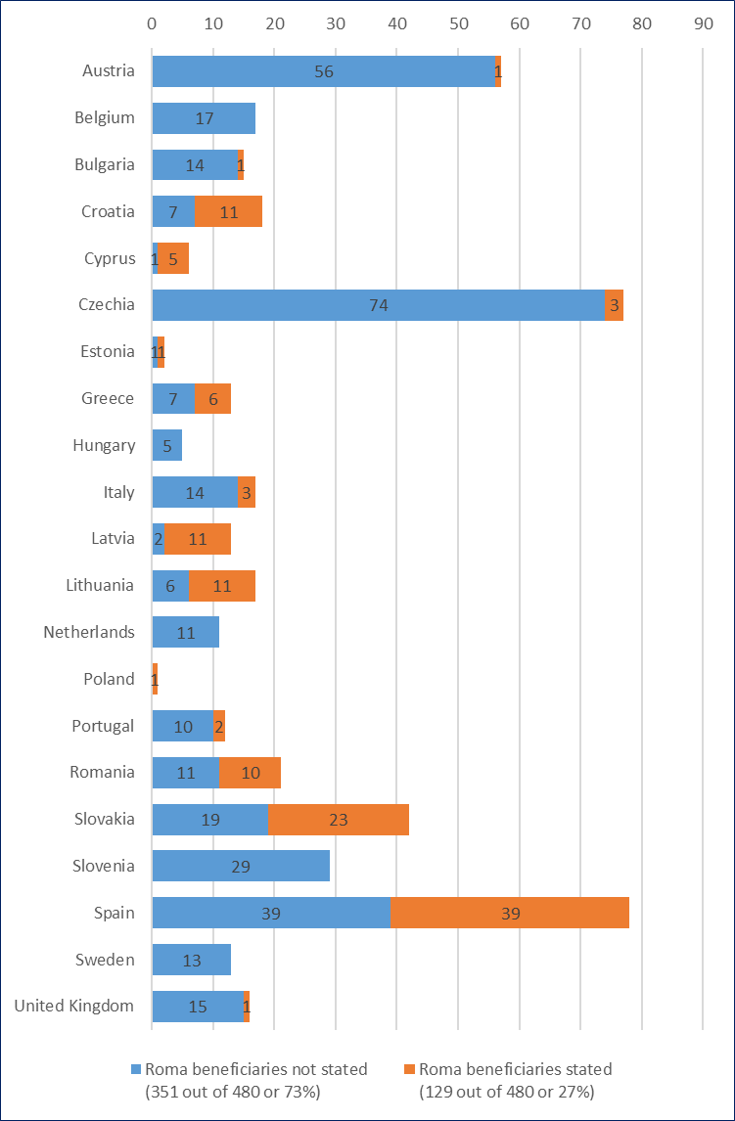

Targeting is only one way of reaching the final beneficiaries. Several Member States base their Roma integration strategies primarily (UK, NL, EL, BG, and HU) or entirely (FR and LU) on mainstream approaches. Such mainstream measures are effective only if they are accessible to disadvantaged groups such as Roma. Although mainstream measures are nominally accessible to disadvantaged groups such as Roma (Roma are citizens of the respective Member States), in reality Roma can face a variety of different barriers. These barriers limit Roma in: (i) access to various mainstream services; and (ii) opportunities to exercise in full their rights enshrined in the Charter of Fundamental Rights. Therefore, the presence of explicit safeguards to compensate for the impact of these disadvantages is important for making mainstream measures work also for Roma.

Figure 3 shows that, on average, only 37% of the mainstream measures have safeguards to ensure that Roma can benefit from them. Such safeguards are missing in 241 measures (or 63% of all 383 mainstream measures). These 241 measures are also reported as ‘Roma relevant’ and the resources they use are accounted for as Roma integration measures. However, because they do not have safeguards these 241 measures have less potential to actually reach and benefit Roma. This picture is even more worrying when looking at the safeguards themselves, because in many cases the reported ‘safeguards’ are merely statements of a general nature.

**Figure 3: Number of mainstream measures with additional safeguards to make them accessible for vulnerable groups such as Roma**

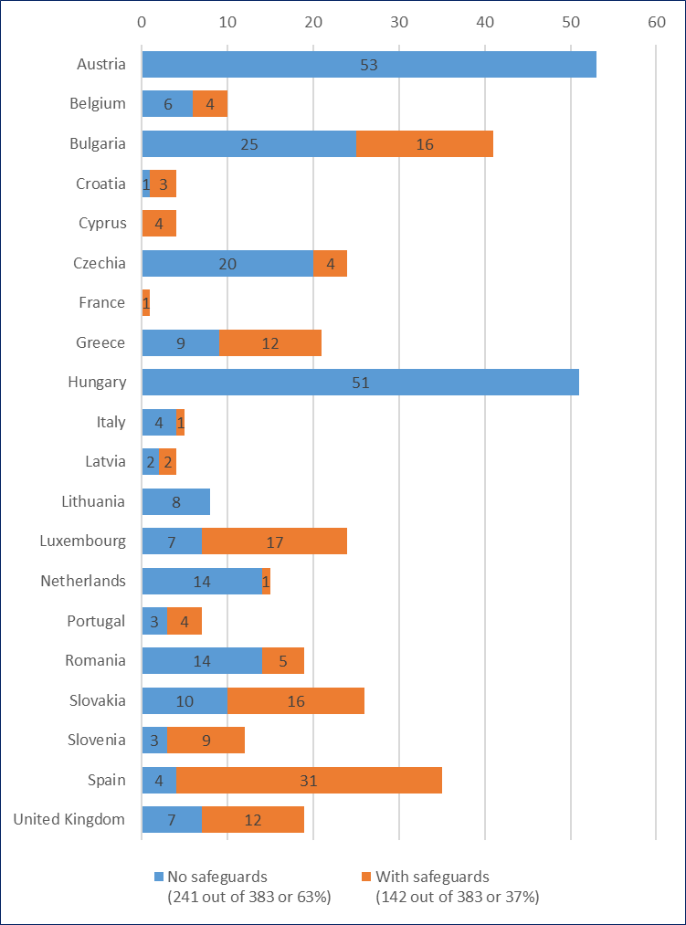

## Type of implementing entities and level of implementation

Table 1 and Figure 4 show the prominent role of governments in the implementation of interventions. 88% of all measures were reported as being implemented by a public authority, and the bulk of these measures are taken at the national level (68%). Implementation by civil society (either individually or in partnership with other stakeholders) was reported in 6% of measures and primarily in Austria at local and regional level. The private sector is rarely mentioned as an implementing entity. Even for measures that focus on promoting employment, the private sector is almost absent. Civil society implementation is reportedly highest in fighting discrimination (11% of measures). Partnerships of different actors (civil society, the private sector and public authorities) are most prevalent in housing. This information on implementing entities should be considered with regard to the context that national authorities (namely NRCPs) did the reporting. A parallel exercise reviewing existing evaluations and studies on Roma inclusion interventions found that 38% of evaluations were on interventions implemented by civil society and 33% by a public authority.[4]

**Table 1: Distribution by type of implementing entity and level of implementation (national, regional, local)**

|  |  |  |  |  |
| --- | --- | --- | --- | --- |
| Type of implementing entity | Level of implementation | Countries | Total (number) | Total (%) |
| Civil society | National | IT, LV, LT, NL | 4 | 0% |
| Regional | AT, LV, NL | 5 | 1% |
| Local | AT, IT, UK | 40 | 5% |
| Private sector | National | EL, LU | 3 | 0% |
| Regional | EE, EL, LU, ES | 4 | 0% |
| Public authority | National | AT, BE, BG, HR, CY, CZ, EL, HU, IT, LV, LT, LU, NL, PT, RO, SK, SI, ES, SE, UK | 571 | 68% |
| Regional | AT, BE, CZ, IT, SK, ES, UK | 109 | 13% |
| Local | AT, BG, CY, EL, HU, IT, LV, LT, NL, RO, SE, UK | 60 | 7% |
| Transnational | EL, IT, SE | 3 | 0% |
| Partnerships or other implementing entity | | BE, BG, LU, SK | 42 | 5% |
| Total* | |  | 841 | 100% |

Notes: * no information about type of entity and level of implementation was provided for 22 measures across various countries (AT, BG, CZ, EE, FR, HU, IT, PL, RO, SK, ES, SE, UK).

Source: EC (2018), NRCPs’ reporting on Roma integration measures implemented in 2017.

**Figure 4: Number of measures by country and type of implementing entity**

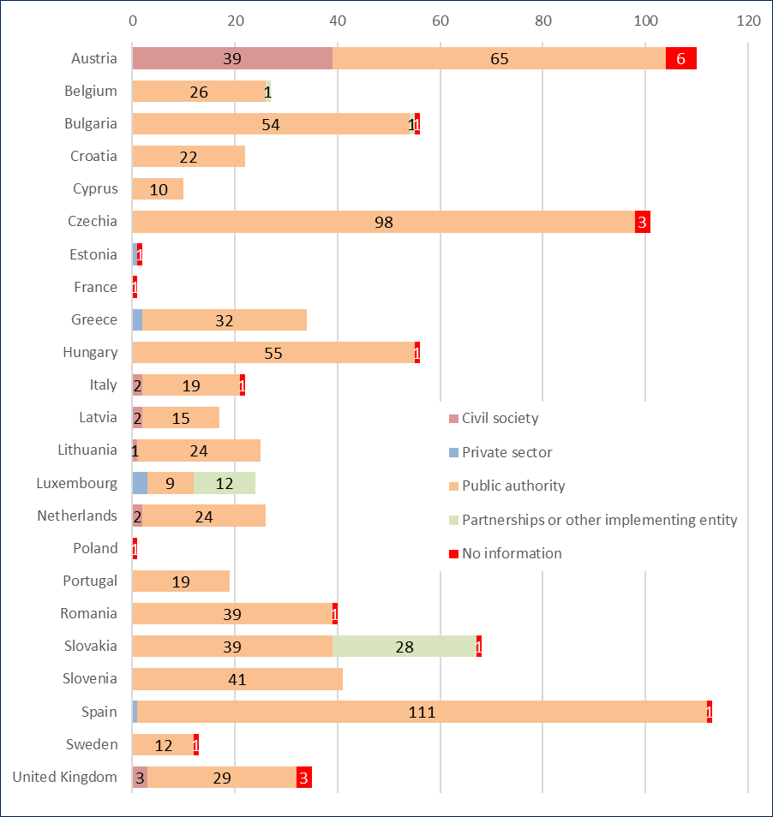

Source: EC (2018), NRCPs’ reporting on Roma integration measures implemented in 2017.

## An integrated approach to Roma inclusion?

Out of 863 measures, as many as 73% (633 measures) were reported as being relevant to only one thematic area, 21% as being relevant to two thematic areas, and 6% as being relevant to three thematic areas. This indicates that the more ‘integrated’ approach was reported for only 27% of the measures taken in 2017 (Figure 5). The largest share of measures that were relevant for more than one thematic area was reported in the area of ‘local action’ (48% of measures in this area were relevant to more than one area), followed by ‘empowerment’ (46% of measures in this area were relevant to more than one area) and ‘poverty reduction’ (46% of measures in this area were relevant to more than one area). This is largely because these areas call for horizontal ways of working. In the case of employment, one third of measures (35%) were reported as also being relevant to other thematic areas, while in the area of housing and education the share was 25% and 29% respectively. The share of measures that were also related to another thematic area was lowest in healthcare, where only 22% of measures were relevant to more than one area.

However, the pattern is different in different countries. Latvia (65%), Luxembourg (63%), Slovakia (59%) and Sweden (54%) all reported that more than half of their measures were relevant to two or three thematic areas. On the other hand, Cyprus, Estonia, France, Poland and Slovenia reported only measures that were relevant to one thematic area. The share of measures relevant to more than one thematic area slightly rises (to 30% of all measures) when only the six thematic areas analysed in Part 2 are considered.

**Figure 5: Distribution of measures by relevance to different thematic areas**

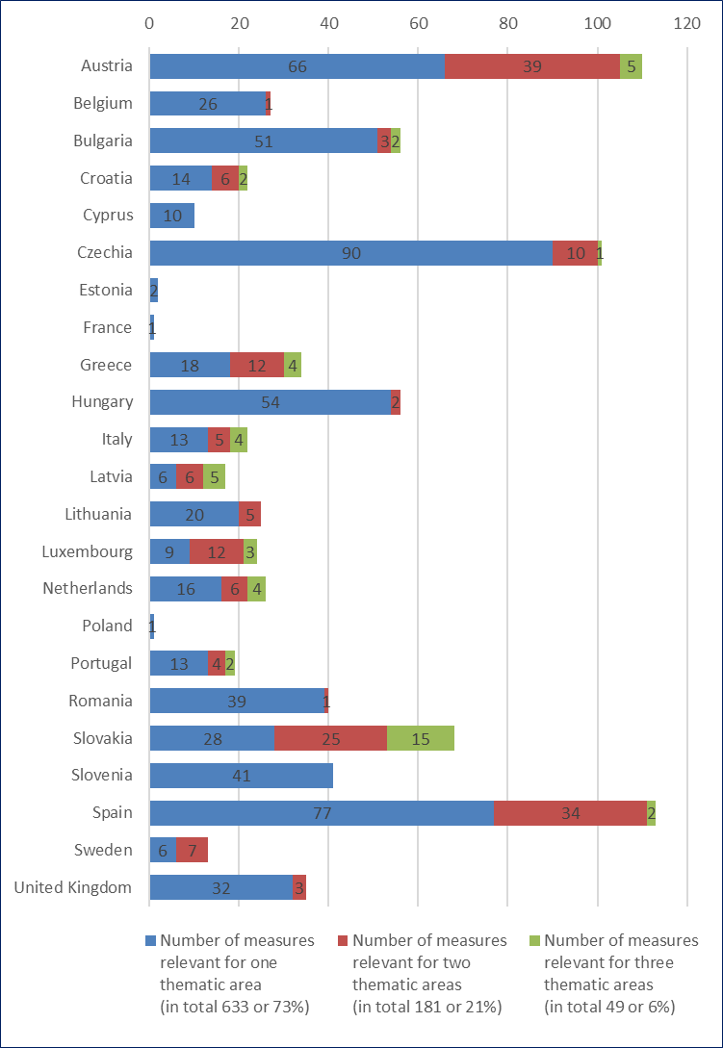

Source: EC (2018), NRCPs’ reporting on Roma integration measures implemented in 2017.

## A firm commitment?

The allocation of funding also indicates the degree to which a measure can actually have an impact or merely remains a formal pledge on paper. On average, only 28% of the measures implemented in 2017 did not have any funding allocated to them (Figure 6). However, huge differences exist between countries. In most of the countries, the majority of measures had funding allocated. In several countries (CZ, UK, SI, BE, EL, PT and HR), the number of measures with funding allocated was below average. And in CZ and UK, less than half of the measures had allocated funding.

**Figure 6: Number of measures by allocated funding**

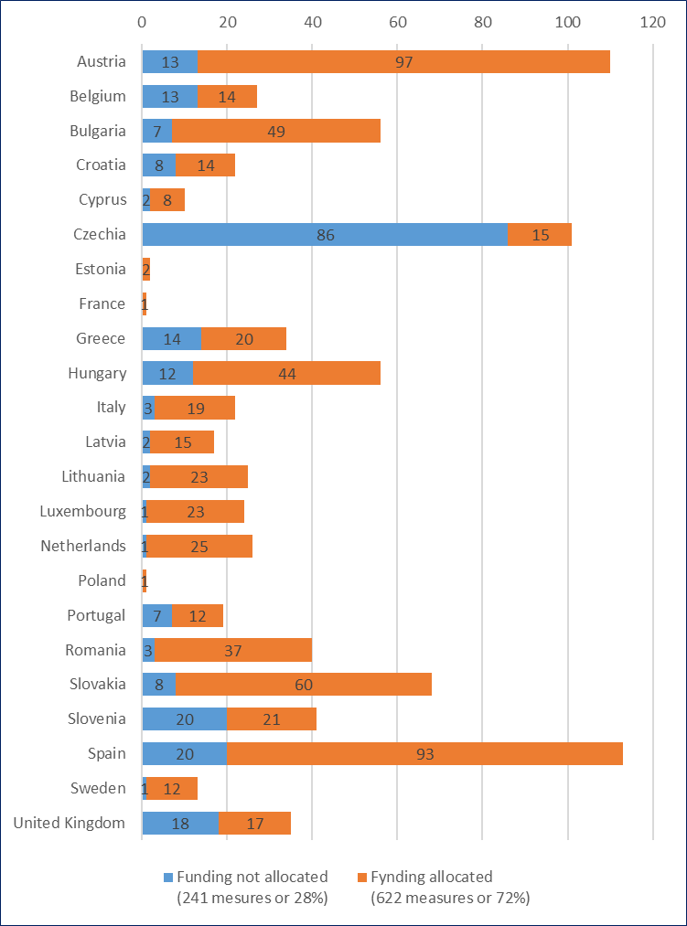

# Overview by key thematic areas

In the following pages, the analysis for the four priority areas (education, employment, healthcare and housing) and two horizontal areas (anti-discrimination and poverty reduction) follows an identical structure. This analysis complements the summary for the key areas in the main text of the Communication. The analysis in this overview starts with selected outcome indicators based on data from FRA surveys to provide a snapshot of the situation in the area. The analysis continues with an overview of the measures by type of measure (mainstream or targeted) and an overview of the substantive focus of the measures in each area. In order to determine what the substantive focus of a measure was, the individual measures were analysed and tagged by the main substantive focus of the activities implemented. A caveat must be highlighted: it is often difficult to identify one leading type of activity to which the measure might be attributed. Nevertheless, such analysis: (i) complements the distribution by sub-areas as specified in the Council Recommendation; and (ii) brings us closer to understanding what the specific content of the measures was (what was actually done) for improving the situation in the thematic area. Brief conclusions close each thematic-area section.

As part of the integrated approach to Roma inclusion, several of the 863 measures implemented in 2017 contribute to improvement in more than one thematic area. These cross-cutting measures are reported as being relevant for (and appear in the thematic analysis for) more than one area. This is why adding up the number of measures **reported as relevant** to specific thematic areas (Table 2) would lead to a higher number than the total number of **implemented** measures (863)[5].

**Table 2: Summary of the measures reported as being relevant for individual thematic areas**

|  |  |  |  |  |  |  |  |  |  |  |  |  |  |  |  |  |  |  |  |  |  |  |  |  |
| --- | --- | --- | --- | --- | --- | --- | --- | --- | --- | --- | --- | --- | --- | --- | --- | --- | --- | --- | --- | --- | --- | --- | --- | --- |
| Thematic area | Country | | | | | | | | | | | | | | | | | | | | | | | Total |
| AT | BE | BG | HR | CY | CZ | EE | FR | EL | HU | IT | LV | LT | LU | NL | PL | PT | RO | SK | SI | ES | SE | UK |
| Education | 36 | 4 | 17 | 8 | 6 | 26 |  |  | 10 | 13 | 5 | 5 | 9 | 10 | 10 | 1 | 6 | 20 | 17 | 7 | 23 | 2 | 8 | 243 |
| Employment | 21 | 1 | 18 | 4 | 1 | 13 |  |  | 5 | 13 |  | 3 | 2 | 10 | 9 |  | 3 | 13 | 11 | 1 | 18 | 1 | 3 | 150 |
| Healthcare | 14 | 1 | 16 | 1 |  | 6 |  |  | 5 | 9 | 1 | 2 |  |  | 2 |  |  | 2 | 10 | 2 | 11 | 2 | 10 | 94 |
| Housing | 12 | 5 | 3 | 3 | 1 | 6 |  | 1 | 4 | 7 | 5 | 1 | 3 | 3 |  |  |  | 1 | 13 | 8 | 10 | 1 | 7 | 94 |
| Anti-discrimination* | 21 | 3 | 7 | 3 |  | 12 | 2 |  |  | 5 | 12 | 6 | 3 | 2 | 1 |  | 5 |  | 10 | 3 | 17 | 5 | 3 | 120 |
| Protection of Roma children and women; multiple discrimination** | 13 |  |  |  |  |  |  |  |  | 1 | 5 |  |  | 2 | 4 |  |  |  |  |  | 10 |  |  | 35 |
| Poverty reduction | 12 | 2 |  | 1 |  | 7 |  |  | 11 | 1 |  | 3 | 1 | 12 | 5 |  | 2 | 1 | 10 | 3 | 28 | 1 |  | 100 |
| Empowerment | 26 | 3 |  | 5 |  | 8 |  |  | 6 | 2 | 6 | 4 | 4 | 1 | 6 |  | 5 | 1 | 20 | 2 | 23 | 5 | 4 | 131 |
| Local action |  |  | 1 | 3 | 1 | 7 |  |  | 8 | 3 | 1 | 3 | 1 |  | 2 |  | 3 |  | 26 | 4 | 4 | 1 | 3 | 71 |
| Monitoring and Evaluation | 9 | 3 |  | 2 |  |  |  |  | 3 | 3 | 5 | 1 |  | 4 |  |  | 2 | 1 | 1 | 4 | 3 |  |  | 41 |
| *Total horizontal measures* | ***81*** | ***11*** | ***8*** | ***14*** | ***1*** | ***34*** | ***2*** | ***0*** | ***28*** | ***15*** | ***29*** | ***17*** | ***9*** | ***21*** | ***18*** | ***0*** | ***17*** | ***3*** | ***67*** | ***16*** | ***85*** | ***12*** | ***10*** | ***498*** |
| Culture |  | 1 | 1 | 1 |  | 16 |  |  |  |  |  | 5 | 7 |  | 1 |  | 1 |  | 4 | 7 | 5 | 2 |  | 51 |
| Other areas not specified in the Council Recommendation |  | 5 |  |  | 1 | 9 |  |  | 2 |  |  |  |  |  |  |  |  | 2 | 1 |  |  |  |  | 20 |
| Transnational Cooperation |  |  |  | 1 |  | 3 |  |  |  | 1 |  |  |  |  |  |  |  |  |  |  |  |  |  | 5 |
| Legend: |  | Priority thematic areas | | | | |  | Horizontal areas | | | | |  | Other areas | | | | |  |  | | | | |
| Notes: |  | | | | | | | | | | | | | | | | | | | | | | | |

* In the analysis in Part 2 of this document, the measures reported under ‘anti-discrimination’ and ‘fighting multiple discriminations’ were pooled together. The total number of measures in the merged sample (142) is lower than the sum of the measures under each of these areas (155) because 13 measures were reported in both thematic areas.

** The measures relevant for the thematic area ‘Protection of Roma children and women’ were reported together with those relevant for ‘fighting multiple discrimination’ (22 out of the total 35).

## Education

The overall situation seems to have improved between 2011 and 2016 for the nine EU countries covered by FRA surveys on: (i) enrolment in early-childhood education and in compulsory education; and (ii) the number of early leavers from education (Table 3). In Portugal and Romania, the enrolment of children between 4 years of age and starting-of-schooling age in pre-primary education has deteriorated. As for the share of compulsory-school-age children attending education, the situation improved in several Member States and deteriorated in none of the nine surveyed Member States. The share of Roma aged 18-24 with minimal education (i.e. completing at most lower-secondary education, and not continuing in further education or training) did not increase in any of the countries surveyed. This is a very positive development and, as illustrated by the measures the Member States reported for 2017, education remains a focus of attention in these countries.

**Table 3: Change in selected education indicators between 2011 and 2016**

|  |  |  |  |  |  |  |  |  |  |  |
| --- | --- | --- | --- | --- | --- | --- | --- | --- | --- | --- |
|  | BG | CZ | EL | ES | HR | HU | PT | RO | SK | Average |
| Share of children between the age of 4 and the age when they must start compulsory primary education who attend early-childhood education, household members (%)* | ↑ | ↔ | ↑ | ↑ | ↑ | ↑ | ↓ | ↓ | ↑ | ↑ |
| Share of compulsory-schooling-age children attending education, household members, aged 5-17 (depending on the country) (%)* | ↔ | ↑ | ↑ | ↔ | ↑ | ↔ | ↑ | ↔ | ↔ | ↑ |
| Early leavers from education and training, household members, aged 18-24 (%)** | ↓ | ↓ | ↔ | ↓ | ↔ | ↓ | ↓ | ↓ | ↓ | ↓ |
| Share of people who felt they were discriminated against because they were Roma in the past 5 years, when in contact with school (as parent or student), respondents, aged 16+ (%) | ↔ | ↓ | ↓ | ↔ | ↑ | ↔ | ↔ | ↓ | ↔ | ↔ |
| Share of Roma children, aged 6-15, attending classes where ‘all classmates are Roma’ as reported by the respondents, household members aged 6-15 in education (%)*** | ↑ | ↔ | ↔ | ↔ | n.a. | ↔ | ↑ | ↔ | ↑ | ↑ |
|  |  |  |  |  |  |  |  |  |  |  |
| NRCP assessment of the situation in this thematic area (2017)**** | **↑** | **↑** | **↑** | **↑** | **↑** | **↑** | **↑** | **↑** | **↑** |  |
| Notes:  * Age for starting compulsory primary education as well as for compulsory schooling age valid for a given country in a given year (European Commission/EACEA/Eurydice (2011 and 2015)). Age is calculated on an annual basis; therefore the figures do not consider earlier or delayed starts in primary education of an individual child. | | | | | | | | | | |
| ** Share of the population aged 18-24 having attained at most lower-secondary education (ISCED 2011 levels 0, 1 or 2) and not involved in further education or training.  *** Comparability between 2011 and 2016 is limited due to differences in how the question was formulated.  Legend: the arrow visualises the direction of change in the respective indicator (‘↑’ increase, ‘↔’ no change and ‘↓’ decline). The background shows improvement (green), deterioration (red) or no change (yellow).  *Sources:*  *FRA, EU-MIDIS II 2016, Roma; FRA, Roma Pilot Survey 2011; UNDP-World Bank-EC 2011 (for Croatia) in European Commission (2017)[6]*  ****For NRCP assessment: EC (2018), NRCPs’ reporting on Roma integration measures implemented in 2017. | | | | | | | | | | |

The detailed overview of the available indicators for 2016 provided in section 3.1 suggests low overall levels of education among adult Roma. On average, only 18% of adult Roma have completed upper secondary, vocational or post-secondary education. Roma tend to have low proficiency in the national language, mainly in reading and writing. The data also indicate high levels of class and school segregation, often, but not always resulting from residential/territorial concentration. On average, 46% of Roma children attend segregated schools and/or classes where all or most children are Roma; and placement of Roma children in special schools is especially common in CZ and SK. Attendance of education by Roma children is promisingly high in primary and lower-secondary education. However, attendance drops dramatically at the upper-secondary level and is almost non-existent at the post-secondary level. On average, almost every third adult Roma who is a parent or guardian of a school-age child recalls their child having faced: (i) name-calling; (ii) someone making jokes about them (ridiculing); or (iii) offensive comments and/or verbal insults in their school, because of their Roma background.

The outcome of measures reported after 2016 cannot be captured with the existing data. But if the trend established between 2011 and 2016 continues, it may indicate a promising return on the investment made in these nine countries to improve Roma access to (and participation in) education.

### The measures relevant for education

Overall, 243 measures were reported as relevant in the area of education in the 21 EU Member States reporting on this thematic area. Out of these, 103 were mainstream measures and 140 were targeted measures (Figure 7). With the exception of Hungary, all countries with large Roma populations (such as BG, CZ, ES, RO and SK) address their education measures for Roma primarily through targeted measures. Mainstream measures are a majority of education measures only in EL, HU, LU, NL and UK. Of the 140 targeted measures implemented in the area of education, 49 (35%) could identify the number of Roma final beneficiaries.

**Figure 7: Number of measures implemented in the area of education by type of measure (mainstream or targeted)**

Source: EC (2018), NRCPs’ reporting on Roma integration measures implemented in 2017.

### Distribution by thematic sub-area

379 measures were reported as being relevant for one or more sub-areas in the thematic area ‘education’, as specified in the Council Recommendation. The countries could link individual measures not only to several thematic areas but also to several sub-areas. Therefore, the total number of measures in the analysis by sub-area is higher than the number of measures reported under the thematic area of education (243). Table 4 provides an overview of: (i) the sub-areas as suggested in the Council Recommendation; (ii) how many measures were relevant for each sub-area; and (iii) in which Member States the measures were reported.

**Table 4: Distribution of measures by relevance to the respective sub-areas of the Council Recommendation**

|  |  |  |  |  |  |  |  |  |  |  |  |  |  |  |  |  |  |  |  |  |  |
| --- | --- | --- | --- | --- | --- | --- | --- | --- | --- | --- | --- | --- | --- | --- | --- | --- | --- | --- | --- | --- | --- |
| **Thematic sub-area** | **AT** | **BE** | **BG** | **HR** | **CY** | **CZ** | **EL** | **HU** | **IT** | **LV** | **LT** | **LU** | **NL** | **PT** | **RO** | **SK** | **SI** | **ES** | **SE** | **UK** | **Total** |
| a) eliminate any school segregation | 2 | 1 | 4 | 3 |  | 4 | 3 |  | 1 |  |  | 1 | 1 |  | 4 | 1 |  | 2 |  |  | 27 |
| b) put an end to any inappropriate placement of Roma pupils in special-needs schools | 4 |  |  | 1 |  | 1 |  |  |  |  |  |  |  |  | 1 | 1 |  | 1 |  |  | 9 |
| c) reduce early school-leaving | 6 | 1 | 8 | 2 | 3 |  | 5 | 2 | 1 | 4 | 2 | 3 | 3 | 2 | 9 | 5 |  | 6 | 1 | 3 | 66 |
| d) increase the access to, and quality of, early-childhood education and care | 3 |  | 3 | 2 | 1 | 1 |  | 5 | 1 |  |  | 2 | 1 |  | 6 | 5 | 1 | 3 |  |  | 34 |
| e) consider the needs of individual pupils in close cooperation with their families | 8 |  |  |  | 1 | 1 |  | 2 | 2 | 3 | 1 | 4 |  | 2 | 7 |  | 1 | 1 | 1 | 1 | 35 |
| f) use inclusive and tailor-made teaching and learning methods | 7 |  | 1 | 1 | 2 | 1 |  |  |  |  | 1 | 2 | 2 |  | 1 | 3 | 1 |  |  | 1 | 23 |
| g) fight illiteracy | 2 |  | 1 | 1 | 2 |  |  | 1 |  |  |  |  | 2 |  | 1 |  |  | 1 |  |  | 11 |
| h) promote the availability and use of extracurricular activities | 3 |  | 1 |  | 2 |  | 1 |  | 1 | 2 | 1 |  |  |  | 2 | 1 | 1 |  |  |  | 15 |
| i) encourage greater parental involvement | 5 | 1 | 1 | 1 | 1 |  |  |  |  | 1 | 1 | 1 |  |  | 2 | 2 |  | 2 |  |  | 18 |
| j) improve teacher training | 3 |  | 1 |  | 1 | 3 |  |  |  |  | 1 |  |  |  | 4 | 1 | 1 | 2 | 1 |  | 18 |
| k) encourage Roma participation in and completion of secondary and tertiary education | 4 |  | 1 | 3 |  | 3 |  | 2 |  | 1 | 2 |  |  | 1 | 4 | 2 |  | 12 |  |  | 35 |
| l) widen access to second-chance education and adult learning | 3 |  | 1 | 1 | 1 | 2 | 1 |  |  |  | 1 | 1 |  |  |  |  |  | 2 |  | 1 | 14 |
| m) provide support for the transition between educational levels | 3 |  | 2 | 1 |  | 2 |  | 1 | 1 |  |  | 2 | 2 | 1 | 2 | 1 |  | 3 |  |  | 21 |
| n) provide support for the acquisition of skills that are adapted to the needs of the labour market | 5 |  | 1 |  |  | 1 | 1 |  |  |  | 1 | 3 | 3 | 1 | 1 | 2 | 1 | 2 |  |  | 22 |
| o) other | 3 | 1 | 2 | 2 |  | 13 |  |  |  |  | 1 | 1 |  | 2 |  | 2 | 1 | 2 |  | 1 | 31 |

Source: EC (2018), NRCPs’ reporting on Roma integration measures implemented in 2017.

As Table 4 shows, the vast majority of the reporting Member States have chosen to invest in measures aiming at reducing early school-leaving (mentioned in 66 measures by 18 Member States). The next most commonly implemented measures are: (i) considering the needs of individual pupils in close cooperation with their families; and (ii) encouraging Roma participation in — and completion of — secondary and tertiary education (mentioned equally in 35 measures). Other commonly implemented measures are: (i) increasing access to, and quality of, early-childhood education and care; and (ii) eliminating any school segregation.

### Substantive focus of the measures in education

Table 5 indicates that countries mainly pay attention to measures that try to improve the educational attainment of Roma — preventing drop-out; encouraging completion of secondary education and continuation to tertiary education; providing catch-up support to compensate for linguistic, cognitive and educational gaps; or providing tuition, financial or other support to compensate for material disadvantage (Table 5). Other frequently reported activities include: vocational training, career-development support, and lifelong learning. These latter activities address some key barriers to the successful transition from education to employment young Roma face[7]. Although NRCPs generally consider mediation to promote access to education as one of their main achievements, only five NRCPs reported specific measures that had mediation as their key focus. This is because mediators or teaching assistants played a significant role — and were mentioned — in more than 40 measures tagged under other types of activity (in particular, among measures to: prevent drop-out; encourage completion of secondary education; or engage in outreach to Roma families to ensure children’s enrolment in education).

**Table 5: Distribution of measures in the area of education by substantive focus of activity**

|  |  |  |
| --- | --- | --- |
| **Type of activity** | **Number of measures** | **Share** |
| Measures to prevent drop-out, encourage completion of secondary education and continue to tertiary education | 32 | 13% |
| Catch-up support to compensate for linguistic, cognitive and educational gaps | 28 | 12% |
| Vocational training, career-development support and lifelong learning | 27 | 11% |
| Tuition, financial or other support to compensate for material disadvantage | 26 | 11% |
| Capacity development of teachers, mediators and public institutions | 23 | 9% |
| Integrated social-inclusion interventions | 15 | 6% |
| Research on Romani culture, history and language and reflecting these in curricula | 14 | 6% |
| Preparatory activities for children enrolling in pre-school | 11 | 5% |
| Anti-discrimination and awareness-raising initiatives | 10 | 4% |
| Outdoor programmes, school contests and extracurricular activities | 10 | 4% |
| Developing strategies and monitoring frameworks to fine-tune policies and improve enrolment | 9 | 4% |
| Capital investment in educational infrastructure | 8 | 3% |
| Desegregation and reduction of children enrolled in ‘special schools’ | 8 | 3% |
| Outreach to families to ensure children’s enrolment | 7 | 3% |
| Information campaigns, exchange of good practices, prevention of early marriages | 7 | 3% |
| Mediation | 5 | 2% |
| Bilingual education | 3 | 1% |
| Total | 243 | 100% |

### Conclusions

The education of Roma (measured through enrolment in early-childhood education, enrolment in compulsory education, and prevention of early school-leaving) improved in almost all countries covered by FRA surveys between 2011 and 2016. Information reported for 2017 indicates that EU countries have invested their resources primarily in those areas where improvement was observed — addressing early school-leaving, overcoming disadvantages to enter schooling, and strengthening efforts to complete upper-secondary education.

Member States applied a very diverse range of measures, most of which were targeted measures. Member States also reported considerable success with these measures. However, it appears to still be a challenge to employ explicit safeguards to secure equal access to education for Roma in mainstream measures, and thus prevent indirect discrimination. Most mainstream measures do not include such safeguards; and in most of the measures that do, the safeguards are not explicit.

Member States seem to make increasing use of evidence and data to monitor programme activities, fine-tune policies, and specify measures. This can increase the efficiency of public investment and its actual impact.

## Employment

The trends for the nine Member States for which comparable data are available depict a deterioration or stagnation in most employment indicators for Roma (Table 7). This is especially true for young Roma (16-24 year olds) who, compared with 2011, increasingly find themselves out of employment, education or training. However, this trend needs to be read in light of the NEET (neither in employment, education or training) situation among the general, non-Roma population, particularly in EU countries still affected by the economic crisis. On the positive side, the share of Roma people feeling discriminated against when looking for a job is declining, especially in the eastern European Member States (BG, CZ, HU).

The outcome indicators for employment (also available in section 3.2 below) suggest that unless dramatic improvement is achieved in the area of employment, the vicious cycle of unemployment-poverty-social exclusion-marginalisation will not end soon.

**Table 7: Change in selected employment indicators between 2011 and 2016**

|  |  |  |  |  |  |  |  |  |  |  |  |
| --- | --- | --- | --- | --- | --- | --- | --- | --- | --- | --- | --- |
|  | | BG | CZ | EL | ES | HR | HU | PT | RO | SK | Average |
| Share of people who self-declared their main activity* status as ‘paid work’ (including full-time, part-time, ad hoc jobs, self-employment), household members, aged 16+ (%) | | ↓ | ↔ | ↔ | ↓ | ↓ | ↑ | ↑ | ↔ | ↔ | ↔ |
| Share of young persons, aged 16-24 with their current main activity as neither in employment, education or training, household members (%)** | | ↔ | ↑ | ↔ | ↑ | ↔ | ↑ | ↓ | ↑ | ↑ | ↑ |
| Share of people who felt discriminated against because they were Roma in the past 5 years, when looking for a job, respondents, aged16+ (%) | | ↓ | ↓ | ↔ | ↔ | ↑ | ↓ | ↑ | ↔ | ↔ | ↓ |
| Share of people who felt discriminated against because they were Roma in the past 5 years, when at work, respondents, aged 16+ (%) | | ↔ | ↓ | ↑ | ↑ | ↓ | ↓ | ↑ | ↑ | ↑ | ↔ |
|  | |  |  |  |  |  |  |  |  |  |  |
| NRCP assessment of the situation in the area of employment (2017)*** | | ↑ | ↑ | ↑ | ↔ | ↑ | ↑ | ↑ | ↑ | ↑ |  |
|  | Notes:  * The question on ‘main activity’ involves asking all household members for their current employment status. This is distinct from the International Labour Organisation (ILO) concept of employment and the concept of employment used in the Labour Force Survey (variable MAINSTAT). ‘Employment’ also includes small amounts of unpaid work in family businesses, as this benefits the family.  ** Based on the self-declared current main activity, excluding those who did any work in the previous four weeks to earn some money.  Legend: the arrow visualises the direction of change in the respective indicator (‘↑’ increase, ‘↔’ no change and ‘↓’ decline). The background shows improvement (green), deterioration (red) or no change (yellow).  Sources:  FRA, EU-MIDIS II 2016, Roma; FRA, Roma Pilot Survey 2011; UNDP-World Bank-EC 2011 (for Croatia) in European Commission (2017).[8]  *** For NRCP assessment: EC (2018), NRCPs’ reporting on Roma integration measures implemented in 2017. | | | | | | | | | | |
|  |

### The measures relevant for employment

Overall, 150 measures were reported as being relevant in the area of employment in the 19 EU Member States reporting on this thematic area. Out of these, 101 were mainstream and 49 were targeted (Figure 8). Of the 49 targeted measures, 14 (29%), specifically identify Roma as final beneficiaries.

**Figure 8: Measures in the area of employment by type of measure (mainstream or targeted)**

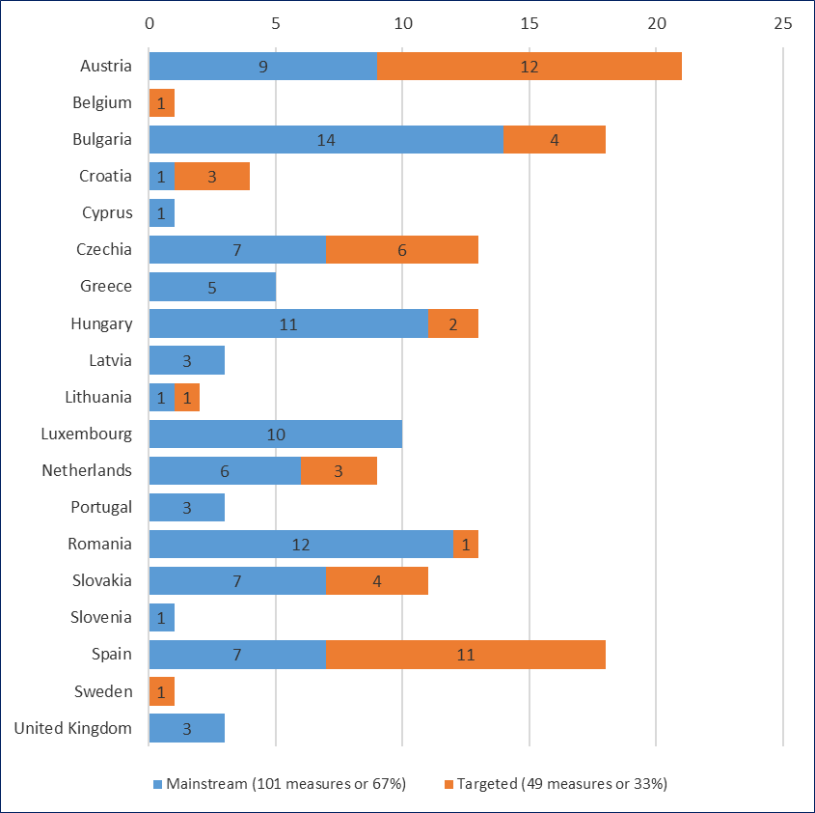

Source: EC (2018), NRCPs’ reporting on Roma integration measures implemented in 2017.

Measures specifically targeting Roma are prominent in AT, ES, HR, SK, CZ and BG. Slovakia specifically identifies Roma as beneficiaries in various measures.

### Distribution by thematic sub-area

215 measures were reported as being relevant for one or more sub-areas in the thematic area of employment as specified in the Council Recommendation (the figure is higher than the 150 stated above, because most of the measures were reported to be relevant for more than one sub-area). Table 8 visualises their distribution by sub-area and country.

**Table 8: Distribution of measures in the area of employment by thematic sub-area (number of measures)**

|  |  |  |  |  |  |  |  |  |  |  |  |  |  |  |  |  |  |  |  |  |
| --- | --- | --- | --- | --- | --- | --- | --- | --- | --- | --- | --- | --- | --- | --- | --- | --- | --- | --- | --- | --- |
| Thematic sub-area | Country | | | | | | | | | | | | | | | | | | | |
| AT | BE | BG | HR | CY | CZ | EL | HU | LV | LT | LU | NL | PT | RO | SK | SI | ES | SE | UK | Total |
| a) support first work experience | 6 |  | 1 | 1 | 1 | 1 | 1 |  |  |  | 2 |  |  | 1 | 1 |  | 1 |  |  | **16** |
| b) support vocational training | 5 |  | 1 |  | 1 |  |  |  | 1 |  | 2 | 2 |  | 1 | 1 |  | 6 |  |  | **20** |
| c) support on-the-job training |  |  | 3 |  |  | 1 |  | 3 | 1 |  | 1 |  |  |  | 1 |  | 4 |  |  | **14** |
| d) support lifelong learning and skills development | 3 |  | 1 | 2 |  |  |  | 1 | 2 | 1 | 1 | 1 | 2 |  |  |  | 4 |  |  | **18** |
| e) support self-employment and entrepreneurship | 3 |  | 3 | 1 |  | 3 | 1 | 2 |  | 2 |  |  |  |  |  |  | 3 |  |  | **18** |
| f) provide equal access to mainstream public employment services |  |  | 3 | 1 |  | 1 |  | 1 | 2 |  |  |  |  |  | 2 |  | 2 |  | 1 | **13** |
| g) support individual job-seekers, focusing on personalised guidance and individual action planning | 12 |  | 1 | 2 |  | 2 | 1 | 1 | 3 |  | 3 | 5 |  | 3 | 2 | 1 | 5 |  |  | **41** |
| h) promote employment opportunities within the civil service |  |  |  |  |  |  | 1 | 3 |  |  |  | 1 |  |  | 3 |  |  |  |  | **8** |
| i) eliminate barriers, including discrimination, to entering or re-entering the labour market | 6 | 1 | 3 | 3 | 1 | 4 | 3 | 3 |  | 1 | 5 | 3 | 2 | 4 | 3 |  | 4 | 1 | 2 | **49** |
| j) other |  |  | 3 |  |  | 5 |  |  |  |  | 1 |  | 1 | 4 | 2 |  | 2 |  |  | **18** |

Source: EC (2018), NRCPs’ reporting on Roma integration measures implemented in 2017.

As seen from the above table, most measures aimed at the elimination of barriers to entering or re-entering the labour market (23% of all measures). 19% of measures aimed at supporting individual job-seekers by providing personalised guidance. Surprisingly, given the high proportion of Roma NEETs mentioned earlier, measures to support first work experience, vocational training, and on-the-job training for young Roma do not appear to feature very prominently. There were also relatively few measures to ensure equal access to employment in the public sector.

### Substantive focus of the measures in employment

Table 9 summarises the distribution, based on tagging individual measures by type of activity. In total, the 150 measures reported in the area of employment in 2017 can be broadly grouped into 16 clusters, notwithstanding their diversity in type, scope, financial allocation, and targeting.

At the top of the list are employment subsidisation and other forms of employment-related cost sharing. The top three categories — all individually oriented forms of support — account for 35% of all measures. Other common clusters include: general social inclusion; local community development; addressing gaps in education and qualification; and supporting entrepreneurship. Interestingly, only a fifth (32 of the 150) of all measures explicitly targeted young people — this is quite a low number given the widespread discourse about addressing youth unemployment. This is especially surprising considering that the increasing share of Roma NEETs was the only area where, as survey data show, the situation deteriorated in 2016 compared to 2011.

**Table 9: Distribution of measures in the area of employment by substantive focus of activity**

|  |  |  |
| --- | --- | --- |
| Clusters of measures | Number of measures | Share |
| Employment subsidisation and other forms of employment-related cost sharing | 20 | 13% |
| Career-development support, mentoring and coaching that targets young people | 18 | 12% |
| Vocational training | 14 | 9% |
| General social-inclusion and labour-market-integration measures | 13 | 9% |
| Professional qualification and catch-up education for adults (aged 16+) | 12 | 8% |
| Local-level community-development initiatives | 11 | 7% |
| Support for small business start-ups and social entrepreneurship | 11 | 7% |
| Job fairs, job matching, mediation, information campaigns | 9 | 6% |
| Awareness raising and training to reduce discrimination | 8 | 5% |
| On-the-job training and apprenticeships with employers | 8 | 5% |
| Public employment schemes | 7 | 5% |
| Activation and motivation of young unemployed people | 6 | 4% |
| Tuition, family allowances or other support to compensate for material disadvantage | 6 | 4% |
| Skills validation and certification | 3 | 2% |
| Using data and monitoring to fine-tune policies and improve the employment of young and long-term unemployed people | 2 | 1% |
| Individual support to address qualification or knowledge gaps | 2 | 1% |
| Total | 150 | 100% |

Source: own calculation based on EC (2018), NRCPs’ reporting on Roma integration measures implemented in 2017.

### Conclusions

Of all the thematic areas reported on, employment was one of the top three areas where the NRCPs assessed the situation as having improved across the most reporting Member States. The recent economic upturn starting in 2016 and continuing in 2017 might be partially credited for this improvement. However, many Member States noted that the measures were specifically tailored — and carefully implemented — with Roma job-seekers’ needs in mind, and that this built a solid foundation for their labour-market success.

Member States used a diverse range of measures, and reported considerable successes, in their efforts to improve labour-market situation of their Roma beneficiaries. Better use could be made of targeting especially towards Roma youth not in education, employment or training (NEET). Making use of measures designed with the specific needs of the Roma communities in mind may help them find and stay in non-subsidised employment in the open and competitive labour market.

It continues to be a challenge to include explicit safeguards to secure equal access for various vulnerable people (including vulnerable Roma) to mainstream measures, and thus prevent indirect discrimination. Most mainstream measures do not have such safeguards, and in most of the measures that do have safeguards, these safeguards are not explicit.

It appears that data are also increasingly being used to monitor programme activities, fine-tune policies and personalise measures. Such data-guided tailoring may well prove to be the best solution to the challenges in targeting and outreach.

## Healthcare

Table 11 summarises selected health indicators for Roma in nine EU Member States (BG, HR, CZ, EL, HU, PT, RO, SK and ES). As the data show, the share of Roma who assess their health as ‘very good’ or ‘good’ increased between 2011 and 2016 (it declined only in HR). At the same time however, the health-insurance coverage rate remained unchanged in most countries, and even declined in CZ and HU. Improvement in health-insurance coverage was registered in only one EU Member State (EL). All this suggests that access to healthcare should be a priority for governments.

**Table 11: Change in selected health indicators between 2011 and 2016**

|  |  |  |  |  |  |  |  |  |  |  |
| --- | --- | --- | --- | --- | --- | --- | --- | --- | --- | --- |
|  | BG | CZ | EL | ES | HR | HU | PT | RO | SK | Average |
| Share of people assessing their health in general as ‘very good’ or ‘good’, respondents, aged 16+ (%) | ↑ | ↑ | ↑ | ↑ | ↓ | ↑ | ↑ | ↑ | ↑ | ↑ |
| Share of people with medical insurance coverage, respondents, aged 16+ (%) | ↔ | ↓ | ↑ | ↔ | ↔ | ↓ | ↔ | ↔ | ↔ | ↔ |
|  |  |  |  |  |  |  |  |  |  |  |
| NRCP assessment of the situation in this thematic area (2017)* | ↔ | ↑ | ↑ | ↔ | ↑ | ↑ | ↑ | ↑ | ↔ |  |
| Note:  The arrow visualises the direction of change in the respective indicator (‘↑’ increase, ‘↔’ no change and ‘↓’ decline). The background shows improvement (green), deterioration (red) or no change (yellow).  Legend: the arrow visualises the direction of change in the respective indicator (‘↑’ increase, ‘↔’ no change and ‘↓’ decline). The background shows improvement (green), deterioration (red) or no change (yellow).  Sources:  FRA, EU-MIDIS II 2016, Roma; FRA, Roma Pilot Survey 2011; UNDP-World Bank-EC 2011 (for Croatia) *in European Commission (2017).[9]*  * For NRCP assessment: EC (2018), NRCPs’ reporting on Roma integration measures implemented in 2017. | | | | | | | | | | |

### The measures relevant for healthcare

Overall, 94 measures were reported as being relevant in the area of healthcare in the 16 EU Member States reporting on this thematic area. Out of these 94 measures, 51 (54%) were mainstream and 43 (46%) were targeted (Figure 9). In some Member States, targeted measures play a significant role (they are especially prominent in ES, IT, HR, LV, SI, SE, SK and UK), whereas in other Member States most measures remain mainstream (AT, BE, BG, HU, NL). The predominance of mainstream measures (and absence or near-absence of targeted measures) could be a concern especially in countries with sizeable Roma populations such as BG and HU. Figure 9 also reveals that relatively few measures were taken in some countries such as BE, HR, IT, LV, NL, RO, SI and SE.

**Figure 9: Distribution of measures in the area of health by country and type of measure (mainstream or targeted)**

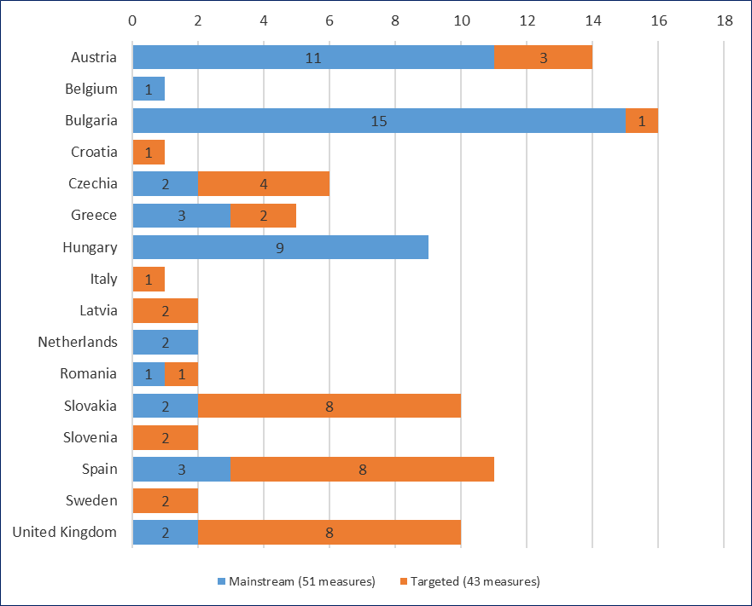Source: EC (2018), NRCPs’ reporting on Roma integration measures implemented in 2017.

Of the 43 targeted measures implemented in the area of healthcare, 14 (33%) could identify the number of Roma beneficiaries.

### Distribution by thematic sub-area

Most of the 117 measures in this thematic area were reported as being relevant to more than one sub-area as suggested in the Council Recommendation. Table 12 visualises the distribution of measures by their linkage to the respective thematic sub-areas.

**Table 12: Distribution of measures in the area of health by thematic sub-area (number of measures)**

|  |  |  |  |  |  |  |  |  |  |  |  |  |  |  |  |  |  |
| --- | --- | --- | --- | --- | --- | --- | --- | --- | --- | --- | --- | --- | --- | --- | --- | --- | --- |
| Sub-area | Country | | | | | | | | | | | | | | | | Total |
| AT | BE | BG | HR | CZ | EL | HU | IT | LV | NL | RO | SK | SI | ES | SE | UK |
| a) remove any barriers to accessing the healthcare system accessible for the general population | 9 | 1 | 11 | 1 | 2 | 1 | 3 | 1 |  |  | 2 | 3 |  | 1 | 1 | 9 | **45** |
| b) improve access to medical check-ups; prenatal and postnatal care and family planning; as well as sexual and reproductive healthcare, generally provided by national healthcare services | 3 |  |  |  |  |  | 3 |  |  |  |  | 1 | 1 | 1 |  | 2 | **11** |
| c) improve access to free vaccination programmes | 2 |  | 3 | 1 |  | 2 | 1 |  |  |  |  | 1 |  |  |  | 1 | **11** |
| d) promote awareness of health and healthcare issues | 4 |  | 3 | 1 | 3 | 2 | 3 | 1 | 2 | 2 |  | 4 | 1 | 8 | 2 | 5 | **41** |
| e) other |  |  |  |  | 3 |  |  |  |  |  |  | 5 |  | 1 |  |  | **9** |

Source: EC (2018), NRCPs’ reporting on Roma integration measures implemented in 2017.

Table 12 shows that most of the reporting Member States have focused their measures on removing barriers to access to healthcare for the general population (mentioned in 45 measures). The second most popular sub-area of measures promoted awareness of health and healthcare issues (mentioned in 41 measures).

In contrast, fewer measures were taken to improve access to medical check-ups; prenatal and postnatal care and family planning; as well as sexual and reproductive healthcare, generally provided by national healthcare services. The same applies to measures to improve access to free vaccination programmes. It remains unclear whether: (i) these less frequently mentioned services were actually being implemented, but were understood by Member States to be included under the framework measures in group one (improving access to mainstream health services), or (ii) Member States simply put less effort into targeted measures to improve Roma access to mainstream health services.

### Substantive focus of the measures in healthcare

In total, Member States reported eight clusters of measures implemented in the area of health in 2017 (Table 13).

At the top of the list, the most commonly implemented clusters were: (i) improving the supply side of health provision infrastructure (staff, facilities); (ii) health awareness and information campaigns targeting Roma communities; and (iii) general social-inclusion actions for improving health and sanitation infrastructure at local level (Table 13). 60 of the 94 measures fall under these three categories, and these three categories reach the most beneficiaries. The provision of preventive services (screening, early diagnostics, immunisation) has also emerged as an important cluster of activities.

**Table 13: Distribution of measures in the area of health by substantive focus of activity**

|  |  |  |
| --- | --- | --- |
| Type of activity | Number of measures | Share |
| Improving the supply side of health provision infrastructure (staff, facilities) | 24 | 26% |
| Health awareness and information campaigns targeting Roma communities | 20 | 21% |
| General social-inclusion actions for improving health and sanitation infrastructure at local level | 16 | 17% |
| Provision of preventive services (screening, early diagnostic, immunisation) | 15 | 16% |
| Inclusion in health-insurance systems | 7 | 7% |
| Anti-discrimination measures, intercultural mediation, awareness campaigns targeting health practitioners | 6 | 6% |
| Research, data collection and monitoring of health challenges faced by Roma | 5 | 5% |
| Development of strategies and policy documents | 1 | 1% |
| Total | 94 | 100% |

Source: EC (2018), NRCPs’ reporting on Roma integration measures implemented in 2017.

### Conclusions

The overview of measures relevant to the area of healthcare highlights the need to intensify efforts to reach the target population (including funding of measures). If the measures are difficult to target by their very nature, it is at least necessary to provide safeguards to ensure that these targeted measures actually benefit the Roma population. This is especially a concern for countries where most measures are mainstream.

The overview also highlights certain topics where relatively few measures were adopted, such as: (i) measures to improve access to medical check-ups, prenatal and postnatal care and family planning, as well as sexual and reproductive healthcare, generally provided by national healthcare services; (ii) measures to secure vaccination coverage of all children; or (iii) measures fighting poor nutrition and unhealthy living conditions. Other measures could significantly improve Roma access to health services, particularly of those living in marginalised and/or remote areas. These other measures include: (i) anti-discrimination and sensitisation measures targeting healthcare professionals; and (ii) more active engagement of health mediators from Roma communities. Such actions should be prioritised for the future.

Finally, civil society actors should be more actively engaged as implementing entities. The modest engagement of NGOs — particularly Roma community organisations — seems to be an untapped opportunity, although civil involvement is possibly underrepresented in Member States reports, with NRCPs being more aware of measures implemented by public authorities. Actively engaging Roma organisations in the implementation of measures in this area would increase trust, boosting the outreach and effectiveness of the measures. This is especially relevant for countries with sizeable Roma populations, where health indicators show a deterioration in the health of the Roma population.

## Housing

The available data and outcome indicators, based on data from representative surveys in nine EU Member States, suggest that the situation in housing remained largely the same between 2011 and 2016 (with some improvements in access to water and basic amenities in some countries, Table 15). However, discrimination when looking for housing continues to be a challenge in a number of Member States with sizeable (CZ, ES) or smaller (PT) Roma populations. This discrimination fell notably in SK.

**Table 15: Change in selected housing indicators between 2011 and 2016**

|  |  |  |  |  |  |  |  |  |  |  |
| --- | --- | --- | --- | --- | --- | --- | --- | --- | --- | --- |
|  | BG | CZ | EL | ES | HR | HU | PT | RO | SK | Average |
| Average number of rooms per person in the household (without kitchen) | ↔ | ↔ | ↔ | ↑ | ↔ | ↔ | ↔ | ↑ | ↔ | ↔ |
| Share of people living in households without tap water inside the dwelling, household members (%) | ↓ | ↓ | ↓ | ↔ | ↓ | ↔ | ↔ | ↓ | ↓ | ↔ |
| Share of people living in households having neither toilet, nor shower, nor bathroom inside the dwelling, household members (%) | ↓ | ↓ | ↔ | ↔ | ↔ | ↑ | ↔ | ↓ | ↓ | ↔ |
| Share of people living in households with electricity supply, household members (%) | ↔ | ↔ | ↔ | ↔ | ↔ | ↔ | ↔ | ↑ | ↔ | ↔ |
| Share of people who felt being discriminated against because of being Roma in the past 5 years, when looking for housing, respondents, aged 16+ (%) | … | ↑ | … | ↑ | … | ↔ | ↑ | … | ↓ | ↔ |
|  |  |  |  |  |  |  |  |  |  |  |
| NRCP assessment of the situation in this thematic area (2017)* | ↔ | ↔ | ↑ | ↑ | ↔ | ↑ | ↑ | ↑ | ↑ |  |
| Legend:  The arrow visualises the direction of change in the respective indicator (‘↑’ increase, ‘↔’ no change and ‘↓’ decline). The background shows improvement (green), deterioration (red) or no change (yellow).  Sources:  FRA, EU-MIDIS II 2016, Roma; FRA, Roma Pilot Survey 2011; UNDP-World Bank-EC 2011 (for Croatia) *in European Commission (2017).[10]*  * For NRCP assessment: EC (2018), NRCPs’ reporting on Roma integration measures implemented in 2017. | | | | | | | | | | |

### The measures relevant for housing

Overall, 94 measures were reported as being relevant in the area of housing in the 19 EU Member States reporting on this thematic area. Out of these, 46 were mainstream measures and 48 were targeted measures (Figure 10). Data suggest that targeted measures play a significant role in some Member States (they are especially prominent in IT, HR, SK and UK), whereas in other Member States most measures remain mainstream (AT, BE, BG, HU, LU). The predominance of mainstream measures (and absence or near-absence of targeted measures) can be a concern in countries with a sizeable Roma population such as BG and HU.

**Figure 10: Measures in the area of housing by country and type of measure (mainstream or targeted)**

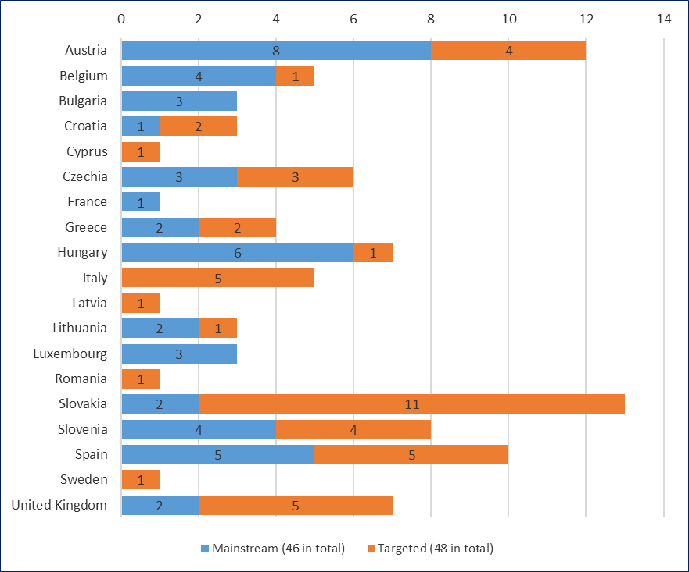

Source: EC (2018), NRCPs’ reporting on Roma integration measures implemented in 2017.

Of the 48 targeted measures implemented in the area of housing, only 16 (33%) could identify the number of Roma final beneficiaries. This relatively low share is surprising given the spatial dimensions of the challenge: a lot of data exist on the location of Roma ghettoes and the number of people living there. It should therefore be relatively easy to determine the number of potential beneficiaries of such targeted interventions.

### Distribution by thematic sub-area

124 measures in this thematic area were reported as being relevant to one or more sub-area as suggested in the Council Recommendation (the figure is higher than the 94 stated above because some measures are relevant for more than one sub-area). Table 16 visualises their distribution by sub-area and country.

**Table 16: Distribution of measures by relevance to the respective sub-areas of the Council Recommendation**

|  |  |  |  |  |  |  |  |  |  |  |  |  |  |  |  |  |  |  |  |
| --- | --- | --- | --- | --- | --- | --- | --- | --- | --- | --- | --- | --- | --- | --- | --- | --- | --- | --- | --- |
| Sub-area | Country | | | | | | | | | | | | | | | | | | Total |
| AT | BE | BG | HR | CY | CZ | EL | HU | IT | LV | LT | LU | RO | SK | SI | ES | SE | UK |
| a) eliminate any spatial segregation and promote desegregation | 1 | 2 | 3 |  |  |  | 1 | 3 | 4 |  | 2 |  | 1 | 1 |  | 4 |  | 3 | 25 |
| b) promote non-discriminatory access to social housing | 4 |  |  |  |  | 3 | 1 | 1 | 2 | 1 | 1 |  | 1 | 3 | 2 | 1 |  | 2 | 22 |
| c) provide halting sites for non-sedentary Roma, in proportion to local needs | 3 |  |  |  |  |  |  |  |  |  |  |  |  |  |  |  |  | 2 | 5 |
| d) ensure access to public utilities (such as water, electricity and gas) and infrastructure for housing in compliance with national legal requirements |  | 1 | 1 | 3 | 1 |  | 2 |  |  |  |  |  | 1 | 7 | 2 | 7 |  | 1 | 26 |
| e) ensure that applications from local authorities for urban regeneration projects include integrated housing interventions in favour of marginalised communities |  | 1 | 1 | 1 |  |  |  | 1 | 1 |  |  |  |  | 3 |  | 4 |  |  | 12 |
| f) promote community-led local development and/or integrated territorial investments supported by the European Structura; and Investment Funds (ESIF) |  |  |  | 1 |  |  |  | 2 | 3 |  |  |  |  |  |  | 3 |  |  | 9 |
| g) other | 4 | 1 | 1 | 2 |  | 3 |  | 1 |  |  |  | 3 |  | 3 | 4 | 2 | 1 |  | 25 |

Source: EC (2018), NRCPs’ reporting on Roma integration measures implemented in 2017.

As Table 16 shows, most of the reporting Member States focus on ensuring access to public utilities (such as water, electricity and gas) and infrastructure for housing, in compliance with national legal requirements (mentioned in 26 measures). Other commonly implemented measures focus on combating spatial/residential segregation and promoting desegregation (mentioned in 25 measures). The promotion of non-discriminatory access to social housing is also a commonly implemented type of measure.

In contrast, fewer measures were taken to: (i) provide halting sites for non-sedentary Roma; (ii) promote community-led local development and/or integrated territorial investments supported by the ESIF; or (iii) ensure that applications from local authorities for urban regeneration projects include integrated housing interventions in favour of marginalised communities.

### Substantive focus of the measures in housing

In total, Member States reported 11 clusters of measures implemented in the area of housing in 2017 (Table 17). At the top of the list were: (i) the provision and maintenance of municipal and social housing; (ii) investments in physical infrastructure in Roma settlements (water, sanitation, electricity, roads); and (iii) legislative measures, construction permits, and informal housing legalisation (Table 17). 47 of the 94 housing measures fall under these three categories and these three categories reach the most beneficiaries. Other significant clusters of activities include: (i) monitoring and evaluation of living conditions, barriers and discriminatory factors in access to housing; (ii) removal of slums and shanty towns; and (iii) social support and infrastructure for homeless persons.

**Table 17: Distribution of measures in the area of housing by substantive focus of activity**

|  |  |  |
| --- | --- | --- |
|  | Number of measures | Share |
| Provision and maintenance of municipal and social housing (including maintenance and repair) | 25 | 27% |
| Investments in physical infrastructure in Roma settlements (water, sanitation, electricity, roads) | 15 | 16% |
| Legislative measures, construction permits, informal housing legalisation | 12 | 13% |
| Monitoring and evaluation of living conditions, barriers and discriminatory factors in access to housing | 9 | 10% |
| Removal of slums and shanty towns | 7 | 7% |
| Social support and infrastructure for homeless persons | 7 | 7% |
| Integrated territorial measures for desegregation | 7 | 7% |
| Traveller mobile home pitches, maintenance of caravan sites | 5 | 5% |
| Community mobilisation, working groups with local authorities | 5 | 5% |
| Meetings, discussions, awareness campaigns | 2 | 2% |
| Total | 94 | 100% |

Source: own tagging based on the NRCPs’ reporting on Roma integration measures implemented in 2017.

### Conclusions

The overview of measures relevant to housing highlights a need to intensify efforts to reach the target population (including funding of measures). If the measures are difficult to target by their very nature, it is at least necessary to provide safeguards to ensure that these targeted measures actually benefit Roma. This is especially a concern in countries where most measures are mainstream and do not include safeguards to ensure that they include Roma as beneficiaries.

Finally, the overview highlights certain topics where relatively few measures were adopted, such as: actions to provide halting sites for non-sedentary Roma; actions to promote explicit active desegregation; community-led local development and/or integrated territorial investments supported by the ESIF; and actions to develop the social housing stock with improved Roma access. These areas should be prioritised for the future. Also, relatively few measures were reported in certain countries. Many of these countries with relatively few measures have sizeable Roma populations where high levels of perceived discrimination rates were recorded.

## Anti-discrimination

The available data on perceptions and experience of discrimination against Roma in nine EU Member States surveyed in 2011 and 2016 suggest that this thematic area is particularly significant for the overall success of Roma integration strategies. As seen from Table 19, the overall situation on discrimination in the nine countries for which data are available has not changed. The detailed overview of the available indicators provided in section 3.6 suggests that the discrimination, harassment and victimisation that Roma frequently experience are driven by racially motivated attitudes.

**Table 19: Change in the overall discrimination rate because of skin colour/ethnic origin/religion in the past 5 years across key areas of life 2011-2016 (decline or increase of the share of people who felt being discriminated because of being Roma in the past 5 years when …)**

|  |  |  |  |  |  |  |  |  |  |  |
| --- | --- | --- | --- | --- | --- | --- | --- | --- | --- | --- |
|  | BG | CZ | EL | ES | HR | HU | PT | RO | SK | Average |
| ...in contact with school (as parent or student), respondents, aged 16+ (%) | ↔ | ↓ | ↓ | ↔ | ↑ | ↔ | ↔ | ↓ | ↔ | ↔ |
| ...looking for housing, respondents, aged 16+ (%) | __ | ↑ | __ | ↑ | __ | ↔ | ↑ | __ | ↓ | ↔ |
| ...looking for a job, respondents, aged 16+ (%) | ↓ | ↓ | ↔ | ↔ | ↑ | ↓ | ↑ | ↔ | ↔ | ↓ |
| ...at work, respondents, aged 16+ (%) | ↔ | ↓ | ↑ | ↑ | ↓ | ↓ | ↑ | ↑ | ↑ | ↔ |
|  |  |  |  |  |  |  |  |  |  |  |
| NRCP assessment of the situation in anti-discrimination (2017) | ↑ | ↑ | X | ↔ | ↔ | ↑ | ↑ | X | ↔ |  |
| NRCP assessment of the situation in multiple discrimination (2017)* | X | X | X | ↑ | ↑ | ↑ | ↑ | X | ↔ |  |
| Notes:  ‘__’ denotes cases when trends are not possible to provide due to the small number of observations  The arrow visualises the direction of change in the respective indicator (‘↑’ increase, ‘↔’ no change and ‘↓’ decline). The background shows improvement (green), deterioration (red) or no change (yellow).  Legend: the arrow visualises the direction of change in the respective indicator (‘↑’ increase, ‘↔’ no change and ‘↓’ decline). The background shows improvement (green), deterioration (red) or no change (yellow).  Sources:  FRA, EU-MIDIS II 2016, Roma; FRA, Roma Pilot Survey 2011; UNDP-World Bank-EC 2011 (for Croatia) *in European Commission (2017).[11]*  * For NRCP assessment: EC (2018), NRCPs’ reporting on Roma integration measures implemented in 2017. | | | | | | | | | | | |

### The measures relevant for anti-discrimination

Overall, 142 measures were reported as being relevant in the area of anti-discrimination. This included measures to fight multiple discrimination in the 18 EU Member States reporting on this thematic area. Out of these 142 measures, 60 (42%) were mainstream measures while 82 (58%) were targeted measures (Figure 11). However, of the 82 targeted measures implemented in the area of anti-discrimination and multiple discrimination, only 16 (20%) could identify Roma beneficiaries. This is the lowest share of targeted measures directly identifying Roma as beneficiaries among all six thematic areas analysed in this overview. This may suggest that the targeting is not particularly effective in the area of anti-discrimination.

**Figure 11: Number of measures implemented in the area of anti-discrimination by type of measure (mainstream or targeted)**

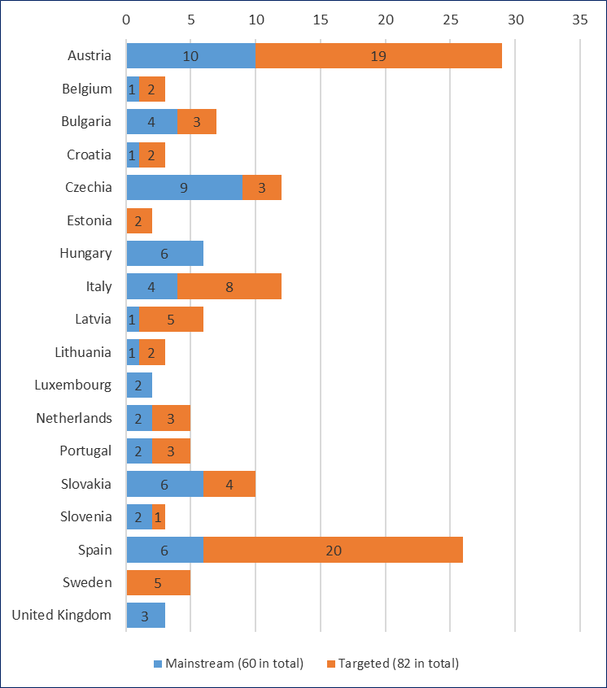  
Source: EC (2018), NRCPs’ reporting on Roma integration measures implemented in 2017.

Five countries (CY, FR, EL, PL, RO) did not report any measures on anti-discrimination. This lack of reporting on is especially worrying for Member States with a sizeable Roma population, such as Romania and Greece.

### Distribution by thematic sub-area

Many of the measures reported were relevant for more than one thematic sub-area. Table 20 visualises the distribution of measures by their linkage to the respective thematic sub-areas. 20% of the measures were in the sub-area ‘Combat antigypsyism by raising awareness about the benefits of Roma integration’, 17% were in the sub-area ‘Combat antigypsyism by raising awareness about the diverse nature of societies and sensitising public opinion to the inclusion problems Roma face’, and 15% were in the sub-area ‘Combat anti-Roma rhetoric and hate speech’. 18% of the measures were reported as relevant for combating all forms of discrimination, including multiple discrimination, faced by Roma children and women. Many measures concerned thematic sub-areas that are not listed in the Council Recommendation from December 2013 and were reported as ‘other’.

Table 20: Distribution of measures by relevance to the respective sub-areas of the Council Recommendation

|  |  |  |  |  |  |  |  |  |  |  |  |  |  |  |  |  |  |  |  |  |
| --- | --- | --- | --- | --- | --- | --- | --- | --- | --- | --- | --- | --- | --- | --- | --- | --- | --- | --- | --- | --- |
| Thematic sub-area | Country | | | | | | | | | | | | | | | | | | | |
| AT | BE | BG | HR | CZ | EE | HU | IT | LV | LT | LU | NL | PT | SK | SI | ES | SE | UK | Total | |
| a) ensure the effective practical enforcement of Directive 2000/43/EC |  |  |  | 1 | 2 |  |  | 2 |  | 1 |  |  |  |  |  |  |  |  | 6 | 3% |
| b) implement desegregation measures both regionally and locally |  |  |  |  |  |  | 1 |  |  |  |  | 1 |  |  |  |  |  | 1 | 3 | 2% |
| c) ensure that forced evictions are in full compliance with EU law as well as with other international human rights obligations |  |  |  |  |  |  |  | 1 |  |  |  |  |  |  |  |  |  |  | 1 | 1% |
| d). combat anti-gypsyism by raising awareness about the benefits of Roma integration both in Roma communities and among the general public | 3 | 1 | 1 |  | 1 |  |  | 6 | 5 | 1 |  |  | 1 | 4 |  | 11 | 1 |  | 35 | 20% |
| e) combat anti-gypsyism by raising awareness about the diversity and sensitising public opinion to the inclusion problems Roma face | 4 | 1 | 1 |  | 1 | 1 |  | 3 | 2 | 1 |  |  | 3 | 4 |  | 8 | 2 |  | 31 | 17% |
| f) combat anti-Roma rhetoric and hate speech | 9 |  | 1 |  | 2 |  | 2 | 2 | 1 | 1 |  |  |  | 2 |  | 5 |  | 2 | 27 | 15% |
| g) fight violence, including domestic violence, against women and girls | 3 |  |  |  |  |  |  | 1 |  |  |  | 1 |  |  |  | 6 |  |  | 11 | 6% |
| h) fight trafficking in human beings | 5 |  |  |  |  |  | 1 |  |  |  |  |  |  |  |  |  |  |  | 6 | 3% |
| i) fight underage and forced marriages | 3 |  |  |  |  |  |  |  |  |  |  | 3 |  |  |  |  |  |  | 6 | 3% |
| j) fight begging involving children, in particular through the enforcement of legislation | 1 |  |  |  |  |  |  |  |  |  |  |  |  |  |  |  |  |  | 1 | 1% |
| k) multiple discrimination, faced by Roma children and women involving all relevant actors including public authorities, civil society and Roma communities | 2 |  |  |  |  |  |  | 4 |  |  |  | 1 |  |  |  | 1 |  |  | 8 | 4% |
| l) encourage cooperation between Member States in situations with a cross-border dimension | 1 |  |  |  |  |  |  |  |  |  |  |  |  |  |  |  |  |  | 1 | 1% |
| Other | 9 | 1 | 4 | 2 | 7 |  | 2 | 1 |  |  | 2 |  | 1 | 1 | 3 | 7 | 2 |  | 42 | 24% |

Source: EC (2018), NRCPs’ reporting on Roma integration measures implemented in 2017.

The distribution of measures in the area of anti-discrimination also indicates that besides combatting anti-Roma rhetoric and hate speech (15%), in line with the Council Framework Decision on combatting racism and xenophobia there were relatively few measures with a particularly European dimension that were reported. For example, there were relatively few measures to: (i) ensure effective practical enforcement of Directive 2000/43/EC; or (ii) ensure that evictions were in full compliance with EU law as well as in compliance with other international human rights obligations. These findings indicate possibilities for further action in the future, fully exploring the potential of European and international human rights law to improve the situation of the Roma population.

Other areas where relatively few measures were reported were areas which could directly affect the living conditions of the Roma population, for example: desegregation measures, cooperation between Member States in situations with a cross-border dimension, and measures to fight trafficking in human beings.

### Substantive focus of the measures in anti-discrimination

The measures reported in this thematic area seem to cluster in two major groups: those targeting persons at risk of discrimination, including multiple discrimination; and those targeting the general public and public institutions (Table 21). The first group includes activities such as: (i) raising awareness of the contribution of Roma to European history and culture (31 of the 142 measures); and (ii) building Roma organisations’ capacity to fight discrimination (17 of the 142 measures). The measures in this first group can boost Roma people’s self-confidence and decrease the prejudice against Roma, ultimately decreasing their social exclusion and risk of discrimination. The measures in the second group include: (i) public campaigns and awareness raising to combat discrimination and promote rights (26 of the 142 measures); and (ii) building public institutions’ capacity to address discrimination (21 of the 142 measures). Addressing discrimination from both angles increases the chances of achieving a sustainable decline in prejudice and discrimination against Roma.

Access to legal protection (including knowledge of the law, access to law enforcement, and access to legal aid) was identified as a key challenge in a number of countries (AT, CZ, LT, PT). However, this seems not to be sufficiently reflected in the substantive focus of the measures reported under anti-discrimination and multiple discrimination. Only 8 of the 142 measures concerned the provision of affordable legal advice and support.

**Table 21: Distribution of measures in the area of anti-discrimination by substantive focus of activity**

|  |  |  |
| --- | --- | --- |
| Type of intervention | Number of measures | Share |
| Promotion of Roma culture and history | 31 | 22% |
| Campaigns, conferences and awareness raising to combat intolerance and discrimination | 26 | 18% |
| Building institutions’ capacity to address discrimination | 21 | 15% |
| Development of the capacity of Roma organisations | 17 | 12% |
| Strengthening human rights’ monitoring mechanisms | 15 | 11% |
| Developing strategies and policy frameworks | 9 | 6% |
| Affordable legal advice and support | 8 | 6% |
| Enhancing the role and participation of women | 8 | 6% |
| Desegregation and social-inclusion initiatives at local level | 7 | 5% |
| Total | 142 | 100% |

Source: own calculations based on the NRCPs’ reporting on Roma integration measures implemented in 2017.

Out of the 142 measures analysed in this section, 21 were reported as relevant under the horizontal area ‘Protection of Roma children and women’. Of these 21 measures, 15 targeted women (5 in AT, 1 in IT, 2 in NL and 7 in ES) and 6 targeted children and youth (2 in AT, 1 in HU, 1 in IT, 1 in NL and 1 in ES). Looking in more detail, the measures explicitly targeting Roma women dealt primarily with: (i) fighting violence, including domestic violence, against women and girls; and (ii) fighting underage and forced marriages. Measures explicitly targeting Roma children and youth dealt primarily with fighting trafficking in human beings.

### Conclusions

The overview of measures in the area of anti-discrimination highlights a need to better target measures to benefit the Roma population. Although most of the measures have funding allocated, some do not and remain only a commitment on paper.

Discrimination is usually driven by prejudice and myths shared by mainstream societies. This is why targeted measures might be less effective in fighting such phenomena. In such cases, it is important for mainstream measures to provide safeguards to ensure that the measures actually benefit the Roma population.

Finally, the overview highlights certain topics where relatively few measures were adopted:

* measures with a specific EU dimension, such as: (i) to ensure effective practical enforcement of Directive 2000/43/EC implementing the principle of equal treatment between persons irrespective of racial or ethnic origin; or (ii) to ensure that evictions are in full compliance with EU law as well as in compliance with other international human rights obligations – while measures combatting anti-Roma rhetoric or hate speech were greater in number;
* desegregation measures;
* cooperation between Member States in situations with a cross-border dimension; and
* measures to fight against trafficking in human beings (in particular, focusing on Roma women and children).

These areas could be prioritised for the future. Also, relatively few (or no) measures were reported in certain countries. Many of these countries with few measures — or no measures at all — were countries with sizeable Roma populations, where high levels of perceived discrimination rates were recorded.

## Poverty reduction

Table 23 and section 3.5 provide trends in the key poverty indicators for Roma in nine EU Member States surveyed in 2011 and 2016. Data suggest that key poverty indicators improved, but the trend in poverty indicators is diverging from that of employment indicators. This divergence suggests that active labour-market policies should be a core component of poverty-reduction strategies. For example, the transition from working in the informal sector to formal (safe and secure) employment could be an integral part of active labour-market policies targeting Roma. It could also potentially be an integral part of active labour-market policies for other groups facing similar problems, such as migrants. The detailed overview of the available indicators for 2016 provided in section 3.5 also illustrates the consequences of monetary poverty — the unaffordability of key household expenditures and goods, indebtedness (especially related to bills for utilities and housing in general), and material deprivation.

**Table 23: Change in key poverty indicators for Roma, 2011-2016**

|  |  |  |  |  |  |  |  |  |  |  |
| --- | --- | --- | --- | --- | --- | --- | --- | --- | --- | --- |
|  | BG | CZ | EL | ES | HR | HU | PT | RO | SK | Average |
| At-risk-of-poverty rate (below 60% of median equivalised income after social transfers), household members (%) | ↔ | ↓ | ↑ | ↑ | ↔ | ↓ | n.a. | ↓ | ↔ | ↓ |
| Share of persons in households where at least one person had to go hungry to bed at least once in the last month, household members (%) | ↓ | ↓ | ↓ | ↔ | ↔ | ↓ | n.a. | ↓ | ↔ | ↓ |
|  |  |  |  |  |  |  |  |  |  |  |
| NRCP assessment of the situation this thematic area (2017)* | X | ↑ | ↑ | ↔ | ↑ | ↑ | ↑ | ↑ | ↑ |  |
| Legend:  The arrow visualises the direction of change in the respective indicator (‘↑’ increase, ‘↔’ no change and ‘↓’ decline). The background shows improvement (green), deterioration (red) or no change (yellow).  Sources:  FRA, EU-MIDIS II 2016, Roma; FRA, Roma Pilot Survey 2011; UNDP-World Bank-EC 2011 (for Croatia) *in European Commission (2017).[12]*  * For NRCP assessment: EC (2018), NRCPs’ reporting on Roma integration measures implemented in 2017. | | | | | | | | | | |

### Measures relevant for poverty reduction

Overall, 100 measures were reported as being relevant to poverty reduction in the 16 EU Member States reporting on this thematic area. Out of these 100 measures, 67 were mainstream measures and 33 were targeted (Figure 12).

Given the horizontal nature of this thematic area, the focus on mainstream measures is not a surprise. In those countries with large Roma populations, only CZ reported more targeted measures than mainstream measures, while ES reported that it had slightly more mainstream measures than targeted measures. While HR and SE reported only targeted measures (one measure each), BE, HU, LT, LU, PT, and RO reported only mainstream measures.

**Figure 12: Number of measures implemented in the area of poverty reduction by type of measure (mainstream or targeted)**

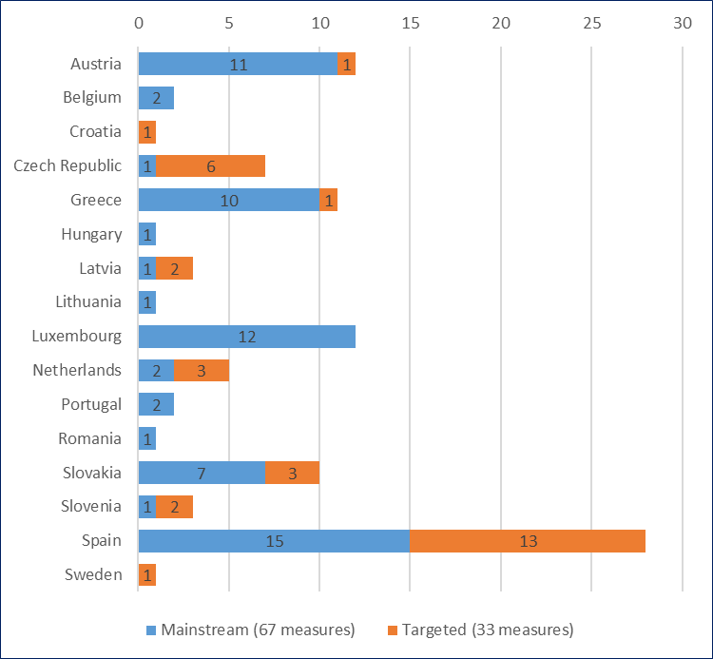  
Source: EC (2018), NRCPs’ reporting on Roma integration measures implemented in 2017.

Of the 33 targeted measures implemented in the area of poverty reduction, 13 (39%) could identify the number of Roma final beneficiaries. This is the highest share among all six thematic areas analysed in this overview.

### Distribution by thematic sub-area

120 measures were reported as being relevant for one or more sub-areas in the thematic area ‘poverty reduction’ as specified in the Council Recommendation. The countries could link individual measures not only to several thematic areas but also to several sub-areas. Therefore, the total number of measures in the analysis by sub-area (120) differs from the number of measures reported under thematic area of poverty reduction (100). Table 24 provides an overview of: the sub-areas as suggested in the Council Recommendation; how many measures were relevant for each sub-area; and in which Member States measures they were reported.

**Table 24: Distribution of measures by relevance to the respective sub-areas of the Council Recommendation**

|  |  |  |  |  |  |  |  |  |  |  |  |  |  |  |  |  |  |
| --- | --- | --- | --- | --- | --- | --- | --- | --- | --- | --- | --- | --- | --- | --- | --- | --- | --- |
| Sub-area of the Recommendation | Country | | | | | | | | | | | | | | | | Total |
| AT | BE | HR | CZ | EL | HU | LV | LT | LU | NL | PT | RO | SK | SI | ES | SE |
| a) support Roma at all stages of their lives, including by investing in good-quality inclusive early-childhood education and care, targeted youth guarantee schemes, lifelong learning and active ageing measures | 6 |  |  | 1 | 5 |  | 1 |  |  | 3 | 2 |  |  | 1 | 12 |  | 31 |
| b) pursue policies of activation and enablement | 8 |  |  |  | 1 |  |  | 1 | 2 | 2 | 1 |  | 6 | 1 | 2 |  | 24 |
| c) support entry and re-entry to the labour market through targeted or mainstream employment support schemes |  |  |  |  | 1 |  | 2 |  | 3 |  |  |  | 3 |  | 10 | 1 | 20 |
| e) make social benefits and social services granted to the disadvantaged more appropriate and sustainable | 2 |  |  | 1 | 4 | 1 | 2 |  | 7 |  |  | 1 | 4 |  | 12 |  | 34 |
| f) other |  | 2 | 1 | 4 |  |  |  |  | 1 |  |  |  |  | 1 | 2 |  | 11 |

Source: EC (2018), NRCPs’ reporting on Roma integration measures implemented in 2017.

As Table 24 suggests, the largest group of measures are related directly to improvement in access to the labour market. These are sub-areas (b) (pursue policies of activation and enablement) and (c) (support entry and re-entry to the labour market through targeted or mainstream employment support schemes). 44 out of the 120 measures are directly related to the labour market.

The second-largest group of measures (34 out of the 120 measures) concerns ‘social safety nets’ aiming at ‘making social benefits and social services granted to the disadvantaged more appropriate and sustainable’ (34 measures across nine countries). The third-largest group of measures (31 measures) was indirectly related to the labour market, and focused on building human capital (the sub-area ‘support Roma at all stages of their lives, including by investing in good-quality inclusive early-childhood education and care, targeted youth guarantee schemes, lifelong learning and active ageing measures’). All this suggests that the Member States have adopted a more holistic approach to poverty reduction by treating poverty not just as a monetary problem, but also as a social-inclusion and human-development problem. This approach is in line with the Council recommendation to focus on poverty from a social-investment perspective.

### Substantive focus of the measures in poverty reduction

The results summarised in Table 25 indicate that countries pay greatest attention to labour-market-related interventions (‘skills development and labour-market integration’, ‘general social-inclusion and labour-market integration’, ‘specific support for children to allow parents to engage in employment’, and ‘measures facilitating the transition from education to employment’). These three groups account for 36% of all measures. The group of ‘safety net’ measures (those providing social assistance and material support for vulnerable families, and those targeted at improving access to social services) account for 38% of the 100 measures.

**Table 25: Distribution of measures in the area of poverty reduction by substantive focus of activity**

|  |  |  |
| --- | --- | --- |
| Substantive area | Total | Share |
| Social assistance, material support for vulnerable families | 25 | 25% |
| Skills development and labour-market integration | 15 | 15% |
| Improving access to social services (health, education) | 13 | 13% |
| Capacity development of public institutions to address vulnerability | 9 | 9% |
| General social inclusion and labour-market integration | 9 | 9% |
| Addressing housing deprivation | 7 | 7% |
| Specific support for children to allow parents to engage in employment | 7 | 7% |
| Local-level community-development initiatives | 6 | 6% |
| Measures facilitating the transition from education to employment | 5 | 5% |
| Anti-discrimination and awareness-raising initiatives | 4 | 4% |
| Total | 100 | 100% |

Source: own calculations based on the NRCPs’ reporting on Roma integration measures implemented in 2017.

More evidence of the cross-cutting nature of the main approach in this thematic area — and its drive to go beyond monetary-poverty reduction — can be seen in the fact that its individual measures are also relevant to other areas. Out of all 100 measures reported as relevant to poverty reduction, only half were ‘purely’ related to poverty reduction. The other half was reported as also being relevant to other thematic areas: 27 were also reported under the thematic area for employment, 16 were reported under the thematic area for education, and 7 were reported under the thematic area for housing. The fact that most of the employment-related measures also appeared under the ‘poverty reduction’ heading is another indicator that the main approach to poverty reduction is through access to jobs.

### Conclusions

The overview of measures in the area of poverty reduction suggests that the Member States adopted a holistic approach to poverty reduction, blending social protection, incentives for education and measures to encourage employment. Consistent implementation of such measures may decrease the dependency of Roma households in vulnerable situations, and therefore help promote the genuine empowerment of Roma.

Two thirds of the measures implemented in 2017 were mainstream measures. Mainstream measures are appropriate for poverty reduction, provided that Roma have genuine access to these measures. The Member States adopt a variety of approaches to ensure this genuine access, and these approaches reflect the specific conditions and circumstances of each Member State. In many cases, however, the safeguards to secure equal access by Roma to mainstream measures are far from perfect. It can therefore be necessary to fine-tune these measures by involving a broad range of stakeholders, including the private sector and civil society.

As is the case in other thematic areas, public authorities are the main implementing partners in poverty reduction. It is only natural that public authorities take precedence in implementing ‘social safety net’ measures. But for other types of measures, a greater role for the private sector and civil society might improve both the effectiveness and efficiency of the resources invested. The dominant role of public authorities brings risks, particularly for measures related to employment in public works implemented at local level, where the decision to include (or not include) a person may be discretionary. The results of the FRA’s ‘Local Engagement in Roma Inclusion’[13] project suggested that such risks exist.

## Legislative measures

Member States also reported on any new legislation introduced in 2017 to improve the situation of Roma. This legislation could involve either targeted measures or mainstream measures with safeguards for Roma. This section summarises the information NRCPs provided, and shows that only four countries reported a change in legislation (FI, FR, PT and SK).

### Substantive policy areas

In January 2017, an amendment was made to the Law on the financing of elementary schools, secondary schools and school facilities (597/2003 Coll.) in **Slovakia**. This amendment enables the founders of elementary schools to receive an allowance from the Ministry of Education and the Ministry of Interior to improve conditions for the education of pupils from a socially disadvantaged environment. The allowance is proportional to the number of pupils from a socially disadvantaged environment in the school. In 2017, the allowance was €260 per pupil.

The contribution is provided only to pupils who have confirmation of their disadvantaged situation issued by the Centre for Pedagogical-psychological Counselling and Prevention and who are enrolled in a normal class in an elementary school. This measure could also be seen as a measure for combating segregation and improving the quality of education in schools with a high proportion of Roma pupils.

This legislative measure followed a set of broader legislative changes initiated in Slovakia in 2015 to address the segregation of Roma pupils. These changes stipulated that a child or student whose special educational needs are solely the result of growing up in a socially disadvantaged environment cannot be accepted in special schools, special kindergarten classes, special primary school classes, or special middle school classes. Those changes also increased the powers of school inspectorates to intervene in cases of misdiagnosis of children placed in the special schools.

In May 2017, **Slovakia** amended its Act on Public Employment Services and other related laws. The amendment provides for an individual action plan to promote employment. The action plan is binding for both the job-seeker and for the Office of Labour, Social Affairs and Family. The Office can work with disadvantaged job-seekers to develop an individual action plan to help the job-seeker to find work. These measures are expected to increase the employment of Roma minorities.

In September 2017, **Slovakia** amended Act No 153/2017 amending Act No 330/1991 on Land Conversion, Settlement of Land Ownership, Land Register Offices, the Slovak Land Fund and Land Communities. The amendment provides for a procedure to clarify the arrangements for ownership and use of the land located under the settlements of marginalised groups in the form of land adjustments. If the procedure is successful, the land of the settlements can be acquired by the municipality, which can then be sold to the inhabitants of Roma settlements. The administrative procedure may only be proposed by municipalities in which settlements of the marginalised population are located.

### Horizontal areas

**Finland** did not report on measures implemented in 2017, but in December the legal basis of the regional Advisory Boards on Roma Affairs entered into force. Since that date, these boards have operated on a proper legislative level instead of merely being based on a governmental decree. This also has practical consequences. These practical consequences include the introduction of a general obligation to carry out equality planning. Starting in January 2018, equality plans must be drawn up in all municipalities, all administrative levels and all larger employers. These plans are monitored by the Non-discrimination Ombudsman’s office. This obligation to have equality plans is expected to have an impact on the situation of Roma populations.

**Portugal** streamlined its legal procedure for anti-discrimination. New legislation entered into force on 1 September 2017, which centralises all the different phases of the procedure to optimise the services and make the application of the law more timely and effective. The High Commission for Migration (www.acm.gov.pt), through the Commission for Equality and Against Racial Discrimination (CICDR) (www.cicdr.pt), will now be responsible for all phases of the administrative offences procedure within their areas of competence. These phases include: reception and analysis of complaints; instruction; decision; and the coordination of actions for the prevention, inspection and combat of discriminatory practices. The CICDR’s capacity was also increased, and it now has 32 advisers, including a representative of the Roma communities.

In **France**, a new law on equality and citizenship entered into force on 27 January 2017. For the ‘gens du voyage’, this new law means that they will no longer be obliged to maintain a booklet of circulation, and their way of life is now recognised.

The Bankruptcy and Restructuring Act entered into force on 1 March 2017 in **Slovakia**. This reform of the personal bankruptcy system provides a tool for persons living in poverty and debt to be able to file for bankruptcy more easily, once every 10 years. A Legal Aid Centre provides free legal aid and support to all who decide to use this tool. The main challenge this year was to increase the capacity of the Legal Aid Centre, so it could handle the increased workload stemming from the personal bankruptcy reform. The Act may help Roma in marginalised communities escape a debt spiral. Under the new Act they may now have better access to debt relief, and therefore should be able to re-enter the labour market

# Selected outcome indicators on Roma inclusion

Unless specified other under the table, all figures in the tables below are extracted from [FRA data visualisation application – Roma](https://fra.europa.eu/en/publications-and-resources/data-and-maps/survey-data-explorer-second-eu-minorities-discrimination-survey). They should be referenced as “FRA, EU-MIDIS II 2016, Roma”.

Results based on less than 20 to 49 unweighted observations in a group total or based on cells with less than 20 unweighted observations are noted in parentheses. Results based on less than 20 unweighted observations in a group total are not published (marked “-“).

## Education

|  |  |  |  |  |  |  |  |  |  |  |
| --- | --- | --- | --- | --- | --- | --- | --- | --- | --- | --- |
| Educational outcomes | | | | | | | | | | |
|  | **BG** | **CZ** | **EL** | **ES** | **HR** | **HU** | **PT** | **RO** | **SK** | **Average** |
| **Highest achieved education (ISCED), respondents, 16+ (%)** | | | | | | | | | | |
| - Never been in formal education / not completed primary education (ISCED 0) | 10 | 6 | 58 | 26 | 27 | 15 | 36 | 14 | 6 | **14** |
| - Primary education (ISCED 1) | 34 | (2) | 33 | 32 | 30 | 50 | 44 | 39 | 12 | **29** |
| - Lower secondary education (ISCED 2) | 44 | 59 | 6 | 32 | 29 | 20 | 18 | 34 | 50 | **38** |
| - Upper secondary, vocational, post-secondary, short cycle tertiary education (ISCED 3 to 5) | 12 | 32 | (2) | 10 | 14 | 16 | (2) | 13 | 31 | **18** |
| **Share of Roma with No skills, Not good at all skills or not so good skills of (one of) the countries national language(s), respondents, 16+ (%)** | | | | | | | | | | |
| - speaking | 9 | 8 | 5 | (2) | 13 | 2 | 9 | 14 | 26 | **12** |
| - reading | 38 | 23 | 56 | 21 | 30 | 29 | 54 | 50 | 44 | **38** |
| - writing | 45 | 34 | 64 | 26 | 32 | 30 | 60 | 56 | 55 | **45** |
| **Share of Roma with good, excellent, mother tongue proficiency of (one of) the countries national language(s), respondents, 16+ (%)** | | | | | | | | | | |
| - speaking | 91 | 92 | 95 | 98 | 87 | 98 | 91 | 86 | 74 | 88 |
| - reading: | | | | | | | | | | |
| Total | 62 | 77 | 44 | 79 | 70 | 71 | 46 | 50 | 56 | 62 |
| Women | 57 | 80 | 39 | 74 | 66 | 71 | 35 | 50 | 56 | 61 |
| Men | 67 | 75 | 49 | 84 | 75 | 71 | 58 | 49 | 56 | 63 |
| - writing: | | | | | | | | | | |
| Total | 55 | 66 | 36 | 74 | 68 | 70 | 40 | 44 | 45 | 55 |
| Women | 52 | 68 | 33 | 72 | 63 | 71 | 29 | 43 | 46 | 55 |
| Men | 59 | 65 | 38 | 78 | 74 | 69 | 53 | 45 | 45 | 56 |
| **Share of Roma currently attending school or vocational training, respondents, 16+ (%)** | 4 | 7 | (1) | 4 | 6 | 4 | (2) | (2) | 9 | 5 |

|  |  |  |  |  |  |  |  |  |  |  |
| --- | --- | --- | --- | --- | --- | --- | --- | --- | --- | --- |
| Segregation in education | | | | | | | | | | |
|  | **BG** | **CZ** | **EL** | **ES** | **HR** | **HU** | **PT** | **RO** | **SK** | **Average** |
| **School segregation – share of Roma children aged 6-15 years in school, who attend the school with the following composition of schoolmates (%)** | | | | | | | | | | |
| All of them are Roma | 27 | 5 | 12 | 3 | 8 | 8 | 11 | 8 | 22 | 13 |
| Most of them are Roma | 33 | 25 | 36 | 28 | 32 | 53 | (3) | 21 | 40 | 33 |
| Some of them are Roma | 38 | 66 | 51 | 62 | 56 | 38 | 84 | 71 | 38 | 53 |
| None of them is Roma | (3) | 4 | (1) | 7 | 4 | (0) | (1) | (0) | (0) | 2 |

|  |  |  |  |  |  |  |  |  |  |  |
| --- | --- | --- | --- | --- | --- | --- | --- | --- | --- | --- |
|  | **BG** | **CZ** | **EL** | **ES** | **HR** | **HU** | **PT** | **RO** | **SK** | **Average** |
| **Class segregation – share of Roma children aged 6-15 years in school, who attend the classes with the following composition of classmates (%)** | | | | | | | | | | |
| All of them are Roma | 29 | 6 | 13 | 4 | 22 | 10 | 11 | 10 | 26 | 15 |
| Most of them are Roma | 31 | 26 | 34 | 27 | 14 | 48 | 8 | 20 | 37 | 31 |
| Some of them are Roma | 37 | 61 | 53 | 57 | 57 | 41 | 80 | 69 | 35 | 51 |
| None of them is Roma | (2) | 6 | (0) | 11 | 7 | (1) | (1) | (1) | 2 | 4 |
| **Share of Roma children aged 6-15 years in education, who attend a special school (%)** | (2) | 16 | n.a. | n.a. | 5 | (3) | n.a. | (1) | 18 | 9 |

Note: n.a. - this question was not asked in the country

Source: FRA, EU-MIDIS II 2016 in [FRA (2016). EU MIDIS II. Roma - Selected findings](https://fra.europa.eu/en/publication/2016/eumidis-ii-roma-selected-findings)

|  |  |  |  |  |  |  |  |  |  |  |
| --- | --- | --- | --- | --- | --- | --- | --- | --- | --- | --- |
| Education attendance | | | | | | | | | | |
|  | **BG** | **CZ** | **EL** | **ES** | **HR** | **HU** | **PT** | **RO** | **SK** | **Average** |
| **Share of children aged between 4 years and (country specific) age of starting compulsory education who participate early childhood education, by sex, household members (%):** | | | | | | | | | | |
| - Total | 66 | 34 | 28 | 95 | 32 | 91 | 42 | 38 | 34 | 53 |
| - Girls | 69 | 35 | 27 | 93 | 37 | 90 | (31) | 41 | 34 | 53 |
| - Boys | 64 | 32 | 29 | 98 | 26 | 92 | 51 | 36 | 34 | 52 |
| **Share of compulsory-schooling-age children attending education, household members, 5-17 (depending on the country), by sex (%):** | | | | | | | | | | |
| - Total | 91 | 98 | 69 | 99 | 94 | 98 | 90 | 78 | 94 | 90 |
| - Girls | 91 | 99 | 66 | 99 | 94 | 98 | 90 | 81 | 95 | 91 |
| - Boys | 92 | 98 | 72 | 98 | 93 | 99 | 90 | 73 | 93 | 89 |
| **Share of Roma children of the respective country specific age that corresponds to primary or lower secondary education (ISCED 1+2) attending this level of education, out of the total number of children of that age (%)** | 89 | 89 | 69 | 89 | 95 | 86 | 88 | 77 | 90 | 86 |
| **Share of Roma children of the respective country-specific age that corresponds to primary or lower secondary education (ISCED 1+2) attending any educational level, out of the total number of children of that age (%)** | 93 | 98 | 73 | 99 | 97 | 99 | 97 | 85 | 94 | 93 |
| **Share of Roma children of the respective country-specific age that corresponds to primary or lower secondary education (ISCED 1+2) NOT attending any educational level, out of the total number of children of that age (%)** | 7 | (2) | 27 | (1) | (3) | (1) | (3) | 15 | 6 | 7 |
| **Share of Roma children of the respective country specific age that corresponds to upper secondary education (ISCED 3) attending this level of education, out of the total number of children of that age (%)** | 40 | 45 | (9) | 20 | 35 | 28 | (20) | 22 | 33 | 30 |
| **Share of Roma children of the respective country-specific age that corresponds to upper secondary education (ISCED 3) attending any educational level, out of the total number of children of that age (%)** | 57 | 67 | 21 | 44 | 47 | 59 | 74 | 34 | 58 | 52 |
| **Share of Roma children of the respective country-specific age that corresponds to upper secondary education (ISCED 3) NOT attending any educational level, out of the total number of children of that age (%)** | 43 | 33 | 79 | 56 | 53 | 41 | 26 | 66 | 42 | 48 |
| **Share of Roma children of the respective country specific age that corresponds to post-secondary and tertiary education (ISCED 4+) attending this level of education, out of the total number of children of that age (%)** | - | - | - | - | - | - | - | - | - | 2 |
|  | **BG** | **CZ** | **EL** | **ES** | **HR** | **HU** | **PT** | **RO** | **SK** | **Average** |
| **Share of Roma children of the respective country-specific age that corresponds to post-secondary and tertiary education (ISCED 4+) attending any educational level, out of the total number of children of that age (%)** | - | - | - | 6 | - | 7 | - | - | 6 | 5 |
| **Share of Roma children of the respective country-specific age that corresponds to post-secondary and tertiary education (ISCED 4+) NOT attending any educational level, out of the total number of children of that age (%)** | 97 | 93 | 97 | 94 | 94 | 93 | 96 | 97 | 94 | 95 |

Note: out of all persons in Roma households of the country-specific age (6 to maximum 24 years) for a given educational level ISCED 2011 in the countries valid for school year 2015-2016

Source: FRA, EU-MIDIS II 2016 in [FRA (2016). EU MIDIS II. Roma - Selected findings](https://fra.europa.eu/en/publication/2016/eumidis-ii-roma-selected-findings)

|  |  |  |  |  |  |  |  |  |  |  |
| --- | --- | --- | --- | --- | --- | --- | --- | --- | --- | --- |
| **Share of households with some child assisted by a Roma teaching assistant at school, households with 6-15 olds in primary or lower secondary education (%)** | **BG** | **CZ** | **EL** | **ES** | **HR** | **HU** | **PT** | **RO** | **SK** | **Average** |
| 6 | 11 | 10 | (3) | 35 | 7 | (9) | 6 | 49 | 16 |

Source: FRA, EU-MIDIS II 2016 in [FRA (2019). EU MIDIS II – Roma women in nine EU Member States](https://fra.europa.eu/en/publication/2019/eumidis-ii-roma-women)

|  |  |  |  |  |  |  |  |  |  |  |
| --- | --- | --- | --- | --- | --- | --- | --- | --- | --- | --- |
| Discrimination and harassment in education | | | | | | | | | | |
| **Share of Roma who felt being discriminated because of being a Roma when in contact with their children's school, respondents, 16+ (%):** | **BG** | **CZ** | **EL** | **ES** | **HR** | **HU** | **PT** | **RO** | **SK** | **Average** |
| - in the past 5 years | (6) | 18 | (18) | 10 | 16 | 15 | 14 | 10 | 16 | 12 |
| - in the past 12 months | (3) | 11 | (10) | (5) | 12 | 8 | (1) | (3) | 7 | 6 |
| **Prevalence of verbal harassment* of children while in school in the past 12 months, out of all respondents who are parents/guardians of school-age children, respondents, 16+ (%)** | **BG** | **CZ** | **EL** | **ES** | **HR** | **HU** | **PT** | **RO** | **SK** | **Average** |
| 12 | 51 | 35 | 16 | 33 | 24 | 18 | 19 | 43 | 28 |

Note: * Name-calling, or Someone making jokes about them (ridiculing), or Offensive comments and/or verbal insults, because of their Roma background

Source: FRA, EU-MIDIS II 2016 in [FRA (2018). A persisting concern: anti-Gypsyism as a barrier to Roma inclusion.](https://fra.europa.eu/en/publication/2018/roma-inclusion)

## Employment

|  |  |  |  |  |  |  |  |  |  |  |
| --- | --- | --- | --- | --- | --- | --- | --- | --- | --- | --- |
|  | **BG** | **CZ** | **EL** | **ES** | **HR** | **HU** | **PT** | **RO** | **SK** | **Average** |
| **Self-declared current main activity status, household members, 16+ (%)** | | | | | | | | | | |
| - Full time work | 17 | 23 | 23 | 10 | 7 | 30 | 4 | 13 | 14 | 16 |
| - Part-time/occasional work | 5 | 6 | 20 | 7 | (1) | 6 | 29 | 14 | 6 | 9 |
| - Unemployed | 55 | 32 | 26 | 57 | 62 | 23 | 17 | 5 | 48 | 34 |
| - A pupil, student, in training | 3 | 7 | 1 | 3 | 6 | 5 | 4 | 3 | 7 | 5 |
| - Domestic tasks and care responsibilities | 3 | 9 | 25 | 12 | 17 | 7 | 24 | 40 | 8 | 17 |
| - In retirement | 14 | 17 | 2 | 6 | 2 | 14 | 12 | 12 | 12 | 12 |
| - Not working due to illness or disability | 1 | 4 | 3 | 4 | 4 | 6 | (1) | 3 | 4 | 4 |
| - Other (military service, other) | (0) | 1 | (0) | 1 | (1) | 8 | 9 | 9 | 1 | 4 |
| **Share of people who self-declared main activity status ‘paid work’ (including full-time, part-time, ad hoc jobs, self-employment and occasional work) or any paid work in the past four weeks, household members, 20-64 years (%):** | | | | | | | | | | |
| - Total | 49 | 43 | 52 | 24 | 21 | 49 | 38 | 46 | 43 | 43 |
| - Women | 35 | 32 | 22 | 16 | 12 | 36 | 21 | 27 | 32 | 29 |
| - Men | 64 | 55 | 82 | 31 | 31 | 62 | 55 | 64 | 54 | 56 |
|  | **BG** | **CZ** | **EL** | **ES** | **HR** | **HU** | **PT** | **RO** | **SK** | **Average** |
| **Share of young persons, 16-24 years old with current main activity neither in employment, education or training, household members (%):** | | | | | | | | | | |
| - Total | 65 | 51 | 60 | 77 | 77 | 51 | 52 | 64 | 65 | 63 |
| - Women | 79 | 52 | 81 | 81 | 82 | 63 | 67 | 77 | 70 | 72 |
| - Men | 52 | 51 | 38 | 74 | 72 | 38 | 36 | 52 | 61 | 55 |
| **Share of Roma aged 0-59 years living in households with a current low work intensity (below 20%), household members (%)** | 52 | 34 | 18 | 59 | 78 | 27 | 38 | 39 | 53 | 44 |
| **Share of Roma who are currently looking for work, respondents, 16+ (%)** | 51 | 34 | 31 | 58 | 49 | 20 | 19 | 20 | 41 | 36 |
| **Women, 16 to 64 years, currently not active in the labour market, not looking for work because taking care of small children/elderly/sick relatives, respondents (%)\*** | 31 | 56 | 46 | 35 | 39 | 55 | 44 | 34 | 41 | 40 |

* Source: FRA, EU-MIDIS II 2016 in [FRA (2019). EU MIDIS II – Roma women in nine EU Member States](https://fra.europa.eu/en/publication/2019/eumidis-ii-roma-women)

## Health

|  |  |  |  |  |  |  |  |  |  |  |
| --- | --- | --- | --- | --- | --- | --- | --- | --- | --- | --- |
|  | **BG** | **CZ** | **EL** | **ES** | **HR** | **HU** | **PT** | **RO** | **SK** | **Average** |
| **Share of Roma assessing their health in general as 'Very good' or 'Good', respondents, 16+ (%)** | 70 | 62 | 83 | 73 | 59 | 66 | 70 | 69 | 67 | 68 |
| **Share of Roma who have some longstanding illness or health problem, respondents, 16+ (%)** | 25 | 25 | 14 | 22 | 29 | 22 | 8 | 18 | 24 | 22 |
| **Share of Roma who were in the past six months severely limited or limited but not severely because of their health in activities people usually do, respondents, 16+ (%):** | | | | | | | | | | |
| - Total | 22 | 35 | 13 | 24 | 33 | 23 | 16 | 29 | 34 | 28 |
| - Women | 25 | 35 | 13 | 30 | 35 | 23 | 18 | 30 | 37 | 30 |
| - Men | 19 | 35 | 13 | 17 | 31 | 24 | 14 | 28 | 31 | 26 |
| **Share of Roma with coverage by the national basic health insurance scheme**, respondents, 16+ (%)** | 47 | 83 | 79 | 98 | 81 | 89 | 96 | 54 | 95 | 76 |

Note: ** This indicator differs from “Share of people with medical insurance coverage” in Table 2. It includes only the national basic health insurance scheme, while the indicator in Table 2 also the coverage by additional insurance of the medical costs.

## Housing

|  |  |  |  |  |  |  |  |  |  |  |
| --- | --- | --- | --- | --- | --- | --- | --- | --- | --- | --- |
| Residential segregation |  |  |  |  |  |  |  |  |  |  |
|  | **BG** | **CZ** | **EL** | **ES** | **HR** | **HU** | **PT** | **RO** | **SK** | **Average** |
| **Share of Roma living in households that live in the neighbourhood where all or most of neighbours are of the same ethnic background (household members, %)** | 83 | 44 | 78 | 44 | 77 | 77 | 57 | 68 | 75 | 67 |

|  |  |  |  |  |  |  |  |  |  |  |
| --- | --- | --- | --- | --- | --- | --- | --- | --- | --- | --- |
| Tenure status | | | | | | | | | | |
| **Share of Roma living in households with the provided tenure (household members, %)** | **BG** | **CZ** | **EL** | **ES** | **HR** | **HU** | **PT** | **RO** | **SK** | **Average** |
| - Ownership | 91 | 10 | 70 | 22 | 77 | 69 | 14 | 84 | 50 | 59 |
| - Rental from council/social housing | 3 | 52 | 1 | 55 | 7 | 7 | 68 | 3 | 22 | 21 |
| - Private rental | 2 | 32 | 8 | 9 | 2 | 5 | 3 | 1 | 4 | 7 |
| - Free of charge/other | 4 | 5 | 22 | 14 | 14 | 20 | 15 | 12 | 25 | 14 |

|  |  |  |  |  |  |  |  |  |  |  |
| --- | --- | --- | --- | --- | --- | --- | --- | --- | --- | --- |
| Access to basic amenities | | | | | | | | | | |
| **Share of Roma living in households with…** | **BG** | **CZ** | **EL** | **ES** | **HR** | **HU** | **PT** | **RO** | **SK** | **Average** |
| … tap water (inside) in their dwelling (household members, %) | 77 | 98 | 91 | 98 | 66 | 67 | 86 | 32 | 73 | 70 |
| … a kitchen (inside) in their dwelling (household members, %) | 76 | 99 | 91 | 99 | 85 | 97 | 96 | 69 | 93 | 86 |
| … indoor (flushing) toilet in their dwelling, household members (%) | 38 | 95 | 71 | 99 | 51 | 56 | 81 | 19 | 57 | 55 |
| … shower or bathroom (inside) in their dwelling, household members (%) | 54 | 94 | 67 | 99 | 58 | 59 | 79 | 20 | 69 | 60 |
| … any kind of heating facility in their dwelling (household members %) | 96 | 99 | 81 | 75 | 95 | 99 | 25 | 94 | 96 | 92 |

|  |  |  |  |  |  |  |  |  |  |  |
| --- | --- | --- | --- | --- | --- | --- | --- | --- | --- | --- |
| Overcrowding | | | | | | | | | | |
| **Share of Roma living in household that does not have the minimum number of rooms according to the Eurostat definition of overcrowding (household members, %)** | **BG** | **CZ** | **EL** | **ES** | **HR** | **HU** | **PT** | **RO** | **SK** | **Average** |
| 76 | 83 | 92 | 64 | 85 | 88 | 63 | 76 | 84 | 78 |

|  |  |  |  |  |  |  |  |  |  |  |
| --- | --- | --- | --- | --- | --- | --- | --- | --- | --- | --- |
| Housing deprivation | | | | | | | | | | |
| **Share of Roma living in households with the listed problems in their accommodation (household members, %):** | **BG** | **CZ** | **EL** | **ES** | **HR** | **HU** | **PT** | **RO** | **SK** | **Average** |
| - It is too dark (meaning there is not enough daylight coming through the windows) | 17 | 17 | 18 | 15 | 23 | 25 | 39 | 14 | 30 | 20 |
| - Too much noise from neighbours or from outside (traffic, business, factory, etc.) | 13 | 28 | 20 | 29 | 18 | 14 | 17 | 10 | 29 | 19 |
| - Leaking roof or damp walls/floors/foundation or rot in window frames or floor | 33 | 21 | 37 | 26 | 43 | 44 | 66 | 26 | 38 | 32 |
| - Pollution, grime or other environmental problems in the local area such as: smoke, dust, unpleasant smells or polluted water | 27 | 41 | 28 | 27 | 31 | 24 | 36 | 11 | 33 | 25 |
| - Crime, violence and vandalism in the local area | 9 | 46 | 22 | 42 | 22 | 23 | 11 | 5 | 33 | 23 |

|  |  |  |  |  |  |  |  |  |  |  |
| --- | --- | --- | --- | --- | --- | --- | --- | --- | --- | --- |
| Discrimination in access to housing | | | | | | | | | | |
| **Share of Roma who felt being discriminated when trying to rent or buy housing (respondents, 16+, %):** | **BG** | **CZ** | **EL** | **ES** | **HR** | **HU** | **PT** | **RO** | **SK** | **Average** |
| - on any ground in the past 5 years | (20) | 66 | (44) | 49 | (53) | 27 | 76 | (13) | 32 | 43 |
| - because of being Roma, in the past 5 years | (14) | 65 | (44) | 45 | (53) | 22 | 75 | (13) | 30 | 41 |
| - because of being Roma, in the past 12 months | (3) | 25 | (1) | 14 | (29) | (8) | (5) | (6) | (8) | 12 |

## Poverty

|  |  |  |  |  |  |  |  |  |  |  |
| --- | --- | --- | --- | --- | --- | --- | --- | --- | --- | --- |
| Income poverty | | | | | | | | | | |
|  | **BG** | **CZ** | **EL** | **ES** | **HR** | **HU** | **PT** | **RO** | **SK** | **Average** |
| **Share of persons in households where at least one person had to go hungry to bed at least once in the last month because there was not enough money for food, household members (%)** | 27 | 20 | 48 | 17 | 38 | 20 | n.a. | 32 | 31 | 27 |
| **At-risk-of poverty rate (current monthly income below 60% of national median equivalised income after social transfers), household members (%)** | 86 | 58 | 96 | 98 | 93 | 75 | n.a. | 70 | 87 | 80 |
| **Share of Roma living in household that are able to make ends meet, household members (%):** | | | | | | | | | | |
| - With great difficulty or with difficulty | 70 | 59 | 90 | 88 | 84 | 80 | 89 | 62 | 76 | 72 |
| - With some difficulty | 17 | 27 | 9 | 9 | 13 | 15 | 7 | 28 | 16 | 19 |
| - Fairly easily | 10 | 10 | (1) | 1 | 2 | 3 | 3 | 7 | 6 | 6 |
| - Easily or very easily | 3 | 3 | 0 | 2 | (1) | 1 | (1) | 3 | 2 | 2 |
| **Share of Roma who have a bank account, respondents, 16+ (%)** | 43 | 41 | 48 | 79 | 47 | 33 | 14 | 8 | 30 | 35 |

Note: n.a. - missing value: data not available for the selected group

|  |  |  |  |  |  |  |  |  |  |  |
| --- | --- | --- | --- | --- | --- | --- | --- | --- | --- | --- |
| Material deprivation | | | | | | | | | | |
|  | **BG** | **CZ** | **EL** | **ES** | **HR** | **HU** | **PT** | **RO** | **SK** | **Average** |
| **Share of Roma living in household that can afford to keep its home adequately warm, household members (%)** | 79 | 80 | 45 | 62 | 66 | 88 | 32 | 84 | 80 | 78 |
| **Share of Roma living in household that can afford to pay for a week's annual holiday away from home, household members (%)** | 13 | 14 | 6 | 6 | 3 | 3 | (0) | 9 | 6 | 8 |
| **Share of Roma living in household that can afford a meal eating meat, chicken or fish every second day (or the vegetarian equivalent), household members (%)** | 46 | 54 | 33 | 61 | 37 | 29 | 73 | 47 | 38 | 46 |
| **Share of Roma living in household that can afford an unexpected but necessary expense of amount corresponding to 1/12 of the national At-risk-of-poverty threshold for a 1-person household in 2013 (from own resources), household members (%)** | 19 | 14 | 9 | 6 | 7 | 14 | (0) | 15 | 10 | 13 |
| **Share of Roma living in household that can afford eating-together with friends, family or relatives or go for a drink/meal at least once a month (in the home or outside), household members (%)** | 39 | 64 | 29 | 55 | 20 | 30 | 32 | 28 | 43 | 41 |

|  |  |  |  |  |  |  |  |  |  |  |
| --- | --- | --- | --- | --- | --- | --- | --- | --- | --- | --- |
| Durables | | | | | | | | | | |
|  | **BG** | **CZ** | **EL** | **ES** | **HR** | **HU** | **PT** | **RO** | **SK** | **Average** |
| **Share of Roma living in household that can afford two pairs of properly fitting shoes for each household member (including a pair of all-weather shoes), household members (%)** | 33 | 65 | 22 | 44 | 18 | 32 | 59 | 23 | 34 | 36 |
| **Share of Roma living in household that can afford replace worn-out clothes by some new (not second-hand) ones, household members (%)** | 34 | 67 | 33 | 50 | 22 | 32 | 55 | 27 | 45 | 40 |

|  |  |  |  |  |  |  |  |  |  |  |
| --- | --- | --- | --- | --- | --- | --- | --- | --- | --- | --- |
|  | **BG** | **CZ** | **EL** | **ES** | **HR** | **HU** | **PT** | **RO** | **SK** | **Average** |
| **Share of Roma who live in household that CANNOT afford the following items, household members (%):** | | | | | | | | | | |
| - TV | 6 | 1 | 18 | 1 | 4 | 2 | 10 | 11 | 9 | 7 |
| - Car/Van for private use | 49 | 42 | 13 | 35 | 61 | 56 | 28 | 58 | 62 | 51 |
| - Private computer/tablet | 42 | 30 | 41 | 57 | 68 | 52 | 36 | 49 | 52 | 47 |
| - Internet access | 42 | 32 | 41 | 46 | 64 | 51 | 35 | 44 | 57 | 46 |
| - Landline | 29 | 20 | 68 | 59 | 51 | 29 | 35 | 32 | 40 | 36 |
| - Smartphone | 46 | 25 | 49 | 21 | 57 | 40 | 44 | 52 | 50 | 42 |
| - Washing machine | 27 | 5 | 27 | 4 | 23 | 11 | 20 | 44 | 21 | 22 |

|  |  |  |  |  |  |  |  |  |  |  |
| --- | --- | --- | --- | --- | --- | --- | --- | --- | --- | --- |
| Indebtedness | | | | | | | | | | |
|  | **BG** | **CZ** | **EL** | **ES** | **HR** | **HU** | **PT** | **RO** | **SK** | **Average** |
| **Share of Roma living in household that was unable to pay the following costs on time at least once in the last 12 months due to financial difficulties, household members (%):** | | | | | | | | | | |
| - Rent or mortgage payments for the house | 6 | 38 | 24 | 36 | 10 | 13 | 23 | 13 | 27 | 21 |
| - Utility bills, such as heating, electricity, water, gas | 52 | 43 | 76 | 52 | 69 | 67 | 29 | 67 | 40 | 55 |
| - Other loan repayments | 18 | 34 | 16 | 13 | 9 | 14 | 6 | 18 | 30 | 20 |
| - Debt repayments to a private lender | 11 | 20 | 12 | 7 | 7 | 16 | 4 | 40 | 29 | 23 |

|  |  |  |  |  |  |  |  |  |  |  |
| --- | --- | --- | --- | --- | --- | --- | --- | --- | --- | --- |
| Material deprivation | | | | | | | | | | |
|  | **BG** | **CZ** | **EL** | **ES** | **HR** | **HU** | **PT** | **RO** | **SK** | **Average** |
| **Share of Roma who live in household that possesses the following items, household members (%):** | | | | | | | | | | |
| - TV | 94 | 97 | 80 | 99 | 95 | 98 | 90 | 87 | 90 | 93 |
| - Car/Van for private use | 36 | 34 | 83 | 58 | 33 | 25 | 65 | 21 | 27 | 34 |
| - Private computer/tablet | 41 | 42 | 22 | 26 | 23 | 27 | 44 | 27 | 34 | 32 |
| - Internet access | 37 | 33 | 23 | 39 | 25 | 27 | 43 | 24 | 27 | 30 |
| - Landline | 5 | 6 | 11 | 16 | 21 | 4 | 18 | 7 | 8 | 8 |
| - Smartphone | 32 | 41 | 25 | 74 | 33 | 36 | 31 | 23 | 24 | 35 |
| - Washing machine | 70 | 93 | 68 | 96 | 76 | 87 | 78 | 48 | 78 | 74 |

## Discrimination and antigypsyism

|  |  |  |  |  |  |  |  |  |  |  |
| --- | --- | --- | --- | --- | --- | --- | --- | --- | --- | --- |
| Perception of discrimination | | | | | | | | | | |
|  | **BG** | **CZ** | **EL** | **ES** | **HR** | **HU** | **PT** | **RO** | **SK** | **Average** |
| **Share of Roma who felt being discriminated on any ground**[14] **in the past 5 years, respondents, 16+ (%):** | | | | | | | | | | |
| - when looking for work | 26 | 65 | 65 | 35 | 52 | 36 | 76 | 37 | 56 | 43 |
| - when at work | 13 | 20 | 38 | 23 | 17 | 13 | 41 | 20 | 20 | 19 |
| - when trying to rent or buy housing | (20) | 66 | (44) | 49 | (53) | 27 | 76 | (13) | 32 | 43 |
|  | **BG** | **CZ** | **EL** | **ES** | **HR** | **HU** | **PT** | **RO** | **SK** | **Average** |
| - when being in contact with their children's school | (6) | 18 | (18) | 10 | 16 | 15 | 14 | 10 | 16 | 12 |
| **Share of Roma who felt being discriminated because of being Roma in the past 5 years, respondents, 16+ (%):** | | | | | | | | | | |
| - when attending education | (6) | 18 | (18) | 15 | 37 | (7) | (7) | (9) | 16 | 12 |
| - when entering a restaurant, night club or hotel | 7 | 34 | 28 | 25 | 30 | 25 | 15 | 6 | 32 | 21 |
| - when in contact with public administration | 8 | 19 | 37 | 9 | 16 | 12 | 27 | 17 | 26 | 16 |
| - when using public transport | 6 | 21 | 28 | 16 | 12 | 11 | 15 | 13 | 29 | 16 |
| - when entering a shop | 4 | 18 | 37 | 30 | 15 | 12 | 34 | 10 | 28 | 17 |
| **Share of Roma who felt being discriminated because of being Roma in all areas, respondents, 16+ (%):** | | | | | | | | | | |
| - in the past 5 years | 22 | 61 | 61 | 51 | 49 | 32 | 71 | 29 | 54 | 41 |
| - in the past 12 months | 14 | 32 | 48 | 35 | 37 | 21 | 47 | 21 | 30 | 26 |
| **Share of Roma who felt being discriminated in the past 5 years in 4 areas (when looking for work, at work, looking for housing, in contact with the school of their child), respondents, 16+ (%)*:** | | | | | | | | | | |
| - on any ground | 24 | 58 | 48 | 38 | 44 | 30 | 61 | 26 | 48 | 37 |
| - based on skin colour | 8 | 39 | 19 | 5 | 23 | 15 | 2 | 13 | 39 | 19 |
| - based on ethnic origin or immigrant background | 19 | 37 | 44 | 35 | 42 | 22 | 61 | 23 | 24 | 27 |

Note: *figure for other grounds (religion or religious beliefs, age, gender, disability, sexual orientation, other) were based on small number of cases, therefore not published

|  |  |  |  |  |  |
| --- | --- | --- | --- | --- | --- |
| Reasons for discrimination | | | | | |
| **Share of Roma who indicated the following main reasons for the most recent incident of discrimination based on ethnic or immigrant background, respondents 16+ (%)*:** | **when looking for work** | **when at work** | **when using healthcare services** | **when looking for housing** | **when in contact with children's school** |
| My skin colour/physical appearance | 81 | 72 | 82 | 76 | 72 |
| My first or last name | 16 | 13 | 16 | 17 | 16 |
| My accent/the way I speak [country language] | 23 | 22 | 28 | 16 | 21 |
| The way I am dressed (such as wearing a headscarf/turban) | 7 | 5 | 16 | (4) | 7 |
| The reputation of the neighbourhood where I live (my address) | 14 | 16 | 19 | 9 | 16 |
| My citizenship | 3 | 5 | 5 | (1) | (6) |
| Other reason | 5 | 6 | 5 | 11 | (7) |

Note: *figures for individual countries were based on small number of cases, therefore not published

|  |  |  |  |  |  |  |  |  |  |  |  |
| --- | --- | --- | --- | --- | --- | --- | --- | --- | --- | --- | --- |
| Reporting discrimination | | | | | | | | | | | |
| **Share of Roma who felt being discriminated and reported the last incident of discrimination based on their Roma background in the nine EU Member States, areas of life, respondents, 16+ (%)\*** | | | | | | | | | | | |
| when looking for work | **6** | | | | | | | | | | |
| when at work | **8** | | | | | | | | | | |
| when using healthcare services | **13** | | | | | | | | | | |
| when trying to rent or buy housing | **10** | | | | | | | | | | |
| when being in contact with their children's school | **18** | | | | | | | | | | |
| when attending education | **15** | | | | | | | | | | |
| when entering a restaurant, night club or hotel | **12** | | | | | | | | | | |
| when in contact with public administration | **13** | | | | | | | | | | |
| when using public transport | **10** | | | | | | | | | | |
| when entering a shop | **8** | | | | | | | | | | |
|  | | | | | | | | | | | |
|  | | **BG** | **CZ** | **EL** | **ES** | **HR** | **HU** | **PT** | **RO** | **SK** | **Average** |
| **Share of Roma who felt being discriminated and reported the last incident of discrimination based on their Roma background, OVERALL, respondents, 16+ (%)** | | 14 | 15 | 7 | 5 | 18 | 6 | (5) | 11 | 18 | 12 |

Note: *figures for individual countries were based on small number of cases, therefore not published

|  |  |  |  |  |  |  |  |  |  |  |
| --- | --- | --- | --- | --- | --- | --- | --- | --- | --- | --- |
| Anti-discrimination awareness | | | | | | | | | | |
|  | **BG** | **CZ** | **EL** | **ES** | **HR** | **HU** | **PT** | **RO** | **SK** | **Average** |
| **Share of Roma who heard of at least one equality body, respondents, 16+ (%)** | 37 | 52 | 39 | 10 | 45 | 31 | 17 | 23 | 27 | 29 |
| **Share of Roma who know of any organisations that offer support or advice to victims of discrimination, respondents, 16+ (%)** | 16 | 21 | 8 | 17 | 22 | 15 | 8 | 9 | 16 | 15 |
| **Share of Roma who are aware of a law that forbids discrimination, respondents, 16+ (%):** | | | | | | | | | | |
| Total | 28 | 55 | 31 | 21 | 54 | 31 | 13 | 32 | 51 | 36 |
| Women | 24 | 54 | 27 | 21 | 53 | 30 | 10 | 28 | 53 | 34 |
| Men | 32 | 56 | 36 | 22 | 55 | 31 | 17 | 36 | 50 | 38 |
| **Share of Roma who are aware of campaigns against discrimination in the last 12 months, respondents, 16+ (%)** | 11 | 15 | 6 | 14 | 24 | 10 | (4) | 9 | 16 | 12 |

|  |  |  |  |  |  |  |  |  |  |  |  |  |  |  |  |  |  |  |  |  |
| --- | --- | --- | --- | --- | --- | --- | --- | --- | --- | --- | --- | --- | --- | --- | --- | --- | --- | --- | --- | --- |
| Experience of harassment | | | | | | | | | | | | | | | | | | | | |
|  | | **BG** | | **CZ** | | **EL** | | **ES** | | **HR** | | **HU** | **PT** | **RO** | | **SK** | | **Average** | | |
| **Share of Roma experiencing harassment due to their Roma background, respondents, 16+ (%):** | | | | | | | | | | | | | | | | | | | | |
| - overall (5 acts) in the 12 months before the survey: | | | | | | | | | | | | | | | | | | | | |
| Total | | 12 | | 56 | | 50 | | 30 | | 31 | | 18 | 20 | 27 | | 37 | | 30 | | |
| Women | | 12 | | 53 | | 49 | | 30 | | 24 | | 18 | 23 | 27 | | 36 | | 29 | | |
| Men | | 13 | | 59 | | 51 | | 30 | | 40 | | 17 | 16 | 28 | | 39 | | 31 | | |
| - overall (5 acts) in the 5 years before the survey | | 15 | | 66 | | 58 | | 34 | | 36 | | 22 | 28 | 34 | | 46 | | 36 | | |
| - in-person (3 acts) in the 12 months before the survey | | 12 | | 55 | | 50 | | 29 | | 31 | | 17 | 20 | 27 | | 36 | | 29 | | |
| - in-person (3 acts) in the 5 years before the survey | | 15 | | 66 | | 58 | | 34 | | 35 | | 21 | 28 | 34 | | 44 | | 36 | | |
| - cyber-harassment (2 acts) in the 12 months before the survey | | (1) | | 7 | | (0) | | (2) | | (4) | | (1) | (0) | (1) | | 6 | | 3 | | |
| - cyber-harassment (2 acts) in the 5 years before the survey | | (1) | | 9 | | (1) | | (2) | | 5 | | (1) | (0) | (2) | | 8 | | 4 | | |
| **Share of Roma who experienced the following incidents in the 12 months before the survey due to their Roma background, respondents, 16+ (%):** | | | | | | | | | | | | | | | | | | | | |
| - offensive or threatening comments | | 10 | | 38 | | 30 | | 16 | | 26 | | 14 | 7 | 20 | | 26 | | 20 | | |
| - being threatened with violence in person | | 2 | | 12 | | 6 | | 5 | | 12 | | 5 | (0) | 8 | | 11 | | 7 | | |
| - offensive gestures or inappropriate staring | | 7 | | 44 | | 47 | | 26 | | 21 | | 11 | 19 | 18 | | 30 | | 23 | | |
| - receiving offensive emails or text messages | | (0) | | 5 | | (0) | | (1) | | (3) | | (0) | (0) | (1) | | 5 | | 2 | | |
| - found offensive, personal comments on the internet | | (1) | | 4 | | (0) | | (1) | | (3) | | (1) | (0) | (0) | | 3 | | 2 | | |
| **Share of Roma who NOT reported the most recent incident of harassment due to their Roma background (of those experiencing harassment), respondents, 16+ (%)** | | 92 | | 89 | | 99 | | 96 | | 86 | | 95 | 99 | 91 | | 84 | | 90 | | |
| **Share of Roma who are aware of a family member or a friend being insulted or called names because of their Roma background in the past 12 months, respondents, 16+ (%)** | | 14 | | 57 | | 49 | | 26 | | 36 | | 17 | 30 | 19 | | 43 | | 29 | | |
| Experience of violence | | | | | | | | | | | | | | | | | | | |
|  | **BG** | | **CZ** | | **EL** | | **ES** | | **HR** | | **HU** | | **PT** | | **RO** | | **SK** | | **Average** |
| **Share of Roma who were physically attacked due to their Roma background (out of all respondents), respondents, 16+ (%):** | | | | | | | | | | | | | | | | | | | |
| - in the 12 months before the survey | (0) | | 5 | | 5 | | (2) | | 7 | | 2 | | (0) | | 3 | | 11 | | 4 |
| - in the 5 years before the survey | (1) | | 10 | | 9 | | 2 | | 9 | | 5 | | (1) | | 4 | | 16 | | 6 |
| **Share of Roma who NOT reported the most recent incident of physical attack due to their Roma background, respondents, 16+ (%)** | - | | 68 | | 95 | | (68) | | (70) | | (77) | | - | | 89 | | 61 | | 70 |
| **Share of Roma who are aware of a family member or a friend being physically attacked because of their Roma background in the past 12 months, respondents, 16+ (%)** | 5 | | 34 | | 21 | | 8 | | 22 | | 7 | | 7 | | 6 | | 25 | | 13 |

|  |  |  |  |  |  |  |  |  |  |  |
| --- | --- | --- | --- | --- | --- | --- | --- | --- | --- | --- |
| Policing | | | | | | | | | | |
|  | **BG** | **CZ** | **EL** | **ES** | **HR** | **HU** | **PT** | **RO** | **SK** | **Average** |
| **Share of Roma who were stopped by police in the past 5 years and they think it was because they were Roma, respondents, 16+ (%)** | (1) | 12 | 30 | 21 | 20 | 9 | 28 | 2 | 6 | 8 |
| **Share of Roma who were stopped by police in the past 5 years and they think it was NOT because they were Roma, respondents, 16+ (%)** | 6 | 9 | 18 | 25 | 25 | 24 | (6) | 2 | 12 | 11 |

|  |  |  |  |  |  |  |  |  |  |  |
| --- | --- | --- | --- | --- | --- | --- | --- | --- | --- | --- |
| Trust | | | | | | | | | | |
|  | **BG** | **CZ** | **EL** | **ES** | **HR** | **HU** | **PT** | **RO** | **SK** | **Average** |
| **Share of Roma who tend to trust the police, respondents, 16+ (%)** | 41 | 33 | 54 | 24 | 41 | 40 | 27 | 48 | 27 | 37 |
| **Share of Roma who tend to trust a country's legal system, respondents, 16+ (%)** | 22 | 31 | 48 | 17 | 28 | 35 | 16 | 40 | 21 | 29 |

|  |  |  |  |  |  |  |  |  |  |  |
| --- | --- | --- | --- | --- | --- | --- | --- | --- | --- | --- |
| Early marriages | | | | | | | | | | |
|  | **BG** | **CZ** | **EL** | **ES** | **HR** | **HU** | **PT** | **RO** | **SK** | **Average** |
| **Share of Roma married for the first time before the age of 18 years, respondents, 16+, by sex (%):** | | | | | | | | | | |
| Women | 37 | (5) | 49 | 36 | 37 | 23 | 45 | 39 | 13 | 29 |
| Men | 12 | (3) | 21 | 16 | 22 | 12 | 11 | 17 | 5 | 12 |

Source: FRA, EU-MIDIS II 2016 in [FRA (2019). EU MIDIS II – Roma women in nine EU Member States](https://fra.europa.eu/en/publication/2019/eumidis-ii-roma-women)

1. 2013/C 378/01, [https://eur-lex.europa.eu/legal-content/en/TXT/?uri=CELEX%3A32013H1224 %2801 %29](https://eur-lex.europa.eu/legal-content/en/TXT/?uri=CELEX%3A32013H1224%2801%29).
2. NRCPs of the following Member States reported in 2018 about the implementation of their integration measures in 2017: AT, BE, BG, CY, CZ, DE, EE, FR, EL, ES, HR, HU, IT, LT, LU, LV, NL, PL, PT, RO, SK, SE, SI, UK. Given the late receipt of the DE report, it could only be included in Annex 1 of this SWD, not in the thematic analysis.
3. In 2016, the [Second European Union Minorities and Discrimination Survey](https://fra.europa.eu/en/project/2015/second-european-union-minorities-and-discrimination-survey) (EU-MIDIS II) collected information on the situation of Roma in Bulgaria, Croatia, Czechia, Greece, Hungary, Portugal, Romania, Slovakia and Spain. The [2011 Roma survey](https://fra.europa.eu/en/project/2013/multi-annual-roma-programme/pilot-survey) covered the same countries, apart from Croatia. However, information on the situation in Croatia was collected in the [UNDP/World Bank/EC 2011 Regional Roma survey](http://www.eurasia.undp.org/content/rbec/en/home/ourwork/sustainable-development/development-planning-and-inclusive-sustainable-growth/roma-in-central-and-southeast-europe/roma-data.html).
4. Meta-evaluation of Roma inclusion interventions, European Commission, Joint Research centre, 2019.
5. The analysis by thematic areas looks for patterns of approaches and does not count the number of beneficiaries or the financial resources invested. This is why such a ‘multiple relevance’ approach is methodologically admissible.
6. EC (2017). Commission Staff Working Document. Roma integration indicators scoreboard (2011-2016). SWD (2017) 286 final/2: [https://eur-lex.europa.eu/legal-content/EN/TXT/?qid=1524737373606&uri=CELEX%3A52017SC0286R%2801 %29](https://eur-lex.europa.eu/legal-content/EN/TXT/?qid=1524737373606&uri=CELEX%3A52017SC0286R%2801%29).
7. FRA (2018). [Transition from education to employment of young Roma in nine EU Member States](https://fra.europa.eu/en/publication/2018/roma-education-to-employment).
8. EC (2017). Commission Staff Working Document. Roma integration indicators scoreboard (2011-2016). SWD (2017) 286 final/2: [https://eur-lex.europa.eu/legal-content/EN/TXT/?qid=1524737373606&uri=CELEX%3A52017SC0286R%2801 %29](https://eur-lex.europa.eu/legal-content/EN/TXT/?qid=1524737373606&uri=CELEX%3A52017SC0286R%2801%29).
9. EC (2017). Commission Staff Working Document. Roma integration indicators scoreboard (2011-2016). SWD (2017) 286 final/2: [https://eur-lex.europa.eu/legal-content/EN/TXT/?qid=1524737373606&uri=CELEX%3A52017SC0286R%2801 %29](https://eur-lex.europa.eu/legal-content/EN/TXT/?qid=1524737373606&uri=CELEX%3A52017SC0286R%2801%29).
10. EC (2017). Commission Staff Working Document. Roma integration indicators scoreboard (2011-2016). SWD (2017) 286 final/2: [https://eur-lex.europa.eu/legal-content/EN/TXT/?qid=1524737373606&uri=CELEX%3A52017SC0286R%2801 %29](https://eur-lex.europa.eu/legal-content/EN/TXT/?qid=1524737373606&uri=CELEX%3A52017SC0286R%2801%29).
11. EC (2017). Commission Staff Working Document. Roma integration indicators scoreboard (2011-2016). SWD (2017) 286 final/2: [https://eur-lex.europa.eu/legal-content/EN/TXT/?qid=1524737373606&uri=CELEX%3A52017SC0286R%2801 %29](https://eur-lex.europa.eu/legal-content/EN/TXT/?qid=1524737373606&uri=CELEX%3A52017SC0286R%2801%29).
12. EC (2017). Commission Staff Working Document. Roma integration indicators scoreboard (2011-2016). SWD (2017) 286 final/2: [https://eur-lex.europa.eu/legal-content/EN/TXT/?qid=1524737373606&uri=CELEX%3A52017SC0286R%2801 %29](https://eur-lex.europa.eu/legal-content/EN/TXT/?qid=1524737373606&uri=CELEX%3A52017SC0286R%2801%29).
13. FRA (2018). [Working with Roma: Participation and empowerment of local communities.](https://fra.europa.eu/en/publication/2018/empowering-roma) .
14. Different grounds of discrimination were also asked about in the area of health, but, due to a routing mistake, this domain cannot be considered for this analysis. Results for this domain are considered in the 12-month overall rate of discrimination based on ethnic or immigrant background. Multiple grounds were not asked about for the category ‘other public or private services’, which includes education, public transport, public administration, restaurant or bar, and shop.