

**EXECUTIVE SUMMARY**

Europe shows solidarity with those who need it most. The European Globalisation Adjustment Fund (EGF) was set up in 2007 to support workers who lose their jobs as a result of globalisation and changing trade patterns. The fund was further adapted to support dismissals resulting from the global financial and economic crisis. The main aim of the fund is to support redundant workers who experience hardship in difficult transitions, by helping them adapt their skills and finding new jobs*.* Measures include personalised job-search assistance and guidance, a variety of vocational training and up-skilling, support to entrepreneurship and business creation as well as temporary financial incentives and allowances. The EGF can also be used specifically to help young people. In regions of high youth unemployment, the EGF provides support for young people not in employment, education or training (NEETs). The EGF co-finances up to 60% of the cost of the measures proposed by the Member States who submit applications for EGF support.

The present Report provides an overview of the EGF activities and results in 2017 and 2018.

* During this period 13 applications were submitted by 10 Member States for a total of EUR 41 million, targeting 12 896 workers and 1 155 young people not in employment, education or training. The largest numbers of workers were in the machinery/equipment sector followed by retail trade and air transport.
* The European Parliament and Council adopted 15 decisions[1] to mobilise the EGF funding for a total amount of EUR 45.5 million to support 14 517 beneficiaries.
* Member States reported back on 23 EGF cases adopted between 2014 and 2016. The results mark an increase compared to 2015-2016 and showed that 60% of the workers who participated in the measures had found new jobs by the end of the implementation period. In 2015-2016, only 47% of the assisted workers had found new jobs. Particularly high reintegration rates were observed in the following cases: Volvo Trucks (Sweden,) 84%, Broadcom (Finland) 84%, Aleo Solar (Germany) 81%, and PWA International (Ireland) 79%.

In its proposal for the EGF post-2020[2], the Commission has proposed to expand its use so that it can intervene more effectively to support more workers who have lost their jobs. As a result, the EGF will offer support to workers not only in case of major structural changes in world trade patterns due to globalisation and a global financial and economic crisis, but also due to other reasons such as automation, digitalisation or transition to low-carbon economy. This takes into account the new challenges of the evolving world of work.

**TABLE OF CONTENTS**

1. Introduction…………………………………………………………………………………………...3

2. Analysis of EGF activities in 2017 and 2018 3

2.1. Applications submitted 3

2.1.1. Applications submitted by cause of dismissals and intervention criterion 5

2.1.2. Applications submitted by sector (NACE Rev. 2) 5

2.1.3. Applications submitted by number of targeted beneficiaries per Member State 6

2.1.4. Applications submitted by amount requested 7

2.1.5. Applications submitted by amount requested per beneficiary 8

2.2. Decisions adopted and contributions granted 9

2.2.1. Actions funded with EGF assistance 13

2.2.2. Complementarity with actions funded by the European Social Fund (ESF) 13

2.3. Applications not meeting the conditions for a financial contribution from the EGF 14

2.4. Results achieved by the EGF 14

2.4.1. Summary of the results reported in 2017 and 2018 18

2.4.2. Reintegration rate for assisted beneficiaries per Member State 18

2.4.3. Qualitative assessment of the Final Reports submitted in 2017 and 2018 19

2.5. Financial execution 21

2.5.1. Funds contributed by the EGF 21

2.5.2. Technical assistance expenditure 22

2.5.3. Irregularities reported 23

2.5.4. Winding-up of EGF financial contributions 23

2.6. Technical assistance activities undertaken by the Commission 27

2.6.1. Information and publicity: Internet site 27

2.6.2. Meetings with the national authorities and EGF stakeholders 27

2.6.3. Electronic data exchange system (SFC2014) 27

2.6.4. EGF mid-term evaluation 2014 -2020 28

3. EGF policy development 29

3.1. Amendment of Regulation (EU) 1309/2013 as part of Regulation (EU) 2018/1046 29

3.2 EGF legislative proposal post-2020 29

**1. Introduction**

The European Globalisation Adjustment Fund (EGF)[3] is a demonstration of European solidarity towards and a tangible support to workers made redundant as a result of major structural changes in world trade patterns due to globalisation or a global economic and financial crisis.

To help redundant workers find new jobs, the EGF co-finances active labour market policy measures implemented by Member States. It supplements national labour market measures in case of sudden collective redundancies, caused by the aforementioned reasons, by providing more personalised and targeted approach to the most vulnerable redundant workers.

In line with Article 19 of Regulation (EU) No 1309/2013 of the European Parliament and of the Council of 17 December 2013 on the European Globalisation Adjustment Fund (2014-2020) and repealing Regulation (EC) No 1927/2006 the Commission is addressing the present report to the European Parliament and Council, providing a quantitative and qualitative assessment of the activities of the EGF in the previous two years. The report focuses on the results achieved by the EGF and contains in particular information on:

* applications submitted;
* decisions adopted;
* actions funded, including their complementarity with actions funded by other Union instruments, in particular the European Social Fund (ESF);
* statistics on the reintegration rate for assisted beneficiaries per Member State;
* winding-up of financial contributions; and
* applications that have been rejected or reduced owing to a lack of sufficient appropriations or to non-eligibility.

The report concludes by explaining how the Commission has addressed the challenges of the future in its proposal for EGF post 2020.

# 2. Analysis of EGF activities in 2017 and 2018

## 2.1. Applications submitted

In 2017 and 2018, the Commission received 13 applications from the following 10 Member States: Belgium, Germany, Greece, Spain, France, Italy, Netherlands, Portugal, Finland and Sweden. All of them had applied for EGF funding in previous years as well. Details of these applications are set out in Table 1.

***Table 1: Applications submitted in 2017 and 2018***



### 2.1.1. Applications submitted by cause of dismissals and intervention criterion

The 2017 and 2018 applications were covered by Regulation (EU) No 1309/2013, which applies to dismissals resulting from:

* **Major structural changes in world trade patterns due to globalisation.**

Nine applications were submitted under the trade criterion out of which one was justified by exceptional circumstances and another concerned a small labour market[4].

* **The effects of the global economic and financial crisis.**

Four applications were submitted because of the repercussions of the global economic and financial crisis, out of which one was justified by exceptional circumstances [5].

### 2.1.2. Applications submitted by sector (NACE Rev. 2)[6]

The 13 applications submitted and adopted were related to redundancies in 11 different sectors:

1) mining of coal and lignite, 2) manufacture of rubber and plastic products, 3) manufacture of computer, electronic and optical products, 4) machinery and equipment, 5) air transport, 6) publishing activities, 7) computer programming and consultancy activities, 8) financial service activities, 9) office administrative and other business support activities,10) wearing apparel (two applications), and 11) retail trade (two applications).

For the first time since the start of the EGF, applications were submitted for the following sectors: mining of coal and lignite, manufacturing of rubber and plastic products, and financial services.

The greatest number of workers targeted were in the machinery and equipment sector (2 285), followed by retail trade (2 225) and air transport (1 858).

***Chart 1: Number of targeted workers per sector (NACE Rev. 2) in 2017–2018***

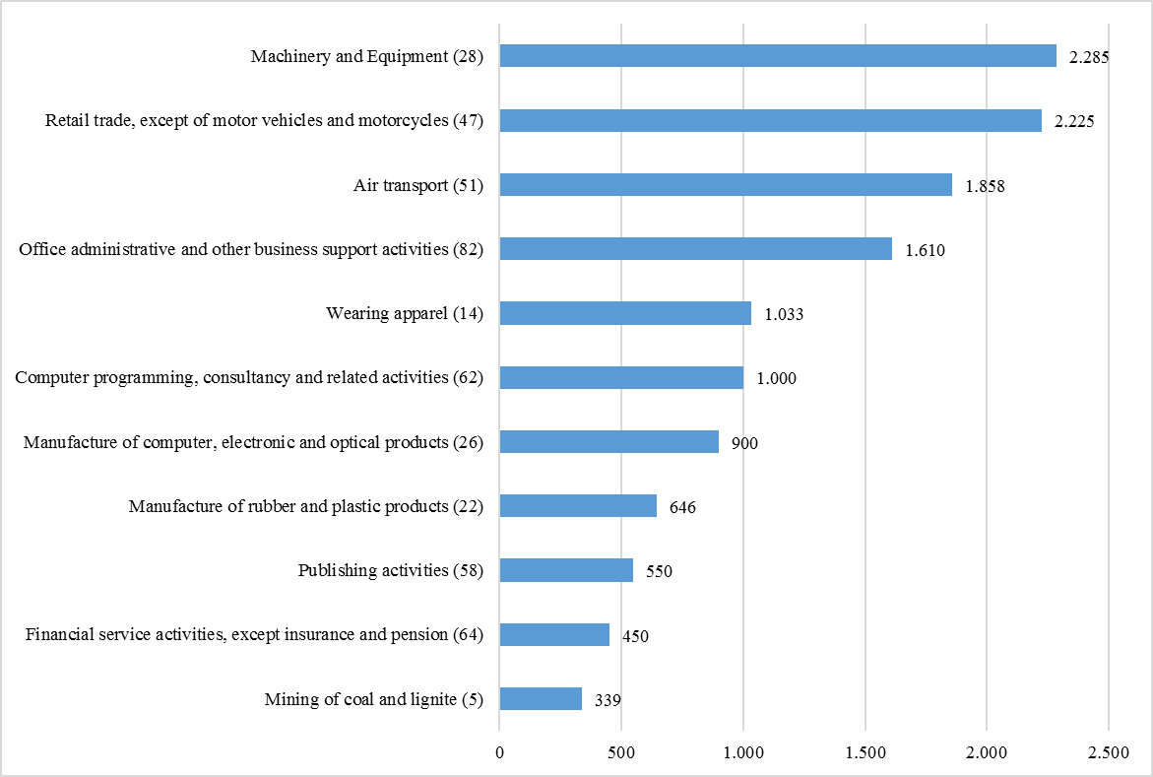

### 2.1.3. Applications submitted by number of targeted beneficiaries per Member State

The total number of beneficiaries (workers and NEETs) targeted for EGF support was 14 051. The numbers of targeted beneficiaries per application ranged from 303 to 2 585, with 6 applications targeting at least 1 000 beneficiaries and 3 applications targeting less than 500 beneficiaries[7] (see Table 1). The average number of targeted beneficiaries per application was 1 081.

From the 14 051 targeted beneficiaries, 12 896 were workers made redundant and 1 155 were NEETs. Finland requested EGF support for the greatest number of workers (2 500), followed by Belgium (2 285) and France (1 858). The three applications in which NEETs were also targeted for support were submitted by Belgium (300 NEETs), Spain (125 NEETs) and Portugal (730 NEETs).

***Chart 2: Number of targeted beneficiaries per Member State in 2017–2018***

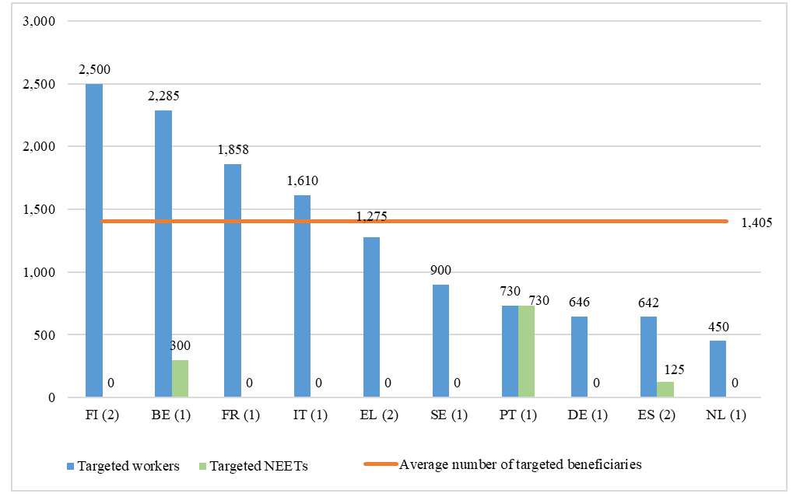

*Number of applications submitted is specified in brackets.*

**Total number of targeted beneficiaries: 14 051**

**Average number of targeted beneficiaries: 1 405**

The 13 applications submitted during the reference period related to 16 133 redundancies, of which 12 896, representing 80%, were targeted by the measures proposed for co-financing by the EGF.

It has to be pointed out that the number of workers affected by a redundancy and the number targeted for EGF support can differ because the Member State may decide to focus only on specific groups of people such as the most vulnerable workers, those facing exceptional difficulties in the labour market and/or the most in need of assistance. The standard support available for redundant workers in Member States might, in some cases, be enough for a quick reintegration into employment or workers might in certain cases choose early retirement.

### 2.1.4. Applications submitted by amount requested

Each Member State applying for EGF support must design a coordinated package of measures that best fits the targeted beneficiaries' profiles, and decide on the amount of assistance to request. Regulation (EU) No 1309/2013 sets out the maximum EGF co-financing rate at 60%.

A total amount of EUR 41 006 837 was requested for EGF support by 10 Member States. France requested the highest amount (EUR 9 894 483 for 1 application), followed by Finland (EUR 6 019 440 for 2 applications) and Greece (EUR 5 257 650 for 2 applications). The EGF requested contributions ranged from EUR 720 000 to EUR 9 894 483 with an average of EUR 3 154 372 per application and EUR 4 100 684 per Member State.

***Chart 3: Total EGF amounts (in EUR) requested per Member State in 2017–2018***

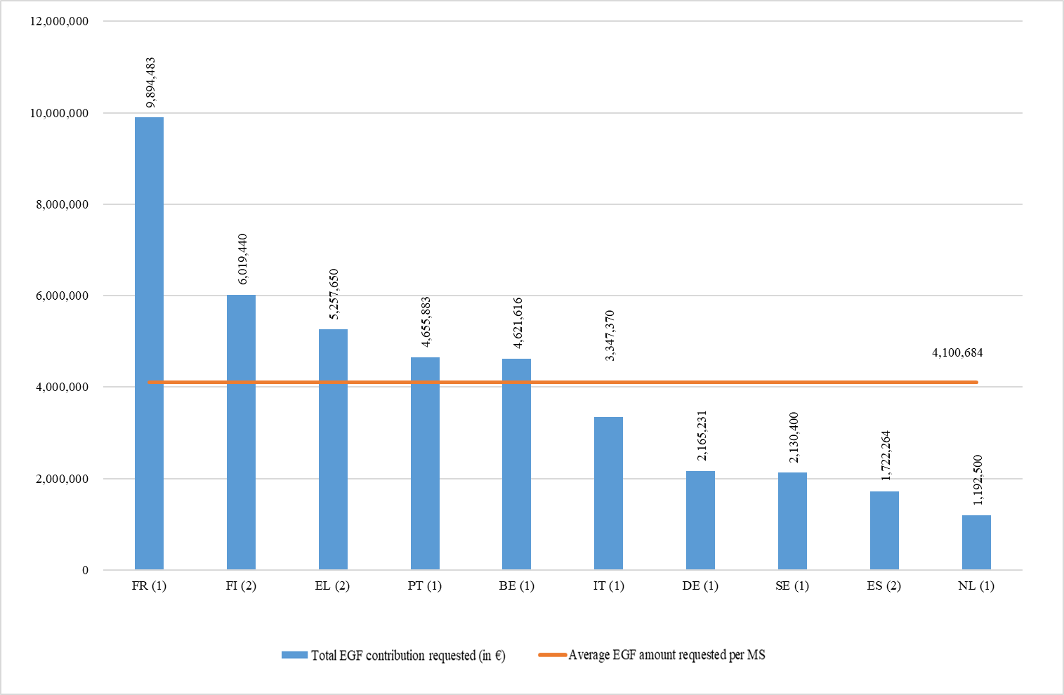

*Number of applications submitted is specified in brackets.*

**Total EGF amount requested: EUR 41 006 837**

**Average EGF amount requested: EUR 4 100 684**

### 2.1.5. Applications submitted by amount requested per beneficiary

Regulation (EU) No 1309/2013 does not limit the total amount requested. The amount requested per targeted beneficiary can therefore vary according to the situation of the affected labour market, the individual circumstances of the targeted beneficiaries, the measures already provided by the Member State, and the cost of providing the services in the Member State concerned. This explains why the proposed amounts of EGF support per beneficiary in 2017 and 2018 varied from EUR 1 666 to EUR 5 325 with an average of EUR 2 918 per targeted beneficiary (as shown in Table 1). The highest average amount per beneficiary has been requested by France (EUR 5 325), followed by Greece (EUR 4 124) and Germany (EUR 3 352).

***Chart 4: EGF amount (in EUR) requested per beneficiary and per Member State   
in 2017–2018***

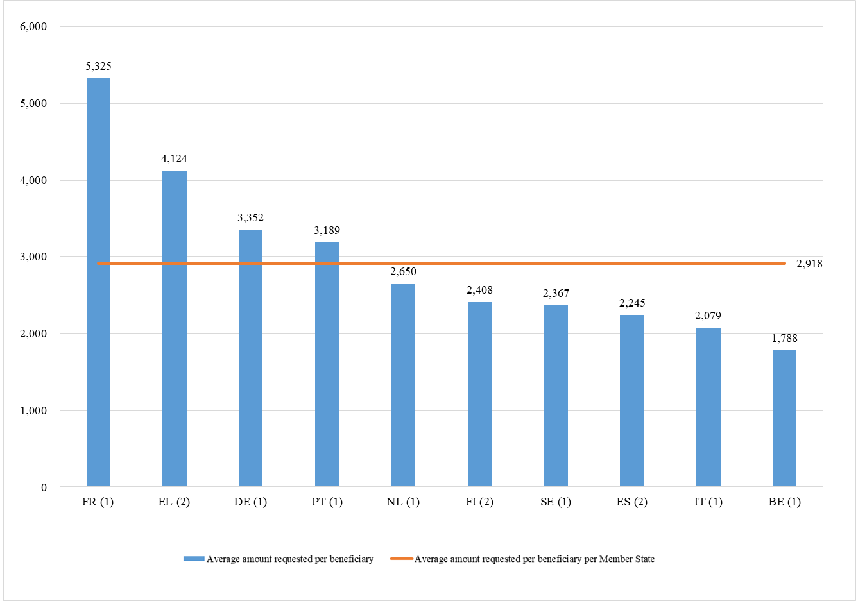

*Number of applications submitted is specified in brackets.*

**Average EGF amount requested per beneficiary: EUR 2 918**

## 2.2. Decisions adopted and contributions granted

The European Parliament and Council adopted seven decisions to mobilise EGF funding in 2017 and eight decisions in 2018. In all cases, the co-financing rate was 60%. Tables 2 and 3 present the details of the funding granted in 2017 and 2018. These two tables include also two applications submitted before 01/01/2017 but adopted in 2017, and therefore cover a different set of cases than Table 1 which presents the applications submitted in 2017 and 2018.

The 15 contributions granted targeted 15 672 beneficiaries (including 1 155 young people not in, employment, education or training[8]) in 10 Member States, with a total amount of EUR 45 467 387 EGF co-funding and an average of EUR 2 901 per targeted beneficiary. From the 14 517 workers targeted (representing 80% of the workers dismissed) 57% were men, 69% were aged 25 to 54 and 98% were EU citizens.

***Table 2: Details of contributions granted in 2017 and 2018***

***(Date of Signature by BA in 2017 and 2018)***



***Table 3: Details of contributions granted in 2017 and 2018***

***Profile of workers targeted (no NEETs included*)***



***Chart 5: Profile of workers targeted per gender***

***Chart 6: Profile of workers targeted per citizenship***

***Chart 7: Profile of workers targeted per age***

### 2.2.1. Actions funded with EGF assistance

Under Article 7 of Regulation (EU) No 1309/2013, a financial contribution from the EGF may be made for active labour market measures that form part of a coordinated package of personalised services, designed to facilitate the reintegration of the targeted beneficiaries and, in particular, disadvantaged, older and young unemployed persons, into employment or self-employment. The measures approved for the 15 EGF contributions granted consisted mainly of the following:

* intensive personalised job search assistance;
* a variety of retraining, upskilling and vocational trainings; horizontal and soft-skills trainings and higher education programmes;
* counselling and mentoring towards reemployment and mentoring during the initial phase of the new job;
* entrepreneurship promotion and contributions to business-start-up;
* one off incentives for quick redeployment and hiring incentives; and
* a variety of allowances (job-search, training) and contributions (commuting, carers of dependant persons).

When designing their support packages, Member States took into account the backgrounds, experiences and educational levels of the individual beneficiaries, their ability to be mobile and the current or expected job opportunities in the regions concerned.

### 2.2.2. Complementarity with actions funded by the European Social Fund (ESF)

The EGF is designed to increase employability and ensure the rapid reintegration of the targeted beneficiaries into employment through active labour market measures, thus complementing the ESF, which is the major EU instrument for promoting employment.

Generally, the complementarity of the two funds lies in their ability to address these issues from two different time perspectives: the EGF provides for redundant workers or self-employed in response to a specific, large-scale mass redundancy which happened within a short period. It offers concrete European support in a crisis situation, whereas the ESF supports – in an anticipatory manner - strategic, long-term goals (e.g. increasing human capital and managing change) through multiannual programmes, whose resources cannot normally be allocated (without amending the operational programme) to deal with crisis situations caused by unexpected mass redundancies.

EGF provides an opportunity to ensure personalised measures that are tailored to the needs of individual redundant workers whereas ESF support is usually more generalised and targets the wider population (both in-work and out of work). Furthermore, the ESF has greater focus on supporting both labour demand and supply (skills, needs and aspirations of beneficiaries) in an integrated manner, while traditionally the EGF is more geared towards the supply side.

EGF and ESF measures are sometimes used by Member States to complement each other to provide both short-term and longer-term solutions. The decisive criterion is the potential of available instruments to help the targeted beneficiaries, and it is up to Member States to select – and to programme – the instruments and actions best suited to achieving the objectives pursued.

The content of the 'coordinated package of personalised services' to be co-financed by the EGF consists of specific personalised services and tailor-made assistance, which go well beyond standard courses and actions. Practice has shown that the EGF allows Member States to offer targeted beneficiaries better tailor-made and more in-depth assistance, including measures to which they would not normally have access (e.g. second- or third-level education).

The EGF allows Member States to pay particular attention to vulnerable people, such as lower-skilled or those with a migrant background, and to provide support with a better counsellor-beneficiary ratio and/or over a longer period of time. This increases the beneficiaries' prospects of improving their situation.

As laid down in Article 9(5) of Regulation (EU) No 1309/2013, all Member States must put in place the necessary mechanisms to avoid any risk of double funding from EU financial instruments. In most Member States, the ESF Managing Authority is also responsible for the implementation of EGF cases. It gives Member States the possibility to seek for complementary between the different interventions. At case level, the EGF commonly builds on existing national or ESF measures by topping them up or by offering different, additional measures. The mid-term evaluation[9] concluded that the EGF created true EU added value by increasing the number and variety of services offered to dismissed workers, and also their level of intensity.

In line with the principle of subsidiarity, the mix of EGF measures designed at Member State level is largely complementary to mainstream ESF provisions to support transitions back to employment. The decision whether to apply for ESF or EGF funding is made at Member State level, on the condition that the ESF operational programme agreed with the Commission is compatible with such support. It is up to the Member State to manage the complementarity between the ESF and EGF in the best possible manner given the local conditions prevailing at the time.

## 2.3. Applications not meeting the conditions for a financial contribution from the EGF

Neither the Commission nor the European Parliament and Council have rejected any application submitted by Member States or reduced the amount of the proposed funding owing to non-eligibility or lack of sufficient appropriations.

## 

## 2.4. Results achieved by the EGF

The main sources of information on the results achieved by the EGF are the final reports submitted by the Member States, six months after the end of the implementation. These are supplemented by information shared by Member States in direct contacts with the Commission, during meetings and conferences and by audit work. The main results and data reported by Member States in 2017 and 2018 are summarised in this section and in Table 4.

***Table 4: Final Reports received in 2017 and 2018***



*\* The labour market status of the beneficiaries provided in this table reflects as a matter of principle the situation at the end of the implementation period.  
** inactive means that people are not available for the labour market any longer for different personal reasons, for example retirement*



*\* The labour market status of the beneficiaries provided in this table reflects as a matter of principle the situation at the end of the implementation period.  
** inactive means that people are not available for the labour market any longer for different personal reasons, for example retirement*



*\* The labour market status of the beneficiaries provided in this table reflects as a matter of principle the situation at the end of the implementation period.  
** inactive means that people are not available for the labour market any longer for different personal reasons, for example retirement*

### 2.4.1. Summary of the results reported in 2017 and 2018

In 2017 and 2018, the Commission received 23 final reports for EGF co-financed cases implemented by eight Member States from November 2013 till March 2018 (see Table 4). These reports showed that 12 723workers (60% of the workers assisted) and 288 NEETs, thus 56% of the 23 030 EGFbeneficiaries, had found new jobs by the end of the EGF implementation period (12 561 as employees, 450 as self-employed). Approximately 2% of the beneficiaries were still in education or training, 38% were unemployed or inactive for various reasons, and for 3% the employment status was not available.

21 out of the 23 cases for which the final reports have been submitted in the reference period, were subject to the mid-term evaluation and have been analysed in their early phase of implementation[10].

Member States' final reports confirmed that the EGF adds value to what the Member States could otherwise do to help the targeted beneficiaries to find new jobs and to reposition themselves on the labour market. The EGF allows Member States to increase the number, variety and intensity of services offered for more targeted beneficiaries and for a longer period of time than would be possible without EGF funding.

### 2.4.2. Reintegration rate for assisted beneficiaries per Member State

Based on the final reports received in 2017 and in 2018, the reintegration rates for assisted beneficiaries per Member State vary from 79% (in Sweden) to 28% (in Greece).

The results in terms of reintegration into work are influenced by absorption capacities of local and regional labour markets in the aftermath of the global economic and financial crisis. Hence, the reintegration rate may differ considerably depending on the economic sector and the area concerned. Furthermore, the reintegration rate is recorded at the end of the implementation period and consequently provides a snapshot of the beneficiaries' employment situation at the moment the data were collected. According to information received from several Member States, reintegration rates tend to rise in the months following the end of the measures and increase further in the medium term.

Member States' institutional capacity and experience to provide assistance in restructuring events is a key to furthering the success of the EGF. Another crucial factor is the degree to which beneficiaries or their representatives are involved from the very start in designing and implementing EGF assistance. It is worth pointing out that the workers supported by EGF measures are usually among those facing the greatest difficulties on the labour market. Therefore the average rate of 60% of assisted workers reintegrated at the end of the implementation period, compared to 47% in the previous reporting period, is an encouraging result. However, it should be acknowledged that the overall improvement of the economic situation in the Member States facilitates the reintegration of workers into the labour market.

***Chart 8: Reintegration rate for assisted beneficiaries per Member State***

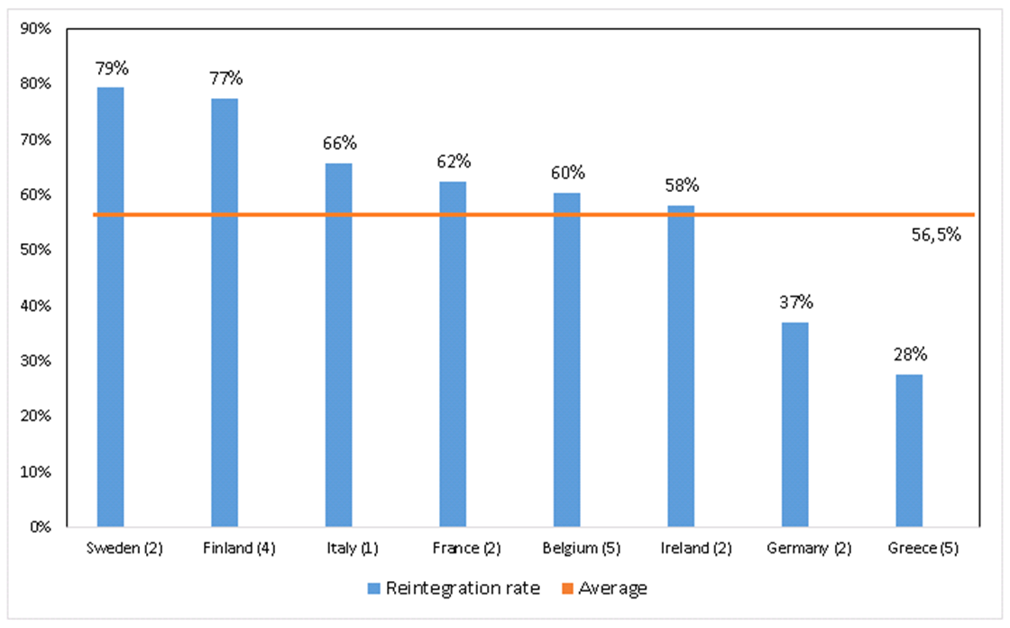

*Number of EGF cases is specified in brackets*

### 2.4.3. Qualitative assessment of the Final Reports submitted in 2017 and 2018

The support packages to the targeted beneficiaries provided by the eight Member States include a wide range of personalised job search, outplacement and (re)qualification measures. The highest amounts were spent on three categories:

* **Individual job search assistance, case management and general information services**: EUR 30.9 million (44% of the total personalised services)
* **Training and retraining**: EUR 26.3 million (38% of the total personalised services)
* **Job search allowances**[11]: EUR 4.4 million (6% of the total personalised services)

The qualification and training programmes were tailored to the needs and wishes of the beneficiaries targeted while taking into account to the extent possible the requirements of the local or regional labour markets and the potentially job-creating sectors.

The EGF assistance helps beneficiaries (redundant workers or NEETs) build-up self-esteem, not only through intense guidance counselling, but also through tailor-made training measures. The EGF often enables beneficiaries to take part in these measures by offering assistance such as mobility allowances or supporting childcare.

In terms of operational effectiveness and efficiency, the EGF cases in Finland (Rauma, Broadcom, Computer programming, Microsoft) can be regarded as very successful and best practice examples. At the end of implementation period, up to 84% of the workers have found reemployment. The number of workers assisted was even higher than the one of the targeted in the applications. The absorption rate[12] was also fairly high: around 80% of the EGF funds were used. Key elements that played an important role in providing such good results include: 1) wide consultation for the preparation and implementation of the EGF measures, including representatives of the dismissed workers, the trade unions, the employers, the regional and national authorities and the local government; 2) experienced regional network of labour offices and regional development offices which, along with the Ministry of Economy and Employment, is very efficient in identification of the beneficiaries, planning, and implementing the EGF measures; 3) service providers experienced in EGF; 4) very quick reaction to the dismissals.

The two Irish cases (Lufthansa Technik, PWA International) can be considered successful and best practice examples. At the end of the implementation period 73% and 79% (respectively) of workers assisted have found employment while one year later even more of them were re-employed and as a result the reintegration rate increased up to 83%. The absorption rate was high: 71% in the first case and 100% in the second. Some of the key reasons for obtaining such good results were: 1) early start of implementation of the measures with own national funding, prior to the mobilisation of Union funds; 2) measures tailor-made to the needs of the dismissed workers, designed following a questionnaire and a survey of workers’ preferences; 3) setting-up of a national EGF coordination unit, located close to the redundant workers so that they could build a relationship; 4) flexibility of choosing a specifically tailored training, second and third level education programmes.

France provided an example of complementarity when the national authorities decided to prolong for an additional 12 months after the EGF intervention the support to the former workers of MoryGlobal who were still unemployed.

The network built by the Italian institutions and the social partners, the implementing bodies and the employment centres on the occasion of the case Alitalia will likely be further developed to tackle future restructuring events.

The Volvo Trucks case in Sweden is a good practice example of EGF supporting all dismissed workers, including temporary workers who would have been outside national programming. The quick and timely reaction to the dismissals was a main priority and resulted in a high (84%) reintegration rate. The various stakeholders collaborated well.  There was a clear complementarity with the national labour market measures and the ESF. Sweden re-allocated the budget between the measures in order to adapt to the changing needs during the implementation period which optimised the use of the available funds.

The Ford Genk case in Belgium is an example of the EGF intervention being a part of a wider policy framework aimed at minimising the consequences of mass redundancies in a region. A strategic action plan for the region of Limburg called ‘SALK’ (Strategisch Actieplan voor Limburg in het Kwadraat) was prepared following the closure of the Ford plant. EGF addressed the short-term consequences (employment impact) of the wide ranging consequences of this event. The long-term actions focusing on improving conditions for economic growth have been supported by the national funding. Lessons learned from this comprehensive approach are being shared with other regions in Belgium which are also looking into similar, all-inclusive support packages.

The EGF cases in Germany have supported innovation in the area of the employers’ engagement. The provision of dedicated services (job scouts) to employers has been mainstreamed into the EGF support. These services have been highly efficient in sourcing vacancies and significantly reduced the cost per beneficiary in the EGF Aleo Solar case.  In the Adam Opel case 'speed dating' events bringing together, in an informal way, jobseekers with employers who have open positions were considered to be extremely successful and would not have been available through national funding mechanisms.

In cases implemented in Belgium (Hainaut Namur Glass, Hainaut Machinery), Greece (Sprider Stores, Odyssefs Fokas, Supermarket Larissa) and Ireland (Lufthansa Technik, PWA International), young people not in employment, education or training were given priority to participate in the EGF measures along with the redundant workers. Evidence shows that, especially in Ireland and in Greece, the help offered has been picked up to a large degree by the young people targeted and has provided them with assistance that they would not have received through national mainstream services. However one of the key challenges in delivering support to NEETs was engaging and activating them through different outreach activities, which took up significant time and resources.

## 2.5. Financial execution

### 2.5.1. Funds contributed by the EGF

In 2017 and 2018, the Budgetary Authority approved 15 contributions from the EGF totalling EUR 45 467 387[13] (see Table 2), out of which EUR 17 778 774 were mobilized in 2017, and EUR 27 688 613 in 2018.

For the period 2014-2020, the maximum annual financial ceiling for EGF is EUR 150 million (2011 prices)[14]. This means that commitment appropriations of EUR 168 924 000 in 2017 and, EUR 172 302 000 in 2018 were made available for EGF.

In terms of payment appropriations, a total amount of EUR 45 467 387 was credited to the EGF budget line in 2017 and 2018. The pre-financing payments[15] amounted to EUR 17 778 774 in 2017 and to EUR 27 688 613 in 2018.

### 2.5.2. Technical assistance expenditure

According to Article 11(1) of Regulation (EU) No 1309/2013, up to 0.5% of the EGF financial resources available for the year (EUR 844 622 in 2017 and EUR 861 514 in 2018) can be used for technical assistance at the initiative of the Commission. This amount is to be used to finance activities necessary to implement the regulation, such as preparation, monitoring, data gathering, creation of a knowledge base, administrative and technical support, information and communication activities, as well as audit, control and evaluation.

The Budgetary Authority made available EUR 310 000 and EUR 345 000 for 2017 and 2018 respectively for technical assistance to finance the aforementioned activities.

***Table 5.1: Technical assistance expenditure in 2017***



***Table 5.2: Technical assistance expenditure in 2018***



### 2.5.3. Irregularities reported

No irregularities were reported to the Commission either under Regulation (EC) No 1927/2006[16] or Regulation (EU) No 1309/2013 in 2017 and 2018.

### 2.5.4. Winding-up of EGF financial contributions

The procedures for winding up EGF financial contributions are laid down in Article 18 of Regulation (EU) No 1309/2013. 29 cases, implemented between 2011 and 2018*,* were wound up in 2017 and 2018. Details of the cases are set out in Table 6.

An EGF case is wound up when the final report with all required information has been sent to the Commission, all outstanding reimbursements have been paid and no further action needs to be taken by the Member State or the Commission, apart from the obligation to keep available for the Commission and the Court of Auditors all supporting documents for three years (Article 21(5) of Regulation (EU) No 1309/2013).

The average absorption rate[17] of the cases wound up was 68.2%, and varied between 1.66%[18] and 100%. The total amount of unspent funds reimbursed to the Commission was EUR 36 671 426, representing 31.8% of the EGF contributions granted for these 29 cases. This recovery rate is a positive development compared to the findings of the ex-post evaluation of EGF 2007-2013[19], which showed that on average 45% of allocated funds, were unspent by the Member States.

There are various reasons why Member States did not use the full amounts granted. While Member States are encouraged to make realistic budget estimates for the coordinating package of personalised services, there can be a lack of accurate and informed planning. They also tend to include a high safety margin in their initial calculations. The number of workers wishing to participate in the proposed measures tends to be overestimated in the planning phase. Some workers have opted for cheaper measures rather than more expensive ones or for short-term rather than long-term measures or they have found new jobs sooner than initially estimated. Other reasons for low spending have been delays in starting up the measures and insufficient use of the available flexibility to reallocate funds between budget items while implementing the package of personalised services.

The Commission continues to offer guidance to Member States to encourage optimal fund management and improve the implementation rate, already at the application stage.

The budgeting of the measures and the forecasting of workers participation over the 24-month period are expected to improve with experience. The Commission is also seeing improvements in the timing of the arrival of the EGF funding in the affected area, the capacities of the various coordination and implementation structures and the quality of communication between the national and the regional/local levels. Member States are making better use of the possibility to review their budgets and reallocate expenditure between the various measures and/or implementing expenditure.

***Table 6: Cases wound up in 2017 and 2018***







## 2.6. Technical assistance activities undertaken by the Commission

### 2.6.1. Information and publicity: Internet site

Article 12(2) of Regulation (EU) No 1309/2013 requires the Commission to set up, maintain and update an internet website, available in all EU languages, to provide information on the EGF, guidance on the submission of applications, as well as updated information on accepted and rejected applications, and on the role of the Budgetary Authority.

The Commission's EGF internet site[20] was regularly updated with relevant information in 2017 and 2018.

### 2.6.2. Meetings with the national authorities and EGF stakeholders

The 19th, 20th, 21st and 22nd meetings of the Contact Persons of the EGF, who are the Member States' correspondents for the EGF, were held in March and October 2017 and in March and October 2018. Part of each meeting was devoted to the ongoing and planned EGF applications, the System for Fund Management in the European Union (SFC2014), the EGF mid-term evaluation 2014-2020, legal and auditing matters, the Omnibus Regulation and the Commission proposal for the post-2020 regulation, as well as a range of other relevant issues.

Additionally, an extra-ordinary EGF Contact Persons Working Group was organised in January 2018 in order to discuss the possible scenarios for the EGF post 2020.

Four EGF Networking Seminars were organised in 2017 and in 2018. The topics were as follows:

* The role and representation of the beneficiaries in the design and implementation of EGF cases.
* EGF in Finland: Expertise supporting the growth of businesses.
* Synergies and complementarity between EGF and other EU funds.
* How can the EGF deliver on the European Pillar of Social Rights?

Furthermore, the seminars were complemented by project visits which gave the opportunity to exchange of experience between peers and meeting with beneficiaries. All four seminars were well attended by Member States’ representatives, stakeholders and EGF implementing bodies.

### 2.6.3. Electronic data exchange system (SFC2014)

In 2014, the Commission sought to simplify procedures further by including the EGF in the electronic data exchange system with Member States, the System for Fund Management in the European Union (SFC2014). Since April 2015, Member States submit EGF applications online through a guided application process and since August 2016 they also submit EGF Final Reports via SFC2014. Using the System for Fund Management in the European Union for the EGF resulted in more correct and complete applications being submitted as the platform provides the opportunity for the Member States to share data with the Commission before the official submission of an application. It made the collection and processing of data easier and the reporting on EGF results faster. Applying for EGF support through the System for Fund Management in the European Union has contributed to reducing the time between submission of an application by a Member State and adoption by the European Parliament and the Council of the proposal submitted by the Commission.

Further improvements in the System for Fund Management in the European Union in 2017 and 2018 included storage of all EGF data in a central drive, translation of the EGF Final Report module in all official languages of the European Union, development of a reporting module for the employment status 12 months after submission of the final report and the possibility for the Commission to generate a report with the employment results using the reporting tool called LaunchPad.

### 2.6.4. EGF mid-term evaluation[21] 2014 -2020

In accordance with Article 20 of Regulation (EU) No 1309/2013, the Commission carried out on its own initiative a mid-term evaluation of the EGF. The aim of the evaluation was to scrutinise the effectiveness, sustainability, efficiency, coherence, relevance and EU added value of the EGF. The mid-term evaluation is presented in the form of a Commission Staff Working Document[22] which is based on an external contractor’s evaluation study[23] conducted in 2016 and which was covered by the Technical Assistance budget. The outcomes and the evaluators’ recommendations were presented to the EGF stakeholders during the Contact Persons Meeting in Tallinn on 19 October 2017. The final report outlines a variety of qualitative and quantitative information.

The main results of the mid-term evaluation were summarised in the Commission’s report[24] and fed into the proposal for a Regulation of the European Parliament and of the Council of the European Globalisation Adjustment Fund published on 30 May 2018[25].

The Commission’s mid-term evaluation concluded that the EGF created true EU added value by increasing the number and variety of services offered to dismissed workers, and also their level of intensity. The assistance offered helped boost the beneficiaries’ self-esteem, who then took a more proactive approach in job-seeking. The EGF also proved to be effective. In comparison to the previous funding period, the reintegration rate of dismissed workers into the job-market improved from 49% to 56%.

According to the mid-term evaluation, further improvement is necessary regarding the length of the decision-making process, and the documentation that needs to be submitted along with an application. The terms “globalisation” and “economic crisis” are not clearly defined, and Member States are unsure how to substantiate an application. As a consequence of the way globalisation is evolving, rendering it difficult to single out one specific factor that led to a restructuring event, the evaluation questions whether mobilisation of the EGF assistance should depend on the cause of the dismissals. Considering that many jobs are lost due other factors such as technological change widening the scope would also seem to be more inclusive.

# 3. EGF policy development

## 3.1. Amendment of Regulation (EU) 1309/2013 as part of Regulation (EU) 2018/1046[26]

As part of a wider amendment of the EU financial rules, Regulation (EU, Euratom) 2018/1046 of the European Parliament and of the Council of 18 July 2018 on the financial rules applicable to the general budget of the Union, amending Regulations (EU) No 1296/2013, (EU) No 1301/2013, (EU) No 1303/2013, (EU) No 1304/2013, (EU) No 1309/2013, (EU) No 1316/2013, (EU) No 223/2014, (EU) No 283/2014, and Decision No 541/2014/EU and repealing Regulation (EU, Euratom) No 966/2012, certain provisions of the EGF Regulation (EU) 1309/2013 were also revised.

The original EGF Regulation provided for a derogation to support NEETs until the end of 2017. The amended EGF Regulation[27] continues the assistance to NEETs until the end of 2020, in regions where the youth unemployment rate is above 20%. It also provides for extended support to regions hit by large number of redundancies and where small and medium-sized enterprises are the main or the only type of business.

## 3.2. EGF legislative proposal post-2020[28]

Based on the results of EGF mid-term evaluation, the Commission put forward a legislative proposal for the EGF post 2020 which was preceded by an impact assessment[29]. The Commission conducted this impact assessment comprising all funds relevant in the area of employment and social affairs. These funds that are key in delivering on the European Pillar of Social Rights and the social and employment priorities endorsed by the European economic governance process:

* the European Social Fund (ESF);
* Youth Employment Initiative (YEI);
* the Fund for European Aid to the Most Deprived (FEAD);
* the European Globalisation Adjustment Fund (EGF);
* the EU Health programme; and
* the Employment and Social Innovation (EaSI) programme.

As the funds complement each other in contributing to the same policy objective, the impact assessment covered them jointly or according to their specific properties, as appropriate.

The impact assessment studied the option to merge the EGF with the other funds but in order to keep the visibility of the fund, the study suggested to keep the EGF as a separate fund.

The Commission took into account the main outcomes of the impact assessment in its proposal for a Regulation post-2020.

Given that the main purpose of the EGF is to rapidly provide financial support in situations of urgency and in specific unforeseen circumstances, the Commission proposes to keep the fund as a flexible and special instrument outside the budgetary ceilings of the Multi-annual Financial Framework. The EGF thus does not have an annual budget, that is expected to be spent, but funding up to a maximum annual ceiling that may be mobilised if needed. The Commission proposes that the maximum amount which could be used by the EGF for the 2021-2027 period is EUR 1.578 billion (in current prices) with an average of EUR 225 million (in current prices) per year.

The Commission’s proposal contains a maximum amount available for EGF for the period 2021-2027. However, the Commission suggests an open-ended EGF regulation, not limited to the duration of the Multi-annual Financial Framework. This will simplify the legislative process and allow flexibility to agree on the maximum amount for the future programming period according to the needs of the constantly changing labour market conditions.

In order to ensure the EGF remains fit-for-purpose to respond to changes in the labour market and economic challenges, the Commission proposes the following improvements:

* Broader scope - workers displaced because of unexpected major restructuring events, caused not only by globalisation-related challenges or financial or economic crises, but also by the transition to low-carbon economy, digitisation or automation.
* Reduction of the threshold of dismissed workers (from 500 to 250) - better reflecting the average size of today’s businesses where in many Member States most workers are employed by small and medium-sized entreprises. The dismissal of 250 workers has a significant impact on the labour market in most regions.
* The alignment of the EGF co-financing rate (which currently stands at 60%) with the highest ESF+ co-financing rate for the given Member State will encourage countries to apply for funding in the most efficient manner.
* Faster application process and mobilisation procedure - expected to reduce the administrative burden linked to extensive justification of an application required from Member State and faster decision-making process.

To better analyse the EGF's effectiveness the Commission proposes to extend the number of common output and results indicators in order to collect more detailed monitoring data, especially on the category of workers (professional and educational background), their employment status and the type of employment found.

1. Including two applications submitted in 2016.
2. Communication: "A Modern Budget for a Union that Protects, Empowers and Defends”, COM(2018) 321 available at: <https://eur-lex.europa.eu/legal-content/EN/TXT/?uri=COM%3A2018%3A321%3AFIN>
3. Set up by Regulation (EC) No 1927/2006 of the European Parliament and of the Council of 20 December 2006 on establishing the European Globalisation Adjustment Fund, amended by Regulation (EC) No 546/2009 of the European Parliament and of the Council of 18 June 2006 and subject to Regulation (EU) No 1309/2013 of the European Parliament and of the Council of 17 December 2013 on the European Globalisation Adjustment Fund (2014-2020) and repealing Regulation (EC) No 1927/2006
4. Article 4(1)(b) of the EGF Regulation requires that at least 500 workers are made redundant over a reference period of nine months in enterprises operating in the same economic sector defined at NACE Revision 2 Division and located in one region or two contiguous regions defined at NUTS 2 level in a Member State. Two applications submitted were derogated from these criteria. In line with Article 4 (2) of the EGF Regulation, this was justified because of exceptional circumstances and because the case happened in a small labour market.
5. See footnote 4
6. NACE Rev. 2 - Statistical classification of economic activities in the European Community: <https://ec.europa.eu/eurostat/web/products-manuals-and-guidelines/-/KS-RA-07-015>
7. Two of these cases targeted all redundant workers, whose number was nevertheless below 500, as the applications have been submitted under Article 4(2) of Regulation (EU) No 1309/2013.
8. The applications do not contain any information on the profile of NEETs, thus they cannot be broken down by gender, citizenship, age or disabilities.
9. See section 2.7.4 on mid-term evaluation 2014-2020
10. See section 2.7.4 on mid-term evaluation 2014-2020.
11. Regulation (EU) No 1309/2013 has capped allowances to a maximum of 35% of the total cost of personalised services.
12. Absorption rate is the percentage of the EGF financial contribution that was spent by the Member State within the 24-month period specified in the application.
13. This amount does not include technical assistance decisions at the initiative of the European Commission.
14. Article 12 of Council Regulation (EU, Euratom) No 1311/2013 of 2 December 2013 laying down the multiannual financial framework for the years 2014-2020
15. The EGF contribution is paid to the MS in a single instalment as a 100% pre-financing within 15 days of the approval by the Budgetary Authority of the EGF mobilising decision.
16. 13 cases wound up in 2017 and 2018 were submitted under Regulation (EC) No 1927/2006.
17. See definition in footnote 12
18. In the Alitalia case a number of workers declined participating in the active job-search support, mostly because they had already found a job. For two measures, the implementing bodies did not request EGF support for the service provided.
19. Available at: <https://publications.europa.eu/en/publication-detail/-/publication/8c4ba2de-ce2f-11e5-a4b5-01aa75ed71a1/language-en>
20. Available in 24 EU languages at: <https://ec.europa.eu/social/main.jsp?catId=326&langId=en>
21. The mid-term evaluation covers 29 funded applications in 10 countries received in 2014 and 2015.
22. SWD(2018) 192 available at : <https://eur-lex.europa.eu/legal-content/EN/TXT/?qid=1562591970533&uri=CELEX:52018SC0192>
23. Available at: <https://publications.europa.eu/en/publication-detail/-/publication/57273012-b7cb-11e8-99ee-01aa75ed71a1/language-en>
24. COM(2018) 297 available at: <https://eur-lex.europa.eu/legal-content/EN/TXT/PDF/?uri=CELEX:52018DC0297&qid=1538573624938&from=EN>
25. COM(2018) 380 final available at: <https://eur-lex.europa.eu/legal-content/EN/TXT/?uri=COM%3A2018%3A380%3AFIN>)

   
26. Available at: <https://eur-lex.europa.eu/legal-content/EN/TXT/?uri=CELEX%3A32018R1046>
27. See footnote 25, Art. 274 of Regulation (EU, Euratom) 2018/1046
28. See footnote 24
29. SWD(2018) 289 available at: <https://ec.europa.eu/transparency/regdoc/rep/10102/2018/EN/SWD-2018-289-F1-EN-MAIN-PART-1.PDF>