

**TABLE OF CONTENTS**

1. Cumulative data for the current programming period (1 January 2014-31 December 2018) 2

Chart 1: Number of applications submitted 2

Chart 2: Number of applications per sector 3

Chart 3: Number of targeted workers per sector 4

Chart 4: Number of targeted beneficiaries per Member State 5

Chart 5: Number of dismissed, targeted and assisted workers 6

Chart 6: Number of dismissed, targeted and assisted workers per Member State 7

Chart 7: EGF amounts requested per Member State 8

Chart 8: Average EGF amount requested per beneficiary and per Member State 9

Table 1: Final Reports submitted 10

2. Cumulative data between 2007 and 2018 13

Table 2: EGF applications submitted per Member State and per application type 13

Chart 9: Number of applications submitted 14

Chart 10: Number of targeted workers per Member State 15

Chart 11: EGF amount requested per Member State 16

Chart 12: Average EGF amount requested per beneficiary and per Member State 17

Table 3: EGF applications per sector 18

Chart 13: Number of applications per sector 21

Chart 14: Number of targeted workers per sector 22

# **1. Cumulative data for the current programming period (1 January 2014-31 December 2018)**

Every year, more data are available to identify trends in applications and to present an overview of the direction of the fund's activities. The data in the following charts and Table 1 relate to 48 applications[1] submitted by Member States (MS) between 2014 and 2018 under Regulation (EU) No 1309/2013 of the European Parliament and of the Council of 17 December 2013 on the European Globalisation Adjustment Fund (2014-2020) and repealing Regulation (EC) No 1927/2006. A total of EUR 155 366 514 has been requested so far for measures in favour of 49 062 targeted beneficiaries[2].

## ***Chart 1: Number of applications submitted between 2014 and 2018***

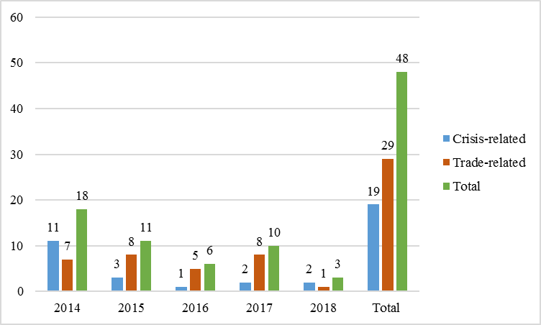

Between 2014 and 2018 the Commission received 19 crisis-related applications and 29 trade-related applications. The total number of applications received each year is volatile with an average of about 10 applications per year. As shown in Table 2 of the Annex, in the current programming period Greece has submitted the highest number of applications (8), followed by Finland (7) and Belgium (6).

## ***Chart 2: Number of applications per sector* (NACE Rev. 2) between 2014 and 2018***

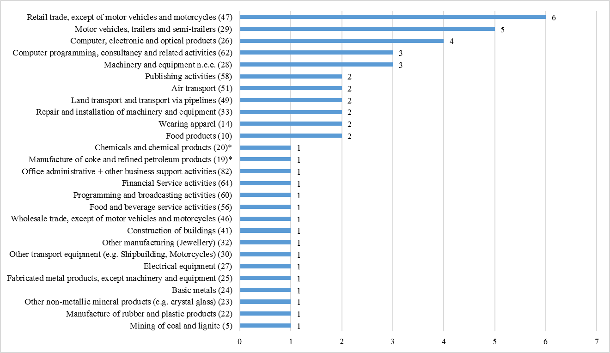

*\*EGF/2016/003 EE/Petroleum and chemicals case refers to two different sectors (19 and 20) and has therefore been counted twice.*

**Total number of sectors: 27**

From 2014 to 2018 the Commission received 48 applications related to a broad range of sectors (27). The greatest number of applications was submitted for the retail trade sector (6), followed by motor vehicles, trailers and semi-trailers (5), and computer, electronic and optical products sectors (4).

Details of the applications submitted per sector are set out in Table 3 of the Annex.

## ***Chart 3: Number of targeted workers per sector (NACE Rev. 2) between 2014 and 2018***

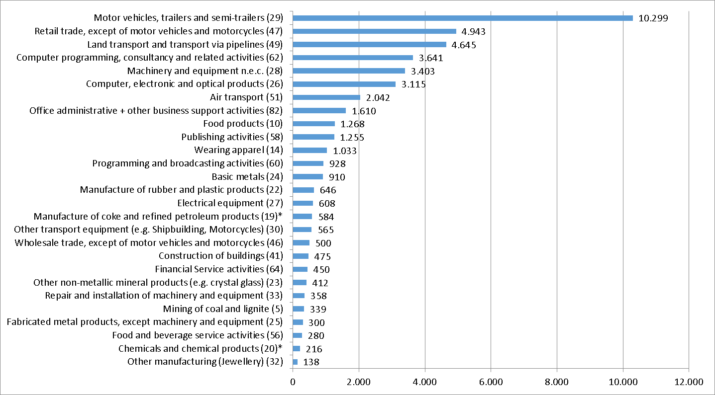

*\*EGF/2016/003 EE/Petroleum and chemicals case refers to two different sectors (19 and 20). The number of targeted workers in these sectors are provided on a prorate basis, reflecting the composition of the group of redundant workers.*

**Total number of targeted workers in 27 sectors: 44 963**

Between 2014 and 2018, the Commission received EGF applications submitted by 12 Member States for 44 963 targeted workers in 27 different sectors. The greatest number of targeted workers were in the sector motor vehicles, trailers and semi-trailers (10 299), followed by the retail trade sector (4 943) and land transport sector (4 645).

## ***Chart 4: Number of targeted beneficiaries per Member State between 2014 and 2018***

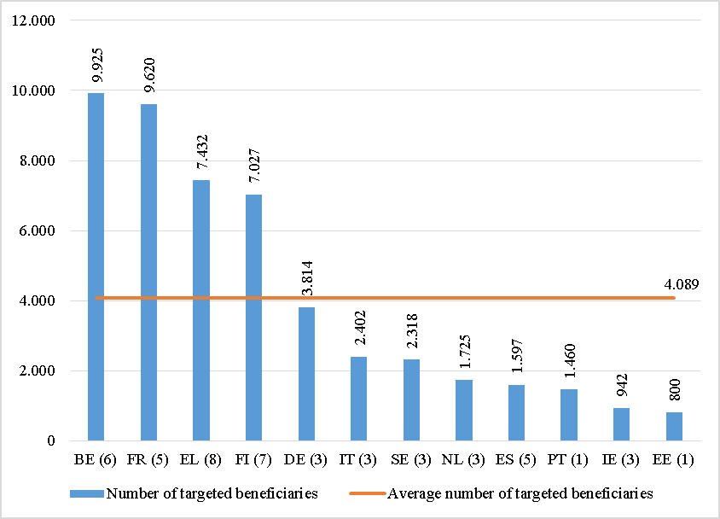

*Number of applications is specified in brackets.*

**Total number of targeted beneficiaries: 49 062**

**Average** **number of targeted beneficiaries: 4 089**

Between 2014 and 2018 the applications submitted from the 12 Member States targeted 49 062 beneficiaries (workers and young people not in employment, education or training (NEETs). Belgium requested support for the greatest number of beneficiaries (9 925) followed by France (9 620) and Greece (7 432).

The number of targeted beneficiaries includes workers and NEETs. Twelve applications submitted by five Member States over 2014 – 2018 period targeted 4 099 NEETs. Member States, which applied for support for NEETs were: Greece (4 applications – 2 098 NEETs), Belgium (3 applications – 700 NEETs), Ireland (3 applications – 446 NEETs), Portugal (1 application – 730 NEETs), and Spain (1 application – 125 NEETs).

Details of the applications per year and per Member State are set out in Table 2 of the Annex.

## ***Chart 5: Number of dismissed, targeted and assisted workers* between 2014 and 2018***

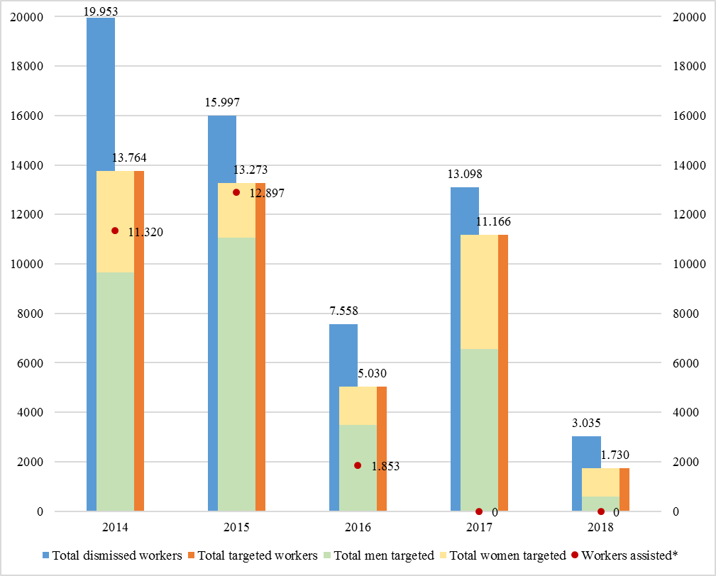

*\*For 17 cases Final Reports have not been submitted by 31 December 2018, therefore the number of assisted workers is only partly available for 2016 and not available for 2017 and 2018.*

**Total number of dismissed workers: 59 641**

**Total number of targeted workers: 44 963**

**Total number of assisted* workers: 26 070**

Between 2014 and 2018, 48 applications were submitted requesting EGF contribution for a total of 44 963 targeted workers (including 31 327 men and 13 636 women) and representing 75% of 59 641 total dismissed workers.

## ***Chart 6: Number of dismissed, targeted and assisted workers* per Member State***

## ***between 2014 and 2018***

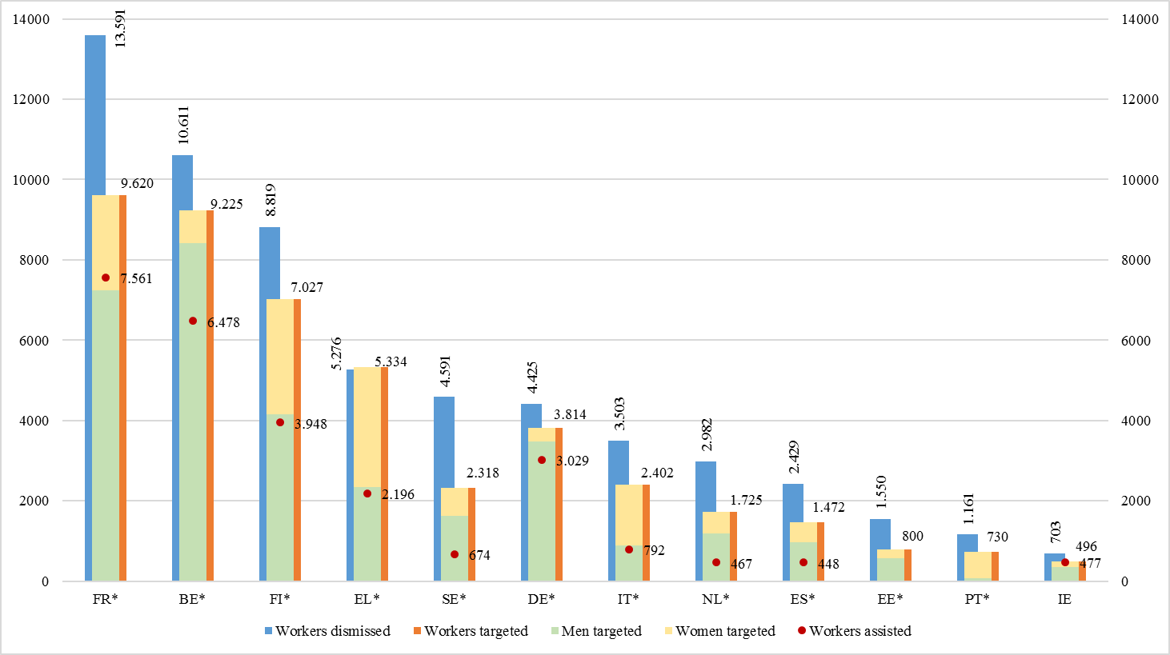

*\*Member States marked with an asterisk still have EGF cases under implementation, therefore the total number of assisted workers is not yet finalised.*

**Total number of dismissed workers: 59 641**

**Total number of targeted workers: 44 963**

**Total number of assisted* workers: 26 070**

Between 2014 and 2018 France requested support for the greatest number of targeted workers (9 620 representing 71% of the workers dismissed), followed by Belgium (9 225 representing 87% of the workers dismissed), and Finland (7 027 representing 80% of the workers dismissed).

## ***Chart 7: EGF amounts requested (in EUR) per Member State between 2014 and 2018***

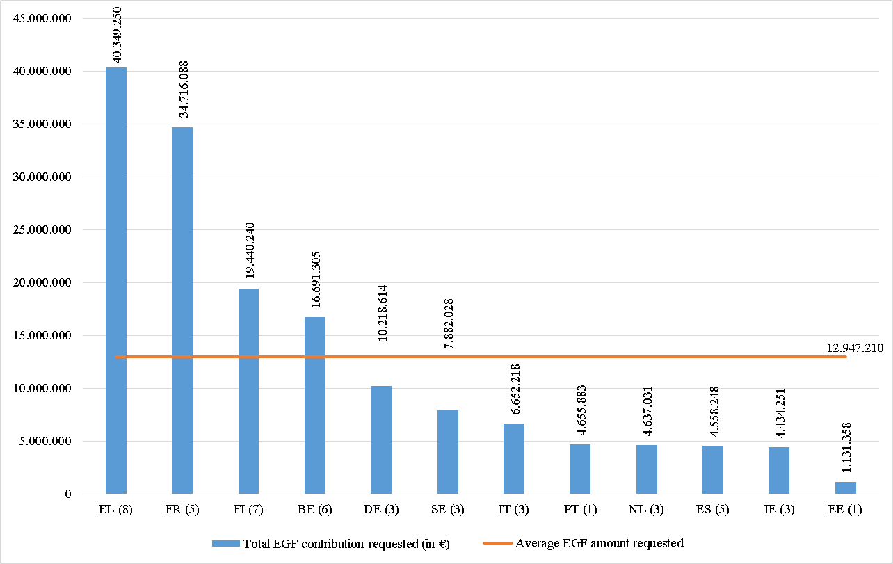

*Number of applications is specified in brackets.*

**Total EGF amount requested: EUR 155 366 514**

**Average EGF amount requested: EUR 12 947 210**

A total amount of EUR 155 366 514 was requested for EGF support by 12 Member States between 2014 and 2018. Greece requested the highest amount (EUR 40 349 250 for eight applications), followed by France (EUR 34 716 088 for five applications), and Finland (EUR 19 440 240 for seven applications).

Details of the applications per year and per Member State are set out in Table 2 of the Annex.

## ***Chart 8: Average EGF amount requested (in EUR) per beneficiary and per Member State between 2014 and 2018***

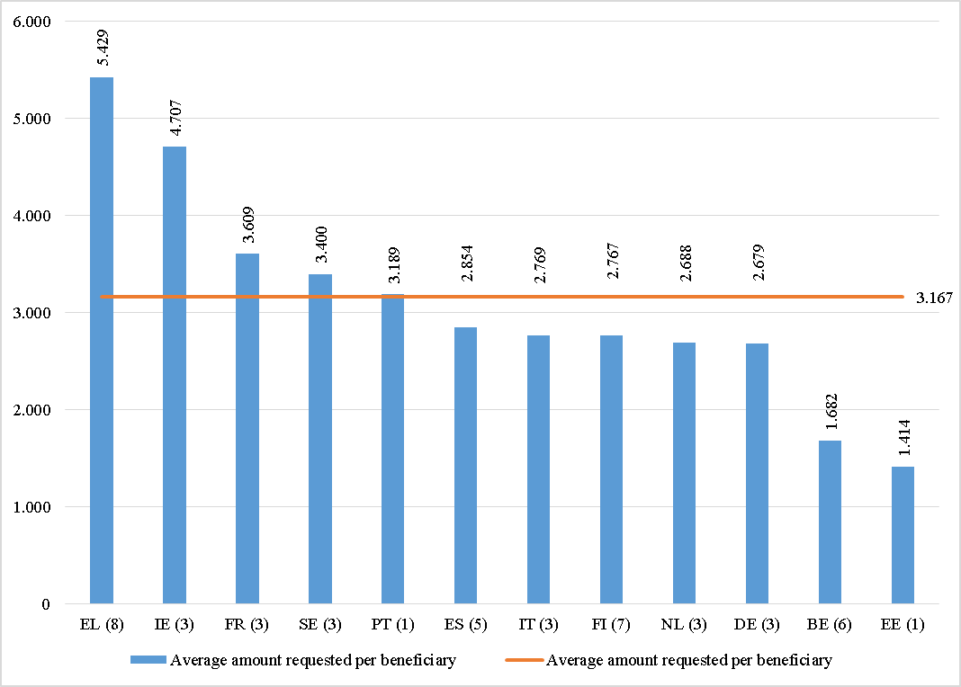

*Number of applications is specified in brackets.*

**Average EGF amount requested per beneficiary: EUR 3 167**

On average, each of the 12 Member States applying for EGF support between 2014 and 2018, requested EUR 3 167 per targeted beneficiary. The highest average amount per beneficiary was requested by Greece (EUR 5 429), followed by Ireland (EUR 4 707) and France (EUR 3 609).

## ***Table 1: Final Reports submitted between 2014 and 2018***



* The labour market status of the beneficiaries provided in this table reflects as a matter of principle the situation at the end of the implementation period.

** inactive means that people are not available for the labour market any longer for different personal reasons, for example retirement .



* The labour market status of the beneficiaries provided in this table reflects as a matter of principle the situation at the end of the implementation period.

** inactive means that people are not available for the labour market any longer for different personal reasons, for example retirement .



* The labour market status of the beneficiaries provided in this table reflects as a matter of principle the situation at the end of the implementation period.

** inactive means that people are not available for the labour market any longer for different personal reasons, for example retirement .

# **2. Cumulative data between 2007 and 2018**

## ***Table 2: EGF applications submitted up to 31 December 2018 per Member State and application type***

## ***(without rejected and withdrawn applications)***



## ***Chart 9: Number of applications submitted between 2007 and 2018***

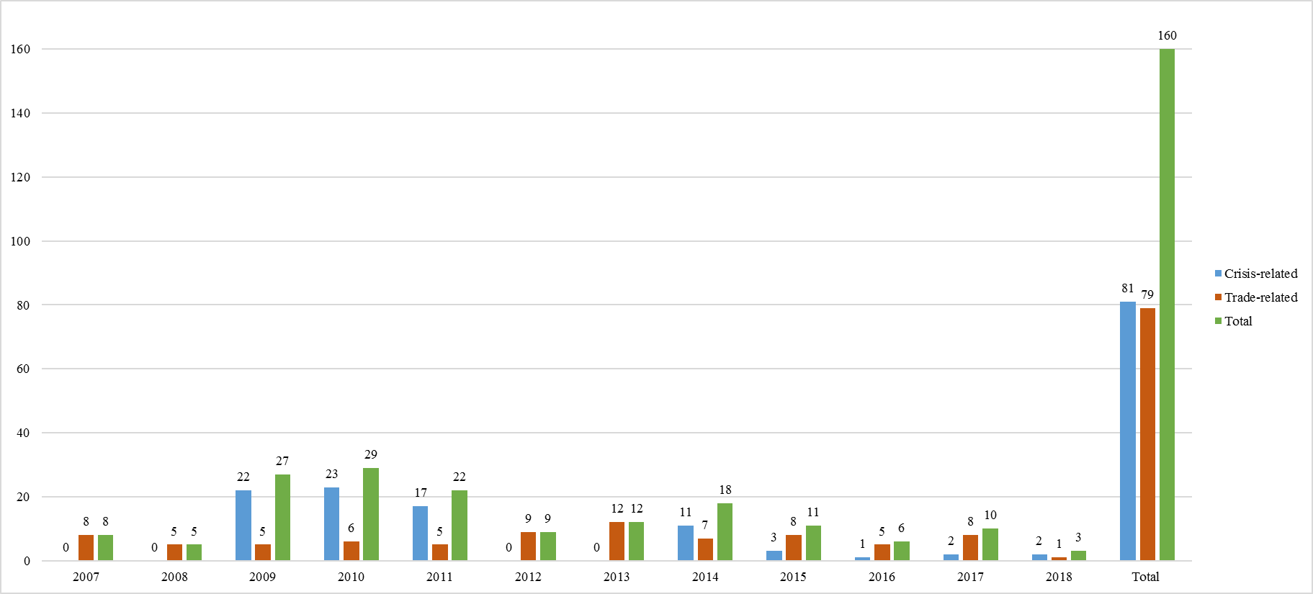

Between 2007 and 2018 the Commission received 81 crisis-related applications and 79 trade-related applications. The total number of applications received each year is volatile with an average of about 13 applications per year.

## ***Chart 10: Number of targeted workers per Member State between 2007 and 2018***

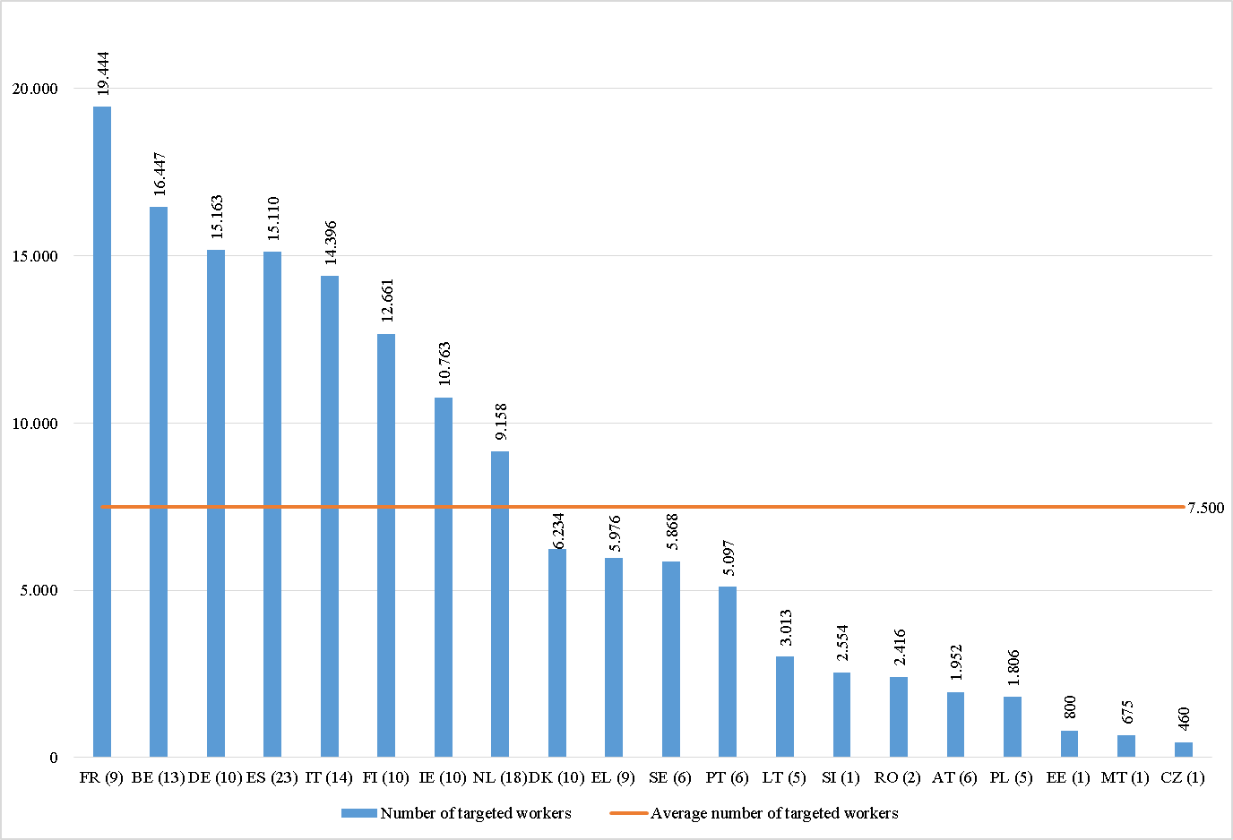

*Number of applications is specified in brackets.*

**Total number of targeted workers: 149 993**

**Average** **number of targeted workers: 7 500**

From 2007 to 2018, 160 applications submitted (excluding withdrawn or rejected) by 20 Member States targeted 149 993 workers. France requested support for the greatest number of workers (19 444 for 9 cases), followed by Belgium (16 447 for 13 cases), and Germany (15 163 for 10 cases).

## ***Chart 11: EGF amount requested (in EUR) per Member State between 2007 and 2018***

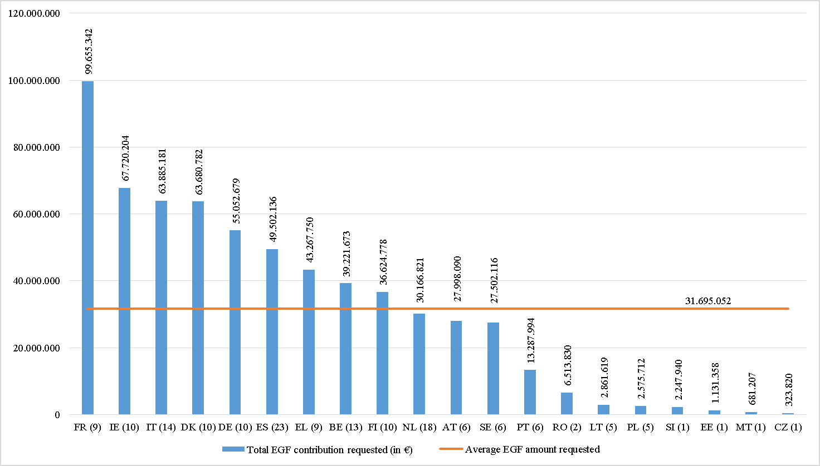

*Number of applications is specified in brackets.*

**Total EGF amount requested: EUR 633 901 032**

**Average EGF amount requested: EUR 31 695 052**

A total amount of EUR 633 901 032 was requested from the EGF by 20 Member States between 2007 and 2018. France requested the highest amount of EGF co-financing (EUR 99 655 342 for 9 applications), followed by Ireland (EUR 67 720 204 for 10 applications), and Italy (EUR 63 885 181 for 14 applications).

## ***Chart 12: Average EGF amount requested (in EUR) per beneficiary and per Member State between 2007 and 2018***

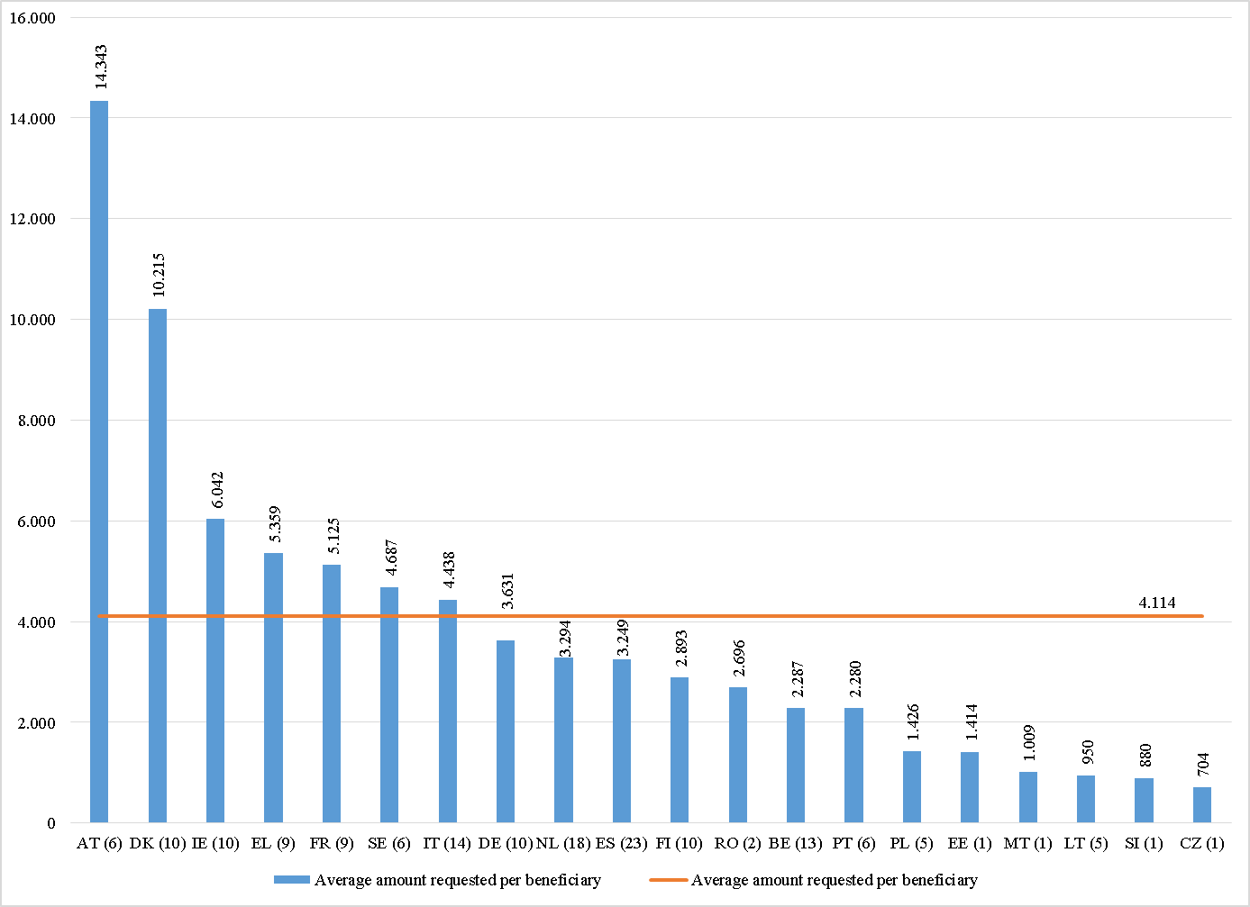

*Number of applications is specified in brackets.*

**Average EGF amount requested per beneficiary: EUR 4 114**

On average, each of the 20 Member States applying for EGF support from 2007 to 2018, requested EUR 4 114 per targeted beneficiary. The highest average amount per beneficiary was requested by Austria (EUR 14 343 for 6 cases and 1 952 beneficiaries), followed by Denmark (EUR 10 215 for 10 cases and 6 234 beneficiaries), and Ireland (EUR 6 042 for 10 cases and 11 209 beneficiaries).

## ***Table 3: EGF applications per sector submitted up to 31 December 2018***







*\*The total number of applications from 2007 to 2018 is 160, but the case EGF/2016/003 EE/Petroleum and chemicals case belongs to two different sectors (19 and 20) and has therefore been listed twice in the table above.*

## ***Chart 13: Number of applications per sector (NACE Rev.2) between 2007 and 2018***

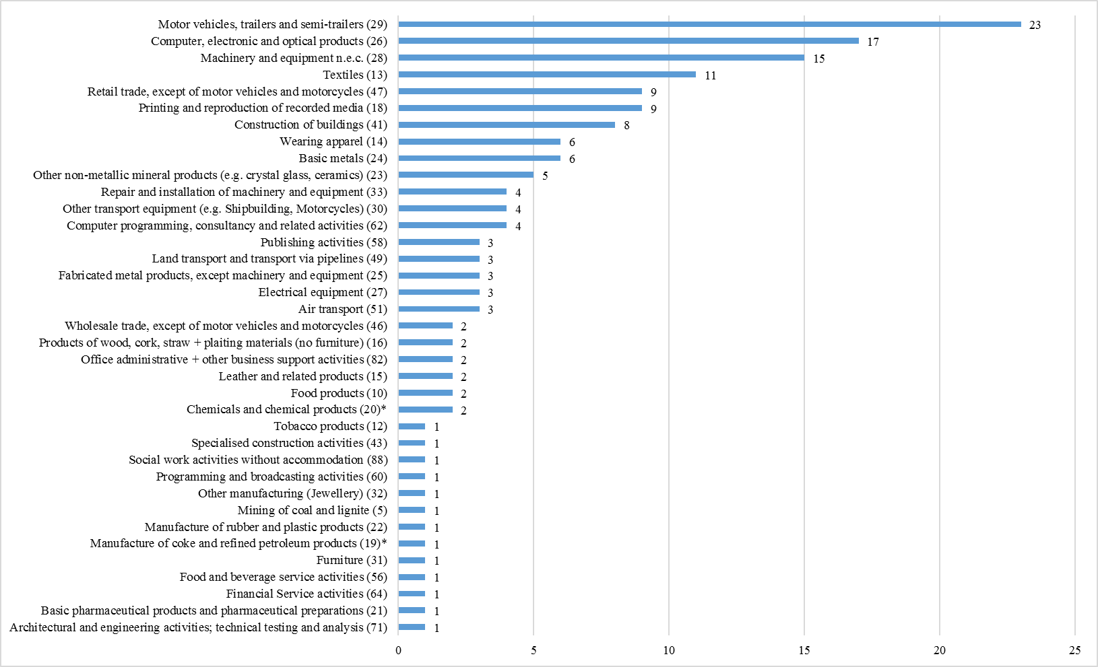

*\*EGF/2016/003 EE/Petroleum and chemicals case refers to two different sectors (19 and 20)*

**Total number of sectors: 37**

From 2007 to 2018 the Commission received 160 EGF applications related to a broad range of sectors (37). The greatest number of applications was received for the motor vehicles, trailers and semi-trailers sector (23), followed by computer, electronic and optical products sector (17) and the machinery and equipment sector (15).

## ***Chart 14: Number of targeted workers per sector (NACE Rev. 2) between 2007 and 2018***

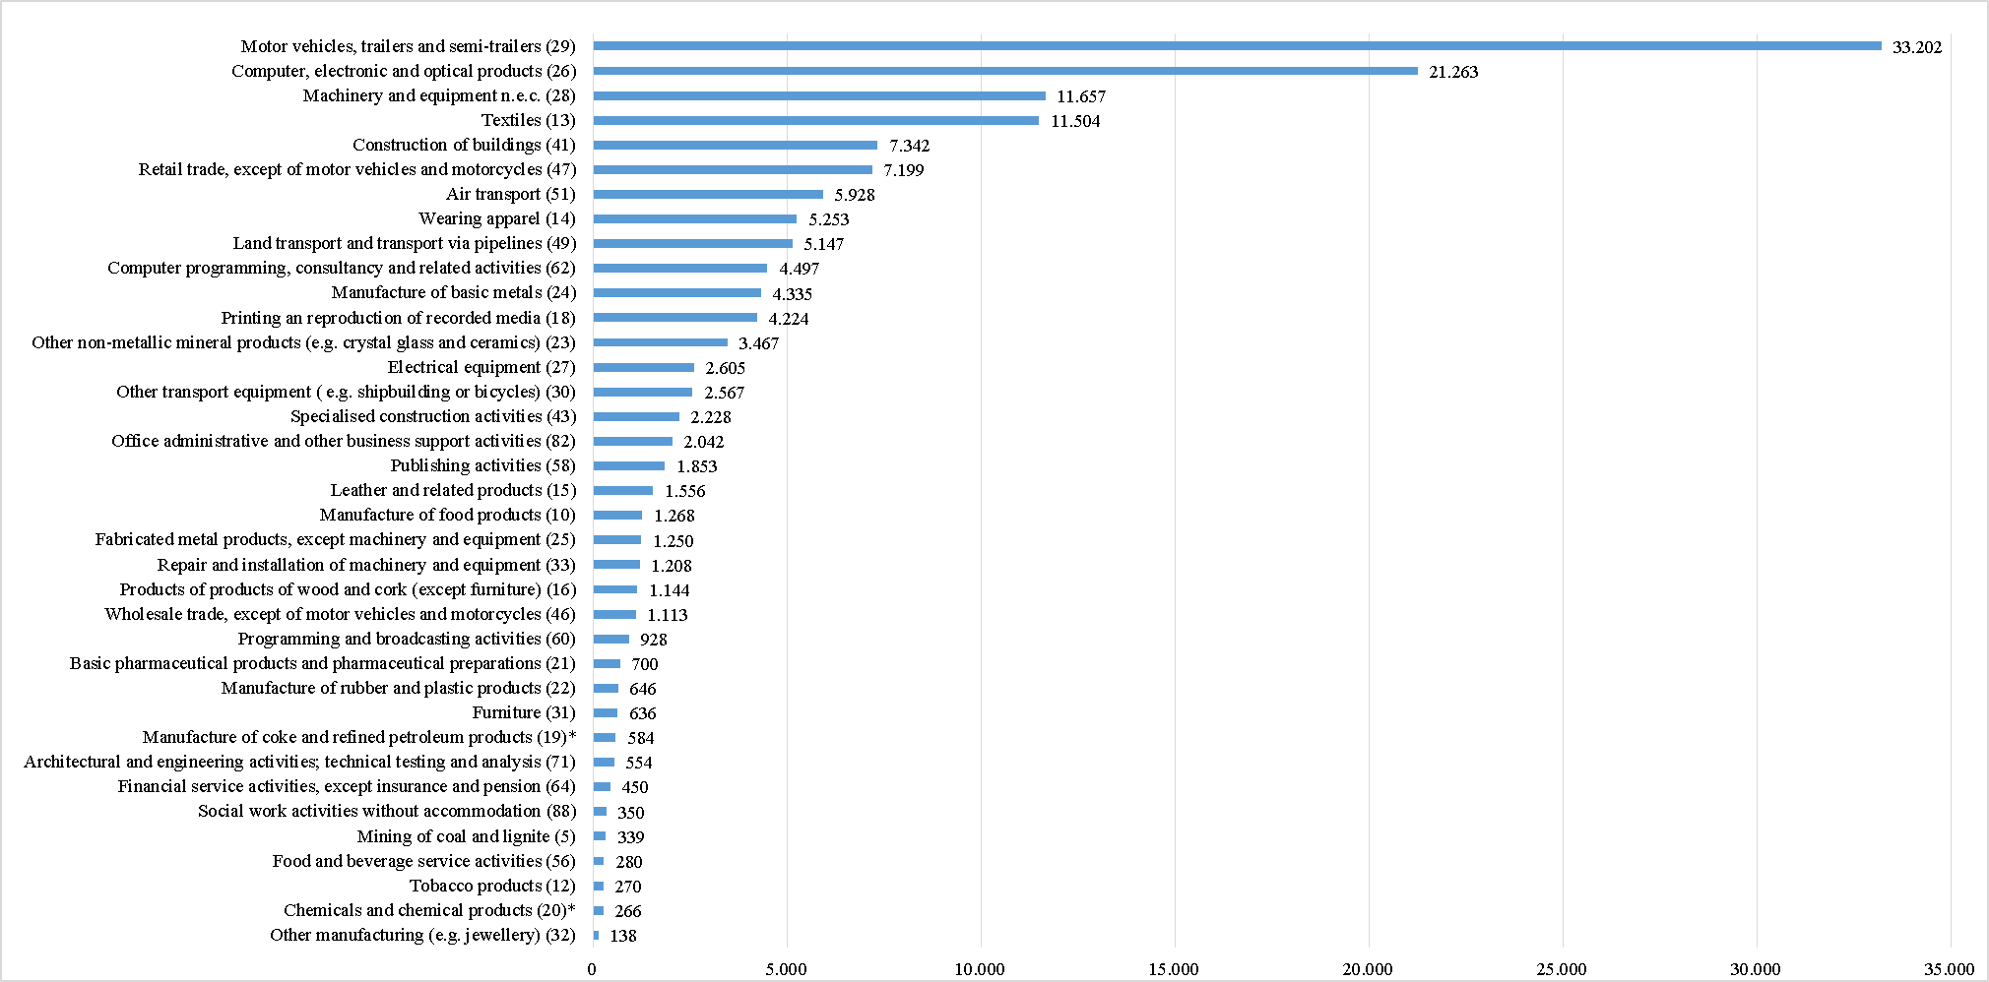

*\*EGF/2016/003 EE/Petroleum and chemicals case refers to two different sectors (19 and 20). The number of targeted workers in these sectors are provided on a prorate basis, reflecting the composition of the group of redundant workers.*

**Total number of targeted workers in 37 sectors: 149 993**

From 2007 to 2018 the Commission received EGF applications submitted by 20 Member States for 149 993 workers made redundant in 37 different sectors. The greatest number of workers was targeted in the sector motor vehicles, trailers and semi-trailers (33 202), followed by the computer, electronic and optical products sector (21 263), and the machinery and equipment sector (11 657).

1. This figure rises to 51 if we take into account the three cases withdrawn. However, withdrawn and rejected cases are not considered in the statistics.
2. Number of targeted beneficiaries estimated by the Member States at the application phase.