

# Introduction

This report presents the implementation of the annual work programme for 2016 (2016 AWP), under the third health programme 2014-2020 established by Regulation (EU) No 282/2014 of the European Parliament and of the Council of 11 March 2014[1].

In accordance with Article 13(1) of the Regulation, the Commission must report to the health programme committee on the implementation of all actions funded under the programme and keep the European Parliament and the Council informed. This report provides detailed information on the 2016 budget and how it was used.

The Commission staff working document accompanying this report sets out examples of key actions co-funded under the second[2] and third health programmes for which final results became available in 2016. It includes actions on the main themes (such as rare diseases and European Reference Networks, care coordination, registries, health security — especially in light of the Ebola epidemic and tobacco) which have been included in successive financing decisions. It also includes a table with a detailed overview of all co-funded activities and contracts.

The 2016 AWP focused on the setting up and supporting the European Reference Networks[3] set up under Directive 2011/24/EU on the application of patients’ rights in cross-border healthcare[4]. European Reference Networks are virtual networks of EU healthcare providers that tackle complex or rare diseases and conditions.

In addition, the AWP 2016 had a strong focus on objective 1 – ‘Promoting health, preventing diseases and fostering supportive environments for healthy lifestyles taking into account the health in all policies principle’, with priority topics addressing key lifestyle factors (alcohol, tobacco, drugs), chronic disease prevention and management and health-related issues concerning migrants’ and refugees’ health.

The Commission closely monitors the implementation of the third health programme and ensures that its results are more widely publicised. It also encourages all Member States and non-EU countries that contribute to the programme to participate in its actions and to create links with other relevant EU funding programmes such as Horizon 2020.

TABLE OF CONTENTS

Introduction 1

Key themes of 2016 3

Implementation of the health programme 6

1. Budget 6

2. Priorities and financing mechanisms 7

3. Implementation by financing mechanism 9

4. Beneficiaries 10

Improvements 11

# Key themes of 2016

The 2016 AWP aims to contribute to the Commission's health priorities as outlined in the President's political guidelines[5] and the mission letter of the Commissioner responsible for health and food safety[6].

*European Reference Networks*

The priority health initiative under the 2016 AWP was to set up the **European Reference Networks** (ERNs) in accordance with: (a) Directive 2011/24/EU of the European Parliament and of the Council of 9 March 2011 on the application of patients’ rights in cross-border healthcare[7]; and (b) the EU policy on rare diseases.

ERNs are virtual networks involving more than 900 healthcare providers across the EU. They aim to tackle complex or rare diseases and conditions that require highly specialised treatment and a concentration of knowledge and resources.

Several financing measures were used to support ERNs in 2016, amounting to more than EUR 8 million (EUR 8 012 343.47). These included:

* a call of interest for ERNs as provided for in Article 2 of the Implementing Decision 2014/287/EU[8], followed by the approval of the individual healthcare providers and the networks as a whole, by a corresponding decision of the Board of Member States as set out in Article 5 of the Decision;
* requests for service for the independent assessment bodies to assess candidate ERNs in accordance with the criteria set out in the Delegated Decision 2014/286/EU[9] (EUR 1 646 638.27);
* a call to fund the coordination costs of the approved networks (EUR 4 386 344.15); and
* a call in support of rare disease patient registries for the ERNs (EUR 1 979 361.05).

Background

Article 12(1) of Directive 2011/24/EU requires that the European Commission supports Member States in developing ERNs[10]. The Commission Implementing Decision 2014/287/EU sets out the process and criteria for the networks' entire lifecycle, from the call for proposals to the assessment, approval, establishment and evaluation of ERNs. The Consumers, Health, Agriculture and Food Executive Agency (Chafea) has supported the Commission in all of these steps, for example by:

* managing the call for networks;
* ensuring the assessment of all candidate networks; and
* channelling EU co-funding to support the coordination costs of the approved networks for 5 years (2017-2021).

Goal

The ERNs aim to offer people in the EU access to the best expertise and often, life-saving knowledge, without having to travel to another country.

Means

To support the sustainability of the ERNs, it was decided to award grants for long-term cooperation through framework partnership agreements (FPAs) between Chafea and the beneficiaries. The annual co-funding is then ensured by signing specific grant agreements (SGAs) that cover the scientific and technical coordination costs of the networks. As of June 2017, all 23 ERNs have signed FPAs and two rounds of annual SGAs[11].

*Promotion of health and prevention of diseases*

In addition to the main focus of the year, several actions supported the **promotion of health and prevention of diseases**, in particular focusing on best practices as regards the vulnerable groups of migrants and refugees.

Background

Building on the financial support provided in this area during the migration crisis in 2015, the annual work programme 2016 promoted sustainability through capacity building and implementation of best practices in care provision for vulnerable migrants and refugees.

Goal

The EU co-funding in this area aims to promote best practices in care provision for vulnerable migrants and refugees.

Means

Within this overall framework, the 2016 AWP co-funded:

* three projects on ‘Migrants’ health: Best practices in care provision for vulnerable migrants and refugees’ (EUR 2 484 164.99);
* two tenders on ‘Training for health professionals with migrants and refugees' (EUR 4 107 214);
* a direct grant agreement with the World Health Organization (WHO) focusing on the development and uptake of technical guidance in view of supporting access of the migrant population in national health care systems (EUR 500 000); and
* an operating grant to the ‘Vulnerability network’ (EUR 326 808.00).

The three projects on **migrants’ health** are:

* MigHealthCare, in which 14 partners from 10 Member States (Austria, Bulgaria, Cyprus, France, Germany, Greece, Italy, Malta, Spain and Sweden) are developing and pilot testing a comprehensive toolbox to put in practice community-based care models for vulnerable migrants and refugees, including predictive models, best practice examples, algorithms and tailor-made health materials.
* MyHealth, in which 11 partners from seven Member States (the Czech Republic, Germany, Greece, Ireland, Italy, Spain and the United Kingdom) are developing health intervention strategies for mental health and communicable and non-communicable diseases. The project will also put in place an ICT-based platform (including an interactive map of EU health systems) to support tools and health information applications for both patients and healthcare professionals.
* ORAMMA, in which eight partners from four Member States (Greece, the Netherlands, Sweden and the United Kingdom) promote safe motherhood and improve access to maternal healthcare. The project pilots and evaluates integrated and cost-effective initiatives for safe motherhood focusing on women with particular risks. It also aims to extend good practices across EU healthcare systems to ensure equity among Member States.

The two tenders on ‘Training for health professionals with migrants and refugees’ (EUR 4 107 214) financed the development of an advanced training package on mental health, post-traumatic stress detection and screening for communicable diseases in migrants and refugees and the training courses themselves in 10 European countries (Bulgaria, Croatia, France, Greece, Italy, Malta, Norway, Serbia, Slovenia and Spain).

The project addresses health professionals, law enforcement officers and trainers of trainers. It should lead to a better understanding of the needs of the migrant population, reinforced skills for those involved in their care and a positive public health impact both in the selected countries and in the EU as a whole.

The direct grant agreement with the WHO focuses on the development and uptake of technical guidance, including checklists, Standard Operating Procedures (SOPs), good practice indicators and fact sheets in 6 priority issues of migrant health [Mental Health, Health Promotion, Non Communicable Diseases, Mother and New Born, Child Health (including immunization) and Elderly Health],with a view to supporting access of the migrant population to national health care systems.

Finally, the AWP 2016 provided financial support to the European network for reducing vulnerabilities in health[12]. This network produced the 2016 Observatory report on access to healthcare for people facing multiple vulnerabilities in health (which covered 31 cities in 12 countries) and the 2016 legal report on access to healthcare (which covered 17 countries).

A detailed overview of all actions funded under the AWP 2016 is provided in the Commission staff working document accompanying this report.

# Implementation of the health programme

1. Budget

The overall budget for the third health programme 2014-2020 is EUR 449.4 million. This includes EUR 30 million for the operating costs of the Consumer, Health, Food and Agriculture Executive Agency (Chafea), mandated by the Commission to manage the programme. Chafea has been providing the Commission with technical, scientific and administrative assistance in implementing the health programme since 2005[13]. It organises annual calls for proposals, coordinates the evaluation of submissions, and negotiates, signs and manages related grant agreements, and disseminates results of the actions. It is also responsible for many procurement procedures.

The budget set out in the work plan for 2016 AWP[14] was EUR 62 160 000, broken down as follows:

* Operational expenditure: EUR 56 451 000, corresponding to the third EU health programme (2014-2020) budget line 17 03 01 (‘*Encouraging innovation in health, increasing the sustainability of health systems and protecting Union citizens from serious cross-border health threats’).*
* Administrative expenditure: EUR 1 500 000, corresponding to the expenditure to support the third EU health programme (2014-2020) budget line 17 01 04 02.
* Contribution of the health programme to Chafea's budget: EUR 4 209 000.

The total operational budget came to EUR 57 992 112 as it included an additional EUR 1 541 112 of EFTA/EEA credits and recovery credits from previous budget years.

A total of EUR 56 695 888.83 was committed under the 2016 AWP: Chafea covered EUR 48 248 609.99 of this amount, while DG SANTE committed an additional EUR 8 447 278.84 covering part of procurement and other actions.

2. Priorities and financing mechanisms

In 2016, the total operational budget committed (EUR 56 695 888.83) was divided among the programme's four specific objectives as follows:

1. **Health promotion**: ***EUR 25 622 317.07*** *(45% of the operational budget in 2016)* for promoting health, preventing diseases and fostering supportive environments for healthy lifestyles taking into account the ‘health in all policies’ principle
2. **Health threats**: ***EUR 3 947 709.3*** *(7%)* for protecting EU citizens from serious cross-border health threats
3. **Health systems**: ***EUR 8 655 656.8*** *(15%)* for contributing to innovative, efficient and sustainable health systems
4. **Better and safer healthcare**: ***EUR 14 892 153.25*** *(26%)* for facilitating access to better and safer healthcare for EU citizens

**Horizontal activities** (IT, communication) amounted to *EUR 3 578 052.41 (7%).*

**Figure 1: Operational budget by third health programme objective in 2016**

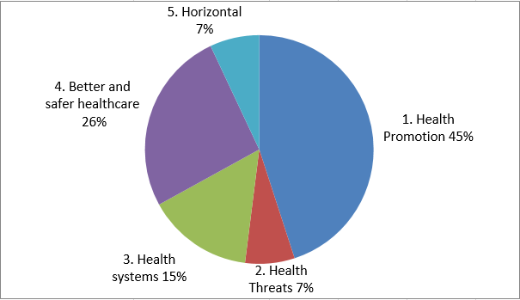

The figure below provides information about the health programme credits invested as EU contribution through the different thematic priorities in year 2016.

**Figure 2: Operational budget per priority theme in 2016**

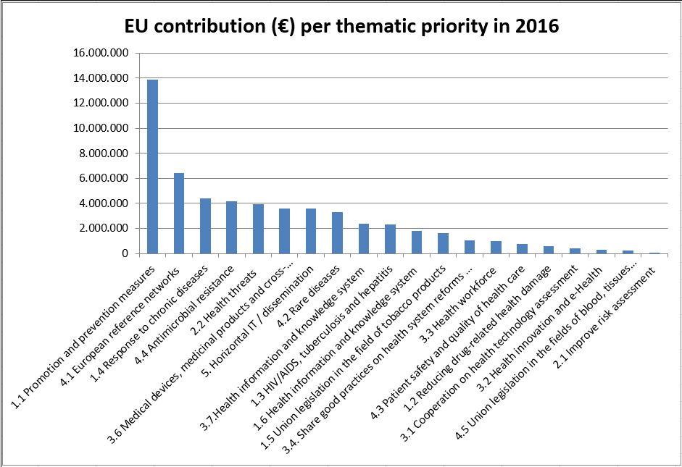

To meet these objectives, the programme comprises a wide range of funding instruments. These are:

* project grants, including the SGAs for the ERNs;
* operating grants in support of non-governmental organisations;
* actions co-financed with Member State authorities (joint actions);
* direct agreements with international organisations;
* public procurement; and
* other actions, such as the support to the scientific committees, administrative agreements with the Joint Research Centre and grants for Presidency conferences.

Competitive selection and award procedures were used to select initiatives for funding. Competitive selection and award procedures are not used for joint actions, direct grant agreements and conferences organised by Council presidencies because in those cases competitive procedures are either not allowed under the specific rules or are not adequate (for example, due to a monopoly situation).

Administrative credits covered expenditure such as studies, meetings of experts, information and publication costs, and technical and administrative assistance for IT systems.

3. Implementation by financing mechanism

|  |  |  |
| --- | --- | --- |
| **Type of financing mechanism** | **Implementation (EUR)** | **Share of mechanism in total implemented budget** |
| **Calls for proposals:** | **18 323 884.19** | **32.3%** |
| Project grants | 8 795 212.04 | 15.5% |
| European Reference Network (ERN) SGAs under FPA by objective | 4 386 344.15 | 7.7% |
| Operating grants | 5 142 328.00 | 9.1% |
| **Grants for joint actions** | **14 376 881.83** | **25.4%** |
| **Conference grants to the Member States holding the Presidency of the EU** | **141 780.43** | **0.3%** |
| **Direct grant agreements** | **4 450 000.00** | **7.8%** |
| **Procurement (service contracts)** | **16 089 842.38** | **28.3%** |
| ***Managed by CHAFEA*** | 10 456 063.54 | 18.4% |
| ***Managed by DG SANTE*** | 5 633 778.84 | 9.9% |
| **Other actions** | **3 313 500** | **5.9%** |
| ***Managed by CHAFEA*** | 500 000.00 | 0.9% |
| ***Managed by DG SANTE*** | 2 813 500.00 | 5% |
| **Budget implemented of AWP 2016** | **56 695 888.83** | 97.76% |
| **Total available budget of AWP 2016** | **57 992 112.00** |  |
| **Credits not used**[15] |  |  |
| ***by CHAFEA*** | 1 282 128.59 | 2.22% |
| ***by DG SANTE*** | 14 094.58 | 0.02% |

4. Beneficiaries

In 2016, more than 200[16] different grants and contracts were signed with diverse beneficiaries and service providers ranging from governmental and non-governmental organisations to academic institutions and private companies.

The category ‘other’ includes beneficiaries such as health care providers and international organisations. Figure 3 provides an overview of the different groups of beneficiaries.

**Figure 3: Types of beneficiaries of the third health programme in 2016**

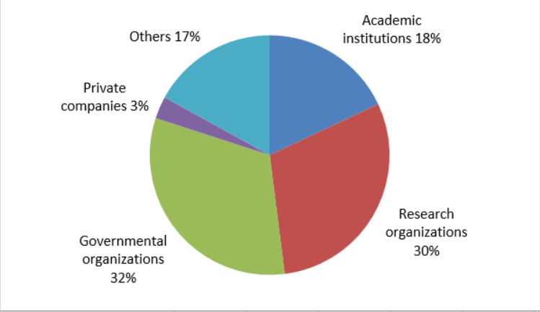

# Improvements

The programme's support for ERNs has stimulated innovation in health care delivery and increased access to quality care across the EU.

Chafea used all simplification tools at its disposal to streamline the EU financial contribution to the ERNs. Awarding FPAs and subsequent specific grants will make implementation and reporting easier and will provide the ERNs with a stable operating framework.

Key actions under the health promotion and disease prevention programme objective were co-funded with competent authorities in the Member States (joint actions). The number of participants in these joint actions[17] reflects the interest of Member States to actively engage in joint initiatives in the areas of tobacco control, prevention of HIV/AIDs, Tuberculosis and viral hepatitis and chronic diseases.

Following the work done in 2015, Chafea continued to invest significantly in information and dissemination activities in close collaboration with DG SANTE and the health programme's network of National Focal Points. Chafea organised several workshops, collaborated in major national and international conferences, and organised stand-alone events with national authorities in EU countries. It also produced a series of brochures and info-sheets on the health programme's key priority areas. Further details on the 2016 dissemination activities are provided in the Commission staff working document.

To monitor the health programme’s implementation, the progress made according to the CORDA system[18] will be followed by an analysis of the feedback on the programme's outcomes and potential impact.

As most actions are still in their early stages, concrete results are not yet available. Deeper insights into the programme's overall impact will only be available once the first generation of co-funded actions has been completed. Nevertheless, the multiannual plan developed at the outset of the third health programme ensures continuity and coherence between the different types of financing instruments available. ERNs are a clear example as their support has been optimised by aligning procurement (assessment of health care providers and ERNs), project grants (for patient registries’ work), joint actions (on rare diseases and ORPHANET) and specific grants under a FPA for coordinating the networks.

1. OJ L 86, 21.3.2014, p. 1.
2. OJ L 301, 20.11.2007, p. 3.
3. <http://ec.europa.eu/health/ern/networks_en>
4. OJ L 88, 4.4.2011, p. 45-65.
5. <https://ec.europa.eu/commission/sites/beta-political/files/juncker-political-guidelines-speech_fr.pdf>
6. <https://ec.europa.eu/commission/commissioners/sites/cwt/files/commissioner_mission_letters/andriukaitis_en.pdf>
7. OJ L 88, 4.4.2011, p. 45-65.
8. OJ L 147, 17.5.2014, p. 79-87.
9. OJ L 147, 17.5.2014, p. 71-78.
10. Under Article 12 of Directive 2011/24/EU on patients’ rights in cross-border healthcare and relevant implementing measures, the European Commission developed — through a service contract managed by Chafea — the methodology and the technical tools for assessing the ‘Networks and healthcare providers’ proposals. The contractor has addressed all the assessment steps from the publication of the call for networks to their approval, including the materials and methods to be used and the expected end products.
11. The AWP 2018 provides for a multiannual grant, to cover the last 3 years of the networks' functioning. This EU funding amounts to EUR 13 800 000 and runs until the end of February 2022.
12. Operating grant to the Vulnerability Network, 2015-2017 FPA.
13. Decision 2004/858/EC of 15 December 2004 (OJ L 369, 16.12.2004, p. 73) amended by Decision 2008/544/EC of 20 June 2008 (OJ L 173, 3.7.2008, p. 27); from December 2014 CHAFEA has replaced the Executive Agency for Health and Consumers (EAHC) [Commission Implementing Decision 2014/927/EU](https://eur-lex.europa.eu/legal-content/EN/TXT/PDF/?uri=CELEX:32014D0927&from=EN).
14. Commission implementing decision of 1/3/2016 C(2016) 1158 final.
15. Differences between the credits available for use only in 2016 and the amounts actually contracted.
16. This excludes contracts with single experts e.g. those participating in the scientific committees.
17. In 2016 there were between 27 and 44 partners (beneficiaries, affiliated entities not included) per joint action which was a challenge for their overall management and coordination as all partners had to sign the grant agreement.
18. CORDA centralises the data collected for all actions managed by Chafea and monitored through the use of the H2020 electronic tools. Implemented by the Common Support Centre of the Research and Innovation it is the key source of information and provides feedback on the attainment of the programme's objectives and priorities, the types of actions and the types of organisations co-funded.