

**TABLE OF CONTENTS**

Contents

1. Summary 2

2. Background 3

3. Approved irradiation facilities 4

4. Results of checks carried out in irradiation facilities in 2016-2017 4

5. Results of checks at product marketing stage 5

# Summary

According to Article 7(3) of Directive 1999/2/EC, of the European Parliament and of the Council of 22 February 1999 on the approximation of the laws of the Member States concerning foods and food ingredients treated with ionising radiation[1], the Member States shall forward to the Commission every year:

* the results of checks carried out in ionising irradiation facilities, including, in particular, the categories and quantities of foodstuff treated with ionising radiation and the doses administered, and
* the results of checks carried out at product marketing stage.

Article 7(4) of the Directive requires the Commission to publish in the Official Journal of the European Union:

* the details of the approved irradiation facilities in the Member States, as well as any changes in their status,
* a report on the information provided every year by the national supervisory authorities.

This report covers the period from 1 January 2016 to 31 December 2017. It contains a compilation of the information forwarded to the Commission by 28 Member States on 2016 and 27 Member States on 2017. Malta did not submit any data for the year 2017.

**Period: 1/1/2016 – 31/12/2017**

**Countries concerned:** EU Member States and EFTA countries

**Source:** 28 Member States and Norway

**Irradiation facilities:**

* Number of countries equipped: 14 Member States & Norway
* Number of approved facilities: 24
* Number of closed facilities: 2
* Number of countries irradiating: 10 Member States & Norway

**Treatment data:**

* Quantity of products treated: 10 211 tonnes (-11.4%) compared to 2015 on average
* Main commodities treated: Frog legs (57%) and dried aromatic herbs, spices and  
   vegetables seasoning(20.77%)
* Main place of irradiation: Belgium (68%) and the Netherlands (13%)

**Checks at marketing stage:**

* Number of samples analysed: 11 162
* Number of non compliant samples: 87 (0.8%)
* Main commodities analysed: Herbs and spices (42%)   
   Cereals, seed, vegetables, fruits and their  
   products (22%)

# Background

Food irradiation is the treatment of foodstuffs by a certain type of radiant energy known as ionising radiation. Radiant energy has differing wavelengths and degrees of power and disappears when the energy source is removed. Irradiation is used for sanitary and phytosanitary purposes to kill bacteria (such as *Salmonella, Campylobacter* and *E. coli*) that can cause food poisoning and to eliminate organisms harmful to plant or plant products such as insects and other pests. It is also used to delay fruit ripening, to stop vegetables (such as onions and potatoes) from sprouting or germination and ultimately to extend the shelf life of foods. Irradiation of food cannot replace proper food handling and irradiated foods still require appropriate refrigeration and to be cooked prior to consumption when necessary.

The EU regulatory framework for irradiation of food ('food irradiation directives') thus consists of:

* Directive 1999/2/EC (framework Directive) of the European Parliament and of the Council of 22 February 1999 on the approximation of the laws of the Member States concerning foods and food ingredients treated with ionising radiation. It lays down specific provisions for the manufacturing, marketing and importation of treated foods and food ingredients.
* Directive 1999/3/EC (implementing Directive) of the European Parliament and of the Council of 22 February 1999 on the establishment of a Community list of foods and food ingredients treated with ionising treatment[2]. This list currently includes one category of food: dried aromatic herbs, spices and vegetable seasonings. The list of national authorisations of food and food ingredients which may be treated with ionising radiation is published by the Commission in the Official Journal of the European Union [3].

Food and food ingredients may be irradiated only in approved irradiation facilities. For facilities in the EU, approval is given by the competent authorities of the Member State. Article 7(3) of Directive 1999/2/EC requires Member States to inform the Commission of the list of their approved irradiation facilities.

Any food irradiated or containing irradiated ingredients must have been treated (irradiated) only at approved facilities. The list of approved irradiation facilities in Member States is published by the Commission in the Official Journal of the European Union [4].

Under Article 6 of Directive 1999/2/EC, any irradiated food or any irradiated food ingredient of a compound food must be labelled with the words ‘irradiated’ or ‘treated with ionising radiation’.

To enforce correct labelling or to detect non-authorised products, several analytical methods have been standardised by the European Committee for Standardisation (CEN), following a mandate given by the European Commission.

# Approved irradiation facilities

There are now 24 irradiation facilities in the EU. Two previously approved irradiation facilities have been closed in 2015.

The facilities are located in 14 Member States: five in France, four in Germany, two in Bulgaria, the Netherlands, and Spain, one in Belgium, Czech Republic, Croatia, Estonia, Italy, Hungary, Poland, Romania and United Kingdom.

Of those 14 Member States equipped with irradiation facilities, Bulgaria, Italy, Romania and the United Kingdom did not irradiate any foodstuffs over the period covered by this report.

# Results of checks carried out in irradiation facilities in 2016-2017

A total quantity of 10 211 tonnes of products were treated with ionising irradiation in EU Member States during the years 2016 and 2017. The treatment took place mainly in two Member States: Belgium, which treated two thirds of the irradiated food of the EU (68%), and the Netherlands (13%).

The two main commodities irradiated in the EU are frog legs (*ca* 57%) and dried aromatic herbs, spices and vegetables seasoning (*ca* 21%). Figure 1 shows the distribution of products irradiated in approved facilities in the EU Member States in 2016 and 2017.

**Figure 1** – Distribution by category of irradiated foodstuffs in the EU in 2016-2017

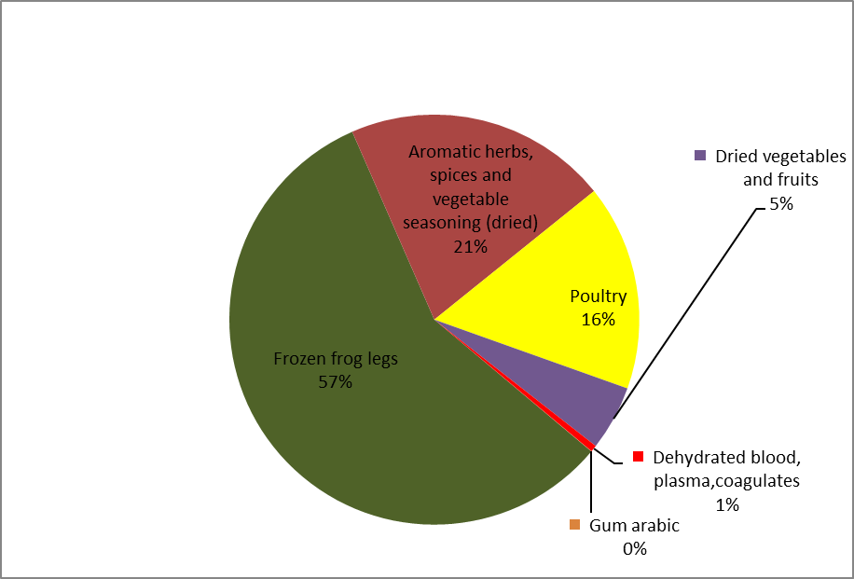

The quantities of foodstuffs (in tonnes) treated by ionising radiation in the EU are decreasing since 2010 as shown in Figure 2.

**Figure 2 –** Quantities of foodstuffs treated by ionising radiation in approved irradiation establishments within the European Union since 2010

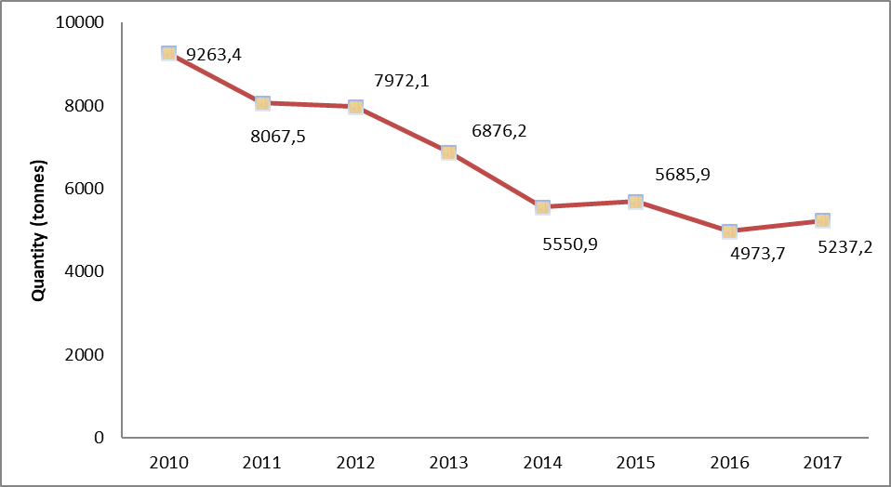

# Results of checks at product marketing stage

For the period 2016-2017, 11 162 samples were analysed by 24 Member States, i.e. overall 7.02% less in average than in 2015. The data are for each Member State are available in Annex II and summarised in Figure 3.

**Figure 3 –** Samples analysed at product marketing stage within each Member State in 2016-2017

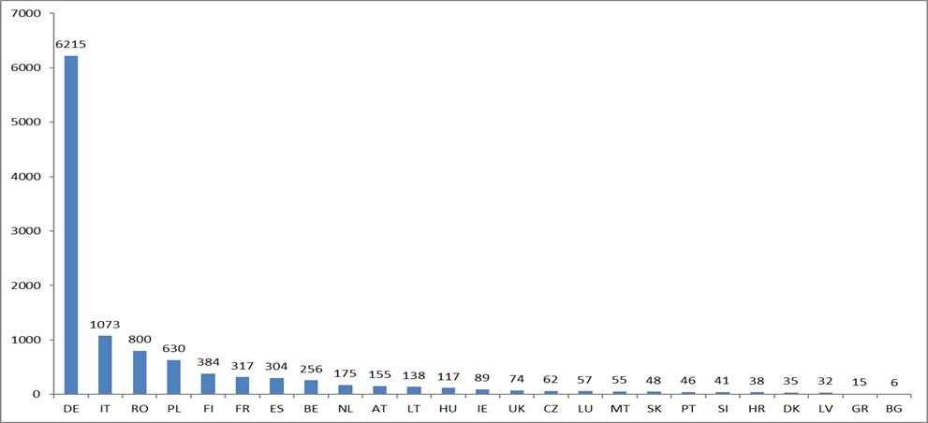

Five countries (four Member States and Norway) did not perform any analytical checks at product marketing stage in 2016-2017 due to budgetary restrictions (Croatia (2016), Denmark (2017) and Norway (2016 and 2017)), lack of laboratory capacity (Estonia and Cyprus (2016, 2017)) or other control priorities (Sweden (2016, 2017)). Malta did not report any sample in 2017.

From the total of 11 162 samples, 87 were not compliant (0.8%) and 113 samples (1%) gave inconclusive results. The non-compliance observed were mainly incorrect labelling and forbidden irradiation. The percentage of non compliance was lower than in the previous report.

At marketing stage, as illustrated in Figure 4, the majority of the products analysed were 'herbs and spices' (42%) and the 'cereals, seed, vegetables, fruit and their products' (22%). Under category 'Other' (foods supplements and soup and sauces) the percentage was 17%.

**Figure 4** – **Foodstuffs** category analysed at product marketing stage within the European Union in 2016-17

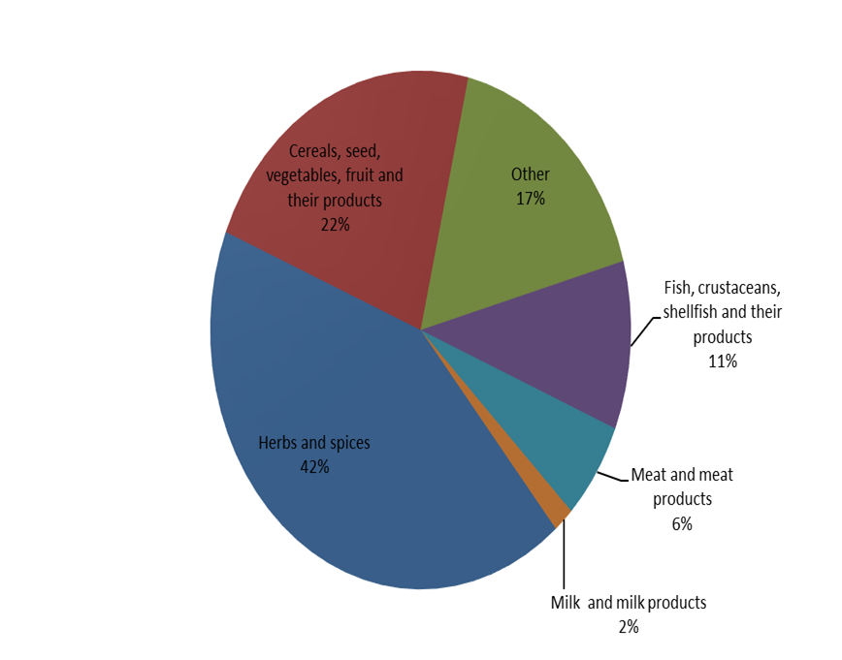

1. OJ L 66, 13.3.1999, p. 16.
2. OJ L 66, 13.3.1999, p. 24
3. OJ C 283, 24.11.2009, p. 5
4. OJ C 37, 30.1.2019, p. 6