

**2019 report on the economic and social situation of Gozo (Malta)**

Without prejudice to the ongoing negotiations on the Multiannual Financial Framework for the period 2021-2027, and in accordance with Declaration 36 on the island region of Gozo annexed to the Treaty of Accession of Malta, the Government of Malta requested in February 2019 the Commission to report to the Council on the economic and social situation of Gozo and, in particular, on the disparities of the social and economic development levels between Gozo and Malta and to propose appropriate measures, to enable the further integration of Gozo within the internal market.

This report assesses the state of development of Gozo and the evolution of disparities within Malta. It provides an assessment by reviewing recent trends on a series of dimensions and indicators relevant for the development of Gozo, i.e. demography and labour market, structure of the economy and economic growth, geography and accessibility. The paper also provides a comparison of Gozo with the rest of Malta and with other European regions. Finally, it analyses how Cohesion policy addresses the development needs of Gozo.

This report uses regional statistics produced by Eurostat and by the Maltese Statistical Office.

# Analysis of the economic and social situation in Gozo

## Geography and land use

Gozo is the second most important island of the Maltese archipelago in terms of surface and population. It is located 5 km northwest of the island of Malta. The island of Comino is located between Malta and Gozo, less than one kilometre away from Gozo and it is almost uninhabited[1]. In terms of land use and land cover[2], urban fabric amounts to 21% of Gozo and Comino area, while agriculture, natural areas and forests amounts to 77.5% of the surface. In comparison, the main island of Malta shows a slightly higher use of land for urban use (23%) and for industrial, commercial and transport units (5.7%) than for agriculture, natural areas and forests (66.7%). The land use reflects the higher population density and degree of industrialisation in Malta compared to Gozo, and the prominent role of agriculture in the Gozitan economy.

As regards its statistical classification as a region, Malta is a country, a NUTS1 and a NUTS2 region. At a NUTS3 level, it is divided into two regions: the island of Malta, and the islands of Gozo and Comino.

**Map 1. Land use and land cover in Malta, Gozo and Comino**

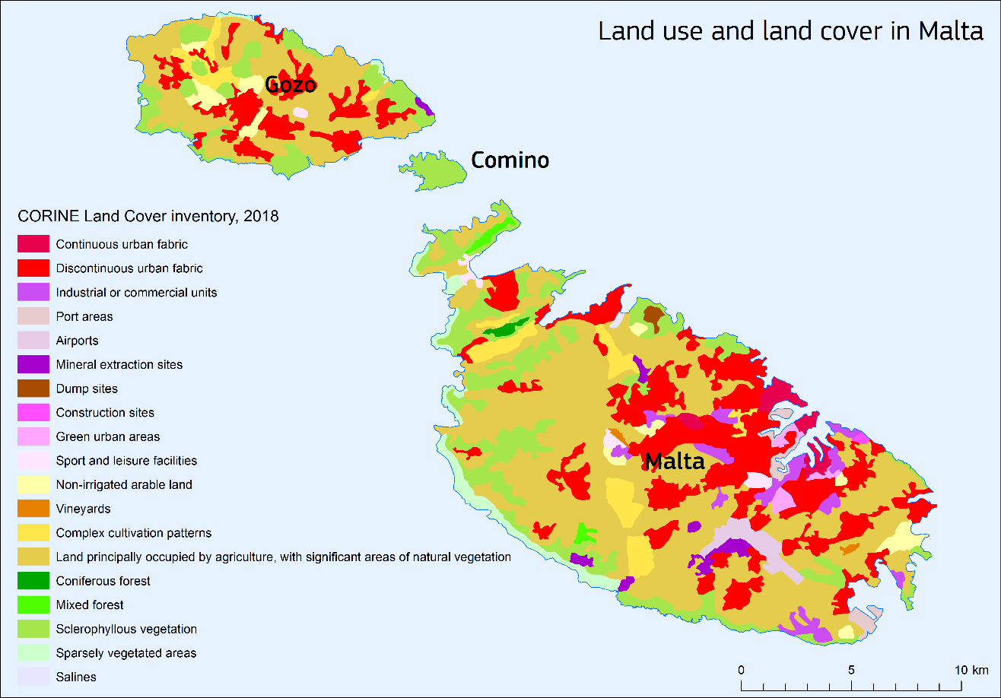

*Source: CORINE Land Cover inventory 2018.*

## Population

As of January 2018, Gozo had 32,723 inhabitants, which represent around 6.9% of the Maltese population. The population density of Gozo in 2018 was 474.5 inhabitants per km2, roughly one fourth of the density on the island of Malta (1,793.8 inhabitants per km2 in the same year). Around 21% of the population live in Victoria (also known as Rabat), the largest city of the Gozo Island.

In absolute terms, the population in Gozo has increased from 2006 to 2018 by around 1,700 inhabitants. In relative terms, Gozo’s population has increased by an average rate of 0.4% per year over the period 2006-2018, compared to a growth rate of 1.4% (leading to a population increase of 69,000) for the population resident on the island of Malta over the same period, also fuelled by a significant increase in migration from 2012 onwards. This difference in growth led to a decrease in the share of Maltese population living in Gozo from 7.7% in 2006 to 6.9% in 2018.

One of the factors leading to this evolution is the ageing of the population. The share of the population aged 65 and above living in Gozo has increased by 8 percentage points between 2006 to 2018, compared to an increase of 2 p.p. for the island of Malta. Although the two regions show significant ageing trends, the share of working age population (age 15-64) for the island of Malta is generally 2 percentage points (p.p.) higher than the same share for the island of Gozo.

**Graph 1. Evolution of the share of working age population (age 15-64) over the total resident population in the regions of Malta, Gozo and Comino, 2006-2018**

*Source: Eurostat*

## Economic Development

In 2017, GDP per capita in Gozo, in Purchasing Power Standards (PPS), corresponded to 60% of the EU-28 average, a level significantly lower than in Malta, which is roughly at the EU-28 average. From 2000 to 2011, GDP per capita for the island of Malta remained below the EU average. The gap started to decrease as from 2012. In comparison, GDP per capita in Gozo fell relative to the EU average between 2000 and 2007. From 2008 this downward trend was halted. The region started converging to the EU average as from 2013, although at a slower pace than the main island.

The gap in relative economic development between the two islands widened from 2000 to 2017, from 26 to 41 percentage points. Note however that the relative proximity between the two islands allows workers to commute to the island of Malta while living in Gozo. In fact, more than 20% of the Gozo resident workforce works on the island of Malta. The GDP per capita measures economic activities on the production side and does not take into account household income. Therefore, the real economic welfare of Gozitan citizens is underestimated by GDP per capita.

Regarding the sectoral composition of the Gross Value Added between two regions, the economy of Gozo relies generally more on agriculture and fishing (+3 p.p.) and construction sectors (+5 p.p.) than the island of Malta, and less on financial, insurance, real estate and other services (-4 p.p.)

**Graph 2. Evolution of GDP per capita in Purchasing Power Standards in the regions of Malta, Gozo and Comino, 2000-2017 (EU-28 = 100)**

*Source: Eurostat*

**Graph 3. Composition of 2016 Gross Value Added in the regions of Malta, Gozo and Comino**

*Source: Eurostat*

## Labour Market

The evolution of employment was similar in Malta and Gozo over the period 2015-2017, with annual growth rates between 5% and 6%, and Gozo registering a slightly higher increase in employment between 2016 and 2017 compared to Malta. On both islands, the employment rate increased over the same period, with Gozo showing faster growth (around +4 p.p. increases per year) between 2015 and 2017 compared to Malta. In 2017, the employment rate of Gozo (74%) exceeds the one of Malta (72%).

The proximity between the two islands and the frequency of ferry connections allow commuting from Gozo to Malta: when comparing employment by place of residence with employment by place of work, more than 3,500 residents in Gozo actually work on the island of Malta, which corresponds to around 22% of the resident workforce.

**Table 1. Employment by place of residence and by place of work in Malta, Gozo & Comino, and employment rate**

|  |  |  |  |  |  |
| --- | --- | --- | --- | --- | --- |
| *Employment by place of residence* | **2015** | **2016** | **2017** | **Growth 15/16** | **Growth 16/17** |
| Malta | 194,329 | 205,002 | 216,492 | 5.5% | 5.6% |
| Gozo & Comino | 13,901 | 14,678 | 15,677 | 5.6% | 6.8% |
| *Employment by place of Work* | **2015** | **2016** | **2017** | **Growth 15/16** | **Growth 16/17** |
| Malta | 197,403 | 208,423 | 219,998 | 5.6% | 5.6% |
| Gozo & Comino | 10,827 | 11,257 | 12,171 | 4.0% | 8.1% |
|  |  |  |  |  |  |
| *Difference (commuters)* | 3,074 | 3,421 | 3,506 |  |  |
|  |  |  |  |  |  |
| *Employment rate* | **2015** | **2016** | **2017** |  |  |
| Malta | 69% | 71% | 72% |  |  |
| Gozo & Comino | 66% | 70% | 74% |  |  |

Employment rate calculated using the population between 15 and 64 as denominator.

*Source: National Statistics Office, Malta and Eurostat.*

The composition of the workforce on the two islands is very similar to the composition of Gross Value Added: Gozo employs 4 p.p. more people in agriculture and fishing, and 3 p.p. more in construction than Malta, but 7 p.p. less in the financial, insurance, real estate and other services.

**Graph 4. Composition of 2016 Employment in the regions of Malta, Gozo and Comino**

*Source: Eurostat*

## Accessibility and tourism

Gozo is 5.3 km distance away from the main island. The travel time by ferry between these two islands is about 30 minutes in fair weather. As pointed out above, many employees commute from Gozo to the main island of Malta, in particular to the capital city using frequent sea connections between the two islands.

The number of sea passengers between the ports of Ċirkewwa in Malta and Mġarrin Gozo has increased by almost 60% from 2003 to 2017 and by almost 34% between 2010 and 2017. This corresponds to an average annual increase of the number of sea passengers between the two ports of 3.4%, and a more noticeable increase is seen from 2013 to 2017, with an annual growth rate of almost 6%.

Gozo is not only a home to commuters; it also attracts tourists. Similarly to Malta, Gozo registered an increasing trend in the number of tourists over the period 2012-2017, although slightly smaller (+33% vs +36%). The number of tourists visiting and staying at least one night in Gozo and Comino is certainly lower than the number of tourists visiting the island of Malta. However, in 2017, they were still almost three times as many as the resident population of Gozo. Regarding offer, the number of bed places in Gozo increased faster than in Malta, from 1,756 to 2,165 units between 2012 and 2017 (+23%), compared to around 40,000 units available in Malta (+7%). However, the duration of the stay is generally shorter: on average, tourists stay for 5 nights in Malta against 3 nights in Gozo and Comino.

**Graph 5. Evolution of the number of passengers between the seaports of Ċirkewwa and Mġarr (in thousands)**

*Source: Eurostat*

**Table 2. Number of guests and bed places in Malta and Gozo**

|  |  |  |  |  |  |  |  |  |
| --- | --- | --- | --- | --- | --- | --- | --- | --- |
| *Number of guests* | **2012** | **2013** | **2014** | **2015** | **2016** | **2017** | **Increase 12/17** | **Average Annual growth** |
| Malta | 1,274,123 | 1,377,594 | 1,464,903 | 1,499,117 | 1,532,666 | 1,731,687 | 36% | 6.3% |
| Gozo and Comino | 73,585 | 83,051 | 86,644 | 86,951 | 86,866 | 97,781 | 33% | 5.9% |
| *Number of bed places* | **2012** | **2013** | **2014** | **2015** | **2016** | **2017** | **Increase 12/17** | **Average Annual growth** |
| Malta | 38,187 | 40,895 | 39,473 | 40,217 | 39,163 | 40,762 | 7% | 1.3% |
| Gozo and Comino | 1,756 | 1,800 | 1,855 | 1,948 | 2,074 | 2,165 | 23% | 4.3% |

*Source: National Statistics Office, Malta.*

## Comparison with other European islands

Compared to other island regions of similar size (in terms of population), GDP per capita in Gozo and Comino in PPS in 2016 was generally lower than in other islands, with the exception of the Greek island regions of Lesvos, Limnos, Ikaria, Samos and Chios. However, Gozo and Comino are one of the few island regions where GDP per capita has increased, especially in the period after the financial crisis (2009-2016).

**Table 3. Evolution of GDP per capita in Purchasing Power Standards in selected island regions (EU-28 = 100)**

|  |  |  |  |  |  |  |
| --- | --- | --- | --- | --- | --- | --- |
| **EU Country** | **NUTS 3 Region** | **2002** | **2009** | **2016** | **Annual growth rate 2002-2016** | **Annual growth rate 2009-2016** |
| DK | Bornholm | 88 | 87 | 89 | 0.1% | 0.3% |
| ES | Fuerteventura | 132 | 88 | 85 | -3.1% | -0.5% |
| ES | Menorca | 103 | 85 | 75 | -2.2% | -1.8% |
| ES | El Hierro | 72 | 87 | 65 | -0.7% | -4.1% |
| ES | La Gomera | 85 | 87 | 70 | -1.4% | -3.1% |
| ES | La Palma | 66 | 80 | 68 | 0.2% | -2.3% |
| FI | Åland | 151 | 144 | 129 | -1.1% | -1.6% |
| EL | Chios | 66 | 73 | 50 | -2.0% | -5.3% |
| EL | Zakynthos | 104 | 104 | 75 | -2.3% | -4.6% |
| EL | Ikaria, Samos | 65 | 79 | 51 | -1.7% | -6.1% |
| EL | Ithaki, Kefallinia | 89 | 94 | 60 | -2.8% | -6.2% |
| EL | Lesvos, Limnos | 64 | 74 | 51 | -1.6% | -5.2% |
| **MT** | **Gozo and Comino** | **55** | **51** | **56** | **0.1%** | **1.3%** |
| SE | Gotlands län | 98 | 93 | 92 | -0.5% | -0.2% |
| UK | Western Isles | 88 | 88 | 76 | -1.0% | -2.1% |
| UK | Shetland Islands | 135 | 127 | 133 | -0.1% | 0.7% |
| UK | Orkney Islands | 95 | 95 | 95 | 0.0% | 0.0% |

*Source: Eurostat.*

## Internal disparities

For the purpose of this report, regional disparities within NUTS2 regions are measured using GDP per capita at NUTS3 level. In the case of Malta, the islands of Malta and Gozo & Comino are two NUTS3 regions being part of a single NUTS2, which coincides with the country as well.

Internal disparities can obviously not be assessed for NUTS2 regions with no NUTS3 subdivision. In addition, measures of regional disparities are generally sensitive to the number of NUTS3 areas within each NUTS2 region.

For this reason, this report uses 4 measures of internal disparity, considering three different sets of NUTS2 regions: 1) all EU NUTS2 regions; 2) NUTS2 regions in transition (where the GDP per capita is between 75% and 90% of the EU average); 3) NUTS2 regions with a capital city, excluding the regions that lack further subdivision into NUTS3 areas.

The four indicators are the following:

* The **Coefficient of Variation**: the ratio between the standard deviation of all NUTS3 with the average NUTS2 GDP per capita. Out of the four measures, this indicator is the least dependent on the number of NUTS3 regions within the NUTS2 region under consideration.
* The **Gini index**: an index between 0 and 1, where 0 corresponds to a situation of perfect equality across NUTS3 regions, and 1 to a situation where all the GDP is concentrated in one NUTS3 region.
* The **Theil index**: an index that returns values closer to zero as internal disparities decrease.
* The **Min/Max ratio**: a simple ratio between the GDP per capita in the NUTS3 region with the lowest value and the NUTS3 region with the highest value, within the same NUTS2 region. Out of the four measures, this indicator is the most sensitive to the number of NUTS3 regions within each NUTS2 area.

Top rankings correspond to regions with low levels of internal disparities: rankings are calculated in ascending order for the coefficient of variation, the Gini index and the Theil index and in descending order for the Min/Max ratio.

The results for Malta are shown in table 4.

When ranking **across the 237 NUTS2** regions having NUTS3 subdivisions, the Theil index and the coefficient of variation return approximately similar results for Malta (respectively 99th/237 and 86th/237). The Gini index seems to underestimate economic disparities within Malta (33rd/237), while the Min/Max ratio seem to overestimate them (164th/237).

The rankings **across the 46 NUTS2 in transition** show a slightly clearer picture. Once again, the Theil index and the coefficient of variation return ranks for Malta which are very close (respectively 26th/46 and 24th/46), the Gini index puts Malta at the 11th place, while the Min/Max ratio at the 39th.

Lastly, Malta is also a **capital region**, therefore a third region selection ranks it among the other 15 capital regions in Europe with more than 1 NUTS3 region. Malta ranks 1st according to the coefficient of variation, the Gini index and the Theil index, and second according to the Min/Max ratio, therefore performing generally better than all the other capital regions in the EU when it comes to internal disparities.

**Table 4. Comparative analysis of regional disparities in terms of 2016 GDP per capita for Malta, based on 4 different indicators and 3 different rankings selections**

|  |  |  |  |
| --- | --- | --- | --- |
| **Values of the 4 indicators for measuring regional inequalities – Malta** | | | |
| **Coefficient of variation** | **Gini index** | **Theil index** | **Min/Max Ratio** |
| 0,11 | 0,03 | 0,01 | 0,57 |
| **Ranking of Malta among all NUTS2 regions in the EU with more than one NUTS3 region (237 regions)** | | | |
| **Coefficient of variation** | **Gini index** | **Theil index** | **Min/Max Ratio** |
| 86 | 33 | 99 | 164 |
| **Ranking of Malta among all NUTS2 regions in transition in the EU with more than one NUTS3 region (46 regions)** | | | |
| **Coefficient of variation** | **Gini index** | **Theil index** | **Min/Max Ratio** |
| 24 | 11 | 26 | 39 |
| **Ranking of Malta among all NUTS2 capital regions in the EU with more than one NUTS3 region (15 regions)\*** | | | |
| **Coefficient of variation** | **Gini index** | **Theil index** | **Min/Max Ratio** |
| 1 | 1 | 1 | 2 |

*\**Capital regions for the following countries: BG, DK, EE, EL, FR, HR, IE, IT, LV, MT, NL, PL, RO, SI and UK.

*Source: DG REGIO calculation based on Eurostat data.*

# Implementation of cohesion policy in Gozo

For the programming periods 2007/2013 and 2014/2020, respectively 11% and 10% of the overall budget available under the ERDF, ESF and CF have focused on territorial investments in Gozo. This is slightly above the proportion of the Gozitan population (around 7%), the main objective being to reduce disparities with Malta, as reported in Chapter 1.

The main investment areas for 2007-2013 were Investing in competitiveness and quality of life and Empowering people for more jobs and a better quality of life, amounting to 107.3 million EUR altogether. For the period 2014/2020, the amount paid as of 1 May 2019 was 95.6 million EUR.

Interventions in Gozo cover a wide range of areas, with significant budgets being invested on e.g. road, transport, water and renewable energy infrastructure, waste management facilities and rehabilitation of historical sites, in particular of the “Cittadella”, to which 12 million EUR of EU funds have been dedicated . Gozo has also benefitted from EMFF funding in support of the fishing industry, to modernise the fishermen’s facilities located at the designated fishing ports of Mgarr and Xlendi, together with the introduction of new related amenities.

Through 79 projects amounting to EUR 12.4 million, ESF also provided support to increase the participation to quality and labour market education and training, career guidance, enhancing employability and adaptability of the workforce, social inclusion of disadvantaged groups.

For the next programming period 2021/2027, the overall EU contribution of the ERDF, the ESF+ and the Cohesion Fund for the entire Maltese archipelago[3] amounts to EUR 672.8 million, a 5% decrease compared to EUR 708 million for 2014/2020. This reflects the successful catching-up process to the EU average in the last years. The discussions regarding the investment priorities for programmes for the 2021-2027 programming period will build upon the Country Report Malta 2019[4] of 27 February 2019, and the Country Specific Recommendations adopted by the Council on 9 July 2019. It does not pre-empt the important question of the share of the funds that will be allocated for Gozo/Comino.

# Conclusions

The statistical analysis of this report shows that the GDP per capita differences between Gozo and the main island of Malta have slightly increased over time. Various elements can explain this trend. Importantly, the island of Malta has a more service-oriented economy than the island of Gozo, which relies more on agriculture, fishing and construction activities. With this different economic orientation, the economic growth of Malta has outpaced that of Gozo.

In recent years, Gozo was able to catch up with the EU average faster than other island regions in the EU. This may be due to the spill over effects of the proximity to the main island of Malta, in particular commuting and the rise in tourism in the region.

When comparing the economic situation of Malta with other transition regions in the EU, internal disparities are average when comparing Malta to other regions in transition.

Additionally, it should be borne in mind that the GDP per capita as an indicator underestimates the real economic welfare of the residents of Gozo, given the significant proportion of workers commuting to the island of Malta.

There has been progress in terms of accessibility, for the benefit of both tourism and Gozitan workers commuting to Malta. Cohesion policy has contributed to this success, through significant investments carried out in road and maritime transport infrastructures, energy and health facilities, and the support to renovation of cultural heritage.

In the framework of the preparation of the 2021/2027 partnership agreement and operational programmes, the Maltese authorities are invited to consider investments and the possible structural measures needed, both at national and at Gozitan levels, to reduce the GDP per capita gap. Further success in supporting the catching up process of Gozo will depend on taking into account Gozo’s specificities, including the fast ageing population.

1. When referring to the NUTS3 region, the report uses the term “Gozo and Comino”, but since Comino is mostly unhabited, the report refers to Gozo to describe the statistical trends.
2. The figures are taken from the 2018 CORINE Land Cover Inventory. They do not add up to 100% because some residual classes like dump sites, construction site etc. are not considered.
3. Annex XXIII of the Commission Proposal for a Regulation - COM(2018) 375 final.
4. SWD(2019) 1017 final.