

TABLE OF CONTENTS

**REPORT FROM THE COMMISSION TO THE EUROPEAN PARLIAMENT AND THE COUNCIL**

**30th annual report on the protection of the European Union’s financial interests and the fight against fraud (2018)**

1. Introduction 6

1.1. The first decade (1989-1998): laying the foundation 6

1.2. The second decade (1999-2008): enlargement, consolidation and operational reforms 7

1.3. The third decade (2009-2018): Reforms and a new leap forward 8

2. Harmonising and reinforcing the fight against fraud across the EU: cross‑cutting anti-fraud policies, measures and results in 2018 9

2.1. Legislative acts adopted by the EU institutions 9

2.1.1. Regulation implementing enhanced cooperation on the establishment of EPPO: state of play 9

2.1.2. The Omnibus Regulation 10

2.2. Shaping the future: European institutions’ legislative and policy initiatives 10

2.2.1. Commission proposal to revise Regulation (EU, Euratom) No 883/2013 10

2.2.2. Commission proposal for a Regulation on the protection of the Union's budget in case of generalised deficiencies as regards the rule of law in the Member States 10

2.2.3. Cross-cutting provisions on protecting the EU's financial interests (PIF provisions) within all the Commission's MFF proposals 11

2.2.4. Fighting corruption in the EU 11

2.2.5. International cooperation 11

2.2.6. Commission anti-fraud strategy (CAFS) and the new governance package 11

2.2.7. Implementation of the Hercule programme 12

2.3. CJEU jurisprudence 12

2.3.1. Sigma Orionis v Commission 12

2.3.2. Case-law related to EDES 12

2.4. Measures taken by Member States 12

2.4.1. Overview of measures taken by Member States 12

2.4.1.1. National anti-fraud strategies (NAFS) 13

2.4.1.2. Enhancing transparency, figthing corruption and conflict of interests in public procurement 13

2.4.1.3. Other measures 13

2.4.2. Implementation of 2017 recommendations 13

2.5. Summary of statistics on detected irregularities and fraud 15

2.5.1. Detected fraudulent irregularities 16

2.5.2. Detected and reported non-fraudulent irregularities 16

2.5.3. OLAF investigations 17

3. Anti-fraud policies, measures and results — Revenue 17

3.1. EU institutions’ anti-fraud measures – revenue 17

3.1.1. Mutual administrative assistance 17

3.1.1.1. Anti-Fraud Information System (AFIS) 17

3.1.1.2. Joint customs operations (JCOs) 18

3.1.2. Mutual assistance and anti-fraud provisions in international agreements 18

3.1.3. Fight against illicit trade in tobacco products 19

3.1.4. Anti-fraud related cooperation with the Joint Research Centre (JRC) 19

3.1.5. Fight against VAT fraud 20

3.2. Member States’ anti-fraud measures – revenue 21

3.3. Statistics on detected irregularities and fraud – revenue 21

3.3.1. Detected fraudulent irregularities 22

3.3.2. Detected non-fraudulent irregularities 22

4. Sectoral anti-fraud policies, measures and results — expenditure 22

4.1. Member States’ sectoral anti‑fraud policies and measures involving several expenditure sectors ……………………………………………………………………………………………………………………………………………………...22

4.2. Agriculture — sectoral anti-fraud policies, measures and results 23

4.2.1. Agriculture — Member States’ anti-fraud measures 23

4.2.2. Agriculture — statistics on detected irregularities and fraud 23

4.2.2.1. Detected fraudulent irregularities 23

4.2.2.2. Detected non-fraudulent irregularities 24

4.3. Cohesion policy and fisheries — sectoral anti-fraud policies, measures and results 25

4.3.1. Cohesion policy and fisheries — Member States’ anti-fraud measures 25

4.3.2. Cohesion policy and fisheries — statistics on detected irregularities and fraud 26

4.3.2.1. Detected fraudulent irregularities 26

4.3.2.2. Detected non-fraudulent irregularities 26

4.4. Indirect management (pre-accession) — statistics on detected irregularities and fraud 26

4.5. Direct management — sectoral anti‑fraud policies, measures and results 26

4.5.1. Direct management — statistics on detected irregularities and fraud 26

4.5.1.1. Detected fraudulent irregularities 27

4.5.1.2. Detected non-fraudulent irregularities 27

5. Recovery and other preventive and corrective measures 27

6. Cooperation with the Member States 27

7. Early detection and exclusion system (EDES) 27

8. Follow-up to the European Parliament resolution on the 2017 annual report 29

9. Conclusions and recommendations 29

9.1. Revenue 29

9.2. Expenditure 30

9.3. A glimpse beyond 30

Table of figures

Figure 1: Irregularities reported as fraudulent in 2018 16

Figure 2: Irregularities reported as fraudulent and associated amounts, 2014-2018 17

Figure 3: Irregularities reported as non-fraudulent in 2018 18

Figure 4: JCOs in 2018 19

Figure 5: TOR - Key facts and patterns 23

Figure 6: Detection rates by CAP component 24

Figure 7: Agricultural policy – key facts and figures 25

Figure 8: Market measures most affected by irregularities (fraudulent and non-fraudulent) 25

Figure 9: Measures adopted by Member States in the cohesion policy area 26

Figure 10: Cohesion and fisheries policies – key facts and figures 26

Figure 11: COCOLAF structure and subgroups 28

Executive summary

**Thirty years protecting the EU's financial interests**

This is the Commission's 30th annual report on the protection of the EU's financial interests and the fight against fraud (PIF Report). This thirty-year period can be divided into three phases of roughly a decade.

During the first phase (1989-1998), the legislative foundations of the fight against fraud and irregularities were laid down.

The second decade (1999-2008) was a period of consolidation, operational reforms and the largest enlargement in the European Union’s history.

During the third decade (2009-2018), the protection of the EU’s financial interests experienced a fresh impetus. The European institutions agreed on a series of new acts and initiatives to further strengthen the fight against fraud at EU level and the conditions were set for a new player — the European Public Prosecutor’s Office (EPPO) — to come on the scene soon.

**Main cross-cutting initiatives adopted and developed in 2018**

During 2018, the last year of the third phase, new financial rules were adopted (in the '*Omnibus regulation'*) to simplify and streamline the use of EU funds and to redefine conflict of interests for all the financial actors implementing the EU budget in the various management modes, including at national level.

As the institutions negotiate the legal framework for the multiannual financial framework for 2021-2027, the anti-fraud provisions for the spending programmes are being further refined. Any person or entity receiving EU funds will have to fully cooperate in the protection of the EU's financial interests. They must grant the necessary access rights to the Commission, OLAF, the EPPO and the European Court of Auditors and ensure that any third parties involved in the implementation of EU funds do the same.

**Highlights in the revenue area**

On the revenue side, the Commission presented a new action plan to continue to effectively fight illicit trade in tobacco.

New rules were adopted to curb transnational VAT fraud. Mutual administrative assistance between Member States increased thanks to a new possibility to set up joint administrative enquiries and to a network of national EU Member State analysts working in different areas of fraud risk under the Eurofisc framework.

In line with the Commission’s recommendations in the 2017 PIF Report, Member States have rolled out new IT tools, risk-based approaches and initiatives to counter the challenges posed by the undervaluation of goods (particularly footwear and textiles), including via e-commerce. Although Member States detected fewer irregularities than in 2017 in the customs area (traditional own resources — TOR), the financial cost of these irregularities was higher. Similarly, detected fraud was stable, but the related financial impact was higher.

In the TOR area, this report recommends further measures to address issues linked to cross-border e-commerce, particularly the potential abuse of low-value consignments.

**Highlights in the expenditure area**

On expenditure, Member States have adopted several operational measures, in particular the introduction of IT risk scoring tools (such as ARACHNE), fraud risk assessments and training courses to raise general fraud awareness, in line with MFF 2014-2020 provisions and Commission recommendations set out in previous PIF Reports.

The detection of fraud and irregularities in the expenditure sectors follows a pattern similar to the revenue area, with fewer cases detected each year, but at a higher financial cost.

As several spending programmes have a multiannual cycle, a comparative analysis was developed for the cohesion policy programming periods 2007-2013 and 2014-2020. This shows patterns that may be a result of the strengthened fraud detection and irregularity prevention capabilities introduced by the adopted anti-fraud measures. The Commission will keep on monitoring these results to assess whether they are actually due to more efficient systems rather than under-detection and under-reporting.

The analysis confirms the findings of previous PIF Reports in terms of areas at risk and the need to improve coordination and cooperation between administrative and judicial authorities. Consequently, this PIF Report calls again on Member States to develop their anti-fraud systems in the framework of dedicated national strategies.

**The achievements of the Juncker Commission**

This report is the last one adopted under the Juncker Commission during whose mandate the fight against fraud and the protection of the EU’s financial interests received a new momentum. The most important achievements include the directive on the fight against fraud by means of criminal law and the regulation to establish the EPPO by enhanced cooperation — both adopted in 2017, and the revision of the financial regulation, which redefined conflict of interests for all financial actors implementing the EU budget. In 2018, the Commission has also tabled a proposal for a targeted revision of the OLAF regulation (Regulation 883/2013), on which trilogue negotiations are expected to start soon.

However, the Commission is aware that it cannot be complacent in this area. New challenges continuously emerge and to keep the public’s trust, EU and national institutions must show their full commitment to the fight against inefficiencies and wrongdoing.

The Commission adopted a new anti-fraud strategy (CAFS) on 29 April 2019 to respond to several of the European Court of Auditors' 2019 recommendations on fraud risk management. The CAFS aims to improve the Commission's analytical capability so that it can react quickly to the ever-changing challenges, for example by integrating new technologies in the control processes and improving the overall internal coordination, which is pivotal for such a complex organisation.

# Introduction

This is the Commission's 30th annual report on the protection of the EU's financial interests and the fight against fraud (PIF Report). The first report was adopted in January 1990. With the entry into force of the Treaty of Maastricht on 1 January 1993, a specific treaty article expressly provided for the fight against fraud affecting the financial interests of, at the time, the Communities.

Since 1 May 1999, following the entry into force of the Treaty of Amsterdam, the annual reporting to the European Parliament and the Council on measures taken to counter fraud and other illegal activities affecting the EU’s financial interests is covered by a specific provision (initially Article 280(5) EC Treaty and now Article 325(5) TFEU).

The EU and the Member States share responsibility for protecting the EU’s financial interests and fighting fraud. Member State authorities manage approximately 74% of EU expenditure and collect the traditional own resources. The Commission oversees both these areas, sets standards and verifies compliance. To protect the EU’s financial interests effectively, the Commission and the Member States have to work closely together.

Since the reporting year 1989, the PIF Report assesses this cooperation with a view to improving it. To this end, it:

* provides a summary of measures taken at EU and Member State level to counter fraud;
* includes an analysis of national and European bodies’ main achievements in detecting fraud and irregularities relating to EU expenditure and revenue. This is based in particular on detected irregularities and fraud reported by the Member States in compliance with sectoral regulations.

The 30th edition of this report will provide an overview of the major achievements of the last 30 years as well as information on the 2018 initiatives. Sections 1.1, 1.2 and 1.3 below will outline the past 30 years of fighting fraud and protecting the EU budget.

The report is accompanied by five Commission Staff Working Documents (SWD), listed in Annex 3[1].

## The first decade (1989-1998): laying the foundation

At the end of 1988 the unit for the coordination of the fight against fraud (**UCLAF)** was set up to direct and oversee all the Commission's fraud prevention activities, with a **45-point work programme** to carry out its objectives.

During this first decade, a number of major legislative acts were adopted, which significantly shaped the anti-fraud landscape up to 2017. In **1991**,the Council adopted **Regulation 595/91** on the reporting of irregularities in the common agricultural policy. The **Treaty of Maastricht** (EUT), which entered into force at the end of **1993**, placed the objectives and the means for combating fraud at the highest legisaltive level and confirmed the Member States' obligation to treat the Community's financial interests in the same way as their own in combating fraud, i.e. by using effective, proportionate and dissuasive means, thanks to a specific article (209A). Title 4 EUT provided for closer cooperation and the tools to achieve it.

In **1994**, the **Advisory Committee for the Coordination of Fraud Prevention** (COCOLAF)[2] was set up. Regulations (EC) No 1681/94 and 1831/94 on the notification of irregularities and the recovery of sums unduly paid in the area of structural and cohesion funds were also adopted and a **freephone** was set up in each Member State so that individuals could help protect the EU's financial interests.

At intergovernmental level, Member States signed the **Convention for the protection of the Community's financial interests under criminal law** (**1995)**. The Convention set out a common definition of fraud and of other serious offences that damage the Community's financial interests, obliging Member States to treat it as a specific criminal offence with appropriate penalties. At the end of the year, the Council adopted **Regulation** (EC, Euratom) **No 2988/95**, a framework legislative act applicable to all expenditure and TOR (not for VAT), which created the basis for the formulation of uniform administrative penalties, with the same legal force throughout the European Community.

Regulation (EC) No 2185/96 on on-the-spot checks and inspections in the Member States carried out by Commission officials to detect fraud and irregularities was adopted in **1996,** as well as the **first protocol on the fight against corruption** attached to the 1995 Convention.

In **1997**,Regulation (EC) No 515/97 on **mutual assistance in the customs and agricultural areas** was adopted. The Convention on mutual assistance and cooperation between customs administrations (the 'Naples II Convention') was signed in Brussels on 18 December 1997 (and entered into force on 23 June 2009). This Convention, in respect of the prosecution and punishment of infringements of EU customs provisions, supplements Regulation (EC) No 515/97 and also Regulation No 389/2012 (on excise matters) on mutual assistance between the administrative authorities of the Member States.

In the same year, Member States signed the **second protocol (dealing with money laundering and judicial cooperation)** to the 1995 Convention. The Council launched the **FISCALIS** programme, improving communication and information exchange tools to prevent VAT and excise fraud. The Commission adopted the '**Agenda 2000**': a communication describing the broad outlook for the development of the EU and its policies on the eve of the new century, the challenges of enlargement and the future financial framework.

The end of the first decade was marked by events that demonstrated a number of weaknesses which required further action in certain areas.

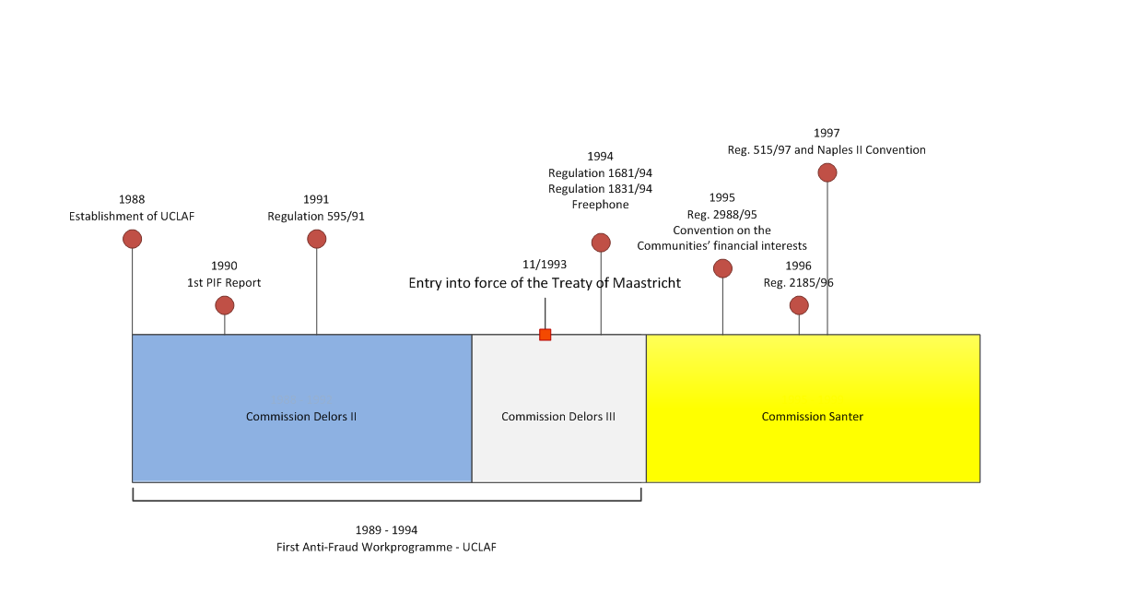

## The second decade (1999-2008): enlargement, consolidation and operational reforms

In April **1999**, a new player came on the scene. The Commission decided to establish the **European Anti-Fraud Office** (OLAF), an independent body for operational activities, which took over the tasks of UCLAF. The **new legislative package** came into force on 1 June 1999 and extended OLAF's responsibilities to all activities related to safeguarding Community interests against irregular conduct affecting the financial interests liable to result in administrative or criminal proceedings. In addition, almost all EU institutions began to entrust OLAF with investigating serious misbehaviour by their members and their staff.

This was part of a major reform and modernisation of the entire EU administration, notably in the area of financial management, which strengthened the Commission’s system of governance and led to clearer lines of accountability and responsibility. As part of the Financial Reform, launched in the year **2000**, the Commission decided to revise its internal control structures to make Authorising Officers by Delegation fully responsible for internal control, including fight against fraud, over their activities.

As the first European investigative body, OLAF's focus is on operational activities. Nonetheless, having combined the operational expertise and the coordination of the Commission's policy initiatives to fight fraud into a single body, the second decade was also rich with **policy** **ideas and projects to further enhance** the fight against fraud. Some of these initiatives would only bear fruit in the third decade, but they were already outlined in the **overall strategic approach (OSA —** **2001-2005)[3]**.

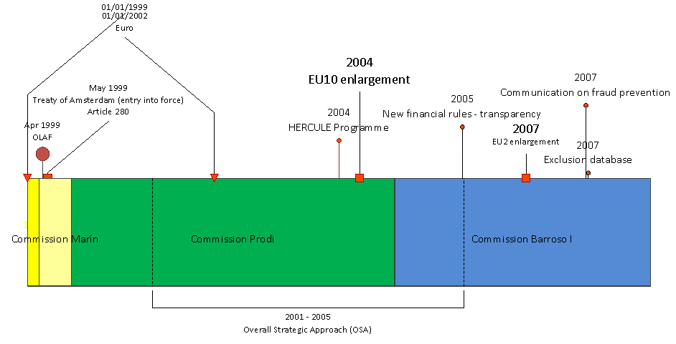

In May **1999** the **Treaty of Amsterdam** entered into force amending and expanding the provisions on the fight against fraud and enshrining the adoption of the PIF Report in paragraph 5 of the new **Article 280**.

The overall architecture was significantly reinforced with the enhanced roles of the European Parliament and the European Court of Auditors (ECA).

The second decade was marked by the introduction of the euro and the biggest enlargement in EU history with the accession of 12 new Member States (in **2004** and **2007**). From an anti-fraud perspective this process required a national Anti-Fraud Coordination Service (AFCOS) to be set up in each new Member State and a huge training effort for all 12 countries by the Commission.

Under the OSA, the Recovery Taskforce was set up to increase recoveries of EU funds in cases of detected fraud or other irregularities.

In **2003,** the Commission proposed the '**Hercule**' **programme** to support training activities, technical assistance measures and data exchange. The programme started in **2004** and was extended under the **2007-2013** and **2014-2020 multiannual financial frameworks (MFF)**.

New **financial rules** were introduced in **2006**, requiring national administrations to establish effective internal control systems and perform the necessary inspections on the EU funds under their management.

As OLAF’s operational experience and results grew, in **2007** the Commission adopted the Communication on '**Prevention of fraud by building on operational results: a dynamic approach to fraud-proofing**' to integrate OLAF’s expertise into the regulatory process. The aim was to identify shortcomings in legislative proposals, in the implementation of EU legislation and in management and control systems.

## The third decade (2009-2018): Reforms and a new leap forward

During the third decade, the number and relevance of the measures adopted at EU level provided new momentum for the fight against fraud in all areas related to the EU budget.

Building on the achievements of the previous 20 years, this decade has seen the finalisation of ambitious initiatives, which will elevate the protection of EU’s financial interests to a new level in the years to come.

Although the most remarkable achievements are legislative acts, operational measures have also brought about notable progress in terms of cooperation between the Member States and the Commission and OLAF, in line with the EU Treaty. As a result of these continuous improvements, during this decade, the ECA gave a qualified opinion on the EU budget for the years 2016 and 2017.

In **2009,** in the customs area a new database (**FIDE**) was deployed and the **Joint Customs Operation** (JCO) Diabolo II launched, representing an excellent model for future operational cooperation. All ASEM (Asian-Europe Meeting) partners were involved and coordinated by OLAF with the support of Europol and Interpol.

By the end of the year, the Lisbon Treaty entered into force. Among the many significant changes it introduced, it completed the integration process into the Union’s system in the area of freedom, security and justice (i.e. police and judicial cooperation in criminal matters) and provided for the possibility of establishing a European Public Prosecutor’s Office (EPPO).

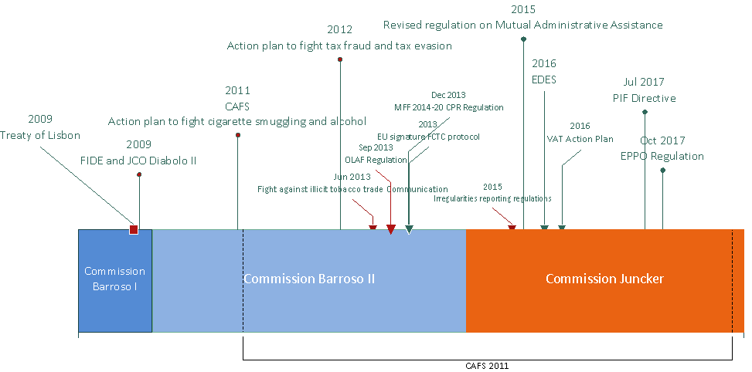

In **2011**, the Commission adopted an ambitious **anti-fraud strategy** (CAFS) and an action plan to fight cigarette and alcohol smuggling along the EU's Eastern border. In **2012**, it presented its plans **to tackle tax fraud and tax evasion**.

**2013** marked some significant advances in protecting EU’s financial interests. In line with the objectives set in the CAFS, specific anti-fraud provisions that required managing authorities to adopt effective and proportionate anti-fraud measures, were introduced into the spending programmes of the 2014-2020 MFF. Regulation (EU) No 883/2013 redefined **investigations conducted by OLAF**, reinforcing the procedural guarantees for the individuals concerned and requiring all Member States to designate an AFCOS to facilitate effective cooperation and exchange of information with the Office. The **Framework Convention on Tobacco Control (FCTC) Protocol** against illicit tobacco trade was signed by 54 parties, including the EU. The Commission also adopted the Communication on the **fight against tobacco smuggling** and an action plan.

The legislative package mandated by the CAFS was completed in **2014** with the adoption of revised public procurement and utilities directives and a new concessions directive. All CAFS priority actions were completed in the course of the same year.

The momentum continued under the Juncker Commission and as the decade drew to a close, two major and long awaited legislative acts were finally adopted to strengthen the criminal law protection of the EU budget: The directive on the **fight against fraud to the EU’s financial interests by means of criminal law** (the PIF Directive)[4]; and the Regulation implementing enhanced cooperation on the establishment of the **EPPO**[5].

In 2017, the Commission revised its internal control framework[6] to ensure that all components, even the one including fight against fraud, are present and effective at all levels of the organisation.

The next chapters of this report focus on the progress made in 2018.

# Harmonising and reinforcing the fight against fraud across the EU: cross‑cutting anti-fraud policies, measures and results in 2018

## Legislative acts adopted by the EU institutions

### Regulation implementing enhanced cooperation on the establishment of EPPO: state of play

Following the adoption of the EPPO regulation, in August 2018, the Netherlands and Malta confirmed their membership to the EPPO, bringing the total number of participating Member States to 22. The EPPO will be competent to investigate, prosecute and bring to judgment criminal offences affecting EU’s financial interests as defined in the PIF Directive.

The EPPO is expected to be operational by the end of 2020, following a setting up period of at least 3 years provided for in the EPPO Regulation. Establishing the EPPO is a Commission priority and this process is well advanced.

In 2018, the Commission appointed an interim Administrative Director, responsible for the administrative and budgetary matters. The procedures for the recruitment of the European Chief Prosecutor and of the European Prosecutors were also launched. The Commission invited Member States to nominate their candidates for the position of European Prosecutor by the end of March 2019.

The participating Member States are being consulted throughout the process through the group of experts that was set up in accordance with the EPPO Regulation.

### The Omnibus Regulation

Regulation (EU, Euratom) 2018/1046, the ‘Omnibus regulation’, was adopted on 18 July 2018. The Omnibus regulation amends the existing Financial Regulation which sets out the overall framework for budget management, as well as a number of acts governing the EU's multiannual programmes in various fields, including cohesion policy. The Omnibus regulation therefore revises the EU's financial rules to simplify them and make them more result-oriented. It includes revisions that simplify the use of financial instruments under the European Structural and Investment Funds.

Article 61 of the Financial Regulation redefines conflict of interests for all financial actors implementing the EU budget in the various management modes, including at national level. This is likely to engender a large increase in the use of “declarations of interest” by financial actors, an increase of transparency, and better public confidence.

## Shaping the future: European institutions’ legislative and policy initiatives

The next section gives an overview of major developments in Commission policy and legislative initiatives in 2018.

### Commission proposal to revise Regulation (EU, Euratom) No 883/2013

On 23 May 2018, the Commission adopted its proposal to amend selected provisions of Regulation No 883/2013[7]. The revision of the Regulation is primarily driven by the need to adapt the operation of OLAF to the functioning of the future EPPO. The revision also aims to increase the effectiveness of OLAF’s investigative function, in particular, by: (i) clarifying to what extent EU and national law apply in the conduct of on-the-spot checks and inspections, thus codifying case-law of the General Court; (ii) improving the admissibility of evidence collected by OLAF in follow-up proceedings; and (iii) providing a clear legal basis for OLAF to access bank account information through the assistance of national competent authorities.

On the future relationship with the EPPO, the Commission proposal sets reporting obligations for OLAF where it encounters possible fraud falling under the EPPO's competence. It also clarifies how and when OLAF can support or complement the EPPO upon its request and when OLAF may open or continue an administrative investigation on its own initiative to ensure that the two bodies complement each other to the greatest extent possible and to ensure the right balance of criminal and administrative means to protect the EU budget.

The Commission proposal is a targeted revision of the OLAF Regulation aiming to ensure that the amendments will be in force by the time the EPPO becomes operational by the end of 2020. A more far-reaching revision to modernise OLAF's legal framework could be envisaged at a later stage.

In 2018, the Commission proposal was discussed in the Council's Group Anti-Fraud (GAF) under the Bulgarian and Austrian Presidencies. The Finnish Presidency has a mandate to start informal negotiations with the Parliament (trilogues) in autumn 2019. The European Parliament adopted its report on the Commission proposal on 16 April 2019[8].

### Commission proposal for a Regulation on the protection of the Union's budget in case of generalised deficiencies as regards the rule of law in the Member States

The Commission proposed on 2 May 2018 a Regulation on the protection of the Union's budget in case of generalised deficiencies as regards the rule of law in the Member States. The proposal is based on the understanding that respect for the rule of law is an essential precondition to comply with the principles of sound financial management. Under the proposal, the EU could suspend, reduce or restrict access to EU funding in a proportionate manner. When deciding to launch this procedure, the Commission will take into account relevant information such as decisions by the Court of Justice of the European Union, reports from the ECA, as well as conclusions of relevant international organisations. The Member State concerned will be given the opportunity to present its position before any decision is taken. Member States would continue to be bound by existing obligations to implement programmes and make payments to final recipients or beneficiaries. The proposal is currently under discussion by Council and Parliament.

### Cross-cutting provisions on protecting the EU's financial interests (PIF provisions) within all the Commission's MFF proposals

OLAF in close cooperation with spending departments and central Commission departments introduced standard provisions on protecting the EU's financial interests in all the Commission's legislative proposals for the post-2020 spending programmes under direct, indirect and shared management. According to these provisions the EU's financial interests are to be protected through proportionate measures, including the prevention, detection, correction and investigation of irregularities and fraud. In addition, any person or entity receiving EU funds is to fully cooperate in the protection of EU’s financial interests, to grant the necessary access rights to the Commission, OLAF, the EPPO and the European Court of Auditors and to ensure that any third parties involved in implementing EU funds grant equivalent rights.

### Fighting corruption in the EU

In 2018 the fight against corruption was a priority in the European Semester process of economic governance. Fourteen country reports[9] included an assessment of the anti-corruption legal, policy and institutional landscape, including progress and remaining challenges.

Six Member States also received country specific recommendations to step up the fight against corruption, adress weaknesses in public procurement, reinforce the anti-corruption framework, more effectively prevent and repress corruption, prevent conflicts of interest, and increase the accountability at prosecution and police level.

Following a call for proposals, seven grants at a total value of EUR 2.2 million were awarded to projects proposing actions in the area of the fight against corruption.

In 2018, the Commission, including OLAF, participated actively in several European and international anti-corruption fora, such as the United Nations Convention against Corruption, the Organisation for Economic Cooperation and Development, the Anti-Corruption Working Group of the G20 and the European Partners Against Corruption (EPAC) / the European Contact-Point Network Against Corruption (EACN).

### International cooperation

To combat fraud against the EU budget beyond the EU borders more effectively, the Commission continued to include anti-fraud provisions in agreements with non-EU countries and in templates for contribution agreements with international financial institutions and other international organisations.

In 2018, OLAF organised two specific events to support non-EU countries:

• its annual seminar (held in Bosnia and Herzegovina in June 2018), for partner authorities in candidate and potential candidate countries, on best practices in successful fraud investigations; and[10]

• a workshop (July 2018) with the participation of all relevant anti-fraud services in Ukraine in the framework of the EU-Ukraine Association Agreement.

OLAF also signed two administrative cooperation arrangements with the African Development Bank and the Office of the Inspector General of the United States Agency for International Development (USAID) respectively.

### Commission anti-fraud strategy (CAFS) and the new governance package

In 2018, the Commission prepared a new CAFS to replace the strategy that was adopted on 24 June 2011[11], the objective of which is to improve prevention, detection and investigation of fraud and ensure that appropriate sanctioning, recovery and deterrence are high on the Commission’s agenda.

The new strategy, which was adopted on 29 April 2019, is based on an elaborate risk assessment which identified as main areas for improvement the collection and analysis of data on fraud, the cooperation between the Commission departments and the corporate oversight on fraud matters inside the Commission. These aspects have therefore been put at the centre of the new CAFS. They are also coherent with an in-house evaluation of the previous strategy.

Governance improvements were implemented[12] by the end of 2018, reinforcing the role of the Commission’s Corporate Management Board also in the anti-fraud domain.

### Implementation of the Hercule programme

The 2014-2020 Hercule III programme[13] promotes activities to counter fraud, corruption and any other illegal activities affecting the EU’s financial interests. In 2018, the fifth year of its implementation, a budget of EUR 15.35 million was made available[14] for:

* funding actions to strengthen the operational and technical capacity of customs and police forces in the Member States, and IT support (75% of the programme’s budget); and
* training activities and conferences, including digital forensic training for staff employed by law enforcement agencies in the Member States and partner countries (25% of the budget).

Beneficiaries of Hercule III grants reported substantial successes achieved with the help of equipment and training funded under the programme[15], such as:

* seizures of smuggled and counterfeit cigarettes and tobacco;
* detection of new fraud schemes and networks of organised crime groups; and
* improved operations and faster investigations into irregularities and corruption perpetrated against the EU's financial interests.

## CJEU jurisprudence

### Sigma Orionis v Commission

In 2018, one ruling by the General Court added to the case-law on the protection of the EU’s financial interests concerning on-the-spot checks and inspections by OLAF.

In the case *Sigma Orionis v Commission*[16]*,* the Court clarified the applicable law during these on-the-spot checks and inspections.

The Court ruled that, in the absence of opposition by the economic operator, on-the-spot checks and inspections are conducted by OLAF on the basis of Regulation No 883/2013 and Regulation No 2185/1996, and of the written authorisation of the Director-General of OLAF. EU law supersedes national law when a matter is regulated by Regulations No 883/2013 or No 2185/1996. Moreover, the Court found that the provisions (in Regulation No 2185/1996) concerning the possible opposition of the economic operator concerned to a check do not include a 'right to oppose' but simply provide for the consequence that the check may be imposed on them through the assistance of national authorities (on the basis of national law). As regards procedural guarantees, the Court recalled that OLAF must respect fundamental rights as laid down in EU law, in particular in the Charter.

In the opinion of the Commission, these important clarifications by the Court will help increase the efficiency of OLAF investigations.

### Case-law related to EDES

The Court of Justice has upheld the validity of the Early Detection and Exclusion System (EDES)[17] established in 2016 both concerning the early detection (Judgment of the General Court of 24 October 2018 in Case T-477/16, Epsilon International SA v European Commission) and the exclusion part (Judgment of the General Court of 8 November 2018 in Case T-454/17, 'Pro NGO!' v Commission)[18].

## Measures taken by Member States

### Overview of measures taken by Member States

This summary gives an overview of trends in and priorities for Member States’ anti-fraud measures, but is not exhaustive. Member States were asked to report a maximum of three anti‑fraud measures, but some may have taken more than three measures[19].

In 2018, Member States reported 71 measures[20] to protect the EU’s financial interests and fight fraud. The measures covered the entire anti‑fraud cycle, mostly in the area of shared management and public procurement, but also on conflicts of interests, corruption and anti-corruption strategies, financial crime, customs and illicit trade. Most of the measures concerned 'prevention' and 'detection'. About one third of the reported measures also dealt with ’investigation and prosecution' and 'recovery and sanctions'.

The majority (64%) were sectoral rather than cross‑cutting (36%). Of the sectoral measures, 14 concerned revenue in the fields of tax fraud and customs. Another 31 concerned expenditure, covering all areas of the budget. Sector‑related measures will be dealt with in the paragraphs dedicated to the various budgetary areas, while this section focuses on the cross‑cutting measures.

### National anti-fraud strategies (NAFS)

By the end of 2018, a total of 11 Member States[21] had adopted a national anti-fraud strategy and sent it to the Commission. **The Commission calls once more on the other Member States to draw up such strategies**, in line with the ECA findings in its Special Report No 06/2019.

### Enhancing transparency, figthing corruption and conflict of interests in public procurement

Thirteen measures were adopted by 10 Member States[22] in 2018 on public procurement. They are aimed at tackling corruption and conflicts of interest and at enhancing transparency. About half these measures involved legislative acts to clarify or consolidate existing rules or to adapt national systems to developments in EU legislation. Organisational and operational measures were also reported, mainly dealing with training activities and the introduction of new IT tools.

### Other measures

Other reported cross‑cutting measures mainly concerned financial and organised crime[23], in particular in view of the establishment of the EPPO[24]. Latvia continued its three-year national anti-fraud campaign (#FraudOff!) to raise public awareness about and promote zero tolerance against fraud.

Two Member States reported measures concerning their internal control systems[25]. Sweden informed about the annual programme of its Council for the Protection of the European Union's Financial Interests (SEFI) and Croatia about an international conference dedicated to irregularity management.

Three Member States reported measures to address revenue and expenditure in certain sectors[26]:

* the Italian Economic and Financial Police drew up specific operational plans to combat embezzlement, undue requests for and/or receipt of EU funds and VAT fraud;
* Slovenia increased cooperation between authorities managing EU’s financial interests and law enforcement and judicial authorities; and
* the United Kingdom reported a measure addressing tax fraud and the protection of the fund for the most deprived (FEAD).

### Implementation of 2017 recommendations

In the 2017 PIF Report, the Commission made two sets of recommendations to the Member States; one of them targeted revenue and the other expenditure.

The Commission had recommended that Member States[27]:

* 1. *Remain vigilant on the risk of undervaluation*

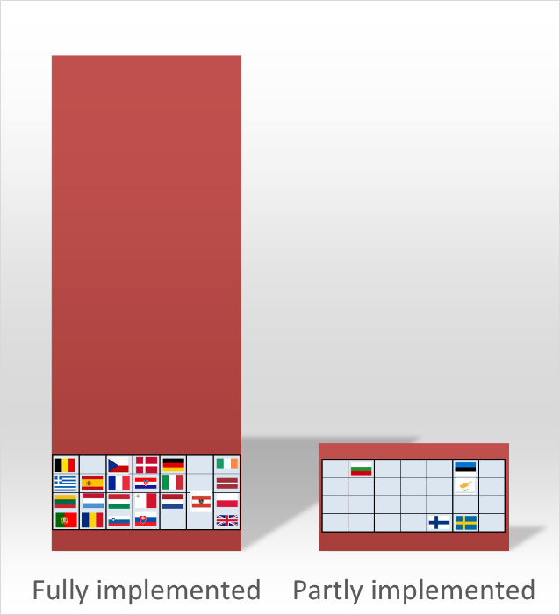

* 1. *Enhance customs controls*

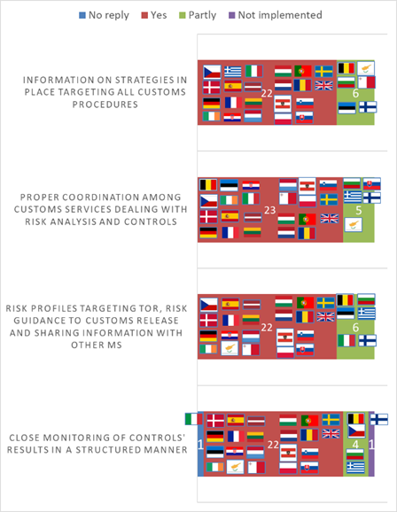

* 1. *Adopt other measures to strengthen customs risk management*

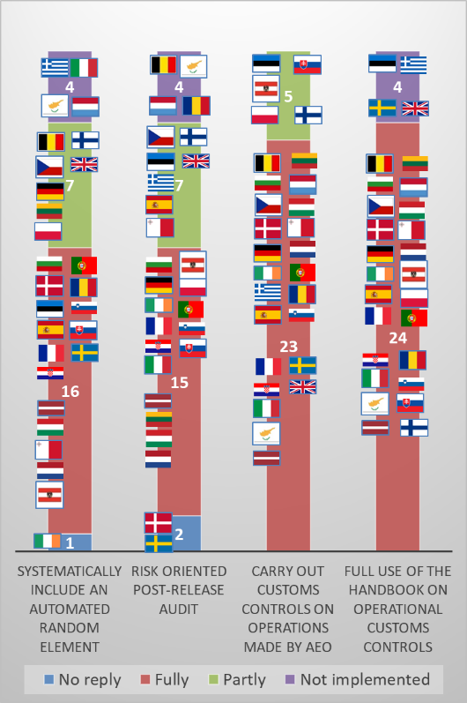

On the expenditure side, Member States were requested to:

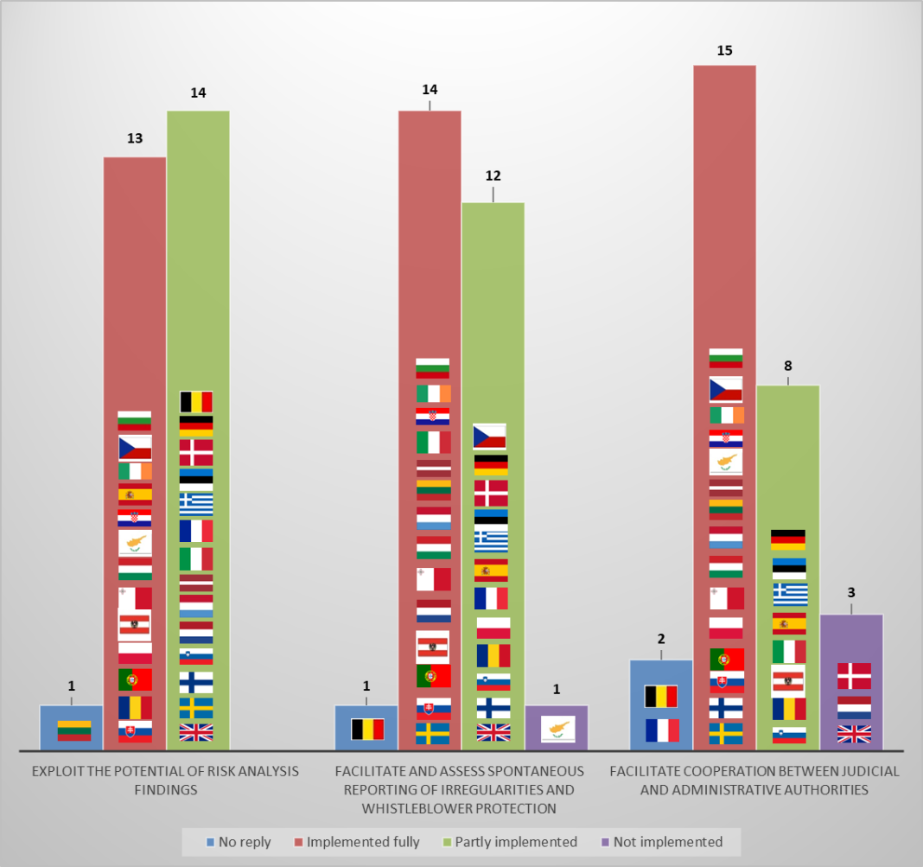

Overall, the follow-up to the recommendations showed that most Member States made progress. The results revealed an effective follow-up on the revenue side of the budget. However, on the expenditure side, there is clearly a growing need for more cooperation between authorities dealing with the protection of the EU's financial interests.

Most Member States put in place a number of tools and procedures to collect tips from whistleblowers and guarantee their anonymity. However, a central coordination or harmonisation of rules and approaches often seems lacking, even at national level. The Directive on the protection of persons reporting on breaches of EU law, agreed between the co-legislators in April 2019[28], will help fill some of the remaining gaps.

Another potential area for improvement is the cooperation between administrative authorities and law enforcement and the judiciary. AFCOS may play an important role in fostering and nurturing such cooperation, also in view of the establishment of the EPPO. This has also been highlighted by the ECA in its Special Report No 06/2019.

## Summary of statistics on detected irregularities and fraud[29]

In 2018, a total of 11 638 fraudulent and non-fraudulent irregularities were reported to the Commission, 25% fewer than in 2017. They involved approximately EUR 2.5 billion, stable in comparison with the previous year.

The detection and reporting of an irregularity implies that corrective measures have been taken in order to protect the EU's financial interests and that, whenever relevant, criminal proceedings have been launched, if fraud is suspected.

Figure 1: Irregularities reported as fraudulent in 2018

### Detected fraudulent irregularities

The number of irregularities reported as fraudulent (which includes cases of suspected or established fraud) and the associated amounts are not a direct indicator of the level of fraud affecting the EU budget. They merely show how many cases of potential fraud are being detected and reported by Member States and EU bodies.

In 2018, a total of 1 152 irregularities were reported as fraudulent (i.e. 10% of all irregularities detected and reported)[30], involving about EUR 1 197.2 million (representing 48% of all financial amounts affected by irregularities)[31] and covering both expenditure and revenue, as shown in Figure 1.

The number of fraudulent irregularities reported in 2018 remained stable as compared with 2017, while the financial amounts involved increased by a significant 183%. Looking at a five‑year period (2014-2018), this was 27% less than in 2014, and 16% below the five-year average. The financial impact fluctuates greatly (see Figure 4), as it can be affected by individual cases involving large sums. The reasons for the sharp increase in 2018 relate to the cohesion policy and are, therefore, addressed in paragraph 4.3.2.1.

Figure 2: Irregularities reported as fraudulent and associated amounts, 2014-2018

A breakdown of fraudulent irregularities reported in 2018, by Member State and by budget sector, is set out in Annex 1.

### Detected and reported non-fraudulent irregularities

In 2018, the Commission was notified of 10 487 irregularities reported as non-fraudulent (27% less than in 2017). The figures decreased for all sectors except pre-accession. The financial amounts involved decreased by 37% to approximately EUR 1.3 billion, as shown in Figure 3.

A breakdown of non-fraudulent irregularities reported in 2018, by Member State and by budget sector, is set out in Annex 2.

Figure 3: Irregularities reported as non-fraudulent in 2018

### OLAF investigations

In 2018, OLAF opened 219 investigations and concluded 167, recommending financial recoveries worth EUR 371 million. At the end of the year, 414 investigations were ongoing.[32]

# Anti-fraud policies, measures and results — Revenue

## EU institutions’ anti-fraud measures – revenue

### Mutual administrative assistance

### Anti-Fraud Information System (AFIS)

AFIS[33] is an umbrella term for a set of anti-fraud IT applications operated by the European Commission (OLAF) which create contacts with the competent authorities in the Member States, ensuring timely and secure exchange of fraud-related information between national and EU competent administrations. The AFIS Portal is a single and common infrastructure for the delivery of the below-mentioned services to nearly 8 800 registered end-users in more than 1 900 competent services from Member States, partner third countries, international organisations, Commission departments and other EU institutions. The AFIS project encompasses two major areas: (i) mutual assistance in customs matters; and (ii) irregularities management (covering several expenditure sectors).

AFIS supports mutual assistance in customs matters with the secure real-time information exchange system VOCU (Virtual Operations Coordination Unit) used for joint customs operations, secure web mail (AFIS-Mail), databases like the CIS+ (Customs Information System) and FIDE (Customs Investigation Files Identification Database) and analysis tools like A-TIS (Anti-Fraud Transit Information System).

The Irregularity Management System (IMS) is a secure electronic tool which helps Member States in their obligation to report irregularities detected in agricultural, structural, cohesion and fisheries funds, the Asylum, Migration and Integration Fund (AMIF), the instrument for financial support for police cooperation, preventing and combating crime, and crisis management (ISF) and the Fund for European Aid to the Most Deprived (FEAD) as well as pre-accession aid. It supports the management and analysis of irregularities.

### Joint customs operations (JCOs)

In addition to its investigations on cases of revenue fraud, OLAF coordinates large-scale JCOs involving EU and international operational partners. JCOs are targeted actions of limited duration that aim to combat fraud and the smuggling of sensitive goods in specific areas at risk and/or on identified trade routes.

In 2018, OLAF provided support in 5 JCOs. The VOCU module of the AFIS was used for the secure exchange of information in four of these JCOs. In addition to the necessary support for the relevant countries to conduct coordinated actions by means of OLAF's permanent technical infrastructure, IT and communications tools, OLAF also provides strategic analysis, administrative and financial support.

These operations: (i) help to improve the effectiveness of customs services in conducting targeted checks at European level; (ii) identify where the risks lie on specific trade routes; (iii) protect the public and legitimate businesses by preventing illegal products from entering the EU; and (iv) safeguard EU public finances.

Figure 4 presents a summary of these operations.

Figure 4: JCOs in 2018

| **Operation** | **Participating countries** | **Scope** | **Results** |
| --- | --- | --- | --- |
| **JCO Poseidon** | Organised by Italian Customs in cooperation with OLAF | Revenue fraud | Evaluation ongoing |
| **Joint Border Control Operation JANUS** | Co-organised by the European Union Border Assistance Mission to Moldova and Ukraine (EUBAM) and OLAF | Smuggling of tobacco products at the EU eastern border | Seizure of more than 7 million pieces of cigarettes |
| **Regional JCO MARCO** | Regional maritime surveillance operation, coordinated by French Customs, in the area of the Atlantic | Detection of illicit trafficking of sensitive goods by sea | Over 200 non-commercial vessels were checked |
| **Joint Action Hansa** | Driven by the United Kingdom Customs in cooperation with Europol. OLAF provided the AFIS system for the secure exchange of the information and took part in the operation | Internal movement of illegal excisable goods, mainly cigarettes | Seizures of high numbers of cigarettes and other tobacco products |
| **Operation SILVER AXE III** | Organised by Europol with the cooperation of OLAF and the participation of customs, police and plant services protection authorities from 27 countries | Import and the intra-Union trade of counterfeit and illicit plant protection products | Seizure of 360 tons of illegal or counterfeit pesticides |

### Mutual assistance and anti-fraud provisions in international agreements

Cooperation with third countries to prevent, detect and combat breaches of customs legislation is based on agreements on mutual administrative assistance (MAA) in customs matters. Currently, there are agreements in force with more than 80 countries, including with major EU trade partners, like the United States, China and Japan. In 2018, the MAA Protocol with New Zealand entered into force. In addition, negotiations with Mercosur (Argentina, Brazil, Paraguay and Uruguay) and Chile were finalised, and were ongoing with Australia, Indonesia, Azerbaijan, Kyrgyzstan, Uzbekistan and Andorra.

Free trade agreements usually contain an anti-fraud clause, which allows for a temporary withdrawal of tariff preference for a product in cases of serious customs fraud and persistent lack of adequate cooperation to combat it. OLAF actively contributes to the negotiations of such clauses. In 2018, a clause was agreed at technical level with Mercosur and New Zealand. The clause will be also introduced to the modernised free trade agreement with Mexico.

The WTO Trade Facilitation Agreement (Bali Agreement), to which the EU is a party, has been in force since 2017. Article 12 on customs cooperation provides for additional possibilities to exchange information with third countries to verify an import or export declaration where there are reasonable grounds to doubt the truth or accuracy of the declaration.

### Fight against illicit trade in tobacco products

In addition to its enforcement role in fighting the illicit tobacco trade, OLAF also helps strengthen EU policy in this field.

**Action plan** - On 7 December 2018, the European Commission presented a new action plan[34] to enable the European Union to continue fighting illegal tobacco trade, a phenomenon that deprives the EU and its Member States of roughly EUR 10 billion of public revenue every year. The action plan outlines concrete steps to address both the supply of and the demand for illegal tobacco products. Moreover, like its predecessor, the second action plan puts forward both policy and operational law enforcement measures since only a combination of these is liable to lead to a sustainable reduction in illicit tobacco trade. The new action plan builds on the analysis of the 2013 strategy to step up the fight against the illicit tobacco trade. It ensures continuity by keeping the focus on the Protocol to Eliminate Illicit Trade in Tobacco Products (FCTC Protocol) at global level and the successful implementation of the new traceability system for tobacco products in the EU.

**FCTC Protocol** - The Protocol will only effectively help curb illicit trade if it is also implemented by third countries which are the main source of illicit tobacco products, or are transit countries on the smuggling routes. The Commission is intensifying its efforts to promote the Protocol outside the EU while assisting Member States in the quick completion of their internal ratification procedures. OLAF is engaged in these discussions on the European and international scene.

The FCTC Protocol entered into force on 25 September 2018. The European Commission, led by OLAF, in close cooperation with the Council Presidency, participated in the first Meeting of Parties to the Protocol which took place on 8–10 October 2018. The parties decided to focus on securing the supply chain of tobacco products and international cooperation and OLAF will continue to contribute to this work at international level.

### Anti-fraud related cooperation with the Joint Research Centre (JRC)

In pursuing anti-fraud objectives in the customs area, OLAF cooperates closely with the Commission's JRC, notably in the following large projects:

**Automated monitoring tool (AMT)** for the analysis of “big data”. The AMT calculates estimates of baseline prices for goods imported in the EU, for each combination of product, third country origin and Member State destination. It also generates automated alerts for price outliers in trade data.

**Data analysis for customs anti-fraud purposes (INTEL4CUSTAF) –** The Hercule III funded project INTELF4CUSTAF was established in 2018 by OLAF, following requests from Member States. The project brings together Commission departments and Member States' customs authorities, to identify ways to make best use of new and emerging data sources and analytical techniques.  Overall, this project will lead to improved EU-wide analytical capacities in the customs anti-fraud field. The two workshops organised in 2018 were attended by a wide range of experts and countries who discussed a range of needs and existing approaches. By the end of the year the community numbered around 100 experts. The work continues in 2019.

**Container Status Messages and analysis of import declarations –** JRC's scientific and technological support was instrumental to check the compliance with Regulation 2015/1525, amending Regulation 515/97 on the submission of Container Status Messages (CSM). Several statistical indicators were developed to continuously monitor the quality and completeness of the CSM reported by the maritime industry. Moreover, in the framework of the Contraffic-SAD services, 191 fraud-signals were generated for the period January 2017 – October 2018 for a total potential customs-duties evasion of EUR 1.9 million.  These fraud-signals resulted from the automatic analysis done by JRC of more than 4 million import declarations.

**Tobacco analysis and data management (TOBLAB) –** In 2015, OLAF concluded an administrative arrangement with JRC-Geel *"Operating a laboratory facility and associated data management for the analysis of tobacco products" (TOBLAB)* funded under the Hercule III programme. TOBLAB will provide scientific and technical support for the management of data of the testing results. In 2018, 103 analyses of tobacco and tobacco products were carried out at JRC.

### Fight against VAT fraud[35]

***Modification of the Council Regulation 904/2010 on administrative cooperation and the fight against fraud in the field of VAT***

In October 2018, a set of modifications[36] was introduced to the legal framework for administrative cooperation and the fight against fraud in the field of VAT (Council Regulation 904/2010) to increase the capacity of the Member States to address the most damaging VAT fraud schemes and diminish the VAT gap, which amounted to EUR 147.1 billion in 2016. The prime measures are:

* Joint administrative enquiries

Carrying out an administrative enquiry is an integral part of combating VAT fraud. This new cooperation instrument was introduced to boost the capacity of tax administrations to check cross-border supplies. It allows two or more tax administrations to form a single team to examine cross-border transactions of one or more related taxable persons carrying out cross-border activities.

In addition, when at least two Member States consider that an administrative enquiry into the amounts declared by a taxable person not established on their territory but taxable therein is necessary, the Member State where the taxable person is established should undertake the enquiry and the requiring Member States should assist the Member State of establishment by actively taking part in the enquiry. This measure is particularly relevant to combat fraud in the e-commerce sector.

* Eurofisc

Eurofisc was established for the swift exchange of targeted information between Member States to tackle large-scale or new VAT fraud patterns. To speed up the joint processing and analysis of data, the Commission is currently deploying a new software called Transaction Network Analysis (TNA).

To maximise TNA’s potential to identify fraudulent networks across the whole EU, the amended Regulation (EU) No 904/2010 clarifies the provision for the joint processing and analysis of data within Eurofisc. Involvement in such processing and analysis remains voluntary, but Member States must grant Eurofisc officials access to their VAT information exchange system (VIES) data on intra-EU transactions through TNA, so that potential fraud networks can be identified, including those involving traders established in non-participating Member States.

Based on the 2018 amendments, Eurofisc will coordinate administrative enquiries launched on the basis of its risk analyses. Eurofisc officials are often the first to be warned about new fraudulent networks, and they have strong expertise in serious VAT fraud. Therefore, they are the best placed to coordinate the corresponding administrative enquiries.

Regulation 2018/1541 also opened up the possibility for Eurofisc officials to forward information on VAT fraud trends, risks and serious cases to Europol and OLAF for cross checking with their records. This covers, in particular, the most damaging VAT fraud, such as missing trader intra community (MTIC) schemes and abuses of customs 'procedure 42'[37] frequently involving criminal organisations, which take advantage of their international networks to create advanced MTIC schemes to extort money from the national budgets.

Cooperation with EU law enforcement authorities allows for the cross-checking of Eurofisc information with criminal records, databases and other information held by OLAF and Europol and will help identify the real perpetrators of fraud and their networks. OLAF obtains, in particular, relevant information in the context of its investigations on customs fraud, which is intrinsically linked to VAT fraud such as customs 'procedure 42' fraud.

* Disclosure of serious VAT fraud cases involving at least two Member States to OLAF and EPPO

Member States participating in the EPPO should communicate to it information on the most serious VAT offences as referred to in Article 2(2) of the PIF Directive. These will be cases involving activity in two or more Member States and with a total damage of at least EUR 10 million.

OLAF remains responsible for administrative investigations into non-fraudulent and fraudulent irregularities affecting the EU’s financial interests. Its mandate and competence on VAT fraud therefore go beyond those cases identified as most serious in Article 2(2). In addition, as not all Member States will be part of the EPPO, OLAF continues with its administrative investigations in relation to non-participating Member States in the same way as it did before[38].

OLAF may also facilitate and coordinate VAT fraud investigations making use of its multidisciplinary approach, as well as provide analysis and intelligence. To this end, the Member States should communicate to OLAF information about VAT offences where they deem it appropriate for the exercise of its mandate.

* Sharing customs procedures 42/63 data with tax authorities

As from 2020, the relevant information on customs 'procedure 42' and 'procedure 63'[39] submitted electronically with the customs declaration (e.g. VAT numbers, value of the imported goods, type of commodities, etc.) will be shared by the Member State of import with the tax authorities in the customer's Member State. The tax authorities in both countries will therefore be able to cross-check this information with the information reported by the importer in their recapitulative statement and VAT return, and by the recipient in their VAT return. This will allow the immediate checking of the importer, if the VAT number of the customer, albeit valid, had been hijacked by the importer and will enable tax authorities to detect cases of undervaluation at the moment of import.

* Sharing vehicle registration data with tax authorities

The 2018 amendments also introduced the exchange of data on car registrations. Eurofisc officials will use this to tackle cross-border fraud involving the sale of second-hand cars and to swiftly indentify who has committed the fraudulent transactions and where.

***EU-Norway agreement***

The EU-Norway agreement on administrative cooperation and recovery assistance in the area of VAT entered into force on 1 September 2018.

The purpose of the agreement is enhanced cooperation, fight against fraud and assistance for the recovery of claims in the VAT area. It allows Norway to participate in the existing cooperation tools among the Member States, such as exchange of information and administrative enquiries, assistance on administrative notifications, presence in administrative offices and participation in administrative enquiries, participation in some Eurofisc working fields, simultaneous controls, as well as assistance for the recovery of claims.

## Member States’ anti-fraud measures – revenue

Eleven Member States reported measures to fight customs and tax fraud. These included:

* refining risk indicators to address the undervaluation of import declarations[40];
* targeting e-commerce[41];
* organisational measures aimed at creating or increasing departments/units intelligence capability[42];
* introducing new IT tools[43]; and
* introducing the split payment mechanism to reduce VAT fraud[44].

## Statistics on detected irregularities and fraud – revenue

Figure 5 presents the main statistical data and findings on the irregularities detected and reported for TOR. On both fraudulent and non-fraudulent irregularities, a decrease in the number of reported cases in comparison with the five-year average is, however, accompanied by an increase in the related amounts.

Figure 5: TOR - Key facts and patterns

### Detected fraudulent irregularities[45]

The number of irregularities reported as fraudulent for 2018 is 20% lower than the five-year average (594 irregularities for the period 2014-2018). The affected amount of TOR estimated and established is 37% higher (EUR 120 million).

The previous report informed on cases of undervaluation detected in the United Kingdom affecting the TOR revenue. The OLAF investigation report released on 1 March 2018 shed light on the dimension of the undervaluation fraud concerning textile and shoes imported from China via the United Kingdom.

As a consequence of this investigation as well as those conducted by the Commission within the framework of own resources management, on 8 March 2018 the Commission decided to start a formal infringement procedure by sending the United Kingdom a Letter of Formal Notice under Article 258 TFEU. The case was eventually referred to the CJEU on 7 March 2019. The Director-General of DG BUDG therefore maintained the reservation in the 2018 Annual Activity Report on the inaccuracy of the TOR amounts transferred to the EU budget by the United Kingdom.

### Detected non-fraudulent irregularities

The number of irregularities reported as non-fraudulent for 2018 is 10% lower than the five-year average (4,545 for years 2014-2018), while the affected amount is 17% higher (EUR 384 million).

Non-fraudulent irregularities were primarily detected by means of post-release controls. The customs controls before or at the time of release of goods remain however indispensable for addressing undervaluation and the detection of new types or patterns of fraud or irregularities. Voluntary admissions became a more and more important source of detection of irregularities.

# Sectoral anti-fraud policies, measures and results — expenditure

## Member States’ sectoral anti‑fraud policies and measures involving several expenditure sectors

Member States reported several measures that address different funds at the same time, mostly the European Structural and Investment Funds (ESIFs)[46]. Some of the measures extend to other shared management funds, such as the AMIF, the Fund for European Aid to the Most Deprived (FEAD) and the European Globalisation Adjustment Fund (EGF). The measures differ widely in nature and purpose, and range from reinforcement of the ex-ante control over public procurement under European funds[47] to a review of the system for recovery and financial corrections[48]; from risk assessments, red flags and IT tools (such as ARACHNE)[49] to training courses on specific cross-cutting issues[50][51].

## Agriculture — sectoral anti-fraud policies, measures and results

### Agriculture — Member States’ anti-fraud measures

Five Member States reported anti-fraud measures specific to agriculture. They concern:

* an action plan to enhance management and control of public procurement in rural development[52];
* strengthening the anti-fraud structure of a paying agency[53];
* setting up an alert system to detect facts indicating fraud or attempted fraud[54];
* strengthening prevention by ensuring direct management and supervision of identification and control of agricultural land and determining eligible areas for financial support under European Agricultural Guarantee Fund (EAGF) and European Agricultural Fund for Rural Development (EAFRD)[55]; and
* developing fraud risk analysis to prepare an inventory of fraud risks in the different processes, using the Commission’s fraud risk template[56].

Two Member States reported measures concerning both agriculture and fisheries. Such measures refer to:

* an in-depth examination of the detected violations and the development of a methodology to sanction them[57]; and
* training activities, updating fraud indicators on fraud prevention and artificially created conditions for employees of an Agency for Agricultural Markets and rural development[58].

### Agriculture — statistics on detected irregularities and fraud

The common agricultural policy (CAP) comprises two main components (see Figure 7):

* direct support (SA), through direct payments to farmers (DA) and market support measures (MM), financed by the EAGF; and
* rural development (RD), mainly financed through the EAFRD.

The EAGF follows an annual implementation cycle, while the EAFRD finances multiannual programmes.

The trend of irregularities detected and reported by Member States over the last five years is influenced by these differences: SA shows a stable, flat trend, while RD follows a curve, peaking in 2015 and then declining. Analysis of the irregularities detected by the Member States confirms the higher risk associated with MM and RD investments[59], in line with the main findings of the ECA and the Commission audits. The impact on payments of irregularities affecting SA is acceptably low, while RD presents a higher level of risk. However, within SA, MM show the highest detection rates of the whole CAP.

Figure 6: Detection rates by CAP component

### Detected fraudulent irregularities

For the reporting years 2014 to 2018, the main trends for fraudulent irregularities are quite stable.

In absolute numbers, the majority of detected potential frauds and the related financial amounts affected RD. This predominance is more evident if one considers that only about 20% of the CAP resources go into RD. However, MM, regardless of some few cases involving very large sums, shows the highest average financial amount of potential frauds and the highest fraud-related indicators (see Figure 6).

Figure 7: Agricultural policy – key facts and figures

This year's specific analysis on the concentration of detection/reporting[60] by Member States in relation to payments received highlights that a few countries report a significant share of the fraudulent irregularities, which is not proportional to the distribution of payments among the Member States. While for direct payments this seems linked to specific issues of the countries where detection is highest, in relation to MM and RD the explanation may be the dishomogeneous approaches to the use of criminal law to protect the EU’s financial interests.

This last conclusion seems strengthened also by the analysis of the ratio of dismissed cases[61], which varies significantly among Member States and is higher in agriculture than in the cohesion policy area. Judicial authorities seem less inclined to prosecute alleged crimes in this sector.

### Detected non-fraudulent irregularities

In general, the patterns described in Section 4.2.2 also apply to irregularities reported as non-fraudulent. RD‑related irregularities predominate both numerically and in terms of total financial amounts. However, the average amount involved in SA cases is higher. Again, a few cases concerning market measures and involving large sums contributed to this higher average. However, even net of these exceptional cases, the average financial amount of non‑fraudulent irregularities in market measures in 2014-2018 is still higher than that of RD cases. The average financial amount of non‑fraudulent irregularities concerning DA is the lowest.

Among the most recurrent detected and reported non-fraudulent irregularities, those related to implementation of the supported action, payment claims and documentary proof are the most frequent.

MM also show the highest Irregularity Detection Rate (IDR), followed by RD. Again, this is influenced by a few cases involving large financial amounts.

Figure 8: Market measures most affected by irregularities (fraudulent and non-fraudulent)

## Cohesion policy and fisheries — sectoral anti-fraud policies, measures and results

### Cohesion policy and fisheries — Member States’ anti-fraud measures

Fourteen countries reported that they had adopted cohesion policy measures. It was in this area that the highest number of initiatives, mainly operational ones, were adopted.

Figure 9: Measures adopted by Member States in the cohesion policy area

Denmark reported one specific measure dedicated to fisheries.

Figure 10: Cohesion and fisheries policies – key facts and figures

### Cohesion policy and fisheries — statistics on detected irregularities and fraud

Analysis of cohesion policy is more complex than for other budget sectors, because information received (reported irregularities) relates to different programming periods (PPs) and partially different rules.

Furthermore, PPs are multiannual, which significantly affects the underlying trends. Given the similarities in management, fisheries and cohesion policies are analysed together.

The number of reported irregularities peaked in 2015 and subsequent variations, also for the related financial amounts, are broadly in line with the implementation cycle. However, the trend of financial amounts is significantly influenced by a few cases involving exceptional financial amounts.

Irregularities reported in 2018 concern four different PPs, with an almost equal share between the PP 2007-2013 and the PP 2014-2020. The financial amounts reported are significantly higher than in the previous year. This increase is due, to a large extent, to two fraudulent irregulariites detected by Slovakia involving very high sums[62].

The current PP began in 2014, but reporting of irregularities commenced in 2016 and increased in 2017 and 2018. This trend is put into perspective by comparing it with the irregularities reported in the first five years of PP 2007-2013[63]..

### Detected fraudulent irregularities

In general, for all funds and periods, average financial amounts (AFA) of fraudulent irregularities were significantly higher than AFA of non-fraudulent irregularities, which underlines the threat posed by fraud and the importance of cooperation with the judicial authorities.

Comparing it with the irregularities recorded during the first five years of PP 2007-2013, the number of irregularities reported as fraudulent and the financial amounts involved were higher for PP 2014-2020 than for PP 2007-2013.

There were significant increases in the number of cases related to incorrect/missing or false documents, infringement of public procurement rules and ethics & integrity. The most significant decreases concerned violations related to eligibility/legitimacy of expenditure or measures and the infringement of contract provisions/rules.

The 'Priorities' most concerned were *'Research and Technological Development (RTD)*', '*Increasing the adaptability of workers and firms, enterprises and entrepreneurs*' and '*Improving access to employment and sustainability*'. The priorities '*Tourism*' and '*Urban and rural regeneration*' stood out in terms of FDR.

The ratio of established fraud was higher and dismissals lower for cohesion policy measures than for agriculture.

### Detected non-fraudulent irregularities

In the first five years of implementation of the current PP, the number of non-fraudulent irregularities reported is around 60% lower than for 2014-2020.

## Indirect management (pre-accession) — statistics on detected irregularities and fraud

The analysis of irregularities relating to indirect management focuses on the pre-accession instruments[64].

Reported irregularities concern three periods (2000-2006, 2007-2013 and 2014-2020), with the bulk of the reported irregularities relating to the period 2007-2013 (IPA I).

As with previous years, the main area affected by fraudulent irregularities is RD support.

## Direct management — sectoral anti‑fraud policies, measures and results

### Direct management — statistics on detected irregularities and fraud

Statistics on direct management are based on recovery orders issued by Commission departments and recorded in the Commission’s accrual‑based accounting system (ABAC).

### Detected fraudulent irregularities

In 2018, 44 recovery items recorded in ABAC were classified as fraudulent[65], accounting for EUR 6.17 million. Compared with the total funds actually disbursed, the FDR was 0.03 %, around the stable five-year average.

### Detected non-fraudulent irregularities

For non-fraudulent irregularities, 1 585 recovery items totalling EUR 67.6 million were recorded in 2018. Over a five-year period, the IDR slightly decreased by around 0.46 %.

# Recovery and other preventive and corrective measures

Detailed information on recoveries, financial corrections and other preventive and corrective measures (interruptions and suspension of payments) is published in the *annual management and performance report*[66].

Irregularities which have been detected and reported, as referred to in the PIF Report, are the object of corrective measures to make sure that EU funds are not used to finance irregular or fraudulent projects. When necessary, recovery procedures are put in place and followed-up by national authorities in line with the national regulatory frameworks.

# Cooperation with the Member States

The Advisory Committee for Coordination of Fraud Prevention (COCOLAF) brings together Commission (OLAF) and Member State experts. It provides a forum for discussing the main developments in the fight against fraud and the preparation of this report, as required by Article 325(5) TFEU. Its work is structured around four working groups and a plenary session (see Figure 11).

The reporting and analysis subgroup of COCOLAF provided the ideal forum for discussing and fine-tuning the analyses presented in the SWD on the 'statistical evaluation of irregularities’.

Within the fraud prevention subgroup work was started to develop a methodology for country profiles describing the anti-fraud systems of the Member States. This tool will continue to be developed over the next years.

Figure 11: COCOLAF structure and subgroups

The anti-fraud coordination services (AFCOS) meet annually under the chairmanship of OLAF. In 2018, the meeting took place on 16 October. OLAF’s investigative cooperation with AFCOS — in particular during on-the-spot checks — and information exchange were discussed. Other topics on the agenda included confidentiality of OLAF final reports, overarching cooperation between the national AFCOS and the Hercule annual work programme for 2019.

The OLAF Anti‑Fraud Communicators’ Network (OAFCN) brings together communication officers and spokespersons from OLAF’s operational partners in the Member States. In 2018, OLAF organised a joint press conference with Swedish customs on the fight against counterfeiting in industrial goods and did a guest posting exercise on Twitter with Latvian AFCOS to present the 2nd edition of their successful campaign encouraging people to say no to fraud.

Member States and the Commission exchanged views on anti-fraud matters in meetings of the Council’s Working Party on Combating Fraud (GAF) under the Bulgarian and Austrian Presidencies.

# Early detection and exclusion system (EDES)

The European Commission manages EDES. Since its inception in 2016, EDES has reached maturity and has proven to be a strong tool for reinforcing the protection of the EU's financial interests against unreliable economic operators and fraudsters (penalties include exclusion from participation in obtaining EU funds). EDES covers a broad range of sanctionable practices. It is rooted in the Financial Regulation applicable to the EU budget revised in 2018 (hereafter referred to as 'FR')[67] (Articles 135 to 145).

In particular, EDES ensures:

* the early detection of economic operators representing risks to the EU’s financial interests;
* the exclusion of unreliable economic operators from obtaining EU funds and/or the imposition of a financial penalty; and
* in the most severe cases, publishing on the Commission’s website the information related to the exclusion or/and to the financial penalty [68].

EDES significantly improves the application of rules on administrative sanctions with respect to fundamental rights of the economic operators concerned, independence and transparency. EDES is also one of the well-established exclusion systems among those provided by various international organisations and multilateral development banks.

The peculiarity and strength of the EDES system is the power given to the European Commission or other EU institutions and bodies[69] to act '*in the absence of a final national judgment or, where applicable, a final administrative decision'*[70]. The imposition of sanctions can be based on established 'facts and findings' stemming from audits, checks or controls performed under the responsibility of the competent authorising officer[71], investigations carried out by OLAF or non-final administration decisions of national authorities or international organisations.

The decision to impose a sanction on unreliable economic operators can only be made after obtaining a recommendation[72] from the centralised interinstitutional Panel which establishes a preliminary classification in law in the absence of the final judgment or final administrative decision[73]. This Panel has no investigative powers. It is composed of a standing high-level independent Chair[74], two permanent members representing the Commission as owner of the system, and one *ad hoc* Member representing the authorising officer of the department requesting the recommendation. The Panel is in charge of the right of defence by means of adversarial exchange with the economic operator concerned, and its recommendations comply with the principle of proportionality[75].

In 2018, 6 admissible cases were referred to the Panel through its permanent secretariat by different authorising services, all coming from the European Commission. In addition to these 6 cases sent to the secretariat of the Panel in 2018, 4 cases referred in 2017 are added in this present report, since they were presented to the Panel in 2018[76]. In the first semester of 2019, 8 cases have been referred.

The Commission must also report on decisions taken by authorising officers[77] including:

* non-exclusion of economic operators where it is indispensable to ensure continuity of service for a limited period and pending the adoption of remedial measures by the economic operators concerned;
* non-publication of information on administrative sanctions on the Commission website, either due to the need for confidentiality of investigations, or to respect the principle of proportionality where a natural person is concerned; and
* any decisions of the authorising officer deviating from the recommendation of the Panel.

Since the Panel began its work in 2016, there have been no deviations from its recommendations, which have been followed in full by the competent authorising officers.

In 2018, the EDES system was audited by the Commission's Internal Audit Service, which resulted in a positive view of the system in place. As a follow up, the Commission has intensified its awareness raising efforts of EDES among internal[78] and external stakeholders[79]. In particular by:

* launching a communication plan and a stakeholder survey;
* closely monitoring in cooperation with OLAF the systematic follow-up of recommendations; and
* embedding EDES use in Commission Directorates-General anti-fraud strategies.

# Follow-up to the European Parliament resolution on the 2017 annual report

On 31 January 2019, the European Parliament adopted a resolution on the Commission's *2017 annual report on the protection of the EU's financial interests – fights against fraud[80]*. The Commission welcomed the European Parliament's resolution and noted the Parliament's recognition of the Commission's actions in the fight against fraud and support for its initiatives in this field, in particular the establishment of the European Public Prosecutor’s Office (EPPO) and the Commission proposal to amend Regulation No 883/2013 on OLAF investigations. The Commission will be able to positively follow up on many topics raised by the Parliament, especially the call for close cooperation between OLAF and the EPPO. The Commission will also continue to encourage those Member States that do not yet participate in the EPPO to join and ensure that the EPPO has adequate resources to carry out its mandate. The Commission will comment in detail on the Parliament’s resolution in its formal reply to be transmitted later this year[81].

# Conclusions and recommendations

## Revenue

In 2018, solar panels were the goods most affected by fraud and irregularities in monetary terms as was the case in 2017 and 2016. The Commission carried out on-the-spot inspections on the control strategy for solar panels in several Member States in 2018 due to the risks involved (evasion of high amounts of anti-dumping duties) and due to various mutual assistance notices issued by OLAF in the past years. Member States’ awareness about the vulnerability of imports of solar panels to fraud and irregularities was raised which led to further controls by Member States in 2018. This only underlines the importance of investigations conducted by OLAF and its coordination role in this particular field.

Revenue fraud through the undervaluation of goods imported in the EU will remain a threat to be dealt with in the coming years. OLAF’s investigations on the undervaluation of textiles and shoes imported from China demonstrated that fraudsters will use any loopholes and that large-scale fraud can pay off.

The digitalisation of the global economy and new economic models like e-commerce are rapidly shifting cross-border trade from a few large/bulk shipments to a large number of low-value and small shipments.

Cross-border e-commerce trade of goods poses risks for the EU’s financial interests and for the Member States. A particular risk is the abuse of the low-value consignment reliefs by: (i) undervaluing e-commerce trade goods; (ii) splitting consignments so that they fall below the relief threshold (EUR 150); (iii) importing commercial consignments declared as gifts; or (iv) importing goods ineligible for the relief.

Growing e-commerce requires that Member States’ adapt their customs control strategies to strike the right balance between trade facilitation/simplification and protecting the EU’s financial interests.

A flexible combination of different controls is therefore pivotal to close any loophole exploited by fraudsters and to enable customs to successfully respond to different economic models applied through technology (like e-commerce) and to effectively protect the EU’s financial interests while permitting trade facilitation and simplification.

**Recommendation 1**

**Member States are asked to enhance and enforce their customs control strategies for cross-border e-commerce trade, particularly for the potential abuse of low-value consignments reliefs (LVCR) and to ensure proper TOR collection.**

**Therefore, Member States are requested to ensure that:**

* **electronic customs declaration systems (ECS) do not automatically apply claimed duty relief on goods with the declared intrinsic value above EUR 150, on commercial consignments declared as gifts and on goods ineligible for relief;**
* **ECS systematically detect potentially undervalued or incorrectly declared goods under LVCR by means of risk profiles or randomly;**
* **specific control measures are in place to prevent artificial splitting of consignments, aiming to benefit from duty relief; and**
* **ex-post controls include verifications on traders’ compliance with customs duty relief for low-value consignments and that authorised economic operators (AEOs) are not excluded from such compliance checks.**

## Expenditure

The main findings of this report's analysis confirm the most significant patterns and conclusions presented in previous reports.

On agricultural expenditure, the main measures at stake are market measures and investments under RD. Regarding direct payments, specific problems may occur at local level and need to be correctly and promptly addressed by the competent national authorities.

Regarding cohesion policy, progress has been noted, particularly in the current programming period. The new anti-fraud provisions in Regulation 1303/2013 are showing promising results as fraud detection seems to improve, while non-fraudulent irregularities seem to decrease. The Commission will keep on monitoring these results to assess whether they are really due to more efficient systems rather than under-detection and under-reporting (in particular for non-fraudulent irregularities).

**Recommendation 2**

**The Commission reiterates the appropriateness of Member States that have not already done so to adopt national anti-fraud strategies.**

**These strategies should be developed in cooperation with all bodies and authorities which have a specific role and expertise in the protection of the EU’s financial interests, including law enforcement and prosecution services.**

**In line with what was recommended in previous years, these strategies should take into account:**

* **the risk analysis conclusions contained in this and previous reports;**
* **the need to structure the coordination between administrative and criminal checks and investigations;**
* **how to incorporate tips from media and whistleblowers in the control system; and**
* **the opportunity to strengthen the risk analysis based approach to detect irregularities and fraud, including the use of IT tools (such as ARACHNE).**

## A glimpse beyond

The Commission, the co-legislators and the Member States are continuously refining the regulatory framework through which the European budget is protected. This report has tried to illustrate this ongoing process and the major advances that have taken place during three decades of joint work and efforts. During the Juncker Commission this process has even accelerated. Major initiatives have been finalised and operational results achieved, demonstrating the continuous effort to tackle emerging challenges and risks.

This process is continuing in 2019, as the co-legislators finalise the adoption of other important legislative initiatives which will further reinforce the anti-fraud framework, namely the directives on the protection of whistleblowers and on the prevention of money laundering.

Concerning the protection of the EU's financial interests on the ground, the ECA annual report has showed over the last years significant improvements with some policy areas showing error rates below the materiality level. For two consecutive years (2016 and 2017), the Court has given a qualified opinion on the EU budget.

This process must continue and more improvements can and must be achieved. In two special reports adopted in 2019[82] the Court has recognised these advances but has also indentified areas where improvements are needed. Most are underpinned by the conclusions presented in the PIF Reports, while some others call for new measures. The new anti-fraud strategy (CAFS) that the Commission adopted on 29 April 2019, addresses most of the Court’s concerns, aiming to strengthen the Commission's analysis capability and internal coordination framework to meet the new challenges posed by a continuously changing environment.

1. (i) Implementation of Article 325 by the Member States in 2018;   
   (ii) Statistical evaluation of irregularities reported for own resources, natural resources, cohesion policy and pre-accession assistance and direct expenditure;  
   (iii) Follow-up of recommendations to the Commission report on the protection of the EU’s financial interests — fight against fraud, 2017;   
   (iv) Early Detection and Exclusion System (EDES) — Panel referred to in Article 108 of the Financial Regulation; and   
   (v) Annual overview with information on the results of the Hercule III Programme in 2018.
2. See paragraph 6.
3. COM(2000) 358 final.
4. Directive (EU) 2017/1371 of the European Parliament and of the Council of 5 July 2017 on the fight against fraud to the Union's financial interests by means of criminal law, OJ L 198, 28.7.2017, p. 29–41.
5. Council Regulation (EU) 2017/1939 of 12 October 2017 implementing enhanced cooperation on the establishment of the European Public Prosecutor’s Office ('the EPPO') (OJ L 283, 31.10.2017, p. 1).
6. C(2017) 2373 final.
7. Regulation (EU, Euratom) No 883/2013 of the European Parliament and of the Council of 11 September 2013 concerning investigations conducted by the European Anti-Fraud Office (OLAF) and repealing Regulation (EC) No 1073/1999 of the European Parliament and of the Council and Council Regulation (Euratom) No 1074/1999 (OJ L 248, 18.9.2013, p. 1).
8. <http://www.europarl.europa.eu/doceo/document/TA-8-2019-0383_EN.html?redirect>.
9. <https://ec.europa.eu/info/publications/2018-european-semester-country-reports_en>.
10.
11. COM(2011) 376 final.
12. See ‘Communication to the Commission : Streamlining and strengthening corporate governance within the European Commission’, C(2018)7704 final of 21.11.2018.
13. Regulation (EU) No 250/2014 of the European Parliament and of the Council of 26 February 2014 establishing a programme to promote activities in the field of the protection of the financial interests of the European Union (Hercule III programme) and repealing Decision No 804/2004/EC (OJ L 84, 20.3.2014, p. 6).
14. Commission Decision C(2018) 1763 final of 28 March 2018.
15. For details, see the SWD referred to in footnote 1, point (v).
16. Judgment of the General Court of 3 May 2018 in case T‑48/16, Sigma Orionis SA v European Commission.
17. See paragraph 7.
18. For a more detailed analysis of the case-law of the European Court of Justice, see SWD, footnote 1, point (v).
19. Reported measures are analysed in detail in the SWD referred to in footnote 1, point (i).
20. Some of these were part of a package including, for instance, legislative, administrative, operational or organisational measures adopted together to apply at various levels in the country’s institutional structure. This brings the total of reported measures to 111.
21. Bulgaria, Croatia, Czechia, France, Greece, Hungary, Italy, Latvia, Malta and Slovakia and Romania reported a NAFS in the past, but this is now outdated.
22. Bulgaria, Cyprus, Czechia, Estonia, Finland, Hungary, Latvia, Lithuania, Malta and Romania.
23. Hungary and Sweden.
24. Czechia, Romania and Greece.
25. Belgium and Sweden.
26. Although the Member States do not explicitly define these as cross‑cutting measures, they fit best in this section.
27. Detailed analysis of the replies can be found in the SWD referred to in footnote 1, point (iii).
28. Provisional agreed text available at <http://www.europarl.europa.eu/doceo/document/TA-8-2019-0366_EN.html>.
29. For a detailed analysis of the reported irregularities, see the SWD referred to in footnote 1, point (ii).
30. This indicator is the ‘fraud frequency level’ (FFL). See Section 2.3.2 of the SWD *Methodology regarding the statistical evaluation of reported irregularities for 2015* (SWD(2016) 237 final).
31. This indicator is the ‘fraud amount level’ (FAL). See Section 2.3.3 of the document referred to in footnote 29.
32. <https://ec.europa.eu/anti-fraud/about-us/reports/olaf-report_en>.
33. Its legal basis is Regulation 515/97 as amended by Regulation 1525/2015.
34. <https://ec.europa.eu/anti-fraud/media-corner/news/07-12-2018/new-action-plan-reaffirms-commission-leading-role-fight-against_en>.
35. On 25 May 2018 the European Commission adopted proposal COM(2018) 329 as regards the introduction of the detailed technical measures for the operation of the definitive VAT system for the taxation of trade between Member States, which according to its Explanatory Memorandum would reduce cross-border VAT fraud by up to EUR 41 billion per annum. This proposal is still being discussed in Council.
36. Council Regulation (EU) 2018/1541 of 2 October 2018 amending Regulations (EU) No 904/2010 and (EU) 2017/2454 as regards measures to strengthen administrative cooperation in the field of value added tax, OJ L 291, 16.10.2018, p. 1.
37. Customs Procedure 42 is a regime that allows importers to, under certain conditions, obtain a VAT import exemption when the imported goods are subsequently transported from the Member State of importation to another EU Member State.
38. See also paragraph 2.2.1 on OLAF-EPPO cooperation.
39. Reimportation with simultaneous entry for free circulation and home use of goods subject to a zero rated onward supply.
40. Estonia, the Netherlands, Portugal, Slovakia and Slovenia.
41. Estonia and the Netherlands.
42. Austria, Czechia, Latvia and Malta.
43. Finland.
44. Poland.
45. For information on the recovery of TOR amounts affected by fraud and irregularities, see the SWD referred to in footnote 1, point (ii).
46. The ESIFs broadly cover rural development, fisheries and cohesion policies.
47. Spain and Slovakia.
48. Greece.
49. Romania and Spain.
50. United Kingdom.
51. For a complete overview, see paragraph 6.1 of the SWD referred to in footnote 1, point (i).
52. Austria.
53. Italy.
54. Luxembourg.
55. Slovakia.
56. Belgium.
57. Lithuania.
58. Slovenia.
59. All the assessments presented in this section are based on findings detailed in Chapter 3 of the SWD referred to in footnote 1, point (ii).
60. *Ibidem*, paragraph 3.4.3.
61. *Ibidem*, paragraph 3.4.4.
62. The Commission stresses again the impact that few exeptional cases can have on trends linked to financial amounts. The analysis of the AFA in the SWD referred to in footnote 1, (ii) is intended exactly to limit these distorting effects.
63. All the assessments presented in this section are based on findings detailed in Chapter 4 of the SWD referred to in footnote 1, point (ii).
64. See Chapter 5 of the SWD referred to in footnote 1, point (ii).
65. Referred to in the system as ‘OLAF notified’ cases.
66. The AMPR is part of the EU budget integrated financial reporting package (COM(2019)299 final/2). Information on recovery on the revenue side is also given in the SWD referred to in footnote 1, point (ii).
67. Regulation (EU, Euratom) 2018/1046 of the European Parliament and of the Council of 18 July 2018 on the financial rules applicable to the general budget of the Union, amending Regulations (EU) No 1296/2013, (EU) No 1301/2013, (EU) No 1303/2013, (EU) No 1304/2013, (EU) No 1309/2013, (EU) No 1316/2013, (EU) No 223/2014, (EU) No 283/2014, and Decision No 541/2014/EU and repealing Regulation (EU, Euratom) No 966/2012, OJ L 193 of 30.7.2018, p.1.
68. <http://ec.europa.eu/budget/edes/index_en.cfm>
69. For their respective budget implementation.
70. Wording used across Article 136 FR.
71. The authorising services can be that of EU institutions, agencies, offices and bodies.
72. For the situations referred to in Article 136(1)(c) to (h) of the Financial Regulation (*i.e*. grave professional misconduct, fraud, serious breaches of contractual obligations, irregularities, shell companies creation).
73. Panel referred to in Article 143 of the Financial Regulation.
74. The Chair has a standing high-level independent Deputy.
75. More information on the Panel is included in the SWD, footnote 1, point (v).
76. To date, out of the 52 cases referred to the Panel, the Panel has issued 29 recommendations. For further details, see the SWD, footnote 1, point (v), and its annexes.
77. Data provided in the SWD, footnote 1, point (v).
78. Commission departments, EU institutions and bodies.
79. Entities involved in indirect and shared budget implementation.
80. 2018/2152(INI).
81. SP(2019)392.
82. SR 01/2019 Fighting fraud in EU spending : action needed ; and SR 06/2019 Tackling fraud in EU cohesion spending: managing authorities need to strengthen detection, response and coordination.