

# 1. Introduction

The Construction Products Regulation[1] (the CPR) regulates the internal market for construction products. It aims for free movement in the sense of Article 8(4) of the CPR. The CPR has been applied fully since July 2013.

This report analyses how the European Organisation for Technical Assessment (EOTA) has carried out the tasks for which it has received EU grants. This entails assessing the relevance, effectiveness, efficiency, coherence and EU added value for these tasks.

Article 34(2) of the CPR requires the European Commission to evaluate the relevance of the tasks set out in Article 31(4) that receive EU financing against EU policies and legislation requirements and to inform the European Parliament and the Council of the outcome of this evaluation. These are the tasks assigned to EOTA, which is the organisation of Technical Assessment Bodies.

The evidence for this report comes from two main sources:

1. information provided by EOTA; and
2. an external study entitled ‘*Supporting study for the evaluation of the relevance of EOTA tasks*’ (the study), completed in December 2016[2].

The information from EOTA was submitted in early 2019 and included quantitative and statistical data for 2014-2018.

The study covered the period between April 2011 and the end of 2015. It analysed the available information as well as additional data collected from the main actors and stakeholders involved in the system established by the CPR[3]. The study acknowledged a number of challenges, notably: (i) the relatively short application period of the CPR (mostly dedicated to the required transition process for the main stakeholders concerned); (ii) the limited consistency and comparability of data; and (iii) the limited representativeness of the stakeholder consultation (resulting from uneven participation). Bearing those potential weaknesses in mind, the study allowed for an initial assessment.

# 2. Setting the scene

## 2.1. The role of EOTA

EOTA is the organisation for technical assessment established by the Technical Assessment Bodies (TABs) pursuant to Article 31(1) of the CPR.

EOTA was assigned a key role in the transition from the former product approval system under the Construction Products Directive (the CPD)[4] to the new CPR performance assessment system.

EOTA offers manufacturers an alternative route for obtaining the CE marking for construction products not covered, or not fully covered, by harmonised European standards developed by the European Committee for Standardisation (CEN). For those construction products, manufacturers can request a European Technical Assessment (ETA), which will form the basis for issuing the declaration of performance and affixing the CE marking, as specified in Article 21(1) of the CPR. This route was also expected to make the entry of innovative products on the market simpler and quicker.

ETAs are developed by TABs on the basis of European Assessment Documents (EADs) that are drawn up by EOTA in application of Article 19 of the CPR and following the procedures set out in its Annex II.

## 2.2. EOTA objectives and tasks

EOTA's objective, as stipulated in Article 31, is to coordinate TABs.

Article 31(4) lists the tasks that EOTA must carry out as a minimum:

1. *organise the coordination of the TABs and, if necessary, ensure cooperation and consultation with other stakeholders;*
2. *ensure that examples of best practice are shared between TABs to promote greater efficiency and provide a better service to industry;*
3. *coordinate the application of the procedures set out in Article 21 and in Annex II, as well as provide the support needed to that end;*
4. *develop and adopt European Assessment Documents;*
5. *inform the Commission of any question related to the preparation of European Assessment Documents and of any aspects related to the interpretation of the procedures set out in Article 21 and in Annex II and suggest improvements to the Commission based on experience gained;*
6. *communicate any observations concerning a TAB not fulfilling its tasks in accordance with the procedures set out in Article 21 and in Annex II to the Commission and the Member State which designated the TAB; and*
7. *ensure that adopted European Assessment Documents and references to European Technical Assessments are kept publicly available.*

EOTA’s core tasks are those mentioned under c and d, as they relate directly to the development of EADs. Tasks a and b can be considered as supporting tasks that have a significant impact on the process and quality of the deliverables. Finally, tasks e, f and g can be considered as monitoring tasks.

Regarding the procedure for developing and adopting EADs (i.e. task d), the CPR defined in its Article 20(1) the following requirements:

1. *be transparent to the manufacturer concerned;*
2. *define appropriate mandatory time limits in order to avoid unjustified delay;*
3. *take appropriately into account the protection of commercial secrecy and confidentiality;*
4. *allow for adequate participation by the Commission;*
5. *be cost-effective for the manufacturer; and*
6. *ensure sufficient collegiality and coordination among TABs designated for the product in question.*

Transparency, confidentiality, cost-effectiveness and timeliness are also stated as imperatives in recitals 19 and 23 of the CPR, and reflected in the procedure established in Annex II, which additionally specifies the Commission involvement.

## 2.3. EOTA's structure

As stated in Article 31(2), EOTA's aim is of general European interest. The organisation comprises 49 TABs in 22 EU Member States (all except Bulgaria, Greece, Latvia, Malta, Estonia and Luxembourg), two EEA and EFTA countries (Norway and Switzerland) and Turkey[5].

EOTA members are public authorities or private bodies designated by the government of participating states. Some Member States have designated only one TAB, others more than one. In some Member States, the designated TAB is responsible for technical assessments and the development of EADs in all product areas, while other Member States have designated TABs specialised in one or more of the product areas set out in Article 29(1) and in Annex IV to the CPR.

According to its statute, EOTA comprises:

* the Executive Board (staff of the Secretariat and six representatives of TABs appointed by the General Assembly);
* the General Assembly (formed by all members of EOTA and the Executive Board); and
* the Technical Board.

The EOTA General Assembly and the Executive Board are responsible for developing EOTA's policy and strategy.

EOTA also has a Secretariat[6] and a Stakeholder Advisory Group[7] that includes one representative of each key party representing the interests of the construction sector and the EOTA Executive Board. The Stakeholder Advisory Group is defined and overseen by the EOTA Executive Board and is chaired by the President of EOTA.

## 2.4. The process for developing EADs

**2.4.1. Procedure defined in Annex II of the CPR**

A manufacturer of a construction product not covered, or not fully covered by a harmonised European standard can request that an ETA be issued for its products. For this, it needs to turn to a TAB. The TAB has then to determine, in line with Article 21(1) of the CPR, whether a particular product is already covered, fully or partially, by either an EAD or a harmonised European standard, and inform the manufacturer accordingly. If an EAD fully covering the product exists, the TAB delivers the ETA based on it.

Where a (new or revised) EAD is required for the issuing of the ETA, the TAB having received the request (called the 'responsible TAB' or 'RTAB') informs EOTA, concludes a contract with the manufacturer and defines within this contract the work programme for drawing up the EAD (point 2 of Annex II). The EAD will cover the performance aspects of the essential characteristics the manufacturer intends to declare.

The new or revised EAD is developed by a working group of TABs in cooperation with the manufacturer and is then adopted by EOTA. The working group is led by the RTAB, and comprises the TABs which have expressed their interest to participate upon EOTA's invitation[8]. The European Commission is informed about the development of the EAD, which is to be completed in 9 months from the receipt of the ETA request (points 3 and 4 of Annex II).

After informing the manufacturer and taking into account their observations (if any), EOTA formally adopts a draft EAD and submits it to the Commission. The Commission has 15 working days to communicate its observations. EOTA has then to amend the draft EAD accordingly and to send the assumed final EAD to the manufacturer and to the Commission (stage 7 of Annex II). At this point an ETA can be issued.

As soon as the first ETA is issued by the RTAB on the basis of the assumed final EAD, that EAD is adjusted, if needed, based on the experience gained. Only then does EOTA adopt the final EAD and send a copy of it to the Commission, together with a translation of its title in all official EU languages for publication of its reference in the Official Journal of the EU (stage 8 of Annex II).

The first ETA is issued and a product can receive a CE mark based on this ETA, pending the citation of the EAD in the Official Journal.

**2.4.2. Use and conversion of CPD documents**

Before the CPR came into force, European technical approvals were issued under the CPD.

According to the CPD (Article 9), European technical approvals were based either on guidelines for European technical approvals (ETAGs) or on the ‘common understandings of approval procedures’ (CUAPs)[9]. The European technical approvals had a maximum validity period of 5 years[10] meaning that such documents could not remain in use (as a basis for drawing up the declaration of performance) after 1 July 2018.

The only way CUAPs could transition from the CPD to the CPR was by developing EADs based on the CUAPs’ technical content, provided they were up to date. European technical approvals issued on the basis of CUAPs had to be replaced by ETAs on the basis of a EAD by 30 June 2018.

In the case of EADs, Article 66(3) states that ETAGs ‘may be used as’ EADs, as a basis for issuing ETAs under the CPR as long as they contain all the elements necessary for EADs in accordance with Article 24 of the CPR and as long as their technical content had not been outdated in the meantime. Owing to the development of new assessment methods and criteria under the CPR, ETAGs have become obsolete and have been progressively converted into EADs. Currently 12 ETAGs (with all their parts) have been converted and cited in the Official Journal by June 2019 and 14 ETAGs are under conversion.

## 2.5. The funding of EOTA

The CPR stipulates the funding arrangements for EOTA and its tasks to be funded.

Article 20 (2) provides that ‘*the TABs shall, together with the organisation of TABs (i.e. EOTA) bear the full costs of the development and adoption of European Assessment Documents*’. According to Article 31 (5), ‘*Member States shall ensure that the TABs contribute with financial and human resources to the organisation of the TABs*.’

However, considering EOTA’s role in the harmonised system for construction products, Article 31(2) specifies that EOTA ‘*shall be considered a body pursuing an aim of general European interest within the meaning of Article 162 of Commission Regulation (EC, Euratom) No 2342/2002 of 23 December 2002 laying down detailed rules for the implementation of Council Regulation (EC, Euratom) No 1605/2002 on the Financial Regulation applicable to the general budget of the European Communities*’.

Therefore ‘*Union financing may be granted to the organisation of TABs for the implementation of the tasks referred to in Art 31(4)*’ under the provisions of Articles 32, 33, 34(1) and 35 of the CPR.

In practical terms, this means that the funding of EOTA is shared between TABs and supported by the European Commission, and that manufacturers are not to bear any of the costs of developing and adopting EADs However, manufacturers pay fees to TABs for issuing of ETAs and these fees vary from one TAB to another.

EAD funding is made available by EOTA to the responsible TAB and to the participating TABs.

**3. Main findings**

## 3.1. Performance of EOTA

### 3.1.1. Activities

EOTA’s activities are divided into four work packages.

Work package 1 - the Secretariat. This package incurs the highest costs in the form of staff remuneration. The Secretariat coordinates and provides the necessary support for the procedures set out in Article 21 and in Annex II of the CPR.

Work package 2 is related to meetings of EOTA bodies and working groups.

Work package 3 is the core activity in terms of developing EADs. In the last 3 years this has represented 41% of the man-days.

Work package 4 relates to supporting expert services and other kinds of support activities. It represents a minimal part of the total man-days.

All these activities have been co-financed by the EU grant to EOTA.

Table 1 - EOTA budgeted activity per work package, in man-days and as a percentage (2013-2018):

|  |  |  |  |  |  |  |
| --- | --- | --- | --- | --- | --- | --- |
| **Budget in man-days\*** | **2013** | **2014** | **2015** | **2016** | **2017** | **2018** |
| **WP1 — Secretariat** | 602 - 85% | 687 - 49% | 693 - 61% | 770 - 41% | 1001 - 50% | 900 - 52% |
| **WP2 — Meetings** | 51 - 7% | 89 - 6% | 160 - 14% | 153 - 8% | 197 - 10% | 242 - 14% |
| **WP3 — EAD dev** | 51 - 7% | 614 - 44% | 239 - 21% | 912 - 49% | 784 - 40% | 602 - 34% |
| **WP4 — Support** | 0 - 0% | 0 - 0% | 42 - 4% | 41 - 2% | 1. - 0% | 0 - 0% |
| **Total** | **705** | **1,391** | **1,134** | **1,876** | **1,982** | **1,744** |
| *Source: 2013-2018 grant agreements* | | | | | | |
| *\*man-days adjusted to a 12-month equivalent for 2013 and 2014 to allow comparison with later years* | | | | | | |

### 3.1.2 Development of EADs

As of 31 December 2018, EOTA had adopted 324 EADs

Of these, 217 have been cited in the Official Journal, and the remaining 107 are being processed for citation.

Of the 217 cited EADs, 20 refer to superseded EADs (replacing formerly cited EADs). Therefore the total net number of EADs listed in the last round of publication in the Official Journal in 2018 is 197. For the last 3 years, where the procedure can be considered fully implemented, an average 61 EADs per year have been cited in the Official Journal.

Table 2 - Number of EADs adopted and cited, per year (2013-2018):

|  |  |  |  |
| --- | --- | --- | --- |
| **Year** | **EADs adopted** | **EADs**  **citations in the Official Journal\*** | **EADs**  **cited in the Official Journal\*\*** |
| 2014 | 24 | 0 | 0 |
| 2015 | 47 | 19 | 14 |
| 2016 | 107 | 65 | 53 |
| 2017 | 53 | 70 | 67 |
| 2018 | 93 | 63 | 63 |
| **Total** | **324** | **217** | **197** |
| * including superseded EADs  ** excluding superseded EADs | |  |  |

The cited EADs can be divided in two categories: EADs resulting either from the conversion of documents based on the CPD (ETAGs or CUAPs[11]), or new EADs Most of the cited EADs are based on documents developed under the CPD era (57%).

Table 3 - Typology of cited EADs per year (2015-2018):

|  |  |  |  |  |  |
| --- | --- | --- | --- | --- | --- |
| **Year** | **2015** | **2016** | **2017** | **2018** | **Total** |
| **EADs based on ETAGs** | 0 | 3 | 10 | 3 | **16** |
| **EADs based on CUAPs** | 18 | 34 | 32 | 24 | **108** |
| **New EADs** | 1 | 28 | 28 | 36 | **93** |
| **Total** | 19 | 65 | 70 | 63 | **217** |

Most of the 93 new EADs are not related to new products entering into the market but on products covered, but not fully covered, by an existing standard or EAD (often resulting from an ETAG or CUAP conversion). These ‘new’ EADs include only one/two additional essential characteristics or refer to a slightly wider scope or additional intended uses[12] compared with the pre-existing harmonised technical specifications.

The 107 EADs adopted but not cited yet include:

* EADs pending EOTA reaction after the Commission's comments[13];
* EADs pending citation after final adoption[14]; and
* EADs rejected by the Commission for not being in line with Article 19(1).

Adjusting the document according to Commission comments can take a long time, so many documents are pending. The EADs adopted by EOTA continue to necessitate a significant amount of technical and legal comments from the Commission. This is why the number of EADs adopted by EOTA but not cited have increased.

**EADs by product area:**

Cited EADs do not cover all 36 product areas (which include the 35 set out in Annex IV of the CPR[15] plus an additional ‘other’ area resulting from Article 29(1)), but only 28 of them.

Graph 1- Cited EADs by main product areas (above 5% of all EADS):

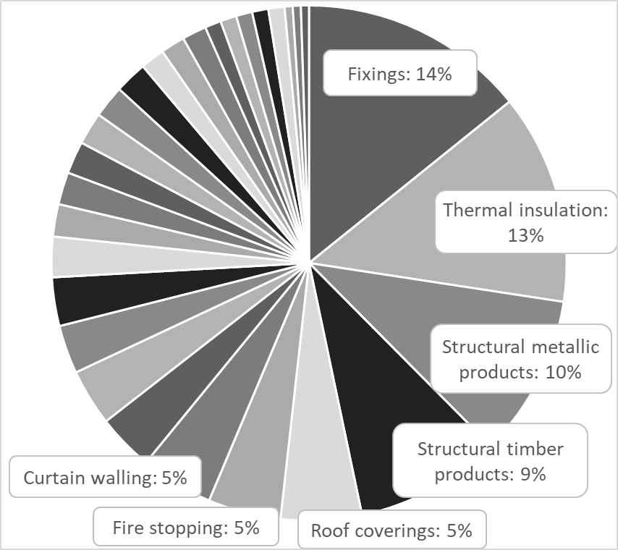

About half of all cited EADs have been developed in four product areas only:

* 14.2% on fixings (area 33);
* 13.2% on thermal insulation products. Composite insulating kits/systems (area 4);
* 10.1% on structural metallic products and ancillaries (area 20); and
* 9.1 % on structural timber products/elements and ancillaries (area 13).

No EADs have been cited in the following areas: 10 (fixed firefighting equipment); 11 (sanitary appliances); 24 (aggregates); 25 (construction adhesives); 27 (space heating appliances); 30 (flat glass, profiled glass and glass block products); and 31 (power, control and communication cables).

**EADs by responsible TAB:**

Twenty-nine out of 49 TABs have developed EADs in the role of 'responsible TAB'. Twenty TABs have not developed any EADs and 23 have not developed any EADs cited in the Official Journal.

A very small number of TABs develop EADs. As shown in the table below, two TABs have developed about 50% of the total amount of cited EADs. These are DIBt[16] (Germany), which has developed 38% of all cited EADs and OIB[17] (Austria), which has developed 13% of them.

Table 4 - Number of adopted and cited EADs, per responsible TAB, 2013-2018   
(excluding TABs that have not developed any EAD):

|  |  |  |  |  |
| --- | --- | --- | --- | --- |
| **Responsible TAB** | **Country** | **Adopted EADs** | **Cited EADs** | **Share of cited EADs** |
| **DIBt** | Germany | 107 | 83 | 38.2% |
| **OIB** | Austria | 46 | 28 | 12.9% |
| **ETA-DK** | Denmark | 34 | 18 | 8.3% |
| **TSUS** | Slovakia | 12 | 11 | 5.1% |
| **TZUS** | Czechia | 13 | 10 | 4.6% |
| **ITeC** | Spain | 14 | 10 | 4.6% |
| **Eurofins** | Finland | 10 | 8 | 3.7% |
| **RISE Certif.** | Sweden | 6 | 6 | 2.8% |
| **CSTB** | France | 10 | 5 | 2.3% |
| **BM Trada** | UK | 8 | 5 | 2.3% |
| **UBAtc** | Belgium | 13 | 4 | 1.8% |
| **BBA** | UK | 6 | 4 | 1.8% |
| **LNEC** | Portugal | 4 | 4 | 1.8% |
| **ITC** | Italy | 4 | 3 | 1.4% |
| **ITB** | Poland | 8 | 2 | 1.4% |
| **KIWA** | Netherlands | 7 | 2 | 1.4% |
| **ZAG** | Slovenia | 3 | 2 | 1.4% |
| **CEREMA** | France | 2 | 2 | 1.4% |
| **IETcc** | Spain | 2 | 2 | 1.4% |
| **SINTEF** | Norway | 2 | 2 | 1.4% |
| **SKG-IKOB** | Netherlands | 2 | 1 | 0.5% |
| **TECNALIA** | Spain | 2 | 1 | 0.5% |
| **ICECON** | Romania | 1 | 1 | 0.5% |
| **ICiMB** | Poland | 1 | 1 | 0.5% |
| **ITECONS** | Portugal | 1 | 1 | 0.5% |
| **STC** | Italy | 1 | 1 | 0.5% |
| **FM App** | UK | 2 | 0 | 0.5% |
| **CPC** | Turkey | 2 | 0 | 0.5% |
| **IBDIM** | Poland | 1 | 0 | 0.5% |
| **Total** | | **324** | **217** |  |

Six TABs have developed 74% of all cited EADs while 23 TABs have developed the remaining 26%.

Twenty TABs (40% of all TABs) have not developed any EADs at all.

### 3.1.3 Issuing ETAs

ETAs are issued at the request of manufacturers on the basis of EADs.

TABs issued 6,240 ETAs in 2013-2018. The number of ETAs issued has increased year on year.

Table 5 - Number of ETAs per year (2013-2018):

|  |  |
| --- | --- |
| **Year** | **ETAs issued** |
| 2013 | 23 |
| 2014 | 643 |
| 2015 | 926 |
| 2016 | 1,262 |
| 2017 | 1,576 |
| 2018 | 1,810 |
| **Total** | **6,240** |

Under the CPR, ETAs are in principle based on EADs. As explained in Section 2.4.2, in order to ensure the transition from the CPD to the CPR, ETAs have also been issued on the basis of ETAGs or EADs converting ETAs and of EADs converting CUAPs.

Table 6 – Number of ETAs by basis (2013-2018):

|  |  |  |
| --- | --- | --- |
| **ETAs based on** | **Number of ETAs issued** | **Percentage of ETAs issued** |
| **ETAGs or EADs converting ETAGs** | 4,873 | 78% |
| **EADs converting CUAPs** | 817 | 13% |
| **new EADs** | 550 | 9% |
| **Total** | **6,240** | **100%** |

As the above table shows, 91% of the ETAs issued have been based on documents with content dating back to the CPD era and only 9% of ETAs are based on new EADs As mentioned above, a clear majority of the ETAs based on new EADs do not concern products newly arrived on the market, but rather slight deviations from harmonised standards (or other EADs).

Three documents (ETAG 001 on metal anchors for use in concrete, ETAG 004 on external thermal insulation composite systems with rendering and ETAG 026 on fire stopping and fire sealing products), have been the basis for more than one third of all ETAs. If we add EAD 330232 (itself one of the three EADs converting ETAG 001), ETAG 005 on liquid applied roof waterproofing kits and ETAG 015 on three dimensional nailing plates, these six documents cover 50% of the ETAs issued.

Graph 2 - ETAs by basis document (2013-2018):

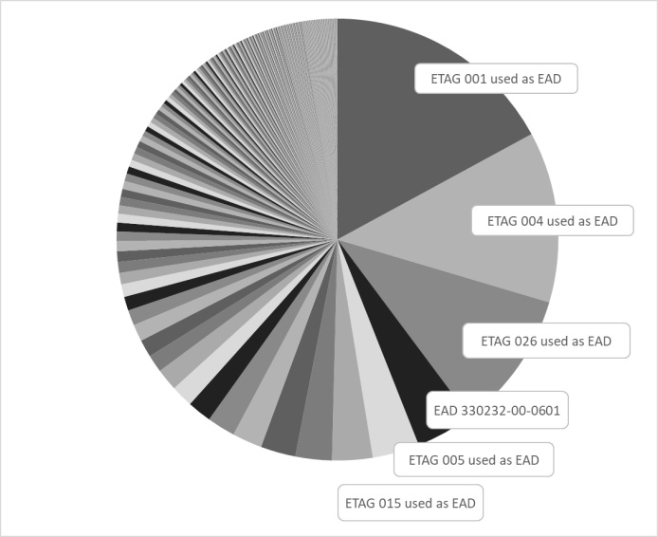

Considering the wide diffusion of the products covered by these six documents and their stability due to their continuous application since the 1990’s, the Commission could apply Article 19(1) of CPR, which gives the possibility to use the EAD as the basis for standardisation requests.

**ETAs by product area:**

Manufacturers' interest in ETAs is focused on few product areas. In fact, two thirds of the 6,240 ETAs are for only three of the product areas defined by Annex IV of the CPR:

* area 33: fixings (36%);
* area 35: fire stopping fire sealing and fire protective products; fire retardant products (17 %); and
* area 4: thermal insulation products; composite insulating kits/systems (15%).

Moreover, more than 85% of ETAs issued in these three product areas are based on ETAGs or EADs converting ETAGs.

Graph 3 - ETAs by product area (2013-2018):

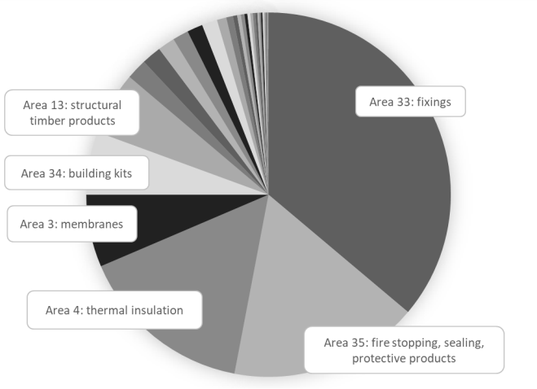

If we include area 3 (membranes including liquid applied and kits); area 34 (building kits, units, and prefabricated elements) and area 13 (structural timber products/elements and ancillaries), the six areas highlighted in the above table make up 86% of the issued ETAs. In comparison, the other 30 areas only make up14%.

This could reinforce the case for possibly applying Article 19(4) of the CPR and preparing a standardisation request.

No ETAs have been issued in the following product areas (and consequently no EADs cited in the Official Journal): area 11 (sanitary appliances); area 24 (aggregates); area 27 (space heating appliances); and area 31 (power, control and communication cables).

**ETAs by country:**

From 2013 onwards, TABs located in Germany have issued 26% of the ETAs, TABs in the Czech Republic 14% and TABS in the United Kingdom 12%. These three countries have issued half of all ETAs.

For Germany, this represents the activity of the sole TAB (DIBt). For the Czech Republic, it is mostly the result of the main TAB, TZUS[18]. The situation is different for the UK where all eight TABs are active.

Graph 4 - Number of ETAs issued per TAB (above 50 per TAB): 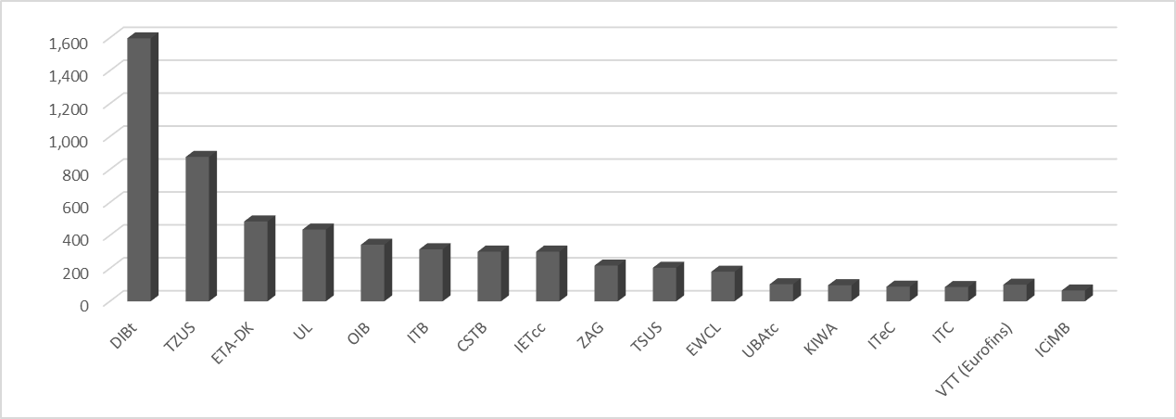

Manufacturers holding an ETA come from 66 different countries all around the world. The main holders from third countries are in Canada (34), India (24) Taiwan (24), USA (21) and United Arab Emirates (20). All other 29 third countries hold less than 15 ETAs each.

Inside the EU, data on the ETA holder country (manufacturer) does not necessarily match the ETA issuing country (TAB). For example, Czech firms hold 3% of the ETAs while the Czech TABs have issued 14% of ETAs. Similarly, UK firms hold 7% of the ETAs and the UK TABs have issued 12% and Danish firms hold 2% of the ETAs and the Danish TAB has issued 8%. In contrast, Italian firms hold 8% of ETAs whereas 2% of ETAs have been issued by Italian TABs.

Graph 5 - ETAs by country of issuing TAB: Graph 6 - ETAs by country of holders:

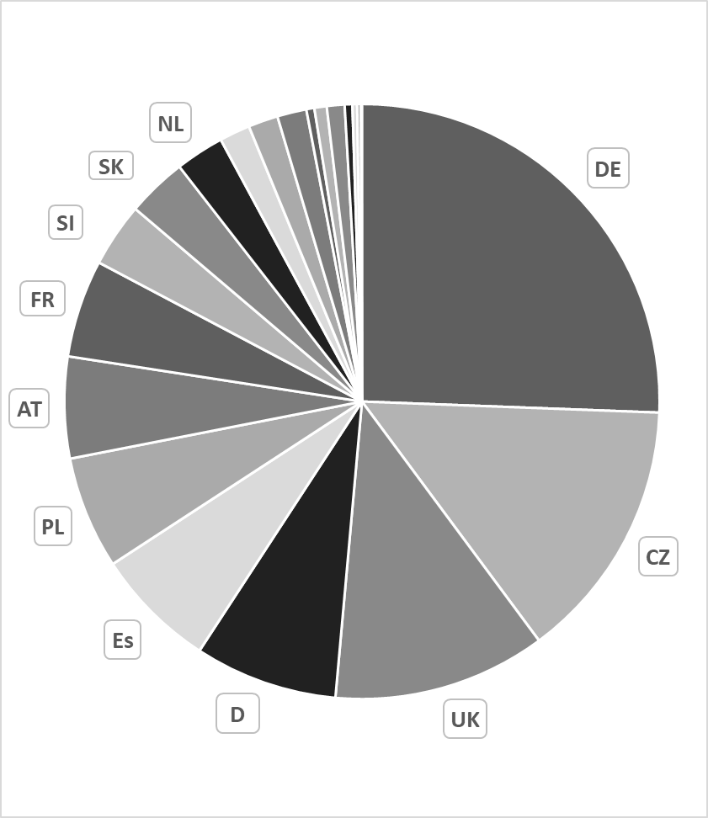 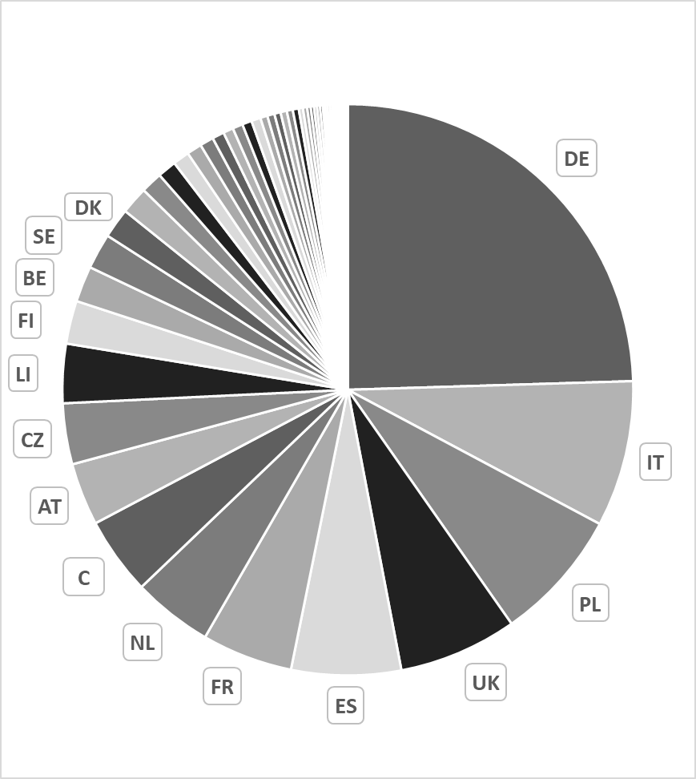

## 3.2. Budget

### 3.2.1 EOTA funding resources

Under Article 33 of the CPR, the European Commission has provided operating grants to EOTA that cover a substantial proportion (40-50%) of its costs, including the costs of developing EADs

Table 7 - EOTA funding sources, 2013-2018 (in € and share of EU funding):

|  |  |  |  |  |  |  |
| --- | --- | --- | --- | --- | --- | --- |
| Source | 2013 | 2014 | 2015 | 2016 | 2017 | 2018 |
| Membership fees received | 487,321 | 757,308 | 760,681.80 | 665,047.14 | 879,917.69 | 886,483.01 |
| EC grant received | 183,790 | 336,612 | 440,000 | 533,133.78 | 570,000 | 550,000 |
| Total | 671,111 | 1,093,920 | 1,200,681.80 | 1,198,190.92 | 1,449,917.69 | 1,436,483.01 |
| **Share of EC funding** | **27%** | **31%** | **37%** | **44%** | **39.31%** | **38.29%** |

### 3.2.2 EAD reimbursement

EOTA's core activity is the development of EADs, for which EOTA finances each RTAB. When the EAD is adopted by EOTA, the responsible TAB confirms to the EOTA Secretariat which TABs participated in its development. The responsible and participating TABs fill in a table with time and travel details as the proof of activity eligible for the reimbursement from EOTA funds. An average number of man-days for EAD development is agreed within the TABs which varies depending on whether a TAB was responsible or had a participating role. However, this average number of man-days does not correspond to the real time investment made by TABs when developing a new EAD that is drafted on the basis of already existing ones and does not require new assessment methods.

The convenors, the members of project teams (PTs)[19] and other groups involved each submit a table to the EOTA Secretariat setting out the number of man-days and travel details. The convenors provide the Secretariat with the list of participants of the meetings held during the reporting quarter.

The EOTA man-day fee is calculated according to the country of origin of the TABs concerned, taking into account comparative price levels of 2013 published by Eurostat.

Travel costs are reimbursed for:

* participants of the meetings of EOTA PTs, WGs and other EOTA groups;
* EOTA officers participating in the meetings of EOTA's statutory bodies;
* members of Executive Board participating in the meeting of Executive Board; and
* participants of other meetings in the interest of EOTA (after the prior consent of the Executive Board).

When a PT or working group meeting is held, only one person for each TAB is eligible for the reimbursement of their travel costs, including any experts participating on behalf of that TAB.

A flat rate of €150 per night is applied to cover costs of accommodation and local transportation at the meeting location. Plane and train tickets are reimbursed according to actual expenses.

Invoices differ widely between RTABs in terms of the information they contain on the working hours involved in developing the EAD. This does not allow an accurate comparison between the work undertaken and the TABs' reimbursement claims, which results in a lack of transparency since the costs claimed by various RTABs for developing EADs cannot be easily compared and analysed. The Commission is working with EOTA to introduce greater transparency and accountability on the reimbursement of these costs on the basis of real time invested in the development (or amendment) of each EAD.

# 4. Evaluation of EOTA in performing its tasks

***4.1 Effectiveness***

This section analyses to what extent the EOTA route has contributed to the internal market of construction products and to what extent it has met its specific objectives. It also identifies intended and unintended impacts.

**4.1.1. Implementation of Article 29 of the CPR on the designation, monitoring and evaluation of TABs and Article 30 of the CPR on the requirements for TABs**:

Setting up the TABs took some time after the entry into full application of the CPR. As of 31 December 2018, 21 Member States and three non-EU countries (Switzerland, Norway and Turkey) had designated TABs. There are no TABs in Bulgaria, Estonia, Greece, Hungary, Latvia, Malta and Luxemburg, so manufacturers from these countries have to address their requests to TABs located in other countries. This can have a clear impact on their access to the EOTA alternative route, if only from a language point of view. Nevertheless, 150 ETAs are held by these seven countries, apart from Malta which does not hold any[20].

All TABs are expected to comply with the requirements set out in Table 2 of Annex IV relating to their competence in analysing risks, setting technical criteria, setting assessment methods, determining the specific factory production control, assessing the product and general management. Once a participating country nominates a TAB, the Commission verifies its competence by examining the information provided by this country in a ten-question list included in the guidelines for evaluating the TABs adopted in 2015[21].

It is important to note that the main active TABs (except German DIBt and Austrian OIB) are also notified bodies under the CPR. Therefore, their position in the market is enhanced by the fact that they can offer a ‘one-stop-shop’ to the manufacturer (issuing of the ETA and subsequently continuing to perform AVCP tasks for the product).

**4.1.2. Implementation of Article 31 of the CPR on the coordination of TABs**

The study has concluded, mainly based on interviews of TAB representatives and manufacturers having received ETAs for their products, that EOTA fulfils the objective set out in Article 31(1) of the CPR and is carrying out all of the tasks set out in Article 31(4). The study has nevertheless shown room for improvement, particularly in the level of communication and cooperation between TABs. A certain tension appears to have emerged between coordination and competition between TABs, leading to some overlap and duplication in TABs’ deliverables. The study also recommends better monitoring of timescales (delivery times) and clarification of roles in the EOTA system.

**4.1.3. Quality of EADs**

The content of an EAD is defined in Article 24.

EOTA has replaced the former European Organisation for Technical Approvals (established by the CPD) and, as stated in the 2016 CPR Implementation Report[22], the paradigm change from the CPD to the CPR, i.e. from ‘product approval’ to ‘performance assessment’, has been its main challenge for developing and adopting EADs

After the Commission adopted the format of the European Technical Assessment in 2013[23], EOTA and the Commission agreed on the format of the EAD in 2015. This led to the first publication in the Official Journal of references to EADs in July 2015. Then in 2016 the Commission developed detailed guidance on the EAD format based on the experience gathered in these processes. This led to a gradual and significant increase in the number of EADs finalised each year and eventually cited in the Official Journal, from 14 in 2015 to 63 in 2018.

Under the current system, the Commission comments on the content of EADs only after the EOTA Technical Board has approved them (see Section 2.4.1). The Commission identifies on average 30 issues requiring adjustments in a given draft EAD proposed by EOTA. 90% of its comments are accepted by EOTA (specifically by the TABs drafting the EADs), which indicates limited prior quality control of the documents submitted to the Commission. This situation leads to increased delays in the citation of EADs particularly as correcting some issues (e.g. exact scope, unnecessary product identification clauses in EADs, factory production control or task for NBs) require longer periods of analysis.

The Commission had developed a checklist to improve the quality of EADs adopted in EOTA at stage 7, which is in use by TABs since June 2019.

However, the Commission's comments are not always systematically incorporated before the issuing of the first ETA, leading to situations where the final EAD requires additional revisions, delaying again the citation.

**4.1.4. Concentration on specific product areas**

The development of EADs has focused on the following products areas:

* area 33: fixings (29 cited EADs);
* area 04: thermal insulation products and kits (26 cited EADs);
* area 20: structural metallic products and ancillaries (21 cited EADs);
* area 13: structural timber products and ancillaries (19 cited EADs);
* area 22: roof coverings, lights, windows, related kits and ancillaries (14 cited EADs); and
* area 9: curtain walling, claddings, structural sealant glazing (12 cited EADs).

It should be noted that these product areas do not necessarily concern the most innovative products. These are also areas where relevant ETAGs were developed under the CPD and many of these EADs are variants of these ETAGs.

In other product areas, less than 10 EADs have been cited in the Official Journal while for seven product families, no EAD has been cited.

**4.1.5. Concentration on specific TABs**

Out of the 49 TABs, only 29 TABs have received manufacturers’ applications requiring them to start developing EADs.

As mentioned earlier, a small number of TABs are very actively developing EADs. These are: DIBt, OIB and ETA-DK[24] (the single TABs for Germany, Austria and Denmark), which have developed 59% of all cited EADs

In contrast, 40% of TABs have not received any applications from manufacturers.

A certain level of specialisation has emerged. For certain product areas, a given main TAB appears to be attracting a major part of manufacturers’ requests. For example, in product area 33 (fixings), 25 out of 40 EADs have been developed by DIBt (63%) whereas only six other TABs have developed EADs (37%) in this product area.

Similarly, it appears that manufacturers tend to submit their request for an ETA to the TAB that has developed the relevant EAD, possibly for reasons of trust. Therefore, the specialisation at the level of EADs is reflected at the level of ETAs, for example DIBt, OIB and ETA-DK have issued 39% of all ETAs. Denmark with ETA-DK represents 8% of EADs and 8% of ETAs and Austria with OIB represents 6% of EADs and ETAs.

This would indicate that EAD-developing TABs could have a competitive advantage in the ETA market.

However, Germany and the Czech Republic do not follow the same pattern. Whereas the German DIBt has developed 38% of EADs, only 26% of ETAs are held by German manufacturers and one third of these have been issued by TABs from other countries, which may suggest that DIBt clients tend to address their requests to other TABs when they have to endorse the costs. The opposite is shown in the case of the Czech Republic and TZUS with a share of 5.6% of EADs compared to 14% of ETAs, showing that TZUS may attract clients from other countries for issuing ETAs.

**4.1.6. Concentration of EADs and ETAs based on past ETAGs**

As mentioned in Section 3.1.3, there is a concentration of issued ETAs in just a few product areas, with two thirds of the 6,240 ETAs belonging only to three areas. More than 85% of the ETAs issued in these three product areas are based on the use of ETAGs as EADs, or on EADs converting ETAGs. In addition, six ETAGs[25], together with their conversions into EADs, constitute the basis for about 60% of all issued ETAs.

As stated in Section 2.4.2, the transition from the CPD to the CPR together with the technical developments of assessment methods, required the conversion of ETAGs and CUAPs into EADs Today 91% of ETAs issued under the CPR are based on documents coming from the CPD era.

**4.1.7. Proliferation of EADs and ETAs**

In a number of instances, several EADs are being developed in parallel for the same kinds of products (e.g. on bonded fasteners). These parallel EADs, if allowed to be adopted, would create serious difficulties for competing products, confusion on the declared performance and confusion for the product user. This proliferation of EADs also promotes a less than optimal use of EOTA and Commission resources, both financial and human.

This approach is sometimes justified on the basis of the confidentiality rules provided for in Article 20(1) c and Annex II to the CPR for ‘*the protection of commercial secrecy and confidentiality*’. However, once adopted, EADs become harmonised technical specifications with direct and Europe-wide consequences in competition and marketing of the relevant construction products. Therefore, confidentiality provisions are taken into account together with other pivotal principles that could be compromised by its blind application. Guidance on the procedure for developing EADs to avoid their unjustified proliferation while ensuring confidentiality is protected is currently being discussed with Member States and EOTA.

One single ETAG represents 24% of all ETAs (1,490) issued (ETAG 001 used as EAD and its associated EAD conversions). Thirteen EADs (or ETAGs used as EADs) have each been the basis for more than 100 ETAs, 49 EADs have each been the basis for less than 100 ETAs and the rest have each been the basis for less than 10 ETAs.

In addition, some products currently on the market are covered by two ETAs, as it is the case of an injection system belonging to the fixings product area (area 33) for which a first ETA has been issued based on ETAG 001-5 used as a EAD and then a second ETA has been issued based on EAD 331522-00-0601 (only adopted) with a slightly different scope.

**4.1.8. Obstacle to SMEs**

The EOTA route for CE marking offered to manufacturers comes at a price. Though companies do not bear any costs for the development of EADs, they pay fees to the TABs for issuing the ETA. These fees can be significant (€24,000 to €36,000 - see more details in Section 4.2.3 on efficiency), and sometimes the investment cannot be recuperated by increased demand on the market. Furthermore, the manufacturer has no guarantee that the EAD on which his ETA is based will not be superseded at any time by a newer version following the request of another manufacturer for some changes, thus potentially generating additional costs.

Incurring these costs and taking such risks is challenging for SMEs, especially in the area of EADs converting ETAGs as they represent the biggest share of ETAs, thus of manufacturers concerned.

A small number of the responses from manufacturers interviewed in the study indicated that the EOTA CE marking route may be used by larger manufacturers in a way that gives them a competitive advantage over their competitors[26].

**4.1.9. Performance of EOTA and TABs when issuing EADs and ETAs**:

The format for European Technical Assessments was adopted in October 2013 and the EAD format was finalised in March 2015. In spite of these early achievements, the vast majority of EADs have not been finalised within the deadlines set out in Annex II.

An IT tool is being developed to improve the exchange of information between EOTA and the Commission (to inform on deadlines, to register all accomplished stages for the development of EADs, to inform on possible delays, etc.) and to automatically update the NANDO database[27] when an EAD is cited.

According to the procedure defined in Annex II of the CPR and owing to the unconditional obligation set in Article 4(1), granting a CE marking for a product based on a EAD not yet cited could be justified. The intention of the legislators was to allow for adjusting the draft EAD after the first ETA had been issued and to avoid delaying the ETA processes for other subsequent manufacturers. However, in those cases where the EAD is rejected and not cited, the validity of the declaration of performance and the CE marking based on the issued ETA may be put in question. This concerns 70 ETAs and 31 EADs (including in particular 18 ETAs issued by six different TABs on a single adopted EAD coming from the conversion of a CUAP). This means that products have received a CE mark and been placed the market based on an EAD that still requires further improvement in order to be cited in the Official Journal.

In addition, although manufacturers have no direct legal obligation to update their ETA and CE marking after the revision of an EAD, market pressure tends to force manufacturers to do so. Moreover, if a new EAD superseding the previous one (or converting an ETAG) contains significantly changed assessment methods, this leads to the obligation to issue a new ETA.

The study suggests the need to revise Annex II to reflect actual responsibilities and timescales required for developing EADs and citing them in the Official Journal[28].

However, the relatively high number of EADs that have been rejected or are pending citation is mostly due to EOTA's lack of appropriate quality control. The in-house technical and legal capacity that EOTA has committed to set up, together with the recent checklist for verifying the quality of EADs at stage 7, are expected to significantly improve the quality of draft EADs and their citation rate and therefore to also reduce deadlines. Such an improvement would also be instrumental in reducing the proliferation of EADs (see earlier Section 4.1.7).

***4.2 Efficiency***

This section assesses whether the expected results and impacts have been obtained at a reasonable/proportionate cost.

**4.2.1. Costs for the Commission**

On the Commission side, costs include the annual grant to EOTA and costs of input by Commission departments into the development of EADs in terms of staff and support (dedicated consultants). These costs are specific to the CPR as other internal market legislation does not propose such alternative routes to standardisation.

Since 2016, the EOTA grant has remained relatively stable: €550,000 in 2016, €570,000 in 2017[29] and €550,000 in 2018. Sixty-five EADs were cited in 2016, 70 in 2017 and 63 in 2018, which gives an indicative ratio per EAD of between €8,143 in 2017 and €8,730 in 2018. As already mentioned, the EOTA budget covers four different work packages, the costliest one being the Secretariat, followed by the development of EADs (representing 34-49% of the budget in 2016-2018), meetings and the support activities.

Human resources deployed by the Commission for monitoring EOTA represent approximately 1.5 full time equivalents. This has remained stable despite the increasing number of EADs adopted by EOTA since 2014 (from 24 in 2014 to 93 in 2018) and despite the EADs adopted by EOTA continuing to need a significant amount of technical and legal comments from the Commission.

The relevant Commission department has also contracted a consultant to review the quality of draft EADs proposed by EOTA and thus decrease the in-house effort (this support has amounted to €120,000 per year since 2014).

The supporting study has shown the need to better link the grant agreement to the CPR objectives and to strengthen the systems to control the financing of EOTA, the financing of the development of EADs, and the funding of TABs.

The Commission has asked EOTA to develop a common invoicing system for TABs so that the real costs for developing each EAD are reflected in the TAB’s invoices sent to EOTA. EOTA has also committed to use a more realistic and accurate TABs reimbursement scheme for the development/amendment of EADs based on the real work invested in each particular case.

**4.2.2. External efficiency**

Concerning the cost-effectiveness for manufacturers enlisting the support of EOTA, 22 out of the 26 manufacturers interviewed in the study (all of EOTA's clients) stated that commercial gains outweigh the costs of compliance, to a large or very large extent (in the case of 12 of them) to a medium extent (for four of them) or to a small or very small extent (for four of them)[30]. In general, EOTA's clients consider that the time for issuing EADs and ETAs could be shortened (according to the replies, the adoption of EADs takes 16.3 months on average), and they complain about ‘delays to market’ despite the improvements made since the CPD era. However, this compares very favourably with the time required to develop a harmonised European standard.

Based on product turnover data provided by nine EOTA clients, the study found that the financial returns of products sales on the internal market outweigh the costs of compliance of an ETA at a benefit to cost ratio of 443 to 1. This calculation is based on an overall product revenue estimated by the nine manufacturers at €157 million. However, the small size of this sample presents its strong reservations for the representativeness of such quantitative results and no other evidence is available.

Regarding the total cost for manufacturers to obtain an ETA, it is estimated by the study in a range of €40,000 to €52,000[31], where the main cost is the TAB fee, varying between €24,500 and €36,000 (with two firms indicating fees of €150,000 or more)[32].

Out of the 35 manufacturers (all EOTA clients) questioned in the study on whether they would request an ETA in the future again, 26 gave a positive reply.

***4.3 Relevance***

Relevance is about the adequacy between the objectives of the EOTA route (and of EOTA and TABs) and the needs of the manufacturers and of the market.

While the CPR does not expressly refer to innovation as the EOTA objective, the EAD procedure targets innovative or novel products, which owing to the duration of standardisation processes cannot be covered by harmonised standards. The Commission's grant agreements identifies as an expected impact of the EAD procedure the possibility given to manufacturers to affix the CE marking to ‘new and often innovative construction products’. The statutes of EOTA indicate that its duties include wider activities concerning ‘the making available and the use of construction products and the facilitation of innovation in construction’.

According to the supporting study, TABs and their clients consider that EOTA is relevant. They consider that, as standardisation does not cover and is not suitable for all products, the EOTA approach is appropriate in particular for brand new and genuinely innovative products, often presented as forming the core of the EOTA activities. Of the 26 TABs asked to what extent the objectives of EOTA meet their needs, 19 replied ‘completely’ and four ‘mostly’. Of the 37 manufacturers asked the same question, 20 replied ‘completely’ and 11 ‘mostly’.

However, no evidence could be found to demonstrate the impact that EOTA would have on innovation within the construction sector.

Relatively speaking, the EOTA route does not cover as many construction products as the ones covered by standardisation. The number of ETAs issued is substantially lower than the number of certificates issued during the same timeframe on the basis of harmonised standards. While there were 6,240 ETAs as of 31 December 2018, the number of certificates issued every year annually can be counted in the millions.

Again, the overwhelming majority of EADs have not been prepared for brand new and really innovative products. Even the TABs participating in the study raised doubts over the number of truly innovative products, which they consider to be less than the 9% of EADs generated from ‘new’ products rather than from documents coming from the CPD era (EADs converting ETAGs or CUAPs).

In reality, manufacturers most frequently apply for an ETA to affix a CE mark on products that are commonly used in construction work and for which, although a harmonised standard is available, the manufacturer wants to declare an essential characteristic or intended use not covered by the harmonised standard. Therefore, the EOTA route could be seen as a way for manufacturers to obtain a market benefit from having a CE mark on their products.

As noted above, there is a tendency to develop new EADs instead of amending existing ones, resulting in a number of EADs that are very close in scope. Consequently, products are placed on the market with two declarations of performance based on two ETAs (e.g. because they cover two different intended uses), which is certainly not the purpose of the EOTA alternative route.

Finally, the study has found that EOTA does not place enough emphasis on supporting the CE marking of innovative products, pointing to the need to provide support to TABs and the need for clear guidance on EADs and innovation to manufacturers through European trade associations.

***4.4 Coherence***

This section assesses the internal coherence of the EOTA system and its coherence with the whole CPR system.

EOTA supports coordination between TABs and the development of standard EADs and standard ETAs has particularly helped ensure internal consistency.

However, the level of activity varies widely between TABs and the study has concluded that increased coherence could be achieved by developing best practices. As noted earlier, insufficient cooperation between TABs contributes to the unjustified proliferation of EADs and ETAs, detrimental to most manufacturers and confusing for the users.

Regarding internal coherence for the whole CPR system, the EOTA route complements the harmonised European standards developed by CEN. Nevertheless, a number of additional considerations need to be taken into account to complement this analysis:

First, circumstantial evidence points to the large uptake of the EOTA being the result of the underperformance of the main standardisation route, in particular as the EOTA route contributes to bridge the gap caused by the absence or incompleteness of exhaustively harmonised standards, in particular for construction products with small market shares, or ‘non-standard’ products, according to the study. This seems to be confirmed by the continued increase in the number of EADs and ETAs and, in particular, the sometimes very large number of ETAs issued under a same EAD for some specific products areas.

Second, one of the main reasons for the opening of this alternative route to standardisation was to allow faster time-to-market of innovative construction products. The predominant use of base documents with content dating back to the CPD, the concentration of ETAs along a limited number of product areas and the observed lack of disruptive innovative products among the ones with ETAs indicate that the EOTA route is not (or only very marginally) used to support this.

Finally, EADs with a large number of ETAs, which also have been operational in the market for long periods (as ETAGs and EADs), indicate a stability that should lead to the development of a harmonised standard being considered.

In the supporting study, of the 26 TABs that were asked whether there would be advantages if some EADs were developed into harmonised standards, 12 replied ‘no’, four replied ‘yes’ and 10 replied ‘don't know’. Of the 39 manufacturers who were asked the same question (all EOTA clients and holding or requesting an ETA), 11 replied ‘yes’, 12 replied ‘no’ and 16 replied ‘don't know’[33].

***4.5 EU added value***

Assessing the EU added value of the EOTA route requires that we consider whether action at Member State-level could have produced similar or better results and impacts.

The study shows that TABs generally recognise EOTA's added value for their actions although they suggest this added value could be increased through efficiency and effectiveness gains.

On the EU added value of the EOTA route to the CPR system, the manufacturers interviewed for the study were not in a position to provide conclusive information on the costs and timescales that alternative national procedures would entail. However, in the absence of this route, mutual recognition would apply. This could well entail delays and rising costs for construction products to be marketed in several Member States, which would complicate the access to the internal market. The main advantage of the EOTA route is the possibility to grant CE marks for products even in the absence of harmonised standards.

Manufacturers have also reported unexpected benefits in external trade where a CE mark, be it based on harmonised standards or EADs, appears to be considered as a quality label. This is for example the case for fixings (product area 33) manufactured in Europe whose manufacturers benefit from a competitive advantage over their competitors from third countries.

Finally, some ETAGs or EADs[34] have been adopted by several third countries as their technical regulation, which gives European companies an important competitive advantage on the international market.

**5. Conclusions**

For the seven tasks set out in Article 31(4) CPR that are covered in this report, evidence indicates that no task remains unfulfilled[35] and that EU financial support is justified.

For the period analysed, the EOTA route has supported the transition from the CPD to the CPR by offering the required flexibility.

Despite this, a series of structural issues have also been identified:

* The EOTA route is used by a limited number of companies manufacturing construction products. In addition, EOTA activities show a very narrow coverage in any of the three possible dimensions (product areas, geographic distribution and TABs involved) and there is no indication that this situation is improving.
* Whereas the EAD route was intended primarily to facilitate speedier entry into market of innovative products, the overwhelming majority of the ETAs do not concern innovative products but products already in the market.
* Circumstantial evidence also strongly suggests that the EOTA route has benefited above all from the underperformance of the standardisation system. Some EADs can even be seen as standards developed through alternative means. This is particularly visible in the area of fixings where one ETAG (currently transformed into EAD) has been the basis for 25% of all ETAs.
* Costs for the development of EADs are high and so are the fees charged to manufacturers to obtain an ETA. The route remains expensive and not SME friendly.

Other areas for improvement in the management of EOTA:

* Competition between TABs is limited due to the absence of transfer of assessment know-how or exchange of best practices which somewhat restricts the participation of a larger number of TABs.
* The coordination of procedures, in relation to the proliferation of EADs and ETAs and insufficient internal draft EADs quality checks lead to multiple verification processes between the Commission and EOTA and hence contribute substantially to delays in the final adoption and citation of EADs in the Official Journal.

Should any revision of the CPR and of the harmonisation system applicable to construction products be proposed, the role of EOTA and of the EOTA route should be analysed in depth as part of the harmonised technical specifications at the centre of the CPR and aligned with the conclusions presented in the evaluation of the CPR[36].

**Annex Product areas (source: Annex IV of the CPR)**

| Area codes | Products areas |
| --- | --- |
| 1 | Precast normal/light weight/autoclaved aerated concrete products. |
| 2 | Doors, windows, shutters, gates and related building hardware. |
| 3 | Membranes, including liquid applied and kits (for water and/or water vapour control). |
| 4 | Thermal insulation products. Composite insulated kits/systems. |
| 5 | Structural bearings. Pins for structural joints. |
| 6 | Chimneys, flues and specific products. |
| 7 | Gypsum products |
| 8 | Geotextiles, geomembranes, and related products |
| 9 | Curtain walling/cladding/structural sealant glazing. |
| 10 | Fixed fire fighting equipment (fire alarm/detection, fixed firefighting, fire and smoke control and explosion suppression products). |
| 11 | Sanitary appliances. |
| 12 | Circulation fixtures: road equipment. |
| 13 | Structural timber products/elements and ancillaries. |
| 14 | Wood based panels and elements. |
| 15 | Cement, building limes and other hydraulic binders. |
| 16 | Reinforcing and prestressing steel for concrete (and ancillaries). Post tensioning kits. |
| 17 | Masonry and related products. Masonry units, mortars, and ancillaries |
| 18 | Waste water engineering products |
| 19 | Floorings. |
| 20 | Structural metallic products and ancillaries. |
| 21 | Internal & external wall and ceiling finishes. Internal partition kits. |
| 22 | Roof coverings, roof lights, roof windows, and ancillary products. Roof kits. |
| 23 | Road construction products |
| 24 | Aggregates. |
| 25 | Construction adhesives. |
| 26 | Products related to concrete, mortar and grout. |
| 27 | Space heating appliances. |
| 28 | Pipes-tanks and ancillaries not in contact with water intended for human consumption. |
| 29 | Construction products in contact with water intended for human consumption. |
| 30 | Flat glass, profiled glass and glass block products. |
| 31 | Power, control and communication cables. |
| 32 | Sealants for joints. |
| 33 | Fixings. |
| 34 | Building kits, units, and prefabricated elements. |
| 35 | Fire stopping, fire sealing and fire protective products. Fire retardant products. |

1. Regulation (EU) No 305/2011 of the European Parliament and of the Council of 9 March 2011 laying down harmonised conditions for the marketing of construction products and repealing Council Directive 89/106/EEC, OJ L 88, 4.4.2011, p. 5.
2. Study carried out by BRE, ECORYS and Vito, available on <https://bookshop.europa.eu/en/supporting-study-for-the-evaluation-of-the-relevance-of-eota-tasks-pbET0115714/>.
3. Interviews of 11 representatives, 26 TABs and 45 companies (including 29 SMEs) and validation workshop with manufacturers, manufacturers’ associations, TABs, Member States and EOTA held in October 2016.
4. Council Directive 89/106/EEC of 21 December 1988 on the approximation of laws, regulations and administrative provisions of the Member States relating to construction products, OJ L 40, 11.2.1989, p. 12-26.
5. Source: NANDO database, as of 31.12.2018. The list is available on <http://ec.europa.eu/growth/tools-databases/nando/index.cfm?fuseaction=directive.notifiedbody&dir_id=33>.
6. The Secretariat employs four full time equivalent staff members: the Secretary General, a project manager, a technical assistant and a secretary.
7. The Stakeholders Advisory Group meets once a year, or at any other time as needed, and provides recommendations to the Executive Board on the following items: the role of EOTA within the implementation of the CPR, EAD and ETA processes, quality systems and procedures promoting greater efficiency and providing a better service to industry, feed-back on tasks fulfilled by TABs, international and stakeholder recognition, partnerships with other organisations, as well as advice on legal viability and financial stability.
8. These are the ‘participating TABs’.
9. The concept of CUAPs was developed inside EOTA under the CPD to provide for a clear basis for issuing European technical approvals in cases provided for in Article 9(2) of the CPD, where this could not be done by means of applying ETAGs.
10. According to Article 8(4) of the CPD.
11. Common understanding of approval procedure - this concept did not appear in the CPD, but was developed within EOTA to provide a clear basis for issuing European technical approvals in cases provided for in Article 9(2) of the CPD, where this could not be done by means of applying ETAGs.
12. This issue is specifically addressed under the relevance issue (see Section 4.3).
13. At stage 7(c) or 8 of the Annex II procedure.
14. At stage 8, where it often appears that the Commission's comments at stage 7(c) have not been taken into account and that an additional assessment is needed.
15. Product areas listed in Annex IV of the CPR are attached in annex.
16. Deutsches Institut für Bautechnik.
17. Österreichisches Institut für Bautechnik.
18. Technický a zkušební ústav stavební Praha.
19. Which are the operating level of the working groups.
20. Greece: 63; Hungary: 31; Latvia: 21; Estonia: 20; Bulgaria: 11; and Luxembourg: 4.
21. Available through: <https://www.eota.eu/ckfinder/userfiles/files/CPR%20Guidelines%20for%20the%20evaluation%20of%20TABs.pdf>.
22. Report from the Commission to the European Parliament and the Council on the implementation of Regulation (EU) No 305/2011 of the European Parliament and of the Council of 9 March 2011 laying down harmonised conditions for the marketing of construction products and repealing Council Directive 89/106/EEC, COM/2016/0445 final, 7.7.2016.
23. Commission Implementing Regulation (EU) No 1062/2013, OJ L 289, 31.10.2013, p. 42-43; this act is based on Article 26(3) of the CPR.
24. ETA-Denmark.
25. ETAG 001, ETAG 004, ETAG 026, ETAG 005, ETAG 015, ETAG 029.
26. See study, page 44.
27. NANDO is the New Approach Notified and Designated Organisations Information System, which is in the form of a website so that manufacturers can search to find a Notified Body for their products. NANDO is also used for EOTA purposes, i.e. to list the EADs cited in the Official Journal and the TABs designated by the Member States.
28. See study, page 82.
29. Source: EC Financial transparency system <http://ec.europa.eu/budget/fts/index_en.htm>.
30. The other two respondents did not specify the extent.
31. The lowest assessment is based on the sample of the nine firms that provided product turnover data, the highest on the 45 firms interviewed.
32. Other costs are the first year factory audit (€11,233 on average) and the HR inputs (between €4,822 and €6,944).
33. See study, page 58.
34. For example, ETAG 001 is used as the basis of the technical specifications in Australia, New Zealand, the United States of America and Canada.
35. EOTA has not communicated observations on a TAB not fulfilling its tasks, but there is no evidence it should have.
36. Evaluation of Regulation (EU) No 305/2011 of the European Parliament and of the Council of 9 March 2011 laying down harmonised conditions for the marketing of construction products and repealing Council Directive 89/106/EEC, SWD(2019) 1770.