

# MEETING THE EU’S INTERNATIONAL COMMITMENTS

***Setting out a vision towards climate neutrality by 2050***

In November 2018, the European Commission presented its Strategic Vision "A Clean Planet for all"[1]. The strategy shows how Europe can lead the way to climate neutrality by investing into realistic technological solutions, empowering citizens, and aligning action in key areas such as industrial policy, finance or research – while ensuring social fairness for a just transition. Figure 1 shows one feasible pathway towards net-zero greenhouse gas (GHG) emissions in 2050.

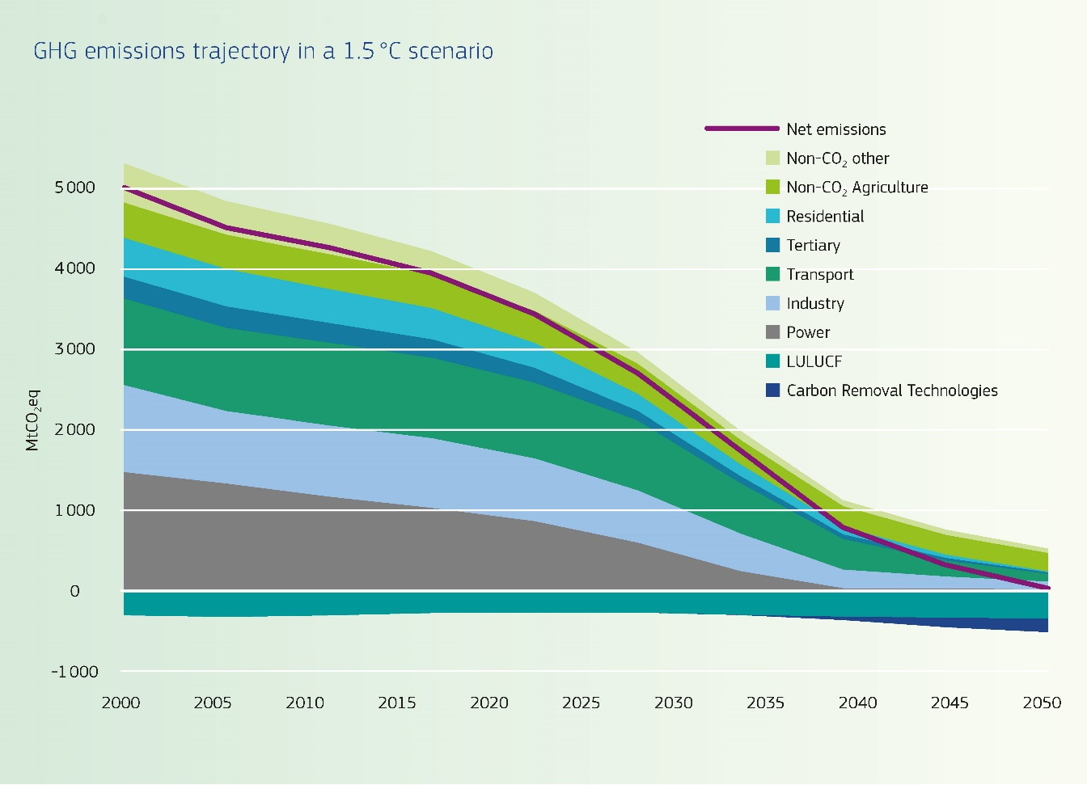

Figure : GHG emissions trajectory for the EU in a 1.5 degree scenario[2]

The Commission’s strategic vision is an invitation to all EU institutions, the national parliaments, business sector, non-governmental organisations, cities and communities, as well as citizens and especially the youth, to participate in ensuring that the EU can continue to show leadership and encourage other international partners to do the same. The Commission’s strategic vision has been widely debated across the EU institutions and among stakeholders during 2019. This informed debate is a step towards adopting and submitting to the United Nations Framework Convention on Climate Change (UNFCCC) an ambitious long-term strategy by early 2020, as required under the Paris Agreement.

## In 2018, GHG emissions declined by 2.0% while the EU economy continued to grow

In 2018, EU greenhouse gas emissions (including international aviation) were down by 23% from 1990 levels, according to preliminary data (see Figure 2). The EU thus remains well on track to achieve its target under the UN Framework Convention for Climate Change of reducing GHG emissions by 20% by 2020[3]. In 2018, emissions were 2.0 % lower than in 2017. EU GHG emissions therefore reached their lowest level since 1990. Between 1990 and 2018, the EU’s combined GDP grew by 61%. The GHG emission intensity of the economy, defined as the ratio between emissions and GDP fell to 303 g CO2eq/EUR, which is less than half of the 1990 level.

Figure : Total EU GHG emissions including international aviation (historical emissions 1990-2018, projected emissions with existing and with additional measures[4] 2019-2030) and GHG reduction targets

Emissions from stationary installations covered by the EU emissions trading system (EU ETS), which are most emissions from electricity and heat production and industry, fell by 4.1% from 2017 to 2018[5]. The reduction came mainly in electricity and heat production. This is in line with the trend over the last five years, where emissions from these sectors have decreased significantly. This reflects in particular changes in the fuels used to produce heat and electricity, including an increase in the use of renewable energy sources.

Emissions not covered by the EU ETS (such as emissions from transport, buildings, agriculture and waste) decreased by 0.9% from 2017 to 2018. The reduction comes after three years of slightly increasing emissions from these sectors. The reduction came mainly from energy use in buildings. Emissions from agriculture also decreased slightly, while there was a small increase in transport emissions as compared to 2017.

Moreover, emissions from international aviation continued increasing in 2018, and are up 19% over the last five years. These are in principle covered by the EU ETS, for the moment limited to flights in the European Economic Area (EEA).

The EU has put in place legislation to reach its 2030 target

The Union has communicated a nationally determined contribution under the Paris Agreement of at least 40% domestic greenhouse gas reductions by 2030 compared to 1990. The EU has put in place legislation as shown in Figure 3 that will enable it to deliver on this commitment. The effective implementation of all climate, energy and mobility targets laid down in Union law could even lead to EU-28 greenhouse gas reductions up to around 45% in 2030 compared to 1990.

## Cooperation with Norway and Iceland to reach the 2030 target

## Norway and Iceland have agreed to cooperate with the EU in reaching their 2030 targets of reducing GHG emissions by at least 40% compared to 1990 levels. In the context of the EEA Agreement, Norway and Iceland will as of 2021 implement the Effort Sharing Regulation and the LULUCF Regulation. Norway and Iceland already take part in the EU ETS since 2008.

|  |  |  |  |  |  |  |
| --- | --- | --- | --- | --- | --- | --- |
|  | **GREENHOUSE GAS EMISSIONS** | **RENEWABLE ENERGY** | **ENERGY EFFICIENCY** | **INTER-CONNECTION** | **CLIMATE IN** | **CO2** |
| **EU-FUNDED PROGRAMMES** | **FROM:** |
| **2020** | -20% | 20% | 20% | 10% | 2014-2020 |  |
| 20% |
|  |  |  |  |  | 2021-2027 | CARS |
| **2030** | **At least** **-40%** | **≥ 32%** | **≥ 32.5%** | **15%** | **25%** |  |
| **-37.5%** |
| Vans **-31%** |
| Lorries **-30%** |
|  | | **Upwards revision clause by 2023** | |  | | |

Figure : 2030 Climate and Energy Framework

Member States identify additional policies and measures to reach 2030 objectives

In 2018, for the first time, Member States prepared draft integrated national energy and climate plans (NECPs)[6]. The draft plans show that Member States make significant progress in defining the path to reaching the 2030 climate and energy targets, although further efforts are still needed. The European Commission has analysed the aggregated effects of the draft plans on reaching the 2030 targets, and issued country-specific recommendations[7]. Member States must finalise their plans by the end of 2019.

With national policies and measures already implemented, emissions are projected to be reduced by 30% in 2030 according to an aggregation of the latest national GHG projections. With implementation of the planned measures or stated ambitions in the draft NECPs, the overall GHG reduction of the EU is estimated to reach the at least 40% reduction target.

The latest projections from Member States, submitted after the draft NECPs, indicate that with implementation of planned policies, but excluding stated ambitions (targets), emissions may be reduced by 36% in 2030. This estimate is somewhat lower than the assessment of the draft NECPs. The main reasons for the difference are that the assessment of the draft NECPs takes into account the national targets expressed by Germany and the Netherlands in their draft NECPs and that Poland presented projections with planned measures in its draft NECP, but did not submit these as part of the reporting exercise on projections in 2019.

# EMISSIONS IN THE EU EMISSIONS TRADING SYSTEM (EU ETS)

The EU emissions trading system (EU ETS) covers emissions from approximately 11 000 power stations and manufacturing plants, and aviation within and between the participating countries.

In 2018, emissions from stationary installations participating in the EU ETS are estimated to have decreased by 4.1% compared to 2017, based on the information recorded in the Union Registry. The decrease in emissions was mainly driven by the power sector, whereas emissions from industry decreased slightly.

With regard to developments in aviation emissions, verified emissions continued to grow and amounted to 67 million tonnes of CO2 in 2018, an increase of 4% compared to 2017.

Figure 4 shows the historical and projected development in ETS emissions, together with the cap and the accumulated surplus of ETS allowances.

Figure : Verified ETS emissions 2005-2018, Member States projections with existing measures 2019-2030, ETS cap phases 2, 3 and 4, and accumulated surplus of ETS allowances 2008-2018. Mt CO2-eq[8]

As of the end of June 2019, the total number of international credits used or exchanged amounts to around 1.51 billion, accounting for over 90% of the estimate for the allowed maximum of 1.6 billion. In phase 3 alone (2013-2020), 453.49 million international credits were exchanged until the end of June 2019.

In preparing for the Market Stability Reserve to become operational in 2019, the Commission has systematically been publishing as from mid-May 2017 the surplus figures[9] for the preceding years. In May 2019, the surplus was published for the third time, corresponding to ca. 1.65 billion allowances[10]. On the basis of the 2018 surplus and the revised EU ETS legislation for the system’s fourth trading period (2021-2030), the auction volumes from September to December 2019, and from January to August 2020 will be reduced by close to 397 million allowances, or 24% of the surplus.

**LIFE15 OPTIMELT\*** - Demonstration of thermochemical reforming of natural gas for reducing GHG emissions in energy intensive industries – glass industry.

The project carries out the first full-scale demonstration of an innovative waste-heat recovery concept. The technology, called OPTIMELT, is able to use an endothermic reaction of natural gas with water vapour/CO2 in the flue gas to recover more heat than previously possible in high-temperature manufacturing processes.

The project has been awarded EUR 2.2 million through LIFE, the EU funding instrument for climate and environment.

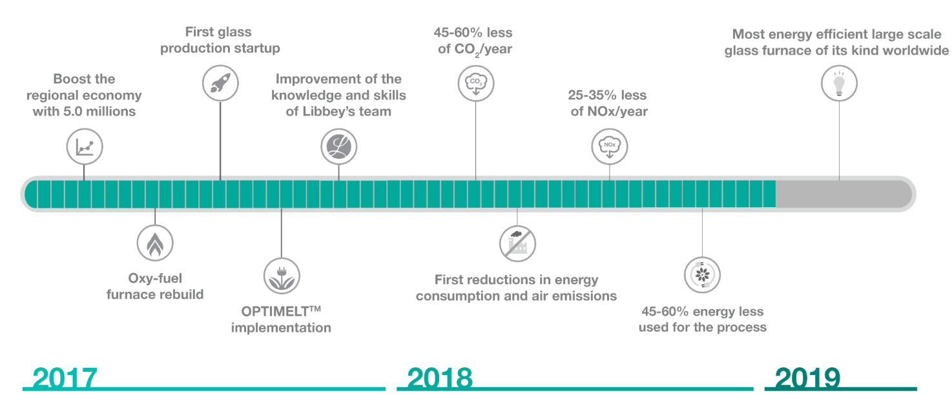

*The project is an example of how EU funds contribute to innovation in sectors covered by the ETS.

# EFFORT SHARING EMISSIONS

Emissions from most sectors not included in the EU ETS, such as transport, buildings, agriculture (non-CO2-emissions) and waste, are covered by the EU effort sharing legislation. The Effort Sharing Decision[11] (ESD) sets national emissions targets for 2020, expressed as percentage changes from 2005 levels. Member States must also respect annual emissions limits from 2013 to 2020. Similarily, the Effort Sharing Regulation[12] (ESR) sets national emissions targets for 2030.

## Progress towards the effort sharing targets

Member States are planning how to achieve their 2030 effort sharing targets. If planned policies are implemented, the EU could reduce effort sharing emissions by 27 to 28% by 2030[13], as compared to 2005. This is clear progress as compared to existing policies, which would reduce emissions by 20% by 2030. However, to achieve the emissions reduction target of 30% for the effort sharing, Member States will need to identify additional measures. The European Commission has recommended several Member States to further specify their strategy for achieving the non-ETS target[14] for the entire period 2021-2030 in their final NECPs.

Figure 5 shows the distance between Member States’ 2030 targets under the ESR and their projections with existing and with additional measures.

Figure : Gaps between 2030 ESR targets and projected emissions with existing measures (WEM) and with additional measures (WAM) in percentage of 2005 base year emissions. Negative values indicate over-achievement of targets; positive values indicate that the targets are not reached.

**Recommendations to Member States on their draft NECPs**

In June 2019, the European Commission issued recommendations to Member States based on their draft NECPs. As regards non-ETS GHG emissions, several Member States were recommended to:

* Clarify how the Member State plans to reach its 2030 greenhouse gas target for sectors outside the EU emissions trading system by considering further cost-efficient policies over the period 2021-30;
* Clarify how the Member State plans to comply with the requirement that land use, land use change and forestry (LULUCF) emissions do not exceed removals;
* Consider also the cost-effective generation of transfers to other Member States under the ESR as a funding source.

Several Member States were also recommended to reconsider their level of ambition for renewable energy and energy efficiency in order to close the ambition gaps at EU level. Moreover, many Member States were recommended to further analyse interactions between planned energy and climate policies and measures and air pollution.

Emissions covered by the ESD were 11% lower in 2018 in comparison to 2005 as shown in Figure 6. This is as an overachievement by 3 percentage points of the interim target of an 8% reduction. Since the system was launched in 2013, EU-wide emissions have been below the total limit each year. This has led to a cumulative surplus of annual emission allocations (AEAs) of about 1110 Mt CO2eq in 2013-2018. Until 2020, emissions are projected to remain below the annual limit and the 2020 target for effort sharing emissions is projected to be over-achieved by 3 percentage points, with existing measures.

Figure : Emissions in sectors presently covered by effort sharing legislation 2005-2030 and AEAs (Mt CO2eq)

Emissions in the sectors covered by the effort sharing legislation decreased gradually from 2005 to 2014. After 2014, emissions increased in three consecutive years, followed by a reduction in 2018.

More than one third of the effort sharing emissions come from **transport**. After a decrease in emissions between 2007 and 2013, emissions from transport have increased in each of the last five years, and are now only 3% lower than in 2005. Towards 2030, Member States project a small reduction (7% compared to 2005) with existing measures. However, with implementation of planned policies and measures, transport emissions are projected to be reduced by 18% by 2030, compared to 2005.

The CO2 emissions standards for new cars and vans are key drivers for road transport emissions reduction. While average CO2 emissions per kilometre of new cars and vans remain below the current applicable targets, as shown in Figure 7 below, provisional data for 2018 shows an increase in emissions as compared to 2017. Therefore, vehicles manufacturers will have to significantly reduce emissions of their fleet, on average by around 25 g CO2/km for cars and 11 g CO2/km for vans, to meet the upcoming 2020 and 2021 targets.

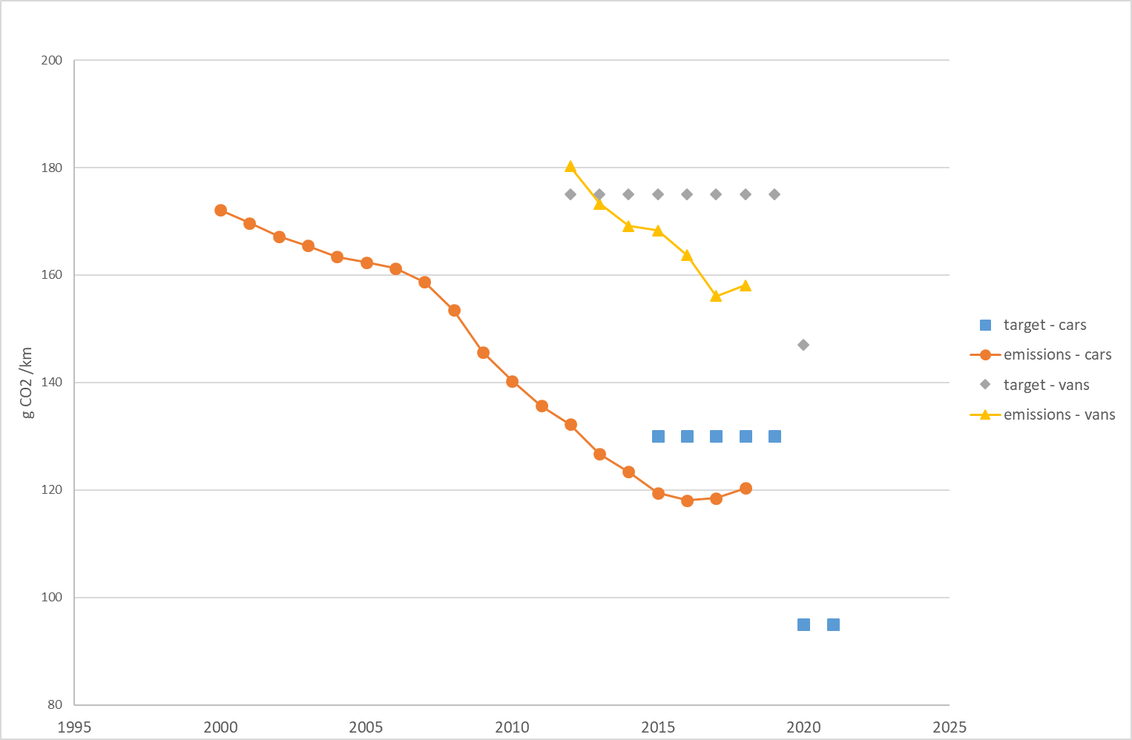

Figure : Average CO2 emissions per kilometre for new cars and vans

The Fuel Quality Directive contributes to decreasing GHG emissions from transport. It obliges Member States to require that fuel suppliers reduce life cycle GHG emissions intensity of fuels supplied by 6% by 2020, compared to 2010. The average GHG intensity of the fuels supplied in 2017 was 3.4% lower than 2010 (based on data from 22 Member States, reported for the first time in 2019). As shown in Figure 8, the progress achieved varies greatly across Member States, but almost all need to take swiftly further action to ensure that the 2020 target will be met.

**Figure 8: Reductions in GHG intensity of fuels achieved by EU fuel suppliers in the 22 reporting Member States, 2010-2017**

Emissions from **energy use in buildings** show some year‑to‑year variation due to weather‑related changes in heating demand. Over the longer term, emissions have shown a downward trend, which is projected to continue towards 2030. The projected emissions decrease reflects the availability of marketable technologies that reduce energy demand and integration of renewables. Member States have planned new policies that can reduce emissions faster.

Emissions from **agriculture** (non-CO2) were at a similar level in 2018 as in 2005 and are projected to remain stable in the period to 2030, with existing policies. Even with the implementation of planned policies, only a minor decrease is projected.

**Verbiostraw biogas plant\***

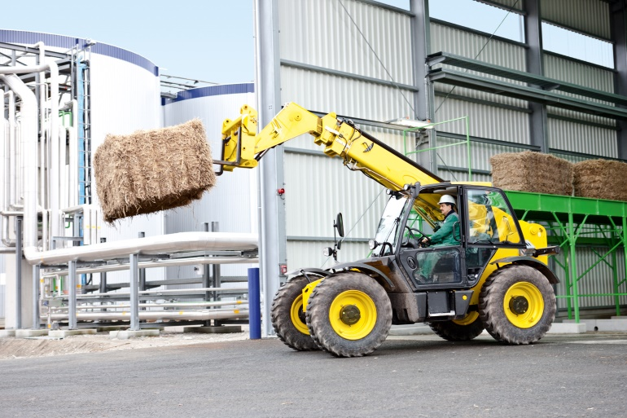

Verbiostraw is a biogas plant that converts straw into biomethane which is fed into the local natural gas network. The current capacity of the plant is 8 MW to be extended up to 16.5 MW generating up to140 GWh of biomethane annually.

Verbiostraw is a first-of-a-kind project that demonstrates an advanced biogas technology at large scale. The plant uses an innovative mono straw fermentation technology to manufacture biomethane from straw only. It demonstrates that not only foodstuff raw materials can be used to produce biofuels but also residual materials from agriculture.

The project is located in Schwedt, Brandenburg (Germany) and received EUR 22.3 million of New Entrants Reserve (NER) 300 funding.

*The project is an example of how EU funds contribute to innovation in sectors covered by the effort sharing legislation.

Emissions from **waste management** decreased by 33% between 2005 and 2018, and this steep downward trend is projected to continue.

ESD emissions from **industry and other sectors** were 12% lower in 2017 than in 2005 and are projected to continue to fall. As part of this, many ozone-depleting substances (ODS) are also powerful greenhouse gases. The EU is already meeting its international obligations to phase out ODS consumption by 2020, as required under the Montreal Protocol. With, the exception of 2012, EU consumption, as counted under the Montreal Protocol[15], has been negative since 2010. The consumption in 2017 was calculated to be -4 080 metric tonnes. Negative consumption means that more ODS are being destroyed or exported than produced or imported. These results show that ODS are not being reintroduced in applications where more environmentally friendly alternatives exist.

The Commission evaluated the ODS Regulation[16] in 2019. The evaluation shows that while the Regulation is very effective in reaching its objectives, it may be possible to achieve these results in a more efficient manner.

Fluorinated gases (F-gases) are a group of gases often used as substitutes for ozone-depleting substances. However, F-gases are powerful greenhouse gases. The Regulation on F-gases[17] provides for an EU-wide phase-down of hydrofluorocarbons (HFC) from 2015 and other measures targeting emissions from F-gases, with the aim of cutting emissions by two thirds by 2030 compared to 2014. HFCs are also covered by the Kigali Amendment to the Montreal Protocol, which entered into force on 1 January 2019.

Data for 2017 shows that the supply of F-gases decreased by 2% in terms of climate impact (CO2eq), but increased by 3%  in terms of mass compared to 2016. In 2017, the total placing on the market under the quota system was 0.4% below the maximum quantity allowed[18]. This success reflects a shift towards gases with lower global‑warming potential and indicates that the Regulation is proving effective in reducing F-gas emissions.

## Member States compliance with the Effort-Sharing Decision (ESD)

All 28 Member States complied with their ESD obligations in 2013-2016. **Malta** exceeded its annual emissions allocations (AEAs) in each of the years in question, but covered the deficit by purchasing AEAs from Bulgaria. **Finland, Poland, Ireland, Germany** and **Belgium** exceeded their AEAs in 2016, but were able to cover the deficit through the surplus of AEAs banked from previous years. **Sweden** did not use its full allocation and cancelled its surplus AEAs from 2013 to 2016 to enhance the environmental integrity of the system. All other Member States banked their surplus allocations for possible use in later years. No international credits from the clean development mechanism (CDM) or joint implementation were used to comply with ESD obligations.

The compliance cycle for 2017 is ongoing. In 2017, **Malta**’s emissions exceeded its AEA by 23 percentage points. Malta will therefore again need to purchase AEAs and/or international project credits. Emissions in **Germany, Poland, Ireland, Estonia, Austria, Bulgaria** and **Cyprus** exceeded the AEAs of 2017 by 2-7 percentage points. Also **Lithuania** and **Luxembourg** had emissions that slightly exceeded their AEAs. These Member States have a surplus of AEAs banked from previous years that can be used to ensure compliance.

The cumulative surplus of AEAs per Member State for 2013-2017 is shown in Figure 9.

Figure : Cumulative surplus of AEAs as percentage of 2005 base year emissions, 2013-2017

Preliminary data for 2018 show a similar picture as for 2017. **Malta** exceeded its AEA by 27 percentage points, **Ireland** by 12 percentage points and **Poland** by 9 percentage points. Also **Estonia, Luxembourg, Germany, Austria, Bulgaria, Cyprus, Finland** and **Belgium** had higher emissions than their AEA. All these Member States already had higher emissions than their AEA in either 2016, 2017, or both years.

For 2018, all Member States, except Malta, may still be able to comply with their obligations through using AEAs banked from previous years. However, in 2019 and 2020, some Member States may no longer have a sufficient amount of banked AEAs to cover potential deficits. Projections indicate that **Malta, Germany, Ireland** and **Austria** are likely to incur a net deficit of AEAs over the period 2013-2020. In case of a net deficit, Member States will have to use the flexibility mechanisms in the Effort Sharing Decision (beyond banking and borrowing AEAs).

# LAND USE, LAND USE CHANGE AND FORESTRY

Land use and forestry can generate both emissions and removals of CO2 from the atmosphere. From 2013 to 2020, EU Member States are committed to ensuring that greenhouse gas emissions and removals from additional action in this sector are accounted towards their reduction target under the Kyoto Protocol. However, these emissions and removals do not count towards the EU domestic reduction target of 20% by 2020.

Figure : Preliminary accounted emissions and removals for activities reported under the Kyoto Protocol, second commitment period, EU-28[19]

The EU’s ‘accounted’ debits and credits per activity for 2013-2017 produce an average sink of -111.9 Mt CO2eq[20]. The accounted net credits fell from -133.9 to ‑80.5 Mt CO2eq from 2013 to 2017. These quantities for the EU include both ‘mandatory’ (Afforestation/Reforestation, Deforestation and Forest Management) and ‘elected’ activities under the Kyoto Protocol[21].

The decrease in net credits described above mainly results from decreasing credits or credits turning into debits for forest management in Croatia, Czechia, Denmark, France, Italy, Lithuania, Portugal, Slovenia and the United Kingdom. The main reason is the increase in harvesting rates. This was driven mostly by a marked increase in wood-demand and national policies that enhanced harvest, and to a lesser extent by more forest reaching mature age, e.g. in Denmark and France. Natural disturbances also contributed to the increased emissions. For instance, 2017 emissions from wildfires in Italy and Portugal were among the highest ever recorded. Pest and windstorms have dramatically affected forests in Lithuania, Slovenia and Czechia.

It remains uncertain whether this trend will continue. Yet, in a context of climate change, natural disturbance events are expected to become more frequent. Market behaviour will mainly depend on the economic context. Material substitution and wood for energy initiatives along with afforestation and reforestation programmes are expected to increase as they are driven by policies that will enter into force in 2021.

Under accounting rules for the Kyoto Protocol second commitment period, Cyprus, Czechia, Finland, France, Italy, Latvia, Lithuania, the Netherlands, Portugal and Slovenia show net debits for at least one year in this preliminary accounting exercise.

The 2030 Climate and Energy Framework integrates, for the first time, emissions and removals from land. From 2021, the LULUCF Regulation[22] requires each Member State to ensure that accounted emissions from land use are entirely compensated by an equivalent removal of CO2 from the atmosphere through action in the sector. This ‘no‑debit rule’ means that Member States have to offset emissions from deforestation, for instance by equivalent carbon sinks from afforestation or improving the sustainable management of existing forests.

Member State have submitted National Forestry Accounting Plans, including proposed forest reference levels. An expert group have technically assessed the proposals[23], and the European Commission has issued technical recommendations for improving the national plans[24]. On this basis, Member States should revise their plans by 31 December 2019.

The Commission Communication “A Clean planet for all”[25] also included emissions and removals from LULUCF. At present, the EU land stores more emissions than it emits. Even though this sink is projected to decline, it will have to play an increasing role, together with other technological solutions, in order to offset the remaining emissions from other sectors and achieve a net-zero balance by 2050 as illustrated in Figure 1.

# POLICY DEVELOPMENTS SINCE OCTOBER 2018

The EU continues developing its policy framework for cutting GHG emissions and adapting to climate change. Over the last year, there has been significant progress to reduce emissions from road transport and promote sustainable finance.

## Road transport

A Regulation[26] adopted on 17 April 2019, sets new emissions standards for passenger cars and vans from 2020 onwards. By 2025 and 2030, respectively, average emissions from new cars will have to be 15% and 37.5% lower than in 2021, and average emissions from vans will have to be 15% and 31% lower than in 2021.

For heavy duty vehicles, a Regulation[27] adopted on 20 June 2019 sets for the first time CO2 emission standards for heavy-duty vehicles in the EU. Emissions from lorries newly put on the market in the EU will by 2025 have to be on average 15% lower than in 2019 and 30% lower by 2030.

Both Regulations include a mechanism to incentivise the uptake of zero and low-emission vehicles based on benchmarks values from 2025 onwards. They also introduce new provisions to ensure the real-world representativeness of the monitored emissions.

In addition, the revision of the Clean Vehicles Directive[28] was adopted on 20 June 2019, to promote clean mobility solutions in public procurement tenders.

Finally, negotiations are ongoing between the European Parliament and the Council on the revision of(i) the Eurovignette Directive[29], to promote smarter road‑infrastructure charging and (ii) the Combined Transport Directive[30], to promote the combined use of different modes (e.g. trucks and trains) for freight transport.

## Sustainable finance

Shifting investment patterns is a necessity for achieving EU climate objectives. As part of the legislative environment, the EU is aligning its financial and capital markets framework to climate challenges. In March 2018, the Commission proposed a comprehensive action plan to integrate sustainability in capital markets[31], with three main objectives: to reorient capital flows towards sustainable investment, to manage financial risks stemming from climate change, environmental degradation and social issues, and to foster transparency and long-termism in financial and economic activity.

In May 2018, the European Commission proposed a first legislative package of measures[32] to implement the action plan. The co-legislators have agreed on the Regulation on disclosures relating to sustainable investments and sustainability risks and on the Regulation on low carbon benchmarks and positive carbon impact benchmarks. The Commission has issued guidelines for corporate reporting of climate-related information under the Non-Financial Reporting Directive[33]. Negotiations are ongoing on the proposal for a regulation on the establishment of a framework to facilitate sustainable investment (through a so-called “taxonomy”). Preparatory and non-legislative work is also progressing on other elements of the action plan.

# FINANCING CLIMATE ACTION

## Mainstreaming climate policies into the EU budget

The EU has set out to spend an average of at least 20% of its budget on climate‑relevant expenditure in 2014-2020. The latest available data show that such expenditure accounted for 20.7% of the budget in 2018.[34] On average, the budget trend would deliver EUR 209 billion (19.7% of the budget) under the current multiannual financial framework (MFF).

Building on this success, on 2 May 2018 the Commission proposed a more ambitious target of 25% of expenditure contributing to climate objectives under the next (2021-2027) MFF. [35]

Figure : Climate-relevant spending in the EU budget, 2014-2020 (EUR million and percentage of the EU budget)

## The use of revenues from the auctioning of EU ETS allowances

In 2018, Member States earned EUR 13.6 billion from the auctioning of EU ETS allowances, EUR 8 billion more than in 2017 as a result of higher carbon price. In 2018, close to 70 % of the revenues were used, or are planned to be usedfor climate and energy purposes.In the period from 2013-2018, close to 80% were used, or are planned to be used for such purposes. Most of the revenues go to national and EU purposes, while a smaller amount goes to international climate and energy purposes. Figure 12 shows the total EU ETS revenues and their use on climate and energy purposes.

Figure : Use of revenues from the auctioning of ETS allowances 2013-2018 (EUR billion)

Of revenues used domestically, the largest amounts were spent on renewable energy, energy efficiency and sustainable transport. Figure 13 shows the domestic use of auction revenues.

Figure : Domestic use of revenues from auctioning of ETS allowances 2013-2018 (EUR billion)

## New Entrants Reserve (NER) 300

NER 300 is one of the world’s largest funding programmes for innovative low-carbon energy demonstration projects. It is funded from the monetisation of 300 million EU ETS emission allowances.

As a result of two calls for proposals, 38 renewable energy projects and one carbon capture and storage project have been awarded funding, in 20 EU Member States and amounting to EUR 2.1 billion. Seven projects are operational and five projects are expected to enter in operation by the end of 2019. Four projects are advancing in their preparations to enter in operation by 30 June 2021 at the latest.

Given the challenging economic and policy context since the NER 300 programme was designed, 19 projects that had been selected for funding, have not been able to raise sufficient additional financial support and were withdrawn by July 2019. Four further projects are under various stages of development.The withdrawals from the two calls for proposals have liberated a total of EUR 1 358 million to be re-invested into existing financial instruments (EUR 623 million from withdrawn from the first call) and into the Innovation Fund (EUR 735,5 million from the second call) (see Box).

**InnovFin Energy Demonstration projects**

The released funds from the cancelled projects from the first call for proposals (EUR 623 million so far) are re-invested in the InnovFin Energy Demonstration Projects and the Connecting Europe Facility Debt Instrument, both managed by the European Investment Bank.

So far, three projects have been selected to benefit from NER 300 unspent funds under the InnovFin EDP, amounting to some EUR 73 million:

1. Wave Roller: NER300 contribution will amount to EUR 10 million;
2. Windfloat: the project is supported by an InnovFin EDP financing of EUR 60 million from NER300 unspent funds. WindFloat also benefits from a grant under the original NER300 programme amounting to almost EUR 30 million;
3. Greenway EV Charging Network: the project was awarded EIB financing under InnovFin EDP amounting to EUR 17 million of which almost EUR 3 million come from the NER 300 unspent funds.

In addition, four projects have benefited from project development assistance financed by NER 300 unspent funds.

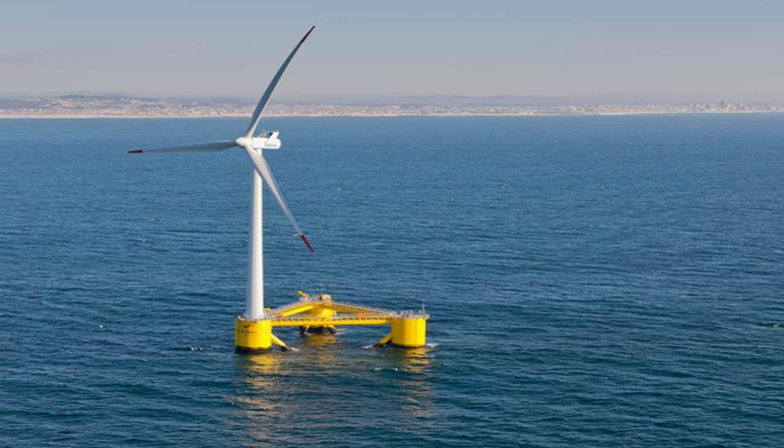

**The Windfloat project, Portugal**

## Innovation Fund

The Innovation Fund was established by the revised ETS Directive[36]. At a carbon price of 20 EUR/tCO2, EUR10 billion would be mobilised for supporting the demonstration of innovative technologies and breakthrough innovation in sectors covered by the EU ETS on a competitive basis. The Delegated Regulation on the operation of the Innovation Fund entered into force in May 2019[37]. Throughout 2019, the Commission has been actively engaged in outreach activities with industry and with Member States to raise awareness about the Innovation Fund and to discuss key issues for each sector related to the selection and implementation of projects. The first call for proposals is planned to be launched in mid-2020, followed by regular calls until 2030[38].

## Modernisation Fund

The Modernisation Fund will support low-carbon investments in the energy systems of ten low-income EU Member States[39] in shares pre-defined by the ETS Directive. At a carbon price of 20 EUR/tCO2, some EUR 14 billion will be generated over the coming decade. The size of the fund more than doubled following the decision from five Member States to transfer part of their solidarity and/or transitional free allowances.The European Commission’s work on establishing the Modernisation Fund started with a series of technical workshops in all beneficiary Member States from September 2018 to January 2019. Further preparatory work is taking place towards adoption of an Implementing Act in the first half of 2020.

## LIFE – Climate Action

The LIFE programme is the EU’s funding instrument for the environment and climate action; it co-finances projects with European added value. The total budget for funding projects in 2014-2020 amounts to EUR 2.5 billion under the sub-programme for environment and EUR 0.86 billion under the sub-programme for climate action. Most LIFE Environment projects also bring climate co-benefits.

LIFE Climate Action supports mitigation and adaptation projects, and climate governance and information. In LIFE call 2018, proposals involving beneficiaries from 21 Member States were recommended for funding, with Spain, Italy and Germany, attracting the most.

The proposed multiannual financial framework for 2021 – 2027 includes an increased budget of EUR 5.45 billion for the LIFE programme for Environment and Climate Action .

In the field of climate action there will be two sub-programmes: ‘Climate Change Mitigation and Adaptation’ and ‘Clean Energy Transition’. The size of the Climate Action budget during 2021-2027 is expected to be some EUR 1 billion. The activities of the sub-programme Clean Energy Transition are currently funded by Horizon 2020 and will be endowed with a similar budget.

Figure : Proposed budget allocation for LIFE 2021-2027

# ADAPTING TO CLIMATE CHANGE

Over the last year, further progress has been achieved under the EU Adaptation Strategy, which was adopted in 2013 to prepare Member States for current and future climate impacts:

* 26 Member States have now a national adaptation strategy in place, while the other Member States are close to finalising their strategies[40];
* more than 1 900 cities and towns in Europe have committed through the Covenant of Mayors to enhancing their climate resilience (increase of some 900 since 2018);
* several draft national energy and climate plans contain adaptation goals;
* the CLIMATE-Adapt platform has been upgraded;
* the European Commission has released an update of its PESETA study[41] on a range of climate impacts, including an economic assessment;
* the LIFE programme funds adaptation projects in crucial areas e.g. water resources.

The AgroClimaWater[42] project promotes water efficiency and supports a shift to more climate-resilient agriculture in Mediterranean countries. LIFE programme provides EUR 1.4 millionof support to it..

The pilot actions of the project focus on olive, citrus and peach orchards. The farmers taking part are adapting their methods to achieve the highest possible yields, despite low or erratic water availability. After only two years of implementation, LIFE AgroClimaWater has achieved impressive results, such as a 15% reduction in water use and 50% less nutrient use in Italy, and a 26% increased yield of the Greek pilot plots despite the extreme climate conditions in 2018.

The EU Adaptation Strategy was evaluated in 2018 with positive conclusions[43]. Some of the **lessons learned** could help defining future adaptation action in Europe, for example:

* International developments have brought about a need for the EU to align its adaptation action with the Paris Agreement, the Sendai Framework for Disaster Risk Reduction and the sustainable development goals;
* The need to adapt to accelerating changes is even bigger than when the Strategy was adopted: we need to better strengthen infrastructure against extreme weather and climate change impacts;
* **Ecosystem-based approaches** need to be better embedded in the assessment and choice of adaptation options;
* **Public health** issues should receive more attention in adaptation policy and planning.

Under the **Horizon Europe,** a **Mission on adaptation and societal transformation** has been launched. The mission board is chaired by Ms Connie Hedegaard. Horizon Europe’s missions will secure and guide research and innovation, and will engage industry and public support through ambitious and communicable milestones.

# INTERNATIONAL CLIMATE COOPERATION

## Aviation

In 2018, the International Civil Aviation Organisation (ICAO) Council adopted standards and recommended practices (SARPs) as part of its carbon offsetting and reduction scheme for international aviation (CORSIA). The objective of CORSIA is to stabilise the impact of international aviation emissions at 2020 levels through offsetting.

At ICAO level, the implementation is ongoing but still incomplete. The first monitoring obligations started in 2019 and a pilot phase will begin from 2021 onwards. While 81 countries, covering 76.6% of global emissions have already volounteered to join as from 2021, there are still uncertainties related to the final coverage and robustness of the scheme, due to the non-participation of countries with important aviation activity, and decisions still having to be taken on the emission units eligible for offsetting.

The EU Member States notified[44] ICAO of the existing differences between the features of the EU ETS for aviation and the legally-binding features of CORSIA contained in the SARPs to protect the EU’s policy space.

## Maritime

In 2018, the International Maritime Organization (IMO) adopted its strategy on the reduction of GHG emissions from ships, including an international commitment to reduce emissions by at least 50% by 2050 compared to 2008 levels (including intermediate carbon intensity targets). As members of the International Maritime Organization, EU Member States need to act on this commitment.

The IMO Strategy includes a list of candidate short, mid and long-term measures to achieve the objectives of the strategy, giving priority to those measures that can deliver further emission reductions already before 2023, also building on existing IMO mesures, such as the Energy Efficiency Design Index and the Ship Energy Efficiency Management Plan. The European Commission is closely involved in the ongoing negotiations of concrete measures at IMO, including proposals made by EU Member States.

In 2018, the ships calling at European Economic Area ports started to monitor and report their emissions, with first emission data published on 30 June 2019[45]. This system aims to provide robust information to support policy-making decisions and the necessary transparency to stimulate up-take of energy efficient technologies and behaviour. By the end of 2019 the European Commission will finalise a report on the first year functioning of the system.

Under the International Maritime Organisation (IMO), monitoring activities on fuel oil consumption of ships started on 1 January 2019 with first reports due in 2020. As a result, ships calling into EU ports have to report under both the EU maritime Monitoring, Reporting and Verification (MRV) Regulation and the IMO data collection system.

## Supporting developing countries

The EU and its Member States remain the world’s biggest providers of official development assistance to developing countries, delivering EUR 74.4 billion in 2018. The EU, its Member States and the European Investment Bank are also the largest providers of public climate finance, with a contribution of EUR 20.4 billion in 2017 (latest available figure)[46].

For the Green Climate Fund (GCF), EU Member States have committed a total of USD 4.7 billion during the Fund’s initial resource mobilisation, accounting for almost half of the USD 10.3 billion of total pledges. The role of Europe will likely further grow in the future. Germany and Norway are the first countries that have announced a doubling of contributions in the ongoing GCF replenishment round.

The Global Climate Change Alliance Plus (GCCA+) is an EU climate flagship initiative. In the period 2007-2020, it provides grants of EUR 750 million for climate action and capacity development in developing countries, mostly Least Developed Countries and Small Islands Developing States. In the current updating of Nationally Determined Contributions to the Paris Agreement, the GCCA+ supports partners in climate policy making and the planning of ambitious climate mitigation and adaptation.

The EU External Investment Plan encourages investment in developing countries in Africa and the EU Neighbourhood region. So far, eight guarantees will help to set up and expand renewable energy and connectivity projects to millions of people in partner countries. For example, the European Guarantee for Renewable Energy, led by four European financial institutions, would leverage up to EUR 3.4 billion for projects in Sub-Saharan Africa. The projects would cut carbon emissions, reduce power shortages, create up to 12 000 jobs and add around 2 GW of generating capacity from renewable sources.

Negotiations on a new partnership between the EU and the ACP (African, Caribbean and Pacific) region after 2020 have started on 28 September 2018. The planned post-Cotonou Agreement[47] shall include a strong joint commitment to climate action. Additionally, a new Africa – Europe Alliance for Sustainable Investment and Jobs was launched in 2018, which among other issues aims to boost environmental and labour protection.

***ETS-linking with Switzerland***

After signing an agreement in November 2017 to link their emissions trading systems, parliaments of both the EU and Switzerland have now approved the agreement. In a next step, Switzerland and the EU have to ratify the linking agreement for the link to become operational as of 1 January 2020.

1. COM(2018) 773 final: A clean planet for all. A European strategic long-term vision for a prosperous, modern, competitive and climate neutral economy.
2. Source: COM(2018) 773 final.
3. In addition to the EU target under the UNFCCC, the EU, together with Iceland, also committed to a binding emission reduction for the second commitment period of the Kyoto Protocol (2013-2020). The target is to reduce emissions by 20% compared to base year emissions (mostly 1990).The scope is slightly different from the scope of the UNFCCC target. In 2017, the EU and Iceland had reduced emissions by 26% compared to the base year.
4. Sum of Member States’ projections. Existing measures means measures the Member States have already implemented. Additional measures means measures the Member States plan to implement.
5. The figure includes all 31 countries participating in the EU ETS.
6. This is required according to Regulation (EU) 2018/1999 on the Governance of the Energy Union and Climate Action.
7. <https://ec.europa.eu/energy/en/topics/energy-strategy-and-energy-union/governance-energy-union/national-energy-climate-plans>
8. The figure shows verified ETS emissions with the sectoral and geographical of the ETS in the relevant year and can therefore not be read as a time series before 2013. Aviation is included in the cap for 2012-2018.
9. The surplus corresponds to the "total number of allowances in circulation" as defined in the decision establishing the Market Stability Reserve.
10. C(2019) 3288 final: Publication of the total number of allowances in circulation in 2018 for the purposes of

    the Market Stability Reserve under the EU Emissions Trading System
11. Decision No 406/2009/EC on the effort of the Member States to reduce their greenhouse gas emissions to meet the Community's greenhouse gas emission reduction commitments up to 2020.
12. Regulation (EU) 2018/842 on binding annual greenhouse gas emission reductions by Member States from 2021 to 2030 contributing to climate action to meet commitments under the Paris Agreement.
13. The Member States’ projections ‘with additional measures’ submitted in March 2019 indicate a 27% reduction, while the assessment of the scenarios with additional measures in the draft NECPs indicate a 28% reduction.
14. The non-ETS targets include the national targets set under the Effort Sharing Regulation and the ‘no-debit’ commitment under the LULUCF Regulation (see chapter 4).
15. An aggregated parameter that integrates imports, exports, production and destruction of ODS, except those for feedstock use).
16. Regulation (EC) No 1005/2009 on substances that deplete the ozone layer
17. Regulation (EU) No 517/2014 on fluorinated greenhouse gases
18. *Fluorinated greenhouse gases 2018 – data reported by companies on the production, import, export and destruction of fluorinated greenhouse gases in the European Union, 2007-2016*, European Environment Agency.
19. Forest Management credits are capped and presented as yearly averages when the total Forest Management credits of the considered period exceed the simulated cap over the same period.
20. Accounting represents a means to evaluate policies and to raise ambition for more action in terms of reducing emissions and increasing removals. Note that debits and credits from accounting are preliminary and simulated, because definitive accounts will only be available after the end of the commitment period (December 2020). Different accounting rules apply depending on the activity: gross-net with baseline 0 for Afforestation/Reforestation and Deforestation, net-net against a baseline (mostly emissions and removals for year 1990) for Grazing Land Management, Cropland Management and Revegetation, and the difference against the Forest Management Reference Level for Forest Management.
21. Seven Member States chose cropland management, six chose grazing land management, one chose revegetation and one chose wetland drainage and rewetting, but has yet to provide quantifications.
22. Regulation (EU) 2018/841 on the inclusion of greenhouse gas emissions and removals from land use, land use change and forestry in the 2030 climate and energy framework.
23. http://ec.europa.eu/transparency/regexpert/index.cfm?do=groupDetail.groupDetail&groupID=3638&news =1
24. SWD(2019) 213 final
25. COM(2018) 773 final
26. Regulation (EU) 2019/631 setting CO2 emission performance standards for new passenger cars and for new light commercial vehicles
27. Regulation (EU) 2019/1242 setting CO2 emission performance standards for new heavy-duty vehicles
28. Directive (EU) 2019/1161 on the promotion of clean and energy-efficient road transport vehicles
29. https://ec.europa.eu/transport/modes/road/news/2017-05-31-europe-on-the-move_en
30. https://europa.eu/rapid/press-release_IP-17-4242_en.htm
31. COM/2018/097 final
32. <https://ec.europa.eu/info/publications/180524-proposal-sustainable-finance_en>
33. <https://ec.europa.eu/info/publications/non-financial-reporting-guidelines_en#climate>
34. https://ec.europa.eu/info/sites/info/files/about_the_european_commission/eu_budget/draft-budget-2020-wd-13-web-1.4_soe.pdf
35. <https://ec.europa.eu/commission/publications/factsheets-long-term-budget-proposals_en>
36. Directive (EU) 2018/410 of 14 March 2018 of the European Parliament and of the Council, amending Directive 2003/87/EC establishing a system for greenhouse gas emission allowance trading within the Union, Article 10a(8).
37. 28/05/2019 - C(2019) 1492 - [Commission Delegated Regulation (EU) 2019/856 supplementing Directive 2003/87/EC with regard to the operation of the Innovation Fund](https://eur-lex.europa.eu/legal-content/EN/TXT/?uri=CELEX:32019R0856) 
38. https://ec.europa.eu/clima/policies/innovation-fund_en
39. BG, CZ, EE, HR, LV, LT, HU, PL, RO and SK.
40. Croatia and Bulgaria are still working on their national strategies.
41. <https://ec.europa.eu/jrc/en/peseta-iii>
42. <http://www.lifeagroclimawater.eu/>
43. <https://ec.europa.eu/clima/policies/adaptation/what_en>
44. <https://eur-lex.europa.eu/legal-content/EN/TXT/?uri=CELEX:32018D2027>
45. Regulation (EU) 2015/757 on the monitoring, reporting and verification (MRV) of CO2 emissions
46. 2018 EU climate finance figures will be published in autumn 2019 Council conclusions on climate finance.
47. The Cotonou Agreement is the overarching framework for EU relations with ACP countries. It will expire in February 2020.