

Table of Contents

1 Introduction 7

2 Scope of the Roaming Regulation and main provisions 8

3 Scope of the roaming review 11

4 The Commission’s approach to the roaming review 12

4.1 Information and data gathering on wholesale and retail roaming markets 12

4.1.1 Operators’ data collected for the BEREC International Roaming Benchmark Reports 12

4.1.2 Online surveys 12

4.2 Data analysis 12

4.3 External studies 12

4.3.1 Study to estimate the costs of providing wholesale roaming services 13

4.3.2 Study to assess technological and market developments that might have an impact on the roaming market 13

4.3.3 Study on mobile broadband prices 14

4.4 BEREC input 14

4.4.1 Benchmark Reports 14

4.4.2 Transparency Reports 14

4.4.3 BEREC Opinion on the roaming market (June 2019) and BEREC Supplementary analysis on wholesale roaming costs (September 2019) 15

4.5 European Parliament study 15

5 Competition in retail roaming markets 15

5.1 Evolution of retail (outbound) roaming volumes 15

5.1.1 The introduction of RLAH has lead to an explosive increase in roaming traffic 15

5.1.2 Retail (outbound) roaming traffic remains a small fraction of domestic traffic 20

5.2 Implementation of fair use policy 22

5.3 Application of the derogation mechanism 25

5.3.1 The number of sustainability derogations is getting smaller every year 26

5.3.2 The maximum surcharges granted by the NRAs are low and generally decreasing every year 28

5.3.3 The share of EU/EEA roaming traffic subject to a surcharge due to the sustainability derogation has remained marginal 28

5.3.4 Operators having been granted the derogation have used the surcharge with parsimony 29

5.3.5 The application of the derogation mechanism should continue to decrease 31

5.4 Use of alternative roaming tariff plans 31

5.5 Evolution of domestic tariff plans 34

5.5.1 Domestic prices 34

5.5.2 Domestic-only tariff plans 34

5.6 Quality of services 36

5.7 Situation of MVNOs 39

5.8 Rest of the World roaming 42

5.9 Consumer perception 43

6 Assessment of the costs of providing wholesale roaming services 45

6.1 Description of the Commission’s approach 46

6.2 Previous estimates of wholesale roaming costs 47

6.2.1 BEREC cost estimates from 2010 and 2012 47

6.2.2 TERA consultants cost estimates from 2016 48

6.3 The Axon Partners cost model 49

6.3.1 The approach and methodology followed by Axon Partners 49

6.3.2 Choice of cost standards and general cost allocation 51

6.3.3 Treatment of seasonality 52

6.3.4 The structure of the cost model 53

6.4 Modelled scenarios 54

6.5 Results derived directly from the cost model 58

6.6 Estimated total costs including transit and termination 61

6.7 BEREC response to the cost model and estimates 64

7 Competition in wholesale roaming markets 66

7.1 Evolution of wholesale (inbound) roaming volumes 66

7.1.1 Net inbounder and outbounder countries 66

7.1.2 Inbound roaming traffic exhibits an explosive increase 73

7.1.3 National wholesale roaming markets are not overly concentrated 75

7.1.4 Group operators keep part of their roaming traffic within the group 76

7.2 Evolution of prices 78

7.2.1 Wholesale roaming prices have been steadily decreasing 78

7.2.2 In-group wholesale roaming rates are not necessarily lower than out-of-group rates 82

7.3 Wholesale structural measures 84

7.4 Situation of MVNOs 84

7.4.1 The various types of wholesale roaming access for MVNOs 85

7.4.2 Specific challenges reported by MVNOs in wholesale roaming agreements 86

7.4.3 Wholesale roaming prices paid by MVNOs 86

7.4.4 Possible measures to improve the situation for MVNOs 90

7.5 Fraud 92

8 Technological developments 93

8.1 The main developments with the prospect for a substantial impact on roaming 94

8.2 The study concludes that there does not seem to be a case for significant changes to the regulatory rules for international roaming under the current review. 95

8.3 The study suggests considering if developments relating to M2M and permanent roaming would call for immediate attention 96

9 Conclusion 98

Figure 1: Regulated wholesale roaming data price cap, Q3 2017 – Q2 2022 10

Figure 2: EEA retail roaming voice traffic (calls made), Q2 2016 – Q1 2019 (millions of minutes) 17

Figure 3: EEA retail roaming data traffic, Q2 2016 – Q1 2019 (millions of GB) 17

Figure 4: EEA average voice roaming consumption (calls made) per month per roaming subscriber, Q2 2016 – Q1 2019 (minutes per month) 18

Figure 5: EEA average data roaming consumption per month per roaming subscriber, Q2 2016 – Q1 2019 (MB per month) 19

Figure 6: Voice services - Ratio between the total volumes after RLAH (Q4 2017 - Q2 2018) and the total volumes over the last period before RLAH (Q4 2016 - Q2 2017), for retail domestic traffic (blue bars) and outbound roaming traffic (red bars) 20

Figure 7: Data services - Ratio between the total volumes after RLAH (Q4 2017 - Q2 2018) and the total volumes over the last period before RLAH (Q4 2016 - Q2 2017), for retail domestic traffic (blue bars) and outbound roaming traffic (red bars) 21

Figure 8: Voice services - Cumulative density distributions of the retail (outbound) roaming voice traffic as % of the retail domestic voice traffic. 22

Figure 9: Data services - Cumulative density distributions of the retail (outbound) roaming data traffic as % of the retail domestic data traffic. 23

Figure 10: Share of total EU/EEA retail roaming traffic which is subject to a surcharge in excess of FUP (%), Q4 2017 – Q1 2019 24

Figure 11: Development of % of voice and data roaming traffic in the EU/EEA subject to a surcharge, due to the sustainability derogation, Q3 2017 – Q1 2019 29

Figure 12: Development of % of voice roaming traffic subject to a surcharge due to the sustainability derogation in the Member States where derogations were granted to MNO(s), Q3 2017 – Q1 2019 30

Figure 13: Development of % of data roaming traffic subject to a surcharge due to the sustainability derogation, in the Member States where the derogation was granted to MNO(s), Q3 2017 – Q1 2019 31

Figure 14: % of roaming voice and data traffic from alternative tariffs in total EU/EEA roaming traffic, Q4 2016 – Q1 2019 33

Figure 15: Cumulative density functions of the % of outbound voice traffic coming from alternative tariffs per operator 34

Figure 16: Cumulative density functions of the % of outbound data traffic coming from alternative tariffs per operator 34

Figure 17: % of domestic-only subscribers per country 37

Figure 18: Individual MVNOs’ market shares (1 dot = 1 MVNO) before and after RLAH 41

Figure 19: Total MVNO market share among the operators (MNOs and MVNOs) that responded to all 19th to 22nd BEREC Benchmark Reports’ data collection, by country 42

Figure 20: Average Retail Revenue Per User (ARRPU) of MVNOs, by country, Q4 2016 to Q1 2019 43

Figure 21: Development of retail roaming prices for travelers roaming in non-EU/EEA countries, Q2 2016 – Q1 2019 44

Figure 22: Roaming-related topics of consumer complaints received by NRAs and their relative importance 46

Figure 23: Outgoing wholesale roaming voice – Estimated costs, TERA model in 2016 49

Figure 24: Wholesale roaming data service – Estimated costs €cent/MB, TERA model in 2016 50

Figure 25: Structural overview of the Axon Bottom-Up LRIC model 55

Figure 26: Cover sheet of the Axon cost model 56

Figure 27: Estimated data roaming unit costs in €/GB, transit costs not included 60

Figure 28: Estimated voice roaming unit cost in €ents/min, transit and termination costs are not included 61

Figure 29: Estimated SMS roaming unit costs in €cents/SMS 62

Figure 30: Estimated data roaming unit costs in €/GB including estimates for transit costs 64

Figure 31: Estimated voice roaming unit costs in €cents/min, including transit and termination costs 65

Figure 32: Voice services, inbounder countries - Left panel: ratio between inbound and outbound roaming voice volumes. Right panel: net outbound roaming voice volumes (outbound voice volumes minus inbound voice volumes) as % of total domestic voice volumes, Q4 2016 – Q1 2019. 68

Figure 33: Voice services, outbounder countries – Left panel: ratio between inbound and outbound roaming voice volumes. Right panel: net outbound roaming voice volumes (outbound voice volumes minus inbound voice volumes) as % of total domestic voice volumes, Q4 2016 – Q1 2019. 70

Figure 34: Data services, inbounder countries. Left panel: ratio between inbound and outbound roaming data volumes. Right panel: net outbound roaming data volumes (outbound data volumes minus inbound data volumes) as % of total domestic data volumes, Q4 2016 – Q1 2019. 72

Figure 35: Data services, outbounder countries. Left panel: ratio between inbound and outbound roaming data volumes. Right panel: net outbound roaming data volumes (outbound data volumes minus inbound data volumes) as % of total domestic data volumes, Q4 2016 - Q1 2019. 73

Figure 36: Inbound roaming voice traffic, Q4 2016 – Q1 2019 75

Figure 37: Inbound roaming data traffic, Q4 2016 – Q1 2019 75

Figure 38: HHI for the wholesale roaming market – Voice volumes 76

Figure 39: HHI for the wholesale roaming market – Data volumes 77

Figure 40: Voice services - Cumulative density distributions of in-group outbound retail roaming voice traffic (calls made) as % of the total outbound retail roaming voice traffic (calls made), per operator, for Q3 2017-Q1 2019 78

Figure 41: Data services - Cumulative density distributions of in-group outbound retail roaming data traffic as % of the total outbound retail roaming data traffic, per operator, for Q3 2017-Q1 2019 79

Figure 42: Voice services: development of the average wholesale roaming rate for voice in the EEA, Q2 2016 to Q1 2019 80

Figure 43: Data services: development of the average wholesale roaming rate for data in the EEA, Q2 2016 to Q1 2019 81

Figure 44: Voice services: average wholesale roaming rate for voice in the Member States, Q2 2017 and Q1 2019 82

Figure 45: Data services: average wholesale roaming rate for data in the Member States, Q2 2017 and Q1 2019 82

Figure 46: Average in-group wholesale voice roaming rates versus average out-of-group wholesale voice roaming rates (Q1 2019) 84

Figure 47: Average in-group wholesale data roaming rates versus average out-of-group wholesale data roaming rates (Q1 2019) 84

Figure 48: Type of wholesale roaming access for full and light MVNOs 87

Figure 49: Wholesale roaming prices paid for voice by MNOs (blue dots) and MVNOs (red dots), 2018 88

Figure 50: Wholesale roaming prices paid for data by MNOs (blue dots) and MVNOs (red dots), 2018 89

Figure 51: Voice services - Average wholesale domestic price plus EU weighted average MTR (as of July 2018) versus average wholesale roaming price paid by MVNOs (1 dot = 1 MVNO), 2018 90

Figure 52: Data services - Average wholesale domestic price versus average wholesale roaming price paid by MVNOs (1 dot = 1 MVNO), 2018 91

# Introduction

In October 2015, the European Parliament and the Council adopted Regulation (EU) 2015/2120[1] which mandated the end of retail roaming charges in the Union from 15 June 2017, subject to fair use policy and a sustainability derogation. These new roaming rules are widely known as "Roam-Like-At-Home" (RLAH).

For RLAH to be provided in a sustainable manner throughout the Union, the co-legislators have agreed to have in place the following measures:

* substantially reduced wholesale roaming price caps[2];
* the possibility for operators to apply a fair use policy to prevent abusive or anomalous use of roaming services at domestic prices, such as the permanent use of a SIM card in other Member States than the Member State of the roaming provider that issued the SIM card;
* an exceptional and temporary derogation system for operators to be used only if authorised by the national regulator, under strict circumstances when the abolition of roaming charges in a specific market could lead to domestic price increases for the customers of the operator in question.

In accordance with the mandate given by the co-legislators, the Commission adopted, on 15 December 2016, the Commission Implementing Regulation (EU) 2016/2286 laying down detailed rules on the application of fair use policy and on the methodology to be used for submitting and assessing a request for a sustainability derogation (hereinafter referred to as the 'Implementing Regulation (EU) 2016/2286')[3].

The above set of rules has been applicable in the EU/EEA[4] since 15 June 2017.

In line with its reporting obligations laid down in the Roaming Regulation[5], the Commission:

* adopted on 12 December 2018 an interim Report to the European Parliament and the Council on the implementation of those rules over the first 18 months (hereinafter ‘the interim Report’)[6];
* published on 28 June 2019 a Staff Working Document (SWD) on the findings of the review of the rules on fair use policy and the sustainability derogation laid down in the Implementing Regulation (EU) 2016/2286 (hereinafter ‘the SWD on fair use policy and the sustainability derogation’)[7].

The interim Report concluded on the overall success of the RLAH reform over the first 18 months, showing in particular that the demand for mobile consumption while travelling in the EU/EEA had rapidly and massively increased since RLAH was introduced. The SWD published on 28 June 2019 concluded that the safeguards foreseen in the Roaming Regulation to avoid distortions on domestic markets, namely fair use policy and the sustainability derogation, had so far worked adequately where needed.

As a follow up to the interim Report and the review of the fair use policy and sustainability derogation, the Roaming Regulation further mandates the Commission to submit, by 15 December 2019, a comprehensive report to the European Parliament (EP) and the Council to assess the functioning of the roaming market under the RLAH rules. This is the subject of the Report from the Commission to the European Parliament and the Council on the review of the roaming market (the Roaming Review Report) and of this accompanying Staff Working Document (SWD).

# Scope of the Roaming Regulation and main provisions

Roaming in the meaning of the Roaming Regulation is a service that allows a customer of a Mobile (Virtual) Network Operator (M(V)NO) in one EU/EEA country to have access to mobile services (voice, SMS or data) from an MNO in another EU/EEA country[8]. The service provider (the mobile operator) ensures that its customers remain connected to a mobile network when travelling abroad while using the same mobile handset (or possibly laptop or tablet in case of data roaming) and the same phone number. The service provider that wants to offer roaming services to its customers ("retail roaming services") in another country has to buy them from an MNO located in the visited country ("wholesale roaming services"). To this end, commercial wholesale roaming agreements between service providers have to be concluded. In practice, when a customer places a call or uses mobile data while roaming abroad, that service is provided by a mobile operator in the visited country. The roaming customer’s home operator has to pay the visited operator for that service. This is called wholesale roaming charges. The level of those charges is capped by the Roaming Regulation and annually decreasing for data (see below in this section).

Since 15 June 2017 mobile operators have not been allowed to levy any charges in addition to the domestic price for the provision of roaming services (voice, SMS and data) to their customers when they periodically travel in the EU/EEA. In order to prevent abusive or anomalous use of roaming services - such as permanent roaming - at domestic prices that may have detrimental effects on the domestic markets, mobile operators may apply a fair use policy.

Fair use policy aims in particular at ensuring that roaming at domestic price is used only when periodically travelling in the EU/EEA. For this purpose, an operator may ask its customers for a proof of residence in, or stable link with, the EU/EEA country where it provides services and issues the SIM card to be used at domestic price when travelling abroad. An operator may also check that the SIM card is used more in its home Member State than abroad. If such a fair use policy is applied and, during a time window of at least four months, the customer has roaming consumption prevailing over domestic consumption or presence in other Member States of the Union prevailing on domestic presence, the operator has to alert the customer to verify whether there is any abusive or anomalous use of roaming services at domestic prices . After a period of at least 14 days from the date of the alert, the operator may apply small roaming surcharges linked to the wholesale price caps if the customer continues to consume mobile services abroad.

In addition, in order to allow for the continuous development of the best data offers on domestic markets (e.g. unlimited data), an operator may apply a volume safeguard on roaming data consumed at domestic prices[9]. Beyond that volume, the operator may apply a small roaming surcharge not exceeding the wholesale roaming price cap on data[10] (see in more detail below in this section).

In any event, even in excess of fair use policy, the sum of the domestic price plus the small roaming surcharge applicable may not exceed the roaming fees in place in the first quarter 2016 (prior to the transitional period that led to RLAH in June 2017)[11].

In exceptional and specific circumstances, in order to avoid a domestic price increase, an operator may obtain from its national regulatory authority (NRA) a so-called sustainability derogation. For this purpose, the operator must demonstrate that the provision of roaming services without the application of a surcharge would not be sustainable with its current domestic charging model. In that case the NRA may authorise the operator to apply a small roaming surcharge for one year. In order to prolong such an authorisation the operator must renew its application yearly.

At wholesale level, the price caps were substantially reduced in 2017 by the Roaming Regulation[12]: as of 15 June 2017, the wholesale roaming price caps were reduced from 0.05 €/min to 0.032 €/min for outgoing calls (voice), from 0.02 €/SMS to 0.01 €/SMS, and from 50 €/GB to 7.7 €/GB for data. The data price caps are programmed, in the Roaming Regulation, to further decline every year until 2022 as displayed in Figure 1, in order to ensure that market players can benefit from wholesale rates that allow for the provision of roaming services to their customers without levying any charge on top of the domestic price. The wholesale roaming price caps also ensure that wholesale costs are fully recovered by the operator providing the wholesale roaming service.

Figure 1: Regulated wholesale roaming data price cap, Q3 2017 – Q2 2022

Note: Prior to 15 June 2017, the wholesale roaming data price cap was 50 €/GB (not shown because out of scale)

Being established by a Regulation, the roaming rules are directly applicable in all EU Member States and also apply in the EEA countries[13]. The Roaming Regulation entrusts NRAs with the task of monitoring, supervising and enforcing the roaming rules in Member States. In order to ensure a consistent approach of all NRAs, the Body of European Regulators in Electronic Communications (BEREC) issued Retail Roaming Guidelines[14] in March 2017 and Wholesale Roaming Guidelines[15] in June 2017, prepared in close collaboration with the Commission and after consulting stakeholders. While not binding in themselves, BEREC Guidelines support the NRAs in the monitoring, supervision and enforcement of the new roaming rules in practice. BEREC Guidelines also serve as detailed guidance for mobile operators on how to implement the new roaming rules in their various offers.

# Scope of the roaming review

The review requirements are laid down in Article 19(3) of the Roaming Regulation:

“The Commission shall (…), after consulting BEREC, submit biennial reports to the European Parliament and to the Council, accompanied, if appropriate, by a legislative proposal to amend the maximum wholesale charges for regulated roaming services laid down in this Regulation. The first such report shall be submitted by 15 December 2019.

Those biennial reports shall include, inter alia, an assessment of:

(a) the availability and quality of services, including those which are an alternative to regulated retail voice, SMS and data roaming services, in particular in the light of technological developments;

(b) the degree of competition in both the retail and wholesale roaming markets, in particular the competitive situation of small, independent or newly started operators, and MVNOs, including the competition effects of commercial agreements and the degree of interconnection between operators;

(c) the extent to which the implementation of the structural measures provided for in Articles 3 and 4, and, in particular, on the basis of the information provided by the national regulatory authorities, of the procedure for prior authorisation laid down in Article 3(6), has produced results the development of competition in the internal market for regulated roaming services;

(d) the evolution of the retail tariff plans available;

(e) changes in data consumption patterns for both domestic and roaming services;

(f) the ability of home network operators to sustain their domestic charging model and the extent to which exceptional retail roaming surcharges have been authorised pursuant to Article 6c;

(g) the ability of visited network operators to recover the efficiently incurred costs of providing regulated wholesale roaming services;

(h) the impact of the application of fair use policies by operators in accordance with Article 6d, including the identification of any inconsistencies in the application and implementation of such fair use policies.”

All elements listed above are analysed and assessed in the remainder of this report.

# The Commission’s approach to the roaming review

In order to cover all review requirements of the Roaming Regulation listed above, the Commission services have conducted the following work streams and used the following inputs and data sources.

## Information and data gathering on wholesale and retail roaming markets

### Operators’ data collected for the BEREC International Roaming Benchmark Reports

BEREC is mandated by the co-legislators in the Roaming Regulation to regularly collect data from NRAs on roaming developments at retail and wholesale levels. For that purpose BEREC and NRAs run a dedicated questionnaire twice a year to collect the relevant data from mobile operators throughout the EU, in particular data on volumes of roaming traffic (retail and wholesale), wholesale roaming revenues, wholesale roaming rates and information on wholesale roaming contracts. For the purposes of this review, the Commission services have had access to, and analysed, these data. Such data are confidential and are published at country and EU aggregate levels. Data shown at operator level are anonymised.

### Online surveys

In order to complement the quantitative market information provided by the BEREC Benchmark data collection, the Commission and BEREC have jointly run two online surveys of MNOs, MVNOs and NRAs in June 2018 and March 2019 to gather information on the implementation of fair use policy, of the sustainability derogation, as well as other elements to be assessed under this review such as quality of services or misuses/fraudulent usage of roam-like-at-home[16].

## Data analysis

The analysis of the operators’ data collected for the BEREC Benchmark exercise and the analysis of the data collected through the online surveys were conducted by DG CNECT and the Competence Centre on Microeconomic Evaluation (CC-ME) of the Joint Research Centre (JRC)[17]. DG CNECT has also relied on BEREC's analysis of this data carried out in parallel to the Commission's analysis (see section 4.4).

## External studies

### Study to estimate the costs of providing wholesale roaming services

In order to estimate the costs of providing wholesale romaing services in the EU/EEA, the Commission ordered an external study to AXON Partners[18]. The study was conducted between March 2018 and June 2019. Building upon cost models used by NRAs for mobile networks and on the cost model developed during the last roaming review[19], the contractor has developed a cost model to estimate the costs of providing wholesale roaming services in each EU Member State and EEA country[20]. The cost model was developed in close collaboration with the BEREC International Roaming Expert Working Group, BEREC experts on terminationrates and NRAs, in particular via the coordination of the study work by the Steering Commmittee composed of DG CNECT and 8 NRAs[21].

The methodology, input data gathering exercise, consultation process and final results of the study are described in section 6. The final version of the cost model developed by the contractor is described in more detail in the final report of the study, which was published on 24 July 2019 together with the final results and a public version of the model accompanied by the necessary documentation[22].

### Study to assess technological and market developments that might have an impact on the roaming market

The Commission ordered to WIK Consult an external study on technological and market developments that might have an impact on the roaming market[23]. The purpose of the study was to assess the availability and quality of services, which are an alternative to regulated retail voice, SMS and data roaming services, in particular in the light of technological developments. The study was conducted between December 2018 and June 2019. The contractor followed a modified greenfield approach to assess the competitive impact of various technological developments in the roaming market, including:

1. Technologies and services that enable roaming bypass: wi-fi and wi-fi aggregation, Over-the-top (OTT) voice and messaging, Rich Communication Services.
2. Technological developments and platforms facilitating competition in the roaming services: virtual SIM, embedded SIM, 5G and network slicing, wholesale capacity trading platforms, Local Break-Out.
3. The role of new business models and players in the roaming space: verticals, equipment manufacturers and Operating Systems providers, communication application providers etc.

The findings of the study are presented in detail in the final report[24] published on 24 July 2019. An overview of these findings and main conclusions is presented in section 8.

### Study on mobile broadband prices

The Commission publishes every year the “Mobile Broadband Prices in Europe” which reports on the level of domestic retail mobile prices in EU Member States and in a number of non-EU countries. For the purpose of cross-country comparisons, the study uses the standard mobile internet usage baskets defined by the Organisation for Economic Co-operation and Development (OECD). The results of this study have been used to monitor the evolution of domestic mobile prices in the EU over the last years.

## BEREC input

The Commission services have worked continuously and closely with the International Roaming BEREC Expert Working Group (EWG) for the purposes of this review. Implemention-related work and questions raised by operators, end users and NRAs since RLAH rules have been adopted have been discussed with the EWG and have fed in this review. In addition, NRAs were closely involved in the Commission’s external study to assess the costs of providing wholesale roaming services (see section 4.3.1).

### Benchmark Reports

BEREC is mandated by the co-legislators in the Roaming Regulation to regularly collect data from NRAs on roaming developments at retail and wholesale level (e.g. traffic, prices). Based on these data, BEREC publishes twice a year country-level results in the BEREC International Roaming Benchmark Report in March and October every year. BEREC Benchmark Reports published since June 2017 have been used for the purposes of this review.

### Transparency Reports

BEREC is mandated by the co-legislator in the Roaming Regulation to collect data from NRAs on transparency and comparability of roaming tariffs once a year. For this purpose NRAs are running another data collection from mobile operators in August every year. Based on these data, BEREC publishes country-level results in the BEREC Report on Transparency and Comparability of International Roaming Tariffs in December every year. BEREC Transparency Reports published since June 2017 have been used for the purposes of this review.

### BEREC Opinion on the roaming market (June 2019) and BEREC Supplementary analysis on wholesale roaming costs (September 2019)

In line with the obligation to consult BEREC before submitting the review Report to EP and Council in December 2019, the Commission services requested BEREC to provide its formal Opinion on the functioning of the roaming market by 19 June 2019. The Review Report and this SWD take utmost account of the BEREC Opinion[25] and BEREC Supplementary cost analysis[26] published on 19 June 2019 and 20 September 2019 respectively.

## European Parliament study

In November 2018, the European Parliament published a study entitled “Roaming: One year after implementation”, which was prepared at the request of the European Parliament’s Committee on Industry, Research and Energy[27]. The study reviews the retail and wholesale roaming markets during the first year after the introduction of the RLAH regime. It acknowledges its benefits to the retail roaming market and makes certain recommendations focusing mainly on the wholesale regulation, including adjusting the wholesale caps. The European Commission has taken note of the study, some recommendations of which are also reflected in theBEREC Opinion.

# Competition in retail roaming markets

## Evolution of retail (outbound) roaming volumes

### The introduction of RLAH has lead to an explosive increase in roaming traffic

The introduction of RLAH and the ensuing elimination of roaming charges in the EU/EEA from 15 June 2017 has triggered an immediate and massive increase in retail roaming traffic. The volume of roaming phone calls made increased by 2.5 times in Q3 2017, compared to one year before and by almost 2 times in Q4 2017, Q1 2018 and Q2 2018, compared to one year before (Figure 2). In summer 2018 (Q3 2018), the volume of roaming phone calls made was about 3 times higher than in the last summer before RLAH (Q3 2016). The increase of traffic continues, though at a much lower level, even when comparing quarters after the introduction of RLAH (12% in Q4 2018 and 9% in Q1 2019, compared to one year before).

Figure 2: EEA retail roaming voice traffic (calls made), Q2 2016 – Q1 2019 (millions of minutes)

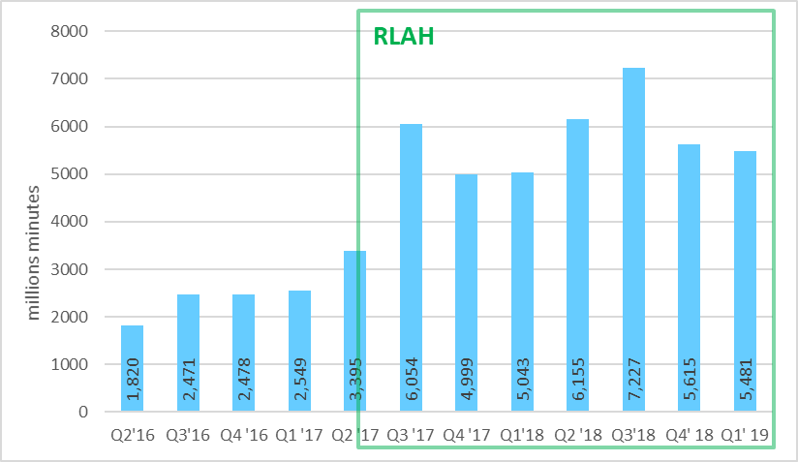

Source: Based on 23rd International Roaming BEREC Benchmark Report

In the first three quarters from the introduction of RLAH (Q3 2017, Q4 2017 and Q1 2018), mobile data consumption while roaming was around 5 times above its level one year before (5.3, 5 and 4.9 times respectively, see Figure 3). In Q2 2018 and Q3 2018, mobile data consumption while roaming was respectively 15 and 12 times more compared to its level two years before. In Q4 2018 and Q1 2019 the increase compared to one year before remains high (above 80%), even though both comparisons are entirely after the introduction of RLAH.

Figure 3: EEA retail roaming data traffic, Q2 2016 – Q1 2019 (millions of GB)

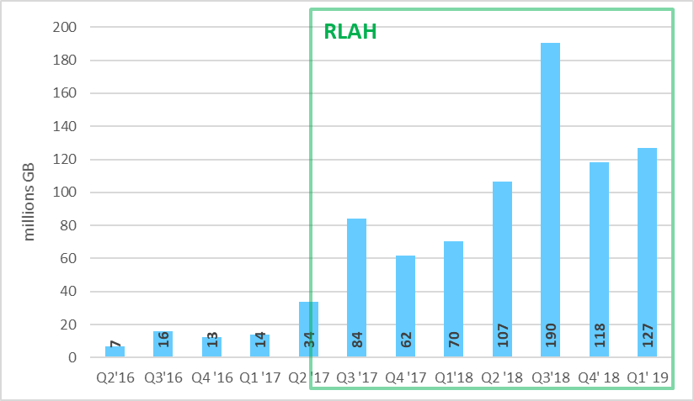

Source: Based on 23rd International Roaming BEREC Benchmark Report

During the first year of RLAH, travellers called on average about 1.7 times more while roaming than before the implementation of RLAH (Figure 4)[28]. During that first year, they used on average almost 4 times more data while roaming than before RLAH (Figure 5)[29]. In Q4 2018 and Q1 2019 we observe a decrease in the average consumption of voice traffic per roamer (6% and 7%), which should be attributed to the increase in the number of subscribers using roaming. In contrast, the average consumption of data traffic per roamer continues to increase at a high pace (51% in Q4 2018 and 38% in Q1 2019 compared to one year before).

Figure 4: EEA average voice roaming consumption (calls made) per month per roaming subscriber, Q2 2016 – Q1 2019 (minutes per month)

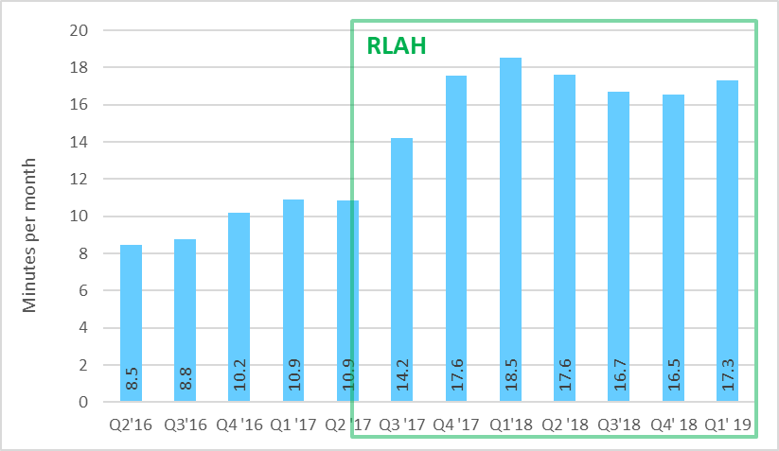

Source: Based on 23rd International Roaming BEREC Benchmark Report

Figure 5: EEA average data roaming consumption per month per roaming subscriber, Q2 2016 – Q1 2019 (MB per month)

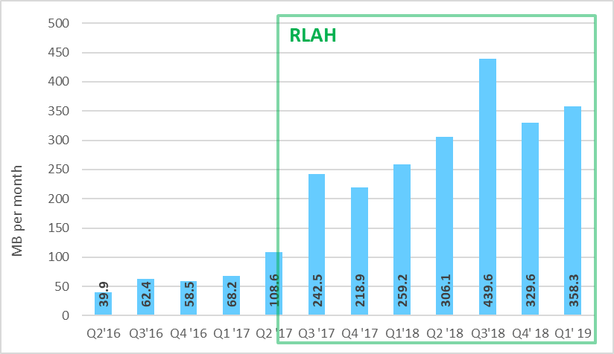

Source: Based on 23rd International Roaming BEREC Benchmark Report

All Member States experienced a considerable increase in roaming consumption by subscribers during the first year of RLAH[30]. Particularly high increases in customers' EU/EEA roaming consumption for voice (by 3 to 5 times) were observed by Bulgarian, Croatian, Polish and Romanian operators (red bars in Figure 6). In contrast, domestic consumption has been stable over the same period (blue bars in Figure 6). The increase observed in roaming voice consumption is therefore entirely due to the introduction of RLAH.

Figure 6: Voice services - Ratio between the total volumes after RLAH (Q4 2017 - Q2 2018) and the total volumes over the last period before RLAH (Q4 2016 - Q2 2017), for retail domestic traffic (blue bars) and outbound roaming traffic (red bars)

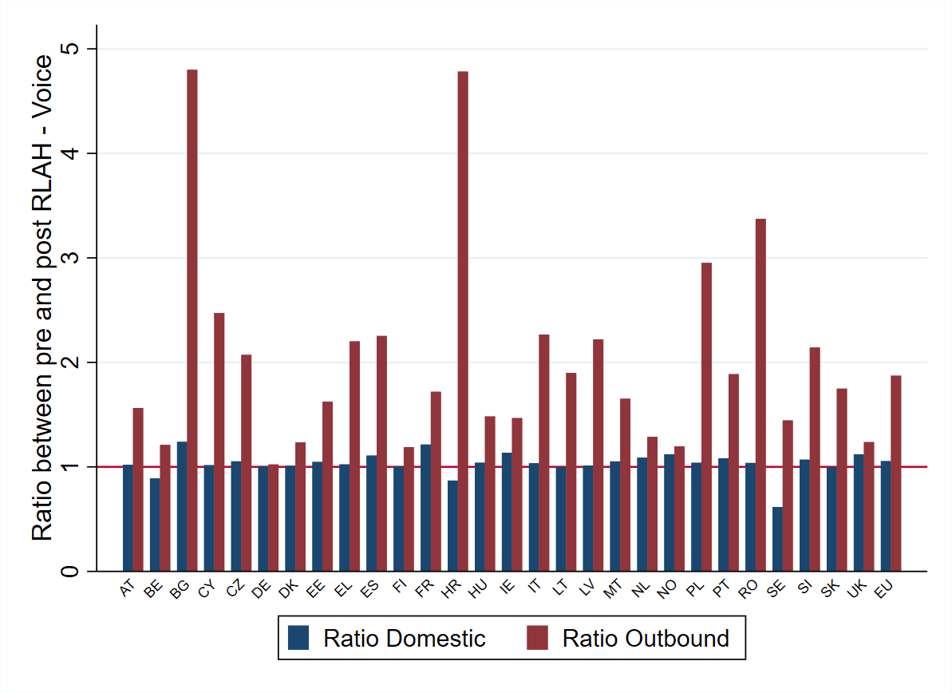

Source: Data collected for the 19th-22nd International Roaming BEREC Benchmark Reports. JRC calculations.

The increase in roaming data consumption during the first year of RLAH was even higher. Bulgarian, Croatian, Czech and Polish operators observed an increase in roaming data consumption by 9 times or more, while in several other countries operators have observed an increase in roaming data consumption by 5 times and more (Austria, Cyprus, Greece, Italy, Latvia, Slovenia and Spain) (red bars in Figure 7). In all Member States, the increase in domestic consumption has been much smaller than the increase in roaming consumption over the same period (blue bars in Figure 7). The increase observed in roaming data consumption is therefore mostly due to the introduction of RLAH.

Figure 7: Data services - Ratio between the total volumes after RLAH (Q4 2017 - Q2 2018) and the total volumes over the last period before RLAH (Q4 2016 - Q2 2017), for retail domestic traffic (blue bars) and outbound roaming traffic (red bars)

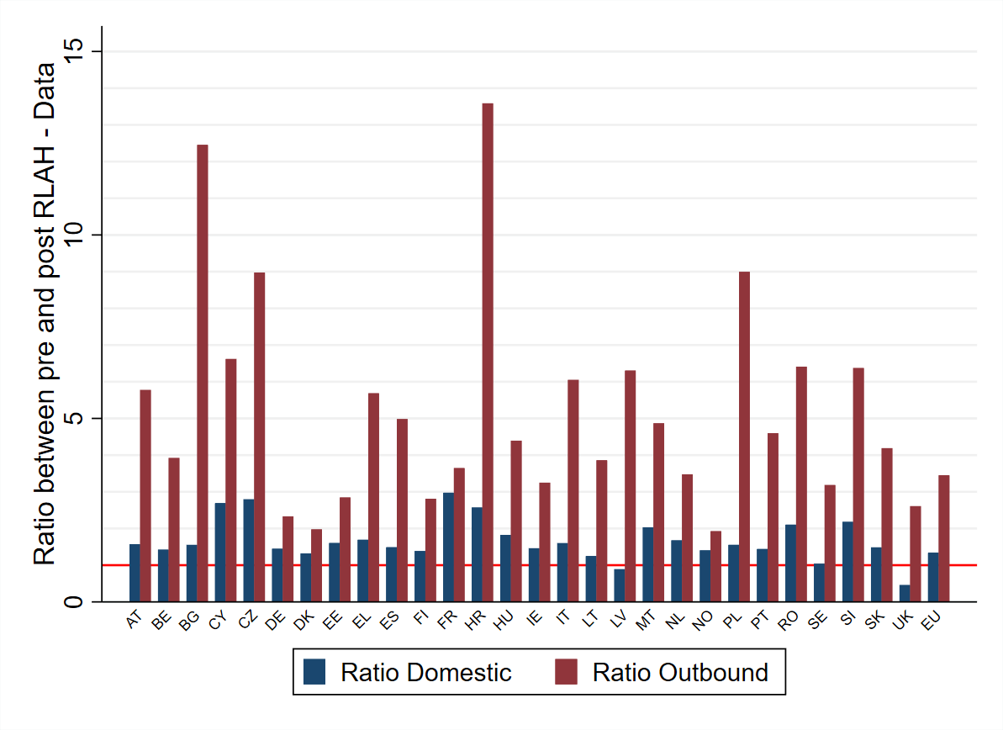

Source: Data collected for the 19th-22nd International Roaming BEREC Benchmark Reports. JRC calculations

In the three Member States where all MNOs have been granted sustainability derogations since 15 June 2017 (Finland, Lithuania and Estonia[31], see section 5.3), users have also markedly increased their consumption of mobile services abroad in the EU/EEA in proportions that are similar to many other Member States. Data consumption in Estonia and Finland has increased by almost 3 times while in Lithuania by almost 4 times. Voice consumption has increased by 2 times in Lithuania and more than 1.5 times in Estonia. This is because operators which were granted derogations nonetheless provided roaming services without surcharges to some extent (section 5.3) and, when applied, the roaming surcharges authorised by the NRA were substantially lower than the surcharges in place prior to 15 June 2017. Therefore customers of these operators have substantially benefitted from the new roaming rules as well and have reacted consequently with increased demand.

### Retail (outbound) roaming traffic remains a small fraction of domestic traffic

The evidence from BEREC International Roaming Benchmark Reports shows that, despite its massive increase, roaming traffic remains only a small fraction of domestic traffic. As shown in Figure 8, in the first year of RLAH, the retail roaming voice traffic represented less than 6.8% of the retail domestic voice traffic for 90% of the operators. The increase, since the introduction of RLAH, is visible: before RLAH, the retail roaming voice traffic was less than 4.2% of the retail domestic voice traffic for 90% of the operators. The seasonality of roaming can be observed as the curve representing the summer period under RLAH (Q3 2018) is shifted to the right, showing that retail roaming voice traffic represents a higher proportion of domestic voice traffic during summer for most operators than during the rest of the year. However, even in summer 2018 with the highest roaming traffic recorded so far, the retail roaming voice traffic was still less than 6.8% of the retail domestic voice traffic for 90% of the operators.

Figure 8: Voice services - Cumulative density distributions of the retail (outbound) roaming voice traffic as % of the retail domestic voice traffic[32].

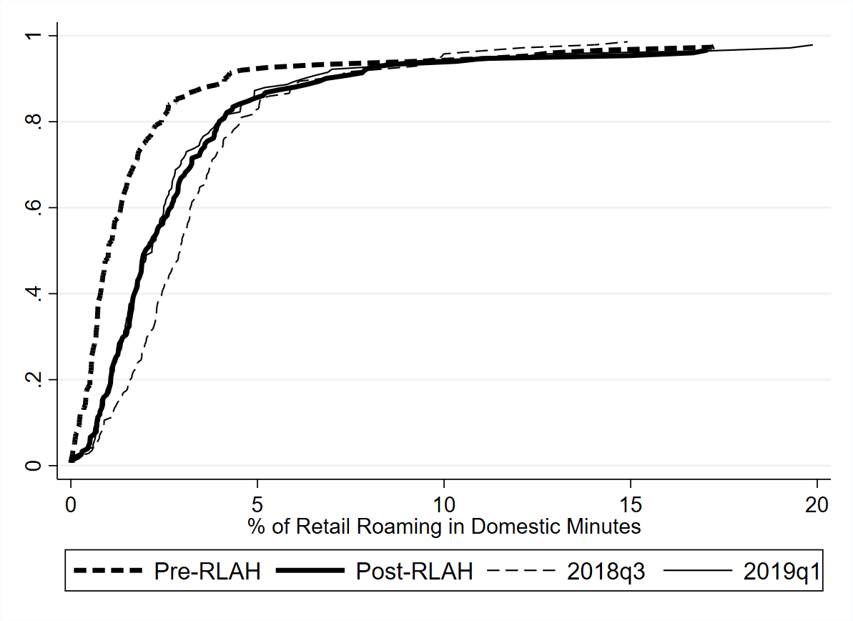

Source: Data collected for the 19th-23rd International Roaming BEREC Benchmark Report. JRC calculations.

Note: 'pre-RLAH' covers the last period before RLAH (Q4 2016 - Q2 2017), 'post-RLAH’ covers the corresponding period after RLAH (Q4 2017 - Q2 2018). Q3 2018 is the last summer available. Q1 2019 is the last available quarter.

The same can be observed for retail roaming data traffic. As shown in Figure 9, in the first year of RLAH, the retail roaming data traffic represented less than 6.2% of the retail domestic data traffic for 90% of the operators. Again, the increase since the introduction of RLAH is visible: before RLAH, the retail roaming data traffic was less than 2.8% of the retail domestic data traffic for 90% of the operators. In the case of data, seasonality is much more marked than in the case of voice. The corresponding ratio for Q3 2018 (post-RLAH) is 10.7%.

Figure 9: Data services - Cumulative density distributions of the retail (outbound) roaming data traffic as % of the retail domestic data traffic[33].

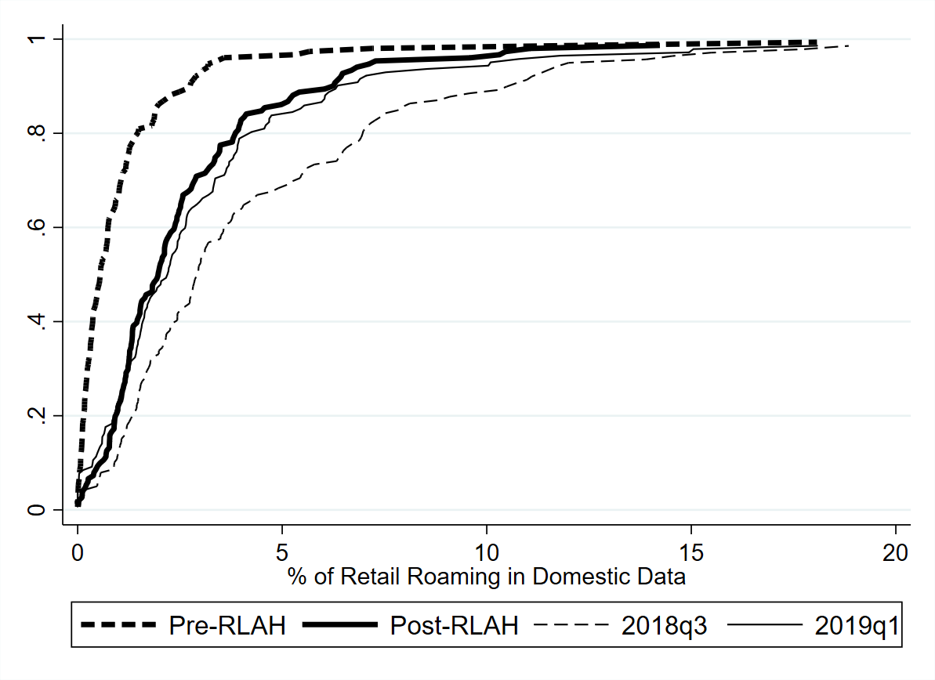

Source: Data collected for the 19th-23rd International Roaming BEREC Benchmark Reports. JRC calculations.

Note: 'pre-RLAH' covers the last period before RLAH (Q4 2016 - Q2 2017), 'post-RLAH covers the corresponding period after RLAH (Q4 2017 - Q2 2018). Q3 2018 is the last summer available. Q1 2019 is the last available quarter.

## Implementation of fair use policy

Regulation (EU) 2016/2286laid down detailed rules to ensure a consistent implementation of fair use policies (FUP) that roaming providers may apply in order to avoid anomalous or abusive use of regulated retail roaming services under RLAH that could have detrimental effects on domestic markets.

The Staff Working Document on the findings of the review of the rules on roaming fair use policy and the sustainability derogation laid down in the Implementing Regulation (EU) 2016/2286[34] published on 28 June 2019 (hereinafter ‘the SWD on fair use policy and the sustainability derogation’) analyses in detail the application of fair use policy, based on the joint survey by the Commission and BEREC (see section 4.1.2). The analysis shows that the overwhelming majority of operators, i.e. 95% of MNOs and 78% of MVNOs have utilised one of the FUP criteria to address abusive or anomalous use of roaming services at domestic prices (such as permanent roaming) by individual customers.

A significant majority of operators (87% of MOs and 80% of MVNOs offering data bundles) have relied on the open data bundle limits[35]. A sizeable number of mobile operators rely on other criteria, notably the residence/stable link criterion[36] (52% of MNOs and 44% of MVNOs), the 4-month window[37] (41% of MNOs and 26% of MVNOs) and the pre-paid limits[38] (32% of MNOs and 33% of MVNOs offering pre-paid tariff plans).

While fair use policy is now a common practice among mobile operators, the overwhelming majority of roaming customers stay abroad for much shorter time periods and therefore do not need to worry about these control mechanisms. As noted by BEREC in its Opinion on the roaming market, MNOs that have responded to the Joint Commission/BEREC survey of March 2019 have alerted in total approximately 0.6% of their subscribers and have imposed a surcharge after the alert to half of them (i.e. approximately 0.3%).

Also, operators’ data collected in the framework of the International Roaming BEREC Benchmark Data Reports, indicate that hardly more than 5.5% of the total roaming data traffic in the EU/EEA and slightly below 4% of the roaming voice traffic is subject to a FUP surcharge (Figure 10). The fact that the share of roaming voice traffic subject to a FUP surcharge is significantly higher than the share of subscribers subject to a surcharge under the 4-month control mechanism shows that this small proportion of long-term travellers generates a significantly higher proportion of the roaming voice traffic.

Figure 10: Share of total EU/EEA retail roaming traffic which is subject to a surcharge in excess of FUP (%), Q4 2017 – Q1 2019

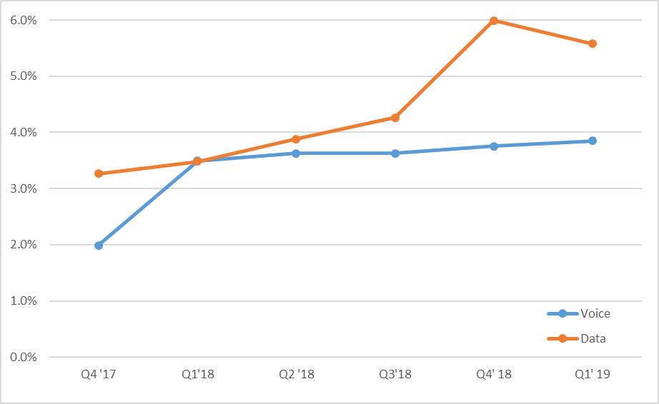

Source: Based on data from 20th-23rd International Roaming BEREC Benchmark Data Report.

Table 1 shows the Member States exhibiting the highest percentage of traffic subject to a FUP surcharge. In these Member States, FUP obviously plays a major role in mitigating the effects of abusive or anomalous use of roaming services at domestic price.

Table 1: Member States with more than 10% of traffic being subject to FUP surcharge

|  |  |
| --- | --- |
| Member States, where >10% of voice traffic is subject to a FUP surcharge | Member States, where >10% of data traffic is subject to a FUP surcharge |
| * Sweden (20%) * Bulgaria (15%) | * Sweden (22%) * Poland (20%) * Bulgaria (18%) * Latvia (14%) * Romania (14%) * UK (11%) |

Source: Based on data from 23rd International Roaming BEREC Benchmark Data Report.

Both Figure 10 and Table 1 indicate that the proportion of data traffic subject to FUP surcharge is higher than the respective proportion of voice traffic. This is consistent with the fact that many operators use the open data bundles limits, beyond which the operator may impose a FUP surcharge only to roaming data traffic.

The analysis in the SWD on fair use policy and the sustainability derogation shows that FUP measures have overall enabled operators to successfully address abusive or anomalous use of roaming services at domestic prices (such as permanent roaming) by individual customers., although this entails some costs and complexity. According to the data from the joint Commission/BEREC survey of March 2019, less than 15% of respondents assesses any of the open data bundles, 4-month window or stable link as unnecessary. Also, more than 75% of the operators that have applied each of these criteria assess them as effective or partially effective.

Furthermore, as noted by BEREC in its Opinion on the roaming market, operators generally comply with the legal provisions when applying a FUP. In the few cases where breaches of those rules have been observed, operators have corrected their offer as requested by the NRA.[39]

BEREC has however noted the increasing number of zero-rated offers in the mobile market[40] and the need to clarify how such offers should be treated under RLAH. NRAs, in the context of the BEREC International Roaming Expert Working Group and in coordination with the Commission services, have agreed on a common approach to enforce the fair use policy rules on such offers. According to NRAs, applying the same domestic charging mechanism while roaming like at home implies that the consumption of zero-rated services may not be counted against the domestic data allowance while roaming in the EU/EEA, as it is the case at home. However, a fair use data volume limit can be applied while roaming in the EU/EEA, in accordance with the formula provided in the Regulation (EU) 2016/2286 for open data bundles. Consumption of normal (non-zero-rated) services and of zero-rated services can be counted against this fair use limit[41]. In its Opinion on the roaming market, BEREC proposes to revise its Retail Roaming Guidelines accordingly, in order to facilitate a common approach on the assessment of zero-rated tariffs within the EU.

Based on the analysis performed, the Commission services observed in the SWD on fair use policy and the sustainability derogation that the evidence available would not support a change in the scope of FUP - be it the duration of the time window, the level of the volume limit on data or the introduction of a volume limit on voice. Since the publication of the SWD in June 2019, the Commission services have not received any information nor additional data that would change that conclusion.

Operators that, with a FUP designed in accordance with the Regulation (EU) 2016/2286, have faced or would have faced levels of roaming usage that threaten their domestic charging model have been granted a sustainability derogations (section 5.3). As to fraud activities using roaming services, they can be tackled by specific appropriate measures that do not fall under the scope of FUP (section 7.5).

## Application of the derogation mechanism

In exceptional and specific circumstances, in order to avoid a domestic price increase, an operator may obtain from its NRA a sustainability derogation, after demonstrating that the provision of roaming services without the application of a surcharge would not be sustainable with its current domestic charging model.

The SWD on fair use policy and the sustainability derogation analyses in detail the application of sustainability derogations, based on the joint survey by the Commission and BEREC of March 2019. The analysis shows that the derogation mechanism has acted as an effective safeguard against possible distortions on the few markets where domestic charging model could have been at risk. The analysis also show that operators authorised by the NRA to apply a surcharge still largely offer RLAH.

### The number of sustainability derogations is getting smaller every year

The table below presents the number of derogations that have been granted during the first two years of RLAH (June 2017 to May 2018, June 2018 to May 2019) and between June and October 2019, per Member State, split by type of operator (MNO and MVNO).

Table 2: Sustainability derogations granted by NRAs during the first two years of RLAH and between June and October 2019, split by MNOs and MVNOs

|  |  |  |  |  |  |  |
| --- | --- | --- | --- | --- | --- | --- |
|  | **Derogations granted between June 2017 and May 2018** | | **Derogations granted between June 2018 and May 2019** | | **Derogations granted between June 2019 and October 2019** | |
|  | MNO | MVNO | MNO | MVNO | MNO | MVNO |
| AT | 0 | 2 | 0 | 2 | 0 | 2 |
| BE | 0 | 1 | 0 | 1 | 0 | 1 |
| DK | 0 | 1 | 0 | 0 | 0 | 1 |
| EE | 3 | 0 | 3 | 0 | 0 | 0 |
| ES | 0 | 1 | 0 | 0 | 0 | 0 |
| FI | 3 | 1 | 3 | 1 | 3 | 1 |
| FR | 0 | 11 | 0 | 6 | 0 | 3 |
| IT | 0 | 4 | 0 | 3 | 0 | 4 |
| LT | 3 | 1 | 3 | 1 | 2 | 1 |
| PL | 4 | 8 | 4 | 7 | 0* | 3** |
| RO | 1 | 0 | 1 | 0 | 1 | 0 |
| SI | 0 | 1 | 0 | 1 | 0 | 1 |
| **Total** | **14** | **30** | **14** | **23** | **6** | **17** |

* In October 2019, for the first time a request from an MNO was rejected. One more request from an MNO is pending and the remaining 2 have not requested a derogation until now.

** 3 more requests are pending.

Sources: Commission's survey of NRAs, June 2018 (first year), Joint Commission/BEREC survey of NRAs, March 2019 (second year), NRA inputs (June 2019 to October 2019)

Since June 2019 (until October 2019), derogations have been granted to 6 MNOs[42] and 17 MVNOs[43]. Some derogations might still be renewed for some MNOs and MVNOs during the first semester of 2020[44].

As expected, MVNOs have been the primary users of the sustainability derogation given their specific situation on the wholesale roaming market[45]. Over the first year of RLAH, about 2/3 of the derogations have been granted to MVNOs (30 vs 14). Over the second year of RLAH, more than 60% of the derogations have been granted to MVNOs (23 vs 14). Since June 2019, 74% of the derogations have been granted to MVNOs (17 vs 6). Still, this is a small fraction of the more than 330 MVNOs existing in the Union. Most of the providers that were granted a derogation have a small market share in their respective countries.

As regards MNOs, there are four Member States in which all MNOs have obtained a sustainability derogation during the first two years of RLAH, namely, Estonia, Finland, Lithuania and Poland (in the latter only since 2018). Romania's smaller MNO was also granted a sustainability derogation. These countries are characterised by particularly low mobile data prices and high net outbound roaming traffic (i.e. operators in these countries have much more roaming traffic by their customers abroad than they receive roaming traffic from foreign users on their networks). However, since June 2019 (start of the third year of RLAH), there has been a significant decrease in the number of derogation requests from the MNOs in these Member States. In Lithuania, one MNO (the incumbent) did not request to renew the derogation anymore, and in Estonia none of the MNOs decided to renew the derogation. Additionally, according to the most recent data, the Polish MNOs have started to record a profit from roaming services provided in the EU Member States[46], and in October 2019, for the first time a request for derogation from a Polish MNO was rejected. Hence, as expected by the Commission and BEREC, with the decreasing wholesale price caps on data, the need for sustainability derogations is decreasing. According to the joint Commission/BEREC survey of March 2019, NRAs are expecting to grant in total around 20 derogations in 2020, which would amount to less than 50% of the derogations granted during the first year of RLAH.

As expected, no derogation has been granted to MNOs in Member States which are net recipients of inbound roaming traffic.

### The maximum surcharges granted by the NRAs are low and generally decreasing every year

The maximum surcharges allowed by the NRAs are normally at or – sometimes even significantly – below the wholesale roaming price caps, so that, when a surcharge is applied, the customers concerned pay only a small fraction of what they used to pay for roaming services before June 2017 (less than 10% for data). As a result of the partial application of the surcharge and its modest level, increases in retail roaming traffic by subscribers from Finland, Lithuania, Estonia and Poland are comparable to that observed in the other Member States.

In most cases, the new maximum surcharges allowed by NRAs are lower than those of the first and second derogations. One reason is the decreasing wholesale roaming prices. For example, in Lithuania, the maximum surcharges for the outgoing calls granted for the period 2019-2020 for the two MNOs and the MVNO which were granted the derogation decreased by 100%, 20% and 71% respectively compared to the year before. For data, the decrease was 57%, 27% and 43% respectively for the same periods.

### The share of EU/EEA roaming traffic subject to a surcharge due to the sustainability derogation has remained marginal

Figure 11 shows the development, in the EU/EEA, of roaming voice and data traffic subject to a surcharge due to the sustainability derogation, as % of the total roaming traffic. Both remain at marginal levels, below 3.5% and 1.5% respectively. The increase observed since 2018 is likely to be linked to several of the first derogations granted only in Q1-Q2 2018 in Poland, the biggest market with derogations, and the progressive application of these derogations since then in that Member State (see the start of the derogation in Poland in Q1 and Q2 2018 in Figure 12).

Figure 11: Development of % of voice and data roaming traffic in the EU/EEA subject to a surcharge, due to the sustainability derogation, Q3 2017 – Q1 2019

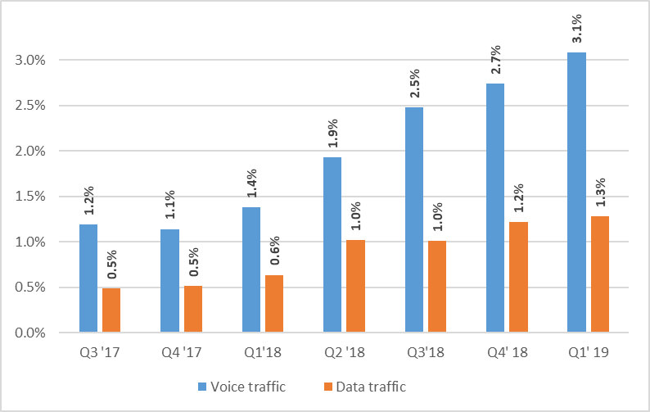

Source: Based on data from the 20th-23rd International Roaming BEREC Benchmark Report

Note: The Q3’17 figures take on board data updates, provided by some operators after the publication of the 20th International Roaming BEREC Benchmark Report

### Operators having been granted the derogation have used the surcharge with parsimony

Figure 12 and Figure 13 show, in the specific Member States where the derogation has been granted to one or more MNOs, the development of roaming voice and data traffic subject to a surcharge due to the sustainability derogation, as % of the total outbound roaming traffic from these Member States. In all other Member States[47] the corresponding percentages are at (or close to) zero.

Figure 12: Development of % of voice roaming traffic subject to a surcharge due to the sustainability derogation in the Member States where derogations were granted to MNO(s), Q3 2017 – Q1 2019

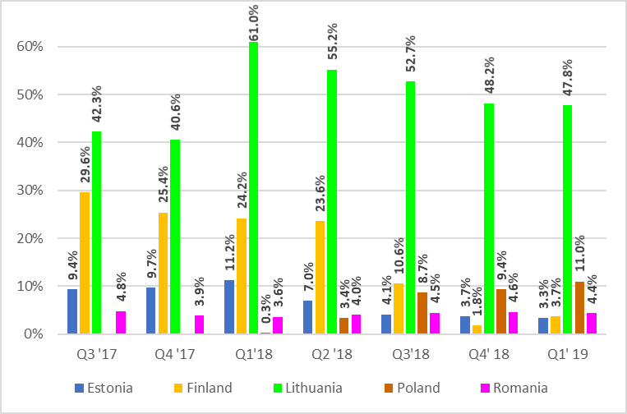

Source: Based on data from the 20th-23rd International Roaming BEREC Benchmark Report

Note: The Q3’17 figures take on board data updates, provided by some operators after the publication of the 20th International Roaming BEREC Benchmark Report.

Figure 13: Development of % of data roaming traffic subject to a surcharge due to the sustainability derogation, in the Member States where the derogation was granted to MNO(s), Q3 2017 – Q1 2019

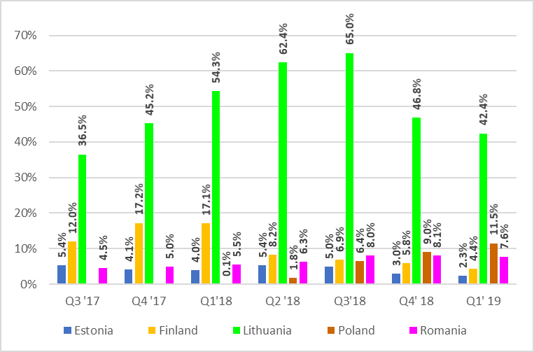

Source: Based on data from the 20th-23rd International Roaming BEREC Benchmark Report

Note: The Q3’17 figures take on board data updates, provided by some operators after the publication of the 20th International Roaming BEREC Benchmark Report.

First of all, the figures show that even in those Member States where all MNOs have been granted the derogation (Estonia, Finland, Lithuania), in general only a minority of the outbound roaming traffic has been subject to a surcharge (exceptions observed only in Lithuania for some quarters of 2018). This shows that MNOs in those countries have used the derogation in a limited manner and have provided large amounts of RLAH to their customers.

Second, the trend in using the surcharge is overall decreasing in Estonia, Finland and Lithuania, where derogations were granted from the beginning of RLAH. In these three Member States voice traffic subject to a surcharge due to the derogation has been decreasing either from the beginning (Finland) or from Q1 2018 (Estonia, Lithuania). In Finland the drop is more than half. Roaming data traffic subject to a surcharge due to the derogation is also presenting a decreasing trend either from Q1 2018 (Finland), Q3 2018 (Estonia) or Q4 2018 (Lithuania). In Romania the proportion of voice and data traffic subject to a surcharge due to derogation decreased for the first time in Q1 2019. The decreasing trend in these Member States can be attributed, on the one hand, to the reduced negative impact of wholesale roaming costs and, on the other hand, to an increasing expectation of consumers for RLAH services, which could act as a competitive pressure.

In contrast, in Poland, roaming traffic subject to a surcharge due to the derogation, as % of total roaming traffic, continues to present an increasing trend, for both voice and data. This evolution is due to the late granting of most of the derogations in Q1-Q2 2018 only and to the application of the surcharge to new contracts.

Given that none of the Estonian operators has renewed its request for derogation from June 2019, no roaming traffic from Estonia is expected to be subject to a surcharge due to the derogation since June 2019 (data not available yet). In Lithuania, the share of roaming traffic subject to a surcharge due to the derogation is expected to be significantly reduced since June 2019 compared to the two Figures above, following the non-renewal of the incumbent’s derogation in June 2019. The first rejection of a request for derogation by an MNO in Poland in October 2019 should also lead to a decrease of the overall share of roaming traffic subject to a surcharge due to the derogation.

### The application of the derogation mechanism should continue to decrease

Based on the analysis performed, the Commission services observed in the SWD on fair use policy and the sustainability derogation that the sustainability mechanism has been applied as intended by the co-legislator and adequately worked as a safeguard to avoid distortions on domestic markets where needed. In its Opinion on the roaming market, BEREC notes that it has been a useful tool for some operators to achieve the overall sustainability of the RLAH. In addition, the derogation has not prevented the concerned end users to massively benefit from the new roaming rules.

As concluded in the SWD on fair use policy and the sustainability derogation, the Commission expects the application of the derogation to continue to decline, as further reductions in regulated wholesale roaming price caps for mobile data services take effect, improving the sustainability of RLAH in the countries concerned. In its Opinion on the roaming market, BEREC notes that the derogation mechanism concerns a small and shrinking part of the market and that NRAs too expect the number of derogations to further decrease in the coming years.

## Use of alternative roaming tariff plans

Pursuant to Article 6e(3) of the Roaming Regulation, mobile operators may offer alternative tariffs, which deviate from the RLAH requirements laid down in Articles 6a, 6b and 6c. Mobile subscribers can choose such tariffs but this choice must be deliberate and requires awareness about the existence of the regulated tariff (i.e. RLAH in the EU/EEA) and the nature of the roaming advantages which would thereby be lost. Furthermore, subscribers using alternative tariffs should have the possibility to switch back to the regulated RLAH tariffs, at no extra charge and without any conditions or restrictions pertaining to elements of the subscriptions other than roaming.

As assessed in the BEREC Report on Transparency and Comparability of International Roaming Tariffs[48], such tariffs are mostly addressed to the business segment providing for example special pay-as-you go tariffs, customized price plans for large customers, pooling tariffs and day-passes. According to the above report, 31% of the operators that responded to the BEREC questionnaire offer alternative roaming tariffs, in the form of daily, weekly, monthly or other packages.

Nevertheless users’ interest in alternative tariffs has substantially decreased, since the introduction of RLAH. As reflected in Figure 14, roaming traffic from alternative tariffs dropped in Q3 2017 to less than half of its level before. Roaming voice traffic from alternative tariffs has remained stable since Q1 2018 to around 6% of the total roaming voice traffic. Roaming data traffic from alternative tariffs has further decreased from around 6% in the first three quarters of RLAH (Q3 2017 to Q1 2018) to around and even below 5% as of Q2 2018.

Figure 14: % of roaming voice and data traffic from alternative tariffs in total EU/EEA roaming traffic, Q4 2016 – Q1 2019

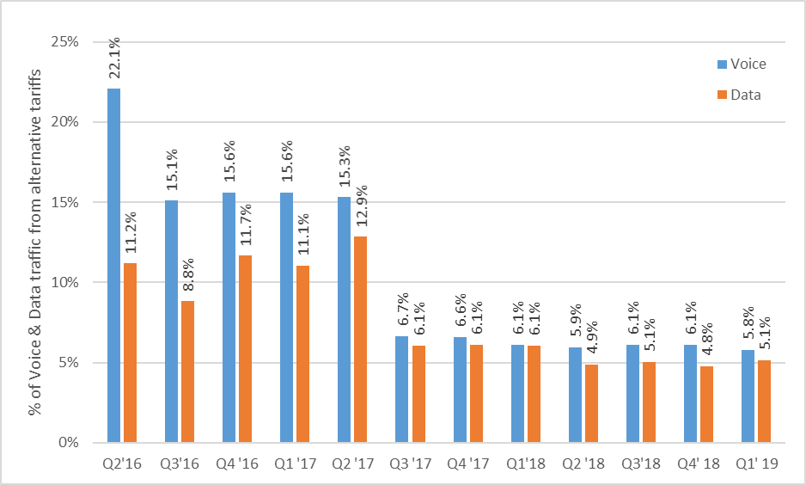

Source: Based on data from the 19th-23rd International Roaming BEREC Benchmark Report

In the majority of countries the use of alternative tariffs is marginal and remains well below 5% for either voice or data. Only in few cases the share of EU/EEA roaming traffic under alternative tariffs exceeds 10% of roaming traffic (Estonia, Germany, Ireland, Italy, Lithuania and Luxembourg for voice; Estonia, Germany, Ireland, Italy, Luxembourg and Slovakia for data).

The declining trend of EU/EEA roaming traffic from alternative tariffs is also reflected in the following figures, depicting the cumulative density function for the proportion of retail traffic coming from alternative tariffs for voice (Figure 15) and for data (Figure 16)

Figure 15: Cumulative density functions of the % of outbound voice traffic coming from alternative tariffs per operator[49]

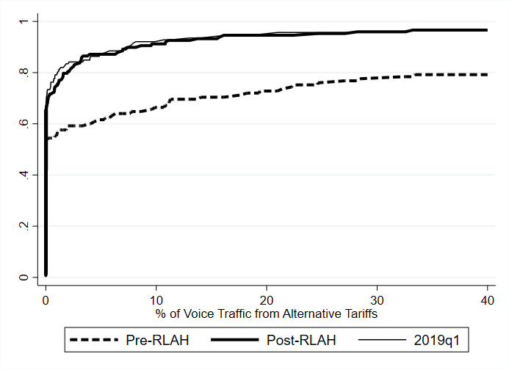

Source: Data collected for the 19th-23rd International Roaming BEREC Benchmark Reports. JRC caculations.

Figure 16: Cumulative density functions of the % of outbound data traffic coming from alternative tariffs per operator[50]

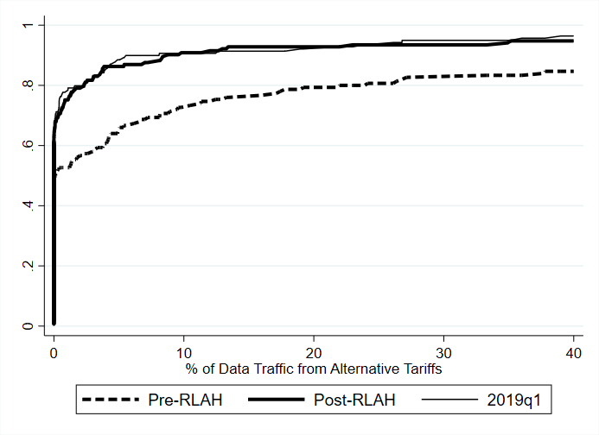

Source: Data collected for the 19th-23rd International Roaming BEREC Benchmark Reports. JRC calculations.

## Evolution of domestic tariff plans

### Domestic prices

As noted by BEREC in its Opinion on the roaming market, operators report to have maintained the overall availability of their tariff plans under RLAH. Less than 15% of MNOs and 10% of MVNOs report to have ceased offering certain domestic tariff plans. According to BEREC, in most cases, the overall domestic tariff structure has not changed. Tariff plans which have been removed relate to certain data-only tariffs, certain pre-paid plans, legacy tariffs with unitary roaming prices or tariff plans with high SMS volumes.

Furthermore, BEREC observes that domestic consumption patterns have remained relatively stable following the introduction of RLAH, and so has the average retail revenue per user (ARRPU).

In the same direction, according to the study “Mobile Broadband Prices in Europe”[51], between 2018 and 2019 (i.e. the second year of application of the RLAH rules) there is no trend for increasing domestic prices. On the contrary, the overall trend on average EU prices is decreasing for all voice and data baskets except the one with unlimited calls as well as for all data-only baskets, as reflected in the following table. A similar observation was made in the interim Report[52];

Table 2: Change in the average EU price for mobile services, 2018-2019.

|  |  |  |  |  |  |  |  |
| --- | --- | --- | --- | --- | --- | --- | --- |
|  | 100MB, 30 calls | 500MB, 100 calls | 1GB,  300 calls | 2GB,  900 calls | 2GB,  100 calls | 5GB,  300 calls | 5GB,  unlim calls |
| Change in average EU price for voice and data baskets, 2018-2019 | -14% | -2% | -4% | -1% | -7% | -10% | 7% |
|  | 512MB | 1GB | 2GB | 5GB | 10GB | 20GB | 50GB |
| Change in average EU price for data only baskets, 2018-2019 | -8% | -12% | -11% | -14% | -15% | -14% | -13% |

Source: Empirica/TUV study on Mobile broadband prices in Europe 2018-2019 (2019 not published yet) commissioned by the European Commission.

The comparison is between prices collected in July 2018 and in February 2019.

### Domestic-only tariff plans

According to the most recent BEREC International Roaming Benchmark Reports[53], the proportion of EU/EEA subscribers that had a roaming-enabled SIM card has remained stable above 95% since summer 2017. SIM cards restricted to domestic use (i.e. SIM cards providing no roaming service abroad at all) are in most cases serving local communication needs and/or data-only plans or fixed wireless access products that can only be used at a specific location[54].

As Figure 17 shows, this proportion has declined in Bulgaria (from 30.9% to 16%), Latvia (from 23.7% to 22%) and Estonia (from 13.1% to 12%) but has increased in Romania (from 21% to 48%). From the other Member States, the proportion of domestic-only subscribers has evolved substantially over the same period in Austria (increase from from 3.2% to 9%) and in the Netherlands (decline from 5.4% to almost 0).

Figure 17: % of domestic-only subscribers per country

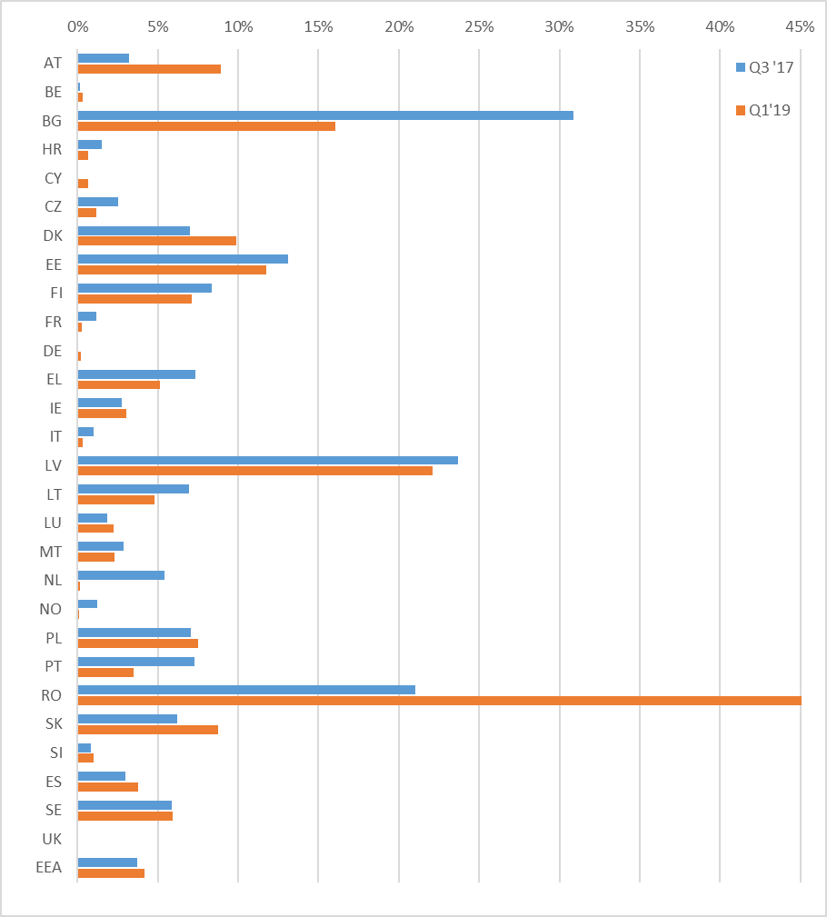

(*) Data for Hungary are not presented.

Source: Data collected for the 20th and 23rd International Roaming BEREC Benchmark Reports. JRC calculations.

In the last quarter available (Q1 2019), MVNOs have a substantially higher share of domestic-only subscribers than MNOs in Cyprus, Lithuania and Spain, while the opposite is true in Romania. In all EU/EEA countries however, the proportion of domestic-only mobile subscribers remains well below the proportion of the population that has not travelled abroad over the last year.

## Quality of services

The Roaming Regulation includes obligations on mobile operators concerning roaming prices at retail level and wholesale levels. It does not include any explicit obligation on the quality of service (QoS) as such. However, the quality of service is an integral part of the product whose price is regulated. By paying a certain price, the user has access to a given mobile service domestically. The Roaming Regulation requires that the user have access to the same service abroad in the EU/EEA for the same price, as long as such service can be delivered on the visited network. The quality of service, in particular data speed, while roaming does not depend entirely on the home operator, it largely depends on the QoS provided by the visited network. However, as 4G technology is now covering almost all of the Union's territory, 4G can normally be expected to be provided while roaming. As noted in the BEREC Opinion on the roaming market, BEREC considers that domestic operators should not deliberately lower the QoS compared to the QoS offered in the home country, so that the end-users could genuinely ‘roam like at home’.

Beyond the intrinsic performance of the mobile network itself, there are multiple factors, influencing the QoS, and in particular the data speed, experienced by an end-user at a specific location and a specific point in time (e.g. network capacity solicited by other users simultaneously, particular end-user equipment used, meteorological conditions). On any given network, the QoS may vary across end-users and time, be they local or roaming end-users.

The BEREC Opinion on the roaming market notes a lack of transparency of a number of operators as regards the data speed provided to their customers while they roam abroad[55]. According to it, 23 NRAs have reported that some operators provide no information about QoS on their websites, some do have roaming QoS information available (and almost half of them clarify that they do not impose any limitations regarding QoS while roaming), while some are transparent about the fact that they limit roaming to 3G access (3G only availability; 3G only for specific countries or 3G only for specific networks in specific countries). BEREC however underlines in its Opinion that the information is incomplete. Therefore, the research is not conclusive at this stage.

In its Report on Transparency and Comparability of International Roaming Tariffs (December 2019) BEREC asked the operators whether they offer 3G roaming when 4G roaming is available. 46% of the respondents gave a positive answer. However, BEREC acknowledges in this report that the question did not specify that operators replying positively offer 3G across all roaming networks and all member states. Therefore, it is not clear, if those operators responding yes, apply this restriction to all countries and networks or only in few instances. This inconclusiveness is further supported by the findings of the joint BEREC/Commission survey of NRAs that took place in March 2019. According to the BEREC Opinion, almost all operators surveyed (98 % of MNOs and 94 % of MVNOs) report that they do not themselves limit QoS or data speeds of roaming services to 3G besides exceptional circumstances (brief limitation of data roaming speeds in order to provide a consistent level of service, lack of 4G roaming implementation for one MVNO, dependence on the speed from the selected MNO in the host country).

In fact, there is no particular evidence that roaming users get lower data speed than local users. According to the joint Commission/BEREC survey of NRAs March 2019, the number of consumer complaints regarding roaming has not increased in most Member States following the introduction of RLAH and end-users’ dissatisfaction with the QoS while roaming ranks low among the consumer complaints received by NRAs (see also section 5.9). Only 3 NRAs found it necessary to undertake some investigations on the speed of data roaming services. None of them concluded on a specific problem in that regard. The above are to a large degree confirmed in the BEREC Report on Transparency and Comparability of International Roaming Tariffs (December 2019). According to it, fewer than half of the responding NRAs (14 out of 30) reported that they received complaints regarding quality of service between July 2018 and August 2019 and only one of them received more than 10 compaints (30).

According to the BEREC Opinion, a few MNOs and MVNOs reported problems with the QoS regarding available data speeds of roaming services for their customers while roaming in the EEA (lower data speeds due to poor capacity, overloaded networks during summer time, low data speed, possible data throttling by some visiting operators)[56]. However, the overwhelming majority of MNOs and MVNOs (89 % of MNOs and 96 % of MVNOs) reported that the introduction of RLAH did not have an impact on their QoS.

At wholesale level, 98 % of all MNOs answered that they do not offer different prices for wholesale roaming access based on the QoS. According to the BEREC Opinion, almost all MNOs do not differentiate in the QoS/data speeds for roaming services in their reference wholesale agreement for roaming access for operators in the EU. MVNOs reported mostly to have a wholesale roaming resale contract without restrictions towards the quality of data roaming (72 %). Almost all MVNOs reported no price difference between 3G or 4G in their wholesale resale roaming access agreement with their host operator.

As for the external studies quoted in the BEREC Opinion, both the Monroe Project and the Speedtest study regarding the quality of mobile broadband access[57] note that routing data traffic through the user’s home network has always been the norm for handling SIM cards that visit foreign networks[58] and that this may naturally introduce short delays for the roaming end-users. The Speedtest study focused on comparing general speeds in a home country and speeds experienced while roaming and concluded that the differences are at least partially due to different speeds offered in different countries in general, i.e. not due to the artificial lowering of speeds for roaming customers. Therefore, the conclusions of both projects indicate that different experiences while roaming are influenced by different speeds available in different EEA countries.

BEREC indicated in its Opinion that its open internet measurement tool, which will allow to measure certain QoS parameters for internet access, could be used for further monitoring the QoS while roaming with the EU/EEA, at least for data. Its specification already mentions that internet access services quality measurements need to reflect the transnational topology and usage of the Internet, which makes it relevant to measure performance across borders, and check the ability to access content from different parts of Europe when the end user is at home, in his domestic network, and when connecting from a visited network when roaming.

Additionally, it is worth noting that when it comes to the use of mobile data, according to the EU rules on the open internet[59] all traffic should be treated equally. Therefore, if end-users travel within the EEA, their use of data is additionally protected by the open internet rules except for limited exceptions (such as temporary congestion management). Finally, in 2020 BEREC will adopt guidelines detailing the relevant QoS parameters pursuant to Article 104 of the EECC aimed to ensure further transparency and comparability of the services offered.

## Situation of MVNOs

Because MVNOs do not own a radio access network in the country(ies) where they operate, MVNOs cannot exchange roaming traffic with MNOs and are therefore in a structurally different situation from MNOs on the wholesale roaming market (see more details in section 7.4). This particularity, inherent to MVNOs’ business model, renders the provision of RLAH more challenging for MVNOs than for most MNOs. It is therefore useful to monitor the evolution of MVNOs’ competitive situation on domestic markets following the introduction of RLAH.

The data on MVNOs from the International Roaming BEREC Benchmark reports seem to indicate that for most of the countries for which data is available, MVNOs have been able to broadly maintain or slightly increase their domestic market share (in subscriber numbers) (Figure 18 and Figure 19). This tends to indicate that MVNOs have overall been able to maintain their competitive position in their respective markets under RLAH.

Figure 18: Individual MVNOs’ market shares (1 dot = 1 MVNO) before and after RLAH

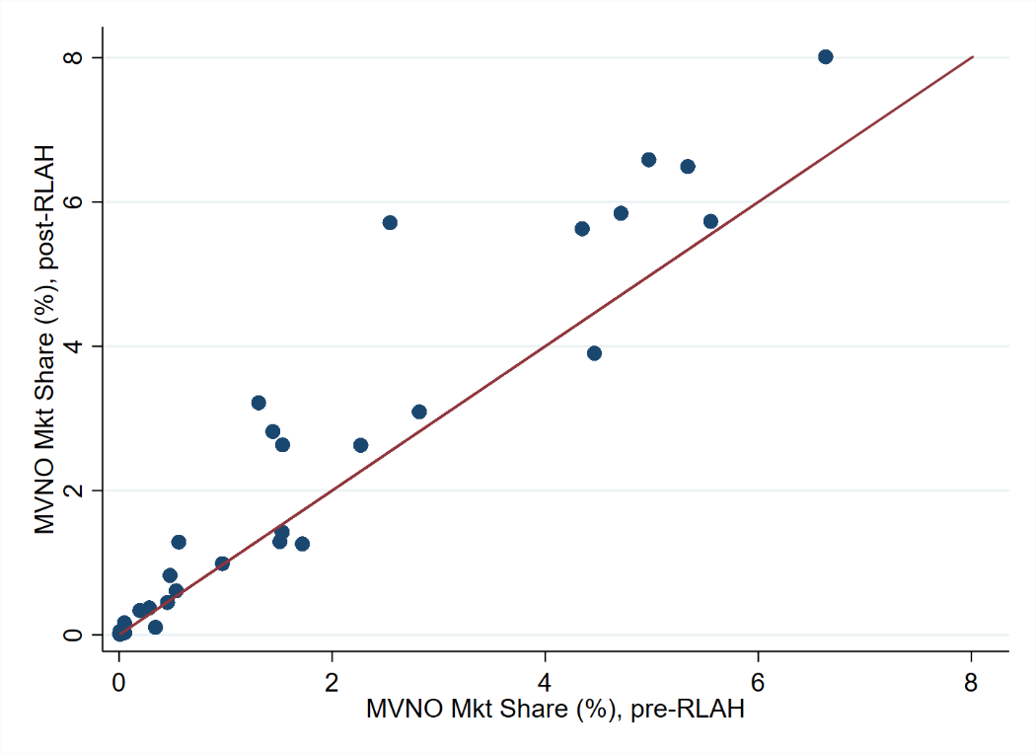

Source: Data collected for the 19th-23rd International Roaming BEREC Benchmark Reports. JRC calculations.

Note 1: Each MVNO market share is calculated over the population of MNOs and MVNOs, in that MVNO’s country, that have provided the number of subscribers in all 19th to 22nd BEREC Benchmark Reports’ data collection.

Note 2: 'pre-RLAH' covers the last period before RLAH (Q4 2016 - Q2 2017), 'post-RLAH covers the corresponding period after RLAH (Q4 2018 – Q1 2019), as Q2 2019 was not available at the time this analysis was made.

Figure 19: Total MVNO market share among the operators (MNOs and MVNOs) that responded to all 19th to 22nd BEREC Benchmark Reports’ data collection, by country



Source: Data collected for the 19th-23rd International Roaming BEREC Benchmark Reports. JRC calculations.

Note: 'pre-RLAH' covers the last period before RLAH (Q4 2016 - Q2 2017), 'post-RLAH covers the corresponding period after RLAH (Q4 2018 – Q1 2019), as Q2 2019 was not available at the time this analysis was made.

Figure 20 shows an overall stability of the Average Retail Revenue Per User (ARRPU) of MVNOs that have replied to all International Roaming BEREC Benchmark data collections.

Figure 20: Average Retail Revenue Per User (ARRPU) of MVNOs, by country, Q4 2016 to Q1 2019



Source: Data collected for the 19th-23rd International Roaming BEREC Benchmark Reports. JRC calculations.

The above Figures however can only partially represent the situation of MVNOs on the various markets as the population of MVNOs having provided sufficient data for such calculations since Q4 2016 is a small sample of all MVNOs operating in Europe.

Section 7.4 below assesses the challenges faced by MVNOs at wholesale level in providing RLAH to their customers and looks at several options to improve their position on the wholesale roaming market.

## Rest of the World roaming

According to data from the most recent BEREC International Roaming Benchmark Reports[60], retail roaming prices of EU/EEA mobile operators in non-EU/EEA countries have continued to decline (Figure 21). Seasonal variations, especially in the rates for calls made, do not affect this conclusion. Between Q1 2017 and Q1 2019, rates for data roaming services in non-EU/EEA countries fell by 78% while rates for voice services fell by more than 30%. The sharp declining trend for data roaming prices in non-EU/EEA countries has therefore continued after the introduction of RLAH.

Figure 21: Development of retail roaming prices for travelers roaming in non-EU/EEA countries, Q2 2016 – Q1 2019

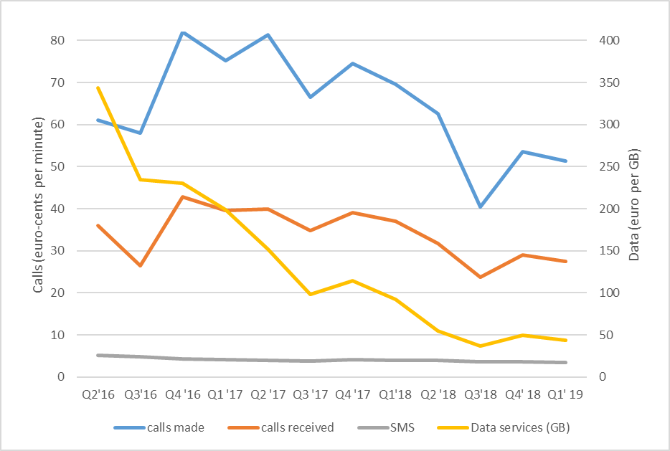

Source: Based on data from the 19th-23rd International Roaming BEREC Benchmark Report

Overall therefore, abolishing intra-EU/EEA roaming charges has not come at the price of higher roaming prices in the rest of the world (so-called "waterbed effect")[61] In particular, many operators include some popular non-EU/EEA destination countries in their RLAH offering or apply a reduced roaming fee to those countries[62].

## Consumer perception

The interim Report[63] noted that the RLAH reform was widely recognised and appreciated by Europeans. One year after the introduction of RLAH, a Eurobarometer survey[64] showed that 81 % of the travelers were aware that roaming charges had ended in the EU/EEA and 69% of all Europeans thought that they, or someone they know, benefit or will benefit. The feedback received by the Commission from consumer associations since June 2017 has overall been very positive.

The study[65] performed on request by the European Parliament one year after the implementation of RLAH (see section 4.5) reports positive feedback not only from consumers but also from business users. It specifically refers to an increase in the productivity of employees because they can connect with their corporate network and interact with their company more frequently when they are abroad in the EU.

The joint Commission/BEREC survey of NRAs of March 2019 indicates that the volume of roaming-related complaints received by NRAs has generally not increased following the introduction of RLAH in June 2017. 17 NRAs found that the number of consumer complaints related to roaming in 2017 was comparable to the previous year, 6 NRAs that it was higher and 1 NRA that it was lower. One year later, only 4 NRAs found that the number of roaming-related consumer complaints had increased. Overall, the total annual number of roaming related complaints received by NRAs remains very small (from a few complaints to a few hundreds of complaints depending on the NRA) compared to the number of users[66].

Figure 22 shows the relative importance of roaming-related topics of consumer complaints received by NRAs. The most important ones have been inadvertent roaming[67], fair use policy volume on data and incorrect billing of roaming volumes, which are among the top complaint topics for close to, or more than, 25% of the responding NRAs, which actually received roaming-related complaints.

Figure 22: Roaming-related topics of consumer complaints received by NRAs and their relative importance

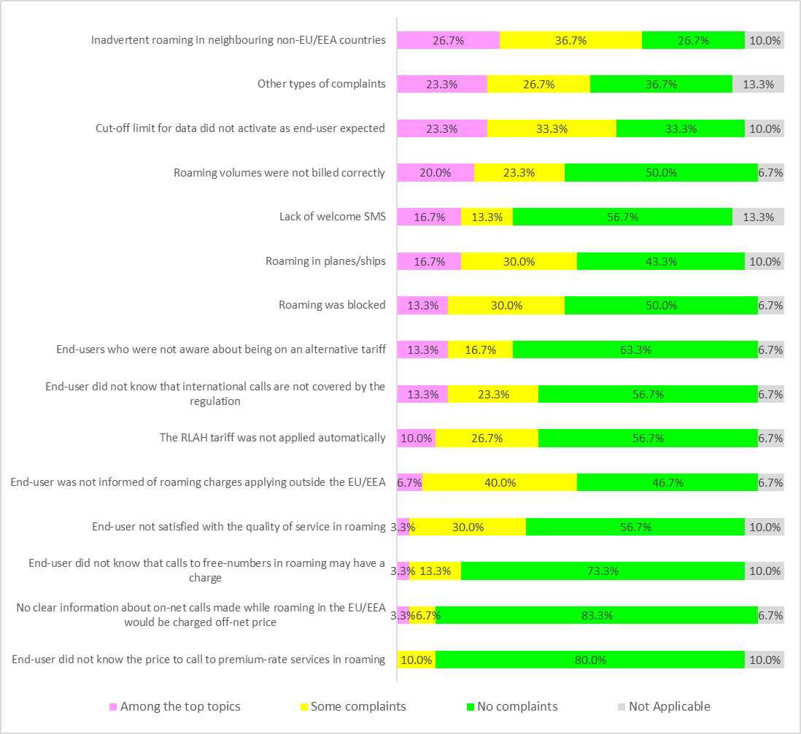

Source: Joint Commission/BEREC survey of NRAs (March 2019).

All figures are % of NRAs who have received complaints relating to roaming (total 26).

In the joint Commission/BEREC survey of operators of March 2019 all responding MNOs report to have received a total of approximately 9000 complaints and MVNOs about 1220 in 2018. BEREC noted in its Opinion that, in comparison with the total number of active subscribers from responding operators (several hundreds of millions) this number seems to be rather negligible. In addition, the total number of consumer complaints is highly unevenly distributed over operators and a few operators have received much more complaints than the others.

# Assessment of the costs of providing wholesale roaming services

This section describes the approach to assessing the costs of providing wholesale roaming services in the EU/EEA. It begins by a description of the Commission’s approach to cost modelling, followed by a reference to previous relevant estimates provided for these services. The cost model developed for the purposes of this review is then described, including the assumptions and methodological decisions made. The results under a specific scenario are then explained, followed by a discussion on additional necessary costs that must be taken into account when evaluating the total costs faced by a visited mobile network operator for providing roaming services. The sections ends with a summary of BEREC’s assessment of the cost model and estimates produced.

Cost assessment and in particular the cost estimates produced by the cost model are one input among other inputs and considerations when it comes to deciding on the appropriate level of wholesale roaming caps, which in any event are not mandated to be set at cost orientation levels.

## Description of the Commission’s approach

In order to assess the costs of providing wholesale roaming services in the 31 EU/EEA countries for the purposes of the roaming review, an independent study was commissioned.[68] The study’s dual objective was to assess the cost of providing both wholesale roaming services and voice call termination rates. For the purposes of this SWD, the main focus of this summary of the study is on the estimated costs related to roaming.

The cost study was conducted by Axon Partners Group from mid-March 2018 to mid-July 2019. At the start of the study, a first workshop with all relevant stakehoders was organised on 10 April 2018 in order to collect feedback on the methodology proposed by Axon. A comprehensive data gathering was then conducted in June-July 2018, via the NRAs, in order to obtain, from mobile operators, the relevant information and inputs needed to populate a country-specific model for each Member State. The aim was to built 31 models with a similar skeleton, based on country-specific input where relevant, facilitating as best possible the estimation of the relevant mobile wholesale costs in each of the 31 Member States.[69] The models would rely on country-specific input where relevant and, where not, on averages/common values across the EU/EEA. On 29 October 2018 the first draft cost model was shared with stakeholders for consultation, followed by a second version of the draft model shared on 15 February 2019 for a second round of consultation. The relevant comments and suggestions received during both consultations were implemented in the draft final model, which was presented to stakeholders at a second workshop on 28 May 2019. The cost model was then finalised and published on 24 July 2019.

To ensure transparency throughout the project, several steps were taken to associate the NRAs, operators and other stakeholders. First, two workshops were held and two rounds of consultation were organised over the period going from October 2018 to March 2019.[70] Stakeholders were also consulted on the structure and content of the data gathering exercise of June-July 2018 itself . Also, a steering committee composed by experts from NRAs was established and regular meetings between the Commission, Axon and the Steering Committee were held throughout the project. The steering committee consisted of representatives from 8 NRAs and was composed of members of the two BEREC Expert Working Groups dealing with roaming and with termination rates.

## Previous estimates of wholesale roaming costs

Prior to the Axon cost model, the costs of providing wholesale roaming services were assessed by the Commission based on two inputs in particular: BEREC cost estimates in 2010 and 2012, followed by a cost model developed by TERA consultants in 2016. This section briefly summarises these cost estimates.

### BEREC cost estimates from 2010 and 2012

In 2010 BEREC estimated the upper bound, average and lower bound of the costs for wholesale roaming services.[71] In 2012 BEREC updated its analysis of wholesale roaming costs.[72] The then estimated costs are shown in Table 3 below.

Table 3 - BEREC's estimations for upper bound, average and lower bound of wholesale costs for wholesale roaming services in 2010 and maximum for 2012.

|  |  |  |  |  |
| --- | --- | --- | --- | --- |
|  | Minimum (2010) | Average (2010) | Maximum (2010) | Maximum (2012) |
| Voice call (out) | €3cents/min | €5.4cents/min | €9.7cents/min | €5cents/min |
| Voice call (in) |  |  | €3cents/min |  |
| SMS | €0.6cents/SMS | €0.8cents/SMS | €2.7cents/SMS | €1cents/SMS |
| Data | €1.6cents/MB | €8.1cents/MB | €15cents/MB | €5cents/MB |

Source: BEREC International Mobile Roaming Regulation Report BoR(10)58 (2010 estimates) and BEREC Analysis of Wholesale Roaming Costs BoR(12)14 (2012 estimates)

These cost estimates informed the setting of the wholesale roaming price caps adopted in 2012.[73] Table 3 shows that the costs have decreased throughout the period.

### TERA consultants cost estimates from 2016

In order to prepare for the then upcoming RLAH regime, TERA was commissioned to estimate the costs of providing wholesale roaming services for a mobile network operator in 29 EU/EEA countries[74]. For this purpose, TERA built a bottom-up cost model - using the relevant inputs from operators and NRAs and a selection of scenarios[75]. The costs estimated by TERA are represented in Figure 23 and Figure 24 below[76].

The wholesale cost for outgoing roaming voice services was estimated between 0.2 and 2.8 €cents per minute in the TERA cost model. The model showed great differences between the lowest and highest cost countries, with Malta having the highest estimated cost.

Figure 23: Outgoing wholesale roaming voice – Estimated costs, TERA model in 2016

  
Source: TERA Consultants, SMART 2015/0006

For wholesale roaming data services, the estimated costs are shown in Figure 24 below. The trend seen from above is also visible here, albeit the variations are smaller, ranging from 0.1 to 0.45 €cents per MB. For data as well, Malta is the country with highest estimated costs.

Figure 24: Wholesale roaming data service – Estimated costs €cent/MB, TERA model in 2016

  
Source: TERA Consultants, SMART 2015/0006

## The Axon Partners cost model

This section briefly describes the main features of the Axon Partners’ cost model (hereinafter, the cost model). For additional information on the methodological approach followed and the results of the cost model, the reader is referred to the full list of materials published with the Axon Partners' cost model[77].

### The approach and methodology followed by Axon Partners

The Axon Partners’ cost model estimates the costs of providing wholesale mobile roaming services as well as voice termination[78] in 28 EU/EEA countries[79]. Each cost model contains a number of adaptable scenarios, allowing the Commission services to evaluate many different scenarios in each country.

Any cost model enables the user to evaluate costs of all elements required to offer mobile services. For the purposes of the roaming review, the relevant costs to be estimated are those related to wholesale roaming services, specifically the estimated costs for:

* Data roaming
* Outgoing voice calls
* Outgoing SMS

Each service and related costs can be evaluated under a number of scenarios. For this purpose it must be noted, that not all scenarios reconcile and as a result, any estimated cost should be evaluated together with the full list of materials published to avoid conclusions based on scenarios which do not reconcile. Furthermore, one should bear in mind that the results produced by the model do not include the costs of international transit nor the cost of terminating a roaming call. Hence, these costs need to be added to the costs estimated by the model when assessing the total costs of providing wholesale roaming services. This addition of transit and termination costs is described further in section 6.6.

The Axon cost model is based on a number of methodological choices. First of all, the model is a bottom-up model, calculating the provision of a service under a given set of methodologies and scenarios. A bottom-up model involves a reasonable approximation of the network that a reference operator would need in order to meet the coverage and capacity requirements of the users. It produces a reasonable approximation of the costs that such an operator would bear and provides service-level results under different scenarios.

A bottom-up model resorts to a number of methods dealing with various aspects of the economics of a communications network. These methodological considerations include the choice of cost standard, the type of operator modelled, the method to forecast the volumes, allocation of joint and common costs as well as seasonality. In Table 4, an overview of each methodological aspect is presented together with the approach adopted.

Table **4: The methodological aspects considered in the Axon cost model**

|  |  |
| --- | --- |
| Methodological aspect | Approach adopted |
| Cost standard | Pure LRIC (termination) and LRIC+ (rest of the services). |
| Cost categories considered | Network CapEx, Network OpEx, General and administration costs (G&A) and Wholesale specific costs |
| Modelled operator | Hypothetical Efficient operator, with a market share equal to 1/#MNOs (subject to a minimum of 20%). |
| Description methodology | Economic depreciation, where two economic depreciation scenarios are included based on (i) demand or (ii) revenues as the relevant production factors. |
| Modelled period | 2015-2025 |
| Volume forecast | Projections are based on an assessment of historical traffic patterns and data provided by the stakeholders. A total of three scenarios are included to assess alternative volume forecasts (conservative, base case and aggressive). |
| Allocation of joint and common costs | Two cost allocation modules are available in the model:  1: Network module: Joint and common costs are allocated to services based on their network usage, by using a routing factors matrix.  2: Regulatory policy module: The allocations performed in the network module are adjusted to take into account regulatory policy decisions (e.g. re-allocation of the joint and common costs initially allocated to the voice/SMS termination service to voice/SMS origination). Please refer to the descriptive manual for further indications on how this is implemented. |
| Treatment of seasonality | The impact of seasonality on all domestic and roaming services was assessed (when data was provided) based on the monthly evolution of traffic. A total of 11 Member States provided the required information to assess the impact of seasonality in their networks. Three alternative seasonality scenarios are included in the model depending on the minimum threshold required between monthly fluctuations and the yearly average to consider that seasonality exists. |

Source: Axon Consulting, SMART 2017/0091

The following section further describes the choice of cost standards, general cost allocation, followed as well as the approach followed to take seasonality into consideration. The full description of the methodological approaches taken by Axon Partners is to be found in the methodological approach document available [here](https://ec.europa.eu/newsroom/dae/document.cfm?doc_id=61087).

### Choice of cost standards and general cost allocation

The Axon cost model allocates costs related to wholesale roaming services following the so-called Long-Run Incremental Cost (LRIC) plus some allocation of joint and common costs (LRIC+). This cost standard can be divided in two parts, essentially the LRIC and the plus (+). LRIC is a way to derive the cost of producing an additional increment of a given output, when assessed over a long period of time (long-run). In economic theory, the long-run means that all inputs relevant to the production of the output are considered variable. The increment refers to the relevant part (service) of interest in the specific situation, here roaming services. The LRIC cost standard encompasses solely the elements needed to provide this specific service. As an illustrative example, the incremental cost of data roaming is therefore the total cost for a fully functioning mobile network minus the cost of an identical network unable to provide data roaming. Accordingly, the LRIC cost standard leaves out any joint and common costs needed in this case for both e.g. data and voice, as only the elements solely linked (i.e. not shared by other services) to data roaming are considered relevant in the LRIC cost standard.

The LRIC+ cost standard allows for including joint and common costs which are relevant for other services as well. Clearly, costs estimated under the LRIC+ cost standard are higher than costs derived under LRIC. However, as these shared elements are also necessary for the relevant service, and in line with the regulatory obligation for the wholesale roaming cap to cover such costs[80], the Axon Cost model deploys the LRIC+ standard for all services related to roaming. This approach ensures that for shared equipment needed for e.g. data and voice the costs are captured in the estimation. As companies need to recover joint and common costs to ensure long-term sustainability, joint and common costs are shared among the services that generate them and accordingly recovered by any price cap set above the estimated costs for those services.

In contrast, incoming voice (voice termination) is calculated purely on the basis of the LRIC cost standard (pure LRIC), in accordance with the the Commission's 2009 Recommendation on Termination Rates, which recommends the estimation of termination rates based on a bottom-up pure LRIC approach.[81] For incoming SMS, the Axon cost model follows the approach adopted in the previous cost model[82], where no costs are allocated to termination of incoming roaming SMS.[83] To ensure cost recovery for these services, the cost of incoming roaming SMS is re-allocated to outgoing roaming SMS.

### Treatment of seasonality

The Axon cost model incorporates seasonality patterns for five Member States[84], following analysis of the 11 Member States[85] who provided the required “high-priority information” to assess the impact of seasonality on their networks. For these 5 countries, country-specific seasonality can be evaluated under a number of scenarios and thresholds. For the remaining countries where seasonality was not proven to have an /relevance, no assessment of seasonality is done.

When proven to be relevant, seasonality is taken into consideration to design a network capable of accommodating the demand requirements at all relevant points in time. Essentially, any network must support the peak demand and the seasonality assessment determines whether traffic is distributed evenly across months or whether it peaks at specific months (e.g. summer period or winter period). Therefore, seasonality is assessed on a country-by-country basis to ensure that the relevant peak-time of the country is considered.

The Data Request Form from Axon requested operators to provide information on traffic per site and month. This exercise reveals whether traffic is evenly distributed over the months (and therefore not subject to seasonality) or if patterns of seasonality exist in the network, to ultimately assess the potential impact on underlying costs. Based on the information collected, seasonality can be further divided into geotypes. The whole process from evaluating the existence of seasonality to allocating the relevant costs to services includes four phases:

* Phase 1: Identification of seasonality
* Phase 2: Assessment of the relevance of seasonality per geotype
* Phase 3: Identification of traffic in the busy month per service
* Phase 4: Cost allocation to services

The four phases are described in detail in the Methodological Approach Document[86] supplied by Axon, under section 3.1.10. A short overview is presented below.

The first phase would conclude whether the specific country is eligible for any seasonality assessment. In this phase, steps were taken to identify the busiest month of the year, defined as a month with 50% more traffic than the yearly average[87]. In this assessment, the annual growth in traffic was taken into account, to evaluate whether any structural growth and resulting increase in traffic by the end of the year would exceed the peak traffic of the seasonal month. Seasonality should only be a cost driver when it is clearly demonstrated that seasonality triggers the extra capacity requirement.

In the second phase, all the reported data from operators on seasonality were assessed to determine the level of details required to properly model the possible effects of seasonality on costs. Each country is, for the purpose of modelling, divided into a subset of geotypes. The purpose of phase 2 is to assess the existence of seasonality per geotype. Seasonality is therefore decided per geotype in each country. Where relevant, seasonality is eventually included in the cost calculation.

Phase 3 assesses the traffic in the seasonal months per service and geotype. For roaming voice, roaming data, domestic voice and domestic data, the traffic in the busiest month per geotype is divided by the yearly traffic per geotype. From this, the total percentage of traffic generated in the busiest month is derived and used as input to the seasonality cost allocation.

The busy month traffic is finally determined in Phase 4. Here, the model obtains the number of network elements required to meet the coverage and capacity constraints in each geotype and the annual costs generated by these elements. From this, the costs per network element and geotype are derived and the model allocates costs to seasonal and non-seasonal geotypes, allocating costs to services based on the busy hour traffic demand. As mentioned above, seasonality was found relevant for Croatia, France, Greece, Malta and Spain and costs are evaluated under three potential thresholds: 10%, 30% and 50%[88].

### The structure of the cost model

As described above, the Axon cost model is a Bottom-Up LRIC model comprising a number of functioning blocks. Costs are estimatd per service following the specific cost allocation required. The structure of the model is graphically represented in Figure 25.

Figure 25: Structural overview of the Axon Bottom-Up LRIC model



Source: Axon Consulting, SMART 2017/0091

The model functions by incorporating the demand - and network inputs from stakeholders initially - and then dimensioning these through a set of modules. The first step is the “Dimensioning Drivers”, whereby traffic is converted into dimensioning drivers which help to perform the network calculations. The “Dimensioning module” calculates the resources needed to supply the main services provided by the reference operator. Additionally, geographical data is introduced in the dimensioning module to take into consideration the relevant geographical aspects of the EU/EEA countries. The “OPEX and CAPEX costing module” addresses the costs of ressources for operational expenses (OPEX) and capital expenditures (CAPEX) respectively. This module also includes factors related to economic depreciation to properly incorporate the lifetime of investments by annualising the capital investments over the years. In “Cost allocation to services” the costs of services are calculated, by allocating the incremental, fixed and common costs to each distinct service. Finally, in the “Regulatory policy allocation module”, the costs are allocated (and reallocated) to reflect the relevant costing methodology as described in section 6.3.2.

The following section presents the scenarios the user can choose in the cost model, followed by a presentation of the wholesale costs produced by the model.

## Modelled scenarios

The Axon cost model estimates costs for mobile services under a given set of scenarios. These scenarios were defined at the outset of the project and adjusted during the modelling period to reflect feedback from stakeholders[89]. Understanding these scenarios is key to assess the costs produced by the model, as different scenarios produces different results. Furthermore, some scenarios have proven not to reconcile optimally, so any results obtained through these scenarios should be treated with the utmost caution. The remainder of this section presents and discusses the various scenarios and highlights the scenarios that do not reconcile.

The cover sheet of the cost model allows the user to choose between the scenarios. The scenario chosen will implement a number of calculations within the cost model. All NRAs have received a cost model tailored to the specific country but with similar modules and possibilities for changing the scenarios. The cover sheet of the publicly available model is shown in Figure 26.

|  |
| --- |
| Figure 26: Cover sheet of the Axon cost model |
|  |
| Source: Axon Consulting, SMART 2017/0091 |

The first two options (“Execution mode” and “Selected Country”) can be modified only in the cost model available to the European Commission, as the models shared with NRAs only contain information specific to their own country. For the others, Table 5 presents the description of the 18 scenarios that can be selected in the cover sheet.

Table **5: Scenarios of the Axon cost model**

|  |  |  |
| --- | --- | --- |
| Scenario | Alternatives | Description |
| VoLTE[90] scenario | 4G Operator | All traffic goes through the 4G network |
| Terminal Adoption | Percentage of VoLTE traffic based on the adoption of VoLTE ready handsets |
| Traffic split per technology forecasts | Same percentages across EEA from 2020 | The traffic split per technology forecasts from 2020 are the same for all countries |
| Country-specific projections | Traffic split per technology forecasts from 2020 are set at country level |
| Annualisation criteria | Economic depreciation based on ARPU[91] | Revenues act as the modulation factor in economic depreciation |
| Economic depreciation based on demand | Demand acts as the modulation factor in economic depreciation |
| Roaming increment | Specific roaming increment | Roaming traffic is grouped in a single increment |
| Joint roaming and domestic increment | Roaming and domestic traffic are assessed within the same increment |
| Specific costs allocation | Allocation based on GB | Wholesale specific costs allocated to services based on equivalent GB |
| Allocation based on drivers | Wholesale specific costs allocated to services based on equivalent GB/TAPs[92] |
| Cell Radii | Mix EEA Average-Country specific figures | Cell radii based on EEA averages except when deviations from EEA average were justified due to country-specific conditions |
| Country specific figures only | Cell radii always set based on data reported by NRAs for each country |
| Threshold to identify seasonal patterns | 10% | Areas are considered as seasonal when the traffic in the peak month (net of structural growth) is above the traffic in the average month by 10% |
| 30% | …The threshold is set at 30% |
| 50% | …The threshold is set at 50% |
| Demand | Conservative | Domestic data traffic forecast based on the historic growth rate with a 30% year-on-year reduction in the annual growth rate |
| Base-case | …Considering a 20% year-on-year reduction in the annual growth rate |
| Aggressive | …Considering a 10% year-on-year reduction in the annual growth rate |

Source: Axon Consulting, SMART 2017/0091

During the consultation rounds, stakeholders expressed various methodological preferences and approaches to cost allocation. The inclusion of 5G in the model, in particular, was discussed at the first workshop in April 2018. Axon and the Commission services invited stakeholders to provide information on 5G during the data collection process, in June 2018, to be included in the cost model. However, no stakeholder could provided the complete set of data requested on 5G and only a few provided some information. Consequently, 5G could not be included in the model[93].

The scenarios described above allow the Commission services to properly evaluate the effects of various inputs and thereby gain a better understanding of the effect of various elements on the estimated costs. There is no preferred combination of scenarios and the Commission services will consider the results obtained under all reconciled scenarios to inform any regulatory policy proposal that could be made.

A scenario is said to reconcile when both the parameters *number of sites* and *cost base* are within ± 20% of the reference value in a country. For the *number of sites*, the reference is the average number of sites per MNO in a country. For the *cost base*, the reference is the average cost base of MNOs in the country or that of a similar operator in terms of market share.

Not all scenarios reconcile for all EU/EEA countries.The results derived under these scenarios should therefore be treated with extra caution. The results may reconcile and be reasonable for a given country, but may not show a proper behaviour for all 28 countries. Specifically, results derived under scenario(s) set to: VoLTE scenario ‘4G operator’, Cell Radii ‘Country specific figures only’ and/or demand ‘Aggressive’ (see Table 5) should be treated with caution in terms of the costs per service and country. In addition, the scenario for cost allocation ‘based on GB’ had a very low acceptance by the industry, although the results for this scenario are reconciling for all countries.

## Results derived directly from the cost model

This section shows the results from the Axon cost model, as published together with the full set of materials[94]. As results are derived under various scenarios and assumptions affecting the results, this section should be read together with the full set of information contained in the materials published. The costs shown below indicate the efficiently incurred costs, as defined in the published materials, of providing regulated wholesale roaming services for the visited network in a specific country. Costs are shown both including and excluding termination and/or transit and each presentation of results must be carefully evaluated to avoid incorrect conclusions.

The results and scenarios shown below do not necessarily reflect the Commission services’ preferences and do not need to represent the combination of scenarios that reconciles the best with MNOs’ financial and operational reality. The combination of scenarios considered here, represents stakeholders’ preferred option for each of the 8 scenarios. Specifically, the results throughout this section are derived under the following assumptions (see Table 5 for a description of each scenario):

* VoLTE scenario ‘Terminal Adoption’
* Annualisation criteria ‘Economic depreciation based on demand’
* Roaming increment ‘Specific roaming increment’
* Allocation of wholesale specific costs ‘Allocation based on drivers’
* Traffic split per technology forecasts ‘Country-specific projections’
* Cell Radii ‘Mix EEA Average-Country specific figures’
* Threshold to identify seasonal patterns ‘50%’
* Demand ‘Conservative’

The unit cost estimates shown in this section in Figure 27 (for data), Figure 28 (for voice) and Figure 29 (for SMS) are the network costs as produced by the Axon cost model under the above-mentioned scenario, without the estimated additional costs for termination and transit. Therefore, these estimates do not show the full costs incurred by the visited operator for providing wholesale roaming services.

The cost model estimates that costs are declining across all countries, with estimates between 0.5 and 4 €/GB in 2017 and converging downwards to a range of 0.5 to 1.5 €/GB in 2025. The convergence is most apparent for Spain and Malta where the largest decreases are observed, followed by Belgium and Hungary. A number of countries, e.g. in Poland, have very limited developments in costs throughout the period. For 2025, the highest estimated costs for roaming data services are found in Hungary.

|  |
| --- |
| Figure 27: Estimated data roaming unit costs in €/GB, transit costs not included |
| Source: Axon Consulting, SMART 2017/0091 |

In 2017, voice roaming costs are estimated between 0.2 and 1.3 €cents/minute, without including costs of transit and termination (Figure 28). Poland displays the lowest costs whereas Belgium and Malta are the two highest cost countries. The estimated costs for 2025 converge to a range of 0.2 to 0.6 €cents/minute for almost all countries, with Malta being the only country remaining above 1.2 €cents per minute throughout the period. Looking at the other high-cost country in 2017, Belgium, convergence is observed already in 2018 and continues downwards until 2025. For Malta, these high estimates are driven by the thickness of walls in Maltesian buildings, requiring operators to build and maintain a comparatively larger number of sites than elsewhere seen[95].

|  |
| --- |
| Figure 28: Estimated voice roaming unit cost in €ents/min, transit and termination costs are not included |
|  |
| Source: Axon Consulting, SMART 2017/0091 |

For roaming wholesale SMS, the estimated costs are presented in Figure 29, showing a more constant level across countries than for roaming voice and data. Unlike voice and data, the cost estimates for roaming SMS derived from the cost model are not subject to additional costs, such as termination or transit, due to the construction of the SMS wholesale regime. This follows from the roaming regulation, attributing any termination costs for incoming SMS to the equivalent outgoing service to ensure cost recovery[96]. Incoming roaming SMS are not charged at neither retail nor wholesale level, which means that the costs generated are reallocated to roaming SMS outgoing (origination of roaming-SMS). This approach towards roaming SMS considered in the cost model is consistent with the previous approach taken in the TERA Consultants cost model[97]

As shown in Figure 29, the cost model estimates unit costs for roaming SMS between 0.05 and 0.4 €cents/SMS in 2017, i.e. a factor 8 between the lowest and highest costs. A couple of countries display some downwards convergence, but not to the extent seen for roaming voice and data. By 2025, the costs are estimated between 0.05 and 0.3 €cents/SMS, indicating a six-fold difference between high- and low- cost countries[98].

|  |
| --- |
| Figure 29: Estimated SMS roaming unit costs in €cents/SMS |
| Source: Axon Consulting, SMART 2017/0091 |

## Estimated total costs including transit and termination

The Axon cost model estimates *network* costs incurred by an efficient operator. Accordingly, any additional (non-network) costs incurred by the visited network when providing wholesale roaming services must be considered in order to ensure full cost recovery.

For roaming data services, transit rates must be added to the estimated network costs. For voice roaming, transit and call termination rates must also be taken into account. This is because the visited network is paying the network operator where the call placed by the roaming customer will terminate. For example, a Spanish customer visiting Germany makes a call back to Spain. To complete the call, the German (visited) operator must first originate the call on the German operators network (cost shown in Figure 28) and then transit the call through a number of countries back to Spain where the call is finally terminated at the receiver. The German operator must cover these transit and termination costs, therefore these costs must be considered to ensure cost-recovery by the German (visited) operator.

As roaming SMS are transited without extra costs incurred by the visited network, for the purpose of comparison, no further costs needs to be added to these estimates. For this purpose and to illustrate a more complete estimate of the cost of providing roaming voice and data services, this section describes these results of the model including transit and call termination costs.

It must be noted, that the transit and termination costs added here are estimates performed outside of the Axon cost model and not subject to the same modelling exercise. The Commission services acknowledge the need to consider call termination and transit costs when assessing the appropriate level of any potential wholesale roaming price cap. For these reasons, these costs are added below to the cost estimates from the Axon model.

For the cost of call termination, the Commission services rely on the latest weighted EU average of Mobile Termination Rates (MTRs) reported by BEREC. In July 2018, the weighted average MTR in the EU was 0.8541 €cents/min[99]. This rate, being the most recent at the time, was included in estimates presented at the second workshop in May 2019. For the purpose of this SWD, the Commission services rely on the latest published average MTR published in June 2019. Here, BEREC calculated a weighted average MTR as applied from January 2019 across EU Member States of 0.79 €cents/min[100]. This most recent MTR is applied to all estimates of voice roaming service from year 2019 and forward[101]. Although MTRs generally decline each year, the purpose of this section is to illustrate the need for additional costs beyond the estimates from the Axon cost model.

The Commission services also apply transit costs derived from estimations outside the Axon cost model. The estimated transit costs used are based on a data collection performed jointly by BEREC and the Commission, where operators provided transit costs incurred in year 2018. These calculations are subject to some uncertainty, as not all operators (or even countries) were able to reply to this specific data collection. However, from the reported data available to the Commission services, the following average transit costs have been estimated:

* Transit price for roaming data service, 2018 : 0.20 €/GB
* Transit price for roaming voice service, 2018 : 0.50 €cents/minute

As these estimates are only available for year 2018, these costs are applied to each year under evaluation here. The above transit costs were consulted with operators during the first consultation round in November 2018, where 75% of NRAs and 48% of MNOs agreed with these estimates. For MNOs it must be noted, that although less than half agreed with the estimates, those who disagreed had contradictory views and considered the estimate to be either too high or too low[102].

Taking the transit prices as described above into account, the resulting costs of providing wholesale roaming data services are presented in Figure 30. The trends observed above still remain, with the range of estimates shifted upwards. Adding the estimated transit costs results in costs between 0.7 and 4 €/GB in 2017, converging towards a range of 0.7 and 1.6 €/GB in 2025.

The estimated costs in Figure 30 represent values more accurately displaying how much the visited network must be paid by the visiting network to ensure cost recovery.

|  |
| --- |
| Figure 30: Estimated data roaming unit costs in €/GB including estimates for transit costs |
| Source: Axon Consulting, SMART 2017/0091 |

Comparing the unit costs presented in Figure 30 (i.e. including transit) with the estimates solely from the model in Figure 27, it is clear that transit costs contribute significantly to the total costs estimates (in the range of 5% for the highest estimated costs and 40% for the lowest).

For voice roaming services, the additional costs faced by the visited network are transit and termination.

The total costs for wholesale voice roaming, including transit and termination, are shown in Figure 31. In 2017, costs in all countries were roughly between 1.5 and 2.7 €cents/min, with an almost similar range between 1.4 and 2.5 €cents/min for 2025. As was the case in Figure 28, almost all countries have seen decreasing estimates of costs, with Malta maintaining a comparatively high estimate throughout the period.

|  |
| --- |
| Figure 31: Estimated voice roaming unit costs in €cents/min, including transit and termination costs |
|  |
| Source: Axon Consulting, SMART 2017/0091 |

Regarding voice roaming services, the impact of adding transit and termination is even more significant than for data. Compared with Figure 28, it is clear that transit and termination costs significantly increase the estimated costs faced by the visited operator. In Figure 28, costs estimates ranging between 0.2 and 0.6 €cents/min were presented, illustrating the significant impact of an additional 1.3 €cents/min[103] to the total cost.

For the reasons outlined and described above, transit and termination costs must always be included, whenever assessing the total costs faced (and to be recovered) by visited operators for hosting roaming customers from abroad on their network.

## BEREC response to the cost model and estimates

As foreseen in the Roaming Regulation[104], BEREC is to be consulted by the Commission for the purposes of the roaming review. In June 2019, BEREC provided its opinion based on information collected from NRA’s and operators[105]. Following the publication of the Axon cost model in July 2019, BEREC published in September 2019 a supplementary analysis regarding the relation between wholesale prices (hereinafter ‘the supplementary analysis’)[106].

In BEREC’s supplementary analysis, a comparison between current and estimated wholesale costs and wholesale caps for the relevant roaming servive is conducted. BEREC analyses the estimates from the Axon cost model combined with estimates for transit- and termination costs, hereby taking the best available estimates of the full range of costs implied in the provision of wholesale roaming services.

BEREC notes some limitations to the cost model including values for cell radii, some few unexpected fluctuations/reductions in number of sites and some concerns regarding reconciliation of the cost base observed for some modelled operators. Finally, some fluctuations in the overall service results were also observed.

Despite these potential limitations however, BEREC expresses overall confidence in the cost model and the estimates produced from it: BEREC considers that *“the cost model provides a range of reliable results to be used for its supplementary analysis*”. The supplementary analysis presents a number of results and comparisons based on the estimates from the cost model.

By defining minimum and maximum values per service as estimated by the cost model, BEREC identifies a range of outcomes for which one can evaluate the costs. As described, these costs are also added to the estimates for transit and termination. These results are then compared with the wholesale prices for unbalanced roaming traffic where possible and the corresponding caps.

BEREC ends its analysis with the following observations: the maximum unit costs for voice roaming services are 40 % lower than the price cap imposed, with minimum unit costs being 60 % lower than the cap applicable in the first half of 2022. For data roaming services, according to BEREC, the unit costs are between 25-50 % lower than the caps in 2022. Regarding roaming SMS, BEREC calculates a 70 % difference between the imposed wholesale cap and the unit costs.

BEREC concludes that “*there is some room for further reduction of the wholesale caps, while still guaranteeing that operators are able to recover their efficiently occurred costs for providing wholesale roaming services, and at the same time still leaving room for negotiating prices below the wholesale caps*.” Finally it is pointed out, that, due to the lack of data provided by operators at the time of building the cost model, 5G is not included in the Axon cost model, implying that any changes brought forward by 5G roll-out will affect the results and conclusion.

# Competition in wholesale roaming markets

## Evolution of wholesale (inbound) roaming volumes

### Net inbounder and outbounder countries

The impact of RLAH on operators can vary markedly depending on the traffic flows of the given operator’s customer base. Based on its traffic flows, an operator can be classified as an outbounder or inbounder operator.

An outbounder operator has a customer base which consumes more mobile services abroad (i.e. on the networks of partner operators in other EU/EEA countries), than those consumed by the partner operators’ customer base on its own network. Conversely, an inbounder operator has a customer base which consumes less mobile services abroad than those consumed by the partner operators' customer base on its own network. The analysis below looks at the impact of the introduction of RLAH on outbounder and inbounder countries separately. Due to tourist flows, typically, operators in Northern European countries are net outbounder operators of roaming traffic, whereas operators in Southern European countries are typically inbounders of roaming traffic.

Based on the data gathered for the BEREC’s International Roaming Benchmark Reports, the left part of the following figures show the relation between inbound and outbound traffic, for voice - inbounder countries (Figure 32) and outbounder countries (Figure 33), for data - inbounder countries (Figure 34) and outbounder countries (Figure 35). Inbounder (resp. outbounder) countries are defined as countries whose total inbound roaming volume is greater (resp. smaller) than the total outbound roaming volume over the first year of RLAH (Q3 2017 to Q2 2018). The right part of the Figures show the share that the net (inbound or outbound depending on the country) roaming traffic represents compared to the domestic traffic for each country.

For voice services, 16 out of the 29 countries providing the data (i.e. the 28 EU Member States plus Norway) are net inbounders of roaming voice traffic while the remaining 13 are net outbounders (Figure 32, left panel)[107]. Figure 32 (right panel) also shows that, in inbounder countries, the net inbound roaming voice traffic (i.e. inbound roaming voice minus outbound roaming voice traffic) has increased under RLAH compared to the period before. It represents typically between 1% and 5% of domestic voice traffic (Figure 32). Malta stands out with a share reaching 10% in summer. Croatia (in summer) [108] and Belgium follow with shares that can reach 7%, followed by Austria at 6% in winter.

Figure 32: Voice services, inbounder countries - Left panel: ratio between inbound and outbound roaming voice volumes. Right panel: net outbound roaming voice volumes (outbound voice volumes minus inbound voice volumes) as % of total domestic voice volumes, Q4 2016 – Q1 2019.

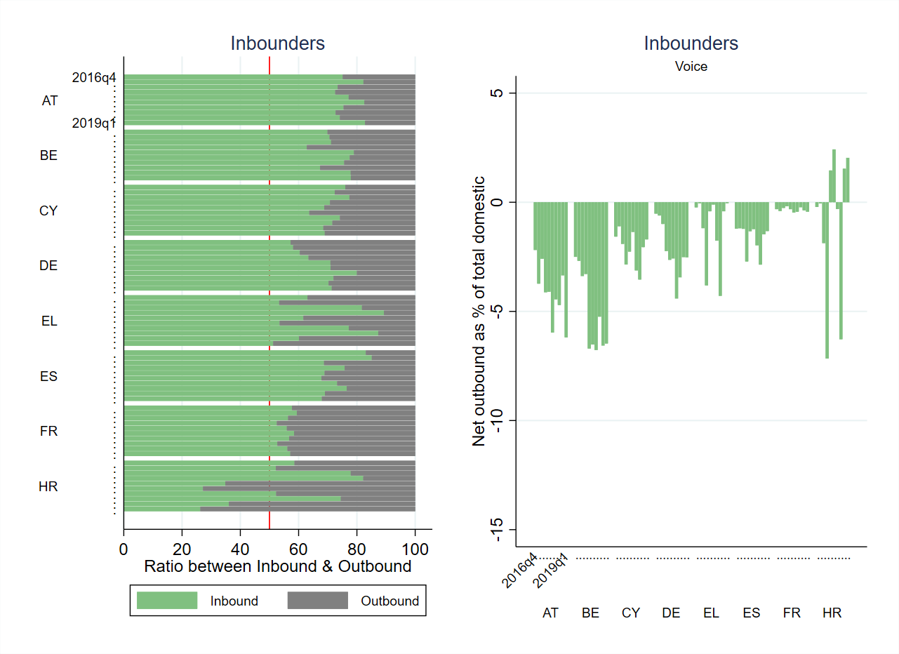

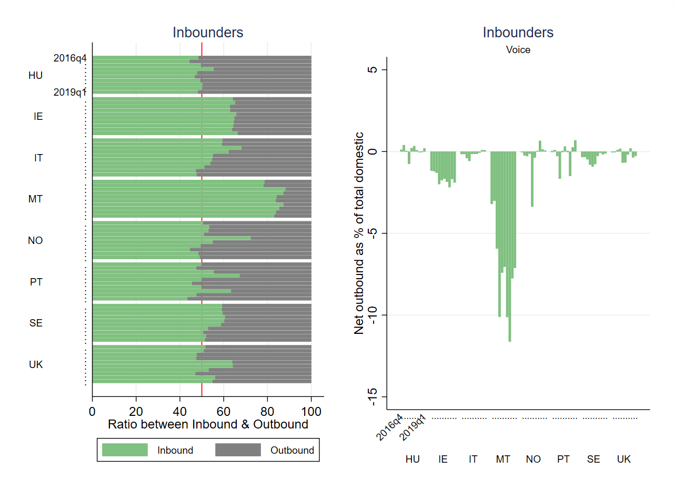

Source: Data collected for the 19th-23rd International Roaming BEREC Benchmark Reports. JRC caculations.

Figure 33: Voice services, outbounder countries – Left panel: ratio between inbound and outbound roaming voice volumes. Right panel: net outbound roaming voice volumes (outbound voice volumes minus inbound voice volumes) as % of total domestic voice volumes, Q4 2016 – Q1 2019.

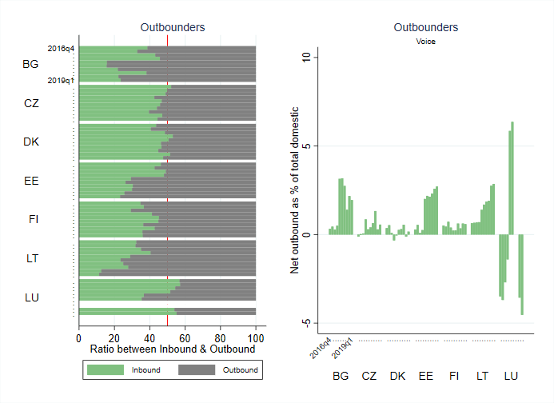

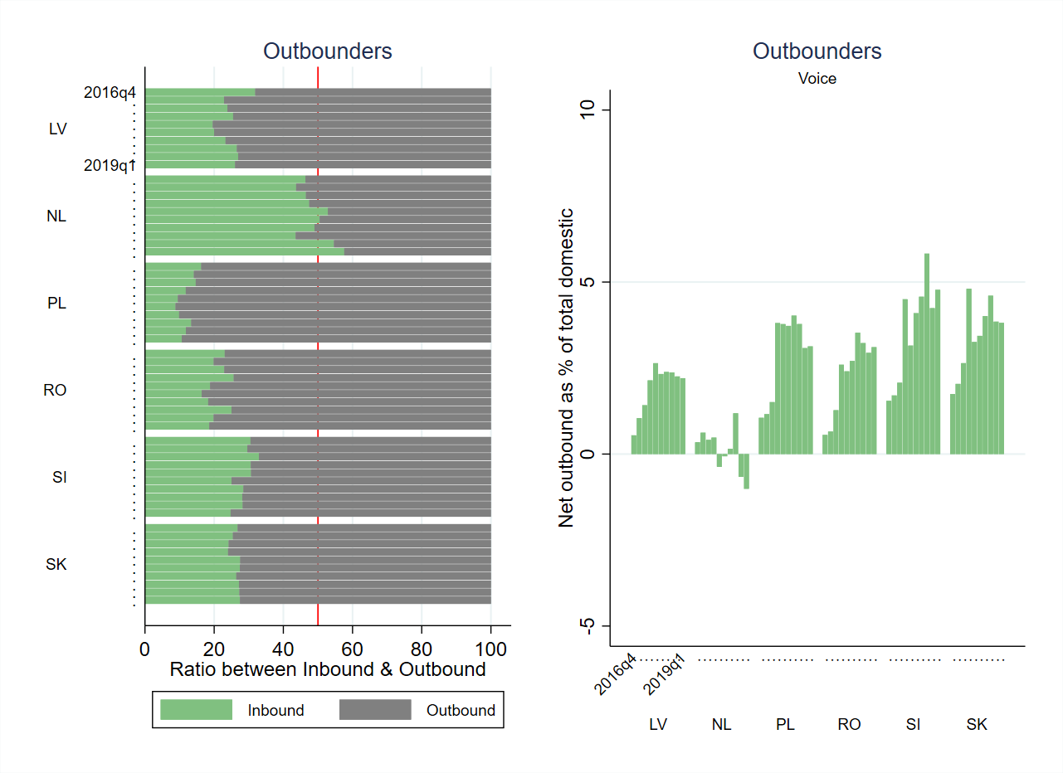

Source: Data collected for the 19th-23rd International Roaming BEREC Benchmark Reports. JRC caculations.

In outbounder countries, although it has increased under RLAH compared to the period before, the net outbound voice roaming traffic (i.e. outbound roaming voice minus inbound roaming voice traffic) still represents a small fraction of the domestic voice traffic of these operators, typically below 4% and not greater than 5% of the domestic voice traffic (Figure 33)[109].

For data services, 12 out of the 29 countries included in the exercise (i.e. the 28 EU Member States plus Norway) are net inbounders of roaming data traffic while the remaining 17 are net outbounders (Figure 34, left panel)[110].

The observations concerning data services are similar to the observations made above for voice services: the net inbound roaming data traffic (i.e. inbound roaming data minus outbound roaming data traffic) represents in general a limited (though increasing with RLAH) share of the domestic traffic. However, in the smaller inbounder countries (Malta, Cyprus, Greece), the net inbound roaming data traffic represents in some quarters a very high share of domestic data traffic (Figure 34, right panel). In Portugal and Croatia too, the net inbound roaming data traffic represented more than 10% of the domestic traffic in summer under RLAH, as well as in Belgium the rest of the year.

In outbounder countries, in spite of the increase in roaming data traffic, the net outbound data roaming traffic (i.e. outbound roaming data minus inbound roaming data traffic) only represents a small fraction of the domestic data traffic of these operators, typically below 3% of the domestic data traffic and only exceptionally up to 5% of the domestic data traffic in some quarters in a couple of countries (Figure 35).

Figure 34: Data services, inbounder countries. Left panel: ratio between inbound and outbound roaming data volumes. Right panel: net outbound roaming data volumes (outbound data volumes minus inbound data volumes) as % of total domestic data volumes, Q4 2016 – Q1 2019.

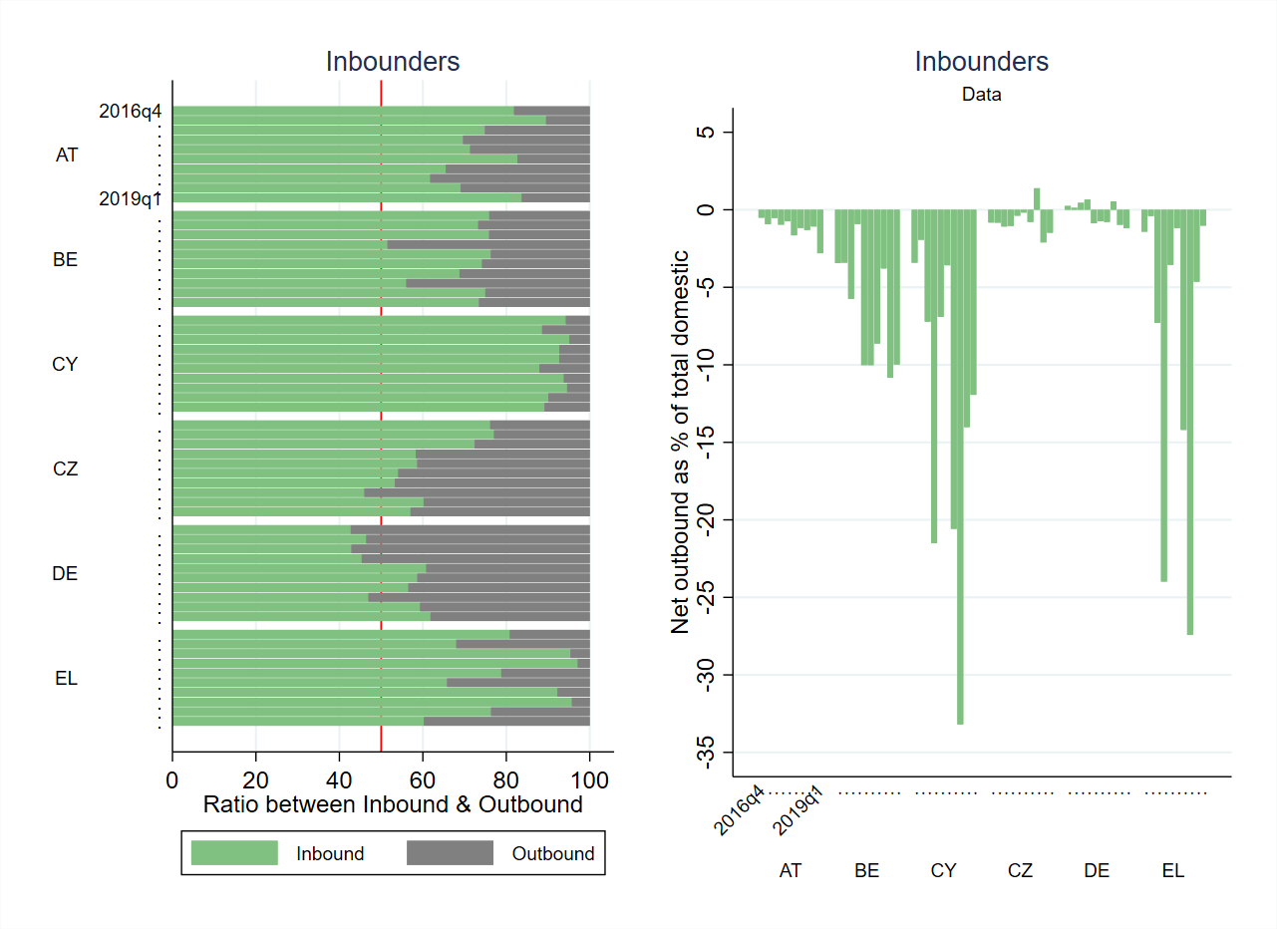

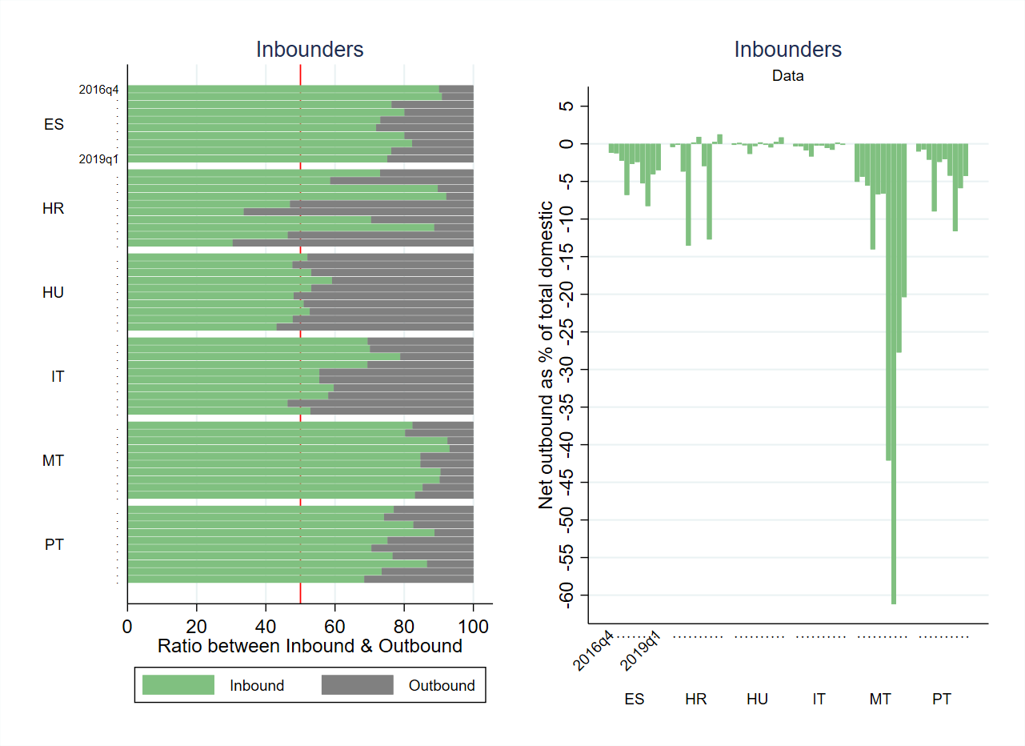

Source: Data collected for the 19th-23rd International Roaming BEREC Benchmark Reports. JRC calculations.

Figure 35: Data services, outbounder countries. Left panel: ratio between inbound and outbound roaming data volumes. Right panel: net outbound roaming data volumes (outbound data volumes minus inbound data volumes) as % of total domestic data volumes, Q4 2016 - Q1 2019.

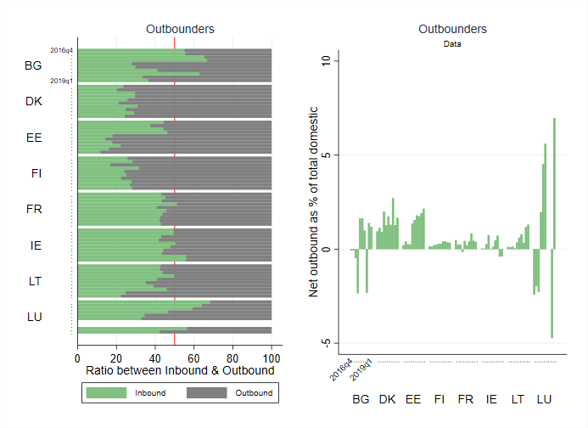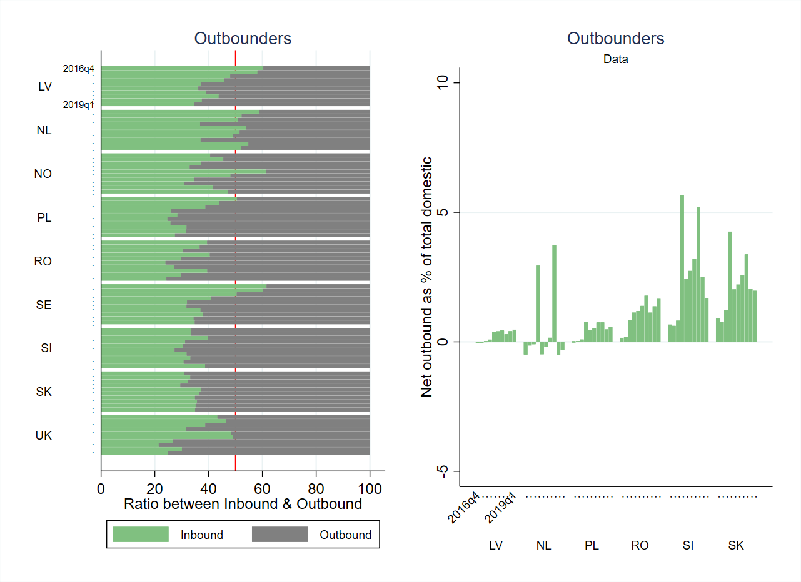

Source: Data collected for the 19th-23rd International Roaming BEREC Benchmark Reports. JRC calculations.

The above analysis shows that operators in inbounder countries have benefited from the increase in demand for wholesale roaming services and that, for operators in outbounder countries, the net outbound roaming traffic - despite the increase under RLAH - only represents a small fraction of the domestic traffic.

### Inbound roaming traffic exhibits an explosive increase

The following two figures show, for inbounder and outbounder countries, the development of inbound roaming traffic for voice (Figure 36) and data, distinguishing the balanced and unbalanced part of the traffic (Figure 37). The balanced roaming traffic is the traffic that both operators exchange (i.e. the roaming traffic equally and reciprocally generated by customers of both operators on both networks). The unbalanced roaming traffic is the additional (unmatched) traffic generated by the customers of one operator on the other operator’s network. The scale on the vertical axis is identical in the two panels within each figure, allowing a direct comparison of the inbound roaming volumes in all countries. The explosive increase in roaming traffic (especially data traffic), the seasonality (in particular for data in countries like Greece, Spain, Croatia, Italy, Portugal and France), and the respective sizes of the inbound roaming markets clearly stand out of the two figures.

Figure 36: Inbound roaming voice traffic, Q4 2016 – Q1 2019

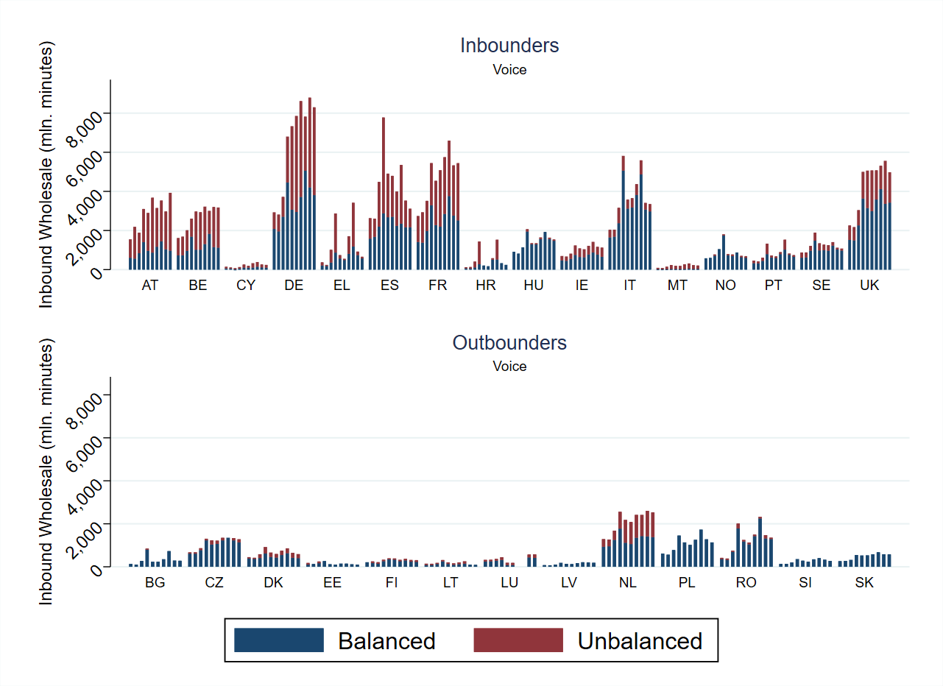

Source: Data collected for the 19th-23rd International Roaming BEREC Benchmark Reports. JRC calculations.

Figure 37: Inbound roaming data traffic, Q4 2016 – Q1 2019

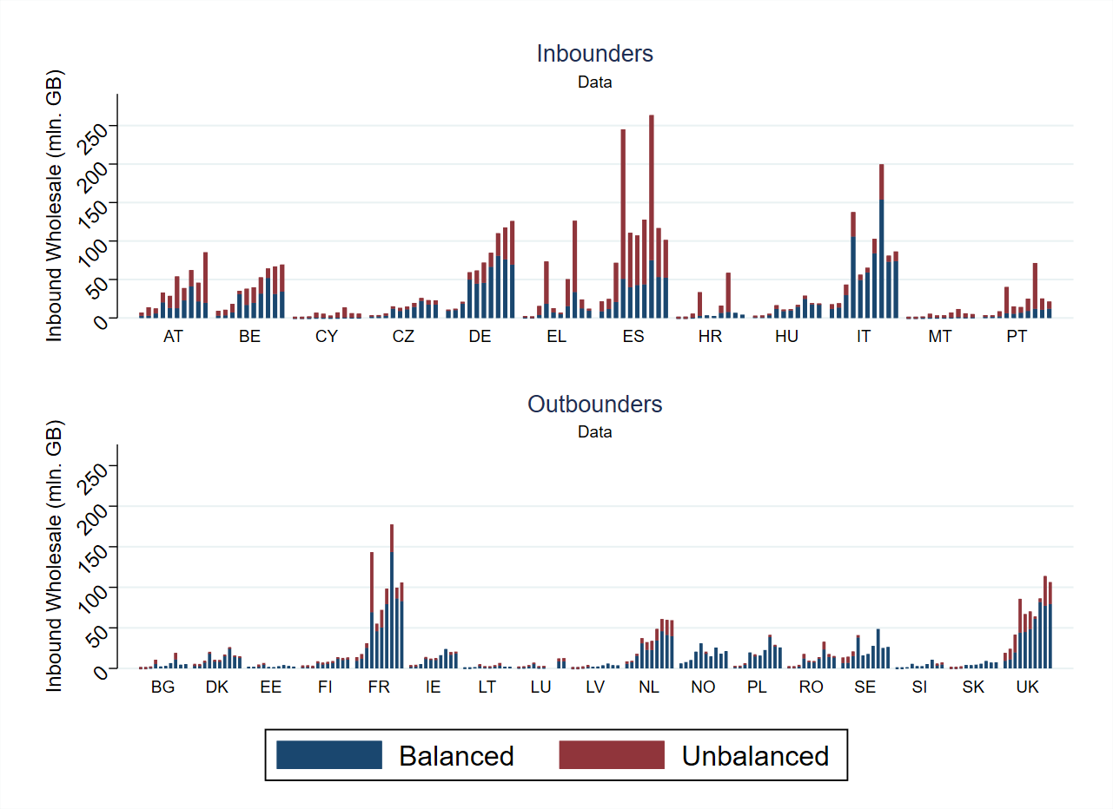

Source: Data collected for the 19th-23rd International Roaming BEREC Benchmark Reports. JRC calculations.

### National wholesale roaming markets are not overly concentrated

The Herfindahl–Hirschman Index, (HHI) provides a measure of concentration in a market. It is calculated as the square sum of the market shares of the different players. When such market shares are expressed as percentages (0-100) the index takes values between 0 (perferct competition) and 10 000 (absolute monopoly). A market with two equivalent players (i.e. with equal market shares) is characterised by an HHI of 5 000, while a market with three equivalent players is characterised by an HHI of 3 333.

The HHI in the wholesale roaming market for both voice (Figure 38) and data (Figure 39) ranges between 3 000 and 5 000 with only few exceptions. This range of values points towards markets with 2 to 3 strong competitors. The only countries with a post-RLAH HHI index below 3 000 are Denmark, Poland and Sweden (for both voice and data) as well as UK (only for data). On the other hand HHIs for both the voice and data markets in Bulgaria, Croatia, Lithuania, Malta and Norway are above 5 000 post-RLAH.

The relative stability of the HHI pre- and post-RLAH (blue and red bars respectively in Figure 38 and Figure 39) shows that RLAH has not significantly impacted the level of concentration on the national wholesale roaming voice markets. If anything, the Member States where the HHI tended to decrease post-RLAH are more numerous than the Member States where it tended to increase, indicating that the level of competition may have slightly increased on the wholesale roaming market under RLAH.

Figure 38: HHI for the wholesale roaming market – Voice volumes



Source: Data collected for the 19th-23rd International Roaming BEREC Benchmark Reports. JRC calculations.

Note: 'pre-RLAH' covers the last period before RLAH (Q4 2016 - Q2 2017), 'post-RLAH covers the corresponding period after RLAH (Q4 2018 – Q1 2019), as Q2 2019 was not available at the time this analysis was made.

Figure 39: HHI for the wholesale roaming market – Data volumes



Source: Data collected for the 19th-23rd International Roaming BEREC Benchmark Report. JRC calculations.

Note: 'pre-RLAH' covers the last period before RLAH (Q4 2016 - Q2 2017), 'post-RLAH covers the corresponding period after RLAH (Q4 2018 – Q1 2019), as Q2 2019 was not available at the time this analysis was made.

### Group operators keep part of their roaming traffic within the group

Mobile operators belonging to a group have the ability of directing outbound roaming traffic to other companies within the group in countries where such companies are present (in-group roaming traffic).

In the case of voice (Figure 40), around 60% of operators responding to the BEREC Benchmark questionnaire do not direct any traffic to in-group companies. These are likely to be mostly non-group operators[111], i.e. MNOs that do not belong to any group and operate in one Member State only and MVNOs. Slightly less than 40% of the responding operators reply that they direct part of their outbound roaming traffic in-group and are therefore affiliates of a group operating in more than one Member State.

The share of roaming traffic that a particular affiliate can send to other affiliates of the same group depends on the presence of the group in the countries where the customers of the given affiliate travel. The in-group share of outbound roaming traffic of an affiliate therefore depends both on the size of the geographical scope footprint of the affiliates' group and on the relative importance of that footprint in the travel destination of the customers of that particular affiliate. Figure 40 shows that, in practice, affiliates of a group direct only a minority of their roaming traffic in-group. Less than 10% of the group affiliates direct more than one third of their outbound roaming traffic within the group, and no affiliate sends more than 50%.

Figure 40: Voice services - Cumulative density distributions of in-group outbound retail roaming voice traffic (calls made) as % of the total outbound retail roaming voice traffic (calls made), per operator, for Q3 2017-Q1 2019

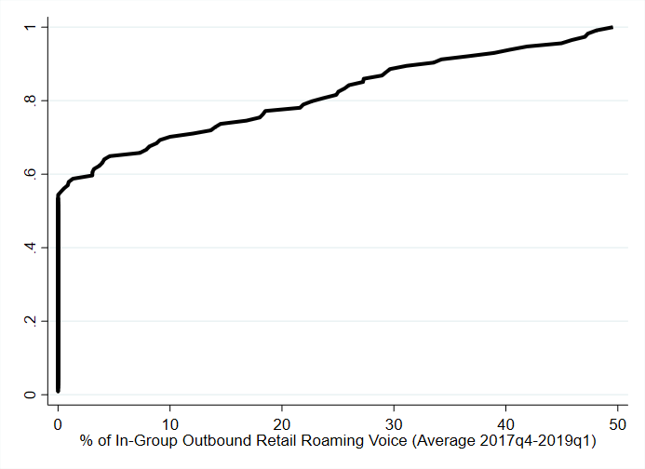

Source: Data collected for the 19th-23rd International Roaming BEREC Benchmark Reports. JRC calculations.

The situation is similar in the case of data (Figure 41): around 10% of operators direct one third of their outbound roaming traffic to in-group networks and none direct more than 50%.

Figure 41: Data services - Cumulative density distributions of in-group outbound retail roaming data traffic as % of the total outbound retail roaming data traffic, per operator, for Q3 2017-Q1 2019

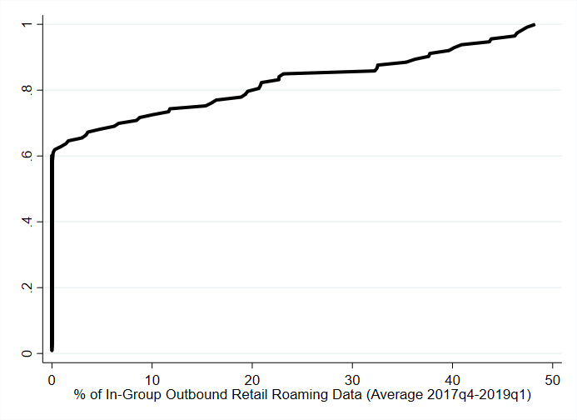

Source: Data collected for the 19th-23rd International Roaming BEREC Benchmark Reports. JRC calculations.

## Evolution of prices

### Wholesale roaming prices have been steadily decreasing

When a customer from one operator roams on the network of a roaming partner operator in another EU country, the first operator needs to pay charges to access the network of the second, the so-called wholesale roaming charges. The introduction of RLAH was accompanied by considerable reductions in maximum regulated wholesale roaming prices, and appears to have triggered further reductions in actual wholesale roaming prices.

The average EEA wholesale roaming price for voice services presents a slowly decreasing trend (Figure 42). The average wholesale roaming price for outgoing voice traffic fell from €2.90 cents/min in Q1 2017 to €1.97 cents/min in Q1 2019[112]. Wholesale prices for net outbound (unbalanced) roaming traffic, which is the part of the roaming traffic generating net payments from one operator to the other, are even lower (€1.75 cents/min in Q1 2019, compared to €2.42 cents/min in Q1 2017).

Figure 42: Voice services: development of the average wholesale roaming rate for voice in the EEA, Q2 2016 to Q1 2019

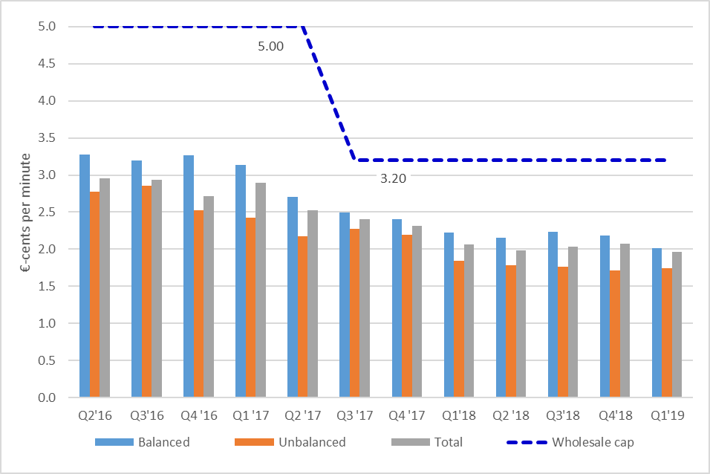

Source: Based on data from the 19th-23rd International Roaming BEREC Benchmark Report

The average EEA wholesale roaming price for data services remained stable throughout 2016 but decreased sharply in 2017 following the sharp reduction in the regulated price cap. It further decreased in 2018 with the next step in the regulated glidepath (Figure 43). Specifically, the average wholesale rate for data decreased from €8.22 /GB in Q1 2017 to €1.78 /GB in Q1 2019. As in the case of voice, wholesale prices for net outbound (unbalanced) roaming traffic are even lower (€1.59 /GB in Q1 2019, compared to €5.44 /GB in Q1 2017).

Figure 43: Data services: development of the average wholesale roaming rate for data in the EEA, Q2 2016 to Q1 2019

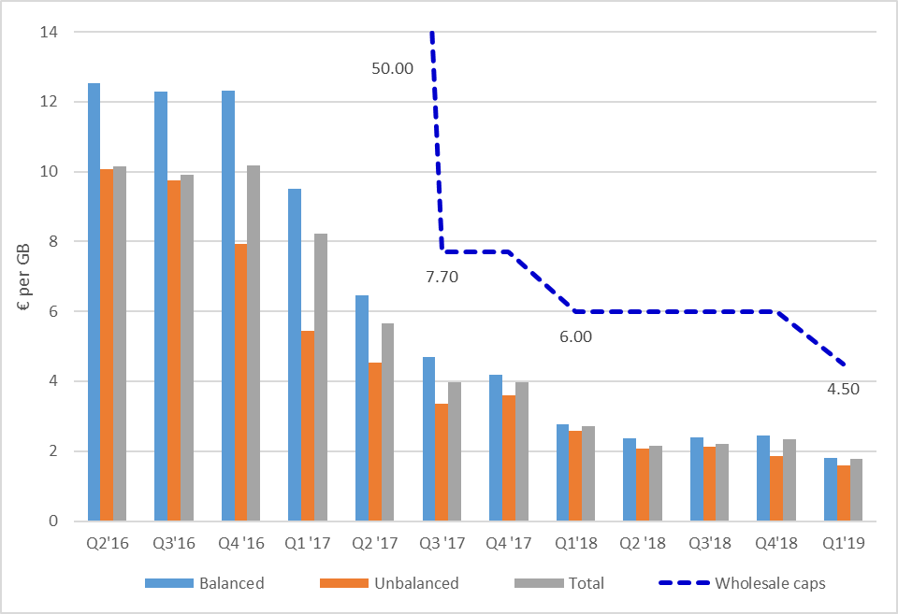

Source: Based on data from the 19th-23rd International Roaming BEREC Benchmark Report

The decline in wholesale roaming prices is observed in all Member States (Figure 44 and Figure 45, showing the last quarter before RLAH, Q2 2017, and the last quarter available, Q1 2019). This decline is determined mainly by two factors. First, new (and, for data, annually decreasing) maximum wholesale roaming prices laid down in the Roaming Regulation have acted as much lower ceilings on prices, triggering competitive market dynamics between operators offering wholesale roaming access below those ceilings. Second, the introduction of RLAH has resulted in significant increases in roaming volumes (as shown in section 5.1.1), thereby fuelling further competition in wholesale roaming prices.

Figure 44: Voice services: average wholesale roaming rate for voice in the Member States, Q2 2017 and Q1 2019

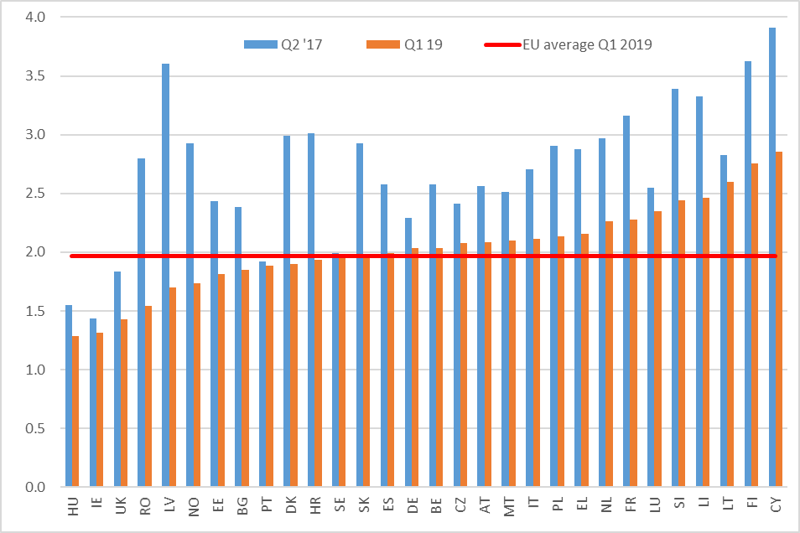

Source: Based on data from the 19th-23rd International Roaming BEREC Benchmark Report

Figure 45: Data services: average wholesale roaming rate for data in the Member States, Q2 2017 and Q1 2019

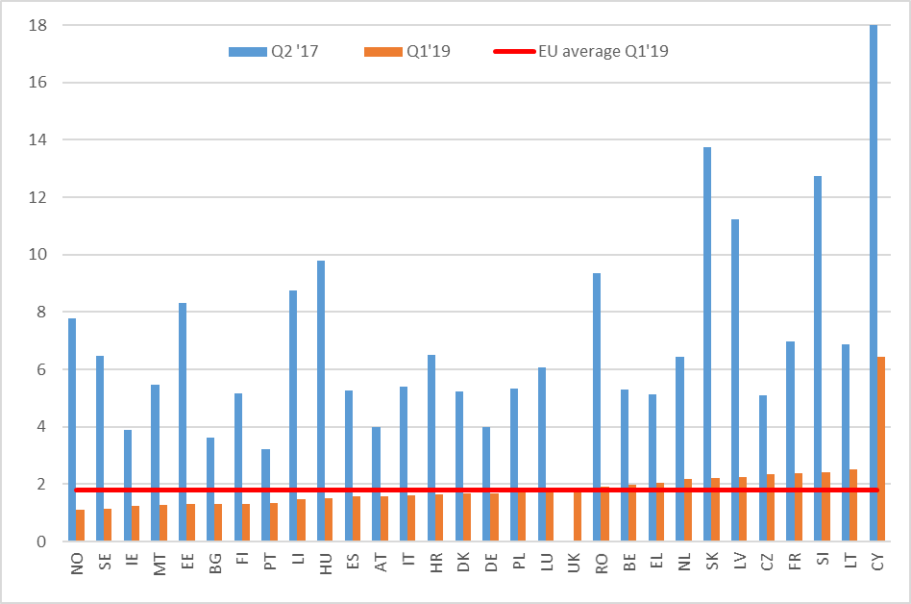

Source: Based on data from the 19th-23rd International Roaming BEREC Benchmark Report

As observed in the interim Report[113], these declines in wholesale roaming prices should be welcomed for three reasons. Firstly, lower wholesale roaming prices have greatly mitigated any potential impact from the introduction of RLAH on outbounder operators (see section 7.1.1), as they have contributed to reduce their wholesale roaming payments. Secondly, such reductions, together with the fact that average wholesale market prices have been below the regulated maximum wholesale tariffs, are persuasive evidence that net inbounder operators have been able to meet the increasing demand in roaming services while at the same time recovering the cost of their network investments, including the cost of capital. Thirdly, such reductions in wholesale roaming prices are a sign of a better functioning internal market at wholesale level, at least as regards a significant share of bilateral relationships between operators. The impossibility to maintain excessive prices for retail roaming services on the various national markets, combined with the release of pent-up demand through the application of RLAH at retail level, appears to have played a positive role in that regard.

### In-group wholesale roaming rates are not necessarily lower than out-of-group rates

Contrarily to what one might expect, the data gathered for the BEREC Benchmark Reports show that wholesale roaming rates within groups of operators (in-group prices) are not necessarily lower than out-of-group wholesale roaming rates.

Figure 46 depicts the relationship between the in-group average versus out-of-group average wholesale roaming rates for voice, per operator. For the majority of operators the two rates are close to each other. For two sizeable subsets of group operators, in-group rates are respectively lower and higher than out-of-group rates.

Figure 46: Average in-group wholesale voice roaming rates versus average out-of-group wholesale voice roaming rates (Q1 2019)

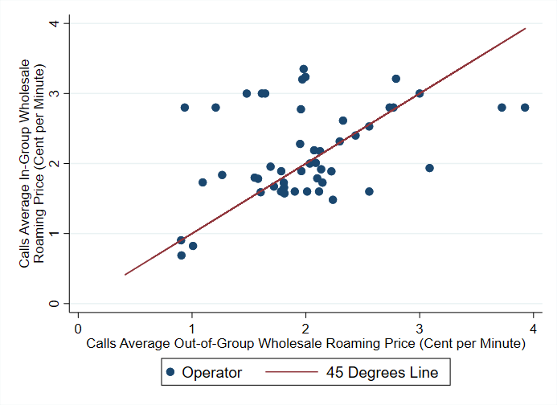

Source: Data collected for the 23rd International Roaming BEREC Benchmark Report. JRC calculations.

Similarly, Figure 47 depicts the relationship between the in-group average versus out-of-group average wholesale data roaming rates, per operator. The same observations as for voice services apply.

Figure 47: Average in-group wholesale data roaming rates versus average out-of-group wholesale data roaming rates (Q1 2019)

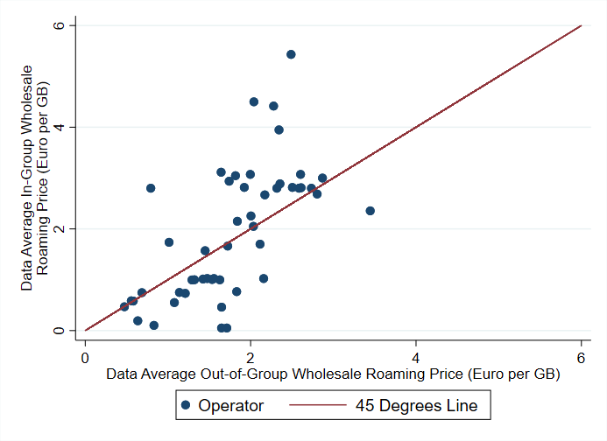

Source: Data collected for the 23rd International Roaming BEREC Benchmark Report. JRC calculations.

The above Figures show that in-group wholesale roaming prices are not necessarily lower than out-of-group prices.

## Wholesale structural measures

The Roaming Regulation provides the possibility to include conditions to prevent permanent roaming or anomalous or abusive use of wholesale roaming access in reference offers for such access. The Roaming Regulation also provides the visited network with the possibility to “terminate the wholesale roaming agreement unilaterally on grounds of permanent roaming or anomalous or abusive use of wholesale roaming access, only upon prior authorisation of the visited network operator’s NRA” (Article 3(6) paragraph 3).

The joint Commission/BEREC online survey of March 2019 shows that 10 % of responding MNOs (9 out of 91) have included explicit measures foreseen in Article 3(6) to prevent permanent roaming or anomalous or abusive use of wholesale roaming access in their reference offers. 7% of the responding MNOs (6 out of 91) and 1 MVNO (out of 89) have experienced cases of termination of wholesale agreements because of permanent roaming or abusive or anomalous use. 3 NRAs (Norway, Sweden and Germany) out of 30 NRAs replied that they received a request for authorisation to terminate a wholesale roaming agreement. In its Opinion, BEREC’s analysis of these NRAs’ replies shows that 2 of the 3 NRAs (Norway and Sweden) indicated “permanent roaming” as the reason for the operators’ request for authorising the termination, 1 NRA (Germany) stated that the case concerned other facts that did not need NRA’s authorisation since it was a case of an ordinary contract termination. Norway’s NRA reported that the request for termination of the wholesale roaming agreement due to permanent roaming was approved on 6 March 2019.

More generally, only 4 NRAs reported having received disputes regarding wholesale roaming access. The remaining 26 NRAs received no notice of roaming access conflicts. The 4 NRAs mentioned that the main reasons for the disputes were wholesale access, wholesale prices and permanent roaming[114].

The above shows that most operators see no need to include specific conditions to prevent permanent or anomalous or abusive usage of wholesale roaming access in their reference offer. In its Opinion, BEREC notes that in general, operators which have detected businesses based on permanent roaming have decided to pursue commercial agreements with access seekers rather than deny access, which would have led to a dispute with the relevant NRA. BEREC concludes that, with the measures provided, the Roaming Regulation sufficiently prevents permanent roaming or anomalous or abusive usage at wholesale level. These measures are useful tools to promote competition and enable NRAs to solve (potential) disputes between operators as well as prevent misuse on the wholesale roaming market.

## Situation of MVNOs

An MVNO does not own a radio access network in the country(ies) where it operates. As a consequence, an MVNO cannot host any roaming traffic from a foreign MNO in return for the roaming traffic that the MVNO sends out to that foreign MNO. An MVNO can only buy at wholesale level the outbound roaming traffic generated by its customers abroad, without the possibility to trade/exchange (part of) this outbound roaming traffic against inbound roaming traffic. MVNOs are therefore in a structurally different situation from MNOs when negotiating wholesale roaming access.

### The various types of wholesale roaming access for MVNOs

As described in the BEREC Opinion, there are various ways of establishing wholesale roaming access agreements for MVNOs. Article 3 of the Roaming Regulation imposes an obligation for MNOs to meet all reasonable requests for wholesale roaming access, which includes direct wholesale roaming access[115] and wholesale roaming resale access[116].

Full MVNOs have their own IMSI[117] numbering range and can negotiate direct bilateral agreements with MNOs. They can also buy wholesale resale access via their domestic host MNO, or from another MNO, or from a hub[118]. Light MVNOs use the same IMSI number as their host MNO and must rely on a form of wholesale resale access. It should be noted that these categories may not be clear-cut and that overlaps between them may occur. Figure 48 shows the distribution of types of access among the full and light MVNOs that responded to the joint Commission/BEREC survey of March 2019. The most common way of getting wholesale roaming access for MVNOs is to rely on their domestic host MNO’s wholesale roaming access. However, a substantial proportion of full MVNOs do buy wholesale roaming services from another MNO.

Figure 48: Type of wholesale roaming access for full and light MVNOs

Source: Joint Commission/BEREC survey of MVNOs, March 2019

### Specific challenges reported by MVNOs in wholesale roaming agreements

In its Opinion, BEREC provides a full description of the specific challenges reported by a few MVNOs[119]on the wholesale roaming market, depending on the type of wholesale access for roaming used. In some cases, MVNOs report having to pay wholesale charges in addition to the regulated wholesale roaming charges (e.g. annual platform fixed costs for hubs, in some cases additional charges to be paid to the MNO reselling the wholesale roaming access, be it the host MNO or another MNO). One MVNO reported a lack of 4G access from the MNO and delaying tactics in negotiations and implementation of a direct bilateral agreement. Around 16 % (7) of the responding light MVNOs had problems to get wholesale access from their domestic host MNO (e.g. large access fees and bank guarantees, lack of 4G access). Several MVNOs report that they do not get discounts on the wholesale roaming price caps. 12 % of the MVNOs (11 out of 89) reported the existence of disputes with their wholesale provider after signing the access agreement.

### Wholesale roaming prices paid by MVNOs

Figure 49 (for voice) and Figure 50 (for data) below present the lowest wholesale roaming prices paid by MNOs (blue) and the average prices paid by MVNOs (red) from each country, showing these prices against the regulated maximum wholesale roaming tariffs (solid line). Although the evidence does not represent the full picture in all countries, as many operators did not provide any data, the following conclusions can be tentatively drawn. First, MVNOs typically pay wholesale roaming prices that are higher than those paid by MNOs; some pay prices broadly in line with the level of the wholesale roaming price caps, however there are many examples of MVNOs that pay wholesale roaming prices well below the regulated tariffs in most EU countries. Thus, it cannot be concluded from this evidence that all MVNOs necessarily pay wholesale roaming prices at the level of the regulated caps. Second, there are a few examples of MVNOs that pay wholesale roaming prices at similar levels to those paid by MNOs.

Figure 49: Wholesale roaming prices paid for voice by MNOs (blue dots) and MVNOs (red dots), 2018



Source: Data collected for the 22nd International Roaming BEREC Benchmark Report (March 2019) and joint Commission/BEREC survey of MVNOs (March 2019). The chart uses the average of the 5 lowest prices paid by MNOs and the average price paid by MVNOs. JRC's calculations.

Figure 50: Wholesale roaming prices paid for data by MNOs (blue dots) and MVNOs (red dots), 2018



Source: Data collected for the 22nd International Roaming BEREC Benchmark Report (March 2019) and joint Commission/BEREC survey of MVNOs (March 2019). The chart uses the average of the 5 lowest prices paid by MNOs and the average price paid by MVNOs. JRC's calculations.

The evidence in Figure 49 and Figure 50 above seems to suggest that the prices paid by MVNOs can vary significantly depending on factors other than just their condition of being a virtual operator. For example, an MVNO may be able to negotiate different prices depending on its size or its negotiating strategy with its host MNO. On the latter, an MVNO attaching more weight to roaming services may be able to negotiate a better wholesale roaming access deal with the MNO than an MVNO that does not attach such weight to roaming services and prefers to focus its strategy on domestic services.

Figure 51 shows, for MVNOs providing the data in the joint Commission/BEREC survey of March 2019, the average wholesale price paid by the MVNO for domestic access and for roaming access for voice services. Figure 52 shows the same for data services. As, in the case of voice services, the roaming access price covers termination, the weighted average MTR in the EU in 2018[120] is added to the domestic price for comparison reasons.

The two Figures show that MVNOs usually pay substantially lower wholesale prices for domestic access than for roaming access, although it is not systematically the case for voice when termination is added to the domestic price. Moreover, it should be noted that wholesale roaming access does entail roaming-specific costs[121] and usually transit costs that are not encountered in domestic access. According to data gathered by the Commission from operators in the second half of 2018, transit prices for voice and data services amount on average to 0.5 cent/min and 0.2 cent/GB respectively.[122] These additional costs for wholesale roaming access, which are not factored in in the two Figures below do, however, not fully explain the difference between the wholesale roaming and domestic prices paid for data by a number of MVNOs.

Figure 51: Voice services - Average wholesale domestic price plus EU weighted average MTR[123] (as of July 2018) versus average wholesale roaming price paid by MVNOs (1 dot = 1 MVNO), 2018

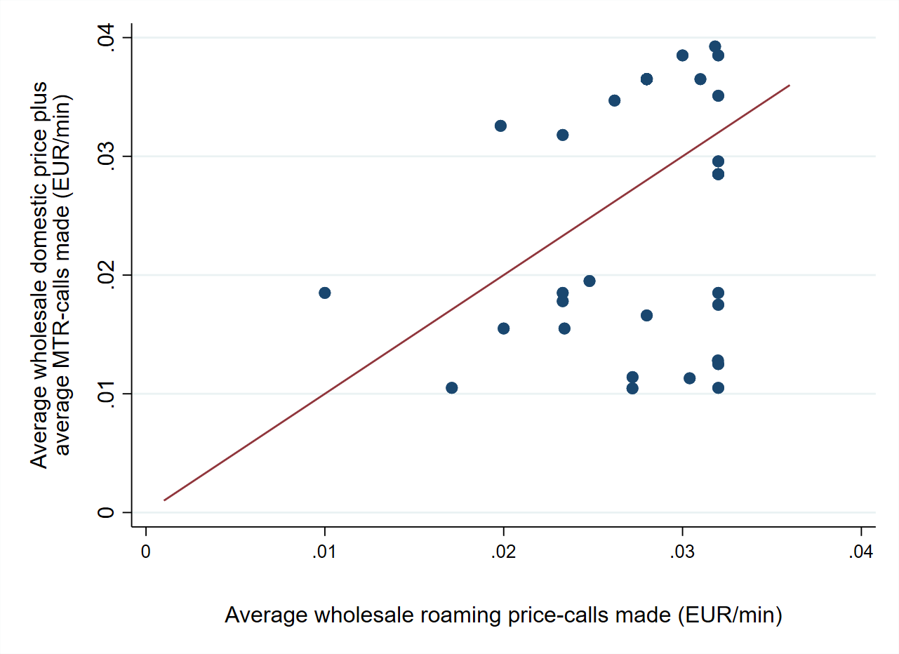

Source: Joint Commission/BEREC survey of MVNOs, March 2019

Figure 52: Data services - Average wholesale domestic price versus average wholesale roaming price paid by MVNOs (1 dot = 1 MVNO), 2018



Source: Joint Commission/BEREC survey of MVNOs, March 2019

### Possible measures to improve the situation for MVNOs

In its Opinion, BEREC proposes a series of measures that could be considered to be introduced in the Roaming Regulation in order to improve the situation of MVNOs in the wholesale roaming market, so that they remain competitive on their respective domestic markets. The benefits and difficulties created by the measures suggested by BEREC in its Opinion are analysed below.

|  |  |
| --- | --- |
| Reduce the wholesale roaming price caps | |
| Pros | Reduces the costs of outbound roaming traffic for MNOs and MVNOs.  The cost assessment produced by the external study (section 6) as well as the market prices reported in the BEREC Benchmark Reports (section 7.2) tend to indicate that there is some room to lower the current price caps while ensuring cost recovery in all Member States. |
| Cons | The level of the price caps should give sufficient assurance of cost recovery for all visited operators in the EU/EEA for the provision of wholesale roaming services, including room for uncertainty around cost estimates and for further commercial negotiations below the caps.  While the market has been found not to function optimally, price regulation to cost is not the norm in the absence of significant market power, and the need to do so for the whole market in order to address the problems of an outlier group would need to be carefully assessed; including the possible knock-on effects in (non-regulated) domestic wholesale negotiations. |
| Impose an obligation on MNOs to pass on to their hosted MVNOs the discount for wholesale roaming services they get from any visited network | |
| Pros | Reduces the costs of outbound roaming traffic for MVNOs to the same extent as their host MNOs. |
| Cons | Does not take into account the costs incurred by the MNO to host the inbound roaming traffic which is a key determinant of the discount obtained by the MNO from a visited network.  Likely knock on effects on domestic wholesale markets (e.g. increase in domestic wholesale prices).  As noted by BEREC, such an obligation would be:   * very complex to implement in practice (e.g. MNOs have several bilateral agreements in each Member State, often with complex price structures; discounts depend on volumes and are often granted at the end of the specified periods) and * difficult to monitor and enforce by NRAs |
| Align wholesale roaming charges with national wholesale rates | |
| Pros | Most favourable price for roaming that an MVNO can get. |
| Cons | Wholesale roaming costs are objectively higher than domestic wholesale costs (section 6).  Does not take into account the actual wholesale roaming price paid by the host MNO: the MNO may be obliged to re-sell wholesale roaming to its hosted MVNO at a lower price than the price it pays for wholesale roaming, therefore re-selling at a loss  Likely knock on effects on domestic wholesale markets (e.g. increase in domestic wholesale prices). |
| Make sure that wholesale caps also apply to alternative wholesale roaming solutions, like sponsored roaming[124] | |
| Pros | This is already the case in the Roaming Regulation; it can be further clarified. |
| Impose an obligation on MNOs to give non-discriminatory access to new technologies to MVNOs also for roaming | |
| Pros | The MNO should give access to its hosted MVNO(s) to the same technology for roaming as it gets from a visited network; while the price for re-selling wholesale roaming access may differ from the price paid by the MNO (while being below the cap), the re-sold product itself should not differ from what the MNO buys to the visited network. |
| Include time limits for signing roaming agreements and for technical implementation | |
| Pros | Article 3 of the Roaming Regulation already includes time limits for providing a draft contract to the access seeker and for granting wholesale roaming access after the conclusion of the contract; a time limit for the contract negotiations themselves could be envisaged, as well as specifying that the access granted should be fully operational within the time limit imposed. |
| Include measures for incoming roaming calls for MVNOs | |
| Cons | BEREC’s Opinion does not specify what such measures should be and for which benefits. |

## Fraud

The interim Report and the BEREC Opinion provide a description of the cases of fraudulent use/misuse of roaming services (other than abusive usage by individual users beyond fair use policy) reported by some MNOs and MVNOs[125]. The most common cases of such fraudulent use are:

* International Revenue Share Fraud, which consists in the artificial generation of traffic towards international destination ranges (within the EU/EEA) with high termination rates that are subject to revenue share. This may concern calls to value added services as well as to operators charging high interconnection costs.
* Abusive use of SIM cards (typically pre-paid), where the entire voice or SMS allowance was used in a very short time frame (often a few hours or even minutes) e.g. for marketing or for SMS messages sent from applications to persons (A2P), for roaming conference calls, etc
* The resale of SIM-cards in other EU/EEA countries for permanent roaming (though observed by less than 7% of the responding MNOs).

The lack of transparency on the higher charges applied to calls to value-added services numbers has been also reported by some operators as an issue: 23 % of the responding operators referred having incurred extra costs at wholesale level from unexpected termination rates related to value-added roaming communications within the EU/EEA. As specified in the BEREC Retail Guidelines[126], the Roaming Regulation does not apply to the whole tariff that is charged for value added services but only to the tariff component corresponding to the connection to such services. Numbering ranges for such value-added services cannot always be recognized by an operator in all countries in advance, hence the unexpected additional costs incurred upon reception of wholesale roaming bills.

Operators have generally taken measures to address the above-mentioned problems (e.g. blocking or suspending SIM cards or roaming services, barring abusive/high-cost number ranges, new contract requirement to activate SIM cards domestically prior to roaming abroad). In addition to measures taken individually by operators, BEREC considers in its Opinion the possibility to create and maintain a European database of value-added services’ number ranges[127]. Additional transparency measures could also be considered to protect consumers against bill-shocks due to calls to value-added services while roaming, for instance including information in the “Welcome SMS” that calls to such services are subject to specific tariffs linked to the service itself[128].

# Technological developments

A variety of technological and market developments could affect competition in wholesale and/or retail roaming markets over the medium term (5-10 years). The study “Technological developments and roaming”[129] assesses such developments with a view to understanding whether regulation of data, voice and SMS roaming will continue to be necessary going forwards.

The developments examined in the study can be broadly categorised into:

1. Developments which enable end-users to **bypass** data roaming or roaming calls and SMS by using alternative technologies to traditional mobile: Wi-Fi and Wi-Fi aggregation services; Over-The-Top (OTT) services; and Rich Communication Services (RCS).
2. Technological developments and platforms which could facilitate **competition in mobile roaming and cross-border connectivity**: Virtual SIM (VSIM); Embedded SIM (eSIM), 5G and 5G network slicing; Voice over LTE (VoLTE); Internet of Things (IoT); Wholesale trading negotiating platforms; and Local data break-out.
3. **New business models and players** entering the roaming space: Multi-MVNO agreements and cross-border MVNOs; entry of equipment, content and service providers into the roaming space.

The study analyses such developments, following a modified Greenfield approach[130]. It concludes that OTT voice and messaging services are likely to present the greatest competitive threat to traditional roaming offers for mobile voice and SMS, while eSIM and (especially for IoT) 5G and network slicing are also expected to disrupt roaming markets.

## The main developments with the prospect for a substantial impact on roaming

**Wi-Fi** has gained popularity across Europe and is likely to remain attractive thanks to its cost, convenience and quality. However, it is unlikely to present a comprehensive substitute for mobile data “roaming” for consumers or mobile IoT because it lacks complete coverage. Moreover, mobile operators may increasingly use the evolving capabilities to integrate seamlessly Wi-Fi technologies within their mobile offer in a 5G environment, thereby encompassing some of its advantages.

**Over-The-Top (OTT)** services are already replacing mobile calls and SMS for certain purposes, domestically as well as when roaming, in both the business and consumer sector. Conversely, more attractive roaming offers (based on RLAH) may have tempted end-users to switch to mobile voice rather than bypassing the network. There is likely to be residual demand for mobile communications from users without smartphones and for calls requiring any-to-any connectivity. However, OTT could limit the potential for mobile operators to increase voice and messaging prices, if cost-effective data roaming or alternatives are available.

**Embedded SIM (eSIM)** is an important development that could facilitate competition and switching in mobile connectivity including roaming. Its effects on competition may differ for different market segments, and depend on the way the standard is implemented and influenced by different interest groups including mobile network operators and device manufacturers. The most significant prospects of eSIM could be in connectivity for IoT including connected cars, where its use is already established. eSIM could also enable customers to select separate specialist roaming providers on their mobile handset, or facilitate their use of local mobile providers. However, customer take-up of specialist services might be limited, while the use of local mobile providers presents other challenges, including trust (for the end-user), identification and security. It is possible that the threat of such competition could limit the ability of MNOs to raise prices, but eSIM in consumer devices is in its infancy and the impact has yet to be seen. The effects of eSIM on competition in consumer roaming in the long term could be significantly improved if GSMA standards were to be revised so as to remove the current limitation of one profile per eSIM.

**5G** technologies are likely to change the nature of roaming services. Among others, it could potentially affect the commercial model applied, e.g. basing pricing on bandwidth as opposed to usage. Network slices could also provide options for MNOs and MVNOs to use access agreements as an alternative to traditional roaming. In this way they could enhance their flexibility on service differentiation (latency, security etc), which could prove to be very important for certain vertical use cases. However, as 5G roaming, wholesaling models and vertical use cases have not yet been defined, the impact of 5G on competition in roaming/global connectivity markets is not yet clear. 5G could provide increased potential for new entry and retail competition if MNOs see its capabilities as an opportunity to build a diverse wholesaling model. On the other hand, some multi-national MVNOs have expressed fears, that 5G could potentially present a threat to them, obliging them to renegotiate existing arrangements, which are often tied to specific technology generations.

The development of new models for **wholesale capacity trading** could also affect the roaming market. Their proponents claim two main benefits, which can help boost competition in wholesale roaming, if these new models are widely adopted. Firstly, such models can anonymise trading, which is currently conducted through face-to-face bilateral negotiations. Secondly, they can break the link between outbound and inbound traffic, which penalises operators and MVNOs with lower countervailing power. If such new models were indeed widely adopted and managed to achieve these expectations, they could in the long run abolish the need for regulating wholesale roaming rates. However, their case is still not proved. A key challenge with such models is that they rely on participation by multiple operators in each country, and there is a lack of incentive for larger mobile groups to participate.

Finally the study notes that the separate sale of data roaming services (**local data breakout**) has not been used by the market. Since 2012, the Roaming Regulation has provided that end-users may not be prevented by operators from accessing regulated data roaming services on a visited network by an alternative roaming provider. This structural measure, known as local data breakout, was meant to foster competition on the roaming market. In its Opinion, BEREC also shows that this solution has not been deployed in practice[131]. Looking forward, based on surveys of the market conducted in 2019 for the purposed of this review, both BEREC and the study note the lack of interest by market players in implementing such solution in the future.

## The study concludes that there does not seem to be a case for significant changes to the regulatory rules for international roaming under the current review.[132]

As discussed above, while several of the examined developments are likely to disrupt roaming markets in the future, they do not seem likely to exert sufficient competitive pressure that would already call for immediate changes in the RLAH rules.

In the medium term, the study considers that OTT might be able to provide a sufficient constraint on pricing to enable the withdrawal of retail roaming obligations on voice and SMS. Still, it expects that reliance on managed communications services is likely to continue, at least for some customers and for some types of communication. The prospective competitiveness of the retail market could also warrant the deregulation of wholesale markets. However, in this case additional challenges will need to be considered, including with the migration to IP-based services by means of VoLTE and/or RCS, and with the associated development of new wholesale offers. All the above could be the subject of attention for a future review of the roaming rules.

At the same time, the reliance of OTT on data connections suggests (according to the study) that the need for retail obligations on data roaming will continue. This need could be relaxed, only if there is evidence that competition from alternative roaming provision (e.g. eSIM or local break-out) can effectively constrain retail data roaming prices.

The study also considers that the need for data roaming regulation at the wholesale level will also continue in the medium term not only for personal communications but also for the growing machine-to-machine (M2M) and IoT communications market. At the same time, possible future bottlenecks, regarding the wholesale provision of roaming services with assured quality of service (e.g. for the M2M services), could call for additional interventions.

## The study suggests considering if developments relating to M2M and permanent roaming would call for immediate attention

The study pinpoints a number of issues, which (according to the study) could benefit from immediate attention, relating to permanent roaming and M2M communications.

Interviewees noted that there could be a lack of clarity about whether a roaming application was “M2M” or involved personal interaction, especially in cases – such as connected cars – where different applications may be provided by the same global connectivity provider under the same contract for different purposes in parallel (e.g. telemetry and in-car entertainment). While in most cases the distinction is clear, they claim that there is a grey area, notably the case of business-to-business (B2B) infotainment, where the consumer does not buy the service. Some operators/regulators decide that it involves human intervention while others see it as an extension of M2M service. In general, they note that the approaches across different countries and operators differ, resulting in a fragmented regulatory landscape that could affect the potential to deploy IoT services across the single market.

MVNOs and Mobile Virtual Network Aggregators (MVNAs) also report that some mobile operators have taken steps to block or limit permanent roaming to avoid the risk of domestic customers being targeted by multi-national connectivity suppliers. In this direction, some have started offering a higher cost product for permanent roaming for IoT – based on a fixed cost for accessing network, together with a service level agreement (SLA).

The proliferation of eSIM may bring this issue into a renewed focus as eSIM is likely to support the expansion of connected things across the EU, which may potentially entail permanent roaming. At the same time, by facilitating the use by consumers of multiple mobile profiles each with different identifiers, eSIM could make it more difficult for MNOs in visited countries to track whether “roaming” consumers are genuinely visiting for a short period, or are permanently roaming.

Therefore, the study suggests examining if there is a case for more explicit rules or guidelines on permanent roaming and the use of non-national IMSIs, as well as for guidance on how M2M should be distinguished from personal communications.

The Commission services note that, while the Roaming Regulation was designed for the benefit of end-users using their mobile device while periodically traveling abroad in the EU/EEA and by reference to a per-unit (volume-based) type of charging model, it does not exclude machine-to-machine communications from its scope[133]. Wholesale roaming access obligations laid down in Article 3 of the Roaming Regulation, as well as the wholesale data price cap, therefore also apply in case such access is sought for the purposes of machine-to-machine communications as long as they are charged on a per unit, volume-based, basis like person-to-person communications. However, per unit price caps are not suited to other types of charging models that would be developed to better account for the use of the network by the specific traffic patterns generated by certain machine-to-machine applications, such as narrow-band IoT. According to information available to the Commission services, there are on-going initiatives to develop such new types of charging models.

As to permanent roaming, it is not prohibited as such by the Roaming Regulation and can be agreed by two roaming partners in the wholesale roaming contract[134]. According to information received by the Commission services, operators often have an interest to host machine-to-machine communications traffic on their networks, including on a permanent basis, in order to benefit from the related wholesale revenues. In order to facilitate the development of pan-European machine-to-machine services in particular, the European Electronic Communications Code adopted by the European Parliament and the Council in December 2018 provides that Member States shall ensure that NRAs make available numbers that may be used on a permanent basis outside of the Member State (known as “extra-territorial use of numbers”)[135]. The implementation of the roaming rules might benefit from the relevant clarifications regarding the wholesale access conditions for permanent roaming for the purposes of connectivity for machine-to-machine/Internet of Things.

# Conclusion

While successive Roaming Regulations since 2007 had brought tangible benefits to consumers in the form of price reductions for voice, SMS and data roaming services, many Europeans continued to avoid, or curtail, usage of their mobile phones and data services when travelling outside of their home Member State in order to avoid incurring mobile roaming charges[136]. The RLAH reform has finally allowed to radically change that situation and met its objective to unleash the demand for mobile consumption among travelers in the EU. Travelers now use roaming services in the EU without worry. The total volume of roaming data in the EU was multiplied by a factor 5 already in the first year of RLAH compared to the last year before RLAH. It continued to increase by a factor 2 in the second year compared to the first year, resulting in a roughly 10-fold increase compared to the last year before RLAH[137]. As to the volume of roaming voice calls, it has been multiplied by 2 to 3 (depending on the quarter of the year) compared to prior to RLAH.

At wholesale level, the sharp reduction in price caps together with competitive dynamics below the caps have resulted in much lower wholesale roaming prices since RLAH is in place. While the pace of the decrease in the average price seems to slow down at around 2 €cent/min for voice, the decrease in the average price continues for data with (and below) each annual downward step of the cap. Similarly to the pre-RLAH period, under RLAH the regulated price caps have been necessary to bring prices down on the wholesale roaming market. The price caps have continued to act as benchmark prices in wholesale roaming negotiations. Any discount on the wholesale roaming market is made from these reference prices. In addition, parts of the market, in particular MVNOs and smaller operators operating in one country and with large outbound roaming imbalances, often pay wholesale roaming prices at, or close to, the cap level.

In that perspective, BEREC “*does not expect that the competitive conditions in the roaming market will change in the near future in a way that a regulatory intervention is not required anymore.” [138]* BEREC recommends that, *“[b]ecause of the successful implementation of the regulation, the roaming rules should remain in their current shape/structure until a new assessment, taking into account future market developments, is done.”* BEREC also recommends to *“further reduce the wholesale caps, in order to increase the competitive strength for MVNOs in the years to come.” [139]*

The above analysis, supported by the BEREC Opinion and an external study on ongoing and future technological developments, shows both the success of the reform and the need for the rules to continue to be applicable in the coming years in order for end-users to continue benefitting from roaming services without extra charges in the EU. While there is some evidence of economic space between the wholesale price caps currently programmed until 2022 and the level of costs of all operators (as also flagged in the European Parliament study – see section 4.5), the case for further reductions in order for the RLAH regime to function better while maintaining domestic competitive dynamics needs to be further analysed. The analysis has also highlighted the aspects of the rules where clarifications could be beneficial to their implementation, namely on the quality of service while roaming, MVNOs’ access to roaming services and the applicability of the roaming rules to machine-to-machine communications. Finally, due to the lack of actual uptake by the market, local data breakout obligations no longer appear to be relevant.

1. Regulation (EU) 2015/2120 of the European Parliament and of the Council of 25 November 2015 laying down measures concerning open internet access and amending Directive 2002/22/EC on universal service and users' rights relating to electronic communications networks and services and Regulation (EU) 531/2012 on roaming on public mobile communications networks within the Union.
2. Introduced by [Regulation (EU) 2017/920 of the European Parliament and of the Council of 17 May 2017 amending Regulation (EU) No 531/2012 as regards rules for wholesale roaming markets](https://eur-lex.europa.eu/legal-content/EN/AUTO/?uri=uriserv:OJ.L_.2017.147.01.0001.01.ENG&toc=OJ:L:2017:147:TOC).
3. Commission Implementing Regulation (EU) 2016/2286 of 15 December 2016 laying down detailed rules on the application of fair use policy and on the methodology for assessing the sustainability of the abolition of retail roaming surcharges and on the application to be submitted by a roaming provider for the purposes of that assessment.
4. Decisions of the EEA Joint Committee No 173/2012 (available [here](https://www.efta.int/sites/default/files/documents/legal-texts/eea/other-legal-documents/adopted-joint-committee-decisions/2012%20-%20English/173-2012.pdf)), 92/2016 (available [here](https://www.efta.int/sites/default/files/documents/legal-texts/eea/other-legal-documents/adopted-joint-committee-decisions/2016%20-%20English/092-2016.pdf)) and 105/2017 (available [here](https://www.efta.int/sites/default/files/documents/legal-texts/eea/other-legal-documents/adopted-joint-committee-decisions/2017%20-%20English/105-2017.pdf)) respectively add Regulations 531/2012, 2015/2120 and 2017/920 to Annex XI to the EEA Agreement “Electronic communications, audiovisual services and information society”.
5. In this report, Regulation (EU) 531/2012 as amended by Regulation (EU) 2015/2120 and Regulation (EU) 2017/920 is called the "Roaming Regulation".
6. Report on the implementation of Regulation (EU) 531/2012 of the European Parliament and of the Council of 13 June 2012 on roaming on public mobile communications networks within the Union, as amended by Regulation (EU) 2015/2120 and Regulation (EU) 2017/920, COM(2018) 822 final, available [here](https://ec.europa.eu/digital-single-market/en/news/report-implementation-regulation-roaming-public-mobile-communications-networks-within-union).
7. Commission Staff Working Document on the findings of the review of the rules on roaming fair use policy and the sustainability derogation laid down in the Commission Implementing Regulation (EU) 2016/2286 of 15 December 2016, SWD(2019) 288 final, available [here](https://ec.europa.eu/digital-single-market/en/news/roaming-review-fair-use-policy-and-sustainability-derogation).
8. A roaming service can be provided domestically (national roaming), i.e. a mobile operator uses the network of another operator to provide mobile services to its customers domestically. However, national roaming is not within the scope of the Roaming Regulation. The latter only regulates international roaming in the EU/EEA, i.e. roaming on a foreign network within the EU/EEA.
9. Implementing Regulation (EU) 2016/2286 provides that such a volume limit on roaming data must be equal to or greater than twice the retail price of the mobile bundle divided by the wholesale roaming price cap. This means that the user can consume the double (or more) of the data volume that their operator can buy (with the price paid by the user) at wholesale level to the visited operator, if the latter charges at the level of the cap
10. Exceeding a data volume safeguard can only lead to the imposing of roaming surcharges on data roaming retail services (see BEREC Retail Roaming Guidelines, BoR (17) 56, point 70).
11. For calls received, the maximum retail roaming surcharge applicable in excess of fair use policy is defined as the weighted average Mobile Termination Rate across Member States and is therefore revised downwards annually by the Commission. It is equal to 0.0085 EUR/min in 2019.
12. In 2019, the following wholesale roaming price caps are applicable: 0.032 € /minute for calls made, 0.01 €/sms, 4.5 €/GB. From 1 January 2020, the new cap for data will be 3.5 €/GB. It will then decrease to 3 €/GB in 2021 and 2.5 €/GB in 2022. In comparison, those caps were 0.05 €/minute, 0.02 €/sms and 50 €/GB until 15 June 2017.
13. Norway, Iceland, Liechtenstein.
14. BEREC Guidelines on Regulation (EU) No 531/2012, as amended by Regulation (EU) 2015/2120 and by Regulation (EU) 2017/920 (Retail Roaming Guidelines), BoR(17)56, available [here](https://berec.europa.eu/eng/document_register/subject_matter/berec/regulatory_best_practices/guidelines/7005-berec-guidelines-on-regulation-eu-no-5312012-as-amended-by-regulation-eu-no-21202015-excluding-articles-3-4-and-5-on-wholesale-access-and-separate-sale-of-services).
15. BEREC Guidelines on Regulation (EU) No 531/2012, as amended by Regulation (EU) 2015/2120 and by Regulation (EU) 2017/920 (Wholesale Roaming Guidelines), BoR(17)114, available [here](https://berec.europa.eu/eng/document_register/subject_matter/berec/regulatory_best_practices/guidelines/7116-berec-guidelines-on-regulation-eu-no-5312012-as-amended-by-regulation-eu-20152120-and-by-regulation-eu-2017920-wholesale-roaming-guidelines).
16. 91 MNOs, i.e. most MNOs in the EU/EEA, and 89 MVNOs replied to the online survey in March 2019. 87 MNOs and 81 MVNOs responded to the survey in June 2018.
17. The Joint Research Centre (JRC) is the European Commission's in-house science service employing scientists to carry out research in order to provide independent, evidence-based scientific advice and support to EU policy. For further information, please visit the JRC's website at: <https://ec.europa.eu/jrc/>.
18. Study SMART 2017/0091 'Assessment of the cost of providing mobile telecom services in the EU/EEA' by AXON, July 2019, available [here](https://ec.europa.eu/digital-single-market/en/news/finalisation-mobile-cost-model-roaming-and-delegated-act-single-eu-wide-mobile-voice-call).
19. Study SMART 2015/006 "Assessment of the cost of providing wholesale roaming services in the EU", TERA Consultants, published in June 2016, available [here](https://ec.europa.eu/digital-single-market/en/news/commission-publishes-study-cost-providing-wholesale-roaming-services-eu-0).
20. Except Iceland, Liechtenstein and Luxembourg which have not provided the necessary data to build the model in these three countries
21. ACM (Netherlands), AGCOM (Italy), EETT (Greece), Arcep (France), BNetzA (Germany), CNMC (Spain) DBA (Denmark), Ofcom (UK)
22. Available [here](https://ec.europa.eu/digital-single-market/en/news/finalisation-mobile-cost-model-roaming-and-delegated-act-single-eu-wide-mobile-voice-call). Note that the public version of the model is based on a hypothetical operator in hypothetical country in order to preserve the confidentiality of the input data to the model.
23. Study SMART 2018/0012 "Technological developments and roaming" by WIK Consult, July 2019, available [here](https://ec.europa.eu/digital-single-market/en/news/technological-developments-and-roaming-smart-20180012-0).
24. Available [here](https://ec.europa.eu/digital-single-market/en/news/technological-developments-and-roaming-smart-20180012-0)
25. BEREC Opinion on the functioning of the roaming market as input to EC evaluation, BoR(19)101, 19 June 2019, available [here](https://berec.europa.eu/eng/document_register/subject_matter/berec/opinions/8595-berec-opinion-on-the-functioning-of-the-roaming-market-as-input-to-ec-evaluation) (hereinafter ‘BEREC Opinion’).
26. BEREC Supplementary analysis on wholesale roaming costs, BoR(19)168, 20 September 2019, available [here](https://berec.europa.eu/eng/document_register/subject_matter/berec/opinions/8756-berec-supplementary-analysis-on-wholesale-roaming-costs).
27. Available [here](https://www.europarl.europa.eu/thinktank/en/document.html?reference=IPOL_IDA(2018)626090).
28. The increase in total roaming voice volumes in the EEA results from larger average consumption by roaming customers but also from more travellers switching on voice roaming.
29. The increase in total roaming data volumes in the EEA results from larger average consumption by roaming customers but also from more travellers switching on data roaming.
30. The comparison is made on the roaming consumption in the period from Q4 2016 to Q2 2017 on the one hand (before RLAH) and in the period from Q4 2017 to Q2 2018 on the other hand (after RLAH).
31. In Poland, three MNOs were granted the derogation in the course of the first semester 2018. The effect of these derogations is progressively becoming visible from Q2 2018 data. Therefore, its impact in the period under consideration here is still marginal.
32. The pre RLAH value is the average for the periods Q4 2016 to Q2 2017. The post RLAH value is the average for the periods Q4 2017 to Q2 2018.
33. The pre RLAH value is the average for the periods Q4 2016 to Q2 2017. The post RLAH value is the average for the periods Q4 2017 to Q2 2018.
34. Commission Staff Working Document on the findings of the review of the rules on roaming fair use policy and the sustainability derogation laid down in the Commission Implementing Regulation (EU) 2016/2286 of 15 December 2016, SWD(2019) 288 final, available [here](https://ec.europa.eu/digital-single-market/en/news/roaming-review-fair-use-policy-and-sustainability-derogation).
35. A mobile bundle is a subscription to a package of mobile services, usually including voice calls, SMS and data services. Operators may set limits to the mobile data consumed by their customers while roaming at domestic price, based on the prices of their bundles and the regulated maximum wholesale roaming tariffs applicable at the time (€4.5/GB in 2019). For a more detailed description as well as the other FUP criteria, please refer to the Regulation (EU) 2016/2286 ([here](https://eur-lex.europa.eu/legal-content/EN/TXT/?uri=CELEX%3A32016R2286)) and the Commission’s Q&A on Roaming ([here](https://ec.europa.eu/digital-single-market/en/faq/question-and-answers-roaming)).
36. Roaming customers should be be either normally residents or have any other stable link entailing frequent and substantial presence in the territory, where the operator is established.
37. A 4-month window may be used to assess prevailing domestic consumption over roaming consumption or prevailing domestic presence of the customer over presence in other Member States of the Union.
38. Roaming customer shall be able to consume volumes equivalent to at least twice the volume resulting from dividing the domestic retail price by the max. wholesale.
39. In the BEREC Report on Transparency and Comparability of International Roaming Tariffs (December 2019) BEREC also refers to the complaints received by NRAs on FUP.
40. Zero-rated data services are not counted against the data allowance of the subscription. Consuming such services therefore does not reduce the volume of data available to the user in a given billing period. In most cases, zero-rated services are unlimited.
41. This interpretation, followed by the German telecom regulator BundesNetzAgentur, has been confirmed by different courts in Germany, namely the Verwaltungsgericht Köln on 20 November 2018 (see the judgement [here](https://www.justiz.nrw.de/nrwe/ovgs/vg_koeln/j2018/1_L_253_18_Beschluss_20181120.html)) and Landgericht Düsseldorf on 19 June 2019 (see the judgement [here](https://www.vzbv.de/sites/default/files/downloads/2019/06/18/lg_duesseldorf_08.05.2019_4.pdf))
42. 3 in FI, 2 in LT, 1 in RO.
43. 2 in AT, 1 in BE, 1 in DK, 1 in FI, 3 in FR, 4 in IT, 1 in LT, 3 in PL and 1 in SI.
44. The last derogations to 3 PL MNOs were granted in the first semester of 2019 and are therefore still valid in December 2019. Their renewal will be at stake during the first semester of 2020.
45. See section 7.4.
46. *The analysis of Roam Like At Home functioning*, Office of Electronic Communications, 1 August 2019, available [here](https://www.uke.gov.pl/akt/analiza-funkcjonowania-roam-like-at-home,233.html).
47. Where the derogation has been granted to MVNOs.
48. BEREC Report on Transparency and Comparability of International Roaming Tariffs (December 2019)
49. 'pre-RLAH' covers the last period before RLAH (Q4 2016 - Q2 2017), 'post-RLAH covers the corresponding period after RLAH (Q4 2017 - Q2 2018). Q1 2019 is the last available quarter.
50. : 'pre-RLAH' covers the last period before RLAH (Q4 2016 - Q2 2017), 'post-RLAH covers the corresponding period after RLAH (Q4 2017 - Q2 2018). Q1 2019 is the last available quarter.
51. “Mobile Broadband Prices in Europe in 2018” available [here](https://ec.europa.eu/digital-single-market/en/news/mobile-broadband-prices-went-down-europe-2018) and “Mobile Broadband Prices in Europe 2019” (to be published), conducted for the European Commission by Empirica/TUV.
52. Report on the implementation of Regulation (EU) 531/2012 of the European Parliament and of the Council of 13 June 2012 on roaming on public mobile communications networks within the Union, as amended by Regulation (EU) 2015/2120 and Regulation (EU) 2017/920, COM(2018) 822 final, available [here](https://ec.europa.eu/digital-single-market/en/news/report-implementation-regulation-roaming-public-mobile-communications-networks-within-union).
53. 20th, 21st,22nd and 23rd International Roaming BEREC Benchmark Data Report, covering respectively April 2017 to March 2019.
54. BEREC Report on Transparency and Comparability of International Roaming Tariffs (December 2019). Only 2% of operators declared having removed roaming services from some specific tariff plans, compared to 17% the year before.
55. For the QoS section, BEREC used feedback from NRAs and operators about complaints of end-users and information about transparency on QoS and wholesale agreements as well as third-party surveys.
56. Based on the Joint Commission/BEREC survey of MNOs and MVNOs, March 2019
57. https://www.speedtest.net/insights/blog/roaming-in-europe-2019/
58. So called home routing: the end-user’s traffic is serviced by their home network.
59. Regulation (EU) 2015/2120 of the European Parliament and of the Council of 25 November 2015 laying down measures concerning open internet access and amending Directive 2002/22/EC on universal service and users’ rights relating to electronic communications networks and services and Regulation (EU) No 531/2012 on roaming on public mobile communications networks within the Union (Text with EEA relevance), OJ L 310, 26.11.2015, p. 1–18
60. 19th, 20th, 21st,22nd and 23rd International Roaming BEREC Benchmark Data Report, covering respectively September 2016 to March 2019.
61. This overall evolution is an average. It does not exclude punctual increases in roaming prices in some non-EU/EEA countries in some tariff plans in some Member States. This may be the case in particular for less visited non-EU/EEA destination countries.
62. According to the BEREC Report on Transparency and Comparability of International Roaming Tariffs (December 2019), almost half of the operators do so.
63. Report on the implementation of Regulation (EU) 531/2012 of the European Parliament and of the Council of 13 June 2012 on roaming on public mobile communications networks within the Union, as amended by Regulation (EU) 2015/2120 and Regulation (EU) 2017/920, COM(2018) 822 final, available [here](https://ec.europa.eu/digital-single-market/en/news/report-implementation-regulation-roaming-public-mobile-communications-networks-within-union)
64. Flash Eurobarometer 468, The end of roaming charges one year later, June 2018, available [here](http://ec.europa.eu/commfrontoffice/publicopinion/index.cfm/Survey/getSurveyDetail/instruments/FLASH/surveyKy/2192).
65. “Roaming: One year after implementation”, available [here](https://www.europarl.europa.eu/thinktank/en/document.html?reference=IPOL_IDA(2018)626090)
66. In 2018, out of 30 NRAs, 26 received a total of 4028 complaints compared to close to 505 million active subscribers reported by the NRAs as of June 2018. According to the BEREC Transparency Report of December 2019, the number of consumer complaints to NRAs remained stable between July 2018 and August 2019.
67. Inadvertent roaming happens near the border between two countries when the mobile phone of an end user located in one country captures the signal of the network of an operator of the neighbouring country.
68. Study SMART 2017/0091: “Assessment of the cost of providing mobile telecom services in the EU/EEA countries”, Axon Partners Group Consulting, published on 24 July 2019, available [here](https://ec.europa.eu/digital-single-market/en/news/finalisation-mobile-cost-model-roaming-and-delegated-act-single-eu-wide-mobile-voice-call).
69. Iceland, Liechentsein and Luxembourg decided not to participate in the data collection process and therefore the estimation of costs was not possible for these countries. Accordingly, the full set of models produced by Axon is 28.
70. See the full publication for all the documents related to interaction with stakeholders, from the two workshops and the two consultation processes [here](https://ec.europa.eu/digital-single-market/en/news/finalisation-mobile-cost-model-roaming-and-delegated-act-single-eu-wide-mobile-voice-call).
71. BEREC (2010), International Mobile Roaming Regulation BEREC Report, BoR(10)58, December 2010, available [here](https://berec.europa.eu/eng/document_register/subject_matter/berec/reports/206-international-mobile-roaming-regulation-berec-report)
72. BEREC (2012), BEREC Analysis of Wholesale Roaming Costs, BoR(12)14, February 2012, available [here](https://www.berec.europa.eu/eng/document_register/subject_matter/berec/reports/72-berec-analysis-of-wholesale-roaming-costs):
73. Regulation (EU) No 531/2012 of the European Parliament and of the Council of 13 June 2012 on roaming on public mobile communications networks within the Union, available [here](https://eur-lex.europa.eu/legal-content/EN/ALL/?uri=CELEX%3A32012R0531).
74. The 28 European Member States and Norway.
75. The full publication is available [here](https://ec.europa.eu/digital-single-market/en/news/commission-publishes-study-cost-providing-wholesale-roaming-services-eu-0).
76. Results derived under the following scenario: For termination, the minimum of either the actual MTR applicable in every country as of the second semester of 2015 or the MTR applicable in Slovakia (the highest BU-LRIC MTR in the second semester of 2015 in the EU) is used to re-balance the costs of call origination. For seasonality, it is assumed that both roaming and domestic traffic exhibit seasonality. See SMART 2015/0006 for more explanation on the scenarios and results.
77. Full publication available [here](https://ec.europa.eu/digital-single-market/en/news/finalisation-mobile-cost-model-roaming-and-delegated-act-single-eu-wide-mobile-voice-call).
78. Cost estimates for termination services are not presented in this report. They can be found in the the Axon study’s material published [here](https://ec.europa.eu/digital-single-market/en/news/finalisation-mobile-cost-model-roaming-and-delegated-act-single-eu-wide-mobile-voice-call).
79. 27 EU Member States and Norway. Iceland, Liechentsein and Luxembourg decided not to participate in the data collection process.
80. Article 19(1) in the Roaming Regulation.
81. Commission Recommendation of 7 May 2009 on the Regulatory Treatment of Fixed and Mobile Termination Rates in the EU, available [here](https://ec.europa.eu/smart-regulation/impact/ia_carried_out/docs/ia_2009/c_2009_3359_en.pdf).
82. TERA Consultants, SMART 2015/0006
83. This is to ensure consistency with Regulation No 531/2012 which states that "roaming customers should not be required to pay any additional charge for receiving a regulated roaming SMS or voicemail message while roaming on a visited network, since such termination costs are already compensated by the retail charge levied for the sending of a roaming SMS or voicemail message", available [here](https://eur-lex.europa.eu/legal-content/EN/TXT/PDF/?uri=CELEX:32012R0531&from=EN).
84. Croatia, France, Greece, Malta and Spain
85. Croatia, France, Germany, Greece, Hungary, Ireland, Malta, The Netherlands, Poland, Slovakia and Spain.
86. Available [here](https://ec.europa.eu/digital-single-market/en/news/finalisation-mobile-cost-model-roaming-and-delegated-act-single-eu-wide-mobile-voice-call).
87. This percentage was defined so as to ensure the representativeness of the analysis. and that a potential consideration of seasonality would become relevant in the dimensioning of the network.
88. For effect on results under the various thresholds, please refer to the full set of published results, available [here](https://ec.europa.eu/newsroom/dae/document.cfm?doc_id=61088).
89. For instance, following the first consultation round, Axon implemented the possibility to choose between country-specific and EEA averages for traffic disaggregation per technology. A similar approach was also adopted for cell-radii. Further information can be found in the full list of consultation documents, specifically “Outcomes of the 1st consultation” and “Outcomes of the 2nd consultation” available [here](https://ec.europa.eu/digital-single-market/en/news/finalisation-mobile-cost-model-roaming-and-delegated-act-single-eu-wide-mobile-voice-call).
90. Voice over Long Term Evelolution network – also known as 4G
91. Average revenue per user
92. Transferred Account Procedure. In order to use GBs and TAPs as the selected regression drivers, services’ demand (in terms of minutes, SMSs or MB) needs to be converted into these units. A TAP record is generated for each data session. Therefore, the number of TAP records generated depends on the traffic, measured in MB and the average size of a data session (measured in MB per session).
93. See “outcomes of 1st consultation round”, published with the full set of materials, available [here](https://ec.europa.eu/newsroom/dae/document.cfm?doc_id=61082).
94. The “Presentation of results” sheet is available [here](https://ec.europa.eu/digital-single-market/en/news/finalisation-mobile-cost-model-roaming-and-delegated-act-single-eu-wide-mobile-voice-call):
95. See p. 136 in the “Methodological approach document” accompanying the full publication of materials.
96. Regulation (EU) No 531/2012, recital 63.
97. See p. 49 in COM(2016) 398 Staff working document accompanying the “review of the wholesale roaming market.
98. Top-three high cost countries for SMS: Estonia, Latvia and Malta
99. See p.2 in BoR (18) 218 - Termination rates at European level July 2018
100. See p.2 in BoR (19) 91 - Termination rates at the European level January 2019
101. For 2017, the Commission services applies a mobile termination rate of 0.9079, as published in BoR (17) 227 - Termination rates at European level July 2017
102. See on slide 16 in “Workshop 2 – Full consultation outcomes” available with the full set of publications.
103. The sum of transit costs (0.5 €cents/min) and termination costs (approx. 0.8 €cents/min).
104. Regulation (EU) 531/2012 of the European Parliament, Article 19(3).
105. BEREC opinion on the functioning of the roaming market as input to EC evaluation, BoR (19)101, available [here](https://berec.europa.eu/eng/document_register/subject_matter/berec/opinions/8595-berec-opinion-on-the-functioning-of-the-roaming-market-as-input-to-ec-evaluation).
106. BEREC Supplementary analysis on wholesale roaming costs, BoR(2019)168, 20 September 2019, available [here](https://berec.europa.eu/eng/document_register/subject_matter/berec/opinions/8756-berec-supplementary-analysis-on-wholesale-roaming-costs).
107. Net inbounder countries of roaming data traffic include: AT, BE, CY, DE, EL, ES, FR, HR, HU, IE, IT, MT, NO, PT, SE, UK. This classification is based on the average inbound/ratio over the first year of RLAH. This does not exclude that in a given quarter, an inbounder country may experience larger outbound than inbound traffic.
108. Figure 32 shows that Croatia is an outbounder country in winter time.
109. With one exception in Slovenia (SI) in Q3 2018, where net outbound roaming voice traffic reached about 6% of the domestic voice traffic.
110. Net inbounder countries of roaming data traffic include: AT, BE, CY, CZ, DE, EL, ES, FR, HR, HU, IT, MT, PT. This classification is based on the average inbound/ratio over the first year of RLAH. This does not exclude that in a given quarter, an inbounder country may experience larger outbound than inbound traffic.
111. Group operators have an interest to keep roaming traffic within the networks of the group.
112. 19th-23rd International Roaming BEREC Benchmark Reports, covering October 2016 – March 2019.
113. Report on the implementation of Regulation (EU) 531/2012 of the European Parliament and of the Council of 13 June 2012 on roaming on public mobile communications networks within the Union, as amended by Regulation (EU) 2015/2120 and Regulation (EU) 2017/920, COM(2018) 822 final, available [here](https://ec.europa.eu/digital-single-market/en/news/report-implementation-regulation-roaming-public-mobile-communications-networks-within-union).
114. See more details on these disputes in section 6.3.4 of BEREC Opinion
115. Direct access means that the retail provider contracts directly with a foreign network in the EEA, allowing its roaming customers to use roaming services when they visit this network .
116. Resale access means that the retail provider bases its retail service on the wholesale service provided by an MNO, usually, but not necessarily, in the end user’s home country.
117. International Mobile Subscriber Identity.
118. A hub will handle the technical set up for roaming. Each operator that is connected to the hub has to sign agreements with the other operators connected to the hub and prices for traffic are negotiated between each of the connected operators .
119. Based on the Joint Commission/BEREC survey of MVNOs, March 2019
120. Maximum MTRs set in Member States as of 1 July 2018.
121. Such as network cost related to roaming provisioning, roaming route testing/monitoring and opening costs, roaming operation and management costs, roaming data clearing costs, roaming financial clearing costs, roaming negotiation and contract management/regulation costs.
122. See section 6.6 above.
123. Wholesale roaming services include both origination and termination of the call, while wholesale domestic services include only the origination of the call.
124. Sponsored roaming is a wholesale solution where the applicant uses a dual IMSI solution, where one IMSI range belongs to the sponsored network. The effect is that the applicant’s end users have a second identity while roaming and they can make use of all the roaming agreements belonging to the sponsor network. Traffic prices are set by the sponsor network.
125. According to the Commission/BEREC survey of MNOs and MVNOs in March 2019, fraudulent use of SIM cards in voice and/or SMS messages in the EU/EEA has been observed by 24% of operators (34% of MNOs and 15% of MVNOs).
126. Available [here](https://berec.europa.eu/eng/document_register/subject_matter/berec/regulatory_best_practices/guidelines/7005-berec-guidelines-on-regulation-eu-no-5312012-as-amended-by-regulation-eu-no-21202015-excluding-articles-3-4-and-5-on-wholesale-access-and-separate-sale-of-services).
127. One NRA, ComReg (Ireland), publishes such information on its website: https://www.comreg.ie/premium-rate/about-premiumrate-services/what-are-premium-rate-services/
128. BEREC Opinion also suggests making compulsory the registration/identification of subscribers of pre-paid tariff plans available while roaming. However, it is not clear how such an obligation would address the misuse issues raised by operators. In view of this uncertainty, such a measure would not appear as proportionate. Finally, BEREC suggests making it compulsory to apply the regulated wholesale termination rates to all numbering resources for the conveyance part of the calls. This does not fall under the scope of the Roaming Regulation. As mandated by the co-legislators in the European Electronic Communications Code, the Commission will adopt by end of 2020 a delegated act setting maximum termination rates for mobile calls and fixed calls.
129. SMART 2018/0012, available [here](https://ec.europa.eu/digital-single-market/en/news/technological-developments-and-roaming-smart-20180012-0)
130. Following the modified Greenfield approach, the study considers the competitive constraints that each technology would introduce, under a hypothetical absence of the RLAH rules.
131. In 2016, the BEREC International Roaming Benchmark Report identified only one operator offering local data breakout services in the EU. It seems however that this operator from Lithuania (Cheap Data Communications) does not exist anymore, at least not in its original form. Since then, according to the information available to the Commission, there has been no further use of the local data breakout solution.
132. This conclusion is without prejudice to the review of maximum wholesale rates.
133. Except from specific provisions in Article 15 of the Roaming Regulation (transparency obligations).
134. While the wholesale level measures provided in Article 3 of the Roaming Regulation to enable a visited operator to prevent permanent roaming are intended to be useful in the case of personal communications of travellers, such measures may also be used in the case of machine-to-machine communications. It is however expected that, in general, visited operators have no interest to prevent permanent roaming in the case of machine-to-machine communications.
135. Article 93(4) of the European Electronic Communications Code. The Code is to be transposed in national legislation by Member States by 21 December 2020 and applied from that date.
136. Special Eurobarometer 414, E-communications and telecom single market household survey, March 2014, http://ec.europa.eu/commfrontoffice/publicopinion/archives/ebs/ebs_414_en.pdf
137. A 9- to 12-fold increase depending on the quarter of the second year of RLAH compared to the same quarter of the last year before RLAH.
138. BEREC Supplementary analysis on wholesale roaming costs, BoR(2019)168, 20 September 2019, available [here](https://berec.europa.eu/eng/document_register/subject_matter/berec/opinions/8756-berec-supplementary-analysis-on-wholesale-roaming-costs).
139. Ibid.