

**Table of Contents**

1. Introduction 4

2. Detailed Information on Planning and progress per project 6

2.1 UCC Registered Exporter System (REX) 6

2.2 UCC Customs Decisions 8

2.3 Direct Trader Access to the European Information Systems (UUM&DS) 10

2.4 UCC Economic Operator Registration and Identification System Upgrade (EORI2) 11

2.5 UCC Surveillance 3 (SURV3) 12

2.6 UCC Binding Tariff Information (BTI) 13

2.7 Authorised Economic Operators (AEO) Upgrade 15

2.8 UCC Information Sheets (INF) for Special Procedures 18

2.9 UCC Notification of Arrival (NA), Presentation Notification (PN), and Temporary Storage (TS) 19

2.10 UCC National Import Systems Upgrade 28

2.11 UCC Special Procedures 32

2.12 UCC Guarantee Management (GUM) 39

2.13 UCC Import Control System Upgrade (ICS2) 45

2.14 UCC Proof of Union Status (PoUS) 48

2.15 UCC Centralised Clearance for Import (CCI) 51

2.16 UCC New Computerised Transit System (NCTS) Upgrade 58

2.17 UCC Automated Export System (AES) 64

3. Annex 1 – Planning Overview – UCC Work Programme Projects 71

4. Annex 2 – Acronyms, Abbreviations & Key Terms 72

**Table of Figures**

Figure 1: Planned versus Actual Completion of Milestones – REX1 6

Figure 2: Planned versus Actual Completion of Milestones – UCC Customs Decisions 8

Figure 3: Planned versus Actual Completion of Milestones – UUM&DS 10

Figure 4: Planned versus Actual Completion of Milestones – EORI2 11

Figure 5: Planned versus Actual Completion of Milestones – SURV3 12

Figure 6: Planned versus Actual Completion of Milestones – BTI Phase 2 13

Figure 7: Planned versus Actual Completion of Milestones – AEO Upgrade – Phase 1 15

Figure 8: Planned versus Actual Completion of Milestones – AEO Upgrade – Phase 2 – Part 1 16

Figure 9: Planned versus Actual Completion of Milestones – AEO Upgrade – Phase 2 – Part 2 16

Figure 10: Planned versus Actual Completion of Milestones – INF 18

Figure 11: Project Status as per Survey – NA 20

Figure 12: Project Status as per Survey – PN 20

Figure 13: Project Status as per Survey – TS 21

Figure 14: Planned Milestones – NA 21

Figure 15: Planned Milestones – PN 22

Figure 16: Planned Milestones – TS 22

Figure 17: Summary of Responses per Milestone – NA 24

Figure 18: Summary of Responses per Milestone – PN 25

Figure 19: Summary of Responses per Milestone – TS 25

Figure 20: Percentage of Completion per Phase – NA 25

Figure 21: Percentage of Completion per Phase – PN 26

Figure 22: Percentage of Completion per Phase – TS 27

Figure 23: Summary of Survey Responses – National Import Systems Upgrade 29

Figure 24: Planned Milestones – National Import Systems Upgrade 29

Figure 25: Summary of Responses per Milestone – National Import Systems Upgrade 30

Figure 26: Percentage of Completion per Phase – National Import Systems Upgrade 31

Figure 27: Project Status as per Survey – Component 1 National SP EXP 33

Figure 28: Project Status as per Survey – Component 2 National SP IMP 33

Figure 29: Planned Milestones – SP – Component 1 Nat SP EXP 34

Figure 30: Planned Milestones – SP – Component 2 Nat SP IMP 34

Figure 31: Summary of Responses per Milestone – SP – Component 1 Nat SP EXP 36

Figure 32: Summary of Responses per Milestone – SP – Component 2 Nat SP IMP 36

Figure 33: Percentage of Completion per Phase – SP – Component 1 Nat SP EXP 37

Figure 34: Percentage of Completion per Phase – SP – Component 2 Nat SP IMP 38

Figure 35: Summary of Survey Responses – GUM – Component 1 39

Figure 36: Summary of Survey Responses – GUM – Component 2 40

Figure 37: Planned Milestones – GUM – Component 1 40

Figure 38: Planned Milestones – GUM – Component 2 41

Figure 39: Comparison of Planned and Actual Dates – GUM – Component 2 42

Figure 40: Summary of Responses per Milestone – GUM – Component 1 42

Figure 41: Summary of Responses per Milestone – GUM – Component 2 43

Figure 42: Percentage of Completion per Phase – GUM – Component 1 43

Figure 43: Percentage of Completion per Phase – GUM – Component 2 44

Figure 44: Planned versus Actual Completion of Milestones – ICS2 – Release 1 45

Figure 45: Planned versus Actual Completion of Milestones – ICS2 – Release 2 46

Figure 46: Planned versus Actual Completion of Milestones – ICS2 – Release 3 47

Figure 47: Planned Milestones – PoUS 49

Figure 48: Summary of Survey Responses – CCI – Phase 1 52

Figure 49: Figure 53: Summary of Survey Responses – CCI – Phase 2 53

Figure 50: Planned Milestones – CCI – Phase 1 53

Figure 51: Planned Milestones – CCI – Phase 2 54

Figure 52: Summary of Responses per Milestone – CCI – Phase 1 56

Figure 53: Summary of Responses per Milestone – CCI – Phase 2 56

Figure 54: Percentage of Completion per Phase – CCI – Phase 1 57

Figure 55: Project Status as per Survey – NCTS – Component 1 or Phase 5 59

Figure 56: Project Status as per Survey – NCTS – Component 2 or Phase 6 59

Figure 57: Planned Milestones – NCTS – Component 1 60

Figure 58: Planned Milestones – NCTS – Component 2 60

Figure 59: Summary of Responses per Milestone – NCTS – Component 1 62

Figure 60: Summary of Responses per Milestone – NCTS – Component 2 62

Figure 61: Percentage of Completion per Phase – NCTS – Component 1 or Phase 5 63

Figure 62: Project Status as per Survey – AES – Component 1 65

Figure 63: Project Status as per Survey – AES – Component 2 65

Figure 64: Planned Milestones – AES – Component 1 66

Figure 65: Planned Milestones – AES – Component 2 66

Figure 66: Summary of Responses per Milestone – AES – Component 1 68

Figure 67: Summary of Responses per Milestone – AES – Component 2 68

Figure 68: Percentage of Completion per Phase – AES – Component 1 69

Figure 69: Percentage of Completion per Phase – AES – Component 2 70

Figure 70: Planning Overview: UCC Work Programme Projects – Status Q4 2019 71

**Table of Tables**

Table 1: Comparison of Planned and Actual Dates – REX1 7

Table 2: Comparison of Planned and Actual Dates – UCC Customs Decisions 9

Table 3: Comparison of Planned and Actual Dates – UUM&DS 10

Table 4: Planned versus Actual Completion of Milestones – EORI2 11

Table 5: Planned versus Actual Completion of Milestones – SURV3 12

Table 6: Comparison of Planned and Actual Dates – BTI 14

Table 7: Comparison of Planned and Actual Dates – AEO Upgrade 17

Table 8: Comparison of Planned and Actual Dates – INF 18

Table 9: Comparison of Planned and Actual Dates – NA 23

Table 10: Comparison of Planned and Actual Dates – PN 23

Table 11: Comparison of Planned and Actual Dates – TS 24

Table 12: Comparison of Planned and Actual Dates – National Import Systems Upgrade 30

Table 13: Comparison of Planned and Actual Dates – SP – Component 1 Nat SP EXP 35

Table 14: Comparison of Planned and Actual Dates – SP – Component 2 Nat SP IMP 35

Table 15: Comparison of Planned and Actual Dates – GUM – Component 1 41

Table 16: Comparison of Planned and Actual Dates – ICS2 47

Table 17: Comparison of Planned and Actual Dates – PoUS 50

Table 18: Comparison of Planned and Actual Dates – CCI – Phase 1 55

Table 19: Comparison of Planned and Actual Dates – CCI – Phase 2 55

Table 20: Comparison of Planned and Actual Dates – NCTS – Component 1 61

Table 21: Comparison of Planned and Actual Dates – NCTS – Component 2 61

Table 22: Comparison of Planned and Actual Dates – AES – Component 1 67

Table 23: Comparison of Planned and Actual Dates – AES – Component 2 67

Table 24: Abbreviations and Acronyms 72

# Introduction

The Union Customs Code (UCC) requires the European Commission and the Member States to upgrade some existing electronic systems and introduce some new systems for the completion of customs formalities. In total, the UCC requires the upgrading or creation of fourteen trans-European systems and three national systems.

The UCC entered into force on 1 May 2016. However, the deadline for completion of the systems is set out as 2020, 2022 or 2025, depending on the system. The legal deadlines for finalising the technical specifications and for deploying the electronic systems are laid down in the UCC Work Programme (UCC WP). The detailed planning per project, containing also other milestones such as for the business case, business process modelling, vision document, conformance testing, etc. are defined in the Multi-Annual Strategic Plan for Customs (MASP-C).

In view of the reporting requirement established by Article 278(a) of the Regulation (EU) 2019/632 amending Regulation (EU) 2013/952, the Commission is committed to provide an annual report to the European Parliament and the Council on the progress in developing the electronic systems of the UCC. The report assesses the progress of the Commission and the Member States in developing each of the electronic systems, taking particular account of the following milestones:

1. The date of publication of the technical specifications for the external communication of the electronic systems;
2. The period of conformance testing with economic operators;
3. The expected and actual dates of deployment of the electronic systems.

The Commission has initiated the preparation of the report in April 2019 in order to deliver a first report by 31 December 2019. The Commission made use of the bi-annual national planning information provided by the Member States. The national planning information is mostly a reflection of the situation on 30 June 2019. In addition, the Commission outsourced the collection of the additional progress reporting information against the milestones indicated in the UCC WP and MASP-C 2019 (= baseline) by means of an EU survey in July 2019. The information gathered from the survey sent to Member States and to parts of the Commission consists of progress information, qualitative comments and quantitative measurements of the assessment of complexity and risk in relation to the seventeen projects listed in the UCC WP.

The seventeen electronic systems can be divided into three categories: i) eleven trans-European central systems to be developed or upgraded by the Commission (often requiring as well developments or upgrades by the Member States of national systems) ; ii) three decentralised trans-European systems that have to be developed or upgraded by the Commission but have a major national component to be implemented by the Member States; and iii) three national systems that have to be developed or upgraded by the Member States themselves.

In this document, the progress with the different projects for systems is presented as follows:

* For the trans-European systems, the analysis refers to the European Commission’s activities only when central while for the systems that involve national input and even in some cases national components the analysis refers to both the Commission’s and Member States’ activities. For the national systems, only Member States’ activities are reported.
* For projects that have already been initiated and even completed, an overview of the project progress, a summary of responses, as well as a visual illustration of progress against planned milestones is provided;
* For projects that have not yet been initiated, an overview of the planned project progress together with a summary of the responses from the survey is provided;

In the survey the Member States were also requested to give an indication of

-the degree of complexity of each project on a scale from 1 to 6, where 1 is the least complex and 6 the most complex;

-the risk of not deploying the IT systems by the dates set in the UCC WP and MASP-C 2019 according to three levels: low, medium and high.

The main outcomes of the progress reporting exercise of 2019 and the assessments in terms of complexity, risks and mitigating measures has been included in the **Report from the Commission to the European Parliament and the Council** pursuant to Article 278a of the Union Customs Code, on progress in developing the electronic systems provided for under the Code. **The detailed information and progress reporting per project is part of this staff working document.**

# Detailed Information on Planning and progress per project

## **UCC Registered Exporter System (REX)**

#### The UCC Registered Exporter System (REX) is a trans-European system. It contains information both on Registered Exporters established in GSP countries (countries benefiting from the EU Generalised Scheme of Preferences (GSP) that provides preferential access to the EU market) and on EU economic operators or in Partner Countries Switzerland, Norway and Turkey exporting to GSP countries and certain other countries.

No risks were identified during the implementation of REX1 and the project was successfully concluded on 1 January 2017. Furthermore, REX2 was put into production at the end of 2018. On the date of the latest update on the status of the project (22/03/2019) there were:

* 33,922 active REX registrations for exporters resident in Beneficiary countries (REX BC module);
* 34,188 active REX registrations for EU operators resident in Member States (REX MS module) (including 35 registrations from Partner Countries Switzerland, Norway and Turkey);

#### **Overview of Project Progress**

The chart below represents the actual completion versus the planning foreseen for REX1. The three completed milestones referred to below are the technical specifications (30/06/2015), conformance testing (31/12/2016) and the deployment (01/01/2017).

1. Technical Specifications
2. Conformance Testing
3. Deployment

Figure 1: Planned versus Actual Completion of Milestones – REX1

In addition, the below table indicates that there were no divergences in the planning compared to the dates set in the Work Programme.



Table 1: Comparison of Planned and Actual Dates – REX1

## **UCC Customs Decisions**

The UCC Customs Decisions system is designed to achieve harmonisation of the processes relating to the application for a customs decision, the decision taking and the decision management. This harmonisation is put into practice via the standardisation and electronic management of the application and decision/authorisation data across the Union. The system covers all applications and decisions that may have an impact in more than one Member State. Member States also have the right to use the Customs Decisions system to manage their national customs decisions, if they so wish.

In regards to the submission of an application, economic operators need to possess an “Economic Operator Registration and Identification” (“EORI”) number and then connect to the EU Trader Portal on the Europa website by authenticating themselves via the Uniform User Management & Digital Signature (UUM&DS). The system is vital to ensure the Union-wide validity of applications and decisions and it also simplifies the conduct of business for economic operators. It thus creates a level playing field among all economic operators irrespective of their size and ensures that all EU businesses can compete in the global market.

The project was fully deployed on 02/10/2017. The Commission published training modules, user guides and an e-Learning module in support of the deployment and the usage of the system. The e-Learning module is available on the Europa website, allowing economic operators to learn about the approach selected by each Member State (i.e. central, combined or hybrid).

The Commission has adopted mitigating measures to correct IT implementation errors compared to the baseline and to address issues regarding the User Interface (UI) design as identified by the Member States. Additionally, it has explored and addressed differences between the baseline project documentation and the legislation. Furthermore, some updates have been proposed and implemented to keep the Trader Portal on the Europa website efficient and up-to-date.

#### **Overview of Project Progress**

The chart below presents the plan versus the actual completion. The three milestones referred to below are the technical specifications (completed 31/12/2015), conformance testing (completed 30/09/2017) and the deployment (completed 02/10/2017).

Figure 2: Planned versus Actual Completion of Milestones – UCC Customs Decisions

In addition, the table below highlights that there were no divergences in the planning compared to the dates set in the Work Programme.



Table 2: Comparison of Planned and Actual Dates – UCC Customs Decisions

## **Direct Trader Access to the European Information Systems (UUM&DS)**

The Direct Trader Access to the European Information Systems system comprises Uniform User Management and Digital Signature components. The system aims to provide a service for user-to-system interfaces targeted to the electronic customs systems provided for in the UCC. In essence, the UUM&DS system facilitates a direct and harmonised trader access to the customs systems. Both components will be integrated into the portals of all pertinent systems on deployment of the latter, providing support for issues regarding identity, access and user management. In this way, the processes will be fully compliant with security policies.

The first deployment of the project was completed and implemented together with the UCC Customs Decisions system on 2/10/2017. The system has also been incorporated into other completed UCC electronic projects such as the BTI and AEO is ready for usage in other systems once they have been completed. The project will further evolve including also system-to-system interfaces and digital signature. Their use will be particularly relevant to the Information Sheets (INF) for Special Procedures system, the Import Control System (ICS2) and the Proof of Union Status system.

Twenty-seven Member States have completed the connectivity configuration. The Commission has delivered operational documentation to the Member States and has created an economic operator’s manual and Service Desk guidelines. In the survey, the Commission reports no risks pertaining to on-time delivery. In fact, the system is now in place but the existence of multiple stakeholders, as well as the complex integration of this system with other UCC projects mentioned above, may carry some risks for future projects.

#### **Overview of Project Progress**

The chart below compares the plan with the actual completion. The three milestones referred to below are the technical specifications (completed 30/09/2015), conformance testing (completed 30/09/2017) and the deployment (completed 02/10/2017).

Figure 3: Planned versus Actual Completion of Milestones – UUM&DS

In addition, the table below highlights that there are no divergences in the planning compared to the dates set in the Work Programme.



Table 3: Comparison of Planned and Actual Dates – UUM&DS

## **UCC Economic Operator Registration and Identification System Upgrade (EORI2)**

This system upgrade provided for minor changes to the existing trans-European Economic Operator Registration and Identification system. These changes enabled the registration and identification of economic operators of the Union, as well as third-country operators and persons apart from economic operators. EORI2 has been in operation since 05/03/2018

#### **Overview of Project Progress**

The chart below compares the plan with actual completion. The three milestones referred to below are the technical specifications (completed 31/07/2016), conformance testing (completed 28/02/2018) and the deployment (completed 05/03/2018).

Figure 4: Planned versus Actual Completion of Milestones – EORI2

In addition, the table below highlights any divergences in the planning compared to the dates set in the Work Programme.



Table 4: Planned versus Actual Completion of Milestones – EORI2

## **UCC Surveillance 3 (SURV3)**

The SURV3 system introduces an upgrade to the standard exchange of information in the earlier (SURV2) system to align the system with UCC requirements. This database records and centralises all EU trade data (imports and exports) that national customs authorities provide on a daily basis. The upgrade implements electronic data-processing techniques and establishes adequate functionalities needed for processing and analysing the full surveillance dataset obtained from Member States.

The project consisted of three phases. Phase 1 has been in production since 02/10/17. Elaboration activities of phase 2 (current Surveillance and CDC functionality) and Phase 3 (new reports) were duly completed. The construction of phases 2 & 3 started in January 2018. A unique software release (2) covered phases 2 & 3. The system was successfully deployed on 01/10/2018 although some data migration is ongoing as the full use and benefits of the system will manifest when all Member States submit the legally defined import and export data from the Member States ‘upgraded national systems.

#### **Overview of Project Progress**

The chart below compares the plan with the actual completion. The three milestones referred to below are the technical specifications (completed 30/09/2016), conformance testing (completed 30/09/2018) and the deployment (completed 01/10/2018).

Figure 5: Planned versus Actual Completion of Milestones – SURV3

In addition, the below table highlights that there were no divergences in the planning compared to the dates set in the Work Programme.



Table 5: Planned versus Actual Completion of Milestones – SURV3

## **UCC Binding Tariff Information (BTI)**

The project for a UCC Binding Tariff Information system aims to upgrade the existing trans-European (EBTI-3) database containing all binding tariff information that has been issued by customs authorities of Member States. Economic operators apply for binding tariff decisions in order to have legal certainty in advance that they are applying the correct classification to goods they are importing into the or exporting from the EU. The customs authorities concerned must then record their decisions in the BTI database.

The changes will ensure the following:

1. Alignment of the EBTI-3 system to the UCC requirements;
2. Alignment of the system to the new Customs Decisions system;

(b) Addition to the system of declaration data required for surveillance purposes;

(c) Monitoring of the usage by economic operators of BTI decisions which is compulsory for Member States;

(d) Monitoring and management of the extended usage of BTI;

The BTI project is divided into two parts or phases. The first phase consists of two steps. Step 1 aims to allow Member States to input the datasets in customs declarations, as provided for under the UCC, until the deployment of the Automated Export System (AES) and the upgrade of the National Import Systems. Step 2 addresses the obligation on Member States to control the BTI usage based on the newly required declaration dataset and on the alignment of the BTI system to the customs decisions process.

The second phase implements the electronic means for economic operators to make BTI applications and receive decisions. Economic operators will thus benefit from an EU-harmonised and electronic trader interface for their applications and decisions.

Concerning the status of the project, by October 2017 both steps 1 and 2 of the first phase were successfully completed. The second phase faced a delay of two quarters during the elaboration phase (vision document, technical specifications and application specifications). Nevertheless, the overall planning still remained on target and entered into operation on 01/10/2019. The construction of the access for this system to the EU Customs Trader Portal was also completed.

#### **Overview of Project Progress**

The chart below shows the actual completion versus the foreseen planning for BTI Phase 2. The three milestones referred to below are the technical specifications (actual completion 30/06/2018), conformance testing (planned completion 01/07/2019) and the deployment (01/10/2019).

1. Technical Specifications
2. Conformance Testing
3. Deployment

Figure 6: Planned versus Actual Completion of Milestones – BTI Phase 2

In addition, the table below highlights that there were no divergences in the planning compared to the dates set in the Work Programme.



Table 6: Comparison of Planned and Actual Dates – BTI

## **Authorised Economic Operators (AEO) Upgrade**

Following the legal changes adopted in the UCC, the Authorised Economic Operators (AEO) upgrade aims to improve the system of applications and authorisations for AEO status. The project consists of two phases. Phase 1 implemented major enhancements to the existing AEO system, in light of the harmonisation to the decision-taking procedure for customs. Phase 2 will implement the electronic form with a view to providing a harmonised interface for economic operators to submit their AEO applications and to receive their AEO decisions electronically. The upgraded system will be deployed in two releases: Part 1 for the submission of the AEO applications and the decision-taking process (Phase 2 Part 1) and Part 2 for the other processes (Phase 2 Part 2)

For the second phase, the Commission delivered a new version of documentation to the Member States at the end of March 2019. The Commission reported that implementation started on 25/01/2019, deployment preparation took place in June 2019 and conformance testing took place in July 2019.

#### **Overview of Project Progress**

The chart below compares the plan for the AEO Upgrade - Phase 1 with the actual completion. The three milestones referred to below are the technical specifications (completed 31/03/2016), conformance testing (completed 28/02/2018) and the deployment (completed 05/03/2018).

1) Technical Specifications

2) Conformance Testing

3) Deployment

Figure 7: Planned versus Actual Completion of Milestones – AEO Upgrade – Phase 1

The chart below compares the plan to the actual completion for the AEO Upgrade – Phase 2 – Part 1. The three milestones referred to below are the technical specifications (completed 31/12/2018), conformance testing (29/07/2019) and the deployment (01/10/2019).

Figure 8: Planned versus Actual Completion of Milestones – AEO Upgrade – Phase 2 – Part 1

The chart below compares the plan to the actual completion for the AEO Upgrade - Phase 2 – Part 2. The three milestones referred to below are the technical specifications (completed 31/12/2018), conformance testing (planned completion 06/11/2019) and the deployment (planned completion 16/12/2019).

1) Technical Specifications

2) Conformance Testing

3) Deployment

Figure 9: Planned versus Actual Completion of Milestones – AEO Upgrade – Phase 2 – Part 2

In addition, the below table highlights that there are no divergences in the planning compared to the dates set in the Work Programme.



Table 7: Comparison of Planned and Actual Dates – AEO Upgrade

## **UCC Information Sheets (INF) for Special Procedures**

The aim of the UCC Information Sheets (INF) for Special Procedures project is to develop a new trans-European system to support and streamline the processes of data management and the electronic handling of data in the domain of Special Procedures.

The technical specifications were completed on 30/06/2018. A pilot was put in place on 1 October 2018, including the deployment of the EU Customs Trader Portal. This allowed for further improvements to the system and no risks for completion by 2020 have been identified.

#### **Overview of Project Progress**

The chart below compares the planning and the actual completion. The three milestones referred to are the technical specifications (completed 30/06/2018), conformance testing (planned completion 10/04/2020 and the deployment (planned completion 01/06/2020). For this project, the Commission used the method of agile delivery and deployed a pilot version on 15 January 2019. This allowed sufficient time to make further improvements to the INF system and the EU Customs Trader Portal before going live with the full system in 2020.

1) Technical Specifications

2) Conformance Testing

3) Deployment

Figure 10: Planned versus Actual Completion of Milestones – INF

In addition, the table below demonstrates that so far there are no divergences in the planning compared to the dates set in the Work Programme.



Table 8: Comparison of Planned and Actual Dates – INF

## **UCC Notification of Arrival (NA), Presentation Notification (PN), and Temporary Storage (TS)**

The goal of this project is to define the processes at national level in respect of the notifications known as Notification of Arrival (NA), Presentation of the goods (PN) and Declaration for Temporary Storage (TS), as described in the UCC. It also aims to support harmonisation across the Member States as regards the data exchange between trade and customs. Further, the project covers the automation of processes at the national level.

#### **Summary of Responses**

*Notification of Arrival (NA)*

BG, DE and EE mention that the NA will be used simultaneously with the rollout of Release 2 of the ICS2 project. BG further mentions that this would cover the implementation of the new Entry Summary Declaration (ENS) obligations pertaining to business and risk management processes for all goods in air traffic. DE advised that the NA will be updated in line with the planning for Release 2 of ICS2 for which activities have not yet started. GR is facing issues in aligning the Shared Trader Interface (STI) functionality with the national implementation and foresees a delay beyond the deadline. It is examining alternative solutions due to the fact that no contract is in place yet.

The responses identify two special cases relating to the application of the NA feature. SE mentioned that the planned end date for deployment Q4 2024 is the date when all operators should be migrated. Since there will be a phased approach their intention is that several operators should be migrated before the Q4 2022 depending mainly on the mode of transport. SE are also considering different measures for example more effective working methods to possibly finalise this project earlier. Furthermore, SE highlights the importance of the link to ICS2. Additionally, any developments from the expert team focused on new approaches to develop and operate Customs IT systems (ETCIT II) or from the European Maritime Single Window (EMSW) project are important factors to be taken into consideration. These developments could potentially affect the project plan. As for IE, it will not require that carriers send an arrival notification, based on the provision of UCC Art. 133 which gives the possibility of waiving the implementation of NA if the Member States already have a system in place whereby information on arrivals is available to customs authorities. IE reports that it receives and stores all arrivals information from the Airport and Maritime authorities and consults this information electronically as required. IE affirms that it will ensure that this consultation system is operating as expected as part of its end-to-end testing.

*Presentation Notification (PN)*

BE identifies the risk and complexity as high due to the fact that the project is being developed jointly with other Member States. EE mentions the short timeframe for developing the PN, as well as a lack of resources as main risks. A risk is also identified by GR, as it will be developing a temporary solution for the ICS2 Release 1 and a long-term solution in parallel. IE reports that the PN will be delayed but will remain within the deadline, identifying the instability of Annex B data, in particular because of the addition of data relating to Low Value Consignments and the VAT Directive, as contributing factors. SE highlighted the same issues as with the Notification of Arrival mentioning also the impact of data requirement changes.

*Temporary Storage (TS)*

BE classifies the risk as high, mentioning the need to implement the project with other Member States as the main element of risk. EE reports that the implementation of Temporary Storage will be delayed, but that the overall project will deliver on time. It attributes this predicted delay to the interdependence of this project with others, namely the ICS2, National Export System and National Import System. SE attributes the complexity of the project to the changes in the EU Customs Data Model (EUCDM) and the Annex B. SE further mentions that its system was ready for deployment in December 2018, but decided to wait for the stabilisation of the EUCDM and a formalisation of the decision regarding Annex B.

*NA/PN/TS*

Pertaining to the projects as a whole, CY and GR note that there is a risk of not meeting the key milestone deadlines due to the fact that they have not yet completed their tender processes. SK also faces a risk of delay, but reports that the key deadlines will be met. SK is currently in the process of performing an impact analysis and therefore no mitigating measures are foreseen yet. CZ identifies a high risk concerning national financial resources for all three projects, as well as because of the complexity of the applications. MT reports that it intends to collaborate with BE on the implementation of all three projects and thus sees this as a risk and as a factor contributing to the complexity. PT mentions that the changes in the UCC DA/IA Annex B could create uncertainty regarding the effectiveness and applicability of the ongoing development work. Thus, PT will engage in a reassessment of this work, which may result in additional costs. Due to the aforementioned point, PT foresees some delays, but overall expects the project to remain within the deadline. Its main concern is that it would like to see a consolidation of the data elements to be requested. As far as mitigating measures are concerned, PT intends to increase its internal resources with the view to meeting the deadlines of the project. LV indicated that their TS system has been updated for all transport modes while their NA/PN systems have been updated for the air transport mode.

The figures below provide an overall summary of the survey responses received from the Member States regarding the status of their project activities.

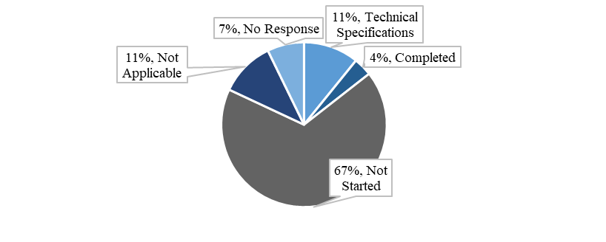

Figure 11: Project Status as per Survey – NA

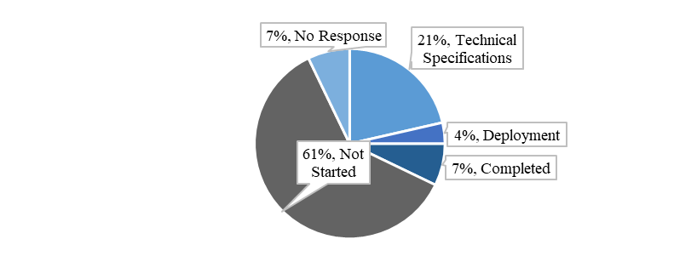

Figure 12: Project Status as per Survey – PN

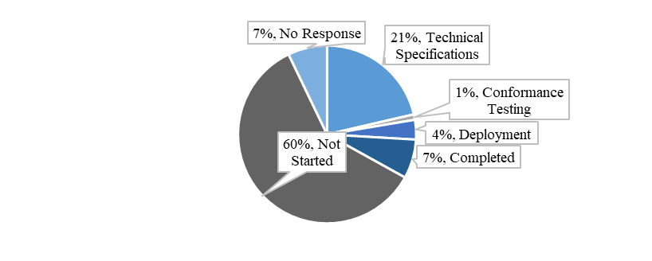

Figure 13: Project Status as per Survey – TS

#### **Overview of Project Progress**

The chart below presents the planning foreseen for NA. The three milestones referred to below are the technical specifications (planned completion 01/03/2022), conformance testing (planned completion 01/10/2022) and the deployment (planned completion 01/12/2022).

Figure 14: Planned Milestones – NA

The chart below presents the planning foreseen for PN. The three milestones referred to below are the technical specifications (planned completion 01/07/2021), conformance testing (planned completion 01/09/2022) and the deployment (planned completion 31/12/2022).

Figure 15: Planned Milestones – PN

The chart below presents the planning foreseen for TS. The three milestones referred to below are the technical specifications (planned completion 01/07/2021), conformance testing (planned completion 01/09/2022) and the deployment (planned completion 31/12/2022).

Figure 16: Planned Milestones – TS

In addition, the tables below highlight any known divergences in the planning compared to the dates set in the Work Programme. BE, DE, FI, PL and SE have indicated a planned deployment date which is later than the one foreseen in the Work Programme.



Table 9: Comparison of Planned and Actual Dates – NA

BE & SE have indicated a planned deployment date for PN, which is later than the one foreseen in the Work Programme.



Table 10: Comparison of Planned and Actual Dates – PN

BE has indicated a planned deployment date for TS which is later than the one foreseen in the Work Programme. In addition, NL was unable to provide planning information as they use an Agile[1] approach that only foresees planning six quarters in advance.



Table 11: Comparison of Planned and Actual Dates – TS

#### **Analysis of Progress against Milestones**

The below figures summarise the status per milestone (technical specifications, conformance testing and deployment). The sum of each bar is 28 (responses from the 28 Member States).

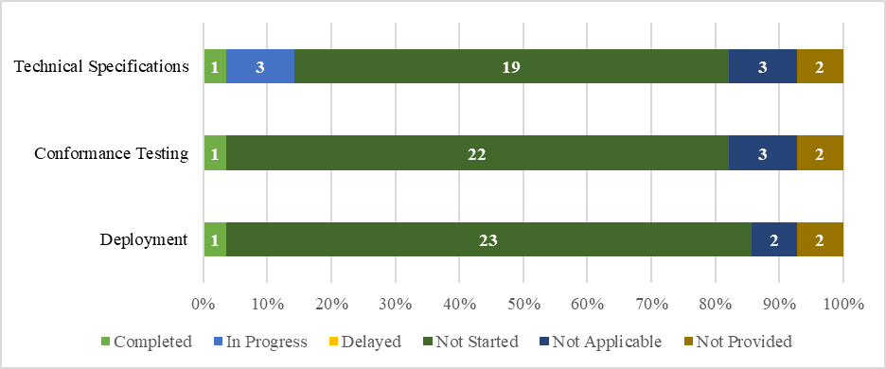

Figure 17: Summary of Responses per Milestone – NA

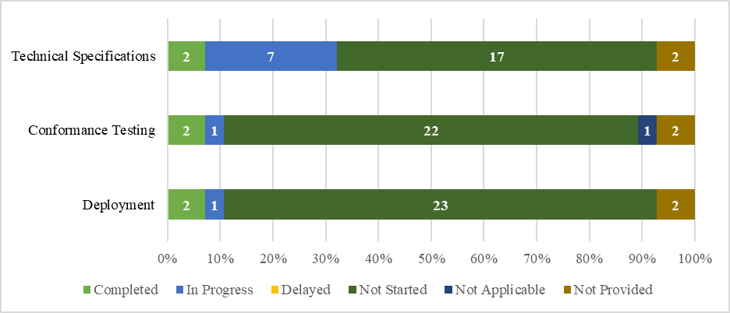

Figure 18: Summary of Responses per Milestone – PN

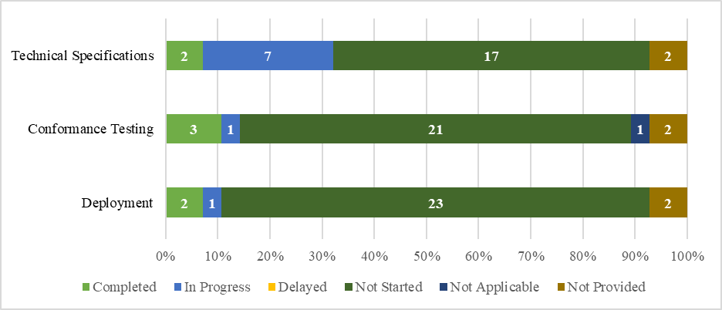

Figure 19: Summary of Responses per Milestone – TS

Additional details regarding the specific percentage of completion per milestone can be seen in the following figures. Regarding NA, the following Member States have not yet started: AT, BG, CY, CZ, ES, FI, FR, GR, HR, HU, LT, LU, MT, NL, PL, PT, SE, SI and SK. IT and the UK did not provide information. Lastly, DE, EE and IE marked NA as Not Applicable.

Figure 20: Percentage of Completion per Phase – NA

Regarding PN, the following Member States have not yet started: AT, CY, CZ, ES, FR, GR, HR, HU, LT, LU, MT, NL, PL, PT, SE, SI and SK. IT and the UK did not provide information.

Figure 21: Percentage of Completion per Phase – PN

Regarding TS, the following Member States have not yet started: AT, CY, CZ, ES, FI, FR, GR, HR, HU, LT, LU, MT, NL, PL, PT, SI and SK. IT and the UK did not provide information.

Figure 22: Percentage of Completion per Phase – TS

## **UCC National Import Systems Upgrade**

The project will implement all processes and data requirements deriving from the UCC which relate to imports of goods into the EU. The existing national import systems must be upgraded in line with these new UCC requirements. The upgrade mainly relates to the changes for the "Release for free circulation" procedure (standard procedure and the simplifications), but also covers the impact of changes in other electronic systems. This project covers the national customs declarations processing systems, as well as national accountancy and payment systems.

#### **Summary of Responses**

SE classifies the complexity of the project as medium-high (5 on a scale out of 6). SE’s survey responses refer exclusively to the standard declaration, while the simplified declaration and the Entry in the Declarant’s Records (EIDR) will follow at a later stage. SE states that everything will be operational as of 30 September 2022. Furthermore, it identifies the risk level as medium because of the uncertainty with the data model.

IE considers the risk as low, foreseeing delays due to the Annex B data changes and to the new Low Value Consignments requirements, but reporting that the deadlines will be met. EE mentions risks pertaining to a lack of resources.

DK and MT both see the highest level of complexity with a high risk level due to the many dependencies with other systems, parallel developments and the plethora of stakeholders involved. Furthermore, DK reports delays due to internal issues, while affirming that some mitigating measures are foreseen. DK explained that a release-based strategy is followed, which means that conformance tests, deployment and migration will happen in multiple iterations. The dates provided in the survey pertain to Release 2.

LU assesses the complexity as medium-high (5 on a scale of 6) due to the integration of import functionalities with various other systems including but not limited to: BTI, SURV3, EOS, AEO and REX. LU further sees the limited number of customs experts - both those in the customs administration and those that could be of assistance to the software developers - as a contributing factor for the high risk. Additionally, LU reports that the Agile methodology employed in its software development activities makes it difficult to provide clear indications on starting dates of activities.

CZ identifies the complexity as medium-high (on a scale of 6) due to the application process and medium risk owing to the high national financial resources needed. CY rates the complexity as the highest and the risk as low, while it has not yet concluded the tender awarding process.

PT underscores the complexity of the project and states that recurrent changes to the data requirements make it difficult to determine whether the work completed continues to be correct and applicable. Consequently, additional costs are created by the need to reassess the aforementioned developments thus further adding to the complexity of the deliverables. Taking into account the fact that the deadline for the conclusion of the harmonisation and amendment of UCC-DA Annex B[2] data requirements and, eventually to UCC-DA Annex A is the end of 2019, PT expresses concern about the planning of the project. The figure below provides an overall summary of the survey responses received from the Member States regarding the status of their project activities.

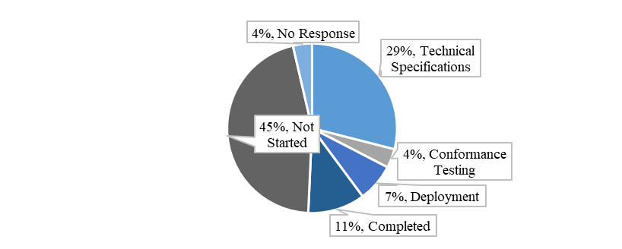

Figure 23: Summary of Survey Responses – National Import Systems Upgrade

#### **Overview of Project Progress**

The below chart represents the foreseen planning. The three milestones referred to below are the technical specifications (planned completion 01/07/2021), conformance testing (planned completion 01/07/2022) and the deployment (planned completion 31/12/2022).

Figure 24: Planned Milestones – National Import Systems Upgrade

In addition, the tables below highlight any divergences in the planning compared to the dates set in the Work Programme. LU reported a very minor delay in the deployment date of two days than the one foreseen in the Work Programme. Therefore, it was decided not to highlight this as an actual delay in the table below.



Table 12: Comparison of Planned and Actual Dates – National Import Systems Upgrade

#### **Analysis of Progress against Milestones**

The figures below summarise the status per milestone (technical specifications, conformance testing and deployment). The sum of each bar is 28 (responses from the 28 Member States).

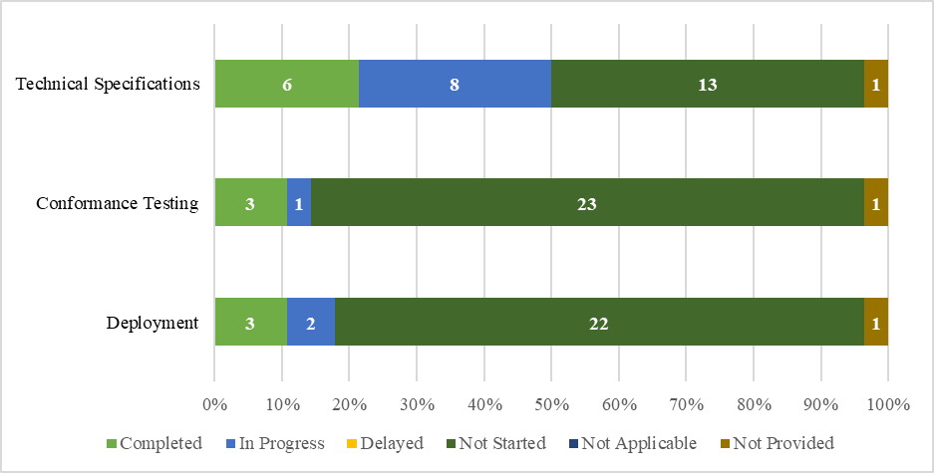

Figure 25: Summary of Responses per Milestone – National Import Systems Upgrade

Additional details regarding the specific percentage of completion per milestone can be seen in the following figures. The following Member States have not yet started: AT, CY, CZ, ES, GR, HU, LT, LU, MT, NL, PL and PT. The UK did not provide information.



Figure 26: Percentage of Completion per Phase – National Import Systems Upgrade

## **UCC Special Procedures**

This national project aims to accelerate, facilitate and harmonise Special Procedures across the Union by means of providing common business process models. The national systems will implement all UCC changes required for all the special procedures (customs warehousing, end-use, temporary admission and inward/outward processing). It should be noted that in many Member States the implementation of this project occurs within the context of the upgrades of the national import and export systems.

In terms of planning, this project will be implemented in two parts. The first component is the "National Special Procedures EXP" (NSP EXP) with the view to providing the required national electronic solutions for the export-related special procedure activities. The second component is the "National Special Procedures IMP" (NSP IMP) with the view to providing the required national electronic solutions for the import-related special procedures activities.

#### **Summary of Responses**

BG and DE report that the first component of the UCC Special Procedures will be implemented in-line with and as part of the national UCC Automated Export System (AES) project, while the second component, will be implemented as part of the national import system. CY and GR are currently facing delays regarding the awarding of the tender; no contracts are in place yet in these Member States. DK indicates that it is following a release-based strategy, including conformance tests, deployment and migration in multiple iterations, while stressing that this shall not affect their national planning. Similarly, Regarding the first component the (NSP EXP) SE plans to follow a phased implementation of the project and start with standard declaration where they plan to be fully operational with all traders migrated by Q4 2023. As a next step, the process will continue with the simplified declaration, entry in the declarants’ records and centralised clearance. They plan to be fully operational by Q4 2025.

CZ and ES alike identified the project complexity as medium-high (5 on a scale out of 6). CZ identifies a medium risk level pertaining to the lack of resources and financial concerns. DK views Component 2 as being highly risky and complex, taking into consideration the dependencies with other systems, the multitude of stakeholders involved, and the parallel development of features that this project requires. It considers scarcity of resources as a possible risk, while some delays have been observed due to internal issues. Nevertheless, DK reiterates that the overall delivery will meet the deadline and that mitigating measures are in place, with others currently planned.

IE and SK also report a risk of delay against the Work Programme deadlines. Both Member States note that a lack of resources is their main concern. IE further mentions the instability of data requirements for the electronic systems, in particular the additions of the new requirements for Low Value Consignments[3] and the e-commerce requirements coming from the VAT Directive[4]. SI identifies a medium risk level, mentioning new functionalities, new data structures, and the transitional period as factors that contribute to a timeline uncertainty.

PT underscores the complexity of the project and, specifically regarding Component 2, states that recurrent changes to the data requirements make it difficult to determine whether the work completed continues to be correct and applicable. Consequently, additional costs are created by the need to reassess the aforementioned developments thus further adding to the complexity of the deliverables.

Taking into account the fact that the deadline for the conclusion of the harmonisation and amendment of UCC-DA Annex B[5] data requirements and, eventually to UCC-DA Annex A is the end of 2019, PT reports an increased complexity of the project. PT further identifies interdependencies with the development of all national, central and other Member States’ systems, as well as national and EU entities connections, as a decisive factor that contributes to the project’s complexity. Regarding the deadlines for the harmonisation of data requirements, PT mentions as further factors that could contribute to delays, the lack of data consolidation in particular because of later additions. However, PT foresees completing the project within the deadline. PT also plans an increase of its internal resources and further support to the Commission activities related to the consolidation of UCC Annex B as mitigating measures to meet the deadlines.

The figures below provide an overall summary of the responses received from the Member States regarding the status of their project activities.

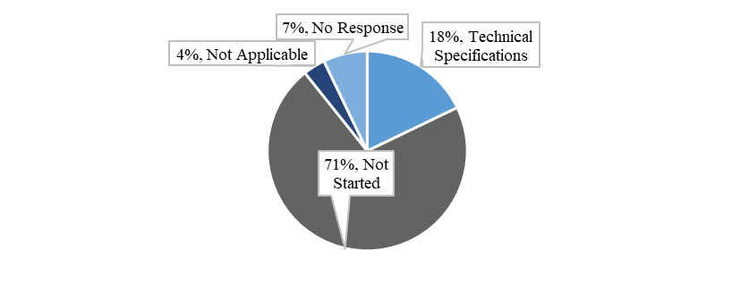

Figure 27: Project Status as per Survey – Component 1 National SP EXP

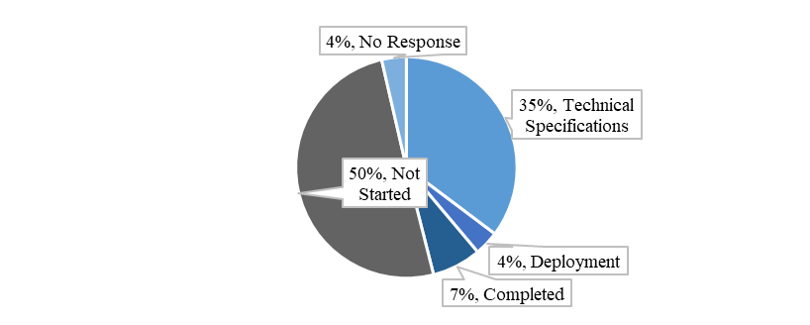

Figure 28: Project Status as per Survey – Component 2 National SP IMP

#### **Overview of Project Progress**

The charts below present the planning foreseen. The three milestones referred to below are the technical specifications (planned completion 01/10/2022 for Component 1 and 30/06/2022 for Component 2), conformance testing (planned completion 15/6/2023 for Component 1 and 07/01/2022 for Component 2) and the deployment (planned completion 01/12/2023 for Component 1 and 31/12/2022 for Component 2).

Figure 29: Planned Milestones – SP – Component 1 Nat SP EXP

Figure 30: Planned Milestones – SP – Component 2 Nat SP IMP

In addition, the below tables highlight any known divergences in the planning compared to the dates set in the Work Programme[6].



Table 13: Comparison of Planned and Actual Dates – SP – Component 1 Nat SP EXP



Table 14: Comparison of Planned and Actual Dates – SP – Component 2 Nat SP IMP

#### **Analysis of Progress against Milestones**

The below figures summarise the status per milestone (technical specifications, conformance testing and deployment). The sum of each bar is 28 (all Member States).

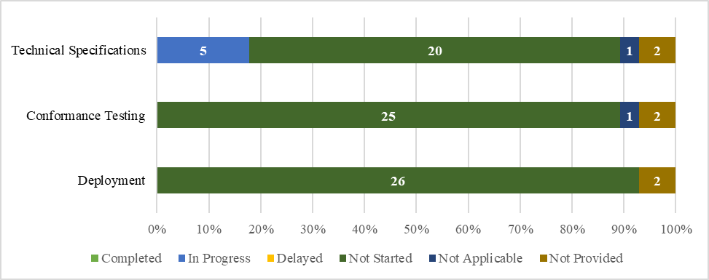

Figure 31: Summary of Responses per Milestone – SP – Component 1 Nat SP EXP

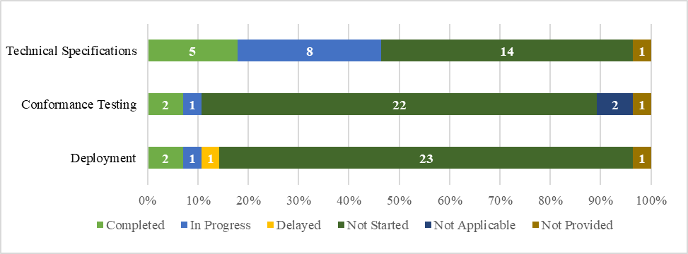

Figure 32: Summary of Responses per Milestone – SP – Component 2 Nat SP IMP

Additional details regarding the specific percentage of completion per milestone can be seen in the following figures. Regarding Component 1, the following Member States have not yet started: AT, BG, CY, CZ, DK, EE, ES, FU, GR, HR, HU, IE, LT, LU, LV, MT, NL, PT, SE, SK. FR, IT and the UK did not provide information. BE marked Component 1 as Not Applicable.

Figure 33: Percentage of Completion per Phase – SP – Component 1 Nat SP EXP

Regarding Component 2, the following Member States have not yet started: AT, CY, CZ, ES, FI, GR, HR, HU, LT, LU, MT, NL, PT, SK. FR and the UK did not provide information.

Figure 34: Percentage of Completion per Phase – SP – Component 2 Nat SP IMP

## **UCC Guarantee Management (GUM)**

The UCC Guarantee Management (GUM) project aims to assure the effective and efficient management of the different types of guarantees.

The system is comprised of two components. The first component is "GUM". GUM is a trans-European system that will cover the management of the comprehensive guarantees that may be used in more than one Member State. GUM would also cover the monitoring of the reference amount for each customs declaration, supplementary declaration or appropriate information needed. Transit is an exception to the above and is handled as part of the NCTS project. As the project initation phase is still ongoing, the exact scope and implementation approach is not yet fully decided upon and will take form in the context of the approval of the business case document. Alternative ways of re-using other systems is looked into. This decision may then also impact the second component of the project, which is the "National Guarantee Management" system. In addition to GUM, the electronic systems existing at the national level which manage the valid guarantees in one Member State are to be upgraded.

#### **Summary of Responses**

BG views the risk and complexity as low since the GUM – Component 1 project activities depend on the decisions taken at the European Commission level. CY also finds the risk as low but mentions that the complexity is high (6), while adding that the tender process awarding has not yet concluded. CZ considers that the complexity is high (6) and the risk level is also high, more specifically pertaining to GUM – Component 1, stating that a considerable amount of financial resources will be required. After a follow-up call with CZ, the updated dates are in full compliance with the Work Programme. Regarding, GUM – Component 2, CZ also identifies risks pertaining to financial resources. DE reports that this project depends on decisions still to be taken on the business case at EU level and as such there is no justification to start national development activities at this stage.

LU assesses the project complexity and risk as medium (4). The complexity of the GUM project is mostly determined by its integration with its national accounting system. LU sees a medium risk due to the limited number of customs experts in the administration and in IT roles, while it also underlines its use of an Agile approach as a factor that makes it difficult to provide future development dates.. FR estimates the risk level as high due to possible impacts on its national Guarantee management system. In addition, FR mentions issues with the preparedness of the regulatory office, marking the complexity of the project as the highest (6).

The figures below provide an overall summary of the survey responses received from the Member States and the Commission regarding the status of project activities.

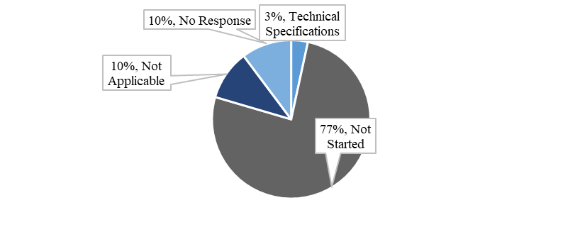

Figure 35: Summary of Survey Responses – GUM – Component 1

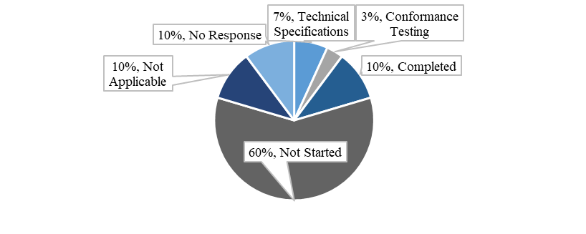

Figure 36: Summary of Survey Responses – GUM – Component 2

#### **Overview of Project Progress**

The charts below present the planning foreseen. The three milestones referred to below are the technical specifications (planned completion 30/09/2022 for Component 1 and 30/11/2024 for Component 2), conformance testing (planned completion 01/04/2025 for Component 1 and 02/01/2025 for Component 2) and the deployment (planned completion 01/06/2025 for Components 1 and 2).

Figure 37: Planned Milestones – GUM – Component 1

Figure 38: Planned Milestones – GUM – Component 2

In addition, the tables below highlight any known divergences in the planning compared to the dates set in the Work Programme. 

Table 15: Comparison of Planned and Actual Dates – GUM – Component 1



Figure 39: Comparison of Planned and Actual Dates – GUM – Component 2

#### **Analysis of Progress against Milestones**

The figures below summarise the status per milestone (technical specifications, conformance testing and deployment). The sum of each bar in Figure 40 is 29 (responses from the 28 Member States plus the European Commission). The sum of each bar in Figure 41 is 28 (responses from the 28 Member States).

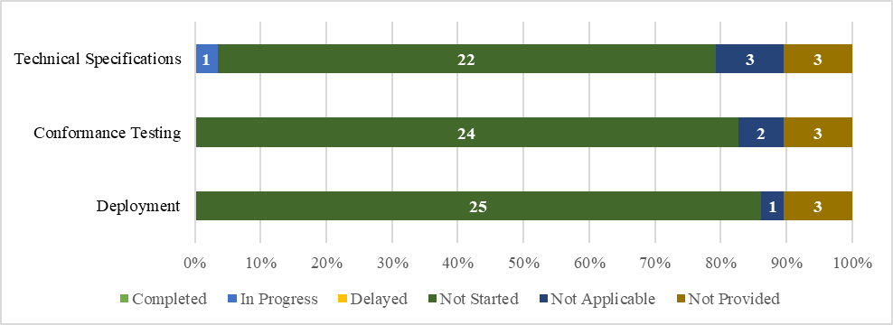

Figure 40: Summary of Responses per Milestone – GUM – Component 1

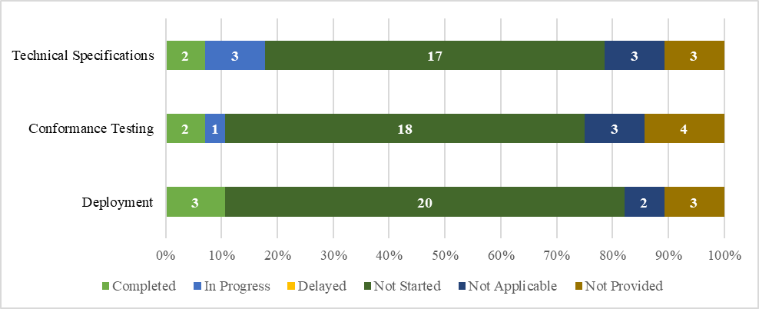

Figure 41: Summary of Responses per Milestone – GUM – Component 2

Additional details regarding the specific percentage of completion per milestone can be seen in the following figures. Regarding Component 1, the only Member State that has started is DK. IT, PL and the UK did not provide information. Lastly, DE marked Component 1 as Not Applicable.

Figure 42: Percentage of Completion per Phase – GUM – Component 1

Regarding Component 2, the following Member States have not yet started: AT, BE, CY, CZ, EE, FI, HR, HU, LU, MT, NL, PT, RO, SI and SK. FR, GR, IT, PL and the UK did not provide information. DE marked Component 2 as Not Applicable. Lastly, LV updated their National guarantee system together with their national import system on 03/06/2018.

Figure 43: Percentage of Completion per Phase – GUM – Component 2

## **UCC Import Control System Upgrade (ICS2)**

The goal of the UCC Import Control System Upgrade (ICS2) project is to strengthen the safety and security of the supply chain for all modes of transport and especially air cargo. The aim is to do so through improving data quality, data filing, data availability and data sharing in regards to the entry summary declaration and related risk and control information. The main purpose of the system is implementing the new requirements resulting from the UCC. The new requirements are in regards to the lodgement and treatment of pre-arrival declarations (“entry summary declarations” – “ENS”), namely the provision of ENS data and the exchange of that data.

In terms of project architecture, this project will lead to a complete new architecture of the existing trans-European ICS system. The project will also facilitate collaboration amongst Member States in the process of risk analysis. In terms of planning, the project will be implemented in three phases or releases. Release 1 will cover the obligation on the relevant economic operators (postal operators and express carriers in air transport) to provide the minimum data i.e. ENS pre-loading dataset. Release 2 will cover the implementation of complete new ENS obligations and related business and risk management processes for all the goods in air traffic. Release 3 will cover the implementation of the complete new ENS obligations and related business and risk management processes for all goods in maritime and inland waterways, road and rail traffic (this includes goods in postal consignments transported in these means of transport).

The Commission centrally develops this project and the technical specifications were completed on 30/06/2018. The complexity is high (6 out of 6) due to very high required availability that affects the infrastructure requirements. Furthermore, it underlines the dependencies on other systems, as well as the fact that conformance testing with economic operators systems is required. Nevertheless, the Commission classifies the risk as low, reporting that on-time delivery is probable.

#### **Overview of Project Progress**

The below charts represent the actual completion versus the plan. The three milestones referred to below are the technical specifications (completed 30/06/2018 for all three releases), conformance testing (planned completion 15/03/2021 for Release 1, 01/03/2023 for Release 2 and 01/03/2024 for Release 3) and the deployment (planned completion 01/10/2021 for Release 1, 02/10/2023 for Release 2 and 01/10/2024 for Release 3).

esFigure 44: Planned versus Actual Completion of Milestones – ICS2 – Release 1

Figure 45: Planned versus Actual Completion of Milestones – ICS2 – Release 2

Figure 46: Planned versus Actual Completion of Milestones – ICS2 – Release 3

In addition, the table below indicates no known divergences in the planning compared to the dates set in the Work Programme.



Table 16: Comparison of Planned and Actual Dates – ICS2 – Release 1

## **UCC Proof of Union Status (PoUS)**

PoUS is a new trans-European system which is designed to allow storage, management and retrieval of certain types of documents (e.g. T2L, T2L/F, customs goods manifest) that traders provide to prove the Union status of their goods. The system will improve the uniformity of the procedures across the European Union and contribute to the establishment of a more consistent, harmonised and thus simplified process related to customs clearance for Union goods.

A system will be created that it will include a Central Repository for the storage and exchange between Customs Authorities across all Member States of data and documents dealing with proof of Union status.

At the moment of the survey, the business case document was not yet finalised and discussions were taking place on the scope and the most appropriate implementation options (central system versus hybrid system versus decentralised system, possibly combined with collaboration initiatives). Whilst substantial progress has occurred in the second half of 2019 as regards the PoUS project, the outcome of the survey shows the uncertainties in the Member States on whether they (need to) consider additional national developments. Discussions are ongoing between the Commission, the Member States and the trade community to analyse and determine the most suitable steps forward for this project and to conclude on the acceptance of the updated business case document by end 2019. Since the survey was conducted it has been decided to take the hybrid approach and a phased development is now envisaged. There are ongoing legal discussions about certain aspects, once these are finalised the results will be considered.

#### **Summary of Responses**

Member States will have the option of using the central PoUS system or developing their own national version. Several Member States conveyed their intention to use the system developed by the European Commission: BG, DE, EE, ES, FI, LT, LV, RO, SE and SI. DK expressed the view that Member States opting to use the Commission system will be subject to the delivery dates indicated in the Work Programme. In terms of the overall project status, PT thought it might be necessary to develop national technical specifications for the purpose of communications with economic operators.

Those Member States opting to develop their national versions of PoUS identified risks for compliance with the timeline and the predicted milestones. The process of awarding the tender is still in progress for CY, while CZ reported that technical and business documentation are unavailable at this stage, due to its ongoing review cycle. CY views the risk as low and the project complexity high (6 on a scale of 6). CZ marks both project complexity (3 out of 6) and the risk level as medium. During a follow-up communication, CZ indicated that they would follow the latest deadlines provided by the Work Programme, yet revealed that it had not yet appointed a National Project Manager. IE expressed the same willingness to readjust national planning deadlines so as to comply with the timeline. SK voiced a concern regarding the sufficiency and expertise of its human resources, identifying the project as medium risk with a medium complexity (3 out of 6). It does not yet foresee any mitigating actions as its impact analysis is still ongoing.

#### **Overview of Project Progress**

The chart below presents the planning. The three milestones referred to below are the technical specifications (planned completion 31/03/2022), conformance testing (planned completion 01/03/2024) and the deployment (planned completion 01/03/2024).

1) Technical Specifications

2) Conformance Testing

3) Deployment

Figure 47: Planned Milestones – PoUS

Taking into account the new developments during the second half of 2019 as regards the implementation approach for the PoUS project, it is not possible to report any firm divergences known at this stage in the planning compared to the dates set in the Work Programme. DK, ES, GR, HR, HU and LU have stated that they foresee a deployment date that is later than the one foreseen in the Work Programme. However, as at the moment of drafting the report the phased approach to the project was not yet concluded and reflected, only the date of 01/03/2024 was mentioned and Member States were only asked to report against this date. In the final version of the UCC WP, a two-phased approach was agreed in order to allow the customs goods manifest implementation to be linked to the European Maritime Single Window implementation. As Member Stats were not asked to distinguish progress versus phase 1 and phase 2, these were not reflected. The delays highlighted in the table below are against the initial date of 01/03/2024 and not against the agreed dates of the two phases 01/03/2024 and 2/06/2025. As none of the dates referred to by Member States were later than 2/06/2025 (i.e. deployment deadline for phase 2), the highlights in red in the table below are not necessarily to be considered as delays. In addition it has to be explained that Member States have provided dates if they considered that this activity would be required at national level and have not provided dates or "N/A" (not applicable) when they considered this activity would occur at EU level.



Table 17: Comparison of Planned and Actual Dates – PoUS

## **UCC Centralised Clearance for Import (CCI)**

The UCC Centralised Clearance for Import (CCI) project aims to coordinate between Member States the system for processing customs declarations and for authorising the release of goods into customs procedures, allowing economic operators to centralise in one place in the EU their customs declaration activities.

In terms of the planning approach as a trans-European system, the project contains components developed centrally and nationally. The project will be implemented in two phases.

Phase 1 will cover the combination of centralised clearance with standard customs declarations and with simplified customs declarations and related supplementary declarations (which regularise simplified customs declarations). In addition, this Phase will cover the placing of goods under the following customs procedures: release for free circulation, customs warehousing, inward processing and end-use. As regards the types of goods involved, this Phase will cover all types of goods with the exception of excise goods and goods subject to common agricultural policy measures. The functional specifications have been completed and work is ongoing as regards the technical specifications. Phase 2 will cover everything that is not covered by Phase 1, namely the combination of centralised clearance with customs declarations through an entry in the declarant’s records and related supplementary declarations; supplementary declarations regularising more than one simplified customs declaration; the placing of goods under the temporary admission procedure; and excise goods.

#### **Summary of Responses**

BG reports that CCI - Phase 1 has been implemented at national level as part of its national import system, while for Phase 2 the planning has not yet started. Therefore, BG has assessed the complexity high but the risk low.

CY has not yet concluded the awarding of the tender process. CZ judges the risk and complexity as medium. Regarding Phase 1, CZ finds the complexity assessment challenging as it only had the opportunity to approve the business documents[7] very recently. CZ further reports that it participated in the Project Group (PG) for the preparation of the above documents, and is now waiting for next steps to be defined by the PG. This might lead to a delay in the deployment. Regarding Phase 2, CZ again faces difficulty in accurately assessing the complexity because it only participated in the last Customs Business Group (CBG) meeting which focused on Phase 2 (Import) (03/06/2019). During this meeting, the Commission presented the draft business case. After the formal approval of the business case CZ reports it will continue with the next steps. The risk CZ sees in Phase 2 pertains to the business and IT documentation that is still not available and it states that this might interfere with their ability to meet the milestones.

DE notes a low risk for the overall project and classifies the complexity as medium-high (4), highlighting that the specifications have not yet been finalised. No delays are predicted at this stage.

In DK’s assessment, the primary complexity lies not in the technical aspects, but with the practical issues regarding the harmonisation between Member States (e.g. national codes, regulations and statistics). For this reason it assesses both the complexity and the risk as being medium. Furthermore, DK reports a delay in developing the import solution and platform necessary for handling CCI. In order to mitigate this, it has included high-level requirements for CCI handling in its tender for the new import solution. It classifies the risk as medium due to the parallel development (with export and transit).

LU judges the complexity as the highest possible, attributing it to the interdependencies with other export systems such as but not limited to: BTI, SURV3, EOS, AEO and REX. LU sees a medium risk with the limited number of customs experts involved in the administration and in consulting with the software developers, while it underlines its use of an Agile approach as a factor that makes it difficult to provide future development dates.

MT classifies the risk and complexity as high for both phases. This is due to the fact that it is difficult to assess complexity before specifications are finalised.

PT also judges the complexity at a level of 6 out of 6. PT finds that since this project will be developed and implemented within the National Import System, which is highly complex, the integration of CCI - Phase 2 will also be complex. The development of this system is also linked to the development of all national, central and other Member States’ systems, which increases the interdependencies and the complexity of the “global system”.

SK finds the risk low and mentions that while there may be delays these should not affect the key milestones. SK further mentions that an impact analysis is ongoing and therefore no mitigation measures are foreseen yet.

The European Commission finds both the risk and the complexity as moderate in view of the agreement achieved on the business case for Phase 2 in October 2019.

The figures below provide an overall summary of the survey responses received from the Member States and the European Commission regarding the status of their project activities.

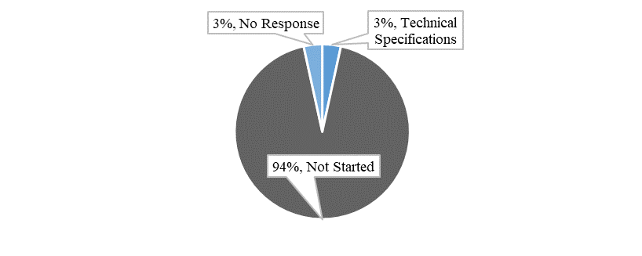

Figure 48: Summary of Survey Responses – CCI – Phase 1

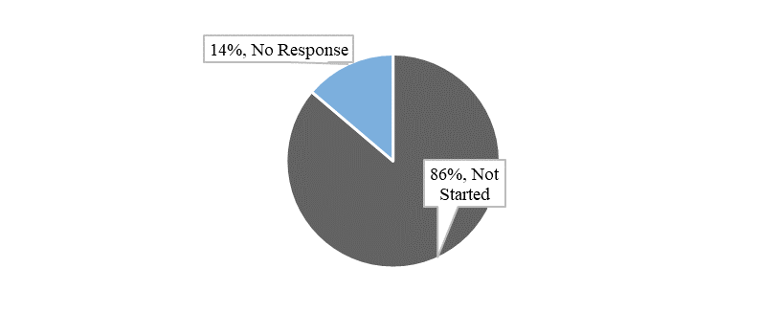

Figure 49: Figure 53: Summary of Survey Responses – CCI – Phase 2

#### **Overview of Project Progress**

The charts below present the planning for CCI Phases 1 and 2. The three milestones referred to below are the technical specifications (planned completion 30/09/2020 for Phase 1 and 30/06/2022 for Phase 2), conformance testing (planned completion 01/10/2023 for Phase 1 and 31/12/2024 for Phase 2) and the deployment (planned completion 01/12/2023 for Phase1 and 01/06/2025 for Phase 2).

Figure 50: Planned Milestones – CCI – Phase 1

Figure 51: Planned Milestones – CCI – Phase 2

In addition, the tables below highlight any known divergences in the planning compared to the dates set in the Work Programme.



Table 18: Comparison of Planned and Actual Dates – CCI – Phase 1



Table 19: Comparison of Planned and Actual Dates – CCI – Phase 2

#### **Analysis of Progress against Milestones**

The figures below summarise the status per milestone (technical specifications, conformance testing and deployment). The sum of each bar is 29 (responses from the 28 Member States plus the European Commission).

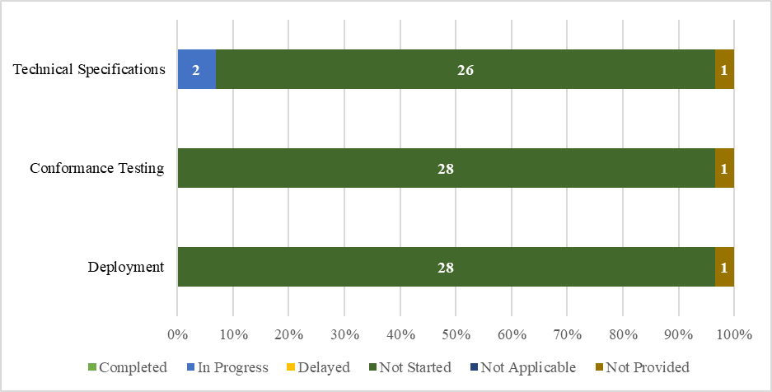

Figure 52: Summary of Responses per Milestone – CCI – Phase 1

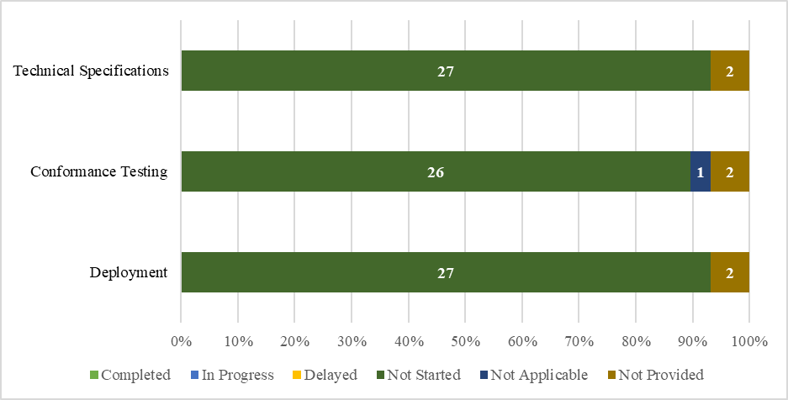

Figure 53: Summary of Responses per Milestone – CCI – Phase 2

Additional details regarding the specific percentage of completion per milestone can be seen in the following figure. Regarding Phase 1, the Commission is currently working on the technical specifications to be provided to the Member States for the development of the national components. PL is the only Member State that has started. The UK did not provide information. CCI – Phase 2 has not yet started.

Figure 54: Percentage of Completion per Phase – CCI – Phase 1

## **UCC New Computerised Transit System (NCTS) Upgrade**

The aim of this project is to align the existing trans-European New Computerised Transit System (NCTS) to the new UCC legal provisions including the alignment of information exchanges to UCC data requirements, the upgrade and development of interfaces with other systems such as AES and the Excise Movement and Control System (EMCS) in addition to new safety and security requirements.

In terms of the planning approach, the project is divided into two components. Component 1, the ‘NCTS Phase 5’ includes steps to provide for the registration of ‘en-route’ events, for the alignment of information exchanges to UCC data requirements and for the upgrade and development of interfaces with other systems. The system includes some parts to be developed centrally but the main components are to be developed at national level.

Component 2, the ‘NCTS Phase 6’ aims to include potential new requirements in the field of safety and security data elements in transit customs declarations. These requirements relate to goods brought into the customs territory of the Union and are also incorporated in the UCC Import Control System Upgrade 2 (ICS2). The scope and implementation solution will be agreed upon during the project initiation phase early 2020, as the business case has not yet been started. The lack of clarity of the implementation requirements for this phase 2 is the reason why some Member States have not yet provided dates or reported "N/A" (not applicable).

#### **Summary of Responses**

The Commission pointed out in its Overview of the Customs Information Systems[8] that the NCTS is a system that is already in operation, with multiple stakeholders, and the functioning of this existing system cannot be jeopardised.

Component 1 requires many changes in specifications, especially message structures, making the transition to the new system extremely complex.

The high complexity (partially due to the decentralised architecture and the migration to the new phase of the system during a transition window) of this project means that there are many associated risks. Despite this, no delays have materialised so far and the project is currently on track. The technical specifications were completed in the second half of 2019 in collaboration with the Member States and Trade associations. All national administrations have indicated to be ready within the foreseen deployment window in the Work Programme, starting operations in Q1 2021 until Q4 2023. DE and PL will be forerunner Member States entering into operations in the first half of 2021, followed by FR in the second half. At time of writing the report, the Member States are finalising their plans and a number have reacted positively to the call of the Commission to bring forward the deployment date (see also footnote). The risks are at this stage under control. The Commission sets up a coordination programme to follow up the implementation plan of the Member States.

Some specific issues raised: BG reports that the national planning has not yet commenced for NCTS Phase 6 (Component 2). CY reports that due to possible delays in the process of awarding the tender, there may be an impact on its ability to meet the milestone deadlines. CZ and ES identify risks pertaining to resourcing and financial constraints. DE notes that further business analysis for NCTS Phase 6 is required to ensure seamless trade logistics at the border when combined with ICS2. CZ is concerned at the complexity of the project, while SE notes that all dates provided are indicative and marks the complexity as medium (4 on a scale out of 6). SE also notes that there is a risk since the data requirements are not yet stable and changes can have an impact on the timelines. Lastly, SK, despite marking the project as low risk, reports that its impact analysis is still ongoing and that so far no mitigating actions are being taken. In short, while some delays are expected, it is expected that all deadlines set out in the Work Programme will be met.

The figures below provide an overall summary of the survey responses received from the Member States and the European Commission regarding the status of their project activities.

Figure 55: Project Status as per Survey – NCTS – Component 1 or Phase 5

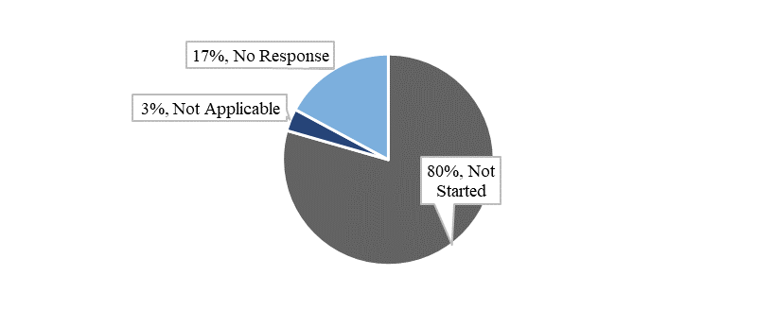

Figure 56: Project Status as per Survey – NCTS – Component 2 or Phase 6

#### **Overview of Project Progress**

The charts below present the planning for both Components 1 and 2. The three milestones referred to are the technical specifications (planned completion 31/12/2019 for Component 1 and 30/06/2022 for Component 2), conformance testing (planned completion 15/06/2023 for Component 1 and 31/12/2021 for Component 2) and the deployment (planned completion 01/12/2023 for Component 1 and 01/01/2025 for Component 2).

­

Figure 57: Planned Milestones – NCTS – Component 1

1) Technical Specifications

2) Conformance Testing

3) Deployment

Figure 58: Planned Milestones – NCTS – Component 2

In addition, the tables below highlight any known divergences in the planning compared to the dates set in the Work Programme[9].



Table 20: Comparison of Planned and Actual Dates – NCTS – Component 1



Table 21: Comparison of Planned and Actual Dates – NCTS – Component 2

#### **Analysis of Progress against Milestones**

The figures below summarise the status per milestone (technical specifications, conformance testing and deployment). The sum of each bar is 29 (responses from the 28 Member States plus the European Commission).

Figure 59: Summary of Responses per Milestone – NCTS – Component 1

Figure 60: Summary of Responses per Milestone – NCTS – Component 2

Additional details regarding the specific percentage of completion per milestone can be seen in the following figures. Regarding Component 1, the following Member States have not yet started: AT, BG, CY, CZ, DK, EE, ES, FI, FR, GR, HR, HU, IE, LT, LV, MT, NL, PT, SE, and SK. The UK did not provide information.



Figure 61: Percentage of Completion per Phase – NCTS – Component 1 or Phase 5

## **UCC Automated Export System (AES)**

The AES consists of an upgrade of both the existing trans-European Export System and the existing national export systems. It aims to implement the UCC requirements for export and exit of goods including re-export.

In terms of planning, the system is comprised of two components. The first component relates to the "Trans-European AES". The aim of the project is to further develop the existing trans-European Export Control System (ECS) in order to implement a full AES that would cover the business requirements for processes and data brought about by the UCC. These processes and data would include the coverage of simplified procedures and centralised clearance for export. It is also envisaged to cover the development of harmonised interfaces with the Excise Movement and Control System (EMCS) and NCTS. As such, AES will enable the full automation of export procedures and exit formalities. The system includes some parts to be developed centrally but the main components are to be developed at national level. The second component related to the upgrade of the national export systems.

#### **Summary of Responses**

The Commission services in their response viewed the project as highly complex, due to the fact that it requires migration from an existing system and a plethora of changes in the messages exchanged. The aim must be to ensure that the transition is completed in a smooth manner and that it leads successfully to the new system.

The high complexity (partially due to the decentralised architecture and the migration to the new phase of the system during a transition window) of this project means that there are many associated risks. Despite this, no delays have materialised so far and the project is currently on track. The technical specifications were completed in the second half of 2019 in collaboration with the Member States and Trade associations.

All national administrations have indicated to be ready within the foreseen deployment window in the Work Programme, starting operations in Q1 2021 until Q4 2023. DE and PL will be forerunner Member States entering into operations in the first half of 2021. At time of writing the report, the Member States are finalising their plans and a number have reacted positively to the call of the Commission to bring forward the deployment date (see also footnote). The risks are at this stage under control. The Commission sets up a coordination programme to follow up the implementation plan of the Member States.

Some specific issues raised: CY foresees delays in meeting the deadlines and milestones, as it has not yet initiated its tender process. Similarly, GR has no contract in place yet. IE is at the stage of reviewing and providing feedback on the AES documentation provided by the Commission. SE notes that there is a risk since the data requirements are not yet stable and changes can have an impact on the timelines. SE plans to follow a phased implementation of the project and to start with standard declaration. As a next step, SE will continue with the simplified declaration, entry in the declarant’s record and centralised clearance at export. SE will have a phased approach with a preliminary date for publication of the first technical specification on 1/05/2021, start of conformance testing on 1/10/2022, and a migration period from the 1/10/2022 with a planned end date of deployment the 30/11/2023. All dates provided by SE are preliminary.

SK is performing an impact analysis and does not foresee mitigating measures at this stage. CZ and ES share a concern pertaining to the lack of resources and the high complexity of the project. CZ judges the complexity as medium-high (5 on a scale out of 6) while ES views the project as falling under level 6, corresponding to the highest project complexity denoted in the survey.

The figures below provide an overall summary of the survey responses received from the Member States and the European Commission regarding the status of their project activities.

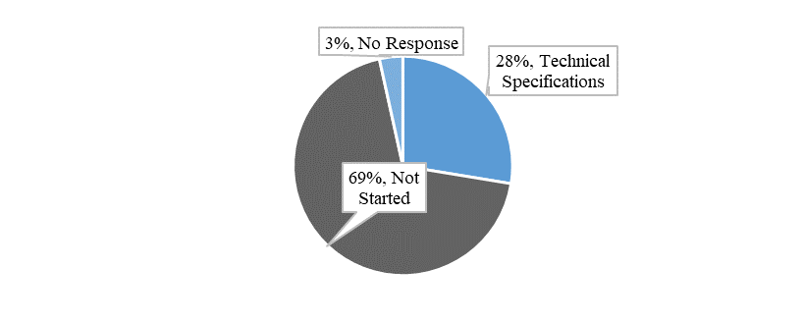

Figure 62: Project Status as per Survey – AES – Component 1

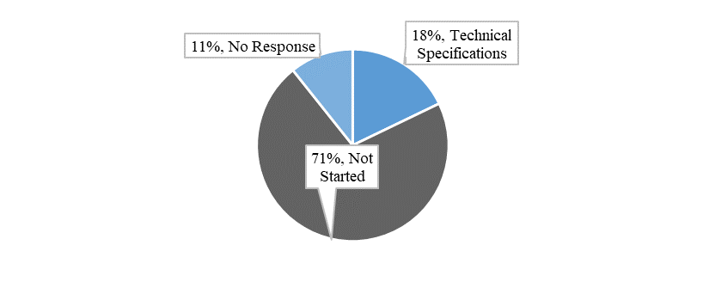

Figure 63: Project Status as per Survey – AES – Component 2

#### **Overview of Project Progress**

The chart below represents the planning for both Components 1 and 2. The three milestones referred to below are the technical specifications (planned completion 31/12/2019 for Component 1 and 01/09/2022 for Component 2), conformance testing (planned completion 01/10/2023 for Component 1 and 01/10/2023 for Component 2) and the deployment (planned completion 01/12/2023 for Component 1 and 01/12/2023 for Component 2).

Figure 64: Planned Milestones – AES – Component 1

Figure 65: Planned Milestones – AES – Component 2

In addition, the tables below highlight some divergences in the planning compared to the dates set in the Work Programme[10].



Table 22: Comparison of Planned and Actual Dates – AES – Component 1



Table 23: Comparison of Planned and Actual Dates – AES – Component 2

#### **Analysis of Progress against Milestones**

The figures below summarise the status per milestone (technical specifications, conformance testing and deployment). The sum of each bar in Figure 64 is 29 (responses from the 28 Member States plus the European Commission). The sum of each bar in Figure 65 is 28 (responses from the 28 Member States).

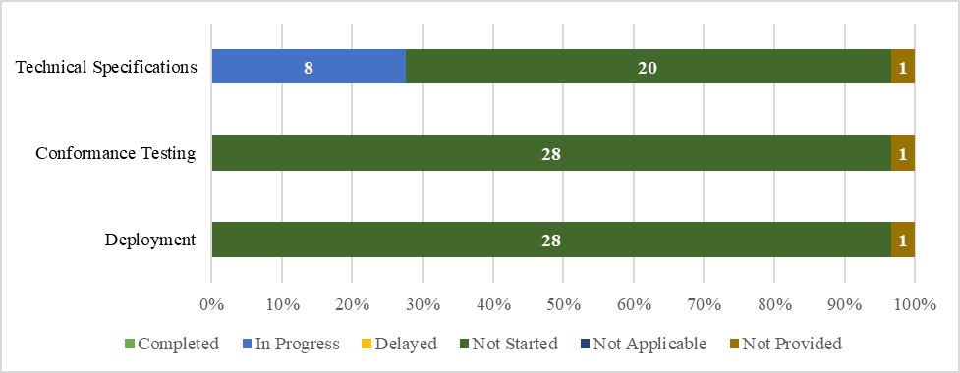

Figure 66: Summary of Responses per Milestone – AES – Component 1

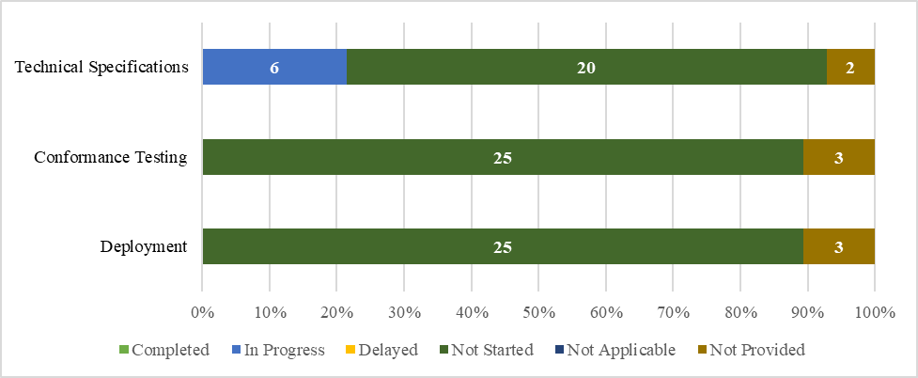

Figure 67: Summary of Responses per Milestone – AES – Component 2

Additional details regarding the specific percentage of completion per milestone can be seen in the following figures. Regarding Component 1, the following Member States have not yet started: AT, BG, CY, CZ, DK, EE, ES, FI, GR, HR, HU, IE, LT, LU, LV, MT, NL, PT, SE, and SK. The UK did not provide information.

Figure 68: Percentage of Completion per Phase – AES – Component 1

Regarding Component 2, the following Member States have not yet started: AT, BG, CY, CZ, DK, EE, ES, FI, GR, HR, HU, IE, LT, LU, LV, MT, NL, PT, SE, and SK. FR and the UK did not provide information.

Figure 69: Percentage of Completion per Phase – AES – Component 2

# Annex 1 – Planning Overview – UCC Work Programme Projects

In the figure below, a visual overview of the planning status of the UCC Work Programme Projects is presented as of Q4 2019. The overview provides the timeline of the development of the projects. The ‘N’ symbol indicates the projects that are national. The other projects are related to trans-European systems, which might have a central architecture or decentralised architecture.

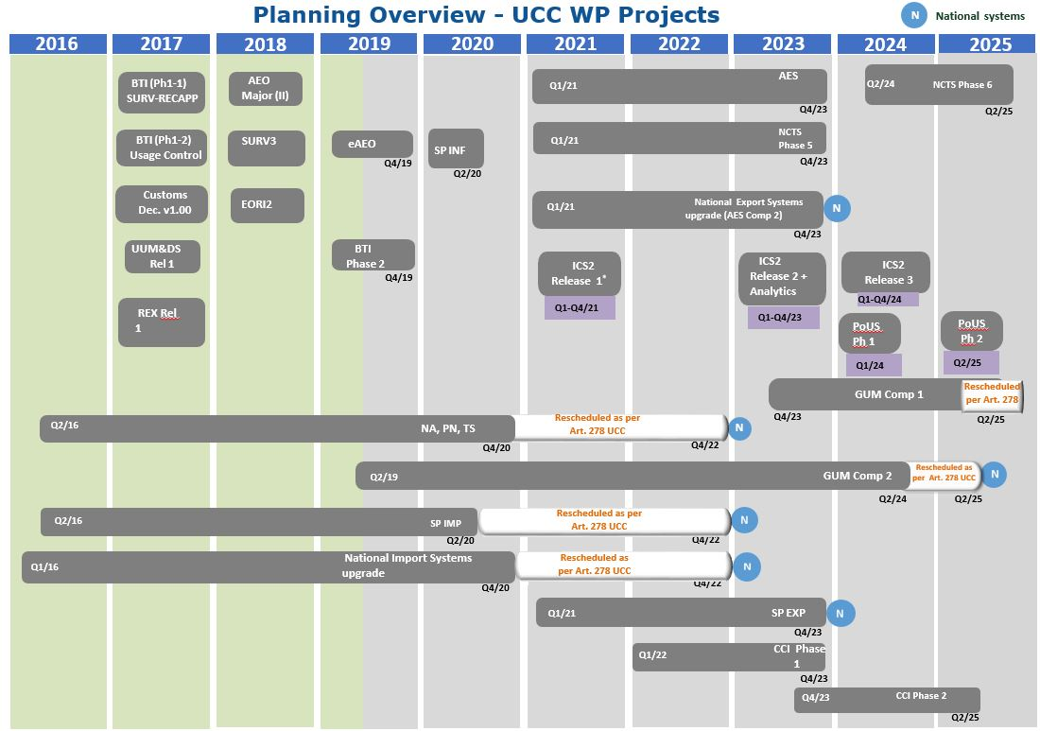

Figure 70: Planning Overview: UCC Work Programme Projects – Status Q4 2019

# Annex 2 – Acronyms, Abbreviations & Key Terms

| **Acronym** | **Description** |
| --- | --- |
| AEO | Authorised Economic Operator |
| AES | Automated Export System |
| BPM | Business Process Model |
| BTI | Binding Tariff Information |
| CAP | Common Agricultural Policy |
| CBG | Customs Business Group |
| CCI | Centralised Clearance for Import |
| CDC | Customs Duties Calculation |
| COM | European Commission |
| DA | Delegated Act |
| DG TAXUD | Directorate General for Taxation and Customs Union |
| EBTI | European Binding Tariff Information |
| ECCG | Electronic Customs Coordination Group |
| ECS | Export Control System |
| EIDR | Entry in the Declarant's Records |
| EMCS | Excise Movement and Control System |
| EMSW | European Maritime Single Window |
| ENS | Entry Summary Declaration |
| EORI | Economic Operators Registration and Identification |
| EOS | Economic Operator System |
| ETCIT II | Grant for expert team on new approaches to develop and operate Customs IT systems |
| EUCDM | European Union Customs Data Model |
| EXP | Export |
| GSP | Generalised Scheme of Preferences |
| GUM | Guarantee Management |
| IA | Implementing Act |
| ICS; ICS2 | Import Control System; Import Control System 2 |
| IMP | Import |
| INF | Information Sheet |
| MASP | Multi-Annual Strategic Plan |
| NCTS | New Computerised Transit System |
| MS | Member State |
| NES | National Export System |
| NSP | National Special Procedures |
| PG | Project Group |
| Q1/2/3/4 | Quarter 1/2/3/4 |
| REX | Registered Exporters System |
| STI | Shared Trader Interface |
| UCC | Union Customs Code |
| UI | User Interface |
| UUM&DS | Uniform User Management & Digital Signature |
| VAT | Value Added Tax |

Table 24: Abbreviations and Acronyms

1. A method of project management, used especially for software development,that is characterised by the division of tasks into short phases of work and frequent reassessment and adaptation of plans.
2. European Commission Delegated Regulation (EU) 2015/2446 of 28 July 2015 supplementing Regulation (EU) No 952/2013 of the European Parliament and of the Council as regards detailed rules concerning certain provisions of the Union Customs Code (OJ L 343, 29.12.2015, p. 1).
3. European Commission Delegated Regulation (EU) 2019/1143 of 14 March 2019 amending Delegated Regulation (EU) 2015/2446 as regards the declaration of certain low-value consignments
4. Council Directive 2006/112/EC of 28 November 2006 on the common system of value added tax
5. European Commission Delegated Regulation (EU) 2015/2446 of 28 July 2015 supplementing Regulation (EU) No 952/2013 of the European Parliament and of the Council as regards detailed rules concerning certain provisions of the Union Customs Code (OJ L 343, 29.12.2015, p. 1).
6. Since the compilation of this data the following Member States have indicated in the context of the national project plans that they will bring forward their deployment dates for AES Component 1 which is linked to this project: AT, BE, BG, DK, FR, HR, LT, LU, MT, NL, PT, SK.
7. CCI Phase 1 - Scope Document, UCC CCI for Import - Vision document and EU Customs Functional Requirements BPM Report for CCI
8. DG TAXUD Customs Information Systems Overview of the Status of the MASP-C Projects Brussels, 22 August 2019
9. Since the compilation of this data the following Member States have indicated in the context of the national project plans that they will bring forward their deployment dates: AT, BG, DK, HR, LU, NL, PT, RO, SK.
10. Since the compilation of this data the following Member States have indicated in the context of the national project plans that they will bring forward their deployment dates: AT, BE, BG, DK, FR, HR, LT, LU, MT, NL, PT, SK.