

Contents

1. Introduction 2

1.1. Context 3

2. The legal framework and its implementation 3

2.1. General principles for supervision and control of shipments 4

2.2. Implementation of the Directive 6

2.3. Opinion of the Advisory Committee 6

2.4. Competent authorities 7

3. Observations and trends 7

3.1. Statistics (2015-2017) 9

4. Follow-up from the previous reporting period 12

5. Conclusions 12

1. Introduction

All Member States had transposed Council Directive 2006/117/Euratom[1] (hereinafter “the Directive”) on the supervision and control of shipments of radioactive waste and spent fuel in 2013. By 25 December 2017, Member States had to send to the Commission reports[2] on the implementation of the Directive. On the basis of these reports, the Commission has to establish a summary report[3] for the European Parliament, the Council and the European Economic and Social Committee, paying particular attention to reshipment[4] related to non-authorised shipments and undeclared radioactive waste.

The Directive lays down a Community system of supervision and control of transboundary shipments of radioactive waste and spent fuel, so as to guarantee an adequate protection of the population. It ensures that Member States concerned are informed about shipments of radioactive waste and spent fuel to or via their territory with the obligation to give either their consent or reasoned refusal to the shipments.

All Member States have submitted their third national report covering the period 2015-2017[5], while Croatia reported for the second time[6].

The Commission has prepared the present report on the basis of those national reports and taking into account the opinion of the Advisory Committee[7]. This report follows up the second report[8] of the Commission for the period 2012-2014.

The report provides an overview of shipments of spent fuel and radioactive waste in the Community; of the recent trends and challenges on import, export and transit of spent fuel and radioactive waste, reported refusals and failed shipments, as well as proposed actions.

The report is accompanied by the Commission Staff Working Document SWD(2019)437 including detailed data and information upon which the conclusions are based.

1.1. Context

All Member States in the EU produce radioactive waste, generated by different facilities (e.g. nuclear power plants, research reactors) and activities, such as radioisotope applications in medicine, industry, agriculture, research and education. Radioactive waste is defined as radioactive material in gaseous, liquid or solid form for which no further use is foreseen by the countries of origin and destination, or by a natural or legal person whose decision is accepted by these countries, and which is controlled as radioactive waste by a regulatory body under the legislative and regulatory framework of the countries of origin and destination.

Operations of nuclear power and research reactors also generate spent fuel, i.e. nuclear fuel that has been irradiated in and permanently removed from a reactor core. It may either be kept as a resource subject to reprocessing or be discarded as radioactive waste for final disposal with no further use foreseen.

When spent fuel and radioactive waste are generated they are stored prior to possible (re)processing and disposal. Movement of such materials, also referred to as shipment, occurs in the majority of Member States, regardless of the scale of their nuclear programmes. From the sites where these materials have been generated or managed spent fuel and radioactive waste are transported mainly by road, rail or sea and in limited cases by air.

Import, export and transit of radioactive waste and spent fuel through Member State(s) are regular practices in the EU.

2. The legal framework and its implementation

Safe and responsible management of radioactive waste and spent fuel, including safe shipment of these materials in and outside the territories of Member States, is a legal requirement stemming from both international and EU law.

At international level, the main reference in this field is the Joint Convention on the Safety of Spent Fuel Management and on the Safety of Radioactive Waste Management (hereinafter “the Joint Convention”)[9]. Among other provisions, the Joint Convention imposes obligations on Contracting Parties in relation to the safety of transboundary movements (import, export and transit) of spent fuel and radioactive waste. It requires each Contracting Party involved in transboundary movements to take the appropriate steps to ensure that such movement is undertaken in a manner consistent with the provisions of the Convention and relevant binding international instruments. All 28 EU Member Sates are Contracting Parties to this Joint Convention[10] which demonstrates their commitment to ensuring a high level of safety of spent fuel and radioactive waste – from generation to disposal.

At EU level, the Directive has the overall objective to enhance the protection against the dangers arising from exposure to ionizing radiation, through supervision and control of shipments of spent fuel and radioactive waste. Moreover, the Council Directive 2013/59/Euratom on basic safety standards[11] defines harmonised clearance criteria and general levels for release of material from regulatory control, while the scope of the basic safety standards extends to cover human activities which involve the presence of natural radiation sources, including the processing of naturally occuring radioactive materials (NORM). The effects of the Council Directive 2013/59/Euratom over the implementation of the supervision and control of transbondary shipments should be followed by the Commission in the next reporting period.

Within the scope of this comprehensive EU nuclear and radiation safety framework, the Directive specifically addresses regulatory authorisations and procedural aspects of transboundary shipments of radioactive waste and spent fuel generated from civilian facilities and activities. The Directive applies whenever:

* The country of origin, the country of destination or any country of transit of the spent fuel or radioactive waste is an EU Member State;
* The quantities and concentration of the spent fuel or radioactive waste for shipment (referred to as consignment) exceed the levels laid down in Council Directive 2013/59/Euratom.

2.1. General principles for supervision and control of shipments

Each Member State remains fully responsible[12] for the definition of the policy for the management of radioactive waste and spent fuel within its jurisdiction. This policy could include export of spent fuel and radioactive waste or import of such materials (e.g. for (re)processing) on its territory.

The Directive[13] requires Member States to use a standard document for the supervision and control of shipments of radioactive waste and spent fuel. When such materials are intended to be shipped to third countries, Member States are also required to apply the criteria for shipment as per Article 16(2) of the Directive and the applicable Commission Recommendation[14].

Where a shipment cannot be completed or if the conditions for shipment are not complied with in accordance with this Directive, the competent authorities of the Member State of origin shall ensure that the radioactive waste or the spent fuel in question is taken back by the holder[15], unless an alternative safe arrangement can be made. The competent authorities shall ensure that the person responsible for the shipment takes corrective safety measures where necessary. In such case the holder shall be liable for costs arising in cases where the shipment cannot or may not be completed[16].

Any refusal of authorisation for shipment of spent fuel and radioactive waste (i) needs to be justified on the basis of the criteria set out in the Directive; (ii) should not be arbitrary; and (iii) should be founded on relevant national, Community or international law. Member States’ decisions for consents or refusals must be in line with the provisions set out in the Joint Convention and the Directive[17] which prohibit export of radioactive waste or spent fuel to a destination south of latitude 60° south, to African, Caribbean or Pacific countries or to a third country which does not have the resources to manage the radioactive waste or spent fuel safely.

In addition to the three-yearly reporting to the Commission, Member States shall:

* Notify[18] every year the Commission and the Advisory Committee any unauthorised shipments to a third country, due to non-compliance with the technical or administrative capacity and regulatory structure for the safe management of spent fuel and/or radioactive waste;
* Forward[19] to the Commission the contact details of the competent authority(ies) and all the necessary information for rapid communication.

2.2. Implementation of the Directive

For all shipments (including imports, exports and transits between Member States and from/to outside the Community) within the scope of the Directive, the Directive requires the use of a standard document[20]. This document was established by Commission Decision in 2008[21] and amended in 2011, and complements the Directive. The standard document includes forms for the following purposes:

* Application for authorisation for shipment of spent fuel or radioactive waste;
* Acknowledgement of receipt of application – request for missing information for spent fuel and radioactive waste;
* Consent or refusal of radioactive waste or spent fuel shipment by the competent authorities concerned;
* Authorisation of shipment of spent fuel and radioactive waste;
* Description of radioactive waste consignment and list of packages;
* Acknowledgement of receipt of radioactive waste and spent fuel.

According to the national reports the majority of Member States did not experience any particular issues in the use of the standard document. For the sake of continous improvement, a few Member States suggested to introduce the “identify shipment number” in a specific section of the standard document. This section would enable easier follow-up of "return shipments" when spent fuel and/or radioactive waste had been sent for (re)processing abroad, and enable cross-referencing to previous authorisations/consents, hence facilitating overall monitoring.

2.3. Opinion of the Advisory Committee

The XI. Advisory Committee meeting was held on 8th of October 2019 in Luxembourg. During the XI. meeting the draft of this report and its accompanying Staff Working Document were discussed. Subsequently the opinion of the Advisory Committee was obtained via written procedure[22].

During the XI. meeting, the Commission presented the modifications on the 3-year reporting template on shipments of spent fuel and radioactive waste. The voluntary reporting template is widely used by the Member States. The Commission services revised the content and the format of the reporting template taking into account the findings by the Commission during the third reporting cycle (described in the Sections 4.4 and 4.5 of the Commission Staff Working Document SWD(2019)437).

2.4. Competent authorities

As of July 2017, all Member States have provided information on their competent authorities under Article 5(13)[23] of the Directive. Following the XI. meeting of the Advisory Committee, some Member States sent updated information (included in Annex I of the accompanying Commission Staff Working Document SWD(2019) 437 final).

The list of competent authorities in the Member States is available on the Commission website: <https://ec.europa.eu/energy/en/topics/nuclear-energy/radiation-protection/transport-radioactive-materials>.

3. Observations and trends

Overall, and having regard to the previous reporting periods, in the current reporting period a lower number of authorisations[24] has been reported, especially for spent fuel shipment (see Figure 1). However, as each authorisation may relate to more than one shipment, this does not necessarily imply a decrease in the number of shipments. This report is the first to include details on the numbers of shipments.

Six Member States (Croatia, Cyprus, Estonia, Greece, Malta and Portugal) never reported authorised shipments on their territory since the reporting obligations were imposed on them by the Directive.

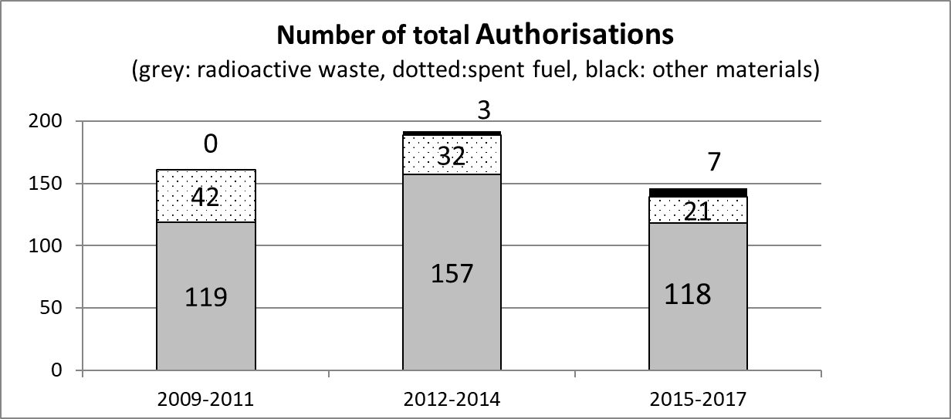

Figure 1. Number of authorisations

In relation to refusal to grant consent, three cases were reported during the current implementation period. It was observed that some of these shipments (that finally were not conducted) were however reported by the countries issuing consent:

* One Member State refused to give its consent to four applications for the transit of contaminated scrap metal, considering the application out of the scope of the Directive – setting provisions for radioactive waste and spent nuclear fuel only. These transits were, however, regularly carried out under the applicable local legislation.
* One Member State refused to import radioactive waste from another Member State for disposal purposes, claiming that the Member State of origin had the capacity to dispose of the waste.

Member States did not report to the Commission any issues that could fall under Article 4 "Reshipment related to non-authorised shipments of undeclared radioactive waste"; Article 12 "Shipment failure" nor Article 16(1)(c) "Prohibited exports". The only reshipment declared during this period was related to the unsuitability of some radioactive waste (from the medical sector) for a processing site abroad. Thus, based on the reported information, no unauthorised shipment was carried out on EU territory during the reporting period.

Delays in the fulfillment of reporting obligations have decreased, compared to the previous reporting period. During December 2017 and January 2018, 24 Member States communicated their national report[25]. Also the overall reporting quality has significantly improved over the three reporting periods. Six Member States use the “identify shipment number”.

Nevertheless, the Commission observed some residual inconsistencies in reporting, which were corrected upon ad-hoc requests from the Commission services[26].

Additionally, the Commission observed some inconsistencies in reporting of different Member States, such as the number of shipments in multiple authorisations, or the total radioactivity and maximum activity per package of some shipments. All these issues were clarified with the Member States.

A detailed presentation of the transboundary shipments of radioactive waste and spent fuel in the EU during the current reporting period is provided in the accompanying Commission Staff Working Document SWD(2019) 437 final.

3.1. Statistics (2015-2017)[27]

This section provides a statistical overview on authorisations and shipments, the type of shipments, the origins of the materials shipped, and the purpose of shipments.

Authorisations vs actual shipments

The 146 authorisations reported by 14 Member States in the period 2015-2017 correspond to 1834 actual shipments (total number of shipments). Some authorisations cover several shipments (on average 12-13), and may exceed the period of time covered by the present report.

As can be seen from Figure 1, 86% of the authorisations are related to radioactive waste shipments (125 authorisations, of which 7 authorisations are related to other materials[28]) and the other 14% of the authorisations are related to spent fuel (21 authorisations).

In terms of actual shipments, 98% (1791 shipments) relates to radiactive waste and 2% (43 shipments) relates to spent fuel.

Below, the authorisations are briefly described according to the types of shipments[29], i.e. intra-Community and extra-Community. 53 authorisations out of 146 involved transit through at least a third Member State.

Intra-Community shipments:

120 authorisations (82% of the total 146) relate to intra-Community shipments. Most of the intra-Community authorisations (106) refer to radioactive waste, the remainder (14) to spent fuel. These 120 authorisations account for 1769 shipments, authorised by 14 Member States.

Compared to the previous reporting cycle the share of intra-Community authorisations is substantially unchanged (83% in the 2012-2014 reporting period).

Extra-Community shipments: Imports, exports and transits through the Community

26 authorisations (18% of all authorisations) relate to extra-Community shipments. 17 were related to **exports** to third countries (12% of all authorisations), while 8 (around 5% of all authorisations) were related to **imports** from outside the EU. With a view to actual shipments, 2% relate to exports and 1% to imports. One single authorisation for a transit through the Community is reported.

With reference to **imports** of radioactive waste from third countries during 2015-2017 five authorisations representing 14 shipments of radioactive waste were issued by three Member States. These imports were returns after treatment of radioactive waste (from USA), and final disposal of waste from non nuclear energy industry (from Bahamas and Monaco). Two Member States imported spent fuel from third countries for research activities, corresponding to three authorisations for 11 shipments.

As regards **exports** of radioactive waste from the Community to third countries, six Member States issued a total of 13 authorisations, representing 35 shipments. The purpose of these exports was never final disposal in the territory of a third country, rather it was research, treatment, and return after treatment/reprocessing. Three Member States issued a total of four authorisations for just as many shipments to export spent fuel to a third country. The purpose of these exports was reprocessing, research, and conversion from high to low enrichment.

One single **transit** originating from a third country was authorised during 2015-2017.

Figure 2. Extra-Community 2015-2017 shipments**[30]**

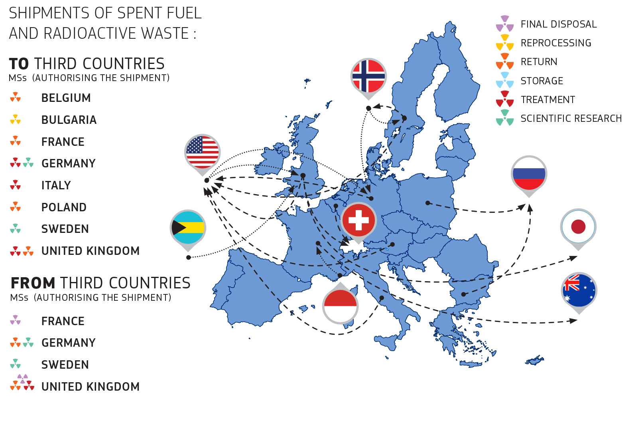

Mode of transportation

Shipments involve very frequently sea transport, around 56% (81 authorisations), while 40% (59 authorisations) of the transports are by road/rail only (i.e. not involving sea or air transport). Only 4% of the authorisations (6 authorisations) involved air transport.

Origin of materials to be shipped

Statistics show that around 75% of the authorisations (110 authorisations) correspond to radioactive waste originated from the nuclear energy industry and spent fuel, 12% originated from research activities, 3% originated from the medical sector, and the rest from other sectors.

However, when considering the actual number of shipments, the share of shipments of the non-nuclear energy industry - including medical and research activities - reaches 43%.

Purpose of shipments

Shipments are mainly related to processing of radioactive waste (such as treatment for volume reduction, or conditioning). This applies to 42 authorisations for transport to the processing facilities (about 29% of the authorisations) and to 48 authorisations for their return after processing (33% of the authorisations).

The reprocessing of spent fuel (5 authorisations) and the return of its radioactive waste after the reprocessing (7 authorisations) corresponds to 8% of authorisations.

4. Follow-up from the previous reporting period

The Second Commission Report to the European Parliament, the Council and the European Economic and Social Committee on the implementation of the Directive highlighted two issues raised by Member States during the first reporting period: lack of harmonisation of clearance levels for radioactive waste in the EU and the unclear rules for waste containing NORM not arising from "authorised practices". The two issues have been addressed in the framework of the Study on "Comprehensive examination and analysis of the situation of transport of nuclear materials" funded by the Commission[31]. The study, based on a questionnaire sent to Member States' competent authorities and other transport stakeholders and on the proceedings of final workshop, delivered the following preliminary conclusions:

* Lack of harmonisation of clearance levels for radioactive waste in the EU has not affected the implementation of the Directive. Council Directive 2013/59/Euratom on basic safety standards addresses the lack of legal provisions on NORM not arising from authorised practices. As pointed out previously8, from a legal point of view all waste containing NORM which requires regulatory control and is categorised as radioactive waste[32] falls under the scope of the Directive.

Modification of the standard document was not considered for this reporting period. However, for the next reporting period, the Commission will collaborate with Member States in order to enhance the harmonization of the standard document with the reporting template requirements.

5. Conclusions

The implementation of the Directive ensures that all transboundary movements of radioactive waste and spent fuel within the Community take place only with the prior informed consent of the competent authorities of all involved Member States (including transit countries), through the use of the standard document. The information related to all authorised shipments within a defined reporting period (three years) is regularly transmitted by all Member States to the Commission. Supervision and control of shipments of radioactive waste and spent nuclear fuel is thus guaranteed, throughout the Community. For that purpose, the use of the provided "reporting template" although not mandatory, is highly encouraged as it allows straightforward data retrieval and avoids the risk of misinterpretation of the provided information.

Some inconsistencies were identified when cross-checking Member States' reports, due mainly to inaccuracy of the provided information. Thanks to the assessment carried out by the Commission, Member States’ awareness of reporting all shipments has been improved. In this respect, it was particularly important to have full data sets (Table of Part B of the reporting template) available also from consent/transit Member States. In addition, the Commission observed that consent/transit Member States have not always been informed when shipments had been withdrawn.

No shipment failures were reported by Member States under the current reporting period. Two refusals to grant consent were reported together with their underlying justification. One reshipment[33] was reported, due to the unsuitability of some radioactive waste for a processing site.

Compared to the previous reporting period, the majority of the Member States submitted their national reports in due time. Four countries did not submit their reports in one month from the deadline; however they did so within six months from the deadline.

Overall, the Commission concludes that the current EU legal package consisting of Directive 2006/117/Euratom, Directive 2011/70/Euratom and Directive 2013/59/Euratom ensures high safety standards with respect to the risks of ionizing radiations in the territory of the EU in the context of transboundary shipments. The preliminary findings of the above mentioned study31 also confirmed the assumption of an overall comprehensive architecture including EU legislation, procedures and practices implemented by Member States, ensuring the safe movement of nuclear material, including radioactive waste and spent nuclear fuel within the Community.

The Commission will take the findings presented in this report into due consideration and will initiate reflections or will take the necessary measures. The Commission worked closely with the EU Member States to improve the reporting template. It is the objective of the Commission to have a common agreement with all Member States about the required information to be provided to facilitate the supervision and control of shipments of radioactive waste and spent fuel for the upcoming reporting period (2018-2020).

1. Council Directive 2006/117/Euratom of 20 November 2006 on the supervision and control of shipments of radioactive waste and spent fuel, OJ L 337, 5.12.2006, pp. 21 – 32.
2. According to Article 20(1) of the Directive by 25 December 2011 and every three years afterwards, Member States shall forward to the Commission reports on the implementation of this Directive.
3. According to Article 20(2): of the Directive, the Commission shall establish a summary report in accordance with the procedure laid down in the Directive Article 21.
4. According to Article 4 of the Directive.
5. More precisely, the third reports cover the period from 26.12.2014 to 25.12.2017 (authorisations).
6. Croatia joined the EU on 1 July 2013.
7. The Advisory Committee was established in 2007 as required by Article 21 of the Directive.
8. COM(2018) 6 final, Report from the Commission to the European Parliament, the Council and the European Economic and Social Committee on the implementation by the Member States of Council Directive 2006/117 Euratom on the supervision and control of shipments of radioactive waste and spent fuels, 19.1.2018 and SWD(2018) 4 final.
9. The Joint Convention entered into force on 18 June 2001. It applies to spent fuel and radioactive waste resulting from civilian nuclear reactors and applications and to spent fuel and radioactive waste from military or defence programmes if and when such materials are transferred permanently to and managed within exclusively civilian programmes, or when declared as spent fuel or radioactive waste for the purpose of the Convention by the Contracting Party. The Convention also applies to planned and controlled releases into the environment of liquid or gaseous radioactive materials from regulated nuclear facilities.
10. As of 26 September 2016 there are 73 Contracting Parties (http://www.iaea.org/Publications/Documents/Conventions/jointconv_status.pdf).
11. Council Directive 2013/59/Euratom of 5 December 2013 laying down basic safety standards for protection against the dangers arising from exposure to ionising radiation, and repealing Directives 89/618/Euratom, 90/641/Euratom, 96/29/Euratom, 97/43/Euratom and 2003/122/Euratom, OJ L 13, 17.1.2014, p. 1–73.
12. In line with Council Directive 2011/70/Euratom of 19 July 2011 establishing a Community framework for the responsible and safe management of spent fuel and radioactive waste, OJ L 199, 2.8.2011, p. 48-56.
13. According to Article 17(1) of the Directive.
14. Commission Recommendation of 4 December 2008 on criteria for the export of radioactive waste and spent fuel to third countries (notified under document number C(2008)7570) (2008/956/Euratom).
15. Holder means any natural or legal person who, before carrying out a shipment of radioactive waste or spent fuel is responsible under the applicable national law for such materials and plans to carry out a shipment to a consignee. (Article 5(9) of the Directive).
16. According to Article 12 of the Directive.
17. According to Article 16 of the Directive.
18. According to Article 16(1) of the Directive.
19. According to Article 18.
20. According to Article 17.
21. Commission Decision of 5 March 2008 establishing the standard document for the supervision and control of shipments of radioactive waste and spent fuel referred to in Council Directive 2006/117/Euratom, (notified under document number C(2008) 793), (2008/312/Euratom), OJ L 107, 17.4.2008, pp. 32 – 59.
22. In accordance with Article 3(5) of Regulation (EU) No 182/211 and the Advisory Committee Rules (25.1.2017) under Article 21 of the Council Directive 2006/117/Euratom.
23. Article 5(13) of the Directive defines "competent authorities" as "any authority which, under the law or regulations of the countries of origin, transit or destination, are empowered to implement the system of supervision and control of shipments of radioactive waste or spent fuel".
24. This figure includes seven authorisations issued for the shipment of "materials" in addition to radioactive waste and spent fuel which accounted for 139 authorisations.
25. The deadline for the notification of the national reports was 25 December 2017.
26. Further details are described under the title 4.4 of the SWD(2019)437.
27. The percentages used in this report are rounded to nearest integer.
28. For example irradiated steel for research purposes.
29. More detailed information on the type of shipments (intra- and extra Community) is given under the title 2 of the SWD(2019)437.
30. The export from Poland is related to the return of the spent fuel of a research reactor.
31. ENER/2017/NUCL/SI2.751899.
32. Radioactive waste means radioactive material in gaseous, liquid or solid form for which no further use is foreseen by the countries of origin and destination, or by a natural or legal person whose decision is accepted by these countries, and which is controlled as radioactive waste by a regulatory body under the legislative and regulatory framework of the countries of origin and destination (Article 5(1) of the Directive).
33. It was not related to non-authorised shipment.