

# Introduction

**The European Green Deal is the European Union’s response to the climate and environmental-related challenges that are this generation’s defining task.** It is a new growth strategy that aims to transform the EU into a fair and prosperous society, with a modern, resource-efficient and competitive economy where there are no net emissions of greenhouse gases in 2050, where the environment and health of citizens are protected, and where economic growth is decoupled from resource use.

**The Sustainable Europe Investment Plan is the investment pillar of the European Green Deal.** A sustainable Europe requires significant investment effort across all sectors of the economy. Reaching the 2030 climate and energy targets[1] will require additional investments of EUR 260 billion a year by 2030[2]. The Commission has already announced its intention to present an impact assessed plan to further increase the EU’s climate ambition for 2030 and additional investments will be necessary for achieving the broader environmental and social objectives that the EU has set itself[3].

**Investor appetite for sustainable opportunities with measurable impact is on the rise.** The annual global issuance of green bonds has tripled since 2016, reaching around EUR 225 billion in 2019 according to the recent estimates. A framework is needed to bridge the gap between policy objectives and the significant private financial resources available.

**The Sustainable Europe Investment Plan will mobilise through the EU budget and the associated instruments at least EUR 1 trillion of private and public sustainable investments over the upcoming decade.** It puts forward a comprehensive framework for the sustainability transition from every corner of the EU. This framework will target climate, environmental and social investments, the latter as far as they are related to the sustainable transition.

However, more is needed to master the challenges ahead. Private actors will need to provide the scale. By pulling together a set of new policy initiatives with reinforced commitments on ongoing instruments within a single policy framework, the Commission gives a new policy push in this area, and ensures enhanced impact and coherence of the EU framework for sustainable investments.The Commission will continue to work on how to further mobilise resources to achieve the objectives of the Green Deal.

**Figure 1. The Investment Plan within the European Green Deal**

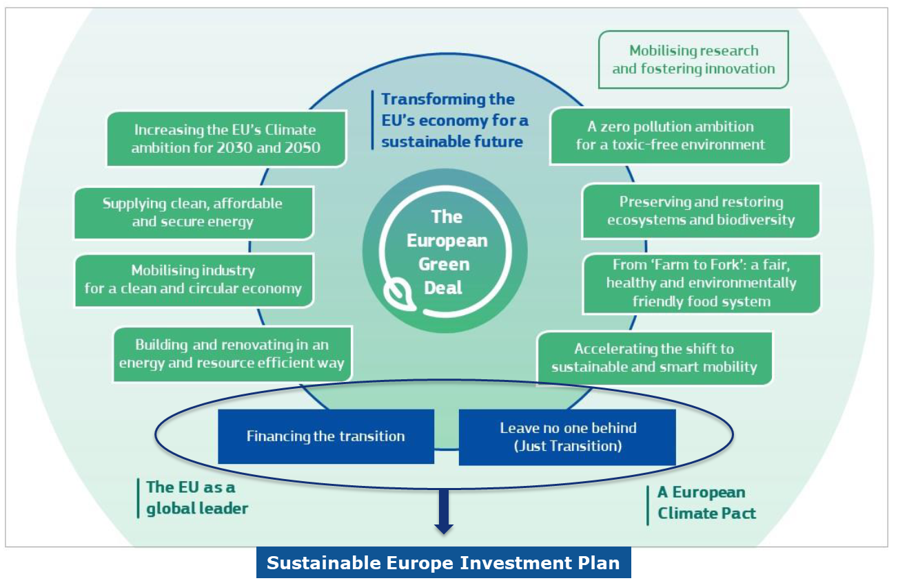

The Sustainable Europe Investment Plan will enable the transition to a climate-neutral, green economy across the following three dimensions:

* **First, the Plan will mobilise at least EUR 1 trillion of sustainable investments over the next decade through the EU budget.** The EU budget will devote a greater share of public spending to climate and environment than ever before. It will crowd in private funding through guarantees and help make the transition a just one by facilitating public sector investments in the regions most affected by the transition through the Just Transition Mechanism.
* **Second, it will create an enabling framework for private investors and the public sector.** It will aim to ensure a cost-effective, just, as well as socially balanced and fair transition. Financial institutions and private investors need to have the tools to properly identify sustainable investments. Notably, the EU taxonomy, the energy efficiency first principle and sustainability proofing will be key to leverage their firepower. For the public sector, the European Semester, the Environmental Implementing Review, the National Energy and Climate Plans under the Energy Union, and the plans required under the sectoral environmental legislation (e.g. on waste, water, biodiversity and air) will allow to properly identify investment needs.
* **Third, the Plan will provide tailored support to public administrations and project promoters in identifying, structuring and executing sustainable projects.** Support for public authorities to assess the financial needs and plan the subsequent investment as well as direct support to public and private project promoters will be reinforced.

**Figure 2. The Sustainable Europe Investment Plan**

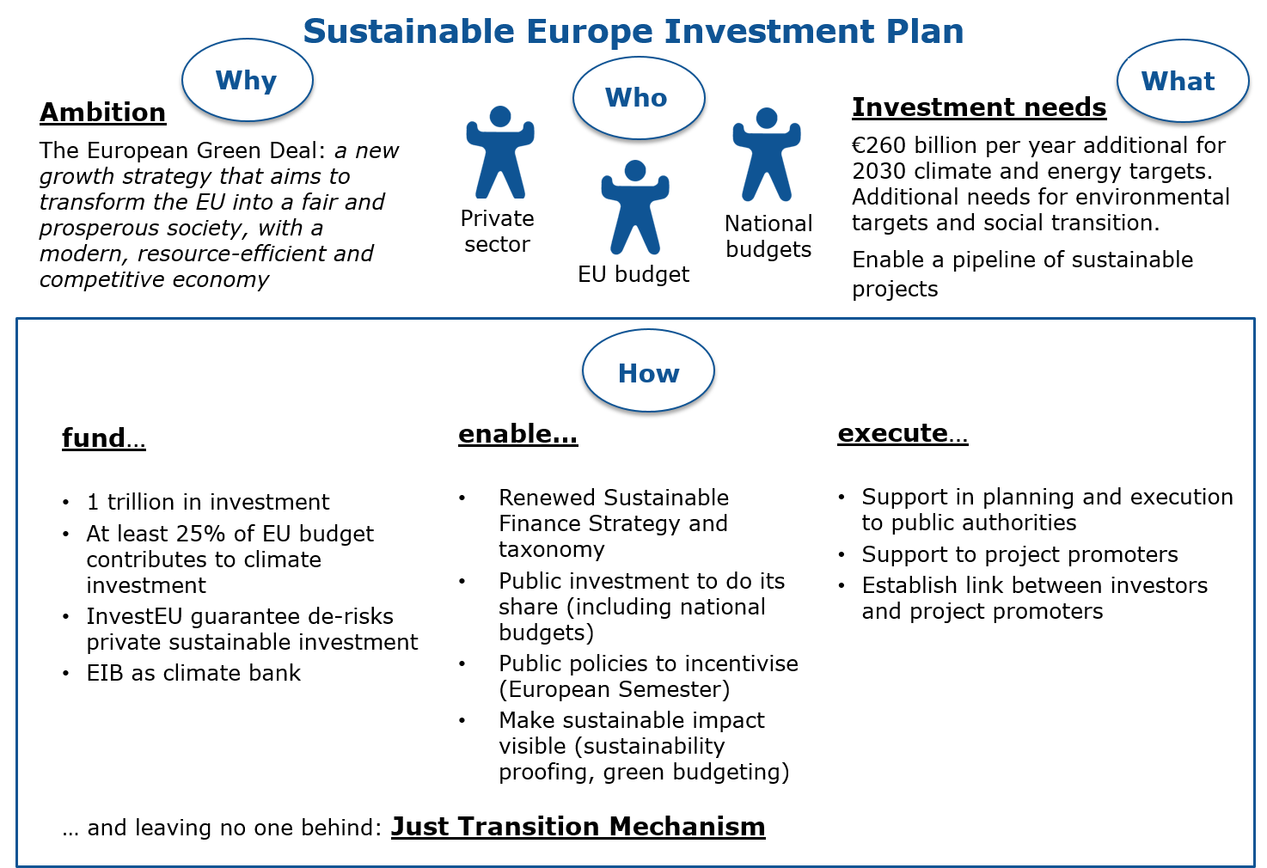

**The Sustainable Europe Investment Plan contributes to the implementation of the Sustainable Development Goals**. This is consistent with the commitment, in the European Green Deal Communication, to put the Sustainable Development Goals at the heart of the EU’s policymaking and action.

# The investment challenge

**The transition to a climate-neutral, climate-resilient and environmentally sustainable economy will require significant investments**. Achieving the current 2030 climate and energy targets requires EUR 260 billion additional investments annually[4]. This figure mainly includes energy-related investments, buildings and part of the transport sector (vehicles)[5]. The average investment needs per sector[6] are most significant in the renovation of buildings. These investment flows would need to be sustained over time.

Significant investments will be also necessary in other sectors, notably in agriculture, to tackle broader environmental challenges, including biodiversity loss and pollution, the protection of natural capital and the support to the circular and blue economy, as well as for human capital and social investments related to the transition.

Digitalisation is a key enabler for the Green Deal. Substantial investment in European strategic digital capacities, as well as in the development and wide deployment of top digital technologies will deliver smart, innovative and tailored solutions to tackle climate-related concerns.

**The plan announced in the European Green Deal to raise the EU’s greenhouse gas emission reductions target further for 2030 will translate into even bigger investment needs.** The in-depth analysis in support of the Commission’s long-term strategic vision for a EU climate-neutral economy already indicated that the transformation to a low carbon economy may require additional investments of up to 2% of GDP by 2040. This may need to be advanced to achieve a higher ambition already by 2030.

# Fund: mobilising sustainable investment from all sources

**As the investment pillar of the European Green Deal, the Sustainable Europe Investment Plan will mobilise at least EUR 1 trillion of sustainable investments over the next decade.** This amount of financing for the green transition is achieved through spending under the EU’s long-term budget, a quarter of which will go to climate-related purposes, and including estimated EUR 39 billion for environmental expenditures. Moreover, the Plan will crowd in additional private funding through leveraging the EU’s budget guarantee under the InvestEU Programme.

In addition to the EU spending related to climate action and environmental policy, the Sustainable Europe Investment Plan also covers the amounts used under the Just Transition Mechanism, which will help the most affected regions going through the transition.

The European Investment Bank will become the Union’s climate bank. It has announced it will gradually increase the share of its financing dedicated to climate action and environmental sustainability to reach 50% of its operations in 2025. Co-operation with other financial institutions will also be crucial.

While this contribution shows the commitment of the EU to fund the European Green Deal, it will on its own not be sufficient to unlock the needed investments. Sizeable contributions will be needed from national budgets and the private sector.

**Figure 3: Financing elements making up at least EUR 1 trillion over the next decade[7] under the Sustainable Europe Investment Plan**

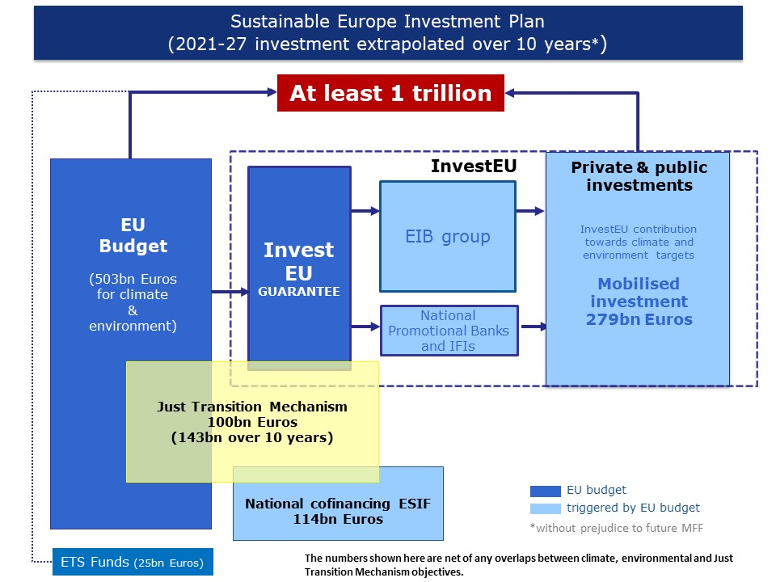

***How will the EU budget mobilise at least EUR 1 trillion over the next decade?***

Mobilising at least EUR 1 trillion over the next decade requires a combination of funds provided by the EU budget as proposed by the Commission and further public and private investments triggered by it.

**Climate and environmental spending under the EU budget will provide EUR 503 billion** from 2021 to 2030, in line with the 25% climate mainstreaming target proposed for the 2021-2027 multiannual financial framework (MFF) and including spending on the environment across all programmes[8]*.* **This will trigger additional national co-financing of EUR 114 billion** over this timeframe on climate and environment.

**The InvestEU Fund will leverage around EUR 279 billion** of private and public climate and environmentally-related investments over the period 2021-2030 by providing an EU budget guarantee to reduce the risk in financing and investment operations.

To leave no one behind, **the Just Transition Mechanism** will include financing from the EU budget, co-financing from the Member States as well as contributions from InvestEU and the EIB to **reach EUR 100 billion of investments to be mobilised over 2021-27**, which, extrapolated over 10 years, will reach EUR 143 billion to ensure a just transition.

The **Innovation and Modernisation funds**, which are not part of the EU budget but are financed through a part of the revenues from the auctioning of carbon allowances under the Emissions Trading Scheme, **will provide at least some EUR 25** **billion** for EU transition to climate neutrality.

## An increased ambition of the EU budget and associated programmes

**Under its proposal for the next EU Multiannual Financial Framework, the Commission has proposed to increase the climate-related ambition to 25%**. The Commission calls on the European Parliament and the Council to maintain at least this level of ambition in the ongoing negotiations.

**The different programmes, as proposed by the Commission for the next EU Multiannual Financial Framework, will include specific measures to strengthen the link between the implementation of the EU budget and the objective of a greener, carbon-free Europe, for example:**

* The Cohesion Fund and the European Regional Development Fund are expected to invest at least EUR 108 billion in climate and environment related projects over the next 7 years (2021-2027), more than 30% of the total envelope.
* The future Common Agriculture Policy will direct 40% of its total envelope to support climate-related objectives. All direct payments will be conditional to enhanced environmental and climate requirements.
* At least 35 % of the budget of Horizon Europe (expected to reach EUR 35 billion) will support climate objectives. Furthermore, in the last year of Horizon 2020, the Commission is preparing an additional call of around EUR 1 billion allocated to Green Deal priorities, on top of the existing allocation of EUR 1.35 billion in 2020.
* The LIFE Programme will see its envelope increased by 72% as compared to 2014-2020 to EUR 5.4 billion. More than 60% of its envelope will pursue climate objectives, including EUR 0.95 billion for climate action, EUR 1 billion for the clean energy transition and EUR 2.15 billion for nature and biodiversity.
* At least 60% of the Connecting Europe Facility budget (supporting transport, energy and digital infrastructures) will be targeted to support climate objectives.
* The European Social Fund + will support the upskilling and re-skilling of an estimated 5 million people for green jobs and the green economy.

**The EU budget will contribute to achieving climate objectives also through the revenue side**. In May 2018, the Commission put forward a proposal for an Own Resource Decision, which included a basket on new Own Resources. One of its key elements is the non-recycled plastic-packaging waste own resource which will contribute to the EU-wide targets defined in the Waste strategy. Furthermore, under the Commission proposal, 20% of the revenues from the auctioning of EU Emissions Trading System (ETS) would be allocated to the EU budget as an Own Resource.

**Additionally, the EU Emissions Trading System Modernisation Fund and Innovation Fund, both financed outside the EU’s long-term budget, will channel additional money to the green transition**. The Innovation Fund will support investments in scaling up break-through low-carbon technologies and processes in renewable energy and energy intensive industries, including carbon capture, use and storage, and energy storage. The aim is to share the innovation risk with project promoters to support first-of-a-kind highly innovative projects and to make European industry a global leader in these clean technologies. The Commission is currently preparing the first call for the Innovation Fund that should be launched in mid-2020 with a volume of EUR 1 billion. Several workshops will take place over the next months to reach out to project promotors and other private and public investors with a view to develop a set of effective selection criteria. The Modernisation Fund will support investments in modernising the power sector and wider energy systems, boosting energy efficiency in 10 lower-income Member States. It can also support the re-skilling and up-skilling of the people affected.The Commission will soon consult on the implementing rules for the Modernisation Fund. The Commission will review both instruments as part of the revision of the EU Emissions Trading System and will consider the allocation of additional revenues to the EU budget to strengthen the financing of the just transition.

**In line with the European Green Deal communication, the Commission will present by summer 2020 an impact assessed plan to increase the EU’s greenhouse gas emission reduction targets for 2030,** including an analysis of the investment needs. Depending on the outcome thereof, it could be appropriate to consider potential changes to the climate-related targets in the next Multiannual Financial Framework.

|  |
| --- |
| **The Commission will:**   * **Defend a high climate ambition of at least 25% of the Multiannual Financial Framework in the inter-institutional negotiations.** * **Enhance the tracking system for monitoring progress towards this target.** |

## Crowding in private investments through InvestEU

**Some investments needed for the transition entail more risk than the private sector can bear alone. This is where public funds can be used in a targeted manner to de-risk projects and leverage private financing.** By providing an EU budget guarantee to partially cover the risk of financing and investment operations, the InvestEU programme, the successor of the European Fund for Strategic Investments and 13 other EU financial instruments, will mobilise EUR 650 billion over 7 years. InvestEU must be used to its full potential to support the objectives of the European Green Deal. Achieving an ambitious climate target for InvestEU in the context of the ongoing inter-institutional negotiations is therefore essential. The Commission has proposed a target of at least 30%, which would trigger approximately EUR 195 billion of climate investment from 2021 until 2027, i.e. close to EUR 28 billion per year and 280 billion over a decade.

**InvestEU will support sustainable investments in all sectors of the economy. It will also diffuse sustainable practices among private and public investors.** The Commission will put forward a climate tracking methodology for measuring the contribution of specific financing and investment operations to the climate and environmental objectives of the programme. In addition, it will put in place a method for ‘sustainability proofing’, on the basis of which promoters of projects above a certain size will be required to assess the environmental, climate and social impact of those projects. As these methods will be applied by all InvestEU Implementing Partners (the European Investment Bank Group, National Promotional Banks and Institutions, International Financial Institutions) and will also be the reference point for private investors and financial intermediaries participating in the programme, they are expected to spill-over beyond the InvestEU Programme. These methods will make appropriate use of the EU-wide classification system for environmentally sustainable economic activities (‘EU taxonomy’).

|  |
| --- |
| **The Commission will:**   * **Enhance the climate and environmental tracking and the sustainability proofing guidance in the second half of 2020. These guidance documents will use in an appropriate way the criteria established by the EU taxonomy after its entry into force.** * **Develop, in cooperation with InvestEU implementing partners, financial products to be deployed under InvestEU that will target environmental, climate and social sustainability.** |

## The European Investment Bank’s contribution and mobilising other financial institutions

**The European Investment Bank (EIB) also plays a key role in financing the shift to a carbon-neutral, sustainable economy.** It uses its own resources and EU budgetary support under various programmes and facilities to finance climate action and environmental investments both inside and outside the EU. In 2018, almost 30% of the EIB-signed operations contributed to climate action, supporting investments in climate change mitigation and adaptation, low-carbon and climate-resilient growth. For 2019, the EIB expects this contribution to have been in the range of 28-31%. For the duration of the Sustainable European Investment Plan over a decade, the EIB is expected to finance outside of EU mandates around EUR 600 billion of climate investments across all Member States.

**The role of the EIB in financing the sustainable transition will grow as it becomes the EU climate bank**. The EIB will gradually increase the share of its financing dedicated to climate action and environmental sustainability to reach 50% by 2025 and beyond. A significant share of this will be carried out under the InvestEU Programme, which will allow the EIB to engage in more innovative, higher policy-added value projects, by covering a part of the risk of financing and investment operations. Moreover, the EIB Group will align all its financing activities with the principles and goals of the Paris agreement by the end of 2020. A first step in that direction was the adoption of the new Energy Lending Policy on 14 November 2019, which prioritises lending to energy efficiency, renewable energy, new green technologies and new types of energy infrastructure required for the future low carbon energy system. The revised Energy Lending Policy also foresees the phasing out of the support to energy projects reliant on fossil fuels after end of 2021, including notably all natural gas infrastructure projects.

**Other International and National Financial Institutions will play an increasing role in financing sustainability in line with EU policy objectives.**  The Commission will therefore work closely with them to explore how their activities could be aligned more closely with the European Green Deal objectives.

|  |
| --- |
| **The Commission will:**   * **Ensure that EIB operations financed under EU mandates provide high additionality, both in terms of sectors covered and of the risk profile of financed projects. This will be done notably by enhancing the reporting and monitoring system, including the climate-tracking methodology.** * **Engage with other International and National Financial Institutions with the aim of aligning their activities more closely with the European Green Deal objectives.** |

# Enable: creating a framework for public and private investments to come about.

**The European Green Deal sets a clear direction for a comprehensive policy framework for the transformation of the EU economy.** The 2050 climate neutrality objective will be enshrined in legislation and the ambition for greenhouse gas emission reductions in 2030 will be raised. The European Green Deal policies will use a mix of regulation and incentives to address externalities and implement the “polluter pays” principle, so that costs for society are reflected in investment decisions. The EU Emissions Trading System will be reviewed and will further help to ensure effective carbon pricing. Specific initiatives will address sector-specific regulatory barriers, such as obstacles to the funding and execution of energy efficiency investments in the building sector. Competitive and integrated markets are also necessary to keep costs down and trigger innovation. Similarly, the European Innovation Council under Horizon Europe will contribute to public-private investment in breakthrough innovation in support of the European Green Deal.

**Within this broader context, the Sustainable Europe Investment Plan will enable the transition through targeted actions in areas that directly touch upon investment decisions of private investors and public entities.**

## Putting sustainable finance at the heart of the financial system

Since private companies and households will have to provide the bulk of the sustainable investments in the next decade, it is crucial to put in place clear long-term signals to guide investors to sustainable investment.

**In order to address the significant amount of investments needed to reach the EU’s climate and broader sustainability objectives, the Commission proposed in March 2018 the Action Plan on financing sustainable growth**.[9] Based on this Action Plan**,** which contributes to building a Capital Market Union,important foundations for conducive frameworks to mobilise finance for sustainable investments have been put in place. This is the case notably of the EU taxonomy, of disclosures on sustainability by the financial sector, as well as of climate benchmarks. Through international co-operation, e.g. via the International Platform on Sustainable Finance, the EU is promoting coherent approaches and an enhanced impact of sustainable finance globally.

**The Commission welcomes in particular the recent political agreement by co-legislators on the Regulation establishing a framework to facilitate sustainable investment (EU taxonomy), to be** **further specified through delegated acts adopted by the Commission.** The EU Taxonomy will determine whether an economic activity is environmentally sustainable, based on performance criteria for its contribution to at least one of the six environmental objectives.

**The Commission will also explore how the EU taxonomy can be used in the context of the European Green Deal by the public sector, beyond InvestEU**. While initially designed for private investors, the taxonomy – once sufficiently developed – could also be used by public sector entities. It is important that there is convergence of standards between the private sector and the public banks/entities, for example the European Investment Bank.

**Building on the 2018 Action Plan and in light of the European Green Deal, the Commission will present a renewed strategy for sustainable finance in the third quarter of 2020, aiming at scaling up sustainable finance even further**. Companies will need to increase their disclosure of climate and environmental data so that investors are fully informed about sustainable investment opportunities and can better direct their investment in support of the Green Deal. To this end, the Commission will review the Non-Financial Reporting Directive. Furthermore, the renewed strategy will further increase investment opportunities by facilitating the identification of sustainable investments through clear labels for a variety of sustainable investment products and by developing and implementing an EU green bond standard.

|  |
| --- |
| **The Commission will:**   * **Prepare in 2020 the delegated acts on the climate change objectives of the EU Taxonomy in 2020 and the delegated acts on the other environmental objectives of the EU taxonomy by the end of 2021.** * **Explore how the EU taxonomy can be used in the context of the European Green Deal by the public sector, beyond InvestEU.** * **Launch a public consultation on a renewed sustainable finance strategy in the first quarter of 2020 with the view to presenting a renewed strategy in the third quarter of 2020.** * **Establish an EU Green Bond Standard, in 2020 and explore how this standard, as well as other enabling frameworks, can increase public and private finance for sustainable investments.** |

## Providing the public sector with guidance and appropriate means for making sustainable investments

**Public actors are the main investors in certain sectors, especially infrastructure and public services.** In many cases, public authorities need to play a guiding and coordinating role for sustainable investments. Public authorities may also need to invest when market actors cannot step in, in particularwhen the social and environmental benefits are not reflected in private returns, or when projects are considered too risky. Where these investments often have a cross-border nature and spill-over effects across Member States, the Commission needs to play a coordinating role at the EU level.

**The European Semester provides a well-established framework for the coordination of economic and employment policies that will facilitate the necessary investment for the green transformation from the EU and its Member States.** The Semester contributes to the identification of investment priorities and barriers in each Member State. The country reports will match the available sources of financing through EU funds with the country-specific challenges identified in the reports, among others in view of climate, environmental and social policy objectives. A joint effort between the EU and its Member States should ensure that the investments are directed to the most sustainable projects.

**The Commission will work with the Member States to screen and benchmark green budgeting practices**. This will make it easier to assess to what extent annual budgets and medium-term fiscal plans take environmental considerations and risks into account, and learn from best practices. The review of the European economic governance framework will include a reference to sustainable public investment in the context of the quality of public finance. This will inform a debate on how to improve EU fiscal governance. The outcome of the debate will form the basis for any possible future steps including how to treat sustainable investments within EU fiscal rules, while preserving safeguards against risks to debt sustainability.

**The Commission will propose minimum mandatory green criteria or targets for public procurements in sectorial initiatives, EU funding or product-specific legislation.** Such minimum criteria will ‘de facto’ set a common definition of what a ‘green purchase’ is, allowing collection of comparable data from public buyers, and setting the basis for assessing the impact of green public procurements. Public authorities across Europe will be encouraged to integrate green criteria and use labels in their procurements. The Commission will support these efforts with guidance, training activities and the dissemination of good practices. At the same time, life-cycle-costing methodologies should be applied by public buyers whenever possible. The Commission calls on all players, including industry, to develop such reliable methodologies.

**The energy efficiency first principle should be applied to ensure that energy efficiency is taken into account wherever relevant.** This would also help avoid waste of resources linked to the generation, transmission, distribution and use of energy that is actually not needed. The Commission will provide guidance on how to apply this principle.

|  |
| --- |
| **The Commission will:**   * **Include environmental sustainability as an integral part of the country reports under the European Semester as of this year.** * **Help Member States identifying their sustainable investment needs and possibilities for funding them each year as of 2020.** * **In cooperation with Member States screen and benchmark green budgeting practices.** * **Propose further legislation and guidance to green public procurement.** * **Provide guidance on the application of the energy efficiency first principle as part of the investment decisions.** |

## Enabling sustainable investments through a supportive State Aid framework.

**The relevant State aid rules will be revised by 2021 in light of the policy objectives of the European Green Deal and support a cost-effective and socially-inclusive transition to climate neutrality by 2050.** State aid rules will be revised to provide a clear, fully updated and fit-for-purpose enabling framework for public authorities to reach these objectives, while making the most efficient use of limited public funds. State aid rules will support the transition by fostering the right types of investment and aid amounts. They will encourage innovation and the deployment of new, climate-friendly technology at market scale. As part of this, the Commission will also consider further procedural facilitation to approve State aid for just transition regions. They will also facilitate the phasing out of fossil fuels, in particular those that are most polluting, thus ensuring a level-playing field in the internal market. This will include, in particular, the Environmental and Energy State aid guidelines.

**Pending the revision, Member States can continue to use the flexibility provided under existing rules to achieve their 2030 targets and the further decarbonisation of the electricity sector and the economy by 2050.** For example, they can choose to increase public investments in renewable electricity schemes for cheaper and more integrated green energy, the roll-out of cheaper and publicly accessible charging infrastructure or circular economy schemes such as the reuse of waste heat or recycling of waste.

**Similarly, Member States can continue to rely on existing State aid rules to alleviate the social and regional consequences from decarbonisation measures.** For example, they can choose to support workers affected by the closure of coal mines, invest in small and medium-sized enterprises and start-ups, or in the up- and reskilling of workers. For key enabling technologies and breakthrough innovation, Member States can pool their funds to unlock significant private investments to make important projects of common European interest a reality – including in the regions most affected by the green transition.

**At the same time, the rules will continue to preserve the integrity of the internal market, while allowing to respect the cohesion objectives enshrined in the EU Treaty, which are at the heart of European integration.** Their aim is to reduce disparities between the development levels of the various regions, by supporting the least favoured regions in catching up. In particular, this means that public productive investment support to large companies must continue to only benefit the poorest regions to be affected by the green transition (Article 107 (3) (a) and (c) TFEU).

**Against this background, current State aid rules will be applied with flexibility, focusing on a number of areas, which seem crucial to achieve the transformation to a climate-neutral economy.**

### More flexibility for State aid to transform to climate neutral production processes

**The Commission will approve Member States’ support of companies to decarbonise or electrify production processes, provided that economic incentives do not already warrant the investment concerned and the companies reduce their impact on the environment beyond Union standards or benchmarks.**

**To minimise costs to the State, public support should be limited to what is necessary.** The current Guidelines typically set the maximum aid amount based on the extra costs of the relevant investment compared to a theoretical alternative investment that is less environmentally friendly. The Commission will assess whether, in the future, for investments that are compatible with the transition to climate neutrality it could instead determine the eligible costs by reference to the funding gap in particular in cases where there is not a hypothetical alternative investment. This could be justified in light of the Green Deal objectives and the fact that such investments present an important way to reduce the carbon footprint of the installations concerned and help achieve climate neutrality.

### Aid to improve energy efficiency for buildings

**Member States will be given more scope to invest in the energy efficiency of buildings under the Guidelines for environmental protection and energy.** In particular, Member States will be given more flexibility to support financing arrangements that are advantageous to consumers of electricity, such as Energy Performance Contracts. In such an arrangement, energy service companies invest in the upgrading of buildings to make them more energy-efficient and are remunerated through the energy savings in the consumer’s electricity bill.

**Member States will also have more flexibility to support upgrades that both address the energy-efficiency of buildings and invest in renewable energy generation for self-consumption.**

**For the identification of the eligible costs for such projects, the Commission may take into account the fact that in many cases there is no counterfactual investment.**

### Aid for district heating

**Support, which is limited to district heating distribution networks, can under certain circumstances be considered to fall outside of State aid control as an infrastructure measure which does not affect competition and trade**. This could in particular be the case when district heating networks are run in the same way as other energy infrastructure through separation from the heating generation, third-party access and regulated tariffs.

**In all other cases, where State aid is present, the Guidelines for environmental protection and energy establish a series of conditions under which support for district heating projects can be approved**. In particular, the rules require that the investment leads to an energy efficient district heating system, as defined in the Energy Efficiency Directive. As regards the amounts, which can be granted, the Guidelines differentiate between aid intensities for the investments costs for the district heating installations and the so-called funding gap method for the financing of construction or upgrades of the distribution network.

**To unlock the potential of district heating to contribute to the transition to a climate-neutral economy, Member States can in the future use a funding gap approach also for the district heating generation as alternative to the maximum aid intensities set in the Guidelines for environmental protection and energy.**

**Member States could also be allowed to grant State aid to district heating networks, which are not part of energy efficient district heating systems** if investments that make the heat generation energy efficient will start within three years of the modernisation of the network.

### Aid for closure of coal fired power plants

**Burning lignite is one of the most polluting and CO2-intensive means of electricity generation.** While the EU Emissions Trading System will lead to a reduction of carbon intensive power production, a number of Member States are planning to accelerate the phase out hard coal and lignite fired power plants.Member States that choose to provide aid to close coal-fired power plant in this context, for example to compensate operators for foregone profits as they cannot continue to sell electricity on the market, should notify such plans to the Commission.The Commission will assess State aid involved in such projects directly under the Treaty.

**In this context, the Commission will in particular examine the proportionality of such support in order to avoid overcompensation.** This means that Member States need to demonstrate that the compensation does not go beyond the loss of profit faced by the installation due to its anticipated closure. It is also important to ensure that the measure is structured in a way that limits to the minimum any distortion of competition in the market.

It should be recalled that any State support, which is not related to economic activity, in particular for the benefit of individuals (e.g. social aid or for re-skilling) or the financing of a publicly available infrastructure, does not fall under State aid rules, as long as it does not confer an indirect advantage to any undertaking.

### Aid for the circular economy

**Member States will be given more scope to support measures needed for the shift from a linear economy to a circular economy: recycling of waste, re-use of waste heat, re-use of CO2, or the separate collection of waste streams.** This flexibility would apply provided that the aid amount is determined taking into account any additional revenues that circular economy investments can deliver.

|  |
| --- |
| **The Commission will:**   * **Continue effective implementation of State aid rules, which are key enablers for the transition and apply the current rules with flexibility in areas crucial for the transition to a climate-neutral economy.** * **Revise State aid rules by 2021 to reflect the policy objectives of the European Green Deal, supporting a cost-effective transition to climate neutrality by 2050.** |

# Execute: creating a pipeline of sustainable projects

**In the current context of high market liquidity, the challenge is to develop a robust pipeline of investment projects aligned with the European Green Deal**. The availability of investment projects that are compatible with the expectations and requirements from investors does not yet match the demand. Financing resources available are not exhausted. Advisory support to project promoters has shown to be very effective in bridging the gap between a concept and an economically sound project.

**On the basis of the established priorities, technical assistance and advisory support will help identify and prepare sustainable projects and provide capacity building to project promoters to facilitate access to finance.** This will be organised at different levels from the support to public administrations in defining their investment plans to support of individual public and private project promoters in developing and implementing their specific projects.

### Supporting administrations

**The Structural Reform Support Programme (and its successor, the Reform Support Programme) will provide technical support to Member States to help design and implement reforms to achieve the twin climate and digital transitions.** Limited administrative capacity, awareness and sustainability expertise of public administrations at national, regional and local level in Member States is one of the major barriers holding back investment in sustainable infrastructure and environment protection.The Programme will help identify investment potentials in clean energy, or actions aimed at increasing the pace of energy efficiency investments in buildings. Through the Reform Support Programme, the Commission also supports Member States in setting out action plans on circular economy, green budgeting or sustainable finance and investments.

### Supporting project promoters

**At the project promoter level, the InvestEU Advisory Hub and the advisory initiatives developed under the InvestEU Programme with a total budget of EUR 500 million as proposed by the Commission, will support the identification, preparation, development, structuring, procuring and implementation of investment projects**. Where needed, it can also enhance the capacity of promoters and financial intermediaries to implement financing and investment operations. This comprehensive service offer will take into consideration sustainability related aspects.

**The InvestEU Advisory Hub will provide a single point of entry for both public and private project promoters, and to financial intermediaries to implement financing and investment operations for the benefit of entities that face difficulties in obtaining access to financ**e. Jaspers, the joint Commission-European Investment Bank initiative for project development for Structural Funds will become part of Hub. Relevant advisory initiatives under the InvestEU Advisory Hub could include the continuation of European Local Energy Assistance programme under the InvestEU Advisory Hub to support local sustainable energy and clean transport projects. It could also include other advisory initiatives under the Sustainable Infrastructure Window providing support for designing the financing and investment operations of sustainable projects in key infrastructure areas (transport, energy, environment, broadband and digital connectivity). Specific attention will also be paid to technical assistance for projects promoting natural capital and nature-based solutions.

**Public investors will profit from tailor-made support on how to implement their projects in practice**. A newly introduced ‘Sustainable Procurement Screening’ instrument – on the basis of the existing voluntary ex-ante mechanism for large infrastructure projects – will help them make use of all the possibilities to green their procurements and guarantee sustainability of the project and the respect of the highest environmental standards throughout the supply chain.

### Ensuring coherence and visibility

**The Commission will ensure that the support to public administration and to each project are provided in a coordinated way, where appropriate**. The capacity building and strategic planning activities by the Commission are showing positive results that could be replicated and scaled up for the purpose of the Green Deal. The existing close cooperation between the Commission services and the European Investment Advisory Hub support to national promotional banks and investment projects will be extended under the relevant successor programmes of the next Multiannual Financial Framework to reinforce the generation and the realisation of sustainable investment project pipelines.

**The InvestEU Portal will build on the current European Investment Project Portal and continue to offer a free, online user-friendly portal, providing EU businesses and project promoters in search of financing with the visibility and networking opportunities they need towards investors worldwide**. The focus of the Portal shall also be the provision of a pipeline of EU-based investment projects to the InvestEU implementing partners, who shall examine the projects falling within their geographical and activity scope.

|  |
| --- |
| **The Commission will:**   * **Through the Reform Support Programme provide technical support to Member States to help design and implement growth-enhancing reforms, including the development of sustainable investment strategies.** * **Through the InvestEU Advisory Hub provide tailored advisory services to private and public promoters of sustainable projects.** * **Propose a Sustainable Procurement Screening’ instrument ensuring the greening of public infrastructure projects**. |

# A Just Transition Mechanism

**The transition to a sustainable and climate-neutral economy will require substantial investment all over Europe and a strong policy response at all levels**. While all regions will require funding for the green transition, the transformation will pose a significant challenge to some territories. Climate neutrality will require a fundamental restructuring of their economies, structural changes in business models, and new skill requirements. This must be acknowledged and addressed in a transition that leaves no one behind.

**Fossil fuel mining and exploration will face a significant decline and highly-greenhouse gas intensive activities will undergo a deep transformation**. Regions and territories highly dependent on these activities will need to restructure their industries, ensure that new economic activities can keep the economic and social texture together and, provide the necessary training to the workers concerned to find new jobs. Without the necessary accompanying measures, the transition will not happen, since it will be neither just nor socially sustainable.

**To address the specific challenges encountered by some regions, the Commission is proposing a Just Transition Mechanism that provides targeted support to generate the necessary investments in these territories.** The Just Transition Mechanism will consist of three pillars:

* a Just Transition Fund,
* a dedicated just transition scheme under InvestEU, and
* a new public sector loan facility for additional investments to be leveraged by the European Investment Bank.

**Figure 4. Financing the Just Transition Mechanism**

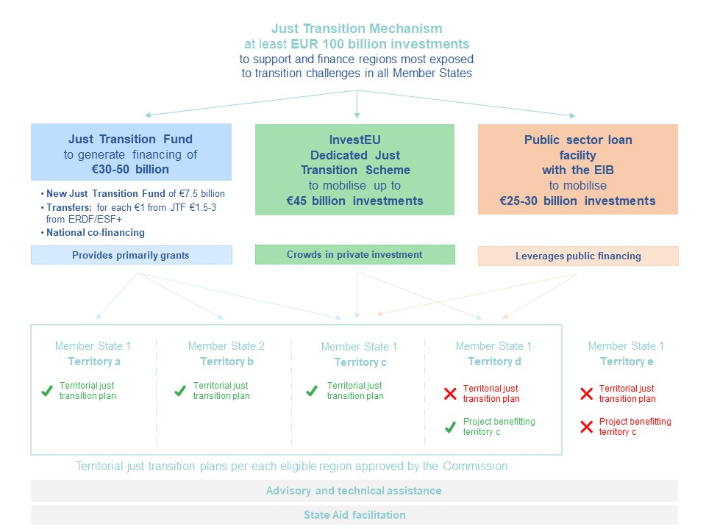

**Each pillar will assist with different grant and financing instruments in order to offer a full range of support options in line with the needs to mobilise investments benefiting the most impacted regions.** To ensure coherence between the three pillars, the Just Transition Fund will be used to provide primarily grants; the dedicated transition scheme under InvestEU will crowd in private investments, and the new just transition public sector loan facility will leverage public financing. These measures will be accompanied by dedicated advisory and technical assistance for the regions and projects concerned. The Just Transition Mechanism will include a strong governance framework centred on territorial just transition plans.

**Taken together, the components of the Just Transition Mechanism could help mobilize investment in the regions most exposed to transition challenges in the order of EUR 100 billion over the period 2021-2027.** All investments financed will be coherent with the Green Deal objectives.

**Additionally, the Commission will propose a revision of the Regulations on the Research Fund for Coal and Steel in order to enable the use a portion of the European Steel and Coal Community assets in liquidation.** This will help with maintaining the annual research programme of at least EUR 40 million as well as to enable the funding of large clean steelmaking R&I breakthrough projects. Research activities in the coal sector will focus on regions in transition in line with the principles of the Just Transition Mechanism.

**Further, the EU ETS Modernisation Fund will complement the Just Transition Mechanism.** Additional EUR 14 billion (subject to eventual carbon price levels) in 2021-2030 will address the low-carbon investments in its ten beneficiary Member States (Romania, Bulgaria, Hungary, Latvia, Lithuania, Estonia, Czech Republic, Poland, Slovakia, Croatia).

## Pillar 1: The Just Transition Fund

**The Just Transition Fund (JTF) will be equipped with its own envelope of EUR 7.5 billion within the EU budget,** **which comes on top of the proposal for the next Multiannual Financial Framework made by the Commission in May 2018[10]** The Fund will aim to alleviate the social and economic costs of the transition to climate neutrality.

**The Commission is adopting today a proposal for a regulation establishing the Just Transition Fund, as well as a proposal for targeted amendments to the Common Provisions Regulation.** To unlock one euro from the Just Transition Fund, eachMember State will be required to allocate a minimum of 1.5 and a maximum of 3 euro from the European Regional Development Fund and the European Social Fund Plus. This spending from the EU budget will be supplemented by national co-financing according to cohesion policy rules. This could bring the total amount of public funds mobilised through the Just Transition Fund to between EUR 30 and 50 billion.

**The Just Transition Fund will benefit territories with high employment in coal, lignite, oil shale and peat production**, as well as territories with greenhouse gas-intensive industries, which will be either discontinued or severely impacted by the transition. The level of support will reflect the magnitude of the challenges in these territories, in terms of the need for both economic diversification and transition towards zero and low-carbon activities with growth potential, and the reskilling of workers in view of equipping them with the necessary skills to take on new jobs.

**The Just Transition Fund will help transform these regions, which will be essential to reaching carbon neutrality by 2050. It will bring together spending on climate action and support for bridging differences between and inside of Member States.** The Just Transition Fund will therefore be implemented under cohesion policy, which is the main EU policy to reduce regional disparities and to address structural changes in Europe’s regions. It will be implemented through shared management in close cooperation with national, regional and local authorities and stakeholders. This will ensure ownership and provide the tools and structures for an efficient management framework.

**The Just Transition Fund will provide support to all Member States, with focus on those that will shoulder the biggest transition challenges**. Resources will be allocated among Member States based on the scale of the decarbonisation challenge of the highest greenhouse gas-intensive regions (through the corresponding industrial emissions), the social challenges in light of potential job losses in industry, coal and lignite mining and production of peat and extraction of oil shale, and the need for subsequent reskilling of workers. To ensure that the transition is fair and acceptable to all, the allocation will reflect the ability of Member States to address this challenge according to their level of economic development.

**Member States will need to identify the eligible territories through dedicated territorial just transition plans, in dialogue with the Commission and consistently with their National Energy and Climate Plans**. This dialogue will be based on an assessment on the territories most affected by the transition to climate neutrality and the employment and economic challenges they will face, as identified in the European Semester. Member States will take into account that assessment for the elaboration of the just territorial transition plans, outlining the transition process and the types of operations envisaged. These plans will be annexed to the Cohesion Policy programmes entailing support for the Just Transition Fund, and will be adopted by the Commission together with these programmes**.**

To ensure the most effective use of the resources, the Just Transition Fund will be able to support investments in the transformation of existing installations, also in EU Emissions Trading System sectors, only when these investments lead to substantial emission reduction, and also bring a positive long-term contribution to the job situation in the territories concerned, in line with the territorial transition plans.

|  |
| --- |
| ***Territorial just transition plans – the centrepiece of the Just Transition Mechanism***  Territorial just transition plans will be at the centre of the Just Transition Mechanism, and a reference for all of its pillars. These plans will set out the social, economic, and environmental challenges stemming from the phasing out of fossil fuel-related activities, or decarbonising greenhouse gas-intensive processes or products. They will also give an outline of the transition process until 2030, including development, reskilling and environmental rehabilitation needs and the approach to tackle them in an integrated manner, the transition timeline, the types of operations envisaged and governance mechanisms. This means that the measures to be supported by the Just Transition Fund might differ among Member States and territories with regard to the priorities and challenges identified. The programming process will be based on the assessment provided in the context of the European Semester. Taking into account this assessment, Member States will prepare territorial just transition plans, which will be part of the programmes under the Just Transition Fund. The approval of the plans by the Commission will open the doors to dedicated financing not only from the Just Transition Fund (pillar 1 of the Just Transition Mechanism), but also from the dedicated just transition scheme under InvestEU (pillar 2) and the public sector loan facility by the EIB (pillar 3). |

## Pillar 2: A dedicated scheme for just transition regions under the InvestEU Fund

**The Just Transition Mechanism will also comprise a dedicated just transition scheme under InvestEU, to generate additional investment to benefit the most affected regions.** This will allow new economic activities to replace those that need to be phased out because of their effect on the climate and environment. Compared to the Just Transition Fund, it will also enable investments in a wider range of projects, in line with the broader eligibility of investments under InvestEU. InvestEU will support financing, among others, to projects for energy and transport infrastructure, including gas infrastructure and district heating, but also decarbonisation projects, economic diversification of the regions, social infrastructure and skills. It will also allow the affected sectors to adapt quicker to climate-friendly production modes. Financing under InvestEU can support economically viable investments in these areas, providing complementarity and synergies with the Just Transition Fund.

**The InvestEU Fund as it stands is expected to trigger EUR 650 billion of additional private and public investment to support EU policy objectives in the next MFF through an EU guarantee of EUR 38 billion.** This guarantee is supported by a combination of an EU budget of EUR 15.2 billion (i.e. 40% provisioning rate) and contingent liabilities for the remaining amount.

**The InvestEU Fund can be an efficient tool for generating significant additional investments in just transition projects in the regions concerned.** To this effect, a portion of the financing under the InvestEU Fund will be focused on the just transition objectives. This could generate up to  EUR 45 billion of investments over the period 2021-2027 to support the transition in the regions concerned, aiming at reflecting the national allocation key under the Just Transition Fund. However, the final use of InvestEU will remain demand-driven and will depend on the project pipeline. The absorption capacity of the regions concerned will be key in achieving the objectives. The overall target of EUR 45 billion correspond to a provisioning of around EUR 1.8 billion from the EU budget for the InvestEU Programme. Moreover, Member States will be able to contribute part of their Just Transition Fund allocation to support investment through guaranteed loans or equity via their Member State compartment. Tailored advisory support to develop the pipeline of projects will be needed. In order to achieve this, it is essential to ensure an adequate level of InvestEU guarantee in the on-going MFF negotiations.

**Projects in the regions having an approved transition plan under the Just Transition Fund Regulation, or projects that benefit those regions (even if they are not located in the regions themselves), can benefit from the scheme, but only when funding outside the just transition territories is key to the transition in those territories**. This is relevant in particular for transport or energy infrastructure projects that improve the connectivity of the just transition territories. Investments pursuing the just transition objectives can count toward climate objectives and contribute to the achievement of the 30% climate objectives set out for the InvestEU Programme.

**Such targeting of the InvestEU guarantee to the just transition objectives will unlock eligible investment under all four policy windows and will be reflected in the underlying financial products.** Dedicated incentives for Implementing Partners may be offered via fees or more advantageous risk coverage for projects to be implemented in transition regions. The just transition objective target will be included in the InvestEU Investment Guidelines and guarantee agreements with the Implementing Partners. Moreover, the call(s) for proposals addressed to Implementing Partners under the InvestEU Fund will prioritise those Implementing Partners offering financial products that contribute to the just transition objectives. **Dedicated technical assistance will be provided to make projects investable through the InvestEU Advisory Hub, for which** **an additional envelope will be made available.**

## Pillar 3: A public sector loan facility with the European Investment Bank Group

**A public sector loan facility with the European Investment Bank will support increased public sector investment in the regions undergoing climate transition. This support will offer concessional loans to the public sector.** These loans would provide public sector entities with resources to implement measures to facilitate the transition to climate neutrality. Supported investments will range from energy and transport infrastructure, district heating networks, energy efficiency measures including renovation of buildings, as well as social infrastructure, and can include other sectors as well. The EU support could take the form of inter alia an interest rate subsidy or an investment grant, financed from the EU budget, which will be blended together with loans extended by the EIB to municipal, regional and other public authorities.

**The geographical coverage will be the same as under the InvestEU just transition scheme (pillar 2 of Just Transition Mechanism), i.e. projects in the regions with an approved transition plans** but also in projects benefiting those regions, but only when funding outside the just transition territories is key to the transition in those territories**.** The just transition public sector loan facility is meant to offer such preferential funding conditions in order to support public sector investment to the benefit of the most affected regions. It will also include advisory support in order to help generate project pipeline.

**The support under the public loan facility will be complementary to the products offered by the InvestEU dedicated just transition scheme.** It will apply to projects, which do not sufficiently generate market streams of revenue and that otherwise would not get financed without a subsidy element.

**With the contribution from the EU budget of EUR 1.5 billion and the EIB lending of EUR 10 billion at its own risk, the public sector loan facility could mobilise between EUR 25 and 30 billion public investments over the period 2021-2027.** This reflects the national allocation key under the Just Transition Fund, to support the transition in the regions concerned. The Commission will table a legislative proposal to set up this new public sector loan facility in March 2020. Over time, the Commission may explore co-operation with additional implementing partners as public sector needs evolve.

## Technical assistance and advisory support

**The just transition will not only depend on the money available to support investment, but also on channelling this money to the right projects.** Assistance will be provided to Member States and regions through a Just Transition Platform, which will be managed by the Commission. The Platform will be building on and expanding the work of the existing Platform for Coal Regions in Transition, which already supports fossil fuel producing regions across the EU in achieving a just transition. It will provide technical and advisory support for the elaboration of the territorial transition plans through an expert network facilitating the sharing of information between Member States, regions, agencies and stakeholders. The Commission will launch already in the first quarter of 2020 a call for requests under the Structural Reform Support Programme to assist Member States with the preparation of their territorial transition plans where needed. The Just Transition Mechanism will also provide advisory support and technical assistance through the same means as described in section 5.1.2.

|  |
| --- |
| **The Commission will:**  **- Engage with the co-legislators in order to work towards the quick adoption of the Just Transition Fund regulation and corresponding amendments of the Common Provisions Regulation.**  **-Work with the EIB Group and other implementing partners to implement the just transition scheme under InvestEU once adopted.**  **- Table a new legislative proposal for a public sector loan facility with the EIB in March 2020.**  **- Assist Member States and regions in the preparation of territorial transition plans.**  **- Provide technical assistance and advisory support in order to generate robust project pipeline to the benefit of just transition regions.** |

# Conclusion and next steps

**The Sustainable Europe Investment Plan is instrumental in mobilising the investments necessary to reach the ambitious objectives set by the European Green Deal**. By committing to mobilise at least EUR 1 trillion of sustainable investments over the next decade through the EU budget, the Commission sets a very concrete objective of its own, against which progress will be monitored. The plan also includes a commitment to use all relevant policy levers to provide private and public investors with a framework that enables sustainable investments to the maximum extent possible. It also entails a renewed commitment to provide the necessary project planning and execution support to authorities and project promoters. Given the magnitude of the financing needs, the Commission is committed to further explore how to mobilise additional funding to achieve the European Green Deal objectives.

**The Just Transition Mechanism included in the Plan will help ensure that the shift towards a sustainable future leaves no one behind**. Regions most exposed to transition challenges will be assisted, both financially and administratively, in this endeavour.

**The success of the Sustainable Europe Investment Plan will depend on the engagement of all relevant stakeholders in its implementation.** It will be vital that Member States and the European Parliament maintain the high ambition of the Commission proposal during the negotiations on the upcoming financial framework. The investment community, including institutional investors, banks, promotional institutions and private equity funds, are invited to make full use of the emerging framework for sustainable investments. Member State authorities in turn will have to take up an active role in identifying, promoting and, where needed, co-financing such investments.

**Every year the Commission will hold a Sustainable Investment Summit, involving all relevant stakeholders**. The summit will be an opportunity to take stock of progress across the different work streams included in the Sustainable Europe Investment Plan, and identify new avenues for action. The Commission will continue exploring with relevant partners additional sources that could be mobilised to meet the long-term financing needs of the transition, and innovative ways to do so. Moreover, in line with the Council conclusions of December 2019, the Commission will develop and provide regular assessments of the environmental and socio-economic impacts of the transition to climate neutrality and related investment needs to address those impacts, where needed.

1. The key targets for 2030 are: at least 40% cuts in greenhouse gas emissions (from 1990 levels), at least 32% share for renewable energy and at least 32.5% improvement in energy efficiency.
2. Compared to a baseline scenario – *United in delivering the Energy Union and Climate Action - Setting the foundations for a successful clean energy transition* (COM(2019) 285).
3. The Commission estimates that, beyond climate-related measures, the broad environmental sustainable investment gap is between EUR 100 billion and EUR 150 billion annually, including environmental protection and resource management. With respect to social investments, the High-level taskforce on investing in social infrastructure has estimated that additional EUR142 billion per year would be needed for affordable housing, health and long-term care, education and life-long training. These do not relate to the cost of supporting the green transition exclusively.
4. Compared to a baseline scenario - COM(2019) 285.
5. For transport, the data include the total investment expenditure in mobile assets, but not investment in infrastructure and in systems facilitating sharing of vehicles etc. The figures do not include the updated technology costs assumptions used for the long-term strategy.
6. These are to be considered as conservative estimates. Important investment needs in agriculture or climate adaptation or the preservation and restoration of ecosystems and biodiversity are not included due to a current lack of data.
7. The figures estimated are a simple extrapolation over 10 years of the Commission proposal for the 2021-2027 multi-annual financial framework (MFF), without prejudice to the future MFF post 2027, while assuming that the climate ambition will be at least maintained.
8. European Agricultural Fund for Rural Development, European Agricultural Guarantee Fund, European Regional Development Fund, Cohesion Fund, Horizon Europe and Life funds.
9. COM(2018) 97 final.
10. COM(2019) 456 final.