

Contents

I. INTRODUCTION 3

II. DATA SUBMITTED AND GENERAL ASSESSMENT 3

II.1. Data Submitted by the Member States 3

II.2. General Considerations 3

II.2.1 Link to the previous statistical reports under Directive 86/609/EEC 4

II.3. Report structure 7

SECTION A: COMPILATION AND OVERVIEW OF THE EU DATA BETWEEN 2015 AND 2017 10

III.1 Numbers of animals used for research, testing, routine production and educational purposes in the EU 10

III.1.1. Numbers of animals used for the first time 10

III.1.2. Origin of animals used for the first time 14

III.1.2.1. Place of birth of animals (other than non-human primates) 14

III.1.2.2. Origin of non-human primates 16

III.1.2.2.1. Non-human primates - Source 16

III.1.2.2.2. Non-human primates - Generation 17

III.2. Details of all uses of animals for research, testing, routine production and educational purposes in the EU 19

III.2.1. Overview of the main scientific purposes and the related severities 19

III.2.1.1. Main categories of scientific purposes 19

III.2.1.2. Severity of uses 21

III.2.1.3. Main animal species used by high level purpose categories 22

III.2.2. Detailed information on use purposes 24

III.2.2.1. Research related uses 24

III.2.2.2. Uses of animals for regulatory purposes 28

III.2.2.3. Routine production uses 38

III.2.2.4. Other types of uses 39

III.2.3. Information on reuses and genetic status of animals 40

III.2.3.1. Reuses 40

III.2.3.2. Use of genetically altered animals 44

III.3. Numbers and uses of animals for the creation and maintenance of genetically altered animals in the EU 47

III.3.1. Numbers of animals used for the creation and maintenance of genetically altered animals 47

III.3.2. All uses of animals for the creation of new genetic altered animal lines 47

III.3.2.1. Creation of new genetically altered animals lines by genetic status 48

III.3.2.2. Creation of new genetically altered animals lines by scientific purposes 49

III.3.2.3. Creation of new genetically altered animal lines by severity 51

III.3.2.4. Reuses 52

III.3.3. All uses of animals for the maintenance of colonies of established genetically altered animal lines 52

III.3.3.1. Maintenance of colonies of established genetically altered animal lines by genetic status 53

III.3.3.2. Maintenance of colonies of established genetically altered animal lines by severity 54

III.3.3.2. Maintenance of colonies of established genetically altered animal lines by species 54

III.3.3.3. Reuses 55

III.4. Glossary of terms 56

# I. INTRODUCTION

This Commission Staff Working Document accompanies “2019 report on the statistics on the use of animals for scientific purposes in the Member States of the European Union in 2015-2017”, which summarises the data and conclusions presented in this document.

The objective of the report is to present statistical information on the use of animals in procedures in the European Union under Directive 2010/63/EU[1] of 22 September 2010 on the protection of animals used for scientific purposes (“the Directive”). The obligation of the Member States to collect statistical data is covered by Article 54(2) of the Directive.

Regulation (EU) 2019/1010[2] (“the Regulation”) amended Article 54(2) of the Directive. This report is based on data provided by Member States in accordance with the previous wording of Article 54(2) requiring the collection on an annual basis of statistical information on the use of animals in procedures, including information on the actual severity of the procedures and on the origin and species of non-human primates used in procedures. The amended Article 54(2) requires Member States to submit the statistical data by electronic transfer in a non-summarised format to the Commission.

As the Regulation was adopted in June 2019, the first annual dataset in line with the new wording of Article 54(2) will be collected in 2020 and is required to be submitted to the Commission by 10 November 2021. That Member State data will then be made available through an open access database in 2022 accompanied by a summary report thereof.

The Regulation also removed the obligation of the Commission to submit a statistical report to the European Parliament and the Council. However, since improved transparency is one of the key objectives of the Directive, the Commission considers it appropriate, as well as necessary in support of the other objectives of the Directive, that the data submitted by the Member States is made available on a yearly basis until 2022.

This first report under Directive 2010/63/EU contains the results of the data collected by all 28 Member States between 2015 and 2017.

# II. DATA SUBMITTED AND GENERAL ASSESSMENT

## II.1. Data Submitted by the Member States

The data were collected according to the Commission Implementing Decision 2012/707/EU of 14 November 2012 establishing a format for the submission of the information pursuant to Directive 2010/63/EU of the European Parliament and the Council on the protection of animals used for scientific purposes.

## II.2. General Considerations

The Section A of this report aims at providing a comprehensive overview on the use of animals in procedures in the European Union between 2015 and 2017. The purposes of the use of animals have been analysed at EU level, and some of these purposes have been broken down into more precise sub-categories.

In this report, data are presented either in the form of figures or summary tables providing information on a specific aspect of the Directive. Overall numbers are given for the three reported years. However, where the statistics focus on a more detailed breakdown to get a better understanding of the area being analysed (for example breakdown of animal species used for the first time), these are based on data from the year 2017. This decision was taken for two main reasons: the first is that 2017 is the most recent year with a comprehensive dataset, the second is that due to the changed reporting criteria, it is expected that the data from 2017 would be of the highest accuracy. Key findings are presented in the form of tables and graphics. However, in some cases, further information in the text may have been drawn both from annexed tables and Member State narratives (see Section C of this Staff Working Document). Member State narratives have been helpful in providing information such as for the content of ‘other’ categories (for example, ‘other rodents’, ‘other basic research’).

It is important to note in this context that the introduction of new reporting criteria represents a number of challenges. Good data quality requires clear understanding, by all involved, of all new requirements (such as severity reporting), any terms used and data categorization. Furthermore, the way in which the reporting requirements have been implemented at the national level, including any additional support (national guidance, training) play an important role in the data quality.

Some elements of the new reporting have proven extremely demanding, having required extensive efforts by Member States and the Commission. One such example concerns the reporting of animals used for the maintenance of genetically altered animals, and uses that should be covered under this category. Another example concerns the reporting of actual, experienced severity.

The two main issues when reporting actual severity were: confusion between prospective severity classification (for the purposes of a project evaluation) assigned for an entire group of animals versus the actual experienced severity, which is assigned to each animal individually on the basis of observed and recorded adverse effects; and how to incorporate expert judgement in the severity assessment in a consistent manner over time and between establishments, regions and Member States.

To help in this process, some Member States have been particularly active in their efforts to improve data quality. Furthermore, some stakeholder organisations have offered workshops to address issues around severity reporting. With these and other efforts, the statistical data quality is expected to continue to improve. As errors are being detected and consistency improved, it is clear that some of the fluctuations in numbers, or even what may seem to appear as trends at this early stage, may indeed instead be due to improved understanding of the reporting obligations. Finally, for these same reasons it is too early to draw conclusions on any firm trends on the basis of the first three years of data.

### II.2.1 Link to the previous statistical reports under Directive 86/609/EEC[3]

As there are significant differences from the previous reporting requirements, the data presented in this report are not, in general, comparable with the information presented in reports published under the former Directive 86/609/EEC.

The new reports were developed to provide significantly more detailed and tailored information on animal use. They include aspects of animal use, which have not previously been available, for example, on the genetic status of animals and the actual severity experienced by the animals during their use in procedures. In terms of numbers, some uses of animals, which were previously grouped together, are now covered by different sections of this report. Moreover, the new reports cover areas of animal use that were not included in the reports under the previous legislation.

With this in mind, the only limited comparison which may be attempted concern the numbers of animals used for the first time for the purposes of research and testing[4]. However, even here the comparison is not obvious, because (1) invertebrate species were not included in the past reports and they are now, and (2) the previous numbers included partly those animals that were used for the creation of genetically altered animal lines (which are now separate), leaving the comparison between 2011 and current numbers of animals only as an estimate.

The main differences from previous reports are summarised below:

1. **The scope** of the Directive and subsequently the related reporting requirements have changed considerably. The new reports include new classes of animals, namely all species of Cephalopods (for example octopus, squid and cuttlefish). In addition, the maintenance (breeding) of certain types of genetically altered animals is covered. Neither of these categories was included in previous reports.
2. **The time of reporting.** The data published previously reported the numbers of animals at the start of their use (“procedure”). However, Directive 2010/63/EU requires that information is reported on the actual impact on the welfare of the animals used for scientific purposes. For this reason, in contrast to previous reporting, the information is submitted when a **use of an animal is complete**. Therefore, the data under Directive 2010/63/EU are **reported at the end** of the procedure.
3. **Each use of an animal is counted.** The data captured by the new reporting criteria include both the numbers of uses of new animals (not previously used in a procedure) and "reuses" (animals that have already previously been used in a procedure). “Uses” therefore includes both the “first use” and all subsequent “reuses”.

Furthermore, previously, the details were reported only from the first use and therefore, no information was captured on any subsequent uses. Although the majority of animals are used only once, the Directive provides for a possibility to reuse animals under certain conditions (Article 16 of the Directive). Reuse can reduce the overall number of animals, where this does not detract from the scientific objective or cause significant welfare compromise. However, the benefit of re-using animals (a reduction in numbers) needs to be carefully balanced against any adverse effects on their welfare, taking into account the lifetime experience of each individual animal. Reuse must be considered on a case-by-case basis (recital 25 of the Directive).

1. **The actual severity experienced by an animal** during a procedure is one of the key innovations of the new report. The severities are categorised as “non-recovery”, “mild”, “moderate” or “severe”. “Non-recovery” means that the animal has undergone a procedure that has been performed entirely under a general anaesthesia and from which the animal has not recovered. This includes also the situation where the animal has failed to recover consciousness from anaesthesia during the first step of a planned recovery procedure.

The following table presents the differences between the reporting requirements of the two Directives:

|  |  |  |
| --- | --- | --- |
| Reporting | Former Directive (86/609/EEC) | Current Directive (2010/63/EU) |
| Scope – species | Only vertebrate species | Vertebrate species and Cephalopods |
| Scope – purpose | No reporting of breeding of genetically altered animals | Maintenance (breeding) of genetically altered (GA) animals with intended harmful phenotype (characteristic/trait) and which have experienced suffering |
| First use and reuse  (animals used versus uses of animals) | Number of new animals, and only the number of reuses of the species covered by the Annex I of Directive 86/609/EEC with no related details of the reuse | Number of new animals, and in addition all reuses. All uses reported with full datasets |
| Source of Non-human primates (NHPs) | Information on European origins but not from other geographical regions | More detailed information on where NHPs have been obtained, in particular outside Europe |
| Generation of NHP breeding | Not reported | Information on progress from wild caught (F0), to first generation purpose-bred (F1), second generation purpose-bred animals (F2), to self-sustaining colonies. |
| Genetic Status | Not reported | * No genetic alteration (GA) * GA with a non-harmful phenotype * GA with a harmful phenotype |
| Purposes | Broad headings | More detailed information of previously reported categories with further sub-categorisation, such as for ecotoxicity, routine production and GA maintenance |
| Creation of a new genetically altered (GA) line | Not reported | Creation of a new GA line together with the intended purpose |
| Actual severity | Not reported | Actual severity reported under four categories   * Non-recovery * Mild * Moderate * Severe |

## II.3. Report structure

For the first time at the level of the EU, the statistical information is collected, not only on the scientific uses of animals for the purposes of research and testing, but also on the scientific uses for the creation and maintenance of genetically altered animal lines in support of research needs. Equally, it is the first time that full datasets are available for each use of an animal, allowing for a much more precise reporting.

It is therefore the objective of this report to present all these data structured in a manner that allows for an improved understanding of when and how animals are still used in science today. It is hoped that, in line with the Directive aims, this way of reporting will better facilitate the identification of animal use areas on which efforts for the development and validation of alternative approaches can be focused.

Therefore, Section A of the report is composed of three parts as illustrated in the picture below:

First uses

Creation and maintenance of genetically altered animals

*) research, testing, routine production and education (including in training)

**Part 1**

**Numbers of animals**

used in research and testing*)

**Part 2**

**All uses of animals**

in research and testing*)

Reuses

Genetically altered animals

**Part 3**

**Numbers and uses of animals**

for the provision of genetically altered animals

**Numbers of animals used for research, testing, routine production and educational purposes[5] in the EU – Part 1 (III.1)**

The first part focuses on the *numbers of animals* used, for the first time, for the purposes of research, testing, routine production and education (term ‘education’ in the context of this report also includes animals used for the purposes of training). These animals can be both conventional animals or those that have been genetically altered. This part reports on their numbers and origins. It excludes animals that have been used for the creation of a new genetically altered animal line, or maintenance of an existing genetically altered animal line. These are covered in part three below.

**Details of all uses of animals for research, testing, routine production and educational purposes in the EU – Part 2 (III.2)**

The second part focuses on the way in which animals are used in these scientific procedures, *covering all uses, both the first and any subsequent reuse.* This serves to draw an overall picture of all uses of animals for the purposes of research, testing, routine production and education in the EU. This part takes into account the nature of the procedures, their legislative context, reuse of animals, the genetic status of the animals, and the severities experienced by the animals.

**Numbers and uses of animals for the creation and maintenance of genetically altered animals in the EU – Part 3 (III.3)**

The third part focuses on the provision of *genetically altered animals* needed to support scientific research in the Union. It reports, on one hand, on animals used in procedures for *the creation* of new genetically altered animal lines and, on the other, *the maintenance* of colonies of existing genetically altered animals. Like in part one of this report, it provides the actual numbers of animals, used for the first time, as well as more detailed information taking into account all uses (first, and any subsequent reuse) for the purposes of creation and maintenance of genetically altered animal lines. It also provides further information on the type of research for which new genetically altered animal lines are being created. These animals have not been used in other scientific procedures, in other words the data are separate from those covered in parts one and two of this report.

Section B of this report contains EU level data that have been used as the basis for conclusions in Section A of the report. Section C of this report provides data from the Member States together with their respective narratives.

**Information outside of the scope of the statistical report**

What remains outside of the scope of annual statistical reporting – even if covered by the scope and provisions of the Directive, are:

* Foetal forms of mammals;
* Animals killed solely for organs and tissues, and sentinels, unless the killing is performed under a project authorisation using a method not included in Annex IV of Directive 2010/63/EU;
* Animals bred and killed without being used, apart from genetically altered animals with intended and exhibited harmful phenotype, and those having been genotyped with an invasive method before being killed.

Additional information on animals bred and killed without being used will be reported in the five-year report on the implementation of the Directive in line with Article 54(1) of the Directive.

# SECTION A: COMPILATION AND OVERVIEW OF THE EU DATA BETWEEN 2015 AND 2017

## III.1 Numbers of animals used for research, testing, routine production and educational purposes in the EU

This part focuses on the numbers of animals used *for the first time* in procedures for the purposes of research, testing, routine production and education. Therefore, it excludes all reuses of animals that are considered in the second part. It also excludes animals that are used either for the creation of new genetic altered lines or the maintenance of colonies of established genetically altered animal lines. However, animals used for research, testing, routine production and educational purposes can be conventional or genetically altered.

In addition to the numbers of animals, this part also provides information on the species in relation to their origin, and for non-human primates, information on progress to purpose-bred animals, by recording generation.

### III.1.1. Numbers of animals used for the first time

Between 2015 and 2017, the number of animals used for the first time in the EU annually is below 10 million. The total number of animals decreased slightly from 9.59 million in 2015 to 9.39 million in 2017 (-2%). However, there was a small increase to 9.82 million in 2016, preventing the identification of a clear trend (Table 1.1).

|  |  |  |  |
| --- | --- | --- | --- |
|  | 2015 | 2016 | 2017 |
| Total | 9,590,379 | 9,817,946 | 9,388,162 |

**Table 1.1: Total numbers of animals used for the first time for research, testing, routine production and education purposes in the EU between 2015 and 2017**

In 2017, the main species used for the first time for research, testing, routine production and educational purposes were mice, fish, rats and birds that together represented 92% of the total number of animals. Species of particular public concern (dogs, cats and non-human primates (NHP)) represented less than 0.3% of the total number of animals. No great apes are used for scientific purposes in the European Union (Figure 1.1).

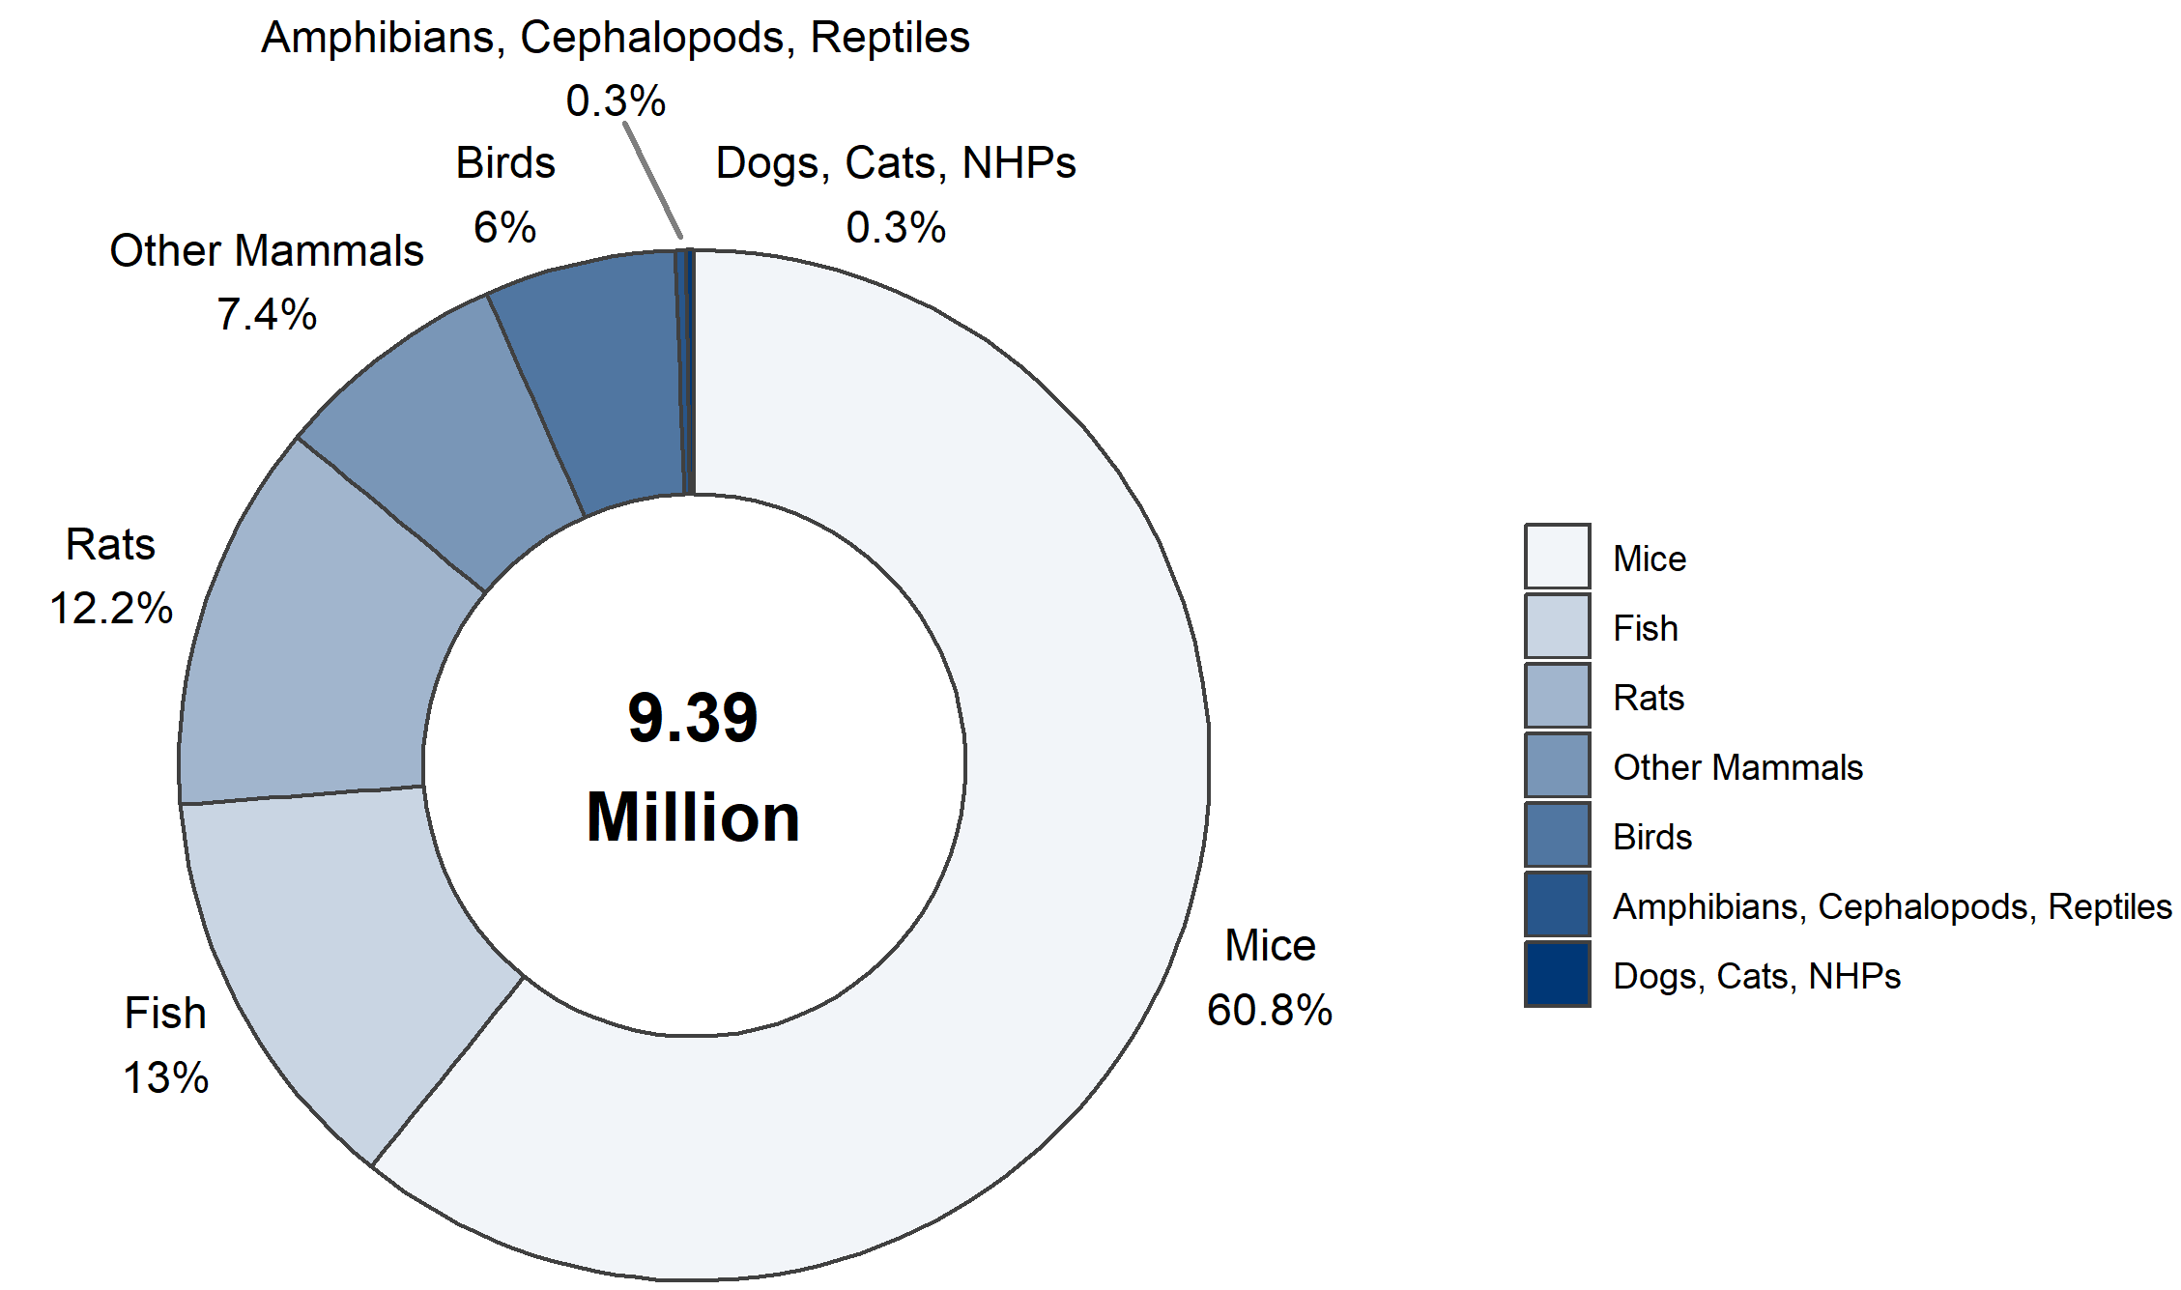

**Figure 1.1: Numbers of animals used for the first time by main classes of species in 2017**

Looking at this higher level of grouping from 2015 to 2017 (table 1.2), the number of birds decreased   
(-11%) as well as the number of amphibians, cephalopods, reptiles (together) (-42%) due to a significant drop in cephalopods in 2016. However, the actual number of cephalopods remains low (15,862 in 2015 to 514 in 2017 - Table 1.4). As a general remark, it is important to note that numbers can fluctuate year to year, particularly so with fish, amphibian and cephalopods where studies on immature forms may involve large numbers (thousands) of animals.

|  |  |  |  |
| --- | --- | --- | --- |
|  | 2015 | 2016 | 2017 |
| Mice | 5,711,612 | 5,989,413 | 5,707,471 |
| Rats | 1,201,189 | 1,173,135 | 1,146,299 |
| Other mammals | 713,113 | 700,262 | 719,576 |
| Fish | 1,275,067 | 1,304,737 | 1,219,695 |
| Birds | 635,211 | 595,724 | 563,963 |
| Amphibians, Cephalopods, Reptiles | 54,187 | 54,675 | 31,158 |
| Total | 9,590,379 | 9,817,946 | 9,388,162 |

**Table 1.2: Numbers of animals used for the first time by main classes of species**

For fish, the Directive distinguishes zebra fish (41% of fish in 2017) from other fish species. The main "other" fish species (719,932 in 2017 - Table 1.4) reported during the period (2015-2017) were seabass, guppies, trout and salmon.

For birds, the Directive distinguishes domestic fowls (82% of birds in 2017) from other birds. The main species reported as “Other birds” (99,410 in 2017 – Table 1.4) were turkey and the Great Tit (*Parus major*).

For amphibians, the Directive distinguishes rana (13% of amphibians in 2017) and xenopus (49% of amphibians in 2017) from other amphibians. The main species reported as “Other amphibians” (10,683 – Table 1.4) during the period was bufo (toads).

First uses of mammals between 2015 and 2017 are reported in more detail in table 1.3 below.

|  |  |  |  |
| --- | --- | --- | --- |
|  | 2015 | 2016 | 2017 |
| Mice | 5,711,612 | 5,989,413 | 5,707,471 |
| Rats | 1,201,189 | 1,173,135 | 1,146,299 |
| Guinea-Pigs | 149,328 | 150,985 | 144,824 |
| Other rodents | 52,512 | 38,490 | 43,298 |
| Rabbits | 346,052 | 350,405 | 351,961 |
| Cats | 1,975 | 1,951 | 1,879 |
| Dogs | 14,501 | 15,691 | 13,688 |
| Other carnivores | 5,860 | 2,974 | 4,402 |
| Farm animals | 126,214 | 128,890 | 124,954 |
| Non-human primates | 7,136 | 7,239 | 8,235 |
| Other mammals | 9,535 | 3,637 | 26,335 |
| Total | 7,625,914 | 7,862,810 | 7,573,346 |

**Table 1.3: Numbers of animals used for the first time in the Mammal category**

Farm animals include horses, donkeys and cross-breeds, pigs, goats, sheep and cattle. "Other carnivores" (4,402 in 2017) reported were ferrets, mink and badgers while "Other rodents" (43,298) were hamsters and wild species of rodents and "Other mammals" mainly bats.

Between 2015 and 2017, the numbers of farm animals remained stable. There was an increase (+14%) in cattle use, while remaining farm animals saw a decrease (-25% for horses, donkeys and cross breed).

The numbers of “Other carnivores” showed some fluctuation but no obvious reason could be identified from the statistics.

Numbers of “Other mammals” increased significantly between 2015 and 2017 due to a high number of bats in 2017 used in procedures to study human infectious disorders.

The species of non-human primates reported during the period were: prosimians, marmoset and tamarins, squirrel monkey, other species of new world monkey (*ceboidea*), cynomolgus monkey, rhesus monkey, vervets chlorocebus, baboons, and other species of old world monkeys (*cercopithecoidea*). In line with the general ban on the use of great apes, introduced by the Directive, no such use was reported during that period.

Between 2015 and 2017, the numbers of non-human primates saw an increase (+15%). The cynomolgus monkey (representing 88% of non-human primates in 2017 – Table 1.4) was the most commonly used species of non-human primates and had a 16% increase between 2015 and 2017. Numbers of marmosets, rhesus monkeys and other old world monkeys (mainly *macaca nemestrina* and *macaca silenus*) also increased slightly. Numbers of other non-human primate species decreased between 2015-2017.

|  |  |  |  |
| --- | --- | --- | --- |
|  | 2015 | 2016 | 2017 |
| Mice | 5,711,612 | 5,989,413 | 5,707,471 |
| Rats | 1,201,189 | 1,173,135 | 1,146,299 |
| Guinea-Pigs | 149,328 | 150,985 | 144,824 |
| Hamsters (Syrian) | 20,195 | 18,614 | 12,700 |
| Hamsters (Chinese) | 30 | 519 | 187 |
| Mongolian gerbil | 6,199 | 5,645 | 5,239 |
| Other rodents | 26,088 | 13,712 | 25,172 |
| Rabbits | 346,052 | 350,405 | 351,961 |
| Cats | 1,975 | 1,951 | 1,879 |
| Dogs | 14,501 | 15,691 | 13,688 |
| Ferrets | 2,212 | 1,530 | 2,016 |
| Other carnivores | 3,648 | 1,444 | 2,386 |
| Horses, donkeys and cross-breeds | 3,217 | 3,474 | 2,414 |
| Pigs | 73,895 | 80,029 | 71,522 |
| Goats | 2,233 | 1,365 | 1,563 |
| Sheep | 20,106 | 21,240 | 18,812 |
| Cattle | 26,763 | 22,782 | 30,643 |
| Prosimians | 169 | 44 | 98 |
| Marmoset and tamarins | 429 | 285 | 465 |
| Squirrel monkey | 13 | 8 | 8 |
| Other species of New World Monkeys (Ceboidea) | 0 | 0 | 3 |
| Cynomolgus monkey | 6,221 | 6,503 | 7,227 |
| Rhesus monkey | 211 | 318 | 353 |
| Vervets (Chlorocebus spp.) | 56 | 19 | 33 |
| Baboons | 37 | 62 | 25 |
| Other species of Old World Monkeys (Cercopithecoidea) | 0 | 0 | 23 |
| Other mammals | 9,535 | 3,637 | 26,335 |
| Domestic fowl | 515,834 | 500,920 | 464,553 |
| Other birds | 119,377 | 94,804 | 99,410 |
| Reptiles | 2,414 | 3,240 | 2,937 |
| Rana | 4,884 | 4,482 | 3,485 |
| Xenopus | 10,837 | 18,511 | 13,539 |
| Other amphibians | 20,190 | 19,558 | 10,683 |
| Zebra fish | 338,815 | 513,011 | 499,763 |
| Other Fish | 936,252 | 791,726 | 719,932 |
| Cephalopods | 15,862 | 8,884 | 514 |
| Total | 9,590,379 | 9,817,946 | 9,388,162 |

**Table 1.4: Numbers of animals used for the first time by species**

### III.1.2. Origin of animals used for the first time

The origin (place of birth) of animals is divided into two categories depending on whether the species belongs to the category of non-human primates or not. For non-human primates, more detailed information is collected on their origin (continent of origin) and in addition their generation is reported (see Part III.1.2.2.).

#### III.1.2.1. Place of birth of animals (other than non-human primates)

In 2017, almost 90% of the animals used for scientific purposes for the first time were born in the EU at registered breeders and less than 2% were born outside of the EU (either in the rest of Europe or outside of Europe). Category 'animals born in the EU but not at a registered breeder' includes animals from, for example, farms, and studies carried out using wild animals (Figure 1.2).

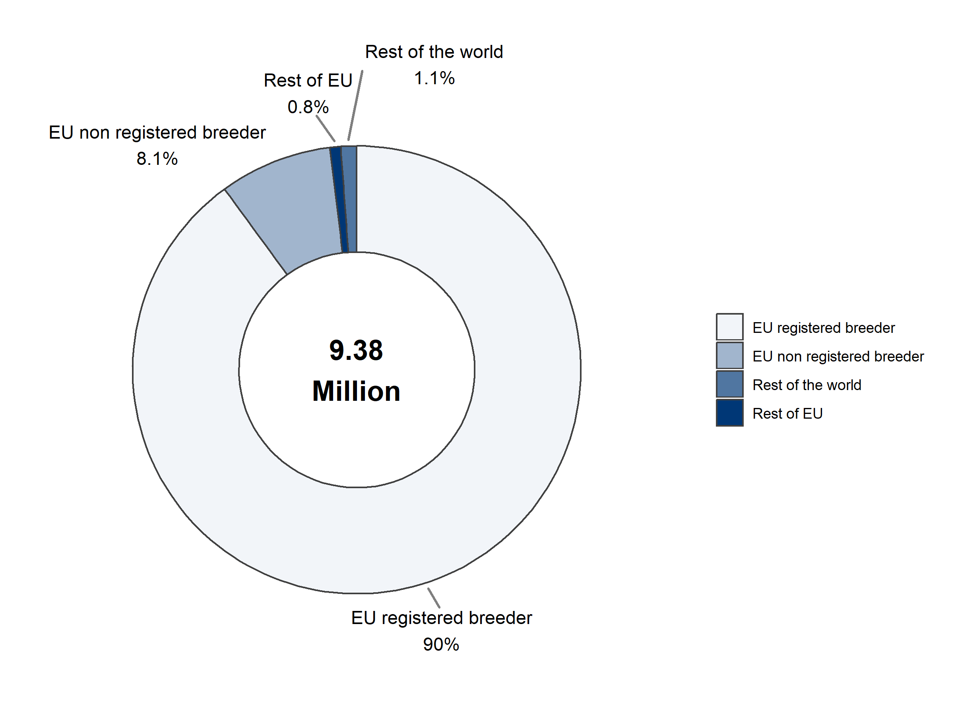

**Figure 1.2: Place of birth of animals other than non-human primates in 2017**

Between 2015 and 2017, animals born in the EU but not at a registered breeder decreased slightly   
(-20%) and animals born in the rest of the world increased (+61%) partly due to a significant import of bats (18,000).

|  |  |  |  |
| --- | --- | --- | --- |
|  | 2015 | 2016 | 2017 |
| Animals born in the EU at a registered breeder | 88% (8,466,666) | 90% (8,874,852) | 90% (8,437,271) |
| Animals born in the EU but not at a registered breeder | 10% (955,563) | 8% (773,612) | 8% (762,288) |
| Animals born in rest of Europe | 1% (94,219) | 1% (82,219) | 1% (72,952) |
| Animals born in rest of world | 1% (66,795) | 1% (80,024) | 1% (107,416) |
| Total | 100% (9,583,243) | 100% (9,810,707) | 100% (9,379,927) |

**Table 1.5: Place of birth of animals other than non-human primates**

Annex I of the Directive contains a list of animals that may only be used where those animals have been bred for use in procedures (see Article 10). Figure 1.3 shows all the animal species listed in Annex I, except non-human primates.

In 2017, amongst the species listed in Annex I, rodents, rabbits and zebra fish were, for the vast majority, born at EU registered breeders (Figure 1.3). Dogs (32%), cats (44%) and to a lesser extent frogs (10%) had a higher proportion of animals born in the EU but at a non-registered breeder (Section B – Table 2). The most common reason for using dogs and cats that came from non-registered breeders in the EU were procedures in pet dogs and cats, which had blood samples taken for studies of genetic disorders, or pet animals, which were involved in patient studies for better treatment methods.

Last, 33% of dogs, 19% of frogs, 9% of hamsters (Syrian) and 8% of cats were imported from the rest of the world, with a significant decrease for cats (-60%) between 2015-2017 (Section B – Table 2).

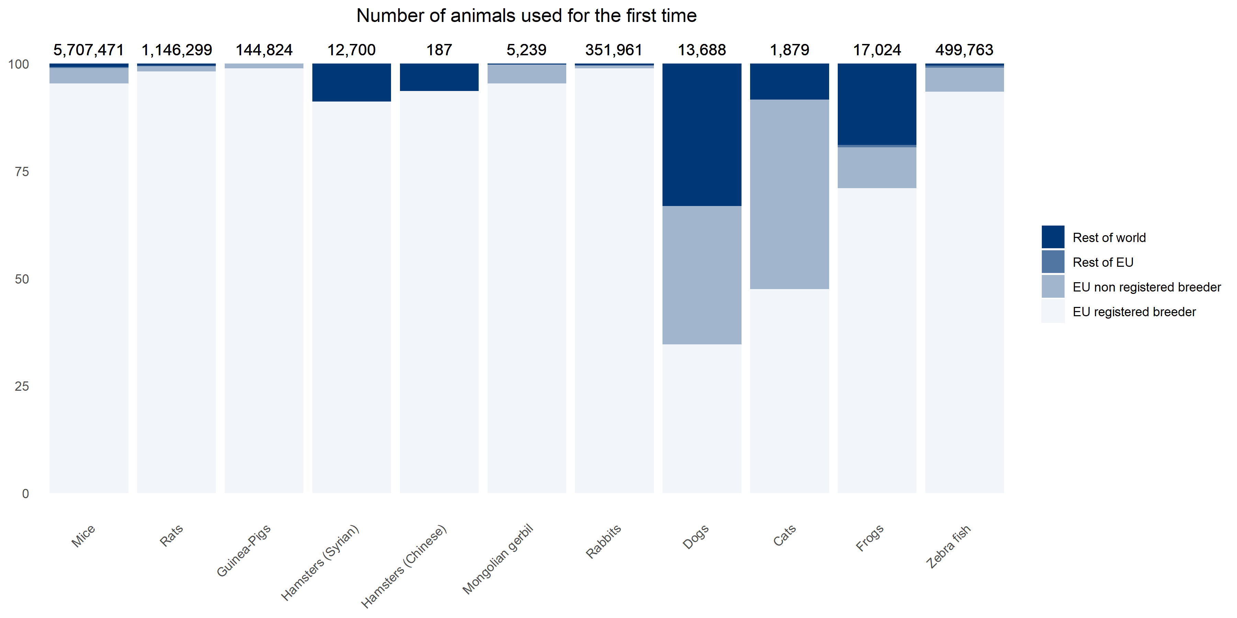

**Figure 1.3: Place of birth of animals other than non-human primates listed in Annex I in 2017**

#### III.1.2.2. Origin of non-human primates

The Directive provides additional protection for non-human primates due to their genetic proximity to human beings, their highly developed social skills and capacity to experience pain, suffering and distress. Furthermore, the Directive recognises that the capture of non-human primates from the wild is highly stressful for the animals concerned and carries an elevated risk of injury and suffering during capture and transport. In order to end the capture of animals from the wild including for the purposes of breeding, the Directive introduced provisions with the objective of moving towards using non-human primates that have been bred, ultimately, in self-sustaining colonies, from parents who themselves have been bred in captivity (see Article 10 of the Directive).

In order to monitor progress, more detailed information is collected on both the origin and generation of non-human primates used in scientific procedures in the EU.

#### III.1.2.2.1. Non-human primates - Source

In 2017, the three main sources of non-human primates were Africa, Asia and EU registered breeders representing more than 97% of non-human primates used for scientific purposes (Figure 1.4).

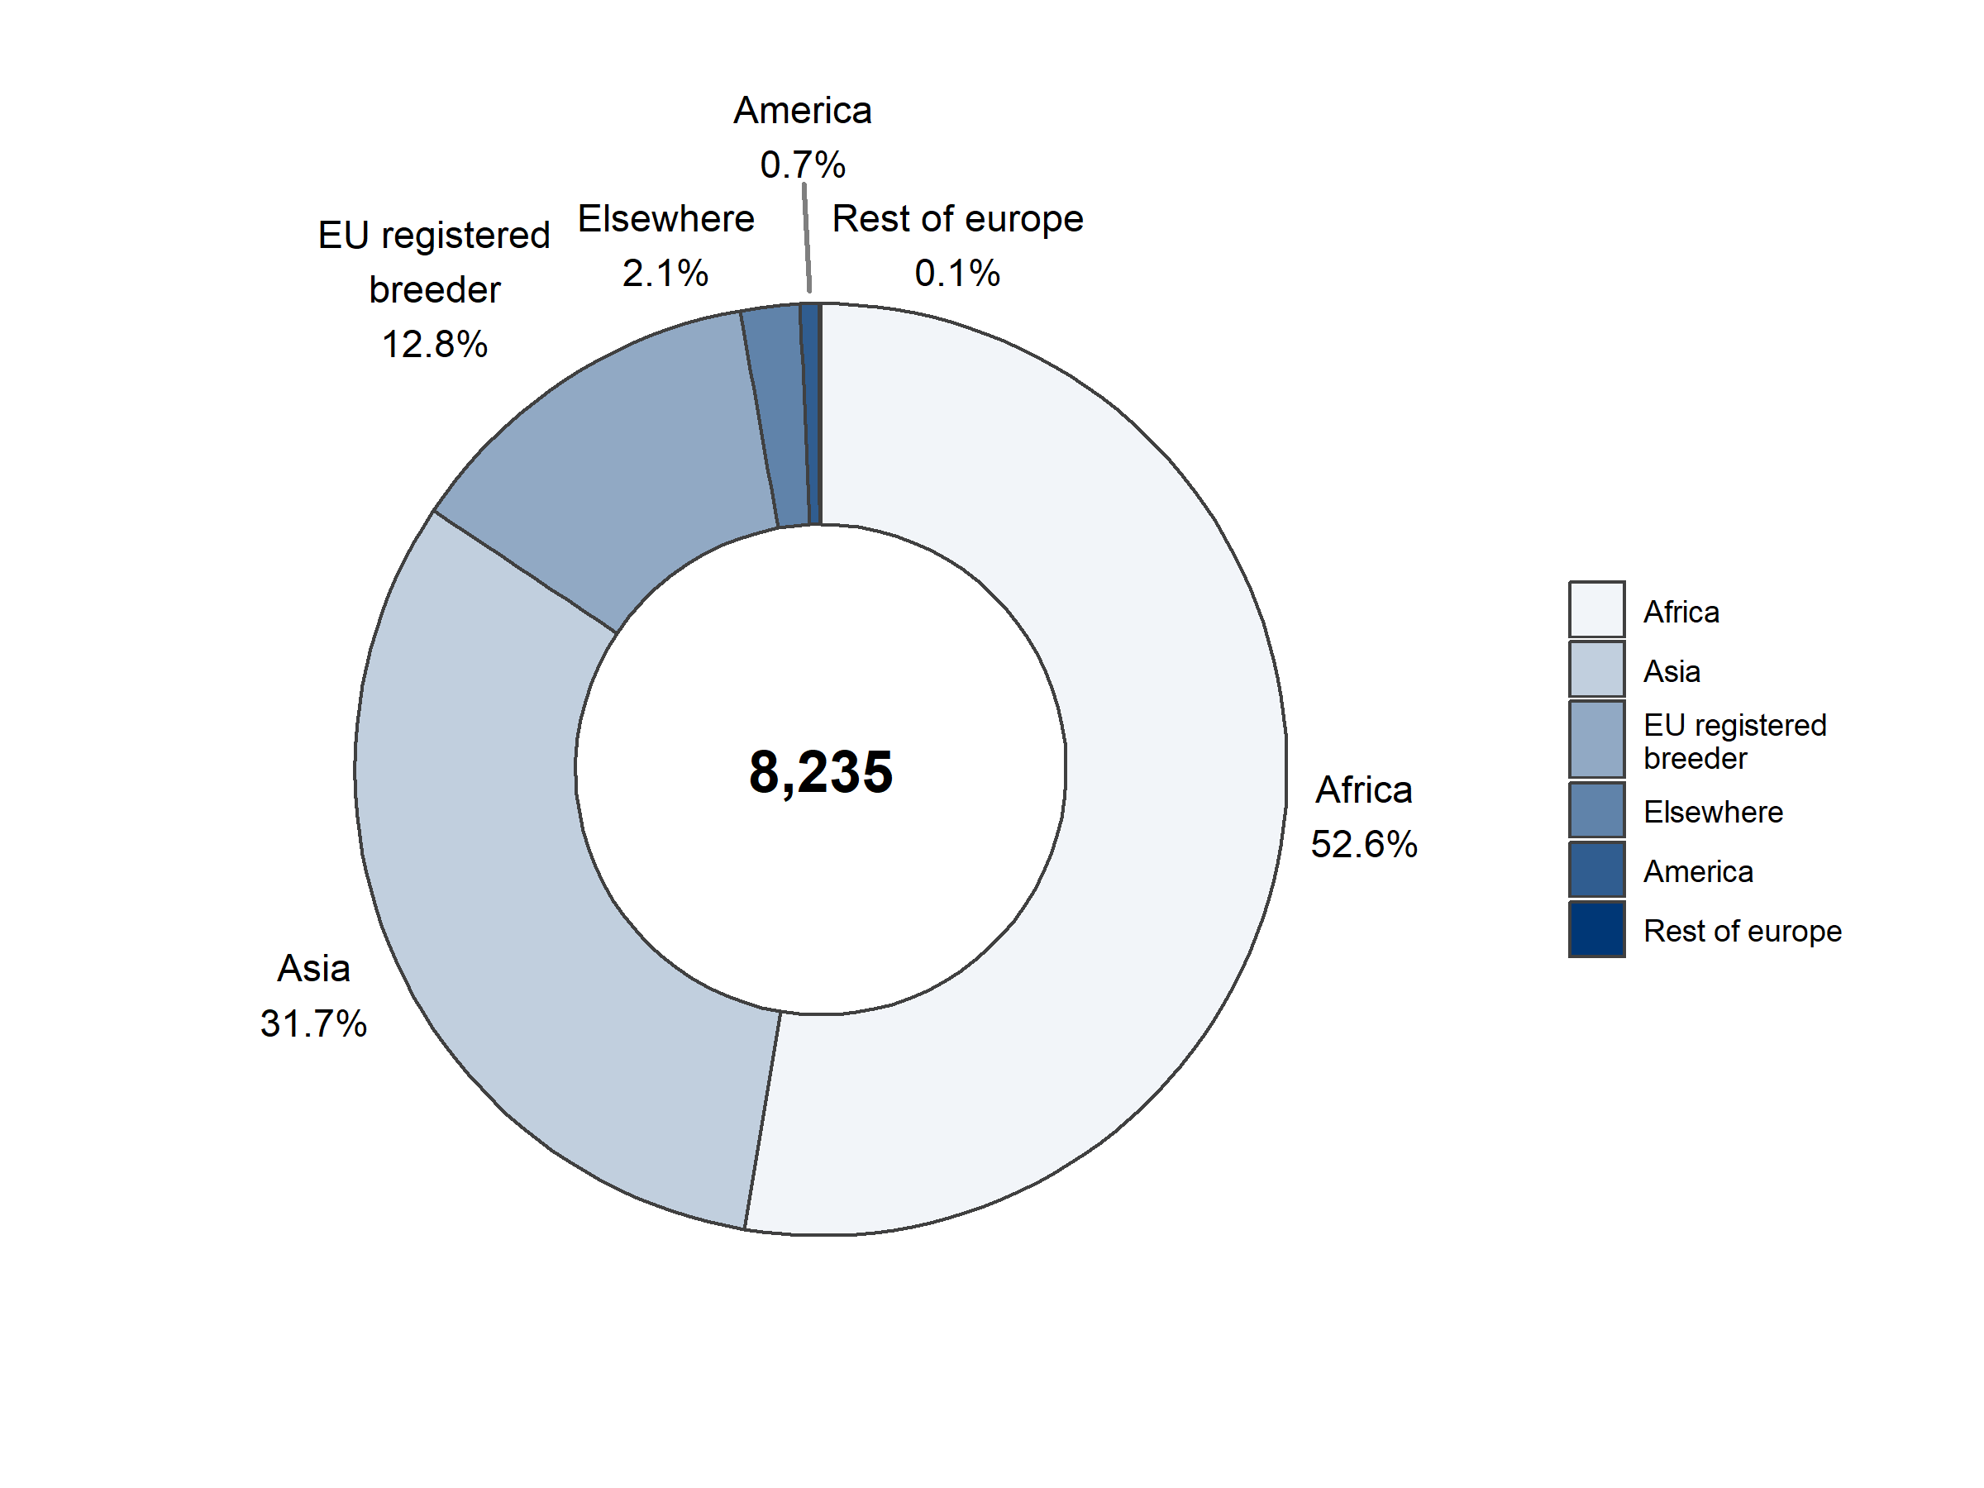

**Figure 1.4: Source of non-human primates in 2017**

In 2017, cynomolgus monkeys represented 88% of non-human primates used for the first time. These were sourced almost entirely from outside of the EU (Table 1.6). In contrast, other species of non-human primates were mainly sourced from EU registered breeders.

|  |  |  |  |  |  |  |  |
| --- | --- | --- | --- | --- | --- | --- | --- |
|  | Animals born at a registered breeder within EU | Animals born in rest of Europe | Animals born in Asia | Animals born in America | Animals born in Africa | Animals born elsewhere | Total |
| Prosimians | 100% (98) | 0% (0) | 0% (0) | 0% (0) | 0% (0) | 0% (0) | 100% (98) |
| Marmoset and tamarins | 81% (377) | 0% (0) | 0% (0) | 0% (0) | 9% (42) | 10% (46) | 100% (465) |
| Squirrel monkey | 62% (5) | 0% (0) | 0% (0) | 25% (2) | 0% (0) | 12% (1) | 100% (8) |
| Other species of New World Monkeys (Ceboidea) | 100% (3) | 0% (0) | 0% (0) | 0% (0) | 0% (0) | 0% (0) | 100% (3) |
| Cynomolgus monkey | 3% (218) | <1% (5) | 36% (2,591) | 0% (0) | 59% (4,290) | 2% (123) | 100% (7,227) |
| Rhesus monkey | 90% (317) | 0% (0) | 4% (14) | 5% (19) | 1% (3) | 0% (0) | 100% (353) |
| Vervets (Chlorocebus spp.) | 0% (0) | 0% (0) | 0% (0) | 100% (33) | 0% (0) | 0% (0) | 100% (33) |
| Baboons | 100% (25) | 0% (0) | 0% (0) | 0% (0) | 0% (0) | 0% (0) | 100% (25) |
| Other species of Old World Monkeys (Cercopithecoidea) | 61% (14) | 0% (0) | 39% (9) | 0% (0) | 0% (0) | 0% (0) | 100% (23) |
| Total | 13%  (1,057) | 0%  (5) | 32%  (2,614) | 1%  (54) | 53%  (4,335) | 2%  (170) | 100%  (8,235) |

**Table 1.6: Source of non-human primates by species in 2017**

#### III.1.2.2.2. Non-human primates - Generation

With regard to the generation of non-human primates being bred in captivity in 2017, the majority of non-human primates were sourced either from self-sustaining colonies (30%) or as second or higher generation purpose-bred (53%). No non-human primates were sourced from the wild (Table 1.7) in 2017.

Between 2015 and 2017, non-human primates coming from self-sustaining colonies decreased slightly (-9%). In line with the Directive objectives, those being second or higher generation purpose-bred increased significantly (+67%) and those being of first generation purpose-bred decreased (-23%).

|  |  |  |  |
| --- | --- | --- | --- |
|  | 2015 | 2016 | 2017 |
| Self-sustaining colony | 39% (2,748) | 31% (2,271) | 30% (2,504) |
| F2 or greater | 37% (2,614) | 47% (3,435) | 53% (4,368) |
| F1 | 25% (1,773) | 21% (1,528) | 17% (1,363) |
| F0 | 0% (1) | 0% (5) | 0% (0) |
| Total | 100% (7,136) | 100% (7,239) | 100% (8,235) |

**Table 1.7: Generation of non-human primates in 2017**

Looking at non-human primate species and their generation:

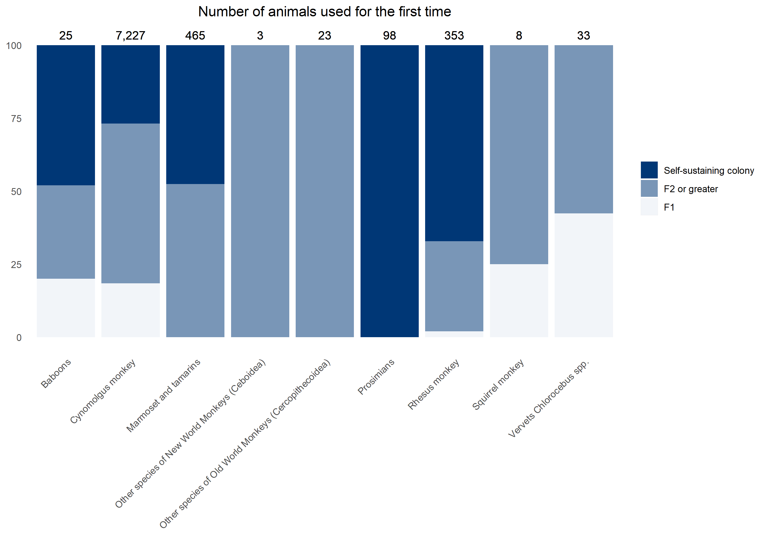

**Figure 1.5: Generation of non-human primates by species in 2017**

For non-human primates born at a registered breeder in the EU, only 3% of non-human primates used for the first time were from the first generation, in Africa first generation of animals represented 26% in 2017 and first generation non-human primates from elsewhere represented 47% (Table 1.8).

|  |  |  |  |  |  |  |
| --- | --- | --- | --- | --- | --- | --- |
|  | Animals born at a registered breeder within EU | Animals born in rest of Europe | Animals born in Asia | Animals born in America | Animals born in Africa | Animals born elsewhere |
| F1 | 3% (32) | 0% (0) | 3% (88) | 30% (16) | 26% (1,147) | 47% (80) |
| F2 or greater | 40% (418) | 100% (5) | 75% (1,948) | 70% (38) | 44% (1,915) | 26% (44) |
| Self-sustaining colony | 57% (607) | 0% (0) | 22% (578) | 0% (0) | 29% (1,273) | 27% (46) |
| Total | 100%  (1,057) | 100%  (5) | 100%  (2,614) | 100%  (54) | 100%  (4,335) | 100%  (170) |

**Table 1.8: Generation of non-human primates by source in 2017**

## III.2. Details of all uses of animals for research, testing, routine production and educational purposes in the EU

This part focuses on all uses of animals for the purposes of research, testing, routine production and education, including the first and any subsequent reuse. It provides detailed information on the reason for use (for example the specific research area, or type of testing) as well as additional information related to the actual severity experienced by the animals, their genetic status and reuse. In addition, information on the use of animals to satisfy legislative requirements is collected.

### III.2.1. Overview of the main scientific purposes and the related severities

Between 2015 and 2017, the total number of all uses (first use and any subsequent reuse) for the purposes of research, testing, routine production and education decreased from 9.78 million in 2015 to 9.58 million uses in 2017 (-2%). However, an increase to 10.03 million in 2016 prevents drawing of firm conclusion with regard to a trend in the number of uses (Table 2.1).

|  |  |  |  |
| --- | --- | --- | --- |
|  | 2015 | 2016 | 2017 |
| Total | 9,782,570 | 10,028,498 | 9,581,741 |

**Table 2.1: Total number of uses of animals between 2015 and 2017**

#### III.2.1.1. Main categories of scientific purposes

In 2017, 9.58 million uses of animals for scientific purposes were reported by Member States in the European Union.

Most uses were conducted for research purposes (68%) with 45% of the uses being carried out for basic research and 23% for translational and applied research purposes. A further 23% of animal uses in procedures were carried out for regulatory use to satisfy legislative requirements, followed by routine production (5%).

Other categories (4%) include the protection of the natural environment in the interest of the health or welfare of human beings or animals, the preservation of species, the higher education or training for the acquisition, maintenance or improvement or vocational skills and the forensic enquiries (Figure 2.1).

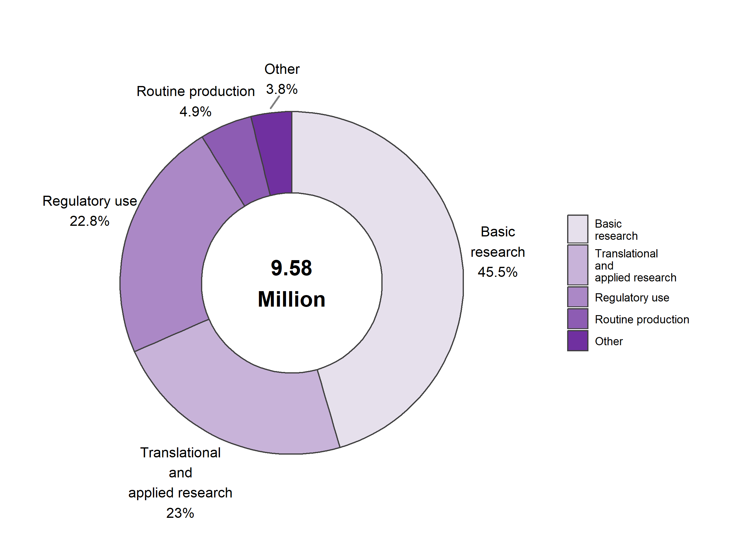

**Figure 2.1: Uses of animals used for scientific purpose in 2017**

Throughout the entire reporting period (between 2015 and 2017), no clear trend can be identified as the variability across purposes is more significant than the yearly changes. Variations in the "protection of the natural environment in the interests of health or welfare of human being and animals" (+19%) and "preservation of species" (+107%) are related to procedures involving fish larvae (Table 2.2).

|  |  |  |  |
| --- | --- | --- | --- |
|  | 2015 | 2016 | 2017 |
| Basic research | 4,513,820 | 4,828,533 | 4,357,653 |
| Translational and applied research | 2,151,261 | 2,214,034 | 2,199,956 |
| Regulatory use | 2,356,352 | 2,214,832 | 2,186,859 |
| Routine production | 455,494 | 455,434 | 469,358 |
| Higher education or training for the acquisition, maintenance or improvement of vocational skills | 162,424 | 164,495 | 163,762 |
| Protection of the natural environment in the interests of the health or welfare of human beings or animals | 104,834 | 78,403 | 124,787 |
| Preservation of species | 38,070 | 71,852 | 78,893 |
| Forensic enquiries | 315 | 915 | 473 |
| Total | 9,782,570 | 10,028,498 | 9,581,741 |

**Table 2.2: Uses of animals by main scientific purposes**

#### III.2.1.2. Severity of uses

Directive 2010/63/EU requires the reporting of the actual severity experienced by the animal when used for scientific purposes. In 2017, just over half, 51% of uses, were reported as ‘mild’ (up to and including), 32% as ‘moderate’, and 11% as ‘severe’. 6% of uses were reported as ‘non-recovery’.

The number of uses reported as severe increased proportionally between 2015 and 2016 (Table 2.3). Almost 35% of this increase can be attributed to an increase in the severe uses for the diagnosis of diseases (85,000). The proportion of severe uses remained the same between 2016 and 2017.

It is important to note that the reporting of actual severities is probably the most challenging element of the Directive to achieve consistent reporting within and between Member States as well as over time. Therefore, any firm conclusions on the results of these early years of reporting should be discouraged.

Furthermore, since the actual severities are linked to the type of uses, and the use patterns vary between Member States, it is not advisable to compare overall actual severities between Member States. As an example, a Member State with high proportion of animal use for the purposes of regulatory testing is likely to have higher proportion of severe uses compared to another Member State having mainly uses in the areas of routine production or education and training.

|  |  |  |  |
| --- | --- | --- | --- |
|  | 2015 | 2016 | 2017 |
| Non-recovery | 6% (622,034) | 6% (620,848) | 6% (621,054) |
| Mild [up to and including] | 54% (5,330,549) | 52% (5,239,321) | 51% (4,865,721) |
| Moderate | 31% (3,010,980) | 31% (3,101,054) | 32% (3,071,828) |
| Severe | 8% (819,007) | 11% (1,067,275) | 11% (1,023,138) |
| Total | 100% (9,782,570) | 100% (10,028,498) | 100% (9,581,741) |

**Table 2.3: Severity of uses**

In 2017, when looking at high level purposes, most of the uses reported as severe were conducted for regulatory purposes (16% of regulatory uses), while routine production were mostly mild. Uses in translational and applied research tended to be more severe than those reported in basic research (Figure 2.2).

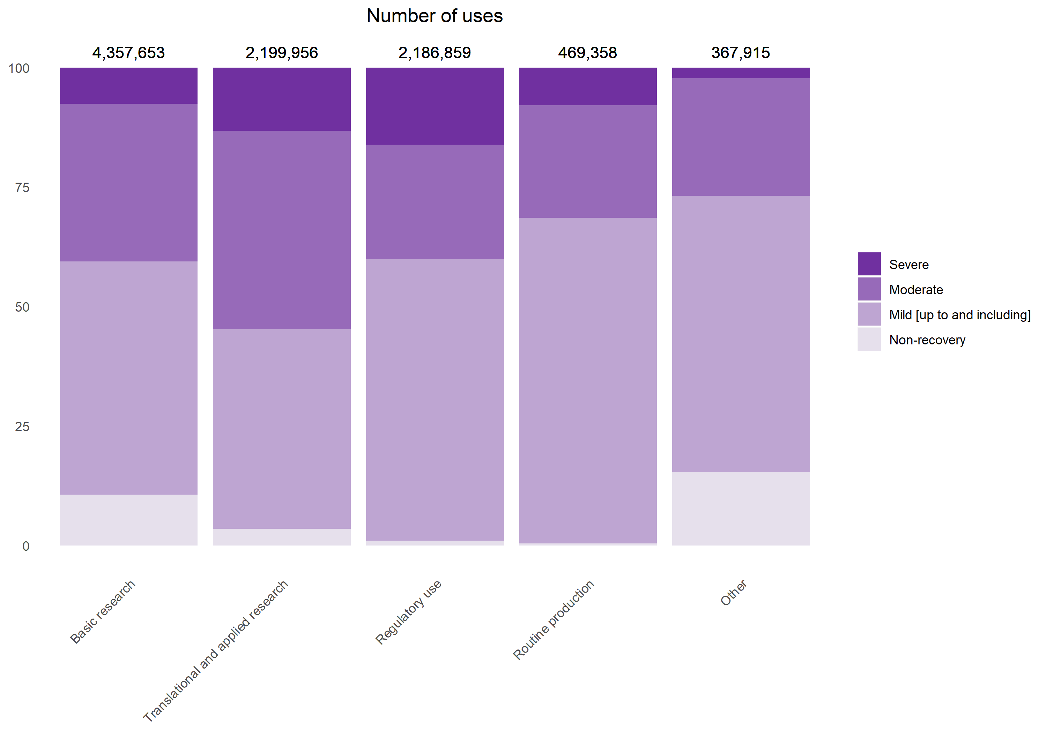

**Figure 2.2: Uses of animals by severity and main categories of scientific purposes in 2017**

When analysing all the sub-categories of purposes, batch potency testing resulted in the highest number of severe uses (over 264K uses - Figure 2.6), followed by studies on nervous system (over 87K uses - Figure 2.4) and diagnosis of diseases (over 81K uses - Figure 2.5).

When analysing the proportion of severe uses within a sub-category: the production of monoclonal antibodies was the highest (70% of all uses for the production of monoclonal antibodies were severe – Figure 2.10), followed by diagnosis of diseases (54% - Figure 2.5) and acute toxicity studies in the area of ecotoxicity (37% - Figure 2.7).

Taking into account sub-categories with more than 30,000 uses, the lowest severities (severe uses below 1% of all uses within the sub-category) can be found in production of blood based products (0.1% of 260,000 uses – Figure 2.10), followed by preservation of species (0.5% of 79,000 uses – Figure 2.11), education and training (0.5% of 164,000 uses – Figure 2.11) and toxicity testing for skin sensitisation (0.7% of 47,000 uses – Figure 2.7)

#### III.2.1.3. Main animal species used by high level purpose categories

In 2017, the main species used in basic research were mice (70%), zebra fish (8%), other fish (8%), rats (7%) and domestic fowl (3%). Similar species feature for applied and translational research with proportionally similar uses of mice (70%) and rat (11%). For regulatory use, the distribution changes again slightly with mice covering now only less than half (48%), followed by rat (26%), domestic fowl (7%), other fish (6%) and rabbits (4%). Routine production has a relatively different pattern compared with the other purpose groups, with rabbits accounting for half (50%), followed by domestic fowl (22%), mice (11%) and sheep (10%).

When looking at different groups of species and the likely purposes they will be used for, fish, mice, amphibians, cephalopods, reptiles and rodents are most likely to be used in basic research. Other mammals (bats), other carnivores are most likely to be used for the purposes of applied and translational research. Rabbits, farmed species and birds are mostly used in routine production and finally guinea-pigs, non-human primates and rats for regulatory purposes (Figure 2.3).

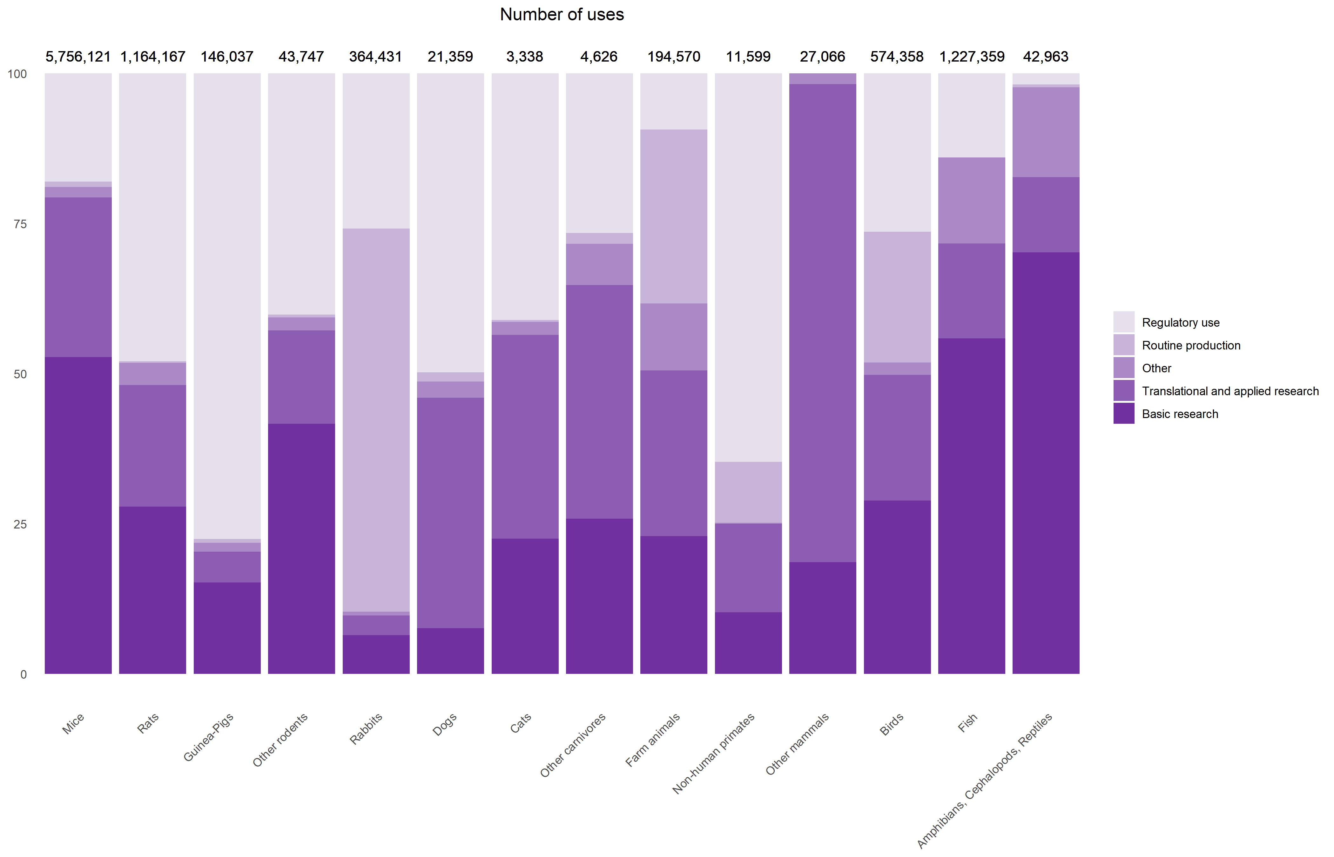

**Figure 2.3: Uses of animals grouped by main classes of species and the main scientific purpose categories in 2017**

Looking at the details of the uses of non-human primates, 65 % are to satisfy legislative requirements for medicinal products for human use (of these 64% are on studies for repeated dose toxicity and 19% for kinetics). In the areas of basic and applied research, non-human primates are mainly used for studying human infectious disorders (7% of all non-human primate uses), nervous system (3%) and non-regulatory toxicology and ecotoxicology (3%). Routine production, of mostly blood based products, represents 10% of non-human primate uses. Some uses of non-human primates were reported for the purposes of education and training, prohibited under the Directive. However, this may have taken place within the transitional provisions under Article 64 of the Directive, allowed until 31.12.2017. The actual reported severities of uses of non-human primates are lower than the EU averages for all species. In 2017, 54% were of mild severity. Only 1,6% of uses were assessed as severe.

### III.2.2. Detailed information on use purposes

#### III.2.2.1. Research related uses

Research-related uses are split between basic research on one side and translational and applied research on the other. Results on these purpose categories are presented with information on related reported actual severities.

##### III.2.2.1.1 Basic research

Basic research was the main area for which animals were used with more than 4.3 million uses in 2017.

The four main domains of basic research using most animals are nervous system, immune system, oncology and ethology/animal behaviour/animal biology that all together account for more than half of the uses in basic research (Figure 2.4).

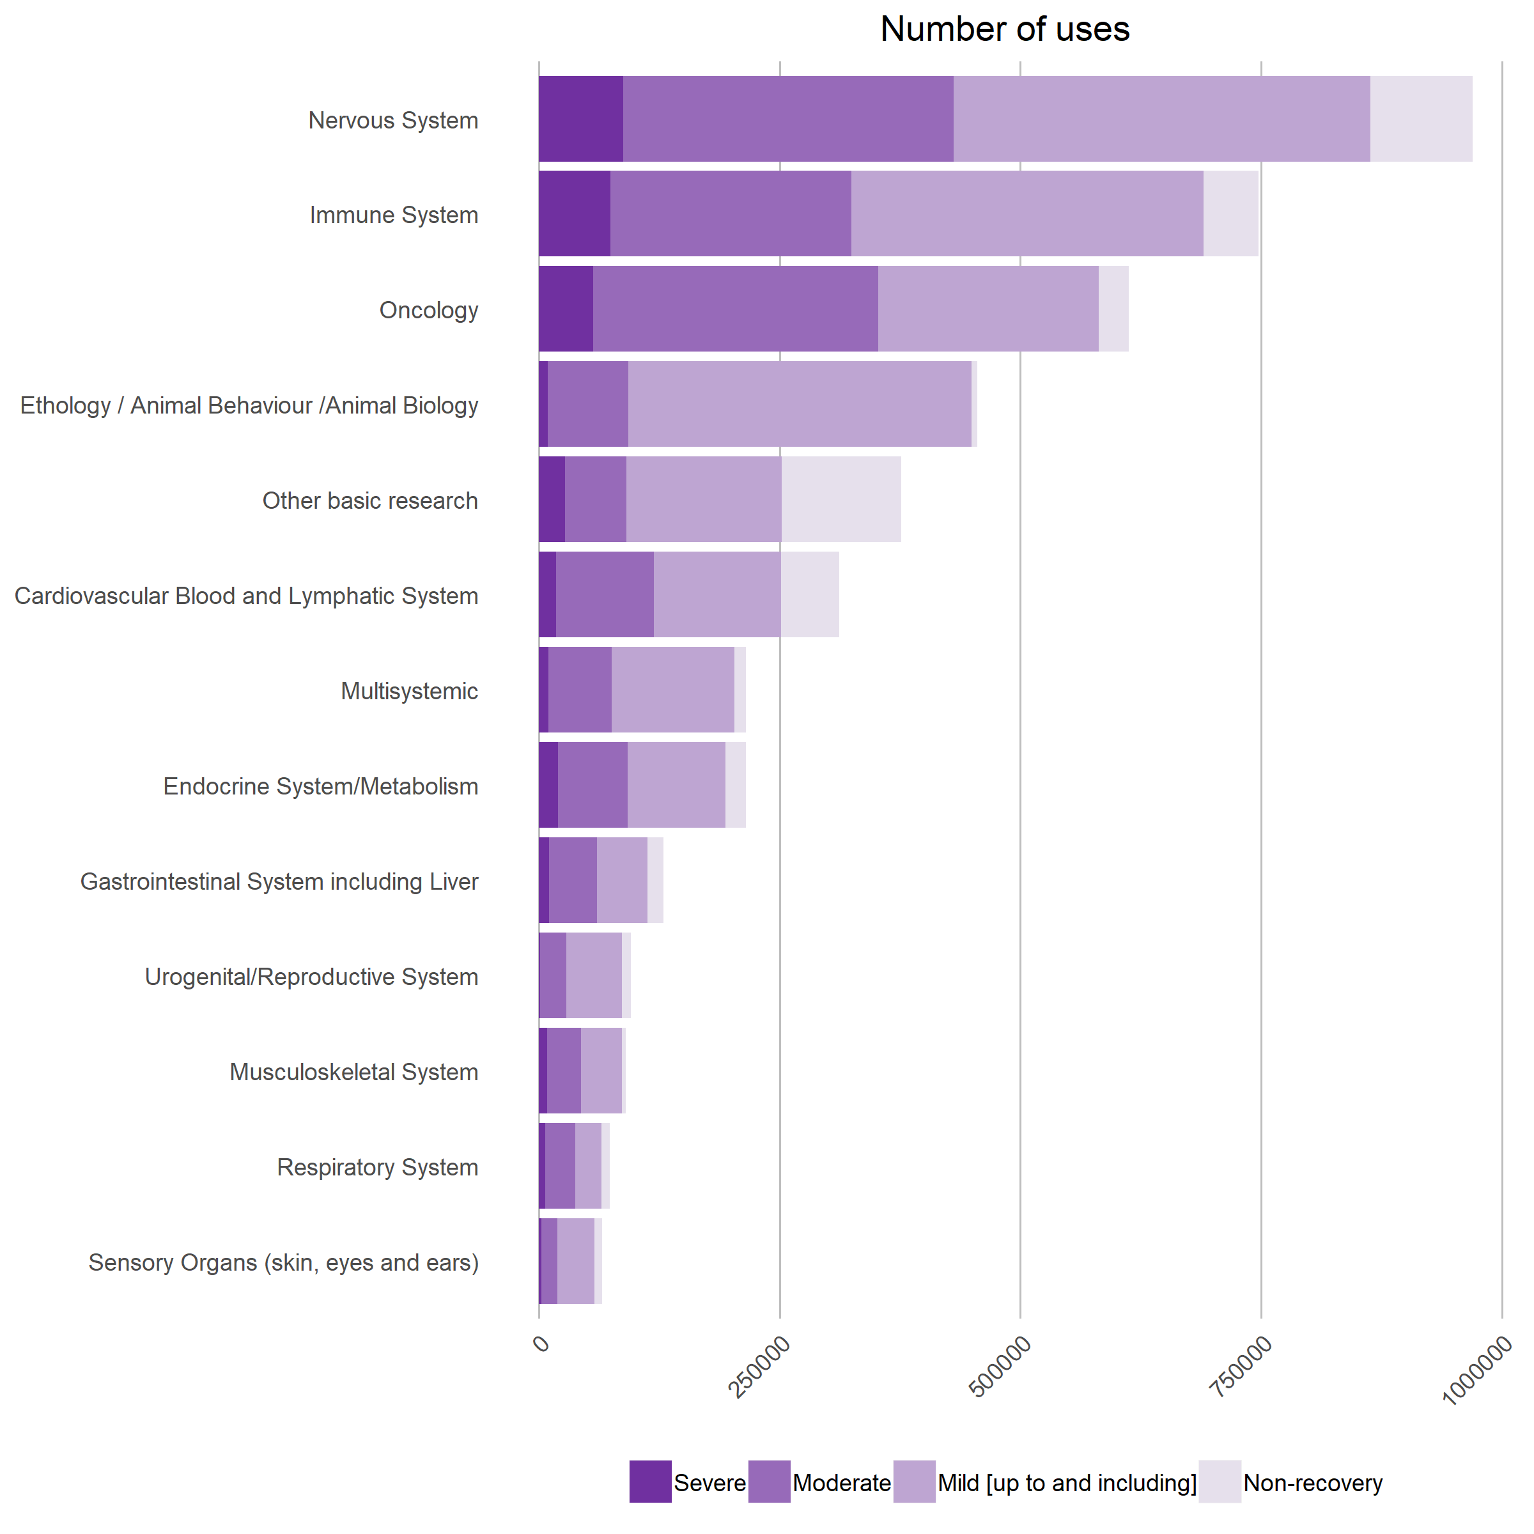

**Figure 2.4: Basic research related uses by type of research and severity in 2017**

In 2017 compared to 2015, there was an increase in the number of uses of animals for oncology (+19%) and nervous system studies (+13%).

During the same period, the sub-categories gastrointestinal system including liver (-38%), urogenital / reproductive system (-31%), ethology/animal behaviour/animal biology (-25%) and immune system (-7%) saw some regular decreases in terms of uses of animals (Table 2.4).

In 2017, in the area of basic research, proportionally highest severities were reported in following sub-categories: immune system (10%), endocrine system/metabolism (9%), oncology (9%), nervous system (9%) and respiratory system (9%).

Proportionally lowest severities were reported for urogenital/reproductive system, ethology/  
animal behavior/animal biology, sensory organs and multisystemic (Figure 2.4).

“Other basic research” includes for example research on nutrition, infectious diseases or embryology.

|  |  |  |  |
| --- | --- | --- | --- |
|  | 2015 | 2016 | 2017 |
| Nervous System | 857,813 | 940,453 | 969,275 |
| Immune System | 804,352 | 753,296 | 746,907 |
| Oncology | 516,404 | 572,117 | 612,344 |
| Ethology / Animal Behaviour /Animal Biology | 605,239 | 564,042 | 455,475 |
| Other basic research | 274,083 | 414,466 | 376,584 |
| Cardiovascular Blood and Lymphatic System | 338,606 | 351,636 | 311,676 |
| Multisystemic | 297,605 | 423,227 | 215,262 |
| Endocrine System/Metabolism | 209,128 | 301,727 | 215,212 |
| Gastrointestinal System including Liver | 208,033 | 153,751 | 129,593 |
| Urogenital/Reproductive System | 137,957 | 112,294 | 95,475 |
| Musculoskeletal System | 92,670 | 93,387 | 90,403 |
| Respiratory System | 85,778 | 75,577 | 73,946 |
| Sensory Organs (skin, eyes and ears) | 86,152 | 72,560 | 65,501 |
| Total | 4,513,820 | 4,828,533 | 4,357,653 |

**Table 2.4: Basic research related uses by type of research**

##### III.2.2.1.2. Translational and applied research

Translational and applied research accounted for about 2.2 million uses of animals in 2017.

The four main areas of translational and applied research were human cancer, human nervous and mental disorders, human infectious disorders and animal diseases and disorders.

In 2017, in the area of translational and applied research, proportionally highest severities were reported in following sub-categories: diagnosis of diseases (54%), animal diseases disorders (24%), human immune disorders (22%), human musculoskeletal disorders (16%) and other human disorders (15%).

Proportionally lowest severities were reported for plant diseases, human sensory organs and non-regulatory toxicology and ecotoxicology (Figure 2.5).

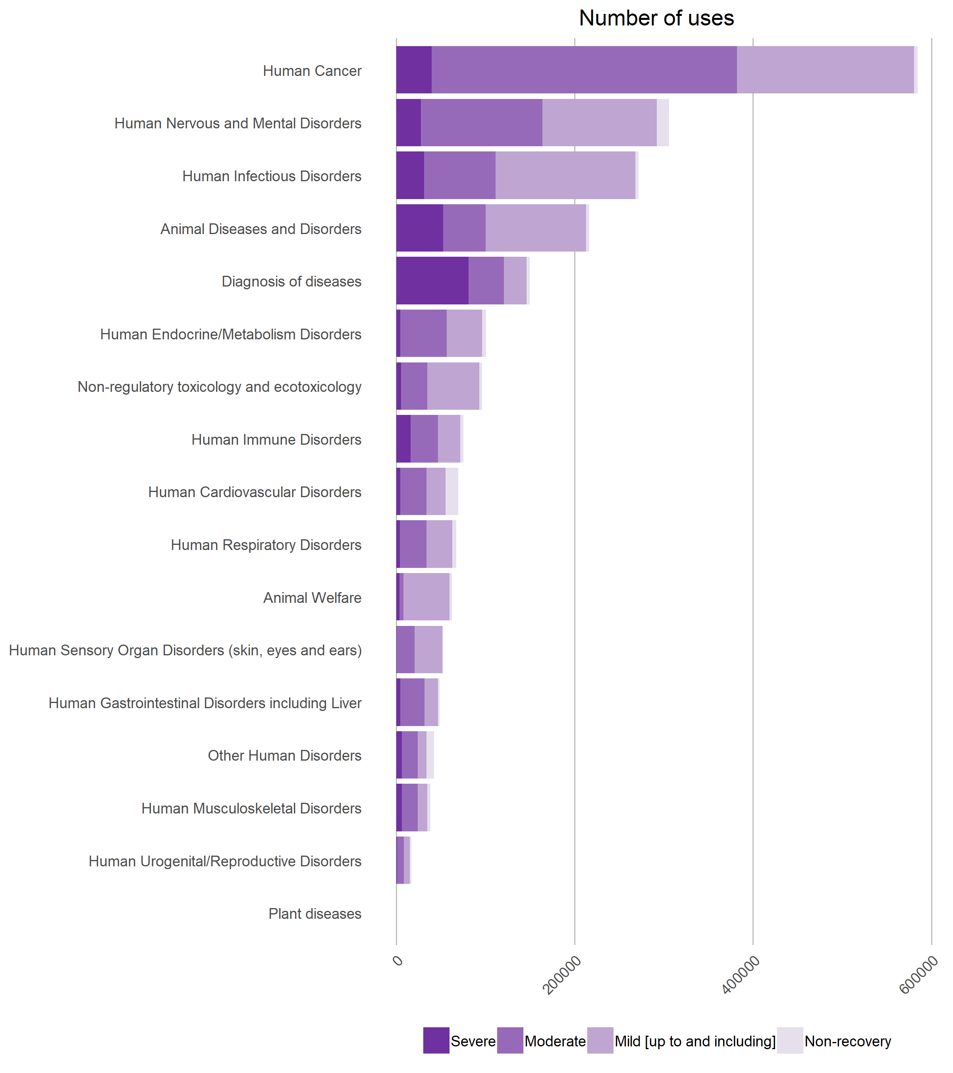

**Figure 2.5: Translational and applied research related uses by type of research and severity in 2017**

Between 2015 and 2017, the sub-categories diagnosis of disease (+76%) and human gastrointestinal disorders including liver (+50%) saw a significant increase. Animal uses for non-regulatory toxicology and ecotoxicology (+20%) as well as human cancer (+19%) showed also an increase.

Sub-categories animal welfare (-20%), human endocrine/metabolism disorders (-18%) and human nervous and mental disorders (-12%) decreased over the same period (Table 2.5).

|  |  |  |  |
| --- | --- | --- | --- |
|  | 2015 | 2016 | 2017 |
| Human Cancer | 492,320 | 538,261 | 584,601 |
| Human Nervous and Mental Disorders | 345,899 | 307,087 | 305,782 |
| Human Infectious Disorders | 282,202 | 283,098 | 271,847 |
| Animal Diseases and Disorders | 223,813 | 259,986 | 216,721 |
| Diagnosis of diseases | 84,963 | 170,738 | 149,687 |
| Human Endocrine/Metabolism Disorders | 123,813 | 107,704 | 100,663 |
| Non-regulatory toxicology and ecotoxicology | 79,911 | 87,350 | 96,160 |
| Human Immune Disorders | 77,250 | 71,555 | 75,342 |
| Human Cardiovascular Disorders | 62,163 | 64,505 | 69,606 |
| Human Respiratory Disorders | 66,384 | 65,857 | 67,395 |
| Animal Welfare | 78,515 | 73,754 | 62,367 |
| Human Sensory Organ Disorders (skin, eyes and ears) | 46,386 | 52,977 | 52,841 |
| Human Gastrointestinal Disorders including Liver | 32,210 | 43,687 | 48,630 |
| Other Human Disorders | 105,773 | 38,528 | 42,654 |
| Human Musculoskeletal Disorders | 31,274 | 36,142 | 38,315 |
| Human Urogenital/Reproductive Disorders | 17,905 | 12,679 | 17,169 |
| Plant diseases | 480 | 126 | 176 |
| Total | 2,151,261 | 2,214,034 | 2,199,956 |

**Table 2.5: Translational and applied research related uses by type of research**

“Other Human Disorders” includes areas such as haemophilia, pharmacokinetics or pain disorders.

#### III.2.2.2. Uses of animals for regulatory purposes

Regulatory uses cover the use of animals in procedures with a view to satisfying regulatory requirements, that is to say for producing, placing and maintaining products/substances on the market, including safety and risk assessment for food and feed. It also includes tests carried out on products/substances for which a regulatory submission was foreseen but ultimately not made, for instance because these were deemed unsuitable for the market by the developer and thus failed to reach the end of the development process.

Between 2015 and 2017, the total number of uses for regulatory purposes decreased (-7%).

In 2017, regulatory uses accounted for 2.18 million uses, just below translational and applied research. 52% of these uses were related to quality control (including batch safety and potency testing), 39% related to toxicity and other safety testing including pharmacology and the remainder (9%) were for other efficacy and tolerance testing (Table 2.6).

|  |  |  |  |
| --- | --- | --- | --- |
|  | 2015 | 2016 | 2017 |
| Quality control (incl batch safety and potency testing) | 1,332,536 | 1,218,170 | 1,131,580 |
| Toxicity and other safety testing including pharmacology | 873,587 | 831,683 | 843,375 |
| Other efficacy and tolerance testing | 150,229 | 164,979 | 211,904 |
| Total | 2,356,352 | 2,214,832 | 2,186,859 |

**Table 2.6: Regulatory uses by main types of uses**

##### III.2.2.2.1. Details of the regulatory use purposes

###### III.2.2.2.1.1. Quality control related uses

Quality control includes uses of animals in the testing of purity, stability, efficacy, potency and other quality control parameters product (and its constituents) such as vaccines, and any controls carried out during the manufacturing process for registration purposes, to satisfy any other national or international regulatory requirements or to satisfy the in-house policy of the manufacturer.

Quality control related uses represented 1.1 million uses in 2017. A large majority of these uses were related to batch potency-testing purposes (79%).

With more than 261,000 severe uses, batch potency testing was the most severe type of procedure, representing more than 25% of all severe uses in EU (Figure 2.6).

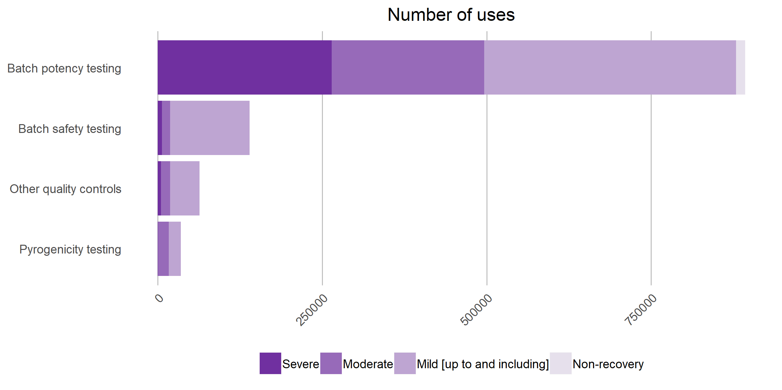

**Figure 2.6: Quality control related uses by type of use and severity in 2017**

Overall, quality control related uses decreased between 2015 and 2017 (-15%) with a decrease for batch safety testing (-39%), for batch potency testing (-14%) and for pyrogenicity testing (-24%) (Table 2.7).

“Other quality controls” are related for example to stability testing of vaccines. Increase in “Other quality controls” (+157%) was mainly due to studies involving fish larvae and no clear trend can be determined.

|  |  |  |  |
| --- | --- | --- | --- |
|  | 2015 | 2016 | 2017 |
| Batch potency testing | 1,032,235 | 945,013 | 892,723 |
| Batch safety testing | 228,817 | 152,443 | 139,602 |
| Other quality controls | 24,931 | 81,280 | 64,083 |
| Pyrogenicity testing | 46,553 | 39,434 | 35,172 |
| Total | 1,332,536 | 1,218,170 | 1,131,580 |

**Table 2.7: Quality control related uses by type of use**

###### III.2.2.2.1.2. Toxicity and other safety testing including pharmacology

Toxicity and other safety testing (including safety evaluation of products and devices for human medicine and dentistry and veterinary medicine) covers studies carried out on any product or substance to determine its potential to cause any dangerous or undesirable effects in humans or animals as a result of its intended or abnormal use, manufacture or as a potential or actual contaminant in the environment.

Toxicity and other safety testing including pharmacology represented more than 840,000 uses of animals in 2017, which corresponds to 9% of all uses of animals.

Most of the uses in this area were related to reproductive toxicity, repeated dose toxicity, pharmaco-dynamics, developmental toxicity, ecotoxicity and acute and sub-acute toxicity.

In 2017, proportionally highest severities were reported in following sub-categories: safety testing in food and feed area (24%), neurotoxicity (23%), ecotoxicity (21%), acute and sub-acute toxicity (18%).

Proportionally lowest severities were reported for skin irritation/corrosion, skin sensitisation, animal safety, kinetics, carcinogenicity, eye irritation/corrosion and reproductive toxicity (Figure 2.7).

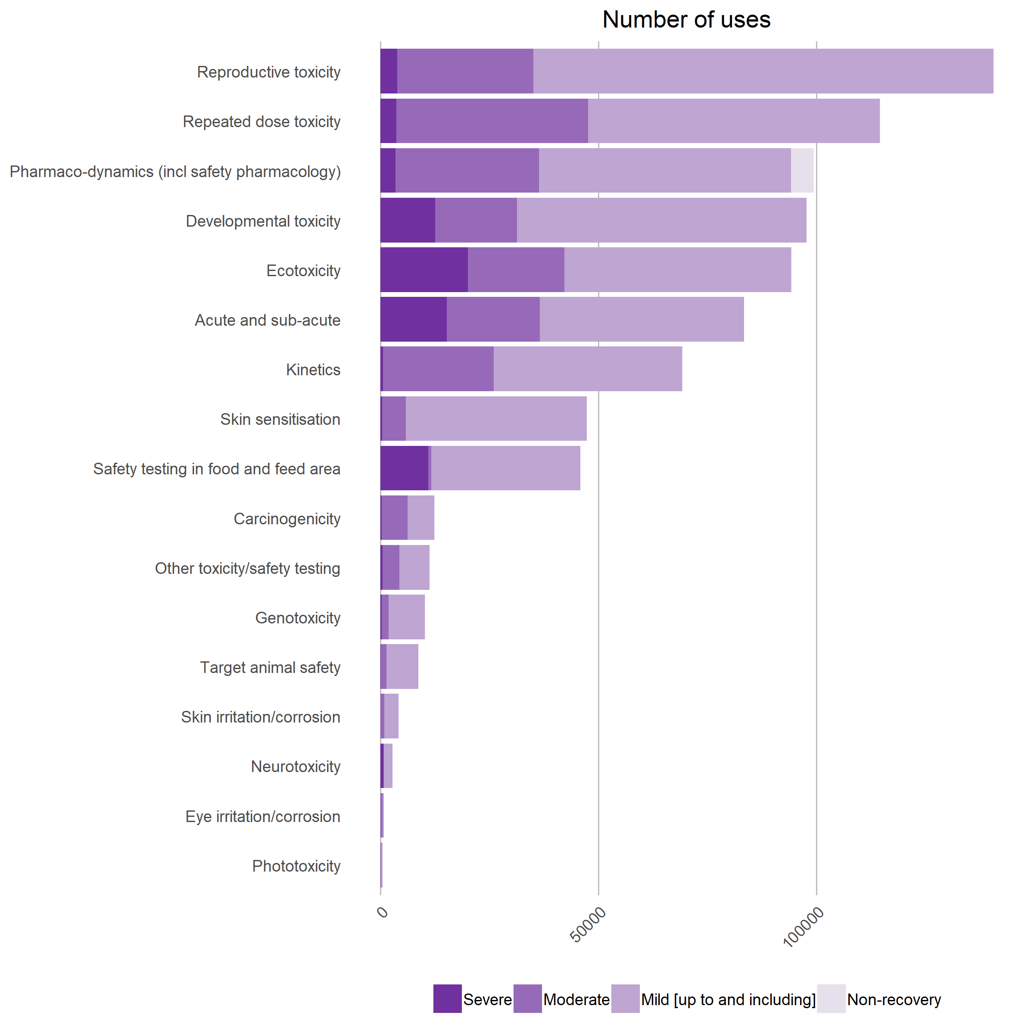

**Figure 2.7: Toxicity and other safety testing including pharmacology by type of use and severity in 2017**

Between 2015 and 2017 (Table 2.8), the total number of uses for toxicity and other safety testing including pharmacology slightly decreased (-4%).

Reproductive toxicity related uses saw a significant increase (+45%) as well as safety testing in the food and feed area (+28%).

A significant decrease in the number of uses was observed in 2017 compared to 2015 for the following areas carcinogenicity (-48%), target animal safety (-42%), neurotoxicity (-72%) and eye irritation/corrosion (-46%) (Table 2.8).

“Other toxicity/safety testing” are related for example to metabolism pharmacokinetic or radiopharmacology.

|  |  |  |  |
| --- | --- | --- | --- |
|  | 2015 | 2016 | 2017 |
| Reproductive toxicity | 96,926 | 102,815 | 140,513 |
| Repeated dose toxicity | 119,910 | 111,720 | 114,573 |
| Pharmaco-dynamics (incl safety pharmacology) | 110,764 | 114,208 | 99,353 |
| Developmental toxicity | 113,026 | 117,435 | 97,671 |
| Ecotoxicity | 105,145 | 88,179 | 94,347 |
| Acute and sub-acute | 94,261 | 99,716 | 83,405 |
| Kinetics | 64,522 | 60,917 | 69,373 |
| Skin sensitisation | 49,549 | 51,645 | 47,341 |
| Safety testing in food and feed area | 35,723 | 40,310 | 45,800 |
| Carcinogenicity | 24,023 | 5,328 | 12,493 |
| Other toxicity/safety testing | 15,528 | 9,959 | 11,258 |
| Genotoxicity | 12,405 | 9,597 | 10,303 |
| Target animal safety | 15,118 | 12,022 | 8,717 |
| Skin irritation/corrosion | 4,773 | 3,222 | 4,120 |
| Neurotoxicity | 9,800 | 3,066 | 2,769 |
| Eye irritation/corrosion | 1,518 | 1,075 | 814 |
| Phototoxicity | 596 | 469 | 525 |
| Total | 873,587 | 831,683 | 843,375 |

**Table 2.8: Toxicity and other safety testing including pharmacology by type of use**

Acute and sub and sub-acute testing methods uses

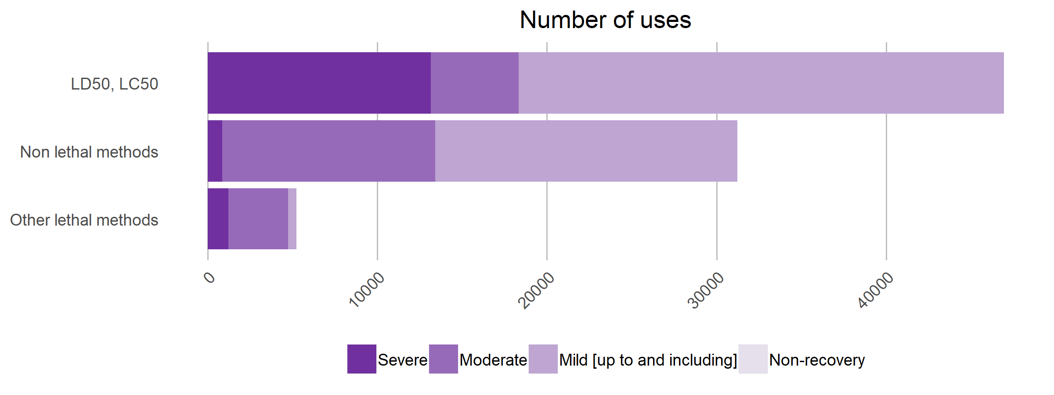

**Figure 2.8: Acute and sub-acute uses testing methods by type of uses and severity in 2017**

|  |  |  |  |
| --- | --- | --- | --- |
|  | 2015 | 2016 | 2017 |
| LD50, LC50 | 58,311 | 63,152 | 46,939 |
| Non-lethal methods | 32,120 | 31,406 | 31,218 |
| Other lethal methods | 3,830 | 5,158 | 5,248 |
| Total | 94,261 | 99,716 | 83,405 |

**Table 2.9: Acute and sub-acute uses testing methods by type of use**

Repeated dose toxicity uses

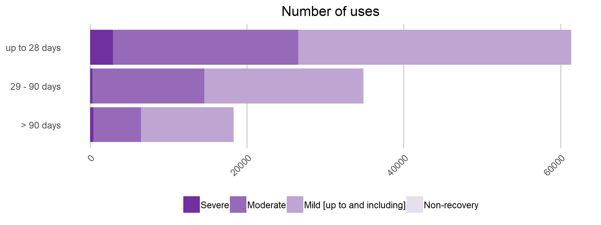

**Figure 2.9: Repeated dose toxicity by type of uses and severity in 2017**

|  |  |  |  |
| --- | --- | --- | --- |
|  | 2015 | 2016 | 2017 |
| up to 28 days | 73,692 | 55,323 | 61,344 |
| 29 - 90 days | 28,023 | 34,558 | 34,931 |
| > 90 days | 18,195 | 21,839 | 18,298 |
| Total | 119,910 | 111,720 | 114,573 |

**Table 2.10: Repeated dose toxicity by type of use**

Ecotoxicity

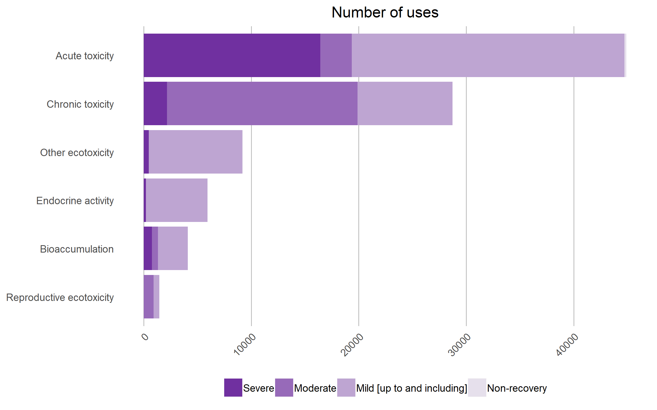

**Figure 2.10: Ecotoxicity by type of uses and severity in 2017**

|  |  |  |  |
| --- | --- | --- | --- |
|  | 2015 | 2016 | 2017 |
| Acute toxicity | 60,094 | 46,581 | 44,915 |
| Chronic toxicity | 20,161 | 23,235 | 28,738 |
| Other ecotoxicity | 8,377 | 2,261 | 9,210 |
| Endocrine activity | 9,910 | 7,769 | 5,924 |
| Bioaccumulation | 2,950 | 4,258 | 4,110 |
| Reproductive ecotoxicity | 3,653 | 4,075 | 1,450 |
| Total | 105,145 | 88,179 | 94,347 |

**Table 2.11: Ecotoxicity by type of use**

###### III.2.2.2.1.3. Other efficacy and tolerance testing

This category of regulatory use refers to uses that are neither linked to quality control nor to toxicity testing. These uses are related to, for example, efficacy testing of biocides and pesticides as well as tolerance testing of additives in animal nutrition. They represented little more than 210,000 uses in 2017.

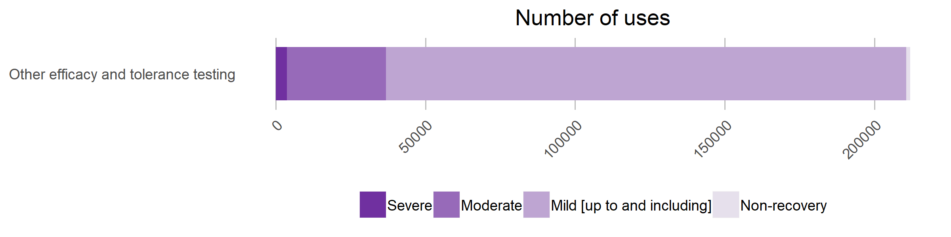

**Figure 2.11: Other efficacy and tolerance testing by type of use and severity in 2017**

Between 2015 and 2017, the total number of uses for other efficacy and tolerance testing increased (+29%) mostly due to the use of fish larvae for nutritional tests in 2016. In 2017, most of the procedures were mild (82%) with particularly low proportion of severe (2%) and non-recovery (0.6%) uses (Table 2.12).

|  |  |  |  |
| --- | --- | --- | --- |
|  | 2015 | 2016 | 2017 |
| Other efficacy and tolerance testing | 150,229 | 164,979 | 211,904 |

**Table 2.12: Other efficacy and tolerance testing**

##### III.2.2.2.2. Legislative aspects of regulatory uses

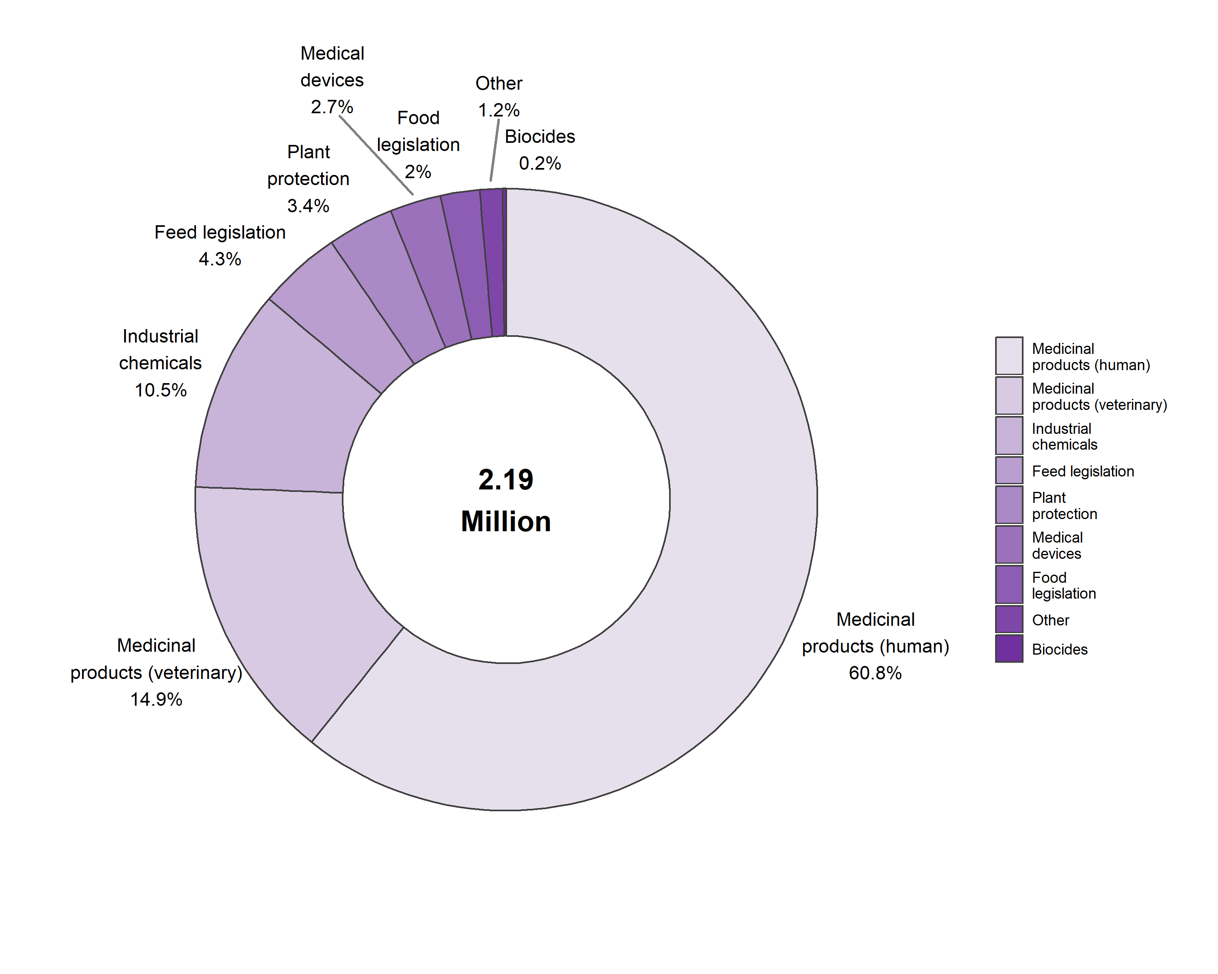

**Figure 2.12: Regulatory uses by type of legislation in 2017**

In 2017, the majority of uses to satisfy legislative requirements of specific sector legislation occurred in relation to placing on the market of medicinal products for humans (61%), veterinary medicinal products (15%) and industrial chemicals (11%) (Figure 2.12).

Between 2015 and 2017, the uses to satisfy legislative requirements for medical products for human use decreased (-12%) while those related to medical device legislation uses (+23%) and industrial chemicals legislation uses (+17%) saw an increase. No uses were reported under cosmetics legislation (Table 2.13).

|  |  |  |  |
| --- | --- | --- | --- |
|  | 2015 | 2016 | 2017 |
| Legislation on medicinal products for human use | 1,518,123 | 1,422,456 | 1,328,948 |
| Legislation on medicinal products for veterinary use and their residues | 368,571 | 337,054 | 325,486 |
| Industrial chemicals legislation | 195,950 | 214,772 | 230,177 |
| Feed legislation including legislation for the safety of target animals, workers and environment | 40,252 | 36,586 | 94,515 |
| Plant protection product legislation | 72,084 | 61,502 | 75,205 |
| Medical devices legislation | 47,270 | 48,944 | 58,312 |
| Food legislation including food contact material | 47,342 | 43,555 | 44,273 |
| Other legislation | 61,864 | 42,875 | 25,814 |
| Biocides legislation | 4,896 | 7,088 | 4,129 |
| Total | 2,356,352 | 2,214,832 | 2,186,859 |

**Table 2.13: Regulatory uses by type of legislation**

In 2017, the majority of regulatory uses were performed to satisfy regulatory requirements originating from the EU (95%). Non-EU requirements accounted for 4% and national requirements for 1% (Table 2.14).

The sub-category on legislation satisfying EU requirements also includes any requirements for which international harmonisation has been achieved, such as for testing to OECD, ICH[6] and VICH[7] standards. Harmonisation of testing requirements at a global level is of utmost importance when aiming to avoid unnecessary duplication of testing.

|  |  |  |  |
| --- | --- | --- | --- |
|  | 2015 | 2016 | 2017 |
| Legislation satisfying EU requirements | 94% (2,222,617) | 93% (2,058,553) | 95% (2,081,082) |
| Legislation satisfying Non-EU requirements only | 4% (92,161) | 5% (110,848) | 4% (82,895) |
| Legislation satisfying national requirements only [within EU] | 2% (41,574) | 2% (45,431) | 1% (22,882) |
| Total | 100% (2,356,352) | 100% (2,214,832) | 100% (2,186,859) |

**Table 2.14: Regulatory uses by origin of regulatory requirement**

Legislation on medicinal products for human or veterinary uses is mainly related to quality controls. Industrial chemical legislation and other legislations focus more specifically on toxicity testing. Feed legislation is mainly related to other efficacy testing.

It is important to note in this context that some of the data submissions still contained entries, which seem to indicate legislation irrelevant to the type of testing being carried out. Further efforts are being undertaken to improve the accuracy of the reporting (Table 2.15).

|  |  |  |  |
| --- | --- | --- | --- |
|  | Quality control (incl batch safety and potency testing) | Toxicity and other safety testing including pharmacology | Other efficacy and tolerance testing |
| Legislation on medicinal products for human use | 889,709 | 353,824 | 85,415 |
| Legislation on medicinal products for veterinary use and their residues | 239,687 | 46,810 | 38,989 |
| Medical devices legislation | 1,591 | 55,733 | 988 |
| Industrial chemicals legislation | 100 | 229,891 | 186 |
| Plant protection product legislation | 0 | 74,763 | 442 |
| Biocides legislation | 260 | 3,219 | 650 |
| Food legislation including food contact material | 0 | 44,187 | 86 |
| Feed legislation including legislation for the safety of target animals, workers and environment | 19 | 9,889 | 84,607 |
| Other legislation | 214 | 25,059 | 541 |
| Total | 1,131,580 | 843,375 | 211,904 |

**Table 2.15: Regulatory use by type of legislation in 2017**

In terms of severity levels, in 2017, for the legislative context, 16% of total uses in the area of regulatory testing were reported as severe, 24% as moderate, 59% mild (and up to mild) and 1% as non-recovery (Figure 2.2).

Even if the total numbers of uses are not the most significant in the area of food legislation, the proportion of severe uses is relatively high. This category included still in 2017 the use of mouse bioassay for the purposes of shellfish toxin testing. In the area of 'Other' legislations, 25% of procedures were reported as severe concerning mainly waste water toxicity studies on fish.

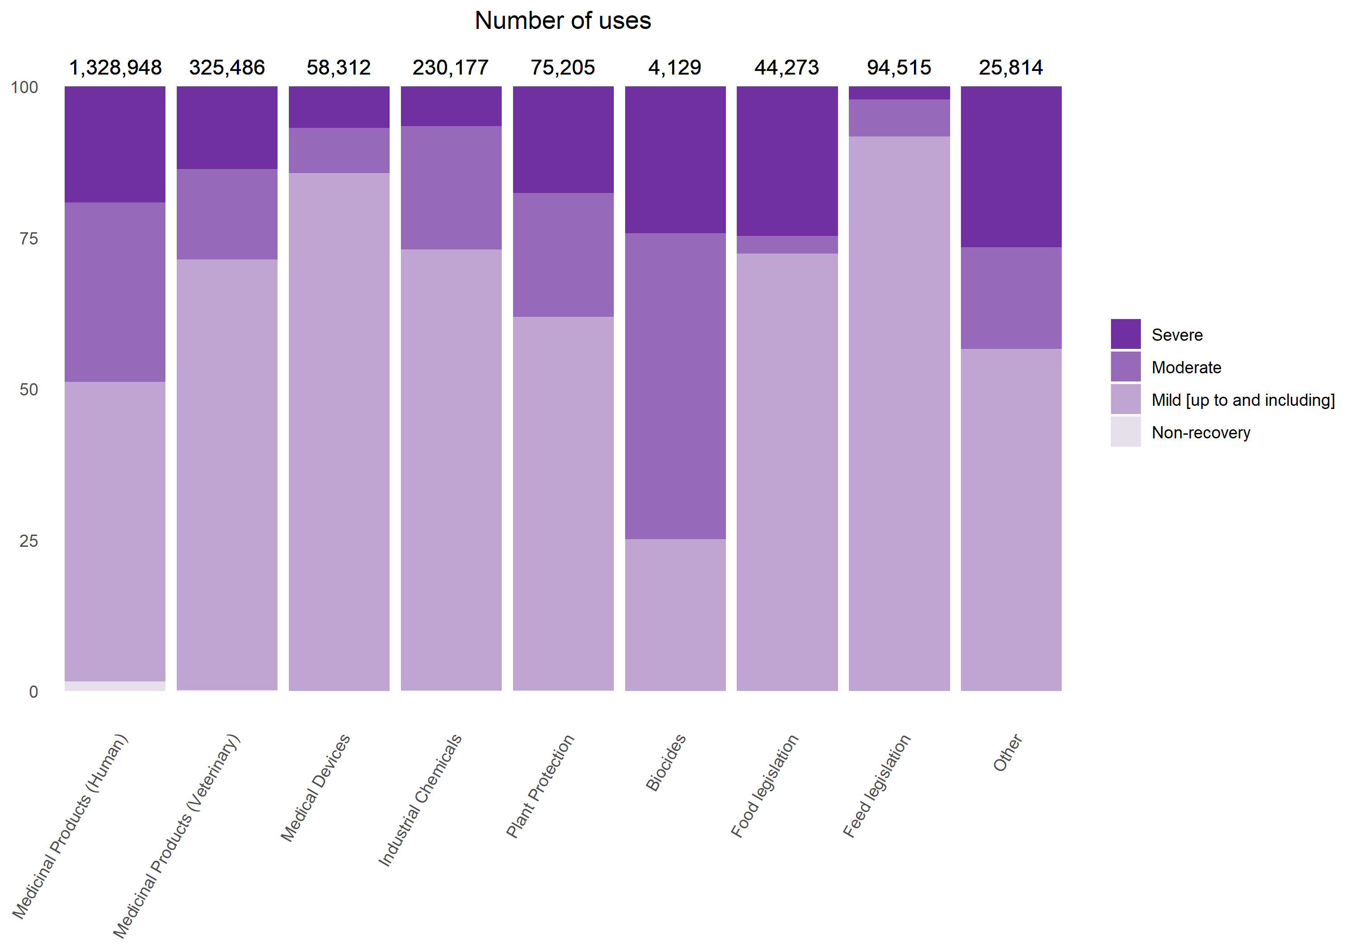

**Figure 2.13: Regulatory use by type of legislation and severity in 2017**

#### III.2.2.3. Routine production uses

Routine production includes the production of antibodies and blood products, including polyclonal antisera by established methods.

In 2017, there were about 469,000 routine production uses, which represented 5% of all uses of animals in the EU. 55% of routine uses were related to the production of blood-based products and 10% for monoclonal antibodies production by mouse ascites method (Figure 2.14).

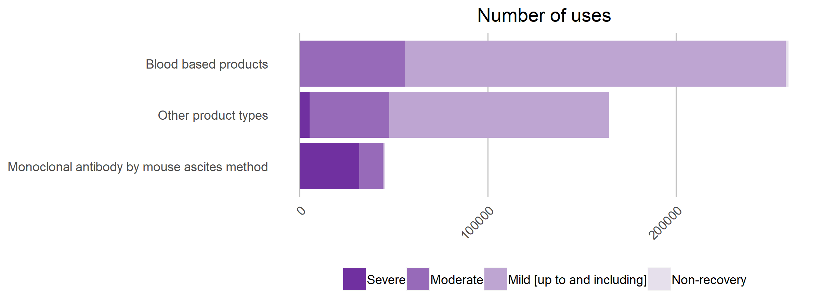

**Figure 2.14: Routine production uses by product type and severity in 2017**

While blood based products involved only mild and moderate levels of severity, monoclonal antibody production by mouse ascites method involved mostly severe uses (70%) (Figure 2.14).

|  |  |  |  |
| --- | --- | --- | --- |
|  | 2015 | 2016 | 2017 |
| Blood based products | 271,393 | 260,228 | 259,780 |
| Other product types | 156,768 | 146,272 | 164,554 |
| Monoclonal antibody by mouse ascites method | 27,333 | 48,934 | 45,024 |
| Total | 455,494 | 455,434 | 469,358 |

**Table 2.16: Routine production uses by product type**

Other product types that represented 35% of the uses were mostly related to antigen and protein production.

Between 2015 and 2017, monoclonal antibody production by mouse ascites method saw an increase of 66%.

#### III.2.2.4. Other types of uses

Lastly, four categories of other uses are also reported as part of the Directive covering more than 367,000 uses: higher education and training for the acquisition, maintenance or improvement of vocational skills; protection of the natural environment in the interests of the health or welfare of human beings or animals; preservation of species; and forensic enquiries.

With 163,000 uses in 2017, higher education and training is the biggest category of the remaining purposes. At the same time, it is important to note that the severities linked to higher education and training, and on studies on preservation of species, are some of the lowest. Higher education has the largest proportion of non-recovery uses (31%). Forensic inquiry uses are limited to just a few hundreds. (Figure 2.15).

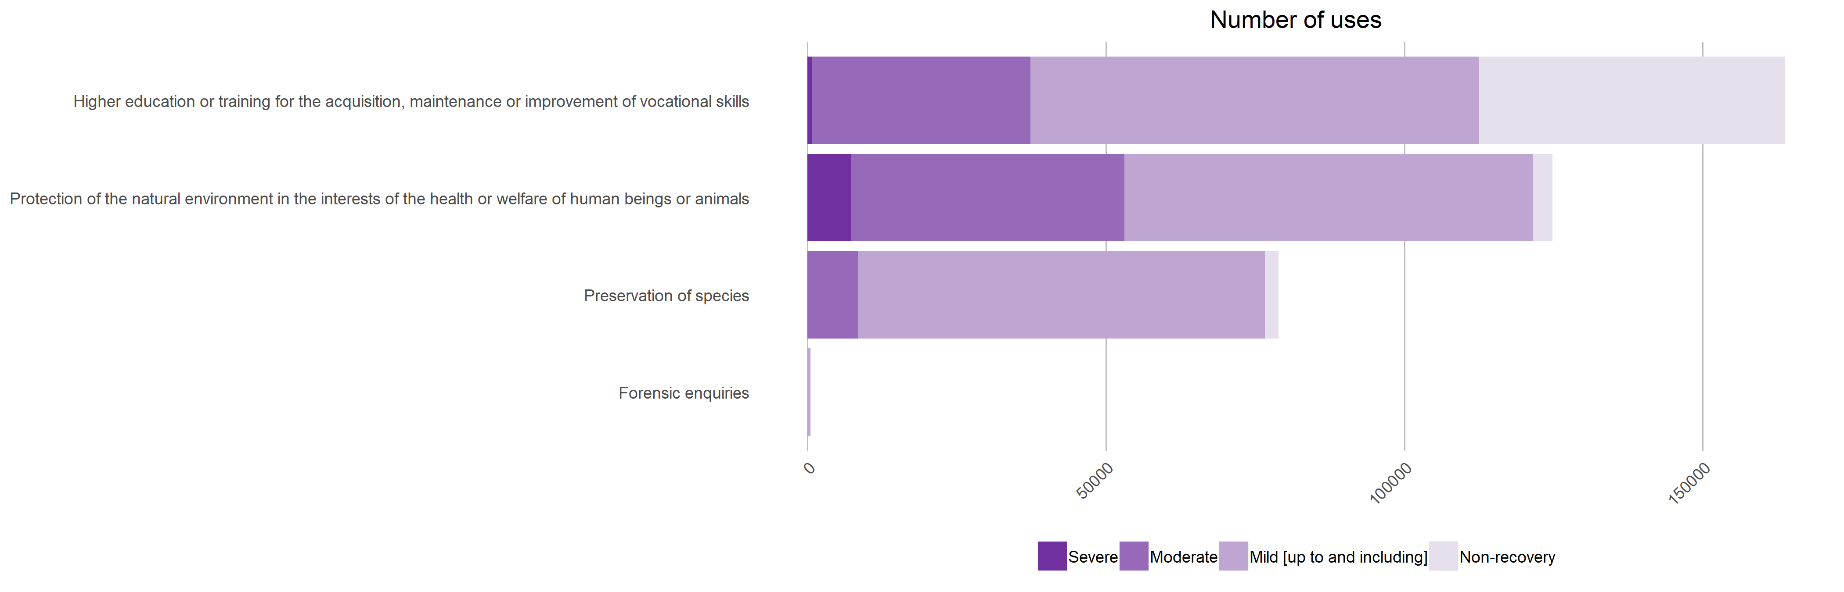

**Figure 2.15: Other types of uses in 2017 including their severity**

Between 2015 and 2017, there was an increase in the number of uses for the preservation of species (+107%) and protection of the natural environment (+16%), with important variations from one year to another due to studies on fish larvae where a single study can contain thousands of fish larvae (Table 2.17).

|  |  |  |  |
| --- | --- | --- | --- |
|  | 2015 | 2016 | 2017 |
| Higher education or training for the acquisition, maintenance or improvement of vocational skills | 162,424 | 164,495 | 163,762 |
| Protection of the natural environment in the interests of the health or welfare of human beings or animals | 104,834 | 78,403 | 124,787 |
| Preservation of species | 38,070 | 71,852 | 78,893 |
| Forensic enquiries | 315 | 915 | 473 |
| Total | 305,643 | 315,665 | 367,915 |

**Table 2.17: Other types of uses**

### III.2.3. Information on reuses and genetic status of animals

The Directive requires additional elements to be recorded related to the use of animals for scientific purposes, such as reuse and information on the genetic status of the animals.

#### III.2.3.1. Reuses

In line with the principle of the Three Rs[8], the total number of animals used in procedures can be reduced by performing procedures on animals more than once. However, this should only take place when this does not result in poor animal welfare, and is evaluated on a case-by-case basis. Under Directive 2010/63/EU, reuse of animals in procedures is permitted only under specific conditions related to the actual level of severity the animal has experienced in a previous procedure, and the health and well-being of the animal, taking into account the lifetime experience of the individual animal. A reuse cannot be authorised for a procedure, in which the animal may reach ‘severe’ level of pain, suffering or distress. Also, an animal may be reused following a severe procedure only in exceptional circumstances and after a veterinary examination of that animal.

Between 2015 and 2017, the proportion of reuses remained stable at 2% (Table 2.18)

|  |  |  |  |
| --- | --- | --- | --- |
|  | 2015 | 2016 | 2017 |
| No | 98% (9,590,379) | 98% (9,817,946) | 98% (9,388,162) |
| Yes | 2% (192,191) | 2% (210,552) | 2% (193,579) |
| Total | 100% (9,782,570) | 100% (10,028,498) | 100% (9,581,741) |

**Table 2.18: Reuses of animals used for research, testing, routine production and educational purposes**

##### III.2.3.2.1. Animal species reused

In absolute numbers, the main species reused for scientific purposed in 2017 were mice, sheep, rats, rabbits, horses, donkeys and cross-breeds.

In proportions, large mammals are more often reused such as horses, donkeys and cross-breeds (82%), sheep (71%), cats (44%), dogs (36%) and cynomolgus monkeys (28%).

Reptiles (55%) and xenopus (37%) amongst amphibians were also often reused (Table 2.19).

|  |  |  |  |
| --- | --- | --- | --- |
|  | Total number of uses | Number of reuses | Proportion of reuses |
| Mice | 5,756,121 | 48,650 | 1% |
| Rats | 1,164,167 | 17,868 | 2% |
| Guinea-Pigs | 146,037 | 1,213 | 1% |
| Hamsters (Syrian) | 12,723 | 23 | 0% |
| Mongolian gerbil | 5,385 | 146 | 3% |
| Other Rodents | 25,452 | 280 | 1% |
| Rabbits | 364,431 | 12,470 | 3% |
| Cats | 3,338 | 1,459 | 44% |
| Dogs | 21,359 | 7,671 | 36% |
| Ferrets | 2,112 | 96 | 5% |
| Other carnivores | 2,514 | 128 | 5% |
| Horses, donkeys and cross-breeds | 13,624 | 11,210 | 82% |
| Pigs | 75,875 | 4,353 | 6% |
| Goats | 2,268 | 705 | 31% |
| Sheep | 65,527 | 46,715 | 71% |
| Cattle | 37,276 | 6,633 | 18% |
| Prosimians | 173 | 75 | 43% |
| Marmoset and tamarins | 646 | 181 | 28% |
| Other species of New World Monkeys (Ceboidea) | 3 | 0 | 0% |
| Cynomolgus monkey | 10,007 | 2,780 | 28% |
| Rhesus monkey | 628 | 275 | 44% |
| Vervets (Chlorocebus spp.) | 53 | 20 | 38% |
| Baboons | 46 | 21 | 46% |
| Other species of Old World Monkeys (Cercopithecoidea) | 35 | 12 | 34% |
| Other Mammals | 27,066 | 731 | 3% |
| Domestic fowl | 472,012 | 7,459 | 2% |
| Other birds | 102,346 | 2,936 | 3% |
| Reptiles | 6,562 | 3,625 | 55% |
| Rana | 3,498 | 13 | 0% |
| Xenopus | 21,443 | 7,904 | 37% |
| Other Amphibians | 10,946 | 263 | 2% |
| Zebra fish | 504,183 | 4,420 | 1% |
| Other Fish | 723,176 | 3,244 | 0% |
| Total | 9,581,032 | 193,579 | 100% |

**Table 2.19: Reuses by type of species in 2017**

##### 

##### III.2.3.2.2. Reuse by purposes of procedures

In 2017, routine production had the largest proportion of reuses (12%) mainly for blood-based products. The second most common use purpose for which animals have been reused was higher education and training (Table 2.20).

|  |  |  |  |
| --- | --- | --- | --- |
|  | Total number of uses | Number of reuses | Proportion |
| Basic research | 4,357,653 | 58,499 | 1% |
| Translational and applied research | 2,199,956 | 29,798 | 1% |
| Regulatory use | 2,186,859 | 34,863 | 2% |
| Routine production | 469,358 | 55,826 | 12% |
| Higher education or training for the acquisition, maintenance or improvement of vocational skills | 163,762 | 13,323 | 8% |
| Protection of the natural environment in the interests of the health or welfare of human beings or animals | 124,787 | 1,259 | 1% |
| Preservation of species | 78,893 | 11 | 0% |
| Forensic enquiries | 473 | 0 | 0% |

**Table 2.20: Reuses by purposes in 2017**

##### III.2.3.2.3. Severity of reuse

According to the Directive, reuse of an animal is not allowed in a procedure classified prospectively as severe. In 2017, most of the reuses, the actual reported severities were mild (74%) or moderate (19%) (Figure 2.16).

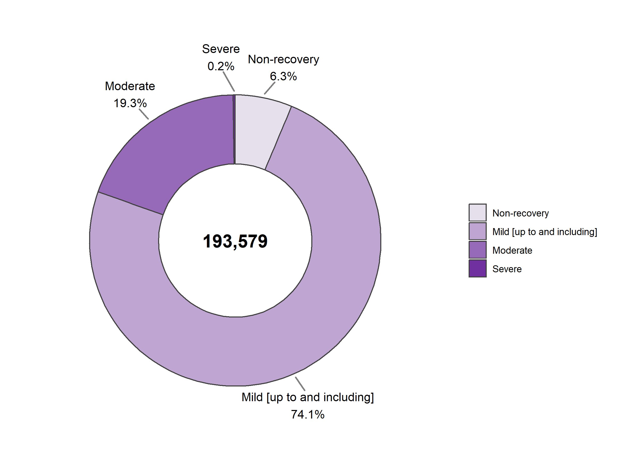

**Figure 2.16: Reuses by severity in 2017**

However, in some cases, even if the procedure is prospectively classified in a lower severity category, an individual animal may reach severity category "severe" due to unforeseen events occurring during the procedure. Only a very small number of such cases (<1 %) was reported.

These cases should be investigated by the user to eliminate any recurrence of any repetitive unforeseen adverse effects. Furthermore, these events, if recurring, may suggest a need for a revision of the prospective classification for future uses.

|  |  |  |  |
| --- | --- | --- | --- |
|  | 2015 | 2016 | 2017 |
| Non-recovery | 3% (5,067) | 6% (12,157) | 6% (12,240) |
| Mild [up to and including] | 80% (152,817) | 80% (168,387) | 74% (143,478) |
| Moderate | 18% (33,983) | 14% (29,743) | 19% (37,411) |
| Severe | 0% (324) | 0% (265) | 0% (450) |
| Total | 100% (192,191) | 100% (210,552) | 100% (193,579) |

**Table 2.21: Severity classification of reuse procedures**

Between 2015 and 2017, the number of reuses remained stable in total with an increase of non-recovery reuses (+39%).

#### III.2.3.2. Use of genetically altered animals

Some of the animals used in procedures for purposes of research, testing, routine production and education are genetically altered. This section presents the types of genetic alteration reported. A welfare assessment is required to be performed on a newly created genetically altered animal line to establish whether the line is expected to have an intended non-harmful or harmful phenotype.

Intended non-harmful phenotypes include animal models where no adverse effects are noted during development, breeding and maintenance under conventional laboratory animal conditions. In addition, non-harmful phenotype lines include inducible and cre-lox lines, which require an active intervention for the harmful phenotype to be expressed.

Intended harmful phenotypes include animal models where gene alteration induces a specific genetic disorder or disease, or increases incidence of / susceptibility to for example tumour development. Other examples of harmful phenotype lines include those that require a specific bio-secure environment (for example, special housing arrangements to protect animals that are particularly sensitive to infection as a consequence of the gene alteration) or additional care beyond that required for conventional animals to maintain their health and well-being.

##### III.2.3.2.1. Type of genetic alteration

In 2017, 2.57 million uses for the purposes of research were carried out on animals that were genetically altered. Of these, 17% were of a harmful phenotypic alteration.

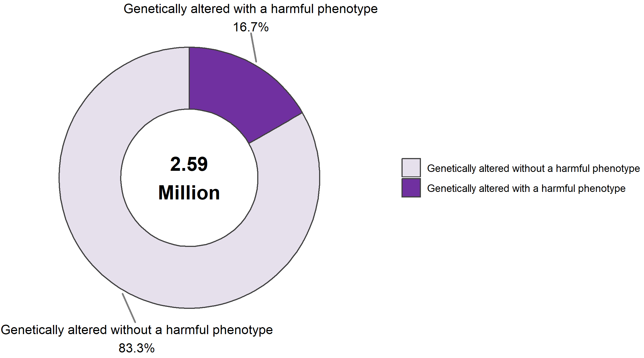

**Figure 2.17: Uses of animals by type of genetic alteration in 2017**

Between 2015 and 2017, the proportion of the uses of genetically altered animals for scientific purposes increased slightly. The percentage of the uses of such animals with a harmful phenotype increased from 4% to 5%, and the uses of such animals without a harmful phenotype increased from 21% to 23%.

|  |  |  |  |
| --- | --- | --- | --- |
|  | 2015 | 2016 | 2017 |
| Genetically altered with a harmful phenotype | 4% (397,525) | 4% (435,075) | 5% (432,206) |
| Genetically altered without a harmful phenotype | 21% (2,038,618) | 23% (2,344,954) | 23% (2,157,696) |
| Not genetically altered | 75% (7,346,427) | 72% (7,248,469) | 73% (6,991,839) |
| Total | 100% (9,782,570) | 100% (10,028,498) | 100% (9,581,741) |

**Table 2.22: Genetic status of animals used**

##### III.2.3.2.2. Genetically altered animals by species

Amongst the species, which have been genetically altered, uses of mice accounted for the highest numbers, followed by zebra fish and rats.

Even if mice accounts for the most animals being genetically altered, in proportion, 64% of zebra fish was genetically altered, followed by mice (38%), while only 3% of rats were genetically altered used in procedures for purposes of research, testing, routine production in 2017 (Table 2.23).

|  |  |  |  |
| --- | --- | --- | --- |
|  | Total number of uses | Uses of genetically altered animals | Proportion |
| Zebra fish | 504,183 | 323,741 | 64% |
| Mice | 5,756,121 | 2,196,801 | 38% |
| Xenopus | 21,443 | 2,146 | 10% |
| Rabbits | 364,431 | 27,630 | 8% |
| Other Amphibians | 10,946 | 671 | 6% |
| Rats | 1,164,167 | 32,399 | 3% |
| Hamsters (Syrian) | 12,723 | 187 | 1% |
| Other Fish | 723,176 | 5,029 | 1% |
| Pigs | 75,875 | 501 | 1% |
| Dogs | 21,359 | 132 | 1% |
| Domestic fowl | 472,012 | 637 | <1% |
| Other Mammals | 27,066 | 23 | <1% |
| Sheep | 65,527 | 5 | <1% |

**Table 2.23: Genetically altered animals by species in 2017**

This situation is mainly explained by the fact that genetically altered animals are used almost exclusively for research purposes. Indeed, in 2017, basic research accounted for 75% of uses of genetically altered animals and translational and applied research for 21% (Table 2.24).

|  |  |  |  |  |
| --- | --- | --- | --- | --- |
|  | Not genetically altered | Genetically altered without a harmful phenotype | Genetically altered with a harmful phenotype | Total |
| Basic research | 55% (2,413,441) | 38% (1,642,212) | 7% (302,000) | **100% (4,357,653)** |
| Translational and applied research | 75% (1,655,814) | 19% (416,794) | 6% (127,348) | **100% (2,199,956)** |
| Regulatory use | 98% (2,139,622) | 2% (45,466) | 0% (1,771) | **100% (2,186,859)** |
| Routine production | 94% (441,479) | 6% (27,879) | 0% (0) | **100% (469,358)** |
| Higher education or training for the acquisition, maintenance or improvement of vocational skills | 92% (150,292) | 8% (12,769) | 0% (701) | **100% (163,762)** |
| Preservation of species | 84% (65,948) | 16% (12,567) | 0% (378) | **100% (78,893)** |
| Protection of the natural environment in the interests of the health or welfare of human beings or animals | 100% (124,778) | 0% (9) | 0% (0) | **100% (124,787)** |
| Forensic enquiries | 98% (465) | 0% (0) | 2% (8) | 100% (473) |

**Table 2.24: Genetic status of animals by use purposes in 2017**

## III.3. Numbers and uses of animals for the creation and maintenance of genetically altered animals in the EU

In the context of Directive 2010/63/EU, Member States are also required to report the animals used in procedures for the creation of new genetically altered animal lines and the maintenance of colonies of established genetically altered animal lines to support the research needs in the EU.

Diagram in part III.3 provides further understanding of the reporting requirements for both creation and maintenance of genetically altered animal lines.

### III.3.1. Numbers of animals used for the creation and maintenance of genetically altered animals

In 2017, 1,276,587 animals were used for the provision of genetically altered animals for the purposes of scientific research.

This included 634,705 animals used for the first time for the creation of new genetically altered animal lines (Table 3.5), and 641,882 animals used for the first time for the maintenance of colonies of established genetically altered animal lines (Table 3.9).

### III.3.2. All uses of animals for the creation of new genetic altered animal lines

The creation of a new genetic altered animal line is reported under the research purpose category for which the line is being created for. The reporting covers all animals carrying the genetic alteration. In addition, those used for superovulation, vasectomy and embryo implantation are equally reported (these may or may not be genetically altered themselves). Genetically normal animals (wild type offspring) produced as a result of creation of a new genetically altered line are not reported in the annual statistics. (Diagram in Part III.4).

Counting all uses, the main species that were used for the creation of new genetic altered animal lines were mice and zebra fish, 75% and 23% respectively. Other species, although in small numbers, include rats, other species of fish, domestic fowl, rabbits, xenopus and pigs.

In 2017, the use of non-human primates (marmosets) for the creation of a new genetically altered line was reported for the first time in the EU.

Between 2015 and 2017, the creation of new genetic lines increased overall by 7% (Table 3.1).

|  |  |  |  |
| --- | --- | --- | --- |
|  | 2015 | 2016 | 2017 |
| Mice | 477,783 | 359,894 | 490,717 |
| Zebra fish | 124,359 | 122,082 | 150,596 |
| Rats | 4,381 | 6,039 | 9,960 |
| Other Fish | 2,556 | 10,737 | 4,569 |
| Domestic fowl | 279 | 515 | 647 |
| Rabbits | 272 | 967 | 475 |
| Xenopus | 7,259 | 1,100 | 250 |
| Pigs | 350 | 284 | 227 |
| Other Mammals | 4 | 0 | 61 |
| Sheep | 31 | 191 | 17 |
| Marmoset and tamarins | 0 | 0 | 10 |
| Guinea-Pigs | 0 | 47 | 0 |
| Other Rodents | 0 | 6 | 0 |
| Total | 617,274 | 501,862 | 657,529 |

**Table 3.1: Uses of animals for the creation of new genetically altered animal lines by species**

#### III.3.2.1. Creation of new genetically altered animal lines by genetic status

Animals that are not genetically altered but reported under the category creation of a new genetically altered animal lines include, for example, genetically normal parent animals or a part of the offspring that does not carry the genetic alteration. Of those that were genetically altered, over 86% were of a non-harmful phenotype.

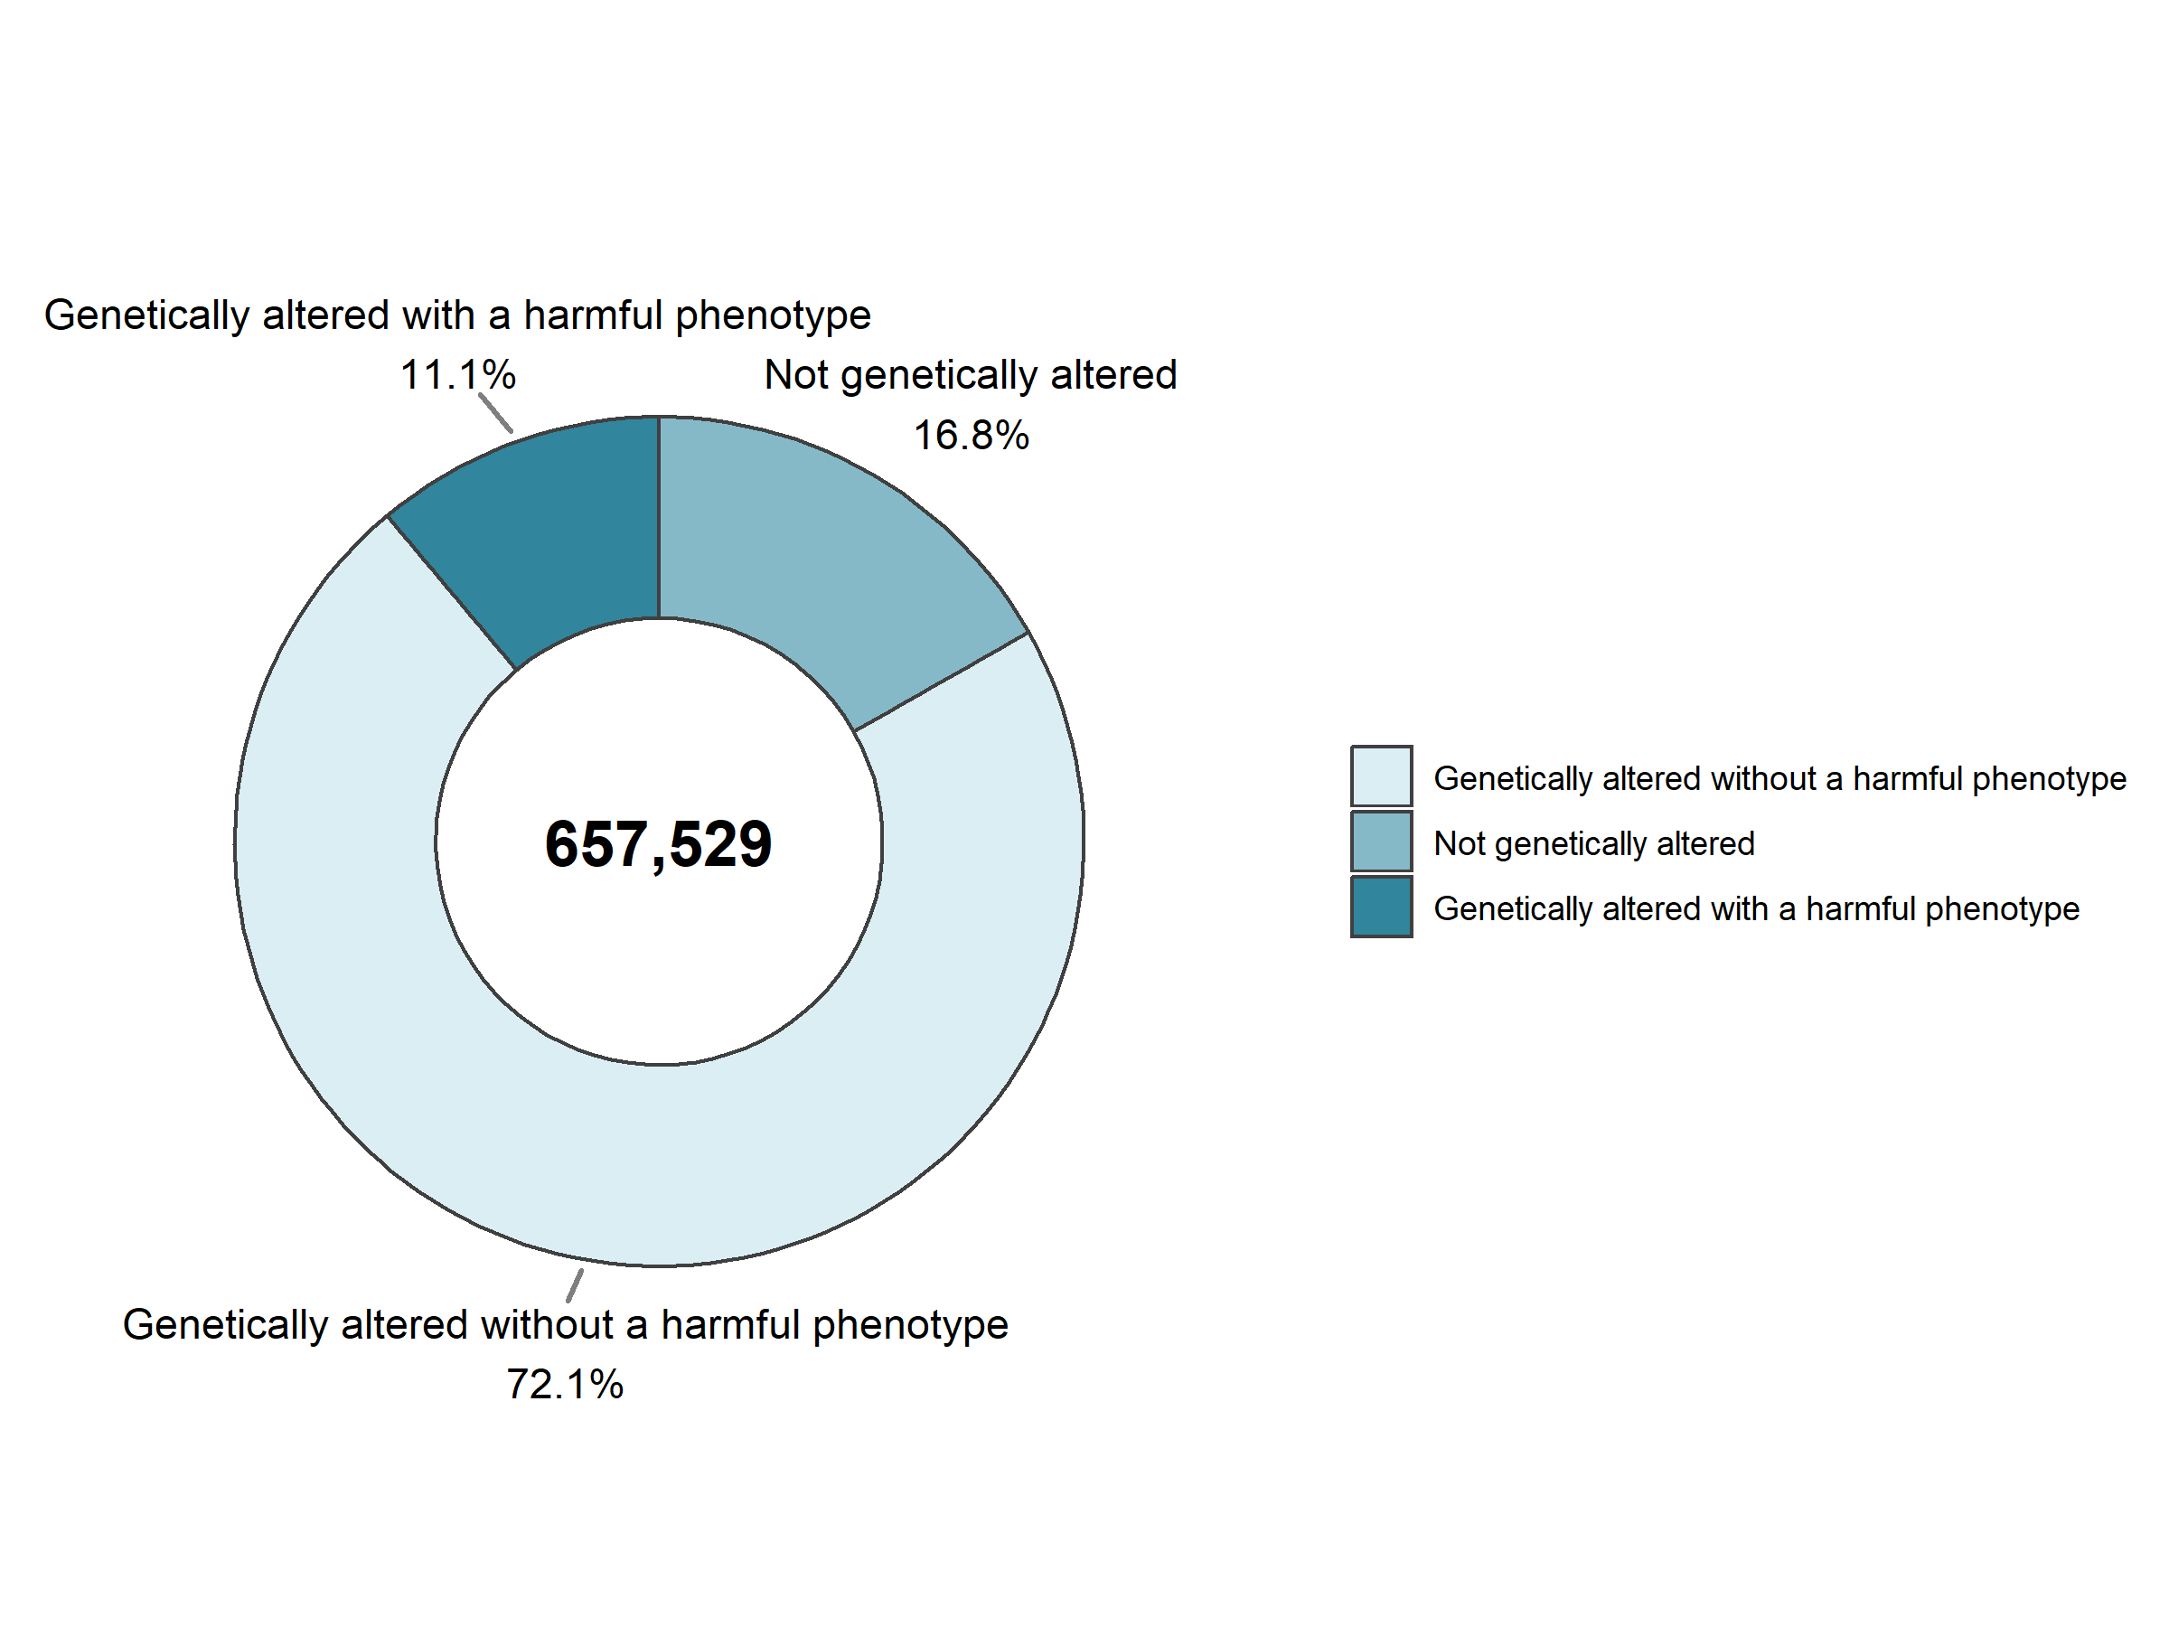

**Figure 3.1: Creation of new genetically altered animal lines: genetic types of animal used in 2017**

|  |  |  |  |
| --- | --- | --- | --- |
|  | 2015 | 2016 | 2017 |
| Not genetically altered | 19% (114,485) | 20% (102,718) | 17% (110,523) |
| Genetically altered without a harmful phenotype | 68% (421,006) | 64% (320,567) | 72% (474,189) |
| Genetically altered with a harmful phenotype | 13% (81,783) | 16% (78,577) | 11% (72,817) |
| Total | 100% (617,274) | 100% (501,862) | 100% (657,529) |

**Table 3.2: Creation of new genetically altered animal lines: genetic types of animal used**

#### III.3.2.2. Creation of new genetically altered animals lines by scientific purposes

The creation of new genetic lines is only carried out for research purposes. In 2017, 658,000 uses (first and any subsequent reuses) were reported for the purposes of creating new genetically altered animal lines.

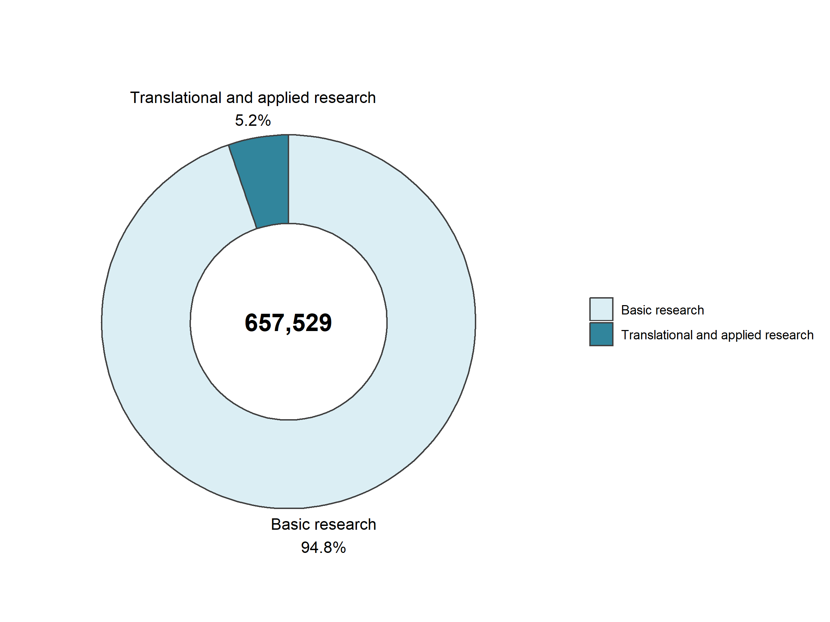

**Figure 3.2: Creation of new genetically altered animal lines: uses for research purposes in 2017**

95% of the new genetically altered lines were created for purposes covered under basic research. The table below presents all sub-categories from both basic and translational and applied research together.

In 2017, for basic research purposes, 21% concerned the multisystemic research (where more than one body system is the primary interest of the research, such as in some infectious diseases), 14% nervous system, 12% oncology and 10% cardiovascular, blood and lymphatic system (Table 3.3).

The most important sub-category under translational and applied research for which new genetically altered animal lines were created was human cancer (1%). Due to the relatively low number of uses for the creation of new genetically altered animal lines for the applied and translational research purposes, Table 3.3 combines all research purposes both from basic, and translational and applied research.

Between 2015 and 2017, the uses of animals for the creation of new genetic lines increased slightly (+7%), but with an important decrease in 2016 preventing the identification of any meaningful trend.

|  |  |  |  |
| --- | --- | --- | --- |
|  | 2015 | 2016 | 2017 |
| Multisystemic | 185,617 | 115,807 | 139,844 |
| Nervous System | 56,223 | 79,174 | 93,284 |
| Oncology | 62,747 | 63,869 | 81,862 |
| Other basic research | 124,948 | 41,976 | 81,265 |
| Cardiovascular Blood and Lymphatic System | 32,479 | 39,993 | 65,759 |
| Immune System | 33,598 | 45,225 | 59,533 |
| Urogenital/Reproductive System | 18,766 | 20,584 | 27,948 |
| Sensory Organs (skin, eyes and ears) | 8,859 | 27,505 | 18,974 |
| Endocrine System/Metabolism | 16,497 | 16,275 | 18,749 |
| Musculoskeletal System | 20,417 | 7,620 | 16,651 |
| Gastrointestinal System including Liver | 7,717 | 6,858 | 10,696 |
| Human Cancer | 15,392 | 14,162 | 9,416 |
| Ethology / Animal Behaviour /Animal Biology | 2,066 | 2,513 | 7,391 |
| Human Endocrine/Metabolism Disorders | 832 | 6,247 | 4,706 |
| Human Nervous and Mental Disorders | 2,569 | 2,950 | 4,090 |
| Human Cardiovascular Disorders | 4,887 | 2,491 | 3,712 |
| Human Gastrointestinal Disorders including Liver | 574 | 1,117 | 2,544 |
| Human Immune Disorders | 836 | 745 | 2,265 |
| Animal Diseases and Disorders | 916 | 465 | 1,851 |
| Respiratory System | 17,236 | 235 | 1,228 |
| Human Infectious Disorders | 1,652 | 847 | 1,220 |
| Human Sensory Organ Disorders (skin, eyes and ears) | 1,072 | 1,879 | 1,168 |
| Human Musculoskeletal Disorders | 353 | 965 | 881 |
| Human Urogenital/Reproductive Disorders | 262 | 481 | 654 |
| Other Human Disorders | 99 | 1,139 | 546 |
| Non-regulatory toxicology and ecotoxicology | 57 | 2 | 510 |
| Diagnosis of diseases | 229 | 239 | 502 |
| Human Respiratory Disorders | 263 | 407 | 263 |
| Animal Welfare | 111 | 92 | 17 |
| Total | 617,274 | 501,862 | 657,529 |

**Table 3.3: Uses of animals for the creation of new genetically altered animal lines by type of research**

#### III.3.2.3. Creation of new genetically altered animal lines by severity

Severities reported under the creation of new genetically altered animal lines include impacts from surgical techniques used during creation (embryo transfer; vasectomy), tissue sampling (using an invasive method for genotyping) and effects caused by the phenotype of the genetic alteration.

|  |  |  |  |
| --- | --- | --- | --- |
|  | 2015 | 2016 | 2017 |
| Non-recovery | 3% (17,031) | 3% (16,007) | 4% (25,467) |
| Mild [up to and including] | 83% (514,080) | 79% (394,322) | 79% (519,551) |
| Moderate | 12% (77,108) | 16% (80,162) | 15% (96,917) |
| Severe | 1% (9,055) | 2% (11,371) | 2% (15,594) |
| Total | 100% (617,274) | 100% (501,862) | 100% (657,529) |

**Table 3.4: Uses of animals for the creation of new genetically altered animal lines by severities**

#### III.3.2.4. Reuses

|  |  |  |  |
| --- | --- | --- | --- |
|  | 2015 | 2016 | 2017 |
| Yes | 4% (26,241) | 2% (8,706) | 3% (22,824) |
| No | 96% (591,033) | 98% (493,156) | 97% (634,705) |
| Total | 100% (617,274) | 100% (501,862) | 100% (657,529) |

**Table 3.5: Reuse of animals used for the creation of new genetically altered animal lines**

Between 2015 and 2017, the number of reuses for the creation of new genetic lines knew an important variation mainly explained by the uses of zebra fish.

|  |  |  |
| --- | --- | --- |
|  | Yes | No |
| Mice | <1% (2,120) | 100% (488,597) |
| Rats | 0% (0) | 100% (9,960) |
| Rabbits | 0% (0) | 100% (475) |
| Pigs | 1% (3) | 99% (224) |
| Sheep | 0% (0) | 100% (17) |
| Marmoset and tamarins | 0% (0) | 100% (10) |
| Other Mammals | 0% (0) | 100% (61) |
| Domestic fowl | 0% (0) | 100% (647) |
| Xenopus | 0% (0) | 100% (250) |
| Zebra fish | 14% (20,701) | 86% (129,895) |
| Other Fish | 0% (0) | 100% (4,569) |
| Total | 3% (22,824) | 97% (634,705) |

**Table 3.6: Reuses by species for the creation of new genetically altered animal lines in 2017**

In 2017, the only species of reused animals were zebra fish, mice and pigs (Table 3.6).

### III.3.3. All uses of animals for the maintenance of colonies of established genetically altered animal lines

Directive 2010/63/EU requires Member States to report animals used for the maintenance of colonies for genetically altered animals. This category contains animals required for the maintenance of colonies of genetically altered animals of established lines *with an intended harmful phenotype* and which *have exhibited pain, suffering, distress or lasting harm as a consequence of the harmful genotype* before being killed*.*

This category also includes genetically altered animals of an established line, irrespective of whether the line is of non-harmful or harmful phenotype, and

* for which the genotype has been confirmed using an invasive method (tissue sampling/  
  genotyping), which was not carried out for the purposes of marking of the animal, and the animal is killed without further use;
* that are of unsuitable genotype, confirmed using an invasive method, which was not carried out for the purposes of marking of the animal.

Given the complexity of the reporting obligations, errors in the reporting of uses under maintenance of colonies are still being detected. In addition, some Member States apply different reporting rules for their national reporting, which has, in some cases, resulted in incorrect   
(over-) reporting for EU purposes, whilst at the same time it seems that not all genotyping using invasive methods has been correctly reported by all Member States, resulting in under-reporting for EU purposes.

Consequently, the level of confidence in the numbers reported under the maintenance of colonies at this early stage, is still relatively low, and any year-to-year comparisons are for the time being discouraged. The Commission is working together with Member States to improve the situation. The identification and correction of some of the misunderstandings of the reporting obligations is likely to explain some of the decrease in total numbers noted for the maintenance of colonies between 2015 and 2017.

#### III.3.3.1. Maintenance of colonies of established genetically altered animal lines by genetic status

In 2017, 642,000 uses were reported under the maintenance of colonies of established genetically altered animal lines. Amongst these uses, 74% were genetically altered without a harmful phenotype, 20% with a harmful phenotype and 6% without genetic alteration (Figure 3.3). This seems to suggest that the majority of uses reported under maintenance of colonies of established genetically altered animal lines concern animals that have been genotyped using an invasive method. Those reported with a harmful phenotype are likely to be a mix of those that were genotyped and those having exhibited the harmful phenotype before being killed.

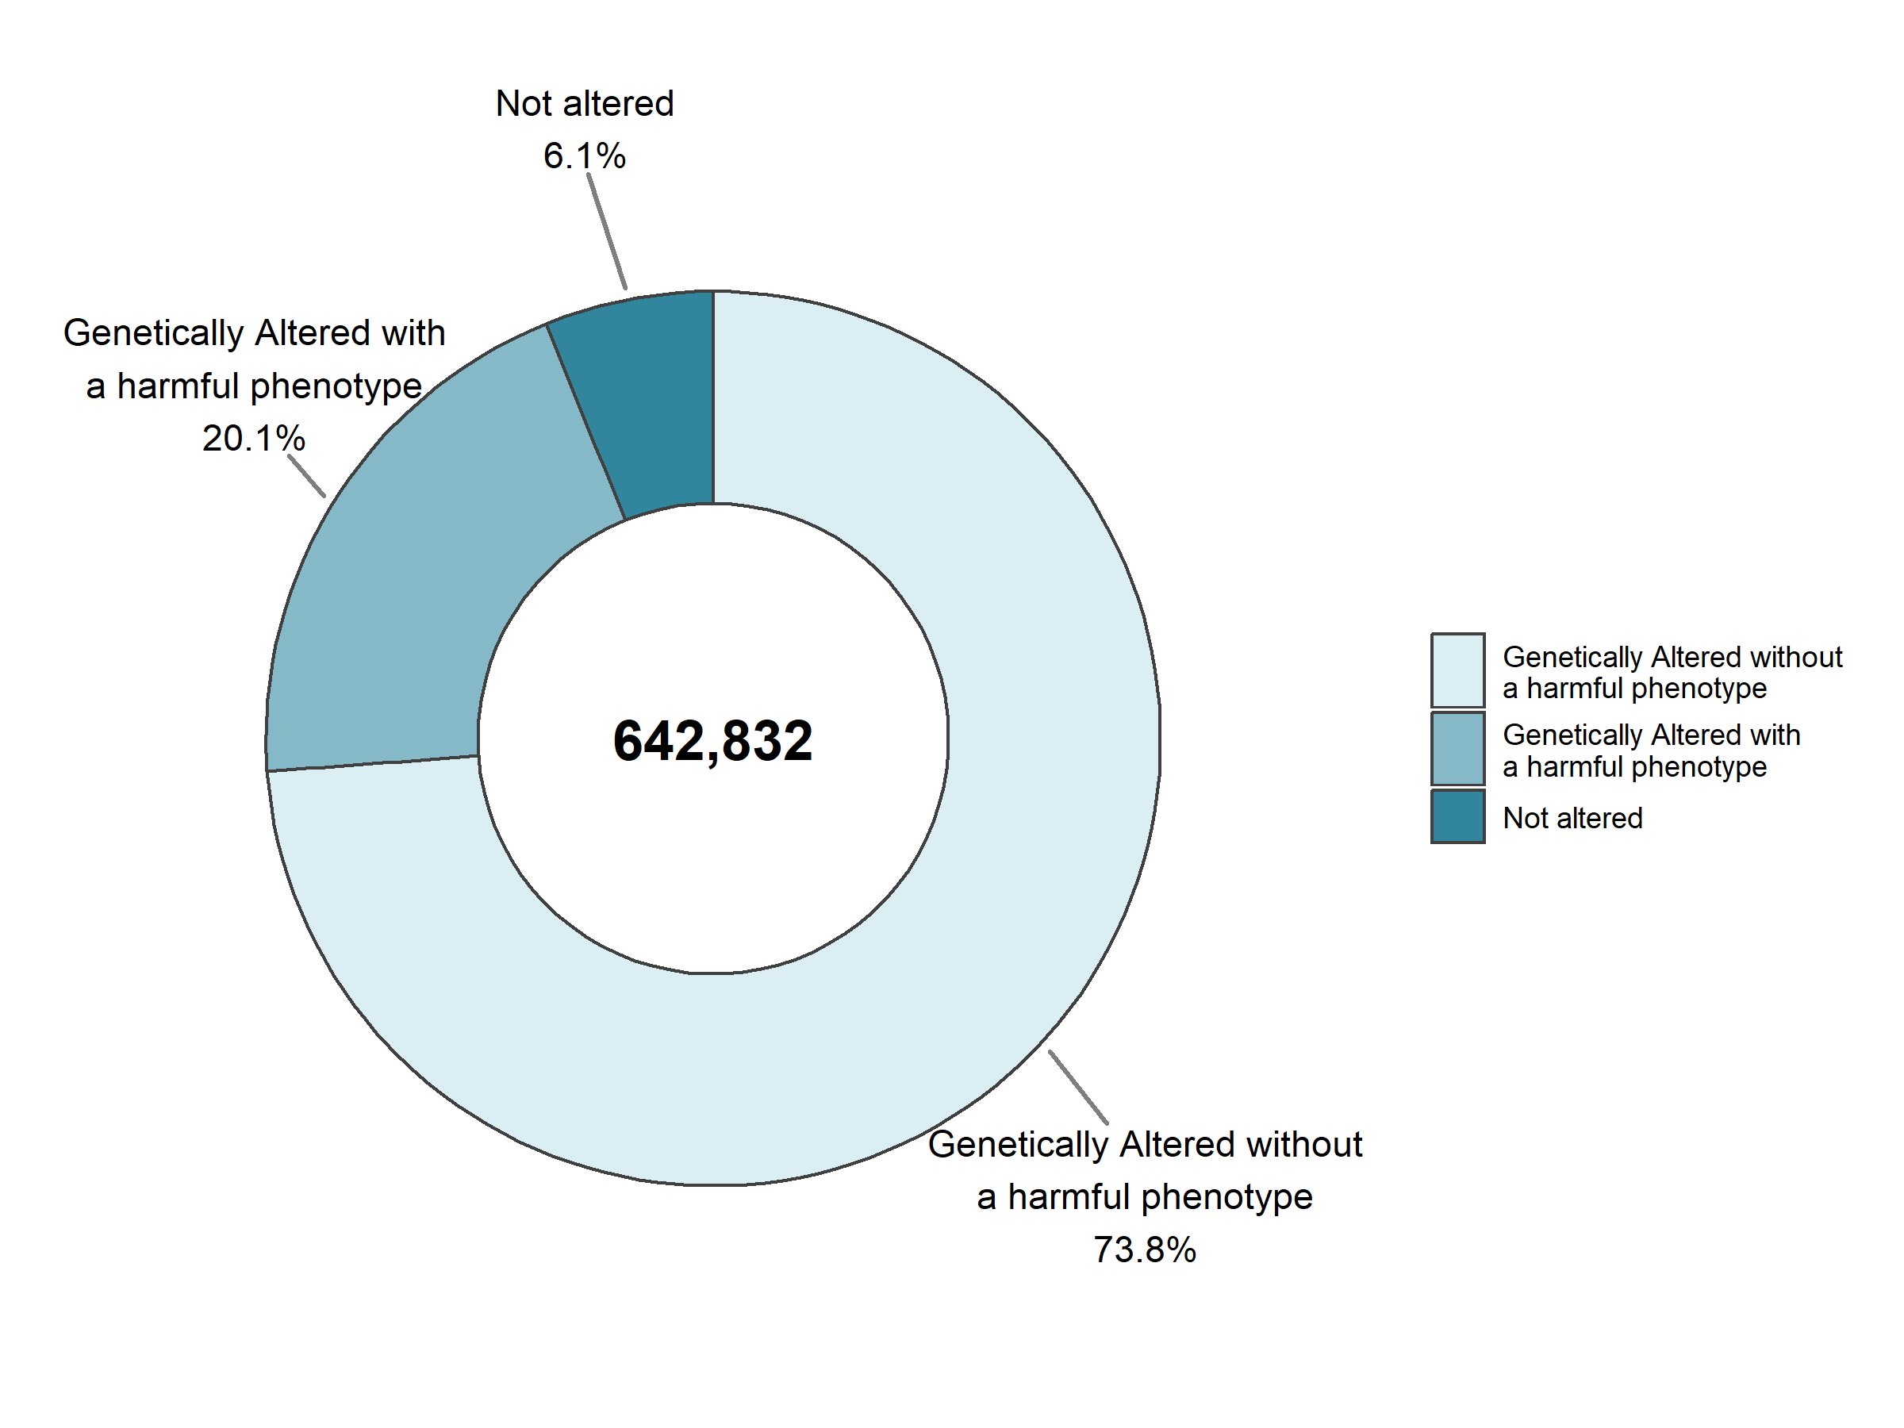

**Figure 3.3: Genetic status of animals used for the maintenance of colonies of established genetically altered animal lines in 2017**

#### III.3.3.2. Maintenance of colonies of established genetically altered animal lines by severity

In 2017, in 79% of the uses the severities remained at mild (and up to mild) level (Table 3.7). Drawing from the previous figure 3.3 in which it was stated that almost 74% percent of animals were of non-harmful phenotype, the severities seem to relate to the effects of tissue sampling (invasive genotyping). For those classed as having a harmful-phenotype, the severities can be linked to the phenotype and invasive tissue sampling. Where animals are found dead with no clear reason, this results in reporting these as ‘severe’.

|  |  |  |  |
| --- | --- | --- | --- |
|  | 2015 | 2016 | 2017 |
| Non-recovery | 1% (5,790) | 0% (1,031) | 0% (740) |
| Mild [up to and including] | 84% (842,365) | 87% (609,140) | 79% (510,466) |
| Moderate | 9% (85,781) | 7% (51,298) | 13% (83,866) |
| Severe | 7% (67,250) | 6% (40,040) | 7% (47,760) |
| Total | 100% (1,001,186) | 100% (701,509) | 100% (642,832) |

**Table 3.7: Uses of animals for the maintenance of colonies of genetically altered animal lines by severity in 2017**

#### III.3.3.2. Maintenance of colonies of established genetically altered animal lines by species

Mice and zebra fish are the most common genetically altered animals used for scientific purposes, and are therefore the main species also used for the maintenance of colonies.

|  |  |  |  |
| --- | --- | --- | --- |
|  | 2015 | 2016 | 2017 |
| Mice | 910,724 | 623,988 | 563,784 |
| Rats | 9,003 | 9,294 | 6,799 |
| Dogs | 7 | 17 | 10 |
| Other Mammals | 0 | 4 | 0 |
| Domestic fowl | 322 | 582 | 367 |
| Xenopus | 188 | 259 | 392 |
| Zebra fish | 80,632 | 66,794 | 70,840 |
| Other Fish | 310 | 571 | 640 |
| Total | 1,001,186 | 701,509 | 642,832 |

**Table 3.8: Uses of animals for the maintenance of colonies of established genetically altered animal lines by species**

#### III.3.3.3. Reuses

|  |  |  |  |
| --- | --- | --- | --- |
|  | 2015 | 2016 | 2017 |
| Yes | 4,193 | 973 | 950 |
| No | 996,993 | 700,536 | 641,882 |
| Total | 1,001,186 | 701,509 | 642,832 |

**Table 3.9: Reuses of animals for the maintenance of colonies of established genetically altered animal lines**

These reuses involved three types of species: zebra fish, xenopus and mice.

|  |  |  |
| --- | --- | --- |
|  | Yes | No |
| Mice | 141 | 563,643 |
| Rats | 0 | 6,799 |
| Dogs | 0 | 10 |
| Domestic fowl | 0 | 367 |
| Xenopus | 197 | 195 |
| Zebra fish | 612 | 70,228 |
| Other Fish | 0 | 640 |
| Total | 950 | 641,882 |

**Table 3.10: Reuses by species for the maintenance of colonies of established genetically altered animal lines**

## III.4. Glossary of terms

**Species of animals**

The Directive applies to live non-human vertebrate animals, including independently feeding larval forms and foetal forms of mammals as from the last third of their normal development, and live cephalopods.

Larval forms and cephalopods are reported in the statistics when they become capable of independent feeding. Due to the small size of many larval forms of fish and cephalopod species, the count for these animals may be done on the basis of estimation.

**Procedure**

"Procedure" means any use, invasive or non-invasive, of an animal for experimental or other scientific purposes, with known or unknown outcome, or educational purposes, which may cause the animal a level of pain, suffering, distress or lasting harm equivalent to, or higher than, that caused by the introduction of a needle in accordance with good veterinary practice.

This includes any course of action intended, or liable, to result in the birth or hatching of an animal or the creation and maintenance of a genetically modified animal line in any such condition, but excludes the killing of animals solely for the use of their organs or tissues.

**Use and reuse**

The “use” of an animal within a project extends from the time the procedure (or first procedure/technique in a series) is applied to it, to the time when the observations, or the collection of data (or other products) for a particular scientific purpose (usually a single experiment or test), are completed.

“Reuse” is a term to indicate any subsequent use of an animal, which has already completed a procedure (or series of procedures/techniques) for a particular scientific purpose. Article 16 of the Directive on reuse defines it as a use when a different animal on which no procedure has previously been carried out could also be used. Article 16 also defines the conditions under which an animal may be reused.

**Reporting of actual severity experienced by the animals**

The impact on animal welfare is reported by assigning an animal’s experience to a ‘severity’ category – "mild", "moderate" or "severe". There is a further category termed "non-recovery" which relates to where animals are placed under general anesthesia before they are used and are killed afterwards before regaining consciousness.

The reported severity reflects the highest degree of pain, suffering, distress or lasting harm observed to be actually experienced by the animal during the course of its use. Further guidance on severity assessment can be found at <http://ec.europa.eu/environment/chemicals/lab_animals/pdf/Endorsed_Severity_Assessment.pdf>*.*

1. **Non-recovery -** Animals which have undergone a procedure that has been performed entirely under general anaesthesia from which the animal has not recovered consciousness shall be reported as Non-recovery.
2. **Mild (up to and including)** - Animals which have undergone a procedure as a result of which the animals have experienced short-term mild pain, suffering or distress, as well as when there has been no significant impairment of the well-being or general condition of the animals shall be reported as Mild.

This cateogry also includes any animals used in an authorised project, but which have ultimately *not* been observed to have experienced a level of pain, suffering, distress or lasting harm above the minimum threshold (equivalent to that caused by the introduction of a needle in accordance with good veterinary practice) for example untreated control animals (“up to mild”). However, animals required for the maintenance of colonies of genetically altered animals of established lines *with an intended harmful phenotype and which have not exhibited* pain, suffering, distress or lasting harm as a consequence of the harmful genotype are not reported in annual statistics.

1. **Moderate** - Animals which have undergone a procedure as a result of which the animals have experienced short-term moderate pain, suffering or distress, or long-lasting mild pain, suffering or distress as well as procedures that have caused moderate impairment of the well-being or general condition of the animals shall be reported as Moderate.
2. **Severe** - Animals which have undergone a procedure as a result of which the animals have experienced severe pain, suffering or distress, or long-lasting moderate pain, suffering or distress as well as procedures, that have caused severe impairment of the well-being or general condition of the animals shall be reported as Severe.

In the exceptional circumstances where, under the safeguard clause, the Severe classification is exceeded these animals and their use will be reported under Severe. Should this occur, further explanation on the circumstances of this use is provided in the respective Member State narrative.

**Genetically altered animals**

For the purposes of statistical reporting, "genetically altered animals" refer to either of the following:

* genetically modified (such as transgenic, knock-out and other forms of genetic alteration) and induced mutant animals (irrespective of the type of mutation);
* animals with spontaneous deleterious mutations maintained for research for that specific genotype.

Genetically altered animals are reported either

1. When used for the creation of a new animal line;
2. When used for the maintenance of an established line with an intended ***and*** exhibited harmful phenotype; This category also includes genetically altered animals during maintenance of an established line, irrespective of whether the line is of intended non-harmful or harmful phenotype, that have been subject to invasive genotyping (genetic characterisation/tissue sampling);
3. When used in other (scientific) procedures (i.e. not for the creation or the maintenance of a line).

The reporting of genetically altered animals are summarised in the above table.

Creation

All animals *carrying a genetic alteration* are reported during the creation of a new line. Also, those used for superovulation, vasectomy and embryo implantation are reported (these may or may not be genetically altered).

Genetically normal animals (*wild-type offspring*) produced as a result of the creation of a new genetically altered line are not reported, unless these have been subjected to a procedure, for example an invasive method for the sole purposes of genotyping.

Establishment and maintenance of breeding colonies

A new strain or line of genetically altered animals is considered to be “established” when transmission of the genetic alteration is stable, which will be a minimum of two generations, and a welfare assessment has been completed. This marks the transition from "creation" to "breeding".

The welfare assessment determines if the newly established line is expected to have an *intended harmful phenotype (characteristic/trait)* i.e. an effect of genetic alteration that impacts negatively on an animal’s health or welfare, such as muscle weakness, diabetes, tumour development.

If the welfare assessment concludes that the line is *not* expected to have a harmful phenotype, its breedingfalls outside the scope of a procedure and is not reported in the annual statistics.

If the welfare assessment concludes that the line *is* expected to have a harmful phenotype, its breeding falls within the scope of a procedure. If this is the case, and if the animal is not used in other procedures and it has exhibited, before being killed, pain, suffering, distress of lasting harm as a result of the harmful phenotype, it is reported under the category *Maintenance of colonies of established genetically altered animals, not used in other procedures.*

Use in procedures (other than creation or maintenance of a genetically altered line)

All genetically altered animals which are used in procedures (not for the creation or maintenance of a genetically altered line) are reported under their respective purposes they were used for(. These animals may or may not exhibit a harmful phenotype.

Diagram for the reporting of the creation, maintenance and use of genetically altered animals

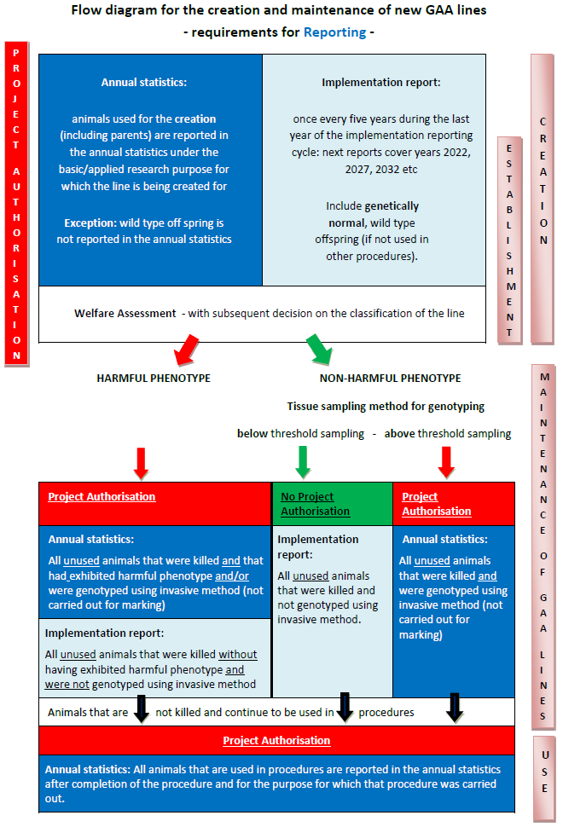

**Main categories of purposes of uses for research, testing, routine production and education (including training)**

Basic research

Basic research includes studies of a fundamental nature including physiology. Studies that are designed to add knowledge about normal and abnormal structure, functioning and behaviour of living organisms and environment, this includes fundamental studies in toxicology. Investigation and analysis focused on a better or fuller understanding of a subject, phenomenon, or a basic law of nature instead of on a specific practical application of the results.

Translational and applied research

Translational and applied research includes animals used for purposes as described in Article 5(b) and (c) of the Directive, that is to say,

*“(b) translational or applied research with any of the following aims:*

*(i) the avoidance, prevention, diagnosis or treatment of disease, ill-health or other abnormality or their effects in human beings, animals or plants;*

*(ii) the assessment, detection, regulation or modification of physiological conditions in human beings, animals or plants; or*

*(iii) the welfare of animals and the improvement of the production conditions for animals reared for agricultural purposes;*

*(c) for any of the aims in point (b) in the development, manufacture or testing of the quality, effectiveness and safety of drugs, foodstuffs and feed-stuffs and other substances or products;”*

This category also includes discovery toxicology and investigations to *prepare* for the regulatory submission and method development. This does not include studies *required* for regulatory submissions.

Regulatory use

Regulatory uses cover the use of animals in procedures with a view to satisfying regulatory requirements, that is to say, for producing, placing and maintaining products/substances on the market, including safety and risk assessment for food and feed. It also includes tests carried out in respect of products/substances for which a regulatory submission was foreseen but ultimately not made, for instance because these were deemed unsuitable for the market by the developer and thus fail to reach the end of the development process.

Routine production

Routine production includes the production of antibodies and blood products including polyclonal antisera by established methods.

Protection of the natural environment in the interests of the health or welfare of human beings or animals

This category includes studies aimed at investigating and understanding phenomena such as environmental pollution, loss of biodiversity, and epidemiology studies in wild animals. This excludes any regulatory use of animals for ecotoxicology purposes.

Preservation of species

Studies aimed at conserving species, often those at risk of extinction, for example to investigate improved breeding strategies or preservation of habitats.

Higher education or training

This category covers the use of animals for the purposes of education and also for the acquisition, maintenance or improvement of vocational skills.

Forensic enquiries

Studies to assist the investigation of forensic enquiries.

1. Directive 2010/63/EU OJ L276, 20.10.2010, p.33-79
2. OJ L 170, 25.6.2019, p. 115–127
3. OJ L 358 , 18/12/1986 P. 0001 - 0028
4. “Research and testing” covers animals used for research, testing, routine production and education (including animals used for training purposes)
5. In this context ‘Research’ means basic, applied and translational research, animals used for the purposes of protection of the natural environment in the interests of the health or welfare of human beings or animals, preservation of the species and forensic enquiries; ‘testing’ refers to regulatory use of animals and ‘education’ includes animals used for training purposes. Glossary in III.4. provides further information on some of the categories of scientific use purposes.
6. The International Conference on Harmonisation of Technical Requirements for Registration of Pharmaceuticals for Human Use
7. The International Cooperation on Harmonisation of Technical Requirements for Registration of Veterinary Medicinal Products
8. To Replace, Reduce and Refine the use of animals in scientific procedures