

**REPORT FROM THE COMMISSION TO THE EUROPEAN PARLIAMENT AND THE COUNCIL**

2019 report on the statistics on the use of animals for scientific purposes in the Member States of the European Union in 2015-2017

# INTRODUCTION

This report presents statistical data on the use of animals for scientific purposes in the Member States of the European Union during the years 2015 to 2017 under Directive 2010/63/EU[1] (“the Directive”) on the protection of animals used for scientific purposes. The obligation of the Member States to collect statistical data is covered by Article 54(2) of the Directive.

Regulation (EU) 2019/1010[2] (“the Regulation”) amended Article 54(2) to require Member States to submit the statistical data to the Commission by electronic transfer in a non-summarised format. As the Regulation was adopted in June 2019, the first annual data set in line with the new wording of Article 54(2) will be collected in 2020 and submitted to the Commission by 10 November 2021. That Member State data will then be made available through an open access database in 2022 accompanied by a summary report thereof.

The Regulation also removed the obligation of the Commission to submit a statistical report to the European Parliament and the Council. However, since improved transparency is one of the key objectives of the Directive, the Commission considers it appropriate, as well as necessary in support of the other objectives of the Directive, that the data submitted by the Member States is made available on a yearly basis until 2022.

A more detailed Commission Staff Working Document[3] accompanies this report.

# DATA SUBMITTED AND GENERAL ASSESSMENT

## Data submitted by the Member States

All 28 Member States submitted data for the years 2015 to 2017 according to the Commission Implementing Decision 2012/707/EU of 14 November 2012, establishing a format for the submission of the information pursuant to the Directive.

The individual Member State data and narratives can be found in Part B of the Staff Working Document.

## Data outside of the scope of the report

What remains outside of the scope of annual statistical reporting, even if covered by the scope of the Directive, are:

1. Foetal forms of mammals;
2. Animals killed solely for organs and tissues, and sentinels, unless the killing is performed under a project authorisation using a method not included in Annex IV of Directive 2010/63/EU;
3. Animals bred and killed without being used, apart from genetically altered animals with intended and exhibited harmful phenotype, and those having been genotyped with an invasive method before being killed.

The five-year report on the implementation of the Directive[4] provides, in addition, for the year 2017, the number of animals bred and killed without being used in procedures. This allows, now for the first time and once every five years, to draw a total picture of all animals needed to support research and testing in the EU.

## Link to the previous statistical reports under Directive 86/609/EEC[5]

It should be noted that this is the first report on animal use data collected according to the changed reporting requirements under the Directive, as laid out in Commission Implementing Decision 2012/707/EU. These requirements are significantly different and cover areas of animal use that were not included under the previous legislation. It is therefore not possible, in general, to compare the detailed information presented in this report with earlier reports published under the previous Directive 86/609/EEC.

With this in mind, the only limited comparison which may be attempted concern the numbers of animals used for the first time for the purposes of research and testing[6]. However, even here the comparison is not obvious, because (1) invertebrate species were not included in the past reports and they are now, and (2) the previous numbers included partly those animals that were used for the creation of genetically altered animal lines (which are now separate), leaving the comparison between 2011 and current numbers of animals only as an estimate.The main differences are summarised below:

1. **The scope** includes new classes of animals, namely all species of Cephalopods. In addition, the creation and maintenance (breeding) of genetically altered animals is covered;
2. **The time of reporting -** the information is submitted when a use of an animal is completed, instead of at the start of the use;
3. **Each use of an animal** is captured, both the number of uses and details thereof;
4. **Genetic status of the animals;**
5. **The actual severity experienced by an animal** during a procedure is one of the key novelties of the new report.

The data quality control revealed shortfalls but the overall assessment showed acceptable quality. Some elements of the new reporting have proven extremely demanding and required extensive efforts by Member States and the Commission. These concern especially the reporting of the severities experienced by animals and the consistency of reporting animal use for the maintenance of genetically altered animals within and between Member States, and over years.

In addition to the Severity Assessment Framework guidance[7] prepared by the Commission together with stakeholders, some Member States have been particularly active in their efforts to improve data quality. Furthermore, some stakeholder organisations[8] have offered workshops to address issues in severity reporting. With these and other efforts, the statistical data quality is expected to continue to improve. It is clear therefore, that some of the fluctuations in numbers, or even what may seem as trends at this early stage, may instead be due to improved understanding of the reporting obligations. Finally, for these same reasons it is too early to draw firm conclusions on trends on the basis of only the first three years of data.

## Presentation of the data

To step up the efforts in improving transparency of animal use in the EU, the statistical information is now much more detailed and elaborated. This allows for a much better understanding of when and how animals are still used in science in the EU.

It is hoped that, in line with the Directive aims, this will better facilitate the identification of animal use areas on which efforts for the development and validation of alternative approaches should be focused.

The report analyses the data in three distinctive areas:

1. **Numbers of animals** used for research, testing, routine production and educational (including training) purposes (“research and testing” from here on). These animals can be both conventional animals or those that are genetically altered.
2. **Details of all uses (first and any subsequent reuse) of animals** for research and testing. This serves to draw an overall picture of all uses of animals for the purposes of research, testing and takes into account the nature of the procedures, their legislative context, reuse of animals, the genetic status of the animals, and the severities experienced by the animal.
3. **Numbers and uses of animals for the creation and maintenance of genetically altered animal lines.** The third section focuses on the provision of genetically altered animals needed to support scientific research in the EU. These animals have not been used in other scientific procedures, covered in sections one and two above.

General information is presented for the three years, 2015 – 2017. A more detailed analysis, however, uses the most recent and likely most accurate data of 2017.

# RESULTS

## Overall numbers of animals used in the EU

Both the numbers of animals used for research and testing and those used for the creation and maintenance of genetically altered animal lines seem to indicate a downward trend in the EU.

### Numbers of animals used for research and testing in the EU

The number of animals used for the first time (naïve animals) **for research and testing** in the EU is below 10 million animals annually.

Between 2015 and 2017, the total number of animals decreased slightly from 9.59 million (2015) to 9.39 million (2017). However, there was a slight increase to 9.82 million in 2016, preventing the confirmation of a clear trend (Table 1).

|  |  |  |  |
| --- | --- | --- | --- |
|  | 2015 | 2016 | 2017 |
| Total | 9,590,379 | 9,817,946 | 9,388,162 |

**Table 1: Total numbers of animals used for the first time for research, testing, routine production and education purposes**

### Numbers of animals used for the creation and maintenance of genetically altered animal lines in the EU

The number of animals used for the first time (naïve animals) for **the creation and maintenance of genetically altered (GA) animal lines** to meet the research needs in the EU is around 1.2 million.

Between 2015 and 2017, despite of the fact that the creation of new genetically altered animal lines increased by 7%, the total numbers of animals used for the creation and maintenance of genetically altered animals showed a combined decrease of almost 20%. However, some of this decrease may be attributed to an increased understanding of the reporting requirements within these categories (Table 2).

|  |  |  |  |
| --- | --- | --- | --- |
|  | 2015 | 2016 | 2017 |
| GA creation | 591,033 | 493,156 | 634,705 |
| GA maintenance | 996,993 | 700,536 | 641,882 |
| Total GA creation and maintenance | 1,588,025 | 1,193,692 | 1,276,587 |

**Table 2: Total numbers of animals used for the creation and maintenance of genetically altered animal lines**

## Animals used for the first time in research and testing

In 2017, the main species used for the first time in research and testing were mice, fish, rats and birds, which together represented 92% of the total number of animals while species of particular public concern (dogs, cats and non-human primates) represented less than 0.3% of the total number of animals. No Great Apes are used for scientific purposes in the EU (Fig. 1).

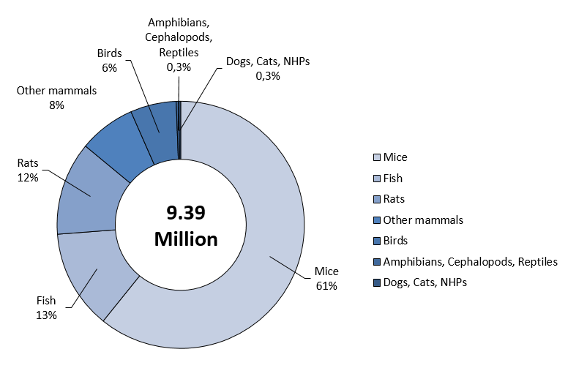

**Figure 1: Numbers of animals used for the first time by main classes of species in 2017**

|  |  |  |  |
| --- | --- | --- | --- |
|  | 2015 | 2016 | 2017 |
| Mice | 5,711,612 | 5,989,413 | 5,707,471 |
| Rats | 1,201,189 | 1,173,135 | 1,146,299 |
| Guinea-Pigs | 149,328 | 150,985 | 144,824 |
| Hamsters (Syrian) | 20,195 | 18,614 | 12,700 |
| Hamsters (Chinese) | 30 | 519 | 187 |
| Mongolian gerbil | 6,199 | 5,645 | 5,239 |
| Other rodents | 26,088 | 13,712 | 25,172 |
| Rabbits | 346,052 | 350,405 | 351,961 |
| Cats | 1,975 | 1,951 | 1,879 |
| Dogs | 14,501 | 15,691 | 13,688 |
| Ferrets | 2,212 | 1,530 | 2,016 |
| Other carnivores | 3,648 | 1,444 | 2,386 |
| Horses, donkeys and cross-breeds | 3,217 | 3,474 | 2,414 |
| Pigs | 73,895 | 80,029 | 71,522 |
| Goats | 2,233 | 1,365 | 1,563 |
| Sheep | 20,106 | 21,240 | 18,812 |
| Cattle | 26,763 | 22,782 | 30,643 |
| Prosimians | 169 | 44 | 98 |
| Marmoset and tamarins | 429 | 285 | 465 |
| Squirrel monkey | 13 | 8 | 8 |
| Other species of New World Monkeys (Ceboidea) | 0 | 0 | 3 |
| Cynomolgus monkey | 6,221 | 6,503 | 7,227 |
| Rhesus monkey | 211 | 318 | 353 |
| Vervets (Chlorocebus spp.) | 56 | 19 | 33 |
| Baboons | 37 | 62 | 25 |
| Other species of Old World Monkeys (Cercopithecoidea) | 0 | 0 | 23 |
| Other mammals | 9,535 | 3,637 | 26,335 |
| Domestic fowl | 515,834 | 500,920 | 464,553 |
| Other birds | 119,377 | 94,804 | 99,410 |
| Reptiles | 2,414 | 3,240 | 2,937 |
| Rana | 4,884 | 4,482 | 3,485 |
| Xenopus | 10,837 | 18,511 | 13,539 |
| Other amphibians | 20,190 | 19,558 | 10,683 |
| Zebra fish | 338,815 | 513,011 | 499,763 |
| Other Fish | 936,252 | 791,726 | 719,932 |
| Cephalopods | 15,862 | 8,884 | 514 |
| Total | 9,590,379 | 9,817,946 | 9,388,162 |

**Table 3: Numbers of animals used for the first time by species**

Between 2015 and 2017, in reference to specific groups of species, the number of amphibians, cephalopods, reptiles decreased altogether by 42%, hamsters by 37%, horses, donkeys and cross-breeds by 25% and birds by 11%. Also, the numbers of dogs (-6%), cats (-5%), rats (-5%) and fish (-4%) decreased slightly. The numbers of sheep and goats decreased by 9% while the numbers of cattle increased (+14%).

The numbers of non-human primates saw an increase of 15%. The cynomolgus monkey, representing 88% of non-human primates in 2017, was the most commonly used species of non-human primates and had an increase of 16% between 2015 and 2017. Numbers of marmosets, rhesus monkeys and other old world monkeys also increased slightly. Numbers of other non-human primate species decreased between 2015-2017. There was a small increase in the numbers of rabbits (+2%).

### Origin of animals (other than non-human primates)

The origin of animals is monitored as accommodation and care standards of the Directive only apply within EU. Moreover, an increase in transport times may impact negatively welfare. In 2017, almost 90% of the animals used for scientific purposes were born in the EU at registered breeders and less than 2% were born outside of the EU (either in the rest of Europe or outside of Europe). The category 'animals born in the EU but not at a registered breeder' includes animals from, for example, farms, and studies on wild animals.

Between 2015 and 2017, animals born in the EU but not at a registered breeder decreased (-23%) and animals born outside of Europe increased (+60%) due to the import of bats (not bred in Europe).

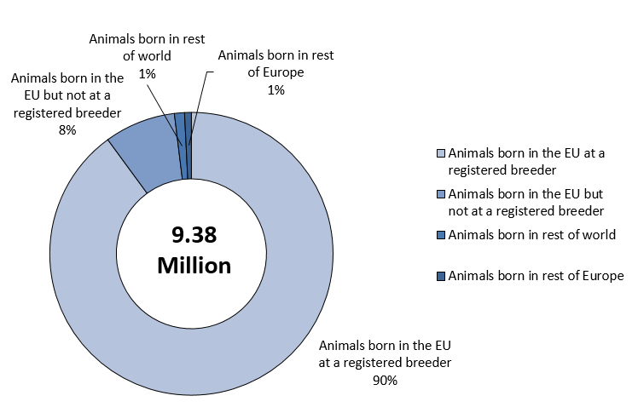

**Figure 2: Place of birth of animals other than non-human primates in 2017**

### Source and generation of non-human primates

The Directive provides additional protection for non-human primates (NHP) due to their genetic proximity to human beings, their highly developed social skills and capacity to experience pain, suffering and distress. In order to end the capturing of animals from the wild including for the purposes of breeding, the Directive requires moving towards using NHPs that have been bred, ultimately, in self-sustaining colonies, from parents who themselves have been bred in captivity.

In 2017, the three main sources of NHP were Africa, Asia and EU-registered breeders (Table 4).

|  |  |  |  |  |  |  |
| --- | --- | --- | --- | --- | --- | --- |
|  | Animals born at a registered breeder within EU | Animals born in rest of Europe | Animals born in Asia | Animals born in America | Animals born in Africa | Animals born elsewhere |
| F1[9] | 3% (32) | 0% (0) | 3% (88) | 30% (16) | 27% (1,147) | 47% (80) |
| F2 or greater | 40% (418) | 100% (5) | 75% (1,948) | 70% (38) | 44% (1,915) | 26% (44) |
| Self-sustaining colony | 57% (607) | 0% (0) | 22% (578) | 0% (0) | 29% (1,273) | 27% (46) |
| Total | 100%  (1,057) | 100%  (5) | 100%  (2,614) | 100%  (54) | 100%  (4,335) | 100%  (170) |

**Table 4: Generation of non-human primates by source in 2017**

In 2017, cynomolgus monkeys represented 88% of NHPs used for the first time and were coming almost entirely from outside of the EU. On the contrary, other species of NHPs were mainly coming from EU registered breeders.

With regard to the generation, the majority of NHPs was coming either from self-sustained colonies (30%) or being second or higher generation purpose-bred (53%).

Between 2015 and 2017, NHPs coming from self-sustained colonies remained stable. However, in line with the Directive objectives, those being second or higher generation purpose-bred increased significantly (+67%). None of the NHPs used for the first time was captured from the wild in 2017.

## All uses of animals for research and testing

Between 2015 and 2017, the total number of uses (first use and any subsequent reuse) for research and testing decreased by 2% from 9.78 million in 2015 to 9.58 million uses in 2017. However, there was an increase to 10.03 million in 2016 (Table 5).

|  |  |  |  |
| --- | --- | --- | --- |
|  | 2015 | 2016 | 2017 |
| Total | 9,782,570 | 10,028,498 | 9,581,741 |

**Table 5: Total number of uses of animals in research and testing between 2015 and 2017**

### Main categories of scientific purposes

In 2017, 9.58 million uses of animals for scientific purposes were reported. The main purpose was research (69%) of which 45% of all uses were carried out for basic research and 23% for translational and applied research purposes. A further 23% of animal uses were for regulatory use to satisfy legislative requirements, followed by routine production (5%).

Other categories are protection of the natural environment in the interest of the health or welfare of human beings or animals, preservation of species, higher education or training for the acquisition, maintenance or improvement or vocational skills and forensic enquiries (Fig. 3).

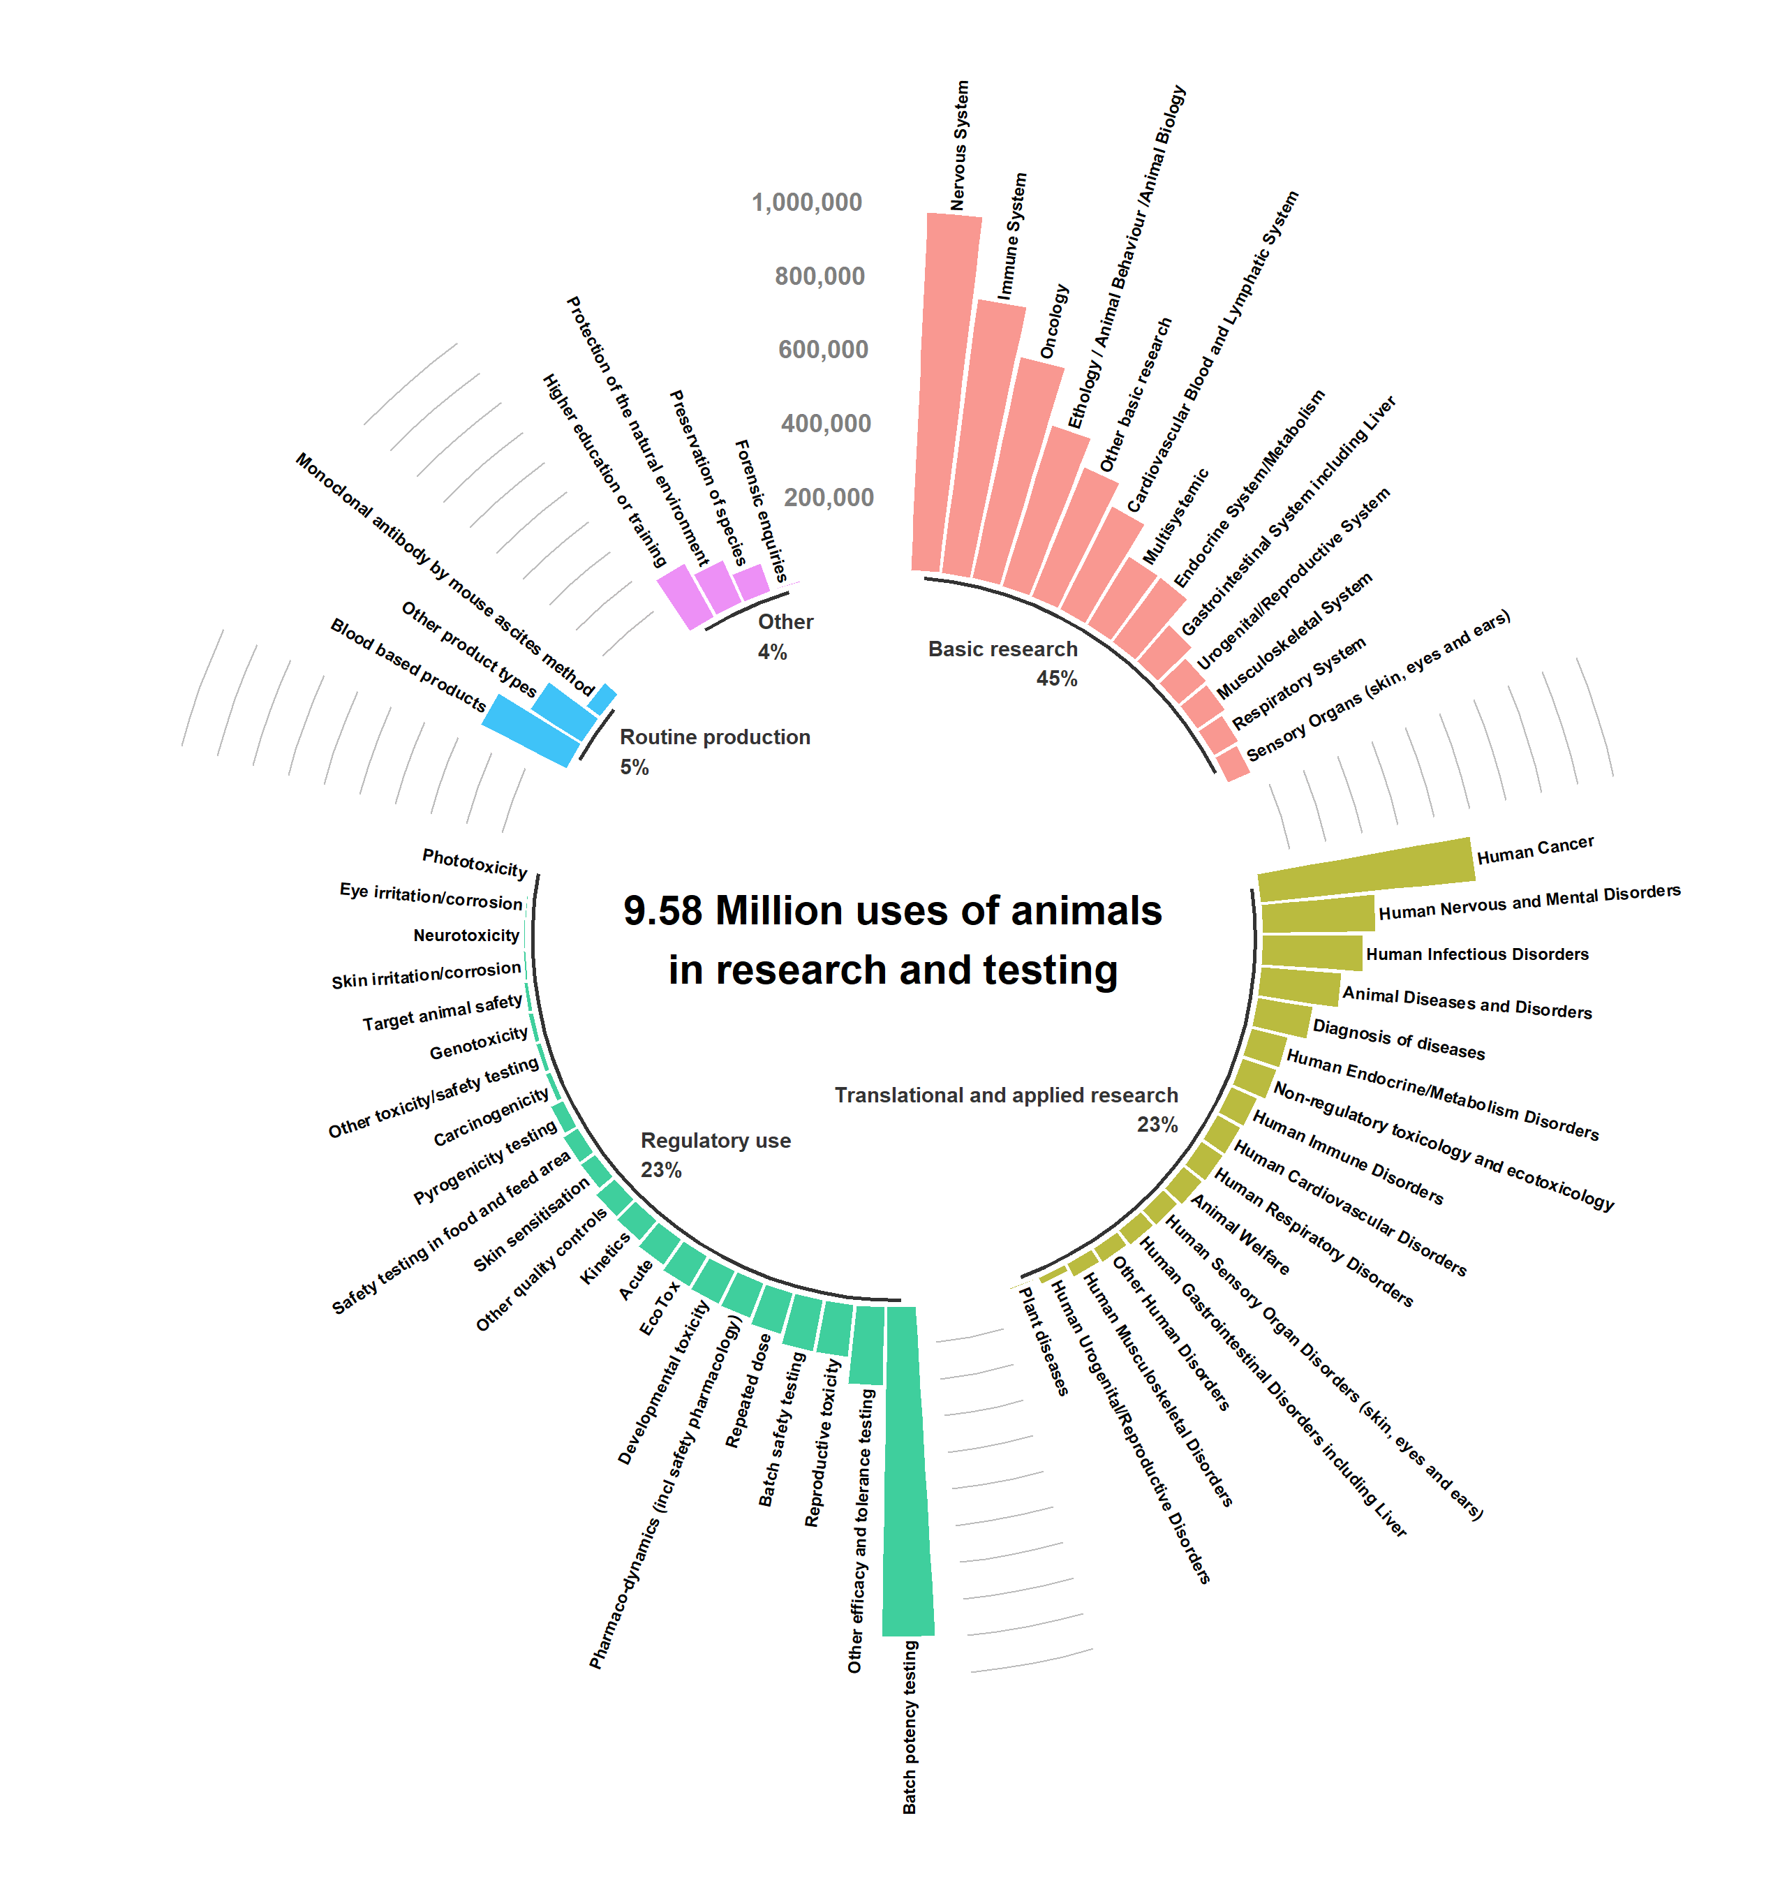

**Figure 3: All uses of animals for research and testing in 2017**

### Severity of all uses in research and testing

The Directive requires the reporting of the actual severity experienced by an animal when used in a procedure.

In 2017, 51% of uses were assessed as ‘mild’ (up to and including), 32% as ‘moderate’, 11% as ‘severe’ and 6% of uses were ‘non-recovery[10]’. The number of severe procedures increased proportionally between 2015 and 2016 mainly because of an increase in the uses for disease diagnosis (Table 6). The proportion of severe uses remained the same between 2016 and 2017.

It is important to note that the reporting of actual severities is probably the most challenging element to achieve consistent reporting within and between Member States as well as over time. Therefore, any firm conclusions on the results of these early years of reporting should be discouraged.

|  |  |  |  |
| --- | --- | --- | --- |
|  | 2015 | 2016 | 2017 |
| Non-recovery | 6% (622,034) | 6% (620,848) | 6% (621,054) |
| Mild [up to and including] | 54% (5,330,549) | 52% (5,239,321) | 51% (4,865,721) |
| Moderate | 31% (3,010,980) | 31% (3,101,054) | 32% (3,071,828) |
| Severe | 8% (819,007) | 11% (1,067,275) | 11% (1,023,138) |
| Total | 100% (9,782,570) | 100% (10,028,498) | 100% (9,581,741) |

**Table 6: Severity of uses**

When analysing all the sub-categories of purposes, batch potency testing resulted in the highest number of severe uses (over 264K uses), followed by studies on nervous system (over 87K uses) and diagnosis of diseases (over 81K) (Fig. 4).

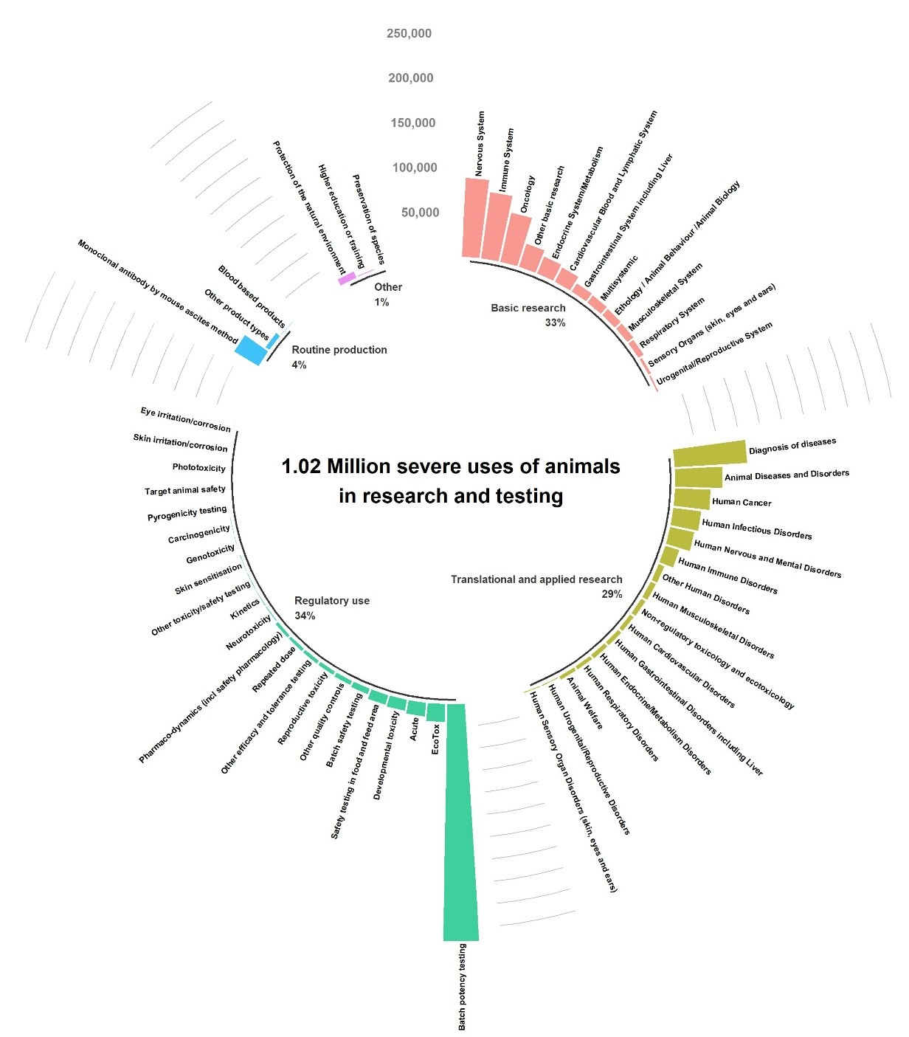

**Figure 4: Severe uses of animals for research and testing in 2017**

Looking at the proportion of severe uses within a sub-category: production of monoclonal antibodies by ascites method was the highest (70% of uses for this purpose were severe – Fig. 10), followed by diagnosis of diseases (54% - Fig. 6) and acute toxicity studies in the area of ecotoxicity (37% - Fig. 8).

When analysing sub-categories with more than 30K uses, the lowest severities, (i.e. severe uses representing less than 1% of all uses within that sub-category,) are the production of blood based products (Fig. 11), preservation of species (Fig. 4), education and training (Fig. 4) and toxicity testing for skin sensitisation (Fig. 8).

### Uses of animals for research purposes

Research-related uses are split between basic research on one side and translational and applied research on the other.

Basic research accounted for more than 4.3 million uses in 2017. The four main domains of basic research are nervous system, immune system, oncology and ethology/animal behavior / animal biology that overall account for more than half of the uses in basic research (Fig. 5).

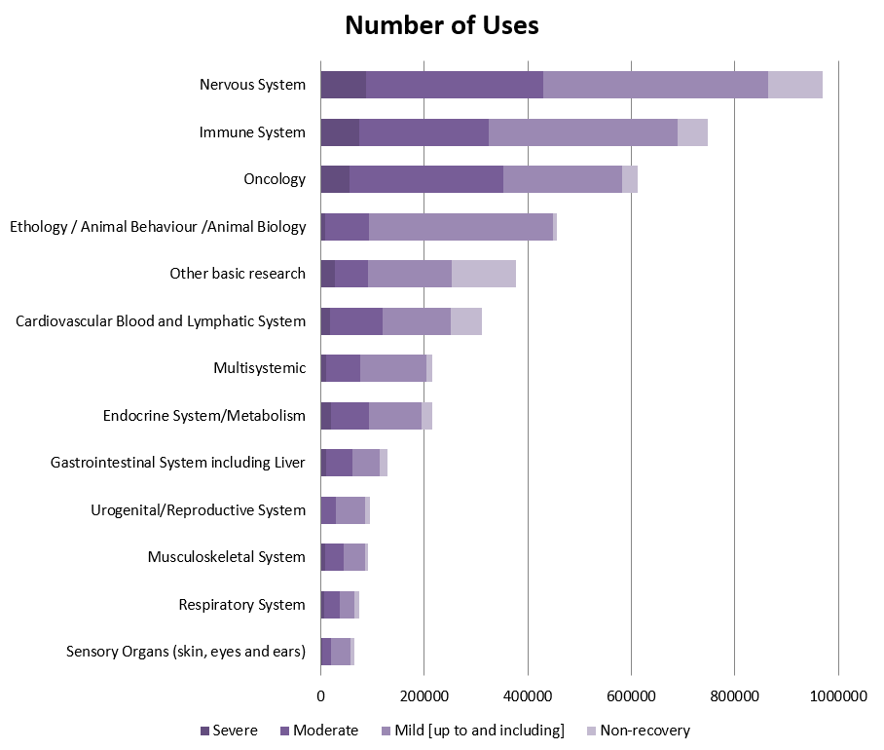

**Figure 5: Basic research related uses by type of research and severity in 2017**

Translational and applied research accounted for about 2.2 million uses of animals in 2017. The four main areas of such research were human cancer, human nervous and mental disorders, human infectious disorders and animal diseases and disorders (Fig. 6).

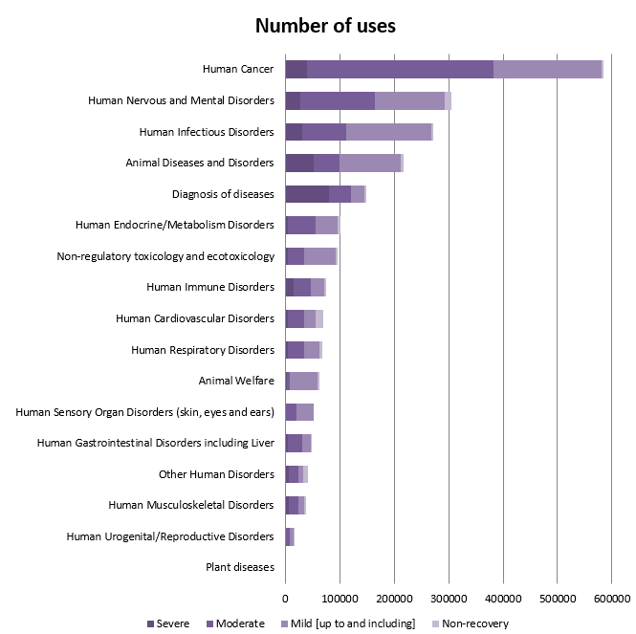

**Figure 6: Translational and applied research related uses by type of research and severity in 2017**

### Uses of animals for regulatory purposes

In 2017, regulatory uses accounted for 2.18 million uses. 52% of these uses were related to quality control (including batch safety and potency testing), 39% to toxicity and other safety testing including pharmacology and the remainder (9%) were for other efficacy and tolerance testing. Quality control related uses represented 1.1 million uses. A large majority of these uses were related to batch potency testing purposes (79%) (Fig. 7).

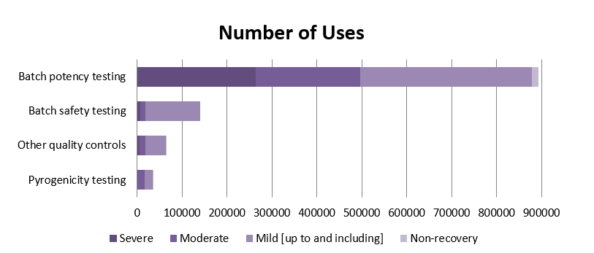

**Figure 7: Quality Control related uses by type and severity in 2017**

Toxicity and other safety testing including pharmacology represented more than 800K uses of animals, which represented 8% of all animal uses (Fig. 8).

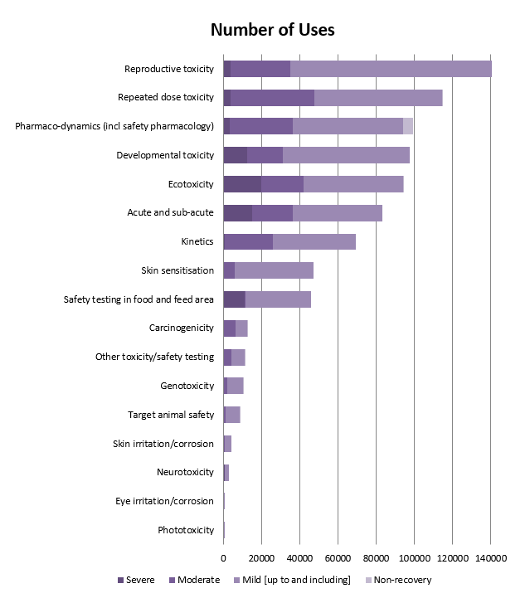

**Figure 8: Toxicity and other safety testing including pharmacology by type of use and severity in 2017**

Most of the uses in this area were related to reproductive toxicity, repeated dose toxicity, pharmaco-dynamics, developmental toxicity, ecotoxicity and acute and sub-acute toxicity.

### Regulatory uses by legislation

In 2017, the majority of uses to satisfy requirements of specific sector legislation occurred for medicinal products for humans (61%), veterinary medicinal products (15%) and industrial chemicals (11%) (Fig. 9).

Between 2015 and 2017, the uses to satisfy legislative requirements for medical products for human use decreased by 13% while those related to medical device legislation uses (+23%) and industrial chemicals legislation uses (+17%) saw an increase. No uses were reported under the cosmetics legislation.

In 2017, the majority of regulatory uses was performed to satisfy regulatory requirements originating from the EU (95%). Non-EU requirements accounted for 4% and national requirements for 1%.

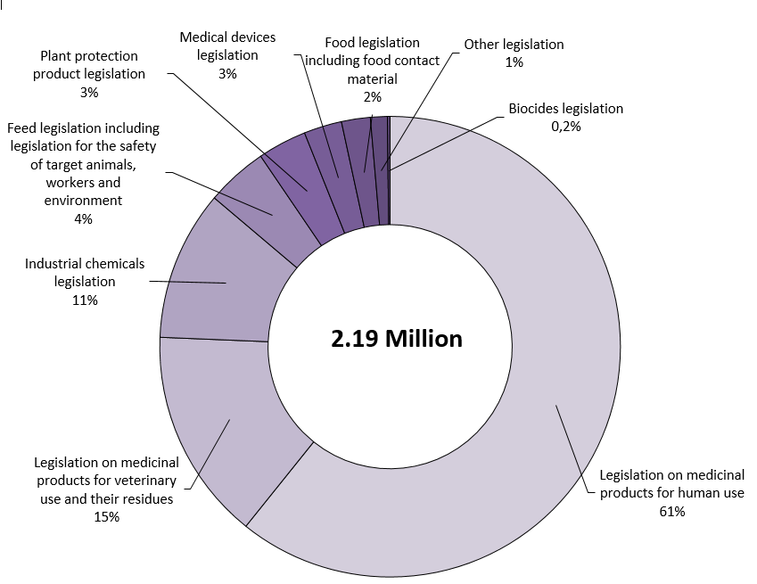

**Figure 9: Regulatory uses by type of legislation in 2017**

Between 2015 and 2017, the total number of uses for regulatory purposes decreased by 7%.

### Uses of animals for routine production

In 2017, there were about 450K routine production uses which represented 5% of all uses of animals. 55% of these were related to the production of blood-based products and 10% to monoclonal antibodies production by the mouse ascites method (Fig. 10).

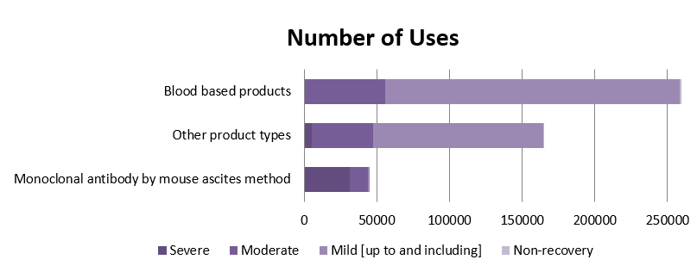

**Figure 10: Routine production uses by product type and severity in 2017**

### Reuse of animals

In line with the principle of the Three Rs, the total number of animals used in procedures can be reduced by performing more than one procedure on an animal. However, reuse of animals is permitted only under specific conditions related to the actual level of severity the animal has experienced in a previous procedure and the health and well-being of the animal, taking into account the lifetime experience of the individual animal. The reuse cannot be authorised for a procedure that is prospectively classified as severe.

2% of all uses were reported as reuses (Table 7).

|  |  |  |  |
| --- | --- | --- | --- |
|  | 2015 | 2016 | 2017 |
| No | 98% (9,590,379) | 98% (9,817,946) | 98% (9,388,162) |
| Yes | 2% (192,191) | 2% (210,552) | 2% (193,579) |
| Total | 100% (9,782,570) | 100% (10,028,498) | 100% (9,581,741) |

**Table 7: Reuses of animals used for research, testing, routine production and educational purposes**

In absolute numbers, the main species reused for scientific purposes in 2017 were mice, sheep, rats, rabbits, horses, donkeys and cross-breeds.

Proportionally, large mammals are more often reused, e.g. horses, donkeys and cross-breeds (82%), sheep (71%), cats (44%), dogs (36%) and cynomolgus monkeys (28%). Reptiles (55%) and xenopus (37%) amongst amphibians were also often reused.

In terms of the purposes of reuse, in 2017, routine production had the largest proportion of reuses (12%) mainly for blood-based products. This was followed by higher education or training of vocational skills (8%).

In 2017, most of the actual experienced severities of reuse were mild (74%) or moderate (19%), with 6% reported as non-recovery. Even if the procedure is prospectively classified in a lower severity category, an individual animal may reach severity category "severe" due to unexpected events occurring during the procedure. Only 0,2% was assessed as severe.

### Genetic status of animals

In 2017, 2.59 million uses for the purposes of research were carried out on animals that were genetically altered, of which 17% exhibited a harmful phenotypic alteration (Fig. 11).

The number of genetically altered animals among all animal uses for research is increasing slightly. Between 2015 and 2017, the percentage of genetically altered increased from 25% to 27%. In 2017, 2.57 million of the 9.38 million animal uses involved genetically altered animals. Zebra fish and mice were the most common genetically altered species with 64% and 38% of them genetically altered respectively.

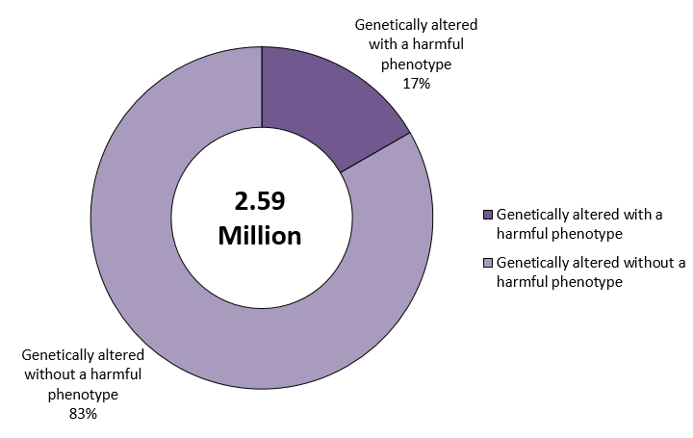

**Figure 11: Genetic status of animals used in research and testing in 2017**

Genetically altered animals are used almost exclusively for research purposes. In 2017, basic research accounted for 75% of uses of genetically altered animals and translational and applied research for 21%.

## Creation and maintenance of genetically altered animal lines for research purposes

### Creation of new genetically altered animal lines

In 2017, 658K animal uses were carried out for the purposes of creating new genetically altered animal lines. The main species used for this purpose were mice and zebra fish, 75% and 23% respectively. Other species, although in small numbers, include rats, other species of fish, domestic fowl, rabbits, xenopus and pigs. In 2017, the use of genetically altered non-human primates (marmosets) was reported for the first time in the EU.

In 2017, 95% of the new genetically altered lines were created for purposes covered under basic research; 22% concerned multisystemic research (where more than one body system is the primary interest of the research, such as in some infectious diseases), 15% nervous system, 13% oncology and 11% cardiovascular, blood and lymphatic system. The most important sub-category under translational and applied research for which new genetically altered animal lines were created was human cancer (27%).

|  |  |  |  |
| --- | --- | --- | --- |
|  | 2015 | 2016 | 2017 |
| Mice | 477,783 | 359,894 | 490,717 |
| Zebra fish | 124,359 | 122,082 | 150,596 |
| Rats | 4,381 | 6,039 | 9,960 |
| Other Fish | 2,556 | 10,737 | 4,569 |
| Domestic fowl | 279 | 515 | 647 |
| Rabbits | 272 | 967 | 475 |
| Xenopus | 7,259 | 1,100 | 250 |
| Pigs | 350 | 284 | 227 |
| Other Mammals | 4 | 0 | 61 |
| Sheep | 31 | 191 | 17 |
| Marmoset and tamarins | 0 | 0 | 10 |
| Guinea-Pigs | 0 | 47 | 0 |
| Other Rodents | 0 | 6 | 0 |
| Total | 617,274 | 501,862 | 657,529 |

**Table 8: Uses of animals for the creation of new genetically altered animal lines by species**

### Maintenance of colonies of established genetically altered animal lines

This category contains animals required for the maintenance of colonies of genetically altered animals of established lines with an *intended harmful phenotype* and which have *exhibited pain, suffering, distress or lasting harm as a consequence of the harmful genotype* before being killed. It also includes genetically altered animals during maintenance of an established line, irrespective of whether the line is of non-harmful or harmful phenotype, for which the genotype has been confirmed using an invasive method of tissue sampling.

The uses of animals for this purposes decreased significantly between 2015 and 2017, from 1 million to 0.6 million respectively. In 2017, 642K uses were reported under the maintenance of colonies. Amongst these animals, 74% were genetically altered without a harmful phenotype, 20% with a harmful phenotype and 6% without genetic alteration.

Given the complexity of the new reporting obligations in this area, errors in reporting are still being detected. In addition, some Member States apply different reporting rules for their national reporting which may have resulted in incoherent reporting for EU purposes. The Commission is working together with Member States to improve the situation.

# Conclusions

The EU has significantly improved the transparency with the new, detailed statistical data. The number of animals reported in 2011 were almost 11.5M. The number of animals used in research and testing reported in 2015, 2016 and 2017 is below 10M, with a decrease also continuing between 2015 and 2017. Although it is not possible to compare the details to previous reports due to several changes to the reporting rules, the results nevertheless would suggest a clear positive development. Mice, fish, rats and birds, together represent over 92% of the total numbers of animals. The use of most common species of non-human primates increased between 2015 and 2017, whereas the use of dogs and cats decreased slightly.

The new reporting requirements allowed to confirm a good progress with the Directive requirements under Article 10, with more than 50% of the non-human primates now being second or higher generation purpose-bred. No non-human primates were coming from the wild in 2017.

The main areas of animal uses remain unchanged, with most uses being in basic research (45%), followed by translational/applied research (23%) and regulatory use (23%).

There is a concern with the uses of animals in areas where alternative methods have reached regulatory acceptance (for example in areas of skin irritation/corrosion, serious eye damage/eye irritation and pyrogenicity testing), which requires further attention by the authorities authorising projects for these use purposes.

The new requirement to report actual experienced severity allows focusing efforts, not only on areas with the highest numbers of animal uses, but also on those with most severe impact on animals. Where replacement is not yet scientifically feasible, efforts should be made to refine these uses. In general, however, over 50% of all uses in research and testing are of mild severity.

Animal reuse has contributed to some reduction of the total number of animals used for scientific purposes. On average 2 % of all animals used have been reused. However, the benefits of reuse against cumulative harm to the animal must always be judged on a case by case basis.

Genetically altered animals used for research purposes are mostly mice and zebra fish. Their use has slightly increased as has the creation of new genetically altered animal lines. Uses reported under the maintenance of genetically altered animals decreased.

1. Directive 2010/63/EU OJ L276, 20.10.2010, p.33-79
2. OJ L 170, 25.6.2019, p. 115–127
3. SWD(2020)10 final
4. COM(2020)15 final
5. OJ L 358 , 18/12/1986, p. 1-28
6. “Research and testing” covers animals used for research, testing, routine production and education (including animals used for training purposes)
7. <https://ec.europa.eu/environment/chemicals/lab_animals/pubs_guidance_en.htm>
8. Federation for Laboratory Animal Science Associations (FELASA), European Society for Laboratory Animal Veterinarians (ESLAV) and European College of Laboratory Animal Medicine (ECLAM)
9. F1: first generation purpose-bred animals; F2: second (or higher) generation purpose-bred animals,
10. Animals which have undergone a procedure that has been performed entirely under general anaesthesia from which the animal has not recovered consciousness.