

**Annex I  
Evolution of the number of checks, non-conformity and category I infringements**

Further information on this table is provided in § 7 of the report.

| **COUNTRY** | | **2012** | **2013** | **2014** | **2015** | **2016** | **2017** |
| --- | --- | --- | --- | --- | --- | --- | --- |
| **BE** | **No of Checks** | 4504 | 4001 | 4095 | 4156 | 7231 | 1623 |
| **% Non-conform** | 17.94% | 19.80% | 19.88% | 28.90% | 26.79% | 28.22% |
| **% Risk Cat. I** | 48.51% | 42.93% | 42.26% | 43.97% | 44.03% | 20.64% |
| **BG** | **No of Checks** | 5424 | 4237 | 3212 | 2772 | 2444 | 2108 |
| **% Non-conform** | 0.59% | 1.06% | 0.72% | 2.31% | 1.27% | 1.90% |
| **% Risk Cat. I** | 84.38% | 31.11% | 30.43% | 18.75% | 25.81% | 27.50% |
| **CZ** | **No of Checks** | 1932 | 1743 | 1640 | 1913 | 1736 | 1524 |
| **% Non-conform** | 11.39% | 10.27% | 12.62% | 7.89% | 13.77% | 10.37% |
| **% Risk Cat. I** | 25.00% | 21.79% | 30.92% | 35.33% | 39.33% | 49.37% |
| **DK** | **No of Checks** | 531 | 323 | 675 | 579 | 266 | 294 |
| **% Non-conform** | 50.28% | 0.31% | 34.67% | 41.45% | 40.98% | 48.64% |
| **% Risk Cat. I** | 35.58% | 83.00% | 71.79% | 71.88% | 72.22% | 73.50% |
| **DE** | **No of Checks** | 55195 | 55344 | 49851 | 45961 | 41290 | 40956 |
| **% Non-conform** | 25.52% | 24.44% | 26.23% | 25.13% | 26.97% | 25.46% |
| **% Risk Cat. I** | 47.65% | 48.65% | 50.97% | 50.26% | 50.80% | 48.36% |
| **EE** | **No of Checks** | 73 | 14 | 34 | 39 | 39 | 149 |
| **% Non-conform** | 17.81% | 42.86% | 50.00% | 43.59% | 25.64% | 5.37% |
| **% Risk Cat. I** | 53.85% | 66.67% | 76.47% | 58.82% | 22.58% | 62.50% |
| **IE** | **No of Checks** | 437 | 370 | 296 | 194 | 148 | 255 |
| **% Non-conform** | 21.28% | 25.68% | 23.31% | 21.13% | 26.35% | 33.73% |
| **% Risk Cat. I** | 35.48% | 23.16% | 37.68% | 10.42% | 10.53% | 15.85% |
| **EL** | **No of Checks** | 757 | 596 | 437 | 324 | 6290 | 20870 |
| **% Non-conform** | 0.53% | 0.17% | 0.23% | 0.31% | 0.62% | 0.20% |
| **% Risk Cat. I** | 75.00% | 100.00% | 100.00% | 100.00% | 94.87% | 66.67% |
| **ES** | **No of Checks** | 9480 | 10382 | 9635 | 7644 | 6025 | 7917 |
| **% Non-conform** | 67.90% | 56.88% | 49.77% | 51.53% | 47.19% | 38.88% |
| **% Risk Cat. I** | 67.07% | 58.54% | 46.24% | 39.27% | 35.39% | 37.33% |
| **FR** | **No of Checks** | 7546 | 7345 | 7746 | 7528 | 7161 | 7450 |
| **% Non-conform** | 13.86% | 13.41% | 13.16% | 8.28% | 6.63% | 7.32% |
| **% Risk Cat. I** | 28.30% | 27.31% | 26.50% | 26.48% | 38.32% | 38.17% |
|  | **No of Checks** | 243 | 394 | 484 | 518 | 453 | 352 |
| **HR** | **% Non-conform** | 22.22% | 13.96% | 20.87% | 18.53% | 20.75% | 24.15% |
|  | **% Risk Cat. I** | 12.96% | 16.36% | 16.83% | 12.50% | 9.57% | 15.29% |
| **IT** | **No of Checks** | 6235 | 4789 | 3120 | 1215 | 851 | 850 |
| **% Non-conform** | 5.21% | 4.34% | 5.00% | 7.41% | 0.00% | 0.00% |
| **% Risk Cat. I** | 26.77% | 25.96% | 29.49% | 6.67% | 42.11% | 36.36% |
| **CY** | **No of Checks** | 88 | 80 | 42 | 28 | 38 | 32 |
| **% Non-conform** | 2.27% | 22.50% | 28.57% | 0.00% | 0.00% | 0.00% |
| **% Risk Cat. I** | 0.00% | 5.56% | 0.00% | #N/A | #N/A | #N/A |
| **LV** | **No of Checks** | 197 | 182 | 259 | 290 | 267 | 320 |
| **% Non-conform** | 19.29% | 20.88% | 10.81% | 12.76% | 16.10% | 15.31% |
| **% Risk Cat. I** | 60.53% | 63.16% | 53.57% | 54.05% | 63.27% | 59.18% |
| **LT** | **No of Checks** | 531 | 577 | 610 | 575 | 613 | 583 |
| **% Non-conform** | 9.60% | 13.00% | 13.61% | 28.35% | 13.87% | 13.89% |
| **% Risk Cat. I** | 21.57% | 10.67% | 26.51% | 56.06% | #N/A | #N/A |
| **LU** | **No of Checks** | 222 | 186 | 98 | 28 | 156 | 181 |
| **% Non-conform** | 52.25% | 37.10% | 46.94% | 17.86% | 36.54% | 41.99% |
| **% Risk Cat. I** | 3.45% | 2.90% | 4.35% | 0.00% | 3.03% | 1.22% |
| **HU** | **No of Checks** | 6184 | 6588 | 9692 | 6860 | 7674 | 7609 |
| **% Non-conform** | 22.93% | 6.27% | 3.96% | 5.93% | 6.46% | 7.25% |
| **% Risk Cat. I** | 4.51% | 32.20% | 42.45% | 27.92% | 30.85% | 44.75% |
| **MT** | **No of Checks** | 77 | 78 | 72 | 73 | 75 | 74 |
| **% Non-conform** | 63.64% | 51.28% | 81.94% | 67.12% | 66.67% | 72.97% |
| **% Risk Cat. I** | 12.24% | 15.00% | 38.98% | 26.53% | 26.00% | 9.26% |
| **NL** | **No of Checks** | 4023 | 3451 | 2956 | 2751 | 3322 | 2314 |
| **% Non-conform** | 30.75% | 30.48% | 14.14% | 18.97% | 21.13% | 26.58% |
| **% Risk Cat. I** | 97.49% | 132.41% | 353.11% | 55.57% | 66.92% | 61.43% |
| **AT** | **No of Checks** | 11966 | 11676 | 13851 | 12927 | 11951 | 11065 |
| **% Non-conform** | 30.32% | 30.44% | 27.10% | 26.30% | 27.39% | 29.42% |
| **% Risk Cat. I** | 19.38% | 17.45% | 16.49% | 14.97% | 13.66% | 13.03% |
| **PL** | **No of Checks** | 19940 | 23607 | 22838 | 20477 | 16047 | 16236 |
| **% Non-conform** | 3.08% | 3.81% | 4.22% | 4.87% | 8.35% | 8.09% |
| **% Risk Cat. I** | 36.59% | 36.89% | 35.41% | 40.48% | 28.88% | 20.62% |
| **PT** | **No of Checks** | 657 | 834 | 633 | 616 | 499 | 661 |
| **% Non-conform** | 29.68% | 27.82% | 44.39% | 50.32% | 50.70% | 49.92% |
| **% Risk Cat. I** | 49.74% | 61.64% | 45.20% | 55.48% | 58.50% | 44.61% |
| **RO** | **No of Checks** | 2417 | 4528 | 5516 | 4890 | 4137 | 5059 |
| **% Non-conform** | 4.43% | 5.96% | 4.82% | 4.76% | 3.34% | 2.85% |
| **% Risk Cat. I** | 16.82% | 23.70% | 27.44% | 23.18% | 29.71% | 22.45% |
| **SI** | **No of Checks** | 1548 | 1878 | 1494 | 774 | 853 | 1282 |
| **% Non-conform** | 2.45% | 2.29% | 3.48% | 4.13% | 7.27% | 10.84% |
| **% Risk Cat. I** | 57.89% | 46.51% | 46.15% | 25.00% | 38.71% | 51.80% |
| **SK** | **No of Checks** | 217 | 2302 | 3531 | 3290 | 3338 | 3518 |
| **% Non-conform** | 1.38% | 0.13% | 0.08% | 0.36% | 2.49% | 2.10% |
| **% Risk Cat. I** | 0.00% | 0.00% | 0.00% | 11.11% | 7.89% | 6.58% |
| **FI** | **No of Checks** | 3073 | 2302 | 2434 | 2076 | 2130 | 2000 |
| **% Non-conform** | 27.43% | 27.15% | 25.43% | 26.01% | 29.91% | 25.00% |
| **% Risk Cat. I** | 12.22% | 17.44% | 17.61% | 15.92% | 17.80% | 12.35% |
| **SE** | **No of Checks** | 6903 | 7147 | 5332 | 4724 | 4949 | 5903 |
| **% Non-conform** | 15.89% | 15.49% | 21.85% | 21.40% | 22.47% | 27.51% |
| **% Risk Cat. I** | 19.78% | 17.89% | 23.78% | 22.06% | 31.29% | 23.90% |
| **UK** | **No of Checks** | 2962 | 3217 | 2765 | 3744 | 3377 | 2871 |
| **% Non-conform** | 37.31% | 25.46% | 58.34% | 31.12% | 36.33% | 24.80% |
| **% Risk Cat. I** | 22.35% | 20.51% | 11.41% | 24.64% | 23.88% | 14.95% |
|  |  |  |  |  |  |  |  |
| **EU** | **No of Checks** | 153362 | 157455 | 150348 | 136966 | 133360 | 144056 |
| **% Non-conform** | 22.12% | 20.08% | 20.80% | 19.64% | 19.88% | 17.07% |
| **% Risk Cat. I** | 44.15% | 45.00% | 42.65% | 40.24% | 39.62% | 36.64% |
|  |  |  |  |  |  |  |  |
| **NO** | **No of Checks** | 563 | 755 | 793 | 862 | 1081 | 1018 |
| **% Non-conform** | 25.75% | 34.70% | 35.31% | 31.79% | 38.48% | 40.86% |
| **% Risk Cat. I** | 26.90% | 25.19% | 25.00% | 31.71% | 26.92% | 24.76% |

**Annex II  
Frequency of checks per million tonne-kilometre**

Further information on these graphs is provided in § 8.1 of the report.

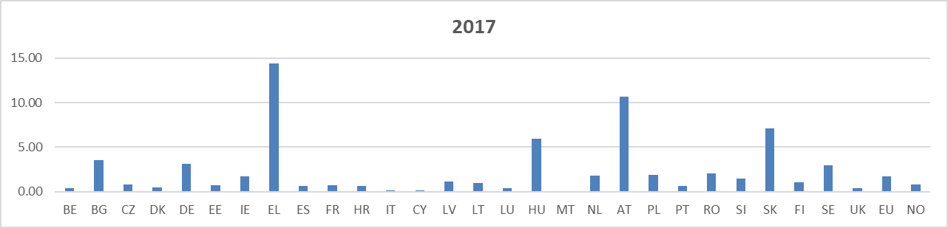

**Annex III - Breakdown of checks by place of origin**

Further information on these graphs is provided in § 8.2 of the report.

|  |  |  |  |  |  |
| --- | --- | --- | --- | --- | --- |
|  | National |  | EU |  | Non EU |

**Annex IV  
Proportion of transport units not conforming to provisions**

Further information on these graphs is provided in § 8.3 of the report.

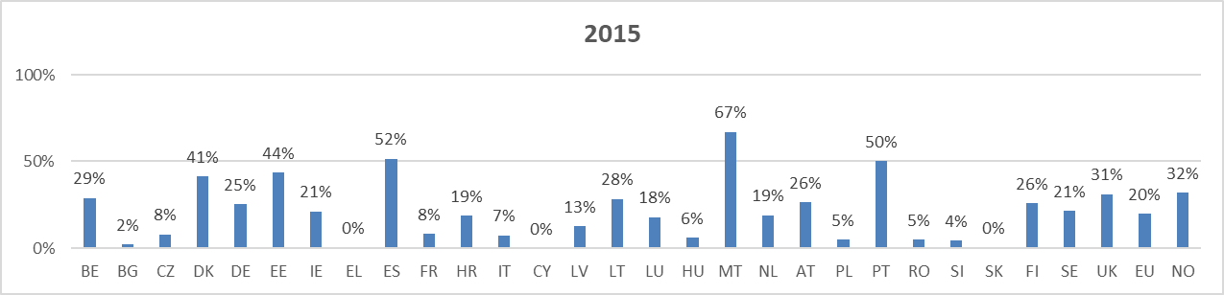

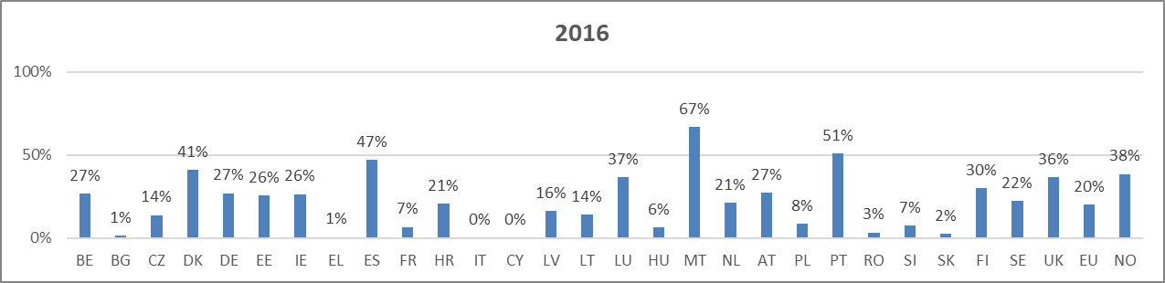

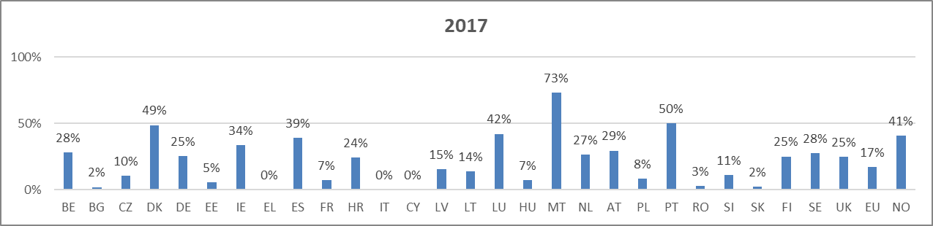**Annex V - Breakdown of transport units not conforming to the provisions by place of origin**

Further information on these graphs is provided in § 8.4 of the report.

|  |  |  |  |  |  |
| --- | --- | --- | --- | --- | --- |
|  | National |  | EU |  | Non EU |

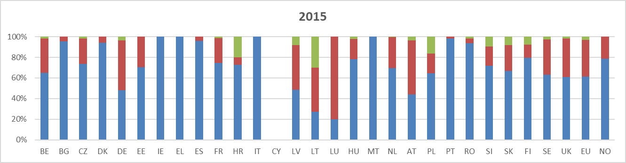

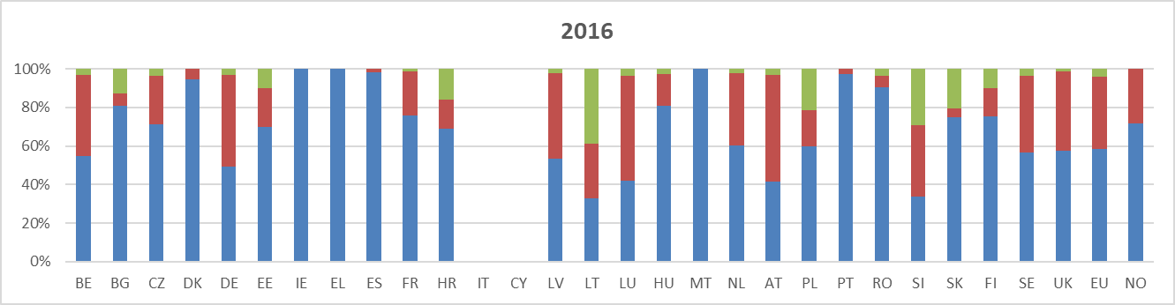

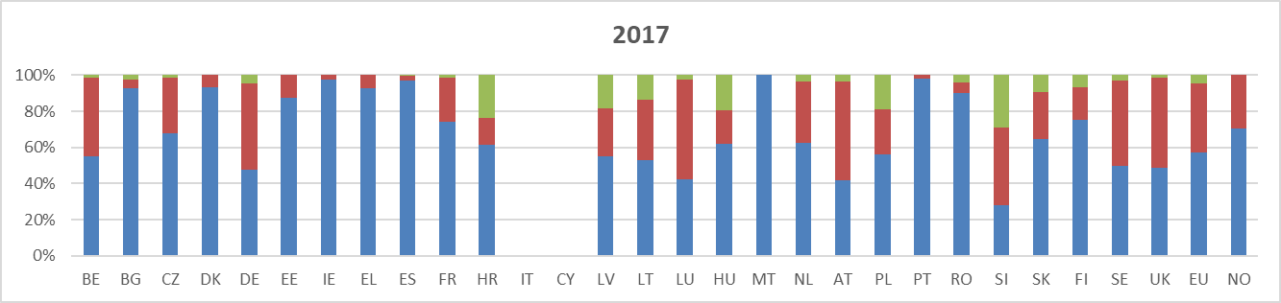

**Annex VI  
Frequency of immobilisation of transport units not conforming to provisions**

Further information on these graphs is provided in § 8.5 of the report.

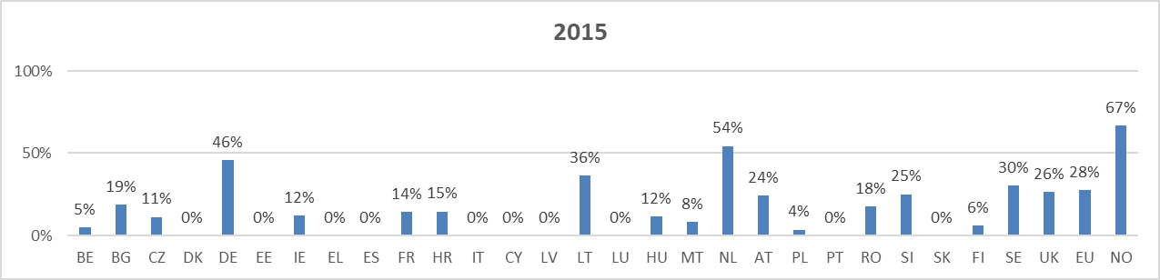

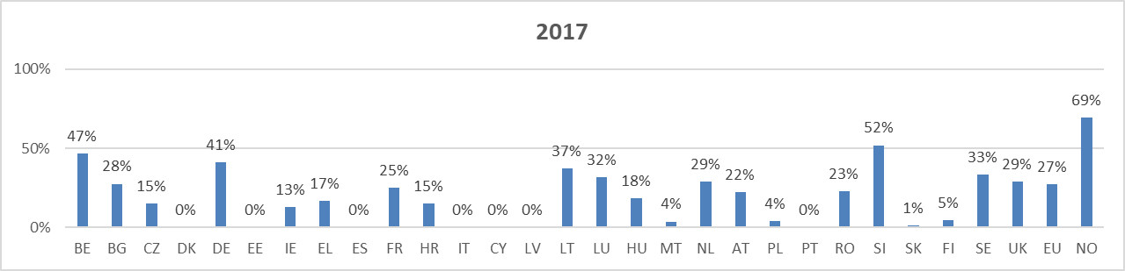

**Annex VII  
Breakdown by risk categories**

Further information on these graphs is provided in § 8.6 of the report.

|  |  |  |  |  |  |
| --- | --- | --- | --- | --- | --- |
|  | Cat.I |  | Cat.II |  | Cat.III |

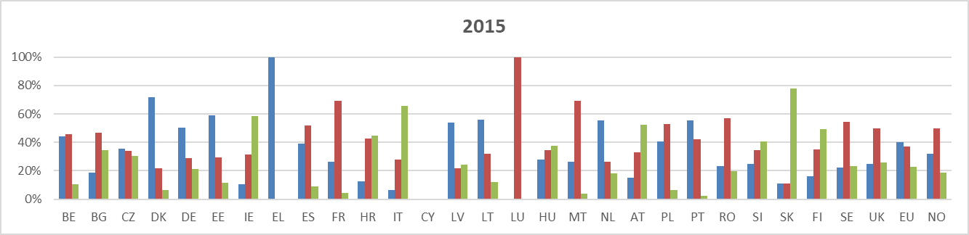

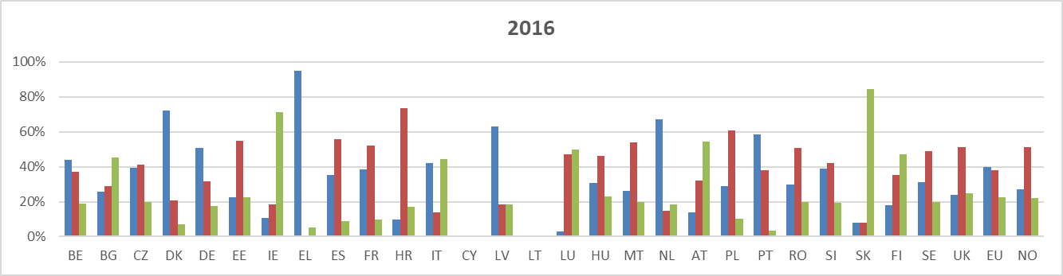

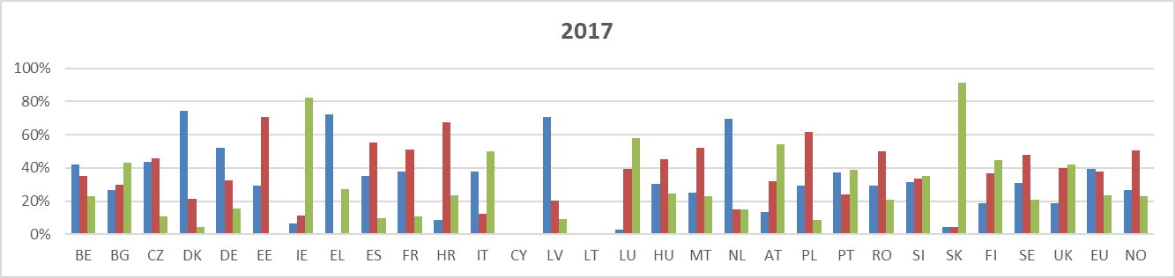

**Annex VIII – Breakdown per types of penalties**

Further information on these graphs is provided in § 8.7 of the report.

|  |  |  |  |  |  |
| --- | --- | --- | --- | --- | --- |
|  | Caution |  | Fine |  | Other |

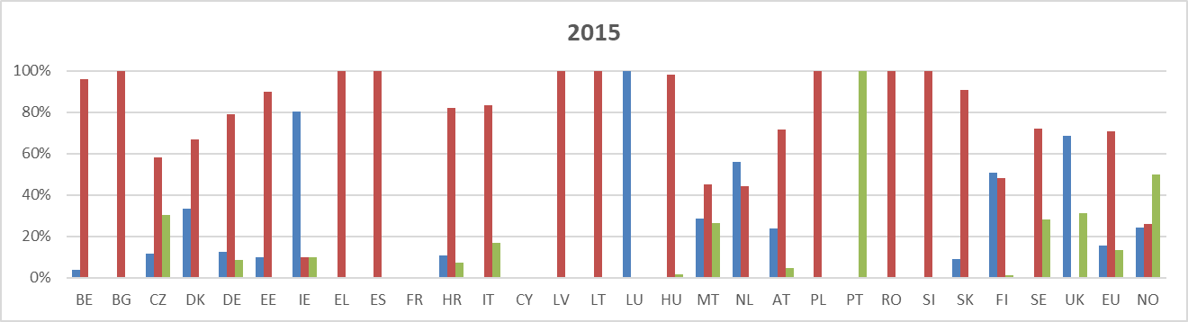

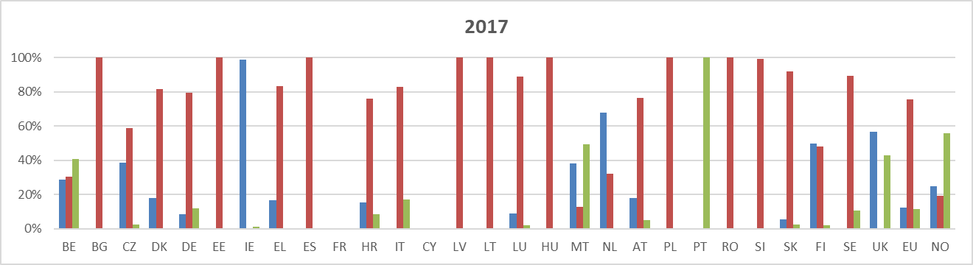

**Annex IX  
Annual road freight transport of dangerous goods in million tonne-kilometres**

|  |  |  |  |  |  |  |
| --- | --- | --- | --- | --- | --- | --- |
| Further information on this table is provided in § 6 of the report. | 2012 | 2013 | 2014 | 2015 | 2016 | 2017 |
| EU-28 | 80,803 | 73,945 | 75,024 | 80,522 | 80,985 | 82,519 |
| EU-27 | 80,292 | 73,462 | 74,523 | 80,067 | 80,454 | 81,938 |
| BE | 1,985 | 2,124 | 1,694 | 3,353 | 4,070 | 3,838 |
| BG | 928 | 958 | 684 | 885 | 469 | 591 |
| CZ | 1,393 | 1,281 | 1,567 | 1,865 | 2,224 | 1,895 |
| DK | 767 | 760 | 690 | 814 | 699 | 621 |
| DE | 12,773 | 12,958 | 12,912 | 12,425 | 12,725 | 12,934 |
| EE | 133 | 163 | 172 | 146 | 145 | 208 |
| IE | 443 | 476 | 355 | 347 | 306 | 146 |
| EL | 2,268 | 1,169 | 1,010 | 1,377 | 798 | 1,451 |
| ES | 11,833 | 10,626 | 11,718 | 12,269 | 11,538 | 12,735 |
| FR | 8,900 | 8,158 | 7,976 | 8,281 | 9,747 | 9,737 |
| HR | 511 | 483 | 501 | 455 | 531 | 582 |
| IT | 8,313 | 8,037 | 7,358 | 6,942 | 6,635 | 7,918 |
| CY | 167 | 181 | 147 | 138 | 165 | 193 |
| LV | 219 | 213 | 227 | 315 | 335 | 282 |
| LT | 392 | 386 | 534 | 488 | 591 | 593 |
| LU | 581 | 700 | 839 | 454 | 482 | 503 |
| HU | 883 | 997 | 1,023 | 1,206 | 1,315 | 1,273 |
| MT (1) | : | : | : | : | : | : |
| NL | 2,232 | 1,342 | 957 | 1,171 | 1,181 | 1,296 |
| AT | 928 | 946 | 933 | 927 | 1,010 | 1,033 |
| PL | 6,801 | 7,024 | 8,778 | 9,174 | 8,444 | 8,785 |
| PT | 715 | 973 | 946 | 1,158 | 983 | 1,035 |
| RO | 1,453 | 1,704 | 1,664 | 1,623 | 2,326 | 2,490 |
| SI | 637 | 552 | 724 | 714 | 857 | 890 |
| SK | 289 | 228 | 329 | 364 | 398 | 496 |
| FI | 1,357 | 1,426 | 1,423 | 1,909 | 2,201 | 1,888 |
| SE | 1,251 | 1,064 | 1,283 | 2,122 | 1,794 | 1,983 |
| UK | 12,653 | 9,017 | 8,583 | 9,601 | 9,015 | 7,121 |
| NO | 1,319 | 1,141 | 1,029 | 1,333 | 1,460 | 1,286 |

(1) Malta: Derogation under Regulation (EU) No. 70/2012

*Source:* Eurostat (online data code: road_go_ta_dg)