

# Introduction

This joint staff working document summarises the results of the structured consultation on the future of the Eastern Partnership. The consultation was launched by then-Commission President Juncker at the high‑level event in the context of the 10th anniversary of the Eastern Partnership on 14 May 2019.

The European Council on 20 June 2019 endorsed the consultation:

‘On the occasion of the Eastern Partnership’s 10th anniversary, the European Council reaffirms the importance of this strategic partnership and invites the Commission and the High Representative to evaluate existing instruments and measures and, on the basis of appropriate consultations, to present by early 2020, with a view to the next Eastern Partnership Summit, a further set of long-term policy objectives.’

This document outlines the **methodology** of the structured consultation process (Section II) and its main **outcomes** (Section III).

Lastly, in Section IV the document summarises an updated assessment of progress on implementing the ‘**20 deliverables for 2020’**[1].The said documentis included as an annex.

# The consultation methodology

The consultation sought to answer five guiding questions:

1. How can we sustainably boost **economic and human capital development** and **prosperity**?
2. How can we further strengthen **good governance, the rule of law and the security dimension of the Eastern Partnership**?
3. How can we enhance **cooperation** between eastern partners, while ensuring **inclusiveness** and **differentiation** in their relations with the EU?
4. How can we do more to enhance **Eastern Partnership and EU visibility**?
5. **Are there any other proposals and reflections on the future of the Eastern Partnership**?

In response to the consultation, **written submissions** were received from nearly all Member States, all six partner countries, the European Parliament, the European Economic and Social Committee, the Committee of the Regions, the European Investment Bank, the Eastern Partnership Civil Society Forum, international financial institutions, United Nations organisations, and youth stakeholders through the Young European Ambassadors. Joint papers endorsed by several Member States were also submitted on the topics of resilience, EaP structures, and youth.

A total of 186 **contributions** were received through a dedicated web page. These came from: (i) public authorities (international organisations, EU bodies, local and regional governments and state bodies); (ii) civil society organisations (including think tanks, academic institutions, civil society partners and business organisations); and (iii) individual citizens.

**Dedicated consultation events** were organised in each of **the partner countries** andin several EU Member States, and meetings were held with international organisations and EU bodies, civil society, social partner organisations (including trade unions and employer organisations), business representatives and think tanks.

The consultation also took into account **reports from bodies in the current Eastern Partnership architecture**, including the four platforms and sectoral panels, and related meetings, including with Member State and partner country representations in Brussels

# Outcomes of the consultation

The consultation **confirmed the strong benefits brought by the Eastern Partnership framework**. The Eastern Partnership’s work on a regional level strengthens and complements the bilateral work between the European Union and partner countries and facilitates the development of common positions and joint activities. It provides a forum for policy dialogue and sharing information and experience among partner countries, Member States and EU institutions, the findings of which feed into the process of monitoring and assessing progress in the implementation of reforms.

There is broad consensus among stakeholders that **the current policy framework is robust and delivering,** particularly on three of its focus areas, namely stronger economy, stronger connectivity, and stronger societies. There was also agreement that more remains to be done in the area of governance, rule of law, the fight against corruption and the role of an independent media and civil society.

The consultation highlighted the clear desire of stakeholders and citizens to **tackle jointly common challenges** including climate change, digital transformation, creating an economy that works for all, investing in the continent’s young people, and security and resilience.

There is agreement that delivering concrete results for citizens in Eastern Partnership countries and putting people first will remain the focus for the post-2020 agenda, building on the positive results achieved through the ‘**20 deliverables for 2020’** framework.

Key outcomes of the consultation are further elaborated below, following the responses to the five guiding questions.

1. *How can we sustainably boost* ***economic******and human capital******development*** *and* ***prosperity****?*

|  |
| --- |
| Key responses:   * An **inclusive economy that works for all,** providing **decent jobs**, is a top priority for most stakeholders. This includes more emphasis on local/regional actors as key drivers for growth. * Investment in the development of **young people’s** skills and **entrepreneurship** is key * Support for the digital transformation would need to be reinforced * Strengthening the **green agenda** is important, building on the achievements to date |

The top priority of respondents was the focus on **growth/jobs** to obtain sustainable economic development and long-term **economic resilience**, through an inclusive **circular economy** that works for all. The development of trade between the EU and the Eastern Partnership (EaP) countries and between the countries themselves will deepen economic integration and strengthen **the overall investment and business climate**. Partnership with international financial institutions will also be enhanced.

**Support to small and medium-sized businesses (SMEs and MSMEs)** including those in **disadvantaged regions** is key, as this could help unleash the partner countries’ growth, jobs and innovation potential. **Access to finance,** particularly in **local currency**, needs to be expanded and support provided to women in business and to young entrepreneurs. Decentralisation will **unleash the full economic potential of the regions,** strengthening regional and local authorities, businesses and civil society organisations, creating local employment opportunities and countering migration towards capital cities.

The creation of EU-EaP **economic zones** in specific sectors was proposed. This would go hand in hand with the accession to the **single euro payments area (SEPA)** of, at first, the associated countries (Ukraine, Moldova and Georgia), enhancing **the international role of the euro**. A dedicated Investment Promotion Office for EaP countries could facilitate foreign direct investment flows and contacts between SMEs and the respective authorities in Member States and partner countries. The importance of the EU’s **External Investment Plan** (which provides entrepreneurs willing to invest with financial support, guarantees and technical assistance) was also underlined.

**Development of core transport networks** and links among the partner countries and with the EU through extension of the TEN-Tis a key initiative. An **EaP connectivity partnership** will ensure that priority is given to green connectivity (green ports, green urban transport, smart cities).

Improving the **environmental and climate resilience** of the partner countries by upscaling support to green actions and policies came out strongly in the consultation. Partner countries need support to implement their commitments under the **Paris Agreement** and the **Sustainable Development Goals (SDGs)**. They could be associated with the **EU’s Green Deal**,commensurate to their capacities. Addressing air, water and land pollution, unlocking the potential of raw materials sector to contribute to the SDGs and overall resource security, tackling deforestation and protecting biodiversity, improving the sustainable management of forests and open access to efficient use and fair trade of food and its derivatives, and investing in sustainable agriculture will improve public health.

A focus on the **energy** sector for the EU and for EaP countries, in tandem with effective **climate** policies, will develop **energy resilience**. Energy dependency can be reduced through green finance, **diversification of energy sources and routes**, security of supply, promoting energy efficiency and renewable energy initiatives. Investing in **infrastructure for energy and transport interconnectivity** between EaP countries and the EU will address infrastructure vulnerability to the impacts of climate change, environmental challenges and hybrid threats.

In the context of the **digital transformation**, respondents also highlighted the importance of increased support for **digital competences/skills**, including focusing on people in the **labour force who are 55 and over**, along with further efforts to **harmonise digital markets**. Several stakeholders from both Member States and partner countries advocate increased access across the region to **broadband,** and steps towards a **common roaming space**.

Further support for **young people and education** is also strongly prioritised, with various suggestions to strengthen EU support to youth education, employability, mobility and engagement in decision-making. A ‘New Deal for Youth’ is proposed; this would bridge the gap between the labour market and the education sector, build capacities of young professionals and enable structured youth policy dialogue including e.g. through a job shadowing scheme for young professionals and a network of ‘Youth Councils’. **Vocational Education and Training (VET) and higher education** reforms should continue and could be extended to primary and secondary education**.** The **Erasmus+** programme is a popular and effective enabler of education reforms and **increased mobility and people-to-people contacts**. The **European School in Georgia** has been recognised as a success and needs to be pursued and further developed.

**Eastern Partnership and EU research and innovation systems and programmes** need to be further integrated**,** for instance by developing a pipeline of strategic EaP innovation projects similar to the TEN-T network**.** Current work on **technology transfer** and **smart specialisation** needs to be further developed. The full implementation of **visa facilitation and readmission agreements** and **integrated border management** should continue.

**Gender equality** needs to be more effectively mainstreamedacross the new policy framework. **The** EaP countries would achieve significant economic and social benefits by empowering **women, young people, people with disabilities and minorities**.

*2. How can we further strengthen* ***good governance, the rule of law and the security dimension of the Eastern Partnership****?*

|  |
| --- |
| Key responses:   * **Governance and rule of law** should remain the cornerstone of the Eastern Partnership * **Smart conditionality** (the principle of ‘more for more’ and ‘less for less’) is important to improve results in governance and particularly rule of law and fight against corruption * **Hybrid and cyber** threats present new challenges which need a coordinated response |

Governance and rule of law emerged as one of the **most important priorities of EU Member States and most partner countries**. This view was supported by **civil society** and by the responses made through the website. Political will continues to be an absolute prerequisite for making a real difference.

**Resilience** needs strengthening at all levels, including democratic, media, civil society, economic, energy and security resilience. To foster long-term resilience, a strong link is needed between **growth and jobs** on the one hand and **governance and rule of law** **reform**, on the other.

**Rule of law** work to be done includes: (i) simplification of laws to reduce corruption; (ii) improving links between state actors and ‘watchdogs’; and (iii) ensuring a zero-tolerance approach to breaches of the rule of law. The effective investigation, sanction and prosecution of economic crime, including through use of digital tools, to tackle corruption are key in this regard. The EU needs to draw more heavily on the monitoring of progress towards governance reforms when incentivising partner countries to continue with reform and discouraging them from backsliding (positive and negative conditionality).

The **capacity of the justice systems** in the partner countries, including parliaments and the judiciary, requires sustained support if reforms are to be tangible and likely to endure. Another leitmotiv of the consultation responses is the desire for greater cooperation between the justice and law enforcement sectors, particularly in combating organised crime and trafficking of human beings and illicit goods.

**Local authorities, academia, think tanks, human rights defenders and civil society organisations** should be involved in monitoring reforms on the ground. More structured dialogue with **think tanks** and academia on EaP policy was suggested in particular.

A significant number of respondents mentioned **security** asa priority area for the EaP; however, the responses are widely ranging in tone. There is a call for more cooperation and integration of partner countries into EU security and resilience structures such as EU Agency for Cyber Security (ENISA)/Permanent Structured Cooperation (PESCO) and the possible participation of partner countries in common security and defence policy (**CSDP) missions**. This call is particularly strong from the three associated countries. Cooperation should continue on **prevention, preparedness and response to disasters**. More joint efforts are needed on **cyber** security and **hybrid** threats, and on fighting disinformation and fake news, with respondents to the consultation sending a clear message about the need to improve cooperation, exchanges and capacity building with partner countries.

There is a need for continued **capacity building** in national, regional and local government and public administration reform needs to be in line with the EU[2]. The **active engagement of local and regional actors** in decision-making needs to increase, including support for grass roots civil society, independent media, **eGovernance** and **eDemocracy**. An EaP **academy for public administration** was proposed.

3*. How can we enhance* ***cooperation******between*** *Eastern partners, while ensuring* ***inclusiveness*** *and* ***differentiation*** *in their relations with the EU?*

|  |
| --- |
| Key responses:   * Striking the right **balance between inclusiveness and differentiation** is key * **Intra-regional cooperation** and mobility need to be increased |

Striking the **right balance between inclusiveness and differentiation** remains key. The bilateral and multilateral approaches are complementary, mutually reinforcing and equally important. Partner countries who so wish should be able to develop deeper bilateral and multilateral cooperation with the EU through targeted sectoral cooperation in key areas of common interest including transport/TEN-T, digitalisation, environment, education and trade.

**Leadership by partner countries** in policy areas where they are perceived to be ahead of the curve should be encouraged and best practice shared both with other EaP countries and with EU Member States.

There are calls for increased cross-sectoral **intra-Eastern Partnership** **cooperation** in areas such as trade, connectivity, digitalisation, **mobility** and knowledge transfer, and in sectoral frameworks such as associations of EaP universities, businesses and chambers of commerce.

*4. How can we do more to enhance* ***Eastern Partnership and EU visibility****?*

|  |
| --- |
| Key responses:   * Building on the achievements so far in increasing **EU visibility**, there is a need to step up a coordinated response to address **disinformation** * Media literacy and the role of an **independent media and civil society** are important |

The EU needs to further enhance its **strategic communication** to ensure better visibility and outreach for EU policy, partners’ reform achievements and concrete projects and initiatives. Concrete proposals to improve **EU visibility** include enlarging the target audience, with emphasis on young people, and reaching out to key multipliers outside the capital and big cities. Enhancing people-to-people contacts and cultural exchanges can generate a new spirit of dialogue, mutual listening and learning, joint capacity building and global solidarity. Strategic communication about Eastern Partnership policy is also needed **within the EU**. A coordinated response to **disinformation** is needed to build **societal resilience,** capitalising on positive developments (including the European External Action Service’s StratCom East Task Force).

Eastern Partnership summits and other high-level meetings could be made more visible by being organised in partner countries, possibly as part of **Eastern Partnership Days**. In addition, responses to the consultation also mentioned the crucial importance of **independent media** and the boosting of **media literacy** in all areas of society as key for **democratic and societal resilience**.

*5. Are there any other proposals and reflections on the future of the Eastern Partnership?*

The final, more open-ended, question invited stakeholders to come up with reflections that may not fit within the first four. A non-exhaustive list is presented below.

|  |
| --- |
| Key responses:   * **Local actors**, including government and **civil society**, need to be more empowered * Support to **vulnerable social groups** and **tackling regional disparities** are important * The **architecture** works but needs to adapt to new challenges and become more efficient and results-oriented |

Increasing **involvement of all key stakeholders in policy dialogue** is something many stakeholders call for. **The EaP structure** can be more effective with fewer, better-prepared and better-managed meetings and increased Member State participation in platforms and panels. To encourage **greater ownership and leadership,** a system was suggested in which individual countries would take a leading role in driving action on a particular subject. **EU Member States, partner countries and civil society** need a stronger role in the design, implementation and monitoring of the EaP.

There are calls for a stronger EU role in existing frameworks for unresolved **conflicts**, and greater support for those affected by conflict, particularly women, children and minorities.

**Health and wellbeing** features as a prominent priority, with a focus on communicable & non-communicable diseases, e-health, medical facility modernisation, training of medical staff, affordable medical care, and sport.

**Culture and the creative industries** emerge as important sectors that contribute to both the social and economic dimensions of the partnership. Investments in cultural projects contribute to the competitiveness, attractiveness and social cohesion of cities and regions. **Regional tourism** requires development through exchanges of best practices, practical course exchanges and organisation of events. This will help address regional disparities and improve economic development of remote areas.

# Implementation of the 20 Deliverables for 2020

The ‘**20 Deliverables for 2020**’ were prepared by the European Commission in 2017 following consultations with Member States, partner countries and other stakeholders. They form a common work plan guiding actions and reforms under the Eastern Partnership for the period up to 2020, and provide a reform agenda aimed at delivering tangible results to citizens. The 20 deliverables were endorsed by partner countries and EU Member States at the Brussels Eastern Partnership Summit in November 2017.

The European Commission regularly monitors the implementation of the deliverables, highlighting both achievements and areas where additional effort may be needed. The latest review of the implementation of this joint reform agenda can be found in Annex I to this document. The review is based on inputs from all partners and stakeholders, including those provided as part of the Eastern Partnership bodies and other consultations. The assessment of the partner countries’ progress in implementing the 20 deliverables is positive overall as regards achieving stronger economies, stronger connectivity and stronger society.

On the **economy**, good progress is noted for instance in deliverables 4 (SME support) and 5 (access to finance), with increases in the number of SMEs benefiting from EU assistance, in local currency lending and in jobs created by SMEs. On **connectivity**, good progress is observed in deliverable 15 (energy efficiency), with 30 more municipalities signing up to CO2 reduction commitments by 2030 under the Covenant of Mayors. As regards stronger society, there has been, for instance, progress in deliverable 18, with a substantial increase in the number of students taking part in the Erasmus+ programme.

The monitoring update also shows achievements in the area of **stronger governance**, including public service delivery (deliverable 11). However, there are outstanding challenges on justice and anti-corruption, as well as on gender, the enabling environment for civil society and non-discrimination. Success stories include support for SMEs in Georgia, Moldova and Ukraine, energy efficiency in Ukraine, access to public and private services in Azerbaijan, academic and youth support under Erasmus +; the first Eastern Partnership European School in Georgia and digital education in Armenia, as well as the Young European Ambassadors initiative.

**Annex I**

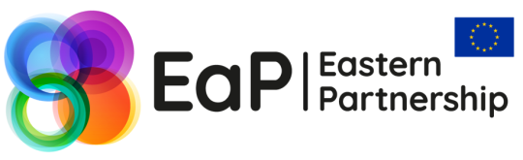

**ECONOMY**

**GOVERNANCE**

**CONNECTIVITY**

**SOCIETY**

**CROSS-CUTTING**

**20 DELIVERABLES FOR 2020**

**Monitoring – State of Play in February 2020**

*The 2017 Eastern Partnership (EaP) Brussels Summit endorsed the ‘20 Deliverables for 2020’ as an ambitious work plan for reforms in the EaP that would bring tangible benefits for citizens.*

*To help Member States and partner countries guide the process, the EEAS and the Commission regularly monitor the implementation of the Deliverables, highlighting both achievements and areas where additional effort may be needed.*

*This document provides an* ***updated overview of both the implementation*** *of the ‘20 Deliverables for 2020’ and* ***concrete results achieved by February 2020****. It does not contain new commitments. Its findings are based on an internal monitoring process that involved the EEAS and the Commission, which also take into consideration results from meetings of the EaP institutional structure (including platforms and panels). This document selectively highlights the most representative findings from the in-depth internal monitoring. The previous report covered results achieved until March 2019.*



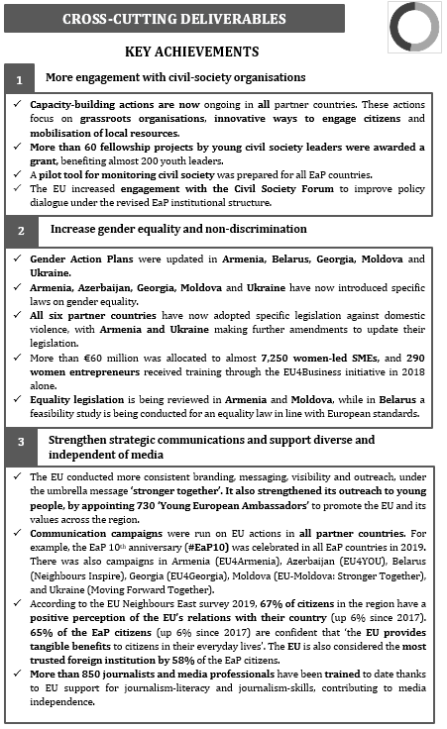

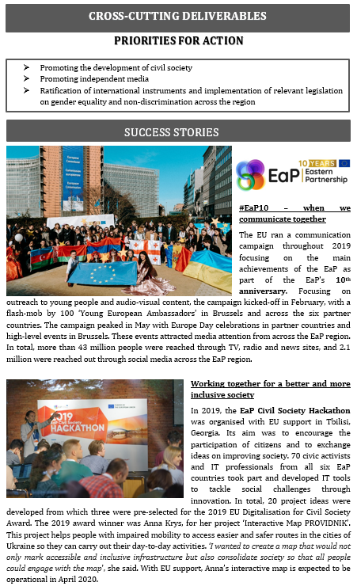

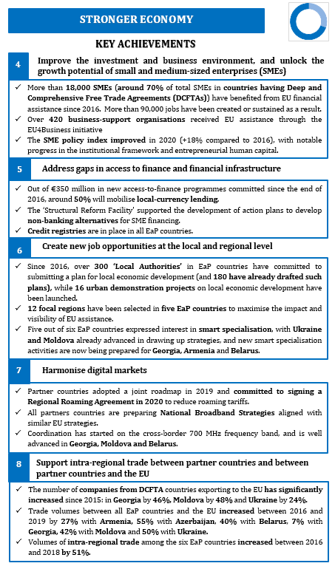

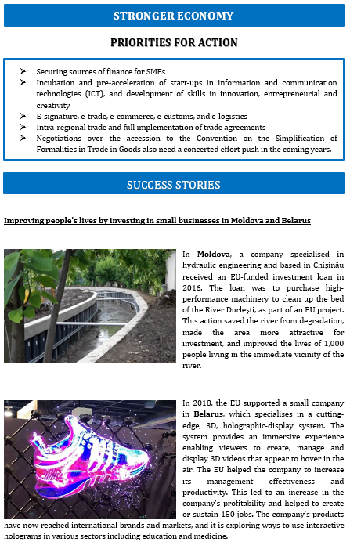

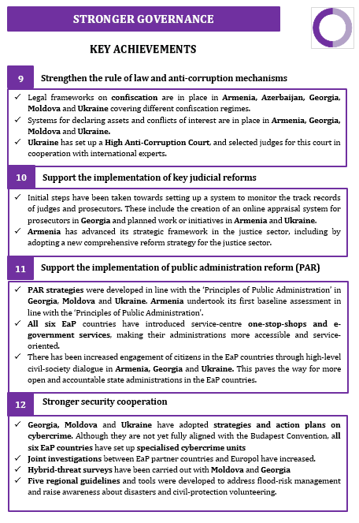

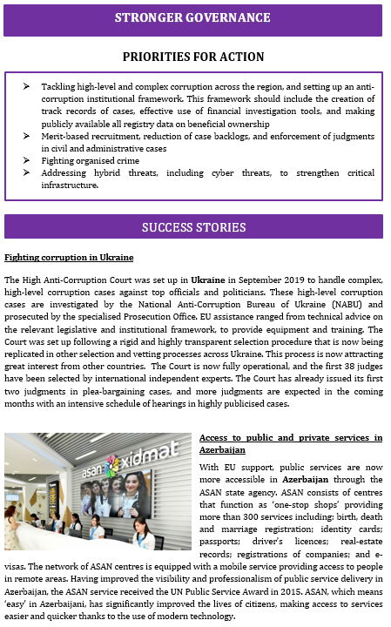

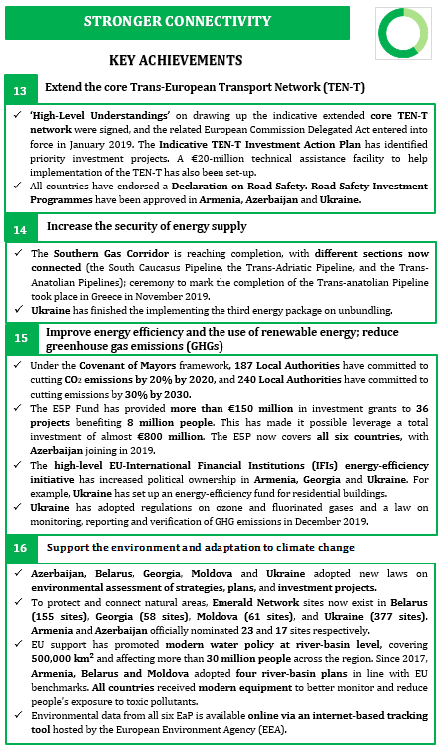

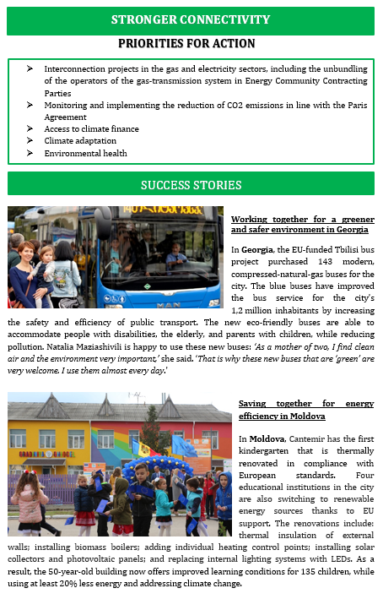

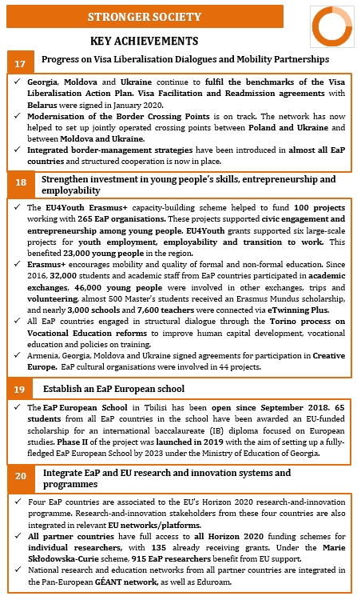

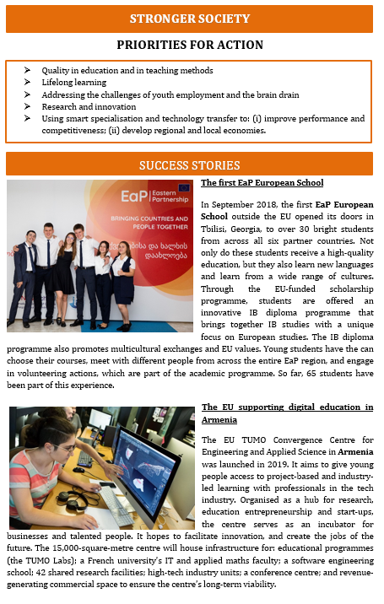

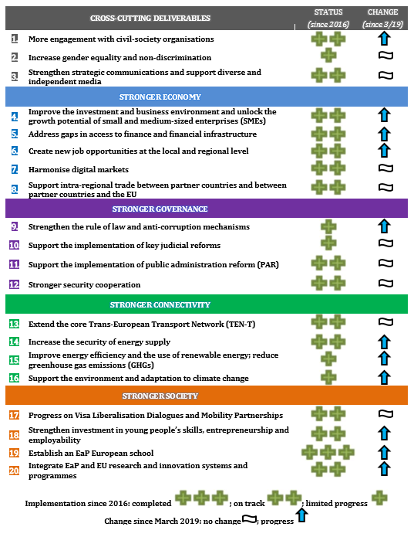

1. Joint Staff Working Document ‘Eastern Partnership – 20 Deliverables for 2020. Focusing on key priorities and tangible results (SWD(2017) 300 final).
2. The EU has agreed a comprehensive definition of public administration, which includes: (i) a strategic framework for public administration; (ii) policy development and coordination; (iii) public service and human resource management; (iv) accountability; (v) public service delivery; and (vi) public financial management.