

REPORT FROM THE COMMISSION TO THE EUROPEAN PARLIAMENT AND THE COUNCIL

2013-2018 report on the financial situation of the unemployment insurance scheme for former members of the temporary or contract staff and parliamentary assistants who are unemployed after the termination of their service in a European Union institution

# SUMMARY

In accordance with the Conditions of Employment of Other Servants (CEOS), the Community unemployment allowance is intended for former contract staff (CAs), accredited parliamentary assistants (APAs) or temporary staff (TAs) who are involuntarily unemployed (excluding, for example, staff who have resigned) following termination of their service in a European Union institution[1]. This unemployment allowance is in addition to any national unemployment allowance received by the former staff member.

These allowances are financed from the Special Unemployment Fund, which is financed by the contributions of staff covered by the CEOS (who are potential beneficiaries) and by their employer’s contributions.

The conditions for granting the allowance, the beneficiary categories and the contribution rates were all changed significantly in the latest reforms of the Staff Regulations, affecting the Fund’s cash balance in particular.

The reform of the Staff Regulations of Officials (‘the Staff Regulations’) and the CEOS which entered into force on 1 May 2004 introduced into the CEOS a new category of staff engaged under contract (i.e. CAs), along with new rules governing contributions to the Unemployment Fund.

In accordance with Council Regulation No 160/2009 of 23 February 2009 amending the Conditions of Employment of Other Servants of the European Communities[2], APAs are also now covered by the Unemployment Fund.

The reform of the Staff Regulations and the CEOS which entered into force on 1 January 2014 changed the maximum duration of contracts of employment for CAs employed under Article 3b of the CEOS from three to six years.

Under Article 28a(11) and Article 96(11) of the CEOS, every two years the Commission must present a report on the financial situation of the unemployment insurance scheme and the Special Unemployment Fund. Moreover, independently of this report, the Commission may, by means of delegated acts in accordance with Articles 111 and 112 of the Staff Regulations, adjust the contributions provided for in Article 28a(7) and Article 96(7) of the CEOS if this is necessary in the interests of the balance of the scheme.

To make it easier to trace the evolution of the Fund, the reference period for the report is December 2013 to December 2018.

Although in 2013 the Unemployment Fund had a deficit of EUR 1 million, and its accumulated reserve fell from EUR 16.1 million at the start of 2009 to EUR 2 million at the end of 2015, the Fund’s reserve has been reconstituted and amounted to nearly EUR 28 million at the end of 2018.

During the reference period, the following can be noted:

* A reduction in the number of monthly unemployment allowances in 2015 and especially in 2016. However, in 2018 there was an increase in the number of CA contracts coming to an end, primarily as a result of the 2014 reform (extension of the duration of CA 3b contracts from three to six years).

|  |  |  |  |  |  |  |
| --- | --- | --- | --- | --- | --- | --- |
| **Number of payments made** | **2013** | **2014** | **2015** | **2016** | **2017** | **2018** |
|
|
| **TA** | 3895 | 3522 | 3728 | 2776 | 2551 | 2357 |
| **CA** | 5658 | 3626 | 2919 | 2827 | 5022 | 6191 |
| **APA** | 624 | 3126 | 3030 | 796 | 610 | 578 |
|  | **10.177** | **10.274** | **9.677** | **6.399** | **8.183** | **9.126** |
|

* The average monthly allowance is significantly influenced by the number of APAs.

|  |  |  |  |  |  |  |
| --- | --- | --- | --- | --- | --- | --- |
| **Average monthly allowance** | **2013** | **2014** | **2015** | **2016** | **2017** | **2018** |
|
|
| **TA** | 2.509 | 2.887 | 3.076 | 2.735 | 2.636 | 2.718 |
| **CA** | 1.570 | 1.765 | 1.907 | 1.721 | 1.589 | 1.642 |
| **APA** | 1.975 | 2.318 | 2.525 | 2.002 | 1.936 | 2.102 |
| **All types of contract** | **1.954** | **2.455** | **2.551** | **2.196** | **1.941** | **1.949** |
|

* The average duration of entitlement to the allowance has been relatively stable since 2015.

|  |  |  |  |  |  |  |
| --- | --- | --- | --- | --- | --- | --- |
| **Duration of benefits cover in months** | **2013** | **2014** | **2015** | **2016** | **2017** | **2018** |
|
|
| **8** | **8** | **10** | **10** | **8** | **10** |
|
|

# Regulatory framework

## Description of the scheme

The reform of the Staff Regulations and the CEOS which entered into force on 1 May 2004 amended the legal basis governing eligibility for the Unemployment Fund and the rules on the payment of contributions to the Fund that had applied since 1985. The changes can be summarised as follows:

|  |  |
| --- | --- |
| **Before May 2004** | **After May 2004** |
| Cover against the risk of unemployment solely for temporary staff (TAs) leaving the service. | A new category of staff engaged under contract (i.e. contract staff (CAs)) benefitting from cover against the risk of unemployment. |
| A 0.4% employee’s contribution and 0.8% employer’s contribution. | New rules on the payment of contributions to the Unemployment Fund (i.e. employee’s contribution increasing to 0.81% and employer’s contribution to 1.62%, and a lump-sum allowance of EUR 1 003.49 for 3b CAs and APAs, and EUR 1 337.99 for TAs). |
| Entitlement to unemployment allowance limited to a maximum of 24 months. | Entitlement to unemployment allowance limited to a third of the period spent in active employment as a member of the temporary staff (TA) or contract staff (CA) or as an accredited parliamentary assistant (APA), and to a maximum of 36 months. Allowance capped from the seventh month of unemployment, and minimum allowance increased. |

The table below shows the maximum and minimum amounts payable to the different categories of staff:

*Amounts in EUR as of 1 January 2019*

|  |  |  |  |
| --- | --- | --- | --- |
|  | **TA** | **CA** | **APA** |
| Maximum (as from the seventh month) | 2 943.56 | 2 207.90 | 2 285.02 |
| Minimum | 1 471.78 | 1 103.83 | 971.13 |

Abatements and maximum and minimum amounts payable are updated annually in the same way as remuneration.

Any family allowances due are paid in addition to the unemployment allowance. The contribution to the Joint Sickness Insurance Scheme (JSIS) of the European Union (5.1% of the unemployed person’s reference basic salary) is paid by the Unemployment Fund.

## Legal references

* Article 28a of the CEOS as amended by Regulation No 1023/2013 of the European Parliament and of the Council of 22 October 2013.
* Article 96 of the CEOS and Article 5 of the Annex to the CEOS as amended by Regulation No 1023/2013 of the European Parliament and of the Council of 22 October 2013.
* Articles 135 and 136 of the CEOS as amended by Regulation No 1239/2010 of the European Parliament and of the Council of 20 December 2010[3].
* Article 65(1) of the Staff Regulations on the adjustment of remuneration and other amounts.
* Commission Regulation No 91/88 of 13 January 1988 laying down provisions for implementing Article 28a of the Conditions of Employment of Other Servants of the European Union[4].
* Commission Rules of 14 July 1988, common accord having been recorded by the President of the Court of Justice of the European Communities on 4 July 1989, laying down the detailed arrangements for applying the provisions relating to the grant of the unemployment allowance to members of the temporary staff, implementing Article 28a (10) of the Conditions of Employment of Other Servants of the European Union.

# Financial position and cash balance of the Unemployment Fund 2013-2018

The evolution of the Unemployment Fund, specifically as regards expenditure and revenue, is set out below.

The amounts under ‘Unemployment allowances’ systematically include the basic unemployment allowance and all the family allowances. Any social benefits received at national level (unemployment benefits, family allowances, sickness benefits, maternity benefits, etc.) are deducted. As stated under point 1.1, ‘Description du régime’, the contribution to the JSIS is not paid by the recipient of the unemployment allowance, but financed from the Unemployment Fund (5.1% of the unemployed person’s reference basic salary).

The Unemployment Fund uses two management instruments for its revenue and expenditure:

* a current account for collecting revenue and paying allowances;
* term accounts for investing accumulated surpluses.

## Cash balance: operating results and accumulated balances 2013-2018

Under cash-based accounting, transactions are recorded only when there is money incoming or outgoing.

Table 1 gives a summary of revenue and expenditure as entered in the accounts and the resulting current balance. It should be noted that for 2014, adjustments were made to the JSIS contributions.



Table 2 shows the evolution of the Unemployment Fund's financial assets both in the current account incorporated in the European Commission’s accounting system (part I) and in the investment accounts managed by DG ECFIN (part II). Part III shows the total accumulated surpluses for the two accounts.



Although there was some decrease in the accumulated surplus between 2013 (the reference year) and 2015, from 2015 onwards the trend reversed and 2016’s significant increase continued and strengthened in 2017, reaching its peak in 2018.

This increase is explained by two concomitant factors:

* the substantial decrease in expenditure linked to unemployment allowance payments made to APAs: between 2015 and 2018, expenditure linked to unemployment allowance payments decreased by 23%, from EUR 23 967 507.66 to EUR 19 419 574.75;
* the increase in revenue from contributions, which rose from EUR 21 721 694.90 to EUR 27 807 160.37 between 2015 and 2018, i.e. an increase of 28%.

Between 2013 and 2018 the accumulated balance increased by 259%.

Table 3 presents an overview of the accumulated balance between 2013 and 2018.

|  |  |  |  |  |  |  |
| --- | --- | --- | --- | --- | --- | --- |
| **TABLE 3** | **UNEMPLOYMENT FUND – ACCUMULATED BALANCE (2013-2018)** | | | | | |
|  |  |  |  |  |  |  |
|  | **2.013** | **2.014** | **2.015** | **2.016** | **2.017** | **2.018** |
|  | **EUR** | **EUR** | **EUR** | **EUR** | **EUR** | **EUR** |
| Current account | 2.284.009 | 1.765.248 | 2.019.435 | 10.358.999 | 19.579.392 | 27.970.009 |
| Investments | 5.510.176 | 2.510.176 | 10.176 | 0 |  |  |
| **Total** | **7.794.186** | **4.275.424** | **2.029.611** | **10.358.999** | **19.579.392** | **27.970.009** |

## Financial position: operating results 2013-2018

Under accrual-based accounting, transactions are entered in the accounts when the contribution to the Unemployment Fund or payment of the unemployment allowance is due. For example:

* Some contributions received at the start of year N cover periods of employment at the end of year N-1.
* Some amounts paid at the start of year N cover periods of unemployment at the end of year N-1.

In accordance with the relevant accounting standards, these transactions are charged to financial year N-1.

Table 4 sets out the revenue and expenditure according to this principle and therefore reflects the Unemployment Fund’s annual financial position with regard to revenue and expenditure.



There were significant increases in expenditure from 2013 to 2015, primarily owing to the new parliamentary term of the European Parliament and the fact that APAs became eligible for the Unemployment Fund. However, from 2016 this expenditure decreased because a majority of APAs ceased to be eligible for unemployment benefits and CA contracts were extended from three to six years (2014 reform of the Staff Regulations).

Revenue continued to rise, primarily because new agencies were created (executive and decentralised agencies) and the number of staff members employed by the agencies increased. There was also an increase in the number of TA and CA contracts within the institutions.

The Fund’s balance was negative; it was in deficit by more than EUR 1 million in 2013 and nearly EUR 4.8 million in 2014. However, this trend – linked to the increase in the number of APAs eligible for the unemployment allowance – was much less pronounced in 2015, with the Fund’s deficit stabilising at EUR 3 million. Since 2016, the end of eligibility for unemployment benefits for various staff categories (but above all APAs) has meant that the Fund has had a net surplus, with the current operating result exceeding EUR 10 million.

The graph below sets out the situation described above.

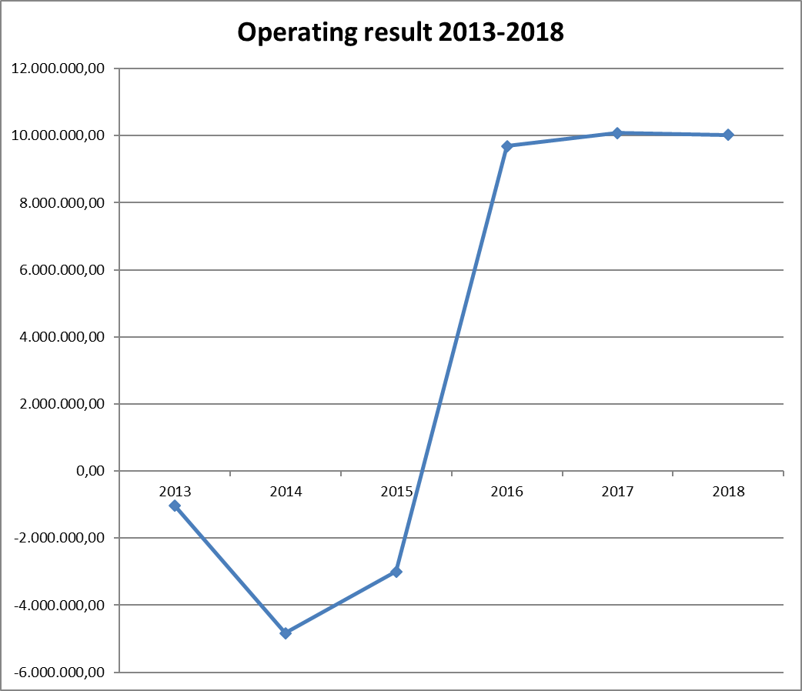

## Financial position: breakdown of expenditure and revenue by institution and for all the agencies 2013-18

Table 5 provides a breakdown of expenditure and revenue by institution and for all the agencies. The first part of the table provides the absolute amounts, while the second part shows the amounts as percentages of total expenditure and revenue. The effect of the end of the European Parliament’s parliamentary term is particularly visible, with an increase in expenditure relating to the European Parliament of over EUR 8 million between 2013 and 2014. In 2015 expenditure remained high but was nevertheless lower than in 2014. It declined strongly from 2016, to around EUR 3 million in 2018.

The agencies in particular currently have a level of contributions that exceeds expenditure. This situation can be attributed to the fact that a large proportion of their staff members have open-ended contracts. However, it should be noted that although expenditure relating to agency personnel increased sharply during the 2013-2015 period, it decreased up until 2018 and ended up at around EUR 4 million, i.e. a decrease of around 50% compared with 2015 (from EUR 6 021 292 in 2015 to EUR 4 083 952.15 in 2018).



# Analysis of persons insured, beneficiaries and allowances paid

## Number of persons insured and average contribution

Table 6 shows the number of TAs, CAs and APAs paying into the Unemployment Fund who were in active service on 31 December of each year.



## Number of persons receiving unemployment allowance in absolute terms and as a percentage of the number of persons insured: unemployment rate at 31 December of the year in question

Table 7 shows the number of unemployed persons who received the unemployment allowance in full or as a top-up to benefits received under the national system for the month of December each year.

By combining the data on the TAs, CAs and APAs in service on 31 December in Table 6 and the number of beneficiaries who received an unemployment allowance in Table 7, it is possible to calculate the ratio of beneficiaries of the Unemployment Fund to the number of persons insured under that Fund. The results are set out in Table 8.



The number of beneficiaries who received an allowance for at least one month of the year decreased sharply from 2013 to 2016 (from 754 to 454), rising again up to 2018 (755) when it was almost the same as the 2013 figure.





With regard to TAs, their numbers increased (from 9 148 in 2013 to 10 584 in 2018), but the ratio of beneficiaries to persons insured fell significantly (3.32% to 1.82%).

With regard to CAs, their numbers increased continuously from 2013, particularly in the agencies (2 611 to 4 082) and at the European Parliament (842 to 1 853), but the ratio of beneficiaries to persons insured decreased slightly (4.12% to 3.68%). This decrease is linked in particular to the possibility of extending CA 3b contracts concluded between 2010 and 2013 from three to six years.

As 2014 saw the end of the parliamentary term, an increased number of former APAs became eligible for the unemployment allowance. This figure decreased from 151 in 2015 to 49 in 2016 and 41 in 2018.

## Number of monthly unemployment allowances, average amount, beneficiaries, and country of residence of beneficiaries

An unemployment allowance can be paid for several months. Table 9 shows the number of monthly unemployment allowances paid to all beneficiaries each year.



Table 10 below shows the average amount of unemployment allowance by beneficiary category. This amount corresponds to the total annual expenditure for each type of beneficiary (TA, CA and APA), divided by the number of monthly payments made. It should be noted that in any given month the allowance paid may be the full amount or a pro-rata amount based on the number of days on which the person was actually entitled to the unemployment allowance.



There was an increase in the average monthly allowance between 2013 and 2015, rising from EUR 1 980 to EUR 2 551. However, from 2016 the average monthly allowance decreased, reaching EUR 1 949 in 2018.

The average amounts paid for APAs also increased sharply in 2014, by nearly 40% in comparison with 2013, to EUR 2 768. The average monthly allowance received by APAs then reduced markedly to EUR 2 102 in 2018.

Table 11.1 sets out the average duration in months of unemployment allowance paid during one year, including any earlier benefits owed. This duration corresponds to the total number of days for which the allowance was paid up to 31 December of the year in question, divided by the number of recipients of the unemployment allowance. The result obtained is divided by 30 to obtain the average period in months for which the unemployment allowance was paid.



The average duration expressed in months of unemployment allowance paid increased from 8 months in 2013 to 10 months in 2016. This represents an increase in the duration of benefit cover of 25%, primarily as a result of the impact of the APAs. The duration decreased from 2017 (8 months) before rising again in 2018 (10 months).

The following tables show the duration of payments by staff category (TAs, CAs and APAs):

**CA/TA:**



**APA:**



Although expenditure relating to the APAs as a share of overall expenditure is high in 2015 (31%), this is due both to the large numbers of staff in this category and to the high average amount of the monthly allowance. The average duration of the period of benefit cover in 2015 and 2016 was greater than that for CAs and TAs, a direct consequence of the increase in the number of APAs eligible for the unemployment allowance. It decreased substantially in 2018 to 7.7 months (as opposed to 12.6 months in 2016).

Having regard to the principle of complementarity as applied to the unemployment insurance scheme, the country of residence of the recipient of the unemployment allowance is significant, particularly in view of the very different eligibility criteria for national unemployment benefit in the different Member States.

Table 12 shows the countries of residence of beneficiaries who received at least one monthly allowance during the year.



In 2013, more than half of beneficiaries were registered as jobseekers in Belgium. This proportion remained stable during the reference period.

# CONCLUSION

## Period 2013-2018

This report shows successive annual deficits from 2013 to 2015 leading to a fall in the Unemployment Fund’s reserve from EUR 16 million in 2009 to only EUR 2 million in 2015.

The 2016, 2017 and 2018 financial years brought successive surpluses of nearly EUR 10 million each year. The reserve thus grew sharply and reached EUR 28 million at the end of 2018.

In accordance with the conclusions of the previous report on the financial position of the unemployment insurance scheme[5], and taking particular account of the risk factors identified in that report, the Commission carried out regular monitoring of the scheme’s financial position. In particular, the Commission continued to assess whether the balance of the scheme required adjustment of the rates of contribution to the scheme’s financing, which it did not up to the end of 2018.

## Prospects of the Unemployment Fund in the short and medium term:

On the basis of past observation of the expenditure level, it seems that the substantial reserve achieved at the end of 2018 should make it possible to finance the increased expenditure relating to the end of the European Parliament’s parliamentary term in view of the expected increase in the number of former APA beneficiaries from mid-2019.

It should also be stressed that there are other factors that could increase expenditure, such as the departure of 3b CAs who have reached the maximum of six years under contract, or the possible consequences of the process of withdrawal of the United Kingdom from the European Union in accordance with Article 50 of the Treaty on European Union.

The Commission will therefore monitor the financial position of the scheme on a regular basis and take appropriate action with a view to ensuring the financial stability of the Fund.

1. The European Data Protection Supervisor is included in the agencies.
2. OJ L 55, 27.2.2009.
3. OJ L 338, 22.12.2010.
4. OJ L 11, 15.1.1989.
5. COM(2016) 754.