

**INCLUSION OF THE REPUBLIC OF NORTH MACEDONIA IN THE “EU STRATEGY FOR THE ADRIATIC AND IONIAN REGION”**

1. **Introduction**

Following the request of the European Council of December 2012 to the Commission to present an EU Strategy for the Adriatic and Ionian Region (EUSAIR) by the end of 2014, the Commission adopted accordingly its Communication[1] on the basis of extensive consultations gathering inputs from stakeholders.

Consequently, the European Council endorsed the EUSAIR in its Conclusions of 24 October 2014[2] and “called on all relevant actors to implement it without delay”.

The general objective of the EUSAIR is to promote sustainable economic and social prosperity in the Region through growth and jobs creation, and by improving its attractiveness, competitiveness and connectivity, while preserving the environment and ensuring healthy and balanced marine and coastal ecosystems.

The EUSAIR is implemented, inter alia, by mobilising and aligning existing EU and national funding of relevance to the four pillars and topics. By endorsing the EUSAIR, the Governments of the participating countries (four EU Member States - Croatia, Greece, Italy, and Slovenia, and four Western Balkan countries - Albania, Bosnia and Herzegovina, Montenegro and Serbia) committed to implementing the Action Plan[3] through relevant funding.

As the EUSAIR remains open to other partners in the Region, the Adriatic and Ionian Council/EUSAIR Ministerial Meeting[4] of 24 May 2018 approved, in its Catania Declaration, the request put forward by North Macedonia to become the ninth Participating Country of the Adriatic and Ionian Initiative[5], and invited the Council of the European Union and the European Commission to undertake all necessary steps to include it in the EUSAIR. On 5 October 2018 the four EU Member States of the EUSAIR sent a letter to the Austrian Presidency of the Council and to the Commission backing this request.

The Council of the European Union, in its Conclusions of 9 April 2019, welcomed and accepted the request by the countries participating in the EUSAIR to include North Macedonia and invited the Commission “to take the necessary steps to include North Macedonia in the EUSAIR and to submit an accordingly amended strategy to the Council”[6].

1. **inclusion of North Macedonia in the EUSAIR**
2. **Political momentum**

In June 2018, Athens and Skopje signed an agreement on the name issue, under the auspices of the United Nations, which brought the longstanding discussions to a conclusion. The Prespa agreement entered into force in February 2019 and was strongly welcomed by the European Union. This agreement represents a significant achievement, setting a positive example for the region and beyond.

The inclusion of North Macedonia in the EUSAIR contributes to the EU enlargement policy in the Western Balkans and to regional cooperation and good neighbourly relations. This expanded cooperation allows participating countries to jointly plan and programme actions and operations in all EUSAIR priority areas (Pillars) while including in the picture a country that geographically and traditionally belongs in the Adriatic and Ionian region.

Beyond contributing to growth, jobs and development, the EUSAIR ensures and promotes European values in the Western Balkans while extending relevant EU policies to the region, thus reinforcing EU transformative power. All actions under the EUSAIR should reinforce the Priority Agenda, endorsed by EU and Western Balkan leaders at the 2018 EU-Western Balkans Summit[7]. The Sofia declaration confirms the EU commitment to the region and spells out the priorities and areas of joint reinforced cooperation, outlining the specific challenges the Western Balkans face. Among them, support to socio-economic development, to a sustainable and climate-friendly society[8], to increasing connectivity (energy and transport) and to better neighbourly relations are particularly relevant for the EUSAIR.

1. **North Macedonia participation in the EUSAIR**

This Addendum to the Commission Communication on the EUSAIR, along with the updated Action Plan, sets out the roles and responsibilities of North Macedonia in the multi-level governance of the EUSAIR as well as its relation with other participating countries.

For North Macedonia, participation in the EUSAIR entails cooperating and coordinating with other countries in the region in planning national and EU financing (Instrument of pre-accession assistance (IPA), European Territorial Cooperation (ETC)) and other available sources of funding for implementing the EUSAIR Action Plan.

With its inclusion in the EUSAIR, North Macedonia will participate in all EUSAIR governance structures[9], with a coordination role in relation to Pillar 2 (Connecting the Region), together with Italy and Serbia, with the aim of developing inter-linked sustainable transport and energy networks in the region.

In order to ensure coherence with the EU’s transport and energy policies, coordination and cooperation between EUSAIR and the Transport Community[10] and the Energy Community[11] would be beneficial.

1. **Conclusions**

The inclusion of North Macedonia in the EUSAIR will enhance cooperation in the Adriatic and Ionian region. The participation of North Macedonia will strengthen the EUSAIR partnership and deepen the linkages between the sea basin and the hinterland. EUSAIR actions and projects will benefit from cooperation in a wider region and facilitate functional integration in areas such as protection of the environment, transport and energy connections, where tangible results can only be achieved with a common approach to address challenges and harness opportunities. Participation in the EUSAIR, on a level playing field with all participating countries, including EU Member States, will allow North Macedonia to become better acquainted with the governance mechanisms of an EU macro-regional strategy while deepening its experience of implementing EU policies.

A new map of the EU Strategy for the Adriatic and Ionian Region is enclosed.

**Map of the EU Strategy for the Adriatic and Ionian Region**

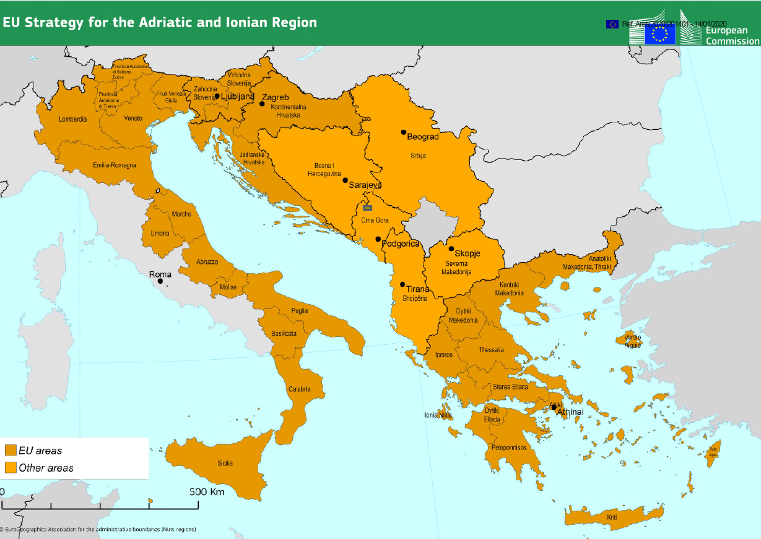

1. COM(2014) 357 final, 17.6.2014.
2. European Council Conclusions (23 and 24 October 2014) EUCO 169/14.
3. SWD(2014) 190 final. The Action Plan aims at making the Strategy operational by identifying concrete priorities for the macro-region.
4. As of the first EUSAIR Annual Forum (Dubrovnik 2-13 May 2016), the political levels of the EUSAIR and of the Adriatic-Ionian Initiative, represented by the Ministers of Foreign Affairs and the authorities for EU funds of participating countries, were merged into a so-called “Adriatic and Ionian Council / EUSAIR Ministerial meeting”.
5. The intergovernmental Adriatic-Ionian Initiative was initiated in 2000 with the aim to strengthening regional cooperation, to promote political and economic stability thus creating a solid base for the European integration process.
6. [General Affairs Council, 09/04/2019](https://www.consilium.europa.eu/media/40130/st08130-en19_final.pdf)
7. [Sofia Declaration, 17 May 2018](https://www.consilium.europa.eu/media/34776/sofia-declaration_en.pdf)
8. In line with the Green Agenda for the Balkans (and its action plan) to be adopted in May 2020, in which North Macedonia is cooperating with the neighbouring countries already included in the EUSAIR.
9. Political level (Ministerial meetings), coordination level (EUSAIR Governing Board), operational level (Thematic Steering Groups).
10. The Transport Community is an international organisation bringing together the EU, represented by the European Commission, and South East European Parties (Albania, Bosnia and Herzegovina, Kosovo*, Montenegro, North Macedonia and Serbia) to develop of the transport network between the European Union and the South East European Parties.
11. The Energy Community is an international organisation bringing together the EU, represented by the European Commission, and its neighbours (Albania, Bosnia and Herzegovina, Georgia, Kosovo*, Moldova, Montenegro, North Macedonia, Serbia and Ukraine) to create an integrated pan-European energy market.

    * This designation is without prejudice to positions on status, and is in line with UNSCR 1244/1999 and the ICJ Opinion on the Kosovo declaration of independence.