

COMMUNICATION FROM THE COMMISSION TO THE EUROPEAN PARLIAMENT, THE COUNCIL, THE EUROPEAN ECONOMIC AND SOCIAL COMMITTEE AND THE COMMITTEE OF THE REGIONS

Tourism and transport in 2020 and beyond

1. **INTRODUCTION**

The last months of the COVID-19 crisis have not only deeply affected those infected and their families, and taken a financial toll on businesses, entrepreneurs and the workforce. They have also required sacrifices from almost everyone. Those in the healthcare frontline or in more intense forms of physical confinement have particularly suffered.

**Handled correctly, safely and in a coordinated manner, the months to come could offer Europeans the chance to get some well-needed rest, relaxation and fresh air, and to catch up with friends and family, in their own Member States or across borders.** Many have kept themselves going with just that thought but want to be reassured that there will be hotels, camping sites and restaurants, bars and cafes to go to, trekking paths, waterfronts and cycling trails accessible, cultural attractions open to visit, transport to get there without restrictions and above all that everything possible has been done to ensure that they will be as safe as possible from infection.

**The months to come should not be lost for the vibrant European tourism ecosystem covering a range of activities such as travel, transport, accommodation, food, recreation on land and water, culture or nature**. Directly and indirectly, it contributes close to 10% to EU GDP and has made the EU the world’s leading tourism destination, with 563 million international arrivals and 30% of global receipts in 2018[1].

For many Member States, European regions and cities, tourism is a key contributor to the economic and social fabric. More than that, it provides much needed jobs and income, often concentrated in regions with no alternative sources of employment and involving low-skilled workers. But this ecosystem has been hit hard.The World Tourism Organisation (UNWTO) foresees a decline of international tourism of 60% to 80% compared to last year, amounting to losses of between EUR 840 billion to EUR 1.100 billion in export revenues worldwide. And the next months are crucial: during an average summer season (June-August) residents of the EU make 385 million tourism trips and spend EUR190 billion.[2]

This Communication and the accompanying initiatives set **a coordinated framework to enable all Europe to benefit from a restful and above all, safe tourism season**, gradually this summer and into the subsequent winter and beyond. In doing so, it also aims to support the sustainability of our valuable tourism ecosystem for generations to come.

It is about helping Member States to lift confinement measures and resume businesses, work and social life, in line with epidemiological and public health criteria.

Building on the Joint European Roadmap towards lifting coronavirus containment measures[3], this coordinated framework is based on common, objective and non-discriminatory principles, criteria and recommendations to guide Member States, competent authorities, industry bodies, economic operators and citizens through the next steps of the de-confinement process.

However, lifting measures too quickly could cause a sudden resurgence of infections. Until a vaccine or treatment is available, the needs and benefits of travel and tourism must be weighed against the risks of facilitating the spread of the virus anda resurgence of cases, which could requirea reintroduction of confinement measures.For this reason, preparedness plans should be in place at all levels – from the EU and national levels down to the level of individual establishments, transport operators, and other segments of the tourism sector – so that appropriate action can be taken swiftly and in a coordinated manner, on the basis of explicit criteria.

This Communication is accompanied by a package that provides reassurances and clarity for people and a pathway to recovery for tourism and transport, to ensure that the EU retains its position as the world leader for sustainable and innovative tourism.

|  |
| --- |
| The package brings together guidance and recommendations to:   * Safely restore unrestricted free movement and reopen internal borders: Guidance on restoring freedom of movement and lifting of internal border controls * Safely restore transport and connectivity: Guidance on transport * Safely resume tourism services: Guidance on tourism, in particular hospitality * Address the liquidity crunch and rebuild consumer confidence: Recommendation on vouchers |

1. **GIVING PEOPLE THE ABILITY, CONFIDENCE AND SAFETY TO TRAVEL AGAIN**

Many Europeans are keen to get away and have a break over the summer months but they also want to be sure that they can travel and spend their holidays safely.

a. Safely restoring unrestricted free movement and reopening internal borders

Since the beginning of the pandemic, virtually all Member States have implemented restrictions on non-essential travel, often accompanied by requirements for cross-border travelers to stay in quarantine. The EU’s external borders have been closed to non-essential travel and many Member States have temporarily reintroduced internal border controls. This meant that millions of European citizens were suddenly unable to travel for work, education or pleasure[4], with many separated from their families and friends for months.

European tourism depends on the possibility for Europeans to move freely across the EU.

The Communication “Towards a phased and coordinated approach for restoring freedom of movement and lifting internal border controls”[5] – adopted by the Commission as part of this package – provides recommendations for a phased lifting of restrictions to free movement and internal border controls across the EU. It proposes a flexible phased approach, requiring close coordination between the Member States and Commission with the objective to gradually lift border controls to ensure unrestricted freedom of movement across the EU and restore the integrity of the Schengen area.

As Member States manage to reduce the circulation of the virus, blanket restrictions to free movement to and from other areas or regions in Member States with a similar overall risk profile should be replaced by more targeted measures, as a complement to physical distancing measures and effective tracing and testing of any suspected cases.

In line with the Joint European Roadmap, within the EU, restrictions on travel should first be lifted in areas with a comparable epidemiological situation and where sufficient capabilities are in place in terms of hospitals, testing, surveillance and contact tracing capacities. Furthermore, the European Centre for Disease Prevention and Control (ECDC), in cooperation with Member States and the Joint Research Centre, is developing and will maintain a map of the level of COVID-19 transmission including at sub-national level. Member States are invited to provide data to ensure that this map is complete, up to date and serves as a transparent tool to provide information at EU level to be used by authorities, transport operators and service providers, and travelers.

**For the gradual removal of restrictions to free movement and lifting of internal borders, proportionality and non-discrimination between EU citizens must be ensured**. Where a Member State lifts its restrictions for movement to and from certain regions or areas in another Member State, on epidemiological grounds, this must apply, without discrimination, to all people residing in these territories, regardless whether they are nationals of the Member States concerned[6] and should apply to all parts of the Union in a similar epidemiological situation. For the average citizen, it will mean being clear where they can travel, allowing them to plan.

|  |
| --- |
| *The Commission is providing guidance to the Member States so that they can gradually lift restrictions to free movement and internal border controls in a phased and coordinated manner.*  *The exchange of information and best practices between the Commission and the Member States, including within the ‘COVID-19 Information group – Home Affairs’, will continue to facilitate this process.*  *The Commission invites Member States to provide data to the ECDC to ensure that the map of the level of COVID-19 transmission at sub-national level is complete and continuously up to date.* |

b) Restoring safe transport

With the **Communication ‘COVID-19: Guidelines on the progressive restoration of transport services and connectivity’[7]**, the Commission is providing guidance based on a framework of principles and a common toolbox.

This will help resume transport services of all kinds across the EU in a consistent and understandable way: taking coordinated and risk-based measures that are non-discriminatory and proportionate, limited in scope and duration to what is necessary to protect public health; taking targeted measures instead of general prohibitions; lifting restrictions on individualised transport; and ramping up safer collective transport options.

The Commission will work to ensure that measures taken in Member States are compatible, coordinated and mutually accepted across borders and between regions. Again, this will give people more freedom, safety and certainty to travel.

These Guidelines also address how to protect the health of transport workers and passengers, and minimise the risk of infections at transport hubs and in vehicles across all modes. Taking into account the development of epidemiological circumstances and changing connectivity needs, Member States will need to adjust measures proactively to ensure the right balance between protecting public health and restoring transport services, in relation to other economic activities, such as tourism. The European Agency for Health and Safety at Work (OSHA) has also published general occupational health and safety measures regarding return to workplaces[8].

|  |
| --- |
| *The Commission is providing guidance to the Member States so that they can progressively restore transport services and connectivity in a coordinated manner.* |

**c. Resuming tourism services with health risks minimised**

With the **Communication, ‘COVID-19: EU Guidance for the progressive resuming of tourism services and for health protocols in hospitality establishments’[9]**, the Commission sets out principles to guide Member States when resuming tourism activities and developing COVID-related protocols for hospitality establishments that will minimize risks of infection for both guests and host personnel.

This Guidance is based on the advice of ECDC and seeks to protect tourists and workforce, while respecting public health rules and physical distancing measures in place in the Member States. Such measures should be flexible, depending on the local health situation and allowing gradual reopening of tourism segments. The Guidance proposes a minimum set of principles, which at the same time meet rigorous health and safety requirements, and highlights the importance of updated and easily accessible information to travelers.

What this will mean for people is that there will be clearly understandable and reasonable rules allowing them to safely:

* Stay at hotels, camping sites, Bed &Breakfasts or other holiday accommodation establishments;
* Eat and drink at restaurants, bars and cafes;
* Go to beaches and other leisure outdoor areas[10].

|  |
| --- |
| *The Commission is providing guidance to Member States so that they can progressively resume tourism services and implement appropriate health and safety protocols.* |

**d. Use of digital technologies**

People must be empowered to protect themselves and others through responsible behavior. They need to have access to information, including through digital means, about borders and travelling, about tourist establishments, about safety and health conditions in the place they intend to go. They need this information both to plan their travel and during actual holidays. They also need to be reassured that the public health and safety rules in place respect the same criteria across the Member States.

Europeans are likely to choose domestic and European tourism destinations this summer and during the following months. To be sure that they can safely travel and spend their holidays, they will need easy access to real-time information on the situation on borders, travel restrictions, travel advice, public health and safety measures, where to go in case of health issues, available tourism services. The Commission will set up a dedicated website with an interactive map combining information from Member States and tourist and travel industry.

Digital technologies and data have a valuable role to play in combating the pandemic. Mobile applications could bolster contact-tracing strategies and support public health authorities in monitoring and containing the spread of the virus. Artificial intelligence (AI) and robotics can also help monitoring physical distancing in line with data protection law or facilitating disinfection, especially in places with regular tourism flows. The Commission will deploy through the Digital Innovation Hubs dedicated support for local tourism businesses to help them cope with the new realities of the tourism season (i.e. robots for disinfecting and cleaning, crowd management, smart booking systems etc.), including a dedicated hackathon on the use of digital technologies in tourism.[11]

At the same time, these technologies may empower people to take their own effective and more targeted physical distancing measures. These applications are particularly relevant in the phase of lifting containment measures, when the infection risk increases as more and more people get in contact with each other.

As travel in the EU resumes, public authorities, commuters, business travelers and tourists can use contact tracing apps to their benefit, while respecting privacy requirements, data protection rules and voluntary use of such apps. For this, interoperability is key so that users are warned by their app no matter where they are in Europe. The Commission and the Member States are working to ensure this: today a protocol on interoperability principles is published, developed by the Member States through the e-health network, with the support of the Commission.

Businesses and governments can also use digital solutions for planning purposes and managing the flow of tourists, for example as regards overall maximum number of overnight stays in a given region, maximum number of visitors for cultural and heritage sites or time planning for those intending to visit a museum or have a dinner in a restaurant.

|  |
| --- |
| *The Commission and the Member States will further develop the European interoperability framework for mobile applications to support contact tracing.*  *The Commission will set up a dedicated website with a map combining real-time information related to tourism.*  *The Commission will support innovative solutions in line with data protection law for the use of AI and robotics to fight the COVID-19 pandemic and help tourism businesses cope with the new realities.* |

**e. Protecting their rights**

People are not always reimbursed directly for money paid in advance for cancelled transport and travel services. In some cases, they may be faced with cancellation penalties for tourism services they were not in a position to use. It is therefore important that they have access to reliable information and efficient assistance and dispute resolution bodies.

Consumers residing in the Union can rely on free of charge support from the network of the European Consumer Centres (ECC) when they book holidays in another EU country. Over the last weeks, ECCs assisting consumers with their cross border purchases have seen a surge in requests for information (over 5000 in the last week of April 2020[12]). National dispute resolution bodies have also noticed an increase in tourism-related disputes.

Transparency of travel booking procedures in the present context is particularly important to give incentives for future travelling and ensure fair commercial practices so that no operator seeks undue advantages from misleading claims such as falsely pretending that certain areas are in high demand. The Consumer Protection Cooperation (CPC) Network, coordinated by the Commission, is in a dialogue with online travel platforms and car rental companies on the transparency and fairness of online bookings and has already reached out to them on information needs in relation to travelling restrictions.

|  |
| --- |
| *The Commission is assisting European Consumer Centres to develop tips and information on cancelled accommodations, car rentals and events booked as individual services[13]. The Commission will consider how ECC services can be extended to travellers residing in third countries based on partnerships with similar bodies in third countries. The Commission will also support capacity building for Alternative Dispute Resolution bodies, which help consumers and traders find amicable solutions.* |

1. **GETTING TOURISM BACK ON TRACK**

The above measures should give people the possibility and the confidence to travel safely. But on their own, they will not be enough to ensure a successful summer season. Our tourism industry is in difficult situation and needs a pathway to exit the crisis and recover.

**a) The crucial importance of tourism**

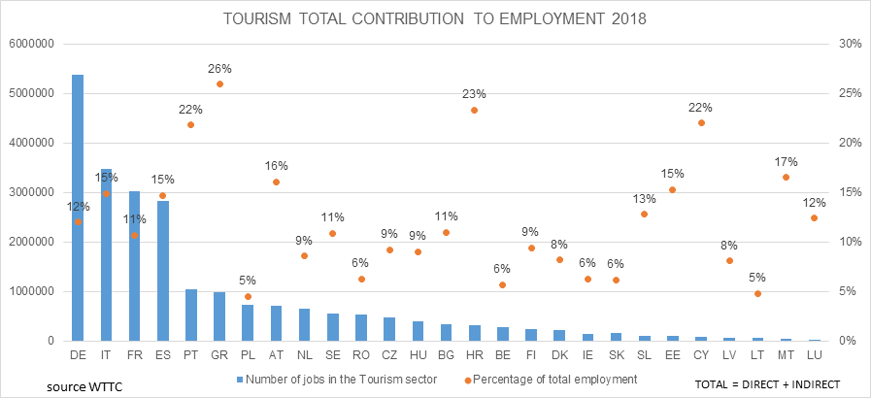

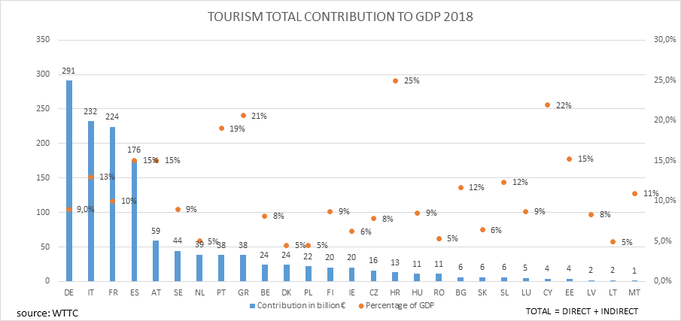

Tourism is the fourth largest EU export category and brings spill-over benefits to the European economy as a whole: 1 EUR of value added generated by tourism results in additional 56 cent of value added in indirect effect on other industries.

Tourism is a complex ecosystem of many players: off-line and on-line information and services providers (tourist offices, digital platforms, travel technology providers), travel agents and tour operators, accommodation suppliers, destination managing organisations, visitor attractions and passenger transport activities. Tourism and transport are also built on major industries (e.g. construction, aircraft manufacture, shipbuilding). Large multinational corporations operate alongside small companies, with 90% SMEs. Tourism is present in many different types of areas and regions: urban centres, insular, coastal, rural, remote areas and the EU outermost regions[14].

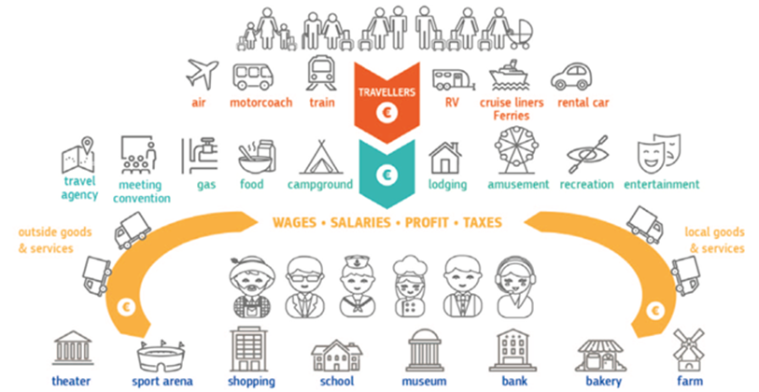

*Source: WTTC*

Tourism is the backbone of the economy for many Member States (four of them are among the top world destinations for international arrivals and receipts[15].) Regions across Europe differ in terms of their reliance on tourism activities. The impact is strong on islands, coastal and outermost regions, due to their dependence on tourism activities or reliance on international air travel. Rural areas, with limited connectivity and dependence on tourism, have also felt a strong impact.

*Regional vulnerability map. Source JRC. The Vulnerability index is peer-reviewed rank calculated taking into account two indicators: tourism intensity and seasonality.*

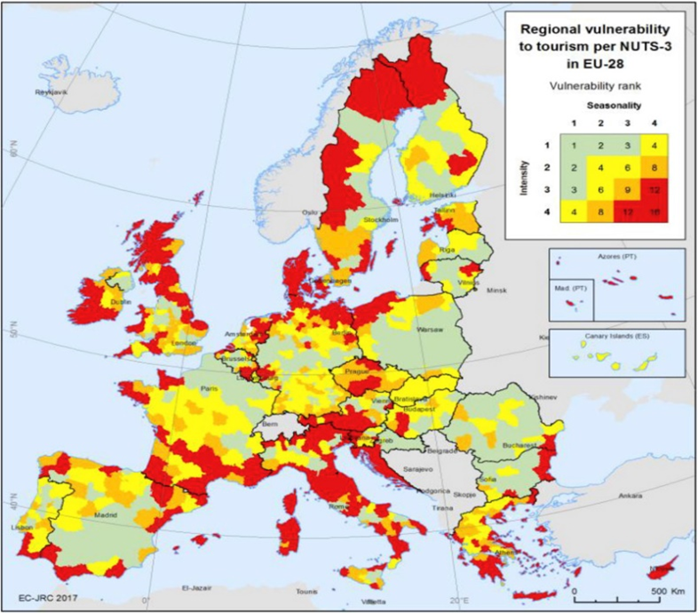

**b) The impact of the crisis**

The pandemic is putting the EU tourism ecosystem under unprecedented pressure. As a result of travel and other restrictions, tourism reached a gradual halt during the first quarter of 2020 in the EU and globally. The OECD estimates this decline to be from 45% to 70%, depending on the length of the health crisis and on the pace of recovery.

Tourism enterprises are facing an **acute liquidity crisis**. According to industry estimates, revenue losses at European level have reached 85% for hotels and restaurants, 85% for tour operators and travel agencies, 85% for long-distance rail and 90% for cruises and airlines. EU travel and tourism industry reports a reduction of bookings in the range of 60% to 90%, compared to the corresponding periods in previous years. The crisis has hit SMEs the hardest: lacking liquidity and facing uncertainty, they struggle to stay afloat, access funding and maintain their employees and talent.

Without urgent action and emergency funding to bridge the period until tourism flows can resume, many companies could become bankrupt in the coming weeks or months.

**Jobs** are also under threat. Tourism heavily relies on seasonal and temporary workers (23%[16]), many of them young (37% of tourism workers are under 35), women (59%), and from other countries (15% EU or non-EU)[17]. These jobs are often concentrated in regions with no alternative sources of employment and involve low-skilled workers, with tourism accounting for 10% to 50% of total employment in many of them, including island, remote and outermost regions. Tourism also comprises an important section of social economy actors, contributing to social inclusion. Without urgent action to support employment, the crisis could lead to a loss around 6 million jobs in Europe and have a negative impact on the livelihood of many more people across different Member States, often among the most economically vulnerable.

c) Addressing the liquidity crunch

A number of Member States have already taken action, under the Temporary State Aid Framework adopted in March 2020, to provide direct grants up to EUR 800 000, or loans or guarantees on very favourable terms for larger amounts; or, in some cases, to grant compensation to businesses for damage suffered due to the pandemic.

The EU has unlocked EUR 1 billion as a guarantee for the European Investment Fund, which will leverage a loan guarantee of EUR 8 billion to help 100 000 SMEs across the EU, including in tourism.

The Coronavirus Response Investment Initiative allow considerable flexibility to Member States to redirect cohesion financing to provide immediate liquidity to tourism SMEs and help them prepare for the 2020 summer/ winter season. In particular, financing of SMEs working capital can cover labour costs, materials and operational inputs, inventories and overheads, rent and utilities. This would also include the possibility of financing for both firms and regional authorities to comply with public health protocols, including cleaning, protective equipment, adaptation of public spaces, health and medical capacities to meet higher numbers of visitors.

Beyond assisting tourism businesses to adapt to public health requirements, EU and national financial support should be available to stimulate additional investments to strengthen resilience.

To help regions most severely affected by the crisis, Member States should develop comprehensive recovery strategies for these regions, based on existing smart specialisation and territorial strategies under cohesion policy. Such strategies should, in a first stage, support firms in tourism and related services to re-launch operations through better access to financing. This should be combined with measures to promote digitalisation, sustainability and investment in skills through the European Regional Development Fund and the European Social Fund to promote sustainable tourism and mobility, as well as economic diversification to build resilience to external shocks.

These strategies should also channel current cohesion funds to investments restoring tourist confidence such as management of public spaces and the implementation of health and safety protocols. The Commission will ensure that support to regions heavily dependent on tourism is more effectively targeted in the next generation of cohesion programmes.

The Commission will also encourage collaboration between regions to develop smart solutions for recovery in the tourism ecosystem. Based on the recent successful pilot, the Commission will launch a new call for an interregional partnership on tourism to share, test, and implement new smart solutions for recovery, creating a new value chain of innovative, responsible, and sustainable tourism.

|  |
| --- |
| *The Commission will encourage Member States and regions most impacted by the downturn in tourism to use the possibilities offered by the Coronavirus Response Investment Initiative to support tourism SMEs as part of the ongoing reprogramming of cohesion funds.* |

**d) Attractive, voluntary vouchers: a win-win for businesses and customers**

The number one liquidity constraint of travel and tourism industry is the lack of new bookings against unprecedented numbers of reimbursement claims for cancellations. To clarify the applicable Union rules in this area, on 18 March, the Commission adopted interpretative guidelines on EU Passenger Rights Regulations, and, on 19 March, issued informal guidance on the application of the Package Travel Directive.

With the **Recommendation on vouchers offered to passengers and travellers as an alternative to reimbursement for cancelled package travel and transport services in the context of the COVID-19 pandemic[18]**, the Commission aims at ensuring that vouchers for passengers and travellers become a viable and attractive alternative to reimbursement for cancelled trips. Carriers and travel operators should follow a joint approach, giving passengers and travellers an attractive and reliable choice between a cash refund, in line with their legal rights under EU law, or accepting a voucher instead.

To provide incentives for passengers and travellers to accept vouchers instead of reimbursement, vouchers should be protected against insolvency of the issuer and be refundable after at most one year if not redeemed. Operators should also combine certain characteristics to make vouchers attractive for passengers or travellers. For example, vouchers should provide flexibility on the range of services for which they can be used and their transferability. This would also allow passenger and travellers to feel more confident about making new bookings. Widely accessible, secured vouchers provide a cost-efficient solution for operators to reimburse travellers and passengers.

|  |
| --- |
| *Carriers and organisers should offer travellers and passengers vouchers that present an attractive and reliable alternative to cash refund, with the characteristics as described in the Commission Recommendation. Vouchers should be protected against the insolvency of the carriers and organisers and refundable after one year if not redeemed.*  *Consumer and passenger organisations at Union and national level should encourage travellers and passengers to accept vouchers that present characteristics as described in this Recommendation, instead of reimbursement in money.*  *Business, consumer and passenger organisations at Union and national level, and Member States authorities, including their national enforcement bodies, should contribute to informing all parties concerned about this Recommendation and cooperate towards its implementation.* |

**e) Saving jobs**

The European Social Fund is supporting short-time work schemes to safeguard jobs. Moreover, the initiative for temporary Support to mitigate Unemployment Risks in an Emergency (SURE) will provide financial relief of up to EUR100 billion to help Member States cover the costs of national short-time work schemes and similar measures allowing companies to safeguard jobs. Such public programmes allow enterprises to reduce the working hours while providing income support to their workers.

A key priority is to support workers who lose their jobs to find new ones. This requires partnerships between employment services, social partners and companies to facilitate swift placement in new jobs and reskilling, with the focus on young people and including support to seasonal workers.

To increase the resilience and to avoid in the future shortages of skills that are necessary for green and digital transition[19], Member States should also increase existing opportunities for upskilling, through national and EU funds (e.g. the European Social Fund, the European Regional Development Fund, InvestEU, and the European Agricultural Fund for Rural Development).

At EU level, the blueprint for sectoral cooperation on skills provides a framework for strategic cooperation between key stakeholders to address short and medium-term skills needs in selected sectors, tourism among them[20]. The upcoming updated Skills Agenda will further support sectoral cooperation to tackle skills needs, with a focus on skills for successful digital and green transitions. Regions with smart specialization strategies for tourism and European clusters active in tourism could join forces in this respect, supported by Erasmus and Interreg programmes.

**f) Promoting local tourism**

Domestic and intra-EU tourism will prevail in the short-term. 267 million Europeans (62% of the population) make at least one private leisure trip per year and 78% of Europeans spend their holidays in their home country or another EU country[21].

Used creatively, once lock-down measures are lifted, the crisis offers an opportunity for Europeans to enjoy the rich diversity of culture and nature in their own or other EU countries and discover new experiences all year around.

Many European regions and cities rely heavily on **cultural tourism**[22]. Technology has helped to reinvent cultural tourism during this pandemic by opening new opportunities for creative expression and by expanding audiences. **Coastal[23], maritime and inland waterway tourism, as well as rural[24] tourism**, is present is many EU regions and is creating innovative, localised tourism offers for off-season business and recreation opportunities. New opportunities arise to discover hidden or forgotten natural and cultural gems closer to home, and taste locally produced products. The proposed European Year of Rail 2021 could focus on this specific travel mode to promote intra-EU tourism.

In Member States where **patronage voucher schemes** have been set up, customers have shown enthusiasm for supporting their favourite hotels or restaurants. Such schemes could extend to other tourism related businesses such as culture and entertainment. The Commission will provide an IT portal to showcase them. The portal will link up suppliers with all initiatives and platforms offering such schemes. It will help citizens to find all initiatives and offers throughout the EU. In addition and in cooperation with Member States, the Commission will call for pledges to launch patronage voucher systems from local tourism organisations, but also from market players who are active in the tourism sector, such as small and large online platforms (through which many tourism businesses connect with their clients), credit card companies and payment system providers.

|  |
| --- |
| *The Commission in cooperation with Member States will call for pledges to launch patronage voucher systems and will set up an online platform to link the pledgers with suppliers in the tourism sector.*  *The Commission will promote a transition toward a more sustainable model of coastal and maritime tourism, as part of its strategic approach for a sustainable blue economy. It will also support agri-tourism as a sustainable model of tourism in rural areas.*  *From June, Europeana[25], the European platform for Digital Cultural Heritage, will further develop its tourism angle showcasing European cultural jewels and hidden gems. The companion web-app Cultural gems[26], will launch a citizen ambassador’s campaign in the second half of the year to support proximity tourism.*  *In cooperation with the Member States, the Commission will continue previous efforts to support information-sharing and encourage Europeans to discover the diversity of landscapes, cultures and experiences in Europe, including the European Capitals of Smart Tourism[27] and the European Destinations of Excellence (EDEN)[28].* |

1. **WORKING TOGETHER**

Tourism, transport and border issues are governed by a complex series of policy frameworks developed and implemented separately at different levels – local, regional, national and EU. Cities and sometimes regions are responsible for a wide range of tourism and transport policies. The diversity of the tourism ecosystem is reflected in its governance, but also poses challenges because policy measures implemented at the various levels without coordination can neutralise or even hinder each other.

Together and linked with local, regional and national measures, these actions and guidance of this package should help put the tourism ecosystem on a solid footing. But for everything to work, there needs to be genuine cooperation across a number of policy frameworks and set of actors relevant for tourism:

• Horizontally, between local, regional and national authorities and with the Commission;

• Vertically between customs officials, transport providers, accommodation providers and all other actors in the ecosystem, in particular to operationalize, put the guidelines in practice an implement them.

In order to ensure adequate and timely coordination among all actors building on established channels, the Commission will create coordination mechanisms linking all the agencies and EU bodies involved in the preparation of COVID-19 related guidelines in close coordination with the existing crisis management system.

1. **NEW HORIZONS - TOWARDS A SUSTAINABLE FUTURE**

Beyond the immediate steps to bring relief, we should look ahead to the future of tourism and transport in the EU and look at how to make it more resilient and sustainable, learning from the crisis and anticipating new trends and consumer patterns related to it.

Our shared ambition should be to maintain Europe as the world's leading tourist destination in terms of value, quality, sustainability and innovation. This vision should guide the use of financial resources and investment at European, national, regional and local levels.

At the core of this new ambition is **sustainability**, contributing to both the European Green Deal and strong communities. Our aim should be to enable affordable and more sustainable transport and improved connectivity, boost smart management of tourism flows based on sound measurement and tools, diversify the tourism offer and extend off season opportunities, develop sustainability skills for tourism professionals and valorise the variety of landscapes and the cultural diversity across Europe – while protecting and restoring Europe’s land and marine natural capital, in line with the strategic approach for a sustainable blue and green economy. This should include the promotion of sustainable tourism accommodations (through voluntary schemes such as EU Ecolabel and EMAS). This ambition towards sustainable tourism should guide investment decisions at EU level, but it can only work in combination with a strong commitment at regional and local level.

Equally, tourism can gain from the **digital transition**, providing new ways of managing travel and tourists flows, opportunities and more choice as well as more efficient use of scarce resources. The use of big data analysis can create and share accurate tourist profile segments and help understand traveller trends and needs. It can enable tourism to respond immediately to the changing customer demand and provide predictive modelling analysis. Finally, the application of blockchain technology would allow tourism operators to have all the available information about safe transactions.

Digital tools can be also confidence-building measures to reassure people that travel and tourism can be safe. This means investment in digital skills, including cybersecurity and fostering digital innovation, and connecting tourism businesses and actors with existing data spaces at local and regional level (for instance through the ongoing work on the European data space on mobility). This is particularly important in rural, remote areas and outermost regions where tourism is fragmented and highly dependent on information, transport and travel accessibility.

Within this transition, SMEs will need particular attention. As announced in the recent SME Strategy, the Commission will work with networks across Europe such as the Enterprise Europe Network, the European Clusters Alliance and European Digital Innovation Hubs to support sustainability and digitalisation and help local tourism companies become more resilient and competitive. This requires cross-sectoral linkages, interdisciplinary knowledge flow, stronger connections and capacity building to ensure accelerated uptake of product, services and process innovations. These networks shall also connect tourism with other industries to accelerate uptake of new solutions, foster cross-sectoral investments in tourism ecosystem with ICT, renewable energies, health and life sciences, agri-food, maritime, cultural and creative industries, including the media sector.

The time calls for a coordinated response at European level for the short-term exit from the crisis, but also for shaping recovery and addressing shared challenges in the longer-term.

|  |
| --- |
| *The European Commission will organise, as soon as health circumstances allow, a European tourism convention, in order to reflect – together with EU institutions, the industry, regions and cities and stakeholders – about the European tourism of tomorrow and jointly start building a roadmap 2050 towards a sustainable, innovative and resilient European tourism ecosystem (‘European Agenda for Tourism 2050’).* |

1. UNWTO
2. Eurostat - Arrivals at tourist accommodation establishments - monthly data (2019)
3. Joint European Roadmap towards lifting COVID-19 containment measures, OJ C 126, 17.4.2020
4. According to UNWTO, ‘Tourism comprises the activities of persons traveling to and staying in places outside their usual environment for not more than one consecutive year for leisure, business and other purpose”.
5. C(2020) 3250
6. Subject to specific measures applicable to vulnerable groups.
7. C(2020) 3139
8. COVID-19: BACK TO THE WORKPLACE - Adapting workplaces and protecting workers, https://osha.europa.eu/en/publications/covid-19-back-workplace-adapting-workplaces-and-protecting-workers/view
9. C(2020) 3251
10. Including areas with outdoor servings, canteens, marinas.
11. https://ec.europa.eu/digital-single-market/en/digital-innovation-hubs
12. ECC-Net data related to COVID-19 can be found here: <https://ec.europa.eu/info/live-work-travel-eu/consumers/resolve-your-consumer-complaint/european-consumer-centres-network-ecc-net_en>

    Consumer queries concern mostly passenger air transport, accommodation services, and package holidays.
13. <https://ec.europa.eu/info/live-work-travel-eu/consumers/resolve-your-consumer-complaint/european-consumer-centres-network-ecc-net/faq-cancellations-individually-booked-accommodations-car-rental-and-events-due-covid-19_en>
14. EU outermost regions as defined in article 349 TFEU – 9 EU regions located in the Atlantic Ocean, in the Indian Ocean, in the Caribbean and in Latin America, all except one are islands dependent on tourism. The Treaty provides for tailor-made EU measures to support these regions.
15. France, Spain, Italy, Germany.
16. There are big differences across the European Union (ranging from 5 % of temporary contracts in tourism in Malta to 45 % in Greece). There are also big differences between various segments of the tourism industry (27% temporary jobs in accommodations, 12% for travel agencies and tour operators, 9% for air transport). Source: https://ec.europa.eu/eurostat/statistics-explained/index.php?title=Tourism_industries_-_employment#Characteristics_of_jobs_in_tourism_industries
17. Eurostat: https://ec.europa.eu/eurostat/statistics-explained/index.php?title=Tourism_industries_-_employment#Characteristics_of_jobs_in_tourism_industries
18. C(2020) 3125
19. <https://ec.europa.eu/growth/sectors/tourism/support-business/skills_en>
20. https://nexttourismgeneration.eu/
21. Eurostat, ‘People on the move. Statistics on mobility in Europe’, 2019
22. Cultural tourism, representing 40% of tourism in Europe, particularly suffers as most cultural activities, like fairs and festivals, cancelled and institutions such as museums have been closed (92%)
23. Over half (51.7%) of the EU’s tourist accommodation establishments are located in coastal areas and 30% of nights spent by Europeans are at beach resorts.
24. In 2018, based on Eurostat, 45% of the tourist accommodation capacity (measured in bed places) of the EU-27 was located in rural areas.
25. https://www.europeana.eu/
26. https://culturalgems.jrc.ec.europa.eu/
27. https://smarttourismcapital.eu/. Goteborg and Malaga are the European Capitals of Smart Tourism in 2020
28. https://ec.europa.eu/growth/sectors/tourism/eden/destinations_en.