

REPORT FROM THE COMMISSION

Austria  
  
Report prepared in accordance with Article 126(3) of the Treaty on the Functioning of the European Union

**1. Introduction**

On 20 March 2020, the Commission adopted a Communication on the activation of the general escape clause of the Stability and Growth Pact. The clause, as set out in Articles 5(1), 6(3), 9(1) and 10(3) of Regulation (EC) 1466/97 and Articles 3(5) and 5(2) of Regulation (EC) 1467/97, facilitates the coordination of budgetary policies in times of severe economic downturn. In its Communication, the Commission shared with the Council its view that, given the expected severe economic downturn resulting from the COVID-19 outbreak, the current conditions permit the activation of the clause. On 23 March 2020, the Ministers of Finance of the Member States agreed with the assessment of the Commission. The activation of the general escape clause allows for a temporary departure from the adjustment path towards the medium-term budgetary objective, provided that this does not endanger fiscal sustainability in the medium term. For the corrective arm, the Council may also decide, on a recommendation from the Commission, to adopt a revised fiscal trajectory. The general escape clause does not suspend the procedures of the Stability and Growth Pact. It allows Member States to depart from the budgetary requirements that would normally apply while enabling the Commission and the Council to undertake the necessary policy coordination measures within the framework of the Pact.

Data notified by the Austrian authorities on 31 March 2020 and subsequently validated by Eurostat[1] show that the general government balance in Austria reached 0.7% of GDP in 2019, while general government gross debt stood at 70.4% of GDP. According to the Stability Programme, Austria plans a deficit of 8.0% of GDP in 2020, while debt is planned at 81.4% of GDP.[2]

The planned deficit for 2020 provides *prima facie* evidence of the existence of an excessive deficit as defined by the Stability and Growth Pact.

Against this background, the Commission has therefore prepared this report, which analyses Austria’s compliance with the deficit and debt criteria of the Treaty. It takes into account all relevant factors and gives due consideration to the major economic shock linked to the COVID-19 pandemic.

**Table 1. General government deficit and debt (% of GDP)**

|  |  |  |  |  |  |  |  |
| --- | --- | --- | --- | --- | --- | --- | --- |
|  |  | 2016 | 2017 | 2018 | 2019 | 2020  COM | 2021  COM |
| Deficit criterion | General government balance | -1.5 | -0.8 | 0.2 | 0.7 | -6.1 | -1.9 |
| Debt criterion | General government gross debt | 82.9 | 78.3 | 74.0 | 70.4 | 78.8 | 75.8 |

Source: Eurostat, Commission 2020 spring forecast.

2. Deficit criterion

Based on the technical update to the Stability Programme, Austria’s general government deficit in 2020 is planned to reach 8.0% of GDP, above and not close to the Treaty reference value of 3% of GDP.

The planned excess over the Treaty reference value in 2020 is exceptional, as it results from a severe economic downturn. Taking into account the impact of the COVID-19 pandemic, the Commission 2020 spring forecast projects a contraction of real GDP in 2020 by 5.5%.

The planned excess over the Treaty reference value would be temporary, based on the Commission 2020 spring forecast, which projects the general government deficit to fall under 3% of GDP in 2021. However, those projections are surrounded by an exceptionally high degree of uncertainty.

In sum, the planned deficit for 2020 is above and not close to the 3% of GDP Treaty reference value. The planned excess is considered to be exceptional as defined by the Treaty and the Stability and Growth Pact, while the nature of the excess is currently considered temporary. Hence, the analysis suggests that *prima facie* the deficit criterion as defined by the Treaty and Regulation (EC) No 1467/97 is not fulfilled.

3. Debt criterion

The government debt-to-GDP ratio decreased from 74.0% in 2018 to 70.4% in 2019. That decline is mainly driven by an improvement of the primary balance and supported by stock-flow adjustments stemming from the divestment of impaired assets from bad banks included into government accounts.

The notified data show that Austria complied with the debt reduction benchmark in 2019, as the gap to the benchmark is -6.1% of GDP.

The analysis thus suggests that the debt criterion is fulfilled based on the 2019 outturn data.

**4. Relevant factors**

Article 126(3) of the Treaty provides that, if a Member State does not fulfil the requirements under one or both of those criteria, the Commission has to prepare a report. That report must also “take into account whether the government deficit exceeds government investment expenditure and take into account all other relevant factors, including the medium-term economic and budgetary position of the Member State”.

Those factors are further clarified in Article 2(3) of Regulation (EC) No 1467/97, which also provides that “any other factors which, in the opinion of the Member State concerned, are relevant in order to comprehensively assess compliance with the deficit and debt criteria and which the Member State has put forward to the Council and to the Commission” need to be given due consideration.

As specified in Article 2(4) of Regulation (EC) No 1467/97, as regards compliance with the deficit criterion in 2020, ~~s~~ince the government debt-to-GDP ratio exceeds the 60% reference value and the double condition is not met – i.e. that the deficit remains close to the reference value and that its excess over the reference value is temporary – those relevant factors cannot be taken into account in the steps leading to the decision on the existence of an excessive deficit on the basis of the deficit criterion for Austria.

In the current situation, a key additional factor to take into consideration regarding 2020 is the economic impact of the COVID-19 pandemic, which has a very substantial impact on the budgetary situation and results in a highly uncertain outlook. The pandemic has also led to the activation of the general escape clause.

**4.1. COVID-19 pandemic**

The COVID-19 pandemic has led to a major economic shock that is having a significant negative impact throughout the European Union. The consequences for GDP growth will depend on the duration of both the pandemic and of the measures taken by national authorities and at European and global level to slow its spread, protect production capacities and support aggregate demand. Member States have already adopted or are adopting budgetary measures to increase the capacity of health systems and provide relief to those individuals and sectors that are particularly affected. Significant liquidity support measures and other guarantees have also been adopted. Subject to more detailed information, the competent statistical authorities are to examine whether those measures entail an immediate impact on the general government balance or not. Together with the fall in economic activity, those measures will contribute to substantially higher government deficit and debt positions.

**4.2 Medium-term economic position**

The COVID-19 pandemic is strongly affecting Austria’s growth prospects. Being a small, open economy, developments in Austria’s economy are strongly linked to those in its main trading partners. As a result, containment measures against the virus and related supply chain disruptions hit both the demand and supply side of the economy, leading to a broad-based downturn. The tourism-related sectors are hit particularly hard due to international travel restrictions. However, given the relatively rapid fall in new infections, Austria was one of the first Member States to announce a progressive relaxation of lockdown measures starting from mid-April. The contraction in the first half of the year is therefore expected to be somewhat less severe than in other euro area Member States. The Commission 2020 spring forecast projects real GDP to decline by 5.5% in the current year, which is broad-based, and affects in particular domestic demand and export of services. This a mitigating factor in the assessment of Member State’s compliance with the deficit criterion in 2020. Assuming a gradual normalistion, GDP growth is expected to rebound in the second half of the year, followed by a solid recovery of 5.0% in 2021. The macroeconomic outlook is marked by an exceptional degree of uncertainty related to the duration of the COVID-19 pandemic and its ensuing economic impact.

**4.3 Medium-term budgetary position**

Based on outturn data and the Commission forecast, Austria was compliant with its medium-term budgetary objective in 2019.

According to the Stability Programme, the mitigation of the socio-economic effects of the pandemic takes centre stage for managing the crisis and largely shapes the budgetary development. The federal government has launched a comprehensive aid package of EUR 38 billion (around 9.9% of GDP). The main purpose of the ‘Corona Aid Package’ is to ensure the provision of health care, secure jobs and preserve Austria as a business location. The package consists of immediate help for SMEs, increased public expenditures for health care and social policy, direct liquidity provision and transfers for distressed companies, funds for short-time work and tax deferrals. In addition, the budgetary impact of further measures to revive the economy is not yet incorporated in the projections.

**4.4. Medium-term government debt position**

According to the Commission 2020 spring forecast, general government debt is expected to rise from 70.4% of GDP in 2019 to 78.8% by 2020. The debt sustainability analysis has been updated on the basis of this forecast. The analysis confirms that, notwithstanding risks, the debt position remains sustainable over the medium term in Austria, also given important mitigating factors (including the debt profile and the historic low level of interest rates). In particular, while the government debt position deteriorates as a result of the COVID-19 crisis, the debt ratio in the baseline is expected to be on a sustainable (declining) trajectory over the medium term (Graph 1).[3]

**Graph 1: Government debt-to-GDP ratio, Austria, % of GDP**

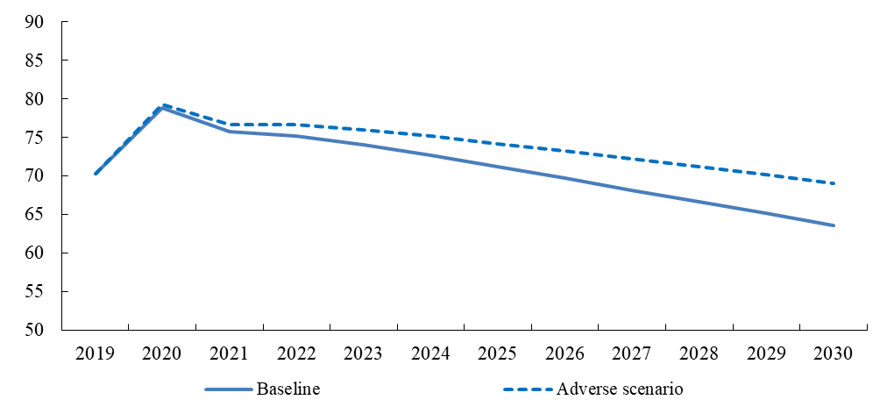

Source: Commission services.

**4.5 Other factors put forward by the Member State**

On 11 May 2020, the Austrian authorities transmitted a letter with relevant factors in accordance with Article 2(3) of Regulation (EC) No 1467/97. The analysis presented in the previous sections already broadly covers the key factors put forward by the authorities. Additional factors not yet mentioned above are measures to revive the economythat the authorities are planning jointly with social partners. As for the measures referred to in the technical update to the Stability Programme, the guiding principle of the announced recovery programme is to preserve the production potential of the Austrian economy.

**5. Conclusions**

According to the technical update to the Stability Programme, Austria’s general government deficit in 2020 is planned to increase to 8.0% of GDP, above and not close to the 3% of GDP Treaty reference value. The planned excess over the reference value is considered to be exceptional and currently considered to be temporary.

The general government gross debt stood at 70.4% of GDP at the end of 2019, well above the 60% of GDP Treaty reference value. Austria complied with the debt reduction benchmark in 2019.

In line with the Treaty and the Stability and Growth Pact, this report also examined relevant factors. As specified in Article 2(4) of Regulation (EC) No 1467/97, as regards compliance with the deficit criterion in 2020, since the government debt-to-GDP ratio exceeds the 60% reference value and the double condition is not met – i.e. that the deficit remains close to the reference value and that its excess over the reference value is temporary – those relevant factors cannot be taken into account in the steps leading to the decision on the existence of an excessive deficit on the basis of the deficit criterion for Austria.

Overall, the analysis suggests that the deficit criterion as defined in the Treaty and in Regulation (EC) No 1467/1997 is not fulfilled.

1. <https://ec.europa.eu/eurostat/documents/2995521/10294648/2-22042020-AP-EN.pdf/6c8f0ef4-6221-1094-fef7-a07764b0369f>
2. On 30 April, the Austrian authorities submitted to the Commission a technical update to the Stability Programme for the years 2019 to 2021. With that update, the Austrian authorities respond to the Commission’s request as formulated in the Commission Opinion on the updated Draft Budgetary Plan for 2020.
3. The baseline is based on the Commission 2020 spring forecast. Beyond 2021, a gradual adjustment of fiscal policy is assumed, consistent with the EU economic and fiscal coordination and surveillance frameworks. Real GDP growth is projected according to the so-called EPC/OGWG T+10 methodology. In particular, (real) actual GDP growth is driven by its potential growth and affected by any additional fiscal adjustment considered (through the fiscal multiplier). Inflation is assumed to converge gradually to 2%. Interest rates assumptions are set in line with financial market expectations. Under the adverse scenario, higher interest rates (by 500 bps.) and lower GDP growth (by -0.5 pp.), with respect to the baseline, are assumed (throughout the projection horizon).