REPORT FROM THE COMMISSION
Croatia
Report prepared in accordance with Article 126(3) of the Treaty on the Functioning of the European Union

1. Introduction
On 20 March 2020, the Commission adopted a Communication on the activation of the general escape clause of the Stability and Growth Pact. The clause, as set out in Articles 5(1), 6(3), 9(1) and 10(3) of Regulation (EC) 1466/97 and Articles 3(5) and 5(2) of Regulation (EC) 1467/97, facilitates the coordination of budgetary policies in times of severe economic downturn. In its Communication, the Commission shared with the Council its view that, given the expected severe economic downturn resulting from the COVID-19 outbreak, the current conditions permit activation of the clause. On 23 March 2020, the Ministers of Finance of the Member States agreed with the assessment of the Commission. The activation of the general escape clause allows for a temporary departure from the adjustment path towards the medium-term budgetary objective, provided that this does not endanger fiscal sustainability in the medium term. For the corrective arm, the Council may also decide, on a recommendation from the Commission, to adopt a revised fiscal trajectory. The general escape clause does not suspend the procedures of the Stability and Growth Pact. It allows Member States to depart from the budgetary requirements that would normally apply while enabling the Commission and the Council to undertake the necessary policy coordination measures within the framework of the Pact.Data notified by the Croatian authorities on 31 March 2020 and subsequently validated by Eurostat show that the general government balance in Croatia reached +0.4% of GDP in 2019, while general government gross debt stood at 73.2% of GDP. According to the 2020 Convergence Programme, Croatia plans a deficit of 6.8% of GDP in 2020, while debt is planned at 86.7% of GDP.
The planned deficit for 2020 provides prima facie evidence of the existence of an excessive deficit as defined by the Stability and Growth Pact.
Against this background, the Commission has therefore prepared this report, which analyses Croatia’s compliance with the deficit and debt criteria of the Treaty. It takes into account all relevant factors and gives due consideration to the major economic shock linked to the COVID-19 pandemic.
Table 1. General government deficit and debt (% of GDP)
 |  | 2016 | 2017 | 2018 | 2019 | 2020  COM | 2021  COM
Deficit criterion | General government balance | -1.0 | 0.8 | 0.2 | 0.4 | -7.1 | -2.2
Debt criterion | General government gross debt | 80.8% | 77.8% | 74.7% | 73.2% | 88.6% | 83.4%
 | Gap to the debt reduction benchmark | -4.1 | -3.2 | -4.1 | -2.7 | 3.6 | 0.6
 | Change in structural balance | +1.5 | +1.3 | -1.1 | -0.3 | -3.2 | +2.5
Source: Eurostat, Commission 2020 spring forecast

2. Deficit criterion
Based on the 2020 Convergence Programme, Croatia’s general government deficit in 2020 is planned to reach 6.8% of GDP, above and not close to the Treaty reference value of 3% of GDP.
The planned excess over the Treaty reference value in 2020 is exceptional, as it results from a severe economic downturn. Taking into account the impact of the COVID-19 pandemic, the Commission 2020 spring forecast projects a contraction of real GDP in 2020 by 9.1%.
The planned excess over the Treaty reference value would be temporary based on the Commission 2020 spring forecast, which projects the general government deficit to fall under 3% of GDP in 2021. However, those projections are surrounded by an exceptionally high degree of uncertainty.
In sum, the planned deficit for 2020 is above and not close to the 3%-of-GDP Treaty reference value. The planned excess is considered to be exceptional as defined by the Treaty and the Stability and Growth Pact, while the nature of the excess is currently considered temporary. Hence, the analysis suggests that prima facie the deficit criterion for the purpose of the Treaty and Regulation (EC) No 1467/97 is not fulfilled.

3. Debt criterion
The government debt-to-GDP ratio decreased from 74.7% in 2018 to 73.2% in 2019. The reduction of debt was driven by solid GDP growth and a headline surplus, which was partly offset by a sizable gross debt-increasing stock-flow adjustment as the government issued debt in excess of its financing needs and used the surplus to build up deposits.
The notified data show that Croatia complied with the debt reduction benchmark in 2019, as the gap to the benchmark is −2.7% of GDP (i.e. overachieving the benchmark).
The analysis thus suggests that the debt criterion is fulfilled based on the 2019 outturn data.

4. Relevant factors
Article 126(3) of the Treaty provides that, if a Member State does not fulfil the requirements under one or both of those criteria, the Commission has to prepare a report. That report must also “take into account whether the government deficit exceeds government investment expenditure and take into account all other relevant factors, including the medium-term economic and budgetary position of the Member State”.
Those factors are further clarified in Article 2(3) of Regulation (EC) No 1467/97, which also provides that “any other factors which, in the opinion of the Member State concerned, are relevant in order to comprehensively assess compliance with the deficit and debt criteria and which the Member State has put forward to the Council and to the Commission” need to be given due consideration.

As specified in Article 2(4) of Regulation (EC) No 1467/97, as regards compliance with the deficit criterion in 2020, since the government debt-to-GDP ratio exceeds the 60% reference value and the double condition is not met - i.e. that the deficit remains close to the reference value and that its excess over the reference value is temporary - those relevant factors cannot be taken into account in the steps leading to the decision on the existence of an excessive deficit on the basis of the deficit criterion for Croatia. In the current situation, a key additional factor to take into consideration regarding 2020 is the economic impact of the COVID-19 pandemic, which has a very substantial impact on the budgetary situation and results in a highly uncertain outlook. The pandemic has also led to the activation of the general escape clause.

4.1. COVID-19 pandemic
The COVID-19 pandemic has led to a major economic shock that is having a significant negative impact throughout the European Union. The consequences for GDP growth will depend on the duration of both the pandemic and of the measures being taken by national authorities and at European and global level to slow its spread, protect production capacities and support aggregate demand. Member States have already adopted or are adopting budgetary measures to increase the capacity of health systems and provide relief to those individuals and sectors that are particularly affected. Significant liquidity support measures and other guarantees have also been adopted. Subject to more detailed information, the competent statistical authorities are to examine whether those measures entail an immediate impact on the general government balance or not. Together with the fall in economic activity, those measures will contribute to substantially higher government deficit and debt positions.
4.2 Medium-term economic position
In 2019, real output finally surpassed its 2008 level and the unemployment rate reached an all-time low. The macroeconomic imbalances (high levels of debt and external liabilities) improved below their 2008 levels. Although still relatively high, government debt decreased markedly, helped by three consecutive years of government surpluses. Furthermore, the average maturity and cost of servicing public debt improved substantially. Cost competitiveness gains and Croatia’s accession to the Union supported the strong export growth until 2019.
The economic fallout of the COVID-19 pandemic is expected to be particularly pronounced in Croatia, due to the large share of tourism in its gross value added as well as substantial exposure through main trading partners. Domestic demand is expected to contract sharply due to relatively strong suppression measures that were put in place in mid-March, phasing out of which began in late April. At the same time, exports should suffer due to particulartly large strong suppression measures put in place in Croatia’s main trading partners (Italy, Slovenia and Austria). That outlook is marked by an exceptional degree of uncertainty on the duration of the pandemic and its economic impact as it depends largely on the effectiveness of government measures and how quickly global demand rebounds.
The projected sharp drop in GDP is a mitigating factor in the assessment of Croatia’s compliance with the deficit criterion in 2020.

4.3 Medium-term budgetary position
Based on outturn data and the Commission 2020 spring forecast, Croatia was compliant with its medium term budgetary objective in 2019.
The 2020 Convergence Programme provides information on the medium-term strategy to support the economy, which consists of using the fiscal space created in recent years to minimize the economic fallout of the COVID-19 pandemic by providing support to otherwise viable businesses and employment. In that respect, the three key measures taken were the wage subsidy for businesses which retain employees, tax deferrals and tax cancellation for hardest-hit businesses. The total impact of those measures is projected at 3.9% of GDP, out of which 2.7% of GDP is deficit-increasing, and the rest are liquidity measures (tax deferrals). Overall, the Convergence Programme projects a deficit of 6.8% of GDP in 2020, followed by a recovery to 2.4% of GDP in 2021.
4.4. Medium-term government debt position
According to the Commission 2020 spring forecast, general government debt is expected to rise from 73.2% of GDP in 2019 to 88.6% by 2020. The debt sustainability analysis has been updated on the basis of that forecast. That analysis confirms that, notwithstanding risks (including those linked to the high share of foreign currency-denominated debt), the debt position remains sustainable over the medium term, which also reflects the debt reduction in recent years. In particular, while the government debt position worsens as a result of the COVID-19 crisis, the debt ratio in the baseline is expected to be on a sustainable (declining) trajectory over the medium term.
Graph 1. General government debt (% of GDP)
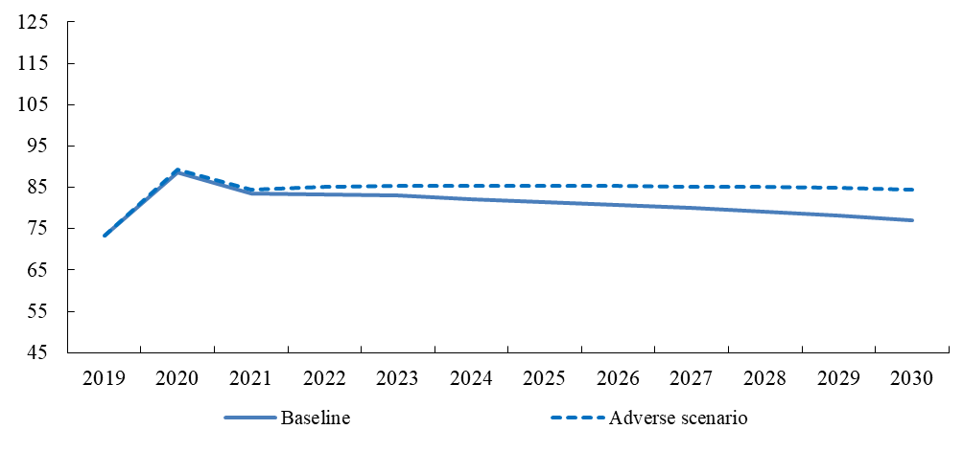

4.5 Other factors put forward by the Member State
On 11 May 2020, the Croatian authorities transmitted a letter with relevant factors in accordance with Article 2(3) of Regulation (EC) No 1467/97. The analysis presented in the previous sections already broadly covers the key factors put forward by the authorities.

5. Conclusions
According to the Convergence Programme, Croatia’s general government deficit in 2020 is planned to reach 6.8% of GDP, above and not close to the 3% of GDP Treaty reference value. The planned excess over the reference value is considered to be exceptional and currently considered to be temporary.
The general government gross debt stood at 73.2% of GDP at the end of 2019, above the 60% of GDP Treaty reference value. Croatia complied with the debt reduction benchmark in 2019.
In line with the Treaty and the Stability and Growth Pact, this report also examined relevant factors. As specified in Article 2(4) of Regulation (EC) No 1467/97, as regards compliance with the deficit criterion in 2020, however, since the government debt-to-GDP ratio exceeds the 60% reference value and the double condition is not met – i.e. that the deficit remains close to the reference value and that its excess over the reference value is temporary – those relevant factors cannot be taken into account in the steps leading to the decision on the existence of an excessive deficit on the basis of the deficit criterion for Croatia.
Overall, the analysis suggests that the deficit criterion as defined in the Treaty and in Regulation (EC) No 1467/1997 is not fulfilled.

https://ec.europa.eu/eurostat/documents/2995521/10294648/2-22042020-AP-EN.pdf/6c8f0ef4-6221-1094-fef7-a07764b0369f
The baseline is based on the Commission spring 2020 forecast. Beyond 2021, a gradual adjustment of fiscal policy is assumed, consistent with the EU economic and fiscal coordination and surveillance frameworks. Real GDP growth is projected according to the so-called EPC/OGWG T+10 methodology. In particular, (real) actual GDP growth is driven by its potential growth and affected by any additional fiscal adjustment considered (through the fiscal multiplier). Inflation is assumed to converge gradually to 2%. Interest rates assumptions are set in line with financial market expectations. Under the adverse scenario, higher interest rates (by 500 bps.) and lower GDP growth (by -0.5 pp.), with respect to the baseline, are assumed (throughout the projection horizon)

