

|  |  |
| --- | --- |
|  |  |

Identifying Europe’s recovery needs

# A Bleak economic outlook

**The scale of the recession facing Europe is immense, as is the policy challenge.** What started as a localised outbreak of a previously unknown virus infection in late 2019 has rapidly spread across the globe, wreaking havoc on European and global health systems and economies in the process. Stemming the tide of CoVid-19 infections has forced all EU Member States to impose wide-ranging restrictions that curtail the production and trade of goods and services. These supply-side problems are compounded by a collapse in spending and investment by households and companies, driven by their confinement, concerns about income and job prospects, worsening financial conditions, and pervasive uncertainty about the future course of the crisis. In recognition of the potential difficulty for Member States to recover from this unprecedented shock, the European Council agreed on 23 April 2020 to work towards the establishment of a Recovery Fund. To this end, they tasked the Commission to “*analyse the exact needs and to come up* *with a proposal that is commensurate to the challenges we are facing”*, further stating that ”*this fund shall be of a sufficient magnitude, targeted towards the sectors and geographical parts of Europe most affected”*.[1]

**The EU economy is expected to contract sharply in 2020.** At the start of the second quarter of 2020 all EU Member States were operating at only a fraction of their usual economic capacity. The Commission Spring 2020 forecast suggests that in Q2 2020 real GDP will be around 14 % below the level recorded in the same quarter of 2019. The second quarter marks the trough of a deep recession that will see GDP fall in 2020 by 7.4 % in the EU, with only a partial recovery in GDP expected in 2021 of 6.1 %. The large majority of Member States will have a lower level of output at the end of 2021 than when the CoVid-crisis erupted. Although containment measures are likely to be progressively lifted from mid-year onwards, the Spring Forecast shows that the path to recovery will not be swift or easy to tread.[2] Risks to this central scenario are strongly tilted to the downside, which is illustrated in the Spring Forecast’s two alternative downside scenarios of a ‘second wave’ of infections and longer-lasting containment measures, which entail GDP contractions of 11 % and 16 % respectively in 2020. While an unusually large degree of uncertainty surrounds any economic forecasts or assessment at the current juncture, the avoidance of downside risks will require policy responses that are timely, comprehensive and effective.

**The crisis will cause large losses in income for households and businesses.** Modern economies are circular systems in which companies and households rely on continued income generation through production and consumption in order to sustain livelihoods, invest, and meet financial obligations. Part of the immediate crisis response therefore focused on supporting income streams for employees through short-time working arrangements, thereby easing labour costs for employers, safeguarding jobs while at the same time shoring up cash flows for businesses. However, the duration of such schemes is typically limited and does not always cover the full wage; temporary workers and those on non-standard contracts may not be covered altogether. For companies, liquidity problems will increase the longer production is stalled, and the use of public or private bridge financing from loans is difficult to sustain over time. Over the course of 2020 a resumption of production and/or an increase in equity levels will be needed for many companies to survive, especially highly leveraged ones or those with low financial buffers.

**A fragile corporate sector means fewer jobs and a meek recovery**. Company failures can cause lasting economic damage in a number of ways. First, the layoffs following a bankruptcy will lead to rising unemployment, leaving many jobseekers struggling to retain their skills and attachment to the labour market, especially in the context of a global downturn. The longer individual unemployment spells last, the greater the loss of human capital and an economy’s productive potential. Second, bankruptcies can waste capital, as company assets such as machinery will only partially be put to other uses while intangible capital such as intellectual property may lose its value if not developed. Third, a company’s failure destroys the equity of its owners and may cause defaults on corporate loans. Business failures also disrupt economic networks and can bring international supply chains to a halt. Even for companies that survive, their capacity to invest will shrink. This will hold back potential growth and employment and slow the transition to a greener, more innovative economy. All the above factors can cause large negative second-round effects on investment, employment, growth and prosperity.

**In spite of efforts to protect workers and jobs, the crisis may cause a large increase in unemployment, hardship and inequality.** Household incomes are likely to suffer, both due to temporary cuts in earnings and permanent job losses — the latter are expected to drive up the unemployment rate to around 9½ % in the euro area and 9 % in the EU in 2020, undoing three years’ worth of job market improvements. This will worsen already low levels of domestic demand and further aggravate the recession. Low-skilled and temporary workers are likely to be hit hardest, as these typically work in client-facing services, manufacturing and agriculture, which cannot be performed remotely. Labour supply is set to decline, particularly due to the young, elderly and vulnerable losing attachment to the labour market. The crisis may therefore predominantly hit poorer and vulnerable households, adding both immediate and longer-lasting social problems to economic ones; to avoid this, both firms and workers need to be protected.

**Government finances may be permanently weakened.** Both the immediate healthcare costs and the effects of the recession will take their toll on Member States’ public finances. Government spending is projected to rise markedly, including for discretionary crisis-related measures, while revenues from taxes and fees will decline on the back of shrinking output. The Commission Spring 2020 forecast expects the average government deficit in the EU to rise from near-balance in 2019 to around 8½ % of GDP in 2020.

This implies significantly higher sovereign financing needs for Member States, much of which will need to be funded in a short period of time and under market conditions characterised by large uncertainty. Beyond the short-term, countries will unavoidably be left with significantly higher debt to be financed in the future. The increase in government debt is a particular challenge for countries that entered the CoVid-19 crisis with elevated debt and deficit levels. Differences in access to financing and its affordability may constrain a country’s ability to respond adequately to the current crisis on its own.

# Uneven impact, divergent dynamics

**The containment measures will have a devastating impact on companies’ production and income levels in 2020, though with large differences between sectors.** Most industries and services have seen significant restrictions being placed on them as part of the effort to stem CoVid transmission. Physical and operational aspects of business models largely determine the degree of production and trading bans. Non-essential client-facing businesses or those involving a high density of workers or customers have generally seen the largest losses in turnover and profit. Especially the entertainment, hospitality and transport sectors are estimated to experience the largest losses in real gross value added in 2020, ranging from 20% to 40% compared to 2019 levels. Corporate earnings are expected to drop very sharply in 2020; for many companies, the resulting cash flow difficulties risks pushing them to the brink of failure within only a few months of quasi-lockdown (see also section 3.1).

**The differing impact across industrial ecosystems and sectors are clearly reflected in confidence indicators.** Confidence in services sectors seems more affected than in manufacturing. The least favourable outlook is that of the tourism ecosystem, followed by the automotive and textile industries, with record-low sentiment readings being fuelled by pervasive current and expected weaknesses in both demand and supply factors. By contrast, the health and — to a lesser extent — retail trade ecosystems show comparatively high levels of confidence indicators, partly owing to continued robust demand.

**The economic impact of the crisis will differ greatly across Member States.** Some had the misfortune of being hit harder by CoVid-19 than others. But the impact also depends on Member States’ economic structures and capacity to absorb and respond to the resulting economic shock, including through financial buffers in the public and private sector.The relative weight of the aforementioned hard-hit sectors in a Member State’s economy is an important determinant of the gravity of the economic shock. The CoVid-19 crisis has affected economies with sizeable tourism sectors particularly severely. Equally, economies with underdeveloped capital markets and those whose structure is mainly based on small and very small enterprises will also face more difficulties to their limited access to financing sources. As a result, GDP losses in 2020 are expected to be particularly large in Greece, Spain, Italy and Croatia, at around 9½% each, compared to recessions of between 6 % and 7½ % in most other Member States. Furthermore, the economic impact of the crisis also differs substantially across regions within countries, showing a pronounced impact of the crisis in all corners of the EU (see Chart 2 below).

|  |
| --- |
| **Chart 1: Confidence Indicator of EU Industrial Ecosystems: Current and Expected Supply and Demand Factors, April 2020.** |
|  |
| *Source: Joint Harmonised EU Programme of Business and Consumer Surveys data.*  *Note: The indicators show, for each ecosystem, the confidence indicator (red bar), the assessment of current supply factors (dark blue bar), the assessment of current demand factors (light green bar), the expectations about future supply factors (light blue marker), and the expectations about future demand factors (dark green marker). Depending on the sector, supply factors refer to the indicators on observed production trend, business situation development and production expectations; demand factors refer to the indicators on reported evolution of demand, order-book levels and expectation about demand.* |

**Some labour markets will register severe employment losses.** The sharp drop in real GDP will cause large employment losses in countries suffering most under CoVid-19 and its economic fallout. For instance, four Member States are expected to witness job losses of more than 5 % in 2020 (France, Italy and Spain and Estonia). By contrast, the majority of EU Member States are likely to see their respective employment levels fall by no more than 3% in the same period. More worrying still, the degree of recovery in employment levels in 2021 is particularly weak in countries severely hit by pandemic, but also in many converging Member States. For instance, while some countries will have fully recouped earlier job losses by 2021, in seven Member States — predominantly ones located in Central and Eastern Europe — employment levels are likely to remain more than 2% below 2019 levels. The expected rise in unemployment across the EU may prove particularly hard to overcome in Member States where unemployment was already at high before the crisis, where the recovery is anticipated to be sluggish, or labour markets and social safety nets lack efficiency and effectiveness.

|  |
| --- |
| **Chart 2: GDP impact at regional NUTS 2 level excluding the impact of policy measures** |
| C:\Users\conteae\Downloads\GDP new covid 1.png |
| *Source: JRC*  *Note: The analysis is carried out using the RHOMOLO macroeconomic framework, a numerical-spatial general equilibrium model based on regional account data and a set of fully observed bilateral final and intermediate shipments consistent with the national accounts. The economic disturbances implemented in RHOMOLO are consistent with the 2020 Spring Forecast.* |

**Some countries are able to provide far more generous support to their economies.** Many of the EU countries currently hit hardest entered the CoVid-19 crisis on weaker budgetary footing and with low macroeconomic resilience due to a mix of legacy factors and policy choices. Starting positions differ according to the extent of debt overhangs from the preceding decade, fiscal deficits, private sector financial buffers and the strength of social safety nets. The Spring Forecast expects budget balances in 2020 to deteriorate across the board as weaker output shrinks the revenue base and government spending rises. Overall, the primary government balance (i.e. the difference between current revenues and expenditures) will worsen in 2020 by around 7½ percentage points of GDP on average for the EU27. The countries most affected by CoVid-19 have tended to extend comparatively low levels of discretionary support to their economies in the form of additional spending and tax relief. In these countries, the deterioration of the primary balance was largely accounted for by the economic impact of the recession. This supports the conclusion that more vulnerable EU countries have been hit harder by the crisis and — due to lower resilience, weaker fiscal positions and a larger economic shock — have been constrained in their ability to take adequate support measures.

**The support through the temporary State Aid framework also varies widely.** Based on data available on 1 May 2020, the approved aid measures in the Member States (and the UK) to address the COVID-19 outbreak totalled about €1.9trn.**[3]** The breakdown of this total by country shows a stark disparity across Member States. For example, Germany accounts for €996bn, equivalent to around 29% of German GDP and 52% of all State Aid provided, followed by France (around €324bn, 13.4% of GDP), Italy (around €302bn, 17% of GDP) and Belgium (around €54bn, 11% of GDP). The aid granted by the vast majority of the other Member States ranges in the lower-single digits of GDP, including Spain with around €27bn (2.2% of GDP).Although partly reflecting national policy preferences, the disparity in support volumes across Member States is also affected by the available fiscal headroom. Leaving normative considerations on individual State aid levels aside, large differences between Member States can exacerbate the divergence of recovery speeds and skew competitive positions in the Single Market. Furthermore, binding financial constraints in some Member States may prevent them from delivering sufficient support relative to the needs of their economy.

**The crisis risks harming the least resilient and still-converging Member States most.** This will increase divergence, tilt the economic playing field and undermine the Single Market. The different starting positions in relative income levels, budget balances and debt levels are bound to further reinforce existing divergences. Member States with stronger starting positions can afford to provide more generous and long-lasting support to business and households without facing significant funding problems or prohibitive rises in sovereign yields. Member States with more limited resources and policy space will find their ability to meet the economic and social needs of their citizens impaired. These countries will likely also face a slower recovery — an expectation that the Spring Forecast confirms. By the end of 2021, real GDP levels will be more than one percentage point below pre-CoVid levels in at least half a dozen Member States, including those affected most by the pandemic. In the longer term, economically weaker countries may also face lower rates of investment and growth, higher and more persistent unemployment, and less favourable debt dynamics. Finally, weaker banking systems will struggle to cope with the rise in non-performing loans, potentially reducing credit to the real economy and denting the recovery. This effect would be magnified for countries where capital markets are underdeveloped and unable to supplement bank financing. In the absence of strong European policy response some Member States may get stuck in a situation of prolonged sluggish growth, high unemployment and a permanently weakened corporate sector, resulting in growing cross-country divergences.

**For the Union as a whole the crisis entails large fundamental risks**. It would lead to a permanent distortion of the level playing field of the Single Market and increased divergence of living standards. These two effects would be economically harmful, jeopardising competition, trade and investment across the Single Market and further aggravating Europe’s long-term growth challenges. Virtually all European industrial ecosystems rely on complex supply chains spread across several Member States. The reliance of value chains on the Single Market is much more pronounced than the reliance on extra-EU suppliers. Disrupted supply chains reverberate across European countries, potentially causing a vicious cycle of reduced inputs and outputs. (See Box 1)

# Box 1 - Zooming into the mobility ecosystem

Within complex ecosystems, the health of the whole depends on the strength of each individual component, and on the ability of the system to swiftly support any weakened elements. The Single Market has provided the right environment for firms, citizens and institutions to create complex and resilient ecosystems able to do just that.

A coordinated recovery must factor in these large interlinkages across sectors and firms, spreading across all Member States. While the Covid-19 crisis represents a symmetric shock, its impact on countries will be asymmetric. However, if parts of an ecosystem is held back due a difficult economic situation in one region or country, the whole ecosystem will suffer. If a firm in one Member State is ramping up again in a supportive economic environment, but its suppliers are in another country where the situation remains difficult, the expected recovery will not materialise, and money will not be used effectively. The ties on which the ecosystem relies would be loosened by result weakening the single market. The lens of ecosystems allows us to identify bottlenecks across the single market, and identify the critical policy levers to revitalise them.

The mobility and automotive ecosystem accounts for around 5% of total EU value added. While carmakers are generally large companies, the size of suppliers varies much more, with a few major companies and a large number of SMEs and midcaps spread all over Europe and beyond. The automotive segment alone is composed by 1.4 million companies, including motor vehicles (cars, vans, trucks, motorbikes), parts and accessories supplier, tractors, batteries, metalworks, dealerships, parts retail & repairers, logistics and mobility services. Yet, the ecosystem extends beyond these. A number of financial institutions, sometimes owned by manufacturers, provide credit and insurance to final clients and support the dealers’ network. Universities and research institutions are involved in R&D activities to design the clean, safe and smart mobility of the future, ranging batteries and digital services. R&D investments in automotive reached €57.4 billion in 2018, i.e. 28% of EU spending (source ACEA). Major original equipment manufacturers have developed strong ties with the academic world either through education partnerships (including vocational training) or through research programs. Public investments in satellite technologies and industry innovation cross-fertilise each other resulting in a range of services for mobility, increasing security, avoiding congestions and offering new business opportunity for data analysts. A fast growing recycling industry cooperates with manufacturers to reduce waste, decrease production costs and reduce EU dependency on foreign materials.

Mobility is the most integrated ecosystem in intra-EU value chains, as it relies for almost half of its total production (45.3%) on cross-border value chains within the Single Market. This is particularly relevant for the most innovative products, as electric cars. While most of the European production is concentrated in relatively few Member States, the exposure to other countries is very significant.

In the case of Germany, for instance, although most of the value added of the average motor vehicle is produced domestically (76.6%), when it comes to the various components necessary for the production, manufacturers and service providers depends heavily on foreign sources of intermediate goods. Almost 70% of value added originates abroad. A very large number of SMEs, highly specialised in specific segments of the value chain (exhausts, interior fittings, precision tooling, etc), are located in Member States as Hungary, Czech Republic, but also France, Spain and Italy, where they play fundamental role for the ecosystem.

**Growing divergences contradict the European ideal and our common objectives, and could undermine the European integration process.** Furthermore, a failure to uphold the social dimension of our market economy would jeopardise one of its proudest features and harm the common objectives of the European Pillar of Social Rights. Counteracting the divisive economic forces unleashed by the crisis requires additional resources that ease the burden on the hardest-hit members. Suitably equipped with instruments to offset the centrifugal forces of divergence, the EU budget and support for structural reform measures can help crisis repair and recovery efforts, as well as longer-term investment challenges for the twin transition to a green and digital economic future.

**Common action at EU level will be instrumental to address immediate crisis-related needs as well as to sustain long-term potential growth.** The revised EU long term budget – the Multiannual Financial Framework – with targeted policy priorities and more modern delivery tools, and reinforced by the Union Recovery Instrument can leverage a substantial amount of investments, foster cross-country convergence and innovation and ensure the well-functioning of the single market.

# Investment and financing needs

This section provides an analysis of the needs, identifying three types of needs: equity repair needs, investment needs (public and private), and social spending needs. It also discusses the link to sovereign financing needs. The different types of needs cannot be simply added to obtain overall investment needs as they may (partly) overlap such that addressing one investment gap will also reduce the other. The analysis of investment needs is made against the backdrop of the EU’s objective to strive for inclusive and sustainable growth. The financing of an investment-led recovery should be in full alignment with EU’s policy goals in terms of digitalisation, decarbonisation and sustainability.

## Equity repair needs

The ability of the European economies to return to growth depends on the resilience and adaptability of the private sector. The Covid-19 crisis has a major impact on the liquidity and equity position of non-financial corporations (NFCs).[4] Solvency concerns impinge strongly on both non-financial corporations and unincorporated businesses, the latter being the main income source of many households. In the most vulnerable sectors — and for viable firms that start from a weaker position — solvency support may be necessary to allow them to stay in business and resume investments and employment growth as the recovery takes hold.

This section provides estimates of the impact of the crisis on corporate equity and assesses equity repair needs in 2020 and 2021 using a multi-dimensional approach. To assess the impact of the Covid-19 crisis on corporate equity it applies firm-level data analysis from the ORBIS database. To gauge the sectoral distribution of losses it combines this analysis with market-based information on the pricing of credit default swaps to calculate implicit default probabilities and expected losses on corporate debt.

To the greatest extent possible, the following needs assessment is consistent with the macroeconomic projections from the Spring 2020 Forecast in terms of GDP trajectory and impact by industry. In addition to the central scenario presented by the Spring Forecast (in which a progressive re-opening of economies during the second quarter 2020 is assumed), the following needs assessment also considers a stress scenario, which illustrates a longer containment phase with a correspondingly deeper and more drawn-out recession. As noted in the Spring Forecast, fundamental uncertainty surround the economic outlook and the downside risks are particularly large.

### **The impact on corporate equity based on firm-level data**

The crisis will impact firms’ balance sheets and capital structure through falls in revenues and accumulation of losses. The magnitude of this effect has been estimated with firm-level data from the ORBIS dataset.[5] Using balance sheet, income and cash flow disclosure statements, the analysis estimates the impact of the economic downturn on firms’ profits/losses, taking into account the implicit solvency support provided by governments through short term work schemes.[6]

Equity recapitalisation will be required to offset the actual losses (i.e. negative net profits) incurred during the downturn and (at least partially) restore balance sheets of companies.

The results of this initial analysis show that in case the baseline economic scenario from the Spring Forecast economic materialises total losses to be incurred by firms could exceed **€720bn** by the end of the year and would increase to above **€1.2trn** in the stress scenario.**[7]** These losses translate directly into a deterioration of the leverage ratio of corporates because they erode companies’ liquid assets. In turn, this limits their capacity to borrow, invest and grow. Additional needs for equity may arise to the extent that firms have to increase their indebtedness to meet the need for additional liquidity, leading to an increase in their leverage ratios (e.g. debt/equity ratios). As highlighted in the Spring Forecast the risks to the baseline scenario are clearly tilted to the downside.

The actual degree of equity recapitalisation that is likely to be required to avoid corporate defaults in the short-term need not be identical with the incurred losses. Firms with strong balance sheets can partially weather the incurred losses by relying on liquid assets and working capital buffers. Additional simulations therefore estimate how firms can use these two first lines of defence to absorb the losses and what the outstanding financing shortfall would be (referred to in Chart 3 as the cash buffer and working capital buffer scenarios).[8]

|  |
| --- |
| **Chart 3: The results of the micro-simulations** |
|  |
| *Source: Commisison services* |

The estimates show that between 25% and 35% of companies would experience a financing shortfall by the end of the year after exhausting working capital and liquidity buffers, respectively. In the adverse scenario, these shares could increase to 35% and 50%, respectively.

This means that around 180,000-260,000 of European companies employing around 25-35 million employees could experience a financing shortfall should the adverse scenario materialise. The corresponding liquidity shortfall to be covered could range between €350bn and €500bn in the baseline scenario, and between €650bn and €900bn in the adverse scenario. The sectors showing the greatest share of firmsfacing liquidity and working capital shortfalls are wholesale and retail trade, accommodation and food services, and transport industries (see Chart 4 below for the case of liquidity; results for working capital are broadly similar). These firms will face an acute risk of bankruptcy.

|  |
| --- |
| **Chart 4: Share of firms with at least 20 employees with a liquidity shortfall by December 2020, by sector.** |
|  |
| C – Manufacturing; F – Construction; G45 – Wholesale and retail of motor vehicles;  G46 – Wholesale except motor vehicles; G47 – Retail except motor vehicles; H49 – Land transport;  H50 – Water transport; H51 – Air transport; I – Accommodation and food services;  J – Information and communication; M – Professional, scientific, technical activities;  N – Administrative, support service activities  *Source: Commission services, analysis based on ORBIS.* |

The cash and working capital shortfalls may translate into a higher risk of default for a substantial share of firms, which were in a vulnerable situation already before the start of the crisis. A large share of the affected companies already have a relatively high leverage or low profitability, which will severely constrain their ability to tap alternative sources of financing. Both baseline and stress scenarios show that, by the end of 2020, between 60 and 75% of the total shortfall is attributable to firms that are financially vulnerable.[9] It indicates that a substantial share of the liquidity needs is likely to fall within firms that may be unable to get access to additional sources of financing.

### **Credit market-based assessment**

Additional information about the extent and distribution of losses across corporate sectors can be obtained from financial market data. The uncertainty and increased risks of corporate defaults translate into higher risk premia and possible credit rationing, particularly for more risky companies. The 10-year BBB corporate bond spread over German Bunds peaked at close to 300bps in mid-March, jumping by some 150bps compared to its level before the CoVid-19 outbreak. Corporate bond yields data by country show that similar increases of over 100bps have been observed in the investment grade segment across the largest euro area Member States. However, available indices for credit default swaps (CDS) suggest that financing conditions have tightened much more significantly for high-yield non-financial corporates, with the CDS spread of high-yield non-financial corporates increasing by close to 450bps by mid-March. These developments suggest that investors have become more risk averse and also see increased risks of corporate failure, particularly among the more vulnerable firms and sectors. Moreover, cost of capital may increase for those firms as a significant share of investment grade bonds is expected to be downgraded to high-yield bonds.

Chart 5 shows the implied risk-neutral probability of default (within 5 years) based on Credit Default Swaps (CDS) for selected sectors. The implied probability of default has risen particularly sharply in the following sectors: leisure, metals and mining, transport, media and auto manufacturing. In most sectors, market-based default risks have declined since early April, while remaining elevated in the leisure and transport sectors. Based on the increase in implicit probability of default, the expected default losses using an industry standard loss-given-default (LGD) would be around **€200bn**. As bond investors internalise in their analysis the ability of the firms to restore equity via lower dividends to existing shareholders, raising equity on the market and the policy support in place and expected from Member States and EU institutions, this number cannot be equated with equity repair needs. The analysis however, provides some indication about the sectorial distribution of recapitalisation needs.

|  |
| --- |
| **Chart 5: EU CDS based Probability of Default by sector** |
|  |
| *Source: JRC based on sector data from Refinitv Thomson Reuters Datastream CDS indices*  *Note: The probabilities of default are calculated using the ISDA standard model for CDS. The probabilities are bootstrapped using as an input the EUR term structure from 6 months to 5 years and the quoted CDS spread by sector.* |

### **Conclusions on equity repair needs**

While is a difficult to precisely quantify equity repair needs given the many modelling assumptions involved, simulations using firm-level data suggest that these needs could be around **€720bn in 2020 in case the baseline scenario underlying the Spring Forecast were to materialise**. These needs would be significantly higher in case the lockdown measures stay in place longer than assumed in the baseline scenario of the Spring Forecast. In the longer-lasting confinement scenario presented in chapter 3 of the Spring Forecast, the damage to corporate equity in the EU could be as big as **€1.2trn.**

The equity repair needs are heavily concentrated in the following sectors: accommodation and food service activities; arts, entertainment and recreation; and to some lesser extent wholesale and retail trade; transportation; and manufacturing.

|  |
| --- |
| **Chart 6: Real gross value added by industry, % change over 2019** |
|  |
| *Source: Commission services* |

If left unaddressed the capital shortfalls may lead to a prolonged period of lower investment and higher unemployment. Whilst solvency and sustained credit insurance support can prevent companies from bankruptcy, this alone will probably not be sufficient to restore the investment capacity of the corporate sector (see section 3.2). The impact of the capital shortfall will be uneven across sectors and Member States, with negative consequences for integrated supply chains in internal market. This is compounded by the fact that the capacity of Member States to provide state aid differs greatly, affecting the level playing field.

## Investment needs

Investment is forecast to be significantly affected by the crisis due to lower levels of demand, higher uncertainty, supply side constraints on investment (lacking availability of raw materials, capital equipment, labour) and worsening financial conditions (mainly due to losses in equity of firms and impacts on the banking sector’s lending capacity).

The short-term impact of the crisis on aggregate EU27 investment is almost exclusively registered in the private sector. However, both public and private sector investment were clearly insufficient already on pre-crisis trends as described below. The analysis at hand distinguishes between three different investment needs.

* **Basic macroeconomic investment gaps** due to the crisis impact, relative to the baseline (see section 3.2.1)
* **Additional investment needs revealed by the crisis,** such as the excessive reliance on third countries for strategic supply chains, including for essential medical equipment(see section 3.2.2).
* **Investment needs irrespective of the crisis**, including additional needs to achieve the Green transition and Digital transformation (see sections 3.2.3) and to avoid a decline in the ratio of the public sector capital stock to GDP (section 3.2.4).

These actual needs should be contrasted with further *potential* needs that may materialise in case the central forecast scenario of the Spring Forecast proves too optimistic. In particular, an additional public investment gap will open up if EU governments scale down public investment in response to the impact of the crisis on budget deficits, debt and sovereign financing needs. In view of the experience following the 2008/09 global financial crisis, this risk is considerable.

### **Closing the basic private sector investment gap**

This analysis constructs a baseline scenario using the Autumn 2019 Forecast trajectory for economy-wide investment. Setting this against the Spring 2020 Forecast projections reveals a **cumulative drop in investment that is estimated at €846bn** in 2020 and 2021 taken together, of which €831bn is accounted for by lower private investment.[10] This sharp reduction in private sector investment can be viewed as an attempt by companies to shore up cash positions in the face of collapsing turnover and profits. The investment gap concerns all types of investment assets and differs substantially across Member States (Chart 8). Addressing the profit-related equity gap of the corporate sector (section 3.1) would be an important, but not sufficient step in restoring the investment capacity of EU non-financial corporations. In view of the weakened corporate balance sheets and elevated uncertainty, instruments providing additional sources of risk finance are likely to be necessary to stimulate investments.

|  |
| --- |
| **Chart 7: Basic investment gap of non-financial corporations by type of investment asset (2020-2021 cumulative)** |
|  |
| *Note: The basic investment gap is defined as the total of 2020 and 2021 (equipment/construction) investments as projected in the 2019 Autumn Forecasts minus the same total as projected in the 2020 Spring Forecast. Here as a share of 2021 GDP.*  *Source: Commission services* |

### **Additional investment to correct vulnerabilities exposed by the CoVid-19 crisis**

**The crisis has exposed certain vulnerabilities of the EU, such as excessive dependence on imports of critical goods and services, whose supplies were disrupted.** Europe should therefore strive to strengthen its strategic autonomy by reducing excessive import dependence for the most-needed goods and services such as medical products and pharmaceuticals,[11] critical materials and key enabling technologies, food, strategic digital infrastructure (e.g. 5G, quantum communication infrastructure), security and other strategic areas (e.g. space and defence). Reducing dependency does not require producing everything at home or closer to home. For some sectors and industrial ecosystems, autonomy can be achieved through diversifying and strengthening global supply chains (e.g. provision of some medical products). For ecosystems considered more strategic, it may require increasing supply capacity within the EU Single Market (e.g. Aerospace). The size and diversity of the EU Single Market allows for such a commitment and allows for striking a good balance between allocative efficiency and strategic autonomy. Additional investments in both infrastructure and innovation will be needed (as done via the European Batteries Alliance to ensure strategic autonomy for electric cars). Avoiding undue third-country control of strategic EU assets (e.g. via FDI screening) will also contribute to maintaining a sufficient level of strategic independence.

Relevant sectors/economic activities for strategic autonomy mentioned in the New Industrial Strategy Communication are:[12]

* **Strategic digital infrastructures** (5G, cybersecurity, quantum communication infrastructure)
* **Key enabling technologies:** robotics, microelectronics, high-performance computing & data cloud infrastructure, blockchain, quantum technologies, photonics, industrial biotechnology, biomedicine, nanotechnologies, pharmaceuticals, advanced materials.
* **Defence & Space**
* **Critical raw materials** crucial fore-mobility, batteries, renewable energies, pharmaceuticals, aerospace, defence and digital applications
* **Medical products & pharmaceuticals.**

**The resilience of these industries and their capacity to continue to meet the needs of EU citizens calls for some additional investments in the short term.** A tentative estimate in view of high uncertainty is €20bn per year in the short run. In the medium- to long term, such investments would have to focus on strategic supply chains and large-scale development of innovative technologies, such as 5G, and production capacity in order to strengthen the resilience of the European economy.

In addition to these investment-led improvements to the resilience of European value chains, businesses throughout Europe are likely to explore options to enhance their supply chains management in light of the CoVid-19 crisis, thereby improving Europe’s industrial resilience from the ground up.

### **Investments needs to deliver the green transition and digital transformation**

**The investment needs for delivering the green transition and digital transformation are estimated to amount to at least €595bn** per year(€1.190bn over the next two years). This amount includes the additional investments needed to reach the **EU’s current 2030 climate and environmental policy goals**, which are around **€470bn** per year, and the EU’s needs to pursue **digital transformation**, which amount to **€125bn** per year.

The total green investment needs cover not only the **current 2030 climate and energy targets** (**€240bn additional annual investment) but also investment needs to deliver on Europe’s wider transport infrastructure (€100bn per year) and environmental objectives (€130bn per year**). Member States in their draft National Energy and Climate Plans already plan for the implementation of the majority of additional investments related to climate, energy and transport for the coming years.[13] Moreover, these investment needs, shown in Table 1, take into account environmental protection more broadly, resource management (with the exception of energy), and additional investments into the circular economy.[14] They notably include the 8th Environmental Action Plan, the Biodiversity Strategy, the Farm to Fork Strategy, the Circular Economy Action Plan, and the Zero Pollution Action Plan.

**It is not possible to quantify all green investment needs at the current stage, making the above estimate a conservative benchmark for adequate green investment levels.** The above needs estimates do not yet include the foreseen increases in policy ambition, nor the strategies for various environmental objectives, some of which are currently under adoption or preparation. In this context, the estimates relating to the broader environmental objectives do not account for investments into climate change adaptation — an important need in view of the EU economy susceptibility to future climate shocks and the natural catastrophes arising from them. Investments related to marine issues and areas covered under the Water Framework and Floods Directives are not included. They also only partially include investment needs for the agri-food sector.

**Table 1: Sectoral breakdown of green transition investment gaps**



Given the rising importance of digital value chains and technologies with the potential to boost productivity and innovation, there are considerable needs for additional investment into the **digital transformation**. As Table 2 below shows, these amount to **€125bn** per year (€250bn over the next two years). The EU suffers from low and fragmented investments in digital capacities and infrastructures and from a slow adoption of digital innovations in private and public sectors, which weakens the entire EU digital ecosystem.[15]

**Table 2: Breakdown of Digital Transformation investment gaps**



### **Additional investments to avoid the decline of the public capital stock**

Already before the crisis, the level of public investment in the EU27 was insufficient to keep the public capital stock constant as a share of GDP. Net public investment, i.e. gross fixed capital formation less consumption of fixed capital, amounted to only 0.3% in the EU27 in 2019, a level which would — if maintained — result in a declining public capital stock as a share of GDP. Stabilising the capital stock in relation to output so as not to erode the EU economy’s capacity to support future growth and prosperity would require an increase in public investment (compared to Spring 2020 Forecast plans) of about **€100bn** per year[16]. Public investment tends to be lowest in Member States with high debt (Chart 8).

To maximise complementarity between EU policy objectives, the annual public investment increase required to stabilise the public sector capital stock should consist of investments that correspond to the investment needs of the green and digital transition as described in section 3.2.3. To the extent that this is achievable, the two needs can be netted out against each other so as to avoid double-counting of investment needs.

|  |
| --- |
| **Chart 8: Public sector net fixed capital formation versus gross government debt (average 2010-2019, %GDP)** |
|  |
| *Source: Commission services* |

**In addition to addressing these investment gaps, sustaining public investment levels at the levels projected in the Spring Forecast may prove challenging**. It should be re-emphasised that the estimates for the *basic investment gap* in the public sector are small (€15bn) as public investment levels are forecast to remain broadly unchanged compared to pre-crisis plans.

However, the 2008-2009 global financial crisis illustrated that cutting public investment has been a common way for governments to limit high deficits and corresponding financing needs. This strategy came at the expense of economic growth in the medium to long run; investment levels a number of Member States with high debts (e.g. ES, IT, PT, and EL) have never recovered. Therefore, it is important to support the recovery and foster potential growth through structural reforms and investments. This is to prevent the crisis from causing lasting damage to economic convergence between Member States. In addition, emergency EU cohesion policies can help to contain economic divergences across countries providing additional funding for the most important sectors investment to repair labour markets, including through employment subsidies, short time work schemes and youth employment measures, support to health care systems and the provision of essential liquidity and solvency support for small- and medium-sized enterprises.

### **Conclusions on investment needs**

Table 3 provides an overview of the basic investment need due to the crisis impact, the additional investment needs to stabilise the public sector capital stock to GDP ratio, the investment needs for the green transition and digital transformation and the needs for strategic investment. While these needs can be quantified individually with a broad degree of precision, they cannot be simply summed to calculate an overall economy-wide investment gap. In particular, addressing the basic investment and public sector investment gap may well lead to increased energy efficiency-enhancing investment or of a digital nature. Given the potential overlap of basic investment needs and those to ensure the green transition and digital transformation and in view of inherent uncertainty on additionality[17], an aggregate conservative minimum investment need can be obtained by allowing for a certain degree of overlap when summing the basic and additional investment needs in the following table.

**Table 3: Overview table of investment gaps**



In total, the overall EU27 investment needs described in this section (public and private) amount to **at least €1.5trn in 2020 and 2021 in addition to the baseline assumed in the Spring Forecast**. Realising these investments now would serve a double purpose: a rapid recovery from the Covid-19 crisis and a transition to a cleaner and more productive economy.

It should be noted that the baseline in the Spring Forecast assumes that the Multiannual Financial Framework with a strong emphasis on modern policies and new delivery tools will be in place. In fact, an unprecedented share of the long-term EU budget, reinforced with the Union Recovery Instrument, will be allocated to policies supporting research and development, connectivity, internal market policies and support for the green and digital transitions. Private investments will add up to the public support for more impact. For investments to be effective, they need to be accompanied by appropriate economic, fiscal, financial and social policies and reforms. Together, these policies will sustain productivity and growth over long term.

## Addressing social needs and supporting employment

**Europe rightly prides itself on universal healthcare and a social safety net to cater for those in need.** The CoVid crisis is putting a strain on the EU’s health and social systems, and highlights scope for enhancing its resilience and treatment capacity. The budgetary impacts of social support and unemployment schemes, as well as healthcare measures that have been adopted, are incorporated in the forecasts and the corresponding financing needs estimates. However, some social investments and future costs deserve particular attention.

To prevent large-scale social hardship caused by surging unemployment, EU Member States have taken swift and decisive support measures by introducing or extending short-term work schemes. This type of crisis response is included in the Commission Spring Forecast’s budgetary projections and financing needs. The budgetary impact of the crisis on expenditures on short-time work schemes in 2020 is estimated at €135bn and can be covered by SURE for countries with high funding costs.

Beyond the short-term, the budgetary pressures of unemployment schemes will remain elevated in the medium term as unemployment is projected to remain above the pre-CoVid level also after 2021. This contributes to higher government deficits and debt levels and may put pressure on public investment expenditure. Cumulated over the period to 2027, the higher unemployment benefit expenditure (excluding short-term work support) due to the CoVid-impact is estimated at €150bn euros by 2027. In this context, policies financed through the Multiannual Financial Framework, such as the European Social Fund Plus, can provide a much necessary support for labour mobility and re-skilling.

The CoVid-19 pandemic has accentuated the need for re-orienting EU health systems towards increased use of hospitals for infectious diseases treatment, prevention and diagnostics, where care is falling short, as well as the need for a more substantive health programme to finance cross border issues related to health security and the resilience of health systems. Analysing variations in public expenditure on these components across the health systems of Member States allows for an estimation of the additional expenditure requirements. These spending needs are likely to exceed €70bn, or around 0.6 % of EU GDP, though with large variations across countries. Key elements in the implementation of such investments will be good governance practices and achieving a sustained improvement of accessibility, quality and efficiency of health systems, including through an emphasis on smart digitalisation and strengthened health prevention.

Taking account of the additional health care needs, estimates of additional investment needs in the area of social infrastructure have been increased to €192bn per year. These estimates cover investment needs for affordable housing, health and long-term care, education and life-long training, with health and long-term care accounting for 62% of the investments needed.

**Table 4: Social infrastructure investment needs**



Social spending not only prevents individual hardship and underpins social cohesion, but it also supports aggregate demand in the recession. As budgetary pressures rise, it will be important that increasing provision of essential social support does not crowd out public investment or liquidity and solvency support to the corporate sector in countries with weaker fiscal positions. A healthy economic recovery requires that both are maintained through the trough of the crisis. The strength of Europe’s recovery also relies on pursuing reforms to generate sustainable and fair growth, including through fair tax policies and broad and equitable tax bases. The alternative of a contractionary path marked by jobs destruction rising poverty, defaults and increasing divergence within societies and across the EU must be avoided by addressing sovereign financing needs and addressing common EU challenges through EU funds.

## Addressing the needs of our neighbourhood countries

The economic outlook for Eastern and Southern neighbourhood countries has radically changed following the global spread of the corona virus in early 2020. Forecasts were for a continued good or improving performance relative to 2019, with growth generally expected to strengthen in 2020. The spread of the corona virus has brought an abrupt deterioration of the outlook: all neighbours appear to be set for a recession this year, while its duration and severity are still difficult to estimate. In order to alleviate the burden of the crisis on the economy and population, most authorities have announced a number of health-related, fiscal and monetary policy measures. However, more funding is likely to be needed. Therefore, several countries in the region will be in need of additional financial support from external partners to provide liquidity, sustain macro-economic stability and avoid adverse fiscal dynamics.

## Sovereign Financing Needs

**Additional government financing needs due to the impact of the CoVid-19 crisis are estimated at almost €1.7trn for EU Member States over 2020 and 2021.** This estimate captures the impact of higher spending and lower tax revenues compared to a pre-crisis baseline scenario; that pre-crisis baseline scenario already foresaw gross financing needs of €3.7trn. Adding the additional financing needs resulting from the crisis brings total financing needs to close to **€5.4trn**. This estimate includes also financing needs to cover governments’ current and public investment spending in 2020 and 2021, as forecast in the Spring Forecast. It also includes funding needed to roll over maturing sovereign debt. It does not, however, include the public sector investment gaps identified in section 3.2 of this paper.[18] Furthermore, risks surround this gross financing needs estimate of €5trn, as EU governments’ finances are also exposed to unbudgeted losses from guarantees and potential banking sector losses.

Gross financing needs will reach exceptional levels as of May 2020, and will involve very high volumes of debt issuance at short-term maturities, which may create crowding-out effects for lower-rated debt. Liquidity remains a challenge despite the ECB’s PEPP, market tensions are emerging, creating challenges for all EU Member States, particularly for higher-debt countries with large rollover requirements. The beneficial financing conditions of EU borrowing can help alleviating the short-term pressure on Member States public finances and allow to put in place the necessary growth enhancing measures and avoiding widening divergence.

# Economic Impact of a recovery instrument

**The revised Multiannual Financial Framework (MFF) for 2021-2027 is reinforced through a** Recovery Instrument that can fill sectoral and regional financing gaps, irrespective of the country they stem from. The creation of a Recovery Instrument linked to the EU budget could add €750bn, equivalent to around 5¼ % of annual EU GDP, to the EU’s capacity to finance the recovery. The majority of this funding would take the form of concessional loans and grants to Member States, channelled to them through a market-based funding capacity linked to the EU budget. A smaller share of the total financing package consists of guarantees for EFSI and InvestEU loans and equity-type funding for private sector investments.

**Simulations using the Commission’s QUEST model can show the macroeconomic impact on the EU27 economy of the Recovery Instrument in operation.** This exercise inevitably takes a stylised form and relies on a number of modelling assumptions. For the purpose of the analysis, 93.5 % of the Instrument’s total size is assumed to be used for public investment purposes, predominantly delivered through grants but with a sizeable component of loan to Member States. The remaining 6.5% share of the Instrument is used as loss provisioning for financing of private investment by EFSI and InvestEU. These guarantees allow the mobilisation of a significantly larger financing volume. A range of scenarios are considered in this exercise using different assumptions about the additionality of investment loans and grants compared to a counterfactual scenario without the Recovery Instrument. The different scenarios also capture uncertainty concerning the pricing and risk structure of the supported investments and final loan demand from borrowers. The total supported investment is assumed to take place in equal portions between 2021 and 2024, i.e. 25% in each year. In all scenarios, the economic additionality of this lending is based on the notion of loan supply restrictions by private banks in the current recession.

**The Recovery Instrument is likely to have a permanent positive effect on EU27 real GDP.** The mobilised investmentis estimated to raise real EU GDP levels by around 1¾ % in 2021 and 2022, rising to 2¼% by 2024. This assumes a total Instrument volume of €750bn, applying prudent assumptions regarding the additionality of loan-based public and private investment.[19] Due also to the productivity-enhancing nature of the supported investments, economic output remains persistently above baseline levels in the medium to long run. Even ten years later, real GDP levels are estimated to be at least 1 % higher compared to the baseline scenario.

**Up to two million additional jobs are estimated to be created in the EU through the operation of the instrument over the medium term.** Employment levels in the 2021-2024 period can be expected to be around 1 % higher on average than in a baseline scenario, which is equivalent to around 2 million jobs. The positive effect on employment mainly results from stronger demand due to the mobilised investment between 2021 and 2024. From 2025 onwards, the positive employment effect gradually gives way to a rise in real wages as productivity increases due to the effect of additional investment.

**The overall package is ‘self-financing’**. A large share of the financing supports public investment; this has a multiplier larger than one, meaning one additional euro in public investment leads to more than one euro additional of GDP share of resources. In turn, this leads to a reduction in the debt-to-GDP ratio in the first year (denominator effect). The assumed favourable effects from additional provision of finance to the private sector increase government revenues via automatic stabilisers. Overall, the average government debt-to-GDP ratio in the EU27 falls by around ¾ of a percentage point in the short run, and falls further below baseline levels over the medium to long term. By 2030, the average debt-to-GDP ratio in the EU is estimated to be almost 3 percentage points lower than in the baseline scenario.

**The impact of the Recovery Instrument is differentiated by Member State, counteracting forces of divergence resulting from the crisis.** Using an illustrative allocation key for apportioning the above €750bn in grant and loan support to individual Member States, QUEST-based analysis can show the impact on real economic variables and debt-to-GDP ratios by country group. Member States with below-average GDP per capita levels — further sub-divided by government debt ratios into a ‘higher debt’ and a ‘lower debt’ cluster for the purpose of this analysis — are estimated to experience the largest boost to economic activity in the medium term, with GDP levels 4½ % above baseline by 2024 for the lower debt cluster and 4¼ % for the higher debt cluster. The group of above-average GDP per capita levels (‘higher-income’) is likely to experience smaller, but still positive GDP effects of around 1¼ % compared to baseline by 2024.[20]

**The Recovery Instrument is estimated to not increase the debt burden significantly for any of the three Member State groups.** Debt-to-GDP ratios are estimated to decline in the higher-debt group (-5 pps) and lower-debt group (-3¼ pps) by 2024, compared to a baseline scenario. Viewed over the longer term, the respective debt ratios decline further in both the higher-debt group (-8½ pps) and lower-debt group (-7 pps by 2030). In the higher-income group, the public debt ratio increases slightly in the medium term but remains no more than 1 pp above baseline levels; by 2030, the debt-to-GDP ratio is estimated to have fallen back to the same level as in the baseline scenario. Sovereign credit spreads in the higher-debt group are reduced compared a baseline scenario due to the favourable economic impact that drives down their debt-to-GDP ratio. Finally, the simulations show that the higher-income group also benefits from the reallocation of investment resources in the sense that its GDP levels are boosted by higher exports resulting from increased demand in the lower income groups.

|  |
| --- |
| **Chart 9: QUEST simulation results of impact of Recovery instrument** |
|  |
| *Source: Commission services* |

**Sensitivity analysis shows that even if only half of the investment grants were absorbed there would still be a significant positive economic impact for all groups.** While the aforementioned results assume that grants made from the Recovery Instrument to Member States are 100% additional — meaning they translate ‘one-for-one’ to extra public investment that would not occur in the baseline scenario — the simulations can also be repeated using unfavourable assumptions regarding the additionality of grants. Assuming that only 50% of the received grants translate into additional public investment, the GDP effects are somewhat smaller but otherwise show little qualitative difference compared to the central scenario described above. In particular, EU GDP levels would still be significantly raised in 2021 and 2022 on average, by around 1 pp compared to the baseline scenario. Debt-to-GDP levels in the EU would fall slightly in 2021 and 2022 on average (by around ½ pp), and would decline further below baseline levels in the longer term due to favourable denominator effects from stronger growth throughout Europe.

# Conclusion

The CoVid-19 crisis has severely affected every EU Member State, business and citizen. In view of an unprecedented economic crisis Europe faces grave threats to macroeconomic stability and internal cohesion alike. The large income losses for households and companies caused by the crisis are partly cushioned by the decisive support measures already taken by Member States and the EU itself. However, the impact of the pandemic differs considerably between Member States, as does their ability to absorb the economic and fiscal shock and to respond adequately to it.

Member States hit hardest by the crisis are, by and large, those that entered the crisis on weaker budgetary footing and with a lower degree of economic resilience. Unless supplemented by a Multiannual Financial Framework that can cater for the size and national disparity of the challenge at hand, the crisis risks undermining convergence, the Single Market and European unity.

Ensuring a swift and sustainable recovery requires identifying unmet needs of our economies and helping to finance these appropriately. The need for EU action in this respect has been assessed from three angles: the crisis impact on European companies’ equity shortfall, new and pre-existing gaps in private and public investment, and the impact on social spending. All three are interrelated, and — if met — can form a virtuous cycle of economic repair, continued employment, social cohesion, reinforced aggregate demand, and long-term economic transformation.

The estimates presented in this assessment are consistent with the Commission’s Spring 2020 Forecast, which presents a comprehensive analysis of the economic and budgetary outlook for EU Member States in the context of the CoVid crisis. As such, the needs assessment is conditional upon the Spring forecast scenario materialising. Significantly worse economic outcomes are conceivable, and their avoidance in part depends on continued forceful policy action at all levels. Should downside risks to the Spring Forecast materialise, this would almost certainly increase estimated financing needs of all kinds.

Equity losses for European incorporated companies (listed and non-listed) resulting from lower profits in 2020 alone are likely to range between **€720bn and €1.2tn**, depending on whether the central scenario of the Spring Forecast or the adverse scenarios materialises. As was highlighted in the Spring Forecast, the risks are clearly tilted to the downside. The sectors with greatest equity losses are wholesale and retail trade, accommodation and food services, and transport industries.

The crisis has opened up new investment gaps resulting from a collapse in private investment plans, which compound structural investment needs in support of long-term growth and transformation. Given that a degree of overlap between the two exists, total investment gaps in 2020 and 2021 amount to at least **€1.5trn**, the majority of which will fall onto the private sector. This estimate includes, in addition to the investment shortfall caused by the crisis, needs to deliver on the green transition and digital transformation. In addressing this gap, an increase in public investment of about €100bn per year would be needed to stop the trend decline in the public capital stock as a share of GDP, while any cuts in current public investment plans to limit high deficits and corresponding financing need to be prevented.

CoVid-19 strains EU health and social systems. Social spending not only prevents individual hardship and underpins social cohesion, but it also supports aggregate demand in the recession. Taking account of the additional health care needs, estimates of additional investment needs in the area of social infrastructure have increased to around **€200bn** per year. These estimates cover investment needs for affordable housing, health and long-term care, education and life-long training. As budgetary pressures rise, it will be important to provide essential social support without crowding out public investment, especially in countries with limited fiscal space. The strength of Europe’s recovery also relies on pursuing social reforms to generate sustainable and fair growth, including through fair tax policies and broad and equitable tax bases.

Meeting all the above needs will in part fall on the public sector, which already faces ample sovereign gross financing needs in the coming period.These amount to around **€5.4trn** in 2020 and 2021 taken together, of which **€1.7trn** is due to the additional crisis impact. Ensuring that this funding is available can help to prevent public investment being cut further, as happened in previous crises.

A Recovery Instrument worth around 5¼ % of EU27 GDP and attached to the EU Budget is estimated to have a permanent positive effect on EU27 economic activity. Real GDP levels could be lifted by around 2¼ % by 2024 compared to a baseline scenario, assuming an instrument size of €750bn financing size and under conservative modelling assumptions. Up to 2 million additional jobs are estimated to be created by 2022 thanks to the operation of the Recovery Instrument; it is also estimated to be self-financing, leaving EU government debt-to-GDP levels slightly lower even in the medium- to long term. While a well-targeted Recovery Investment package would be particularly beneficial for lower-income Member States, it would also raise GDP growth in higher-income Member States by increasing demand for their exports.

This needs assessment should be seen as a central element of the recovery strategy. The latter also depends on appropriate reform implementation, which can and will also be supported through financial incentives. For a genuine, investment-led and sustainable recovery to be achievable, a concerted effort will be required by all actors and levels.

# Annex I: Assessment of corporate financing needs with firm-level data

The unfolding of the CoVid-19 pandemic has had an unprecedented impact on firms’ financial situation in the EU. In such an environment, firm sales and profits have taken a hit. Using firm-level balance sheet, income and cash flow disclosure statements, this Annex presents initial estimates of the financing needs of firms in the EU, and obtains the potential impact of the crisis on firms’ balance sheets. These impacts are gauged in terms of months of operations until net losses, illiquidity and working capital shortfalls occur and the share of firms that experience them.

The calculations make use of a number of important assumption, including as regards the strength and duration of disturbances to sectoral activity as well as the impact on different elements of firms’ revenues and expenditures. In view of important uncertainties and data limitations, the simulations are based on rather conservative technical assumptions and the results should be seen as providing lower bounds for the needed equity repair. At the same time, it must be stressed that there is a large margin of error around the estimates.

1. **The approach**

The firm-level data base Orbis has been used to assess the financing needs of the corporate sector due to the impact of the impact of the CoVid-19 pandemics.

The crisis will impact the firms’ balance sheets and capital structure through drops in revenues and accumulation of losses. A degree of recapitalisation will be required to (at least partially) restore the financial position prevailing before the crisis, and offset the actual losses (i.e. negative net profits) incurred during the downturn. The amount of corporate profits or losses is calculated from the following specification:

${profit/loss}_{it}=\frac{\left(1-d_{st}\right)S_{i}}{12}-\frac{\left(1-{ε_{M}d}_{st}\right)M_{i}}{12}-\frac{\left(1-{ε_{W}d}_{st}\right)W_{i}}{12}-\frac{\left(1-{ε_{F}d}_{st}\right)F_{i}}{12}-\frac{I_{i}}{12}-\frac{T_{i}}{12}$

where

$S_{i}$ is firm *i*'s annual sales/revenue in the last reported year;

$d_{st}$ is the demand shock in sector *s* and month *t*, derived from the SF2020;

$M_{i}$ is firm *i*'s annual expenses on material input in the last reported year;

$W_{i}$ is firm *i*'s annual expenses on labour input in the last reported year;

$F_{i}$ is firm *i*'s annual expenses on fixed inputs (e.g. rent) in the last reported year;

$I_{i}$ is firm *i*'s annual interest payment in the last reported year;

$T_{i}$ is firm *i*'s annual taxes in the last reported year;

$ε_{M}$ is the elasticity (common across all dimensions) of material cost wrt sales, currently set at **0.5**;

$ε_{W}$ is the elasticity (common across all dimensions) of labour cost wrt sales, currently set at **0.8**;

$ε_{F}$ is the elasticity (common across all dimensions) of fixed cost wrt sales, currently set at **0.1.**

The assumed elasticities are in line with existing papers.[21]

The evaluation of the impact of the crisis in terms of total corporate losses is seen as the **central simulation**. To better gauge the extent of the additional financing needs, the calculations on corporate profits / losses is complemented by **assessing to what extent firms can weather the incurred losses by relying on liquid assets and/or working capital (capital that can easily be converted to liquid assets).** Additional simulations have been performed in order to estimate how the profit losses dent these two buffers respectively. As variables of interest, the calculations use **cash and demand deposits** (for liquid assets) and **current assets minus current liabilities** (for working capital).

The simulations take this form (example for the case of liquidity):

$liquidity_{it}={liquidity}_{it-1}+\frac{\left(1-d_{st}\right)S_{i}}{12}-\frac{\left(1-{ε_{M}d}_{st}\right)M_{i}}{12}-\frac{\left(1-{ε_{W}d}_{st}\right)W_{i}}{12}-\frac{\left(1-{ε_{F}d}_{st}\right)F_{i}}{12}-\frac{I_{i}}{12}-\frac{T_{i}}{12}$

Result Buffer Initial Buffer Revenue-Expense = Profit or Loss

It is assumed that the situation of firms at the beginning of the crisis was broadly the same as in 2018, the latest available data in the Orbis data set. To correct for possible data issues or legacy problems (i.e. firms with liquidity problems already before the crisis), it is assumed that if a firm’s starting position in terms of liquidity or working capital is negative, it is set at zero. Additional cleaning has been done on the Orbis data base to keep firms with reasonable quality of data. Representative estimates are then derived through re-weighting based on the Eurostat Structural Business Statistics data set. Due to data quality issues for small-sized firms in Orbis, results are only reported for **companies with 20 and more employees**.

*Policy simulations*

**The central simulation** (and the variants with buffers) also reflects **the impact of policy measures** that have been put in place to alleviate the impact of the crisis on firms’ wage bill, in particular short-time work schemes. These measures are modelled in a stylised way **by increasing the elasticity of the wage bill to 0.8** from 0.15, which is used when firms have to bear the brunt of the shock themselves and find it difficult to quickly adjust their labour costs.

To better assess the potential impact of policies, we ran a **no policy simulation**, which assumes no wage bill support, i.e. keeping the respective elasticity at 0.15, and **an extended policy simulation**, which on top of the employment measures also includes deferral of tax and interest payments. The latter is modelled as setting interest and tax payments (Ii and Ti) to zero. This is clearly a gross simplification and it is likely that over a longer time horizon the deferrals will be phased out (although the tax payments will be considerably lower considering the hit to profits).

*Macroeconomic scenarios*

Two macroeconomic scenarios are used, namely the ones presented in the Spring Forecast 2020: a **baseline scenario for country-sector shocks** and a **stress scenario (also called adverse scenario) assuming longer lock down**.

*Overview of simulations*

The table below describes the individual simulations that have been made. These explore the financing needs under two macroeconomic scenarios included in the SF2020 (baseline and stress), three variants on policy (no policy, short-time work schemes, short-time work schemes and deferral of tax and interest payments), and three assumptions regarding the firms’ buffers (no buffer, liquidity buffer, working capital buffer).

**Table 1: Description of simulations**

|  |  |  |  |  |  |  |
| --- | --- | --- | --- | --- | --- | --- |
|  | **Baseline scenario** | | | **Stress scenario** | | |
| **No buffer** | **Liquidity buffer** | **Working capital buffer** | **No buffer** | **Liquidity buffer** | **Working capital buffer** |
| **Policy** | Accumulated losses  STW ($ε_{W}$: 0.15→0.8)  SF: baseline | Liquidity shortfall  STW ($ε_{W}$: 0.15→0.8)  SF: baseline | Working capital shortfall  STW ($ε_{W}$: 0.15→0.8)  SF: baseline | Accumulated losses  STW ($ε_{W}$: 0.15→0.8)  SF: ‘longer lasting’ lockdown | Liquidity shortfall  STW ($ε_{W}$: 0.15→0.8)  SF: ‘longer lasting’ lockdown | Working capital shortfall  STW ($ε_{W}$: 0.15→0.8)  SF: ‘longer lasting’ lockdown |
| **“Extended” policy** | Accumulated losses  STW ($ε_{W}$: 0.15→0.8) + deferred I &T (set at 0)  SF: baseline | Liquidity shortfall  STW ($ε_{W}$: 0.15→0.8) + deferred I &T (set at 0)  SF: baseline | Working capital shortfall  STW ($ε_{W}$: 0.15→0.8) + deferred I &T (set at 0)  SF: baseline | Accumulated losses  STW ($ε_{W}$: 0.15→0.8) + deferred I &T (set at 0)  SF: ‘longer lasting’ lockdown | Liquidity shortfall  STW ($ε_{W}$: 0.15→0.8) + deferred I &T (set at 0)  SF: ‘longer lasting’ lockdown | Working capital shortfall  STW ($ε_{W}$: 0.15→0.8) + deferred I &T (set at 0)  SF: ‘longer lasting’ lockdown |
| **No policy** | Accumulated losses  No policy  SF: baseline | Liquidity shortfall  No policy  SF: baseline | Working capital shortfall  No policy  SF: baseline | Accumulated losses  No policy  SF: ‘longer lasting’ lockdown | Liquidity shortfall  No policy  SF: ‘longer lasting’ lockdown | Working capital shortfall  SF: ‘longer lasting’ lockdown |

The simulations provide information on firms incurring losses, and to what extent the available buffers can cover these losses, and consequently what potential equity injections they may need. The results span the period until end-2020.

**T**his approach provides **a range of possible needs**, as a function of how firms can use such buffers. If there is no buffer, the overall financing gap is clearly bigger. However, this assumption is too strong in reality, and many firms will be able to cushion the shocks by using their buffers. So the main question is how the firm will adjust to the loss (replenish equity, take on more debt, sell some of its assets):

* The “liquidity buffer” exercise assumes that all firms can deplete cash reserves. As a result, the volume of financing shortfall is smaller. The results can also show how big the shortfall is in fragile firms (those with initially low profitability or excessive leverage), as for these fragile firms going to the market to get credit may be difficult.
* The “working capital” exercise allows the firms to deplete other liquid assets, beyond cash. In such a case, the firm can sell off all liquid assets (sell inventories, go after debtors, deplete its cash reserves) but only to the extent that these assets are larger than its current liabilities (short term debt, people to whom firm owes money). Eventually, the shortfall of working capital is one-for-one to need for the equity replenishment if we want no firm to drive down its assets further, i.e. assuming the firm cannot deplete its fixed assets.

It should be stressed that there is **a large margin of error around the estimates** for a number of reasons: because of uncertainty regarding sectoral shocks (depth, duration), assumptions on cost elasticities, and flaws in the used micro-data (data 2 years old; not full universe of firms covered; data quality heterogeneous between countries and sectors).

1. **Results on financial need based on the simulations**

This section presents the results of the “Policy scenario” simulation described in the table above. This simulation captures some of the policy measures that have been put in place to alleviate the impact on firms' financial situation, namely short-time work schemes. The financing needs are reported for both the baseline shock scenario and the stress scenario that assumes an extended lockdown. The results reflect the situation by the end of Q4, accumulating the losses from the start of the lockdown in March until December 2020. All figures refer to firms with at least 20 employees, across all Member States of the EU, across all sectors of the total business economy.

The charts below show that these firms would experience a total loss of 725 billion EUR in the baseline scenario and around 1.25 trillion EUR in the stress scenario.[22] Allowing firms to absorb the incurred losses by relying on their liquid assets ("cash buffer") or working capital ("working capital buffer") considerably reduces the financing shortfall. After exhausting their liquidity and working capital buffer, the distressed firms would experience a financing shortfall of 450 and 350 billion EUR in the baseline scenario, respectively.

The estimates show that around 325 000 (375 000) firms would be distressed by the end of the year in the baseline (stress) scenario, assuming no buffer to cushion the shock. This corresponds to 60% (70%) of all companies. Allowing firms to deplete their cash reserves would reduce the share of distressed firms to around 35% (50%) in the baseline (stress) scenario. Allowing firms to absorb the shock with their working capital results in a share of distressed firms of around 25% (35%) in the baseline (stress) scenario. The number of people employed in distressed companies amounts to ca 45 million assuming no buffer, 30 million with cash buffer and roughly 20 million when working capital buffers can be depleted.

Graph A.1: Impact of CoVid-19 on financial shortfalls in the corporate sector (for different buffer assumptions and baseline and stress scenario)

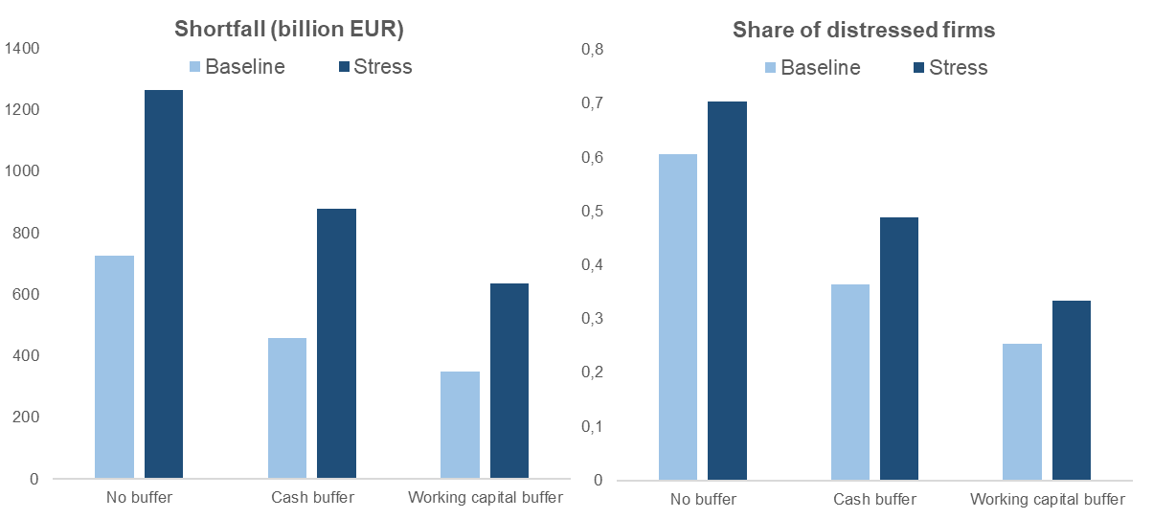

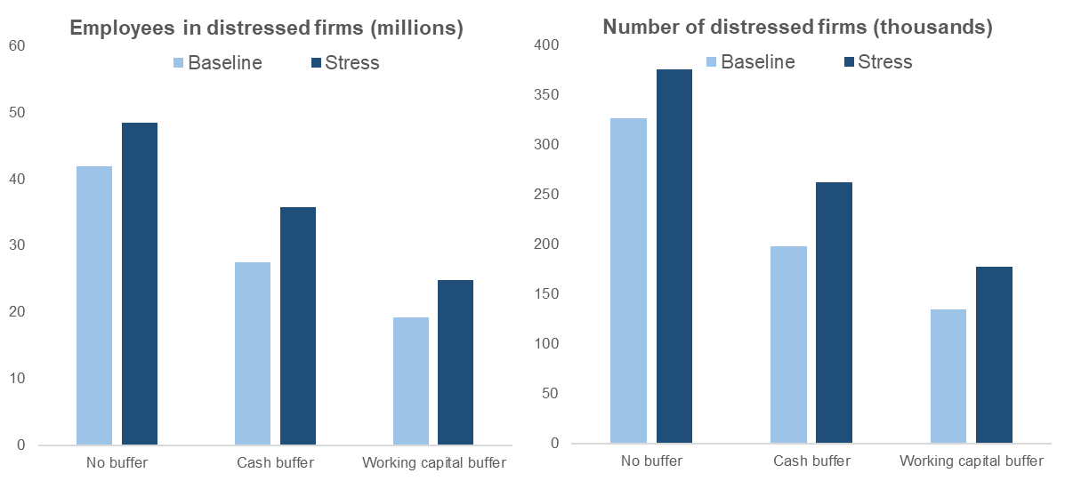

The above presented results correspond to a situation where some policy measures have been put in place to alleviate the impact on firms' financial situation, namely short-time work schemes. These figures can be confronted with those from a simulation that assumes an additional set of policy measures, namely deferral of interest and tax payments, or a simulation without any policy put in place. The chart below shows the financing needs for both the baseline and stress scenario under the different set of policies, assuming no buffer to absorb the losses ("STW scheme" refers to the simulation for which results have been presented so far). The baseline shortfall of 725 billion EUR would increase to ca 825 billion EUR in the absence of STW schemes. Financing needs would be reduced to less than 600 billion EUR if interest and tax payments would be deferred at least to 2021.

Graph A.2: Comparison of total shortfall (under different policy variants, for baseline and stress scenario)

The charts in Graph A.3 present the share of distressed firms across the different EU sectors, under both the baseline and stress scenario, for the case of no buffer as well as cash buffer. Not surprisingly, the sectors showing the greatest share of firms facing liquidity shortfalls are wholesale and retail trade (G), accommodation and food services (I), and transport industries (H).

Graph A.3: Share of distressed firms by sector (for no buffer and cash buffer variant and baseline and stress scenario)

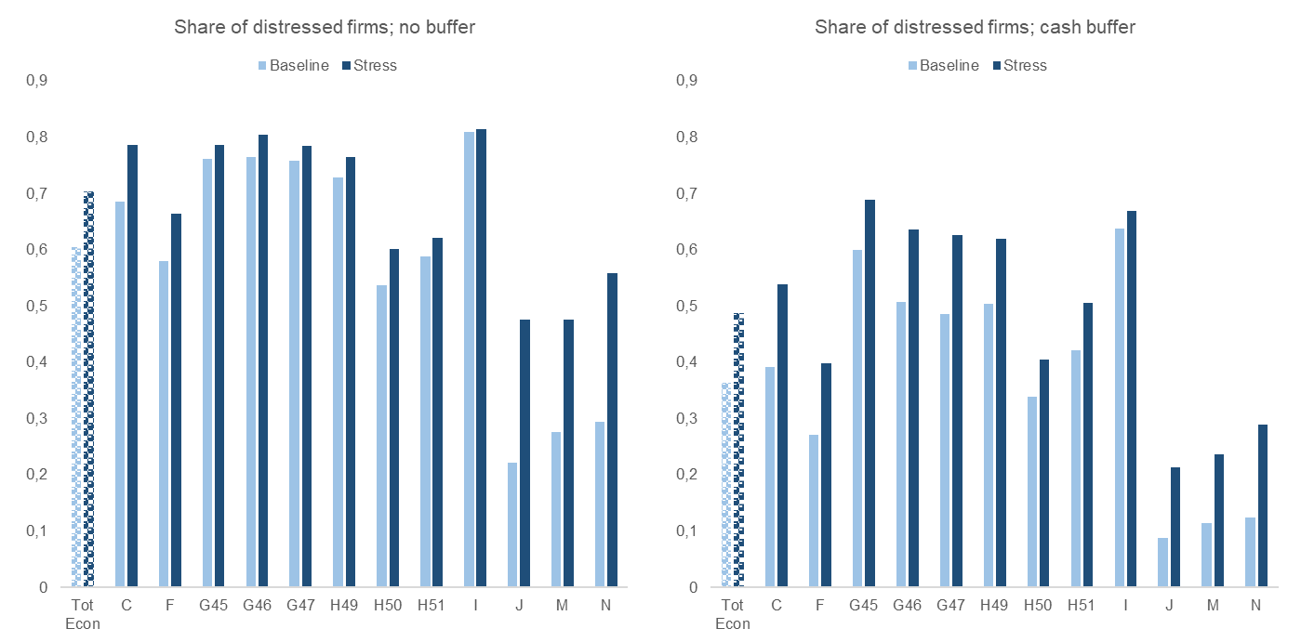

C – Manufacturing; F – Construction; G45 – Wholesale and retail of motor vehicles; G46 – Wholesale except motor vehicles; G47 – Retail except motor vehicles; H49 – Land transport; H50 – Water transport; H51 – Air transport; I – Accommodation and food services; J – Information and communication; M – Professional, scientific, technical activities; N – Administrative, support service activities

The liquidity shortfall may translate into **a higher risk of default especially for firms who already find themselves in a vulnerable position.** A firm is considered as financially vulnerable when it is situated in the top leverage quartile (defined as the ratio of debt to equity) or in the bottom profitability quartile (defined as the ratio of EBIT to turnover). Such vulnerable firms may face difficulties in obtaining access to credit that may be required to cover the shortfall. Indeed, in all scenarios with policy (short-term work schemes and deferral of interest and tax payments), between **58% and 75% of the total liquidity shortfall** is attributable to financially vulnerable firms.

In the **baseline scenario with policy**, the total shortfall attributable to such firms after activation of the liquidity buffer amounts to 250 bn EUR by the end of 2020. The corresponding amount after activation of the working capital buffer is only slightly lower, i.e. about 200 bn EUR. In the **adverse scenario with policy**, the *share* of the total shortfall in vulnerable firms is somewhat smaller because many more firms become illiquid, but the *total amount* of the shortfall in vulnerable firms nearly doubles because the shocks are more severe. The shortfall in financially vulnerable firms amounts to 450 bn EUR after activation of the liquidity buffer and 400 bn EUR after activation of the working capital buffer (see Graph A.4).

Graph A.4: Total shortfall in financially vulnerable firms (with policy)

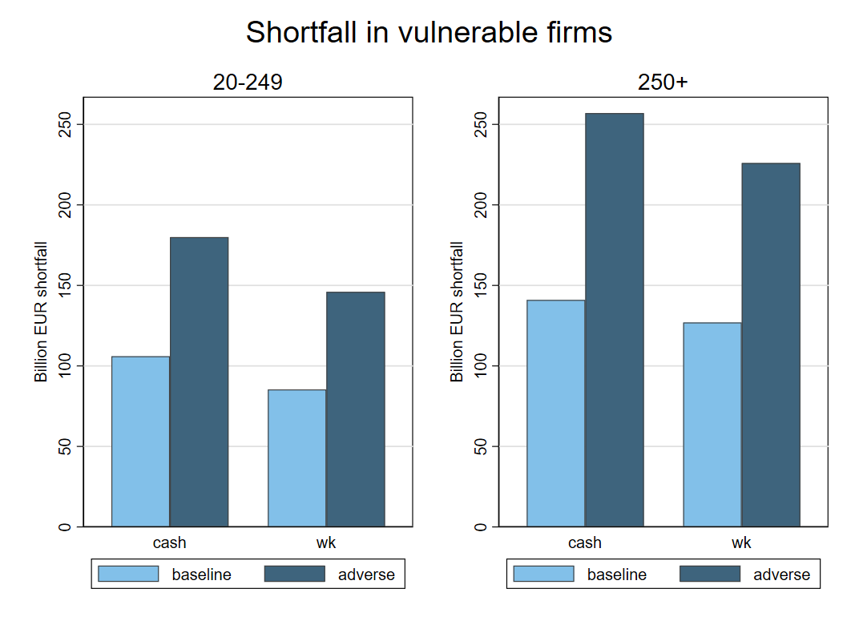

From a sectoral perspective, manufacturing (C) and retail (G) are the two sectors in which a relatively large share of the total shortfall after activation of the liquidity buffer falls within the vulnerable firms. For example, in **retail**, about a quarter of the total shortfall is attributable to the vulnerable firms in the group with 250+ employees while a third of the total shortfall is attributable to such firms in the group with 20-249 employees. In the other sectors, the share of vulnerable firms in the total liquidity shortfall is below 5%. Results are qualitatively similar in the adverse scenario as well as in the case of the working capital buffer.[23]

Graph A.5: Share of total liquidity shortfall in high leverage – low profitability firms (baseline with policy)

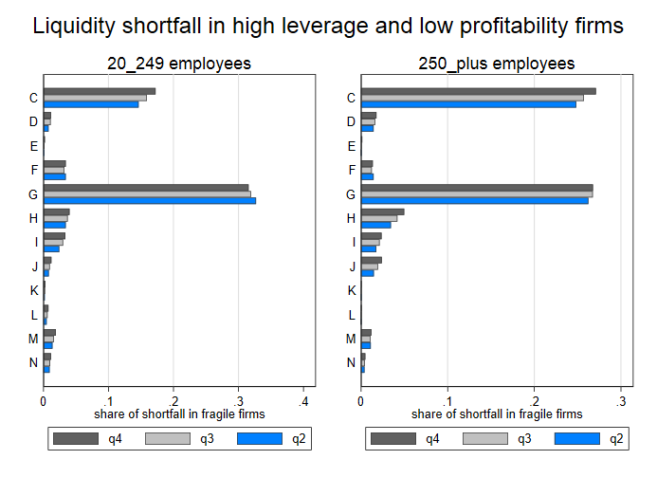

# Annex II: *indicative equity and investment losses for 14 industrial ecosystems*

*The breakdown is indicative, based on available survey data.*

**Estimated distribution of equity and investment needs across ecosystems using survey data**

Given the unique nature of this crisis the uncertainty surrounding any estimate is bigger than usual. . Survey data and information from stakeholders, if properly validated, reflect real time information and can be a valuable asset to complement other estimates.

The notion of Ecosystems captures the complex set of interlinkages among sectors and firms spreading across countries in the Single Market, and is therefore useful to support this analysis. The Ecosystems encompass all players operating along a value chain: the smallest start-ups and the largest companies, the research activities, the services providers and suppliers. They allow for a bottom-up approach that takes into account specificities of business models, high percentage of vulnerable players (SMEs and micro) and interdependencies. So far, 14 industrial ecosystems spreading across the EU have been identified.

It suggests how the overall financing needs could be distributed across ecosystems, using stakeholder and survey information on their expected drops in turnover (compared to a year earlier). This information complements other sources on the actual extent of the impacts as is in line with the approach followed by other institutions.[24]

**Equity losses**

The note has shown that the estimation of equity losses is a difficult endeavour, leading to a range of estimates, between 720 billion in the baseline scenario and 1.200 billion in the stress scenario. Understanding in which ecosystems these equity needs lie is crucial to prioritise spending and support with limited means. To assess the toll the current crisis has taken we have used survey methods to identify expected revenue losses in the most important industrial ecosystems in Europe which then we use as a key –together with size- proxy to allocate the equity losses.

|  |
| --- |
| **Current and expected drops in turnover reported by industry (share of turnover)** |
|  |
| Source: DG GROW survey, March and April 2020. Data aggregated by ecosystem. For the scope of this exercise, each ecosystem has been defined in a relatively narrow way to avoid double counting of losses. The retail ecosystem does not include sales and repair of vehicles, which are included in the mobility ecosystem. |

These figures should be interpreted with caution because of sample limitations. Nevertheless these expected drops in revenue might provide a rough proxy for how different ecosystems are impacted. The table and figures below shows the resulting equity loss distribution starting from the aggregate equity needs developed in the note, across two scenarios:

|  |  |  |  |
| --- | --- | --- | --- |
|  | Scenario €720bn |  | Scenario €1200bn |
| Tourism | 171 |  | 285 |
| Mobility-Transport-Automotive | 91 |  | 152 |
| Aerospace & Defence | 13 |  | 22 |
| Construction | 113 |  | 188 |
| Agri-food | 22 |  | 37 |
| Energy Intensive Industries | 61 |  | 101 |
| Textile | 12 |  | 20 |
| Creative & Cultural Industries | 33 |  | 55 |
| Digital | 16 |  | 27 |
| Renewable Energy | 3 |  | 5 |
| Electronics | 3 |  | 5 |
| Retail | 57 |  | 94 |
| Proximity & Social Economy | 52 |  | 87 |
| Health[25] | N/A |  | N/A |
| Total | **€648bn** |  | **€1080bn** |

The ecosystems listed in the table represent roughly 70% of the EU economy, but roughly 90% of the business economy (as a share of value added). We can attribute the estimated equity losses to each ecosystem based on this share and on the information collected from stakeholders.

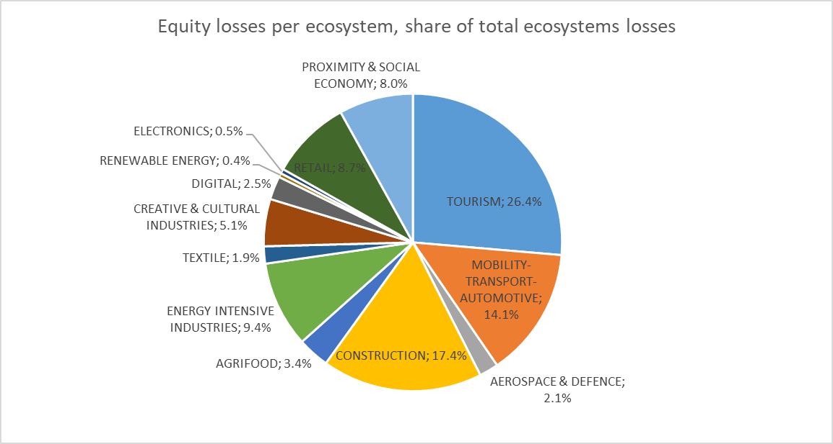

**Investment needs**

Investment needs are allocated across ecosystems next. At this stage, **only the basic investment needs are distributed** while further work will be carried out for green, digital and resilient investment. As we move on, the challenge will be to allocate to each ecosystem the amount of investment needed not just to bounce back to pre-crisis levels, but to bounce forward and meet the pressing challenges of strengthening resilience and digital and green transitions.

The note suggests a cumulative drop in investment of €846bn in 2020 and 2021 taken together, of which €831bn is accounted for by lower private investment. This figure represent the fall compared with pre-crisis levels, which were, nevertheless, worryingly low. In order to attribute such investment needs across ecosystems, we apply a combination of the share of the ecosystem in the economy together with the pre-crisis level of investment. The resulting figures, then, can be used to attribute the share of investment corresponding a 90% share of the total envelope, which probably better reflects the actual investment needs of the ecosystems.

|  |  |  |
| --- | --- | --- |
| Basic investment needs | | |
| Tourism | 161 |  |
| Mobility-Transport-Automotive | 64 |  |
| Aerospace & Defence | 4 |  |
| Construction | 54 |  |
| Agri-food | 32 |  |
| Energy Intensive Industries | 88 |  |
| Textile | 6 |  |
| Creative & Cultural Industries | 6 |  |
| Digital | 66 |  |
| Renewable Energy | 100 |  |
| Electronics | 18 |  |
| Retail | 115 |  |
| Proximity & Social Economy | N/A |  |
| Health | 32 |  |
| Total | **€748bn** |  |

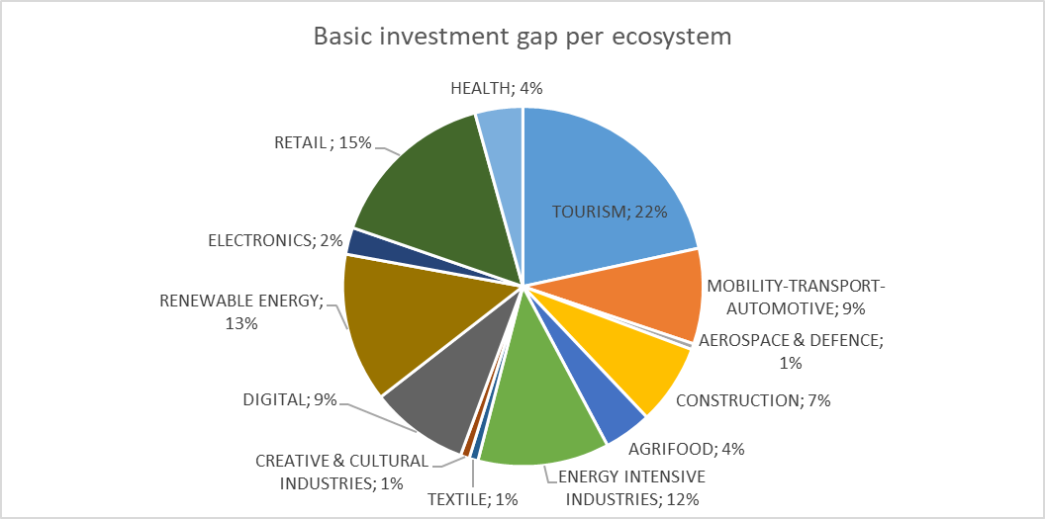

# Annex III: QUEST Simulations of the economic impact of a Recovery Instrument

# Overview:

**This note reports QUEST model simulations on macroeconomics effects of the Recovery Instrument** included in the multiannual financial framework 2021-2027 (MFF).[26]

**A particular focus of this note is the distributional dimension across stylized blocks in the EU.** This note thereby complements previous work by ECFIN B3 on different assumptions regarding the additionality of public and private investment.

# Scenario setup

## Modeling framework

**The analysis builds on a multi-region QUEST model featuring three blocks of the EU-27** and the rest-of-the-world. A rich empirical trade matrix links all regions of the model.

**For the modelling exercise, Member States are grouped according to GDP per capita and debt-to-GDP ratios.** The high-income group consists of all Member States with a GDP per capita above the average.[27] The other two groups include the Member States with a below-average income per capita. Here, the “EU below average (high debt)” includes the Member States characterized by high public indebtedness. All remaining Member States are grouped as “EU below average (low debt)”. Assuming either pegged currencies or common monetary policy, the Member States in the high-income group and high-debt group form a currency union, where monetary policy is constrained by the effective lower bound.[28]

**The model accounts for region-specific features such as a nonlinear exposure to sovereign debt risk** and vulnerable financial markets in the high-debt group, as well as region-specific trade openness and trade linkages. These features matter for the macroeconomic effects of the Recovery Instrument and motivate the stylized grouping for this modelling exercise.

To summarize, the blocks includes the following Member States:

* EU above average GDP per capita: AT, BE, DE, DK, FR, FI, IE, LU, NL, SE
* EU below average GDP per capita (high debt): CY, EL, ES, IT, PT
* EU below average GDP per capita (low debt): All EU-27 members not included in the previous groups.

## Size and time profile of the Recovery Instrument

**Table 1 presents an overview of the configuration of the Recovery Instrument** considered in this note.The overall package of EUR 750 bn, in total, evenly allocated across four years (25% in each year from 2021 to 2024). This corresponds to around 5.4% of annual EU-27 GDP or 1.35% of 2019 GDP in each year.

Table 1: Simulation inputs (Scenario 2)



*Note:* All components of the package are allocated between 2021 and 2024 (25% in each of the four years). GDP shares refer to shares of annual GDP in 2019.

## The allocation key

**The Recovery Instrument implies important redistribution across Member States.** The analysis aggregates a detailed allocation key. Table 1 presents the respective shares for each of the three clusters. Annex A provides further details at the Member State level.

**The simulations assume that the same allocation key applies for all components of package** (grants, loans, additional provisioning to InvestEU, see below). The group with a GDP per capital above average receives 24.5% of the package, the “EU below average (low debt)” receives 25.0%, and the “EU below average (high debt)” receives around 50.6%. It is assumed that all Member States contribute according to their GDP shares.[29]

## Components of the package

### Grants and loans

**The largest share of the overall packages goes to boost public investment** **in forms of grants and loans.** EUR451 bn. (out of EU 750 bn) will be provided in the form of grants to finance public investment. EUR 250 bn. resources will be lending to the Member States to finance public investment. These back-to-back loans will be repaid gradually over 20 years by the beneficiary Member States.

**Grants and loans have different implications for net foreign assets and government debt:**

* Providing a grant increases government debt and reduces net foreign assets (vice versa in case of receiving a grant).
* Providing a loan increases net foreign assets (vice versa in case of obtaining a loan).

### Additional provisioning to InvestEU and ESFI

**ESFI and InvestEU use the remaining share of the package as loss provisioning for the financing of private investment.** In times of inefficient loan provision by private banks, these guarantees allow the mobilisation of significantly larger financing volumes for private investment. Assuming a provisioning rate of 40%, the guarantees can be larger than additional provisioning by a factor of 1/0.4=2.5. However, there are opportunity costs. The government must set aside the guarantees in case of loan defaults, which could have been invested directly in the economy. Therefore, the factor needs to be adjusted to 1/0.4-1 =1.5.[30]

## Assumptions on additionality

### Loans and grants

**The simulations assume that Member States use 50% of the EU loans and 100% of EU grants for additional public investment.** Only 50% of EU loans are used for public investment. Since the other half finances general government spending, which would take place anyway (and thereby frees resources), the impact on debt is also 50%. This assumption relates, for example, to borrowing costs. With loans, the receiving government still faces the problem of rising interest rates. It has an incentive to use the loan to finance existing investment, which reduces additionality.

**The note also considers the case of 50% additionality of grants (labelled below as “L scenario”).** This sensitivity check reflects a potential lower absorption of EU grants given the large package size.

### Additional provisioning and private lending

**The economic additionality of private lending is based on the notion of loan supply restrictions by private banks in the current downturn**. The additionality is likely much lower outside of a credit crunch.[31]

**The analysis here assumes that all additional funding is provided as equity**: One additional euro in provisioning for EFSI and Invest EU leads to 1.5 euro of additional private investment.

**How these assumptions can be achieved is not addressed here**: The additional investment in the private sector based on the provisioning for EFSI and Invest EU is an assumption and not an outcome of the model-based analysis.[32]

## Sovereign debt risks

**The Recovery Instrument addresses concerns about intertwined financial-sovereign debt risks** following the unprecedented adverse effects of the COVID19 pandemic. The analysis of sovereign debt risks in the context builds on earlier work by B3 and is based on the debt projections of ECFINs Spring Forecast 2020.[33]

**The analysis assumes a nonlinear relationship between the default risk premia and the level of government debt** in the high-debt cluster. Higher debt-to-GDP ratio associated with sovereign debt risks implies higher financing costs for the government and the private sector. Annex B provides additional information.

**The calibration builds on a high risk-scenario of 2011 - admittedly an extreme case of distress. Current spreads are much lower.** Yet, it provides useful insights into the potential macroeconomic fallout from sovereign debt risks.[34]

**Reallocation, grants, and reduced indebtedness help avoid increases in risk premia** and adverse sovereign-corporate feedback loops**.** This mechanism will be an important driver in the results for the high debt group.

# Summary of Main Results

## Transmission

**For the public investment share of resources, the fiscal multiplier slightly above one contributes to a reduction in the debt-to-GDP ratio in the first year** (denominator effect). In the following years, there is an increase in debt ratios (see below). However, it remains modest as higher revenues from VAT, labour taxes, and profits as well as lower unemployment benefits relative to a no-policy change baseline partly offset the budgetary cost of higher public investment. The growth effect depends crucially on the assumed productivity of public capital.[35]

**All regions benefit from positive spillover due to the coordinated fiscal effort.**

**The “multiplier” of private investment is large in case of loan supply restrictions by private banks**. By assumption, one additional euro in provisioning for EFSI and Invest EU leads to one and a half euros of additional GDP. Correspondingly, the assumed increase in private investment is sizable (see Table 2).

**The absence of budgetary costs for the additional provisioning to ESFI and InvestEU is critical.** It has strong implications for the evolution of public debt and implies favourable debt dynamics.

## Quantitative results

### Dynamics of real GDP and debt

**Because of the mobilized investment, the level of GDP in the EU-27 is estimated to be around [2.3%] higher in 2024 than foreseen in our baseline**.[36] The GDP level increases in the first years (2021-2024) relative to a no-policy change baseline. Figure 1 shows this result graphically by reporting the level deviation of key variables compared to our baseline. Further below we also discuss the positive labour market developments and stronger private investment in more detail.

**Figure 1 also shows that the Recovery Instrument is estimated to lower the debt-to-GDP ratio by up to [0.9 pp.] on average (2021-2024)** for the EU27 aggregate. While debt increases in nominal terms, the budget deficit increases by less than the ex-ante stimulus due to automatic stabilisers. The average debt-to-GDP ratio is lower on impact (denominator effect) but - given the persistent GDP effect – remains below the baseline.

**Turning to the distributional effects, Figure 2 shows that GDP effects are positive but quantitatively different across block**s. Given the allocation key, the clusters with below-average GDP per capita levels are estimated to experience the largest boost to GDP levels. The increase in output reaches almost [4.6 %] for the low debt group and [4.2 %] for the high debt group in 2024, under full additionality of grants. The group of above-average GDP per capita levels is likely to experience smaller, but still sizable GDP effects of [1.2%] compared to baseline over the same period.

**The debt-to-GDP ratio falls for the groups with a below-average per capita GDP (low and high debt), but increase slightly in the high-income group** (Figure 3).Loans increase the debt ratio only slightly since the public investment also leads to sizable GDP growth. By construction, receiving grants and additional provisioning lowers the debt-to-GDP ratio compared to baseline, respectively.

**Real GDP in the low-debt (below average) cluster increases strongly** in 2021. Most of the growth effects come from grants (orange). By contrast, the low debt levels imply negligible effects from reduced sovereign debt risks compared to the high-debt cluster.

Figure 1: Results for the EU-27 as a whole

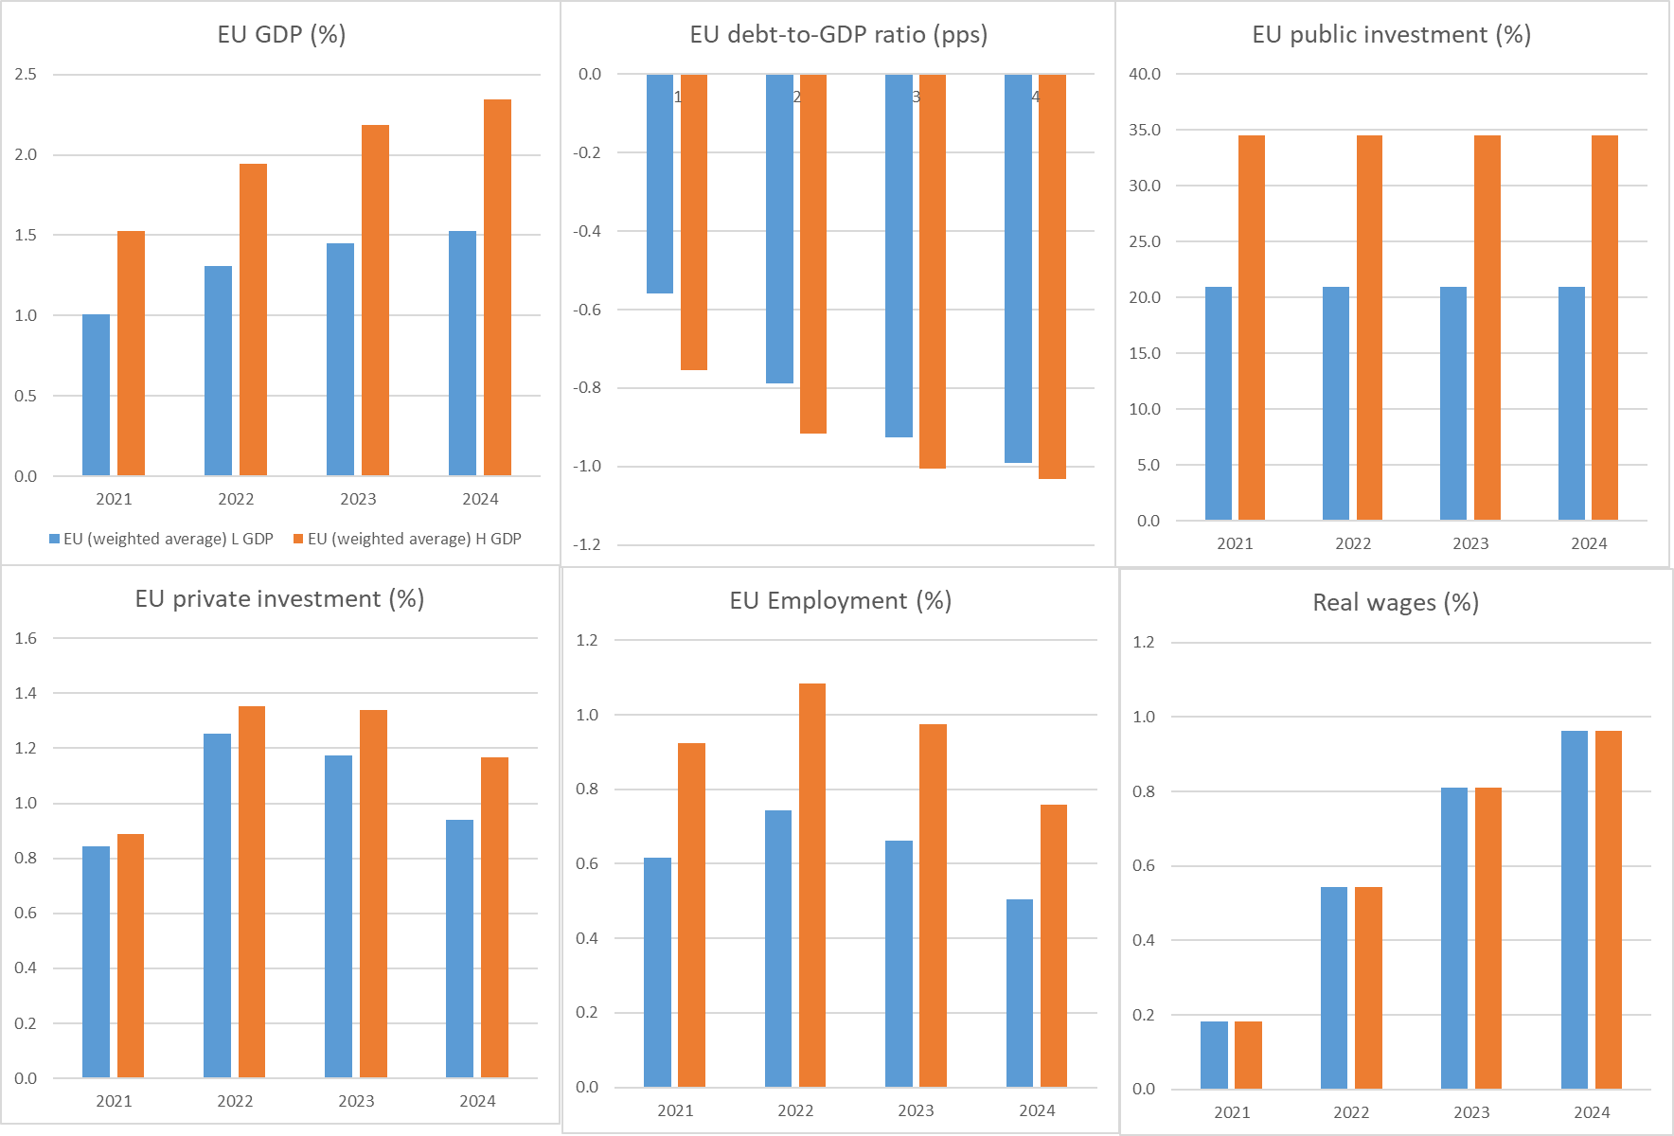

*Note:* This figure reports the debt-to-GDP ratio (all other variables) in percentage point (percent) deviation from a no-policy change baseline. All variables are reported in levels. H (orange) and L (blue) scenarios refers to high and low additionality of *grants* (loans are always 50% additional). EU refers to EU-27 (weighted) averages.

**The high debt group benefits from reallocation and reduced sovereign debt risks – given the assumption of high spreads** (see Figure 3, yellow bars). Relatively lower risk premia and spreads improve private investment and consumption of durable goods. The lower pass-through of sovereign risk avoids distress in the private-sector borrowing costs, which was a key transmission channel in the sovereign debt crisis. Turning to public sector borrowing costs, note that the sovereign risk increase only affects new issuance. The maturity structure thus implies a gradual increase in debt service in light of average maturity of around seven years.[37] This delayed effect also explains the persistent beneficial effects on the debt-to-GDP ratio. Note, however, that current spreads would imply smaller gains. As pointed out above, the calibration of debt risks is based on extreme assumptions, namely adverse sovereign-corporate loops of the severity observed in 2011-2013.

**Interestingly, reallocation increases GDP in the high-income group due to higher exports** following improved demand from the groups with a GDP per capita below average.[38] Nonetheless, the provision of (net) grants increases the debt-to-GDP ratio in the high-income group. In sum, the debt ratio increases slightly in the high-income group in the first years but decreases in the other blocks.

Figure 2: GDP (%) across clusters

High additionality of grants (H scenario)

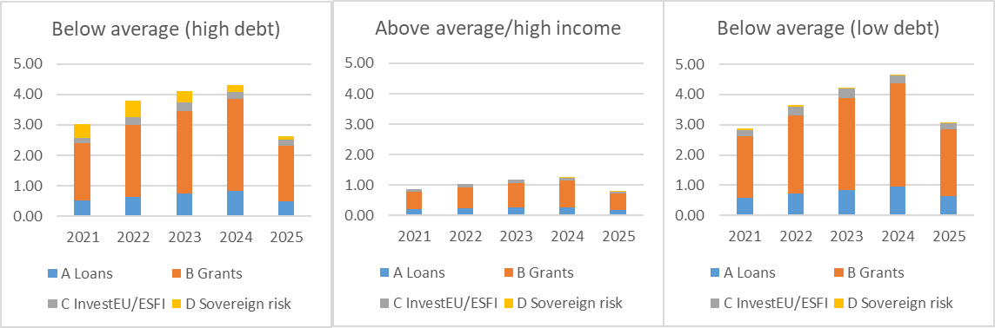

Low additionality of grants (L scenario)

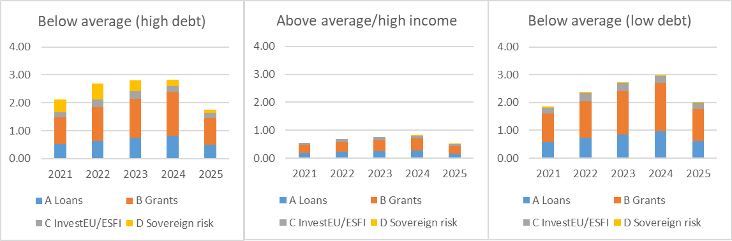

*Note:* The figure reports GDP in percent deviation from a no-policy change baseline (in levels). H and L scenarios refers to high and low additionality of *grants* (loans are always 50% additional).

**The GDP effects are smaller under lower additionality of grants** sincenot all resources are used for additional public investment (L scenario in the Figure 1-3 and Table 2). Nonetheless, the EU grants free budgetary resources. Consequently, the debt-to-GDP ratio falls more in the clusters with below-average GDP per capita compared to a scenario with full additionality. Exports in the above-average group, however, benefit less from sizable positive spillover (GDP effects in the other regions are small) and the debt-to-GDP ratio is slightly higher than in the full additionality case due to a smaller output expansion.

Figure 3: Debt-to-GDP ratio (pps) across clusters

High additionality of grants (H scenario)

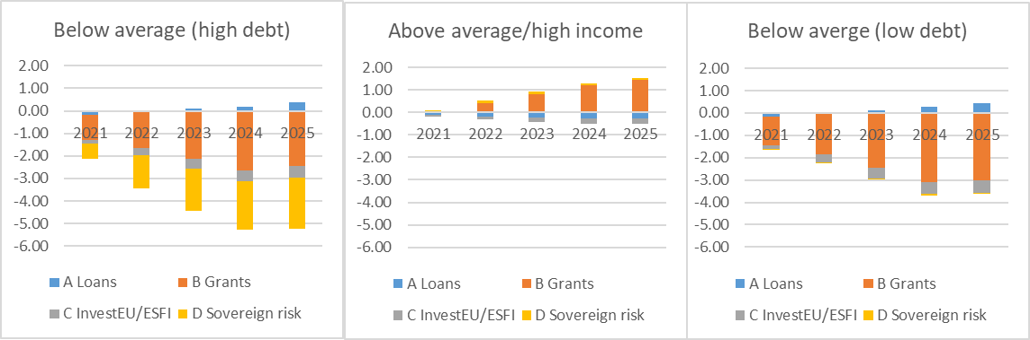

Low additionality of grants (L scenario)

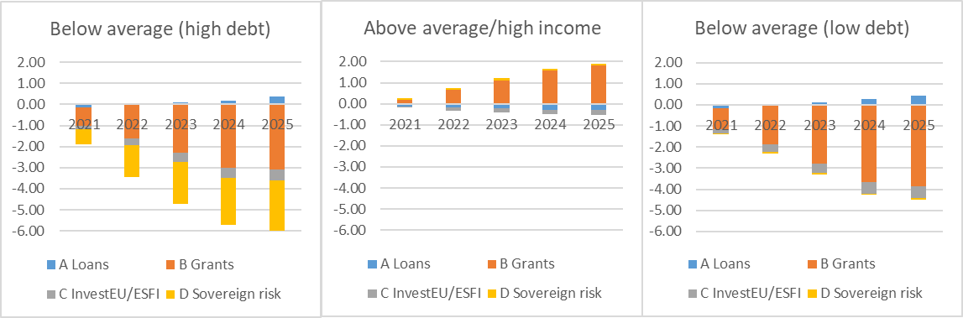

*Note:* The figure reports the debt-to-GDP ratio deviation from a no-policy change baseline (in levels). H and L scenarios refers to high and low additionality of *grants* (loans are always 50% additional).

### Labour markets

**The model simulations suggest a short-run increase in employment of in the range of two million jobs for the EU as a whole.** Figure 4 showsas employment increases by up to [1.1 pp.] in 2022, the year with the highest impact resulting from stronger demand. The strength depends on the assumed additionality of EU grants. There is also marked heterogeneity across regions. Similar to the GDP effects, employment growth is highest in the below-average groups – in particular in the low debt cluster, which receives the largest share (in terms of own GDP).

**In the medium run, real wage increases relative to the baseline reflect higher productivity and the improved labour market conditions.** In the model, real wages adjust sluggishly due to wage adjustment frictions (e.g. bargaining processes). Real wages increase following higher private capital and productivity gains from public investment. The rise in real wages persists after the governments discontinue direct stimulus packages.

### Private investment

**The level of private investment in the EU-27 is estimated to be more than [1%] higher than in the baseline (on average) following assumed improvements in loan supply from InvestEU and ESFI**, which effectively lower the cost of capital.Monetary policy is constrained by the zero lower bound, and nominal rates are not raised in response to the investment boom for two years. This monetary accommodation contributes to the ex-post impact on investment. The dynamics of the real interest rate give rise to second-round effects on investment and the consumption of durable goods.[39]The effects on private investment are persistent.

### The medium run

**Table 2 shows that the levels of real GDP, real wages, and private investment remain persistently above a no-policy change baseline** (here shown until 2030). The table also includes the time series of public and private investment, GDP and debt, as well as employment and real wages for all regions and both scenarios. It shows the increases in GDP, real investment, and real wages are persistent.

Figure 4: Labour markets and investment

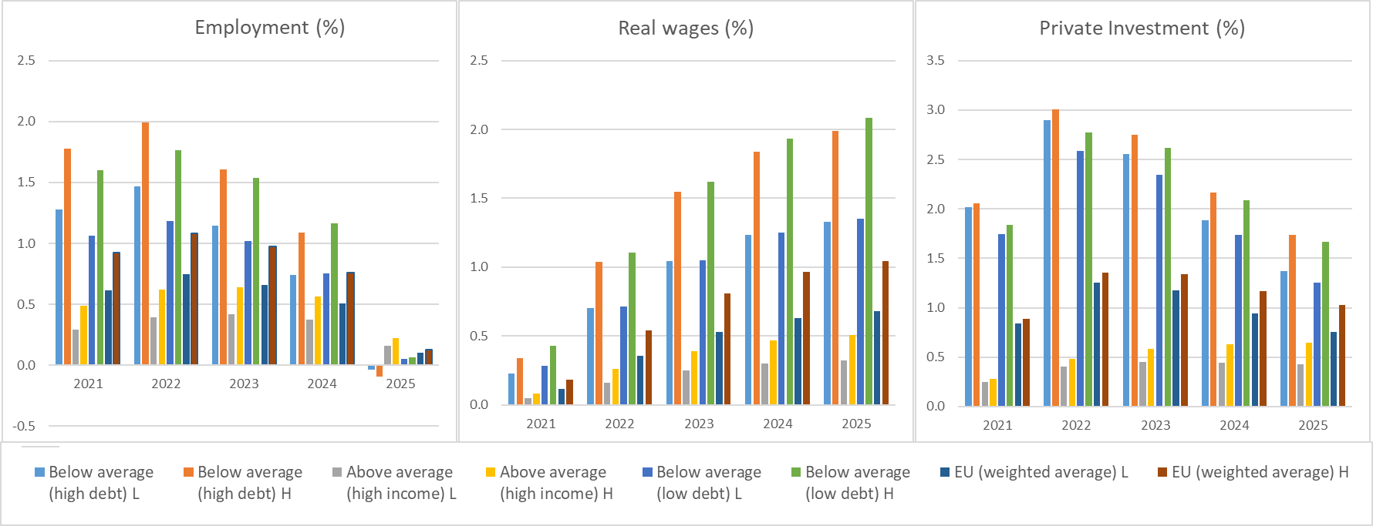

*Note:* This figure reports the all variables in percent deviation from a no-policy change baseline. All variables are reported in levels. H and L scenarios refers to high and low additionality of *grants* (loans are always 50% additional). EU-27 values are (weighted) averages.

Table 2: Detailed simulation results



*Note:* All variables are reported in levels. The debt-to-GDP ratio is reported in percentage point deviation from a no-policy change baseline. Other variables are reported in real terms and in percent deviation from a no-policy change baseline. H and L refer to the assumed additionality of grants.

Allocation keys

Table A.1: Allocation key

*Note:* E, S, and H groups refer to EU below average GDP per capita (low debt), EU below average GDP per capita (high debt), and EU above average per capita income (high income), respectively.

Sovereign debt risk

**Figure B.1 shows the historical and current evolution of spreads in IT and ES** (expressed in basis point difference to 10-year government bond yields in DE).

Figure B.1: Dynamics of Spreads

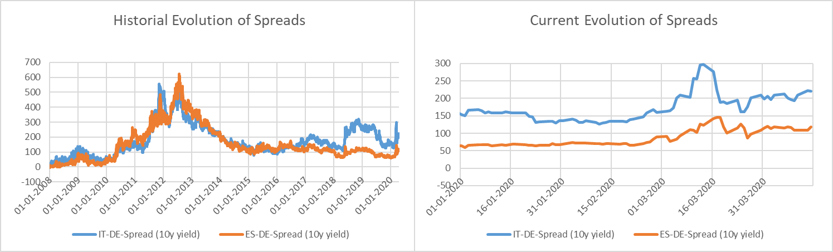

*Note:* This figure shows the historical (left panel) and current (right panel) evolution of spreads of 10-year government bonds yields in IT (blue) and ES (orange). The vertical axis reports spreads in bps. and in difference to DE government bond yields.

**Current spreads are relatively low but rising.** Current levels (as of 16/04/2020) are at 230 basis points (bps) and 127 bps for IT and ES, respectively. Yet, they remain significantly below the spreads observed in 2011-2013.

**The sovereign debt crisis in the euro area provides historical evidence on sovereign default risk and government debt in times of distress.** Models of sovereign debt and empirical evidence often point to a nonlinear relationship between the default risk premia and the level of government debt: Corsetti et al. (2013) find such a relationship between credit default swaps (CDS) for governments bonds (5-year maturity) and the level of government debt (as a share of GDP) for OECD countries.[40] Figure B.2, taken from Roeger and In ‘t Veld (2013, p.7), shows the highly convex relationship between CDS spreads for governments bonds (5-year maturity).[41]

**Figure B.2 shows the nonlinear relation of debt levels and spreads during the peak of the sovereign debt crisis.** Later on, the announcement of OMT in the second half of 2012 has reduced spreads, and the convexity of the relationship is lower in February 2013. As emphasized in Roeger and In ‘t Veld (2013), non-linearities become more severe for debt levels beyond 90%. There is also significant time variation and dispersion across countries.

**As shown in Table B.1, the Spring forecast projects as strong rise in the debt-to-GDP ratios in the EU high-debt group.** The average debt ratio is projected to reach 132%. According to the evidence on Figure B.2, the fall in debt based the Recovery Instrument would imply a reduction in risk premia by around 20 to 25 bps.

**The simulations assume that 50% of the sovereign risk premia spill over to the private sector borrowing costs**. This value is high but in line with the evidence on sovereign-to-corporate risk spillover in Durbin and Ng (2005), implying a substantial increase financing costs for private investment. The quantification of sovereign-to-private spillover in financing costs is also comparable to simulation results from the QUEST version with a banking sector (Breuss et al. 2015). In this model version, the spillover of sovereign risk to loans supply and equity investment is endogenous and occurs through the balance sheet, notably the capital requirements, of banks. See also the discussion and evidence in In ‘t Veld (2013) and Zoli (2013). [42]

Figure B.2: 5-year sovereign CDS spreads vs debt-to-GDP ratios (July 2011)



Table B.1: Debt levels (% of GDP) in the high debt group (ECFIN Spring forecast projection for 2021)



1. <https://www.consilium.europa.eu/en/press/press-releases/2020/04/23/conclusions-by-president-charles-michel-following-the-video-conference-with-members-of-the-european-council-on-23-april-2020/>
2. See Communication of 15 April <https://ec.europa.eu/info/sites/info/files/communication_-_a_european_roadmap_to_lifting_coronavirus_containment_measures_0.pdf>
3. Includes COVID-19 aid measures approved by the Commission based on the State aid Temporary Framework and Articles 107(2)(b) and (3)(b)TFEU. 1)). This does not include support that countries may have granted support without needing Commission approval (e.g. general measures for the whole economy such as “Kurzarbeit” schemes and/or aid measures that are block-exempted from approval by the Commission). There are important caveats about the data, which e.g. might have been based on different assumptions, do not reflect economic effect of measures, are based on the budgets of the notified measures, not the aid element involved. Irrespective of this, they can still serve as a first indication of potential trends as regards support measures in the current crisis.
4. The containment measures lead to a very sharp drop in production and turnover. Firms are likely to react to this by scaling back production, postponing capital expenditure, cutting dividends (and share buyback programmes) and spending down cash reserves. The running down of cash reserves and the cuts in dividends have a direct impact on equity value of firms. Financial analysts have estimated that in 2020 EU listed corporates will spend down cash reserves to the tune of €550bn and cut dividends by €90bn in 2020 alone. See e.g. <https://www.bridgewater.com/research-library/daily-observations/greg-jensen-20-trillion-hit-to-global-corporations/>
5. Annex I documents this analysis in a greater detail. In view of important uncertainties and data limitations, the simulations are based on rather conservative technical assumptions and the results should be seen as providing lower bounds for the needed equity repair.
6. The simulations reported in the Annex I also consider, in a stylised form, additional policy measures such as deferred tax and interest payments. Further measures that Member States have introduced to support companies, e.g. loans or guarantees, are not modelled.
7. The stress scenario corresponds to the “longer lasting” adverse scenario as described in the Commission’s Spring Forecast.
8. The “liquidity buffer” simulations assume that all firms can deplete their cash reserves to (at least partially) cover the losses. As a result, the volume of financing shortfall is smaller than the volume of accumulated losses. The “working capital” simulations consider that firms can also deplete other liquid assets, beyond cash. In such a case, the firm can sell off all liquid assets but only to the extent that these assets are larger than its current liabilities. Eventually, the shortfall of working capital is a good approximation of needed equity replenishment, under the assumption that firms cannot (quickly) deplete their fixed assets.
9. A firm is considered to be financially vulnerable when it is situated in the top leverage quartile (defined as the ratio of total debt to total equity) or in the bottom profitability quartile (defined as the ratio of EBIT to turnover).
10. Note that due to the large slack in the economy due to the CoVid crisis, additional investment is likely to have limited crowding out effects. Model simulations of investment increases to meet the EU’s current 2030 climate and energy policy goals (see below) assumed that the economy operates at full capacity. In such context any increase in investment across the economy must be met by a decrease in private consumption through a reallocation of resources.
11. APIs (active pharmaceutical ingredients) constitute the most important component of the pharmaceuticals supply chain. EU accounts for 27.9 % of the world’s API production (60.5 % being produced in China and India, 4.6 % in North America and 7% in the rest of the world). Europe imports 80% of chemical raw materials and APIs from China and India, mainly for generics (67% of all medicine supplies on the EU market). The dependency on chemical raw materials, necessary for production of APIs, is considered critical worldwide and the outbreak and the spread of virus has illustrated the vulnerability of the EU supply chains.
12. COM(2020) 102
13. [Communication assessing the 28 draft NECPs,](https://eur-lex.europa.eu/legal-content/EN/TXT/?qid=1565713062913&uri=CELEX:52019DC0285) COM(2019) 285 final
14. Investments into the circular economy are partially addressed. In order to account for the increased policy ambition of these initiatives, estimates will need to be adjusted and may need to be increased.
15. The main investment needs for the digital transformation are in telecommunications infrastructure. There is consensus among experts that market forces will not guarantee the achievement of the Digital Agenda for Europe and European Gigabyte Societies targets. According to a recent study commissioned by the EIB (forthcoming), the estimated investment needs to meet such targets as from 2018 amount to €345-360bn for the EU27 (€380-395bn for the EU28). Expected private funding will cover about one third of this amount, leaving an estimated investment gap on an annual basis of around 42bn€ until 2025. As the private funding baseline was projected before he COVID crisis, the gap may have increased due to investment cut backs in the private sector (that are covered in the cumulative investment drop estimated in section 3.2.1) In addition, there are investment gaps for e.g. digital skills, high performance computing, AI, digitalisation of businesses, digitalisation of the public administration.
16. Note that the €100bn investment gap to stabilise the capital stock as share of GDP is based on the current depreciation rate for public capital. During the green and digital transition phase, part of the capital stock will have to be replaced before it has reached the end of what would have otherwise been its normal economic life. If the transition would lead to a depreciation rate of 7% instead of the current 5,5%, the annual investment gap to stabilise the capital stock to GDP share would be around 190 bn.
17. Even if the sector-based assessments take full account of the extent to which new investment is net of substitution and replacement investments (e.g. old vehicles are replaced by energy efficient low emission vehicles at the end of their economic life), it does not consider the scope for reallocation of investments and the extent to which existing policies at EU or national level address the investment gaps in the baseline. For instance the European Green Deal's Investment Plan should lead to at least €1trn of investments over the coming decade, and the Sustainable Finance agenda aims to use market forces to redirect investments towards support of the green objectives.
18. Below-average income economies with high debt have particularly high total financing needs, not only because of higher budget deficits but also due to larger refinancing needs for maturing government debt. EU instruments contribute to ensuring market access, avoiding undue tightening of fiscal policy and squeezing public investment.
19. EU averages quoted in this section refer to GDP-weighted averages for the 27 EU Member States, using 2019 GDP shares.
20. Member States are grouped according to GDP per capita levels and by general government debt ratios as follows: ‘*higher-income*’ (FR, AT, BE, DE, DK, FI, IE, LU, NL, SE), ‘*Higher-debt’* below-average income (CY, EL, ES, IT, PT), ‘*lower-debt’* below-average income (BG, RO, HR, LV, PL, HU, LT, EE, SK, CZ, MT, SI).
21. Corporate sector vulnerabilities during the Covid-19 outbreak: assessment and policy responses, OECD, ECO/CPE/WP1(2020)12 and Schivardi and Romano (2020).
22. Note that these figures represent the total loss across the firms making losses. It does not account for the drop in profit due to the CoVid-19 crisis among firms that remain profitable.
23. In manufacturing, 13-15% in 20-249 group and 23-25% in 250+ group. In retail, 28-29% in the 20-249 employee group and 20-22% in the 250+ employee group. So the shares are smaller but the total amounts to which these shares correspond are significantly bigger.
24. For instance, the ECB in its Economic Bulletin box (1 May 2020: <https://www.ecb.europa.eu/pub/economic-bulletin/focus/2020/html/ecb.ebbox202003_01~767f86ae95.en.html>) presents a sectoral analysis that is “*indicative and based on anecdotal evidence and available survey evidence. It helped derive economy-wide estimates for the likely economic losses, which are broadly in line with available estimates from other institutions*”.
25. The Health Ecosystem is assumed not to have incurred any equity losses. So far the immediate support provided has helped to cope with the increasing demand and needs. However, the CoVid crisis is putting a strain on the EU’s health and social systems, highlighting the scope for enhancing its resilience and treatment capacity, and the most recent surveys point to relevant negative expectations for the sector, mainly about the capacity of supply to match increasing demand. As a consequence, this is likely to lead to an underestimation of total needs.
26. The note is part of a sequence of confidential notes shared in April and May 2020. QUEST is the global macroeconomic model that the DG ECFIN uses for macroeconomic policy analysis and research. It is a structural macro-model in the New-Keynesian tradition with rigorous microeconomic foundations and frictions in goods, labour and financial markets. Additional information and bibliography can be found here: <https://ec.europa.eu/info/business-economy-euro/economic-and-fiscal-policy-coordination/economic-research/macroeconomic-models_en>
27. Unweighted average using 2019 data, based on chain linked volumes (2010). See Annex A for additional details.
28. This builds on the assumption that the ECB does not raise nominal rates in response to the investment stimulus for two years.
29. Very small rounding error are possible. The GDP shares are 64.5%, 10.7%, 24.8% for high income, below average (low debt), below average (high debt), respectively.
30. The amount of funding that the EIB can provide against 1 euro of capital can be larger for special operation loans to the private sector. Still, for equity, the “multiplier” is one. We will consider only the case of full equity here. A previous note performed additional sensitivity analysis (circulated 28/04/2020).
31. For example, an evaluation of the literature for SME credit guarantees (probably the group most affected by market failure) shows that while CGSs increase the availability of credit and/or reduce its costs, the evidence as regards economic additionality are mixed.
32. **The simulations are based on the following additional assumptions:** (i) There are no budgetary costs of this provisioning for EFSI and InvestEU for the government and the reduction in private sector borrowing costs is exogenous. (ii) The pricing of loans is such that the remuneration covers the losses. (iii) The simulations account for improved credit access via an exogenous decrease in risk premia.
33. A confidential note shared on 17/04/2020 (by Philipp Pfeiffer, ECFIN B.3) and a recent ECFIN discussion paper examine the sovereign-bank nexus in the euro area in more detail (Bellia et al., 2019).
34. Corsetti et al. (2013) find such a relationship between credit default swaps (CDS) for governments bonds (5-year maturity) and the level of government debt (as a share of GDP) for OECD countries. Corsetti, G., Kuester, K., Meier, A. and Müller, G.J. (2013), “Sovereign Risk, Fiscal Policy, and Macroeconomic Stability”. *Economic Journal*, 123: F99-F132.
35. The simulations assume an output elasticity of public capital is 0.12 (roughly median estimate in the empirical literature).
36. The EU-27 variables are weighted averages based on 2019 GDP shares.
37. Household and firm expectations of higher future taxes to cover the budgetary costs generate some feedback.
38. This result was obtained by simulating the investment programmes only in the groups with below-average GDP per capita.
39. In addition, the expansionary effects of the other components of the package stimulate private investment further, leading to a sizable increase in private investment. Investment adjustment frictions explain why private investment increases more in 2022 than in 2021.
40. Corsetti, G., Kuester, K., Meier, A. and Müller, G.J. (2013), “Sovereign Risk, Fiscal Policy, and Macroeconomic Stability”. *Economic Journal*, 123: F99-F132. doi: 10.1111/ecoj.12013
41. Roeger W., and In ‘t Veld, J. (2013): “[Expected sovereign defaults and fiscal consolidations](https://ec.europa.eu/economy_finance/publications/economic_paper/2013/ecp479_en.htm)”, European Economy. Economic Papers 479. April 2013.
42. Jan in ’t Veld (2013) “[Fiscal consolidations and spillovers in the Euro area periphery and core](https://ec.europa.eu/economy_finance/publications/economic_paper/2013/pdf/ecp506_en.pdf)”. European Economy. Economic Paper no.506.

    Zoli, E. (2013), Italian Sovereign Spreads: Their Determinants and Pass-through to Bank Funding Costs and Lending Conditions, IMF Working Paper 13/8.