

PURPOSE OF THE REPORT

The euro is meant to be the single currency of the European Union as a whole. It is now used every day by around 342 million people in 19 Member States in the euro area. The practical benefits of the euro include stable prices, lower transaction costs for citizens and businesses, more transparent and competitive markets and increased intra-EU and international trade. The euro is also the second most used currency worldwide.

Article 140(1) of the Treaty on the Functioning of the European Union (hereafter TFEU) requires the Commission and the European Central Bank (ECB) to report to the Council, at least once every two years, or at the request of a Member State with a derogation[1], on the progress made by such Member States in fulfilling their obligations regarding the achievement of economic and monetary union. The latest Commission and ECB Convergence Reports were adopted in May 2018.

The 2020 Convergence Report covers the following seven Member States with a derogation: Bulgaria, Czechia, Croatia, Hungary, Poland, Romania and Sweden[2]. A more detailed assessment of the state of convergence in those Member States is provided in the Staff Working Document accompanying this Report[3].

Article 140(1) TFEU requires the reports to include an examination of the compatibility of national legislation, including the statutes of the national central bank, with Articles 130 and 131 TFEU and the Statute of the European System of Central Banks and of the European Central Bank (hereafter ESCB/ECB Statute). The reports must also examine whether a high degree of sustainable convergence has been achieved in the Member State concerned by reference to the fulfilment of the convergence criteria (price stability, public finances, exchange rate stability, long-term interest rates), and by taking account of other factors mentioned in the final sub-paragraph of Article 140(1) TFEU. The four convergence criteria are developed further in a Protocol annexed to the Treaties (Protocol No 13 on the convergence criteria).

The 2008-2009 financial and economic crisis, along with the euro-area sovereign debt crisis, had revealed certain gaps in the economic governance system of the Economic and Monetary Union (EMU) and showed that its instruments needed to be strengthened and used more comprehensively. With the aim of ensuring a sustainable functioning of EMU, an overall strengthening of economic governance in the Union was undertaken. The assessment of convergence is thus aligned with the broader European Semester approach which takes an integrated look at the economic and employment policy challenges facing the EMU in ensuring fiscal sustainability, competitiveness, financial market stability, economic growth and high employment. The key governance reforms, reinforcing the assessment of each Member State's convergence process and its sustainability, included *inter alia* the strengthening of the excessive deficit procedure by the 2011 reform of the Stability and Growth Pact and new instruments in the area of surveillance of macroeconomic imbalances. In particular, this report takes into account the findings under the Macroeconomic Imbalances Procedure[4].

These crises also revealed the existence of problematic links between national banking sectors and their sovereigns, and unleashed strong fragmentation forces in financial markets. The Banking Union was created to break those links and reverse fragmentation, as well as to ensure better risk diversification across Member States and adequate financing of the Union’s economy. Several key elements of the Banking Union are by now established, i.e. the Single Rulebook, the Single Supervisory Mechanism (SSM) and the Single Resolution Fund (SRF). Member States which adopt the euro will also participate in the Banking Union. The procedure to enter the Banking Union is distinct from the assessment of the convergence criteria undertaken in this report.

*Convergence criteria*

The examination of the **compatibility of national legislation**, including the statutes of national central banks of Member States with a derogation, with Article 130 TFEU and with the compliance duty under Article 131 TFEU encompasses an assessment of observance of the prohibition of monetary financing (Article 123 TFEU) and the prohibition of privileged access to financial institutions (Article 124 TFEU); consistency with the ESCB's objectives (Article 127(1) TFEU) and tasks (Article 127(2) TFEU), and other aspects relating to the integration of national central banks into the ESCB.

The **price stability criterion** is defined in the first indent of Article 140(1) TFEU: *“the achievement of a high degree of price stability; this will be apparent from a rate of inflation which is close to that of, at most, the three best performing Member States in terms of price stability”*.

Article 1 of the Protocol on the convergence criteria further provides that *“the criterion on price stability […] shall mean that a Member State has a price performance that is sustainable and an average rate of inflation, observed over a period of one year before the examination, that does not exceed by more than 1.5 percentage points that of, at most, the three best-performing Member States in terms of price stability. Inflation shall be measured by means of the consumer price index on a comparable basis, taking into account differences in national definitions”*[5].

The requirement of sustainability implies that the satisfactory inflation performance must essentially be attributable to the behaviour of input costs and other factors influencing price developments in a structural manner, rather than the influence of temporary factors. Therefore, the convergence examination includes an assessment of the factors that have an impact on the inflation outlook and is complemented by a reference to the most recent Commission services' forecast of inflation[6]. Related to this, the report also assesses whether the country is likely to meet the reference value in the months ahead.

The inflation reference value was calculated to be 1.8% in March 2020, with Portugal, Cyprus and Italy as the three 'best-performing Member States'[7].

The convergence **criterion dealing with public finances** is defined in the second indent of Article 140(1) TFEU as *“the sustainability of the government financial position; this will be apparent from having achieved a government budgetary position without a deficit that is excessive as determined in accordance with Article 126(6)”*.

Furthermore, Article 2 of the Protocol on the convergence criteria states that this criterion means that *“at the time of the examination the Member State is not the subject of a Council decision under Article 126(6) of the said Treaty that an excessive deficit exists”*.

The TFEU refers to the **exchange rate criterion** in the third indent of Article 140(1) as *“the observance of the normal fluctuation margins provided for by the exchange-rate mechanism of the European Monetary System, for at least two years, without devaluing against the euro”.*

Article 3 of the Protocol on the convergence criteria provides that: *“The criterion on participation in the exchange rate mechanism of the European Monetary System […] shall mean that a Member State has respected the normal fluctuation margins provided for by the exchange-rate mechanism of the European Monetary System without severe tensions for at least the last two years before the examination. In particular, the Member State shall not have devalued its currency’s bilateral central rate against the euro on its own initiative for the same period”*[8].

The relevant two-year period for assessing exchange rate stability in this report is 24 April 2018 to 23 April 2020. In its assessment of the exchange rate stability criterion, the Commission takes into account developments in auxiliary indicators such as foreign reserve developments and short-term interest rates, as well as the role of policy measures, including foreign exchange interventions, and international financial assistance wherever relevant, in maintaining exchange rate stability. Currently none of the Member States with a derogation assessed in this Convergence Report participates in ERM II. Entry into ERM II is decided upon request of a Member State by mutual agreement of all ERM II participants[9]. This Report is not related to the ERM II entry process and it does not provide an assessment of a Member State’s capacity to enter into ERM II.

The fourth indent of Article 140(1) TFEU requires that *“the durability of convergence achieved by the Member State with a derogation and of its participation in the exchange rate mechanism” is “reflected in the* ***long-term interest rate levels****”*. Article 4 of the Protocol on the convergence criteria further lays down that *“the criterion on the convergence of interest rates […] shall mean that, observed over a period of one year before the examination, a Member State has had an average nominal long-term interest rate that does not exceed by more than 2 percentage points that of, at most, the three best-performing Member States in terms of price stability. Interest rates shall be measured on the basis of long-term government bonds or comparable securities, taking into account differences in national definitions”*.

The interest rate reference value was calculated to be 2.9% in March 2020[10].

Article 140(1) TFEU also requires the reports to take account of **other factors** relevant to economic integration and convergence. Those additional factors include the integration of markets, the development of the balance of payments on current account and the development of unit labour costs and other price indices. The latter are covered within the assessment of price stability. The additional factors to be considered are important indicators that the integration of a Member State into the euro area would proceed without difficulties and broadens the view on the sustainability of convergence.

The **COVID-19 pandemic** represents a severe shock that fundamentally disrupts the economy of the EU and of its Member States. Accordingly, it could have a significant impact on economic convergence indicators, making it more difficult to assess the sustainability of convergence. However, the impact of the COVID-19 pandemic on the historical data used in the 2020 Convergence Report is limited. This is mainly due to the constraints imposed by its cut-off date (23 April), which together with the Treaty-defined calculation methods of the price stability and long-term interest rate criteria (i.e. one year averages have to be used), mean that the corresponding data still largely reflect the situation prior to the COVID-19 pandemic. In addition, the latest Commission assessment of macroeconomic imbalances has also taken place before the pandemic (see footnote 3).

The implications of the COVID-19 pandemic for the forward-looking elements of this Report are taken into account through inputs from the Commission services’ Spring 2020 Forecast, i.e. using the latest available Commission forecast. This forecast is the first comprehensive assessment from the Commission of the likely economic effects of the COVID-19 crisis in 2020 and 2021, and as such, it is surrounded by higher than usual uncertainty[11]. Furthermore, on 20 May 2020, the Commission proposed policy guidance to each Member State in the form of its Recommendations for country-specific recommendations (CSRs) under the European Semester[12]. These reflect among other things that on 19 March 2020 the Commission set out its view that the conditions allowing the Union institutions to activate the general escape clause of the EU fiscal framework were fulfilled, to which the Finance Ministers of the Member States reacted favourably on 23 March 2020, which facilitates the necessary budgetary response to the economic consequences of the COVID-19 crisis. The activation of the general escape clause allows for a temporary departure from the adjustment path towards the medium-term budgetary objective, provided that this does not endanger fiscal sustainability in the medium term[13].

1. **BULGARIA**

**In the light of its assessment on legal compatibility and on the fulfilment of the convergence criteria, and taking into account the additional relevant factors, the Commission considers that Bulgaria does not fulfil the conditions for the adoption of the euro.**

**Legislation in Bulgaria** – in particular the Law on the Bulgarian National Bank – **is** **not fully compatible** with the compliance duty under Article 131 TFEU. Incompatibilities and imperfections exist in the fields of central bank independence, the prohibition of monetary financing and central bank integration into the ESCB at the time of euro adoption with regard to the tasks laid down in Article 127(2) TFEU and Article 3 of the ESCB/ECB Statute.

**Bulgaria does not fulfil the criterion on price stability.** The average inflation rate in Bulgaria during the 12 months to March 2020 was 2.6%, above the reference value of 1.8%. However, it is projected to approach the reference value in the months ahead.

Annual HICP inflation rose from 1.7% in April 2018 to 3.7% by August and returned to 2.3% by end-2018. It then increased to 3.1% by April 2019, before falling back to 1.6% by September. Inflation then started to rise again, reaching 3.4% in January 2020. The fluctuation of inflation was mainly driven by energy and unprocessed food prices. Services inflation was strong, partly due to rapid unit labour cost growth. Processed food prices increasingly contributed to headline inflation, while non-energy industrial goods had a dampening effect. Annual inflation decreased from January 2020 and stood at 2.4% in March 2020.

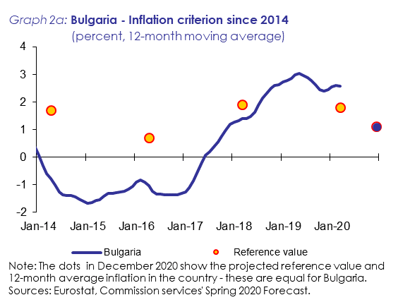

Inflation is projected to decline to 1.1% in 2020 and remain at the same level in 2021 according to the Commission services’ Spring 2020 Forecast. The headline inflation is expected to decline significantly in 2020, as a result of falling energy prices and a sharp decrease in services inflation due to reduced demand in the service sectors affected by the COVID-19 pandemic. The relatively low price level in Bulgaria (about 49% of the euro-area average in 2018) suggests significant potential for price level convergence in the long term.

**Bulgaria fulfils the criterion on public finances.** Bulgaria is not the subject of a Council Decision on the existence of an excessive deficit. The general government budget surplus increased from 1.1% of GDP in 2017 to 2.0% of GDP in 2018 and 2.1% of GDP in 2019. According to the Commission services’ Spring 2020 Forecast, the general government balance is projected to turn negative to -2.8% of GDP in 2020 due to the adverse impact of the COVID-19 pandemic and reach -1.8% of GDP in 2021 under a no-policy-change assumption. However, the Bulgarian government projects a deficit of the government balance of slightly over 3%. On 20 May 2020, the Commission adopted a report under Article 126(3) TFEU due to a planned breach of the Treaty reference value of 3% of GDP. The report concluded that the deficit criterion of the Stability and Growth Pact is fulfilled and Bulgaria is the only EU country where that is the case in 2020. The gross public debt ratio decreased from around 25% of GDP in 2017 to 20.4% of GDP in 2019 but it is projected to increase to 25.5% of GDP in 2020 and stay at 25.4% of GDP in 2021. The Bulgarian fiscal framework has been strengthened over the recent years and Bulgaria is bound by the Fiscal Compact provisions of the intergovernmental Treaty on Stability, Coordination and Governance in the Economic and Monetary Union (TSCG).

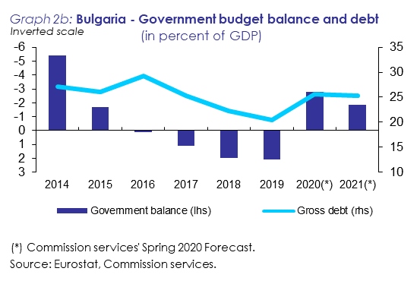

**Bulgaria does not fulfil the exchange rate criterion.** The Bulgarian lev is not participating in ERM II. In July 2018, Bulgaria announced its intention to put in place the necessary elements for a successful entry into ERM II. In order to ensure a smooth transition to, and participation in, ERM II, Bulgaria committed to implement before joining the ERM II a number of measures (i.e. prior-commitments) in the following six policy areas: banking supervision, macro-prudential framework, supervision of non-banking financial sector, insolvency framework, anti-money laundering framework and governance of state-owned enterprises. Bulgaria is currently working towards the completion of these prior-commitments, in close liaison with the Commission and the ECB who monitor their progress. The Bulgarian National Bank (BNB) pursues its primary objective of price stability through an exchange rate anchor in the context of a Currency Board Arrangement (CBA). Bulgaria introduced its CBA in 1997, pegging the Bulgarian lev to the German mark and later to the euro. During the two-year assessment period, the Bulgarian lev remained fully stable vis-à-vis the euro, in line with the operation of the CBA.

**Bulgaria** **fulfils the criterion on the convergence of long-term interest rates.** The average long-term interest rate in Bulgaria in the year up to March 2020 was 0.3%, well below the reference value of 2.9%. Long-term interest rates in Bulgaria declined from 1.1% in May 2018 to 0.1% in February 2020. The spread vis-à-vis German benchmark bond hovered mostly around 60 basis points, with significantly lower spreads around October 2018 and higher ones around August 2019. The spread stood around 70 basis points in March 2020.

**Additional factors** have also been examined, including balance of payments developments and integration of markets. Bulgaria recorded sizable external surpluses over recent years. The Bulgarian economy is well integrated with the euro area through trade and investment linkages. On the basis of selected indicators related to the business environment, Bulgaria performs worse than many euro-area Member States. Challenges also relate to the institutional framework including corruption and government efficiency. However, action is being taken to improve the business environment, in particular regarding the insolvency framework and governance of state-owned enterprises. Progress has also been made in strengthening financial sector governance and addressing outstanding regulatory issues. Bulgaria's financial sector is well integrated with the EU financial sector, in particular through a high level of foreign ownership in its banking system. In the context of the Macroeconomic Imbalance Procedure, Bulgaria was identified as warranting an In-Depth Review (IDR). The latter concluded that Bulgaria does not experience macroeconomic imbalances (thereby revising the previous conclusion of macroeconomic imbalances).

1. **CZECHIA**

**In the light of its assessment on legal compatibility and on the fulfilment of the convergence criteria, and taking into account the additional relevant factors, the Commission considers that Czechia does not fulfil the conditions for the adoption of the euro.**

**Legislation in Czechia** – in particular the Czech National Council Act No. 6/1993 Coll. on the Česká národní banka (the ČNB Law) – **is not fully compatible** with the compliance duty under Article 131 TFEU. Incompatibilities concern the independence of the central bank and central bank integration in the ESCB at the time of euro adoption with regard to the ČNB's objectives and the ESCB tasks laid down in Article 127(2) TFEU and Article 3 of the ESCB/ECB Statute. In addition, the ČNB Law also contains imperfections relating to the prohibition of monetary financing and the ESCB tasks.

**Czechia** **does not fulfil the criterion on price stability.** The average inflation rate in Czechia during the 12 months to March 2020 was 2.9%, well above the reference value of 1.8%. It is projected to remain well above the reference value in the months ahead.

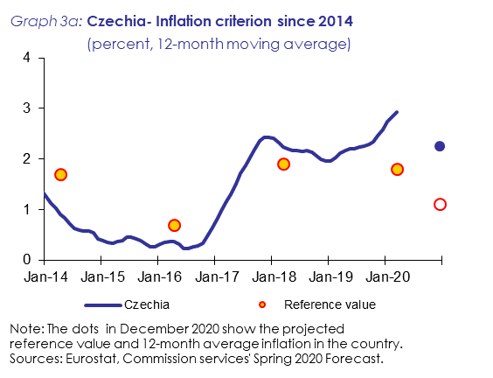

The annual HICP inflation rate increased from 1.6% at the time of the last assessment in March 2018 to 2.4% in August 2018. After dropping to 1.6% in December 2018, HICP inflation steadily increased throughout 2019. The annual HICP inflation rate thus averaged 2.0% and 2.6% in 2018 and 2019, respectively. The pick-up in annual inflation throughout 2019 reflected larger inflation contributions from food and energy prices as well as higher price increases in the service sector. Annual inflation picked-up substantially at the end of 2019 and remained elevated in the beginning of 2020 mainly due to a hike in food prices, increasing administered prices, and changes in indirect taxes. In March 2020, annual HICP inflation stood at 3.6%.

Due to a fall in demand related to the COVID-19 pandemic, an easing of the labour market and declining oil prices, the Commission services’ Spring 2020 Forecast projects annual HICP inflation to average 2.3% in 2020 and 1.9% in 2021. The price level in Czechia (about 69% of the euro-area average in 2018) suggests that there is potential for further price level convergence in the long term.

**Czechia fulfils the criterion on public finances.** Czechia is not the subject of a Council Decision on the existence of an excessive deficit. The general government balance in 2019 stood at a surplus of 0.3% of GDP. Under the impact of the COVID-19 crisis, according to the Commission services’ Spring 2020 Forecast, the general government balance is projected to turn to -6.7% of GDP in 2020 and, under a no-policy-change assumption, to -4% of GDP in 2021. On 20 May 2020, the Commission adopted a report under Article 126(3) TFEU due to the planned breach of the Treaty reference value of 3% of GDP. The report concluded that the deficit criterion of the Stability and Growth Pact is not fulfilled. In light of the current situation, the Commission considers that at this juncture a decision on whether to place Czechia under EDP should not be taken. The gross public debt ratio declined to below 31% of GDP in 2019. It is projected to increase to 39% of GDP in 2020 and 40% in 2021. The Czech national fiscal framework is well developed. Against the backdrop of the COVID-19 pandemic, the Parliament recently fast-tracked a legislative amendment to widen the structural deficit ceiling in 2021 from 1% to 4% of GDP and alter the adjustment path until 2027.

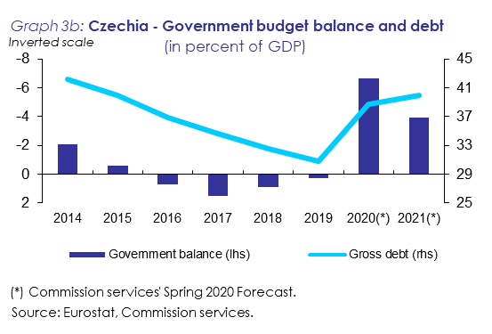

**Czechia** **does not fulfil the exchange rate criterion.** The Czech koruna is not participating in ERM II. Czechia operates a floating exchange rate regime, allowing for foreign exchange market interventions by the central bank. The koruna traded at around 25.6 CZK/EUR in May 2018 and appreciated only temporarily after the CNB increased policy rates four times in the second half of 2018. Beginning 2019, it fluctuated in a relative narrow band around 25.7 CZK/EUR before depreciating to 25.9 CZK/EUR in September 2019 (i.e. by around 1%). Thereafter, the koruna appreciated steadily and reached 25.1 CZK/EUR in February. Following the lock-down measures due to the COVID-19 pandemic, the koruna depreciated significantly and stood above 26.6 CZK/EUR in March 2020. Short-term interest rate differentials vis-à-vis the euro area increased from around 120 basis points in May 2018 to around 240 basis points by March 2020. During the two years before this assessment, the koruna depreciated against the euro by 4.3%.

**Czechia** **fulfils the criterion on the convergence of long-term interest rates.** The average long-term interest rate in Czechia in the year to March 2020 was 1.5%, below the reference value of 2.9%. The long-term interest rate of Czechia increased slightly from 1.9% in May to 2.1% in June 2018. It remained stable at 2.1% until October 2018 and decreased steadily to 1.4% in the first half of 2019. After dropping temporarily to 1% in August 2019, it increased again and reached 1.6% in January 2020. It recently declined and stood at 1.3% in March 2020. The spread against the German benchmark bond fluctuated around 190 basis points in early 2020.

**Additional factors** have also been examined, including balance of payments developments and integration of markets. The external balance of Czechia recorded a surplus of 0.6% of GDP in 2018 and 0.5% of GDP in 2019. The Czech economy is highly integrated with the euro area through trade and investment linkages. On the basis of selected indicators relating to the business environment, Czechia performs around the average of euro-area Member States. The Czech financial sector is highly integrated into the EU financial sector, in particular through a high degree of foreign ownership of financial intermediaries.

1. **CROATIA**

**In the light of its assessment on legal compatibility and on the fulfilment of the convergence criteria, and taking into account the additional relevant factors, the Commission considers that Croatia does not fulfil the conditions for the adoption of the euro.**

**Legislation in Croatia is fully compatible** with the compliance duty under Article 131 TFEU.

**Croatia fulfils the criterion on price stability.** The average inflation rate in Croatia during the 12 months to March 2020 was 0.9%, below the reference value of 1.8%. It is projected to remain below the reference value in the months ahead.

After having peaked at 2.2% in July 2018 due to rising prices of energy, services and unprocessed food, the annual inflation rate moderated thereafter, declining to a low of 0.5% in June 2019. VAT reduction on selected unprocessed foods depressed HICP inflation in the first half of 2019, while energy inflation started moderating already towards the end of 2018 and remained low throughout 2019. With dissipating effects of the VAT rate change, the annual inflation rate picked up gradually in the last quarter of 2019. After having peaked at 1.8% in January 2020, it declined significantly due to the sharp drop in energy prices in the following two months, reaching 0.5% in March 2020.

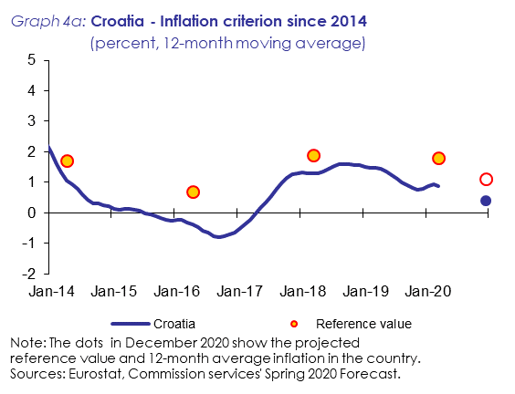

Due to weaker overall demand and the fall in oil prices in the first quarter of 2020, the annual HICP inflation is projected to decline to 0.4% in 2020 before picking up slightly to 0.9% in 2021 according to the Commission services’ Spring 2020 Forecast. At about 66% of the euro-area average in 2018, the price level in Croatia suggests that there is potential for price level convergence in the long term.

**Croatia fulfils the criterion on public finances.** Croatia is not the subject of a Council Decision on the existence of an excessive deficit. The government balance was slightly positive at +0.2% of GDP in 2018. In 2019, it improved slightly further to stand at +0.4% of GDP, in spite of the materialisation of substantial contingent liabilities associated with ailing shipyards. The Commission services’ Spring 2020 Forecast projects the general government balance to fall to -7.1% in 2020 as a result of a significantly worsened macroeconomic outlook and a sizeable fiscal package aimed at supporting employment and companies faced with markedly declining revenues due to the COVID-19 pandemic. In 2021, the government balance should improve to ‑2.2% of GDP on a no‑policy‑change basis. On 20 May 2020, the Commission adopted a report under Article 126(3) TFEU due to the planned breach of the Treaty reference value of 3% of GDP. The report concluded that the deficit criterion of the Stability and Growth Pact is not fulfilled. In light of the current situation, the Commission considers that at this juncture a decision on whether to place Croatia under EDP should not be taken. The general government debt is forecast to increase to almost 89% of GDP in 2020 before resuming its downward path, dipping below 84% in 2021. The Croatian fiscal framework remains relatively weak, requiring further legislative steps and implementation efforts.

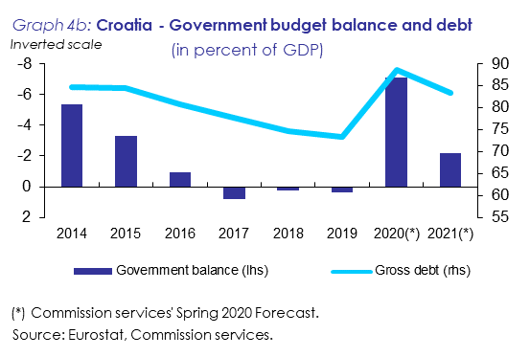

**Croatia** **does not fulfil the exchange rate criterion.** The Croatian kuna is not participating in ERM II. In July 2019, Croatia announced its intention to put in place the necessary elements for a successful entry into ERM II. In order to ensure a smooth transition to, and participation in, ERM II, Croatia committed to implement before joining the ERM II a number of measures (i.e. prior-commitments) in the following six policy areas: banking supervision, macro-prudential framework, anti-money laundering, statistics, public sector governance and business environment. Croatia is currently working towards the completion of these prior-commitments, in close liaison with the Commission and the ECB who monitor their progress. The HNB operates a tightly managed floating exchange rate regime, using the exchange rate as the main nominal anchor to achieve its primary objective of price stability. Between early 2018 and early 2020, the kuna was mostly stable against the euro, fluctuating slightly around 7.44 HRK/EUR and exhibiting a seasonal pattern of temporary and limited appreciation in summer months thanks to foreign currency inflows related to the tourism sector. The kuna experienced a limited depreciation episode in March 2020 amid the COVID-19 pandemic when it weakened to around 7.60 HRK/EUR, which was around 2% lower than two years earlier.

**Croatia fulfils the criterion on the convergence of long-term interest rates.** The average long-term interest rate of Croatia stood at 0.9% in March 2020, well below the reference value of 2.9%. The long-term interest rate of Croatia declined gradually during 2018. It fell more sharply in the first half of 2019 dropping even slightly below 0.50% in September 2019 as the Croatian sovereign debt was raised to investment grade with positive outlook. After having fluctuated just above 0.50% in the following months, it rose sharply to close to 1% in March 2020 amid the COVID-19 outbreak, with the spread to the German long-term benchmark bond widening to 150 basis points.

**Additional factors** have also been examined, including balance of payments developments and integration of markets. Croatia's external surplus increased from 3.3% of GDP in 2018 to 4.5% of GDP in 2019, benefiting from an improvement in the capital and current transfers balance. The Croatian economy is well integrated with the euro area through trade and investment linkages. On the basis of selected indicators relating to the business environment, Croatia performs worse than many euro-area Member States. Challenges also relate to the institutional framework including regulatory quality. However, there has been renewed effort to improve the business environment, in particular to reduce the administrative burden and regulatory restrictions. The financial sector is highly integrated with the EU financial system, in particular through a high share of foreign ownership of financial intermediaries. In the context of the Macroeconomic Imbalance Procedure, Croatia was identified as warranting an In-Depth Review (IDR). Although the latter concluded that Croatia continued to experience macroeconomic imbalances, stock imbalances have been narrowing over the past years, driven by resuming growth and a prudent fiscal policy. Remaining vulnerabilities are linked in particular to high levels of public, private and external debt in a context of low potential growth.

1. **HUNGARY**

**In the light of its assessment on legal compatibility and on the fulfilment of the convergence criteria, and taking into account the additional relevant factors, the Commission considers that Hungary does not fulfil the conditions for the adoption of the euro.**

**Legislation in Hungary** - in particular the Law on the Magyar Nemzeti Bank (MNB) - **is not fully compatible** with the compliance duty under Article 131 TFEU. Incompatibilities notably concern the independence of the MNB, the prohibition of monetary financing and central bank integration into the ESCB at the time of euro adoption with regard to the ESCB tasks laid down in Article 127(2) TFEU and Article 3 of the ESCB/ECB Statute. In addition, the Law on the MNB also contains further imperfections relating to MNB integration into the ESCB.

**Hungary does not fulfil the criterion on price stability.** The average inflation rate in Hungary during the 12 months to March 2020 was 3.7%, well above the reference value of 1.8%. It is projected to remain well above the reference value in the months ahead.

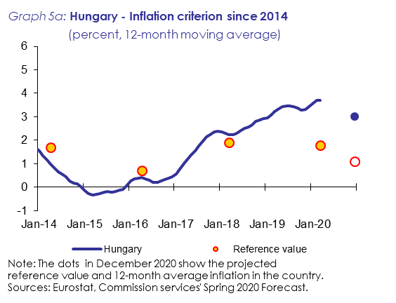

Annual HICP inflation in Hungary was on an upward path over the last two years, on the back of broad-based price increases, reflecting strong demand growth and rising unit labour costs. Unprocessed food and energy prices added volatility to the headline figure. Inflation rose to 3.9% in October 2018, before moderating to 2.8% by end-2018. It increased to 4% by May 2019 and decreased to 2.9% by September, before rising again to 4.1% in December. The annual HICP inflation rate thus averaged 2.9% in 2018 and 3.4% in 2019. It increased further until January 2020, due to a rapid increase of unprocessed food and energy prices and stood at 3.9% in March 2020.

Inflation is projected to decrease to around 3.0% in 2020 and 2.7% in 2021 according to the Commission services’ Spring 2020 Forecast, as the oil price declines and the COVID-19 recession is expected to reduce core inflation. The relatively low price level in Hungary (about 61% of the euro-area average in 2018) suggests that there is potential for further price level convergence in the long term.

**Hungary fulfils the criterion on public finances.** Hungary is not the subject of a Council Decision on the existence of an excessive deficit. Hungary has been under consecutive Significant Deviation Procedures since June 2018. The general government deficit decreased to 2.1% of GDP in 2018, compared to 2.5% in 2017, and then further to 2.0% in 2019. According to the Commission services’ Spring 2020 Forecast, it is projected to increase to 5.2% of GDP in 2020 due to the COVID‑19 crisis, before decreasing to 4.0% of GDP in 2021, under a no-policy-change assumption. On 20 May 2020, the Commission adopted a report under Article 126(3) TFEU due to the planned breach of the Treaty reference value of 3% of GDP. The report concluded that the deficit criterion of the Stability and Growth Pact is not fulfilled. In light of the current situation, the Commission considers that at this juncture a decision on whether to place Hungary under EDP should not be taken. The gross public debt ratio decreased to 66.3% of GDP in 2019 and it is projected to increase to 75.0% of GDP in 2020 and to reach 73.5% of GDP in 2021. The Hungarian fiscal framework is well-developed around stringent rules and procedures of debt control across all layers of general government; however, the role of the Fiscal Council in scrutinizing and shaping fiscal policies is weak.

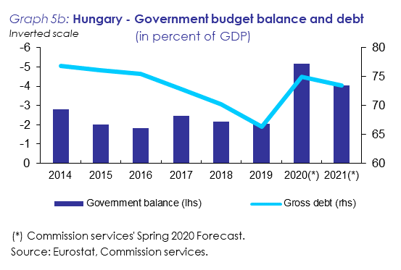

**Hungary** **does not fulfil the exchange rate criterion.** The Hungarian forint is not participating in ERM II. Hungary operates a floating exchange rate regime, allowing for foreign exchange market interventions by the central bank. The Hungarian forint traded around 317 HUF/EUR in May 2018, before depreciating to 325 HUF/EUR by September 2018. It then appreciated, reaching 316 HUF/EUR in March 2019. Thereafter the forint depreciated to the euro, as the MNB signalled its intent to keep loose monetary conditions longer than other regional central banks and inflation rose above its target. The forint weakened further in March 2020, amid the COVID-19 outbreak. Short-term interest rate differentials vis-à-vis the euro area increased from around 40 basis points in May 2018 to around 100 basis points by March 2020. In March 2020, the forint was by about 10% weaker against the euro than two years earlier.

**Hungary** **fulfils the criterion on the convergence of long-term interest rates.** The average long-term interest rate in the year to March 2020 was 2.3%, below the reference value of 2.9%. The monthly average long-term interest rate increased from around 2.9% in May 2018 to about 3.7% by October 2018, as higher exchange rate risk of the forint was priced in. It then started to decrease again and reached 1.9% in December 2019, reflecting a renewed international search for yield, as major central banks embarked on further monetary easing. As the long-term interest rate increased to 2.4% in March 2020, amid the unfolding COVID-19 crisis, the long-term spread vis-à-vis the German benchmark bond reached around 300 basis points.

**Additional factors** have also been examined, including balance of payments developments and the integration of markets. The external balance deteriorated over the past two years, mainly due to strong growth of goods imports, but it remained in a small surplus. The Hungarian economy is highly integrated with the euro area through trade and investment linkages. On the basis of selected indicators relating to the business environment, Hungary performs worse than many euro-area Member States. Hungary's financial sector is well integrated into the EU financial system.

1. **POLAND**

**In the light of its assessment on legal compatibility and on the fulfilment of the convergence criteria, and taking into account the additional relevant factors, the Commission considers that Poland does not fulfil the conditions for the adoption of the euro.**

**Legislation in Poland** - in particular the Act on the Narodowy Bank Polski (NBP) and the Constitution of the Republic of Poland - **is** **not fully compatible** with the compliance duty under Article 131 TFEU. Incompatibilities concern the independence of the central bank, the prohibition of monetary financing and central bank integration into the ESCB at the time of euro adoption. In addition, the Act on the NBP also contains some imperfections relating to central bank independence and the NBP integration into the ESCB at the time of euro adoption.

**Poland does not fulfil the criterion on price stability.** The average inflation rate in Poland during the 12 months to March 2020 was 2.8%, well above the reference value of 1.8%. It is projected to remain well above the reference value in the months ahead.

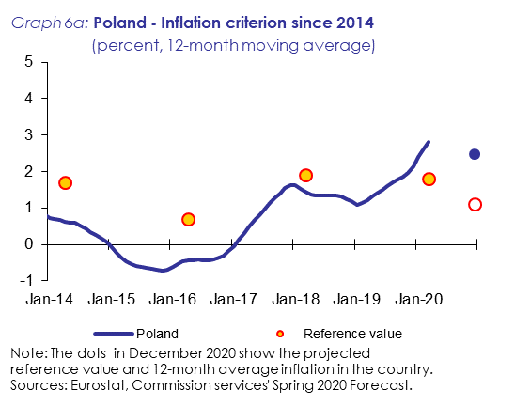

Annual HICP inflation rose to 1.5% by September 2018, before dipping back to 0.6% by January 2019. It increased to 2.1% by April 2019 and further up to 2.4% by November, mainly on the back of rising services inflation, partly due to increasing unit labour costs. Annual inflation rose sharply further at end-2019 and early 2020, reaching 3.8% in January 2020. This overall volatile pattern is explained by strong swings in the dynamics of energy and unprocessed food prices. In March 2020, annual HICP inflation stood at 3.9%.

Inflation is projected to increase from 2.1% in 2019 to 2.5% in 2020 and to 2.8% in 2021 according to the Commission services’ Spring 2020 Forecast, driven mainly by growth of food prices in 2020 and the economic recovery in 2021. The relatively low price level in Poland (about 56% of the euro-area average in 2018) suggests significant potential for price level convergence in the long term.

**Poland fulfils the criterion on public finances.** Poland is not the subject of a Council Decision on the existence of an excessive deficit. The general government deficit declined from 1.5% of GDP in 2017 to 0.2% in 2018. The deficit-to-GDP ratio deteriorated to 0.7% in 2019 and according to the Commission services’ Spring 2020 Forecast it is projected to reach 9.5% in 2020 and, under a no-policy-change assumption, 3.8% in 2021, driven mainly by the effect of the COVID-19 pandemic on activity and measures to support the economy. On 20 May 2020, the Commission adopted a report under Article 126(3) TFEU due to the planned breach of the Treaty reference value of 3% of GDP. The report concluded that the deficit criterion of the Stability and Growth Pact is not fulfilled. In light of the current situation, the Commission considers that at this juncture a decision on whether to place Poland under EDP should not be taken. The general government debt-to-GDP ratio is forecast to strongly increase from 46% in 2019 to over 58% in 2021. Poland's domestic fiscal framework is overall strong, with weaknesses mainly in the areas of budgetary planning and procedures, and independent monitoring.

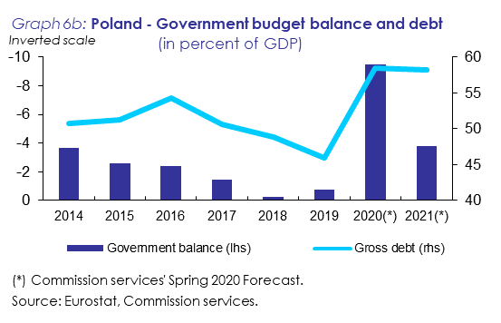

**Poland** **does not fulfil the exchange rate criterion.** The Polish zloty is not participating in ERM II. Poland operates a floating exchange rates regime, allowing for foreign exchange market interventions by the central bank. The zloty mostly traded in a quite narrow range against the euro at around 4.3 over the past two years. There was a short period of relative zloty weakness in July 2018 and in August-September 2019 (with PLN/EUR 4.35), amid signs of an economic slowdown. This was followed by a period of strength, with the average exchange rate reaching 4.25 PLN/EUR in January 2020, after monetary easing in some major advanced economies. The COVID-19 crisis resulted in a depreciation of the zloty to an average of 4.4 PLN/EUR in March 2020. Short-term interest rate differentials vis-à-vis the euro area increased from around 200 basis points to around 210 in July 2019, but decreased to around 190 basis points on average in March 2020. In March 2020, the zloty was by around 5% weaker against the euro than two years earlier.

**Poland** **fulfils the criterion on the convergence of long-term interest rates.** The average long-term interest rate in the year to March 2020 was 2.2%, below the reference value of 2.9%. The monthly average long-term interest rate was around 3.2% between May and November 2018, before decreasing to 2.7% by early 2019. It decreased further to around 2% in summer 2019 and reached around 1.8% in March 2020. The long-term interest rate spread vis-à-vis the German benchmark bond stood at around 230 basis points in March 2020.

**Additional factors** have also been examined, including balance of payments developments and integration of markets. Poland’s external balance stayed in surplus, over the past two years supported by an improvement in the services trade balance. The Polish economy is well integrated with the euro area through trade and investment linkages. On the basis of selected indicators relating to the business environment, Poland performs around the average of euro-area Member States. Poland's financial sector is well integrated into the EU financial sector.

1. **ROMANIA**

**In the light of its assessment on legal compatibility and on the fulfilment of the convergence criteria, and taking into account the additional relevant factors, the Commission considers that Romania does not fulfil the conditions for the adoption of the euro.**

**Legislation in Romania** – in particular Law No. 312 on the Statute of the Bank of Romania (the BNR Law) – **is not fully compatible** with the compliance duty under Article 131 TFEU. Incompatibilities concern the independence of the central bank, the prohibition of monetary financing and central bank integration into the ESCB at the time of euro adoption. In addition, the BNR Law contains imperfections relating to central bank independence and to central bank integration in the ESCB at the time of euro adoption with regard to the BNR's objectives and the ESCB tasks laid down in Article 127(2) TFEU and Article 3 of the ESCB/ECB.

**Romania does not fulfil the criterion on price stability.** The average inflation rate in Romania during the 12 months to March 2020 was 3.7%, well above the reference value of 1.8%. It is projected to remain well above the reference value in the months ahead.

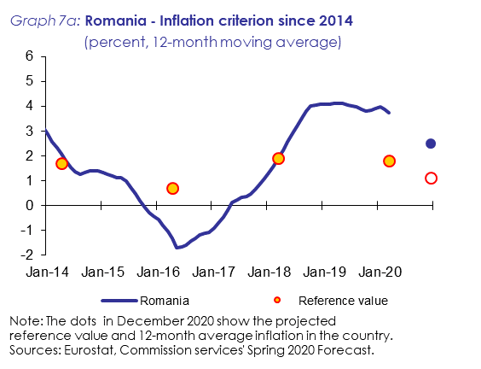

Annual HICP inflation in Romania accelerated to 4.1% in 2018 and remained relatively high in 2019 at an average of 3.9%, supported by robust consumer demand. Inflation peaked at 4.7% in September 2018, as the effect of past VAT cuts faded away, global oil prices picked up and the January 2017 cut in excise duties was reversed. It decelerated to 3.0% by the end of 2018, including due to a sharp drop in the international price of crude oil in the fourth quarter of 2018. After a rise to 4.4% in April 2019, it decelerated to 3.2% by October 2019, but increased again to 4% in December 2019. Inflation eased in the first three months of 2020, reaching 2.7% in March 2020.

According to the Commission services’ Spring 2020 Forecast, the annual average rate of inflation is projected to decrease to 2.5% in 2020 and 3.1% in 2021. The relatively low price level in Romania (about 50% of the euro-area average in 2018) suggests significant potential for price level convergence in the long term.

**Romania does not fulfil the criterion on public finances.** As a consequence of the breach of the Treaty deficit threshold in 2019, the Council on 4 April 2020 opened an excessive deficit procedure for Romania, indicating 2022 as deadline for the correction of the excessive deficit. Romania had been under consecutive Significant Deviation Procedures since June 2017, but did not take effective action. Thus, the general government deficit increased from 2.9% in 2018 to 4.3% in 2019, driven by increases in current expenditures and a rebound of capital spending from the record-low levels of the previous years. The Commission services’ Spring 2020 Forecast projects the general government deficit to increase further to around 9.2% of GDP in 2020 and around 11.4% of GDP in 2021 under the no policy change assumption. The expansionary trend largely driven by legislated pension increases is set to be reinforced by the impact of the COVID-19 crisis. The public-debt-to-GDP ratio is expected to increase from 35.2% in 2019 to around 46.2% in 2020 and 54.7% in 2021. Despite having the appropriate legislative setting, the implementation track record of the Romanian fiscal framework has been generally weak and has not improved since the last report. This is because the authorities continued their practice of derogating from the national fiscal rules, rendering them ineffective.

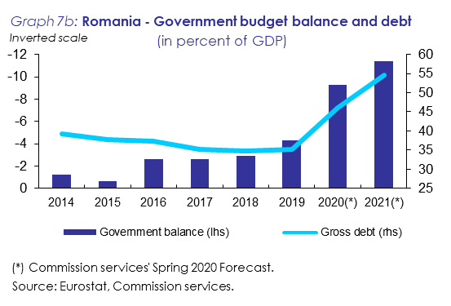

**Romania does not fulfil the exchange rate criterion.** The Romanian leu does not participate in ERM II. Romania operates a floating exchange rate regime, allowing for foreign exchange market interventions by the central bank. The leu averaged a RON/EUR level of 4.65 in 2018. After weakening against the euro by around 1% between January and May 2019, the leu experienced a short episode of moderate appreciation over the summer of 2019 but the depreciation trend resumed moderately after October 2019. Amid the COVID-19 outbreak, the leu depreciated by around 1.1% between mid-February and end of March 2020. The three-month interest rate spread relative to the euro stood at around 325 basis points in March 2020 compared to its peak of 370 basis points in July 2018. In March 2020, the leu was about 3% weaker against the euro than two years earlier.

**Romania does not fulfil the criterion on the convergence of long-term interest rates.** The average long-term interest rate in Romania in the year to March 2020 was 4.4%, above the reference value of 2.9%. Long-term interest rates increased gradually from around 4.5% in April 2018 to 5.1% in July 2018. After remaining stable at around 4.8% on average between August 2018 and May 2019, long-term interest rates started to decline and reached 4.3% in November 2019. The decline reflected the monetary policy loosening measures by major central banks, which depressed long-term yields. As the COVID-19 crisis intensified, the long-term interest rate increased to 4.6% in March 2020 and the long-term spread versus the German benchmark bond reached 510 basis points in that month.

**Additional factors** have also been examined, including balance of payments developments and the integration of markets. Romania's external balance turned negative in 2017 for the first time in five years and deteriorated further to -3.2% of GDP in 2018 and -3.3% of GDP in 2019, the worst among the countries analysed in this Report. According to selected indicators relating to business environment, Romania performs worse than many euro-area Member States. The persistent regulatory unpredictability has been one of the main factors negatively affecting the business environment in recent years. Romania's financial sector is well integrated with the EU financial sector, in particular through a high level of foreign ownership in its banking system. In the context of the Macroeconomic Imbalance Procedure, Romania was identified as warranting an In-Depth Review (IDR). The latter concluded that Romania continued to experience macroeconomic imbalances. In particular, the current account continued to widen in 2019, while risks linked to cost competitiveness were building up in a context of an expansionary fiscal policy and an unpredictable business environment.

1. **SWEDEN**

**In the light of its assessment on legal compatibility and on the fulfilment of the convergence criteria, and taking into account the additional relevant factors, the Commission considers that Sweden does not fulfil the conditions for the adoption of the euro.**

**Legislation in Sweden** - in particular the Sveriges Riksbank Act, the Instrument of Government and the Law on the Exchange Rate Policy - **is not fully compatible** with the compliance duty under Article 131 TFEU. Incompatibilities and imperfections exist in the fields of independence of the central bank, prohibition of monetary financing and central bank integration into the ESCB at the time of euro adoption.

**Sweden fulfils the criterion on price stability.** The average inflation rate in Sweden during the 12 months to March 2020 was 1.6%, below the reference value of 1.8%. It is projected to remain below the reference value in the months ahead.

Sweden's average inflation rate reached 1.7% in 2019, down from 2.0% in 2018. After a brief spell at 2.1% in April and May 2019, inflation decreased, reaching 1.3% in September and, after a short rebound to 1.8% in November it moderated again driven by the slowdown in economic growth and a sharp decrease in energy prices. In March 2020, annual HICP inflation stood at 0.8%.

Oil prices are projected to exert downward pressure on HICP in 2020 and wage growth is projected to remain moderate, which should more than compensate the impact of the expected krona depreciation. Accordingly, the Commission services’ Spring 2020 Forecast projects annual average inflation at 0.4% in 2020 and 1.1% in 2021. The price level in Sweden is relatively high (about 116% of the euro-area average in 2018).

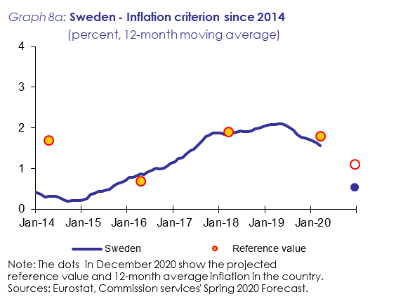

**Sweden fulfils the criterion on public finances.** Sweden is not the subject of a Council Decision on the existence of an excessive deficit. The general government surplus slightly decreased from 0.8% of GDP in 2018 to 0.5% of GDP in 2019, reflecting in particular weaker revenue performance as real GDP growth slowed. According to the Commission services’ Spring 2020 Forecast, the general government balance is expected to reach -5.6% of GDP in 2020 and -2.2% in 2021 on the back of the COVID-19 crisis. On 20 May 2020, the Commission adopted a report under Article 126(3) TFEU due to the planned breach of the Treaty reference value of 3% of GDP. The report concluded that the deficit criterion of the Stability and Growth Pact is not fulfilled. In light of the current situation, the Commission considers that at this juncture a decision on whether to place Sweden under EDP should not be taken. The gross general government debt-to-GDP ratio decreased to 35.1% in 2019 and is expected to increase to 42.6% of GDP in 2020 and remain broadly stable at 42.5% of GDP in 2021. Sweden has a strong fiscal framework, which was subject to reform in 2019, preserving the key pillars of the previous set-up and reinforcing it with new elements (such as a debt anchor at 35% of GDP).

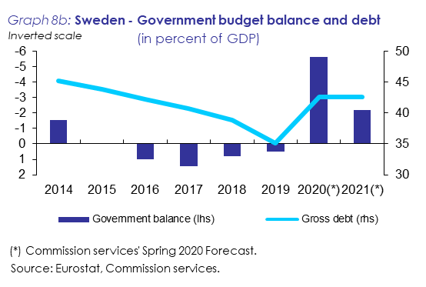

**Sweden does not fulfil the exchange rate criterion.** The Swedish krona is not participating in ERM II. Sweden operates a floating exchange rate regime, allowing for foreign exchange market interventions by the central bank. In 2018-19, the krona continued its long-term depreciating trend against the euro. The depreciation took place despite some monetary tightening (compared with the euro area) and of a widening three-months STIBOR-EURIBOR spread during 2019, with the latter averaging -7 basis points in 2018 and 33 in 2019. In March 2020, the spread stood at around 65 basis points. The depreciation was not uniform over the period covered by the report, with the euro reaching a peak at 10.80 SEK/EUR in October 2019, before slightly depreciating to the 10.5-10.6 range between December 2019 and February 2020. The COVID-19 crisis resulted in a temporary strong krona depreciation. During the two years to March 2020, the krona averaged a SEK/EUR rate of about 10.5 and depreciated against the euro by roughly 7%.

**Sweden fulfils the criterion on the convergence of long-term interest rates.** The average long-term interest rate in Sweden in the year to March 2020 was -0.1%, well below the reference value of 2.9%. Swedish long-term interest rates on a monthly basis recorded a new all-time low in August 2019, reaching -0.36. After exiting negative territory last November, the interest rate turned negative again in February 2020 to reach -0.17% in March 2020, amid the COVID-19 crisis. The spread vis-à-vis the German benchmark bond remained low, even if it increased slightly in 2019, after decreasing in 2018. In March 2020 it stood at 37 basis points.

**Additional factors** have also been examined, including balance of payments developments and integration of markets. Sweden's external balance has remained in surplus, at 1.7% of GDP in 2018 and 3.9% in 2019. Sweden's economy is well integrated with the euro area through trade and investment linkages. Based on selected indicators relating to the business environment, Sweden performs better than most euro area Member States. Sweden's financial sector is well integrated into the EU financial sector. In the context of the Macroeconomic Imbalance Procedure, Sweden was identified as warranting a further In-Depth Review (IDR). The latter concluded that Sweden continues to experience macroeconomic imbalances as overvalued house price levels coupled with a continued rise in household debt poses risks of a disorderly correction.

1. The Member States that have not yet fulfilled the necessary conditions for the adoption of the euro are referred to as "Member States with a derogation". Denmark negotiated an opt-out arrangement before the adoption of the Maastricht Treaty and does not participate in the third stage of EMU.
2. Denmark has not expressed an intention to adopt the euro and is therefore not covered in the assessment.
3. The cut-off date for the data used in this report is 23 April 2020. The convergence assessment is based on a range of monthly convergence indicators that are calculated up to March 2020. The report also draws on the Commission services’ Spring 2020 Forecast and the policy guidance under the European Semester, including the Macroeconomic Imbalance Procedure.
4. The Commission published its latest Alert Mechanism Report (AMR) in December 2019 and the results of the corresponding in-depth reviews in February 2020.
5. For the purpose of the criterion on price stability, inflation is measured by the Harmonised Index of Consumer Prices (HICP) defined in Regulation (EU) 2016/792 of the European Parliament and of the Council.
6. All forecasts for inflation and other variables in the current report are from the Commission services' Spring 2020 Forecast. The Commission services' forecasts are based on a set of common assumptions for external variables and on a no-policy-change assumption while taking into consideration measures that are known in sufficient detail.
7. The respective 12-month average inflation rates were 0.2%, 0.4% and 0.4%.
8. In assessing compliance with the exchange rate criterion, the Commission examines whether the exchange rate has remained close to the ERM II central rate, while reasons for an appreciation may be taken into account, in accordance with the Common Statement on Acceding Countries and ERM2 by the Informal ECOFIN Council, Athens, 5 April 2003.
9. ERM II participants are the euro-area finance ministries, the ECB, non-euro area ERM II finance ministries and central banks.
10. The reference value for March 2020 is calculated as the simple average of the average long-term interest rates of Portugal (0.5%), Cyprus (0.8%) and Italy (1.6%), plus two percentage points.
11. Beyond the forecast horizon, the COVID-19 crisis could also have a significant effect on the economic structures of the Member States with a derogation, for instance in terms of labour mobility or integration in global value chains. Assessing this impact is, however, beyond the scope of this report.
12. See: https://ec.europa.eu/info/business-economy-euro/economic-and-fiscal-policy-coordination/eu-economic-governance-monitoring-prevention-correction/european-semester/european-semester-timeline/eu-country-specific-recommendations_en
13. For more information, see: https://ec.europa.eu/info/sites/info/files/economy-finance/2_en_act_part1_v3-adopted_text.pdf