

This staff working document accompanies the Communication ‘Towards more sustainable fishing in the EU: state of play and orientations for 2021’. It looks in greater depth at:

1. the state of stocks;
2. the setting of fishing opportunities for 2020;
3. specific actions in the Mediterranean and Black Seas;
4. the balance between fleet capacity and fishing opportunities;
5. the economic performance of the EU fishing fleet;
6. progress in implementing the landing obligation;
7. the role of recommendations by advisory councils in EU decision-making; and
8. the actions taken under the EU’s International Ocean Governance Agenda.
9. **The state of stocks**

**Monitoring results of the common fisheries policy progress report**

Each year, the Commission requests the Scientific, Technical and Economic Committee for Fisheries (STECF) to assess progress in achieving the maximum sustainable yield exploitation rate (FMSY) in line with the objectives of the common fisheries policy (CFP)[1]. The exploitation rate relative to FMSY is calculated by three bodies: the STECF, the International Council for the Exploration of the Sea (ICES) and the General Fisheries Commission for the Mediterranean (GFCM).

In line with recommended best practice, all historic data series have been updated. This means that some new methods have been introduced, new science taken into account, and new data added. Information in this section is generally based on data collected in 2018 and analysed and published in 2019. It therefore reflects the state of stocks of fish measured in the sea in 2018 as an outcome of the set of management measures implemented (setting TACs, capacity management, technical measures, landing obligation, etc., including effort management where applicable).

The main findings as well as the graphs of the STECF technical report[2] are summarised below.

* 1. **Stock status** 
     1. **Northeast Atlantic**[3]

The status of stocks in the northeast Atlantic has steadily and significantly improved. Information was available to assess time-trends in the fishing mortality rate with respect to the MSY rate from 68 stocks. The proportion of overexploited stocks (i.e. F>Fmsy) decreased from around 71% in 2003 to 38% in 2018, the lowest value recorded since monitoring began. The proportion of stocks outside the safe biological limits, computed for the 44 stocks for which both reference points are available, also followed a decreasing trend, from 70% in 2003 to 32% in 2018 (Figure 1).

**Figure 1. Trends in stock status in the northeast Atlantic area, 2003-2018[4]**

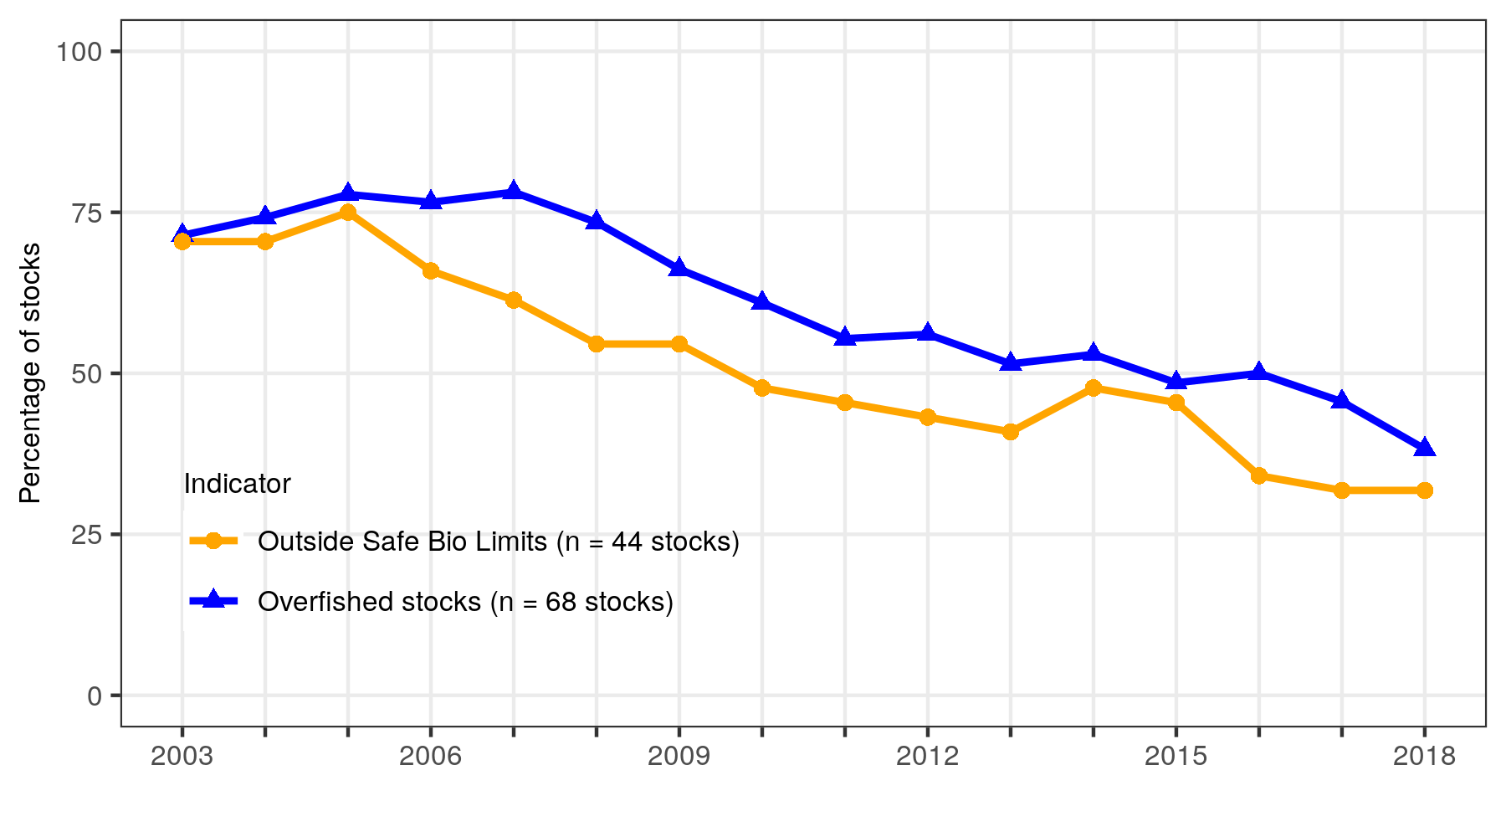

* + 1. **Mediterranean and Black Seas**

In the Mediterranean and Black Seas, 47 stocks were assessed in 2016 but information was only available for 21 stocks in 2018[5]. This reduced availability of data makes historical comparisons difficult, and steps are being taken to improve the transparency and information transmission of fish stock assessments made in the General Fisheries Commission for the Mediterranean (GFCM). For this reason, updated figures for the proportion of stocks fished above Fmsy are not sufficiently reliable to be presented.

* 1. **Trends in fishing pressure (ratio of F/Fmsy)**
     1. **Northeast Atlantic area**

In the northeast Atlantic area**,** the fishing pressure relative to the MSY rate (F/Fmsy) shows an overall downward trend between 2003 and 2018 (Figures 2, 3, 5, 6 and Table 1).

For 12 stocks located in the ICES areas but jointly managed with other international partners, the positive overall trend observed in EU waters until 2014 is confirmed, with the median value of the F/Fmsy indicator closely tracking that produced for EU waters. After 2014, however, the indicator seems to show an increasing number of stocks exploited above Fmsy, although the STECF notes that the indicator for ICES area stocks outside EU waters is based on comparatively few stocks, where uncertainty is high.

* + 1. **Mediterranean and Black Seas**

The F/Fmsy indicator for the Mediterranean and Black Seas remained at a very high level for the entire 2003-2017 period. Since 2011 when the F/Fmsy peaked at its highest historical level, the value of F/Fmsy has remained at around 2.4. This indicates that the stocks are being exploited on average at rates well above the Fmsy CFP objective (Figure 4). There has been a slightly decreasing trend since 2011, from 2.7 to 2.4, which indicates a small improvement in exploitation. Nevertheless, the instability in the dataset used, due to reduced data availability, may have an impact on the results.

**Figure 2. Trends in fishing pressure (northeast Atlantic area and Mediterranean and Black Seas), 2003 - 2018**

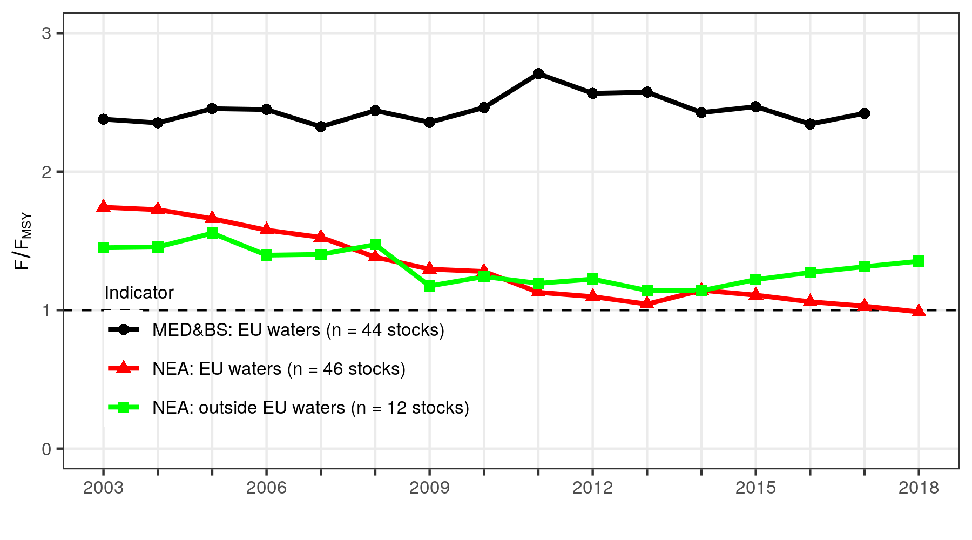

**Figure 3. Trend in F/Fmsy in the northeast Atlantic area, 2003 - 2018[6]**

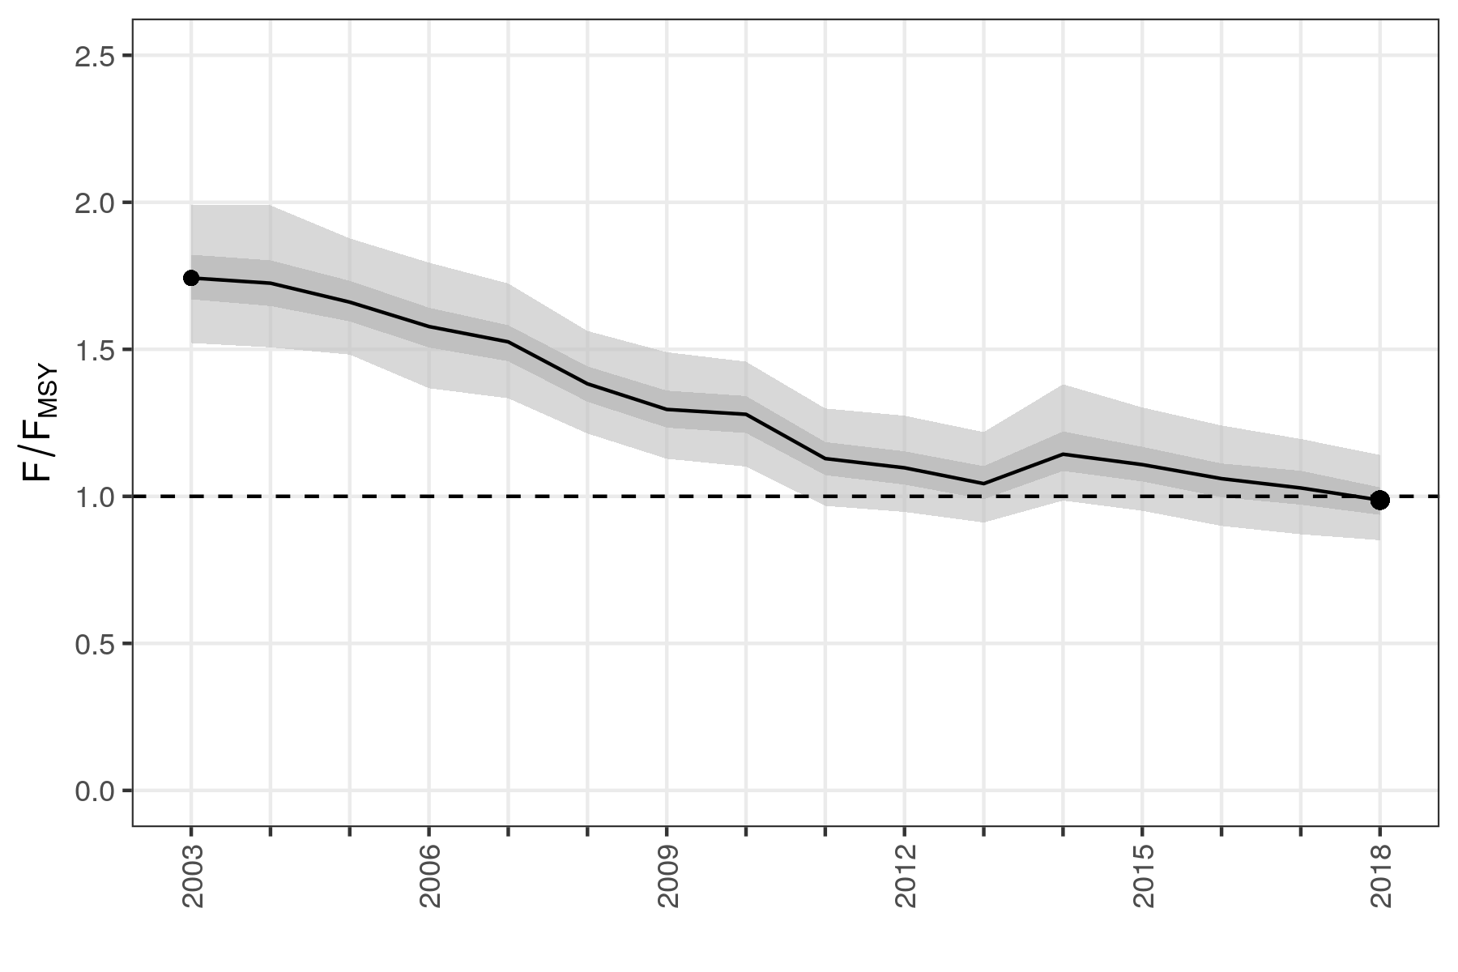

**Figure 4. Trend in F/Fmsy in the Mediterranean and Black Seas, 2003 - 2017[7]**

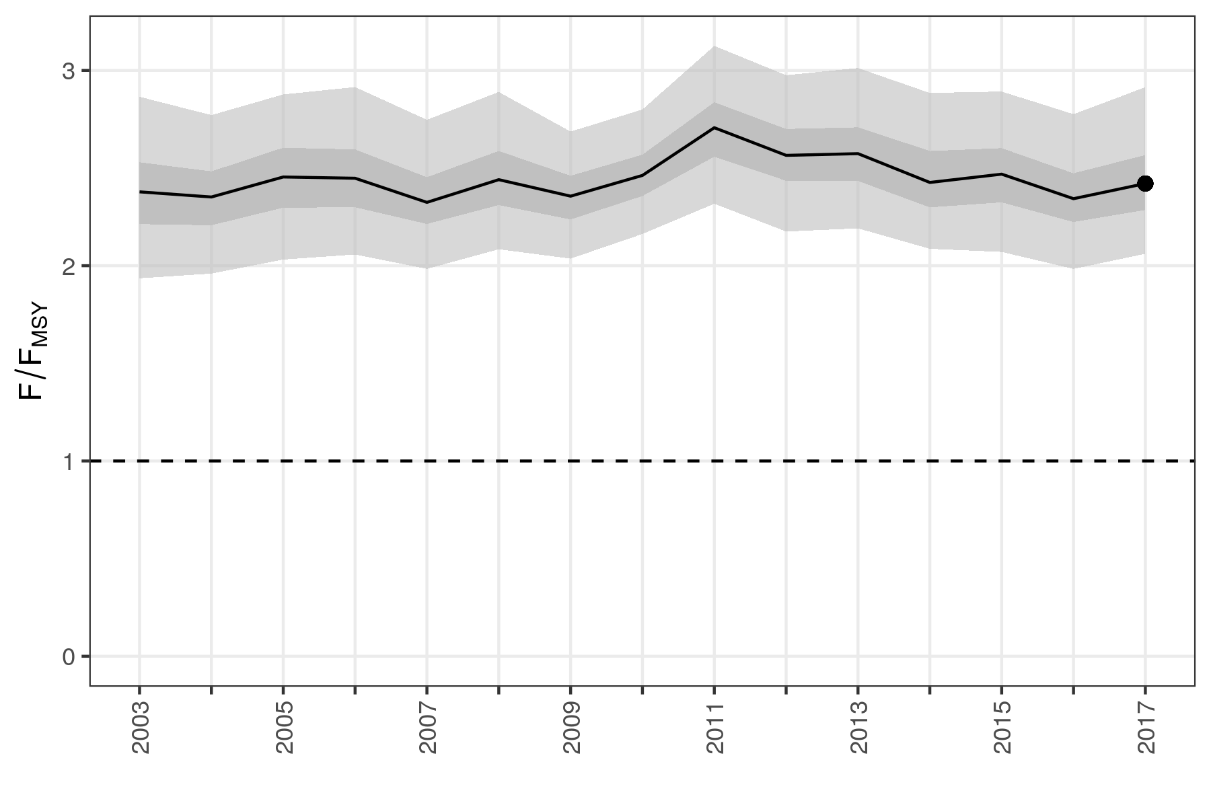

**Figure 5. Percentage of stocks in the northeast Atlantic area where fishing mortality was equal to, or less than, Fmsy, 2003 - 2018**

**Figure 6. Number of stocks by year by ecoregion for which fishing mortality (F) did not exceed Fmsy, 2003 - 2018**

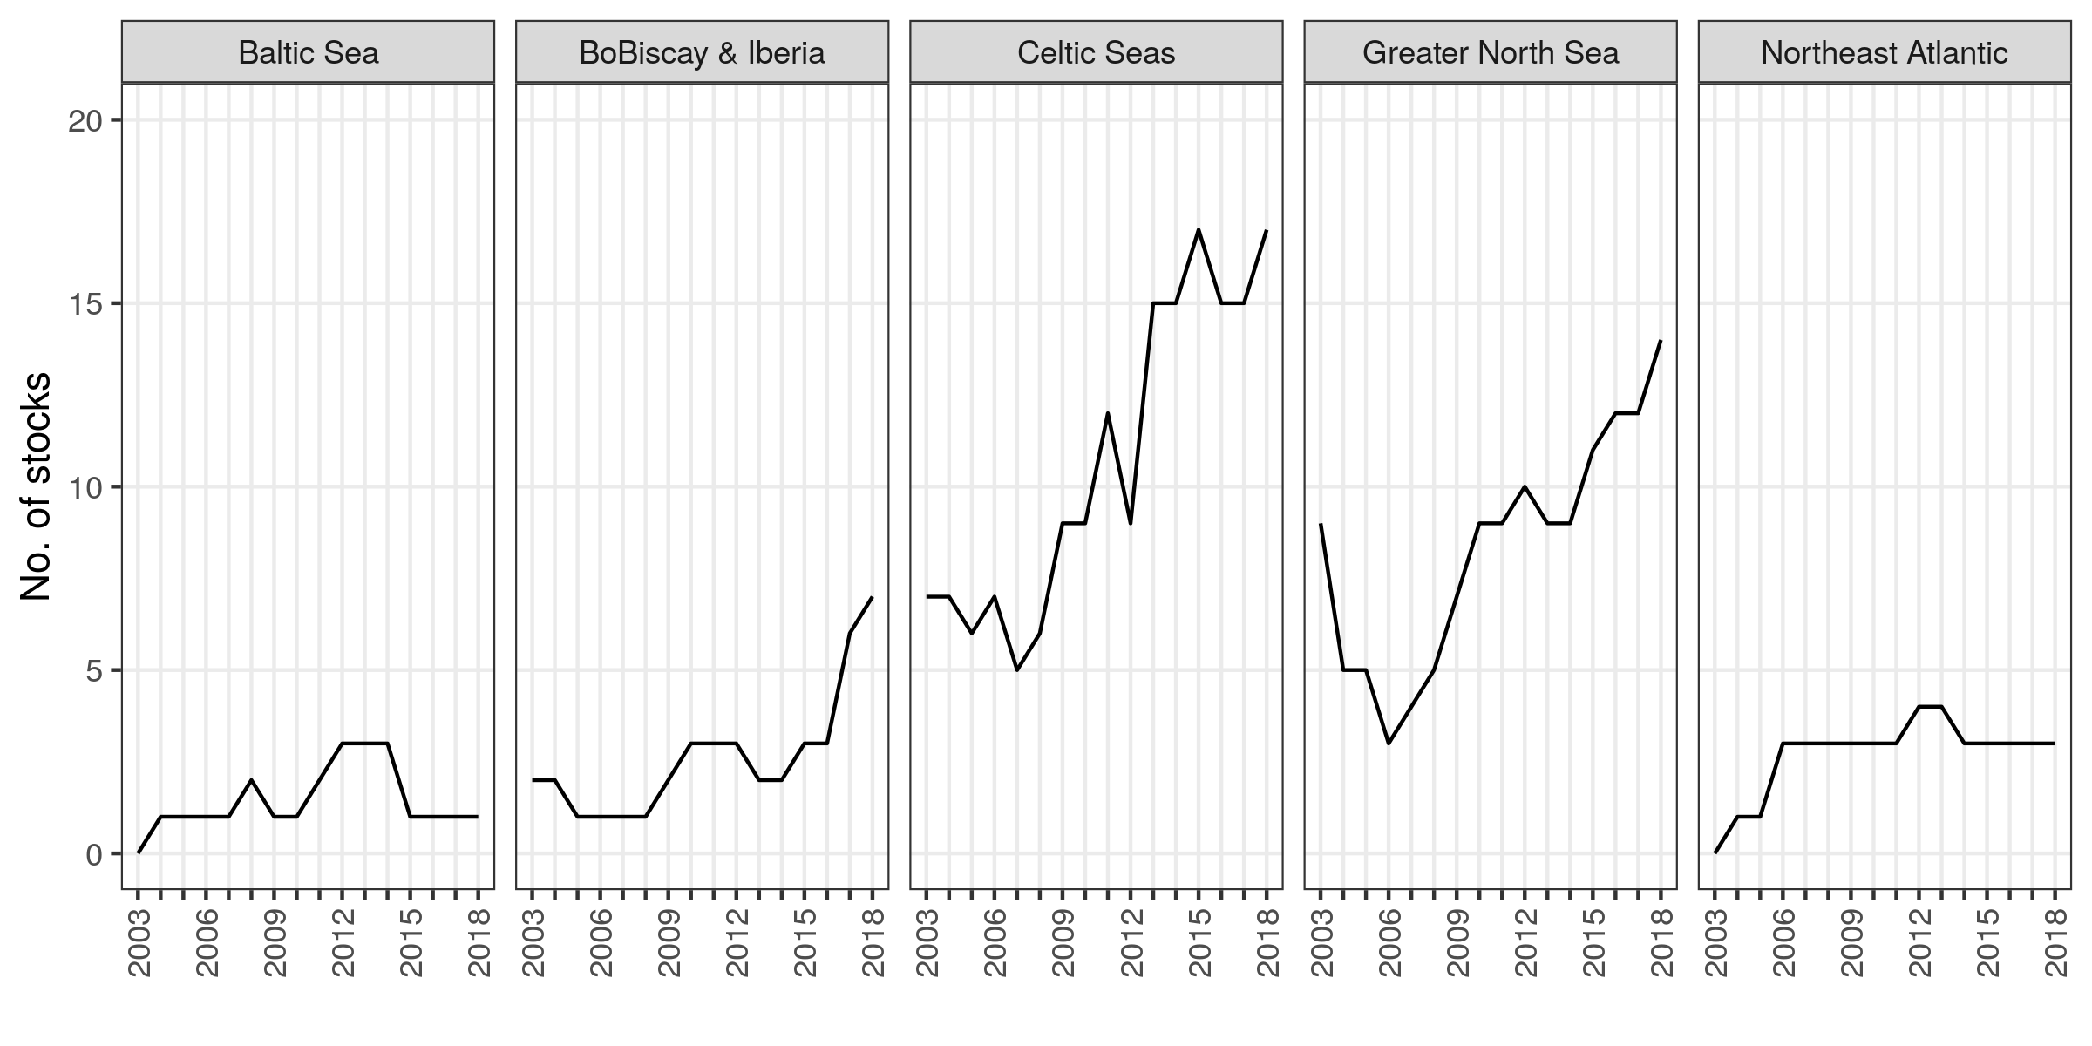

**Table 1. Number of stocks by ecoregion for which fishing mortality (F) did not exceed Fmsy, 2003 - 2018**

|  |  |  |  |  |  |  |  |  |  |  |  |  |  |  |  |  |
| --- | --- | --- | --- | --- | --- | --- | --- | --- | --- | --- | --- | --- | --- | --- | --- | --- |
| EcoRegion | 2003 | 2004 | 2005 | 2006 | 2007 | 2008 | 2009 | 2010 | 2011 | 2012 | 2013 | 2014 | 2015 | 2016 | 2017 | 2018 |
| ALL | 18 | 16 | 14 | 15 | 14 | 17 | 22 | 25 | 29 | 29 | 33 | 32 | 35 | 34 | 37 | 42 |
| Baltic Sea | 0 | 1 | 1 | 1 | 1 | 2 | 1 | 1 | 2 | 3 | 3 | 3 | 1 | 1 | 1 | 1 |
| BoBiscay & Iberia | 2 | 2 | 1 | 1 | 1 | 1 | 2 | 3 | 3 | 3 | 2 | 2 | 3 | 3 | 6 | 7 |
| Celtic Seas | 7 | 7 | 6 | 7 | 5 | 6 | 9 | 9 | 12 | 9 | 15 | 15 | 17 | 15 | 15 | 17 |
| Greater North Sea | 9 | 5 | 5 | 3 | 4 | 5 | 7 | 9 | 9 | 10 | 9 | 9 | 11 | 12 | 12 | 14 |
| Northeast Atlantic | 0 | 1 | 1 | 3 | 3 | 3 | 3 | 3 | 3 | 4 | 4 | 3 | 3 | 3 | 3 | 3 |

* 1. **Trends in biomass** 
     1. **Northeast Atlantic area**

There has been improvement in the northeast Atlantic area with the biomass generally increasing since 2007. For fully assessed stocks, it was 48% higher in 2018 than in 2003 (median value, Figure 7).

* + 1. **Mediterranean and Black Seas**

In the Mediterranean and Black Seas**,** the situation has remained essentially unchanged since the start of the data series in 2003, although since 2012 there may have been a slight increase in biomass. The STECF notes, however, the large uncertainty surrounding this indicator.

**Figure 7. Trends in the indicators of stock biomass**

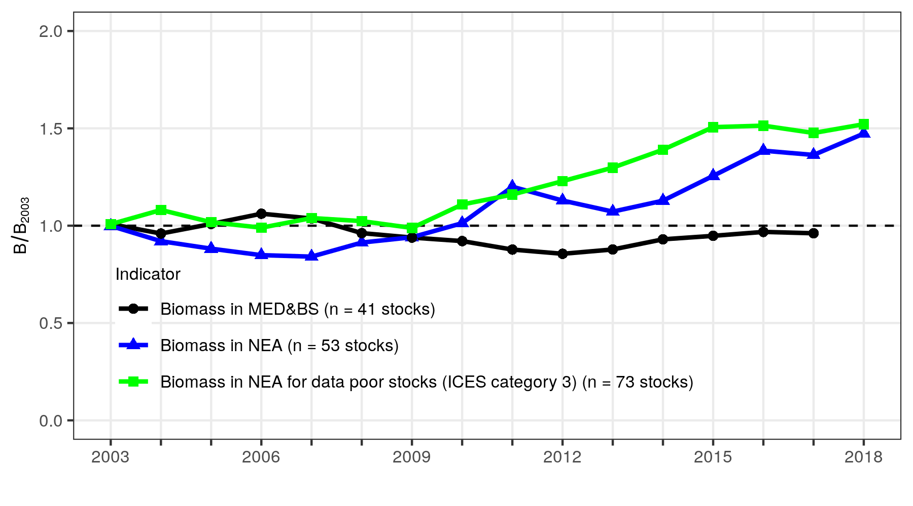

* 1. **Coverage of scientific advice**

The STECF notes that 156 total allowable catches (TACs) (combination of species and fishing management zones) were in place in 2018 in the EU waters of the ICES area. In many cases, the boundaries of the TAC management areas are not aligned with the biological limits of stocks used in ICES assessments. The STECF considered a TAC to be ‘covered’ by a stock assessment when at least one of its divisions matched the spatial distribution of a stock for which reference points have been estimated from an ICES full assessment. Based on this indicator, 54% of the 156 TACs were covered, at least partially, by stock assessments that provide estimates of Fmsy (or a proxy), 49% by stock assessments that have Bpa, but only 19% by stock assessments that provide estimates of MSY-Btrigger (Figures 8 and 9, Tables 2[8] and 3). These figures show little change since 2017.

**Figure 8. Number of stocks in the ICES area for which estimates of F/Fmsy are available by year, 2003 - 2018**

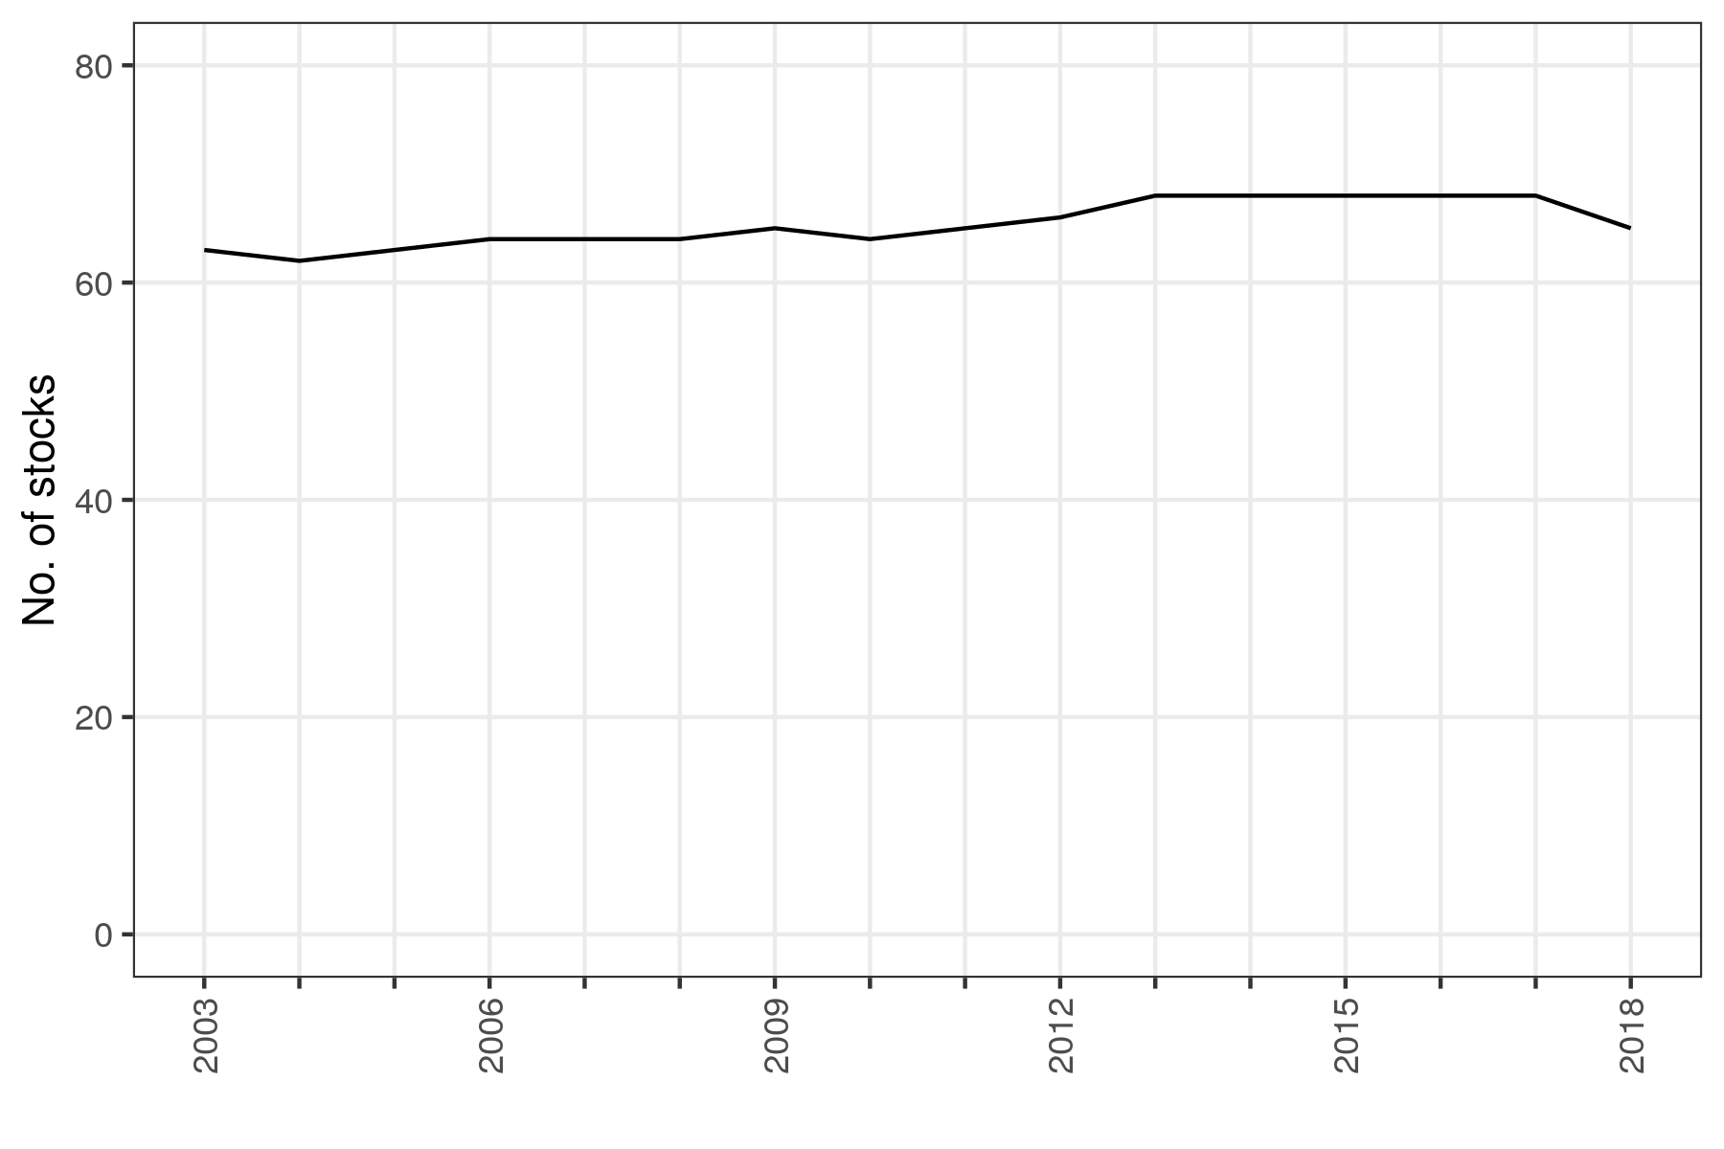

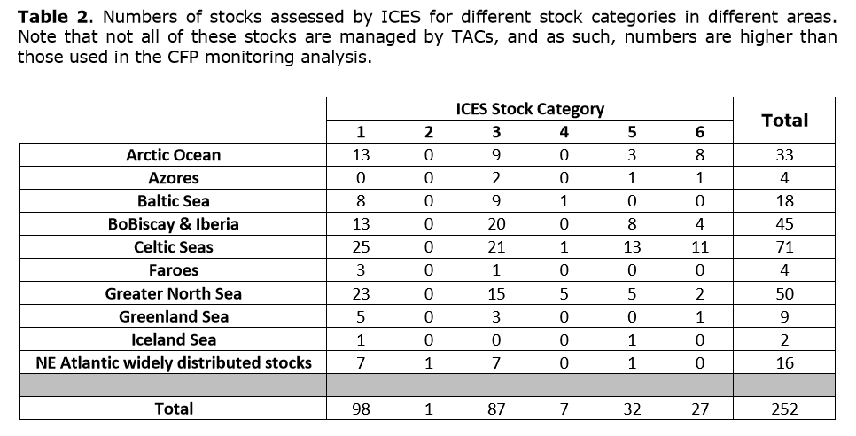

Table 3. Number of stocks in the ICES area for which estimates of F/Fmsy are available by ecoregion and year, 2003 - 2018

|  |  |  |  |  |  |  |  |  |  |  |  |  |  |  |  |  |
| --- | --- | --- | --- | --- | --- | --- | --- | --- | --- | --- | --- | --- | --- | --- | --- | --- |
| EcoRegion | 2003 | 2004 | 2005 | 2006 | 2007 | 2008 | 2009 | 2010 | 2011 | 2012 | 2013 | 2014 | 2015 | 2016 | 2017 | 2018 |
| ALL | 63 | 62 | 63 | 64 | 64 | 64 | 65 | 64 | 65 | 66 | 68 | 68 | 68 | 68 | 68 | 65 |
| Baltic Sea | 7 | 7 | 7 | 7 | 7 | 7 | 7 | 7 | 7 | 7 | 7 | 7 | 7 | 7 | 7 | 7 |
| BoBiscay & Iberia | 9 | 9 | 9 | 9 | 9 | 9 | 9 | 9 | 9 | 9 | 9 | 9 | 9 | 9 | 9 | 9 |
| Celtic Seas | 19 | 18 | 19 | 20 | 20 | 20 | 21 | 20 | 21 | 22 | 24 | 24 | 24 | 24 | 24 | 23 |
| Greater North Sea | 22 | 22 | 22 | 22 | 22 | 22 | 22 | 22 | 22 | 22 | 22 | 22 | 22 | 22 | 22 | 22 |
| Northeast Atlantic | 6 | 6 | 6 | 6 | 6 | 6 | 6 | 6 | 6 | 6 | 6 | 6 | 6 | 6 | 6 | 4 |

**Figure 9. Number of stock assessments available in the Mediterranean and Black Sea. The totals include stocks in GSAs 1, 5-7, 9, 10-19, 22-23, 25 and 29**

***(data 2017, pending GFCM assessment)***

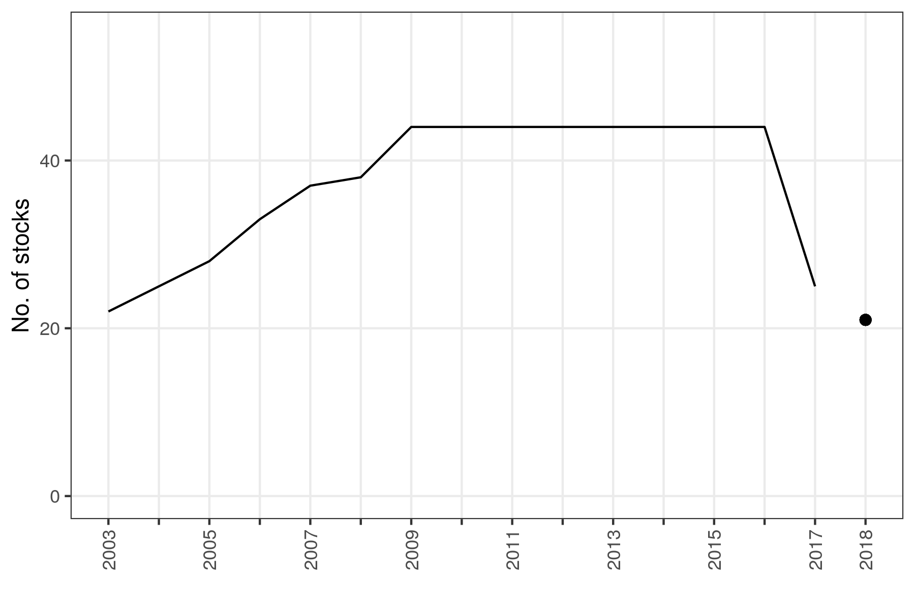

1. **Setting of fishing opportunities for 2020**

For 2020, the number of total allowable catches (TACs) set in line with Fmsy increased from 59 in 2019 to 62 in 2020, representing 79% of the Fmsy-assessed TACs fished in the northeast Atlantic, North Sea and Baltic Sea[9]. Of the 16 Fmsy-assessed TACs that are not fixed at MSY level, 6 are in EU waters and 10 are outside EU waters. The rest of the overall expected catches for 2020 do not have Fmsy advice, but are assessed by ICES based on precautionary advice, with various degrees of data uncertainty. During the discussions with Member States, socio-economic considerations were taken into account, with Member States sending detailed submissions to the Commission.

**Table 1. MSY-assessed fishing opportunities 2020 (in tonnes)**

|  |  |  |  |  |
| --- | --- | --- | --- | --- |
|  | **EU stocks** | **EU/Norway jointly managed stocks** | **Coastal state stocks** | **Total** |
| **Total TAC (Fmsy-assessed stocks)** | 1,348,039 | 534,835 | 814,256 | 2,697,130 |
| **TAC fished at Fmsy** | 1,339,215 | 519,726 | 0 | 1,858,941 |
| **TAC not fished at Fmsy** | 8,824 | 15,109 | 814,256 | 838,189 |
| **% fished at Fmsy** | 99.3% | 97% | 0% | 69% |
| **% not fished at Fmsy** | 0.7% | 3% | 100% | 31% |

**Table 2. MSY-assessed fishing opportunities 2020 (number of TACs)**

|  |  |
| --- | --- |
|  | **2020** |
| **TACs with MSY advice** | 78 |
| **TACs set in accordance with or lower than advice** | 62 |
| **TACs set above advice** | 16 |
| **% of TACs in accordance with or lower than advice** | 79% |

1. **Specific actions for the Mediterranean and Black Seas**

The EU continued working, including with its international partners, to improve the situation of stocks in the Mediterranean and Black Seas.

The Commission has further stepped up its efforts to implement the 2017 Malta MedFish4Ever Declaration and the 2018 Sofia Declaration towards establishing sustainable management of fisheries in these basins. Increased cooperation and political engagement enshrined in the Declaration enabled substantial progress to be made in 2019, especially with the adoption of ground-breakings measures. The main achievements are summarised below.

At international level, considering the shared nature of most fish stocks, the EU continued to promote multilateral cooperation in the competent regional fisheries management organisations (RFMOs), including the General Fisheries Commission for the Mediterranean (GFCM) and the International Commission for the Conservation of Atlantic Tuna (ICCAT). With the adoption of the MedFish4Ever (March 2017) and the Sofia (June 2018) Declarations, there is a detailed work plan to rebuild Mediterranean fish stocks, in close collaboration with the Barcelona Convention, and rebuild Black Sea fish stocks to protect the region’s ecological and economic wealth and boost the sustainable development of aquaculture for the next 10 years. This is complemented by the regional plan of action for sustainable small-scale fisheries (September 2018).

*Within the framework of the GFCM*

At the 43rd session of the GFCM in November 2019, a record 15 EU proposals were adopted, of which 8 were binding recommendations. They include ground-breaking management measures, such as the MAP for demersal stocks in the Adriatic, which is a first MAP addressing the alarming state of key stocks, in particular hake, of great relevance for Member States such as Italy and Croatia. It provides for a cut of 16% in effort over 2020 and 2021 before further reductions are agreed on the basis of scientific advice. This MAP also comprises a pilot joint inspection scheme. Other iconic species are now covered by MAPs, with the adoption of MAPs for red coral, blackspot seabream in the Alboran Sea, deep water shrimp in the Strait of Sicily, as well as dolphinfish under fish aggregating devices (FADs).

In 2019 the Commission also emphasised the importance of protecting sensitive habitats and species, with the adoption of GFCM decisions on the protection of vulnerable marine environments and the prevention of by-catches, including through better selectivity of gears.

Lastly, and importantly, 2019 saw the adoption of important measures leading to improved compliance and the active fight against illegal, unreported and unregulated fishing. Of particular notice are the new powers given to the GFCM to identify non-compliance by GFCM members, thus strengthening enforcement.

*Within the framework of ICCAT*

Thanks to EU efforts, in November 2019 the International Commission for the Conservation of Atlantic Tunas (ICCAT) adopted a one-year interim measure to end overfishing of bigeye tuna in the Atlantic and managed to introduce changes to the management of fishing activities on fishing aggregating devices (FADs) needed to reduce juvenile mortality for bigeye and yellowfin tuna. For the first time, and based on EU proposals, ICCAT adopted a quota for blue sharks. This ground-breaking decision is the first of its kind for sharks in ICCAT and will provide a platform for the efficient long-term management of sharks.

*At EU level*

2019 was an important year for the implementation of the common fisheries policy in the Mediterranean with the adoption of the Western Mediterranean MAP. This was the first ever MAP in the Mediterranean, providing a comprehensive plan to redress the state of demersal stocks in this sub-regional area, in particular through a reduction of 10% of Member States’ efforts in 2020 and up to 40% in total by 2025.

On the implementation of the Mediterranean Regulation[10], some important progress was recorded in 2019, in particular with the commitment obtained from Italy, the largest fishing nation in the Mediterranean, to cut effort for demersals by up to 40% over 5 years.

On discard plans, in 2019 the Commission extended the discard plan for demersal fisheries in the Mediterranean. Some of the high survivability and *de minimis* exemptions were extended for another 2 years (until December 2021).

2020 will see a consolidation of the significant progress recorded in 2019. It will be the first year of full implementation of the MAP for demersal stocks in the western Mediterranean with the first effort reduction and the setting of fisheries closures for the protection of juveniles. 2020 will also be the second year in which a specific fishing opportunities regulation for the Mediterranean and the Black Seas is adopted.

*Fishing opportunities for the Mediterranean and Black Seas*

As a result of the actions mentioned above, in 2019 the Commission presented for the first time a stand-alone proposal for fishing opportunities in these two sea basins, comprising the following elements:

1. implement the 10% reduction of the fishing effort for demersal stocks in the western Mediterranean Sea, following the adoption of the MAP;
2. implement the measures adopted at the 2018 annual session of the GFCM, in particular for small pelagic species in the Adriatic and for eel, and implement the additional measures adopted by the GFCM in November 2019, in particular the multiannual plan for demersal stocks in the Adriatic; and
3. set fishing opportunities for the Black Sea, including an autonomous quota for sprat, as in previous years, and put forward the regional allocation scheme adopted in 2019 by the GFCM for turbot.

1. **Report on the balance between fishing capacity and fishing opportunities**

In line with Article 22(4) of Regulation 1380/2013 (the Common Fisheries Policy Regulation), the Commission must report annually to the European Parliament and to the Council on the balance between fishing capacity and fishing opportunities, taking into account the assessment by the STECF [11].

This report covers the year 2018. It assesses the annual capacity of all the EU fleet segments based on the information included in the Member States’ reports submitted to the Commission in 2019[12]. These reports must follow the 2014 Commission Guidelines[13] and, for the fleet segments for which structural overcapacity has been identified, they must contain an action plan. The action plan must set out the adjustment targets, tools and a clear time-frame for its implementation.

The submission of the annual fleet reports is an ex ante conditionality under the European Maritime Fisheries Fund (EMFF)[14]. Not submitting the annual fleet report and/or failing to implement the action plan could result in a proportionate suspension or interruption of relevant EU financial assistance to the Member States for the fleet segments concerned as provided by the EMFF Regulation.

* 1. **Member States' annual reports and action plans, STECF assessment**

All 23 coastal Member States submitted their reports for 2018 to the Commission[15]. Eleven national reports included a new or a revised action plan[16]. The Commission requested the STECF to:

* assess balance indicators for all EU Member States’ fleet segments, including for the outermost regions of France, Portugal and Spain;
* review national reports on Member State efforts to strike a balance between fleet capacity and fishing opportunities; and
* assess action plans submitted for fleet segments where Member States identified structural overcapacity.

The data used to compile the various indicators were collected under the Data Collection Framework (DCF)[17]. All balance indicators provided and used in the STECF Expert Working Group (EWG) 19-13 were calculated in accordance with the 2014 Commission Guidelines, which provide a common approach for estimating the balance over time between fishing capacity and fishing opportunities. Regarding the coverage of the data, the STECF concluded that, overall, there has been an improvement in the data quality and coverage compared to previous years despite some discrepancies.

The STECF confirmed that in general, the national fleet reports from Member States provided pertinent information on the fleet composition and structure, together with accompanying action plans for those fleet segments deemed to be out of balance with fishing opportunities. It noted, however, that in some national reports, the rationale for concluding whether a fleet segment is deemed to be in or out of balance with fishing opportunities is not clear and in other cases such an assessment is on the basis of a single indicator value. The STECF recalled that while Member States are best placed to provide an assessment of whether a fleet segment is in or out of balance with fishing opportunities, such an assessment cannot be made solely on the basis of a single indicator value. The Commission has again drawn the Member States’ attention to the need to follow the Commission’s 2014 guidelines in this regard.

Since the entry into force of the 2013 common fisheries policy, 20 Member States[18] have identified, using biological, economic or technical indicators and/or supplementary information, fleet segments whose fishing capacity is not effectively balanced with fishing opportunities or shows latent signs of being imbalanced. Over that period only 3 Member States never reached the conclusion that one or several of their fleet segments demonstrated an imbalance and therefore did not submit action plans[19].

**Table 1. Active fleet segments with sustainable harvest indicator out of balance**

|  |  |  |  |  |  |  |  |
| --- | --- | --- | --- | --- | --- | --- | --- |
| **Active fleet segments with sustainable harvest indicator out of balance (2017 values)\*** | | | | | | | |
| **Member States** | **Total number of active fleet segments** | **Number of fleet segments assesssed**  **(including clustering)** | **Number of assessed fleet segments out of balance** | **Percentage of assessed fleet segments out of balance (%)** | **Area 27 Atlantic Northeast** | **Area  37 Mediterranean and Black Sea** | **Other fishing regions** |
| **BE** | 9 | 2 | 1 | 50 | 1 | - | - |
| **BG** | 25 | 25 | 25 | 100 | - | 25 | - |
| **HR** | 35 | 14 | 13 | 93 | - | 13 | - |
| **CY** | 7 | 2 | 1 | 50 | - | 1 | - |
| **DK** | 19 | 14 | 11 | 79 | 11 | - | - |
| **EE** | 5 | 4 | 4 | 100 | 4 | - | - |
| **FI** | 8 | 2 | 2 | 100 | 2 | - | - |
| **FR** | 95 | 34 | 15 | 44 | 9 | 4 | 2 |
| **DE** | 20 | 10 | 10 | 100 | 10 | - | - |
| **GR** | 23 | 2 | 1 | 50 | - | 1 | - |
| **IE** | 32 | 14 | 14 | 100 | 11 | - | - |
| **IT** | 28 | 15 | 14 | 93 | - | 14 | - |
| **LV** | 3 | 3 | 1 | 33 | 1 | - | - |
| **LT** | 11 | 3 | 3 | 100 | 3 | - | - |
| **MT** | 18 | 4 | 3 | 75 | - | 3 | - |
| **NL** | 25 | 6 | 5 | 83 | 5 | - | - |
| **PL** | 18 | 2 | 2 | 100 | 2 | - | - |
| **PT** | 66 | 7 | 4 | 57 | 4 | - | - |
| **RO** | 6 | 6 | 6 | 100 | - | 6 | - |
| **SI** | 14 | 1 | 1 | 100 | - | 1 | - |
| **ES** | 90 | 42 | 29 | 69 | 15 | 12 | 2 |
| **SE** | 24 | 15 | 9 | 60 | 9 | - | - |
| **UK** | 46 | 20 | 8 | 40 | 7 | - | 1 |
| **Total** | 627 | 247 | 182 |  | 94 | 80 | 5 |

* Sustainable harvest indicator assessment by STECF 19-13

To address situations of imbalance, Member States proposed a variety of management tools in their action plans, including[20]:

* *fleet measures* (ban of new vessels, fleet conversion, reduction of the fishing capacity, temporary cessation of activities and modernisation of fishing fleet);
* *technical measures* (monitoring of landings, more selectivity or energy-efficient gear, permitting schemes for certain fisheries, space and time-related fishing restrictions);
* *economic measures* (support for the development of marketing initiatives or assistance to improve competitiveness).

The STECF concluded that the information in the action plans was only sufficient to note the actions that Member States intended to implement to address any imbalances in the fleet segments identified but was not sufficient to quantitatively assess whether such measures would be sufficient to redress any such imbalances. The Commission has written to all Member States to emphasise the need to provide more detailed action plans, specifying the objectives of the measures proposed for each of the segments identified as being out of balance. This would allow for a better monitoring of the effectiveness of these action plans.

In general terms, the Commission expects the STECF to enhance its assessment of the soundness of national fleet reports and action plans in the forthcoming period.

* 1. **The overall capacity of the EU fishing fleet**

The number of vessels in the EU fleet continued to decline. In December 2019, the EU fleet register (including outermost regions) contained 81 279 vessels with an overall capacity of 1 521 189 in gross tonnage (GT) and 6 047 356 in kilowatts (kW). This is a reduction compared to the previous year of 0.45% in terms of number of vessels, 0,78% in GT and 0,47% in kW.

The accuracy of the information recorded in the EU fleet register has been enhanced following the 2017 Commission Regulation on the Union fishing fleet register[21], which has introduced a procedure that guarantees the update of the EU fleet register in real time. It gives the Commission the possibility to check the correctness and correspondence between data submitted by Member States and vessel data already registered. However, some countries are still not in a position to submit their data in real time but only on a monthly basis and/or they cannot yet send snapshots (data for a set of vessels) requested by the Commission. Over the past period verifications of the number of vessels decommissioned with public aid were carried out. Since February 2020, a new application of the EU fleet register has become publicly available on the Commission’s Europa website[22].

The veridicity of the data recorded in the EU fleet register remains an issue of concern. In particular the widespread non-compliance with declared engine power undermines control effort regimes, but also raises questions about the overall compliance of the Member States with the fishing capacity ceilings established by the Common Fisheries Policy Regulation.

**Figure 2. Compliance with capacity ceilings based on the Union fleet register (effective capacity as percentage of capacity ceiling by Member State**

**(Mainland fleets), situation in December 2019)**

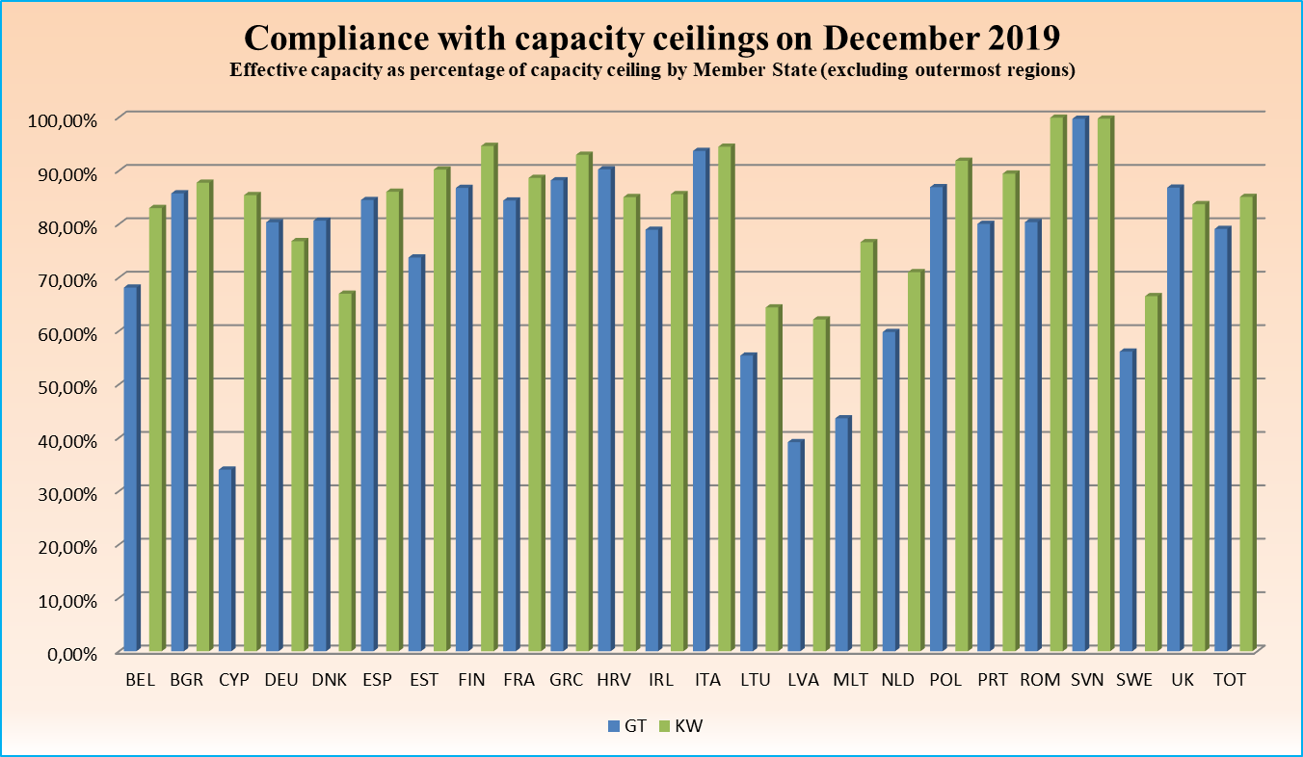

* 1. **Regional assessment**

According to the STECF, in the **northeast Atlantic** there are still a significant number of fleet segments which most probably are not in balance with their fishing opportunities. Based on an assessment using the sustainable harvest indicator, out of 147 assessed fleet segments active in this area in 2017, 94 were out of balance. In terms of the level of activity of the fleet, 74 fleet segments with 10 497 inactive vessels are reported for 2018. Twelve fleet segments show a decrease in the number of inactive vessels, 7 show an increasing trend. The vessel use indicator shows that out of the 231 segments assessed for this indicator, 70 fleet segments appear not to be in balance with their fishing opportunities. An increasing trend in the vessel use indicator can be observed for 40 segments, while a decreasing trend is shown for 45 segments.

Also in the **Mediterranean and the Black Seas**, a large number of fleet segments may not be in balance with their fishing opportunities. According to the STECF analysis, of the 91 fleet segments for which the sustainable harvest indicator can be considered meaningful to assess balance or imbalance, it was concluded that 80 fleet segments may not be in balance with their fishing opportunities in 2017. The inactive vessel indicator shows that in 2017 there were 41 inactive fleet segments for a total of 6 377 inactive vessels of which 5 916 had an overall length of less than 12 metres. The data over the recent period are influenced by the Croatian authorities’ registration of 3 500 small-scale fishing vessels in 2015 that were formerly considered ‘subsistence fishing vessels’ falling outside fisheries statistics. The vessel use indicator shows that out of the 113 segments assessed for this indicator, 25 fleet segments appear not to be in balance with their fishing opportunities. An increasing trend in the vessel use indicator can be observed for 12 segments, while a decreasing trend is shown for 13 segments.

Finally, the fleet in the **outermost regions** has seen a reduction in the number of vessels and overall capacity. Between December 2018 and December 2019, the number of vessels decreased by 66 vessels to a total of 4 009. The capacity in GT decreased by 5 007 to 57 507 GT. The capacity in kW decreased by 10 142 to a total of 398 322 kW. STECF noted that despite the improved data provided by Member States, there remain a number of fleet segments where it was impossible for some indicators to be determined. The latest report by the STECF provided a listing of those segments in outermost regions where at least one of the biological, technical or economic indicators was imbalanced. However, at this stage, given the lack of data, in particular regarding the biological indicators, it is impossible to draw definitive conclusions on the overall balance/imbalance of these fleet segments.

**Figure 3. Number of vessels in outermost regions (situation in December 2019)**

**Figure 4. Total GT in the outermost regions (situation in December 2019)**

**Figure 5. Total KW in the outermost regions (situation in December 2019)**

* 1. **Conclusions**

The overall capacity of the EU fleet (outermost regions included) continued to decrease in number of vessels, GT and kW.

In 2019, all 23 coastal Member States complied with their obligation to report information on the capacity of their fleet segments. However, some Member States will need to readjust their reporting to better comply with the Commission’s guidelines and address discrepancies between their national reports and the findings of the STECF. Eleven of the Member State reports included a new or revised action plan with a large variety of measures to address overcapacity, but more needs to be done to make the action plans more specific, timebound and objective driven.

In December 2019, the fishing capacity of the EU fleet (outermost regions excluded) was 21 % below the capacity ceilings for tonnage and 15% below the power ceilings. This is expected to have some positive effect on the conservation of marine biological resources, considering that capacity measures can be of relevance for countries and regions where conservation and management measures are not (yet) effective enough to regulate the use of fishing capacity through enforceable input and output measures.

1. **Economic performance of the EU fishing fleet**

According to preliminary data submitted by MemberMember States, the economic performance of the EU fleet continued to remain generally high, with an average net profit margin of 18% in 2018. The projections for the economic performance of the EU fleet in 2020 remain highly uncertain so far due to the combined effects of decline in demand and supply chain disruption resulting from the COVID-19 health crisis.

*COVID-19 pandemic*

Early indications suggest that the fishery sector has been hard hit by the market disruption caused by the COVID-19 pandemic, as demand has seen a sudden decline. The decline in demand, and subsequent drop in first sale prices, has caused many vessels to cease activity as it has become no longer profitable. The closure of HORECA channels has had significant impacts on the EU fishing fleet’s activities, especially for fleet segments targeting high-value species and small-scale coastal fisheries which tried to maintain some limited activity to reach a new balance between the supply and the reduced demand.

Data from fish auctions in Spain, France, the Netherlands and Denmark report high volatility (increases and decreases) as a result of either less demand or less supply, but overall first sale prices tend to be lower as a result of containment measures. Fishermen, retailers and processors are also confronted with limited stocking capacity (e.g. freezing products).

In addition to these demand and supply problems, sanitary measures (distance between crew members at sea) cannot be guaranteed for some fisheries, resulting in activity ceasing and/or fishing seasons being postponed.

On the other hand, low fuel prices in 2020 will help to ease operating costs in EU fleets.

To tackle this unprecedented situation, the Commission has proposed a range of actions addressing the urgent challenges that the EU seafood community faces. These measures will help to protect thousands of jobs in the EU’s coastal regions and maintain food security. Such measures include: i) extending the scope of the European Maritime and Fisheries Fund (EMFF) to allow compensation to be paid to fishermen for economic losses caused by a public health crisis, ii) granting EMFF support to fishermen for the temporary cessation of fishing activities due to the coronavirus, iii) reallocating financial resources within the operational programme of each Member State in a more flexible manner and v) simplifying the procedure for amending operational programmes in order to introduce the new measures. In addition to these EMFF measures, the adoption of a new temporary framework for State aid will enable Member States to provide relief to economic operators active in the fishery sectors who have been hit by the pandemic by allowing them to grant up to EUR 120 000 in State aid (national funding) per undertaking.

*Findings of the STECF report on the economic performance of the EU fishing fleet*

The 2019 STECF report on the economic performance of the EU fishing fleet gives a detailed and comprehensive narrative of the status of the fishing fleets in 2017, with preliminary data for 2018 and forecasts for 2019. These results confirm that, on average, the EU fleets continued to be profitable, with slightly lower figures than in 2016, yet still at historical heights. The positive results have been driven by three main factors:

* continued relatively low fuel costs resulting from lower fuel consumption and relatively low fuel prices.
* stable or, in some cases, increased average first sale prices for a number of commercially important species.
* progress in achieving sustainable fisheries. A positive economic trend is observed for a number of fleets targeting stocks exploited sustainably (such as anglerfish and megrim in the Irish Sea; sole in the western English Channel and megrim in the North Sea), as this tends to improve their profitability and salaries. Conversely, fleets targeting overexploited stocks tend to register poorer economic performance.

At sea basin level, there are some noteworthy differences. Fishing fleets operating in the Atlantic continue to present, on average, higher profits than fleets operating in the Mediterranean. Yet, while profitability remained stable or decreased in the Atlantic, an increase was observed in the Mediterranean and the Black Sea.

* 1. **Employment and salaries**

In 2017, the EU fishing fleet directly employed a total of 151 981 fishers, corresponding to 107 807 full-time equivalents (FTEs). Compared to 2016, they fell 0.2% and 6% respectively. The fall in employment alongside the 2% increase in personnel costs meant a 7.6% increase in annual average wage per FTE (EUR 28 652 compared to EUR 26 370 in 2016).

Employment has steadily decreased over the period of analysis (2008-2017): -13% in total jobs and -14.7% in FTE, while average annual wages per FTE increased by 38% in the same period.

**Figure 1. Trends in employment (in persons employed and FTE)**

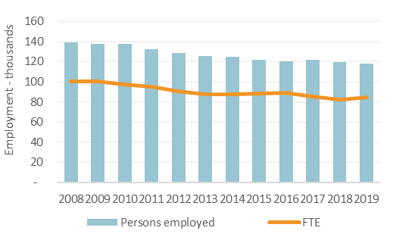

**Figure 2. Variation in employment and average wage (based on 2008=100)**

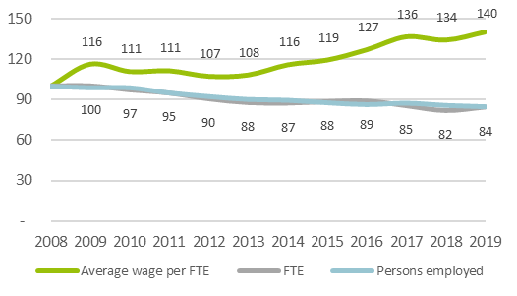

* 1. **Main economic indicators**

The EU fishing fleet generated EUR 7.7 billion in total revenue in 2017, while total costs amounted to EUR 6.4 billion (i.e. 83% of the revenue generated). In addition, the fleet received EUR 51.6 million in subsidies and EUR 39.8 million in income from leasing out fishing rights. Of the costs incurred, 89% were operating costs (EUR 5.7 billion), and the remaining 11% were capital costs (EUR 688 million).

The Spanish fishing fleet continues to obtain the highest revenue (EUR 2 billion), a quarter of the total. It is followed by the French fleet (EUR 1.35 billion).

**Figure 3. Trends and variations in revenue by main type of fishing activity[23]**

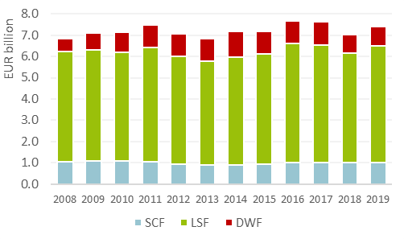

* 1. **General trends by fishing region**

Collectively, all regional fleets generated gross profits over the period analysed, with the following breakdown per fishing region:

*North Sea and Eastern Arctic region*

The North Sea and Eastern Arctic fleet produced 1.6 million tonnes in weight and EUR 1.7 billion in value. The revenue in 2017 showed a 5% decrease over 2016. Gross value added (GVA) was over EUR 1 billion in 2017 (-11% to 2016) and gross profits EUR 547 million (-16%).

**Figure 4. Trends in revenue and profits for Member States fleets operating in the North Sea & Eastern Arctic**

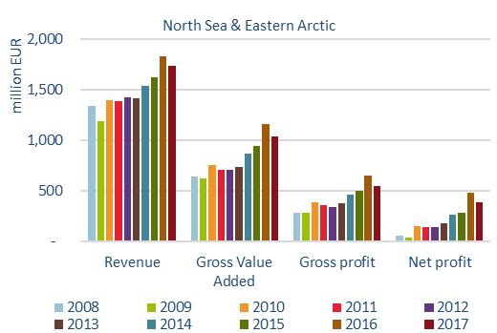

*The Baltic Sea region*

The weight and value of landings were 632 538 tonnes and EUR 217 million respectively. The Baltic fleet employed 8 533 fishers, i.e. 4 422 FTEs.

In general, the Baltic fleet was profitable in 2017, generating gross and net profits. Nevertheless, four Member States fleets (Denmark, Finland, Germany and Lithuania) suffered aggregated net losses. The revenue generated was estimated at EUR 226 million. GVA was EUR 112 million, gross profit was EUR 44.3 million and net profit was EUR 9.4 million.

**Figure 5. Trends in revenue and profits for Member States fleets operating in the Baltic Sea**

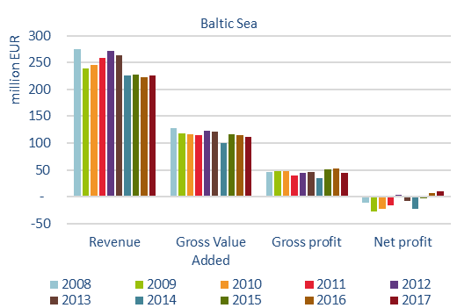

*The North Western Waters region*

The Member States fishing in the North Western Waters are Belgium, Denmark, France, Germany, Ireland, Lithuania, the Netherlands, Portugal, Spain and the United Kingdom. The French, UK and Irish fisheries have the highest level of landings in the North Western Waters. The Irish fleet is also the most dependent on the region, with 85% of the country’s landed value coming from that region. The North Western Waters comprised 5 664 active vessels (+1.6% over 2016).

The weight and value of landings amounted to 1.09 million tonnes and EUR 1.57 billion respectively. They were mainly generated by the large-scale fleet (LSF).). The volume of landings increased but the fishing effort decreased, i.e. the fleets spent 473 thousand days at sea. For 2017, total landings in weight increased by 5% compared to 2016. Additionally, fuel prices rose slightly while fuel consumption was down 1%.

Employment was estimated at 15 500 jobs or 11 000 FTEs, a 7% decrease compared to 2016. The average yearly wage per FTE for the small-scale coastal fleet (SCF) rose by 8% in 2017 (to around EUR 38 000), while for the LSF it increased by 12% to EUR 53 500, the highest value recorded for the 2010-2017 period. As for labour productivity, it continues an increasing trend for the LSF and remains flat for the SSCF.

The revenue generated amounted to EUR 1.7 billion. GVA was estimated at EUR 949 million, a 1% increase from 2016. Gross profit came to EUR 397 million and net profits totalled EUR 259 million.

**Figure 6. Trends in revenue and profits for Member State fleets operating in the North Western Waters**

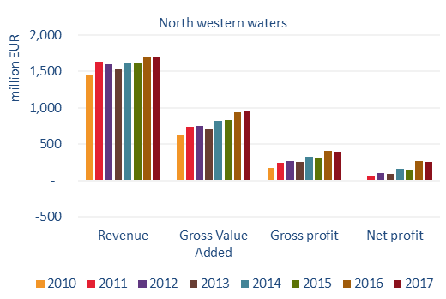

*South Western Waters region*

Total employment in the region was 37 000 (24 600 FTE). Figures show a decreasing trend (-3.7% since 2010). Average annual wages per FTE since 2010 have increased for SSCF (+8%) and for the LSF (+18%).

The weight and value of landings generated were 557 600 tonnes and EUR 1.23 billion respectively. Compared to 2016, landings in weight went up by 3.3% and in value by 1%.

Revenue for the South Western Waters was EUR 1.3 billion, a 0.7% decrease over 2016. The GVA was EUR 832 million, while gross profits were EUR 243 million. Overall, the fleet was profitable and registered net profits of EUR 152 million.

**Figure 7. Trends in revenue and profits for Member State fleets operating in the Southern Western Waters**

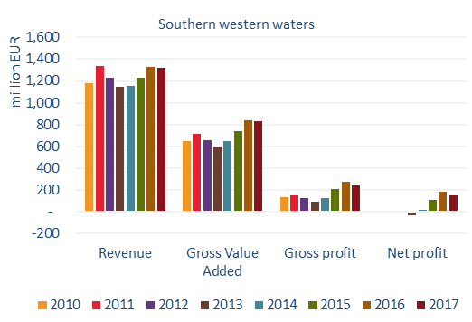

*The Mediterranean Sea region*

The fleet generated about 46 217 jobs, corresponding to 30 630 FTEs (-7% compared to 2016). In 2017, annual wages saw a 6.5% increase for SSCF and a 6.7% increase for LSF compared to 2016. The weight and value of landings generated by the fleet in 2017 amounted to approximately 363 000 tonnes (+1% compared to 2016) and EUR 1.46 billion (+8%), respectively. Energy consumption fell by 5% (505 million litres).

In 2017, labour productivity (GVA per FTE) for both the SSCF and the LSF increased by around 14% compared to 2016. The revenue generated by the Mediterranean fleet in 2017 was estimated at about EUR 1.5 billion (+5% compared to 2016). GVA stood at EUR 922 million (+7%), gross profit was at EUR 430 million (+16%) and net profits of EUR 227 million. All Member States reported net profits, with the exception of Malta. The profit figures were the highest over the covered period.

**Figure 8. Trends in revenue and profits for Member States fleets operating in the Mediterranean Sea**

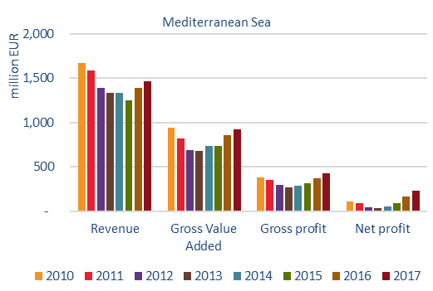

*The Black Sea region*

Landings in weight and value increased in 2017. However, the fishing effort remained largely unchanged. The weight of landings was approximately 17 000 tonnes worth EUR 9.22 million.

Employment in the region was estimated at 2 353 jobs (776 FTEs). The revenue generated by the Black Sea fleet was EUR 9.6 million, an increase of 4% compared to 2016. GVA was estimated at EUR 6.2 million (+4% over 2016), gross profit was EUR 3.9 million (+7%) and net profit was EUR 3 million.

**Figure 9. Trends in revenue and profits for Member State fleets operating in the Black Sea**

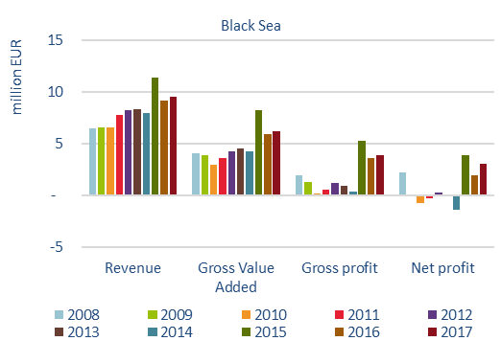

*EU outermost regions*

*The fleet in the Canary Islands:* generated EUR 50.2 million in revenue, EUR 36 million in GVA, EUR 3.7 million in gross profits and EUR 2 million in net profits.

*The Madeiran fleet*: generated EUR 16 million in revenue, EUR 12.3 million in GVA, EUR 4 million in gross profits and EUR 3.3 million in net profits.

*The Azorean fleet*: generated EUR 38.5 million in revenue, EUR 27.6 million in GVA and EUR 11.6 million in gross profits. Overall, the fleet was profitable with a net profit of EUR 6.6 million. All fleet segments were profitable.

Analysis for the rest of the fleets was not possible due to a lack of data or incomplete data.

**6. Implementation of the landing obligation**

As in previous years, the Commission obtained information from Member States, advisory councils and other relevant sources to use as a basis for the mandatory annual report on the implementation of the landing obligation, as stated in [Regulation (EU) 2015/812](https://eur-lex.europa.eu/legal-content/EN/TXT/?uri=uriserv:OJ.L_.2015.133.01.0001.01.ENG)[24]. Since 2016, these reports have been based on a questionnaire developed by the STECF.

The Commission received reports from 18 Member States[25] (Figure 1) and five advisory councils. As with previous years, care is required in interpreting year-on-year change, since the composition of respondents in the different areas has changed. It is also important to recognise that changes reported in a questionnaire do not necessarily imply a successful outcome for the landing obligation. Similarly, failure to respond or reports showing no change do not necessarily mean an unsuccessful outcome. To be able to give the best picture of implementation, the Commission has used other sources of information aside from the reports.

Effective and successful implementation of the landing obligation will depend on: i) confidence that there has been significant change in fishing practices at sea, ii) adequate monitoring and control of all fishing operations to ensure that catches are fully accounted for and iii) a significant reduction in unwanted catches.

**Figure 1. Member State reports, 2016-2019 (STECF 20-01adhoc report)**



In line with Article 9 of Regulation (EU) 2015/812, the information obtained includes the following:

* steps taken by Member States and producer organisations to comply with the landing obligation;
* steps taken by Member States to verify compliance with the landing obligation;
* information on the socio-economic impact of the landing obligation;
* information on how the landing obligation has affected safety on board fishing vessels;
* information on the use and outlets of catches below the minimum conservation reference size of a species subject to the landing obligation;
* information on port infrastructures and vessel fittings in relation to the landing obligation;
* for each fishery concerned, information on the difficulties encountered in implementing the landing obligation and recommendations to address them.

This section focuses on these elements as well as on the state of play of the discard plans and on control and enforcement. It also provides an update of the use of the EMFF to implement the landing obligation.

* 1. **Progress report**

The changes reported in 2019 tend to refer to activities taking place across the different elements of the Regulation. Many Member States have provided more quantitative data. Information on discard quantities is more detailed, but based on the questionnaires, it is still not possible to say definitively whether there have been any changes in discard quantities. Member States and the advisory councils continue to report that the fishing industry remains negative for the landing obligation. This is backed up by the presentations given at European Parliament hearings, where industry representatives routinely rejected the policy as unworkable and ill-conceived. Evidence to suggest behavioural change in operating practices when at sea is still limited, and even with full implementation in 2019, maintaining ‘business as usual’ seems to be the main objective.

* + 1. **Implementation of the landing obligation – state of play**

Overall, it appears that the landing obligation continues to have a low impact on Member States and the fishing industry. This is contrary to indications given by Member States and the advisory councils in 2018 that impacts would increase with full implementation in 2019. Most Member States in the North Western Waters, South Western Waters, Baltic and North Sea have put more focus on control and enforcement, but compliance in general would appear to be still low. The lack of accurate reporting by most countries of fish discarded under exemptions allowed for under the landing obligation, the very low volumes of fish below minimum conservation reference sizes (MCRS) being landed and the difficulties experienced by Member States in monitoring such catches are major concerns and areas that have not been addressed. In the Mediterranean and the Black Sea, the impression given by Member States and supported in the case of the Mediterranean by the advisory councils is that the impacts of the landing obligation will be minimal if the current exemptions remain in place. However, the reliance on exemptions suggest there is a lack of willingness or difficulty to change operational behaviour or take steps to increase selectivity. Most of the gaps and weaknesses highlighted in the 2018 reports covering implementation remain, and full implementation is still some way off from being achieved in all sea basins.

More Member States than in the past have adjusted their national quota management systems. Inter-species quota flexibility has mostly not been used but inter-annual flexibility mechanisms continue to be used extensively. There is no evidence of any significant increases in quota swapping between Member States, and this is confirmed by the Commission’s QUOTA database (Figure 2). However, it remains an important mechanism, and there are specific cases where Member States report that quota swaps have helped to avoid choke situations. The quota pool put in place for 2019 to provide quotas for by-catch species for which Member States had no quota is thought to be a good initiative that should be continued, even if these quotas have not been fully utilised. Given that the STECF analysed the by-catch reduction plan of the Member States in 2019[26] and concluded that the measures were not effective enough to increase selectivity and therefore reduce by-catches, the Commission aimed at linking remedial measures and control measures to the by-catch quota pool for 2020.

To increase transparency and facilitate the swapping, the Commission publishes the quota swaps list per year on a publicly available website[27]. The file for the current year is updated on a weekly basis.

**Figure 2a - b: 1997 – 2020 quota swaps[28]**

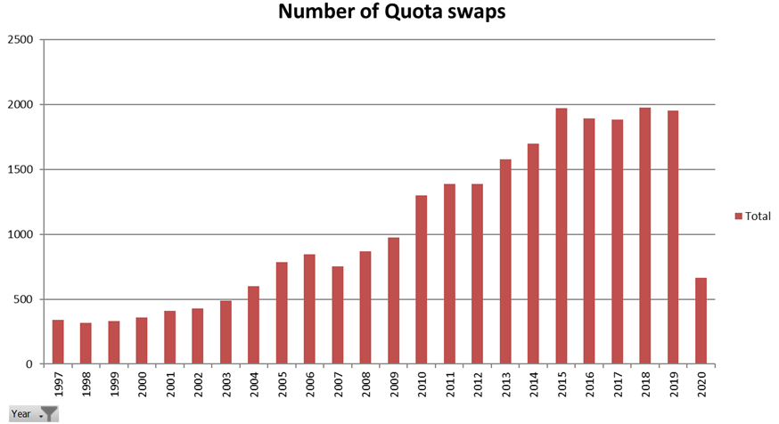

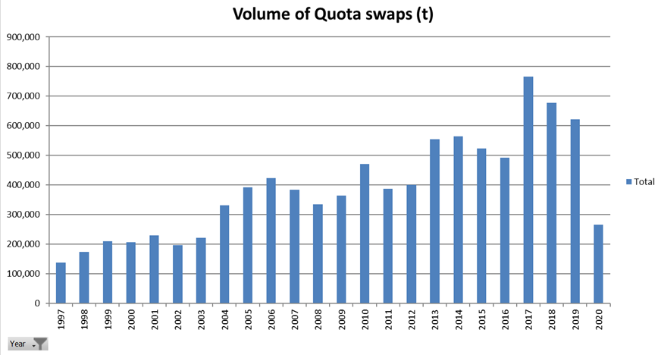

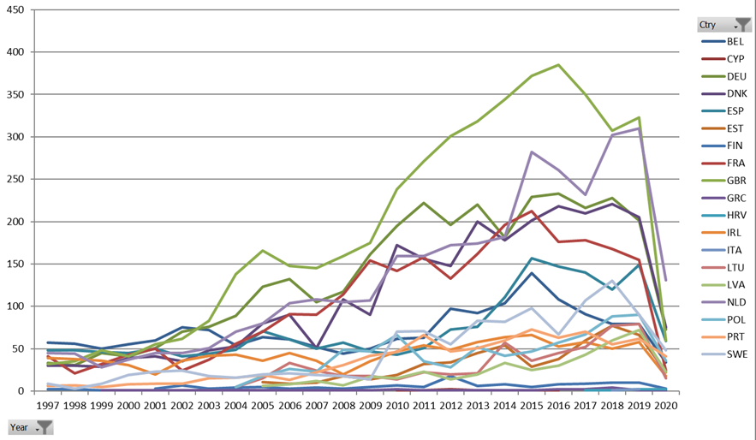**Figure 2.C Number of quota swaps per Member State 1997 - 2020**

**6.1.2 Socio-economic impact and port infrastructure and vessels fit for purpose**

Most Member States report that it remains difficult to assess the *socio-economic impacts* of the landing obligation, indicating that problems remain minimal across sea basins. For 2019, very limited information was supplied, and anything provided merely repeated the same information provided in 2017 and 2018. However, extensive modelling of the impacts of the landing obligation were provided in the DiscardLess[29] and Minouw[30] projects funded under the Horizon 2020 programme. The general conclusion was that while there were initial short-term negative economic impacts, in the longer term these were more positive.

However, efficient mitigation strategies may reduce this negative economic effect of the landing obligation in some of the fisheries. The possibility to swap quotas may also reduce the economic losses caused by the landing obligation. These possibilities are available within the current framework, and it is important to further intensify collaboration in 2020.

During 2019, as in previous years, there was again no clear evidence of the landing obligation causing *safety issues on board fishing vessels;* reports from Member States were identical to the previous years in that no incidents or issues were recorded. Several Member States reiterated their perception that such impacts exist and will become issues over time the longer the landing obligation is fully enforced. However, no substantive evidence has been provided to support this assertion. Other than in several Member States, the reports for 2019 saw limited funding provided under the EMFF to improve the *infrastructure of ports as well as modifications on board fishing vessels*. Specific actions so far include the provision of cold storage facilities onshore and aboard vessels for the storage of unwanted catches.

**UK House of Lords reports on implementation and enforcement of the landing obligation**

The EU Energy and Environment Sub-Committee of the UK House of Lords published a report on 8 February 2019 on [the implementation and enforcement of the EU landing obligation inquiry](https://www.parliament.uk/hlinquiry-implementation-enforcement-landing-obligation/), and a second report in July 2019. The government responded in April 2019 and October 2019. The debate took place in January 2020. When the Committee examined the issue, they found little evidence of the landing obligation being followed to date and an almost unanimous view that the UK was not ready for full implementation. The report stresses the importance of having mechanisms in place to monitor and enforce compliance. One of the ways suggested in the report is the use of remote electronic monitoring.

*‘Landing obligation as a policy instrument can be compared to a speed limit on the highway – you cannot deploy inspectors everywhere. It requires a cultural shift between government, regulators and the industry for successful implementation: a partnership.’ [Hearing 23 January 2020]*

* + 1. **Control and enforcement**

The European Commission has a responsibility to control and evaluate the application of the rules of the common fisheries policy by Member States (Article 96(1) of Council Regulation (EC) No 1224/2009). In fulfilling this role, the European Commission launched an audit series in 2020 to evaluate the measures adopted by Spain, France, Belgium, Ireland and the Netherlands to **ensure** control, enforcement and inspection of activities relevant to the landing obligation and to **ensure** the full documentation of all fishing trips and relevant data. Member States were selected on the basis of those having access to by-catch quotas as provided for by Council Regulation (EU) 2019/124. To date, audits have been conducted in Spain and France and audits in Belgium, Ireland and the Netherlands will follow, depending on the restrictions imposed by the COVID-19 health crisis.

The preliminary findings of the first audits indicate that the quantities recorded as discarded and the landed quantities of catches below the MCRS are very low. This information differs from scientific data and indicates extensive unreported discarding. This latter finding is also supported by various reports, including three European Fisheries Control Agency’s (EFCA) compliance evaluation reports on the implementation of the landing obligation, which all found that non-compliance with the landing obligation was widespread in specific fisheries during the evaluation periods (2015/2016-2017) in the North Sea and North Western Waters[31].

Reporting by fishermen continues to be sporadic for fish discarded under exemptions (i.e. *de minimis*, high survivability and damaged by predators), for discards of fish currently not subject to the landing obligation and for catches of fish below MCRS. More Member States (Cyprus, Denmark, Finland, Germany, Greece, Ireland, the Netherlands, Portugal and Spain) than in previous years provided quite detailed information on such catches for 2019, while others provided no data, claiming there were still difficulties in recording such catches in the electronic recording system (ERS). Despite the better reporting of catches discarded under exemptions and landings of catches below MCRS, which is evidenced by the Member States’ reports for 2019, it is extremely doubtful that they reflect the true quantities being caught. Observer data from ICES and last-haul analysis by EFCA (see Figure 3) indicate large discrepancies between what is reported and what is observed. Member States should ramp up efforts to ensure better reporting of such catches. Until there is sufficient confidence that all the catch has been accurately accounted for, uncertainty will remain. The fact that such a high proportion of on-board fishing operations takes place without scrutiny remains a serious issue for successful implementation of the landing obligation.

Member States still rely on conventional controls such as inspections at sea, inspections at landing and aerial surveillance which are ineffective at ensuring control and enforcement of the landing obligation at sea and are limited in promoting a culture of compliance among all operators and fishermen. This failure is very serious in the context of monitoring compliance with the landing obligation and for ensuring that all catches are documented in accordance with European Union legislative provisions. This deficiency poses a significant risk to the long-term sustainability objectives of the common fisheries policy, especially when the capacity of the Member States’ fleets and the biological status of certain stocks are taken into consideration. The Commission supported the use of the REM tools, such as closed-circuit television and sensor data, in its proposal for a revised Fisheries Control System[32]. The absence of meaningful control measures in 2020 is disappointing, considering the time afforded to Member States’ control authorities to apply effective controls since the phasing-in period that started in January 2015. This effort by Member States resulted, for example, in a set of guidelines[33] published with the EFCA in 2019 focused on defining REM systems requirements and technical guidelines to monitor the implementation of the landing obligation across EU waters. As well as trials and pilot studies conducted by the Member States on the testing of the REM tools.

**Synthesis of the landing obligation measures and discard rates**

The Directorate-General for Maritime Affairs and Fisheries (DG MARE) launched a study in 2019 ‘Synthesis of the landing obligation measures and discard rates’, which was carried out by two consortia led by Wageningen Marine Research and MRAG Europe Limited, contracted by the European Commission’s Executive Agency for Small- and Medium-Sized Enterprises (EASME).

The objective of the study is to identify and qualitatively assess the integration of (management) measures put in place to facilitate the implementation of the landing obligation, including an overview of the measures adopted by Member States to ensure control, enforcement and the detailed documentation of all trips. In order for this assessment to take place, an overview of the catch composition and discard patterns will be incorporated.

This study will be based upon all the previous projects and studies carried out, such as DiscardLess, concerning the landing obligation as well as other information sources.

**Figure 3. Number of last-haul inspections conducted in 2019**

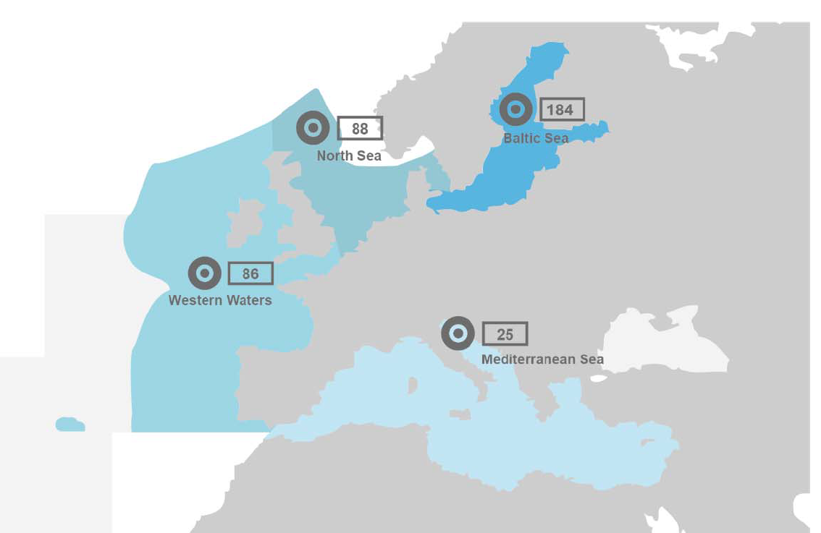

* + 1. **Market outlets for catches below minimum conservation reference sizes**

Landings of fish below the MCRS reported for 2019 by Member States are generally low compared to overall catches (typically less than 1-2% of total catches) across the different regions. Not all Member States have provided quantitative information, so the picture is incomplete. The landed material below MCRS continues to be used for fish meal, pet food or as bait for pot fisheries, with low economic returns. Two studies of alternative uses of below MCRS catches are reported for 2019 and suggest that although alternatives exist and although transport links are available, the prohibitive cost to the fishermen of storage and transport makes the alternatives still economically unattractive. This is supported by a study carried out by the European Market Observatory for Fisheries and Aquaculture Products (EUMOFA) on the market outlets for unwanted catches[34]. Closer collaboration between fishers and producer organisations with ports and market operators who have infrastructure to collect fish offal and other raw material for fishmeal and fish oil production could potentially reduce the cost burden to the industry of handling these unwanted catches. Several Member States and the South Western Waters Advisory Council suggest that the legislation should be changed to allow such catches to be used for charitable purposes.

* + 1. **State of play – discard plans**

To ensure successful and feasible implementation, exemptions from the obligation are provided under Article 15(2) and (4) of the common fisheries policy. In principle, the details of *de minimis* and survivability exemptions are specified in multiannual plans (MAP). In addition, in the absence of a MAP, the Commission is empowered by the co-legislators to adopt discard plans through delegated acts via joint recommendations submitted by the regional groups for a period of 3 years. For those sea basins with no MAP, the possibility to introduce exemptions to ensure successful and feasible implementation of the landing obligation would have been lost. This required an extension of discard plans for an additional period of 3 years, a proposal agreed upon by the co-legislators[35]. Most of the discard plans will reach the total period of 6 years by the end of 2020 and 2021.

There are currently 11 discard plans in place:

1. Commission Delegated Regulation (EU) 2018/190 of 24 November 2017 amending Delegated Regulation (EU) No 1393/2014 establishing a discard plan for certain pelagic fisheries in North-Western waters;
2. Commission Delegated Regulation (EU) 2018/188 of 21 November 2017 amending Delegated Regulation (EU) No 1394/2014 establishing a discard plan for certain pelagic fisheries in South-Western waters;
3. Commission Delegated Regulation (EU) 2018/189 of 23 November 2017 amending Delegated Regulation (EU) No 1395/2014 establishing a discard plan for certain small pelagic fisheries and fisheries for industrial purposes in the North Sea;
4. Commission Delegated Regulation (EU) 2018/161 of 23 October 2017 establishing a de minimis exemption to the landing obligation for certain small pelagic fisheries in the Mediterranean Sea;
5. Commission Delegated Regulation (EU) 2018/211 of 21 November 2017 establishing a discard plan as regards salmon in the Baltic Sea;
6. Commission Delegated Regulation (EU) 2019/2239 of 1 October 2019 specifying details of the landing obligation for certain demersal fisheries in North-Western waters for the period 2020-2021;
7. Commission Delegated Regulation (EU) 2019/2237 of 1 October 2019 specifying details of the landing obligation for certain demersal fisheries in South-Western waters for the period 2020-2021;
8. Commission Delegated Regulation (EU) 2019/2238 of 1 October 2019 specifying details of implementation of the landing obligation for certain demersal fisheries in the North Sea for the period 2020-2021;
9. Commission Delegated Regulation (EU) 2020/4 of 29 August 2019 amending Delegated Regulation (EU) 2017/86 establishing a discard plan for certain demersal fisheries in the Mediterranean Sea;
10. Commission Delegated Regulation (EU) 2018/306 of 18 December 2017 laying down specifications for the implementation of the landing obligation as regards cod and plaice in Baltic Sea fisheries;
11. Commission Delegated Regulation (EU) 2020/3 of 28 August 2019 establishing a discard plan for Venus shells (Venus spp.) in certain Italian territorial waters.

The regional groups, the Commission and the advisory councils worked hard together to ensure optimal implementation of the landing obligation in accordance with the necessary scientific justification in the delegated regulations adopted in 2019. To facilitate implementation of the landing obligation for challenging fisheries or cases, the co-legislators provided for exemptions.

**7. The role of advisory councils in 2019**

In 2019, the 10 advisory councils[36] submitted 72 recommendations to the Commission, versus 73 in 2018. These recommendations covered a large range of subjects, from issues relating to the common fisheries policy to Commission proposals, specific environmental issues or issues relating to the integrated maritime policy. In addition, several legislative proposals were adopted in 2019 which took on board previous recommendations received from advisory councils.

**Figure 1. Number of recommendations received from advisory councils**

**Figure 2. Recommendations received from each advisory council**

* 1. **Recommendations by advisory councils on specific issues related to the common fisheries policy**

In 2019, the advisory councils’ recommendations on issues relating to the common fisheries policy mainly concerned the state of stocks and the allocation of fishing opportunities. Many recommendations were also related to ICES and the STECF, to the landing obligation and to the trade of fish.

The information provided by the Baltic Sea Advisory Council on the state of **Baltic cod** was very useful in the context of the emergency measures and for the preparation of the Commission proposal to modify the Baltic multiannual plan and the EMFF in order to tackle the root causes of the very bad state of this stock and alleviate the socio-economic consequences for the fishing sector.

The Mediterranean Sea Advisory Council was also very active in preparing the **Adriatic demersal plan** adopted by the GFCM in November 2019, which was adopted in alignment with its advice.

In addition, advisory councils were involved in preparing joint recommendations **for five discard plans adopted in 2019:** discard plans for certain demersal fisheries in North Western Waters (with a contribution from the North Western Waters Advisory Council and the Pelagic Advisory Council), the South Western Waters (with a contribution from the South Western Waters Advisory Council and the Pelagic Advisory Council) and the North Sea (with a contribution from the North Sea Advisory Council and the Pelagic Advisory Council) as well as a discard plan for Venus shells in certain Italian territorial waters as well as a discard plan for certain demersal fisheries in the Mediterranean Sea, which were both adopted with a contribution from the Mediterranean Sea Advisory Council.

Through their recommendations, the Mediterranean Sea Advisory Council and Black Sea Advisory Council helped to implement the GFCM regional plan of action for small-scale fisheries in the Mediterranean and Black Sea. The Aquaculture Advisory Council recommendations were very useful for the revison of the aquaculture guidelines, while different recommendations in the context of meetings of Regional Fisheries Management Organisations were highly appreciated.

2019 was also characterised by a high number of recommendations on the STECF or ICES. Some requests could not be retained, as the advisory councils’ advice was not sufficiently specific or had to be dealt with by other bodies[37], while certain other requests (such as the inclusion of a chapter on pelagics in the STECF Annual Economic Report on the EU fishing fleet) were taken on board already in 2019.

* 1. **Legislative texts adopted in 2019 which took on board previous recommendations by advisory councils**

In 2019, two multiannual plans (MAP) were adopted, including the recommendations received from the advisory councils. The first one is the **Western Waters MAP** which includes recreational fisheries, by-catches caught in the Western Waters, and the ecosystem-based approach to fisheries management as recommended by the North Western Waters Advisory Council and/or the South Western Waters Advisory Council.

The second one is the **multiannual plan for the fisheries exploiting demersal stocks in the western Mediterranean Sea**, which incorported many Mediterreanean Sea Advisory Council suggestions, namely on:

- postponing the MSY target by 5 years,

- managing recreational fisheries, including effective monitoring, control and surveillance,

- using fishing opportunities based on effort limits in accordance with the scientific advice.

2019 was also the year of the adoption and entry into force of the **new Technical Mesaures Regulation**[38], supported by many advisory councils[39], who all endorsed the need to revise the technical measures regulations. For the North Sea Advisory Council for instance[40], the rules and requirements contained in the previous technical measures framework had proven to be complex and often very difficult to achieve. It had also been very difficult for fishermen to understand and enforce, and had generated perverse outcomes, most notably by generating a pattern of regulatory discards. The North Sea Advisory Council considered that the Commission’s proposal offered a radical break, providing the prospect of a more dynamic and flexible approach, compatible with the overall policy objectives within the basic regulation on the comon fisheries policy. It strongly supported the adoption of specific technical rules for fisheries at regional seas level. It was also very supportive of a shift away from prescriptive micro-management towards an approach focused on results and outcomes, and supportive of the fact that the new Technical Measures Regulation applies not just to the exploitation of marine biological resources but also to the interaction of fishing activities with marine ecosystems. All these recommendations were finally present in the final regulation.

* 1. **Contributions of advisory councils to legislative proposals prepared in 2019**

*Fishing opportunities*

The Commission paid great attention to the recommendations of advisory councils on fishing opportunities when elaborating its proposals in 2019. In the Baltic Sea, the Commission proposal retained in several cases the Baltic Sea Advisory Council’s minority position of Other Interest Groups[41] and in three cases (central herring, Riga herring, and Gulf of Finland salmon), it retained the Baltic Sea Advisory Council’s advice. Management measures for seabass in the Commission proposal took on board the North Western Waters Advisory Council advice. For the southern horse mackerel, the Commission proposed a 50% reduction of the quota as recommended by the Pelagic Advisory Council.

The differences between the Commision proposal for 2020 fishing opportunities and the proposals of the advisory councils resulted from the methodology the Commission used. In particular, with the full application of the landing obligation since 1 January 2019, the Commission proposed TACs on the basis of **catch advice** instead of previously used landings advice and also took into account the fact that certain **limited discards based on established exemptions** would occur, and thus would not be landed and counted against the quotas. These amounts therefore were deducted from the catch-based TAC. **Where MAPs were available, the Commission used MSY ranges**. For instance, the Commission proposed to limit the decrease of the TACs for northern and southern hake to -20%, using the upper part of the MSY range according to the Western Waters multiannual plan. While the TAC for haddock in the Celtic Sea could increase massively according to ICES advice (+100%), the Commission proposed a 30% increase, using the lower part of the MSY range, in order to protect the vulnerable cod stock that is also caught as a by-catch of haddock.

*The new control system and the EMFF proposals*

In 2019, the Commission received 6 new recommendations on the proposal for revising the fisheries control system and 2 recommendations on the EMFF. Although these came after the Commission adopted its proposal, they helped to clarify the Commission proposal for stakeholders and were useful in inter-institutional discussions.

* 1. **Consultations by the Commission**

Advisory councils were also consulted in 2019 on some files (the evaluation of the Eel Regulation, possible research projects for Horizon Europe, and the review of the State aid framework), with the advice received beingwere very useful.

* 1. **A case study on advisory councils published in 2020**

In February 2020, a study on Civil Dialogue Groups for the Common Agricultural Policy was published on the Europa website, in which the advisory councils were a case study [42] [43].

The summary of key findings of this case study are as follows:

|  |  |
| --- | --- |
| **Strengths of the case** | **Weaknesses of the case** |
| The advisory councils generate specific output to the Commission in the form of recommendations, suggestions or information. This output can also be consulted by other external organisations (such as the European Parliament), which increases the impact of the advisory councils beyond their official goals. | There are insufficient standardised rules or sharing of best practices between advisory councils with regard to the format of work programmes or rules of procedures. This leads to inefficiencies, as advisory councils are now developing these for themselves |
| The advisory councils strive for consensus in their input to DG MARE, resulting in widely supported recommendations that reflect all the views from the relevant stakeholders. | The functioning of the advisory councils is indicated to be (highly) dependent on the functioning of the chair. However, given that the chair is one of the representatives of a member organisation, the chair is not always as suitable or impartial as desired. |
| The advisory councils have a stakeholder-led structure, which makes it very efficient for DG MARE. DG MARE contributes to their operational costs and has one person in DG MARE to coordinate all advisory councils. | The aim of the advisory councils to provide consensus advice sometimes hinders the timely provision of recommendations to DG MARE |
| Due to the thematic approach of the advisory councils, the advisory councils can provide expert advice on particular topics that are connected to the common fisheries policy. Seeing that the advisory councils are divided based on the regions/topics of the common fisheries policy, the advisory councils are well positioned to provide expert recommendations. | The seats allocated to other interest groups are not always filled due to lack of resources from the other interest groups. Therefore, the balance in representation as set out by the Commission is not always achieved in practice, with seats remaining vacant. |
| The advisory councils have a defined set of criteria for the balance between sector organisations and other interest groups, as well as for the balance between Member States. |  |

**8. International ocean governance**

The EU continued to implement its policy on international ocean governance for the conservation and sustainable use of oceans and seas. The promotion of sustainable fisheries beyond EU jurisdiction in international fora and bodies and through bilateral relations is a central element of this policy.

The EU remains the key driver for progress in **regional fisheries management organisations** (RFMO) and for increasing their performance. EUR 10.6 million were committed in 2019 to improve RFMO governance, science and capacity-building and to increase compliance[44]. Due to the decisions taken in RFMOs, the stocks under their purview are generally in good shape, with fisheries managed at sustainable levels. In addition to the decisions mentioned under point 3 above, a crucial achievement in 2019 was the re-opening of the shrimp fisheries in the Area 3M by the Northwest Atlantic Fisheries Organization (NAFO). This was done on the basis of scientific advice and after a nine-year moratorium. The management, control and surveillance systems are also continuously improving, and consequently illegal, unreported and unregulated (IUU) fishing is increasingly addressed as a matter of priority. Currently, roughly 160 vessels (non-EU vessels) are listed as IUU in RFMOs, a powerful deterrent to IUU fishing. In 2019, there was also good progress in the protection of vulnerable species such as sharks, mobula ray, seabirds, and vulnerable marine ecosystems.

1. Due to the COVID-19 pandemic, the, STECF March Plenary could not take place in its usual setting and therefore could not endorse the STECF Ad hoc 20-01 report in its usual manner. The STECF adopted this report in a written procedure instead.
2. STECF Ad Hoc 20-01: *Monitoring the performance of the Common Fisheries Policy (WP)*. ISSN 1831-942. The information provided in this staff working document is a selection of the most relevant findings of the STECF report and therefore not an exhaustive reproduction of the whole report.
3. Reference to the ICES area or ‘northeast Atlantic’ covers FAO area 27 and includes the waters of the Baltic Sea, North Sea, Irish Sea, Celtic Sea and adjacent waters.
4. Two indicators are presented: blue line: the proportion of overexploited stocks (F>FMSY) within the sampling frame (62 to 68 stocks fully assessed, depending on year) and orange line: the proportion of stocks outside safe biological limits (F>Fpa or B<Bpa) (out of a total of 44 stocks).
5. In 2018, GFCM assessed a number of additional stocks, but the data could not be included in the analysis as they have not been made available yet by the GFCM.
6. Dark grey zone shows the 50% confidence interval; the light grey zone shows the 95% confidence interval.
7. Dark grey zone shows the 50% confidence interval; the light grey zone shows the 95% confidence interval.
8. Explanations of the different categories of ICES advice are available at: <https://www.ices.dk/sites/pub/Publication%20Reports/Advice/2018/2018/Introduction_to_advice_2018.pdf>.
9. The Agreement on the withdrawal of the United Kingdom of Great Britain and Northern Ireland from the European Union and the European Atomic Energy Community (’Withdrawal Agreement’) provides for a transition period that started on 1 February 2020 and ends on 31 December 2020. During that transition period, unless otherwise provided by the Withdrawal Agreement, Union law applies.
10. Council Regulation (EC) No 1967/2006 of 21 December 2006 (OJ L 36, 8.2.2007, p.6).
11. See: <https://stecf.jrc.ec.europa.eu/reports/balance>
12. Article 22(2) Regulation (EU) No 1380/2013 of the European Parliament and of the Council of 11 December 2013 on the Common Fisheries Policy, amending Council Regulations (EC) No 1954/2003 and (EC) No 1224/2009 and repealing Council Regulations (EC) No 2371/2002 and (EC) No 639/2004 and Council Decision 2004/585/EC, OJ L 354, 28.12.2013, p. 22.
13. Guidelines for the analysis of the balance between fishing capacity and fishing opportunities according to Article 22 of Regulation (EU) No 1380/2013 of the European Parliament and the Council on the Common Fisheries Policy, COM(2014) 545 final.
14. See Annex IV of Regulation (EU) No 508/2014 on the European Maritime and Fisheries Fund and repealing Council Regulations (EC) No 2328/2003, (EC) No 861/2006, (EC) No 1198/2006 and (EC) No 791/2007 and Regulation (EU) No 1255/2011 of the European Parliament and of the Council, OJ L 149, 20.05.2014, p. 1.
15. Reports and action plans can be found at: https://ec.europa.eu/fisheries/cfp/fishing_rules/fishing_fleet_en
16. Bulgaria, Croatia, France, Germany, Italy, Malta, Poland, Portugal, Slovenia, Spain and the UK.
17. Regulation (EU) 2017/1004 of the European Parliament and the Council on the establishment of a Union framework for the collection, management and use of data in the fisheries sector and support for scientific advice regarding the common fisheries policy and repealing Council Regulation (EC) No 199/2008, OJ 157, 20.06.2017, p. 1.
18. Belgium, Bulgaria, Croatia, Cyprus, Denmark, France, Germany, Greece, Ireland, Italy, Latvia, Lithuania, Malta, Poland, Portugal, Romania, Slovenia, Spain, Sweden and the United Kingdom.
19. Estonia, Finland and the Netherlands.
20. See STECF-18-14, p.121-142.
21. Commission Implementing Regulation (EU) 2017/2018 of 6 February 2017 on the Union fishing fleet register, OJ, L 34, 9.5.2017, p.9.
22. <https://webgate.ec.europa.eu/fleet-europa>
23. SCF stands for small-scale coastal fleet, LSF – for large-scale fleet, DWF – for distant-water fleet.
24. Regulation (EU) 2015/812 of the European Parliament and of the Council of 20 May 2015 amending Council Regulations (EC) No 850/98, (EC) No 2187/2005, (EC) No 1967/2006, (EC) No 1098/2007, (EC) No 254/2002, (EC) No 2347/2002 and (EC) No 1224/2009, and Regulations (EU) No 1379/2013 and (EU) No 1380/2013 of the European Parliament and of the Council, as regards the landing obligation, and repealing Council Regulation (EC) No 1434/98, OJ L 133, 29.5.2015, p. 1–20.
25. The report from Lithuania was received but due to transmission issues was not part of the assessment.
26. STECF PLEN 19-02, <https://ec.europa.eu/jrc/en/publication/eur-scientific-and-technical-research-reports/scientific-technical-and-economic-committee-fisheries-stecf-61st-plenary-meeting-report-plen>.
27. After notifying the Commission, the Member States may exchange all or part of the fishing opportunities allocated to them (Article 16(8) Common Fisheries Policy Regulation). The quota swaps are published every year by the Commission on https://ec.europa.eu/fisheries/cfp/fishing_rules/tacs_en**.**
28. Source: Directorate-General for Maritime Affairs and Fisheries, European Commission (QUOTA). The year 2020 is not completed.
29. <http://www.discardless.eu/>
30. <http://minouw-project.eu/>
31. Link to executive summaries: <https://www.efca.europa.eu/en/content/pressroom/evaluation-suggests-non-compliance-landing-obligations-certain-fisheries-north-sea>.
32. COM(2018)368 final.
33. <https://www.efca.europa.eu/sites/default/files/Technical%20guidelines%20and%20specifications%20for%20the%20implementation%20of%20Remote%20Electronic%20Monitoring%20%28REM%29%20in%20EU%20fisheries.pdf>.
34. <https://www.eumofa.eu/documents/20178/84590/Ex.+Summary+-+Market+outlets+for+unwanted+catches.pdf>
35. Regulation (EU) 2017/2092 of the European Parliament and of the Council of 15 November 2017 amending Regulation (EU) No 1380/2013 on the Common Fisheries Policy (OJ L 302, p. 1).
36. These 10 advisory councils are the Aquaculture Advisory Council (AAC), the Baltic Sea Advisory Council (BSAC), the Black Sea Advisory Council (BlSAC), the Long Distance Advisory Council (LDAC), the Market Advisory Council (MAC), the Mediterranean Advisory Council (MEDAC), the North Sea Advisory Council (NSAC), the North Western Waters Advisory Council (NWWAC), the Pelagic Advisory Councilpelagic (PELAC) and the South Western Waters Advisory Council (SWWAC).. In 2019, the Commission received an application for setting up the Advisory Council AC for Outermost Regions (CC RUP), but this advisory council did not become fully operational until 2020.
37. Such as a working group on underwater noise.
38. Regulation (EU) 2019/1241 of the European Parliament and of the Council of 20 June 2019 on the conservation of fisheries resources and the protection of marine ecosystems through technical measures, amending Council Regulations (EC) No 1967/2006, (EC) No 1224/2009 and Regulations (EU) No 1380/2013, (EU) 2016/1139, (EU) 2018/973, (EU) 2019/472 and (EU) 2019/1022 of the European Parliament and of the Council, and repealing Council Regulations (EC) No 894/97, (EC) No 850/98, (EC) No 2549/2000, (EC) No 254/2002, (EC) No 812/2004 and (EC) No 2187/2005.
39. See SWD(2016) 57 dated 11 March 2016, p.77.
40. See Advice 05-1617.
41. This was the case for western cod, Bothian herring, plaice and sprat.
42. You will find below the link to this case study (see pages from 191 to 206), https://op.europa.eu/en/publication-detail/-/publication/42188fa9-5464-11ea-aece-01aa75ed71a1/language-en/format-PDF/source-search
43. The link to the whole study, where advisory councils are also mentioned, is available here:

    <https://ec.europa.eu/info/food-farming-fisheries/key-policies/common-agricultural-policy/evaluation-policy-measures/regulation-and-simplification/cdg-cap-analysis-eu-policy-consultation_en>.
44. The EU represented by the Commission, plays an active role in 5 tuna and 12 non-tuna RFMOs and other organisations across all oceans.