

**TABLE I:**

**Overview table summarising the monthly reports of the Turkish Cypriot Chamber of Commerce according to Article 8 of Commission Regulation (EC) No 1480/2004 in EUR**

|  |  |  |  |  |  |  |  |  |  |  |  |  |  |
| --- | --- | --- | --- | --- | --- | --- | --- | --- | --- | --- | --- | --- | --- |
| **Traded products** | **January** | **February** | **March** | **April** | **May** | **June** | **July** | **August** | **September** | **October** | **November** | **December** | **Total** |
| Animal/vegetable fats and oils and their cleavage products; prepared edible fats; animal or vegetable waxes | 45,660.00 | 9,600.00 | 36,900.00 | 36,900.00 | 36,900.00 | 27,100.00 | 37,750.00 | 36,310.00 | 8,750.00 | 27,560.00 | 37,560.00 | 24,840.00 | **365,830.00** |
| Building / construction materials (articles of stone, plaster, cement, asbestos, mica or similar materials; ceramic products; glass and glassware) | 50,153.35 | 106,419.14 | 65,419.40 | 52,950.09 | 128,459.11 | 69,564.04 | 93,743.49 | 62,387.89 | 86,527.98 | 101,436.32 | 63,456.72 | 97,184.98 | **977,702.51** |
| Base metals and articles of base metal | - | - | 2,778.00 | 8,200.00 | 1,580.00 | 10,400.00 | 11,505.75 | - | 7,615.00 | 44,393.40 | 16,473.17 | 9,475.33 | **112,420.65** |
| Footwear, gaiters and the like; parts of such articles | - | - | 150.00 | 6,460.00 | - | 22,627.70 | 920.00 | 8,180.00 | 1,250.00 | 4,410.00 | - | - | **43,997.70** |
| Electrical machinery and equipment and parts thereof; machinery and mechanical appliances | - | - | - | 6,360.00 | - | - | - | 17,140.00 | 500.00 | 8,850.00 | 2,800.00 | - | **35,650.00** |
| Miscellaneous manufactured articles including furniture | 84,496.95 | 95,610.63 | 96,257.55 | 104,123.83 | 102,197.09 | 85,372.55 | 109,510.18 | 48,580.90 | 107,881.50 | 162,607.82 | 124,190.28 | 229,866.76 | **1,350,696.04** |
| Fresh Fish | 46,175.00 | 65,757.30 | 102,806.00 | 80,676.50 | 80,376.40 | 92,428.10 | 130,887.50 | 90,663.00 | 66,650.00 | 72,007.00 | 70,468.50 | 62,359.50 | **961,254.80** |
| Plastic products | 137,886.16 | 112,954.99 | 98,751.70 | 127,059.01 | 165,341.70 | 100,977.43 | 167,864.70 | 123,394.13 | 169,476.52 | 149,837.78 | 131,869.89 | 124,449.81 | **1,609,863.82** |
| Residues and waste from food industries | 386.00 | - | - | 470.00 | 470.00 | - | 1,800.00 | - | - | - | - | 709.00 | **3,835.00** |
| Chemical products | 3,970.10 | 971.25 | 3,807.30 | 7,761.32 | 10,578.40 | 8,202.53 | 14,220.00 | 14,199.80 | 14,715.92 | 6,694.85 | 17,176.58 | 6,840.10 | **109,138.15** |
| Paper products | 9,500.00 | 9,000.00 | 1,208.40 | 12,000.00 | 10,320.00 | 2,258.40 | 6,000.00 | - | 3,561.60 | 3,660.00 | 2,400.00 | - | **59,908.40** |
| Textile articles | 2,000.00 | 900.00 | 3,693.00 | 640.00 | 2,714.00 | 6,882.70 | 8,700.00 | 1,750.00 | 7,419.00 | 85,500.00 | 4,155.00 | 2,860.00 | **127,213.70** |
| Vegetable products | 76,555.00 | 4,530.00 | 112,153.00 | 98,666.00 | 45,000.00 | 38,500.00 | 10,400.00 | 38,200.00 | 23,550.00 | 29,200.00 | 13,850.00 | 34,700.00 | **525,304.00** |
| Wood and articles of wood | 2,246.00 | 1,490.00 | 1,464.00 | 1,287.00 | 2,418.00 | 2,157.00 | 1,509.00 | 2,281.00 | 4,908.00 | 2,548.00 | 4,577.50 | 3,311.00 | **30,196.50** |
| **Total** | 459,028.56 | 407,233.31 | 525,388.35 | 543,553.75 | 586,354.70 | 466,470.45 | 594,810.62 | 443,086.72 | 502,805.52 | 698,705.17 | 488,977.64 | 596,596.48 | **6,313,011.27** |

**Source:** Turkish Cypriot Chamber of Commerce

TABLE II:

Value of goods crossing the Green Line reported by the authorities of the Republic of Cyprus for 2019 in EUR

|  |  |
| --- | --- |
|  | **Total** |
| January | 354,146 |
| February | 402,483 |
| March | 452,587 |
| April | 412,989 |
| May | 454,304 |
| June | 430,195 |
| July | 494,559 |
| August | 431,542 |
| September | 490,969 |
| October | 499,038 |
| November | 507,932 |
| December | 533,493 |
| **TOTAL** | **5,464,237** |

**Source**: table based on data received from Cyprus Customs and Excise Department

**TABLE III:**

**Value of goods which crossed the Green Line and value of goods for which accompanying documents were issued in 2019**

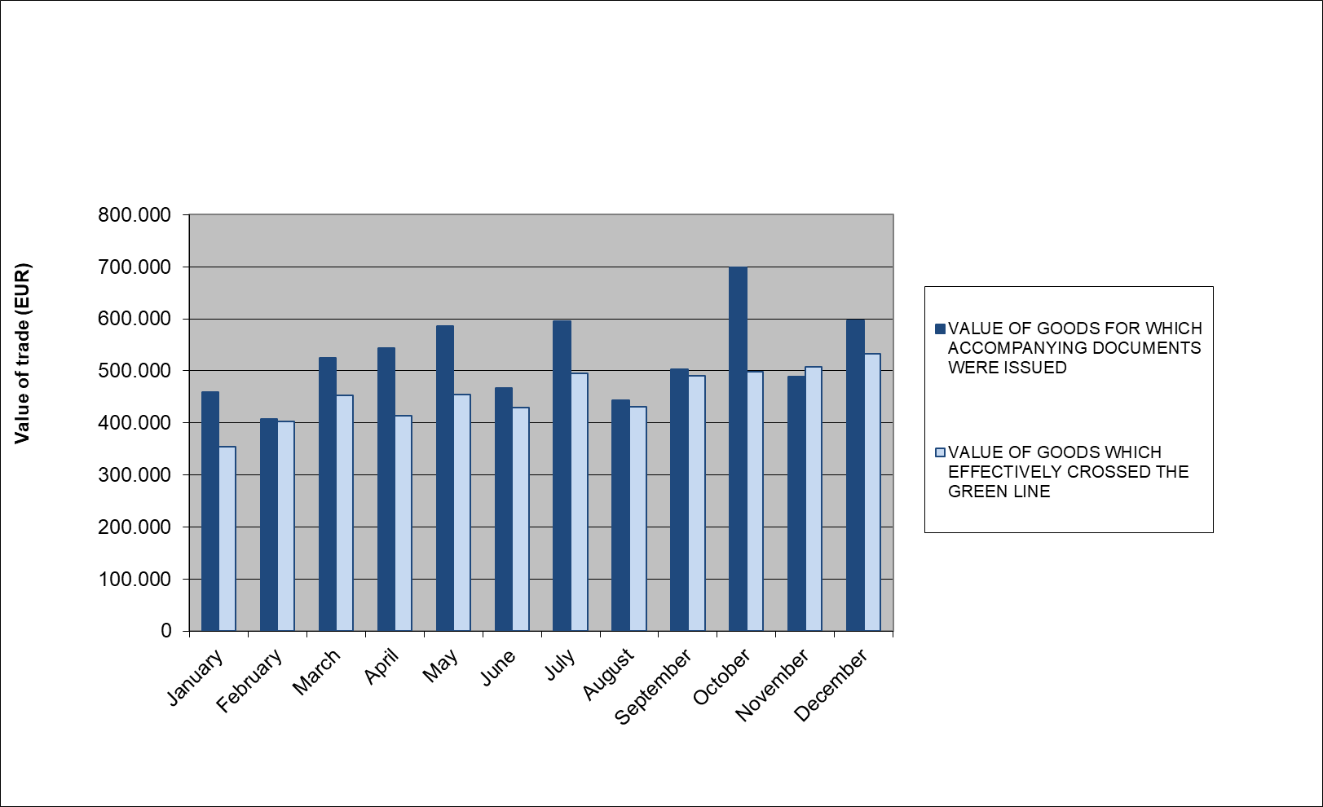

**Source**

- For the value of goods for which accompanying documents were issued: Turkish Cypriot Chamber of

Commerce

- For the value of goods which crossed the Green Line: Cyprus Customs and Excise Department

**TABLE IV:**

**Most traded products in 2019 in EUR**

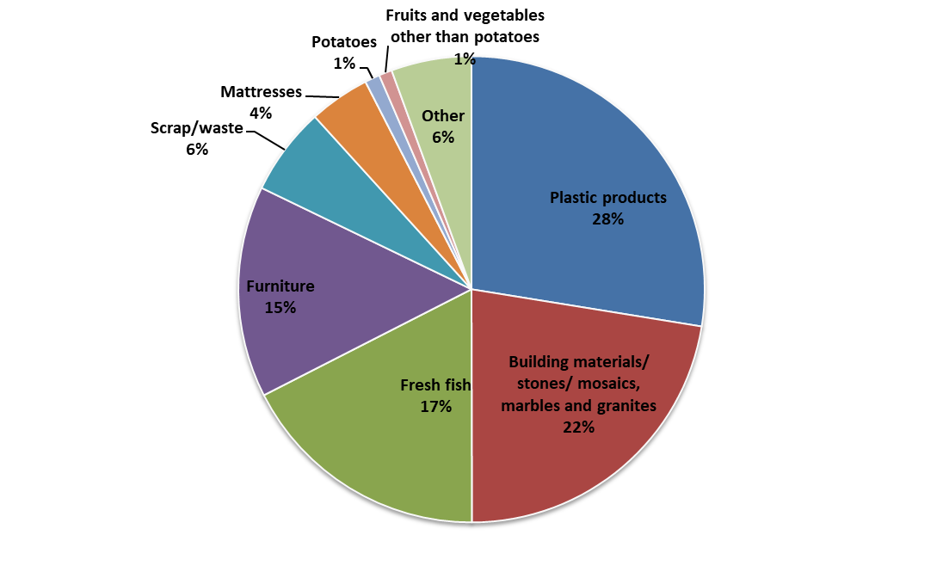

|  |  |  |
| --- | --- | --- |
| Plastic products | 1,505,322.67 | 28% |
| Building and construction materials/stones/mosaics, marbles and granites | 1,225,539.11 | 22% |
| Fresh fish | 957,072.80 | 17% |
| Furniture | 801,610.00 | 15% |
| Scrap/waste | 333,607.25 | 6% |
| Mattresses | 230,252.05 | 4% |
| Potatoes | 56,752.00 | 1% |
| Fruits and vegetables other than potatoes | 49,821.80 | 1% |
| Other | 304,259.37 | 6% |
| Total | 5,464,237.05 | 100.0% |

**Source**: table based on data received from Cyprus Customs and Excise Department

**TABLE V:**

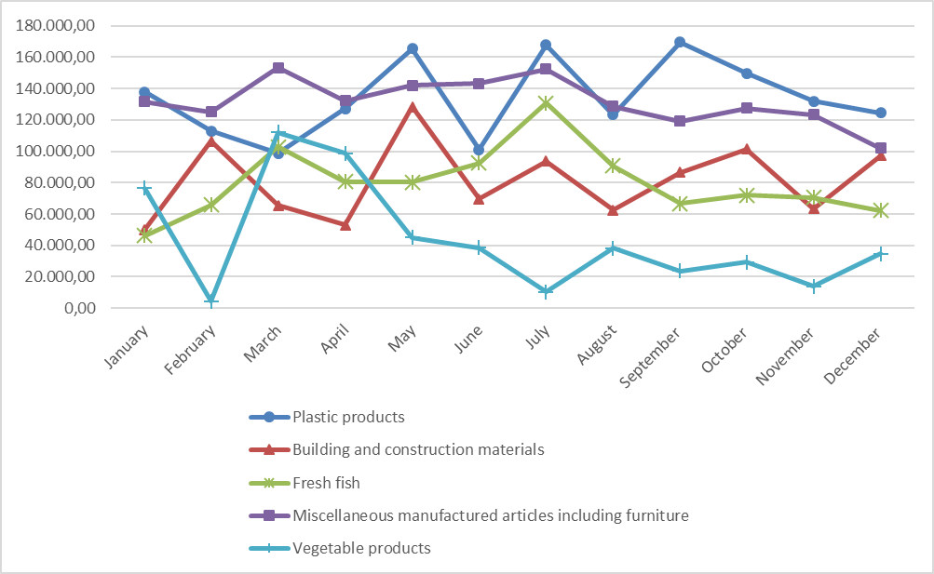**Development of accompanying documents issued for the most traded goods in 2019 (highest value)**

**Source**: Graph based on data on issued accompanying documents received from the Turkish Cypriot Chamber of Commerce

**TABLE VI**

|  |  |  |  |  |  |  |
| --- | --- | --- | --- | --- | --- | --- |
| **Movement of Greek Cypriot and Turkish Cypriot persons and vehicles across the crossing points as per Council Regulation no.866/04**  **(01/01/2019 – 31/12/2019)** | | | | | | |
| **MONTH** | **MOVEMENTS OF PERSONS** | | | **MOVEMENTS OF VEHICLES** | | |
| GREEK CYPRIOTS | TURKISH CYPRIOTS | **TOTAL** | VEHICLES  GCs | VEHICLES TCs | **TOTAL** |
| **01 / 2019** | 118421 | 99332 | **217753** | 65036 | 38370 | **103406** |
| **02 / 2019** | 135532 | 104414 | **239946** | 71493 | 39526 | **111019** |
| **03 / 2019** | 158410 | 108046 | **266456** | 85806 | 40057 | **125863** |
| **04 / 2019** | 205402 | 99362 | **304764** | 106467 | 38577 | **145044** |
| **05 / 2019** | 192859 | 107346 | **300205** | 95555 | 41260 | **136815** |
| **06 / 2019** | 249391 | 115665 | **365056** | 128629 | 44795 | **173424** |
| **07 / 2019** | 220687 | 108295 | **328982** | 116776 | 43597 | **160373** |
| **08 / 2019** | 264223 | 114539 | **378762** | 137240 | 46609 | **183849** |
| **09 / 2019** | 231418 | 113511 | **344929** | 121219 | 44044 | **165263** |
| **10 / 2019** | 227833 | 107918 | **335751** | 124891 | 44185 | **169076** |
| **11 / 2019** | 197446 | 109635 | **307081** | 105447 | 42420 | **147867** |
| **12 / 2019** | 197647 | 107626 | **305273** | 107898 | 40080 | **147978** |
| **TOTAL** | **2399269** | **1295689** | **3694958** | **1266457** | **503520** | **1769977** |

**Source**: CYPOL

**TABLE VII**

|  |  |
| --- | --- |
| **Nationality** | **Number of irregular migrants apprehended after crossing the Green Line[1]**  **(01/01/2019 – 31/12/2019)** |
| Syria | **2005** |
| Cameroon | **1133** |
| Bangladesh | **954** |
| Pakistan | **950** |
| Nigeria | **329** |
| Georgia | **323** |
| Iran | **313** |
| Congo | **278** |
| Somalia | **150** |
| Turkey | **140** |
| Guinea | **108** |
| Egypt | **92** |
| Palestine[2] | **88** |
| India | **88** |
| Iraq | **54** |
| Vietnam | **52** |
| Democratic Republic of the Congo | **43** |
| Sri Lanka | **41** |
| Sierra Leone | **34** |
| Lebanon | **31** |
| Jordan | **27** |
| Côte d'Ivoire | **26** |
| Nepal | **19** |
| Gambia, The | **15** |
| Ukraine | **13** |
| Haiti | **11** |
| Philippines | **10** |
| Zimbabwe | **9** |
| Ghana | **9** |
| China (including Hong Kong) | **9** |
| Uzbekistan | **8** |
| Armenia | **8** |
| Russia | **7** |
| Morocco | **6** |
| Yemen | **6** |
| Togo | **4** |
| Rwanda | **4** |
| Tunisia | **3** |
| Afghanistan | **3** |
| Mali | **2** |
| Kenya | **2** |
| Libya | **2** |
| Israel | **2** |
| Burkina Faso | **2** |
| South Africa | **2** |
| Brazil | **2** |
| Tanzania | **1** |
| Indonesia | **1** |
| Angola | **1** |
| Moldova | **1** |
| Eritrea | **1** |
| Mongolia | **1** |
| Central African Republic | **1** |
| Liberia | **1** |
| Gabon | **1** |
| Senegal | **1** |
| Suriname | **1** |
| Serbia | **1** |
| Tajikistan | **1** |
| Seychelles | **1** |
| Belarus | **1** |
| Cambodia | **1** |
| Ethiopia | **1** |
| Azerbaijan | **1** |
| Kyrgyzstan | **1** |
| Myanmar/Burma | **1** |
| Kazakhstan | **1** |
| Albania | **1** |
| Sudan | **1** |
| Saudi Arabia | **1** |
| Turkmenistan | **1** |
| **TOTAL** | **7442** |

**Source**: CYPOL

1. These figures include both the 7409 irregular migrants apprehended in the government-controlled areas and the 33 irregular migrants apprehended in the SBA.
2. This designation shall not be construed as recognition of a State of Palestine and is without prejudice to the individual positions of the Member States on this issue.