

Contents

1. Introduction 2

2. Participation in the elections 3

2.1. The strongest turnout in a generation 3

2.1.1. Communication and citizens’ mobilisation ahead of the elections 6

2.2. Participation of specific groups 9

2.2.1. EU citizens residing in a Member State other than their own 9

2.2.2. By age group 13

2.2.3. Gender 14

2.2.4. Other underrepresented groups 18

2.3. Funding of projects supporting the enjoyment of EU electoral rights and the democratic participation of EU citizens 22

3. The European dimension and the exercise of EU electoral rights 23

3.1. European dimension 23

3.2. Supporting the exercise of EU electoral rights 26

3.3. Prevention of multiple voting 28

4. Addressing disinformation and protecting the integrity and resilience of the electoral process 31

4.1. Unprecedented cooperation: election networks and other actions 35

4.1.1. National networks 35

4.1.2. European Cooperation Network on Elections 40

4.2. Enhancing transparency and exposing disinformation 42

4.2.1. Member States 43

4.2.2. Political parties 46

4.2.3. Private companies 47

4.2.4. Interactions between social media companies and Member States’ authorities and political parties 49

4.3. Data protection 51

4.3.1. General 51

4.3.2. Action by data protection authorities 51

4.3.3. Input from political parties 53

4.3.4. New legal mechanism for data protection breaches by European political parties 54

4.4. Cybersecurity 55

5. Annex: Replies to the questionnaires 60

# Introduction

This Commission Staff Working Document accompanies the Report on the 2019 elections to the European Parliament. It follows the same structure as this Report in detailing its findings.

The European elections are among the largest democratic exercises in the world. In May 2019, EU citizens directly elected 751 Members of the European Parliament (MEPs) from over 15,000 parliamentary candidates, with over 250 million votes cast across the EU.[1]

Before the elections, the Commission published a package of measures (‘the electoral package’) aimed at securing free and fair elections. This package notably promoted:

* enhanced cooperation between competent authorities with the establishment of elections networks at national and at European level to protect the electoral process;
* improved transparency in political campaigning;
* increased clarity on the application of data protection requirements in the electoral context and promoted greater awareness and readiness to meeting the challenges of the online environment[2];
* awareness raising, monitoring and enforcement

This package, coupled with the Commission’s initiatives on disinformation – the code of practice on disinformation committed to by IT platforms[3], the action plan against disinformation[4] – including the Rapid Alert System and the counter-narrative and myth-busting network – contributed to securing the integrity of the electoral process and maintaining voters’ confidence.

Ahead of the elections, the Commission also took a number of initiatives to support the European dimension of the elections, building on the findings of Commission’s report on the 2014 elections[5] and delivering on the Commission’s 2017 EU citizenship report,[6] and supporting the efforts of the European institutions, political parties and Member States.

This report reviews these elements, as well as turnout and the implementation of EU law. It is based on:

* information provided in particular by Member States, European and national political parties, and IT platforms in response to Commission questionnaires;[7]
* direct feedback from citizens; and
* Eurobarometer surveys and other studies including the post-election survey published by the European Parliament.

# Participation in the elections

## The strongest turnout in a generation

Of the EU citizens eligible to vote 50.66%[8]took part in the 2019 elections. This is the highest turnout in 25 years and the first time since 1979 that turnout for the elections has increased. While there has been an increase in turnout for all groups, the increase was highest among young people and first-time voters (see section 2.2).[9]

*Figure 1: Overall turnout in the European Parliament elections since 1979*

*Source*: European Commission (based on the [2019 European election results](https://europarl.europa.eu/election-results-2019/en/) as published by the European Parliament)[10].

Turnout increased in 20 Member States, with double-digit increases since 2014 in Poland, Romania, Spain, Austria, Hungary, Germany and Czechia, as well as significant increases in countries with the lowest turnout, such as Slovakia, Croatia and Slovenia. However, turnout fell in eight Member States,[11] albeit by no more than 3 percentage points (pps). Despite the overall increase in turnout, there are substantial differences between Member States, ranging from 88% in Belgium (where voting is compulsory)[12] to 23% in Slovakia.

*Figure 2: Turnout in the Member States in the European elections 2014 compared to 2019*

*Source*: European Commission, based on the 2019 European election results as published by the European Parliament. Note: The European average reflects a European Union of 27.

The reasons citizens reported for voting in these elections appear to be increasingly based on European issues rather than national issues. According to the European Parliament’s post-election survey[13], the most common reason for voting in the 2019 elections was that people felt it was their ‘duty’ as EU citizens (52%).[14] This has gained in importance since 2014 (+12 pp). Compared with 2014, respondents are now also more likely to say they voted because they are in favour of the EU (25%, +11 pp) and because voting can make things change (18%, +6 pp). Other reasons included that the respondent always votes (35%, -6pp) and to support the political party they feel close to (22%, no change). Around a fifth (22%) of respondents indicated that the UK leaving the EU also had at least some impact on their decision to vote.

As regards the reasons for non-voting, no major changes were observed compared to 2014. Respondents to the post-election survey most cited a lack of trust in or dissatisfaction with politics in general (22%) and a lack of interest in politics (18%). Furthermore, 14% of respondents believe that voting has no consequences or does not change anything.[15]

*Figure 3: What are the main reasons why you decided to vote in the recent European Parliament elections? (Max 3 answers) (% - EU)[16]*

*Source*: European Commission (based on the European Parliament post-election survey, 2019).

According to the same survey, the main issues that encouraged EU citizens to vote in the 2019 elections[17] were:

* economy and growth (44%);
* combatting climate change and protecting the environment (37%);
* promoting human rights and democracy (37%);
* the way the EU should be working in the future (36%); and
* immigration (34%).

Economy and growth were the main issues for voters in 15 Member States,[18] while climate change and the environment were the main issues in eight Member States.[19]

*Figure 4: What are the issues that made you vote in the recent European Parliament elections? Firstly? And then? (% the most mentioned answer by country)*

*Source*: European Commission (based on the European Parliament post-electoral survey, 2019).

### 2.1.1. Communication and citizens’ mobilisation ahead of the elections

Studies conducted ahead of the European Parliament elections showed that citizens would be more likely to vote if they had been informed better about the content and implications of EU policies for their everyday lives.[20]

The Commission implemented a wide range of communication measures, campaigns and outreach activities between 2014 and 2019[21] with specific measures aiming at raising citizens’ awareness of how EU issues affect their daily life and the importance of EU elections. Transparently showing the real-life impact of the European Union and driving up turnout are crucial elements of European democracy.

In the run-up to the elections, the Commission enhanced its cooperation with the European Parliament aiming to encourage citizens to take part in the elections and take informed decisions about The EU’s future. This cooperation took place not only at headquarters level in Brussels, but also between the Commission’s Representations and the European Parliament’s Liaison Offices in the Member States, which focused their communication activities increasingly on the elections. All Commission departments took part in the communication activities.[22]

To support electoral participation, and in close cooperation with the European Parliament, the Commission communicated from the following different perspectives:

What the EU does: explaining to citizens what the EU stands for, what it does and how it affects their daily lives, to encourage participation in the elections[23] This included preventing, detecting and rebutting disinformation about the EU;

Why and how to vote: explaining the importance of the elections and how to vote. With many different national registration deadlines and voting methods, it was essential to inform mobile EU citizens about the specific formalities and options affecting the exercise of their electoral rights (see section 2.2.4.);[24]

How to engage: informing staff about the materials, tools and initiatives at their disposal to help engage citizens. In the context of the Commission’s corporate campaigns, examples include the ‘back-to-school’ and ‘back-to-university’ initiatives, the social media staff advocacy tool SMARP, and the ‘staff as ambassadors’ campaign.

The Commission published an election communication toolkit in 24 languages and organised more than 1,400 elections-related events.[25] These efforts complemented the three corporate campaigns that were launched ahead of the elections (Invest EU, #EUandME and EU Protects).

The Commission actively encouraged political debates to highlight the European dimension of local problems, as well as the local dimension of European policy issues. Between 2014 and 2019, the Commission organised events to engage with EU citizens in public debates on European issues and the future of Europe. It launched a series of town-hall-style debates in the run-up to the elections. Up to 30 April 2019, 1,572[26] such citizens’ dialogues took place in 583 locations, attracting over 194 000 participants and 1.6 million online viewers via web streaming.[27] Across The EU, 14 transnational dialogues were also organised through cross-border partnerships of local Europe Direct Information Centres[28] in Member States and through a youth network that was established.

The Commission Representations and European Parliament Liaison Offices also organised numerous events of different formats to engage citizens in a multifaceted manner. They also communicated about the European elections during the 2019 Europe Day celebrations.

Specific events were organised in close cooperation with the European External Action Service’s East StratCom Task Force and focused on briefing journalists about Russian election meddling and pro-Kremlin disinformation in electoral contexts.

Almost 300 pieces of election-related content were published through the Commission’s social media accounts, which attracted significant interest from EU citizens. The Commission also worked closely with the European Parliament in developing the central EU elections webpage.[29] The Commission furthermore actively promoted the European Parliament’s ‘Choose your future’ film.[30]

On their part, Member States’ authorities and civil society organisations[31] and other bodies[32] engaged in numerous awareness-raising activities, and supported citizens’ participation including through information on the functioning of the EU and on how the elections work (voting process, parties and programmes).

These initiatives included citizens’ assemblies and ‘citizen cabinets’.[33] In these bodies citizens were actively involved in:

* making policy recommendations;
* producing election manuals;
* sending letters to all first-time voters;
* staffing helpdesks;
* participating in paid outdoor and online advertisements;
* putting up posters identifying polling stations;
* providing online tutorials, mobile applications and financial support for private media to cover the elections; and
* acting as electoral ambassadors.[34]

This was done using television, radio, websites and social media.

Building on the experience gained from the cooperation between the European Parliament and the Commission ahead of the European elections and driven by the acknowledgement that communication is a shared responsibility,[35] the directors-general in charge of communication in both institutions signed a ’Joint Statement on Communicating together at the service of citizens and European democracy’ on 5 December 2019 in order to further deepen their strategic communication partnership.

## Participation of specific groups

Diversity and inclusion of all groups are essential elements of healthy democracies. This section examines the electoral participation of mobile EU citizens, young voters, women, ethnic minorities, and citizens with disabilities[36].

### EU citizens residing in a Member State other than their own

A growing group within the EU are ‘mobile EU citizens’: people who moved to another Member State to work, live or study. In line with EU law, they have the right to vote and stand as parliamentary candidates in European elections in their Member State of residence under the same conditions as nationals of that Member State.[37] It is estimated that of the over 17 million mobile EU citizens in the EU, almost 14 million were eligible to vote.[38] This is a population larger than several Member States, and accounts for over 3% of the total voting population across the EU.

Mobile EU citizens can also vote in their Member State of origin.[39] Eurobarometer data[40] suggests that most EU citizens indicate they would prefer to exercise their voting rights for European elections in their country of residence (56%) rather than voting in their country of origin (26%). However, data obtained from Member States shows that four times as many mobile EU citizens registered to vote in the European elections in their Member State of origin, than in their Member State of residence (see Table 1).

A relatively low number of mobile EU citizens made use of their electoral rights in the elections. Data received from the Member States shows that the registration of mobile EU citizens in their countries of residence remains low across the EU, although the numbers vary greatly between Member States (as does the availability of relevant data), from 0.1% in Croatia and 0.2% in Latvia, to 17% in Spain and 24% in Malta.

Table 1: national and non-national (‘mobile’) EU citizen voters on the electoral roll

|  |  |  |  |  |  |  |
| --- | --- | --- | --- | --- | --- | --- |
| **Member State** | **Resident nationals on electoral roll in own country** | **Non-resident nationals on electoral roll in own country** | **Resident non-national EU citizen** | **Resident non-national EU citizen on electoral roll in resident country** | **Proportion of national residents to non-national residents on roll** | **Proportion of non-resident to resident nationals on roll** |
| **Belgium** | 7 989 802 | 54 832 | 755 569 | 73 251 | 0.9% | 0.7% |
| **Bulgaria** | 6 288 656 | 8 148 | - | - | - | 0.1% |
| **Czechia** | 8 314 451 | - | 213 310 | 2 286 | - | - |
| **Denmark** | 4 222 135 | 636 | 4 219 314 | - | - | 0.0% |
| **Germany** | 61 361 569 | 15 294 | 4 243 327 | 202 106 | 0.3% | 0.0% |
| **Estonia** | 882 232 | 58 408 | 15 640 | 1 618 | 0.2% | 6.6% |
| **Ireland** | 3 304 052 | 1 112 | - | 84 313 | 2.6% | 0.0% |
| **Greece** | 9 922 294 | 14 865 | - | 15 367 | 0.2% | 0.1% |
| **Spain** | 34 803 796 | 582 036 | 2 137 901 | 365 603 | 1.1% | 1.7% |
| **France** | 45 800 000 | 1 250 000 | - | 264 915 | 0.6% | 2.7% |
| **Croatia** | 3 678 130 | 33 569 | 15 992 | 13 | 0.0% | 0.9% |
| **Italy** | 49 207 309 | 1 673 837 | - | 93 848 | 0.2% | 3.4% |
| **Cyprus** | 624 487 | 6 135 | 158 601 | 10 559 | 1.7% | 1.0% |
| **Latvia** | 1 408 563 | 2 168 | 13 958 | 28 | - | 0.2% |
| **Lithuania** | 2 449 759 | 62 525 | 5 330 | 331 | 0.0% | 2.6% |
| **Luxembourg** | 261 513 | 862 | 200 240 | 0 | 0.0% | 0.3% |
| **Hungary** | 7 889 638 | 115 325 | 113 285 | 3 390 | 0.0% | 1.5% |
| **Malta** | 353 267 | - | 74 956 | 18 376 | 5.2% | - |
| **Netherlands** | 13 044 534 | 39 311 | - | 56 637 | 0.4% | 0.3% |
| **Austria** | 6 332 782 | 44 723 | - | 38 672 | 0.6% | 0.7% |
| **Poland** | 30 005 000 | 106 000 | - | 2 500 | 0.0% | 0.4% |
| **Portugal** | 9 318 580 | 688 898 | 158 915 | 10 751 | 0.1% | 7.4% |
| **Romania** | 18 267 618 | 384 943 | - | 114 | 0.0% | 2.1% |
| **Slovenia** | 1 609 705 | 94 158 | 21 711 | 1 000 | 0.1% | 5.8% |
| **Slovakia** | 4 429 801 | - | - | 824 | - | - |
| **Finland** | 4 256 326 | 240 711 | 88 019 | 7 444 | 0.2% | 5.7% |
| **Sweden** | 7 359 384 | 75 624 | 275 434 | 49 072 | 0.7% | 1.0% |
| **Total** | **343 385 383** | **5 554 120** | **12 711 502** | **1 303 018** |  |  |

*Source*: Replies from Member States to the Commission’s questionnaire, 2019, see the Annex.

Most Member States do not collect data on the effective turnout of mobile EU citizens that registered to vote. Those that do, report that up to a half of the registered mobile EU citizens vote: Czechia (50%), Finland (50%) and Cyprus (30%).

In 21 Member States, 168 mobile EU citizens exercised their right to stand as a candidate in the elections. This represents a consistent trend compared to 170 candidates in 2014. Out of the total number of these candidates (representing 1% of the total number of candidates that stood), 3 MEPs were elected in France and 2 in the United Kingdom.

Table 2: national and non-national (‘mobile’) EU citizens candidates

|  |  |  |  |
| --- | --- | --- | --- |
| Member State | Own nationals as candidates | Non-national EU citizen candidates | Non-national EU citizens elected |
| *Belgium* | 260 | 37 | 0 |
| *Bulgaria* | 316 | 2 | 0 |
| *Czechia* | 840 | 1 | 0 |
| *Denmark* | 135 | - | 0 |
| *Germany* | 1 358 | 22 | 0 |
| *Estonia* | 66 | 0 | 0 |
| *Ireland* | 58 | 1 | 0 |
| *Greece* | 1 195 | - | - |
| *Spain* | - | 20 | - |
| *France* | 2 652 | 34 | 3 |
| *Croatia* | 396 | 0 | 0 |
| *Italy* | - | 2 | - |
| *Cyprus* | 72 | - | 0 |
| *Latvia* | 244 | 2 | 0 |
| *Lithuania* | 300 | 1 | 0 |
| *Luxembourg* | 58 | 2 | 0 |
| *Hungary* | 291 | 0 | 0 |
| *Malta* | 40 | 1 | 0 |
| *Netherlands* | 306 | 2 | 0 |
| *Austria* | 236 | 14 | 0 |
| *Poland* | 866 | - | 0 |
| *Portugal* | 482 | 1 | 0 |
| *Romania* | 476 | 1 | 0 |
| *Slovenia* | - | 1 | - |
| *Slovak Republic* | 336 | 1 | 0 |
| *Finland* | 265 | 4 | 0 |
| *Sweden* | 553 | 3 | 0 |
| *United Kingdom* | 574 | 16 | 2 |
| *Total* | 12 375 | 168 | 5 |

*Source*: Replies from Member States to the Commission’s questionnaire, 2019, see the Annex.

Figure 5: non-national (‘mobile’) EU citizen candidates standing in the Member States

*Source*: Replies from Member States to the Commission’s questionnaire, 2019, see the Annex.

Mobile EU citizens still face challenges in exercising their electoral rights,[41] for example regarding registration on the roll. Registration procedures differ from country to country and can be difficult to implement for non-nationals aiming at voting in their country of residence.[42] These procedures may create concerns for mobile EU citizens where there is a lack of clarity about which election they are registering for,[43] and with regard to their obligations in Member States where voting is compulsory.[44]

A study[45] on remote voting solutions[46] conducted on behalf of the Commission, found that issues can also arise from insufficient remote voting options,[47] as well as the administration of such options, such as with letters being sent too late, or insufficient provisions being made to enable citizens to vote remotely.[48] It furthermore found that when implemented effectively,[49] remote voting solutions can support mobile citizens in the exercise of their voting rights.[50]

Before the elections, the Commission promoted the sharing of best practices among Member States to encourage mobile EU citizens to vote, and provided specific support and information on voting and standing as a parliamentary candidate, including:

* information on voting formalities and deadlines through the Your Europe advice portal;[51]
* practical information on formalities to be completed and voting methods through the central EU elections webpage and factsheets, produced in cooperation with the European Parliament;
* support to projects under its Rights, Equality and Citizenship programme (see section 2.3); and
* a targeted social media campaign encouraging mobile EU citizens to vote.

### By age group

Turnout among young people and first-time voters increased significantly for the 2019 elections: these increases drove turnout figures up, exceeding any increase for other age groups.[52] According to recent data,[53] 44% of 18-24[54] year olds indicated they had voted in the 2019 elections (an increase of 50%) compared to a youth turnout of only 28% in 2014. The turnout also increased for the 25-39 age group, rising from 35% to 49%.[55]

This is also reflected in the elected representatives: 21% of the new European Parliament or 158 of the MEPs are under the age of 40.

The oldest current Member is 82 years old and the youngest is 21, the youngest ever sitting MEP.

Table 3 – Turnout by demographic group

|  |  |  |  |
| --- | --- | --- | --- |
|  | Voted **2014** | Voted **2019** | Diff. **‘19-’14 (percentage points)** |
| EU27 | 43% | 52% | +8 |
| Gender |  |  |  |
| Man | 45% | 54% | +7 |
| Woman | 41% | 51% | +8 |
| Age |  |  |  |
| 16/18-24 | 28% | 44% | **+16** |
| 25-39 | 35% | 49% | **+14** |
| 40-54 | 45% | 53% | +8 |
| 55+ | 51% | 56% | +5 |
| Education (end of) |  |  |  |
| 15- | 43% | 47% | +4 |
| 16-19 | 38% | 50% | +12 |
| 20+ | 51% | 61% | +10 |
| Still studying | 37% | 53% | **+16** |
|  | Voted **2014** | Voted **2019** | Diff. **‘19-’14 (percentage points)** |

*Source*: European Commission (based on European Parliament post-election survey, 2019).[56]

### Gender

The EU is committed to gender-balanced representation and participation in European political life. The full participation of women in politics and in all aspects of the political process is essential for building and sustaining strong and vibrant democracies. Women’s political participation results in tangible gains for democracy, including greater responsiveness to people’s needs and more trust.

Women face challenges in exercising their political rights, due to various forms of sexism, harassment and violence, including online. Research shows that violent online content targeted against women is an emerging form of violence, with women politicians and other women active in public life particularly affected.[57]

The participation and representation of women increased in the 2019 elections. Turnout increased among women compared to the previous election, reducing the gender gap in voter turnout from 4 pps in 2014 to 3 pps.[58] The number of female MEPs also increased from 37% to 39.4%. There remain, however, major differences between Member States and a number of challenges persist. Only Finland and Sweden elected more women than men with 8 out of 14 and 11 out of 21 seats being taken by women respectively. Five Member States elected as many women as men (Denmark, Latvia, Luxembourg, Malta, Slovenia). France, Ireland, the Netherlands and Portugal each only have one more male MEP than they have female MEPs. Five Member States elected at least 40% of each gender (Denmark, Ireland, Spain, Italy and Portugal). Estonia, Bulgaria, Greece, Lithuania, Romania and Slovakia elected fewer than 30% female MEPs. All MEPs from Cyprus are men.

*Figure 6: Female candidates vs. female Members of the European Parliament*

*Source*: European Commission, based on European Parliament’s data.[59]

Although some Member States have legislation in place to ensure gender balance for MEPs,[60] this legislation can vary from 33% to 50% for gender balance and does not always cover candidatures. In Hungary, Malta, Czechia, Slovakia and Cyprus, more than 70% of candidates were men.

*Figure 7: Probability of being elected to the 2019 European Parliament for male and female candidates*

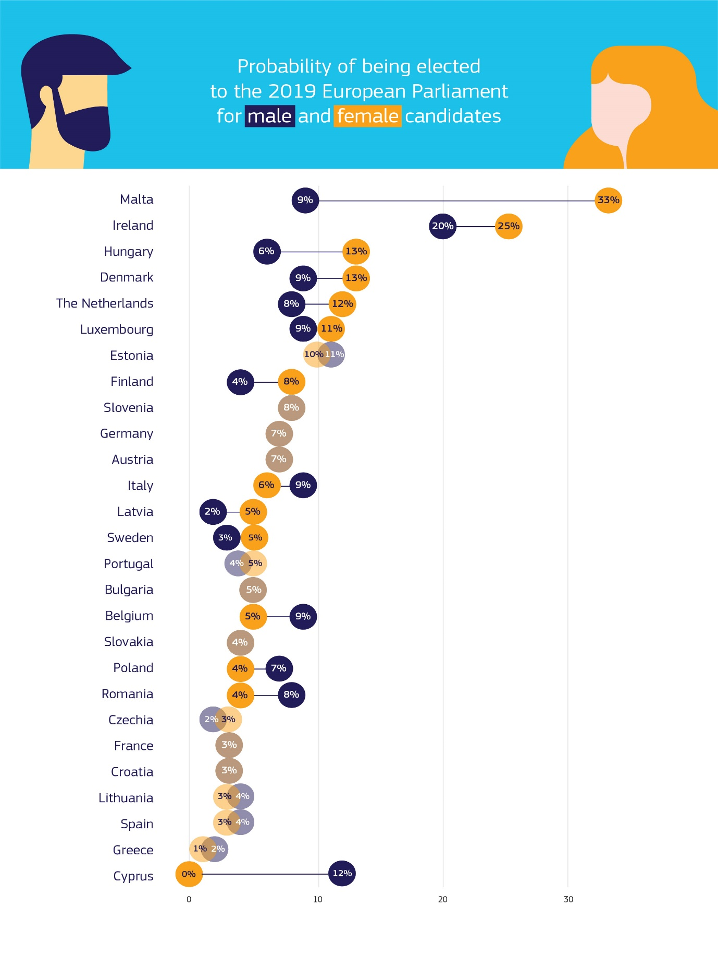

*Source*: European Commission (based on European Parliament’s data).[61]

Figure 7 shows the Member States in which it is more likely that women candidates would be elected compared to male candidates.[62] Female candidates are more likely to be elected in Malta (1 out of 3 female candidates) and Ireland (1 out of 5). For most other countries, the probability of being elected is fairly balanced between male and female candidates. However, a large discrepancy remains for Cyprus, where none of the 20 female candidates were elected, while 6 of the 52 male candidates took their seats in the European Parliament.

In the run up to the elections, the Commission asked its Advisory Committee on Equal Opportunities for Women and Men[63] to provide examples of measures to promote women’s participation in the elections. Some are outlined below.

**Examples of measures reported by Member States to promote women’s participation**

Several Member States referred to national laws that introduced a quota system for the lists of candidates, linking the allocation of public funding for political parties to the promotion of political participation of women (Ireland) or introducing a general obligation for political parties to have gender-balanced candidate lists (Romania). Others reported that legislation to promote gender balance in political life is being prepared (Malta) or being considered (Cyprus).

Civil society has also been active in promoting female turnout and participation in elections. For instance, prior to the EU elections in Finland, *Eurooppanaiset*, a Finnish non-governmental organisation, led a year-long campaign that included seminars and various events to encourage women to vote and increase women’s participation in the EU institutions. The National Council of Women of Finland (together with its member organisations) led a social media campaign with the tag lines: ‘vote for a female candidate’ and ‘it’s time for a Female EU Commissioner.’ A list of female candidates was compiled and a conference with the European Parliament Liaison Office took place to increase women's participation in the EU titled: ‘Is the European Union also for women?’

### Other underrepresented groups

The President of the Commission stated in her political guidelines, ‘in business, politics and society as a whole, we can only reach our full potential if we use all of our talent and diversity.’[64] It is essential that all groups participate in the political process. Yet certain groups continue to face difficulties when taking part in elections and remain underrepresented.

Aside from women, this includes mobile EU citizens, ethnic minorities, people with a disability, younger people, people from disadvantaged backgrounds, and people from areas which have seen depopulation, unemployment and demographic change. These groups share a lower representation in the voting activity and in the Parliament than their representation in the population.

The Commission issued a Recommendation in February 2018[65] calling on Member State authorities to meet in spring 2018 to exchange best practicesto enable underrepresented groups to exercise their electoral rights. These issues were also discussed at the 2018 Fundamental Rights Colloquium dedicated to Democracy in Europe[66]. Exchanges of best practice take place in the expert group on electoral matters[67] and the European Cooperation Network on Elections (see Section 4.1.2.).

Data on regional voting behaviour across The EU is not available. However, certain regions, and particularly rural areas, are affected by demographic and socioeconomic challenges[68] which could affect their electoral participation[69]. The trend in rural areas facing important challenges is, in a number of cases, aligned with the vote in urban and industrial zones in decline.

Regarding the territorial dimension, there appear to be differences in a number of countries in the levels of trust in the EU reported by rural, small and large towns[70].

In the absence of official data on ethnic and racial minority[71] participation, civil society organisations have published their own analyses. The analysis of the European Network Against Racism shows an increase in ethnic minority representation compared to the previous mandate of the European Parliament.[72] However, this amounts to 5% of MEPs, whereas the European Network Against Racism estimates that ethnic minorities make up at least 10% of the EU population. Moreover, the number of elected parliamentary candidates has decreased for some groups. In the case of the Roma minority, the number has dropped from five to three.59

For ethnic minorities, entering candidate lists, registering for elections or fulfilling other electoral procedures can be more demanding than for the rest of the population. For instance, voters belonging to certain communities, such as the Roma, are more likely to face difficulties in accessing voter registration procedures. This is in part due to a lack of documentation, a lack of clarity about the procedural requirements needed to vote (such as how to provide valid proof of address), and support in completing these steps.[73]

No data are available regarding participation of people with disabilities[74]. A report published by the European Economic and Social Affairs Committee[75] before the elections estimates that 800,000 EU citizens from 16 Member States are in practice deprived of the exercise of their right to participate in the elections because of their disability or mental health problems61. Research undertaken by the Fundamental Rights Agency indicates that persons with intellectual disabilities are generally underrepresented among elected persons[76].

Citizens with disabilities face difficulties when participating in elections[77]. The report of the European Economic and Social Affairs Committee found that in all Member States certain laws or organisational arrangements limit the ability of people with disabilities to participate in elections. For instance, in 18 Member States, visually impaired voters cannot vote independently as they can only entrust somebody accompanying them to cast their vote on their behalf. In many countries, polling stations are designated by a citizen’s place of residence. In 12 Member States, it is not possible to choose another station that would better accommodate voters with a specific disability. In eight Member States, citizens who cannot get to a polling station are not able to vote, because they do not have the option of an alternative form of voting (postal voting, voting by mobile ballot box or electronic voting). However, many people with disabilities, even when given the option of alternative ways of voting, prefer to vote at a polling station, considering it as the best form of participation.

National systems vary on candidacy and voting rights for people with intellectual disabilities. A total of 12 Member States extend voting rights to people under guardianship[78]. Four Member States[79] have recently adopted legislation and have reviewed the thresholds they apply in order to enable people deprived of legal capacity to participate in the democratic process[80].

In order to support the electoral rights of citizens with disabilities, several Member States have implemented specific actions[81].

**Examples of best practice include:**

* mobile ballot boxes for people with disabilities (Bulgaria);
* targeted information material drafted in plain language and braille (videos, brochures) to support specific groups in different languages (Belgium);
* trial project on autonomous electronic voting for the visually impaired (Belgium);
* accessible polling stations and ballot boxes in hospitals, nursing homes or similar institutions (Ireland)[82];
* braille paper ballots (Slovakia);
* dedicated support for parliamentary candidates with disabilities including funded internships with political parties (UK – Scottish government project).

On 26 and 27 November 2018, First Vice-President Frans Timmermans, together with Commissioner Věra Jourová hosted the European Commission's Annual Colloquium on Fundamental Rights, which this year was dedicated to democracy in the EU. This high-level event brought together over 400 politicians, national and EU policymakers, representatives of International Organisations, civil society leaders, academics, legal practitioners, activists, representatives from across the tech industry and the wider business community, trade unions, media representatives and journalists. Participants worked together to identify avenues to foster free, open and healthy democratic governance in an era of low turnout in elections, populism, disinformation and challenges facing civil society. It included substantial discussion of practices to support participation, which are summarised in its conclusions.[83]

## Funding of projects supporting the enjoyment of EU electoral rights and the democratic participation of EU citizens

The Commission used available funding to support national authorities and civil society groups in implementing projects aimed at encouraging European citizens to get involved in the democratic process.

Under its Rights, Equality and Citizenship programme, the Commission supported the participation of underrepresented EU citizens, including people with disabilities. Between 2014 and 2020, programme financed initiatives for € 20 million, with more than 20 projects having received funding.

|  |
| --- |
| In the run-up to the elections, these projects have included:   * tools to raise EU citizens’ awareness of their political rights and of the procedures to participate in European Parliament elections;[84] * good practice guides for Member States’ authorities to support EU citizens in exercising their voting rights;[85] * multilingual tools providing information about the programmes promoted by political parties during the electoral campaign;[86] * targeted initiatives to encourage the participation of underrepresented groups.[87] |

The Europe for Citizens programme supported activities that cover civic participation in the broad sense with the aim of encouraging citizens to participate in the shaping of the political agenda of the EU. Under the multi-annual priority ‘Debating the future of Europe and challenging Eurosceptics’ project applicants were invited in 2019 to identify ways of further enhancing the European dimension and the democratic legitimacy of the EU decision-making process. In light of the low turnout rates in European elections of the past years and the rise of populism in many Member States, town-twinning projects and civil society projects supported by Europe for Citizens addressed the question of how to reach voters, including first time/young voters, or voters living in remote areas.[88]

## The European dimension and the exercise of EU electoral rights

## European dimension

The European elections are unique in the way they are organised: 28 Member States, each with national campaigns, national lists and distinctive rules and traditions contribute to a collective result in the European Parliament whose members represent all EU citizens. Taking into account that the elections are organised nationally and remain for the most part regulated by national laws (even if some common rules apply), one of the challenges is to make sure that they are truly European and more than the sum of national ones.

The European Electoral Act sets out the provisions necessary for the election of the Members of the European Parliament by direct universal suffrage in accordance with principles common to all Member States. When the European Electoral Act was adopted in 1976,[89] it already contained specific measures to promote the European dimension of the elections, providing, for instance, that results should be announced jointly,[90] not only to preserve the freedom of elections principle, but also to help creating a shared European democratic experience. Over the years, different initiatives have been promoted for further fostering of the European dimension of the elections.[91] In 2015, the European Parliament proposed a reform of the European electoral procedure under the 1976 Act,[92] which included the following provisions:

* A joint constituency to be created, with lists headed by each political family’s candidate for the post of President of the Commission. The candidate should be nominated at least 12 weeks before the election period;
* Gender balanced lists of candidates for the European Parliament elections to be established at least 12 weeks before the election period;
* Deadline of 8 weeks before the first election day for the establishment and finalisation of the electoral roll;
* Democratic procedures and transparency in selecting parliamentary candidates for the elections to be observed by all political parties participating in the elections;
* Ballot papers to give equal visibility to the names and logos of national parties and to those of the European political parties;
* Member States to encourage and facilitate the provision of those political affiliations, for example, by
  + including them in electoral campaign materials and television and radio broadcasts;
  + linking electoral campaign materials, where possible, to the manifesto of the European political party, if any, to which the national party is affiliated; and
  + making the European political party affiliation on national campaign communications and ballot papers visible;
* Mandatory minimum threshold for seats in the European Parliament for larger Member States ranging between 3 and 5% for allocations of seats in single constituency and constituencies comprising of more than 26 seats;
* Member States allowed to introduce electronic and internet voting for elections to the European Parliament and, if they do so, measures sufficient to ensure the reliability of the result, the secrecy of the vote and data protection to be adopted;
* Member States allowed to grant postal voting to their citizens;
* Voting rights for citizens residing outside their Member States of origin;
* Member States to designate contact authorities responsible for exchanging data on voters.

Consensus could only be found on certain elements of these proposals, including providing for:

* different remote voting methods as long as there is a reliability of the result, and the secrecy of the vote and the data protection are ensured;
* the option for Member States to allow their citizens residing in third country to take part in the elections;
* the option for Member States to allow the display of the name or logo of the European political party to which the national political party or individual candidate is affiliated on the ballot paper;
* penalisation of double voting by national legislation;
* a deadline for submitting the lists three weeks before election day;
* designation of a contact authority responsible for exchanging data on mobile EU citizens being voters and/or candidates with other Member States and starting of the exchange of data at least 6 weeks before the elections;
* a threshold between 2 and 5 % that would apply to constituencies of more than 35 seats.[93]

The amendments did not enter into force in time for the 2019 elections.[94]

On the basis of the existing common rules, Member States vote on the day on which national elections are traditionally held. This means that the elections occurred over a period of four days, from 23 to 26 May 2019, with results to be published only after the last polls closed on 26 May 2019 at 23:00. Within the framework of the Commission’s expert group on electoral matters, Member States exchanged on a number of aspects of administrating the elections, including on relevant deadlines, including details of the opening and closing of the polls.

In 2017, the Commission proposed to reform the rules on the funding of European political parties and foundations.[95] This included proposals to strengthen the enforcement of the obligations on political parties which receive funding under the regulation, including as regards their obligation to respect the common EU values under Article 2 of the Treaty of European Union, as well as the consequences for the misapplication of European funds. Another important element of the reform was to improve **transparency** by making the **links between European and national parties** clearer, so that EU citizens can be better informed on whom they are voting for[96]. European parties were required to make sure that the national parties with which they were affiliated displayed their European logo and political programme on their own websites.[97] Whether European political parties which applied for funding did indeed meet the requirements set out in the amended Regulation has not yet been reported.[98] The Commission will review the application of this Regulation by 2021.

In 2018, the Commission adopted a Recommendation on enhancing the European nature and efficient conduct of the 2019 elections to the European Parliament[99] addressed to Member States and political parties. It called on them to build on the lead candidate system and to make the link between national parties and European parties more visible, inviting national political parties to display prominently with which European political party they were affiliated in all campaign materials, communications and political broadcasts. Political parties were encouraged to communicate clearly which political group in the European Parliament they intended to join or create in the next legislature. Member States were encouraged to allow the indication of the affiliations to European political parties on the ballot papers.

The following elements can be highlighted based on the contributions received from the Member States and European and national parties. When it comes to displaying the logo or name of the European political party on ballot papers alongside its affiliated national political party, 17 Member States[100] stated that their national laws do not permit this,[101] 10 reported that they do,[102] and 5 Member States reported that political parties had made use of this option.[103]

In terms of the national political parties themselves, there seems to be a lack of knowledge on whether the name or logo of the relevant affiliated European political party could be displayed on the ballot paper. Out of the 18 political parties that replied, two indicated they were not aware of any provisions allowing them to display the names or logos of these European political parties,[104] while what 5 stated was inconsistent with the response of their Member State authorities.[105] This suggests that further awareness-raising activities are necessary.

Furthermore, the campaign topics appeared to have become more European in nature than previously. Based on over 11,000 electoral materials, including posters, television commercials, social media posts and printed announcements by 418 political parties or candidates, as well as 193 official Facebook accounts,[106] the European Elections Monitoring Center identified the most common issues raised in election campaigns, namely ‘Europe’ (15% of all topics), followed by ‘values,’ ‘economics,’ ‘social’ and the ‘environment’. In many countries, the keyword ‘Europe’ covered the discussions about the country’s position and its future role in the EU.

## Supporting the exercise of EU electoral rights

The Commission took many different actions before the elections to ensure that EU law was being implemented and to eliminate possible obstacles to EU citizens’ exercise of their electoral rights. EU electoral rights include the rights provided to all citizens under the Treaties to participate in the democratic life of the Union, and to elect the Members of the European Parliament by direct universal suffrage in a free and secret ballot. They also include the rights provided to EU citizens which exercise their right to move freely to another Member State, to vote and stand in the European elections in their Member State of residence. These rights are enshrined in the Treaties and the European Charter of Fundamental Rights and Freedoms, and are elaborated in the European electoral Act, Directive 93/109/EC[107] and the relevant case law of the Court of Justice.

The Commission was in dialogue with four Member States on the right of mobile EU citizens to join a political party.[108] Discussions were also held with several Member States to ensure information is exchanged within the five days envisaged so that candidates who have been disqualified in their home Member State can be prevented from being elected in another Member State.[109] Following these discussions, several Member States[110] amended their laws.

Dialogue with one Member State addressed successfully the issue of protecting the secrecy of voting and discussions with another Member State resolved an issue on enabling people without fixed place of residence to exercise their electoral rights.

Before the elections and immediately following them, many EU citizens contacted the Commission to express their concerns regarding the elections, or to request the enforcement of EU electoral rights. The most common issues were:

* Citizens unable to vote remotely (by post, by proxy or online) or in person outside their country of origin (in consulates, embassies or specially established polling stations), or where such an option was provided, experiencing administrative complexities, delays or other issues which prevented them from completing the procedure;
* Citizens encountering delays or complications in national registration procedures. This applied to EU citizens attempting to complete formalities established by their country of nationality when voting from outside that country, and by non-national EU citizens attempting to complete formalities established by their country of residence.

The two largest groups of complaints concerned the possibility for:

* EU citizens to exercise their voting rights in the UK effectively[111]; and
* Romanian citizens voting from abroad at embassies and consulates.[112]

Citizens themselves are generally confident that their countries were doing what is needed to prevent illegal and fraudulent activities during elections[113].

The EU and its Member States conduct and promote election observation globally and are committed to facilitating access for international and citizen election observers[114]. Some Member States have implemented this commitment in national law, but there is no common approach. In the context of the European network on elections, experts on election observation presented to Member States to facilitate discussion of the differing national approaches and to provide additional information to support policymaking in this area, including from the Office for Democratic Institutions and Human Rights of the OECD and the voluntary group, Election-Watch.EU.[115]

## Prevention of multiple voting

The European elections are organised nationally. This means that voters vote on national lists and candidates stand on national lists. EU law provides some common rules for the Member States to enable mobile EU citizens to exercise their right to vote, which includes a process to prevent voting in more than one Member State for the elections, which is prohibited.[116] The process is based on Member States exchanging information about the relevant voters and candidates. Well in advance of polling day, the Member State of residence has to supply the Member State of nationality with information on the latter State’s nationals entered on its electoral rolls or standing as candidates. The Member State of nationality must then take appropriate action to ensure that its nationals do not vote more than once or stand as candidates in more than one Member State.[117]

The Commission supported Member States’ efforts to exchange data through contact points, adding a secure platform to perform the exchange to the IT tool it provided in 2014 to encrypt the data. The development and implementation of a process to achieve the exchange efficiently[118] was coordinated in the framework of the expert group on electoral matters[119]. The Commission also supported Member States to compile an overview of the relevant procedural deadlines in the run-up to the elections. It comprised information on the date of opening and closing of the electoral register, campaigning periods where relevant, and on date of the closure of the polls in the different Member States. This revealed significant and challenging divergences.[120] The Commission also supported the development of a multilingual form to facilitate the prompt exchange of information on candidates, which was used by 10 Member States.

Between February and May 2019, Member States exchanged data on around 1.3 million voters and 114 parliamentary candidates. This exchange resulted in the identification of over 213 000 multiple registration of citizens.

Feedback from Member States indicates that while the process has improved both in terms of its security and efficiency, they still face difficulties to exchange information allowing accurate and timely identification of the EU citizens concerned[121]. This stems particularly from the diversity of the national electoral processes, including incompatible national deadlines to prepare and close the electoral census (the roll) and the effect of registration and deregistration on a citizen’s ability to vote in other national elections. This diversity in the types of data exchanged and the timetables to which the data was being collected affected its quality and its usability.

Table 5: Data exchange to help prevent dual voting of mobile EU citizens

|  |  |  |  |  |  |
| --- | --- | --- | --- | --- | --- |
| **Member State** | **Used multilingual form** | **Records sent** | **Records received** | **Duplicate records identified** | **Identification rate** |
| **Belgium** | Yes | 73 298 | 66 767 | - | - |
| **Bulgaria** | No | 100 | 34 165 | - | - |
| **Czechia** | No | 2 286 | 6 540 | 2 046 | 31.3% |
| **Denmark** | No | 16 445 | - | - | - |
| **Germany** | No | 202 128 | 148 539 | 23 255 | 15.7% |
| **Estonia** | Yes | 1 615 | 3 430 | - | - |
| **Ireland** | No | 1 741 | 14 649 | - | - |
| **Greece** | Yes | 15 367 | 23 833 | 17 061 | 71.6% |
| **Spain** | Yes | 365 603 | 51 501 | 25 089 | 48.7% |
| **France** | Yes | 264 949 | 98 348 | 32 380 | 32.9% |
| **Croatia** | Yes | 13 | 10 276 | - | - |
| **Italy** | Yes | 93 848 | 172 372 | - | - |
| **Cyprus** | No | 10 559 | 1 346 | 587 | 43.6% |
| **Latvia** | Yes | 30 | 6 448 | 1 181 | 18.3% |
| **Lithuania** | - | 207 | 2 689 | 2 515 | 93.5% |
| **Luxembourg** | No | 49 850 | 3 911 | - | - |
| **Hungary** | Yes | 3 014 | 10 650 | 2 438 | 22.9% |
| **Malta** | No | 18 376 | 370 | - | - |
| **Netherlands** | Yes | 56 639 | 61 737 | - | - |
| **Austria** | No | 38 672 | 5 266 | 665 | 12.6% |
| **Poland** | No | - | - | - | - |
| **Portugal** | Yes | 10 752 | 125 630 | 81 158 | 64.6% |
| **Romania** | Yes | 115 | 166 234 | 454 | 0.3% |
| **Slovenia** | No | 554 | 52 | - | - |
| **Slovak Republic** | No | 825 | 8 597 | 3 183 | 37.0% |
| **Finland** | No | 7 513 | 15 658 | 14 439 | 92.2% |
| **Sweden** | No | 48 991 | 14 772 | 7 024 | 47.5% |
| **Total** |  | **1 283 490** | **1 053 780** | **213 475** | **20.3%** |
|  |  |  |  |  |  |
| **Totals for comparison (where data are available in all cases)** | |  | **686 051** | **213 475** | **31.1%** |

*Source*: Replies from Member States to the Commission’s questionnaire, see the Annex.

## Addressing disinformation and protecting the integrity and resilience of the electoral process

Campaigning in the 2019 European elections was the most digital to date. The internet is now used at least once a week by most Europeans[122] and is an essential source of information for EU citizens in the electoral context. Almost half of EU citizens now rely primarily on online news sources for information about national and European politics[123]. Social media is also an important tool for politicians to reach voters and for campaigns groups to organise supporters.

The digital revolution has brought many benefits in terms of EU citizens’ democratic participation. It has reduced the barriers and costs for EU citizens to join in the democratic debate and participate in the democratic process.

However, the speed, ease and reach of online communication, as well as the possibilities that online social platforms have created to target people through political advertisements and communications also pose new challenges. Most EU citizens, while agreeing that online social networks are a modern way to keep up to date with politics also believe that online political information cannot be trusted[124].

Elections in The EU and around the world have become a target for interference from a variety of bad actors who seek to exploit the opportunities that the digital environment provides[125].

Electoral interference can take many forms. Bad actors try to shape public opinion and electoral choices using disinformation and other misleading narratives shared on social platforms, the amplification of content through fake accounts, fake engagement or abusive bots, online intimidation and cyberattacks to steal information about candidates and to deface political websites. Disinformation and misleading narratives can be disseminated and amplified through social media using the micro-targeting functionality that social media providers have created to enable advertisers to reach specific potential customers. Such micro-targeting works on the basis of collated personal data and sophisticated psychological profiling techniques, which are not always transparent to the citizen and might not have been consented to by the people affected. Interference can also be financial, through direct and indirect opaque financial support of political actors, campaigns or other involved bodies. Extremist content can be used to generate funds, sometimes for personal gain, sometimes to fund further interference. Some interference tries to undermine confidence in the system with cyberattacks targeting electoral processes and misleading information seeking to suppress the vote or erode public trust. Electoral interference can stem from external intervention but also from actors operating within the EU. As a low cost, high impact phenomenon, interference in elections can be a tool for hybrid influencing, organised criminality or promoting private interests.

Certain actors seek to undermine the EU’s credibility as a guarantor of the core EU values, including democracy and equality of all citizens (e.g. gender equality and the protection of specific groups). Polarising narratives, disinformation and other manipulation attempt to encourage citizens to disconnect from politics and weaken the credibility of EU institutions, fuelling discontent and distrust.[126]

Together with the action plan against disinformation, the Commission’s electoral package provides a toolkit to tackle these challenges, bringing together all the parties responsible in the Member States and in the EU institutions.

The electoral package supports enhanced cooperation between national and European authorities, promotion of online transparency of political ads and communications targeting EU citizens, the fight against disinformation campaigns and other manipulation, strengthening resilience against cybersecurity incidents and awareness-raising activities. It also promotes the oversight of the application of relevant safeguards including electoral ones and supports data protection compliance in the electoral context. It contains a specific recommendation addressed to Member States and political parties, data protection guidance, and a legislative proposal providing sanctions for the deliberate misuse of personal data by European political parties and foundations to attempt to influence the outcome of the elections.[127]

The electoral package was welcomed by the Council in its Conclusions of 19 February 2019 on securing free and fair elections.[128] The European Parliament also welcomed the package in its Resolution of 25 October 2018 on the use of Facebook users’ data by Cambridge Analytica and the impact on data protection,[129] and acknowledged the positive impact of the measures implemented by the Commission and the Member States in response to the fight against disinformation and interference in elections.[130]

The action plan against disinformation included setting up a Rapid Alert System in collaboration with Member States, to create a direct connection between relevant experts both in Member States and EU institutions in order to exchange information on disinformation, as well as to coordinate – where possible – appropriate responses. The action plan also put in place close monitoring program for the code of practice on disinformation (see below section 4.2.3).[131]

The EU institutions and the Member States worked intensively to deliver the measures contained in the electoral package and the action plan against disinformation in the run-up to the European Parliament elections. Competent Member State authorities, civil society organisations, journalists, fact-checkers, platforms, and other stakeholders joined together in efforts to protect the resilience of the electoral process. Such efforts contributed to deterring attacks and electoral manipulation, as well as to exposing disinformation and other manipulative interference in the democratic debate.

While Russia's ongoing disinformation campaigns recurrently focused on politically sensitive topics and EU audiences ahead of the elections, no coordinated covert interference in the 2019 elections has been identified on the basis of available analyses.[132] The identification of covert interference campaigns is however complicated by the lack of transparency and research access to public interest data held by online platforms, as well as the lack of relevant common terms.

Manipulative efforts were nevertheless identified at a smaller scale making use of the techniques described above, for instance to suppress turnout through attacks on government websites[133], or to disseminate disinformation or other manipulative content.

In the context of the comprehensive efforts undertaken prior to the elections, it should be underlined EU citizens appeared to be more satisfied with free and fair elections in the EU after the elections than before them. Comparing the results between a pre-election survey on democracy and elections from September 2018,[134] and the European Parliament’s post-election survey, citizens’ satisfaction with free and fair elections has increased since September 2018 in 21 Member States. The biggest increases can be seen in Greece (80%, +18 pps), Lithuania (78%, +14 pps), Romania (65%, +14 pps), Spain (77%, +12 pps), Portugal (92%, +11 pps), Malta (79%, +11 pps), Poland (84%, +10 pps) and Italy (71%, +10 pps). Most respondents in all Member States are satisfied that there are free and fair elections in the EU. Nine in ten say they are satisfied in Portugal (92%), the Netherlands (89%) and Germany (88%), while satisfaction is lowest in Bulgaria (46% vs 41% ‘not satisfied’) and Croatia (55%).[135]

*Figure 8: How satisfied or not are you with the following aspects of democracy in the European Union? Free and fair elections (% Total - 'satisfied')*

*Source*: European Commission (based on the European Parliament post-election survey, 2019).

* 1. Unprecedented cooperation: election networks and other actions

A key rationale for the electoral package was that protecting the integrity of elections cannot be achieved by any stakeholder acting alone.[136] The Commission’s Recommendation[137] therefore called on Member States to set up national election networks, involving competent national authorities. Contact points from these national networks were appointed to take part in the European Cooperation Network on Elections, gathering representatives of all Member States. This network serves to alert on threats, share best practices, discuss common solutions to challenges including with specific stakeholders and encourage common projects and exercises.

Enhanced cooperation among competent authorities and relevant stakeholders is indeed required to protect the resilience and integrity of electoral systems, and is central to confidence and trust of citizens. The Council specifically recognised the value of this approach in its Conclusions of 10 December on countering hybrid threats.[138]

* + 1. National networks

National networks on elections bring together national authorities with responsible for monitoring and enforcing rules related to online activities relevant to the electoral context.[139] Their composition, working methods and powers vary, reflecting the diversity in national traditions, administrative and jurisdictional specificities as well as the priorities identified by the Member States concerned.

All Member States established national election networks, some by creating new coordination structures, others by strengthening and broadening existing ones. While most national election networks were established as informal structures, 10 Member States set them up through formal decisions.

*Figure 9:*

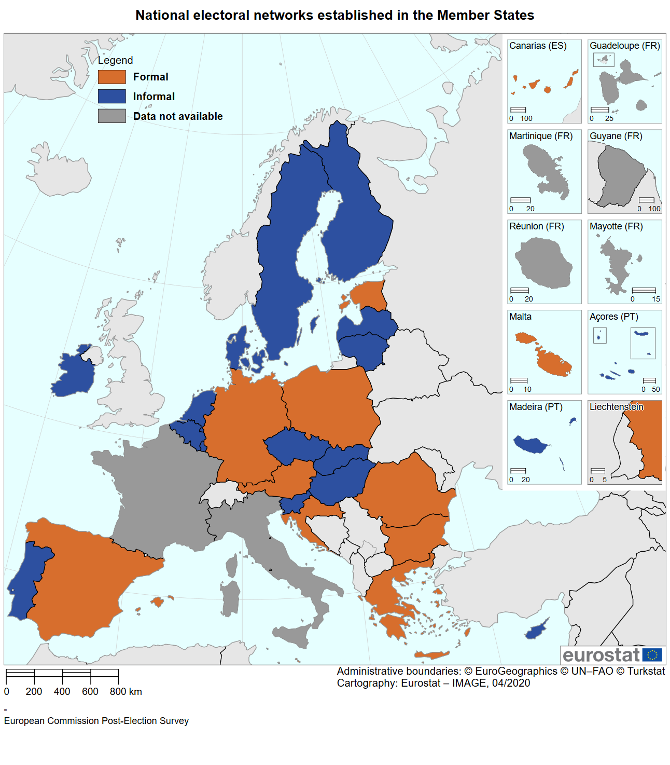

*Source*: European Commission based on replies from Member States to the Commission’s questionnaire, see the Annex. Cartography by Eurostat.

The electoral package recommends involving electoral authorities, data protection authorities, authorities in charge of cybersecurity and media regulators in the national networks. Some Member States included national security and intelligence authorities, Prime Minister’s offices and ministries, such as Foreign Affairs, Justice, Internal Affairs, Digital Affairs and Public Administration in their national election networks. Half of national data protection authorities[140] reported being involved in the work of the national election networks. In terms of engagement with the media regulators, national electoral authorities in six Member States[141] have not established any specific cooperation with them due to lack of need or lack of existing procedures. In four Member States,[142] such cooperation was conducted within the national election network, whereas in most other cases communication was based on specific exchanges of information when necessary.

The coordinating bodies varied. For example, Ministries of Interior coordinate the networks in seven Member States.[143] The task is conducted by the Ministries of Justice in two Member States[144], and by the Ministries of Foreign Affairs in two other Member States.[145] Member States indicated that networks which were championed by senior leadership worked well.

The Commission also urged Member States to ensure that appropriate links with relevant structures were formed. In 13 Member States, the national contact point for the EU Rapid Alert System[146] is also included in the national election network, and in 16 Member States national networks are themselves using the Rapid Alert System to share alerts on disinformation affecting elections. In Belgium and Latvia for instance, the same contact point coordinated the work of the national network and served as the national contact point for the Rapid Alert System prior to the 2019 elections.

14 Member States reported that the national networks have been or will be involved in monitoring the conduct of other elections at the national, local or regional level.

*Figure 10: Application of national electoral networks to elections beyond the European elections*

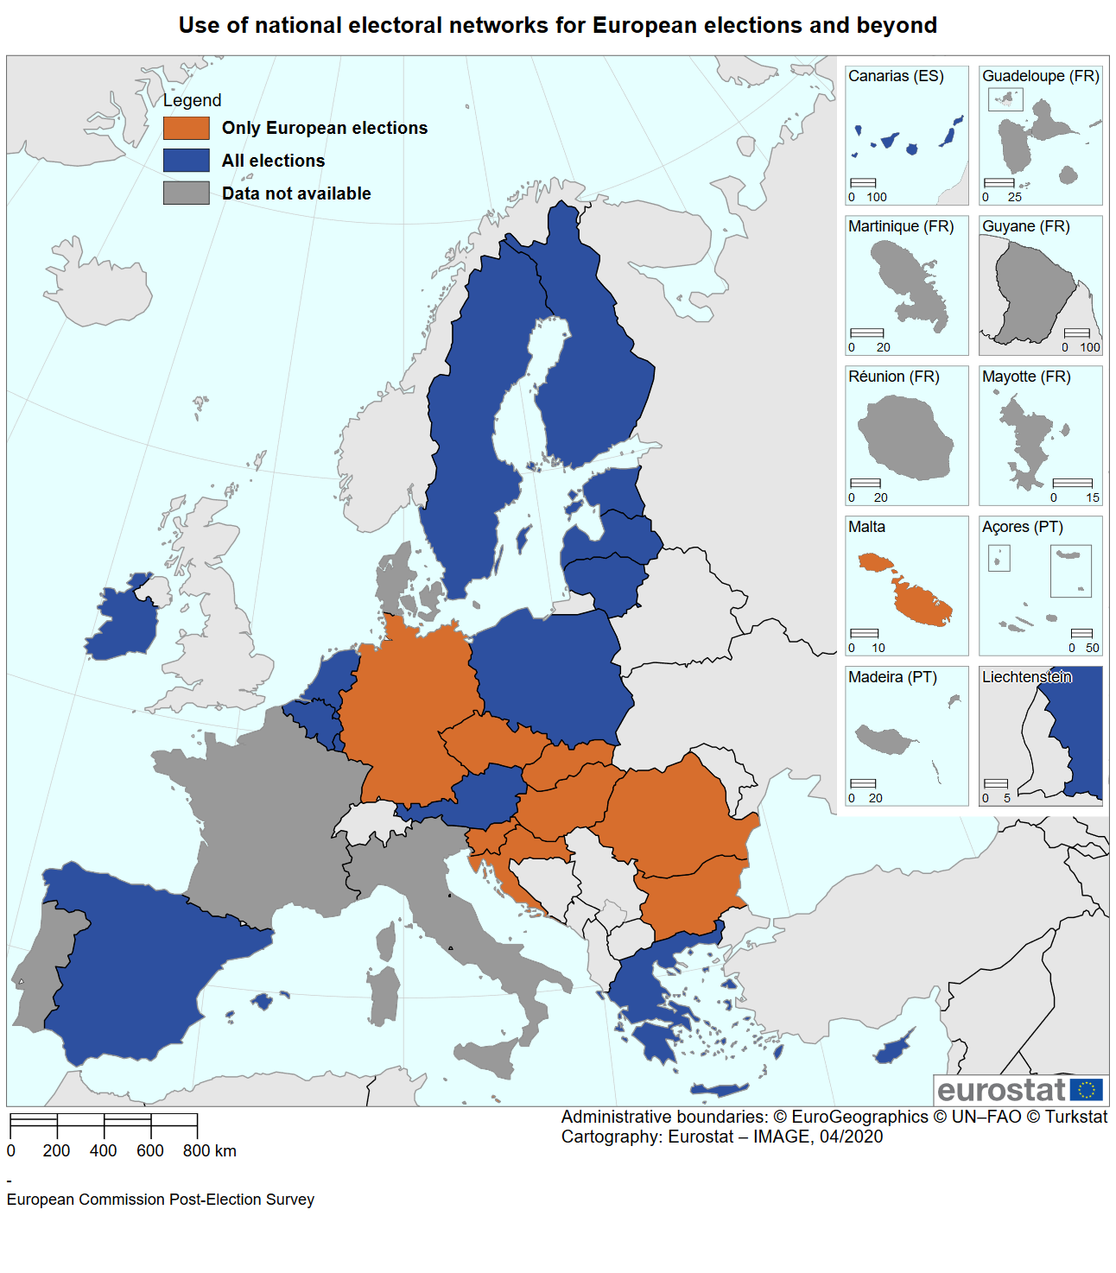

*Source*: European Commission based on replies from Member States to the Commission’s questionnaire, see the Annex. Cartography by Eurostat.

A total of 11 Member States conducted a mapping exercise or analysis of their laws relevant to the electoral context through their national electoral networks. Some 20 Member States reported having carried out exercises to identify threats and gaps in monitoring and enforcing the rules, and/or to assess risks to electoral processes before the elections (see Figure 11). Beyond testing cyber-risk scenarios, these activities included assessing risks related to disinformation and hybrid threats, and simulations of elections to test and develop contingency plans.

*Figure 11: national electoral networks that conducted exercises ahead of the elections*

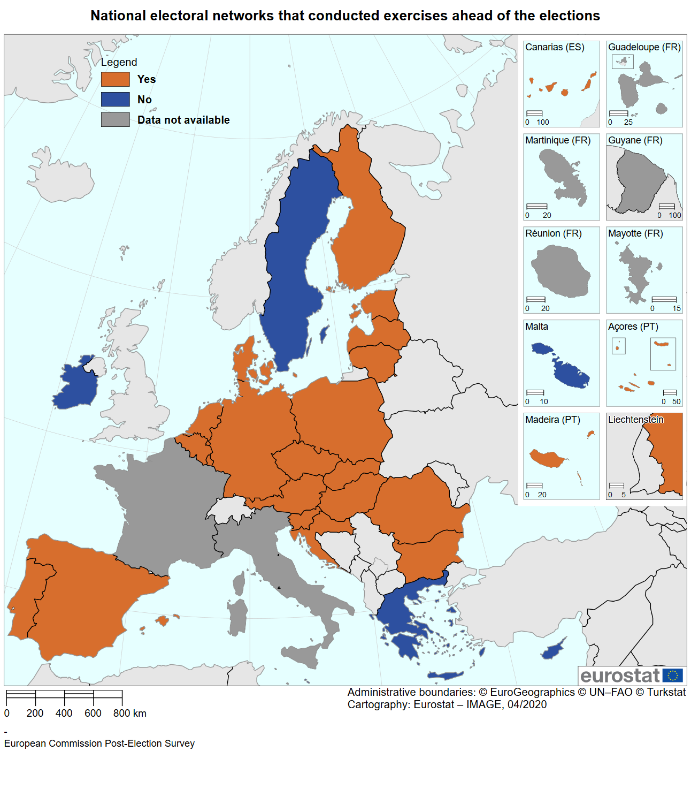

*Source*: European Commission based on replies from Member States to the Commission’s questionnaire, see the Annex. Cartography by Eurostat.

In addition to holding regular meetings (22 Member States) and communicating by email, five Member States reported having established secure channels for classified or sensitive information, and three have a dedicated IT platform.

Member States’ authorities reported that no additional resources were provided to national election networks to facilitate their work. The importance of adequate resources was nevertheless underlined. To support the national election networks and the coordination of these networks at EU level, the Commission published a call for proposals in 2019 under the Rights, Equality and Citizenship Programme 2014-2020.[147] While no public authorities or bodies with competence in electoral matters were in a position to apply for these grants in 2019, most Member States expressed interest to apply for these grants in the future.[148]

Member States have provided feedback on their experience with the national elections networks. They indicated that a clear political commitment to promoting a cross-government approach was valuable. Establishing links with independent bodies had some challenges, but it was felt that an informal approach in this respect could help.

A number of Member States have indicated that they intend to makes these structures permanent. Several have indicated that the work of the national networks should be evaluated and where scope for improvement is identified, adjustments would be made accordingly[149].

* + 1. European Cooperation Network on Elections

The Commission supported Member States by establishing and organising meetings of the European Cooperation Network on Elections. This European network consists of national contact points appointed by Member States to represent their national networks on elections and serve as a liaison between the national and European level of coordination.[150]

All Member States have appointed contact points for the European network. The contact points vary across Member States in terms of the functions of nominated individuals or bodies, and can include (representatives of) electoral authorities, ministries of the Interior, Justice, Public administration, or the State Chancellery.

The then Commissioner for Justice, Consumers and Gender Equality Vera Jourová inaugurated the European Cooperation Network on Elections on 21 January 2019. Four additional meetings were held on 27 February, 4 April, 7 June and 27 November. A table top exercise on cyber resilience was organised on 5 April 2019 (see section 4.4).

The European Cooperation Network on Elections supports Member States’ authorities in sharing knowledge, expertise and best practice, including on threats, gaps and enforcement. Discussions focused on meaningful and practical exchange of practices on a range of topics relevant to ensuring free and fair elections, implementing the electoral package and building more resilient electoral systems, including on data protection, cyber security, transparency and awareness-raising. Some of the examples are summarised in the table below.

**Latvia** presented an application, which allows EU citizens to monitor political party financing and report cases of potential abuse to the Anti-corruption Bureau. This participatory application had a deterrent, as well as enforcement effect.

An awareness-raising campaign conducted by **the Netherlands**, which targets disinformation in general, focuses on critical reading tips and therefore can be applied beyond the elections.

**Austria** described a national master plan for digitalisation and a safer internet initiative.

**Luxembourg** devised a national action plan covering all areas highlighted in the election package.

**Spain** produced a bilingual website and guidance for elections, and a 24-hour helpline on disinformation.

**France** enacted a new law on political campaigning in December 2018 . France is also considering legislation to shape EU citizens’ education. Further legislation is being considered to establish further responsibilities for social media platforms.

To support the sharing of best practices, a mapping of the rules relevant to the electoral context was carried out within the network.[151] The mapping reviewed rules applicable to: (i) contributions (bans on foreign funding, limits, disclosure rules), (ii) spending (earmarking and limits), (iii) campaigning (duration, silence period, polling and other restrictions), and (iv) media (broadcasting, transparency of political advertising and social media rules).

Some of the main findings include:

* most Member States have some rules on the transparency of donations and/or prohibit anonymous donations;
* most Member States ban foreign funding of political parties and campaigns, though some only limit its amount or impose disclosure requirements;
* about half of the Member States require transparency for paid political adverts and communications;
* few Member States have specific rules applying to social media;
* over a third of the Member States have rules that control the broadcast media in an electoral context;
* few Member States have such rules applicable online;
* a third of Member States have clearly defined campaign periods. In other Member States, there are no specific requirements applicable; and
* most Member States have silence periods.

The network meetings also provided a platform for exchanges with relevant stakeholders such as the European Parliament, the Authority for European Political Parties and Foundations, the European Regulators Group for Audiovisual Media Services (ERGA), EUROPOL, the Organization for Security and Co-operation in Europe (OSCE), the OSCE Office for Democratic Institutions and Human Rights (ODIHR), the European Data Protection Board (EDPB) and the European Data Protection Supervisor (EDPS), as well as with other, non-institutional stakeholders including elections observers and fact-checker organisations.

The European Cooperation Network on Elections will continue its work to support the integrity of elections. Following the elections, Member States asked to exchange more information among themselves by using the existing channels, and to further improve the European network by conducting risk assessments or organising dedicated workshops. Specific suggestions regarding future work included

1. sharing experiences in conducting electoral reforms, particularly in view of the changing and increasingly digital environment;
2. establishing and broadening cooperation with social media platforms;
3. awareness raising, also in relation to third parties such as the media and
4. transparency of political advertising and party financing.

Some suggestions also related to expanding the scope of the network to include topics such as advance/remote voting and voting for persons with disabilities. Member States have also underlined the added value of the mapping exercise, which should be maintained and further developed.

* 1. Enhancing transparency and exposing disinformation

Open democratic societies depend on public debate to allow citizens to be well informed and to express their will through free and fair political processes.

Public debate was a key focus in efforts to interfere in elections. Political actors (candidates, journalists, activists and members of civil society) have been subjected to increased online interference, including harassment, hate speech, distributed denial-of-service (DDoS) attacks and attempts to access personal information[152]. Disinformation targeting the democratic process, as well as divisive and manipulative narratives, have been observed and amplified through targeted communications on social media in the period running up to the elections.[153]

A characteristic of many of these efforts to interfere with elections is the lack of transparency, which leads to a lack of accountability and scrutiny. Comments and content may be posted by fake or misleading accounts, or the source of these comments may not be identified. Editorial content may be presented as journalism, and facts or authorship misrepresented. Paid for content may not be readily distinguished from ‘organic’ content (content recommended by social media connections without payment), and sources of funding or expenses in paid political communication may not be disclosed. Further, users of social media may be unable to tell when messages are targeted at them, on what basis (which characteristics and/or behaviour informed the targeting algorithm) and where the personal data used to target the message were collected.

Transparency is central to EU values and to democracy. To address specific risks stemming from lack of transparency, disinformation and other electoral manipulations, several strands of action were pursued.

Beyond the actions taken by the Commission to address issues of disinformation including by specific information activities (such as daily rebuttals by the Spokesperson Service of the Commission and by the European Commission Representations in the Member States, long-term myth-busting strategies and multi-dimensional public awareness raising actions), measures were implemented by other bodies and stakeholders.

* + 1. Member States

The Commission in its electoral package, invited Member States to encourage the transparency of paid online political advertisements and communications by promoting active disclosure of who is behind the paid political advertisements and communications. It also encouraged more transparency in campaign spending for online activities as well as information on the targeting criteria being used. Applying sanctions, where available, when transparency is not ensured, was also recommended.[154] The purpose is to address opaque practices in political advertising so that EU citizens know who is sending the political advert and who is behind it. The objective is also to create a barrier for covertly influencing elections via opaque paid advertisements and communications.

In most Member States, laws exist to ensure transparency of paid online political advertisements and communications (see Figure 12). While in some Member States the law explicitly refers to online media and includes a legal obligation on parties, campaigners and candidates to report what they have spent on advertising, in others the law does not cover such activities.

Where transparency requirements exist, the monitoring of rules is based on different models. The bodies in charge of monitoring vary across the Member States. Examples are: the Election Commission,[155] the Authority for political parties,[156] the Audio-visual Regulator,[157] the Corruption Prevention and Combating Bureau,[158] and the national audit office.[159]

*Figure 12: Member States with national requirements regarding the transparency in paid online political advertisements and communications*

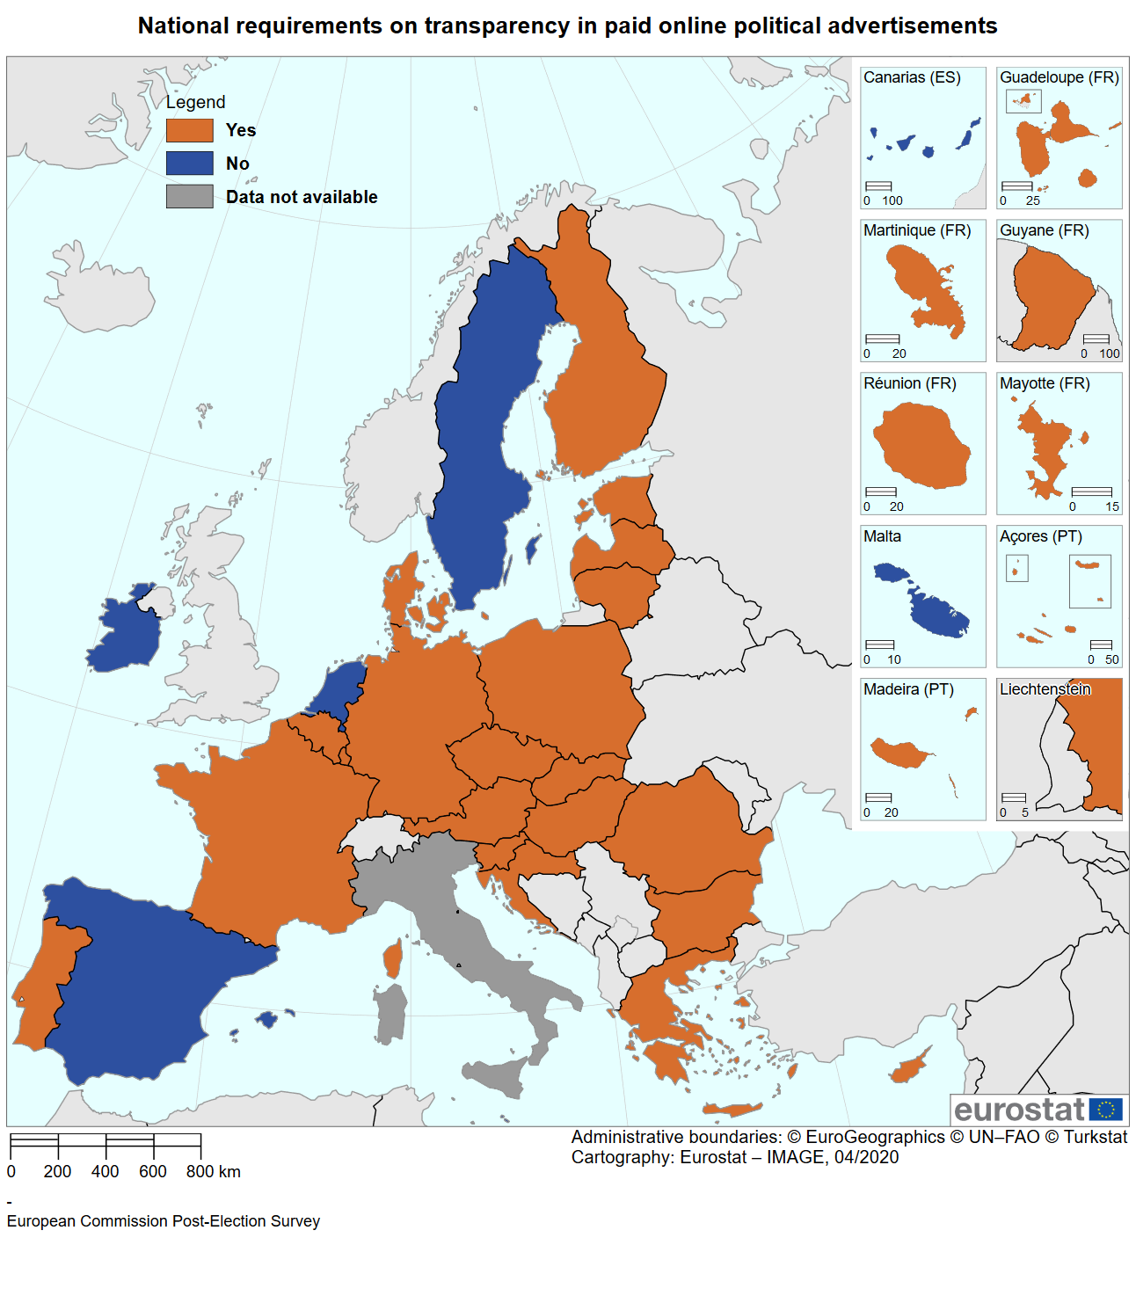

*Source*: European Commission based on replies from Member States to the Commission’s questionnaire, see the Annex. Cartography by Eurostat.

As mentioned above, Latvia developed a mobile application to enable EU citizens to report illegal advertising or misuse of administrative resources to the electoral authorities. This application was made available to other Member States to develop for use in their own jurisdictions.

Many Member States also promoted the transparency of online political adverts to stakeholders in line with the Commission’s Recommendation.

In most cases, this was done in cooperation with other authorities from the national election network by holding seminars for political parties, media and advertising service providers. In some Member States, the national authorities passed on the Commission’s package of measures for free and fair elections to all registered political parties.

Some Member States issued their own guidelines on transparency and some used social media accounts to share information on transparency.

To further improve transparency in political advertising, Member States suggested that there should be further exploration on how to enforce advertising bans on social media during silence periods. Some Member States stressed the need to further improve advertising transparency measures provided by social media and to make them permanent and equally available in all Member States.

A number of Member States have developed detailed policy plans in this respect, notably Ireland[160] and the Netherlands.[161] In its contribution, one Member State called for European political parties and social media companies to observe national law when placing political advertising in the EU. Others suggested that social media platforms should conduct a pre-approval procedure for political communications in collaboration with electoral commissions and national media regulators, and that public authorities and public broadcasters should be pre-cleared to enable prompt and unobstructed dissemination of content relevant for informing voters. One Member State pointed out that recurring issues with a lack of transparency should be addressed in public service media and possibly on social networks, in order to put such problematic behaviour under public pressure and in this way encourage behaviour which is more transparent.

Some Member States amended their national laws ahead of the elections to ensure increased financial transparency. For instance, in Croatia new measures included the publication of financial statements of electoral participants on the webpages of the State Electoral Commission.[162]

In general terms, the method and extent of the financial disclosures required vary among Member States. In some, disclosure requirements are rather general and do not facilitate identification of the source of funding or where this funding was used. The absence of transparency on the online platforms in this respect further complicates monitoring, and Member States pointed out the need to improve such disclosures.

Transparency of the targeting criteria used does not appear to have been included in national legislation so far. The Irish policy proposal for online political advertising stipulates that i) the person or party behind the advert must be clearly identified; ii) it must be made clear whether targeting was applied; and iii) a description of the target audience/criteria applied must be provided.[163]

* + 1. Political parties

Beyond Member States, the Commission’s Recommendation is directly addressed to political parties, foundations and campaign organisations, which were invited to take specific steps to promote transparency in political advertisements and communications. This includes (i) ensuring that EU citizens can easily recognise online paid political advertisements and communications and the party, foundation or organisation behind them, and (ii) making available on their websites information about the amounts spent on online political advertisements and communications as well as on any targeting criteria used in their dissemination.[164]

In March 2019, then Commissioner Vera Jourová wrote to national political parties[165] calling on them to put Commission’s Recommendation into practice.

In their replies to the Commission’s questionnaire, political parties indicated that they abided by the relevant national and EU law, and have to follow the terms of service set by the social media platforms for running political advertising on their services, including those introduced by Facebook in April 2019.

Regarding the display of political advertising records and transparent communication thereof on the webpages of political actors, there is still room for progress. With a few exceptions, political parties did not generally undertake additional transparency activities such as listing their adverts, or disclosing their spending for online political adverts on their websites. Most political parties indicated that they relied on the transparency databases of the social media companies to report on this or that their spending on online adverts is included in their general post-campaign financial reporting. Some political parties emphasised that transparency could be improved by simplifying and clarifying the laws governing electoral campaigns and providing information about the rules for access to the media for political parties. Open access online disclosure portals maintained by electoral authorities were put forward as a way to improve this.

Some political parties reported that the procedures established by social media companies for online political advertising were too complicated, slow and not sufficiently transparent. They also pointed to specific problems in placing their adverts such as late approval for their adverts, editorial censorship or not being able to place adverts targeting voters who are voting from abroad. One political party complained that a social media company closed all its accounts during the campaign period. Furthermore, two European political parties identified Facebook’s policy changes in March 2019, which introduced a requirement for advertisers to be separately authorised in each country in which political advertising was being run, as presenting an obstacle to communications at a European level.

Some Political parties proposed measures to increase trust in communications by creating ‘official channels’ for political parties and candidates on social media.

* + 1. Private companies

The Commission worked with industry to protect the 2019 elections from disinformation campaigns and online manipulation. A self-regulatory [code of practice on disinformation](https://ec.europa.eu/digital-single-market/en/news/code-practice-disinformation)[166] was drafted by stakeholders and was first implemented in October 2018. On this basis, the online platforms Facebook, Google, Twitter, and Microsoft have committed to:

1. provide for the transparency and public disclosure of political advertising;[167]
2. prevent the manipulative use of their services by bad actors;
3. further empower citizens and researchers; and
4. take other actions to improve the accountability and trustworthiness of the online social media market ecosystem.

Trade associations from the advertising sector have committed to cooperating with the platforms to improve scrutiny of ad placements and disrupt advertising and monetization incentives for disinformation.

As called for in the action plan against disinformation, prior to the elections, the Commission, with the assistance of Member States’ authorities (the European Regulators Group for Audio-visual Media Services (ERGA), carried out targeted intermediate monitoring of the implementation of the Code by Facebook, Google and Twitter, based on monthly reports from the platforms and focussing on actions most urgent and pertinent to the integrity of elections.[168]

The Commission, with ERGA’s assistance, is currently assessing the overall effectiveness of this Code during its first year of operations.[169] In October 2019, the platforms and other Code signatories already submitted annual self-assessment reports covering actions undertaken to implement their commitments Code during the Code’s first year of operations.[170]

The Code has provided an opportunity for greater transparency into the platforms’ policies on disinformation as well as a framework for structured dialogue to monitor, improve and effectively implement those policies. In particular, in the run-up to the 2019 elections:

* In the run-up to the 2019 elections, Facebook, Google and Twitter stepped up efforts to provide for the transparency of political ads, in particular by labelling them and making them publicly available via searchable ad repositories;
* platforms made efforts to ensure the integrity of their services by detecting and closing down manipulative activities, such as coordinated operations aimed at amplifying content as well as the abusive use of bots and fake accounts; and
* the three platforms improved the scrutiny of ad placements to limit malicious click-baiting practices and reduce advertising revenues for purveyors of disinformation.

Moreover, a number of measures designed to promote content from authentic and authoritative sources and limit the distribution of disinformation on platforms’ services’ have been taken and have contributed to deter media manipulation and malicious interferences.

Further actions by individual signatories and the community as a whole remain however necessary. There are differences in the scope of actions undertaken by each platform to ensure they fulfil their commitments, as well as differences across Member States in the deployment of the individual policies.[171] Furthermore, progress is less advanced with respect to platforms’ commitments to empower consumers and commitments to empower the research community. In particular, the provision of data and search tools to the research community is still episodic and arbitrary and does not respond to the full range of research needs.[172] Moreover, cooperation with fact-checkers across the EU is also sporadic and a genuine coverage of all Member States and EU languages is still not in sight, showing the need for a mechanism which allows truly independent organisations to cooperate with the platforms (including via relevant and data protection compliant access to datasets for research purposes). Within the European Cooperation Network on Elections, three Member States pointed specifically to issues in registering fact-checkers with Facebook.

Apart from Microsoft, no additional platform stakeholders, brands or other corporate actors from the advertising ecosystem operating in the EU subscribed to the Code since its inception.

* + 1. Interactions between social media companies and Member States’ authorities and political parties

A total of 18 Member States report having superficially engaged with social media platforms in the run-up to the elections, in particular Facebook, and without access to their data. In the framework of the European elections network Member States exchanged information on their experience engaging with the social media platforms, as well as in their responses to the Commission’s questionnaires. Member States provided some examples of where engagement worked well, which included:

* Several Member States reported having established direct communication channels with social media networks for rapid response on urgent security issues;
* A few Member States indicated direct contacts with platforms where specific training was provided to officials to assist them in understanding the platform environment.

Many Member States nonetheless indicated concerns regarding:

* Inequality and inconsistency in the approach adopted towards the Member States, with experiences differing between Member States and between platforms. Support provided directly to actors in the political context was flagged as potentially problematic. Member States exchanged on the terms under which such engagement was provided to them, if at all.
* Poor or lacking operational engagement with the platforms – examples were provided of a lack of responsiveness when Member State authorities drew to platforms attention content which did not appear to conform to the platform’s terms of service, and general difficulties accessing platform decision-makers. Member States considered that the value of specific operational points of contact should be explored, including to enable their authorities better to perform their oversight functions in the context of elections. Appropriate access to data was also stressed in this regard;
* A lack of own-language engagement and understanding of national jurisdictions. In this regard Member States provided examples where definitions included in platform terms of service did not align with national rules, or where platform measures, e.g. on transparency, were introduced late, after official campaigning periods had begun;

On their part, online social media platforms report[173] that in terms of engagement with national authorities, no formal frameworks have been established.

*Figure 13: Member States engaging with social media platforms*

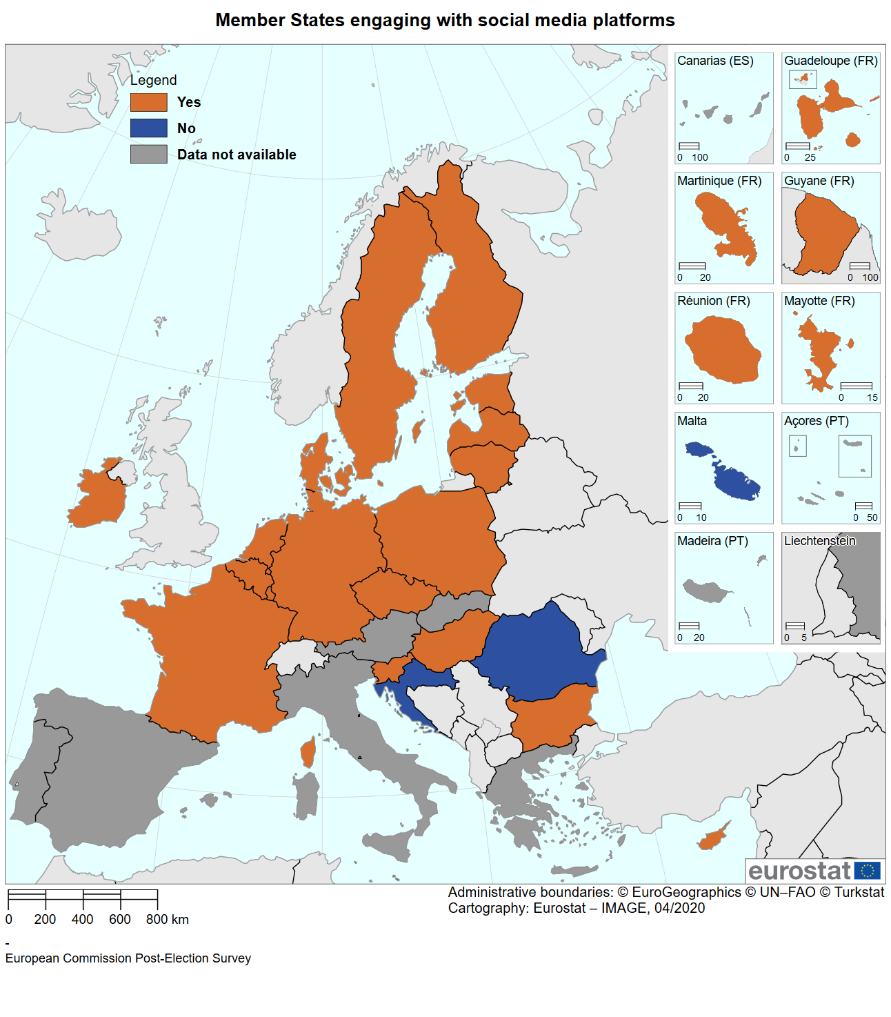

*Source*: European Commission based on replies from Member States to the Commission’s questionnaire, see the Annex. Cartography by Eurostat.

Facebook referred to the Integrity & Security Initiative launched together with the German Federal Office for Information Security in early 2019, which aimed to create a better and more comprehensive understanding of interference into elections and develop guidance on how to combat election interference. Since the launch, Google and the Dutch Ministry of the Interior have also joined the Initiative.

In the run up to the elections, Facebook also reported that it launched an Election Security Escalation Channel for trusted security and intelligence partners to directly report potential cybersecurity and information operations threats. Facebook indicated that this reporting channel includes partners from 11 EU Member States.

Facebook also indicated that both of these initiatives would continue to be maintained post-election. In general, all platforms indicate that they will continue with the established engagement with national authorities following the elections.

Platforms indicate that they engaged with other organisations, including national and European political parties. Google reports having organised in person and online security training courses on how to use their advanced protection programme, and trained 2,508 campaign and election officials, journalists and people from election-related NGOs in 20 Member States. These training courses focused on political advertising, and support was offered to political parties regarding the verification process for their adverts. Twitter produced a dedicated online guide to Advertising for the Elections.[174]

Social media platforms highlight the usefulness of cooperating with the Member States' authorities on workshops and training courses for political parties, and call for more clarity on how to apply national rules, for instance in relation to online political campaign advertising for the elections. A specific suggestion refers to establishing points of contact within Member States that would assist smaller platforms in understanding the possibilities for outreach and engagement in the context of elections, enabling them to better respond to the challenges regarding the misuse of their services to harm or mislead users.[175]

* 1. Data protection
     1. General

The 2019 elections were the first European elections to which the General Data Protection Regulation (GDPR)[176] applied. The Commission published specific guidance[177] on the applying EU data protection law in the electoral context as part of the electoral package. The guidance, provided clarity to those actors involved in election processes - national electoral authorities, political parties, data brokers and data analytics companies, social media platforms and online advertising networks - on the principles and obligations of GDPR regarding the lawfulness of processing of personal data (including sensitive data such as political opinions), transparency requirements, automated decision-making and micro-targeting. It called on the national data protection authorities, as enforcers of the GDPR, to make full use of their strengthened powers to monitor the situation and address possible data protection breaches.

National data protection authorities adopted a number of measures to take into account data protection requirements during the electoral process. Some electoral commissions also took specific measures in this context.

* + 1. Action by data protection authorities

Before the elections, the European Data Protection Board, composed of Member States’ data protection authorities, adopted a statement on the use of personal data in the course of political campaigns.[178] The European Data Protection Supervisor also adopted an opinion on the Commission’s electoral package.[179] A number of national data protection authorities issued statements and guidelines on data processing in the context of political campaigns.[180]

Political parties in many Member States were directly informed by their respective data protection authorities about the measures to be taken when processing personal data during the elections. For instance, the Latvian Data Protection Authority sent a letter to all the political parties on processing personal data in the context of elections. The Dutch Data Protection Authority conducted an exploratory investigation in February/March 2019 involving all political parties in the House of Representatives, asking questions about how those parties process personal data during election campaigns and any service providers who help parties with their campaigns such as with micro-targeting. In Finland, political parties were sent the Commission's guidance on the application of EU data protection law in the context of the elections, as well as the Commission's Recommendation on election cooperation networks, online transparency, cybersecurity disruption and anti-disinformation campaigns in the European elections. Four data protection authorities organised seminars or consultations for political parties[181] and the head of one data protection authority held personal meetings with representatives of all the political parties, as well as independent groupings and candidates.

Some data protection authorities also published material aimed at voters on the processing of personal data during the elections of the European Parliament. For example, when the United Kingdom was still a Member State, its Information Commissioner’s Office ran an awareness campaign tagged 'be data aware', that provided information to EU citizens on how to protect their data and how to raise concerns if they believed the rules had been breached.

A regards data protection incidents, the French and Spanish authorities reported the highest numbers,[182] with several Member States reporting a lower number of incidents[183] and the majority reporting no incidents. In France, 697 complaints were received during the European elections via a dedicated form made available online during the election campaign to report suspicious practices. These mainly concerned unsolicited political communication operations by telephone (SMS and the use of automated calling machines) and by sending emails (especially targeting French citizens living outside France). Also 11 claims against political parties were received.

In Spain, 102 complaints about political parties and administrations involved in the electoral process were received. The most striking claims referred to the potentially wrongful publication of electoral roll data (including names) on public websites or social media networks. Three security breaches were detected that affected personal data in relation to the publication of the names of people working at polling stations in a town hall, the publication of the census of a locality and the attack on the website of a national party. Poland also reported infringements relating to, among other things, online disclosure of an attendance list of members of a local voting commission.

Concerning specifically social media platforms, the Irish data protection authority engaged with them in support of monitoring and enforcement efforts, while the Latvian Data Protection Authority envisages engaging with social media platforms for future elections.

In one case, where the Italian Data Protection Authority considered that Facebook acquired and processed personal data disclosing political opinions without providing the appropriate information, contact was made with the Irish Data Protection Authority through the Internal Market Information System, with the request to investigate under the GDPR.[184]

At the time of reporting, most of these cases were under investigation. Greece however noted that the investigation of one complaint is completed and the national data protection authority issued a fine of € 2 000 to a candidate for the European Parliament for sending unsolicited emails to promote his candidacy.

* + 1. Input from political parties

Most political parties indicate having complied with the GDPR, as well as specific guidelines of the national data protection authorities, where these were issued. Political parties also specifically mentioned engaging legal counsel to ensure the compliance with all laws and regulations, as well as employing a digital campaign manager responsible for this issue. Information sessions on obligations under the GDPR were held with candidates and activists, and as with cybersecurity, parties also mention participating in sessions organised by the European Parliament on the issue of data protection.

While political parties generally appreciated being able to contact their national data protection authority for specific questions, they indicate that more information and active support would be desirable. One European political party specifically pointed out that there is insufficient clarity on key legal concepts such as ‘targeting’ and ‘consent’, under the GDPR. Political parties underlined the need to receive guidance well in advance of the next elections and with clearer guidance on certain aspects of the GDPR.

* + 1. New legal mechanism for data protection breaches by European political parties

As part of the electoral package, the Commission proposed introducing financial sanctions for European political parties and foundations that breached data protection rules in order to deliberately influence or attempt to influence the outcome of the European elections.

Regulation 2019/493 as regards a verification procedure related to infringements of rules on the protection of personal data in the context of elections to the European Parliament was adopted before the 2019 elections and now provides for sanctions in these circumstances.[185]

Most Member States have established a contact point between the national data protection authorities and the Authority for European political parties and European political foundations.[186] Based on responses received, in six Member States the contact point is designated within the data protection authority,[187] in two within the Ministry of the Interior,[188] and one each within the electoral commission, the Ministry of State, Ministry of Justice and the Ministry of Foreign Affairs.[189]

*Figure 14: Member States that reported establishing points of contact with national data protection authorities[190]*

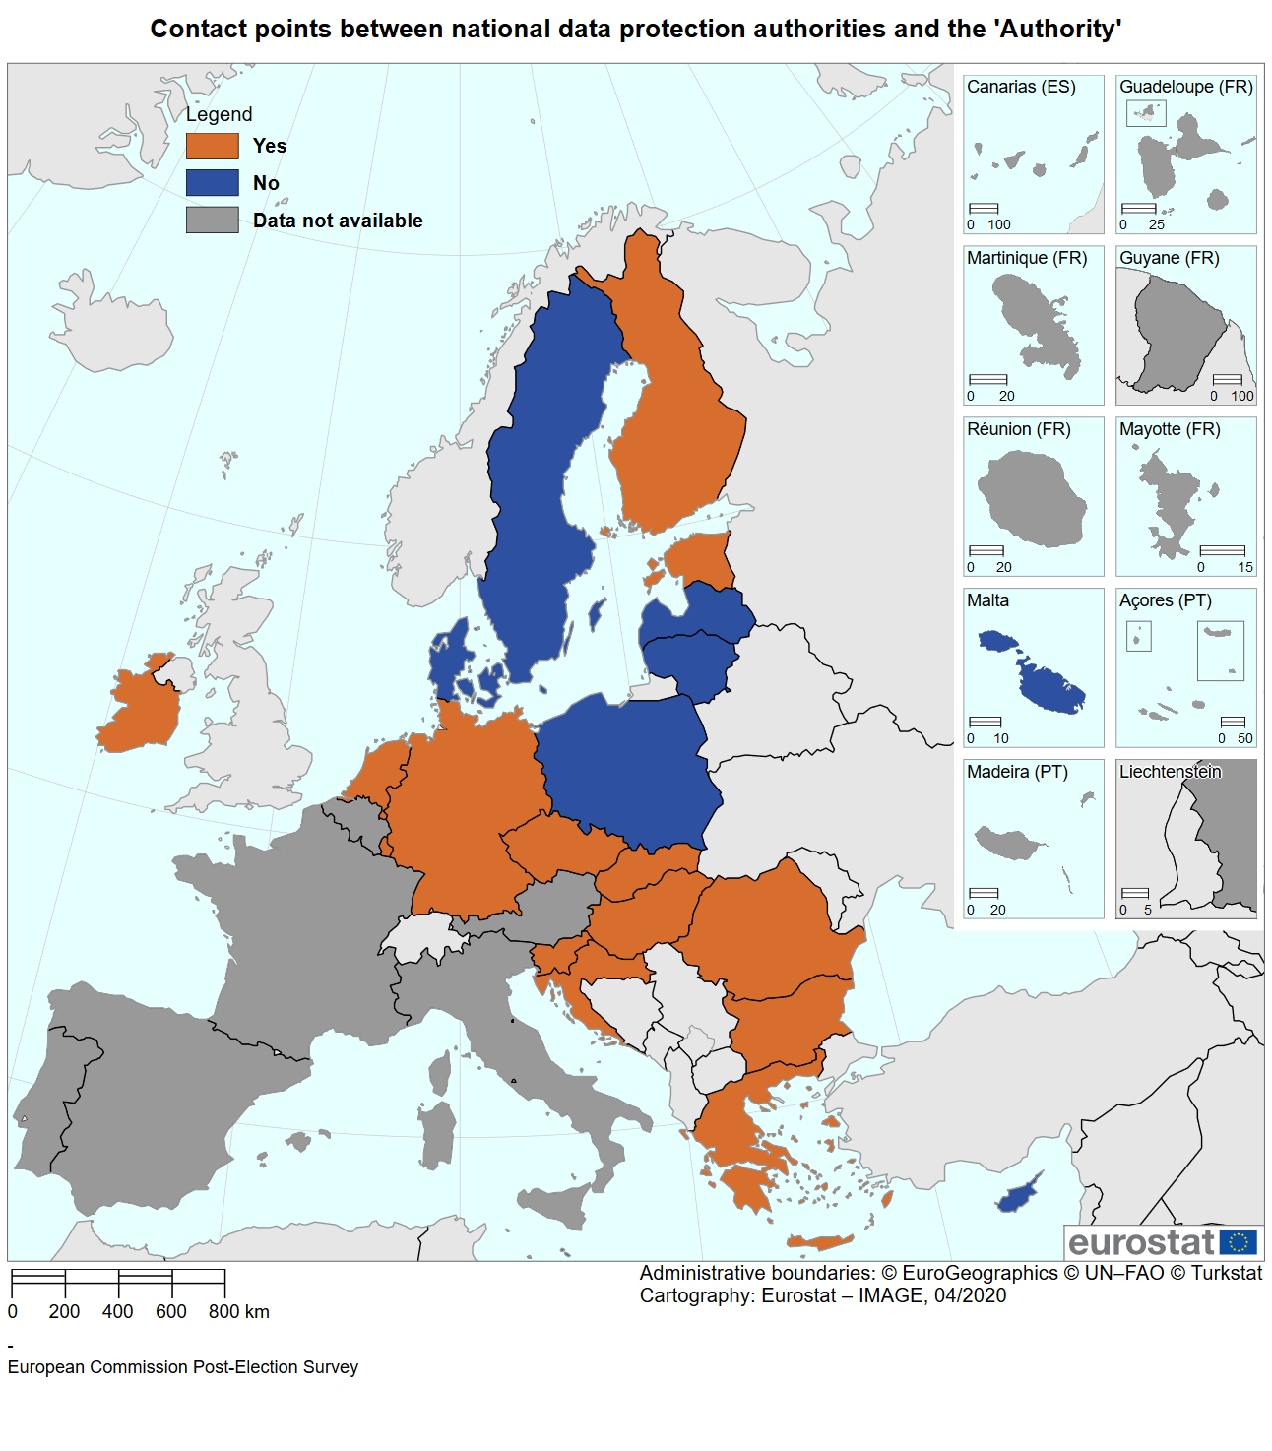 *Source*: European Commission based on replies from Member States to the Commission’s questionnaire, see the Annex. Cartography by Eurostat.

* 1. Cybersecurity

Cybersecurity is central in securing free and fair elections, and cyberattacks against the electoral infrastructure, the authorities responsible in the electoral process, the IT systems of political parties and candidates, and of media, civil society and other actors in the political process are widespread. These attacks range from sophisticated efforts to undermine particular actors in the process by stealing personal data to simple acts of online vandalism and distributed denial-of-service (DDoS) attacks. No network system can ever be made completely secure. In this context, the Commission engaged early with experts as it recognises (i) the importance of cybersecurity in an electoral context to maintaining EU citizens’ confidence and trust in the process, and (ii) the value of sufficient preparation from both government and other actors.

The Commission’s Recommendation invited Member States to:

* take appropriate and proportionate measures to manage the risks posed to the security of network and information systems used to organise the elections;
* apply the Compendium[191] developed by the Cooperation Group established under the Directive on the security of Network and information systems (NIS Cooperation Group) (EU) 2016/1148[192] over the course of the election process; and
* perform a comprehensive assessment of risks to identify potential cyber incidents that could affect the integrity of the electoral process.

The Recommendation also invited European and national political parties, foundations and campaign organisations to implement specific and appropriate measures to prevent cyber incidents and protect themselves against cyberattacks.

In order to support the implementation of the Recommendation and enhance cooperation between different national authorities, the Commission organised a high-level workshop on cyber-enabled threats to elections in October 2018[193], where also cybersecurity authorities had a first discussion with election authorities to discuss the upcoming challenges. The outcome of that workshop also fed in to the Colloquium on Fundamental Rights held at the end of November 2018, focused on ‘Democracy in the European Union’.[194]

In addition, a first ever table-top exercise with competent authorities was organised on 5 April 2019. The Commission, the European Parliament, the Member States, and the European Union Agency for Cybersecurity (ENISA) worked together on an exercise to test the effectiveness of the EU's and Member States response procedures and crisis plans. The exercise sought to identify ways to prevent, detect and mitigate cybersecurity incidents that may affect the elections. It focused on a range of possible scenarios in the week leading up to the elections.

The exercise tested the level of resilience of election systems across the EU, as well as the risks linked to the cybersecurity. It also raised awareness of the importance of increased cooperation between national authorities and cooperation networks at EU level.[195]

TENISA sent a report to the Member States outlining the main conclusions including the policies and capabilities that are considered central to supporting cyber security resilience in European elections. Approximately two thirds of Member States also reported having organised specific cybersecurity exercises at national level.

Member States reported having implemented a range of specific technical and organisational measures to prevent, detect, manage and respond to cyberattacks and to understand and manage network security risks and information systems used to organise the elections. These included:

* heightening the level of alert;
* deploying specific risk analysis and risk mitigation strategies;
* conducting detailed risk analysis and developing an action plan to manage risks;
* conducting penetration testing and vulnerability scanning on key components of the information systems used in the electoral process;
* increasing cooperation between Computer Security Incident Response Team (CSIRTs), as well as cooperating with the companies contracted to extract a complete inventory of the systems.

Member States also reported on efforts to take the use of network systems out of certain parts of the process, including by replacing certain electronic systems with paper.

Bulgaria mentioned that an organisation was set up to interact with Europol’s European Cybercrime Centre and, where necessary, with other governmental and private partners abroad.

In many Member States, dedicated mechanisms to exchange information quickly and efficiently were set up so that any threats or incidents could be investigated and handled. Some examples include putting in place a security operations centre, activating a crisis management mechanism, and activating operational and strategic cells on the day of the elections, including a technical cockpit, an evaluation cell and a coordination cell.

Several Member States pointed to measures specific to the elections, primarily for ensuring confidentiality of the election results until their publication after 23:00 CET on 26 May 2019, and in securing their transmission nationally and to the European Parliament on election night.

In nearly two thirds of Member States, work carried out to ensure the cyber resilience of network and information systems used to organise the elections was informed by the Compendium on the security of election technology (see Figure 16).

In Luxembourg for instance, the cybersecurity subgroup within the national election network set up a national action plan that considers each recommendation listed in the Compendium and identifies the actions needed to implement them.

*Figure 15: Member States that took steps to apply the Compendium on the security of election technology*

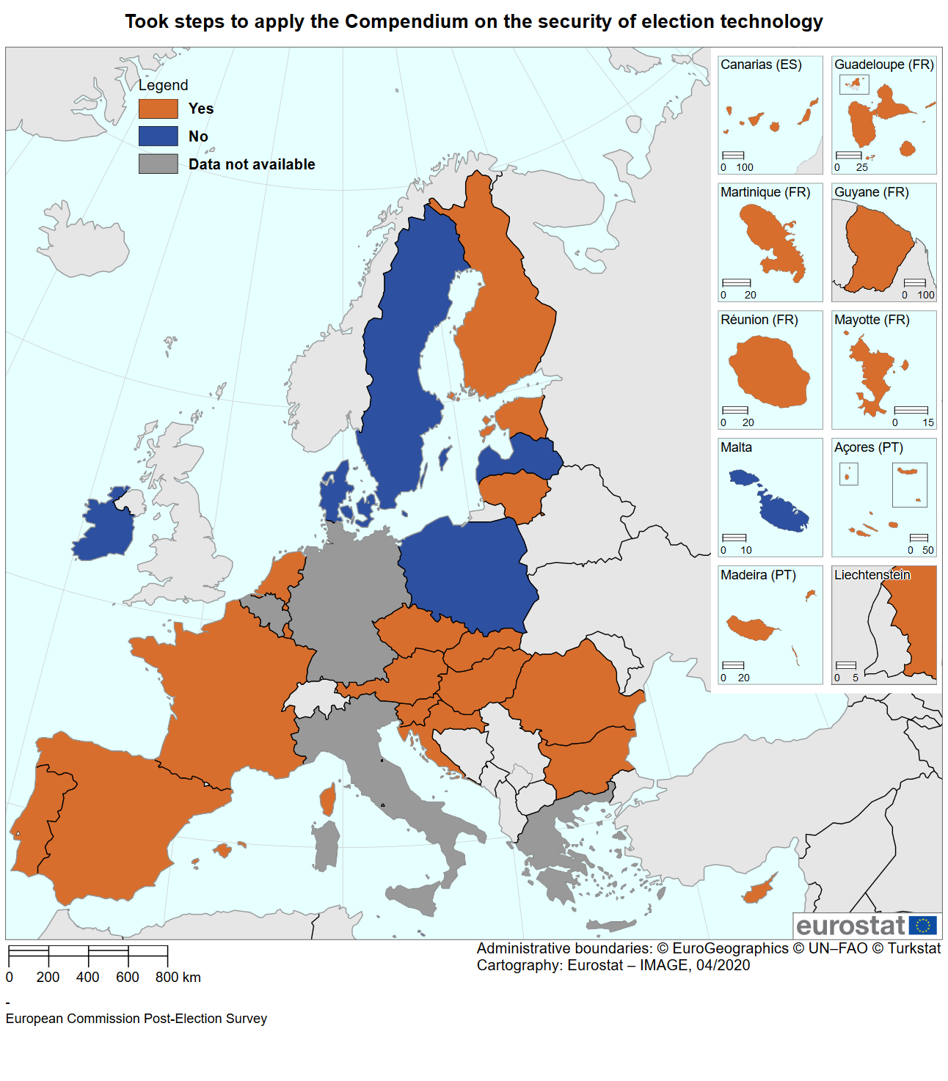

*Source*: European Commission based on replies from Member States to the Commission’s questionnaire, see the Annex. Cartography by Eurostat.

In the transmission of results, France noted the lack of a dedicated and secured channel of communication between the European Parliament and the national authorities.

One third of Member States also applied some of the measures addressed in the Joint Communication on increasing resilience and boosting capabilities to address hybrid threats.[196]

No Member State reported having applied criminal law under Directive 2013/40/EU.[197] Similarly, no non-EU investments were encountered in Member States or by platforms that could affect public order by giving access to sensitive information, including personal data, or the ability to control such information, or by potentially interfering with an electoral infrastructure.[198] At least one Member State intends to set up a national screening mechanism to monitor foreign direct investments that might raise security concerns.

Several Member States reported having encountered cyber incidents that were successfully resolved. Several Member States reported having established direct communication channels with social media networks for rapid response. Google and Twitter did not observe or detect any significant cyber incidents that were election related in the course of the election period.

Facebook pointed to the removal of accounts, pages and groups for violations of their ‘coordinated inauthentic behaviour policy’. In the run-up to the European elections, Facebook reported having disrupted networks engaged in ‘inauthentic misleading behaviour’ from inter alia Moldova, Iran, Russia, Kosovo and Macedonia.

Several political parties reported not taking action to address cybersecurity risks.[199] Others reported carrying out activities or taking measures. These included:

1. distributing information sheets to party membership on cybersecurity risks;
2. participating in seminars organised by the European Parliament on cybersecurity;
3. improving monitoring of the security of digital platforms and tools; and
4. employing dedicated software and analytics specialists during the campaign period.

In most cases, political parties relied on firewall systems and anti-virus software for cybersecurity. The political parties also took advice from their IT departments or companies hosting their websites or servers. Two political parties, one national and one European, reported that they participated in a campaign security workshop held by Microsoft, while one European party referred to dedicated seminars also being provided by Google, Facebook and YouTube.

Several political parties mentioned that they received support from national authorities, which included information sessions organised by the national intelligence agency, or the national cybersecurity authority examining the resilience of the app used by the party members. One political party reported a number of DDoS attacks on its website platform, after which they involved the national cybersecurity authority and the police.[200] In most cases however, political parties have not detected any cyber incidents.

1. Annex: Replies to the questionnaires

**Member States (27):**

|  |  |  |  |  |  |  |
| --- | --- | --- | --- | --- | --- | --- |
| Austria | Cyprus | Finland | Hungary | Luxembourg | Portugal | Spain |
| Belgium | Czechia | France | Ireland | Italy | Malta | Romania |
| Bulgaria | Denmark | Germany | Latvia | Netherlands | Slovakia | Sweden |
| Croatia | Estonia | Greece | Lithuania | Poland | Slovenia |  |

**European and national political groups and parties (22):**

European People’s Party

Renew Europe

European Democratic Party

Belgium: (2) *Nieuw-Vlaamse Alliantie*, sp.a

Germany: (1) *Freie Demokratische Partei*,

Greece: (2) *Komma Neon*, *Elliniko Orama*

Lithuania: (1) *Lietuvos Socialdemokratu Partija*

Luxembourg: (6) *Parti démocrate européen, Chrëschtlech Sozial Vollekspartei, Dei Lenk, Dei Greng,* Pirate, Volt

Malta: (2) *Imperium Romanum, Partit Laburista*

Netherlands: (3) CDA, Volt, 50 PLUS

Portugal: (2) PAN, *Basta*

**Data protection authorities (14)**

|  |  |  |  |  |  |  |
| --- | --- | --- | --- | --- | --- | --- |
| Croatia | Estonia | Greece | Italy | Luxembourg | Malta | Slovakia |
| Cyprus | France | Hungary | Ireland | Latvia | Poland | Slovenia |

**Platforms**

Google, Snapchat, Twitter, Facebook

Direct contributions were also received from the Members of the Advisory Committee on Equal Opportunities for Women and Men from the following 16 Member States:

Austria, Belgium, Bulgaria, Cyprus, Denmark, Finland, Germany, Greece, Ireland, Latvia, Malta, the Netherlands, Poland, Romania, Slovenia and Spain.

1. On 31 January the UK left the EU, and the UK’s elected Members ceased to be MEPs. The European Parliament reduced from 751 to 705 elected representatives, with 46 of the 73 seats vacated by the UK to be held in reserve, potentially for allocation to new countries joining the EU. The remaining 27 seats were redistributed among 14 EU countries, to better reflect the principle of degressive proportionality as follows: France (+5), Spain (+5), Italy (+3), Netherlands (+3), Ireland (+2), Sweden (+1), Austria (+1), Denmark (+1), Finland (+1), Slovakia (+1), Croatia (+1), Estonia (+1), Poland (+1) and Romania (+1). Since then figures for UK candidates and voters have been removed from the data reporting on results of the elections, but do remain in some other data where relevant, e.g. data reporting on public opinion from before the election. This is clearly marked where it is done.
2. Adopted on the 12 September 2018, State of the Union 2018. <https://ec.europa.eu/commission/presscorner/detail/en/IP_18_5681>.
3. <https://ec.europa.eu/newsroom/dae/document.cfm?doc_id=54454>.
4. Jointly issued in 2018 by the European Commission and the High Representative of the Union for Foreign Affairs and Security Policy, <https://eeas.europa.eu/sites/eeas/files/action_plan_against_disinformation.pdf>.
5. <https://ec.europa.eu/info/sites/info/files/com_2015_206_en.pdf>
6. <http://ec.europa.eu/newsroom/document.cfm?doc_id=40723>
7. In total, 27 Member States, 3 European political parties, 17 national political parties from 7 Member States, and 4 IT platforms replied to the questionnaire. See the Annex.
8. If the UK is excluded from the results, this number rises to 52.4%.
9. The turnout for young people aged under 25 is 42% (+14 percentage points). For the ones aged 25–39, it is 47% (+12 percentages points). This remains below the turnout of those aged 55 or over (54%, +3 pp).
10. <https://europarl.europa.eu/election-results-2019/en/turnout/>.
11. Bulgaria, Portugal, Belgium, Ireland, Italy, Luxembourg, Malta and Greece in order of percentage decrease.
12. Voting is compulsory in Belgium, Bulgaria, Greece, Cyprus and Luxembourg.
13. European Parliament, *The* *2019 post-electoral survey*, p.42, see: <https://www.europarl.europa.eu/at-your-service/files/be-heard/eurobarometer/2019/post-election-survey-2019-complete-results/report/en-post-election-survey-2019-report.pdf>.
14. The figure however reveals a discrepancy between younger and older voters. While they are similar in voting out of a sense of duty and out of concern for climate change, younger citizens were more concerned with promoting human rights and democratic values and the economy. In contrast, older voters were more concerned with helping shape the future of the EU.
15. Citizens also differ moderately in their reason for not voting according to age and gender. Older people and men were more likely to say that they were dissatisfied with politics, younger people and women were more likely to say they were uninterested in politics. Older people were also more likely to feel that their vote does not matter.
16. EU28 numbers included in this survey, which was conducted before the UK withdrew from the EU, among citizens eligible to vote at the time of the elections.
17. Observed on average at EU level. Respondents were asked to select several issues.
18. Bulgaria, Estonia, Ireland, Greece, Spain, Croatia, Italy, Cyprus, Latvia, Lithuania, Hungary, Poland, Portugal, Romania and Slovenia.
19. Denmark, Germany, France, Luxembourg, the Netherlands, Austria, Finland and Sweden.
20. Being better informed about the EU’s impact on daily life is the factor most likely to increase motivation to vote in the European Parliament elections – Special Eurobarometer 477 on Democracy and elections in the EU, November 2018.
21. See the White Paper on the future of Europe and the Commission’s contribution to the Sibiu Leaders’ meeting on 9 May 2019.
22. This included activities undertaken by Erasmus students and members of the European Solidarity Corps, European civil society organisations, the research community, stakeholders in the areas of agriculture, regional policy and transport, and citizens who had previously contacted the Europe Direct Contact Centre (Europe’s single phone number for citizens — 00 800 6 7 8 9 10 11) with questions about the EU.
23. This was mentioned by 43% of respondents in the 2018 autumn Eurobarometer survey as the single most important reason to vote*.* See Special Eurobarometer 477 on Democracy and elections, November 2018.
24. The Commission focused on the top 10 expat groups. It cooperated with the Parliament on this, for example by feeding content into the EP’s central elections page www.european-elections.eu, in addition to contributing to the interinstitutional ‘Your Europe’ portal under the Commission’s responsibility.
25. Joint working groups of the representations of the Commission and Liaison offices of the European Parliament were established in 27 Member States, which in some cases also included Member States’ authorities in Belgium, Germany, Estonia, Latvia, Luxembourg, the Netherlands, Austria and Sweden.
26. 1,730 in total from November 2014 until the elections in May 2019.
27. ‘Citizens’ dialogues and citizens’ consultations - key conclusions’, European Commission, 7 May 2019, <https://ec.europa.eu/commission/sites/beta-political/files/euco-sibiu-citizensdialogues_en.pdf>.
28. The network of around 500 walk-in centres is one of the main tools of the European Commission to engage with the public on EU-related topics at local and regional level. These centres are found in all EU Member States. Their mission is to inform EU citizens at local and regional level about the EU, referring them to specialised information sources and other services and networks.
29. <https://www.european-elections.eu./>.
30. The film was offered to the members of the Europa Cinemas network.
31. See point 3.5 below.
32. This included private sector.
33. For instance, the Belgian authorities stated that Brussels-Wallonia established a ‘citizen cabinet’ which aimed to involve citizens in the making of policy recommendations with a focus on ‘fake news’. Citizens’ assemblies are deliberative bodies used in a number of Member States to enable citizens to contribute to policymaking. A notable example is Ireland, where they are commonly used to develop options for referenda.
34. Public figures promoted participation in the elections.
35. ‘[Europe in May 2019: Preparing for a more united, stronger and more democratic Union in an increasingly uncertain world](https://ec.europa.eu/commission/sites/beta-political/files/comm_sibiu_06-05_en.pdf)’ – The European Commission's contribution to the informal EU27 leaders' meeting in Sibiu (Romania) on 9 May 2019: 5 recommendations on communication, in particular ‘Recognise that communicating about the European Union is a joint responsibility for EU Member States, governments at all levels and EU institutions alike’.
36. The data in this section excludes the data originally collected on UK citizens, to help ensure that future policymaking is based on data from current Member States (EU27).
37. This right, enshrined in Article 22(2) TFEU and Article 39(1) of the EU Charter of Fundamental Rights, is given effect in Council Directive 93/109/EC of 6 December 1993 laying down detailed arrangements for the exercise of the right to vote and stand as a candidate in elections to the European Parliament for citizens of the Union residing in a Member State of which they are not nationals, OJ L 329, 30.12.1993, p. 34–38. Mobile EU citizens may vote on the lists of their countries of origin in line with applicable national law (e.g. postal voting, vote in consular posts etc.).
38. 3.68 millions of EU citizens resided in UK whereas 850 000 UK citizens resided in a Member State of the European Union.
39. All but four Member States (Czechia, Ireland, Malta and Slovakia) allow for some possibility of voting from another Member State, either at an embassy/consulate, by post or on the internet. Denmark, Germany, Ireland, Cyprus and Malta limit the right to vote in the European elections in their state of origin when their citizens have been resident outside their territory for a certain period. Conditions vary.
40. Special Eurobarometer 477 – Democracy and Elections, November 2018.
41. See point 4.1.
42. Article 9 of Council Directive 93/109/EC requires Member States to ‘*take the necessary measures to enable a Community voter who has expressed the wish for such to be entered on the electoral roll sufficiently in advance of polling day*.’ Article 12 requires Member States to inform mobile citizens in good time and in an appropriate manner of the conditions and detailed arrangements for the exercise of the right to vote in that State.
43. In some Member States, such as Ireland, enrolment in the Register of Electors will cover all relevant elections. Other Member States, such as Germany, maintain different electoral rolls for different types of election.
44. Some Member States, including Belgium, Greece and Luxembourg provide for compulsory voting for their own nationals, and have differing approaches towards registered non-national citizens. For instance, Belgium extends the obligation to vote to non-nationals on the electoral roll, but permits such citizens to indicate that they no longer wish to exercise this right. Any such obligations must in any event be interpreted compatibly with the prohibition for citizens from voting more than once in the European elections.
45. See Commission study on remote voting: <https://ec.europa.eu/info/policies/justice-and-fundamental-rights/eu-citizenship/electoral-rights/studies_en>.
46. Postal voting, proxy voting, voting in consulates and embassies.
47. Postal voting is provided for in 15 Member States, proxy in 4 Member States, e-voting in 1. Voting in diplomatic missions is possible for 21 Member States <https://www.europarl.europa.eu/RegData/etudes/ATAG/2018/623556/EPRS_ATA(2018)623556_EN.pdf>
48. e.g. slow or cumbersome postal voting procedures, insufficient voting booths and staffing at consulates
49. With good communications to inform citizens of their voting options based on straightforward procedures and with realistic deadlines and sufficiently well-resourced facilities.
50. The same applies to other groups with particular needs, such as citizens with disabilities.
51. <https://europa.eu/youreurope/citizens/residence/elections-abroad/european-elections/index_en.htm>.
52. Despite the increased turnout among younger people, the overall voter population continues to show a strong representation among older people, including 43% aged 55 or over (unchanged from 2014).
53. European Parliament post-election survey (see footnote 9), p. 22.
54. Except in Austria, where this group includes ages 16-24, and Greece, where it includes 17-24, as voters become eligible younger in those countries.
55. European Parliament post-election survey (see footnote 9), p. 22.
56. This table has been adapted from the post-election survey, to show numbers for EU27.
57. According to a 2018 study by the Inter-Parliamentary Union and the Parliamentary Assembly of the Council of Europe, 85.2% of women parliamentarians reported having experienced psychological violence during their terms in office. 46.9% of the respondents reported having received death threats or threats of rape and beatings directed against themselves or against their children and other family members, mainly delivered through social media and e-mail.
58. In some countries the turnout of women increased markedly for instance in Finland from 38% to 43.4%.
59. See <https://europarl.europa.eu/election-results-2019/en/mep-gender-balance/2019-2024/>. At the time of the data collection, the Netherlands and Spain had not confirmed all of their Member of European Parliament yet.
60. Legislated quotas applied in 11 countries (Belgium, Greece, Spain, France, Croatia, Italy, Luxembourg, Poland, Portugal, Romania and Slovenia) at the European Parliament elections in 2019 (EP Briefing March 2019 ‘Women in politics in the EU – State of play’).
61. See <https://europarl.europa.eu/election-results-2019/en/mep-gender-balance/2019-2024/> and <https://www.europarl.europa.eu/news/en/press-room/20190516BKG51011/european-elections-2019-country-sheets>.
62. For instance in Malta, 33% of all female candidates were elected and only 9% of male candidates. This reflects, in part, the number of candidates. Malta saw 9 female and 32 male candidates participate.
63. For more information on this committee, see its pages in the Register of Commission Expert Groups: <https://ec.europa.eu/transparency/regexpert/index.cfm?do=groupDetail.groupDetail&groupID=1238&NewSearch=1&NewSearch=1>.
64. President Ursula von der Leyen, A Union that strives for more: My agenda, Political Guidelines for the next European Commission 2019-2024.
65. Commission Recommendation (EU) 2018/234 of 14 February 2018 on enhancing the European nature and efficient conduct of the 2019 elections to the European Parliament, OJ L 45, 17.2.2018, p. 40–43. Following the Recommendation, Member States’ authorities, with Commission support, met on 25 April 2018 to exchange practices on how to best foster the democratic participation of EU citizens (including mobile EU citizens and other underrepresented groups). This included the exchange of best practices on i) awareness raising and communications activities; ii) candidacy funding for specific underrepresented groups; iii) support networks, community championing etc.; iv) adjustments to help people to vote and stand as a candidate; v) measures to assist officials in managing local and European elections; vi) measures to support the European dimension of the elections and to support campaigning that is focused on European issues (e.g. display of EU party logos in manifestos and transparency about European party affiliation); and vii) measures to support remote voting solutions and other practical simplifications.
66. <https://ec.europa.eu/info/events/annual-colloquium-fundamental-rights/2018-annual-colloquium-fundamental-rights-2018-nov-26_en>.
67. <https://ec.europa.eu/transparency/regexpert/index.cfm?do=groupDetail.groupDetail&groupID=617>.
68. Demographic change has various impacts on European societies and way of life. <https://ec.europa.eu/eurostat/web/products-statistical-books/-/KS-HA-19-001>
69. https://ec.europa.eu/regional_policy/en/information/publications/working-papers/2018/the-geography-of-eu-discontent
70. Scipioni, M., Tintori, G., Alessandrini, A., Migali, S. and Natale, F., Immigration and trust in the EU, EUR 30042 EN, Publications Office of the European Union, Luxembourg, 2019, ISBN 978-92-76-14661-2 (online), doi:10.2760/76114 (online), JRC118855 https://publications.jrc.ec.europa.eu/repository/bitstream/JRC118855/immigration_and_trust_in_the_eu_1.pdf
71. There is no generally accepted definition of the term ‘minority’ in the EU. This lack of definition has also been acknowledged in relation to various international conventions and treaties. Francesco Capotorti, in his role as Special Rapporteur to the United Nations, proposed a definition that is now commonly used: ‘A group numerically inferior to the rest of the population of a State, in a non-dominant position, whose members - being nationals of the State - possess ethnic, religious or linguistic characteristics differing from those of the rest of the population and show, if only implicitly, a sense of solidarity, directed towards preserving their culture, traditions, religion or language.’ (Capotorti, 1979, par. 586).
72. The European Network Against Racism, ‘ENAR’s Election Analysis: Ethnic Minorities in the New European Parliament 2019-2025’, 2019, [https://www.enar-eu.org/IMG/pdf/2019_06_racial_diversity_eu_  
    parliament_elected_meps_final.pdf](http://www.enar-eu.org/IMG/pdf/2019_06_racial_diversity_eu_parliament_elected_meps_final.pdf).
73. Study conducted for the Commission by the network of academics on EU citizenship on the participation of underrepresented citizens in the EU, 2018 <https://ec.europa.eu/info/policies/justice-and-fundamental-rights/eu-citizenship/electoral-rights/studies_en>.
74. 15.1% of women and 12.9% of men aged 15-64 report a difficulty with a basic activity. See Eurostat <https://ec.europa.eu/eurostat/statistics-explained/images/8/8c/Infographic_Disability_statistics_final.png>.
75. Real rights of persons with disabilities to vote in European Parliament elections – March 2019, <https://www.eesc.europa.eu/sites/default/files/files/qe-02-19-153-en-n.pdf>.
76. Fundamental Rights Agency, ‘Developments in the right to vote of people deprived of legal capacity in EU Member States’, 2019.
77. All EU Member States, as well as the EU, have ratified the UN Convention on the Rights of Persons with Disabilities (UN CRPD), guaranteeing to persons with disabilities political rights and the opportunity to enjoy them on an equal basis with others.
78. Estonia, Greece, France, Croatia, Italy, Latvia, Hungary, the Netherlands, Austria, Finland, Sweden and the United Kingdom.
79. Belgium, Denmark, Germany and Spain.
80. Fundamental Rights Agency Report, ‘Who will (not) get to vote in the 2019 European Parliament elections? Developments in the right to vote of people deprived of legal capacity in EU Member States’, February 2019.
81. The Dutch government is conducting research into the obstacles politicians with disabilities face and what measures need to be taken in order for them to participate and carry out their duties. Politicians and candidates with disabilities, as well as DPOs, will be interviewed. For the 2015 General Election in the United Kingdom, prospective candidates with disabilities standing for election could access grants of between £250 and £40,000 for disability related costs including specialist transport, screen reader software, sign language interpretation and Braille transcription (United Kingdom, Government Digital Service (2015), Access to Elected Office Fund). In Romania, the lowering of the threshold for establishing political parties was indicated as a measure generally supporting the access of underrepresented groups to the political process.
82. <https://www.housing.gov.ie/sites/default/files/publications/files/01_-_info-voters_with_disability-english.pdf>
83. <https://ec.europa.eu/info/files/conclusions-colloquium-2018_en>.
84. See for example <http://www.spaceu2019.eu/>.
85. See for example <http://smp.eelga.gov.uk/migrant-workers/act-project.aspx>.
86. See for example <https://euandi2019.eui.eu/> and <https://yourvotematters.eu/en/>.
87. See for example <http://www.diversitygroup.lt/fwp_portfolio/migrant-political-participation/> and <https://www.lawcentres.org.uk/lcn-s-work/living-rights-project>.
88. Projects included ALDA (Belgium) <https://www.alda-europe.eu/newSite/Towards-EU-Elections-2019.php>, Expert Pool - (Bulgaria) <https://vote4europe.org/>, Council of European Municipalities and Regions (Belgium) <https://www.ccre.org/en/activites/view/8>, EAVI – European Association for Viewers Interests (Belgium) <https://eavi.eu/>

    <https://europeanhouse.hu/>, Europski Dom Slavonski Brod (Croatia) <http://europski-dom-sb.hr/projekti/>, European Movement International (Belgium) <https://europeanmovement.eu/news/the-european-movement-international-in-2019/> European University College Association (Belgium) <https://www.euca.eu/messagetoeuropeans>, Europeum Institute for European Policy (Czech Republic ), Young European Federalists (Belgium) <https://www.jef.eu/activities/projects/european-youth-together-road-to-the-future-project-towards-the-european-elections-2019/>. See also <https://eacea.ec.europa.eu/europe-for-citizens_en> and ‘European elections 2019 feedback from the ground’ <https://op.europa.eu/en/publication-detail/-/publication/87410a7b-cec0-11e9-992f-01aa75ed71a1/language-en/format-PDF/source-111528910>.
89. Act concerning the election of the members of the European Parliament by direct universal suffrage, OJ L 278*,* 8.10.1976, p. 5.
90. So that the announcement of results in one Member State cannot influence ongoing voting in another.
91. See Commission Recommendation (EU) No 2013/142 of 12 March 2013 on enhancing the democratic and efficient conduct of the elections to the European Parliament of 12 March 2013, OJ L 79, 21.3.2013, p. 29–32.
92. European Parliament Resolution of 11 November 2015 on the reform of the electoral law of the European Union (2015/2035(INL)), OJ C 366, 27.10.2017, p. 7–18.
93. Council Decision (EU, Euratom) 2018/994 of 13 July 2018 amending the Act concerning the election of the members of the European Parliament by direct universal suffrage, annexed to Council Decision 76/787/ECSC, EEC, Euratom of 20 September 1976, OJ L 178, 16.7.2018, p. 1–3.
94. The relevant procedure (Article 223 TFEU) requires that the Council, acting unanimously in accordance with a special legislative procedure and after obtaining the consent of the European Parliament, which shall act by a majority of its component Members, lays down the necessary provisions. These provisions will enter into force following their approval by the Member States in accordance with their respective constitutional requirements. Not all Member States had approved the agreed amendments early enough before the elections.
95. European Commission, Proposal for a regulation amending Regulation (EU, Euratom) No. 1141/2014 of 22 October 2014 on the statute and funding of European political parties and European political foundations, COM(2017)481.
96. A recital called on political parties also to provide transparency on the gender balance of their candidate lists.
97. The Commission’s proposal also included the publication, on its member parties' websites, of information on the gender representation among the candidates at the last European elections.
98. Regulation (EU, Euratom) No 1141/2014 of the European Parliament and of the Council of 22 October 2014 on the statute and funding of European political parties and European political foundations, OJ L 317, 4.11.2014, p. 1–27.
99. Commission Recommendation (EU) No 2018/234 of 14 February 2018 on enhancing the European nature and efficient conduct of the 2019 elections to the European Parliament, OJ L 45, 17.2.2018, p. 40–43.
100. Bulgaria, Czechia, Denmark, Germany, Estonia, Spain, Croatia, Latvia, Lithuania, Hungary, Malta, Poland, Portugal, Romania, Slovakia and Sweden.
101. One Member State did not respond.
102. Belgium, Ireland, Greece, France, Cyprus, Luxembourg, the Netherlands, Austria, Slovenia and the United Kingdom.
103. 1 party in Greece, 4 in France, 2 out of 10 in Luxembourg, 2 out 18 in the Netherlands and four in Ireland.
104. *Christen-Democratisch Appèl* (the Netherlands) and *Eilliniko Orama* (Greece).
105. The *Socialistische Partij Anders* claimed that it was not allowed in Belgium, when in fact it is. The same was the case for Volt in both Luxembourg and the Netherlands as well as for the *Chrëschtlech Sozial Vollekspartei* in Luxembourg. On the other hand, the social democratic party of Lithuania, *Lietuvos socialdemokratų partija*, thought that displaying the European logo or name on the ballot papers was allowed in Lithuania, while actually it is not permitted there.
106. Johansson, Bengt and Novelli, Edoardo, ‘2019 European elections campaign – Images, topics, media in the 28 Member States’, 9 July 2019, <https://op.europa.eu/en/publication-detail/-/publication/e6767a95-a386-11e9-9d01-01aa75ed71a1/language-en>.
107. Council Directive 93/109/EC of 6 December 1993 laying down detailed arrangements for the exercise of the right to vote and stand as a candidate in elections to the European Parliament for citizens of the Union residing in a Member State of which they are not nationals OJ L 329, 30.12.1993, p. 34–38
108. Czechia, Latvia, Lithuania and Poland.
109. Either by being prevented from standing altogether, or, where this is not possible, from being elected or from exercising their mandate. See Council Directive 2013/1/EU of 20 December 2012 amending Directive 93/109/EC. The case of Oriol Junqueras, ECJ Case C-502/19- decided by the Court of Justice in December 2019, is relevant to the scope of EU law.
110. Belgium, Greece, the Netherlands, Slovenia and Finland.
111. The UK Electoral Commission published its report on 8 October 2019 <https://www.electoralcommission.org.uk/who-we-are-and-what-we-do/elections-and-referendums/past-elections-and-referendums/european-parliamentary-elections/report-may-2019-european-parliamentary-elections-and-local-elections> regarding the voting registration process for EU citizens resident in the UK for the 2019 European Parliamentary elections held in the UK. Of the 149 calls and 618 formal complaints that the Electoral Commission received, over half were not aware of the ‘UC1’ declaration requirement, a smaller number did not submit it in time and around one sixth completed it in time but were still unable to vote. The Electoral Commission also noted that approximately four in five EU citizens (1.7 million) who had previously registered to vote did not submit an additional declaration in time to be registered to vote at the European Parliament elections in the UK. This data reflected complaints by mobile EU citizens in media reports at the time - see <https://www.bbc.com/news/uk-politics-48384000>.
112. At the 2019 European Parliamentary elections, Romanians abroad faced long queues at embassies and consulates, resulting that some citizens didn’t get the chance to vote in the end - see <http://business-review.eu/news/thousands-of-romanians-abroad-unable-to-vote-due-to-long-queues-201321>.
113. Special Eurobarometer 477 — Democracy and elections, November 2018.
114. Through their respective commitments to supporting electoral observation, inter alia by endorsing the Declaration of Principles for International Election Observation <http://ec.europa.eu/external_relations/human_rights/eu_election_ass_observ/docs/code_conduct_en.pdf>
115. An observation mission by ODIHR was not invited by the Member States for the 2019 elections, and has not been done so since 2009. Election-Watch.EU conducted an own initiative survey of the European elections the findings of which can be accessed online <https://www.wahlbeobachtung.org/en/european-parliament-elections-2019-election-watch-eu-eam-final-report-with-16-recommendations/>.
116. See Council Directive 93/109/EC of 6 December 1993 laying down detailed arrangements for the exercise of the right to vote and stand as a candidate in elections to the European Parliament for citizens of the Union residing in a Member State of which they are not nationals, OJ L 329, 30.12.1993, p. 34-38.
117. Article 13 of Council Directive 93/109/EC. Also, Member States are also required to exchange information to ensure that citizens who have had their rights to vote or stand as a candidate withdrawn, do not do so in another Member State.
118. This is conducted using a combination of a bespoke encryption/decryption tool (the crypto-tool) which allows the personal data to be encrypted and compressed, and a dedicated space within the Commission’s CIRCABC platform <https://circabc.europa.eu/faces/jsp/extension/wai/navigation/container.jsp>, to which only relevant Member State officials have access. The crypto-tool performs validation of the data being encrypted against a pre-specified standard which is provided as an annex to the Directive.
119. <https://ec.europa.eu/transparency/regexpert/index.cfm?do=groupDetail.groupDetail&groupID=617>.
120. For instance, the periods during which citizens could register as voters and candidates were not common from Member States to Member States, and in some instances were wholly separate (meaning that citizens in some states would be expected to start registering to vote after the possibility to register in other states had closed).
121. Data on the identification rate are incomplete. On the basis of the Member States for which complete data was exchanged, the overall identification rate was around 31%, though some Member States managed to identify over 90% of the records received. However, the rate was very low in some cases, mostly reflecting the mismatch between the information collected about voters seeking to register to vote in one country, and the information required to identify a citizen in another country.
122. Ahead of radio and print media, and second to television.
123. This number has increased by 15 pps since 2010. Standard Eurobarometer 90 – Media use in the European Union, December 2018. 44% and 41% of Europeans said that the internet is one of the main information sources for national and European political matters, respectively.
124. 59%, 57% and 54% respectively. Standard Eurobarometer 90 —Media use in the European Union, December 2018.
125. The scope and nature of interference in elections is a matter of ongoing research and monitoring by a number of organisations, including the European Commission. The Computer Emergency Response Team for the EU Institutions, bodies and agencies (CERT-EU) monitors the online environment as part of its task to support the security of the ICT infrastructure of all EU institutions, bodies and agencies. It does this by helping to prevent, detect, mitigate and respond to cyber-attacks and by acting as the cyber-security information exchange and incident-response coordination hub. CERT-EU provides reports and analysis of incidents to the Member State authorities through the European Cooperation Network on Elections. The European External Action Service maintains a number of bodies tasked in this respect, including the Rapid Alert System and the <https://euvsdisinfo.eu/> website. The EU-NATO European Centre of Excellence for Countering Hybrid Threats supports research into external interference in elections (for instance, see the research into the use of cyber-interference to manipulate elections, <https://www.hybridcoe.fi/wp-content/uploads/2018/10/Strategic-Analysis-2018-8-Past.pdf>. Member State organisations are also involved in supporting research in this field. Relevant research organisations include Cardiff University’s Crime and Security Research Institute <https://www.cardiff.ac.uk/crime-security-research-institute> and the Computational Propaganda Project <https://comprop.oii.ox.ac.uk/>. The Commission monitors the implementation of the self-regulatory code of practice (see point 4.2.3). The EU-NATO European Centre of Excellence for Countering Hybrid Threats supports research into external interference in elections (see for instance research into the use of cyber-interference to manipulate elections, <https://www.hybridcoe.fi/wp-content/uploads/2018/10/Strategic-Analysis-2018-8-Past.pdf>. Member State organisations are also involved in supporting research in this field. Relevant research organisations include Cardiff University’s Crime and Security Research Institute <https://www.cardiff.ac.uk/crime-security-research-institute> and the Computational Propaganda Project <https://comprop.oii.ox.ac.uk/>.
126. For a survey of such narratives, see for instance <https://ec.europa.eu/regional_policy/sources/docgener/work/2018_02_geog_discontent.pdf>. For a behavioural approach to impact of information on political decision-making, see <http://publications.jrc.ec.europa.eu/repository/bitstream/JRC117161/understanding-our-political-nature.pdf>.
127. Regulation (EU, Euratom) 2019/493 of 25 March 2019 amending Regulation (EU, Euratom) 1141/2014 as regards a verification procedure related to infringements of rules on the protection of personal data in the context of elections to the European Parliament, OJ L 85I , 27.3.2019, p. 7–10 (and it entered into force on 27 March 2019). A corresponding recommendation was addressed to Member States as regards national political parties.
128. <https://data.consilium.europa.eu/doc/document/ST-6573-2019-REV-1/en/pdf>. It was further welcomed and supported by the European Council in its conclusions of March 2019 <https://data.consilium.europa.eu/doc/document/ST-1-2019-INIT/en/pdf> and June 2019 <https://www.consilium.europa.eu/media/39922/20-21-euco-final-conclusions-en.pdf>. Further Council Conclusions supporting the implementation of the electoral package and the continuation of the work of the electoral network were adopted in December 2019 <https://data.consilium.europa.eu/doc/document/ST-14972-2019-INIT/en/pdf>.
129. <http://www.europarl.europa.eu/doceo/document/TA-8-2018-0433_EN.pdf?redirect>.
130. <http://www.europarl.europa.eu/doceo/document/TA-9-2019-0031_EN.html>.
131. The Code is a self-regulatory measure, supported by the Commission, whereby the major online platforms and trade associations from the advertising sector commit to carry out policies and actions aimed at ensuring public disclosure of political advertising and at improving the transparency, trustworthiness and accountability of online services. The Code was signed in October 2018 by Facebook, Google, Twitter and Mozilla, as well as advertising trade associations. Microsoft joined the Code in May 2019, and additional trade associations from the advertising sector also subscribed to the Code since.
132. Data enabling precise analysis of the scope of disinformation campaigns around the elections on social media and on the extent to which foreign actors might have been involved is not available.
133. Distributed denial-of-service (DDOS) attacks against the websites of public authorities offering advice about the elections were observed in a number of states, including Finland and Czechia, where detection and recovery were very prompt. Such attacks continue: efforts to suppress the vote in the recent national elections through disinformation were reported in Poland, and the websites of political parties were attacked in the run up to the national elections in the UK.
134. Special Eurobarometer 477—Democracy and elections, November 2018.
135. According to the European Parliament post-election survey (see footnote 12), the lowest levels of satisfaction are seen in relation to the fight against disinformation in the media ‘(48%) and the fight against corruption (43%).
136. The Commission also encouraged Member States to apply the principles of this Recommendation to other elections and referenda they organise at national level.
137. C(2018) 5949 final.
138. <https://data.consilium.europa.eu/doc/document/ST-14972-2019-INIT/en/pdf>.
139. The Commission’s Recommendation referred for instance to electoral authorities, data protection authorities, authorities in charge of cybersecurity and media regulators.
140. Out of the 14 national data protection authorities which responded to the questionnaire of the Commission.
141. Czechia, Germany, Austria, Latvia, Portugal and Sweden.
142. Bulgaria, Croatia, Luxembourg and Romania.
143. Czechia, Germany, Spain, Cyprus, the Netherlands, Austria and Portugal.
144. Denmark and Finland.
145. Bulgaria and Slovakia.
146. The Rapid Alert System was set up pursuant to the action plan against disinformation adopted in December 2018. This platform facilitates the sharing of insights related to disinformation campaigns and coordinating responses among the EU institutions and Member States.
147. <http://ec.europa.eu/research/participants/data/ref/other_eu_prog/rec/wp/rec-awp-2019_en.pdf>, p. 22.
148. And will be open for applications until March 2020, see <https://ec.europa.eu/info/funding-tenders/opportunities/portal/screen/opportunities/topic-details/rec-rcit-citi-ag-2020>.
149. Fourth Meeting of the European Cooperation Network on Elections, 7 June 2019.
150. Its terms of reference and minutes are published online, see <https://ec.europa.eu/info/policies/justice-and-fundamental-rights/eu-citizenship/electoral-rights_en#electionsnetwork>.

     In the same way, the European Parliament achieves transparency with a website of mainly financial information pursuant to Article 32 of Regulation (EU, Euratom) 1141/2014 of 22 October 2014 on the statute and funding of European political parties and European political foundations, as amended by Regulation (EU, Euratom) 2018/673.
151. Sources used: Member State authorities’ websites, academic literature, online databases, Member State feedback to DG JUST questionnaires.
152. Information received from Member States indicated that limited DDoS attacks were encountered on a number of occasions and responded to successfully and promptly. The NATO Communications and Information (NCI) Agency and the Computer Emergency Response Team for the European Union’s institutions, bodies and Agencies (CERT-EU) held a workshop on ‘Cyber Threat Vector Analysis’ ahead of the European Parliament elections in May 2019 which considered a range of threats to the elections process <https://ec.europa.eu/info/news/nato-and-cert-eu-discuss-cyber-threats-ahead-eu-elections-2019-may-06_en>. For an overview of cyberthreats in elections see <https://www.idea.int/sites/default/files/publications/cybersecurity-in-elections-models-of-interagency-collaboration.pdf>.
153. While greatly increased and externally coordinated disinformation campaigns and cyberattacks were not observed, the systematic long-term pro-Kremlin disinformation campaigns, spread through known state-controlled disinformation sources and amplified via social media and domestically, included attacks on European democratic processes and institutions, and continued through the elections period. See for instance: <https://euvsdisinfo.eu/eu-elections-update-reaping-what-was-sown/>.
154. Commission Recommendation of 12.9.2018 on election cooperation networks, online transparency, protection against cybersecurity incidents and fighting disinformation campaigns in the context of elections to the European Parliament, C (2018) 5949 final, p. 8.
155. Bulgaria and Cyprus
156. Czechia and Estonia.
157. France.
158. Latvia.
159. Hungary.
160. <https://merrionstreet.ie/en/News-Room/News/Proposal_to_Regulate_Transparency_of_Online_Political_Advertising.html>.
161. <https://www.rijksoverheid.nl/onderwerpen/desinformatie-nepnieuws/nieuws/2019/10/18/kabinet-zet-in-op-transparantie-in-strategie-tegen-desinformatie>.
162. Act on the Financing of Political Activities, Election Campaigns and Referenda, 2019.
163. Outline Policy Proposal to Regulate Transparency of On-line Political Advertising <https://assets.gov.ie/39188/8c7b6bc1d0d046be915963abfe427e90.pdf>.
164. Complementing the commitments made by the major online platforms under the Code of Practice to provide for the transparency and public disclosure of political advertising on their services, see next section.
165. <https://ec.europa.eu/info/sites/info/files/letter_political_parties_final_en.pdf>.
166. EU code of practice on disinformation, available at: <https://ec.europa.eu/digital-single-market/en/news/code-practice-disinformation>.
167. Under the code of practice, the signatory platforms have committed to developing approaches to the transparency and public disclosure of ‘issue-based advertising.’ This is a wider concept than ‘political advertising’ (defined under the Code as advertising advocating for or against a candidate or referenda in national and European elections) and encompasses advertising concerning, for instance, economic and social issues. To date, only Facebook has adopted a policy at EU level with respect to issue-based advertising. The Commission’s Recommendation refers in points 7-10 to ‘paid communications’ which encompasses ‘issue-based advertising’.
168. The monthly reports, submitted by Facebook, Google and Twitter for January through May 2019, have been [published on the Commission’s website](https://ec.europa.eu/digital-single-market/en/news/code-practice-disinformation), available at: <https://ec.europa.eu/digital-single-market/en/news/code-practice-disinformation>. Microsoft, which subscribed to the code of practice on 22 May 2019, was not subject to the Commission’s program of targeted monthly monitoring.
169. In addition to ERGA, the Commission is also being supported in its assessment of the Code by an independent consultant.
170. The signatories’ annual self-assessment reports, along with a summary overview from the Commission, [have been published on the Commission’s website](https://ec.europa.eu/digital-single-market/en/news/annual-self-assessment-reports-signatories-code-practice-disinformation-2019), available at: <https://ec.europa.eu/digital-single-market/en/news/annual-self-assessment-reports-signatories-code-practice-disinformation-2019>.
171. Available at: <https://ec.europa.eu/digital-single-market/en/news/annual-self-assessment-reports-signatories-code-practice-disinformation-2019>.
172. Social Science One, a partnership between a Social Science Research Council and private industry, for example, found in a meeting in December 2019 that the Facebook Ad Library was incomplete, inconsistent and difficult to use for research purposes in Czechia, Germany, Italy and the UK (EAC Workshop December 2019).
173. Google, Facebook, Snapchat and Twitter responded to a dedicated questionnaire on the implementation of the electoral package.
174. <https://business.twitter.com/en/a/twitter-ads-guide-eu-elections.html>.
175. These findings echo the recommendations made by the NATO Stratcom Centre of Excellence in its study on the role of social media in combatting inauthentic behaviour, which stressed the importance of increased and meaningful transparency, independent oversight and reporting, as well as greater self-regulation effort <https://www.stratcomcoe.org/how-social-media-companies-are-failing-combat-inauthentic-behaviour-online> .
176. Regulation (EU) 2016/679 of the European Parliament and of the Council of 27 April 2016 on the protection of natural persons with regard to the processing of personal data and on the free movement of such data, and repealing Directive 95/46/EC (General Data Protection Regulation), OJ L 119, 4.5.2016, p. 1–88.
177. Commission guidance on the application of Union data protection law in the electoral Context— contribution from the European Commission to the Leaders' meeting in Salzburg on 19-20 September 2018, (COM(2018) 638 final).
178. Statement 2/2019 of 13 March 2019 <https://edpb.europa.eu/sites/edpb/files/files/file1/edpb-2019-03-13-statement-on-elections_en.pdf>.
179. <https://edps.europa.eu/sites/edp/files/publication/18-12-18_opinion_on_election_package_en.pdf>.
180. In response to the Commission questionnaire, data protection authorities from Bulgaria, Ireland, France, Croatia, Cyprus, Latvia, Luxembourg, Malta, Romania, Slovenia, Slovakia and Finland reported dissemination guidelines to political parties and candidates or the electorate more generally through information packages, press statements, online guidance, video blogs and social media outreach. Latvian and Lithuanian authorities also provided trainings. Spanish authorities provided a Frequently Asked Questions section on their website and published a legal report ahead of the elections.
181. Based on the answers to the Commission questionnaire, data protection authorities from Estonia, Latvia, Greece and Cyprus.
182. The follow-up to be given, where appropriate, to all of these reports and complaints is under investigation.
183. Bulgaria, Denmark, Ireland, Cyprus, Luxembourg, Hungary, Malta, Romania and Slovakia.
184. Article 60 of the GDPR (cooperation between the lead supervisory authority and the other supervisory authorities concerned).
185. It inserted Article 10a Verification procedure related to infringements of rules on the protection of personal data into Regulation (EU, Euratom) 1141/2014 of 22 October 2014. It provides that where the Authority is informed of a decision of a national supervisory authority regarding a personal data infringement linked to political activities by a European political party or a European political foundation in the context of elections to the European Parliament, it must refer the matter to the committee of independent eminent persons (Article 11). The committee shall give its opinion as to whether the European political party or European political foundation concerned has deliberately influenced or attempted to influence the outcome of elections to the European Parliament by taking advantage of that infringement. The Authority shall then decide on sanctions.
186. Established under Regulation 1141/2014.
187. Ireland, France, Croatia, Italy, Poland and Slovakia.
188. Germany and Greece.
189. Luxembourg, Romania, Slovenia and Finland respectively.
190. National data protection authorities in France, Italy and Poland reported that they established some contact with other authorities.
191. <https://ec.europa.eu/information_society/newsroom/image/document/2018-30/election_security_compendium_00BE09F9-D2BE-5D69-9E39C5A9C81C290F_53645.pdf> .
192. First EU-wide cybersecurity rules (the Directive on security of network and information systems, (NIS Directive) establish the Computer Security Incident Response Team Network to promote swift and effective operational cooperation between the Member States.
193. <https://ec.europa.eu/epsc/events/election-interference-digital-age-building-resilience-cyber-enabled-threats_en>
194. See above, <https://ec.europa.eu/info/events/annual-colloquium-fundamental-rights/2018-annual-colloquium-fundamental-rights-2018-nov-26_en>.
195. Beyond the European Cooperation Network on Elections, the NIS Cooperation Group, CSIRTs Network.
196. JOIN(2018) 16 final.
197. Directive 2013/40/EU of the European Parliament and of the Council of 12 August 2013 on attacks against information systems and replacing Council Framework Decision 2005/222/JHA, OJ L 218, 14.8.2013, p. 8–14.
198. Regulation (EU) 2019/452 of the European Parliament and of the Council of 19 March 2019 establishing a framework for the screening of foreign direct investments into the Union, OJ L 79I , 21.3.2019, p. 1–14.
199. Four out of 20 that replied.
200. Such attacks have continued to affect political parties. In the context of national elections in December 2019, the UK Labour party was hit with two DDoS attacks. Both were aimed at taking down Labour’s digital infrastructure, mainly targeting some important canvassing and campaigning tools (source <https://cert.europa.eu/cert/>).