

**Map 6. Net migration**[1] **in NUTS3 regions, 2014-2018**

*Annual average change (per thousand)*

# 8. infrastructure and access to services

**8.1 Accessibility to passenger flights**

The indicator shows how many departures of passenger flights (average number per day) can be found at airports reachable within 90 minutes by road. If more than one airport can be reached, the number of available flights at these airports is summed.[2]

**Map 7. Access to passenger flights by NUTS3 region, 2018**

(average number of flights per day: population-weighted average number of flights per day, accessible within 90 minutes by road)

# 

# 9. URBAN, INTERMEDIATE AND RURAL REGIONS

The impact of demographic change depends on the speed of change. Slow population change, positive or negative, can usually be easily accommodated. Rapid change, however, generates adjustment costs.

Each region seeks to provide services and infrastructure to serve the needs of its population. When the population grows or declines, the services and infrastructure in that region need to be adjusted accordingly (e.g. transport infrastructure, housing, schools, hospitals). Whether the population is growing or shrinking, regions need to keep pace with the shifts in people’s needs:

* If population change unfolds relatively slowly, regions have time to adjust and costs are relatively limited
* In case of a sudden surge or drop in the population, the adjustment costs are likely to be higher
* Poor regions faced with rapid population change may struggle to find the necessary funding to adjust their infrastructure and services.

Map 8 shows the regions with rapid population growth in green and rapid population reductions in red. These regions have gained (or lost) 4% or more of their population between 2011 and 2019. The shade of green and red is determined by the level of GPD per head in 2017. Dark green and dark red regions have a GDP per head below 75% of the EU average, medium green and medium red have a GDP per head between 75% and the EU average. Regions in light green and light red have a GDP per head above the EU average.

The map shows that most of the rapidly shrinking regions have a low GDP per head, while most of the rapidly growing regions have a high GDP per head. This is also reflected in the population shares. Almost two thirds of the population in a rapidly shrinking region lives in a region with a low GDP per head, compared to 28% in the whole of the EU. Of the population in a rapidly growing regions, 83% lives in a region with a high GDP per head, compared to 46% in the whole of the EU.

The link between rapid population decline and GDP per head also has a strong urban-rural dimension. Of the population in poor regions with rapid population reductions, 55% live in a rural region and only 1% in an urban region, while for the total EU population 21% lives in a rural region and 40% in an urban region.

**Map 8. GDP per person (PPS) 2017 by NUTS 3 regions with strong population increase or decline, 2011-2019**

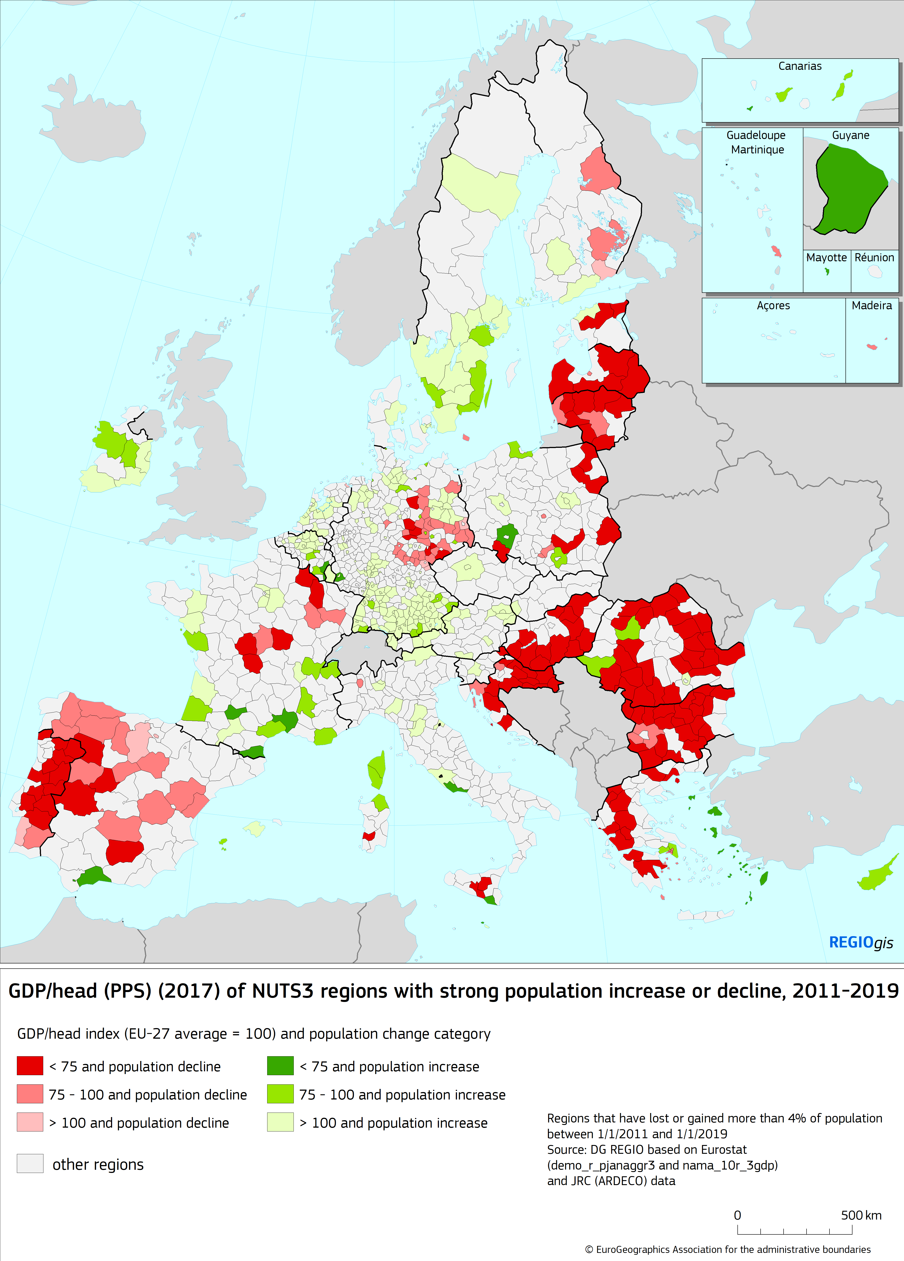

## 9.1 Population by level of regional GDP per head

The chart classifies all NUTS 3 regions according to their level of GDP per head, relative to the EU-27 average. The regions with the lowest level of GDP/head (< 75% of the average) cover 29% of the Union’s population.

**Figure 22. Population 2019 by level of regional GDP per head (NUTS3), EU-27, 2017**



*Source: Eurostat (online data table: demo_r_gind3 and nama_10r_3gdp)*

## 9.2 Population in low-income regions by urban-rural typology

Amongst the NUTS-3 regions with the lowest GDP/head one finds 38% of population in rural regions.

**Figure 23. Population in low-income regions by urban-rural typology, EU-27, 2018**



*Source: Eurostat (online data table: demo_r_pjangrp3 and nama_10r_3gdp)*

## 9.3 Population in rapidly shrinking regions by urban-rural typology

Rural regions account for 44% of population of all regions that have experienced substantial population decline in recent years. Urban regions have been less prone to recent population decline.

**Figure 24. Population in rapidly shrinking regions by urban-rural typology, EU-27, 2018**



*Source: Eurostat (online data table: demo_r_gind3) and JRC (ARDECO) data*

## 9.4 Population in rapidly shrinking, low-income regions by urban-rural typology

Rural regions are overrepresented in terms of population when considering the group of rapidly shrinking regions (see **Figure 24.**) with a low GDP/head (see **Figure 23**). Almost no urban regions can be found in this group.

**Figure 25. Population in rapidly shrinking, low-income regions by urban-rural typology, EU-27, 2018**



*Source: Eurostat (online data table: demo_r_pjangrp3 and nama_10r_3gdp) and JRC (ARDECO) data*

**9.5 Crude birth rate by urban-rural regional typology**

Crude birth rate is the ratio of the total number of live births during the year to the average population in that year. Population is expressed in thousands, this being often referred to as ‘pro mille’. The crude birth rate is almost systematically higher in urban regions than in intermediate and rural regions, probably due to the differences in age structure of the population.

**Figure 26. Crude birth rate, 2018**

(per thousand residents, by urban-rural regional typology)



*Source: Eurostat (online data table: demo_r_fagec3 and* *the urban-rural regional typology[3] )*

*EU-14 consists of the current Member States that joined the EU prior to 2004.*

*EU-13 consists of the Member States that joined the EU in 2004, 2007 and 2013.*

## 9.6 Crude death rate by urban-rural regional typology

The crude death rate is the ratio of the total number of deaths during the year to the average population in that year. It is higher in rural regions than in intermediate regions, and lower in urban regions with few exceptions.

**Figure 27. Crude death rate, 2018**

(per thousand residents, by urban-rural regional typology)



*Source: Eurostat (online data table: demo_r_magec3 and* *the urban-rural regional typology)*

*EU-14 consists of the current Member States that joined the EU prior to 2004.*

*EU-13 consists of the Member States that joined the EU in 2004, 2007 and 2013.*

## 

## 9.7 Total fertility rate by urban-rural regional typology

The total fertility rate is below 2.1 in all EU-27 Member States. Overall, it is higher in rural regions (1.62) than in intermediate (1.56) and urban regions (1.51).

**Figure 28. Total fertility rate, 2018**

(by urban-rural regional typology) 

*Source: Eurostat (online data table: demo_r_find3 and* *the urban-rural regional typology)*

*EU-14 consists of the current Member States that joined the EU prior to 2004.*

*EU-13 consists of the Member States that joined the EU in 2004, 2007 and 2013.*

**9.8. Population change by urban-rural regional typology**

In recent years EU-27 population has grown in urban and in intermediate regions (with 4.4 and 1.2 pro mille per year respectively), while it has somewhat declined in rural regions (-1.7 pro mille per year). Population growth in urban regions has been positive in most of the Member States, except in Greece, Latvia and Italy (in descending order of urban population reduction). Population in rural regions has shrunk in most Member States, but it has grown in Sweden, Ireland, Belgium, Austria, Denmark, Germany, Czechia and Slovakia (ranked by descending rural growth rates). In most cases, intermediate regions show a population evolution somewhere in between the values for urban and for rural regions.

**Figure 29. Average annual population change between 1 January 2014 and 2019**

(pro mille change by urban-rural regional typology) 

*Source: Eurostat (online data table: demo_r_gind3 and* *the urban-rural regional typology)*

*EU-14 consists of the current Member States that joined the EU prior to 2004.*

*EU-13 consists of the Member States that joined the EU in 2004, 2007 and 2013.*

Net migration in the EU-27 has been positive in urban, intermediate and rural regions. Nevertheless, negative rates of net migration (representing a larger outflow than inflow) can be seen in several Member States. For instance, rural regions in Latvia and Lithuania and intermediate regions in Estonia and Lithuania have experienced a far larger population outflow than inflow. In most of the Member States the net migration rate in urban regions is positive (except in Greece, France and Latvia in descending order of urban population reductions).

**Figure 30. Average annual net migration rate[4] between 1 January 2014 and 2019**

(pro mille change by urban-rural regional typology)



*Source: Eurostat (online data table: demo_r_gind3 and* *the urban-rural regional typology)*

*EU-14 consists of the current Member States that joined the EU prior to 2004.*

*EU-13 consists of the Member States that joined the EU in 2004, 2007 and 2013.*

Recent natural population change is slightly positive in urban regions and negative in intermediate and rural regions. In about half of the Member States natural population change is negative in urban regions. In most Member States natural change is lower in intermediate and in rural regions than it is in urban regions.

**Figure 31. Average annual natural population change between 1 January 2014 and 2019**

(pro mille change by urban-rural regional typology)



*Source: Eurostat (online data table: demo_r_gind3 and* *the urban-rural regional typology)*

*EU-14 consists of the current Member States that joined the EU prior to 2004.*

*EU-13 consists of the Member States that joined the EU in 2004, 2007 and 2013.*

## 10. CITIES, TOWNS AND SUBURBS, AND RURAL AREAS

This section shows data by degree of urbanisation, which classifies local administrative units, such as municipalities, into cities, towns and suburbs, and rural areas.

**10.1 Employment rate by degree of urbanisation[5]**

The EU-27 employment rate for people aged 20-64 years in 2019 showed little difference by type of area. However, this average is the combined result of two distinct patterns we can observe when analysing employment rates by degree of urbanisation:

* in eastern parts of the EU and in Baltic countries, it was commonplace to find that employment rates for cities were the highest (for example, in Bulgaria, Lithuania or Poland), whereas their employment rates for rural regions tended to be considerably lower;
* in western Member States, the picture was often reversed, insofar as the highest employment rates were usually recorded for people living in rural areas (for example, in Belgium, Germany or Austria), whereas their lowest employment rates were recorded in cities.

**Figure 32. Employment rate, 2019**

(%, people aged 20-64 years in employment as a share of the total population aged 20-64 years, by degree of urbanisation)

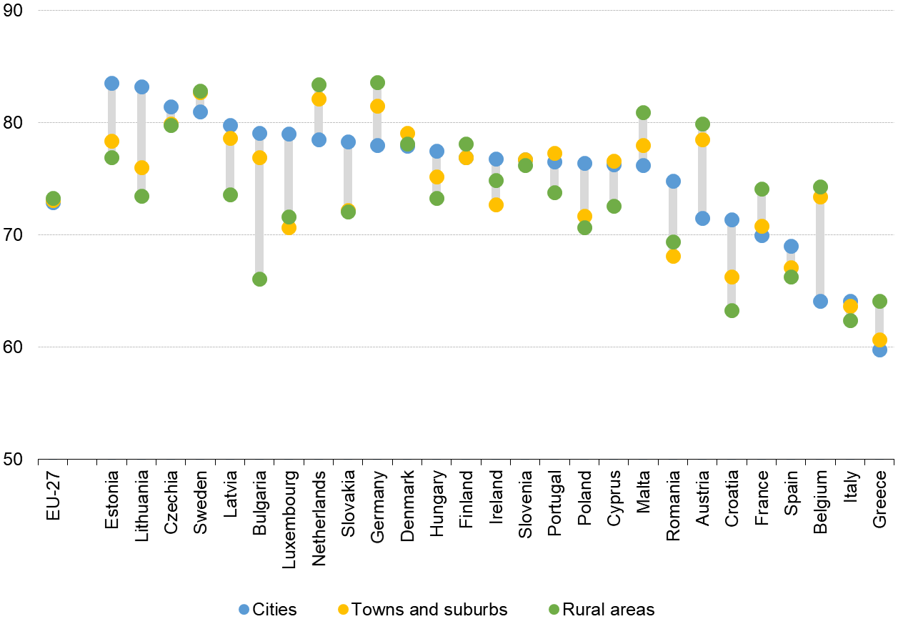

*Source: Eurostat (online data table: lfst_r_ergau)*

**10.2 Unemployment rate by degree of urbanisation**

In 2019, the lowest unemployment rates — among types of areas — were recorded in rural areas in 12 of the EU Member States — including France, Austria and Germany. By contrast, there were eight EU Member States — including Lithuania, Bulgaria and Slovakia — where the highest unemployment rates were recorded for those living in rural areas. The gap in unemployment rates between those living in cities and rural areas widened to above 5 percentage points in Bulgaria and Austria, showing that wide disparities by degree of urbanisation are visible in both the eastern and western parts of the EU.

**Figure 33. Unemployment rate, 2019**

(%, unemployed people aged 15-74 years as a share of the total labour force aged 15-74 years, by degree of urbanisation)

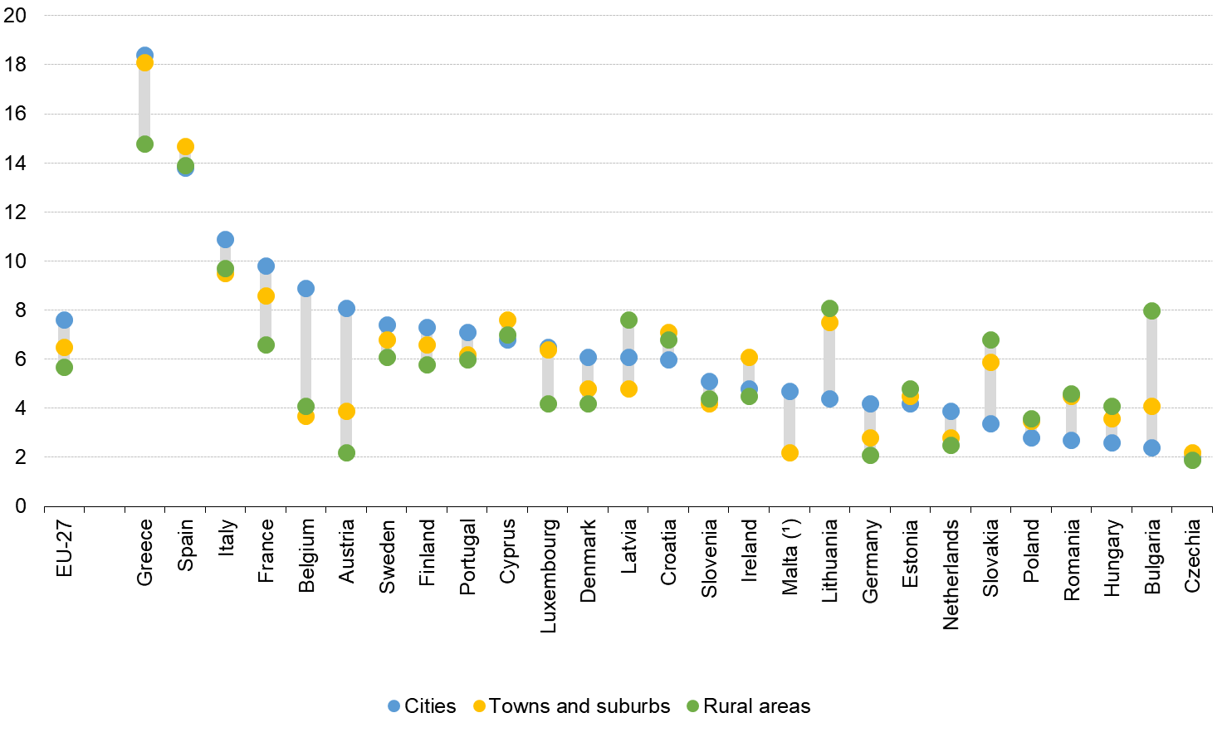

*Source: Eurostat (online data table: lfst_r_urgau)*

(¹) Rural areas: not available.

**10.3 NEET by degree of urbanisation**

The share of young people aged 18-24 years who were neither in employment nor in education or training (NEET) may be expressed relative to the total population of the same age (18-24 years). The NEET rate was highest in rural areas and lowest in cities. In 18 Member States the lowest rate was registered in cities. This figure may reflect, to some degree, the concentration of educational establishments in cities. The NEET rate ranged from a low of 4.1 % in the cities of Slovakia, up to over 30 % in the rural areas of Bulgaria and Greece.

**Figure 34. Young people neither in employment nor in education and training (NEETs), 2019** (%, share of people aged 18-24 years, by degree of urbanisation)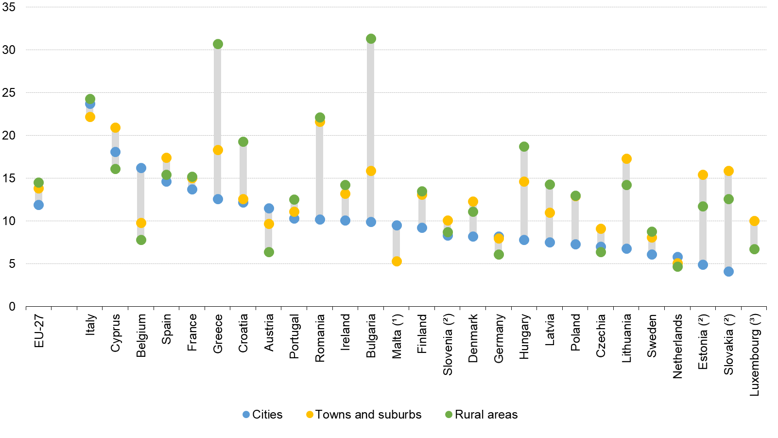

*Source: Eurostat (online data table: edat_lfse_29)*

(¹) Rural areas: not available.

(²) Cities: low reliability.

(³) Cities: not available.

**10.4 Early leavers from education and training by degree of urbanisation**

The share of early leavers from education and training is defined as the proportion of 18–24 year-olds with at most a lower, secondary level of education and who are no longer in further education or training. An analysis of early leavers from education and training by degree of urbanisation reveals that across the EU-27, the highest share of early leavers in 2019 was recorded among young people living in towns and suburbs (11.2 %), while the lowest share was recorded for those living in cities (9.1 %). The majority of the EU Member States recorded their lowest rates in cities.

**Figure 35. Early leavers from education and training, 2019**

(%, share of people aged 18-24 years, by degree of urbanisation)

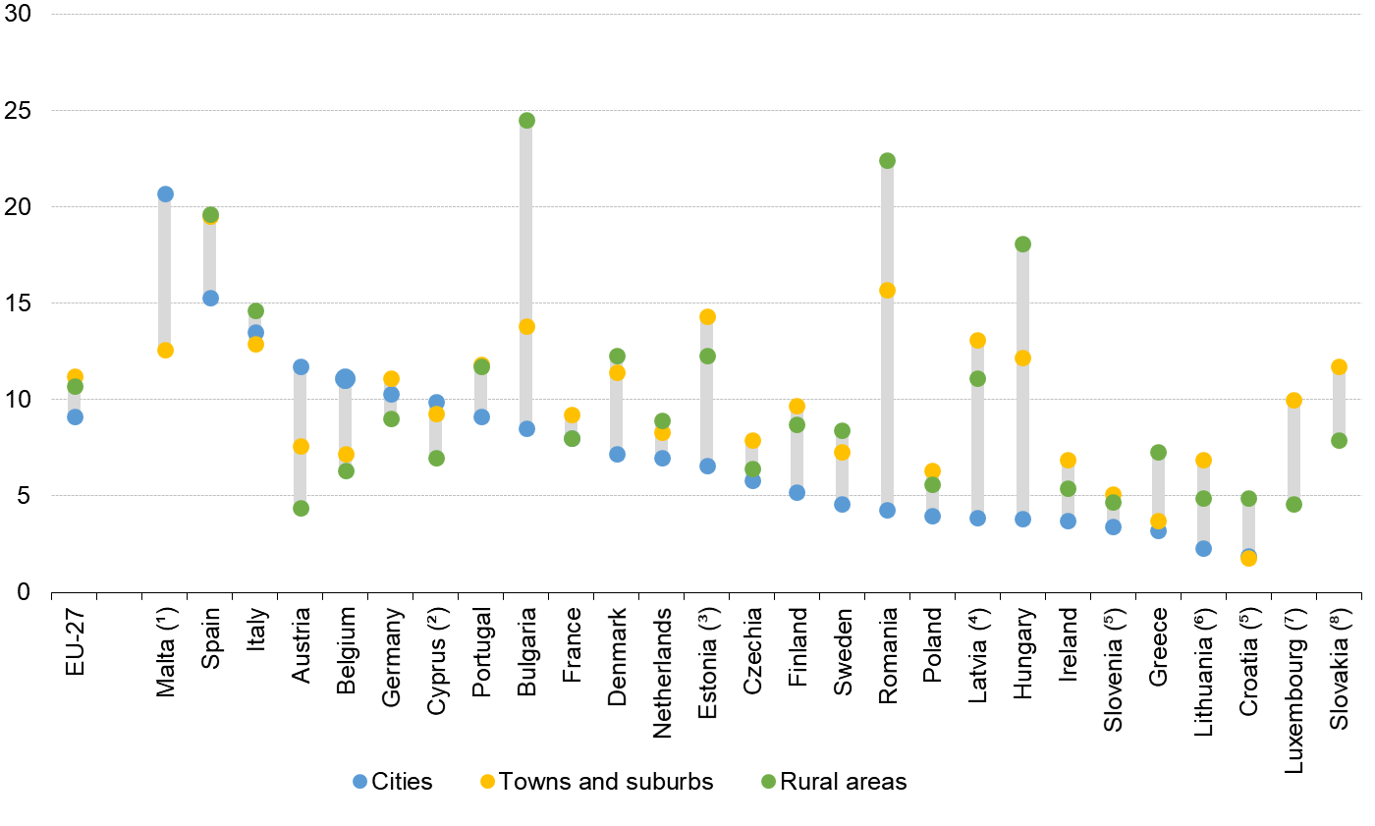

*Source: Eurostat (online data table: edat_lfse_30)*

(¹) Rural areas: not available.

(²) Rural areas: low reliability.

(³) Towns and suburbs: low reliability.

(⁴) Cities: low reliability.

(⁵) Cities, Towns and suburbs and Rural areas: low reliability.

(⁶) Cities and Towns and suburbs: low reliability.

(⁷) Cities: not available, Rural areas: low reliability.

(⁸) Cities: not available.

**10.5 At-risk-of-poverty rate by degree of urbanisation**

In 2018, there were wide disparities across the EU Member States regarding areas where the at-risk-of-poverty rate after deducting housing costs tended to be concentrated. The share of the population that was at risk of poverty after deducting housing costs was particularly high among people living in cities in much of western Europe, while in eastern and southern parts of the EU, it was more common to find the highest incidences among those living in rural areas.

**Figure 36. At-risk-of-poverty rate after deducting housing costs, 2018**

(%, share of total population, by degree of urbanisation)

*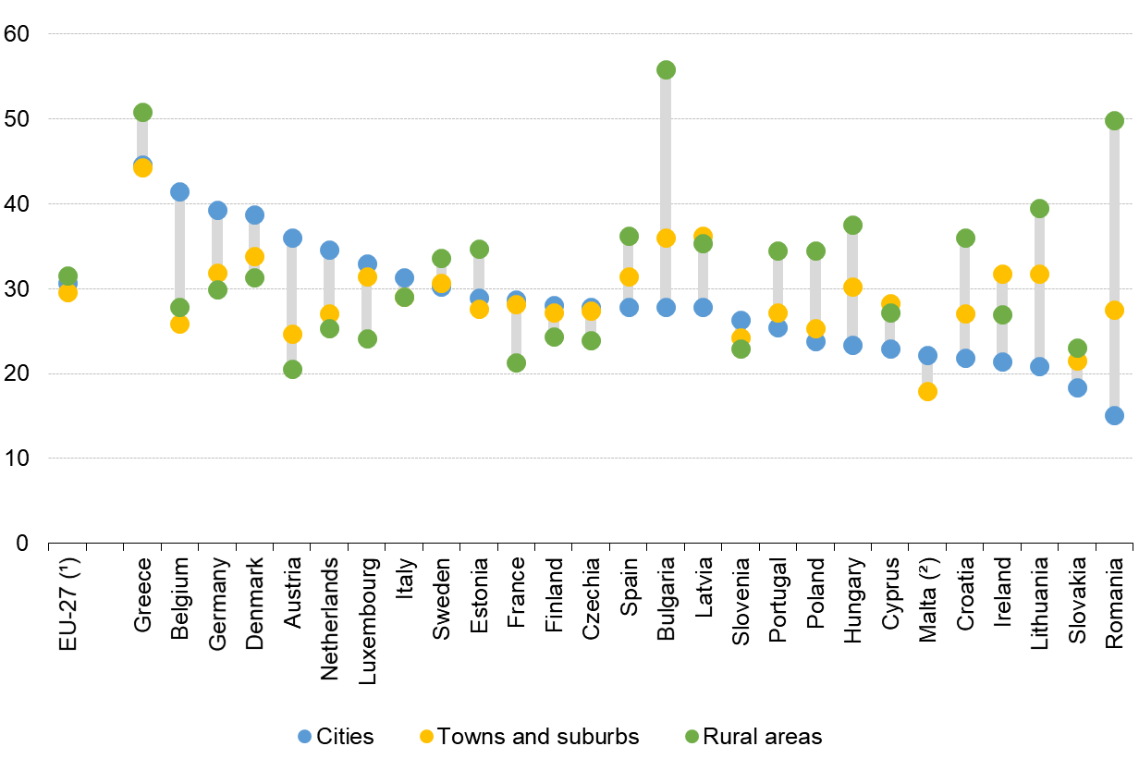Source: Eurostat (online data table: ilc_li48)*

(¹) Estimated

(²) Rural areas: not available.

**10.6 Median equivalised income by degree of urbanisation**

In 2018, median equivalised net income expressed in purchasing power standards (PPS), in order to take account of the differences in the cost of living across countries, analysis by degree of urbanisation shows that income levels were, on average, higher for those living in towns and suburbs and cities, while the median income in rural areas was lower. In 20 Member States, the highest median income was recorded in cities.

**Figure 37. Median equivalised net income, 2018**

(Purchasing power standard (PPS), by degree of urbanisation)

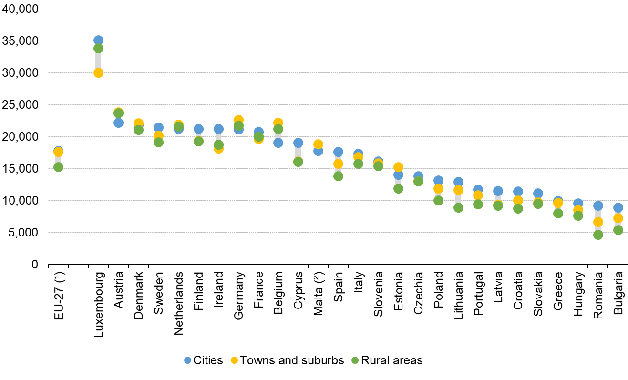

*Source: Eurostat (online data table: ilc_di17)*

(¹) Estimated

(²) Rural areas: not available.

**10.7 Tertiary educational attainment by degree of urbanisation**

In 2019, more than 40 % of the EU-27 working-age population (defined here as those aged 25‑64) living in cities had a tertiary level of educational attainment. This was considerably higher than the corresponding shares recorded among those living in towns and suburbs (27.7%) or rural areas (22.2 %). The proportion of working-age population with a tertiary level of educational attainment was higher among those living in cities, compared with those living in rural areas, in all EU Member States except Malta.

**Figure 38. Tertiary educational attainment, 2019**

(%, share of people aged 25-64 years, by degree of urbanisation)

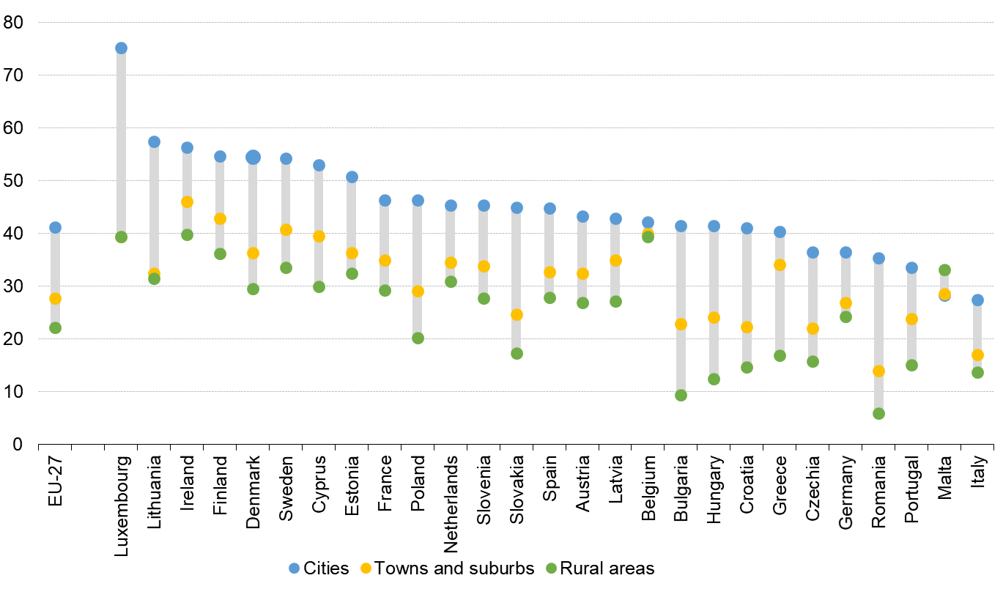

*Source: Eurostat (online data table: edat_lfs_9913)*

**10.8 People who perceive their health as good health by degree of urbanisation**

In 2018, more than two thirds of the adult population perceived their own health to be good or very good. This share was highest for people living in cities (70.3 %), followed by people living in towns and suburbs (69.2 %) and then people living in rural areas (65.6 %). Note that self-perceived health status is strongly related to age, and therefore the analysis of health status by degree of urbanisation may reflect, to some degree, differences in age structures. A closer analysis among the EU Member States reveals that a higher proportion of people living in cities perceived their own health as good or very good in a majority (19) of the EU Member States. By contrast, in Belgium and the Netherlands, people living in the rural areas were more likely to perceive their own health to be good or very good. The gap between cities and rural areas was particularly pronounced (by more than 10 percentage points) in Bulgaria, Lithuania and Portugal.

**Figure 39. People who perceive their own health as good or very good, 2018**

(%, share of population aged ≥16 years, by degree of urbanisation)

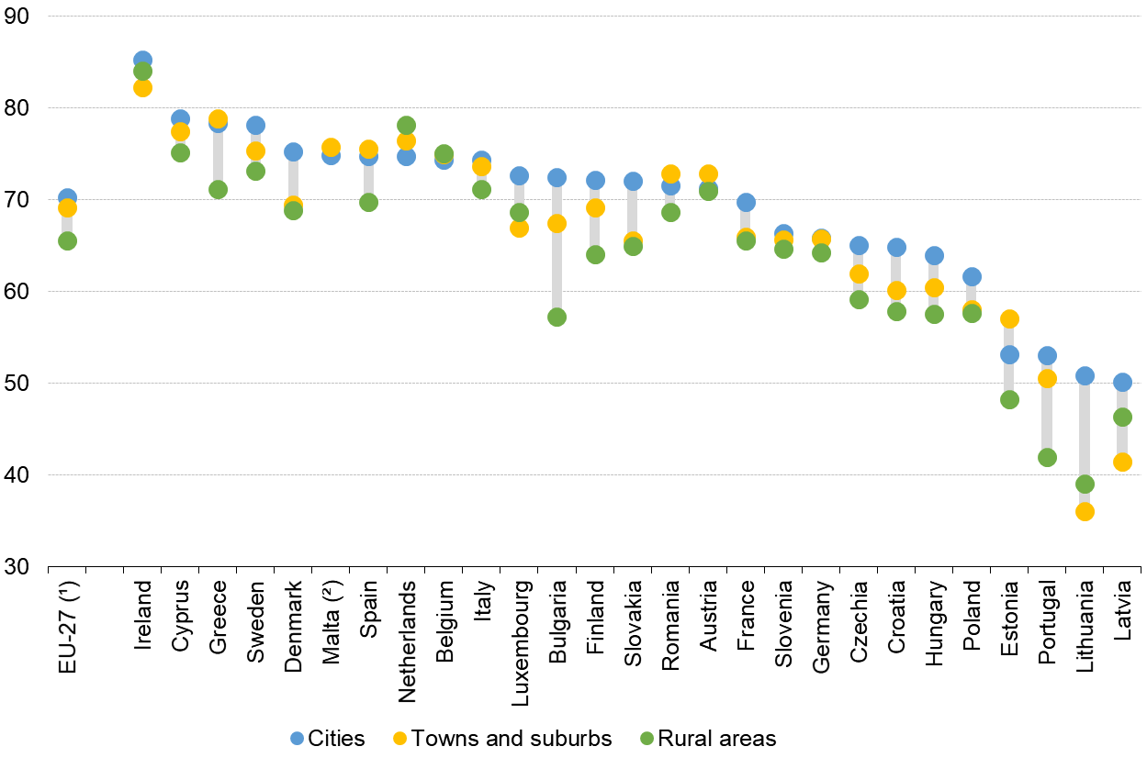

*Eurostat (online data table: hlth_silc_18)*

(¹) Estimated

(²) Rural areas: not available.

**10.9 Proportion of population born outside EU**

Migration from non-EU countries has led to a large share of non-EU foreign-born residents in some EU Member States. Even within a country, the distribution of the population born outside of the EU is far from being geographically dispersed. Their share in the adult population (aged 15 years or over) in cities is (11.7%) - three times higher than that of rural areas (3.7%). In almost all EU Member States, the highest proportion of population born outside the EU were recorded in cities.

**Figure 40. Proportion of population born outside the EU, 2019**

(%, share of population aged 15 years or over, by degree of urbanisation)

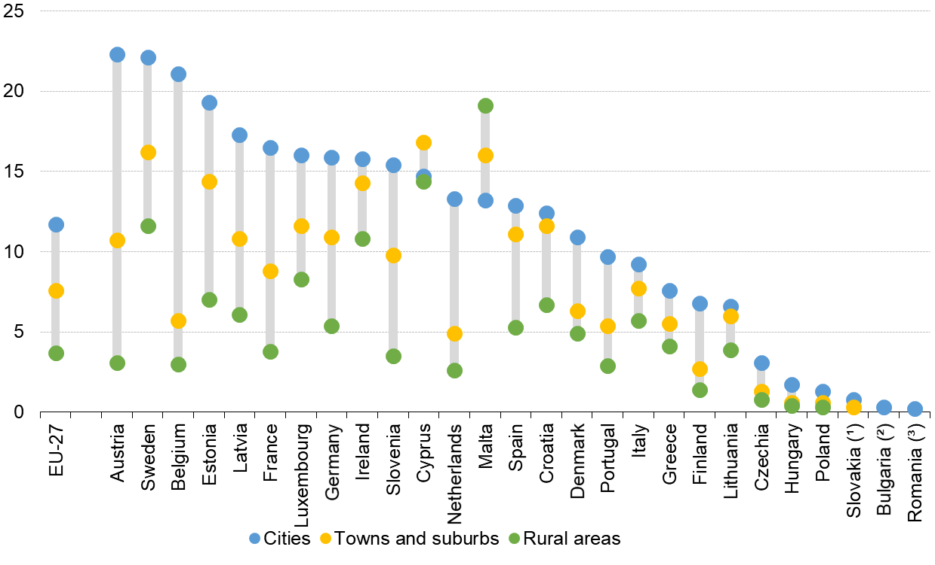

*Source: Eurostat (online data table: lfst_r_pgauwsc)*

(¹) Rural areas: not available.

(²) Towns and suburbs: not available, Rural areas: low reliability.

(³) Cities: low reliability, Towns and suburbs and Rural areas: not available.

**10.10 Proportion of population born in another EU Member State by degree of urbanisation**

Adult residents (aged 15 years or over) born in a different EU Member State are far less concentrated in cities than those born outside the EU. Nevertheless, similar to non-EU born migrants, in most Member States (20 Member States), the cities, as compared to towns, suburbs and rural areas, attract more adult residents born in a different Member State.

**Figure 41. Proportion of population born in another EU Member State, 2019**

(%, share of population aged 15 years or over, by degree of urbanisation)

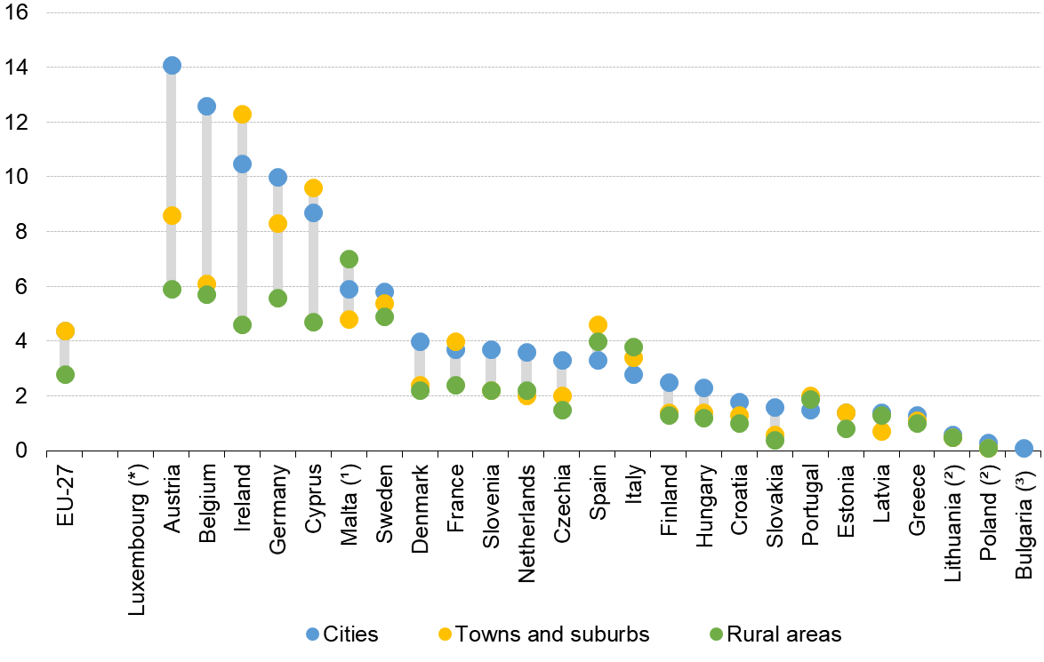

*Source: Eurostat (online data table: lfst_r_pgauwsc)*

(*) The values for Luxembourg are: Cities: 59%, Towns and suburbs: 37%; Rural areas: 34%

(¹) Rural areas: low reliability.

(²) Towns and suburbs: low reliability.

(³) Cities: low reliability, Towns and suburbs and Rural areas: not available.

(⁴) Romania: Data not available.

1. Including statistical adjustment
2. <http://ec.europa.eu/regional_policy/en/information/publications/regional-focus/2013/measuring-accessibility-to-passenger-flights-in-europe-towards-harmonised-indicators-at-the-regional-level>
3. Urban-rural regional typology: <https://ec.europa.eu/eurostat/web/rural-development/methodology>
4. Net migration includes statistical adjustment: i.e. it is calculated as the difference between total population change and natural population change.
5. Employment and unemployment rates are based on 2019 data, before the outbreak of COVID-19 pandemic.