

Contents

I: The drivers of demographic change in Europe 3

1. Increasing life Expectancy 3

1.1 Life expectancy in the EU by sex 3

1.2 Life expectancy in Member States 6

1.3 Healthy life years 7

2. births and fertility rates 10

3. Ageing population 13

3.1 Median age 13

3.2 Population age structure 15

3.3 Old-age dependency ratio 16

4. Smaller households 21

4.1 Trends of households by type 21

4.2 Trends of households with and without children 23

4.3 Households in 2019 24

4.4 Households by number of children in 2019 25

4.5 Change of the number of persons in household from 2010 until 2019 25

4.6 Differences in household composition by age and sex 26

5. Mobile Europe 28

5.1 Immigrants and emigrants 28

5.2 Age structure by citizenship 29

6. changing population 31

6.1 Natural population change in the EU 31

6.2 Demographic balance in the Member States in 2018 34

II: THE IMPACT OF DEMOGRAPHIC CHANGE – territorial differences 36

7. regional and local dimension 36

7.1 GDP (in PPS) per person employed 36

7.2 Natural population change and net migration 38

8. INFRASTRUCTURE AND ACCESS TO SERVICES 40

8.1 Accessibility to passenger flights 40

9. URBAN, INTERMEDIATE AND RURAL REGIONS 42

9.1 Population by level of regional GDP per head 44

9.2 Population in low-income regions by urban-rural typology 44

9.3 Population in rapidly shrinking regions by urban-rural typology 45

9.4 Population in rapidly shrinking, low-income regions by urban-rural typology 45

9.5 Crude birth rate by urban-rural regional typology 46

9.6 Crude death rate by urban-rural regional typology 47

9.7 Total fertility rate by urban-rural regional typology 48

10. CITIES, TOWNS AND SUBURBS, AND RURAL AREAS 52

10.1 Employment rate by degree of urbanisation 52

10.2 Unemployment rate by degree of urbanisation 53

10.3 NEET by degree of urbanisation 54

10.4 Early leavers from education and training by degree of urbanisation 55

10.5 At-risk-of-poverty rate by degree of urbanisation 56

10.6 Median equivalised income by degree of urbanisation 57

10.7 Tertiary educational attainment by degree of urbanisation 58

10.8 People who perceive their health as good health by degree of urbanisation 59

10.9 Proportion of population born outside EU 60

10.10 Proportion of population born in another EU Member State by degree of urbanisation 61

This Commission Staff Working Document complements the report of the Commission on the impact of demographic change (COM(2020) 241 final) with additional figures, maps and tables.[1] The document follows the sequence and order of topics from the report.

**I: The drivers of demographic change in Europe[2]**

**1. Increasing life Expectancy**

The most commonly used indicator for analysing mortality trends is life expectancy at birth: the mean number of years that a person can expect to live at birth if subjected to current mortality conditions throughout the rest of their life. It is a simple but powerful way of illustrating the developments in mortality.

* 1. **Life expectancy in the EU by sex**

Life expectancy at birth in the EU-27 was estimated at 81.0 years in 2018, reaching 83.7 years for women and 78.2 years for men.

Overall, between 2002 (the first year for which life expectancy data became available for all EU Member States[3]) and 2018, life expectancy in the EU-27 increased by 3.4 years, from 77.6 to 81.0 years; the increase was by 2.8 years for women and 3.9 years for men. Population projections[4] built on this ascending trend, with the assumptions of increasing life expectancy at birth in the EU Member States, and gradual convergence among the EU Member States. Under these assumptions, the average life expectancy at birth in the EU would increase by 2070 to 86.1 years for men, and 90.3 years for women.

**Figure 1. Life expectancy at birth for men, 2002-2070**

*Observed (2002-2018) and projected (2019-2070) data (years)*

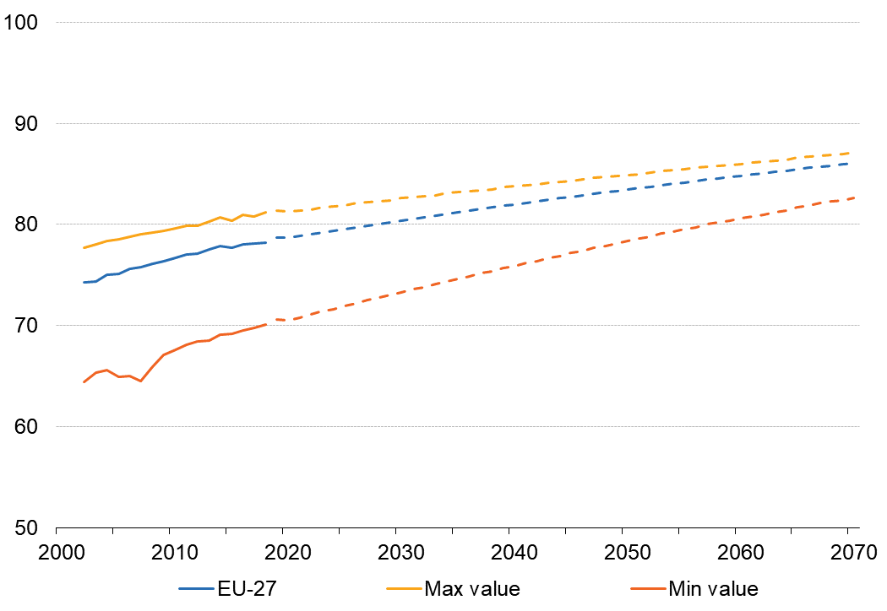

*Source: Eurostat (online data tables: demo_mlexpec and proj_19nalexpy0)*

**Figure 2. Life expectancy at birth for women, 2002-2070**

*Observed (2002-2018) and projected (2019-2070) data (years)*

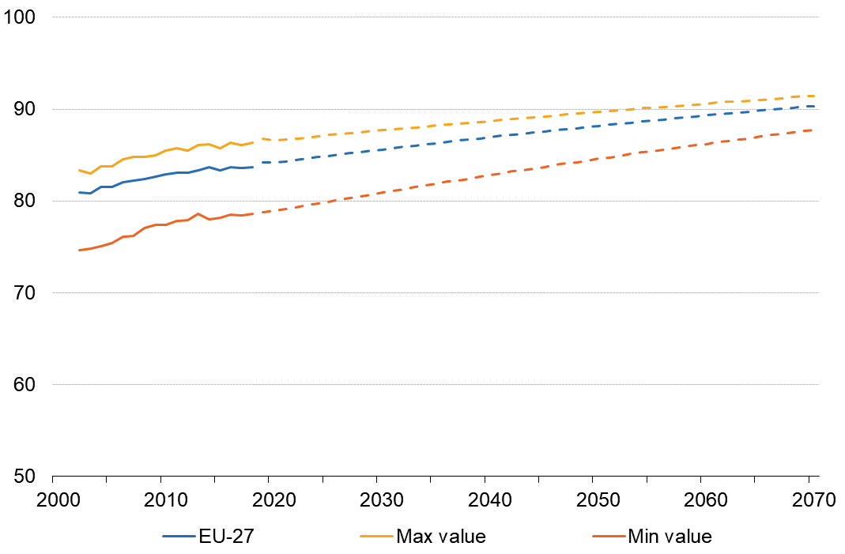

*Source: Eurostat (online data tables: demo_mlexpec and proj_19nalexpy0)*

* 1. **Life expectancy in Member States**

In the years between 2000 and 2018, the rise in life expectancy at birth for men in the EU Member States[5] ranged from a minimum of 3.1 years (in Bulgaria) to a maximum of 8.4 years (in Estonia). For women, the increase ranged from 2.1 years (in Germany) to 6.3 years (in Estonia).

There are still differences between countries. In 2018, the differences between the highest and lowest life expectancies among EU Member States amounted to 11.1 years for men and 7.7 years for women.

In 2018, the life expectancy for women is higher than the life expectancy for men. With a gender gap of 5.5 years of life in 2018, newly born women in the EU-27 should generally expect to outlive men. The projections suggest a further reduction of this gap, down to 4.5 years by 2050 and to just over 4 years by 2070. Furthermore, this gap varies between EU Member States.

**Table 1. Life expectancy at birth, 1980-2018**

*(years)*

*Source: Eurostat (online data table: demo_mlexpec)*

* 1. **Healthy life years**

In 2018, the number of healthy life years at birth[6] was estimated 64.2 years for women and 63.7 years for men. The difference between women and men is lower for healthy life years than for life expectancy.

The time series show a changing trend over the period 2010-2018: slight decrease in the first years, followed by an increase from 2015 onwards (most notably for men). Higher values in 2015 compared to the past years are due to a major methodological change introduced by Germany, which led to the break in series also at the EU level. The new time series, initiated in 2015 shows that the number of healthy life years is increasing slightly at EU level.

**Figure 3. Healthy life years at birth, EU-27, 2010-2018**

*Number of years that a person is expected to continue to live in a healthy condition*

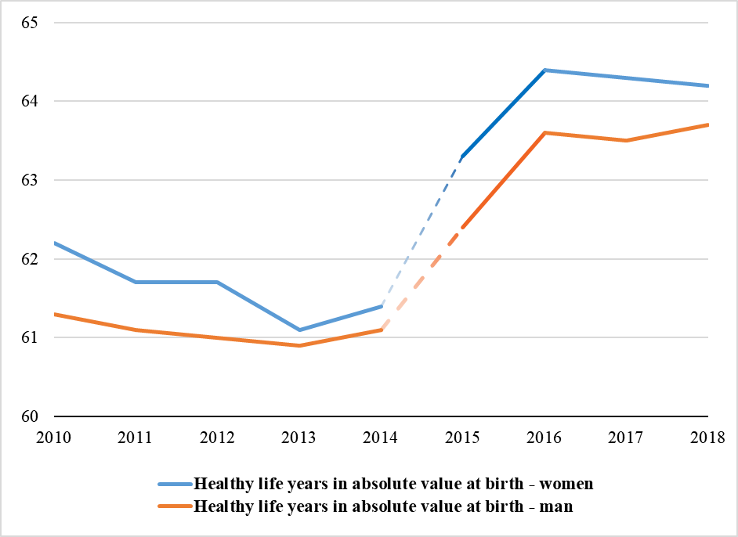  
Note: break in series in 2015

*Source: Eurostat (online data tables: hlth_hlye)*

**Table 2. Healthy life years in absolute value at birth – women (2010-2018)**

|  |  |  |  |  |  |  |  |  |  |  |
| --- | --- | --- | --- | --- | --- | --- | --- | --- | --- | --- |
|  |  | **Healthy life years in absolute value at birth - women** | | | | | | | | |
| **2010** | | **2011** | **2012** | **2013** | **2014** | **2015** | **2016** | **2017** | **2018** |
| **EU-27** | 62.2 | | 61.7 | 61.7 | 61.1 | 61.4 | 63.3(b) | 64.4 | 64.3 | 64.2 |
| **Belgium** | 62.6 | | 63.6 | 65,0 | 63,7 | 63,7 | 64,0 | 63,8 | 64,1 | 63.8 |
| **Bulgaria** | 67,1 | | 65,9 | 65,7 | 66,6 | 66,1 | 65,0 | 67,5(b) | 66,2 | 67.6 |
| **Czechia** | 64,5 | | 63,6 | 64,1 | 64,2 | 65,0 | 63,7 | 64,0 | 62,4 | 63.4 |
| **Denmark** | 61,4 | | 59,9 | 61,5 | 60,1 | 61,4 | 57,6 | 60,3 | 59,7 | 59.1 |
| **Germany** | 58.7 | | 58.6 | 57.9 | 57.0 | 56.5 | 67.5(b) | 67.3 | 66.7 | 66.3 |
| **Estonia** | 58.2 | | 57.9 | 57.2 | 57.1 | 57.1 | 56.2 | 59.0 | 57.2 | 55.0 |
| **Ireland** | 66.9 | | 68.3 | 68.5 | 68.0 | 67.5 | 68.0 | 69.8 | 69.3 | 70.4(p) |
| **Greece** | 67.7 | | 66.9 | 64.9 | 65.1 | 64.9 | 64.1 | 64.7 | 65.1 | 65.9 |
| **Spain** | 63.8 | | 65.6 | 65.8 | 63.9 | 65.0 | 64.1 | 66.5 | 69.9 | 68.0 |
| **France** | 63.4 | | 63.6 | 63.8 | 64.3 | 64.2 | 64.6 | 64.1 | 64.9 | 64.5 |
| **Croatia** | 60.4 | | 61.7 | 64.2(b) | 60.4(b) | 60.0 | 56.8 | 58.7 | 58.0 | 58.5 |
| **Italy** | : | | 62.5 | 61.4 | 61.2 | 62.3 | 62.7 | 67.2(b) | 66.4 | 66.9 |
| **Cyprus** | 64.2 | | 61.0 | 64.0 | 65.0 | 66.1 | 63.4 | 68.8 | 65.8 | 62.4 |
| **Latvia** | 56.4 | | 56.6 | 59.0 | 54.2(b) | 55.3 | 54.1 | 54.9 | 52.2 | 53.7 |
| **Lithuania** | 62.3 | | 62.0 | 61.6 | 61.6 | 61.7 | 58.8 | 59.4 | 59.8 | 59.1 |
| **Luxembourg** | 66.4 | | 67.1 | 66.4 | 62.9 | 63.5 | 60.6 | 58.9(b) | 58.1 | 59.8 |
| **Hungary** | 58.6 | | 59.2 | 60.4 | 60.1 | 60.6 | 60.1 | 60.2 | 60.8 | 61.8 |
| **Malta** | 71.3 | | 70.7 | 72.2 | 72.7 | 74.5 | 74.6 | 72.4 | 73.4 | 73.4 |
| **Netherlands** | 60.2 | | 59.0 | 58.9 | 57.5 | 59.0 | 57.2 | 57.8(b) | 57.6 | 57.2 |
| **Austria** | 60.8 | | 60.1 | 62.5 | 60.2 | 57.8 | 58.1 | 57.1 | 56.8 | 57.0 |
| **Poland** | 62.3 | | 63.2 | 62.8 | 62.7 | 62.7 | 63.2 | 64.6 | 63.5 | 64.3 |
| **Portugal** | 56.7 | | 58.6 | 62.6(b) | 62.2 | 55.4(b) | 55.0 | 57.4 | 57.0 | 57.5 |
| **Romania** | 57.5 | | 57.0 | 57.6 | 58.1 | 59.1 | 59.3 | 59.0 | 58.3 | 59.6 |
| **Slovenia** | 54.6 | | 53.8 | 55.6 | 59.5 | 59.6 | 57.7 | 57.9 | 54.6 | 54.6 |
| **Slovakia** | 52.0 | | 52.3 | 53.1 | 54.3 | 54.6 | 55.1 | 57.0 | 55.6 | 56.6 |
| **Finland** | 57.9 | | 58.3 | 56.2 | : | 57.5 | 56.3 | 57.0 | 56.4 | 55.7 |
| **Sweden** | 65.5 | | 64.6 | : | 65.0 | 72.8(b) | 72.2 | 73.3 | 71.9 | 72.0 |

Note: (b) break in the series, (p) provisional

*Source: Eurostat (online data tables: hlth_hlye)*

**Table 3. Healthy life years in absolute value at birth – men (2010-2018)**

|  |  |  |  |  |  |  |  |  |  |  |
| --- | --- | --- | --- | --- | --- | --- | --- | --- | --- | --- |
|  |  | **Healthy life years in absolute value at birth - men** | | | | | | | | |
| **2010** | | **2011** | **2012** | **2013** | **2014** | **2015** | **2016** | **2017** | **2018** |
| **EU-27** | 61,3 | | 61,1 | 61,0 | 60,9 | 61,1 | 62,4(b) | 63,6 | 63,5 | 63,7 |
| **Belgium** | 64,0 | | 63,4 | 64,2 | 64,0 | 64,4 | 64,4 | 63,7 | 63,5 | 63,2 |
| **Bulgaria** | 63,0 | | 62,1 | 62,1 | 62,4 | 62,0 | 61,5 | 64,0(b) | 62,9 | 64,0 |
| **Czechia** | 62,2 | | 62,2 | 62,3 | 62,5 | 63,4 | 62,4 | 62,7 | 60,6 | 62,2 |
| **Denmark** | 62,3 | | 63,7 | 61,2 | 60,7 | 60,3 | 60,4 | 60,3 | 59,8 | 62,5 |
| **Germany** | 57,9 | | 57,8 | 57,3 | 57,7 | 56,4 | 65,3(b) | 65,3 | 65,1 | 65,1 |
| **Estonia** | 54,2 | | 54,2 | 53,1 | 53,9 | 53,2 | 53,8 | 54,4 | 54,7 | 52,7 |
| **Ireland** | 65,9 | | 66,1 | 66,0 | 65,7 | 66,3 | 66,5 | 67,2 | 67,9 | 68,4(p) |
| **Greece** | 66,1 | | 66,2 | 64,8 | 64,7 | 64,1 | 63,9 | 63,8 | 64,4 | 65,0 |
| **Spain** | 64,5 | | 65,4 | 64,8 | 64,7 | 65,0 | 63,9 | 65,9 | 69,0 | 68,0 |
| **France** | 61,8 | | 62,7 | 62,6 | 63,0 | 63,4 | 62,6 | 62,6 | 62,5 | 63,4 |
| **Croatia** | 57,4 | | 59,8 | 61,9(b) | 57,6(b) | 58,6 | 55,3 | 57,1 | 57,3 | 56,5 |
| **Italy** | : | | 63,6 | 62,1 | 62,0 | 62,5 | 62,6 | 67,6(b) | 66,2 | 66,8 |
| **Cyprus** | 65,1 | | 61,6 | 63,4 | 64,3 | 65,8 | 63,1 | 67,5 | 64,7 | 62,0 |
| **Latvia** | 53,1 | | 53,6 | 54,6 | 51,7(b) | 51,5 | 51,8 | 52,3 | 50,6 | 51,0 |
| **Lithuania** | 57,4 | | 57,0 | 56,6 | 56,8 | 57,6 | 54,1 | 56,2 | 56,4 | 56,3 |
| **Luxembourg** | 64,4 | | 65,8 | 65,8 | 63,8 | 64,0 | 63,7 | 61,4(b) | 60,1 | 61,4 |
| **Hungary** | 56,3 | | 57,7 | 59,1 | 59,0 | 59,1 | 58,2 | 59,5 | 59,6 | 60,4 |
| **Malta** | 70,1 | | 69,9 | 71,5 | 71,6 | 72,3 | 72,6 | 71,1 | 71,9 | 71,9 |
| **Netherlands** | 61,3 | | 64,0 | 63,5 | 61,4 | 63,3 | 61,1 | 62,8(b) | 62,3 | 61,1 |
| **Austria** | 59,4 | | 59,5 | 60,2 | 59,7 | 57,6 | 57,9 | 57,0 | 57,4 | 56,8 |
| **Poland** | 58,5 | | 59,1 | 59,1 | 59,2 | 59,8 | 60,1 | 61,3 | 60,6 | 60,5 |
| **Portugal** | 59,3 | | 60,7 | 64,5(b) | 63,9 | 58,4(b) | 58,2 | 59,9 | 60,1 | 59,8 |
| **Romania** | 57,2 | | 57,4 | 57,6 | 58,8 | 58,9 | 59,0 | 59,8 | 59,2 | 59,2 |
| **Slovenia** | 53,4 | | 54,0 | 56,5 | 57,6 | 57,8 | 58,5 | 58,7 | 55,3 | 56,3 |
| **Slovakia** | 52,4 | | 52,1 | 53,4 | 54,5 | 55,5 | 54,8 | 56,4 | 55,6 | 55,5 |
| **Finland** | 58,5 | | 57,7 | 57,3 | : | 58,7 | 59,4 | 59,1 | 58,3 | 58,8 |
| **Sweden** | 66,6 | | 66,3 | : | 66,4 | 73,0 | 73,1 | 73,0 | 73,2 | 73,7 |

Note: (b) break in the series, (p) provisional

*Source: Eurostat (online data tables: hlth_hlye)*

**2. births and fertility rates**

The most widely used indicator for analysing population due to birth is the total fertility rate: this is the mean number of children that would be born alive to a woman during her lifetime if she were to pass through her childbearing years conforming to the age-specific fertility rates of a given year. A total fertility rate of around 2.1 live births per woman is considered the replacement level in developed countries: in other words, the average number of live births per woman required to keep the population size constant in the absence of migration.

Fertility declined steadily from the mid-1960s to the turn of the century in the EU countries. In most of the EU Member States, the total fertility rate diminished considerably between 1980 and the end of 1990s. After reaching a low point around year 2000, the total fertility rate increased in most Member States. Since 2011, fertility stays roughly stable at EU-27 level.

In the past 45 years, in general, total fertility rates among the EU Member States have been converging. In 1970, the disparity between the highest rates for which data exist and the lowest rates ) was around 2.0 live births per woman. By 1990, this difference had decreased to 1.1 live births per woman. By 2010, the difference had fallen to 0.8 live births per woman and by 2018 it had narrowed to 0.6. According to the projections baseline scenario, the figure would be down to 0.37 in 2070.

**Table 4. Total fertility rate (1960-2018)**

*(live births per woman)*

*Source: Eurostat (online data table: demo_find)*

**Figure 4. Total fertility rate, 1960-2070**

*Observed (1960-2018) and projected (2019-2070) data (live births per woman)*

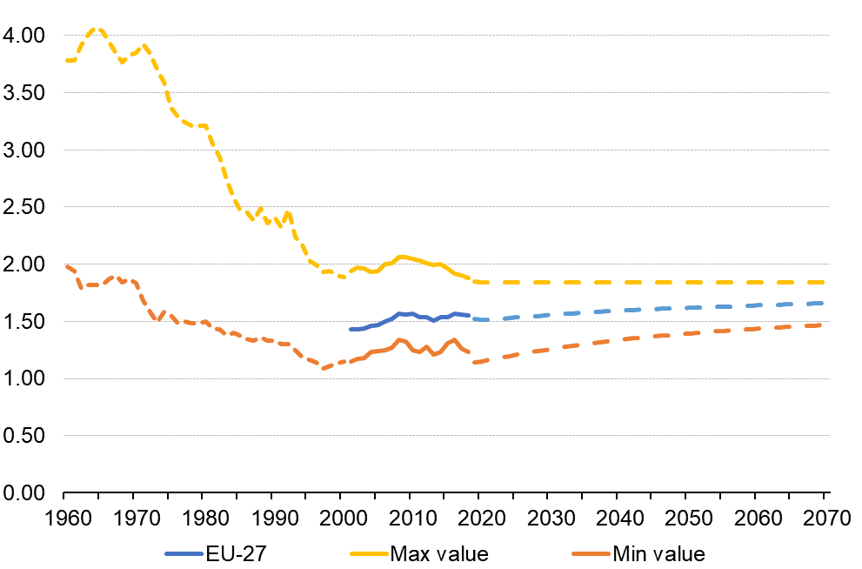

Note: For the interval 1960-2000, the values are indicative and should be understood as minimum or maximum values among the countries for which data is available.

*Source: Eurostat (online data tables: demo_find and proj_19naasfr)*

**Figure 5. Total fertility rate, 2018**

*(live births per woman)*

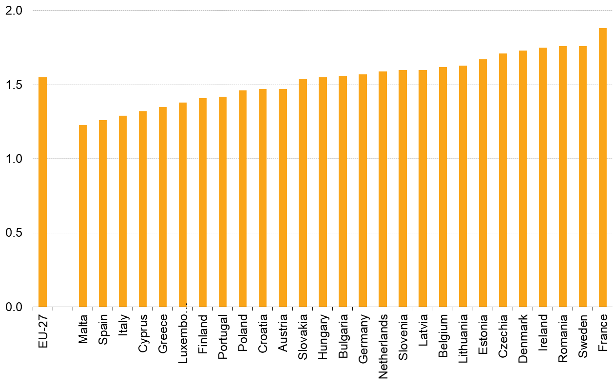

*Source: Eurostat (online data table: demo_frate)*

**3. Ageing population**

* 1. **Median age**

The median age of the EU-27 population has been continuously increasing, to reach 43.7 years in 2019, up from 38.4 years in 2001. There are significant differences among Members States: 9.0 years difference between the lowest median age in Ireland and Cyprus (both at 37.7 years) and the highest median age in Italy (46.7).

The median age in the EU-27 increased by 5.3 years (on average, by 0.3 years per annum) between 2001 and 2019. It increased in all of the EU Member States, rising by more than 7 years in Romania, Lithuania and Portugal. The median age reflects the (cumulated) demographic development in each country.

**Figure 6. Median age of population, 2001 and 2019**

*(years)*

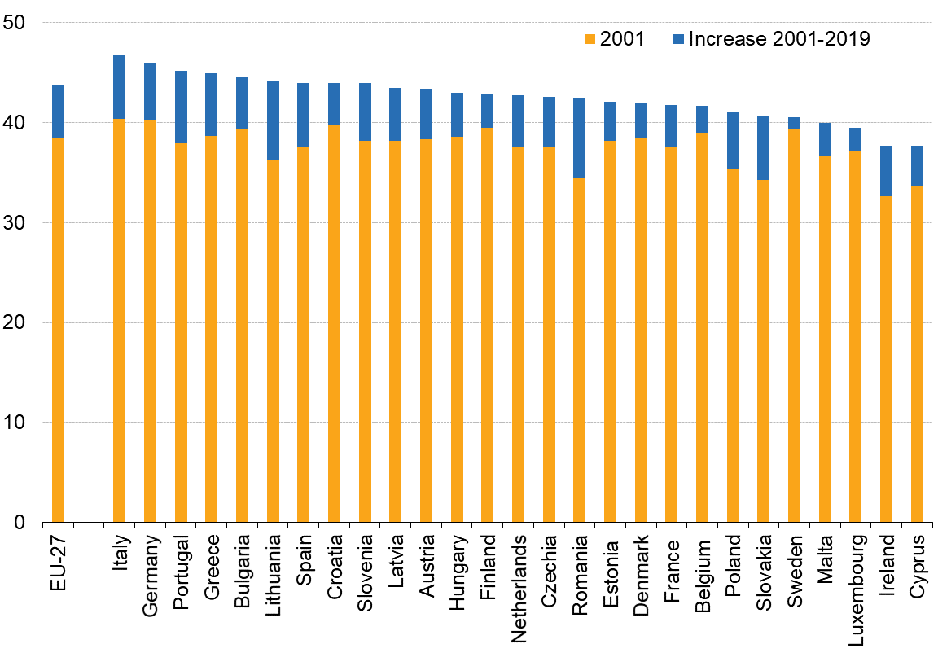

*Source: Eurostat (online data table: demo_pjanind)*

**Map 1. Median age of population by NUTS3[7] region, 2019**

*(years)*

* 1. **Population age structure**

Population pyramids show the distribution of the population by sex and by age. Each bar corresponds to the share of the given sex and age group in the total population. The EU-27 population pyramid, in 2019, is narrow at the bottom and is becoming more like a rhomboid.

As the EU-27 population is projected to continue to age, by 2070, the pyramid would transform towards the shape of a pillar.

**Figure 7. Age pyramid, EU-27, 2019 and projected for 2070**

*(%)*

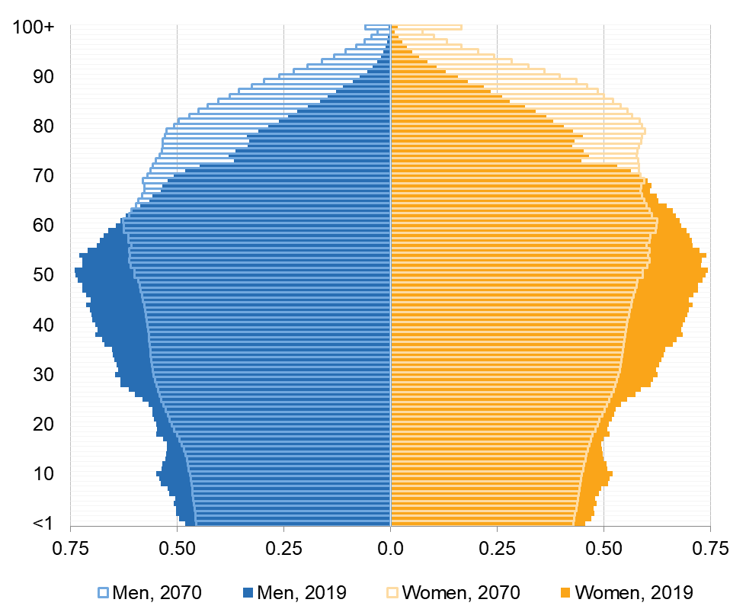

*Source: Eurostat (online data tables: demo_pjan and proj_19np)*

* 1. **Old-age dependency ratio**

**Old-age dependency** ratios aim at demonstrating the level of support available to older persons by the demographic working age population. Values are expressed in percentage terms, in other words, per 100 persons of working age. This document features data for an old-age dependency ratio calculated as the ratio of the number of people aged 65 or older, compared to the number of people aged 20-64 years old.

For the EU-27, the above old-age dependency ratio stood at 34.1% in 2019: there were just less than three persons of working age for every person aged 65 or over. An increasing trend can be observed: the old-age dependency ratio increased by 5.7 percentage points (or by 20.1% of its former value) during the past decade (from 28.4% in 2009, which corresponded to 3.5 persons of working age for each person aged 65+).

**Figure 8. Old-age dependency ratios, EU-27 and World**

*Observed or projected Eurostat data; estimated or projected UN data (%)*

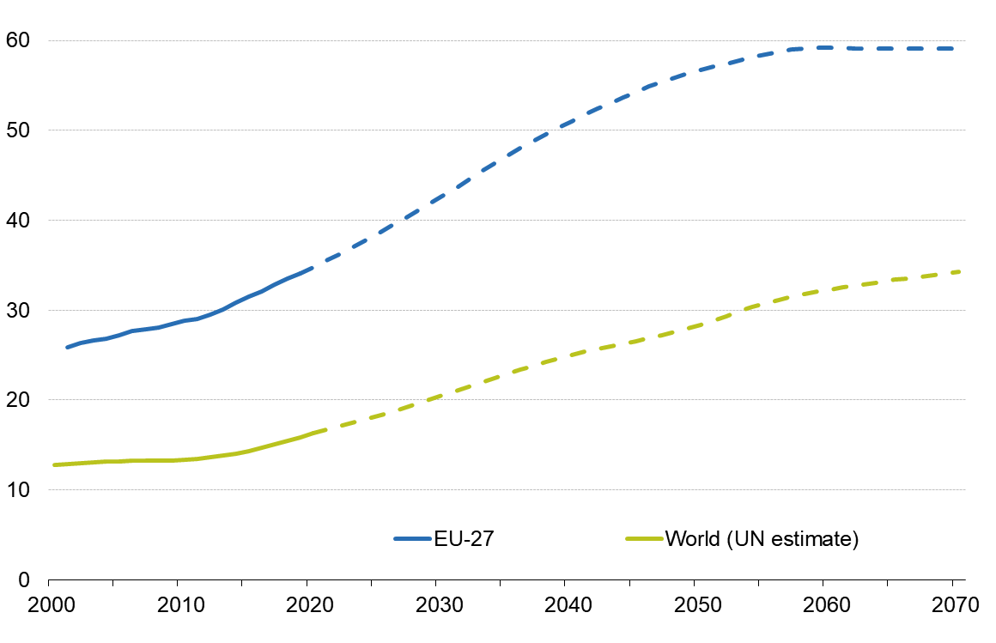

*Sources: Eurostat (online data tables: demo_pjan and proj_19ndbi) for EU-27 data; and, for world data, United Nations, Department of Economic and Social Affairs, Population Division (2019)*

According to Eurostat’s latest population projections, during the period from 2020 to 2070 the share of the population of working age (20-64), is expected to decline, while the older persons will likely account for an increasing share in the total population. Those aged 65 years or over are projected to account for 30.3% of the EU-27 population by 2070, compared with 20.3% in 2019. As a result, the EU-27’s ratio of the number of people aged 65 or over, compared to the number of people aged 20-64 years old is projected to reach 59.1% by 2070.

The old-age dependency ratio in 2019 ranged across the EU Member States from a low of 22.4% in Luxembourg and 24.0% in Ireland, with between four and five working age people for every person aged 65 or over, to highs of 38.6% in Italy, 38.4% in Finland and 37.6% in Greece, thus with less than three working age people for every person aged 65 or over.

**Map 2. Old-age dependency ratio by region, 2019**

*(%)*

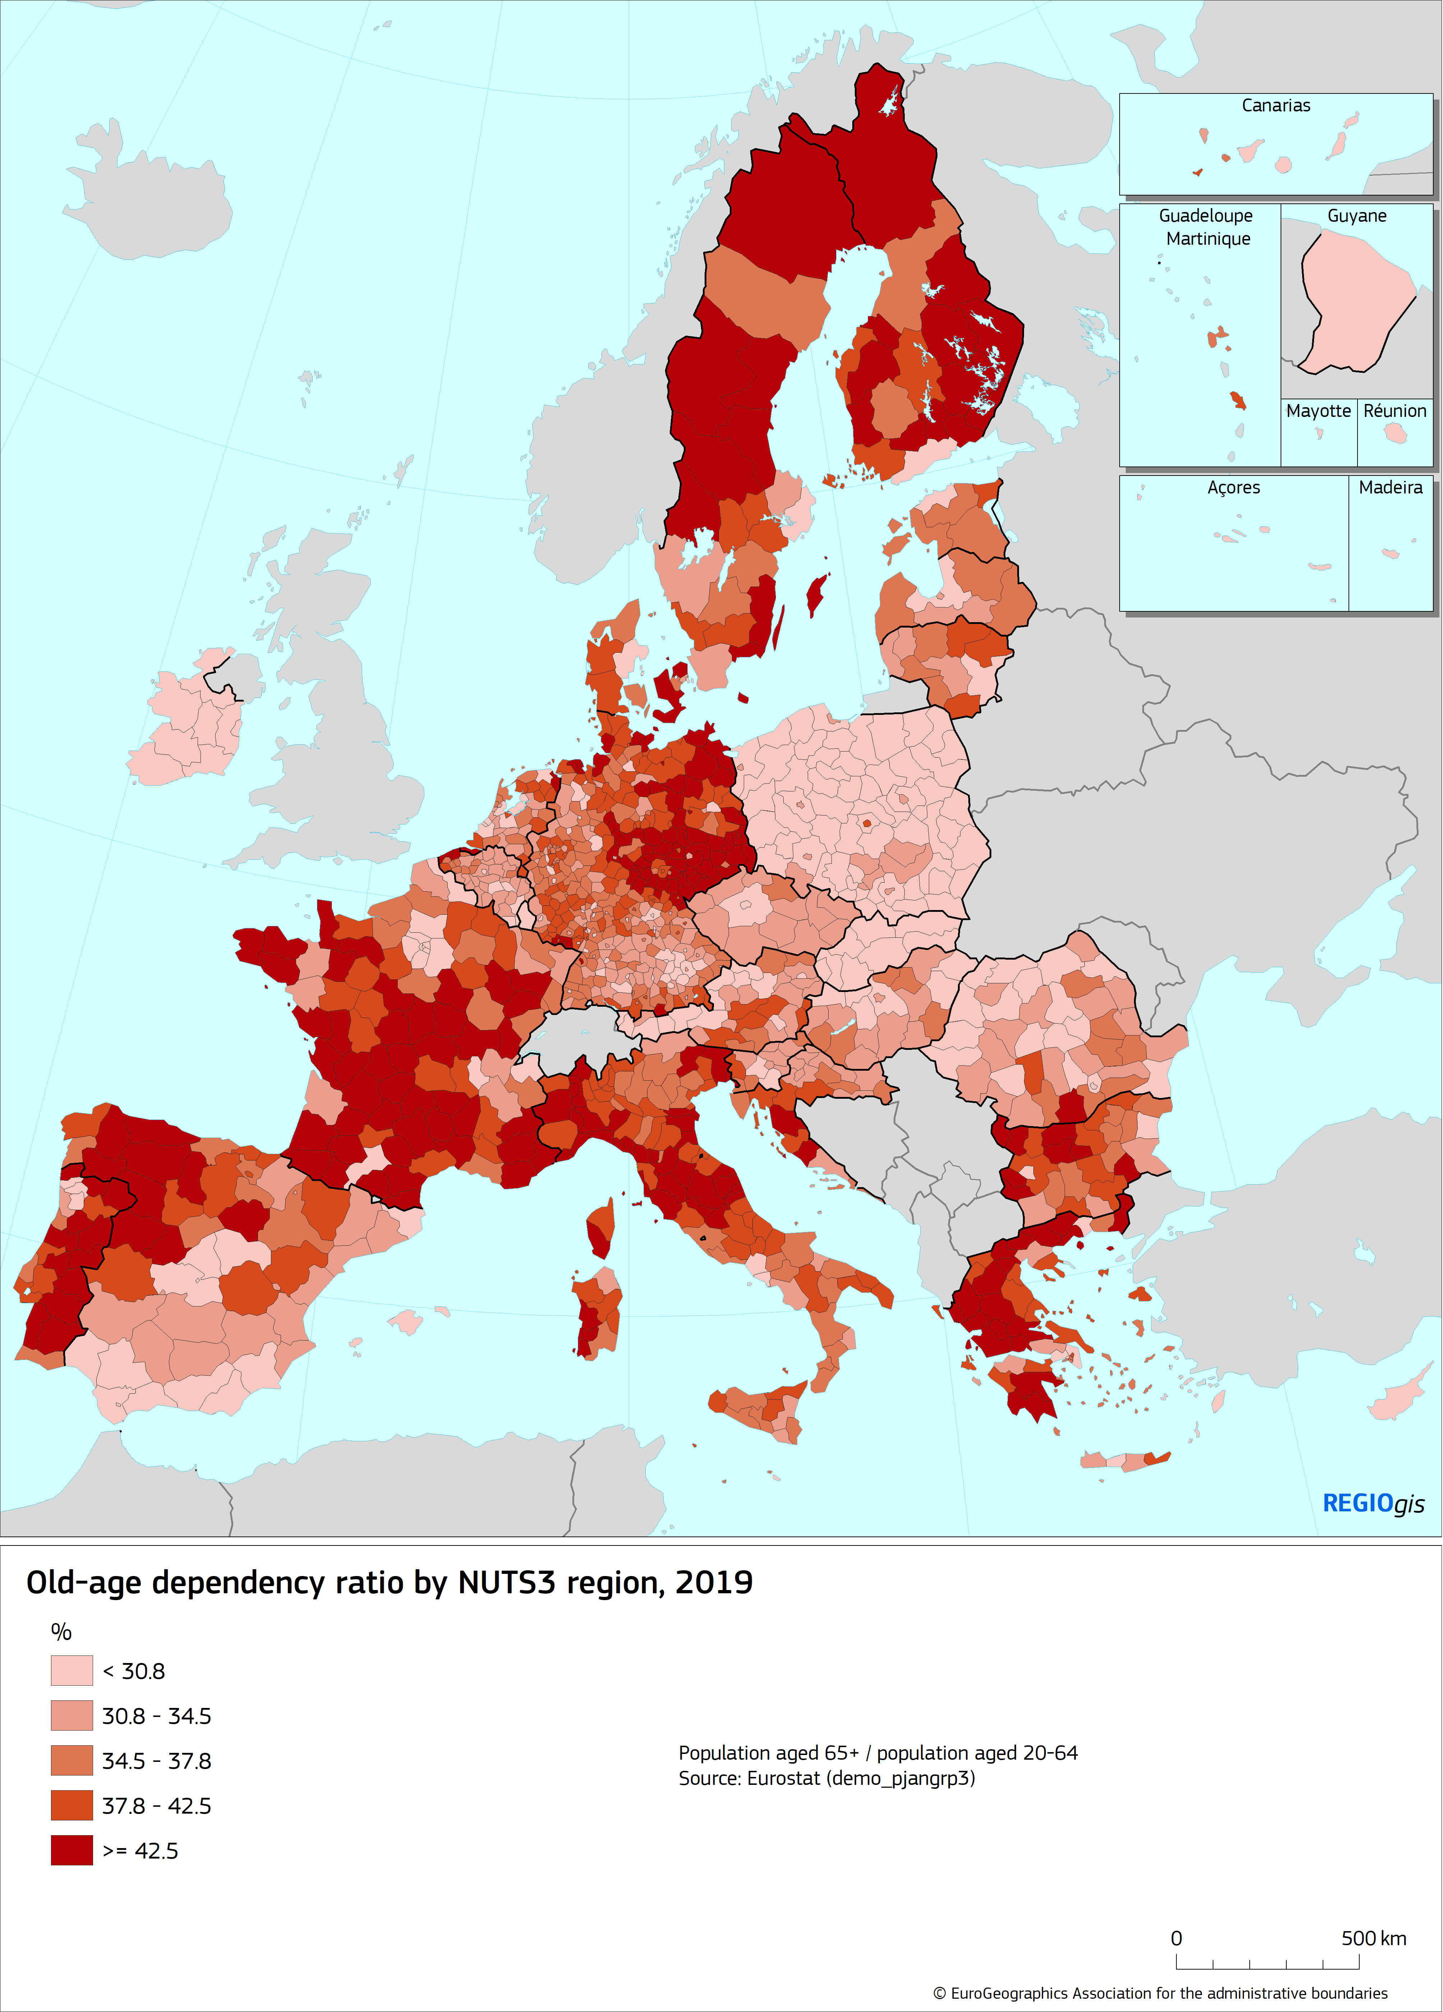

**Map 3. Projected old-age dependency ratio, 2070**

*(%)*

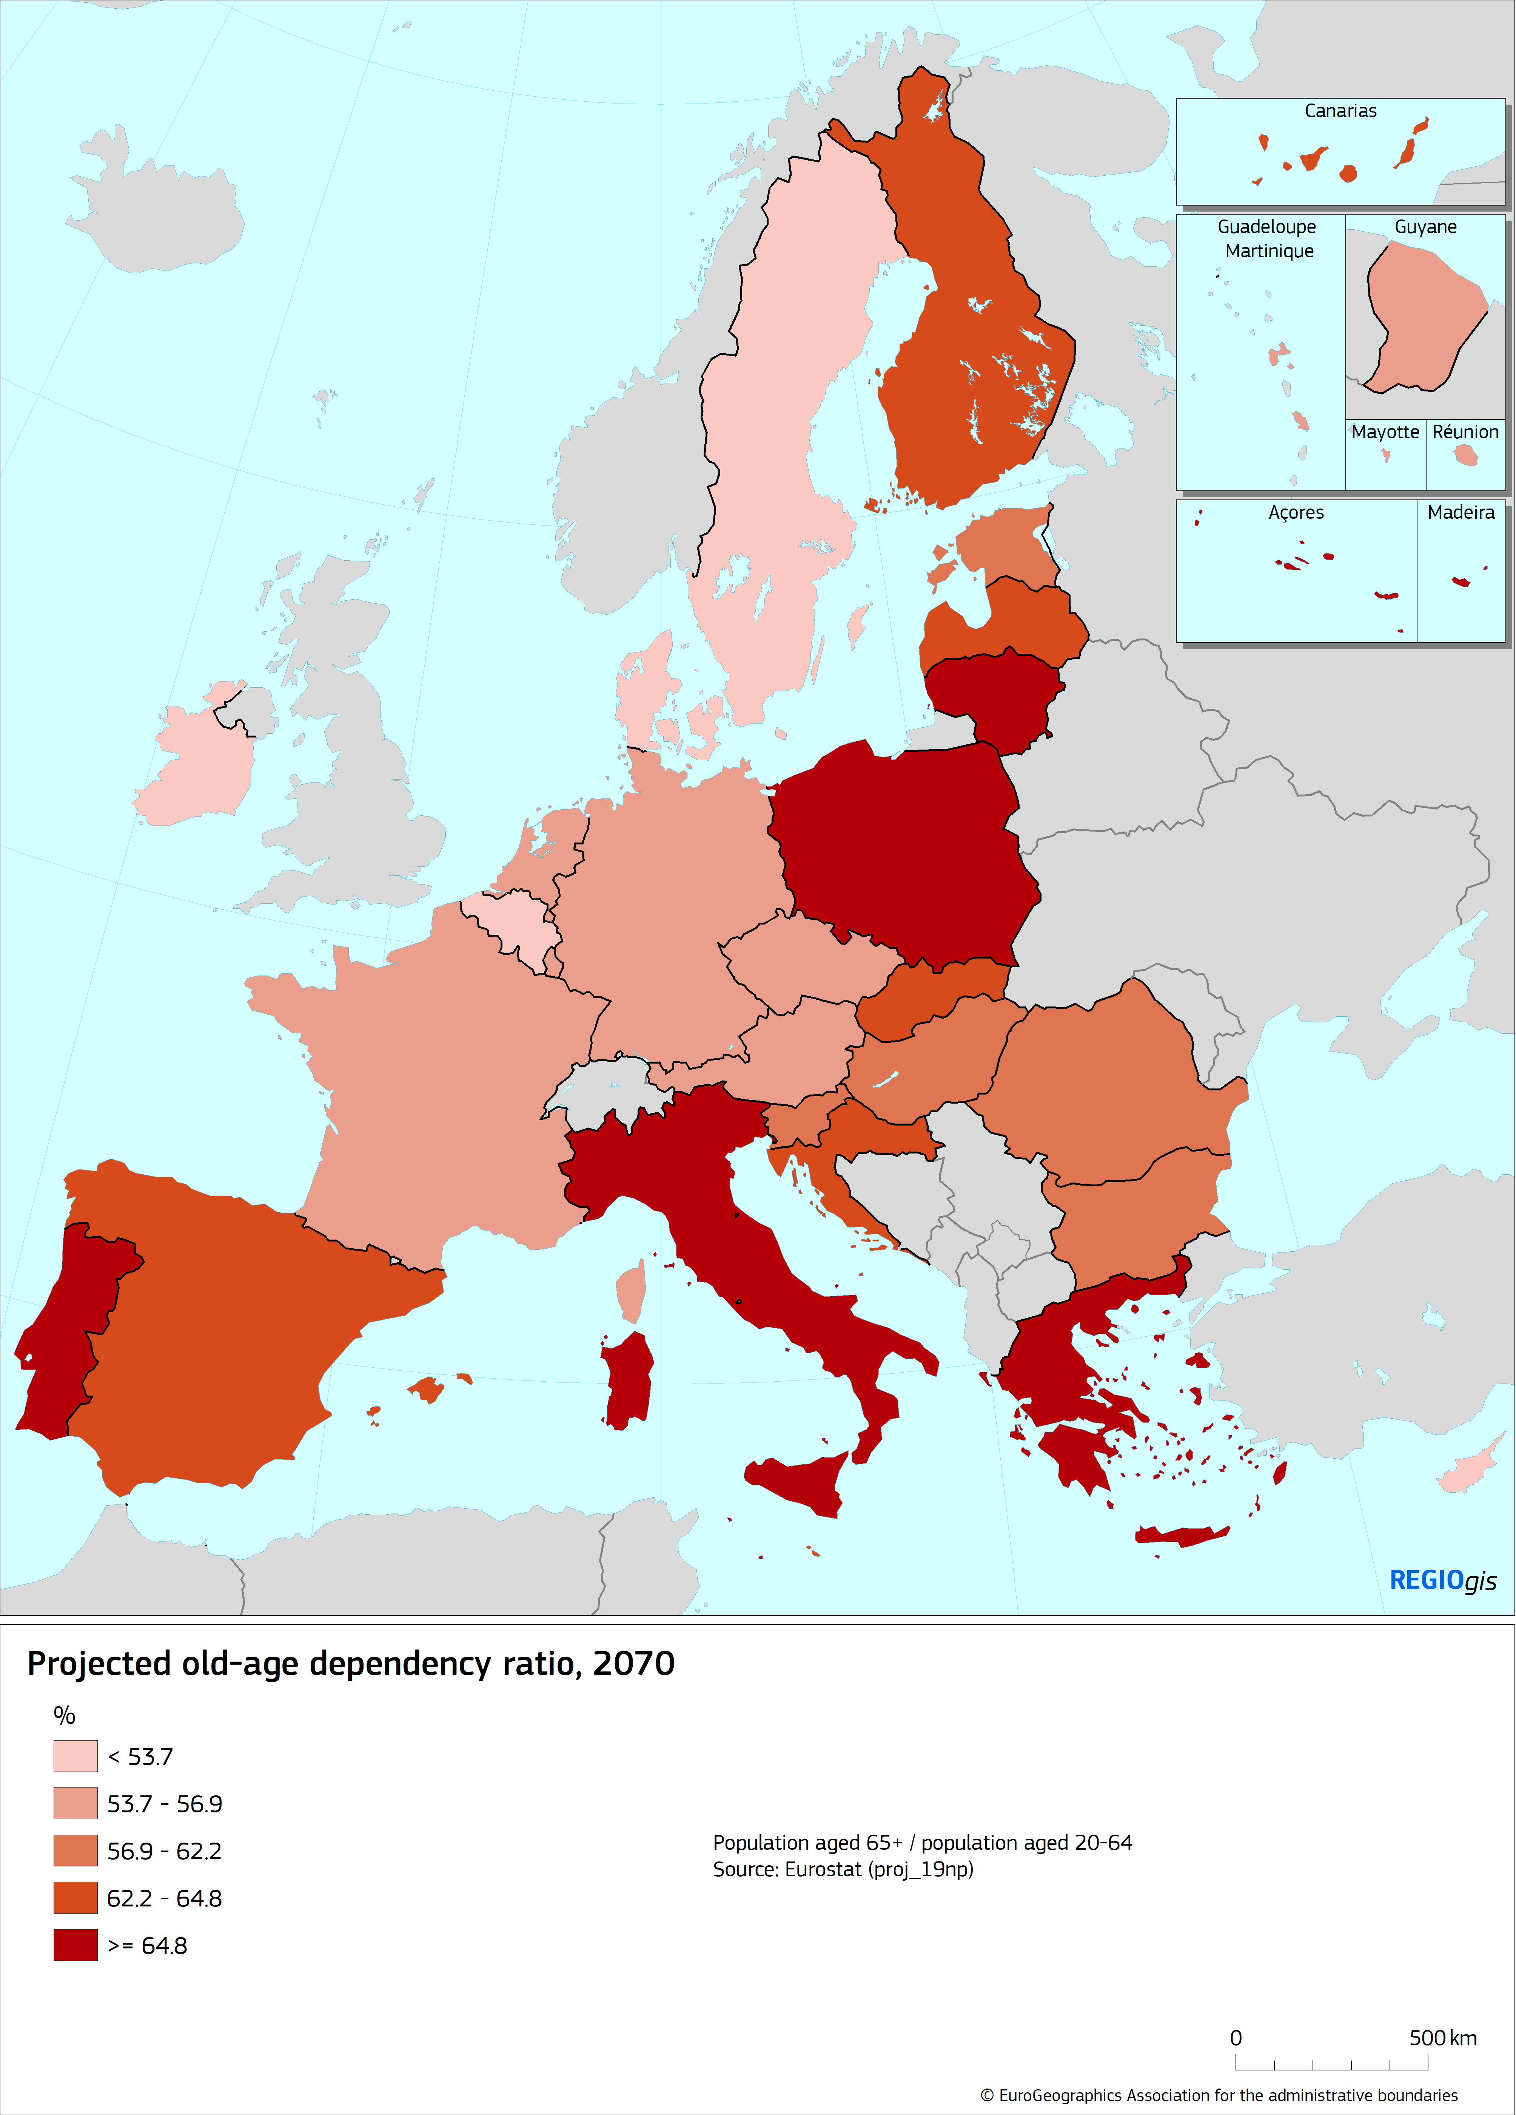

According to the latest United Nations Population Prospects 2019[8], the old-age dependency ratios are projected to increase at world level and for all continents. At world level, ratio of the number of people aged 65 or over, compared to the number of people aged 20-64 years old developed from 10.1% in 1960 to estimated 16.3% in 2020 and projected 34.3% in 2070.

Europe is experiencing an increase of the old-age-dependency ratio. From more than four persons of working age for every older person in 1980s, the old-age-dependency-ratio is projected to decrease to less than two persons of working age for every older person from mid-2040s onwards.

**Figure 9. Old-age dependency ratio by continent**

*(%)*

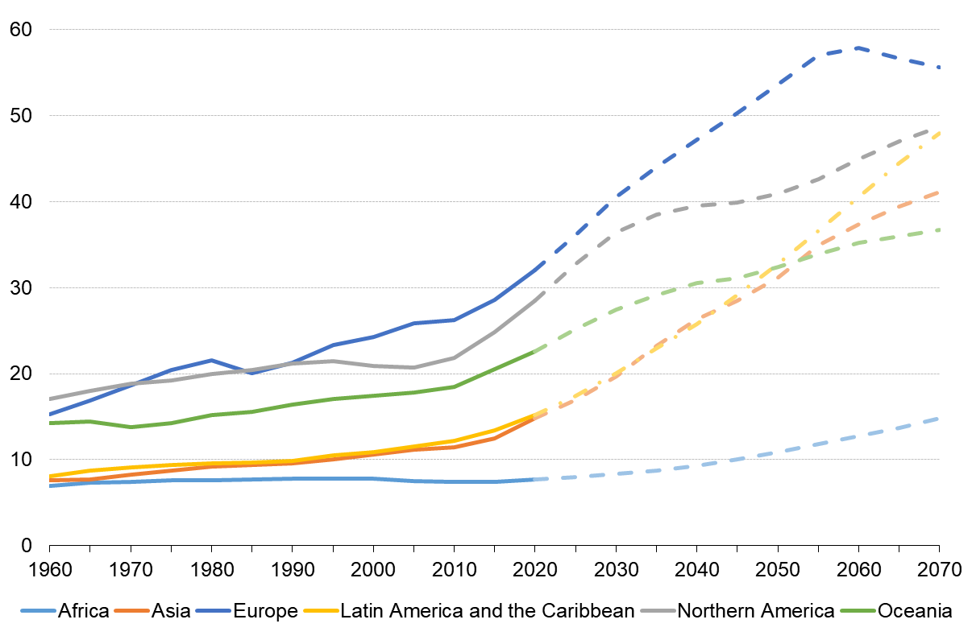

*Source: United Nations, Department of Economic and Social Affairs, Population Division (2019)*

**4. Smaller households**

**4.1 Trends of households by type**

The overall number of households has increased by 7%, from 182 million in 2010 to 195 million in 2019.

Single-adult households have registered the most significant increase (18%), this growth is more significant for the households of single adults without children (19%) than for the ones with children (13%).[9]

The households in which couples (lawful unions or by contract) live have registered an increase of 4%. This growth is exclusively due to the higher number of couples living without children.

Moreover, households with two adults (not a couple) or more adults[10] decreased by 6%. The decrease over the 2010-2019 period is higher in the presence of children (-14%).

**Figure 10. Households by type, EU-27, 2010-2019**

*(millions)*

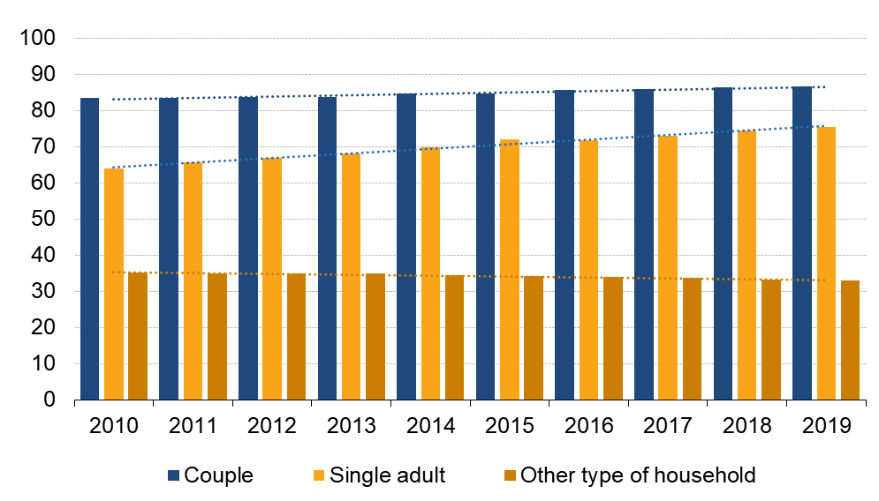

*Source: Eurostat (online data table: lfst_hhnhtych)*

The changes varied among Member States and also depended on the household composition.In Malta, Cyprus, Latvia and Estonia, the number of households consisting of adults living alone have risen the most in the period 2010-2019, respectively by 125%, 64%, and 55% for the last two. Spain and Italy has also recorded an increase of single adults with children (32% for both). On the contrary, Hungary and Romania registered the largest decreases of households of adults living alone with children (-23% and -14% respectively).

Households including couples have increased in Malta (42%), Poland (21%) and Belgium (18%) more than in the other EU Member States but the highest growths occurred for the households consisting of couples without children and have been registered in Malta (67%), Poland (32%), Slovakia (30%) and Slovenia (26%).

In the EU, from 2010 to 2019 the households including two adults (not a couple) or more adults decreased by 6%. In Estonia and Sweden, the number of those households has diminished by 42% and 56%. In contrast, these specific households have increased by 67% in Luxembourg and by 23% in the Netherlands.

**4.2 Trends of households with and without children**

**Figure 11. Growth rate of households with and without children, 2010-2019**

*(%)*

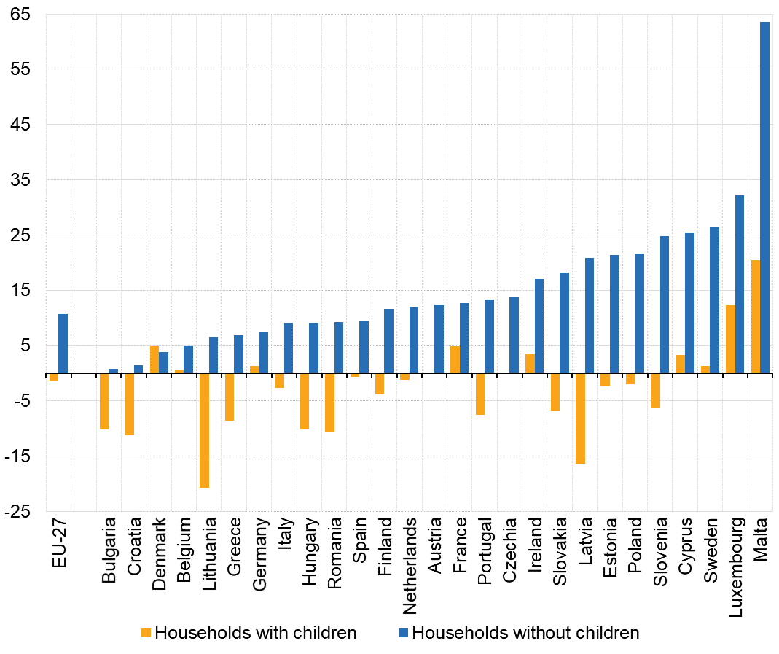

*Note: Break in series in Bulgaria, Germany, Poland and Romania in 2010*

*Source: Eurostat (online data table: lfst_hhnhtych)*

On the EU level, from 2010 to 2019, the number of households with children decreased slightly (-1%) and households without children increased by 11%. The number of households with children decreased in 16 Member States over the same period and increased in the others.

* 1. **Households in 2019**

**Figure 12. Type of household composition by country, 2019**

*(% of total households)*

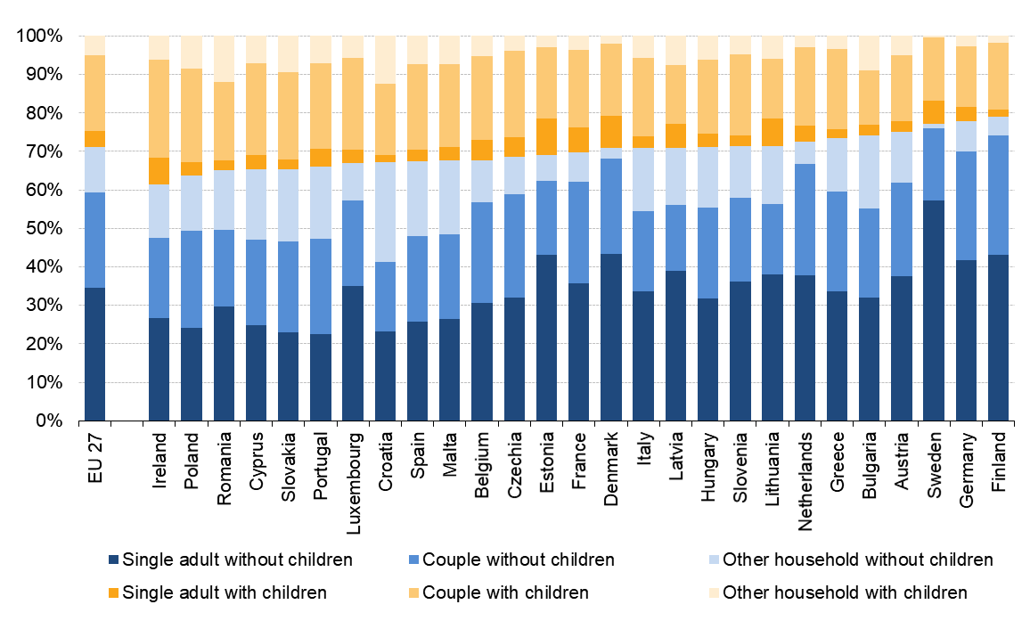

*Source: Eurostat (online data table: lfst_hhnhtych)*

In 2019, almost half EU households were couples (44%), ranging from 49% in the Netherlands, Czechia, Poland and Finland to 35% or less in Sweden, Lithuania and Latvia (respectively 35%, 34% and 32%).

Four out of ten EU households were adults living alone (39%) with differences between countries, from 63% in Sweden, 52% in Estonia and Denmark to 25% in Croatia, 26% in Slovakia, 27% in Portugal, 28% in Poland and 29% in Spain and Cyprus.

Two adults that were not a couple or more than two adults lived in 17% of all households. They represented less than 10% in Sweden, Denmark, Finland and in the Netherlands. They were most frequent in Croatia (38%), Slovakia, Romania and Bulgaria (28% in all three).

Households with children accounted for 29% of the EU households in 2019. The highest rates were registered in Ireland (39%), Poland (36%), Romania, Cyprus and Slovakia (35% each). The lowest were in Finland (21%), Germany (22%), Sweden (23%) and Austria (25%).

* 1. **Households by number of children in 2019**

Households with one child were the most common among households with children. In 2019, in the EU-27 almost half of the households with children only included one child (47%); Portugal, Bulgaria, Lithuania and Latvia showed the highest shares of households with children including only one child i.e. from 58% to 55%. Differently in Sweden, Ireland and the Netherlands, the households with one child constituted 40% or less of the households with children; households with 2 children or more were most frequent in these countries.

**Figure 13. Households by number of children, 2019**

*(% of total households with children)*

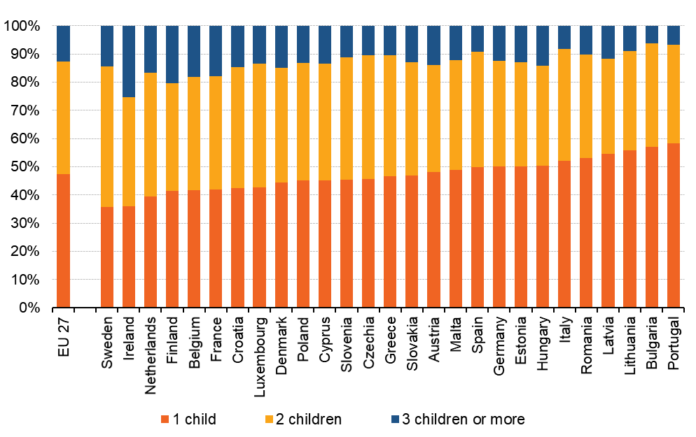

*Source: Eurostat (online data table: lfst_hhnhtych)*

* 1. **Change of the number of persons in household from 2010 until 2019**

In most of EU Member States, the average size of household has decreased from 2010 to 2019, except in three countries in which it remained stable (Belgium, Denmark and the Netherlands). At the EU level, the average size decreased from 2.4 in 2010 to 2.3 persons in 2019. Latvia, Malta, Estonia and Sweden recorded the largest decreases in the household size, i.e. 10% or more over the whole period.

In 2019, Croatia had the highest average number of persons living per household among the EU Member States with 2.8 persons followed by Ireland, Romania, Cyprus, Poland and Slovakia with all 2.6 persons in average. At the other end, two or less persons lived in average per household in Sweden (1.8 persons) and in Finland, Estonia, Germany and Denmark, all those recording an average of 2.0 persons in 2019.

* 1. **Differences in household composition by age and sex**

In the EU, for persons between 15 and 64 years, approximately the same proportions of men and women live alone (19% each), in couple (48% for men, 51% for women) and with another adult (not a couple) or more adults (33% and 30% for men and women respectively).

Conversely, differences are visible among persons aged 65 and over. In the EU, four out of ten women live alone comparing to 19% of men. Four out of ten women and six out of ten men live in a couple, likely because women on average live longer.

**Figure 14. Adults by household composition, by sex and broad age group, EU-27, 2019**

*(%)*

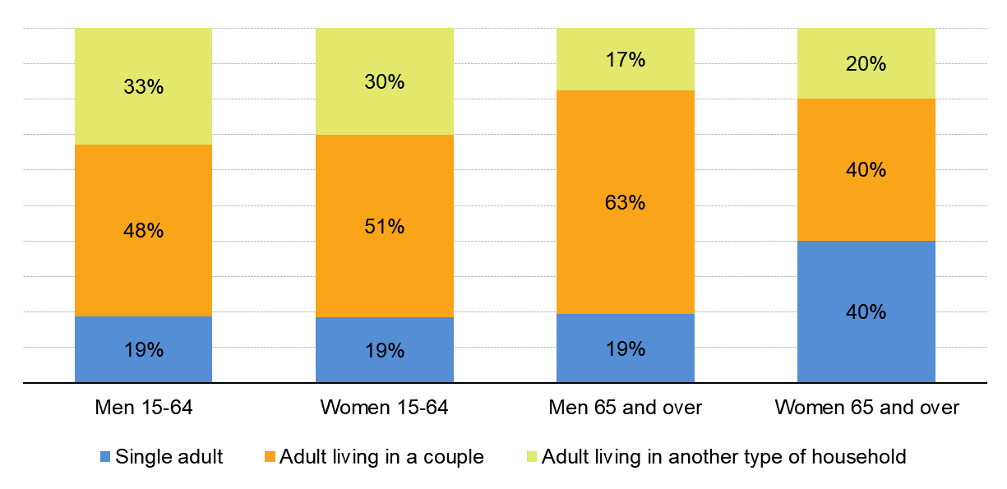

*Source: Eurostat (online data table: lfst_hhindws)*

**Figure 15. Women and men aged 65 and over who live alone 2019**

*(% of total women and men aged 65 and over)*

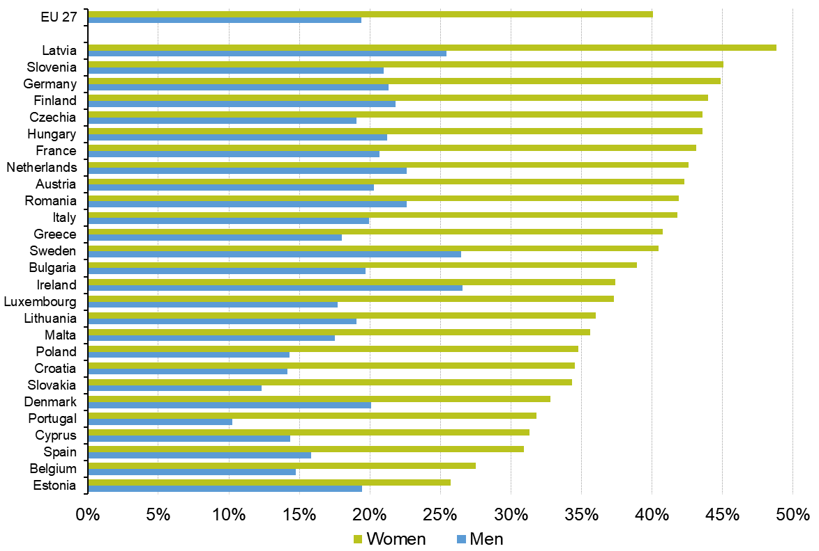

*Source: Eurostat (online data table: lfst_hhindws)*

**5. Mobile Europe**

**5.1 Immigrants and emigrants**

Migration is the most volatile demographic component. It is not straightforward to measure and, during periods of faster change, the situation is even more complex, as migration becomes more unstable. For comparability, it is important to apply strict definitions. Following Eurostat’s definitions, immigration is the action by which a person establishes his or her usual residence in the territory of a Member State for a period that is, or is expected to be, of at least 12 months, having previously been usually resident in another Member State or a third country.

A total of 3.9 million people [immigrated](https://ec.europa.eu/eurostat/statistics-explained/index.php?title=Glossary:Immigrant) to one of the [EU](https://ec.europa.eu/eurostat/statistics-explained/index.php?title=Glossary:EU_enlargements) Member States during 2018, while at least 2.6 million [emigrants](https://ec.europa.eu/eurostat/statistics-explained/index.php?title=Glossary:Emigrant) were reported to have left an EU Member State. Within this, about 2.4 million people immigrated to EU from a country outside the EU and about 1.1 million people emigrated from EU to a country outside the EU[11].

**Figure 16. Immigrants from outside EU-27 and emigrants to outside EU-27, 2013-2018**

*(million persons)*

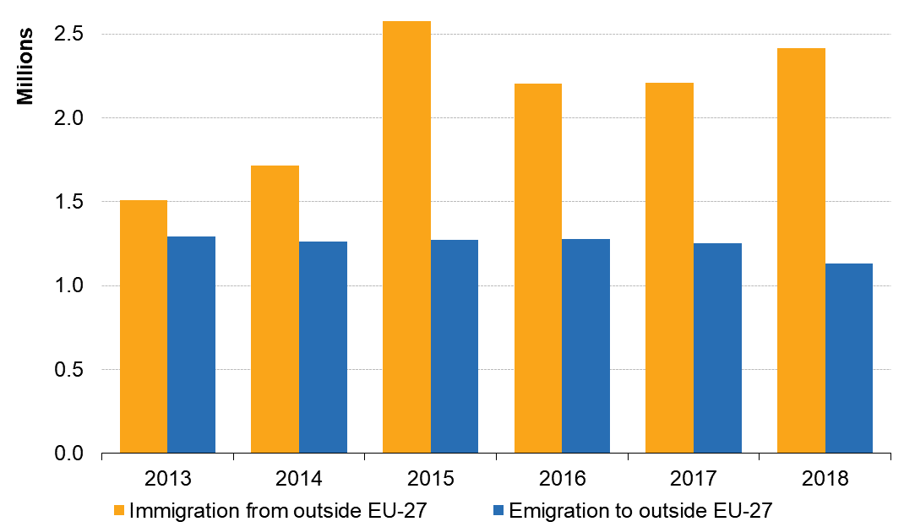

*Source: Eurostat (online data tables: migr_imm5prv, migr_imm12prv, migr_emi3nxt and migr_emi5nxt)*

**5.2 Age structure by citizenship**

Considering the population of all the Member States together, the non-nationals (persons not having the citizenship of the country they reside in) tend to be younger than the nationals (persons having the citizenship of the country they reside in). In 2019, the median age of the nationals residing in the EU-27 was 45, while the median age of non-nationals was 36. The largest age groups among non-nationals were around 30 years of age, while they were around 50 for the nationals.

**Figure 17. Age structure by citizenship and sex, EU-27, 2019**

*(% of the nationals, or non-nationals)*

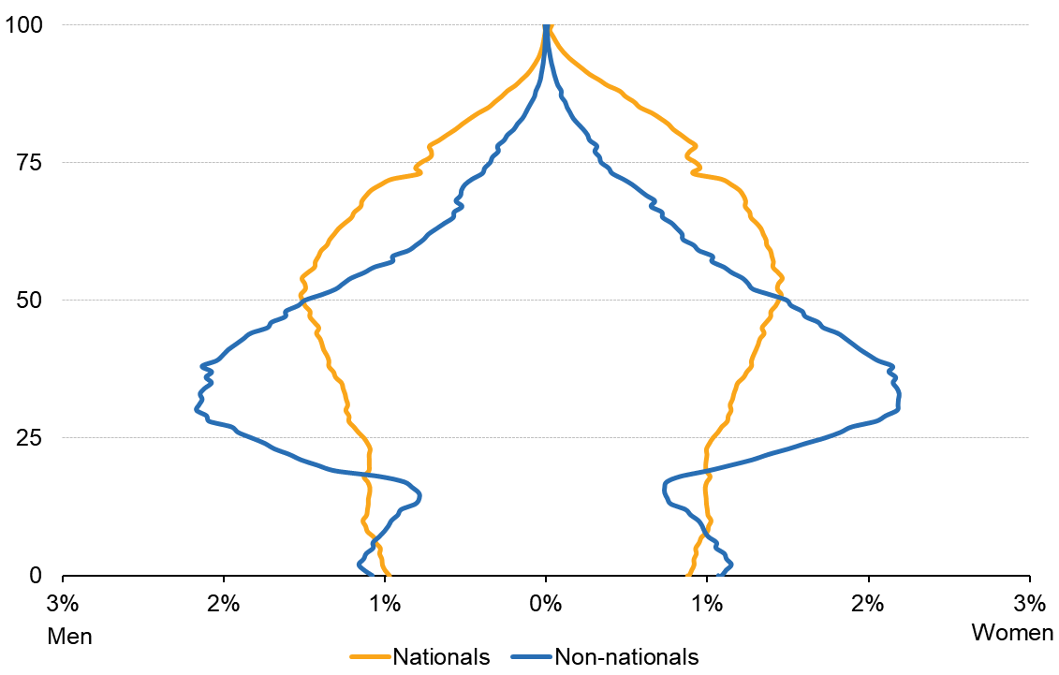

*Source: Eurostat (online data table: migr_pop2ctz)*

The number of people residing in EU-27 without citizenship of a Member State in 2019 was 21.8 million, representing 4.9% of the EU-27 population. In addition, there were 13.3 million non-nationals living in one of the EU Member States with the citizenship of another EU Member State.

**Figure 18. Share of non-nationals in the resident population, 2019**

*(%)*

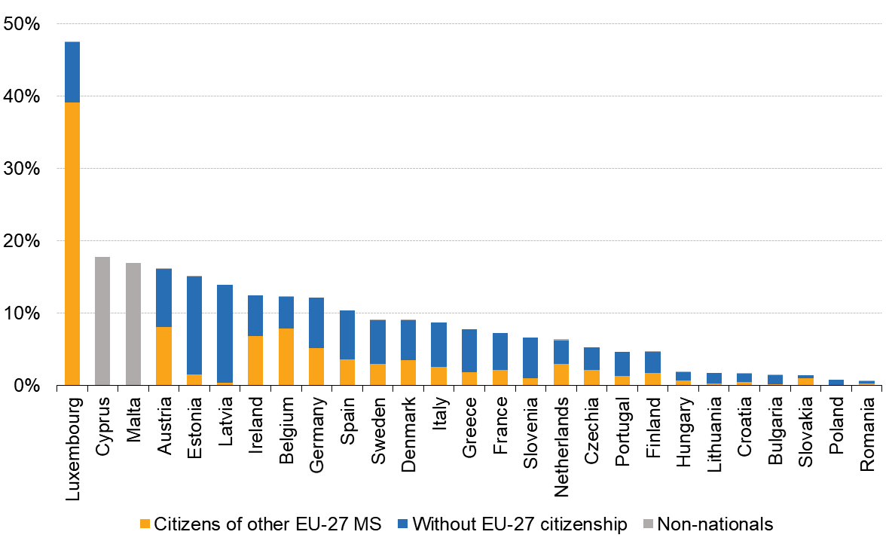

Note: For Cyprus and Malta, breakdown by citizenship not available

*Source: Eurostat (online data table: migr_pop1ctz)*

**6. changing population**

* 1. **Natural population change in the EU**

The natural change in population (the gap between live births and deaths) in the EU-27 was narrowing from 1960s. From 2012 onwards, as the number of deaths surpassed the number of births, EU-27 experienced a natural population decrease. Since then, the gap between life births and deaths has been increasing and in 2018 deaths outnumbered births by 0.5 million at EU level.

During the period 1961-2018, the highest annual total for the number of live births in the EU-27 was recorded in 1964, at 6.797 million. From this relative high up to the beginning of the 21st century, the number of live births in the EU-27 declined at a relatively steady pace, reaching a low of 4.5 million in 1995. This was followed by an increase in the number of live births, with a high of 4.7 million children born in the EU-27 in 2008, in turn followed by reduction down to 2018 (4.2 million live births), which is the lowest value recorded. The downward trend is projected to continue, with under 4 million births in a year for most of the period until 2070.

In 2018, some 4.7 million persons died in the EU-27. The annual number of deaths is the highest observed over the previous five decades.

**Figure 19. Live births and deaths, EU-27, 1961-2070**

*Observed (1961-2018) and projected (2019-2070) data (millions)*

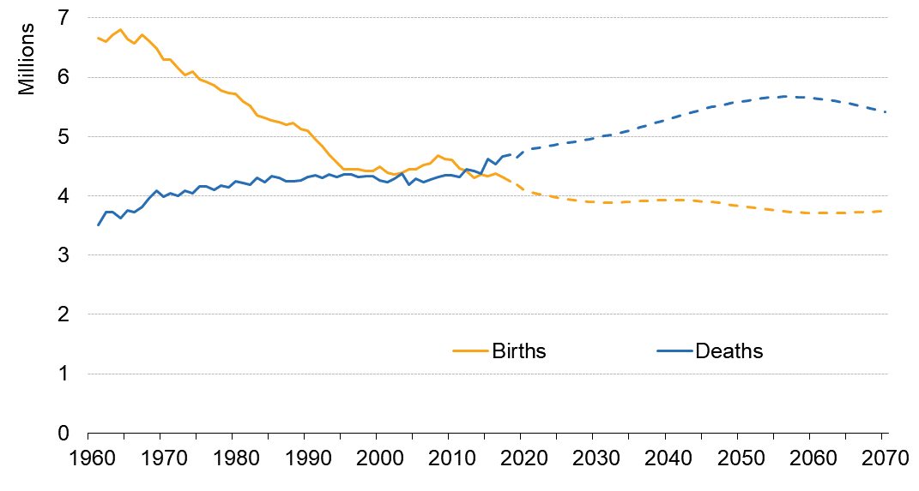

*Source: Eurostat (online data tables: demo_gind and proj_19ndbi)*

The 4.2 million children born in the EU-27 in 2018 correspond to a [crude birth rate](https://ec.europa.eu/eurostat/statistics-explained/index.php?title=Glossary:Birth) (the number of live births per 1 000 persons) of 9.5. For comparison, the EU-27 crude birth rate had stood at 10.5 in 1995, dropping from 16.4 in 1970. The crude death rate (the number of deaths per 1 000 persons) was of 10.5 in 2018.

Since 2012, the average crude rates in EU-27 were positive for the net migration and statistical adjustment and negative for the natural population change. In 2018, the crude rate for net migration and statistical adjustment stood at 2.6 per 1 000 persons, while the crude rate of natural population change was of -1.0. Their sum gives the crude rate of total change: 1.6 per 1 000 persons.

Population projections build on the observed trends of the crude rate for net migration and statistical adjustment over the last three decades. The annual average over the whole projection period stands at 2.3 migration events per 1 000 persons, which is close to the 2016-2018 average (2.2). While in 2016-2018 the net migration safeguarded the overall population growth, in less than a decade this value is projected to be insufficient to counterbalance the negative natural change. This would mean declining total population of the EU for most of the period until 2070. The population is projected to diminish to 424 million persons by 2070, a 5% reduction compared to the current value.

**Figure 20. Population change by component, EU-27, 1960-2070**

*Observed and projected annual crude rates (per1 000 persons)*

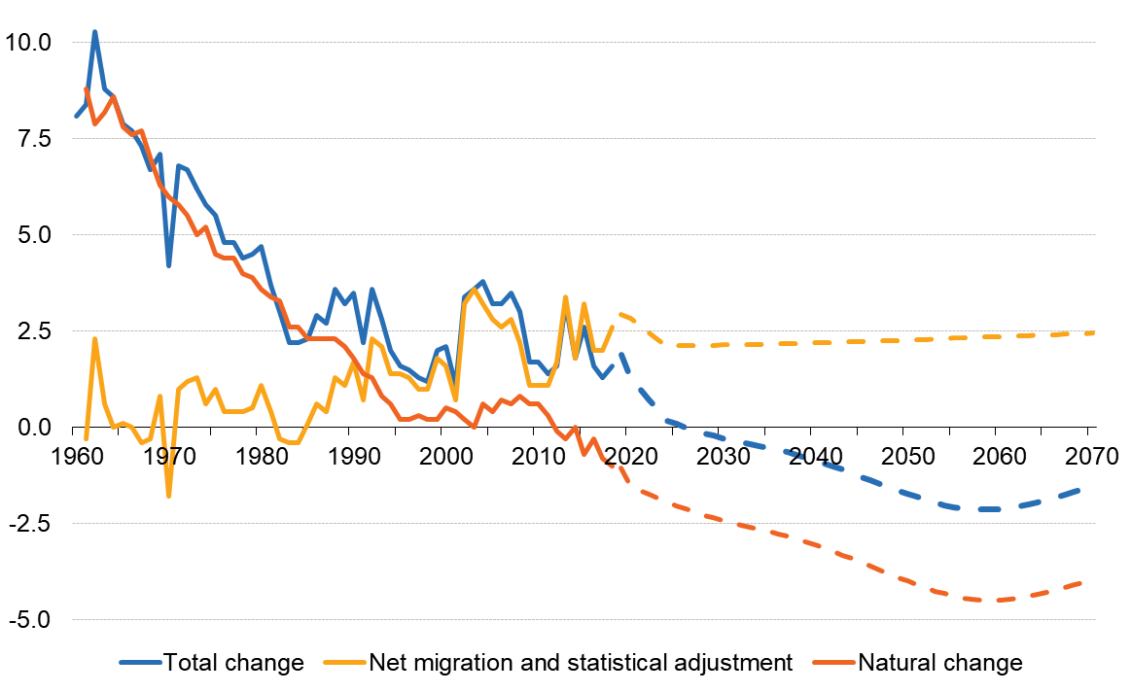

*Source: Eurostat (online data tables: demo_gind and proj_19ndbi)*

**Figure 21. Crude rates of natural change and net migration, average 2014-2018**

*Ordered by ascending natural population change crude rate (per 1000 persons)*

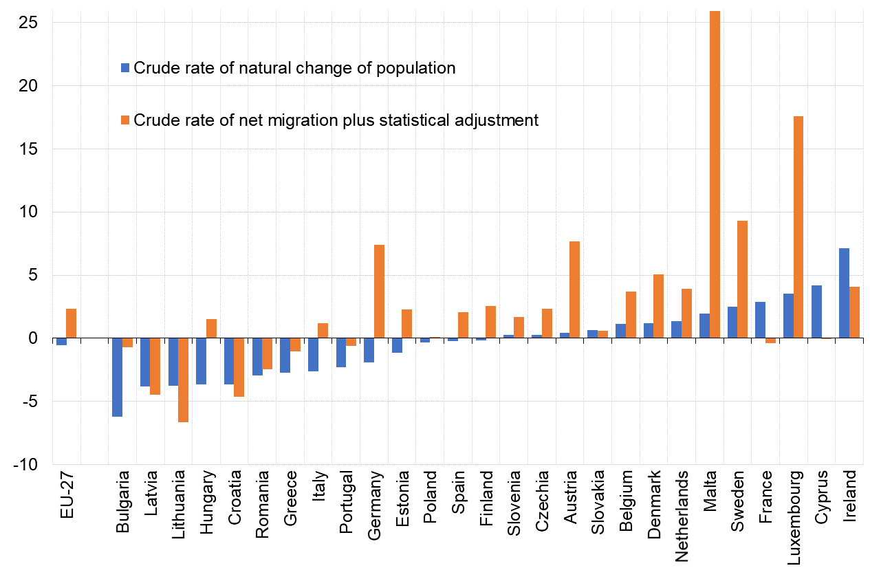

*Source: Eurostat (online data table: demo_gind)*

* 1. **Demographic balance in the Member States in 2018**

The population of individual EU Member States on 1 January 2019 ranged from 0.5 million in Malta to 83 million in Germany. While the population of the EU-27 as a whole increased during 2018, the population of 10 EU Member States declined.

**Table 5. Demographic balance, 2018**

*(thousands)*



*Source: Eurostat (online data table: demo_gind)*

In 2018, population change diverged across the EU Member States: 17 Member States observed an increase in their respective populations, while the population fell in the remaining 10 Member States. Malta, Luxembourg, Ireland, Cyprus and Sweden recorded the highest population growth rates, with increases above 10.0 per 1 000 persons. Among these five EU Member States with the highest rates of population growth, the fastest expansion in population was recorded in Malta with an increase of 36.8 per 1 000 persons. The largest relative decreases in population were reported by Latvia (-7.5), Bulgaria and Croatia (both -7.1).

**Table 6. Crude rates of population change, 2016-2018**

*(per 1 000 persons)*

*Source: Eurostat (online data table: demo_gind)*

**II: THE IMPACT OF DEMOGRAPHIC CHANGE – territorial differences**

**7. regional and local dimension**

**7.1 GDP (in PPS) per person employed**

Differences at regional level are visible for example in different levels of GDP per person.

Gross domestic product per person employed is a measure of labour productivity of the total economy of a country or region. Expressing GDP in purchasing power parities (PPS) compensates for cost of living differences between countries. Employment is measured at the place of work. Consequently, regional GDP per person employed is not distorted by commuting across regional boundaries.

**Map 4. GDP (in PPS) per person employed by NUTS3 region, 2017**

*(EU-27 = 100)*

## 7.2 Natural population change and net migration[12]

**Map 5. Natural population change in NUTS3 regions, 2014-2019**

*Annual average change (per thousand)*

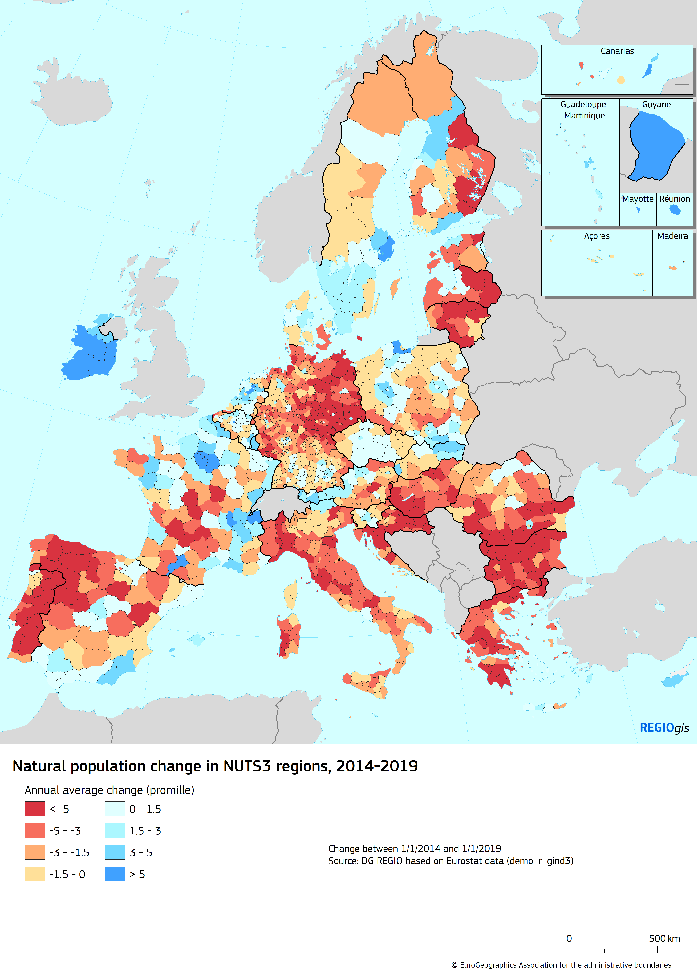

1. Eurostat statistics in this Staff Working Document were extracted from the Eurostat database in May 2020.
2. In this Staff Working Document, the terms Europe and EU refer to EU-27 unless otherwise specified.
3. See Eurostat table demo_mlexpec
4. In April 2020, Eurostat published population projections based on 2019 data. At the time of projections’ production, the effects of the COVID-19 pandemic were not available, and they were not incorporated in the assumptions. For more information on Eurostat’s population projections, see: <https://ec.europa.eu/eurostat/web/population-demography-migration-projections/population-projections-data>.
5. Excluding Croatia and Latvia for which data for 2000 is not available
6. Healthy life years, also called disability-free life expectancy, is defined as the number of years that a person is expected to continue to live in a healthy condition. A healthy condition is defined as self-reported one without limitation in functioning and without disability. For more information on the concept and data, <https://ec.europa.eu/eurostat/statistics-explained/pdfscache/1101.pdf>. A similar indicator, Healthy life expectancy based on self-reported state of health describes how many years a person is expected to live in good self-perceived health. For the EU-27, the number of healthy life expectancy at birth in 2018, was estimated at 76.7 years for women and 73.2 for men (source: Eurostat online table [hlth_silc_17](https://appsso.eurostat.ec.europa.eu/nui/show.do?query=BOOKMARK_DS-273736_QID_-8F71CA5_UID_-3F171EB0&layout=SEX,L,X,0;TIME,C,X,1;GEO,L,Y,0;INDIC_HE,L,Z,0;UNIT,L,Z,1;INDICATORS,C,Z,2;&zSelection=DS-273736INDIC_HE,HE_BIRTH;DS-273736UNIT,YR;DS-273736INDICATORS,OBS_FLAG;&rankName1=INDIC-HE_1_2_-1_2&rankName2=UNIT_1_2_-1_2&rankName3=INDICATORS_1_2_-1_2&rankName4=SEX_1_2_0_0&rankName5=TIME_1_0_1_0&rankName6=GEO_1_2_0_1&rStp=&cStp=&rDCh=&cDCh=&rDM=true&cDM=true&footnes=false&empty=false&wai=false&time_mode=NONE&time_most_recent=false&lang=EN&cfo=%23%23%23%2C%23%23%23.%23%23%23) ). Cultural differences in self-reporting both health and disability can influence comparability of both indicators.
7. For an explanation of the NUTS classification (“Nomenclature of territorial units for statistics”), see: <https://ec.europa.eu/eurostat/web/nuts/background>
8. For more information regarding the 2019 Revision of World Population Prospects, see: https://population.un.org/wpp/
9. In this context, children are considered economically dependent up to 24 years old.
10. ‘Two adults (not a couple) or more adults’: this group includes all households of 2 or more persons where two adults that are not a couple can be found among members of the household, e.g., an economically independent adult child living with one or two parents parent, elderly person living with other members of the family, economically independent roommates)
11. For some immigrants the country of previous residence and for some emigrants the country of next residence are not known. For Cyprus, migration data includes UK in the composition of the EU. EU-27 data is not available for Cyprus.
12. See section 6 for definitions.