

Table of Contents

1. INTRODUCTION 2

2. THE DRIVERS OF DEMOGRAPHIC CHANGE IN EUROPE 4

2.1. LONGER LIFE EXPECTANCY 4

2.2. FEWER BIRTHS 7

2.3. AN AGEING POPULATION 9

2.4. SMALLER HOUSEHOLDS 10

2.5. A MORE MOBILE EUROPE 11

2.6. A CHANGING POPULATION SIZE 12

3. THE IMPACT OF DEMOGRAPHIC CHANGE ON OUR SOCIAL MARKET ECONOMY 14

3.1. PEOPLE, WORK AND SKILLS 15

3.1.1 A LARGER AND MORE INCLUSIVE LABOUR MARKET 16

3.1.2. PRODUCTIVITY THROUGH SKILLS AND EDUCATION 18

3.2. HEALTH AND LONG-TERM CARE 19

3.3. THE IMPACT ON PUBLIC BUDGETS 21

3.4. THE REGIONAL AND LOCAL DIMENSION 22

3.4.1. QUALITY OF LIFE, INFRASTRUCTURE AND ACCESS TO SERVICES 25

4. THE TWIN TRANSITIONS AND DEMOGRAPHIC CHANGE 28

5. THE GEOPOLITICS OF DEMOGRAPHICS: EUROPE IN THE WORLD 29

CONCLUSIONS AND OUTLOOK 32

# INTRODUCTION

The outbreak of the COVID-19 pandemic changed Europe and the world within the blink of an eye. It tested our healthcare and welfare systems, as well as our economic and social resilience. It will leave a lasting impact on the way we live and work together – even once the virus has disappeared. And it struck at a time when Europe had already been going through a period of profound transformation through climate, societal and demographic change.

**Demographic change is about people and their lives**. It is about what we do, how we work and where we call home. It is about our communities and the way we all live together. It is about embracing the variety of people and backgrounds that enrich and shape our societies, make us stronger and bring to life the EU’s motto, *United in Diversity*. This is more needed than ever. As we slowly and cautiously emerge from the lockdowns imposed across Europe, we are reminded of the importance of understanding and responding to the impact that demographic change has on our society. This work will have to be factored into Europe’s recovery and lessons learnt– be it on the social and economic dimension, or on health and long-term care and much more besides.

Over the last weeks and months, the link between demographic structures and the impact and recovery potential has been sharply and often painfully exposed. We have seen our oldest generation suffer the most, with the elderly being the most vulnerable in this crisis. They are not only at higher risk of complications if they catch the disease but are also some of the most isolated and cut off by the social distancing and lockdown measures taken to save lives across Europe. **The need for solidarity between generations is one of the driving forces of Europe’s recovery.**[1]

Managing the impact of long-term demographic change has many different facets: how we manage our public health, public budgets or public life, but also on how we tackle issues like loneliness, care in the community and access to vital services. Addressing these issues will be important for a successful recovery and will determine the speed and the extent to which we will be able to rebuild our everyday lives, social networks and economies. In the longer term, this is an opportunity for Europe to **build a fairer and more resilient society**.

We can never underestimate the damage from the crisis or the need to deal with all kinds of loss. In that context, it may appear contradictory to say that **Europeans are generally living longer, healthier and safer lives**. However, in the longer-term this is still the reality and we should be proud of the great strides made in the past decades to achieve this. Europe’s welfare and healthcare systems are the most advanced globally. Coupled with the skill and sacrifice of so many frontline workers they have helped save countless lives since the beginning of the crisis. However, the stress they were put under, especially in areas with an older population, has shown the need to support them further.

Thanks to this progress, our quality of life remains unique and our societies some of the most equal in the world, even if inequalities still persist. We are becoming an older population and generally choosing to live in smaller households. We are increasingly on the move, working longer, learning more and changing jobs more often. These trends all have a significant impact on our society - and some of these may have been factors in the way the virus took hold and spread in some countries, whether it be ageing population, household composition or population density.

These issues can often best be addressed at the local and regional level. This reflects the fact that demographic change often varies significantly between different parts of the same country.Some regions face a twin-challenge of low income and rapidly declining population. With 31 million people living in these, mostly rural, regions, the stakes are high. **Europe will strive to improve living standards and reduce disparities.** It is about ensuring people’s needs are catered for and that there are prospects and job opportunities where they live. It is about access to healthcare, childcare and education, as well as other vital local services, such as post offices, libraries or transport.

Whilst changes in demographics are not new, the difference in our lives is felt more acutely. Addressing this change will be all the more important as Europe embarks on its path towards recovery. Maintaining the focus on the twin green and digital transitions will help provide many of the innovative and sustainable solutions we need to address the impact of demographic change.

**Demographic change also affects Europe’s place in the world.** As the share of Europe’s population in the world continues to shrink, the need for the EU to speak and act as one, leveraging all of its collective strengths and diversity, becomes all the more important. This should also be seen in the light of major demographic changes in our neighbourhood and across the world, which will have a direct impact on Europe itself.

**This report presents the drivers of demographic change and the impact they are having across Europe[2].** It will help identify how the people, regions and communities most affected can best be supported to adapt to changing realities – through crisis, recovery and beyond. The aim of the Commission’s work in this area is about improving our knowledge and foresight to ensure we can support those that need it – both today and in the future. It is not necessarily about reversing or slowing down any of the trends; it is about equipping ourselves with the right tools to provide new solutions and support people through change.

This is ultimately about **ensuring that no region and no person is left behind -** a feeling which can ultimately lead to a loss of faith in our democracy. This is why this Commission has for the first time a Vice-President for Democracy and Demography and it is why this topic will also feature in the Conference on the Future of Europe, through which citizens will play a leading role in building a more resilient, sustainable and fair Union. While many of the competences in these areas are in the hands of Member States, the Commission is ready to lead the way by identifying issues and supporting national, regional and local action.

# THE DRIVERS OF DEMOGRAPHIC CHANGE IN EUROPE[3]

As Europeans, we are living longer than ever before and becoming an older population with every year that passes. More of us are choosing to live, work or study in another EU country and migration to or from Europe continues to fluctuate. Increasing numbers of us are also now living in smaller households and we are having fewer children than before. These drivers of demographic change vary across Europe, often significantly between different regions of the same country[4].

## 2.1. LONGER LIFE EXPECTANCY

**Europeans enjoy longer lives, on average for longer in good health**. Life expectancy at birth has increased by about 10 years for both men and women over the last five decades[5]. The pandemic has exposed the vulnerabilities of an ageing population, but is not thought likely to have changed this overall positive trend on life expectancy.

In 2070, life expectancy at birth is projected[6] to reach 86.1 years for men, up from 78.2 in 2018. For women, it is estimated at 90.3 – up from 83.7. Where you live has a major influence on your life expectancy. At national level, life expectancy at birth ranges from 83.5 in Spain to 75 in Bulgaria.

There are differences between women and men living in different parts of the EU. While women’s life expectancy at birth for the EU-27 is 5.5 years higher than men’s, the picture is not the same everywhere. In Latvia and Lithuania, the gap is more than nine years, while in Denmark, Ireland, Cyprus, the Netherlands, Sweden, it is less than four.

**Gap between life expectancy at birth between women and men, 2018**

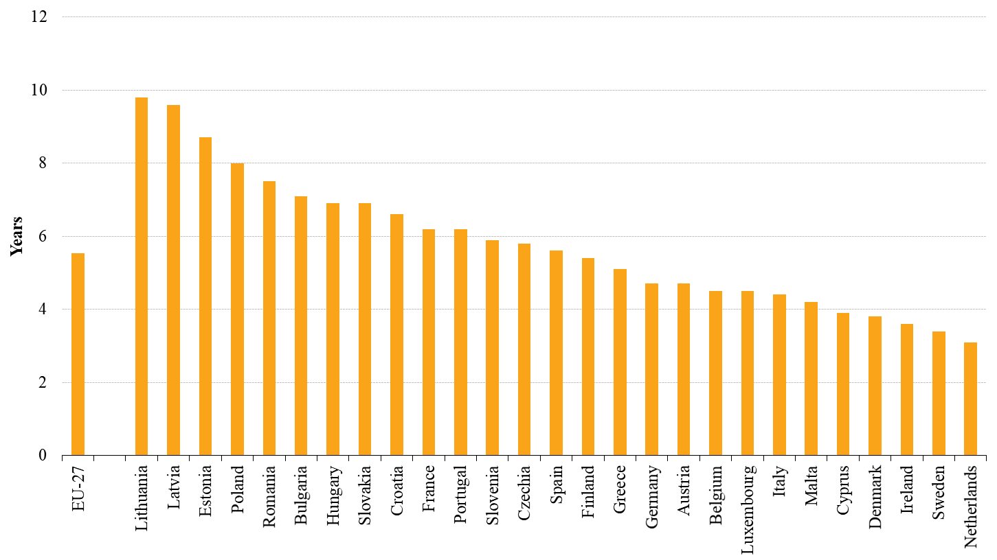

*Source: Eurostat*

**We spend a large part of our life in good health.** The number of reported *healthy life years*[7] varies by sex and country. For the EU as a whole, the number of healthy life years at birth in 2018 was 64.2 years for women and 63.7 for men[8]. Again, this varies significantly depending on where you live. For example, a man living in Sweden has on average more than 73 healthy life years, compared to 51 for a man in Latvia. Almost half of older people have a disability[9] – with this figure getting higher as people get into the older age groups. They are more prone to face challenges of reduced mobility and their quality of life depends on how inclusive and accessible our societies and environment are.

**Healthy life years at birth, 2018**

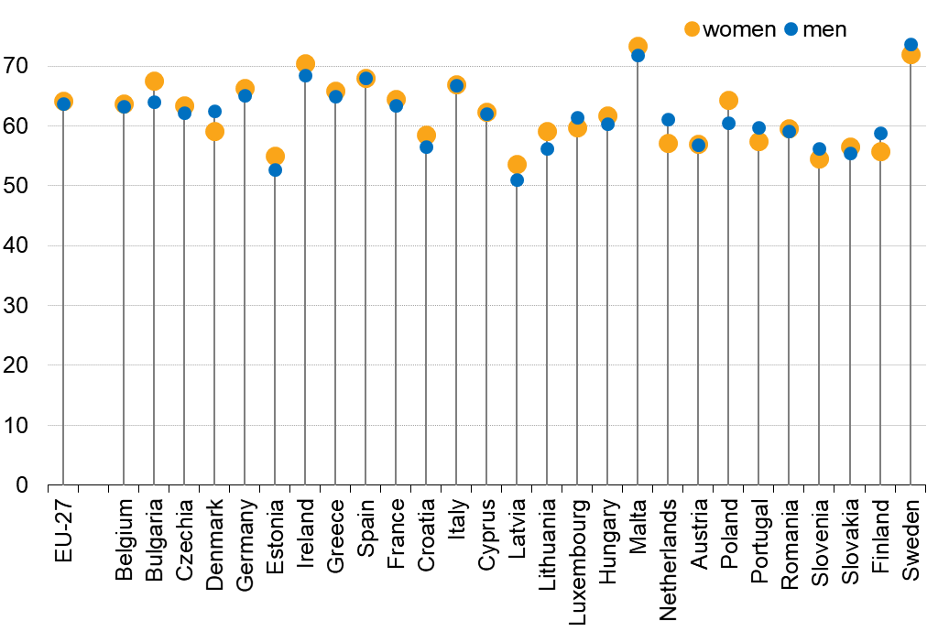

*Source: Eurostat*

**Life expectancy at birth by region[10], 2018**

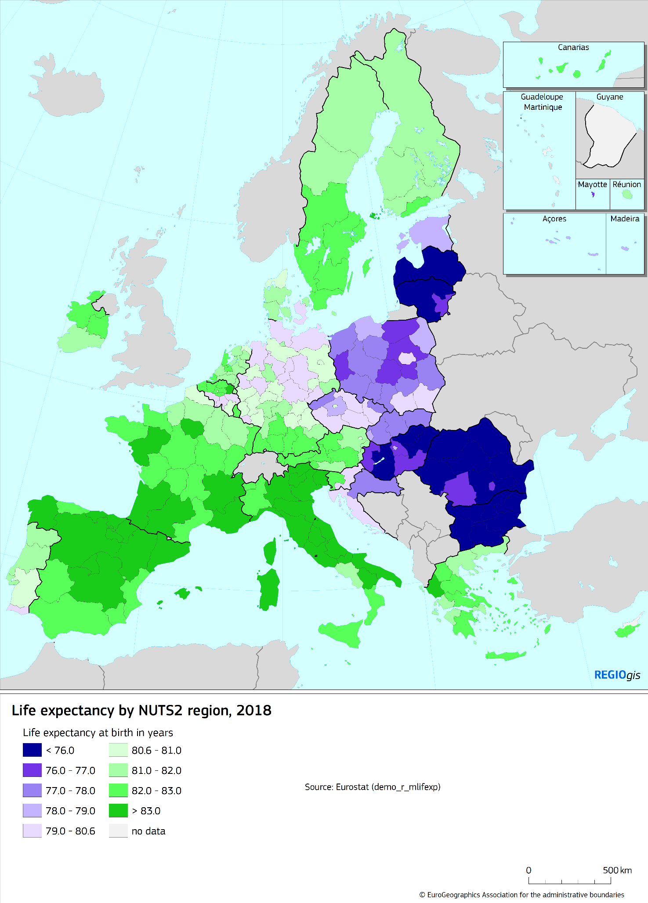

## 2.2. FEWER BIRTHS

From the 1960s until the mid-1990s, the average number of childbirths per woman in Europe decreased[11]. It recovered somewhat in the 2000s and then roughly stabilised in the decade that followed.

In 2018, the figure stood at 1.55 children per woman. This is below the value of 2.1 considered to be the level required to keep the population size constant in the absence of migration. Almost no region in Europe has a rate at this level[12], with some regions registering a rate of less than 1.25. This is the case for instance in the north-west of the Iberian peninsula, South East Italyand Sardinia, and some parts of Greece.

Women are also on average giving birth to their children later in life. Between 2001 and 2018, the mean age of women at childbirth in the EU went from 29.0 to 30.8.

**Fertility indicators, EU-27, 2001–2018**

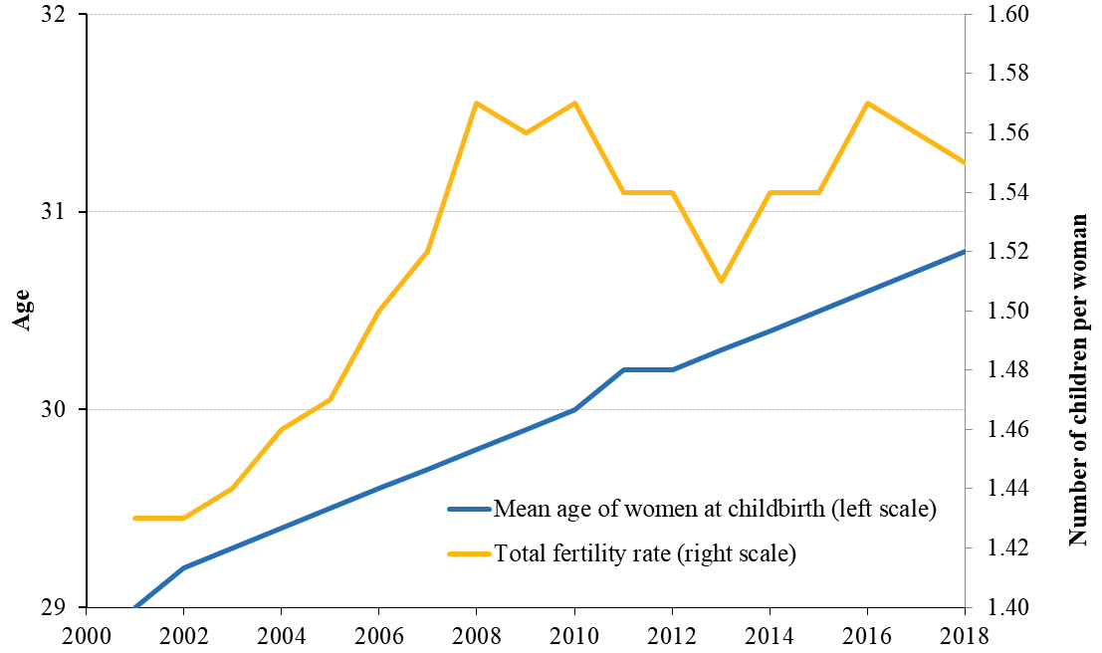

*Source: Eurostat*

**Total fertility rate by region[13], 2018**

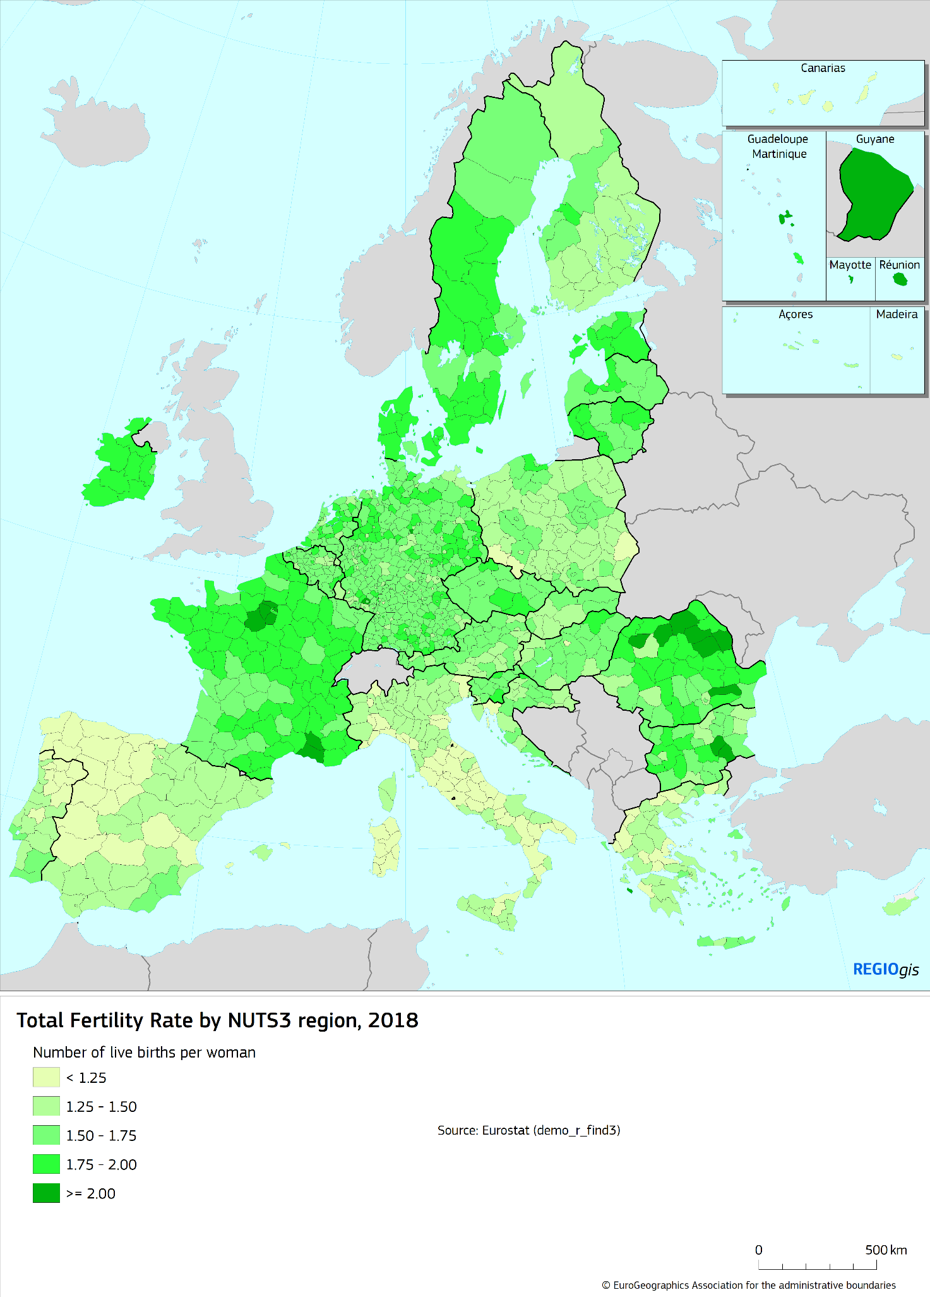

## 2.3. AN AGEING POPULATION

**Europe’s population is getting older**.The median age[14] of the EU-27 population has been increasing for years and is projected to increase at a similar pace for another two decades. The median age may reach 49 in 2070 – up around five years from today.

**Median age of EU-27 population, 2001-2070**

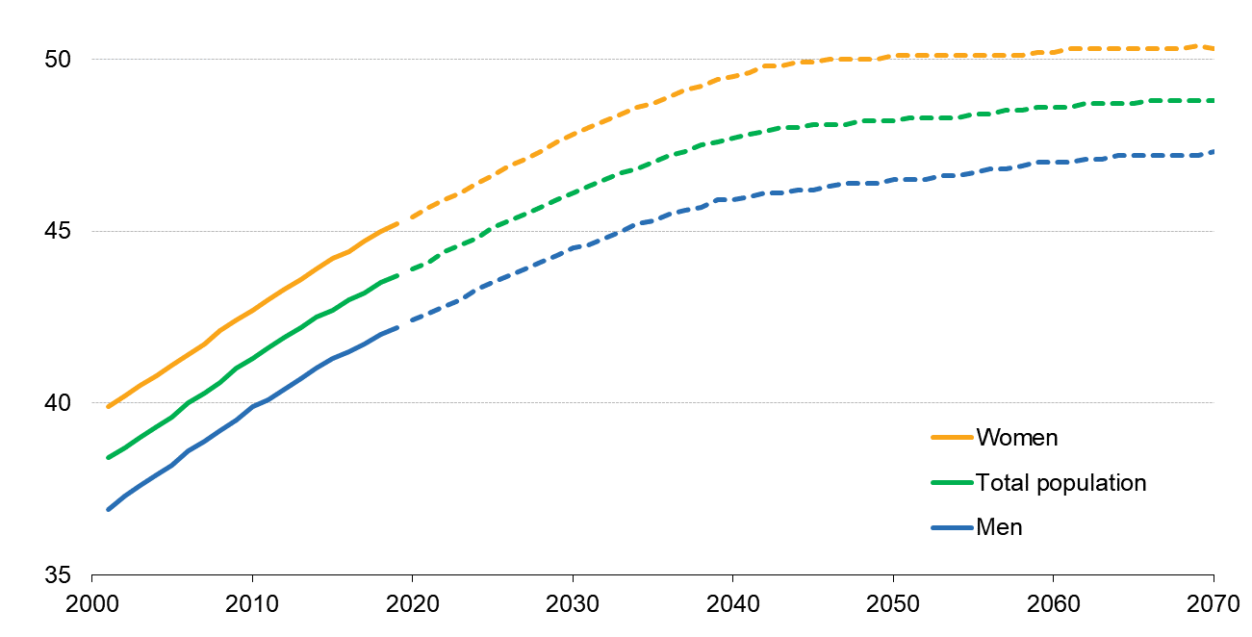

*Source: Eurostat*

**As our median age increases, so does the** **number and share of people in the older age groups**. By 2070, 30% of people in Europe are estimated to be aged 65 and above, up from about 20% today. From 2019 until 2070, the share of people aged 80 or over is projected to more thandouble to 13%[15].

**At the same time, the working-age population (20-64 years)[16] is projected to decrease**. In 2019,it amounted to 59% of the entire population. By 2070, it is projected to be down to 51%. In that time, the number of children and young people (aged 0-19) is projected to decrease by 12.6 million.

**Population by age groups, EU-27, 2001-2070**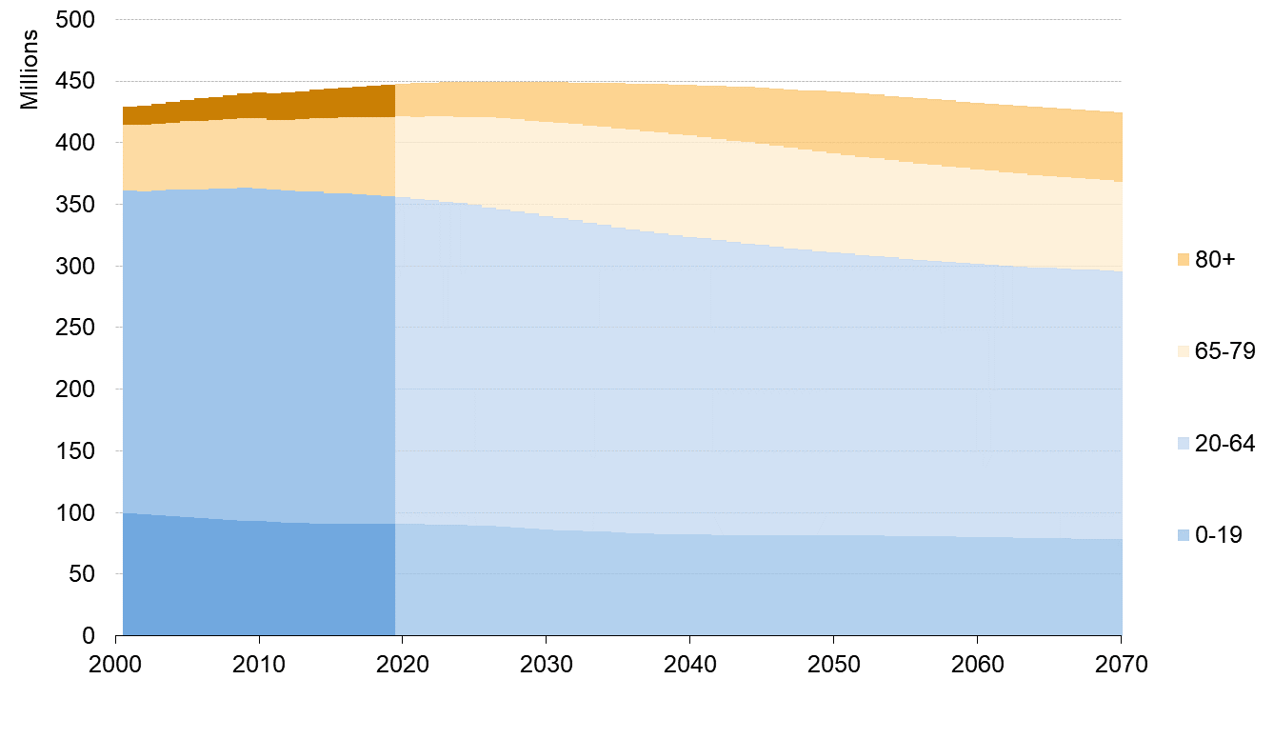

*Source: Eurostat*

## 

## 2.4. SMALLER HOUSEHOLDS

**As the number of households in Europe goes up, their average size goes down**.In 2019, there were 195 million households in Europe, an increase of 13 million since 2010. Those households are on average getting smaller. In 2010, the average household consisted of 2.4 people. Over the last decade, it was decreasing slowly and by 2019, it was down to 2.3.

**About a third of all households consist of a single person** – a 19% increase since 2010. The overall trend is towards households consisting of couples without children, persons living alone and single parents. In the majority of households, there are no children while single parent households have gone up by 13% since 2010. Such patterns may also play a role in the context of the pandemic, where particular household structures may have affected the spread of the virus.

As Europe gets older, **a growing number of people aged 65 and above will live alone**[17]. This applies especially to women. In 2019, the share of older women living alone was 40%, more than double the figure for men.

**Households by presence of children, EU-27, 2010-2019** *(in millions)*

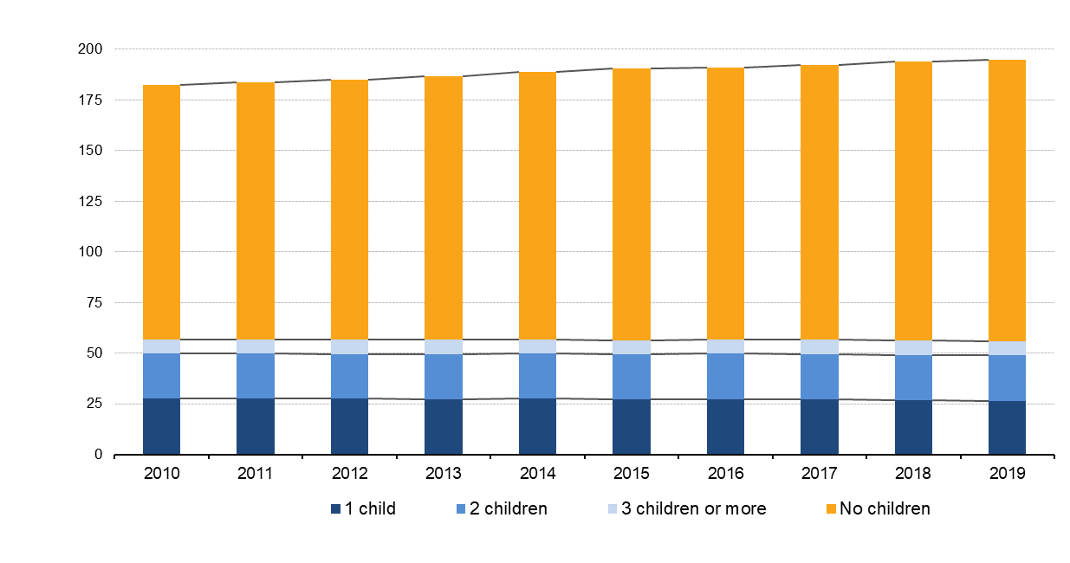

*Source: Eurostat*

## 2.5. A MORE MOBILE EUROPE

**The movement of people, both within and beyond Europe’s borders, is a key driver of demographic change**.

**Some people cross the EU’s external border**, moving in or out of Europe. In 2018, 2.4 million people immigrated into the EU-27, while 1.1 million people emigrated to a non-EU-27 country[18]. Thanks to the free movement of people in Europe**, many people choose to move within the EU.** These movements have no effect on the size or age structure of the EU as a whole – but they have a significant effect at national, regional and local level. In 2018, 1.4 million people moved to another Member State. This group also includes third country nationals living in Europe.

On 1 January 2019, there were 21.8 million third country nationals in the EU-27 population, representing 4.9% of the population. 13.3 million EU citizens were living in another EU country.

**The yearly size of these flows can change but the long-term trends are relatively stable**. In the last 35 years, Europe has been a continent of net immigration. Since the mid-1980s, each year more people moved into the EU than left, resulting in positive net migration.

It remains to be seen how emergency measures limiting the mobility of people will affect mobility patterns and preferences in the longer term. This includes whether those who have lost jobs and livelihoods in one place may seek opportunities elsewhere again.

**Net migration, EU-27, 1961-2018**

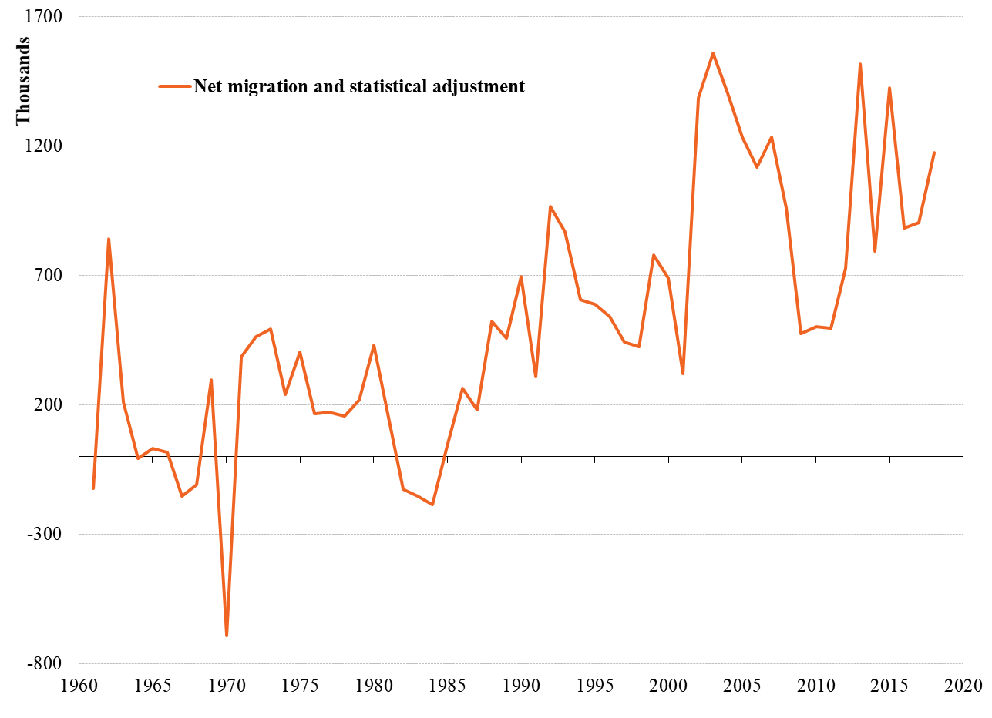

*Source: Eurostat*

## 2.6. A CHANGING POPULATION SIZE

**Europe’s population has grown consistently over time.** In the EU-27, the total population has grown by a quarter since 1960, up to just under 447 million in 2019. However, there are differences between countries. While Belgium, Ireland, Cyprus, Luxembourg, Malta and Sweden have seen a relatively steady increase, Bulgaria, Croatia, Latvia, Lithuania and Romania have seen their population decline after 1990[19].

**The overall trend of population growth is set to continue – but not for long.** Since 2012, the number of deaths in the EU-27 has exceeded the number of births. This means that without positive net migration, Europe’s population would have already started to shrink**.**

Projections[20] show that the size of Europe’s total population will remain rather stable for the next two decades and then start declining. **It is projected to reach a plateau of about 449 million people before** **2025** **and then decrease progressively after 2030** to 424 million by 2070 – a 5% reduction in 50 years.

Some Member States are projected to have a declining population over the entire period until 2070, namely Bulgaria, Greece, Croatia, Italy, Latvia, Lithuania, Hungary, Poland and Romania. Some are projected to experience population growth up to 2070: Denmark, Ireland, Cyprus, Luxembourg, Malta and Sweden. Others are projected to see an initial growth followed by a decline, and these are Belgium, Czechia, Estonia, Spain, France, Germany, Netherlands, Austria, Portugal, Slovenia, Slovakia and Finland.

**Total population and annual population change, EU-27, 1960-2070**

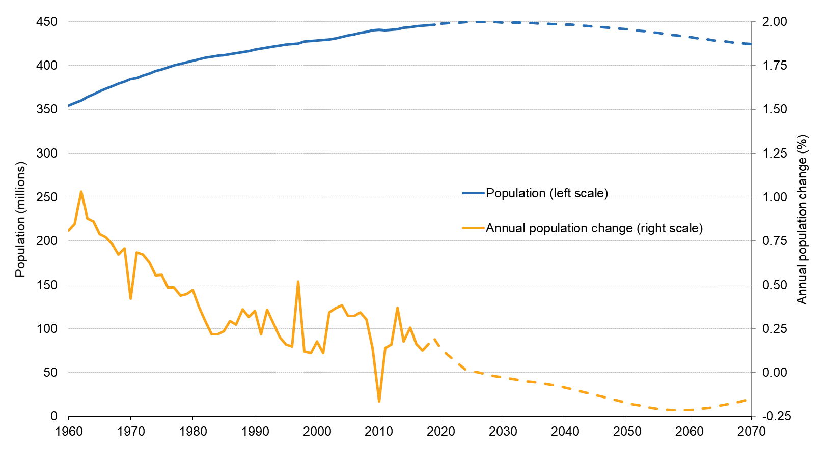

*Source: Eurostat*

# THE IMPACT OF DEMOGRAPHIC CHANGE ON OUR SOCIAL MARKET ECONOMY

The impact of Europe’s demographic change can be felt right across our economy and society. This has become evident in recent months with large parts of the economy brought to a standstill and necessary social distancing measures affecting our everyday lives. It has implications for the future of our welfare and health systems, budgets, housing and infrastructure needs. Our cities and urban areas will potentially become more crowded and rural areas will face their own set of challenges. Our careers will continue to change and we will have to find solutions to ensure Europe stays competitive in the face of a shrinking working-age population.

A country’s economic and demographic structure will be a factor in the speed and ability to recover. There will be other points where long-term demographic change and recovery needs are matched. This includes everything from the need to make our healthcare and long-term care systems more resilient to ensuring our urban and rural areas can cope with population density or a lack of services.

The Commission Recovery and Resilience Facility will provide large scale financial support to make Member States economies more resilient and better prepared for the future, notably for demographic change. The investment priorities will be in line with the challenges identified in the Country Specific Recommendations in the European Semester.

## 3.1. PEOPLE, WORK AND SKILLS

**The impact of demographic ageing on the labour market is becoming more pronounced.** The EU-27’s working-age population has been shrinking for a decade and is projected to fall by 18% by 2070. The situation differs significantly between Member States and regions.

**Change in population aged 20-64 by region[21], 2020-2030**

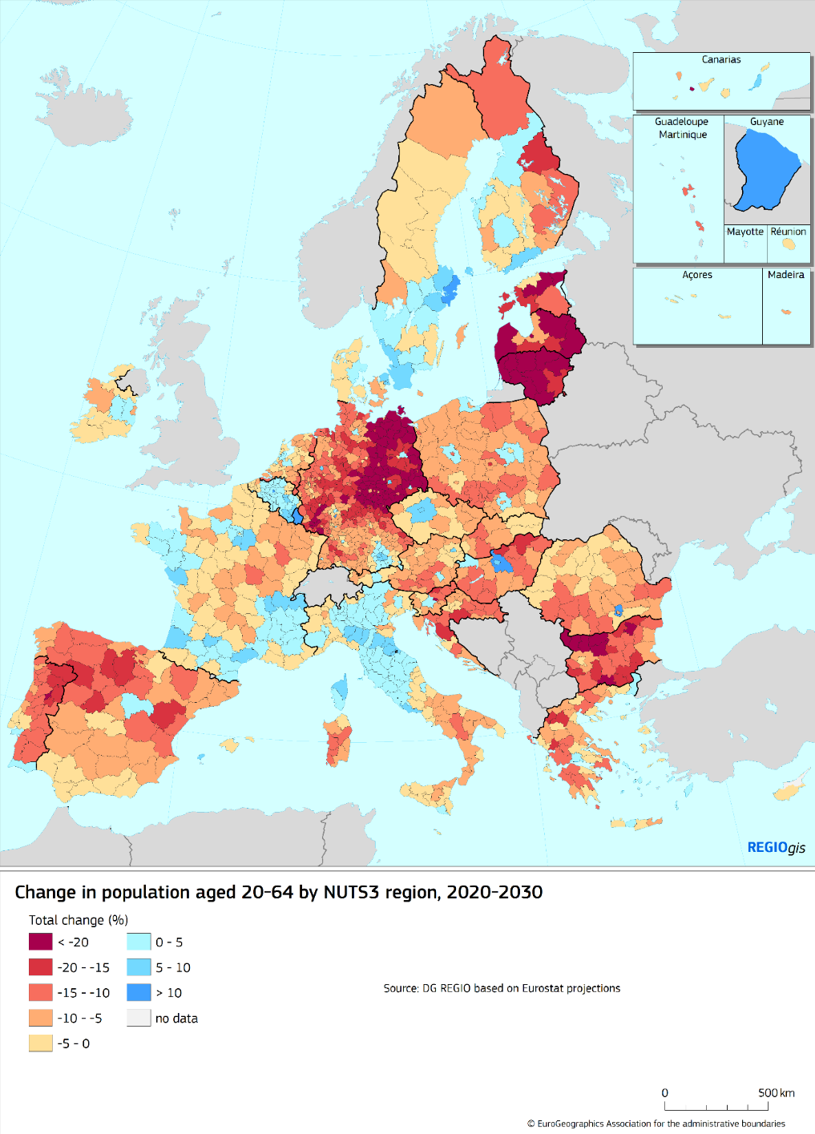

Economic projections made in 2018 estimated that **the number of employed people could peak around 2020,** followed by a steady decline over the course of the next decades[22]. While it is too early to tell whether the current crisis will change long-term projections, the first forecasts done since the start of the outbreak[23] estimate significant contractions of employment. Depending on how the virus spreads, this could result in even fewer people being active at the same time. Combating unemployment, in particular of young people, and attracting more people to the labour markets will therefore become an even more pressing challenge.

It is also clear that the impact of a smaller working-age population will be felt stronger and faster unless and until more people currently underrepresented join or participate more in the labour market.

**Working age population (20-64), EU-27, 2001-2070**

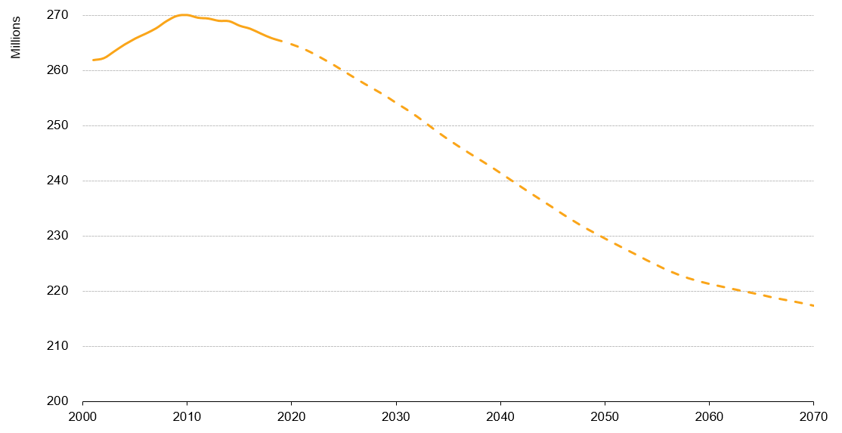

*Source: Eurostat*

## 3.1.1 A LARGER AND MORE INCLUSIVE LABOUR MARKET

The shrinking working-age populationunderlines the need for Europe and its labour market to draw on all of its strengths, talents and diversity.

**Boosting the employment rate of women will be of critical importance**. The employment gap between women and men stood at 12% in 2019. This is even more pronounced when taking into account the significant difference in the uptake of part-time work between men and women. In 2019, around three out of 10 employed women were working part-time, almost four times the figure for men. Such situations may have been felt even more acutely during the pandemic where the care of the elderly, persons with disabilities or children has had to be organised privately and has largely fallen upon women. A lack of adequate formal long-term care services, of flexible working opportunities and of incentives for second earners in some Member States all play a part in accentuating this issue.

At the heart of this lies the challenge of **reconciling work and family life**. In 2019, the employment rate for women with children less than 6 years old was almost 14 percentage points lower than for those without children. Women still also receive lower pay for their work than men, with the gender pay gap currently at 14.8%. The Commission is addressing these issues as part of its work on equality and through the new **EU Gender Equality Strategy 2020 - 2025**[24].

**Making further progress in bringing older workers** **into employment would also help**. In 2019, the employment rate of older workers (aged 55-64) stood at 59.1% for the EU 27, up from 44.1% in 2009. Making further progress would require policies that enable people to work longer, stay fitter and maintain their skills up-to-date, and recognising new skills and qualifications. In the medium term, population ageing will likely require more people to work longer. The upcoming **Green Paper on Ageing** will focus on this issue in more depth, taking full account of the vulnerabilities that have emerged during the pandemic.

**Investing in the qualifications of people with low educational levels** will continue to be essential. Over 10% of young people between 18 and 24 leave education or training with low or no qualifications, exceeding 20% in the outermost regions. Among these “early school-leavers”, 45% are in employment. The work on making the European Education Area a reality by 2025, revamping the European Research Area and supporting youth employment will be important tools to redress the balance.

**Bringing more people from different backgrounds into employment** would contribute to further increasing the employment rate. The employment rate for people born outside the EU is 9.6 percentage points lower than for those born within the EU and is particularly low among women. The situation for third-country nationals provides a similar picture.

**Opening up the labour market to people with disabilities** would contribute to a fairer society and address the impact of demographic change. However, the employment rate of people with disabilities in the EU is low due to the many barriers they face, including discrimination and lack of accessibility in the work place, in accommodation and high quality education. Such barriers can be rooted in negative perceptions and an unfair reluctance to hire people with disabilities.

**Having a larger and more inclusive labour market** means combating all forms of discrimination, based on sex, racial or ethnic origin, religion or belief, disability, age or sexual orientation. Social economy actors and enterprises can play an important role in fostering a more inclusive labour market, to the benefit of workers and local communities.

## 3.1.2. PRODUCTIVITY THROUGH SKILLS AND EDUCATION

**As the pool of those working starts to shrink, economic resilience and productivity growth will become all the more important**. This will also be important for a sustainable recovery from the crisis. Prior to the coronavirus outbreak, Commission projections showed that stabilising GDP growth at 1.3% per year until 2070 would require labour productivity to grow by 1.5% a year on average[25]. However, productivity growth has been declining and was estimated at below 1% before the crisis started.

**The transition to a climate-neutral and digital economy can help boost productivity.** The twin transitions will require innovation and technological diffusion, with a more circular and digital economy creating new business models and ways of working. The pandemic and its consequences on our lives and economies have highlighted the importance of digitalisation across all areas of the EU’s economy and society. It will also need competition and a level playing field, as set out in the recently adopted **New Industrial Strategy for Europe**[26].

Automation and new, cleaner technologies can help boost labour productivity in the future, a just transition for all will be essential for those who will have to learn new skills or change jobs.In this spirit, the Commission has proposed to strengthen the Just Transition Fund - to alleviate the socio-economic impacts of the transition, supporting re-skilling, helping SMEs to create new economic opportunities, and investing in the clean energy transition.

**Europe needs a highly-skilled, well-trained and adaptable workforce[27].** Making lifelong learning a reality for all will become all the more important. In the coming years, millions of Europeans will have to upskill or reskill. Better attracting skills and talent from abroad will also help to address labour market needs.

As the twin transitions gathers speed, Europe will need to ensure that its skills keep pace, including green and digital skills. Before the crisis, there were around 1 million vacancies in Europe for digital experts and 70% of companies reported that they werer delaying investments because they could not find the people with the right skills. This is because 29% of the EU population had low-level digital skills in 2019, whilst 15% had none at all. The crisis has further highlighted the importance of digital skills, for children, students, teachers, trainers and all of us to communicate and work. It has shown that many still do not have access to the necessary tools. The Commission will come forward with a **Digital Education Action Plan** to provide concrete actions to address these challenges**.**

**The solution lies in investment in people and their skills and improving access to training and education.** This will require collective action of industry, Member States, social partners and other stakeholders to contribute to up- and reskilling and to unlock public and private investment in the workforce. The update of the **Skills Agenda**, and the recommendation on Vocational Education and Training, will also be important steps to achieve this.

## 3.2. HEALTH AND LONG-TERM CARE

Europe’s healthcare and long-term care systems have been at the forefront throughout the COVID-19 pandemic[28]. They have been put under severe strain in the fight against the virus and were already under increasing pressure, not least as a result of the ageing of our society**.** This particularly affects those regions projected to have a significant increase in over 65 year olds between now and 2030.

**Change in the share of population aged 65 and over by region[29], 2020-2030**

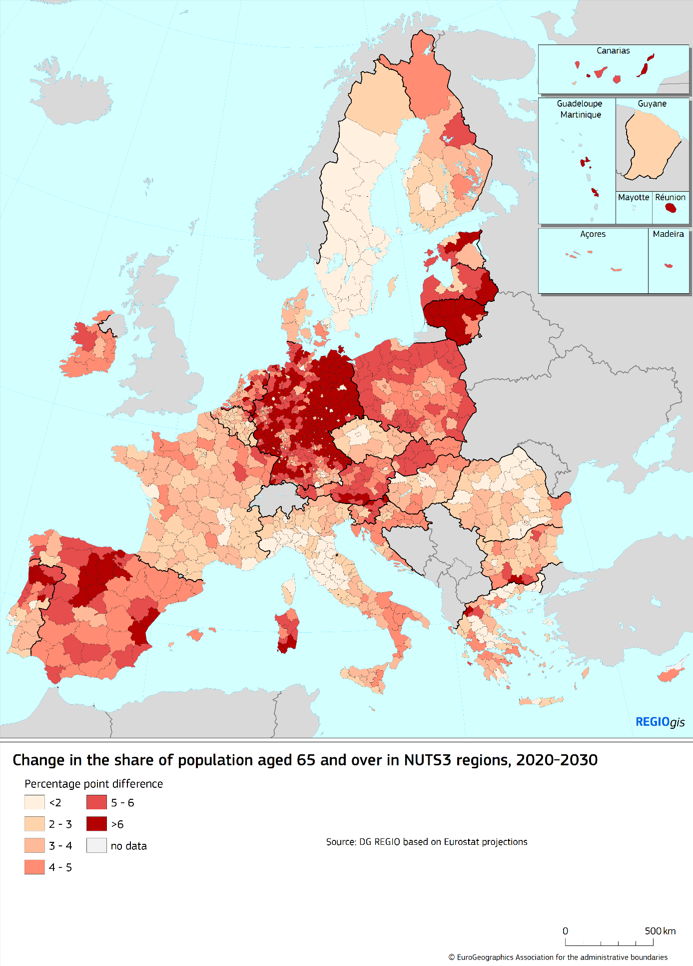

The outbreak of the Coronavirus exposed the vulnerability of older people to pandemics and other diseases, notably because they are more likely to have underlying health conditions. It has also highlighted the need for robust public health systems and the need for higher capacities of intensive care units.

More resilient health systems need proper investment and financial support that matches their leading role. This is why the Commission has recently proposed a standalone EU4Health programme to support Member States and the EU to build up capacity and preparedness[30]. It will help deliver a long-term vision for well-performing and resilient public health systems, notably by investing in disease prevention and surveillance, and improving access to healthcare, diagnosis and treatment for all. It can also be the starting point of a debate about what more we can do together to face up to crises, but also more generally in the health sector.

**The growing burden of chronic diseases will also be a challenge for Europe’s healthcare systems**. These diseases already account for an estimated 70-80% of healthcare costs.[31]Currently, around 50 million European citizens suffer from two or more chronic conditions[32], and most of these people are over 65. As part of efforts to step up prevention, the **Farm to Fork Strategy[33]** aims to equip Europeans with more information and support them to make better dietary choices. Given the higher risks linked with chronic diseases, the work on **Europe’s Beating Cancer Plan** will be essential for our health and that of our health systems. Sports and physical activity can also play in important role in health prevention and promotion.

The demand for professional staff is expected to rise in line with the demand for health and long term care. There are already indications of labour shortages[34] in the health[35] and long-term care sector. On-going work of the OECD on the staff employed in the long-term care sector[36] points to the importance of improving working conditions in the sector and making care work more attractive. Despite the rising number of doctors and nurses over the past decade in nearly all EU countries, shortages of general practitioners persist, particularly in rural and remote areas and the outermost regions.

The main challenge is **meeting a growing demand for sufficient, accessible, good quality and affordable health and long term care services** **as enshrined in the European Pillar of Social Rights**. Ensuring a high level of human health protection[37] requires the right infrastructure, such as hospitals, long-term care homes and housing adapted and equipped for older people. Contrary to healthcare, social protection for long-term care does not exist in all Member States. Formal long-term care is expensive and is often taken on by the person in need or their family. As Europe’s population gets older and households get smaller, this is likely to be a continued challenge for many.

**The emerging “*silver-economy*” can provide opportunities for the health and long-term care sectors.** It can be a driver of innovation to help provide high-quality care services in a more efficient way. Digitalisation can provide elderly people with the possibility to independently monitor their health condition. The impact of digital technologies in health and long term care can be a triple win: improved quality of life, increased efficiency of health and long-term care, market growth and industry development[38]. Research and innovation will be crucial in this regard.

## 3.3. THE IMPACT ON PUBLIC BUDGETS

**An older Europe with a smaller workforce will likely increase pressure on public budgets** – at a time when recovery efforts require significant funding. Before the crisis, the total cost of ageing[39] in the EU was projected to account for 26.6% of GDP by 2070.

Europe will face a major challenge in funding its age-related spending, in a way that is also **fair across generations**. This is because the ratio between people paying taxes and social security contributions and those receiving pensions and other benefits is decreasing rapidly. In 2019, there were on average 2.9 persons of working-age for every person above 65. In 2070, this ratio is projected to fall to 1.7.

While most age-related spending will be on health and long-term care, expenditure for public pensions is also projected to rise relative to GDP until 2040. Thanks to the impact of **substantial reforms of pension systems in most Member States**, it is subsequently projected to grow more slowly than GDP, returning to about the same share of GDP as in 2016, although in a number of Member States recent pension reforms will lead to higher projected pension expenditure.In designing solutions to these issues, **policy makers have to deal with a high degree of uncertainty**. The manner in which public expenditure will develop depends not only on demographic trends but also on other factors such as technological progress in diagnostics, treatments, pharmaceuticals and medical devices, or increased demand for publicly provided health and long-term care[40]. All these entail additional costs over the medium and long-term. Without policy change, increasing pressure will also be put on private expenditure, as people in long-term care may have to cover a higher share of overall costs.

Most existing projections mostly work with the age of 65 as the upper limit of those in the group of working-age population. However, in the future more people will remain in employment later in life. Taking a higher-upper limit changes the projections significantly. However, all evidence shows the importance of good working conditions, strong public health systems, life-long learning and continued investment in skills and education.

**Old-age poverty is likely to be a growing concern as demographic change continues**. Today, the majority of retired people have an income from pensions that enables them to maintain their living standard and protects them against old-age poverty[41]. This does not mean that old-age poverty has been eradicated among people above the age of 64. In 2018, in the EU-27, 15.5% of people aged 65 or above were at risk of poverty[42].

**Women are more likely to be affected by old-age poverty.** This is because they tend to have lower employment rates, more career breaks, lower wages and they work more in part-time[43] and temporary work[44]. Women receive monthly pensions that are about one third lower than those of men, while they have a longer life expectancy.

**Persons with disabilities, a group at higher risk of poverty, may face additional risks.** Working age people with a disability are often eligible for specific benefits and support. However, when they reach the pension age, they may no longer be eligible, which can be an additional cause for poverty or social exclusion.

**At the same time, an older population also offers new opportunities for our economies.** Older consumers account for a large part of the economy and the consumption of people above 50 across the EU was €3.7 trillion in 2015. It is projected to rise at around 5% per year, reaching €5.7 trillion by 2025. The Commission’s Green Paper on Ageing will also address how we can make the most of these opportunities.

## **3.4. THE REGIONAL AND LOCAL DIMENSION**[45]

**Different regions are affected differently by demographic change**. Some have a relatively elderly population, with a median age over 50 years, while in others it is less than 42.5 years - such as in (or parts of) Luxembourg, Cyprus, Ireland, southern Spain, Poland, northern Romania, Slovakia, and southern Sweden.

At regional level,population movements also have a big impact on a region’s demographic profile. This is acutely felt in places where predominantly young people move. These movements also affect a region’s total population. 65% of the EU population lives in a region that saw population increase between 2011 and 2019. For some, population decline is a protracted trend, often over decades, and more regions can be expected to experience population decline in the next decade and beyond.

To avoid this situation to be further exacerbated as a consequence of the pandemic, the Commission has proposed to dedicate additional resources for cohesion policy for crisis repair and recovery measures through a new initiative called REACT-EU[46]. The proposed recovery instrument, Next Generation EU foresees additional support to ensure funding for key crisis repair measures and to support workers and SMEs, health systems and the green and digital transitions in the regions. In addition, the EU Rural Development Programme will play a crucial role in supporting the recovery.

**Total population change by region[47], 2011-2019**

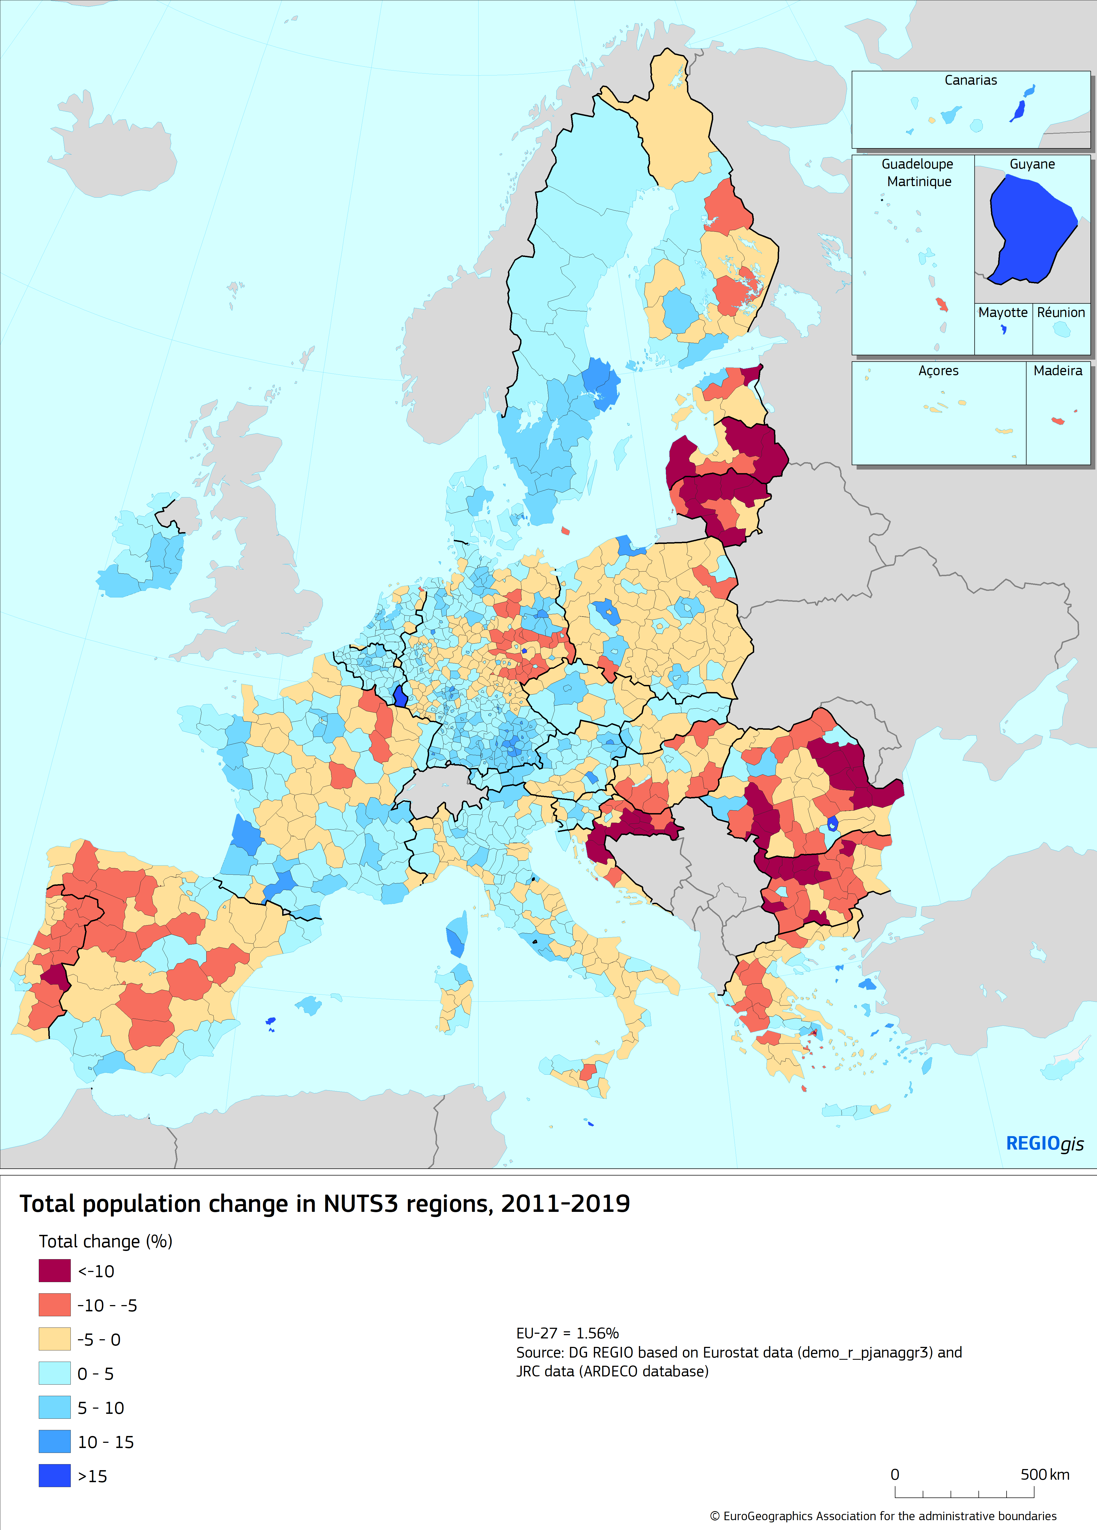

**Demographic change plays out differently in urban and rural regions.** Regions in the EU belong to different categories, depending on whether they are more urban or more rural in nature, or in between. Each of the three categories has its own characteristics. The population size and density of settlements decreases from urban, to intermediate and to rural regions. During the pandemic, population density and the category of region appear to have been a factor in the spread of the virus. It is estimated that the virus arrived earlier in urban regions and spread faster as compared to intermediate and rural regions[48].

**EU-27 population by urban-rural regional typology, 2019**



*Source: Eurostat*

**In rural regions, the population dropped by 0.8 million between 2014 and 2019.** However, this tells only part of the story. In some Member States these regions grew by more than 0.2% a year while in others they decreased by the same amount. In eight Member States, rural regions have been losing population since 1991: the three Baltic States, Bulgaria, Croatia, Hungary, Portugal and Romania. Recent work by the OECD shows that regions close to cities tend to grow, while the more remote regions[49] tend to lose population.

**Urban regions in the EU present a different picture – their population grew by 3.8 million over the same period**. However, in Latvia and Greece it dropped by 0.3% and 0.6% respectively. 22% of the urban population lived in a region that lost population between 2014 and 2019. In fourteen Member States, all urban regions gained population.

### 3.4.1. QUALITY OF LIFE, INFRASTRUCTURE AND ACCESS TO SERVICES

Every part of Europe seeks to provide services and infrastructure to serve the needs of its population. Whether the population grows or declines, the services and infrastructure need to be adjusted accordingly, whether on transport, digital, housing, schools, health and long term care and social integration.

The impact of demographic change on a specific region depends very much on the pace and size of the population change, and whether a region has the means to cope with this change**.** Most regions that experience rapid population growth have a GDP per capita above the EU average, while regions with rapid population decline tend to have a comparatively low GDP per capita. Regions that have a low income and suffer from rapid population change face the most challenging situation.

31 million people, or 7% of the EU population, live in a region that face the ***twin-challenge* of rapid population decline and low GDP per head**. Many of these regions are in the Baltic States, Bulgaria, Croatia, Hungary, Portugal and Romania. There are also some regions in this situation in Greece and Spain as well as a few regions in eastern Germany, France and Poland.

Addressing the impact of local and regional demographic change needs to factor in what makes people want to move to or leave a region. This often comes down to employment opportunities and the quality of life. The quality of life in a specific region can be influenced by many different factors, be it the natural environment, access to services (such as childcare, accessibility for people with a disability, good quality education, healthcare, long-term-care, housing, leisure and cultural services) or the availability and quality of the infrastructure (such as roads, rail, energy supply, access to internet).

**Accessibility and connectivity will** **become more important for a region’s outlook**. They influence a region’s economic outlook and potential to offer attractive jobs. As Europe embarks on its green transition, the need for clean, frequent, accessible and affordable public transport will play an increasing role in a region’s attractiveness. As Europe becomes ever-more digital, people will expect high-quality access to next generation broadband. Next generation broadband access can help bridge the urban-rural divide in the digital area.

**Coverage of Broadband Next Generation Access**



**Investments in infrastructure and services, also through cohesion policy, are an essential part of the solution**.Infrastructure has many different dimensions, including the availability of digital services (including access to information and communication technology and 5G coverage), education and healthcare services, as well as leisure and culture.

**Accessibility by rail by region[50], 2014**

Regional initiatives can improve quality of life, access to services and infrastructure, and address the negative impacts of depopulation. For example, local business environments can be improved through business support services, incentivising innovation and research. Community-led local development can respond to citizens’ needs and improve local quality of life. A swift agreement on the next long-term EU budget, and its recovery instrument Next Generation EU[51], will ensure that EU funds and cohesion policy programmes can play an important role in supporting this work.

**The key question for public policies is how to develop sustainable solutions**. The regional and local level has shown its ability to innovate and manage demographic change in a smart way. Drawing on this experience will be essential to share best practice and scale-up innovative ideas, products or services.

**Any policy-response to deal with challenges at a regional level has to zoom-in on the situation on the ground.** This reflects the fact that the situation is different between and within each country, with a larger rural-urban divide in some areas and counter-trends elsewhere. In 2018, the share of the population at risk of poverty was particularly high among people living in cities in much of Western Europe, while in eastern and southern parts of the EU this applies to those living in rural areas**.**

In cities, the use of energy, transport and land is more efficient. It is easier to organise and maintain public infrastructure, such as public transport or access to internet, and access to social services, for example in the care sector. The matching of skills supply and demand tends to be easier, which results in higher productivity and income per head. Cities have better access to good quality education, including more higher education institutions, which can help generate innovation[52].

On the other hand, **high population growth rates in cities needs to be well managed to avoid further increasing congestion, pollution and housing costs**[53]. Cities will also have to adjust their services in areas such as healthcare and mobility, as well as public infrastructure, housing, education and social policy to cater to the changing demographics. Given the strong link between ageing and disability, this also includes improving accessibility, notably of products, services and infrastructure.

**Rural areas are abundant in land, and enjoy a lower cost of living and low levels of air pollution**. However, they also face a number of challenges, in particular in ensuring good access to public and private services. Rural areas that are faced with a significant population reduction may experience land abandonment and increased risk of forest fires[54] and it generally becomes harder to attract new investments. One cause of concern is the decreasing number of young farmers and the importance of “generational renewal”.

A key question for rural areas is whether they are close to a city or far away from any functional urban area. Rural areas that are close to a city may have frequent interactions with that city. People may work in the city but live outside, commuting every day. This pattern brings specific requirements, for example for transport. There can be a specific division of tasks, for example, with the city offering access to hospitals, including to the people who live in the rural area nearby.

On the other hand, some rural areas are not in the vicinity of any bigger city. In this case, rural development faces different challenges, for example, the preponderance of the primary sector and associated value chains[55] or lower population and economic growth[56]. Economic decline in specific regions is not only a challenge for territorial cohesion, but it can also lead to a geography of discontent. If people start feeling left behind, they may lose faith in the fairness of our economy and democratic institutions.

All of these questions and more will be addressed in a **Commission Long-term Vision for Rural Areas** which will be presented next year, following a wide ranging public consultation and taking into account the various aspects highlighted by the COVID-19 pandemic.

## 4. THE TWIN TRANSITIONS AND DEMOGRAPHIC CHANGE

**Demographic change and the twin green and digital transition will often affect or accelerate each other.** Strategic foresight can be an important tool to identify and predict challenges that will affect each of these transitions and better prepare policies to address them together.

The pressures created globally by demographic change are likely to be exacerbated by the impact of climate change and environmental degradation. Business as usual would mean a huge and simultaneous increase in the global need for food, energy and water in the next decades: 60 percent more food, 50 percent more energy and 40% more water by 2050[57].

As set out in the European Green Deal and the Climate Law[58], Europe will transition to a climate neutral and resource efficient economy over that same time**.** This reinforces the need for clean energy, sustainable and smart mobility, a shift to a more circular economy and a big step up in the protection and restoration of our biodiversity. The recent lockdowns due to the COVID-19 pandemic have shown us the value of green urban spaces for our physical and mental wellbeing. Many European cities have also taken steps to make active mobility, such aswalking and cycling, a safer and more attractive option during the pandemic. To facilitate this work, the Commission will in 2021 set up an EU Urban Greening Platform, under a new ‘Green City Accord’ with cities and mayors.

As cities become more crowded, urban areas will have to continue and step up their efforts towards urban green spaces, which can also act as carbon sinks, helping to remove emissions from the atmosphere. The implementation of the **Circular Economy Action Plan,** and the **EU Biodiversity Strategy** and **Farm to Fork Strategy** as well as the **upcoming revised EU Strategy for Adaptation to Climate Change,** address many of these issues.

**Climate change and biodiversity loss are expected to significantly influence migration patterns**. This is because changes in the environment, such as desertification, ocean acidification, and coastal erosion, directly impact people’s livelihoods and their capacity to survive in their places of origin’[59]. It is predicted that this trend will only continue as the effects of climate change become more pronounced. According to the World Bank, up to 143 million people in Sub-Saharan Africa, South Asia, and Latin America could be displaced within their own countries by 2050 if no climate action is taken[60].This reinforces the need for Europe to be the global leader on climate and environment measures, notably by implementing the European Green Deal and stepping up its Green Deal diplomacy across all of its policies and partnerships

The digital revolution and the rapid diffusion of the Internet has already changed peoples’ lives and habits. Digitalisation can boost productivity and economic growth but uneven access to the internet is generating a digital divide that is becoming an important dimension of inequality. In addition to that, insufficient digital skills and strong divergence in skills levels between countries and regions and a lack of accessibility might aggravate this divide.

The current crisis has underpinned the urgency of turning this digital transition into a reality for everyone as fast as possible: with social distancing measures in place across Europe, many people have had to work from home or resort to internet or mobile applications to socialise with family and friends. The access to reliable and fast internet and being able to use digital tools have become all the more essential for businesses, workers and the self-employed.

## 5. THE GEOPOLITICS OF DEMOGRAPHICS: EUROPE IN THE WORLD

Demographic change also has an impact on Europe’s geopolitical outlook and position in the world. Population and economic size plays an important role in the world’s power structures. As Europe’s nations become smaller and less economically powerful relative to other emerging economies, the need for the European Union to use all of its collective weight becomes all the more important. At the same time, as we are seeing during the pandemic, a virus knows no border and creates challenges common for many parts of the world.

**Europe’s share of the world population is diminishing**. In 1960 the population of EU-27 made up about 12% of the world’s population. That is down to about 6% today, and is projected to fall to below 4% by 2070. The other notable development is the rise of Africa’s share in the world’s population: it would rise from 9% to 32%, while the share of the population in Asia would decrease somewhat[61].

**World population by continent, 1960-2070**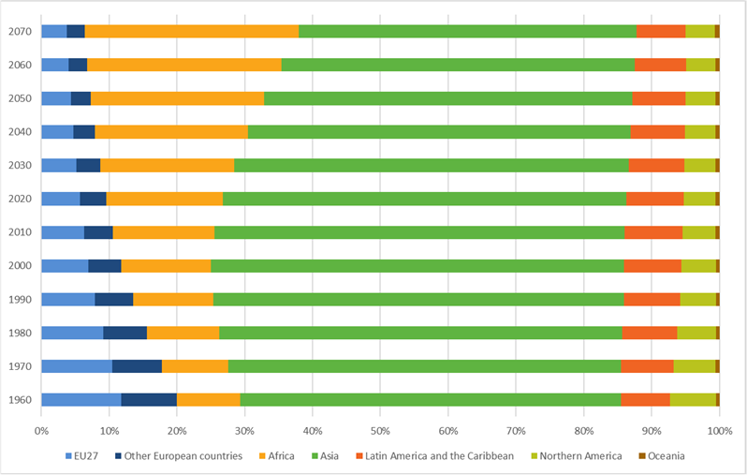

*Source: United Nations, Department of Economic and Social Affairs, Population Division (2019).*

**Europe is not the only continent that is ageing, but it is the oldest on average.** When comparing the trend in Europe with other parts of the world, it becomes clear that other continents go through a similar process of ageing, albeit with a time lag as compared to Europe. Projections show that the average age in Africa will also increase over time but it is expected to stay the youngest continent between now and 2070.

**Median age of the world population by continent, 1960-2070**

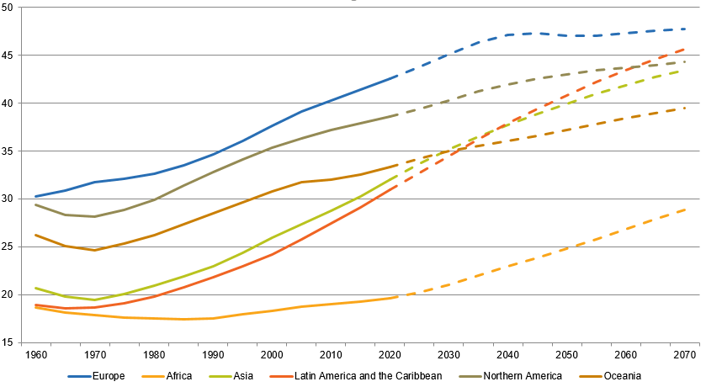

*Source: United Nations, Department of Economic and Social Affairs, Population Division (2019).*

**Europe’s share of global GDP is also shrinking**. In 2004, Europe accounted for 18.3% of the global GDP, shrinking to 14.3% in 2018[62]. With a shrinking working-age population, there is a risk that this trend will continue, or even accelerate. Member States will become smaller economic players but collectively the EU will continue to be a major economic, political and diplomatic player.

Europe will need to be stronger, united and more strategic in the way it thinks, acts and speaks. We will need to strengthen existing partnerships and create new ones, notably with our closest partners and neighbours. The new **Comprehensive Strategy with Africa[63]** is particularly important given the complementary demographic challenges our continents will face. Upholding the rules-based global order and its institutions, such as the United Nations or the World Trade Organization, and playing a more active role in international structures will be all the more important.

## 

## CONCLUSIONS AND OUTLOOK

At this time of extraordinary hardship and uncertainty, the European Union, its Member States and their regions have a shared interest in responding to the impact of demographic change for the benefit of all Europeans.It is part of Europe’s recovery and of building a more resilient, sustainable and fair Union. The way ahead depends on a number of strategic questions, including how to stimulate innovation and productivity; how to bring more people into employment; how to modernise healthcare systems, social protection and social services and how to address territorial disparities

With this in mind, and using the findings in this report as a starting point, the Commission will put forward a **Green Paper on Ageing** and a **Long-term vision for Rural Areas**. The Commission will also look closely at other issues that are highlighted by this report, such as loneliness, social isolation, mental health, economic resilience and long-term healthcare, among others.

This report also shows the need to **embed demographic considerations across EU policy**. The Commission is ready to play its full part, using all instruments at its disposal, notably through the next long-term EU budget and its recovery instrument Next Generation EU. Its recovery efforts will support social cohesion, integration and inclusion, rural development, and education and training. It will support structural reforms where needed and work towards competitive sustainability, making the most of the European Semester*.*

At the same time, it is clear that there is no one size fits all approach. **Policymaking needs to zoom in on the reality on the ground and reduce the disparities between regions**. In this spirit, the Commission will continue to promote upward convergence, ensure a just transition, uphold social fairness, equal opportunities and non-discrimination, notably through the European Pillar of Social Rights and the EU Gender Equality Strategy.

**The twin challenge of democracy and demography must be tackled head-on**. The demographic transformation presents challenges and opportunities for our democracy, some of which have been highlighted by the crisis. If this transformation is well-managed, it will help ensure that our systems of government and participation are dynamic, resilient, inclusive and represent the diversity of society. We need to address the root causes of problems and avoid a "geography of discontent[64]". The Conference on the Future of Europe will be a key platform to listen, learn and find solutions.

While it is too early to draw substantiated demographic lessons from the COVID-19 crisis, the dedicated website launched in parallel with this Report will contribute to the analysis of large-scale comparable statistical data across the Union, once it becomes available, so that they can form a reliable basis for informed policy reflections and decisions.

**On the basis of this report, the Commission will engage in a dialogue** **with relevant stakeholders**, in particular at regional level, and discuss with Member States, EU institutions and bodies, notably the European Economic and Social Committee and the Committee of the Regions.

1. COM(2020) 456 final: Europe’s moment: Repair and Prepare for the Next Generation
2. - The Commission Staff Working Document (SWD(2020) 109 final) complements the report with additional figures, maps and tables.
3. In this report the terms Europe and EU refer to EU-27 unless otherwise specified.
4. Eurostat statistical data used in this report are based on figures taken from the Eurostat database in May 2020.
5. For more information, cf Eurostat’s “Statistics Explained” on mortality and life expectancy statistics:

   <https://ec.europa.eu/eurostat/statistics-explained/index.php?title=Mortality_and_life_expectancy_statistics>
6. Population projections are hypothetical ‘what-if’ scenarios based on observed data to help understand population dynamics. Importantly, projections must not be taken as forecasts. For more information, Eurostat’s population projections: <https://ec.europa.eu/eurostat/web/population-demography-migration-projections/population-projections-data>
7. For more information on the concept and data, see: <https://ec.europa.eu/eurostat/statistics-explained/pdfscache/1101.pdf>
8. For more information see State of Health in the EU, Health at a glance: Europe 2018, OECD/EU (2018) – <https://ec.europa.eu/health/state/glance_en>
9. In 2018, 49% of persons 65 years or older perceived having a disability or long standing activity limitation. (Source: Eurostat online table hlth_silc_06)
10. There are three types of regions used in the common classification of territorial units for statistics, known as NUTS. This map shows NUTS2 regions. The average NUTS2 region in a country has a population between 800,000 and 3 million people.
11. For more information, see Eurostat’s “Statistics Explained” on fertility statistics:

    <https://ec.europa.eu/eurostat/statistics-explained/index.php?title=Fertility_statistics>
12. Out of the 1169 NUTS-3 regions, only four have a fertility rate above 2.1: Mayotte (4.6), Guyane (3.8), La Réunion (2.4) and Melilla (2.3).
13. This map shows NUTS3 regions. The average NUTS3 region in a country has a population between 150,000 and 800,000 people.
14. The median age is a broad measure of how old a population is: half the population is older than the median age while the other half is younger.
15. For more information, see Eurostat’s “Statistics Explained” on population structure and ageing:

    <https://ec.europa.eu/eurostat/statistics-explained/index.php?title=Population_structure_and_ageing>
16. The working-age population is conventionally defined between 20-64 years. As the population ages and more people of 65 years and over remain in employment, this conventional definition may change.
17. Ageing Europe: Looking at the lives of older people in the EU, European Commission (2019).
18. In addition to third country nationals, these figures include EU citizens who return to/or leave from the EU. For more information, see Eurostat’s “Statistics Explained” on migration statistics: <https://ec.europa.eu/eurostat/statistics-explained/index.php?title=Migration_and_migrant_population_statistics>
19. For more information, see Eurostat’s “Statistics Explained” on population and population change statistics:

    <https://ec.europa.eu/eurostat/statistics-explained/index.php?title=Population_and_population_change_statistics>
20. In April 2020, Eurostat published population projections based on 2019 data. At the time of data production, the effects of the COVID-19 pandemics were not known, and they are not incorporated. For more information, see Eurostat’s “Statistics Explained” article on population projections: <https://ec.europa.eu/eurostat/web/population-demography-migration-projections/population-projections-data>.
21. This map shows NUTS3 regions. The average NUTS3 region in a country has a population between 150,000 and 800,000 people. Data corresponds to the Eurostat regional projections (EUROPOP2013).
22. The 2018 Ageing Report: Economic and Budgetary Projections for the EU Member States (2016-2070), Institutional Paper 079, European Commission and Economic Policy Committee (2018).
23. The Commission’s Spring 2020 Economic Forecast, 6.5.2020
24. A Union of Equality: Gender Equality Strategy 2020-2025, adopted on 5 March 2020 (COM(2020)152 final).
25. The 2018 Ageing Report: Economic and Budgetary Projections for the EU Member States (2016-2070), Institutional Paper 079, European Commission and Economic Policy Committee (2018)
26. A New Industrial Strategy for Europe, adopted on 10 March 2020 COM(2020) 102 final.
27. See e.g. Canton, E., Thum-Thysen, A., Voigt, P. (2018) Economists’ musings on human capital investment: How efficient is public

    spending on education in EU Member States? European Economy Discussion Paper 81:

    <https://ec.europa.eu/info/publications/economy-finance/economists-musings-human-capital-investment-how-efficient-public-spending-education-eu-member-states_en>
28. <https://www.ecdc.europa.eu/en/cases-2019-ncov-eueea>
29. This map shows NUTS3 regions. The average NUTS3 region in a country has a population between 150,000 and 800,000 people. Data corresponds to the Eurostat regional projections (EUROPOP2013).
30. For more information on EU4Health, see: <https://ec.europa.eu/health/funding/eu4health_en>
31. <https://data.consilium.europa.eu/doc/document/ST-12983-2013-INIT/en/pdf>
32. State of Health in the EU, Country Health Profiles 2019, SHARE survey (2017).
33. For more information, see: <https://ec.europa.eu/food/farm2fork_en>
34. These shortages can have different causes, including the level of pay and working conditions.
35. State of Health in the EU, Health at a glance: Europe 2018, OECD/EU (2018), p. 178 and 180
36. For more information, see: <https://www.oecd.org/els/health-systems/who-cares-attracting-and-retaining-elderly-care-workers-92c0ef68-en.htm>
37. Article 35 of the Charter of Fundamental Rights of the European Union.
38. The "triple win" is supported by the European Innovation Partnership on Active and Healthy Ageing. For more information, see: <https://ec.europa.eu/eip/ageing/about-the-partnership_en>
39. In the 2018 Ageing Report, the total cost of ageing is defined as public spending on pensions, health-care, long-term care, education and unemployment benefits.
40. For detailed analysis of the drivers of growth in healthcare and long-term care expenditure see: Joint Report on Healthcare and Long-Term Care Systems and Fiscal Sustainability, European Commission and Economic Policy Committee (EPC), 2016.
41. Old-age poverty has two components; people whose income is below 60% of the national median and people who cannot afford at least four among ten essential items (see <https://ec.europa.eu/eurostat/statistics-explained/index.php/Glossary:Material_deprivation>)
42. For a detailed analysis of the impact of demographic change on the adequacy of pensions: The 2018 Pension Adequacy Report: current and future income adequacy in old age in the EU, European Commission and Social Protection Committee (SPC), 2018.
43. In 2018, in the EU-27, 30.5% of women and 9.2 % of men worker part-time (Eurostat, LFS).
44. The share of temporary contracts for people aged 15 – 64 has been stable in recent years. In 2018, it amounted to 12.1% of total employment. The share among women is slightly higher (13.1%) than for men (11.2%) (Eurostat).
45. Regional refers to NUTS3 and local refers to LAU (local administrative units).
46. COM(2020) 451 final, 28.5.2020
47. This map shows NUTS3 regions. The average NUTS3 region in a country has a population between 150,000 and 800,000 people.
48. <http://publications.jrc.ec.europa.eu/repository/handle/JRC120680>
49. For more information, see: [https://doi.org/10.1787/b902cc00-en](https://urldefense.com/v3/__https:/doi.org/10.1787/b902cc00-en__;!!DOxrgLBm!XIOlO0824qKuoP5_CkmxzkAXuVqDihmiPLY6WWZqia09gnpYwaWx4PkOST04llZWbklw13At$)
50. This map shows NUTS3 regions. The average NUTS3 region in a country has a population between 150,000 and 800,000 people.
51. For more information, see: <https://ec.europa.eu/info/publications/mff-legislation_en>
52. For more information, see: <https://ec.europa.eu/regional_policy/en/information/publications/regional-focus/2018/access-to-universities-in-the-eu-a-regional-and-territorial-analysis>
53. For more information, see: <https://urban.jrc.ec.europa.eu/thefutureofcities/ageing#the-chapter>
54. Forest fires — Sparking fire smart policies in the EU, European Commission (2018).
55. OECD, 2018. Policy note Rural 3.0 – a framework for rural development.

    <https://www.oecd.org/cfe/regional-policy/Rural-3.0-Policy-Note.pdf>
56. <https://ec.europa.eu/regional_policy/en/information/publications/regional-focus/2008/remote-rural-regions-how-proximity-to-a-city-influences-the-performance-of-rural-regions>
57. For more information, see: <http://www.fao.org/global-perspectives-studies/en>
58. For more information, see: <https://ec.europa.eu/info/strategy/priorities-2019-2024/european-green-deal_en>
59. For more information, see: <https://news.un.org/en/story/2019/07/1043551>
60. For more information, see: <https://openknowledge.worldbank.org/handle/10986/29461>
61. For more information on the 2019 Revision of UN World Population Prospects, see: <https://population.un.org/wpp/>
62. Source: World Bank, GDP PPP (Purchasing Power Parity) data from database: Wold Development Indicators.
63. JOIN(2020) 4 final, 9.3.2020
64. <https://ec.europa.eu/regional_policy/en/information/publications/working-papers/2018/the-geography-of-eu-discontent>