

Table of Contents

1. Introduction 3

2. General requirements of the MSFD 4

2.1. Main implementation stages in a six-year cycle 4

2.2. Geographic scope 5

2.2.1. Member State marine waters (Article 3(1)) 5

2.2.2. MSFD marine regions and subregions (Article 4) 6

2.3. Regional and subregional implementation (Article 5 and 6) 8

2.4. Integration with other EU legislation 9

3. Determination of good environmental status (Articles 3(5) and 9, Annexes I and III) 11

3.1. Overall objectives of the Directive 11

3.2. The determination of GES is central to MSFD implementation 12

3.3. Provisions of the Directive in relation to GES 13

3.3.1. The definitions of environmental status and good environmental status (Article 3) 14

3.3.2. GES Descriptors (MSFD Annex I) 15

3.3.3. GES elements (ecosystem elements and pressures of MSFD Annex III) 16

3.3.4. GES criteria and methodological standards (Article 9(3); GES Decision) 17

3.4. Relationship between the Directive and the GES Decision 18

3.5. Relationship between GES (Article 9) and assessments (Article 8) 21

3.6. Relationship between GES (Article 9) and environmental targets (Article 10) 21

3.7. Consistency between Member States in the determination of GES (Article 3(5) and 5(2)) 22

3.8. Updating the determination of GES (Article 17(2)) 22

4. An integrated framework for MSFD implementation 23

4.1. An ecosystem-based approach and use of the DPSIR framework 23

4.2. General principles - activities, pressures, impacts and state 24

4.3. The nature of a GES determination – state, impact and pressure 27

4.4. Priorities for MSFD implementation and use of risk-based approaches 29

4.5. Steps in a prioritised implementation process 30

5. An integrated process to determination of GES and its assessment 31

5.1. GES Decision supports an integrated process 32

5.2. Main steps in the assessment and determination process 35

5.3. Elements for assessment of progress towards GES 36

5.3.1. Elements for Article 8(1)(b) assessments: pressures and impacts 37

5.3.2. Elements for Article 8(1)(a) assessments: ecosystem structure, functions and processes 39

5.4. Scales of assessment and assessment/reporting areas 41

5.5. Identifying the GES criteria to be used and how they are assessed 45

5.6. Determining GES: criteria on quality, proportion, distribution and duration 46

5.7. Setting of threshold values 48

5.7.1. Use of reference condition in setting threshold values 50

5.7.2. On setting threshold values at an appropriate scale 52

5.8. GES in relation to ecosystem characteristics, dynamics and climate change 53

5.9. Links to quality standards of other policies 54

5.10. Expressing the extent to which GES is being achieved 56

5.11. Reporting on the determination of GES and the extent to which it has been achieved 57

5.12. Time period for assessments 58

6. Environmental targets (Article 10) 59

6.1. Follow-up actions to Article 8 assessments depend on the environmental status 59

6.2. The nature of environmental targets 60

6.3. Indicators 62

6.4. Reference points 62

6.5. Links to monitoring (Article 11) 62

6.6. Links to measures (Article 13) 63

7. Use of risk-based approaches in MSFD implementation 63

8. Research needs 65

Annex 1. Glossary of terms 67

Annex 2: Quality and proportion aspects of GES – worked examples 80

Annex 3: Criteria for biodiversity and links to other policies 86

# Introduction

In 2012 Member States prepared the first elements of their marine strategies for the Marine Strategy Framework Directive (MSFD, [Directive 2008/56/EC](https://eur-lex.europa.eu/eli/dir/2008/56/oj)). This comprised an initial assessment (Article 8)[1], the determination of good environmental status (GES) (Article 9) and the establishment of a set of environmental targets (Article 10). This first stage in MSFD implementation was supported by the [Commission Decision 2010/477/EU](https://eur-lex.europa.eu/legal-content/EN/TXT/?uri=CELEX%3A32010D0477%2801%29) on criteria and methodological standards on good environmental status of marine waters, which provided a framework for Member States to determine their GES and to assess the current environmental status of their marine waters. To aid the preparation of the 2012 reports, the Commission released a Staff Working Document which aimed to clarify the relationship between the initial assessment and the criteria for good environmental status ([SEC(2011) 1255](http://ec.europa.eu/environment/marine/pdf/SEC_2011_1255_F_DTS.pdf)). In addition, the [Common understanding of Articles 8, 9 and 10 (2011)](https://circabc.europa.eu/ui/group/326ae5ac-0419-4167-83ca-e3c210534a69/library/ae13d0d6-8787-4d62-b2b6-1718cf760fe8/details), prepared within the MSFD Common Implementation Strategy (CIS)[2], provided support to the first implementation of these articles in 2012.

The Commission’s assessment of this first implementation stage (Article 12 report, [COM(2014)97](http://ec.europa.eu/transparency/regdoc/rep/1/2014/EN/1-2014-97-EN-F1-1.Pdf)) found a considerable divergence in approaches amongst Member States, particularly regarding the determination of GES, the use of Decision 2010/477/EU and the relationship between the determination of GES under Article 9 and the setting of environmental targets under Article 10. The Commission's assessment recommended that Decision 2010/477/EU, together with MSFD Annex III which provided indicative lists of ecosystem characteristics, pressures and impacts, be reviewed and if necessary revised as one key mechanism to help overcome this lack of coherence. This review led to both the 2010 Decision and MSFD Annex III being revised in 2017 as [Commission Decision (EU) 2017/848](http://eur-lex.europa.eu/legal-content/EN/TXT/?qid=1495097018132&uri=CELEX:32017D0848) and [Commission Directive (EU) 2017/845](http://eur-lex.europa.eu/legal-content/EN/TXT/?qid=1495097018132&uri=CELEX:32017L0845), respectively[3].

The technical work of the review raised various generic or cross-cutting issues, particularly concerning the use of the GES Decision in Member State's determinations of GES under Article 9 and for assessments under Article 8. Further, Annex IV of Staff Working Document [SWD/2014/049](http://eur-lex.europa.eu/legal-content/EN/TXT/?uri=CELEX:52014SC0049), which accompanied the Commission's 2014 Article 12 report, set out some principles which are considered essential in the further implementation of the Directive. The present document aims to further develop and substantiate these principles, taking into account expert discussions within the CIS since SWD/2014/049 was published, to provide guidance on the future updates of Articles 8, 9 and 10 and implementation of the MSFD more generally.

The concepts and approaches described here are intended to be generally applicable across all Member States. However, as Member States implement the Directive in the context of differing characteristics of each marine region and subregion and practical challenges which may vary between Member States, they may seek solutions that are adapted from these general approaches.

Furthermore, this document presents the state-of-the-art in approaches to implementation of the Directive and the GES Decision. Further experiences in practical implementation, together with improvements in knowledge and understanding, may lead to a need to update some aspects. Section 8 highlights certain knowledge gaps where such improvements in understanding are known to be needed.

To assist in understanding the present document, key messages have been highlighted as boxed text. Definitions of terms are provided in Annex 1 and shown in ***italic bold red text*** at their first mention.

# General requirements of the MSFD

## Main implementation stages in a six-year cycle

Member States implement the MSFD via the development of a 'marine strategy' for each of their marine regions and subregions (section 2.2.2). These strategies are prepared in stages and reported at specified times, starting in 2012 (Article 5(2)).

Updates of these individual stages are undertaken on a six-year cycle, enabling adaptive management and new understanding to be accommodated into the MSFD implementation process. The linkages between the main ***elements*** of the strategies and the overall cyclical process of the MSFD are illustrated in Figure 1.

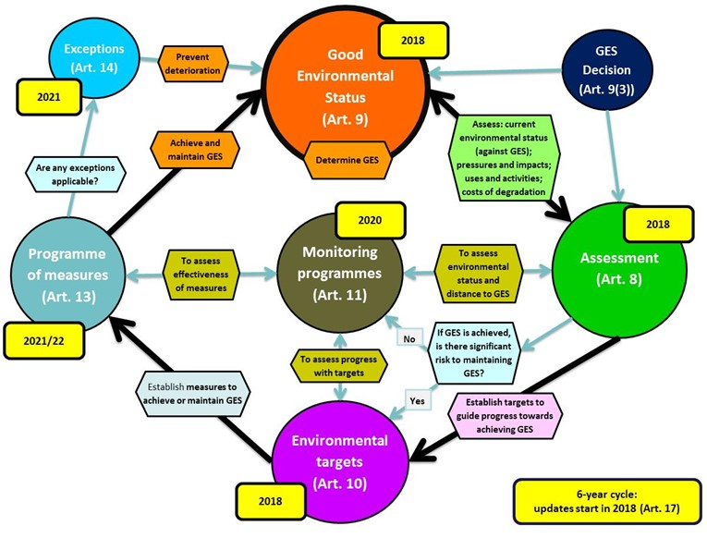**Figure 1:** The MSFD implementation process encompassing the main stages in the six-year implementation cycle, and showing the reporting dates of the second cycle, starting in 2018.

This document focuses on the determination of GES and associated ***assessments*** of ***(current)*** ***environmental status***, but also addresses relationships to the setting of environmental targets and to the monitoring programmes which collect the data needed to monitor progress towards achieving GES and the environmental targets as well as the effectiveness of measures. The outcomes of the assessments inform whether there is need for environmental targets and consequently lead to the measures which are established to achieve (or maintain) GES.

## Geographic scope

### Member State marine waters (Article 3(1))

The Directive applies to the ‘marine waters’ of Member States, which are defined in Article 3(1) as:

* + - * 1. *‘waters, the seabed and subsoil on the seaward side of the baseline from which the extent of territorial waters is measured extending to the outmost reach of the area where a Member State has and/or exercises jurisdictional rights[4], in accordance with the Unclos[5]*’. This is understood to include territorial waters (0-12nm[6]), contiguous zones (12-24nm), exclusive economic zones (out to 200nm or median lines with neighbouring states) and other types of jurisdictional designation; additionally where a Member State has informed the Commission that it possesses and/or exercises jurisdictional rights on a Continental Shelf area which extends beyond these zones, the Directive applies also to the seabed and subsoil of these areas.
        2. *‘coastal waters as defined by Directive 2000/60/EC[7], their seabed and their subsoil* *in so far as particular aspects of the environmental status of the marine environment are not already addressed through that Directive or other Community legislation’.* This indicates that waters inside the baseline and extending up to the landward boundary of coastal waters[8] are within the scope of the MSFD as far as MSFD-relevant aspects are concerned which are not already covered by the Water Framework Directive (WFD) or other Union legislation. Waters designated as Transitional Waters under the WFD are excluded from the geographic scope of the MSFD[9].

Beyond these areas of national jurisdiction there is a need to cooperate with neighbouring states in the same marine region or subregion (sections 2.2.2 and 2.3).

### MSFD marine regions and subregions (Article 4)

**Key message**

**The MSFD regions, subregions and subdivisions provide an important tool for an ecosystem-based approach to delivery of the Directive.**

In support of an ***ecosystem-based approach*** to delivery of the Directive, Article 4 indicates that Member State waters form an integral part of four marine regions of Europe, two of which (North-East Atlantic Ocean, Mediterranean Sea) are each divided into four subregions. These MSFD regions and subregions are illustrated in Figure 2.

The regions and subregions provide the basis for implementation of the marine strategies following an ecosystem-based approach and for defining ***scales*** and areas for reporting. Article 4 further provides for subdivision of each region or subregion, thus providing an important tool for delivery of an ecosystem-based approach below the scale of region and subregion. The scales used may differ between the GES determination (Article 9) and assessments of the extent to which GES has been achieved (Article 8). The scales used may differ between the GES Descriptors (section 3.3.2) and in relation to environmental targets (Article 10). See section 5.4 for further details.

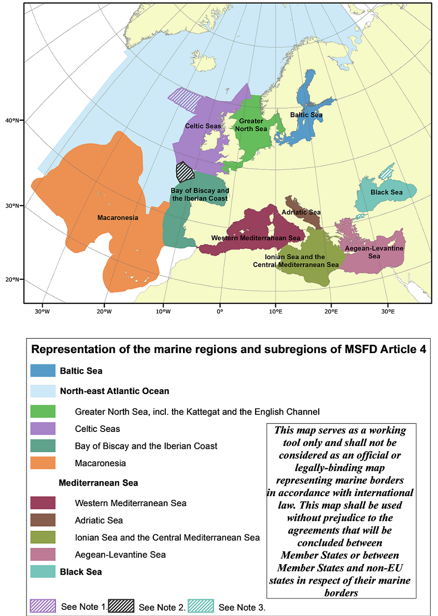

**Figure 2:** Representation of the marine regions and subregions of MSFD Article 4. Note: Within the North-East Atlantic Ocean region, the four subregions listed in MSFD Article 4(2) are shown, without addressing the remaining parts of the region (e.g. waters in the Iceland Sea, Norwegian Sea and Barents Sea) (EEA[10]).

**Note 1**: The area shaded in purple and white indicates an area to which both the United Kingdom and the Government of the Kingdom of Denmark together with the Government of the Faroes have transmitted overlapping submissions to the Commission on the Limits of the Continental Shelf (CLCS) in fulfilment of their respective rights and obligations under Article 76 and Annex II to the United Nations Convention on the Law of the Sea in order to determine entitlement of outer continental shelf areas. This map should not be used in any way to prejudice the determination of that question by the CLCS in due course.

**Note 2**: The area shaded in black and white shows the delineation of the outer limits of the continental shelf beyond 200 M from the territorial sea baselines of France, Ireland, Spain and the United Kingdom in respect of the area of the Celtic Sea and the Bay of Biscay, as provided by the four countries to the Commission on the Limits of the Continental Shelf (CLCS) and included in its recommendations issued on 24 March 2009. The map of the continental shelf’s extent shall be used without prejudice to the agreements that will be concluded in due course between these Member States on their marine borders in this area.

**Note 3**: The seas of Azov and Marmara are shown as shaded as they do not fall within the geographic scope of application of the Bucharest Convention.

## Regional and subregional implementation (Article 5 and 6)

**Key message**

**Member States cooperate within each region or subregion to ensure their marine strategies are coherent and coordinated, and endeavour to follow common approaches to their delivery.**

Article 5(1) sets out the need for Member States to implement the Directive in respect of each region or subregion in which it has marine waters. This regional or subregional approach can be considered to have two aspects: a) those related to cooperation between Member States and b) those related to cooperation with non-EU states in the region or subregion.

This regional or subregional approach of the Directive provides an essential framework for the successful implementation of the Directive.It is particularly important because the ***characteristics*** of marine waters and their biodiversity are shared across each region or subregion and because many of the issues (***pressures***) which need to be addressed to achieve GES can only be effectively addressed through joint or common actions within the region or subregion. In addition, the implementation could differ in each region or subregion, for example, to reflect the differing characteristics of each region or subregion and the differing (degrees of) anthropogenic pressure it faces.

Within each region or subregion, Member States are required to cooperate amongst themselves to ensure their marine strategies are coherent and coordinated, and to endeavour to follow a common approach to their implementation (Article 5(2)). This applies to each element of Member States' marine strategies (also referred to as 'plan of action' in Article 5(2)): assessment, determination of GES, establishment of environmental targets, establishment and implementation of monitoring programmes, development and entry into operation of programmes of measures.

The practical delivery of Article 5(2) requirements can be at regional or subregional level, or a mixture of the two. Because Member States are obliged to implement the Directive in their marine waters and these may form only part of the whole region or subregion, some aspects can be achieved through direct cooperation between several Member States in the region or subregion, rather than always involving all states in the region or subregion.

The link to non-EU states within a region or subregion is important because achieving GES may be dependent upon actions by other states within the region or subregion, due to the inter-connectedness of their waters. This is particularly relevant where anthropogenic pressures arise outside Member States’ waters but have transboundary effects which prevent the achievement of GES within their waters[11]. In such situations, cooperation with non-EU states is necessary to address the issues. There may, however, also be situations where it is appropriate to collect data and undertake assessments, for example for commercial fish and other species whose ranges extend beyond Member States’ national borders, and for which joint management of them is important to secure their good ***status***.

Article 6 indicates that ‘*Member States shall, wherever practical and appropriate, use existing regional institutional structures, including those under Regional Sea Conventions’* (RSC). The four RSCs dealing with seas around Europe (Helsinki Convention, OSPAR Convention, Barcelona Convention and Bucharest Convention) correspond to the four MSFD marine regions. They provide a key mechanism for such cooperation, bringing together the States which share the region and having broadly similar objectives to protect the marine environment as the MSFD. For regional cooperation issues related to commercial fishing, the Regional Fisheries Management Organisations (RFMOs), including the General Fisheries Commission for the Mediterranean (GFCM), the North East Atlantic Fisheries Commission (NEAFC) and the International Commission for the Conservation of Atlantic Tunas (ICCAT), have an important role.

Because the need for cooperation does not just extend across the marine waters of a region or subregion, but also to the freshwater catchment areas, particularly for land-based sources of pollution, the Directive also indicates a need for coordination and cooperation with land-locked Member States. Here it makes the links with the WFD, where the River Basin Management Plans provide an important mechanism for addressing land-based sources of pollution. Exchange of information and cooperation between the River Basin District Authorities and International River Commissions on the one side and the Regional Sea Conventions on the other side is needed.

Overall, these cooperation processes indicate that there is not a single way in which regional and subregional aspects of the Directive can be implemented, but a variety of approaches depending on the particular needs. Hereafter the term ***(sub)regional*** is used to reflect the multiple approaches that may be appropriate.

## Integration with other EU legislation

**Key message**

**Integration between other relevant EU policies and the MSFD marine strategies helps ensure coherence across policies and reduce administrative burden.**

Article 1(4) states ‘*This Directive shall contribute to coherence between, and aim to ensure the integration of environmental concerns into, the different policies, agreements and legislative measures which have an* ***impact*** *on the marine environment*.’ The Directive explicitly mentions the following Union legislation:

1. Urban Waste Water Treatment Directive 91/271/EEC
2. Habitats Directive 92/43/EEC
3. Water Framework Directive 2000/60/EC
4. Environmental Information Directive 2003/4/EC
5. Bathing Water Directive 2006/7/EC
6. INSPIRE Directive 2007/2/EC
7. Birds Directive 2009/147/EC

The Directive refers also to the need to encompass international and regional agreements (e.g. regarding protected species and ***habitats***, and marine protected areas) and, due to the topics addressed by the Directive, needs to engage in further policies, such as the Common Fisheries Policy (CFP), the Common Agriculture Policy and the Maritime Spatial Planning Directive (MSPD, 2014/89/EU), in order to achieve its goals effectively.

This linkage with other policies is illustrated in Figure 3.

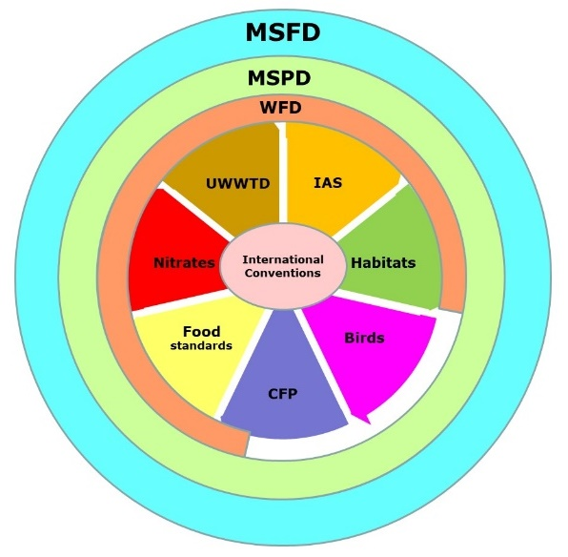

**Figure 3:** Illustration of the MSFD and WFD’s framework nature for environmental protection through association with various other policies and international conventions (only a selection of relevant policies are shown: IAS - Regulation (EU) No 1143/2014 on invasive alien species; Habitats - Habitats Directive; Birds - Birds Directive; CFP - Common Fisheries Policy; Food standards - Regulation (EC) No 1881/2006 on contaminants in foodstuffs; Nitrates - Nitrates Directive; UWWTD - Urban Waste Water Treatment Directive). The Maritime Spatial Planning Directive (MSPD) has a similar spatial scope to MSFD.

Integration of the MSFD with these other policies can be considered in relation to the environmental objectives to be achieved, assessments against these objectives, spatial overlaps, monitoring requirements and the measures implemented to achieve the objectives. This document focuses on the first three of these issues (in relation to Articles 9 and 8).

In accordance with Article 1(4) of the Directive, the GES Decision has set out specifically how the determination and assessment of GES is linked with the standards and assessments under other Union policies (such as WFD, Habitats Directive and Birds Directive). Legislation adopted after the MSFD, such as CFP and MSPD, refer to the MSFD itself, thereby indirectly adding to the list in Article 1(4). This helps achieve both coherence between policies (through not having different assessment outcomes for the same topic[12]) and reduce administrative burden (by assessing once, using for several policy needs). The differing requirements of the policies, and the processes in place to establish methods and standards to be used, can mean that harmonisation across policies is a complex task that may only be partially achievable.

Further details are given in section 5.9.

# Determination of good environmental status (Articles 3(5) and 9, Annexes I and III)

This section focuses on the provisions of the Directive that relate to the determination of GES. The assessments of environmental status (Article 8) in relation to this determination are considered in section 5. Section 6 addresses the establishment of environmental targets (Article 10) which are needed when GES has not yet been achieved.

## Overall objectives of the Directive

Article 1 sets the wider context within which GES is to be determined. This includes that:

‘1. *Member States shall take the necessary measures to achieve or maintain good environmental status in the marine environment by the year 2020 at the latest.*’ (Article 1(1));

‘2. *[…] marine strategies shall be developed and implemented in order to:*

*(a) protect and preserve the marine environment, prevent its deterioration or, where practicable, restore marine ecosystems in areas where they have been adversely affected;*

*(b) prevent and reduce inputs in the marine environment, with a view to phasing out pollution […], so as to ensure there are no significant impacts on or risks to marine biodiversity, marine ecosystems, human health or legitimate uses of the sea.*’ (Article 1(2));

‘3. *Marine strategies shall apply an ecosystem-based approach to the management of human activities, ensuring that the collective pressure of such activities is kept within levels compatible with the achievement of good environmental status and that the capacity of marine ecosystems to respond to human-induced changes is not compromised, while enabling the sustainable use of marine goods and services by present and future generations.*’ (Article 1(3)).

## The determination of GES is central to MSFD implementation

**Key message**

**Good environmental status (GES) is the core concept to be achieved by Member States in implementing the MSFD.**

**All operational provisions of the Directive are in one way or another linked to GES.**

**Successful implementation depends on having sufficient clarity in the determination of GES to enable adequate decision-making in implementation of the Directive.**

Good environmental status (GES) is the core concept that has to be achieved by Member States in implementing the MSFD[13]. All operational provisions of the Directive are in one way or another linked to GES, which is the central objective allowing the measurement of progress and success in its implementation:

1. It is needed as the benchmark[14] against which to assess current environmental status (Article 8, particularly Article 8(1)(a) and 8(1)(b));
2. The assessment under Article 8 determines whether and what environmental targets are needed under Article 10 in order to achieve GES;
3. These targets, in turn, determine what measures are needed under Article 13 to achieve and/or maintain GES;
4. It guides the monitoring needed under Article 11, which provides the data and information needed to assess whether GES has been achieved or is being maintained, and to assess progress in delivery of the environmental targets and for assessing the effectiveness of measures;
5. It provides the benchmark for assessing if an exception is warranted under Article 14(1) and, read in conjunction with the precautionary principle, for assessing if there is significant risk to the marine environment which could warrant the application of Article 14(4).

It is therefore paramount that Member States determine GES, and monitor and assess whether it has been achieved[15]. The associated implementation of related articles depends on having sufficient clarity in this determination (ideally in a quantitative way) to enable adequate decision-making in implementation of the Directive. Further details are given in section 5.

## Provisions of the Directive in relation to GES

**Key message**

**The determination of GES is progressively refined from its overall definition in MSFD Article 3(5), through the descriptors of MSFD Annex I, elements in MSFD Annex III and criteria of the GES Decision to the region- and subregion-specific determinations of Article 9(1).**

GES is defined in Article 3(5) and further elaborated by the descriptors in MSFD Annex I. GES is further determined through the provisions of Article 9. This is based firstly on EU-level criteria and ***methodological standards*** which are set out in the GES Decision, adopted under Article 9(3), and secondly by Member States when determining the characteristics of GES in accordance with Article 9(1). The determination of GES under Article 9 is additionally guided by the indicative list of elements provided in MSFD Annex III.

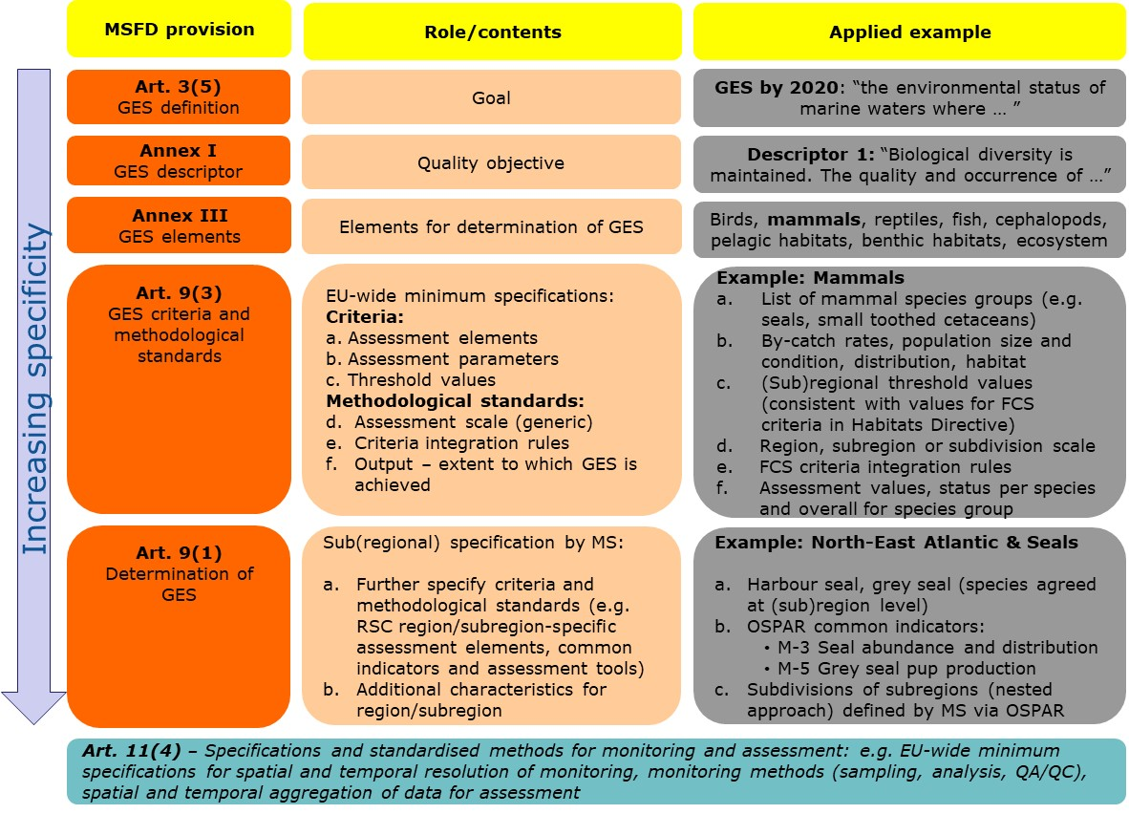**Figure 4**: Relationship of MSFD provisions for determining GES. The specificity of what constitutes GES increases from Article 3(5) through to Article 9(1). The generic role outlined in the central column is applied and worked through with an example for Descriptor 1 and the ecosystem component ‘Mammals’ in the right-hand column. Note that MSFD Annex III must also be taken into account.

GES is thus progressively refined from its high-level definition in Article 3(5) via the Descriptors of MSFD Annex I, the elements of MSFD Annex III and the criteria and methodological standards of Article 9(3) through to the more specific determinations of Article 9(1). This is illustrated, with a worked example, in Figure 4. In this context, the term '***determination***' is taken to mean a more precise definition of GES than is provided in the Directive or the GES Decision, that allows for an assessment of whether GES has been achieved or not.

Figure 4 presents an architecture for how the GES Decision under Article 9(3) relates to determination of GES. This architecture has been developed to ensure the role and contents of each provision are fully compatible and avoid overlap. This overall structure has arisen from the ongoing experiences in implementation of the Directive at Union, regional and national levels and is aimed at promoting greater coherence and consistency in the determination and assessment of GES in the next implementation cycles, including through the common use of particular terminology.

### The definitions of environmental status and good environmental status (Article 3)

The definition of environmental status in Article 3(4) provides a high-level perspective on what needs to be taken into account when assessing the ‘state’ of the environment:

*‘the structure, function and processes of the constituent marine ecosystems together with natural physiographic, geographic, biological, geological and climatic* ***factors****, as well as physical, acoustic and chemical conditions, including those resulting from human activities inside or outside the area concerned’.*

The definition of good environmental status (GES) in Article 3(5) further elaborates on this by defining the high-level goal of the Directive:

*‘good environmental status' means the environmental status of marine waters where these provide ecologically diverse and dynamic oceans and seas which are clean, healthy and productive within their intrinsic conditions, and the use of the marine environment is at a level that is sustainable, thus safeguarding the potential uses and activities by current and future generations, i.e.:*

1. *the structure, functions and processes of the constituent marine ecosystems, together with the associated physiographic, geographic, geological and climatic factors, allow those ecosystems to function fully and to maintain their* ***resilience*** *to human-induced environmental change. Marine species and habitats are protected, human-induced decline in biodiversity is prevented and diverse biological* ***components*** *function in balance;*
2. *hydro-morphological, physical and chemical properties of the ecosystems, including those properties which result from human activities in the area concerned, support the ecosystems as described above. Anthropogenic inputs of substances and energy, including noise, into the marine environment do not cause pollution effects.’*

Good environmental status is further referenced in Articles 5(2), 5(3), 9(1), 9(3), 10(1), 13(1), 14(1), 14(2), 14(4), 15(1), 17(2), 19(2), MSFD Annex I, MSFD Annex IV.2, IV.3, IV.10, IV.12, MSFD Annex V.1, V.4 and MSFD Annex VI.6.

The Directive also indicates the need to prevent deterioration (Articles 1(2)(a) and 14(4)). Article 1(2)(a) also refers to restoration of marine ecosystems, where practicable, in areas where they have been adversely affected.

### GES Descriptors (MSFD Annex I)

**Key message**

**The qualitative Descriptors of MSFD Annex I provide the basis for determining GES, either in relation to particular pressures and their impacts or directly for particular aspects of the state of the marine environment.**

MSFD Annex I provides a set of eleven qualitative Descriptors for use in the determination of GES under Article 9 (Table 1). These provide more specific objectives for GES than is provided in the Article 3(5) definition.

**Table 1**: Qualitative descriptors for determining GES (from MSFD Annex I).

| **No.** | **Short name** | **MSFD Annex I text** |
| --- | --- | --- |
| D1 | Biodiversity | Biological diversity is maintained. The quality and occurrence of habitats and the distribution and abundance of species are in line with prevailing physiographic, geographic and climatic conditions. |
| D2 | Non-indigenous species (NIS) | Non-indigenous species introduced by human activities are at levels that do not adversely alter the ecosystems. |
| D3 | Commercial fish and shellfish | Populations of all commercially exploited fish and shellfish are within safe biological limits, exhibiting a population age and size distribution that is indicative of a healthy stock. |
| D4 | Food webs | All elements of the marine food webs, to the extent that they are known, occur at normal abundance and diversity and levels capable of ensuring the long-term abundance of the species and the retention of their full reproductive capacity. |
| D5 | Eutrophication | Human-induced eutrophication is minimised, especially adverse effects thereof, such as losses in biodiversity, ecosystem ***degradation***, harmful algae blooms and oxygen deficiency in bottom waters. |
| D6 | Sea-floor integrity | Sea-floor integrity is at a level that ensures that the structure and functions of the ecosystems are safeguarded and benthic ecosystems, in particular, are not adversely affected. |
| D7 | Hydrographical conditions | Permanent alteration of ***hydrographical conditions*** does not adversely affect marine ecosystems. |
| D8 | Contaminants | Concentrations of contaminants are at levels not giving rise to pollution effects. |
| D9 | Contaminants in seafood | Contaminants in fish and other seafood for human consumption do not exceed levels established by Community legislation or other relevant standards. |
| D10 | Litter | Properties and quantities of marine litter do not cause harm to the coastal and marine environment. |
| D11 | Energy, including underwater noise | Introduction of energy, including underwater noise, is at levels that do not adversely affect the marine environment. |

The qualitative descriptors can be broadly characterised as relating to:

1. Particular aspects of marine ecosystem state (which are potentially subject to any or multiple pressures): D1 (biodiversity), D3 (commercial fish and shellfish), D4 (food webs) and D6 (sea-floor integrity);
2. Particular anthropogenic pressures (which can potentially affect any aspect of marine ecosystem state): D2 (non-indigenous species), D5 (eutrophication); D7 (hydrographical conditions); D8 (contaminants), D9 (contaminants in seafood), D10 (litter) and D11 (energy, including underwater noise).

It should be noted that this state and pressure categorisation at Descriptor level is not maintained at the criteria level in the GES Decision, where a more mixed pressure/impact/state approach per descriptor is followed, and where impact is, in effect, a particular reflection of state (see section 4.3).

### GES elements (ecosystem elements and pressures of MSFD Annex III)

**Key message**

**MSFD Annex III provides an indicative list of elements (state and pressure) to be used in determining GES and for assessing the extent to which it has been achieved.**

**It also provides an indicative list of uses and human activities in or affecting the marine environment, for use in relation to Article 8(1)(b) and 8(1)(c).**

Whilst the descriptors of MSFD Annex I provide the basis for determining the environmental quality (GES) which is to be achieved, MSFD Annex III can be considered as providing the elements to be used when determining that quality (GES) under Article 9(1) and consequently for assessments of whether GES has been achieved under Article 8. These lists comprise:

1. ***Species groups*** (of marine birds, mammals, reptiles, fish and cephalopods); ***broad habitat types*** of the water column (pelagic) and seabed (benthic) and other habitat types; ecosystem structure, functions and processes (physical and ***hydrological***, chemical and biological characteristics, functions and processes) (MSFD Annex III Table 1), and
2. Anthropogenic pressures (biological, physical, substances, litter and energy) which can adversely affect the state of the marine ecosystems and their elements (MSFD Annex III Table 2a).

The elements given in MSFD Annex III are indicative (i.e. should only be used where relevant to a particular (sub)region) and are broadly-defined. They are further specified at Union level in the GES Decision and at (sub)region level by Member States under Article 9(1) in order to provide clarity and consistency in how GES is determined and assessed (Figure 4).

The relationship between MSFD Annex I and the original (2008) MSFD Annex III was not explicit. The review of the Decision 2010/477/EU was therefore accompanied by a review of the original MSFD Annex III[16], leading to both being updated in 2017. These revisions provide clarity on the relationships between MSFD Annex I, MSFD Annex III and the GES Decision, following the approach outlined in Figure 4. The role of MSFD Annex III is as follows:

1. To provide an indicative list of elements and ***parameters*** for monitoring and assessment of state, pressure and impacts under Article 8(1)(a) and (1)(b) and Article 11, linked explicitly to the descriptors of MSFD Annex I. Each of the eleven descriptors has been specifically linked to particular elements in MSFD Annex III. However MSFD Annex III includes additional pressures, which are not explicitly referred to in a descriptor but which should be considered where relevant under Article 8(1) assessments;
2. To provide an additional indicative list of elements and parameters for monitoring which may be needed to support environmental assessments (e.g. physical and hydrological parameters useful for indicating wider climatic variation);
3. To provide a new indicative list of uses and activities to be considered under MSFD Article 8(1)(b) and (1)(c). The list distinguishes those uses and activities which are ‘sea-based’, and thus relevant for Article 8(1)(b) and (c), from those which are ‘land-based’ and thus relevant only for Article 8(1)(b) in the context of the pressures they may generate on the marine environment.

In updating the lists for the revised MSFD Annex III, a review was made of other key policies and those used by the RSCs to ensure the lists were comprehensive.

GES elements are further specified in the GES Decision (section 5.3).

### GES criteria and methodological standards (Article 9(3); GES Decision)

The Commission has delegated powers under Article 9(3), and in accordance with the provisions of Article 25, to lay down criteria and methodological standards to be used by Member States ‘*to ensure consistency and to allow for comparison between marine regions or subregions of the extent to which GES is being achieved’*.

**Key message**

**The criteria and methodological standards under Article 9(3) and specifications and standardised methods under Article 11(4) provide EU-wide minimum requirements for the determination and assessment of GES.**

Article 3(6) defines ‘criteria’ as ‘*distinctive technical* ***features*** *that are closely linked to qualitative descriptors’.* To fulfil their role these criteria need to include quality elements (e.g. species, habitats, pressure types), parameters (e.g. concentration of a substance, extent of a pressure or habitat) and quality standards (criteriathreshold values). The criteria enable assessment of the status of the elements in MSFD Annex III. Monitoring and assessment in relation to these criteria should follow the ***specifications and standardized methods*** set in accordance with Article 11(4).

The first use of Article 9(3) led to Decision 2010/477/EU which guided, in particular, the 2012 stage of implementation and the 2014 monitoring programmes. The application of Decision 2010/477/EU revealed that it provided insufficient detail and clarity to support the determination of GES[17], leading to its revision in 2017. The following specifications are included in the revised GES Decision:

1. Elements for assessment (of whether GES has been achieved) (section 5.3);
2. Criteria for assessment of the elements, including parameters to be used (section 5.5);
3. Threshold values for assessing quality and trends (including distinguishing 'In GES' from 'Not in GES') (sections 5.6-5.7);
4. Assessment scales (section 5.4);
5. Use of the criteria (e.g. to express the extent to which GES is achieved, or for other descriptor assessments) (section 5.10);
6. Approaches to and methods for monitoring to collect the data needed for assessment;
7. Aggregation methods for the data (spatial, temporal);
8. Units of measurement for the criteria.

Where available, the elements, threshold values and methods for use of criteria are drawn from existing EU policies (section 2.4 and section 5.9) and where not the GES Decision makes provision for these to be set at EU, regional or subregional level. The information provided for points (f) and (g) is not complete.

The criteria and methodological standards under Article 9(3) and specifications and standardised methods under Article 11(4) provide EU-wide minimum requirements for the determination and assessment of GES.

To avoid confusion between the use of the term ‘criteria’ in this specific context and its use in other respects (such as criteria used to guide ***indicator*** selection or selection of species for assessments), it is recommended that the criteria of the GES Decision be referred to as ‘GES criteria’ in situations where there could be confusion[18].

## Relationship between the Directive and the GES Decision

**Key message**

**The GES Decision provides a common EU-level framework for determining GES.**

**The determination of a set of characteristics of GES under Article 9(1) by Member States provides specificity to these criteria and methodological standards for each region or subregion.**

The interrelationships between Articles 8 and 9, MSFD Annexes I and III and the GES Decision are illustrated in Figure 5. The integrated implementation of these provisions is described in section 5.

Article 9(3) provides for criteria and methodological standards to be laid down ‘*in such a way as to ensure consistency and to allow for comparison between marine regions or subregions of the extent to which good environmental status (GES) is being achieved’*, whilst Article 9(1) provides for Member States to determine a set of characteristics of GES, but without specific reference to the criteria set under Article 9(3).

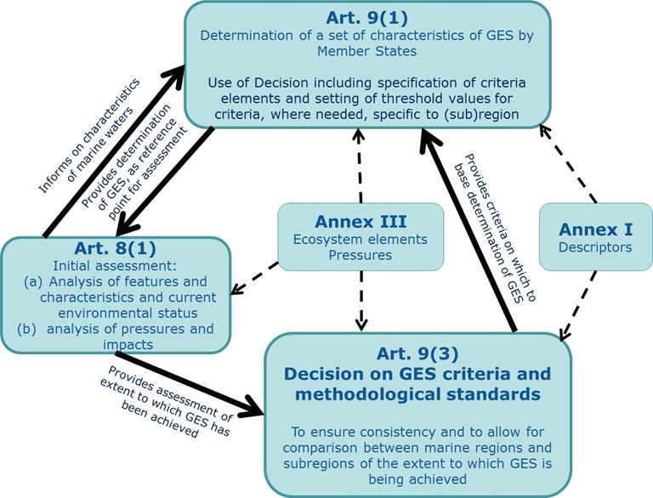

**Figure 5**: Relationship between the GES Decision and MSFD Articles 9(1) and 8(1) and MSFD Annexes I and III.

The inter-relationship between these two provisions can be considered as follows:

1. The GES Decision provides a common Union-level framework for determining GES, thereby helping to ensure consistency across the marine regions in the determinations of GES; it does this through specifying (in generic terms or providing for these to be specified at Union or (sub)regional level) the elements, parameters and geographic scales of assessment, the threshold values for each criterion and methods for use of the criteria;
2. The determination of a set of characteristics of GES under Article 9(1) by Member States provides specificity to these criteria and methodological standards for each region or subregion, thereby reflecting the particular ecological characteristics and differing nature of pressures in each region or subregion. Additional characteristics, not included in the GES Decision, can be included in this determination.

The GES Decision therefore provides a basis and structure for determining GES, providing a further level of detail to that of MSFD Annexes I and III. However, it does not in itself provide a determination of GES, as this requires the additional specificity to be set by Member States for each region or subregion.

The GES Decision has been structured to make explicit its relationship to MSFD Annexes I and III, and to the assessments required under Article 8(1)(a) and (1)(b), which relate to the assessment of current environmental status and of predominant pressures and impacts respectively. It also supports a more integrated approach to the determination and assessment of GES (section 5.1, Figure 8), as does the structure and content of MSFD Annex III. This has been achieved by:

1. Structuring the GES Decision in two parts, each referring explicitly to the relevant Descriptors of MSFD Annex I, to the indicative elements of MSFD Annex III and to the relevant paragraphs of Article 8(1);
2. The pressure-related descriptors are presented first (Part I), as logically these should be considered first under the Article 8 assessments in order to provide information on the level of impacts from each of the pressures assessed. These assessments of impacts should then inform the assessments of the different ecosystem elements (Part II), whose overall status effectively reflects the cumulative effects of the impacts from all the pressures to which they are subject.
3. Part I of the GES Decision supports the assessments required under Article 8(1)(b) concerning an analysis of the predominant pressures on the marine environment and their impacts; it includes the criteria and methodological standards for the pressure-related descriptors which are directly linked to the indicative list of pressures in MSFD Annex III Table 2a; there are additional pressures in this table which are not linked to a pressure-based descriptor and thus have no GES criteria defined. They, nevertheless, may be of importance in some areas and for some ecosystem elements and therefore warrant assessment;
4. Part II of the GES Decision supports the assessments required under Article 8(1)(a) concerning an analysis of the essential features and characteristics and current environmental status; it includes the criteria and methodological standards for the state-related descriptors which are directly linked to the indicative list of ecosystem elements in MSFD Annex III Table 1;
5. To ensure the predominant pressures of MSFD Annex III Table 2a are adequately addressed under Part I, the criteria relating to fishing pressure (extraction of species) and to physical loss and disturbance have been placed in this part, even though labelled in relation to the state-based Descriptors D3 and D6. Criterion D3C1 addresses the impacts of fishing on commercial species (the level of mortality), whilst criteria D3C2 and D3C3 address the state of commercial fish and shellfish to be considered also under Part II. Criteria D6C1, D6C2 and D6C3 have their origins in the D6 criteria of Decision 2010/477/EU, and are focused only on the assessment of the pressures ‘physical loss’ and ‘physical disturbance’; they provide an important contribution to the broader assessment needed for Descriptor 6, which is addressed fully in Part II (in combination with assessments of seabed habitats of Descriptor 1).

## Relationship between GES (Article 9) and assessments (Article 8)

**Key message**

**The determination of GES forms the benchmark against which to assess current environmental status.**

**In subsequent MSFD implementation cycles, the assessment of current environmental status under Article 8(1)(a) and (b) is reported against the latest determination of GES, including any updates for that reporting cycle.**

The Directive does not make clear the relationship between the determination of GES under Article 9 and the assessments (of current environmental status and of the pressures and their impacts) under Article 8. However, from the overall purpose of the Directive, it is logical that the determination of GES should form the benchmark against which to assess current status and hence progress towards GES.

In the 2012 stage of the first MSFD implementation cycle, the determination of GES needed to take account of the initial assessment, as well as the criteria in Decision 2010/477/EU. The initial assessment was particularly relevant for identifying the specific ecological characteristics and pressures and impacts for each region or subregion, thus providing a basis upon which to determine GES. In this sense the determination of GES in 2012 could be considered as dependent upon firstly undertaking the initial assessment and therefore considered as a subsequent step in the implementation process. In practice, most Member States followed this approach and thus did not specifically use their 2012 determination of GES as the benchmark against which current environmental status in 2012 was assessed.

In the second and subsequent implementation cycles, the updating of the GES determination should be done in close association with updating of the initial assessment, as the two elements are intricately linked, such that at each reporting cycle the updated assessment of current environmental status is based upon the updated determination of GES reported at the same time. See Section 5.11 regarding the reasons for updating the determination of GES.

## Relationship between GES (Article 9) and environmental targets (Article 10)

**Key message**

**Articles 9 and 10 have distinct roles in the MSFD implementation process, each with different legal obligations which are not interchangeable.**

Articles 9 and 10 have distinct roles in the MSFD implementation process, each with different legal obligations which are not interchangeable. The main purpose of Article 9 is to determine the specific environmental objectives of the Directive (i.e. what is GES) in sufficient (and where possible quantifiable) detail to be able to know whether they have been achieved or not for the different descriptors and in accordance with the overall definition in Article 3(5). The main purpose of Article 10 is to establish a set of environmental targets to guide progress towards achieving these objectives (GES). This indicates that Article 10 provides a declaration of intent to take action, compared with the objective-led role of Article 9. For example, setting an environmental target for the maximum allowable input of nutrients to the sea in order to lead to nutrient levels in the sea which do not give eutrophication effects (Descriptor 5).

This 'declaration' is then delivered through the Programmes of Measures (Article 13) as the ‘*measures shall be devised on the basis of the initial assessment … and by reference to the environmental targets*’ (Article 13(1)). To continue the example above, nutrient input reduction targets could be achieved through various possible measures, such as controls on the use of fertilisers in agriculture or the use of phosphates in detergents, and by improving urban waste water treatment.

Targets thus provide an operational tool, used in conjunction with the programme of measures, for the management of human activities and their pressures and for actions which should lead to improvements in the environmental status of marine waters and ultimately to GES. Targets are not meant to be used to provide a more refined determination of GES, as was often the case in the first reporting of environmental targets in 2012.

## Consistency between Member States in the determination of GES (Article 3(5) and 5(2))

**Key message**

**GES is determined at the level of the region or subregion (Article 3(5)).**

**The provisions of the Directive and the GES Decision provide for levels of consistency in the determination of GES, partly at EU level and partly at (sub)regional level.**

**This EU and (sub)regional consistency ensures a ‘level playing field’ across Member States in the different stages of the MSFD implementation process.**

From the overview given in Figure 4 it can be seen that some aspects of GES determinations are laid down in the Directive and in the GES Decision, whereas further specifications are determined, where needed, at regional and subregional level via Article 9(1). This task under Article 9(1) is the responsibility of Member States, undertaken in collaboration with other Member States, as required under Article 5(2), in order to ensure GES is determined at the level of the marine region or subregion in accordance with Article 3(5), using, ‘*where practical and appropriate, existing regional institutional cooperation structures, including those under the RSCs*’ (Article 6). The provisions of the Directive thus provide for levels of consistency in the determination of GES, partly at Union level and partly at (sub)regional level. This Union and (sub)regional consistency is important to ensure a ‘level playing field’ across Member States in the different stages of the MSFD implementation process.

## Updating the determination of GES (Article 17(2))

The Directive provides in Article 17 for a six-year review and updating of each element of the marine strategies. For GES, this is a key mechanism to refine the determinations to take account of developments since the previous determination[19].

See section 5.11 for further details.

# An integrated framework for MSFD implementation

## An ecosystem-based approach and use of the DPSIR framework

The Directive calls for ‘*an ecosystem-based approach to the management of human activities, which should ensure that the collective pressure of such activities is kept within levels compatible with the achievement of GES and that the capacity of marine* ***ecosystems*** *to respond to human-induced changes is not compromised, whilst enabling the sustainable use of marine goods and services by present and future generations*’ (Article 1(3)).

Whilst the ecosystem-based approach has a number of facets, its relevance in relation to the determination, assessment and achievement of GES is focused upon here.

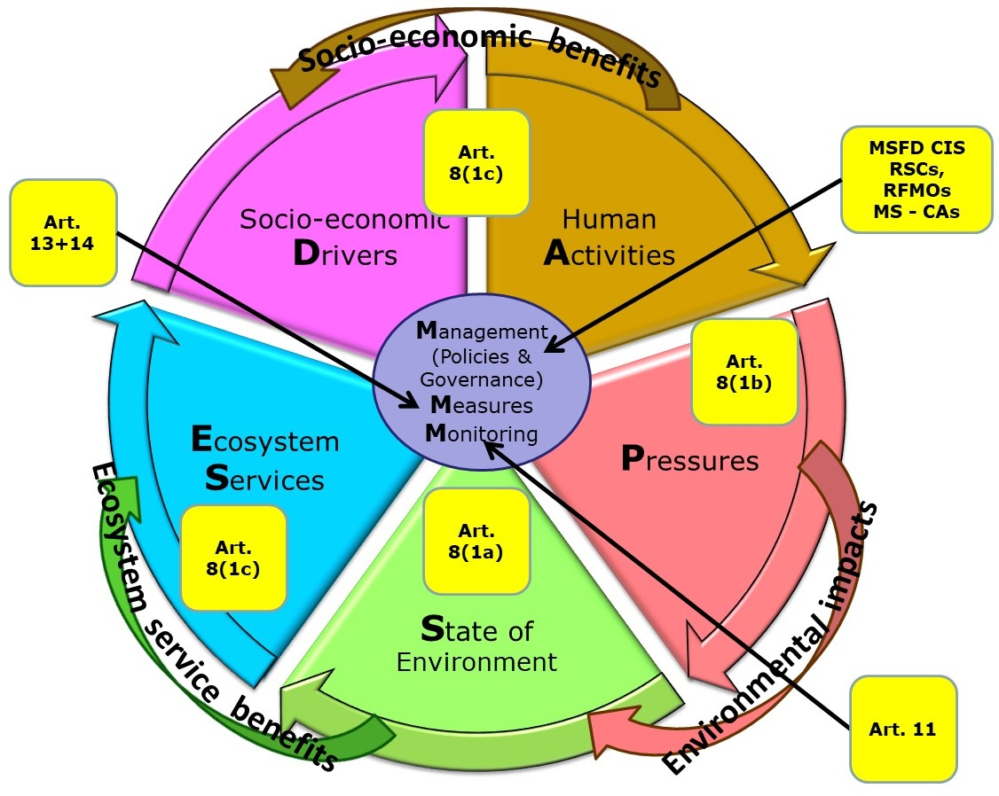

**Figure 6**: Modified DPSIR framework (DAPSES-MMM), showing links to relevant MSFD articles. MSFD CIS=MSFD Common Implementation Strategy, RSCs=Regional Sea Conventions, RFMOs=Regional Fisheries Management Organisations; MS-CAs=Member State Competent Authorities (modified from [MSCG_11-2013-16](https://circabc.europa.eu/w/browse/7a6fb9b8-16a8-4042-be23-b6b65d33b873)).

The relationship between human activities, their pressures and the consequent ***state*** of the environment is encompassed within the well-established DPSIR (***Drivers***-Pressure-State-Impact-***Response***) framework[20] for environmental management. For MSFD purposes, the framework has been modified[21] to address ambiguities in use of the terms ‘driver’ and ‘impact’ and to accommodate the concept of ***ecosystem services[22]*** more explicitly. Human activities are distinguished from drivers, as these are the consequence of drivers and are a specific focus of the Directive (e.g. under Article 8(1)(c)); impacts are distinguished into those on the environment (resulting from pressures and affecting state) and those affecting ecosystem services (e.g. as 'costs of degradation' under Article 8(1)(c)). This modified framework is referred to here as the DAPSES-MMM framework (Drivers-Activities-Pressures-State-Ecosystem Services: Management, Measures and Monitoring); it is illustrated in Figure 6 which shows its links to relevant MSFD articles.

This model can be closely associated with the different main stages of MSFD implementation and thus follow much of the established understanding of how to improve environmental quality. The Directive requires an economic and social analysis of uses of the marine waters and of the ***cost of degradation*** (Article 8(1)(c), ~Drivers, Impacts on ecosystem services), pressures and impacts (Article 8(1)(b), ~Pressures, Impacts on environmental state), and current environmental status (Article 8(1)(a), ~State). In Article 10 a set of environmental targets are to be established and in Article 13 the Directive calls for a programme of measures to achieve these targets and consequently achieve or maintain GES (~Response).

## General principles - activities, pressures, impacts and state

**Key message**

**The terms pressure, impact (adverse effect) and state (status) are used with specific meanings in the MSFD context.**

**Pressures can be considered ‘at source’ (close to the activity), with relevance for environmental targets and measures, and ‘at sea’ (level in the marine environment), with relevance for GES determinations and status assessments.**

Section 4.1 introduced the DAPSES-MMM (DPSIR) framework as an underlying basis for implementation of the Directive. In section 3.5, the inter-relationships between the determination of GES and its assessment were outlined. In this section, these two aspects are further elaborated.

The activity-pressure-(impact)-state part of the DAPSES framework can be directly related to the needs of the Article 8 assessments, where an integrated approach to the assessments, across all GES descriptors and between pressures and state, is needed. This is because an assessment of current environmental status (Article 8(1)(a)) is, in effect, an assessment of the state of the environment that reflects the range of environmental impacts (adverse effects), including cumulative impacts/effects, acting upon it. As these impacts are in turn caused by the pressures exerted on the environment by human activities (Article 8(1)(b)), these elements of the initial assessment are intricately linked.

Pressures can be considered in two ways:

1. At source – i.e. close to the activity generating the pressure. This aspect is particularly relevant for setting environmental targets and for measures as these need to focus on reducing the pressures, when needed to achieve or maintain GES. Some pressures, such as nutrients, contaminants and litter, originate on land and enter the marine environment as diffuse sources (including via the atmosphere) or from point sources. Pressures generated by sea-based activities may remain closely associated to those activities (e.g. extraction of species by fishing and physical disturbance by dredging or bottom trawling), while others may dissipate away from the activity (e.g. contamination from oil extraction activities, noise from shipping);
2. At sea – i.e. the level of the pressure in the marine environment (to which the different elements of the ecosystem are subjected). This aspect is particularly relevant for determining GES (for the pressure-based descriptors) and for assessment of environmental status in relation to GES.

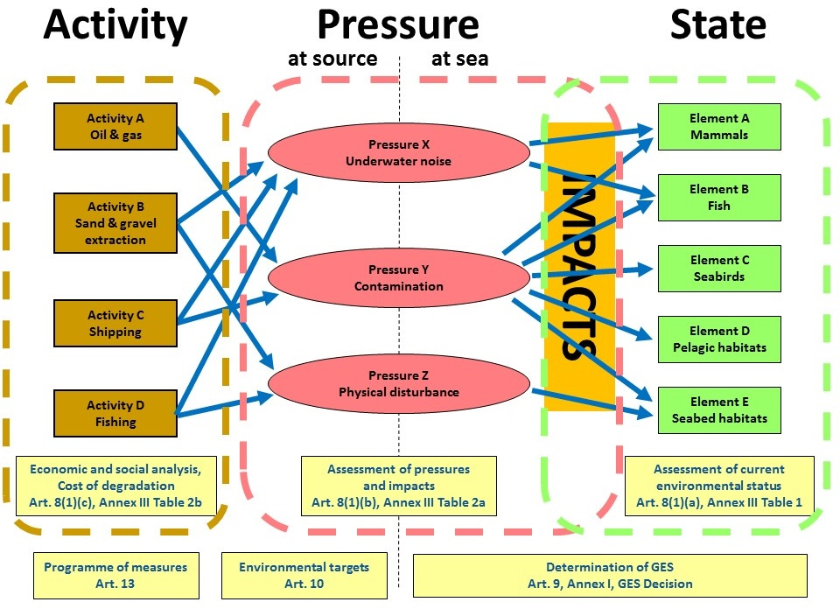

**Figure 7**: Conceptual relationship between human activities, the pressures they exert on the environment and the consequent state of the environment, taking account of the impacts (adverse effects) from the pressures. Each is indicated with illustrative examples of activities, pressures and state ecosystem components. The links to the three parts of Article 8(1) assessments and the associated Tables in MSFD Annex III are shown, together with the main scope for Article 9 (determination of GES), Article 10 (targets) and Article 13 (programme of measures). (Modified from [European Commission, 2012[23])](https://circabc.europa.eu/w/browse/d13fa277-5147-4c02-aea0-3be8f9344807).

These relationships, for multiple activities, pressures and state elements, are illustrated in Figure 7, which additionally shows the main scope of Articles 9, 10 and 13 in relation to activities, pressures, impacts and state:

1. Article 9 GES should be determined by reference to both state elements covered by Article 8(1)(a) and pressure and impact elements covered by Article 8(1)(b), noting that this refers to the levels of pressure in the marine environment (at sea);
2. Article 10 environmental targets should focus on addressing the pressures which are preventing GES from being achieved, or which put at risk the maintenance of GES. In this case, the targets should focus on the pressures at source, although pressure reduction at sea may also be desirable (e.g. for litter);
3. Article 13 programmes of measures are likely to be most effective when directly addressing those activities contributing to the generation of the pressures (which are preventing GES from being achieved).

These links to the DAPSES (DPSIR) model are important regarding the application of the terms pressure, impact and state (status) as used in the Directive. Because the prime focus of the Directive is the achievement of GES, requiring assessments of environmental status and progress towards achievement of GES, these terms need to be used in this context[24]. Table 2 provides illustrated examples of each term to help demonstrate their application, differences and relationships.

**Table 2**: Selected examples of the terms activity, pressure, impact and state, as relevant to different MSFD descriptors.

| **Descriptor** | **Activity** | **Pressure at source** | **Pressure at sea** | **Environmental impact (adverse effect)** | | **State (status)** |
| --- | --- | --- | --- | --- | --- | --- |
| **D2** | Ship/boat transport | Introductions of non-indigenous species via ship hulls and ballast water | Populations of NIS established in marine waters | Changed composition of native marine communities, displacement of native species | | Altered condition of pelagic and benthic communities, and bird, mammal and fish communities. |
| **D3** | Fishing | Removal of commercial fish and other (non-commercial) species | | | Mortality of fish and other species | Reduced population size, altered age/size structure of population |
| **D5** | Agriculture | Introduction of nutrients through rivers or directly from land | Raised nutrient levels (enrichment) in sea | Increased algal productivity, oxygen depletion, benthic mortality, fish mortality | | Altered condition of plankton and benthic communities, hypoxia/anoxia |
| **D6** | Fishing (demersal/ benthic) | Physical disturbance of seabed | | | Changes in sediment structure, injury and mortality of species | Altered benthic community and habitat condition |
| **D6/D7** | Infrastructure developments | Change in seabed substrate (e.g. to concrete, metal) | | | Loss of natural habitat, altered hydrological conditions (D7) | Habitat loss, altered habitat condition (hydrological conditions and community) |
| **D8/D9** | Industry (emissions) | Contaminants in atmosphere | Contaminants in water, sediment and biota | Effects of contaminants on life history aspects of species; accumulation of contaminants in seafood and human health effects | | Altered condition of species (e.g. reproductive ability) |
| **D10** | Tourism | Input of litter – discarded on beach | Litter on seabed | Smothering of benthic habitats, injury to marine animals | | Altered habitat condition, affected condition or population size of species |
| **D11** | Pier-piling for wind farms | Noise from piling | Noise level in sea | Disturbs cetaceans, moving away from noise | | Altered species distribution |

Because the use of these terms (pressure, impact and state) across policies and countries is quite variable, it is important for MSFD purposes to apply them in a consistent manner. Based on the application of the term ‘pressure’ in the MSFD context and upon a review of the types of pressures in use under other Directives and by the RSCs[25], the term pressure in this document is as defined in Annex I to this document.

## The nature of a GES determination – state, impact and pressure

**Key message**

**The determination of GES addresses, through the eleven descriptors, aspects relating to the state of the marine environment, and to the levels of pressures in the marine environment and their associated impacts.**

**Assessments of progress towards achieving GES are therefore encompassed within both Article 8(1)(a) and (1)(b).**

The determination of GES concerns the desired state of the marine environment, including the structure, functions and processes of its constituent marine ecosystems. This is reflected in the state-based definition of GES in Article 3(5) and in the general theme of the descriptors in MSFD Annex I, which either express a particular state which is to be achieved or a particular state to be achieved in relation to a specific pressure.

Because the environment can be adversely affected (impacted) by pressures from human activities, GES can also be expressed in relation to specific environmental impacts (i.e. a more specific way to express the desired state which relates directly to the particular anthropogenic pressures). For example, nutrient enrichment can lead to changes in plankton biomass (chlorophyll-a concentrations) and to oxygen depletion, and thus provide a focus for how to determine GES for Descriptor 5 on eutrophication.

Determining GES also includes defining the acceptable levels of pressures in the marine environment (at sea). This is because:

1. the ‘pressures’ may be deviations from natural conditions (e.g. nutrients, certain contaminants, underwater noise) and thus can also be considered state elements[26];
2. there can be a known causal relationship between the level of the pressure and its adverse effects (impacts) on marine ecosystem elements, enabling a level of pressure to be determined, when there is sufficient evidence, which should ensure acceptable levels of impact on ecosystem elements. For example, the levels of nutrient enrichment and hazardous substances in the sea (for Descriptors 5 and 8) which are considered to ‘equate’ to GES, can be determined based on established effects (impacts) on particular ecosystem elements[27];
3. an ‘acceptable pressure level’ in the marine environment is needed for situations where the pressure-impact relationship is not yet fully understood. This should follow the precautionary principle, by using precautionary levels of the pressure until the knowledge gaps for determining the pressure-impact relationship are closed. There can be refinement over time of this ‘acceptable pressure level’, based on improved understanding of this pressure-impact relationship. For litter (D10) and underwater noise (D11), scientific understanding of impacts on the environment is currently more limited and so setting precautionary pressure levels may be the only feasible option at present.

This approach is relevant for each of the pressure-based descriptors: the desired levels in the marine environment of non-indigenous species (D2), fishing mortality (D3), enriched nutrients and organic matter (D5), physical disturbance (D6), physical loss and associated alteration of hydrographical conditions (D6, D7), contaminants (D8, D9), litter (D10) and inputs of energy, including underwater noise (D11) are determined under Article 9. Further pressures, such as those listed in MSFD Annex III Table 2a but which are not specified in one of the descriptors, could also be included in a GES determination.

This consequently means that levels of non-indigenous species, nutrients, contaminants, litter and noise in the sea are referred to as the level of the pressure in the marine environment and are needed to assess their impacts[28] on state elements (species, habitats, food webs or wider ecosystem) of the marine environment[29].

It is common practice to determine both the acceptable pressure level and the associated state characteristics which are considered to be good status (e.g. for D5 eutrophication, for D3 commercial fish and shellfish). Both aspects are needed in the MSFD implementation process, to enable responses to measures to be assessed (via reductions in the level of pressure at sea) and consequent improvements in environmental status to be seen (via reductions in impacts and recovery of the ecosystem).

From the above, and due to the nature of those Annex I Descriptors which focus on pressures and their impacts, assessments of environmental status (in relation to the determination of GES) are not confined to Article 8(1)(a), but should also include those under Article 8(1)(b)[30].

## Priorities for MSFD implementation and use of risk-based approaches

**Key message**

**Implementation of the Directive, including use of risk-based approaches, is most effective when focused on the anthropogenic pressures that are preventing, or likely to prevent, the achievement or maintenance of GES.**

**The determination of GES provides the benchmark against which to assess the degree of risk.**

**Management actions which help reduce these pressures allow the marine environment to recover towards GES.**

The broad subject matter and wide geographic scope of the Directive present significant challenges to its implementation, to ensure it can deliver satisfactorily according to its objectives in an effective and efficient manner. The complex and very broad scope of its biodiversity objectives and the offshore areas of the Union's marine waters, sometimes extending up to 350 nautical miles out from the coast and to depths of over 5000m, present particularly challenging aspects. There remain many scientific uncertainties, especially to fully understand the relationships between anthropogenic pressures and their impacts on the marine environment, and on how the ecosystems will respond to particular management actions. In addition, there are many aspects where data and monitoring systems are not sufficiently developed or lack sufficient time series, giving uncertainties in how best to implement the Directive.

The overall goal of the Directive, good environmental status, is expressed in high-level terms in the Article 3(5) definition and through the eleven descriptors of MSFD Annex I. These provide for a potentially very wide need for monitoring and assessment, particularly concerning biodiversity, food webs and sea-floor integrity (Descriptors 1, 4 and 6) and especially for those Member States where the marine waters are very extensive.

The assessment of the current state of marine waters is important for assessing the degree of risk to achieving GES (how far the marine waters are from GES) and the risk of status deteriorating from GES to a sub GES level; the determination of GES thus provides the benchmark against which to assess the degree of risk.

With this reasoning, the implementation of the Directive can be most effective when it is clearly focused on reducing the anthropogenic pressures which are considered to be, or likely to be, adversely affecting environmental status in each region or subregion, and on assessing the nature and scale of associated environmental impacts. With this approach, attention is drawn towards assessing the scale of the pressures and their impacts on particular aspects of the marine environment, rather than attempting to monitor and assess every possible aspect of the environment in all areas of marine waters. Such an approach can allow the majority of resources in Member States to be focused on those issues which can make the biggest contribution towards achieving GES, with fewer resources focused on lesser issues (pressures) and wider surveillance of the marine environment. The latter is however important in the role of monitoring ‘unimpacted’ areas and wider ecosystem changes, which help in understanding monitoring results that are focused on specific pressures and impacted ecosystem elements and areas.

At the same time, the mechanisms for Member States to achieve GES lie primarily in the control of the anthropogenic pressures which are causing ***adverse effects*** on the marine environment and hence preventing the achievement of GES. Most management approaches (measures) anticipate passive recovery of the marine ecosystem following a reduction in pressure levels. Measures tend to mostly focus on reducing or eliminating the new input of the pressure to the marine environment, whilst some actively aim to reduce/remove the existing pressure once in the marine environment (e.g. removal of litter). The alternative management mechanism, that of direct intervention to improve the status of the marine environment (such as active restoration of species, habitats and areas), is unlikely to be possible or cost-efficient in other than a minority of situations. Both of these approaches are delivered via the programmes of measures.

The use of risk-based approaches can thus play an important part in the delivery of the Directive, allowing a focus on those aspects (pressures, impacts, areas and activities) which provide most risk to Member State’s achievement or maintenance of GES.

Refer to section 7 for more specific information on application of risk-based approaches.

## Steps in a prioritised implementation process

**Key message**

**The following steps support a prioritised implementation process:**

**a. Map the distribution and intensity of human uses and activities;**

**b. Assess the spatial distribution and intensity (and temporal aspects, where necessary) of each (predominant) pressure;**

**c. Assess the extent of environmental impacts from these pressures in relation to the elements to be used for the state-based assessments;**

**d. Assess the state, bringing together the relevant assessments of impacts from (c) to lead to an overall assessment of status per ecosystem element.**

The following provides a generalised step-wise approach to a prioritised implementation of the Directive:

1. Map the distribution and intensity of uses and human activities (identifies main areas of activity, potential for use as proxy pressure assessment, supports later identification of measures[31]). This approach is most relevant for sea-based activities, especially those on or affecting the seabed, but is also relevant for fishing and shipping activities (with regard to fishing and underwater noise pressures);
2. Assess the pressures – spatial distribution and intensity (and temporal aspects, where necessary) of each pressure, identifying those which are of greatest concern; this may be somewhat less relevant for assessments of mobile species such as birds, seals and cetaceans, as these can be wide-ranging and thus more difficult to know where and when they are exposed to particular pressures;
3. Identify those aspects of the marine environment (species, habitats, ecosystem functions and processes) and areas most (likely to be) affected by these pressures;
4. Assess the environmental impacts – extent of impacts in relation to the elements to be used for the state-based and the pressure assessments; focus monitoring and assessment on these aspects (e.g. species, habitats, ecosystem functions and processes) and areas which are considered to be most at risk of adverse effects (environmental impact). Monitoring focused on the boundary zone between ‘good status’ and ‘not good status’, may help reduced efforts in areas where status is known to be good or known to be poor. This more limited monitoring in areas of good status however provides important reference data with which to compare the impacted areas and any change in status over time (including both continued improvements in status or signs of deterioration in status which could risk leading to a sub GES status);
5. Assess the state – bringing together the relevant assessments of impacts from point (d) to lead to an overall assessment of current status;
6. Direct management responses (measures) towards those pressures and areas which are considered to be causing the greatest adverse effects (in terms of intensity and/or extent) and contributing most to any failure to achieve GES.

# An integrated process to determination of GES and its assessment

**Key message**

**The determination of GES (Article 9) and assessments (Article 8) are intricately linked, indicating a need to structure both assessments and determination in a mutually compatible way.**

**Assessments are on specified topics (*features*, elements) in defined parts of marine (sub)regions/marine waters (Marine Reporting Units, MRU). Each assessment expresses the extent to which GES has been achieved in each assessment area (MRU).**

The intricate link between Articles 8 and 9 and with the GES Decision (section 3.4 and 3.5, Figure 5) indicates a need to structure both assessment and determination in a mutually compatible way. Assessments are on specified topics (elements) in defined parts of marine (sub)regions/marine waters (***Marine Reporting Units*** – see section 5.4) and should give a clear expression of the extent to which GES has been achieved in each area. This structuring is shaped by MSFD Annex I (i.e. the descriptors) and the requirements of Article 8(1) (particularly Article 8(1)(a) and (1)(b)), and supported by MSFD Annex III and the GES Decision, the latter indicating how to express the extent to which GES has been achieved.

## GES Decision supports an integrated process

***Key message***

**The pressure-based descriptors can be assessed as predominant pressures and their impacts to contribute to the needs of Article 8(1)(b) and should, where possible, provide an assessment of impacts which is directly relevant to assessments of ecosystem elements under Article 8(1)(a).**

**The state-based descriptors can be assessed as specified elements of marine ecosystems (e.g. birds, mammals, seabed habitats) to fulfil the needs of Article 8(1)(a), reflecting the impacts upon each state element from all the (predominant) pressures to which each is subject (from the pressures assessed under Article 8(1)(b)).**

**This structured approach provides clarity on how to assess the extent to which GES is achieved, and is supported by the structure of the GES Decision.**

**To support this connection, the scales of assessment and the ecosystem elements used under Article 8(1)(a) and (1)(b) should be compatible.**

The eleven GES descriptors and their separate treatment in Decision 2010/477/EU (now repealed) fostered processes for MSFD implementation in the first cycle which typically maintained the descriptors in ‘silos’ without a strong integration that reflects their inter-connectedness and the ecosystem-based approach which is sought in Article 1(3).

The revised GES Decision has been structured and specified to facilitate a more integrated approach to the determination and assessment of GES, as described in section 3.3.4. The assessment (Article 8(1))[32] and the descriptors (section 3.3.2) fall into two broad themes:

* 1. Assessments of pressures and their impacts - Article 8(1)(b), Descriptors 2, 5, 8, 9, 10 and 11, together with the additional main pressures of MSFD Annex III Table 2a: ‘extraction of wild species’ (Descriptor 3), ‘physical disturbance’ (Descriptor 6), ‘physical loss’ and associated ‘hydrological changes’ (Descriptors 6 and 7)[33]. The other pressures listed in MSFD Annex III Table 2a should be assessed where relevant;
  2. Assessments of ecosystem state – Article 8(1)(a); the main elements of marine ecosystems from MSFD Annex III Table 1 (birds, mammals, reptiles, fish and cephalopods, and pelagic and benthic habitats including their biological communities) structure the state-based assessments, integrating the state-based Descriptors 1, 3, 4 and 6. These elements are complemented by a whole ecosystem perspective, reflected by structure and functional aspects of Descriptors 1 and 4.

Figure 8 illustrates how these two broad themes can be organised. Article 8(1)(b) is undertaken as a set of pressure-impact assessments ('satellites'), with the outcomes concerning impacts being used to feed into assessments of a specified set of ecosystem elements for Article 8(1)(a) (‘pizza slices’).

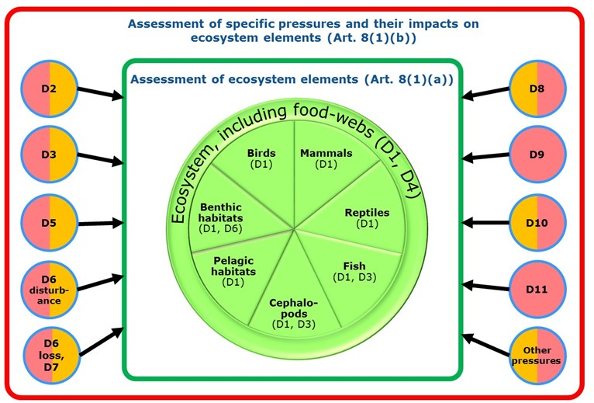

**Figure 8**: An ecosystem-based approach to determination and assessment of GES follows the main elements of the ecosystem (state-based descriptors, centre) and is closely linked to the adverse effects of pressures from human activities via their environmental impacts (pressure-based descriptors, satellite circles, in which pink depicts pressure and orange the impact). Note that Descriptors D2, D3, D5, D6, D7, D8 and D10 include both pressure and impact criteria in the GES Decision. For D11, impact criteria are not yet available. For D9 the 'impact' is built into the 'pressure' via the setting of the environmental quality standard (EQS) levels for the contaminants[34] and is not assessed separately.

This approach has the following benefits:

1. Achievement of the goals of the Directive is not encompassed within a single overall assessment, but spread over a number of defined components, allowing the achievement of GES to be measured as a set of smaller goals, which together contribute to the overall goal laid down in Article 1(1), thereby allowing progress towards GES to be expressed in a more tangible manner;
2. Focusing on a specific set of assessments provides a way of dividing the complexity of marine ecosystems in each (sub)region into a set of more manageable units for monitoring, assessment, target setting and measures;
3. It brings structure and functional aspects of ecosystems together at an appropriate resolution (i.e. within each main ecosystem element rather than only at the whole ecosystem level); this overcomes some of the inherent overlaps between the descriptors (e.g. benthic habitats under D1 and sea-floor integrity under D6; ecosystems under D1 and food-webs under D4);
4. It relates more readily to practical monitoring and assessment processes (e.g. monitoring of birds, mammals and fish is typically undertaken separately using different techniques);
5. It links more effectively to management needs, relating more specifically to pressures and human activities which can be managed in specified areas in order to achieve GES;
6. It provides an indication of whether there is need for particular (additional) environmental targets under Article 10 and (additional) measures under Article 13 in order to reach GES (bearing in mind that in some cases all necessary targets and measures may have been put in place but the ecosystem may not yet have reached GES due to slow response times);
7. It provides an important means to express to stakeholders and the public the progress being made in implementation of the Directive and achievement of its overall goals.

Whilst this structure (Figure 8) has these practical advantages, this compartmentalisation may mask some elements of an ecosystem-based approach; these could be addressed by more holistic assessments of ecosystem structure and functions (including food webs).

Based on the structure of the GES Decision and the criteria, the interrelationships between the relevant parts of Article 8, the MSFD Annex I Descriptors, the ecosystem elements and pressures of MSFD Annex III, and the criteria in the GES Decision are illustrated in the framework for assessment shown in Figure 9.

This framework leads to two sets of assessments, as shown in Figure 8:

1. A set of pressure-impact assessments under Article 8(1)(b) and the pressure-based descriptors (columns in Figure 9). These assess impacts in a way which relates directly to the ecosystem state elements being assessed under Article 8(1)(a), and to provide outcomes which are directly useful for the state-based assessments. For example, for the assessment of impact on non-commercial species, incidental by-catch needs to be separated into at least the specified species groups of birds, mammals, reptiles and fish and preferably at species level, in order to feed into species-level assessments under D1.
2. A set of ecosystem element assessments under Article 8(1)(a) and the state-based descriptors (rows in Figure 9). These state-based assessments reflect the impacts upon each state element from all the (predominant) pressures to which each is subject. For example, assessment of a benthic habitat should encompass, where appropriate, the impact assessments from the pressures: physical loss, physical disturbance, non-indigenous species, nutrient enrichment, removal of species and, if appropriate, other pressures. This framework facilitates assessment of cumulative effects of multiple pressures on the ecosystem elements, whereby the impacts assessed under individual pressures (Article 8(1)(b)) can be considered collectively for the assessments of each element under Article 8(1)(a).

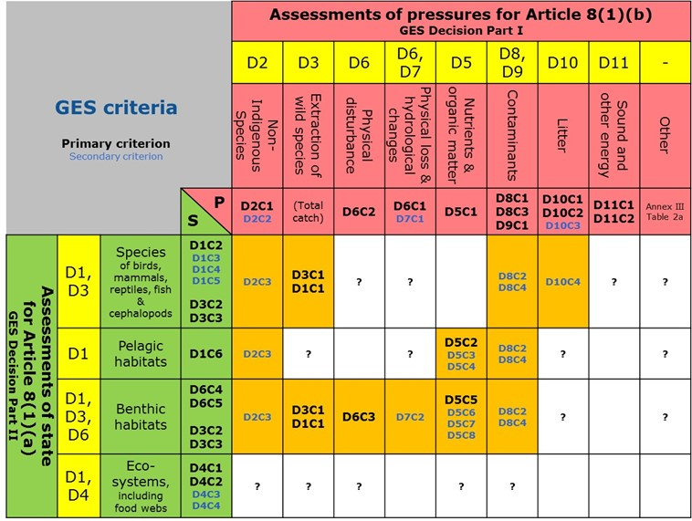

**Figure 9**: Outline framework for the GES Decision, showing the primary (in bold) and secondary criteria (D*C* codes[35]) in relation to the predominant pressures for use under Article 8(1)(b) and the ecosystem elements for use under Article 8(1)(a), each associated to particular Descriptors (D* codes). Criteria in the pink cells concern pressures (P), criteria in orange cells concern impacts (I) and criteria in green cells concern state (S) assessments. In several cases, the impact criteria are repeated (e.g. D2 and D8 criteria) because they are applicable to several ecosystem elements (species groups, pelagic and benthic habitats). Cells marked ‘?’ indicate an impact from the pressure is possible in some situations but the GES Decision does not provide a criterion.

## Main steps in the assessment and determination process

Within the overall approach for implementation outlined in section 4, it is necessary to define the particular ways in which the pressures, impacts and state elements are to be assessed in each (sub)region under Article 8(1)(a) and 8(1)(b), and to determine the extent to which these assessments indicate whether GES as determined under Article 9(1) has been achieved. This requires an iterative process, as illustrated in Figure 5, between the assessments and the determination of GES. This can be considered in a number of stages which should lead to an operational framework to meet the requirements of Articles 8 and 9 at the level required for reporting, as specified in the GES Decision and associated CIS reporting guidance[36]:

1. Define the elements for assessment, based on the requirements of the GES Decision and MSFD Annex III and adjusted to the main pressures and ecosystem elements present in the (sub)region. This should consider the need to use the outcomes of the pressure-impact assessments to contribute to the state assessments. The elements should reflect both the range of ecosystem characteristics in each (sub)region and the main pressures affecting or potentially affecting their environmental status, and can be selected on a risk-based approach (section 5.3);
2. Define the scales for each assessment, as the reporting areas (MRUs), as these can strongly influence the outcomes of the assessments (section 5.4);
3. Identify the GES criteria to be used for each of the elements, including possible deselection of primary criteria and selection of secondary criteria; in some cases, this step is undertaken prior to step (a), e.g. for D2, D5, D10 (section 5.5);
4. Define how each criterion will be assessed, based on the data to be used (from Article 11 monitoring programmes or other sources) and how it will be processed, including its spatial and temporal aggregation within the MRU. This process is often described as a scientific indicator which provides a suitable dataset (often as a time-series or as a spatial distribution map) for the criterion (section 5.5);
5. Where required by the GES Decision, determine a threshold value for the criterion/element, based on an associated ***reference condition***; if such values are not yet available, it may be possible to indicate any change in status (trend) compared with previous reporting (section 5.7);
6. Use the outcomes of the criterion assessment as specified by the GES Decision: to either express the extent to which GES has been achieved or to contribute the outcome to a state-based assessment. In some cases, this requires an integration of the criteria per element (species D1, D3, habitats D6), species group (D1) or descriptor (e.g. D5, D10, D11) (section 5.10);
7. Report on the assessment outcomes (extent to which GES has been achieved) and associated specific characteristics of GES (elements, threshold values, proportion values) using the Article 8 reporting schema (section 5.11);
8. Update, if necessary, the more general (descriptive) determination of GES, at descriptor and/or criterion level, to reflect the specific determination of GES resulting from steps a-g, using the Article 9 reporting schema (section 5.11).

Within this overall framework (Figures 8 and 9), the GES Decision sets out more specific requirements for expressing the extent to which GES has been achieved (section 5.10), for example as a set of species group and broad habitat type assessments (section 5.3) and where criteria for particular descriptors should be integrated at descriptor level or used to contribute to the assessment of another descriptor.

## Elements for assessment of progress towards GES

Section 3.3 and Figure 4 outline that elements for assessment of progress towards GES are progressively defined from the broad topics provided in MSFD Annex III to finer topics in Article 9(1), via the elements which are specified in the GES Decision. This hierarchical approach provides both consistency and flexibility, accommodating the need for coherent approaches at Union and regional levels whilst also reflecting the differences in characteristics at (sub)regional and national levels.

For each Descriptor, the GES Decision makes clear the elements to be assessed and the scale of assessment, such that use of the criteria should lead to assessments per element per assessment area (MRU); in a number of cases these elements need to be further specified at (sub)regional level.

### Elements for Article 8(1)(b) assessments: pressures and impacts

A set of pressures on the marine environment is provided in MSFD Annex III Table 2a. Criteria in the GES Decision address a number of these for the pressure-based descriptors and other key pressures (extraction of species, physical disturbance, physical loss), together with associated impact criteria (Table 3). Other pressures (listed in MSFD Annex III Table 2a) should also be assessed where they cause risk to the species, habitats and ecosystems of a (sub)region. The selection of pressure elements (and criteria) to be assessed in each (sub)region may follow a risk-based approach (section 7).

**Table 3**: Indicative list of pressures to be considered for Article 8(1)(b) assessments. Certain pressures are directly relevant for particular descriptors and have associated criteria in the GES Decision (primary criteria are in bold), whilst other pressures may need to be considered in relation to Article 8(1)(a) assessments.

| **MSFD Annex III Table 2a** | | **GES Decision** | | **Article 9(1) Determination of GES** |
| --- | --- | --- | --- | --- |
| **Theme** | **Pressure** | **Criteria elements (pressures)** | **Criteria elements (impacts)** | **Elements** |
| Biological | Input or spread of non-indigenous species | **D2C1** - Newly-introduced NIS  D2C2 - Established NIS | D2C3 - Species groups and broad habitat types at risk | Primary criteria: criteria elements relevant to (sub)region  Secondary criteria: criteria elements at risk in (sub)region  Pressures without GES Decision criteria: where relevant (causing risk) for (sub)regional species, habitats and ecosystems  Criteria elements for impact assessments should, where possible, be relevant to the elements used for D1, D3, D4 and D6. |
| Input of microbial pathogens |  |  |
| Input of genetically modified species and translocation of native species |  |  |
| Loss of, or change to, natural biological communities due to cultivation of animal or plant species |  |  |
| Disturbance of species (e.g. where they breed, rest and feed) due to human presence |  |  |
| Extraction of, or mortality/injury to, wild species (by commercial and recreational fishing and other activities) | **D3** – commercially-exploited fish and shellfish | **D3C1** - commercially-exploited fish and shellfish  **D1C1** – incidentally by-caught species at risk |
| Physical | Physical disturbance to seabed (temporary or reversible) | **D6C2** – Physical disturbance to seabed | **D6C3** – Benthic broad habitat types used for D1/D6 |
| Physical loss (due to permanent change of seabed substrate or morphology and to extraction of seabed substrate) | **D6C1** – Physical loss of seabed |  |
| Changes to hydrological conditions | D7C1 – Alteration of hydrographical conditions of the seabed and water column | D7C2 – Benthic broad habitat types used for D1/D6 |
| Substances, litter and energy | Input of nutrients – diffuse sources, point sources, atmospheric deposition | **D5C1** – Nutrients (DIN, TN, DIP, TP) | **D5C2**-D5C3-D5C4-**D5C5**-D5C6-D5C7-D5C8 – Chlorophyll-a, harmful algal blooms, photic limit, dissolved oxygen, opportunistic macroalgae, macrophyte and macrofaunal communities |
| Input of organic matter – diffuse sources and point sources |  | D5C8 - macrofaunal communities |
| Input of other substances (e.g. synthetic substances, non-synthetic substances, radionuclides) – diffuse sources, point sources, atmospheric deposition, acute events | **D8C1** – contaminants from WFD and other contaminants which may give rise to pollution effects  **D8C3** – acute pollution events  **D9C1** – contaminants in food regulation; additional contaminants | D8C2 – species and habitats at risk  D8C4 – species of species groups and benthic broad habitats |
| Input of litter (solid waste matter, including micro-sized litter) | **D10C1** - litter (10 categories)  **D10C2**-D10C3 – micro-litter (2 categories) | D10C4 - species at risk |
| Input of anthropogenic sound (impulsive, continuous) | **D11C1** – anthropogenic impulsive sound  **D11C2** – anthropogenic continuous low-frequency sound |  |
| Input of other forms of energy (including electromagnetic fields, light and heat) |  |  |
| Input of water – point sources (e.g. brine) |  |  |

### Elements for Article 8(1)(a) assessments: ecosystem structure, functions and processes

The set of ecosystem elements shown in Figure 8 is based on the structural elements of marine ecosystems provided in MSFD Annex III Table 1 and the set of species groupsand pelagic and benthic broad habitat types, including their biological communities, provided in the GES Decision (Tables 4 and 5).

**Table 4**: Species groups (for species which are not associated to specific habitat types, which should be encompassed with the broad habitat types of Table 5) to be used for determination and assessment of GES.

| **MSFD Annex III Table 1** | | **GES Decision Table 1** | **Article 9(1) Determination of GES** |
| --- | --- | --- | --- |
| **Theme** | **Ecosystem elements** | **Species groups** | **Elements** |
| **Species** | **Birds** | Grazing birds | Species groups relevant for the (sub)region  Specific species per species group (selected according to the scientific and practical criteria in the GES Decision) |
| Wading birds |
| Surface-feeding birds |
| Pelagic-feeding birds |
| Benthic-feeding birds |
| **Mammals** | Small toothed cetaceans |
| Deep-diving toothed cetaceans |
| Baleen whales |
| Seals |
| **Reptiles** | Turtles |
| **Fish** | Coastal fish |
| Pelagic shelf fish |
| Demersal shelf fish |
| Deep-sea fish |
| **Cephalopods** | Coastal/shelf cephalopods |
| Deep-sea cephalopods |

**Table 5**: Broad habitat types to be used for determination and assessment of GES.

| **MSFD Annex III Table 1** | | **GES Decision Table 2** | **Article 9(1) Determination of GES** |
| --- | --- | --- | --- |
| **Theme** | **Ecosystem elements** | **Broad habitat types** | **Elements** |
| **Habitats** | **Pelagic broad habitats** | Variable salinity[37]  Coastal  Shelf  Oceanic/beyond shelf | Broad habitat types relevant for the (sub)region  Other habitat types (e.g. from Habitats Directive, RSCs, EUNIS levels 4-6), selected according to the scientific and practical criteria in the GES Decision, which are used for assessment of the broad habitat type (criterion D6C5) and/or for assessment in their own right |
| **Benthic broad habitats[38]** | Littoral rock and biogenic reef  Littoral sediment  Infralittoral rock and biogenic reef  Infralittoral coarse sediment  Infralittoral mixed sediment  Infralittoral sand  Infralittoral mud  Circalittoral rock and biogenic reef  Circalittoral coarse sediment  Circalittoral mixed sediment  Circalittoral sand  Circalittoral mud  Offshore circalittoral rock and biogenic reef  Offshore circalittoral coarse sediment  Offshore circalittoral mixed sediment  Offshore circalittoral sand  Offshore circalittoral mud  Upper bathyal rock and biogenic reef  Upper bathyal sediment  Lower bathyal rock and biogenic reef  Lower bathyal sediment  Abyssal |
| Other habitat types | - |

For Article 9(1), the set of species groups and broad habitat types needs to be adjusted (reduced) to those types which are present in each (sub)region. The GES Decision indicates that each species group should be represented by a set of species and provides selection criteria for this purpose. Similarly, the assessment of each broad habitat type can be supported by assessments of specified sub-types, according to these selection criteria, although the broad habitat types can also be assessed directly. The selection criteria aim to ensure both representivity of the ecosystem component and risk from the main pressures.

At the ecosystem level, and as indicated in the GES Decision, a set of at least three trophic guilds should be selected, based on the selection criteria provided in the GES Decision. Ecosystems in this context should be considered as broad-scale parts of a region or subregion, each encompassing a set of species groups and broad habitat types. It might be appropriate to consider coastal, shelf and open ocean/deep sea zones separately. The definition of GES refers to ecosystem functions and processes; these are only partly addressed via the trophic guilds to be included under D4 (food webs) and may therefore need further specification.

## Scales of assessment and assessment/reporting areas

This section deals specifically with scales for assessment and reporting of current environmental status under Article 8. Scales for other aspects of MSFD implementation may differ: for example, the setting of environmental targets could be at national level, linked to national implementation of measures. And the implementation of monitoring programmes can be organised at various scales, depending on the monitoring methods and organisational needs. For both monitoring and assessment, the Directive seeks consistency across each (sub)region in the methods used (Article 11(2) and 11(4)); thus the methods could be agreed at (sub)regional level, but delivered at national or even subnational scales. In other cases, international monitoring programmes, such as for mammals and fisheries, are undertaken.

It is clear from the Directive that GES must be determined at a (sub)regional scale (Article 3(5)). However, assessments of whether GES has been achieved can be at a finer scale, as provided in the GES Decision.

The broad range of topics to be assessed across the eleven descriptors calls for a variety of scales to be used as part of an ecosystem-based delivery of the Directive. For example, wide-ranging species such as baleen whales are more appropriately assessed at the regional scale, whilst nutrient enrichment and litter may be more appropriately assessed at finer scales linked to their land-based sources and management needs. Also, there may be several populations of particular species (e.g. commercial fish) in a region and subregion; each should typically be assessed separately.

A variety of assessment scales are therefore necessary to reflect:

1. Ecologically-relevant scales for the various ecosystem elements (species, habitats, ecosystems);
2. Management and administratively-relevant scales for pressure elements, bearing in mind the need to link impacts from such pressures to the scales used for those impacted elements.

Additionally, the outcome of the assessment, i.e. whether GES has been achieved, is intrinsically linked to the scale of assessment. For example, assessing pressures and their impacts at too broad a scale can mask significant areas of impact in certain parts of a region or subregion and render the Directive ineffective. On the other hand, the Directive must be applied across the entire area of marine waters and adoption of too fine a scale for assessments could lead to burdensome assessment processes.

The GES Decision sets out a generic set of scales to be used for assessment of each descriptor, criterion or element, applicable across all marine regions.

Table 6 summarises the scales for assessment in the GES Decision, in which scales for particular pressures are linked to the state elements for which they are most relevant (e.g. extraction of fish and fish stock assessments, physical disturbance and benthic habitats, underwater noise and cetaceans).

**Table 6**: Scales of assessment for elements and criteria as specified in the GES Decision.

| **Elements for assessment** | | **Region** | **Subregion** | **Subdivision (of region or subregion)** | **National part of subdivision** | **Coastal waters (WFD)** |
| --- | --- | --- | --- | --- | --- | --- |
| **Pressure elements** | **Pressure criteria** | | | | | | |
| Non-indigenous species (D2) | |  |  | C1, C2 | |  |
| Nutrient enrichment (D5) | |  |  | C1 (beyond WFD coastal waters) | | C1: as WFD |
| Physical loss and disturbance (D6) | | C1, C2: as used for broad habitat types under D1 and D6 | | | | | |
| Hydrographical conditions (D7) | | C1: as used for broad habitat types under D1 and D6 | | | | | |
| Contaminants (D8) | | C3 (divided by national borders, where needed) | | C1 (beyond WFD territorial waters) | | C1: as WFD (to 12nm) |
| Contaminants in seafood (D9) | | C1: catch or production areas of Reg. No 1379/2013 | | | | | |
| Litter (D10) | |  |  | C1, C2, C3 | |  |
| Underwater noise (D11) | | C1, C2 | | |  |  | |
| **Impact elements** | **Impact (adverse effect) criteria** | | | | | | |
| D1 (incidental by-catch) | | C1: as used for species groups under D1C2-D1C5 | | | | | |
| D2 | | C3: as used for corresponding species groups and broad habitat types under D1 and D6 | | | | | |
| D3 | | C1: ecologically-relevant scales for each population, based on ICES, GFCM and FAO areas | | | | | |
| Nutrient enrichment (D5) | |  |  | C2-C8 (beyond WFD coastal waters) | | C2-C8: As WFD |
| Physical loss and disturbance (D6) | | C3: as used for broad habitat types under D1 and D6 | | | | | |
| Hydrographical conditions (D7) | | C2: as used for broad habitat types under D1 and D6 | | | | | |
| Contaminants (D8) | |  |  | C2 (beyond WFD territorial waters) | | C2: as WFD (to 12nm) |
| C4: as used for species groups and broad habitat types under D1 and D6 | | | | | |
| D10 (Litter) | | C4: as used for species groups under D1 | | | | | |
| **State elements** | | | | | | | |
| Species groups (D1): Birds | | Baltic & Black Sea regions or subdivisions: all groups | NE Atlantic & Mediterranean: all groups |  |  |  |
| Species groups (D1): Mammals | | Deep-diving toothed cetaceans, baleen whales.  Baltic & Black Sea regions or subdivisions: small toothed cetaceans, seals (latter not present in Black Sea) | NE Atlantic & Mediterranean: small toothed cetaceans, seals |  |  |  |
| Species groups (D1): Reptiles | |  | Turtles |  |  |  |
| Species groups (D1): Fish (excepting commercial species - see D3) | | Deep-sea fish  Baltic & Black Sea regions or subdivisions: pelagic & demersal fish | NE Atlantic & Mediterranean: pelagic & demersal fish | Coastal fish |  |  |
| Species groups (D1): Cephalopods (excepting commercial species - see D3) | | Baltic & Black Sea regions or subdivisions: all groups[39] | NE Atlantic & Mediterranean: all groups |  |  |  |
| Commercial fish and shellfish (D3) | | C2, C3: ecologically-relevant scales, based on ICES, GFCM and FAO areas (same as C1) | | | | | |
| Pelagic and benthic habitats (D1, 6) | |  |  | Biogeographically-relevant scales |  |  |
| Ecosystems/food webs (D1/D4) | | Baltic & Black Sea | NE Atlantic & Mediterranean |  |  |  |

Figure 10 illustrates these scales in a nested way, such that all finer scales sit within a broader scale, thereby allowing aggregation up to subregional and regional scales. This generic scheme needs adaptation to meet the operational requirements of each region and 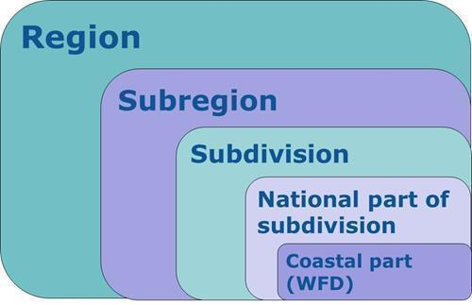subregion.

**Figure 10**: Schematic representation of a nested set of assessment scales to be used to cover all assessment needs for MSFD. Region, subregion and subdivision are provisions of Article 4[40]. 'National part of a subdivision' should be delineated using national borders of marine waters. 'Coastal part' refers to the coastal waters defined under WFD (MSFD Article 3(1b)) extending to 1nm for ecological status and 12nm for chemical status.

From this definition of the scale of assessment to be used comes the need to define the specific areas of each region or subregion to which each assessment applies and for which the extent to which GES has been achieved is reported. These have been termed the Marine Reporting Units (MRU), each being the area over which a judgement is made on whether GES has been achieved for a specified element or Descriptor. Within a single MRU, there may be multiple observations, of relevant parameters (e.g. in point, transect or grid type monitoring) over specified timeframes, which are aggregated to conclude on the extent to which GES has been achieved.

Given the number of different assessments to be undertaken, there is potential to develop a complex unconnected set of MRUs which may lead to confusion in their use (e.g. presentation of assessments, communication to stakeholders). The following approach is therefore considered most logical:

1. use a nested system of MRUs, based on the same set of smallest areas and aggregating these where needed;
2. minimise the number of areas defined, e.g. by using the same areas for several species groups, pelagic and benthic habitats. This can still respect the need for ecologically-relevant scales as the characteristics of water masses influence species composition in the pelagic and benthic habitats and associated mobile species;
3. ensure as far as possible that the state and pressure-based assessments are compatible, in terms of scales of assessment and resolution of the ecosystem elements which are assessed under state (Article 8(1)(a)) and as impacts (Article 8(1)(b)) (section 5.3 and 5.4);
4. associate the areas used for pressure-based and ecosystem-based assessments to each other (e.g. areas for assessment of physical disturbance are the same as used for the assessment of seabed habitats or nested within the area).

The following boundaries for a nested system of MRUs are already defined:

1. marine regions (Figure 2)
2. marine subregions (Figure 2)
3. national borders[41]
4. WFD coastal and territorial waters (for D5 and D8 assessments)

This leaves the main consideration as to whether there is need to subdivide each (sub)region into a suitable (and preferably low) number of subdivisions. Article 3(2) provides criteria which are relevant for defining subdivisions (namely, hydrological, oceanographic and biogeographic features). Additionally, some Member States have used the provisions of Article 4(2) to define national subdivisions.

Whilst an outline approach to defining and using such a nested system is presented here, it is necessary for Member States, working together in each region, to develop this into an operational mechanism. This has already been achieved for the Baltic Sea region by HELCOM (Figure 11); similar systems are under development by other RSCs.

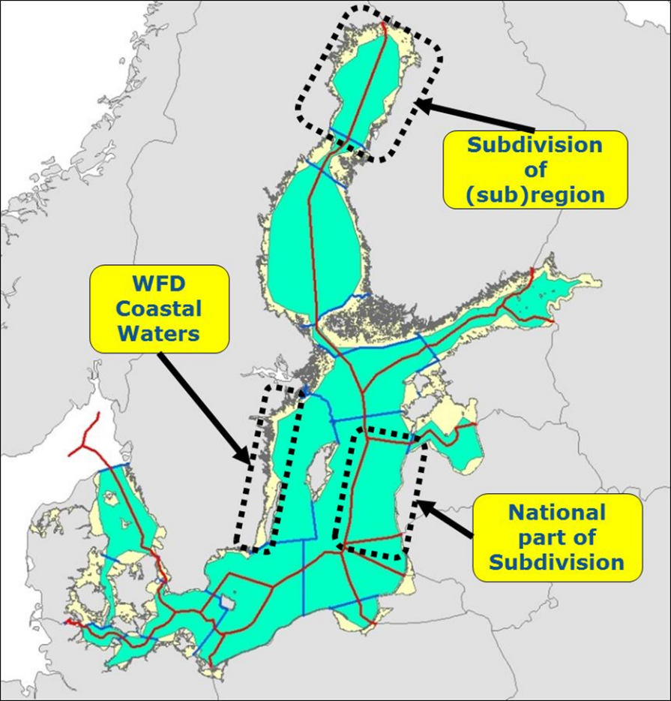**Figure 11**: HELCOM system of nested assessment areas[42]. Blue lines show the subdivisions of the region. The 'national part of a subdivision' is delineated using national borders of marine waters (red lines)[43]. WFD Coastal Waters extending to 1nm from baselines are shown (yellow areas).

## Identifying the GES criteria to be used and how they are assessed

The GES Decision provides a set of criteria to be used for each descriptor, distinguishing those which must be used (primary) from those which Member States may choose to use, based mainly on risk (secondary). The GES Decision has provision for the primary criteria to not be used in certain situations.

The selection of criteria is often considered in conjunction with selecting the elements to be assessed, particularly for some descriptors: D2, D4, D5, D7 (for C1), D8 (for C2) and D10. However, the GES determination and assessments are focused on the elements (being components of the marine ecosystem or pressures upon it) and the criteria (used singly or in combination) are there to provide a means to assess the quality of the element rather than being the end point of the assessment itself.

The majority of criteria assessments depend on data collected from the Article 11 monitoring programmes for MSFD purposes or available from other sources (e.g. satellite data from Copernicus, or pressure data derived from human activity data, such as Vessel Monitoring System data for fishing vessels or Automatic Identification System data for ships). In a minority of cases a more qualitative approach may be appropriate (e.g. assessment of habitat quality for species D1C5).

The use of data, whether from direct observations or modelled, enables robust assessment of the criterion, allowing a clear means to assess current status and to follow changes both spatially and over time. The robustness of such assessments is further enhanced when the data are processed according to methods agreed across the countries of each (sub)region, as required by Article 11(2) and 11(4). The ongoing processes of (sub)regional cooperation in the RCSs or between Member States (e.g. in the Black Sea region and Macaronesia subregion) are leading to data-driven indicators which serve this purpose.

## Determining GES: criteria on quality, proportion, distribution and duration

***Key message***

**Determinations of GES set, whenever possible, both the quality of the pressure, impact and state elements that is to be achieved and the proportion of the element that should achieve such quality levels. This ensures that the assessment concludes on whether GES has been achieved or not in a particular assessment area.**

The GES Decision sets out the criteria to be used and how to express the extent to which GES has been achieved for each descriptor. These can be categorised into four principle types:

1. Quality: the quality to be achieved for each element assessed, which is expressed as a threshold value, whether it is a state element, a pressure or its impacts (e.g. contaminant concentration, condition of a habitat in relation to a particular pressure, age and size structure of a population). This quality level can be assessed at any given location within an MRU and can vary across the MRU.
2. Proportion: the proportion of certain criteria elements (e.g. populations of species, habitats) that should achieve those quality threshold values. This includes criteria related to population size and mortality rates (e.g. spawning stock biomass (SSB) and fishing mortality (F) for commercial fish) and benthic habitat criteria that include thresholds for the proportion of allowable habitat loss and proportion of habitat to achieve an acceptable condition.
3. Distribution: the distribution of certain pressures, for instance to avoid certain sensitive areas for species, or impacts;
4. Duration: the duration of certain pressures, such as to avoid particular pressures at sensitive periods for species, or impacts.

The GES Decision criteria are allocated to one or several of these four types in Table 7, which also indicates where threshold values for the GES criteria need to be set (see section 5.7).

**Table 7**: Categorisation of the GES Decision criteria requiring threshold values (‘p’ indicates part of the criterion applies to the category).

| **Type** | **Pressure criteria** | **Impact criteria** | **State criteria** |
| --- | --- | --- | --- |
| **Quality** | D2C1[44]  D5C1  D8C1  D9C1  D10C1p, C2p, C3  D11C1p, C2p | D2C3  D5C2, C3p, C4, C5, C6, C7p, C8  D6C3  D7C2  D8C2  D10C4 | D1C3, C6  D3C3  D6C5p  D4C1, C2, C3, C4 |
| **Proportion** |  | D1C1  D3C1  D5C3p | D1C2  D3C2  D6C4, C5p |
| **Distribution** | D10C1p, C2p  D11C1p, C2p | D5C7p | D1C4 |
| **Duration** | D11C1p, C2p | D5C3p |  |
| **No threshold value requested (criterion contributes to other assessments)** | D2C2  D6C1, C2  D7C1  D8C3 | D7C2  D8C4 | D1C5 |

Most criteria do not express the proportion of the assessment area, or of a species population or habitat type in the assessment area, over which the defined quality threshold value should be achieved. Where it is not explicit in the criterion, such proportion values should be expressed as part of the determination of GES under Article 9(1) (GES Decision Recital 16). For certain descriptors, the aspect of distribution (e.g. of species) or duration (e.g. of underwater noise) is also relevant for the GES determination.

Figure 12 provides a generic depiction of the relationship between quality and proportion. Some worked examples are provided in Annex 2.

The quality of a particular element can vary across an MRU, leading to areas where the quality is above the threshold value and areas where it is below the threshold value. For a population of a species, there can be parts of the population in good health, whilst other parts are not. From Figure 12 and the examples in Annex 2, it can be seen that defining the proportion of the MRU (including of a population for species assessments) that needs to achieve the quality threshold value is an important aspect of the GES determination. There may be cases where some parts of the MRU are below the quality threshold value, but the extent of this is considered acceptable (i.e. as defined through the Article 9(1) GES determination) in relation to the objectives for GES (for example the long-term viability of a species population).

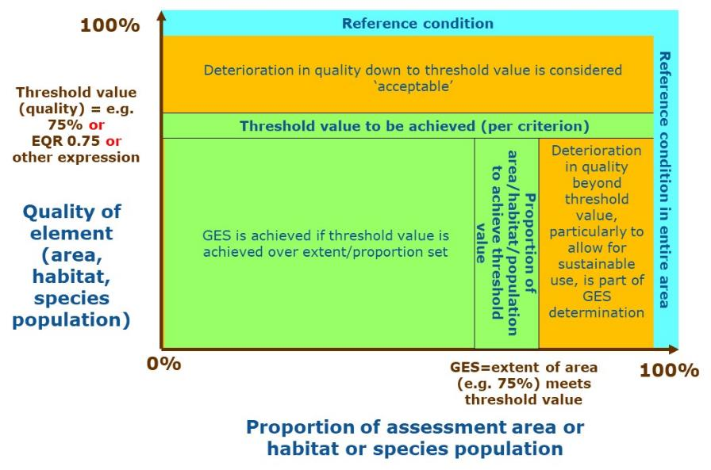

**Figure 12**: Generic quality and proportion framework for determining GES. The threshold and proportion values shown are for illustrative purposes only. These values are set per criterion and/or element in accordance with the GES Decision. See text for explanation.

The quality threshold value is typically set on scientific grounds in relation to the degree of change in quality (deviation from reference condition; see section 5.7) that can be tolerated before the element is considered to be adversely affected (impacted). For pressures, this represents the level of pressure that would give rise to such adverse effects. The proportion value set for population levels and mortality rates for species is typically set on a scientific basis in relation to their long-term viability.

Determinations of GES must be clear about both aspects (quality and extent/proportion) so that after assessment it is clear whether GES has been achieved or not. This can also be important in giving clear boundaries within which industry can operate, allowing for sustainable uses of the sea, especially where the industry exerts certain pressures and impacts on the environment.

## Setting of threshold values

A number of stages in the Directive’s implementation process require knowledge of whether GES has been achieved or not (section 3.2). In the absence of a clear determination of GES, it is not always possible to determine by how much the pressures which are causing impacts on or risks to the marine environment, human health and legitimate uses of the sea, should be reduced. This gives uncertainty to both policy makers and users of the sea.

The Commission’s Article 12 assessment (COM/2014/097) revealed that there was considerable variation in the approaches used by Member States to defining reference condition (as a basis to define the threshold values to be achieved for GES) and the baseline (e.g. current status) from which to measure progress towards achieving GES. Variation in how reference condition is defined can significantly affect the basis for determining GES and hence can substantially alter the GES quality level to be achieved for each Descriptor in each (sub)region. This consequently leads to the lack of a 'level playing field', and associated socio-economic consequences, within and across regions.

The GES Decision (Article 4.) provides requirements for the setting of threshold values (through Union, regional or subregional cooperation). The points set out in this article are further reflected in this document, as ‘*those values shall:*

1. *be part of the set of characteristics used by Member States in their determination of good environmental status* (section 5.6)*;*
2. *be consistent with other Union legislation* (section 5.9)*;*
3. *where appropriate, distinguish the quality level that reflects the significance of an adverse effect for a criterion and be set in relation to a reference condition* (section 5.7)*;*
4. *be set at appropriate geographic scales of assessment to reflect the different biotic and abiotic characteristics of regions, subregions and subdivisions* (section 5.4)*;*
5. *be set on the basis of the precautionary principle, reflecting the potential risks to the marine environment* (sections 3.2, 4.3, 6.1)*;*
6. *be consistent across different criteria when they relate to the same ecosystem element* (section 5.7)*;*
7. *make use of best available science* (section 5.6)*;*
8. *be based on long time-series data, where available, to help determine the most appropriate value* (section 5.7)*;*
9. *reflect natural ecosystem dynamics, including predator-prey relationships and hydrological and climatic variation, also acknowledging that the ecosystem or parts thereof may recover, if deteriorated, to a state that reflects prevailing physiographic, geographic, climatic and biological conditions, rather than to a specific state of the past* (section 5.8)*;*
10. *be consistent, where practical and appropriate, with relevant values set under regional institutional cooperation structures, including those agreed in the Regional Sea Conventions).’*

For point (f), assessment of the pressure-based descriptors includes an assessment of the level of the pressure and of the impacts on ecosystem state[45]; the threshold values set for these two aspects should correlate (GES Decision Article 4(1)(f)), such that both criteria fail or pass GES at the same time; in situations where one passes and the other fails, it suggests the two aspects may not be sufficiently correlated and may need adjustment of the threshold values set (unless the state is still recovering following a reduction in the pressure, e.g. fishing mortality rates for D3 or nutrient levels for D5).

For some aspects of GES, particularly assessments at ecosystem level including food-webs (D1, D4), it may not currently be possible to make quantitative judgements on GES. Scientific understanding is such that anthropogenic pressure is often difficult to distinguish from the environmentally-influenced variability. It may either not be possible (through lack of evidence) to define threshold values based on knowledge of the ecosystem or where the link to anthropogenic pressures is weak or unclear, so direct management actions cannot be prescribed. In the absence of strong indicators reflecting pressure–state relationships, the scientific indicators may best be used to trigger further research or investigation to better understand any changes observed.

In some cases, the data for a particular criterion/element (e.g. population size of a mammal) may indicate improvements in status over time since the start of a time series, without indicating a stable state that could be used to set a threshold value. In such cases, the criterion/element can be reported as improving towards GES (trend), but a suitable threshold value cannot yet be established. In other cases, such time series data may be lacking, as well as suitable information on reference condition (e.g. for some benthic habitats), giving uncertainties as to what could be a suitable threshold value, and necessitating use of a precautionary value in the meantime. Where the element is clearly subject to pressures causing adverse effects, removal of the pressure and monitoring recovery towards a stable state may be a suitable option for setting threshold values.

### Use of reference condition in setting threshold values

**Key message**

**Threshold values are set in relation to a reference condition, and may include an ‘acceptable deviation’ from this reference condition. This allows for sustainable uses of the marine environment whereby some level of pressures and their impacts can be accommodated, provided the overall quality of the environment is maintained.**

The GES Decision (Article 4(1)(c)) indicates that threshold values ‘*shall […] be set in relation to a reference condition*’. This is illustrated in Figure 12.

The Commission provided the following guidance as part of its Article 12 assessment (SWD/2014/049):

It is common practice in EU Directives and in regional assessment methodologies to define environmental objectives (i.e. the threshold value to be achieved) in relation to a reference condition. For example, threshold values for contaminants and eutrophication are typically set in relation to ‘background’ or ‘natural’ levels in the environment, with threshold values set as a specified deviation from these conditions. This philosophy is typical for setting objectives for other pressures, such as litter and noise. For assessing the environmental status of biodiversity components, a similar approach is also used in the WFD and Habitats and Birds Directives, whereby threshold values are set in relation to natural characteristics, such as the distributional range of a species, the extent of a habitat or the condition of its biological community. This overall philosophy for setting environmental objectives is often termed the ‘reference condition and acceptable deviation’ approach. The possibility to allow for a ‘deviation’ is important, particularly to allow for sustainable uses of the marine environment whereby some level of pressures and their impacts can be accommodated, provided the overall quality of the environment is maintained, or for other reasons (e.g. because achieving a reference condition is not technically feasible).

In the reports provided in 2012 by Member States for Articles 8, 9 and 10, the approach to using reference condition and setting of threshold values was very varied, both across the different descriptors and across Member States for the same descriptor. In some cases, the current state in the 2012 assessment was used as the baseline (from which a particular quality is to be maintained), without fully assessing whether that state was adequate to begin with. In many cases, the reference levels to be used for the determinations of GES and environmental targets were not documented.

This degree of variation and lack of clarity can lead to substantial problems in subsequent implementation phases, as differences in approach lead to conflicts between descriptors (e.g. between state and pressure assessments) and a lack of common understanding of what constitutes GES. Instead, a common approach, based on the reference condition plus an acceptable deviation, should be used across descriptors to achieve a suitable level of consistency in future implementation phases.

Guidance on determining baselines is given in the [2012 MSFD reporting guidance section 6.2.3.6](https://circabc.europa.eu/d/a/workspace/SpacesStore/d03fab61-6d50-4f02-9896-cc2f68cfb6f0/MSFD%202012%20reporting%20guidance_incl_database_v1.0.doc):

GES threshold values must be set in relation to the reference condition (sometimes referred to as reference state or background levels) (Figure 13). The reference condition can be determined using the following approach:

A state of the environment considered largely free from the adverse effects of anthropogenic activities (*i.e.* negligible impacts from pressures). This can be defined in relation to aspects of environment state (physical, chemical and/or biological characteristics), or to levels of pressure or impact (*e.g.* an absence of contaminants or certain impacts). This type of baseline is typically used to allow an acceptable deviation in state to be determined which acts as the quality threshold value to be achieved. Reference condition can be determined using a variety of methods, including:

* 1. Historic conditions, based on various evidence about conditions before there was significant anthropogenic activity;
  2. Past date/period, based on time-series datasets in which a time that is considered to best equate to ‘reference condition', is selected;
  3. Current conditions, in areas considered substantively free from anthropogenic pressures;
  4. Modelling, to predict current state in the absence of pressures.

In all these approaches, there is often a need to use expert judgement, but this should be used in a well-documented and transparent manner, consistently across the (sub)region.

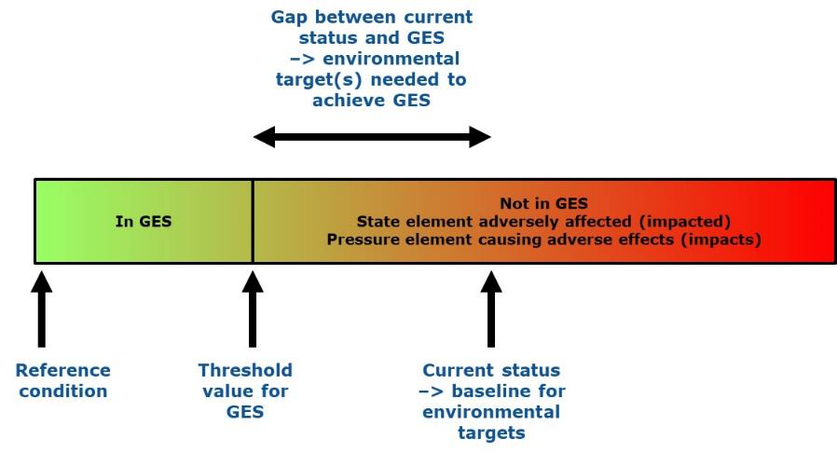

**Figure 13**: Relationship between reference condition and threshold values in relation to the quality to be achieved for an element to be in GES (one or several criteria with threshold values may be needed). A current status which is below GES is also shown, indicating the gap to be reduced, through one or more environmental targets and associated measures, in order to reach GES.

The use of a specified/known state (of the environment, or the pressures and impacts acting upon it), such as the state at the time of the 2012 initial assessment, is appropriate in setting environmental targets (section 6), where it can be used as the baseline state from which to assess progress. However, use of such baselines is generally not appropriate for setting threshold values for a determination of GES as it usually implies that it is not a reference condition.

### On setting threshold values at an appropriate scale

On a number of occasions the GES Decision requires that Member States set threshold values through Union, regional or subregional cooperation. This specifically refers to the process by which these thresholds need to be set and not to the scale.

GES Decision Article 4(1)(d) clearly indicates that the thresholds need to be set at appropriate geographical scales, to reflect the different biotic and abiotic characteristics of regions, subregions and subdivisions. This, for example means, when setting threshold values for D11 at Union level, that these values may differ from one region/subregion to another, or from one subdivision to another, to take into account the specific characteristics of the area in question, but they are nevertheless set through a Union-level process (i.e. through the work of Technical Group on Noise in the MSFD Common Implementation Strategy). Similarly, those thresholds being set through a regional/subregional process – for example through work carried out by the RSCs – may vary from one subregion/subdivision to another to take into account the specificities of the area.

Threshold values should generally be consistent with the scales of assessment (MRUs) used (section 5.4).

## GES in relation to ecosystem characteristics, dynamics and climate change

***Key message***

**Threshold values are set to ‘*reflect natural ecosystem dynamics, including predator-prey relationships and hydrological and climatic variation, also acknowledging that the ecosystem or parts thereof may recover, if deteriorated, to a state that reflects prevailing physiographic, geographic, climatic and biological conditions, rather than to a specific state of the past*’ (GES Decision Article 4(1)(i)).**

Differences in the characteristics of ecosystems between regions and subregions will likely lead to different GES determinations especially to state-based descriptors being different in order to reflect, for example, the differing ranges of species present and different environmental conditions, such as water clarity and sea temperature. There may also be instances where such ecosystem differences warrant adjustments to the determination of GES at national level, such as via selection of specific species and habitats to be assessed, but such cases should be within the overall level of consistency determined at (sub)regional level. In contrast, the same does not apply for determining acceptable levels of pressures upon the environment in different ways according to the (sub)region, as the levels to be reached in order to achieve GES should be consistent across all Member States.

Climate change is influencing the characteristics of the marine environment and can be expected to affect hydrological conditions (e.g. sea level, wave action from increased storminess, water temperature, water circulation patterns, salinity and freshwater run-off from land), water chemistry (increased acidification) and biodiversity (e.g. species distribution changes due to sea temperature changes).

Assessing the effects of climate change is not a specific objective of the MSFD. However, it is important to be able to distinguish wider climate-change effects (e.g. temperature, acidification, biodiversity) from more local effects caused by other anthropogenic pressures, as these latter cases can and should be addressed within the context of the MSFD. It is therefore important to monitor wider changes in the ecosystem and use this to help interpret monitoring data which is focused on assessment of GES. For efficiency, this wider monitoring can be coupled with monitoring of reference sites used for descriptor-specific monitoring.

The setting of threshold values needs to reflect the dynamic nature of ecosystems and their elements, which can change in space and time through climatic variation, predator-prey interactions and other factors. For example, determining good status for a benthic or pelagic community could focus on the functional components and trophic guilds (e.g. filter feeders, deposit feeders, primary producers, decomposers) which are typical of the community in (near) unimpacted state, rather than specifying the precise species composition which is more prone to fluctuation. The presence of sensitive/fragile/long-lived species can be good indicators of (near) unimpacted state, but if lost from a community due to anthropogenic pressures, the community may not recover to the same species composition but could still be judged to have recovered to GES if the community has all the functional components, similar diversity and alternative sensitive, fragile or long-lived species of a (near) unimpacted state.

GES should be determined in a way that takes account of ongoing changes in species composition, abundance and distribution due to the dynamics of marine ecosystems, some of which may be affected by climate-induced effects.

## Links to quality standards of other policies

The GES Decision sets out how standards and assessments under other Union legislation are to be used for MSFD purposes. This is summarised in Table 8.

**Table 8**: Overview of how other existing legislation is to be used when determining and assessing GES, as provided in the GES Decision.

| **Descriptor** | **Criteria elements** | **Criteria threshold values** | **Scales of assessment** | **Use of criteria** |
| --- | --- | --- | --- | --- |
| **D1 – Biodiversity (species)** | Incidental bycatch species via CFP Data Collection Framework Regulation (EU) No 1380/2013 and Commission Implementing Decision (EU) 2016/1251.  Species to include Annex II species of Habitats Directive 92/43/EEC, and may use species from other Habitats Directive Annexes, Birds Directive 2009/147/EC, and CFP Regulation (EU) No 1380/2013. | Criteria aligned with Habitats Directive, Birds Directive and D3 (CFP) assessments.  Threshold values consistent with Favourable Reference Population and Favourable Reference Range values for species of Habitats Directive 92/43/EEC.  For commercially-exploited species, threshold values as used under D3 (CFP) | For commercially-exploited species, areas as used under D3 (CFP) | For species from Habitats Directive 92/43/EEC, overall status as per Habitats Directive.  For commercially-exploited species, overall status as per D3 |
| **D1 – Biodiversity (pelagic habitats)** |  |  |  |  |
| **D1 – Biodiversity (benthic habitats) and D6 – seafloor integrity** | May include habitats under Habitats Directive 92/43/EEC | Criteria aligned with Habitats Directive 92/43/EEC |  | Reuse of assessments under Habitats Directive 92/43/EEC and WFD 2000/60/EC wherever possible |
| **D2 – Non-indigenous species** | Invasive alien species in Regulation (EU) No 1143/2014 |  |  |  |
| **D3 – Commercial fish & shellfish** | Species under Common Fisheries Policy Regulation (EU) No 1380/2013 and associated instruments:  Data collection framework Council Regulation (EC) No 199/2008;  Species with TACs and quotas under Article 43(3) of TFEU;  Species with minimum conservation reference sizes and species under national plans in Regulation (EC) No 1967/2006 | F and SSB values under CFP Regulation (EU) No 1380/2013 | As used under CFP Regulation (EU) No 1380/2013 |  |
| **D4 – Food webs** |  |  |  |  |
| **D5 - Eutrophication** | Elements equivalent to Water Framework Directive 2000/60/EC quality elements | Threshold values of WFD Directive 2000/60/EC for coastal waters | As used under WFD Directive 2000/60/EC for coastal waters | As used under WFD Directive 2000/60/EC for coastal waters |
| **D6 – Seafloor integrity** | Criteria for physical loss and disturbance:Data and assessments from Water Framework Directive 2000/60/EC for coastal waters | | | | |
| **D7 – Hydrographical conditions** | Data and assessments from Water Framework Directive 2000/60/EC for coastal waters | | | | |
| **D8 - Contaminants** | Contaminants from Water Framework Directive 2000/60/EC, including EQS Directive 2008/105/EC  Acute pollution events involving substances under Directive 2005/35/EC | Threshold values of WFD Directive 2000/60/EC for coastal and territorial waters | As used under WFD Directive 2000/60/EC for coastal and territorial waters | uPBTs distinguished as under EQS Directive 2008/105/EC |
| **D9 – Contaminants in seafood** | Contaminants listed in Contaminants in foodstuffs Regulation (EC) No 1881/2006 | Threshold values of Contaminants in foodstuffs Regulation (EC) No 1881/2006 | Catch or production areas of Regulation (EU) No 1379/2013 |  |
| **D10 - Litter** |  |  |  |  |
| **D11 – Energy, including underwater noise** |  |  |  |  |

Where Union legislation standards are not available, the GES Decision provides for their development through Union, regional or subregional cooperation, depending on the descriptor. These processes must be consistent, where practical and appropriate, with relevant values and standards set or under development in regional institutional cooperation structures, including the Regional Sea Conventions and in other international agreements.

In cases where the standards in these other Union policies are set only at national level, the GES Decision requires the development of (sub)regional standards which are consistent with those national standards. This is to ensure compliance with Article 5(2). Such (sub)regional standards have usually been or are being developed by the RSCs and other international agreements, or can be developed by Member States through regional or subregional cooperation. It should be noted that the use of different methodologies (e.g. criteria, assessment scales) and quality standards (i.e. threshold values to be achieved) between policies can lead to different assessment outcomes (i.e. classification of environmental status) for the same quality element, and thereby hamper harmonisation of assessments.

Assessments of species and habitats under different policies and conventions are undertaken according to a variety of criteria and methodologies. Annex 3 summarises the relationships between the criteria used under key instruments of relevance.

## Expressing the extent to which GES is being achieved

***Key message***

**The GES Decision informs the assessment of the extent to which GES is being achieved.**

**The ways in which the underlying data, indicators and criteria are processed and aggregated, and the threshold values and rules for use of criteria adopted, have important implications for the ultimate outcomes of the assessments.**

**Where such methodological standards and specified methods are not defined at Union level, they should be agreed at regional or subregional level in order to ensure consistency in the outcomes.**

**Due to the often slow change in the state of the marine environment and the pressures upon it, reporting on trends in status is important to demonstrate progress towards achieving GES.**

The GES Decision sets out how to express the ‘extent to which GES is being achieved’.

Each assessment entails the use of a number of elements (e.g. contaminants, nutrients, species and habitats), criteria, scientific indicators and monitoring data. These are then aggregated to reach conclusions on the extent to which GES has been achieved for each assessment. The Article 8 guidance[46] provides further details on how this can be achieved as part of a structured assessment process. The ways in which data are processed and aggregated, and the threshold values and rules adopted for use of criteria, have important implications for the ultimate outcomes of the assessments. For transparency and repeatability, these processes need to be documented in Article 8 reporting, when not already defined in other Union policies or provided in the GES Decision. The methods also need to be consistent across Member States to ensure the outcomes of the assessments are comparable (Article 5(2) and Article 11).

In some cases, the elements or criteria are aggregated to draw conclusions per Descriptor (or per species group for D1) but higher aggregation of assessments across descriptors is not needed. Section 5.3 sets out the elements to be used in relation to the different descriptors and criteria.

Bearing in mind the range of topics to be considered and the large areas of marine waters to be assessed, there are the following considerations:

1. The degree of precision may vary; some assessments may provide only a coarse evaluation (e.g. an estimate to nearest 10 or 20%), but this may be adequate, especially if the area is clearly achieving GES or conversely clearly not achieving GES. Greater precision is likely to be needed if the area/element is close to the border between ‘being in GES’ and ‘not being in GES’.
2. Due to the often slow rate of change in the state of the marine environment and the pressures upon it, such as following the introduction of measures, the assessments of status may often not change from one reporting period to the next, despite underlying improvements in the status. This is particularly exaggerated under MSFD with its two status classes (in GES, not in GES) compared with, for example, the Water Framework Directive, which has five status classes. In order to provide additional evidence of progress towards GES it is therefore important to indicate the trend in status (i.e. whether the status has improved, is stable or has deteriorated) compared with the previous reporting period.

## Reporting on the determination of GES and the extent to which it has been achieved

**Key message**

**Updates of the determination of GES should take account of:**

**a. The adoption of Commission Decision (EU) 2017/848;**

**b. Advances in scientific and technical understanding;**

**c. Changes in ecosystem dynamics since the last determination;**

**d. Progress made in each (sub)region to determine GES in accordance with Articles 3(5) and 5(2) of the MSFD.**

The Directive provides in Article 17 for a six-year review and updating of each element of the marine strategies. For GES, this is a key mechanism to refine the determinations to take account of developments since the previous determination[47] including:

1. The 2017 GES Decision; the 2018 and subsequent updates must use the 2017 GES Decision, leading to a more explicit, and where possible quantitative, determination of GES than was reported in 2012;
2. Advances in scientific and technical understanding since the last reporting under Article 9;
3. Changes in ecosystem dynamics, which justify a modification to the previous determination of GES (section 5.8);
4. Progress made in improving the consistency of GES determinations in each (sub)region in accordance with Articles 3(5) and 5(2), such as through the RSCs.

These 6-yearly updates are a refinement of the determination (e.g. making it more clear and precise) and to improve the coherence within the (sub)region, rather than a change in the overall quality level that is to be achieved. However, the first update in 2018 is likely to be more substantive, given the wide range in approaches and levels of detail reported in the first cycle (2012).

The updates can be considered at two levels of detail:

Generic level: this sets out the objectives to be achieved by the Member State within each (sub)region. This is likely to be a qualitative description of GES, expressed at descriptor and/or criterion level, based respectively on the Annex I Descriptors and the GES Decision criteria. This qualitative description expresses GES in a way adjusted to the characteristics of the (sub)region and consistent with that of other Member States in that (sub)region. Updates are reported using the Article 9 GES reporting schema[48], and should be consistent with the characteristics reported at the specific level (see below).

Specific level: this sets out the particular characteristics of GES, including the threshold values for each relevant criterion, in each (sub)region. It also expresses, where appropriate, the proportion of each assessment area (or ***criteria element***, where appropriate) that should achieve these threshold values (GES Decision, Recital 16) (see section 5.6). This level of specificity is closely linked to the assessments under Article 8 and should enable an assessment of the extent to which GES has been achieved (section 5.10).

The updated set of characteristics for GES includes:

1. Identification of the specific characteristics for each region or subregion, such as the specific criteria elements relevant or not relevant to the (sub)region;
2. Determination of threshold values where these are not yet provided in the GES Decision;
3. Determination of the proportion of the assessment area or proportion of criteria elements per assessment area over which the threshold values are to be achieved to constitute GES.

It should also be clear, via reporting of methodological standards under Article 8, how the criteria have been integrated to conclude on the overall status of particular descriptors (e.g. D5) or particular criteria elements (e.g. D3 species and D1 species and species groups). If these methodological standards are not yet agreed at Union or (sub)regional level, in accordance with the GES Decision, the national approaches used should be specified.

Reporting on the assessment outcomes (extent to which GES has been achieved) and associated specific characteristics of GES (elements, threshold values, proportion values) is done through the Article 8 reporting schema, due to the inherent relationship between the specific (indicator-based) assessments and the threshold values set, as part of the determination of GES, for particular criteria and elements.

## Time period for assessments

The Directive has a six-year cycle, with reporting for each part of the marine strategy set at intervals within each six-year period (Figure 1). The determination and assessment of GES under Articles 9 and 8 respectively (together with the setting of environmental targets under Article 10) effectively marks the start of each cycle (2012, 2018, 2024, etc). It is necessary to update the assessments of environmental status at least once every six years, in order to assess and report on the current status in relation to the determination of GES and to show progress achieved since the previous report six years before (also against targets set and measures established). This does not preclude the updating of assessments at more frequent intervals, where this is feasible and desirable. The latter situation could arise, for example, where monitoring is undertaken on an annual or more frequent timescale and processing of the data has become routine or because of other obligations. Annual assessments are, for example, undertaken for commercial fish stocks under CFP.

When undertaking assessments there is a need to:

1. Consider data over as long a time period as possible, so as to help understand changes in the data, including natural variability as well as anthropogenic influences. This can be particularly relevant for setting threshold and ***referemce condition*** values;
2. Use the latest available data from monitoring programmes in the assessment to ensure the assessments reflect the most recent situation;
3. Update the data to be used at least once in the six-year period, so that the status and trend assessments are based on the latest available data;
4. Use, as far as possible, data from the same time period when considering combinations of data (e.g. pressure and state/impact data, background oceanographic data);
5. Compare the most recent six-year assessment period with the previous six-year assessment period in order to report progress in achieving GES (trends) and environmental targets.

# Environmental targets (Article 10)

## Follow-up actions to Article 8 assessments depend on the environmental status

The Article 8 assessments inform whether there is need for environmental targets (Article 10) and consequently for measures (Article 13).

There are four possible classifications of environmental status:

1. 'In GES' – for which monitoring is needed to check pressures do not increase to a point where impacts could become unacceptable and status begins to deteriorate; this is coupled with measures to maintain GES.
2. 'Not in GES' – If GES has not been achieved, it is necessary to identify the pressure or pressures causing the failure in environmental quality; where this is not possible, further investigative action is necessary to better understand the reasons for not achieving GES. The follow-up action focuses on managing and reducing the anthropogenic pressures causing this failure. In the marine environment, the option to take direct management action on the environment itself (e.g. to actively restore a species or habitat) is typically less appropriate and usually more costly. Article 10 (environmental targets) and Article 13 (measures) are the key mechanisms in the Directive to be used to achieve and maintain GES. In situations where GES is clearly not yet achieved, and threshold values are not yet available, actions to reduce pressures should be taken in accordance with the precautionary principle[49].
3. Unknown status (potentially 'Not in GES') - it may not be possible in all cases to identify a status which is clearly In GES or clearly Not in GES. Follow-up actions depend on the shortcomings in the individual case e.g. development of improved assessment methods, more monitoring or complementary research. These actions should be undertaken as soon as possible so that a clear classification of status can be determined. In addition, in accordance with the precautionary principle, this uncertainty of classification must not be used for postponing action or taking proportionate measures to reduce pressures causing impacts on or risks to the marine environment, human health and legitimate uses of the sea, and to prevent further deterioration (Article 1(2)(a, b) and Article 14(4)).
4. 'In GES', but with a clear trend or risk towards 'Not in GES' - in such cases, increased monitoring may be necessary and the setting of environmental target(s) may be required.

## The nature of environmental targets

**Key message**

**The purpose of environmental targets and their relationship to measures under Article 13 suggests that they should primarily focus on the pressures from human activities causing the failure to achieve GES, or the associated environmental impacts.**

**They can do this by defining the necessary level of reduction in each anthropogenic pressure needed to achieve GES.**

**Environmental targets are not an alternative to determining GES under Article 9, but a support tool for the achievement of GES.**

**Environmental targets need to be specific, measurable, achievable, realistic and time-bound (SMART).**

Article 3(7) defines ‘environmental target’ as ‘*a qualitative or quantitative statement on the desired condition of the different components of, and pressures and impacts on, marine waters in respect of each marine region or subregion. Environmental targets are established in accordance with Article 10’*. Article 10(1) states that Member States shall establish ‘*a comprehensive set (…) so as to guide progress towards achieving good environmental status in the marine environment, taking into account the indicative list of pressures and impacts set out in Table 2 of Annex III, and of characteristics set out in Annex IV’*.

The MSFD leaves considerable flexibility for Member States in setting environmental targets; however, in order to make them fully operational in relation to their specified role in the Directive, targets need to be specific, measurable, achievable, realistic and time-bound (SMART) ([SWD(2014) 49](http://eur-lex.europa.eu/legal-content/EN/TXT/?uri=CELEX:52014SC0049)).

The Directive provides for setting a wide range of targets. To be more effective, targets should primarily focus on the pressures from human activities causing the failure to achieve GES. Most pressures arise from specific human activities and can be controlled, reduced or eliminated through management of the associated activities. Such actions are the primary management tool to achieve improvements in environmental quality. Setting adequate targets in relation to all relevant pressures means that, by reaching all targets, GES would be achieved.

Environmental targets should define the necessary level of reduction in each anthropogenic pressure needed to achieve GES, with a particular focus on targets for the reduction in the spatial extent, intensity or frequency of anthropogenic pressures at their source or entering the marine environment (Figure 13). For example, targets can include setting levels for the inputs of nutrients and pollutants into the marine environment via riverine or atmospheric sources. Generalised targets per pressure (e.g. nutrient input levels to the sea) can then lead to specific actions as Article 13 measures towards one or more human activities/sectors (e.g. waste water treatment, fertilizer use, detergent compounds). A regional example of an environmental target is the MAI/CART[50] target of HELCOM to address nutrient enrichment. Another example is the setting of fish catch levels (under CFP) in relation to Descriptor 3 in order to manage the quantity of fish removed.

According to Article 3(7), targets can also be an expression of the desired condition of the different components of marine waters, indicating a more state-based focus. Such types of targets can be expressed as the reduction in environmental impact which is needed for particular ecosystem components to achieve GES (e.g. an X% reduction in the extent of an impacted component) and where possible associated to a specific pressure or pressures.

State-based targets may be appropriate as interim targets, for example, where they are a stepping stone to the overall objective to be achieved as defined under Article 9(1). This could include, for example, setting an interim proportion of an MRU that should achieve a particular quality threshold value (for a pressure, impact or state element), when the overall proportion value set as GES is greater. However, targets are not an alternative to determining GES under Article 9, such as targets which determine a desired species composition and/or abundance that cannot be directly achieved by management actions, but are a support for the achievement of GES.

Environmental targets can be defined even in situations where Member States have not determined GES. For example, it is possible to set targets for reductions in pressures (e.g. for litter) in the absence of a clear determination of GES. In such cases, the current state (or a specified/known state in the past) can be used as the baseline from which to measure progress with the environmental target.

Article 10 does not make specific provision for assessment of progress in achieving the environmental targets; rather this should be taken up within the context of Article 8 assessments as follows:

1. Directly, as part of the assessment of anthropogenic pressures under Article 8(1)(b), focusing on whether the input levels of a pressure (pressure at source) (e.g. nutrient input levels from land-based or atmospheric sources) have been reduced in accordance with the target set;
2. Indirectly, by assessing whether the levels of pressure in the marine environment (at sea), their impacts or the state of ecosystem elements is moving towards GES.

Reporting on progress with environmental targets, as required under Article 17, is incorporated into the Article 10 reporting schema.

## Indicators

The term indicator is an established term, which is used in different ways in the scientific community (see glossary in Annex 1).

For MSFD legal purposes, the term ‘indicator‘ refers only to their use in association with environmental targets (Article 10), where they are used to monitor/assess progress and guide management decisions with a view to achieving these targets (MSFD Annex IV(7)).

The quantitative (SMART) aspect of a target should be reflected in the indicator(s) chosen to track progress with the target.

## Reference points

In the indicative list of characteristics to be taken into account for setting environmental targets, MSFD Annex IV(8) refers to, where appropriate, specification of ***reference points*** (target and limit reference points). These are the values which are to be achieved or not exceeded respectively in order to achieve the environmental target. The term reference point should not be confused with threshold values for GES Decision criteria, set in relation to reference conditions.

The setting of reference points could be in relation to a baseline, which is a specified/known state (of the environment, or the pressures and impacts acting upon it), such as the state at the time of the 2012 initial assessment (Figure 13). This baseline can be used to assess progress towards achieving the target. A baseline state can be determined using a variety of methods, including:

1. Past state, at a specified time (e.g. when a policy or programme was adopted);
2. Past state, based on time-series data, but where the data are known to reflect certain levels of impact;
3. Current state.

## Links to monitoring (Article 11)

Measurement of progress with the environmental targets is typically done through the Article 11 monitoring programmes, when the targets are related to pressures on the marine environment and or their environmental impacts. Given that targets are best focused on the gap between current status and GES (i.e. they define the amount of a pressure that needs to be reduced), it follows that monitoring of progress with the target would focus on measuring the extent, distribution or intensity of the pressures, particularly at their source (if sea-based) or entry point to the marine environment (if land-based). For example, monitoring of riverine inputs (of nutrients, contaminants and litter) and monitoring of atmospheric deposition rates (for nutrients and contaminants) would be linked to environmental targets rather than directly to GES assessments.

## Links to measures (Article 13)

The delivery of the environmental targets set under Article 10 is via the Programme of Measures defined under Article 13. Targets could be focused on the main pressures and be expressed rather generically (e.g. reduce litter or physical disturbance by X% or by Y amount). The associated measures would then address the specific uses and activities generating the pressure (e.g. tourism and urban waste management for litter; aggregate dredging and bottom trawling for physical disturbance) and be more specific than the associated environmental target.

# Use of risk-based approaches in MSFD implementation

This section sets outs how a risk-based approach can be used in the context of the GES Decision and implementation of Articles 9, 8, 10, 11 and 13, including examples.

Article 9(3) – criteria and methodological standards for GES (GES Decision)

The GES Decision makes explicit reference to the risk-based approach and sets out criteria for good environmental status in relation to the predominant pressures and their impacts and on state elements which can best reflect these pressures and impacts.

1. Selection of criteria: for several descriptors, use of particular criteria should take risk (and hence relevance to the region or subregion) into consideration. For example, use of criteria D5C3 and D5C4 where the effects of nutrient enrichment are not adequately assessed via use of criterion D5C2 and use of criteria D7C2, D1C4 and D1C5 only in cases where there may be particular risk from certain pressures.
2. Selection of criteria elements: these are selected or, in cases where these still need to be defined, should be selected with a clear focus on risk, firstly through focusing on predominant pressures in each region or subregion and, secondly, through focusing on those ecosystem elements (species, habitats) which are most indicative of impacts from these pressures. For example, selection of additional contaminants for criteria D8C1 and D9C1 should be on the basis of risk; similarly, selection of species, species groups and habitat types for criteria D10C4, D2C2 and D2C3, D7C2 and species for Descriptor 1 species groups.
3. ‘De-selection’ of criteria elements: Criterion D8C1, via established processes under the WFD, and criterion D9C1 anticipate the de-selection of contaminants in cases where there is low risk.
4. Parameters for assessment of the criteria: the parameters to be used for each criterion are those identified from the scientific and technical review of Decision 2010/477/EU, as best reflecting the needs for assessment of environmental status, considering the most relevant aspects of the pressures and their impacts, and those aspects of ecosystem state for species and habitats considered most relevant. In this sense, the criteria generally reflect a risk-based approach. In cases where the criteria are less-well specified, for example for assessing the effects of contaminants on biota (D8C2) and assessing the health of species (D1C3), Member States should focus their efforts on particular species and parameters of most relevance to the criterion.
5. In addition, the GES Decision also provides for the possibility not to use certain criteria in justified circumstances (Article 3 of the GES Decision): whilst the primary criteria are to be used by all Member States, there is provision to not use one or more of these criteria. This could, for example, be relevant in cases where the activities (and hence pressures) are not present in the waters of a Member State.

Article 9(1) – determination of GES

1. The determination of GES should focus on expressing the desired state of the environment in relation to aspects which are (potentially) impacted by anthropogenic pressures. This can be done by identifying the elements (e.g. species and habitats) and parameters (e.g. population size, species composition, biomass) which will most effectively indicate environmental status in relation to specific pressures (e.g. chlorophyll-a and oxygenation levels in relation to nutrient enrichment; mortality rates in relation to fishing).
2. In cases where the GES Decision anticipates the identification at regional or subregional level of criteria elements and threshold values, these should focus on those aspects which are most relevant to each area in question. In some cases, for example criteria D10C4, D7C2, D2C2 and D2C3, the number of species/species groups/habitat types selected could be rather limited and focused on key elements of relevance rather than aiming to be more exhaustive.

Article 8 - assessments

1. Given that GES will most effectively be achieved through the management of human activities and reductions in anthropogenic pressures where needed, the assessments under Article 8 should aim, as a priority, to assess the distribution and intensity of the predominant pressures in each region and subregion (using first a mapping of human activities, if appropriate), together with their associated impacts.
2. From this, it follows that assessments can focus on areas which are subject to anthropogenic pressure and, on the basis of low risk, provide less focus on areas which are not subject to the pressure (excepting where these act as reference sites). Where the source of a pressure is land-based (e.g. nutrients) and the coastal zone is assessed to be in good status (e.g. from WFD assessments) it may indicate the offshore zone can also be expected to be in good status (unless there is reason to consider atmospheric or sea-based sources of nutrients, internal loads from ‘old inputs’ of nutrients, other substances and litter as a potential risk). This type of screening process is used in the OSPAR Common Procedure for eutrophication and offers a measured way to focus assessment efforts towards areas of higher risk and reducing the need for assessments in areas of low risk (provided there is some continued surveillance of the issue which would identify possible change in risk in the future).

Article 10 – environmental targets

1. Environmental targets should focus on the predominant pressures, in terms of their intensity, frequency or extent, as identified on the basis of the initial assessment made under Article 8, identifying the reductions in their intensity, frequency or extent that are needed to achieve GES.

Article 11 - monitoring

1. It follows from the above approaches to risk that monitoring should focus on priority areas affected by the predominant pressures, with monitoring in areas considered to be at low risk from a pressure used as reference sites generally undertaken at lower intensity (cf for instance D10 where there is a possibility to choose the monitoring matrix on the basis of risk).
2. Further, particular attention is needed on the boundary zone between good status and poor status (particular areas and ecosystem elements selected to assess this status boundary); if an area is clearly in a poor status, there is limited benefit in continued monitoring unless to follow its recovery following introduction of measures.
3. This is likely to also focus on gathering data regarding pressure-impact relationships to improve confidence in assessments. Monitoring in areas considered to be unimpacted by the pressure is needed as reference sites, but could be undertaken at lower intensity.

Article 13 - measures

1. Measures should focus on actions which will reduce or mitigate the pressures and their impacts identified as contributing most to poor status.

From the above considerations, risk-based approaches focus implementation efforts towards those aspects (areas, pressures, impacts, ecosystem elements) which are of most importance in understanding the current state of marine waters and hence to efforts to improve its state, where needed. Use of a risk-based approach can reduce efforts particularly for monitoring and assessment, provided it is done in accordance with the GES Decision.

# Research needs

The implementation of the Directive raises questions requiring increased scientific knowledge and understanding and/or further survey and monitoring data, such as:

1. Determining pressure levels that clearly equate to acceptable levels of environmental impact on state elements is needed for a number of marine pressures. A key priority for future research should be to further our understanding of these pressure-state (impact) relationships in the marine environment, as well as the integrated assessment of cumulative effects;
2. develop more quantifiable determinations of GES, based on specific scientific indicators, and more quantitative reference conditions, particularly for benthic habitats;
3. identify long-term ecosystem changes not or only indirectly influenced by human activities that may make it necessary to adjust GES thresholds accordingly;
4. distinguish wider climate-change effects (e.g. temperature, acidification, biodiversity) from more local effects caused by other anthropogenic pressures, as these latter cases are the most practical to address within the context of the MSFD.

Whilst continued research and survey is needed and should lead to improved understanding of how best to implement the Directive, a considerable wealth of scientific knowledge already exists and can already be used to effectively support implementation and decision-making processes for the Directive. The lack of scientific understanding should not be used as an excuse for inaction where there are (suspected) risks to the marine environment or evidence of deterioration in environmental quality.

1. Glossary of terms

The definitions provided in the Directive and in Decision (EU) 2017/848 are not repeated here, but are of relevance to this document.

**Adverse effect**

'Adverse effect' is the term used in the MSFD GES Descriptors, and hence in the GES Decision, to refer to environmental impacts (that need to be avoided or reduced in order to achieve or maintain GES). The term (or similar wording) is referred to in Article 1(2)(a) and in MSFD Annex I (Descriptors 2, 5, 6, 7 and 11). See definition under 'impacts'.

**Assessment**

For the purposes of the MSFD, an assessment is both a process and a product. As a process, an assessment is a procedure by which information is collected and evaluated following agreed methods, rules and guidance. It is carried out from time to time to determine the level of available knowledge and to evaluate the environmental status. As a product, an assessment is a report that synthesizes and documents this information, presenting the findings of the assessment process, typically according to a defined methodology, and leading to a classification of environmental status in relation to the determination of GES. Article 8 sets out what needs to be analysed in MSFD assessments, whilst the GES Decision provides the criteria and methodological standards for assessment.

**Baseline**

From an assessment perspective, a baseline is a specified environmental state against which subsequent/other values of state, impact or pressure can be compared. The most appropriate type of baseline to use depends on the purpose.

Baselines can be:

a non-impacted environmental state (often termed the reference condition – see definition). The setting of GES threshold values should be done in relation to (e.g. as an acceptable deviation from) reference condition (GES Decision Article 4(1)(c)).

a known state in the past, such as the beginning of a data time series. This can be used to show trends in status and, if suitable, to define a reference condition.

the current state. This can be used for setting an environmental target (e.g. a reduction in the intensity, frequency or extent of a pressure) or for assessing change in environmental status (improvement, deterioration).

a potential (future) state (e.g. a predicted/modelled state in the absence of pressures). This can be used as a predicted reference condition.

The term baseline is also used in the context of jurisdictional boundaries of marine waters (see section 2.2.1).

**Characteristics**

The term ‘characteristics’ is used is a number of places in the Directive, relating to different topics:

1. ‘Characteristics' in Article 8(1) is distinguished from 'features' and can be understood to refer to particular/specific attributes of the marine waters;
2. 'Characteristics' in Article 9(1) and MSFD Annex I refers to something that is particular/specific about the determination of GES (including specifically about the MSFD Annex I descriptors) in the marine waters [of a Member State] of a (sub)region.
3. 'Characteristics' in Article 10(1) and MSFD Annex IV refers to the range of possible attributes of an environmental target.
4. 'Characteristics' in Article 14(1) refers to particular/specific attributes of the physical features of marine waters;
5. MSFD Annex III Table 1 provides a list of possible parameters and 'characteristics' of the listed ecosystem elements to be used for monitoring and assessments.

The term 'characteristics' is thus used in different contexts in the MSFD, but overall refers to determining further specific or typical details/attributes for features/elements (Article 8), for GES/descriptors (Article 9), and for targets (Article 10), particularly in the context of (sub)regional or Member State/area-specific differences.

For Article 9(1), the characteristics are further determining GES in relation to the specific Member State/(sub)region, based on what is provided in the GES Decision (Article 9(3)).

**Component and feature**

The terms components and features are used in the Directive as follows:

1. 'Components' is used in Articles 3(5) and 3(7), MSFD Annex VI.2 and MSFD Annex VI.7 to refer to the constituent elements of an ecosystem, particularly its biological elements (species, habitats and their communities), or of marine waters.
2. 'Features' (physical, hydrological, oceanographic, chemical, biological, biogeographic, habitat types, other, transboundary) refers to abiotic and biotic elements of the marine regions or marine waters (i.e. species, habitats, physical structures, physical and chemical elements) and are used in Articles 3(2), 8(1), 8(3), 9(1), 10(1) and 11(2). The reference to 'transboundary' implies that features (referred to elsewhere) can occur across national borders and thus are a physical entity (can include species). The term was also used in MSFD Annex III Table 1 (2008 version), where is also referred more specifically to physical and chemical features of habitat types.

In MSFD, components are the constituent parts of a marine ecosystem, region or MS’s marine waters (i.e. its species/species groups, habitats/communities and physical, hydrological and chemical elements). ‘Components’ can be considered more or less synonymous with the MSFD term ‘Features’ or ‘elements’.

Each of these can be further characterised by their 'properties' (e.g. the population size of a species, the concentration or distribution of a nutrient) which are often termed parameters in a monitoring context.

See also **Feature (of criteria)**.

**Cost of degradation**

The cost of degradation (as per Article 8(1)(c)) can be reflected in two ways: i) the reduction in the value of the ecosystem servicesprovided compared to another state; and ii) the efforts/costs needed to restore the quality of the marine environment to a level which achieves GES.

**Degradation**

Degradation is the reduction in the quality status of the marine environment, or any part (element) of it, or in the provision of ecosystem services compared to a more healthy environmental status.

**Determination (of GES)**

A more precise definition of GES than is provided in the Directive or the GES Decision, that allows for an assessment of whether GES has been achieved or not.

**Driver**

Drivers, as per the Driver-Pressure-Impact-State-Response (DPSIR) framework, are aspects of human society that lead to uses of and activities in the (marine) environment, some of which may consequently give rise to pressures upon the natural environment. Drivers include social and economic goals of society (e.g. for human health and well-being, for wealth and for food provision) as well as policies and governance systems (such as subsidies and regulations).

The DPSIR framework does not clearly distinguish the societal issues, as expressed above, from the uses and activities which result from them; however the MSFD specifically requires an analysis of the uses and activities under Article 8(1)(c); it is therefore helpful to distinguish drivers from uses and activities, not least because uses and activities are more readily quantified and closer to the pressures, which also need to be assessed and managed under the MSFD (see [MSCG-11_2013_16](https://circabc.europa.eu/d/a/workspace/SpacesStore/7a6fb9b8-16a8-4042-be23-b6b65d33b873/MSCG-11_2013_16_MarineIntegrationStreamlining.docx) for further details).

**Ecosystem**

For the purposes of assessments of environmental status under MSFD, the term ‘ecosystem’ is considered to mean all the constituent species groups, pelagic and benthic habitats within a suitably-defined and ecologically-relevant area; such ‘ecosystems’ could be at the scale of a (sub)region or suitable subdivision; For assessments it may be appropriate to distinguish coastal, shelf and open ocean/deep sea ecosystems as these comprise quite different suites of species and habitats and are subject to different ranges of pressures.

The use of the term ecosystem in scientific research is often much wider, being applied at a wider range of ecological and spatial scales.

**Ecosystem-based approach (to management)[51]**

An 'ecosystem-based approach' or 'ecosystem-based management' is an integrated approach to management of human activities that considers the entire ecosystem including humans. The goal is to maintain ecosystems in a healthy, clean, productive and resilient condition, so that they can provide humans with the services and goods upon which we depend. It is a spatial approach that builds around a) acknowledging connections, b) cumulative impacts and c) multiple objectives. In this way, it differs from traditional approaches that address single concerns e.g. species, sectors or activities.

A comprehensive integrated management of human activities, based on best available scientific knowledge about the ecosystem and its dynamics, can lead to the identification and action on influences which are critical to the health of marine ecosystems, thereby achieving sustainable use of ecosystem goods and services and maintenance of ecosystem integrity.

**Ecosystem service[52]**

Ecosystem services are the final outputs or products from ecosystems that are directly consumed, used (actively or passively) or enjoyed by people.

The Common International Classification of Ecosystem Services (CICES) is the 'EU reference' typology for all ecosystem services. CICES considers that the generation of ecosystem services must involve living organisms; therefore, abiotic environmental outputs (e.g. sea salt) are not services under this typology.

CICES separates ecosystem services (e.g. fish biomass) from the benefits they can provide to people (e.g. the nutritional value of the fish biomass). Marine ecosystem services include provisioning services (such as food from fish); regulation and maintenance services (such as the sea's ability to absorb greenhouse gases, thus regulating the climate); and cultural services (such as the availability of charismatic marine species to observe or to research). We get many benefits from these services such as nutrition, reductions in anthropogenic CO2, and recreation. CICES does not include supporting or intermediate services.

**Element**

The term ‘elements’ is used in the Directive in the following ways:

1. 'Elements of the marine strategies' are listed in Article 5(2) as the initial assessment, determination of GES, setting of environmental targets, establishment of monitoring programmes and programmes of measures, and referred to again in Articles 12, 14(4), 17(2) and 19(2).
2. ‘Elements regarding coastal, transitional and territorial waters covered by relevant provisions of existing Community legislation' in Article 8(2) refer to aspects of other assessments, for example the Water Framework Directive.
3. An 'indicative list of elements', referred to in Articles 8(1), 9(1) and 11(1), MSFD Annex IV.1, MSFD Annex IV.3 and MSFD Annex V.12, is the list of ecosystem elements and anthropogenic pressures in MSFD Annex III Tables 1 and 2a.
4. 'Elements of the marine food webs' from Descriptor 4 in MSFD Annex I refers to the different components of food webs (e.g. producers, consumers, decomposers).
5. 'Non-essential elements of the Directive’ is used in Articles 9(3) and 11(4) and refers to Treaty language for adoption of delegated acts (comitology).

From the above, it can be concluded that the term ‘element’ is used simply to refer to the different parts or topics of the marine strategies, of MSFD Annex III (to be used for assessments), of the Directive or other assessments, and of food webs.

**Element (criteria)**

‘ “*Criteria elements” means constituent elements of an ecosystem, particularly its biological elements (species, habitats and their communities), or aspects of pressures on the marine environment (biological, physical, substances, litter and energy), which are assessed under each criterion’* (Article 2(4) of GES Decision). They are to be used in the determination of GES under Article 9 and hence for assessments under Article 8. Broadly-defined indicative lists of criteria elements are provided in MSFD Annex III; these are more precisely defined in the GES Decision or via Article 9(1). For reporting purposes[53], criteria elements are associated with particular features in a hierarchical structure, such that the environmental status of features and their constituent elements is assessed leading to reports on the extent to which GES is being achieved.

More generally, the MSFD uses the term ‘element’ to refer to the different parts or topics of the marine strategies, of MSFD Annex III, of the Directive or other assessments, and of food webs.

**Environmental status (current)**

Current environmental status is mentioned in Articles 5(2), 8(1), 8(2), 11(1), 19(3) and 20(3).

Assessment of the 'current' environmental status (Article 8(1)(a), undertaken by Member States, comprises a number of elements (indicative list in MSFD Annex III Table 1) and is based on current/latest data from monitoring programmes (Article 11) and from other assessments (e.g. Water Framework Directive, by Regional Sea Conventions).

The assessment of current status is accompanied by an assessment of the effects of pressures and impacts from human activities on the status (Articles 5(2)(i) and 8(1)(b)), implying that these are somewhat distinct from the assessment of environmental status. However, both are encompassed within the GES Decision and determination of GES and hence should fall within the overall scope of 'assessments of current environmental status' under Article 8.

**Factor**

‘Factors’ is used in Articles 3(4) and 3(5) as a technical term concerning the physiographic, geographic, biological, geological and climatic properties/characteristics of marine ecosystems.

'Properties' (Article 3(5)), MSFD Annex I.10, MSFD Annex IV.3) refers to specific aspects of physical, hydrological, chemical or biological features or of litter - these can typically be measured and hence monitored to show how these features change.

'Factors' and 'properties' are similar in essence, relating to technical/scientific attributes of marine ecosystems or their components/features which can generally be measured/monitored to characterise them or to assess change in space and time (e.g. the speed of water flows, the clarity of water, the concentration of nutrients) as a means to assess environmental status.

**Feature (of criteria)**

The term 'feature', as used in the Article 3(6) definition of criteria, seems to be used in a different sense to all other places in the Directive (see Components and features). These 'features' provide further 'distinctive technical' definition to the GES Descriptors that enable the assessment of whether GES has been achieved or not. In this sense the term feature can be broadly equated to the criteria of the GES Decision.

See also **Components and features**.

**Habitat (types of)**

The term habitat has two distinct uses:

1. firstly, to refer to the environment used and occupied by a single species (termed 'habitat of a species' under Directive 92/43/EEC); in this case, the nature and scale of the habitat can vary markedly according to the particular needs of the species across all stages of its life history (e.g. a seal or bird may need breeding, resting, feeding and migratory areas which are very different in nature and location; some invertebrate species have a pelagic juvenile phase and a benthic adult phase);
2. secondly, to refer to particular areas that are characterized by specific communities of species (i.e. a multi-species concept of habitat); in this case the habitat comprises particular biotic and abiotic characteristics (often referred to as a biotope and termed 'natural habitats' under Directive 92/43/EEC);) which make it distinguishable from surrounding habitat types. In contrast to the habitat of a single species, this use of the term habitat refers to something that is more uniform in its character, leading to the definition and classification of habitat types and the ability to produce maps of habitats. The European Environment Agency's EUNIS habitat classification provides a Europe-wide classification of marine (and terrestrial) habitats in a 6-level hierarchical system. The Habitats Directive and several international conventions (e.g. HELCOM, OSPAR) have developed lists of habitat types which require protection.

MSFD Annex III and the GES Decision refer to 'broad' and 'other' habitat types, in the sense of the second meaning of habitat above:

1. Broad habitat types (formerly referred to as 'predominant habitats' in the 2008 MSFD Annex III and SEC(2011) 1255: these are a set of broadly-defined habitat types which together cover all benthic and pelagic habitat types of Union marine waters. A list of benthic broad habitat types is provided in Table 2 of the GES Decision, including their equivalence to classes in the revised EUNIS marine habitat classification[54]; for pelagic broad habitat types, the GES Decision refers simply to four classes (variable salinity, coastal, shelf, oceanic/beyond shelf) as the EUNIS classification is not currently useful for MSFD purposes;
2. Other habitat types: this refers to habitat types which are more finely-defined EUNIS types, defined in other classification systems or which are listed for protection under the Habitats Directive and international conventions (formerly referred to as 'special habitats' in the 2008 MSFD Annex III). Their typologies are often not easily related to those in EUNIS. Special habitats are encompassed within the broad habitat types, although due to their definitions they may not always sit within a single broad habitat type.

**Hydrographical conditions**

Hydrographical conditions refers to the measurement or description of the physical characteristics of marine waters, including the bathymetry, topography and morphology of the seabed and coastline.

**Hydrological processes (conditions, characteristics)**

Hydrological processes refer to the movement, distribution and properties of water. They include the temperature, salinity, tidal, current and wave regimes, upwelling, mixing and residence time, sediment and freshwater transport, and the turbidity and transparency of the water. Changes in hydrological conditions can lead to permanent alteration of hydrographical conditions.

**Impact**

There are many references to impact in the Directive, with most referring to environmental impact (Articles 1(2), 1(4), 3(7), 5(2), 8(1b), 8(3), 9(1), 10(1), 11(2), 13(5), 13(8), 14(1) and 15(1), MSFD Annex III Table 2a). 'Impact' here is referring to adverse effects on the environment. These are caused by pressures from human activities (i.e. resulting from these pressures) and by implication can be measured as changes in environmental state.

Environmental impact is an alteration from natural conditions, whether permanent or temporary, in a physical, chemical or biological aspect of environment state that is considered undesirable (an adverse effect). In applying the GES Decision, this undesirable state (for a GES criterion) is distinguished from the desirable state by a threshold value.

Impact is used in Article 13(3) to refer to the social and economic effects (positive or negative) of measures taken. These socio-economic impacts could include the degradation of ecosystem goods and services, resulting from a degraded (impacted) environment, with its consequences for human welfare and for use of the marine environment. Also in Article 13(3), as well as in MSFD Annex V.3, the use of ‘impact’ seems to refer to both environmental and socio-economic impacts.

The term impacts is thus used in two different ways in the Directive; firstly in relation to the adverse effects of anthropogenic pressures on environmental state (and which thus might affect reaching or maintaining GES), and secondly in relation to effects (positive or negative) on socio-economic issues.

When referring to impacts it is thus important to be clear whether the reference is to environmental impacts or to socio-economic impacts; it is also important to be clear whether the impacts are negative or positive effects or both.

In the DPSIR framework, the term impact is used in this dual way (environmental, socio-economic), leading to considerable confusion in its use. This document has focused on its use as environmental impact, whilst socio-economic impact can alternatively be referred to as loss or degradation in ecosystem services (see Section 4.1, Figure 6 and [MSCG-11_2013_16](https://circabc.europa.eu/d/a/workspace/SpacesStore/7a6fb9b8-16a8-4042-be23-b6b65d33b873/MSCG-11_2013_16_MarineIntegrationStreamlining.docx) for further details).

**Indicator**

‘Indicator‘ is an established term which is used in different ways. In general, an indicator consists of one or several parameters chosen to represent (‘indicate’) a certain situation or aspect and to simplify a complex reality.

The term ‘indicator’ is used in different contexts:

1. For the legal purposes of the MSFD, the term ‘indicator‘ refers only to environmental targets (Article 10), where they are used to monitor progress and guide management decisions with a view to achieving these targets (MSFD Annex IV (7)).
2. For the purposes of assessing environmental status, the Decision 2010/477/EU on criteria and methodological standards referred to ‘indicators’ to specify the criteria and support their assessment. This use of the term ‘indicator’ caused confusion with its use under Article 10 and so only the term 'criteria' is used in Decision (EU) 2017/848.
3. Under Article 9(1), the determination of GES can be expressed by reference to scientifically-based indicators which provide an operational expression of a GES Decision criterion and hence the means to assess the extent to which GES has been achieved. The 'common' or 'core' indicators developed by the RSCs fulfil this role. Such indicators typically refer to quality elements and parameters which are specific to a (sub)region. There is often a 1:1 relationship between a (sub)regional indicator and the GES Decision criterion; however, in some cases several indicators may be used to assess a single Decision criterion.
4. Within the DPSIR framework, there is a need for ‘pressure indicators‘ in the meaning of Article 10, for scientific ‘state indicators‘ in the meaning of criteria and methodological standards according to Article 9(3) (EU-wide) or as determined under Article 9(1) ((sub)regionally or nationally specific) and for ‘response indicators’ used specifically for monitoring and assessing progress on and effectiveness of measures under Article 13[55]. The MSFD system for 2018 reporting has been developed to accommodate such multiple use of indicators for Articles 8, 10 and 13, via a common indicator structure.

**Marine Reporting Unit**

Marine Reporting Units (MRUs) (formerly termed Marine Units or assessment areas in 2012 reporting) are defined areas of the marine regions to which MSFD reporting information is associated and applicable. To accommodate the different articles to be reported, these areas can be of differing scales, such as the entire marine region or subregion, the area of a Member State's marine waters or subdivisions of these areas.

In relation to Article 8 assessments, an MRU is a specified area of a marine region for which a judgement is made on whether GES has been achieved for a specified feature/element or Descriptor. Within a single MRU, there may be multiple observations, of relevant parameters (e.g. in point, transect or grid type monitoring) over specified timeframes, which are aggregated to conclude on the extent to which GES has been achieved.

**Methodological standard**

Methodological standard means a scientific or technical method, developed at Union or international level, including regional or subregional level, for assessing and classifying environmental status and the predominant pressures and impacts thereon.

Article 9(3) provides for a regulatory process to lay down criteria and methodological standards as EU-wide minimum requirements for assessing GES.

Methodological standards can include, for example, assessment tools or methods for aggregation / integration across assessment parameters, assessment elements (e.g. across contaminants, species, habitats), or criteria, and methods or approaches to defining assessment scales. Examples of such assessment methods are the HEAT (HELCOM) and COMP (OSPAR) tools/assessment methods for eutrophication, and the methodology for integrating Favourable Conservation Status criteria under the Habitats Directive.

**Parameter**

Parameters are the specific properties or attributes of an ***element*** (e.g. population size, biomass, concentration). An indicative list of parameters for monitoring and assessment of ecosystems and pressures is given in MSFD Annex III. The GES Decision specifies the particular parameters to be used for each GES criterion.

**Pressure**

Pressure, in the sense of the Driver-Pressure-Impact-State-Response (DPSIR) framework and MSFD, is an input, alteration or extraction, in relation to natural conditions, of physical, chemical or biological elements or properties which results directly from human activities. The pressure can be measured at its source (i.e. close to the activity generating it) or away from its source in the different parts of the environment (land, air, water, sea). When the pressure is sufficiently intense, widespread or frequent it can lead to environmental impacts (adverse effects) on particular aspects of natural ecosystems.

From references in the Directive (Articles 1(3), 3(7), 8(1b), 9(1) and 10(1), MSFD Annex III) it is clear that 'pressures' arise from human activities and can have an adverse effect on the marine environment. One can deduce that 'impacts' (‘adverse effects’) on the environment arise from these pressures and consequently can be measured through changes in state.

The Directive does not define what a pressure is. However, one can deduce from MSFD Annex III Table 2a that they are concerning the topics in the table (e.g. physical damage, nutrient inputs, biological disturbance). The term pressure is thus used in the sense of direct physical, chemical and biological consequences of human activities which can lead to adverse environmental impacts.

A pressure acts directly or via pathways on physical, chemical or biological elements of the marine ecosystem, or on its natural functions and processes, e.g. inputs to the sea (such as substances, litter, energy, non-indigenous species), extractions from the sea (catch of target and non-target species, extraction of sand and gravel) and interferences or changes to the elements of the ecosystem (e.g. mechanical disturbances from trawling, alterations of water flows).

A pressure, at particular levels of intensity, has the potential to have direct or indirect impacts on parts of the ecosystem. For example, the introduction of non-indigenous species (NIS) as a consequence of human activities (such as via shipping or aquaculture) may provide a pressure on the native biodiversity through the displacement of and competition with the native species. When such NIS species become abundant within habitats, they can alter the structure and functioning of the habitat and its native biodiversity and thus be considered to be causing an impact (adverse effect).

A pressure can be a natural characteristic of the environment (e.g. nutrient concentrations) which is altered by anthropogenic activity or refer to the input of anthropogenically-generated substances, matter (e.g. litter) and energy (e.g. sound) which are not natural.

**Properties** – see **Factors**

**Reference condition (or reference state)**

Reference condition describes the state of the environment (or a component) in which there is considered to be no, or very minor, disturbance from the pressures of human activities. This is sometimes referred to as an unimpacted or natural state, although it is widely acknowledged that no part of the marine environment is likely to be completely free of such influences.

For assessment purposes, it is often necessary to define a baseline against which current and future state is compared. Reference condition is one type of baseline. It plays a central role in the concept of the Water Framework Directive (WFD) and other environmental assessment tools (e.g. HELCOM's HEAT system). It is common in such assessment systems to then determine an 'acceptable deviation' from this reference condition to allow for a specified level of disturbance from the pressure(s) and hence to determine the threshold value(s) which distinguish between an acceptable state (GES) and an unacceptable state for a given criterion (or associated scientific indicator).

For the purposes of MSFD, the terms reference condition and GES threshold values are used. Other equivalent terms are adopted in other policies (e.g. favourable reference area and range in Habitats Directive, reference levels in ICES advice for CFP, background levels for hazardous substances in OSPAR), noting that there is considerable variance in their use and definition. The term reference point is avoided in the context of Article 9, as it is used under Article 10.

**Reference point**

In the indicative list of characteristics at MSFD Annex IV to be taken into account for setting environmental targets, point (8) refers to specification of reference points (target and limit reference points). This relates to values which must either be achieved or not exceeded in order to bring a pressure or impact to a level that achieves the environmental target and consequently allows the marine waters concerned to recover towards GES.

**Resilience**

From an ecological perspective, resilience means the ability of an ecosystem or component, such as a habitat, to return to its original state after being disturbed. The recovery period (often measured in months and years) is used to assess sensitivity (to pressures or activities) for management purposes.

**Response**

Response, as per the Driver-Pressure-Impact-State-Response (DPSIR) framework, refers to the management response, such as actions and measures, taken in environmental management systems, in order to reduce the adverse effects (impacts) of pressures and restore the state of ecosystems.

**Scale (of assessment)**

The spatial resolution at which environmental status is assessed for the different ecosystem and pressure elements. The GES Decision allows for different scales to be used depending on the Descriptor and elements being assessed. These scales can differ to the scale for determination of GES, which is required to be at regional or subregional level (Article 3(5)). From identification of the appropriate scale for assessment, there is a need to define the specific areas of each region or subregion for subsequent assessment (termed Marine Reporting Units).

**Species group (formerly functional group of species)**

As a way of simplifying and categorizing biodiversity, species can be assigned to groups. Such groups comprise species with similar structural, functional or taxonomic characteristics, such as their mode of feeding or their habitat. Each group represents an ecological role (e.g. surface-feeding birds, demersal fish) within the marine ecosystem.

For MSFD purposes, the term 'functional group' was specifically applied to groups of bird, mammal, reptile, fish and cephalopod species to provide a set of groups for the assessment of status of these often highly mobile or widely-dispersed species groups. A working list of functional groups was provided in SEC(2011) 1255 in order to provide consistency in the assessments of birds, mammals, reptiles, fish and pelagic cephalopods in the first implementation cycle. Because the term is also used in a more specific manner (e.g. within habitats – see definition), it has been replaced by the more neutral term 'species group'. The list of species groups to be assessed was revised in the GES Decision (Table 1).

Within a habitat (benthic or pelagic), the term functional group is used in the context of assessing community condition, through assessment of the range of functional groups present (e.g. filter feeders, deposit feeders, grazers).

**Specifications and standardised methods**

Article 11(4) provides for a regulatory process to adopt specifications and standardised methods as EU-wide minimum requirements for monitoring and assessment performed under the MSFD.

‘Specification‘ means an element for the design of monitoring and assessment performed under Directive 2008/56/EC.

'Standardised method' means a method for the monitoring and assessment performed under Directive 2008/56/EC:

'standardised method for monitoring' refers to a method for field sampling, and other types of data collection, and for laboratory analysis, including quality assurance and quality control mechanisms (e.g. standards from the European Committee for Standardization (CEN) and the International Standardisation Organisation (ISO));

'standardised method for assessment' refers to a method for the spatial and temporal aggregation of data and their use, agreed at Union or international level, including regional or subregional level.

**State/status**

The term ‘state’, in the context of the DPSIR framework and MSFD, refers to the quality/condition of species/habitat/ecosystem elements. This can be determined through measurements in the environment of relevant parameters for such elements; such measurements, by definition, will reflect any impacts (individual and cumulative) to which the element has been subjected.

The Directive makes only one reference to the term state (of the environment) (in Article 3(4)) where the term is used to qualify the term 'environmental status', by indicating it comprises a number of elements, processes and properties of marine ecosystems.

The word ‘status’, as used in the context of Environmental Status (Article 3(4)), draws together assessments of the ‘state’ of individual ecosystem elements, through use of particular criteria and methodological standards, to assess the overall 'status' of the marine environment. This status can be classified as 'good' (in GES) or 'not good' (not in GES) according to the determination of GES under Article 9(1). For WFD five status classes are used, for Habitats Directive three status classes are used. ‘Status’ can either be applied to the overall quality/condition of the marine environment, at the level of the individual descriptors of GES (for pressure-based descriptors) or at the level of individual species groups, habitat types, species or populations.

**(Sub)region**

Article 4 defines four regions for MSFD implementation, two of which (North-East Atlantic Ocean and Mediterranean Sea) are further divided into four subregions each. The expression ‘(sub)region’ is used to indicate application of the Directive at either regional or subregional scale.

# 

Annex 2: Quality and proportion aspects of GES – worked examples

See section 5.6 for an introduction to this annex.

Note that all quality and extent values shown here are purely for illustrative purposes. These values are to be set by Member States through Union, regional or subregional cooperation, as set out in the GES Decision.

**D6 – benthic habitats**

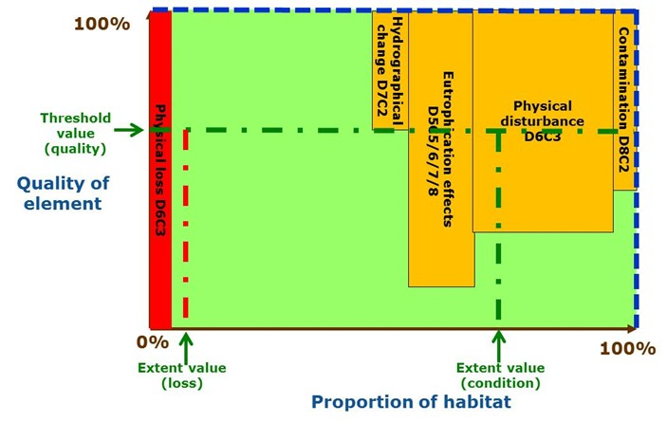

**Figure A2.1:** Illustrative example of GES quality/proportion for a D6 benthic habitat.

Figure A2.1 shows a hypothetical example for a single habitat type in an assessment area (MRU).

**Habitat loss (D6C4)**

1. Loss of the habitat is essentially non-reversible and represents the most severe form of habitat degradation (the habitat has '0%' of its original quality). In the example shown, the extent of loss is within the extent threshold value set for D6C4 (red vertical dashed line) (i.e. the criterion has achieved the value set for the habitat in this assessment area). However, as specified in the GES Decision, this extent of loss should also be taken into account as part of the total extent of adverse effect under criterion D6C5.

**Habitat condition (D6C5)**

1. Other pressures acting upon habitats can alter/degrade the condition of the habitat – possible examples are shown (contamination D8C2, physical disturbance D6C3, eutrophication D5C5-C6-C7-C8 and alteration of hydrographical conditions D7C2).
2. The 'depth' of each orange bar indicates the severity of the change in habitat quality. In the figure the alteration of hydrographical conditions (D7C2) is shown within quality threshold values, whilst eutrophication such as from oxygen depletion (D5 criteria), contamination such as from chronic pollution from oil platforms (D8C2) and physical disturbance such as from benthic trawling or aggregate extraction (D6C3) have exceeded the quality threshold value (horizontal green dashed line). Eutrophication is shown in the figure as more severe in its effects on the condition of the habitat than physical disturbance and contamination.
3. The 'width' of the orange bars represents the extent (footprint) of adverse effect on the habitat from each pressure. In the example, physical disturbance has a larger footprint than the other pressures.
4. The total extent of habitat adversely affected (i.e. below the quality threshold value) comprises:
   1. Extent affected by eutrophication (D5C5, C6, C7 and C8);
   2. Extent affected by physical disturbance (D6C3);
   3. Extent of loss (D6C4);
   4. Extent affected by contaminants (D8C2).
5. In this illustration, the extent of alteration of hydrographical conditions (D7C2) is excluded as it does not cause sufficient change to exceed the quality threshold value.
6. In this illustration, the total extent of adversely affected habitat (i.e. a+b+c+d) exceeds the 'extent value' set for D6C5 (habitat condition) (green vertical dashed line) - this can be seen as the proportion of adversely affected habitat (including habitat loss) which lies within the vertical and horizontal green dashed lines.

**Assessment of current status (against the determination of GES) and follow-up actions**

1. In this illustration, the habitat in the assessment area has failed to achieve GES.
2. Given that this failure results from several sources (pressures), there could be different management responses to reduce the impacts and thereby achieve GES (e.g. some reduction in eutrophication, some on physical disturbance, some on contamination), depending on, for example, the feasibility of addressing the issues and cost-benefit analyses.

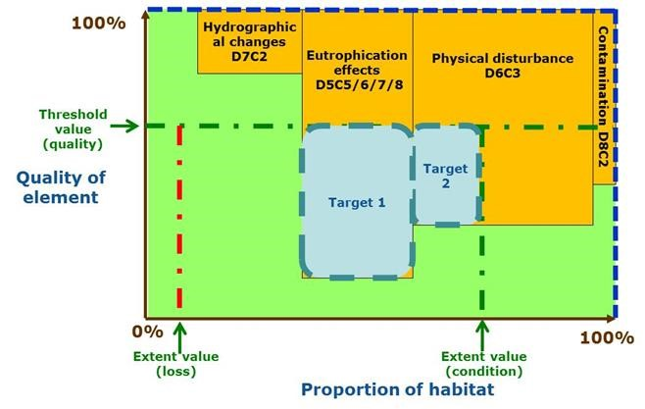

**Figure A2.2:** Determination of GES and links to targets for pressures and associated impacts

Figure A2.2 shows a similar scenario for a benthic habitat as shown in Figure A2.1, excepting there is no habitat loss (D6C4).

Environmental targets (Article 10) are intended to be used to 'guide progress towards achieving GES'. A key way to do this is for targets to focus on the reduction in pressures needed to achieve GES. In this example, two targets are needed to reduce the impacts by a sufficient amount to allow the habitat to recover to the threshold values set: target 1 on nutrient enrichment and target 2 on physical disturbance.

**D1 – species**

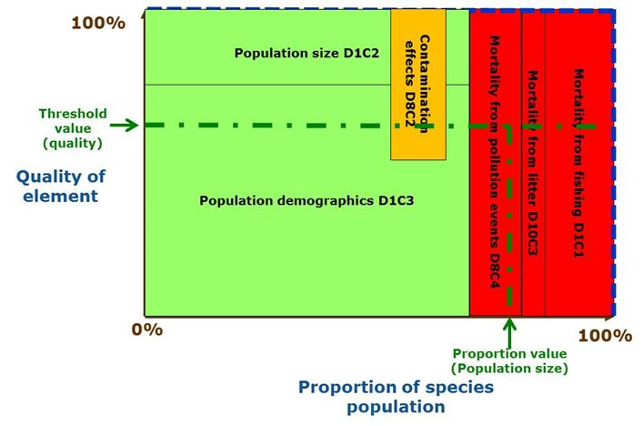**Figure A2.3:** Illustrative example of GES quality/proportion for the population of a D1 species (e.g. the leatherback turtle).

In this example:

1. Anthropogenic mortality from fishing incidental catch (D1C1), litter (D10C3) and acute pollution events (D8C4) is preventing the population (D1C2) from achieving its population size threshold;
2. Population demographic assessments under D1C3 are OK;
3. Part of the population is suffering from chronic contamination effects (D8C2) (possible link to D1C3 assessments);
4. Conclusion – the species has not achieved its threshold value for population size and needs actions to reduce anthropogenic mortality (via reductions in mortality due to pollution events, litter and/or fishing).

**D5 – eutrophication and benthic habitats**

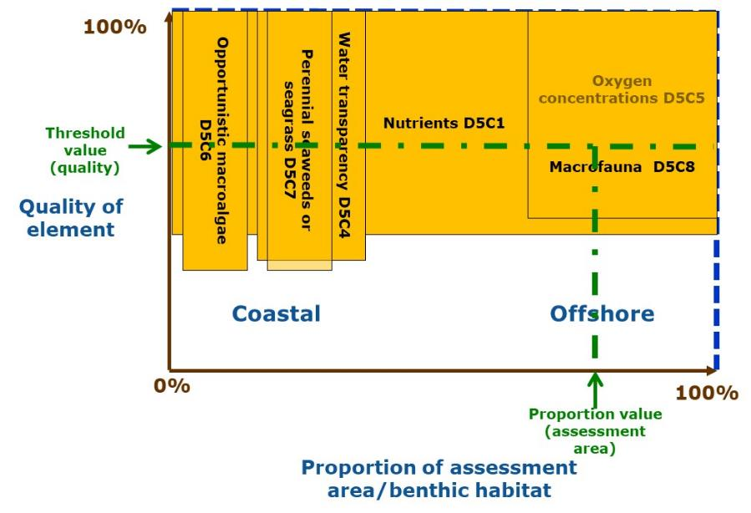**Figure A2.4:** Illustrative example of GES quality/proportion for D5 criteria and benthic habitats.

In this example:

1. The pressure (nutrient enrichment) D5C1 is shown as spread throughout the assessment area and failing to meet the threshold value;
2. Criteria for the impacts on the seabed are also failing:
3. In the coastal waters, opportunistic macroalgae (D5C6) fail to achieve the threshold value in part of the area and perennial seaweeds or seagrasses (D5C7) fail in another part. The latter correlates with poor water transparency (D5C4);
4. In offshore waters, oxygen levels (D5C5) are below threshold levels, supported by the secondary criterion macrofaunal composition (D5C8) which also fails in the same area and to a similar degree;
5. The degree of failure of the criteria (how far beyond threshold values) is shown as similar because the threshold values for the pressure D5C1 should auto-correlate with the impacts D5C4, D5C6 and D5C7 (coastal) and D5C5 and D5C8 (offshore).

**D5 – eutrophication and pelagic habitats**

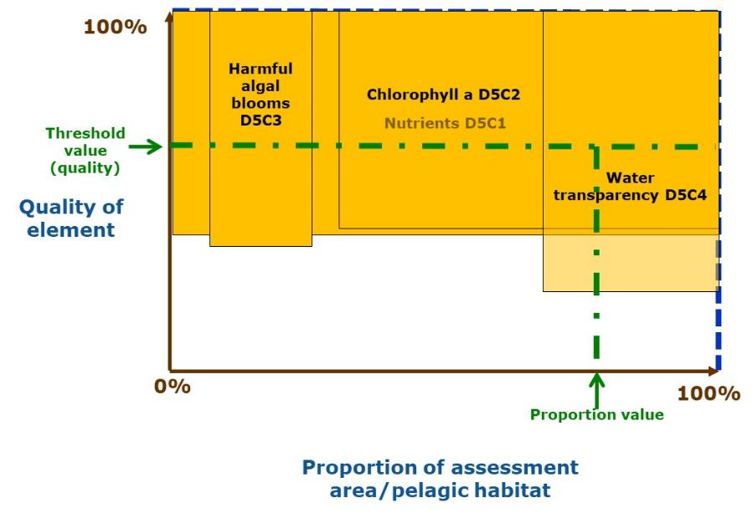**Figure A2.5:** Illustrative example of GES quality/proportion for D5 criteria and pelagic habitats.

In this example:

1. The pressure (nutrient enrichment) D5C1 is shown as spread throughout the assessment area and failing to meet the threshold value;
2. Criteria for the impacts on the water column are also failing to achieve their threshold values: Chlorophyll-a (D5C2) in part of the area and harmful algal blooms (D5C3) in another part;
3. The degree of failure of the criteria (how far beyond threshold values) is shown as similar because the threshold values for the pressure D5C1 should auto-correlate with the impacts D5C2 and D5C3;
4. Water transparency (D5C4) also shows a failure but to a deeper extent and over less area, perhaps indicating the thresholds are not well correlated (or the criterion is more relevant to seabed affects).

Annex 3: Criteria for biodiversity and links to other policies

Assessment of the status of biodiversity (species and habitats) is undertaken in a number of fora, via both formal and informal mechanisms. Tables A3.1 (species) and A3.2 (habitats) set out a correlation of criteria used for assessment under related policies.

**Table A3.1**: Correlation of criteria used for assessment of species in the 2010 GES Decision (first column) and under other relevant policies with those in the 2017 GES Decision (last column).

| **MSFD GES Decision 2010/477/EU (repealed)**  **(D1, 3)** | **Habitats Directive[56]** | **Birds Directive[57]** | **HELCOM[58] (IUCN 2008 criteria)** | **OSPAR Texel-Faial criteria[59]** | **UNEP/MAP EcAp[60]** | **IUCN Red List[61]** | **MSFD GES Decision (EU) 2017/848** |
| --- | --- | --- | --- | --- | --- | --- | --- |
| Fishing mortality (3.1.1) |  |  |  |  |  |  | By-catch mortality rate (D1C1); fishing mortality rate (D3C1) |
| Population size (1.2); reproductive capacity (3.2) | Population | Population size | Declining population, small or very small population size | Decline (numbers) | Population abundance | Population size  Small population | Population abundance (D1C2); spawning stock biomass (D3C2) |
| Population condition (1.3); age & size distribution (3.3) |  |  | Decline (quality) | Population demographic characteristics | Mature individuals included above | Population demographics (D1C3); age and size distribution (D3C3) |
| Distribution (1.1) | Range | Breeding distribution map and range | Geographic range size and fragmentation | Decline (occurrence in area/ extent) | Species distributional range | Range (Extent Of Occurrence, Area Of Occurrence) | Distributional range and pattern (D1C4) |
|  | Habitat for the species |  |  |  |  | Habitat quality included in Range | Habitat for the species (D1C5) |
|  | Future prospects |  | Included above | Included above |  | Included above | Not used as Article 8 requires current status[62] |
|  |  |  | Quantitative analysis of extinction risk (e.g. population viability analysis) | * Global proportion * Regional importance * Rarity * Sensitivity * Keystone species |  |  |  |

**Table A3.2**: Correlation of criteria used for assessment of habitats in the 2010 GES Decision (first column) and under other relevant policies, with those in the 2017 GES Decision (last column).

| **MSFD Decision EU/2010/477**  **(D1, 6)** | **Habitats Directive[63]** | **HELCOM[64] (IUCN criteria)** | **OSPAR Texel-Faial criteria[65]** | **UNEP/MAP EcAp[66]** | **EU Red List[67] (IUCN approach)** | **MSFD Decision (EU) 2017/848** |
| --- | --- | --- | --- | --- | --- | --- |
| Distribution (1.4) | Range | Declining distribution (quantity) | Decline (extent) | Habitat distributional range [extent] | Quantity, restricted distribution (Extent Of Occurrence) | - |
| Extent (1.5) | Area covered | Restricted distribution | Quantity, restricted distribution (Area Of Occurrence) | Extent of loss of habitat (D6C4) |
| Condition (1.6, 6.2) | Structures & functions | Qualitative degradation | Decline (quality) | Condition of habitat's typical species and communities | Quality (abiotic, biotic) | Extent of adverse effects on habitat condition (D6C5) |
|  | Future prospects |  | Included above |  | Historic & future trends included above | Not used as Article 8 requires current status[68] |
|  |  |  | * Global proportion * Regional importance * Rarity * Sensitivity * Ecological significance |  | Probability of collapse | - |

Whilst the criteria used for these assessments are often similar, the precise methodology adopted (e.g. threshold values, assessment scales, rules for use of criteria, timing) often differs, leading to inconsistencies in the outcomes of the assessments. This is further exacerbated when the same species and habitat types are listed for protection (and hence needing assessment) in several policies, leading to multiple assessments of the same species or habitat, sometimes with differing outcomes.

To ensure equivalent outcomes from assessments (i.e. whether the species and habitat is in good status or not) and to reduce administrative burden (through undertaking multiple assessments of the same species or habitat), further harmonisation of different approaches within and across each region is needed, as each policy, overall, is aiming to ensure the species and habitats are protected and the species and habitats achieve a good status. Further detailed discussion is therefore needed across the policies to work towards a closer harmonisation of assessment methods.

1. Hereafter, all references in this document to 'Directive' and to particular articles (Article) refer to the MSFD (Directive 2008/56/EC), unless specifically indicated otherwise. To improve readability the article relevant to the initial assessment (Article 8), the determination of GES (Article 9), environmental targets (Article 10), monitoring programmes (Article 11) and programmes of measures (Article 13) is only stated when needed for the sake of clarity.
2. The Common Implementation Strategy is a governance mechanism between the European Commission, the Member States and other interested parties, established to support a coherent and harmonious implementation of the Directive across the Union.
3. Hereafter, all references in this document to 'GES Decision' and ‘Annex III’ refer to the 2017 versions of the GES Decision ([Commission Decision (EU) 2017/848](http://eur-lex.europa.eu/legal-content/EN/TXT/?qid=1495097018132&uri=CELEX:32017D0848)) and MSFD Annex III ([Commission Directive (EU) 2017/845](http://eur-lex.europa.eu/legal-content/EN/TXT/?qid=1495097018132&uri=CELEX:32017L0845)), unless specifically indicated otherwise.
4. As jurisdictional issues are a matter of national competence, it is for Member States to define the jurisdictional area over which the MSFD applies, in accordance with this definition of marine waters in Article 3(1). There may be cases where these jurisdictional areas overlap with those claimed by neighbouring states, such that no agreement on marine borders has yet been agreed between the states concerned.
5. ‘*with the exception of waters adjacent to the countries and territories mentioned in Annex II to the Treaty and the French Overseas Departments and Collectivities.’*
6. In some states the territorial waters extend only to 3 or 6, rather than 12 nautical miles.
7. ‘*Coastal water means* ***surface water*** *on the landward side of a line, every point of which is at a distance of one nautical mile on the seaward side from the nearest point of the* ***baseline*** *from which the breadth of territorial waters is measured, extending where appropriate up to the* ***outer limit of transitional waters****’* (Water Framework Directive, 2000/60/EC, Article 2(7)) (emphasis added).
8. Highest Astronomical Tide is the landward boundary for WFD coastal waters ([WFD Guidance Document no. 5](http://www.waterframeworkdirective.wdd.moa.gov.cy/docs/GuidanceDocuments/Guidancedoc5COAST.pdf)).
9. Whilst WFD Transitional Waters formally lie outside the scope of the Directive, Member States may decide to apply elements of the GES Decision to its Transitional Waters (Recital 18); this may, for example, be appropriate in cases where the distribution of certain marine species and habitats extends into those waters and it is thus ecologically more appropriate to include such areas.
10. Jenson, H.M., Panagiotidis, P., & Reker, J. (2017) Delineation of the MSFD Article 4 marine regions and subregions. Version 1.0. European Environment Agency, Copenhagen.
11. Article 15 has provisions relating to this issue.
12. Provided that the criteria, methodological standards and assessment scales are the same for each policy.
13. [SWD/2014/049](http://eur-lex.europa.eu/legal-content/EN/TXT/?uri=CELEX:52014SC0049)
14. Cf Article 9(1): ‘By **reference to the initial assessment made pursuant to Article 8(1),** Member States shall, in respect of each marine region or subregion concerned, determine, for the marine waters, a set of characteristics for good environmental status, …’ (emphasis added).
15. [SWD/2014/049](http://eur-lex.europa.eu/legal-content/EN/TXT/?uri=CELEX:52014SC0049)
16. [GES_14-2015-05](https://circabc.europa.eu/d/a/workspace/SpacesStore/1508d460-acac-4376-aa81-1cf79d3365b1/GES_14-2015-05_MSFDAnnexIIIdrafttables.docx), [GES_14-2015-06](https://circabc.europa.eu/d/a/workspace/SpacesStore/d42c40d9-17a5-400b-9dc5-c981eadf6d02/GES_14-2015-06_RevisionMSFDAnnexIII_technicalbackground.doc)
17. Commission’s Article 12 report: [Commission Report on the first phase of implementation of the MSFD](http://eur-lex.europa.eu/legal-content/EN/TXT/?uri=CELEX:52014DC0097) (COM/2014/097 final) and [Commission Staff Working Document on the first steps in the implementation of the MSFD - Assessment in accordance with Article 12](http://eur-lex.europa.eu/legal-content/EN/TXT/?uri=CELEX:52014SC0049) (SWD/2014/049 final).
18. In this document, all references to ‘criteria’ refer to the GES criteria of Commission Decision (EU) 2017/848, unless specifically indicated otherwise.
19. Some Member States prepared updates of their GES determinations (and environmental targets) following the specific recommendations of the Commission’s 2014 assessment of the 2012 reporting ([COM(2014)97](http://ec.europa.eu/transparency/regdoc/rep/1/2014/EN/1-2014-97-EN-F1-1.Pdf)).
20. See for example <http://www.integrated-assessment.eu/guidebook/dpsir_framework>.
21. Further explanation for this modified DPSIR framework is provided in [MSCG_11-2013-16](https://circabc.europa.eu/w/browse/7a6fb9b8-16a8-4042-be23-b6b65d33b873), whilst a more detailed reflection is provided in the [State of Europe's seas](http://www.eea.europa.eu/publications/state-of-europes-seas) (EEA, 2015, Figure I.1).
22. Since the MSFD was adopted in 2008, the ecosystem services concept has received more prominence, for example, through the [EU Biodiversity Strategy (COM/2011/0244/final)](https://eur-lex.europa.eu/legal-content/EN/TXT/?uri=CELEX:52011DC0244)
23. European Commission. 2012. *Approach to reporting for the Marine Strategy Framework Directive*. DG Environment, Brussels. pp26. MSFD Guidance Document 03a.
24. In other situations, the terms are used in different ways, such as referring to the levels of contaminants in water as a 'state' measurement.
25. [GES_13-2015-02](https://circabc.europa.eu/w/browse/53b2e4e2-2921-468a-941f-499811ee12f9)
26. This is in line with SWD(2014) 49 Annex IV, as determining and assessing levels of pressures in the marine environment can also be expressed as 'state' measurements.
27. For contaminants, the levels set for application under WFD (Environmental Quality Standard values) relate to an effect level shown in laboratory testing of certain animal species rather than effects detected in the marine environment itself.
28. For 'analysis of predominant pressures and impacts' for Article 8(1)(b) assessments.
29. The rationale behind this pressure/impact/state terminology is further explored in [GES_13-2015-02](https://circabc.europa.eu/ui/group/326ae5ac-0419-4167-83ca-e3c210534a69/library/53b2e4e2-2921-468a-941f-499811ee12f9/details) Annex 2.
30. Note, Article 8(1)(b) may also include assessments in relation to environmental targets, e.g. targets to reduce the input of pressures to the marine environment.
31. The mapping of activities can also be a contribution to the assessments under Article 8(1)(c) and support the ecosystem-based approach to management of activities in order to achieve GES. This should, wherever possible, be linked to work in support of the Maritime Spatial Planning Directive (2014/89/EU).
32. There is additionally an economic and social analysis of the use of marine waters and of the cost of degradation of the marine environment (Article 8(1)(c)). These uses are relevant as they can generate pressures, whilst the costs of degradation can relate to costs for recovery from impacts and of reducing pressures, where needed, or for loss or changes in ecosystem services.
33. In the GES Decision, Descriptors 3 and 6 include pressure and impact criteria and are therefore addressed firstly under Article 8(1)(b), due to the significance of these pressures/impacts, before considering them under Article 8(1)(a) as state-based descriptors.
34. This is also the case for D8 contaminants; however the GES Decision includes an impact criterion (effects on biota) for D8 but not for D9.
35. See GES Decision for further details on each criterion.
36. For 2018 Article 17 updates of Articles 8, 9 and 10: [MSFD 2018 Reporting Guidance for Article 8-9-10 (MSFD Guidance Document 14)](https://circabc.europa.eu/ui/group/326ae5ac-0419-4167-83ca-e3c210534a69/library/5b9e26e4-e03c-4a45-a4b0-f510592803d2/details)
37. Retained for situations where estuarine plumes extend beyond waters designated as WFD Transitional Waters
38. In the GES Decision Table 2, each benthic broad habitat type is equated to one or several EUNIS level 2 classes, thus ensuring a direct link between the European habitat classification system (EUNIS) and the MSFD habitat assessment categories.
39. Cephalopods do not occur in the Black Sea region.
40. Stock assessments under CFP use specified areas based on ICES/GFCM/FAO assessment areas which can be broadly related to the above scales.
41. Although reaching formal agreements between states on marine borders may lead to their modification over time.
42. [HELCOM Monitoring and assessment strategy](http://www.helcom.fi/Documents/Action%20areas/Monitoring%20and%20assessment/Monitoring%20and%20assessment%20strategy/Monitoring%20and%20assessment%20strategy.pdf)
43. This national part of a subdivision is not formally part of HELCOM’s system.
44. Allocated to 'quality' in the sense that the criterion assesses a reduction in quality (species composition) of the assessment area in relation to the native and existing non-indigenous species.
45. Excepting D8 and D9 where EQS values for the pressure (contaminant) are set under laboratory conditions and do not necessarily relate to impacts apparent in the environment.
46. [Guidance on MSFD Article 8 assessments](https://circabc.europa.eu/d/a/workspace/SpacesStore/cea61b55-06df-4e9e-9830-b0f41ca46fbe/GES_17-2017-02_Guidance_MSFDArt8_Feb2017TestVersion.pdf) (GES_17-2017-02) and subsequent updates.
47. Some Member States prepared updates of their GES determinations (and environmental targets) following the specific recommendations of the Commission’s 2014 assessment of the 2012 reporting ([COM(2014)97](http://ec.europa.eu/transparency/regdoc/rep/1/2014/EN/1-2014-97-EN-F1-1.Pdf)).
48. Reporting schemas are defined in MSFD Guidance Documents on reporting.
49. EU Commission Communication COM(2000)1final
50. Maximum Allowable Inputs/Country Allocated Reduction Targets – <http://helcom.fi/baltic-sea-action-plan/nutrient-reduction-scheme/targets>
51. European Environment Agency. (2014). Marine messages – our seas, our future – moving towards a new understanding. Copenhagen and <http://ia2dec.pbe.eea.europa.eu/knowledge_base/Frameworks/doc101182>
52. EEA (2015) State of Europe's Seas. <http://www.eea.europa.eu/publications/state-of-europes-seas>
53. Guidance Document 14, Annex IV (b) Feature_enum.
54. Evans, D. 2016. Revising the marine section of the EUNIS habitat classification – report of a workshop held at the European Topic Centre on Biological Diversity, 12 & 13 May 2016. ETC/BD Working Paper No. A/2016.
55. [GD10 - MSFD recommendations on measures and exceptions - final.pdf](https://circabc.europa.eu/d/a/workspace/SpacesStore/0ee797dd-d92c-4d7c-a9f9-5dffb36d2065/GD10%20-%20MSFD%20recommendations%20on%20measures%20and%20exceptions%20-%20final.pdf)
56. <https://circabc.europa.eu/w/browse/0de47902-0a08-41dd-943c-520066a3c529>
57. Criteria given are for reporting purposes, as a formal status assessment is not required at national level.
58. HELCOM, 2013 HELCOM Red List of Baltic Sea species in danger of becoming extinct. Balt. Sea Environ. Proc. No. 140. <http://helcom.fi/Lists/Publications/BSEP140.pdf>
59. # OSPAR. 2003. Criteria for the Identification of Species and Habitats in need of Protection and their Method of Application (The Texel-Faial Criteria). Reference no. 2003-13.

   
60. UNEP/MAP (2016) Integrated Monitoring and Assessment Programme of the Mediterranean Sea and Coast and Related Assessment Criteria. Barcelona Convention, Athens ([Decision IG. 22/7](https://wedocs.unep.org/rest/bitstreams/8385/retrieve)).
61. IUCN (2012) IUCN Red List categories and criteria. Version 3.1, 2nd edition. IUCN, Gland. 32pp. (<https://portals.iucn.org/library/node/10315>).
62. To be taken into account in implementation process, e.g. risk-based approach and measures.
63. <https://circabc.europa.eu/w/browse/0de47902-0a08-41dd-943c-520066a3c529>
64. HELCOM 2013. Red List of Baltic Sea underwater biotopes, habitats and biotope complexes. Baltic Sea Environmental Proceedings No. 138. <http://helcom.fi/Lists/Publications/BSEP138.pdf>.
65. # OSPAR. 2003. Criteria for the Identification of Species and Habitats in need of Protection and their Method of Application (The Texel-Faial Criteria). Reference no. 2003-13.

   
66. UNEP/MAP (2016) Integrated Monitoring and Assessment Programme of the Mediterranean Sea and Coast and Related Assessment Criteria. Barcelona Convention, Athens ([Decision IG. 22/7](https://wedocs.unep.org/rest/bitstreams/8385/retrieve)).
67. S. Gubbay, N. Sanders, T. Haynes, J.A.M. Janssen, J.R. Rodwell, A. Nieto, M. García Criado, S. Beal, J. Borg, M. Kennedy, D. Micu, M. Otero, G. Saunders and M. Calix. 2016. European Red List of habitats. Part. 1. Marine habitats. Publications Office of the European Union, Luxembourg. 52pp.
68. To be taken into account in implementation process, e.g. risk-based approach and measures.