

Table of Contents

Introduction 5

Descriptor 1: ‘Biological diversity is maintained. The quality and occurrence of habitats and the distribution and abundance of species are in line with prevailing physiographic, geographic and climatic conditions’ 9

1. MSFD framework 9

2. Observed status of EU marine biodiversity 9

2.1. Ongoing reporting under the MSFD 9

2.2. Other assessments of marine biodiversity 13

2.2.1. Mammals 14

2.2.2. Birds 16

2.2.3. Fish 16

2.2.4. Reptiles 18

2.2.5. Pelagic habitats 19

3. Some observed trends 19

4. Technical observations 21

5. Key messages 22

Descriptor 2: Non-indigenous species introduced by human activities are at levels that do not adversely alter the ecosystems 24

1. MSFD framework 24

2. Presence of non-indigenous species in EU marine waters 25

2.1. Ongoing reporting under the MSFD 25

2.2. Other assessments 26

2.2.1. Pathways of introduction of non-indigenous species 26

2.2.2. The native distribution range of non-indigenous species 27

3. Observed trends 28

4. Main impacts 30

5. Technical observations 31

6. Key messages 32

Descriptor 3: Populations of all commercially-exploited fish and shellfish are within safe biological limits, exhibiting a population age and size distribution that is indicative of a healthy stock 33

1. MSFD and broader legal framework 33

2. Observed status of the EU’s commercial fish and shellfish 35

2.1. Ongoing reporting under the MSFD 35

2.2. Other assessments 35

3. Observed trends 38

4. Technical observations 42

5. Key messages 43

Descriptor 4: All elements of the marine food webs, to the extent that they are known, occur at normal abundance and diversity and levels capable of ensuring the long-term abundance of the species and the retention of their full reproductive capacity 44

1. MSFD framework 44

2. Status and trends of marine food webs in EU waters 45

2.1. Ongoing reporting under the MSFD 45

2.2. Setting the scene for the analysis of food webs 46

2.3. Results from other assessments 47

3. Technical observations 51

4. Key messages 52

Descriptor 5: Human-induced eutrophication is minimised, especially adverse effects thereof, such as losses in biodiversity, ecosystem degradation, harmful algae blooms and oxygen deficiency in bottom waters 54

1. MSFD framework 54

2. Eutrophication and its consequences in EU marine waters 55

2.1. Ongoing reporting under the MSFD 55

2.2. Member States’ assessments under the MSFD 56

2.3. Assessment of coastal waters under the Water Framework Directive 58

2.4. Other assessments 59

3. Observed trends in eutrophication 61

4. Technical observations 61

5. Key messages 61

Descriptor 6: Sea-floor integrity is at a level that ensures that the structure and functions of the ecosystems are safeguarded and benthic ecosystems, in particular, are not adversely affected 63

1. MSFD framework 63

2. Observed integrity of the sea-floor in EU marine waters 64

2.1. Ongoing reporting under the MSFD 64

2.2. Previous MSFD reporting 65

2.3. Other assessments 66

2.3.1. Status of benthic habitats 66

2.3.2. Pressures on benthic habitats 68

3. Temporal trends 72

4. Main impacts 72

5. Technical observations 73

6. Key messages 74

Descriptor 7: Permanent alteration of hydrographical conditions does not adversely affect marine ecosystems 76

1. MSFD framework 76

2. Changes in hydrographical conditions in EU marine waters 77

2.1. Ongoing reporting under the MSFD 77

2.2. Member States’ assessments under the MSFD 78

2.1. Other assessments 78

3. Temporal trends and links with broader climate aspects 80

4. Further developments under this descriptor 81

5. Technical observations 82

6. Key messages 82

Descriptor 8: Concentrations of contaminants are at levels not giving rise to pollution effects 84

1. MSFD framework 84

2. Contaminants in EU marine waters: concentrations and trends 85

2.1. Ongoing reporting under the MSFD 85

2.2. EU assessments of contaminants in the marine environment 86

2.3. Regional assessments of contaminants in the marine environment 88

2.4. Significant acute pollution events 92

3. Impacts: Effects of contaminants on the health of species and the condition of habitats 93

4. Technical observations 94

5. Key messages 95

Descriptor 9: Contaminants in fish and other seafood for human consumption do not exceed levels established by Union legislation or other relevant standards 97

1. MSFD framework 97

2. contaminants in marine fish and other seafood in EU waters: concentrations and potential impacts 98

2.1. Ongoing reporting under the MSFD 98

2.2. Member States’ assessments under the MSFD 98

2.3. Other assessments 103

3. Observed trends 105

4. Technical observations 106

5. Key messages 107

Descriptor 10: Properties and quantities of marine litter do not cause harm to the coastal and marine environment 108

1. MSFD framework 108

2. Marine litter in EU marine environment 109

2.1. Ongoing reporting under the MSFD 109

2.2. MSFD and other assessments 110

2.2.1. Shoreline litter 110

2.2.2. Water column litter 112

2.2.3. Seafloor macro litter 113

2.2.4. Micro-litter 115

3. Litter impacts 116

4. Technical observations 117

5. Key messages 117

Descriptor 11: Introduction of energy, including underwater noise, is at levels that do not adversely affect the marine environment 119

1. MSFD framework 119

2. Underwater noise in the EU marine environment 119

2.1. Ongoing reporting under the MSFD 119

2.2. MSFD efforts to address underwater noise 120

2.3. Other assessments 121

3. Effects of underwater noise 123

4. Technical observations 124

5. Key messages 124

References 126

# Introduction

The first cycle of implementation of the Marine Strategy Framework Directive[1] (MSFD) – with its holistic and integrative approach, large implementation area and knowledge requirements – demonstrated to be challenging. The first ‘marine strategies’ developed by Member States are just finalised and the evidence base to evaluate their effectiveness is still scarce.

The first assessment of EU marine waters was reported by Member States in 2012-13 under Article 8(1). Decision 2010/477/EU provided for methodological standards and criteria for determining good environmental status. From that first reporting, it was not possible to build a coherent marine knowledge base across Europe due to, among other reasons, inconsistency on indicators reported per criterion, high heterogeneity of methodological approaches, inconsistencies and gaps in the reported information, and lack of data or adequate time-series to assess all MSFD criteria. The number of unknown or not assessed areas largely outnumbered the assessed ones (Figures 1 and 2). To improve that situation, the Commission adopted in 2017 the new Decision 2017/848/EU, repealing the abovementioned 2010 Decision, setting out a detailed framework of criteria and methodological standards as well as methodologies for monitoring and assessment. Member States are required to work at regional or EU wide level to set threshold values to determine the extent to which good environmental status is achieved across the various descriptors[2] of the Directive.

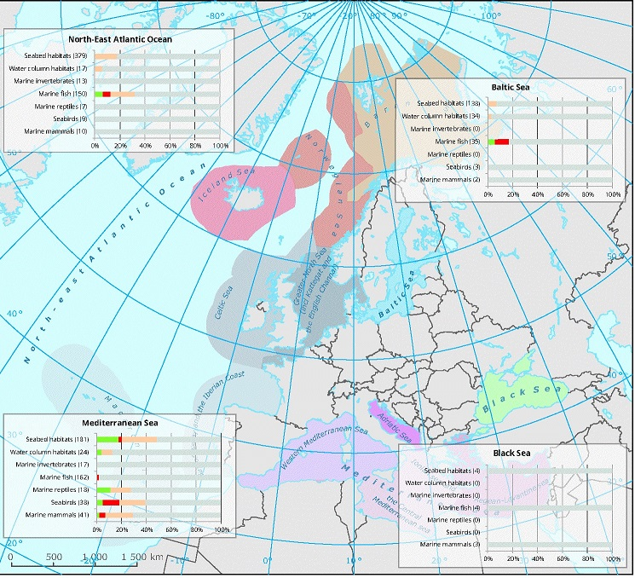

Figure 1: Status assessment of natural features reported by EU Member States under MSFD Article 8(1) in 2012-13 (<https://www.eea.europa.eu/data-and-maps/figures/status-assessment-of-natural-features-1>). Green=good, red=not good, beige=other, grey=unknown. The figures in parenthesis are the number of reported features by EU Member States. Disclaimers: the associated confidence rating of the information is rarely high; the numbers are not comparable across regions; there are no marine reptiles in the Baltic and the Black Seas.

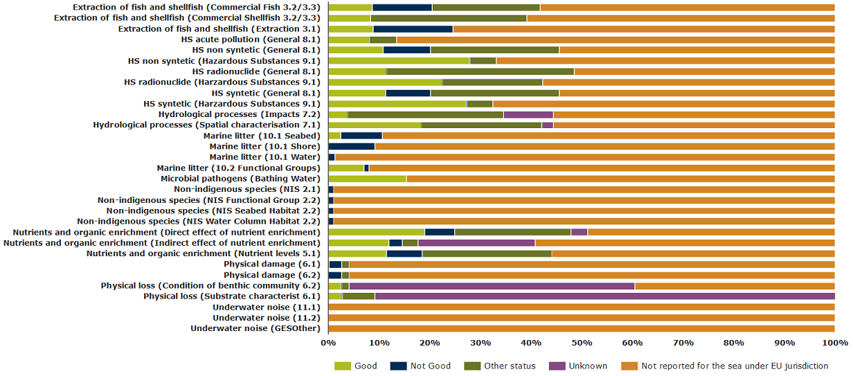

Figure 2: Status assessment of pressures reported by EU Member States underMSFD Article 8(1) in 2012-13 (<https://www.eea.europa.eu/data-and-maps/daviz/percentage-of-area-with-different#tab-chart_1>). **The figure shows the percentage of area with different assessment status with respect to the size of the MSFD marine regions.** **The “not reported” class (in orange) may be overestimated since not all pressures are relevant for all regions and Member States.**

By October 2018, Member States had to update their initial assessments (as well as their determinations of good environmental status and their targets), as required by Article 17 of the MSFD. By October 2019, one year after the deadline, only 14 Member States had reported in paper format, of which only 10 had reported through the agreed electronic sheets. The aggregated information coming from those 10 electronic reports is shown at the beginning of each chapter of this Staff Working Document[3]. Table 1 shows the legend code used to illustrate the status assessments. For more updated information, see the online dashboards on the WISE-Marine website[4].

|  |  |  |
| --- | --- | --- |
|  | *Overall level: Good environmental status assessments provided per descriptor and feature* | *Criteria level: Criteria status assessments* |
|  | GES achieved | Good |
|  | GES expected to be achieved by 2020 | Good, based on low risk |
|  | GES expected to be achieved later than 2020, Article 14 exception reported | Not good |
|  | GES expected to be achieved later than 2020, no Article 14 exception reported |  |
|  | Not relevant |  |
|  | Not assessed | Not assessed |
|  | Unknown | Unknown |
|  |  | Contributes to assessment of another criterion/element |

Table 1: Colour legend of the status assessments reported under the MSFD**. The available assessments will be illustrated under each descriptor’s section.**

Given the lack of MSFD-reported information that could give a broad (geographical and temporal) overview of the status of the EU marine environment, this Staff Working Document complements the official data reported by Member States with assessments coming from a variety of non-MSFD sources, such as the most recent quality status reports coming from the Regional Sea Conventions[5] or independent studies. The European Environmental Agency and the European Commission’s Joint Research Centre compiled the available information about the European marine regions and framed it to feed this report. Over time, MSFD-reported information is expected to be readily available and increasingly delivered according to defined methods and standards.

This Staff Working Document presents evidences or proxies of the status of EU marine ecosystems and the pressures acting on them through the 11 MSFD descriptors. The criteria are briefly introduced for each descriptor, allowing for a comparison between those used for the 2010 (reviewed and repealed by the following) and 2017 Commission Decision, respectively. This is followed by an overview of the (still incomplete) update of the status of marine waters by Member States, a scientific assessment of the available information (on status and/or pressures), an analysis of trends and impacts (if feasible), technical observations (regarding methodologies or knowledge gaps), and key messages (conclusions). Although understanding the consequences of cumulative impacts is intrinsic to the MSFD, the lack of systematic information prevents this review to tackle this important issue yet.

Descriptor 1: ‘Biological diversity is maintained. The quality and occurrence of habitats and the distribution and abundance of species are in line with prevailing physiographic, geographic and climatic conditions’

# MSFD framework

|  |  |  |
| --- | --- | --- |
| COM DEC 2017/848/EU | | COM DEC 2010/477/EU |
| D1 Biodiversity – species[6] | | |
| D1C1 Incidental by-catch rate | The mortality rate per species from incidental by-catch is below levels which threaten the species |  |
| D1C2 Population abundance | The population abundance of the species is not adversely affected due to anthropogenic pressures, such that its long-term viability is ensured | 1.2 Population size  1.2.1 Population abundance |
| D1C3 Population demographics | The population demographic characteristics of the species are indicative of a natural population which is not adversely affected due to anthropogenic pressures | 1.3 Population condition  1.3.1 Population demographics |
| D1C4 Population distributional range and pattern | The species distributional range and, where relevant, pattern is in line with prevailing physiographic, geographic and climatic conditions | * 1. Species distribution   1.1.1 Species range  1.1.2 Species pattern |
| D1C5 Habitat for species | The habitat for the species has the necessary extent and condition to support the different stages in the life history of the species |  |
|  |  | 1.1.3 Area covered by species |
|  |  | 1.3.2 Population genetic structure |
| D1 Biodiversity – pelagic habitats | | |
| D1C6 Pelagic habitat condition | The condition of the habitat type, including its biotic and abiotic structure and its functions is not adversely affected due to anthropogenic pressures | 1.6 Habitat condition  1.6.1 Condition typical species  1.6.2 Relative abundance  1.6.3 Habitat condition |

# Observed status of EU marine biodiversity

## Ongoing reporting under the MSFD

Mammals

|  |  |
| --- | --- |
|  |  |
|  | |

Figure 3: Latest MSFD assessments of good environmental status per species group (left) and per criteria (right) under Descriptor 1: Mammals. The information comes from 10 Member States’ electronic reports.

Most of the assessments of marine mammals refer to seals and small toothed cetaceans. For seals, GES is achieved only in 3 assessments, but 15 assessments report that GES will be achieved by 2020. However, the situation of the small toothed cetaceans is more concerning. None of the reported assessments has resulted in an achievement of the GES, and, in almost 70% of the cases, GES will be achieved only later than 2020 without any exception having been reported under Article 14. In the case of baleen whales and deep-diving toothed cetaceans, in 3 out of the 4 assessments that have been reported for each group, GES will be achieved only later than 2020 without any exception having been reported under Article 14.

Most of the criteria of Descriptor 1 for mammals have been assessed and reported. For the population abundance (D1C2), the population distribution (D1C4) and the habitats condition for the species (D1C5), they have achieved the ‘good’ status in 30 , 41 and 13 assessments respectively, although also a big number of assessments result in the criteria being ‘not good’ (25, 19 and 18 respectively). On the other hand, only 5 assessments on by-catch (D1C1) and 4 assessments on the demographic characteristics (D1C3) have been reported as ‘good’ while 5 and 23 respectively are ‘not good’.

Birds

|  |  |
| --- | --- |
|  |  |

Figure 4: Latest MSFD assessments of good environmental status per species group (left) and per criteria (right) under Descriptor 1: Birds. The information comes from 10 Member State’s electronic reports. See legend in Figure 3.

Except one report that has been done for all birds, the rest of the assessments have been reported per species groups. The status of the species groups is very diverse, the best one being the grazing birds (where almost 60% of assessments achieved GES), followed by the pelagic-feeding birds (where almost 50% of cases achieved GES) and the surface-feeding birds (around 30%).

On the other hand, the benthic-feeding birds and the wading birds seem not to be in good shape (in both cases there are only 2 assessments where GES is achieved). However, the reports show for these groups that Member States expect to achieve GES by 2020 at a great extent. Member States have not reported exceptions under Article 14 when GES is expected to be achieved later than 2020.

For the criterion on by-catch (D1C1), 16 assessments conclude that the status is ‘good, based on low risk’, while 68 cases have been reported as ‘not assessed’. Similarly, both the population distribution (D1C4) and the habitats condition for the species (D1C5) have been reported as ‘not assessed’ or ‘unknown’ at a great extent.

The most frequently assessed criteria are the population abundance (D1C2) and the demographic characteristics (D1C3). In the first case, the status has been reported as ‘good’ in 230 assessments, and as ‘not good’ in 180 assessments. In the second case, there are 59 cases reported as ‘not assessed’, and 37 assessments resulting in ‘not good’, 33 in ‘good’ and 17 in ‘good, based on low risk’.

Fish

|  |  |
| --- | --- |
|  |  |

Figure 5: Latest MSFD assessments of good environmental status per species group (left) and per criteria (right) under Descriptor 1: Fish. The information comes from 10 Member State’s electronic reports. See legend in Figure 3.

Except one report that was done for all fish, the rest of the assessments have been reported per species groups. GES is achieved in very few cases for coastal fish (in 2 assessments) and pelagic shelf fish (in 1 assessment), and no cases of GES achieved have been reported for demersal shelf fish nor for deep-sea fish (where only 1 assessment has been reported and is ‘unknown’). It is worth noting that for coastal fish a significant number of assessments have been reported as ‘not relevant’, and a lot of cases in all the species groups have been reported as ‘not assessed’ or as ‘unknown’.

The reports show that Member States expect to achieve GES by 2020 in some cases. Member States have not reported exceptions under Article 14 when GES is expected to be achieved later than 2020.

The majority of criteria assessments have been reported as ‘not assessed’, except for population abundance (D1C2), which has been assessed in almost 30% of the cases. For the abundance, 53 assessments have been reported as in ‘good’ status, while 62 conclude that the status of this criterion is ‘not good’. In the case of the demographic characteristics (D1C3) and the habitats condition for the species (D1C5), only one assessment has been reported as ‘good’. For the by-catch (D1C1) and the population distribution (D1C4) only 3 and 8 assessments respectively have been reported as ‘good’.

To date, there has been almost no reports on cephalopods and reptiles. Hence, the corresponding figures have not been added to the present summary.

Habitats

|  |  |
| --- | --- |
|  |  |

Figure 6: Latest MSFD assessments of good environmental status per ecosystem component (left) and per criteria (right) under Descriptors 1: Habitats (in this case only pelagic habitats, as benthic habitats are shown under Descriptor 6). The information comes from 10 Member State’s electronic reports. See legend in Figure 3.

GES is achieved in very few cases for the pelagic habitats (only 6 assessments), and is expected to be achieved by 2020 in very few cases as well. Most Member States have not reported exceptions under Article 14 when GES is expected to be achieved later than 2020. A significant number of assessments have been reported as ‘not assessed’ or ‘not relevant’. The status of benthic habitats (although also linked to Descriptor 1) will be discussed under Descriptor 6.

The pelagic habitats do not seem to be in good shape. The habitat condition (D1C6) has only achieved the ‘good’ status in 14 cases, while 64 assessments have been reported as ‘not good’.

## Other assessments of marine biodiversity

The information presented in this section aims to shed light on the MSFD criteria and to contribute to the overall goal of Descriptor 1, i.e. to know whether species groups and habitat types are reaching a ‘good environmental status’. The status categories used here (see Table 2) however do not refer to any established MSFD methodology, given the Directive only speaks of *good* environmental status. In the absence of most MSFD reporting under the second implementation cycle, the main sources of information are the quality status reports from the Regional Seas Conventions, additional knowledge from Red List assessments about special or threatened species and habitats, and information from the previous reporting of the Habitats Directive (i.e. the 2007-2012 period) (Table 2). Most of this information comes from ETC/ICM (2019a).

|  |  |  |  |  |  |  |
| --- | --- | --- | --- | --- | --- | --- |
| Ecosystem Component | | North-east Atlantic Ocean by OSPAR | Baltic Sea by HELCOM | Mediterranean Sea by UNEP-MAP | European assessment by the Red List[7] | European assessment based on the Habitats Directive |
| Species | Seals |  |  |  |  |  |
| Cetaceans |  |  |  |  |  |
| Birds |  |  |  |  | n/a |
| Bony fish |  |  |  |  |  |
| Elasmobranchs |  |  |  |  | n/a |
| Cephalopods |  |  |  |  | n/a |
| Reptiles |  | n/a |  |  |  |
| Habitats | Benthic[8] |  |  |  |  |  |
| Pelagic |  |  |  | n/a | n/a |

Table 2: Summary of the main marine biodiversity assessments found at regional or pan-European level. More detailed evidence is presented in the following tables. Green: positive trends or status. Yellow: mixed or no clear trends. Orange: negative trends or low status. Red: very negative trends or bad status. Grey: insufficient data.

The general EU picture is worrying, with many knowledge gaps and an overall status that ranges from bad to moderate.

### *Mammals*

The abundance and condition of marine mammals, as top predators, can help indicate whether a marine ecosystem is in a good state or not. Seals and cetaceans (whales and dolphins) are assessed separately because they have different life histories and ecological requirements. Seals are also much easier to study and count because they come onto land to rest and to breed. Cetaceans range widely across Europe’s seas, and are therefore more difficult to monitor and there are generally not enough long synoptic time series to accurately assess the status of their populations. During the first MSFD cycle, the Regional Sea Conventions have greatly aligned their assessment methodologies with the MSFD requirements. In many cases, the Regional Sea Conventions play a leading role in the development and implementation of harmonised methods to assess the status of species and habitats. On the contrary, the IUCN criteria are not well aligned with the MSFD criteria, as they have been developed to determine the extinction risk of species, rather than their population status. Table 3 summarises all available assessments.

|  |  |
| --- | --- |
| IUCN | In Red List assessments of status and trends in European seal populations, most species are of Least Concern, except for the Mediterranean monk seal (Temple and Terry, 2007). Still, many trends are unknown (see Table 10). |
| Habitats Directive | While the Habitats Directive includes seven seals in its Annexes, three of them are vagrant in the EU waters and only four can be assessed: grey seal, Mediterranean monk seal, ringed seal and common or harbour seal.  Only the monk seal populations in the Mediterranean and Macaronesia regions were reported in 2013 under Article 17 of the Habitats Directive where four member states reported unfavourable status, and one reported the status as unknown (EEA, 2013a). |
| OSPAR | In the non-Arctic OSPAR region grey seal populations are generally stable or increasing in most assessed areas although some harbour seal populations are declining (OSPAR, 2017a). |
| HELCOM | In the Baltic Sea, grey seal populations are increasing but their nutritional and reproductive states are not good. Harbour seals are only in a good state in one sub-region and the state of the ringed seal population is critical with less than 100 animals (HELCOM, 2018a). |
| UNEP-MAP | The distribution of monk seal in the Mediterranean remains stable or expanding though it is still endangered and systematic monitoring is needed to assess overall status (UNEP-MAP, 2018) |

Table 3: Conclusions from different assessments about the status of seals’ populations in the European seas.

|  |  |
| --- | --- |
| IUCN | Of the 20 cetacean species present in European waters (excluding those with marginal occurrences), 60% were assessed as data deficient. 3 species were regarded as threatened (Atlantic right whale, Sei whale and Blue whale) while 2 species, harbour porpoises and sperm whales, were regarded as Near Threatened (Temple and Terry, 2007). |
| Habitats Directive | In the 2013 reporting of the Habitats Directive for cetaceans in Annexes I, III and IV, the status was generally reported as ‘unknown’ (73% at European level, with 18% ‘unfavourable’ and 9% ‘favourable’). These proportions differed in the Black Sea (67% ‘unfavourable’, 3 cetaceans) and the Baltic Sea (100% ‘unfavourable’, 1 species *Phocoena phocoena*). |
| OSPAR | In the OSPAR region, there is no evidence of changes in abundance for white-beaked dolphin, minke whale and harbour porpoise since 1994 (OSPAR, 2017a). There is insufficient evidence for other species except for some coastal bottlenose dolphin populations which have remained low but stable.  An assessment of killer whales, another top predator in the North-east Atlantic Ocean, could only be performed as a pilot exercise due to lack of data. However, the potential impacts from accumulation of pollutants were noted as these could have led to a reduction in numbers due to reproductive failure (OSPAR, 2017b). Recent scientific studies of populations of killer whales show adverse effects of PCB on their reproduction, threatening >50% of the global population. This may cause the disappearance of killer whales from the most contaminated areas within 50 years despite PCB having been banned for 30 years. These waters include areas around the UK and around the Strait of Gibraltar (Desforges et al., 2018). |
| HELCOM | A particular concern is the local population of harbour porpoise in the Baltic Proper, with a population size recently estimated at around 500 animals (HELCOM, 2018a). |
| UNEP-MAP | In the Mediterranean Sea, there is some evidence of declining numbers of fin whales and common dolphins (UNEP-MAP, 2018). Fin whale abundance in the Western Mediterranean was estimated as 3,500 in the mid-1990s (Forcada, 2011), but more recent estimates in 2017 suggested 460 individuals. The first estimate, however, includes individuals entering the Mediterranean from the Atlantic Ocean, while the second estimate refers only to the Mediterranean residents. |

Table 4: Conclusions from different assessments about the status of cetaceans’ populations in the European seas.

### *Birds*

There are around 150-200 species of birds in Europe that, at some point in their annual life cycle, are reliant on coastal and/or offshore marine areas (IUCN and BirdLife International, 2014). These include waders and waterbirds, such as ducks, geese, swans, divers and grebes; as well as birds that are usually referred to as seabirds: petrels, shearwaters, gannets, cormorants, skuas, gulls, terns and auks. The assessments below were based on monitoring data from breeding populations and/or non-breeding populations during migration or over the winter, depending on the species, primarily for the OSPAR and HELCOM areas. Similar long-term trend data within the Mediterranean and Black Sea regions are rare.

|  |  |
| --- | --- |
| IUCN | Birds associated with marine habitats in Europe have a relatively high proportion of threatened species (20%), which reflect the prevalence of human pressures such as habitat disturbance, bycatch and pollution, but also predation at colony sites often by invasive species (IUCN and BirdLife International, 2014) This is the case for the Critically Endangered Balearic Shearwater. |
| OSPAR | Since the mid-2000s, the breeding abundance of more than a quarter of the marine bird species which breed in the OSPAR Maritime Area has been below the 1992 baseline, indicating that the populations are not healthy (Figure 8) (OSPAR, 2017c). A similar pattern was found in the non-breeding abundance of species that visit the Arctic Waters and Celtic Seas during migration and/or during winter. In contrast, non-breeding populations in the Greater North Sea are doing much better, and with 75% or more of species meeting assessment values in every year since 1993 are considered healthy (OSPAR, 2017c). Within the breeding birds, populations of water column feeders (e.g. gannets) were healthier than those in feeding at the surface, indicating changes in availability of small surface dwelling fish. This was also reflected in widespread breeding failure in surface-feeding species (OSPAR, 2017c). |
| HELCOM | A similar pattern of decline is suggested in the Baltic Sea where open sea species are considered to have strongly declining trends, though the formal assessment covered primarily coastal-dwelling species. Here, 31% of waterbirds in the breeding season have declined, compared to 18% of over-wintering species. The pattern of status for feeding groups differs in the HELCOM assessment from the OSPAR region, as in the Baltic Sea, surface and pelagic feeders have a good status (HELCOM, 2018a). |
| UNEP-MAP | Status of birds from the Mediterranean Sea is unclear with most of the data coming from North-western areas. Trends in the critically endangered Balearic shearwater suggest marked declines (UNEP-MAP, 2018) primarily from predation by introduced land carnivores and from fisheries by-catch (IUCN and BirdLife International, 2014). Of the 16 bird species regarded as Endangered or Vulnerable in the IUCN Red List assessment, all are marine species (IUCN and BirdLife International, 2014). |

Table 5: Conclusions from different assessments about the status of marine birds’ populations in the European seas.

### *Fish*

There are over 1200 fish species in the North-east Atlantic Ocean and Mediterranean Sea (Nieto et al., 2015), which includes both commercial and non-marketable species. 15% of these are endemic to the region. The areas with the highest diversity of fish species are the coast of Portugal, the archipelagos in Macaronesia and the western Mediterranean Sea which are also the areas with the highest number of threatened species (Nieto et al., 2015; EEA, 2019a). While fish populations appear to be recovering in the North-east Atlantic Ocean, populations in the Black and Mediterranean seas are under continuing downward pressures. This conclusion refers to commercial fish species and to fisheries subjected to several management measures, especially in the North-east Atlantic.

|  |  |
| --- | --- |
| IUCN | 85 fish species (7 % of the total of European marine fish species) and 11 of the endemic species are either Threatened or Near Threatened under the IUCN Red List classification.  Among the bony fish, only <3 % of the species are classified threatened, but with the uncertainties related to the smaller species this share may theoretically extend up to 23 % if all data deficient species were threatened. |
| OSPAR | The OSPAR assessment showed that there has been an improvement in the proportion of large demersal fish at least in the Greater North Sea, leading to recovery by 2022 but only if current trends continue (OSPAR, 2017d). More sensitive demersal species have shown a recovery in the Celtic Seas at least and typical lengths are increasing, suggesting higher proportion of mature individuals since 2010 in the Greater North Sea and Celtic Seas. The pelagic fish assemblage shows no long-term change in much of the OSPAR maritime area (OSPAR, 2017d). |
| HELCOM | HELCOM has two indicators for the species that can be allocated under Descriptor 1: (1) abundance of key coastal fish species, and (2) abundance of coastal fish key functional groups (HELCOM, 2018a). For the first indicator, good status is achieved in 13 out of the 21 coastal HELCOM assessment units that were assessed. Generally, good status is more often reached in the Northern and Eastern parts of the Baltic Sea where perch is the key species, while in the Western and Southern areas, where flounder is the key species, the status is more often not good. For the second indicator, good status is achieved in 13 coastal HELCOM assessment units out of the 16 that were evaluated for piscivores, and in 7 of the 16 evaluated assessment units for cyprinids/mesopredators. |
| UNEP-MAP | Around 85% of the analysed stocks in the Mediterranean and the Black sea have been overfished. The situation is particularly alarming for demersal fish that experience higher mortality rates than the target. For example, hake, a charismatic and economically important species in the Mediterranean, shows the highest fishing mortality with a rate that is on average 5 times higher than the target and reaches up to 12 times higher for some stocks. On the other hand, small pelagic fish show moderate fishing mortality rates close to the target or even below the target for some specific species. Data expressed through Spawning Stock Biomass indicates that up to 42% of the stocks assessed in the Mediterranean show a low biomass (UNEP-MAP, 2018). |

Table 6: Conclusions from different assessments about the status of teleost (ray-finned fish) in the European seas.

Cartilaginous fish (sharks, skates and rays) is less fished in Europe than in previous times, but by-catch is still a significant problem, both for demersal and pelagic species (European Commission, 2016).

|  |  |
| --- | --- |
| IUCN | Sharks, rays and skates cover two thirds (56 species) of all the threatened species. Many of these chondrichthyans are poorly known and of the 204 Data Deficient species many were benthic sharks.  In the Mediterranean Sea, sharks, skates and rays are particularly threatened with almost 40% of species facing a declining population trend (FAO, 2012; Nieto et al., 2015). The increased extinction risk of many of these species can be linked fishing practices in the Mediterranean Sea, where their status has worsened (Cavanagh and Gibson, 2007; Nieto et al., 2015). |
| OSPAR | OSPAR has included 11 chondrichthyan species on the OSPAR list of Threatened and Declining species, covering species at most risk (OSPAR, 2019a). Long-term trend assessment indicated population decline particularly in larger species (spurdog and common skate) where commercial fisheries existed (Sguotti et al., 2016). Catches has been highly variable and declining until 2010. |
| HELCOM | HELCOM’s Red List assessment also included two shark species (porbeagle and spurdog) that have suffered dramatic reduction in populations. |

Table 7: Conclusions from different assessments about the status of elasmobranchs (cartilaginous fish) in the European seas.

### *Reptiles*

|  |  |
| --- | --- |
| IUCN | In the North-east Atlantic Ocean and the Mediterranean Sea, both OSPAR and the Barcelona Convention list the loggerhead and leatherback turtles as threatened and/or declining species (OSPAR, 2019a; UNEP-MAP, 2018). Marine turtles are very rare visitors in the Black Sea, while they have not been observed in the Baltic Sea. The Mediterranean poses the highest average threats to marine turtles out of all global ocean basins (Wallace et al., 2011). |
| Habitats Directive | The Habitats Directive Annex IV includes the following species: *Caretta caretta, Chelonia mydas, Dermochelys coriacea, Eretmochelys imbricate, Lepidochelys kempii.* However, only the two first species are assessed in the Mediterranean and the North-east Atlantic. There are no data or established populations for the other species.  Overall, the conservation status of marine reptiles was unknown in 67% of the reports, with 33% in unfavourable status. However, for the marine Mediterranean region, 60% of the reports were unfavourable, compared to 40% unknown (EEA, 2013a) (Figure 7). |
| UNEP-MAP | At present, knowledge on sea turtle abundance and demography is patchy at best for each component and that effort needs to be placed on filling existing gaps in order to predict with any certainty the future viability of sea turtle populations in the Mediterranean (UNEP-MAP, 2018) |

Table 8: Conclusions from different assessments about the status of reptiles (in this case, sea turtles) in the European seas.

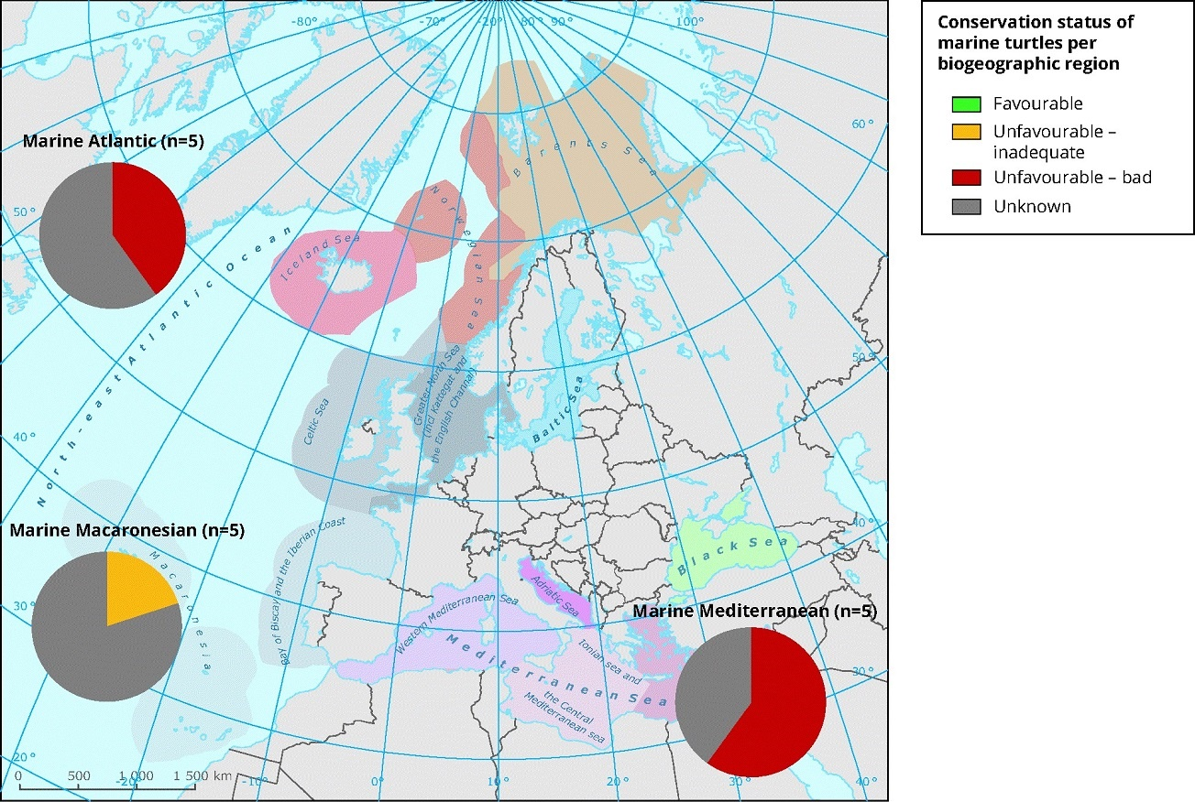

Figure 7: Conservation status of marine turtles per sea region. Source: EEA (2013b). Based upon the previous reporting round of the Habitats Directive 2007-2012, none of the five species normally occurring in European waters were in ‘favourable conservation status’. Of these, two species breed in European waters: the green turtle (Chelonia mydas) which breeds in the south-eastern portion of the Mediterranean Sea and the loggerhead turtle (Caretta caretta) which breeds in the southern part of the same basin.

### *Pelagic habitats*

|  |  |
| --- | --- |
| HELCOM | Using indicators for phytoplankton and zooplankton, HELCOM reported good status for pelagic habitats is achieved in the Kattegat, but not in any other open sea sub-basin during 2011-2016. 20% of the coastal areas achieve good integrated status. |
| OSPAR | In the OSPAR region, local and large-scale changes in phytoplankton biomass and zooplankton abundance were observed from 1958 to 2002. Since 2004, plankton communities experienced significant changes in relative abundance, indicating alterations to key aspects of ecosystem functioning. The inference is that those changes are linked to prevailing environmental conditions such as climate change, nutrient enrichment or other factors (OSPAR, 2017e). |

Table 9: Conclusions from different assessments about the status of pelagic habitats in the European seas.

# Some observed trends

There are not consistent metrics of trends to evaluate marine biodiversity as a whole, but the following tables and figures show some examples of specific regional-scale studies.

|  |  |  |  |  |  |
| --- | --- | --- | --- | --- | --- |
|  | World | Europe | Baltic Sea | North-east Atlantic Ocean | Mediterranean Sea |
| Ringed seal | ? | LC |  |  |  |
| Grey seal | LC | LC | LC |  |  |
| Harbour seal | ? | ? LC |  |  |  |
| Harp seal | LC | ? |  |  |  |
| Monk seal | EN | EN |  |  | EN |
| Hooded seal | ? VU | ? |  |  |  |
| Bearded seal | ? LC | ? |  |  |  |

Table 10: Population trends of seven seal species globally, in Europe, and in three marine regions. Red List status: EN-Endangered, VU-Vulnerable, NT-Not threatened, LC-Least concern. Arrows represent upward/downward trends while question marks are unknown trends.

Several seal populations in Europe start showing positive trends, although their evolution is still unmonitored or endangered in many cases.

|  |  |  |  |  |  |  |
| --- | --- | --- | --- | --- | --- | --- |
|  | World | Europe | Baltic Sea | North-east Atlantic | Mediterranean | Black Sea |
| Improving | 3 spp | 1 sp | 1 pop | 6 spp |  |  |
| Stable | 1 sp | 3 spp |  | 3 spp |  |  |
| Declining | 1 sp | 2 sp | 1 pop | 3 spp | 5 spp | 3 spp |
| Unknown | 27 spp | 27 spp |  | 13 spp | 6 spp |  |

Table 11: Population trends of 41 cetacean species globally, in Europe and in four marine regions. Source: Temple and Terry, 2007; OSPAR, 2017a; HELCOM, 2018a.

With the only possible exception of the North-east Atlantic Ocean, there are very few examples of an improving situation for cetaceans in European waters. The percentage of unknown trends is very high.

|  |  |
| --- | --- |
|  |  |

Figure 8: OSPAR marine bird abundance assessment. Change in the annual proportion of species exceeding assessment values for the relative breeding (left figure) and non-breeding (right figure) abundance of marine birds in the Norwegian part of the Arctic waters, Celtic Seas and in the Greater North Sea. The black line denotes the multi-species assessment value of 75%. Source: OSPAR (2017c).

Overall, the abundance of marine bird species in the OSPAR area seems to have decreased during the last 15 years. See also Table 5.

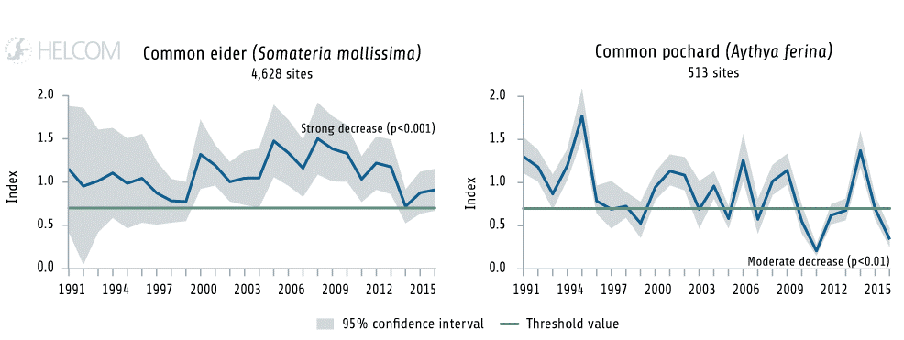

Figure 9: Population trends of two bird benthic feeders in the Baltic Sea. The trends show common eider (*Somateria mollissima*) in the breeding season and common pochard (*Aythya ferina*) in the wintering season at the whole Baltic Sea scale. Based on abundance index values during 1991-2016. The green line shows the index value of 0.7 which is the threshold to determine whether the populations have reached a good status or not. Source: HELCOM (2018a).

In the case of elasmobranchs, catches of sharks in the Mediterranean Sea and Black Sea have declined at least for the larger species as a result of increased fishing pressure especially since the 1960’s (FAO, 2012). Similar findings were found in the North Sea (Sguotti et al., 2016) where two species, common skate and angelshark became locally extirpated. However, changes in overall distribution, particularly of smaller non-commercial elasmobranch species, could also be linked to climate change and habitat degradation as well as fishing pressure (Sguotti et al., 2016). The HELCOM Red List assessment found the common skate (*Dipturus batis*) to be already regionally extinct in the Baltic Sea.

# Technical observations

The MSFD, Habitats Directive and other scientific assessment and monitoring programmes have helped understanding the ranges, distribution and condition of individual ecosystem components. Still, many habitats and species groups are not systematically monitored and high mobile species are not well covered. Also, the understanding of how whole ecosystems functions is still very low. This means that it is not always possible to clearly state if trends are indicative of improving or worsening levels of human pressure, as changes in other biological components may also be an influential factor.

Europe’s biological ocean observation capability needs to be more integrated (across different countries and purposes), harmonised and strengthened. Support is needed in taxonomic expertise and in the use of new emerging technologies, data science and management. Supporting technological innovation can bring cost-effective automated monitoring of biological variables; and supporting ‘citizen science’ can improve observation capacity, increase public confidence in science and the public’s emotional connectedness with the marine environment (from EMB, 2018).

Some contrasting conclusions coming from different assessments of species and habitats must be due to the use of different threshold values and classification criteria. The harmonisation of the methods and criteria to set threshold values for the status assessment of species and habitats under the MSFD will greatly facilitate the management and policy decision-making process.

# **Key messages**

* Thanks to the MSFD, progress has been made on understanding biodiversity elements and the relative intensity of human pressures. This knowledge aims at underpinning management measures and policy objectives.
* Assessment of the status is inadequate for most assessed species and habitats. Still, the available information point to the following conclusions:
  + Marine mammals, being the top mobile predator, are exposed to multiple pressures across their distributional range and not well monitored. Existing measures have contributed to stable or increasing abundance for some species of seals (e.g. some populations of grey and harbour seals in the Baltic Sea and in the North Sea) and joint regional programmes have been launched recently. The population status and trends of cetaceans are mostly unknow or, with the only possible exception of the North-east Atlantic Ocean, in slight decline.
  + Assessments for marine birds in the Baltic Sea and the North-east Atlantic show a diverse assessment status. Over 20% in seabird populations have declined in the last 25 years for more than a quarter of the species assessed in the North-east Atlantic. In the Baltic Sea, 31% of breeding water bird populations have declined, while in general surface and pelagic feeders have a good status. The level of harmonisation in the assessments’ methods among regions should improve.
  + Elasmobranchs comprise most of the classified threatened species (both in continental and regional Red Lists), although most of them are very poorly monitored. For example, in the Mediterranean Sea 40% of sharks, skates and rays are facing a declining population trend.
  + Cephalopods and reptiles are too poorly monitored (e.g. 33% of the reports on marine turtles under the Habitats Directive were in unfavourable conservation status and 67% unknown).
* There are relatively few cases with unambiguous improvements in trends of populations, species or groups of species. These include commercially exploited fish in the North-east Atlantic Ocean and Baltic Sea, grey seals in general, harbour seals in the Kattegat, monk seal in the Mediterranean, white-tailed eagle in Baltic Sea and the Mediterranean bluefin tuna. These positive effects are normally the result of joint efforts that managed to reduce selected pressures in the regional seas during the last one or two decades.
* Despite these examples, halting marine biodiversity loss remains a challenge. Some marine populations and groups of species are still at threat, including some seal populations (e.g. monk seals, harbour seals and ringed seals), some seabirds, commercially exploited fish in Mediterranean and Black seas, reptiles, sharks and rays, and killer whales.
* We can therefore conclude that biodiversity loss was not halted in Europe’s seas during the first MSFD cycle. Overall, marine life is still under threat across Europe’s seas with multiple pressures affecting individual species and habitats. Of particular concern are the hotspots of biodiversity, places where endemism is high and/or rare species are present in significant numbers. These tend to be in areas already under significant human pressure or where the monitoring or management measures are still being developed such as the Mediterranean Sea or Macaronesia.

Descriptor 2: Non-indigenous species introduced by human activities are at levels that do not adversely alter the ecosystems

# MSFD framework

|  |  |  |
| --- | --- | --- |
| COM DEC 2017/848/EU |  | COM DEC 2010/477/EU |
| D2 Non-indigenous species | | |
| D2C1 Newly-introduced non-indigenous species | The number of non-indigenous marine species which are newly introduced into a given EU marine region via human activities is minimised and, where possible, reduced to zero. |  |
| D2C2 Established non-indigenous species | Abundance and spatial distribution of established non-indigenous species, particularly of invasive species, contributing significantly to adverse effects on particular species groups or broad habitat types. | 2.1 Abundance/state of non-indigenous species  2.1.1 Trends in abundance of non-indigenous species |
| D2C3 Adverse effects of non-indigenous species | Proportion of the species group or spatial extent of the broad habitat type which is adversely altered due to non-indigenous species, particularly invasive non-indigenous species. | 2.2 Impacts of invasive non-indigenous species  2.2.1 Ratio invasive to native species  2.2.2 Impacts of non-indigenous species |

Non-indigenous, or alien, species refers to any live specimen of a species, subspecies or lower taxon of animals, plants, algae, fungi or micro-organisms introduced outside its natural range. It includes any part (e.g. gametes, seeds, eggs or propagules) of such species as well as any hybrids, varieties or breeds that might survive and subsequently reproduce (modified from the EU Regulation 1143/2014 on Invasive Alien Species[9]).

# Presence of non-indigenous species in EU marine waters

## Ongoing reporting under the MSFD

|  |  |
| --- | --- |
|  |  |
|  | |

Figure 10: Latest MSFD assessments of good environmental status related to non-indigenous species and corresponding criteria under Descriptor 2. The information comes from 10 Member States’ electronic reports.

The analysis of newly introduced non-indigenous species conclude that GES has been achieved only in 6 assessments (around 25% of the cases), while other 6 assessments have concluded that it will be achieved by 2020. More than 50% of the results have been reported as ‘GES expected to be achieved later than 2020 and where no Article 14 exception has been reported’.

A number of assessments have been reported on the established non-indigenous species, where in almost 40% have either achieved GES or will achieve it by 2020. 3 assessments have been reported as ‘not relevant’, therefore not concluding on the status of those species.

A large proportion of assessments of the criteria about the number of newly introduced non-indigenous species (D2C1) and the adverse effects of those species on other ecosystem components (D2C3) are reported in ‘not good’ status. The majority of asse The abundance and distribution of established non-indigenous species (D2C2) is mostly ‘not assessed’ or used for other criterion/element.

## Other assessments

### Pathways of introduction of non-indigenous species

Increased trade and tourism and the related maritime transport as well as the development of aquaculture and fisheries have provided pathways for the introduction and spread of marine alien species across Europe’s seas. In addition, many non-indigenous species already introduced in the marine waters of a country have significantly expanded their distribution range (ETC/ICM, 2019b). Full eradication is no longer a suitable solution for management once an alien species has established a viable population, although controlling species population might be achieved, for instance capturing the species and commercialising them as seafood. There is a wide international consensus that pathways-based preventive management is of absolute priority in effectively combating marine alien species (Ojaveer et al., 2018).

The main pathways for introductions of marine non-indigenous species in Europe´s seas (Figure 11) are shipping (49%) and marine and inland corridors (33 %, notably the Suez Canal). However, the contribution of these two pathways is widely different across the EU marine regions. Shipping contribution ranges from 45% in the Eastern Mediterranean Sea to approximately 82 % in the Black Sea. Among the marine alien species transferred by shipping, most species have been possibly transferred in ballast water (346 species), while the introduction of 287 species is tentatively attributed to boat hull fouling (EEA, 2019b). Marine and inland corridors are main pathways of introductions in the Eastern Mediterranean Sea (>46% of all marine introductions are via the Suez Canal) and in the Baltic Sea (15 % via inland canals). Additionally, important pathways of introduction are the unintentional movement of live organisms (11%) (i.e. by aquaculture activities), and escapes from aquaria and aquaculture (5%). Aquaculture (directly related to oyster culture) is responsible for more than 30% of marine introductions in the North-east Atlantic (Celtic, Iberian, Icelandic and North seas) (EEA, 2019b). Intentional releases in nature account for around 2%.

|  |  |
| --- | --- |
| a) | b) |
| c) | |

Figure 11: a) Trends in introductions of new non-indigenous species in European marine regions since 1949 per pathway. b) Relative importance of the pathways of introduction of non-indigenous species in EU marine regions since 1949. c) Trends in introductions of new non-indigenous species in each EU marine region since 1949 per pathway (EEA, 2019b).

### The native distribution range of non-indigenous species

The vast majority of the European marine non-indigenous species originate in the Western and Central Indo Pacific, being mostly associated with introductions into the Mediterranean Sea through the Suez Canal (Tsiamis et al., 2018). However, a more detailed analysis reveals various patterns of the dominating native distributions introduced in Europe, depending on the European marine subregions where they have been initially introduced (Figure 12).

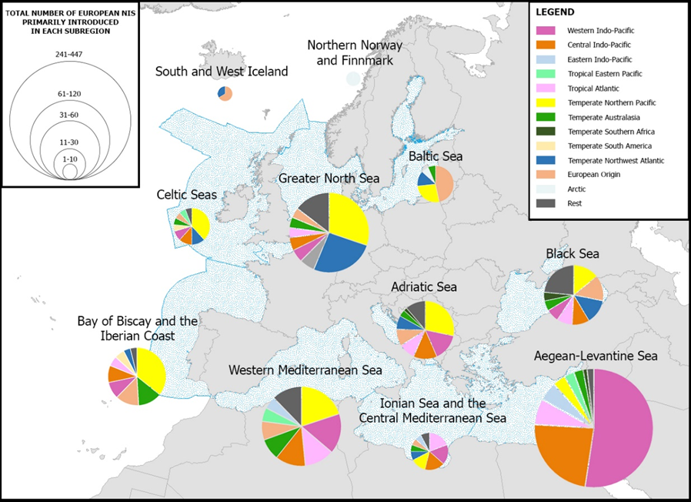

Figure 12: Proportion of the major native distribution ranges of established European marine non-indigenous species, associated with their first introduction events in Europe, depicted per marine sub-regions following the MSFD and Spalding et al. (2007). The size of each pie chart represents the total number of non-indigenous species primarily introduced in a subregion (the subregion of the initial arrival at European scale). The species of European origin have been counted in the subregion of first introduction within their alien European range. Non-indigenous species associated with “European Origin” are those with native distribution in at least one European Sea but with alien range into other(s). Source: © 2018 REABIC, Tsiamis et al. (2018).

# Observed trends

The number of newly introduced non-indigenous species shows both temporal and spatial variation when looking across Europe’s seas since the early fifties. Available data show that around 1 223 non-indigenous species are present in the Europe’s seas, of which almost 81% (1 039) were recorded in the period 1949-2017 (EEA, 2019c).

When considering the four EU marine regions altogether as well as each individual region, there is a decreasing trend of new introductions observed during the last decade (Figure 13), and this is most significant in the Black Sea, Greater North Sea and Celtic Seas. However, the abrupt increase in monitoring efforts during the 1990s and 2000s could have given an inflated increased peak for newly introduced species during that period, resulting in the subsequent “decreasing trend” observed during the 2010s.

According to an ICES[10] evaluation of the period 2012-2017, at the national level, the number of non-indigenous species introduced via human activity has been reduced to zero in the marine waters of Belgium, Denmark, Estonia, Finland, Germany, Ireland, Latvia, Lithuania, Netherlands, Poland, Sweden and United Kingdom (ICES, 2018a). However, this could be related to the insufficiency of monitoring programmes; thus, these data should be considered with caution.

In a recent work led by the Joint Research Centre, refined baseline inventories of non-indigenous species were set per Member State in the context of the MSFD Descriptor 2 (Tsiamis et al., 2019). The inventories were based on the initial assessment of the MSFD of 2012 and the updated data of the European Alien Species Information Network (EASIN), in collaboration with experts appointed by the Member States[11]. The analysis revealed that a large number of non-indigenous species was omitted from the initial assessments. Moreover, several species initially listed are currently considered as native in Europe or were proven to be historical misreporting. The refined baseline inventories constitute a milestone for the MSFD Descriptor 2 implementation, providing an improved basis for reporting new introductions of non-indigenous species by the Member States (Figure 14). In addition, the inventories can help Member States in the establishment of monitoring systems of targeted species, and foster cooperation on monitoring alien species across or within shared marine subregions.



Figure 13: Introductions of new non-indigenous species in Europe’s seas since the 50s (EEA, 2019c).

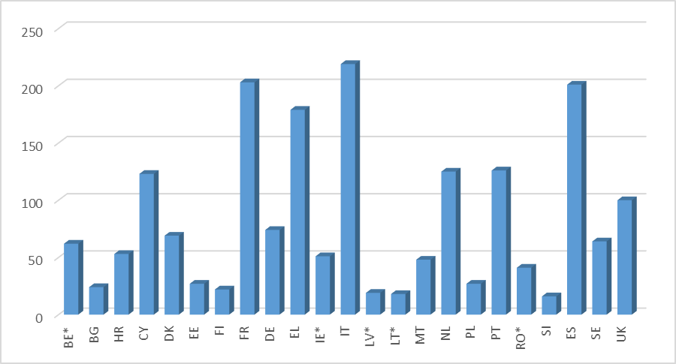

Figure 14: Refined total number of non-indigenous species up to 31.12.2011 per EU Member State. For Member States with an * data are exclusively based on the comparison assessment between the initial reporting lists of non-indigenous species and EASIN. Source: © 2019 Marine Pollution Bulletin, Tsiamis et al. (2019).

Data sources

Georeferenced data for the selected non-indigenous species were provided by:

* AquaNIS, Information system on Aquatic Non-Indigenous and Cryptogenic Species. World Wide Web electronic publication. www.corpi.ku.lt/databases/aquanis Version 2.36+
* EASIN, JRC European Alien Species Information Network. https://easin.jrc.ec.europa.eu/; last assessed 03.08.2018
* ELNAIS: https://services.ath.hcmr.gr/
* EPPO: http://www.eppo.org/INVASIVE_PLANTS/ias_plants.htm
* ESENIAS: http://www.esenias.org/
* EurOBIS, http://www.eurobis.org/citation: data assessed on 17.05.2017
* GISIN, Global Invasive Species Information Network: http://www.gisinetwork.org/
* HCMR, additional information: HCMR and EEA offline database for the Mediterranean (last update from July 2018);
* ICES/IMO/IOC WGBOSV and WGITMO reports 2002-2018: http://www.ices.dk/community/groups/Pages/WGITMO.aspx and http://www.ices.dk/community/groups/Pages/WGBOSV.aspx
* MAMIAS, UNEP-MAP-RAC/SPA, 2018. Marine Mediterranean Invasive Alien Species: http://www.mamias.org/
* NOBANIS, European Network on Invasive Alien Species: http://www.nobanis.org/
* REABIC, Regional Euro-Asian Biological Invasions Centre: http://www.reabic.net/

# Main impacts

Introductions of non-indigenous species are widely perceived as one of the main threats to biological diversity. Of particular importance are the invasivealien species, namely those non-indigenous species that, once established, spread rapidly and impact the native biological diversity in various ways. Their impacts can range from reduced genetic variation, eroded gene pools, through to altered habitats and ecosystems functioning, to the extinction of endemic species (Katsanevakis et al., 2014). Some examples of marine invasivealien species include the alien comb jelly *Mnemiopsis leidyi* in the Black and Caspian seas (Dumont et al., 2004) and the Lessepsian fish *Siganus luridus* in the Eastern Mediterranean Sea (Azzurro et al., 2016) (Figure 15).

|  |  |
| --- | --- |
| American comb jelly - Mnemiopsis leidyi | Siganus luridus |

Figure 15: Left: Mnemiopsis leidyi; photo author Karl Van Ginderdeuren. Right: Siganus luridus, photo author Roberto Pillon. These photos are under a Creative Commons Attribution-Noncommercial-Share Alike 4.0 License (downloaded from the World Register of Marine Species).

The cumulative impact of invasivealien species in the European seas is maximum in a restricted coastal area. The total area of Europe’s marine and coastal ecosystems *invaded* by invasivealien species is 8%. Out of this, the total area *impacted* by invasivealien is slightly lower, at 7%, which corresponds to approximately 421 231 km2 (ETC/ICM, 2019b). However, these numbers should be considered with caution in the absence of related information regarding the impact of numerous marine non-indigenous species and due to the knowledge gaps on the species distribution, especially when it comes to the offshore areas.

# Technical observations

* As already recommended in previous Commission reports under the MSFD, joint monitoring approaches spanning whole EU marine regions could close knowledge gaps in terms of new introductions of non-indigenous species.
* There is a need to investigate the impacts of non-indigenous species on the native communities, ecosystems and the services they provide.
* Measures would need to better address the main pathways of introduction in order to minimise new introductions, and would, thus, differ from region to region. In terms of preventing the impacts from such introductions, measures would need to focus on increasing the resilience of Europe’s seas ecosystems and minimising the conditions that can promote non-indigenous species to become invasive. Such conditions include the existence of ‘empty niches’ in the food web because of the reductions of certain native species resulting from human activities, such as the loss of top predators caused by fisheries, or climate change impacts reflected in an increased sea surface temperature.
* The implementation of current global and EU legislative instruments and policies, such as the MSFD, the Invasive Alien Species Regulation, and the Ballast Water Management Convention[12], should be monitored in terms of their efficiency in decreasing the risk of new introductions of alien species.

# Key messages

* There are over 1200 marine non-indigenous species in Europe’s seas. The cumulative number of non-indigenous species is still increasing, since they are still introduced into Europe’s seas. However, the rate of new introductions seems to be decelerating.
* The main pathways for introductions of alien species in Europe´s seas seem to be shipping (49%) and marine and inland corridors (33 %).
* The vast majority of the European marine non-indigenous species have their native distribution in the Western and Central Indo Pacific. However, there are various patterns of the dominating native distributions of the introduced species in Europe, depending on the European marine subregions where they have been initially introduced.
* Some non-indigenous species already introduced have significantly expanded their distribution range in some areas. However, it is difficult to assess the proportion of marine species and habitats that have been adversely affected.
* New refined baseline inventories of non-indigenous species per Member State show discrepancies with the initial assessments reported under the MSFD. Italy, France, Spain and Greece had the largest numbers of non-indigenous species back in 2011 (more than 150 species each). These baselines provide an improved basis for reporting new introductions and for establishing of monitoring systems.
* More than 80 non-indigenous species correspond to invasive alien species. Their impacts may be scored and mapped, their impacts are obvious in coastal areas but not offshore. The total area of Europe’s marine and coastal ecosystems impacted by invasive alien species is 7%. However, this is most likely an underestimation due to the knowledge gaps regarding their actual distribution and impacts.

1. Directive 2008/56/EC of the European Parliament and of the Council of 17 June 2008 establishing a framework for community action in the field of marine environmental policy (Marine Strategy Framework Directive) (OJ L 164, 25.6.2008, p. 19).
2. The 11 qualitative descriptors are defined in Annex I of the Marine Strategy Framework Directive and further specified in Commission Decision 2017/848/EU. They include D1- Biodiversity, D2- Non indigenous species, D3- Commercial fish and shellfish, D4- Food webs, D5- Eutrophication, D6- Sea-floor integrity, D7- Hydrographical changes, D8- Contaminants, D9- Contaminants in seafood, D10- Litter, D11- Energy, including underwater noise.
3. A number of figures in this Staff Working Document represent the information recently reported by 10 Member States (Belgium, Denmark, Germany, Estonia, Spain, Latvia, Netherlands, Poland, Finland, Sweden) using the ART8_GES schema: <https://cdr.eionet.europa.eu/help/msfd/MSFD%20Schemas>. The figures show the percentage (vertical axis) and the total number of assessments (numbers on the bars) with conclusions at the “overall status level” and the “criteria level” (see Table 1). Not all Member States have reported on all the criteria or all the descriptors, therefore the percentages refer to the proportion out of the total number of assessments reported.
4. <https://water.europa.eu/marine>
5. Baltic Sea: HELCOM HOLAS II (<http://www.helcom.fi/helcom-at-work/projects/holas-ii>); North-east Atlantic Ocean: OSPAR Intermediate Assessment 2017 (<https://oap.ospar.org/en/ospar-assessments/intermediate-assessment-2017/introduction/ospar-and-intermediate-assessment-2017/>); Mediterranean Sea: UNEP/MAP Quality Status Report 2017 (<https://www.medqsr.org/>); Black Sea: Black Sea State of Environment Report 2009-2014/5, which was not available at the time of preparation of this report (<http://www.blacksea-commission.org/SoE2009-2014/SoE2009-2014.pdf>).
6. Applicable to birds, mammals, reptiles, fish and cephalopods; taking into account the absence of cephalopods in the Black Sea and of reptiles in the Baltic Sea.
7. The European Red List is funded by the European Commission and compiled by IUCN’s Global Species Programme. It assesses all vertebrates (mammals, amphibians, reptiles, birds and fishes). The status is based on percentage of species.
8. Even if benthic habitats are described under Descriptor 6, they were also included in this table to allow for the comparison of all ecosystem components.
9. Regulation (EU) No 1143/2014 of the European Parliament and of the Council on the prevention and management of the introduction and spread of invasive alien species. Official Journal of the European Union (L315), pp. 35-55.
10. International Council for the Exploration of the Seas
11. AquaNIS (2018), which is routinely updated by the ICES Working Group of Introduction and Transfers of Marine Organisms, substantially contributed to the Baltic Sea and several North-east Atlantic countries.
12. The International Convention for the Control and Management of Ships' Ballast Water and Sediments adopted by the International Maritime Organization (IMO) in February 2004 in order to halt invasive aquatic species.