

Descriptor 3: Populations of all commercially-exploited fish and shellfish are within safe biological limits, exhibiting a population age and size distribution that is indicative of a healthy stock

# MSFD and broader legal framework

|  |  |  |
| --- | --- | --- |
| COM DEC 2017/848/EU | | COM DEC 2010/477/EU |
| D3 Commercial fish and shellfish | | |
| D3C1 Fishing mortality rate (F) | The Fishing mortality rate of populations of commercially-exploited species is at or below levels which can produce the maximum sustainable yield (MSY). Appropriate scientific bodies shall be consulted in accordance with Article 26 of Regulation (EU) No 1380/2013. | 3.1 Level of fishing pressure  3.1.1 Fishing mortality  3.1.2 Fish catch/biomass ratio |
| D3C2 Spawning stock biomass (SSB)[1] | The Spawning Stock Biomass of populations of commercially-exploited species are above biomass levels capable of producing maximum sustainable yield. Appropriate scientific bodies shall be consulted in accordance with Article 26 of Regulation (EU) No 1380/2013. | 3.2 Reproductive capacity of stock  3.2.1 Spawning stock biomass  3.2.2 Biomass indices |
| D3C3 Population age/size distribution[2] | The age and size distribution of individuals in the populations[3] of commercially-exploited species is indicative of a healthy population. This shall include a high proportion of old/large individuals and limited adverse effects of exploitation on genetic diversity. | 3.3 Population age/size distribution  3.3.1 Proportion of larger fish  3.3.3 Fish length distribution  3.3.4 Fish size at maturation |
|  |  | 3.3.2 Maximum length of fish |

Descriptor 3 deals with the state of all commercially exploited fish and shellfish. Commercially exploited populations applies to all marine biological resources targeted for economic profit, including the bony fish (teleosts), sharks and rays (elasmobranchs), crustaceans such as lobsters and shrimps, and molluscs (including bivalves and cephalopods). The scope of the MSFD concerning Descriptor 3 is particularly broad. It encompasses the precautionary principle, the ecosystem approach and exploitation levels that correspond to the maximum sustainable yield (MSY)[4].

The EU has an exclusive competence in the area of the conservation of marine biological resources under the Common Fisheries Policy (Article 3 of Treaty on the Functioning of the EU, TFEU) for capture fisheries in EU waters and for fisheries outside EU waters conducted by EU vessels. Under the MSFD, measures relating to fisheries management can be taken in the context of the Common Fisheries Policy. Under the Common Fisheries Policy, the fishing pressure on stocks concerned should be aligned as soon as possible, and by 2020 at the latest, to the objective of restoring and maintaining stocks to levels that can produce MSY. Exploiting fish stocks at or below the exploitation levels which is associated with MSY allows them to be maintained or allows them to recover to healthy levels, and providing food for consumers while contributing to important ecosystem and marine food web functions. Achieving this objective will also contribute to achieving good environmental status in European seas by 2020, as required by the MSFD, and to reducing the negative impact of fishing activities on marine ecosystems.

The tools available under the Common Fisheries Policy for achieving sustainability include Total Allowable Catches, effort control and access restrictions. These measures can be packaged in multi-annual plans in order to allow some stability of the industry, whilst continuing to ensure the sustainability of the fisheries. Furthermore, the EU introduced an obligation for all catches of species subject to a catch limit to be landed, as well as all catches subject to a minimum catching size in the Mediterranean Sea[5]. Implemented this obligation is expected to lead to a decreased fisheries pressure on juveniles, as fish previously banned from being landed now have to be landed and are counted towards the Total Allowable Catches. The vast majority of Member States reported some of these fisheries management measures as part of their MSFD programme of measures.

# Observed status of the EU’s commercial fish and shellfish

## Ongoing reporting under the MSFD

|  |  |
| --- | --- |
|  |  |
|  | |

Figure 16: Latest MSFD status assessments per feature (left) and per criteria (right) under Descriptor 3. The information comes from 10 Member States’ electronic reports.

Only in 2 of the reported assessments for commercially exploited fish and shellfish GES is achieved, while in 8 cases GES will be achieved by 2020 and in 8 it will be achieved only later than 2020 and no Article 14 exception has been reported. Almost 50% of the assessments have been reported with no conclusion.

The most reported criteria for fish stocks assessments are the fishing mortality rate (D3C1) and the spawning stock biomass (D3C2). For fishing mortality, around 35% of the assessments are reported in ‘good’ status and another 35% as ‘not good’. For spawning stock biomass, 50% of the assessments conclude that the status of the stocks is ‘good’. There are still a number of assessments without conclusion in these two criteria, but the proportion of ‘not assessed’ is much higher (over 95%) for the criterion related to the population age/size distribution (D3C3). The few reported assessment of this criterion resulted in ‘not good’.

## Other assessments

The capture fisheries or wild fisheries in the EU are usually classified into two areas under the Common Fisheries Policy: the Atlantic waters (including the MSFD North-east Atlantic Ocean and Baltic Sea regions) and the Mediterranean Sea and Black Sea regions together. The present assessment is based on the same selection of stocks that are used by the Common Fisheries Policy monitoring report: stocks in the North-east Atlantic Ocean are included if they are managed by total allowable catches, whereas the advisory committee (STECF) decided on a list of stocks in for the Mediterranean area (STECF, 2019). Still, it must be noted that such analysis may cover less than half of the commercially exploited fish/shellfish stocks landed across Europe’s seas (EEA, 2019g - table 4.1). The results presented in this chapter (see the selection criteria in the next paragraph) seem to cover over one third of the commercial fish/shellfish stocks in the North-east Atlantic Ocean and Baltic Sea regions and around half of the stocks in the Mediterranean Sea and Black Sea regions (based on EEA, 2019d and STECF, 2019).

The number of stocks inside/outside biological limits (Figure 17) corresponds to indicators 3.3 and 3.4 of the annual Common Fisheries Policy monitoring report (Annex 1 of STECF, 2019)[6]. The safe biological limit (SBL) is defined as the fishing mortality (F) being below the precautionary reference exploitation level (Fpa) and the spawning stock biomass being above the precautionary biomass level (Bpa)[7]. However, as data from the Mediterranean or Black Sea stocks are not enough to perform the analysis adequately (i.e. having available estimates for fishing mortality, biomass, and point for both), it was decided to use only the fishing mortality estimates and comparing them to the fishing mortality that produces the maximum sustainable yield (Fmsy) as a reference point. A similar analysis is presented in EEA (2019d).

None of these assessments include the third MSFD D3 criterion on age and size structure of the populations as this cannot be assessed at present. Hence, an overall conclusion about the ‘good environmental status’ of fish/shellfish stocks cannot be reached at the moment according to the MSFD standards.

Currently, 41% of the assessed fish and shellfish stocks in the North-east Atlantic Ocean and Baltic Sea regions are within safe biological limits[8]. The situation is worst in the Mediterranean and Black Sea regions where only 13% of the stocks[9] considered in this analysis are not overfished and 87% are overfished[10]. The Central Mediterranean Sea is the worst performing ecoregion in terms of percentage of overfishing. Given this context, the 2020 objective of having healthy commercial fish and shellfish populations seems unlikely to be met in all Europe´s seas and further collective action is required[11].

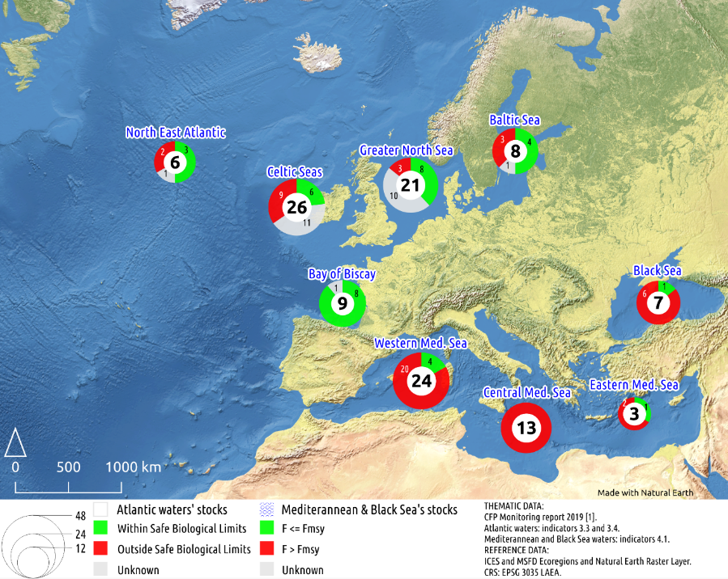

Figure 17: European waters’ fish stocks analyses based on indicators from the Common Fisheries Policy monitoring report 2019. The number of stocks are a subsample of all stocks following the same selection procedure as the Common Fisheries Policy monitoring report. The total number of stocks is displayed using proportional circles with labels in the middle; parts of the total are displayed using a doughnut diagram with labels reporting absolute number of stocks in each category. © European Union, reproduced with permission, STECF (2019).

As a reflection of data availability and quality, Figure 18 shows commercial European fish landings by MSFD regions in 2017 (EEA, 2019d). Within this figure, fish landings are divided into three categories, namely (1) landings for assessed stocks for which adequate information is available to determine fishing pressure and reproductive capacity (covering MSFD criteria D3C1 and D3C2), (2) landings for assessed stocks for which insufficient information is available to determine one of those criteria, and (3) landings for assessed stocks for which information on both criteria is insufficient to determine GES. While the information base continues to improve, knowledge gaps remain. For the EU waters, about a third of the landings (34%) are from stocks for which their status could be assessed against at least one GES criterion. However, there are distinct regional differences. Figure 18 shows that an assessment of status is only possible for 6.5% of total landings from the Mediterranean Sea and the Black Sea, compared with 36% of those from the North-east Atlantic Ocean and Baltic Sea. Therefore, the EU still faces the need to assess more stocks to obtain better information to inform GES assessments specially for many of the smaller and less commercially stocks which often lack information upon which to base an assessment of GES.

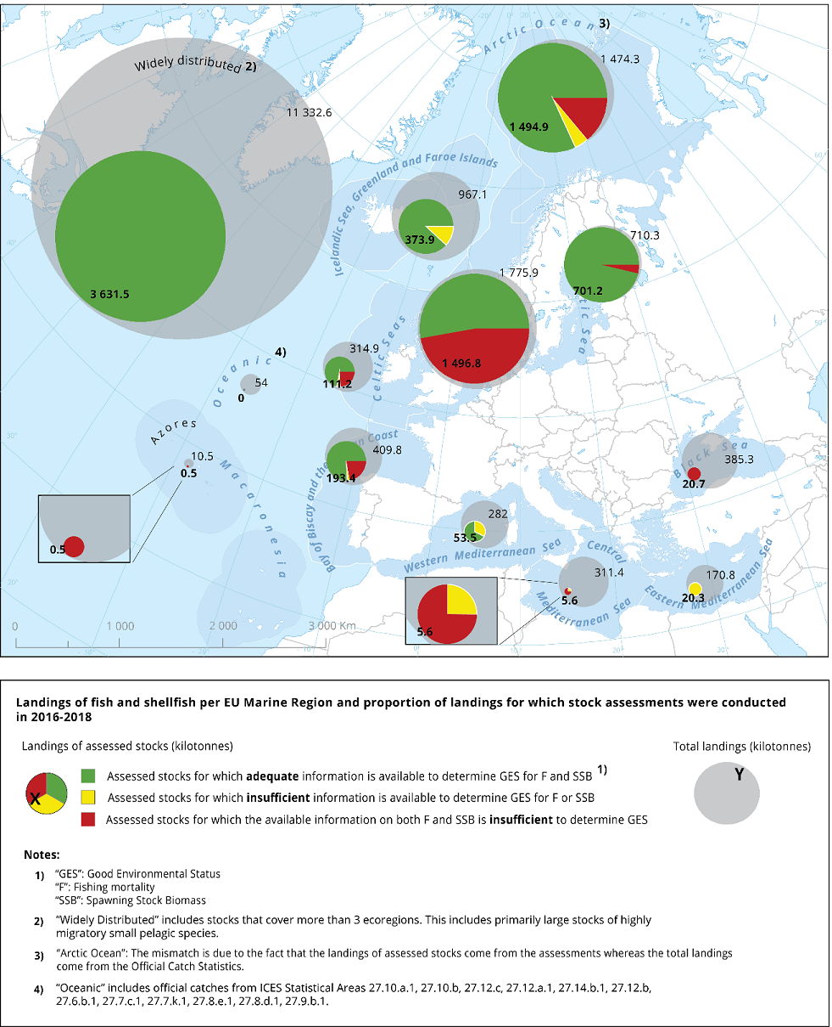

Figure 18: Landings of commercial fish and shellfish per regional sea, and proportion of landings for which stock assessments are available (EEA, 2019d).

# Observed trends

Fishing mortality

Trends in F with respect to the Fmsy reference point corresponds to indicator 3.7 of the Common Fisheries Policy report (Annex 1 of STECF, 2019). A value greater than 1 (F > Fmsy) indicates exploitation exceeds the level that would produce the maximum yield, and is likely less sustainable in the long term.

In the Atlantic waters (covering the MSFD North-east Atlantic Ocean and Baltic Sea regions), the average fishing mortality has decreased since 2003 towards the Fmsy reference point. All Atlantic sub-regions (or ‘ecoregions’ as referred to in the Common Fisheries Policy) mirror this trend with the exception of the Baltic Sea where the average fishing mortality has slightly increased over the past few years. The other ecoregions have an average fishing mortality that is below or very close to the average Fmsy (Figure 19). In order fulfil the Common Fisheries Policy requirements completely, the management-by- Fmsy-coverage of the stocks needs to increase to all stocks.

|  |
| --- |
| a) |
| b) |

Figure 19: Trend in F/Fmsy in a) Atlantic waters as a whole (based just on 48 stocks) and b) by ecoregion (number of stocks are in parenthesis). No uncertainty envelopes were calculated due to the low number of stocks available within each region. The confidence intervals shown are 50% (dark grey) and 95% (light grey). STECF (2019) © European Union.

The fishing mortality in the Mediterranean and Black Sea has remained virtually unchanged since 2003. It remains extremely high, indicating that most selected stocks are severely overfished. In recent years, a small decrease in average fishing mortality is encouraging, but not enough to fulfil the Common Fisheries Policy requirement to fish at Fmsy levels by 2020. Regional trends mirror the overall trend with the exception of the Eastern Mediterranean, where a severe drop in fishing mortality has been observed. This drop can be explained in part through the low number of stocks in this region used by this analysis and its persistence into the future cannot be taken for granted (Figure 20).

|  |
| --- |
| a) |
| b) |

Figure 20: Trend in F/Fmsy in a) the Mediterranean and Black Seas (based on 47 stocks) and b) the individual ecoregions (number of stocks are in paranthesis). No uncertainty envelops were calculated due to the low number of stocks available within each region. The confidence intervals shown are 50% (dark grey) and 95% (light grey). STECF (2019) © European Union.

Although only the trend analysis since 2003 is consistent in methods and the suite of assessed stocks, longer-term indicators have been estimated for the period 1947-2017[12]. Such indicators show that fishing mortality in the North-east Atlantic Ocean and Baltic Sea increased over time from approximately sustainable levels (F = 1) in the 1950s to a maximum of more than twice the sustainable level, reached in the late 1990s. This was followed by a constant decline towards sustainable levels, and reached F<FMSY in 2017. Some of these trends may have been caused by newly assessed stocks being introduced into the analysis. As not all stocks are assessed every year, spurious trends can be introduced by chance in years when more heavily-fished stocks or more lightly-fished stocks may be chosen for assessment.

Despite recent improvements in the North-east Atlantic Ocean region, Nimmo and Cappell (2017) considered that a major step change was required to reduce both the proportion of Total Allowable Catches set above scientific recommendations and the number of Total Allowable Catches set without scientific recommendations, since this contravenes opportunities for earlier stock recovery.

Spawning stock biomass

Trends in spawning stock biomass with respect to the spawning stock biomass in 2003, fitted using a generalised linear model. This indicator corresponds to indicator 3.8 of the Common Fisheries Policy report (Annex 1, STECF, 2019). A value greater than 1 (B > B2003) means that spawning stock biomass is above the 2003 levels indicating that the reproductive capacity of stocks is improving.

The spawning stock biomass has slightly increased since 2003. The biggest relative increase is observed in the stocks of the Bay of Biscay and the North-east Atlantic Ocean. The trend over the recent years is upwards in most ecoregions. Trends in recruitment have started to increase after a decline (compared to 2003) that lasted from 2003 until 2014 in some areas. An exception to the average trend is the Celtic Sea region, which has seen no consistent decline in that period (Figure 21).

|  |
| --- |
| a) |
| b) |

Figure 21: Trend in spawning stock biomass with respect to the 2003 level in a) Atlantic waters (based on 55 stocks) and b) by ecoregion (number of stocks are in parenthesis). The confidence intervals shown are 50% (dark grey) and 95% (light grey). STECF (2019) © European Union, reproduced with permission.

Similarly to the Fmsy trend, the biomass trend in the Mediterranean and the Black Seas shows no statistically significant change since 2003. The average biomass has slightly increased in the last 2 years, which has been driven by the increase in spawning stock biomass in the Central and Eastern Mediterranean Sea. The ecoregions exhibit a large variation in trends and in number of stocks, which makes it difficult to make any assertions (Figure 22).

|  |
| --- |
| a) |
| b) |

Figure 22: Trend in spawning stock biomass with respect to the 2003 level in a) the Mediterranean and Black sea regions based on the selected stocks, and b) by ecoregion (number of stocks are in parenthesis). The confidence intervals shown are 50% (dark grey) and 95% (light grey). STECF (2019) © European Union, reproduced with permission.

# Technical observations

Since 2010, an increasing proportion of EU Total Allowable Catches have been set in line with MSY advice[13], climbing from 6% in 2005 to 71% in 2018 and 79% in 2020. Still, strong management decisions and transparent decision-making processes continue to be required if Total Allowable Catches are to be brought fully in line with scientific advice.

It is urgent to improve data collection and perform regular and more stock assessments in particular in the Mediterranean Sea, Black Sea and Macaronesia. It is particularly important to develop and implement management arrangements for bringing the operation of fishing fleets in line with MSY parameters.

# Key messages

Although further improvements are still necessary, the trend analysis shows important signs of improvement in the North-east Atlantic Ocean and Baltic Sea. Since the early 2000s, better management measures have contributed to a decrease in fishing pressure on commercially exploited fish and shellfish stocks in these two regional seas, and signs of recovery in their reproductive capacity have started to appear. Currently, 41% of the assessed fish and shellfish stocks in the North-east Atlantic Ocean and Baltic Sea regions are within safe biological limits; although the assessed stocks cover around one third of the total commercial fish/shellfish stocks in the area. The spawning stock biomass has increased in these areas and it is now 36% higher than in 2003 and the number of assessed stocks inside safe biological limits has almost doubled from 2003 to 2017[14]. If management and implementation efforts are sustained, fishing pressure and reproductive capacity should continue to improve in the North-east Atlantic Ocean and Baltic Sea, although the progress is not enough to meet the relevant common fisheries policy objectives yet.

In contrast, in the Mediterranean Sea and the Black Sea the situation remains worrying with 87% of the assessed stocks overfished (based on the analysis of half of the total commercial fish/shellfish stocks in the area) and insufficient information about reproductive capacity to estimate safe biological limits. Both the trends in fishing mortality and the biomass trend in the Mediterranean and the Black Seas show no statistically significant change since 2003.

The figures indicate that further concerted efforts are required to achieve the 2020 objective of having healthy commercial fish and shellfish populations. Success will depend on the availability and quality of information and the commitment to implement the scientific advice and adequate uptake of management measures. Many stocks remain overfished and/or outside safe biological limits and it is clear that efforts by all actors will need to be intensified to meet CFP and MSFD objectives, considering in particular that 2020 is the first year when all stocks with an Fmsy assessment should be managed at Fmsy.

Descriptor 4: All elements of the marine food webs, to the extent that they are known, occur at normal abundance and diversity and levels capable of ensuring the long-term abundance of the species and the retention of their full reproductive capacity

# MSFD framework

|  |  |  |
| --- | --- | --- |
| COM DEC 2017/848/EU |  | COM DEC 2010/477/EU |
| D4 Food webs / D1 Biodiversity - ecosystems | | |
| D4C1 Trophic guild species diversity | Are anthropogenic pressures adversely affecting the diversity of the trophic guilds? | 1.7 Ecosystem structure  1.7.1 Composition ecosystem |
| D4C2 Abundance across trophic guilds | Is the balance of total abundance between the trophic guilds adversely affected by anthropogenic pressures? | 1.7 Ecosystem structure  1.7.1 Composition ecosystem  4.3 Abundance of trophic groups or species  4.3.1 Abundance of groups or species |
| D4C3 Trophic guild size distribution | Are anthropogenic pressures adversely affecting the distribution of individuals across the trophic guild? | 4.2 Proportion of species at top of food webs  4.2.1 Large fish by weight |
| D4C4 Trophic guild productivity | Is the productivity of the trophic guild adversely affected due to anthropogenic pressures? | 4.1 Productivity of species or trophic groups  4.1.1 Productivity of key predators |

# Status and trends of marine food webs in EU waters

## Ongoing reporting under the MSFD

|  |  |
| --- | --- |
|  |  |
|  | |

Figure 23: Latest MSFD assessments of good environmental status of marine food webs per feature (left) and associated criteria (right) under Descriptor 4 (closely linked to Descriptor 1). The information comes from 10 Member States’ electronic reports.

Under Descriptor 4, there is only available information for coastal and shelf ecosystems. For the coastal ecosystems, GES is achieved in 1 case, and 3 assessments conclude that GES will be achieved later than 2020 and where no Article 14 exception has been reported. In more than 60% of the cases, the coastal ecosystem are ‘not assessed’. For the shelf ecosystems, 2 assessments conclude that GES will be achieved later than 2020 and where no Article 14 exception has been reported, while the rest of assessments (almost 90%) are either ‘not assessed’ or ‘unknown’.

The most reported criterion on the assessment of the status of food webs is the abundance across trophic guilds (D4C2), for which 14 assessments result in ‘good’, 10 in ‘not good’, and 10 and 12 have been reported as ‘not assessed’ or ‘unknown’ respectively.

The criteria on trophic guild species diversity (D4C1), trophic guild size distribution (D4C3) and trophic guild productivity (D4C4) have a similar distribution. A few assessments result in ‘good’ status (or ‘good, based on low risk’), a larger number of assessments are in ‘not good’ status, and more than half of the assessments do not reach any conclusion.

## Setting the scene for the analysis of food webs

Descriptor 4 of the MSFD represents one of the most complex and unknown aspects of marine ecosystems. There are still very few assessments and reports under the Directive, and they are hardly comparable. The Regional Sea Conventions are also struggling with making assessments of food webs.

Food chains describe biological communities in terms of their predator-prey relationships and are often referred to in terms of their structure (e.g. diversity, trophic levels), dynamics (e.g. robustness, resilience) and function (e.g. physicochemical and biological processes) (Rooney and McCann, 2012). Food chains are pathways that transfer energy and matter between feeding levels or trophic levels (i.e. guilds) and their natural interconnections form complex networks called food webs.

Human activities cause direct, indirect, diffuse and emergent changes in food webs (Layman et al., 2005). Overexploitation, pollution, eutrophication, habitat destruction, species invasions and climate change, all pose potential threats to the structure and dynamics of food webs, acting at variable spatial scales and affecting food webs in different ways (Moloney et al., 2010). Nutrient enrichment, for example, can drive bottom-up effects propagating up food webs from lower trophic levels (Davis et al., 2010), whereas the removal of top-predators (e.g. overfishing) can initiate top-down cascade effects through to basal trophic levels (Cury et al., 2003). All these changes can lead to abrupt, large and long-lasting reorganisations of the food web. These reorganisations, often referred to as ecological regime shifts, can bring forward undesirable effects on both the wider marine ecosystem and people (EEA, 2015).

Regime shifts are particularly undesirable notably because they may be very costly or impossible to reverse and often have considerable impacts on the economy and society (Biggs et al., 2009). This is because they affect the flow of marine ecosystem services and associated benefits to people (Rocha et al., 2014). Nevertheless, even without such extremes, existing food web impacts have already economic and management implications such as for fisheries management and viability. For example, the relatively small pelagic fish (e.g. sprat, anchovy and horse mackerel) have increased in recent decades in the Greater North Sea due to seawater warming as a result of climate change; whereas the larger species cod and plaice have decreased at their southern distribution limit (Perry, 2005). This change may have important socio‑economic consequences as the stocks moving out tend to have a higher value than the stocks moving in (EEA, 2019a). Other implications of such distributional changes include the greater distances that must be travelled by fishing boats to reach certain target species increasing fuel cost and time at sea (Rijnsdorp et al., 2010).

The relationships between food webs and anthropogenic pressures, though, are highly complex and mostly indirect. In fact, given the complexity of marine food webs and the numerous interactions between marine ecosystems and human activities, it is difficult to clearly link visible signs of degradation of trophic guilds with specific anthropogenic causes (ICES, 2015).

Despite these difficulties, different approaches are currently used to investigate food web properties. For example, whilst data-based approaches are applied to reveal natural processes, modelling techniques are used to provide a more integrative image of the structure, functioning and dynamics of systems under different environmental and human pressures (Schewe et al., 2019, Liquete et al., 2016). Unfortunately, the application of food web models to derive indicators and assess ecosystem status, in general, is often constrained by the extensive data requirements needed to perform the analysis (Piroddi et al., 2015).

Also, while an ecosystem-based approach is increasingly used in fisheries management to study ecosystem responses to fishing pressure and to assure sustainable use of resources, similar holistic approaches to evaluate the combined influences of other anthropogenic stressors on food webs has received less attention to date.

## Results from other assessments

Due to the complexity to analyse the state of marine food webs and, in most cases, the lack of data/knowledge of cause-effect relationships in Europe’s seas, this section aims at showing few examples of food web degradation or recovery through the use of food web indicators, rather than a comprehensive assessment (Tam et al., 2017) that reflect all pressure-state relations within food webs.

The various examples of food web indicators come from national assessments or models. They show as major trends either (1) signs of long-term impact on a range of biodiversity features pointing towards a deteriorating state of food webs, or (2) food web recovery, which can be attributed to the implementation of key EU and other policies.

|  |  |  |
| --- | --- | --- |
| **(Type of) indicator** | **Case study** | **Key observations** |
| Large Fish Indicator | North Sea and Celtic Sea | Different multiannual trends, mostly degrading with some positive trends in the North sea |
| Primary productivity | OSPAR area | Very variable behaviour in different areas, e.g. stable in Liverpool bay, decreasing in Skagerrak |
| Zooplankton composition, Continuous Plankton Recorder | OSPAR area (esp. Celtic and North seas) | Changes in the proportion of zooplankton species affect fish and bird communities |
| Zooplankton abundance | HELCOM area | Copepods’ abundance correlate with the fish condition and weight |
| Biomass of several trophic guilds | Central Baltic Sea | Regime shift |
| Keystone index and transfer efficiency | Black Sea | Regime shift |
| Biomass of selected functional groups | Mediterranean Sea | Decrease of forage fish and demersal fish, increase of invertebrates, 41% drop of top predators |
| Biomass of selected functional groups + trophic level indices | Multiple areas around the European seas | Different trends in marine ecosystems, mostly degrading but with some positive trends |

Table 12: Summary of the examples presented in this section.

Among these indicators, size-based indicators have been widely used to demonstrate the effects of fishing on fish community structure, and the Large Fish Indicator (LFI), in particular, has been specifically developed to support the OSPAR ecosystem approach to marine management (Greenstreet et al., 2011; Shephard et al., 2013). The LFI describes the proportion of fish biomass contributed by large individuals in the demersal fish community and is defined as the ratio between the biomass of demersal fish above a length threshold over the total fish biomass.

This indicator has been widely used to assess demersal stocks impacted by fisheries in the North and Celtic seas. In fact, in the North Sea, LFI showed a continuous declined until 2001 followed by a recovery in 2008. Yet, analyses of longer-term groundfish survey data suggest that, even reducing fishing pressure to early 20th century levels, LFI would unlikely rise to initial conditions (Figure 24a). In the Celtic Sea, the decline in LFI was consistent throughout the survey period (19 years) reflecting high exploitation rates (Figure 24b).

|  |  |
| --- | --- |
| a) | b) |

Figure 24: a) LFI trends in the North Sea (Greenstreet et al., 2011) b) in the Celtic Sea Celtic Sea. For 1b two overlapping LFI series are shown: the UK West Coast Groundfish Survey (WCGFS) that concluded in 2004, and the ongoing Irish Groundfish Survey (IGFS) (Shephard et al., 2013).

Another indicator, primary production of phytoplankton from the OSPAR pilot assessment, showed site-specific changes, but it was not possible to arrive at OSPAR-wide conclusions. For example, in the North Sea and Skagerrak, long-term primary production decreased from the mid-1980s to 2013, although the reasons for such a reduction have not been identified. In other areas, like Liverpool Bay, no long-term trend in the primary production of phytoplankton was identified (OSPAR, 2017e).

Long-term changes in zooplankton composition, observed in the North-east Atlantic Ocean through the Continuous Plankton Recorder survey, have been used to assess shifts in ecosystem function and dynamics. In particular, the copepod community of the Celtic and the Greater North Seas over 1960s to 2000s changed from a cold-water species *Calanus finmarchicus* to a warm water species *Calanus helgolandicus*. *C. finmarchicus* has a higher energy content than *C. helgolandicus*, and is considered to be a key element for the larval survival of some commercial fish species (EEA, 2015; 2019a). In fact, this shift in copepod community composition has been observed impacting the growth, recruitment and survival of other trophic levels such as seabirds (Wanless et al., 2005) and fish (Beaugrand et al., 2008). Since the 1970, there has also been a northward shift in fish species in the same area. Despite the observed warming of the surface ocean, the overall productivity level from oceanic features continues to sustain mesozooplankton and appears to be stable in the North Atlantic although with regional disparities (Druon et al., 2019).

In the Baltic Sea, fish body condition and weight-at-age of sprat and young herring correlate positively with copepod abundance/biomass. Consequently, indicators based on biomass of zooplankton and zooplankton/phytoplankton ratios have been used to assess environmentally driven changes in the food web, and the possible impact of eutrophication (HELCOM, 2012). The underlying principle of the zooplankton/phytoplankton ratio is that higher grazing efficiency implies fewer losses in the food web, less energy and nutrients passing through the microbial loop, and, consequently, more energy transferred to the higher trophic levels such as fish.

Casini et al. (2009) showed quantitative evidence of a shift in the functioning of the central Baltic Sea ecosystem during the last 3 decades. In particular, until the end of 1980, the system had a cod-dominated configuration, characterised by low sprat abundance and a marked independence between zooplankton and sprat variations. From the beginning of 1990, the system shifted to a sprat-dominated configuration, characterised by low cod biomass and zooplankton strongly controlled by sprat predation (Figure 25). In the latter configuration, the sprat control on zooplankton biomass was substantially higher compared to the whole period investigated, suggesting a shift in the strength of sprat predation pressure on zooplankton. In the cod-dominated configuration, on the other hand, sprat and zooplankton were clearly uncoupled likely because sprat abundance was not high enough to regulate the zooplankton resource.

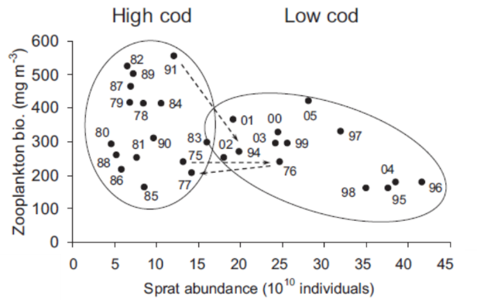

Figure 25: Relation between sprat abundance, cod abundance and zooplankton biomass. The configuration corresponds to the situations of high cod/low sprat (left ellipses) and of low cod/high sprat (right ellipses), respectively. Numbers associated with each point indicate observation years. The dashed lines show the transit from one configuration to the other (Casini et al., 2009).

Several food web indicators have been also used to assess Black Sea ecosystems and their regime shift. In particular, the keystone index evidenced a top-down control system, dominated by dolphins, in the 1960-1969 period and a bottom-up control system between 1988-1994 dominated by jellyfish (Mnemiopsis) (Figure 26). One other interesting outcome of the keystone analysis was the lack of recovery of dolphins, even though the dolphin fishery was banned after 1966 in the USSR, Bulgaria, Romania and 1983 in Turkey. This was supported by the study of energy transfer efficiency between trophic levels (Akoglu et al., 2014) that highlighted intensive eutrophication, which did not propagate up the food web because of the interference of the gelatinous population. As shown in Figure 26, in 1988–1994, Mnemiopsis was the second most significant keystone species after the zooplankton group.

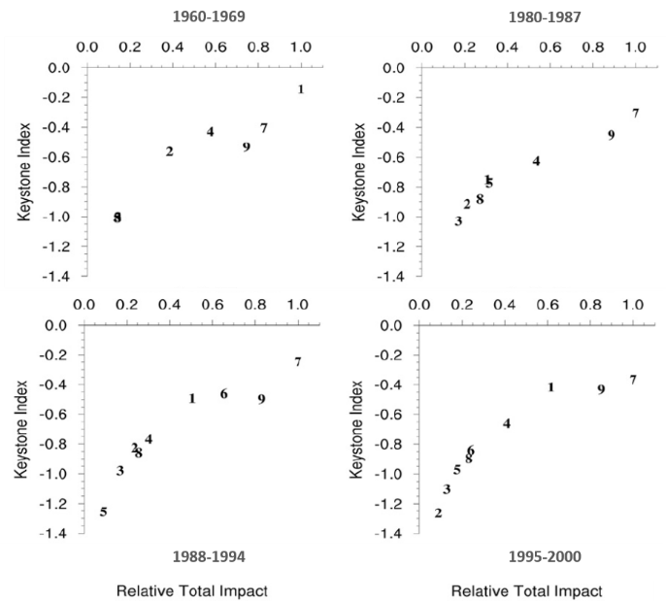

Figure 26: a) Keystoneness (key role in the ecosystem of certain species/groups of species) and relative total impact of functional groups on the structure of the Black Sea food web in four model periods. 1) dolphins, 2) piscivorous fish, 3) demersal fish, 4) small pelagic fish, 5) Aurelia, 6) Mnemiopsis (jellyfish), 7) zooplankton, 8) Noctiluca, 9) phytoplankton. b) Transfer efficiency (%) of flows across trophic levels in the four assessed periods. Source: Akoglu et al. (2014).

Other food web indicators used to assess the health status of European seas refer to those based on abundance and biomass of selected functional groups and/or species that can inform on the structural/functional properties of food webs. In the Mediterranean Sea, for example, these indicators have highlighted that fishing pressure and changes in environmental conditions caused the decline of forage fish (European sardine and anchovies) and demersal fish (European hake, Mullidae) biomasses and consequently the increase in invertebrates groups (crustaceans, benthos) (Piroddi et al., 2017). Sharks, rays and skates biomass, on the other hand, declined in the Western and Adriatic Sea but not in the Ionian and Eastern sub-areas. Overall, this analysis revealed the Mediterranean Sea to be a degraded ecosystem that has lost 41% of its top predators (e.g. marine mammals) and 34% of the total fish population over the past 50 years.

These type of biomass indicators in association with trophic levels indices have been also used to assess and overview the health status of several North and South European marine ecosystems (Figure 27, Coll et al., 2016). A combined analysis of predatory fish, total biomass and the distribution of trophic levels, showed an overall degradation of food webs and ecosystems in most of the European sub-basins (Figure 27).

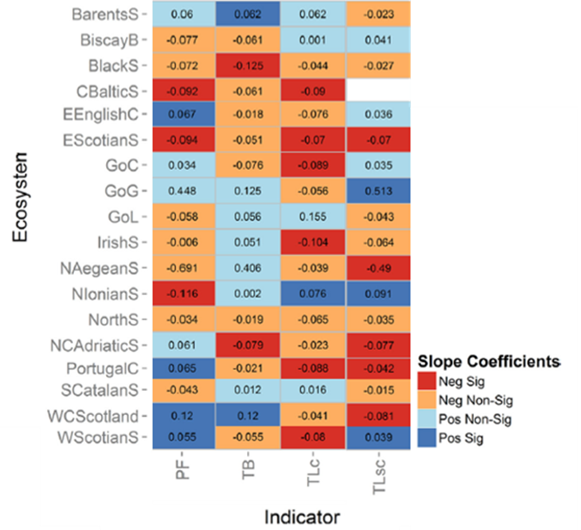

Figure 27: Trend indicators’ slope coefficients (1980–2010) for selected indicators (PF: proportion of predatory fish; TB: Total biomass in the food web; TLc: mean trophic level of the catch; TLsc: mean trophic level of surveyed community) and marine ecosystems (BarentS: Barent Sea; BiscayB: Biscay Bay; BlackS: Black Sea; CBalticS: Central Baltic Sea; EEnglishC: Eastern English Channel; EScotianS: Eastern Scotian Shelf; GoC: Gulf of Cadiz; GoG: Gulf of Gabes; GoL: Gulf of Lions; IrishS: Irish Sea; NAegeanS: North Aegean Sea; NIonianS: North Ionian Sea; NorthS: North Sea; NCAdriatic: North and Central Adriatic Sea; PortugalC: Portuguese Coast; SCatalanS: Southern Catalan Sea; WCScotland: West Coast Scotland; WScotianS: West Scotian Shelf). Neg: negative, Pos: positive, Sig: significant, Non-Sig: non-significant trend.

In conclusion, multiple anthropogenic pressures are affecting: 1) the species or communities’ diversity within a trophic guild; 2) the balance of the total abundance of species or species groups between trophic guilds; 3) the distribution of individual species within a trophic guild; and 4) primary production. The lack of wide scale assessments for Descriptor 4 and the delay in viewing the response of existing measures (e.g. fisheries management) will hamper achieving GES for Descriptor 4. Harmonized monitoring programmes and methods for the assessment of the D4 criteria are required to generate informative assessments at relevant geographical scales for trophic guilds.

# Technical observations

* Some of the best data available come from commercially exploited fish and shellfish stocks for which extensive monitoring programmes exist and from zooplankton communities through the Continuous Plankton Recorder, although this is the case only for the Atlantic Ocean. Other aspects of the food-web appear to be under-sampled in comparison. Satellite remote sensing of ocean colour (chlorophyll-a content and productive fronts) appears to be, in the last two decades, a synoptic source of data for monitoring changes of plankton (phyto- and zoo-) distribution at community level after effect of climate variability and eutrophication, disentangling the impact of fishing on food-web productivity.
* Size-based approaches may be inappropriate for assessing processes in benthic communities, since both size dependent (e.g. predation) and size independent interactions (e.g. consumption of amorphous detritus) can co-occur, suggesting that the energy available to species of a particular size is not solely derived from smaller species in the food web.
* Theoretical and empirical models may help to identify potential impacts and elucidate key properties that should be monitored, thereby promoting the development of more effective and comprehensive operational food web indicators. The complementary use of empirical and modelling approaches to derive population, community and ecosystem indicators is key to the development operational food web indicators for ecosystem-based management in the marine environment.
* Harmonised monitoring programmes are required to generate proper assessments for trophic levels (and marine regions), to support potential management measures. These programmes should in turn be used to strengthen assessment baselines and targets for existing indicators. ICES (2015) and Tam et al. (2017) provide a wide performance analysis for potential indicators that better fit to the requirements of Descriptor 4. Such indicators could then be linked to human activities and their pressures. Long-term data series and cross-regional cooperation will further facilitate improved and consistent assessments.

# **Key messages**

* While the overall state of marine food webs across all European seas cannot be fully assessed, there are many examples of trophic guilds showing deteriorating trends over time, being affected by anthropogenic pressures. This especially concerns the reductions in abundance of several top predators, such as birds, sharks and marine mammals.
* There are examples of communities and possible entire trophic guilds that do not occur at the proper abundance to retain their full productive capacity, as observed for many commercial fish and shellfish stocks in the Mediterranean and Black seas, which are below their sustainable levels due to overfishing.
* Yet, few examples of recovery for key species or groups of species are observed in EU marine regions. This might be the direct response to on-going measures to manage the human activities, such as fisheries, contaminants or nutrients.
* There are also signs of changes in the size structure/distribution of species or communities (indicative of a trophic level) due to anthropogenic pressures, e.g., phytoplankton in the Baltic Sea and zooplankton (copepods) species in parts of the North-east Atlantic Ocean.
* The productivity of some trophic guilds is impacted, although the exact reasons are unclear.
* There is a lack of consistent approaches to assess the state of food webs across European seas. There are many instances where assessments are incomplete, thus associated with high uncertainty, or are simply impossible due to lack of suitable data.

1. SSB is an estimate of the mass of the fish of a particular stock that reproduces at a defined time, including both males and females and fish that reproduce viviparously.
2. Commission Decision 2017/848/EU acknowledges that D3C3 may not be available for use for the 2018 review of the initial assessment and determination of good environmental status under Article 17(2)(a) of the MSFD, reflecting ongoing discussions on relevant indicators and lack of reference points.
3. The term ‘populations’ shall be understood as the term ‘stocks’ within the meaning of Regulation (EU) No 1380/2013
4. MSY means the highest theoretical equilibrium yield that can be continuously taken on average from a stock under existing average environmental conditions without significantly affecting the reproduction process
5. Article 15 of Regulation (EU) No. 1380 of the European Parliament and of the Council of 11 December 2013 on the Common Fisheries Policy, amending Council Regulations (EC) No 1954/2003 and (EC) No 1224/2009 and repealing Council Regulations (EC) No 2371/2002 and (EC) No 639/2004 and Council Decision 2004/585/EC. O.J. L 354 , 28.12.2013, p.22.
6. The precise methodology for SBL and trends analyses as well as the corresponding data sources are explained in detail in the Annex of STECF (2019).
7. Note that these precautionary reference values are different, usually less strict, than the MSY levels although they allow to make a more comprehensive analysis of safe biological limits. This is driven by data availability.
8. This is based on an analysis of 70 stocks with data and reference points available (see figure 17 and STECF, 2019) while the total commercially exploited stocks in the area can exceed 200 stocks (EEA, 2019d).
9. Or 7.5% of the stocks (3 out of 40) according to EEA (2019d).
10. This is based on an analysis of 47 stocks that can represent half of the total commercially exploited stocks in the area.
11. An alternative estimation (EEA, 2019d) shows that around 45 % of the assessed commercially exploited fish and shellfish stocks in Europe’s seas are not in GES based on both fishing mortality and reproductive capacity criteria, or in cases where only one criteria was available and not in GES. The other 55 % of the stocks met at least one of the criteria for GES. This assessment does not include the third GES criterion on age and size structure of the populations as this cannot be assessed at present.
12. Trend in the status of stocks assessment and the progress made in GES assessment in the North-east Atlantic Ocean and Baltic Sea since 1945, <https://www.eea.europa.eu/data-and-maps/figures/trend-in-the-status-of>
13. Table 4 of Commission staff working document accompanying the document Communication from the Commission on the state of play of the Common Fisheries Policy and consultation on the Fishing Opportunities for 2019. SWD(2019) 205 final.
14. Communication from the Commission on the state of play of the Common Fisheries Policy and consultation on the Fishing Opportunities for 2020 (COM(2019) 274 final).