

Section 2 –  
Internal control and financial management

1. The Commission manages the EU budget in a complex environment

The Commission attaches great importance to the sound financial management of the EU budget, as well as of the European Development Fund and the EU Trust Funds. It is the Commission’s duty to make the best possible use of taxpayers’ money to support the achievement of the EU’s policy objectives. It is therefore essential to ensure both a high level of compliance with the applicable rules and that funding reaches the intended beneficiaries in an effective, efficient and economical manner. Consequently, the Commission strives to achieve the highest standards in financial management while striking the right balance between a low level of errors, fast payments and reasonable costs of controls.

* 1. The EU budget: a wide variety of areas, beneficiaries and spending

In 2019, the expenditure ([1]) from the EU budget amounted to EUR 147 billion (see chart below), corresponding to 240 000 payments ranging from a few hundred euros (Erasmus scholarships) to hundreds of millions of euros (large projects such as ITER or Galileo and Copernicus, as well as budgetary support to developing countries). These payments are made to support activities as varied as farming and the development of rural and urban areas, the improvement of transport and digital infrastructure, research, aid to small and medium-sized enterprises, protection of the environment, training for unemployed people, the integration of migrants and border protection, support to countries wishing to join the EU and aid to neighbouring and developing countries. The recipients of EU funds are very diverse and numerous.

|  |  |  |  |  |  |
| --- | --- | --- | --- | --- | --- |
| **Natural resources** | **Cohesion** | **Research, industry, space, energy and transport** | **External relations** | **Other internal policies** | **Other services and administration**  EUR 7 billion (5%) |
| EUR 59 billion (40%) | EUR 47 billion (32%) | EUR 15 billion  (10%) | EUR 12 billion (8%) | EUR 7 billion (5%) |
|  |  |  |  |  |
| **6.2 million farms** supported out of 10.5 million | Regions and cities  Almost **500 000** **enterprises** supported since 2014 | More than **12 000 small and medium-sized enterprises** supported,  as well as researchers, laboratories and large organisations | **90 non-EU countries** and territories receiving direct support, as well as numerous international and non-governmental organisations | Erasmus+: almost **360 000 students** supported in 2019  (more than **4.6 million participants** since 2014) |

Relevant expenditure of the EU budget implemented by the Commission in 2019, per policy area, in % and billion EUR

*Source:* European Commission annual activity reports.

More than two thirds of the budget is implemented under shared management. Member States or bodies assigned by them distribute funds and manage expenditure in accordance with EU and national law (e.g. in the case of expenditure on cohesion and natural resources). The rest of the budget is spent either directly by the Commission or indirectly in cooperation with entrusted entities. The table below describes the three management modes.

|  |  |  |  |  |
| --- | --- | --- | --- | --- |
| Management mode | Description | % of 2019 relevant expenditure | Examples of programmes/ spending | Other actors involved, in cooperation with the Commission |
| Direct management | Funds are implemented by the Commission | *22%* | Horizon 2020;  Connecting Europe Facility;  administrative expenditure | *n/a (funding goes directly to the beneficiaries)* |
| Indirect management | Funds are implemented in cooperation with external entities | *7%* | Erasmus+;  part of development and humanitarian aid; pre-accession assistance | Agencies,  joint undertakings,  United Nations, World Bank, European Investment Bank, European Bank for Reconstruction and Development, non-EU countries |
| Shared management | Funds are implemented in cooperation with Member States’ national and/or regional authorities, which have a first level of responsibility | *71%* | Agricultural funds; Maritime and Fisheries Fund;  European Regional Development Fund; European Social Fund;  migration and security funds | Paying agencies for common agricultural policy: 76;  managing authorities for cohesion funds: 492, in all Member States |

Given that the EU budget is implemented in many different ways, involving different actors, the associated risks vary from one programme and management mode to another (see Annex 3). This is taken into account when developing the control strategies (see Section 2.2).

* 1. Governance, accountability and transparency

The chain of accountability

The governance system used by the European Commission is tailored to its unique structure and role. The Commission’s governance arrangements have been strengthened over time and adapted to changing circumstances. Recent work by the internal and external auditors has confirmed that these arrangements are robust. The von der Leyen Commission, which took office in December 2019, has continued to put accountability and transparency at the core of its work, as confirmed in the updated working methods ([2]) and mission letters addressed to all Members of the Commission. The latest developments are reflected in the updated communication on governance in the Commission, published alongside this report ([3]).

The College of Commissioners is politically responsible for the management of the EU budget. The main building blocks of the EU budget’s governance, underpinned by a clear division of responsibilities between the political and the management levels, lead to a solid chain of assurance building and accountability. They are presented in the chart below. At Commission level, the accountability framework is based on well-defined management responsibilities and reporting (see below).

These robust governance arrangements help the College of Commissioners to deliver on the Commission’s objectives, to use resources efficiently and effectively and to ensure that the EU budget is implemented in accordance with the principles of sound financial management.

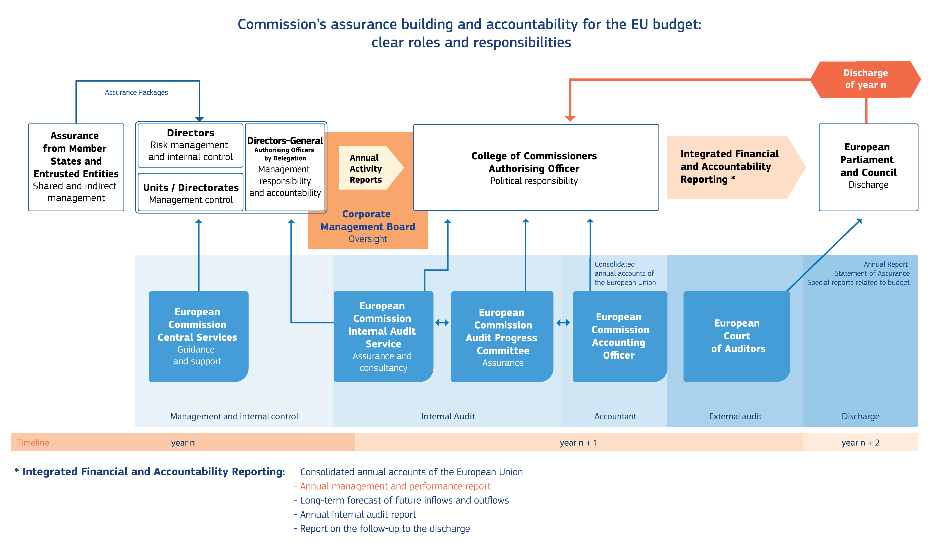

The Commission’s assurance building and accountability: clear roles and responsibilities

*Source:* European Commission.

Accountability and reporting at department level

The College of Commissioners delegates the day-to-day operational management to the 50 Directors-General ([4]) or equivalent ([5]) (hereafter the Directors-General), who lead the administrative structures of the Commission. In accordance with the Commission’s corporate rules and standards, they manage and shape their departments in order to deliver on their objectives as defined in their strategic plans and taking into account available resources. They are accountable for the share of the EU budget implemented in their departments.

In their annual activity reports, they report in a transparent way on the performance and results achieved, on the functioning of their internal control systems and on the financial management of their share of the EU budget – taking account of the assurance provided by Member States under shared management. In the declaration of assurance, which is part of the annual activity report, they declare whether they have reasonable assurance that:

* the information contained in their report presents a ‘true and fair view’ (i.e. reliable, complete and correct) on the state of affairs in their department;
* the resources assigned to their department have been used for their intended purpose and in accordance with the principle of sound financial management;
* the control procedures put in place in their department give the necessary guarantees concerning the legality and regularity of the underlying transactions.

In order to obtain this assurance, the Directors-General use all available information (summarised in their annual activity reports), namely:

* the results of the controls carried out by their own services or on their behalf;
* the management and control information reported by Member States and other entrusted entities based on their own control systems, in the case of shared and indirect management;
* the work done by the Internal Audit Service (see Annex 6);
* audits by the European Court of Auditors, the EU’s independent external auditor.

If they identify weaknesses with a significant impact, they are required to qualify their declaration of assurance with a reservation. In parallel, they put in place action plans to mitigate future risks and to strengthen their control systems (see Section 2.3.5 and Annex 4).

Accountability and reporting at corporate level

The annual management and performance report for the EU budget presents the situation at Commission level. This report is part of the Commission’s integrated financial and accountability reporting package ([6]) which is adopted by the College and is based on the assurance and reservations contained in all the annual activity reports.

The ensuing annual discharge procedure allows the European Parliament and the Council to hold the Commission politically responsible for the implementation of the EU budget. The European Parliament’s decision on the discharge is based on:

* the European Court of Auditors’ reports in which it gives an opinion on the reliability of the annual accounts and an opinion on the regularity of revenue and expenditure, and presents the results of its audits of specific spending or policy areas, or budgetary or management issues;
* the Commission’s integrated financial and accountability reporting;
* hearings of Commissioners and Directors-General and replies to written questions;
* a recommendation from the Council.

The Commission reports each year on its follow-up of requests addressed by the European Parliament and the Council to the Commission during the discharge procedure.

1. The Commission relies on various instruments to ensure that the taxpayers’ money is well managed

In order to ensure that the budget is well implemented and protected from weaknesses and irregularities within this complex environment, the Commission has several instruments at its disposal.

* 1. A strong internal control framework

The Commission has in place a strong corporate internal control framework based on the highest international standards ([7]).

The Directors-General implement this corporate framework within their departments through tailored internal control systems, taking into account their specific operating environments, risks and needs. They are supported in this task by the central services ([8]), which provide instructions, guidance and advice and facilitate the sharing of good practice. Each year, they assess the functioning of their internal control systems according to a common methodology and summarise their conclusions in their annual activity reports.

In addition, the Internal Audit Service may conduct audit engagements on the functioning of the internal control systems and the assessment by the Commission departments of these systems (see Annex 6).

For 2019, the 2nd year of the full implementation of the current internal control framework, the assessments by the Commission departments indicate that their internal control systems remain effective. The overall situation is presented in the chart below.

The assessment confirms the improvements made in relation to control activities, the positive impact from the reinforced corporate oversight on risk identification and risk management, and improvements in the field of information technology.

These results demonstrate that the Commission has reached an advanced level of internal control. The central services will continue to provide guidance and facilitate the sharing of good practice in order to further promote the internal control framework as a management tool that helps the organisation to achieve its objectives.

Assessment of the functioning of the 17 internal control principles

*Source:* European Commission annual activity reports.

* 1. Multiannual control strategies ensure that the taxpayers’ money is well spent

Within the Commission’s corporate framework, the Directors-General, as managers of the EU budget, put in place multiannual control strategies designed to prevent errors and, if it is not possible to prevent errors, to detect and correct them. To do so, they need to build their assurance from the bottom up and to assess the errors affecting EU spending at a detailed level, i.e. by programme or other relevant segment of expenditure. This allows the Commission to detect the weaknesses and correct them, and also to identify the root causes of systemic errors (e.g. complexity of rules), take targeted corrective actions and ensure that any lessons learned are factored into the design of future financial programmes.

From prevention to detection and correction

As EU spending programmes are multiannual by design, the related control systems and management cycles also cover multiple years. This means that while errors may be detected in a given year, they are corrected in the current or in subsequent years after the payment was made – up until the moment of closure at the end of the programmes’ life cycle. Moreover, the control strategies are risk differentiated, i.e. they are adjusted to the different management modes, policy areas and/or funding arrangements and their associated risks.

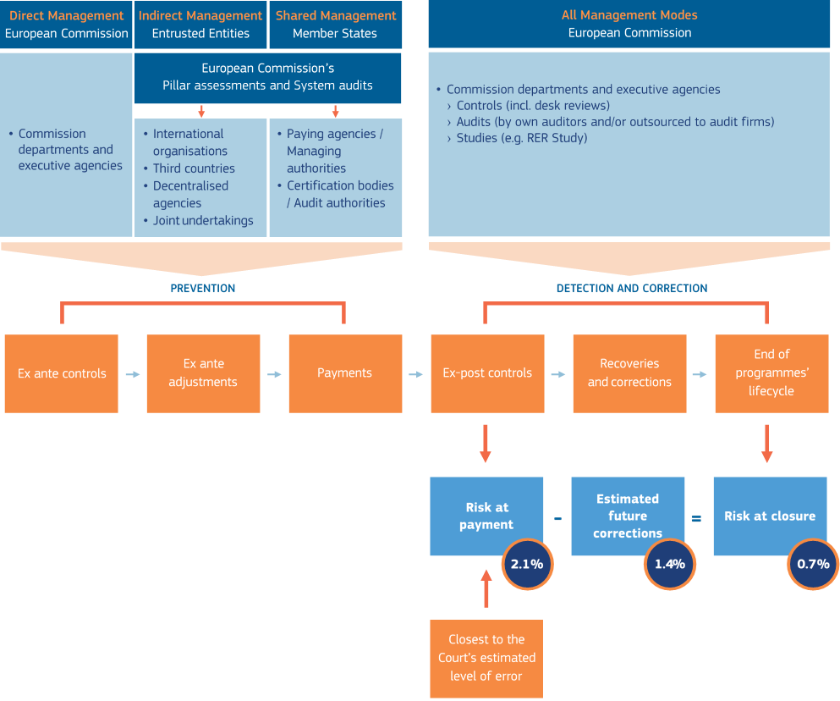

The Commission’s multiannual control cycle (for the 2019 results mentioned inside the circles see Section 2.3.1 below)

*Source:* European Commission.

Prevention of errors

Prevention is the first line of defence against errors. The Commission’s key preventive mechanisms include verifications by Member States’ managing authorities (under shared management), *ex ante* controls leading to the rejection of ineligible amounts before the Commission accepts expenditure and makes payments, systems audits to detect weaknesses in the implementing partners’ management and control systems (preventive for future expenditure) and the interruption and suspension of payments until the deficiencies in the systems are fixed.

These measures also serve as incentives for Member States to correct payments before they submit their cost claims to the Commission. This explains why, under shared management, the risk at payment is relatively low as regards the payments made by the Commission to the Member States, as errors have already been corrected by the Member States at their level before they submit their payment claims or annual accounts for clearance to the Commission.

In 2019, the preventive measures confirmed amounted to EUR 416 million. These include deductions and other adjustments before payment/acceptance of accounts by the Commission, Member State deductions from new expenditure declared to the Commission (at-source deductions) and other *ex ante* adjustments.

Furthermore, for cohesion policy funds, the Member States have applied corrections totalling EUR 670 million for the 2014-2020 period. This is a result of the strengthened regulatory provisions that increase managing authorities’ accountability and significantly strengthen the Commission’s position in protecting the EU budget from irregular expenditure.

In addition to these mechanisms, the guidance provided to implementing partners also help to prevent errors.

Detection and correction of errors affecting EU expenditure

Where preventive mechanisms have not been effective, it is important that errors affecting EU expenditure are detected a posteriori, through controls on amounts the Commission has accepted and paid out (*ex post* controls).

These errors are corrected by the Commission during the same or in subsequent years, by way of financial corrections or replacement of ineligible expenditure in shared management, and recoveries from final recipients in direct and indirect management.

In 2019, the corrective measures confirmed amounted to EUR 1.5 billion (25% higher than in 2018). These relate mainly to errors affecting payments made in previous years.

In parallel, weaknesses in control systems, detected through risk-based system audits, are subsequently addressed and systems corrected to avoid recurrence of the same errors in the future. In the context of shared and indirect management, this is done in the first place by the implementing Member States and partners.

For more information on the protection of the EU budget, see Annex 5.

A reliance on implementing partners’ control systems

Almost 80% of the budget is implemented in cooperation with the Member States and entrusted entities as implementing partners (see second table in Section 2.1.1). It is thus important to check that these partners demonstrate a level of protection of the EU financial interests equivalent to that achieved when the Commission manages the budget itself. To this end, the Commission carries out an assessment of the systems, rules and procedures of the persons or entities implementing EU funds. This concerns in particular the assessment of the Member States’ and entrusted entities’ management and control systems through system audits accompanied by substantive testing on expenditure and other types of verifications called pillar assessments or designation procedures before the partner is entrusted with implementing the EU budget on behalf of the Commission.

In indirect management, each year the partners report on the sound financial management of the entrusted budget through a management declaration. This is the basis upon which the related Commission departments are able to build their assurance in this management and control environment.

The Commission is currently working on setting up an automated workflow for the different verifications, encompassing the whole process. Such a tool would ensure that all the necessary phases allowing an entity to qualify for working with the Commission in indirect management take place in a centralised, coherent and coordinated manner.

In the area of shared management, Member States report each year on their controls on the use of EU funds at national level and on the sound financial management of their respective programmes through an assurance package, containing a management declaration, an annual summary of the verifications carried out and an annual control report containing an error rate based on representative samples and an audit opinion on the legality and regularity of the expenditure. This reporting is the basis for the Commission’s acceptance of programme accounts and for enabling the related Commission departments to build their assurance. It is also used for determining the potential risks to the EU budget, as well as for identifying weaknesses and the areas where further checks are needed.

Best practice on internal control matters is shared with and among Member States in the framework of the networks for structural and agricultural funds as well as the public internal control network, led by the Commission.

Furthermore, the Commission has put forward a proposal ([9]) to protect the EU budget in case of generalised deficiencies as regards the rule of law in the Member States. This proposal, an integral part of the future multiannual financial framework, is subject to ongoing negotiations in the European Parliament and the Council.

The Commission is also working with the Member States to facilitate the understanding and implementation of the reinforced rules on conflict of interest in force since the entry into application of the revised financial regulation on 2 August 2018. It is also monitoring all the allegations brought to its attention in this context.

The cost-effectiveness of controls

All Commission departments apply the common control features described above, by which preventive and corrective measures are applied on a multiannual basis at the level of specific programmes or other expenditure segments. However, as seen in Section 2.1.1, individual spending programmes may be very diverse and therefore control strategies need to be adapted to different management modes, policy areas and/or funding modalities and their associated risks. Such differentiation of the control strategies is needed to ensure that the controls remain cost-effective, i.e. that they strike the right balance between a low level of errors (effectiveness), fast payments (efficiency) and reasonable costs (economy). Riskier areas will trigger a higher level of scrutiny and/or frequency of controls, whereas low-risk areas should lead to less intensive, costly or burdensome controls. Also, the actual recovery potential of unduly spent EU funds will be considered when setting up the control strategy (e.g. the cost-benefit analysis of on-site audits).

**ECONOMY**

**EFFECTIVENESS**

**EFFICIENCY**

Cost-effective-ness

The Commission and the Court of Auditors: different roles lead to different control approaches

The Commission and the Court of Auditors play different roles in the control chain of the EU budget and therefore their control approaches differ considerably. The Commission’s duty as manager of the EU budget is to prevent and, if necessary, to correct errors and recover unduly spent funds. This requires a detailed bottom-up assessment of the control systems to identify where the weaknesses are, so that targeted corrective measures can be taken at programme level or even at the level of the implementing partners. On the other hand, the role of the Court of Auditors is to provide an annual audit opinion on the legality and regularity of EU spending as a whole, which may be supplemented by specific assessments of major areas of the EU budget (see comparative table on the next page). Therefore, although both institutions converge on several concepts, the Commission’s methodology differs duly from that of the Court.

These approaches can lead to differences between the error rates reported by the Court of Auditors and by the Commission. In particular, when the Court of Auditors detects procurement errors and/or the late availability of supporting documents for grants, in a (few) sampled transaction(s), it extrapolates the impact to the whole heading or to the whole EU budget, which often amplifies the importance of such errors. Given its more detailed segmentation of expenditure according to risk profiles and control systems, the Commission, when detecting such errors, is able to extrapolate them more precisely to the population that is most likely to be affected. It is thus able to give a more nuanced view of the level of error across the payments made and to clearly identify the areas where improvements are needed.

Some examples of these differences are given in the box below.

Natural resources

In 2018, the Court of Auditors found errors in three of the six transactions sampled related to the **European Maritime and Fisheries Fund**. This fund being covered by the ‘Natural resources’ heading, the Court of Auditors extrapolated the errors to the entire heading, even though fisheries account for only **1.3%** of the spending under this heading, and despite the fact that their management and control systems differ from those for spending on the common agricultural policy. The Commission applies a higher level of granularity to the extrapolation of errors.

Indeed, the European Maritime and Fisheries Fund is part of the Structural Funds and follows an identical management and control cycle to that of spending in the context of cohesion. For cohesion, the Court of Auditors assesses the legality and regularity of transactions after the annual clearing of accounts, i.e. once all *ex ante* controls have been completed. This is in line with the Commission’s methodology for all expenditure under the Structural Funds, whereas for the audited transactions under fisheries the Court of Auditors’ findings were made before the completion of all *ex ante* controls and could still have been corrected before the Commission’s payments.

Cohesion

Whilst the Court of Auditors and the Commission share the same view on the main causes of errors in spending under cohesion, in some cases **the Court of Auditors has diverging and more restrictive interpretations** of applicable national or EU rules. This has an impact on the calculated error rate, which once extrapolated amplifies the error rate for the whole heading.

Beyond the interpretation of applicable rules, the Court of Auditors’ **quantification of errors ‘may differ** from that used by the Commission or Member States when deciding how to respond to the misapplication of the public procurement rules’ ([10]).The Court of Auditors systematically quantifies errors in public procurement procedures at 100%. The Commission, however, will assess the actual financial impact based on its legal interpretations and guidance ([11]), i.e. a financial correction of 100% would not be considered proportionate by the Commission for such a breach. Likewise, the Commission’s applicable guidelines can provide for a quantification of public procurement errors of 5%, 10% or 25% when the Court of Auditors would consider an error to be only a compliance issue, with no impact on its calculation of the error rate.

External relations

In previous years, the (timely) access to supporting documents from entrusted entities, including international organisations, was a source of irregularities. This was also a reason for the Court of Auditors’ relatively high estimated level of error for the European Development Funds (5.2% for 2018). However, that **estimated level of error was** calculated before all *ex ante* controls had been implemented and especially before supporting documents had been provided. The Court of Auditors acknowledged that ‘[o]f the 39 payment transactions containing *quantifiable errors*, 9 (23%) were final transactions authorised once all *ex ante* checks had been carried out’ ([12]). Therefore, for the other 30 transactions the level of error might have been lower if the Court of Auditors had audited them once all *ex ante* controls had been performed.

|  |  |  |
| --- | --- | --- |
|  | **European Commission** management perspective | **European Court of Auditors** audit perspective |
| **Roles** | * Provide annual management assurance * Identify weaknesses and take action on a multiannual basis * Protect the EU budget | * Provide an audit opinion on the legality and regularity of financial transactions of a specific year |
| **Level of granularity** | * Error rate for the EU budget as a whole and individual error rates for each department and policy area under Headings 1 to 5, plus for revenue * Error rates calculated per policy area, programme and/or relevant (sub)segments * Expenditure and revenue of the year (or 2 years for research) with a multiannual perspective | * Error rate for EU budget as a whole and individual error rates for Headings 1a, 1b, 2 and 5, plus for revenue * Expenditure and revenues of the year |
| **Multiannuality** | * Two error rates (risk at payment and risk at closure ([13])); multiannuality prospectively taken into account for the risk at closure through estimated future corrections for all programmes | * One error rate (most likely error) * Multiannuality retroactively taken into account, only through financial corrections implemented for closed programmes |
| **Materiality threshold** | * 2% * Except for revenue (1%) and for Horizon 2020 (between 2% and 5%) | * 2% |
| **More information** | * Annex 3 to this report | * Annex 1.1 to the Court of Auditors’ annual report |

Comparison between perspectives of the Commission and the European Court of Auditors

* 1. Fraud to the taxpayers’ detriment is prevented through multilayered strategies and controls

It should be underlined that fraud represents a very limited part of illegal or irregular spending, most of which relates to errors. The Commission has zero tolerance for fraud.

|  |
| --- |
| The Commission’s anti-fraud strategy is taking hold  Pursuant to Article 325 of the Treaty on the Functioning of the European Union, the Commission and the Member States protect the EU’s budget from fraud and other illegal activities. To this end, the Commission and its departments and executive agencies have each developed an anti-fraud strategy, which identifies vulnerabilities to fraud and priorities in the fight against fraud.  On the European Anti-Fraud Office’s initiative, the Commission adopted a new corporate anti-fraud strategy in April 2019 with the following main objectives:   * to enhance the Commission’s knowledge about fraud and its analytical capability to steer anti-fraud action; * to ensure close cooperation among Commission departments and executive agencies in fighting fraud; * to strengthen the Commission’s corporate oversight of the fight against fraud.   The European Anti-Fraud Office and the other Commission departments have started implementing the new Commission anti-fraud strategy ([14]).  The flagship of strategic anti-fraud analysis is the report on the protection of the EU’s financial interests. On the occasion of its 30th edition, issued on 11 October 2019, the European Anti-Fraud Office published a brochure containing the main highlights in the fight against fraud and corruption over the past 30 years ([15]).  The irregularity management system, through which the Member States, candidate countries and potential candidate countries report detected fraud and other irregularities in the implementation of EU funds to the Commission, has been further developed as provided for in the anti-fraud strategy action plan. The data collected in the system will enable users to perform some predefined real-time analyses. The tool gives users the possibility to exploit data easily and intuitively in order to build evidence-based policies, thus strengthening their motivation to report in an accurate and timely way.  To promote cooperation and supervision, a structure has been set up to facilitate hands-on exchange of views and good practice between Commission departments, including the peer review of their anti-fraud strategies. Strengthening corporate oversight currently focuses on the monitoring of the follow-up given to European Anti-Fraud Office recommendations by the Commission and its executive agencies. The heads of the Commission’s central services ([16]) will regularly discuss the conclusions of this ongoing exercise. |

The European Anti-Fraud Office ([17]) is essential to the fight against fraud, not only as a policymaking department but, crucially, as an independent investigatory body. The European Anti-Fraud Office’s administrative investigations into fraud, corruption and other crimes and irregularities help to bring fraudsters to account and repair damage done to the EU budget. In 2019, the European Anti-Fraud Office closed 181 investigations and completed 1 174 selections ([18]).

|  |
| --- |
| Fighting fraud in practice  Example: Investigating alleged misuse of EU research funds  The basis of this investigation was allegations of, among others, the possible embezzlement and misuse of several million euros of EU research funds by a company that did not pay out, as contractually required, amounts due to its partners in the research project, while also fraudulently avoiding insolvency proceedings.  As part of the operations, and in close cooperation with the European Anti-Fraud Office from the outset, German authorities conducted searches of commercial premises and private homes of persons concerned in various locations in Germany. French police also carried out simultaneous searches in France, based on a request for mutual legal assistance by the German judicial authorities. The European Anti-Fraud Office participated in the searches, which had been coordinated in advance with the help of the EU judicial authority, the European Union Agency for Criminal Justice Cooperation.  As a result of the coordinated searches, the German authorities seized huge amounts of evidence essential for the development of the investigation, which is ongoing.  Example: Joint customs operation ‘Hygiea’  Approximately 200 000 counterfeit perfumes, toothpastes and cosmetic items, 120 tonnes of counterfeit detergents, shampoos and diapers, more than 4.2 million other counterfeit goods (battery cells, footwear, toys, tennis balls, shavers, electronic devices, etc.), 77 million cigarettes and 44 tonnes of counterfeit waterpipe tobacco were seized by Asian and EU customs authorities in an operation coordinated by the European Anti-Fraud Office.  During this operation, the customs authorities carried out targeted physical or X-ray controls on several hundred selected shipments transported in sea containers. The European Anti-Fraud Office facilitated the cooperation between the participant countries with the support of a team of 10 liaison officers from Bangladesh, China, Japan, Lithuania, Malaysia, Malta, Portugal, Spain, Vietnam and the European Union Agency for Law Enforcement Cooperation, all working together in Brussels. A Virtual Operational Coordination Unit – a secure communications channel for such joint customs operations – was used to channel the flow of incoming information. This exchange of information in real time allowed all the experts involved to identify the suspect flows of counterfeit goods out of ordinary commercial transactions. |

In parallel, and to a large extent on the basis of information collected through the European Anti-Fraud Office’s investigations, fraud prevention and sanctioning take place through the early detection and exclusion system, which allows for the early detection and exclusion of unreliable economic operators from EU funds in direct and indirect management implementation. In 2019, awareness raising across the Commission departments was stepped up and the year was marked by a substantial increase in cases registered in early detection and in cases submitted for possible administrative sanctions (i.e. exclusion and/or financial penalties and, where applicable, the publication thereof). These are determined in line with the proportionality principle (cf. seriousness of the situation, including the impact on the EU’s financial interests and image; time that has elapsed since the relevant conduct; duration and recurrence; intention or degree of negligence; and amount at stake).

1. The Commission’s control results confirm that the EU budget is well protected

The Commission considers that the budget is effectively protected when the risk at closure is below 2% of the relevant expenditure, which is the materiality threshold also used by the Court of Auditors.

If weaknesses or errors are detected during the life cycle of the programme, the Commission takes all the necessary actions.

By the closure of the programme at the latest – i.e. when all controls, corrections, recoveries, etc. have been made – the risk at closure should be and is estimated to be below 2%.

* 1. At the end of the programmes’ life cycles, the risk is below 2%

On the basis of the audits and controls carried out as described above, every year each Commission department estimates the risk to the legality and regularity of EU spending at two stages in the multiannual control cycle: at payment and at closure.

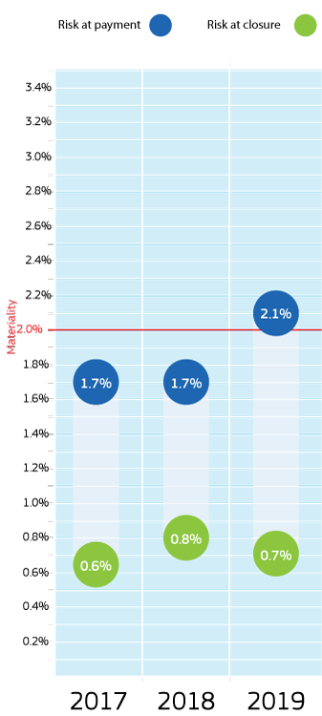

Risks at payment and at closure, for the entire Commission, for 2017-2019

*Source:* European Commission annual activity reports.

The risk at payment is an estimate of the errors that have not been prevented and may still affect the payments (made to Member States, intermediary organisations, beneficiaries, etc.) despite the *ex ante* controls. They are detected through *ex post* controls and audits on the payments made.

The risk at closure is an estimate of the errors that will remain at the end of the programmes’ life cycle, once all *ex post* controls and corrections have been made. It is equal to the risk at payment less a conservative estimate of the future corrections under the multiannual corrective mechanisms – those that will take place between the time of the reporting and the end of the programme’s life cycle.

For more details on these concepts and the methodology used to determine these estimates, as well as the rates per policy area and per Commission department, see Annex 3.

For 2019, the overall risk at closure is estimated at 0.7% of the Commission’s relevant expenditure (see graph).

Due to the higher risk at payment in cohesion spending during this year, the overall risk at payment is 2.1% for 2019 (1.7% in 2018). However, as the related estimated future corrections are also higher (1.4%, compared to 0.9% in 2018) this results in a stable and low risk at closure of 0.7% (0.8% in 2018).

As this is estimated to be less than 2%, taking into account the future corrections,this means that, overall, the Commission’s multiannual control systems ensured the effective protection of the EU budget in 2019.

The situation regarding risks at payment and at closure, per policy area, is described below for 2019, and their evolution for the period 2017-2019 is shown in graph format. For more details, including about the departments covered in each policy area, see Annex 3.

Natural resources

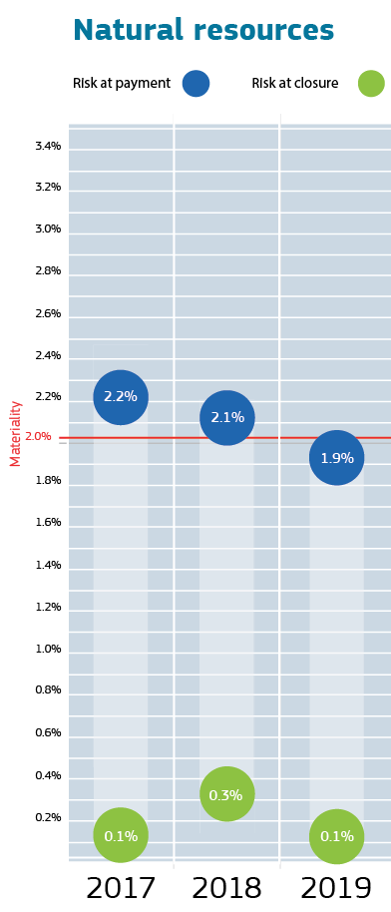For natural resources, the risk at payment is continuing its downward trend, with a further decrease from 2.1% in 2018 to 1.9% in 2019, which is below the materiality threshold. This corresponds to the risk at payment for agriculture expenditure given that this represents the bulk of the expenditure under this policy area (98%) – compared to the maritime and fisheries ([19]), environment and climate expenditures.

In the common agricultural policy, first, the risk at payment is lowest in the Guarantee Fund’s direct aid payments (1.6%) and below the materiality threshold for the 3rd consecutive year. This expenditure, which belongs to the common agricultural policy’s pillar 1, is inherently low risk due to the ‘entitlement-based’ reimbursement mechanism (see Section 2.3.2). Second, still under the common agricultural policy’s pillar 1, the risk at payment remains higher in the Guarantee Fund’s market interventions (2.8%). Third, in the common agricultural policy’s pillar 2, the risk at payment in rural development is higher as well (2.7%), but has constantly declined over recent years.

For both pillars, the continuous decrease in error rates is due to the efficient management and control systems applied, in particular the Integrated Administration and Control System, including the Land Parcel Identification System, and the successful cooperation between the Commission and the Member States, in which action plans by Member States have proven to be an effective tool to remedy the weaknesses identified in certain paying agencies.

Owing to the design of the management and control systems in this policy area, nearly all errors affecting payments not detected at the year end are expected to be covered by subsequent recoveries (by Member States) or financial corrections. This explains the high level of estimated future corrections (1.8%). Thus the estimated risk at closure ([20]) remains very low at 0.1%.

At the end of 2019, there were five reservations for segments of expenditure or programmes where control weaknesses and/or error rates above 2% had been identified (see Section 2.3.5 and more details in Annex 4), namely:

* three reservations for agriculture: the European Agricultural Guarantee Fund market measures and direct payments, and the European Agricultural Fund for Rural Development measures, corresponding to those Member States and paying agencies that (temporarily) face control weaknesses and/or high error rates;
* one recurrent non-quantified reservation for the EU emissions trading system registry;
* one new reservation in 2019 for the European Maritime and Fisheries Fund, corresponding to one Member State and operational programmewith a material error rate.

Cohesion

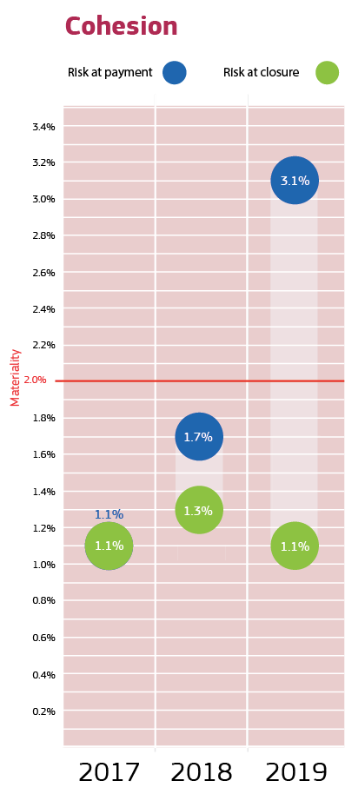For cohesion, implementation of the current programmes is fully up to speed. The risk at closure is estimated at 1.1%, which is in line with 2018 (1.3%). Even though the risk at payment has increased from 1.7% in 2018 to a range between 2.2% and 3.1% in 2019, the estimated future corrections have increased as well (1.1% to 2%).

The estimation of the future corrective capacity derives from the control system itself: indeed, under cohesion policy ([21]), errors detected by the Member States, the Commission or the Court of Auditors in their respective audits are systematically subject to financial corrections. Individual programmes concerned are disclosed with full transparency in the annual activity reports, which also contain reporting on the subsequent steps taken to implement the required corrections. Under shared management, the Commission annually applies further financial corrections when the level of error (reported or recalculated) remains above 2% in annual programme accounts. At the end of the programme life cycle under cohesion policy, programmes are not closed until all required financial corrections have been implemented.

In cohesion, a number of operational programmes in Member States proceeded to their first payments in 2018 and 2019. This means that auditors had the possibility to examine the full process for a higher number of programmes and a higher number of payments. This resulted in an increased number of errors found, as well as a higher error rate. For the European Regional Development Fund, in particular, which has the largest share of expenditure under this policy area, the risk at payment has increased from 2% in 2018 to a level in the range of, taking into account all possible risks, 2.7%-3.8% in 2019. For the European Social Fund, the risk at payment is in the range of 1.7%-2.4%.

In 2019, the Member States’ audit authorities reported irregularities under a common typology agreed with and recommended by the Commission. Ineligible expenditure, public procurement irregularities and audit trail issues are the main sources of audit findings and irregularities identified by both the audit authorities and the Commission through their audits.

In order to tackle the most frequent errors, besides financial corrections for past expenditure and corrective measures for the system in the future in all cases, the Member States’ audit authorities are encouraged by the Commission to report back to their managing and certifying authorities on the main sources of identified irregularities. This allows these programme authorities to adjust their internal controls, reinforce their checklists and further train their staff and beneficiaries. The Commission also organises capacity-building events and joint workshops with the programme authorities, in particular managing and audit authorities. It provides detailed audit recommendations and requires detailed remedial action plans where system deficiencies are found.

Given the importance of public procurement for cohesion policy, the Commission is continuing to implement its updated public procurement action plan to improve the compliance of public procurement procedures in this policy area. Particular emphasis is being given to actions helping Member States to further professionalise procurers, in line with the public procurement package adopted by the Commission in October 2017. The Commission is making extensive guidance, examples of good practices and explanations available online. Peer-to-peer exchanges are being promoted to support contracting and programme authorities in dealing with these issues and reducing errors.

The two cohesion departments have issued reservations for the 2014-2020 operational programmes with errors above the materiality level in 2019. In addition, for 2007-2013, there are still a few operational programmes with a non-quantified reservation (see Section 2.3.5 and more details in Annex 4).

External relations

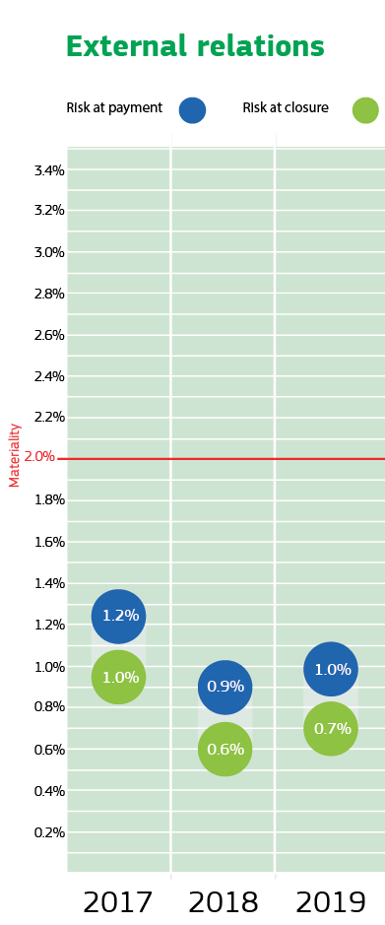For external relations, both the risks at payment (1%) and at closure (0.7%) remained stable and are well below 2%.

In 2019, the Commission continued its efforts to improve the risk-differentiated control strategies for its development and neighbourhood expenditure, thereby better focusing specific actions on the higher-risk segments. The two departments responsible have also further enhanced the transparency of their residual error rate studies (see Annex 3). For example, for development expenditure, the overall rate (1.13%) is now split into one for the EU budget (1.14%) and one for the European Development Fund (1.13%), clearly showing their similar risk profiles.

Among the non-compliance issues, the (timely) access to supporting documents from entrusted entities, including international organisations, remains a source of irregularities. This is also a reason for the Court’s relatively high estimated level of error for the European Development Fund (5.2% for 2018), which is determined before all controls have been implemented (corrective capacity of 0.3%) and especially before supporting documents have been provided. Therefore, an action plan has been put in place aiming at a more fluid flow of information between the entrusted entities, the Commission and/or the Court of Auditors.

At the end of 2019, DG Neighbourhood and Enlargement Negotiations has maintained its two reservations: one for ‘grants under direct management’ (level of error at 2.65%) and one for ‘projects in Libya and Syria’ (assurance building not possible for safety reasons) (see Section 2.3.5 and more details in Annex 4).

Research, industry, space, energy and transport

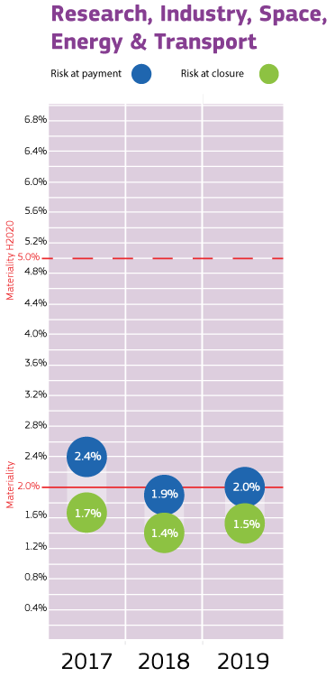For the broad research, industry, space, energy and transport policy area as a whole, the risks at payment (2%) and at closure (1.5%) remained stable.

Within this policy area, the risk at payment for the Horizon 2020 research programmes (3.3%) remains above 2%. This higher risk is inherent in grants based on the reimbursement of actual eligible costs (see Section 2.3.2) that are used in Horizon 2020 and the competiveness of small and medium-sized enterprise programmes, as per the related legal bases. Complexities in determining the exact costs that can be charged to projects lead to errors in cost claims and the related payments.

In order to mitigate this situation, the well-established *ex post* control strategy for the Horizon 2020 programme, common to all departments involved in its implementation, has led to significant *ex post* corrections over the years, which are also used as the basis for the estimated future corrections.

Nevertheless, the research departments continuously strive to reduce the risk at payment: for example, through further simplification of the model grant agreement, clearer communication on eligibility rules and further extending lump-sum financing. In addition, the Commission’s proposal for the next research programme (Horizon Europe from 2021) further expands the use of simplified cost options.

Regarding the other programmes, the risks at payment and closure for the Connecting Europe Facility (transport, energy and telecommunications), implemented by the Innovation and Networks Executive Agency, are globally below 2%. The EU space programmes ([22]), implemented by the European Space Agency and the European Global Navigation Satellite Systems Agency, also have inherently lower risks at payment and closure thanks to the type of funding and the level of auditing carried out. They have nevertheless been set, conservatively, at 0.5%.

As in previous years, the research departments and executive agencies have not qualified their declarations of assurance with any reservations in relation to the Horizon 2020 programme despite a current level of error at 2.3%. This is because they apply the programme’s specific 2%-5% materiality threshold to take into account its inherent risks and the control limitations ([23]).

For 2019, there is only one reservation related to the previous seventh framework programme for research and technological development (see Section 2.3.5 and more details in Annex 4).

Other internal policies

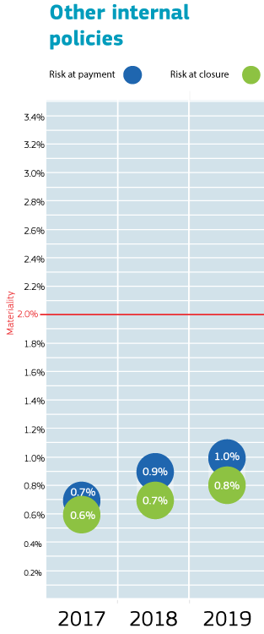For other internal policies, comprising mainly education and culture, migration and home affairs, and economic and financial affairs, the risks at payment and at closure remained stable, at 1.0% and 0.8% respectively, and are well below 2%.

Even if some education and culture programmes have a higher risk profile, which is also related to the complexity of the reimbursement programmes, their control systems mitigate those risks.

DG Justice and Consumers has maintained its reservation for a material error rate in grants under direct management. DG Migration and Home Affairs has maintained two reservations in shared management (for the Asylum, Migration and Integration Fund and the Internal Security Fund, and for the solidarity and management of migration flows programmes, under reservation in a few Member States) and one reservation in direct management grants because of a material level of error (see also Section 2.3.5 and more details in Annex 4).

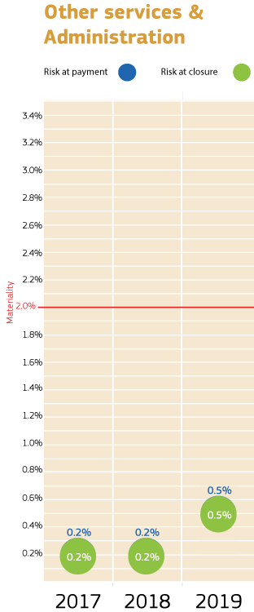Other services and administration

Finally, the Commission’s other services and administration departments cover mostly low-risk types of expenditure, such as the administrative expenditures by the paymaster’s office. Nevertheless, the risk at payment is prudently set at 0.5%. As most of the corresponding control systems involve predominantly *ex ante* controls, the estimated future corrections are often set at a conservative 0.0%. Thus, the risk at closure is almost equal to the risk at payment and remains very low at 0.5%.

In this policy area, DG Structural Reform Support has maintained its reservation for a material level of error in one segment of grants under direct management (see Section 2.3.5 and more details in Annex 4).

* 1. Relatively lower- and higher-risk programmes

From the above, it appears that there are programmes or segments of expenditure with fairly low levels of error and others with relatively higher ones. This is closely related to the nature of the funding, notably the difference between rather complex reimbursement-based schemes on the one hand and fairly straightforward entitlement-based payments ([24]) on the other hand.

On this basis, the Commission’s portfolio can be subdivided into lower-risk and higher-risk strata (see chart below), as explained in the following.

* **Lower risk.** Expenditure with risk at payment below 2% stands at EUR 80 billion (54%);   
  this includes: agriculture – direct payments; the Maritime and Fisheries Fund; Marie Skłodowska-Curie actions; Research Council grants; the European Space Agency and Global Navigation Satellite Systems Agency; the Connecting Europe Facility; Erasmus+; the Asylum, Migration and Integration Fund; budget support, subsidies, administrative expenditure, etc.
* **Higher risk.** Expenditure with risk at payment above 2% stands at EUR 67 billion (46%);   
  this includes: agriculture – market measures and rural development; the Regional Development Fund; the Social Fund; Horizon 2020 research grants; other departments’ complex grants, etc.

Furthermore, taking into account the multiannual character of the control systems, if this split were based on the risk at closure instead, then the difference would be even more pronounced. For example, the European Social Fund expenditure (EUR 11.2 billion; risk at closure of 1.3%) would then be classified in the lower-risk stratum.

|  |
| --- |
| It is important to highlight that this estimation results from an analysis of the error rates at the level of programmes and other relevant expenditure segments. This split is different from that of the Court of Auditors, which is based on the type of reimbursements made – i.e. entitlements being considered inherently low risk and reimbursements being considered inherently high risk – regardless of the level of error rate actually found. From a management perspective, thanks to the results of the controls in place, the actual level of error can be lower than the materiality threshold and programmes that are considered high risk by the Court of Auditors can actually be quite low risk in reality.  Therefore, the issue of complexity and of whether something is considered as having a higher risk and/or higher error rate has also been considered in the context of the Commission’s proposals for simplification embedded in the next multiannual financial framework programmes (see Section 2.4.2 below). |

* 1. The Commission is further improving the efficiency of its operations

In a context of tight budgetary constraints, the Commission is striving to improve efficiency in all areas of its activity while maintaining a high level of delivery. The Corporate Management Board steers work across the Commission in domains such as human resources management, financial management, information technology and management, communication, logistics and events management. Working methods and processes are being streamlined to ensure the most efficient use of limited resources. This work will continue in order to ensure an optimal allocation of resources and a high level of performance faced with an increasing workload in many areas, including most recently in relation to the response to the COVID-19 pandemic.

In its communication ‘The synergies and efficiencies initiative: stock-taking and way forward’ (March 2019), the Commission established DG Budget as the domain leader for financial management and the internal control framework. The objective is to continuously improve sound financial management through further professionalisation of the domain, taking better account of recent evolutions in the way the EU budget is managed. Within the current decentralised system, actions are taken in two directions: improving centralised governance and oversight, and strengthening the coordination and modernisation of financial management across the Commission. In 2019, further steps were taken to harmonise, standardise and simplify financial management across the Commission, in addition to promoting sound financial management. The focus was on setting up more interoperable and flexible post-2020 funding programmes.

Simplification can be achieved through the simplification of rules; harmonised and, as far as possible, standardised corporate models of legal instruments and modern corporate financial information technology tools; and ensuring consistency in relations with partners implementing EU funds under indirect management.

Actions undertaken at corporate level during 2019 include developing more efficient corporate workflows (for grants, procurement, financial instruments) through simplified corporate models and procedures (building on the single electronic data interchange area). In addition, the Commission has stepped up guidance and coordination vis-à-vis both Member States and other Commission departments in areas that are relevant to the implementation of the EU budget (e.g. internal control systems in Member States, conflicts of interest, rule of law, anti-fraud measures). Other information technology initiatives are e-cohesion in shared management and the geospatial system used for agriculture.

Initiatives to further increase efficiency in financial management were also taken at the level of the Commission departments.

* Firstly, a number of Commission departments have further digitalised their financial processes. This contributes to a leaner, less bureaucratic, better integrated and more flexible Commission. As a result, resources are increasingly focused on frontline activities. Moreover, automated dashboarding tools enhance the monitoring process and facilitate improved management and better use of data, while reducing the chances of missed opportunities for early reaction.
* Secondly, several Commission departments also reported that they have reviewed their control strategies and/or their financial workflows, with a view to simplifying procedures and further aligning the control frequency and intensity with the risk of the transactions.

The abovementioned initiatives ensure the effective protection of the EU budget, while reducing the time needed to complete the financial processes. In particular, the ‘time-to-pay’ indicators continued their very favourable downward trend. In 2019, the Commission’s average net payment time was 16 days (down from 20 and 18 in the 2 previous years), well below the statutory ceiling of 30 days. The Commission made 95% of its payments on time (the number of payments affected by delays was down from 10% and 8% in the 2 previous years). Nevertheless, the aim is still to meet the statutory payment time for every payment. See details in Annex 8.

* 1. The cost of controls remains proportionate to the associated risks

Overall, the estimated costs of control are reasonable in view of the nature of the programmes and/or the control environments. Furthermore, they remain stable due to the unchanged control environments and strategies in place for the current programmes.

Direct comparison between programmes is often not possible because of their different features and cost drivers, examples of which are given in the box below.

|  |
| --- |
| Examples of common cost drivers   * The degree of complexity of the programmes managed. * The volumes and amounts to be processed: i.e. processing a high number of low-value transactions is more labour-intensive than processing a low number of high-value transactions. * The specific risk profiles of the programmes managed: for instance programmes in external relations where funds are mostly spent in non-EU countries. * Possible diseconomies of scale for certain smaller programmes, in terms of amount of funding, as well as programmes that are being phased out, or funds managed by smaller entrusted entities, or Commission departments managing smaller amounts of funds, as there is always an irreducible number of controls to be carried out regardless of the amounts of funding involved. * The type of management: indirect and shared management imply that the costs of controls are shared between the Commission and its implementing partners, national authorities or entrusted entities, and so the costs at Commission level may be much lower for such programmes compared to others that are directly managed by the Commission. |

For the sake of transparency and completeness, those departments dealing with shared and/or indirect management have also reported in their annual activity reports on the cost of controls in Member States and entrusted entities, separately from the Commission’s own cost of controls. For example, for the common agricultural policy, the costs reported by Member States for delivery represented 3.5% of the expenditure for 2019.

In a recent audit about the cost of implementation of Cohesion Funds ([25]), the Court of Auditors found that the overall cost of implementing the cohesion policy funds presented by the Commission in its annual activity reports is comparatively low compared to other EU funds and internationally funded programmes. These costs represented, as a percentage of the payments made in 2018, 2.87% for the European Social Fund, 2.45% for the European Regional Development Fund and 2.03% for the Cohesion Fund, respectively.

In 2019, following the combined assessment of their effectiveness, efficiency and economy, all Commission departments concluded that, overall, their controls were cost-effective.

* 1. Management assurance, audit opinions and discharge authority

Director-Generals’ assessments, assurance and reservations

In their 2019 declarations of assurance ([26]), all 50 Directors-General (or equivalent) declared they had reasonable assurance that: (i) the information contained in their report presents a ‘true and fair view’ (i.e. reliable, complete and correct) on the state of affairs in their department; (ii) the resources assigned to their activities have been used for their intended purpose and in accordance with the principle of sound financial management; and (iii) the control procedures put in place give the necessary guarantees concerning the legality and regularity of the underlying transactions.

Within the context of their overall assurance-building process and from their management perspective, the Directors-General also perform a more detailed analysis for each programme or segment of their portfolio. They use all available information, especially the results of their controls, to spot any potential significant weakness in quantitative or qualitative terms. At the end of each financial year, they determine whether the financial impact from such a weakness is likely to be above the materiality threshold of 2% and/or whether the reputational impact is significant. If so, they qualify their declaration of assurance with a reservation for the specific portfolio segment affected.

For 2019, 11 of the 50 Directors-General issued a qualified declaration with a total of 18 reservations. This significant decrease in number, compared to 2018 (when 40 reservations were reported by 20 departments), is explained as follows.

* Six reservations were lifted because the underlying weaknesses have been resolved.
* For 17 reservations, the ‘de minimis’ rule was applied, whereby reservations are no longer considered meaningful under certain conditions, namely the limited expenditure involved (less than 5% of the department’s payments) and low resulting financial impact (less than EUR 5 million). These were mostly related to 2007-2013 legacy programmes in research, competitiveness, education and culture, and external relations.
* A total of 17 reservations are recurrent from previous year(s), and only one is new in 2019, mainly because the root causes of the material level of error can be partially mitigated but not fully eradicated under the current programmes’ legal frameworks. See details in Section 2.3.1 and concepts in Annex 4.

The total financial impact from all reservations (EUR 1 053 million for 2019; i.e. 2% lower than the EUR 1 078 million in 2018) is comparable to the level in the previous 2 years. For each reservation, the Directors-General concerned put in place mitigating actions to address the underlying weaknesses and mitigate the resulting risks.

Annex 4 provides the complete list of reservations for 2019 as well as further explanations and details.

Work of the Internal Audit Service and overall opinion

The Commission departments also based their assurance on the work done by the Internal Audit Service. The Internal Audit Service audits the management and control systems within the Commission and the executive agencies, providing independent and objective assurance on their adequacy and effectiveness.

As required by its mission charter ([27]), the Internal Audit Service issued an annual overall opinion on the Commission’s financial management, based on the audit work it had carried out in the area of financial management in the Commission during the previous 3 years (2017--2019). The overall opinion also takes into account information from other sources, namely the reports from the European Court of Auditors. Based on this audit information, the internal auditor considered that, in 2019, the Commission had put in place governance, risk management and internal control procedures which, taken as a whole, are adequate to give reasonable assurance on the achievement of its financial objectives. However, the overall opinion is qualified with regard to the reservations the authorising officers by delegation made in their declarations of assurance issued in their respective annual activity reports.

In arriving at the overall opinion, the internal auditor also considered the combined impact of (i) all amounts estimated to be at risk at payment as these go beyond the amounts put under reservation and (ii) the financial corrections and recoveries related to deficiencies and errors the Commission departments will detect and correct in coming years due to the multiannual corrective mechanisms built into the Commission’s internal control systems. Given these elements, the Internal Audit Service considers that the EU budget is adequately protected in total and over time.

The COVID-19 outbreak and the Commission’s response did not affect the Commission’s ability to protect the EU budget during 2019. It may however do so in 2020 and the following years as *ex post* corrective measures that have so far led to corrections may become less effective (affecting corrective capacity). This may result from lightening certain procedures governing expenditure and issues concerning recovery of illegal or irregular expenditure from final beneficiaries facing financial and economic difficulties as a consequence of the coronavirus crisis. Without further qualifying the opinion, the internal auditor added two ‘emphases of matter’, which are described in Annex 6 to this report, regarding:

* the implementation of the EU budget in the context of the current crisis related to the COVID-19 pandemic, notably the need for a detailed assessment of emerging risks and defining and implementing related mitigating measures; and
* supervision strategies for third parties implementing policies and programmes.

With a view to contributing to the Commission’s performance-based culture and greater focus on value for money, the Internal Audit Service also carried out performance audits in 2019 as part of its 2019-2021 strategic audit plan. These audits resulted in recommendations, all accepted by the auditees, concerning: supervision strategies regarding the implementation of programmes by third parties; control strategies of selected departments; human resources and information technology management processes; and performance-related aspects of the implementation of operations and programmes by the departments. For all recommendations, the auditees drafted action plans, which were submitted to and assessed as satisfactory by the Internal Audit Service.

Finally, in line with its strict follow-up policy, the Internal Audit Service assessed on a regular basis the actual implementation of its recommendations by the Commission’s departments and executive agencies. The work confirmed that 98% of the recommendations issued during 2015-2019 and followed up were adequately and effectively implemented by the auditees. This result indicates that the Commission services are diligent in implementing the recommendations and mitigating the risks identified by the Internal Audit Service.

Annex 6 includes more information on the assurance provided by the Internal Audit Service. In addition, a report of the internal auditor’s work is forwarded by the Commission to the discharge authority in accordance with Article 118(8) of the financial regulation, as part of the integrated financial and accountability reporting package.

The work of the Audit Progress Committee

The Audit Progress Committee ([28]) oversees audit matters within the Commission and reports annually to the College. It does this by ensuring the independence of the Internal Audit Service, monitoring the quality of internal audit work and ensuring that internal (i.e. from the Internal Audit Service) and external (i.e. from the European Court of Auditors) audit recommendations are properly taken into account by the Commission departments and that they receive appropriate follow-up.

During the reporting year, the Audit Progress Committee continued to play its important role in enhancing governance, organisational performance and accountability across the entire organisation. It held three rounds of meetings while focusing its work on the four key objectives set out in the 2019 and 2020 work programmes. The Audit Progress Committee was satisfied about the independence and quality of the internal audit work and found that the internal auditor’s planning adequately covers the audit universe and continues to cover the key risk areas. The committee considered it encouraging that the effective implementation rate of the internal auditor’s recommendations remained high (i.e. 98% for recommendations issued in 2015-2019) and that only six very important audit recommendations were overdue by more than 6 months as of January 2020. The progress in implementing the European Court of Auditors’ recommendations was also satisfactory. Only one recommendation issued in 2001-2014 remained outstanding as of February 2020. Finally, the Audit Progress Committee was satisfied that for the 12th consecutive time the Court of Auditors gave a clean opinion about the reliability of the EU consolidated accounts.

Annex 7 includes more information on the committee’s work and conclusions.

The Court of Auditor’s opinions on the 2018 accounts and on the legality and regularity of transactions

In 2019, the European Court of Auditors gave a positive (clean) opinion on the 2018 EU annual accounts, for the 12th consecutive year.

Validation of local systems

The accounting officer is required to sign off on the annual accounts, certifying that he/she has reasonable assurance that they present a true and fair view of the financial situation of the Commission. The validation of local systems consists of a number of monitoring and supervisory controls aimed at providing assurance that he/she can rely on the information entered by the various Commission departments in the accounting systems. This is in addition to the departments’ own management assessments of the internal control systems in place.

The work carried out in 2019 has identified strengths as well as a number of weaknesses and issues, resulting in recommendations intended to improve the control environment and accounting quality in the departments ([29]) – mitigating risks to the accuracy of the financial and regulatory management reporting ([30]). None of the weaknesses identified is likely to have a material impact on the annual accounts.

For the legality and regularity of the underlying transactions, the Court of Auditors gave a qualified (favourable, but with observations) opinion for the EU budget, but an adverse (negative) opinion for the European Development Fund.

The Commission follows up on the Court of Auditors’ recommendations, and reports on the measures taken in the annual activity reports. Moreover, the Commission reports on a regular basis on the implementation of recommendations to the Audit Progress Committee, which performs certain monitoring activities in this respect under its updated mandate ([31]).

The Court of Auditors monitors the Commission’s implementation of its recommendations and provides feedback, helping the Commission to enhance its follow-up activities. In its 2018 annual report, the Court of Auditors assessed the quality of the Commission’s follow-up of 184 audit recommendations from 25 special reports published in 2015. The Court of Auditors noted that the Commission had implemented around three quarters of the recommendations fully or in most respects, and slightly less than one fifth in some respects. The remaining recommendations were not accepted by the Commission and therefore not implemented. This is broadly in line with previous years.

Discharge 2018

The European Parliament granted discharge to the Commission for the financial year 2018 by a clear majority on 14 May 2020 after having examined the reports of the European Court of Auditors, the Commission’s integrated financial reporting package and the Council’s discharge recommendation. The European Parliament’s Committee on Budgetary Control also invited selected Commissioners and Directors-General for exchanges of views during the discharge procedure. The European Parliament’s discharge resolution for 2018 includes recommendations for improving budget implementation, as well as recommendations linked to specific policy areas and situations concerning, for example, rule of law and alleged conflicts of interest. As usual, the Commission is taking the action to implement these recommendations and will follow up on them in a specific report ([32]).

1. Further developments: outlook for 2020 and the 2021-2027 period
   1. Effect of the coronavirus health crisis on sound financial management in 2020

The Commission has taken a range of measures to respond to the crisis caused by the COVID-19 outbreak, such as the coronavirus response investment initiatives to mitigate the socio-economic impact. The pandemic itself, through its massive impact on EU beneficiaries, national authorities and Commission services, and the measures taken will have an impact on the performance of the EU budget but will also present potential challenges for the assurance building of the Commission.

For instance, the specific context of the crisis required adjustments to the control procedures and more flexibility in the management of funds (e.g. the European Structural and Investment Funds) to allow funds to be rapidly deployed where they are most needed. These specific adjustments have been embedded in modified legislation, against which compliance will be measured for the period affected by the crisis.

The Commission is currently working on a detailed identification of these new risks and challenges, on assessing their impact and on establishing mitigating measures to strike a balance between the required flexibility to make funds available to Member States and other implementing partners and beneficiaries to fight the crisis, and the need to respect the principle of sound financial management.

* 1. Efforts to ensure sound financial management are maintained in the next multiannual financial framework

The Commission is constantly striving to ensure that the EU budget is managed in accordance with the highest standards of sound financial management. In the current circumstances, this remains as necessary as ever. In May, the Commission adopted its revamped proposals for the 2021-2027 multiannual financial framework. These proposals reconfirm the Commission’s commitment to sound financial management, with particular attention given to maximising simplification, synergies and efficiencies, as well as to implementing risk-differentiated and cost-effective control systems.

The aim is to achieve both the policy/programme and the internal control objectives, i.e. fast payments, a low level of errors and economical costs of control. Examples that can contribute to these three goals are the increased use of lump-sum grants (which furthermore reduces the need for detailed record-keeping) and the possibility of funding based on outputs or results (which, for example, eliminates the need to track working hours through time sheets or to submit detailed invoices for the incurred costs).

Sound financial management of the EU budget will also be facilitated by providing templates for the establishment act and delegation instruments for the future delegations of programmes to the executive agencies during the next multiannual financial framework, as well as guidelines for the establishment and operation of executive agencies.

* 1. Further enhancing and strengthening collaboration with Member States

As part of the overall initiative from the Commission to enhance and strengthen its collaboration with Member States, the Better Spending Network (comprising representatives of Member States and of the Commission) should help with the exchange of good practices, sharing of knowledge and information, identifying weaknesses and finding solutions at an early stage on issues related to public spending, including areas such as conflict of interest, rule of law and fraud and corruption. Interactions with Member States will take place at a high level (annual conference of the High Level Group of the Better Spending Network) and at the technical level, with the organisation of workshops on specific topics.

The issue of conflicts of interest is high on the Commission’s agenda and has frequently been the subject of discussions and calls for action, in particular from the Committee for Budgetary Control of the European Parliament. As a response, and following the revision of rules on avoidance of conflicts of interest in the 2018 financial regulation that explicitly extended their application to shared management, the Commission is preparing a guidance note on avoidance of conflicts of interest covering all management modes (direct/indirect/shared management). Its purpose is to facilitate understanding and to raise awareness among the various stakeholders using EU funds, within the EU institutions and in the Member States, of the rules on conflicts of interest. Its publication is scheduled for the end of the year.

The Commission is also considering other actions to address specific concerns raised by the European Parliament and potential issues or loopholes identified in the past year. These actions may include proposals to improve the quality and interoperability of the data on EU beneficiaries that is made available to the Commission and ensure enforcement of recoveries of EU funds.

**On the basis of the assurances and reservations in the annual activity reports** ([33]), the College adopts this *Annual Management and Performance Report for the EU Budget – Financial year 2019* and takes overall political responsibility for the management of the EU budget.

1. () The amount of the Commission’s relevant expenditure corresponds to the payments made in 2019 minus the prefinancing paid out in 2019 plus the prefinancing paid out in previous years and cleared in 2019 (see Annex 3 for definitions and more details).
2. () Communication from the President to the Commission: The Working Methods of the European Commission, 1.12.2019, p. 3.
3. () Communication to the Commission: Governance in the European Commission, 24.6.2020, C(2020) 4240.
4. () They are formally named authorising officers by delegation. Article 74(1) of the financial regulation states that: ‘The authorising officer shall be responsible in the Union institution concerned for implementing revenue and expenditure in accordance with the principle of sound financial management, including through ensuring reporting on performance, and for ensuring compliance with the requirements of legality and regularity and equal treatment of recipients.’
5. () Heads of executive agencies, offices, services, task forces, etc.
6. () As required by Article 247 of the financial regulation, the integrated financial and accountability reporting package also includes: the consolidated annual accounts of the European Union; the report on the follow-up to the discharge for the previous financial year; the annual report to the discharge authority on internal audits carried out; and the long-term forecast of future inflows and outflows of the EU budget.
7. () Committee of Sponsoring Organizations of the Treadway Commission.
8. () DG Budget, in cooperation with the Secretariat-General, DG Human Resources and Security, DG Communication and the European Anti-Fraud Office.
9. () COM(2018) 324 final
10. () European Court of Auditors’ 2018 annual report, Methodological Annex 1.1, paragraphs 18-19.
11. () Commission’s 2019 guidelines on financial corrections in case of public procurement irregularities in the annex to the Commission decision of 14.5.2019 laying down the guidelines for determining financial corrections to be made to expenditure financed by the Union for non-compliance with the applicable rules on public procurement, C(2019) 3452.
12. () European Court of Auditors’ 2018 annual report, section on European Development Funds, paragraph 17.
13. () For the spending related to the common agricultural policy, the term ‘final amount at risk’ is used, as the measures under the European Agricultural Guarantee Fund are not ‘closed’.
14. () Communication from the Commission to the European Parliament, the Council, the European Economic and Social Committee, the Committee of the Regions and the Court of Auditors (COM(2019) 196).
15. () <https://ec.europa.eu/anti-fraud/sites/antifraud/files/pif_2018_30_years_brochure_en.pdf>
16. () The Secretariat-General, the Legal Service, DG Human Resources and Security and DG Budget.
17. () For more information, see the European Anti-Fraud Office’s annual reports at: <https://ec.europa.eu/anti-fraud/about-us/reports/olaf-report_en>
18. () Selection is the process of examining incoming information and preparing the decision of the European Anti-Fraud Office’s Director-General on whether to open an investigation or not.
19. () The European Maritime and Fisheries Fund expenditure, although included under the ‘Natural resources’ heading, follows the same delivery mechanism as cohesion expenditure.
20. () As there is no closure of the European Agricultural Guarantee Fund measures, in the area of agricultural expenditure the risk at closure is replaced by the final amount at risk.
21. () The European Maritime and Fisheries Fund shares cohesion policy’s management and control systems.
22. () Such as Galileo and the European Geostationary Navigation Overlay Service (the European satellite navigation systems) and Copernicus (the EU earth-observation system).
23. () The legislative financial statement accompanying the Commission’s proposal for the Horizon 2020 regulation states: ‘The Commission considers therefore that, for research spending under Horizon 2020, a risk of error, on an annual basis, within a range between 2-5%, is a realistic objective taking into account the costs of controls, the simplification measures proposed to reduce the complexity of rules and the related inherent risk associated to the reimbursement of costs of the research projects. The ultimate aim for the residual level of error at the closure of the programmes after the financial impact of all audits, corrections and recovery measures will have been taken into account is to achieve a level as close as possible to 2%.’
24. () This is also recognised by the European Court of Auditors (in its 2018 annual report, paragraphs 1.16-32).
25. () European Court of Auditors, Special Report No 7/2020, Implementing Cohesion Policy: comparatively low costs, but insufficient information to assess simplification savings, 16.4.2020.
26. () <https://ec.europa.eu/info/publications/annual-activity-reports_en>
27. () Latest version: C(2020) 1760 final.
28. () The Audit Progress Committee comprises nine members. A maximum of six are Members of the Commission, and at least three are external members with proven professional expertise in audit and related matters. Half of the Commission membership of the Audit Progress Committee is renewed halfway through the term. Contracts with external members are drawn up each year.
29. () Mainly concerning six departments (DG Agriculture and Rural Development, DG European Civil Protection and Humanitarian Aid Operations, DG Human Resources and Security, DG Neighbourhood and Enlargement Negotiations, DG Research and Innovation and the Research Executive Agency).
30. () The main risks concerned various issues with the accounting control environment, the registration of reflows from financial instruments, the timely clearing of pre-financing, the timely issuance of recovery orders and issues related to the synchronisation of accrual-based accounting with local information technology systems.
31. () Communication to the Commission: Update of the charter of the Audit Progress Committee of the European Commission, 27.2.2020, C(2020)1165.
32. () Report on the follow-up to the discharge for the 2018 financial year, which will also be part of the Integrated Financial and Accountability Reporting package.
33. () Article 74(9) of the financial regulation.