

REPORT FROM THE COMMISSION

Annual Synthesis Report for the year 2018 on the implementation of the FLEGT licensing scheme provided for in Regulation (EC) No 2173/2005 of 20 December 2005 on the establishment of a FLEGT licensing scheme for imports of timber into the European Community

**1. Introduction**

This annual synthesis report presents the status of implementation of the FLEGT licensing scheme for the year 2018. It has been prepared in line with Article 8(3) of Regulation (EC) No 2173/2005[1] of 20 December 2005 on the establishment of a FLEGT licensing scheme for imports of timber into the European Community (hereinafter the FLEGT Regulation) and is based on the information submitted by the Member States in their annual reports, in accordance with Article 8(1) of the FLEGT Regulation.

This is the third report[2]; it provides an analysis of the second full year of implementation of the FLEGT licensing scheme (2018) across the EU and outlines conclusions and next steps. In 2018, Indonesia was still the only country to operate such scheme.

A more detailed analysis of the national reports, prepared for the Commission by UNEP-WCMC, is available on the Commission website[3]. It provides the methodology for data analysis, further details of the datasets submitted by Member States and the associated caveats resulting from the varying completeness and quality of national datasets.

Annual reports of all 28 Member States were analysed. These were submitted through an online reporting template – laid down by the Commission in line with Article 8(2) of FLEGT Regulation – with some sections pre-filled with information provided in previous annual reports.

1. **Implementation state of play**

The FLEGT Regulation requires Member States to designate Competent Authority/ies and to adopt effective, proportionate and dissuasive penalties to enforce the Regulation.

The national reports are a means to assess the status of implementation and the level of consistency achieved across the Member States.

* 1. **Designation of Competent Authorities**

In accordance with Article 7(1) of the FLEGT Regulation, all Member States have designated a Competent Authority (CA) or Competent Authorities (CAs)[4] and all but one reporting Member State (Portugal) provided information on the legislative act designating the CAs.

In 11 Member States, the customs authority has been designated as the CA for FLEGT licensing, or as part of the CA. In 17 Member States, customs and the CA are separate authorities. In these 17 Member States, it is important that arrangements are in place to ensure that the authorities are able to cooperate effectively on the processing of FLEGT licences, with the CA able to delegate relevant tasks to customs and obtain the information required to verify that a FLEGT licence corresponds to a given shipment. This delegation of tasks has been established in all of these Member States, either by an agreement or a Memorandum of Understanding. The frequency and arrangement of data exchange varied across Member States.

* 1. **Quantities of timber imported and related number of** **FLEGT Licences**

*Number of licences received by Member States and number of licences cleared by customs*

In 2018, all Member States except Luxembourg reported having received FLEGT licences. A total of 31,785 licences were received and over 99% (31,605) of these were validated/approved for import by CAs. The Netherlands, United Kingdom, Germany, France and Belgium received the highest numbers (Figure 1a). Twelve Member States reported rejecting a combined total of 66 FLEGT licences, with the largest number (20) reported by France.

Member States reported that 23,238 licences were cleared for import by customs in 2018[5]. Among the 25 Member States reporting customs data at the FLEGT licence level, the Netherlands, Germany and France cleared the highest number of licences (Figure 1b).

Explanations for the observed differences between the number of FLEGT licences received by CAs and the number of licences cleared by customs in 2018 (Figures 1a and 1b), include: incompleteness of the customs datasets (see footnote 10); ‘year-end’ trade[6]; goods not being released by customs (e.g. due to phytosanitary controls); the importer deciding not to clear the goods; or the goods at the point of import into the EU not requiring a FLEGT licence due to HS code reclassification by customs.

**Figure 1**: Number of FLEGT licences (a) received by the CA for validation and (b) cleared by customs in 2018. * Licence data from Romania could not be included as it was not submitted in a suitable format. Italy and Romania did not provide customs data, and the United Kingdom did not associate customs data with licences numbers; customs data for Greece was incomplete. ** Estimated total number provided by Spain, who did not provide their customs data associated with licence numbers. *** This does not include the licences cleared by retrospective submission of customs declarations by specific approved importers, the data for which was not associated with licences numbers.

*Quantities imported*

Member States reported on the quantities of timber and timber products actually imported in 2018 (i.e quantities cleared by customs), as well as the corresponding quantities as per the FLEGT licences received and validated by CAs. In 2018, over 694 million kg of timber and timber products were reported on validated FLEGT licences[7] and over 2,993 million kg of FLEGT-licensed timber and timber products were reported as cleared for import by EU customs[8],[9] (Figure 2), of which 2,470 million kg of furniture for bedroom use (HS 9403.50) was reported by the United Kingdom’s customs. This was two orders of magnitude greater than the quantity for the same HS code reported on FLEGT licences validated by the Competent Authority. These figures were queried with the United Kingdom but no clarification was provided. The main FLEGT-licensed product types imported into the EU by weight, according to customs data, included furniture for bedroom use (HS 9403.50), amounting to close to 2,472 million kg and accounting for 83% of imports; writing paper (HS 4802); other furniture (HS 9403.60 and 9401); builder’s joinery and carpentry (HS 4418); plywood, veneered panels and similar laminated wood (HS 4412); and continuously shaped wood (HS 4409) (the HS codes of FLEGT products imported in 2018 are listed in Annex A). The main importing Member States for these products were the United Kingdom, Germany and the Netherlands.

Some Member States also reported imports where the HS codes would not have required a FLEGT licence (including some codes requiring a V-legal licence), amounting to 2099 customs records and totalling 1.35 million kg of timber products. This may partially be due to reclassification of goods by EU customs.

Possible explanations for the discrepancies between quantities reported on FLEGT licences and quantities reported by customs (Figure 2) may include: missing customs data in particular and the variable quality of national datasets submitted; reclassification of goods by customs to different HS codes; licences received but not yet cleared by customs; HS codes reported to a different number of digits; or quantities reported in different units of measure.

*Taxa imported*

Information on taxa in trade was provided for 84.6% of timber on validated FLEGT licences. The Netherlands did not provide this level of information for the 107 million kg of timber on validated FLEGT licences it imported. In addition, over 32,000 kg of timber products on validated FLEGT licences were reported without taxon information by the Czech Republic, France, Italy and Sweden.

In total, 204 different species and 80 higher taxa (e.g. genera) were reported on validated FLEGT licences in 2018, comprising 235.5 million kg of individual taxon shipments and 351.7 million kg of mixed taxa shipments. Where individual taxa were specified, the most highly traded taxa by weight were *Acacia mangium* (mangium), *Shorea* spp.(meranti) and *Tectona grandis* (teak).

*Processing FLEGT licences*

The FLEGIT/TRACES system[10] was used to process FLEGT licences in 21 Member States, whilst 7 Member States used national systems. Of the 21 Member States using FLEGIT/TRACES, 14 Member States reported its use by both the CA and customs, 5 Member States reported its use just by the CA, and 2 Member States reported its use only by customs. Member States also reported on the format in which FLEGT licences were submitted; 14 Member States reported receiving FLEGT licences in more than one format. In total, 18 Member States reported the submission of paper licences, 18 reported licences submitted via FLEGIT/TRACES, 5 via email and 2 by national electronic systems.

The number of days taken by Member States to process licences could be analysed for 24 Member States; 53% of licences were validated by CAs the same day or the day after being received, licences were validated within 3 days in more than 66% of cases and within 21 days in 97% of cases.

**

**Figure 2:** Quantities of the main FLEGT-licensed product types reported by HS code* on validated FLEGT licences and as cleared by customs (excluding HS 9403.50**) into the EU in 2018, reported by weight (kg)***. (Licence data from Romania could not be included. Italy and Romania did not provide customs data, and that provided by Greece was incomplete). *Where possible, HS codes were reconciled to 6 digits; 4-digit HS codes only include trade reported by Member States at the 4-digit level. **To facilitate visualisation of the data, the 2,472 million kg of HS 9403.50 reported in Member States’ customs data was excluded from this figure, as this was several orders of magnitude greater than the rest of the data. The 2,470 million kg of HS 9403.50 reported as cleared by the United Kingdom customs was queried with the United Kingdom since this was not reflected on validated licences to a comparable extent, but no clarification was provided. ***Quantity was reported by weight on >99% of validated FLEGT licences and 97% of customs data, but may not be representative of all trade. Note that as customs reported fewer products by weight, and more products as volume (m3) or no. of items, quantities reported by weight on FLEGT licences and by customs are not fully comparable.

* 1. **Further verification of FLEGT licences and shipments**

According to Article 5(4) of the FLEGT Regulation, the CAs shall decide on the need for further verification of shipments using a risk-based approach. Provisions were in place in 21 Member States to carry out further verification checks on FLEGT licences[11], and in 22 Member States to carry out further verification checks on FLEGT shipments[12] (Annex B, Tables 1 & 2). A total of 1,782 FLEGT licences had additional verification checks carried out in 2018 (for example by contacting LIU, the Indonesian Licensing Information Unit, for further verification), with checks carried out by 19 Member States. Additionally, the Netherlands reported carrying out additional verification checks daily, but did not record the number of checks in order to limit administrative burden.

Member States reported using a number of risk criteria to establish whether additional verification of a FLEGT licence or shipment is needed, including in cases of mismatches between the FLEGT licence information and other documentation (Annex B, Tables 1 & 2). Seventeen Member States reported using SILK, the Indonesian Timber Legality Information System, to verify the FLEGT licences they received from operators, including 4 Member States who reported ‘sometimes’ using SILK.

A total of 265 physical inspections of FLEGT-licensed shipments were carried out by 18 Member States in 2018, with the shipment matching the details of the FLEGT licence in 94% of the cases.

* 1. **Provisions for penalties**

Article 5(8) of the FLEGT Regulation provides that "*each Member State shall determine the penalties to be imposed where the provisions of this Regulation are infringed. Such penalties shall be effective, proportionate and dissuasive*." 17 Member States have provisions in place for administrative fines, 17 for criminal fines, 20 to impose imprisonment, 7 to suspend the authority to trade and 9 for notices of remedial action or warning letters. Potential maximum penalties for imprisonment range from 1 month to 15 years (15 Member States reported maximum potential penalties of 1-5 years).

In line with Article 5(7) of the FLEGT Regulation, customs may suspend the release of or detain timber products where they have reason to believe that the FLEGT licence may not be valid. Twenty-four Member States reported that they may seize timber products, with the disposal of confiscated timber provided for in their national legislation (Figure 3). Where the disposal of confiscated timber is provided for in national legislation, 9 Member States reported this to be the responsibility of customs, 4 Member States reported this to be the responsibility of the CA, 5 Member States reported that another institution was responsible in addition to the CA and/or customs, and 5 Member States reported that it was the responsibility of an institution other than the CA or customs.

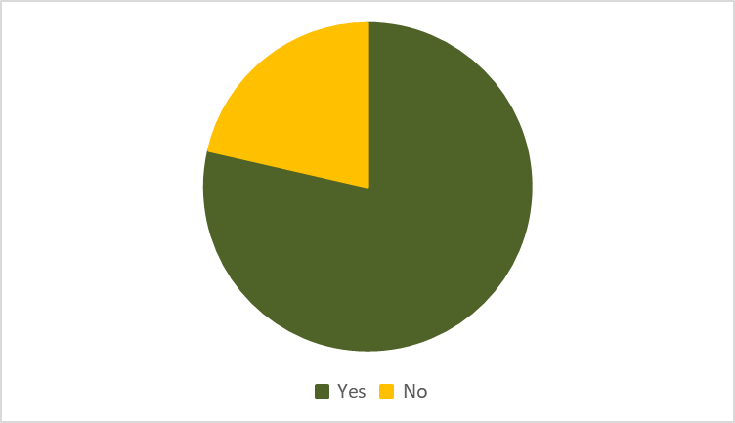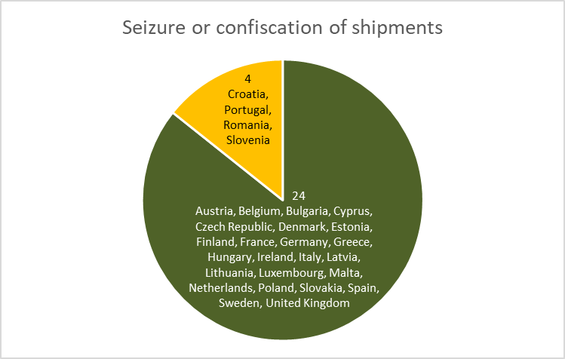

**Figure 3:** Member States with penalties that include the seizure or confiscation of timber shipments.

* 1. **Penalties applied**

Two Member States (Bulgaria and Spain) applied Article 6(1)[13] to a combined total of 29,130 kg of products. Bulgaria and the Netherlands applied Article 6(2)[14], the former where a scanned FLEGT licence was presented for validation (with an expired validity date) and the latter for a shipment which included a CITES species without a CITES permit.

* 1. **Fees for processing FLEGT licences**

Member States may charge fees for the processing of FLEGT licences, as per Article 5(6) of the FLEGT Regulation. Six Member States reported doing so, with fees ranging from around EUR 10 (GBP 9.60) to up to EUR 105.90 (Annex B, Table 3).

**2.7 Other implementing measures and challenges**

Twenty-six Member States provided information on other implementing measures and challenges. Eleven of these reported collaborating with other CAs, indicating that this was beneficial, particularly regarding goods arriving in one Member State but destined for elsewhere within the European Union. Nine Member States noted collaboration with or support from the European Commission and several reported good communication with the European Commission regarding FLEGIT. There were several suggestions that Member States should be given access to all FLEGT licences on SILK[15], irrespective of the country of destination within the EU, to facilitate verification of licences.

The types of implementation challenges raised by one or more Member States included: communication with Indonesia’s Licence Information Units (although several Member States noted that response times had improved); cases of mismatching information between FLEGT licences and customs declarations, including mismatches in HS codes or country codes; and FLEGT licences issued for HS Codes outside the scope of the FLEGT Regulation and Indonesia Voluntary Partnership Agreement (VPA).

**3. Conclusions**

The third report on the implementation of the FLEGT licensing scheme shows that it has progressed well. In 2018 – the second full year of implementation of FLEGT licensing scheme – 31,785 licences were received, of which over 99% of licences were validated/approved for import by CAs; over 2,993 million kg of timber and timber products were cleared by customs and imported into the EU. Positive collaboration has been reported between CAs and with the Commission. Comparision of data reported by Member States on validated FLEGT licences with data cleared by customs has facilitated the identification of potential explanations for the observed discrepancies. Additonal guidance to Member States on standardising and cross-checking national data has been incorporated into the online reporting template.

Some challenges still remain, including mismatching information between FLEGT licences and customs declarations, and restricted access of Member States to all data on SILK.

**4. Next Steps**

The Commission will continue to work in cooperation with Member States on the effective and consistent application of the FLEGT Regulation across the EU, including by developing additional guidance documents and on revising the *Customs and FLEGT Implementation Guidelines[16],* where necessary,in the light of the experience to date. The Commission, in line with Article 3(2) of implementing Regulation (EC) 1024/2008, will continue to provide, when necessary, Member States with the names and other relevant details of the Licensing Authorities designated by Indonesia, authenticated specimens of stamps and signatures for each Licensing Authority, and specimens of the FLEGT licence template used by Indonesia.

The Commission will also continue to work in cooperation with Member States on the improvement of reporting, including moving the online reporting into DECLARE[17], encouraging the consistent reporting of data on FLEGT licences and customs declarations, the consistent use of measurement units and the further improvement of the reporting format, taking into account the experience gained. Furthermore, the Commission will continue encouraging Member States that do not currently use FLEGIT/TRACES to do so, as it will -inter alia- facilitate reporting. Finally, the Commission will continue to work on the further improvement of the FLEGIT/TRACES IT system, taking into account the experience and suggestions by Member States and cooperate on data exchange with Member States that have developed their own national electronic systems.

In parallel, the Commission will continue to work closely with the Indonesian authorities to address the issues and challenges identified above, as part of the broader discussions on the implementation of the EU-Indonesia FLEGT VPA and monitoring of its impacts. The pilot work with Indonesia on the integration of the respective IT systems, ie FLEGIT/TRACES with SILK, towards a fully electronic-based licensing system in the future is ongoing.

Finally, the Commission will conduct a fitness check of the FLEGT Regulation (together with the EU Timber Regulation) to review the functioning and the effectiviness of the Regulation, in accordance with Article 9[18] of the FLEGT Regulation. The experience with the implementation of the FLEGT Regulation may potentially provide valuable input to the assessment of additional demand-side measures for other commodities, the preliminary findings of the fitness check will be taken into account for the assessment of demand-side measures to increase supply chain transparency and minimise the risk of deforestation and forest degradation associated with products placed on the EU market[19].

1. OJ L 347, 30.12.2005, p.1.
2. The first report covered the period 15 November – 31 December 2016, COM/(2018/)448 final and the second report covered the 2017 calendar year, COM(2019)249 final.
3. <http://ec.europa.eu/environment/forests/flegt.htm>
4. See <http://ec.europa.eu/environment/forests/pdf/list_competent_authorities_flegt.pdf>
5. This figure includes an estimated number of FLEGT licences by Spain. Italy and Romania did not provide any customs data, the United Kingdom did not provide customs data associated with FLEGT licence numbers, the customs data submitted by Greece was incomplete, and the Netherlands’ customs data for retrospective customs declarations was not associated with FLEGT licence numbers.
6. Customs data includes FLEGT licences that were received in 2017 but cleared in 2018. Licences validated in 2018 that were cleared by customs in 2019 will be included in the 2019 annual report.
7. Over 99% (31,806) of FLEGT licences validated in 2018 reported the weight of the commodity in trade; the 8 instances where weight was not reported affected 61 m3 and 174 items.
8. Information on quantities cleared by customs was provided by 25 Member States – Italy and Romania did not provide customs data and the dataset provided by Germany was incomplete.
9. The weight of the commodity in trade was reported for 97% of the 23,238 FLEGT-licensed shipments cleared by customs; in the 884 instances where weight was not reported, a further 447,813 m3 and 543,003 items were reported.
10. FLEGIT/TRACES is a web application - a component of the TRACES NT system (TRAde Control and Expert System, New Technology) - and can be used by EU importers and their agents, the Member States’ FLEGT Competent Authorities and the EU customs for the electronic verification and management of FLEGT Licences in a quick and secure way.
11. ‘Additional’ verification of FLEGT licences is understood as checks which go beyond basic verification of the licence, and may include checks in case of doubt as to the validity of the licence, which may involve asking the licensing authorities for further clarification, as set out in the Voluntary Partnership Agreement with the exporting partner country.
12. ‘Additional’ verification of FLEGT-licensed shipments is understood as checks which go beyond the usual checks performed by customs, and may include checks requested by the Competent Authority based on a risk based approach, or where customs had reason to believe that the licence may not be valid.
13. Article 6(1): if Competent Authorities establish that the requirement laid down in Article 4(1) is not fulfilled, they shall act in accordance with national legislation in force. [Article 4(1): Imports into the Community of timber products exported from partner countries shall be prohibited unless the shipment is covered by a FLEGT licence.]
14. Article 6(2): Member States shall notify the Commission of any information suggesting that the provisions of this Regulation are being, or have been, circumvented.
15. Licensing authorities in Indonesia use an electronic information system named ‘SILK’ or ‘SVLK’ (Sistem Verificasi Legalitas Kayu) to generate FLEGT licences.
16. The updated Guidelines were published on 20 January 2020, *OJ C 20, 21.1.2020, p. 1–14*
17. DECLARE is an EU-wide web-based tool that FLEGT Competent Authorities can use for reporting on the implementation of the FLEGT licensing scheme.
18. As amended by Article 9(2) of Regulation (EU) 2019/1010 of the European Parliament and of the Council of 5 June 2019 on the alignment of reporting obligations in the field of legislation related to the environment, and amending Regulations (EC) No 166/2006 and (EU) No 995/2010 of the European Parliament and of the Council, Directives 2002/49/EC, 2004/35/EC, 2007/2/EC, 2009/147/EC and 2010/63/EU of the European Parliament and of the Council, Council Regulations (EC) No 338/97 and (EC) No 2173/2005, and Council Directive 86/278/EEC (Text with EEA relevance), OJ L 170, 25.6.2019, p. 115–127
19. In the framework of action in the [Communication on Stepping up EU Action to Protect and Restore the World’s Forests](https://eur-lex.europa.eu/legal-content/EN/TXT/?qid=1565272554103&uri=CELEX:52019DC0352) COM(2019)352, see <https://ec.europa.eu/environment/forests/eu_comm_2019.htm>