

**REPORT FROM THE COMMISSION TO THE EUROPEAN PARLIAMENT AND THE COUNCIL on the reviews required under Article 19 (1) of Regulation 2017/852 on the use of mercury in dental amalgam and products**

1. **INTRODUCTION**

Mercury is a toxic element and a major risk to the environment and human health. Human exposure to mercury occurs mainly through intake of seafood. It is a potent neurotoxin inducing permanent brain and kidney damage in adults and affecting foetal and early childhood development. It is bio-accumulative and, via the food-webs and transboundary transport of air pollution, travels around the globe. Mercury in the air deposits on land and water bodies.

The international community has therefore recognised mercury as a substance of global concern.

Over the past fifteen years, the EU has developed a far-reaching policy[1] and legislative framework to control, eliminate and, where this is not feasible, reduce use and exposure, thereby reducing the risks posed by mercury. One important EU instrument is Regulation (EU) 2017/852 on mercury (the Regulation)[2], which addresses the whole life-cycle of mercury from primary mining to its final disposal as waste.

This reports concerns two assessments undertaken by the Commission in accordance with Article 19(1) of the Regulation, which requires the Commission to assess and report, by 30 June 2020, to the European Parliament and to the Council on:

1. *‘the need for the Union to regulate emissions of mercury and mercury compounds from crematoria’;*
2. ‘*the feasibility of a phase out of the use of dental amalgam in the long term, and preferably by 2030, taking into account the national plans referred to in Article 10(3) and whilst fully respecting Member States' competence for the organisation and delivery of health services and medical care;’*
3. *‘the environmental benefits and the feasibility of a further alignment of Annex II with relevant Union legislation regulating the placing on the market of mercury-added products.’*

Dental amalgam is the largest mercury use remaining in the EU. The Regulation already prohibits its use, as from 1 July 2018, for dental treatment of deciduous teeth and for dental treatment of vulnerable members of the population, i.e. children under 15 years and pregnant or breastfeeding women. In accordance with Article 19(1)(b) of the Regulation, this report informs on the feasibility of phasing out the use of dental amalgam in the EU for all members of the population. In doing so, the Commission has concomitantly covered emissions of mercury and mercury compounds from crematoria.

EU internal market law prohibits the placing on the EU market (including the import)[3] of many mercury-added products. For a selection of these, but not for all, the Regulation also prohibits manufacturing and export. This differentiated legal treatment of various mercury-added products results from the international policy context, in which the Regulation has been adopted, i.e. the Minamata Convention on Mercury (the Convention)[4]. This Convention, which has been ratified by the EU[5] and the vast majority of Member States, prohibits the manufacture, export and import of a range of mercury-added products. Hence, as a general principle, where mercury-added products are regulated under the Convention, the prohibition under EU law to place them on the EU internal market is widened to include manufacture and export, in order to comply with requirements of international law. In accordance with Article 19(1)(c), this report informs on the feasibility and possible environmental benefits of applying the manufacturing and export prohibition under the Regulation to all products whose placing on the market is prohibited under other instruments of EU law, even if the Convention does not prohibit them.

The reviews contribute to the Zero Pollution ambition for a toxic-free environment announced in the European Green Deal.[6]

1. **Reviews** 
   1. **Dental amalgam and mercury emissions associated to its use**

***Review process and consultation***

Dental amalgam has been used as a restorative material for centuries, in order to fill cavities caused by tooth decay and to repair tooth surfaces. It is an alloy of mercury and other metals (e.g. silver, tin, copper).

The Commission contracted a consultant to perform a study on the use of dental amalgam in the EU. The final report of the study[7] provides the basis for the assessment of the technical and economic feasibility of a phase out of dental amalgam and documents its environmental implications.

The study collected information on the use of dental amalgam and mercury-free alternatives, implications for the organisation of health services in Member States and dental amalgam phase down plans established by Member States under Article 10(3) of the Regulation. Extensive data collection included the review of scientific articles and reports, EU-wide data collection through an online survey and interviews. A workshop gathering experts from Member States and stakeholders (dentistry organisations, NGOs) organised in January 2020 validated the preliminary findings of the study, whilst providing additional input to improve the modelling and conclusions.

***Trends of the use of dental amalgam***

Dental amalgam is the largest remaining use of mercury in the EU. The estimated annual demand for dental amalgam (EU28) amounted to 27-58 t of mercury in 2018. This represents a significant decrease, by approximately 43%, compared to the previous estimate 55-95 t of mercury a year in 2010[8]. It is estimated that in 2018, approximately 372 million dental restorations were carried out in EU28. Of these, only between 10% and 19% would have used dental amalgam. This share however varies significantly among Member States, as shown in Figure 1[9].

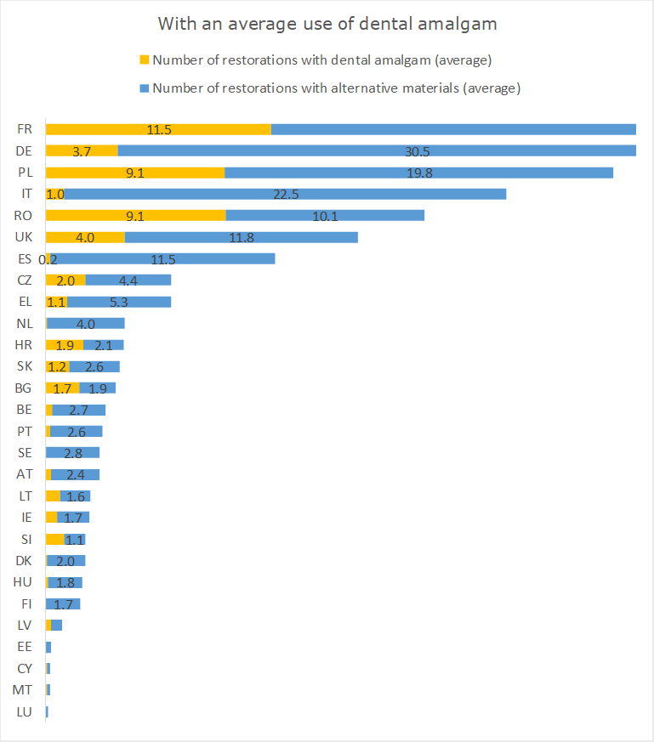

Increasing consumer awareness of the environmental and associated indirect health effects of dental amalgam, as well as more desirable aesthetics of alternative materials, appear to be main drivers for the decreasing use of dental amalgam.

In the absence of additional policy measures at EU and Member State levels, dental amalgam use is expected to decrease by approximately 70% between 2018 and 2030. However, the resulting use would still be substantial, at approximately 8-17 t of mercury in 2030.

***Economic feasibility***

The progressive substitution of dental amalgam with mercury-free materials (such as e.g. composite resins, ceramics, and glass ionomer cements) is already taking place. The overwhelming majority of EU manufacturers (95%) produce mercury-free materials, which represent a major share of the market. A regulatory requirement to phase out dental amalgam would accelerate the reducing trend and require manufacturers to increase production of alternative materials.

Figure 1: Number of restorations per filling material per Member State with an average use of dental amalgam (million, 2018)

The difference between the prices of dental restorations per type of material is relatively small due to improvements in mercury-free restoration techniques. Furthermore, the price difference between dental amalgam and mercury-free materials has decreased. This limits the socio-economic impact of an accelerated shift to mercury-free fillings on the costs of dental care, and hence the distributed economic impact on dentists, patients and healthcare reimbursement schemes.

In most Member States, the difference in the coverage of national health insurance reimbursement schemes for different materials is limited.

In conclusion, an accelerated shift to mercury-free fillings would not imply significant negative impacts on patients, dentists or dental filling manufacturers. It might however require adjustments of national reimbursement systems in Member States where the variation per material used is high.

***Technical feasibility***

Given the high use of mercury-free materials across the EU, it can be assumed that the vast majority of dental facilities in the EU already have the equipment required for mercury-free restorations and that most, if not all dentists, master the necessary techniques.

Evidence has shown that mercury-free materials exhibit satisfactory mechanical properties, with a lower cavity preparation requirement for composites[10] as well as better aesthetics[11]. Four main factors influence the longevity of a filling: the material, the method of restoration, the dentist’s skills and the patient’s dental hygiene. Mercury free materials are nowadays of good quality, effective restoration methods are widely available and dental schools are increasingly teaching the necessary skills. Dental hygiene should continue improving thanks to public health communication. Hence, the longevity of restorations should further improve.

Dentist representative organisations have however expressed concerns regarding a lack of available information on mercury-free materials, as well as the safety profile and biocompatibility of certain materials, some of which contain Bisphenol A (BPA) and nano-sized particles. Available scientific reviews concluded that release of BPA from certain dental materials was associated with only negligible health risks[12] and exposure to BPA is within the Tolerable Daily Intake[13]. However, these conclusions are based on the 2015 BPA risk assessment by the European Food Safety Authority, which is currently under review.

***Environmental aspects***

Dental amalgam causes significant emissions of mercury to air, water and soil.

Emissions to air were estimated[14] to be 19 t over the dental amalgam life cycle (2012, EU27[15]). Emissions to water[16] by dental clinics were estimated to be 3 t (2010, EU27), which will reduce as the Regulation mandates dental practices to be equipped with high level retention dental amalgam separators.

The presence of mercury in wastewaters is problematic for the residues (sludge) from urban wastewater treatment plants. Depending on the type of wastewater treatment, mercury may end up in sludge from wastewater plants. Mercury emissions from dental amalgam to soil, estimated at 8 t (2010, EU27), are primarily due to the spreading on land of such sludge. Directive 86/278/EEC on the use of sewage sludge in agriculture[17] sets limit values for heavy metal concentrations, including for mercury.

A phase out of dental amalgam would eventually eliminate these emissions and thus their contribution to the amounts of mercury in the environment, which would result in incremental environmental and health benefits. This would also contribute to the EU Circular Economy Action Plan[18] that calls for better wastewater treatment and revision of the Sewage Sludge Directives, in order to apply circular economy practices to wastewater and sludge management.

***Emissions of mercury and mercury compounds from crematoria***

Emissions of mercury and mercury compounds from crematoria are a lasting source of emissions to air stemming from the use of dental amalgam. They were estimated at approximately 1.6 t in 2018. It is expected that these emissions will remain at a similar level until about 2025 and then decrease. However, the evidence base is tenuous and further work is needed to improve these estimations, also to factor in the dramatic impacts, in terms of lost lives, due to the COVID-19 crisis.

There is currently no EU requirement to install mercury abatement technologies in crematoria. Only the Oslo-Paris Convention[19], to which the EU and 11 of its Member States are Parties, refers to best available techniques to prevent and control emissions of mercury from crematoria under its non-legally binding Recommendation 2003/4.

***Way forward***

Progressive substitution of dental amalgam with mercury-free materials is occurring without policy intervention as patients, in general, and increasingly dentists, prefer mercury-free fillings. Nevertheless, without legislative action, significant amounts of dental amalgam are still expected to be used in the coming years. This would prolong the associated environmental and health issues associated with the current use of dental amalgam, including significant emissions of mercury to air.

Both phase down and phase out of dental amalgam require addressing a number of issues, including improving the understanding of specific medical conditions where dental amalgam should continue to be allowed, increasing the information on available mercury-free materials and gathering further data on emissions of mercury, associated to the use of dental amalgam.

* 1. **Mercury-added products**

***EU and international law on placing on the market and trading of mercury-added products***

The EU has enacted one of the most comprehensive bodies of legislation worldwide regulating the content in mercury in products placed on the market, including imported products.[20] The objective has been two-fold, i.e. to protect human health and the environment and to ensure the good functioning of the internal market.

This includes Directive 2011/65/EU that limits mercury content in electric and electronic equipment,[21] Directive 2006/66/EC that regulates the mercury content in batteries[22] and Regulation (EC) No 1907/2006 that prohibits the placing on the EU internal market of certain mercury-added non-electronic measuring devices irrespectively of the mercury content[23]. The full list of legislation concerned is available in the impact assessment report[24], which the European Commission finalized in 2016, in preparation of its legislative proposal for the Regulation.

At international level, the Convention prohibits the manufacture, import and export of the mercury-added products listed in its Annex A (Part I).

Hence, whereas EU internal market law generally only prohibits the placing on the EU market of mercury-added products, the Convention prohibits their manufacture, import and export. Therefore, for the EU to comply with the Convention, the Regulation complements EU internal market legislation by prohibiting also the manufacture and export of the products listed in the Convention.

This different treatment of mercury-added products under EU and international law is the reason why the EU legislator required the Commission to undertake the present review.

***Objective of the review***

This review seeks to identify the most environmentally and economically effective manner of reducing and eliminating the presence on the international market of mercury-added products.

Two main approaches are available:

1. Unilaterally prohibiting the manufacturing and export from the EU of all mercury-added products that are prohibited from being placed on the EU market. This would be achieved by adding those products to Annex II to the Regulation;
2. Agreeing at global level on the prohibition of further products. This would be achieved in two steps by (i) extending the list of mercury-added products contained in Annex A to the Convention, and (ii) implementing such extension in Annex II to the Regulation.

The potential environmental benefits of these approaches are considered below.

***Unilateral EU manufacturing and export prohibition***

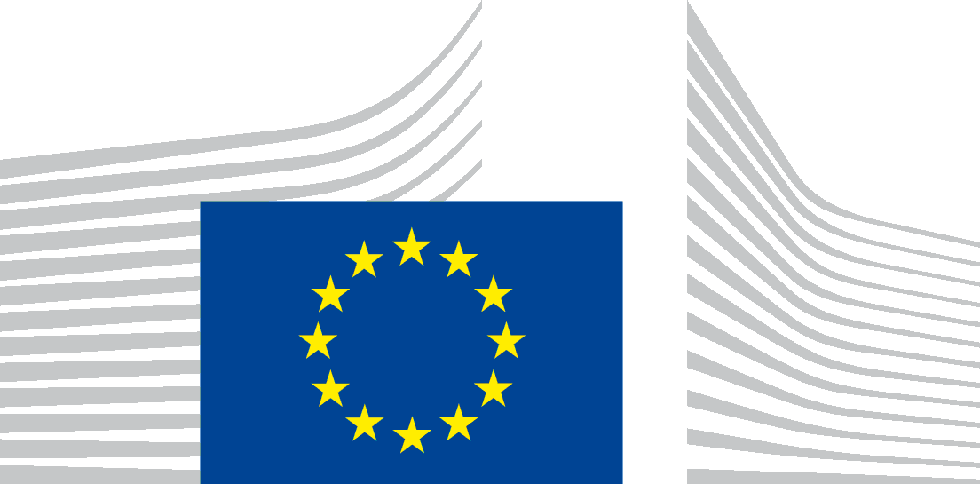

EUROPEAN

COMMISSION

Brussels,

XXX

[…]

(2020)

XXX

draft

**REPORT FROM THE COMMISSION TO THE EUROPEAN PARLIAMENT AND TO THE COUNCIL**

**-**

**on the reviews required under Article 19 (1) of Regulation 2017/852 on the use of mercury in dental amalgam and products**

The potential impacts of a wider unilateral EU manufacturing and export prohibition was discussed during the co-decision procedure on the Regulation. The Commission provided an initial assessment in the above-mentioned impact assessment report accompanying its proposal. This was complemented during the co-decision procedure with an information paper summarising a further assessment undertaken with the support of a consultant[25] for certain batteries, non-electronic measuring devices and lamps. The Commission provided this information paper to the European Parliament and to the Council and made it publicly available. The conclusions were as follows:

1. In the case of batteries and non-electronic measuring devices not allowed on the EU internal market, there is limited, if any, production in the EU. Therefore, applying the proposed manufacture and export prohibition to those products would not have direct environmental benefits nor economic impacts;
2. The situation is different for certain mercury lamps manufactured in and exported from the EU, in particular halophosphate lamps. In the absence of EU exports, the demand in third countries would remain unchanged due to price differences between mercury lamps and mercury-free alternatives. Furthermore, manufacturers located in third countries would increase their supply to meet that demand. Hence, applying the proposed export prohibition to those mercury lamps (1) may result in adverse impacts on the environment due to increased global emissions of mercury by third country manufacturers who would not be subject to as stringent pollution controls as in the EU, and (2) would have affected about 8% of EU's lamps industry with impacts on jobs and revenue.

Based on this assessment, the legislator included in the Regulation an export prohibition applicable to the concerned batteries, non-electronic measuring devices and several types of lamps, with the exclusion of halophosphate lamps. The Commission contracted a study on [mercury-added products and their alternatives](http://ec.europa.eu/environment/chemicals/mercury/pdf/ToR_MAPs_ARES_2019_688017.pdf)[26].

A major challenge the contractor faced was the scarcity of information on the markets of mercury-added products in third countries. This limits this review to a qualitative assessment of environment benefits, based on the same considerations as the above-mentioned Commission information paper. As long as there is international demand, it is likely that third country manufacturers would increase production to meet any demand not anymore satisfied by EU exports. Hence, the environmental impacts of a unilateral EU export ban are uncertain. It could be positive if it would result in reduced use of mercury worldwide. However, impact could be negative if emissions from possibly less-controlled manufacturing plants located in third countries would increase.

***Global prohibition under the Convention and way forward***

At the time of adoption of the Regulation, the Commission stated that it ‘*is committed to supporting continued cooperation, in accordance with the* *Convention and subject to applicable EU policies, rules and procedures, with a view to narrowing the gap between EU law and the provisions of the Convention*.’

The Commission has since advanced negotiations on the review of the list of products regulated by the Convention. Article 4(8) of the Convention requires the Conference of the Parties (COP) to review its Annex A by August 2022. The COP launched this review at its third meeting[27] and has invited Parties to submit information, to be analysed by a group of experts. This will be the basis for Parties to propose amendments to Annex A for consideration at the fourth meeting of the COP (November 2021).

The EU is playing a leading role in this review. Based on the aforementioned study on mercury-added products and their alternatives, the EU provided an extensive submission to the Convention Secretariat to feed the review process[28]. The Commission will prepare in early 2021 draft amendments to Annex A to the Convention, to be proposed by the EU. This will aim primarily at narrowing the gap between the EU *acquis* and the Convention.

This additional information, expected to become available as part of the work of an international group of experts, will not only allow a better assessment of the feasibility of a prohibition under international law, but also will improve the understanding of the impacts of a potential unilateral EU manufacture and export prohibition of those products.

1. **Conclusions and next steps**

Mercury is still used and causes continued pollution affecting globally human health and the environment, in particular by contaminating the food chain. The EU is therefore successfully pursuing, since more than a decade, at EU and international levels, the discontinuation of its use and the reduction of emissions of mercury to the environment.

The review undertaken makes clear that the phase out of the largest remaining use of mercury in the EU - dental amalgam - is technically and economically feasible, before 2030. Therefore, the Commission will present to the European Parliament and the Council in 2022 a legislative proposal to phase out the use of dental amalgam. The preparatory work will include the assessment of the need for accompanying measures, such as reducing emissions of mercury associated to the use of dental amalgam and enhancing the availability of information on mercury-free dental fillings.

In addition to continued work to phase out the placing of mercury-added products on the EU internal market*,* the EU will actively participate in the international negotiations to extend the list of mercury-added products regulated under the Convention. The principal aim will be to add to its Annex A mercury-added products whose placing on the EU internal market is prohibited. In light of the progress made, the Commission will assess the need for further work at EU level to prohibit not only the placing on the market, but also the manufacture and export of certain mercury-added products through an amendment to Annex II of the Regulation.

These initiatives will contribute to the European Green Deal Zero Pollution ambition for a toxic-free environment.

1. COM/2005/20 and COM/2010/723.
2. Regulation (EU) 2017/852 of the European Parliament and of the Council of 17 May 2017 on mercury, and repealing Regulation (EC) No 1102/2008 (OJ L 137, 24.05.2017, p. 1).
3. For the purpose of this report and in accordance with the provisions of the relevant EU instruments: ‘placing on the market’ means supplying or making available, whether in return for payment or free of charge, to a third party. Import shall be deemed to be placing on the market.
4. [Text of the Minamata Convention](http://www.mercuryconvention.org.).
5. Council Decision (EU) 2017/939 of 11 May 2017 on the conclusion on behalf of the European Union of the Minamata Convention on Mercury (OJ L 142, 02.06.2017, p. 4).
6. Communication from the Commission of 11.12.219, *The European Green Deal*, COM(2019) 640 final.
7. Link to [Study on assessment of the feasibility of phasing out dental amalgam](https://circabc.europa.eu/ui/group/19e66753-84ca-4e4e-a4a1-73befb368fc2/library/d862c135-5602-4f21-9abf-4bb26fc024b2?p=1&n=10&sort=modified_DESC).
8. [Bio Intelligence Service (2012), Study on the potential for reducing mercury pollution from dental amalgam and batteries](http://ec.europa.eu/emvironment/chemicals/mercury/pdf/review_mercury_strategy2010.pdf).
9. See footnote n˚7 for information on inter alia the calculation of number of restorations per filling material per Member State, prices of mercury-free alternative materials etc.
10. Mulligan, S., et al. "The environmental impact of dental amalgam and resin-based composite materials." *British Dental Journal* 224.7 (2018): 542.
11. Milosevic, Milos. "Polymerization mechanics of dental composites–advantages and disadvantages." Procedia Engineering 149 (2016): 313-320.
12. [SCENIHR, 2015. Scientific opinion on the Safety of Dental Amalgam and Alternative Dental Restoration Materials for Patients and Users](https://ec.europa.eu/health/scientific_committees/emerging/docs/scenihr_o_046.pdf).
13. Bisfenol a i dentala material socialstyrelsen, 2015.
14. [BIO Intelligence Service (2012), Study on the potential for reducing mercury pollution from dental amalgam and batteries](http://ec.europa.eu/environment/chemicals/mercury/pdf/review_mercury_strategy2010.pdf).
15. Does not include Croatia that joined the EU in 2013.
16. Mercury passes from the dental clinics through waste water treatment plants. Treatment technologies employed reach different removal efficiencies, and mercury, as other heavy metals tend not degrade but to adsorb in sludge. (Pistocchi et al. 2019; Hargraeves et al. 2016).
17. Council Directive 86/278/EEC of 12 June 1986 on the protection of the environment, and in particular of the soil, when sewage sludge is used in agriculture (OJ L 181, 04.07.1986, p. 6).
18. Communication from the Commission: *A new Circular Economy Action Plan - For a cleaner and more competitive Europe,* COM(2020) 98 final of 11.03.2020.
19. Convention for the Protection of the Marine Environment of the North-East Atlantic, OSPAR.
20. See footnote n˚3.
21. Directive 2011/65/EU of the European Parliament and of the Council of 8 June 2011 on the restriction of the use of certain hazardous substances in electrical and electronic equipment (OJ L 174, 01.07.2011, p. 88).
22. Directive 2006/66/EC of the European Parliament and of the Council of 6 September 2006 on batteries and accumulators and waste batteries and accumulators and repealing Directive 91/157/EEC (OJ L 266 of 26.09.2006, p.1).
23. Regulation (EC) No 1907/2006 of the European Parliament and of the Council of 18 December 2006 concerning the Registration, Evaluation, Authorisation and Restriction of Chemicals (REACH), establishing a European Chemicals Agency, amending Directive 1999/45/EC and repealing Council Regulation (EEC) No 793/93 and Commission Regulation (EC) No 1488/94 as well as Council Directive 76/769/EEC and Commission Directives 91/155/EEC, 93/67/EEC, 93/105/EC and 2000/21/EC (OJ L 396 of 30.12.2006, p. 1).
24. SWD(2016) 17, see Annex VI.
25. [COWI & ICF (2017)](https://ec.europa.eu/environment/chemicals/mercury/pdf/Final%20Report_KH0617141ENN.pdf)
26. [Link to final report](https://circabc.europa.eu/ui/group/19e66753-84ca-4e4e-a4a1-73befb368fc2/library/267dcf75-d336-46d3-bb21-d2640e6191e7?p=1&n=10&sort=modified_DESC)
27. [Decision MC-3/1](http://www.mercuryconvention.org/Portals/11/documents/meetings/COP3/English/UNEP-MC-COP-3-23-Report_Advance.English.pdf)
28. [EU submission on Annexes A and B for COP4 (2020)](http://www.mercuryconvention.org/Portals/11/documents/meetings/COP4/submissions/EU_AnnexAB.pdf)