

Table of Contents

1. INTRODUCTION 2

2. EFSI OPERATIONS SUPPORTED BY THE EU GUARANTEE 2

2.1 IIW OPERATIONS 2

2.2 SMEW OPERATIONS 2

2.3 BREAKDOWN OF EFSI OPERATIONS BY SECTOR AND COUNTRY 3

3. EFSI GF FINANCIAL STATEMENTS 5

4. PROVISIONING OF THE EFSI GF 7

5. ASSET MANAGEMENT 7

5.1 COMPOSITION OF THE PORTFOLIO 7

5.2 KEY RISK CHARACTERISTICS OF THE PORTFOLIO 9

# INTRODUCTION

This Staff Working Document (SWD) accompanies the Report on the Management of the European Fund for Strategic Investments Guarantee Fund (EFSI GF) in 2019. The SWD provides further information and tables on (2) operations under the IIW and SMEW (signatures and disbursed amounts, breakdown by sector and country), (3) financial statements, (4) provisioning of the EFSI GF and (5) asset management.

# EFSI OPERATIONS SUPPORTED BY THE EU GUARANTEE

This section provides a breakdown of the EFSI operations supported by the EU Guarantee in terms of number of operations, investment volume (signature and investment mobilised) as well sector and country breakdown.

## IIW OPERATIONS

As at 31 December 2019, 532 operations in 28 Member States were signed under the IIW. The total signatures amount to EUR 49.2 billion which is expected to mobilise investments of EUR 244.4 billion. Half of the signed operations in terms of volume were in the energy (26%) and research sector (21%), followed by the provision of financial support to SMEs and small Mid-Cap companies (18%) and transport (15%).

## SMEW OPERATIONS

As at 31 December 2019, 630 operations in 28 Member States were signed under the SMEW. The total financing of EUR 19.5 billion is expected to mobilise investments of EUR 156.3 billion. The most important sectors in terms of volume were research and development (69%) and digital (17%).

## BREAKDOWN OF EFSI OPERATIONS BY SECTOR AND COUNTRY

Table 1: Distribution of signed EFSI IIW and SMEW operations by sector as at 31 December 2019 (EUR million).



*Source: EFSI Operational Report provided by the EIB*

Note: Objective and subcategory as defined in Art.9 of EFSI Regulation. Totals may not always add up exactly due to rounding.

Table 2: Distribution of signed EFSI IIW and SMEW operations by country as at 31 December 2019 (EUR million)



*Source: EFSI Operational Report provided by the EIB*

Note: Totals may not always add up exactly due to rounding.

# EFSI GF FINANCIAL STATEMENTS

Statement of Financial Position as at 31 December 2019

|  |  |  |
| --- | --- | --- |
| **ASSETS** |  |  |
|  |  |  |
|  | **31 December 2019** | **31 December 2018** |
|  | **EUR** | **EUR** |
| **NON-CURRENT ASSETS** | **5 151 007 135** | **4 233 866 211** |
|  |  |  |
| Available for sale financial assets | 5 151 007 135 | 4 233 866 211 |
|  |  |  |
| **CURRENT ASSETS** | **1 536 875 909** | **1 217 907 446** |
|  |  |  |
| Available for sale financial assets | 1 502 587 447 | 765 897 485 |
|  |  |  |
| Financial assets at fair value through surplus or deficit | 2 708 066 | 1 923 458 |
|  |  |  |
| Short-term deposits (>3 months and ≤ 1 year)  incl. accrued negative interest | - | - |
|  |  |  |
| Receivables (i.e. bond lending fees) | 39 578 | 160 147 |
|  |  |  |
| **Cash and cash equivalents** | 31 540 818 | 449 926 356 |
| *Current accounts* | *5 083 651* | *418 899 111* |
| *Cash equivalents* | *26 462 735* | *31,139,540* |
| *Accrued interest on cash and cash equivalents* | *(5 568)* | *(112 295)* |
| **TOTAL ASSETS** | **6 687 883 044** | **5 451 773 656** |
|  |  |  |
| **NET ASSETS AND LIABILITIES** |  |  |
|  |  |  |
|  | **31 December 2019** | **31 December 2018** |
|  | **EUR** | **EUR** |
| **NET ASSETS** | **6 687 770 451** | **5 451 673 202** |
|  |  |  |
| Contribution from EU Budget | 6 626 955 272 | 5 460 743 179 |
| Fair value reserve | 49 616 101 | 1 442 436 |
| Retained earnings | (10 512 413) | 3 364 100 |
| Economic result of the year | 21 711 491 | (13 876 513) |
|  |  |  |
| **CURRENT LIABILITIES** | **112 593** | **100 455** |
|  |  |  |
| Financial liabilities at fair value through surplus or deficit | - | - |
| Other payables | 112 593 | 100 455 |
| Accrued charges | - | - |
| **TOTAL NET ASSETS AND LIABILITIES** | **6 687 883 044** | **5 451 773 656** |

Statement of financial performance for the year ended 31 December 2019

|  |  |  |
| --- | --- | --- |
|  | **2019** | **2018** |
|  | **EUR** | **EUR** |
| **Revenue from operating activities** | **47 488 284** | **103 725 359** |
| Foreign exchange gains | 47 488 284 | 103 679 180 |
| Other revenue from operating activities | - | 46 179 |
|  |  |  |
| **Expenses from operating activities** | **(65 064 399)** | **(86 684 186)** |
| Foreign exchange losses | (65 049 399) | (86 669 186) |
|  |  |  |
| Other expenses from operating activities | (15 000) | (15 000) |
| *Audit fees* | *(15 000)* | *(15 000)* |
|  |  |  |
| **RESULT FROM OPERATING ACTIVITIES** | **(17 576 115)** | **17 041 173** |
|  |  |  |
| **Financial revenue** | **54 280 642** | **50 409 147** |
| Interest revenue on: | 18 842 645 | 17 548 278 |
| *Cash and cash equivalents* | *66 473* | *134 210* |
| *Available for sale assets* | *18 776 172* | *17 412 590* |
| *Other interest revenue* | *-* | *1 478* |
|  |  |  |
| Realised gains on sale of AFS assets | 18 506 857 | 4 275 489 |
|  |  |  |
| Other financial income - fair value changes of derivatives | 16 447 915 | 28 389 730 |
|  |  |  |
| Security lending income | 483 225 | 195 651 |
|  |  |  |
| **Financial expenses** | **(14 993 036)** | **(81 326 833)** |
| Interest expenses on cash and cash equivalents | (527 706) | (247 367) |
|  |  |  |
| Realised losses on sale of AFS assets | (1 390 733) | (17 550 692) |
|  |  |  |
| Other financial expenses - fair value changes of derivatives | (12 008 473) | (62 913 181) |
|  |  |  |
| Custody fees and other financial expenses | (1 066 124) | (615 593) |
|  |  |  |
| **FINANCIAL RESULT** | **39 287 606** | **(30 917 686)** |
|  |  |  |
| **ECONOMIC RESULT OF THE YEAR** | **21 711 491** | **(13 876 513)** |

# PROVISIONING OF THE EFSI GF

The Guarantee Fund is provisioned through:

* Contributions from the general budget of the Union; the budget allocated for the EFSI contributions amounts to EUR 8 425 million;
* Revenues and any other payments received by the Union in accordance with the EFSI Agreement (i.e. projects benefitting from EFSI support); these assigned revenues to the EFSI GF amount to EUR 675 million.
* Returns (interests) on guarantee fund resources invested in the financial markets;
* Amounts recovered from projects for which the EU Guarantee was called (i.e. defaulting debtors);

The Guarantee Fund is provisioned progressively up to the target amount of EUR 9 100 million by 2022.

Table 3: Provisioning of the EFSI GF for the period 2015-2022 (EUR million)

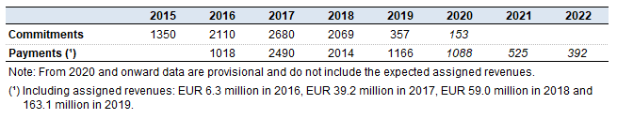

# ASSET MANAGEMENT

The following sections provide some further details on (a) the composition of the portfolio and (b) the key risk characteristics of the portfolio.

## COMPOSITION OF THE PORTFOLIO

The EFSI GF portfolio at the year-end is well diversified in terms of asset classes and rating categories. In addition, it is diversified in non-euro denominated securities (USD) in the form of an allocation to US Treasuries and other issuers (e.g. Supranational, other Sovereigns or Agencies) for about 6% of the portfolio. The currency risk is hedged. The exposure of the portfolio to bonds complying with environmental, social and governance criteria was more than 5 times higher when compared to its benchmark (6,93% for the portfolio vs 1,24% for the benchmark).

As shown in Figure 1, over 26% of the market value of the portfolio is invested in AAA securities and the rest is well distributed across the whole spectrum of the investment-grade scale. The AAA category includes for example securities issued by the US Government and covered bonds issued by financial institutions.

In terms of main asset classes, 47% of the portfolio is invested in Sovereign securities, sub-sovereigns, supra-nationals and agencies (SSA) and foreign Governments and 18% in covered bonds while 23% in bonds issued by corporates and financial institutions (other than covered bonds).

Figure 1: Portfolio exposure by rating as at 31 December 2019

*Source: European Commission services*

Figure 2: Portfolio exposure by asset class as at 31 December 2019

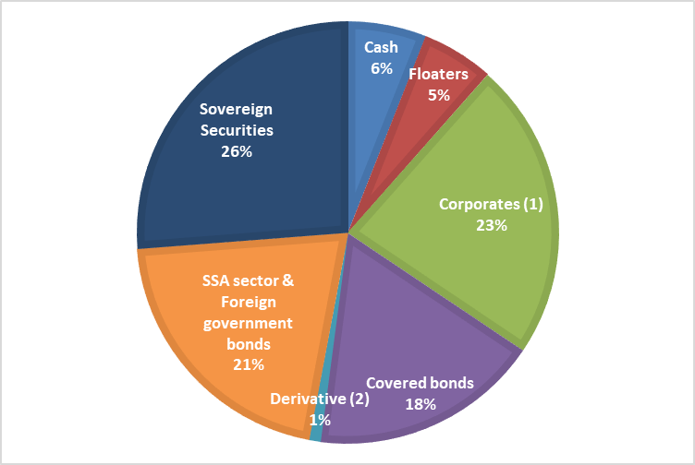

*Source: European Commission services*

*(¹) Corporate: unsecured bonds issued by financial and non-financial corporations.*

*(²) Derivative: inflation-linked bonds.*

## KEY RISK CHARACTERISTICS OF THE PORTFOLIO

*Market Risk*

Market risk is, inter alia, assessed by way of calculating the duration[1] of the portfolio.

As at 31 December 2019, the portfolio had a duration of 3.07 years.

*Currency risk and hedging activities*

USD investments represented 6% of the portfolio market value as at 31 December 2019. The currency risk of USD-denominated investments was hedged via forward contracts.

*Credit Risk*

The credit quality of the EFSI GF portfolio is high with an average rating[2] of BBB+, suggesting a low default probability (0.11% at 1-year).

*Liquidity characteristics of the portfolio*

About 21% of the portfolio consists of bonds with a maturity below 1-year, floating rate notes and short-term money market instruments which provide a further liquidity buffer for the portfolio.

1. The duration figure refers to 'modified duration' which measures the price sensitivity of a bond to interest rate movements.
2. The average rating is calculated on the basis of portfolio’s average 1-year default probability.