

Table of contents

**1.** **Budget procedure** 2

**1.1.** **Financial framework** 2

**1.2.** **Draft Budget (DB) 2019** 2

**1.3.** **The adoption of the 2019 Budget** 3

**1.4.** **The adoption of the Amending Budgets** 3

**2.** **Management of appropriations** 3

**2.1.** **Management of commitment appropriations** 3

*2.1.1.* *EAFRD rural development programmes* 3

*2.1.2.* *Technical assistance* 4

**2.2.** **Management of payment appropriations** 4

*2.2.1.* *EAFRD rural development programmes* 4

*2.2.2.* *Technical assistance* 5

**3.** **Implementation of the 2019 EAFRD budget** 5

**3.1.** **Implementation of commitment appropriations** 5

*3.1.1.* *EAFRD rural development programmes* 5

*3.1.2.* *Technical assistance* 7

**3.2.** **Implementation of payment appropriations** 7

*3.2.1.* *EAFRD rural development programmes* 7

*3.2.2.* *Technical assistance* 12

**3.3.** **Analysis of expenditure declared by measure** 12

**3.4.** **Implementation of EAFRD programmes** 14

*3.4.1.* *Programming period 2007-2013* 14

*3.4.2.* *Programming period 2014-2020* 14

**1. Budget procedure**

**1.1. Financial framework**

Rural development expenditure in 2019 is funded within the multiannual financial framework (MFF) 2014-2020. The financial framework is provided by Council Regulation (EU) No 1311/2013. The allocation for rural development and the allocation for market related expenditure and direct payments after the annual technical adjustment of the MFF are presented in table 1.

Table 1 – Financial framework 2014-2020

|  |  |  |  |  |  |  |  |
| --- | --- | --- | --- | --- | --- | --- | --- |
| **HEADING 2.** | In million EUR; current prices | | | | | | |
| **Sustainable growth: natural resources** | **2014** | **2015** | **2016** | **2017** | **2018** | **2019** | **2020** |
| **TOTAL** | **49 857** | **64 692** | **64 262** | **60 191** | **60 267** | **60 344** | **60 421** |
| of which : | | | | | | | |
| - Rural Development a), b), c), d), e) | 5 298.9 | 18 183.7 | 18 683.7 | 14 371.2 | 14 381.0 | 14 690.6 | 14 709.4 |
| - Market related expenditure and direct aids, a), b), c), d) | 43 778.1 | 44 189.8 | 43 950.2 | 44 145.7 | 44 162.4 | 43 880.3 | 43 887.1 |
|  |  |  |  |  |  |  |  |
| a) After net transfer of EUR 351.9 million between EAGF and EAFRD for the financial year 2014 (see note f for details) | | | | | | | |
| b) After net transfer of EUR 51.6 million between EAGF and EAFRD for the financial year 2015 (see note f for details) | | | | | | | |
| c) After net transfer of EUR 28 million between EAGF and EAFRD for the financial years 2014-2020 (see note f for details) | | | | | | | |
| d) After net transfer of EUR 4 313.9 million between EAGF and EAFRD for financial years 2015-2020 (see note f for details) | | | | | | | |
| e) After the reprogramming of the EAFRD allocation of year 2014 following the application of Article 19 of MFF Regulation (EU) No 1311/2013 a total amount of EUR 8 705 million deducted from 2014 commitments was equally distributed to 2015 and 2016 commitments | | | | | | | |
| f) The transfers to rural development (EAFRD) mentioned in notes a) to d) above involve: EUR 4 million transferred annually for the whole period 2014-2020 from the cotton sector (Greece) on the basis of Article 66(1) of Regulation (EU) No 1307/2013, EUR 296.3 million set for the voluntary adjustment transferred for the financial year 2014 (UK) on the basis of Article 10b and 10c(2) of Regulation (EC) No 73/2009, EUR 51.6 million for unspent amounts transferred each year for financial years 2014 and 2015 (SE and DE) on the basis of Articles 136 and 136b of Regulation (EC) No 73/2009 and EUR 4 313.9 million for the reduction of payments and the flexibility between pillars on the basis of Articles 7(2) and 14(1) of Regulation (EU) No 1307/2013 | | | | | | | |

**1.2. Draft Budget (DB) 2019**

The Draft Budget (DB) 2019 was adopted by the Commission and proposed to the Budgetary Authority on 21 June 2018.

The Draft Budget included EUR 14 679 million in commitment appropriations and EUR 13 122 million in payment appropriations for the European Agricultural Fund for Rural Development (EAFRD) 2014-2020 programming period.

The Council adopted its position on the 2019 Draft Budget on 4 September 2018 and the European Parliament adopted its position on 24 October 2018. The Conciliation Committee had to be convened. The Conciliation Committee did not agree on a joint text within the 21-day time-limit. The European Commission presented a second draft general budget for 2019 on 30 November 2018. The amounts for the EAFRD were not changed as compared with the first Draft Budget. The Council and the European Parliament approved the joint text respectively on 11 December and 12 December 2018.

**1.3. The adoption of the 2019 Budget**

The 2019 Budget adopted on 12 December 2018 was, as regards the EAFRD, equal to the Commission’s proposal.

Table 2

|  |  |  |
| --- | --- | --- |
| **Adopted Budget 2019** | | |
| **Budget Item** | **Commitment appropriations** | **Payment appropriations** |
| (in EUR) | (in EUR) |
| **2014-2020** | | |
| 05.046001 (Rural development programmes) | 14.656.460.137 | 13.100.000.000 |
| 05.010404 (Non-operational technical assistance) | 5.034.000 | 5.034.000 |
| 05.046002 (Operational technical assistance) | 17.115.400 | 16.725.400 |

**1.4. The adoption of the Amending Budgets**

None of the 2019 amending budgets concerned the EAFRD.

**2. Management of appropriations**

**2.1. Management of commitment appropriations**

*2.1.1. EAFRD rural development programmes*

As regards commitment appropriations for the EAFRD rural development programmes, the 2019 voted budget amounted to EUR 14 656 million, all related to the 2014-2020 programmes.

Table 3

|  |  |
| --- | --- |
| **Management of commitment appropriations in 2019 – EAFRD** | **Budget Item** |
| **05.046001** |
| (in EUR) |
| Appropriations at the beginning of 2019 | 14.656.460.137 |
| **Appropriations available in 2019** | **14.656.460.137** |
| Appropriations used in 2019 | 14.656.460.137 |

*2.1.2. Technical assistance*

Article 51(1) of Regulation (EU) No 1305/2013 provides that the EAFRD may use up to 0.25% of its annual allocation to finance technical assistance actions at the initiative of the Commission. In the 2019 budget, the initial amount available for this purpose was EUR 5.0 million for non-operational technical assistance and EUR 17.1 million for operational technical assistance.

**2.2. Management of payment appropriations**

*2.2.1. EAFRD rural development programmes*

For the rural development programmes 2014-2020, the payment appropriations of the voted budget 2019 amounted to EUR 13 100 million. In addition, the available assigned revenue transferred from the previous year amounted to EUR 12.4 million and the assigned revenue collected during the year, amounted to EUR 25.1 million. The payment appropriations were reinforced with the transfer of EUR 0.5 million from the line “EAFRD 2014-2020 contribution to European Solidarity Corps", EUR 265.6 million with the global transfer and EUR 100 million with the end-of-the year transfer. In addition, the transfer of EUR 961.7 million of assigned revenue from prior to 2014 EAFRD programmes was executed to cover in full the Member States' declarations of expenditure of the third quarter of 2019. An amount of EUR 1.8 million was transferred to the operational technical assistance line. Taking into account all transfers, the total amount of payment appropriations available in 2019 amounted to EUR 14 463.4 million. In total, EUR 13 840.0 million of payment appropriations were used and EUR 623.4 million of assigned revenue were automatically carried over from 2019 to 2020.

Table 4

|  |  |
| --- | --- |
| **Management of payment appropriations in 2019** | |
| **(in EUR)** | |
|  | |
| **EAFRD (2014-2020)** | |
| **Budget Item - 05.046001** | |
| Appropriations at the beginning of 2019 | 13.100.000.000 |
| Transfer from "EAFRD 2014-2020 contribution to ESC" line | 540.000 |
| Transfer to Technical Assistance line of EAFRD 2014-2020 | -1.800.000 |
| Global transfer | 265.580.630 |
| End-of-the year transfer | 100.000.000 |
| Assigned revenue carried over from 2018 | 12.400.084 |
| Assigned revenue collected in 2019 | 25.056.900 |
| Transfer of Assigned revenue from EAFRD prior to 2014 | 961.659.440 |
| **Appropriations available in 2019** | **14.463.437.054** |
| Appropriations used in 2019 | 13.839.996.951 |

*2.2.2. Technical assistance*

As regards the EAFRD technical assistance at the initiative of the Commission, total payment appropriations in the 2019 budget amounted to EUR 21.8 million. EUR 1.8 million were transferred from the EAFRD 2014-2020 programmes line to cover the payment needs. The final payment appropriations was EUR 23.6 million.

**3. Implementation of the 2019 EAFRD budget**

**3.1. Implementation of commitment appropriations**

*3.1.1. EAFRD rural development programmes*

The total amount of commitment appropriations available in the 2019 budget for the EAFRD programmes 2014-2020 (EUR 14 656.5 million) was committed.

Table 5 shows, per Member State, the allocation established by Regulation (EU) No 1305/2013 as last amended by Regulation (EU) 2019/288[1] and the amounts committed in 2019.

Table 5

|  |  |  |
| --- | --- | --- |
| ***Regulation (EU) No 1305/2013 (as amended) vs. amounts committed by the end of 2019*** | | |
| **Budget item: 05.046001** | | *(in EUR)* |
| **MS** | **Regulation (EU) No 1305/2013** | **Amounts committed in 2019** |
| **2019 Allocation** |
|  | **(a)** | **(b)** |
| BE | 102.912.713 | 102.912.713 |
| BG | 339.523.306 | 339.523.306 |
| CZ | 323.242.050 | 323.242.050 |
| DK | 152.367.537 | 152.367.537 |
| DE | 1.397.914.658 | 1.397.914.658 |
| EE | 127.277.180 | 127.277.180 |
| IE | 312.764.355 | 312.764.355 |
| GR | 700.043.071 | 700.043.071 |
| ES | 1.183.448.718 | 1.183.448.718 |
| FR | 1.984.761.729 | 1.984.761.729 |
| HR | 282.342.500 | 282.342.500 |
| IT | 1.498.573.799 | 1.498.573.799 |
| CY | 18.889.108 | 18.889.108 |
| LV | 159.374.589 | 159.374.589 |
| LT | 247.213.599 | 247.213.599 |
| LU | 14.464.074 | 14.464.074 |
| HU | 487.402.356 | 487.402.356 |
| MT | 13.876.504 | 13.876.504 |
| NL | 148.107.797 | 148.107.797 |
| AT | 565.713.368 | 565.713.368 |
| PL | 1.189.103.987 | 1.189.103.987 |
| PT | 581.637.133 | 581.637.133 |
| RO | 1.141.925.604 | 1.141.925.604 |
| SI | 120.384.760 | 120.384.760 |
| SK | 214.844.203 | 214.844.203 |
| FI | 343.198.337 | 343.198.337 |
| SE | 249.710.989 | 249.710.989 |
| UK | 755.442.113 | 755.442.113 |
| **Total** | **14.656.460.137** | **14.656.460.137** |

*3.1.2. Technical assistance*

For the programming period 2014-2020, the amount of commitment appropriations for operational technical assistance in the budget 2019 was EUR 17.1 million. Table 6 shows the consumption of the commitment appropriations available for operational technical assistance in 2019. The most important part relates to the European Network for Rural Development.

Table 6

|  |  |
| --- | --- |
| ***Operational technical assistance – Implementation of commitment appropriations*** | |
| **Budget Item: 05.046002** | *(in EUR)* |
| **Description** | **Amount committed** |
| European Network for Rural Development | 4.980.794 |
| Information technology* | 3.111.799 |
| European Innovation Partnership | 2.736.732 |
| European Evaluation Network | 1.975.414 |
| Corporate Communication | 1.380.000 |
| Technical Advisory Platform for Financial Instruments | 500.000 |
| Organic agriculture database | 433.295 |
| Audit and Controls | 644.735 |
| **Total** | **15.762.767** |
| * Including BCO (Broadband Competence Offices) | |

**3.2. Implementation of payment appropriations**

*3.2.1. EAFRD rural development programmes*

For the programming period 2014-2020, EUR 13 840.0 million of the payment appropriations were implemented out of EUR 14 463.4 million available. Table 7 shows the breakdown of payments made in 2019 by declaration period:

Table 7

|  |  |  |
| --- | --- | --- |
| ***Payments 2019 for EAFRD rural development programmes (in EUR)*** | ***2007-2013*** | ***2014-2020*** |
|  |  |  |
| Pre-financing 2014-2020[2] | - | 2.714.793 |
| Reimbursement of payment claims prior to Q4 2018 | - | 134.874 |
| Reimbursement of payment claims Q4 2018 | - | 5.755.256.476 |
| Reimbursement of payment claims Q1 2019 | - | 2.754.299.275 |
| Reimbursement of payment claims Q2 2019 | - | 2.741.814.776 |
| Reimbursement of payment claims Q3 2019 | - | 2.585.776.756 |
| Closure payments 2007-2013 | 257.692.857 | - |
| **Total 2019** | **257.692.857** | **13.839.996.951** |

The monthly consumption of payment appropriations during the year (January to December 2019) is shown in the graph below.

Graph 1

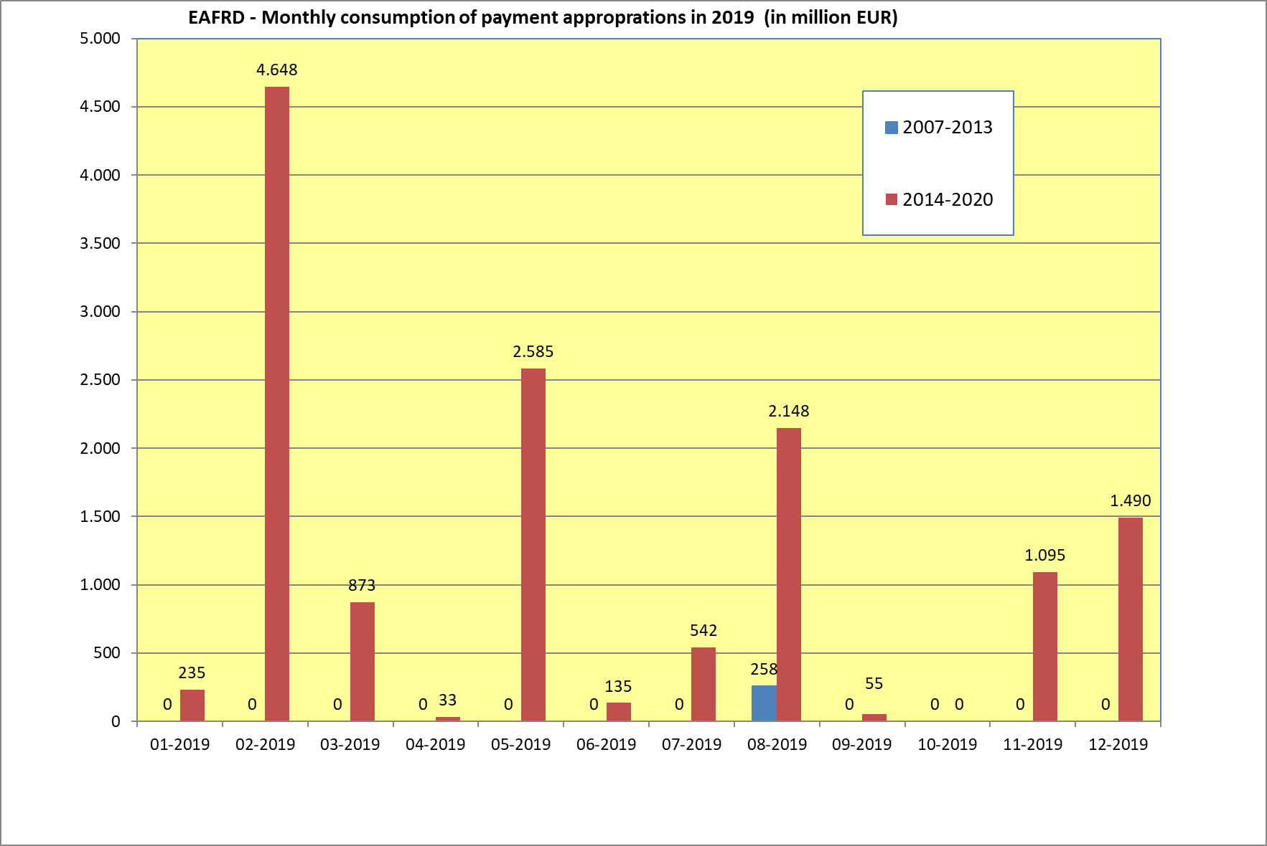The breakdown per Member State and per declaration period of the amounts paid by the Commission in budget year 2019 is shown in tables 8a and 8b.

Table 8a: EAFRD 2007-2013

|  |  |
| --- | --- |
| **Payments effectively made between 01/01/2019 and 31/12/2019** | |
| **EAFRD 2007-2013 - Budget item 05.040501 (in EUR)** | |
| **MS** | **Closure** |
| **BE** |  |
| **BG** | 97.225.956 |
| **CZ** |  |
| **DK** |  |
| **DE** |  |
| **EE** |  |
| **IE** |  |
| **GR** |  |
| **ES** |  |
| **FR** | 160.466.901 |
| **IT** |  |
| **CY** |  |
| **LV** |  |
| **LT** |  |
| **LU** |  |
| **HU** |  |
| **MT** |  |
| **NL** |  |
| **AT** |  |
| **PL** |  |
| **PT** |  |
| **RO** |  |
| **SI** |  |
| **SK** |  |
| **FI** |  |
| **SE** |  |
| **UK** |  |
| **Total** | **257.692.857** |

Table 8b: EAFRD 2014-2020

|  |  |  |  |  |  |  |  |  |  |
| --- | --- | --- | --- | --- | --- | --- | --- | --- | --- |
| **Payments effectively made between 01/01/2019 and 31/12/2019** | | | | | | | | | |
| **EAFRD 2014-2020 - Budget item 05.046001** | | | | | | | | ***(in EUR)*** | |
| **MS** | **Pre-financing** | **Prior to Q4 2018** | **Q4 2018** | **Q1 2019** | **Q2 2019** | **Q3 2019** | **Total** | |
| **BE** | 0 | 0 | 17.334.254 | 9.482.574 | 33.218.285 | 18.837.316 | **78.872.428** | |
| **BG** | 0 | 0 | 55.344.911 | 77.499.583 | 107.997.278 | 67.792.991 | **308.634.763** | |
| **CZ** | 0 | 0 | 52.848.870 | 204.165.511 | 86.450.814 | 50.362.856 | **393.828.050** | |
| **DK** | 0 | 0 | 42.034.170 | 25.776.718 | 25.047.434 | 8.208.342 | **101.066.664** | |
| **DE** | 0 | 0 | 596.910.906 | 291.497.999 | 208.933.806 | 176.253.592 | **1.273.596.303** | |
| **EE** | 0 | 0 | 23.539.059 | 65.082.476 | 12.226.795 | 24.060.415 | **124.908.745** | |
| **IE** | 0 | 0 | 157.269.176 | 30.982.563 | 39.397.304 | 96.373.396 | **324.022.439** | |
| **GR** | 0 | 0 | 275.111.064 | 34.505.407 | 46.860.555 | 54.936.575 | **411.413.602** | |
| **ES** | 0 | 0 | 527.423.244 | 148.716.407 | 278.660.313 | 210.819.806 | **1.165.619.770** | |
| **FR** | 2.703.993 | 0 | 1.042.261.975 | 457.277.445 | 301.119.386 | 260.160.776 | **2.063.523.575** | |
| **HR** | 0 | 0 | 74.467.768 | 73.992.801 | 98.848.103 | 52.326.860 | **299.635.531** | |
| **IT** | 0 | 0 | 689.961.184 | 221.751.805 | 237.813.915 | 299.554.216 | **1.449.081.121** | |
| **CY** | 0 | 0 | 8.867.428 | 2.616.579 | 2.550.300 | 6.918.518 | **20.952.824** | |
| **LV** | 0 | 0 | 96.634.492 | 46.651.363 | 26.091.992 | 37.097.820 | **206.475.667** | |
| **LT** | 10.800 | 0 | 73.287.933 | 49.310.142 | 34.191.233 | 24.451.057 | **181.251.164** | |
| **LU** | 0 | 0 | 5.119.156 | 5.653.405 | 2.121.682 | 1.587.351 | **14.481.595** | |
| **HU** | 0 | 0 | 184.133.619 | 133.238.829 | 97.309.058 | 96.688.026 | **511.369.533** | |
| **MT** | 0 | 0 | 11.087.890 | 620.865 | 4.054.663 | 3.666.529 | **19.429.947** | |
| **NL** | 0 | 0 | 13.721.305 | 53.369.141 | 6.469.479 | 16.838.579 | **90.398.504** | |
| **AT** | 0 | 0 | 304.858.442 | 42.762.776 | 141.825.329 | 48.725.218 | **538.171.765** | |
| **PL** | 0 | 0 | 341.817.663 | 278.763.628 | 241.914.834 | 229.788.859 | **1.092.284.985** | |
| **PT** | 0 | 0 | 315.985.382 | 89.332.030 | 55.471.630 | 62.260.191 | **523.049.233** | |
| **RO** | 0 | 0 | 323.746.321 | 136.212.495 | 224.930.153 | 282.184.080 | **967.073.048** | |
| **SI** | 0 | 134.874 | 34.717.325 | 14.449.325 | 47.516.257 | 23.279.066 | **120.096.847** | |
| **SK** | 0 | 0 | 56.642.464 | 37.855.996 | 65.152.780 | 49.710.435 | **209.361.675** | |
| **FI** | 0 | 0 | 140.089.247 | 26.542.166 | 59.579.240 | 124.962.860 | **351.173.513** | |
| **SE** | 0 | 0 | 134.063.084 | 33.824.471 | 32.298.532 | 26.112.103 | **226.298.189** | |
| **UK** | 0 | 0 | 155.978.145 | 162.364.775 | 223.763.628 | 231.818.923 | **773.925.472** | |
| **Total** | **2.714.793** | **134.874** | **5.755.256.476** | **2.754.299.275** | **2.741.814.776** | **2.585.776.756** | **13.839.996.951** | |

Table 9 compares, for each Member State, the EAFRD 2014-2020 payments made in 2019 with the payments in 2018. Overall, the payments increased by 14% compared to year 2018 (EUR 13.8 billion vs. EUR 12.2 billion).

Table 9

|  |  |  |  |  |  |  |  |  |
| --- | --- | --- | --- | --- | --- | --- | --- | --- |
| **Payments made to Member States - Comparison 2019 vs 2018 - EAFRD 2014-2020** | | | | | | | ***(in EUR)*** |  |
|
| **MS** | **2018** | | | **2019** | | | **Difference 2019 vs. 2018** | |
| **Interim payments** | **Pre-financing** | **Total** | **Interim payments** | **Pre-financing** | **Total** | **(in EUR)** | **(in %)** |
| **BE** | 69.095.529 |  | 69.095.529 | 78.872.428 | 0 | 78.872.428 | 9.776.899 | 14,15% |
| **BG** | 205.683.318 |  | 205.683.318 | 308.634.763 | 0 | 308.634.763 | 102.951.445 | 50,05% |
| **CZ** | 324.647.223 |  | 324.647.223 | 393.828.050 | 0 | 393.828.050 | 69.180.827 | 21,31% |
| **DK** | 89.687.155 |  | 89.687.155 | 101.066.664 | 0 | 101.066.664 | 11.379.509 | 12,69% |
| **DE** | 1.117.668.890 |  | 1.117.668.890 | 1.273.596.303 | 0 | 1.273.596.303 | 155.927.413 | 13,95% |
| **EE** | 128.104.065 |  | 128.104.065 | 124.908.745 | 0 | 124.908.745 | -3.195.320 | -2,49% |
| **IE** | 318.709.149 |  | 318.709.149 | 324.022.439 | 0 | 324.022.439 | 5.313.290 | 1,67% |
| **GR** | 579.944.832 |  | 579.944.832 | 411.413.602 | 0 | 411.413.602 | -168.531.230 | -29,06% |
| **ES** | 899.726.086 |  | 899.726.086 | 1.165.619.770 | 0 | 1.165.619.770 | 265.893.684 | 29,55% |
| **FR** | 1.708.849.535 | 16.198.977 | 1.725.048.512 | 2.060.819.582 | 2.703.993 | 2.063.523.575 | 338.475.063 | 19,62% |
| **HR** | 206.150.392 |  | 206.150.392 | 299.635.531 | 0 | 299.635.531 | 93.485.139 | 45,35% |
| **IT** | 1.045.757.040 |  | 1.045.757.040 | 1.449.081.121 | 0 | 1.449.081.121 | 403.324.081 | 38,57% |
| **CY** | 14.530.171 |  | 14.530.171 | 20.952.824 | 0 | 20.952.824 | 6.422.653 | 44,20% |
| **LV** | 192.664.101 |  | 192.664.101 | 206.475.667 | 0 | 206.475.667 | 13.811.566 | 7,17% |
| **LT** | 217.968.861 | 1.502.340 | 219.471.201 | 181.240.364 | 10.800 | 181.251.164 | -38.220.037 | -17,41% |
| **LU** | 14.530.735 |  | 14.530.735 | 14.481.595 | 0 | 14.481.595 | -49.140 | -0,34% |
| **HU** | 385.929.544 |  | 385.929.544 | 511.369.533 | 0 | 511.369.533 | 125.439.988 | 32,50% |
| **MT** | 9.391.195 |  | 9.391.195 | 19.429.947 | 0 | 19.429.947 | 10.038.752 | 106,90% |
| **NL** | 78.872.378 | 1.800.000 | 80.672.378 | 90.398.504 | 0 | 90.398.504 | 9.726.126 | 12,06% |
| **AT** | 512.804.158 |  | 512.804.158 | 538.171.765 | 0 | 538.171.765 | 25.367.607 | 4,95% |
| **PL** | 944.569.722 |  | 944.569.722 | 1.092.284.985 | 0 | 1.092.284.985 | 147.715.262 | 15,64% |
| **PT** | 503.033.323 |  | 503.033.323 | 523.049.233 | 0 | 523.049.233 | 20.015.909 | 3,98% |
| **RO** | 1.146.152.415 |  | 1.146.152.415 | 967.073.048 | 0 | 967.073.048 | -179.079.366 | -15,62% |
| **SI** | 110.943.349 |  | 110.943.349 | 120.096.847 | 0 | 120.096.847 | 9.153.498 | 8,25% |
| **SK** | 200.196.868 |  | 200.196.868 | 209.361.675 | 0 | 209.361.675 | 9.164.806 | 4,58% |
| **FI** | 351.787.931 |  | 351.787.931 | 351.173.513 | 0 | 351.173.513 | -614.418 | -0,17% |
| **SE** | 195.642.880 |  | 195.642.880 | 226.298.189 | 0 | 226.298.189 | 30.655.309 | 15,67% |
| **UK** | 580.998.528 |  | 580.998.528 | 773.925.472 | 0 | 773.925.472 | 192.926.944 | 33,21% |
| **Total** | **12.154.039.375** | **19.501.317** | **12.173.540.691** | **13.837.282.157** | **2.714.793** | **13.839.996.951** | **1.666.456.259** | **13,69%** |

*3.2.2. Technical assistance*

For the programming period 2014-2020, the amount for payment appropriations available for the operational technical assistance was EUR 18.5 million. The original amount of EUR 16.7 million in the Budget 2019 has been reinforced by EUR 1.8 million transferred from the rural development programmes under EAFRD 2014-2020 line. The final implementation amounted to EUR 17.0 million.

Table 10 hereafter presents the payments grouped by main activities. The most important part relates to the European Network for Rural Development.

Table 10

|  |  |
| --- | --- |
| ***Technical assistance – Implementation of payment appropriations*** | |
| **Budget Item: 05.046002** | *(in EUR)* |
| **Description** | **Amount paid** |
| European Network for Rural Development | 4.237.354 |
| Information technology* | 3.001.302 |
| Technical Advisory Platform for Financial Instruments | 3.064.333 |
| European Innovation Partnership | 2.648.305 |
| European Evaluation Network | 1.428.387 |
| Corporate Communication | 1.000.000 |
| LIFE Programme | 840.847 |
| Audit and Controls | 632.480 |
| Organic agriculture database | 139.108 |
| LOGO protection | 50.000 |
| **Total** | **17.042.118** |

* Including Broadband Competence Offices

**3.3. Analysis of expenditure declared by measure**

Table 11 shows the payment claims declared by Member State and by measure for rural development in 2019 (4th quarter of 2018 to 3rd quarter of 2019), the cumulative declared expenditure from the beginning of the programming period and also the financial plan of EAFRD 2014-2020 programmes.

The expenditure for EAFRD 2014-2020 in 2019 concentrated mainly in Measure 04 (Investments in physical assets), in Measure 13 (Payments to areas facing natural or other specific constraints) and in Measure 10 (Agri-environment-climate).

Table 11

|  |  |  |  |  |  |  |  |
| --- | --- | --- | --- | --- | --- | --- | --- |
| **EAFRD declared expenditure 2019 (Q4 2018-Q3 2019) & Total cumulative expenditure (Q4 2014 to Q3 2019*)** | | | | | | | |
| **compared with Financial Plans - EAFRD 2014-2020** | | | | | | | |
|  | | **Declared expenditure 2019 (Q4 2018 to Q3 2019)** | | **Cumulative declared expenditure (Q4 2014 to Q3 2019)** | | **Financial Plans 2014-2020** | |
| **EAFRD Measure** | | **(million EUR)** | **(%)** | **(million EUR)** | **(%)** | **(million EUR)** | **(%)** |
| Measure 01 | Knowledge transfer and information actions | 93,4 | 0,7% | 250,5 | 0,5% | 973,6 | 1,0% |
| Measure 02 | Advisory services, farm management and farm relief services | 39,7 | 0,3% | 87,1 | 0,2% | 606,1 | 0,6% |
| Measure 03 | Quality schemes for agricultural products and foodstuffs | 37,1 | 0,3% | 98,7 | 0,2% | 368,6 | 0,4% |
| Measure 04 | Investments in physical assets | 2.801,0 | 20,2% | 7.966,7 | 16,9% | 22.860,8 | 22,8% |
| Measure 05 | Restoring agricultural production potential damaged by natural disasters and catastrophic events and introduction of appropriate prevention actions | 75,2 | 0,5% | 235,8 | 0,5% | 807,5 | 0,8% |
| Measure 06 | Farm and business development | 813,5 | 5,9% | 2.838,8 | 6,0% | 6.701,1 | 6,7% |
| Measure 07 | Basic services and village renewal in rural areas | 1.022,7 | 7,4% | 2.403,2 | 5,1% | 6.893,5 | 6,9% |
| Measure 08 | Investments in forest area development and improvement of the viability of forests | 411,4 | 3,0% | 1.436,0 | 3,0% | 4.257,4 | 4,3% |
| Measure 09 | Setting-up of producer groups and organisations | 24,0 | 0,2% | 73,4 | 0,2% | 266,4 | 0,3% |
| Measure 10 | Agri-environment-climate | 2.483,1 | 17,9% | 9.841,7 | 20,9% | 16.443,4 | 16,4% |
| Measure 11 | Organic farming | 1.321,1 | 9,5% | 4.207,6 | 8,9% | 7.451,3 | 7,4% |
| Measure 12 | Natura 2000 and Water Framework Directive payments | 92,6 | 0,7% | 340,9 | 0,7% | 606,6 | 0,6% |
| Measure 13 | Payments to areas facing natural or other specific constraints | 2.654,5 | 19,2% | 11.916,0 | 25,3% | 16.732,2 | 16,7% |
| Measure 14 | Animal Welfare | 309,8 | 2,2% | 1.152,4 | 2,4% | 1.809,1 | 1,8% |
| Measure 15 | Forest environmental and climate services and forest conservation | 15,1 | 0,1% | 46,6 | 0,1% | 240,0 | 0,2% |
| Measure 16 | Co-operation | 107,1 | 0,8% | 246,1 | 0,5% | 1.676,4 | 1,7% |
| Measure 17 | Risk management | 358,6 | 2,6% | 884,4 | 1,9% | 1.613,0 | 1,6% |
| Measure 18 | Financing of complementary national direct payments for Croatia | -0,1 | 0,0% | 108,2 | 0,2% | 111,9 | 0,1% |
| Measure 19 | Support for LEADER local development — community-led local development (CLLD) | 857,0 | 6,2% | 1.851,4 | 3,9% | 7.011,4 | 7,0% |
| Measure 20 | Technical assistance Member States | 278,7 | 2,0% | 794,3 | 1,7% | 2.155,0 | 2,2% |
| Measure 113 | Early retirement | 42,9 | 0,3% | 402,2 | 0,9% | 493,8 | 0,5% |
| Measure 131 | Meeting standards based on Community legislation | 0,0 | 0,0% | 0,0 | 0,0% | 0,0 | 0,0% |
| Measure 341 | Skills acquisition, animation and implementation | 0,1 | 0,0% | 0,5 | 0,0% | 0,6 | 0,0% |
| **Grand total** |  | **13.838,4** | **100,0%** | **47.182,5** | **100,0%** | **100.079,5** | **100,0%** |

*Member States declare their expenditure quarterly. However, for year n, Q4 declarations are submitted in January of year n+1. Consequently, the corresponding reimbursements by the Commission to the Member States in year n go from Q4 of year n-1 until Q3 of year n.

**3.4. Implementation of EAFRD programmes**

*3.4.1. Programming period 2007-2013*

Graph 2 presents the final absorption rate of rural development programmes 2007-2013 per Member State. The EU average reached 97%.

*3.4.2. Programming period 2014-2020*

Graph 3 presents the absorption rate of rural development programmes 2014-2020 per Member State: payments from the beginning of the programming period including payments made for the 4th quarter of 2019 that are reimbursed in financial year 2020 compared to the total 2014-2020 allocation.

In 2019 the level of consumption for the first time resulted in the decommitment of EUR 16.5 million.

Overall, the implementation of the EAFRD 2014-2020 rural development programmes reached by end 2019 on average an absorption rate of 56%. Programmes are generally well on track in terms of implementation, with the variation in the averages per Member State illustrated in graph 3 below.

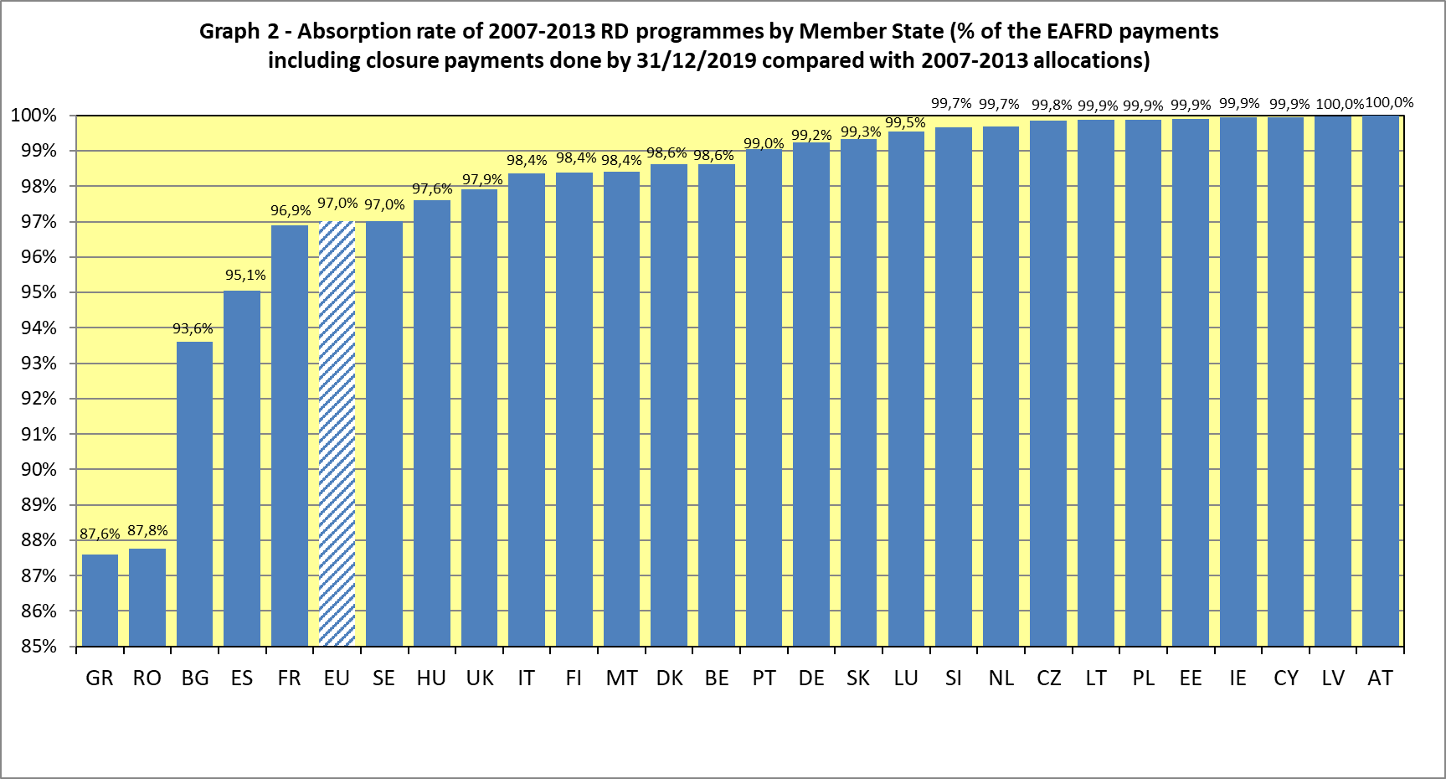

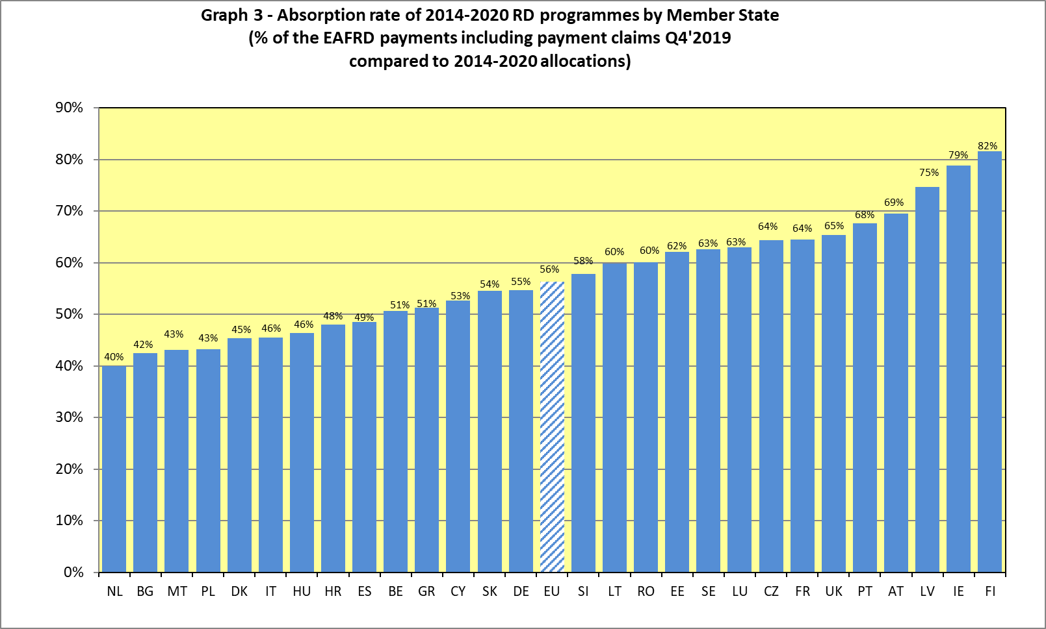

1. Regulation (EU) 2019/288 of the European Parliament and of the Council of 13 February 2019 amending Regulations (EU) N° 1305/2013 and (EU) N° 1307/2013 as regards certain rules on direct payments and support for rural development in respect of the years 2019 and 2020
2. The pre-financing paid in financial year 2019 concerns only pre-financing for the additional amounts transferred from direct payments to rural development