

Contents

4. The European Structural and Investment Funds (ESIF) 76

Executive summary 76

Introduction 83

4.1. General analysis 84

4.1.1. Irregularities reported as fraudulent 90

4.1.2. Irregularities not reported as fraudulent 100

4.1.3. Irregularities reported in relation to the PP 2014-2020: comparison with PP 2007-2013 105

4.2. Specific Analysis – Irregularities reported in relation to the Programming Period 2007‑2013 124

4.2.1. Objectives concerned by the reported irregularities 124

4.2.2. Priorities concerned by the reported irregularities 129

4.2.3. Profile of persons involved 141

4.3 Reasons for performing control 144

4.4. Antifraud and control activities by Member States 145

4.4.1. Duration of irregularities 146

4.4.2. Detection of irregularities reported as fraudulent by Member State 146

4.4.3. Fraud detection rate 149

4.4.4. Irregularity Detection Rate 152

4.4.5. Follow-up to suspected fraud (programming period 2007-13) 154

4.5 Other shared management funds 158

**PART II - EXPENDITURE**

4. The European Structural and Investment Funds (ESIF)

Executive summary

*Analysis of general trends*

**As it could be expected, detections related to the Programming Period (PP) 2007-2013 have been decreasing, while those related to PP 2014-2020 have been increasing.** The number of PP 2007-2013 detections kept on decreasing from the peak in 2015, when the PP closed, while the number of PP 2014-2020 detections has been growing. These opposite trends are due to the different phases these PPs were going through.

**For both programming periods, the average financial amount (AFA) involved in irregularities have been increasing during the period 2015-2019.** **The AFA related to PP 2014-2020 has constantly been higher than that related to PP 2007-2013 during the same period 2015-2019**. With reference to PP 2007-2013, the irregular financial amounts decreased at a slower pace than the number of detections, which implies an increase in the AFA. With reference to PP 2014-2020, the irregular financial amounts increased at a higher pace than the number of detections, which also implies an increasing AFA.

**The AFA of the reported irregularities can be taken as an indicator of the detection capacity, but the focus should be on ‘core’ trends.** Cases where exceptionally high financial amounts were involved should be excluded from the analysis, in order to better understand the structural performance of the management, control and reporting systems.

**The ‘core’ AFA of the Cohesion Fund (CF) has been following a continued upward trend, whereas, there was a slowdown for the other funds in 2019. AFA dynamics should be supported by risk analysis and co-operation with judicial authorities.** During the period 2015-2019, considering together PP 2007-2013 and PP 2014-2020, CF ‘core’ AFA was largely the highest and experienced a clear and constant raise. The European Regional Development Fund’s (ERDF) ‘core’ AFA was the second highest and recorded a similar trend until 2018, while in 2019 there was a noticeable decrease. With respect to ERDF, the European Social Fund’s (ESF) ‘core’ AFA followed a similar, but flatter trend. European Fisheries Fund (EFF) and European Maritime and Fisheries fund (EMFF) ‘core’ AFA also decreased in 2019, confirming the downward trend that it has followed during the whole period. For all funds, the ‘core’ AFAs of fraudulent irregularities were always higher than those of non-fraudulent irregularities, underlining the importance of co-operation with judicial authorities.

**The tendency of the Member States to focus on fraudulent irregularities seems to be higher for PP 2014-2020, but the irregular financial amounts detected decreased in 2019. This downturn for PP 2014-2020 was not expected and requires attention.** During the period 2015-2019, the financial amounts associated to fraudulent irregularities related to PP 2007-2013 have been constantly decreasing, while those related to PP 2014-2020 took off in 2018. During the period 2015-2019, on average, more than one irregularity out of ten has been reported as fraudulent for PP 2014-2020, while it was one out of twenty for PP 2007-2013. Despite this tendency, excluding ‘exceptional’ cases, the financial amounts involved in fraudulent irregularities have been decreasing for all funds, including for PP 2014-2020 in 2019.

**ERDF was the fund impacted by the highest number of cases reported as fraudulent and the highest related irregular financial amount. However, in 2019 there was a significant drop, also this one unexpected, due to reporting on the PP 2014-2020.** After a few years during which reporting concerning PP 2007-2013 was rather stable or was decreasing, but being compensated by the growth of PP 2014-2020, in 2019 there was an overall drop. With specific reference to PP 2014-2020, instead of continuing on an upward trend, both detections and financial amounts declined. Also this development requires attention.

**Since 2015, the fraudulent irregularities related to ESF declined, except for an isolated rebound in 2018.** The variations in the related financial amounts were more accentuated and did not necessarily follow the changes in numbers, due to a few ‘exceptional cases’. Fraudulent irregularities affecting the CF have been reported regularly since 2010. However, there are significant fluctuations of the amounts in respect of these cases, because of fewer cases and high amounts involved in the projects financed by the Cohesion Fund. In 2019, the majority of detections related to CF took place in Slovakia.

**Member States showed different reporting patterns, in terms of their tendency to detect fraudulent irregularities with high financial amounts involved.** For the CF, Slovakia showed a robust tendency to detect and report fraudulent cases with large financial amounts, supported by the propensity to identify irregularities covering most of the related expenditure. Czechia showed the opposite pattern. For the ERDF, Italy, Portugal and Slovakia showed a robust tendency to detect and report fraudulent cases with large financial amounts, supported by the propensity to identify irregularities covering most of the related expenditure, in particular, again, for Slovakia. Hungary and Spain showed the opposite pattern. For the ESF, Portugal, Poland and Romania showed a robust tendency to detect and report fraudulent cases with large financial amounts. For Portugal, this was supported by the propensity to identify irregularities covering a significant share of the related expenditure. Germany showed the opposite pattern. Italy tends to detect few irregularities, but with exceptionally high amounts involved.

**For PP 2014-2020, detected irregularities not reported as fraudulent and related irregular financial amounts have been increasing for all funds, but less than it could be expected in view of the by now advanced stage of implementation of that PP.** Furthermore, in 2019, there was a slow-down in terms of financial amounts, not justified by the dynamics of the number of detections. At the same time, after 2015, the decrease in the number of irregularities and financial amounts related to PP 2007-2013 was significant, but this could be expected.

**Also with reference to non-fraudulent irregularities, Member States showed different reporting patterns.** For CF, Slovakia had a robust tendency to detect and report non-fradulent irregularities with large financial amounts involved. For the ERDF, this was the case for Slovakia, Romania, Italy, Czechia and Poland. Spain showed the opposite pattern. For the ESF, Slovakia and Hungary showed a robust tendency to detect and report non-fraudulent cases with large financial amounts, despite no propensity to identify irregularities covering a significant share of the related expenditure.

**Considering other funds supporting the cohesion policy, the Fund for European Aid to the Most Deprived (FEAD) was the most affected by fraud.** Financial amounts involved in these FEAD irregularities tend to be high. The highest financial amounts related to non-fraudulent irregularities were linked to YEI irregularities, followed by FEAD.

*Is reporting for PP 2014-2020 in line with past trends?*

**Apart from outliers, the number and financial amounts reported as fraudulent in relation to PP 2014-2020 were in line with those that had been detected in relation of PP 2007-2013 after a comparable period from the start of the programming period. This was the outcome of different patterns followed by different funds.** While the raise of CF fraudulent irregularities was basically due to detections in Slovakia, the surge concerning ERDF had a broader basis, with the highest increase in Hungary. Only for the ESF was the detection and reporting of fraudulent irregularities lower than before, mainly due to the decrease recorded in Germany.

**Focusing instead on the non-fraudulent irregularities, the fall in the number and financial amounts reported after six years from the start of the programming period is striking and can be hardly explained by delayed implementation.** The number of detections related to PP 2007-2013 suddenly climbed at the beginning of the fifth year of implementation and then continued to increase at a sustained pace. For PP 2014-2020, reporting quickened about one year later and not at the same pace. Delayed implementation during the current programming period might be contributing to this drop. However, this does not seem enough to justify a fall of 55% in irregularity reporting.

**The gap is significant for all funds, but in particular for the ERDF.** For the CF, ESF and the fisheries funds, there were significant gaps in reporting for PP 2014-2020 compared to PP 2007-2013 (-28% for the CF, -42% for the ESF, -47% for the fisheries funds), but they were not as wide as for the ERDF (-62%). With reference to the ERDF, for the majority of Member States, the numbers of non-fraudulent irregularities related to the two PPs were on persistently diverging paths. The drop in reporting related to the ERDF was generalised across Member States also in terms of irregular financial amounts.

**A number of rules changed from PP 2007-2013 to PP 2014-2020.** For example, the legal framework at the basis of PP 2014-2020 requires the managing authorities put in place effective and proportionate anti-fraud measures taking into account the risks identified. Another change that may be of relevance to explain the pattern of non-fraudulent irregularities is the introduction of the annual accounts, which might have contributed to strenghtening internal control at Member State level.

**Wider use of simplified cost options (SCOs) might be contributing to the decline of non‑fraudulent irregularities for ESF, but the situation should still be closely monitored.** For PP 2014-2020, the possibility to use SCOs has been extended. It is expected that for the ESF the share of costs covered by SCOs might increase from 7% (for PP 2007-2013) to 33% (for PP 2014-2020). Together with some implementation delays, these may have been contributing factors to the drop of non-fraudulent irregularities. However, the situation should be closely monitored, also because (1) any possible effect of delayed implementation will keep on fading out (2) it is not clear whether the increase of SCOs use will actually materialise (3) and to what extent it will concern projects that are more relevant for irregularity reporting; and (4) it is not clear when, during the programming period, the impact of increased SCOs adoption on irregularities patterns can be more significant. The number of detections related to non-eligibility and to the implementation of the action strongly declined. The decrease of eligibility violations might be related to increased adoption of SCOs, but, if this were actually the case, the more stringent controls on the implementation of the action that should accompany this change could have been expected to lead to the detection of more irregularities relating to projects’ implementation. So far, this increase has not occurred. It may come later, if the timing of verifications on projects’ implementation is different from the timing of verifications on the eligibility of costs.

**These are just a few possible examples of factors that may potentially influence the number of irregularities. For all funds, the competent national authorities can build on the analysis presented in this Report.** The actual relevance and impact of these and other changes in the different Member States should be properly evaluated before being taken as the explanation of a persistent decline in detections. Further analysis by the compentent authorities in the Member States is warranted to understand the causes of these trends. If they are due to different rules/prevention activities in comparison with the previous programming period, the measures that brought these huge changes should be pointed out. If they are due to less enforcement or to reporting issues, these shortcomings should be acted upon in a timely manner.

*Objective and priorities*

**For PP 2007-2013, the reported irregularities and related financial amounts followed patterns that could be expected in relation to the implementation cycle. The majority of detections and financial amounts concerned the ‘*Convergence*’ objective.** The prevalence of the ‘*Convergence*’ objective is influenced by the fact that the largest share of the EU budget was spent on this objective. In order to get a better perception of the impact of irregularities on different objectives, the irregular financial amounts should be put into relation with the financial resources spent on them. This is achieved through the Fraud Detection Rate (FDR) and the Irregularities Detection Rate (IDR).

**Detection rates for the different objectives ranged from 0.5% to 3.3%.** Looking at the overall detection rate (FDR + IDR), ‘*Regional competitiveness and employment*’ programmes show a relatively low level of detection. ‘*European Territorial Cooperation*’ programmes, however, show an anomalously low level of detection (about four times lower than the previous objective), especially if one considers that the Fraud Frequency Level (FFL) and the Fraud Amount Level (FAL) were high (see below about these indicators). The situation is different for ‘*Multiobjective*’ programmes, ‘*Convergence*’ and ‘*Fisheries*’ where the detection rate was about 3%

**Five irregularities out of 100 were reported as fraudulent for PP 2007-2013, representing EUR 15 out of EUR 100. This indicates the higher financial impact of fraudulent irregularities compared to the non-fraudulent infringements.** Irregularities reported as fraudulent represented 4.7% of the total number of irregularities reported for PP 2007-13. The highest percentage (FFL) was related to the ‘*Fisheries’* (6.5%), the ‘*European Territorial Cooperation’* (about 7%) and to the ‘*Convergence’* (about 5.5%) objectives. ‘*Regional competitiveness and Employment’* had the lowest FFL (2.7%). Financial amounts involved in irregularities reported as fraudulent represented 14.7% of the total reported for PP 2007-13. The highest share (FAL) was related to *Fisheries* (17.3%), *Convergence* (about 17%), and the *European Territorial Cooperation* (19%). *Regional competitiveness and Employment* had the lowest FAL (4.7%). The comparison between FFL and FAL shows that the average financial value involved in irregularities reported as fraudulent is more than three times higher than that related to the non-fraudulent types.

**For PP 2007-2013, 40% of irregularities reported as fraudulent were related to three priorities, including *'Research and Technological Development, innovation and entrepreneurship*' (*RTD*).** **From the financial amounts point of view, the most significant impact concerned *'RTD*' and '*Transport'.***In terms of numbers, the priorities most concerned were *‘RTD’*, '*Increasing the adaptability of workers and firms, enterprises and entrepreneurs*' and '*Improving access to employment and sustainability*'. In terms of financial amounts, the frontrunners ‘*RTD*’ and ‘*Transport*’ were followed, at a distance, by another group of priorities*: 'Urban and rural regeneration', 'Environmental protection and risk prevention'* and *'Tourism'.* With reference to PP 2014-2020, the prevalence of the priority '*RTD*' was even more marked than for PP 2007-2013.

**While, on average, five irregularities out of 100 were fraudulent, this frequency was nearly double for a number of priorities.** For PP 2007-2013, FFL was highest for '*Tourism*', but it was quite high also for other priorities, such as '*Increasing the adaptability of workers and firms, enterprises and entrepreneurs*' and '*Improving access to employment and sustainability*'.

**While, on average, EUR 15 out of EUR 100 of irregular financial amounts were reported as fraudulent, this frequency was more than double for a number of priorities.** For PP 2007‑2013, FAL was highest for '*Urban and rural regeneration*', '*Improving human capital*' and '*Tourism*'. The priorities '*Tourism*' and '*Urban and rural regeneration*' stood out in terms of FDR.

**Focusing on non-fraudulent irregularities in relation to PP 2007-2013, ‘*RTD’*, ‘*Environmental protection and risk prevention*’ and '*Transport*' represented 25% of the total number and 47% of the total amounts.** Irregularities related to funding to improve human capital and employment were also frequent, but with much lower financial impact.The priorities '*Tourism*', ‘*RTD*’, *'Information society'* and ‘*Transport*’ show an IDR higher than or equal to 2%.

**The comparison between the two programming periods is particularly difficult because of the mixing of old and new priorities and the marked decrease of irregularities without priority.** For PP 2014-2020, the reporting of the priorities improved, but contrary to the Regulations in force, the Member States continued to encode the irregularities in the Irregularities Management System (IMS) using the priorities that were valid for PP 2007-2013. This makes difficult to draw clear findings from the analysis. However, it can be noticed that '*RTD, innovation and entrepreneurship*' was still the priority most affected by non-fraudulent irregularities.

**The COVID-19 crisis could call for more funding, in particular for the health sectors, in the years to come.** It is therefore important to analyse the irregularities that impacted on this area so far, considering both the experience made during the whole PP 2007-2013 and what is already emerging in relation to the current programming period. Investment in health infrastructure is part of the wider framework covering investment in social infrastructure.

**5% of the irregularities related to health infrastructure were reported as fraudulent, accounting for 8% of the irregular financial amounts.** Actions concerning health infrastrucure were affected by 25 fraudulent irregularities, accounting for about EUR 9.5 million and 469 non-fraudulent irregularities, accounting for about EUR 105.5 million.

**Fifteen MS reported irregularities in actions related to health infrastructures; seven of them also detected fraud.** More than half of the fraudulent irregularities and related financial amounts were reported by Romania and Slovakia. More than one third of the non-fraudulent irregulaties were detected by Poland, while Slovakia reported more than half of the irregular financial amounts.

**Actions related to health infrastructure are strongly affected by violations of public procurement rules.** The range of violations was wide and included pre-tendering infringements, such as unlawful and/or discriminatory selection and/or award criteria in the tender documents, selection criteria not related and not proportional to the subject matter of the contract, discriminatory technical specifications, infringements related to the tendering phase, such as lack of transparency and/or equal treatment during evaluation, and post-tendering infringements, such as substantial modification of the contract elements set out in the tender specifications.

**Non-eligibility of the project/activity and infringement of contract provisions/rules were other main sources of irregularities with reference to health infrastructure.** Non-eligibility was relevant both for fraudulent and non-fraudulent cases. For the majority of the relevant non-fraudulent irregularities, the implementation infringement was not specified. For the few case where the infringement was specified, it is worth mentioning control, audit, scrutiny, etc. not carried out in accordance with rules or plans, action not completed or not implemented, violations related to the co-financing system.

**Most often fraud impacting on health infrastructure involves issues relating to supporting documents.** The most reported category of infringement for fraudulent irregularities was ‘*Incorrect, missing, false supporting documents*’. In this context, the highest number of violations and financial amounts involved were related to the use of false documents, but incomplete or incorrect documents were also mentioned.

*Profile of the persons involved*

**In 77% of the fraudulent irregularities one or more legal entities were involved, in particular private companies and sub-national governmental bodies.** The vast majority of cases report a single natural or legal person, while only about 20 report more than two. Focusing on legal entities, nearly half of them were private companies, while the second largest group consisted of Sub-national governmental bodies, comprising just over one-quarter of the total, the majority reported by just three Member States: Spain, Romania and Slovakia.

*Anti-fraud and control activities by the Member States*

**To enhance the capability to detect irregularities, the Commission recommended to the Member States to improve risk analysis and the use of spontaneous reporting.** In the context of the antifraud cycle, the detection capability is a key feature, which contributes to the effectiveness and efficiency of the system for the protection of the EU budget. With the 2017 PIF Report, the Commission recommended to further exploiting the potential of risk analysis, facilitating and assessing the spontaneous reporting of potential irregularities and strengthening the protection of whistle-blowers that are also a crucial source for investigative journalism.

**So far, it seems there has been little improvement on the ground, at least in terms of detection after request for reimbursement to the Commission, but it could be too early to draw conclusions.** With reference to irregularities reported as fraudulent, there seems to be no improvement in the use of risk analysis or information published by media. There was a significant increase in the use of tips from informants, but this was not widespread. There was also a noticeable increase in the share of non-fraudulent irregularities detected following risk analysis. However, this does not point to a wider adoption of this proactive approach, because most of these irregularities were reported by the same two Member States that were amongst the Member States that detected most often irregularities on the basis of risk analysis also before 2018. The situation was more stable with reference to the use of tips or information from the media.

**For PP 2007-2013, half of the irregularities have been protracted during a span of time, which was more than 1 year and a half, on average.** **The share was higher for fraudulent irregularities, but the duration was similar.** About 50% of the total involved infringements that have been protracted during a span of time (58% for irregularities reported as fraudulent). The remaining part of the dataset refers to irregularities which consisted of a single act identifiable on a precise date (about 23% of the whole dataset and 30% of that including exclusively the fraudulent irregularities) or for which no reliable information has been provided by the Member States (27% of the whole dataset and 11% of the irregularities reported as fraudulent).

**On average, irregularities were detected about 3 years after their perpetration and reported eight months after their detection. After that, the period to case closure was much longer for fraudulent irregularities compared to non-fraudulent ones, reflecting longer penal proceedings.** Three years was the result of nearly two years and a half to come to the suspicion that an irregularity had been or was being perpetrated, plus half a year to actually detect the irregularity. It can be added that the procedures for imposing sanctions or penalties were started after a similar time period after detection (8 to 10 months), but then it took, on average, one year to close the procedure in case of a non-fraudulent irregularity and nearly two years in case of a fraudulent irregularity. This may be due to overlaps with penal procedures.

**For PP 2007-2013, FDR ranged from 1.17% of Slovakia to zero (or nearly zero) for Luxembourg, the Nordic countries, Belgium, France, Hungary, Lithuania, Malta. IDR ranged from more than 10% of Slovakia to less than 0.5% in the Nordic countries, France and Luxembourg. This was also related to different reporting patterns** (see above)**.** For PP 2014-2020, FDR and IDR are still volatile, because of the lower number of cases and the evolution of payments. These data are expected to change as implementation progresses. If the trend of the previous PP is confirmed, most of the irregularities are still to be detected. The increase in irregular financial amounts reported will be counterbalanced by the growing amounts of payments to the Member States.

**Analysis suggests that the concentration of detections is not fully explained by the distribution of payments across Member States during the programming period 2007-2013, but this was less evident than in agriculture (during the period 2014-2018).** For PP 2007-2013, the number ofdetections reported as fraudulent significantly varied across Member States, from 0 in Luxembourg to 330 in Poland. For 2014-2020, differentation was still high, but it is still too early to draw comparative conclusions. Excessive concentration of detections in a number of Member States could be due to many different factors, including different underlying levels of irregularities and fraud, a different quality of the prevention or detection activities or different practices concerning the stage of the procedure when potentially fraudulent irregularities were reported. The divergence between the distribution of detections and the distribution of payments among Member States was smaller for the cohesion and fisheries policies than for Common Agriculture Policy (CAP), especially with reference to fraudulent irregularities. This may suggest that approaches of Member States to the use of criminal law to protect the EU budget might be more homogeneous in the cohesion and fisheries policies than in the agriculture domain.

**Concerning the follow-up the Member States give to suspected fraud they reported, about 21% of the irregularities reported as fraudulent were dismissed, on average after more than four years. The *dismissal ratio* varied across the Member States, as the related average times.** High *dismissal ratios*, especially when associated with high numbers of irregularities still reported as suspected fraud (*pending ratio*), may be due to a detection phase that led to report to the judicial authority cases that were not fraudulent or to an investigation/prosecution phase that gave low priority or did not have enough tools, resources or information to properly address the case, especially when high dismissal ratios are associated with high average times*.* Low *dismissal ratios* may be positive, but they may also be the result of many irregularities still pending as suspected fraud.

**Analysis suggests a significant underestimation of the *dismissal ratio*.** About 64% of the irregularities reported as fraudulent were still pending, but for one fourth of them no changes of status are to be expected. This is due to the fact that 24% of the irregularities that were still labelled as suspected fraud at the end of 2019 were already closed.

**The cases of established fraud were few and, on average, these decisions were reached after about three years. This may point to the need to invest further in the investigation/prosecution phase.** At EU28 level, the *established fraud ratio* was about 14%. It ranged from zero or about zero, in half of the Member States, to 45%, in just one Member State. The *established fraud ratio* is not likely to increase significantly because, while 64% of cases were still classified as suspected fraud (*pending ratio*), about one fourth of them were already closed and, in any case, between 6 and 13 years have already passed since the detection of the irregularity.

Introduction

Over half of EU funding is channelled through the five European Structural and Investment Funds (ESIF). The ESIF are:

* **European Regional Development Fund** (ERDF) – promotes balanced development in the different regions of the EU;
* **European Social Fund** (ESF) - supports employment-related projects throughout Europe and invests in Europe’s human capital – its workers, its young people and all those seeking a job;
* **Cohesion Fund** (CF) – funds transport and environment projects in countries where the gross national income (GNI) per inhabitant is less than 90% of the EU average. In 2014-2020, these are Bulgaria, Croatia, Cyprus, Czechia, Estonia, Greece, Hungary, Latvia, Lithuania, Malta, Poland, Portugal, Romania, Slovakia and Slovenia;
* **European Agricultural Fund for Rural Development** (EAFRD) [1] – focuses on resolving the particular challenges facing EU's rural areas;
* **European Maritime and Fisheries fund** (EMFF) – helps fishermen to adopt sustainable fishing practices and coastal communities to diversify their economies, improving quality of life along European coasts. Due to the rules of functioning of the EMFF and EFF, which are very similar to those of the other structural funds, irregularities reported by Member States in relation to fisheries policies are treated in this Section, jointly with the funds for cohesion and economic convergence.

ESIF are jointly managed by the European Commission and the EU Member States. Each Member State prepares a partnership agreement, in collaboration with the Commission, setting out how the funds will be used during the current funding period 2014-2020. Partnership agreements lead to a series of investment programmes channelling the funding to the different regions and projects in the policy areas concerned.

For 2014-2020, EUR 454 billion[2] has been allocated to ESIF funding. National co-financing is expected to amount to at least EUR 183 billion, with total investment reaching EUR 637 billion. The purpose of all these funds is to invest in job creation and a sustainable and healthy European economy and environment. They mainly focus on five areas: (1) research and innovation, (2) digital technologies, (3) supporting the low-carbon economy, (4) sustainable management of natural resources, and (5) small businesses. More in detail, these resources contribute to:

* strengthening research and innovation;
* supporting the digital single market;
* supporting the growth of Europe’s small and medium-sized enterprises (SMEs);
* supporting the energy union and the low-carbon economy;
* investing in environmental protection and resource efficiency;
* climate change and risk prevention;
* supporting sustainable transport;
* promoting sustainable and quality employment;
* promoting social inclusion;
* investing in education and training;
* supporting youth employment;
* strengthening institutional capacity and efficient public administration.

This section of the report covers both the programming period (PP) 2007-2013[3] and the PP 2014-2020, including through a comparison of the irregularities reported during the first six years of implementation of the two PPs.

4.1. General analysis

In general, Member States are requested to communicate irregularities with financial amounts above EUR 10,000.[4] However, a number of cases with irregular financial amounts equal to or below this threshold have been reported by several Member States. Table CP1 provides an overview by Member State. Furthermore, Member States reported cases with financial amounts involved equal to zero. This may be because the competent national authority, at the time of reporting, did not have enough information yet to quantify the irregular amounts involved. However, this should not be the case once the case is closed. Table CP1 provides also an overview by Member State of the closed cases, for which the national authorities have not mentioned the irregular financial amounts involved.

It is not clear why there are some Member States that reported many more *'below-the-threshold*' irregularities than others. It should be considered that an irregularity may consist of irregular or fraudulent operations which are interlinked and whose total financial impact exceeds EUR 10,000, even though each individual operation remains below the threshold.[5] In this case, a Member State may have chosen to report these irregularities separately, while other Member States may have combined them in one irregularity. Another explanation may relate to irregularities that were reported because the initial estimation of the irregular financial amounts involved exceeded EUR 10,000, but subsequent updates lowered these financial amounts below the threshold. Furthermore, about 15% of the '*below-the-threshold*' irregularities were still open at the cut-off date[6]; the competent national authority might have reported them with a provisional estimation, pending the exact quantification of the financial amount involved. Other explanations may include typographical errors or mis-interpretation of the reporting rules.

As shown by Table CP1, there were about 1,800 irregularities with a financial amount below EUR 10,000, which represented 6% of all the relevant irregularities (2%, not including the UK, which accounts for 70% of the ‘*below-the-threshold*’ irregularities). In order to make use of all information reported by the Member States, all these irregularities are considered in the analysis for this Report. However, Table CP1 provides the reader with additional information to put into context data about detections in different Member States.



Table CP2 offers an overview of the number of irregularities (both fraudulent and non‑fraudulent) reported from 2015 to 2019, by PP and fund. In comparison with the other budget sectors, the analysis of the cohesion policy poses a higher level of complexity, as information refers to different PPs, which are regulated by different rules.

In the whole Report, when reference is made to ‘fraudulent’ or ‘fraud’, it includes ‘*suspected fraud*’ and ‘*established fraud*’. [7]



**The number of PP 2007-2013 detections has been decreasing from the peak in 2015, when the PP closed, while the number of PP 2014-2020 detections has been growing. These opposite trends are due to the different phases these PPs were going through.** With reference to PP 2007-2013, Table CP2 does not suggest any major diversion from known trends and patterns in detection and reporting of irregularities[8], with the exception of year 2015, when the number of reported irregularities doubled, before decreasing in the following years. The abnormal increase in 2015 was mainly linked to the reporting of irregularities by Spain, which covered about half of the total number of irregularities reported in 2015. This anomalous Spanish increase was due to delayed reporting of irregularities detected throughout the programming period. If they were to be excluded, the number of reported irregularities would still be higher than in 2014, but more in line with the programming cycle of the funds. A minor, yet still striking increase in reporting was observed in relation to the previous PP 2000-2006. The number of irregularities relating to that PP almost doubled from 2014 to 2015, many years after its end. In this respect, the explanation is belated reporting by Ireland.

**With reference to PP 2007-2013, the irregular financial amounts decreased at a slower pace than the number of detections, which implied an increase in the AFA.** Table CP3 offers an overview by PP and fund of the financial amounts involved in irregularities detected and reported to the Commission over the past five years. While the number of PP 2007-2013 irregularities peaked in 2015 and significantly decreased in the following years (see Table CP2), the financial amounts involved were stable in 2016, before declining at a slower pace. This trend implied an accelerating raise of the AFA (+27% in 2016, +33% in 2017 and +53% in 2018). In 2019, the decline of financial amounts (-70%) exceeded the decrease of the number of detections (-57%), so the AFA decreased by 30%, with respect to the peak reached in 2018.



**With reference to PP 2014-2020, the irregular financial amounts increased at a quicker pace than the number of detections, which implied an increasing AFA. The latter was constantly higher than that related to PP 2007-2013 during the same period.** The irregular financial amounts related to PP 2014-2020 have been following a growing trend, which was steeper than that of the number of detections. The decrease in 2019 was just due to the exceptional jump experienced in the year before, because of two irregularities accounting for about EUR 590 million. Excluding these two irregularities, the irregular financial amounts have increased in all years of PP 2014-2020. Also the AFA has been growing and, in 2019, it was quite high, at about EUR 450 000, higher than the AFA of PP 2007-2013 irregularities in every year in the period 2015-2019 (with the exception of 2018, when the AFA was similarly high).

**The AFA of the reported irregularities can be taken as an indicator of the detection capacity. The analysis of ‘core’ trends can provide useful insights.** Targeting the limited resources that are available for detection, investigation and (as relevant) prosecution on cases with a higher financial impact can be beneficial in terms of efficiency, recovery and deterrence. Thus an increase in the AFA of detected irregularities may point to better targeting of controls in this area and viceversa. However, the trend of the financial amounts must always be assessed while bearing in mind that it can be strongly influenced by single events of significant value. During 2015-2019, cases involving more than EUR 5 million represented less than 1% in terms of numbers, but 44% in terms of amounts.[9] On these cases, 66% concerned the ERDF, while 25% concerned the CF. In such a context, where a significant portion of the financial amounts is linked to a relatively low number of cases, fluctuations are more likely and should not be misinterpreted. In an attempt to isolate the 'core' trends, Graphs CP1-CP4 show the financial amounts and AFA during the past five years, where the first and the last percentiles are excluded from the analysis[10].



**In relation to PP 2007-2013, the ‘core’ AFAs of ERDF and ESF irregularities have been following upward trends. The EFF ‘core’ AFA was rather flat. CF recorded the highest ‘core’ AFA.** Considering the whole period 2015-2019, this translated into increases of 38% and 91% for the ESF and ERDF, respectively. The ‘core’ AFA of CF irregularities experienced ample fluctuations around an average of nearly EUR 450,000, which was much higher than the ‘core’ AFA for the other funds. The ‘core’ AFA of EFF irregularities followed a downward trend until 2018, while in 2019 it jumped back, nearer to the value of 2015.

**With reference to PP 2014-2020, CF ‘core’ AFA followed a steep upward trend. ‘Core’ AFA trends were based on very few cases during 2015-2016.** **‘Core’ AFA dynamics should be supported through risk analysis.** Considering the period 2016-2019, CF ‘core’ AFA increase by 91%. However, in 2019, the ‘core’ AFA decreased. During the previous programming period, as the number of detections grew, CF ‘core’ AFA started a downward trend from the fifth year of implementation until the eighth year. Thus the decrease in 2019 could be the start of similar dynamics for the current programming period, but improvements in terms of risk analysis for targeting controls could induce different patterns. The ESF ‘core’ AFA has been decreasing, while that of EMFF was rather stable. Since 2017, the ERDF ‘core’ AFA has stabilised around EUR 145 000, which is lower than the average for the PP 2007-2013 during the the period 2015-2019.



**Considering the two programming periods together, the continued upward trend of CF ‘core’ AFA is confirmed, while, in 2019, there was a slowdown for the other funds.** For the years 2015‑2019, PP 2007‑2013 and PP 2014-2020 are considered together in Graphs CP3. The raise of CF ‘core’ AFA is clear and constant. ERDF ‘core’ AFA experienced a similar trend until 2018, while in 2019 there was a noticeable decrease. ESF ‘core’ AFA followed a similar, but flatter trend. EFF/EMFF ‘core’ AFA also decreased in 2019, confirming the downward trend that it has followed during the whole period.



**Separated analyses of fraudulent and non-fraudulent irregularities shows a marked difference in the trend followed by CF ‘core’ AFAs. For all funds, ‘core’ AFAs of fraudulent irregularities were higher, underlining the importance of co-operation with judicial authorities.** Graphs CP4 deepen the analysis of the ‘core’ AFAs, making the distinction between irregularities reported as fraudulent and not reported as fraudulent.[11] For CF, the ‘core’ AFA of fraudulent irregularities strongly decreased until 2017 and then stabilised, while the ‘core’ AFA for non-fraudulent irregularities followed a constant upward trend. For the other funds there were no significant differences. For all funds, the ‘core’ AFA of fraudulent irregularities was always higher than that of non-fraudulent irregularities. This underlines the importance of co-operation with the judicial authorities to protect the EU financial interests.



**The findings reported above suggest the need to continue improving the targeting of control activities. This is in line with the recommendations that have been made in the 2017 PIF Report[12], in particular concerning risk analysis.** See also Section 4.3 for an analysis of the follow-up to this recommendation.

4.1.1. Irregularities reported as fraudulent

4.1.1.1. Trend by programming period

Table CP4 provides an overview by PP and fund of the irregularities reported as fraudulent in the past five years (2015-2019). In some cases, the Member States reported irregularities as non- fraudulent, while a penal procedure had been started. This may be due to the need to wait for some procedural steps before classifying an irregularity as fraudulent. These cases are not included as fraudulent in the analysis for this Report; considering them as such would increase the number of fraudulent irregularities by about 9% (2% in terms of financial amounts involved).

**Fraudulent irregularities related to PP 2007-2013 have been constantly decreasing, while those related to PP 2014-2020 took off in 2018. The tendency to focus on fraudulent irregularities seems to be higher for PP 2014-2020.** No fraudulent irregularities linked to PP 2000‑06 were detected in 2019. Those related to the PP 2007-13 peaked in 2015, gradually decreased in the following years and, in 2018, they were overcome by those related to PP 2014-2020. These dynamics were linked to the implementation cycle of PP 2007-2013 and the closure of PP 2000‑2006. Reporting related to PP 2014‑2020 basically started in 2017, accelerated in 2018, but unexpectedly decreased in 2019, at a pace similar to the one of PP 2007-2013. However, it must be acknowledged that 2018 has been a peculiar year for PP 2014-2020, as 17% of all cases were reported as fraudulent (FFL). In 2019, FFL fell back to 8%. This contributes to explaining the decrease in 2019. To put it into context, during the period 2007-2019, FFL for PP 2007-2013 was just 5%. Furthermore, in 2019, FFL for PP 2007-2013 was largely above this average, at 15%, which slowed down the decline of fraudulent irregularities related to this PP. Overall, the current average FFL of PP 2014-2020 (10.5%) is higher than that of PP 2007-2013 (5%). This tendency to focusing on fraudulent behaviours is analysed further in the next sections.



**Excluding ‘exceptional’ cases, the financial amounts involved in fraudulent irregularities are decreasing for all funds, including for PP 2014-2020 in 2019.** Table CP5 provides an overview by PP and Fund of the financial amounts involved in cases reported as fraudulent. As already mentioned, the trend for the financial amounts is more subject to fluctuations due to the possibility of individual cases involving high amounts. For PP 2007-2013, while the number of irregularities peaked in 2015, the financial amounts involved remained rather stable until 2017 then started decreasing in 2018. The strong decrease in 2019 was the result of the drop of the ERDF since 2018 and the downswing of the ESF after an extemporary peak in 2018, primarily due to one case reported by Portugal, involving an exceptional financial amount. For PP 2014-2020, in 2019, the financial amounts involved in fraudulent irregularities abruptly fell. This was the result of different and complex dynamics. The financial amounts strongly increased for CF. However, about 97% of the amounts in 2019 are due to one case reported by Slovakia. A similar situation took place in 2018 for the ERDF, when EUR 590 million out of EUR 650 million were due to two irregularities reported by Slovakia. Excluding these ‘exceptional’ cases reported by Slovakia, in 2019, both the financial amounts involve in CF and ERDF irregularities decreased. The same trend was followed by the ESF and the EMFF.



**Also because of the higher share of EU financing channelled through the ERDF, irregularities affecting this fund were prevalent.** Focusing on PP 2007-2013, during 2015‑2019, 70% of irregularities (80% of financial amounts) concerned ERDF (versus 4%, for the CF and 23% for the ESF). For PP 2014-2020, this percentage was 61% (69% of financial amounts).

4.1.1.2. Trend by Fund

The analysis of the same data presented in Tables CP4 and CP5 but focussed on the distribution by Fund of the irregularities reported as fraudulent (Tables CP6 and CP7) highlights the following situations:

* + 1. **ERDF was impacted by the highest number of cases reported as fraudulent and related financial amounts. After a few years when reporting concerning PP 2007-2013 was stable or decreasing, but compensated by the growth of PP 2014-2020, in 2019 there was an overall drop. With specific reference to PP 2014-2020, instead of continuing on an upward trend, both detections and financial amounts declined.**

The number of irregularities reported as fraudulent jumped in 2015, then fluctuated around the new, higher level until 2018. In 2018, this was possible because the drop in new cases related to PP 2007-2013 was compensated by the sharp rise in detected irregularities related to PP 2014-2020. This did not happen in 2019: the decline in PP 2007-2013 irregularities continued, but also PP 2014-2020 cases experienced a significant decrease. As a result, the number of ERDF detections reported as fraudulent nearly halved.

Instead of peaking in 2015, the financial amounts continued to increase until 2018, when they litterally burst. The extreme rise in 2018 was strongly influenced by the two irregularities reported by Slovakia (totalling EUR 590 million) with reference to PP 2014-2020. Also excluding these cases, the financial amounts for PP 2014-2020 rose in 2018, but then declined in 2019, in line with the decrease experienced in terms of number of detections. The financial amounts related to PP 2007-2013 peaked in 2017 (instead of 2015) and then dropped at sustained pace;

* + 1. **Since 2015 the irregularities related to ESF declined, with an isolated rebound in 2018. The variations in the related financial amounts were more accentuated and did not necessarily follow the changes in numbers, due to few ‘exceptional cases’.**

In 2015, the financial amounts recorded an extraordinary increase, due to a sudden, isolated and extreme rise related to PP 2000-2006, based on two 'exceptional' irregularities reported by Italy and accounting for more than EUR 40 million. In addition, while the number of cases related to PP 2007-2013 increased by about 50%, the financial amounts increased nearly fourfold, mainly due to one 'exceptional' irregularity reported by Portugal.[13] The following two years, the financial amounts dropped back, before another upswing in 2018, due to one irregularity reported by Portugal[14];

* + 1. **Potential fraud affecting the CF is now reported regularly (since 2010). Fluctuations of the amounts, however, can be particularly significant, because of the low number of cases and high amounts involved in the projects financed by the CF. In 2019, the majority of detections took place in Slovakia.** In 2017, the irregular financial amounts doubled, due to one case reported by Greece (accounting for more than EUR 14 million). In 2018, the irregular financial amounts decreased, despite a jump in the number of detections, but they did not return to the level recorded before. This would have been the cases in 2019, net of an irregularity where more than EUR 270 million are involved, reported by Slovakia. Net of that ‘exceptional’ case, about 60% of the irregular financial amounts related to CF during 2015-2019 were reported by Slovakia (90%, including the ‘exceptional’ case). This was in line with the share of detections reported by Slovakia (56%).





**Member States showed different reporting patterns. To get a better understanding of these patterns, this phenomenon can be examined from different angles.**

This analysis focuses on the irregularities reported as fraudulent during the period 2015-2019. First, a comparison can be made between the share of irregular financial amounts reported by a Member State (over the whole EU) and the share of detections reported by that same Member State. The higher the share of financial amounts net of the share of detections, the higher may be considered the tendency of this Member State to detect and report high financial amounts. This indicator (going forward, ‘*Tendency for high/low amounts*’) is reported in Graph CP5a, for irregularities reported as fraudulent. This indicator is influenced by both the size of the Member State (in terms of number of detections and related financial amounts) and by the occasional reporting of cases involving exceptionally high or low financial amounts (the outliers).

In order to take into consideration the ‘outliers’ issue, the irregularities that have been used to estimate the AFA ‘core’ trends can be considered (see Section 4.1). For these irregularities, the AFA can be calculated and used as another indicator of the tendency of a Member State to detect and report high financial amounts. This indicator (going forward, ‘*Core AFA’*) is reported in Graph CP5c. It is built by dividing the core AFA of each Member State by the core AFA at EU-28 level. For example, when the indicator scores ‘2’ this means that this Member State has a core AFA that is double the average ‘core’ AFA at EU level.

Another aspect can be brought into the picture: the different propensity of the Member States to detect irregular financial amounts that are a significant share of the expenditure of the related project/operation. The higher the ratio (irregular amount/total expenditure[15]) the easier it is for a Member State to also score high for the two other indicators. At the same time, if a Member State scores high for the two other indicators, while showing a low propensity, this points to a higher tendency of this Member State to target controls on large projects, absorbing more expenditure. This indicator (going forward, ‘*Share of expenditure’*) is reported in Graph CP5b (when including all relevant irregularities reported as fraudulent) and Graph CP5d (when excluding the outliers – going forward, ‘*Core share of expenditure’*).

Finally, Table CP8a shows the figures at the basis of the calculation of the *‘Core AFA’*. This table has been introduced in order to allow considering the number of detections on which the above mentioned indicators are based for each Member State (to help assessing how robust the findings are). Table CP8b completes the picture with the irregularities that are left out of the calculation of the *‘Core AFA’*.

**For the CF, Slovakia showed a robust tendency to detect and report fraudulent cases with large financial amounts, supported by the propensity to identify irregularities covering most of the related expenditure. Czechia showed the opposite pattern.** Slovakia had marked ‘*Tendency for high amounts*’ and high *‘Core AFA’,* fueled also by high ‘*Share of expenditure*’. In specific cases (and not only for CF), Slovakia preventively reported 100% of the project expenditure as the financial amount of the irregularity and suspended financing, in order to protect the funds of the entire project. Czechia scored a significant ‘*Tendency for low amounts*’ and low *‘Core AFA’*, despite high ‘*Share of expenditure*’. Overall, this points to the targerting of projects with low expenditure involved, which may suggest that better targeting would be warranted. There were other Member States with high ‘*Core AFA*’, such as Romania, Greece and Latvia, but this was based on few irregularities (see Table CP8a).

**For the ERDF, Italy, Portugal and Slovakia showed a robust tendency to detect and report fraudulent cases with large financial amounts, supported by the propensity to identify irregularities covering most of the related expenditure, in particular for Slovakia. Hungary and Spain showed the opposite pattern.** Slovakia stood out in terms of ‘*Tendency for high amounts*’. This Member State, Portugal and Italy recorded high *‘Core AFA’*. For all these Member States, the ‘*Share of expenditure*’ was high, but it decreases when outliers are excluded, in particular for Italy and, even more, for Portugal. This may lead to the conclusion that Portugal tends to target projects involving higher expenditure. The ‘*Core AFA*’ of Portugal and Italy are based on 11 and 18 cases, respectively, while that of Slovakia on 94. However, it is worth noticing that both Italy and Portugal reported a high number of outliers, which represented, respectively, 25% and 50% of all their irregularities related to ERDF reported as fraudulent. Hungary and Spain had marked ‘*Tendency for low amounts*’; in the case of Spain, this was supported by a low ‘*Share of expenditure*’. Overall, this may point to the need for better risk assessments to focus enforcement on irregularities with a larger impact of the EU budget. This finding about Hungary and Spain is based on a high number of detections and is confirmed by low *‘Core AFA’*. There were other Member States with high ‘*Core AFA*’, such as Croatia and Slovenia, but this was based on less than 10 irregularities (see Table CP8a).

**For the ESF, Portugal, Poland and Romania showed a robust tendency to detect and report fraudulent cases with large financial amounts. For Portugal, this was supported by the propensity to identify irregularities covering a significant share of the related expenditure. Germany showed the opposite pattern. Italy tended to detect few irregularities, but with exceptionally high amounts involved.** Portugal had a marked ‘*Tendency for high amounts*’ and high *‘Core AFA’*, supported by relatively high ‘*Share of expenditure*’. Also Italy had a similar ‘*Tendency for high amounts*’, but low *‘Core AFA’*. This is due to the fact that, during the period 2015-2019, Italy detected five irregularities that are considered (high) outliers and represented more than 50% of all fraudulent irregularities related to ESF reported by Italy (see Tables CP8a and CP8b). The ‘*Share of expenditure’* is always 100%. Overall, this points to a particular situation in Italy, which confirms the finding for the ERDF. Germany showed a significant ‘*Tendency for low amounts*’ and low *‘Core AFA’*, supported by its relatively low ‘*Share of expenditure’.* Overall, this may point to the need for better risk assessments to focus enforcement on irregularities with a larger impact of the EU budget. There were other Member States with high ‘*Core AFA*’, such as the UK, Sweden, the Netherlands, Romania, Poland and Austria but only for Poland and Romania was this based on more than 10 irregularities (see Table CP8a).







4.1.2. Irregularities not reported as fraudulent

Table CP9 provides an overview by PP and fund of the irregularities not reported as fraudulent in the past five years (2015-2019). Table CP10 shows the financial amounts involved in these irregularities. As mentioned, fluctuations in the financial amounts are broader and more frequent than in the number of detections, as they can be linked to individual irregularities or groups of irregularities of significant value, which produce distortive effects from one year to the next. The reasons behind the high increase in 2015 were explained under Section 4.1.

**After 2015, the decrease in the number of irregularities and financial amounts related to PP 2007-2013 was significant, as it could be expected.** For the ERDF, the decrease in the number of detections was already sustained in 2016 and it accelerated in 2017 and 2018, leading to a drop by 96% from 2015 to 2019. The related decline of the financial amounts was slower, but it resulted in a similar overall drop. For the ESF, the decrease in the number of detections was milder in 2016, but accelerated later, with a global fall of 98%. The irregular financial amounts even increased in 2016, but then embarked on a downward trend, which led to an overall fall comparable to that of the number of detections. For the CF, the acceleration of the decrease in the number of detections took place even later, in 2018, but the overall outcome was similar.[16] Similar to the ESF, the irregular financial amounts related to CF increased in 2017, before starting a steep decline, that was then interrupted in 2019, despite the continued fall in the number of detections.



**Detections and irregular financial amounts related to PP 2014-2020 have been increasing for all funds, but less than it could be expected. Furthermore, in 2019, there was a slowdown regarding the financial amounts, that was not justified by the dynamics of the number of detections.** Basically detections related to PP 2014-2020 began to be reported in 2016; since then the percentage increases have been high. There was also a sustained increase of the financial amounts. However, these high percentage increases were due to the low starting point, while there are indications that the absolute number of detections and related financial amounts were much lower than expected based on trends related to the previous PP (see Section 4.1.3). In addition, in 2019, despite the significant percentage increase in terms of detections, the reported financial amounts were stable for ERDF and ESF.



**The slowdown in terms of financial amounts was avoided for CF only because of a few cases involving extremely high amounts, which were reported by Slovakia**[17]**. Slovakia had a robust tendency to detect and report non-fraudulent irregularities with large financial amounts involved.** During 2015-2019, 45% of the non-fraudulent irregular financial amounts related to CF were reported by Slovakia (by far the highest share among Member States). The tendency to report irregularities with higher or lower financial amounts can be analysed through the methodology introduced in Section 4.1.1.2, which results in the indicators reported in Graph CP6 and Tables CP11a and CP11b. For the CF, Slovakia had a marked ‘*Tendency for high amounts*’ and a high *‘Core AFA’.* Its ‘*Share of expenditure*’ was about 30% (about 10%, when focusing on the *‘Core share of expenditure’*). This was high in comparison with the EU28 average (which was below 3%). There were other Member States with high *‘Core AFA’*, such as Bulgaria, Greece, Malta and Slovenia, but only for Bulgaria and Greece was this based on a significant number of irregularities (see Table CP11a). This was not supported by a high ‘*Share of expenditure*’ for either country, which points to the targeting of projects with higher expenditure involved. Czechia and Spain showed a ‘*Tendency for low amounts*’, coinciding with low ‘*Share of the expenditure’*, especially in the case of Spain.

**For the ERDF, Slovakia, Romania, Italy, Czechia and Poland showed a robust tendency to detect and report non-fraudulent cases with large financial amounts. Spain showed the opposite pattern.** Slovakia and, to a lesser extent, Czechia and Poland recorded noticeable ‘*Tendency for high amounts*’. The ‘*Share of expenditure*’ was about 8% for Slovakia and Poland and below the EU28 average (5%), at 2%, for Czechia. Besides these Member States, Italy and Romania showed high *‘Core AFA’.* For Italy, the *‘Core share of expenditure’* was higher than the EU28 average (4%), at 6.5%. Spain recorded ‘*Tendency for low amounts*’ and low *‘Core AFA’*. There were other Member States with high *‘Core AFA’*, such as Lithuania, Croatia, Latvia and France, but this was based on significantly fewer irregularities, in particular for some of them (see Table CP11a).



**For the ESF, Slovakia and Hungary showed a robust tendency to detect and report non-fraudulent cases with large financial amounts, despite no propensity to identify irregularities covering a significant share of the related expenditure.** Slovakia and Hungaryhad a marked ‘*Tendency for high amounts*’ and *‘Core AFA’*. The *‘Share of expenditure’* was not high. There were other Member States with high *‘Core AFA’*, such as Cyprus, Estonia, Croatia, Ireland, the Netherlands, but these were based on significantly fewer irregularities (see Table CP11a). With specific reference to the UK, the indicator *‘Core AFA’* was high because more than 650 irregularities were filtered out, which is the result of excluding from this analysis all irregularities not exceeding EUR 10,000 (before identifying the outliers – see Section 4.1, footnote 9).





4.1.3. Irregularities reported in relation to the PP 2014-2020: comparison with PP 2007-2013

**Comparison with PP 2007-2013 provides context to assess current reporting trends of PP 2014-2020.** The current Programming Period started in 2014, about six years ago. Reporting of irregularities basically began in 2016 and increased in 2017 and 2018 (see Table CP2). To put this trend into perspective, it can be compared with the number and financial amounts of the irregularities that were recorded during the first six years of PP 2007‑2013. Tables CP12 and CP13 provide this information.[18] The following graphs provide a more precise comparison based also on the actual date of reporting.[19] In any case, it must be borne in mind that this comparison is affected by the fact that the irregularities related to PP 2007‑2013 are more 'mature' than irregularities related to PP 2014-2020, which have been just reported. The number and the financial amounts involved in the irregularities related to PP 2007‑2013 are the result of several years of investigation (after detection) that brought into the picture additional information to confirm or refute the hypothesis that an irregularity had been perpetrated[20], to classify the irregularity (fraudulent or non-fraudulent), to quantify the financial amounts actually involved, etc.





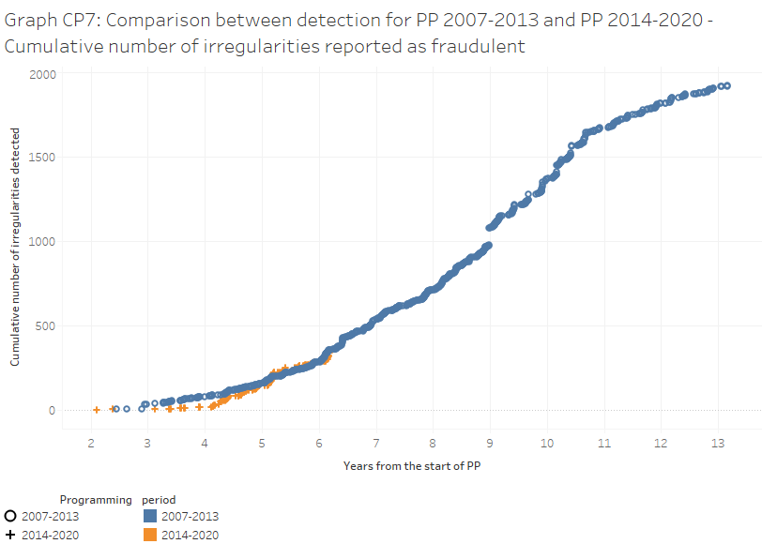

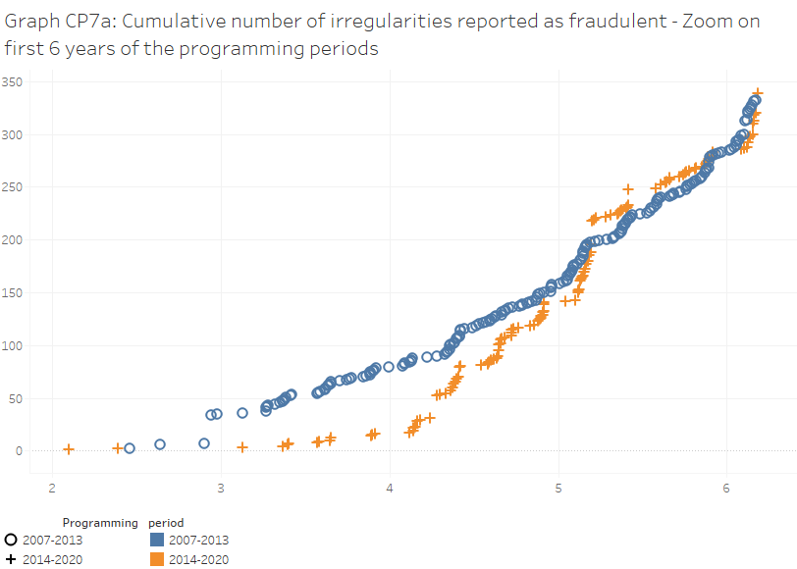

**Apart from outliers, the number and financial amounts reported as fraudulent by 2019 in relation to PP 2014-2020 were in line with those that had been detected in relation to PP 2007-2013.** As shown by Graph CP7 and Graph CP7a, the number of irregularities reported as fraudulent was similar for PP 2014-2020 and PP 2007-2013, after a comparable period from the start of the programming periods. There was a slower start of reporting related to the current programming period, but, during the fifth year of implementation, there was a strong acceleration that filled the gap. The comparison is more difficult in terms of financial amounts (see Graph CP8) because of the impact of a few cases involving exceptional financial amounts. The financial amounts reported in relation to PP 2014-2020 were much higher than for the previous PP, because there were two noticeable jumps at the beginning of the fifth and seventh years of implementation. The first upswing was due to the two cases reported by Slovakia in relation to ERDF, which totalled about EUR 590 million (see Section 4.1.1.1). The second jump was due to one case reported by Slovakia related to CF, accounting for more than EUR 270 million (see Section 4.1.1.2). However, it should be noticed that PP 2007-2013 experienced similar – if smaller - shifts, because, at the end of the fourth and sixth years of implementation, two cases were reported, which each accounted for about EUR 120 million. In addition, at the beginning of the sixth year, an irregularity accounting for about EUR 33 million was reported. Taking these outliers out of the analysis, the financial amounts involved in the fraudulent irregularities reported within PP 2014-2020 were aligned with those reported in relation to PP 2007-2013 during the same period after the start of the programming period.

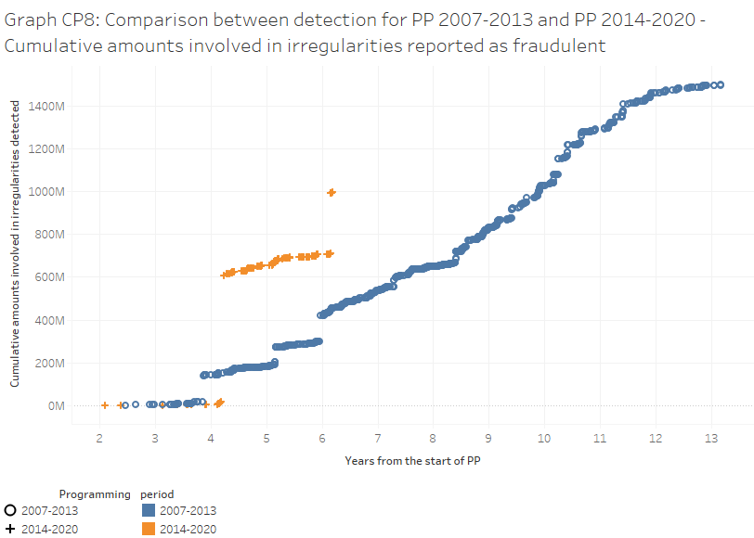

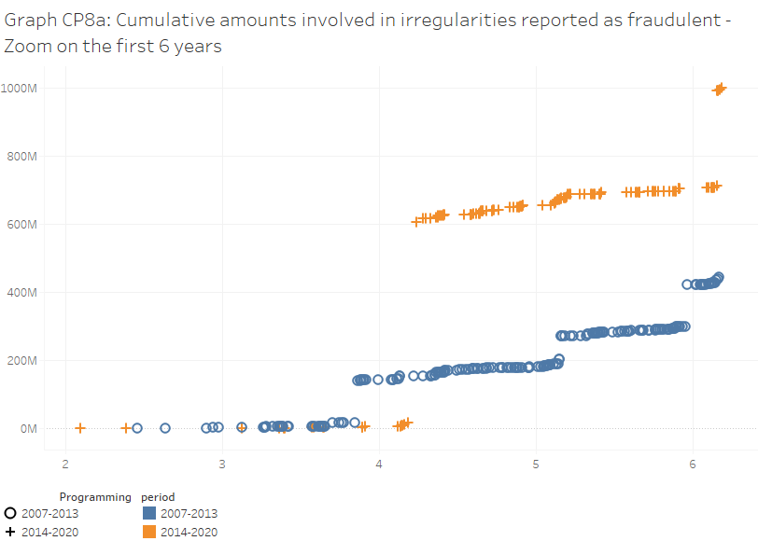

**This was the outcome of different patterns followed by different funds. Only for the ESF the detection and reporting of fraudulent irregularities was lower than before.** This is shown in Graphs CP9. The irregularities reported as fraudulent in relation to CF, ERDF and the fisheries funds significantly increased from PP 2007-2013 to PP 2014-2020. Those related to the ESF were lagging behind by a rather stable number of cases until the end of the sixth year. Then the gap increased due to an upswing of detected irregularities related to PP 2007-2013. However, the financial amounts associated with the fraudulent irregularities related to ESF for PP 2014-2020 were considerably higher than those for PP 2007-2013, at least until the beginning of the seventh year, when two cases totalling more than EUR 9 million were reported in relation to PP 2007-2013.

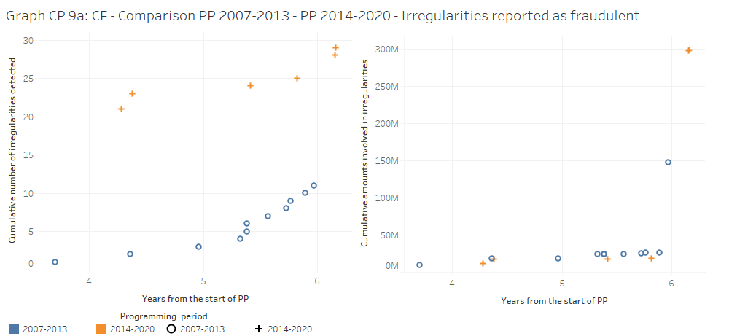

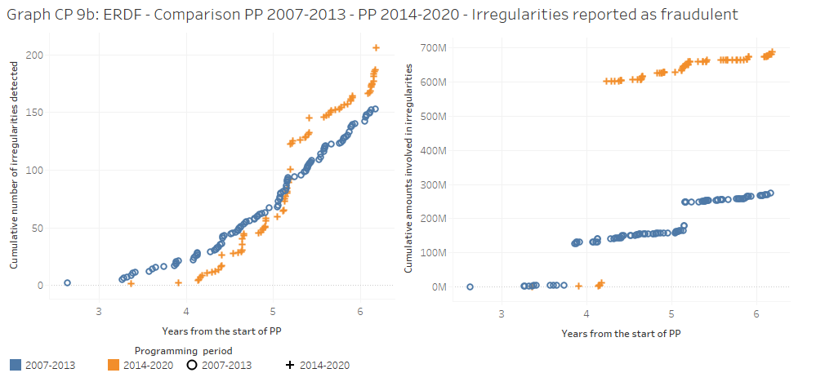

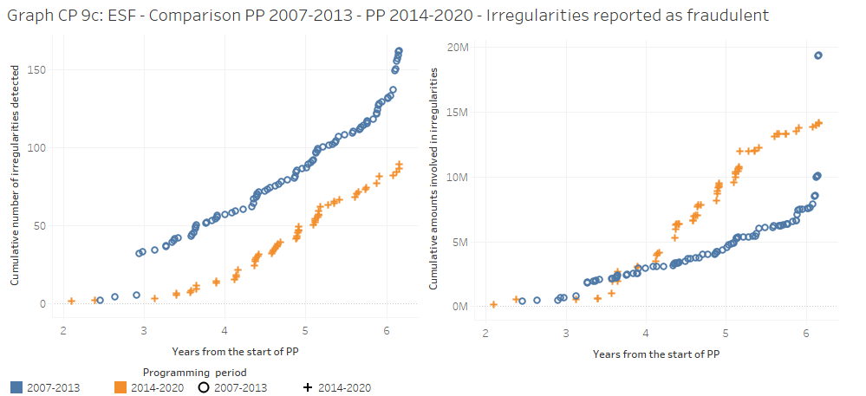

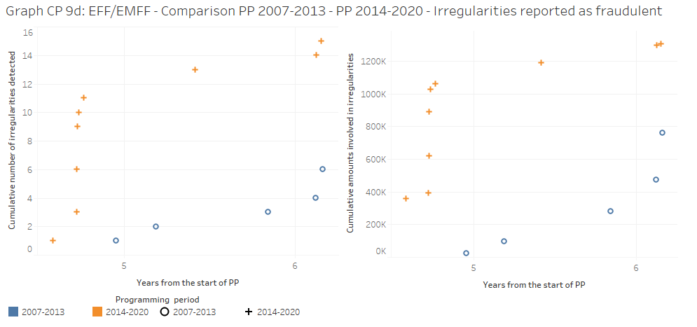

**While the increase in CF fraudulent irregularities was mainly due to detections in Slovakia, the surge concerning ERDF had a broader basis, with the highest increase in Hungary. The decline of ESF fraudulent irregularities was mainly due to the decrease recorded in Germany, which was influenced by reporting practices.** Twelve Member States recorded an increase of ERDF fraudulent irregularities (in particular, Hungary with 59 cases more than in PP 2007-2013, followed by Romania, +13, and Slovakia, +10) and for 10 Member States there was a decrease (in particular, Italy with 13 cases less than PP 2007-2013, followed by Poland and the UK, with 12 cases less). For the ESF, eigth Member States recorded an increase, while nine Member States recorded a decrease. However, the overall number of detections has been declining, because of a drop in the irregularities reported by Germany (- 59 cases)[21] and, to a lesser extent, Romania (-22 cases) and Bulgaria (-14 cases). The only Member State that recorded a significant increase was Poland (+25 cases).

**Focusing instead on the non-fraudulent irregularities, the fall in the number and financial amounts reported after six years from the start of the programming period is striking**. The irregularities not reported as fraudulent in relation to PP 2014-2020 showed completely different behaviour from PP 2007-2013 (see CP10 and CP11). This significant difference between these two programming periods warrants further analysis.

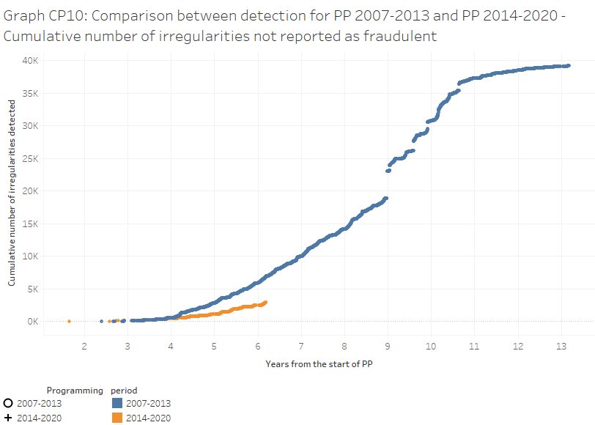

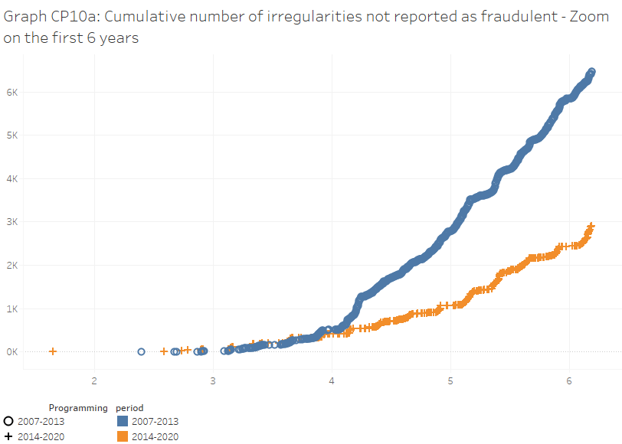

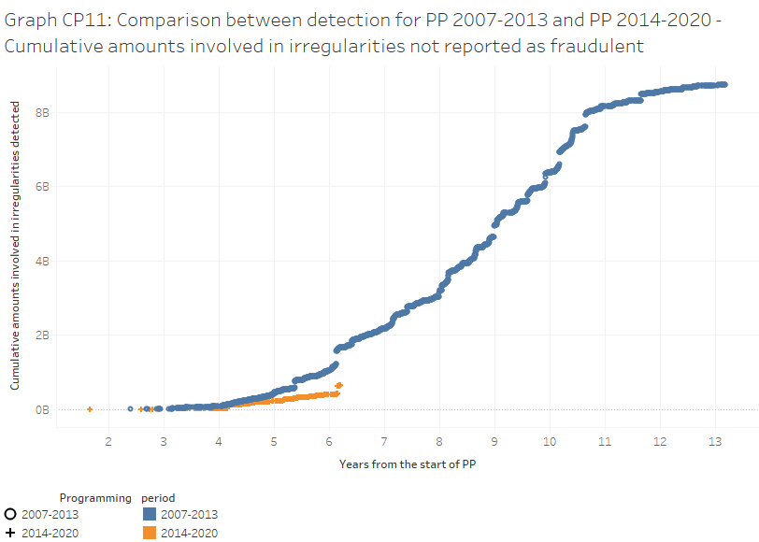

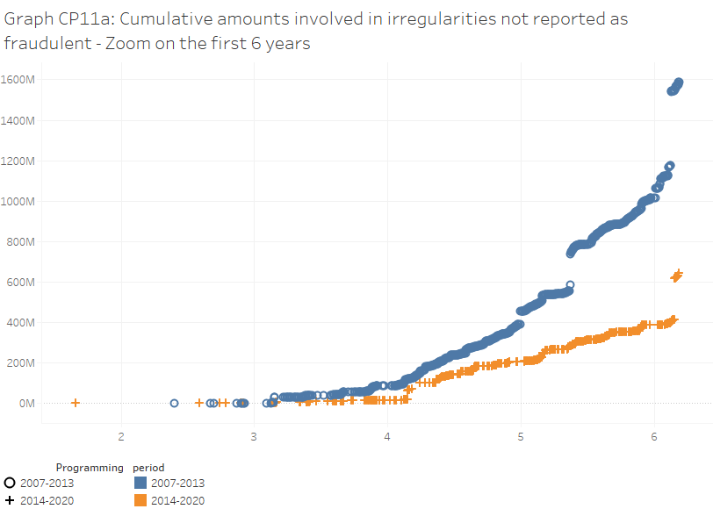

**Delayed implementation during the current programming period might be contributing to this drop. However, this can hardly justify a fall of 55% in irregularity reporting.** The number of irregularities not reported as fraudulent (and the related amounts) can be influenced by the state of implementation of the programming period. An indicator to gauge this state of implementation may be the interim payments that have been made to the Member States, as these payments should reflect the progression of eligible expenditure.[22] This is shown by Graph CP12, which covers CF, ERDF and ESF, as they absorb most of the financial resources. During the first six years from the start of PP 2014-2020 (from 2014 to 2019), the Member States have received less interim payments than during the first six years from the start of PP 2007-2013 (from 2007 to 2012). At the end of 2019, this (cumulative) gap still amounted to about -20% and it had been higher before (see Graph CP12). However, at least part of this gap may be simply due to the fact that interim payments are limited to 90% of eligible expenditure and the remaining 10 % is released after the yearly examination and acceptance of the accounts. As such, this would not reflect delayed implementation.[23] Overall, these findings suggest that the dynamics of the gap in interim payments may contribute to partly explain some of the difference in terms of number of non-fraudulent irregularities, but by far not all of it (as the total difference is about -55% - see Table CP12 and Graph CP10a).



**The number of detections related to PP 2007-2013 suddenly climbed at the beginning of the fifth year and then continued to increase at a sustained pace. During PP 2014-2020, reporting quickened about one year later and not at the same pace.** A closer look at Graph CP10a and the underlying data reveals that a significant share of the gap is due to a sudden acceleration in the number of irregularities related to 2010 (fourth year of implementation of PP 2007-2013), which were reported at the beginning of 2011. It was mainly due to irregularities reported by two Member States (Greece and the UK – see also below Graph CP14). Then during the fifth and sixth year of implementation (2011 and 2012) the number of irregularities continued to grow at a sustained pace. PP 2014-2020 followed a different pattern. There was no significant increase related to 2017 (fourth year of implementation, as it was 2010 for PP 2007-2013); reporting continued to raise at the same pace as before. At the beginning of 2019, reporting related to PP 2014-2020 accelerated, but still not at the pace of PP 2007-2013 during the sixth year of implementation. This can be noticed by comparing the slopes of the curves representing the cumulative number of irregularities related to the two PPs in Graph 10a: during the sixth year, the slope of the PP 2014-2020 curve increases, but but remains less than the slope of the PP 2007-2013 curve during the same number of years from the start of the programming period.

**The gap is significant for all funds, but in particular for the ERDF.** In Graphs CP13, the irregularities not reported as fraudulent are split by fund. The widest gap is recorded for the ERDF, for which the irregularities reported were just one-third of those reported during the first six years of PP 2007-2013. Also for the CF, ESF and the fisheries funds, there were significant gaps with respect to PP 2007-2013, even if they were not as wide as for the ERDF (-28% for the CF, -42% for the ESF, -47% for the fisheries funds, but -62% for the ERDF). Furthermore, for the CF, the financial amounts reported in relation to PP 2014-2020 were not far from those related to PP 2007-2013. For the ESF, the negative gap started to widen towards the end of the fifth year of implementation, both in terms of number and financial amounts. For the fisheries policy, the number of irregularities decreased (from 104 for PP 2007-2013 to 55 for PP 2014-2020), while the curves of the financial amounts have been overlapping until the end of the sixth year, before diverging due to a sudden upswing of the financial amounts related to PP 2007-2013.

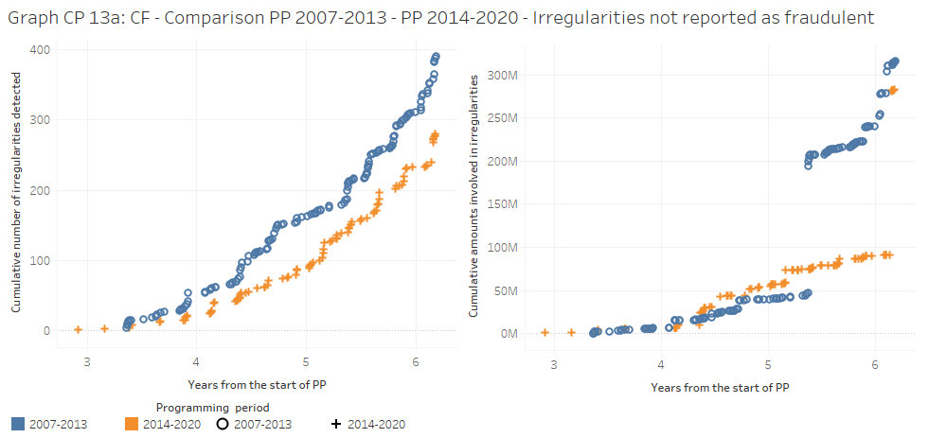

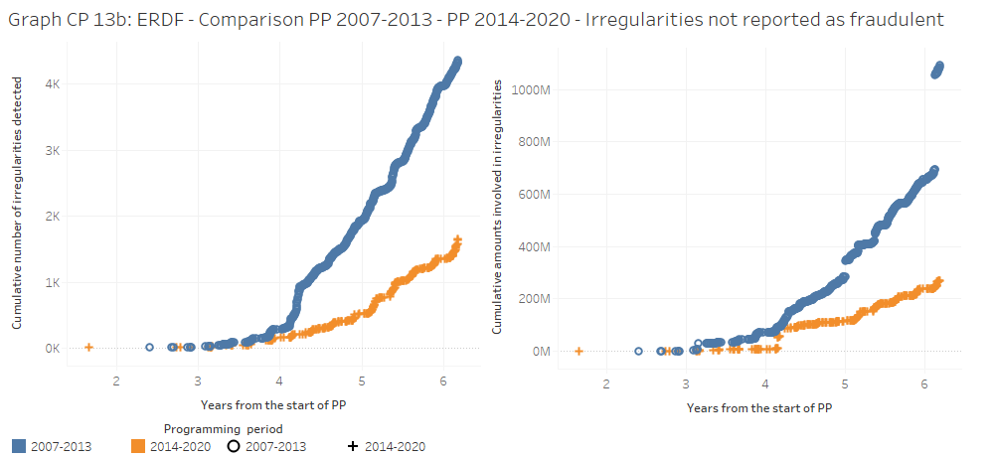

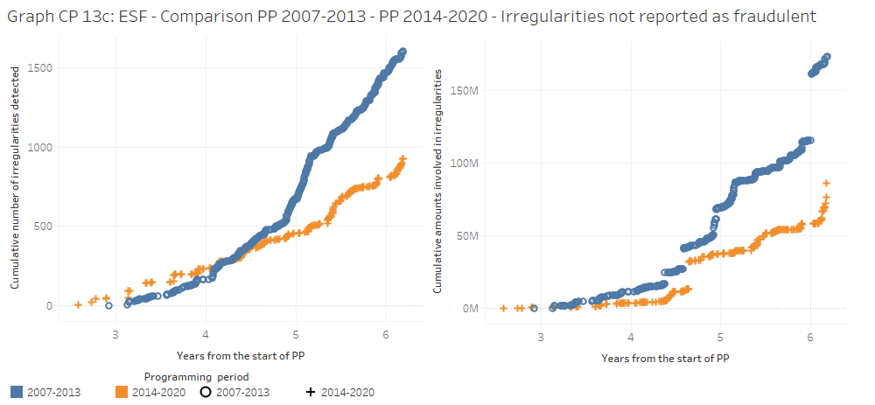

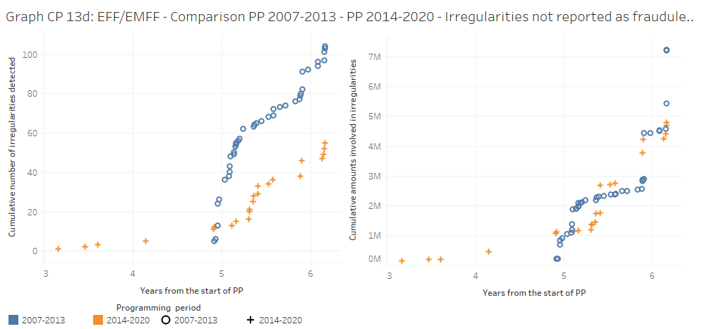

**With reference to ERDF, for the majority of Member States, the numbers of non-fraudulent irregularities related to the two PPs were on persistently diverging paths. Further analysis by the compentent authorities of the MS would be warranted, including of trends for the other funds.** Given that ERDF showed the widest gap between PP 2007-2013 and PP 2014-2020, Graph CP14 shows the comparison, Member State by Member State, in terms of number of irregularities not reported as fraudulent, with specific reference to this fund. These data should be read while comparing the stage of implementation of the two PPs, for example on the basis of the payments already received by the Member State (see above), but this is outside the scope of this Report. This analysis can be performed by the compentent authorities in the Member States, not only for ERDF trends, but also with reference to the other funds. For the majority of Member States, the detections of ERDF non-fraudulent irregularities related to the two PPs were on persistently diverging paths (Austria, Belgium, Czechia, Germany, Spain, Greece, Italy, Lithuania, Latvia, the Netherlands, Poland, Portugal, Romania, Sweden, Slovenia and the UK). For other Member States, at the cut-off dates, the gap was significant, while there had been times during these six years when the number of non-fraudulent irregularities related to PP 2014-2020 were nearer to those related to PP 2007-2013 (Estonia, Slovakia and the UK). In Bulgaria, the gap was less significant. Apart from Member States that reported very few irregularities, France, Croatia and Hungary were the only Member States with more non-fraudulent irregularities in PP 2014-2020 than in PP 2007-2013. During the first six years of both PP 2007-2013 and PP 2014-2020, Ireland and Luxembourg have not reported any non-fraudulent irregularity related to ERDF.

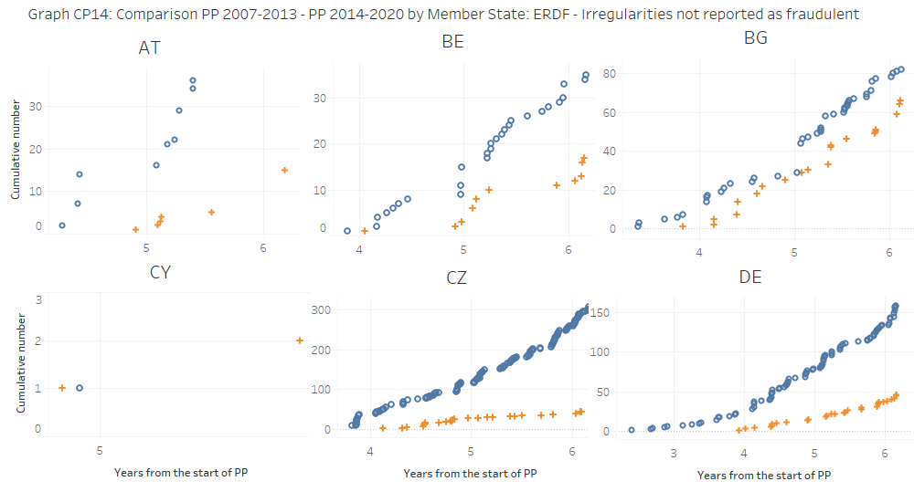

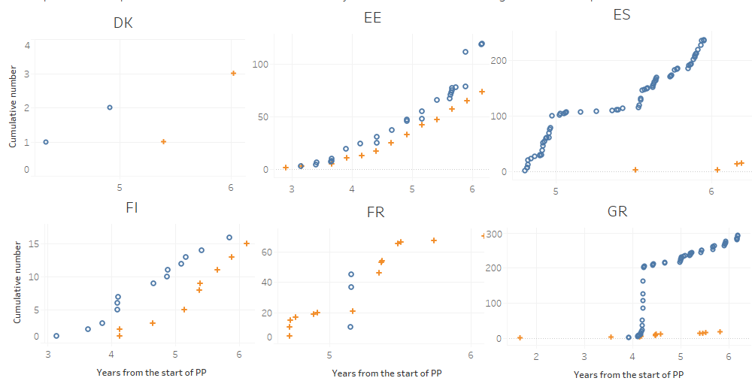

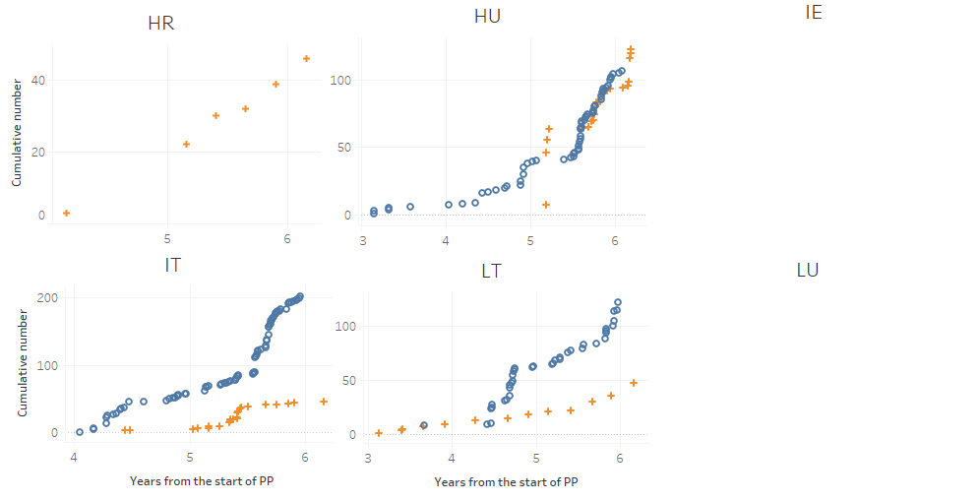

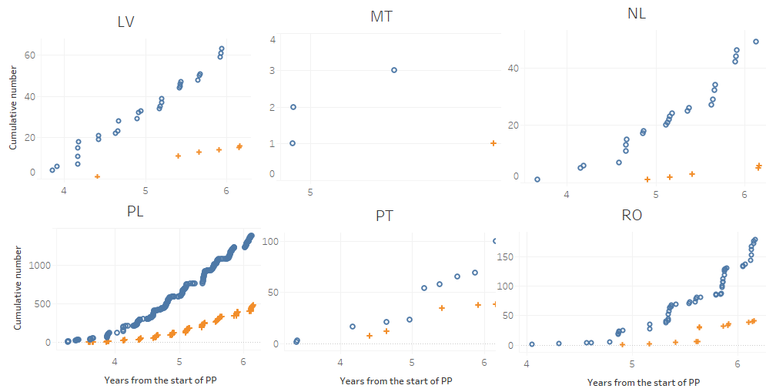

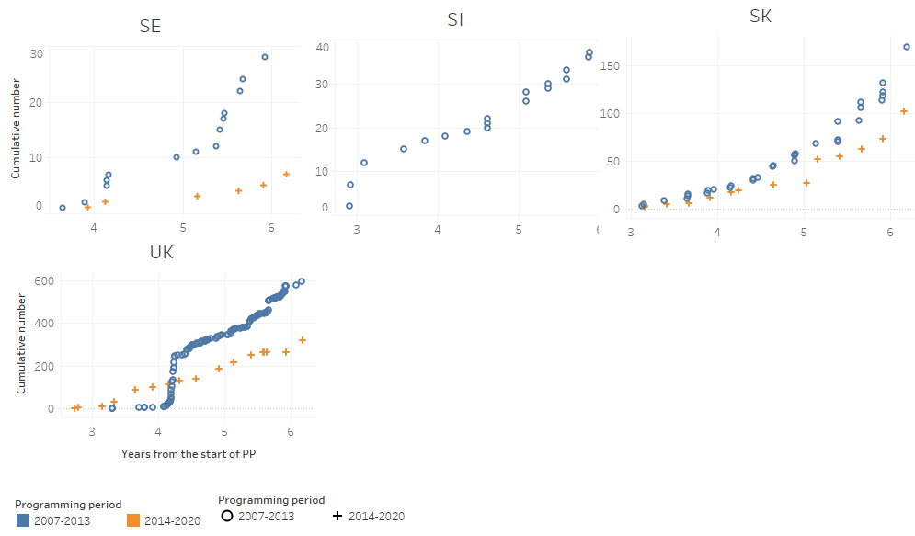

**The drop of reporting related to ERDF was generalised also in terms of irregular financial amounts.** Graphs CP15 shows the same comparison Member State by Member State, but in terms of financial amounts. For the majority of the Member States, the financial amounts involved in non-fraudulent irregularities related to the two PPs were on persistently diverging paths (Austria, Czechia, Germany, Estonia, Spain, Greece, Hungary, Italy, Lithuania, Latvia, the Netherlands, Poland, Portugal, Romania, Sweden, Slovenia, the UK). For other Member States there was no significant gap or the irregular financial amounts detected in relation to the current PP were higher than those related to PP 2007-2013, such as for Belgium, Bulgaria, France, Croatia, Slovakia. As mentioned, during the first six years of both PP 2007-2013 and PP 2014-2020, Ireland and Luxembourg have not reported any non-fraudulent irregularity related to ERDF.

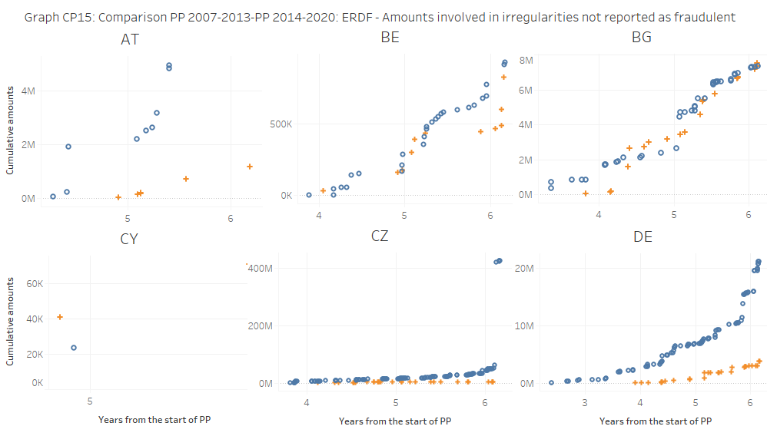

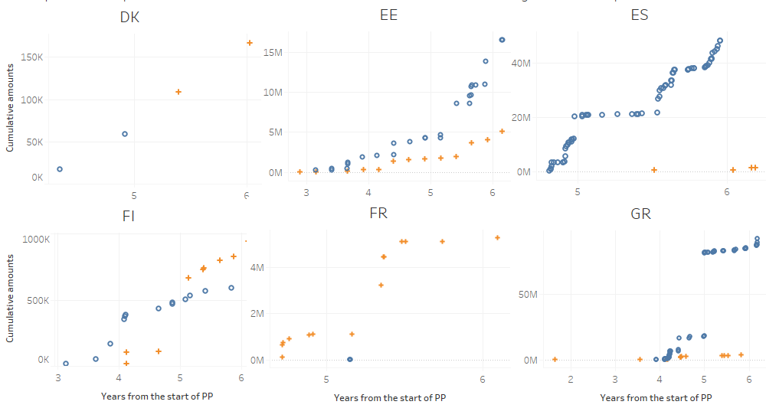

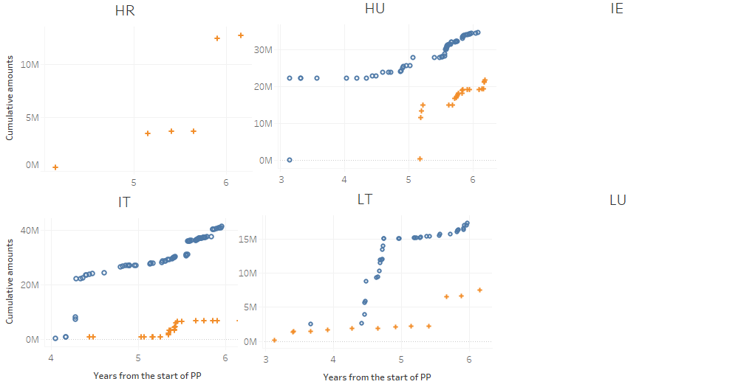

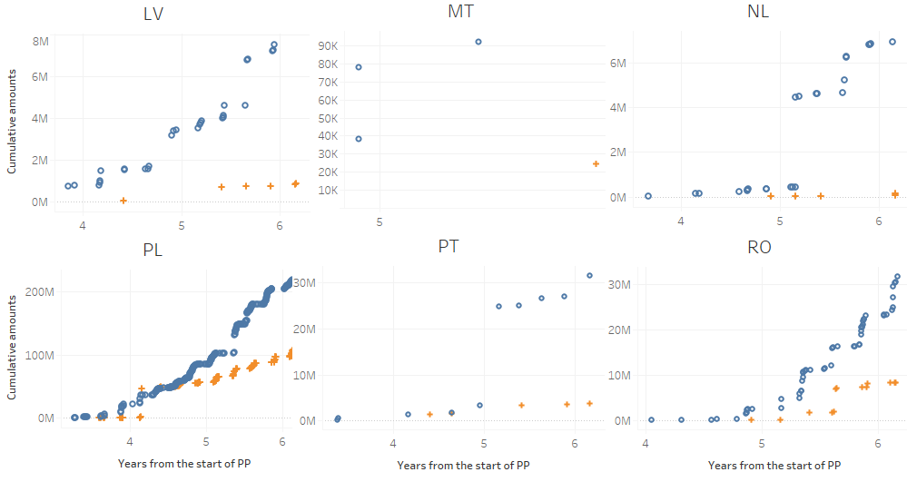

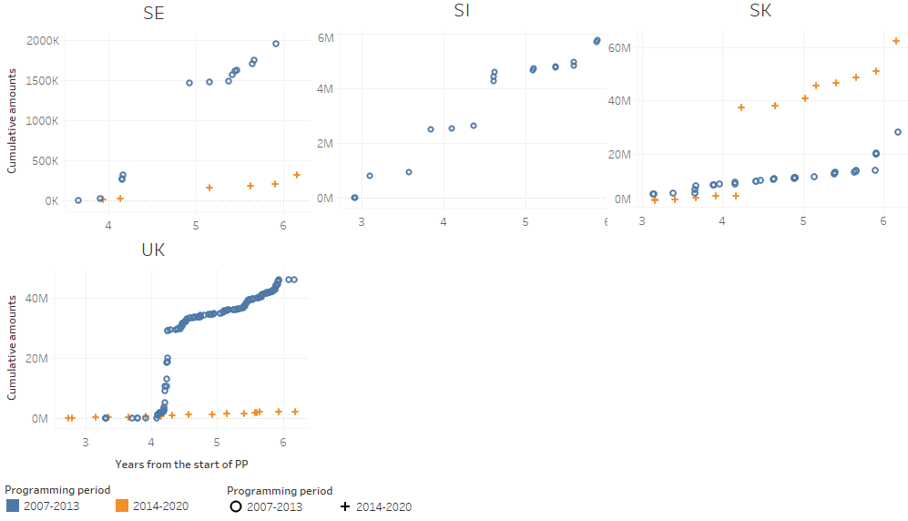

**For all funds, the competent national authorities can build on this analysis, to understand the causes of these trends in the different Member States. If they are due to different rules/prevention activities in comparison to the previous PP, the measures that brought these huge changes should be identified. If they are due to less enforcement or to reporting issues, these shortcomings should be acted upon** **in a timely manner.** The above reported comparative analysis between PP 2007-2013 and 2014-2020 suggests the need for the Member States to monitor the situation carefully, also in order to exclude that the decrease of non‑fraudulent irregularities is due to a decline in the intensity or quality of detection activities. As mentioned, this decrease might be partly due to a slower implementation of PP 2014-2020 in comparison with PP 2007-2013. However, even if this could be part of the explanation, it does not seem to be enough to account for the huge fall in non-fraudulent irregularities reported by the Member States in relation to all funds. Besides detection efforts and degree of implementation, other explanatory factors may lay in differences in the management and control systems of the different Member States in relation to the two programming periods, with an impact in terms of prevention.

**A number of rules changed from PP 2007-2013 to PP 2014-2020.** In general, rules on thematic concentration[24] might have led to more effective spending. Focusing more on the management side, the 2007-2013 National Strategic Reference Frameworks (NSRF) have been replaced with the 2014-2020 Partnership Agreements. *Inter alia*, the latter must present an assessment of the administrative capacities of the authorities involved in implementation of the ESI Funds together with – where necessary – a summary of actions in order to improve them.[25] Last but not least, the legal framework at the basis of PP 2014-2020 requires the managing authorities to put in place effective and proportionate anti-fraud measures taking into account the risks identified.[26]

**One of these changes concerns wider use of simplified cost options (SCOs). This may be relevant for the ESF, but not for the ERDF and CF, given the low adoption of SCOs in these funds. In any case, the situation should be closely monitored.** For PP 2014-2020, the possibility to use SCOs has been extended, but the impact depends on the extent to which implementing partners used this possibility. For PP 2007-2013, about 7% of the declared ESF expenditure was under SCOs, with significant differences from one Member State to another. According to estimates made in 2016 and 2018, for PP 2014-2020, this percentage was expected to rise to 33-35% for the ESF by the end of the programming period. However, the expectation concerning the percentage of the ERDF-CF budget covered by SCOs was much lower, at 4%. Strong differences among Member States were expected.[27] Consequently, for the ESF, the increase of the percentage of expenditure covered by SCOs (from 7% to 33%) together with some implementation delays (still 17% at the end of 2019, as measured through interim payments) may have been contributing factors to the drop of non-fraudulent irregularities (decrease by 42%). However, the situation should be closely monitored, also because (1) any possible effect of delayed implementation will fade (2) it is not clear whether the increased use of SCOs will actually materialise (3) it is not clear to what extent the increased use of SCOs will concern projects that are more relevant for irregularity reporting[28]; and (4) it is not clear when, during the programming period, the impact of increased SCOs adoption on irregularities patterns can be more significant. In addition, the fact that the number of irregularities dropped even more for the ERDF, where the adoption of SCOs was very low, may point to other factors, which could apply also to the ESF.

**Another change that may be of relevance to explain the pattern of non-fraudulent irregularities is the introduction of annual accounts.** As from PP 2014-2020, accounts are prepared by the Member States and then examined and accepted by the Commission each year (instead of at the closure of the programming period only).[29] This might have contributed to strengthening internal control at Member State level. In this framework, Member States may have an increased tendency to exclude from the annual accounts expenditures whose legality and regularity they have doubts. Such expenditures can be included in an application for interim payment relating to subsequent accounting years, while being automatically recovered by the Commission during the current year (without constituting a financial correction and without reducing support from the fund to the relevant operational programme).

**These are just a few possible examples of factors that might potentially influence the number of irregularities, but the actual relevance and impact of these and other changes in the different Member States should be properly evaluated before being taken as the explanation of a persistent decline in detections.**

**The most reported irregularity types detected by the Member States can shed further light on differences between PP 2007-2013 and the current PP.** Changes in the legal framework and implementation context, including anti-fraud systems, may be reflected in the type of irregularities detected in the Member States. The following tables provide an overview for the irregularities reported as fraudulent (Table CP14) and not reported as fraudulent (Table CP15) by the Member States in relation to PP 2007-2013 and PP 2014-2020. As above, for PP 2007-2013, only the irregularities that had been reported after a comparable amount of time from the start of the programming period are considered. See Annex 13 for the specific types of violations (IMS codes) that are included in the categories mentioned in Tables CP14 and CP 15.





**Both for fraudulent and non-fraudulent irregularities, the number of detections related to non-eligibility and to the implementation of the action strongly declined.** **The decrease of eligibility violations might be related to increasing use of SCOs. However, if this were actually the case, the more stringent controls on the implementation of the action that should accompany this change could be expected to lead to the detection of more of this type of irregularities.** **This increase may come later, if the timing of verifications on projects’ implementation is different from the timing of verifications on the eligibility of costs.** For the irregularities reported as fraudulent (see Table CP14), there were significant increases in the number of cases related to false documents, infringement of public procurement rules[30] and conflict of interest[31]. The most significant declines concerned violations related to eligibility and the infringement of contract provisions/rules, in particular action not implemented[32]. For the irregularities not reported as fraudulent, as expected from the findings above, Table CP15 shows a generalised decrease for all categories of violations. For each of the four most reported categories for PP 2014-2020, the number of cases where they were mentioned dropped significantly. Violations concerning eligibility or implementation of the action fell by 77% and 52%, respectively. Concerning the implementation of the action, the specific type of infringement that decreased the most was ‘*Other*’ so it provides no further information. Other specific types that were significantly less reported were related to ‘*Failure to respect deadlines*’ and ‘*Irregular termination, sale or reduction’*. There were also specific types of ‘implementation’ infringements that were reported more, such as ‘*Action not completed*’ and ‘*Control not carried out in accordance with the rules*’[33]. For both public procurement infringements and incorrect/missing/false supporting documents, the drop was about two thirds.

4.2. Specific Analysis – Irregularities reported in relation to the Programming Period 2007‑2013

This section of the analysis focuses on the irregularities reported in relation to the PP 2007-13. The closure for the programming period started in March 2017[34]; it therefore offers an ideal opportunity to present an overview of what has happened. Consequently, the analysis will cover a greater time span than the previous section (2015 to 2019), to examine all information available, which dates back to 2008. Comparisons between the first years of implementation of PP 2007-2013 and the situation concerning PP 2014-2020 until December 2019 are included, where relevant.

It will cover the following aspects:

* Objectives;
* Priorities and themes affected;
* Types of irregularity

4.2.1. Objectives concerned by the reported irregularities

**The reported irregularities followed the pattern that could be expected in relation to the implementation cycle. The majority of detections concerned the ‘Convergence’ objective.** As shown by Table CP16, the majority of the irregularities were reported over the period 2015-2017, which was between the ninth and eleventh year from the start of the programming period. They mainly concerned the Convergence objective (60% of the total), in line with the fact that this is the objective to which the greatest financial resources were allocated. The anomaly concerning the year 2015 has already been explained (see Section 4.1). For 175 irregularities, the objective was not mentioned by the Member States (less than 0.5% of all irregularities).



**The irregular financial amounts broadly followed a pattern similar to that of the number of irregularities and they mostly concerned the ‘Convergence’ objective.** Table CP17 provides information about the financial amounts involved in the reported irregularities. The trend of irregular financial amounts diverged from that of number of detections in few instances:

* the ‘Convergence’ objective: the irregular financial amounts reported in 2012 exceeded those related to 2013 and 2014. In addition, the irregular financial amounts related to 2016 were higher than those reported in 2015 (which was the peak, in terms of numbers). In 2016, irregular amounts reported in relation to the Cohesion Fund were exceptionally high, as already shown in Table CP3 and highlighted in Section 4.1;
* the Multiobjective actions: in 2018, the irregularities fell abruptly while the financial amounts involved were stable. This was impacted by two cases reported in 2018 by Slovakia, whose irregular financial amounts totalled about EUR 160 million. To put this into perspective, it can be considered that the two largest cases reported during the previous year (by Spain) totalled up to about EUR 75 million.

As for the number of irregularities, the majority of financial amounts were notified during the period 2015-2017 and mainly concerned the Convergence objective (75%).



4.2.1.1. Irregularities reported as fraudulent by Objective

**In 2016, irregularities reported as fraudulent peaked for the ‘Convergence’ objective and nearly dropped to zero for ‘Regional competitiveness and employment’.** Tables CP18 and CP19 include only the irregularities reported as fraudulent in relation to PP 2007-13. The trends are similar to those presented in the previous section for all irregularities. A difference that is worth highlighting is the strong increase in the number of irregularities in 2016 in relation to ‘Convergence’ (while the sum of fraudulent and non fraudulent irregularities decreased) and the exceptional drop in 2016 in relation to 'Regional competitiveness and employment'.

**With reference to the financial amounts, fluctuations are emphasized, as high profile cases can have a significant impact.** **‘Convergence’ was the most affected objective both in terms of numbers and, even more, financial amounts.** It is worth highlighting the record-high reporting of irregular financial amounts in 2018 for the Multiobjective. This was due to two large cases reported by Portugal and Czechia, summing up to about EUR 45 million. Also with specific reference to fraudulent irreguarities, the *‘*Convergence’ objective accounted for most of the detections (69%) and related financial amounts (88%), even more than for all irregularities (where these percentages were 60% and 75%, respectively – see above).



**Irregularities reported as fraudulent represented 4.7% of the total number of irregularities reported for PP 2007-13.** The highest percentage (FFL[35]) was related to the ‘Fisheries’ (6.5%), the ‘European Territorial Cooperation’ (about 7%) and to the ‘Convergence’ (about 5.5%) objectives. ‘Regional competitiveness and Employment’ had the lowest FFL (2.7%).



**Financial amounts involved in irregularities reported as fraudulent represented 14.7% of the total reported for PP 2007-13.** The highest share (FAL[36]) was related to ‘Fisheries’ (17.3%), followed by ‘Convergence’ (about 17%), and the ‘European Territorial Cooperation’ (19%). ‘Regional competitiveness and Employment’ had the lowest FAL (4.7%).

**The difference between FFL and FAL indicates the higher financial impact of fraudulent irregularities compared to the non-fraudulent infringements.** In fact, the average financial value involved in irregularities reported as fraudulent is more than three times higher than that related to the non-fraudulent types.

4.2.1.2. Fraud and Irregularity Detection Rates by Objective

Table CP20 shows the FDR and the IDR per objective.



**Detection for different objectives ranged between 0.5% to 3.3%.** Looking at the overall detection rate (FDR+IDR), ‘Regional competitiveness and employment’ programmes show a relatively low level of detection. ‘European Territorial Cooperation’ programmes, however, show an anomalously low level of detection (about four times lower than the second lowest objective), especially considering that the previous two indicators (FFL and FAL) were high. The situation is different for ‘Multiobjective’ programmes, ‘Convergence’ and ‘Fisheries’, where the detection rate was about 3%.

4.2.2. Priorities concerned by the reported irregularities

4.2.2.1. Irregularities reported as fraudulent (fisheries not included)

The operational programmes financed by the Cohesion Policy are implemented in relation to the already mentioned objectives, but also along identified Priorities and Themes. The information provided by the Member States allows for an analysis of the priority areas in relation to which projects potentially affected by fraudulent practices have been identified. Table CP21 shows the number of irregularities reported as fraudulent by priority area since the beginning of the PP 2007-2013, their related financial amounts, the average amount per irregularity, FFL, FAL and FDR.

**Of the irregularities reported as fraudulent, 40% were related to three priorities.** In terms of numbers, the priorities most concerned were *'Research and Technological Development, innovation and entrepreneurship*' (going forward, *‘RTD’*), '*Increasing the adaptability of workers and firms, enterprises and entrepreneurs*' and '*Improving access to employment and sustainability*'.

**On average, one irregularity out of 20 was reported as fraudulent. For the priorities most affected, this concerned nearly one irregularity out of ten.** FFL was the highest for '*Tourism*' (9.9%). The following three top priorities (in terms of FFL) in Table CP21 were all between 8 and 9%, which was about double the average.[37]

**From the financial amount point of view, the most significant impact concerned *'RTD*' and '*Transport'.***Financial amounts related to the irregularities reported as fraudulent in relation to these two priorities represented 43% of the total. ‘*Transport*’ retained by far the highest average value, about eleven times ‘*RTD’* and the overall average. These two priorities were followed, at a distance, by *'Urban and rural regeneration', 'Environmental protection and risk prevention'* and *'Tourism'.*

**On average, EUR 15 Euro out of EUR 100 of irregular financial amounts in the Cohesion policy were reported as fraudulent.** **For the priorities most affected, this was nearly EUR 30 out of EUR 100.** FAL was the highest for '*Urban and rural regeneration*' (about 34%), '*Improving human capital*' (31.5%) and '*Tourism*' (about 29%). The priorities '*Tourism*' and '*Urban and rural regeneration*' stood out also in terms of FDR.



Irregularities linked to the EFF have not been included. Reference to '*Technical assistance Fisheries*' and '*Measures of common interest – fishery*' in Table CP21 may depend on errors in encoding by Member States.

**For one-fourth of the irregularities, the Member States did not specify a priority, which affects this analysis.** For about 26% of the irregularities used for this analysis, information was not provided as to the priority area concerned. This percentage increased in comparison with previous years, but just because the total number of irregularities reported as fraudulent decreased.

Table CP22 is related to PP 2014-20. It shows the number of irregularities reported as fraudulent by priority area since the beginning of the PP, their related financial amounts, and allows the comparison with the situation concerning PP 2007-2013 when the same amount of time had passed after the start of the programming period. [38] Comparison with the full 2007-2013 would be misleading as projects pertaining to different priorities can have different implementation timelines, which may influence the time when irregularities are more likely to be detected.



**For PP 2014-2020, the reporting of the priorities improved, but the Member States have still been using the PP 2007-2013 priorities for the PP 2014-2020 irregularities.** First of all, in Table CP22, it can be noticed that the fraudulent irregularities detected by the Member States were rather stable from the previous to the current programming period. The number of cases where the priority was not specified decreased from more than 43% to less than 14%, which was a remarkable improvement.[39] However, the priorities for the PP 2014-2020 are listed in the Commission Implementing Regulations (EU) 184/2014 and 215/2014 and they are different from the priorities for PP 2007-2013. In Table CP22, the priorities for PP 2014-2020 are reported in white; basically, contrary to the Regulations in force, the Member States continued to encode the irregularities in IMS using the priorities that were valid for PP 2007-2013. While the situation improved in comparison with last year, the correct priorities were used only in about 10% of the irregularities.

**With reference to PP 2014-2020, the prevalence of the priority '*RTD*' was even more marked than for PP 2007-2013**. The priority *'Increasing the adaptability of workers and firms, enterprises and entrepreneurs’* ranked second in relation to PP 2014-2020, with an increasing number of cases with respect to PP 2007-2013, but lower financial amounts involved. A relatively high number of irregularities (and related financial amounts) have been detected in relation to '*Environment protection and risk prevention*', which was not yet the case at the same stage of PP 2007-2013. This was primarily due to reporting by Slovakia. While ranking third, the number of irregularities related to the priority ‘*Improving access to employment and sustainabily*' decreased from PP 2007-2013, also when considered together with the new PP 2014-2020 priority ‘*Promoting sustainable and quality employment and supporting labour mobility*’.

4.2.2.2. Irregularities not reported as fraudulent (fisheries not included)

The same analysis shown in the previous section for the irregularities reported as fraudulent is presented here for the irregularities not reported as fraudulent in relation to the PP 2007-13. Table CP23 provides an overview of the number of irregularities not reported as fraudulent by priority area since the beginning of the PP 2007-13, their related financial amounts and average amount per irregularity and IDR.

**Irregularities related to ‘*RTD’*, ‘*Environmental protection and risk prevention*’ and '*Transport*' represented 25% of the total number and 47% of the total amounts. Irregularities related to funding to improve human capital and employment[40] were also frequent (12% of detections), but with lower financial impact (5% of the amounts).** ‘*RTD*’ was the priority with the highest number of occurrences, followed by ‘*Environmental protection and risk prevention*’. Then there were four priorities that each recorded between 1,500 and 2,000 irregularities. Two of them relate to investments in infrastructures ('*Investment in social infrastructure*' and '*Transport*') while the other two refer more to investing in human capital (‘*Increasing the adaptability of workers and firms, enterprises and entrepreneurs*' and '*Improving human capital'*). ‘*RTD*’ was first also in terms of financial amounts, closely followed by '*Transport*' and, at a distance, ‘*Environmental protection and risk prevention*’.

**The priorities '*Tourism*', ‘*RTD*’, *'Information society'* and ‘*Transport*’ show an IDR greater than or equal to 2%.**



Irregularities linked to the EFF have not been included. Reference to priorities specific to this policy area may depend on errors in encoding by national authorities.

**For more than 40% of the irregularities, the Member States did not specify a priority, which affects this analysis.** The number of cases not reported as fraudulent for which information about the priority area concerned was missing remained high (42%) and higher than for the fraudulent irregularities, although it was improving.

Table CP24 is related to PP 2014-20. It shows the number of irregularities not reported as fraudulent by priority area since the beginning of the PP, their related financial amounts, and allows the comparison with the situation concerning PP 2007-2013 when the same amount of time had passed after the start of the programming period.



**For PP 2014-2020, the reporting of the priorities improved, but the Member States are continuing to use the PP 2007-2013 priorities for the PP 2014-2020 irregularities.** As highlighted in Section 4.1.3, non-fraudulent irregularities detected by the Member States decreased by about 60%. The number of cases where the priority was not specified decreased from more than 47% to 15%, which is a remarkable improvement that significantly impacts on the comparison between single priorities in different programming periods. In relation to the first six years of implementation of PP 2007-2013, 2,997 non-fraudulent irregularities were reported without specifying a priority and thus can not be part of this analysis. In relation to PP 2014-2020, this number declined to just 419. As mentioned above, there are new priorities for PP 2014-2020, which are reported in white in Table CP24. Contrary to the Regulations in force, the Member States continued to encode the irregularities in IMS using the priorities that were valid for PP 2007-2013. The correct priorities were used only in about 20% of irregularities (last year, this percentage was just about 3%).

**The comparison between the two programming periods is particularly difficult because of the mixing of old and new priorities and the marked decrease of irregularities without priority.** Comparability is limited because, as mentioned, the priorities for PP 2014-2020 are different from the priorities 2007-2013. In addition, as mentioned, any change highlighted in Table CP24 must be interpreted keeping in mind that it may have been influenced by the huge difference between the two PP, in terms of cases where the priorty was not specified. However, it can be noticed that '*RTD, innovation and entrepreneurship*' was the priority most affected by irregularities, with the second highest financial amounts involved. In addition, under PP 2014-2020, this type of actions is covered by the priority ‘*Development of endogenous potential’*, which is the PP 2014-2020 priority most affected by non-fraudulent irregularities during the first six years of implementation. The highest financial amounts were associated to the new PP 2014-2020 priority ‘*Infrastructure providing basic services and related investment’,* in particular the theme ‘*TEN-T motorways and roads — core network’* (all irregularities reported by Slovakia). The increase in the irregularities related to the priorities concerning energy[41] and social inclusion was noticeable, in both instances mostly due to reporting by the UK and Poland.

4.2.2.3. Irregularities related to investments in health, education and social infrastructure

The 2017 PIF Report included an analysis by themes of the priorities '*RTD*' and '*Transport*'. [42] In the 2018 PIF, the focus was on the priorities *'Tourism'* and ‘*Environmental protection and risk prevention*’. [43]

**This year the focus is on investment in health, education and social infrastructures.** This choice follows the COVID-19 crisis, which could call for more funding in particular to the health sectors, in the years to come. It is therefore important to analyse the irregularities that affected this area so far, considering both the experience made during the whole PP 2007‑2013 and what is already emerging in relation to the current programming period.

**The priorities under the two programming periods are comparable, so the related irregularities can be considered together, for the purpose of this analysis.** Under PP 2007-2013, one of the priorities was ‘*Investment in social infrastructure*’, which covered education, health, childcare, housing and other social infrastructure. Under PP 2014-2020, the priority ‘*Social, health and education infrastructure and related investment*’ broadly covers the same type of expenditure.

**The highest number of detections and financial amounts were associated with actions for education infrastructure. However, irregularities were frequent also in investments in health infrastructure and these were more costly. Of these irregularities, 5% were reported as fraudulent, accounting for 8% of the irregular financial amounts.** Figures CP1 and CP2 focus on the irregularities reported as fraudulent and non-fraudulent, respectively. The larger the square, the higher the number of detections; the darker the square, the higher the financial amounts involved. Actions concerning health infrastrucure were affected by 25 fraudulent irregularities, accounting for about EUR 9.5 million and 469 non‑fraudulent irregularities, accounting for about EUR 105.5 million. The AFA involved in irregularities related to health infrastructures were higher than those related to education infrastructure; AFA of health infrastructure were about EUR 375,000 and EUR 225,000, respectively, for fraudulent and non-fraudulent irregularities, while the values for education infrastructure were EUR 149,000 (fraudulent) and EUR 144 000 (non-fraudulent).

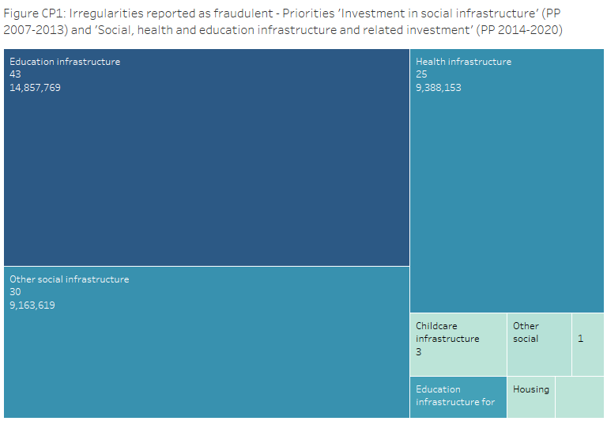

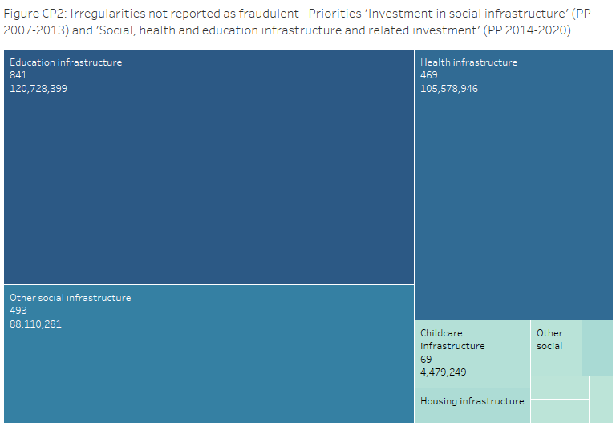

**Fifteen MS reported irregularities in actions related to health infrastructures (in particular Poland, Hungary and Slovakia); seven of them also detected fraud (in particular Romania and Slovakia).** In Maps CP1 and CP2, the number of detections is explicitly below the name of the Member State. In addition, the darker the Member State in the map, the higher the financial amounts involved. Maps CP1a and CP1b refer to all investments in social infrastructure. Concerning cases reported as fraudulent, the Member States with the highest number of detections and irregular financial amounts were Latvia, Slovakia and, to a lesser extent, Romania. Reporting of non-fraudulent irregularities was more widespread, with Poland leading in terms of numbers and Slovakia in terms of financial amounts. Maps CP2a and CP2b focus on health infrastructure. More than half of the fraudulent irregularities and related financial amounts were reported by Romania and Slovakia. More than one third of the non-fraudulent irregularities were detected by Poland, while Slovakia reported more than half of the irregular financial amounts.

*Maps CP1: Priorities 'Investment in social infrastructure' (PP 2007-2013) and 'Social, health and education infrastructure and related investment' (PP 2014-2020)*

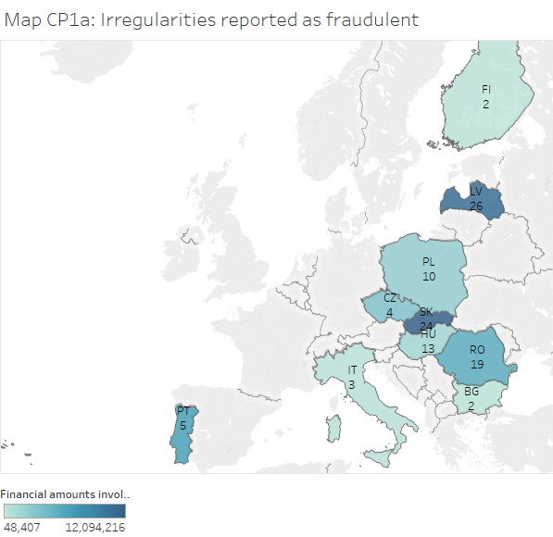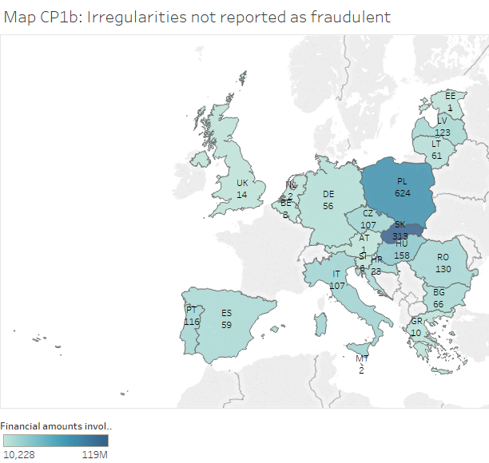

*Maps CP2: Theme 'Health infrastructure' (PP 2007-2013 and PP 2014-2020)*

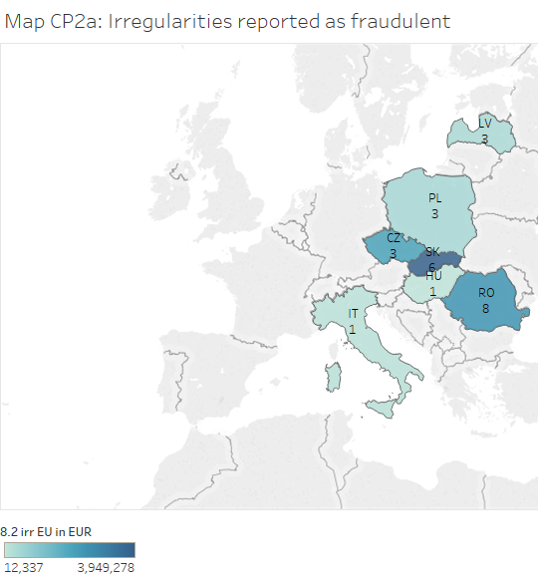

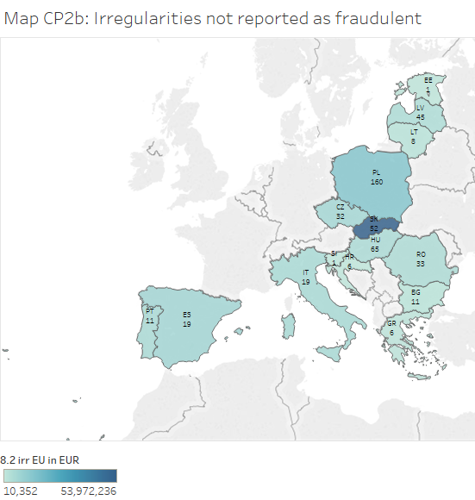

**Actions related to health infrastructure are strongly affected by violations of public procurement rules.** Considering investments in social infrastructure (Table CP 25[44]), infringements of public procument rules concerned 21% and 59% of fraudulent and non‑fraudulent irregularities, respectively. Focusing on health infrastructures (Table CP 26), these percentage were 16% and 69%. Irregularities affected by public procurement violations represented an even more significant share in terms of financial amounts: 29% and 60% (fraudulent and non-fraudulent, respectively), changing to 24% and 77% when focusing on health infrastructure. With specific reference to health infrastructure, the range of violations was wide and included pre-tendering infringements, such as unlawful and/or discriminatory selection and/or award criteria in the tender documents, selection criteria not related and not proportional to the subject matter of the contract, discriminatory technical specifications, infringements related to the tendering phase, such as lack of transparency and/or equal treatment during evaluation, and post-tendering infringements, such as substantial modification of the contract elements set out in the tender specifications.



**Non-eligibility of the project/activity and infringement of contract provisions/rules were other main sources of irregularities.** Non-eligibility was relevant for fraudulent (21%) and non-fraudulent (27%) cases and also when focusing on health infrastructure (40% and 19%, respectively). With general reference to social infrastructures, for fraudulent infringements related to the implementation of the action (see Table CP25, infringement of contract provions/rules), most of the time, the specific violation was not mentioned, but when it was, it concerned, in particular, ‘*action not completed*’. Also for the majority of the relevant non-fraudulent irregularities, the implementation infringement was not specified. When it was, it is worth mentioning infringements concerning the co-financing system[45], action not completed or not implemented, control, audit, scrutiny, etc. not carried out in accordance with rules or plans, failure to respect deadlines. The situation looks similar when focusing on health infrastructure. For the majority of the relevant non-fraudulent irregularities, the implementation infringement was not specified. For the few case where the infringement was specified, it is worth mentioning control, audit, scrutiny, etc. not carried out in accordance with rules or plans, action not completed or not implemented, violations related to the co-financing system

**Most often fraud involves issues relating to supporting documents.** Concerning fraud, the most reported category of irregularity was ‘*Incorrect, missing, false supporting documents*’, in particular false documents. This also applied when focusing on health infrastructure. In this context, where there were infringements concerning supporting documents, the highest number of violations and financial amounts involved were related to the use of false documents, but incomplete or incorrect documents were also mentioned.



4.2.3. Profile of persons involved

**Persons involved**[46] **were most often legal entities.** This analysis is not limited to PP 2007-2013 and concerns the 1,524 cases reported as fraudulent in relation to Cohesion and Fisheries policies and other shared management funds (see Section 4.5) between 2015 and 2019. Findings are based on the characteristics of the entities (natural or legal persons) involved in the irregularities reported as fraudulent.[47] Graph CP16 shows their distribution in relation to the type of entity. For the vast majority of these cases (77%), the person involved consisted of either a single or multiple legal entities – the remaining 21% consisted of cases where the persons involved were one or more natural persons and mixed groups of natural persons and legal entities.

*Graph CP16: Types of persons involved in irregularities reported as fraudulent - Cohesion and Fisheries policies and other shared management funds (2015-2019) – EU28*

**Most often there was a single person involved.** Some 1,777 entities were associated with these 1,524 cases; the vast majority of cases reported a single entity, while only about 20 report more than two. These 1,777 persons consisted of 1,413 legal entities and 364 natural persons. This analysis does not attempt to determine persons involved who are named in multiple cases and thus such parties would be counted once for every irregularity in which they are reported. IMS does not provide structured information regarding the corporate form or legal status (‘*organisational status*’) of these legal entities. However, for the purpose of this analysis, their ‘*organisational status*’ has been surmised based on the examination of their names.[48]

This made it possible to classify 1,239 (88%) of these legal entities. For purposes of this analysis, the following classification has been adopted: (1) ‘*private companies*’, (2) ‘*public companies*’, (3) ‘*simple structures*’, (4) ‘*national governmental bodies’*, (5) *‘sub-national governmental bodiess’*, and (6) *‘non-profits and cooperatives’* (see Annex 15)*.* The category ‘*Private companies’* includes entities such as limited companies, whose shares are not traded on the stock market. ‘*Public companies’* includes entities such as limited companies, whose shares are publicly traded. ‘*Simple structures’* includes entities lacking legal distinction between the owner and the business entity such as sole proprietorships and partnerships. ‘*National governmental bodies’* includes any governmental entity operating at the national or central level (ministries, agencies, etc.). ‘*Sub-national governmental bodies’* includes all governmental entities operating below the national level (regional bodies, municipalities, local officials, etc.). ‘*Non-profits and cooperatives’* is a catchall for entities such as associations, educational institutions, cooperatives and generally organisations whose primary goal is not the generation of income for members or shareholders.

**Most often legal entities involved were private companies or sub-national governmentat bodies.** Graph CP17 shows the distribution of the 1,239 legal entities based on this classification. Nearly half of them (567) were *‘private companies*’, while the second largest group was *‘sub-national governmental bodies’* (337), comprising just over one-quarter of the total – three-fourths of the *‘sub-national governmental bodies’* entities were reported by just three Member States: Spain, Romania and Slovakia.

*Graph CP17: Legal entities involved in irregularities reported as fraudulent - Cohesion and Fisheries policies and other shared management funds (2015-2019) – EU28*

**For most Member States, private companies represent the majority of the persons involved.** Table CP27, below, show the statistics by Member State. Given the low number of reported entities in most Member States, it is not possible to draw meaningful conclusions at the Member State level. However, it is notable that for most Member States, private companies represent the majority of persons involved. The only exception with a larger sample is Spain, for which four out of five reported entities were sub-national governmental bodies.

*Table CP27: Legal entities involved in irregularities reported as fraudulent by MS –*

*Cohesion and Fisheries policies and other shared management funds (2015-2019)*



4.3 Reasons for performing control

**To enhance the capability to detect irregularities, Commission recommended to the Member States to improve risk analysis and the use of spontaneous reporting.** In the context of the antifraud cycle, the detection capability is a key feature, which contributes to the effectiveness and efficiency of the system for the protection of the EU budget. In the 2017 PIF Report, an analysis of the reasons for performing control was introduced and led to the recommendation to further exploiting the potential of risk analysis, tailoring the approach to the different types of expenditure and taking advantage of best practices and the risk elements highlighted in that Report. Furthermore, it was recommended to facilitating and assessing the spontaneous reporting of potential irregularities and strengthening the protection of whistle-blowers that are also a crucial source for investigative journalism.[49]

**So far, it seems there has been little improvement on the ground, at least in terms of detection after request for reimbursement to the Commission, but it could be too early to draw any conclusion.** This is suggested by Tables CP28-CP29. The 2017 PIF Report was adopted at the beginning of September 2018 and effective evolution from reactive to proactive detections based on risk analysis may take time. It should also be considered that non-fraudulent irregularities that are detected and corrected at national level before inclusion of the expenditure in a statement submitted to the Commission for reimbursement do not have to be reported in IMS (which is the source for this Report). In case, for example, risk analysis is having a higher impact in terms of ‘early’ detection of these irregularities, this is not captured by Table CP29. This exception does not apply to fraudulent irregularities, which should always be reported, even when detected before submission of the expenditure to the Commission.

**With reference to irregularities reported as fraudulent, there seems to be no improvement in the use of risk analysis or information published by media. There was a significant increase in the use of tips from informants, but this was not widespread.**

With a focus on controls that led to discover irregularities reported as fraudulent, Table CP28 provides information on the number of controls that were performed because of reasons that can be linked to the above mentioned recommendations. It compares the situation during the period 2007-2017 with the situation in 2018-2019. On the one hand, Table CP28 does not show any significant change concerning the use of risk analysis or information published by the media.[50] On the other hand, it shows a noticeable increase in the share of fraudulent irregularities detected through tips (from 8% to 20%), but this was not broad-based in terms of the Member States contributing to this improvement. [51]



**There was a noticeable increase in the share of non-fraudulent irregularities detected following risk analysis, but this does not point to a wider adoption of this proactive approach. The situation was more stable with reference to the use of tips or information from the media.** As shown by Table CP29, the share of non-fraudulent irregularities detected following risk analysis (in the strict sense) rose from 1% to 5%. However, about 87% of non-fraudulent irregularities detected through risk analysis in 2018-2019 were reported by Poland and Czechia, which were amongst the Member States that most often detected irregularities on the basis of risk analysis also before 2018.



4.4. Antifraud and control activities by Member States

Previous sections have examined the trend and main characteristics of the reported irregularities. The present section aims at examining some aspects linked to the anti-fraud and control activities and results of Member States. Four elements are taken into account:

* + - duration of irregularities (fraudulent and non-fraudulent). No analysis by Member State is presented in this section;
    - the number of irregularities reported as fraudulent by each Member State;
    - the (FDR) the ratio between the amounts involved in cases reported as fraudulent and the payments occurred in relation to the PP 2007-13) and the IDR (the ratio between the amounts involved in cases not reported as fraudulent and the payments occurred in relation to the PP 2007-13) [52];
    - the follow-up given to suspected fraud.

4.4.1. Duration of irregularities

**Half of the irregularities have been protracted during a span of time, which averaged more than one-and-a-half years.** **The share was higher for fraudulent irregularities (58%), but the duration was similar.** With reference to the Cohesion and Fisheries policies, of the 41,046 irregularities (fraudulent and non-fraudulent) reported by Member States in relation to the PP 2007-13, 20,452 (50% of the total) involved infringements that have been protracted during a span of time. For the 1,921 irregularities reported as fraudulent, this percentage was higher, at 58%. The remaining part of the dataset refers to irregularities which consisted of a single act identifiable on a precise date (about 23% of the whole dataset and 30% of that including exclusively the fraudulent irregularities) or for which no reliable information has been provided by the Member States[53] (27% of the whole dataset and 11% of the irregularities reported as fraudulent). The average duration of the irregularities that protracted over time was 21 months, one month longer than for fraudulent irregularities.

**With reference to PP 2007-2013, on average, irregularities were detected three years from their perpetration and reported eight months after their detection. After that, the period to case closure was much longer for fraudulent irregularities, reflecting longer penal proceedings.** The average duration of the different phases a case can go through, from perpetration to case closure, has been analysed in detail in the framework of the 2018 PIF Report.[54] This analysis has not been replicated for this Annual Report. However, it is worth remembering some of the findings related to PP 2007-2013. Both for fraudulent and non-fraudulent irregularities, on average, it took nearly two years and a half to come to the suspicion that an irregularities had been or was being perpetrated. Once the suspicion arose, the Member State detected the irregularity in less than half a year.[55] Then the irregularity was reported to the Commission only eight months after detection. The only significant difference between fraudulent and non-fraudulent irregularities was in the average time from the reporting to the Commission to the case closure, which was much longer for the irregularities reported as fraudulent compared to the non-fraudulent ones. This delay is consistent with the longer duration of penal proceedings and is also reflected in the procedures for imposing santions or penalties. They started after a similar time period after detection (8 and 10 months for fraudulent and non-fraudulent irregularities, respectively), but then it took, on average, one year to close the procedure in case of a non-fraudulent irregularity and nearly two years in case of a fraudulent irregularity. This may be due to overlaps with the penal procedure.

4.4.2. Detection of irregularities reported as fraudulent by Member State

**For PP 2007-2013, the number of detections reported as fraudulent significantly varied in different Member States and ranged from zero in Luxembourg to 330 in Poland. For PP** **2014**-**2020, differentiation was still high, but it is still too early to draw comparative conclusions.** Map CP3 shows the number of irregularities reported as fraudulent by Member State in relation to the PP 2007-13. In Maps CP3, CP4 and CP5, the darker the Member State in the map, the higher the number of detections. Only Luxembourg has not reported any irregularity as fraudulent; fourteen Member States reported less than 30 potentially fraudulent irregularities; three Member States reported between 30 and 60; three Member States between 60 and 90; seven more than 90. Poland, Romania and Germany are the three Member States that have reported the highest numbers. Map CP4 shows the geographic distribution of detections related to the current PP 2014-2020. Twenty-two Member States have already reported at least one irregularity as fraudulent. Map CP5 refers to the irregularities that had been reported after a comparable amount of time from the start of the programming period 2007-13. It is too early to draw any conclusion. However, the decrease in the number of irregularites reported as fraudulent by Germany and the increase of those reported by Hungary and Slovakia are noticeable.

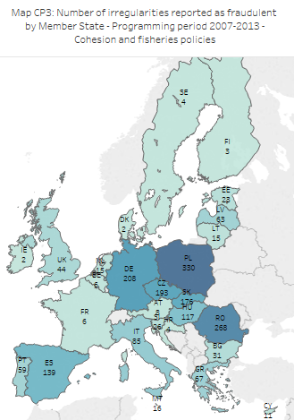

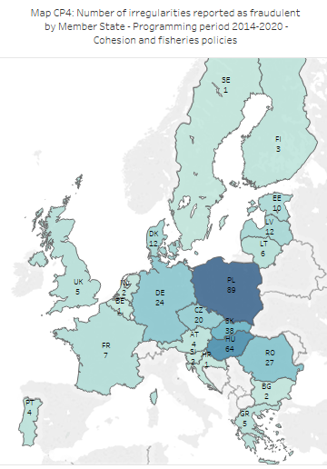

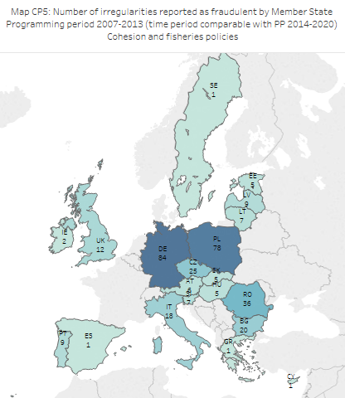

**Analysis suggests that the concentration of detections is not fully explained by the distribution of payments during the programming period 2007-2013, but this was less evident than in agriculture (during the period 2014-2018).** Concentration was analysed in detail in the context of 2018 PIF Report.[56] The outcome of the analysis could be due to many different factors, including different underlying levels of irregularities and fraud, different quality of prevention or detection activities or different practices concerning the stage of the procedure when potentially fraudulent irregularities were reported. This analysis found that the divergence between the distributon of detections and the distribution of payments among Member States was smaller for the cohesion and fisheries policies than for CAP, especially with reference to fraudulent irregularities. This may suggest that approaches of Member States to the use of criminal law to protect the EU budget might be more homogeneous in the cohesion and fisheries policies domain than in agriculture.[57]

4.4.3. Fraud detection rate

The FDR compares the results obtained by Member States in their fight against fraud with the related payments. Considering the multi-annual nature of the cohesion policy spending programmes, no annual analysis is proposed, focusing instead on the whole PP 2007-13, for which the documents for closure have been presented during 2017. Table CP30 shows the FDR for each Member State. The corresponding heat map is centered on the FDR at EU28 level). Programmes under the Territorial Cooperation Programme (designated in the table under the country code 'CB', last row before the total) can involve several countries and, therefore, paid amounts are spread among the beneficiaries in various Member States. However, in general, irregularities for these programmes are reported by the Member State in which the expenditure is paid out by the beneficiary in implementing the operation. For this reason, the sums paid have been included in the total, while the irregularities reported as fraudulent and the related amounts have already been computed in relation to the country having reported them. The 'CB' numbers have been included in the table to calculate the FDR related to these programmes, but they are not summed in the total row to avoid a double counting.

**For PP 2007-2013, FDR ranged from 1.17% for Slovakia to zero (or nearly zero) for Luxembourg, the Nordic countries, Belgium, France, Hungary, Lithuania and Malta.** The FDR is the highest for Slovakia and Romania, above 1%. Other Member States (Czechia, Latvia, Portugal, Slovenia and Poland) show a FDR between 0.5% and 1%.



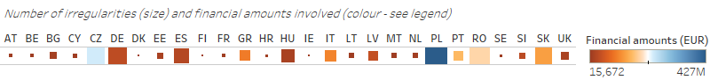



**For PP 2014-2020, FDR are still volatile, because of the lower number of cases and the evolution of payments.** Table CP31 shows data about fraud detection in the Member States with reference to the ongoing PP 2014-2020. These data are expected to change as implementation progresses. If the trend of the previous PP is confirmed, most of the fraudulent irregularities are still to be detected. The increase in the financial amounts involved in irregularities will be counterbalanced by the growing amounts of payments to the Member States.[58] It is too early to draw conclusions and the FDR in Table CP31 can not be directly compared with those in Table CP30, but Section 4.1.3 already contains a preliminary comparison between PP 2007-2013 and PP 2014-2020. [59]



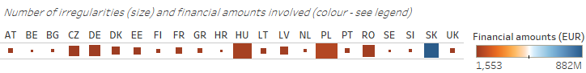



4.4.4. Irregularity Detection Rate

The irregularity detection rate compares the results obtained by Member States in detecting non-fraudulent irregularities with the related payments. Considering the multi-annual nature of the Cohesion policy spending programmes, no annual analysis is proposed, focusing instead on the whole programming period 2007-13, for which the documents for closure were presented during 2017. Table CP 32 shows the IDR for each Member State. Programmes under the Territorial Cooperation Programme (designated in the table under the "country-code" 'CB', last row before the total) can involve several countries and, therefore, paid amounts are spread among the beneficiaries in various Member States. However, in general, irregularities for these programmes are reported by the Member State in which expenditure is paid out by the beneficiary in implementing the operation. For this reason, the sums paid have been included in the total, while the irregularities not reported as fraudulent and the related amounts have already been computed in relation to the country having reported them. The 'CB' numbers have been included in the table to calculate the IDR related to these programmes, but they are not summed in the total row to avoid a double-counting.

**For PP 2007-2013, IDR ranged from more than 10% for Slovakia to less than 0.5% for the Nordic countries, France and Luxembourg.** The IDR of Czechia, Spain, Greece and Romania ranged between 3% and 5%. Half of the Member States recorded an IDR between 1% and 3%. The IDR of Cyprus, Germany, Estonia and Portugal was between 0.5% and 1%.



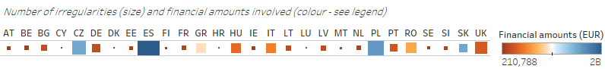



**For PP 2014-2020, FDR are still volatile, because of the lower number of cases and the evolution of payments.** Table CP33 shows data about detection in the Member States with reference to the ongoing PP 2014-2020. These data are expected to change as implementation progresses. If the trend of the previous PP is confirmed, most of the non-fraudulent irregularities are still to be detected. The increase in the financial amounts involved in irregularities will be counterbalanced by the growing amounts of payments to the Member States. It is too early to draw conclusions and the IDR in Table CP33 can not be directly compared with those in Table CP32, but Section 4.1.3 already contains a preliminary comparison between PP 2007-2013 and PP 2014-2020.



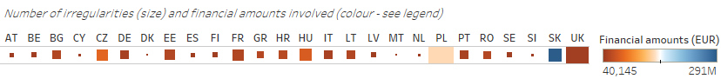



4.4.5. Follow-up to suspected fraud (programming period 2007-13)

Since the 2014 PIF Report, the analysis has also focused on the follow-up the Member States give to suspected fraud they reported. The simple methology adopted in past PIF Reports leads to assess that only for 19% of irregularities reported as fraudulent, fraud was then actually established, while in another 19% of these cases fraud was dismissed. As mentioned, this methodology is open to a number of shortcomings, due to the possibility that irregularities are cancelled or reclassified from non-fraudulent to fraudulent during their lifetime.

The following table is the result of a different, more precise approach to the analysis of the follow-up Member States give to the suspected fraud they report. It addresses the above mentioned issues[60]:

* This analysis focuses on PP 2007-2013 and considers the irregularities that have been reported from 2007 to 2013, so that the most recent irregularities have been reported six years before the end of 2019;
* The irregularities that have been cancelled after they have been reported are not considered;
* The irregularities that initially had been considered as non-fraudulent and then were reclassified as fraudulent before the end of 2013 are included in the analysis and their incidence is pointed out;
* The irregularities that initially had been considered as fraudulent and then were reclassified as non-fraudulent before the end of 2013 are included in the analysis.

Table CP34 is based on five indicators:

* *Reclassification ratio*: it gives the percentage of irregularities that initially had not been reported as fraudulent and then were reclassified as fraudulent before end 2013. This percentage is calculated with reference to the total number of non-fradulent irregularities;[61]
* *Incidence of reclassification*: it gives the percentage of fraudulent irregularites that had initially been reported as non-fraudulent. As mentioned, the numerator takes into consideration only the instances of reclassification from non-fraudulent to fraudulent that took place before the end of 2013. Differently from the *Reclassification ratio*, the percentage is calculated with reference to the total number of fraudulent irregularities;[62]
* *Dismissal ratio*: it gives the percentage of fraudulent irregularites that have been reclassified as non-fraudulent during their lifetime, until end of 2019;[63]
* *Established fraud ratio*: it gives the percentage of fraudulent irregularites that were classified as established fraud by the end of 2019;[64]
* *Pending ratio*: it gives the percentage of fraudulent irregularities that were still classified as suspected fraud at the end of 2019; [65]

Table CP34 includes the average times. For example, the average time related to the dismissal ratio quantifies the number of days for an irregularity to change classification from fraudulent to non-fraudulent.[66]



**About 11% of the fraudulent irregularities had previously been reported as non-fraudulent and then were reclassified, on average after about one year. These irregularities had a higher tendency to be dismissed than other irregularities**.An irregularity can be part of the statistics in Table CP34 either because it was initially reported as fraudulent or because during 2007-2013 it was reclassified from non-fraudulent to fraudulent. Actually, 11.1% of these irregularities entered into the analysis because of reclassification, which on average took place 377 days after the reporting as non-fraudulent. In 38% of cases, these irregularities were reclassified back to non-fraudulent, which is much higher than the general *dismissal ratio* (21%).

**This reclassification was concentrated in just half of the Member States, with different average times. This could be the result of different reporting practices or co-operation agreements between administrative and judicial authorities or could point to the need to improve the capability of control authorities to timely spot potential fraud**. This phenomenon was concentrated in 13 Member States, with average times of reclassification ranging from about three months to more than two years. The *incidence of reclassification* in Slovakia was the highest, but then most of the relevant irregularities were reclassified back to non-fraudulent. The *incidence of reclassification* was high and based on a significant number of cases also in Czechia and Poland. In Czechia, about half of the relevant irregularities were reclassified back to non-fraudulent. Different values of this indicator are not positive or negative *per se*. Different *incidences of reclassification* across Member States could be due to different reporting practices, for example in terms of the phase of the procedure when an irregularity is labelled as suspected fraud, or in terms of co-operation between the administrative authority and the authority entrusted with investigating intentionality, which is usually the judicial authority. In any case, cooperation should be based on a clear commitment by the judicial authority to act quickly on the notification by the administrative authority. On the other hand, if the reclassification was not due to the development of the initial procedure, but to another subsequent event - such as tip from an informant or information from the media - this could point to the need to improve the capability of the authorities in charge of control to identify potential fraud, for example on the basis of red flags.

**About 21% of the irregularities reported as fraudulent were dismissed, on average after more than four years. Another 64% of these irregularities were still pending, but for about one-fourth of them no changes of status are to be expected.** This is due to the fact that 24% of the irregularities that were still labelled as suspected fraud at the end of 2019 were already closed. This point to a significant underestimation of the *dismissal ratio,* which could be already considered above 35%, with the potential to exceed 80%, if most of the pending cases of suspected fraud will be dismissed.

**The *dismissal ratio* varied across the Member States, as the related average time. High *dismissal ratios*, especially when associated with high *pending ratios*, may be due either to the detection phase or to the investigation/prosecution phase, especially when they are associated with high average times*.* Low *dismissal ratios* may be positive, but they may also be the result of many irregularities still pending.** After six years following the end of the period under consideration, the *dismissal ratio* was zero or very low in many Member States. This indicator must be read in combination with the *pending ratio*. The latter points to the possibility that the *dismissal ratio* increases in the future (depending on the number of cases that are still open) or to an underestimation of the *dismissal ratio* (depending on the number of cases that are already closed). For example, in Germany the *dismissal ratio* was low at 14% and only 40% of irregularities were still pending. However, about half of pending cases of suspected fraud were already closed at the end of 2019, so the *dismissal ratio* could be already considered above 30%, with the potential to exceed 50%. In Italy, the *dismissal ratio* was already much higher than in Germany, at 32%, with 68% of irregularities still pending. About 22% of the pending cases of suspected fraud were already closed at the end of 2019, so the *dismissal ratio* could be already considered above 45%, with the potential to approach 100%. The average times of reclassification were very high, ranging from about three years, in Czechia, to six years, in Slovakia.

**The cases of established fraud were few and, on average, these decisions were reached after about three years. This may point to the need to further invest in the investigation/prosecution phase.** At EU28 level, the *established fraud ratio* was about 14%. It ranged from zero or about zero, in half of the Member States, to 45%, in Germany. The *established fraud ratio* is not likely to increase significantly because, while 64% of cases are still classified as suspected fraud (*pending ratio*), about 24% of them are already closed and, in any case, between 6 and 13 years have already passed since the detection of the irregularity.

4.5 Other shared management funds

There are other funds used under shared management. Tables CP35 and CP36 provide an overview of all the irregularities and related financial amounts that have been reported by the Member States up to 2019 with reference to:

* *Asylum, Migration and Integration Fund (AMIF):* This Fund was set up for the period 2014-2020, with the current total envelope of EUR 7.2 billion. It is meant to promote the efficient management of migration flows and the implementation, strengthening and development of a common Union approach to asylum and immigration. The largest share of the total amount of the AMIF (approximately 62%) is channelled through shared management. Member States implement their multiannual National Programmes, which are prepared, implemented, monitored and evaluated by the responsible national authorities, in partnership with the relevant stakeholders in the field, including the civil society. All Member States except Denmark participate in the implementation of this Fund. Examples of beneficiaries of the programmes implemented under this Fund can be state and federal authorities, local public bodies, non-governmental organisations, humanitarian organisations, international organisations and public law companies and education and research organisations.
* *Fund for European Aid to the Most Deprived (FEAD):* Over EUR 3.8 billion are earmarked for this Fund for the period 2014-2020. FEAD supports Member States' actions to provide material assistance to the most deprived, including food, clothing and other essential items for personal use. Material assistance needs to go hand in hand with social inclusion measures, such as guidance and support to help people out of poverty. National authorities may also support non-material assistance to the most deprived people, to help them integrate better into society. Following the Commission's approval of national programmes, national authorities decide about the delivery of the assistance through partner organisations (public bodies or often non-governmental organisations).
* *European Globalisation Adjustment Fund (EGF):* This Fund provides support to people losing their jobs as a result of major structural changes in world trade patterns due to globalisation or as a result of the global economic and financial crisis. The EGF has a maximum annual budget of EUR 150 million for the period 2014-2020. It can fund up to 60% of the cost of projects designed to help workers made redundant find another job or set up their own business. EGF cases are managed and implemented by national or regional authorities. Each project runs for two years.
* *Internal Security Fund (ISF):* This fund was set up for the period 2014-20, with the current total envelope of EUR 4.1 billion. The Fund promotes the implementation of the Internal Security Strategy, law enforcement cooperation and the management of the Union's external borders. The ISF is composed of two instruments, ISF Borders and Visa (B&V) and ISF Police. For the 2014-20 period
  + EUR 2.9 billion is available for funding actions under the ISF B&V instrument, of which EUR 2.4 billion are to be channelled through shared management. All Member States except Ireland and the United Kingdom participate in the implementation;
  + about EUR 1.2 billion is available for funding actions under the ISF Police instrument, of which EUR 754 million are to be channelled through shared management. All Member States except Denmark and the United Kingdom participate in the implementation.
* *Youth Employment Initiative (YEI):* While supporting the Youth Guarantee, YEI is targeted to young people who are not in education, employment or training (NEETs), including the long-term unemployed or those not registered as job-seekers. It ensures that in parts of Europe where the challenges are most acute, young people can receive targeted support. The total budget of the YEI is EUR 8.8 billion for the period 2014-2020. Of the total budget of EUR 8.8 billion, EUR 4.4 billion comes from a dedicated Youth Employment budget line, which is complemented by EUR 4.4 billion more from ESF national allocations.

**Concerning non-fraudulent irregularities, the highest financial amounts were associated to YEI irregularities, followed by FEAD.** More than 85% of detections were related to AMIF and FEAD. Most of AMIF irregularities were reported in 2018; then in 2019 there was a significant decrease in detections related to this Fund. The Commission strengthened efforts in the monitoring process with the Responsible Authorities to support beneficiaries with relevant guidance and information on legality and regularity of the expenditure. Half of the irregular financial amounts were associated to YEI, but this was just due to one irregularity where nearly EUR 3.5 million was involved. To put it into context, only one irregularity affecting the other funds exceeded EUR 500 000.



**FEAD was the fund most affected by fraud. Financial amounts involved in these irregularities tend to be high.** More than half of the irregularities report as fraudulent were related to FEAD and they represented 89% of the irregular financial amounts. The AFA of these cases was higher than EUR 1.3 million and this was not due just to one case; all cases ranged between about EUR 900,000 and more than EUR 1.7 million.



1. Expenditure through EAFRD is considered in Section 3 'Common Agricultural Policy', when focusing on rural development.
2. In 2011 prices.
3. For a description of the objectives of PP 2007-13, see the Commission Staff Working Document ‘*Statistical evaluation of irregularities reported for 2014 Own Resources, Natural Resources, Cohesion Policy, Pre-accession and Direct expenditure*’, Section 5, pages 48-49.
4. When inputting a case, the contributor is requested to specify the currency in which the amounts are expressed. Where the value of this field is 'EUR' or the field has been left blank, no transformation is applied. Where this field has been filled with another currency, the financial amounts involved in the irregularity have been transformed based the exchange rates published by the ECB at the beginning of 2020.
5. See Sections 8.1 and 9.3 of the '*Handbook on Reporting of Irregularities in shared management*'.
6. Data for this analysis have been downloaded from IMS on 9/3/2020.
7. ‘*Suspected fraud*’ means an irregularity that gives rise to the initiation of administrative or judicial proceedings at national level in order to establish the presence of intentional behaviour, in particular fraud, as referred to in Article 1(1)(a) of the Convention drawn up on the basis of Article K.3 of the Treaty on European Union, on the protection of the European Communities’ financial interests’. Regardless of the approach adopted by each Member State, the ratification of the 1995 Convention has equipped every country with a basis for prosecuting and possibly imposing penalties for specific conduct. If this happens, i.e. a guilty verdict is pronounced and is not appealed against, the case can be considered ‘*established fraud*’. See ‘*Handbook on ‘Reporting irregularities in shared management*’ (2017).
8. When support is based on multi-annual programmes, it can be expected that the number of irregularities increases around the end of the eligibility period and decreases afterwards, when routine controls are less intense. In general, it should be kept in mind that increases in the number of reported irregularities can be influenced by detection capacity building by the Member State.
9. There were 26 cases over EUR 20 million accounting for 26% of the financial amounts.
10. Only cases with financial amounts involved greater that EUR 10,000 are considered (about reporting of cases below the reporting threshold, see first part of this section). The remaining cases reported in 2015-2019 were split by fund and then sorted by financial amount involved in the irregularity. Then, separately for each fund, the largest (1%) and the smallest (1%) of these cases were excluded.
11. To this aim, the set of data at the basis of CP3a and CP3b has been split between fraudulent (CP4a and CP4b) and not fraudulent (CP4c and CP4d) irregularities.
12. ‘*Report from the Commission to the European Parliament and the Council – 29th Annual Report on the Protection of the European Union's Financial Interests – Fight against Fraud – 2017*', COM(2018)553
13. Meaning an irregularity where the financial amounts involved exceeded EUR 10 million. Getting a broader view, it can be noticed that two irregularities reported by Portugal, accounted together for nearly EUR 20 million.
14. This time, the irregularity reported as fraudulent involved more than EUR 30 million.
15. As for the irregular amount, also for the expenditure only the EU part is considered.
16. CF spending takes longer to implement, typically involving large infrastructure and environmental projects. Spending stretches until the very end of the eligibility period (i.e. 2015). Controls continue during the spending years. Spending under ERDF reached the 95% ceiling earlier for some MS, who stopped declaring expenditure until closure. This may have an impact on the timing of detection of the irregularities.
17. Two irregularities accounted together for nearly EUR 125 million. Another case accounted for about EUR 20 million, bringing to EUR 145 million to amounts involved in the three largest irregularities reported by Slovakia. Net of these three cases, the total financial amounts did not increase from 2018 to 2019. To be noticed that in 2018, just one irregularity accounting for more than EUR 10 million was reported.
18. Tables CP12 and CP13 include irregularities on the basis of the year to which the irregularity is associated, regardless of when it is reported. Typically, the irregularities reported during the first months of year x+1 refer to the year x. However, there can be cases where an irregularity reported later during the year x+1 is still associated to year x. In order to take this factor into consideration, all subsequent comparisons are based on irregularities associated to the first 6 years of implementation (2007-2012 – for PP 2007-2013 - or 2014-2019 – for PP 2014-2020) AND reported before 9/3/2013 (for PP 2007-2013) or 9/3/2020 (for PP 2014-2020). See also next footnote. Together with inclusion or not of the fisheries policy, this justifies differences between figures reported in Tables CP12 and CP13 and figures reported later in this report.
19. For PP 2014-2020, irregularities are considered if they were reported before 9/3/2020, which is the date when data was extracted from IMS for this analysis. This does not include irregularities referring to the year 2020. For PP 2007-2013, irregularities reported before 9/3/2013 are considered, in order to improve comparability. This does not include irregularities referring to the year 2013 or later.
20. For example, it is possible that data related to PP 2014-2020 now includes a number of irregularities that during the next years will be cancelled (as investigations will possibly ascertain that no irregularity was committed). Irregularities related to PP 2007-2013 have already undergone this process, as 9-13 years have passed from their initial reporting. The same applies to the classification as fraudulent or non-fraudulent, etc.
21. However, the high number of detections reported by Germany towards the end of the third year of implementation during PP 2007-2013 (year 2009) was largely due to the separate reporting of many interlinked cases, each involving less that EUR 10,000. This increased the number of PP 2007-2013 and consequently the drop from PP 2007-2013 and 2014-2020. Consistently, at EU level, there was no significant gap in terms of financial amounts at the end of the third year of implementation. It started to materialise more than one year later (see Graph CP9c).
22. It should be considered that with PP 2014-2020, an ‘annual accounts’ system has been introduced. The accounting year starts on 1 July and ends on 30 June (except for the first accounting period). This might have changed the time gap between actual occurrence of expenses and interim payments by the Commission. If it increased, at least part of the difference of the trends in interim payments for the two programming periods may be due to the difference in the reimbursement mechanisms rather than actual implementation delays.
23. As mentioned, with PP 2014-2020, an ‘annual accounts’ system has been introduced. In this new framework, reimbursement of interim payments is limited to 90 % of the amount resulting from applying the relevant co-financing rate to the expenditure declared in the payment request. However, the remaining 10 % is released after the yearly examination and acceptance of the accounts. In case this 10% is not attributed to the same year of the declaration of expenditure, this generates a slower pace of interim payments, which is not the result of a slower implementation of the programme.
24. Obligation for Member States to concentrate support on interventions that bring the greatest added-value in relation to the Europe 2020 strategy. A key focus is concentrating ERDF and ESF financial allocations on a limited set of thematic objectives or investment priorities.
25. In 2009, there was also a relevant change in the reporting regulation. The Commission Regulation n. 846 of 1 September 2009 changed the derogation to reporting for irregularities detected and corrected by the managing authority or certifying authority. Before the change, detection and correction should have taken place ‘before any payment to the beneficiary of the public contribution and before inclusion of the expenditure concerned in a statement of expenditure submitted to the Commission’. After the change, the derogation has been broadened, as it is enough that detection and correction took place ‘before inclusion of the expenditure concerned in a statement of expenditure submitted to the Commission’. It could be argued that this contributed to lower the number of reported non-fraudulent irregularities from PP 2007-2013 to PP 2014-2020. However, this is not the case, because most of the irregularities related to PP 2007-2013 were reported - and the gap between the two PPs increased - after the change in the derogation.
26. Article 125(c) of the Common Provisions Regulation 1303/2013.
27. ‘*Simplified Cost Options in the European Social Fund - Promoting simplification and result-orientation’*:working document prepared by the European Commission Services, December 2016

    *Use and intended use of simplified cost options in European Social Fund (ESF), European Regional Development Fund (ERDF), Cohesion Fund (CF) and European Agricultural Fund for Rural Development (EAFRD):* study commissioned by DG Regional and Urban Policy of the European Commission,June 2018
28. The Member States are obliged to report only the irregularities with a financial amount over EUR 10,000. As SCOs tend to be used more for smaller projects, this may undermine the explanatory power of SCOs in the drop of reported irregularities. The more this increase from 7% to 33% is concentrated in smaller projects, the less it has the potential to impact on irregularity reporting, which concerns irregular financial amounts above EUR 10,000.
29. The accounting year starts on 1 July and ends on 30 June (except for the first accounting period). The certifying authority prepares the annual accounts for the operational programme, which are then submitted to the Commission together with the management declaration of assurance, the annual summary of controls prepared by the managing authority, and the accompanying control report and audit opinion prepared by the audit authority. The EC examines these documents, in view of issuing a yearly declaration of assurance.
30. 12 irregularities reported by Romania concerning modification of tenders during evaluation (combined with non-eligibility and false documents) significantly contributed to this increase.
31. In particular, cases reported by Czechia.
32. The biggest decrease related to the type ‘*Other*’, which provides no further information on the violation. It was followed by action not implemented, in particular due to the drop of cases reported by Germany.
33. Mostly because of cases reported by Slovakia.
34. The deadline for the presentation of the documents for closure was 31 March 2017.
35. For details on the calculation of the FFL, see SWD(2016)237final.[http://ec.europa.eu/anti- fraud/sites/antifraud/files/methodology_statistical_evaluation_2015_en.pdf](http://ec.europa.eu/anti-%20fraud/sites/antifraud/files/methodology_statistical_evaluation_2015_en.pdf)
36. For details about the calculation of the FAL, see SWD(2016)237final.[http://ec.europa.eu/anti- fraud/sites/antifraud/files/methodology_statistical_evaluation_2015_en.pdf](http://ec.europa.eu/anti-%20fraud/sites/antifraud/files/methodology_statistical_evaluation_2015_en.pdf)
37. ‘*Productive investment*’ and ‘*Social, health and education infrastructure and related investments*’ are not mentioned because there are priorities related to PP 2014-2020, so these irregularities are part of Table CP21 as a result of misreporting.
38. The exceptional financial amount related to these irregularities was due to 2 cases related to the priority ‘*Research and technological development, innovation and entrepreneurship*’, accounting for about EUR 590 million, and one case related to the priority ‘*Infrastructure providing basic services and related investment*’, accounting for about EUR 270 million.
39. However, this improvement impacts on the comparison at the level of single priorities, because, to a different extent, increases in the number of irregularities may have been underpinned by the higher number of irregularities for which the priority has been specified rather than by the higher number of detections. This is impacting even more the analysis of the non-fraudulent irregularities (see Section 4.2.2.2).
40. Meaning ‘*Increasing the adaptability of workers and firms, enterprises and entrepreneurs*', '*Improving human capital*' and ‘*Improving access to employment and sustainability*’.
41. In addition, the new priority ‘*Infrastructure providing basic services and related investment’* covers actions that were before covered by the priority ‘*Energy*’.
42. ‘*Report from the Commission to the European Parliament and the Council – 29th Annual Report on the Protection of the European Union's Financial Interests – Fight against Fraud – 2017*', COM(2018)553
43. ‘*Report from the Commission to the European Parliament and the Council – 30th Annual Report on the Protection of the European Union's Financial Interests – Fight against Fraud – 2018*', COM(2019)444
44. See Annex 13 for the specific types of violations (IMS codes) that are included in the categories mentioned in Tables CP25 and CP 26.
45. In general, this type of violations is related to the fact that a part of the foreseen co-financing (being it private or public – national, regional) has not been contributed.
46. A person involved is anyone who had or has a substantial role in the irregularity. This could be the beneficiary, the person who initiated the irregularity (such as the manager, consultant or adviser), the person who committed the irregularity, etc.
47. For the purpose of this analysis, when reference is made to person or entity, without further specification, it is a reference to both types of person/entity (natural and legal). When reference is only to natural or to legal person/entity, this is specified.
48. The actual organisational status has not been verified on the basis of searches of the specific entities involved, but it has been deduced based on identifiers in the names of the entities involved (i.e., companies with “Ltd” in their name were identified as private limited companies, etc.).
49. Section 4.3 of ‘*29th Annual Report on the Protection of the EU’s financial interests – Fight against fraud – 2017*’, COM(2018)553 final and ‘*Statistical evaluation of irregularities reported for 2017: own resources, agriculture, cohesion and fisheries policies, pre-accession and direct expenditure*’, SWD(2018)386 final.
50. In the able also other reasons that might hint to the use of some forms of risk analysis have been introduced (comparison of data, probability checks and statistical analysis).
51. About 75% of the cases detected in 2018-2019 were reported by Hungary, Czechia and Poland. While Czechia and Poland were amongst the Member States that detected more often irregularities on the basis of tips also before 2018, this was not the case for Hungary.
52. The Member States have the obligation to report only irregularities for which payment and certification to the European Commission occurred. As a consequence, the IDR focuses on the 'repressive' side of the anti-fraud cycle and does not include the results of 'prevention' activities. This does not apply to the FDR, as fraudulent cases must be reported regardless.
53. This includes cases where start date and end date were not filled in and cases where only the end date was filled in.
54. ‘*Report from the Commission to the European Parliament and the Council – 30th Annual Report on the Protection of the European Union's Financial Interests – Fight against Fraud – 2018*', COM(2019)444
55. The date of the PACA has been taken as reference for the date of detection. PACA is a ‘primary administrative or judicial finding’, meaning a first written assessment by a competent authority, either administrative or judicial, concluding on the basis of specific facts that an irregularity has been committed, without prejudice to the possibility that this conclusion may subsequently have to be revised or withdrawn as a result of developments in the course of the administrative or judicial procedure.
56. Section 4.4.2 of ‘*Statistical evaluation of irregularities reported for 2018: own resources, agriculture, cohesion and fisheries policies, pre-accession and direct expenditure*’, SWD(2019)365 final
57. However, it should also be considered that differences in terms of detections of irregularities reported as fraudulent are influenced also by difference practices in different Member States concerning the stage of the procedure when potentially fraudulent irregularities are reported.
58. The FDR in Table CP31 and the IDR in Table CP33 are based on net payments. These include the pre-financing, which is frontloaded at the beginning of the programming period.
59. It is worth repeating that the higher FDR related to PP 2014-2020 is significantly influenced by 3 cases reported by Slovakia, where nearly EUR 850 mn are involved. This is reflected also in the anomalous FDR associated to Slovakia (23%)
60. IRQ2 stands for non-fraudulent irregularities, IRQ3 stands for suspected fraud, IRQ5 stands for established fraud. The evolution of the irregularities has been analysed. The following paths are kept into the analysis: from non-fraudulent to fraudulent (IRQ2IRQ3, IRQ2IRQ3IRQ5, IRQ2IRQ5), from fraudulent to non-fraudulent (IRQ3IRQ2), from suspected fraud to established fraud (IRQ3IRQ5), ‘back-and-forth’ (IRQ2IRQ3IRQ2). Other more complex or unclear paths have been left out of the analysis, because they are more likely to be the result of reporting mistakes rather than actual changes in the substance of the case. These ‘special paths’ are: IRQ3IRQ5IRQ2 (1 case), IRQ3IRQ5IRQ3 (1), IRQ3IRQ5IRQ3IRQ2 (1), IRQ5IRQ2 (4). They represent about 1% of the relevant irregularities.
61. Reclassification before end 2013 makes these irregularities part of this analysis. On the contrary, other irregularities that initially had been reported as non-fraudulent during 2007-2013, but were reclassified as fraudulent after 2013 are not part of this analysis. The ‘*Reclassification ratio*’ includes also the irregularities that, at a later stage, have been reclassified back to non-fraudulent. So the numerator of this indicator is made of the following paths: IRQ2IRQ3, IRQ2IRQ3IRQ2, IRQ2IRQ3IRQ5, IRQ2IRQ5. For the denominator, all the IRQ2 irregularities are added (of course the irregularities reported between 2007 and 2013 only).
62. This indicator has the same numerator of the ‘*Reclassification ratio*’, but the denominator is made of all irregularities that became fraudulent (the numerator) or were initially reported as fraudulent (even if, at a later stage, they were reclassified as non-fraudulent). From now onwards, the irregularities considered in this denominator will be referred to as the ‘population’.
63. The numerator of this indicator is made of the following paths: IRQ2IRQ3IRQ2 and IRQ3IRQ2. So it includes also the reclassification of fraudulent irregularities that initially had been reported as non-fraudulent (IRQ2IRQ3IRQ2). The denominator of this indicator is the population (see above), as for the ‘*Incidence of reclassification*’, the ‘*Established fraud ratio*’ and the ‘*Pending ratio*’
64. The numerator of this indicator includes also the irregularities that were reported as established fraud since the beginning. The denominator of this indicator is the population (see above), as for the ‘*Incidence of reclassification’*, the ‘*Dismissal ratio*’ and the ‘*Pending ratio*’.
65. The numerator of this indicator is made of the following paths: IRQ2IRQ3, IRQ3, IRQ5IRQ3. The denominator of this indicator is the population (see above), as for the ‘*Incidence of reclassification*’, the ‘*Dismissal ratio*’ and the ‘*Established fraud ratio*’.
66. *Average time related to reclassification ratio*: Time from initial reporting (as non-fraudulent) until the first reclassification as fraudulent. As mentioned, only irregularities for which the first reclassification as fraudulent took place before the end of 2013 are considered in the analysis.

    *Average time related to dismissal ratio*: Time from initial reporting (as suspected fraud) until the reclassification as non-fraudulent (this reclassification can take place during the whole lifetime of the irregularity). For an irregularity that followed the path IRQ2IRQ3IRQ2, the start date for the calculation is the date of the reclassification to IRQ3 (and not the date of initial reporting as IRQ2) and the end date is the date of reclassification back to IRQ2.

    *Average time related to established fraud ratio*: Time from initial reporting (or reclassification) as suspected fraud until reclassification as established fraud. Irregularities that have been reported as established fraud since the beginning are not considered in the calculation of the average.

   