

EXECUTIVE SUMMARY 2

1. Introduction 4

2. Progress and achievements in the area of digital education to date 6

*2.1 Impact of the 2018 Action Plan* 11

*2.2 Challenges in the implementation of the 2018 Action Plan* 12

3. Lessons from the COVID-19 crisis 14

*3.1 Challenges in managing remote emergency education* 17

4. Priorities and direction for strategic action 22

5. Supporting evidence 24

5.1 Using digital technologies for teaching and learning 24

*5.1.1 Infrastructure and connectivity* 26

*5.1.2 Digital capacity in educational institutions across the EU* 29

*5.1.3 Educators’ digital competence* 33

*5.1.4 Quality of digital education content* 36

5.2 Digital competence development 39

*5.2.1 Level of digital competence across the EU* 41

*5.2.2 Addressing the gender gap* 51

*5.2.3 Advanced digital skills and emerging areas of digital competence* 53

6. Implementation and monitoring 58

Annex 1: Procedural Information 62

Annex 2: Stakeholder Consultation Synopsis Report 65

Annex 3: European Digital Competence Frameworks 90

Annex 4: Glossary 93

Annex 5: Literature and sources 99

## EXECUTIVE SUMMARY

This staff working document accompanies the Communication on the Digital Education Action Plan 2021-2027 and provides **evidence and analysis** of the opportunities and challenges that the digital transformation brings to education and training today.

The **EU’s first framework for digital education** was launched in 2018 through the Digital Education Action Plan, with 11 actions focusing on the formal education sector. The 2018 Action Plan contributed to an emerging policy dialogue and was welcomed by Member States, but its short-term duration (2018-2020) and limited budget meant that the actions could not reach their full potential and achieve the impact needed.

This staff working document outlines the lessons learnt from implementing the 2018 Action Plan and discusses the latest developments in digital education. It explains why **stronger action at EU level is needed**, taking into account early evidence from the COVID-19 crisis and the more structural challenges faced by digital education in Europe. It is based on data, research and policy documents published in the last two years and input received through extensive stakeholder consultations with, among others, representatives of Member States and EFTA countries, international and pan-European umbrella organisations, Members of the European Parliament and the general public. The experiences and educational implications of the COVID-19 crisis were the focus of a public consultation**,** which received 2,716 replies and more than 130 position papers.

The **COVID-19 crisis** led to a sudden and large-scale use of digital learning practices. The range of solutions put in place to ensure continuity of education and training was wide, including low- and high-tech practices, with marked differences within and between countries. Higher levels of digital capacity and experience with alternative and flexible forms of learning led to faster and better responses. Evidence shows differences between levels and sectors of education and training: in most cases, higher education institutions continued their lessons virtually, while many schools and vocational and training (VET) providers lacked expertise and struggled to offer distance and online learning opportunities to all their students. On average, 9% of 15-year-old students do not have a quiet place to study in their homes, and there are significant gaps related to availability of computers and connectivity, especially for children from low-income families, disadvantaged backgrounds and remote areas. At present, there is not enough data on whether the distance and online learning practices put in place in response to the COVID-19 crisis have ensured effective and equitable access to quality learning opportunities. The rapid switch to distance and online teaching and learning saw innovative practices emerge, but also significant challenges for those educators lacking the competences and confidence to use digital technologies in an effective way. Results of the public consultation show overwhelmed parents, educators struggling to ensure a structured process while keeping students engaged, and learners lacking interaction and unable to access suitable devices and reliable internet connection. Looking beyond the crisis, the vast majority of consulted stakeholders considered that the switch to distance and online learning would accelerate the transformation of education and training systems and called for stronger support and guidance at EU level.

This staff working document supports the action plan outlined in the Communication on the Digital Education Action Plan 2021-2027. Evidence is presented in two main sections:

* **Using digital technologies for teaching and learning**: while most EU Member States have developed strategies in the field of digital education, few undertake regular monitoring and evaluation to review these strategies or update them to respond, for example, to developments in technology and related learning needs. Using digital technologies effectively in teaching and learning practices is a complex process and requires planning, ongoing monitoring, and a strong focus on learner-driven pedagogy. Evidence confirms that providing students and educators with appropriate infrastructure and connectivity is essential. However, the proportion of students attending highly equipped and connected schools differs widely across Europe, ranging from 35% to 52% or 72% depending on the level of education (ISCED 1,2,3), and is higher in the Nordic countries. Evidence confirms that the older the students, the higher the likelihood that they attend a school with a fast internet connection, with large differences between and within EU countries. Research clearly shows that investment and development in infrastructure needs to be accompanied by systemic organisational change underpinned by pedagogical values. This includes measures to reinforce educators’ digital competences through flexible and sustained professional development opportunities, yet only 39% of teachers in the EU felt well or very well prepared to use digital technologies for teaching. If properly designed and planned, online learning courses and Massive Open Online Courses (MOOCs) can help meet the lifelong learning needs of an ever-growing population of learners, and yet European countries are late adopters of such opportunities, with an offer unevenly distributed across Member States and none of the EU MOOC platforms being amongst the five leading global platforms. Structural challenges exacerbated by the COVID-19 crisis and the sudden switch to digital education modes has confirmed the need to boost the digital capacity of Europe’s education and training systems and to work together to support the development of a high performing digital education ecosystem.
* **Digital competence development:** well before the COVID-19 crisis, evidence was clear on the need to support digital competence development of adults and young people in Europe. Today more than ever, being digitally competent is both a necessity and a right. However, digital skills levels across Europe remain unsatisfactorily low, with 44% of EU citizens having an insufficient level of digital skills. In addition, digital divides related to gender, socio-economic background and urban/rural areas persist. At present, more than a third of the EU labour force lacks the basic digital skills required in most jobs across sectors, and over half of EU companies report difficulties in filling vacancies for ICT specialists. The digital skills level of European students is higher compared to that of the overall population and labour force, but more than one third of 13-14 year olds who participated in the International Computer and Information Literacy Study did not have a high proficiency level in digital competence. At the same time, the availability of computing and informatics, as either compulsory or elective subjects is not uniform across Europe and less than 5% of graduates and students at higher education level are studying or have completed ICT-related programmes. The COVID-19 crisis is likely to have an impact on the level and future demand for digital skills. However, more research is needed to see whether the increased use of digital technologies will lead to more critical, confident, and creative usage or to greater inequalities and negative experiences with technology. To thrive in a technology-driven economy, Europe needs a digitally competent workforce and a large pool of digital talent with basic and advanced digital skills, including those related to emerging technologies such as Artificial Intelligence.

This staff working document presents the challenges described above in detail and outlines how the Digital Education Action Plan 2021-2027 will be implemented and monitored. **Five annexes** provide: further information on how the initiative was prepared (Annex 1); views of the consulted stakeholders (Annex 2); the European frameworks on digital competence (Annex 3); a glossary of key terms (Annex 4); references and main sources (Annex 5).

## 1. Introduction

Digital technologies are changing the world at an incredible speed and are reshaping how people in Europe live, work and study. Ongoing digital transformation impacts many parts of our daily life, from the ever-increasing integration of digital technologies in all sectors of the economy to the societal impact of emerging technologies such as Artificial Intelligence (AI). Connected devices and intelligent systems surround us and support activities in terms of access and exchange of information, communication and collaboration, modes of work, business operations and, finally yet critically, learning opportunities.

Like other sectors, education and training is undergoing a process of change. When properly planned and designed, the use of digital technologies for teaching and learning offers manyopportunities, including the possibility to open up to a more diverse cohort of learners, increase flexibility, personalisation and inclusion, and offer more interactive and engaging forms of cooperation and communication. At the same time, it brings challenges: educators need to master the digital environment to design high quality and engaging learning experiences and learners also need to be technologically savvy[1]. Education and training systems have an essential role to play in embracing digital technologies and enabling societies to reap the benefits of the digital transformation, while avoiding the risks that may come from digital exclusion or inappropriate use of technology.

In the context of the COVID-19 crisis, digital technologies are supporting individuals and organisations in their daily tasks, allowing for business continuity, including in the field of education and training. However, the sudden and large-scale use of digital technologies to ensure continuity of teaching and learning has shown major discrepancies between and within Member States and has brought to the fore the benefits and risks of digitalisation. Today more than ever, ensuring inclusive and quality education and training that responds to the lifelong learning need to develop the competences necessary for future life and employment requires that education and training institutions use digital technologies in a critical, purposeful and effective way.

In this staff working document, digital education covers two different but interlinked dimensions[2]: the pedagogical use of digital technologies to support and enhance teaching, learning and assessment (including in face-to-face or blended practices[3], but also for remote education[4]), and the development of digital competence. Recognised as one of the key competences for lifelong learning[5], being digitally competent involves the confident, critical and responsible use of and engagement with digital technologies for learning, work, and participation in society[6]. It includes a set of knowledge, skills and attitudes essential for any learner at any stage of their personal and professional life.

The Political Guidelines of the European Commission President Ursula von der Leyen[7] underlined the **need for Europe to lead the green and digital transitions**[8] and announced the **update of the Digital Education Action Plan** as a key initiative to help unlock the potential of digital technologies for education and to address a widening digital skills gap[9]. Education and training is called upon to contribute to a European society powered by digital solutions that are strongly rooted in our common values and respond to the lifelong needs of people and organisations [10]. In this context, the crisis period has shown the essential role of technology for educational continuity and the need to work together to make education and training systems resilient and future-ready. Boosting the level of digital competences and capabilities to support the effective and pedagogical use of digital technologies is a key enabling factor in improving the quality, inclusivity and effectiveness of education and training[11].

The EU framework for digital education was set in 2018 with the first **Digital Education Action Plan**[12], an integral part of the European Education Area[13]. While limited in scope and duration to assess its overall impact, the 2018 Action Plan has received strong support, including from the European Parliament and the Committee of the Regions. Considering its achievements and the COVID-19 disruptions, stakeholders and Member States are now seeking a more ambitious approach to addressing challenges and harnessing opportunities for the future. Consequently, the Communication on repairing and preparing for the next generation[14] announced the adoption of a renewed Digital Education Action Plan in the context of the recovery plan. The aim is to address and support the increased responsibility of Europe’s education and training systems in managing the aftermath of COVID-19, in parallel with the ongoing digital transformation.

In recent years, digital education policies have evolved at both European and national level. Almost all Member States now have national and/or regional strategies for digital education[15]. Examples include the ‘INcoDe.2030 - National Digital Competences Initiative’ in Portugal, the ‘Pacte pour un Enseignement d’Excellence’ in the French Community of Belgium, and the ‘DigitalPakt Schule’ in Germany. In some cases, digital competence is part of broader strategies on lifelong learning, as in Estonia, or sustainable development, as in Poland[16]. Many countries are currently in the process of updating their digital strategies, and the disruptions caused by the COVID-19 pandemic will undoubtedly lead to a deeper reflection on the role digital technologies can play in supporting teaching and learning to make sure that no one is left behind.

Stakeholders consulted in the preparation of this initiative, through both a public consultation and targeted consultations, highlighted that the European Commission can play an important role in advancing these discussions and setting a common vision by leveraging good practices and linking European and national initiatives that promote innovation in teaching, learning and assessment[17].

**Stronger support and guidance at EU level** is needed to learn from the experiences so far, including more recently from the COVID-19 crisis, and to boost the level of preparedness for the future. Common efforts and a comprehensive approach are needed to harness digital technologies for effective and inclusive education and training and to enable Europeans of all ages and backgrounds to live and thrive in the digital age.

This staff working document accompanies the Communication on the renewed Digital Education Action Plan 2021-2027. It provides analysis and evidence that supports its priorities and actions and addresses the challenges arising from the COVID-19 crisis and the wider digital transformation. The renewed Action Plan presents a long-term vision for digital education and covers formal (primary, secondary, tertiary, and adult education, including VET), non-formal and informal education (youth work, community-based organisations, libraries, cultural and creative spaces, etc.). It takes a lifelong learning perspective, addressing the needs of children, young people and adults, learners as well as education and training staff.

## 2. Progress and achievements in the area of digital education to date

As part of the European Education Area[18], in January 2018, the European Commission adopted the first Digital Education Action Plan[19]. It set out 11 actions for the 2018-2020 period, aiming to help Member States meet the challenges and opportunities stemming from the use of digital technologies in education and training.

The 2018 Action Plan focused on formal education (i.e. primary and secondary schools, VET, and higher education) and covered three priority areas:

* Making better use of digital technology for teaching and learning;
* Developing digital competences and skills;
* Improving education through better data analysis and foresight.

The first priority aimed to support the use of digital technology in education, fostering its full potential as a tool for teaching and learning. The second priority addressed the development of digital competence as a ‘life skill’, crucial for playing an active role in society, engaging in further education and training, and accessing the labour market. The third priority focused on foresight, and how improving the use of data in education can support policymaking.

Welcomed by Member States, the European Parliament, the Committee of the Regions, and stakeholders at large, the 2018 Action Plan contributed to an emerging policy dialogue and confirmed the EU's added value in this field. The implementation of its actions is ongoing until the end of 2020. The table below provides an overview of the state of implementation of each action to date.

|  |  |  |
| --- | --- | --- |
| Priority 1: Making better use of digital technology for teaching and learning | | |
| 1. Connectivity in Schools | Scope: high-speed internet for schools.  Objective: support connectivity in schools through voucher schemes.  Achievements: three calls of Wifi4EU (Free Wi-Fi for Europeans) were launched under the Connecting Europe Facility Programme[20]. So far, 7,980 municipalities have received vouchers to install free Wi-Fi access points in public spaces, including schools. A series of newsletters and webinars helped raise awareness of the opportunities under this action.  Next steps: the final call of Wifi4EU was launched in June 2020.  Lessons learnt: Wifi4EU was designed for municipalities, with schools being only indirect beneficiaries. Nevertheless, experience has shown that a significant proportion of municipalities made use of the Wifi4EU funding to install free Wi-Fi access points in schools. In fact, 37.5% of all access points installed as a result of the first three Wifi4EU calls were installed in schools. |
| 2. SELFIE | Scope: online tool to help schools (upper primary, secondary and VET) to review how they use digital technologies for teaching and learning and to plan for improvements.  Objective: reach one million teachers, trainers and learners and promote peer learning through a mentoring scheme for innovation in schools.  Achievements: released in October 2018, the SELFIE tool is available in 32 languages and has been extended to countries beyond the EU (notably the Western Balkans). So far used by more than 650,000 students, teachers and school leaders, SELFIE has received extensive support and interest from Ministries of Education. A call for a mentoring scheme for innovation in schools was published in November 2019 and its evaluation is currently ongoing.  Next steps: the SELFIE tool is regularly updated with new features, based on user feedback. The latest release included questions related to remote education. Support material to help schools use their results from SELFIE are being developed. A pilot project to extend SELFIE for work-based learning systems in VET is currently taking place. The projects funded through the mentoring scheme will start between November 2020 and January 2021.  Lessons learnt: implementation has been highly successful, which shows that the action meets a direct need for schools (primary and secondary, including VET) to reflect on technology use, support teachers and plan for organisational change. Feedback from stakeholders highlights the need to further support the development of digital capacity of schools by providing more support materials. Anonymised and aggregated data from the tool could be used to support policymaking. |
| 3. Digitally signed credentials | Scope: digital authentication of qualifications.  Objective: create a framework for digitally-signed credentials, i.e. proof of individual learning achievement.  Achievements: the technical framework is under development and piloted by 18 Member States in 2020.  Next steps: the final version of the framework will be released after the pilot and published though Europass[21] and the certifying institutions.  Lessons learnt: the action addresses the lack of digital solutions for storing and validating credentials, diplomas and certificates. Interest from Member States is high but, as the pilot is ongoing, it is too early to draw conclusions, especially regarding uptake by end users. |
| Priority 2: Developing digital competences and skills | | |
| 4 Higher Education Hub | Scope: higher education institutions’ use of digital technologies.  Objective: create a Europe-wide platform for digital higher education.  Achievements: the OpenU project (Online Pedagogical resources for European Universities) is funded through Erasmus+ and started in April 2019. It is implemented by a consortium of 20 partners from 11 countries.  Next steps: by the end of 2021, a European hub for online and blended learning, virtual mobility and exchange of best practices will be created.  Lessons learnt: the action is based on one Erasmus+ project, which limits the scale of the potential outcomes to the capacity of the consortium to deliver on the objectives of the call. |
| 5 Open Science Skills | Scope: open science skills.  Objective: training for students and staff on open science skills.  Achievements: a call to support open science skills development was published through Erasmus+. Three proposals were received but none satisfied the minimum quality criteria. In 2020, the open science skills training will therefore be delivered through European University alliances.  Next steps: the development of course material and training modules for students and staff is ongoing, supported by several European University alliances, which have committed to sharing resources, training and best practice on the effective implementation of open science.  Lessons learnt: lack of demand for this action. |
| 6 EU Code Week in schools | Scope: coding and digital creativity.  Objective: increase schools’ participation in EU Code Week, a grassroots initiative promoting computational thinking, coding and the creative and critical use of digital technologies.  Achievements: there have been two editions, with 116,000 coding activities in more than 80 countries, involving 6.9 million people, mainly from schools (48% of participants were female). It is estimated that 10% of EU schools were involved. The action is supported by teacher training and other activities that help and support organisers.  Next steps: the 2020 edition of EU Code Week will take place between 10 and 25 October 2020, combined with a European Parliament pilot project in six countries (LV, ES, IT, IE, RO, SI) and a closing event in Brussels (BE) in 2021.  Lessons learnt: implementation has been successful, contributing to the development of teachers' and young people’s digital skills through activities planned in cooperation with a wide range of stakeholders from different Member States. |
| 7 Cybersecurity in Education | Scope: online safety, cyber hygiene and media literacy.  Objective: an awareness campaign and a blended course for 6,000 secondary school teachers.  Achievements: #SaferInternet4EU, a campaign combining actions from different stakeholders at EU and national level to improve awareness of digital challenges/opportunities for children, involved 30 million people in 2018 and 33 million people in 2019. In 2020, the EU-funded network of Safer Internet Centres in Member States carried out a Better Internet for Kids (BIK)[22] mini-campaign in response to COVID-19; this included educational resources.  Next steps: a blended learning course for teachers on cybersecurity has been piloted and will be rolled out in the second half of 2020.  Lessons learnt: #SaferInternet4EU continues to reach a growing audience, which shows the clear need to deepen efforts to foster online safety. The design, implementation and delivery of the blended learning course on cybersecurity, however, has seen delays and required mitigation measures to achieve the expected results. |
| 8 Training for girls | Scope: overcoming the digital gender gap.  Objective: workshops on digital and entrepreneurship skills for 20,000 female students (aged 12-18).  Achievements: a series of workshops were organised and reached 4,104 girls in 16 countries (10 Member States, 6 candidate and other European countries).  Next steps: additional workshops will take place for 12,275 girls in 2020-2021.  Lessons learnt: the objective of this action remains highly relevant; however, the delivery mechanisms of the workshops were not efficient due to public procurement rules and needed mitigation measures to achieve the expected results. |
| Priority 3: Improving education through better data analysis and foresight | | |
| 9 Studies on ICT in education | Scope: use of Information and Communication Technologies (ICT) in schools.  Objective: publish a study on the use of ICT in schools, revise the OECD’s Programme for International Student Assessment (PISA) questionnaire on use of ICT and explore the feasibility of benchmarks on digital and entrepreneurship competences.  Achievements: a report on the use of ICT in schools was published in March 2019[23]. Two technical notes explaining the feasibility of new benchmarks on digital and entrepreneurship competences were also published.  Next steps: the new optional PISA questionnaire on ICT use is in a pilot phase and will be included in PISA 2022[24].  Lessons learnt: the publication of studies providing recent data on digital education and competence was a good initial step, but more efforts are needed to improve the availability of comparable, cross-national data and ensure continuous monitoring of the level of digital competence across the EU. |
| 10 Artificial Intelligence and analytics | Scope: artificial intelligence and learning analytics in education.  Objective: launch artificial intelligence and analytics pilot projects to predict future skills and skills shortages.  Achievements: two pilots took place: the first focused on a skills gap analysis in the energy storage sector and resulted in an online system to match people with jobs and available courses or training[25]. The other led to the development of two proofs of concept to predict future skills shortages.  Next steps: both pilot projects will be further tested and developed in late 2020 and recommendations on how to use them in the future will be produced.  Lessons learnt: the action was limited to two pilot projects with limited scope; these are still ongoing and so it is too early to draw conclusions. |
| 11 Strategic foresight | Scope: exploring trends in digital education.  Objective: publish foresight papers, launch an education hackathon.  Achievements: a foresight paper on AI in education was published in 2018[26]; a second on makerspaces was published in 2019[27] and a third one on teachers in the digital age is under development[28]. The Digital Education Hackathon was piloted in November 2019; 1,700 people from 21 countries joined the event, identifying and presenting solutions to 60 challenges in 24 hours. The event gathered 130 solutions in total and resulted in 33 winners at local level, 10 finalists and three global winners who each received a 5,000-euro award to implement their ideas.  Next steps: the third foresight paper on teachers in the digital age will be published in autumn 2020, along with a report on future assessment in primary and secondary education. The second edition of the Digital Education Hackathon will take place in November 2020[29].  Lessons learnt: the foresight papers helped increase the body of prospective work available in Europe. Further work on the topic is needed and should be better communicated, disseminated and discussed with practitioners. The Digital Education Hackathon was highly successful. Feedback from stakeholders highlighted the need to continue and expand this initiative. |

**Table 1: State of play of the 2018 Digital Education Action Plan**

As Table 1 shows, a full evaluation of the outcomes of the 2018 Action Plan will only be possible in early 2021. To date, most actions have been delivered as planned. Six calls for funding were published, as well as two reports and one study. In terms of outreach, SELFIE, EU Code Week, and the #SaferInternet4EU campaign have reached more than 37.5 million students, teachers and parents in Europe.

## *2.1 Impact of the 2018 Action Plan*

The 2018 Action Plan was the European Commission's first policy initiative on digital education since the 2013 Communication on Opening up Education[30]. It played an important role in bringing together existing and new EU initiatives within one framework and coordinating the overall approach to technology in education and digital competence development. The 2018 Action Plan had an impact beyond its 11 actions as it triggered discussion and influenced policy more widely across Europe.

Its implementation **boosted cooperation and dialogue on digital education**. Several high-level events brought education stakeholders and policy makers together to discuss innovative teaching and learning practices, including the Bulgarian and Romanian Presidency events organised in 2018 and 2019. Additional activities were carried out in response to stakeholder requests and feedback, as for instance, the development of a new dimension on digital transformation and capability in the HEInnovate framework[31]. The 2018 Action Plan also influenced national policies and initiatives on digital education in a number of Member States, including Belgium, Bulgaria and France[32].

The Erasmus+ programme supports a wide range of projects focusing on different topics connected to innovative teaching and learning practices and the effective use of digital technologies. The 2018 Action Plan adoption gave more recognition and prominence to the topic of digital education in various Erasmus+ calls for proposals, giving it greater visibilityduring its implementation period. For instance, in the 2019 Erasmus+ call for policy experimentation in the field of education and training led by high-level public authorities, digital education and competence was the first priority area[33].

Overall, the number of projects on digital education funded annually has tripled since the adoption of the 2018 Action Plan. For instance, in 2018-2019, only considering the Erasmus+ centralised actions[34], more than 35 projects addressing the development of digital competence and the use of digital technologies for teaching and learning have been funded. These projects are cross-sectoral and involve organisations from all fields of education and training in more than 50 different countries. Those with the highest evaluation score focused on the use of digital technologies as a means to build innovative practices (e.g. in teacher professional development, work-based learning, assessment, etc.) and increase the digital capacity of schools, initial and continuing VET, or higher education. In almost all projects, the focus was on using digital technologies to make education more inclusive and to respond to changing labour market needs.

Digital education and related topics have also been included in the work of online platforms and communities, including eTwinning[35], the School Education Gateway[36], EPALE[37] and the Erasmus+ Virtual Exchange[38]. These bring together educational stakeholders to exchange views and discuss the use of digital education content and practice.

The European Commission published an additional report on the status of digital education in schools in Europe in 2019, providing updated and comparative information on strategic approaches to digital education and policies supporting schools, school curricula and teachers’ professional development, students' digital competences evaluation and the use of technology for assessment[39].

## *2.2 Challenges in the implementation of the 2018 Action Plan*

Systemic results in education and training take time and require sustained efforts at different levels[40]. Consequently, the main challenges in implementing the 2018 Action Plan relate to its **short-term duration and the subsequent sustainability of its actions** in the longer term[41]. Even though the 2018 Action Plan should be seen in complementarity with policies and initiatives developed at the national level in line with the principle of subsidiarity, stakeholders consulted to prepare this initiative highlighted the importance of more guidance, cooperation and funding at the EU level[42].

Feedback from consulted stakeholders highlighted that the Action Plan'soutreach activities and international dimension could be strengthened to increase visibility[43]. More specifically, opportunities and challenges for digital education should be better explained to build a common understanding of key problems and how to address them. In general, consulted stakeholders highlighted the need to further support education and training to adapt to the digital transformation, including a more inclusive approach to digital competence development and looking **beyond formal education in a lifelong learning perspective**.

Experience gathered over the last two years and input received from stakeholders show that the renewed Action Plan needs to ensure **stronger cooperation and closer collaboration** with other European Institutions, Member States and related stakeholders[44]. Results of the public consultation confirm that the COVID-19 crisis has increased the need for a more coordinated and structured EU-level approach to digital education, based on continuous dialogue and exchange[45].

**Box 1: cooperation and stakeholder engagement during the 2018 Action Plan**

During the implementation of the 2018 Action Plan, cooperation and stakeholder engagement were supported mainly through two initiatives: the Education and Training 2020 (ET2020) Working Group on Digital Education and the Digital Education Hackathon.

The **ET2020 Working Group on Digital Education (2018-2020)**[46] is a dynamic forum for exchange of views and experiences on using technology in education and training and digital competence development. The group brings together public authorities (mainly digital education experts from Ministries of Education), social partners and civil society working on formal and non-formal education.

Through regular online and face-to-face meetings, the group explores how digital technology can and is impacting on teaching, learning and assessment and shares good practice from systems which are using these tools to implement real change. Experts and guest speakers take part in the meetings and members share their own perspectives and experiences. The group has provided Member States with a platform that gathers information that can feed into their strategic approaches to digital education and digital competence development across all sectors of society.

Over the years, the group has worked in synergy with other ET2020 working groups[47] and has been highly effective, including in supporting the implementation of the 2018 Action Plan with regular discussions and progress reports on its 11 actions, in particular the SELFIE tool for schools. The group produced key policy messages from their discussions, for example on AI in education, teacher professional development, game-based learning and digital content and resources. Feedback from meetings has been highly positive[48] and the many peer-learning activities hosted by Member States highlighted the willingness to deepen discussions and engage with a wider group of stakeholders.

The **Digital Education Hackathon**[49]is a 24-hour contest that engages organisations working in education and training in the EU and globally to identify challenges and co-create solutions for the future of education in the digital age[50]. Piloted in the framework of the 2018 Action Plan and implemented by the EIT Climate-KIC[51] and Aalto University, the Digital Education Hackathon proved to be a highly successful concept for user-driven innovation and collaboration. The first edition involved 1,700 people from 21 countries globally (Figure 1); the second will take place in November 2020.

**Figure 1: The first edition of the Digital Education Hackathon in numbers**

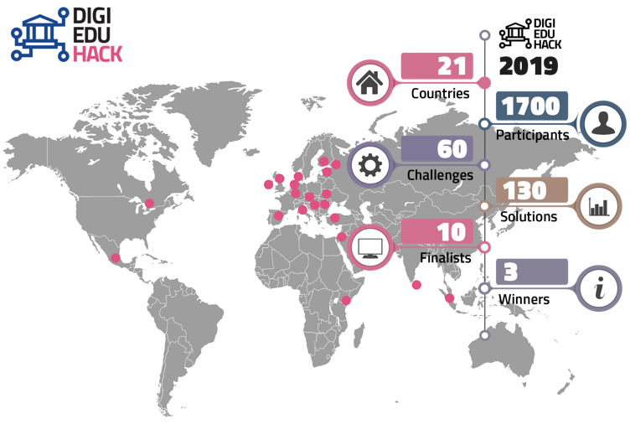

Source: DigiEduHack (2019)

Feedback from stakeholders was highly positive: participants perceived their involvement in the first Digital Education Hackathon very useful (94%) and confirmed their intention to take part in the next edition (77%); more than half of the hosting organisations (54%) expressed their willingness to further work on implementing the most innovative ideas. The Hackathon generated policy and technical solutions to problems identified by educational stakeholders on the ground.

During the implementation of the 2018 Action Plan, the **EU Code Week[52]** was also a successful action boosting cooperation. The initiative is supported by the European Commission and Ministries of Education in EU and Western Balkan countries. At the heart of EU Code Week is the community of volunteer activity organisers who are teachers, mentors, coding clubs, libraries, private companies, parents and non-governmental organisations. They dedicate their time, energy and skills to bring computational thinking, coding, robotics, tinkering with hardware, computer science and digital skills at large to as many people as possible in Europe and around the world. In 2019, more than 4.2 million people participated in over 80 countries around the world.

Overall, these very different examples highlight the **potential to work together and engage with a wide range of stakeholders** on the opportunities and challenges of digital education.

## 

## 3. Lessons from the COVID-19 crisis

In 2020, the world was hit by the COVID-19 pandemic. Like other parts of the world, Europe faced an unprecedented crisis and urgent need to respond to immediate public health challenges and consequent economic and social issues. In March 2020[53], most EU countries restricted or prohibited access to buildings and campuses of schools, universities and other centres of education and training, as part of their measures to slow down the spread of the virus (Figure 2)[54].

**Figure 2: Schools and higher education closure in Europe in April 2020**

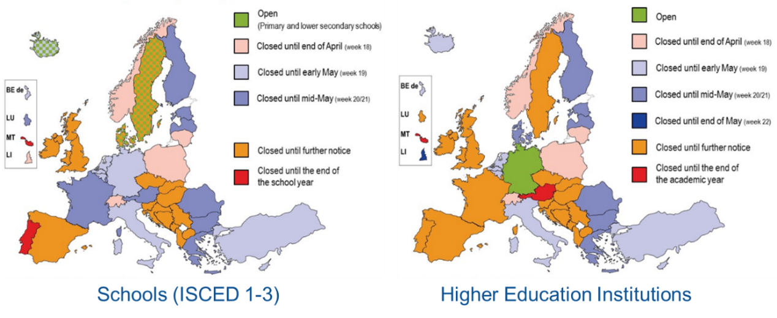

Source: EURYDICE (2020)

Within weeks, the global education landscape was upended, affecting 100 million pupils and students in the EU and over 1.3 billion children around the world[55]. Some education systems announced exceptional ‘holiday’ periods at the beginning of the closure to better prepare their response, but within a short period of time, learning started to take place through experiences of **remote emergency education**[56] in most parts of Europe[57]. Results of the public consultation show that a large part of those respondents reporting not to have used distance and online learning before the crisis, but they actually did so during the lockdown period[58]. The range of solutions put in place to ensure continuity of education and training was wide. They included low- and high-tech practices (e.g. using digital platforms, radio and TV channels, or other electronic resources) and varied from country to country, and within countries, depending on the level and sector of education and training .

Experiences during the period of lockdown showed that a higher level of pre-existing digital capacity led to faster and better responses. Where this was not the case, the efficiency and quality of the measures suffered: for instance a study in Germany from June 2020 showed that the amount of time children devoted to school activities halved during the COVID-19 crisis, falling from 7.4 hours to 3.6 hours daily[59]. Research shows that closure of education and training institutions, even if temporary, can have significant consequences for learners. Reduction in instructional time can impact negatively on learning outcomes[60]. They can increase existing inequalities, with economically advantaged families having more resources to fill learning gaps and provide stimulating activities to their children[61].

Across Member States, having already in place options for alternative and flexible forms of learning, interaction and communication allowed a faster and more efficient response, with the emergence of some good examples of innovation[62]. However, access to and quality of the learning experience varied a lot depending on the availability of infrastructure and devices, the presence of digitally competent educators, including capacity to adapt pedagogical methods, and the existence or not of usable and accessible digital content, tools, services and platforms. All these elements, at national or local level, helped create the conditions for learning to continue.

For instance, higher education institutions were somewhat better prepared than other education sectors, due to their prior experience with providing blended learning options and online digital content in their courses and programmes[63]. In most cases, their lessons continued virtually through streaming and use of existing learning management systems[64] but this happened with a wide degree of quality regarding the learning design. On the other end, schools and VET providers had to pivot rapidly, under similarly difficult circumstances and in most cases for the first time, to remote emergency education[65].

In this rushed and unplanned situation, the production of new online learning content was rarely an option, especially because of time constraints. Most educators and students were confined in their homes at short notice and, as long as they had internet access and digital devices, in most cases a synchronous technology-mediated virtual classroom was considered the most practical and feasible approach[66]. This is confirmed by the results of the public consultation where it is possible to observe an increase in the use of distance and online learning both ‘in real time’ (e.g. live online classes) and ‘in own time’ (e.g. watching videos of recorded lectures, consulting online learning materials, etc.); however, according to respondents, the former increased more than the latter. Due to unexpected closure of education and training institutions, most educators replaced face to face teaching and learning with synchronous online classes and this happened despite the use of distance and online learning ‘in own time’ done before the crisis was higher than the one ‘in real time’[67]. Innovative instructional approaches, which stimulate learner autonomy, motivation and engagement were lacking. As practice and research on the topic shows, high-quality and inclusive digital education requires time, skills and appropriate resources for planning and design[68].

## 

## *3.1 Challenges in managing remote emergency education*

Results from the public consultation confirm the manifold challenges in managing the sudden and large-scale shift to distance and online teaching and learning. Institutions and educators in Europe and around the world showed creativity and resilience, but many struggled to adapt to the needs and context of the learners, including their access, or not, to devices and connectivity. Individual perceptions of the solutions put in place varied considerably, with education and training staff having more positive views than learners and their parents[69].

Overall, stakeholders highlighted that, in most cases, the transition to distance and online teaching and learning happened in a rush and unplanned manner. For younger students and pupils, education and training institutions relied heavily on parents and carers’ collaboration. Many publishers and technology providers opened up their resources and platforms. In a number of countries, new public-private partnerships were quickly established to expand national and local capacities in deploying distance and online learning solutions[70]. The transition was also supported by rapidly developed television and radio programmes and by many educators who shared resources and practices to help colleagues, particularly those less experienced with online instructions.

Although remote education has been present in education and training for many decades, the situation generated by the COVID-19 crisis saw a **shift at an unprecedented scale,** with millions of learners and educators moving simultaneously to distance and online teaching and learning. Given the emergency context, re-organising courses and lessons online was not the result of a well-planned instructional design process inspired by the opportunities offered by digital education and rooted in a thorough needs analysis.

Evidence from the OECD’s Programme in International Student Assessment (PISA) in 2018 showed that education systems were unprepared for this shift online. On average, 9% of 15-year-old students did not have a quiet place to study in their homes and access to computers and connectivity was a concern[71]. Evidence confirms that the availability and use of digital solutions to enhance teaching and learning depends largely on national and local policies and practices. For instance a study from 2018 shows that the availability of Virtual Learning Environments (VLE) varies across Member States, with primary schools using them less than lower and upper secondary schools (37%, 50% and 59% respectively)[72]. Platforms for school-home communication are less available than VLEs and educators use of technology for providing feedback and creating digital resources are even less prevalent than for other activities[73]. For remote education to work, devices and internet access are vital but in addition, effective communication with learners is crucial[74] to ensure engagement and prevent online learning from becoming passive and a matter of reading materials[75].

During the COVID-19 crisis, many people experienced for the first time how technology could be used to teach, learn and assess in new and innovative ways. Results of the different consultation activities, including the open consultation, shows that, in some cases, this generated a positive reaction, with educators feeling comfortable with remote teaching and learners being happier to have a more personalised dialogue with their teachers[76]. Educators who were lacking the confidence and competence to use digital technologies effectively faced immense challenges to adapt to learners’ social, learning and technological needs. Results of the public consultation confirm that adapting to this new working environment sometimes meant an increased workload, thus affecting educators’ own work-life balance[77]. Given differences between face-to-face and distance or online teaching and learning, educators need to be supported on a practical, pedagogical and technical level, feel competent to adapt their methods and confident to use digital means to communicate, assess, and provide feedback. Students, in turn, need to be guided to stay motivated and engaged, as there is a risk of being excluded if they lack resources, connectivity, skills or motivation.

Emerging evidence confirms that, in the circumstances caused by the COVID-19 crisis, educators and learners were not always in a position to harness the potential of distance and online teaching and learning nor were they able to deal with its limitations. An analysis of the experiences across Member States also shows that educational institutions with pre-existing digital capacity did not use distance and online learning extensively and sistematically until they had to. In this regard, exchange of best practice’ and professional learning and collaboration, both within and across educational institutions, emerges as a strategy for resilience[78].

Many Ministries of Education across Member States (such as Italy[79], the first European country struck by the COVID-19 pandemic) quickly published guidelines to provide educators with easy access to video-conferencing applications, open educational platforms or online resources, and collaboration tools, allowing synchronous and asynchronous teaching and learning. In some cases, they also prepared or collected materials to bridge the length of a temporary school closure[80] and quickly put in place training courses for teachers on how to design lessons for remote education[81]. Surveys and feedback show that finding an appropriate response was not easy, especially for certain sectors such as VET[82]. Assessment of learners’ achievements, re-organisation of final exams as well as testing to determine entry requirements for higher education were highlighted as major challenges[83]. Urgent support was also needed from authorities on how to validate and recognise qualifications[84]. Organisations, including OECD[85], UNESCO[86] and the European Commission[87] pooled expertise and resources to facilitate exchange between countries, rapidly collect and analyse information on education responses, and support efforts to design workable solutions. Despite differences in education structures and curricula, international collaboration helped countries to share and exchange resources and learn from each other’s contingency plans.

However, significant differences between and within countries in terms of digital capacity and competences as well as learners’ connectivity and access to devices, meant that entire groups of learners, including those from remote areas, migrant and refugee children and other learners from disadvantaged backgrounds, risked being excluded from distance and online teaching and learning[88].

Education and training institutions are first and foremost a place of social interaction and the psychological consequences of facing the pandemic and related disruptions, while being away from their educators and peers, have been manifold for all learners. Students in upper secondary and tertiary education may have had already acquired skills to work independently, while younger learners were particularly challenged in this regard. Younger pupils needed additional support and guidance from parents and carers, including limiting their exposure to ‘screen time’ and passive usage of devices. Challenges were greater for families where parents had lower levels of education and no or low-level of digital skills (Figure 3)[89] .

**Figure 3: Level of digital skills in EU households with children**

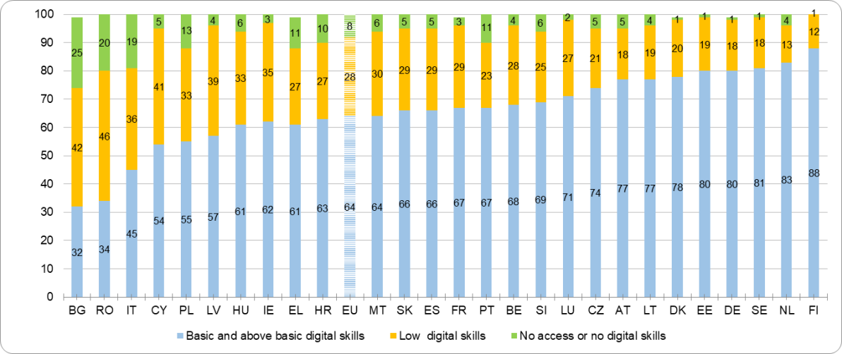

Source: Eurostat (2019) - Percentage of individuals (16-24) living in households with children (0-16) by digital skills level, country and EU level

Ensuring learners’ well-being and addressing the risks of increasing inequalities required targeted support, including to students with disabilities[90], special needs and the most vulnerable, who, may, for example, be entitled to free school meals[91]. By forcing learners to a different routine with restricted social connections and increased academic stressors, the COVID-19 crisis has placed an unprecedented mental health burden on learners, which may require further intervention[92]. For instance, a recent study shows that approximately 25% of learners experienced anxiety symptoms, which were positively correlated with concerns about academic disruption and delays, economic effects of the pandemic, and impacts on daily life[93]. This is confirmed by the results of the public consultation where learners indicated ‘support for mental health’ as something they were lacking as well as ‘interaction, clear instructions and guidance from educators’ and ‘regular interaction and communication with other learners’[94]. Specific support as well as further research and investigation on the impact of the COVID-19 crisis on mental health of individuals and young people may be needed in the future[95].

Even though research efforts are underway, at present, robust data is missing on whether and how the distance and online teaching and learning practices put in place in response to the COVID-19 crisis ensured **effective and equitable access to quality learning opportunities for all**. Emerging evidence suggests that while delivering educational activities remotely ensured some degree of continuity of learning for many learners, low motivation levels, stress, absenteeism and disengagement were not uncommon[96]. Without considering the consequences that this could have on dropout rates in the long term, the crisis has affected learners across the board and in particular those needing additional pedagogical and psychological support and those lacking reliable internet access and suitable devices for remote education[97].

Flexible learning might be needed in emergencies, such as public health crises or natural disasters, but also in other situations where learners cannot access education and training buildings (e.g. to reach geographically isolated regions, to support students with long-term illness, to offer learning opportunities to working students, supplemental teaching or fill curriculum gaps). Overall flexible learning can help enrich and extend education and training, making it more inclusive and responsive to learners’ needs.

The use of digital technologies for educational purposes can also support blended formats, combining face-to-face and online[98], which is one of the approaches considered by Member States in education and training institutions re-opening. However, it needs to be planned properly with sufficient support, resources and guidance, otherwise it risks becoming a negative experience for educators and learners alike[99]. It is important to note that online learning can be perceived as being of lower quality than face-to-face instruction, despite research showing otherwise[100]. As with other instructional approaches, its effectiveness is a matter of who is learning, who is teaching and how teaching and learning are accomplished and assessed. Suitable platforms and tools are of course vital but many other considerations are required[101]. Teaching and learning online, whether in crisis or routine contexts, requires a fundamentally different approach to designing learning and engaging students[102].

Emerging evidence on the educational impact of the crisis confirms that more systemic research on the future of education and training is needed. This needs to be based on a **thorough and critical reflection on the positive and negative experiences generated by the COVID-19 crisis** across Member States[103]. However, in Europe, there is a relatively small body of prospective research[104] focussed on what may happen to education over the medium or long term[105]. Considering the megatrends shaping the future of education and training, including emerging technologies for teaching and learning, efforts are needed for more future-oriented, data-driven research and development in education and training. As widely confirmed by stakeholders, this will help ensure that in the future digital technologies enhance teaching and learning in an effective and sustainable way, while addressing concerns related to data use and protection, privacy and ethics[106].

**Box 2: Big data in education**

Global investments in educational technology reached US$18.66 billion in 2019, a stark increase over previous years[107]. Yet, during the crisis, education and training institutions used, even within the same institution, a wide range of different online platforms and tools, sometimes provided for free or at reduced cost by the private sector and often not known by educators and learners. In many cases, there was a shortage of online content and other digital resources linked to national curricula. Solutions were often implemented as ‘quick fixes’[108] and generated concerns about the hasty adoption of commercial digital learning solutions whose design might be driven by business models that leverage user data for profitmaking, rather than meaningful pedagogical practices[109].

The digitalisation of education and training is increasingly generating data that has the potential to be used to improve educational performance, personalise learning, reduce dropouts and increase the efficiency of teaching and learning provision[110]. However, apart from a small number of successful pilot deployments[111], the use of predictive or learning analytics in Europe is not used to its full potential[112]. Many countries have not yet established guidelines governing the ethical use of data in research or education. Education and training providers and policy-makers lack an overall vision and strategies on how to use technologies with regard to data[113]. On the other side, the EdTech sector is currently offering a number of products and tools that make use of data-driven solutions[114]. However, in these cases, data use and protection, ethics and privacy are not always taken in account[115]. This is a critical moment, therefore, to reflect on what is needed to ensure that the choices and decisions educational institutions are current making impact positively on the future of education and training.

In this context, quality assurance and trust play a crucial role: the former to promote a shared understanding of key quality standards for digital education; the latter to ensure respect of key principles regarding data use, ethics and privacy. These two elements, besides boosting the level of digital preparedness of Europe’s education and training institutions, can increase the cooperation between the public and private sector (beyond the crisis period) and improve the overall quality of the digital solutions available.

## 4. Priorities and direction for strategic action

Results of the public consultation confirm that, during the lockdown, learning in confinement and without proper support raised **questions around the effective use of technology for teaching and learning**. Even though practice and research show that digital technologies can enrich and extend face-to-face education, its full potential remains unexploited.

For the majority of respondents (95%), the COVID-19 crisis is a ‘turning point’ for digital education. They consider that the forced shift to distance and online learning would have a longer-term impact on education and training[116]. Respondents said that effective provision of digital education, both in its online or blended format[117], would require educators’ digital competence development, the existence of a vision or a strategy on integrating digital technologies in education and training, and high quality digital resources and materials. In the view of education and training staff and parents, addressing socioeconomic inequalities between learners also requires investments in connectivity and infrastructure. Stakeholders also highlighted the key role that the European Commission can play in supporting national efforts, to promote networking and practice exchange and to build on lessons learnt during the COVID-19 crisis[118]. The new Digital Education Action Plan takes on this challenge and sets out principles, vision and a series of measures to support high quality and inclusive digital education.

Considering the debate that the use of technology for remote learning that the COVID-19 crisis has generated[119], the Action Plan addresses the challenges and opportunities for digital education in different learning environments (formal, non-formal and informal) and extends its scope to lifelong learning[120]. The renewed Action Plan also has a longer duration, covering the next Multiannual Financial Framework (2021-2027), with a review foreseen in 2024.

As confirmed by stakeholders, the priorities of the 2018 Action Plan remain relevant[121], but they are updated to reflect its longer duration and better address the challenges for education and training raised and, in some cases increased, by the COVID-19 crisis. In more details, the renewed Action Plan is based on two priorities, each accompanied by a limited number of targeted actions(see Table 2):

|  |  |  |  |
| --- | --- | --- | --- |
| Priority Area | Short description | Objectives | Actions |
| Fostering the development a high performing digital education ecosystem | Effective use of digital technologies for quality and inclusive education and training needs to be planned in a sustainable way, with sufficient support, resources and guidance. Providing infrastructure and digital devices is fundamental, but a critical and purposeful use of digital technologies for teaching and learning needs to be underpinned by strong digital capacity. Actions under this priority promote closer collaboration and exchange in digital education among all parts of society. | * Boosting peer learning and policy cooperation * Investing in infrastructure and connectivity * Fostering digital capacity building in educational institutions * Supporting high-quality digital education | * Enabling factors for successful digital education * Online and Distance Learning for Primary and Secondary Education * European Digital Education Content Framework and European Exchange Platform * Support for connectivity and digital equipment for education * Digital transformation plans and digital pedagogy and expertise * Ethical guidelines on AI for educators |
| Enhancing digital skills and competences for the digital transformation | Today, the lack of digital competences is a societal challenge for adults and young people alike. The COVID-19 crisis has reinforced the need to promote a sound understanding of the digital world and support the development of digital competence of citizens and learners of all ages. Actions under this priority look at both basic and advanced digital skills with the aim of fostering digital citizenship and inclusion. | * Fostering the development of digital competence * Promoting digital literacy for informed choices as citizens * Boosting the development of advanced digital skills | * Tackling disinformation and promoting digital literacy through education and training * Digital Competence Framework update * European Digital Skills Certificate * Improving the provision of digital skills in education and training * Digital competence benchmark * Digital Opportunity Traineeship * Women’s participation in STEM; |

**Table 2: Priorities, objectives and actions of the renewed Action Plan**

## 5. Supporting evidence

This section of the staff working document provides evidence supporting the actions of the renewed Digital Education Action Plan. It examines key opportunities and challenges regarding the pedagogical use of digital technologies for teaching and learning and the development of digital competence.

## 5.1 Using digital technologies for teaching and learning

Digital technologies have the potential to improve education and training and increase its accessibility and quality, but for this to happen proper planning and instructional design play a key role. Evidence on the effects of digital technologies on learners’ academic performance[122], including the development of transversal competences (e.g. problem solving, creativity, etc.) and basic skills (e.g. reading, mathematics and science), is positive but mixed[123].

Even though education and training systems are evolving and increasingly making use of digital technologies to stimulate innovation, there is limited evidence of the extent to which educational institutions have made progress in **adapting their leadership, culture and delivery models**[124]. As outlined in section 3[125], the sudden and large-scale shift to distance and online learning during the COVID-19 outbreak has been far from simple. Despite being a positive experience for some institutions with high levels of digital capacity, it raised significant challenges in terms of equity and quality. These ranged from the unprecedented need for distance and online teaching and learning to be offered to all, the risk of increasing existing learning, social and digital inequalities and the pressure on educators to suddenly change their practices.

The COVID-19 crisis has clearly shown that quality of access and infrastructure are crucial for ensuring equity in education and training[126]. However, availability of digital technologies is not enough to have quality outcomes and improve the student experience. A positive relationship between the use of digital technologies and learning outcomes depends on a number of contextual and process-related variables.

First, **educators play a key role** in adopting and using digital technologies for teaching, learning and student assessment in an effective way, fully online, remotely, or in a blended format. Educators themselves need to have an appropriate level of digital competence and be able to recognise their potential for educational purposes. The effectiveness of digital technologies for teaching and learning hinges on teacher practice and on how they integrate these tools into their teaching process[127]. Educators’ perception of technologies as a learning tool are, in turn, influenced by the organisational culture[128], which allows for different levels of autonomy or agency and shapes the way digital technologies are implemented and used for teaching and learning in a specific context.

Another factor linked to this, is the **extent to which technology is deployed in purposeful and targeted ways**. A recent study using data from the Trends in International Mathematics and Science Study (TIMSS) shows that, while using computers to look for information positively affects student achievement, the opposite occurs when computers replace face-to-face instruction time to practice skills[129]. An analysis of data from the OECD's Programme for International Student Assessment (PISA) finds that there is a positive relationship between students’ achievements and the use of digital technologies for certain purposes[130]. There is also evidence that low-intensity users may see their learning achievements increase from additional use and that high-intensity users would benefit from a more moderate use[131].

In addition, the location of the use of digital technologies matters. Their use at home for learning can be beneficial, but the presence of a space conducive to learning, parental monitoring for young people and general guidance for adults makes usage more effective[132]. Literature suggests that the effect of the use of digital technologies on learning outcomes may also vary according to student age and socio-economic status as well as attitudinal factors[133].

However, digital technologies are part of our everyday life and also need to be part of our learning experience, especially in a lifelong learning perspective. Their uptake and use for teaching and learning requires a **critical approach and a holistic perspective**. Embedding digital technologies in teaching and learning processes does not mean simply replicating or transposing face-to-face practices or traditional approaches online. It is a complex process, which requires robust digital capacity, including planning for organisational change, ongoing monitoring and adaptation, and a strong focus on learning driven pedagogy. As confirmed by the results of the public consultation, other relevant factors include leadership, professional development, and a shared understanding and approach to using technology to support and enhance teaching and learning[134].

## *5.1.1 Infrastructure and connectivity*

Early policies and strategies in digital education were largely infrastructure-led[135], looking at access (in terms of both connectivity and availability of devices). The digital divide was initially focused on those who could and could not access technology.[136]. Over the years, investments at EU, national, regional and local level have been made, and connectivity and access have improved. In the 2009 OECD’s Programme for International Student Assessment (PISA), about 15% of students on average reported that they did not have access to internet at home. By 2018, that number shrunk to less than 5% across all levels of education[137] (Figure 4).

**Figure 4: Students' access to internet at home**

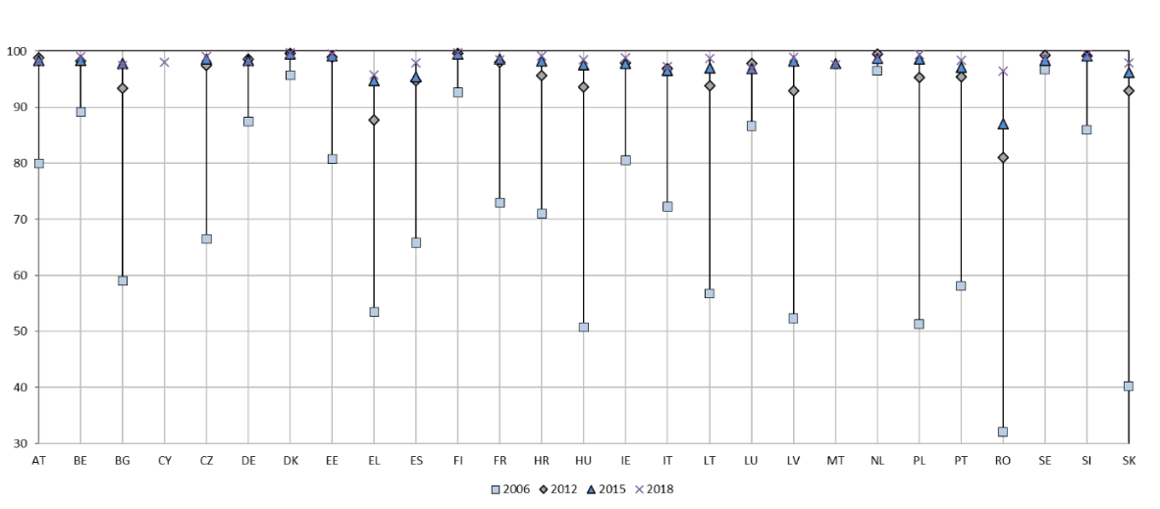

Source: OECD (2018, 2015, 2012 and 2006)[138]

Nowadays the vast majority of people in the EU use internet in their everyday lives and 90% of households have internet access, with a connectivity rate between 98% (NL) and 75% (BG). These figures are very similar to the ones registered for households with dependent children: in this case 87% have access to internet, with a connectivity rate between 98% (NL) and 70% (BG). Furthermore, data reveal that access to internet is significantly higher for high-income households (98%, with income in the fourth quartile) compared to low-income households (77%, with income in the first quartile)[139]. The growth in access to online services is likely to be even steeper than suggested by these figures, which do not show improvements in the quality of internet services and the explosion of mobile internet access over the past decade[140]. According to the 2020 Digital Economy and Society Index (DESI), internet access at home is provided mainly by fixed technologies (97%), while high speed broadband covers 86% of homes in the EU, up from 83% a year earlier. Over a period of five years, more and more people have taken up broadband services of at least 100 Mbps, with the current level of 26% of households, five times higher than five years ago. Even though little progress has been registered on the 5G networks[141], 4G mobile coverage is today almost universal (99%).

Nonetheless, as the COVID-19 crisis has shown, **important infrastructure gaps still exist in Europe**: broadband availability and adoption of digital equipment are not spreading at the same speed in rural and urban areas and between Member States[142].

For instance, the EU-27 connectivity rate of households is at 86% in rural areas[143], with great disparities between countries[144], and broadband coverage continues to be lower than national coverage[145]. Rural fixed coverage improved marginally from 88% in 2019 to 90% in 2020, while high-speed broadband increased from 52% to 59% compared to the year before. Still, 10% of households in rural areas are not covered by any fixed network and 41% by any fast broadband technology[146]. Mobile coverage went up slightly compared to last year but it is still mainly used as a complementary technology.

When it comes to equipment at home, latest figures from Eurostat show that, in 2017, 94% of households with dependent children had access, via one of its members, to at least one computer (i.e. 6% of EU households with dependent children did not have access to at least one computer)[147]. These findings are in line with 2nd Survey of Schools: ICT in education showing that most students have access to computers at home (e.g. 92% at primary, 96% at lower secondary and 97% at upper secondary education)[148]. These figures however do not provide information regarding how many computers are available per individual household, and whether students can have access to a computer at any time[149]. Data on the topic shows that the share of students who use own digital equipment for learning purposes remains relatively stable compared to 2011/2012. In this case, the own equipment most used for learning purposes is a smartphone, while the use of laptops owned by students is quite low across Europe and depends largely on family’s income[150]. Similarly to connectivity, disadvantaged learners such as those from low-income or migrant backgrounds have less access to computers at home[151] and start using digital devices later in life and with a lower frequency compared to their more advantaged peers[152]. Overall, education and income of parents appear to be positively correlated with young people’s access to digital technologies[153].

With gaps in access to digital technologies, **education institutions, and schools in particular, act as a key socio-economic driver** and play an important role in preventing digital exclusion. Accessibility and quality of connectivity at school provide many advantages, including having access to resourcesand material in multiple formats, using platforms for collaboration, accessing tools for inquiry-based pedagogies and sophisticated online software, using applications for video conferencing or streaming.

Infrastructure for educational purposes can be rich, varied and differentiated. It can go from minimum and essential components to highly equipped and connected classrooms with, for instance, ultra-fast broadband and one device per student[154]. However, wired internet connections[155] are still the norm in many European schools. The results of the 2nd Survey of Schools: ICT in education[156] show that the share of students attending highly digitally equipped and connected schools differs widely: it ranges from 35% to 52% to 72% depending on the level of education (ISCED 1,2,3). The EU average suggests that the older the students, the higher the likelihood that they attend a school with a fast internet connection: on average in the EU, 11%, 17% and 18% of students are in schools that have an internet speed above 100 mbps at ISCED levels 1, 2 and 3, respectively. Moreover, as in the case of connectivity at home, large differences between and within EU countries exist: whereas Nordic countries are frontrunners regarding the deployment of high-speed access to internet in schools, other countries and schools located in villages or smaller cities are lagging behind (Figure 5).

**Figure 5: Internet speed according to location of schools**

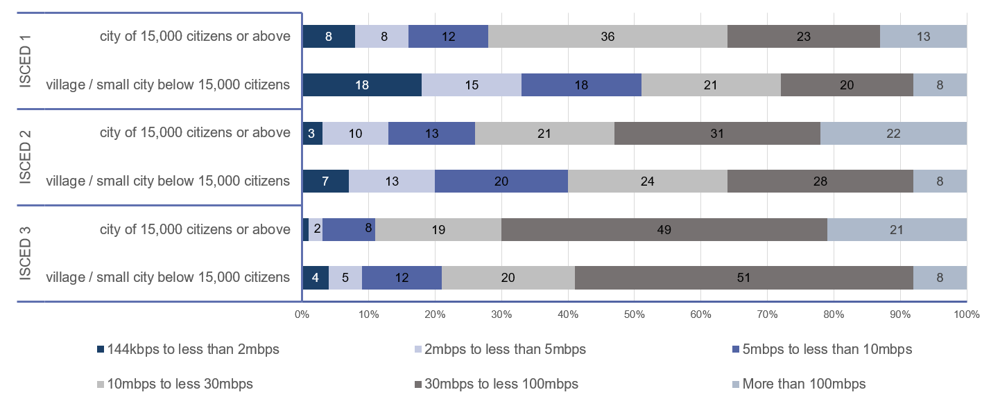

Source: 2nd Survey of Schools (2019) – Percentage of students, all ISCED levels, EU level

EU broadband targets foresee that by 2025 all schools should have access to Gigabit internet connectivity[157]. These findings therefore highlight the need to further support school access to high-speed internet, as already recognised in the Communication on Shaping Europe’s Digital Future[158]. While Member States have the primary role in tackling infrastructure provision and connectivity , the EU is actively supporting efforts to fulfil this goal. For instance, the European Regional Development Fund (ERDF) invests in education infrastructure and equipment and creates incentives for educational reforms in the Member States. Nearly EUR 7 billion of ERDF resources have been invested in education and training in the 2014-2020 programming period. This means that almost 7 million young people will be able to use new or improved educational facilities across different Member States. The need to support the roll-out of higher-capacity broadband in schools was included in the 2018 Action Plan, with an initiative aiming at raising awareness on the funding opportunities provided by the EU for connectivity. The first three Wifi4EU calls led to 7,980 municipalities, including schools, received vouchers for Wi-Fi hotspots. Analysis of this action and input from stakeholders[159] indicated that stronger support for school infrastructure and equipment would help achieve more systemic results.

## *5.1.2 Digital capacity in educational institutions across the EU*

While availability and access to technologies is an important and necessary pre-condition for digital education, improvements in education and training can only come through **systemic organisational change underpinned by pedagogical principles and values**[160]. Research on the topic shows that infrastructure and connectivity need to be accompanied by a range of measures, including digital leadership and vision and teacher professional development, and that digital education should be firmly embedded across education and innovation policies[161].

To date, most Member States have developed digital strategies to support educational organisations in using digital technologies to enhance learning[162], but very few undertake regular monitoring or evaluation to review and update them on the basis of new developments in technology and related learning needs[163]. In countries with less advanced digital economies[164], investments continue to be directed towards improving digital infrastructure, but increasingly policy interventions are more holistic in focus, and include digital leadership and educator competences as key drivers to encourage and sustain innovation[165].

During the COVID-19 crisis, the need toprovide teaching and learning remotely led to examples of educational innovation at scale but also to suboptimal practices due to the lack of experience and digital capacity of institutions at all levels of education. Indeed, several national studies[166] confirm that the effectiveness of the response was linked to levels of preparedness. This included factors such as availability of infrastructure, connectivity and devices; access to online content aligned with national curricula and programmes; confidence and skills of educators to design and facilitate distance and online learning; levels of interaction and support for learners; capacity to monitor access; track the learning process and assess learning outcomes.In drawing lessons for the future, it is important to build digital capacity and preparedness to avoid replicating the experience of the past months, which saw widening gaps, inequalities and learning losses [167]. As confirmed by the public consultation, education and training institutions can learn and build upon the experience by enhancing their digital capacity[168].

A strategic and planned approach for technology use and digital competence development can help ensure learning continuity in situations where on-site attendance is not possible. This includes emergencies such as with COVID-19, but also other circumstances, for example offering learning opportunities to a diversified cohort of students, reaching geographically isolated regions, offering supplementary teaching, etc.

**At school level**, recent research shows that teachers working in institutions with an organised and collaborative approach to technology are more likely to use digital technologies in their teaching and value the importance of students’ digital competence[169]. However, a planned and systematic approach to integrating technology in school activities is currently the exception rather than the norm.For instance, the 2nd Survey of Schools on ICT in Education found that only around one third of students attended schools that had written statements on the use of digital technologies for pedagogical purposes[170]. In cases where schools are required to development such a plan, digital competence and innovative teaching and learning methods become central to school development as part of a whole school approach[171].

Effective use and integration of digital technologies in teaching and learning require **careful planning for pedagogical, technological and organisational change**. Defining the starting point of an education and training institution regarding the use of technologies in their teaching and learning activities is key to initiate this process. Assessing the current situation, sharing experiences and discussing why and how technology can be used are key drivers for learning how to use technology in a meaningful way, while better understanding the institution’s learning culture and wider system-level barriers[172]. For this reason, the 2018 Digital Education Action Plan included actions to support educational institutions in assessing their digital capacityand planning for organisational change.

At school level, **SELFIE**[173] , launched in October 2018, is a free, customisable self-reflection tool, which allows school plan for technology use[174]. By gathering (anonymised) views and perspectives from students, teachers and school leaders, results can be used to kick-start an internal debate and develop concrete actions for improving technology use and digital competence development. Feedback from end-users was highly positive and the tool was singled out as a best practice example of a practical and useful tool to help school and support policy goals[175]. SELFIE has been used by over 650,000 users (32 language versions available) and from the outset has received extensive support and interest from Ministries of Education in Member States[176] and partner countries[177]. The SELFIE tool is continuously improved based on feedback from schools: in August 2020, a new release of SELFIE has been published to include questions on online and blended learning [178] to help schools reflect on and learn from the period of school closure and disruption. Following a feasibility study, a version of the tool for work-based learning (e.g. students on apprenticeships programmes) is also being piloted[179]. The activities carried out so far indicate that the inclusive and flexible design of SELFIE provides schools with valuable information to harness the potential of technology in all aspects of education, but more support is needed to help schools use their results to develop digital learning plans and increase their digital capacity[180].

Similarly, the response of the **higher education sector** to digital transformation is uneven: higher education institutions vary widely in their levels of digital capacity and there is a substantial knowledge and experience gap, both within and across institutions. Emerging evidence from the COVID-19 crisis indicate a general higher level of preparedness[181], with many courses and programmes continuing online through asynchronous and synchronous instruction and by scaling up of existing learning management systems. Challenges were many including assessment, administration of exams, and selection and admission of new students[182] as well as learner engagement and adapting instructional design to online learning[183].

Although many higher education institutions are spearheading new approaches and good practice examples can be found throughout the sector, the system-wide take-up of effective digital education practices remains slow. A number of surveys are underway to investigate the level of digital preparedness and the response of higher education to the COVID-19 crisis[184], but overall scarcity of data and detailed information on the adoption and impact of digitalisation at university level hinders the effective use of policy measures to stimulate, monitor and assess institutional practices[185].

During the implementation of the 2018 Action Plan, debate on how to support further universities to modernise and drive organisational change led to a further development of **HEInnovate**[186], a guiding framework to support higher education institutions and systems to develop their innovative and entrepreneurial potential. A new set of statements on ‘digital transformation and capability’ were added, covering areas such as organisational culture and vision for digital learning, fit-for-purpose digital infrastructure, and the development of digital competences of staff and learners. Since its launch in June 2018, around 1300 institutional self-assessments have used this new dimension.[187] The HEInnovate community has particularly welcomed the new focus on the digital transformation underlining that it addresses a clear demand coming from universities. Higher education’s interest in the topic has been also confirmed by the active participation in the HEInnovate Webinar Serieslaunched in Spring 2020 during the lockdown period. The objective of these webinars was to leverage the expertise of the HEInnovate community to discuss the current challenges facing higher education institutions, share approaches and solutions, and discuss how educational practices are being adapted to meet the requirements of the digital world[188].

As for other levels of education, the COVID-19 crisis has forced higher education institutions to radically change how they operate and deliver their educational offer. This has significantly accelerated the digital transformation that some institutions were preparing for or undergoing prior to the crisis[189].

Higher education in the EU is evolving with a growing demand for short-term learning opportunities, the need for more flexible provision for degree programmes and demand from adult learners and professionals looking to re-skill or upskill[190]. In this context, the use of digital technologies has the potential to open up higher education to a wider audience, offering certain economies of scale and providing learning that is more inclusive and flexible. Before the COVID-19 crisis, there was a clear trend towards integrating blended learning in formal educational offers (e.g. using digital learning mainly in face-to-face degree programmes), as programme managers and educators consider this type of learning the most effective one[191]. However, establishing high quality digital content requires careful instructional designand planning to ensure that learning, teaching and assessment methods are suited to online and blended modes[192].

Recently, a new impetus for creating and sharing digital content for students, staff, researchers and citizens was given through the European Universities initiative[193] , which supports transnational alliances of higher education institutions. Online and blended learning support the goal of the European Universities to increase mobility of their students and staff; offer more flexible learning pathways and increase transdisciplinary approaches to link students and staff with the public and private sector. In addition, the Erasmus+ OpenU project under the 2018 Action Plan aims at fostering policy dialogue between higher education institutions and national high-level authorities on the use of digital technologies for teaching and learning[194].

The entry point for digital transformation in higher education institutions is often connected to online or blended teaching and learning, however digitalisation covers much more than the online delivery of content. The uptake of digital technologies in higher education should be based on **strong leadership and a holistic, well-designed and integrated strategy** that consider technologies as a key enabler for all institutional processes and activities[195]. It is in this context that the concept of *digital-first thinking* has been developed to indicate a shift in organisational culture, which embraces the opportunities offered by digital technologies and shapes activities and practices accordingly. Evidence shows that higher education institutions play a key role in supporting central and local authorities in developing and implementing their digital agenda[196]. Supporting these efforts by promoting best practices exchange and capacity building may have a multiplier effect on higher education practices but also on society and the economy.

## *5.1.3 Educators’ digital competence*

In a rapidly changing world, teaching, learning and assessment face new challenges and demands. Teaching professionals in all sectors of education, from early years to adult learning, are at the fore of this change, and need to be equipped with the confidence and competence to use technology effectively[197].

In the context of the COVID-19 crisis, stakeholders pointed to the importance of boosting digital competence of education and training staff as a way to ensure effective and pedagogically driven use of digital technologies for teaching, learning and assessment. Providing support, training and guidance for educators was indicated by half of the respondents of the public consultation as the most important area in which the EU can add value [198].

Emerging evidence confirms that, during the period of education and training institutions’ closure, many educators struggled with the situation and lacked the knowledge and experience on how to plan, develop and deliver teaching through digital means, including identifying platforms and tools that were effective, easy to use, viable and secure. A number of national studies show that educators faced a heavy increase in workload and felt tremendous pressure[199], not least due to having to quickly design and organise remote and online learning[200]. In some cases, they lost daily contact with their students[201] and many adopted strategies which attempted to reproduce standard classroom approaches and timetabling online[202]. In this regard, educational institutions which had experience in organising teaching, learning and assessment as a team activity and taking organisation-wide approaches were able to transition more readily to remote education. [203].

In Europe, three out of four education systems recognise digital competence as an essential element that educators must have for teaching, but this is reflected in recommendations for initial teacher training in only half of European education systems’[204].

The vast majority of teachers and school leaders who participated in the 2018 OECD’s Teaching and Learning International Survey (TALIS) say that their schools are open to innovative practices and have the capacity to adopt them[205]. The frequency with which teachers have students use digital technologies for projects or class work has risen in almost all Member States since 2013, and this is reflected in increased participation rates in teachers’ formal education and training including digital skills for teaching. However, prior to the COVID-19 crisis, when asked about their level of preparedness, **only 39% of teachers in the EU felt well or very well prepared to use digital technologies for teaching**, with significant differences across EU countries[206]. More than half of the teachers had participated in professional development activities that covered the use of digital technologies for teaching and learning, but, on average, 16% of teachers still reported a strong need for professional development in the area of digital competences (Figure 6).

**Figure 6: Teachers’ need for professional development**

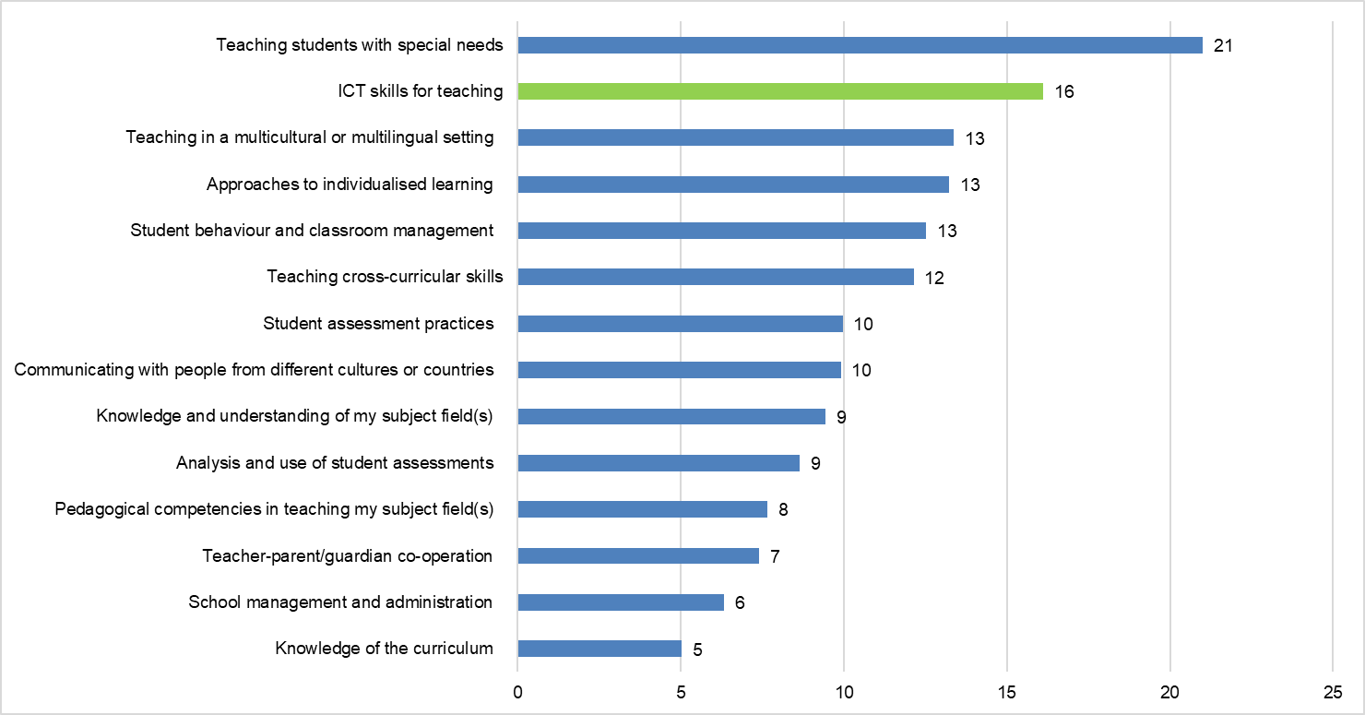

Source: OECD (2018) - Percentage of teachers reporting their need for professional development (EU-23)

Results from the public consultation show that educators and education and training staff are the target groups with the highest share of respondents declaring that they have improved their digital skills during the COVID-19 crisis and that they plan to take up new initiatives and courses to further improve their digital competences in the future[207].

There is also evidence that current forms of teacher professional development are not necessarily meeting teachers’ needs[208]. In particular, teachers’ professional learning opportunities need to move from acquiring skills to master certain tools or technological competencies to finding ways to tailor technology to specific subjects, objectives and activities[209]. The emergence of new technologies such as AI, virtual or augmented reality and social robotics, challenge educators and requires them to take a more active role in the design and implementation of these tools to ensure their use is effective, desirable and inclusive[210]. In addition, there is a growing interest in more flexible, innovative and sustained models of professional development, in particular where educators learn from their peers. Despite the interest, these models of professional development activities are not as widespread as other more traditional approaches (Figure 7)[211].

Figure 7: Type of professional development attended by teachers

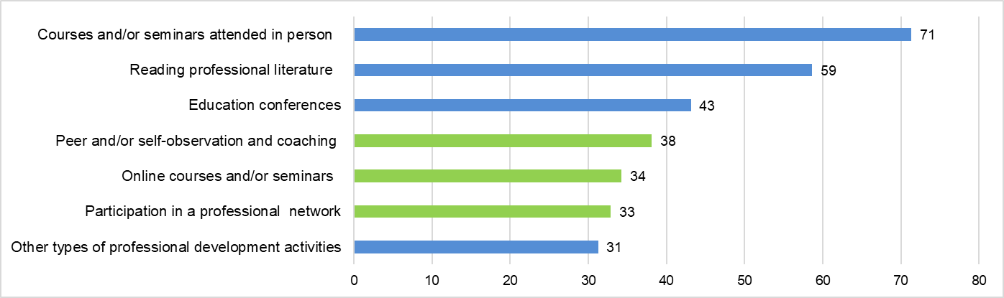

Source: OECD (2018) - Percentage of teachers who participated in the various professional development activities (EU-23 average)

Exchanges between teachers and educators using digital tools in teaching and learning are taking place though a number of platforms for peer learning and professional development, but efforts are needed to further recognise and reward their use[212]. For instance eTwinning, one of the largest and most dynamic educational networks in Europe, has involved 760,000 teachers from 200,000 schools since its creation 15 years ago. More than 100,000 projects have been run using eTwinning, involving students at all educational levels from 44 participating countries (36 European countries and 8 neighbouring countries)[213]. The Evaluate Erasmus+ policy experimentation project[214] has examined the impact of virtual exchanges on students and teachers in initial teacher education across Europe and its findings offer clear evidence of the benefits that activities, such as eTwinning, can bring to initial teacher education. Virtual exchange activities help teachers to step away from their accustomed learning and teaching approaches and develop new skills to engage in linguistic, intercultural, and digital learning experiences, which they may not be confronted with in their day-to-day practice[215].

As the COVID-19 crisis has shown, the **level of preparedness of educators is key to enable innovation**[216]: boosting educators’ digital competence and recognising the use of (digital) networks such as eTwinning can help improve the effectiveness of educators’ practices and related professional development activities as well as the overall pedagogical use of digital technologies in Europe’s education and training institutions.

## *5.1.4 Quality of digital education content*

High-quality digital education is crucial to boost the attractiveness, quality and inclusiveness of European education and training at all levels. Options for part-time studies and online courses are especially suitable for working people, students with family commitments in need of flexibility and adult learners – all categories which are on the rise in EU higher education systems[217]. According to a recent study, recognised online courses in higher education do not act as a substitute for face-to-face programmes but create new demand from people that would otherwise not have participated[218].

The Eurostat Survey on ICT usage in households and by individuals[219] shows that in 2019, an average of 10% of European citizens aged between 16 and 74 reported taking an online course in the previous three months for educational, professional or private purposes. Already before the COVID-19 crisis, the growth rate across EU-27 was accelerating and this happens also for the use of internet to access online learning material other than an online course (e.g. audio-visual, electronic textbooks, learning apps, etc.).

Beyond the use of digital learning for degree programmes, higher education institutions can benefit from the integration of online learning opportunities in non-degree programmes to complement their educational offer and respond to the growing need for upskilling and reskilling[220]. Online learning can also provide small and medium enterprises, which typically have more difficulty in organising and delivering training, with easily accessible and tested content and training material for their staff. In this regard, results from the public consultation confirm that the use of online learning is expected to be the most popular format that will be used for improving staff’s digital competences, followed by a mix of online and face-to-face training[221].

The latest results from the EU labour force survey show that adult participation in education and training is limited (11%, vs the target of at least 15% of adults participating in lifelong learning by 2020) and that people with little or no qualifications– those most in need of access to learning –are the least likely to benefit from it[222]. Considering the potential of online learning for the (direct or indirect) acquisition of digital skills and more efficient use of educators/learners’ time[223], digital learning can form part of the response to the challenge of boosting adult participation in education and training.

For example, **Massive Open Online Courses** (MOOCs), one of the more widespread forms of online learning, are recognised by job seekers and workers as an effective tool for acquiring the skills needed in the labour market and for keeping them updated[224] (Figure 8).

**Figure 8: Workers’ benefits from taking MOOCs (1-5 scale)** [225]

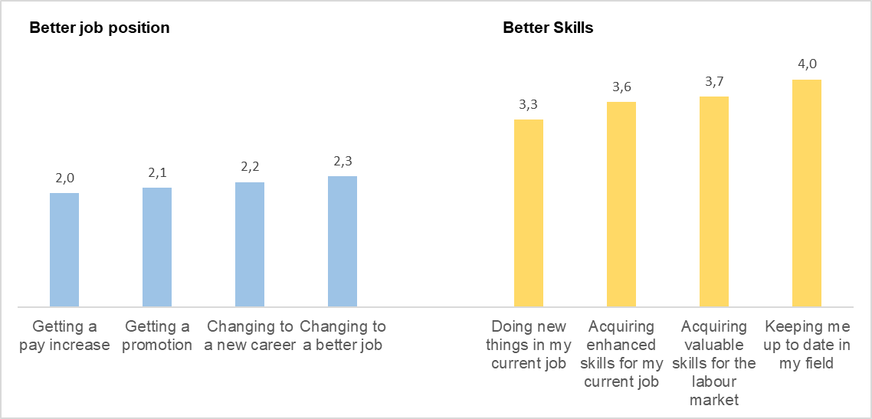

Source: JRC MOOC Survey (2019)

Over the last few years, MOOCs have continued to expand in terms of courses and number of learners[226]. Despite this, **EU countries can be considered late adopters** compared to the US and highly dependent on non-EU countries for the provision of MOOCs[227].

Data on the main global platforms, provided by Class Central Inc[228], highlights that MOOCs production is twice as prevalent [in the US in comparison to the EU. Three out of the five main MOOC platforms are US-based and together attract 73% of all MOOC learners[229] . **None of the EU-based MOOC platforms are amongst the five leading ones**[230]. Available data show not only that EU higher education institutions are less intensive MOOC producers than US ones[231] but also that the offer of MOOCs in the EU is unevenly distributed across Member States, with France, Spain and Italy being the leaders in absolute numbers.

Online education and MOOCs were seen originally as a way of opening up and democratising education[232], but current evidence shows that not all individuals benefit on equal footing[233]. In their current form, MOOCs reach people with more qualifications and higher levels of organisational, self-regulation and digital skills[234]. In order to make MOOCs more inclusive and truly useful tools for acquiring and updating the skills needed in the labour market, the offer needs to be more diverse in terms of content and language and include qualityinstructional designs and pedagogies[235].

According to stakeholders, further support at EU level is needed to boost expertise and provide the conditions to deliver **high quality multilingual online (and blended) learning content**, along with promoting interoperability and synergies between different national and European online platforms[236]. A number of Ministries of Education (NL, DE, NO) called for a pan-European approach towards flexible learning pathways, based on quality assurance and secure infrastructure. Additionally, higher education institutions and the private sector are particularly in favour of measures to support the recognition of online and blended learning in order to stimulate lifelong learning and upskilling[237].

However, this can be achieved only if online learning courses and micro-credentials are recognised for employment and further study[238] - a goal that is limited by several factors. First, MOOCs and other forms of online learning courses often fall outside the scope of existing quality assurance processes and mechanisms [239]. Second, the lack of a shared definition and common approach makes in some cases employers feel unsure about what micro-credentials are and which ones to trust. Recognition of prior learning is the most relevant method currently to recognise micro-credentials for further studies. However, practices vary among higher education systems and institutions in the Member States and there are doubts about whether the current procedures could cope with a potentially growing numbers of micro-credentials. Another set of barriers concerns the lack of digital solutions for storage and validation, and the impact it may have on portability and scaling.

Within the 2018 Action Plan, the European Commission piloted a framework for digitally-signed credentials(e.g. statements that provide a proof of individual learning achievement) to be deployed within the new Europass[240].Free tools will be offered to institutions across the EU to issue credentials, diplomas and certificates in a digital format with automatic verification of their authenticity. The framework is built on a single data model, which can describe all forms of learning achievement, including micro-credentials, and provide a basis for storing credentials accumulated over time. In addition, the ongoing European Student Card Initiative aims to help students move more easily between campuses, both for physical mobility and when participating in online learning[241]. However, available data highlights the need to further **support the creation, use and sharing of high-quality digital education content**. Stakeholders consulted in preparation of this initiative confirmed a strong interest in this and stressed the need to build upon ongoing activities. They highlighted in particular the need to pay attention to instructional design principles, multilingualism, accessibility[242], and recognition as well as to consider interoperability, certification, verification and transferability of such content[243].

## 5.2 Digital competence development

Europe’s digital transformation is accelerating rapidly in part due to the expanded application and use of AI, mixed reality, robotics, and blockchain[244]. The level of digital competitiveness[245], in all its subdomains[246], is becoming an increasingly important condition for modern economies to innovate and thrive. This requires the recognition of digital competence as a key component for individual and societal development and for labour market inclusion[247].

Today more than ever, **being digitally competent is both a** **necessity and a right**. Participating actively, continuously and responsibly in society at all levels (political, economic, social, cultural and intercultural) means being able to harness the benefits and opportunities of the online world, while building resilience to potential risks[248]. The pervasive use of digital technologies for social and democratic participation requires the ability to engage positively, critically and competently in the digital environment. Skills are needed to access, select and interpret information, to communicate effectively and create content in a way, which is respectful of human rights and dignity and uses technology in a responsible way. However, levels of digital competences across Europe remain on average low,with 44% of citizens lacking basic digital skills[249].

The COVID-19 crisis has highlighted the importance of basic and advanced digital skills for sustaining our economies and societies. The need for a sound understanding of the digital world has increased to ensure business continuity and to counter the growing rise of false information, disinformation and cybersecurity threats.[250]While the challenges of digital transformation are changing rapidly, impacted by technologies such as AI, young people and adults need to develop their digital skills on an ongoing basis, in a perspective of lifelong learning. Over the coming years, the digital economy is likely to play a leading role in Europe’s recovery and demand for digital skills will grow. New specialist digital skills are emerging[251] and greater efforts are needed to address the current shortage of ICT professionals in Europe[252].

Results from the public consultation confirm the growing importance of digital competences, shows that the use of technologies done during the crisis can lead to a perceived increased level of digital skills and shows individuals’ willingness to further improve them in the future[253].

All phases and stages of education and training play a key role in enabling learners to acquire and develop on an ongoing basis the digital competences they need to live, work and learn [254]. There are also concerns connected to the effects of technology on young people’s well-being[255] and the potential impact of ‘screen time’ on children’s socio-emotional, cognitive and physical development[256]. International trends are pointing to increased access to and use of technology by younger age groups[257], and, despite evidence on the topic being relatively sparse[258], attention is required on the possible links between technology use and children’s development. Considering that effects of technology may depend on many factors, including the type of technology being used and its purpose[259], evidence-based guidelines and effective practices are needed to encourage healthy and meaningful uses of digital technology from an early age.

Efforts cannot stop at the borders of formal education with youth work, non-formal education and lifelong learning being an integral part of the education and training systems in a digital age. The cultural and creative sectors also play a key role. They can provide learning materials, help reach a wider group of people, and support activities promoting both artistic and technological skills[260], including creativity - one of the most important competences for innovation and employability[261].

All levels and sectors of education and training have a key role in addressing digital skills gaps and emerging competence requirements by recognising the growing importance and supporting the development of digital competence for individual participation in society and for Europe’s innovation and competitiveness. Beyond digital skills and in line with the Recommendation on Key Competences for Lifelong Learning[262], Europe’s society and digital economy also require complementary transversal skills such as adaptability, communication and collaboration skills, problem-solving, critical thinking, creativity, entrepreneurship, and readiness to learn.

## *5.2.1 Level of digital competence across the EU*

The human capital dimension of the Digital Economy and Society Index (DESI)[263], which provides comparative data on digital skills in Member States, shows that **44% of EU citizens still have an insufficient level of digital skills**.

The digital skills index, a composite indicator based on the Digital Competence Framework for Citizens[264] and calculated on the basis of self-reported data [265], show that digital skills levels are increasingly slightly over time. However, major disparities still exist between Member States: the share of people with basic or above basic digital skills ranges from 29% in Bulgaria and 31% in Romania (despite noticeable progress in both countries) to 80% in the Netherlands and 76% in Finland (Figure 9).

**Figure 9: EU population digital skills**

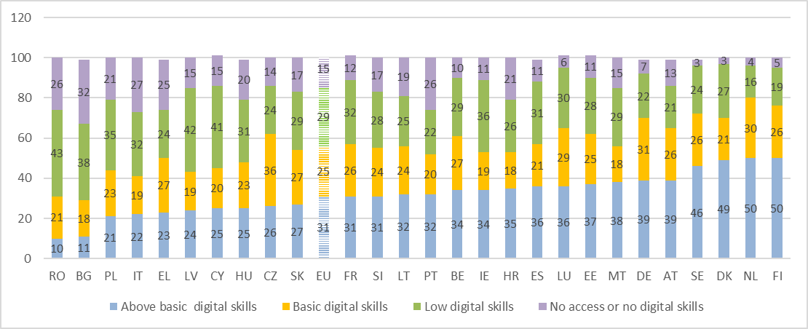Source: Eurostat (2019) – Percentage of individuals, by digital skills level[266]

Figure 10 shows that the number of people not using the internet in the three months prior to the survey fell in almost all countries between 2015 and 2019.Some Member States registered important improvements such us Romania (18 percentage points - pps decrease in people not using the internet); Cyprus (14 pps); Spain and Poland (12 pps); Bulgaria and Lithuania (11 pps); Italy, Ireland, and Slovenia (10 pss)[267].

**Figure 10: Decrease of individuals not using internet**

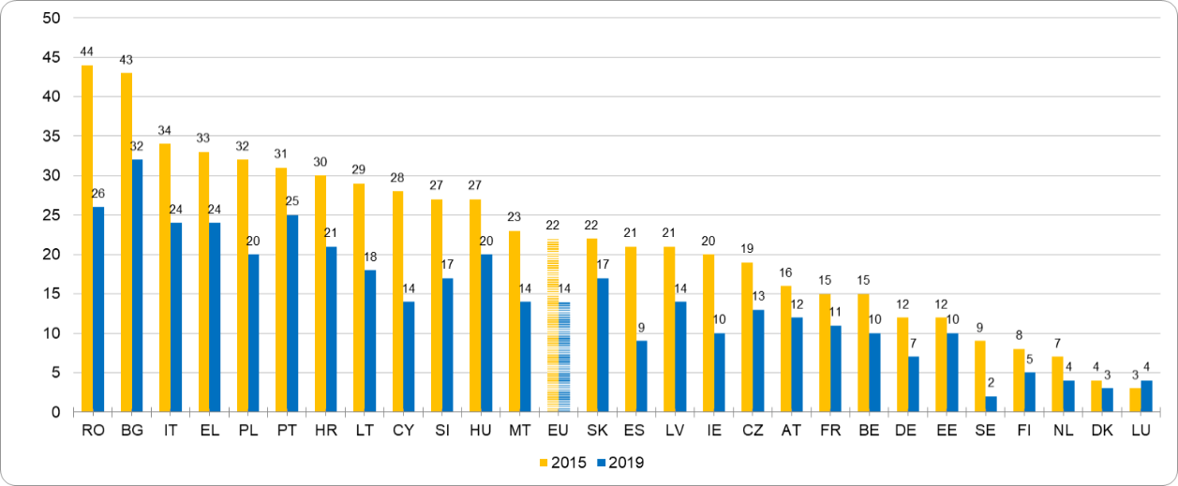

Source: Eurostat (2019) – Percentage of individuals not using internet in the last 3 months

Across Europe there is an encouraging trend with the percentage of individuals living in households with income in the two lower quartiles (out of four) who did not access internet decreasing over time, in both quartiles by 12 percentage points between 2015 and 2019 (see yellow line in Figure 11). However, having an internet connection is not sufficient and the level of digital skills remains strongly linked to higher income households (see black line in Figure 11).

**Figure 11: Level of digital skills in the EU by household income**

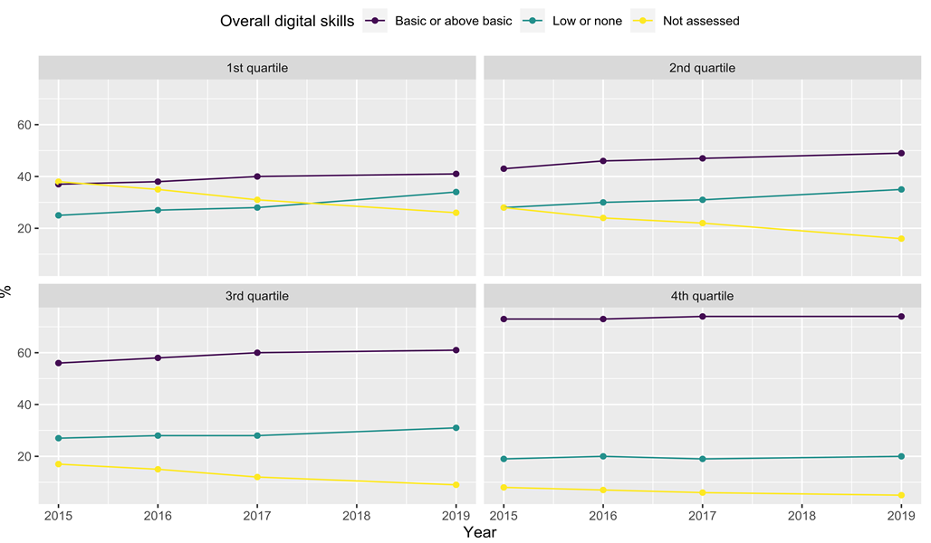

Source: Eurostat (2019) – Individual level of digital skills by household income[268]

On average, the **level of digital skills among the labour force** is higher than that of the population as a whole. However, slightly more than a third of the labour force in the EU, including employed people and those seeking employment, are lacking basic digital skills, even though such skills are now required in most jobs, including in sectors not traditionally related to digitisation (e.g. farming, health care, construction, etc.)[269]. This trend is confirmed by the OECD’s Survey of Adult Skills (PIAAC), which shows that on more than 50% of the adult population in the EU can carry out only the simplest set of computer-based tasks (e.g. writing an email or browsing the web), or have no digital skills. This means that many workers use ICT every day at work without having the skills to do so effectively[270], an element considered to have a negative effect on workplace performance[271]. This is confirmed by a recent publication examining which workers were best positioned to work from home during the COVID-19 lockdown (equal to around 28,5% in the EU[272]). The study shows that the likelihood of working from home decreases for workers without tertiary education and with lower levels of skills. These findings raises important questions on the extent to which the pandemic could exacerbate existing labour market inequalities, and whether these inequalities could worsen with intensified adoption of technology in the aftermath of the crisis[273].

On the one hand, a growing number of employers are declaring their intention to incorporate telework on a more systematic basis; on the other, the greater capacity for data collection, processing and analytics, paired with machine learning and AI, means that tasks requiring more analytical and digital skills are likely to grow[274]. Indeed, recent data from Eurostat[275] show that in 2018, the job tasks of 15% of employed internet users (e.g. people who use internet in their work) in the EU had changed due to new software or computerised equipment in the twelve months prior to the survey. In the same period, 27% had to learn how to use new software or equipment for their job. As recognised in the new Skills Agenda[276], these findings call for renewed and focused action to develop the digital skills of the workforce[277] through, for instance, initiatives boosting the level of adults digital competences and acknowledging the role of employers and the private sector in promoting and providing specific training and on-the-job-learning of digital skills.

Digital competence has become **crucial for employability and for participation in society**: the need for all citizens to develop digital skills to thrive in today's world is increasingly evident. The more knowledge technology allows to search and access, the more important the capacity to filter and better understand information becomes[278]. As technological breakthroughs rapidly change the way people live, work and study, Europe needs digitally competent citizens and workers to be able to use technologies in a critical way. Individual digital skills across Europe are insufficient to meet the needs of the economy and the society, as suggested by aggregate statistics both from the supply side (measured as individual digital skills) and the from the demand side (measured as the level of skills required for worker occupation). In spite of its policy relevance, evidence on this topic is insufficient, also because of the lack of clarity given by the different definitions of digital competence and related measurement methods. However, any action on competence development requires a thorough and recognised assessment of the individual level of digital competence: defining the starting point is crucial to identify what learning opportunities can be offered to specific target groups in a lifelong learning perspective.

**Box 3: digital literacy for informed choices as citizens**

Low levels of digital skills pose risks to our democracies and act as a barrier to social inclusion. **Citizens’ exposure to large-scale disinformation,** including misleading or false information, is a major challenge for Europe[279] and it has become even more evident with the COVID-19 crisis. The virus outbreak dominated the media and it has been accompanied by an ‘infodemic’, a term indicating a massive amount of information that has made it hard for people to find trustworthy sources and reliable guidance[280]. The need for all citizens to have a critical understanding of and interaction with the media and digital environments, to become resilient to disinformation and improve their participation in democratic processes has never been as vital as it is in today's digital world[281].

The 2019 Reuters Institute Digital News Report revealed that 55% of respondents across 38 countries globally remain concerned about their ability to distinguish between what is real and what is fake on the internet. Concerns about disinformation remain high and the average level of trust in the media is down to 42% (Figure 12) [282]. Daily, 37% of Europeans come across news that they believe misrepresent reality or are even false, while 31% say it happens at least once a week. More than eight in ten respondents think that the existence of fake news is a problem in their country (85%) and for democracy in general (83%)[283].

Figure 12: Percentage of trust in the news

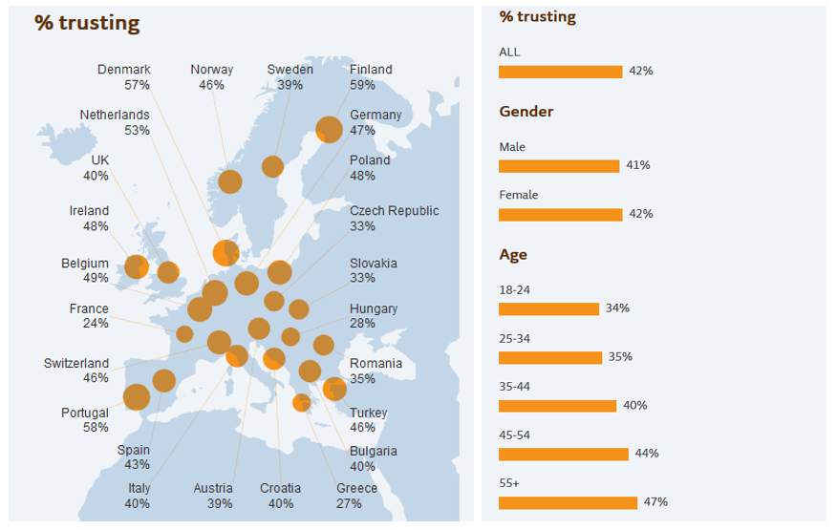

Source: Reuters Institute (2019)

During the COVID-19 outbreak, worries about the reliability of information available on the virus were even higher[284]. The situation was exacerbated by the use of social media to find information (especially amongst young adults) and the overall increase in time children spent online, with possible consequences on the likelihood of being exposed to disinformation, inappropriate content and more general negative experiences[285].

The evolution of digital technologies has radically changed the way information and news are produced, consumed and communicated; new risks affecting both adults and children have emerged from ubiquitous access to the internet. Given that end-users play a critical role not only in accessing and selecting but also in reproducing and disseminating information, an analysis of disinformation in relation to the functioning of our democracies is crucial. For example, some research suggests that the sharing of fake news or incorrect information by young people may be related to their need for self-expression and socialisation[286]. Another study shows that even if the majority of students might be fluent in social media, they are not equally knowledgeable when it comes to understanding the property and status of material they find and reproduce[287]. In this sense, **being able to check quality and accuracy of information**, in addition to understanding the values and ethics of those involved in the process of generating this information, are key aspects in addressing the phenomenon[288]. Results of the public consultation confirm the importance of finding, filtering and managing information. Evidence on the different target groups shows that information and knowledge management and identification of fake news are among the most important competences selected by all respondents, while protection of personal data rank high among learners and parents[289].

Prior to the COVID-19 crisis[290], different measures had been taken at EU level to minimise the risks of fake news and online disinformation and foster digital literacy, but further action tailored to the needs of the different age groups is needed. As highlighted by the European Commission’s High-Level Expert Group on fake news and online disinformation, promoting digital literacy in teacher training, curricula reforms and with targeted educational interventions can help users navigate the digital environment[291]. However, a survey released in March 2019 illustrates that 42% of young people think that critical thinking, media and democracy are not taught sufficiently in school[292]. The challenge is particularly relevant for younger students as virtually go online every day, for education, entertainment and social contact[293]. There is a pressing need for a responsible and safe use of digital technologies through improving digital literacy skills, further developing critical thinking, and raising awareness of individual rights and obligations while online, especially among young people and minors.

Dealing with disinformation, harmful speech and online threats is a key competence that everybody needs to develop, whether it is in formal or non-formal education settings or in the context of lifelong learning. In recent years, a number of initiatives have been put in place to address the challenges. The DigComp framework[294], for instance, aims to foster confident, critical and responsible digital citizens; while the UNESCO’s Media and Information Literacy framework[295] focuses on the role and functions of media in democratic societies. However, despite these efforts, the ability of young people to access and critically evaluate information and its sources in digital environments remains low, indicating for example difficulties differentiating between paid and non-paid search results returned by a search engine[296].

The 2018 Action Plan included an action focused on cyber culture. Its objective was raising awareness on the risks faced when being online (including disinformation) and promoting the skills necessary to act in a safe and responsible way. The #SaferInternet4EU campaign targeting educators, parents and learners with a wide range of activities and supporting materials (e.g. awards, online courses for teachers, Back2School campaign, etc.) was part of this action. Participation in the initiative grew consistently reaching 63 million EU citizens by 2019 through the Safer Internet Centres[297]. This showed a strong interest in strengthening efforts to foster a safe and responsible use of digital technologies by young people through activities in formal and informal education. However, as highlighted by all consulted groups[298], boosting the skills needed to safely navigate today’s digital world is an area where further efforts at EU level are needed, especially in reinforcing the ability of all levels and sectors of education and training to promote a critical understanding and interaction with the media.

The **level of digital skills of European students** (i.e. individuals above 16 whose employment status is ‘student’) is higher compared to the overall population and labour force, with 66% of them having above basic digital skills (Figure 13).

**Figure 13: EU students’ digital skills**

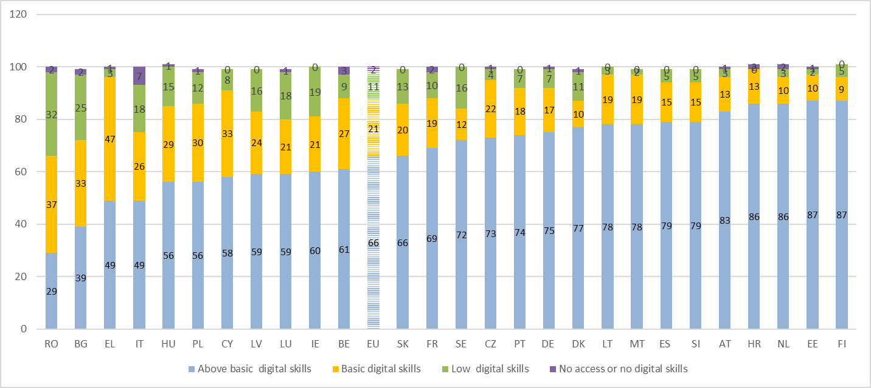

Source: Eurostat (2019) - Percentage of students, by digital skills level

However, more than one third of 13-14 year olds who participated in the International Computer and Information Literacy Study (ICILS) in 2018 were working below the lowest proficiency level of digital skills[299] and evidence shows that there is a digital divide increasingly related to socioeconomic status and years of experience of using devices (beyond simple access)[300].

High-level demand for digital skills and ICT professionals is likely to increase in the aftermath of the COVID-19 crisis, which highlights the need to address the development of digital talent before higher education, as. Europe cannot grow a critical mass of top talent if we disregard the initial stages of education.

**Box 4: Computing and informatics education as a tool to boost digital competence**

Computing and informatics education in school allows young people to gain a critical and hands-on understanding of the digital world. If taught from the early stages, it can complement digital literacy interventions[301]. The benefits are societal (young people should be creators not just passive users of technology), economic (digital skills are needed in sectors of the economy to drive growth and innovation) and pedagogical (computing, informatics and technology education is a vehicle for learning not just technical skills but key skills such as critical thinking, problem solving, collaboration and creativity).

Computational thinking and related concepts (e.g. coding, programming, algorithmic thinking) have a long history in education. Although coding and programming are an important part of computational thinking, the latter entails other core elements such as problem analysis and decomposition[302]. Computational thinking represents a way of approaching problems which are relevant for many areas of education and is an essential skill for a growing number of jobs[303].

Evidence shows that computational thinking activities, in both formal and non-formal settings, help learners develop critical transversal skills (e.g. creativity or critical thinking)[304] and, together with digital literacy, can equip students with the complementary skills to become active, critical and creative users of digital technologies[305]. Introducing all pupils to computing and informatics education from an early age can also help foster interest in digital studies and future careers. Yet, **many young people in Europe leave school without any exposure to computing and informatics education**[306].

In 2019, half of the European education systems were reforming their curricula related to digital competence, for example, introducing new components, including computational thinking, or making the subject area more prominent. Some reforms (for instance in BG, IE, EL, CY, LT, PL, RO [307]), were broadly in line with reforms in jurisdictions outside Europe (e.g. US[308], Australia, China, New Zealand, Singapore and South Korea). Despite these changes, provision in computing and informatics education in Europe remains uneven.

Figure 14 shows the level of education at which EU students experience their first contact with informatics and related concepts[309]. This happens rarely in primary education (only in six cases in Figure 14), most likely because more than half of the European education systems include digital competence as a more general cross-curricular theme. Teaching digital competence as a separate and specific subject, like computing and informatics education, is more common at lower and especially upper secondary education[310] (in the former case mostly as a compulsory subject and in the latter mostly as optional)[311].

Figure 14: First contact with informatics

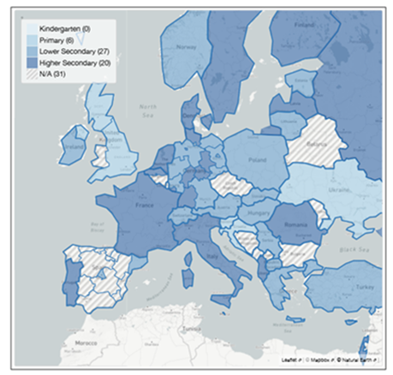

Source: Committee on European Computing Education (2017)

However, as Figure 15 shows, there is a high percentage of students at lower and upper secondary level (76 and 79% respectively) who never or almost never undertake coding and programming activities. This is a practice done on a daily basis only by 3% of students in lower and 6% of students in upper secondary education[312].

**Figure 15: Students frequency in coding/programming during lessons**

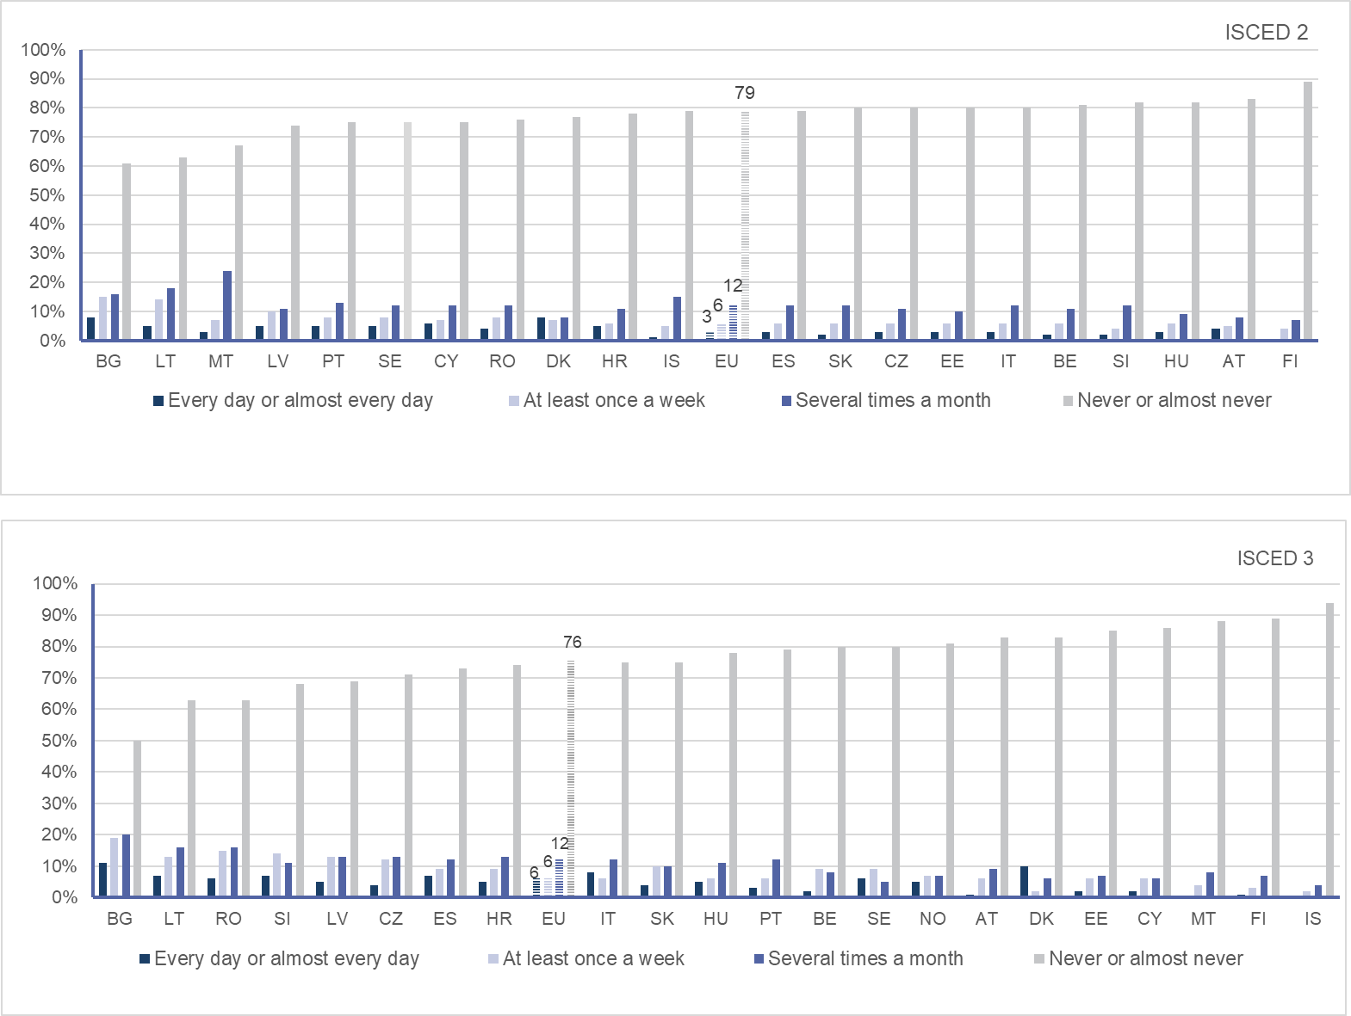

Source: Second Survey of Schools (2019) - Percentage of students, country and EU level

In Europe, the availability of computing and informatics education, as a compulsory or at least elective subject[313], is not uniform, with opportunities for young people to study this subject varying widely[314]. Where it does exist, uptake can be low and gender imbalance is a major problem[315]. Recent research assessing students’ computational thinking shows that achievements tend to be higher among male students, and that socio-economic status, access to and experience with computers are associated with higher scores. Even though a small number of Member States participated in the study (seven in total), it reveals that students’ computational thinking varies a lot within countries and that there is a large proportion of students who are able to complete only the most basic computational thinking-related tasks[316].

In recent years, a number of initiatives addressing computational thinking in both formal and non-formal settings have been organised, both at national and international level, to complement the lack of provision in computing and informatics education[317]. For instance EU Code Week[318], promoted in the framework of the 2018 Action Plan, brought coding activities to many schools across Europe, reaching 4.2 million participants in 2019[319].

Stakeholders consulted for the preparation of this initiative highlighted the importance of supporting students’ computational thinking from an early age as a way to promote a better understanding of the digital world and to do this with age-appropriate teaching methods[320]. In particular, Member States and organisations participating in the ET2020 Working Group on Digital Education called for EU support on a number of shared challenges (e.g. how to teach and assess computational thinking in an age-appropriate way, how to recruit and train teachers, how to ensure gender balance and equity).

The COVID-19 crisis is likely have an impact on the demand for digital skills of EU citizens, especially for learners and the labour force, considering that many schools, universities and VET providers shifted to distance and online learning, and companies and organisations to telework. Results from the public consultation confirm that this can lead to more experiences with digital technologies, but being digitally competent entails more than being able to use them[321]. Monitoring will be essential to see if a more critical, confident, and creative use of digital technologies for learning purposes and for participation in society will arise as a consequence of the situation or if the COVID-19 crisis will contribute to widening gaps, new inequalities and negative experiences in using digital devices.

**Box 5: Availability of cross-national data on the level of digital competence in the EU**

Digital competence acquisition is an important priority, but the **availability of cross-national data on the current level of digital skills in the EU is limited**. Major data sources include:

* The International Computer and Information Literacy Study (ICILS)[322], a performance test measuring international differences in computer and information literacy[323] and computational thinking[324] of students in their eighth year of schooling[325].
* The Digital Economy and Society Index (DESI)[326], a composite index that summarises relevant indicators on Europe’s digital performance[327], including an area on human capital, which provides an overview of citizens’ digital skills[328].

However, **both ICILS and DESI have certain constraints**. While scientifically sound, ICILS has so far had limited geographical coverage: only 14 EU Member States combined (nine and seven respectively) participated in its two first cycles[329]. DESI’s methodology relies on self-reported data largely based on respondents’ replies to a set of questions on their internet use rather than a direct measurement of actual digital competence[330]. These are recurring issues in studies and surveys focusing on digital skills, as they provide indirect approximations and limit the ability to analyse and assess digital competence development and tendencies.

Under the 2018 Action Plan, studies were undertaken to measure progress in the use of digital technologies in school education, resulting in three key achievements:

* The 2nd Survey of Schools: ICT in education (ESSIE2)[331], published in March 2019, provided 1) an overview of the progress made in mainstreaming technology use in primary and secondary education, and 2) guidance on features and costs of a highly connected classroom (entry, advanced and cutting-edge level).
* A new version of the ICT questionnaire of the OECD's Programme for International Student Assessment (PISA), used in 2018 to gather information on students’ perceptions on their use of ICT for learning purposes, was also developed. The new version of the questionnaire will be deployed in the next round of PISA in 2022. It relies on students’ self-reported attitudes and self-efficacy and can provide valuable insights into how pupils access and use digital resources in and outside of school, in addition to identifying how teachers and schools integrate them into pedagogical practices and learning environments.
* Discussions have also been held with Member States on how to better track progress in entrepreneurship and digital competences, and possibly setting EU targets in these areas. With regard to entrepreneurship, existing data collections do not have the required level of international comparability to support the monitoring of an EU target. This is, however, possible for digital competence, using ICILS, which provides a solid base for direct assessment of digital competence.

Stakeholders consulted in preparation of the renewed Action Plan recognise the benefits of cross-national, comparative and longitudinal studies to inform education and training and call for reinforced efforts with a view to improve the understanding of digital competence development across Member States and at EU level [332].

## *5.2.2 Addressing the gender gap*

There is a **significant gender gap in digital skills**. There are proportionally more men than women with at least basic digital skills and the difference increases with age and level of digital skills[333]. At a young age, girls outperform boys in Information and Computer Literacy[334] and in Science, Technology, Engineering and Mathematics (STEM)[335], but the context changes as they progress through their educational and professional lives[336].

Women constitute just over half of tertiary students[337] (54%) and they are particularly underrepresented in the digital fields where men still account for more than 80% of the workforce. Despite large differences between countries[338], women on average hold only 17% of tech sector jobs[339], a participation rate that occurs at all levels of the digital economy but also in women’s numbers as employees, corporate leaders and entrepreneurs[340]. The pace of change is not promising[341] and the low share of women in AI (22%)[342] shows that, without intervention, the gap in Europe will widen[343].

According to the OECD's Programme for International Student Assessment (PISA), boys and girls are almost equally likely to expect to work in a science-related field[344]. Yet, data from Eurostat shows that only one in three STEM graduates is a woman[345]. With age and at higher levels of education, girls tend to steer away from STEM and ICT subjects and this is reflected in their lower participation in related higher education studies[346].

Research shows that young women are more likely to choose careers in the biological sciences, social sciences, environmental sciences and medicine over the mathematically based sciences because they perceive the latter to be less people-oriented and to have less value to society[347]. Inherent biases and sociocultural norms limit women and girls’ ability to benefit from the opportunities offered by the digital transformation[348]. In addition, girls’ lower enrolment in disciplines linked to the digital sector could lead to widening gaps and greater inequality[349]. Addressing the underlying causes of gender disparities in the digital and STEM fields requires **targeted interventions** early on, to raise awareness and interest[350], tackle gender stereotypes, provide role models and, more generally, enable enhanced, safer and more affordable access to digital tools[351].

Many initiatives, such as the Ministerial declaration of commitment on women in digital[352] and WeGate[353], are ongoing in the EU to promote women’s participation in ICT or STEM but the complexity surrounding gender equality requires stronger and more concerted efforts. Greater inclusion of women in the digital economy and diversity in the labour market can bring social and economic value for Europe’s competitiveness, growth and innovation[354].

The need to address the gender gap was recognised in the 2018 Action Plan with an action promoting workshops on digital and entrepreneurial skills for girls in primary and secondary education, organised across Europe and particularly in those countries and regions that belong to the so-called ‘modest and moderate innovators’[355]. The action was partially successful due to constraints in its implementation modalities. However, the positive feedback from participating female students[356] and the evidence on the level of digital skills and labour market participation of women show the need to scale-up measures fostering gender equality in the STEM sector. The urgency to reinforce efforts in this direction was clearly recognised in the consultations informing the renewed Action Plan[357].

## *5.2.3 Advanced digital skills and emerging areas of digital competence*

As technological breakthroughs rapidly shift the boundary between tasks performed by people and those performed by machines, global labour markets are undergoing major transformations[358]. Rapid advances in AI, cloud computing, robotics, and other emerging technologies are happening in short cycles, quickly changing the nature of existing jobs or creating new ones, and strongly impacting the skills required in both existing and new occupations. Demand for specialist digital skills[359], including technology design and programming, is growing along with non-cognitive skills that computers cannot master, such as creative thinking and problem-solving[360].

While the COVID-19 crisis has massively affected all working environments and sectors of the economy, the ICT sector proved to be critical for business continuity and recovery. Extensive efforts were made to reinforce the digital infrastructure of governments, hospitals, and education and training institutions; development of tools and apps using emerging technologies to fight and contain the virus; services and packages to help workers and enterprises address the business challenges arising from the crisis and online learning solutions and donation of equipment and connectivity to students[361]. The crisis demonstrated the extreme importance of an ICT sector, which can cope with unexpected challenges. This makes the need to attract young people to ICT studies and, more generally, equip post-secondary students and graduates with digital skills, more urgent than ever. As a result, the crisis also demonstrated the extreme importance of continued training and education for healthcare professionals in the area of digital skills in order to successfully implement new digital technologies to ensure that our healthcare systems become more resilient, accessible and effective in providing quality care to European citizens.

In Europe and beyond, **mismatches exist between skills available and those needed** **for the digital transformation of the economy**. ICT specialists, people who deal with developing, operating and maintaining information technology systems, are employed across all sectors of the economy, with a different percentage depending on the size of the organisation[362]. As Figure 16 shows, in 2019, over half of both large and small and medium enterprises in all Member States (58%) who recruited or tried to recruit ICT specialists reported difficulties in filling these vacancies.[363]

**Figure 16: Hard-to-fill vacancies for ICT specialists**

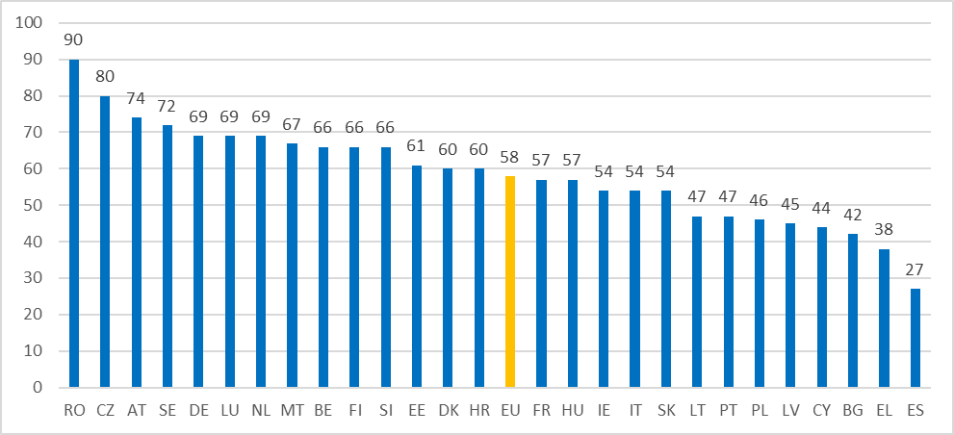

Source: Eurostat (2019) - Percentage of enterprises that recruited or tried to recruit ICT specialists, without financial sector

These skill shortages are connected to a shortage of supply of digital skills in the EU labour force but they are also affected by firms’ ability to adopt a competitive recruitment strategy. Recent research shows that ‘genuine’ skill shortages, defined as instances where employers cannot fill a job vacancy because job applicants do not possess the required skills, even though a competitive job offer is made, are more likely to arise in high-innovative and international sectors and occupations[364].

In 2018, there were around 7.4 million ICT specialists in employment across the EU, the highest number of which were employed in Germany (1.7 million) and France (1,1 million). In general, the number of ICT specialists employed in the EU grew by 47.9% from 2011 to 2018, eight times as much as the increase (5.9 %) for total employment. Less than two thirds (62.2%) of employed ICT specialists in the EU have a tertiary level of education[365], which shows the importance of increasing the number of ICT graduates from upper-secondary and higher education[366] - especially considering that in these disciplines entry requirements and dropout rates are high, and female participation is low.

On the supply side, approximately 3.9 million students graduated from tertiary education in the EU in 2017. ICT makes up less than 5% of the total number of enrolled students and graduates (4.9% and 3.8%)[367], even though it is most commonly associated with technological progress and high employability[368]. On average in the EU and across OECD countries, only 4% of tertiary-educated adults hold a qualification in this field and the proportion across countries varies much less than for other fields of study. It reaches 7% in Costa Rica and Luxembourg or 6% in Finland, Hungary, Mexico and Spain and 1% or less in Russia and Turkey[369]. In 2015 India was the country with the highest share of ICT graduates (almost 600,000), five times as many as the United States[370].

The low number of ICT graduates and the growing number of ICT vacancies[371] suggest that the gap between the demand and supply of ICT specialists may be widening. To lead digital transformation, Europe needs excellent higher education institutions, which can attract and retain students in ICT and related fields by offering high quality education, including in forward-looking ICT-related fields.

In this respect the European Universities initiative, which supports transnational alliances of higher education institutions, will work to boost higher education capacity, mobility and cooperation in the design and development of flexible, innovative and challenge-based approaches, which foster basic and advanced digital competences. Moreover, the Digital Europe Programme will support the development of advanced digital skills mainly through specialised education programmes, such as master courses. As the COVID-19 crisis has shown, having ICT specialists and a digitally competent workforce is a crucial element for an inclusive and competitive digital economy and society. Several actions at both EU and Member States’ level aim to tackle the digital skills mismatch[372], but, as highlighted by consulted stakeholders[373], renewed support is needed especially considering that the digital economy is likely to play a leading role in Europe’s recovery.

**Digitally-enabled automation and AI** are set to become the primary drivers of the next technological revolution[374]. They permeate all spheres of life (from machine translation, to image recognition and music generation) and bring significant benefits, including increased productivity and societal wellbeing, but also challenges connected to the need to manage a socially responsible transition by carefully addressing socio-economic, legal and ethical impacts[375], as well as cybersecurity, safety, and data protection risks[376]. Its use also entails opaque decision-making and risks of gender-based or other kinds of discrimination.

Being at the forefront of the technological revolution is crucial to ensure competitiveness and shape the conditions for its development and use[377]. EU investment and efforts to analyse the current implications and future impact of AI have increased over time with various research and policy initiatives, including ‘AI Watch’, which monitors the development, uptake and impact of AI in Europe[378].

However, as highlighted in the White Paper on AI[379], companies all over Europe struggle to find qualified workers who are able to develop and deploy AI[380]. On the other hand, citizens (more than 6 in 10) tend to be positive regarding the impact of AI on the economy and society, but their opinion and concerns depend strongly on their level of information and knowledge on the topic[381] (Figure 17).

Figure 17: Views on robots and AI among citizens

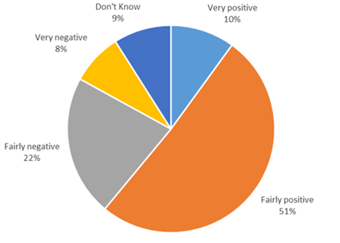

Source: Eurobarometer (2017)

As AI systems rapidly evolve, with applications in many different areas, there is a growing and pressing need not only for professionals but also for citizens to have basic understanding of AI to engage positively, critically and ethically with this increasingly pervasive technology[382].

**Box 6: Impact of AI on education and training**

The impact of AI on education and training could potentially be transformative but, given the data needed by AI systems to operate, it also comes with major risks connected to fundamental rights such as the right to non-discrimination, including gender equality[383], as well as ethical, data protection and privacy concerns,. A recent report[384] shows that many EU-funded research projects in recent years have been focusing on technology-enabled learning by using AI-driven technologies to build intelligent tutoring systems or agents and personalised learning environments that take advantage of adaptive user models. So far, they have had limited impact in actual educational settings but recent technical developments connected to improvements in algorithms and the exponential growth in the volume and variety of digital data suggest that the situation may be changing rapidly.

The number of technological devices and tools that generate detailed data about young people is unprecedented[385]. As with all surveillance mechanisms, questions arise as to who collects, controls, selects, interprets and uses the data[386]. At times, schools and teachers, or learners and parents themselves, can be providing such data without properly understanding the ramifications of disclosing such data[387].

While education and training institutions have progressively started experimenting with the use of emerging technologies, there is very little systematic analysis and monitoring, including early experimentations involving educational stakeholders (e.g. living labs ideas) and small-scale qualitative research (e.g. case studies), that would allow to assess their impact on the educational process. Moreover, the impact of emerging technologies on students’ performance and overall learning experience has not been systematically studied with, for instance, large-scale pilots (e.g. by comparing educational settings with vs without digital intervention) and specific attention to data collection and use.

Overall, there is a need to develop and test new pedagogies**,** also by investigating how emerging technologies can be smoothly integrated in existing teaching and learning practices and how respect of data protection legislation can be ensured. On the other end, flexibility and affordability of digital technologies in education and training remain an issue as their use in teaching and learning needs to be carefully designed, tailored and assessed against European values and norms, especially when targeting children[388]. Finally, challenges regarding the involvement of end-users,accessibility, inclusion and equity,as well as ethics, data protection and privacy and security considerations need to be duly addressed.

As indicated by stakeholders[389], better collaboration between the AI education technology industry and educators is vital to support the testing, growth and adoption of the most promising AI tools for education. Research shows that AI-driven education technology needs to be informed by pedagogy, with a focus on user-centred design, ensuring that teachers and students are empowered rather than marginalised by technology[390]. Moreover, a recent study shows that any educational application of AI needs careful consideration as to how, where and when human intervention and interpretation is needed[391].

Against this backdrop, initiatives are also needed to **increase the awareness and understanding of AI at all levels of education** in order to prepare citizens for informed decisions that will be increasingly affected by AI. The development of new skills will be crucial for both educators and learners to understand the applications and implications of AI and related data, and harness its potential for innovative teaching and learning. In the longer term, the development of AI and data-related skills from an early age, and with particular attention to the principle of non-discrimination and gender equality, can have a positive effect on the pipeline of professionals in the industry.

Consulted stakeholders have called for the EU to address this specific skills gap by providing guiding frameworks on knowledge, skills and attitudes related to AI for different ages and stages of education and training. Considering the transformative power of this technology, there is a growing need to understand the skills required to use and deploy its applications in a responsible way and help their development with different levels of proficiency and in a lifelong learning perspective. In particular, there is a shared view about the support required for the development of a diverse set of competences: from understanding everyday and educational uses of AI to advanced skills for the labour market and teacher training.

The topic was addressed in the 2018 Action Plan with pilot projects using AI and learning analytics to predict future skills shortages and the publication of a foresight paper on the impact of AI on learning, teaching and education[392]. The pilot projects are limited in scale and ongoing, thus making it difficult to draw conclusions. The foresight paper confirms that educators and learners have to better understand the potential of AI for teaching and learning.

## 6. Implementation and monitoring

The renewed Digital Education Action Plan builds on the lessons learnt from the 2018 Action Plan and on feedback from extensive consultations with stakeholder[393]. It sets out a co-ordinated policy approach at EU level with actions and support measures designed to have greater impact than isolated initiatives at the level of Member States. The Action Plan will be implemented in the context of the European Education Area enabling framework and will involve working groups and players at various levels (EU, national, regional, local). It will run over the full duration of the next EU financial programming period (2021-2027). This longer timeline will allow for more forward-looking planning, piloting, proper assessment and scaling up, thus generating greater and more structural impact.

All actions of the renewed Action Plan require **reinforced coordination and collaboration at the EU level** in order to:

* Promote digital education as a strategic EU policy response to the COVID-19 crisis and to transform Europe’s education and training systems in a lifelong learning perspective for the digital age;
* Share knowledge, good practices and experience across the education and training sectors, and amongst the diverse stakeholders in the digital education ecosystem, in order to cross-fertilise, exploit synergies and encourage new collaboration and partnerships;
* Address key issues that would benefit from reflection and action across levels and sectors of education and training and on the basis of a common European approach (e.g. AI in education, quality of online content, ethical use of big data, etc.);
* Analyse data, monitor results, report on progress and offer strategic foresight and research on digital education in order to feed policy making, strategies and decisions at regional, national and EU level;
* Experiment with new and innovative co-creation methods, support agile development and trials, and ensure early involvement of educators and learners with innovative learning tools, practices and processes;
* Provide easy access to European online learning tools, content and learning support that is multilingual, of high quality and respectful of European values, legislation and standards, for instance, regarding accessibility and equity, data use and protection, privacy and ethics.

Given the need to increase the impact, coherence and effectiveness of EU efforts in digital education a **European Digital Education Hub** will be established. The Hub will serve to boost cooperation and stakeholder engagement while working on the implementation of the measures of the new Action Plan. In line with input and ideas received during the consultation, the Hub will support Member States’ efforts by scaling up ongoing activities[394], linking relevant initiatives[395], monitoring developments, promoting peer learning and good practices exchange, and acting as think-and do-tank for agile development of digital education across Europe[396].

Successful implementation goes hand-in-hand with proper funding, which needs to both responsive to policy priorities and flexible. Depending on the outcomes of the inter-institutional negotiation process on the future EU programmes, the renewed Action Plan will be implemented **with the support of and in** **close synergy with a number of EU programmes and instruments.** These include Erasmus+, Digital Europe, Horizon Europe, the European Social Funds, the European Regional Development Fund and smart specialisation policies, and the resources made available by the Next Generation EU. Technical support for national policy reforms will be offered also through the Technical Support Instrument[397].

As requested by stakeholders, this would include clear communication on the funding opportunities within each specific action (Table 3).

|  |  |  |
| --- | --- | --- |
| Priority Area | Actions | Relevant Funding Programme |
| Fostering the development of a high performing digital education ecosystem | * Enabling factors for successful digital education | * EU and national funding programmes |
| * Online and Distance Learning for Primary and Secondary Education | * Erasmus+ |
| * European Digital Education Content Framework and European Exchange Platform | * Erasmus+ |
| * Support for connectivity and digital equipment for education | * Connected Europe Facility 2 * RRF * InvestEU * ERDF * ESIF |
| * Digital transformation plans and digital pedagogy and expertise | * Erasmus+ |
| * Ethical guidelines on AI for educators | * Erasmus+ * Horizon Europe |
| Enhancing digital skills and competences for the digital transformation | * Tackling disinformation and promoting digital literacy through education and training | * Erasmus+ |
| * Digital Competence Framework update | * Erasmus+ |
| * European Digital Skills Certificate | * ESIF |
| * Improving the provision of digital skills in education and training | * Erasmus+ |
| * Digital competence benchmark | * Erasmus+ |
| * Digital Opportunity Traineeship | * Erasmus+ |
| * Women’s participation in STEM | * Erasmus+ * COSME * Horizon Europe (EIT, KIC) |

**Table 3: Funding programmes supporting the implementation of the renewed Action Plan**

The future Erasmus+ programme should play an essential role in supporting efforts towards a more resilient, green and digital Europe. Its impact will be measured against its capacity to address major policy priorities in the field, including those set by the new EU framework for digital education. To this end, **all key actions of the future Erasmus+ programme** will offer more targeted support to the implementation of the renewed Digital Education Action Plan. Erasmus+ has been instrumental for the implementation of the 2018 Action Plan by making digital education and competence development a more prominent feature of the projects funded[398]. However, considering the short and longer-term implications of the COVID-19 crisis and the need for Europe to be a leader in digital transformation, Erasmus+ support to mainstream digital education practices and boost digital competences should be be reinforced to better support education and training institutions and local/national ecosystems across all sectors of education and training. This should be done in close synergy with other EU funding programmes. For instance, the **Recovery and Resilience Facility (RRF)** allows Member States to fund and commit to important investments and reforms, such as to make education and training buildings and infrastructure digital and green, provide devices or digital and open educational resources, help institutions provide digital and online learning, train education and training staff, or to update and reform curricula, regulations and the structure of education and training systems.

**Citizens’ engagement** will be ensured by reinforced efforts to communicate the policy objectives and funding opportunities of the renewed Action Plan. This will be done, among others, through communication factsheets providing information on each action and by publishing detailed information on the renewed Action Plan and related opportunities on Commission websites and social media channels.

The Commission will also organise a biennial outreach event, **a stakeholder forum,** with the aim of increasing participation – and creating a sense of ownership – by a wide range of stakeholders. By bringing together Member States, EU institutions, and education stakeholders (including teacher and parent organisations, local authorities, civil society groups, and businesses – including companies committed to the digital education agenda) the event will further promote exchange of best practice and discussions on emerging challenges and opportunities thus raising the visibility of digital education and the renewed Digital Education Action Plan.

**Stronger international outreach** to partner countries will underpin the renewed Action Plan. Exchanges with other international organisations and fora, including OECD, UNESCO, G7, G20 and the ASEM education process will be intensified to address prominent issues related to digitalisation in education and training. This will allow for exchange, peer-learning and joint initiatives. The EU framework for digital education and the examples of innovative and good practice in Europe will serve to promote stronger cooperation in a global context, and specifically with priority regions for the EU, including Western Balkans, Africa, East and South neighbouring countries. The renewed Action Plan will support the implementation of education and youth cooperation strategies, developed in the context of regional and bilateral cooperation frameworks and policy dialogues. The aim will be to support these regions in their effort to enhance the competitiveness of their ICT sectors, while promoting the development of digital competence both in formal and non-formal education settings together with teacher professional development, youth employability and entrepreneurship. This will be achieved mainly by expanding the use of specific actions, tools and frameworks on digital competence that have proved to be successful in the EU context[399].

**The monitoring and evaluation** of the Action Plan will take place in the context of the European Education Area enabling framework. To ensure transparency and accountability, Key Performance Indicators (KPIs) will be developed for each action to help monitor and assess progress. A more general set of KPIs will be proposed to measure overall impact of the renewed Digital Education Action Plan. The European Commission will undertake a comprehensive review in 2024 in order to assess outreach and impact of the Action Plan and propose adjustments or additional measures where needed.

Effective implementation, active engagement of stakeholders, and efficient monitoring and evaluation will be key to address the challenges of the ongoing COVID-19 crisis and to support the longer-term transition of education and training systems to the digital age. This is a unique opportunity to learn from the past, step up efforts and be more efficient in our response to future challenges. Collaboration across sectors and strategic and concerted action at EU, national, regional and local level are key to making high quality, inclusive digital education a reality for all.

## Annex 1: Procedural Information

The Digital Education Action Plan 2021-2027 is a collegial work led by Directorate-General for Education, Youth, Sport and Culture (DG EAC) with the contribution of six other Directorates-General (CNECT, EMPL, GROW, JRC, REGIO, RTD), and of the European Institute of Innovation and Technology (EIT) and its Knowledge and Innovation Communities (KICs).

This Annex presents the procedural information concerning the preparation of the Communication and the supporting staff working document on the renewed Digital Education Action Plan:

**Leading Directorate General**: DG EAC

**Work Programme/Decide references**: In the Communication ‘A Union that strives for more’ presenting the Commission Work Programme for 2020  (COM(2020) 37 final), the update of the Digital Education Action Plan is presented as a non-legislative initiative foreseen in Q2 2020 under the headline ‘A Europe fit for the digital age’. Following the COVID-19 crisis, the Communication ‘Europe's moment: Repair and Prepare for the Next Generation’ (COM/2020/456 final) announced the adoption of the update of the Digital Education Action Plan in the context of the Recovery Plan, scheduled for Q3 2020 in the adjusted Commission Work Programme for 2020 (COM(2020) 440 final). The Decide Planning reference is [PLAN/2019/6206](https://intragate.ec.europa.eu/decide/sep/entrance?view-planning-ref=PLAN/2019/6206&with-consultation-id=CIS_CONSULT6261599561300024).

**Organisation and timing**: The preparation of the initiative started in January 2020 with the setup of a cross-DG project team within DG EAC. Considering digital education as a cross-cutting issue, the project team saw the participation of relevant Directorates in DG EAC.

The inter-service group accompanying the initiative was led by the Secretariat General (SG) and included representatives of the following 10 DGs: CLIMA, CNECT, ECFIN, EMPL, GROW, HOME, JRC, JUST, REGIO, RTD[400].

Three inter-service meetings took place chaired by SG:

* The first one, on 25 February 2020, had the objective to present and discuss the vision and objectives of the new Digital Education Action Plan on the basis of the lessons learned from the first edition, the political guidance and priorities of the new Commission, and taking into consideration developments in the area over the last two years. Eight different DGs participated in the meeting. Following the meeting, DGs were invited to provide their contributions by 9 March 2020. In response, 27 proposals for actions were received: 10 from EAC, 9 from CNECT, 2 from EMPL, 2 from GROW, 2 from JRC, 2 from RTD.
* The second inter-service meeting took place on 30 March 2020 with the objective to discuss in detail the overall vision and scope of the new Digital Education Action Plan, present a tentative list of actions to be included and the main points to be addressed in the Communication. Prior to the meeting, a scoping paper was disseminated to the services, framing the discussion. The meeting was attend by ten DGs. The inter-service group agreed on the need to adapt the objectives of the initiative to the challenges posed by the COVID-19 crisis to education and training systems. Following the meeting, DGs were invited to send written comments by 1 April 2020. Specific comments on the scoping paper were received from five DGs: CNECT, EMPL, HOME, JUST, RTD.
* The third inter-service meeting took place on 22 April 2020 with the objective to discuss the draft Communication text. Nine DGs participated in the meeting. The inter-service group welcomed the draft Communication and especially its quick adaptation to the COVID-19 implications. Following the meeting, DGs were invited to send written comments on the Communication text by 24 April 2020. Contributions were received from eight DGs (CNECT, GROW, EMPL, HOME, JRC, JUST, NEAR, RTD ).

Following the Communication ‘Europe's moment: Repair and Prepare for the Next Generation’ (COM/2020/456 final) and the adjusted Commission Work Programme for 2020 (COM(2020) 440 final), the Communication and the supporting staff working document on the renewed Digital Education Action Plan were revised to better address the COVID-19 crisis and related disruptions in education and training. This was done, among others, on the basis of a Open Public Consultation (18 June 2020- 4 September 2020) targeting parents and carers, employers and companies, students and citizens, besides stakeholders from education and training (see Annex 2 for further details).

The final draft of the Communication and its supporting staff working document were scrutinised in a fast-track inter-service consultation, which took place from 9 until 14 September 2020. Positive opinion was given by all services, with written comments from 18 DGs (BUDG, CLIMA, CNECT, DEVCO, ECFIN, EMPL, ENV, ESTAT, GROW, HOME, JRC, JUST, NEAR, REFORM, REGIO, SANTE, SG, SJ). Positive opinion without written comments was given by COMP.

The fourth and last inter-service meeting took place on 14 September 2020 with the objective to discuss the final text of the Communication and related staff working document and mark the end of the inter-service consultation. The meeting was chaired by SG and 14 DGs participated in the meeting (CLIMA, CNECT, COMP, ECFIN, EMPL, GROW, HOME, JRC, JUST, NEAR, REFORM, REGIO, SANTE, SJ). The received feedback was positive, with a number of comments from services. Those comments included the need to reinforce the link between the renewed Digital Education Action Plan and other relevant existing EU policy initiatives and funding mechanisms (CNECT, EMPL, REFORM, REGIO, ECFIN), to underline the lifelong learning aspect of digital learning (EMPL) and make a stronger reference to inclusion, accessibility and existing socio-economic inequalities (HOME, JUST, SG).

All comments during the meeting were addressed through a protocol, which kept track of DG’s comments per sections of the draft Communication and staff working document.

**Evidence, sources and quality**

Evidence presented in this staff working document covered:

* Research reports, policy documents and academic literature published in the last two years, since the adoption of the 2018 Digital Education Action Plan.
* Specific data from DESI, EURYDICE, EUROSTAT, ICILS, PIAAC, PISA, TALIS.
* Key messages of the ET2020 Working Group on Digital Education: teaching, learning and assessment.
* Recent articles, opinion posts, guidelines, official documents and national research on the lessons learnt and likely impact of the COVID-19 crisis on education and training. Those were identified and discussed, among others, through a participatory workshop,  gathering researchers from different Member States.
* Input received in the stakeholder consultations run in preparation of the initiative, including an open public consultation, targeted meetings and workshops, input papers and bilateral meetings with stakeholders and organisations with a stake in the domain.

The staff working socument has been written in close cooperation with the **Unit B4 (Human Capital and Employment) of the Joint Research Center**, which provided ad hoc contributions with analysis and evidence on the several topics, including, among others, the use of online learning and MOOCs; the impact of digital technologies on learning outcomes; the use of self-reflection tools for organisational change; digital competence frameworks. Unit B4 of the Joint Research Center supported the quantitative analysis of the open public consultation and the organisation of one of its outreach events, targeting the research and innovation community.

A detailed description of the stakeholder consultation activities is provided in Annex 2. Literature and main sources are described in Annex 5.

**Annex 2: Stakeholder Consultation Synopsis Report**

This synopsis report describes all stakeholder consultation activities conducted in preparation of the Digital Education Action Plan (2021-2027), which allowed collecting stakeholders’ views on:

* The 2018 Digital Education Action Plan and its implementation;
* The COVID-19 crisis and its implications for digital education;
* Areas to be addressed in the renewed Action Plan.

**1. Consultation activities, context and consultation methodology**

The consultations of the new Digital Education Action Plan included two main strands:

* Targeted stakeholder consultations (February-September 2020);
* Open public consultation and accompanying activities (Roadmap feedback, live chat and OPC closing event) (June-September 2020).

Table 1 provides an overview of the stakeholder groups, the respective format and the number of participants in each consultation activity.

**Table 1: Overview of the consultation activities and groups**

|  |  |  |  |  |
| --- | --- | --- | --- | --- |
|  | Stakeholders | Format | Time period | Number of participants |
| Targeted consultation activities | Members of ET2020 WG DELTA: Ministries of Education from EU Member States, EFTA countries, candidate countries and education organisations. | Webinar  Online workshop | 21 February 202024 March 2020 | Webinar: 28 participants (13 Member States, 1 Member of EFTA, 6 organisations)[401]  Online workshop: 30 participants (14 Member States, 2 EFTA countries, 2 candidate countries, 6 organisations)[402] |
| Education and youth attaché(e)s from Member States and EFTA countries | Online workshop and follow-up | 13 March 2020 | 24 representatives (14 EU Member States, 1 EFTA country and EFTA secretariat)[403] |
| International and pan-European umbrella organisations | Online questionnaire  Online workshop | 2 February 2020  3 March 2020 | Questionnaire: 41 valid responses[404]  Online workshop: 40 participants from 35 organisations  Submitted input papers: 18 from 16 organisations. |
| eTwinning National Support Services in Member States | Online questionnaire | 25 February -13 March 2020 | 5 replies[405] |
| General public in personal capacity through social media | Social media survey using Twitter, Facebook and Instagram accounts of the European Commission (Erasmus+, European Youth and European Digital Education) | 27 February- 30 March 2020 | 555 replies[406] |
| Members of the European Parliament (Committee on Culture and Education, and Committee on Industry, Research and Energy) | Video conference | 31 March 2020 | 10 Members of the European Parliament (MEPs), coming from 5 Member States and 5 political groups[407] |
| The European Institute of Innovation and Technology (EIT) and its community | Video conference[408] | 3 April 2020 | The EIT and the 8 thematic Knowledge and Innovation Communities (KICs)[409] |
| Non-governmental organisations in the area of employment, social affairs and inclusion | Strategic dialogue video conference | 8 July 2020 | 17 organisations |
| Members of the Committee of the Regions (Social Policy, Education, Employment and Culture Commission - SEDEC) | Video conference | 16 July 2020 | 10 Members, coming from 8 Member States and 4 political groups[410] |
| Secondary students and teachers from Ørestad Gymnasium, upper secondary school in Copenhagen, Denmark | Citizen dialogue | 17 August 2020 | c.45 secondary students and teachers |
| Researchers | Online participatory workshop | 25 August 2020 | 17 researchers |
|  | Teachers, headmasters and students[411] | Video conference | 7 September | 12 representatives of the teachers, school leaders and students communities |
| Higher Education Institutions Rectors[412], students and representatives of the higher education community | Video conference | 21 September | 16 representatives of the higher education community |
| Individual organisations | Bilateral meetings and submission of position papers on ad-hoc basis | February- September 2020 | 21 organisations (public and private sector)[413] |
| Open public consultation and accompanying activities | Wide public in personal or organisational capacity | Open public consultation (OPC) | 18 June 2020-4 September 2020 | 2716 replies  136 written contributions |
| Roadmap feedback | 17 June 2020-15 July 2020 | 59 replies |
| Live chat | 14 July 2020 | c.35 questions received via social media |
| OPC closing event | 9 September | 20 participants from different backgrounds[414], and c.20 questions from social media |

***1.1. Targeted stakeholder consultations***

As a first step of the targeted stakeholder consultations, a stakeholder mapping was conducted to identify the different groups with a stake in the discussion of digital education, taking into account geographical and sectorial coverage. The final list of consulted groups included:

* Members of the ET2020 Working group on digital education (ET2020 WG DELTA);
* Education and youth attaché(e)s of Member States and EFTA countries;
* International and pan-European umbrella organisations;
* eTwinning National Support Services (NSS);
* Members of the European Parliament;
* Members of the Committee of the Regions;
* Researchers working on the implication of the COVID-19 crisis on education;
* The European Institute of Innovation and Technology (EIT) and its community;
* Non-governmental organisations working in the area of employment, social affairs and inclusion;
* The general public in personal capacity through social media;
* Secondary students and teachers at a schools in Copenhagen, Denmark (citizen dialogue);
* Teachers, head masters and students;
* Higher education rectors.

Online questionnaires hosted on EUSurvey[415], video conferences and participatory workshops were the main consultation methods used. Meetings scheduled until the end of March were originally planned to take place face-to-face, but were later moved online due to the COVID-19 pandemic and related social distancing guideline. All following meetings were online, with the exception of the citizen dialogue with students and teachers in Copenhagen, which took place in the school premises, fully respecting national COVID-19 guidelines.

The targeted consultations activities took place in English, with the exception of the citizen dialogue in Copenhagen, which was in Danish. The consultations covered similar topics[416], collecting feedback on the 2018 Action Plan (relevance of the policy, extent of addressing different groups’ needs, funding and communication opportunities), assessing the relevance of the three priority areas of the 2018 Action Plan and aspects that needed to be covered under each of them.

Due to the COVID-19 pandemic, the meetings in March were readjusted to also include questions on the implications of the crisis for education and training systems and how the European Commission could address these in the renewed Action Plan. This was possible for discussions with the attaché(e)s, ET2020 WG DELTA and umbrella organisations, but not for the online questionnaires, as the respective surveys had been already launched or closed by the time the pandemic reached Europe. All meetings after April included stronger focus on the COVID-19 crisis and asked for reflection on the experiences during the lockdown and how the renewed Action Plan can support digital education in Europe in the long term. The researchers’ participatory workshop specifically focused on evidence on the lessons learnt and the likely impact of COVID-19 on education and training, besides gathering experts’ feedback on the Roadmap of the new Digital Education Action Plan.

Quantitative and qualitative methods were deployed to analyse the collected information. In the questionnaires, where the results were analysed quantitatively, data was anonymised and, where relevant, disaggregated to consider characteristics such as organisation type, level of education, or respondents’ background. The written contributions and the meetings’ discussions were analysed in a qualitative way.

***1.2. Open public consultation and accompanying activities***

Due to the COVID-19 pandemic and the increased relevance of digital education across sectors and levels of education and more widely for the society, the Commission launched an **Open Public Consultation (OPC)**. Its goal was to ensure that the new Action Plan draws lessons from experiences during COVID-19 crisis and supports education and training through the long-term digital transformation

The OPC was published on the Have your say portal[417] and it was open between 18 June and 4 September. It was open to all citizens and organisations interested to share their view on the topic. In particular, it sought the views of learners[418], educators, education and training staff, parents/carers/family members of learners, representatives of education and training institutions, along with governmental and non-governmental organisations, representatives from the public sector and industry and others. In order to grasp the variety of experiences of the respondents, the questionnaire was adapted to the characteristics to the different profiles, while inquiring about the same topics.

The OPC was available in 23 official languages[419] and included four sections, reflecting largely the COVID-19 crisis and its implications for education and training:

* Information on respondents’ background;
* Questions on education and training experience during the COVID-19 crisis and expectations for the recovery period;
* Questions on the vision for digital education in Europe;
* Submission of a position paper (optional).

Quantitative and qualitative methods, including the DORIS tool[420], were deployed to analyse the collected data. Quantitative questions were analysed using descriptive statistics reporting absolute frequencies or percentages. In cases where respondents could select more than one option, in such cases (as opposed to those with only one answer option) percentages do not add up to 100%. In cases where, a 5-point Likert scale was applied, answers are therefore distributed on five different categories (2 negative, 2 positive and 1 neutral). It is important to note that the data represents the views of those that responded. The respondents are self-selecting and are not a statistical sample of the EU population. The detailed analysis of the OPC can be found on the ‘Have your say’ page of the Digital Education Action Plan [421].

The OPC registered 2,716 replies, with 136 input papers submitted in addition to the questionnaire or separately. Respondents came from 60 countries, with the top 10 countries being Romania (58.03%), Portugal (9.61%), Spain (4.82%), Belgium (4.16%), Italy (3.98%), Germany (3.65%), Bulgaria (2.03%), the Netherlands (1.33%), France (1.51%) and Greece (0.96%).

When accounting for categories and subcategories, representation varies widely, showing good coverage of the different respondents groups across different countries. In particular, the top 8 countries replying on behalf of an organisationwereRomania (17.31%), Belgium (14.42), Portugal (13.22%), Germany (9.86%), Spain (6.49%), Italy (5.05%), Netherlands (4.57%) and Bulgaria (3.61%). When it came to respondents in personal capacity, the most represented countries were Romania (65.39%), Portugal (8.96%), Spain (4.52%), Italy (3.78%), Germany (2.52%), Belgium (2.30%), Bulgaria (1.74%) and France (1.22%). Further details are presented in Table 2.

In total, 84.68 % of respondents replied in personal capacity, while 15.32 % on behalf of an institution. Among those in personal capacity, the majority were parents/carers/family of learners (44.4%), followed by educators (38.1%), learners (6.7%) education and training staff (5.8%), researchers (2%) and employers (0.7%). Among those in organisational capacity, the most numerous group were education and training institutions (44.4%), society/NGOs (17.6%), providers of digital tools (5.8%), trade unions (5.6%), international/national or regional public authorities (5.3%), academic organisations (5.1%), followed by employers’ associations (4.3%), private sector (2.7), organisations representing providers of digital tools (2.2%) and youth and youth organisations (1.9%).

There was a good representation[422] of the different sectors of education, reflecting all levels of education- from early childhood education and care to adult education and non-formal. Most of them represented secondary education (37.5%), followed by primary (27%), higher education (23.2%) and vocational education and training (15.3%). The least represented sector was the non-formal one (8.6%).

**Table 2: Details on respondents of the open public consultation - Top 5 country distribution**

|  |  |  |  |  |  |  |
| --- | --- | --- | --- | --- | --- | --- |
| **Respondents in organisational capacity** | Education and training institutions | RO  (31.52%) | PT  (27.72%) | IT  (5.98%), | ES  (5.43%) | NL  (5.43%); |
| Civil society/NGO’s | BE  (42.47%) | DE  (12.33%), | RO  (8.22%) | IT  (5.48%), | ES  (4.11%) |
| Providers of digital tools for teaching and learning/organisations representing providers | BE  (15.15%) | UK  (15.15%) | US  (12.12%) | ES  (12.12%) | FR; DE  (9.09%) |
| Academic research organisation | ES  (19.05%) | DE  (14.92%) | RO  (14.29%) | UK  (9.52%), | IT  (9.52%) |
| Private sector/employers association/trade unions | DE  (25.85%) | BE  (17.31%) | BG  (15.38%) | AT  (5.77%) | RO  (5.77%) |
| Public authorities (local, regional, national, international) | BE  (16.67%) | EE  (8.33%) | EL  (8.33%) | NO  (8.33%) | PT  (8.33%) |
| **Respondents in personal capacity** | Learners | RO  (64.47%) | DE  (5.92%) | IT  (5.92%) | ES  (4.61%) | EL  (3.29%) |
| Parents/carers/family of learner/s | RO  (85.9%) | BE  (2.27%) | IT  (2.37%) | DE  (1.97%) | ES  (1.18%) |
| Educators | RO  (52.63%) | PT  (20.6%) | ES  (5.52%) | IT  (3.22%) | DE  (2.07%) |
| Education and training staff | RO  (25.56%) | ES  (15.04%) | IT  (15.04%) | IT  (7.52%) | BE; PT  (6.77%) |
| Researchers | RO  (21.74%) | IT  (13.04%) | DE  (10.87%) | BG  (8.7%) | CY; ES  (6.52%) |

Source: Open public consultation on the new Digital Education Action Plan (2020)

The Romanian overrepresentation in specific subcategories is likely to be a result of significant media coverage of the OPC on national television and radio, reinforced efforts from the Ministry of Education and strong promotion on social media. In order to achieve a more geographically balanced response, the Commission reinforced the communication campaign on the OPC in the other Member States, mainly through its Representations, social media channels and other relevant networks. This led a better coverage across the Union; nevertheless Romania remained the country of origin of most respondents. Still, within the different respondents groups there is a good representation of other countries, as visible in Table 2.

To observe differences in the replies and verify whether the results are overly driven by Romanian respondents, two analyses were conducted for all questions: one including all results (2,716 observations in total-sample ‘All countries’) and the other tackling the group without the respondents from Romania (1,140 observations in total- sample ‘Without RO’). To report transparently the findings, in all instances where a similar trend between the two samples was observed, the percentage included in the text refers to the sample ‘All countries’**.** In cases where the trend in Romanian respondents is significantly different from the overall trend, a more limited sample without Romania is included in the text, and the differences are explained in a corresponding footnote[423].

Additionally, the **Roadmap** of the renewed Action Plan, outlining the main aims of the initiative, was published for four weeks on the Have your say portal for the feedback of citizens and organisations. The Roadmap was available in English and submission of feedback was open in all EU official languages. In total, 59 responses from 14 countries were received - 32 from organisations and 27 by individuals[424]. The Roadmap attracted responses from various backgrounds NGOs working on digital skills and education, informatics societies, trade unions, higher education institutions, local public authorities, representatives of the private sector. The analysis was done in a qualitative way, identifying key trends and patterns.

As part of the outreach of the OPC, the Commissioner for Innovation, Research, Culture, Education and Youth, Mariya Gabriel hosted an online **live chat**, addressing questions on the renewed Action Plan from citizens. The OPC closing was marked by a **high-level online** **event**, hosted by the Executive Vice-President for a Europe fit for the Digital Age, Margarethe Vestager, which brought around 20 stakeholders, including representatives of the European Parliament, the Committee of the Regions and the German Presidency of the EU, for a discussion and collected questions and reflections online.

All conclusions from the stakeholder consultations are reflected in the summary below.

**2. Summary of the consultation results**

***2.1. Overall relevance of the 2018 Action Plan and the new Action Plan***

The consulted groups unanimously welcomed the idea of a new Action Plan and recognised it as particularly timely, especially in the context of COVID-19 related disruptions for the education and training systems and the increased use of digital tools

The relevance of the 2018 Action Plan to the needs of stakeholders remained high and a few Member States in the meeting with attaché(e)s stated that it was particularly adequate to their national context and inspired national initiatives (BE-FR, BG, FR). On the other hand, some Ministries (NL, DE) pointed out that the 2018 Action Plan had a limited impact at national level, attributed to low visibility or the short implementation period (FI). The majority (86%) of the consulted international and pan-European organisations indicated that the 2018 Action Plan addressed their needs either ‘fully’ or ‘to a certain extent’ (20% and 66% respectively). The relevance of the Action Plan was highly recognised by stakeholders representing school education (headmasters, school networks and learners) - 57% indicated that the 2018 Action Plan completely addressed their needs, while 42% stated that to a certain extent. On the opposite end, the groups that did not find the 2018 Action Plan relevant to their needs, not surprisingly, came from youth, the non-formal learning sector and publishers’ associations, underlining that their respective areas of operation were not within the scope of the first Action Plan.

Similarly, during the OPC closing event, the MEPs, Committee of the Regions and the DE Presidency placed an emphasis on the timeliness of the renewed Action Plan, especially in the context of COVID-19 and the need to support the adaptation and resilience of education and training to the digital transformation in times of crisis and in the longer term. The provided feedback on the Roadmap was also highly positive regarding of the need to renew the Action Plan and the relevance of the proposed way ahead, in particular in view of addressing the crisis and the increased need to boost digital education across the EU in a comprehensive way.

***2.2. Scope of the new Action Plan***

Extending the scope of the Action Plan beyond formal education to ***non-formal, informal and lifelong learning*** was strongly requested by all consulted groups in the targeted stakeholder activities, as well as in the open public consultation (submitted papers as part of the OPC, live chat and closing event).

In particular, some Member States (NL, BG, FI, SI, DE, CZ) considered the scope of the 2018 Action Plan as a main limitation that should be addressed by ***expanding towards non-formal and youth sectors***and covering digital education in a lifelong learning perspective. Supporting these views, SK pointed out the need to reinforce efforts to promote digital competence upskilling and reskilling of the labour force. In the umbrella organisations’ questionnaire, 75% of the respondents recognised the need to go beyond formal education. Position papers submitted by business, NGOs working on life-long learning and adult education also asked for expanded scope, reflecting the concept of learning through life. Additionally, organisations in the OPC closing event, but also in the Strategic dialogue, emphasised that the new Action Plan should adopt ***a more inclusive approach***, being particularly sensitive to supporting disadvantaged groups and such with disabilities or special educational needs. The EIT Community indicated that an expanded scope would be an opportunity to promote continuous professional development.

Member States and MEPs, along with stakeholders working in the field of digital education also welcomed extending the scope and strongly called for a ***lifelong learning approach, including adults and parents***, as specific groups directly affected by COVID-19 and the switch to distance learning and working.

When it comes to extending the scope to ***youth and youth workers*** specifically, the youth and your work community vocalised strongly this need, as a way to further promote inclusion and better address the specific needs of the field. Organisations representing the sector and 57% of the youth workers in the social media survey called on the Commission to promote digital competences and skills in the youth sector, an argument reiterated in the Strategic dialogue. ***Vocational education and training*** is a sector already supported in the 2018 Action Plan, but some Member States (DE, NL) and stakeholder organisations from the field, as well as from industry, underlined that the support in this sector should be strengthened.

Lastly, the topics of the ***three priorities of the 2018 Action Plan*** remained relevant for the consulted stakeholders from different backgrounds. In particular, in the questionnaire, umbrella organisations strongly highlighted the relevance of the areas, pointing to developing digital competences and skills as the most relevant one, followed very closely by making better use of digital technologies for teaching and learning (seen as very or quite relevant by 95% and 93% of the respondents respectively). The third priority- harnessing data and foresight- was still seen as relevant but to a lesser extent, having been seen as very or quite relevant by 88% of the respondents.

***2.3. Lessons from the COVID-19 crisis and implications for education and training***

The COVID-19 crisis gave the new Digital Education Action Plan a sharper focus, where certain issues such as the digital readiness of education and training institutions, teachers’ digital competences and the design and implementation of online learning, the creation of a digital education ecosystem were increasingly identified as pressing to be tackled at European level.

The results of the OPC contributed to contextualising the extent of digital technologies use for education and training during the crisis. The majority (66.6%) of consulted groups[425] reported that the ***use of distance and online learning had increased during the crisis*** (Figure 1)**.** This trend was observed for all levels of education and training and was most prominent for early childhood education and care and primary and secondary education. It was also seen in terms of online learning ‘in real time’, which increased from 10.8% to 87.3%, and ‘in own time’[426]- from 31.3% to 76.9%. A large proportion of the respondents having reported no prior use of distance and online learning before the crisis did so during (56.9%). Additionally, the vast majority of the respondents indicated they would continue using distance and online learning after the crisis period (31% reported ‘yes’ and 40.8% to a ‘certain extent’), a view especially common view among education and training staff (48.9%). The citizen dialogue with students and teachers in Copenhagen identified a greatly positive view of the students admitting to have had a more personalised dialogue with their teachers during online learning. The private sector and providers of digital education tools reconfirmed the increase in the use of their services for teaching and learning during the crisis- 40% shared a significant increase, while 46.7% - such to a certain extent.

**Figure 1: Use of distance and online learning before, during and after the COVID-19 crisis**

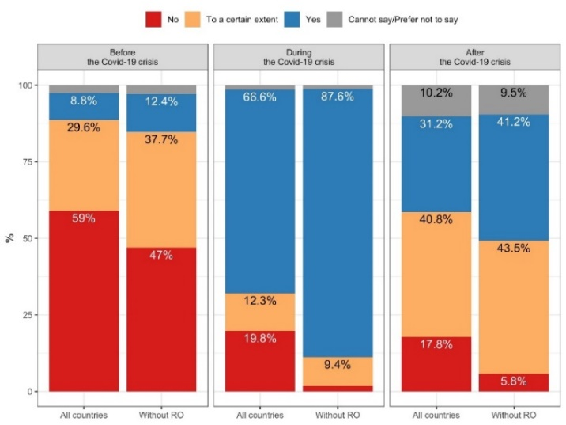

Source: Open public consultation on the new Digital Education Action Plan (2020)

When it came to the success of the measures to ensure continuity of education and training during the crisis, most respondents identified the measures taken in their community as ***predominantly******successful*** (59.4%).[427] Education and training staff, educators, and representatives of education and training institutions were the most satisfied with the measures taken to ensure the continuity of education during the COVID-19 crisis (83.5%, 73.6%, and 83.7%). Learners and especially parents appeared to be less positive about the success of the measures - 40.8% and 63.3% saw them unsuccessful respectively. In the sample ‘Without RO’ the trends for parents were inversed - 65.3% of saw the measures successful, in comparison to 34.7% who defined them as unsuccessful. Representatives from the higher education sector showed highest level of satisfaction – 85.6%, compared to those from early childhood and care, which proved to be the least satisfied - 69%.

The respondents in personal capacity had the opportunity to reflect on the experience of online and distance learning during the crisis. They reported ***most positive experience*** with the availability of digital equipment (64.6%), and the ability to connect to the internet (62.3%), while ***the most negative experiences*** were related to examination and assessment (41%) and motivation to learn (48.1%)[428]. ***Educators and education and training staff were those reporting the most positive feedback***in relation to their experience- in line with the general trend, this was particularly pronounced in view of the ability to connect to internet (67.3% and 84.2%), the availability of digital equipment (65.6%, and 73.7%)and the interaction/communication with learners(60.4% and66.9%).On the other hand***, parents appeared to be the most dissatisfied group,*** reporting low satisfaction with the motivation to learn of their children (66.6%), examination/assessment and feedback (52.3%), quality of online learning content(49.1%), interaction/communication with learners/peers and availability of online resources (46.2% each).[429]. Similar trends were confirmed in the follow-up open question, where parents shared that they were overwhelmed with the workload of supporting children’s education, especially those of young age. Learners, predominantly positive group in the closed questions, shared that the lack of face-to-face interaction led to difficulties to focus. Educators admitted having struggled to ensure continuation of the education and training process due to the limited of digital readiness in their institution, but also low infrastructure and digital equipment in the families of some learners.

The results of the question where the OPC respondents were asked to identify ***what they needed that was not available to them*** during the crisis show certain discrepancies. As visible in Table 3 below, the needs of the different groups were diverse, reflecting the specificities of their experience. Nevertheless, issues around ***connectivity, digital equipment*** were seen as particularly problematic, especially by educators, education and training staff and representatives of education and training institutions, while the two first groups indicated positive experience with these during the crisis. Partially aligned with above, was seen the need for ***better interaction and guidance from educators, management or public authorities,*** which was in top three of the unsatisfied needs of most groups, along with guidance on how to adapt the learning material was missing to educators. Guidance on ***support for mental health*** was particularly sought by learners, parents and education and training staff. ***Funding and financial support*** would have been appreciated by public authorities and education and training institutions, while the private sector would have liked ***more cooperation with public authorities and education and training institutions.***

**Table 3: Top three unsatisfied needs during the COVID-19 crisis per respondent category**

|  |  |  |
| --- | --- | --- |
| **Target group** | **Most unsatisfied needs** | **Other unsatisfied needs** |
| Learners | * Regular interaction and clear instruction by educators (53.3%). | * Regular communication with other learners (40.1%); * Regular and clear communication from the management of the education institution (35.5%) * Support for mental health (33.6%)[430] |
| Educators | * High-speed and stable connection at home (38.4%). | * Training and guidance to adapt the class material and the teaching methodology to distance and online learning (36.1%); * More regular clear communication, guidance and support from public authorities and lack of digital devices suitable for distance and online learning (34.3% each).[431] |
| Education and training staff | * Lack of a high speed and stable internet connection at home for learners and teachers (44.4%). | * Lack of digital devices suitable for distance and online learning (33.8%); * Financial support at national or regional level (33.1%). |
| Parents | * More regular interaction, instruction and guidance from teachers/trainers/educators (57.4%). | * More regular and clear communication, guidance and support from the educational institutions of their child(ren) (45.6%); * Easy to use platforms (32%)[432]. |
| Education and training institutions | * Lack of digital devices suitable for distance and online learning (58.2%). | * High speed and stable internet connection (49.5%); * Guidance how to support the mental health and well-being of staff and learners (38.6%). |
| Private sector and digital technology providers | * More cooperation with public authorities during the COVID-19 crisis (47.7%) | * More cooperation with education and training institutions (31.8%); * Opportunities to scale existing business (29.5%). |
| Public authorities | * Financial support to address the immediate challenges of the COVID-19 crisis (36.4%) | * Easy to use platforms, digital devices that can be used for online and distance learning and high-speed and stable internet connection (27.3% each). |

Source: Open public consultation on the new Digital Education Action Plan (2020)

The targeted stakeholder consultations were aligned with the findings above underlining that the crisis served as an accelerator of existing inequalities and challenges, but also created new ones.

In these consultations, educators were often referenced to be in a ***particularly vulnerable position,*** often having to find the best way to implement new ways of learning considering the needs of their learners and without specific support and guidance. Additionally, educators responding to the OPC shared in the open question fields that they felt ***they had limited digital competences and experience with digital tools prior to COVID-19.*** Aligned with this, ET2020 WG DELTA and MEPs pointed out that the crisis showed very prominently the need ***to further support the*** ***digital competences of educators*** to use digital learning. In addition, ET2020 WG DELTA members highlighted the value of ***practical guidelines*** at European level for ministries and education and training institutions on how to implement distance and online learning, including how to address particularly challenging aspects such as assessment and adapting the learning content to online environments. Organisations providing feedback on the Roadmap requested this issue to be addressed in a ***comprehensive and ambitious way***, learning from the experience during the crisis.

Also, consulted MEPs and stakeholders in the OPC closing event raised their concerns that the COVID-19 crisis would ***deepen already existing inequalities and create new ones***. They suggested leveraging EU funding programmes to support ***infrastructure and access to digital technologies*** across Member States for both formal and non-formal settings. This resonated to great extent with the OPC results in terms of unsatisfied needs, as most of the respondents groups referred to disparities infrastructure and digital tools as needs that were not met during the crisis (Table 3). The consulted members of the Committee of the Regions strongly referred to the need for ***digital cohesion*** across regions, especially when it came to groups of lower socio-economic background and remote areas. The respondents providing feedback to the Roadmap and participants in the Strategic dialogue, also saw the crisis ***deepening already existing inequalities*** in terms of access to connectivity and equipment of disadvantaged groups and minorities, but also the accessibility of groups with disabilities.

Linked to that, the discussions during the researchers’ workshop resonated with the trends from the OPC- the participants shared that the crisis has prominently showed the ***overall limited capacity of the education and training institutions*** to implement online and distance learning. Such low readiness was visible at individual and organisational level and was particularly prominent in terms of methodologies used, the quality of the infrastructure and the overall planning. They shared the observation that institutions, which used a strategic plan and open education policies, ***were better prepared for the switch to online learning and performed in a more efficient way.***

The challenging times to social distancing also asked for reinforced effort in supporting ***mental health and well-being.*** As visible in Table 3, this was a need identified by many parents, but also education and training institutions saw it as unmet during the crisis times and asked for additional support on how to address it. In the open questions, parents, especially from RO, expressed worry that the crisis could negatively affect pupils’ mental well-being. Closely related to that, the participants in the researchers’ workshop pointed out the need to address ***digital well-being*** and not overlook the psychological impact of the crisis, which should be a subject of further research.

Ministries, both in the workshops with the attaché(e)s and in the ET2020 WG DELTA, pointed out the need to ***map and research*** how the crisis was addressed at national level and identify strengths and weaknesses of the different approaches. Sharing the same view with stakeholders representing digitalisation in higher education, Ministries called for a ***space for exchange of practices and communication***, which would provide guidance and support in times of crisis and during the recovery period. In line with that, DE proposed the creation of a ***dedicated entity at European level***, which would help Member States to deal with the implications of the situation and promote digital readiness of educations systems and institutions in the longer-term. Similar views were observed in the researchers workshop, where some participants also put forward the idea of ***a European Observatory***, which would lead the research and adopt a future-oriented approach towards digital education , focusing on peer-learning and networking, bringing communities together and studying existing research and studies.

Lastly, referring to the results of the OPC, ***the lack of precedency of the situation*** and its impact on digital education in the longer term was widely recognised and led to changes in the views towards digital education.More than 90% respondents, with negligible differences between the groups, agreed fully (67%) or to a certain extent (28%) with the statement that ***the crisis will have a long-term impact on the*** ***education and training.***  In the open follow-up question, some educators identified the crisis as an ***opportunity to explore new approaches of teaching and learning***, as well as positive experience with distance learning, which can lead to further opportunities ***for cooperation and establishing networks.*** The private sector, including providers of digital tools and technologies for education defined the situation as a ‘***point of no return’***, where the initial resistance of the education and training community had been already overcome. Nevertheless, not all saw the transformation as positive- aligned with the already identified trend above, the sentiment distribution of the qualitative analysis indicated a more negative trend in the responses of Romanian respondents- only 23% of the replies were positive, compared to 47.8% for the other countries.

The experience during the crisis also ***led to changes in the views towards digital education*** of a great group of the respondents (45.9%)[433]- education and training staff, educational and training institutions, educators, respondents from the private sector and from public authorities all significantly improved their view (74.4%, 67.4%, 57.1%, 63.6% and 72.2% respectively). In comparison, fewer learners and parents improved their views – 55.6% and 57.8% respectively.[434] As main advantages of digital education were seen flexibility, learning/teaching at own pace (41.7%)and innovative and engaging ways of learning/teaching(37.1%)On the other hand, as particularly significant drawbacks were seen thelack of face-to-face interaction and communication (60.5%) and the need for connectivity equipment at home (46.1%).

***2.4 Using digital technologies for teaching and learning***

The need for actions in this area was widely supported by different consulted stakeholders, both in the targeted stakeholder consultation, but also in the open public consultation. The importance of addressing the issue also progressively increased during the consultations with the roll out of the COVID-19 crisis.

Firstly, using digital technologies for better teaching and learning was recognised as the second most important topical priority of the 2018 Action Plan by the umbrella organisations (*see section 2.2*), but it was also recognised as particularly pressing to address by Member States and MEPs in the context of the COVID-19 pandemic and the switch to online and distance learning. In particular, FR even identified it as the most important area of action, which should be tackled with priority in the renewed Action Plan.

Within this area of action, all groups in the targeted consultation considered ***supporting pedagogies for teaching and learning*** and ***the development of educators’ digital competences***, as anessential area for action. More than half of the respondents in the stakeholder questionnaires recognised these among their top five aspects in using technologies for better teaching and learning, with particular strong support from teachers (70.8% and 71.7% respectively) and higher education staff (56% and 64%) in the social media survey. The OPC respondents also strongly identified the need for reinforced efforts in this area: endowment of educators and teachers with relevant digital competences was seen as the ***most important element for the provision of digital*** ***education*** (61.7%; Figure 2), while at the same time teacher training and guidance remained one of ***the greatest challenges for digital education***. The latter gained the support of by 41.5% of the respondents[435], especially by learners and parents (48% and 42.9%). Not unexpectedly, teacher training and support also appeared to be the ***aspect of digital*** ***education where the EU could add value the most***- 51.5% of the respondents identified it as leading area of support (Figure 3), especially those representing education and training institutions (58.7%), learners (53.9%) and education and training staff (57.9%). Educators also recognised it as an important point to be addressed, but positioned it second (52.6%), after support for connectivity and infrastructure (53%). MEPs and respondents giving feedback on the Roadmap strongly underlined that improving educators’ digital competences is a prerequisite for efficient, successful and purposeful integration of digital technologies in the education process, asking for a stronger focus on this topic in comparison to the 2018 Action Plan.

The support in the other stakeholder consultations was also prominent- the eTwinning NSS urged for a reflection of using digital technologies in cases where they could support the teacher and improve the education process. ET2020 WG DELTA members stressed the need to equip educators more broadly with the skills and knowledge to design and implement digital and online learning, a view supported by students’ organisations in their position paper. The participants in the researchers’ workshop asked for stronger focus on the pedagogical design competence, including also assessment and evaluation. A unified European approach in teacher training on digital competences, combined with reinforced funding in this direction, was seen as an enabler for digital readiness in the longer term- an argument supported by MEPs and the Committee of the Regions. Additionally, Ministries and MEPs highlighted this area as crucial in the context of emerging technologies, such as Artificial Intelligence, entering the education process, while students’ organisations proposed reinforced teacher training in digital literacy.

**Figure 2: Essential elements of education and training institutions for the provision of digital education (all target groups together)[436]**

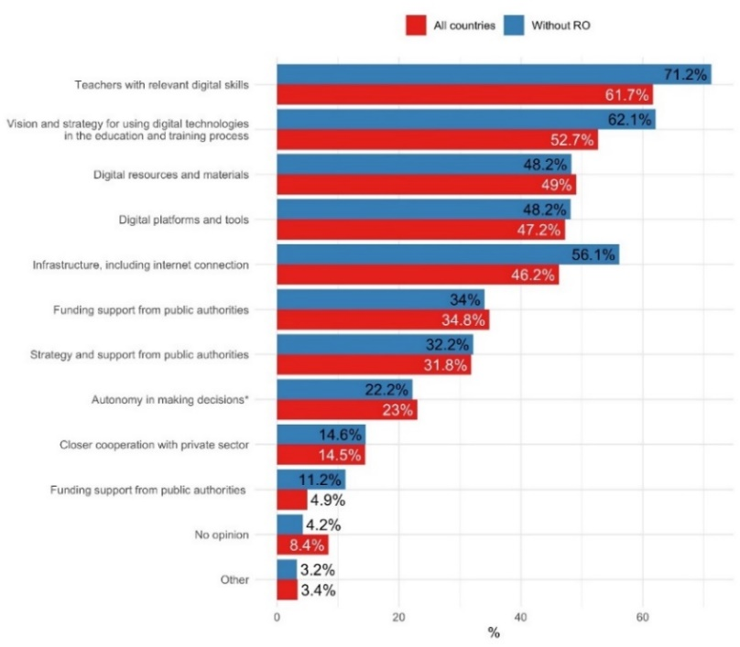

Source: Open public consultation on the new Digital Education Action Plan (2020)

***Promoting inclusion in access and use of digital technologies for teaching and learning*** was another topic that was of central relevance during the stakeholder consultations. It received a wide support by all groups in the targeted consultation- the general public (41%), umbrella organisations (39.2%), along with Member States and MEPs. FR pointed out that inclusion should be a leading priority in the new Action Plan, especially in the context of ***infrastructure and connectivity*** ***divides*** between urban and rural areas. The OPC results reinforced this message, especially as respondents saw addressing ***socioeconomic inequalities and insufficient infrastructure as*** ***the*** ***two greatest challenges for digital education in Europe,*** supported by the vast majority (45.5% and 42.4% respectively), recognised strongly by education and training institutions (58.2% and 53.3%) and educators (52.8% and 51.4%). Public authorities also saw socio-economic inequalities as a top challenge (68.2%), but ranked infrastructure as a less relevant challenge- 36.4%. Parents however recognised supporting inclusion as challenge of second highest relevance (37.7%), right after teacher training and guidance (42.9%). It should be noted that the issue of infrastructure was reported slightly more important than addressing socio-economic inequalities by the respondents from the VET sector (55.1% and 54.4% respectively). Similarly to teacher training, these trends corresponded to ***where the EU could add value,*** with connectivity and infrastructure and inclusion being second and fourth most popular areas, supported by 42.6% and 40.5% of the respondents respectively, especially among educators and education and training institutions. Aligned with all these findings, infrastructure and connectivity were among the ***essential elements in the provision of digital education***, supported by 42.6% respondents, again from education and training institutions (58.7%), but this time also by the private sector (81.8%). Nevertheless, infrastructure was a point of concern of very few umbrella organisations in the targeted stakeholder survey- only 17%.

A very strong message to tackle connectivity and equipment inequalities came from MEPs in ***encouraging synergies between different funding programmes*** to support Member States in formal, non-formal and informal settings of education. Position papers submitted with the OPC, coming from NGOs, but also private sector, additionally reinforced the message of deepened inequalities and ***‘digital poverty***’ and need for support in connectivity and digital equipment to address those disparities.

The importance of supporting the ***digital capacity of education and training institutions and systems*** became particularly strong with the COVID-19 crisis. Opinions on the importance of this aspect were present before the crisis, usually coming from organisations focusing particular on digital education and capacity in the beginning of the consultation period, but with the development of the crisis, they became more prominent in the consultations. For example, ***institutional leadership and culture*** was seen as important by 37% of the umbrella organisations and 28% of the respondents in the social media survey. Participants in the researchers’ workshop shared that the crisis boosted the need to address ***digital strategies and capacity building***- and asked the Commission to prioritise them, especially in view of developing leadership and supporting institutional change, beyond infrastructure and tools. The OPC results resonated with this urgency- ***supporting education and training institutions to develop*** ***digital education strategies*** was seen as the third most popular area ***where the EU could add value***. It was supported 42% of respondents (Figure 3), especially those representing providers of digital tools and technologies for education (60.6%) and education and training staff (45.1 %) and to a lesser extent by educators (42.6%) who positioned in fifth in their ranking. In broader terms, the ***lack of planning and vision for integrating digital technologies*** was the fourth most popular challenge for digital education in Europe, supported by 37.9% of the respondents, mainly from the private sector (54.5%), but also by education and training staff (48.9%), providers of digital tools (42.4%) and lesser extent education and training institutions (37.5%). The closely linked ***vision and strategy for using digital technologies in the education process,*** was seen as the second most important element of providing digital education (52.7%; Figure 2). It had the support of the same respondents’ categories but in a slightly different order- digital technology providers-81.8%, private sector- 75%, education and training staff- 66.2%, but this time, also the prominent support of learners (52.6%) as the second most important element. During the researchers workshop, participants reiterated the need to develop human ***capacity and*** ***strategy***, not on technology, and should address groups like school leaders in the process. Self-reflection tools like the ***SELFIE tool*** were given as examples by Ministries of education and researchers as particularly useful ones in supporting planning and strategies.

In the researchers workshop digital leadership and capacity were linked not only to implementing digital education, but also to ensuring ***effective*** ***hybrid solutions between online and on-site delivery, also referred to as blended learning***. In view of this, more support was requested to help systems and institutions to ensure a ***fluid and organic*** ***continuum between online and offline education***. Members of the Committee of the Regions also pointed out that blended learning would be increasingly used in future; therefore boosting the capacities in this direction is needed. However, the views of across the stakeholder groups towards blended learning varied- for example, students’ organisations (both at school level and higher education) emphasised that the digital tools should not dominate over the physical aspects, ensuring that face-to-face contact remains central in the education and training process. ***The respondents in the OPC also shared divergent views-*** in the sample ‘All countries’, less than half of the replies were positive - 49.5% (in comparison the negative views were 41.7%), however, this was not the case in the sample ‘Without RO’, where the vast majority of the replies was positive, reaching 76.2%. The positive opinion was consistent across the different target groups, while parents, learners and respondents from the group other in personal capacity were on the more sceptical side (25.2%, 16.7% and 19.5%)[437]. As benefits of mixing face-to-face and online learning were outlined flexibility and learning at own pace (70.2%), face-to-face communication and interaction (63.5%), integration of innovative practices (58.2%), along with the opportunity to better support learners from disadvantaged groups (58.1%)[438], greatly resonating with the replies to the follow-up questions, defining physical presence as ‘unreplaceable’. It should be noted that the ***support for blended learning across respondents from non-formal education, higher education, adult education and VET was the most significan***t (79.%, 75.6%, 79.9% and 69.8% respectively). In comparison, when it came to the barriers the main ones were the difficulty for parents or carers to combine work with supporting their children’s learning (72.9%), and exclusion of learners without access to suitable technology (70.6%). It is interesting to observe that one of the most recognised advantages of blended learning- face-to-face communication and interaction actually addresses the previously discussed highest ranked disadvantage of digital education as a whole- thelack of face-to-face interaction and communication *(see section 2.3).*

**Figure 3: Where could the EU add value when it comes to digital education**

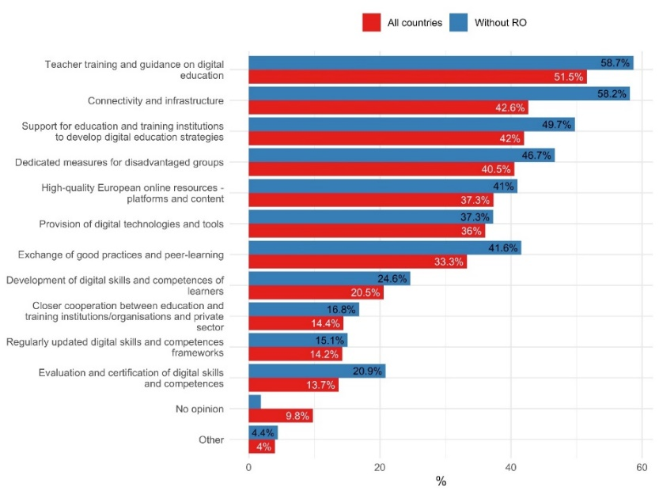

Source: Open public consultation on the new Digital Education Action Plan (2020)

The need to ***support*** ***online learning and high-quality online content*** also became even more prominent and urgent under the COVID-19 crisis and was perceived as an area for EU intervention. Particularly strong was the support from students in the social media survey with 75.6% of them asking for this area to be tackled in the renewed Action Plan. Although not recognised as among the top challenges for education in the digital age by the respondents in the OPC, the ***availability of EU high-quality online learning content*** and ***easy to use platforms*** were seen as important challenges for digital education by 24.5% and 13% of the respondents respectively, with consistent trends across all target groups. Nevertheless, high-quality online learning resources (platforms and content) were seen as the ***fifth most popular area where the*** ***EU could bring value,*** supported by 37.3% of respondents, specially by public authorities, learners and parents (64.5%, 37.5%[439] and 34.3% respectively), in comparison the group that ranked them as a particularly low area of interest was the private sector (18.2%). Ultimately, the existence of ***digital resources and materials and digital platforms and tools*** ***remained an essential part in the provision of digital education,*** ranked at third and fourth place by all respondents (49% and 47.2%), with groups like education and training staff and parents keeping with this trends. However, the former was seen in top two from the educators (55%[440]) and the latter was seen as a leading element for the vast majority of providers (84.8%). In comparison, a fourth of the respondents from the private sector and digital services providers identified the importance for platforms to be scalable. In addition, the views of the various umbrella organisations resonated with the trend: 43% of them identified promoting high-quality online learning as one of the five aspects under this priority area. More precisely, stakeholders from higher education institutions and student organisations and Member States asked the Commission to provide ***guidance for quality standards of online learning and content***. Researchers pointed that most learning materials were conservativeand many times replicated of traditional learning sources, asking for adapting the content and methods to online learning. Interoperability and synergies between existing national and European online platforms, was considered as a valuable contribution to be made at EU level, by DE and FI, and researchers in the workshop. Member States advised the Commission to promote cross-linking and orchestrating socio-technical ecosystems and data spaces of existing platforms. Additionally, the members of the Committee of the Regions and in particular the SEDEC Chair Anne Karjalainen underlined the importance of creating a ***European digital ecosystem,*** promoting European content, platforms and tools, a view supported by Member States (BE-FL). ET2020 WG DELTA and MEPs highlighted the potential of online platforms and content to promote lifelong learning, upskilling and reskilling. As a way to achieve better access to online content, some Member States attaché(e)s (NL, FI) and researchers in the workshop argued in favour of expanding open access and Open Education Resources (OER). Educators in the video-conference on the European Education Area also supported this view, asking for open and free access to quality materials for all teachers and students.

The OPC responses provided an extra level of depth of what makes digital content useful- most respondent suggest as a leading characteristic ***interactivity and user friendliness*** (50.4%), followed by ***content developing skills needed on the labour market*** (39.5%) and ***recognition by national authorities*** (37.5%). The aspect of ***multilingualism*** ranked fourth- supported by more than a third of the respondents in the OPC (30.5%). In addition, in position papers and during the Strategic dialogue, the need to ensure ***accessible digital learning environments*** with adapted materials for learners with disabilities was underlined continuously.

In line with that, ***recognition of online and blended learning*** was seen by Member States and international organisations as closely linked to the provision of online learning and high-quality content. This wasan area particularly highlighted by the non-formal and youth sector, and by higher education institutions. Private sector representatives particularly encouraged the Commission to support recognition of alternative learning pathways and promote short-term programmes for upskilling and reskilling, providing job-ready skills. The support for flexible learning paths and the recognition of new forms of learning was underlined by certain Ministries (NL, DE, NO) who argued for the benefit of a pan-European approach in order to support lifelong learning, upskilling and reskilling. They were in favour of building on actions such as the Digitally Signed Credentials of the 2018 Action Plan and asked for quality assurance as well as a secure and transparent infrastructure for credentials.

The opportunities that digital technologies offer to ***gather data, inform and improve education*** were widely recognised by the different groups, including Member States, umbrella organisations and researchers. 88% of the umbrella organisations survey recognised ***data and foresight*** as an important topic to be addressed. In comparison, the area was considered a low priority among the social media survey respondents (10%). More specifically, stakeholders asked for ***comparative longitudinal data on effective teaching and learning on European level***, looking at different aspects of digital education. Organisations working on digital skills, as well as parents and private sector, asked ***for better******data and measurement on the levels of digital competence*** across the EU, going beyond self-assessment. Researchers in the workshop called for a ***framework for*** ***exchange of data,*** along with ***education policy indicators***, which could be mapped to research constructs and data points. They pointed out as a specific policy measure of high importance the need to look into the ***future of education,*** rather than tackle current data that focuses on the past and the COVID-19 crisis. The OPC questionnaire addressed this topic to a lesser extent, while the Roadmap feedback referred to the need to increase ***research in designing and evaluating teaching methods and content.***

Despite a positive attitude towards data usage to inform and improve education, concerns on ***privacy*** and ***ethical*** implications of data gathering, and in particular of technologies such as AI, were voiced strongly by Member States (DK, DE, FI, FR, NL) and education and training institutions. Organisations that represented students and educators asked for informed data gathering and usage. Private sector representatives pointed in their position papers the importance to create a ***safe and secure online environment for pupils and students of all levels***. Supporting this view, Ministries of Education suggested training and awareness raising among educators on the use of AI and data in education to ensure they have the knowledge and confidence to leverage these technologies for enhanced learning and teaching experience, while keeping full control of the education process. Additionally, the researchers in the workshop asked for EU level framework to address learning analytics research and related trust and privacy issues. Both Member States and organisations working on digital learning or skills asked for specific attention to raising awareness of digital footprint among young people and adults.

***2.5. Digital competences development***

The need to ***enhance digital competences for the digital transformation*** was recognised as particularly important throughout the whole stakeholder consultation process, both in terms of targeted and the OPC and its accompanying activities.

Apart from being seen as a topic of leading relevance from the 2018 Action Plan *(see section 2.2)*, Ministries of Education in ET2020 WG DELTA strongly recognised boosting digital skills and competences as a ***fundamental area of work for ensuring high-quality digital education*** and underlined the value of the European Framework for Digital Competences for Citizens (DigComp)[441]. Many stakeholders stated that the crisis additionally deepened the need to support the development of digital skills, in terms of use in everyday life but also on the labour market. In position papers, coming from private sector, NGOs, but also Ministries, the Commission was asked to work towards boosting basic digital skills, along with advanced ones in order to support the European recovery effort.

This view was confirmed by the results in the OPC, where the vast majority of the respondents - 74.5% of those in personal capacity and 85.1% of those organisational capacity shared the view that the switch online learning and working ***had increased the importance of digital skills and competences on the labour market.*** Representatives of the private sector during the targeted stakeholder consultations and the OPC closing event also reiterated their expectations for such trends on the labour market.

When it came to their experience during the crisis, in the OPC, more than two thirds (62%) of the respondents in personal capacity reported that they had***improved their skills***during the crisis and 63.7% ***took*** ***specific steps to do so.*** Additionally, more than a half (55.4%) planned to take steps and improve their digital skills and competences in future[442]. Among the target groups, those with most positive attitude towards these three questions were educators and education and training staff (84.7%, 86.2% and 78.9%, along with 86.5%, 86.5% and 83.5% respectively). Parents shared less positive views- only 58.5% shared they had improved their skills and 46.3% planned to take any steps to enhance their digital skills[443]. Among the groups replying in organisational capacity, the vast majority shared that their organisation or institution had taken steps to improve the skills of their staff (74.2%) and that the digital skills of the staff had improved during the crisis (81.5%). In line with the findings in individual capacity, a great part of the respondents from this group (71.3%) shared that their organisation planned to improve the skills of the staff in future and identified ***online learning as the most preferred method for upskilling*** (56.9%), followed by ***blended learning*** (42.5%).

A number of respondents across the groups self-assessed their skills or those of theirs staff ***as sufficient to implement digital learning/working or support their children*** in that (around 84% in both). Still, the need of digital skills and competences during the crisis was seen as unmet by around a fifth of the respondents (18.8%) and seen as an area where the EU could add value by more than a fifth of the respondents (21%).

**Figure 4: Most important digital skills and competences for living and working in the 21 century[444]**

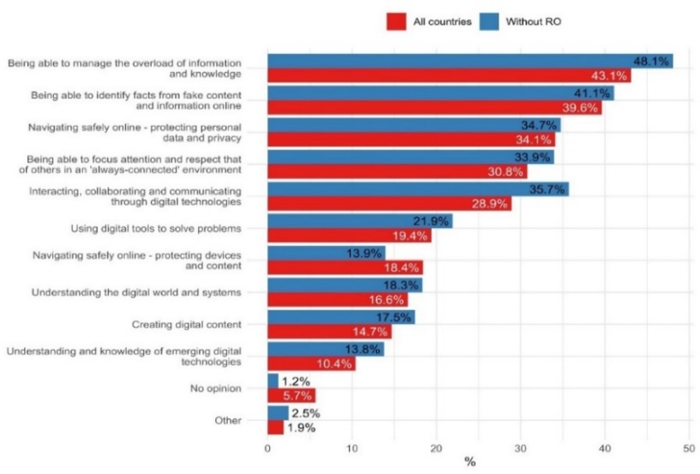

Source: Open public consultation on the new Digital Education Action Plan (2020)

When looking into the different types of digital skills and competences, ***digital literacy, including media literacy, fighting disinformation, hate speech and online threat*s** received the strongest support from all consulted groups. In particular, it was identified as a priority for EU support by 78% of the umbrella organisations and 68% of the social media respondents and by three of the five eTwinning NSS. Different stakeholder groups noted that information and media literacy were already well-used concepts and digital literacy should build on them, establishing a clear link with the concept of digital citizenship, in order to ensure coherence and comprehensiveness in the approach of the new Action Plan. Ministries of Education and the MEPs stressed the need to address this issue in a strong life-long learning and inclusive perspective, equipping young people and adults with the skills to engage with information critically. The results in the OPC were similar- when asked to indicate top five important digital skills and competences for living and working in 21 century, respondents positioned ***identifying facts from fake information and content online the highest*** (39.6%),which was preceded only by ***managing the overload of information and knowledge*** (43.1%), an aspect that could be also be seen as part of digital literacy (Figure 4). The former was particularly supported by learners (43.4%) and digital technology providers (42.4%), while the majority of the other consulted groups positioned the latter as most important[445]. Aligned with that, when asked on the ***digital skills and competences they would like to improve in future***, respondents positioned managing overload of information as the second most wanted skill (supported by 30.4%), but identifying facts from fake information and content online was seen as far less appealing- at seventh place (supported by 19.4%)[446]. Nevertheless, the support of learners remained high, but also from parents, especially in regards to managing overload of information (supported by 31.6%), which was the second most popular skills they wanted to develop. Trade unions representing educators in Member States, but also Member States participating in the OPC (CZ, BE-FL) asked for targeted action in boosting media and digital literacy.

Secondly, ***ethics and privacy*** was another field where European support was particularly needed, especially in the context of drastically increased use of digital technologies during the COVID-19 crisis. During the meeting of ET2020 WG DELTA, a number of Ministries raised the issue of private companies opening their platforms free to use during the crisis, without always revealing how personal data was used and stored. This showed a clear demand for enhancing knowledge and understanding of privacy and ethics implications of digital technologies use. This area came as the second most supported by the umbrella organisations under this priority (51%) and in the social media survey (49%). It was also particularly requested by the teachers and students in the outreach event on the new Action Plan and European Education Area. The OPC results positioned ***navigating safely online*-*protecting personal data and privacy*** as the third most important type of skill for 21 century, supported by 34.1% of the respondents[447] and especially strongly supported by 50% of the respondents from private sector[448]. It was a skill that many wanted to improve the future, especially learners and parents (respectively 33.3%[449] and 32%), who positioned it in their top three; when it came to respondents in organisational capacity, it ranked fourth (36%). The related digital skills of ***protecting devices and content*** received lower recognition for 21 century, having positioned at seventh place by the respondents (18.4%[450]), and ranking slightly higher when it came to the interest of respondents in personal capacity to develop it in future- at fourth place (23.3%[451]) and organisational- at sixth (27.7%). In the exchange with education and youth attaché(e)s, the topic was discussed in the context of increased pervasiveness of emerging technologies, such as AI. Member States (FR, NL, DE, DK, SI and SK) perceived the ***role of the Action Plan*** ***as central for European efforts to reinforce knowledge on ethics and privacy among young people***. In their position papers, international organisations providing humanitarian aid for children also called for reinforced European efforts in the area of cybersecurity and saw the role of parents, but especially teachers as a key in the process.

Closely linked to the theme above, was the need to work towards a ***better knowledge and understanding of AI and related data*** in education processes and in society. This was viewed as a pressing area to be addressed in the new Action Plan, both in the umbrella organisations questionnaire (41% positioned it among the top five areas for action) and during the consultations with Member States and position papers submitted on ad-hoc basis or as part of the OPC (NL, CZ). ET2020 WG DELTA highlighted that AI called for a differentiation of the type of skills- understanding and knowledge of everyday and educational use and advanced level skills for the labour market. The Commission was encouraged to address them in an age-appropriate way, while promoting good understanding on all levels of education. Additionally, Ministries asked for regular updates of digital competences frameworks (DigComp, DigCompEdu and DigCompOrg)[452] with respect to associated new skills. Stakeholder organisations working on digitalisation in higher education pointed out that existing national initiatives should be leveraged, and exchange of practices promoted through funding mechanisms and better conditions for collaboration. Consulted MEPs placed a stronger emphasis on better teacher training and continuous professional development, especially in the context of AI and data. With respect to the social media survey, AI was not identified as a priority for support, recognised as such only by a fifth of the respondents. Similar was the trend in the OPC- the closely related aspect of ***understanding new and emerging technologies*** was supported by only 10.4% of the respondents. When looking at the different categories, this one predominantly supported by the private sector and the providers of digital tools for education, which selected it among their five most important skills- supported by 27.3% and 36.7% respectively. These skills were also not the front-runners when it came to the digital skills and competences respondents wanted to develop in future- they positioned at sixth place (supported by 26.3%[453]) and by organisations- seventh (18%).

High-quality ***computing, informatics and technology education*** as a way to promote better understanding of the digital world was another focus area of action at European level, especially by stakeholder organisations, eTwinning NSS and citizens. Strengthened efforts in this area were requested by 40% of the umbrella organisations in the questionnaire, coming from different levels of education as well as the private sector. During the workshop and in ad-hoc meetings, higher education institutions and research centres on informatics as well as organisations representing IT professionals, asked for integrating the subject across curricula at all levels and identifying a respective framework of high-quality informatics. The need for a common language resonated in the views of the Ministries of education participating in ET2020 WG DELTA. During the meeting in March, the Chair of the CULT Committee, Sabine Verheyen, expressed particular support for integrating informatics and technology education across all levels of education, as an important component of ensuring young people had a good understanding of the digital world. Additionally, computing, informatics and technology education was often linked ***to creative use of digital technologies***, an aspect that received a particularly strong support by the general public (44%) and the consulted umbrella organisations (41%). In contrast, the majority of the respondents in the OPC did not consider the related skill of ***understanding the digital systems and world as key for 21 centur***y, having gained the support of only 16% of all respondents, but still well recognised by the private sector (27.3%) and respondents in organisational capacity from the group ‘other’ (23.5%). Another computer science related skill- ***creating digital content-*** was also not identified as particularly important in 21 century (supported by only 14.7% of the respondents, mainly educators, private sector representatives, education and training staff). Nevertheless, it turned out to be the ***digital competence that most respondents wanted to improve in the future***- 35%- especially educators (more than 60%) and education and training staff (46%).

Lastly, European guidance and support on ***assessment and recognition of digital skills*** was prominently called for during the consultations with umbrella organisations, visible in the questionnaire (41% supported it), position papers and in the workshop. This was a point coming from civil society but also trade unions and parents and Ministries of Education asking for guidance on assessing and certifying digital competences and skills, going beyond self-assessment. Some Member States, such as FR, asked for unified EU approach towards assessment and recognition of digital competences. In addition, respondents in the social media survey had moderate support for this area (36.7%), especially those representing higher education staff. Organisations representing the IT and private sector suggested to link the assessment of such skills in secondary level to DigComp 2.0[454] framework and to then promote it across Member States, a trend observed in the Roadmap feedback and the Position papers submitted. The researches in the workshop also reiterated the need to focus on validation and certification and to also explore the options ***blockchain certificates*** offer. The OPC results also reflect evaluation and certification of skills as important area where the EU could bring value, but to a lesser extent - 13.7% of the respondents supported this statement[455].

Bridging the ***gender digital skills gap*** was considered as going hand in hand with promoting digital competences. The issue was strongly highlighted during the exchange with Members States attaché(e)s and MEPs, and identified as a priority area by a quarter of the consulted umbrella organisations, mostly education employers, non-formal sector and business. In particular, private sector called for measures to attract more women in STEM studies and careers through synergies with the EU STEM Coalition. Reinforced activities, engaging both formal and non-formal sector, together with dedicated cross-country exchanges to promote exchange of practices were seen as valuable by some Ministries (FR). During the live chat with Commissioner Gabriel, the relevance in the topic was reconfirmed by questions on how the Commission would address this issue; even though the recognition of this as a challenge for digital education was very low in the OPC (less than 2% of the respondents saw it as such).

***2.6 Cooperation and exchange***

The need for reinforced cooperation and dialogue between different stakeholders in the area of digital education was identified in all stakeholder consultations in different contexts. The COVID-19 crisis also impacted this area, by underlining the fragmentation of national policies and experience. Stakeholders pointed out to the need for the new Action Plan to ***enhance cooperation as a key element to achieve systemic impact and identify sustainable solutions, supporting education and training in the long term.***

During the consultations with MEPs and Members of the Committee of the Regions, it was underlined at different occasions that in order to have a strong and impactful digital education strategy in Europe, it would be necessary to mobilise all levels ***– local, regional, national as well as European and engage a broad variety of stakeholders in the discussion.*** The DE Presidency also reiterated this message in the OPC closing event by underlining that ***cooperation would lay at the core of making Europe the global leader in digital education.***

During the researchers workshop, experts underlined unanimously the ***important role of collaboration and cooperation between different parties***, in particular between research, international organisations and policy makers. They underlined the role that the Commission could play in supporting such exchange through instruments, such as an ***EU Observatory*** as a space to bringing voices of distinct stakeholders together at a European level. In line with this idea, in their non-paper, DE advocated for the creation of a dedicated entity to promote the ***exchange of knowledge, good practices and data***, especially in view of the COVID-19 crisis. A follow-up position paper supported by 6 organisations from 4 Member States (AT, DE, FR, NL) underlined the need for orchestrated cross-sectoral exchange, discourses and actions in the field of digital education, along with strategic collaboration and co-creation at different levels and across stakeholders. Very closely aligned to this was the proposal of other Member States (NL) for stronger European cooperation, creating policy scenarios, supporting national policies and exchange of good practices between Member States, along with promoting ***national networks and agencies in the area of digital education to cooperate further***.

Additionally, a number of papers submitted as part of the OPC, coming from a variety of stakeholders- employers, NGOs, private sector, social partners, also Member States, ***called for the enhanced cooperation between stakeholders and establishment platforms***, which would bring the community together in a structured dialogue on digital education. The quantitative questions of the OPC resonated with these views to a great extent- 41.6% of the respondents ***saw exchange of good practices and peer-learning as an area where the EU could add value***[456]. Notably, in questions referring specifically to ***cooperation between public authorities, education and training institutions and private sector***, there seemed slightly less support. In the question on the EU added value, the cooperation between education institutions and private sector was seen as of limited value, supported by 15.1% of the respondents, mainly from the private sector who saw it missing during the crisis (Table 3)[457]. In contrast, public authorities recognised it as a low value action, supported by only c.30%, of them, but still higher than education and training institutions, where only 13% identified it as an area of EU added value.

***2.7. Funding***

There was an overall agreement that the new Action Plan could offer reinforced funding opportunities.

The consulted MEPs called for the strong ***mobilisation of different funding programmes*** - Erasmus+, Horizon Europe, Digital Europe Programme, Cohesion funds, the Recovery and Resilience Facility, InvestEU to support the ambitious long-term objectives of the new Action Plan and address the implications of the COVID-19 crisis. Aligned with that, Member States also called for the new Action Plan to leverage a broad range of funding programmes- paying special attention to integrating the objectives of digital education in their yearly and multi-yearly planning cycles (NL) but also share information and good practices of the use of European Structural and Investment Funds, for example (BE-FL).

Members of the ET2020 WG DELTA also pointed that funding for the development of digital competences ***should be reinforced in programmes*** such as Erasmus+ and the Digital Europe Programme. They suggested ***mapping different funding opportunities*** for development of basic to advanced skills as a way to support beneficiaries. Social partners participating in the OPC asked for increased funding from ESF+ and ESIF to further support adult learning and digital skills development. Aligned with these views, in the umbrella stakeholders’ questionnaire, more than a fifth of the organisations did not consider that the 2018 Action Plan had provided enough funding opportunities. In view of the new Action Plan, they asked for funding in particular for ***digital competences and skills (for educators and learners); high-quality online content and community-learning networks.***

***2.8. Communication opportunities***

The majority of stakeholders suggested that there is room for improvement of the communication of the new Action Plan. This was a strong message from the consultations with the Member States attaché(e)s (BG, NL, SK, DE) which explained that the visibility on a national level was often not satisfactory, with disparities between the communication of the different actions. As three preferred ways to learn about the Action Plan, they identified newsletters, events and webpages.

## Annex 3: European Digital Competence Frameworks

With the aim of establishing a shared understanding for tackling digital skills challenges, the European Commission has developed **three digital competence frameworks**: DigComp, DigCompEdu and DigCompOrg. A competence framework defines and describes the most important competences in a given area, usually accompanied by detailed descriptors, proficiency levels and/or learning outcomes. Competences are defined as the combination of knowledge, skills and attitudes, following the 2006 European Recommendation on key competences for lifelong learning (updated in 2018)[458].

The competence frameworks are widely used within Europe and beyond for developing policy initiatives, educational planning and reform, training courses and curricula, self-reflection and/or self-assessment and certification, amongst others. In the EU use is voluntary, fully respecting the principle of subsidiarity. Reference frameworks serve the purpose of the Open Method of Coordination because they provide a common language.

**1. The Digital Competence Framework for Citizens (DigComp)**

The DigCompframework describes the most important competences people need to have to participate in the digital world. As Figure 1 shows, it consists of five competence areas, 21 competences, examples of use and detailed proficiency levels. DigComp was first published by the Joint Research Center in 2013 and updated in June 2016 (DigComp 2.0) and May 2017 (DigComp 2.1), the latter focussing on detailed proficiency levels.

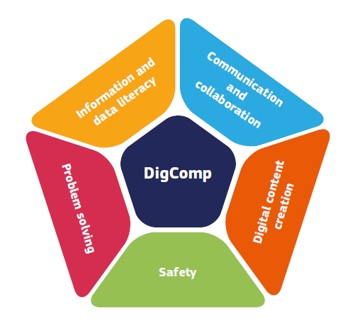

**Figure 1: The five competence areas of the DigComp framework**

‘DigComp into action’, a guide for stakeholders presenting 38 inspiring examples of DigComp adoption and use from all over Europe, was released in May 2018.

DigComp is taken up in more than 16 Member States, for curricula review, student assessment, employability and digital skills strategies and policies. The European Training Foundation works with DigComp in the EU neighbouring and developing countries. DigComp also formed the conceptual basis for the calculation of the digital skills part of the European Digital Economy and Society Index (DESI), a composite index that summarises relevant indicators on Europe’s digital performance and tracks the evolution of EU Member States in digital competitiveness[459].

At the global level, UNESCO and the International Telecommunication Union are considering DigComp for the development of a Global Digital Literacy framework as a contribution to the Sustainable Development Goals (4.4.2 - measuring digital literacy skills)[460].

More than 70 projects in Europe are using DigComp as an implementation tool for digital education/skilling, assessment/certification and/or defining digital professional profiles. So far at least 335,000 DigComp based training courses have been developed and 500.000 DigComp based certificates have been provided by external stakeholders. In addition, the Joint Research Centre just released ‘DigComp at Work’ report[461] and ‘DigComp at Work Implementation Guidelines’[462], focused on labour market intermediaries and the development of digital competences for employability and in employments contexts.

Further work will concentrate on developing an approach to combine DigComp with other related frameworks such as EntreComp[463], and on finalising a reliable and validated self-assessment instrument for DigComp (end 2020). Finally, an updated version, i.e. DigComp 2.2 is foreseen for end 2020/early 2021, with new examples covering emerging trends (e.g. fake news) and technologies (e.g. AI), amongst others. External stakeholders have in the meantime also launched a DigComp Community of Practice to bring DigComp users together and learn from each other[464].

More information available at: <https://ec.europa.eu/jrc/digcomp/>

**2. Digital Competence Framework for Educators (DigCompEdu)**

DigCompEduwas published in 2017 describing what it means for educators to be digitally competent. It is directed at educators at all educational levels, from pre-primary to vocational, higher and adult education. It provides a general reference framework to support the development of educator-specific digital competences in Europe. It details 22 educator-specific competences for teaching in a digital society along six competence areas (Figure 2).

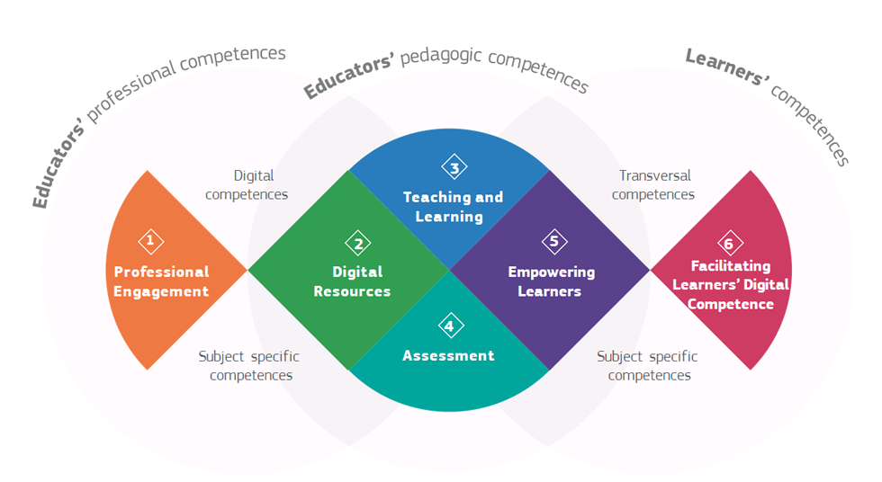

**Figure 2: The six competence areas of the DigiCompEdu framework**

Subsequent to the publication of the framework an online community has been set up, inviting stakeholders interested in using and implementing the DigCompEdu framework to exchange experiences and training materials. The community has around 200 members and brings together all those interested in educators’ digital competence at national and regional agencies, researchers, training providers and educators.

Based on the framework, the Joint Research Center is currently piloting a self-reflection questionnaire (DigCompEdu Check-in[465]) for educators from primary, secondary, vocational and higher education. The self-reflection exercise has already been completed by almost 35,400 educators, allowing them to reflect on their digital practices, test their practical knowledge and guide them in further developing their skills. Based on psychometric analysis of the pilot results, the instrument will be further revised and piloted again, specifically for school education teachers. A revised version of the self-reflection tool is foreseen for 2021: SELFIE for teachers.

More information available at: <https://ec.europa.eu/jrc/digcompedu>

**3. Digital Competence framework for educational organisations (DigCompOrg) and a self-reflection tool for schools digital capacity (SELFIE)**

DigCompOrg is a comprehensive and generic conceptual framework that reflects all aspects of the process of systematically integrating digital learning in educational organisations from all education sectors. The conceptual model was published by the Joint Research Center in 2015. It contains 8 key areas and 74 specific descriptors on digital age learning. While DigCompOrg is for all educational organisations, a specific tool for schools was developed on its basis: SELFIE.

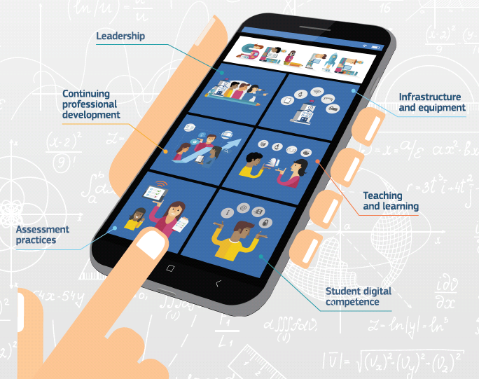Officially launched as part of the 2018 Digital Education Action Plan, SELFIE[466] is an online, free and customisable application that schools in EU and beyond can use to self-reflect on their level of digital capacity. Several Member States and partner countries are integrating SELFIE in their digital education strategies. With the support of the European Training Foundation, the tool has been extended to the countries in the Western Balkans and other partner countries such as Turkey, Georgia and Moldova. In collaboration with UNESCO´s Institute for Information Technology in Education the tool has been tested by Russian schools. Selfie is available in 32 languages and it has more than 650.000 users (students, teachers and school leaders) in 57 countries.

A feasibility study to adapt the SELFIE tool for work-based learning systems in Europe has just been published[467]. The study finds that there is a large potential for the SELFIE tool to be applied widely in work-based learning, especially to bring Vocational Education and Training (VET) institutions and companies closer in discussing how they jointly embed digital technology in their education and training provisions. The development of a full version of SELFIE for work-based learning in VET is foreseen for 2020-2021.

Further analysis of SELFIE data is also undertaken, such as on the psychometric reliability and construct validity of SELFIE core items; a random sampling of schools to get representative agregated data; and qualitative case studies on the impact of SELFIE in schools and on how the tool and its impact can be further improved.

More information available at: <https://ec.europa.eu/jrc/digcomporg>

## Annex 4: Glossary

|  |  |
| --- | --- |
| Term | Definition |
| Artificial Intelligence (AI) | AI refers to IT systems that display intelligent behaviour by analysing their environment and taking actions - with some degree of autonomy - to achieve specific goals. AI-based systems can be purely software-based, acting in the virtual world (e.g. voice assistants, search engines, speech and face recognition systems, etc.), or embedded in hardware devices (e.g. advanced robots, autonomous cars, drones, etc.)[468]. |
| Basic and advanced digital skills | Major digital transformations such as artificial intelligence, machine learning or big data are changing labour market’s skills requirements and, in turn, affecting skills development for the digital economy.  All individuals should understand how digital technologies can support communication, creativity and innovation, and be aware of their opportunities, limitations, effects and risks. Basic digital skills allow a basic ability to use of digital devices and online applications (for instance to access, filter and manage information, create and share content, communicate and collaborate), and are widely considered a critical component of a new set of literacy skills in the digital era, with reading, writing, and numeracy skills[469].  At the advanced end of the spectrum of digital skills are the higher-level abilities that allow individuals to make use of digital technologies in empowering and transformative ways, such as professions in ICT[470]. Advanced digital skills are specialized skills, i.e. skills in designing, developing, managing and deploying technologies such as high performance computing, artificial intelligence and cybersecurity at ISCED level 4 and above [471]. |
| Benchmark(s) in education and training | Quantitative indicators are used to measure and compare progress in the EU as part of the open method of coordination in education and training. Under the strategic framework for cooperation in education and training (ET2020) [472], EU Member States agreed on a limited number of targets to be reached by the EU as a whole before 2020. These targets are referred to as ‘EU benchmarks’ and aim to increase tertiary educational attainment; reduce early leaving from education and training; increase participation in early childhood education and care; reduce underachievement in basic skills (maths, science and reading); increase adult learning; increase employment rate of recent graduates; increase learning mobility. A new cooperation framework in education and training, equipped with a revised set of EU targets, is in preparation. |
| Big data (including digital traces) | Big data refers to large amounts of different types of data produced with high velocity from a high number of various types of sources[473]. A key construct in big data is the concept of digital traces. These are in essence records of human – or human like – online, digital activity captured and stored by online information systems[474]. |
| Blended learning | Blended learning is a pedagogical approach mixing face-to-face and online learning, with some element of learner control over time, place, path, and pace. An example of blended learning is the flipped classroom model, in which students view lecture material prior to class, then spend class time engaging in exercises under the supervision of the teacher[475]. |
| Broadband | Broadband refers to high-speed telecommunications systems, i.e. those capable of simultaneously supporting multiple information formats such as voice, high-speed data services and video services on demand[476]. |
| Cyber security | Cyber security refers to all the measures adopted to defend information systems from external unauthorized access as well as user actions that compromise or support the confidentiality, integrity and availability of both information and systems[477]. |
| Computational thinking (including programming and coding) | Computational thinking, programming and coding are often used in an interchangeable way in education settings, but they are distinct activities. Programming refers to the activity of analysing a problem, designing a solution and implementing it. Coding means implementing solutions in a particular programming language. Computational thinking, shorthand for ‘thinking as a computer scientist’, refers to the ability to understand the underlying notions and mechanisms of digital technologies to formulate and solve problems[478]. |
| Computing and informatics education (including computer science) | Computing and informatics education, also known as computer science in many countries, is a distinct scientific discipline, characterised by its own concepts, methods, body of knowledge, and open issues. It covers the foundations of computational structures, processes, artefacts and systems, and their software designs, their applications, and their impact on society[479]. |
| Digital capacity or readiness | Digital capacity or readiness is the ability to integrate, optimise and transform digital technologies in different processes and activities. It can be measured by variety of indicators on different levels. |
| Digital citizenship | Digital citizenship is a set of values, skills, attitudes, knowledge and critical understanding citizens need in the digital era. A digital citizen knows how to use technologies and is able to engage competently and positively with them. He/she participates actively and responsibly in both on and offline communities (local, national, global) at all levels (political, economic, social, cultural and intercultural)[480]. |
| Digital competence | Digital competence is recognised as one of the key competences for lifelong learning[481]. Being digitally competent involves the confident, critical and responsible use of, and engagement with, digital technologies for learning, work, and participation in society[482]. The European Digital Competence Framework (Annex 3) has identified the key components of digital competence in five areas: information and data literacy; communication and collaboration; digital content creation; safety; and problem solving[483]. |
| Digital education | Digital education comprises two different but complementary perspectives: the pedagogical use of digital technologies to support and enhance teaching, learning and assessment and the development of digital competences by learners and education and training staff[484]. |
| Digital literacy | Digital literacy is defined by the Digital Competence framework (Annex 3) as the ability to articulate information needs; to locate and retrieve digital data, information and content; to judge the relevance of the source and its content; and to store, manage, and organise digital data, information and content. It is the first of the five competence areas of digital competence (i.e. being digitally literate is part of being digitally competent)[485]. |
| Digital transition/ transformation | Digital transition (digitisation) refers specifically to the conversion of information or data from analogue to digital format. Digital transformation (digitalisation), by contrast, refers to the adoption or increase in use of digital technology by an organisation, an industry, or a country and therefore describes more generally the way digitisation is affecting economy and society[486]. |
| Disinformation | False or misleading information that is created, presented and disseminated for economic gain or to intentionally deceive the public and may cause public harm[487]. |
| EdTech (as industry and scientific field) | EdTech, short for educational technology, indicates the industry that combines education and technological advances as well as the scientific field which involves the interdisciplinary knowledge informing the use of technological tools and devices, processes and procedures, resources and strategies to improve learning experiences in a variety of learning settings[488]. |
| Formal, non-formal and informal education | Formal education is intentional, organised and structured. It is usually provided in schools, colleges, universities and other formal education and training institutions, and leads to recognised diplomas and qualifications. Non-formal education takes place through planned activities (in terms of learning objectives and learning time) where some form of learning support is present, but which is not part of the formal education and training system. Informal education results from daily activities related to work, family or leisure which is not organised or structured in terms of objectives, time or learning support[489]. |
| Information and Communication Technology (ICT) | Diverse set of technological tools and resources used to transmit, store, create, share or exchange information. These technological tools and resources include computers, the internet, live broadcasting technologies, recorded broadcasting technologies and telephony[490]. |
| Instructional design | The theory and practice of designing, developing, using, managing and evaluating processes and resources for learning[491]. The instructional design process goes beyond simply creating teaching and learning materials and it is based on carefully analysing how students learn and what content, methods and tools will most effectively help them achieve a specific set of learning outcomes. It consists of determining the needs of the learners, defining the learning outcomes and objectives of instruction, organising and planning assessment tasks, and designing teaching and learning activities to ensure the quality of instruction[492]. |
| ISCED 1,2,3 | The International Standard Classification of Education (ISCED) is a statistical framework for organizing information on education. It has nine levels: ISCED 0 refers to early childhood education, ISCED 1 to primary education, ISCED 2 to lower secondary education, ISCED 3 to upper secondary education, ISCED 4 to post-secondary non-tertiary education, ISCED 5 to short-cycle tertiary education, ISCED 6 to bachelor’s or equivalent level, ISCED 7 to master’s or equivalent level, ISCED 8 to doctoral or equivalent level [493]. |
| Lifelong learning | Lifelong learning includes all activities undertaken throughout life, with the aim of improving knowledge, skills and competences for personal, civic, social and/or professional reasons.[494] It covers education and training across all ages and in all areas of life - be it formal, non-formal or informal[495]. |
| Learning Management System (LMS) | LMS is a web-based software platform made for delivering, tracking and managing online and blended learning. The main features of an LMS (e.g. course management, learners’ enrolment, online activity tracking, etc.) allow handling all aspects of the learning process beyond content delivery[496]. |
| Learning outcomes (including learning objectives) | Learning outcomes are statements of what a learner knows, understands and is able to do on completion of a learning process in formal, non-formal or informal education. Learning outcomes indicate actual attainment levels, while learning objectives define the competences to be developed in general terms[497]. |
| Makerspace | A makerspace refers to any generic space that promotes active participation, knowledge sharing and collaboration among individuals through open exploration and creative use of tools and technology. Its focus is on having a publicly accessible creative space that explores the maker mind-set and tinkering-practices[498]. |
| Massive Open Online Course (MOOC) | MOOCs are a subpart of the existing online learning offer. The term refers to online courses designed for a large number of learners, accessible by anyone anywhere, as long as they have an internet connection. Access and participation are free of charge, although extra services and certificates may require payment[499]. |
|
|
| Micro-credentials | Micro-credentials, micro-degree, nanodegree, digital badge or alternative digital credential, often used interchangeably, refer to any credential that covers more than a single course but is less than a full degree[500]. |
| Next Generation Access (NGA) vs Fixed Networks | NGA refers to wired access networks, which consist wholly or in part of optical elements and which are capable of delivering broadband access services with enhanced characteristics. The term fixed networks is used to describe the traditional wired networks, which have lower sustained bandwidths and are characterised by lack of mobility[501]. |
| Online learning | Online learning is a methodology involving the use of information and communication technologies (ICTs) to support both teaching and learning. The term may refer to the use of various technologies and tools to support learning in different contexts, including face-to-face settings and distance learning, separately or in combination, in which case is usually called blended learning. There are many terms used to describe online learning including ICT-based learning, distance learning, virtual learning and e-learning[502]. |
| Remote education | Method of delivery, which involves teaching and learning activities where educators and learners are not physically present in one location at the same time. In this case, learning happens away from the physical site of an educational provider with educators and learners using different means to connect and engage with a programme, course or educational activity[503]. In this staff working document, remote education is used as a broad term which compromises, among others, the possibility to organise and deliver teaching and learning activities at distance (e.g. by using radio, TV or electronic resources) or online (e.g. requiring learners to use a connected device). |
| Synchronous vs asynchronous digital teaching and learning | There are two kinds of digital teaching and learning: synchronous, (happening collaboratively and at the same time with a group of online learners and usually an educator) and asynchronous (happening at any time, individually or in group, with interaction and communication spanning across time)[504]. Synchronous vs asynchronous digital teaching and learning are differentiated in terms of the time of the online presence, but also available tools, instructional practices, number of people involved and social mode of communication[505]. |
| Upskilling/reskilling | Upskilling refers to short-term targeted training typically provided following initial education or training, and aimed at supplementing, improving or updating knowledge, skills and/or competences acquired during previous training. Reskilling enables individuals to acquire new skills giving access either to a new occupation or to new professional activities[506]. |
| User-driven innovation | From a business point of view, user-driven innovation means placing the final user of a particular product or service at the core of the innovation process in a more systematic way.[507] User-driven innovation can also be applied to education and training by engaging educators, learners and staff in the analysis of a specific educational problem and the design of possible solutions for it. |
| Virtual Learning Environment (VLE) | In the most general case VLE refers to a learning situation that is supported by Internet-enabled technologies to provide tools for students to learn specific content, communicate and submit work, while providing components for an instructor to manage the learning process, collect input, and provide feedback to students. The concept is called virtual because students use computer programs and tools while working from remote locations to accomplish activities that would otherwise be done in real locations such as a school or classroom[508]. |
| Virtual Reality (VR) /Augmented reality (AR) | VR involves the use of a computer to visually simulate an artificial environment within which a user can interact with objects and be fully immersed. AR refers to the real-time digital overlay of information over physical elements. A user’s real, visible environment is the predominant element, with extra information intended to augment the actual environment a user sees on an ad hoc basis, rather than fully replacing it[509]. |

## Annex 5: Literature and sources

The present Annex presents recent research reports and literature on digital education and related topics. The full list of resources used to write the staff working document is provided in the document’s footnotes.

Beblavý M., Baiocco, S., Kilhoffer, Z., Akgüç, M., & Jacquot, M. (2019). Index of readiness for digital lifelong learning: changing how Europeans upgrade their skills. Final Report 2019.

CEDEFOP (2018). Insights into skill shortages and skill mismatch: Learning from Cedefop’s European skills and jobs survey. Luxembourg: Publications Office of the European Union.

Committee on European Computing Education (2017). Informatics Education in Europe: Are we all in the same boat?

EDUCUASE (2019). Horizon Report: 2019. Higher Education. Louisville: EDUCAUSE.

EENEE (2019). Education outcomes enhanced by the use of digital technology. Reimagining the school learning ecology. Luxembourg: Publications Office of the European Union.

Ehlers U.D., Kellermann S.A. (2019). Future Skills - The Future of Learning and Higher education. Results of the International Future Skills Delphi Survey. Karlsruhe.

EIGE (2018), Women and men in ICT: a chance for better work–life balance. Research Note. Luxembourg: Publications Oﬃce of the European Union.

EQUALS (2019). I’d blush If I could. Closing gender divides in digital skills through education.

European Commission (2019). Digital Education at School in Europe. Eurydice Report. Luxembourg: Publications Office of the European Union.

European Commission (2019). 2nd Survey of Schools: ICT in Education. Luxembourg: Publications Office of the European Union.

European Commission (2018). The 2018 International Computer and Information Literacy Study (ICILS). Main findings and implications for education policies in Europe. Luxembourg: Publications Office of the European Union.

European Commission (2019). PISA 2018 and the EU - Striving for social fairness through education. Luxembourg: Publications Office of the European Union.

European Commission (2019). Education and Training Monitor EU analysis. Luxembourg: Publications Office of the European Union.

European Commission (2018). Study on the impact of the internet and social media on youth participation and youth work (Final report). Luxembourg: Publication Office of the European Union.

European Commission (2018). Women in the Digital Age. Luxembourg: Publication office of the European Union.

European Parliament (2020). Education and employment of women in science, technology and the digital economy, including AI and its influence on gender equality. Luxembourg: Publication office of the European Union.

European Parliament (2018). The underlying causes of the digital gender gap and possible solutions for enhanced digital inclusion of women and girls. Luxembourg: Publication office of the European Union.

Fraillon, J. Ainley, J., Schulz, W., Friedman, T., Duckworth, D. (2019). Preparing for Life in a Digital World: International Computer and Information Literacy Study 2018 International Report. Amsterdam: IEA.

Hodges C., Moore S., Lockee B., Trust T., Bond A. (2020). The difference between emergency remote teaching and online learning. Educase Review.

Huang, R.H., Liu, D.J., Tlili, A., Yang, J.F., Wang, H.H., et al. (2020). Handbook on Facilitating Flexible Learning During Educational Disruption: The Chinese Experience in Maintaining Undisrupted Learning in COVID-19 Outbreak. Beijing: Smart Learning Institute of Beijing Normal University.

IFO Institut (2020), Bildung in der Coronakrise: Wie haben die Schulkinder die Zeit der Schulschließungen verbracht, und welche Bildungsmaßnahmen befürworten die Deutschen?

Joint Research Center (upcoming). Emerging technologies and the teaching profession. Ethical and pedagogical considerations based on near-future scenarios. Luxembourg: Publications Office of the EU.

Joint Research Center (2020). The likely impact of COVID-19 on education: Reflections based on the existing literature and recent international datasets. Luxembourg: Publication of the European Union.

Joint Research Center (2019), Makerspaces for Education and Training. Exploring future implications for Europe. Luxembourg: Publications Office of the European Union. JRC117481.

Joint Research Center (2019). Innovating Professional Development in Compulsory Education. Luxembourg: Publication of the European Union.

Joint Research Center (2019). Innovating Professional Development in Higher Education. Luxembourg: Publication of the European Union.

Joint Research Centre (2019). The changing nature of work and skills in the digital age. Luxembourg: Publications Office of the European Union.

Joint Research Centre (2019). Evidence of Innovative Assessment: Literature Review and Case Studies. Luxembourg: Publications Office of the European Union.

Joint Research Center (2018). The impact of Artificial Intelligence on Learning, Teaching and Education. Policies for the future. Luxembourg: Publications Office of the European Union.

Joint Research Center (2018). Artificial Intelligence: A European perspective. Luxembourg: Publications Office of the European Union.

Joint Research Center (2017). Digital Education Policies in Europe and beyond: key principles for most effective policies. Luxembourg: Publications Office of the European Union.

Joint Research Centre (2017). DigComp 2.1 - The digital competence framework for citizens with eight proficiency levels and examples of use, Luxembourg: Publications Office of the European Union.

Joint Research Centre (2017). European Framework for the Digital Competence of Educators (DigCompEdu), Luxembourg: Publications Office of the European Union.

Joint Research Centre (2015). Promoting effective digital-age learning. A European framework for digitally-competent educational organisations. Luxembourg: Publications Office of the European Union.

Joynes C., Gibbs E., Sims K. (2020). An overview of emerging country-level responses to providing educational continuity under COVID-19: what’s working? What isn’t? Report for EdTechHub.

Livingstone S., Haddon L., Gorzig A. (2019). Children, Risk and Safety on the Internet: Research and Policy Challenges in comparative perspective.

NESET (2020). The effects of digital technology use on children´s empathy and attention capacity. Luxembourg: Publications Office of the European Union.

NESET (2020). Mapping and analysis of student-centred learning and teaching practices: usable knowledge to support a more inclusive high-quality higher education. Luxembourg: Publications Office of the European Union

NESET (2018). Teaching media literacy in Europe: evidence of effective school practices in primary and secondary education. Luxembourg: Publications Office of the European Union.

NESTA (2020). Education for all: Making the case for a fairer adult learning system.

NESTA (2020). What motivates adults to learn: A rapid evidence review of what drives learning new skills in the workplace.

OECD (2018). Getting ready for the digital world. PISA 2018: Insights and Interpretations. Paris: OECD Publishing.

OECD (2019), PISA 2018 Results. Paris: OECD Publishing.

OECD (2019), TALIS 2018 Results (Volume I): Teachers and School Leaders as Lifelong Learners. Paris: OECD Publishing.

OECD (2020). How can teachers and school systems respond to the COVID-19 pandemic? Some lessons from TALIS - OECD Education and Skills Today.

OECD (2020). A framework to guide an education response to the COVID-19 Pandemic of 2020.

OECD (2019). Skills Matter: Additional Results from the Survey of Adult Skills. OECD Skills Studies. Paris: OECD Publishing.

OECD (2019). Education at glance. Paris: OECD Publishing.

OECD (2019). Skills Outlook 2019. Thriving in a digital world. Paris: OECD Publishing.

OECD (2018). Bridging the Digital Gender Divide. Include, Upskill, Innovate.

Paniagua A., Istance D. (2018). Teachers as Designers of Learning Environments: The Importance of Innovative Pedagogies. Educational Research and Innovation. Paris: OECD Publishing.

Rampelt F., Orr D., Knoth A. (2019). Bologna Digital 2020: White Paper on Digitalisation in the European Higher Education Area.

Selwyn N. (2019). Should Robots Replace Teachers? AI and the Future of Education. Policy Press. Oxford, United Kingdom.

Selwyn N., Hillman T., Eynon R., Ferreira G., Knox J., Macgilchrist F., Sancho-Gil J.M. (2019). What’s next for Ed-Tech? Critical hopes and concerns for the 2020s. Learning, Media and Technology.

Smahel D., Machackova H., Mascheroni G., Dedkova L., Staksrud E., Ólafsson K., Livingstone S., Hasebrink U. (2020). EU Kids Online 2020: Survey results from 19 countries. EU Kids Online.

Southgate, E., Blackmore, K., Pieschl, S., Grimes, S., McGuire, J. & Smithers, K. (2018). Artificial intelligence and emerging technologies (virtual, augmented and mixed reality) in schools: A research report. Newcastle: University of Newcastle.

Williamson B. (2020). New pandemic edtech power networks. Code acts in education.

Williamson B. (2019). Big Data in Education: The digital future of learning, policy and practice. 1st Edition.

World Economic Forum (2020). Schools of the Future Defining New Models of Education for the Fourth Industrial Revolution.

World Economic Forum (2019). Assessing Gender Gaps in Artificial Intelligence.

World Economic Forum (2018). The Future of Jobs Report.

1. Paniagua A., Istance D. (2018). Teachers as Designers of Learning Environments: The Importance of Innovative Pedagogies. Educational Research and Innovation. Paris: OECD Publishing.
2. While developing the renewed Digital Education Action Plan, it became apparent that definitions pertaining to digital education are being used fluidly, often changing depending on context and audience. Terms used to refer to a specific aspect of digital education vary not only when comparing approaches but also because influenced by organisational policy, the recent proliferation of sector guidance, or because of a dislike of other terms relating to the same concept. Definitions of terms used in this staff working document are provided in a glossary in Annex 4.
3. Blended learning is a pedagogical approach mixing face-to-face and online learning, with some element of learner control over time, place, path, and pace. See the glossary in Annex 4 for further information.
4. In this staff working document, remote education is used as a broad term which compromises, among others, the possibility to organise and deliver teaching and learning activities at distance (e.g. by using radio, TV or electronic resources) or online (e.g. requiring learners to use a connected device). See the glossary in Annex 4 for further information.
5. Council Recommendation of 22 May 2018 on Key Competences for Lifelong learning. 2018/C 189/01.
6. According to the DigComp Framework, digital competence includes information and data literacy, communication and collaboration, media literacy, digital content creation, safety, intellectual property related questions, problem solving and critical thinking. See Annex 3 for further details.
7. President of the European Commission, Ursula von der Leyen, A Union that strives for more. My agenda for Europe. Political Guidelines for the next European Commission 2019-2024, available at: <https://ec.europa.eu/commission/sites/beta-political/files/political-guidelines-next-commission_en.pdf>.
8. Commission’s Communication on the European Green Deal (COM/2019/640 final) and the new Skills Agenda (COM(2020)441 final/2) recognise the links between the green and digital transitions and the need to exploit synergies between them.
9. Mission Letter to Mariya Gabriel, Commissioner for Innovation, Research, Culture, Education and Youth, available at: <https://ec.europa.eu/commission/commissioners/2019-2024/gabriel_en>.
10. Communication from the Commission to the European Parliament, the Council, the European Economic and Social Committee and the Committee of the Regions on Shaping Europe's digital future. COM(2020) 67 final.
11. Efforts under the Digital Education Action Plan and those under the new sSkills Agenda (COM(2020)441 final/2) and the accompanying proposal for a Council Recommendation on VET (COM (2020) 275) will all contribute to the overall objective set out in the Skills Agenda, to ensure that 70% of 16 to 74 year olds have at least basic digital skills by 2025.
12. Communication from the Commission to the European Parliament, the Council, the European Economic and Social Committee and the Committee of the Regions on the Digital Education Action Plan. COM(2018) 22 final.
13. Communication from the Commission to the European Parliament, the Council, the European Economic and Social Committee and the Committee of the Regions on Strengthening European Identity through Education and Culture. COM(2017) 673 final.
14. Communication from the Commission to the European Parliament, the Council, the European Economic and Social Committee and the Committee of the Regions - Europe's moment: Repair and Prepare for the Next Generation. COM/2020/456 final.
15. In 2019, only six countries did not have a strategy on digital education. European Commission (2019). Digital Education at School in Europe. Eurydice Report. Luxembourg: EU Publications Office.
16. A full list of strategies for digital education is available in Annex 4 of European Commission (2019). Digital Education at School in Europe. Eurydice Report. Luxembourg: EU Publications Office.
17. See Annex 2 for further details.
18. Communication from the Commission to the European Parliament, the Council, the European Economic and Social Committee and the Committee of the Regions on Strengthening European Identity through Education and Culture. COM(2017) 673 final.
19. Communication from the Commission to the European Parliament, the Council, the European Economic and Social Committee and the Committee of the Regions on the Digital Education Action Plan. COM(2018) 22 final.
20. The WiFi4EU initiative aims to provide free public Wi-Fi connectivity for citizens and visitor networks in 6,000-8,000 communities across the EU by the end of 2020. Its funding comes from the Connecting Europe Facility, a funding instrument to promote growth, jobs and competitiveness through targeted infrastructure investments at EU level.
21. Europass (<https://europass.cedefop.europa.eu/>) is a service helping individuals to communicate their skills and qualifications effectively by using standardised document templates.
22. Better Internet for Kids: [betterinternetforkids.eu portal](https://www.betterinternetforkids.eu/web/portal/practice/awareness/detail?articleId=5882569)
23. European Commission (2019). 2nd Survey of Schools: ICT in Education. Objective 1: Benchmark progress in ICT in schools. Luxembourg: EU Publications Office.
24. OECD (2019). Upgrading the ICT questionnaire items in PISA 2021. OECD Education Working Paper No. 202
25. The beta version of the ‘SkillCharge’ system developed in the framework of action 10 of the 2018 Action Plan is available at <https://skillcharge.innoenergy.com>
26. Joint Research Centre (2018). The impact of Artificial Intelligence on Learning, Teaching and Education. Policies for the future. Luxembourg: Publications Office of the European Union.
27. Joint Research Centre (2019), Makerspaces for Education and Training. Exploring future implications for Europe. Luxembourg: Publications Office of the European Union.
28. Joint Research Centre (upcoming). Emerging technologies and the teaching profession. Ethical and pedagogical considerations based on near-future scenarios. Luxembourg: Publications Office of the EU.
29. More information is available at: https://digieduhack.com/en/
30. Communication from the Commission to the European Parliament, the Council, the European Economic and Social Committee and the Committee of the Regions on Opening up Education: Innovative teaching and learning for all through new Technologies and Open Educational Resources. COM/2013/0654 final.
31. HEInnovate, a guiding framework to support higher education institutions and systems to develop their innovative and entrepreneurial potential: <https://heinnovate.eu/en>
32. The 2018 Action Plan influenced the ‘Education for Tomorrow’ programme in BG and the digital education strategy of BE-FR. In FR, a number of national initiatives were inspired by the 2018 Action Plan, which also triggered inclusion of digital competence across the curricula, development of a digital competence framework, reinforced support on science, technology, engineering and mathematics. Furthermore, the 2018 Action Plan inspired a Hungarian request for structural reform support (under the SRSS) on the digital transformation of the Hungarian higher education sector. See Annex 2 for further details.
33. More information is available at: https://eacea.ec.europa.eu/erasmus-plus/funding/european-policy-experimentations-in-the-fields-of-education-and-training-led-by-high-level-public-authorities-2020_en
34. The Erasmus + programme is divided into centralised and decentralised actions. The centralised actions are managed at a European level by the Education, Audiovisual and Culture Executive Agency (EACEA) located in Brussels, Belgium. The decentralised actions are managed in each programme country by National Agencies that are appointed by their national authorities. More information is available at: https://eacea.ec.europa.eu/erasmus-plus/actions_en
35. eTwinning, a community for schools in Europe and beyond: [www.etwinning.net/en/pub/index.htm](http://www.etwinning.net/en/pub/index.htm)
36. School Education Gateway, Europe's online platform for school education: [www.schooleducationgateway.eu/en/pub/index.htm](http://www.schooleducationgateway.eu/en/pub/index.htm)
37. EPALE, an Electronic Platform for Adult Learning in Europe: <https://epale.ec.europa.eu/en>
38. Erasmus+ Virtual Exchange, a platform enabling youth to engage in meaningful intercultural experiences online as part of their formal or non-formal education: <https://europa.eu/youth/erasmusvirtual>
39. European Commission (2019). Digital Education at School in Europe. Eurydice Report. Luxembourg: EU Publications Office.
40. Joint Research Centre (2017). Digital Education Policies in Europe and Beyond. Luxembourg: EU Publications Office.
41. The duration of the 2018 Action Plan was determined, among others, by the EU Multiannual Financial Framework.
42. Respondents to the public consultation used the last open question of the questionnaire to provide comments on the role that the European Commission can play in supporting digital education in Europe and to call for more cooperation among stakeholders. In the targeted stakeholder consultations, stakeholders identified the funding opportunities of the 2018 Action Plan as insufficient and called for reinforced funding and specific guidance. See Annex 2 for further details.
43. Most of the consulted stakeholders, especially from Member States, considered the visibility of the 2018 Action Plan as not satisfactory and called for further efforts in this direction. See Annex 2 for further details.
44. For instance, the European Training Foundation has played a key role in implementing the 2018 Action Plan, as a member of the ET2020 Working Group on Digital Education, as well as in disseminating the European Frameworks for digital competence (see Annex 3) and in extending some of the actions to accession and candidate countries.
45. See Annex 2 for more details.
46. ET2020 Working Groups are set up as part of the EU’s policy cooperation process in education and training supporting common policy objectives. Members of the Working Groups are government officials appointed by EU Member States and other participating countries, plus a number of representatives from stakeholder organisations and social partners. The ET2020 working groups are organised around seven different themes, including Digital Education: Learning, Teaching and Assessment. More information is available at: <https://ec.europa.eu/education/policies/european-policy-cooperation/et2020-working-groups_en>
47. The ET2020 Working Group on Innovation and Digitalisation in VET (2018-2020) has also served as a forum for exchange and discussion on how to use innovation and digitalisation to boost high-quality VET, including higher VET. In this context, for instance, the expansion of SELFIE to work-based learning has also been extensively discussed and prepared.
48. Surveys taken in a regular way showed that members found the meetings relevant and useful mutual learning opportunities.
49. Digital Education Hackathon: <https://digieduhack.com/en/>
50. Using participatory methods in education and training, including through digital tools, is a new approach that is slowly gaining ground in Europe to crowdsource ideas and stimulate user-driven innovation. Educational hackathons, which have proliferated in the last years, are a good example of involving educators and learners in a forward-looking reflection and co-creation process. In education and training, they are often organised around a ‘challenge’ to solve in a limited period of time and focus on building solutions for today's education problems by bringing up creative ideas, sometimes in the form of a prototype . The challenge can be formulated, for example, by learners, educators, school or university boards, regional and national authorities or even set in collaboration with EdTech sector in order to ensure that technology products meet the needs of education and training today.
51. EIT Climate-KIC is one of the Knowledge and Innovation Communities of the European Institute of Innovation and Technology (EIT). More information available at: https://www.climate-kic.org/
52. EU Code Week: <https://ec.europa.eu/digital-single-market/en/eu-code-week>.
53. In IT, the European country hit first by the pandemic, schools and universities closed on 5 March 2020. This decision was followed by AL, EL, CZ and RO. Most European education systems closed their education and training institutions’ buildings by 16 March 2020. The last country to announce such measures was the UK, where schools and universities closed their doors by 20-23 March 2020. Only few countries in Europe decided not to close their education and training institutions and rely upon stricter social distancing and hygiene measures.
54. EURYDICE (2020). Impact of Covid-19: closure of education systems in Europe.
55. Figures based on UNESCO Institute for Statistics data and related to the number of learners affected by the school and university closures around Mid-April and enrolled at pre-primary, primary, lower-secondary, upper-secondary (ISCED 0-3) and tertiary education levels (ISCED 5-8).
56. Hodges C., Moore S., Lockee B., Trust T., Bond A. (2020). The difference between emergency remote teaching and online learning. Educase Review.
57. Results of the public consultation show that, during the lockdown, learning and teaching activities continued from home, using digital tools and internet, for the large majority or respondents. See Annex 2 for further details.
58. The emergency situation forced and in some cases encouraged many individuals and organisations that had no previous experience in using distance and online learning to get at least some exposure to it. On the other hand, practically all respondents already using distance and online learning before the crisis have continued to do so during the lockdown. See Annex 2 for further details.
59. A recent study from DE shows that more than half of the students (57%) had online lessons less than once a week, only 6% daily. 38% of the students declare they dedicated a maximum of two hours and 74% a maximum of four hours a day to school activities. For further information: IFO Institut (2020): Bildung in der Coronakrise: Wie haben die Schulkinder die Zeit der Schulschließungen verbracht, und welche Bildungsmaßnahmen befürworten die Deutschen?
60. Joint Research Centre (2020). The likely impact of COVID-19 on education: Reflections based on the existing literature and recent international datasets. Luxembourg: Publication of the European Union.
61. UNESCO (2020). 290 million students out of school due to COVID-19: UNESCO releases first global numbers and mobilizes response.
62. Ferdig, R. E., Baumgartner, E., Hartshorne, R., Kaplan-Rakowski, R., & Mouza, C. (2020). Teaching, Technology, and Teacher Education during the COVID-19 Pandemic: Stories from the Field. Association for the Advancement of Computing in Education.
63. European University Association (2018). Trends 2018. Learning and teaching in the European Higher Education Area.
64. The Erasmus Student Network conducted a survey on student higher education exchange (<https://esn.org/covidimpact-report>) whose findings show that a great majority of students (85%) moved to some kind of online classes and that mobility continued in the majority of cases (65%). However, one of the biggest challenges for the higher education sector is connected to the selection and admission process of new students and potentially to the disruption of their calendar for next year.
65. OECD (2020). Education responses to Covid-19: Embracing digital learning and online collaboration.
66. For further details see ‘synchronous vs asynchronous digital teaching and learning’ in the glossary of Annex 4.
67. It is important to note that to reduce possible exclusion, public authorities and education and training institutions provided learners with digital devices to study or work from home. As for the future, respondents are planning to continue to use such measures to a lower extent compared to during the COVID-19 crisis but to a greater extent compared to the pre-COVID-19 crisis. See Annex 2 for further details.
68. When time and resources are available, the range of possible distance or online teaching and learning approaches is very wide. It includes synchronous video-conferencing, as done in some cases during COVID-19, ranging all the way to the delivery of self-directed online courses offering asynchronous collaboration.
69. Results from the public consultation show a different perception among target groups regarding the effectiveness of the measures taken to ensure continuity of education and training: learners and parents tend to be sceptical while education and training staff are more positive. The level of satisfaction appears to be higher in higher education compared to other educational levels and especially to early childhood education and care and primary education. See Annex 2 for further details.
70. In the public consultation, 50% of respondents from public authorities state that their organization supplied digital tools for teaching and learning and 40% of respondents from digital technology providers that their company provided certain tools and services for free for education and training. See Annex 2 for further details.
71. OECD (2020). A framework to guide an education response to the COVID-19 Pandemic of 2020.
72. European Commission (2019). Second Survey of Schools: ICT in Education. Objective 1: Benchmark progress in ICT in schools. Luxembourg: Publications Office of the European Union.
73. Fraillon, J. Ainley, J., Schulz, W., Friedman, T., Duckworth, D. (2019). Preparing for Life in a Digital World: International Computer and Information Literacy Study 2018 International Report. Amsterdam: IEA.
74. Organisational communication is part of area 1 of the Digital Competence Framework for Educators (see Annex 3).
75. OECD (2020). How can teachers and school systems respond to the COVID-19 pandemic? Some lessons from TALIS - OECD Education and Skills Today.
76. For instance, this came out very strongly during the citizen dialogue in Copenhagen organised as part of the consultation activities in preparation to the renewed Digital Education Action Plan. See Annex 2 for further details.
77. Results of the public consultation shows for instance that educators would have welcomed more training and guidance on how to adapt classroom material and the teaching methodology to distance and online learning. See Annex 2 for further details.
78. UNESCO (2020). Education in a post-COVID world: nine ideas for public action. OECD (2020). Policy responses to COVID-19.
79. Italian Ministry of Education guidance: <https://www.istruzione.it/coronavirus/didattica-a-distanza.html>
80. Examples include, among others, AT, EL, FI FR, IT, PL
81. This happened for instance in BG, ES, RO.
82. VET providers pointed out the difficulty to find learning resources specific for VET and appropriate for work-based learning with consequences on the ability to cover the more practical part of their curriculum via remote learning formats (EU VET Survey: <https://ec.europa.eu/social/vocational-skills-week/fight-againt-covid-19_en>). In most cases, work-based learning and apprenticeship were suspended, with exception of few sectors such as healthcare, food and construction. On the topic, see CEDEFOP (2020). How are European countries managing apprenticeships to respond to the COVID-19 crisis? - ILO online survey for TVET providers, policy-makers and social partners on addressing the COVID-19 pandemic (<https://www.ilo.org/skills/Whatsnew/WCMS_742817/lang--en/index.htm>) - UNESCO on TVET peer support (<https://unevoc.unesco.org/home/COVID-19+disruptions>). On VET see also results of the open consultation of the renewed Digital Education Action Plan in Annex 2.
83. Council of the European Union (2020). Council conclusions on countering the COVID-19 crisis in education and training. Available at: <https://data.consilium.europa.eu/doc/document/ST-8610-2020-INIT/en/pdf>
84. See the results of the survey on recognition during the COVID-19 crisis among the members of the network of Academic Recognition Information Centres (ENIC-NARIC), available at <https://www.coe.int/en/web/education/recognition-of-qualifications-in-this-time-of-coronavirus>.
85. The OECD coronavirus (COVID-19) policy hub: <http://oecd.org/coronavirus/en/>
86. UNESCO Global Education Coalition: <https://en.unesco.org/covid19/educationresponse/globalcoalition>
87. The European Commission launched the Virtual Distance Learning Networks at school and higher education levels and published a page with available online learning resources in response to the COVID-19 crisis (<https://ec.europa.eu/education/resources-and-tools/coronavirus-online-learning-resources_en>).
88. Beaunoyer E., Dupéeré S., Guitton M.J. (2020). COVID-19 and digital inequalities: Reciprocal impacts and mitigation strategies. Computers in Human Behavior, 111, 106424.
89. In the EU equal to 36% of the total number of individuals living in households with children (see Figure 3).
90. This group of students was particularly affected by limited accessibility of digital content and assistive technology. These are elements of particular importance in order to address the needs of educators and learners with disabilities.
91. Council of the European Union (2020). Council conclusions on countering the COVID-19 crisis in education and training. Available at: <https://data.consilium.europa.eu/doc/document/ST-8610-2020-INIT/en/pdf>
92. Grubic N., Badovinac S., Johri A.M. (2020). Student mental health in the midst of the COVID-19 pandemic: A call for further research and immediate solutions. International Journal of Social Psychiatry.
93. Cao W., Fang Z., Hou G., Han M., Xu X., Dong J., Zheng J. (2020). The psychological impact of the COVID-19 epidemic on college students in China. Psychiatry Research, 287, Article 112984.
94. Similar concerns were are highlighted by parents, who also stated that they missed assistance on how the could support their children for online and distance learning and overall well-being. See Annex 2 for further details.
95. For instance, the Commission has set up a special space within the EU Health Policy Platform to boost discussions about public health concerns, share knowledge and best practices. A space under this platform is designed for all interested organisations to come together to discuss and share information on COVID19-related mental health issues. The aim is to develop into a central place for sharing resources and develop guidance that can help tackle the psychological burden of the pandemic.
96. UNESCO (2020). Webinars on COVID-19 education response: <https://en.unesco.org/covid19/educationresponse/webinars>
97. Doyle O. (2020). COVID-19. Exacerbating Educational Inequalities? PUBLIC POLICY.IE
98. On the topic, see the guidelines published by the European Commission in consultation with representatives of different Ministries of Education on blended learning in school education. Available at: <https://www.schooleducationgateway.eu/en/pub/resources/publications/blended-learning-guidelines.htm>
99. On the topic (e.g. advantages/disadvantages of online and blended learning) see results of the public consultation in Annex 2.
100. Hodges C., Moore S., Lockee B., Trust T., Bond A. (2020). The difference between emergency remote teaching and online learning. Educase Review.
101. Barbour M. K. (2013). The landscape of K-12 online learning: Examining what is known. In M. G. Moore (Eds.), Handbook of distance education (3rd ed.). New York: Routledge.
102. Bacsich P., Bristow S.F., Camilleri A., Op de Beeck I.; Pepler G., Phillips B., Virtual schools and colleges. Providing alternatives for successful learning. Volume 2. Belgium: Roosbeek.
103. Member States and organisations from the ET2020 Working Group on Digital Education called for additional evidence and stressed the need to map and research national responses and make sure that the positive examples and lessons learnt from the crisis are analysed, shared with practitioners and discussed at political level. See Annex 2 for further details.
104. See for instance EDUCAUSE Briefs and New Horizon Report series (<https://www.educause.edu/>)
105. Some improvements have been made in the framework of the 2018 Action Plan with the publication of three foresight papers presenting the state of play and providing evidence on the impacts of a given technology (e.g. AI) or approach (e.g. makerspaces).
106. Outcomes of the researchers’ participatory workshop organised in the framework of the public consultation of the renewed Action Plan confirm the need of further research looking into the future and investigating the possible gains of the experiences of remote emergency education. Experts highlighted that analysing the challenges is important but more evidence on practices that work would help to progress. They also called for strengthened cooperation, including better links between research and

     policy, as a key element to achieve systemic impact and identify sustainable solutions, which could support education and training in the long term. See Annex 2 for further details.
107. World Economic Forum (2020). The COVID-19 pandemic has changed education forever. This is how. Available at: <https://www.weforum.org/agenda/2020/04/coronavirus-education-global-covid19-online-digital-learning/>
108. Selwyn N. (2020). Digital education in the aftermath of Covid-19: Critial concerns and hopes. TECHLASH (1), 6-10. Williamson B., Hogan, A. (2020). The EdTech pandemic shock.
109. Teräs M., Suoranta J., Teräs H., Curcher M. (2020). Post-Covid-19 Education and Education Technology ‘Solutionism’: a Seller’sMarket. Postdigital Science and Education.
110. Williamson B. (2017). Big data in education. The digital future of learning, policy, and practice. Thousand Oaks: Sage.
111. The Nottingham Trent University (NTU), for instance, deploys predictive analytics on a student dashboard that measures learners’ engagement. The institution-wide rollout of the NTU Student Dashboard to facilitate dialogue between students, their tutors and support staff has seen widespread uptake, positive impacts on student engagement, and a change in organisational culture towards a more data driven approach across the University. More information available at: <https://analytics.jiscinvolve.org/wp/files/2016/04/CASE-STUDY-I-Nottingham-Trent-University.pdf>
112. Hilbig R., Renz A., Schildhauer T. (2019). Data Analytics: The Future of Innovative Teaching and Learning
113. Nouri J. et al. (2019). Efforts in Europe for Data-Driven Improvement of Education. A Review of Learning Analytics Research in Seven Countries. International Journal of Learning Analytics and Artificial Intelligence for Education, 1(1), 8-27.
114. Renz A., Krishnaraja S., Gronau E. (2020). Demystification of Artificial Intelligence in Education. How much AI is really in the Educational Technology? International Journal of Learning Analytics and Artificial Intelligence for Education, 2(1).
115. Joint Research Centre (upcoming). Emerging technologies and the teaching profession. Ethical and pedagogical considerations based on near-future scenarios. Luxembourg: Publications Office of the EU.
116. Respondents agree on the statement either fully (67%) or to a certain extent (28%). See Annex 2 for further details.
117. Views on blended learning are different among respondents of the public consultation. A positive opinion is expressed by all target groups considered separately, and particularly by education and training staff, private sector, digital technology’s providers, and others as an organisation. Moreover, there is a large support for blended learning across respondents from non-formal education, higher education, adult education and VET. See Annex 2.
118. See details on stakeholder vision on digital education and the role of the EU in Annex 2.
119. Public debate about how educational institutions used digital technologies to deal with the emergency has proliferated in the media with diverse outcomes. On one side, there are negative considerations on the fact that distance and online teaching and learning cannot replace face-to-face practices; on the other, the experience generated optimistic expectations that this ‘great online learning experiment’ would naturally lead to an increased readiness for online and blended learning. For details see: Hodges C., Moore S., Lockee B., Trust T., Bond A. (2020). The difference between emergency remote teaching and online learning or Zimmerman J. (2020). Coronavirus and the Great Online-Learning Experiment. The Chronicle of Higher Education.
120. Extending the scope of the renewed Action Plan is seen as essential by all consulted groups. They call for the renewed Action Plan to be comprehensive and address all age groups and socio-economic backgrounds, with attention to inclusion especially in the context of the COVID-19 crisis. See Annex 2 for further details.
121. During the targeted consultations, digital competence development (priority 2 of the 2018 Action Plan) has received the highest score in terms of relevance among the consulted organisations, followed by the use of digital technologies for teaching and learning (priority 1 of the 2018 Action Plan), rated respectively very relevant by 85% and 78% of respondents. Views on the third priority area, on data analysis and foresight, are less strong. See Annex 2 for further details.
122. Falck O., Mang C., Woessmann L. (2018). Virtually no effect? Different use of classroom computers and their effect on student achievement. Oxford Bulletin of Economics and Statistics, 80(1), 1-38.
123. Escueta et al. (2017). Education technology review: an evidence based review. NBER Working paper.
124. OECD (2016). Innovating Education and Educating for Innovation. The Power of Digital Technologies and Skills. Paris: OECD Publishing.
125. See section ‘3. Lessons from the COVID-19 crisis’ for further details.
126. Staff Working Document accompanying the document Communication from the Commission to the European Parliament, the Council, the European Economic and Social Committee and the Committee of the Regions on the Digital Education Action Plan. SWD(2018) 12 final.
127. Comi S.L., Argentin L., Gui M. Origo F., Pagabi L. (2017). Is it the way they use it? Teachers, ICT and student achievement, Economics of Education Review, 56(1), 24-39.
128. Ayub A. F. M., Bakar K. A., Ismail R. (2015). Factors predicting teachers’ attitudes towards the use of ICT in teaching and learning. In Mohamed I., How L.T., Mui A.C.Y., Bin W.K. (Eds.). AIP Conference Proceedings. Melville, NY: AIP Publishing.
129. Falck O., Mang C., Woessmann L. (2018). Virtually no effect? Different use of classroom computers and their effect on student achievement, Oxford Bulletin of Economics and Statistics, 80(1), 1-38.
130. Biagi F., Rodrigues M. (2017). Digital technologies and learning outcomes of students from low socio-economic background: An analysis of PISA 2015. JRC Science for Policy Report.
131. Rodrigues M. (2018). Can digital technologies help reduce the immigrant-native educational achievement gap? Luxembourg: Publications Office of the European Union.
132. Vigdor J. L., Ladd H. F., Martinez E. (2014). Scaling the digital divide: Home computer technology and student achievement. Economic Inquiry, 52(3), 1103–1119.
133. European Commission. (2017). Digital technologies and learning outcomes of students from low socio-economic background: An Analysis of PISA 2015. JRC Science for Policy Report.
134. See Annex 2 for further details.
135. European Commission (2017). Digital Education Policies in Europe and Beyond. Key Design Principles for More Effective Policies. JRC Science for Policy Report. Luxembourg: Publications Office of the European Union.
136. Staff Working Document accompanying the document Communication from the Commission to the European Parliament, the Council, the European Economic and Social Committee and the Committee of the Regions on the Digital Education Action Plan. SWD(2018) 12 final.
137. EU-27 average is equal to 98%. OECD (2018). Getting ready for the digital world, PISA 2018: Insights and Interpretations. Paris: OECD Publishing.
138. Reading notes: data by Member States not available for PISA 2009. Data not available for CY in 2006, 2012 and 2015 and for MT in 2006 and 2012. The original name of the variable according to OECD terminology is: "A link to the internet".
139. Eurostat (2019). Survey on ICT usage in households and by individuals.
140. OECD (2018). Getting ready for the digital world, PISA 2018: Insights and Interpretations.
141. European Commission (2020). Digital Economy and Society Index (DESI) – EU-28 values (including UK).
142. In this regard, data from the public consultation show that while equipment and connectivity is increasing, there are still pockets of limited availability that need to be addressed. See Annex 2 for further details.
143. Eurostat (2019). Survey on ICT usage in households and by individuals.
144. Across Member States internet access ranges from 99% to 62% and internet use from 99% to 58%.
145. European Commission (2018). Broadband Coverage in Europe 2018.
146. European Commission (2020). Digital Economy and Society Index (DESI) – EU-28 values (including UK).
147. Eurostat (2019). Survey on ICT usage in households and by individuals.
148. European Commission (2019). 2nd Survey of Schools: ICT in Education. Objective 2: Model for a ‘highly equipped and connected classroom’. Luxembourg: EU Publications Office.
149. In the context of the COVID-19 crisis, it is important to note that young people often needed to share one computer for their remote education tasks with other siblings or the parents, who were working from home at the same time.
150. European Commission (2019). 2nd Survey of Schools: ICT in Education. Objective 2: Model for a ‘highly equipped and connected classroom’. Luxembourg: EU Publications Office.
151. OECD (2018). Getting ready for the digital world, PISA 2018: Insights and Interpretations. Paris: OECD Publishing.
152. Biagi F., Rodrigues M. (2017). Digital technologies and learning outcomes of students from low socio-economic background: An analysis of PISA 2015. JRC Science for Policy Report.
153. For instance data from Eurostat shows that while the average EU proportion of households with a broadband internet connection in the lowest income quartile is approximately 74%, the corresponding figure for those in the highest income quartile is about 97%.
154. European Commission (2019). 2nd Survey of Schools: ICT in Education. Objective 2: Model for a ‘highly equipped and connected classroom’. Luxembourg: EU Publications Office.
155. A network that provides access to internet by being hard wired to the provider (e.g. cable, DSL, etc.).
156. European Commission (2019). 2nd Survey of Schools: ICT in Education. Objective 1: Benchmark progress in ICT in schools. Luxembourg: EU Publications Office.
157. Gigabit internet connectivity is a broadband service with up to gigabit-per-second download speeds. It is typically delivered over fiber optic lines and provides speeds of 1,000Mbps, which is also referred to as 1 Gbps or Gigabit internet.
158. Communication from the Commission to the European Parliament, the Council, the European Economic and Social Committee and the Committee of the Regions on Shaping Europe's digital future. COM(2020) 67 final.
159. Promoting inclusion in access and use of technologies is a horizontal aspect emerging from both the public consultation and the targeted stakeholder consultations. See Annex 2 for further details.
160. Commission Staff Working Document accompanying the Communication from the Commission to the European Parliament, the Council, the European Economic and Social Committee and the Committee of the Regions on the Digital Education Action Plan. SWD/2018/012 final.
161. European Commission (2017). Digital Education Policies in Europe and Beyond. Key Design Principles for More Effective Policies. JRC Science for Policy Report. Luxembourg: Publications Office of the European Union.
162. In 2019, only six countries did not have a strategy on digital education. European Commission (2019). Digital Education at School in Europe. Eurydice Report. Luxembourg: EU Publications Office.
163. European Commission (2019). Digital Education at School in Europe. Eurydice Report. Luxembourg: Publications Office of the European Union.
164. The Digital Economy and Society Index (DESI), a composite indicator on Europe's digital performance, includes six dimensions: connectivity, human capital, use of internet services, integration of digital technology, digital public services, and research and development ICT. In 2020, according to this index, Finland, Sweden, the Netherlands and Denmark, followed by Malta, Ireland and Estonia have the most advanced digital economies among the EU member states. Conversely, Bulgaria, Greece, Romania, Italy and Cyprus score lowest. For further information see European Commission (2020). Digital Economy and Society Index (DESI) – EU-28 values (including UK).
165. Cachia R. et al. (2010). Creative Learning and Innovative Teaching: Final Report on the Study on creativity and Innovation in Education in the EU Member States. Luxembourg: Publications Office of the European Union.
166. See for instance Giovannela C., Passarelli M., Persico D., Measuring the effect of the Covid-19 pandemic on the Italian Learning Ecosystems at the steady state: a school teachers’ perspective in Italy. Vgl. Vodafone-Stiftung (2020). Schule auf Distanz or Vgl. Robert Bosch Stiftung (2020). Das Deutsche Schulbarometer 2020: Coronakrise zeigt Nachholbedarf bei digitalen Lernformaten in Germany.
167. Doucet A., Netolicky D., Timmers K., Tuscano F.J. (2020). Thinking about Pedagogy in an Unfolding Pandemic - An Independent Report on Approaches to Distance Learning During COVID19 School Closures.
168. In this staff working document, digital capacity is defined as the ability to integrate, optimise and transform digital technologies in their teaching, learning and assessment activities. See the glossary in Annex 4 for further details.
169. Fraillon, J. Ainley, J., Schulz, W., Friedman, T., Duckworth, D. (2019). Preparing for Life in a Digital World: International Computer and Information Literacy Study 2018 International Report. Amsterdam: IEA.
170. European Commission (2019). 2nd Survey of Schools: ICT in Education. Objective 1: Benchmark progress in ICT in schools. Luxembourg: Publications Office of the European Union.
171. European Commission (2019). Digital Education at School in Europe. Eurydice Report. Luxembourg: EU Publications Office.
172. Ilomäki, L. & Lakkal, M. (2018). Digital technology and practices for school improvement: innovative digital school model. Research and Practice in Technology Enhanced Learning, 13(1), 25.
173. SELFIE Tool: <https://ec.europa.eu/jrc/en/digcomporg/selfie-tool>
174. SELFIE covers the following key areas: leadership and governance, collaboration and networking, infrastructure and equipment, continuing professional development, pedagogy, assessment practices, student digital competence.
175. Beblavý, M., Baiocco, S., Kilhoffer, Z., Akgüç, M., & Jacquot, M. (2019). Index of readiness for digital lifelong learning: changing how Europeans upgrade their skills. Final Report 2019.
176. Including BE, BG, CY, ES, IT, MT, PT
177. Including AL, GE, IS, Kosovo, ME, North Macedonia, MD, RS, TR. The European Training Foundation is highly active supporting the roll-out and use of SELFIE in many of these countries.
178. They include questions supporting schools in assessing the needs of the students regarding access to equipment at home and focus on online and blended learning strategies, which support autonomy in learning as well as student resilience.
179. Joint Reserach Centre (2020). Adapting the SELFIE tool for work-based learning systems in Vocational Education and Training. Publications Office of the European Union.
180. Castano-Munoz, J., Costa, P., Hippe, R., & Kampylis, P. (2018). Within-school differences in the views on the use of digital technologies in Europe: evidence from the SELFIE tool. In L. Gómez Chova, A. López Martínez, & I. Candel Torres (Eds.). Proceedings of the 10th International Conference on Education and New Learning Technologies. Spain: IATED.

     Costa, P., Castano-Munoz, J., & Kampylis, P. (submitted). Capturing schools' digital capacity: psychometric analyses of the SELFIE self-reflection tool. Computers & Education.
181. OECD (2020). Education responses to Covid-19: Embracing digital learning and online collaboration.
182. Council of the European Union (2020). Council of the European Union (2020). Council conclusions on countering the COVID-19 crisis in education and training. Available at: <https://data.consilium.europa.eu/doc/document/ST-8610-2020-INIT/en/pdf>
183. Content creation, skill development and practical subjects are also areas of challenge. JISC (2020). Learning and teaching reimagined. Change and challenge for students, staff and leaders.
184. For instance, the International Association of Universities launched a survey on the impact of COVID-19 on the higher education sector; the European University Association (EUA) mapped the situation regarding digitally enhanced teaching and learning across Europe, and the U-Multirank survey investigated the digital preparedness of universities from the student perspective and how they handled the crisis.
185. Rampelt F., Orr D., Knoth A. (2020). Bologna Digital 2020: White Paper on Digitalisation in the European HE Area.
186. European Commission (2013). HEInnovate Tool: <https://heinnovate.eu/en>
187. The HEInnovate framework covers the following areas: leadership and governance; organisational capacity: funding, people and incentives; entrepreneurial teaching and learning; pathways for entrepreneurs; digital transformation and capability; knowledge exchange and collaboration; the internationalised institution, impact measurement. More than 1,200 universities across 80 countries have used the HEInnovate self-assessment tool. Moreover, country reviews are regularly organised to support higher education systems. These reviews assess the current situation regarding entrepreneurial higher education in the Member States and provide recommendations for change and improvement where needed. So far 9 country reviews have been undertaken (AT, BU, HU, HR, IE, IT, NL, PL, RO) and 4 more are planned for 2020.
188. Five online seminars were held between April and June 2020 by high-level speakers, mainly representatives of higher education institutions from Europe and abroad, to discuss topics connected to how the higher education sector responded to the challenges created by the Covid19 crisis. Those include online teaching and learning, MOOCs, assessing skills and exams, policy approaches to digital transformation. The HEInnovate webinar series will continue after the Summer break.
189. EDUCAUSE (2019). EDUCAUSE Horizon Report - 2019 Higher Education Edition.
190. European University Association (2018). Trends 2018. Learning and teaching in the European Higher Education Area.
191. Castaño-Muñoz J., Punie Y., Inamorato dos Santos A., Mitic N., Morais, R. (2016). How are Higher Education Institutions Dealing with Openness? A Survey of Practices, Beliefs, and Strategies in 5 European Countries. JRC Science for Policy Report.
192. Means B., Bakia M., Murphy R. (2014). Learning Online: What Research Tells Us about Whether, When and How. New York: Routledge.
193. European Universities Initiative: https://ec.europa.eu/education/education-in-the-eu/european-education-area/european-universities-initiative_en
194. The project will focus in the first phase on those institutions participating in the European Universities initiatives. The expected outcomes include the creation of a hub, i.e. an integrated single point of access for innovative courses, best practices exchange, networking and curriculum collaboration. See table 1 for further details.
195. Kane G.C. et al. (2015). Strategy, Not Technology, Drives Digital Transformation: Becoming a Digitally Mature Enterprise. MITSloan Management Review.
196. OECD/EU (2019). Supporting Entrepreneurship and Innovation in Higher Education in Italy. OECD Skills Studies. Paris: OECD Publishing.
197. Caena, F., & Redecker, C. (2019). Aligning teacher competence frameworks to 21st century challenges: The case for the European Digital Competence Framework for Educators (Digcompedu). European Journal of Education, 54(3), 356-369.
198. This finding was also supported by the consulted stakeholders, including the ET2020 Working group on Digital Education, who underline that improving educators’ digital competences is a prerequisite for efficient, successful and purposeful integration of digital technologies in the education and training process. Such competences should be developed in a sustainable manner, starting from initial teacher training and ensuring continuous professional development. DE and FR suggested promoting exchange of practices and reinforced cross-border collaboration as a way to boost educators’ digital competences. See Annex 2 for further details.
199. Burke J., Dempsey M. (2020). Covid-19 Practice in Primary Schools in Ireland Report. Available at: <https://www.into.ie/app/uploads/2020/04/Covid-19-Practice-in-Primary-Schools-Report-1.pdf>
200. Survey by the Centre for Teacher Education at the University of Vienna. Available at: <https://oesterreich.orf.at/stories/3048783/>
201. Vodafone-Stiftung (2020). Schule auf Distanz. Available at: <https://www.vodafone-stiftung.de/umfrage-coronakrise-lehrer/>
202. Giovannela C., Passarelli M., Persico D. (2020). Measuring the effect of the Covid-19 pandemic on the Italian Learning Ecosystems at the steady state: a school teachers’ perspective in Italy. Available at: <https://www.researchgate.net/publication/343127257_Measuring_the_effect_of_the_Covid-19_pandemic_on_the_Italian_Learning_Ecosystems_at_the_steady_state_a_school_teachers'_perspective>
203. Jenavs E., Strods J. (2020). Managing a school system through shutdown: lessons for school leaders. Edurio, Latvian Ministry of Education and Science. Available at : <https://home.edurio.com/report-shutdown-lessons>
204. European Commission (2019). Digital Education at School in Europe. Eurydice Report. Luxembourg: EU Publications Office.
205. OECD (2019), TALIS 2018 Results (Volume I): Teachers and School Leaders as Lifelong Learners, TALIS. Paris: OECD Publishing.
206. European Commission (2019). Primary and secondary education in the digital age. Education and Training – Monitor 2019. Luxembourg: Publications Office of the European Union.
207. In particular, digital content creation appear to be one of the most important digital competence educators and education and training staff would like to improve in the future to be able to develop their own material for online learning. See Annex 2 for further details.
208. Joint Research Centre (2019). Innovating Professional Development in Compulsory Education. Luxembourg: Publication of the European Union. Joint Research Centre (2019). Innovating Professional Development in Higher Education. Luxembourg: Publication of the European Union.
209. OECD (2019). TALIS 2018 Results (Volume I). Paris: OECD Publishing.
210. Joint Research Centre (upcoming). Emerging technologies and the teaching profession. Ethical and pedagogical considerations based on near-future scenarios. Luxembourg: Publications Office of the EU.
211. Joint Research Centre (2019). Innovating Professional Development in Compulsory Education. Luxembourg: Publication of the European Union. Joint Research Centre (2019). Innovating Professional Development in Higher Education. Luxembourg: Publication of the European Union.
212. European Commission(2019). 2nd Survey of Schools: ICT in Education. Objective 1: Benchmark progress in ICT in schools. Luxembourg: Publications Office of the European Union.
213. Pateraki, I. (2018). Measuring the impact of eTwinning activities on teachers’ practice and competence development - Monitoring eTwinning Practice Framework. Central Support Service of eTwinning - European Schoolnet, Brussels.
214. Evaluate Project - Evaluating and upscaling telecollaborative initial teacher training: [www.evaluateproject.eu](http://www.evaluateproject.eu).
215. The EVALUATE Group (2019). Evaluating the impact of virtual exchange on initial teacher education: a European policy experiment. Research-publishing.net.
216. Council of the European Union (2020). Council conclusions on European teachers and trainers for the future. Available at: <https://www.consilium.europa.eu/media/44115/st08269-en20.pdf>
217. Currently, 51% of students in Europe work during the whole lecture period, or from time to time, and 50% of them would not be able to afford to study without a paid job. For further details: Eurostudent (2019). Motives and benefits of working while studying. Eurostudent intelligence brief.
218. Goodman J., Melkers J., Pallais A. (2016). Can online delivery increase access to education? Harvard Kennedy School Faculty Research Working Paper Series.
219. Eurostat (2019). Survey on ICT usage in households and by individuals.
220. Gonzalez Vazquez I. et al (2019). The changing nature of work and skills in the digital age. EU Publications Office.
221. Face-to-face training options (including short versions of it) appear to have less consensus among respondents. See Annex 2 for further details.
222. European Commission (2019). Education and Training Monitor EU analysis. Luxembourg: EU Publications Office.
223. Element usually recognised among the most important advantages of digital content. For further details see Castaño-Muñoz, J., Punie; Y., Inamorato dos Santos, A., Mitic, N., & Morais, R. (2016). How are Higher Education Institutions Dealing with Openness? A Survey of Practices, Beliefs, and Strategies in Five European Countries. JRC Science for Policy Report.
224. González-Vázquez et al (2019). The changing nature of work and skills in the digital age.Luxembourg:EU Publications Office.
225. Scale of usefulness from 1 (not useful) to 5 (very useful). Average values. N=268.
226. Nuffic (2018). Oops a MOOC! Policy paper.
227. Goglio V. (2019). The Landscape of MOOCs and Higher Education in Europe and the USA. Proceedings of EMOOCs 2019: Work in Progress Papers of the Research, Experience and Business Tracks.
228. No comprehensive data source for MOOCs. Classcentral aggregates data from 45 course providers.
229. Shah D (2019). By The Numbers: MOOCs in 2019.
230. At EU level, the European MOOC Consortium (https://emc.eadtu.eu/partners), co-funded by Erasmus+, brings together the five major MOOC platforms and partnerships in Europe (Future Learn, FUN, MiriadaX, EduOpen and OpenupEd) and has been working on boosting MOOC collaboration in a network of 400 higher education institutions and companies.
231. In the EU, 250 institutions have offered 2232 MOOCs (8.9 per institution on average) whereas, in the US, 273 institutions have offered 4302 MOOCs (15.8 per institution on average). An EU example of excellence in the field is the TU Delft University, which has been listed at the top of a new global university ranking based on MOOC performance. For further details see MoocLab's World University Rankings: <https://www.mooclab.club/pages/WURMP-top-100/>
232. Carver L., Harrison L.M. (2013). MOOCs and Democratic Education. Liveral Education, Vol. 99, No. 4.
233. Lambert S.R. (2020). Do MOOCs contribute to student equity and social inclusion? A systematic review 2014-2018. Computers & Education 145.
234. Castaño-Muñoz J., Kreijns K., Kalz M., Punie Y. (2017). Does digital competence and occupational setting influence MOOC participation? Evidence from cross-course survey. Journal of Computing in Higher Education.
235. Margaryan A., Bianco M., Littlejohn A. (2015). Instructional quality of Massive Open Online Courses (MOOCs). Computers & Education, 80, 77–83.
236. Education and training institutions, public authorities, and others as an organisation consider interactivity and user-friendliness of online content a key characteristic. In each of these three target groups, at least one third of respondents state that it is important for online learning content to be available in their own language. In addition the need for scalable and interoperable platforms is mentioned by one fourth of the respondents. See Annex 2 for further details.
237. See Annex 2 for further information.
238. There are two approaches used to deploy micro-credentials in education and training: (1) complementing the existing credentialing systems, which involves adding skill-based modules that require learners additional efforts in order to earn a micro-credential, (2) the total integration of micro-credentials as part of formal credentials that learners have to earn on top of traditional credentials. Ideally both approaches should be enabled by the micro-credential creator or issuing institution, giving learners the flexibility to choose. However, newly created micro-credentials get increasingly embedded only within degree programs, while MOOC platforms experiment to find a sustainable business model and to respond to trends and learners’ feedback.
239. Sometimes this is the result of legal restrictions, especially in the case of quality assurance taking place at the level of study programmes rather than institutional level, and when the online course is offered as a stand-alone learning unit. For further details, see Nuffic (2019). Academic recognition of e-learning. Recommendations for online learning providers.
240. Europass: <https://europass.cedefop.europa.eu/>
241. The initiative aims at facilitating online enrolment processes in line with the vision for an EU-wide digital Once-Only Principle by digitalising and streamlining administrative processes related to student mobility and rolling out a European Student eID, through the EU Student eCard initiative supported under the [Connecting Europe Facility programme](https://ec.europa.eu/newsroom/dae/document.cfm?doc_id=65246).
242. Including the need to provide access to students with disabilities on equal basis with others. In this regard, full participation of children and young people with disabilities is recognised as essential to succeed in the green and digital transitions.
243. See Annex 2 for further details.
244. EDUCUASE (2019). EDUCAUSE Horizon Report: 2019. Higher Education Edition. Louisville: EDUCAUSE.
245. The IMD World Competitiveness Centre, for instance, defines digital competitiveness as the capacity of an economy to adopt and explore digital technologies leading to the transformation in government practices, business models and society in general. Its Digital Competitiveness Ranking encompasses organizational, institutional and structural elements captured through: knowledge, technology and future readiness. For further information: IMD World Competitiveness Centre (2020). World Digital Competitiveness Ranking 2019 results.
246. The Digital Economy and Society Index (DESI) is a composite index tracking Member States’ evolution in digital competitiveness by considering the following dimensions: connectivity, human capital, use of internet services, integration of digital technology, digital public services. European Commission (2020). Digital Economy and Society Index.
247. Joint Research Centre (2017). DigComp 2.1 - The digital competence framework for citizens with eight proficiency levels and examples of use. Luxembourg: Publications Office of the European Union. See Annex 3 for further details.
248. Council of Europe (2018). Reference Framework of Competences for Democratic Culture.
249. European Commission (2020). Digital Economy and Society Index - EU-28 values (including UK).
250. Martens B., Aguiar L., Gomez-Herrera E., Mueller-Langer F. (2018). The digital transformation of news media and the rise of disinformation and fake news - An economic perspective. Digital Economy Working Paper.
251. International Telecommunications Union (2019). Digital Skills Insight.
252. CEEDEFOP (2018) Insights into skills shortages and skill mismatch. Learning from Cedefop’s European skills and jobs survey. Luxembourg: Publications Office of the European Union.
253. The vast majority of respondents (74.5%) believe that, after the crisis, digital skills will be more important in the labour market. 62% of respondents declare that they have improved their digital skills during the crisis and more than 50% of respondents declare they want to further improve them in the future. See Annex 2 for further details.
254. Council of Europe (2019). Recommendation of the Committee of Ministers to Member States on developing and promoting digital citizenship education. CM/Rec(2019)10.
255. Stiglic N., Viner R.M. (2019). Effects of screen time on the health and well-being of children and adolescents: a systematic review of reviews. BMJ Open 2019.
256. Many groups concerned with children’s health, including governments and medical societies, advocate for partially or fully limiting screen time for children and adolescents. For example, the American Association of Paediatrics, a prominent international voice in child health, published guidelines for screen time in children, the most recent of which were made available in 2016. Similar guidelines suggesting limits on screen time and good practices for parents and families exist across many countries.
257. Graafland H.J. (2018), New technologies and 21st century children: recent trends and outcomes. OECD Education Working Papers, No. 179. Paris: OECD Publishing.
258. OECD (2019). Impact of technology use on children: exploring literature on the brain, cognition and well-being. OECD Education Working Paper No. 195. Paris: OECD Publishing.
259. Bavelier D., Green C., Dye M. (2010). Children, Wired: For Better and for Worse. Neuron, Vol. 67/5.
260. European Parliamentary Research Service (2019). The relationship between artistic and digital technology development.
261. Council of Europe (2016). European Council Resolution 2123 on culture and democracy.
262.
263. European Commission (2020). Digital Economy and Society Index – EU-28 values (including UK).
264. See Annex 3 for further details.
265. The human capital dimension of DESI provides an overview of digital skills, calculated as the weighted average of two sub-dimensions, ‘internet user skills’ and ‘advanced skills and development’, each made up by three indicators, whose data come from the Eurostat Community Survey on ICT usage by households and individuals and the Labour Force Survey.
266. In the EU-27, 56% of individuals have basic or above digital skills (25% and 31%) and 29% low digital skills. The rest is divided between those not having digital skills (1%) and those individuals for whom the digital skills could not be assessed (e.g. individuals that have not used the internet in the last 3 months – equal to 14%). Eurostat (2019). Survey on ICT usage in households and by individuals.
267. This positive trend is registered also for the overall percentage of individuals who never used internet (10%), which went down 8 percentage points compared to 2015. Eurostat (2019). Survey on ICT usage in households and by individuals.
268. Chart based on aggregate data for EU27. Data is available for all Member States, except for Denmark and Sweden in 2015.
269. Cedefop (2018). Insights into skills shortages and skill mismatch.
270. OECD (2016). Skills for a Digital World. Policy Brief on the Future of Work.
271. European Commission (2017). ICT for Work: Digital Skills in the Workplace.
272. Eurofound (2020), Work, teleworking and COVID-19. Available at: <https://www.eurofound.europa.eu/fr/data/covid-19/working-teleworking>.
273. Espinoza R., Reznikova L. (2020). Who can log in? The importance of skills for the feasibility of teleworking arrangements across OECD countries. OECD Social, Employment and Migration Working Papers, No. 242, OECD Publishing: Paris.
274. Arregui Pabollet E. et al. (2019). [The changing nature of work and skills in the digital age](https://ec.europa.eu/jrc/en/publication/eur-scientific-and-technical-research-reports/changing-nature-work-and-skills-digital-age). Luxembourg: Publications Office of the European Union.
275. Eurostat (2019). Survey on ICT usage in households and by individuals.
276. European Skills Agenda for sustainable competitiveness, social fairness and resilience. COM(2020)441 final/2.
277. Several studies report that although it remains crucial to develop digital skills that empower workers to thrive in a changing digital economy, comprehensive skills strategies should embed these within a broader set of transversal skills. Concretely, research findings point to a) the increasing labour market needs for transversal, soft or non-cognitive skills; b) that these are required in combination with digital skills; and c) their development mutually reinforce each other.
278. OECD (2018). Getting ready for the digital world. PISA 2018: Insights and Interpretations.
279. Communication from the Commission to the European Parliament, the Council, the European Economic and Social Committee and the Committee of the Regions on tackling online disinformation: a European approach. COM(2018)236 final.
280. World Health Organization (2020). Novel Coronavirus (2019-nCoV). Situation Report.
281. Joint Communication to the European Parliament, the European Council; the Council, the European and Social Committee and the Committee of the Regions - Action Plan against Disinformation. JOIN(2018) 36 final.
282. Reuters Institute (2019). Digital News Report 2019.
283. Flash Eurobarometer 464 - Fake news and disinformation online. Available at: <https://data.europa.eu/euodp/en/data/dataset/S2183_464_ENG>.
284. Edelman Trust Barometer (2020). Special Report: Trust and the Coronavirus.
285. Hasebrink U. (2019). Young European's online environments: a typology of user in Eds Livingstone S., Haddon L., Gorzig A. (2019). Children, Risk and Safety on the Internet: Research and Policy Challenges in comparative perspective.
286. Chen X., Sin S.C. J., Theng Y.L., Lee C.S. (2015). Why Students Share Misinformation on Social Media: Motivation, Gender, and Study-level Differences. The Journal of Academic Librarianship, 41(5), 583-592.
287. Stanford History Education Group (2019). Evaluating information the corner stone of civic online reasoning.
288. Ireton C., Poseti J. (2018). Journalism, Fake news and Disinformation. Handbook for Journalism education and Training.
289. See Annex 2 for further details on responses given by the different target groups.
290. During the COVID-19 outbreak, independent fact-checkers moved quickly to respond to the growing amount of false or inaccurate information around the virus and the scale of the problem led public authorities and institutions to initiatives tracking and responding to myths and rumours and supporting citizens to find reliable and factual information.
291. European Commission (2018). A multi-dimensional approach to disinformation. Report of the independent

     High level Group on fake news and online disinformation. Luxembourg: Publications Office of the European Union.
292. Flash Eurobarometer 478. How do we build a stronger, more united Europe? The views of young people, available at <https://data.europa.eu/euodp/en/data/dataset/S2224_478_ENG>.
293. Smahel D., Machackova H., Mascheroni G., Dedkova L., Staksrud E., Ólafsson K., Livingstone S., Hasebrink U. (2020). EU Kids Online 2020: Survey results from 19 countries. EU Kids Online.
294. See Annex 3 for further information.
295. Unesco’s Media and Information Literacy framework: <http://www.unesco.org/new/en/communication-and-information/media-development/media-literacy/mil-as-composite-concept/>
296. Fraillon, J. Ainley, J., Schulz, W., Friedman, T., Duckworth, D. (2019). Preparing for Life in a Digital World: International Computer and Information Literacy Study 2018 International Report. Amsterdam: IEA.
297. During COVID-19 crisis, the Safer Internet Centres (<https://www.betterinternetforkids.eu/web/portal/saferinternet4eu>) were very active in supporting pupils, teachers and parents through dedicated resources and a mini-campaign to respond to the challenges of the lockdown. For further information see [betterinternetforkids.eu portal](https://www.betterinternetforkids.eu/web/portal/practice/awareness/detail?articleId=5882569).
298. Including Member States, educational stakeholders, and Members of the European Parliament. See Annex 2 for further details.
299. Fraillon, J. Ainley, J., Schulz, W., Friedman, T., Duckworth, D. (2019). Preparing for Life in a Digital World: International Computer and Information Literacy Study 2018 International Report. Amsterdam: IEA.
300. Smahel D., Machackova H., Mascheroni G., Dedkova L., Staksrud E., Ólafsson K., Livingstone S., Hasebrink U. (2020). EU Kids Online 2020: Survey results from 19 countries. EU Kids Online.
301. Committee on European Computing Education (2017). Informatics Education in Europe: Are we all in the same boat?
302. European Commission. (2016). Developing computational thinking in compulsory education - Implications for policy and practice. JRC Science for Policy Report.
303. Balanskat A., K. Engelhardt (2015), Computing Our Future. Computer Programming and Coding. Priorities, School Curricula and Initiatives across Europe.
304. OECD. (2019). OECD Skills Outlook 2019: Thriving in a Digital World. Paris: OECD Publishing.
305. Gretter, S., & Yadav, A. (2016). Computational Thinking and Media & Information Literacy: An Integrated Approach to Teaching Twenty-First Century Skills. TechTrends, 60(5), 1–7.
306. Committee on European Computing Education (2017). Informatics Education in Europe: Are we all in the same boat?
307. Curriculum approaches and related reforms available in Annex 1a-b of European Commission (2019). Digital Education at School in Europe. Eurydice Report. Luxembourg: Publications Office of the European Union.
308. In the US, Code.org, the Hour of Code movement and the Computer Science for All initiative launched by President Obama are working to provide high quality computing education for all students.
309. Committee on European Computing Education (2017). Informatics Education in Europe: Are we all in the same boat?

     An interactive view of the map is available at: http://cece-map.informatics-europe.org/map/informatics_first_contact/pt
310. Croatia, Slovenia, Ukraine, and all UK regions (6 – 12%) include it at primary level. After primary school, there is a split between places introducing informatics at lower secondary level (27 out of 53 countries/regions; 50%) and those introducing it at higher secondary level (20 out of 53 countries/regions; 38%).
311. European Commission (2019). Digital Education at School in Europe. Eurydice Report. Luxembourg: Publications Office of the European Union.
312. European Commission (2019). 2nd Survey of Schools: ICT in Education. Objective 1: Benchmark progress in ICT in schools. Luxembourg: Publications Office of the European Union.
313. 22 out of 50 countries/regions in Europe offer computing and informatics education; however, in 10 out of 50 countries/regions, the possibility is available only to a subset of students.
314. Committee on European Computing Education (2017). Informatics Education in Europe: Are we all in the same boat?
315. European Commission (2019). Digital Education at School in Europe. Eurydice Report. Luxembourg: Publications Office of the European Union.
316. Fraillon, J. Ainley, J., Schulz, W., Friedman, T., Duckworth, D. (2019). Preparing for Life in a Digital World: International Computer and Information Literacy Study 2018 International Report. Amsterdam: IEA.
317. European Commission (2016). Developing computational thinking in compulsory education - Implications for policy and practice. JRC Science for Policy Report.

     Balanskat, A. & Engelhardt, K. (2015 & 2016). Computing, our Future. Brussels. European Schoolnet.
318. EU Code Week: https://codeweek.eu/
319. In 2019 more than 72,000 activities took place globally - 92% of them was at school level. For more information on EU Code Week see Table 1.
320. 40% of the consulted organisations position computing and informatics education in their top five areas of focus. Representatives of the private sector, in particular, strongly advocate for integrating the subject across curricula, as a way to lay the foundation for advanced digital skills. See Annex 2 for further details.
321. See Annex 2 for more details on respondents’’ views on digital competence.
322. ICILS: <https://www.iea.nl/studies/iea/icils>
323. The definition of computer and information literacy is very close to the one of the DigComp framework (see Annex 3) and focuses on students’ ability to use computers to investigate, create, and communicate in order to participate effectively at home, at school, in the workplace, and in the community.
324. Computational thinking, defined as an individual’s ability to recognize aspects of real-world problems which are appropriate for computational formulation and to evaluate and develop algorithmic solutions to those problems so that the solutions could be operationalized with a computer, is an optional component of the ICILS survey.
325. On average between 13 and 15 year old students, depending on the country.
326. DESI : <https://ec.europa.eu/digital-single-market/en/desi>
327. At high level, DESI addresses five interconnected policy areas for a digital economy and society (connectivity, human capital, use of internet services, integration of digital technology, digital public services). DESI data collection is annual and allows tracking the evolution of Member States in digital competitiveness.
328. The area on human capital provides an overview of digital inclusion and skills, calculated as the weighted average of two sub-dimensions, ‘internet user skills’ and ‘advanced skills and development’, each made up by three indicators (‘At least basic digital skills’, ‘Above basic digital skills’, ‘At least basic software skills’ for the sub-dimension ‘internet user skills’; ‘ICT specialists’, ‘Female ICT specialists’ and ‘ICT graduates’ for the sub-dimension ‘Advanced skills and development’), whose data come from the Eurostat Community Survey on ICT usage by households and individuals and the Labour Force Survey.
329. Two ICILS reports have been published (in 2013 and 2018) and the next data collection cycle will take place in 2023.
330. On the other hand ICILS measures students digital skills in a computer-based assessment where they complete a range of tasks, including skills-based tasks using software tools and web content, based on real-world scenarios and problems.
331. European Commission (2019). 2nd Survey of Schools: ICT in Education. Objective 1: Benchmark progress in ICT in schools. Luxembourg: Publications Office of the European Union.
332. When asked about the type of data that would be useful at EU level, Member States and consulted organisations indicated the need to gather comparative and longitudinal data related to effective teaching and learning, efficient online learning, and digital competence development. Member States in ET2020 Working group on Digital Education support this statement, especially in view of the need of data on COVID-19 and its implications for education and training. See Annex 2 for further details.
333. European Commission (2020). Digital Economy and Society Index - EU-28 values (including UK).
334. Fraillon, J. Ainley, J., Schulz, W., Friedman, T., Duckworth, D. (2019). Preparing for Life in a Digital World: International Computer and Information Literacy Study 2018 International Report. Amsterdam: IEA.
335. OECD (2019). Why don’t more girls choose to pursue a science career? PISA in Focus, n° 93.
336. STEM fields and the digital sectors are among the employment domains where gender bias prevails.
337. Eurostat (2019). Tertiary education statistics.
338. For instance in Bulgaria and Eastern Europe women occupy nearly half of the high-tech jobs.
339. The percentage of women in ICT careers still remains below 2% of women's total share in the European labour market See European Parliament (2020). Education and employment of women in science, technology and the digital economy, including AI and its influence on gender equality. Luxembourg: Publication office of the European Union.
340. European Commission (2018). Women in the Digital Age. Luxembourg: Publication office of the European Union.
341. 0.5% increase in the number of women in ICT jobs between 2012 and 2016. EIGE (2018). Women and men in ICT: a chance for better work-life balance. Luxembourg: Publications Oﬃce of the European Union.
342. World Economic Forum (2019). Assessing Gender Gaps in Artificial Intelligence. On the topic, see also LinkedIn (2019). AI Talent in the European Labour Market.
343. Another digital domain where the gender gap is particularly strong is cybersecurity. See European Parliament (2020). Education and employment of women in science, technology and the digital economy, including AI and its influence on gender equality. Luxembourg: Publication office of the European Union.
344. OECD (2017). What kind of careers in science do 15-year-old boys and girls expect for themselves? PISA in focus. Paris: OECD publishing.
345. Eurostat (2019). Women in science and technology.
346. A recent study shows that the period for consolidating STEM interest for students is confined to lower secondary education, within a period when girls are less likely than boys to maintain STEM interest or maintain positive self-concept of computer ability. See European Parliament (2020). Education and employment of women in science, technology and the digital economy, including AI and its influence on gender equality. Luxembourg: Publication office of the European Union.
347. Eccles J.S., Wang M.T. (2016). What motivates females and males to pursue careers in mathematics and science? Int. J. Behav. Dev. 40, 100–106.
348. OECD (2018). Bridging the Digital Gender Divide. Include, Upskill, Innovate.
349. EQUALS (2019). I’d blush If I could. Closing gender divides in digital skills through education.
350. Wang M.T., Degol J.L. (2017). Gender gap in STEM: current knowledge, implications for practice, policy, and future directions. Educational psychology review, 29(1), pp.119-140. Wang M.T., Degol J. (2013). Motivational pathways to STEM career choices: using expectancy–value perspective to understand individual and gender differences in STEM fields. Developmental Review, Volume 33, Issue 4.
351. European Parliament (2018). The underlying causes of the digital gender gap and possible solutions for enhanced digital inclusion of women and girls.
352. Women in digital: <https://ec.europa.eu/digital-single-market/en/women-ict> and https://ec.europa.eu/digital-single-market/en/news/eu-countries-commit-boost-participation-women-digital
353. WEGate, the European gateway for women entrepreneurship: <https://wegate.eu/>
354. Gender parity affects GDP, levels of employment, and productivity. For instance, a strong correlation is found between the Women in Digital Index and the Digital Economy and Society Index: Member States who lead in digital competitiveness are also leaders in women in digital.
355. The European Innovation Scoreboard provides a comparative assessment of research and innovation performance across the EU. Analysed countries are divided in innovation leaders – performing well above the EU average; strong innovators – performing slightly above or close to the EU average; moderate innovators – performing below the EU average; modest innovators – perform well below the EU average.
356. The large majority of the students who participated in the workshops had a positive experience developing their interest in becoming entrepreneurs (92%) and/or work in the ICT sector (87%). Data shows that the workshops boosted students’ self-confidence and allowed them to develop transversal skills such as teamwork and communications, which are two highly sought-after skills by today’s employers.
357. Closing the gender digital skills gap is considered a priority area of focus by a quarter of the consulted stakeholder organisations, predominantly coming from education employers and non-formal sector. See Annex 2 for further details.
358. World Economic Forum (2018). The Future of Jobs Report.
359. The Commission proposal for a Digital Europe Programme (COM/2018/434 final) defined advanced digital skills as ‘specialized skills, i.e. skills in designing, developing, mana
360. Research Centre (2019). The changing nature of work and skills in the digital age. Luxembourg: Publications Office of the European Union.
361. This was a positive effort but raised concerns among some of the stakeholders, especially Ministries of Education, on the storage and use of personal data of educators and learners. See Annex 2 for further details.
362. The percentage of large enterprises employing ICT specialists (75%) is more than 4 times higher than that for small and medium sized enterprises (18 %). Eurostat (2018). ICT specialists - statistics on hard-to-fill vacancies.
363. 66 % for large enterprises and 57 % for small and medium enterprises.
364. CEDEFOP (2018) Insights into skills shortages and skill mismatch. Learning from Cedefop’s European skills and jobs survey. Luxembourg: Publications Office of the European Union.
365. Eurobase database (data extracted on 11/09/2020) for the following sources: employed ICT specialists - total, employed ICT specialists by sex, employed specialists by educational attainment level and employment by sex, age and citizenship.
366. The share of ICT specialists in employment with a tertiary level of educational attainment rose by 7.2 percentage points between 2011 and 2018.
367. For other STEM fields, engineering, construction and manufacturing makes up 15.2% of the total number of graduates and 15.8% of enrolled students; while natural science, mathematics and statistics 6,4% of graduates and 7.2% of enrolled students.
368. Eurostat (2019). Tertiary education statistics.
369. OECD (2019). Education at glance. Paris: OECD Publishing.
370. OECD (2017). Science, Technology and Industry Scoreboard 2017. Paris: OECD publishing.
371. For instance in the EU in 2017 there were approximately 496,000 unfilled positions in the area of big data and analytics. Communication from the Commission to the European Parliament, the Council, the European Economic and Social Committee and the Committee of the Regions on a European strategy for data. COM/2020/66 final.
372. Among the actions at EU level, in 2018, the European Commission piloted a new scheme, the Digital Opportunity Traineeships, which allowed higher education students to participate in temporary work placements and improve their digital skills, in fields like cybersecurity, big data, quantum technology and machine learning, or in business areas like web design, digital marketing, and software development. The initiative showed mutual benefits, for the participating students, who gained hands-on experience, and for the hosting companies, who had the opportunity to train the future European workforce. The pilot took place in 2018-2020 with more than 12.000 work placements in enterprises and companies, involving 53% female and 47% male students, including 10% from disadvantaged backgrounds.
373. Closing the gender digital skills gap was widely supported during exchanges with Member States and Members of the European Parliament and seen as a priority area of focus by a quarter of consulted groups. See Annex 2 for further details.
374. McKinsey& Google (2020). Future of Work in Europe.
375. Joint Research Centre (2018). Artificial Intelligence. A European perspective. Luxembourg: EU Publications Office.
376. Joint Reserach Centre (2020). Robustness and Explainability of Artificial Intelligence - From technical to policy solutions. Luxembourg: Publications Office of the European Union.
377. Communication from the Commission to the European Parliament, the European Council, the Council, the European Economic and Social Committee and the Committee of the Regions on Artificial Intelligence for Europe. COM(2018)237.
378. AI Watch: <https://ec.europa.eu/knowledge4policy/ai-watch/about_en>
379. White Paper on Artificial Intelligence: a European approach to excellence and trust. COM(2020) 65 final.
380. Joint Research Centre (2019). Academic offer and demand for advanced profiles in the EU – Artificial intelligence, High Performance Computing and Cybersecurity. Luxembourg: Publications Office of the EU.
381. Eurobarometer 460 - Attitudes towards the impact of digitisation and automation, available at <https://data.europa.eu/euodp/en/data/dataset/S2160_87_1_460_ENG>.
382. For instance the translation of Elements of AI (https://www.elementsofai.com), the online course published in 2018 by Reaktor and the University of Helsinki, will allow citizens acquire basic understanding of AI. For more information: <https://ec.europa.eu/digital-single-market/en/news/elements-artificial-intelligence-course-gives-basic-introduction-ai>
383. Communication from the Commission to the European Parliament, the Council, the European Economic and Social Committee and the Committee of the Regions. COM/2020/152 final.
384. Joint Research Centre (2018). The impact of Artificial Intelligence on Learning, Teaching and Education. Policies for the future. Luxembourg: Publications Office of the European Union.
385. Lupton, D., & Williamson, B. (2017). The datafied child: The dataveillance of children and implications for their rights. New Media & Society, 19(5), 780-794.
386. Bradbury, A., & Roberts-Holmes, G. (2017). The Datafication of Early Years of Primary Education: Playing with Numbers. Abingdon: Routledge.
387. Manolev, J., Sullivan, A., & Slee, R. (2019). The datafication of discipline: ClassDojo, surveillance and a performative classroom culture. Learning, Media and Technology, 41(1), 36-51.
388. UNICEF (2014). Childrens’ rights in the Digital Age.
389. Consulted stakeholders, especially Member States and education and training institutions, strongly underlined the importance of an ethical approach and focus on data protection and privacy in relation to emerging technologies, such as AI. ET2020 Working Group on Digital Education widely supports this view, being one of the key results of a dedicated peer-learning activity on AI in education. See Annex 2 for further details.
390. Selwyn N. (2019). Should Robots Replace Teachers? AI and the Future of Education. Oxford: Policy Press.
391. Joint Research Centre (2020). Emerging technologies and the teaching profession. Ethical and pedagogical considerations based on near-future scenarios Luxembourg: Publications Office of the European Union.
392. Joint Research Centre (2018). The impact of Artificial Intelligence on Learning, Teaching and Education. Policies for the future. Luxembourg: Publications Office of the European Union.
393. See Annex 2 for an overview.
394. As for instance, the Digital Education Hackathon piloted during the 2018 Action Plan.
395. Including existing online tools and platforms (e.g. eTwinning, School Education gateway, EPALE , or Erasmus+ Virtual Exchange ), which bring together educational stakeholders to exchange best practice.
396. All consulted stakeholders, including those who participated in the public consultation, called for reinforced cooperation at EU level as a way to support efforts promoting a sustainable approach to digital education in the long term. For instance, experts involved in the researchers’ participatory workshop, organised in the framework of the public consultation, called for the setup of a facility focusing on peer-learning and networking, so that dispersed stakeholders and communities could be brought together, and the analysis of existing policies and practices could be shared in a more systematic way. See Annex 2.
397. Former Structural Reform Support Programmes - COM(2020) 409 final.
398. See section ‘2.1 Impact of the 2018 Action Plan’ for further details.
399. The list, not exhaustive, includes initiatives such as eTwinning, EU Code Week, SELFIE, HEInnovate, Digital Education Hackathon, and the different European Frameworks on Digital Competence (see Annex 3 for further details).
400. DG REFORM and Legal Services (SJ) were invited to the first meeting of the inter-service group but they did not attend.
401. BG, BE-FR, DE, DK, ES, FR, HR, HU, LT, MT, NL, PT, RO, NO, All Digital, European Distance and E-learning Network (EDEN), European Training Foundation (ETF), European Computer Driving Licence (ECDL), European Trade Union Committee for Education (ETUCE), European Federation of Education Employers (EFEE).
402. AT, BE-FR, CZ, DE, ES, FI, FR, HR, HU, LU, LT, NL, RO, SI, NO, CH, RS, TU, Council of Europe, EDEN, The Lifelong-Learning Platform, ECDL, ETUCE, EFEE.
403. BG, BE, CY, DE, DK, ET, FI, FR, LU, LV, NL, SE, SK, SI, NO, EFTA. Written contributions/Non-papers: BG; CY; DE, FI, FR, NL, SI, SK, NO.
404. The majority of the respondents came from civil society, non-governmental organisations and the voluntary sector (41%), followed by education and training institutions (10%) and employers’ associations (7%). Youth and youth work organisations, trade unions and public authorities were represented to a lesser extent (5% each). A large share of the respondents identified themselves as ‘other’ (24%), nevertheless, when asked to clarify, they declared to be mostly civil society/NGOs or representing specific groups in education (students’ associations, departments of informatics, etc.).
405. HR, CY, LT, LV and SI.
406. From 62 countries globally, 71% coming from the EU. The majority of the respondents were students (29.6%), teachers (19.1%) and higher education staff (13.5%), followed by researchers (7.4%), youth workers (6.8%), experts in the field of educational technology (6.3%), volunteers (3%), parents (2%), private sector representatives (3.8%) and 8.5% identified as ‘other’.
407. The list of Members of the European Parliament: Sabine VERHEYEN (DE/EPP), Dace MELBARDE (LV/ECR), Lina GALVEZ MUNOZ (ES/S&D), Michaela ŠOJDROVA (CZ/EPP), Petra KAMMEREVERT (DE/S&D), Laurence FARRENG (FR/Renew), Salima YENBOU (FR/Greens), Ilana CICUREL (FR/Renew), Niklas NIENASS (DE/Greens), Iban GARCIA DEL BLANCO (ES/S&D).
408. The EIT and the KICs were also among the 72 organisations invited to fill in the online questionnaire for umbrella organisations and attend the follow-up workshop.
409. EIT Climate KIC, EIT Digital, EIT Food, EIT Health, EIT InnoEnergy, EIT Manufacturing, EIT Raw Materials, EIT Urban Mobility.
410. The list of Members of the Committee of the Regions: Anne KARJALAINEN (FI/PES), Matteo Luigi BIANCHI (IT/ECR), Jacint HORVATH (HU/PES), Csaba BORBOLY (RO/EPP), Kieran MCCARTHY (IE/EA), Yoomi RENSTRÖM (SE/PES), Markku MARKKULA (FI/EPP), Emil BOC (RO/EPP), Mikel Irujo AMEZAGA (ES/EA), Jan TREI (EE/EPP).
411. The consultation sought feedback jointly on European Education Area and the new Digital Education Action Plan was led by the Vice-President for our European Way of Life, Margaritis Schinas.
412. The consultation sought feedback jointly on European Education Area and the new Digital Education Action Plan Plan was led by the Vice-President for our European Way of Life, Margaritis Schinas.
413. Eurofound, Coursera, Class Central, EdX, Reaktor, Google, Federica Web learning, Informatics for all, Digital Europe, Council of European Professional Informatics Societies (CEPIS), Federation of European Publishers, Hochschulforum Digitalisierung, European Foundation for Management Development (EFMD), Lifelong learning Platform, Wiley Education Services, Berkman Klein Centre, Harvard, German Academic Exchange Service (DAAD), AI Campus, iMOOX, SURF, France Université Numérique.
414. Members of the European Parliament, Members of the Committee of the Regions, The German Presidency of the EU, stakeholder organisations representing learners, educators, education and training institutions, parents, advocated for digital education and private sector.
415. EU Survey: <https://ec.europa.eu/eusurvey/>
416. Adjustments were made to address the specificities of each group, for example, some aspects of the social media survey were simplified or shortened to be better fit for purpose.
417. Have your Say page on the renewed Action Plan: <https://ec.europa.eu/info/law/better-regulation/have-your-say/initiatives/12453-Digital-Education-Action-Plan>
418. Individuals under 18 years of age were asked not to respond to the consultation themselves, but to refer to a parent/carer/adult family member to respond and reflect their experience.
419. As of 9 July, the consultation was available in the following languages: BG, CS, DA, DE, EE, EL, EN, ES, FI, FR, HR, HU, IT, LT, LV, MT, NL, PL, PT, RO, SK, SI, SE.
420. DORIS (Data Oriented Services) is a European Commission-tool created to analyse the qualitative data of public consultations by providing data analytics services. The tool features a Sentiment box which divides the responses into ‘positive’, ‘neutral’ and ‘negative’ sentiment with 81% accuracy. It also identifies key words, based on frequency.
421. <https://ec.europa.eu/info/law/better-regulation/have-your-say/initiatives/12453-Digital-Education-Action-Plan>.
422. On the basis of the following target groups: educators, education and training staff, educational and training institutions representatives, but also private sector, public authorities and others who indicated education and training was their main area of activity).
423. The OPC analysis observed a generally more negative trend in the level of satisfaction about the experience of online teaching and learning during the COVID-19 crisis, in the sample ‘All countries’ in comparison to the sample “Without RO”.
424. Anonymously and non-anonymously.
425. The question was asked to educators, education and training staff, representatives of education and training institutions and public authorities.
426. Online learning in own time refers to watching videos of recorded lectures, consulting online learning materials and Massive Open Online Courses and others.
427. It should be noted that there was a significant difference between the two samples, even though the trend was the same- in the sample ‘Without RO’, the satisfaction went to 83.5%. In general, there was an overall more negative trend in the level of satisfaction about the experience of online teaching and learning during the COVID-19 crisis in the sample ‘All countries’, in comparison to ‘Without RO’.
428. The presented trends are for the sample ‘All countries’, in the sample ‘Without RO’, the trends are similar but overall more positive- examination and feedback was seen as the most negative experience but still predominantly positive (only 24.6% saw it as negative) and was followed by the motivation to learn ( seen as negative by 21% of the respondents).
429. The presented trends are for the sample ‘All countries’. In the sample ‘Without RO’, the responses were slightly more positive, but with minor changes in the listing of most negative experiences. They ranked the following way: examination/assessment and feedback (47.6%), interaction with teachers/management (43.5%), motivation to learn came third (41.5%), followed by interaction and peer-learning with learners and availability of online learning resources (35.4% each) and quality of online learning content (34.7%).
430. The presented trends are for the sample ‘All countries’. In the sample ‘Without RO’, regular interaction, clear instruction and guidance from teachers/educators/trainers was again the most vastly supported need, regular communication with other learners, such with the management of the education institution and support for mental health, which were seen as equally important (40.7% each.)
431. The presented trends are for the limited sample ‘Without RO’. In the sample ‘All countries’, the most important unsatisfied need were more regular clear communication, guidance and support from public authorities (53.3%)’, followed by lack of high-speed internet connection at home (36.1%) and equally the lack of training and guidance on how to adapt the class material and the teaching methodology to distance and online learning (36.1%). They were then followed by the lack of digital devices suitable for distance and online learning (34.3%).
432. This trend is for the sample ‘Without RO’. In the sample ‘All countries’, the third most significant need was the guidance on how to support the mental health and wellbeing of my child(ren)’, supported by 35.9% of the respondents. The first two needs were the same for the two samples; therefore, the presented data above is for all countries.
433. This percentage went up to 67.2% in the sample ‘Without RO’.
434. The percentage presented is for the sample ‘Without RO’. In the sample ‘All countries’, the trends for parents and learners were much less positive and also reinverted- - 52.8% of the parents indicated that their view became more negative, in the sample ‘Without RO’ the rate went down to 22.4%. For learners the difference was equally significant- 42.1% and 14.8% respectively.
435. Positioned at third place among the challenges for digital education, preceded only by socio-economic inequalities (45.5%) and insufficient infrastructure and internet at school/campus and outside (42.4%).
436. Respondents could select all relevant.
437. The presented findings are for the sample ‘Without RO’. The sample ‘All countries’ was much more sceptical towards blended learning - parents expressed predominantly negative opinion (63.4%), along with other in personal capacity (36.8%) and learners (38.3%.)
438. Resonating with the previous question, there was also significant difference between the two samples. In the sample ‘All countries’, there the most highly ranked benefits are linked to the physical interaction- ‘face-to-face communication between teachers and learners’ (57.5%), followed by ‘opportunity to better support learners from disadvantaged groups’ (49.6%) and ‘less time spent in front of the computer and more time for physical activities’ (49.3%) and ‘face-to-face communication with peers’ (49.2%).
439. The presented figure for the sample ‘All countries’. It should be noted that there was a significant difference in the sample ‘All countries’ and ‘Without RO’- in the latter it was supported by 50% becoming one of the three most popular areas where the EU can add value ( alongside teacher training and connectivity, each supported by 50% in this sample).
440. The presented figure is for the sample ‘All countries’. In the sample ‘Without RO’ digital resources and materials are also seen as very important by 49.8%, but rank a little bit lower- at four place. Importantly, they rank a little bit lower than infrastructure (55.3%), which is not the case in the sample ‘All countries’.
441. See Annex 3 for further details.
442. The reported figure is for the sample ‘All countries’. These trends were even higher in the sample ‘Without RO’, reaching respectively 80.5% of respondents who self-reported improvement in their skills and competences, 79.4% who took steps to improve then and 74.9% who had such plans in future.
443. These trends present the sample ‘Without RO’, as there were significant differences in the views when looking at all respondents. In this case, only 40.7% of the parents they had improved their skills (54.7% said they did not) and the majority (59.6%) did not plan to take any steps to improve their digital skills in future (in comparison only 33.4% shared plans to do so).
444. Respondents could select up to 5 digital skills and competences.
445. Managing large amount of information was the most highly supported type of digital skills by educators- 45.7%; education and training staff: 45.9%; parents- 41.9%; other in personal capacity- 42.1%, education and training institutions- 45.1% and public authorities – 52.4%.
446. The presented figures and order is for the sample ‘All countries. When looking at the sample ‘Without RO’, navigating safely online remained second most wanted digital skill (26.8%), but identifying fact from fake information was positioned eight, gaining the support of far 12.2% of the respondents.
447. This figure is for the sample ‘All countries’. In the sample ‘Without RO’, this aspect was at fourth place of importance (34.7%), preceded by interacting, collaborating and communicating through digital technologies (35.7%), which positioned third.
448. Navigating safely online-protecting personal data and privacy was seen as the most important digital skill for 21 century for the sample ‘Without Romania’, while when considering the Romanian respondents, the most popular skills for the private sector is collaborating and communicating through digital technologies - 54.5% compared to 37.5% ‘Without RO’.
449. The figure is presented is for the sample ‘Without Romania’. The learners in the sample ‘All countries’ position navigating safely online at first place (34.2%), followed by being able to manage the overload of information (31.6%) and creating digital content (30.3%). In the sample ‘Without RO’, navigating safely fell to third place (33.3%), after creation of digital content (42.8%) and managing overload of information and knowledge (38.9%).
450. The figure presented is for the sample ‘All countries’. In the sample ‘Without RO’, the relevance to protecting devices and content for 21 century was recognised as much lower- at ninth place, supported only by 13.9% of the respondents and preceding only understanding and knowledge of emerging digital technologies.
451. These figure and order are for the sample ‘All countries’. In the sample ‘Without RO’, protecting devices and content was recognised again of low relevance- at seventh place- having gained the support of 18.3%.
452. See Annex 3 for further details.
453. The provided figure and order is for the sample ‘Without RO’. In the sample ‘All countries’, these skills were positioned at eight place, gaining the support of 16.7% of the respondents.
454. See Annex 3 for further details.
455. The percentage in the sample without Romania was slightly higher-20.9% but it is still ranked at 8 place among all areas where the EU can add value.
456. The presented figure is for the sample ‘Without RO’. In the sample ‘All countries’, the peer-learning and exchange of practices was still strongly supported but to a bit lesser extent by 33.3% of the respondents.
457. It was also very strongly advocated for in the position papers submitted with the OPC, where private sector called for stronger cooperation in terms of infrastructure and digital tools.
458. Recommendation of the European Parliament and of the Council of 18 December 2006 on key competences for lifelong learning (2006/962/EC) – Council Recommendation of 22 May 2018 on key competences for lifelong learning (2018/C 189/01).
459. European Commission (2020). Digital Economy and Society Index (DESI) – EU-28 values (including UK).
460. UNESCO - Measuring digital literacy skills: SDG indicator 4.4.2: <http://gaml.uis.unesco.org/wp-content/uploads/sites/2/2019/08/GAML6-WD-3-Measuring-4.4.2-proposal.pdf>
461. DigComp at Work: https://ec.europa.eu/jrc/en/publication/eur-scientific-and-technical-research-reports/digcomp-work
462. DiComp at Work Implementation Guide : https://ec.europa.eu/jrc/en/publication/digcomp-work-implementation-guide
463. Entrepreneurship Competence framework: <https://ec.europa.eu/jrc/en/entrecomp>
464. DigComp Community of Practice: <https://all-digital.org/invitation-to-digcomp-community-of-practice-cop/>
465. DigCompEdu Check-in: <https://ec.europa.eu/jrc/en/digcompedu/self-assessment>
466. SELFIE: <https://ec.europa.eu/education/schools-go-digital_en>
467. Report available at: <https://ec.europa.eu/jrc/en/publication/adapting-selfie-tool-work-based-learning-systems-vocational-education-and-training>
468. Communication from the Commission to the European Parliament, the European Council, the Council, the European Economic and Social Committee and the Committee of the Regions on Artificial Intelligence for Europe. COM(2018) 237 final.
469. Council Recommendation of 22 May 2018 on key competences for lifelong learning. 2018/C 189/01.
470. UNESCO (2018). Digital skills critical for jobs and social inclusion.
471. Proposal for a Regulation of the European Parliament and of the Council establishing the Digital Europe programme for the period 2021-2027. COM/2018/434 final - 2018/0227.
472. Council of the European Union (2020). Council Conclusions of 12 May 2009 on a strategic framework for European cooperation in education and training (ET 2020). (2009/C 119/02).
473. Berendt B., Littlejohn A., Kern P., Mitros P., Shacklock X., Blakemore M. (2017). Big data for monitoring educational systems. Luxembourg: Publications Oﬃce of the European Union.
474. Howison J., Wiggins A., Crowston K. (2011). Validity Issues in the Use of Social Network Analysis with Digital Trace Data. Journal of the Association for Information Systems, 12(12).
475. Lifelong Learning Platform (2019). Lexicon, avaiable at http://lllplatform.eu/resources/lexicon/.
476. Shaping Europe’s digital future: Broadband Glossary, available at <https://ec.europa.eu/digital-single-market/en/broadband-glossary>.
477. ENISA (2018). Cybersecurity culture guidelines: behavioral aspects of cybersecurity.
478. European Commission (2016). Developing computational thinking in compulsory education. Implications for policy and practice. JRC Science for Policy Report.
479. CECE (2017). Informatics Education in Europe: Are we all in the Same Boat?
480. Council of Europe (2019). Digital Citizenship Education Handbook.
481. In this framework, competences are defined as a combination of knowledge, skills and attitudes. Key competences are those individuals needed for personal fulfilment and development, active citizenship, social inclusion and employment.
482. Council Recommendation of 22 May 2018 on Key Competences for Lifelong learning. (2018/C 189/01).
483. Joint Research Centre (2017). DigComp 2.1: The Digital Competence Framework for Citizens with eight proficiency levels and examples of use. Luxembourg: Publications office of the European Union.
484. European Commission (2019). Digital Education at School in Europe. Eurydice Report. Luxembourg: Publications Office of the European Union.
485. Joint Research Centre (2017). DigComp 2.1: The Digital Competence Framework for Citizens with eight proficiency levels and examples of use. Luxembourg: Publications office of the European Union.
486. OECD (2017). Going Digital: Making the Transformation Work for Growth and Well-Being. Paris: OECD publishing.
487. Joint Communication to the European Parliament, the European Council, the Council, the European and Social Committee and the Committee of the Regions - Action Plan against Disinformation. JOIN(2018) 36 final.
488. Huang R., Spector J.M., Yang J. (2019). Introduction to Educational Technology. In R. Huang J.M. Spector, J. Yang (Eds.), Educational Technology: A Primer for the 21st Century. Singapore: Springer.
489. Erasmus + Programme Guide (2020). Annex III- Glossary of terms.
490. UNESCO Institute for Statistics (2020). Glossary.
491. ## Seels B.B., Richey R.C. (1994). Instructional technology: the definition and domains of the field. Washington DC: Association for Educational Communications and Technology.

    
492. Educational Technology (2017). Definitions of instructional design.
493. UNESCO (2011). International Standard Classification of Education. ISCED 2011.
494. CEDEFOP (2003). Quality in education and training. Glossary. Paris: OECD publishing.
495. Lifelong Learning Platform (2019). Lexicon (http://lllplatform.eu/resources/lexicon/).
496. Watson W., Watson S. L. (2007). An Argument for clarity: what are learning management systems, what are they not and what should they become. TechTrends, 51(2), 28–34.
497. European Commission (2019). Digital Education at School in Europe. Eurydice Report. Luxembourg: Publications Office of the European Union.
498. Joint Research Centre (2019). Makerspaces for Education and Training. Exploring future implications for Europe. Luxembourg: Publications office of the European Union.
499. Eurydice (2019). Digital Education at School in Europe. Luxembourg: Publication Office of the European Union.
500. CORSHIP (2019). Result 1.1c. Micro-credentials in EU and Global.
501. Communication from the Commission. EU Guidelines for the application of State aid rules in relation to the rapid deployment of broadband networks. (2013/C 25/01).
502. Lifelong Learning Platform (2019). Lexicon (http://lllplatform.eu/resources/lexicon/).
503. QAA Guidance (2020). Building a Taxonomy for Digital Learning. Available at: <https://www.qaa.ac.uk/news-events/news/qaa-publishes-building-a-taxonomy-for-digital-learning>
504. International Baccalaureate Organization (2020). Online learning, teaching and education continuity planning for schools.
505. Spector J. M. (2015). The SAGE Encyclopedia of Educational Technology. SAGE Publications.
506. CEDEFOP (2008). Terminology of European education and training policy. A selection of 100 key terms.
507. Joseph W., Deryckere T., Martens L. (2010). User-driven innovation? Challenges of user involvement in future technology analysis. Science and Public Policy. 37.
508. Spector J. M. (2015). The SAGE Encyclopedia of Educational Technology. SAGE Publications.
509. Digital Transformation Monitor. Augmented and Virtual Reality, available at: <https://ec.europa.eu/growth/tools-databases/dem/monitor/category/augmented-and-virtual-reality>.