

**REPORT FROM THE COMMISSION TO THE EUROPEAN PARLIAMENT AND THE COUNCIL**

**Regulation (EU) No 995/2010 of the European Parliament and of the Council of 20 October 2010 laying down the obligations of operators who place timber and timber products on the market (the EU Timber Regulation)**

**Biennial report for the period March 2017 - February 2019**

1. **Introduction**

The European Union (EU) adopted Regulation (EU) No 995/2010 of the European Parliament and of the Council of 20 October 2010 laying down the obligations of operators who place timber and timber products on the market[1] (hereinafter ‘the EUTR’) as part of the implementation of the EU Action Plan for Forest Law Enforcement, Governance and Trade (FLEGT)[2].

Timber trade plays a significant role in the EU. According to Eurostat, 2.3 billion tonnes of timber and timber products[3] (worth more than EUR 1.3 trillion) were placed on the internal market in 2008-2018; 25 % of this timber was imported from outside the EU, and some of the remaining intra-EU trade may be in timber or timber products originally imported into the EU. The EU’s wood-based industries, as measured by gross value added, amounted to EUR 129 billion and employed 3.1 million people in 2018 (7.1 % and 10.5 % of the manufacturing total respectively), excluding the United Kingdom[4].

The EUTR is applicable in the EU since March 2013. As a trade measure, it is relevant for the European Economic Area (EEA) and is therefore applicable in Iceland, Liechtenstein and Norway.

The EUTR establishes three key obligations:

1. It prohibits the supply for the first time on the internal market in the course of commercial activity (‘placing on the market’) of illegally harvested timber (i.e. timber harvested in contravention of the applicable legislation in the county of harvest) or timber products derived from such timber (‘prohibition’);
2. It requires operators placing timber and timber products on the internal market to put in place a due diligence system and, on that basis, exercise ‘due diligence’. Operators have to undertake a risk management exercise ensuring that only legally harvested timber (i.e. timber harvested in accordance with the applicable legislation in the county of harvest) or timber products derived from such timber are placed on the internal market or timber and timber products, where the risk of illegal harvest is, at most, negligible, and document it[5] (‘due diligence obligations’);
3. It requires traders of timber and timber products already placed on the internal market to keep records of their suppliers and customers (‘obligation of traceability’).

Until the present reporting period, March 2017 to February 2019 included, Article 20(2) of the EUTR required the Commission to draw up a report based on the information submitted by the Member States in their biennial reports, and to submit it to the European Parliament and to the Council every two years.[6] This report provides an analysis of the reports on the EUTR implementation submitted by all 28 countries, which were EU Member States throughout the reporting period, and Norway[7]. It details how the EUTR is being implemented across the EU and in the EEA (hereinafter ‘the internal market’) and outlines conclusions. In addition, this report pays regard to the progress made in respect to the FLEGT Voluntary Partnership Agreements, legally binding trade agreements between the EU and timber producing countries outside the EU, and their contribution to minimising the presence of illegally harvested timber and timber products on the internal market.

1. **Implementation** – **state of play**

**2.1 Designation of Competent Authorities**

In accordance with Article 7(1) of the EUTR, countries are required to designate one or more Competent Authorities that are responsible in particular for carrying out checks at regular intervals on operators’ compliance with the EUTR as per Article 4 of the EUTR (prohibition) and Article 6 of the EUTR in conjunction with Article 5 of the Implementing Regulation on due diligence and monitoring organisations (due diligence obligations). All reporting countries, as well as Liechtenstein and Iceland provided details on the designated Competent Authorities[8]. The institutional structures, legal powers and status of the designated authorities vary between countries due to their different legal and institutional frameworks.

According to the reports, for imported timber, the national Competent Authorities have the sole responsibility for checking operators in 18 countries; for domestic timber, this is the case in 11 countries. The responsibility to check operators has been partly or fully delegated to regional Competent Authorities in 10 countries for domestic timber and in 7 countries for imported timber. In some cases, other authorities, such as customs and police, can support the checks.

**2.2 Penalties as defined in the national legal systems**

In accordance with Article 19 of the EUTR, countries are required to lay down the rules on penalties applicable to infringements of the provisions of the EUTR; the penalties must be effective, proportionate and dissuasive. They are also required to take all necessary measures to ensure that these rules are implemented. All reporting countries provided details of their legal framework.

All reporting countries provided information on the range of penalties for potential infringements of the EUTR[9]. Penalties can be both administrative and criminal in 9 countries, only administrative in 11 countries, and only criminal in 7 countries.

In 28 countries, notices of remedial action or similar (all reporting countries except Italy) can be issued where shortcomings are detected. These allow operators to adjust their due diligence system prior to being re-checked. They can be combined with interim measures such as seizure of timber or prohibition to place it on the internal market.

Details on the fines applicable to infringements of the EUTR were provided by 29 countries; these range from as little as EUR 50 to unlimited fines (see Figure 1). The largest fines reported are those relating to the prohibition of placing illegally harvested timber and timber products derived from such timber on the internal market:

* Up to EUR 100 000: Austria, Bulgaria, Croatia, Greece, Hungary, Italy, Lithuania, Malta, Portugal, Romania and Slovenia;
* Up to EUR 1 000 000: Czech Republic, France, Ireland, Italy, Latvia, Luxembourg, Netherlands, Poland, Slovakia and Spain;
* Above EUR 1 000 000: Belgium, Estonia.

Denmark, Finland and Sweden reported that they do not have a set limit. There is also no upper ceiling for criminal fines in Germany (breaches of prohibition) and the United Kingdom (breaches of prohibition or due diligence obligations).

The seizure of timber or timber product(s) was reported as a potential penalty by 23 countries, while 17 countries can suspend the authorisation to trade.

Breaches of the EUTR are punishable by imprisonment in 17 countries, with 10 years being the longest potential maximum sentence (Greece).

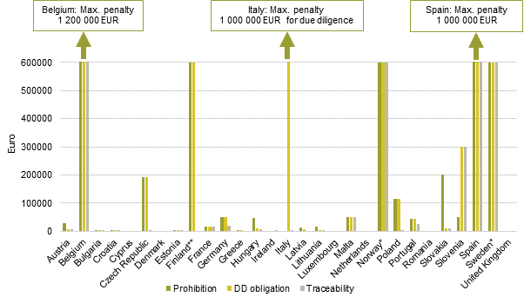**Figure 1**: Maximum **administrative fines** issued to operators as a result of infringements related to the obligations to exercise due diligence, the prohibition of placing illegally harvested timber and timber products derived from such timber on the market, and the obligation of traceability throughout the supply chain to the EUTR, where specified. No national report was submitted by Iceland or Liechtenstein. Key: *= no upper limit for fines for breaches of prohibition, due diligence and traceability; ** = no upper limit for fines for breaches of prohibition and due diligence.

For the majority of countries reporting on comparable legislation (e.g. laws for the implementation of the FLEGT Regulation[10] or for the Wildlife Trade Regulation[11]), fines foreseen for violations of the EUTR are of a similar level to those imposed for violations of the comparable legislation.

**2.3 Checks on operators, traders and monitoring organisations**

*2.3.1 Estimation of number of operators*

Twenty-two countries provided estimates of the total number of operators (see Table 1). It is important to note that, while this it is not a EUTR requirement, some countries require operators to be registered. In others, estimations are based on a variety of sources (customs data and other national databases or registers, including logging permits). Furthermore, the number of operators depends on the size of each country’s timber industry and the structure of its forestry sector. Moreover, figures on the number of operators are not always directly comparable as some of the estimates may include only active operators, whereas others include operators that may no longer be active. Operators may also differ in terms of size, level of risk in the supply chains, frequency of timber imports and quantities and value of the timber imported.

**Table 1:** Total number of operators placing domestic, imported or both timber types onto the internal market over the reporting period, by country (*countries reporting for the period March 2017 to February 2019; remaining countries reported for January 2017 to December 2018). [Numbers in italics are estimated. Some countries reported excluding some natural or legal persons from these estimates or counts of operators within the meaning of the EUTR, for a variety of reasons].

| Country | Domestic operators | Importing operators | Domestic and importing operators | Exclusions / Comments |
| --- | --- | --- | --- | --- |
| Austria* | *140 000* | *7 000* | unknown | Unknown number of domestic operators excluded as very small forest owners were not included in the Farm Structure Survey (these forest owners were not included in the plan for controls, however, all forest owners were covered by the forest inspectorate enforcing forest legislation including the EUTR).  Unspecified number of importing operators excluded as they lacked an EORI number and/or a VAT number (these imports are not excluded per se but taken into account in the risk-based approach) |
| Belgium | *2 340* | *4 800* | unknown | There is no detailed information available about domestic operators |
| Bulgaria* | *4 000* | unknown | unknown | There is no register of importing operators |
| Croatia | unknown | 3 589 | unknown |  |
| Cyprus | 62 | 780 | 2 |  |
| Czech Republic* | *300 000* | *2 500* | unknown |  |
| Denmark* | *24 000* | 3 889 | (24 000) | “Virtually no” domestic operators are also importing operators, but <1 % of importing operators are also domestic operators |
| Estonia | *10 000* | *450* | 1 | 20 domestic operators excluded due to volume of timber placed on the market being below a certain threshold |
| Finland | *350 000* | *2 000* | unknown |  |
| France | *5 000* | *14 000* | unknown |  |
| Germany | *2 000 000* | *27 000* | unknown |  |
| Greece* | *1 600* | 1 228 | unknown | Unspecified number of domestic operators excluded as natural persons placing timber on the market were not counted |
| Hungary | *46 946* | *2 920* | 246 |  |
| Iceland | No national report submitted | | |  |
| Ireland* | unknown | *2 169* | unknown | Unspecified number of importing operators excluded as natural persons placing timber on the market were not counted.  Unspecified number of importing operators excluded as they imported only once during a 12-month period.  Excluded operators may still be subject to checks |
| Italy | unknown | 30 210 | unknown | The national list of EUTR operators is still being compiled |
| Latvia | *135 000* | 400 | unknown | Unspecified number of importing operators excluded as their annual import value was below a certain threshold (these operators may still be subject to checks) |
| Liechtenstein | No national report submitted | | |  |
| Lithuania | *17 000* | 1 481 | unknown |  |
| Luxembourg | *400* | 484 | 0 |  |
| Malta | 0 | *750* | 0 |  |
| Netherlands | *100* | *4 900* | unknown |  |
| Norway | 120 000 | 5 500 | unknown |  |
| Poland | unknown | *8 000* | unknown |  |
| Portugal | *1056* | *4 144* | unspecified | Registration is mandatory for operators. The current registration system does not formally categorise operators as domestic or importing, though this feature will soon be available. In the meantime, estimates are based on the economic classification of the company and the type of product placed on the market |
| Romania* | *3 700* | *161* | unspecified |  |
| Slovakia | unknown | 2 550 | unknown |  |
| Slovenia | unknown | 2 124 | unspecified | Every forest owner that sells wood becomes an "operator". Given the number of forest owners, total number of domestic operators could not be estimated.  428 importing operators excluded as natural persons placing timber on the market were not counted; 670 importing operators excluded as they were foreign importers |
| Spain* | *800* | *6 000* | unspecified | A number of operators have indicated this through the responsible declarations they [have to] submit |
| Sweden* | 880 | 4 473 | 10 | Unknown number of domestic operators excluded if harvest constituted Felling less than 0.5 hectares or thinning.  6100 importing operators excluded as natural persons placing timber on the market were not counted, nor were limited companies, limited partnership companies and trading companies |
| United Kingdom* | unknown | *6 000* | unknown | Unspecified number of importing operators excluded as natural persons placing timber on the market were not counted |

*2.3.2 Plans for checks on operators and traders*

According to Article 10 of the EUTR, countries are required to prepare and periodically review plans for checks following a risk-based approach, with the flexibility to conduct additional checks in response to new information, such as substantiated concerns[12]. They are also required to keep records of these checks (Article 11). All countries confirmed that such plans were in place. In addition, the majority of responding countries reported keeping records of checks on traders (28) and monitoring organisations (16).

Plans for checks on operators are primarily informed by customs data and national operator or forest owner registers. All countries, when developing their risk-based plans for checks, take into consideration a range of risk criteria including – among others – the country of harvest, product, species and concerns provided by third parties (see Figure 2).

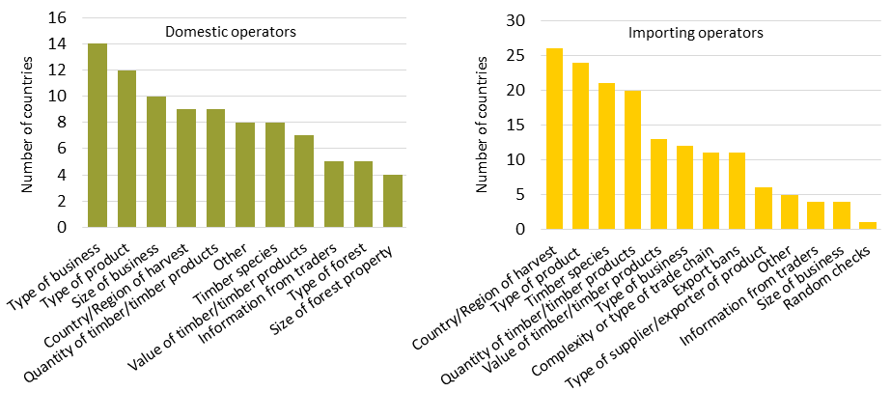

**Figure 2:** Risk criteria considered by countries when planning checks, by number of countries using them in their risk based planning, for checks on domestic operators and importing operators.

*2.3.3 Checks on operators*

From March 2017 to February 2019, 17 280 checks were performed in total by Competent Authorities on operators placing domestic timber on the market and 3 976 checks on operators placing imported timber on the market.

For domestic timber, 16 countries performed 80% or more of the checks they had planned, and for imported timber, 21 countries did so (see the Annex to the report).

The number of checks on operators dealing with domestic timber varied significantly from one country to another, with some countries reporting thousands of checks and others reporting limited or no checks. In some countries, EUTR checks are integrated as part of the checks carried out by the authorities responsible for forest management. In these cases, countries reported differently on the numbers of checks (e.g. Germany did not report any plans or number of checks, but nonetheless reported a number of sanctions being applied). Belgium, Croatia, Denmark, Latvia, Malta, the Netherlands and the United Kingdom did not perform checks on operators for domestic timber, stating a number of reasons, including limited domestic production.

*2.3.4 Checks on traders*

Twenty-three countries checked a total of 2 333 traders and their compliance with the traceability obligation, with the number of checks ranging from 1 (Belgium and Slovakia) to 683 (Bulgaria).

*2.3.5 Substantiated concerns*

In accordance with Article 10(2) of the EUTR, in addition to the checks conducted in accordance with risk-based plans, checks may be conducted when a Competent Authority is in possession of relevant information, including on the basis of substantiated concerns provided by third parties, concerning compliance by an operator with the EUTR. Eighteen countries reported having received substantiated concerns about operators, mainly from non-governmental organisations (NGOs) and customs (see Figure 3). Of the 289 operators identified, 282 (98%) were checked, and enforcement actions were implemented against 73 (around 26 %) of them. In some cases, the checks were still ongoing at the time of reporting.

Substantiated concerns were also received by 3 countries in relation to traders from NGOs and members of the public. The 214 concerns received involved 188 traders, all of which were checked (100 %) and 165 penalties were applied.

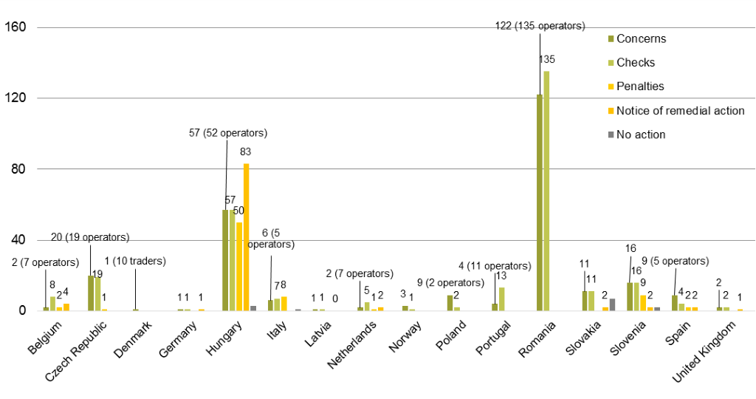

**Figure 3:** Countries receiving substantiated concerns regarding operators over the reporting period, including subsequent checks and enforcement action (Austria, Bulgaria, Denmark, Czech Republic, Greece, Ireland, Romania, Spain, Sweden and the United Kingdom reported for the period March 2017 to February 2019; the remaining countries reported for January 2017 to December 2018). No national report was submitted by Iceland or Liechtenstein.

*2.3.6 Enforcement action resulting from checks*

A total of 2 273 infringements were identified; 1 552 infringements related to domestic timber, 700 to imported timber and 21 to unspecified timber. The majority of infringements involving domestic timber related to placing illegally harvested timber on the market (1 228), while the majority of infringements involving imported timber related to breaches of due diligence requirements (390).

Of a total 2 450 enforcement actions, the majority (1 665) applied to domestic timber, with 762 to imported timber, and 23 to unspecified timber (Figure 4).

For domestic timber, 488 administrative fines, 231 notices of remedial action, 23 suspensions, 6 seizures and 911 “other penalties” were applied. For imported timber, the majority of enforcement actions were notices of remedial action (412) and administrative fines (272); 6 seizures, 4 trade suspensions and 61 “other penalties” were also applied. Thirteen court cases concluded during the period (11 related to imported timber, 2 to domestic timber).

Issues with the traceability by traders of domestic timber led to 422 notices of remedial action, 206 administrative fines, 58 seizures, 92 trade suspensions and 20 other enforcement actions applied to traders. For imported timber, 1 notice of remedial action, 32 administrative fines and 3 seizures, 17 trade suspensions and 2 other enforcement actions were applied to traders. For 121 notices of remedial action and 27 penalties it was not determined whether the timber was imported or domestic.

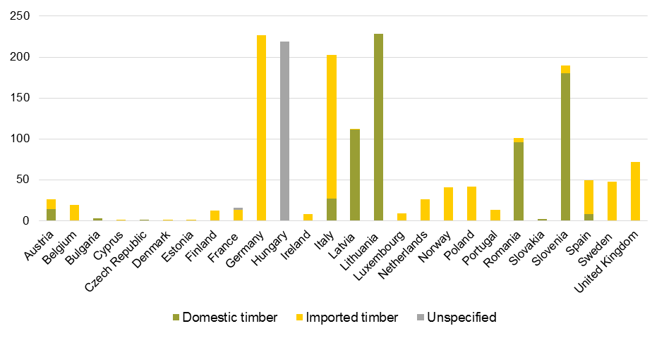

**Figure 4:** Total number of enforcement actions taken against operators over the reporting period, by country, for those countries that reported taking action (Austria, Bulgaria, Czech Republic, Denmark, Greece, Ireland, Romania, Spain, Sweden and the United Kingdom reported for the period March 2017 to February 2019; the remaining countries reported for January 2017 to December 2018). Totals exclude 804 cases concerning domestic timber that were referred to the police and ongoing cases for imported timber (Latvia), and 26 cases concerning imported timber that received a verbal warning but no further action as yet (Malta). No national report was submitted by Iceland or Liechtenstein.

*2.3.7 Checks on monitoring organisations*

In accordance with Article 8(4) of the EUTR and Article 6(1) of the Implementing Regulation on due diligence and monitoring organisations, the Competent Authorities should check the monitoring organisations registered in their country at least once every two years. Up to the end of the reporting period (February 2019), 13 monitoring organisations[13] have been recognised in the EU.

Germany, Italy, Latvia and the United Kingdom checked all monitoring organisations with their main seat based in their countries. France and the Netherlands, where 2 monitoring have their registered main seat, checked 1 each. Estonia and Spain with 1 registered monitoring organisation each, did not report having done any checks on them. Estonia noted that operators were not using the monitoring organisation’s services and Spain stated that the monitoring organisation in their country was not acting in this capacity. None of the checks resulted in a notification to the Commission of issues that could lead to the withdrawal of a recognition as a monitoring organisation.

**2.4 FLEGT Voluntary Partnership Agreements (VPAs)** – **contribution to the implementation and enforcement of the EUTR**

Since 2003, when the FLEGT Action Plan was adopted, seven VPAs have been ratified (Cameroon, Central African Republic, Ghana, Indonesia, Liberia, Republic of the Congo and Vietnam) and two VPAs have been initialled (Guyana and Honduras). Negotiations are ongoing with six countries (Côte d’Ivoire, Democratic Republic of the Congo, Gabon, Laos, Thailand, Malaysia). Indonesia is the only FLEGT licensing country. It started to issue licenses on 15 November 2016.[14]

A facilitation of compliance with the EUTR due to the ongoing VPA processes was noted by 10 countries. Additionally, one country reported that these processes resulted in a reduced number of checks. However, 16 countries noted that there were still no reliable findings on whether and how VPA processes were contributing to the implementation and enforcement of the EUTR.

In terms of contribution to the implementation and enforcement of the EUTR, the countries’ assessments of the potential relevance of the various VPA processes (both concluded or under negotiation) differed considerably, depending on the different levels of trade exposure. Indonesia, Vietnam, Cameroon, and Malaysia, are among the VPA processes most commonly considered of high or medium relevance. The potential relevance of VPAs with Guyana, Honduras, Laos, and Liberia, on the other hand, were mostly perceived as low. There are some exceptions – for example, one VPA with high potential relevance for only one or two countries.

Competent Authorities identified several other countries not engaged in a VPA process as priorities for the implementation and enforcement of the EUTR, including Ukraine, the Russian Federation, China, Brazil, Belarus, Myanmar and Serbia.

**2.5 Cooperation on implementation and enforcement of the EUTR**

Article 12 of the EUTR encourages cooperation to ensure compliance with the EUTR and the exchange of information on serious shortcomings detected during checks and on the penalties that have been imposed nationally. Twenty-seven countries reported working together with national agencies to exchange information or to coordinate joint checks, in particular customs or tax agencies, CITES authorities, and police or other enforcement agencies.

Furthermore, 25 countries reported working together with other Competent Authorities and EU institutions. This related mostly to participation in EUTR-FLEGT Expert Group meetings, use of the EUTR-FLEGT Competent Authorities online platform managed by the Commission, collaboration with the Commission and participation in the Nordic-Baltic cooperation.

An exchange of information with institutions in countries from outside the EU, particularly in the United States, and with NGOs was reported by 16 countries.

**2.6 Resources available for the implementation and enforcement of the EUTR**

The human and financial resources available to Competent Authorities to implement and enforce the EUTR varied greatly across countries, although the reported resources are difficult to compare due to the varying levels of detail provided by countries. Combined human resources ranged from as little as one-eighth (0.125) of a full time equivalent (FTE) to 20 FTEs[15] for imported and for domestic timber, although core staff are supported by additional human resources in a range of countries. Available financial resources vary greatly as budgets appear extremely limited in some countries. Ten countries reported that there was no specific budget for implementation and enforcement of the EUTR; it is unclear which of these countries do not need to adhere to a specific upper limit and which countries have not been allocated a specific budget at all.

1. **Technical assistance to and capacity development of operators**

During the reporting period, 24 countries provided assistance and training to operators, mainly through courses, lectures or seminars, followed by the provision of information online. The most frequently reported training type was the provision of information on operators’ obligations under the EUTR (24 countries) followed by the provision of specific guidance on how to implement a due diligence system (20 countries), and guidance on the process of checks of the implementation of obligations under the Regulation (16 countries). Four countries reported that they had not delivered training to operators during the reporting period.

The reported number of operators reached by these activities varied among countries, from 7 (Cyprus) to 4 000 (Germany). The proportion of operators receiving training that were micro enterprises and small and medium-sized enterprises (SMEs) ranged from zero (Cyprus, Germany, Greece, Norway and Romania) to 100% (Czech Republic, Denmark, Italy and Sweden); on average, SME’s comprised 59% of operators reached (for those countries, which provided detailed numbers of operators reached).

1. **Conclusions**

This third report on the EUTR implementation reveals progress after six years of its application. All countries comply with the formal requirements of the EUTR. Over the reporting period, the number of checks conducted on domestic operators has remained almost the same compared to the previous period, while checks on importing operators have increased. Overall, sanctions applied for violations of the EUTR as a percentage of all checks performed has decreased.

Despite progress, continuous efforts are needed to ensure a uniform and effective application of the EUTR across countries. Uneven implementation can have potential implications in terms of both the effectiveness of legislation and a level playing field for market operators. In several countries, the number of checks remained relatively low compared to the number of operators, and it is doubtful, whether such a low number of checks can have a truly dissuasive effect across the industry. In addition, further effort should be made to ensure that the scope and quality of the checks carried out reflect a more consistent approach across the EU.

While progress has been made in some countries, the current level of technical capacity and resources (both human and financial) allocated to the Competent Authorities often does not correspond to the needs and must be strengthened in most of the Member States in order to increase the number and quality of compliance checks.

Based on the experience of Member States, evidence of how VPAs help implement the EUTR is slim.

1. OJ L 295, 12.11.2010, p. 23–34, consolidated version: <https://eur-lex.europa.eu/legal-content/EN/TXT/?uri=CELEX:02010R0995-20200101>
2. Communication from the Commission to the Council and the European Parliament - Forest Law Enforcement, Governance and Trade (FLEGT) - Proposal for an EU Action Plan, COM/2003/0251 final
3. Timber and timber products as classified in the combined nomenclature set out in Annex I to Council Regulation (EEC) No 2658/87 to which the EUTR applies.
4. Eurostat 2020, Wood products and trade under activity (NACE Rev 2) manufacturing (wood-based industries (manufacture of wood and wood products (16) +manufacture of pulp, paper and paper products (17) + printing and service activities related to printing (18.1) + manufacture of furniture (31)) (these include estimates), <http://ec.europa.eu/eurostat/statistics-explained/index.php/Wood_products_-_production_and_trade>
5. Article 5 Commission Implementing Regulation (EU) No 607/2012 of 6 July 2012 on the detailed rules concerning the due diligence system and the frequency and nature of the checks on monitoring organisations as provided for in Regulation (EU) No 995/2010 of the European Parliament and of the Council laying down the obligations of operators who place timber and timber products on the market (Text with EEA relevance), OJ L 177, 7.7.2012, p. 16–18, hereinafter ‘Implementing Regulation on due diligence and monitoring organisations’.
6. Article 20 of the EUTR was amended by Article 8 of Regulation (EU) 2019/1010 of the European Parliament and of the Council of 5 June 2019 on the alignment of reporting obligations in the field of legislation related to the environment, and amending Regulations (EC) No 166/2006 and (EU) No 995/2010 of the European Parliament and of the Council, Directives 2002/49/EC, 2004/35/EC, 2007/2/EC, 2009/147/EC and 2010/63/EU of the European Parliament and of the Council, Council Regulations (EC) No 338/97 and (EC) No 2173/2005, and Council Directive 86/278/EEC (Text with EEA relevance), OJ L 170, 25.6.2019, p. 115–127. It entered into force on 1 January 2020. Member State reports now cover one calendar year. Therefore, some Member States chose to report on the two calendar years 2017 and 2018 rather than the period March 2017 to February 2019.
7. No reports were received from Iceland and Liechtenstein.
8. See <http://ec.europa.eu/environment/forests/pdf/list_competent_authorities_eutr.pdf>
9. Where the information was not included in the national report, additional information was requested from national authorities.
10. Regulation (EC) No 2173/200511 of 20 December 2005 on the establishment of a FLEGT licensing scheme for imports of timber into the European Community
11. Council Regulation (EC) No 338/97 of 9 December 1996 on the protection of species of wild fauna and flora by regulating trade therein
12. Any relevant information regarding non-compliance with the EUTR – and supported by proof or evidence – that is brought to the attention of a Competent Authority.
13. <http://ec.europa.eu/environment/forests/pdf/List_of_recognised_MOs.pdf>
14. Commission Delegated Regulation (EU) 2016/1387 of 9 June 2016 amending Annexes I and III to Council Regulation (EC) No 2173/2005 following a Voluntary Partnership Agreement with Indonesia for a FLEGT licensing scheme for imports of timber into the European Union, C/2016/3438, OJ L 223, 18.8.2016, p. 1–9.
15. The high number of staff reported by Italy, Latvia and possibly others may be based on the inclusion of customs personnel or forestry inspectors in general.