

**Table of Contents**

**1.** **Introduction** 2

**2.** **Decarbonisation: climate, energy, mobility** 2

**3.** **Circular economy** 7

**4.** **Depollution: air, water and soil** 9

**5.** **Sustainable food systems and rural areas** 12

**6.** **Biodiversity: protection and restoration of ecosystems** 13

**7.** **Mechanisms of Implementation** 14

**8.** **Financing Instruments** 19

# **Introduction**

This Staff Working Document (SWD) outlines in more detail the actions related to the **Green Agenda for the Western Balkans** included in the Communication on an Economic and Investment Plan for the Western Balkans adopted by the European Commission. It further details the five pillars of the Green Agenda: (1) climate action, including decarbonisation, energy and mobility, (2) circular economy, addressing in particular waste, recycling, sustainable production and efficient use of resources, (3) biodiversity, aiming to protect and restore the natural wealth of the region, (4) fighting pollution of air, water and soil and (5) sustainable food systems and rural areas. Digitalisation will be a key enabler for the above five pillars in line with the concept of the dual green and digital transition. The objectives of these pillars should be pursued through concrete actions and supported by mechanisms and financial instruments set out in the following sections.

# **Decarbonisation: climate, energy, mobility**

***Climate Change***

* The Western Balkans is one of the **regions in Europe most heavily affected by the impact of climate change** and this trend is projected to continue, with estimates of temperature increases of 1.7 – 4.0°C, and even exceeding 5.0°C by the end of the century[1], depending on the global effort in greenhouse gasses emission reduction.
* The **Paris Agreement**, ratified by five of the Western Balkan partners, commits its signatories to take action to ensure that the global average temperature increase is kept well below 2° and to pursue efforts towards limiting global warming to 1.5°. In line with the European Climate Law, climate neutrality will be reflected in the EU’s bilateral relations and accession negotiations with the Western Balkans, who should already now start transforming their societies accordingly.
* 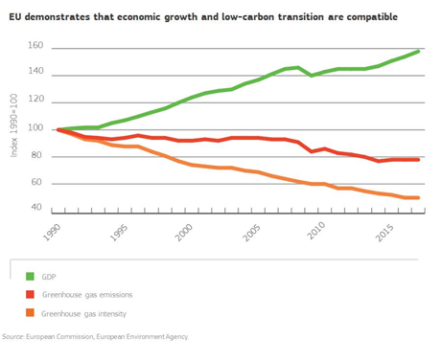Achieving climate neutrality by 2050 means making far-reaching changes to the way we live today, which is why the Commission is proposing to **cut greenhouse gas emissions 55% by 2030**. This increased level of ambition for the next decade will put the EU on a balanced pathway to climate neutrality by 2050.
* So far, the EU has been leading the way in the transition towards a climate-neutral economy and has much to offer in terms of experience with **decoupling economic growth from resource use**. The EU’s experience, know-how and resources can support Western Balkans in their efforts to enhance resilience and adapt to the unavoidable impacts of climate change, while also achieving synergies with the clean air objectives (one atmosphere approach).
* Policy cooperation and provision of viable alternatives to fossil fuels can prove pivotal in helping partner countries **reconsider unsustainable infrastructure and energy investments.** Technical and financial assistance will be needed to tap into the enormous potential of a new economic model based on sustainability and climate-neutrality.
* Climate change will continue to create significant stress in Europe in spite of mitigation efforts. Strengthening the efforts on **climate proofing, resilience building, prevention and preparedness** in the region is therefore crucial. It should include engaging the private sector in resilience investments and developing natural disaster risk transfer mechanisms.
* A broad consensus is emerging that **carbon pricing** will be an important instrument in achieving climate goals. The early inclusion of the Western Balkans in the **Emissions Trading Scheme** could be explored. It could be a key tool to create economic incentives for climate action and help smoothen the transition to climate-neutrality.
* The transition to climate-neutrality must be **socially** **just and inclusive** in order to be a success. It must be recognised that not all countries or regions start the transition from the same point or have the same capacity to respond, and that the most vulnerable are the most exposed to the harmful effects of climate change. A system equivalent to the European Just Transition Mechanism foreseen in the European Green Deal could be explored.
* These changes will require the backing of the citizens. According to an EU survey[2], 93 % of EU citizens consider climate change to be a serious problem. A similar survey conducted in the Western Balkans in 2019[3] revealed that only 65% of the region’s population consider climate change a threat. **The European Climate Pact** extended to the regioncould be a tool to raise awareness and ensure buy-in from the civil society and individual citizens.

**INITIATIVES**

* Facilitate swift **alignment with the EU Climate Law**
* Assist the partners in the preparation and implementation of **long-term climate adaptation strategies** to increase resilience, notably through climate-proofing of investments
* Provide technical assistance on **Emissions Trading Scheme** and **alternatives to fossil fuels**
* Explore options for early **inclusion of the Western Balkans in the EU Emissions Trading Scheme** if fully aligned
* Include the region in the **European Climate Pact** and its activities

***Clean Energy Transition***

Coal is still fundamental to the energy sector in the Western Balkans, accounting for around 70% of electricity produced in the region, and in some countries even 97%. Albania, with strongly developed hydropower, is a notable exception.

Western Balkan governments have committed **to pursuing a clean energy transition** and sustainable development at the Ministerial Meeting in Podgorica in February 2019. This transition should reduce energy imports, develop renewable energy sources, strengthen regional energy security, unlock greater economic growth[4], and address persistent air and related health pollution challenges.

* 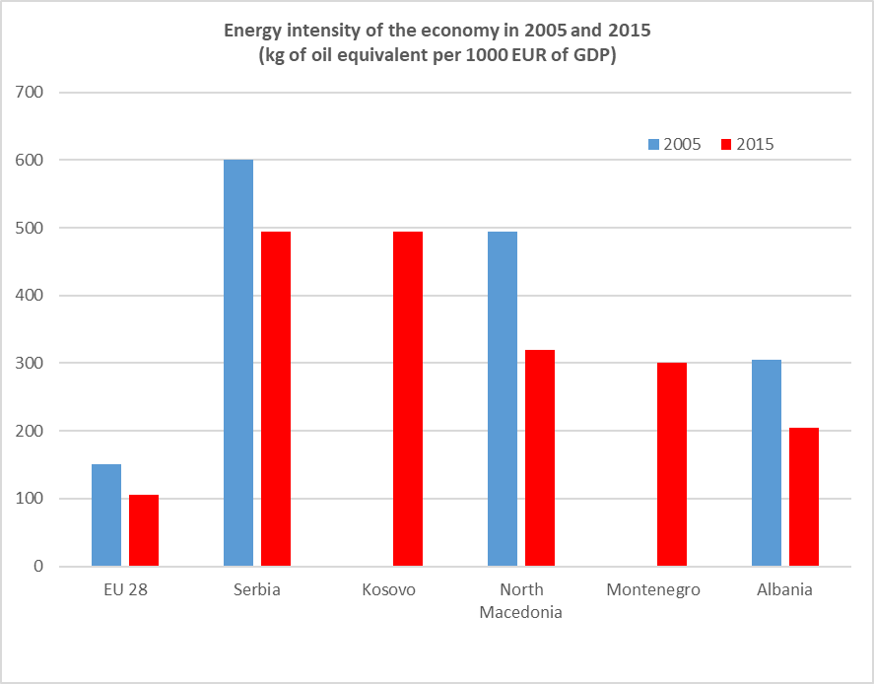Although significant progress has been made towards improving connectivity between Western Balkans partners, the regional energy market is yet to be accomplished. In this sense, a **regional approach to** **infrastructure management and planning** is fundamental to deliver resource efficiency gains and reduce costs. **Energy efficiency**, a prerequisite for achieving decarbonisation at the lowest possible cost, must be integrated in the future energy-related policy and investment decisions. Data and electronic communication technologies can support the decarbonisation of the energy system and the availability and cross-sector sharing of data, in a secure and trustworthy manner, can facilitate innovative solutions. The preparation and submission of **National Energy and Climate Plans and Targets** will demonstrate a commitment to tackle the issue, targeting the sectors with the highest energy savings potential.
* **Renewable energy sources** already make a significant proportion of the electricity mix in some economies of the region. With hydropower and bioenergy dominating the picture, it is important to diversify these sources and tap into solar and wind potential. The roll-out of modern technologies needs to be accompanied by a better **investment environment**.

Source: SQ Consult 2018

* **Natural gas** may also be seen as a stepping stone in the gradual decarbonisation, particularly for those partners with the heaviest reliance on coal, provided appropriate markets, financing and expertise are available. The establishment of clear standards and thresholds to qualify the transition readiness of such projects should be encouraged.
* Reducing the cost of capital, harmonising regulatory frameworks and facilitating access to finance for the procurement of appliances could be an essential element in this context. More work needs to be done as regards confidence-building measures to encourage consumers to turn more to renewable energy and stimulate adequate grid development.
* Transformation of energy intensive industries towards climate-neutrality will require integrated actions, including e.g. creation of markets for climate-neutral products, developing new technologies and speeding up their uptake as well as ensuring availability of climate-neutral energy and feedstock at globally competitive prices.
* **Energy poverty** is the social dimension of energy transition that must be addressed for households that cannot afford key energy services to secure a basic standard of living and citizens buy-in. Effective programmes should be designed to address affordability issues, reduce energy bills and help the environment.
* The **building sector** is one of the key areas where the highest energy cost savings could be reaped. Different financial instruments (guarantee facilities, energy performance contracts, on-tax and on-bill financing) could be used to achieve higher renovation rates of both private and public buildings through attracting private finance. Digital upgrades can also improve energy efficiency of buildings by 15-25% and at the same time provide possibilities for telework, telehealth and tele-education. Extending the “EU renovation wave” to the Western Balkans could stimulate investment and create jobs.
* At the same time, greater circularity and more efficient use of materials present new opportunities for further reducing greenhouse gas emissions in buildings. Hence, comprehensive approaches targeting materials efficiency along the entire lifecycle of buildings should be encouraged and supported, for example during renovation efforts.
* Finally, it would be beneficial to extend all the dimensions of the **Energy Union** to the Western Balkans: supporting energy security, market integration and energy transition, energy efficiency and renewable energies. The EU should support capacity building of energy regulators and transmission system operators so that they can participate fully in EU-level networks.

**INITIATIVES**

* Continue to assist partners in the **alignment with the *acquis* related to decarbonisation** of the energy sector in the framework of the Energy Community
* Assist partners in the development of **National Energy and Climate Plans**
* Assist partners in developing **private and public building renovation schemes** and securing appropriate financing, by extending the “EU renovation wave” to the Western Balkans
* Assist partners in implementing programmes addressing **energy poverty** in the region
* Associate the Western Balkans partners with the **Coal Regions in Transition** EU initiative
* Carry out an assessment of the **socio-economic impact** of decarbonisation in the region

***Smart and Sustainable Mobility***

* The road, rail and inland waterway connections in the Western Balkans are underdeveloped due to lack of sufficient investment and poor maintenance. Rail is still heavily dependent on fossil fuels with more than 30% of the TEN-T Core and approximately 50% of the Comprehensive Networks not electrified. The Green Agenda will be an opportunity to **revisit the overall transport strategies and to** promote a **greener and more sustainable transport network.**
* The top priority in this respect remains the **revitalisation of the rail network.** The Regional Rail Strategy and its action plan aim at making rail a credible and sustainable alternative to road transport.
* There should be a focus on the deployment of **Intelligent Transport System** solutions (ITS) aimed at making transport operations more efficient, and reducing CO2 emissions. Wide availability and use of data technologies in public transport systems has the potential to make them smarter, less polluting and customer friendly.
* The promotion of **multimodal transport solutions and modal shift,** through targeted policies, including investment in inland waterways, will be needed. The infrastructure connections between sea/inland waterways ports and the rail network are currently weak or non-existent.
* The region suffers greatly from outdated and underdeveloped **transport logistics**. Improving operational logistics and the use of modern software at border crossing points both within the region and between the region and the EU, could also improve the environmental situation.
* **Cleaner fuels and higher fuel efficiency** could also help reduce the environmental and health impacts of transport in the Western Balkans. The EU Communication on Clean Power for Transport[5] could be a reference point for the Western Balkans region.
* **Charging for infrastructure** use, e.g. through vignettes or electronic tolls, is another effective tool, which could be used to influence the price of transport and the demand for greener transport. It could also be a source of funding for the maintenance of the existing infrastructure.
* **Innovative solutions** could challenge some of these consumption patterns whilst still ensuring that mobility needs are met. Smart mobility can combine different transport modes and options (public transport, car-sharing, car rental services, taxis and public bike-sharing/urban mobility schemes) to cater for mobility needs by using IT.

**INITIATIVES**

* Actively support the implementation of the **regional action plan for rail reforms**,
* Define rail freight corridors and an overall **strategy to increase rail capacity and develop more environmentally friendly transport modes**;
* Ensure implementation of EU technical standards in all transport modes, in particular the **European Railway Traffic Management System**;
* Actively support the implementation of the **regional action plan for transport facilitation, including border-crossing points**, aiming at resource-efficient transport operations;
* Support the implementation of the **road safety action plan and the road action plan, including road maintenance and resilience**;
* Assist partners in developing and implementing **climate resilience plans for their national transport networks**;
* Assist in defining and implementation of **sustainable urban mobility plans** for the major urban areas of the region supported by the smart cities digital platforms and dedicated applications;
* Support the region in planning and implementing **sustainable mobility solutions**, including alternative fuels infrastructure, charging stations, etc.

# **Circular economy: sustainable production and consumption**

***Resources, Production and Innovation***

* Half of total greenhouse gas emissions come from resource extraction and processing. It is not possible to achieve the climate-neutrality target without transitioning to a fully circular economy. The new Circular Economy Action Plan is at the core of the European Green Deal, the EU roadmap towards climate-neutrality. The circular economy model where **value and resources are maintained in the economy for as long as possible and waste generation is minimised**, reduces pressures on natural resources while boosting sustainable growth and jobs creation. It can make a decisive contribution to decarbonising the economy.
* In order to achieve circularity, measures should be taken to address the entire life cycle of products, from design and manufacturing to consumption, repair, reuse, recycling, and bringing resources back into the economy. Preventing waste from being created in the first place is key, but once waste has been created, it needs to be transformed into high-quality resources. **The region has to look for options to reduce the consumption footprint and increase the circular material use rate,** which in turn will boost economic growth. This should be done in full cooperation with stakeholders and business.
* **Ensuring the sustainable supply of raw materials**, in particular critical raw materials, by diversifying supply from **both primary and secondary sources**, is a pre-requisite for a transition to a circular economy. The increase of the **resources productivity within the economy**, making the best possible use of the raw materials extracted from the domestic territory of the local economy is another requirement. Western Balkans economies currently find themselves at the lower end of resource productivity, with values (i.e. 0.35 euro/kg) much below the EU average (i.e. 2.07 euro/kg[6]). Thirdly, **resources should be retained in the economy** for as long as possible, maximising their value and minimising waste. This involves good product design, efficient material and energy use, long life-cycles, well-designed circular industrial sites, new business models and, when a product eventually becomes waste, effective recycling to provide high quality secondary raw materials.
* Since each industry sector is different when it comes to resource use, waste generation and management, Western Balkan authorities issuing permit requirements for industrial installations should be encouraged to use the EU best practices in different industrial sectors through the **'best available technique reference documents'** (BREFs). Circular economy promotes **innovative and more efficient ways of producing and consuming** and the Western Balkans businesses and consumers should be encouraged to adopt them. The **local SMEs should benefit from the business opportunities** of increased resource efficiency and seek access to innovative technologies. Improving the uptake of the EU Eco-Management and Audit Scheme (EMAS) should also be encouraged.
* Further efforts are therefore needed to develop a comprehensive approach to foster **sustainable lifestyles and consumption**, and to accompany **consumers and public authorities** towards sustainable choices.
* **Industrial policy** will be key in the achievement of the Green Agenda for the Western Balkans. Integration with the EU internal market means integrating with its industrial eco-systems as they transform in the spirit of the Green Deal of the EU. This implies not only the need for a green modernisation in enterprises, but also investments in the co-operative linkages in the industrial eco-systems such as innovation, inward foreign direct investment, export prerequisites and skills development. Their green focus can be informed by the smart specialisation strategy of the economies and regions.
* Over the last ten years the Western Balkans have significantly improved in terms of **innovation** performance. However, catching up with other European regions would require a sustained annual GDP growth of some 7%. Currently, exports are still focused on medium- and low-technology products and innovative efforts mostly accommodate traditionally strong sectors. Although some Western Balkan economies record increases in patent activity, patent intensity in the region is still low, while on the other hand, scientific publication production displays a stable upwards trend. Therefore, the deployment of effective innovation measures is essential. Furthermore, the **research and innovation systems** in the region need to continue shifting their focus towards businesses to provide better balance between public and private sector efforts. Finally, promoting a strategic green approach in conducting **public procurement** will allow for a more responsible and sustainable way of spending public money, support investment and can help levelling the playing field by ensuring that all bidders have to follow the same standards.

***Waste and Plastics***

* The generation of waste in the Western Balkans has been increasing steadily over the last years due to economic development and increased consumption, currently being at around 1000kg/capita. While this is still lower than the EU average of 1700kg/capita, the **very low recycling rates** (below 3%, in comparison to the EU average of 44%) result in higher per capita amount of waste not being recycled.
* Important efforts and investments are needed to establish proper functioning waste management centres and recycling facilities, so that the countries can use the existing resources currently ending up in landfills (over 90% landfilling rate in the region) or incinerators. The Western Balkans will need to implement **effective separate collection schemes** for at least paper, metal, plastic, glass and bio-waste, which are key to quality recycling, and establish built-in economic incentives to reduce waste generation (e.g. pay-as-you-throw schemes) and better waste treatment (e.g. landfill/incineration charges), as well as efficient Extended Producers Responsibility Schemes.
* The Western Balkans will need to align with the single-use plastic legislation and to fully implement the modernised **EU waste legislation,** including its recycling and landfill reduction targets.
* The **rivers** in the Western Balkan region carry disproportionate loads of **litter** to the Adriatic and to other seas. Poor practices of solid waste management, lack of infrastructure and awareness of the public at large about the consequences of their actions aggravate substantially the situation. Wastewater treatment in the region is very poor or non-existent. Litter from fishing and shipping in the Adriatic Sea further add to the problem. Marine and coastal plastic litter is a critical issue for the region where coastal tourism is an important source of income.

# **Depollution: air, water and soil**

**INITIATIVES**

* Support the region in improving the **sustainability of production of raw materials**
* Work towards integrating the Western Balkans into the **EU industrial supply chains**, in particular for key industrial ecosystems such as renewable energy, textiles, tourism, digital, mobility-transport-automotive and energy-intensive industries;
* Support the region in developing **circular economy strategies** looking at the entire lifecycle of products, waste prevention, modern waste management and recycling, re-use, repair and re-manufacturing,
* **Consumer targeted initiatives** raising awareness of citizens on waste, separate collection and sustainable consumption
* Assist the region in preparing and implementing **waste prevention** programmes, **waste** **management and** **recycling strategies**, and programmes for re-use, repair and manufacturing
* Continue supporting the construction and maintenance of **waste management infrastructure**
* Develop a **regional agreement on the prevention of plastic pollution**, including specifically addressing the priority issue of marine litter
* Support the establishment of sustainable development and innovation policies for the economies via the implementation of **Smart Specialisation Strategies**

***Air***

* 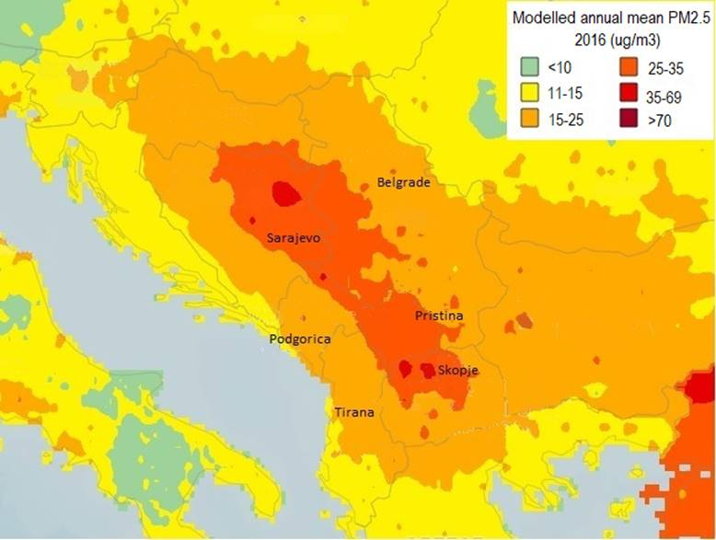Air pollution in the Western Balkans remains one of the highest in Europe and has a direct impact on citizens’ health. The very **high concentrations of particulate matter** pollution are mainly due to emissions from industrial installations (such as coal power plants), domestic heating (notably wood and coal fired stoves and boilers as well as domestic burning of waste) and traffic (older vehicles). Moreover, transboundary pollution occurs not only within the Western Balkans but also between the region and the EU[7]
* In their efforts to implement air quality legislation, the Western Balkans need to be able to ensure **air quality monitoring and assessment** through modern and extended monitoring system, air quality management and reporting, and the development and implementation of air quality plans in order to comply with air quality standards pursuant to the Ambient Air Quality Directives[8].

Modelled annual mean concentration of PM2.5 in the WB region, 2016. Source: WHO

* Progress is needed in the establishment and reporting of **emission inventories and projections** of emissions, as well as for the development of national air pollution control programs in accordance with the National Emissions Ceilings Directive[9] For industrial emissions, the region is struggling with the effective implementation of the **Industrial Emissions Directive**,which requires additional capacity building and investment. In addition, application of Best Available Techniques (BATs) is essential in particular when considering investments in new projects.
* The main challenge is the implementation gap, as all the Western Balkan partners are recording **exceedances of air quality standards for at least one pollutant in at least one location** (and often for several pollutants at several locations). This implementation gap is most pronounced for particulate matter (PM), nitrogen dioxide (NO2), and sulphur dioxide (SO2). Addressing these exceedances will require urgent action at different policy levels to reduce emissions from key sectors, identified on the basis of harmonised methodologies.
* Political commitment will be essential for the successful implementation of the Ambient Air Quality Directives and to secure a reduction in overall national emissions including air pollutant emissions from energy, transport, agriculture and industry. More effort is needed in certain areas to develop more up-to-date and accurate emission estimations7. Such work would also enable the partners in the region to ratify the latest protocols of the United Nations Economic Commission for Europe (UNECE) Air Convention.

***Water***

* 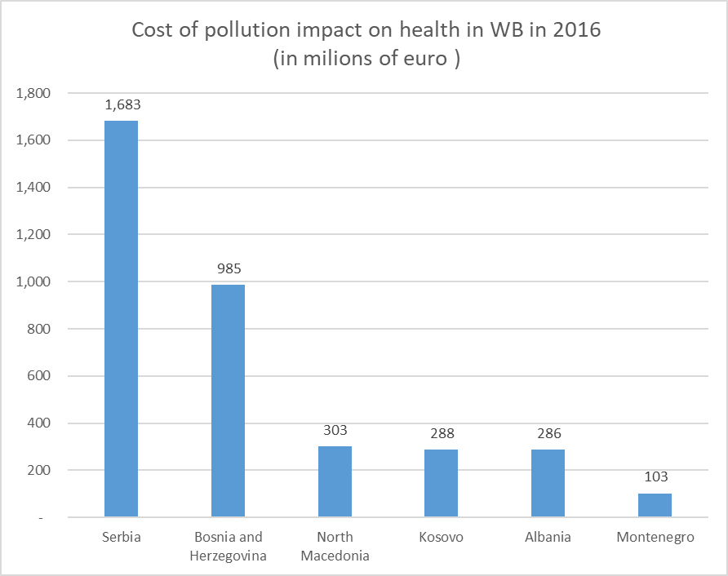The Western Balkans are home to some of the last pristine rivers of the continent, but their protection remains a challenge. The region represents **17% of the population of the Danube River** basin and 8.5% of its area. There is a high share of population in rural areas (30 to 50%) with only **basic sanitary facilities** and wastewater collection, while urban areas with collection of wastewater via sewer networks discharge mostly **untreated wastewater**[10]**.** The risk of **release of nitrates and pesticides** into groundwater needs to be further controlled.
* The main **pressures on quantity** are water abstraction for industry, agriculture and public water supply. The widespread droughts in the last years in the region have further underlined the importance of securing water availability and resilience in the long-run across Europe.

Source: Regional Cooperation Council

* A unique challenge to the region’s rivers is also a **steep increase in hydropower capacity** across the region as much as fourfold between 2015 and 2017, having significant environmental and social impacts, both at the country and at the wider regional level. **Transboundary water cooperation** is often a politically sensitive issue, especially where water bodies show receding water levels due to climate change and over-abstraction or deterioration of water quality downstream of the rivers.
* The main task ahead is the **implementation of the water related legislation**, which requires more resources for investments in water infrastructure and in the governance structure for sustainable water management (monitoring and reporting, planning, coordination across relevant sectors, impact assessment capacity, etc.). More precisely, priority could initially go to investment in monitoring infrastructure based on a mapping of the needs at river basin level followed by the development and implementation of appropriate measures to reduce pressures on water bodies.

***Soil***

* Soil erosion or **land use degradation** is considered as a problem in many mountainous areas of the Western Balkans. The European Environmental Agency concluded in 2010 that erosions affects about 20% of the combined Serbian and Montenegrin territory. Albania is losing between 20 and 70 hectares of soil annually.
* Combating land degradation and restoring degraded land include **sustainable food production**, improved sustainable **forest management**, soil **organic carbon management**, ecosystem conservation and land restoration, reduced deforestation and degradation, and reduced food loss and waste.
* Western Balkans could undertake actions to address land degradation and desertification which can offer co-benefits also for other key environmental issues such as water pollution and scarcity, and biodiversity loss, as mentioned in the **EU Soil Thematic Strategy**[11] .

**INITIATIVES**

* Assist region in developing and implementing **Air Quality Strategies**,
* Increase uptake of Best Available Techniques in line with the Industrial Emissions Directive
* Accreditation of **air quality monitoring networks**
* Including the region in **pan-European networks** supporting depollution initiatives e.g. Air Quality: Forum on Air Quality Modelling (FAIRMODE) & Network of Air Quality Reference Laboratories (AQUILA); Soil: European Soil Bureau Network (ESBN) etc.
* Support **Modernisation of water monitoring** infrastructure
* **Implementation** of Water Framework, Urban Waste Water and Extractive Waste Directives
* Supportregional and/or bilateral agreements and/or protocols on transboundary water pollution and on land-based sources of pollution
* Investment in **waste and manure management** and **wastewater treatment plants for reuse of water in agriculture**
* Investment in **urban wastewater collection and treatment** including advanced treatment of nutrients
* Support the Western Balkans to **use and contribute to the potential of programmes** such as European Earth Observation programme, Copernicus and Destination Earth.

# **Sustainable food systems and rural areas**

* In addition to the deficiencies identified in the other pillars that also relate to the food sector (e.g.: waste, packaging, transport, consumption, etc.) particular attention should be paid to the specificity of this sector and to the rural areas in the Western Balkans.
* Agriculture and related sectors **still contribute around 10% of the Gross Domestic Product** (GDP), while in some countries, the share of agriculture, forestry, and fisheries is close to 20% of the total workforce (40% in the case of Albania).
* Despite the rich natural resource base, agri-food systems in all countries in the region faces numerous challenges and remain constrained by **deeply-rooted structural problems**: the average farm size is several times lower than in the EU, labour productivity and yields are very low – due to underdeveloped technological capabilities and many households are still engaged in subsistence agriculture.
* The level of **compliance** of Western Balkans with the EU animal and plant health, food safety and animal welfare standards varies significantly, and major efforts are still necessary with regard to food safety and animal welfare. This has become even more pertinent in the context of the recently proposed EU’s Farm to Fork Strategy.
* The common challenge is to bring **food processing establishments** into conformity with EU standards. At the same time, the demand for food in the region is increasing – both in terms of quantity and quality. A growing middle-class chooses to follow healthier and more nutrient-rich diets, including indigenous Balkan food products. Coupled with the growing tourism market and export potential, this represents a major opportunity for the region, provided the transition is sustainable.
* While gradually transforming agri-food production systems in the Western Balkans, it will be necessary to ensure that **the transition does not contribute further to unemployment or depopulation of rural areas** or to deterioration of the rural landscapes and biodiversity loss. It will need to be countered with the creation of alternative and sustainable economic opportunities in rural areas. The rural areas of the region will also require assistance in adapting **to possible consequence of climate change**, which may result in water scarcity and extreme climate events, such as floods. Support to local governance and social capital in rural areas via the “LEADER approach”, dissemination of good practices and innovations, and networking will enable rural communities to better respond to these challenges.
* EU pre-accession assistance, and in particular the instrument of support for agriculture and rural development (IPARD) can be used to assist the economies of the region in reforming and restructuring their agri-food sectors to be able to compete in the global markets upon EU accession, increase food security and quality, reduce waste and improve compliance with EU food safety and animal welfare standards. It should also contribute to enabling rural communities to harness opportunities in the circular and bio-economy, making the rural economies of the region more resilient to potential climate change impacts and the rural areas – vibrant spaces for Western Balkan citizens.
* In the long run, to transition to a sustainable **food system**, the Western Balkan countries will need to transform not only their primary production sector, but also the food processing sector and promote sustainable food consumption.

# **Biodiversity: protection and restoration of ecosystems**

**INITIATIVES**

* Support **alignment of the agri-food and primary production sectors with EU standards** for food safety, plant and animal health and welfare (improving livestock farm biosecurity and animal health and disease prevention; upgrading agri food establishments)
* Strengthen the official **sanitary controls** along the entire food chain and improve the **traceability and labelling of food products** (including harmonised electronic system certification) to ensure food safety
* Improve **consumer information** and promote sustainable food.
* Promote **environmentally friendly and** **organic farming** and reduction of synthetic chemical products used in food production: pesticides, veterinary medicines and fertilisers
* Support cooperation among scientific and educational bodies and producers and processors in the agri-food sector to facilitate **transfer to innovative and environmentally friendly technologies** and farming methods
* Support actions to **reduce waste** **in rural and coastal areas** (along roads, in rural rivers)
* Stepping-up efforts for **sustainable development of rural areas** by implementation of Leader, modernisation of physical assets in the agri-food sector, supporting economic diversification and improvement of rural infrastructure under IPARD.
* Besides **providing food, fresh water and clean air**, protection from floods and storms, nature **mitigates natural disasters**, pest and diseases, contributes to regulating the climate, combating land degradation and enhance food security.
* As a region with a wealth of habitats and species, including a number of important endemic species, the Western Balkans should spare no effort to protect the biodiversity and the ecosystem services including through alignment with EU legislation.
* The main challenges at the regional and national level are related to the lack of **political commitment** to improve implementation of biodiversity policy, lack of **financial resources** and the **impact of economic activities**, such as agriculture, forestry, fisheries and, to a lesser extent, transport, tourism and energy infrastructure developments. This is due in part to the structure of current production systems and in part to lack of awareness, misunderstanding of and lack of guidance related to the added value of services generated by biodiversity for these sectors (e.g. pollination) and of key nature legislation requirements (infrastructure development) or to development pressures.
* While a comprehensive policy framework exists, implementation on the ground in the region is lagging behind. In addition, the success of any national biodiversity strategy depends to a large degree on the effective **mainstreaming of nature and biodiversity** into other policies (agriculture, forestry, regional development, energy, transport, fisheries, etc.).
* In this context, Western Balkans partners are encouraged to align their policies to the EU Biodiversity Strategy for 2030 and to support the EU position at the upcoming international negotiations on the global post-2020 biodiversity framework.
* **Deforestation and illegal logging** are an important related challenge. The increase of dramatic forest fires in the Western Balkans and pest and disease outbreaks require better risk prevention in sustainable forest management and land use. The Western Balkans need to build close inter-institutional relations and private sector networks between each other and with Member States to develop good governance in the forest sector and reduce the risk of illegal timber exports to the EU.
* The new **EU Forest Strategy**, planned for 2020 under the European Green Deal would serve as a guidance on effective afforestation and forest restoration in Europe, that will help to improve sustainable forest management, increase the absorption of CO2 and the promotion of the bioeconomy. Measures that support the fight against illegal logging and deforestation-free value chains will also be adopted and will contribute to improve the conservation status and the resilience of the forests in the Western Balkans. Finally, **coastal and marine habitats** are under high pressure. As highlighted by the EUSAIR macro-regional strategy, sustainable blue economy offers interesting opportunities for development in coastal regions. Integrated Coastal Zone Management and Maritime Spatial Planning are essential cross-cutting tools that can be deployed in the Western Balkans.

**INITIATIVES**

* Support the region in developing and implementing a Western Balkans 2030 **Biodiversity Action Plan**
* Assist in preparing and implementing a **Western Balkans Forest Landscape Restoration Plan**
* Assist in an analysis of **biodiversity benefits of nature-based solutions** and of opportunities for their integration into the development of climate and other plans
* Strengthen the mechanisms for **regional cooperation on biodiversity** **conservation** as well as the engagement with the United Nations Rio Convention
* Support **knowledge exchange among the WB and EU research centres**, and explore options to set up the Western Balkans Biodiversity Information Hub

# **Mechanisms of Implementation**

***Greening the current framework***

The Green Agenda for the Western Balkans should be seen as a blueprint for possible measures to be adopted jointly by the EU and each of the Western Balkans partners, based on the existing **political and technical cooperation frameworks**, including in particular the Stabilisation and Association Agreements, the Negotiation Frameworks and Economic Reform Programs. The Agenda should enable the Western Balkans and the EU to create stronger links between climate and environment actions, policy reforms and EU approximation. It should also guide the definition of financial and technical assistance strategies both at bilateral and regional level.

***Public Administration Reform***

Ensuring policy coherence at all levels of governance is essential to achieving better synergies between the economic, environmental and social dimensions of sustainable socioeconomic development, and to reduce trade-offs between them. Increasing the focus of EU public administration reform assistance in the Western Balkans on **policy coherence and the green growth dimension** in particular could make a major contribution to the Green Agenda. This could specifically target inter-institutional coordination, statistics and administrative data (through for example common data spaces for public administration, to improve transparency and accountability) to support decision-making, improved strategic planning and impact assessments for legislation, policies and infrastructure investments.

***Public Finance Management***

Utilities in the Western Balkans require considerable investment, especially in the waste and water sectors, and they need to be self-sustaining. Hence the tariffs need to reflect the real full cycle of the costs, and preparation is needed for future use of EU Structural Funds. From this perspective, it is important that the partners start now a **macroeconomic process**, establishing a sustainable system for investments, based on polluter pays principle. Specific “green” funds should turn from a budget line to a real co-financing instrument. **Mainstreaming environment and climate** into relevant policy areas requires working with ministries responsible for economic development, planning and finance and to build their capacity on areas such as natural capital accounting and valuation, green budgeting/green taxation and the use of market-based instruments, such as environmental taxes, charges and subsidies to steer markets.

***Emissions Trading Scheme***

Early access of the Western Balkans to the EU **Emissions Trading Scheme** (ETS), as was done in Croatia, is an option to be explored. The Western Balkans partners would require significant technical assistance and administrative capacity building in order to reach a stage where this could be feasible. Using the revenues from additional aviation allowances under the scheme could be an additional source of income.

***Greening Economic Reform Programmes***

One of the vehicles to implement the Green Agenda is by designing relevant policies and reforms in the Economic Reform Programmes. These aim at building national consensus on country-wide structural challenges to economy and at prioritising reforms. ERPs should therefore **assess the transition to a more environmentally sustainable, circular and low-carbon economy** in the Western Balkans. To that end, the ERPs should include indicators on Sustainable Development Goals and resource efficiency, in line with the European Semester exercise. For example, the Resource Efficiency Scoreboard, on which the Western Balkans are already partially reporting, could be used to get information on their transition to sustainable economic growth model.

***Environmental governance, implementation and enforcement***

Establishing the necessary wider **environmental governance framework** will be challenging. This includes having in place effective mechanisms for public participation, access to information, access to justice in environmental matters and environmental reporting. There is a need to strengthen the administrative capacity of competent authorities responsible for **environmental assessments for strategic planning, programmes and projects**. Environmental assessments ensure that the environmental implications of decisions on strategic planning, programmes and projects likely to have significant effects on the environment are taken into account before the decisions are made. The involvement of civil society as well as of environmental, local and regional authorities is essential.

Achieving a high level of environmental protection is only possible if an alignment to the relevant EU environment legislation is implemented and enforced. Strengthening capacities of competent authorities of the Western Balkan partners to **monitor, promote and enforce compliance with environmental obligations** is crucial. This includes ensuring administrative capacity for **combating environmental crime** and other serious offenses by effective environmental inspections and administrative and criminal enforcement.

***Western Balkans Just Transition Mechanism***

The transition to climate-neutrality must be **socially** **just and inclusive** in order to be a success. It must be recognised that not all regions and partners start the transition from the same point or have the same capacity to respond, and that the most vulnerable are the most exposed to the harmful effects of climate change. The European Green Deal proposed the establishment of the Just Transition Mechanism and Fund to support societies in the transition process. This system could be a model for a similar mechanism for the Western Balkans economies. The mechanism could focus on regions and cities most affected by the transition, marked by high energy intensity and fossil fuels reliance. It would mobilise resources for providing access to re-skilling programs and jobs in new economic sectors.

***Involving Local and Regional Governments***

The EU supports coal and carbon-intensive regions in transition with a view to ensuring a just transition, in which no region or citizen is left behind. The EU Platform for **Coal Regions in Transition** facilitates the exchange of best practices, strategies and projects with a potential to kick-start the transition process. It also delivers tailor-made assistance such as e.g. development and implementation of long-term transition strategies. Extending the Platform to the Western Balkans could help the region in the transition towards climate neutrality.

Another action, which could be of interest to the Western Balkan region, is the **pilot action for regions in industrial transition**, which supports EU regions in managing the transition to a low-carbon economy. So far, twelve pilot regions receive region-specific support to boost innovation capacity, remove investment barriers, and equip workers with the right skills to prepare for the economic transformation. The pilot action seeks new ways to help these regions harness globalisation through decarbonisation, innovation, digitization and developing people’s skills. If the action continues beyond the pilot, it could be extended to the Western Balkans.

The EU **Covenant of Mayors for Climate & Energy** brings together more than 9000 cities and towns in Europe, voluntarily committed to fast-track implementing EU climate and energy objectives. Signatory cities pledge action to implement the EU 40% greenhouse gas-reduction target by 2030 and adopt a joint approach to tackling mitigation and adaptation to climate change. A number of Western Balkans cities are already associated with the Covenant, more should be encouraged to join.

***Smart Specialisation***

The Green Agenda for the Western Balkans can greatly benefit from **Smart Specialisation Strategies**, which are conceived as place-based, innovation-led transformation agendas for sustainability. They create the opportunity to engage regions and cities in transformation contributing to the European Green Deal, providing an overall framework and directionality for innovation investments. The strategies of Montenegro and Serbia can serve as inspiration to the other Western Balkan countries. The Smart Specialisation Strategy of Montenegro, adopted in 2019, addresses environmental and sustainability in two priority domains: first, sustainable agriculture and food value chain; and second, energy and sustainable environment.

***Research and Innovation***

The Western Balkans are already participating in Horizon 2020 – the EU’s Framework Programme for Research and Innovation – with some 200 stakeholders and EUR 30 million funding awarded in 2019. The new **Horizon Europe Framework Programme** for Research and Innovation will have a stronger focus on spreading excellence and reducing the R&I divide, which will specifically benefit the Western Balkans economies. Two EU macro-regional strategies with a strong innovation component are implemented in the Western Balkans: the Danube Strategy and the Adriatic-Ionian Strategy, and they should continue to support innovation and cross-border cooperation on a medium-term vision for the regions.

***Regional Cooperation Programmes***

**Regional cooperation** provides the opportunity for tackling common problems and for sharing knowledge and good practice. The EU has been financing dedicated regional cooperation projects in the area of environment and climate for a number of years. The **Regional Environmental Network for Accession** project contributed to environmental and climate improvements in the Western Balkans and approximation of the region to EU standards. The **Environment and Climate Regional Accession Network** continued to strengthen regional cooperation between the candidate countries and potential candidates. It is currently followed up by the **EU Environment Partnership Programme for Accession** and the EU Support for Climate Action in IPA II beneficiaries – “Transition towards the low emissions and climate-resilient economy”, which supports the EU integration of the Western Balkan partners in the field of environment and climate.

***Regional Cooperation Council***

The **Regional Cooperation Council** could play an important role in building the regional dimension of the Green Agenda. The **RCC** is a regionally owned and led cooperation framework aiming at advancing the European and Euro-Atlantic integration of the region. It works to develop and maintain a political climate of dialogue, reconciliation, tolerance and openness towards cooperation through the implementation of regional initiatives aimed at economic and social development. In terms of environment and climate change, RCC maintains a permanent high-level regional policy dialogue and supports regional cooperation towards achieving Paris Climate commitments and 2030 energy and climate targets.

***Transport Community***

The **Transport Community Treaty** in force since 2017 aims at the integration of the Western Balkan transport market systems in the EU. To achieve this, the Treaty foresees the setting up of technical committees to assist partners in transposing the acquis and implementing appropriate reforms. The Transport Community can be instrumental in identifying the priority transport investments with a focus on the TEN-T, addressing regulatory barriers to green transition, and promoting and developing green mobility strategies and investments throughout the region, as well as mainstreaming the environment in all aspects of transport. In this vein, the Transport Community is developing a rolling work plan for the development of priority projects, which shall contribute, to balanced sustainable development in terms of economics, spatial integration, environmental and social impact.

***Energy Community***

Established in 2005, the **Energy Community** brings together the European Union and its neighbours to create an integrated pan-European energy market. Its key objective is to extend the EU internal energy market rules and principles to South East Europe, the Black Sea region and beyond on the basis of a legally binding framework. A stable regulatory and market framework capable of attracting investment in power generation and networks, right conditions for cross-border energy trade, enhanced security of supply and increased uptake of renewable energy and energy efficiency are the Community’s core axes of focus.

It will remain a crucial promoter of clean energy transition rules and standards in the Western Balkan region. The Energy Community will keep monitoring the implementation of an expanding EU acquis and will engage in the setup of the Coal Regions in Transition Platform for the Western Balkans and Ukraine.

***Capacity Building***

Many of the actions proposed here will require strong capacity building components. In addition to the traditional consultancy-type assistance, DG NEAR oversees two important instruments for administrative capacity building which can be useful in the delivery of the Agenda. The Technical Assistance and Information Exchange (**TAIEX**) supports public administrations with regard to the approximation, application and enforcement of EU legislation as well as facilitating the sharing of EU best practices. It is needs-driven and delivers short-term tailor-made expertise on the transposition, implementation or enforcement of a specific part of EU legislation. **Twinning** is a European Union instrument for institutional cooperation between Public Administrations in the Member States and the beneficiaries. It brings together public sector expertise to achieve concrete results through peer to peer activities defined in a medium term programme. Both TAIEX and Twinning are important instruments when it comes to capacity building in the Western Balkans.

***EU level networks***

The European Environment Agency and EU-level networks of environmental practitioners, such as the European Environment Information and Observation Network (Eionet), the European Union Network for the Implementation and Enforcement of Environmental Law, the European Network of Prosecutors for the Environment, the EU Forum of Judges for the Environment and EnviCrimeNet (police), play an important role in sharing good practices, developing practical tools for detection and investigation and training. These networks have demonstrated the added value of the multi-disciplinary approach necessary for an effective environmental compliance assurance and are open for candidate countries and potential candidates.

***Education and awareness raising***

In order to raise awareness of the effects of climate change on society in the Western Balkans, it is important to organise more **events and campaigns**, and thereby stimulate policy debate and help society come up with solutions to tackle these challenges. This will not only inform citizens about the consequences of climate change, but also inspire them to act and demand change. Existing actions such as **Climate Diplomacy** **Week** and the **European** **Climate Pact** foreseen under the European Green Deal could be extended to the Western Balkans.

Education is key to positively affect behaviours regarding the environment, starting from an early age as well as to reskill workers from transition industries. Curricula need to include key competences and skills necessary to perform in the green economy. To be successfully implemented, the Green Agenda for the Western Balkans needs to be reflected in the **reforms of the education systems** in order to guarantee that people are equipped and prepared for the labour market and society of tomorrow. With proper information and education, the youth of the region can contribute decisively to the implementation of the Green Agenda. The European Green Deal will also have to be translated into the different components of Erasmus+, the EU flagship programme for education available in the region.

# **Financing Instruments**

The implementation of an ambitious Green Agenda for the Western Balkans will require **substantial public and private funding, at national, regional and international level**. The external instruments under the next EU Multiannual Financial Framework (MFF, 2021-2027) are currently being negotiated with the Council and the European Parliament. This EU public funding will further need to leverage private finance in order to fill the significant investment gap. Moreover, additional support from EU Member States and own funds from the beneficiary parties will need to be mobilised. To this extent, the Commission can consider supporting innovative financial instruments, such as green bonds, that can mobilise public and private investments at the scale needed for the implementation of the Green Agenda.

**Financial assistance** in the field of environment and climate change has to date been mainly sectoral, focused on the process of alignment to the EU *acquis* under the requirements of chapter 27, with both actions at bilateral (mainly investments) and regional level (mainly capacity building). Given the all-encompassing nature of the Green Agenda, the focus in the years to come will have to **extend to the wider sustainable economic development** issues, to further mainstream green issues in financial assistance and support all relevant institutions. In that perspective, the green oath to “do no harm” and the EU taxonomy should be respected to the extent possible.

The **Instrument for Pre-Accession (IPA) III** proposal foresees a dedicated window of the programming framework for the implementation of the Green Agenda and sustainable connectivity.

According to the draft proposal, IPA beneficiaries will be **encouraged to develop energy efficiency and renewable energy sources** and to shift to **resource-efficient, safe, and sustainable low-carbon economies** in line with the wider EU targets for climate action and environmental protection. Through a sustainable use of natural resources, our partners can attain higher standards of environment and human health protection and increase climate change mitigation and adaptation. This would not only directly benefit the health and well-being of the citizens, but also make the region attractive for investments and tourism, and tap into the significant economic potential of green growth and the circular economy.

The Commission can also explore the feasibility of using existing financial assistance instruments for setting up or supporting a range of **market-based instruments in the region,** such as Natural Capital Investment Fund(s) or a dedicated Green Window under the External Investment Plan supporting projects that have positive community, ecological, economic and environmental impacts, but cannot access traditional financing because of perceived risks.

Albania, Montenegro, North Macedonia and Serbia are set to continue to benefit from the multi-annual **rural development programmes under** the **Instrument for Pre-Accession** (IPARD). IPARD programmes contain a menu of 11 measures, selected for implementation by the partners. Under each of the measures, beneficiaries may prioritise and select sectors, which should receive assistance. Sustainable agriculture and food production should be the centrepiece of IPARD under the new MFF.

While IPA funding may be sufficient to kick-start action in key areas, substantial funding form other stakeholders, in particular **international financial institutions** (IFIs), will be essential. The European Investment Bank, now the EU’s “climate bank”, would have to play a distinct role in close coordination with the European Commission. The establishment of a **Structural Reform Support Facility**, providing on-demand support for growth-enhancing reforms, could also be explored. The Commission can also continue to use well-proven blending instruments and innovative financial instruments to ensure maximum impact.

The **Western Balkans Investment Framework** (WBIF) is one such blending financial instrument which can support the Green Agenda. It is already active in the environment and energy sectors. Under the upcoming Multi-Annual Framework, the EU is set to look to the WBIF to provide investment grants and capacity building in these areas. In particular, two existing WBIF blending facilities focusing specifically on renewable energy and energy efficiency can be further mobilised. The **Green for Growth Fund** (GGF), structured as public private partnership, can continue to provide financing for green investments, while the **Regional Energy Efficiency Programme** (REEP) can support the transposition and implementation of the EU energy efficiency acquis combined with financing to enterprises, households and public sector entities undertaking energy efficiency investments.

Funding will also be crucial for research and innovation. The **European Innovation Council (EIC)** is the most ambitious EU initiative for disruptive and breakthrough innovation and it fully includes the Western Balkans. The region can also benefit from the **InnovFin Financial Instruments** under Horizon 2020.

Finally, the extension to the Western Balkans of the **Western Balkans Guarantee Facility** (EFSD+), the successor of the current European Fund for Sustainable Development (EFSD), could be considered to be used to attract private funding to scale up green investments in relevant areas, boosting the region’s competitiveness and job creation. The use of these guarantees could be particularly relevant for the implementation of the Green Agenda when it comes to activities such as: (1) kick-starting commercial sub-sovereign financing in support of WBIF priorities, including environmental, recycling, energy-efficiency and renewable energy municipal infrastructure investments, as well as smaller-scale PPP projects where feasible; (2) scaling up investments in “green entrepreneurship” as well as supporting the transition towards a circular economy in innovative and economically viable ways.

1. <https://www.rcc.int/news/383/rcc-publishes-study-on-climate-change-in-the-western-balkans-alarming-increase-of-temperature-over-the-whole-territory>
2. Special Eurobarometer 490 April 2019 “Climate Change” Report
3. Balkan Barometer 2019 <https://www.rcc.int/pubs/89/balkan-barometer-2019-public-opinion-survey>
4. IRENA’s REmap study demonstrates the region’s high potential for cost-competitive renewable energy developments, with a 43% cost-effective renewables potential for the WB6 by 2030: https://irena.org/remap.
5. COM(2013) 17 final of 24.1.2013
6. Eurostat
7. JRC, Status of air pollutants and greenhouse gases in the Western Balkans (2019) Report JRC1186779.
8. Directives 2004/107/EC and 2008/50/EC, as amended by Commission Directive (EU) 2015/1480.
9. Directive (EU) 2016/2284 on the reduction of national emissions of certain atmospheric pollutants.
10. Wastewater Management in the Danube Region: Challenges and opportunities of EU Accession (2017) <https://www.umweltbundesamt.at/en/services/services_resources/services_water/ref_watermanagement/>
11. COM(2006)231