

# Introduction

This progress report is presented by the Commission in line with Article 24(3) of Directive 2012/27/EU on energy efficiency, as amended by Directive (EU) 2018/2002 (the ‘Energy Efficiency Directive’ or the ‘EED’), and in line with Article 35 of the Governance Regulation (EU) 2018/1999. This is the last report under the EED, as Article 24(3) will no longer apply as of 1 January 2021. All reporting on progress in various energy efficiency policy areas will be superseded by Article 35 of Regulation (EU) 2018/1999.

As this report combines two reporting obligations, it has a different format than in the previous years. In addition, it contains: (i) new reporting on the buildings sector, *i.e.* information on the uptake of the number of nearly zero-energy buildings (NZEBs) in accordance with Article 9(5) of Directive 2010/31/EU on the energy performance of buildings (the ‘Energy Performance of Buildings Directive’ or the ‘EPBD’); and (ii) a short update on the cost-optimal levels of minimum energy performance requirements for buildings, in accordance with Article 5(4) of Directive 2010/31/EU.

The report therefore builds mainly on: (i) the information provided in the annual reports submitted by Member States in 2020[1]; (ii) the cost-optimal calculation reports submitted by Member States in 2018 and 2019[2]; and (iii) further relevant information related to the building sector.

The 2019 energy efficiency report[3] adopted earlier this year covered the Eurostat data up to 2018 and no new data were available[4] at the time of publication of this report. For these reasons, the analysis of progress towards the 2020 targets has not changed in this report compared to the previous report and has not been repeated. Instead, a more forward-looking perspective has been added by looking at the progress towards the 2030 targets.

# Summary of the findings

The report looks at the EU-28 and covers data and supplementary information up to 2018. The analysis of progress towards the 2030 targets looks at the EU-27.

The main findings are as follows.

* Primary energy consumption declined by 0.6% in 2018 compared to 2017. Final energy consumption increased by 0.1% year-on-year. Even so, both indicators are above the fixed trajectory for the 2020 targets.
* In 2018 energy consumption continued to be driven by economic growth.
* Energy efficiency obligation schemes remain an effective tool to achieve energy savings. Although the aggregated progress towards cumulative savings under Article 7 of the EED in 2018 seems to be sufficient, twelve Member States are unlikely to reach their targets.
* The partial and preliminary data for 2020 indicate that the impact of the COVID-19 crisis has significantly affected energy demand. As a result, the 2020 energy efficiency targets may be met even though there were insufficient measures in place before the crisis. However, this is expected to be a temporary situation, because the reduction of energy consumption has not been driven by structural measures. Without targeted climate-measures, the economic recovery is likely bring energy consumption back towards pre-COVID-19 crisis levels.
* Most Member States adopted the cost-optimal approach in an appropriate way and used it to set minimum requirements for the energy performance of new and existing buildings and NZEBs.
* The share of NZEBs in the total construction market has increased, but NZEB requirements in most countries are still less ambitious than the Commission’s benchmarks of 2016. However, almost half of the Member States set significantly more ambitious NZEB requirements compared to cost-optimal levels for new buildings.

# Progress towards the EU’s energy efficiency target

## The EU-28’s 2020 targets

The revised Eurostat figures for 2018[5] indicate that final energy consumption[6] in the EU-28 fell by 5.9%, from 1194 Millions of tons of oil equivalent (Mtoe) in 2005 to 1124 Mtoe in 2018. This is still 3.5% above the 2020 final energy consumption target of 1086 Mtoe. In 2018, it increased by 0.1% compared to the previous year. Primary energy consumption[7] in the EU-28 dropped by 9.8%, from 1721 Mtoe in 2005 to 1552 Mtoe in 2018. This is 4.6% above the 2020 target of 1483 Mtoe. Following three years of increase, a year-on-year drop in primary energy consumption of 0.6 % was recorded in 2018. For both indicators, the trend in 2018 was above a linear trajectory to the 2020 targets.

In 2018, higher energy consumption was mainly observed in the transport (+1.0% year-on-year increase compared to 2017) and industry sectors (+0.8%). By contrast, energy consumption declined in the residential (-1.7%) and services sector (-1.4%).[8]

## The EU-27’s 2030 targets

The insufficient progress towards the 2020 targets until 2018 also has negative consequences on the level of efforts needed to reach the 2030 targets[9]. Due to the present delivery gap the distance to the 2030 targets is bigger than expected and stands at 22% for primary energy consumption and 17% for final energy consumption (Figure 1). In addition, the EU wide assessment of the national energy and climate plans (NECPs)[10] identifies a collective ambition gap of national contributions. As a result Member States will need to significantly increase their efforts in the next decade to reach the 2030 targets of at least 32.5%. This is particularly important if the post-COVID-19 recovery leads to a return to the previous levels in energy consumption. In addition, the increased climate ambition, as announced in the 2020 Climate Target Plan[11], will also require significantly higher energy efficiency efforts going beyond the current level of targets for 2030 (36-37% reduction in final energy consumption and 39-41% reduction in primary energy consumption).

Figure 1: Progress towards 2030 targets at EU27 level

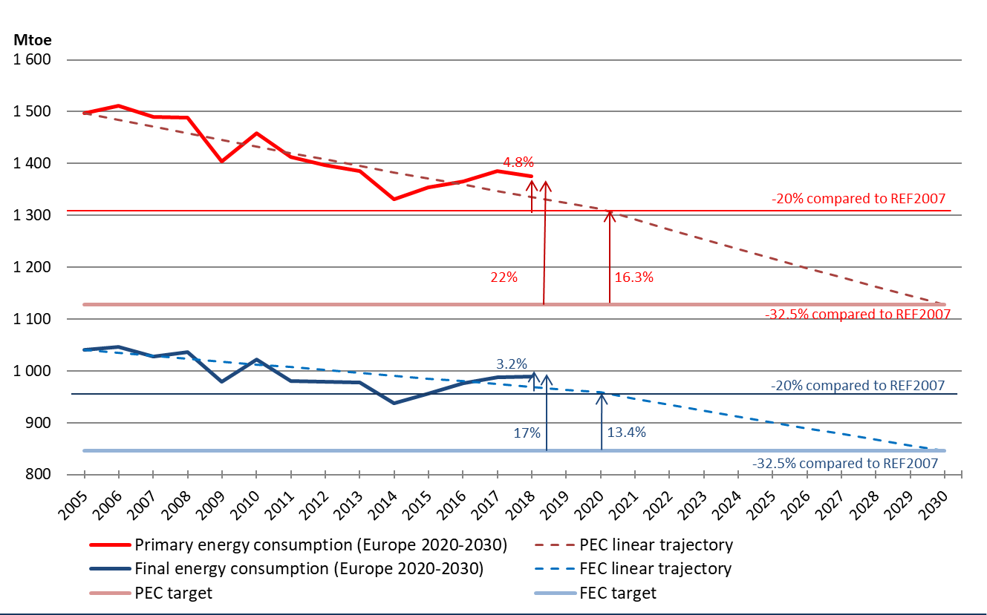

*Source: Eurostat data, DG ENER’s own calculations*

## Impact of COVID-19 on energy consumption so far

The impact of COVID-19 on energy consumption in 2020 will be significant. In the first quarter of 2020 EU gas consumption decreased by 5% compared to Q1 2019, mainly due to limited heating needs because of: (i) the mild winter weather; (ii) decreasing gas use in power generation; and (iii) the introduction of lockdown measures in March, leading to a decrease in GDP and less industrial demand for gas.[12] Electricity consumption in the EU fell by 3.2% year-on-year in Q1 2020, similarly driven by warm weather in the first half of the reference period and the onset of COVID-19 related restrictions. As large populations spent more time at home household electricity consumption increased. However, this increase did not offset a considerable fall in demand from the commercial and industrial sectors.[13] As a result, electricity consumption during the months when the lockdown measures were in place was significantly lower than the same months in the year before (by 4.3% in March, 11.8% in April, 10.5% in May and 7.6% in June).[14]

Similarly, energy consumption in transport also decreased to unprecedented levels as a result of the lockdown measures. According to the IEA, road transport in Europe fell to 38% of its 2019 level by the end of March 2020. The overall drop in global road transport activity led to a reduction in global oil demand of 57%.[15] The International Transport Forum estimates that the mobility restrictions to contain COVID-19 could reduce global freight transport by up to 36% by the end of 2020[16]. Air travel in certain regions has almost come to a halt, with aviation activity in some European countries declining more than 90%. By the end of August, air traffic in Europe was more than 50% below levels of the previous year.[17]

# Progress towards national energy efficiency targets

Some Member States communicated upward revisions (lowering of ambition) of their national 2020 targets (Denmark, Spain, Hungary). After these updates the sum of national 2020 absolute consumption targets is 1536.8 Mtoe in primary energy consumption and 1084.3 Mtoe in final energy consumption. In 2018 progress towards the indicative targets (assuming a linear trajectory) was insufficient in twelve countries (Belgium, Bulgaria, Denmark, Germany, Ireland, Spain, France, Cyprus, Austria, the Netherlands, Poland, and Sweden) for primary energy consumption and in fifteen (Belgium, Bulgaria, Germany, Estonia, Ireland, France, Lithuania, Luxembourg, Hungary, Malta, Austria, Poland, Slovakia, Sweden and the United Kingdom) for final energy consumption (see Table 3).

Member States indicated that stable and growing final energy consumption in 2018 was driven by economic growth and an increase in: (i) production/ value added (industry); (ii) transport of passengers and goods (transport); (iii) the number of households and disposable income (residential); and (iv) value added and employment (services).

# EED – current situation

## Updates on transposition of the revised EED

Following the amendment of the EED in December 2018[18], Member States are obliged to transpose new rules on energy efficiency obligation schemes (*i.e.* the new Articles 7, 7(a) and 7(b)by 25 June 2020. By 31 August 2020, the Commission received notifications from only thirteen Member States (Austria, Croatia, Czechia, Denmark, France, Germany, Italy, Latvia, Lithuania, the Netherlands, Poland, Spain and Sweden) and the United Kingdom. In addition, most of these notifications are partial, meaning that some provisions of the Directive have not yet been transposed or notified.

By 25 October 2020, Member States must also transpose new rules on metering and billing (*i. e.*, new Articles 9, 9(a), 9(b) and 9(c), 10 and 10(a) and finally 11 and 11(a) and a new Annex VII(a). By 31 August, five countries have also notified their transposition of these new rules (Denmark, Spain, France, Italy and Lithuania).

By the time of publication of this report, all Member States, except for Latvia, submitted their 2020 annual reports as required under Article 24 of the EED[19]. The Joint Research Centre (JRC) will analyse these annual reports in a separate document[20].

## Progress under Article 7 (the energy savings obligation)

Under Article 7, Member States reported achieving energy savings for 2014-2018 as part of their commitments to deliver their national energy savings obligation for 2014-2020. Table 5 shows the current state of Member States’ progress towards the cumulative energy savings required by 31 December 2020. Aggregated at EU-level, Member States achieved by the end of 2018 about 58% (133.83 Mtoe[21]) of the sum of the cumulative end-use energy savings obligations for 2014-2020 (230.17 Mtoe).

To forecast the likelihood of achieving the required cumulative energy savings per Member State by 31 December 2020, the basic assumption is that all implemented policy measures continue delivering new annual savings in 2019 and 2020 as they did in 2018. The cumulative energy savings are then compared to the required energy savings by 31 December 2020 per Member State.

Table 6 shows the projections for how likely it is that each Member State will achieve the required cumulative energy savings per Member State by 31 December 2020. This analysis does not consider potential concerns about eligibility, additionality and materiality. Besides, the possible impacts of the COVID-19 crisis on the amount of new annual savings achieved in 2020 are difficult to assess. All energy savings that have been reported by the Member States are considered.

There are seven Member States (Bulgaria, Croatia, Czech Republic, Lithuania, Luxemburg, Portugal, Romania) that will very likely not achieve the required amount of energy savings by 31 December 2020, if they do not take additional actions. Another five (Estonia, Greece, Slovenia, Spain, Sweden) are unlikely to achieve the required amount of energy savings without additional actions. And the remaining sixteen Member States will likely or very likely achieve the required amount of cumulative energy savings.

On the energy savings achieved by each type of implemented policy measures, energy efficiency obligation systems contribute to around 35% of the savings, whereas financing schemes contribute only around 13% of the energy savings. Taxes on energy and CO2 taxes account for 16% of total achieved energy savings.

Figure 2: Share of reported energy savings by type of policy measure at EU-level

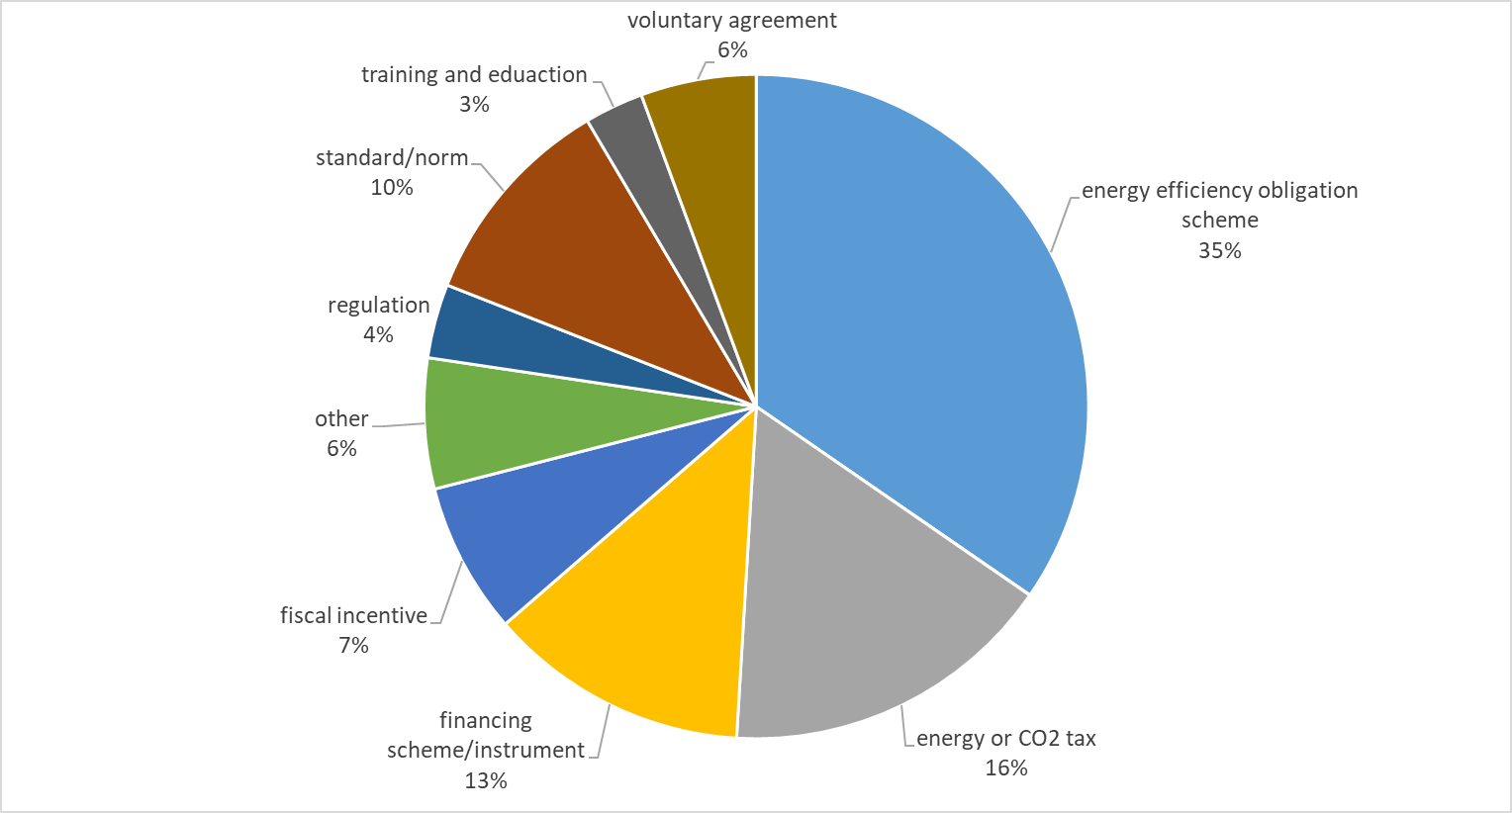

*Source: DG ENER’s own calculations based on the 2020 national annual reports.*

On the sectors targeted by the implemented policy measures, the largest share of energy savings reported by Member States results from cross-cutting measures, which cannot be attributed to a single sector (Figure 3). Most measures (by count of reported measures) target services and industry, which cover most companies (except for transport companies) and the public sector (except for housing owned by public bodies, which is included in the private households sector).

Figure 3: Share of reported savings by sector

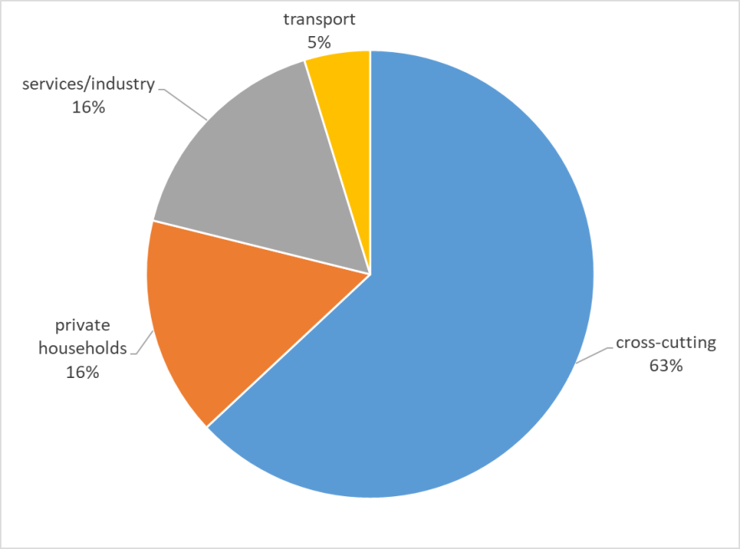

*Source: DG ENER’s own calculations based on the 2020 national annual reports.*

There are 36 new measures reported for the year 2018 under Article 7. Of these, 10 were implemented by both Romania and Spain, 4 by Belgium and 3 by Romania. Almost half of the new measures under Article 7 fell under the category ‘Funds, financial & fiscal incentives’ (47.2%), followed by ‘Other measures’ (transport sector measures, voluntary agreements etc.) (27.8%), ‘Regulations’ (16.7%), ‘Information, education and training’ (5.6%) and ‘Taxation’ (2.8%).[22]

## Progress under Article 5 (exemplary role of buildings used by public bodies)

Compared to 2019, there was a similar level of compliance with reporting obligations. Six Member States did not provide the requested update on Article 5 progress in 2019: Belgium, Romania, Denmark, France, Croatia and the Netherlands (the last four notified their achievements for 2018 but not for 2019).

Among the Member States with available reports that chose the default approach[23], only three Member States achieved their annual targets for renovated floor area. These are Bulgaria, Lithuania and Luxemburg. In addition, based on the provided data, four countries have fulfilled their total targets for the period 2014-2019. These are Spain, Italy, Luxembourg and Lithuania. Among the Member States that implemented the alternative approach, only three Member States achieved their annual energy saving targets in 2019. These are the Austria, Poland and Slovakia. Croatia and France achieved their targets for 2018. At the same time, six countries provided data allowing establishing that they fulfilled their total target for 2014-2019. These are Austria, Finland, Ireland, Slovakia, Poland and UK. France, Belgium, Croatia and Netherlands fulfilled their total target for the period 2014-2018.

# Nearly zero-energy buildings

Following the adoption of the EPBD in 2010, under which all new public buildings must be  [NZEB](https://ec.europa.eu/energy/topics/energy-efficiency/energy-performance-of-buildings/nearly-zero-energy-buildings_en) from 31 December 2018 and all new buildings from 31 December 2020, the number of NZEBs and highly performing buildings in Europe increased significantly from 2012 to 2016. Almost 1.25 million buildings were built or renovated to NZEB (or similar) standards during this period, most of which were residential. The share of NZEB in the total construction market increased during 2012-2016 in the EU from 14% in 2012 to 20% in 2016, on average[24].

The NZEB requirements are currently 70% more ambitious than the national cost-optimal minimum energy performance requirements. This was obtained through progressive legislative steps over the last 10 years.

Based on the latest information available[25], 23 Member States currently have a completed national NZEB definition in force. For the remaining Member States, the definition of what constitutes an NZEB is still under development or under review. Most of the provided definitions include an energy indicator of primary energy use, and twelve of the definitions include the obligation to cover a minimum share of energy demand from renewable sources. Almost half of the Member States have drawn up an energy class or energy label equivalent for NZEB requirements. Also half of Member States have provided the required u-values for walls, roofs, floors, windows and doors.

On the level of ambition for the NZEB definition, the NZEB primary energy values for most Member States have less demanding requirements than the benchmarks recommended by the Commission[26] in both residential and non-residential buildings[27].

**Figure 4: Indicative comparison of NZEB definitions for single family houses to the Commission’s recommended benchmarks**

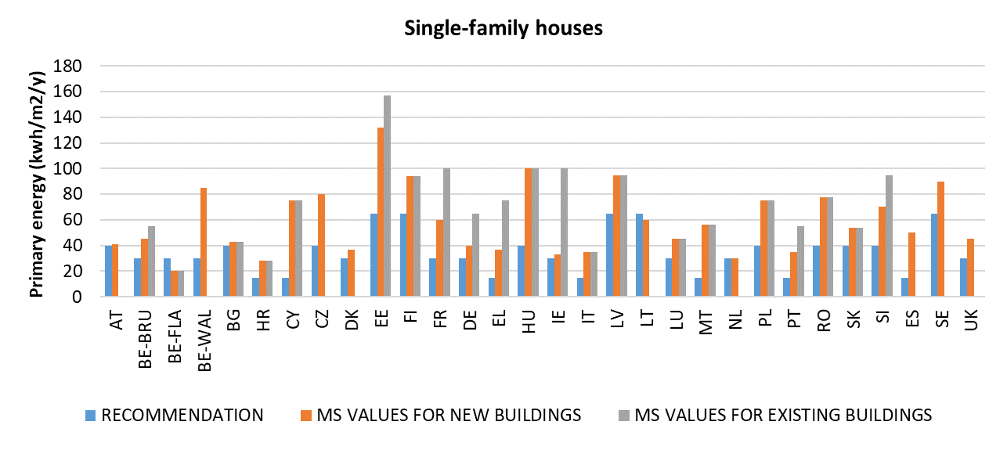

*Source: JRC’s own calculations based on Member States reporting*

**Figure 5: Indicative comparison of NZEB definitions for offices to the Commission’s recommended benchmarks**

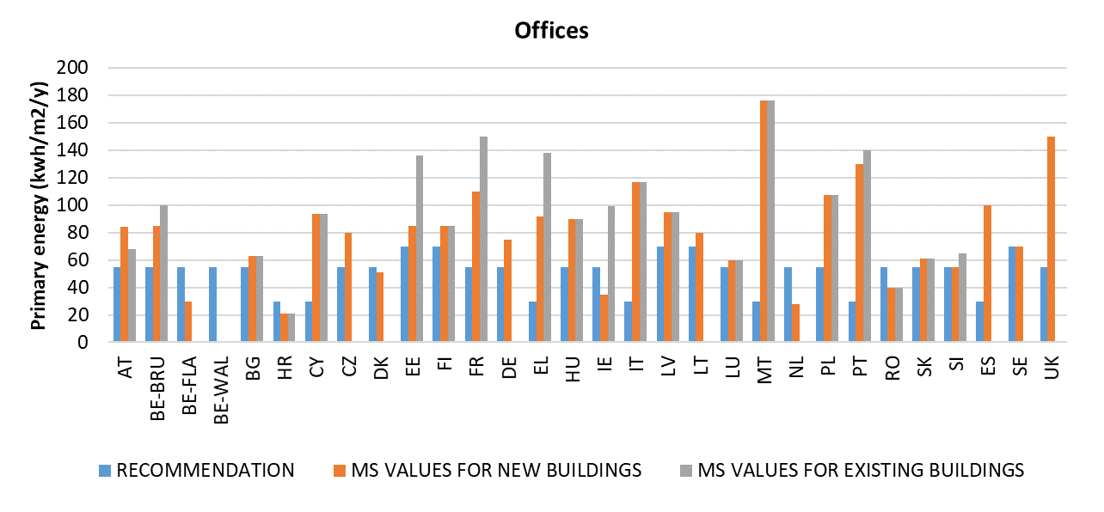

*Source: JRC’s own calculations based on Member States reporting*

Most of Member States also reported a number of measures to increase the number of NZEBs. These measures are mainly: (i) regulatory (energy standards, setting NZEB requirements, regulations and laws); (ii) financial (subsidies, renovation grants, operational programmes, fiscal incentives); (iii) informative (information campaigns, leaflets and websites); and (iv) educational (training for engineers and architects, publication of NZEB guidelines). Several Member States also set long-term milestones for NZEB implementation.

There are some positive signs in the market for key NZEB technologies. For instance, some Member States have set targets – or have adopted financial or fiscal measures – to favour the use of heat pumps. This may lead to an increase in heat pump installations in the coming years, and this will in turn result in a significant reduction (10-40%) in the cost of heat pumps in Europe between now and 2050. Some Member States also give incentives for the wider use of biomass boilers, which could potentially reduce their cost by 10-20% between now and 2050. The cost of heat recovery systems is also expected to decrease significantly (by 35-60%) between now and 2050. Moreover, it is expected that the cost of solar thermal collectors cost will fall by 20-50%, and that the cost of photovoltaics will decrease by 40-60% in the same period. Energy storage will be more important in the near future and projections indicate that the cost of stationary batteries will drop around 65%.

It also appears clear that NZEB will play a strong role in alleviating environmental and social issues, such as energy poverty, affordability of housing and accessibility.[28]

# Cost-optimal levels of minimum requirements for buildings

The EPBD requires Member States to develop cost-optimal calculations every five years to verify and update the minimum energy performance requirements in force. Member States submitted the first cost-optimal reports in 2013 and the second round of reports in 2018[29]. The overall picture for these reports is that for both new and existing buildings, the choice of a cost-optimal methodology has been an efficient approach for steering existing national energy performance requirements towards cost-efficient levels.

For **new building types**, most of cost-optimal points fell between 50 and 100 kWh/m2/year, with an average of 80 kWh/m2/year for the residential sector and 140 kWh/m2/year for the non-residential sector. The associated global costs to reach these levels are often lower than EUR 1 500/m2, with an average of EUR 925/m2 for the residential sector and EUR 800/m2 for the non-residential sector.

For **existing building types**, most of cost-optimal points fell between 75 and 175 kWh/m2/year, with an average of 130 kWh/m2/year for the residential sector and 180 kWh/m2/year for the non-residential sector. Here the global costs are usually lower than EUR 600/m2, with an average of EUR 500/m2 for the residential sector and EUR 385/m2 for the non-residential sector.

**Table 1: Average cost-optimal levels for new and existing buildings per climatic condition**

|  |  |  |  |  |  |  |  |  |
| --- | --- | --- | --- | --- | --- | --- | --- | --- |
| Climate | New single-family house | | New multi-family house | | New office | | New other non-residential | |
| Primary energy [kWh/m2y] | Global costs [EUR/m2] | Primary energy [kWh/m2y] | Global costs [EUR/m2] | Primary energy [kWh/m2y] | Global costs [EUR/m2] | Primary energy [kWh/m2y] | Global costs [EUR/m2] |
| Cold | 77 | 1882 | 62 | 2 076 | 66 | 1 681 | 120 | 2481 |
| Mid | 83 | 590 | 80 | 551 | 130 | 591 | 176 | 558 |
| Warm | 81 | 887 | 105 | 698 | 221 | 648 | 423 | 607 |
|  |  |  |  |  |  |  |  |  |
| Climate | **Existing single-family house** | | **Existing multi-family house** | | **Existing office** | | **Existing other non-residential** | |
| Primary energy [kWh/m2/y] | Global costs [EUR/m2] | Primary energy [kWh/m2/y] | Global costs [EUR/m2] | Primary energy [kWh/m2/y] | Global costs [EUR/m2] | Primary energy [kWh/m2/y] | Global costs [EUR/m2] |
| Cold | 183 | 643 | 77 | 303 | 78 | 336 | 122 | 236 |
| Mid | 112 | 524 | 124 | 460 | 136 | 412 | 268 | 392 |
| Warm | 161 | 500 | 148 | 467 | 175 | 396 | 775 | 808 |

*Source: JRC’s own calculations based on Member States reporting*

From this comparison, it is interesting to observe that in almost all cases, the primary energy consumptions associated with cost-optimal levels are lower in the cold regions. Global costs are usually lower in warm and mid regions, but there are some exceptions (existing multi-family buildings and offices). That implies that in colder regions the requirements are stricter, while more investments are associated with the higher level of energy performance.

The comparison of the cost-optimal levels between the two calculation rounds in 2013 and in 2018 shows that Member States set more ambitious values in 2018 for almost all building types.

**Table 2: Average reduction of cost-optimal levels obtained from the calculations of Member State reports in 2013 and 2018 for new and existing buildings**

|  |  |  |  |  |  |  |
| --- | --- | --- | --- | --- | --- | --- |
| Member States’ average | New single-family house | New multi-family house | New office | Existing single-family house | Existing multi-family house | Existing office |
| -23% | -23% | -17% | -17% | -21% | -9% |

*Source: JRC’s own calculations based on Member States reporting*

Depending on the building type or the component under discussion, gaps greater than 15% were observed in only three or four Member States[30].

**Figure 6: Identified gap between the calculated cost-optimal levels and the requirements in force**

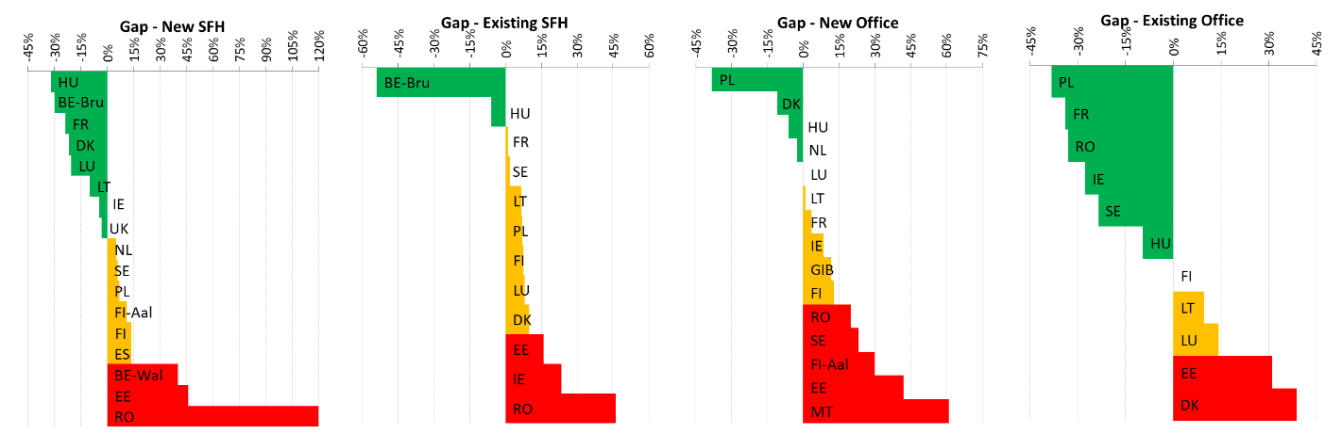

*Source: JRC’s own calculations based on Member States reporting*

The results presented in the figures above are not fully comparable, because Member States are free to choose different options that reflect national market conditions (e.g. takin different macroeconomic or financial perspective).

On the comparison between the cost-optimal levels and the latest NZEB definitions, the overall picture is quite positive. In fact, almost half of Member States introduced NZEB requirements which are significantly more ambitious than cost-optimal references, which implies that the construction market is ready to take steps towards the improvement of the energy performance of the future building stock.

# Conclusion

The findings of this 2020 progress report do not differ much from the previous report. The level of energy-saving effort made in 2018, when not considering the impacts of COVID-19, would most likely not be enough to reach the 2020 targets. Although the external factors of a warm winter and a substantial drop in energy demand in 2020 due to COVID-19 may lead to the achievement of the 2020 targets, the insufficient policies in place will have to be compensated for to reach the 2030 targets. In addition, the subsequent recovery from the pandemic is expected to lead to a rebound in energy demand, and there is a risk that the implementation of new policies and policies announced in the NECPs and the national long-term renovation strategies could be delayed as a result of the current crisis.

For this reason, it is of vital importance that new energy efficiency measures are part of the recovery plans and are implemented without delays. In addition, the increased 2030 climate target for GHG emissions reduction of at least 55% compared to 1990 would require even higher energy efficiency ambition. There will also need to be more widespread uptake of the ‘energy efficiency first’ principle, so that the full potential and benefits of energy savings are taken into consideration in the recovery investments. Furthermore, the upcoming review of the EED will also look at ways to promote energy efficiency efforts at EU level, given that the collective ambition of Member States presented in their integrated plans falls short of the necessary level of effort. The review will be supported by the sustainable product legislative initiative, which will look into widening the eco-design approach to include other product categories.

The NZEB requirements in the most Member States are less ambitious than the benchmarks recommended by the Commission in both residential and non-residential buildings. However, before the implementation of new NZEB standards, a significant reduction of relevant technology costs is expected, which could make it possible to further increase the level of ambition for NZEBs. With the forthcoming introduction of NZEB requirements for all new buildings as of 2021, the main challenge for the decarbonisation of the building stock by 2050 is to increase the current low renovation rates and the application of ambitious minimum requirements for existing buildings. Member States present a wide range of building types, climatic and financial conditions, and therefore targeted measures are needed to stimulate a large scale diffusion of NZEBs retrofit. Future generations of NZEBs will integrate smart technologies and digitalization solutions and could also be scaled-up and integrated at district level, shifting the focus and scale from the single building to the district.[31] The Renovation Wave initiative of the European Green deal and the national long-term renovation strategies are key tools to steer public and private funding towards renovation projects, facilitating the cost-effective transformation of existing buildings into NZEBs.

The Commission invites the European Parliament and the Council to express their views on this progress report.

Table 3: Overview of variations of main energy indicators (part 1) [32]



The + symbol is used if Member States decreased their primary and final energy consumption between 2005 and 2018 at a rate which is greater than the rate of decrease that would be needed in 2005-2020 to meet the 2020 targets for primary and final energy consumption. The - symbol is used for the other cases. FEC stands for final energy consumption, PEC for primary energy consumption.

Table 4: Overview of variations of main energy indicators (part 2)



Source: Eurostat (old methodology for energy balances), JRC, Odyssee.

**Table 5: 2018 reported energy savings overview under Article 7 (ktoe)**

|  | 2018 | | | Progress towards the target | | | |
| --- | --- | --- | --- | --- | --- | --- | --- |
| **New savings** | **Total annual savings** | **Cumulative savings in 2014-2018** | **Total cumulative savings required by 2020 (target)** | **Progress towards total cumulative savings required by 2020** | **Estimated annual savings required for 2014- 2018** | **2014-2018 compared to estimated annual savings** |
| **Austria** | 372 | 1307 | 4032 | 5200 | 78% | 2786 | 145% |
| **Belgium** | 234 | 1176 | 3879 | 6911 | 56% | 3702 | 105% |
| **Bulgaria** | 32 | 175 | 496 | 1942 | 26% | 1040 | 48% |
| **Croatia\*** | 3 | 73 | 248 | 1296 | 19% | 694 | 36% |
| **Cyprus** | 77 | 83 | 162 | 242 | 67% | 130 | 125% |
| **Czechia** | 176 | 577 | 1634 | 4565 | 36% | 2446 | 67% |
| **Denmark** | 173 | 1045 | 3187 | 3841 | 83% | 2058 | 155% |
| **Estonia** | 88 | 99 | 370 | 610 | 61% | 327 | 113% |
| **Finland** | 543 | 1377 | 4701 | 4213 | 112% | 2257 | 208% |
| **France** | 1413 | 5698 | 17429 | 31384 | 56% | 16813 | 104% |
| **Germany** | 2950 | 13695 | 28953 | 41989 | 69% | 22494 | 129% |
| **Greece** | 211 | 474 | 1355 | 3333 | 41% | 1786 | 76% |
| **Hungary** | 131 | 1731 | 1731 | 3680 | 47% | 1971 | 88% |
| **Ireland** | 87 | 466 | 1408 | 2164 | 65% | 1159 | 121% |
| **Italy** | 3998 | 3998 | 12729 | 25502 | 50% | 13662 | 93% |
| **Latvia**\* |  |  | 436 | 851 | 51% | 456 | 96% |
| **Lithuania** | 79 | 152 | 511 | 1004 | 51% | 538 | 95% |
| **Luxembourg** | 9 | 44 | 113 | 515 | 22% | 276 | 41% |
| **Malta** | 5 | 17 | 47 | 67 | 71% | 36 | 132% |
| **Netherlands** | 611 | 2274 | 7777 | 11512 | 68% | 6167 | 126% |
| **Poland** | 331 | 2977 | 8891 | 14818 | 60% | 7938 | 112% |
| **Portugal\*** |  |  | 453 | 2532 | 18% | 1356 | 33% |
| **Romania** | 59 | 366 | 1343 | 5817 | 23% | 3116 | 43% |
| **Slovakia** | 106 | 466 | 1420 | 2284 | 62% | 1224 | 116% |
| **Slovenia** | 38 | 133 | 447 | 945 | 47% | 506 | 88% |
| **Spain** | 539 | 2296 | 6958 | 15979 | 44% | 8560 | 81% |
| **Sweden** | 1436 | 1436 | 4654 | 9114 | 51% | 4883 | 95% |
| **UK** | 1032 | 5056 | 18469 | 27859 | 66% | 14924 | 124% |
| **Total** | **14634** | **80692** | **134068** | **230169** | **58%** | **123305** | **109%** |

*Source: Information reported by Member States and complemented by the Commission’s calculations and estimates where necessary.*

* Data on energy savings achieved in 2018 were not available for analysis for Croatia, Latvia and Portugal. Cumulative savings over 2014-2018 are based on energy savings achieved in previous years up to 2017, but do not include new savings for 2018.

Table 6: Projections and likelihood of achieving Article 7 target per Member State by 31 December 2020*

|  |  |  |  |
| --- | --- | --- | --- |
| **Scenario 1 (when ratio of new vs total annual savings < 40%)** | | | |
| Member State | Projected savings in ktoe with total annual savings from 2018 continuing to deliver until 2020 and new savings as in 2018 until 2020 | Relative target achievement in 2020 (projected savings compared to savings target) | Likelihood of target achievement |
| **Austria** | 7391 | 142% | very likely |
| **Belgium** | 6700 | 97% | likely |
| **Bulgaria** | 909 | 47% | very unlikely |
| **Croatia** | 399 | 31% | very unlikely |
| **Czechia** | 3140 | 69% | very unlikely |
| **Denmark** | 5624 | 146% | very likely |
| **France** | 31651 | 101% | likely |
| **Hungary** | 5455 | 148% | very likely |
| **Ireland** | 2513 | 116% | very likely |
| **Italy** | 28721 | 113% | very likely |
| **Luxembourg** | 218 | 42% | very unlikely |
| **Netherlands** | 13547 | 118% | very likely |
| **Poland** | 15506 | 105% | likely |
| **Portugal** | 846 | 33% | very unlikely |
| **Romania** | 2192 | 38% | very unlikely |
| **Slovakia** | 2564 | 112% | very likely |
| **Slovenia** | 788 | 83% | unlikely |
| **Spain** | 12628 | 79% | unlikely |
| **UK** | 30645 | 110% | likely |
| **Scenario 2 (when ratio of new vs total annual savings > 90%)** | | | | |
| Member State | Projected savings in ktoe with new annual savings until 2020 as in 2017 (lifetime =1 year) | Relative target achievement in 2020 (projected savings compared to savings target) | Likelihood of target achievement | |
| **Cyprus** | 316 | 131% | very likely | |
| **Estonia** | 546 | 90% | unlikely | |
| **Lithuania** | 669 | 67% | very unlikely | |
| **Sweden** | 7526 | 83% | unlikely | |
| **Scenario 3 (when ratio of new vs total annual savings > 40% but < 90%)** | | | | |
| Member State | Projected savings in ktoe with new annual savings until 2020 as in 2018 (75% lifetime > 7 years; 25% lifetime = 1 year) | Relative target achievement in 2020 (projected savings compared to savings target) | Likelihood of target achievement | |
| **Finland** | 8260 | 196% | very likely | |
| **Germany** | 57608 | 137% | very likely | |
| **Greece** | 2647 | 79% | unlikely | |
| **Malta** | 87 | 129% | very likely | |

* All Member States have been classified according to the estimated lifetime of the implemented measures. This assessment was based on a comparison of the rate of new energy savings compared to total annual savings to identify the expected lifetimes of implemented policy measures. The assessment led to three scenarios. Where the ratio of new savings compared to total annual savings is ~1, the assumed lifetime of an implemented measure is 1 year (scenario 1). If the ratio is <40 % (for the year 2017), the assumed lifetime of an implemented measures is longer than 7 years (scenario 2). For a ratio in between, a mixed scenario is used (scenario 3). The following ruleset for assessing the likelihood of achieving the target was applied

|  |  |
| --- | --- |
| **Relative target achievement in 2020** | **Assessment of likelihood** |
| > 105% | very likely |
| >95% | likely |
| >75% | unlikely |
| <75% | very unlikely |

1. https://ec.europa.eu/energy/topics/energy-efficiency/targets-directive-and-rules/national-energy-efficiency-action-plans_en
2. https://ec.europa.eu/energy/topics/energy-efficiency/energy-performance-of-buildings/energy-performance-buildings-directive/eu-countries-2018-cost-optimal-reports_en?redir=1
3. COM(2020) 326 final
4. The revised figures by Eurostat (latest extraction in July 2020) show small changes compared to the figures used in the 2019 report and do not change the analysis presented in that report.
5. https://ec.europa.eu/eurostat/documents/38154/4956218/Energy-Balances-April-2020-edition.zip/69da6e9f-bf8f-cd8e-f4ad-50b52f8ce616
6. Indicators from Eurostat’s energy balances in line with the methodology up to 2018 (FEC 2020-2030 and PEC 2020-2030) are used to monitor progress towards achieving the Europe 2020 energy efficiency targets.
7. Idem 11
8. The developments in specific sectors did not change compared to the last report. For additional information see chapter 5 of the 2019 Progress Report COM(2020) 326 final
9. Following Brexit the 2030 energy efficiency targets will cover 27 Member States.
10. [COM(2020) 564 final](https://eur-lex.europa.eu/legal-content/EN/TXT/?qid=1600328628076&uri=COM:2020:564:FIN)
11. [COM(2020) 562 final](https://ec.europa.eu/clima/sites/clima/files/eu-climate-action/docs/com_2030_ctp_en.pdf)
12. <https://ec.europa.eu/energy/sites/ener/files/quarterly_report_on_european_gas_markets_q1_2020.pdf>
13. <https://ec.europa.eu/energy/sites/ener/files/qr_electricity_q1_2020.pdf>
14. <https://ec.europa.eu/eurostat/en/web/products-eurostat-news/-/DDN-20200907-1?inheritRedirect=true&redirect=/eurostat/en/news/whats-new>
15. <https://www.iea.org/reports/global-energy-review-2020/oil#abstract>
16. <https://www.itf-oecd.org/sites/default/files/global-freight-covid-19.pdf>
17. <https://www.eurocontrol.int/covid19>
18. Directive 2018/2002
19. The reports of Croatia and Portugal were submitted too late to be included in this analysis.
20. Tsemekidi-Tzeiranaki, S., Paci, D. et al. (2020), *Analysis of the annual reports 2020 under the Energy Efficiency Directive,* JRC Technical Report.
21. This figure might be revised once data about new savings achieved in 2018 by Latvia and Portugal are available.
22. Tsemekidi-Tzeiranaki, S., Paci, D. et al. (2020), *op. cit.*
23. The default approach refers to measures taken to renovate 3% of the total floor area of heated and/or cooled buildings over 250 m2 owned and occupied by central government which do not meet minimum energy requirements. The alternative approach refers to other cost-effective measures taken to achieve equivalent energy savings.
24. Based on the comprehensive study of building energy renovation activities and the uptake of NZEBs in the EU.

    https://ec.europa.eu/energy/studies/comprehensive-study-building-energy-renovation-activities-and-uptake-nearly-zero-energy_en?redir=1
25. Information provided by MS, the JRC assessment and the ‘Concerted Action EPBD’ reports
26. In 2016 the Commission published recommendations for the promotion of NZEBs and best practices to ensure that, by 2020, all new buildings are NZEBs (C/2016/4392).
27. It is important to note that heterogeneity in climatic zones and national conditions of the building stock and different approaches in calculation methodologies across Member States prevent a full direct comparison. The comparison in Figures 4 and 5 is indicative and based on relevant assumptions to facilitate Commission’s own calculations.
28. Since poor energy efficiency of dwellings is a major risk factor for energy poverty, NZEB can play a beneficial role, particularly in social housing and in segments of the private housing market occupied by low-income or lower middle-income households – provided they can (still) afford to live in these dwellings.
29. In 2016 the Commission published a report on the progress by Member States in reaching cost-optimal levels of minimum energy performance requirements (COM/2016/0464 final). DG ENERGY with the assistance of the JRC analysed and assessed the 2018 calculations. The summary report is under publication: Zangheri, P. et Al., Assessment of 2nd cost optimal calculations in the context of the EPBD, JRC 2020.
30. The evaluation of the gaps between the calculated cost-optimal levels and the requirements in force is the most important step of the whole calculation, since it should provide useful indications for the update of existing energy performance regulations. National minimum energy performance requirements should not be more than 15% higher than the outcome of the cost-optimal levels and a plan should be drawn up to reduce the gaps that cannot be strongly justified.
31. Saheb, Shnapp,.and Paci (2019), *From nearly-zero energy buildings to net-zero energy districts-Lessons learned from existing EU projects*, EUR 29734 EN, Publications Office of the European Union, Luxembourg; Shnapp, Paci, and Bertoldi, (2020), *Enabling Positive Energy Districts across Europe: energy efficiency couples renewable energy*, EUR 30325 EN, Publications Office of the European Union, Luxembourg.
32. The energy intensity for the whole economy is the ratio between PEC2020-2030 and GDP2010. For industry and services it is the ratio between final energy consumption and gross value added in chain-linked volumes (2010). Due to data limitations, the denominator of gross value added at current prices has been used for Malta.