

**PART II**

**ENERGY COSTS for the economy, households and industry**

# The EU energy bill[1]

In this chapter we outline the main drivers of the import bill and estimate its size in the last couple of years.

**Main findings**

* EU has high import dependency and faces an important energy import bill.
* After bottoming out in 2016, energy commodity prices and the import bill have been on the rise, resulting in an increasing import bill.
* In 2013, the EU's estimated import bill reached EUR 400 billion. In 2013-2016, falling energy prices allowed the import bill to decrease significantly, although the weakening of the euro has partly offset this effect. In 3 years, the import bill has almost halved, thereby giving a boost to the economy.
* The prices of all three fuels increased in 2017, resulting in a growing import bill, but still well below the 2013 level: in 2017, the estimated import bill amounted to EUR 269 billion, 26% more than in 2016. Fuel prices continue to rise in 2018, resulting in continuing growing import bill, estimated at EUR 331 billion, 23% more than 2017.
* Crude oil is by far the main component of the import bill, making up 69% of the total in 2018. The share of gas and hard coal was 27% and 4%, respectively.
* Oil and other energy commodity prices started decreasing towards end of 2019 due to slowing of major developed and developing economies, and especially in the beginning of 2020 due to COVID-19 reduction of economic activity and transport. Along with reduced volume, this could reduce the energy bill for 2020.

## Introduction

The EU is a net importer of energy: in 2018, the import dependency[2] stood at 55.7%, the highest in the years, plateauing between 2008 and 2016 but with clear upward trend visible in last couple of years as energy consumption grew. This means that the EU needs to import over half of the energy it consumes. Import dependency is particularly high in case of fossil fuels: in 2018, it was 86.6% for Oil and petroleum products, 77.4% for natural gas and 45.1% for solid fuels (from which 68.9% for hard coal).

Since 2014, import dependency increased for gas (because of rising consumption and falling indigenous production, and switching of industry and power generation from coal) but decreased for solid fuels (the consumption of which decreased to a larger extent than production). The import dependency for oil has not changed significantly.

EU energy import dependency seems to have stabilised in recent years: since 2005, it has been fluctuating between 52% and 56%. While the import dependency of fossil fuels shows a long-term increasing trend, their share within the energy mix is gradually decreasing. The share of renewables, on the other hand, is steadily growing and these are typically produced within the EU.

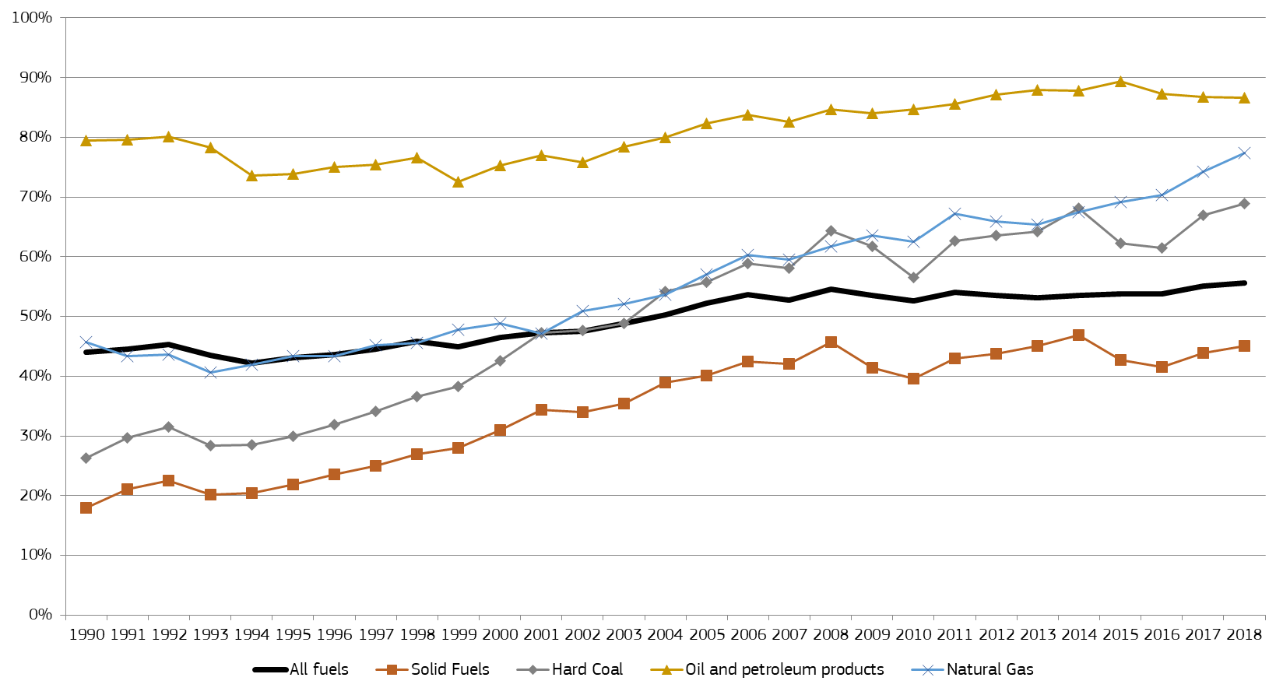

Figure 106 - EU import dependency by fuel

Source: Eurostat

The high import dependency poses significant challenges in terms of energy security and the diversification of suppliers and supply routes but, in addition, it also means that the EU is facing a significant energy import bill.

## Methodology

*Scope*

In this analysis, we focus on the import bill of the EU as a whole, therefore only extra-EU imports are considered. (When the import bill of an individual Member State is looked at, it is of course reasonable to take all imports into account, including those coming from other Member States.)

The analysis covers the main fossil fuels: crude oil, natural gas and solid fuels. These fuels still cover nearly three-quarters of the EU's gross inland energy consumption and the overwhelming majority (98% in 2016) of net energy imports. Crude oil alone makes up well over half of the EU's net energy imports while gas accounts for 30%.

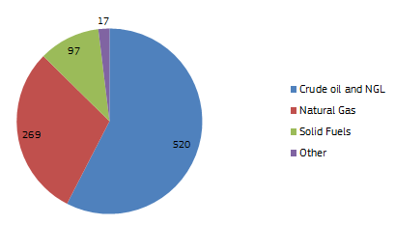

Figure 107 - EU net imports of energy in 2018 (mtoe)

Source: Eurostat

In addition to crude oil, the EU is also an importer of petroleum products. However, considering the practical difficulties of finding reliable volume and price data for a multitude of products with different specifications and the fact that the EU is also exporting petroleum products and exports and imports are of a similar magnitude (the EU typically exports motor gasoline and imports middle distillates), petroleum products were not included in the calculation of the import bill.

Lignite/brown coal is typically not traded internationally and the imports arriving to the EU are negligible. Therefore, the analysis of solid fuels was restricted to hard coal.

In terms of time horizon, we provide import bill estimates for the period 2013-2018.

*Data sources*

In case of oil, we are in comfortable position as Member States report on a monthly basis the volume and the average CIF price[3] of imported oil under Regulation (EC) No 2964/95 of 20 December 1995 introducing registration for crude oil imports and deliveries in the Community.[4] Every year, the collected and aggregated information is published on the website of DG Energy[5] and this will continue in the future but in DG EUROSTAT database.

For gas, the import volumes used are from the Transparency Platform of the European Network of Transmission System Operators for Gas (ENTSO-G)[6] which is based on the gas flows reported by gas transmission system operators. Gas imports arrive to the EU from Russia, Norway, Algeria and Libya through several pipelines while, in 2017, LNG was arriving from 12 supplying countries to around 25 terminals in 13 Member States.[7] Volumes were calculated by adding the gas flows at the relevant entry points to the EU gas network.

Gas import prices can vary across Member States depending on the supplier, the supply route, the type of contracts (spot or long-term), the way of pricing (hub-based or oil-indexed) and the level of competition. Based on available sources, including customs data, national agencies (e.g. BAFA in Germany) and commercial data providers, for each supplier (Russia, Norway, Algeria, Libya and LNG) and for each year an estimated average price was established.

Table 4 - Estimated average gas import prices by supplier (€/MWh)

|  |  |  |  |  |  |
| --- | --- | --- | --- | --- | --- |
| Year | Russia | Norway | Algeria | Libya | LNG |
| 2013 | 30.0 | 25.0 | 30.0 | 31.0 | 28.5 |
| 2014 | 25.5 | 20.0 | 27.5 | 29.5 | 25.5 |
| 2015 | 22.0 | 19.5 | 23.5 | 23.5 | 20.5 |
| 2016 | 16.0 | 14.0 | 16.0 | 14.5 | 15.5 |
| 2017 | 17.8 | 17.1 | 18.1 | 15.4 | 18.3 |
| 2018 | 21.7 | 23.3 | 20.8 | 20.8 | 23.1 |

Source: DG Energy estimation

In case of coal, volumes are the imports of hard coal[8], reported in Eurostat annual (2013-2018) statistics. For price, the CIF ARA spot price reported by Platts was used; this is deemed to be representative for most of the hard coal imports arriving to the EU.

For the conversion from US dollars to euros, we used the annual average of the daily official exchange rates published by the European Central Bank[9].

## Drivers

The import bill basically depends on the volume and the average price of imports. Like most commodities, energy sources are typically traded in US dollars and therefore the development of the USD/EUR exchange rate will also influence the import bill (if expressed in euros).

*Volumes*

Import volumes will depend mainly on the level of consumption. In addition, the development of indigenous production (falling production results in increasing import dependency even if consumption is unchanged) and, to a smaller extent, stock changes can also affect import volumes. In principle, exports can also influence import volumes (higher exports has to be offset by higher imports) but extra-EU exports of crude oil, natural gas and coal are negligible.

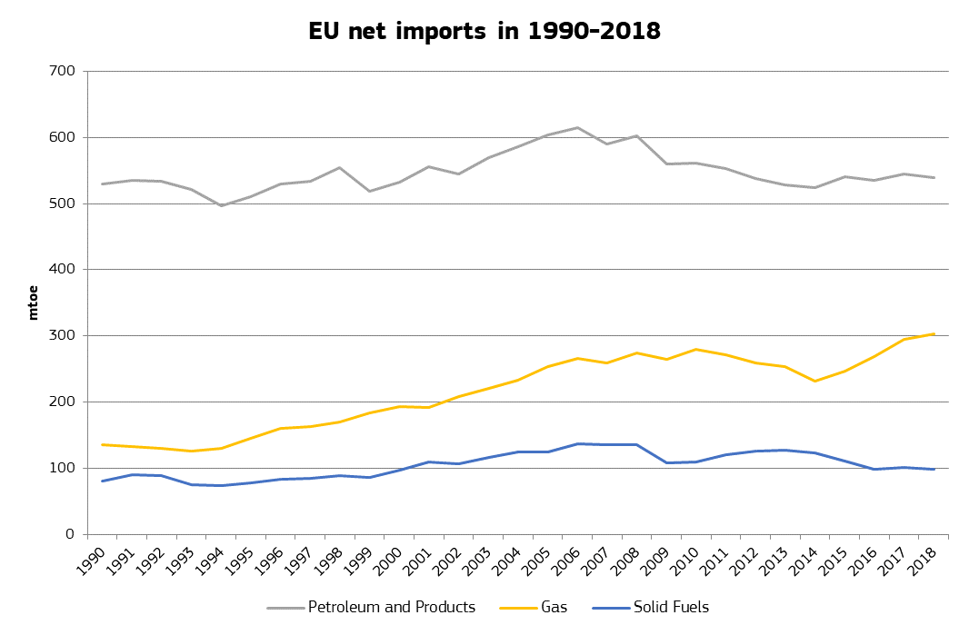

Figure 108 - EU net imports

Source: Eurostat

EU imports of fossil fuels showed a marked increasing trend during the 1990s and for most of the 2000s. Since then, the tendencies of the different fuels are diverging.

In case of oil, imports have been decreasing since 2008 but bounced back in 2015, as the significant fall of oil prices triggered an increase in fuel demand, and stayed steady in that *niveau* since.

Gas imports decreased in 2010-2014 when this fuel lost ground in the electricity sector where it had to face increasing competition from renewables and coal. The trend turned after 2014 as increasing gas consumption and the ongoing fall of indigenous production increased import needs, as well as for switching of industrial and power generation needs from coal, with clear rising trend in recent years.

In case of hard coal, imports increased from 2009-2010, helped by low prices (cheap shale gas squeezed out the fuel from the US power sector and made it available for export), coupled with the low carbon prices. In 2013-2014, the trend reversed and coal imports started to fall again. The competitiveness of gas has improved compared to coal and, in addition, many Member States announced plans to phase out coal.

*Prices*

International commodity prices generally decreased in 2014-2016 and have been rising since 2016. There is a strong correlation between international commodity prices; in particular, one can observe a strong correlation between Brent and TTF (the Dutch gas benchmark) since 2015.

In the short run, changes in the import volumes are usually moderate but prices can be rather volatile. For example, the price of oil fell by more than 70% between mid-2014 and early 2016, whereas coal prices have more than doubled between the beginning and the end of 2016. Coal prices remained at that level until end of 2018, and then have decreased due to decreasing of growth in big users (like China). Other commodity prices followed the pattern except for oil that had important developments on demand and supply side.

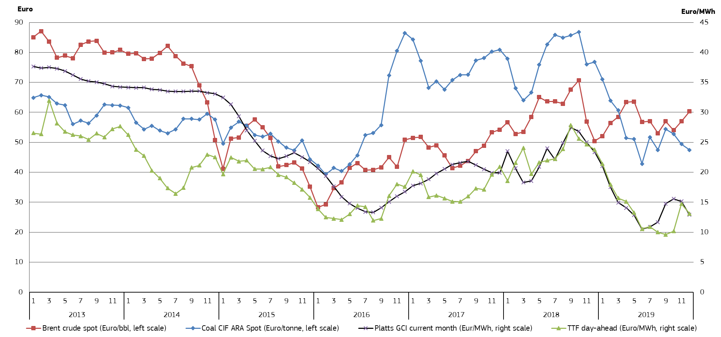

Figure 109 - Comparison of European oil, gas and coal prices

Source: Platts; GCI is the North West Europe Gas Contract Indicator, a theoretical index showing what a gas price linked 100% to oil would be.

As the EU is a net crude oil importer, price volatility impacts the energy expenditure of EU consumers and at macroeconomic level the impact can be tracked in economic growth and inflation. According to an analysis carried out by the European Commission, in 2015 and 2016 decreasing oil prices resulted in an additional GDP growth of 0.8% and 0.5%, respectively. As since crude oil prices started to rise again, an opposite impact is anticipated.

*Exchange rates*

Most energy is traded in US dollars. Accordingly, the fluctuations of the USD/EUR exchange rate can directly affect the prices and the import bill when these are measured in euros.

Historically, there has been a consistently negative correlation between oil prices and the US dollar, although recently, with the decline of US oil imports, the relationship has weakened. In other words, it can be observed that the price of oil and the value of the US dollar generally move in an opposite direction: a strengthening dollar typically coincides with decreasing oil prices and vice versa. This means that changes in the oil price, whether upwards or downwards, are mitigated by the exchange rate and the volatility of the oil price expressed in euros is smaller than the volatility of the price expressed in dollars. In view of the correlation between oil, gas and coal prices, to a certain extent this is true for coal and gas prices, too.

The euro has considerably weakened compared to the US dollar in the second half of 2014: the exchange rate went down from nearly 1.40 USD/EUR in early May 2014 to 1.06 in March 2015, a depreciation of 24% in 10 months. In spite of the weakening of the euro in the second half of 2014, the 2014 average exchange rate was practically the same as in 2013, 1.33, but in 2015 it decreased to 1.11.

In 2015-2016, the exchange rate had been rather stable, moving in the 1.05-1.15 range during most of this period.

Throughout 2017, the euro strengthened compared to the US dollar ending slightly below 1.20 USD per EUR. Euro continued to gain strength until beginning of 2018, touching 1.25 US per EUR. After that recent peak, euro weakened towards the end of the period towards 1.10 US per EUR.

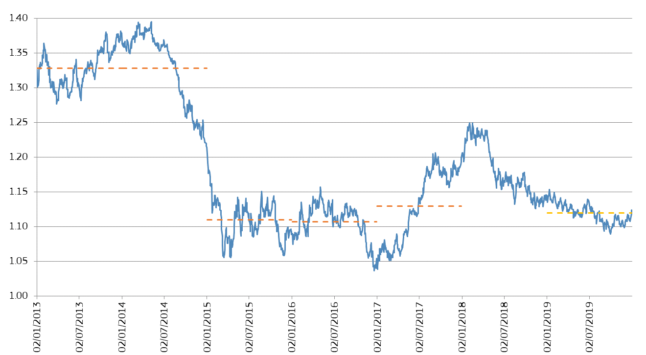

Figure 110 - The USD/EUR exchange rate since 2013

Source: ECB

The red dotted lines represent the annual average in 2013, 2014, 2015, 2016, 2017, 2018, and 2019

The European Union has a strong intention to "do more to allow the euro to play its full role on the international scene"[10]. As the EU is a net importer of petroleum products, gas and coal, broader deployment of euro in the international trade of these energy products could eliminate the risk of price volatility stemming from the fluctuation of euro against other major currencies, such as the US dollar.

## Import bill calculation

*Oil*

Table 5 - EU crude oil import bill in 2013-2018

|  |  |  |  |  |  |  |
| --- | --- | --- | --- | --- | --- | --- |
|  | 2013 | 2014 | 2015* | 2016* | 2017* | 2018* |
| Volume (million bbl/day) | 9.83 | 10.01 | 10.48 | 10.29 | 10.53 | 10.45 |
| Average Brent price (USD/bbl) | 108.66 | 98.95 | 52.39 | 43.73 | 54.19 | 60.19 |
| Average CIF import price (USD/bbl) | 108.83 | 98.65 | 51.72 | 42.11 | 53.16 | 70.45 |
| EUR/USD exchange rate | 1.3281 | 1.3285 | 1.1095 | 1.1069 | 1.1297 | 1.1810 |
| Import bill (bn USD) | 390.6 | 360.4 | 197.8 | 158.6 | 204.3 | 268.7 |
| Import bill (bn EUR) | 294.1 | 271.3 | 178.3 | 143.2 | 180.8 | 227.5 |

Source: DG Energy, based on Member State reports under Regulation (EC) No 2964/95, Platts, ECB

*for confidentiality reason, from 2015 figures do not include the Czechia (in 2014, imports by the Czechia made up around 1.5% of total EU imports, implying an estimated annual import bill of 2-3 billion euros in 2015-2018)

In spite of the growing import volumes, the EU oil import bill significantly decreased in 2014-2016 as a result of the oil price fall. While in 2013 the oil import bill was close to USD 400 billion, in 2016 it dropped below USD 160 billion, a decrease of almost 60% within three years. The depreciation of the euro in the same period mitigated this trend: measured in euros, the import bill decreased from EUR 294 billion in 2013 to EUR 143 billion euros in 2016, a decrease of 51%.

2017 was the first year since 2012 when the average Brent price increased: it was 54 USD/bbl, 24% more than in 2016. The volume of daily imports also rose (by 2.3%), helped by falling indigenous production, rising fuel consumption and a relatively good refining environment. Driven mainly by the increasing oil prices, the EU's oil import bill increased from EUR 143 billion in 2016 to EUR 181 billion in 2017 (an increase of around 26%) but remained well below the level observed in 2013, the last year before the oil price fall. The euro slightly strengthened in 2017, which moderated the increase of the oil price bill.

In 2018 average oil price (measured by Brent) continued to increase to 60.19 USD per barrel. That combined with roughly the same volume of energy consumption as in 2017 produced higher oil import bill of 227.5 billion EUR. Should the oil price of oil and energy consumption continue to rise in 2019, we can expect continuation of the rise of import bill.

*Gas*

Table 6 - EU gas import bill in 2013-2018

|  |  |  |  |  |  |  |
| --- | --- | --- | --- | --- | --- | --- |
|  | 2013 | 2014 | 2015 | 2016 | 2017 | 2018 |
| Volume (TWh) | 3 390 | 3 113 | 3 445 | 3 853 | 4 238 | 4 111 |
| Estimated average import price (€/MWh ) | 28.1 | 23.6 | 21.0 | 15.2 | 17.7 | 21.94 |
| Import bill (bn EUR) | 95.4 | 73.5 | 72.1 | 58.4 | 74.5 | 90.2 |

Source: ENTSO-G, DG Energy estimations

Gas imports showed a robust increase since 2014, but prices had been on the decline, bottoming out in 2016 and increasing again in 2017. In spite of the rising volumes, the estimated import bill decreased in 2014, 2015 and 2016 (as a result of the falling prices) but bounced back in 2017 when both import volumes and prices increased.

In 2017, the gas import bill increased by 27%, reaching EUR 74.5 billion, and due to continuing rise in prices and roughly the same volume, it reached 90.2 billion EUR.

*Coal*

Table 7 - EU hard coal import bill in 2013-2018

|  |  |  |  |  |  |  |
| --- | --- | --- | --- | --- | --- | --- |
|  | 2013 | 2014 | 2015 | 2016 | 2017 | 2018 |
| Volume (million tons) | 233.0 | 227.3 | 203.7 | 182.1 | 184.6 | 176.8 |
| CIF ARA spot price (USD/ton) | 81.56 | 75.23 | 56.86 | 60.18 | 84.73 | 91.65 |
| EUR/USD exchange rate | 1.3281 | 1.3285 | 1.1095 | 1.1069 | 1.1297 | 1.1810 |
| CIF ARA spot price (EUR/ton) | 61.41 | 56.63 | 51.25 | 54.37 | 75.00 | 77.60 |
| Import bill (bn USD) | 19.0 | 17.1 | 11.6 | 11.0 | 15.6 | 16.2 |
| Import bill (bn EUR) | 14.3 | 12.9 | 10.4 | 9.9 | 13.9 | 13.7 |

Source: Eurostat, Platts, ECB

Similarly to oil and gas, the coal import bill also decreased between 2013 and 2016 although the absolute values are significantly lower. The estimated coal import bill decreased by 29%, from EUR 14.3 billion in 2013 to EUR 9.9 billion in 2016. International coal prices significantly increased in 2017 and 2018 which offset the decrease of the imported volumes, resulting in a 40% increase of the import bill to EUR 13.9 billion in 2017 and EUR 13.7 billion in 2018.

*Total*

In 2013, the total import bill was about EUR 400 billion, more than EUR 1 billion per day. Falling prices helped the EU to decrease its estimated import bill to EUR 358 billion in 2014 (-11%), EUR 261 billion in 2015 (-27%) and EUR 211 billion in 2016 (-19%). The cumulative decrease between 2013 and 2016 was 47%.

In 2017, however, the import bill increased by 27%, reaching EUR 269 billion. Continuing growth of energy consumption and rise of prices led to an increase of another 23%, reaching 331.4 billion EUR.

When expressed as a percentage of EU GDP (at current prices), the share of the estimated import bill decreased from 3.0% in 2013 to 1.4% in 2016. This saving gave a significant boost to GDP growth in 2015-2016: lower energy prices meant more disposable income for households, lower energy costs for businesses and increasing activity of energy intensive sectors (e.g. transport, refining and chemicals). In 2017, the estimated import bill increased to 1.7% of the GDP and in 2018 to 2.1% of the GDP.

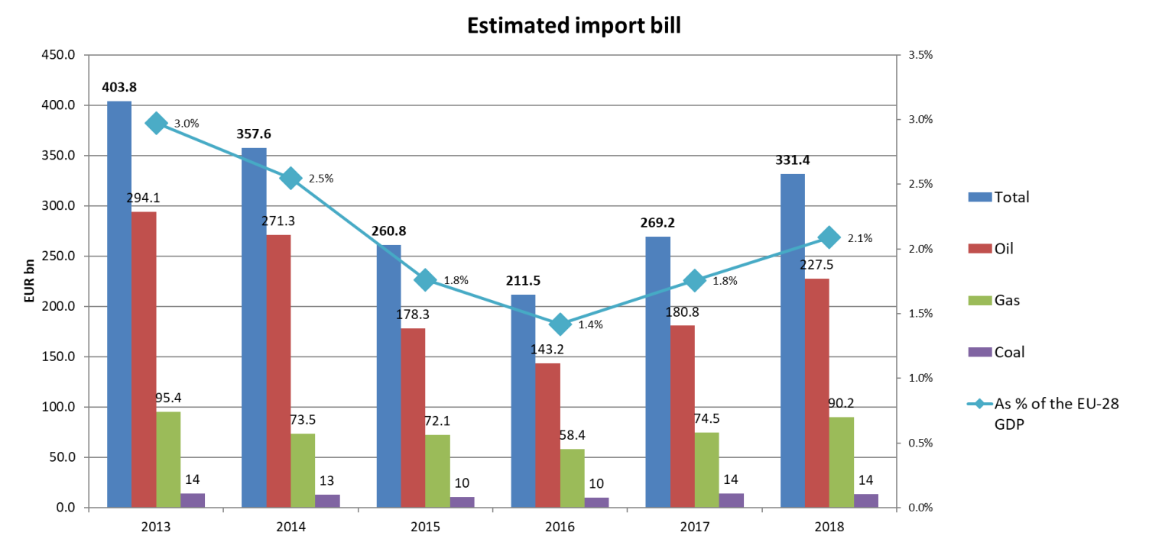

Figure 111 - The estimated EU import bill

Source: DG Energy calculation

# Household energy expenditure and energy poverty

**Introduction**

Energy covers basic needs for households. Increasing proportions of energy related expenditures in total expenditure may imply less spending on other consumer purposes. Monitoring household energy expenditure is thus important to get an idea of how much ‘efforts’ households do to cover their basic energy needs (heating, transport, communication) but also to identify the households’ ability to actually cover these needs and avoid energy poverty.

This chapter provides an analysis on the importance of energy products and transport fuels expenditure for households with different levels of income across the EU Member States, while looking at the particular circumstances of those households in energy poverty and vulnerable consumers.

Ensuring the fairness of the transition towards a climate neutral Union by 2050 lies at the heart the European Green Deal proposed by the Commission in December 2019[11].

The COVID-19 crisis has accentuated the urgency of addressing the challenge to deliver a social Europe that leaves no one behind. Vulnerable energy consumers may also be the most affected by the economic consequences of the crisis triggered by COVID. Energy poverty levels across Member States could likely be shifting as more Europeans struggle to keep their income and jobs to afford their necessary access to energy, particularly when forced to stay at home during lockdown. The “first-response” Next Generation EU[12] Recovery Package was presented to “guide and build a more sustainable, resilient and fairer Europe for the next generation”. In this regard, the Renovation Wave as an important facilitator of the green recovery will “help save money on energy bills, provide healthier living conditions and reduce energy poverty”.

In its Clean Energy for All Europeans legislative package, the European Commission has provided useful high-level principles and insights as to the potential causes and consequences of energy poverty, highlighting the importance of polices that tackle energy poverty, in particular in the context of the National Energy and Climate Plans (NECP) and Long-term Renovation Strategies[13].

Energy poverty has its root in a combination of low income, high energy bills and poor energy efficiency, in particular when it comes to the performance of buildings. The broad range of socio-economic factors surrounding general poverty, and challenges around housing tenure systems make the issue complex to address.

The Commission continues to support and finance the platforms provided by the European Energy Poverty Observatory (EPOV), aiming at collecting data, developing indicators and presenting best practices to tackle energy poverty in the EU Member States. The Commission Recommendation on energy poverty[14] adopted alongside this report (as part of the accompanying package of the 2020 State of the Energy Union report) and strongly linked to the Renovation Wave underlines the importance that the Commission gives to this matter. All these initiatives should help to tackle energy poverty in line with the citizens’ right to have access to energy as proclaimed in the European pillar of social rights.

**Main findings**

* In 2018 the poorest households in the EU spent on average € 945 on energy products (electricity, gas, liquid and solid fuels, central heating), representing around 8.3% of their total consumption expenditure. There were important differences across the EU Member states. Energy expenditure ranged from below to € 500 to € 2500 per household, but it is also important to consider that the purchase power also varies largely amongst Member States.
* When compared to the total energy expenditure (excluding transport), the poorest households in Sweden spent only 3.2% on energy, while in Slovakia this share was more than 22%.
* Households with middle income, though spending higher amounts on energy products, spent proportionally less on energy within their total expenditure, only 6.3% on EU average, as opposed to the aforementioned 8.3% in the case of the poorest.
* The relative spending on energy also vary importantly within the EU. Middle income households in Central and Eastern Europe spent around 10-15% of their expenditure on energy, owing to lower income compared to North and Western Europe, where this share was typically around 3-8% in 2018.
* The share of households being unable to keep their home adequately warm serves as a good complementary indicator on energy poverty, showing a positive correlation with the share of energy products within the total household expenditure. In 2018 around 19% of lower middle income households in the EU could not keep their home adequately warm, ranging from 3.1% in Finland to 56% in Bulgaria.
* Expenditures on transport fuels (petrol and diesel) represented € 390 (3% of the total expenditure) on EU average in the case of the poorest, while for middle income households it reached € 1060 (4.4% of the total expenditure). Once again, it is important to consider differences in purchase power capacities between Member States.
* Households with higher income spent proportionally more on transport fuels within their total expenditure than the poorer, and diesel had an increasing importance in their fuel spending compared to lower income households.
* Overall, the share of energy expenditure slightly decreased since 2008. In the case of the lower income decile households, this indicator rose to 9.1% in 2012 as a consequence of the economic crisis, falling to 8.3% in 2018. The middle income households were less affected as the share of energy expenditure fell slightly since 2008, with a peak in 2012 (7.1%), reaching 6.3% in 2018.
* While in energy the shares did not changed significantly over the period 2008-2018, the share of energy expenditure in transport has experienced a general increase over the same period of time. In the case of lower income households, this indicator rose steadily from 2008 (2.3%) until reaching a peak in 2013 (3.4%) and then it maintained relatively stable until 2018 (3.0%). The middle income households experienced a less significant change from 2008 (4.2%), reaching a peak in 2013 (4.9%) and then slowly decreasing until 2018 (4.4%).

Table 8 – Summary Table: Evolution of energy, affordable warmth and transport share 2008-2018

|  |  |  |  |
| --- | --- | --- | --- |
|  | 2008 | 2018 | 2008-2018 change |
| Share of energy expenditure in the lowest income decile | 8,3% | 8,3% | 0.0% |
| Share of energy expenditure in the lower-middle income decile | 7,5% | 7,4% | -0.1% |
| Share of energy expenditure in the middle income decile | 6,8% | 6,3% | -0.5% |
| Share of households below 60% of median equivalised income being unable to warm up their home sufficiently | (2010)  22.4% | 19% | (2010-2018)  -3.4% |
| Share of energy expenditure in the transport sector of the lowest income decile | 2.3% | 3.0% | 0.7% |
| Share of energy expenditure in the transport sector of the lower-middle income decile | 3.5% | 4.0% | 0.5% |
| Share of energy expenditure in the transport sector of the middle income decile | 4.2% | 4.4% | 0.2% |

Source: DG ENER ad hoc data collection on household consumption expenditures

## Energy products’ expenditure in household budgets

In this chapter we primarily rely on data collected from national statistical authorities (NSIs) on expenditure on energy products of households in the twenty-seven EU Member States and ad hoc data collection on household consumption expenditures by the Directorate General for Energy. A letter was sent to the Members of the Household Budget Survey Working Group (EU Member States) requesting data collection on energy expenditure by 15th June 2020. The data collected allowed the Commission to improve its evidence-based policy making regarding affordability of energy services. Energy expenditure of the residential sector usually covers heating, lighting, cooking needs, and the operation of electrical appliances. Household Budget Survey (HBS) and Standard Income and Living Conditions (SILC) data, available in both Eurostat and NSI databases provide information on expenditures on products and services and the quality of living conditions. In order to analyse the burden energy expenditures mean to households, we assess the households’ expenditure on major energy products households (electricity, gas, solid fuels, liquid fuels and heating – mainly district heating) and look at how much these households with different income levels spend on these products, in absolute figures and as a share of their total expenditure on products and services.

In the 2018 edition of the Energy prices and costs report, detailed data were provided on energy expenditures in each income quintiles (one fifth of the population regarding their income), in this report for most of the EU countries we have more refined data, detailed expenditures in each decile[15] (one tenth of the population, arranged into income strata). Furthermore, detailed data is available on expenditures on transport fuels (fuels total, expenditures on petrol and diesel). The analysis in this report intends to cover the share of energy consumption of household’s expenditure, focusing primarily on the latest available data for the most interesting household’s income deciles: first (lowest income), third (lower-middle income) and fifth (middle income), while also looking at the evolution of energy and transport expenditures over a ten-year long period (2008-2018). The first and third deciles were chosen for analysis in order to have an assessment on energy expenditure for the possibly most ‘vulnerable consumers’ which could also have higher risks of suffering energy poverty. The fifth decile was chosen to have an idea of the energy expenditures of the average (middle income) consumers.

In order to assess the importance of energy products in household expenditures in different EU Member States, it is useful to look at how the share of energy expenditure compares to expenditures related to the consumption of other goods and services, in particular to those covering basic needs such as food, housing, transport (mobility services), fuels for personal transport, etc.

**Figure 112** shows the decomposition of consumption expenditure of households in 2018 in the EU Member States. Looking at energy expenditures in each country, households in Hungary spent proportionally the most on energy products (12.8% of their total expenditures), while households in Luxembourg spent only 2.7% of their total budget. In the EU, the average household spent almost 6.4% of their total expenditure on energy products in 2018.

The share of *energy* related expenditures were higher in Member States with lower GDP per capita (mainly Central and Eastern European countries), while *housing* related expenditures were generally higher and *energy* expenditures were lower than the EU average in Member States having higher GDP per capita. *Food* and non-alcoholic beverages had the biggest shares in household’s expenditures in almost all Member States in 2018 (food products had higher shares in countries with lower purchasing power per capita). *Transport related expenditures* (mobility services and transport fuels) were also significant in most of the Member States; ranging between 13.6% and 7.8% measured in Slovenia, and 2.8% and 1.8% in Romania and Luxembourg, if expressed as the share of total consumption expenditure.

In most of the EU Member States, the expenditure on all ‘basic’ goods and services ranges between 45%-60%, with ‘energy’ expenditures representing slightly more than 10% in only one-fourth of the Member States.

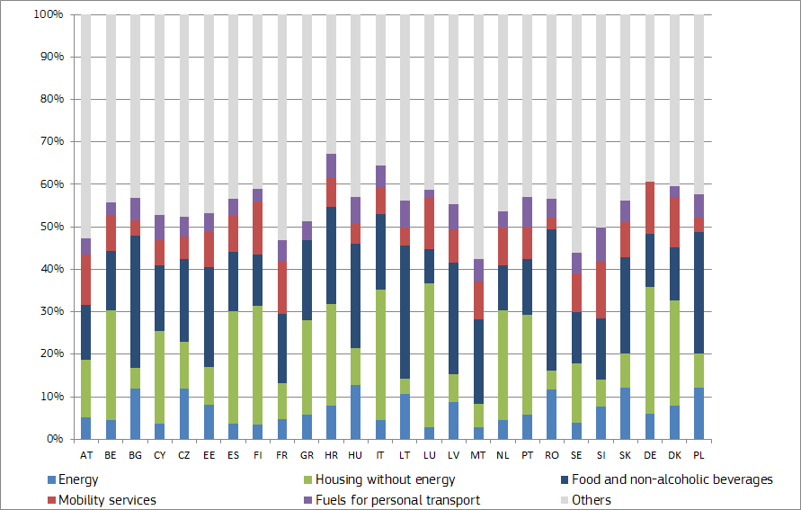

Figure 112 - Shares of consumer goods groups in household expenditure in Member States

Source: DG ENER ad hoc data collection on household consumption expenditures[16]

After looking at the overall consumption of goods and services in the household sector, the analysis will now focus on household expenditures on energy products. Almost all of the twenty-seven EU Member States responded to the Commission request for detailed data on the final household expenditures by decile over the last ten years. This has provided an excellent basis for analysis of households’ expenditure on energy and other products. Each income decile represents 10% of the population regarding the income of households; hereinafter, the lowest income decile is called Decile 1, the lower-middle income of households is called Decile 3 and the middle income of households is called Decile 5. Households in different income deciles normally spend different shares of their financial resources on energy products as **Figure 113** shows. As it is presented on this chart, there were significant differences across EU Member States spending the share of energy products within the total household expenditure in 2018 in the main three deciles studied. We observe that the share of total expenditure on energy products is inversely proportional to income, implying that poorer income households spend proportionally more on energy products (a basic good) than households with high income.

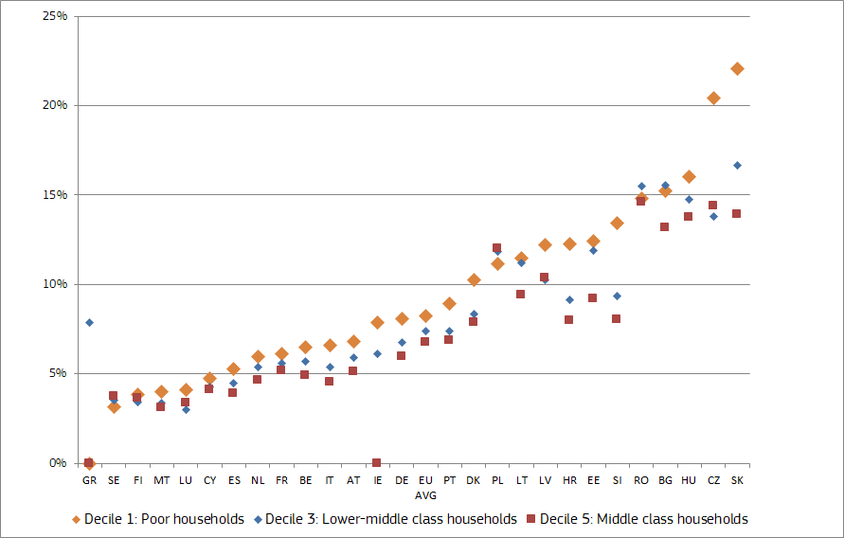

Figure 113 - Energy share in the total households’ expenditure by income decile in 2018

Source: DG ENER ad hoc data collection on household consumption expenditures

### Energy expenditure (excluding transport) in households

In order to have a better understanding athow consumption and monetary expending on energy products change over time in households, it is useful to analyse the purposes of energy consumption in the residential sector.

EUROSTAT, the Statistical Office of the European Union, has published the results of the latest data survey on final energy consumption of households. From this dataset some interesting conclusions can be drawn. **Figure 114** shows the distribution of energy products used in the residential sector: most of the EU final energy consumption in households is covered by natural (32.1%) and electricity (24.7%). On the other hand, renewables (mainly solid biofuels) and waste cover the 19.5% followed by petroleum products (11.6%) and derived heat (8.7%). A small proportion is still covered by coal products (solid fuels) (3.4%).

Most EU Member States rely mainly on electricity to meet their household needs. Nine Member States use electricity as the main energy source in households, followed by renewable energies (mostly in the form of solid biofuels) which is the main source of energy for eight Member States. Natural gas is the main source of energy for seven Member States. Three Member States use mostly other energy products: Denmark relies mainly on derived heat, Poland’s main source of energy are solid fuels and Ireland uses mostly petroleum products.

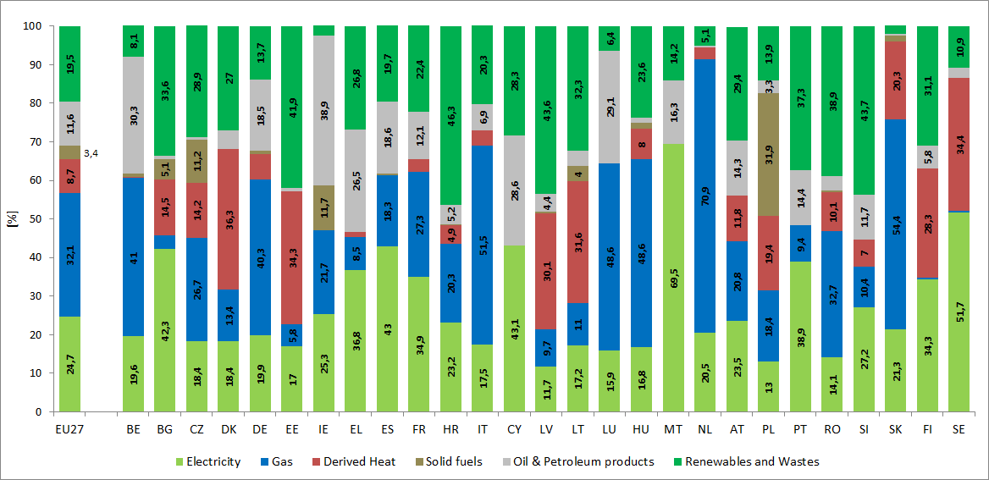

Figure 114 - Share of fuels in final energy consumption in the residential sector by EU Member State (2017)

Source: EUROSTAT Energy consumption in households[17]

**Figure 115** shows the share of final energy consumption in the residential sector by type of end-use in 2018 for the EU member states. From the perspective of energy consumption in households, energy is mostly used for space heating (63.6%). Lighting and appliances represent 14.1% of the final energy consumption in households, while the proportion of energy used for water heating is slightly higher, representing 14.8%. Main cooking devices require 6.1% of energy used by households, while space cooling and other end-uses cover 0.4% and 1.0% respectively. It is worth mentioning that numbers for space cooling are much higher for Southern Europe and Mediterranean Member States (notably Malta with a 12.3% of the share of final energy consumption). It is interesting to note that heating of space and water consequently represents 78.4% of the final energy consumed by households.

According to the latest EUROSTAT information, heat energy, solid and liquid fuels are mostly used for space and water heating, and to a small extent also for cooking. Electricity is used largely for lighting and appliances, but also for water and space heating, while natural gas is utilised mainly for space heating and cooking purposes. Renewables (mainly solid biofuels) are used mostly for space heating purposes.

Furthermore, the highest proportions of energy used for space heating are observed in Luxembourg (78.7%), Belgium (73.5%), Estonia (72.7%), Hungary (71.7%) and Lithuania (70.3%), while the lowest quantities are used in Malta (20.4%), Portugal (28.2%) and Spain (43.1%).

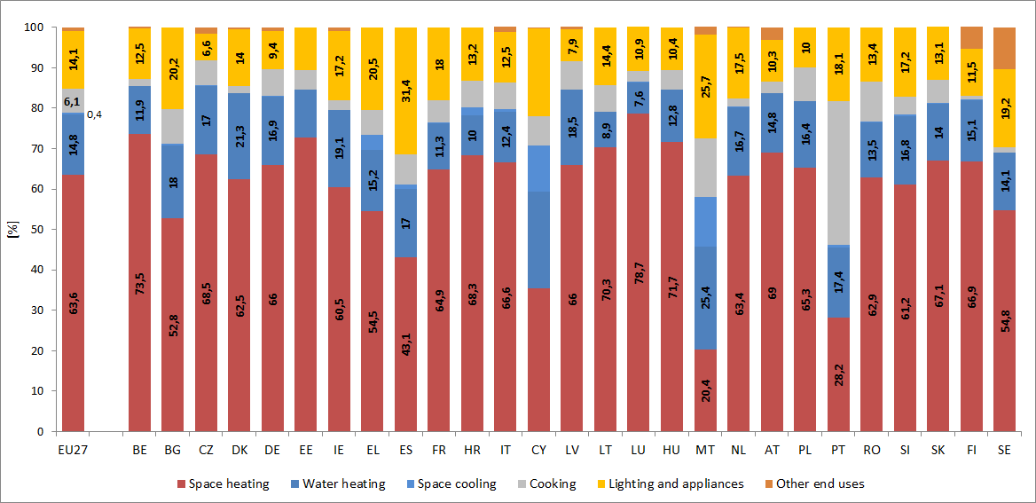

Figure 115 - Share of end-use energy consumption in the residential sector by EU Member State (2018)

Source: EUROSTAT Energy consumption in households[18]

### Energy expenditure (excluding transport) in households with low income

The next chart (**Figure 116**) shows energy expenditure of households in the lowest decile (the poorest ten per cent of the population) in the EU countries[19]. In the EU € 945 was spent on energy on average by the poorest household according to the latest data[20], which represented **8.3%** of their total consumption expenditure. There were very significant differences across the EU on both absolute expenditures and the share of energy in the total household expenditure. In Latvia and Romania the annual energy expenditure remained below € 500[21], in contrast, in Denmark it was above € 2500 in 2017-2018. This five-fold difference in energy expenditures reflect mainly differences in average household incomes in different EU Member States, however, differences between household energy prices also play a role. In the case of heating related expenditure the quality of residential building stock also has of particular importance, as energy expenditure can be reduced if buildings are more energy efficient.

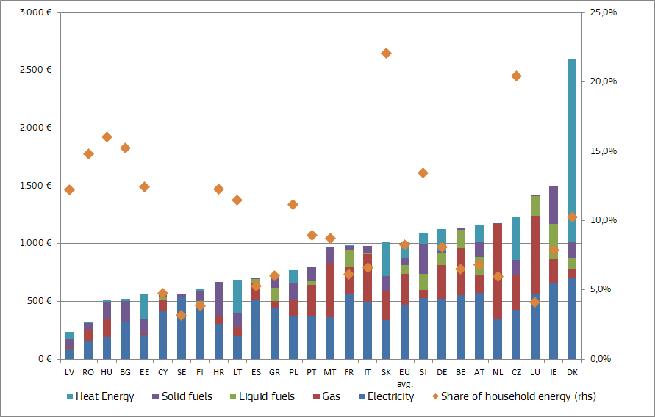

Figure 116 – Energy products expediture for the poorest households and the energy share in total household consumption expenditure by EU Member State

Source: DG ENER ad hoc data collection on household consumption expenditures

As **Figure 117** shows, looking at the shares of energy products in the households' budget[22], in Sweden the poorest households spent only 3.2% of their total expenditure on energy, whereas in Slovakia this share was higher than 22.1%. Countries in Central and Eastern Europe, primarily owing to lower incomes compared Northern and Western Europe, spent significantly higher share on energy within their household expenditure.

The role of different household energy products may also differ across the EU. A good example for this is the high share of district heating in Denmark, representing more than half of the total energy-related household expenditures[23]. In Estonia, Lithuania, the Czech Republic and Slovakia district heating also had an important share in household energy.

Electricity accounts for a high share of the household expenditure in Sweden, Finland, Cyprus and Spain; in these countries this energy source is dominant not only for residential lighting but also for heating. Natural gas represented a high share of household expenditure in the Netherlands, Malta and Luxembourg, and liquid fuels, mainly in the form of heating oil, are of importance within household energy in Ireland, Greece and France. Solid fuels only represented a small fraction in the total energy expenditure in the EU, however, in some Central and East European countries they still had a measurable share.

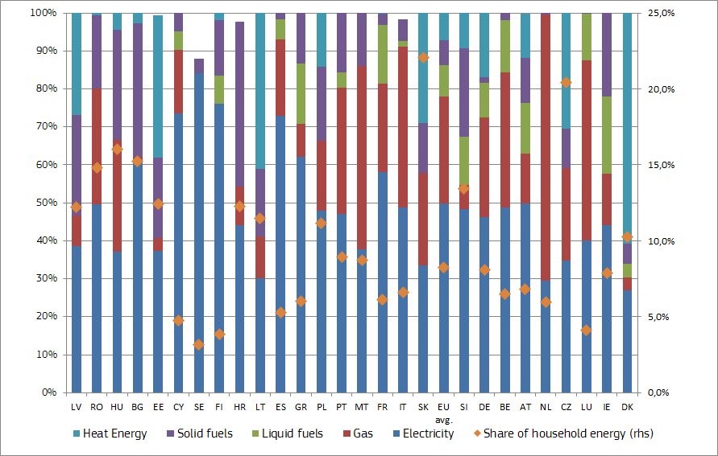

Figure 117 - Share of expenditure on household energy products and share of energy in total expenditure for the poorest households by EU Member State

Source: DG ENER ad hoc data collection on household consumption expenditures[24]

### Energy expenditure (excluding transport) in households with middle income

Beside the poorest households, it is also important to analyse the situation of the lower-middle income and middle-income households. These household income levels are represented by the third and the fifth income decile (or by the second and the third quintile, for countries where deciles are not available) in the expenditure data**.** As **Figure 118**, **Figure 119**, **Figure 120** and **Figure 121** show, the order of the countries regarding the absolute spending on energy products and that the distribution of individual energy sources within the total spending on energy is similar in all income deciles. Naturally, the higher income a given household has, the higher is the amount it spends on energy products[25].

Conversely, households with higher income spend proportionally less on energy products, compared to their total consumption expenditure, than poorer households. In the third decile (lower-middle income households) the average share of energy in total spending was only 7.4% (as opposed to 8.3% in the case of the poorest), and in the fifth decile (middle income households it was 6.3%. However, even for middle income households differences across Europe are perceivable regarding the share of energy in total spending, as households in Northern and Western Europe spent typically between 3% and 8% of their expenditure on energy, in Central and East Europe this share was 10-15% in recent times, implying that amid current income levels energy represents a significant burden for households in these latter countries.

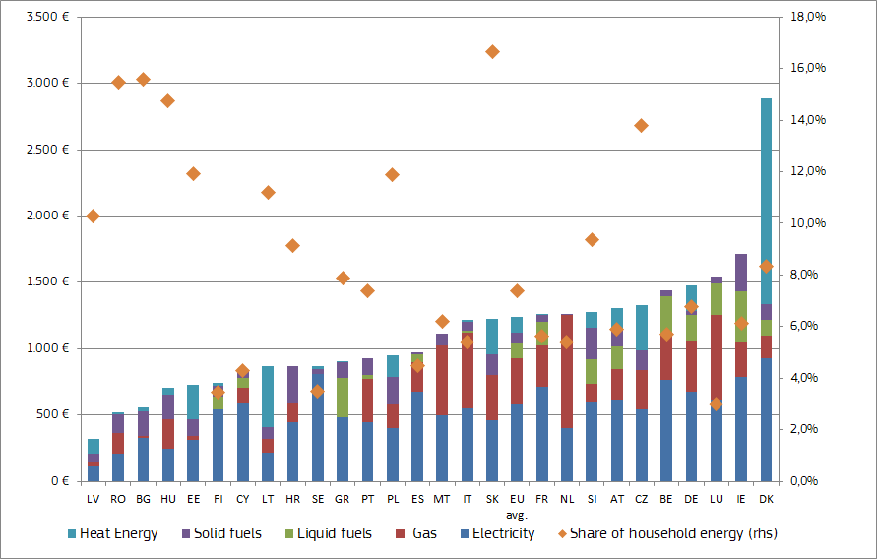

Figure 118 - Energy product expenditure for lower-middle income households and the energy share in household expenditure by EU Member State

Source: DG ENER ad hoc data collection on household consumption expenditures

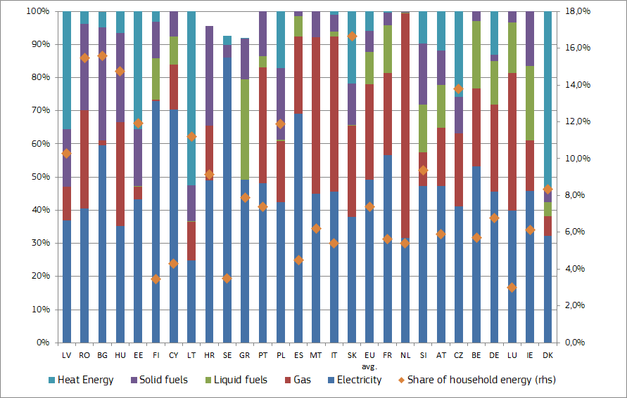

Figure 119 - Share of expenditure on household energy products and share of energy in total expenditure for lower-middle income households by EU Member State

Source: DG ENER ad hoc data collection on household consumption expenditures[26].

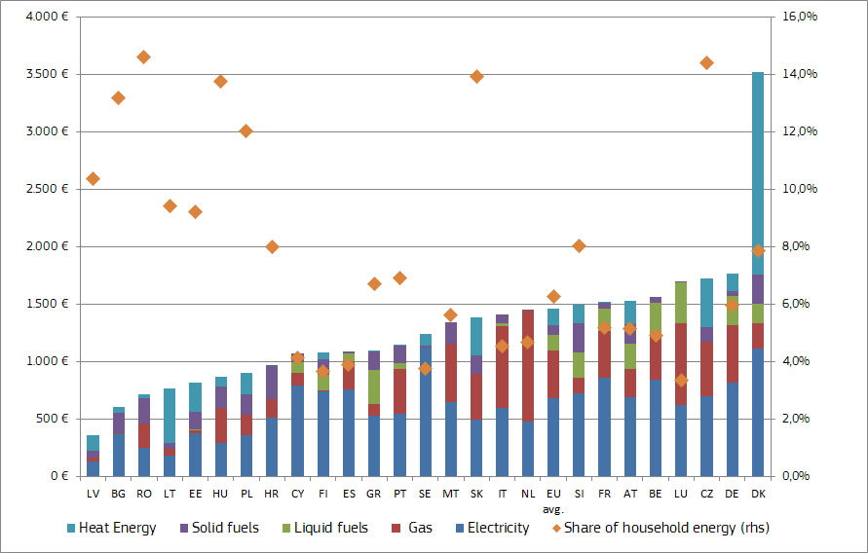

Figure 120 – Energy product expenditure for middle income households and the energy share in household expenditure by EU Member State

Source: DG ENER ad hoc data collection on household consumption expenditures

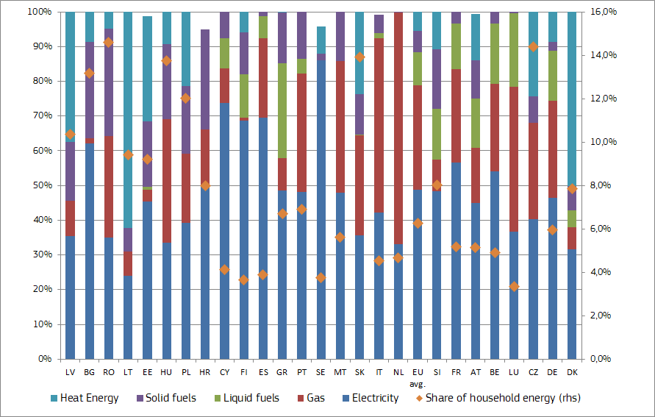

Figure 121 - Share of expenditure on household energy products and share of energy in total expenditure for middle income households by EU Member State

Source: DG ENER ad hoc data collection on household consumption expenditures[27]

A few other indicators exist that shed light on the burden of household relating to paying their energy bills and/or keeping their home sufficiently warm. **Figure 122** shows the relation between spending on energy (in the share of the total) for lower-middle income households and the share of those being unable to warm up their home sufficiently.

Whereas in Finland only 3.1% of the households being under 60% of the median income were not able to keep their home adequately warm, in Bulgaria this share was more than 56% in 2018. The share of homes non-adequately warm shows a positive correlation (though not very strong, having a coefficient around 0.21) with the share of energy in total expenditures. The correlation is weakened by the data in some Mediterranean EU Member States, owing to lower energy expenditure amid warmer climate; however, this is not reflected in the perception of households on having a sufficiently warm home.

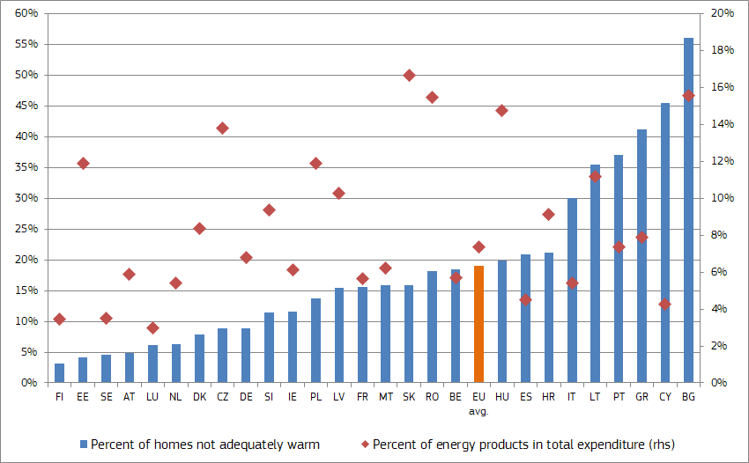

Figure 122- Ratio of homes not adequately warm for households below the 60% of the median income and the share of energy products in expenditure for the lower-middle income households

Source: DG ENER ad hoc data collection on household consumption expenditures and Eurostat

**Box –Energy efficiency of the household sector**

Energy efficiency measures can help the reduction of total residential energy consumption. Consumption of energy in the EU residential sector, accounting for around a quarter of total final energy use, dropped by 1.8% between 2016 and 2018. Over the last years, due to a well-established regulatory framework for energy performance of buildings and higher standards for equipment and appliances, the EU building stock became more efficient. This is particularly the case for new buildings. However, in order to reach climate-neutrality by 2050, consumption in households must decrease further. To achieve this, we need highly energy and resource efficient buildings and efficient heating systems and efforts should shift to existing households as almost 75% of the existing building stock in the EU is inefficient and current renovation rates are only about 1%. This is exactly the aim of the Renovation Wave initiative, a flagship initiative of the European Green Deal with central role to the Recovery package. It will seek to steer public and private funding towards renovation projects with the biggest societal gains. The aim of the Renovation wave is to significantly increase the renovation rate, support fast, integrated, high-quality deep renovation of buildings with direct impact on energy consumption in households. The Renovation Wave initiative in line with key tools like the national long-term renovation strategies, will pay special attention at the residential sector as it represents the majority of buildings and will carefully consider the social context, housing accessibility, affordability of housing and health issues linked to housing of poor quality, housing of low-income people and energy poverty. The national long-term renovation strategies are key for improving the energy performance of the existing building stock into a highly efficient and decarbonised building stock by 2050. These strategies should encompass a roadmap with measures, measurable progress indicators and indicative milestones for 2030, 2040 and 2050 as well as address many elements, such as energy poverty, health, policies targeting the worst performing buildings, split-incentive dilemmas, and social housing.

In addition, the efforts to ensure compliance and enforcement of the existing Energy labelling and Eco-design regulations needs to continue, and the Eco-design and Energy Labelling Working Plan under preparation will identify priorities for the years ahead.

That said, energy consumption in the residential sector is not only impacted by the energy efficiency of buildings and their equipment and appliances. A higher number of households, the higher floor area of buildings and a higher disposable household income may result in higher energy consumption. In addition, high energy prices could also result in lower consumption, although energy is a rather price-inelastic product. The weather and climate conditions influence importantly energy consumption (particularly in the cold seasons of the year as two thirds of total energy consumed by households is related to heating needs).

### Share of energy in the household expenditure by income and Member States

The following charts show the share of energy in final expenditure in three different income deciles (poorest, lower-middle and middle income) in the EU-27 Member States. A regional approach has been followed to enable comparisons for the Member States with their neighbouring peers[28].

As **Figure 123** shows[29], these seven North Western European countries spent slightly less than the EU average on energy products in the most recent years. In the middle income decile households spent 3%-6% of their total expenditure on energy, while in the lowest income decile this share varied between 4% and 8%. In these Member States households have high household expenditures in EU comparison and this must be a principal reason why the share of energy is less than the EU average. In the case of Ireland, only data on the share of energy expenditure from the lowest and lower-middle income households was available.

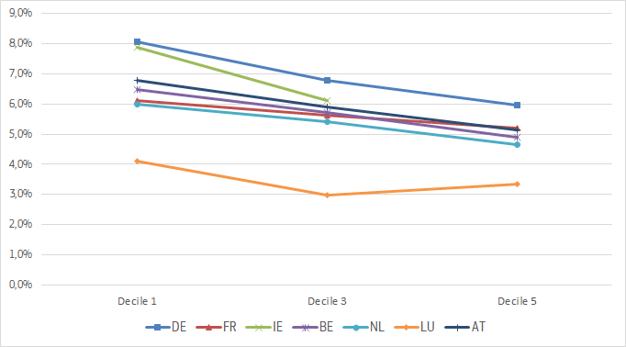

Figure 123 - Germany, France, Ireland, Belgium, Netherlands, Luxembourg and Austria - Share of energy in final household expenditure per income deciles

Source: DG ENER ad hoc data collection on household consumption expenditures

In the South European and Mediterranean islands countries the share of energy within total household expenditures was also lower than the EU average as shown in **Figure 124**. It is worth mentioning the dispersion in shares of energy within the total expenditure in different countries was quite significant[30]. In the lowest income decile households spent 4-9% of their total expenditure on energy, while in the middle income decile this share varied between 4% and 7%. Heating needs are commonly lower in these countries compared to other regions of Europe due to favourable weather conditions; this might also contribute to lower than EU average shares on energy within the total household expenditure.

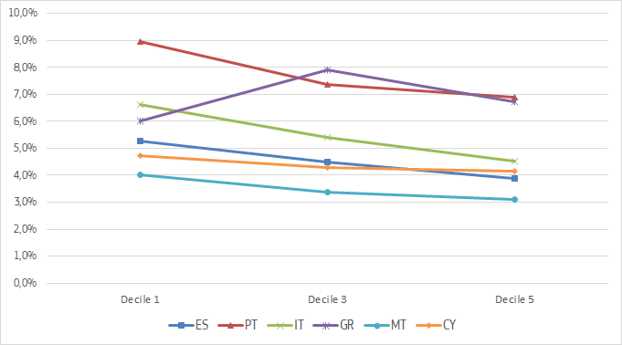

Figure 124 - South European countries: Spain, Portugal, Italy, Greece, Malta and Cyprus - Share of energy in final household expenditure per income deciles

Source: DG ENER ad hoc data collection on household consumption expenditures

Central and Eastern European countries (**Figure 125**) presented a share of energy in total household expenditures considerably higher than the EU average, ranging from 11% to 22% in the lowest income decile, while in the middle income decile it varied between 12% and 14%. Higher-than-EU average share of energy in the total household expenditure might reflect potential of improvements in energy efficiency of residential buildings and a relatively low purchasing power and total consumption expenditure in these Member States.

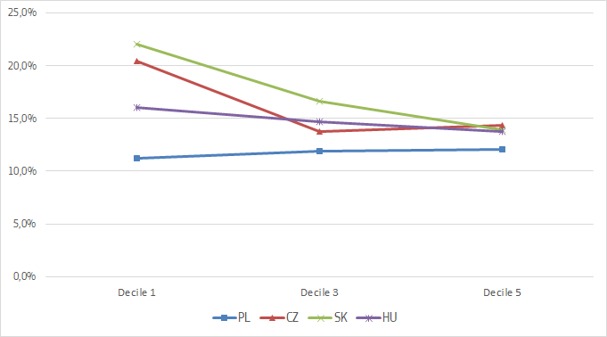

Figure 125 - Poland, Czechia, Slovakia and Hungary - Share of energy in final household expenditure per income deciles

Source: DG ENER ad hoc data collection on household consumption expenditures

Even when the climate conditions in Sweden and Finland (**Figure 126**) imply significant heating needs in comparison with other EU Member States, the share of energy in total household expenditures are among the lowest in the EU, reflecting high efficiency standards of residential buildings and elevated purchasing power and consumption expenditures of households. Low retail electricity prices in EU comparison also contribute to low energy expenditures in these two countries as electricity makes up the bulk of energy expenditures.

In contrast, the share of energy expenditures in the three Baltic States is significantly higher than in the Nordic countries, in spite of the similar climate conditions and low retail electricity and gas prices in comparison with EU Member States.

Furthermore, the importance of energy in total household expenditures in Denmark is higher than in the rest of the Nordic countries, due to the relatively high energy prices.

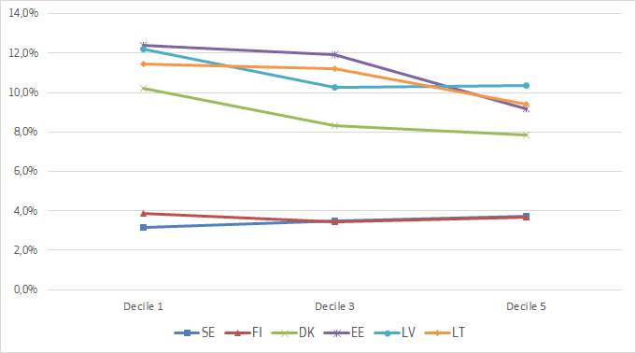

Figure 126 - Nordic and Baltic countries: Sweden, Finland, Denmark, Estonia, Latvia, Lithuania - Share of energy in final household expenditure per income deciles

Source: DG ENER ad hoc data collection on household consumption expenditures

Finally, in spite of having low retail energy prices in EU comparison, Croatia, Slovenia and Romania presented shares of energy expenditure higher than EU average according to the latest data (**Figure 127**). Low purchasing power and consumption expenditure of households plus low energy efficiency of residential buildings might be the potential cause for these results.

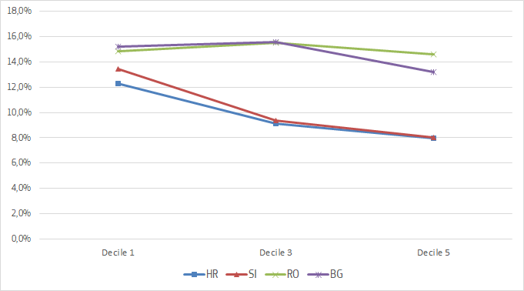

Figure 127 - South East Europe: Croatia, Slovenia, Romania and Bulgaria - Share of energy in final household expenditure per income deciles

Source: DG ENER ad hoc data collection on household consumption expenditures

### Energy expenditures in the transport sector

**Figure 128, Figure 129**, **Figure 130** and **Figure 131** show the expenditures and the respective shares on transport fuels (petrol and diesel, or in the case of some Member States where detailed data were not available, fuels and lubricants total). Similarly to household energy products, there were significant differences across the Member States, both in absolute spending on fuels and in their share in the total household expenditure.

There were five Member States (Romania, Slovakia, Bulgaria, Estonia and Croatia) where spending on transport fuels remained below € 100 per household in 2018, whereas in Luxembourg, France, Cyprus and Malta it was above € 600. In the EU the poorest households spent € 390 on average on transport fuels, representing 3% of the total consumption expenditure. The lowest share of transport fuels within the total expenditure could be observed in Romania (0.6%), whereas in Malta the poorest households spent 9.5% on transport fuels of their total expenditure.

The share of petrol and diesel within transport fuels was different across the EU. In countries like the Netherlands, Sweden, and Czechia and most of the countries in Central and Eastern Europe expenditures on petrol dominated the transport fuel bill, whereas in France, Luxembourg, Latvia and Romania diesel had a significant share (though with the exception of Romania it was higher than the share of petrol).

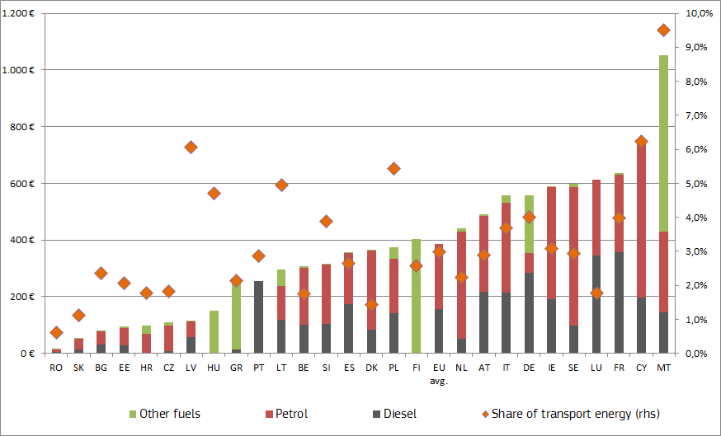

Figure 128 - Expenditures on transport energy products for the poorest households by EU Member State, and energy transport share in household expenditure

Source: DG ENER ad hoc data collection on household consumption expenditures[31]

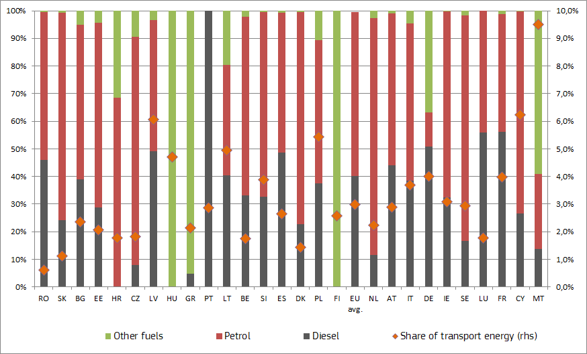

Figure 129 - Share of expenditure on transport energy products and share of transport energy in total expenditure for the poorest income households by EU Member State

Source: DG ENER ad hoc data collection on household consumption expenditures

In contrast to household energy products, the share of transport fuels within the total expenditure proportionally increases with the income of households, otherwise saying richer households tend to spend more on transport fuels within their total expenditure. As it was mentioned before, the poorest households spent 3% on transport energy on EU average, while those in the third income decile (lower-middle income) and in the fifth decile (middle income) respectively spent 4% and 4.4%. Expenditures on transport fuels reached € 1060 in the case of middle income households in 2018 in the EU.

Comparing the details of transport fuel expenditures of the poorest and middle income households, it seems that the share of diesel fuel is higher in the case of middle income households than for the poorest. Diesel engine cars are more popular among those who use their car more frequently, or having a higher annual mileage, as in many countries taxation of diesel fuels is more favourable (or at least it used to be in the past) compared to petrol.

As households with higher income rely more on private transport, they spend proportionally more on diesel than the poorer. However, in the future this might change as difference in taxation of petrol and diesel (mainly excise duties) will diminish and due to the changing environmental rules and public acceptance; thus diesel may not be as attractive alternative to petrol cars as in the past.

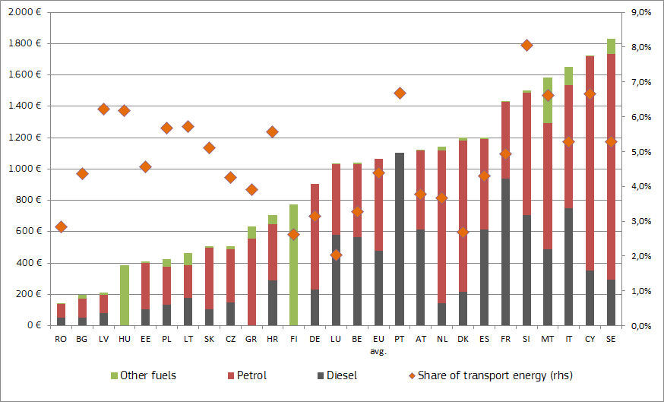

Figure 130 - Expenditures on transport energy products for middle income households by EU Member State, and energy transport share in household expenditure

Source: DG ENER ad hoc data collection on household consumption expenditures

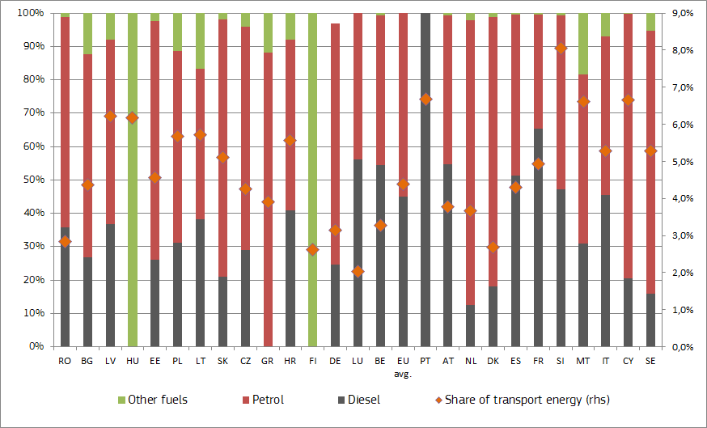

Figure 131 - Share of expenditure on household transport energy products and share of transport energy in total expenditure for middle income households by EU Member State

Source: DG ENER ad hoc data collection on household consumption expenditures

**Energy poverty and other indicators**

The European Energy Poverty Observatory looks at a wide array of income-related indicators, beyond the share of energy expenditure in the total expenditure of households. Where Member States have updated data, they can provide relevant insights about households suffering from energy poverty. Energy poverty can be revealed by households having high levels of their expenditure on energy. This may occur when there is a prioritisation of household expenditures which puts basic needs (including energy) first. One of these indicators measures the proportion of households whose energy expenditure is more than twice the national median share as shown in **Figure 132.**

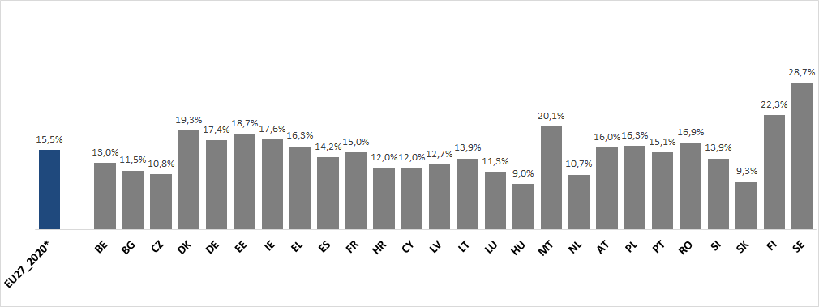

Figure 132 - Proportion of households whose share of energy expenditure in income is more than twice the national median share (2M)

Source: Eurostat, Household Budget Surveys, 2015

But not always higher shares of spending on energy may be revealing situations of energy poverty. In cases of extreme poverty, energy might be considered ‘less necessary’ than other spending on basic goods and services like food or house-renting. This re-prioritisation of spending can result in energy spending (while necessary) remaining at very low levels, ‘hiding’ that households are depriving themselves from having adequate levels of energy consumption. For these cases, an additional indicator which captures when the share of households whose absolutely energy expenditure is particularly low is useful and complements other indicators in identifying households’ energy poverty. **Figure 133** shows the ‘hidden’ energy poverty across MS, defined as *‘the share of households whose absolute energy expenditure is below half the national median’.* Where high shares of the indicator appear, it is important to assess whether they are caused by households seriously under-consuming energy, for example due to a lack of access to the market, or cases where high shares may depict high energy efficiency standards.

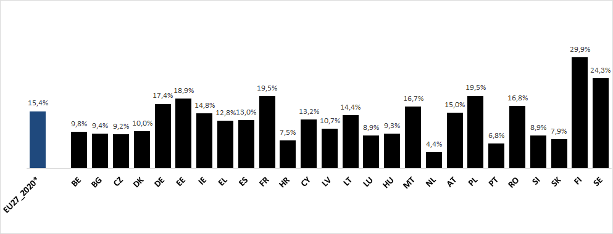

Figure 133 - Share of households whose absolute energy expenditure is below half the national median (M/2, hidden energy poverty).

Source: Eurostat, Household Budget Surveys, 2015

These two indicators show a shift in literature towards increased use in expenditure base metrics of relative thresholds rather than just fixed thresholds.

Whilst the above indicators aim to compare energy expenditure and income, income levels are beyond the scope of energy policy. In contrast, energy costs affecting energy expenditure and the energy-efficiency of dwellings are areas relevant for energy policy.

Another interesting indicator is to look into arrears on utility bills, i.e. the situation where a household has not been able to pay the utility bills (heating, electricity, gas, water, etc.) of the main dwelling on time due to financial hardship.

**Figure 134** shows the evolution of arrears of utility bills in the European Union between 2010-2018, compared with the change in share of energy expenditure for the most susceptible deciles of income to suffer from this issue in same period of time (lowest, lower-middle and middle income).

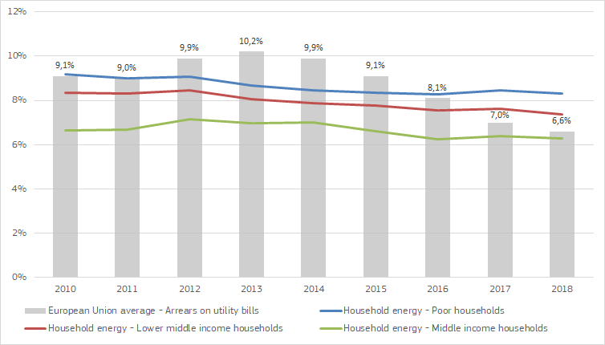

Figure 134 - Arrears on utility bills for EU average households and expenditures on household energy (electricity, gas, heating, etc.) for the poorest, lower-middle and middle income households by EU Member State

Source: Eurostat, SILC, [ilc_mdes07] and DG ENER ad hoc data collection on household consumption expenditures

It is interesting to observe that arrears on utility bills have been evolving favourable since the end of the last economic crisis, as this indicator rose from 9.1% in 2010 to 10.2% in 2013, and ever since it has been falling steadily to 6.6% in 2018. This trend can be explained by the increase of household income since the end of the 2008 financial crisis. Therefore as the economy improves, wages and incomes also ameliorate, thereby enabling households to pay for their energy expenditures.

### Change in energy expenditures in the Member States (2008-2018)

**Figure 135** shows how the share of energy and transport in the final household consumption expenditure has changed between 2008 and 2018, as the evolution in time for the poorest, lower-middle and middle income households of the energy expenditures on households (electricity, gas, heating and other fuels) and transport fuels (petrol and diesel, or in the case of some Member States where detailed data were not available, fuels and lubricants total).

The blue lines represent the share of energy and transport (dotted lines) in the first income decile, while the red and green lines represent households with lower-middle income and middle income for the average of EU27.

In the case of the share of energy expenditure in households, there is a marginal decreasing trend over the years that can be observed in the different deciles of income, as opposed by the slow but steady increase of energy expenditure in transport. It is interesting to notice that while poorest households tend to spent more on energy for appliances, gas, heating and other fuels, the same decile of income spent less on transport. The opposite situation happens for the middle income deciles: they spent less on energy for electricity, gas, heating, and other fuels, while they tend to spent more on transport related activities. As mentioned in the previous section, this can be explained as households with higher income, rely more on private transportation than lower income households.

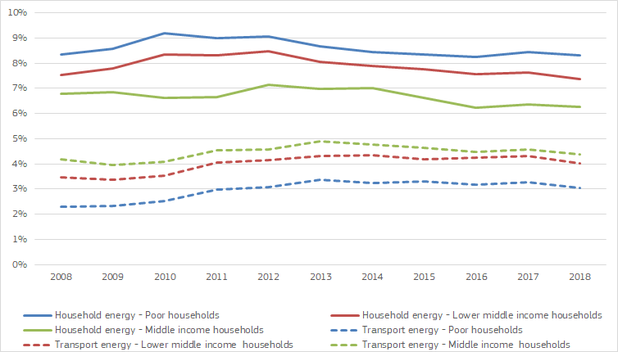

Figure 135 - Expenditures on household energy (electricity, gas, heating, etc.) and transport energy (petrol, diesel, etc.) for the poorest, lower-middle and middle income households by EU Member State

Source: DG ENER ad hoc data collection on household consumption expenditures

It is also worth noting different trends across the last ten years, as detailed in **Table 9.** While in 2008 the share of household expenditure on energy was 8.3% in the case of the poorest households, in 2012 this value reached 9.1%, as retail energy prices underwent a significant increase as consequence of the 2008 economic crisis. From 2012 to 2016, the lowest income decile experienced a slight decrease on the share of energy expenditure, leading to 8.3%. There was no meaningful change until 2018, where the share of energy expenditure in this decile remained in the same value (8.3%).

The share of energy expenditure in the middle income households was less affected by the economic crisis, as this value increased slightly from 6.8% in 2008, to 7.1% in 2012. From 2012 to 2018, the middle income decile experienced a decreasing overall trend with a peak in 2012 (7.1%) falling to 6.3% in 2018.

In the case of energy expenditure in transport, the data in **Table 10** shows an increasing overall trend from 2008 (2.3%) to 2013 (3.4%) in the lowest income decile of households, in spite of the effects of the global economic recession post 2008. This indicator remained relatively stable, reaching a value of 3.0% in 2018. Middle income households presented a similar pattern on energy transport expenditure, as share of transport energy expenditure rose from 4.2% in 2008, to 4.9% in 2013. Furthermore, this indicator marginally decreased to 4.4% in 2018. It is interesting to note that transport energy expenditure does not reflect the volatility of oil prices, showing that domestic fuel prices and expenditure are not directly related.

Table 9 - Timely evolution of energy expenditure shares (%) 2008-2018

|  |  |  |  |  |  |  |
| --- | --- | --- | --- | --- | --- | --- |
|  | 2008 | 2012 | 2018 | 2008-2012 change | 2012-2018 change | 2008-2018 change |
| Poor households | 8.3 | 9.1 | 8.3 | 0.7 | -0.7 | 0.0 |
| Lower middle income households | 7.5 | 8.5 | 7.4 | 0.9 | -1.1 | -0.1 |
| Middle income households | 6.8 | 7.1 | 6.3 | 0.4 | -0.9 | -0.5 |

Source: DG ENER ad hoc data collection on household consumption expenditures

Table 10 – Timely evolution of transport energy expenditure shares (%) 2008-2018

|  |  |  |  |  |  |  |
| --- | --- | --- | --- | --- | --- | --- |
|  | 2008 | 2013 | 2018 | 2008-2013 change | 2013-2018 change | 2008-2018 change |
| Poor households | 2.3 | 3.4 | 3.0 | 1.1 | -0.3 | 0.8 |
| Lower middle income households | 3.5 | 4.3 | 4.0 | 0.8 | -0.3 | 0.6 |
| Middle income households | 4.2 | 4.9 | 4.4 | 0.7 | -0.5 | 0.2 |

Source: DG ENER ad hoc data collection on household consumption expenditures

1. This chapter analyses EU-28.
2. Import dependency is calculated as net imports divided by gross inland consumption.
3. The CIF price includes the FOB price (the price actually invoiced at the port of loading), the cost of transport, insurance and certain charges linked to crude oil transfer operations.
4. <http://eur-lex.europa.eu/legal-content/EN/ALL/?uri=CELEX:31995R2964>
5. <https://ec.europa.eu/energy/en/statistics/eu-crude-oil-imports>
6. https://transparency.entsog.eu/
7. Including small-scale terminals in Finland and Sweden.
8. This includes anthracite, coking coal, other bituminous coal and sub-bituminous coal
9. <http://www.ecb.europa.eu/stats/exchange/eurofxref/html/index.en.html>
10. See Commission President Juncker's speech on the State of the Union, 2018. https://ec.europa.eu/commission/sites/beta-political/files/soteu2018-speech_en_0.pdf
11. COM(2019) 640 final – Commission Communication on the European Green Deal.
12. European Commission, Communication From The Commission To The European Parliament, The European Council, The Council, The European Economic And Social Committee And The Committee Of The Regions Europe’s moment: Repair and Prepare for the Next Generation, 27 May 2020
13. As pursuant to Article 2a of the Energy Performance of Buildings Directive 2018/844/EU.
14. COM(2020) XX final – Commission Recommendation on Energy Poverty. [B3].
15. Data for Germany, Denmark and Poland remain as income quintiles.
16. Information was not available for IE.
17. [https://ec.europa.eu/eurostat/statistics-explained/index.php/Energy_consumption_in_households#Energy_products_used_in_the_residential_sector](https://ec.europa.eu/eurostat/statistics-explained/index.php/Energy_consumption_in_households)
18. [https://ec.europa.eu/eurostat/statistics-explained/index.php/Energy_consumption_in_households#Energy_products_used_in_the_residential_sector](https://ec.europa.eu/eurostat/statistics-explained/index.php/Energy_consumption_in_households)
19. For some countries (Germany and Denmark) data of the lowest quintile (the poorest 20% of the population) was used for the computations as we did not receive decile data from the national authorities or there were issues with the data quality.
20. EU average is calculated as weighted average from Member States' expenditure data, using the number of households as weight. Latest available data in most cases mean 2017 or 2018 data, however, due to different data collection in different countries, in some cases data might be of earlier time period.
21. In this chapter expenditures are expressed per household.
22. As HBS data are not fully harmonised in the EU, the actual shares might differ from the result of this analysis. In some countries the share of energy is low in the total expenditure, as energy bills are "hidden" in the rental payments in the housing sector.
23. The high expenditures on district heating in Denmark was rather due to the broad deployment of district heating, not to the costs of this technology. According to the Danish District Heating Association, around 64% of all Danish households were connected in 2017 to the district heating grid, and district heating companies were legally bound to run on a non-profit basis.
24. Ad hoc data collection was not complete for all Member States and this results in small shares of some products that could not be accounted for.
25. Not big differences were found in the share of energy products in lower deciles, including for solid and liquid fuels (6.5% and 8% for the poorest households and 6% and 10% for middle income households) as well as gas (28% for the poorest households and 30% for middle income households). In the case of electricity, the share in the poorest households accounts for 50% while in the middle income decile was 49%.
26. Ad hoc data collection was not complete for all Member States and this results in small shares of some products that could not be accounted for.
27. Ad hoc data collection was not complete for all Member States and this results in shares of some products that could not be accounted for.
28. In Annex I a comparison of the timely evolution of share of energy in total consumption in each the five quintiles can be found for each EU Member States.
29. In this chapter figures always show the most recent available data for each country. As the reporting periods for Household Budget Surveys are not harmonised across the EU countries, data might not stem from different years.
30. It is worth noting here that the curves for different countries represent substantially different time periods, pending on the last available data, which makes cross country comparisons less reliable.
31. Note: "Fuels and lubricants total" cover diesel, petrol and other fuels and lubricants. A split is not available by fuel in these EU Member States.